

COMMISSION STAFF WORKING DOCUMENT

Accompanying the document

Report from the Commission to the Council and the European Parliament

Final report on the E-commerce Sector Inquiry

**Table of Contents**

A. INTRODUCTION 9

1. The wider context: The Digital Single Market strategy 9

2. The reasons for launching the sector inquiry 10

3. The purpose of the sector inquiry 17

4. The main steps of the sector inquiry 17

5. Analytical framework 18

6. Selection of addressees: goods 22

6.1 Selection of retailers 22

6.2 Selection of manufacturers 23

6.3 Selection of marketplaces, price comparison tools and payment system providers 23

6.4 Responses received 23

7. Selection of addressees: digital content 25

7.1 Selection of digital content providers (retail markets) 25

7.2 Selection of right holders (wholesale markets) 27

B. E-COMMERCE IN GOODS 29

1. Characteristics of respondents 29

1.1 Retailers 29

1.2 Manufacturers 32

1.3 Marketplaces 34

1.4 Price comparison tools 38

1.5 Payment service providers 42

2. Main features of competition in e-commerce in goods 43

2.1 The concentration of manufacturers and retailers in the sectors covered by the sector inquiry 43

2.2 Main parameters of competition 44

2.3 Pricing 51

2.4 Differences between online and offline offers 54

3. Distribution strategies 55

3.1 Distribution strategies of manufacturers 56

3.1.1 Sales channels 56

3.1.2 Trends in manufacturers' distribution strategies 60

3.2 Distribution strategies of retailers 64

3.3 Different types of distribution agreements used 65

3.3.1 Territorial exclusive distribution agreements 65

3.3.1.1 Prevalence of territorial exclusive distribution 66

3.3.1.2 Reasons for using territorial exclusive distribution agreements 68

3.4.3 Selective distribution 71

3.4.3.1 Overview and development of selective distribution 71

3.4.3.2 The reasons for opting for selective distribution 75

3.4.3.3 The selection criteria 77

3.4.3.4 Pure online players in selective distribution 82

3.4.3.5 General considerations on selective distribution 83

3.4.4 Agency agreements 86

4. Restrictions to sell and advertise online 88

4.1 Motivations for restrictions 88

4.1.1 Product quality, brand image and price 88

4.1.2 Customer services, promotion and advertising 89

4.1.2.1 Types of customer services 90

4.1.2.2 Financing of customer services 91

4.1.2.3 Promotion and advertising 94

4.1.3 Customers' purchasing behaviour and free-riding between the online and offline retail channel 97

4.2 Overview of restrictions 102

4.3 Cross-border e-commerce and geographic restrictions to sell and advertise online 105

4.3.1 Geographic sales strategies of manufacturers 106

4.3.2 Geographic sales strategies of retailers and cross-border e-commerce 108

4.3.2.1 Retailers not selling cross-border 108

4.3.2.2 Cross-border visits and transactions on retailers’ own websites 111

4.3.2.3 The role of online marketplaces for cross-border sales 113

4.3.2.4 The role of price comparison tools for cross-border sales 115

4.3.2.5 Geo-blocking measures 116

4.3.2.6 Geo-filtering and cross-border price and offer differences 118

4.3.2.7 Commercial reasons for not selling cross-border and costs of supplying abroad 121

4.3.3 Contractual territorial restrictions to sell and/or advertise online 123

4.3.3.1 Agreements between manufacturers and retailers restricting cross-border online sales 123

4.3.3.2 Monitoring of customer location 127

4.3.3.3 Geo-blocking measures, territorial restrictions and the EU competition rules 127

4.3.3.4 Indications of contractual territorial restrictions 132

4.4 Restrictions to sell on online marketplaces 133

4.4.1 Importance of marketplaces as a sales channel for retailers 134

4.4.2 Impact of sales through marketplaces on the business of manufacturers 140

4.4.3 Prevalence and characteristics of marketplace restrictions 142

4.4.4 Reasons put forward for marketplace restrictions by manufacturers 146

4.4.5 Reasons for marketplace restrictions reported mainly by retailers and some marketplaces 149

4.4.6 Possibilities offered by marketplaces to address quality requirements 149

4.4.7. Notice and take down procedures on marketplaces 149

4.4.8 Marketplace restrictions under EU competition rules 150

4.5 The use of price comparison tools and restrictions on the use of price comparison tools 155

4.5.1 Usage of price comparison tools by retailers 156

4.5.2 Restrictions on the use of price comparison tools 159

4.5.3 Reasons put forward for restrictions to use price comparison tools 162

4.5.4 Restrictions on the use of price comparison tools under EU competition rules 164

4.6 Pricing restrictions 167

4.6.1 Price setting at retail level 167

4.6.2 Monitoring of recommended retail prices 170

4.6.3 Retailers' compliance with price indications and reasons 172

4.6.4 Pricing restrictions under EU competition rules 173

4.6.5 Charging different wholesale prices for different sales channels 173

4.6.6 Online price transparency and the use of price monitoring software 175

4.7 Exclusivity and parity agreements ("MFN" clauses) between retailers and marketplaces and/or price comparison tools 177

4.7.1 Agreements between retailers and marketplaces 178

4.7.2 Agreements between retailers and price comparison tools 180

4.8 Other types of restrictions to sell or advertise online 180

5. Other observations 182

5.1 Data 182

5.1.1 Data collected by marketplaces and price comparison tools 182

5.1.2. Data collected by retailers 185

5.1.3 The use of data in e-commerce and potential competition concerns 186

C. E-COMMERCE IN DIGITAL CONTENT 188

1. Characteristics of respondents 188

1.1 Digital content providers 188

1.1.1 Types of operators 188

1.1.2 Business models 190

1.1.3 Size of activities 191

1.1.4 Revenue breakdown and advertising revenues 192

1.2 Right holders 195

1.2.1 Types of right holders 195

1.2.2 Size of activities of right holders 195

1.3 Types of content 196

2. Market trends and licensing practices 197

2.1 Market trends in the provision of online digital content services 197

2.2. Licensing practices 198

3. The scope of licensed rights: technologies 199

3.1 Definitions and data set 199

3.2. The scope of reception technology rights 210

3.3 The scope of ancillary and usage rights 214

3.4 Exclusive technology rights 218

3.5 Bundling of rights 220

3.5.1 Prevalence of bundling of rights 221

3.5.2 Bundling of rights 222

4. The scope of licensed rights: territories 223

4.1 Introduction 223

4.2 The territorial scope of online rights 224

4.2.1 The territorial scope of online rights in relation to different types of digital content 225

4.2.2 The territorial scope of online rights in relation to different types of digital content providers 227

4.2.3 The territorial scope of online rights in relation to the different business models used by digital content providers 229

4.3 Exclusive territorial rights 230

4.4 Reasons for non-availability of content across borders 231

4.5 Catalogue differences 234

4.6 Reasons for catalogue differences 235

4.7 Reasons provided by right holders why online rights are not licensed for certain territories 236

4.8 Geo-blocking of digital content services 237

4.8.1 Existence and extent of geo-blocking 237

4.8.2 Geo-blocking required by licensing agreements 241

4.8.3 Geo-blocking measures used to restrict cross-border access and portability 243

4.8.4 Restrictions on access and use in the terms of service for users 245

4.8.4.1 Unilateral restrictions on access and use in the terms of service for users 245

4.8.4.2 Contractual restrictions on access and use in the terms of service for users 246

4.9 Contractual provisions concerning monitoring, sanctions and compensation in relation to geo-blocking 248

4.9.1 Monitoring provisions 249

4.9.2 Sanctions and compensation for non-compliance with territorial and geo-blocking clauses 252

4.10 Use of VPN and IP routing services 255

5. The Scope of licensed rights: Release windows 256

6. Exclusive rights in content in licensing agreements between right holders and digital content providers 259

7. Duration of licensing agreements and contractual relationships 265

7.1 Duration of on-going licensing agreements 265

7.2 First time agreements 266

7.3 Length of the existing contractual relationships 267

7.4 Renewal clauses and rights of first refusal 269

7.4.1 Right of first refusal 269

7.4.2 Renewal clauses 271

7.5 Matching offer rights 272

8. Payment structures in digital content licensing agreements 273

8.1 Definitions and data set 273

8.2 Payment structures for online rights: Overall, by product type and by type of operator 275

8.3 Payment structures: combinations of specific payment mechanisms 282

8.4 Level of payments 282

9. Financing of digital content products 284

D. Key findings 288

1. Key Findings: Goods 288

1.1 Key features of e-commerce with a substantial effect on distribution strategies 288

1.1.1 Price transparency leading to an increase in price competition 288

1.1.2 Free-riding 288

1.1.3 Increased direct retail activities by manufacturers 288

1.1.4 Expansion of selective distribution 288

1.2 Potential barriers to competition 289

1.2.1 Cross-border sales restrictions 289

1.2.2 Restrictions on the use of marketplaces 290

1.2.3 Restrictions on the use of price comparison tools 291

1.2.4 Pricing restrictions 291

1.2.5 Other types of restrictions to sell or advertise online 292

1.2.6 The use of data in e-commerce 293

2. Key Findings: Digital Content 294

2.1 Licensing of rights: A key factor for competition in online digital content services 294

2.2 Contractual restrictions in relation to transmission technologies, timing of releases and territories 294

2.3 Duration of the agreements 295

2.4 Payment structures 295

2.5 Impact of licensing practices 296

# A. INTRODUCTION

1. The wider context: The Digital Single Market strategy

1. On 6 May 2015, the Commission adopted the Digital Single Market strategy.[1]
2. The Digital Single Market strategy[2] outlines several key actions under three pillars by means of which the Commission envisages to create a Digital Single Market. One of these pillars relates to ensuring better access for consumers and businesses to goods and services via e-commerce across the EU.
3. Under this pillar the Commission has already undertaken and will further undertake several actions, including legislative proposals in the following areas: (i) harmonised EU rules on contracts for the supply of digital content and for the online and other distance sales of goods [3] and the cooperation between national authorities responsible for the enforcement of consumer protection laws,[4] (ii) efficient and affordable cross-border parcel delivery,[5] (iii) unjustified geo-blocking,[6] (iv) simplified VAT rules[7] and (v) copyright modernisation.[8] The Commission is also assessing the role of online platforms and intermediaries.[9]
4. Under this pillar of the Digital Single Market strategy, the Commission decided on 6 May 2015, on the basis of the EU competition rules, pursuant to Article 17 of Regulation 1/2003,[10] to launch a sector inquiry into trade of consumer goods ("goods") and digital content in e-commerce in the EU.[11]
5. While most of the actions of the Digital Single Market strategy essentially seek to address regulatory barriers to cross-border online trade in goods and services, the sector inquiry into e-commerce investigated barriers created by companies.[12]
6. The sector inquiry focused on distribution agreements for goods and services that may create barriers to e-commerce. With respect to online platforms, the sector inquiry gathered information on conduct of companies active in e-commerce (notably marketplaces and price comparison tools). It does not relate to conduct of online platforms more generally. The sector inquiry therefore complements the Commission's legislative proposals and the initiatives on online platforms under the Digital Single Market strategy.

2. The reasons for launching the sector inquiry

1. E-commerce in the EU has grown steadily over the past years. Today the EU is one of the largest e-commerce markets in the world. Based on Eurostat data, the percentage of individuals aged between 16 and 74 having ordered goods or services over the internet, has continuously grown from 30 % in 2007 to 55 % in 2016.[13]
2. The proportion of online buyers varies from Member State to Member State, but it is growing steadily everywhere. The highest percentage of online buyers can be found in the United Kingdom (where 87 % of the total population aged between 16 and 74 made purchases online) and the lowest in Romania (where 18 % of the total population aged between 16 and 74 made purchases online).[14] There is a positive correlation between the percentage of customers engaging in online shopping and the internet penetration rate.[15]

Figure A. 1: Internet users who bought or ordered goods or services for private use over the internet in the previous 12 months, 2012 and 2016 (% of internet users) - Source: Eurostat[16]

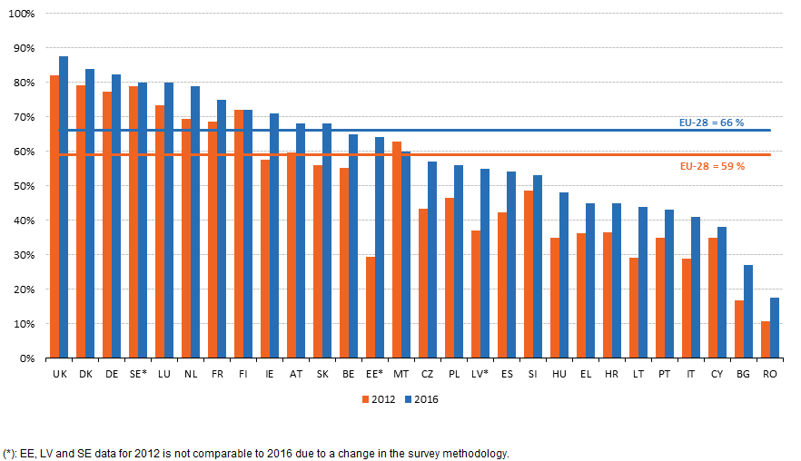

1. Figure A. 2 below presents the estimated evolution of online and total retail sales in the EU between 2000 and 2014. During that period, the estimated average annual growth rate in the online sales of goods was approximately 22 %, despite the 2008 economic crisis and the drop in overall retail sales between 2007 and 2012. At the same time the proportion of companies engaging in online sales did not grow significantly between 2004 and 2014.[17]

Figure A. 2: Estimated evolution of the total and online retail sales in goods, 2000-2014 (in billion EUR) - Source: Duch-Brown and Martens[18]

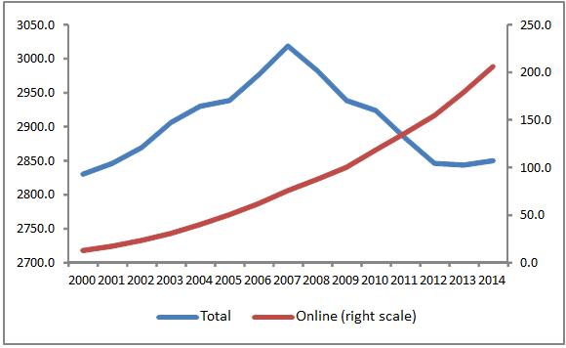

1. E-commerce in the EU is geographically concentrated: the United Kingdom, Germany and France concentrate more than 60 % of EU online sales.[19]
2. The proportion of individuals aged between 16 and 74 in the EU, who ordered goods or services over the internet for private use reached 66 % in 2015.[20] Despite the growth of e-commerce, in the same year 18 % shopped online from a seller established in another Member State.[21]

Figure A. 3: Domestic and cross-border online shopping, EU-28, 2008-2016 (% of people aged 16 to 74) - Source: Eurostat[22]

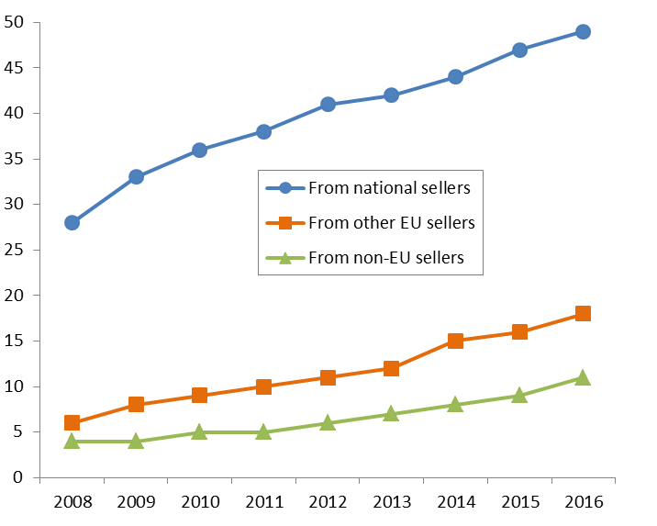

1. Eurostat data reveal that in 2014 in the EU 19 % of companies engaged in online sales, but only 8 % of them made online sales to customers located in other Member States.[23] In 2014, 85.4 % of online sales of companies stem from domestic sales and 10.3 % stem from EU cross-border sales.[24]
2. A mystery shopping survey conducted on behalf of the Commission at the end of 2015 found that only 37 % of websites allow cross-border EU customers to reach the stage of successfully entering payment card details, i.e. the final step before completing a purchase.[25]
3. There are also significant differences between Member States when it comes to the proportion of customers in a particular Member State that shop online from retailers located cross-border. For example, while 70 % of residents of Luxembourg engage in cross-border online shopping, only 2 % of residents of Romania do the same. As a general trend, the relative (population-weighted) intensity of cross-border e-commerce is inversely related to population size: customers in smaller Member States are more active in cross-border purchases than those of larger ones.[26]

Figure A. 4: Cross-border internet purchases by individuals, 2016 (% of people aged 16 to 74)  
Source: Eurostat[27]

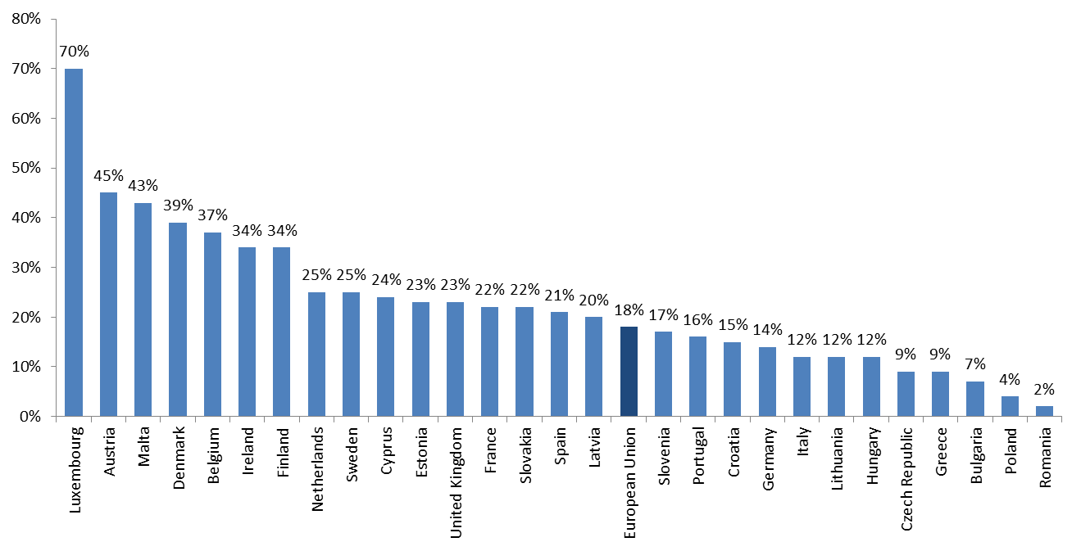

1. Digital content in the EU accounted for 32 % of online trade by individuals buying online in 2014.[28] A total of 40 % of individuals used the internet to access media content online in 2014, up from 21 % in 2007.[29]
2. A Eurobarometer report[30] indicates that in 2014, around half of the EU citizens responding to the survey accessed or downloaded audio-visual content and music online, with 30 % of them doing so via subscriptions or individual transactions. However, only a third of them could find the audio-visual content they wanted. While a minority of customers reported trying to access online digital content cross-border (8 %), this proportion is substantially higher for younger people (17 %) and is growing, as they look for digital content which is available outside their Member State of residence. According to the same report, more than 50 % of customers have experienced problems when trying to access digital content cross-border.
3. Different studies point to a wide range of reasons, both on the side of customers and on the side of the retailers that may explain the modest growth of cross-border e-commerce in the EU. For instance, according to a Eurobarometer report, the most common difficulties companies encounter when selling online are related to cost. Retailers are concerned that delivery costs are too high (51 %), that guarantees and returns are too expensive (42 %), or that dispute resolution is too expensive (41 %).[31] According to the same report, for almost one third (32 %) of retailers slow internet speeds are a problem, and for 15 % of retailers, the complications or costs of dealing with foreign taxation is a major problem. Additional reasons for not engaging in cross-border sales are lack of knowledge of applicable laws and lack of foreign language skills.
4. When it comes to customers, they are more confident in making domestic online purchases (61 %) than they are in purchasing online from retailers in other Member States (38 %).[32] Surveys and studies invoke different reasons for this difference. Concerns regarding delivery and return possibilities, as well as doubts about misuse of payment card information and personal data may deter customers from shopping online from retailers in another Member State.[33] This adds to the more subjective obstacles to cross-border sales, such as language differences and customer preferences.
5. Similarly to private persons, when companies purchase online, they are mostly concerned that delivery costs are too high (57 %), that resolving complaints and disputes cross-border is too expensive (53 %), and that their data are not well protected in another Member State (44 %).[34]
6. However, there are also indications that companies establish barriers to cross-border online trade through contractual provisions or concerted practices that limit the ability of retailers or service providers in one Member State to serve online customers located in another Member State. For example, according to a 2015 Eurobarometer report[35], 16 % of companies that sold online in 2014 or tried to do so indicate that the existence of restrictions imposed by their suppliers on selling to customers located in another Member State is a problem (and for 6 % it is a major problem).
7. The growth of e-commerce provides for a number of challenges for companies in terms of their distribution strategies.
8. New distribution methods and models emerge online. Smartphones and mobile apps are increasingly used for e-commerce. New apps also allow customers to scan product codes, compare prices and purchase products online. Based on Euromonitor data, mobile internet retail amounts to more than one-third of total e-commerce.[36]
9. Companies and customers increasingly use platforms, in particular marketplaces and other intermediaries/price comparison tools.[37] An increase in online sales puts challenges to existing distribution networks, in particular to brick and mortar retailers. Some companies react to these challenges with recourse to vertical restraints.
10. Over the last decade certain National Competition Authorities have been particularly active in assessing contractual restrictions in e-commerce. For instance, in 2012 the French Authority conducted a sector inquiry into e-commerce[38]; while the German, French, UK and other National Competition Authorities carried out several investigations[39] into different types of contractual restrictions used in e-commerce.
11. These cases indicate that certain contractual restrictions used in e-commerce have given rise to concerns and warrant closer scrutiny from the Commission in order to ensure effective competition across the EU and to contribute to a consistent interpretation of the existing rules.

3. The purpose of the sector inquiry

1. Sector inquiries are investigations that the Commission decides to carry out in sectors of the economy or types of agreements when there are indications that competition may be restricted or distorted within the internal market.[40]
2. A sector inquiry is a systematic investigatory tool used to obtain a better understanding of the functioning of a given sector and the types of agreements used in this sector. Through this sector inquiry, the Commission sought to understand how the growth of e-commerce has influenced the choices made by companies regarding the distribution of their products and services and to what extent the growth of e-commerce has led to an increase in contractual restrictions or the emergence of new types of contractual restrictions.
3. Sector inquiries do not target specific companies. However, the results of a sector inquiry may point to potentially anti-competitive practices and the Commission may – following a sector inquiry – decide to open case-specific investigations. Thus, sector inquiries allow the Commission to set priorities in the enforcement of EU competition rules.
4. In view of the purpose and nature of the e-commerce sector inquiry, the data collected and presented in the Report should be read as summaries of the qualitative information obtained. They are not intended to be read as statistically relevant figures in the strict sense.

4. The main steps of the sector inquiry

1. Following the decision[41] to launch the sector inquiry, the Commission started a large-scale fact finding exercise, on the basis of requests for information pursuant to Article 17 of Regulation 1/2003 ("questionnaires") between June 2015 and March 2016.
2. Questionnaires were sent to various actors in the EU in relation to online sales of both goods and digital content.
3. As an interim step, the Commission published in March 2016 initial findings on geo-blocking in an Issues paper.[42] On 15 September 2016 the Commission published a Preliminary Report.[43]
4. The publication of the Preliminary Report was followed by a public consultation open to all interested stakeholders. The public consultation ended on 18 November 2016. Altogether, the Commission received 66 submissions.[44]
5. Interested stakeholders also expressed their views at a stakeholder conference in Brussels on 6 October 2016. The event provided an opportunity for different stakeholders to put forward their views on the Preliminary Report.
6. The sector inquiry is completed by the adoption of a Communication from the Commission to the Council and the European Parliament. The Communication is accompanied by this Report which summarises the main findings of the sector inquiry.

5. Analytical framework

1. The following paragraphs outline briefly the relevant analytical framework underlying the analysis of the data gathered in the sector inquiry. The aim is not to provide a comprehensive summary of the possible positive or negative effects on competition of contractual restrictions used in e-commerce, but to set the legal and economic background in the light of which the information provided during the sector inquiry will have to be read.
2. On the one hand, vertical restraints may affect the market structure and the intensity of competition, mainly through foreclosing markets, softening competition and facilitating collusion. Importantly, and as acknowledged in the Vertical Guidelines[45], competition concerns with vertical restraints would normally arise only if there is insufficient competition at one or more levels of the supply chain. Moreover, an important objective which guides any assessment under European competition law is that of achieving an integrated internal market. As a result, the creation of obstacles to market integration is a concern with regard to vertical restraints.
3. In relation to goods, the sector inquiry examines the prevalence of certain distribution models, such as exclusive and selective distribution agreements, as well as contractual provisions limiting the ability of retailers (i) to sell cross-border within the EU, (ii) to sell on marketplaces, (iii) to use price comparison tools, and (iv) to set the retail price freely. Such provisions may restrict competition and may lead to the partitioning of the internal market in breach of the EU competition rules. A detailed assessment of the different restrictions and the applicable legal framework is presented in the sections dedicated to the specific restrictions.
4. In relation to digital content, the sector inquiry investigates the presence of territorial restrictions and geo-blocking in the online distribution of digital content, with a focus on music and audiovisual content. The sector inquiry also examines the prevalent copyright licensing models for online distribution and their possible impact on competition, in particular, with respect to market entry and the possibility of developing new business models or new services.
5. The focus is on exclusive licensing and in particular its modalities which, under certain conditions, could raise concerns of input foreclosure and the resulting reduction of competition at the distribution level.[46] Exclusive licensing may also raise concerns about exclusion of actual or potential competing distributors at the distribution level.[47] The issue of access to digital content and potential exclusion of digital content providers is particularly important given the nature of digital content distribution, where offering certain (premium) content may be necessary in order to attract customers.
6. On the other hand, vertical restraints may benefit customers, mainly, but not only, through allowing companies along the supply chain to internalise external effects arising either vertically (between a supplier and its distributors) or horizontally (between distributors or between suppliers). Vertical restraints may also help avoiding hold-up in case of relationship-specific investments, alleviate capital market imperfections and, more generally, reduce transaction costs.[48] Dynamic considerations related to investments in the creation of new products may also be relevant for the assessment of certain vertical restraints.[49]
7. Vertical externalities arise because of the complementary nature of the role of suppliers and distributors in the process through which goods and services reach customers. The decisions and actions taken at the different levels of the supply chain determine aspects of the product offering such as price, quality, service level and marketing, which affect not only the company taking the decisions but also its commercial partners at other levels of the supply chain.
8. For instance, retail investment in assuring a particular quality or brand image and, more generally, the offering of demand-enhancing customer services, such as promotion, pre-sale advice by specialised selling staff, or post-sale assistance, do not only benefit distributors but also their suppliers. However, a distributor deciding independently on the level of such services will not take into account the profits accruing to the supplier from each additional sale or from maintaining a reputation for high quality. Hence, he may choose a suboptimal level of these services from the point of view of the supplier and, under certain conditions, also from the point of view of customers.
9. Similarly, independent retail price setting may lead to higher retail prices and lower joint profits compared to a situation where decisions of suppliers and distributors were to be coordinated with a view to maximising their joint profits.[50]
10. Horizontal externalities may arise between distributors of the same product when a distributor cannot appropriate fully the benefits of his (costly) sales effort. For instance, demand-enhancing pre-sale services offered by one distributor, such as personalised product advice, may lead to increased sales from competing distributors offering the same product and, thus, create incentives among distributors to free-ride on costly services provided by others. For example, customers may visit a brick and mortar shop to try out a product or obtain other useful information on the basis of which they take the decision to purchase, but then order the product online from a different distributor.
11. The possibility of such free-riding and the respective inability of the distributor that offers customer services to appropriate fully the benefits, may lead to suboptimal provision (in terms of quantity and/ or quality) of such services from the point of view of the vertical supply chain.[51]
12. In the presence of such externalities, suppliers have the incentive to control some aspects of the distributors' operations. In particular, through establishing common ownership of the different levels of the supply chain (vertical integration) or through employing different vertical restraints, suppliers could internalise the abovementioned external effects, increase the joint profit of the vertical supply chain and, under certain circumstances, consumer welfare.
13. For example, granting exclusivity or setting up a selective distribution system may be a way for suppliers to alleviate free-riding and to restore the incentives of retailers to increase sales effort. Imposing price restraints could achieve the same objective.[52] Free-riding concerns among retailers and the need for exclusivity may be particularly relevant in cases where establishing a new brand or an existing brand in a new market requires substantial (sunk) investments on the retailer side.[53]
14. A selective distribution system may also help suppliers build reputation for high quality and convey a desired brand image.[54] Sometimes it may be important for a supplier to signal its quality through limiting its distribution to certain distributors that have a reputation for selling high quality products only[55] and this can be achieved, for example, through exclusive or selective distribution.
15. Vertical restraints could also be employed to deal with opportunistic behaviour that may arise with the so-called relationship-specific investments, i.e. investments that have little value outside the specific vertical relationship.[56]
16. Once such investment has taken place and to the extent that it is largely sunk, the party which bears the cost of the investment could find itself in a weak bargaining position vis-à-vis its trading partner who may have an incentive to engage in opportunistic renegotiation of the terms of the deal. In anticipation of this, the incentives to invest are likely to be weaker and, therefore, the level of investment may be suboptimal from the point of view of the vertical supply chain.
17. Such situations may arise with respect to investments made both by distributors and by manufacturers. For instance, distributors may have to invest in special retail facilities, which cannot be used for the distribution of other manufacturers' products. Granting exclusivity could be a way for manufacturers to provide sufficient investment incentives to distributors.
18. Finally, exclusivity may contribute to the alleviation of problems related to the presence of asymmetric information in the context of capital provision.[57] Such considerations could be particularly relevant for the digital content sectors, where one may encounter high uncertainty on the demand side and high sunk production costs on the supply side.
19. Often the same objective could be achieved through different vertical restraints but their effectiveness in solving the problems mentioned in the previous paragraphs and the extent to which customers benefit will depend on the specific circumstances of the vertical relationship.
20. Different vertical restraints can also play a complementary role, as sometimes the impact of a vertical restraint may be limited when it is employed in combination with another type of vertical restraints.[58]
21. The sector inquiry is not case-specific and does not aim at assessing in detail whether certain restraints are justified in the context of a particular vertical relationship but rather to provide insights into the motivation of companies to employ vertical restraints in relation to e-commerce and to explain the considerations viewed by the Commission as relevant for the analysis of those restraints.

6. Selection of addressees: goods

1. The e-commerce sector inquiry is carried out on the basis of responses to questionnaires sent to a large number of companies active in e-commerce.

### 6.1 Selection of retailers

1. There is no single data source covering the population of retailers selling online in the Member States. Therefore, for the list of addressees to the retailers' questionnaire, the Commission relied on a number of databases, such as Amadeus[59], Euromonitor[60] and Veraart Research[61], as well as information received from professional associations. The Commission also conducted desk research to verify the relevance of potential addressees of questionnaires and, ultimately, to refine the list of selected addressees.
2. In order to ensure that the list of addressees included companies of different sizes, and also covered a large part of the market in terms of sales, the Commission followed a two-step approach.
3. First, all companies relevant for the purposes of the sector inquiry and for which contact details could be obtained were selected among the "large" and "very large" companies active under given NACE code contained in the Amadeus database[62], as well as among the companies contained in the Euromonitor database.
4. Second, a number of smaller companies were randomly chosen for each Member State from the Amadeus database (excluding the "very large" and "large" companies) and the data received from professional associations. For some Member States, a dataset from Veraart Research was also used to cross-check and complement the list of addressees.
5. The Commission also sought to achieve a broad geographic coverage with a minimum of 20 addressees per Member State. The Commission relied on available Eurostat data to obtain a rough approximation of the distribution of companies selling online across Member States.
6. Specifically, the datasets used contained, per Member State, the total number of companies with at least 10 employees, as well as the percentage of companies having received orders via computer mediated networks, belonging to NACE code G[63] in 2012. On the basis of these data, the Commission approximated the distribution of companies selling online across the Member States and calculated weights for the 28 Member States.
7. The number of responses received per Member State was then affected by varying response rates in the Member States, the inclusion of additional websites that were reported by addressees of the questionnaires[64] as well as by spontaneous requests for participation and de-activation of questionnaires for companies that were either never active or no longer active in e-commerce.

### 6.2 Selection of manufacturers

1. The questionnaire addressed to retailers requested a significant amount of data on their business relationships with manufacturers. The responses provided by retailers were useful for selection of the companies to which a "manufacturer questionnaire" was addressed. In addition, the Commission sought to include manufacturers in all the product categories covered by the sector inquiry and to ensure that the major players in those product categories were included.

### 6.3 Selection of marketplaces, price comparison tools and payment system providers

1. Relevantmarketplaces and price comparison tools were identified based on information received from professional associations and complemented by desk research. The selection includes the most important marketplaces and price comparison tools in the EU, including both the biggest international players and the most relevant regional ones, covering the sale and price comparison of all products within the scope of the sector inquiry. Similarly to retailers, marketplaces were requested to respond on a per website basis.
2. Payment service providers were identified based on information received from professional associations and complemented by desk research. The selection includes players that could provide information about their services in most of the Member States, as well as the most important regional players that offer their services in only one or a few Member States.

### 6.4 Responses received

1. Different questionnaires were sent to online retailers ("retailers"), marketplaces, price comparison tools, payment system providers and manufacturers.
2. Questionnaires to retailers, marketplaces and price comparison tools had to be filled out on a per website basis, which means that some companies have received and responded to several questionnaires for each website they operate (in one or more Member States). Each such website specific response is counted separately and included in the number of respondents.[65] Therefore throughout this Report the terms "retailer" and "respondent to the retailers' questionnaire" refers to a response with regard to a retailer website. Questionnaires were sent out to companies in all Member States.

1. Table A. 1 shows the number of respondents to the retailers' questionnaire per Member State as well as the number of respondents to the questionnaires sent to other market participants.

Table A. 1: Respondents to the sector inquiry in relation to goods



1. The 1453 respondents submitted in total 2605 agreements related to the distribution of goods.
2. Questionnaires were mainly sent to market participants active in the product categories most sold online, namely:
   1. Clothing, shoes and accessories;
   2. Consumer electronics (including computer hardware);
   3. Electrical household appliances;
   4. Computer games and software;
   5. Toys and childcare articles;
   6. Media: books (including e-books[66]), CDs, DVDs and Blu-ray discs;
   7. Cosmetics and healthcare;
   8. Sports and outdoor equipment (excluding clothing and shoes); and
   9. House and garden.

7. Selection of addressees: digital content

1. The part of the sector inquiry related to digital content aims at identifying potential contractual restrictions between suppliers (right holders) and providers of online content services.

### 7.1 Selection of digital content providers (retail markets)

1. The sector inquiry focuses only on companies offering online services as part of, or as the entirety of, their services. At the retail level, i.e. at the level of services provided directly to users, such companies are referred to as digital content providers.
2. For the purposes of this Report a digital content service is considered as being offered online when it is transmitted using the packet switching protocol standard used on the internet, i.e. TCP/IP, when being delivered to end users' premises.
3. The starting point for the digital content provider addressee list was a database comprising more than 2 000 online audio-visual operators across the EU. The list was then narrowed down, with a view to ensuring that the final list of addressees would include the following three categories of providers in each Member State:
   1. The most important market operators in each Member State;
   2. Any potential recent entrant or operator using innovative business models; and
   3. A sufficient number of smaller / local operators.
4. Given the nature of digital content services the final list includes a relatively limited number of operators in each Member State which however account for the majority of the audience / market. They are referred to as digital content providers from Member States.
5. Some of the operators contacted, have a relatively large cross-border presence, either directly or via subsidiaries. These groups were identified separately and defined as those which have operations in at least five Member States. They are referred to as large groups.
6. A number of additional questionnaires were addressed to operators which offer online content through agreements whereby such operators host service providers within a hosting environment with a specific set of characteristics, either via software ("hosting online operator") or via hardware ("hosting device"). A revenue sharing agreement can be part of the relationship between the service provider and the hosting operator, while the relationship with the customer may be directly with the former or with the latter, depending on the specific situation. This category of providers is referred to as hosting operator.
7. Respondents belonging to each of the three categories above were chosen on the basis that they offer an online service. The online service did not need to be their exclusive or even main activity. However the questionnaires only refer to the online service and not any other aspect of the companies’ offer. A set of questionnaires was sent to providers of VPN[67] and IP routing services, which are often accessed by users to bypass geo-blocking. Many of these companies are not established in the EU, even though they might provide services to customers in the EU. Therefore the number of respondents was unsurprisingly low for this category.
8. Digital content providers were asked to submit information in relation to the following categories of products:
   1. Films: Feature films and motion pictures;
   2. Sports: Sports events and sports programmes, including commentaries;
   3. Television fiction: Television comedy, drama and animation series or programmes;
   4. Children television: Television programmes and series aimed at children, excluding feature films;
   5. News: Television news and current affairs programmes and series;
   6. Non-fiction television: Television content other than films, television fiction, children's programmes, news and sports events; and
   7. Music: Recorded music, excluding music contained in audiovisual content such as background music in films and television programmes.
9. A total of 278 digital content providers submitted information in the context of the sector inquiry, including 6 426 licensing agreements. A further 9 companies offering VPN and IP routing services responded to their questionnaire. Table A. 2 below provides the number of respondents per Member State and by category of respondent identified above.

Table A. 2: Respondents to the sector inquiry in relation to digital content (digital content providers)



### 7.2 Selection of right holders (wholesale markets)

1. Questionnaires were also sent to right holders. Right holders were asked to submit information solely in relation to licensing agreements covering, partly or fully, the rights for digital content services provided online.
2. Right holders were selected on the basis of the information provided by digital content providers about their main suppliers and with a view to ensuring a relatively broad coverage across the EU and sufficient diversity across product types.
3. Compared to the questionnaires sent to digital content providers, fewer product types were covered in those sent to right holders. In particular, films were excluded in order to avoid any potential overlaps with an investigation into the cross-border provision of films by pay-TV providers[68] that the Commission is conducting. News and non-fiction television products were also excluded from the questionnaire to right holders, since these products were already amply covered in the questionnaires to digital content providers.
4. Right holders were asked information in relation to the following product types:
   1. **Sports**: A sports event, such as a football match, or a set of sports events, such as a football season, which is the object of a broadcast production or productions;
   2. **Television fiction and children television**: Television series, comedy, drama, or entertainment programmes, excluding feature films, and televisionprogrammes and series aimed at children, excluding feature films;[69] and
   3. **Music**: Recorded music, excluding music contained in audiovisual content such as background music in films and television programmes.
5. A total of 53 right holders replied to the sector inquiry and submitted a total of 282 licensing agreements (table A. 3).

Table A. 3: Respondents to the sector inquiry in relation to digital content (right holders)



# B. E-COMMERCE IN GOODS

1. Characteristics of respondents

### 1.1 Retailers

1. Overall, the Commission received responses to its questionnaire from 1051 retailers. Respondent retailers cover a wide variety of companies in terms of size, measured either by the number of employees or by the annual turnover generated.[70] Figure B. 1 shows the distribution of retailers across predefined ranges in terms of the number of employees. About half of the respondent retailers have less than 49 employees and more than one third have less than 9 employees.

Figure B. 1: Proportion of retailers by number of employees



22 % of the retailers generated a turnover of less than EUR 500 000 in 2014, whereas 28 % had a turnover above EUR 100 million, with an approximately equal distribution of retailers of intermediate sizes.[71]

1. Approximately 30 % of the respondent retailers[72] are also acting as wholesalers and/or manufacturers: 26 % of the respondent retailers are active both at the retail and wholesale level, while 9 % are (also) active in manufacturing.
2. The respondent retailers are mainly active in nine broad product categories (a tenth category covers all "other" products):

Figure B. 2: Distribution of retailers across product categories (number of retailers)

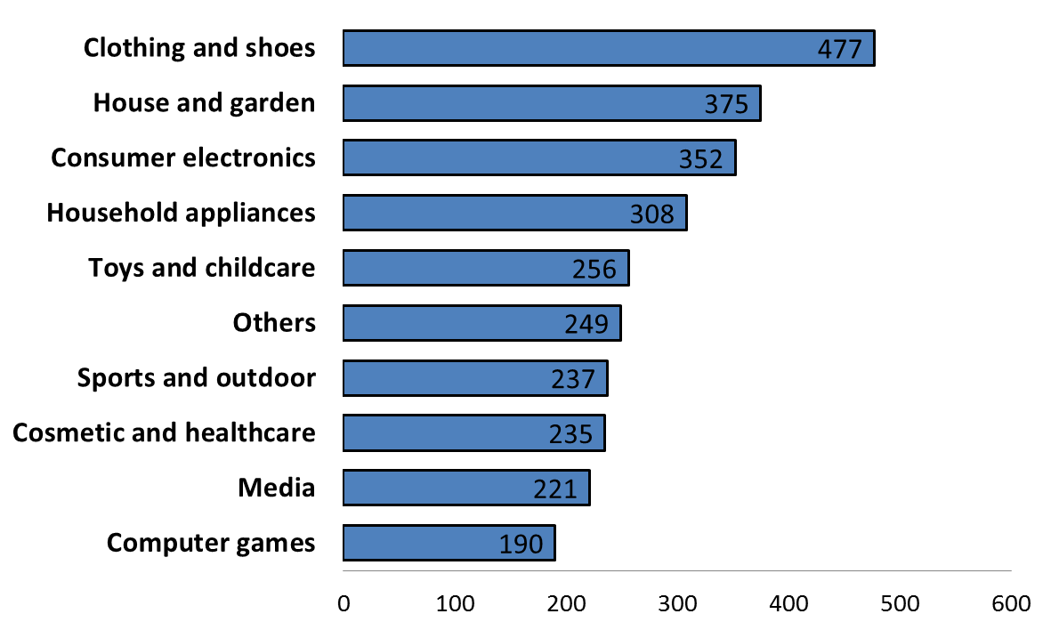

1. A significant number of retailers are active in several product categories: 46 % are active in one product category, nearly 20 % in two categories, 8 % in three categories, 11 % sell products in four or five different categories and more than 15 % sell products in at least six different product categories.
2. The majority of respondent retailers are selling both offline and online while a considerable proportion is only selling online without any brick and mortar shop.[73]

Figure B. 3: Proportion of retailers by sales channel, 2014



1. 92 % of respondent retailers are selling via their own website (which does not exclude that they also sell via other sales channels).[74] Around a third of respondent retailers are selling via a marketplace[75] or supply data-feeds to price comparison tools[76] in order to advertise their products. 38 respondents (representing approximately 4 %[77] of respondent retailers) were selling online only via marketplaces, i.e. without having their own website. 22 of these respondents were not selling offline. For them, marketplaces are the only sales channel they rely on.

Figure B. 4: Online sales and advertisement activities of respondent retailers[78]



1. For the purposes of this Report, the terms "pure offline players" and "brick and mortar retailers" refer to retailers that only sell in their offline (physical) shop."Pure (online) players" refers to retailers that only sell online, whether via their own website and/or via third party websites (i.e. marketplaces). "Click and mortar" retailers, "brick and click" retailers and "hybrid" players refer to retailers that sell both online and offline.

### 1.2 Manufacturers

1. Respondent manufacturers are evenly distributed in terms of size as measured by the number of employees:

**Figure B. 5: Proportion of manufacturers by number of employees**

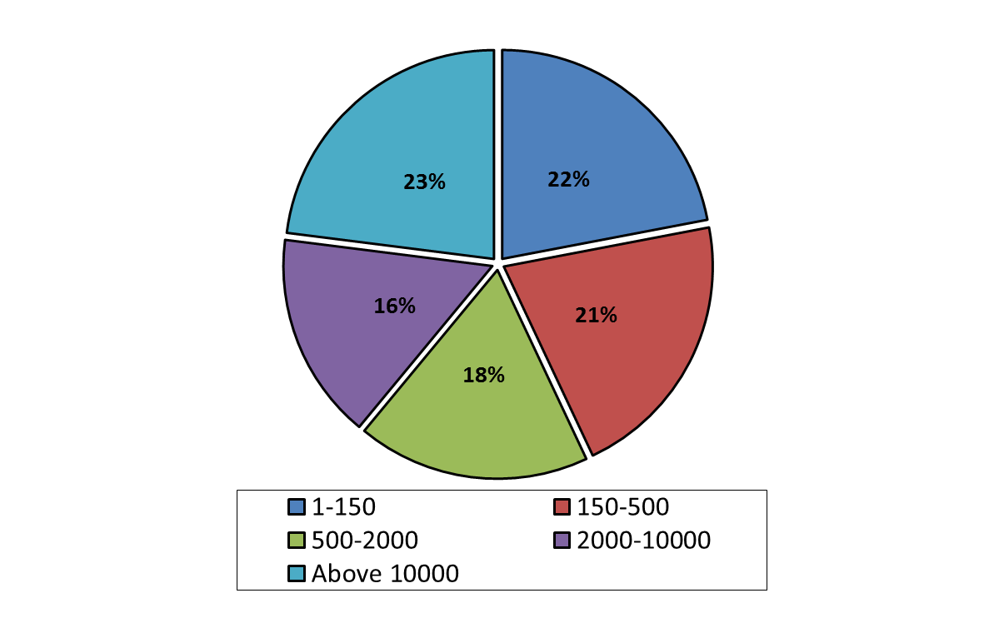

1. In terms of revenues generated in 2014 in the EU, 13 % of respondent manufacturers have a turnover of less than EUR 10 million, approximately 50 % between EUR 10 million and EUR 500 million, and approximately 35 % above EUR 500 million.
2. Respondent manufacturers are active in all product categories covered by the sector inquiry, with 26 % active in at least two product categories.

Figure B. 6: Distribution of respondent manufacturers in terms of product categories (number of manufacturers)

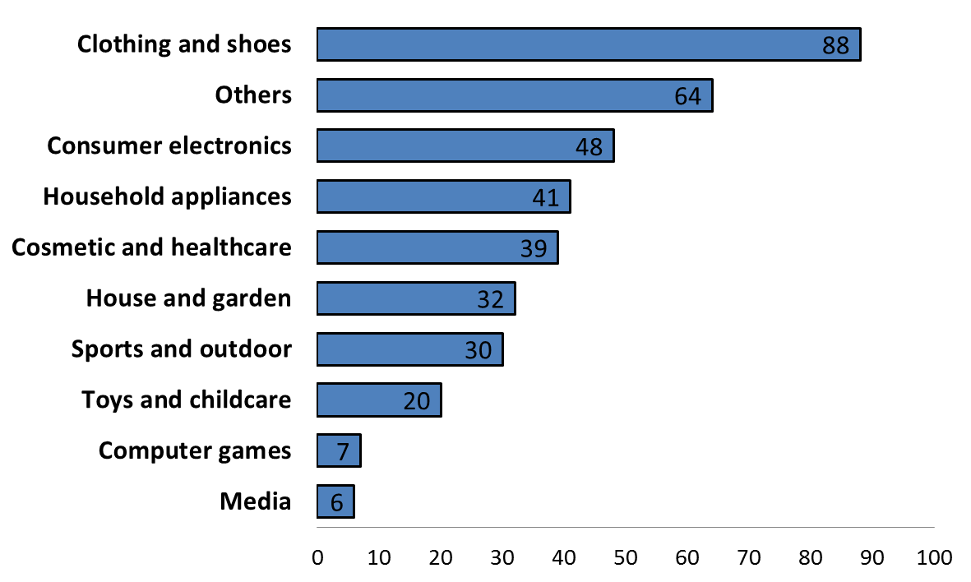

1. For the purposes of this Report, in relation to e-commerce of goods, the terms "manufacturers" or "suppliers" refer to both manufacturers that (fully or partially) own the manufacturing facilities and control the manufacturing process, and those that (fully or partially) outsource manufacturing, but own the brand and control distribution strategies.

### 1.3 Marketplaces

1. Online marketplaces are multi-sided platforms bringing together different user groups (sellers, buyers and potentially advertisers) and facilitating transactions between them. They allow sellers to list their products on the marketplace and allow buyers of the marketplace to find and buy these products.
2. 37 marketplaces responded to the questionnaire addressed to marketplaces. The respondents to the questionnaire operate marketplaces targeting altogether customers in 14 Member States. The Member States which are most targeted by marketplaces are Germany and France.
3. The "oldest" marketplaces in the sample were launched in the EU between 1998 and 2001. The marketplaces that were established first tend to be the biggest marketplaces today. Nonetheless, seven respondents launched their marketplaces in 2013 or later. The size of marketplaces varies widely and ranges from marketplaces with a 2014 turnover exceeding EUR 1 billion to marketplaces with a 2014 turnover of less than EUR 100 000.
4. The business models followed by marketplaces vary significantly between different marketplace operators.
5. Some marketplace operators provide solely the sales platform without engaging in any activity as a seller on that platform ("pure" marketplaces). Other marketplace operators also act as a retailer in addition to offering the sales platform to sellers. In this case, they typically present the products for which they are a retailer together with products of other sellers on the marketplace website. In many cases, they sell the same products in direct competition with those of other sellers on the platform.
6. The proportion of third party sales on such marketplaces compared to own retail sales varies from one marketplace to the other and depends to a large extent on the chosen business model of the operator and whether its business started as a retailer or as a marketplace provider. As can be seen from figure B. 7, out of the 37 respondent marketplaces, more than two thirds are pure marketplaces, while approximately a third also acts as a retailer.[79]

Figure B. 7: Proportion of "pure" marketplaces and marketplaces that act as a retailer

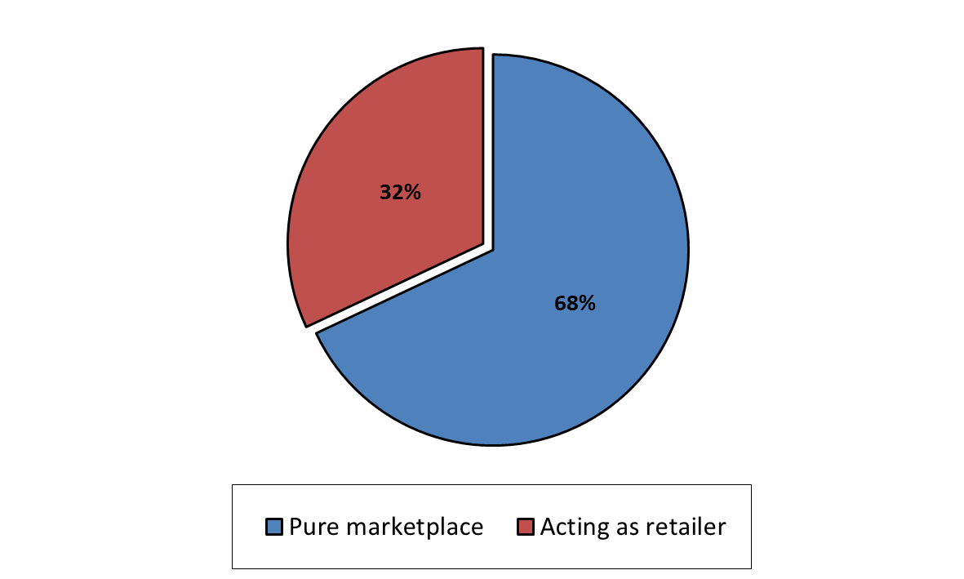

1. Marketplaces also differ in terms of the sellers they accept and the selection criteria they apply in relation to sellers. Most marketplaces are open to all interested sellers that comply with basic requirements,[80] accept the conditions of the marketplace and are considered sufficiently professional and reliable. However, some marketplace operators do not open their marketplace to all third party sellers. The main business model of these operators is typically that of a retailer.
2. Third party sellers in such "closed" marketplaces are usually sellers whose product range complements the product portfolio offered by the marketplace operator/retailer in question or sellers that pre-existed as suppliers of the marketplace operators/retailer in question. A customer buying a product via a "closed" marketplace will not necessarily know that there is a third party involved in the sale.
3. Most marketplaces allow sales of all products, provided that such products can legally be sold and the retailer is able to provide the product information required by the marketplace. A number of marketplaces reported that they only accept new products and do not allow the listing of second-hand products. Some marketplaces do not allow sales of products which are sold under a selective distribution agreement, unless the retailer can prove that he or she is authorised to sell them.
4. There are also a number of differences between marketplaces concerning the contractual arrangements with customers. The party contracting with the customer is not necessarily the third party seller in all marketplaces. Some marketplaces report that they are either separately or jointly with the third party seller contractually liable vis-à-vis the customer. Approximately 8 % of respondent marketplaces indicate that they act as an agent for the seller.
5. While, in general, marketplaces established earlier cover a broad range of different product categories, more recent market entrants tend to launch their marketplace to target niche product segments or specific customer groups. Such marketplaces may, for example, specifically target customers in a certain city or region, sellers aiming to get rid of overstock, or specialise in certain product categories or fair-trade products. However, more than 80 % of the respondents report being active in all product categories covered by the sector inquiry.
6. Many marketplaces allow sales only by professional sellers, i.e. trading as a business. Some marketplaces offer different remuneration models depending on the intended level of activity of the seller. Others accept also private sellers, i.e. individual persons selling on their own account. On average, approximately 78 % of sellers on the respondent marketplaces are professional sellers, whereas 22 % are either private sellers or sellers which chose a remuneration scheme for limited sales activities.[81] Some marketplaces have initially started as platforms targeting private sellers and only later opened up to professional sellers. The amount of active professional sellers[82] reported by marketplaces range from less than 50 to more than 300 000 for 2014.[83]
7. The business models of marketplaces also differ in terms of services offered to sellers.[84] As can be seen from figure B. 8, more than half of the respondent marketplaces provide sellers with a standard layout for product presentation, offer advertising possibilities, customer services (including complaints handling), and dispute resolution assistance as well as payment services. Less than a third of the marketplaces that responded to the questionnaire offer delivery services, product return management services or storage space.

Figure B. 8: Proportion of marketplaces offering certain services in addition to marketplace function

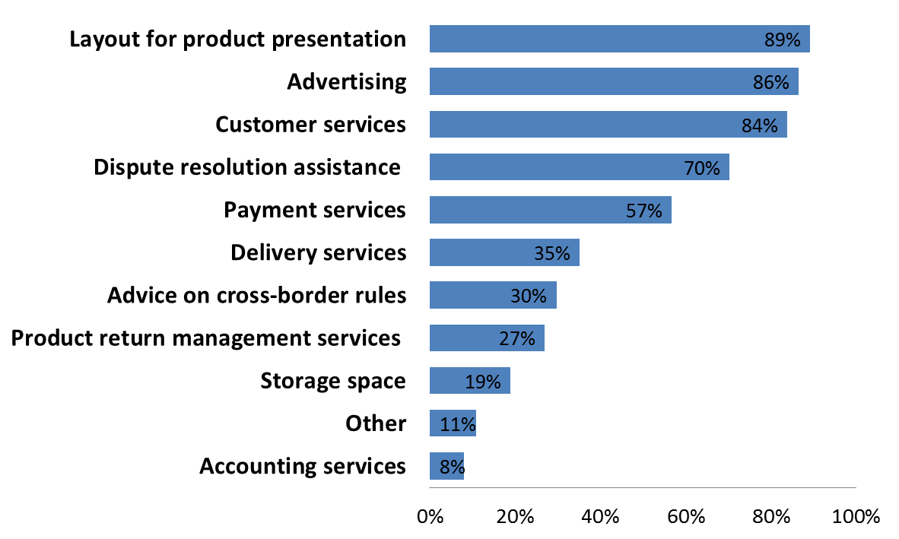

1. Remuneration models also differ between the various respondent marketplaces. Most operators use a fixed (monthly) fee and a per sale transaction fee/commission, which requires the seller to pay a certain proportion of the sales value to the marketplace operator. The level of the per sale transaction fee/commission may differ between different marketplaces as well as between different product categories and the margins achievable by retailers in these product categories. Fee levels are typically lower for consumer electronics than for other products. Some respondents also indicate that they only charge a per sale transaction fee/commission without a fixed fee. Some marketplaces additionally charge a fee per item that is being listed on the marketplace for sale. Rebates offered by marketplaces to sellers take the form of discounts on the per sale transaction fees to either key sellers or to sellers that make use of specific offerings of the marketplace (i.e. top rated seller programs) or sellers that establish a seller shop on the marketplace.
2. The majority of the contractual relationships that marketplaces have in place with sellers are based on standard agreements. Only 13 % of the marketplaces indicate that more than 10 % of the agreements they have in force with professional sellers are negotiated individually.
3. More than half of the marketplaces indicated to supply data-feeds to price comparison-tool providers[85] and to use external online payment systems.[86] 86 % of marketplaces report that some of their professional sellers are using third parties for managing their business processes on the marketplace. Such third parties can help sellers to upload their product, inventory and price information on one or more marketplaces, process orders, manage inventory and assist with cross-border trade. They can provide sellers with easily accessible data on their sales activities across multiple online sales channels.[87]
4. Some marketplaces do not only offer a website, but also an app which can be easily accessed with mobile devices such as smartphones.

### 1.4 Price comparison tools

1. Price comparison tools are websites/apps that allow customers to search for products and compare their prices across several retailers and provide links that lead directly or indirectly to the product offerings. They do not offer the possibility to purchase the products directly through the website/app of the price comparison tool. Price comparison tools typically do not charge buyers for access to the services on their websites or apps. They are rather financed via payments by the sellers whose products are listed on the websites/apps. Price comparison tools allow customers to quickly compare prices for the same product across a large number of sellers, thereby increasing price transparency and allowing them to find the best available purchase option.
2. 89 price comparison tools responded to the Commission's questionnaire addressed to price comparison tools.[88] The respondents to the questionnaire operate price comparison tools which altogether target customers in 22 different Member States. The Member States which are targeted by most price comparison tools are Germany, UK and France.
3. The majority of the price comparison tools each generated revenues below EUR 500 000 in 2014.

Figure B. 9: Proportion of price comparison tools per total turnover in 2014[89]

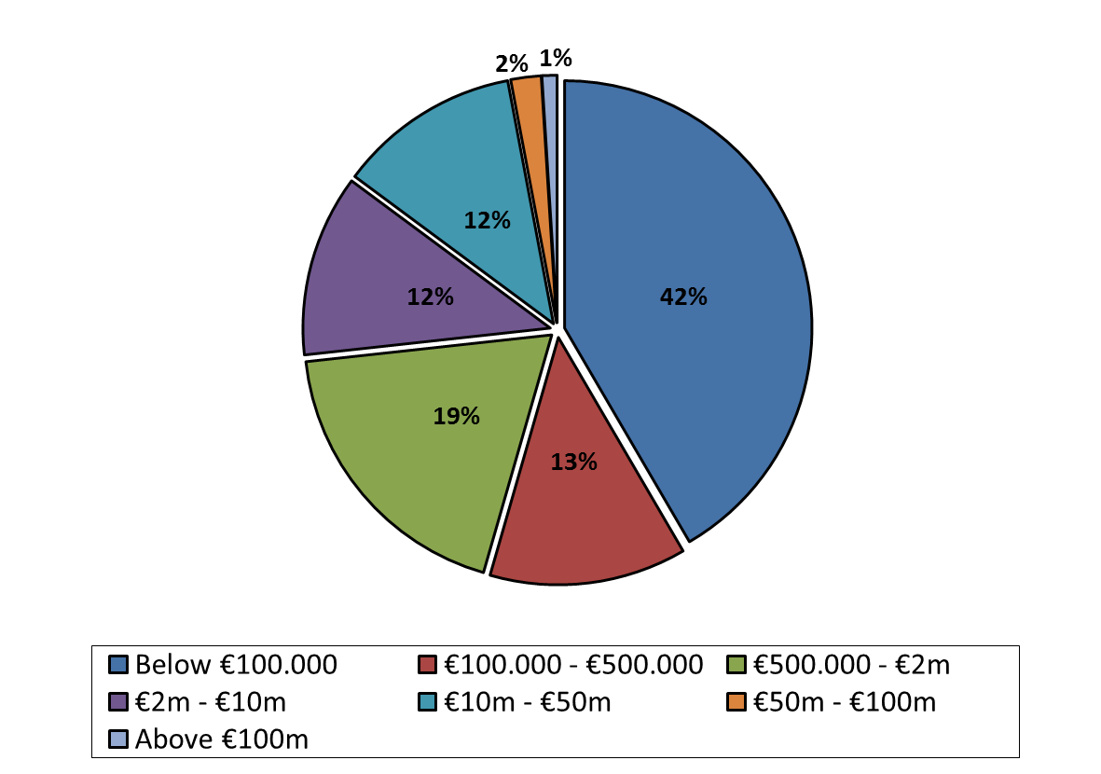

1. Price comparison tools are rarely specialised in comparing products for specific product categories. 78 % of respondents indicate that they provide pricing information on eight or more of the product categories covered by the sector inquiry. Almost all respondents provide pricing information in relation to consumer electronics (98 %) and household appliances (97 %), followed by computer games (94 %) and cosmetics and healthcare (82 %).
2. The "oldest" price comparison tools in the sample were launched between 1997 and 1999. Price comparison tools normally do not require a registration of the customers and they can easily move from using one price comparison tool to another.
3. Business models of price comparison tools differ considerably in terms of remuneration schemes, additional features such as product reviews and methods of data collection on product offerings.
4. The majority of price comparison tools finance themselves via per unit charges to sellers. As can be seen from figure B. 10 most respondents operate on a pay-per-click basis[90] whereby sellers are charged each time a customer is re-directed to the seller's website. The majority of respondents indicated that they (also) charge fees on a pay-per-sale/order basis.[91] Such fees often represent only a small proportion of the income of the respective price comparison tools and are frequently only applied to sales by a limited number of important sellers. Per unit charges typically differ between different product categories, reflecting the different profit margins of the products. Some respondents also charge fixed monthly fees to the sellers or allow them to bid to improve the placement of their products on the price comparison tool. Only a quarter of the respondents offer rebates to the sellers that list their products on the price comparison tool (such as volume discounts or free listings).

Figure B. 10: Per unit charges applied by price comparison tools[92]

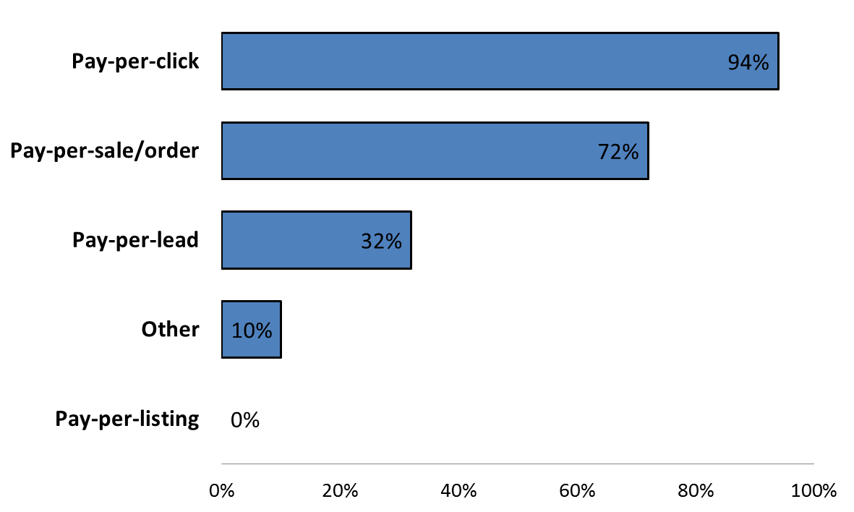

1. There are a number of ways in which price comparison tools obtain the relevant product and pricing information which is displayed on their website/app. 9 out of 10 price comparison tools indicate that they receive relevant data feeds from the sellers. The majority of price comparison tools also source data from third parties which consolidate information from various sources. Some respondents also use publically available information (e.g. crawling and indexing seller's websites) on product offerings and prices.

Figure B. 11: Collection of relevant information by price comparison tools[93]

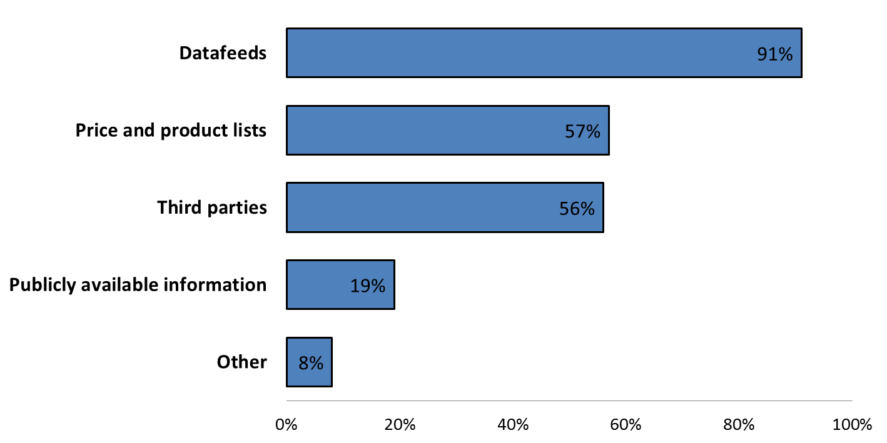

1. Price comparison tools frequently offer a number of other services to customers next to the price comparison function. These include, for example, customer reviews concerning products or web shops, professional product reviews, information on price history, price alarms and newsletter functionalities. Some operators also offer the possibility to ask product related questions or create lists of favourite products. Additional services which price comparison tools offer to sellers include provision of performance data, premium placement of offers, or advertising.
2. As can be seen from figure B. 12 price comparison tools often offer a range of possible product ranking criteria, the default ranking usually being according to price.

Figure B. 12: Proportion of price comparison tools offering certain ranking criteria[94]

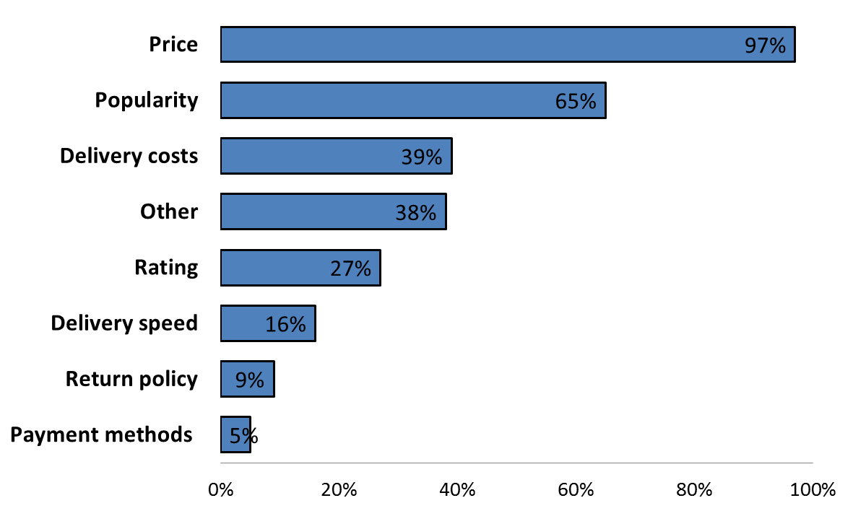

1. Price comparison tools usually accept listing products if they fall within a tool's product category catalogue, the seller is able to provide the required information, and the seller is legally allowed to sell the product. Many price comparison tools report that they do not accept listing second hand goods. Price comparison tools typically also verify whether the seller's website is trustworthy and complies with basic legal obligations.

### 1.5 Payment service providers

1. In total, 17 online payment service providers replied to the relevant questionnaire. The respondents range from large multinationals with a turnover over EUR 1 billion to a small regional player that achieved a turnover of below EUR 2 million in the last financial year.
2. The value of online purchases that these payment service providers processed for retailers established in the EU grew by approximately 25 % per year since 2012.
3. In terms of geographic coverage, the majority of respondent payment service providers provide services across the 28 Member States of the EU, and only three respondents serve fewer than 10 Member States.
4. The main function of payment service providers is to facilitate payments between retailers and customers. For this reason, payment service providers tend to form partnerships with various financial entities in order to cover as many payment methods[95] as possible. On average, there are approximately 20 different payment methods for e-commerce available via payment service providers, according to the replies received. Some payment service providers accept over 50 different payment methods.
5. The number of methods payment system providers accept varies from one Member State to another: several payment system providers accept more than 20 different payment methods in one Member State and less than 10 in others.

**Summary**

**Manufacturers** and **retailers** of all sizes are represented in the sample both in terms of number of employees and in terms of turnover. The majority of the respondent retailers sell products in more than one product category covered by the sector inquiry, but more than 25 % sell in at least four product categories. More than half of the respondent manufacturers also sell directly to customers. About one-third of respondent retailers use marketplaces to sell their products.

The business models as well as remuneration schemes of respondent **marketplaces** and **price comparison tools** are diverse. Sales via marketplaces occur directly on the website of the marketplace whereas price comparison tools only re-direct the customer to the website of the seller on which the transaction subsequently takes place. A third of the respondent marketplaces also act as retailers in addition to providing platforms that bring together third party sellers and buyers. Marketplaces as well as price comparison tools typically offer or display a wide range of products to attract customers and most offerings cover multiple product categories.

The coverage of Member States by **payment service providers** is fairly broad, while the number of methods available may significantly vary depending on the Member State.

2. Main features of competition in e-commerce in goods

### 2.1 The concentration of manufacturers and retailers in the sectors covered by the sector inquiry

1. The degree of market power of parties to an agreement is a relevant aspect for the assessment of vertical restraints, as acknowledged by the Vertical Block Exemption Regulation ("VBER").[96] While the sector inquiry covers broad product categories that do not constitute relevant markets for the purposes of EU competition law, the results of the sector inquiry offer general insights regarding the level of concentration in the product categories covered, both at the retailer and manufacturer levels.
2. In order to approximate the level of concentration of manufacturers and retailers in the product categories covered by the sector inquiry, the Commission requested manufacturers and retailers to name their "most important competitors" in the product categories in which they are active.
3. The main manufacturers are active in the majority of Member States, with the exception of the category of house and garden where most manufacturers are only active in a few Member States. In clothing and shoes, more than 20 manufacturers are mentioned in each Member State, with the same 5 to 10 brands listed throughout all Member States. In the toys and childcare category, also the same 5 to 10 manufacturers are typically mentioned as main competitors in all regions of the EU. More than 20 manufacturers are mentioned in consumer electronics, in all Member States, referring largely to the same players. 10 to 20 manufacturers are reported in electrical household appliances, and sports and outdoor equipment. Over 20 main brands are mentioned in all Member States in cosmetics and healthcare, with a significant portion of those listed in the majority of Member States.
4. At the retail level, in clothing and shoes, consumer electronics, as well as in cosmetics and healthcare, a significant number of retailers are mentioned as main competitors, with however a few retailers being active in nearly all Member States, and the leading (most mentioned) retailers varying from one Member State to the other. In household appliances, computer games and software; and in media, apart from one online player that is active in most Member States, the main retailers differ from one region of the EU to another.
5. The findings of the sector inquiry do not indicate a high level of concentration at the manufacturing or retail level in the covered product categories. These findings are, however, without prejudice to the assessment of the relevant product and geographic markets in a particular case.[97]

**Summary**

The responses provided in the sector inquiry do not generally point to a high level of concentration at the manufacturing or retail level in relation to the covered product categories: the number of manufacturers and retailers perceived as main competitors is significant throughout the different regions of the EU.

### 2.2 Main parameters of competition

1. In order to understand better the competitive landscape in the sectors covered by the sector inquiry, the Commission sought the views of both retailers and manufacturers regarding the importance of various parameters of competition.

Figure B. 13: Rating the parameters of competition by manufacturers[98]

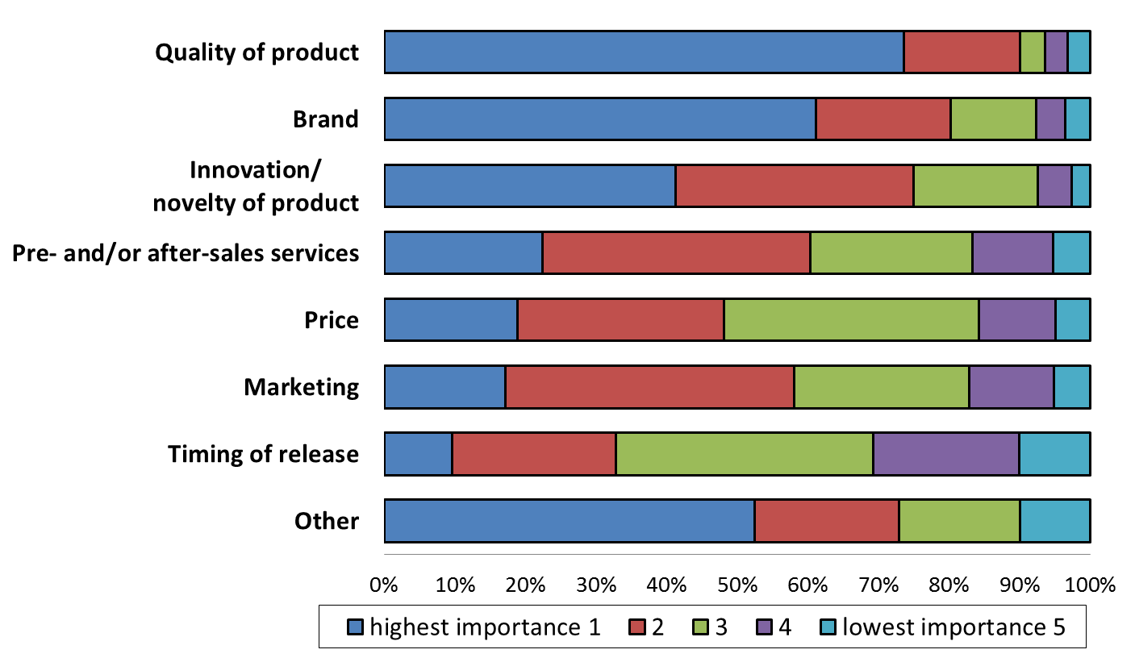

1. Although there are some differences between product categories in terms of the importance of each parameter, product quality, brand image and the novelty of the product are given the greatest importance by manufacturers in all product categories (with the exception of media products[99]). Ranked on the basis of the proportion of respondent manufacturers that have attached to it the highest level of importance, price only comes at between the fourth and sixth place, with on average only about 20 % of the manufacturers considering it as highly important.[100]
2. Under "other" parameters, manufacturers mostly stress the importance of the creative / innovative nature, the safety, the design, the ease of use of the product, the quality of the distribution network, the individual shopping experience, the ability to offer personalised advice, the satisfaction of individual customer needs, the number of points of sale, the delivery time, the diversity of products and environmental/sustainability considerations in the production process.
3. Responses by retailers show a different picture. In particular, ranked on the basis of the proportion of respondents that have attached to it the highest level of importance, price emerges as either the most or the second most important parameter of competition throughout all product categories. The range of brands, availability of the latest models and quality are the next three most important parameters of competition. However, the importance of parameters varies according to the sales channel the retailer uses. Figure B. 14 shows the responses by hybrid players which operate both offline and online shops, while figure B. 15 represents the responses by pure online players.

Figure B. 14: Rating the parameters of competition by hybrid players[101]

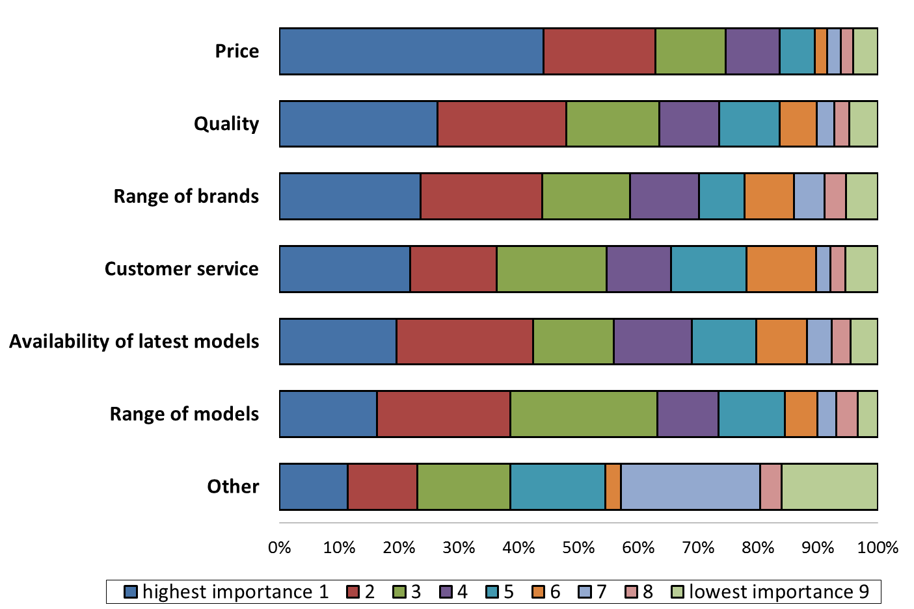

Figure B. 15: Rating the parameters of competition by pure online players[102]

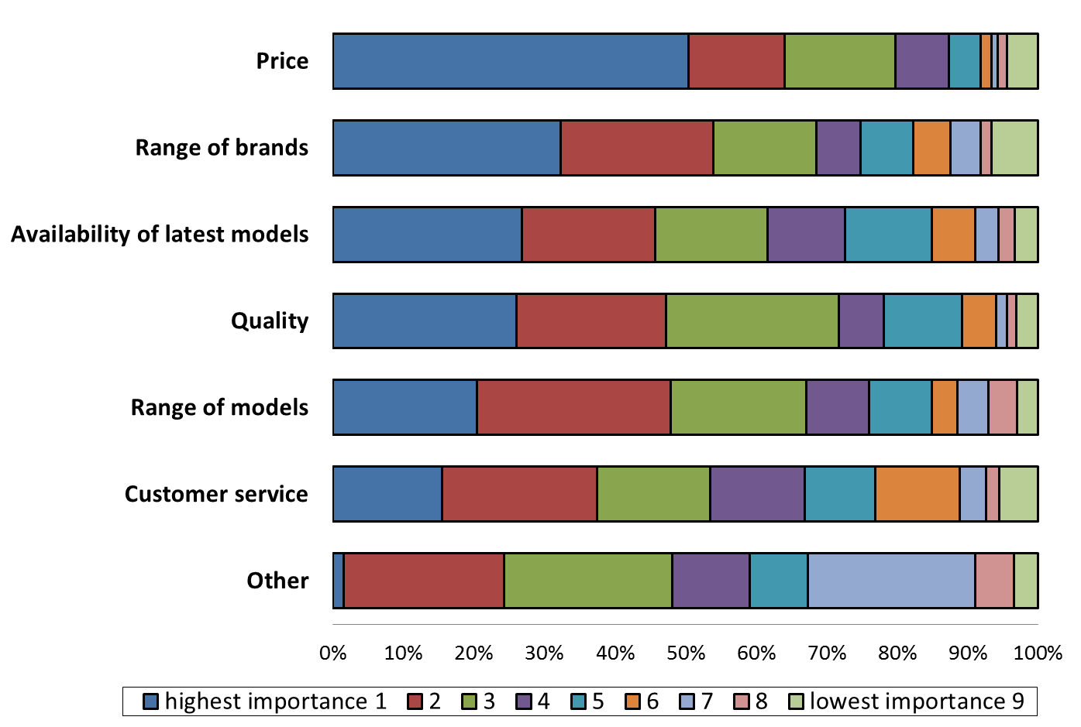

1. Price is the parameter which is considered highly important by the highest proportion of both hybrid and pure players in nearly all product categories.
2. However, in terms of proportion of retailers which attach to it a high level of importance, quality and customer service is often higher ranked by hybrid players, while the range of brands and/or availability of latest models are typically higher ranked by pure online players. In the product category of cosmetics and healthcare, a higher number of both hybrid and pure online players attach the highest level of importance to quality, rather than to price.
3. Marketplaces were also asked about the importance of various parameters of competition with other marketplaces for buyers. For them, the range of available products as well as the marketplace image and user-friendliness of the website precede price considerations.

Figure B. 16: Rating the parameters of competition with other marketplaces for buyers[103]

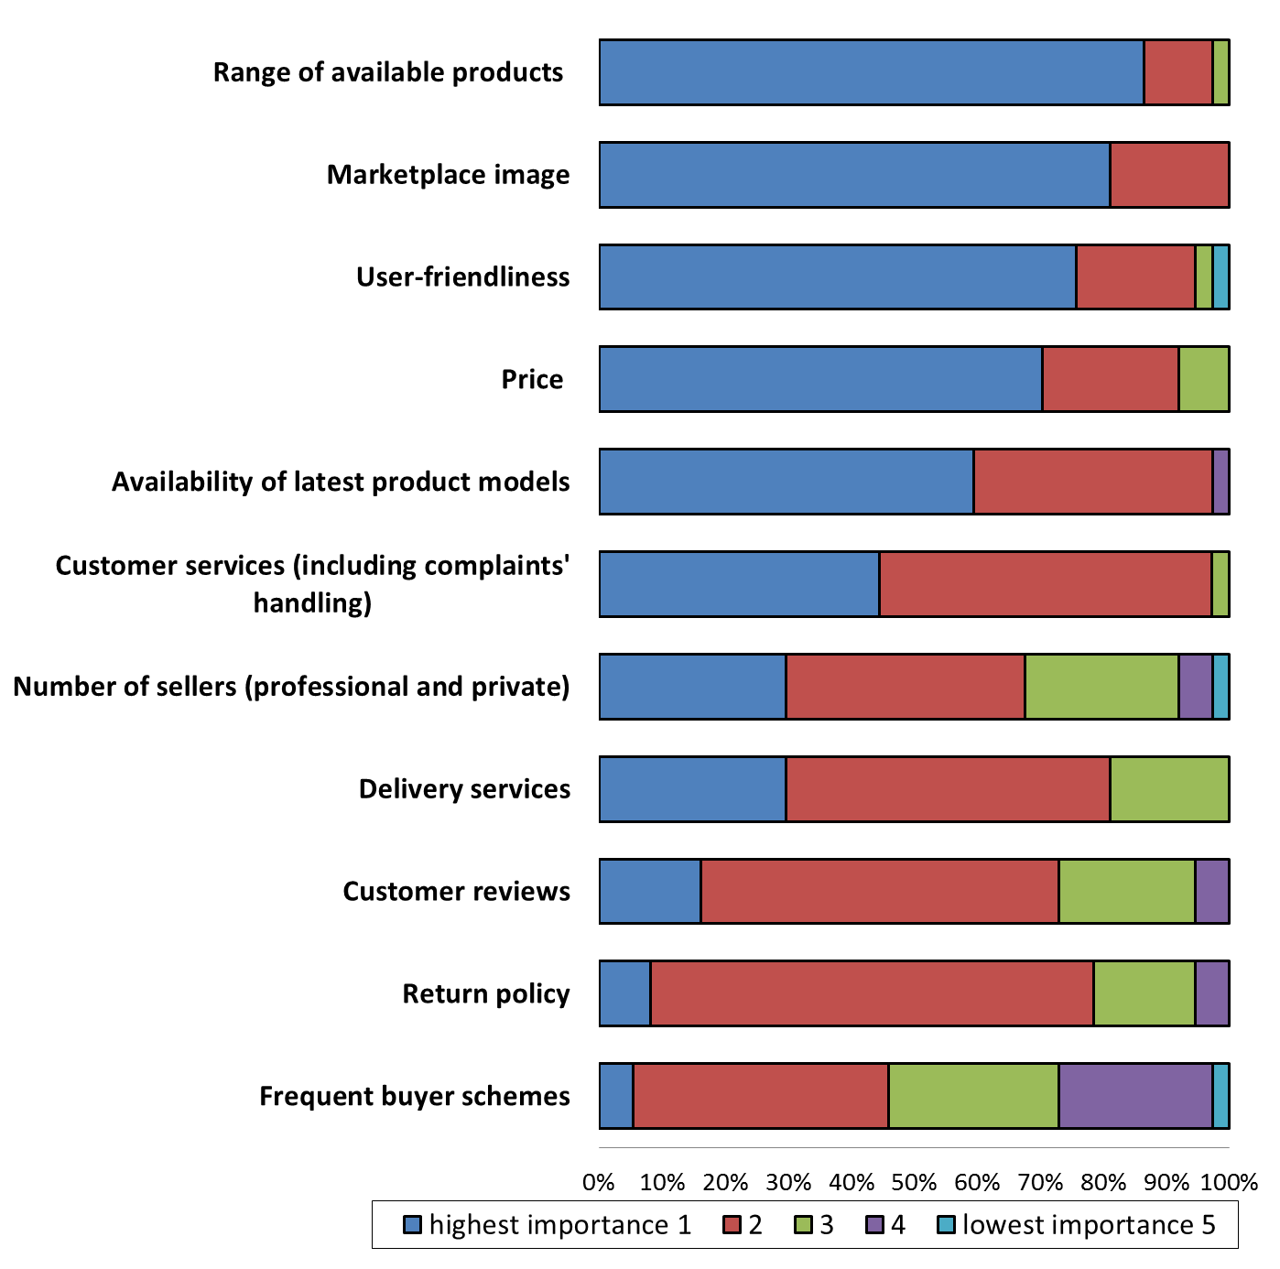

1. Marketplaces were also asked to indicate the level of importance of a number of pre-defined factors for attracting sellers to their platform. On average, across product categories, the factors to which marketplaces attach the highest importance are number of buyer visits followed by conversion rates and charges to professional sellers.

Figure B. 17: Rating the parameters of competition with other marketplaces for sellers[104]

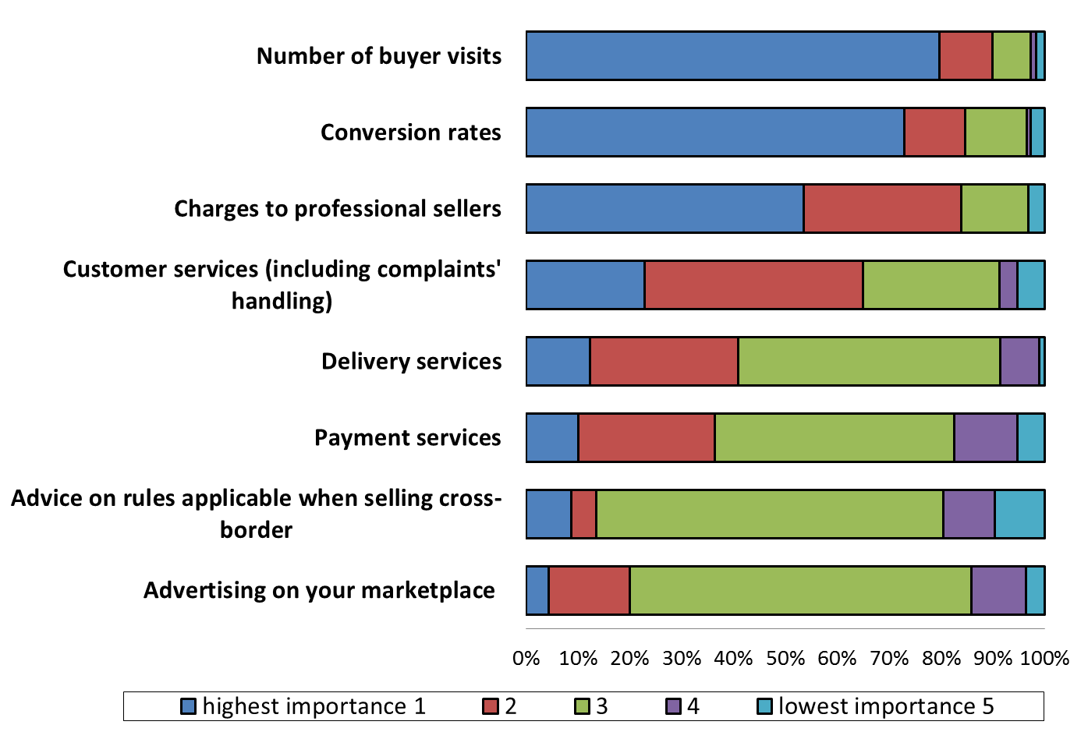

1. Price comparison tools were asked about the importance of several factors for competing with other price comparison tools for buyers. As can be seen from figure B. 18, price comparison tools consider the availability of the latest product models as well as the range of available products as important. User-friendliness and the number of registered sellers are also factors considered as important. The ability to be found by search services, speed, and the accuracy of data/prices were also mentioned as key factors for competing with other providers.

Figure B. 18: Importance of certain parameters of competition with other price comparison tools for buyers[105]

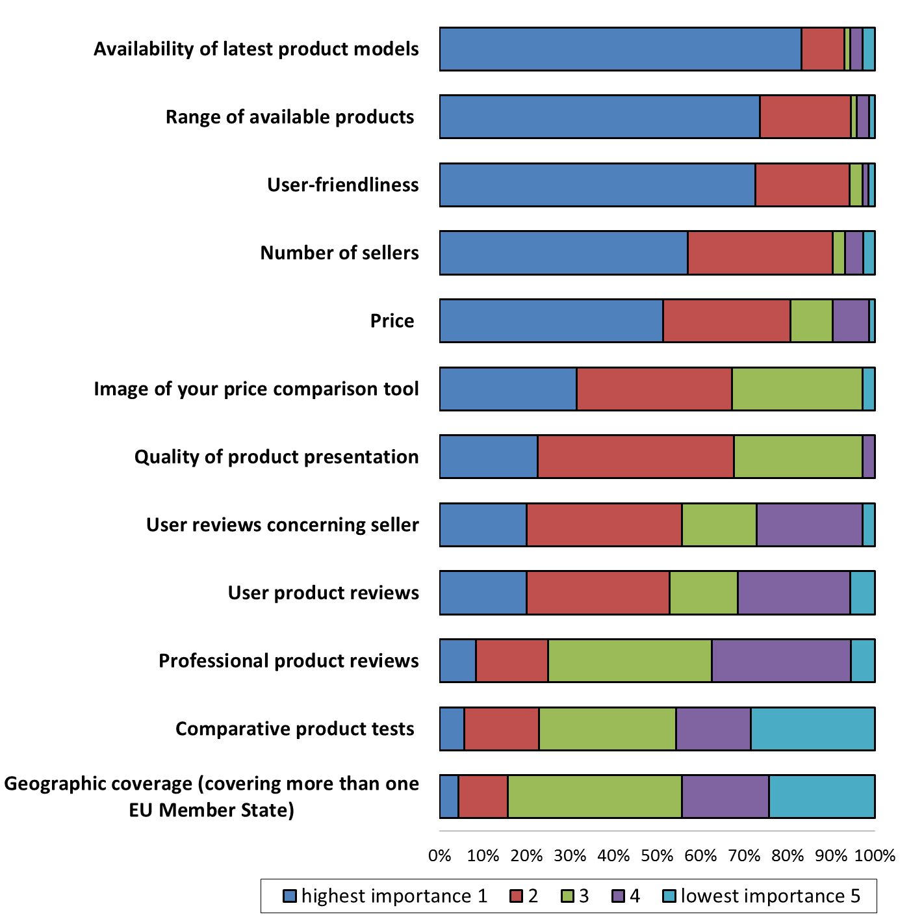

1. Price comparison tools were also questioned about the importance of several factors in attracting more sellers on their website/app. The factors considered of highest importance by the largest proportion of respondents are the number of customer visits and charges applied to sellers followed by the image of the price comparison tool and the quality of product presentation. Geographic coverage as well as product and customer reviews were considered as less relevant.

**Summary**

Product quality and brand image are considered to be the most important parameters of competition by manufacturers, while price is considered as most important for both pure online and hybrid retailers. Quality and range of available brands are the second and third most important parameters for hybrid players, while the range of available brands and availability of the latest models are respectively the second and third most important parameters for pure online players. Marketplaces consider the range of available products, the marketplace image, user-friendliness, and the price of products as the parameters of the highest importance for their ability to compete for buyers.

### 2.3 Pricing

1. The results of the sector inquiry show that the increased price transparency online is the feature that most affects the behaviour of customers and retailers. It lowers search costs for customers who are able to instantaneously obtain and compare product and price information online and switch swiftly from one channel to another (online/offline). Manufacturers and retailers are also able to easily monitor prices.
2. The ability to directly compare prices of products across a number of online retailers, leads to increased price competition, affecting both online and offline sales. The ability to easily compare prices furthers cross-border trade as customers can more easily compare between products or services from different Member States and benefit from price differentials of competing retailers.[106] Likewise, if a retailer in one Member State is contemplating entering the market in another Member State, this is facilitated by better awareness of the conditions in that market.[107]
3. 53 % of the respondent retailers track the online prices of competitors, out of which 67 % use automatic software programmes for that purpose. Larger companies have a tendency to track online prices of competitors more than smaller ones. The majority of those retailers that use software to track prices subsequently adjust their own prices to those of their competitors (78 %).[108] For more details on price tracking and price adjustments, see section B.4.6 Pricing restrictions.
4. The frequency of online price adjustments depends on the sector, but daily and promotional price changes are reported as the most prevalent ones, as can be seen from the figure B. 19 below.

Figure B. 19: Frequency of modifying online prices[109] based on the responses of retailers

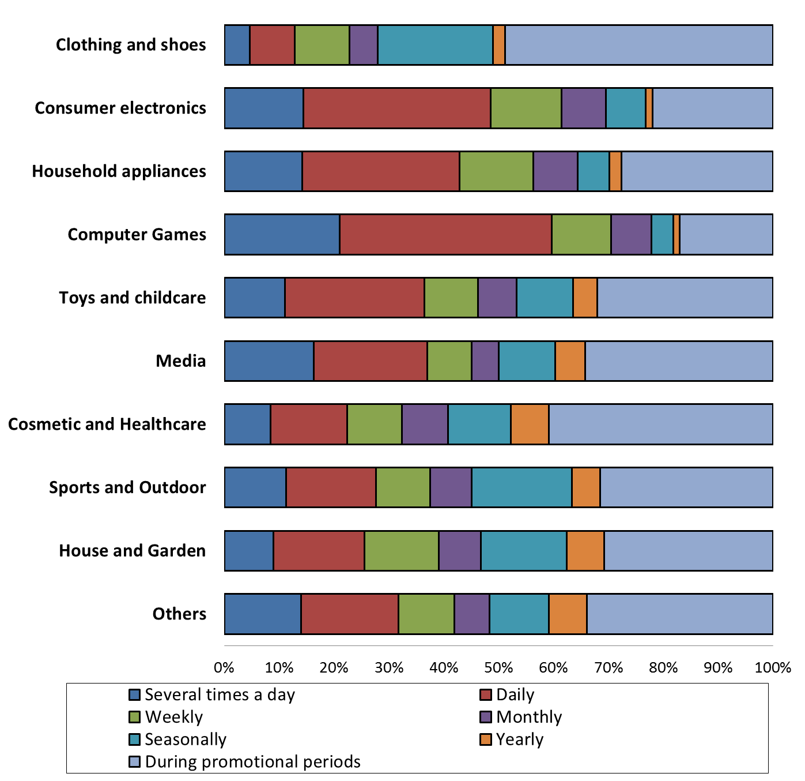

1. Price comparison tools report that daily online price changes are prevalent across sectors, whereas weekly price changes are also frequent. Seasonality plays a role for the category house and garden, and somewhat for sport and outdoor equipment, as well as clothing. Marketplaces indicate that almost one-third of prices change on a weekly basis. Most of them report daily changes for computer games, software and consumer electronics.
2. Dynamic/personalised pricing, in the sense of setting prices based on tracking the online behaviour of individual customers, is reported as rather rare. 87 % of the retailers participating in the sector inquiry declare that they do not apply that type of pricing. No pattern in terms of size or profile can be established among the few retailers (2 %) explicitly declaring that they use or have used such dynamic/personalised pricing. Such pricing strategies may, however, be used more frequently in the future, as the technical ability to collect and analyse large amounts of customer-specific data increases possibilities to differentiate between customers and provide targeted, individualised advertisements or offers (see also section B.5.1.3 The use of data in e-commerce and potential competition concerns).[110]
3. In order to understand the pricing strategies of the different market players, the Commission requested information on various aspects of manufacturers' and retailers' pricing, and in particular on (i) the differences between online and offline pricing of goods; (ii) pricing in case of cross-border transactions; and (iii) agreements on pricing between manufacturers and retailers. This section reports on online and offline pricing. The findings on the latter two issues are set out in sections B.4.3.2.6 Geo-filtering and cross-border price and offer differences and B.4.6 Pricing restrictions respectively.
4. Most hybrid retailers that responded to the specific question (80 %[111]) do not set different prices online and offline. Retailers that do so give diverse reasons for setting different prices. According to their explanation, the response depends among others on the business model of the company. Some respondents see their online business as ancillary to their offline activities. For instance, they sell online only to clear/liquidate stock and therefore set lower prices online. Others have the opposite business model. They are mainly active online and have a few showrooms to complement their online activities. Other respondents do not treat their online and offline activities interdependently and manage their online and offline businesses separately. Finally some of the respondents have a genuine omni-channel approach and consider these channels as parts of one single distribution system.
5. The majority of retailers that elaborated on price-level differences explain that their online prices are lower due to more intense price competition online. Others indicate that lower online prices are also due to lower costs, such as the lack of showroom costs and substantially lower pre-sale services' costs. In turn, others suggest that online prices for some products are higher. The main online-specific sales costs retailers mention are delivery costs, platform commissions and payment transaction fees. The main offline-specific ones are showroom and staff costs.
6. The majority of hybrid retailers (70 %[112]) do not achieve different margins online and offline. However, two thirds of the hybrid retailers that charge different prices online and offline[113] also achieve different margins across the two sales channels and about a fifth of the hybrid retailers that charge the same prices online and offline[114] also achieve different margins. Half of those achieving different margins charge different prices across the two channels, while the other half do not. The majority of those achieving different online and offline margins report that their online margins are lower.
7. The results of the sector inquiry also indicate that any existing price differences between the online and the offline channels cannot be explained by different wholesale prices. Only 26 respondent retailers[115] report that they pay different wholesale prices depending on whether products are meant to be sold online or offline and only half of them pass these differences on through the retail prices.[116]

**Summary**

Increased price transparency and price competition are the features that most affect the behaviour of market players and customers.

Online prices are adjusted frequently. Retailers increasingly track online prices of competing sellers and many of them react instantaneously to adjust their own prices accordingly. 53 % of the respondent retailers track the online prices of competitors, and 67 % of them use also automatic software programmes for that purpose. Larger companies track online prices of competing sellers more than smaller ones. 78 % of those retailers that use software to track prices subsequently adjust their own prices.

The majority of the respondent retailers do not set different prices online and offline. 70 % of hybrid retailers do not achieve different margins online and offline. However, two thirds of the hybrid retailers that charge different prices online and offline achieve different margins in these two sales channels. Respondents indicate that online prices are lower due to greater price competition and lower operational costs.

### 2.4 Differences between online and offline offers

1. The Commission also investigated to what extent retailers differentiate their product offering online and offline.
2. Approximately 70 % of respondent retailers[117] offer roughly the same number of brands online and offline. Slightly less than 20 % offer more brands online than offline, while approximately 10 % offer a greater brand choice in their brick and mortar stores.
3. In terms of models (within the offered brands), 21 % offer a greater choice of models online than offline, while only 6.5 % provide a greater choice of models in their brick and mortar stores.
4. The main reasons mentioned for offering a greater choice online are as follows: space and stock level constraints in brick and mortar shops (not enough space to show and/or stock all brands and models); competitive pressure by pure retailers to present an exhaustive offer online; marketing reasons (such as avoiding to show models in brick and mortar shops where many sizes are no longer available, whereas the models with "missing" sizes would only be available online as many customers search by size or to clear stock); greater flexibility (easier to add or remove products, change prices, add product-descriptions online, etc.); shipping of products from centralised warehouses allows for easier logistics; and the complementary nature of the types of products offered in different sales channels (typically, the more popular brands/models would be sold online while the more exclusive ones offline, the older models online while the new models offline).
5. The main reasons listed by respondent retailers for offering a wider choice in their brick and mortar shops are: less developed website with the desire to keep the core business in the brick and mortar shop (one of the main reasons for this mentioned by the retailers is the quick price "erosion" online/low online profit margins); limits on the sale of certain brands or certain models of a brand (high end products, new models) online; the avoidance of delivery issues; and the cost and resource-intensity of maintaining a complete online catalogue.

**Summary**

72 % of the respondent retailers offer an equivalent choice of brands and models offline and online. Approximately 20 % offer a greater choice online while less than 10 % offer a greater choice offline.

3. Distribution strategies

1. Today, many more customers are willing to buy products online as compared to 10 years ago. Online sales have grown exponentially in the EU since 2000 with an annual average growth rate of approximately 22 %.[118] Given the significant growth of e-commerce and the potential to reach a large number of customers online, many manufacturers as well as retailers are keen to make use of new business opportunities by selling online.
2. A number of reasons have been put forward by respondent manufacturers to explain the increasing importance of online sales:
3. Increasing customer trust and confidence in online shopping;
4. Faster internet connections coupled with increased computer literacy and the widespread use of smartphones and apps;
5. Availability of a wider range of products;
6. Wider geographic reach of retailers;
7. Lower prices;
8. Convenience of a 24/7 shopping opportunity;
9. Timely delivery and the introduction of new delivery methods (such as "click and collect");
10. Establishment of secure payment methods;
11. Traditional offline retailers starting and expanding online sales and engaging in a multi-channel-strategy;
12. Increased support by manufacturers to retailers in relation to their online activities (i.e. trainings, tools, provision of online content);
13. Increased relevance of large marketplaces and pure online retailers;
14. Improvement of product information available online as well as presentation of content;
15. Increased quality of services online.
16. In the context of the sector inquiry, the Commission asked manufacturers, retailers and marketplaces a number of questions about their distribution strategies, the types of distribution agreements used, and the rationale for their choices. In addition, the Commission reviewed more than 2 600 agreements concerning the distribution of goods in the EU.
17. This section sets out the observed trends and explanations regarding distribution strategies that manufacturers and retailers develop and the types of distribution agreements they use, with a particular focus on the impact of e-commerce on these strategies.

### 3.1 Distribution strategies of manufacturers

#### ***3.1.1 Sales channels***

1. In order to analyse the trends in the distribution of products via online and offline channels, the questionnaires to manufacturers inquired about the proportion of their sales through the different sales channels in the years 2005, 2010 and 2015. As can be seen from figure B. 20, the average proportion of sales via independent distributors selling only offline is decreasing, whereas sales via retailers that sell either only online or both online and offline are increasing significantly.

Figure B. 20: Average proportion of EU sales via the different sales channels[119]

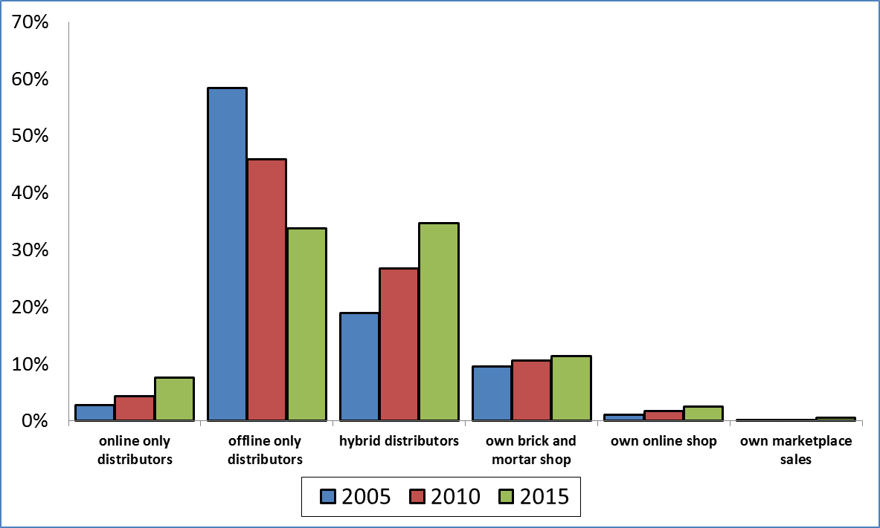

1. In order to evaluate how manufacturers view these different sales channels, the questionnaires to manufacturers asked which channels are perceived by them as beneficial for their business.
2. The great majority of respondent manufacturers consider sales through retailers' websites as well as sales through brick and mortar shops[120] as being potentially beneficial to their businesses (for at least one of the product categories in which they are active), while 57 % of the respondents think similarly of sales via pure online retailers.
3. At the same time, only a third of respondent manufacturers view sales via (certain) marketplaces as potentially beneficial and less than a third think similarly of promotion via price comparison tools. There is however some variation across product categories as can be seen from figure B. 21.[121]

Figure B. 21: Sales channels viewed by manufacturers as potentially beneficial for their businesses, per product category



1. In internal studies prepared by manufacturers in recent years regarding the effects of the evolution of online sales on their businesses, the following aspects are highlighted most frequently:
   * 1. constant price pressure / constraint on the ability to increase prices due to improved price transparency and price awareness / minor price increases may lead to important losses;
     2. quick online price "erosion";
     3. constant pressure to offer a comprehensive/exhaustive range of products / need to increase on-shelf availability of products;
     4. growing importance of keeping uniform, consistent brand image, product and service quality, consistent styles and prices, leading to a growing need for intensified control over distribution;
     5. growing need for individuality/personalisation;
     6. free-riding concerns (free-riding by online retailers on the services offered offline and vice-versa);
     7. substantial requests for support both from online and offline retailers and difficulties of support methods due to different cost structures for these two sales channels;
     8. increased need for systematic customer relationship management, targeted advertisement, targeted offers/services;
     9. increased importance of the shopping experience both in brick and mortar shops and online ("website experience");
     10. growing importance of distribution strategy and quality;
     11. enhanced competition on delivery terms;
     12. importance of pre-purchase online search (online product reviews and other product information) throughout the customers' purchasing processes ("shopper journey"), whether the purchases take place online or offline;
     13. importance of social media.
2. The questionnaires to manufacturers also inquired about the sales or advertisement channels that manufacturers consider as having a potentially adverse impact on their business.

Figure B. 22: Sales channels viewed by manufacturers as having a potentially adverse impact on their businesses, per product category



1. Almost half of the manufacturers that responded to the questionnaire (48 %) indicate that they consider sales via (certain) marketplaces as having a potentially adverse impact on their businesses for at least one of the product categories in which they are active. 32 % of the respondents perceive promotion via price comparison tools to have a potentially adverse impact and 25 % perceive sales via pure online players as having a potentially adverse impact. Only 10 % perceive sales via retailers' website(s) to have a potentially adverse impact on their business (for at least one of the product categories).
2. The same picture emerges when looking at the responses per product category.[122] However, as can be seen from figure B. 22 there is some variation in the relative importance of each factor across product categories.
3. For instance, while about 60 % of the respondents active in clothing and shoes as well as those active in sports and outdoor equipment, consider that sales through (certain) marketplaces could have an adverse impact on their businesses, only 7 % of those active in clothing and a quarter of those active in sports equipment perceive sales through a retailer's online website as potentially harmful.
4. The opposite is true for the perceived negative impact of promotion via price comparison tools: 43 % of manufacturers active in clothing have pointed to such negative impact in their response as opposed to 27 % of manufacturers active in sports equipment.
5. There are differences across product categories also with respect to the potentially adverse impact of sales via pure online retailers, which are indicated by at least 30 % of the respondent manufacturers in sports equipment, cosmetics, and toys and childcare, and by less than 20 % of the manufacturers in the rest of the product categories (excluding "Other").

#### ***3.1.2 Trends in manufacturers' distribution strategies***

1. In order to assess the impact of the growth of e-commerce on the distribution strategies of manufacturers, the Commission asked the manufacturers about the main measures they have taken in the last decade to react to this growth.

Figure B. 23: Measures taken by manufacturers in the last 10 years to react to the growth of e-commerce[123]

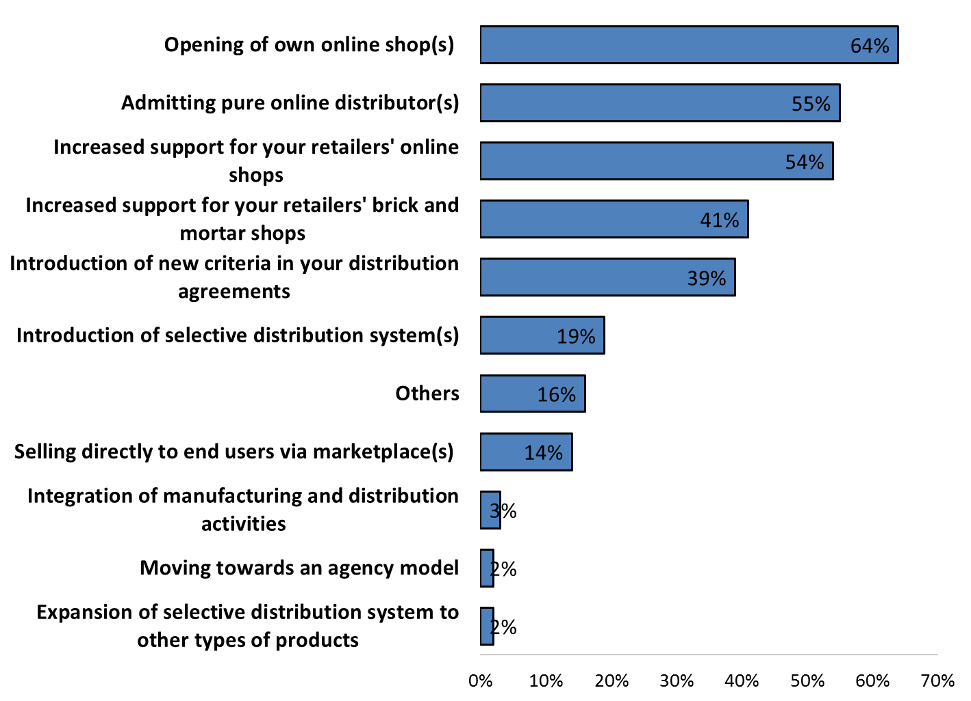

1. As figure B. 23 shows, the prevalent reaction to the growth of e-commerce by manufacturers is opening their own online shop. 64 % of respondent manufacturers[124] launched their own websites within the last 10 years.
2. Manufacturers also increasingly rely on marketplaces for their direct sales to customers: 20 %[125] of respondent manufacturers sell products via marketplaces and 14 % of respondent manufacturers have started to do so in the last 10 years.[126]
3. Many manufacturers acknowledge that the decision to engage in direct selling at retail level is largely due to the fact that, with relatively small investments, they can benefit from the advantages of online sales, including better knowledge and control over distribution both in terms of quality and price.
4. Despite the growth of e-commerce, many manufacturers stress the importance of selling their products via brick and mortar shops. Almost half of the respondent manufacturers (45 %) that answered the relevant question (also) operate their own brick and mortar shops[127], and figures show (see figure B. 20 above) that sales via the manufacturers' own brick and mortar shops have increased. These shops are frequently mono-brand stores opened by manufacturers[128] in order to promote a specific brand. Another strategy is the use by manufacturers of showrooms, usually limited in number, to present their brand(s) which are then sold predominantly online.
5. Respondent manufacturers, in particular, those marketing luxury branded goods, such as fashion clothing or perfumes, consider the traditional shopping experience in a specific luxury shopping environment with extensive pre-sale advice to be a central element of their distribution strategy. Other respondents report that the introduction of websites for the sale of certain luxurious brands/products was unsuccessful, because customers prefer to purchase high priced products in a traditional, offline luxurious shopping environment.
6. At the same time, increased direct online sales typically do not lead to a full elimination of the existing independent retail or wholesale network. Average sales via self-owned websites only amount to a small proportion (less than 3 %) of the total sales of manufacturers, although they have become increasingly important and have on average more than doubled since 2005. Direct sales by manufacturers via marketplaces have also increased throughout the last 10 years, but still amount on average only to less than 1 % of total sales in 2015.
7. Figure B. 24 shows the proportion of manufacturers, by product category, that are also active at retail level (offline and online). The product category with the highest number of respondent manufacturers also active in retail distribution is clothing and shoes where 85 % of the respondent manufacturers are selling their products directly to customers. In five further product categories more than half of the respondent manufacturers are selling directly to customers.[129]

Figure B. 24: Proportion of manufacturers also active at retail level, by product category[130]

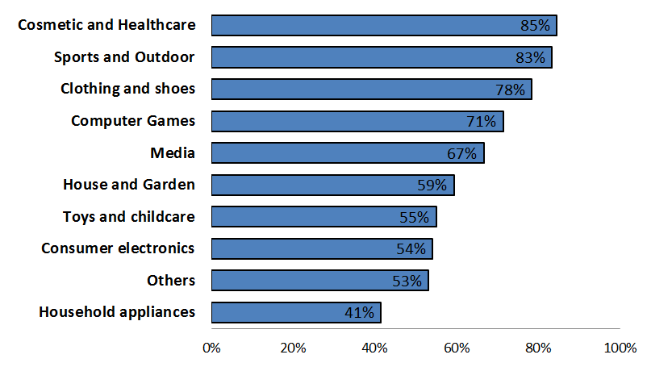

1. Manufacturers that own multiple brands do not necessarily operate a uniform distribution policy across Member States and brands. Rather, their strategies may differ from brand to brand and from Member State to Member State.
2. In addition to direct online sales to customers, manufacturers have recourse to other measures that allow for a higher level of control of the (in particular online) distribution networks. The significant increase in the recourse to selective distribution, together with the large-scale introduction of new criteria in distribution agreements (see figure B. 23 above) provide clear indications of the efforts of manufacturers to achieve a higher level of control over the ways their products are distributed.

**Summary**

Online price transparency, the challenge of a level-playing field between online and offline retailers and difficulties of maintaining a coherent brand image across online and offline sales channels affect the distribution strategies of manufacturers. On the one hand, manufacturers have significantly increased their direct sales in the last ten years by opening own online shops and by selling directly via online marketplaces. On the other hand, many manufacturers have taken measures to exercise a higher level of control over their distribution networks, by introducing selective distribution systems or special distribution criteria in relation to online sales.

A majority of respondent manufacturers consider sales through retailer websites as well as sales through brick and mortar shops as being potentially beneficial, while, only a third of respondent manufacturers view sales via (certain) marketplaces as potentially beneficial and less than a third think similarly of promotion via price comparison tools.

The proportion of sales via retailers selling only in brick and mortar shops has decreased, whereas sales through pure online retailers and hybrid retailers has increased. Despite the growing importance of e-commerce, many manufacturers, in particular of luxury branded products, stress the importance of brick and mortar shops and of a high quality shopping experience.

### 3.2 Distribution strategies of retailers

1. In order to analyse the trends in the distribution of products via various online and offline channels, the Commission asked retailers about their distribution strategies. Most of them have embraced online sales and are selling online either in addition to selling offline ("hybrid", "click and mortar", or "brick and click" retailers) or as "pure" online sellers. The majority (59 %) of the 1 031 retailers that responded to the relevant question in the sector inquiry sell goods both offline and online whereas approximately 40 % sell only online without operating any brick and mortar shops.
2. Some retailers start off as pure online sellers but then expand by opening brick and mortar shops. Out of those respondents that are selling only online, 8 % report that they plan to open a brick and mortar shop within the next two years. The reasons provided for this relate to enabling buyers to pick up products ordered online in a brick and mortar shop or to receiving products from manufacturers that refuse to distribute their products through "pure" online sellers.
3. While many retailers still have a one-channel focus and use the other sales channel as ancillary, many report about an evolution into a true omni-channel strategy whereby the sales channels complement each other and form part of the same distribution system, with a high level of flexibility for customers to navigate between those two channels back and forth.
4. Several retailers report about the possibility for their customers to buy online but pick up the products in a brick and mortar shop ("click and collect" option), or the development of online tools in brick and mortar shops to allow immediate online comparison, review and even purchase while being in the brick and mortar store. For instance, some retailers report about their shops offering the direct option of purchasing a product online in their shop in case the product is not on stock.
5. One example is offering customers to pick up or return the products purchased online in a brick and mortar store.

**Summary**

6 out of 10 retailers that participated in the sector inquiry adopted a multichannel distribution strategy selling goods both offline and online whereas approximately 40 % sell only online.

While many retailers still have a one-channel focus and use the other sales channel as ancillary, many report about an evolution to a true omni-channel strategy whereby the sales channels fully complement each other.

### 3.3 Different types of distribution agreements used

1. The results of the sector inquiry indicate that a wide variety of distribution agreements are used. These range from general terms and conditions of sale or general framework agreements without any selection criteria (with simple purchase order forms and confirmations) to territorial exclusive distribution, selective distribution and franchising agreements. In some limited instances, agency agreements are also used.
2. In line with the focus of the sector inquiry being on contractual restrictions to e-commerce, this section reports on trends with regard to territorial exclusive distribution, selective distribution, and agency agreements, where the results of the sector inquiry show that restrictions on online sales are most prevalent.

#### ***3.3.1 Territorial exclusive distribution agreements***

1. In a territorial exclusive distribution agreement, the manufacturer agrees to sell its products only to one distributor (wholesaler or retailer) for resale in a particular territory.[131] While territorial exclusivity may reduce intra-brand competition and lead to market partitioning, it may also create efficiencies which justify certain territorial protection. The exclusive distributor may be incentivised to invest in additional promotion and marketing efforts, for example to introduce a product or brand in a new geographic market, on which other distributors could free ride absent any territorial protection.
2. The findings of the sector inquiry show that territorial exclusivity is typically granted in relation to both offline and online sales channels in a territory. Given the potential of e-commerce for increased cross-border sales and the territorial restrictions inherent in territorial exclusivity, territorial exclusive distribution relationships and the underlying reasons for territorial exclusivity are analysed below in more detail.
3. Exclusive territorial distribution agreements are exempted by the VBER if the market shares of both the manufacturer and the distributor do not exceed 30 % and provided that none of the hardcore restrictions listed in Article 4 of the VBER are present.[132]
4. The Commission questioned manufacturers as well as retailers about their usage of territorial exclusive distribution agreements in order to better understand the prevalence of territorial exclusive distribution and the reasons for its use.

##### 3.3.1.1 Prevalence of territorial exclusive distribution

1. Half of the manufacturers (49 %) that responded to the relevant question indicated that they make use of territorial exclusive distribution agreements.[133] However, the information received on distribution relationships between manufacturers and retailers shows that only a small portion of the relationships is based on territorial exclusivity, meaning that many respondents use territorial exclusivity in a limited number of their distribution agreements.[134]
2. Manufacturers provided information in relation to the territories within the EU in which they grant territorial exclusivity. Based on their responses, in some Member States territorial exclusivity is used more frequently, such as in Greece, Spain and Cyprus. Member States in which territorial exclusivity is less frequently used include for example Germany, Austria and Ireland.
3. As can be seen from figure B. 25, 8 % of the manufacturers that provided this type of information use territorial exclusivity in one Member State only and most manufacturers use territorial exclusivity in multiple Member States. Territorial exclusivity is mostly granted in relation to entire Member States, but in some cases also in relation to certain regions, islands, cities or even airports.

Figure B. 25: Proportion of manufacturers using territorial exclusive distribution agreements split by geographic coverage

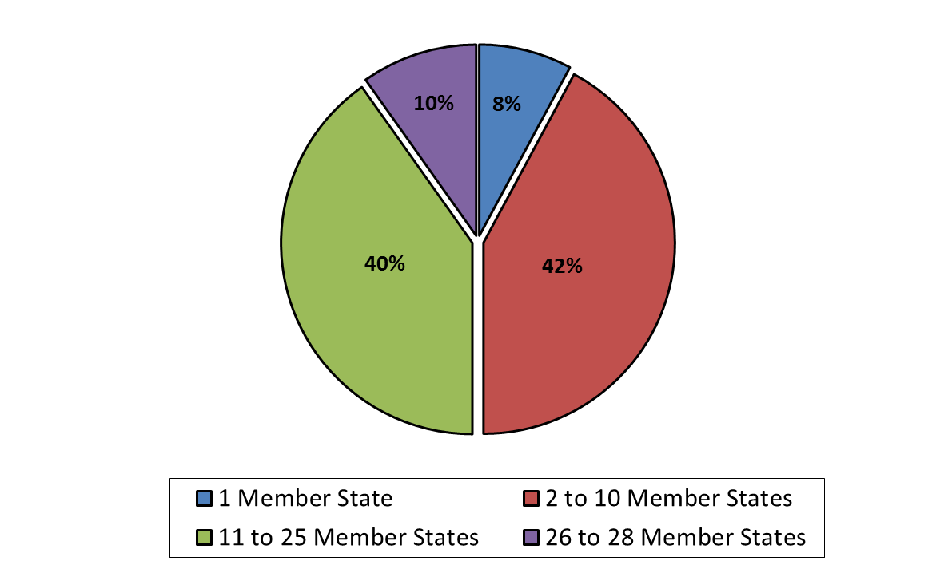

1. The Commission also asked retailers whether they act (in relation to some products) as an exclusive distributor for certain manufacturers. 11 % of respondents indicate that they concluded exclusive territorial distribution agreements with at least one manufacturer. The product category with the highest proportion[135] of retailers that have at least one territorial exclusive distribution agreement is clothing and shoes (10 %) followed by household appliances (8 %) and cosmetics and healthcare (8 %). A smaller proportion of respondents use exclusive territorial distribution agreements in the product categories media (5 %) and computer games and software (2 %).

Figure B. 26: Use of exclusive territorial distribution agreements by retailers per product category

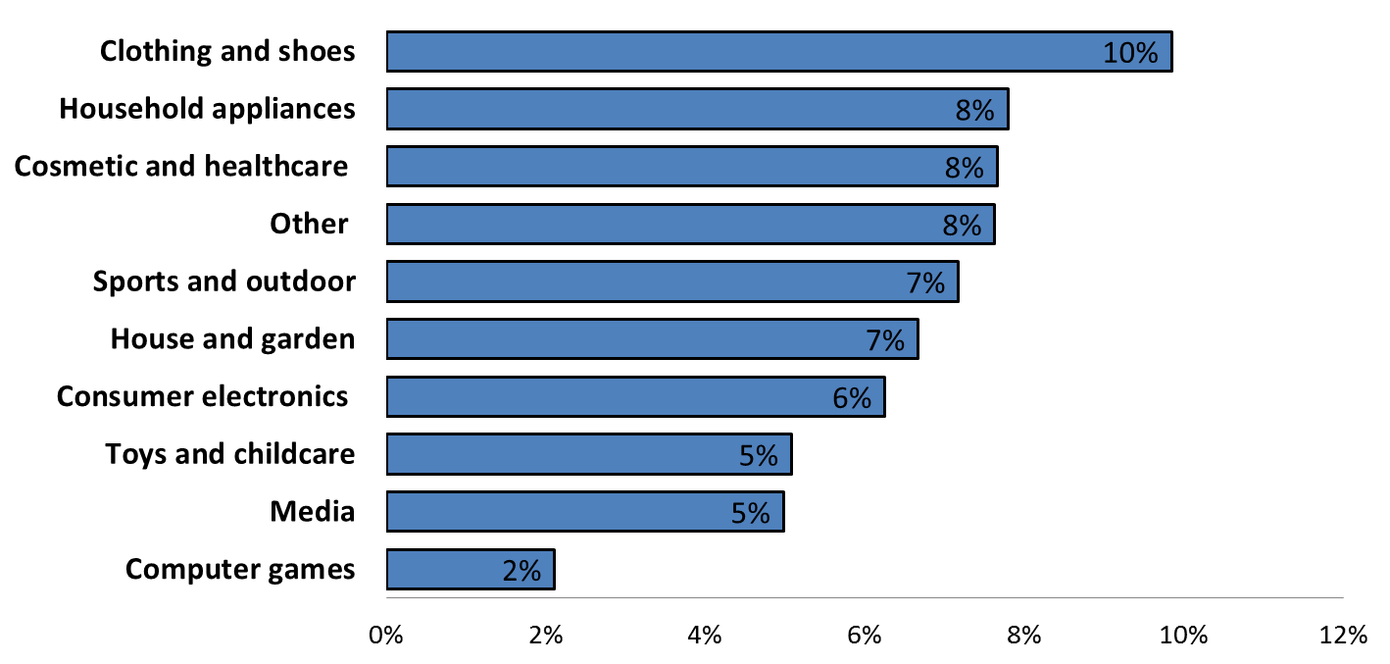

1. Manufacturers that make use of exclusive territorial distribution typically appoint an exclusive distributor at the wholesale level rather than at the retail level. They do so in particular in those Member States or territories where they do not have their own subsidiaries with a dedicated sales force. This may, for example, be typically the case in Member States considered to be too small in terms of business volume or where the brand is not sufficiently known to justify the setting up of a subsidiary. In such cases, manufacturers need experienced distribution partners with knowledge of local market conditions and who can reach out to retailers and undertake the investments necessary for launching, promoting and advertising a certain brand or product.
2. Exclusive distributors may also be useful in larger Member States where market structures are regionally fragmented and where customers typically buy from smaller or medium sized retailers rather than from a few large retail chains.
3. In some cases, territorial exclusivity at the wholesale level is combined with the operation of a network of authorised retailers with selective distribution at the retail level. In such a case, the "exclusive" wholesaler is in charge of developing and managing a network of authorised retailers according to the criteria defined by the manufacturer in a given Member State.
4. The development of this type of network may require significant investments by the wholesaler (e.g. for selection of and assistance to authorised retailers, promotion of the brand, control of the "closed" network, and application of the selection criteria in order to ensure high quality distribution and a consistent marketing strategy respecting the brand image).
5. Under EU competition rules (see B.4.3.3.3), such a system must be set up carefully without restrictions of cross-supplies within a selective distribution system (including at different level of trade).
6. However, territorial exclusivity at the wholesale level is not necessarily linked with territorial (active) sales restrictions imposed on the exclusive distributor or on distributors in other Member States or territories.[136] The manufacturer may simply decide to sell its products only via a single appointed wholesaler in a certain Member State or region. In such a case, territorial exclusivity is limited to an obligation of the manufacturer not to appoint other wholesalers in the territory without granting the exclusive distributor any protection from sales coming from outside its territory.

##### 3.3.1.2 Reasons for using territorial exclusive distribution agreements

1. Manufacturers were asked whether they consider granting territorial exclusivity to an independent distributor as necessary for a number of pre-defined reasons.
2. As can be seen in figure B. 27 below, granting territorial exclusivity was in particular considered as necessary in order to launch and establish a brand/product in a new (national) market. On average 27 % of the respondents in a product category consider it as necessary for this purpose.
3. There is, however, significant variation across product categories. For instance, only 15 % of manufacturers active in consumer electronics consider exclusivity necessary to enter a new market as opposed to 46 % of respondents active in cosmetics and healthcare and 40 % active in sports and outdoor equipment.
4. The second most mentioned reason for territorial exclusivity is in order to expand sales and reach a viable scale of operations (23 %) followed by the need to preserve the incentives of independent distributors to invest in facilities and human resources specifically related to selling the manufacturer's products (22 %). Manufacturers consider territorial exclusivity less relevant for launching and establishing a new brand/product (11 %) in an already served (national) market.

Figure B. 27: Average proportion of manufacturers across product categories that consider granting territorial exclusivity necessary for each of the reasons mentioned[137]

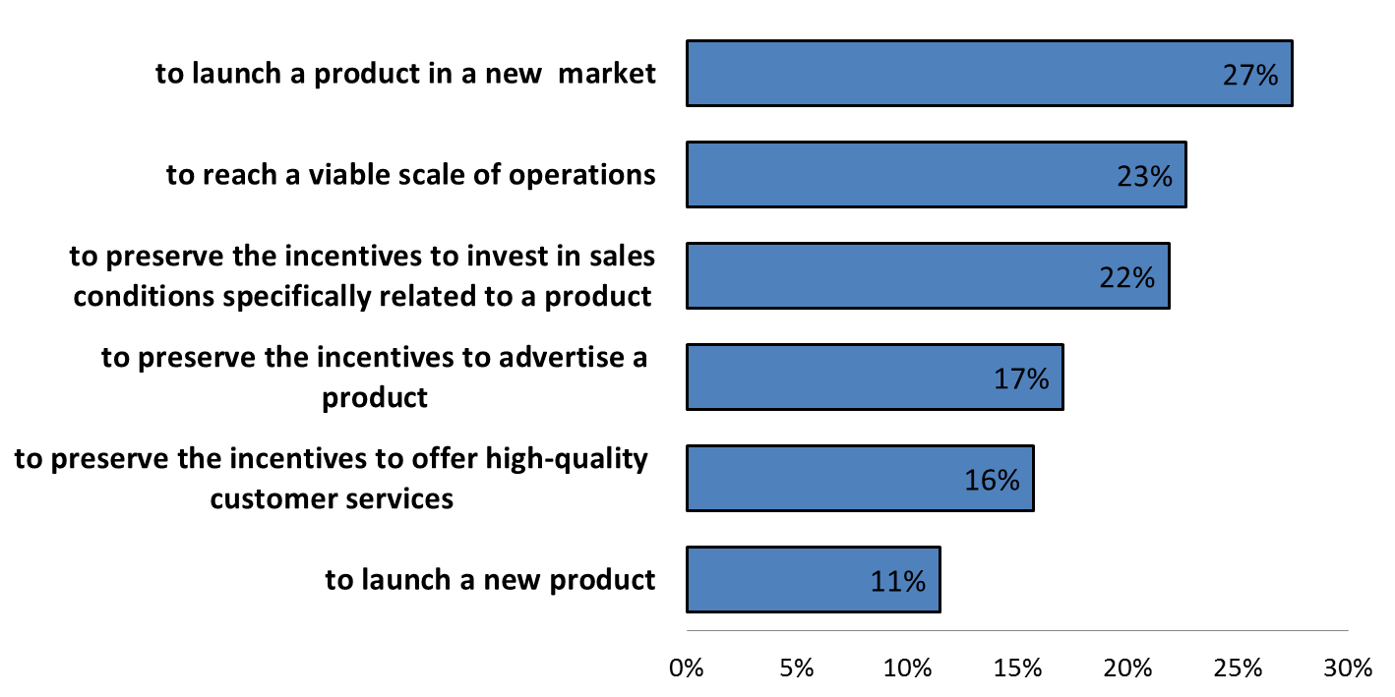

1. The responses of the manufacturers show that granting territorial exclusivity to distributors is normally not a general distribution policy applied by the manufacturer across all Member States and brands/products concerned. It is rather a case-by-case decision for which the manufacturer takes into account the product and brand characteristics, the local market conditions (size, maturity and structure of the market) as well as its own knowledge of the market.
2. Whether territorial exclusivity is granted depends also on the willingness of distributors to enter into a distribution agreement absent any territorial exclusivity. In some markets (e.g. decorative cosmetics) territorial exclusivity has been reported to be a standing industry practice. In these markets distributors will typically not be prepared to enter into a distribution arrangement without territorial exclusivity.
3. Exclusivity may be considered necessary by manufacturers (and demanded by distributors) to protect against free-riding from other distributors in cases in which a distributor is required to significantly invest in order to build up a business in a certain territory.
4. Such investments can, among others, relate to necessary warehouse facilities and the setting up of logistical distribution arrangements; human resources such as sales and back-office personnel; showrooms; high-quality customer services; and promotion and marketing activities.
5. Territorial exclusivity can guarantee a sufficient return on investment for the distributor and thereby ensure a long-term commitment. Without territorial exclusivity distributors may, in certain cases, not be willing to enter into a distribution agreement and commit to these investments.[138]
6. Territorial exclusivity may also be useful for a number of other reasons not mentioned in the above figure. Dealing with only one distributor in a certain Member State is considered by some manufacturers as beneficial as it allows for efficiently monitoring the performance of the distributor and coordinating both parties' promotional and presentational efforts in order to communicate a consistent brand image. Having a single distributor also simplifies business processes (e.g. fewer agreements to negotiate and fewer orders to execute) thereby reducing transaction costs.
7. Retailers were also asked whether they consider territorial exclusivity as a necessary or very important factor for a number of pre-defined reasons.[139] Most retailers do not consider territorial exclusivity as necessary or important. Out of the 673 retailers that responded to this question 82 % do not consider territorial exclusivity as a necessary or important factor for any of the reasons provided.
8. For those that consider territorial exclusivity as a necessary or important factor, the reasons for which territorial exclusivity is mostly considered as relevant are entering a new market, launching a new product/brand or expanding and reaching a viable scale of operations.
9. Retailers consider territorial exclusive distribution less important for incentivising them in investing in advertising and promotion of certain brands or products. However, as indicated earlier, exclusivity is more widespread on wholesale than on retail level.

**Summary**

Almost half of the respondent manufacturers make use of territorial exclusive distribution agreements. However, in terms of numbers, only a small portion of their distribution relationships is actually based on territorial exclusivity.

Whether to use exclusive territorial distribution is typically decided by manufacturers on a case-by-case basis, taking into account product and brand characteristics, local market conditions as well as the own knowledge of the market.

Manufacturers that make use of territorial exclusive distribution typically appoint an exclusive distributor at the wholesale level rather than at the retail level. In some cases, territorial exclusivity at the wholesale level is combined with the operation of a network of authorised retailers within a selective distribution network. In this case, the exclusive wholesale distributor is in charge of developing and managing a network of authorised retailers according to the criteria defined by the manufacturer in a given Member State.

Granting territorial exclusivity is in particular considered as necessary in order to launch and establish a brand/product in a new (national) market. Almost one-third of the respondent manufacturers in a given product category consider it as necessary for this purpose. There is, however, significant variation across product categories.

Exclusivity is also considered necessary (and demanded by distributors) to protect against free-riding by other distributors in cases in which a distributor is required to significantly invest in order to build a business in the exclusively allocated territory.

#### ***3.4.3 Selective distribution***

##### 3.4.3.1 Overview and development of selective distribution

1. In selective distribution systems[140], distributors are selected on the basis of specific criteria, set out in the distribution agreement.
2. Changes to the selective distribution systems represent one of the most frequent reactions of manufacturers over the last 10 years to the growth of e-commerce. Most manufacturers (56 %) that responded to the relevant question indicate that they make use of selective distribution agreements for some of their products.[141]
3. However, as most of the manufacturers that responded to the relevant question indicated that their selective distribution agreements were limited to some of their products, the overall share of selective distribution agreements in all distribution agreements remains significantly lower.
4. When asked about the measures they took in reaction to the growth of e-commerce in the last 10 years, 19 % of manufacturers report having introduced a selective distribution system where they did not apply selective distribution beforehand, while 2 % extended their existing selective distribution systems[142] to other types of products. 67 % of manufacturers that use selective distribution[143] report having introduced new criteria in their distribution agreements.
5. The adaptation of the selection criteria to online (pure online or hybrid) retailers is reported widely. A frequent way of introducing such changes is the creation of an "internet addendum" to the existing distribution agreements that sets out the selection criteria for online distribution.
6. Figure B. 28 below shows the use of selective distribution, by reference to the number of manufacturers that responded to the relevant question, by country of origin of the respondent manufacturer. Slightly more than half of German respondent manufacturers use selective distribution for at least one of their products, while this share is higher in France and the Netherlands, and lower in the United Kingdom.

Figure B. 28: The use of selective distribution, by country of origin of respondent manufacturers (number of manufacturers)[144]



1. Figure B. 29 below provides an indication of the share of manufacturers per product category (covered by the sector inquiry) that make use of selective distribution.

Figure B. 29: Number of respondent manufacturers that are active in one product category only and sell via selective distribution or other forms of distribution[145]

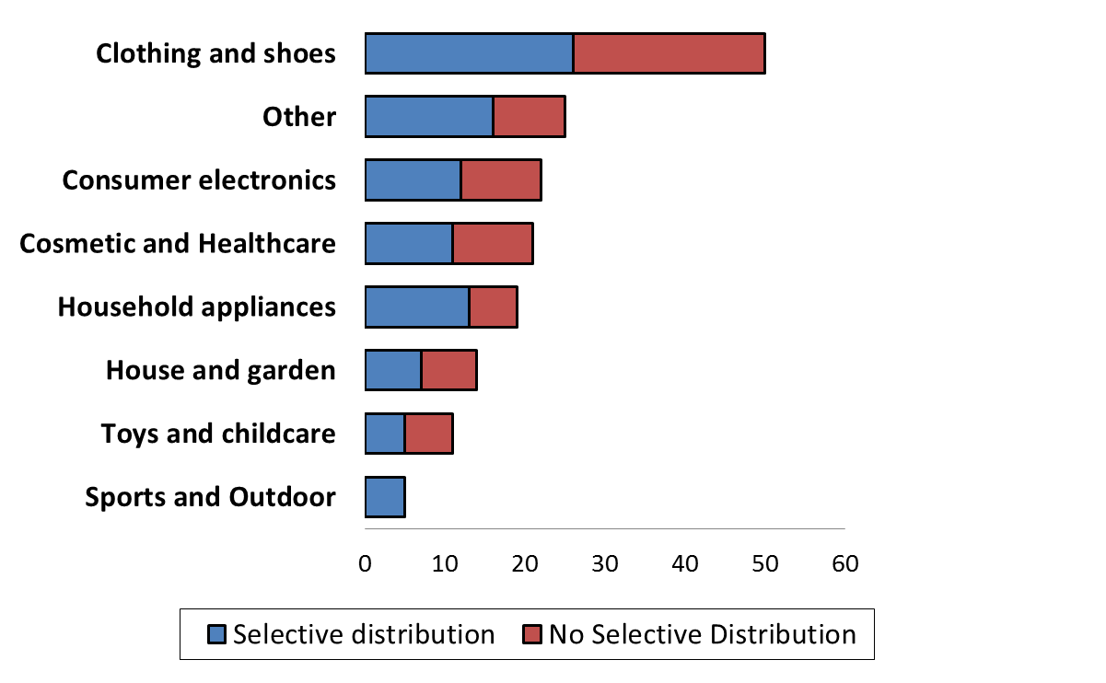

1. Selective distribution thus is used by more than half of the manufacturers in the product categories of clothing and shoes, cosmetics and healthcare, consumer electronics and household appliances, but also fairly widespread in the other product categories.
2. The following figure B. 30 shows the distribution of manufacturers using selective distribution, by turnover. Almost one third of manufacturers using selective distribution has a turnover over EUR 1 billion, and almost two third over EUR 100 million.

Figure B. 30: Manufacturers using selective distribution, by turnover in 2014[146]

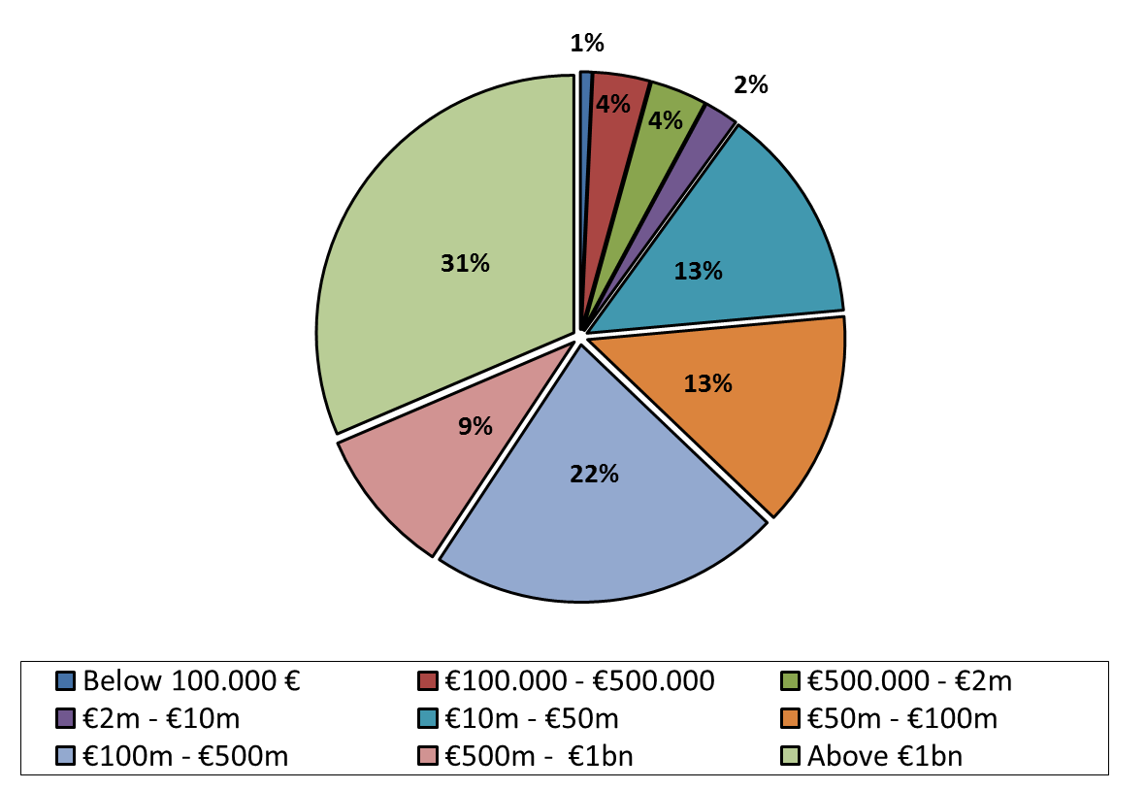

1. As mentioned above, 67 % of manufacturers that use selective distribution[147] report having introduced new criteria in their distribution agreements in the last 10 years. This share is even higher in the categories of clothing and shoes (77 %), and house and garden (71 %). Figure B. 31 shows the number of manufacturers that were already using selective distribution and introduced new selection criteria in the last 10 years, per product categories.

Figure B. 31: Number of respondent manufacturers that sell via selective distribution and introduced new selection criteria in the last 10 years[148]



##### 3.4.3.2 The reasons for opting for selective distribution

1. For the purpose of providing a comprehensive overview of the typical selection criteria applied in selective distribution agreements across the different product categories covered by this Report, as well as of the reasons leading to the above mentioned changes and their impact on retailers, both manufacturers and retailers were asked a number of questions relating to selective distribution.
2. Manufacturers were asked to describe their main reasons for operating a selective distribution system and for the application of the criteria set out in their selective distribution agreements.
3. In general, manufacturers stress the importance of high quality distribution as an important factor of competition, affecting brand image, the quality of pre- and after-sales services and the overall "shopping experience" of customers. The most typical reasons put forward for operating a selective distribution system are set out below:[149]
   * 1. to protect market positioning;
     2. to preserve brand image / reputation;
     3. to ensure an environment for the sales point that mirrors the brand's market positioning and reputation;
     4. to preserve the prestige and luxury perception and reputation of the products / brand;
     5. to respond to customer expectations when buying premium brands / premium products of brands;
     6. to ensure high quality pre- and after-sales services with skilled, professional staff, able to provide quality/professional advice (also, in the case of certain products, with a view to ensuring safe use of the product);
     7. to ensure individualised advice to customers / to best respond to individual needs and follow-up / to achieve customer engagement;
     8. to ensure the highest quality of technical presentation by specialists / highest level of information about product, about compatibilities with other products, about installation;
     9. to ensure a coherent and homogenous presentation of the products within the EU, with a view to conveying a coherent "message" to customers. This includes design and esthetical coherence of product presentation;
     10. to guarantee an overall positive shopping experience to customers;
     11. to avoid or minimise free-riding by online sales channels on investments by high-quality physical points of sale;
     12. to protect products more efficiently against counterfeit products by increased traceability.
4. The reasons put forward by the manufacturers do not vary considerably depending on the product categories: the above justifications are equally put forward by manufacturers of clothing and shoes, of electronic devices, of toys, cosmetics or of sports equipment.
5. To provide a few examples, in addition to the clothing, cosmetics and consumer electronics sectors, where selective distribution is wide-spread, selective distribution systems are largely used by manufacturers of kitchen appliances, gardening equipment, cleaning equipment, sports shoes and sports accessories, toys, prams and other accessories for babies, accessories and food for animals (pets), hair-dryers and other hair-care equipment or trekking equipment.
6. Several manufacturers report about a differentiated distribution system, whereby only the premium product line is sold under selective distribution, while the rest of their products are sold in open distribution.
7. Other manufacturers report about multi-level selective distribution systems, where most of the authorised retailers only get access to a certain part of the entire product range. The more additional selection criteria a retailer fulfils, the bigger the part of the product range he or she can distribute. In these multi-level selective distribution systems, the different levels of selected retailers are contractually restricted from selling a given product (line) to those retailers that are not authorised to sell that product (line): i.e. to those retailers that are at a lower level in the selective distribution system.
8. The idea behind these multi-level systems is usually to differentiate between the "mass-distribution" of a wide range of products with a lower threshold of quality requirements and the high-quality distribution of the premium or high-end product lines, with a high threshold of qualitative criteria. As a result, while not all authorised retailers of the same brand necessarily comply with the same set of criteria[150], those that sell the same product range do so.

##### 3.4.3.3 The selection criteria

1. Both manufacturers and retailers were asked to describe the criteria listed in their selective distribution agreements. In addition, manufacturers were asked to provide for each of the Member States with the highest sales in 2014, the selective distribution agreements with the three largest independent distributors. Many of the submitted agreements by retailers, in response to other questions, are also selective distribution agreements.
2. Based on the above information, the most typical examples of criteria applied (a) to both online and offline sales, (b) specifically to offline sales, and (c) specifically to online sales, are set out below[151]:
3. Typical examples of selection criteria in relation to both online and offline sales:

* promotional / marketing campaigns must be pre-approved by brand/ must adhere to brand's promotion policy;
* marketing material must be pre-approved by brand;
* respect of fixed criteria relating to marketing campaigns;
* marketing must be targeted to certain territories;
* ensure shipment and installation service / ensure shipment and installation service within a given number of hours / days;
* fulfil criteria for quality and rapidity of repair / after-sales services;
* have at least one physical point of sale / showroom;
* respect determined volume restriction per order;
* keep appropriate level and immediate availability of stock;
* offer an appropriate / representative level of product range out of the brand's products;
* respect minimum purchase quantity;
* dispose of a minimum annual turnover per point of sale;
* point of sale must be specialised in the sale of the given category of products (for instance, specialised in gardening / kitchen appliances / lightening);
* products of the brand must represent a certain fixed minimum/maximum share of all products sold in the point of sale;
* no sale of other products that may harm the image of the brand;
* respect specific criteria for presentation of new product lines;
* not to remove or alter serial numbers;
* send regular sales reports to the manufacturer;
* comply with storing and shipment conformity rules (such as safe packaging, respecting temperature / humidity / other storage conditions).

1. Typical examples of specific criteria in relation to offline sales:

* geographic location criteria (for instance in city centre / high street / premium shopping mall / walking area / easy access / ensuring parking area / immediate neighbourhood of shop must reflect similar standing);
* minimum number of sales points in a given geographic area;
* minimum size of the physical shop;
* quality requirements for inside aspect of the shop (for instance with respect to fixtures, furnishing, design, lightening, floor coverings);
* product presentation requirements (such as the minimum number of colour options displayed next to each other, a minimum number of the brand's products exposed, the minimum space requirement between products/product lines /brands in the shop);
* minimum number of competing brands (of same product category and of similar quality/reputation) exposed near to brand;
* minimum number of staff present in shop;
* trained staff and/or training requirements for staff;
* dedicated, distinct area for the brand in the shop ("shop in the shop");
* ban of resale via outlets;
* minimum space (m² / number and size of shelves, etc.) reserved for the brand;
* specific, distinct area for demonstration of products / personnel able to provide technical presentation of all qualities of product and advise on technical aspects;
* ways to ensure that customers can directly try the product (for instance availability of fitting rooms)/ in case of audio-visual presentation: with latest digital content provided by brand, such as TV demonstration, music);
* minimum opening hours;
* minimum number of cash registers corresponding to shop's size;
* quality of gift-wrapping; and
* quality appearance of staff.

1. Typical examples of specific criteria in relation to online sales:

* the retailer must own the website / operate the website directly;
* the website must be pre-approved by the manufacturer;
* discount websites or websites perceived as discount websites are excluded;
* different criteria relating to the "high-end" look and feel of the website;
* for product presentation (product description, agreed videos, pictures) and website design, display only of pre-approved content (images/text) / of content fully prepared by manufacturer;
* prohibition to sell the products via all or certain third party platforms (marketplaces);
* in case of launch of a new website, the website must be pre-approved by the manufacturer;
* prohibition to promote via third party websites (such as price comparison tools);
* requirements relating to the search criteria applied by website to identify a product;
* set of criteria aiming at a clear and easy navigation on the website;
* criteria for the domain name of website (such as the domain name must correspond to the name of the authorised retailer / domain name of website and name of the brick and mortar shop of the retailer must correspond / must suit the brand image);
* the website should be specialised in sale of products of the same product category;
* criteria relating to the display of the product on the website, (such as the requirement to display the brand's products only amongst products with similar quality reputation, 360° videos, picture quality, not to display products next to unrelated product categories, products of the brand displayed as a "block", i.e. not mixed with other brands);
* requirement to display the agreed logo (typically logo of the brand or logo of the authorised retailer or text identifying the brand or the authorised retailers, such as "authorised ____ (brand) partner");
* website's general conformity with brands' graphical and picture identity, quality and standards / compliance with graphic charter of the brand;
* prohibition of using links, messages, banners or any images that may negatively affect brand reputation;
* banning links to any other website;
* criteria relating to banners / banners must direct customers to official brand website / to physical shops;
* banning pop-up windows;
* offering the option to the customer to create an account;
* requiring immediate notification of counterfeit products / removal of counterfeit products within a limited number of hours;
* requiring the use of secure payment systems;
* respecting detailed criteria for online product marketing;
* option to have a separate webpage / dedicated brand area (online "shop in the shop");
* technical requirements for the website, such as fixed % of availability of website (99.9 % availability rate…) or rapidity of website;
* option to "like" products on Facebook and follow the Tweets by the brand;
* providing product descriptions that notify customers if a newer version of the product is available;
* displaying accessories of products;
* prices displayed inclusive of shipping costs;
* responding to online enquiries of customers within a given number of hours/days;
* providing call centre / hotline or other personal availability for support via phone (including quality criteria for the hotline, such as rapidity of answering calls, professionalism, availability hours);
* clearly displaying delivery terms and conditions and providing information to customer on delivery date;
* organise warranty / repair / after-sales services of products;
* displaying available stock;
* maintaining a representative line of products on the website;
* sending confirmation of orders by individual e-mail;
* banning advertising banners on of product presentation pages;
* criteria for search key-words (that must be compatible with brand image);
* introducing a procedure to certify customer reviews to make sure they reflect of views of real buyers;
* displaying a FAQ page;
* website must be hosted by a reputable service provider / reliable server / sufficient bandwidth;
* free trial option for customers;
* requirements relating to the language versions of the website.

1. In many cases, the criteria introduced for online sales mirror the quality requirements for offline sales. The often detailed online sales requirements reflect a clear intention by the manufacturers to keep control of the environment where the product is presented, the coherent brand-marketing of the product and the quality of the display of the product itself.
2. To get a better overview of the tangible impact of the introduction of selective distribution criteria for online sales, retailers were asked whether they have been removed from a selective distribution network in the last three years as a result of a change in the criteria required by the supplier for online selling. Out of 904 responses, 108 retailers (12 %) responded that they had indeed been removed from a selective distribution network in the last three years as a result of the new criteria for online sales.
3. Retailers were also asked whether any supplier refused their admission to a selective distribution network in the last three years because they were selling online or because of the way or geographic area where they were selling online. Out of 901 responses, 173 (19 %) confirmed that their admission to a selective distribution network had been refused by at least one supplier, for the above reasons, in the last three years.

##### 3.4.3.4 Pure online players in selective distribution

1. Overall, a large majority of the manufacturers using selective distribution[152] exclude pure online players from their selective distribution network for at least part of their products. 47 % of the manufacturers using selective distribution[153] reported that they do not accept pure online players to their selective distribution network, while many of the remaining manufacturers reported that they accepted pure online players for the distribution of part of their products, but required the presence of at least one brick and mortar shop for their high-end/ professional/ latest product lines.
2. The need to ensure proper advice to customers by qualified staff; the possibility to demonstrate the operation/ the use/ technical specificities of the product; the ability of customers to visualise the product; the luxury environment when presenting the product; special shopping experience, with personalised care and attention; and safety demonstration and explanations are the main reasons listed by the manufacturers for requiring their distributors to operate one or more brick and mortar shops.
3. While many of the criteria applied for brick and mortar distribution can be mirrored by equivalent requirements for online distribution, the above mentioned requirements are claimed by some manufacturers to be inherently linked to brick and mortar distribution, impossible by nature to be reproduced in an equivalent manner and with equivalent results for customers, in a purely online environment. On the other hand, a number of retailers expressed concerns regarding the requirement of having a brick and mortar shop which, in their view, would not be justified by the nature of the products and would not correspond to the actual needs of customers in relation to those products. Several online retailers emphasised the broad possibilities that online distribution offers in terms of services: specialised "click to chat" services, with brand specialists chosen by the relevant brands, that can offer 24/24, 7/7 advice via direct chat, permanent technical "hotlines", customer reviews, dedicated brand "corners" fully designed by the brand, 3D video product presentations, express delivery service with home installation and after-sales services that can be provided either directly by the brands or by service providers of online retailers.

##### 3.4.3.5 General considerations on selective distribution

1. The findings of the sector inquiry suggest that the use of selective distribution systems has significantly increased with the growth of e-commerce.
2. According to established case-law the organisation of a selective distribution network is considered to fall outside Article 101(1) TFEU, provided that resellers are chosen on the basis of objective criteria of a qualitative nature, laid down uniformly for all potential resellers and not applied in a discriminatory manner, that the characteristics of the product in question necessitate such a network in order to preserve its quality and ensure its proper use and, finally, that the criteria laid down do not go beyond what is necessary.[154]
3. Qualitative and quantitative selective distribution agreements are also exempted by the VBER as long as the market share of both supplier and buyer each do not exceed 30 %. The VBER exempts selective distribution regardless of the nature of the product concerned and regardless of the nature of the selection criteria as long as none of the hardcore restrictions listed in Article 4 are present. The results of the sector inquiry show that recourse to selective distribution is the most frequent measure used by manufacturers to keep a certain level of control over the distribution of their products, in particular high-end and new product lines. Selective distribution allows manufacturers to control the distribution of their products all the way to customers. It serves as a tool to maintain a coherent brand image and to address potential free-riding amongst retailers in the distribution network.
4. The ability of manufacturers to choose, via selective distribution, the qualitative and quantitative distribution criteria that best fit their products and positioning, has been central for distribution, in particular for high-end business models, for several decades. The results of the sector inquiry do not suggest that the Commission's general approach to qualitative and quantitative selective distribution, as set out in the Vertical Guidelines, needs to be changed.
5. At the same time, selective distribution is a tool which may, in some cases, serve to facilitate the implementation and monitoring of other types of vertical restraints, some of which may raise competition concerns. Many restrictions to online sales are mainly found in the context of selective distribution systems. For example, within a selective distribution system, it may be easier for a manufacturer to control pricing, effectively engage in resale price maintenance or prohibit (certain forms of) online sales or advertisement.[155]
6. The results of the sector inquiry also show a frequent recourse to the requirement, in selective distribution systems, to *operate one or more brick and mortar shops*. This requirement responds to a large extent to brand image and distribution quality concerns, reflected in the quality criteria set out in the respective selective distribution agreements. Thus, brick and mortar shops may bring additional value to customers.[156] A requirement to operate such shops is therefore generally covered by the VBER.
7. However, in some cases brick and mortar shop requirements essentially aim at shielding products from price competition by pure online players, without enhancing competition on other parameters than price. In those cases brick and mortar requirements may be unjustified and may not warrant an exemption under the VBER.[157] In this regard paragraph 176 of the Vertical Guidelines points out that, where the requirement to operate a brick and mortar shop does not bring about sufficient efficiency enhancing effects to counterbalance a significant reduction in (intra-brand) competition, the benefit of the VBER is likely to be withdrawn.
8. As a result, while generally covered by the VBER, certain requirements to operate brick and mortar shops that are not linked to justified brand image or distribution quality concerns may – where appreciable anticompetitive effects occur – need further scrutiny in individual cases.[158]
9. Several retailers have complained about the *lack of transparency and objectivity* of the selection criteria used by the manufacturers to choose the members of their distribution network.
10. In particular a number of retailers that qualify themselves as "discount" retailers raised concerns. These retailers suggest that even if they complied with all quality criteria, the suppliers would refuse their admission to the network due to the low retail prices they set for the products. Due to high price transparency online, these retailers would be seen by manufacturers as driving product prices down, thereby putting at risk the margins of many other authorised retailers in the distribution network.
11. When asked about the transparency of their selection criteria, 24 % of the manufacturers[159] report that they do not communicate their selective distribution criteria to retailers wishing to be part of the selective distribution network. Out of the 76 % that communicate their selection criteria to retailers, some however specify that they would not necessarily do so when, based on information available to them regarding the retailer (such as for instance the lack of a brick and mortar shop), it is clear that the retailer would anyway not fulfil their set of selection criteria. These manufacturers typically explain that they would however send a letter to the retailer setting out the reason for the refusal. Manufacturers also put forward concerns that selective distribution criteria form part of the business strategy of the manufacturers and should, as such, remain confidential.
12. Manufacturers have no legal obligation to publish their selection criteria.[160] Manufacturers that provide, upon the retailer's request, a minimum level of information, allow the retailer to identify the reason for its refusal to be admitted to the selective distribution network or for an exclusion from a given network.[161] Appropriate measures may be put in place by manufacturers to ensure that no confidential information or business secrets are being revealed.

**Summary**

Increased recourse to selective distribution and the use of new selection criteria represent one of the most frequent reactions of manufacturers over the last 10 years to the growth of e-commerce. 56 % of manufacturers that responded to the relevant question indicate that they make use of selective distribution agreements, although often limited to their high-end or new product lines.

The sector inquiry shows a more widespread use of selective distribution by manufacturers with relatively higher annual turnovers: one third of manufacturers using selective distribution have a turnover over EUR 1 billion, and almost two third over 100 million.

The sector inquiry also shows that selective distribution is the most frequent measure used by manufacturers to keep a certain level of control over the distribution of their products, in particular high-end and new product lines. The results of the sector inquiry do not suggest that the Commission's general approach to qualitative and quantitative selective distribution, as set out in the Vertical Guidelines, needs to be changed. At the same time, a large majority of the manufacturers using selective distribution exclude pure online players from their selective distribution network for at least part of their products, via the requirement for the retailer to operate at least one brick and mortar shop. While promoting the quality of services via brick and mortar shops can bring additional value to customers, unjustified brick and mortar requirements that essentially aim at excluding pure online retailers from the distribution network, thereby shielding products from price competition by pure online players, without enhancing competition on other parameters than price may not warrant an exemption under the Block Exemption Regulation.

As a result, while generally covered by the VBER, certain requirements to operate at least one brick and mortar shop which are not linked to justified brand image or distribution quality concerns may – where appreciable anticompetitive effects occur – need further scrutiny in individual cases.

Several retailers complained about the lack of transparency and objectivity of the selection criteria used by the manufacturers to choose the members of their distribution network.

Manufacturers have no legal obligation to publish their selection criteria. Manufacturers that provide, upon the retailer's request, a minimum level of information, allow the retailer to identify the reason for its refusal to be admitted to the selective distribution network or for an exclusion from a given network.

#### ***3.4.4 Agency agreements***

1. An agent is a legal or physical person vested with the power to negotiate and/or conclude contracts on behalf of another person (the principal), either in the agent's own name or in the name of the principal, for the sales of the goods/services of the principal.[162] The typical agent/principal relationship in retail markets, such as those covered by the sector inquiry, are the ones where retailers act as agent selling goods on behalf of manufactures. The manufacturers involved in the sector inquiry reported using agency agreements rather exceptionally.
2. Approximately 19 % of manufacturers indicate using this type of agreement in at least one contractual relationship.[163] The majority of them report, however, that those agreements constitute a rather small percentage of their distribution relationships (single digit percentages, and in some cases below 1 %) and do not represent a significant proportion of their total turnover. In many cases, sales via agents amount to less than 1 % of the total turnover of the manufacturer.
3. Agency agreements are most commonly used by manufacturers active in the clothing and shoes sector. There are no significant differences as regards the use of agents by manufacturers in different Member State.
4. Manufacturers use agency agreements for a variety of purposes but the rationale is mostly the same, namely to exercise more control over the distribution of their products, especially in markets where the manufacturer does not have its own sales force.
5. The use of agency agreements is seen by manufacturers as a way to exercise control with lower fixed costs. Many of the agency agreements provided by manufacturers contain detailed requirements on how the agent should carry out its activities and, often, on how the agent is to report extensively on market conditions, customers' feedback, and product performance.
6. Few manufacturers also use agents to provide more services and assistance to customers. Agents are in most cases equally used in online and offline channels, although it was occasionally reported by few manufacturers that they use agents only in one of these channels.
7. The agency agreements that manufacturers provided to the Commission in the course of the sector inquiry are almost exclusively with wholesalers. In those cases the agreements establish that the wholesaler is under the obligation to ensure that the retailers comply with established quality criteria for the sale of products. In many instances, the duration of the agency agreement is indefinite, either because the agreement provides for it, or the agreements are automatically renewed after a given duration.
8. Marketplaces can also act as agents of professional sellers. However, this type of relationship is not frequently used. Only 8 % of all of respondent marketplaces report that they do act as an agent for their sellers.[164] The turnover achieved by marketplaces through this type of agreements is however not insignificant and, in certain cases, can reach almost EUR 200 million.
9. Entering into an agency relationship gives principals stronger control over the agent as compared to independent distributors. For instance, restrictions regarding prices or the geographic scope of the agent’s sales activities are not caught by Article 101(1) TFEU when they occur within a genuine agency relationship.[165]
10. This enhanced control comes at a cost. For the relationship to be considered genuine agency, it is essential that the agent does not bear the economic risk in relation to the activities for which it is appointed.[166]
11. Certain provisions concerning the relationship between the agent and the principal, such as single branding provisions or post-term non-compete, may, under certain circumstances, infringe Article 101(1) TFEU.[167] Those provisions may benefit from the VBER, in particular if the conditions of Article 5 of that regulation are fulfilled.[168]

**Summary**

Agency agreements are not commonly used in the product categories covered by the sector inquiry. Less than a fifth of the respondent manufacturers use this type of agreement while less than 1 in 10 marketplaces would act as an agent for their professional sellers. Manufacturers use agency agreements with their wholesalers rather than with retailers. They do so to exercise increased control over the distribution of their products while saving on the costs of setting up their own sales force/infrastructure in a given market.

Agency relationships allow for better control over retail activities than other distribution models, for instance over prices or the geographic scope of sales. However, this comes at a cost for the principal who must make sure that the agent does not bear the economic risk for its activities.

4. Restrictions to sell and advertise online

### 4.1 Motivations for restrictions

1. Manufacturers may employ different price and non-price restrictions (vertical restraints) in their agreements with retailers, with the aim of protecting their reputation for quality and brand image, limiting free-riding and incentivising retailers to provide demand-enhancing customer services and promote their brands and products.
2. On the other hand, increased online price transparency and the resulting enhanced price competition may also lead retailers to put pressure on manufacturers for ensuring a certain level of minimum resale prices throughout the distribution network, or a certain level of guaranteed profit margin.
3. The sector inquiry provides insights into the prevalence and importance of these considerations. This section presents the findings regarding (i) the importance of, product quality, brand image and price, (ii) customer services offered at the retail level, as well as promotion and advertising and (iii) free-riding between the online and the offline retail channel. A more detailed presentation of the motivations behind specific vertical restraints is provided in the sections dedicated to the different types of restrictions.

#### ***4.1.1 Product quality, brand image and price***

1. The results of the sector inquiry (see section B.2.2 Main parameters of competition) reveal that the great majority of manufacturers in all product categories consider the quality of the product and the brand image to be of high importance for their ability to attract customers. A much lower proportion of manufacturers considers the price to play a primary role to attract customers.
2. At the same time, among the different parameters of competition at the retail level, price is most often considered as important by retailers. Relatively fewer respondent retailers attach such a high level of importance to product quality.
3. The possibility of misaligned incentives when it comes to building and maintaining a brand image and quality reputation may lead manufacturers to seek to achieve this goal by means of contractual obligations in distribution agreements. For instance, as outlined in section B.3.4.3Selective distribution, manufacturers might find it necessary to introduce selective distribution systems for certain products or introduce detailed selection criteria.
4. Some manufacturers explain how sales on marketplaces could undermine the brand image, especially in the case of premium products. This is presented as an important consideration with regard to marketplace restrictions (see section B.4.4 Restrictions to sell on online marketplaces). Moreover, as outlined in more detail in section B.4.5 The use of price comparison tools and restrictions on the use of price comparison tools, the main reasons for manufacturers' limiting the use of price comparison tools are the protection of the brand image and the quality standard of distribution.
5. Similarly, one of the reasons stated by manufacturers for recommending retail prices to retailers (see section B.4.6 Pricing restrictions) is to signal the quality of their product and to create or convey a desired brand image. This is particularly relevant for premium products.

#### ***4.1.2 Customer services, promotion and advertising***

1. In principle, customer services at the retail level can play a complementary role in conveying a certain brand and quality image, as well as in enhancing demand for a manufacturer's products. A comment by one respondent manufacturer captures this consideration: *"[…] a manufacturer of quality brands and products […] strongly depends on the retail level for conveying the characteristics and features of its products, as well as their quality and image, to consumers. Accordingly, the efforts and investments made at the retail level, […] are extremely important for enhancing the demand for the brands and products. The company wants dealers to present its products in an attractive way, to respect the corporate identity of its brands, and to provide to consumers all the information they need to take an informed purchasing decision."*
2. When it comes to value added customer services offered by retailers, the majority of respondent manufacturers (85 %) consider such services (in particular pre-sale services such as showroom presentation by dedicated staff, customer support, call centres) to be important for enhancing demand for most or some of their brands/ products.[169] As explained in section A.5. Analytical framework, selective and exclusive distribution, as well as certain price restraints may be partly motivated by manufacturers' willingness to incentivise retailers to provide more of these services.
3. The results of the sector inquiry show that 75 % of the manufacturers that consider customer services at retail level as important[170] sell their products via a selective and/or territorial exclusive distribution system,[171] while 85 % recommend sales prices to retailers or wholesalers. 66 % of the manufacturers that consider customer services at the retail level as important monitor the level and/or quality of these services.[172] Depending on the product, a considerable number of manufacturers also request retailers to have a brick and mortar shop or to invest in point-of-sale or shop-in-shop brand presentation.[173]
4. Manufacturers also explain that the degree of customer services required from the retailers differs depending on a variety of factors. For example, they consider qualified customer advice to be more important for innovative, technically complex, high-value products than for simpler products. They also consider the provision of customer services, particularly at the pre-purchase stage to be important in terms of persuading customers that investing in a product will be worthwhile. Moreover, the provision of customer services at the retail level is considered the more relevant, the more premium, meaning prestigious, a brand is.

##### 4.1.2.1 Types of customer services

1. As manufacturers explain, the type of customer service provided depends both on the nature and brand category of the product, but also on the sales channel.
2. When it comes to pre-sale services, independently of the product category and the sales channel, almost every respondent manufacturer underlines the key importance of providing expert advice to customers.
3. Manufacturers report that they require trained and knowledgeable personnel to explain the use/application and features in particular of technically complex products or provide dedicated personalised advice for more prestigious branded products. For technical products, it is also often required that the retailer invests in diagnostic and repair tools. Many respondents explain that they organise trainings for the retailer's personnel, where depending on the scheme, participation is either obligatory or financially incentivised.
4. Online, the advice and detailed product information is provided via product descriptions, product pictures (some of which high resolution and/or 360 degree) and videos presentations (either on their own website or on hosting sites), documents for downloading (such as user-guides technical specifications), product availability information, customer reviews and ratings, press reviews, blogs and newsletters, emails, chat services, and (multi-language) call-centres.
5. Manufacturers consider the adequate representation of the brands and products, both online and offline as key.
6. For offline sales, manufacturers' main requirements relate to shop design, decoration, specific installations, shop-in-shops, cleanness and attitude of the personnel. For instance, manufacturers explain that for premium cosmetics and clothing, it is crucial that customers can see, touch, feel, smell and experience the products in an environment that is in line with the brand image.
7. Manufacturers also explain that it is important that retailers which sell online, provide product presentation/demonstration through high quality images, videos and detailed explanations of the functioning and features of the product.
8. Some hybrid players explain that in their philosophy and business practice they do not see a major difference between offline and online pre-sale services. As one of them summarises: *"[…] we have specialized stores with knowledgeable staff, both offline and online. We spread information about our products both online (web shop, blog, social media, newsletter) and offline (in-store). Since we are a true omnichannel company the distinction between online and offline in our sales is not easy to make. We don't have a preference whether the customer informs itself online or offline or whether the customer buys online or offline. We feel that giving the customer both options without clearly steering them is the best way to get happy clients."*
9. Manufacturers consider after-sales services as particularly important for certain product categories, such as electronics and other long-life goods, both online and offline. Assembly, installation, data transfer from old devices, problem solving, products customer support by phone, service desks or service department for reclamations, recycling, warranty services and handling of customer queries, complaints and defects, regular product and information updates, as well as spare part supplies are seen as important. Efficient handling of return of the purchased products; return/money-back guarantees and flexible return solutions are more important in case of online sales. Order tracking is another after-sales service specific to online sales.

##### 4.1.2.2 Financing of customer services

1. In some cases direct compensation may substitute or complement vertical restraints to incentivise the provision of retail services. Indeed, the findings of the sector inquiry show that manufacturers compensate retailers for part of demand-enhancing customer services. Overall, 50 % of the respondent manufacturers[174] declare to provide incentives to retailers to increase the provision or to improve the quality of customer services. About 24 % of the respondent manufacturers[175] declare to offer compensation to retailers for having an online shop or for services provided by the online shop and 10 % do so with respect to most of their retailers.
2. Offline service compensation patterns are similar to the online ones. 36 % of the respondent manufacturers[176] declare to offer offline service compensations and 10 % do so with respect to most of its retailers. 12 % of the retailers declare to obtain compensation for offline services and 11 % for online services at least from some manufacturers.
3. Based on the responses of retailers, incentives provided by manufacturers may take diverse forms that can range from material support (such as in-store materials, manuals, catalogues, marketing material, sample products); non-material support (in particular trainings) to financial support (for example rebates, bonuses or cost sharing schemes).
4. Manufacturers and retailers explain that manufacturers may provide financial support. Such support is either cost or performance-related and may take diverse forms and be linked to diverse conditions. Many manufacturers have marketing development funds to provide financial incentives for retailers to carry out promotion and advertisement activities. Manufacturers often set up a complex system of conditions which retailers must comply with to benefit from these funds.
5. Retailers also recurrently mention that manufacturers may provide incentives for promotion or marketing by either reducing the wholesale prices on certain products or providing direct payments that are often but not necessarily linked to turnover/sales volume. For instance, some manufacturers pay additionally for promotional banners on the website or for preferred product positioning whether on the retailer's website or in the brick and mortar shop. Some manufacturers grant a marketing cooperation budget for specific marketing campaigns. The budget is invoiced by the retailer at the end of the campaign.
6. Some retailers also report that manufacturers finance advertisement campaigns/promotions by providing extra discounts for a limited quantity of products, in order to advertise them. They explain that they pass on the discount to the customers, in order to benefit from the extra attention and increased traffic that may lead to cross-selling of complementary products. Some explain that they benefit from indirect incentives to advertise more the products of a specific manufacturer in the form of back-end-rebate (a wholesale price reduction if they reach a set target). Many mention to have cost-sharing/cost-compensation/co-investment agreements.
7. In terms of non-financial support, retailers report that they benefit from trainings, technical assistance and advice, promotion events, workshops, point-of-sale marketing materials, in-store displays such as promotional stands, shop furniture; and sample products. Specific online marketing materials may include software, product care and installation descriptions, product photos and videos, and other commercial and brand contents.
8. Some manufacturers have a differentiated incentive scheme through the range of products that they make available to retailers. The higher the quality of the customer service offered by the retailer, the wider and more premium product range the retailer can have access to.
9. The findings of the sector inquiry show that the more a manufacturer participates financially in providing customer services, and the more stringent the obligations on retailers are, the more intensively the manufacturer monitors the compliance and performance of the retailers. Thus, while some only monitor regularly services for premium brands/models and carry out random checks for others; other manufacturers regularly visit, audit, inspect and carry out shop satisfaction surveys and engage in mystery shopping. The two most mentioned monitoring tools are visits and mystery shopping.
10. 43 %of the respondent manufacturers[177] expressly require retailers to invest in specific facilities or human resources related to selling their brands/products. Almost half of those manufacturers require such investments from most retailers, whereas the rest from only some retailers.
11. According to the respondent manufacturers, in many cases investment requirements are part of the criteria to be admitted to the selective distribution system. For others, they are included in distribution agreements as part of the obligations of the retailers. 79 % of manufacturers that require investment in specific facilities or human resources at the retail level have a selective distribution system in place, while 57 % have territorial exclusive distribution system.[178] Whether such investments can be characterised as relationship-specific, giving rise to the so-called "hold-up problem" (see paragraphs (41) and (50)) and, therefore, justifying certain vertical restraints to overcome possible underinvestment would normally require a case-by-case assessment.

##### 4.1.2.3 Promotion and advertising

1. To the extent that promotion and advertising at the retail level is important for attracting customers or conveying and maintaining a particular brand image, manufacturers may take measures to incentivise retailers to increase their promotion efforts, either through direct compensation or, indirectly, through making sure that retailers can appropriate the respective benefits.
2. As regards the level of the supply chain where most of the advertising and promotion takes place, no clear conclusion can be drawn from the responses of manufacturers and retailers. Manufacturers and retailers both believe that most of the advertising and promotion activity is typically undertaken at their respective level.
3. According to manufacturers, across all product categories, on average the manufacturers are mostly in charge of promotion and advertisement. With regard to specific product categories, relatively more manufacturers indicate that they are in charge of promotion and advertisement for clothing and shoes than for books, CD's and DVD's. In case of consumer electronics and household appliances almost one-third of the respondent manufacturers indicate that promotion and advertisement is mostly done by the retailers.

Figure B. 32: The proportion of manufacturers, wholesalers and retailers that typically carry out most of the advertisement and promotion per product category (based on the responses of manufacturers)[179]

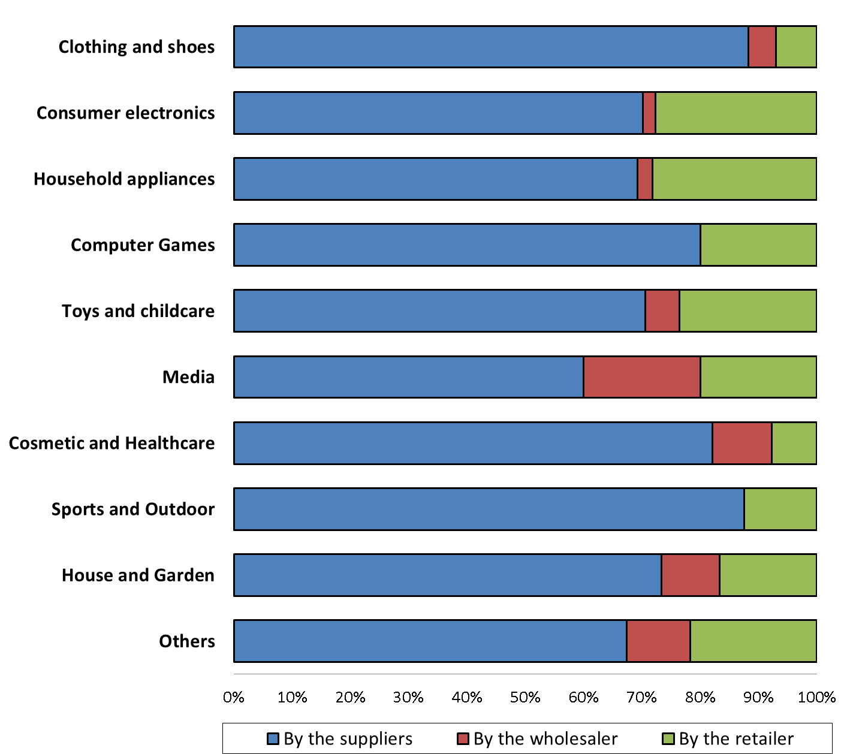

1. The view of retailers differs from that of the manufacturers, as the great majority of them (on average roughly 80 %), independently of the product category, consider that most of the advertising and promotion is carried out by the retailers.
2. These seemingly opposing views may be due to the different types of advertising and promotion that takes place at each level – manufacturers invest in promoting their brands, while retailers focus on the promotion of specific products. As one of the respondents summarises *"[…] advertising in regard of demand creation is done by brand manufacturers alone (see for example generic TV product advertising) and the actual advertising for individual B2C products is done by the retailer".*
3. Retailers consider that in the majority of sectors manufacturers only provide incentives to advertise and promote to a limited extent. The responses of retailers indicate that incentives are most important for computer games, as well as for consumer electronics and household appliances.[180]

Figure B. 33: The proportion of retailers that report to be incentivised for advertisement and promotion online per product category (based on the response of retailers)[181]

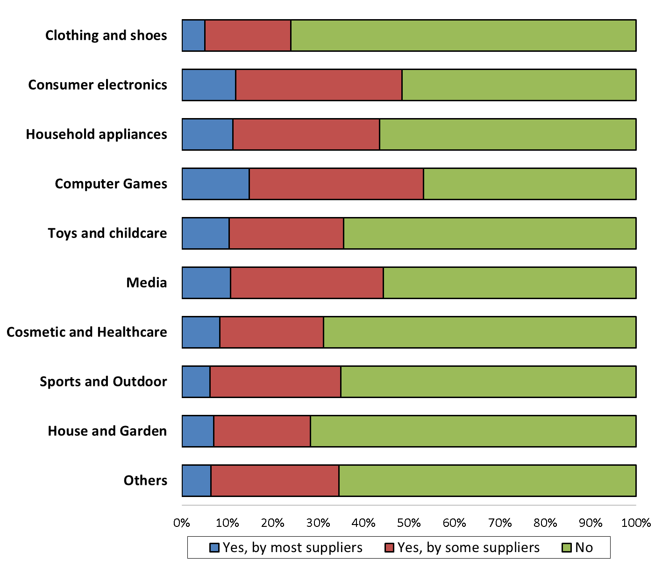

Figure B. 34: The proportion of retailers that are incentivised for advertisement and promotion offline per product category (based on the response of retailers)[182]

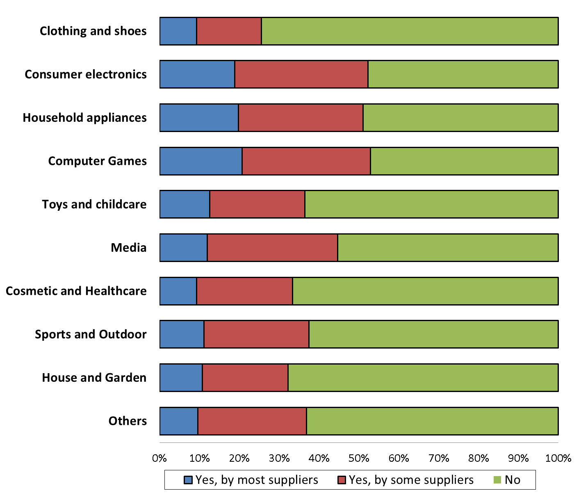

1. Somewhat more manufacturers state that they incentivise distributors for promoting and advertising offline (63 %)[183] than online (51 %)[184], whereas many indicate that they do not distinguish between the two channels (although among the listed compensations some are only meaningful for either offline or online sales). Many manufacturers explain that they set up complex multi-level marketing support and compensation schemes. The criteria to benefit from those schemes may advantage offline or online retailers. Few respondents explain that the Vertical Guidelines restrict their freedom to manage and compensate online and offline distribution channels independently.

#### ***4.1.3 Customers' purchasing behaviour and free-riding between the online and offline retail channel***

1. In view of the considerable efforts by both manufacturers and retailers in terms of offering customer services, promotion and advertising, the Commission assessed the importance of free-riding between the offline and online retail channels[185], i.e. where customers benefit from services offered by one of the sales channels to make their choice, but then purchase the product via the other sales channel. Such customer behaviour and, hence, free-riding can be observed both ways.
2. Independently of the sales channel, customer services involve costs for the retailer that offers them. If following these customer services actual sales take place to a significant extent via other sales channels, it could reduce the incentives of retailers to invest in those services. As explained in section A.5. Analytical framework, vertical restraints may be helpful in overcoming the free-riding problem.
3. While the Commission did not survey customers in the framework of the sector inquiry, it asked retailers and manufacturers to indicate, based on their business experience and knowledge, how prevalent "free-riding" between online and offline sales channels is, where customers benefit from services offered via one of the sales channels but carry out the actual purchase through the other channel. The Commission also asked respondents to describe the impact of free-riding on different aspects of their commercial decisions.
4. Overall, 45 % of respondent manufacturers indicate that free-riding, whereby customers benefit from services offered by brick and mortar shops to make their choice, but then purchase the product online is common (35 %) or very common (10 %). 27 % report that it is occasional and 2 % are of the view that it does not exist.[186]
5. Quite similarly to the above figures, 42 % of the respondent manufacturers find that free-riding by offline retailers on services offered by online retailers (i.e. purchase in brick and mortar shops typically following online search) is common (32 %) or very common (10 %). 20 % of the manufacturers believe that the practice is occasional, while only 4 % indicates that it does not exist.[187]
6. Free-riding by online retailers on services offered by brick and mortar shops is also acknowledged by the retailers: 7 % believe such behaviour is very common and 15 % that it is common. 21 % indicate that it is occasional, while 8 % are of the view that such behaviour does not exist.[188]
7. The figures are fairly similar for free-riding by offline stores on services offered online: 8 % of the respondent retailers are of the view that such free-riding is very common and 14 % that it is common, 16 % believe that it is occasional, while 8 % are of the view that such behaviour does not exist.[189]
8. Although both manufacturers and retailers fully recognise the existence of free-riding in both directions, their comments show a greater sensitivity to the risks of free-riding by online retailers on the services offered by offline retailers.
9. The main reasons set out by both manufacturers and retailers are related to the costs of investment in brick and mortar shops which they claim are higher than the costs of investment in online sales. In particular, the premises (often required to be in city-centres or other higher priced areas, with specific requirements by the different manufacturers for the inside quality and arrangements of the shop), the specific facilities required by the manufacturers and human resources (in particular in qualified staff / training of staff) require substantial investments.
10. Some manufacturers also emphasise the difference between free-riding by online retailers on offline services and free-riding by offline retailers on online services in terms of their impact on marginal cost. More specifically, the manufacturers claim that free-riding on services offered online would not increase the marginal cost of online players, while free-riding on the services offered by brick and mortar shops would increase the marginal costs of offline retailers.
11. A number of manufacturers as well as hybrid retailers point to a risk of seeing significant number of brick and mortar shops disappear, as a result of what they qualify as a general trend to use brick and mortar shops as "service providers", while making the actual purchases of goods via online sales channels, therefore directing to a large extent the money-flow to online retail.
12. The costs of online investments are also fully acknowledged by the respondents. The online retail investment costs that are most referred to are the costs of promoting the website, including search engine optimisation, platform commissions and online advertising, the costs (including human resources and software) of creating and maintaining the website, costs of maintaining a full online (interactive) catalogue on all websites, for all language versions, the costs of a call centre.
13. Manufacturers and retailers were asked about the way free-riding practices affected their business decisions. The trends described below represent the most typical ways to overcome free-riding between online and offline sales channels.
14. *Compensations*: as set out under paragraph (293), 36 % of manufacturers provide compensation to offline retailers for their offline shop and services, and the same proportion of manufacturers offers compensations to online retailers. Many manufacturers provide financial incentives and support to their retailers. Compensations for brick and mortar stores can typically depend on certain quality requirements, such as the offering of specific services or the presence of qualified staff. The financial incentives can take the form of bonuses, display discounts, exposure fees. The payment of a fixed fee to support offline sales efforts is one of the mentioned reactions to counter-balance the effects of free-riding. Compensations for online retailers are typically linked to the costs of online marketing / advertisement, to the marketing tools of the website, to the completeness of the information provided on the website, to the overall quality of the product display.
15. *Direct provision of material and training*: manufacturers and retailers equally report that manufacturers provide material to both offline and online retailers. To support offline retail, manufacturers provide "point of sale" material to brick and mortar shops, such as display furniture, marketing material, specific facilities or technology for shop design or for enabling optimised product presentation. To support online retail manufacturers provide digital tools such as digital catalogue, digital data for website content (photos, videos, all relevant data to optimise search), digital apps, marketing tools and material and buy keywords for search advertising. Many of the direct provisions of material form part of the obligations of manufacturers set out in the relevant distribution agreements.
16. *Recommended resale prices - online / offline price equivalence*: A harmonised online-offline resale price policy (whether by hybrid retailers or by manufacturers) is one of the most typical reactions to free-riding. Manufacturers that directly sell their products state that they typically set equal prices online and offline, including equivalent discounts and promotional periods. Manufacturers also report about setting equivalent recommended resale prices to online and offline independent retailers as an attempt to limit free-riding. For the same purpose, several manufacturers explicitly state that they try to ensure harmonised retail prices across their online and offline distribution network.
17. Many retailers also report that they apply price equivalence across their online and offline shops to minimise free-riding concerns. The Commission asked hybrid retailers whether free-riding between sales channels affects their pricing decisions. More than 25 % of the respondent retailers report that free-riding by online retailers directly affects the prices they set in the different sales channels.[190] Similarly, 23 % of the respondent retailers report that free-riding by offline retailers affects the prices they set in the different sales channels.[191]
18. *Ensuring overall equivalence online and offline*: beyond price equivalence, many manufacturers strive to maintain overall equivalence and consistency between online and offline to ensure a level playing field between those two channels. They state that they seek to maintain coherence of brand image on both sales channels, coherent design, equivalence of available product range, available product information, consistent product launch dates and marketing actions, and equivalent advertising messages. About a third of the respondent retailers indicate that free-riding across the two sales channels affects the range of brands and models they offer online and offline.[192]
19. *Manufacturers opening own online shops*: many manufacturers also indicated that they started directly selling their products to customers as a reaction to free-riding concerns. Some manufacturers even substantially increased their turnover in direct sales to customers. For more details on manufacturers' direct sales to customers, see section B.3.1.2 Trends in manufacturers' distribution strategies above.
20. *Changes in selective distribution / exclusion of pure online players*: to ensure a level-playing field between retailers, several manufacturers also state that they introduce the requirement in their selective distribution system for all retailers to run at least one brick and mortar shop. The exclusion of pure online players from the distribution network is one of the most commonly stated reactions to the concern of free-riding by online players. Also, many manufacturers explain that the amendments of their selective distribution criteria, namely the introduction of quality criteria for online sales and the focus on the equivalence of online and offline requirements also serve to ensure a homogenous brand image and a level-playing field between the two distribution channels.
21. *Requirement to sell a certain amount offline*: with a view to counterbalancing the impact of free-riding by online retailers and ensuring an efficient operation of the brick and mortar shops, some manufacturers request a certain absolute amount (whether in volume or in value) of sales via brick and mortar stores.
22. *Opening of showrooms*: to respond to the demand of both manufacturers and customers regarding the importance of offline shops, a number of initially pure online players report that they opened or intend to open showrooms or shops.

**Summary**

The results of the sector inquiry show that manufacturers attach high importance to product quality and brand image to attract customers and consider the price to be relatively less important. In turn retailers attach high importance to price as a parameter of competition. Building and maintaining brand image and quality reputation, according to manufacturers, is an important motivation for the implementation of different vertical restraints, such as marketplace restrictions, restrictions on the use of price comparison tools and recommended retail prices.

The majority of manufacturers consider that customer services at the retail level are important to enhance demand across product categories, independently of the sales channel (online or offline). Most of these manufacturers also sell via selective or exclusive distribution and/or provide recommended prices to retailers. Manufacturers employ complex schemes to provide financial and non-financial support to retailers in order to incentivise them to provide customer services.

Almost half of the respondent manufacturers expressly require retailers to invest in specific facilities and human resources related to selling their brands/products. Whether such investments can be characterised as client-specific, giving rise to the so-called "hold-up problem" and, therefore, justifying certain vertical restraints to overcome possible underinvestment, would require a case-by-case assessment.

Advertising and promotion activity takes place both at retail and manufacturing level. The findings show that retailers and manufacturers focus on different types of advertising. Manufacturers invest in promoting their brands, while retailers rather tend to promote specific products. About half of the manufacturers provide incentives to retailers to advertise and promote their products, with a higher proportion doing so vis-à-vis hybrid retailers.

Almost half of respondent manufacturers indicate that the practice, whereby customers benefit from services offered by brick and mortar shops in order to make their choice, but then purchase the product online (a situation, which gives rise to "free-riding"), was either common or very common. A slightly smaller proportion of respondent manufacturers find free-riding by offline retailers on services offered online (purchase offline following online search) also very common or common. The respondent retailers also confirm that free-riding takes place, although to a lesser extent. About a fifth of respondent retailers believe free-riding by online retailers on services offered offline is either very common or common and the same proportion of respondents indicate it is occasional. Figures are also largely similar for free-riding by offline retailers on services offered online.

Many respondents (both retailers and manufacturers) consider that the costs of investments in offline stores are higher than the costs of investments in websites. Compensation and direct provision of material to both sales channels, online/offline price-equivalence and overall coherence, increasing direct sales to customers by manufacturers and changes to the selective distribution criteria, including the requirement of having at least one brick and mortar shop, are the most typical reactions to free-riding.

### 4.2 Overview of restrictions

1. This section of the Report is dedicated to the analysis of restrictions of online sales of goods. It will in particular focus on a number of contractual[193] restrictions which limit the retailers' ability to sell or advertise their products online. The restrictions encountered in the sector inquiry are predominantly found in vertical agreements, i.e. in agreements entered into between undertakings operating for the purpose of the agreement at different levels of the production or distribution chain, and relating to the conditions under which the parties may purchase, sell or resell certain products.[194]
2. The restrictions analysed in this section should not be understood as an exhaustive list of restrictions. As new business models and market trends emerge other restrictions may be used by market players.
3. Figure B. 35 below provides an overview of the prevalence of certain restrictions amongst retailers that participated in the sector inquiry and responded to the questionnaire.

Figure B. 35: Proportion of retailers having contractual restrictions, per type of restriction[195]

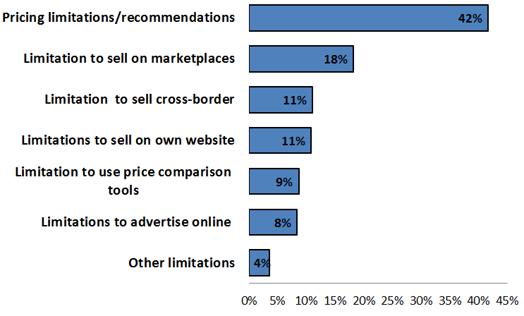

1. Pricing restrictions are by far the most widespread restrictions reported by retailers. For the purposes of this Report, the term "pricing restrictions" not only includes restrictions that fix the resale price or impose a minimum resale price, but also recommended resale prices or maximum resale prices. Restrictions on the use of marketplaces are the second most reported restrictions.
2. All product categories are affected by restrictions although to a different extent. With the exception of media, computer games and software, at least 1 in 10 retailers active in each product category has experienced some form of restriction with respect to selling or advertising online. Clothing and shoes is the product category with the highest proportion of retailers having reported the presence of restrictions, followed by sports and outdoor equipment and consumer electronics.

Figure B. 36: Proportion of retailers having at least one contractual restriction per product category[196]

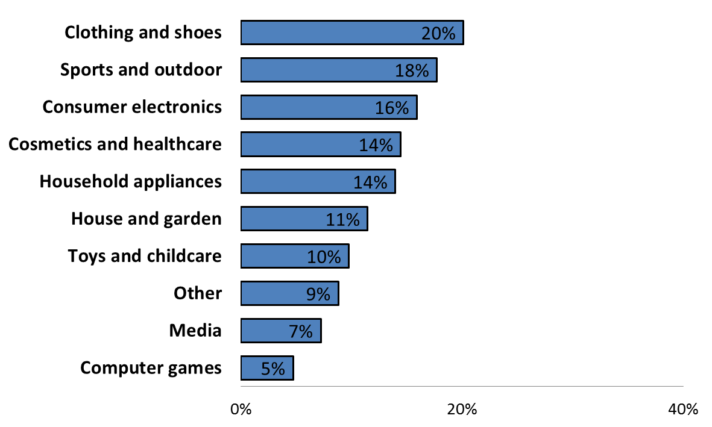

1. Half of the respondent retailers report to be affected by at least one restriction to sell or advertise online.[197] In terms of geographic coverage, in all Member States retailers report to have at least one restriction to sell or advertise online. The figures below provide a snapshot of the contractual restrictions encountered by retailers in 11 selected Member States and across all product categories.[198]

Figure B. 37: Proportion of retailers having at least one contractual restriction per EU Member State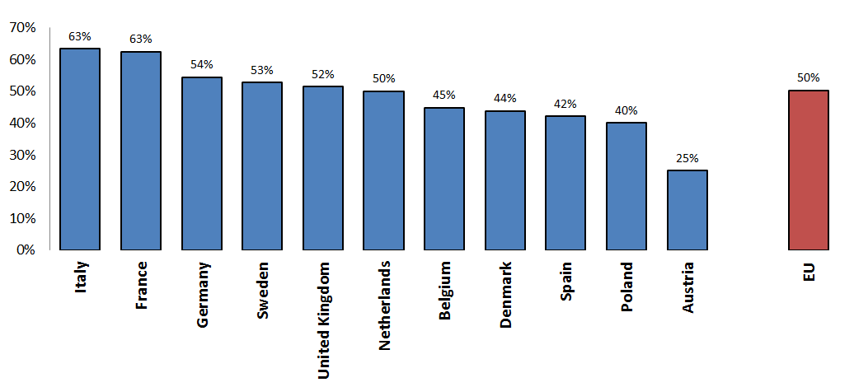

1. In the following sections various restrictions will be discussed in more detail.

**Summary**

Pricing restrictions are the most widespread contractual restrictions reported by retailers. Restrictions to use marketplaces are the second most reported restriction.

Half of the respondent retailers report to be affected by at least one contractual restriction to sell or advertise online.

All product categories are concerned by contractual restrictions although to a different extent: clothing and shoes is the product category with the highest proportion of retailers having reported the presence of contractual restrictions, followed by sports and outdoor equipment and consumer electronics.

### 4.3 Cross-border e-commerce and geographic restrictions to sell and advertise online

1. Cross-border e-commerce has the potential of contributing to the integration of the EU's internal market as customers may find it easier to purchase products from another Member State online, rather than crossing the border and buying products in brick and mortar shops. Cross-border online purchases are however frequently not possible for customers, because retailers refuse to sell to customers abroad, for example by blocking access to websites, re-routing customers to websites targeting other Member States or by simply refusing to deliver cross-border or to accept cross-border payments.
2. These measures are also known as "geo-blocking". Geo-blocking can be distinguished from "geo-filtering" measures, which refer to commercial practices whereby online retailers allow customers to access and purchase goods or services cross-border, but offer different terms and/or conditions depending on the location of the customer in a Member State different from that of the retailer.
3. This section outlines first the geographic sales policies and activities of manufacturers and retailers. This is followed by a section where geo-blocking and geo-filtering practices by retailers are discussed as well as the potential commercial reasons for retailers not to sell cross-border. The last part of the section will present the findings on contractual cross-border sales restrictions.[199]

#### ***4.3.1 Geographic sales strategies of manufacturers***

1. Manufacturers were asked to provide information about the way they set up their distribution networks in the EU.
2. Manufacturers reported a wide variety of distribution arrangements. Manufacturers can be grouped into two broad categories: the manufacturers that apply by and large the same distribution model across the EU and those that apply different distribution models depending on where their products are sold.
3. Manufacturers that use different distribution models across the EU consider that certain markets/Member States have certain peculiarities in particular with regard to local customer tastes/preferences or habits or the market structure at the distribution level that require tailored approaches. For example, wholesalers may be an important intermediate level to ensure a broad geographic coverage in some Member States and be of lesser relevance in other Member States in which large retail chains provide for a good geographic coverage. A factor that manufacturers also take into account when deciding on the use of specific distribution models is the degree of development of e-commerce in a given Member State.
4. Manufacturers were asked to indicate in how many EU Member States they sold their products in 2014 either directly or via independent wholesalers or retailers. As can be seen in figure B. 38 the responses show that taking all product categories together the majority of manufacturers distributed their products in at least 21 Member States, while only a limited proportion (4 %) supplied them in only one Member State.

Figure B. 38: Geographic scope of manufacturers' sales activity split by number of Member States (all product categories)[200]

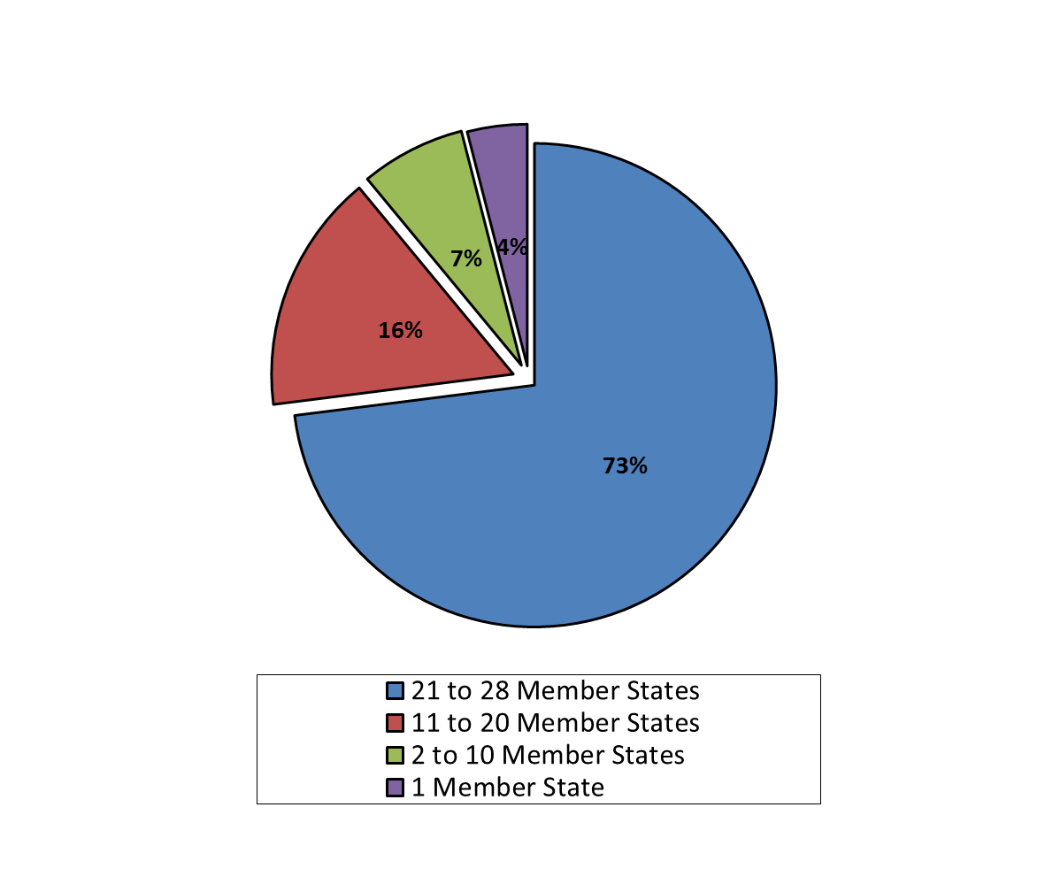

1. The majority of manufacturers in each product category supplied their products in 21 to 28 EU Member States. The highest proportion of manufacturers selling in at least 21 Member States are those active in cosmetics and healthcare products followed by those that supply consumer electronics.[201]
2. Manufacturers explain that the strategy of selling directly to retailers without involving wholesalers is used in those Member States which manufacturers consider to be most important from a business perspective. Where in-depth knowledge of a given market in a Member State or territory is needed, manufacturers tend to sell via well-established wholesalers rather than directly to retailers.
3. Manufacturers also use different types of distribution agreements to target specific Member States. Manufacturers may, for instance, use selective distribution agreements in some Member States in which their brand is well-established and use exclusive distribution agreements in Member State for products or brand(s) that are newly introduced and require specific sales efforts from distributors.[202]

#### ***4.3.2 Geographic sales strategies of retailers and cross-border e-commerce***

1. Geographic sales strategies of retailers vary significantly amongst the respondents to the retailers' questionnaire.
2. Many retailers focus their sales activity on a single Member State and their respective website is targeting customers in this Member State only. Others try to expand their activity into other Member States (for example by selling cross-border via an existing website or a marketplace or by launching a new website targeting specifically customers in another Member State).

##### 4.3.2.1 Retailers not selling cross-border

1. 36 % of retailers that responded to the relevant question report they do not sell cross-border for at least one of the relevant product categories.[203] Across the 28 EU Member States the median proportion of the retailers that report that they do not sell cross-border for at least one of the relevant product categories is 47 %. This means that for half of the Member States this proportion is below 47 % and that for the other half it is above 47 %.
2. At Member State level, the proportion of respondents that do not sell cross-border is typically lower for larger online markets, such as France and Germany, compared to smaller markets, such as Belgium, where retailers reported to focus more on national sales. Figure B. 39 below provides an overview of the proportion of respondents that report that they do not sell cross-border in at least one product category in each Member State.

Figure B. 39: Retailers that do not sell cross-border in at least one product category for selected Member States[204]

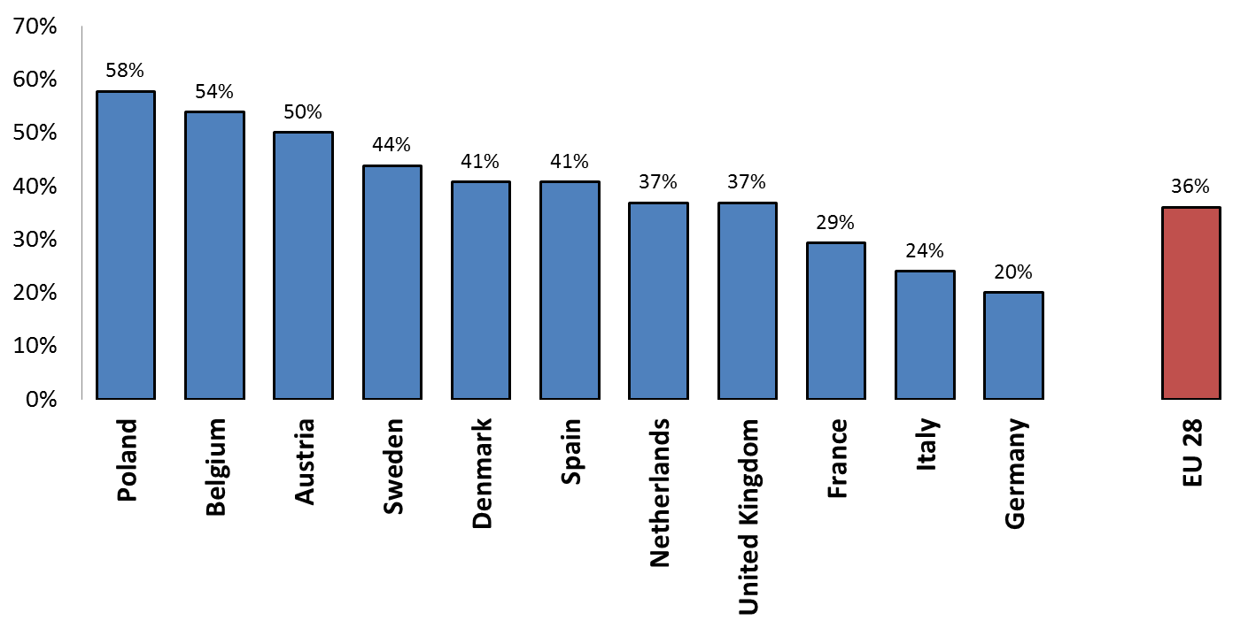

1. The decision of a retailer not to sell cross-border does not appear to be related to the product category sold. As can be seen from figure B. 40 below, in all product categories apart from clothing and shoes, more than half of the respondents that replied to the relevant question in relation to the respective product category reported that they do not sell cross-border.[205]

Figure B. 40: Retailers that do not sell cross-border for each product category

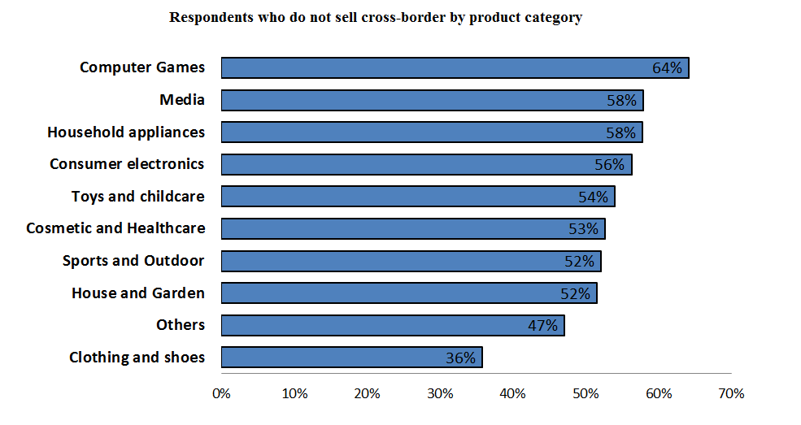

1. The proportion of retailers not selling cross-border in at least one product category is slightly higher in the higher turnover categories. More than a third of respondents in the turnover categories above EUR 2 million indicated that they do not sell cross-border in at least one product category. Larger retailers active in several Member States often decide not to sell cross-border from a given website, but rather to establish/buy a new country-specific website in order to target customers in another Member State.[206]

Figure B. 41: Retailers that do not sell cross-border in at least one product category for each 2014 turnover category[207]

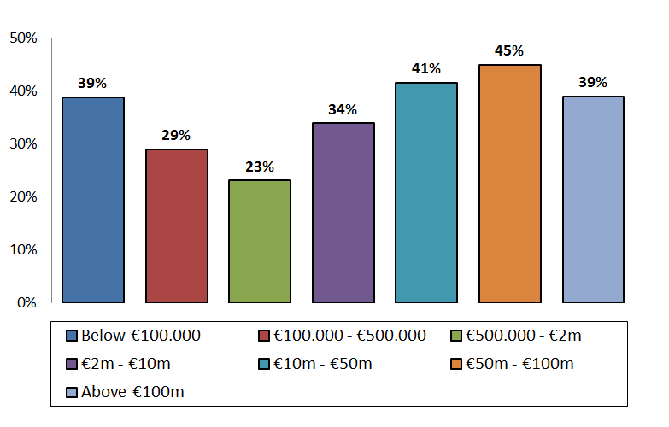

##### 4.3.2.2 Cross-border visits and transactions on retailers’ own websites

1. In order to assess the extent of cross-border business activity amongst retailers, in terms of both cross-border visits and transactions, retailers were asked to provide information about the number of visits to their websites and the number of purchases that were made in 2014 from customers located in each Member State.
2. Altogether the average proportion of visits coming from other Member States (as opposed to domestic visits[208]) is approximately 20 % of all visits in the EU, across all respondents that provided the relevant information.[209]
3. At Member State level, the proportion of visits from abroad varies greatly, as can be seen from the figure below. This is also due to the fact that the number of visits is to a certain extent influenced by the size of the population. Therefore, even in traditionally larger e-commerce markets such as Germany and the UK, the proportion of visits from abroad is relatively modest compared to the proportion of domestic visits. A high proportion of cross-border visits was reported for some of the Nordic Member States.[210]

Figure B. 42: Proportions of domestic and EU cross-border visits on retailers' own website in 2014 per Member State[211]

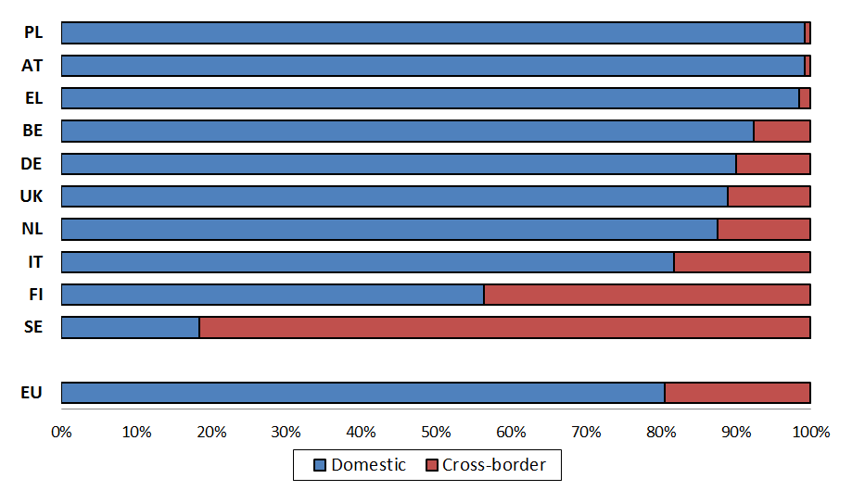

1. Looking at actual purchases, 55 % of respondents[212] report that all their customers were located in one Member State, while 12 % sold to customers located in 26 or more Member States. On average, the proportion of EU cross-border purchases reported by respondents is the same as the proportion of EU cross-border visits, namely approximately 20 %. Also in the case of purchases, the size of the population of a Member State is one of the elements that may influence the relationship between domestic and cross-border purchases.[213]

Figure B. 43: Proportions of domestic and EU cross-border purchases on retailers' own website out of all purchases in 2014 per Member State[214]

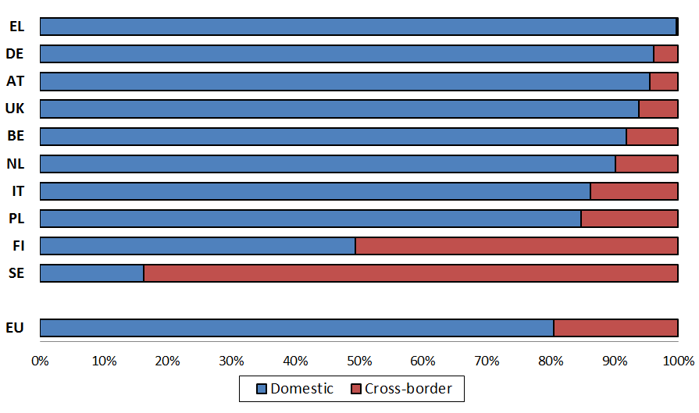

##### 4.3.2.3 The role of online marketplaces for cross-border sales

1. Marketplaces typically allow retailers to choose whether they want to deliver abroad.[215] Marketplaces may make it easier for companies to sell cross-border for a number of reasons. Sellers that want to increase sales into another Member State may be able to do so without incurring the cost of launching a new dedicated website for this Member State. Moreover, some marketplaces facilitate cross-border delivery or provide advice on the applicable rules when selling cross-border.
2. Information received from retailers in the context of the sector inquiry suggests that marketplaces indeed facilitate cross-border sales and that retailers that sell (also) via marketplaces are more likely to sell cross-border compared to those which only sell via their own website.
3. Approximately 44 % of retailers that sold only via their own website reported not to sell cross-border (in any product category), whereas approximately only 20 % of retailers that sold only or also on marketplaces reported not to sell cross-border.[216] Moreover, approximately two thirds of the marketplaces report to be open to professional sellers from all 28 Member States.
4. On the other hand, information received from retailers in relation to actual purchases on marketplaces as well as information received from marketplaces indicates that approximately half of the sellers on marketplaces choose to sell into one Member State only and not sell cross-border.
5. The Commission asked retailers to provide information on the number of purchases completed via marketplaces by buyers located in each Member State. 55 % of retailers that provided this information indicate sales to buyers in one Member State only.[217] 45 % of retailers report that they sold products to buyers in two or more Member States out of which 7 % report to sell their products via marketplaces to 26 or more Member States.

Figure B. 44: Retailers indicating purchases that occurred via marketplaces in 2014 split by geographic coverage

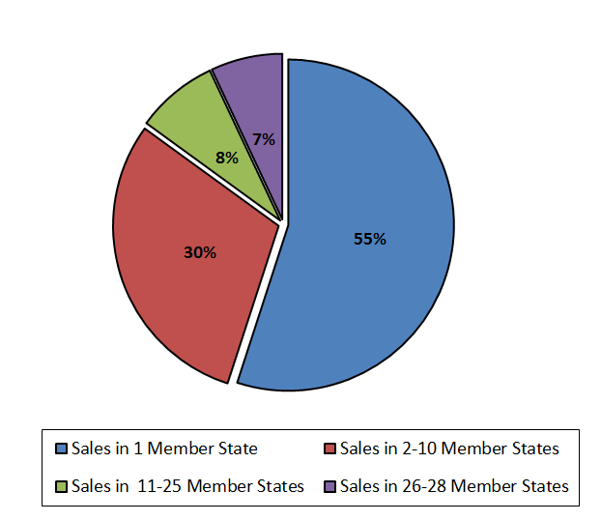

1. Marketplaces report that on average in 2014 approximately 28 % of sellers chose to make their goods available for delivery to at least 21 Member States while 51 % chose to have their goods delivered to one Member State only.[218]
2. The figure below provides an overview of the average proportion of domestic and cross-border transactions completed in 2014 by retailers on their own website as well as on marketplaces. It shows that websites of large retailers achieve a higher proportion of cross-border transactions with customers located in other Member States compared to the websites of smaller and medium-sized retailers.

Figure B. 45: Average proportion of retailers' sales on own website and on marketplaces, domestic and cross-border[219]

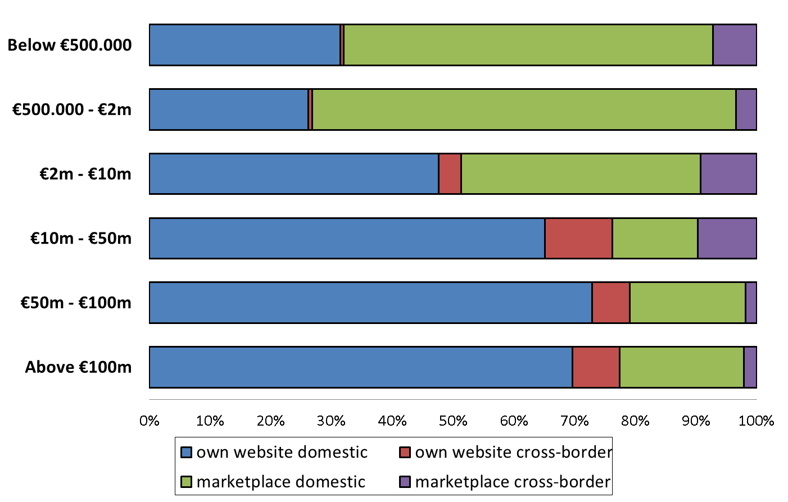

1. The average proportion of cross-border sales via marketplaces is significantly higher than the proportion of cross-border sales via the own website for retailers which achieved a total turnover of less than EUR 10 million, whereas it is lower for all turnover categories above this threshold. This suggests that marketplaces represent an important gateway for smaller and medium-sized retailers to sell cross-border whereas they are less relevant for cross-border sales of large retailers with a turnover above EUR 50 million.

##### 4.3.2.4 The role of price comparison tools for cross-border sales

1. Another way for retailers to make customers aware of their online offering both domestically and abroad is using price comparison tools. Price comparison tools have adopted a business model that supports retailers' visibility also outside the Member State where the price comparison tool is established.
2. The majority of price comparison tools allow customers to compare offerings across retailers active in different Member States. 60 % of the 83 price comparison tools that responded to the relevant question stated that they provide information about product listings from retailers that are active in Member States other than the Member State the price comparison tool is targeting. Almost two thirds of those price comparison tools that list products from retailers based in other Member States also inform their potential customers upfront of the location of the seller.

##### 4.3.2.5 Geo-blocking measures

1. In case retailers do not sell cross-border or do not sell cross-border into particular Member States they may implement the following geo-blocking measures in order to reject cross-border purchase requests: (i) prevent the customer from accessing the website, (ii) automatically re-route the customer to a website targeted at another Member State, (iii) refuse payment or (iv) refuse delivery. Each of these measures may be implemented by a retailer either unilaterally or as a consequence of an agreement with its supplier(s).
2. Retailers usually collect some type of information about the location of customers. They do so for a variety of reasons, including, delivering goods or verifying that orders are legitimate. Retailers were asked whether they gather any location related information from (potential) customers (e.g. IP address, credit/debit card details) for geo-blocking purposes.
3. The percentage of respondents at EU level that collects such data for geo-blocking purposes is 38 %.[220] The figure below provides an overview of the proportion of respondents that use information about (potential) customers' geographic location for each of the geo-blocking purposes.

Figure B. 46: Retailers that gather location information for each geo-blocking purpose – EU 28[221]



1. To implement geo-blocking, retailers collect various types of information on the location of the customer. The type of information that respondents most commonly collect for geo-blocking purposes is the postal address of the customer, followed by the customer's credit/debit card details or country of residence.
2. The figures below show the proportion of respondents that gather location information for geo-blocking purposes per type of information and per 2014 turnover category of the respondents, respectively.[222]

Figure B. 47: Retailers that gather location information for geo-blocking purposes, per type of information – EU 28



Figure B. 48: Retailers that gather location information for geo-blocking purposes for each 2014 turnover category[223]

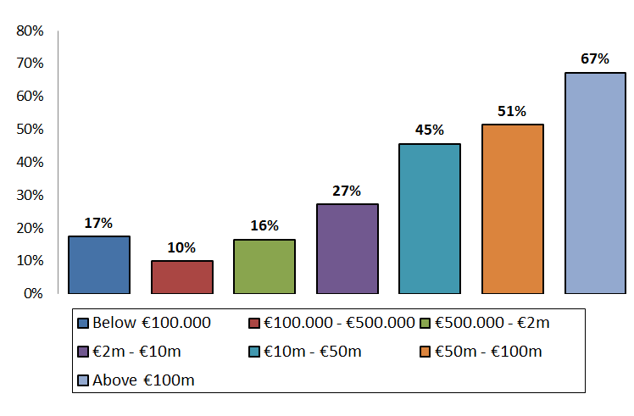

1. There is a positive correlation between the total turnover and the proportion of respondents that gather location information for geo-blocking purposes. With the exception of the lowest turnover bracket, the higher the turnover, the higher the proportion of retailers that gather information for geo-blocking purposes. The reason for this may partly be that respondents in the higher turnover categories are more likely to have visits by (potential) customers located in another Member State.

##### 4.3.2.6 Geo-filtering and cross-border price and offer differences

1. The Commission also analysed the extent to which geo-filtering practices are applied by retailers. Retailers were therefore asked whether they charge different prices when they sell the same product cross-border to any Member State other than the one in which their website is established.
2. Approximately, three quarters of respondents that sell cross-border indicated that they do not charge different prices for such sales, whereas one quarter of respondents indicated that they charge different prices at least for some products.[224] The majority (79 %) of retailers that provided information about margins that they obtained from cross-border sales reported they did not achieve different profit margins for the same product depending on whether it is sold cross-border to another EU Member State.[225]
3. Figure B. 49 below shows the proportion of respondents that reported that they charge a different price for the same model of a product brand when selling cross-border to any EU Member State other than the one in which their website is established.[226]

Figure B. 49: Respondents that charge different prices (excluding delivery costs) when selling cross-border, in each product category at EU level

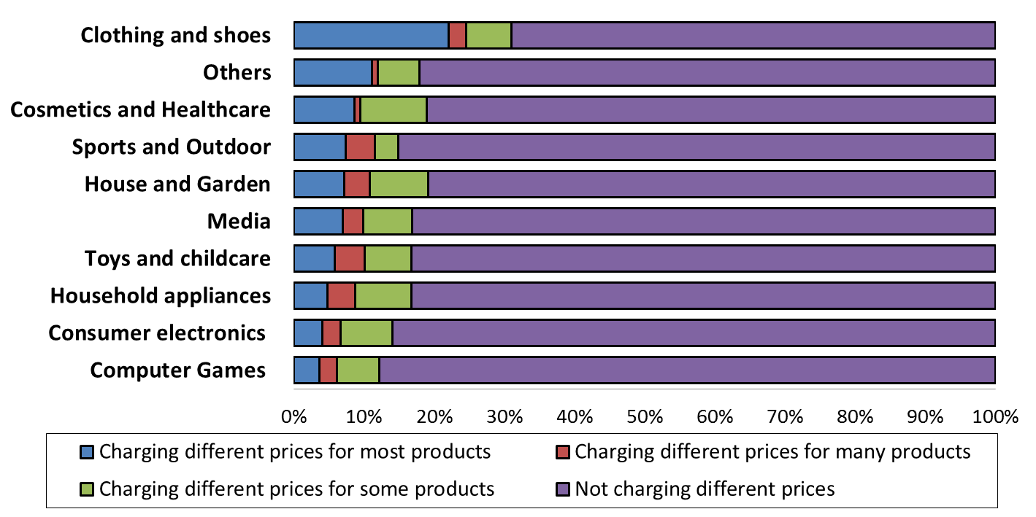

1. The product category in which the highest proportion of retailers charges different prices is clothing and shoes, where 31 % of retailers reported that they charge different prices out of which 22 % charge different prices for the large majority of products offered.
2. Retailers that charge different prices when selling cross-border were questioned about the main reasons for doing so. They were requested to indicate the level of importance of a number of predefined reasons. The reasons that were considered most important were different tax regimes, costs and product demand as well as differing competitive pressure in other markets. Requests by manufacturers were considered less relevant.

Figure B. 50: Number of retailers indicating the level of importance of pre-defined options for charging different prices when selling cross-border[227]

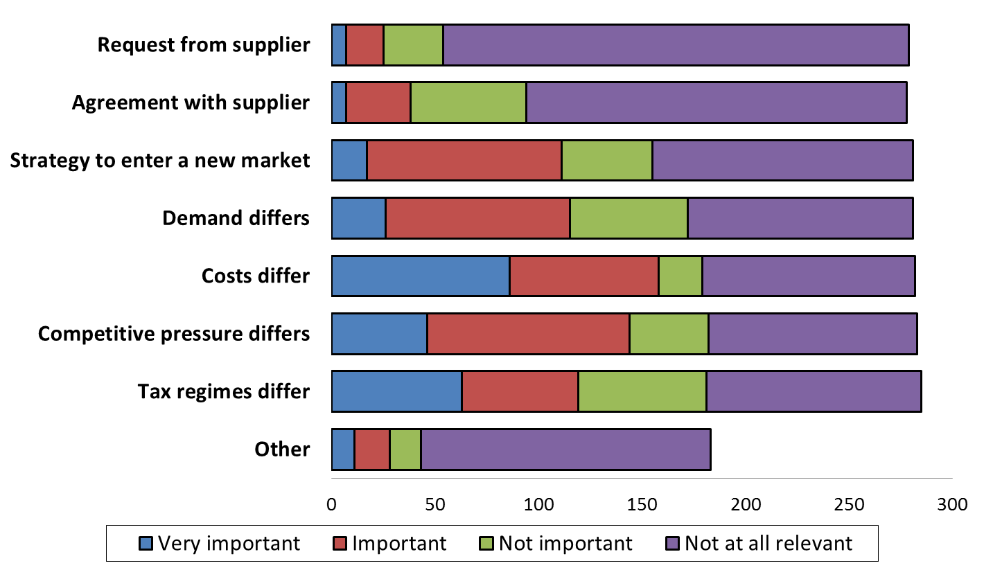

1. It emerges from the responses to the marketplaces' questionnaire that charging different prices for cross-border sales is not common when retailers sell their products via marketplaces. Only 1 out of 33 marketplaces that responded to the relevant question reported observing price differences in some product categories for the same product model sold by sellers on their platform cross-border to any Member State other than the one in which the professional seller is established.
2. Manufactures were also asked whether the products they supply differ in terms of characteristics depending on the intended Member State of sale. The majority of manufacturers report that their products would not differ while slightly less than a quarter of the respondents reported that there were differences but only in relation to some of the products.
3. That said there are appreciable differences reported between product categories. In the product categories clothing and shoes as well as sports and outdoor equipment over 85 % of the manufacturers report that there are no differences between the products they supply depending on where the product is sold. In other categories, such as consumer electronics and household appliances, over 45 % of manufacturers report that their products differ depending on where they are meant to be sold[228]. The main reasons reported to explain those differences are technical requirements, such as different plugs for products sold in certain Member States or local customer preferences.
4. Product differentiation may help manufacturers and retailers to price differentiate across countries by charging different prices for different versions of the products. This may explain why for consumer electronics price differences for specific products are reported to be rather limited despite the high proportion of product differences that were reported.
5. Cross-border sales restrictions, implemented through geo-blocking or geo-filtering could be motivated by suppliers' interests to ensure that different prices are applied in different Member States for the same product. For that to be possible, (potential) customers from the Member States where prices are higher for a specific product must be prevented from buying the product from the Member States where it is cheaper. Geo-filtering and geo-blocking measures may serve to prevent such "arbitrage" opportunities. Overall consumer welfare is expected to decrease if, as a result of the price discrimination and geo-filtering/geo-blocking, total output decreases or remains the same. In case total output would increase, the welfare effect of price discrimination along national borders is a priori ambiguous.[229] However, in case price discrimination allows the company to serve a market which would otherwise not be served, the effect on overall consumer welfare should normally be positive.

##### 4.3.2.7 Commercial reasons for not selling cross-border and costs of supplying abroad

1. Targeting customers cross-border requires specific measures that come at a cost and limited cross-border activities of retailers can partially be explained by the costs/efforts needed to successfully sell in other Member States. The figure below shows the percentage of retailers that either took or would take the predefined measures in order to launch or increase online sales in other Member States, where they were not significantly present or not present at all.

Figure B. 51: Proportion of retailers indicating that they took or would take certain steps in order to launch or increase online sales in other Member States[230]

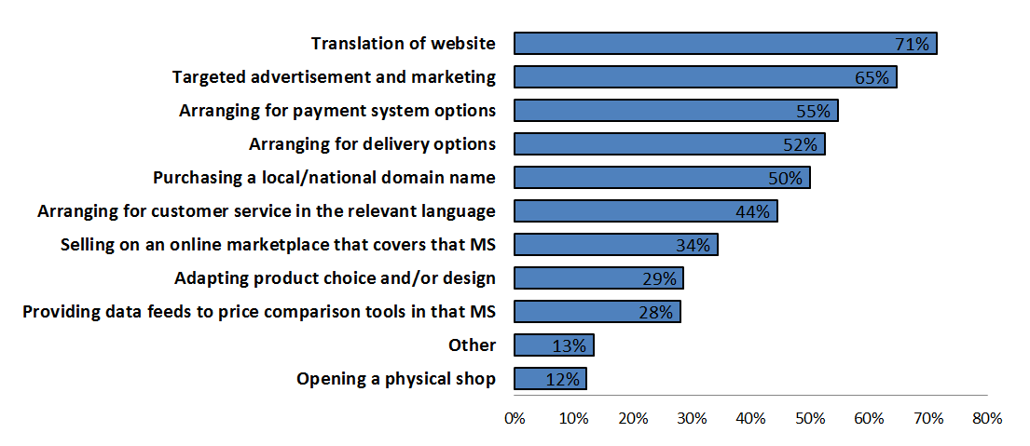

1. The responses show that retailers consider a significant number of measures to be advisable in order to successfully sell online into a new geographic market.
2. The measure mentioned by most respondents involves translation of the website, while the second most often indicated one involves targeted advertising and marketing.
3. The majority of respondents that mention translation of the website as a measure to increase cross-border sales in Member States where they were not (significantly) present have also pointed to other measures. For instance, almost three quarters of the respondents mention targeted advertising or marketing as a measure they have or would take in order to enter or increase sales into a Member State.
4. Similarly, of the respondents that would translate the website as a measure (i) almost three quarters indicate that they would, in addition, start providing data feeds to price comparison tools in that Member State, (ii) three quarters would, in addition, start selling on an online marketplace that covers also that Member State, and (iii) 86 % indicate that they, in addition, would purchase a local/national domain name.
5. Retailers were also asked about the main categories of costs they incur when entering as an online retailer in a new Member State. In addition to costs which are related to the measures described in figure B. 51 above, companies frequently face costs due to the need for local legal or tax advice as well as the need for specific IT to handle the processing of orders.
6. The actual costs incurred are case-specific and depend on the strategy of the retailer. They can range from a few thousands to several million Euros. Based on the responses by retailers, opening a new dedicated website in another Member State is generally considered to be more expensive than selling via marketplaces where the additional costs are typically limited to commissions paid to the marketplace.
7. Retailers also incur additional costs when serving customers located in a Member State other than the one where the retailer's website is established. Additional costs that were reported typically include higher costs for delivery and return handling as well as higher payment costs related to higher charges by some payment service providers for cross-border transactions or the need to introduce alternative payment systems.
8. Often, the decision on whether to sell cross-border or not is a general business decision by a retailer and is not related to contractual or other arrangements with suppliers. Many retailers decide to sell to customers in a certain Member State only and refrain from selling cross-border as it adds additional costs.
9. Even if retailers decide to enter a new geographic market, many do so rather by setting-up a dedicated website with a Member State specific URL and support staff in the Member State than by selling cross-border from an established website. Based on the responses received, such newly established websites frequently target only customers from that Member State.

#### ***4.3.3 Contractual territorial restrictions to sell and/or advertise online***

1. As just explained, there may be a number of reasons and factors why retailers decide not to sell cross-border to customers in other Member States. Unilateral business decisions of non-dominant retailers not to sell cross-border at all or not to sell cross-border to customers in certain EU Member States do normally not raise any concerns under the EU competition rules.
2. There are, however, also indications of contractual restrictions[231] which restrict retailers from selling cross-border to customers outside their home Member State.

##### 4.3.3.1 Agreements between manufacturers and retailers restricting cross-border online sales

1. To evaluate the existence of cross-border online sales restrictions, retailers were asked whether they have contractual restrictions limiting their ability to sell cross-border to customers located in a Member State different from where the seller is established. In the 28 EU Member States, almost 12 % of respondents to the retailers' questionnaire report to have such restrictions in at least one product category.
2. It is important to note that, since this percentage only indicates the proportion of retailers that have contractual cross-border sales restrictions in at least one product category, it does not allow to draw any conclusions as to how many of their agreements include such restrictions and about the number of products within a certain product category that are affected by such restrictions. While some respondents may only be restricted in relation to one product in one agreement with one supplier, others may have territorial restrictions in agreements with multiple suppliers and for multiple products.[232]
3. As regards the relationship between the respondents' size and the presence of contractual territorial restrictions, a higher proportion of retailers with 2014 turnover above EUR 500 000 had contractual cross-border sales restrictions in at least one product category than of retailers with 2014 turnover below EUR 500 000.[233] This can be explained among others by the fact that larger retailers frequently sell more products and have more suppliers. The likelihood of cross-border online sales may also be higher for larger retailers than for smaller retailers.
4. As can be seen from figure B. 52, the proportion of retailers that have contractual cross-border sales restrictions in at least one product category for each of the Member States varies significantly.

Figure B. 52: Retailers that have contractual restrictions to sell cross-border in at least one product category, by Member State[234]

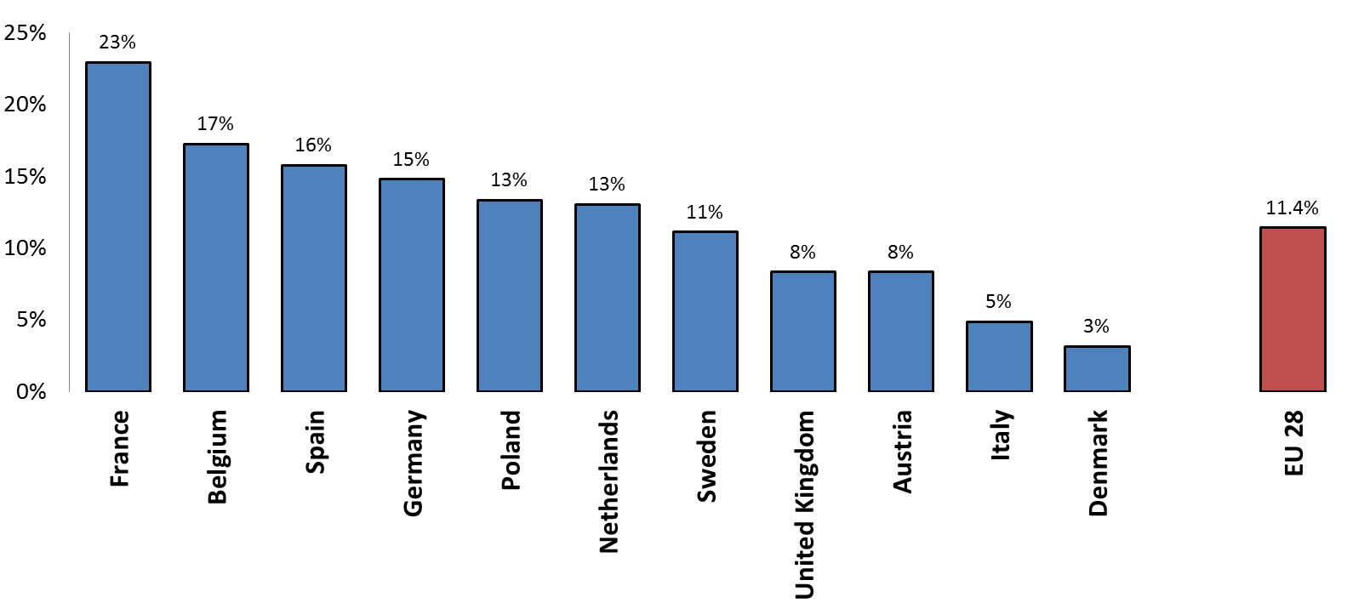

1. Contractual territorial restrictions were reported in all product categories. The product category with the highest share of contractual territorial restrictions is clothing and shoes followed by consumer electronics and sports and outdoor equipment. The figure below summarises the proportion of respondents out of all retailers active in a given product category that reported that they have a contractual restriction to sell cross-border for the relevant product category.

Figure B. 53: Retailers that have a contractual restriction to sell cross-border for each product category – EU 28[235]

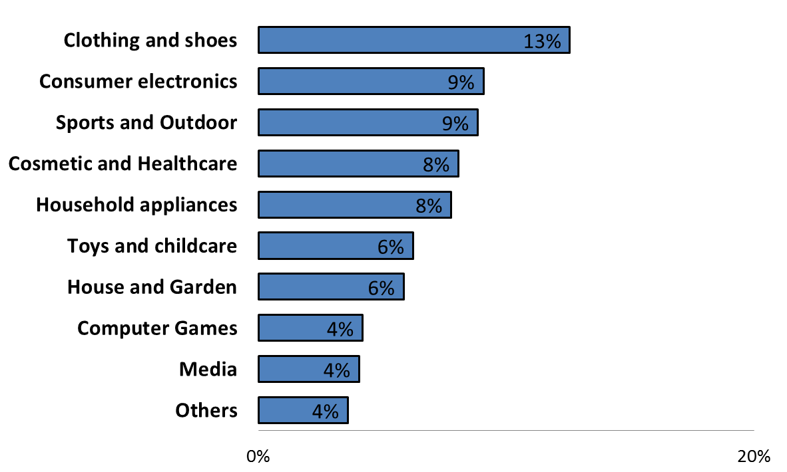

1. Contractual cross-border sales restrictions appear in multiple forms. The cross-border sales restrictions reported by respondents range from outright bans to sell outside one or more EU Member State to less straightforward restrictions on the ability of retailers to sell their products cross-border. Sometimes the retailer is not explicitly prohibited from selling cross-border, but is obliged to translate its website into the languages of all those Member States into which it is willing to deliver the product. Such a provision may limit any ad-hoc sales cross-border and may increase the costs of selling to customers outside the targeted Member State.
2. The above mentioned restrictions are not always formulated as prohibitions, but sometimes as requirements, whereby approval by the supplier is needed, before sales into other Member States are permitted. The impact of such approval requirements may often be the same as an outright prohibition. Only an explicit approval allows retailers to sell cross-border. Frequently, retailers may not request such an approval and even if they request it a rejection of their request may follow.
3. Based on the responses of the retailers, cross-border sales restrictions are not only included in written distribution agreements, but also communicated orally. Some retailers report that they have experienced retaliatory measures by manufacturers including the discontinuation of delivery to them because they sold cross-border or launched a website targeting another Member State than their home Member State.
4. Based on observations by some retailers, the contractual restrictions on cross-border sales are sometimes driven by the manufacturer's desire to keep prices in different Member States at a different level. Many manufacturers work with different "recommended price lists" for different Member States. Some respondents reported ad hoc interventions by suppliers to "stabilise" retail prices in certain countries by asking the retailer not to sell products in certain Member States (or raise the price to a certain level) to not negatively affect the price level in this Member State.
5. Cross-border sales restrictions can also result from the manufacturer not providing a Union-wide guarantee service under which normally all retailers are obliged to provide the guarantee service and are reimbursed for this service by the manufacturer, even if they were sold by other foreign retailers to customers in their territory.[236]
6. Approximately 5 % of respondent retailers report that some of the manufacturers indicated that the manufacturer guarantee would not be recognised for products which they sell cross-border.[237] 97 % of the respondent manufacturers indicated that they do not provide different commercial guarantees for cross-border transactions.[238] Furthermore, 99 % of the respondents do not apply different guarantees online and offline unless for regulatory reasons or due to the obligation towards a marketplace that requires longer guarantee periods as an admission criterion.
7. Few respondents indicate that they extend or reduce the commercial guarantee in cross-border sales to adapt to local legal requirements of the Member State of the customer. Some manufacturers indicate that local sales points have the commercial autonomy to make promotions on commercial guarantees that apply only within their own territory as long as they do not fall below minimum legal requirements.
8. There are also examples of contractual clauses under which manufacturers grant distributors territorial protection by limiting the possibility of other distributors to sell into their territory for a certain period of time in relation to new products which are introduced at different times in various Member States.[239]

##### 4.3.3.2 Monitoring of customer location

1. The Commission has questioned manufacturers as well as retailers whether they monitor the compliance with contractual territorial restrictions and the reasons for doing so.
2. 13 % of respondent manufacturers report to either monitor or ask retailers to monitor the location of customers to which retailers sell their products within the EU.[240] Only a small proportion of retailers indicate that they collect information concerning the location of the customer because their manufacturers request them to do so and the majority indicate that they do this based on their own business decision.[241]
3. On the other hand, approximately 22 % of respondent retailers indicate that some of their manufacturers use a system of serial number tracking or an equivalent system to identify the retailer from which a specific product was bought.[242]
4. Manufacturers were asked about the reasons for their monitoring activities. Next to ensuring compliance with territorial sales restrictions (such as active sales restrictions into exclusively allocated territories) the main reasons reported were:
5. To be able to understand the market and adopt the right (online) sales and marketing strategies for each Member State,
6. To be able to apply existing bonus policies and incentivise retailers appropriately,
7. To monitor guarantees and allow the activation of products,
8. To ensure the desired after-sales services,
9. To prevent unauthorised sales (within selective distribution systems),
10. To prevent the sale of counterfeit products.

##### 4.3.3.3 Geo-blocking measures, territorial restrictions and the EU competition rules

1. In the absence of a dominant market position, the EU competition rules are not concerned with geo-blocking on the basis of unilateral business decisions taken by companies, but only with geo-blocking measures which implement contractual restrictions limiting the ability of online retailers to sell to certain territories or customer groups.[243]
2. The European Courts have on a number of occasions held that agreements/concerted practices which are aimed at partitioning markets according to national borders or which make the interpenetration of national markets more difficult, in particular those which are aimed at preventing or restricting parallel exports, have as their object the restriction of competition pursuant to Article 101(1) TFEU.[244]
3. Geo-blocking measures implemented by undertakings that manufacture goods and sell them through their own websites fall outside the scope of Article 101 TFEU.[245] Equally, if a retailer unilaterally decides not to sell to customers in certain Member States and implements this decision through geo-blocking measures, that decision does not fall under Article 101 TFEU.[246]
4. If geo-blocking measures result from an agreement or concerted practice that is not a genuine agency agreement[247] between two undertakings (such as a manufacturer and a retailer), they may fall within the scope of Article 101(1) TFEU.

Territorial sales restrictions under Article 4(b) of the VBER

1. Article 4(b) of the VBER provides that, subject to a number of limited exceptions, the exemption provided for in the VBER does not apply to a vertical agreement between a supplier and distributors that directly or indirectly has as its object to restrict the territory into which, or the customers to whom, the distributor may sell the contract goods.
2. Article 4(b) of the VBER covers both direct and indirect restrictions (such as reduction of bonus payments or rebates) aimed at inducing distributors not to sell to customers in certain territories.[248]
3. A supplier can, however, restrict the territory into which or the customers to whom a distributor may sell the goods or services if one of the exceptions listed in Article 4(b)(i) to (iv) of the VBER is met.
4. In particular, Article 4(b)(i) of the VBER provides that a supplier can restrict active sales into the exclusive territory or to an exclusive customer group reserved to the supplier or allocated by the supplier to another distributor. Active sales mean actively approaching individual customers by for instance direct mail, including the sending of unsolicited e-mails, or visits; or actively approaching a specific customer group or customers in a specific territory through advertisement in media, on the internet or other promotions specifically targeted at that customer group or targeted at customers in that territory.[249] Online advertisement which is specifically addressed to customers in certain territories is also considered as a form of active selling (e.g. territory-based banners on third party websites or paying a search engine or online advertisement provider to have advertisements displayed in a particular territory[250]). Similarly, launching a website which is targeting a specific Member State by using the country-specific top-level domain (e.g. ".it" for Italy) can be considered as actively selling into that territory.
5. The reason for the exception in Article 4(b)(i) of the VBER is that exclusive territorial distribution can create efficiencies that justify a restriction on active sales. A distributor that has been exclusively allocated a territory may be incentivised to invest in additional promotion and marketing efforts, possibly to enter a new geographic market, on which other distributors could free ride absent any territorial protection.[251]
6. By contrast, a restriction of passive sales into an exclusively allocated territory falls outside of the scope of Article 4(b)(i) of the VBER and constitutes a hardcore restriction as this would grant the distributor absolute territorial protection. Passive sales generally mean sales in response to unsolicited requests from individual customers including delivery of goods to such customers.[252] Sales that result from advertising or promotion aimed to customers in one's own territory/in non-exclusive territories but that also reaches customers in other distributors' (exclusive) territories or customer groups are considered passive sales.[253]
7. The Vertical Guidelines provide several examples of restrictions that are considered to have as their object to restrict passive sales via the internet and thus to be hardcore restrictions unable to benefit from the exemption provided in the VBER.
8. This includes for example restrictions that require a retailer to apply different geo-blocking measures (such as blocking access to its website to customers located in another Member State or re-routing customers to an alternative website).[254]

Territorial sales restrictions concerning end users by members of a selective distribution system operating at the retail level under Article 4(c) of the VBER

1. Article 4(c) of the VBER provides that the exemption does not apply to a vertical agreement between a supplier and a retailer that directly or indirectly has as its object to restrict active or passive sales to end users by members of a selective distribution system, without prejudice to the possibility of prohibiting a member of the system from operating out of an unauthorised place of establishment.
2. Retailers in a selective distribution network should, therefore, generally be free to sell to all customers and this freedom can only be restricted to protect an exclusive distribution system operated in another territory.[255]
3. Conversely, sales to end users by distributors operating at the wholesale level can be restricted according to Article 4 (b) (iii) of the VBER without losing the benefit of the block exemption.

Territorial sales restrictions between distributors within a selective distribution system under Article 4 (d) of the VBER

1. The exemption of the VBER does also not apply to restrictions of cross-supplies between distributors within a selective distribution system, including between distributors operating at different level of trade. Unlike Article 4 (c) of the VBER, Article 4 (d) does not concern sales to end users. If a selective distribution system is operated across several Member States, cross-border sales restrictions (either active or passive) between authorised distributors at whatever level of trade would amount to a hardcore restriction under Article 4(d) of the VBER.
2. This means that within a selective distribution system, members must not only be free to sell cross-border to other members at the different levels of the selective distribution system. They must also be free to source products from any other member of the selective distribution network in another Member State, including those that are active at the wholesale level.[256]
3. The hardcore restrictions under Article 4 of the VBER therefore significantly constrain the ability to combine territorial exclusivity and a selective distribution system within the same territory.[257] While a supplier can agree with a certain authorised distributor in a selective distribution system not to supply itself to any other distributor in a particular part of the territory where the selective distribution system is applied, it cannot protect this distributor from active or passive sales from other authorised distributors into its territory. The supplier can however impose restrictions on the ability of other distributors to determine the location of their business premises.[258]
4. Companies can therefore - as frequently observed in the sector inquiry – in principle operate a selective distribution system by appointing specific "exclusive" wholesalers for certain Member States. Such wholesalers would typically be members of the selective distribution system as they undertake not to sell to unauthorised distributors in the territory in which the selective distribution system is operated. They would normally select authorised retailers on behalf of the supplier in the territory by applying the selection criteria provided by the supplier. However, any restrictions imposed on other authorised members of the selective distribution network concerning active or passive sales into the territory of this "exclusive" wholesaler would constitute hardcore restrictions of competition under Article 4 (d) VBER.

Combination of selective and exclusive distribution for the same products in different Member States

1. Companies can in principle also combine selective and exclusive distribution in different territories, for example use a selective distribution system in some Member States in which their brand is already well established while using exclusive distribution in Member States in which their brand is less well known. In this case, an active sales restriction imposed on the selective distributors with regard to sales into exclusive territories not covered by the selective distribution system is possible under the VBER.[259] Conversely, a restriction imposed on distributors (exclusive or not) operating outside the territory in which selective distribution is applied, not to actively or passively sell into the territory in which selective distribution is applied, including to unauthorised distributors, is a hardcore restriction under Article 4 (b) of the VBER as the territory in which selective distribution is applied is not and can - based on Article 4 (c) of the VBER - not be exclusively allocated to any distributor.

##### 4.3.3.4 Indications of contractual territorial restrictions

1. The findings of the sector inquiry suggest that a number of territorial restrictions may raise concerns regarding their compatibility with Article 101 TFEU.
2. First, there are indications of contractual restrictions limiting retailers' ability to sell to customers outside their Member State of establishment or to customers located in certain Member States. Such restrictions would exclude both active and passive sales into other Member States.
3. Second, certain suppliers appear to restrict active sales by distributors outside a designated territory, irrespective of whether other territories have been exclusively allocated to other distributors or reserved to the supplier.
4. Third, certain manufacturers seem to restrict passive sales into territories that have been exclusively allocated to other distributors or reserved for the supplier.
5. Fourth, certain suppliers operating a selective distribution system across several Member States appear to limit the ability of authorised retailers to actively and passively sell to all customers within those Member States (in some cases by limiting the ability of the retailers to launch websites targeting other Member States than their home Member State).
6. Fifth, a few manufacturers combine the appointment of an exclusive distributor for a certain territory at the wholesale level with a selective distribution system operated across several Member States and limit the ability of the appointed wholesalers to actively sell to all authorised distributors within the Member States in which the selective distribution network is operated.
7. The territorial limitations observed above may amount to hardcore restrictions under Article 4 of the VBER. The review of the agreements provided by respondents shows that territorial exclusive distribution agreements can only partially explain the existence of restrictions on (active) cross-border sales and many cross-border sales restrictions are unrelated to exclusive distribution agreements.

**Summary**

Manufacturers active in all product categories tend to sell their products in a large number of Member States, either by selling directly to retailers or by selling to wholesalers.

Geographic sales strategies of retailers vary significantly amongst the respondents.

Across all product categories covered by the sector inquiry, many retailers are limiting their sales efforts to specific Member States and are not selling cross-border. Engaging in targeted sales cross-border comes at a cost and the decision not to sell cross-border is often based on a general business decision of the retailer whether to expand the geographic scope of its activities to other Member States or not.

36 % of respondent retailers reported they do not sell cross-border for at least one of the relevant product categories in which they are active. 38 % of retailers collect information on the location of the customer in order to implement geo-blocking measures. Retailers with a higher turnover are more likely to apply geo-blocking compared to smaller retailers. Geo-blocking most commonly takes the form of refusal to deliver goods to customers in other Member States, followed by refusals to accept payments from such customers. The majority of geo-blocking measures in relation to goods result from unilateral business decisions of retailers not to sell cross-border.

Marketplaces can facilitate cross-border online sales. They are particularly relevant for smaller and medium-sized retailers which report to generate on average the majority of their cross-border sales via marketplaces. Marketplaces are of less relevance for large online retailers which typically realise the majority of their cross-border sales on their own websites.

Approximately three quarters of respondent retailers which sell cross-border indicated that they do not charge different prices when selling cross-border to customers in another Member State.

Almost 12 % of retailers indicate that they have contractual cross-border sales restrictions in at least one product category in which they are active.

A higher proportion of the larger retailers (in terms of turnover) experience cross-border sales restrictions compared to smaller retailers. The product category in which the highest proportion of retailers experiences cross-border sales restrictions is clothing and shoes with 13 %, followed by consumer electronics and sports and outdoor.

Contractual cross-border sales restrictions have multiple forms and are not always written in agreements, but are sometimes communicated orally.

The findings of the sector inquiry suggest that certain territorial restrictions may raise concerns regarding their compatibility with EU competition rules.

### 4.4 Restrictions to sell on online marketplaces

1. As described earlier, different marketplaces with varying business models have emerged in the last 15 to 20 years allowing independent sellers and buyers to sell and purchase products online on their platform.[260]
2. Marketplaces have become an important sales channel for many online retailers as well as some manufacturers as they can provide them with access to a large number of customers which are looking for products on the respective marketplace. Marketplaces may allow starting an online sales business with lower initial investments. They may also facilitate cross-border sales.[261] On the other hand, some manufacturers are critical of marketplaces mainly because of brand image considerations.
3. The question to which extent contractual restrictions that preclude retailers from selling via online marketplaces (so-called marketplace or platform bans) may raise concerns under the EU competition rules has attracted significant attention in the past years in some Member States, in particular in Germany.
4. One of the aims of the sector inquiry is to better understand the prevalence and characteristics of marketplace restrictions and the importance of marketplaces as an online sales channel for retailers and manufacturers. In order to gather relevant data, retailers, marketplaces as well as manufacturers were questioned about the use of marketplaces and contractual restrictions limiting the ability of retailers to sell on marketplaces.
5. The following section analyses the importance of marketplace sales as a sales channel for retailers and the impact that marketplace sales may have on the business of manufacturers. This will be followed by an analysis of contractual restrictions to sell on marketplaces encountered in the sector inquiry.

#### ***4.4.1 Importance of marketplaces as a sales channel for retailers***

1. To determine the importance of marketplaces as an online sales channel, the Commission has questioned retailers as well as marketplaces about their sales activities.
2. As shown in figure B. 54 below, more than 90 % of respondent retailers use their own online shop when selling online. 61 % of respondent retailers use their online shops as the sole online selling channel, whereas 31 % of respondent retailers sell via their online shops as well as on marketplaces.4 % of the respondent retailers sell online only via marketplaces.[262]

Figure B. 54: Proportion of retailers using different sales channels for selling online

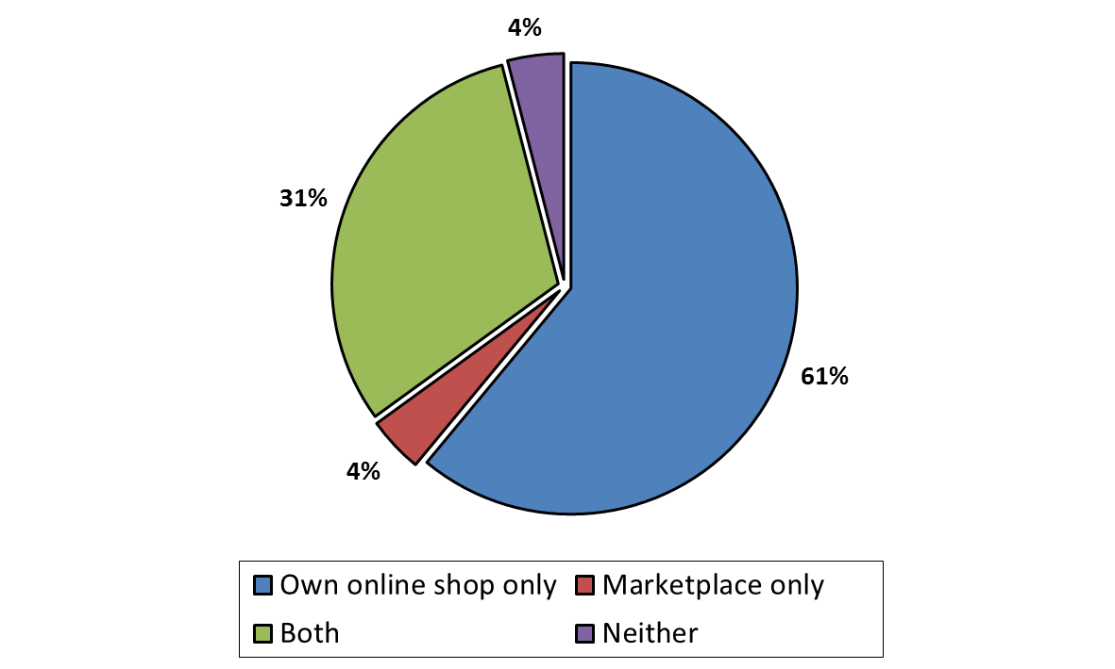

1. The average conversion rate, that is, the proportion of website visits which result in a purchase, on retailers' own website tends to be slightly lower (4 %)[263] than the conversion rates achieved on marketplaces (5 %).[264]
2. Based on the information provided by respondent retailers, the use of marketplaces as a sales channel appears to be unrelated to the size of the retailer in terms of its turnover (see figure B. 55). However, information provided by marketplaces shows that the majority of professional sellers (89 %[265] for the EU as a whole) that sold via these marketplaces in 2014 generated a turnover lower or equal to EUR 50 000 irrespective of the Member State in which they were established. This suggests that marketplaces are particularly useful for small retailers with limited sales activity.

Figure B. 55: Proportion of retailers in each turnover category that sell on marketplaces[266]

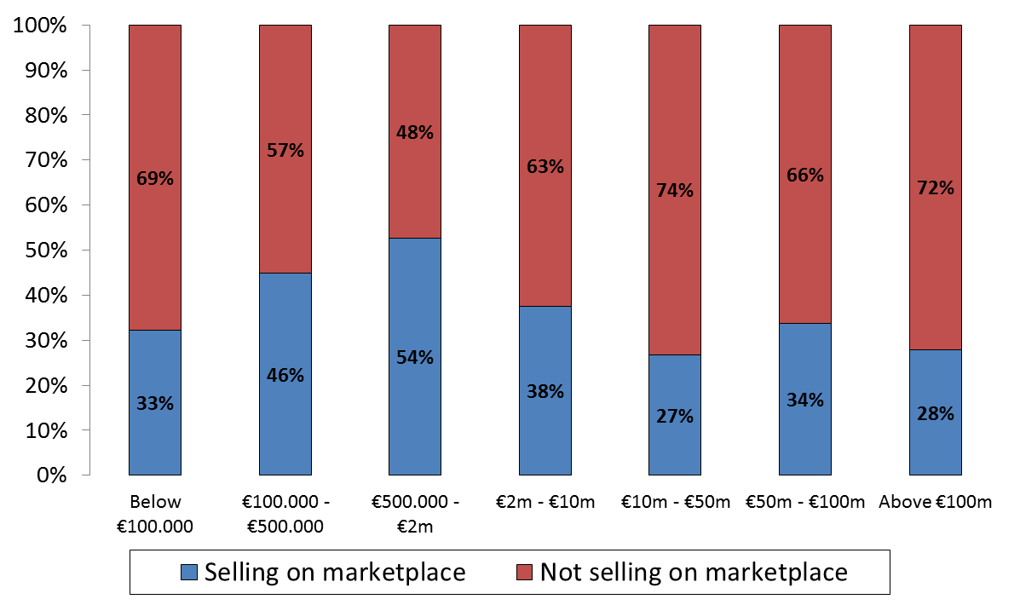

1. Moreover, when focusing on the different turnover categories, it can be observed that the proportion of retailers that sell via their own online shop only and do not use marketplaces tends to be higher within the larger turnover bands, whereas the proportion of retailers that sell via marketplaces only and do not have their own websites tends to be higher within the smaller turnover bands (see figure B. 56 and figure B. 57 below).

Figure B. 56: Proportion of retailers in each turnover category that sell through own online shop only[267]

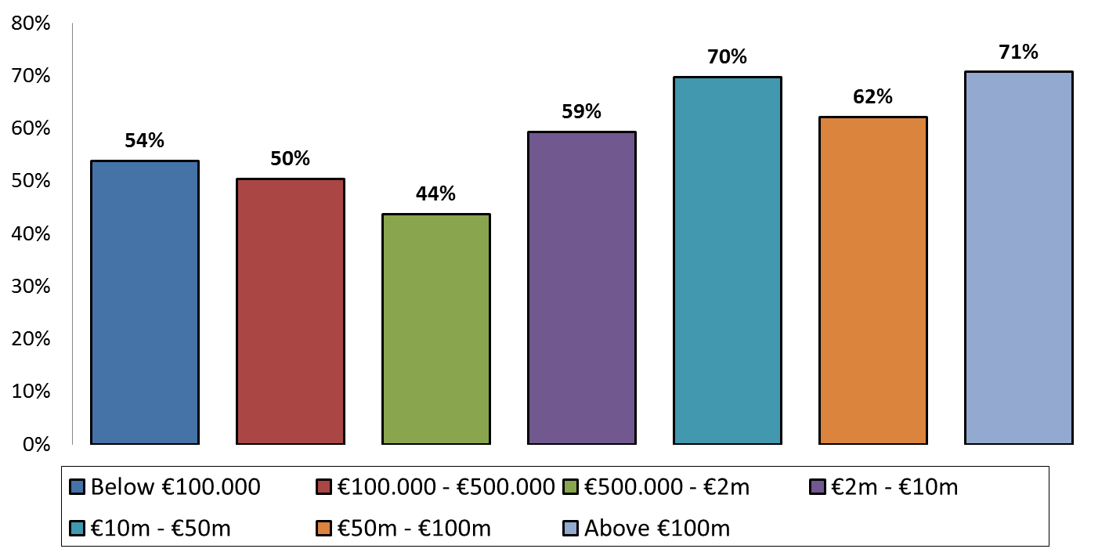

Figure B. 57: Proportion of retailers in each turnover category that sell on marketplaces only[268]

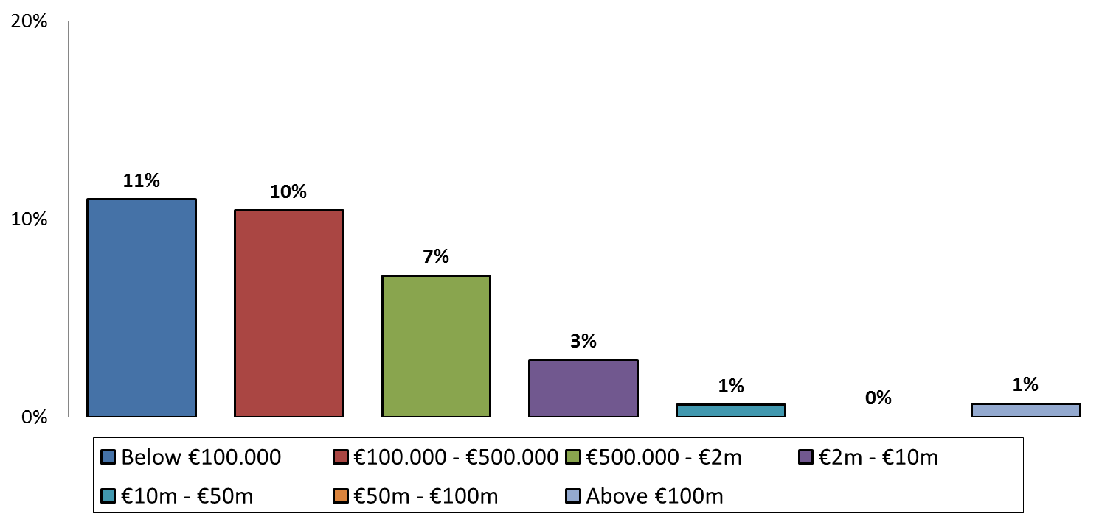

1. For those retailers that use both own online shops as well as marketplaces for selling goods online, figure B. 58 shows the proportion of purchases carried out via each of these channels. According to these findings, smaller retailers tend to realise a larger proportion of their sales via marketplaces than the larger retailers.

Figure B. 58: Proportion of purchases carried out via marketplaces and own online shops for retailers using both channels in each turnover category[269]

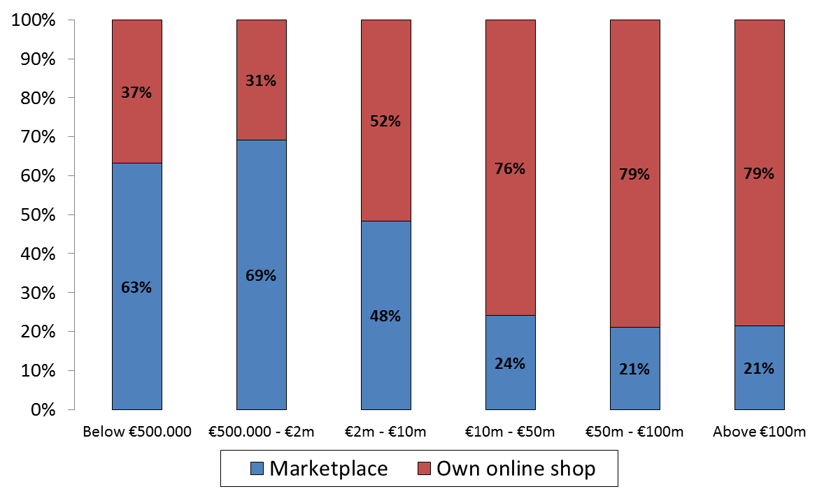

1. There are significant differences in the proportion of retailers that use marketplaces across EU Member States (see figure B. 59 below).

Figure B. 59: Proportion of retailers in each Member State that use marketplaces[270]

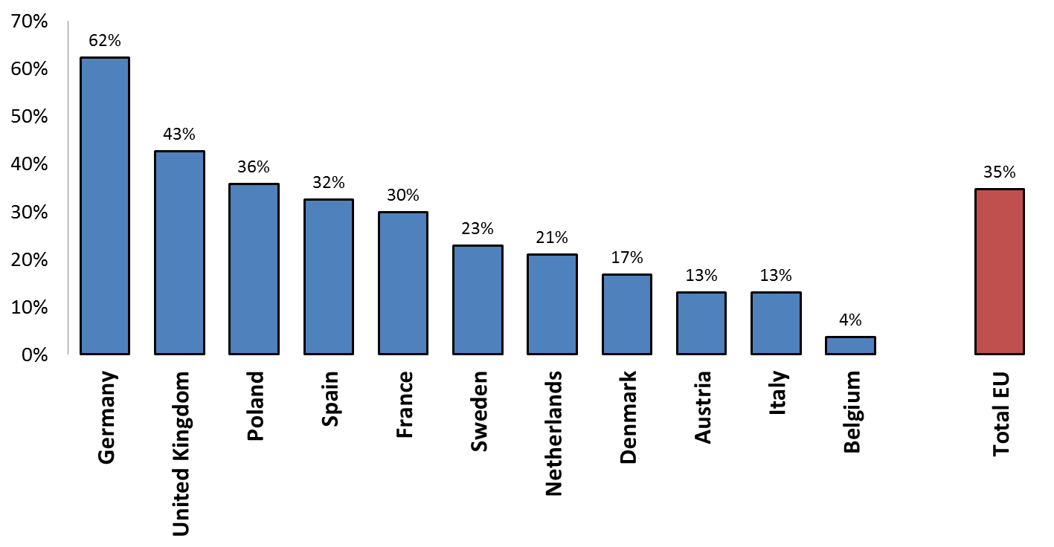

1. While these figures are necessarily affected by the number and types of retailers that responded to the questionnaire from each of the Member States, they are largely confirmed by the information provided by marketplaces. Out of all professional sellers that listed products on one of the marketplaces in the sample in 2014, 85 % were established in United Kingdom, Germany or Poland. Sellers from the remaining Member States account together for only 15 % of all sellers that listed products on these marketplaces in 2014.
2. Although marketplaces tend to offer a wide variety of product categories, the proportion of professional sellers on the marketplace varies depending on the product category in question (see figure B. 60).

Figure B. 60: Average proportion of professional sellers on marketplaces per product category[271]

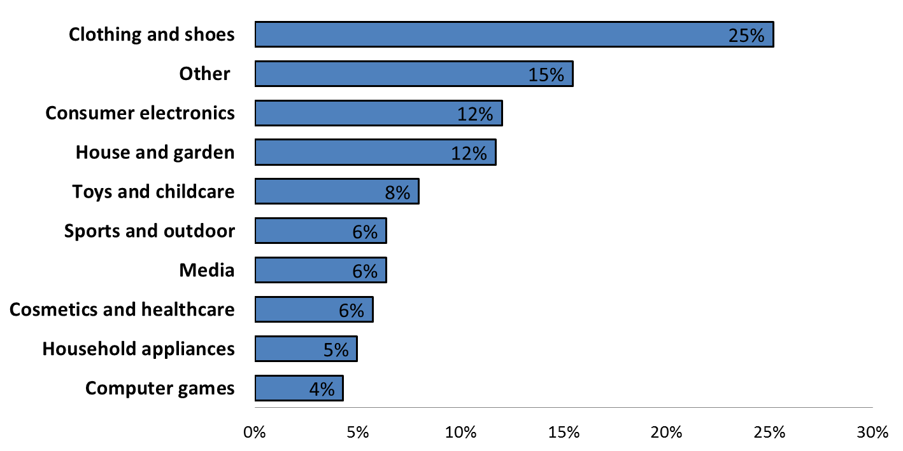

1. Although the average number of professional sellers selling via the respondents' marketplaces was just below 28 000 sellers in 2014, the median number of sellers was just below 2 000. In other words, half of the marketplaces in the sample had less than 2 000 professional sellers selling via their platform whereas half of the marketplaces had more than 2 000 professional sellers. This means that the marketplaces vary considerably in terms of the number of professional sellers selling via their platform. For the marketplaces which were active since at least 2012, the average increase in the number of professional sellers between 2012 and 2014 was 47 % (the median increase for the same period was 26 %) which indicates a growing importance of marketplaces as a sales channel for retailers.[272]
2. All in all, the findings show that, while own online shops are the most important online sales channel for retailers, marketplaces are an important sales channel especially for smaller and medium-sized retailers. For some of them, marketplaces are the only sales channel whereas some others conclude the majority of their online transactions using this sales channel. The importance of marketplaces is especially apparent in some Member States such as Germany and the United Kingdom. The overall use of marketplaces seems to be increasing over time.

#### ***4.4.2 Impact of sales through marketplaces on the business of manufacturers***

1. Manufacturers were asked whether they consider sales via (certain) marketplaces as having a potentially adverse impact on their business. 48 % of manufacturers indicated that they consider that selling on marketplaces could have a potential adverse impact on their businesses. The proportion of manufacturers that considered marketplaces as a sales channel with a potentially adverse impact is particularly high in the product categories sports and outdoor equipment followed by clothing shoes and accessories as can be seen from the following figure B. 61.[273]

Figure B. 61: Proportion of manufacturers in each product category that consider (certain) marketplaces as potentially having an adverse impact[274]

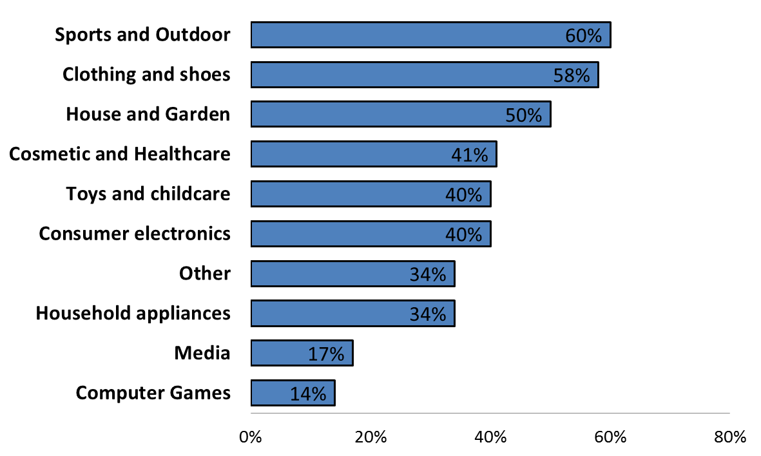

1. Some manufacturers point out that the various sales channels including marketplaces can have both a potentially adverse and beneficial impact on their businesses.[275] This depends on the particular features of the marketplace such as whether the products are presented in an attractive way, whether the identity of their brands is respected, and whether customers are sufficiently informed about characteristics, features and quality of the products in order to allow them to take an informed buying decision. Should this be the case, marketplaces can – according to these manufacturers – enhance online sales without negatively affecting the brand image.
2. 19 % of respondent manufacturers are using marketplaces to sell products directly to customers and many manufacturers have stated that they consider that sales via (certain) marketplaces can be beneficial to their business. According to the manufacturers, marketplaces provide high visibility of the products and the brands and enable retailers to reach more customers with low advertising costs. Marketplaces also allow the purchase of the products at any time of the day and from almost any location. In particular manufacturers active in consumer electronics frequently consider marketplaces as beneficial for their business as can be seen from figure B. 62.

Figure B. 62: Proportion of manufacturers in each product category that consider (certain) marketplaces as potentially having a beneficial impact[276]

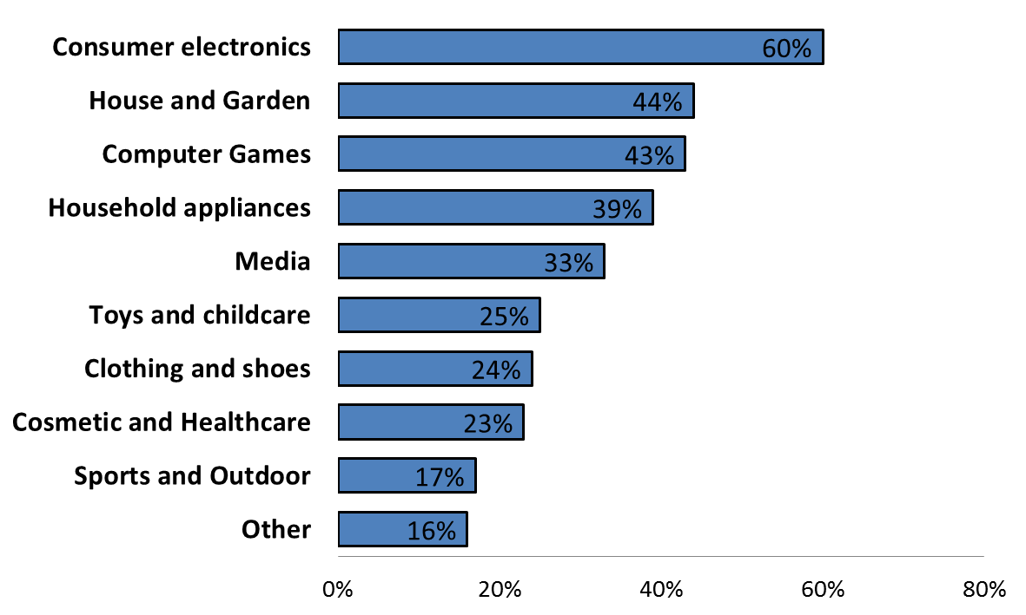

#### ***4.4.3 Prevalence and characteristics of marketplace restrictions***

1. There are two main reasons for the choice of retailers not to use marketplaces for their online sales – a unilateral business decision by the retailer and restrictions imposed on the retailer by manufacturers. The following analysis focuses on the latter.
2. 18 % of retailers that responded to the retailers' questionnaire reported that they have provisions in their agreements with manufacturers or other obligations implemented by indirect means that limit their ability to sell products on one or more marketplaces.
3. As can be seen from figure B. 63, the proportion of retailers that have provisions in their agreements with manufacturers or other obligations implemented by indirect means that limit their ability to sell products on one or more marketplaces differs significantly between Member States.
4. The highest proportion of retailers that reported having in place agreements containing some form of marketplace restriction is in Germany followed by France, whereas retailers active in other Member States such as Belgium or Denmark rarely report to have marketplace restrictions.
5. These findings show that marketplace restrictions tend to be more often used in Member States in which marketplaces have established themselves as an important sales channel.

Figure B. 63: Proportion of retailers in each Member State that have agreements containing marketplace restrictions[277]

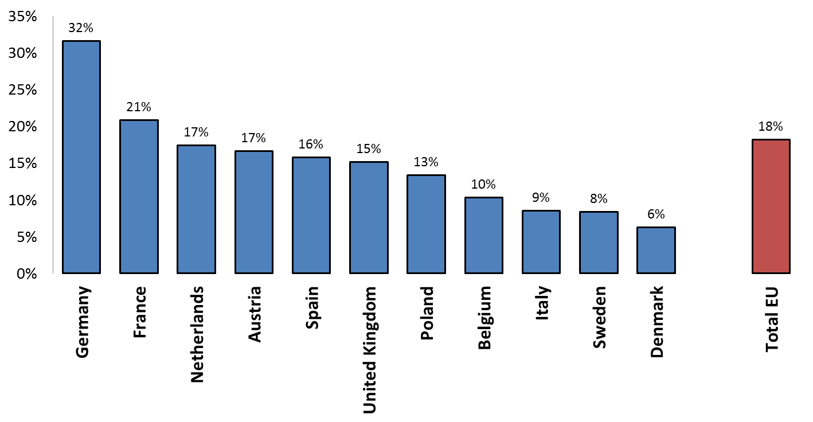

1. The responses of retailers also indicate that the types of restrictions regarding sales via marketplaces which retailers encounter differ to a large extent. They range from absolute bans to restrictions of selling on marketplaces that do not fulfil certain quality criteria. Some manufacturers allow sales only on marketplaces that do not offer sales through auctioning. See figure B. 64 for more details.

Figure B. 64: Proportion of retailers that have agreements containing different types of marketplace restrictions[278]

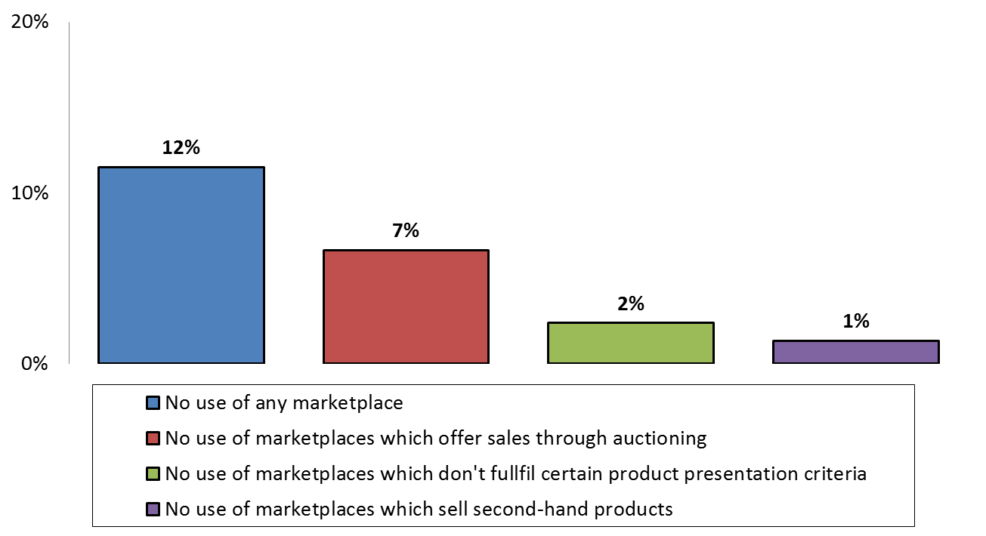

1. The findings show that not only absolute marketplace bans may make it impossible for retailers to sell via all or most of the existing marketplaces.
2. Qualitative criteria may have the same impact on retailers as an absolute marketplace ban, if they *de facto* exclude marketplace sales by requiring compliance with conditions which no marketplace does effectively meet. This may, for example, be the case, if the retailer's website has to appear under a domain name which contains the name of the retailer's business, if the website on which products are sold has to be operated by the retailer or in case of a prohibition to sell via marketplaces that have their logo visible.
3. Restrictions allowing sales of products only on specialised marketplaces may in certain circumstances also exclude existing marketplaces as a sales channel for retailers. Whether a specific restriction *de facto* excludes sales via all or most marketplaces can only be determined on a case-by-case basis.
4. Some manufacturers require specific approval for any marketplace via which the retailer intends to sell their products. The result of such approval requirements may be the same as an explicit prohibition to sell via marketplaces. Retailers may not request such an approval and even if they request it a rejection of their request may follow.
5. Restrictions to sell on marketplaces are mostly found in selective distribution agreements. They typically concern branded goods, but they are not limited to luxury products or complex or technical consumer products. Some manufacturers operate selective distribution systems (including marketplace restrictions) only in relation to a subset of their products (typically high-end/premium products) and not for their whole product portfolio.
6. The Commission has analysed whether small and medium-sized retailers are more likely to have agreements containing marketplace restrictions compared to larger retailers. As can be seen from figure B. 65 according to the findings there is no correlation between the size of the retailer and the presence of marketplace restrictions in the retailer's distribution agreements. This may be explained by the fact that the terms of selective distribution agreements normally do not differentiate between smaller and larger retailers. However, several retailers claim that some manufacturers use marketplace bans in a discriminatory manner by including them in the agreements with smaller retailers and not including them in the agreements with certain larger retailers.

Figure B. 65: Proportion of retailers in each turnover category that have agreements containing marketplace restrictions[279]

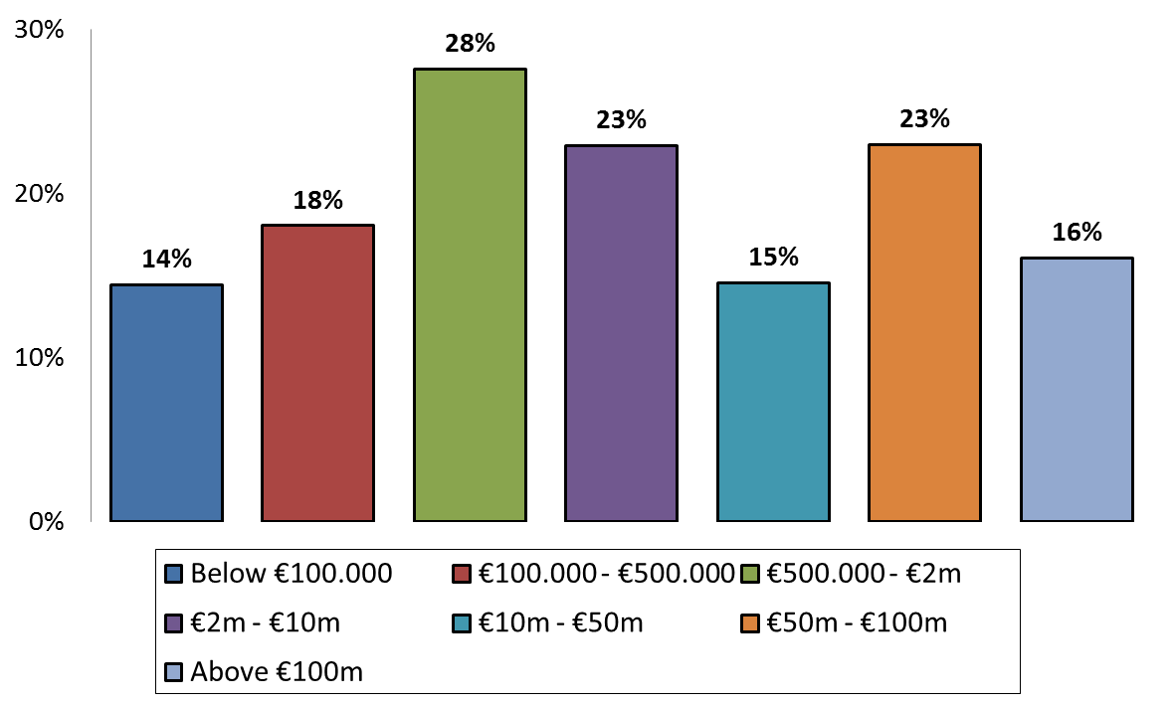

1. There are however significant differences between product categories when it comes to the prevalence of marketplace restrictions. As shown in figure B. 66, retailers selling sports and outdoor equipment or clothing and shoes are more likely to have agreements with restrictions to sell on marketplaces whereas retailers selling media or computer games and software rarely have such agreements in place.

Figure B. 66: Proportion of retailers in each product category that have agreements containing marketplace restrictions[280]

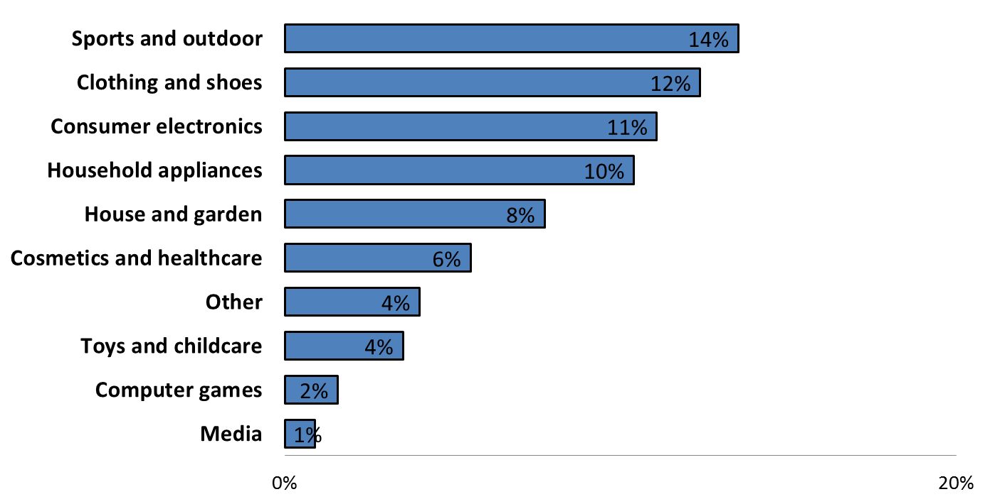

1. Interestingly, 88 % of the 669 respondent retailers that did not sell on marketplaces in 2014 have not pointed to any restrictions regarding their ability to sell or advertise on marketplaces. This indicates that the decision not to sell via marketplaces is most of the time based on other business considerations and not because retailers are limited in their ability to do so by manufacturers.
2. Approximately half of the marketplaces that responded to the relevant questionnaire indicated that they are aware of many restrictions on the ability of retailers to sell through marketplaces. 32 % of marketplaces reported that they are aware of some restrictions while 16 % of marketplaces reported that they are not aware of any such restrictions.
3. Moreover, information provided during the sector inquiry shows that some manufacturers, whose agreements with retailers contain absolute marketplace bans, are either themselves listing their products directly for sale on certain marketplaces or are selling their products to the marketplace operator as a retailer for further re-sale.

#### ***4.4.4 Reasons put forward for marketplace restrictions by manufacturers***

1. Manufacturers were given the opportunity to explain why they consider sales via all or some marketplaces as potentially harmful for their business. Marketplaces as well as retailers were also questioned about potential reasons for restrictions on sales via marketplaces.
2. A number of reasons to restrict sales via all or some of the marketplaces have predominantly been put forward by manufacturers or been reported by retailers as the reason put forward by manufacturers. These are as follows:
3. Protection of the image and positioning of the brand
4. Some brand owners argue that they spend substantial amounts of money and time to build certain brands and their reputation and that sales via certain marketplaces can have a detrimental impact on these brands. If customers can buy these brands in an environment that is not considered suitable and in which customer expectations in terms of product information, services, advice and ability to experience the products are not met, then this may diminish the value of the brand. The required high level of quality of the selling environment does not only ensure that the customer gets the product that he or she wants, but also allows the customer to understand the key features of the products as well as key differences compared to other products/brands. Products which are sold without meeting the customer expectation will trigger complaints and dissatisfaction and negatively impact the reputation of the products and brands.
5. Presenting the products on a non-specialised marketplace alongside products of a lesser quality or alongside used or defect products is often considered harmful for the brand image. In particular, owners of luxurious brands have concerns that the presentation on marketplaces in a non-luxury environment without personalised advice and a luxurious shopping experience does not reflect the brand's reputation and therefore diminishes the brand image.[281]
6. Moreover, marketplaces are often considered to be too rigid in the way the content and information is presented to the customer. Many brands want to present to their customers a special image (including by means of pictures, text and potentially videos) which is sometimes considered as not sufficiently possible on marketplaces.
7. Combating the sale of counterfeit products[282]
8. A large number of manufacturers consider counterfeit products being sold on marketplaces as a serious problem, which is in their view frequently not sufficiently addressed by marketplace operators.[283] According to some respondents, marketplaces usually spare the costs of protecting customers and intellectual property right holders against illicit products and try to avoid liability by denying the existence and the extent of counterfeit sales on the marketplace. Moreover, marketplaces earn commissions even for the sale of counterfeit products which, according to some manufacturers, reduces their incentives to effectively combat counterfeit sales on the marketplace.
9. The presentation of authentic products alongside counterfeit products is considered to be detrimental for the brand image and some manufacturers consider the level of control over sales on the marketplace as insufficient to address this issue adequately.
10. Ensuring sufficient pre-and post-sale services
11. Some manufacturers argue that it is difficult to ensure that sufficient pre-and post-sale services are provided by retailers selling on marketplaces. They argue that marketplaces leave few opportunities for retailers to differentiate between the service level and quality offered. Selling on marketplaces is often purely focused on the price of the products disregarding the features of the different products in terms of quality, design and innovation, all of which are important for the products concerned. If innovative products with new features are not presented and explained adequately, customers may not appreciate the value of the products and turn to products of lower quality.
12. Moreover, ensuring a high level of advice is considered crucial by manufacturers for certain products for which improper handling or use can create safety and security risks.
13. Protection of existing distribution channels and brick and mortar shops/free-riding
14. A number of manufacturers put forward that sales via marketplaces allow retailers which provide little or no pre- or post-sale services to free-ride on investments made by brick and mortar shops that provide customers the possibility to examine and experience the products, but have to invest in specific facilities and human resources to be able to do so. This view was shared by some retailers operating brick and mortar shops.
15. Concerns about the market position of certain marketplaces and the lack of relationship with customers
16. Some manufacturers have expressed concerns about the market position of certain marketplaces that may already enjoy a strong bargaining position vis-à-vis manufacturers (i.e. hybrid marketplaces that offer a marketplace functionality to third party sellers and also act as a retailer).
17. Moreover, some marketplaces impose restrictions on the ability of the retailers to prominently present themselves on the marketplace and establish a direct relationship with the customer. Marketplace sales may therefore not help the retailers to establish a long-term customer relationship with future sale opportunities. Brands frequently consider such a direct and lasting relationship between the authorised retailers and their customers to be important in order to successfully communicate a certain brand image.

#### ***4.4.5 Reasons for marketplace restrictions reported mainly by retailers and some marketplaces***

1. Many retailers as well as marketplaces see the main reason for introducing marketplace restrictions in the desire of manufacturers to reduce the number of sellers selling online and to avoid increased price transparency and increased price competition.
2. Some retailers and marketplaces consider that marketplaces allow buyers to compare prices across a number of sellers on the marketplace and purchase the products from the seller with the lowest price. They consider that marketplace bans may help manufacturers to stabilise retail prices and reduce competitive pressure on prices. Marketplace bans may therefore not only be in the interest of traditional brick and mortar retailers, but also of manufacturers that operate their own online shop or sell directly via marketplaces to customers.

#### ***4.4.6 Possibilities offered by marketplaces to address quality requirements***

1. Many marketplaces argue that they invest in order to improve their offering, ensure a high-quality shopping environment and address requests of manufacturers or retailers concerning quality of the content presentation. 86 % of respondents to the marketplace questionnaire indicated that they have taken steps in the last few years to increase the quality and image of their marketplace and related services.
2. Some marketplaces offer sellers the ability to design their own seller shop within a special area of the marketplace which can reflect the look and feel of a brand or to have specific "showrooms" dedicated to certain brands and designed in line with the suggestions of the brands.
3. Some marketplaces also run programs which allow them to keep track which sellers are authorised sellers within a selective distribution system of a manufacturer in order to only allow sales via sellers which have been approved and which qualify for the selection criteria applied by manufacturers.

#### ***4.4.7. Notice and take down procedures on marketplaces***

1. The Commission questioned marketplaces about the procedures they have in place to allow third parties to notify allegedly illegal conduct or unauthorised sales. Such procedures are in particular put in place in order to allow customer or intellectual property right owners to notify the listing of counterfeit products or otherwise prohibited items on the marketplaces.
2. The majority of marketplaces (slightly more than 60 %) have specific mechanisms or tools in place providing third parties with the possibility to report such items and request their take down. Some of those that indicate not to have specific notification mechanisms in place are smaller marketplaces that verify the listing of each product manually thereby limiting risks of illegal or counterfeit products being sold on the marketplace. Others contractually oblige retailers not to sell such products and to respect existing rights of third parties.
3. A number of marketplaces have established specific programs with right owners to establish procedures that facilitate the protection of intellectual property rights, some of which include informing the intellectual property right owners on suspicious listings.
4. Marketplaces were asked who would generally notify them regarding illegal conduct or unauthorised sale of products. Almost all marketplaces report to receive notifications from the owners of intellectual property rights (97 %) whereas the majority of marketplaces indicate to receive notifications from competent authorities (73 %), from customers (70 %) and from competitors of the seller (65 %).[284] Four out of five marketplaces report to remove items or sellers from the marketplace also on their own initiative, i.e. without a prior complaint from a third party. Items removed are typically prohibited items or items that may infringe third party intellectual property rights.
5. Sellers are typically removed if they fail to comply with the standards/terms and conditions of the marketplace.
6. Some retailers stress the importance of the transparency of the process and consider the possibilities of retailers to defend their interest and request review of the decision taken by the marketplace as not sufficient.

#### ***4.4.8 Marketplace restrictions under EU competition rules***

1. There is currently a discussion, whether marketplace restrictions which are not linked to qualitative criteria (absolute or per se marketplace bans) amount to hardcore restrictions in the form of restrictions of "passive sales" within the meaning of the VBER. A reference for a preliminary ruling is currently pending in this regard before the Court of Justice.[285]
2. The list of so-called "hardcore" restrictions in Article 4 of the VBER describes certain restrictions which do not benefit from the block exemption on the basis of the nature of those restrictions and the fact that they are likely to produce negative effects on the market. The lists of hardcore restrictions contained in Article 4 of the VBER reflect the types of agreements, which at the time of its adoption were seen as having as their object a restriction of competition.
3. The question of whether an absolute marketplace ban constitutes a hardcore restriction within the meaning of Article 4(b) and/or (c) of the VBER has so far not been appraised by the European Courts. As can be seen from paragraph 54 of the Vertical Guidelines, the Commission did – at the time when the VBER was adopted – not consider marketplace bans to amount to hardcore restrictions which are incapable of qualifying for a block-exemption.
4. Based on the Pierre Fabre-judgment of the Court of Justice, a contractual or a *de facto* ban of the use of the internet as a method of marketing has as its object the restriction of passive sales and can be considered a restriction by object pursuant to Article 101(1) TFEU and a hardcore restriction under Article 4(c) VBER.[286] If a marketplace ban de facto amounts to a total ban of the use of the internet as a method of marketing, then it could, in direct application of the Pierre Fabre-judgment*,* be considered as having as its object the restriction of passive sales and as a hardcore restriction under the VBER.
5. The findings of the sector inquiry do not show that absolute marketplace bans generally amount to a *de facto* prohibition to sell online. Marketplace bans should not therefore be equated to a *de facto* prohibition to sell via the internet similar to the restriction at stake in the *Pierre Fabre* judgment.
6. Also, the findings of the sector inquiry show that the importance of marketplaces and, consequently, the impact of marketplace bans, varies significantly. Marketplace bans should not therefore be considered as restricting the effective use of the internet as a sales channel irrespective of the markets concerned:
7. Own online shops remain the most important online sales channel for retailers. More than half of the respondent retailers sell via their own online shop only. They do not see a need to complement this sales channel by selling also through marketplaces.
8. The importance of marketplaces as an online sales channel differs from one Member State to another to a significant extent. While in Germany, more than 60 % of retailers reported to be selling via marketplaces, less than a quarter of retailers did so for other Member States such as Italy, Belgium or Sweden.
9. The importance of marketplaces as a sales channel also varies from one product category to another and within product categories. Marketplaces are particularly relevant for retailers selling clothing and shoes and consumer electronics. In contrast, the average proportion of sellers on marketplaces selling household appliances or computer games and software is more limited. The importance of marketplaces as a sales channel also differs depending on the nature of the product and whether customers would expect to find the products for sale on marketplaces.
10. Marketplace sales are more important for smaller and medium-sized retailers than for larger retailers. Marketplace bans may therefore affect smaller and medium-sized retailers more. The proportion of retailers selling only via marketplaces is significantly lower for retailers with a turnover above EUR 2 million while smaller and medium sized retailers with a turnover below 2 million are more likely to sell only via marketplaces. The proportion of retailers selling only on marketplaces is highest for retailers with a turnover below EUR 100 000 (11 %). However, even in this turnover category the majority of respondents (54 %) indicated to be selling through their own online shop only. Retailers with a turnover below EUR 2 million that sold on their own online shop as well as on marketplaces also realised the majority of transactions via marketplaces whereas the majority of transactions of such retailers with a turnover above EUR 2 million were realised on their own online shops.
11. In addition, according to the manufacturers, the impact of sales via marketplaces on manufacturer's business depends on the type of product as well as particular features of a marketplace.
12. The findings of the sector inquiry show that the potential justifications and efficiencies that manufacturers invoke for requesting absolute marketplace bans differ from one product to another:
13. Potential efficiencies linked to the protection of a certain brand image may be more relevant for some products and brands than for others.
14. For some products, pre-and post-sale service considerations are of greater importance for the products sold and potential free-riding by marketplace sellers may be more prevalent than for products which require only limited pre- and post-sale services.
15. In light of those findings and without prejudice to the forthcoming judgment of the Court of Justice in Case C-230/16, *Coty Germany vs. Parfümerie Akzente GmbH*, the findings from the sector inquiry indicate that marketplace bans should not be considered as hardcore restrictions within the meaning of Article 4(b) and/or Article 4(c) of the VBER.
16. Such clauses do not have as their object (i) a restriction of the territory or the customers to whom the retailer in question may sell or (ii) the restriction of active or passive sales to end users. They are not aimed at segmenting markets in the internal market based on territory or customers.
17. Such an approach is in line with the Vertical Guidelines which specify that marketplace restrictions requiring the retailer to use third party platforms (e.g. marketplaces) only in accordance with the quality criteria agreed between the manufacturer and its retailers for the retailer's use of the internet are not considered a hardcore restriction.[287] They concern the question of *how* the distributor can sell the products over the internet and do not have the object to restrict *where or to whom* distributors can sell the products.
18. This does however not mean that the Commission considers marketplace bans in all cases compatible with European competition law.
19. The Commission or a National Competition Authority may decide to scrutinise marketplace bans in agreements that fall outside the application of the VBER, either because the market share thresholds in Article 3 VBER are exceeded or because the agreements contain any of the listed hardcore restrictions in Article 4 of the VBER.
20. The Commission or a National Competition Authority may also decide to withdraw the benefit of the VBER pursuant to Article 29 of Regulation 1/2003, if in a particular case marketplace bans are restricting competition within the meaning of Article 101(1) TFEU and are incompatible with Article 101(3) TFEU.
21. The importance of marketplaces as an online sales channel in relation to the product and geographic market in question, the type of restrictions applied (absolute ban or qualitative criteria) as well as the credibility of brand protection considerations and the need for pre- and post-sale advice will be important elements in the analysis.
22. Brand protection considerations or an alleged lack of sufficient pre- or post-sale advice on marketplaces will be less convincing if the manufacturer has accepted the marketplace operator as an authorised seller within its selective distribution agreement or if the manufacturer is itself selling on the marketplace directly to customers.

**Summary**

The question to which extent restrictions limiting the ability of retailers to sell via online marketplaces may raise concerns under the EU competition rules has attracted significant attention in the past years in some Member States. In this regard, a reference for a preliminary ruling is currently pending before the Court of Justice. One of the aims of the sector inquiry is to better understand the prevalence and characteristics of marketplace restrictions and the importance of marketplaces as a sales channel for retailers and manufacturers.

Marketplace restrictions are not uncommon and 18 % of retailers report to have agreements with their suppliers containing marketplace restrictions. The Member States with the highest proportion of retailers experiencing marketplace restrictions are Germany (32 %) and France (21 %).

Marketplace restrictions encountered in the sector inquiry range from absolute bans to restrictions on marketplaces that do not fulfil certain quality criteria. Restrictions on the usage of marketplaces are mostly found in selective distribution agreements and typically concern branded goods without being limited to luxury or complex or technical goods. They are most widespread in the product categories sports and outdoor (14 % of retailers active in the product category) and clothing and shoes (12 %) followed by consumer electronics (11 %).

Manufacturers provide a number of reasons for restrictions on sales via marketplaces. These relate essentially to the following aspects:

(a) the protection of the image and the positioning of their brand;

(b) combatting the sale of counterfeit products on marketplaces;

(c) ensuring proper pre- and post-sale services by retailers;

(d) protecting existing distribution channels from free-riding; and

(e) concerns about the market position of certain marketplaces.

Conversely, many retailers as well as marketplaces allege that manufacturers want to reduce the number of sellers selling online and avoid increased price transparency and increased price competition by introducing marketplace restrictions.

The information obtained in the sector inquiry indicates that the level of importance of marketplaces as a sales channel varies depending on the size of the retailers, the Member States concerned as well as the product categories concerned:

(a) For the majority of retailers (61 %) that responded to the relevant question marketplaces are not important as a sales channel as they sell their products only via their online shop. 31 % of retailers sell via their online shops as well as on marketplaces and only 4 % of the retailers reported to be selling online only via marketplaces.

(b) Marketplaces are more important as a sales channel for smaller and medium-sized retailers with a turnover below EUR 2 million while they are of lesser importance for larger retailers with a higher turnover. The results show that smaller retailers tend to realise a larger proportion of their sales via marketplaces than larger retailers.

(c) The importance of marketplaces as an online sales channel differs from one Member State to another to a significant extent with a high proportion of retailers using marketplaces in Germany (62 %) and the United Kingdom (43 %) compared to a substantially smaller proportion in Austria (13 %), Italy (13 %) or Belgium (4 %).

(d) The importance of marketplaces differs between the different product categories and within product categories depending on the nature of the product and whether customers would expect to find the products for sale on marketplaces. Marketplaces are most relevant for retailers selling clothing and shoes and consumer electronics.

These findings do not show that marketplaces bans amount to a *de facto* prohibition to sell online similar to the restriction in the *Pierre-Fabre* judgment of the Court of Justice. The findings do also not indicate that marketplace bans can – at this stage – be said to be aimed at restricting the effective use of the internet as a sales channel. The majority of responding retailers sell via their own website and only a small proportion of respondent retailers is selling on marketplace only. The findings also show that the potential justification and efficiencies that manufacturers invoke differ from one product to another.

Without prejudice to the forthcoming judgment of the Court of Justice in Case C-230/16, *Coty Germany vs. Parfümerie Akzente GmbH*, the findings of the sector inquiry indicate that absolute marketplace bans should not be considered hardcore restrictions within the meaning of Article 4(b) and Article 4(c) of the VBER as they do not have the object of segmenting markets in the internal market based on territory or customers. They concern the question of *how* the distributor can sell the products over the internet and do not have the object to restrict *where or to whom* distributors can sell the products.

This does not mean that marketplace bans are generally compatible with European competition law. The Commission or a National Competition Authority may decide to scrutinise marketplace bans in agreements falling outside the application of the VBER, either because the market share thresholds in Article 3 of the VBER are exceeded or because the agreements contain any of the listed hardcore restrictions in Article 4 of the VBER. The Commission or a National Competition Authority may also decide to withdraw the benefit of the VBER if in a particular case the marketplace bans restrict competition within the meaning of Article 101(1) TFEU and are incompatible with Article 101(3) TFEU.

### 4.5 The use of price comparison tools and restrictions on the use of price comparison tools

1. Price comparison tools allow potential customers (in particular those which consider the price as an important buying criterion) to find retailers that offer certain products, compare prices with limited efforts across these retailers and call up the offers they consider suitable. The actual sale generally does not take place on the website of the price comparison tool, but on the website of the retailer to which potential customers are directed via the website of the price comparison tool, at which point there is no longer any connection to the website of the price comparison tool.
2. Price comparison tools allow retailers to increase their visibility and thereby generate traffic to the retailer's own website. Compensation paid to price comparison tools by retailers is typically on a pay-per-click basis[288] and takes place irrespective of whether a sale is ultimately concluded on the website of the retailer or not. The most commonly used means by which price comparison tools obtain relevant pricing and product information is via data feeds from retailers.[289]
3. On the one hand, price comparison tools increase price transparency and intensify intra-brand and potentially inter-brand price competition between different retailers. On the other hand, some manufacturers are critical of price comparisons tools as they typically focus mainly on price and do not – in the views of these manufacturers - allow retailers to differentiate themselves sufficiently in terms of scope and quality of service which can have a negative impact on the brand image.
4. Some agreements between manufacturers and retailers therefore contain contractual restrictions under which the retailers are limited in their ability to actively provide information or otherwise promote their online product offering with price comparison tools.
5. The Commission has analysed the usage of price comparison tools by retailers as well as the contractual restrictions encountered in the sector inquiry.

#### ***4.5.1 Usage of price comparison tools by retailers***

1. According to the findings of the sector inquiry, the use of price comparison tools is widespread. 36 % of retailers reported that they supplied data feeds regarding their products to price comparison tool providers in 2014.[290] As shown in figure B. 67 below, larger retailers (in terms of turnover) are more likely to use price comparison tools than smaller ones.

Figure B. 67: Proportion of retailers in each turnover category that use price comparison tools[291]

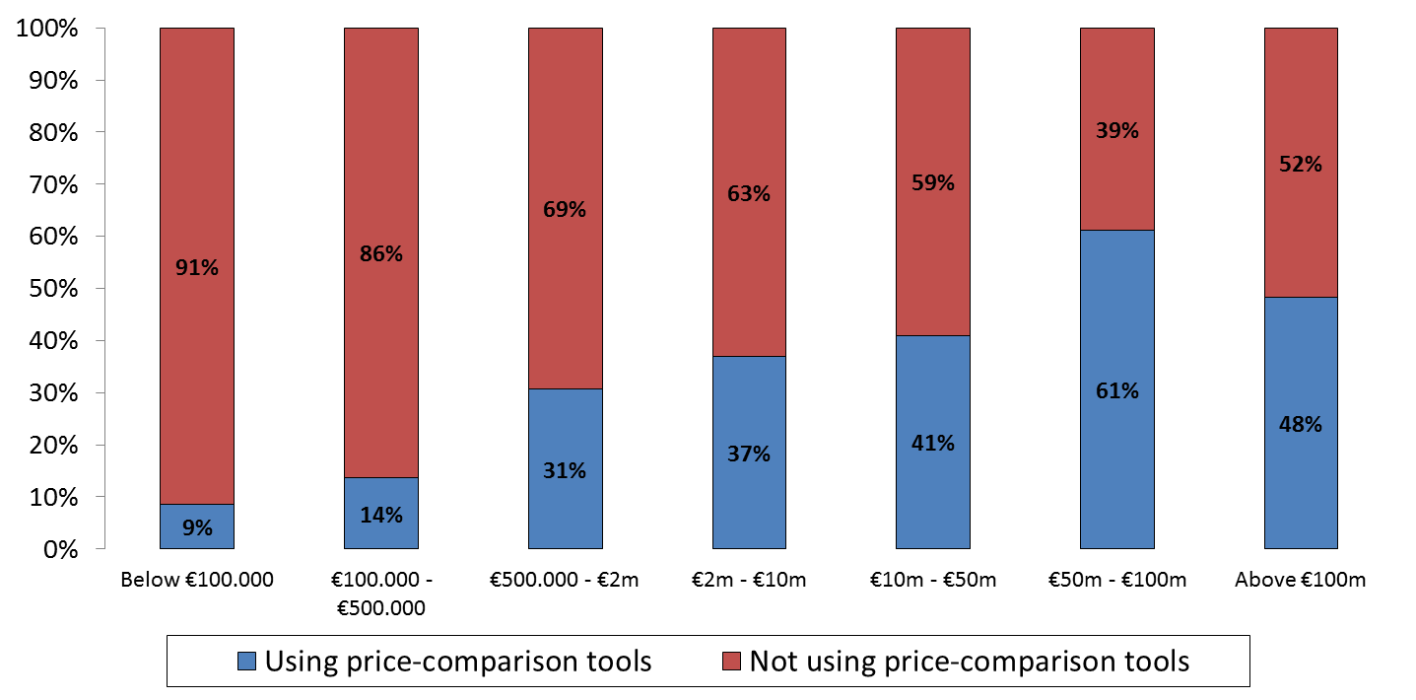

1. The proportion of retailers that use price comparison tools differs considerably across different Member States (see figure B. 68) and in some Member States more than half of the retailers reported using price comparison tools.

Figure B. 68: Proportion of retailers in each EU Member State using price comparison tools[292]

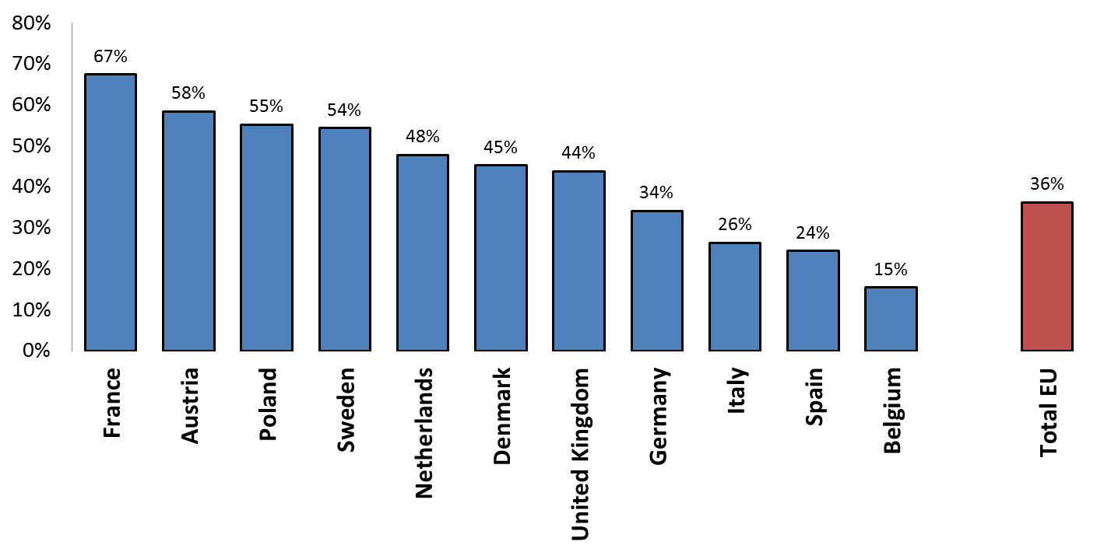

1. The average number of retailers listing their product offering on the price comparison tools that provided information to the relevant question in 2014 was almost 4 000.[293] Between 2012 and 2014, the number of registered retailers and/or retailers whose product offerings were listed on the price comparison tools has on average increased by almost 240 %.
2. The average conversion rate reported by the retailers realised via links from price comparison tools is 3 %[294], which is lower than the average conversion rate on retailers' own website (4 %) and marketplaces (5 %).
3. Generally, price comparison tools are not specialised in a certain product category. In fact, the findings show that an average price comparison tool offers a comparison of products in eight of the relevant product categories.[295] However, as shown in figure B. 69, there are some differences in the number of registered retailers across the different product categories. Moreover, in terms of number of clicks on the product listings on price comparison tools one can observe similar differences among product categories (see figure B. 70). More precisely, the figures show that for clothing and shoes, consumer electronics and house and garden products the use of price comparison tools is more prominent than for the product categories media and computer games and software.

Figure B. 69: Average proportion of sellers on price comparison tools in each product category[296]

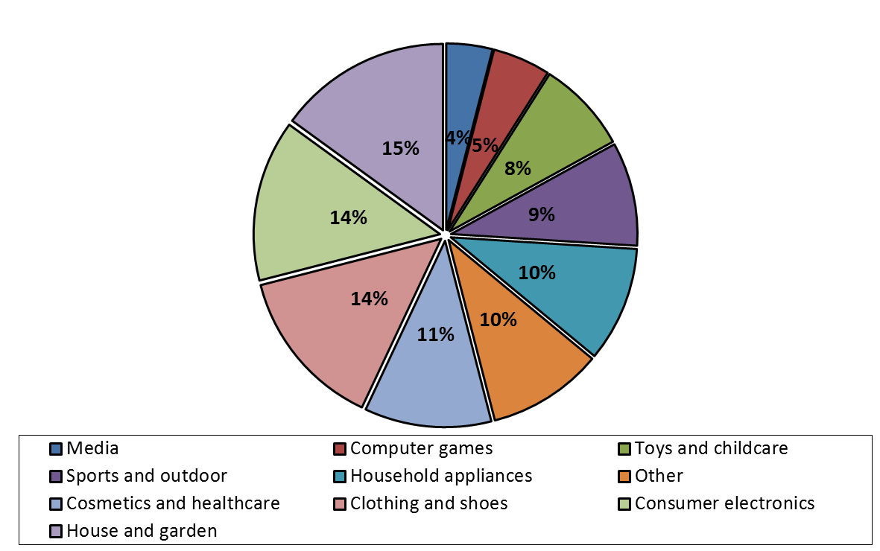

Figure B. 70: Average proportions of visits on price comparison tools in each product category[297]

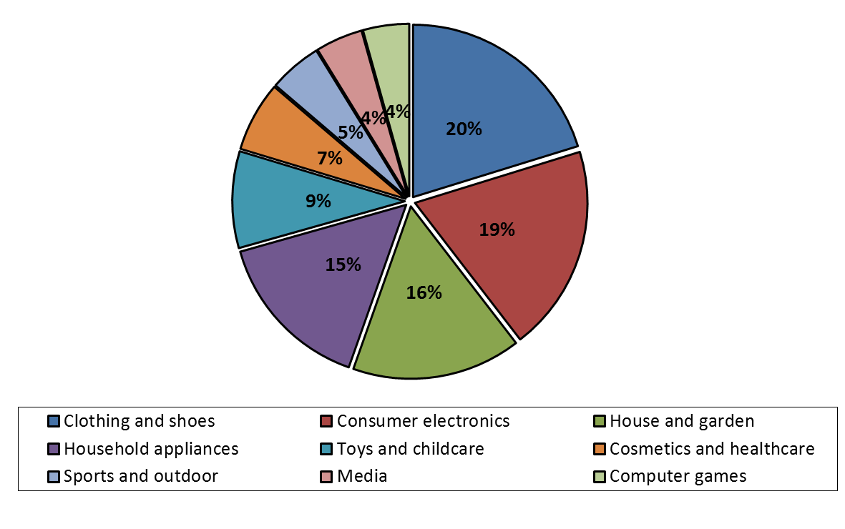

#### ***4.5.2 Restrictions on the use of price comparison tools***

1. Some agreements between manufacturers and retailers include contractual restrictions with regard to the use of price comparison tools. 9 % of respondent retailers reported that they have agreements with manufacturers which contain some form of restriction in their ability to use price comparison tools.
2. As can be seen from figure B. 71, the proportion of retailers that have agreements containing some form of price comparison use restrictions differs between Member States. Retailers which are active in Germany and the Netherlands are most affected by the restrictions to use price comparison tools. Restrictions on the use of price comparison tools are not related to the observed frequency of the use of price comparison tools by retailers in a Member State (see figure B. 68 above).

Figure B. 71: Proportion of retailers in each EU Member State that have agreements containing a restriction to use price comparison tools[298]

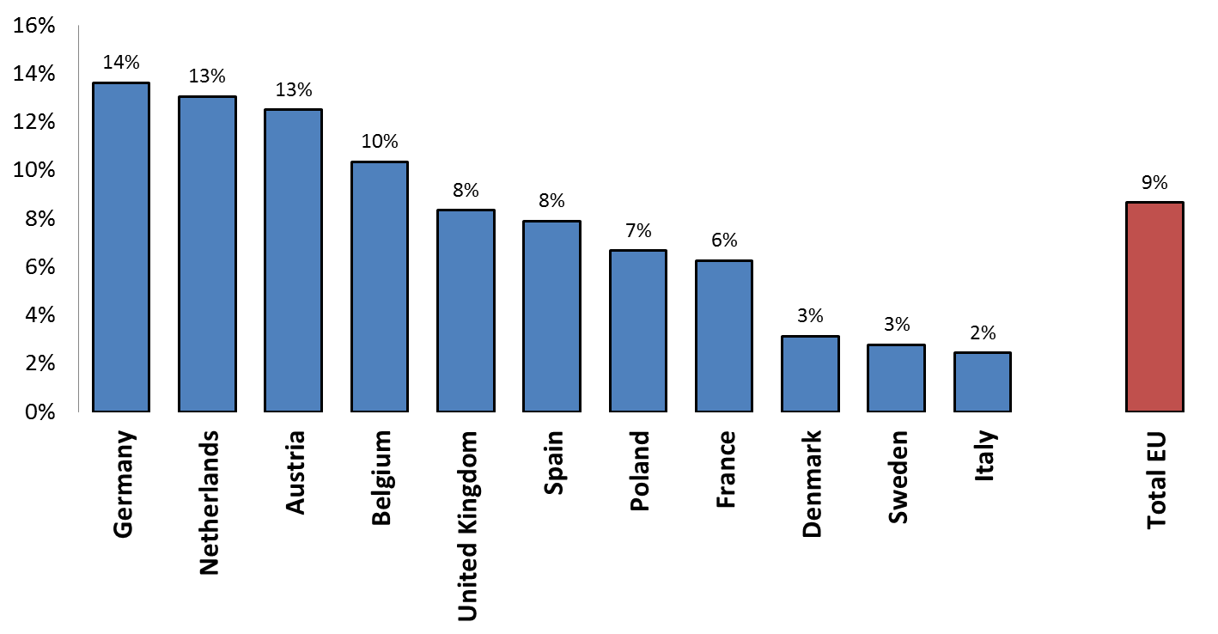

1. Retailers were questioned about the type of restrictions they have. Based on these responses, the most widespread type of restriction to use price comparison tools is a prohibition to use any price comparison tool, which is encountered by 5 % of the retailers.[299] Other types of restrictions, such as restrictions based on certain quality criteria of a price comparison tool are used to a lesser extent.
2. The review of the agreements provided in the context of the sector inquiry shows that there are different contractual clauses which may limit the ability of retailers to use price comparison tools to promote their product offering and attract (potential) customers to their website. They include among others the following types of provisions:
3. restrictions to use, sell or promote on any price comparison tool;
4. restrictions to actively provide price and product information to price comparison tools;
5. restrictions to use price comparison tools targeting customers in other (in some cases exclusively allocated) territories;
6. restrictions to use price comparison tools that present individual products and prices (which is typical for price comparison tools) rather than a whole range of products offered by the manufacturer; and
7. restrictions on the use of the brand name or of any information/pictures provided by the manufacturer in connection with price comparison tools or for marketing purposes in general.
8. In some instances, the restrictions are not formulated as outright prohibitions, but as requirements, whereby approval by the manufacturer is needed, before the use of price comparison tools is allowed. The Commission considers that the result of such an approval requirement may be the same as an outright prohibition as retailers may either not request approval or their request may be denied. In some cases, retailers need to confirm in writing that they will not use price comparison tools in order to be admitted as a member of the selective distribution network of the manufacturer.
9. As shown in figure B. 72, the initial findings in the sector inquiry do not indicate any relation between the size of the retailer and the likelihood of having a restriction to use price comparison tools.

Figure B. 72: Proportion of retailers in each turnover category that have agreements containing restrictions to use price comparison tools[300]

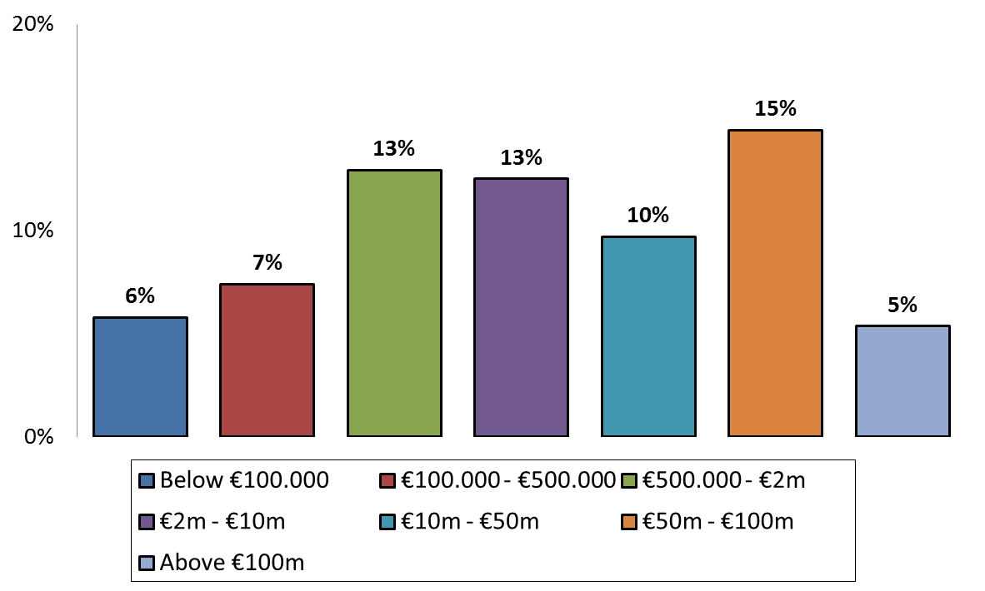

1. There are, however, some differences when it comes to the prevalence of restrictions to use price comparison tools across different product categories. Product categories, for which the use of price comparison tools is least widespread, such as media and computer games and software, are also product categories in which there are the least restrictions.

Figure B. 73: Proportion of retailers in each product category that have agreements containing restrictions to use price comparison tools[301]

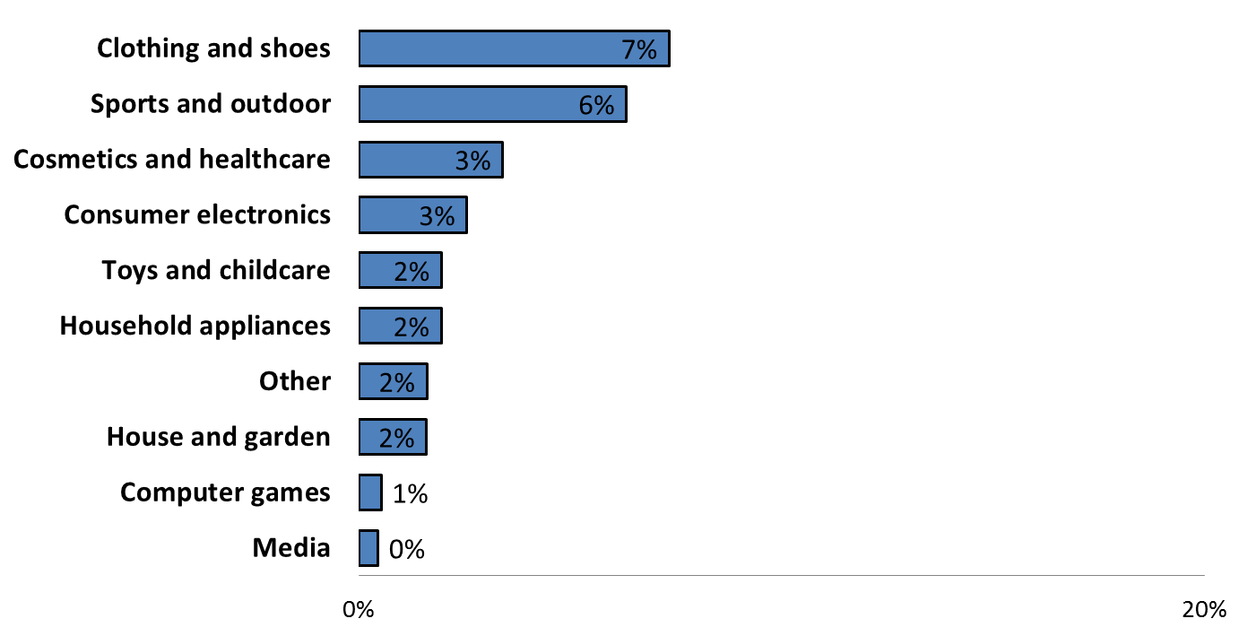

1. Less than 20 % of price comparison tools have reported that they are aware of restrictions on retailers' ability to list product offerings on their price comparison tool which are contained in the agreements with the manufacturers of the products in question.[302]

#### ***4.5.3 Reasons put forward for restrictions to use price comparison tools***

1. When asked about the potential impact of price comparison tools on their business, 32 % of manufacturers that responded to the questionnaire indicated that they consider them as having a potentially adverse impact on their business whereas 29 % stated that they consider them as having a potentially beneficial impact on their business. There is quite some divergence between the various product categories. For example, in consumer electronics the majority of manufacturers consider them as having a potentially beneficial impact (60 %) and only a much smaller proportion (21 %) considers them as potentially having an adverse impact on their business.[303] Conversely, in clothing and shoes, 43 % of manufacturers consider them as potentially having an adverse impact for their business whereas only 17 % consider them as potentially having a beneficial impact.
2. Manufacturers that consider price comparison tools as good for their business point out that customers increasingly use them to take or prepare purchasing decisions. Price comparison tools allow potential customers to find (authorised) retailers and direct them to their websites. They enhance visibility for the brand on the internet and often provide product and seller reviews which further inform customers about the products and the sellers.
3. A substantial number of manufacturers see price comparison tools rather critically. According to these manufacturers price comparison tools focus only on price which is not necessarily the most important element for the attractiveness of their product and other factors are equally affecting the choice of the customer (luxurious image, quality, features, and style).
4. In addition, it is difficult for retailers to differentiate themselves in terms of service quality and delivery/return options on price comparison tools and retailers with low service quality might free-ride on other retailer's investments. Low service quality could negatively reflect on the brand image. On some price comparison tools authentic products and their prices may also be compared with second hand or counterfeit products which again could damage the brand image.
5. Some manufacturers point out that price comparison tools intensify competition on price – not on other parameters – and may contribute to making customers increasingly price sensitive. They may create downward pressure on prices and reduce margins if retailers are starting to undercut each other's prices to feature prominently on price comparison tools. This may be detrimental for specialised retailers with brick and mortar shops (but also specialised online retailers) which have higher cost structures because of the additional services they provide. While price comparison tools may therefore increase sales in the short term, they may reduce incentives of specialised retailers to invest in quality and services and lead to a reduced number of retailers in the long run.
6. According to price comparison tools, the most quoted reasons for limiting the use of price comparison tools by the manufacturers are protection of the brand image and the quality standard of distribution.
7. Most price comparison tools do not consider these reasons to be justified. They claim that price comparison tools provide objective information on features and reviews of products which do not interfere with brand image or the quality of product distribution. Most price comparison tools offer the possibility to the retailers to display their logo as well as product pictures on their website. Some of them offer customer reviews and additional product-related information as well as information on delivery times.
8. Moreover, more than 90 % of the price comparison tools have taken particular steps in the last few years to increase the quality and the image of the services, which they offer. Some examples include improved layout of the website, increase in the number of retailers, use of videos, inclusion of expert reviews, improved accuracy of information provided on the website, improved functionality of the website, optimisation of search relevance, ability for retailers to include promotions of certain products, support of better quality product images, marketing campaigns, compatibility with mobile phones and tablets, increased frequency of information update, improved interface with the retailers, fraud monitoring and protection programmes for customers.
9. Many retailers confirm that protecting the brand images as well as the quality of service are among the reasons most frequently put forward by manufacturers with regard to the contractual restriction limiting the retailer's ability to use price comparison tools. Some retailers consider that the main aim of manufacturers is to decrease price transparency and limit price competition among retailers, in some case also in order to protect their own online offering.

#### ***4.5.4 Restrictions on the use of price comparison tools under EU competition rules***

1. The Commission has not yet taken a position on whether and under which conditions restrictions on the use of price comparison tools may violate Article 101 TFEU and any decision would depend on the specifics of the case and the concrete restriction at hand. The Vertical Guidelines do not specify how to assess a restriction or bans to use price comparison tools.
2. The Commission considers that marketplaces and price comparison tools differ in a number of respects.
3. Marketplaces by definition incorporate a sales functionality and constitute, as such, a distinct online sales channel for the concerned products. Conversely, the visitors of a genuine[304] price comparison tool are redirected to the website of the (authorised) distributor from which the product can be purchased and which generally fulfils all the criteria set out by the manufacturer of the product (within its selective distribution system) as to how its products should be sold.
4. Price comparison tools are not a distinct online sales channel, but offer retailers the ability to present and advertise their online offerings to a wider audience, increase the findability of the online offering and generate traffic to the retailer's own website. Customers can filter out those offers which they consider suitable based on the information provided on the price comparison tool.[305] They can then access the websites of the relevant retailers and compare their offerings, if desired.
5. Price comparison tools allow customers to obtain an overview of a number of online retailers which are selling certain products and their respective offer.
6. Within a selective distribution system, they make it easier for customers to find those authorised sellers which sell the product via the internet. As such they directly increase transparency for customers. They are also an important mechanism to facilitate price competition on the internet.
7. Moreover, price comparison tools do not hamper the ability of retailers to establish a direct customer relationship with the customers that are redirected to their website via a price comparison tool.
8. On the one hand, manufacturers are allowed under the VBER to require quality standards when it comes to advertising and promotion of their products by retailers on the internet, just like they are in the offline world.[306]
9. On the other hand, one of the main functions of price comparison tools is that they allow customers to swiftly identify the relevant retailers and their offers, compare them and find / be directed to the retailers' websites that offer the relevant products for sale. Absolute price comparison tool bans may make it more difficult for (potential) customers to find the retailer's website and may thereby limit the (authorised) distributor's ability to effectively generate traffic to its website. Absolute bans may make it also more difficult to attract (potential) customers outside the physical trading area of the retailer.
10. Restriction to use price comparison tools therefore potentially restrict the effective use of the internet as a sales channel by retailers by taking away an effective means to guide customers (including customers outside their physical trading area) to their own (authorised) website.
11. Based on these considerations, absolute price comparison tool bans which are not linked to quality criteria, potentially restrict the effective use of the internet as a sales channel and may amount to a hardcore restriction of passive sales under Article 4 b) and 4 c) of the VBER.
12. Conversely, restrictions on the usage of price comparison tools based on objective qualitative criteria are covered by the VBER. Manufacturers operating selective distribution systems are in principle allowed to require quality standards in relation to the promotion of their products on the internet.
13. Price comparison tools can also allow retailers to specifically target (potential) customers in certain territories outside their home Member State. In these cases, price comparison tools may be used to promote an online offering in certain other Member States.
14. Limitations on the use of price comparison tools targeting specific territories may be a permissible restriction of active sales into this territory provided that it has been exclusively reserved for the supplier or has been exclusively allocated to another distributor.

**Summary**

Price comparison tools allow (potential) customers to find retailers that offer certain products, compare prices with limited efforts across these retailers and call up the offers they consider suitable. The actual sale does not generally take place on the website of the price comparison tool, but on the website of the retailer to which customers are directed via the website of the price comparison tool.

The Commission has analysed the usage of price comparisons tools by retailers and the contractual restrictions limiting their ability to use such tools.

The findings of the sector inquiry indicate that the use of price comparison tools is widespread with 36 % of retailers reporting that they supplied data feeds to price comparison tool providers in 2014.

Larger retailers (in terms of turnover) are more likely to use price comparison tools than smaller ones. The use of price comparison tools is more prominent for some product categories than for other, with the product categories clothing and shoes, consumer electronics and house and garden being the product categories in which price comparison tools are most relevant.

9 % of retailers reported that they have agreements with manufacturers which contain some form of restriction in their ability to use price comparison tools.

Restrictions on the usage of price comparison tools encountered in the sector inquiry range from absolute bans to restrictions based on certain quality criteria.

A substantial number of manufacturers see price comparison tools rather critically as they focus only on price which is not necessarily the most important element for the attractiveness of their product and other factors are equally affecting the choice of the customer (luxurious image, quality, features, and style).

Marketplaces and price comparison tools also differ in a number of respects, including the fact that no transaction takes place on the price comparison tool's website/app. Instead interested customers are being directed to the website of the (authorised) distributor from which the product can be purchased and which generally fulfils all the quality criteria requested by the manufacturer of the product (within its selective distribution system).

Absolute price comparison tool bans may make it more difficult for (potential) customers to find the retailers' website and may thereby limit the (authorised) distributor's ability to effectively promote its online offer and generate traffic to its website. Such bans may also make it more difficult to attract (potential) customers outside the physical trading area of the retailer via online promotion.

Absolute price comparison tool bans which are not linked to quality criteria therefore potentially restrict the effective use of the internet as a sales channel and may amount to a hardcore restriction of passive sales under Article 4 b) and 4 c) of the VBER. Restrictions on the usage of price comparison tools based on objective qualitative criteria are generally covered by the VBER.

### 4.6 Pricing restrictions

1. The Commission has asked retailers to provide information in relation to their pricing policies and the role of manufacturers in their price setting. Manufacturers, in turn, were asked about their input to retailers' pricing policies.

#### ***4.6.1 Price setting at retail level***

1. Retailers were asked whether manufacturers provide certain pricing recommendations or specify other parameters affecting the resale prices set by retailers to customers. 38 % of retailers report that manufacturers recommend resale prices, while less than 10 % report being provided with a discount range or receiving indications from manufacturers to apply the same retail price online and offline.[307] A smaller proportion of retailers receive indications of what minimum price they should apply or which advertised price they should use.[308]
2. Looking at the responses per product category (see also figure B. 74 below), at least a third of the retailers in each product category (with the exception of house and garden) receive some form of price recommendations from manufacturers. The highest proportion of retailers that do so are those active in clothing and shoes, followed by those selling sports equipment and then consumer electronics.

Figure B. 74: Proportion of retailers that reported pricing recommendations per product category[309]

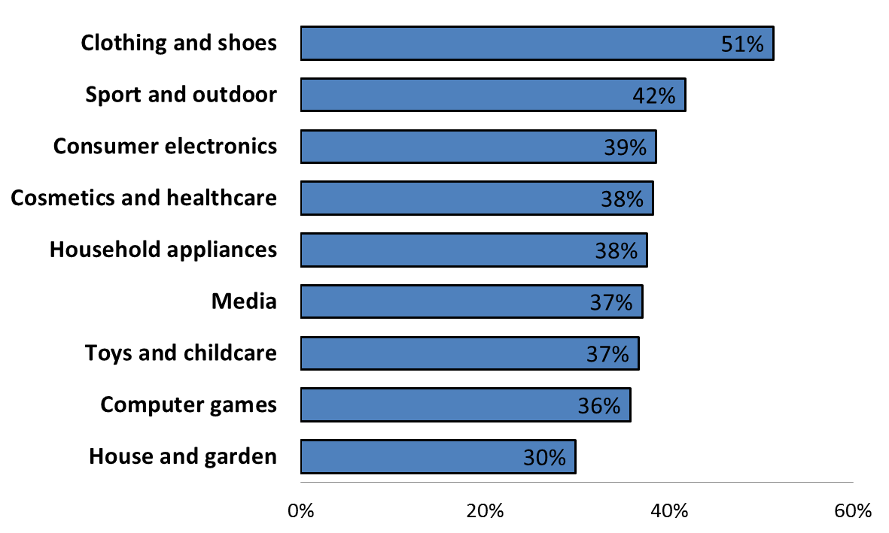

1. Manufacturers report about an even more widespread use of recommended retail prices: four out of five manufacturers use price recommendations to distributors.[310]
2. To better understand why pricing recommendations are so widespread, manufacturers were asked to explain the main considerations behind the decision to recommend retail prices to distributors.
3. Manufacturers express the view that the price of a product is the most immediate way to communicate its quality to the customers and have provided a number of reasons for recommending retail prices.
4. First of all, manufacturers explain that an important factor taken into consideration when setting the recommended retail price of a product is the intended positioning of the brand or of the specific product. This is reported to be particularly important for premium products and for luxury brands, although manufacturers active in all product categories have argued that there is a strong link between recommended retail prices and brand/product positioning. The level of recommended retail prices is chosen in order to reflect a certain brand/product image or to strengthen the image or its perceived value. Many of the comments received during the public consultation from manufacturers and manufacturer trade associations repeated this underlining rationale for suggesting retail prices.
5. Manufacturers further explain that products tend to be designed and manufactured taking already into consideration an estimated retail price level. Therefore, their investments in research and development as well as other manufacturing costs are inextricably linked to a given recommended retail price.
6. Recommended retail prices are set also on the basis of market studies that allow manufacturers to gauge customers' willingness to pay. Manufacturers state that they have a better understanding than retailers of the price a customer would be prepared to pay for their products and, therefore, are better placed to evaluate market conditions and develop a marketing strategy, which includes the price of the products. Market knowledge, manufacturers explain, is particularly important when a product is launched.
7. Another reason brought forward is that manufacturers either believe that retailers need price guidance or that they receive requests from retailers for such guidance. Some of the comments received during the public consultation further pointed to the benefits of price recommendations following retailers' requests.
8. Many manufacturers explained that they provide recommended retail prices in order to help retailers to position manufacturers' products next to many other competing products. According to manufacturers, recommended retail prices can also help independent retailers to compare their prices against the manufacturers own retail activities.
9. Along the same lines, manufacturers explain that recommended retail prices may help avoiding or reducing cannibalization across channels and geographies. Some manufacturers consider it important to support the brick-and-mortar channel by preventing online prices from falling below a certain level. Recommended retail prices can help in this regard. It was pointed out by some of the comments submitted during the public consultation that price recommendations may enable manufacturers to address the structural differences that exist between the two channels. Furthermore, when setting the recommended retail prices, manufacturers indicate that they also build-in an estimated profit margin for the retailer.
10. Manufacturers also elaborate on what types of products warrant for recommended retail prices. Although few argue that recommended retail prices may be necessary in relation to all types of products, more often the use of recommended retail prices is linked to the launch of new products or to the sales of premium brands/products. For this type of products, it is argued that the price should reflect the quality of the product. When a service is directly related to the sale of the product, manufacturers explain that the recommended retail prices would take this into account as well.
11. Beyond price recommendations, retail prices are set by the retailers with a view to achieving a certain expected profit margin.
12. In this regard, several manufacturers emphasised the strong negotiating position of large retailers / groups of retailers. Several retailers[311] explicitly report about contractually guaranteed profit margins which shift, at least to a certain extent (depending on the individual agreements), the commercial risk back to the supplier.
13. Due to their strong negotiating power, certain retailers can, as explained by a number of manufacturers, also obtain ad hoc negotiated compensations for lower profit margins as compared to the expected level of profit margins, leading to a de facto guarantee of profit margins.
14. Guaranteed profit margins and occasional compensations of losses or of decreased profit margins may put increasing pressure on manufacturers to ensure a minimum retail price level throughout their distribution network and thereby minimise the risk of compensations to retailers.

#### ***4.6.2 Monitoring of recommended retail prices***

1. One aspect relevant for the assessment of recommended retail prices under Article 101 TFEU is whether manufacturers that use recommended retail prices monitor resale prices in order to ensure compliance with pricing recommendations. Such monitoring of retail prices by manufacturers may be a first step leading to subsequent attempts to unduly influence price setting at retail level.
2. The Commission therefore asked, on the one hand, retailers - whether they were aware that manufacturers would monitor their compliance with recommended retail prices and what would be the most common way to do so - and, on the other hand, manufacturers - whether they monitor retail prices and, if they do, via what means and for what reason.
3. Approximately 18 % of retailers report that manufacturers monitor their retail prices. According to retailers, the most common ways used by manufacturers are visiting the retailers' brick and mortar store or website, obtaining information via an external company, such as a market analyst or companies specialised in tracking prices, or by using dedicated software that would crawl the internet to gather price data, or simply based on complaints from other retailers.
4. Nearly 30 % of manufacturers indicated that they systematically track the online retail prices of their products sold via independent distributors.[312] Others reported that they would not do so systematically but in a targeted manner. Targeted monitoring, manufacturers explain, tends to focus on premium products and key markets.
5. Manufacturers, which indicate that they monitor the retail prices of independent distributors, also provide information on the methods they use for that purpose. The most commonly used method is manual tracking, with two thirds of the manufacturers (out of those that monitor retail prices) making use of such method, followed by the use of price-tracking software.

Figure B. 75: Most commonly reported methods to monitor retail prices by manufacturers[313]



1. Manufacturers provided a wide range of reasons to explain why they monitor retail prices.
2. One of the main reasons given is that monitoring retail prices allows manufacturers to better understand market trends and how successful a given product may be. Some manufacturers explain that they look at their products and competitors’ products in order to determine future recommended retail prices, brand/product positioning, as well as calculating manufacturing costs of future products. Monitoring also provides indications to manufacturers as to the price expectations customers have for particular products and to the price pressure by competitors.
3. In addition, manufacturers that are, vis-à-vis certain retailers, under a contractual or de factoconstraint to guarantee a minimum profit margin or to compensate for certain losses or lower profit margins, also have a direct interest in monitoring retail price levels.
4. Another reason to monitor retail prices is the medium- or long-term impact of the retail price level of a product on the wholesale prices. In general, the level of retail prices affects wholesale prices that are set with a view to the expected achievable retail prices (often by using a multiplier) and therefore the expected profit margin. 3 % of the manufacturers report that their wholesale prices are contractually linked to the resale price of their products.[314]

#### ***4.6.3 Retailers' compliance with price indications and reasons***

1. Retailers were asked whether they typically comply with manufacturers' pricing indications. Out of those retailers that replied to the relevant question,[315] almost a third reports they normally comply with price indications given by the manufacturers while slightly more than a quarter would not comply. The remaining retailers report compliance with manufacturers' pricing indications would depend on the specific circumstances.[316]
2. The responses of the retailers indicate three main reasons for complying with manufacturers' pricing indications.
3. First, retailers follow pricing indications because they find it profitable. Certain retailers explain, for instance, that, on certain occasions, manufacturers' price indications allow them to obtain a good margin and the price indicated would be in line with market expectations.
4. Second, retailers, especially smaller ones, decide to comply with the pricing indications because they do not want to damage their business relationship with the manufacturers. For instance, some retailers report that when pricing indications are not followed, manufacturers would contact them and put pressure on them to align their prices. Subsequently, these retailers would tend to accept and follow the indications they receive.
5. Finally, some retailers follow manufacturers' pricing indications because of explicit threats or retaliatory measures taken by manufacturers in case the retailer would not comply with those indications. Retailers active in the product categories of clothing and shoes, consumer electronics, as well as house and garden, reported more commonly actions by manufacturers to ensure compliance with pricing indications. The main measures retailers referred to were loss of discounts, delayed supplies, severance of contracts or expulsion from the distribution network.
6. Retailers report that interference with retail prices would typically occur via emails or other means of online communication or, more frequently, via direct phone calls by the manufacturer to the employees of the retailers responsible for pricing.
7. Several manufacturers emphasise that certain retailers would monitor competing retailers' resale prices and pressure the manufacturers to intervene vis-à-vis low pricing competitors, with a view to achieving a higher price level and thereby the expected profit margins.

#### ***4.6.4 Pricing restrictions under EU competition rules***

1. Resale price maintenance (RPM) i.e. agreements or concerted practices between independent undertakings that establish a minimum or fixed price (or price range), are considered restrictions of competition by object under Article 101(1) TFEU.[317]
2. Under Article 4(a) of the VBER, the block exemption provided by the VBER does not apply to vertical agreements that, either directly or indirectly, have as their object RPM. This is without prejudice to the possibility of the supplier to impose a maximum sale price or recommend a sale price, provided that they do not amount to a fixed or minimum sale price as a result of pressure from, or incentives offered by, any of the parties.
3. Any efficiencies RPM may lead to in particular cases, are to be evaluated on the basis of the specific circumstances of the case.[318]
4. The practice of recommending a non-binding resale price or requiring the retailer to respect a maximum resale price is covered by the VBER provided that the market share thresholds set out in the Regulation are not exceeded and that the recommended price or the maximum price do not amount to a fixed or minimum sale price as a result of pressure from, or incentives offered by, any of the parties.[319]
5. As explained in the Vertical Guidelines, in the case of contractual provisions or concerted practices that directly establish the resale price, the restriction is clear cut.[320] However, RPM can also be achieved through indirect means. When providing pricing recommendations it is important that manufacturers do not take actions, such as providing financial or other business incentives to retailers that follow the recommended prices or, to the contrary, apply measures discouraging or threatening retailers that do not follow such prices, as this would interfere with the freedom of retailers to set their final prices to customers independently. This type of interventions may entail that the recommended retail price or the maximum retail price become equivalent to a minimum or fixed price.

#### ***4.6.5 Charging different wholesale prices for different sales channels***

1. Another way manufacturers can influence retail prices is by charging different wholesale prices to retailers depending on the channel where the product is intended to be resold. Such different prices may take various forms such as a discount mechanism whereby a manufacturer would grant a discounted price to a retailer for products sold in one channel while a different or no discount would be granted for the same product sold in the other sales channel.
2. Setting different wholesale prices depending on the channel in which the products are to be sold is, however, rarely considered as a viable option by manufacturers. As already mentioned under section B.2.3 Pricing above, only 2.5 % of retailers reported that they pay a different price depending on whether the product would be sold online or offline. Half of those reported that they were passing on these differences to customers in the retail price. The little use of such practices is often explained by the risk that such a dual pricing strategy could be in breach of Article 101 TFEU.[321]
3. In this regard, it is useful to clarify the rules relating to pricing practices where the manufacturer sets a different (wholesale) price for the same product, to the same (hybrid) retailer, depending on whether those products are intended to be resold via the online or via the offline channel of that (same) retailer, and those where the manufacturer sets a different (wholesale) price for the same product to different retailers.
4. Charging different (wholesale) prices to different retailers is generally considered a normal part of the competitive process.[322] Dual pricing for one and the same (hybrid) retailer is generally considered as a hardcore restriction under the VBER.
5. Dual pricing rules and practices constitute one of the most commented sections of the Preliminary Report.
6. In particular, the current legal framework only allows for a fixed fee to support offline and/or online sales efforts by the same retailer and only provides limited possibilities to address differences in the costs of investments between sales channels.[323] Many stakeholders call for more flexibility regarding performance-related price reductions/discounts/bonuses allowing for differences between sales channels which would be better adapted to the actual circumstances of the retailers and would incentivise hybrid retailers to support investments in more costly (typically offline), value added services.
7. Paragraph 64 of the Vertical Guidelines explicitly envisages the possibility for dual pricing agreements to fulfil the conditions of Article 101(3) TFEU where, for instance, sales via one of the sales channels lead to substantially higher costs for the manufacturer than sales via the other channel. The example provided is not the only possible situation in which the criteria of Article 101 (3) TFEU could be fulfilled.
8. The Commission remains open to consider efficiency justifications in particular cases under Article 101(3) TFEU. This could for instance be the case, where it can be shown that a dual pricing arrangement is indispensable to address free-riding between offline and online sales channels in the case of hybrid retailers that are part of the distribution network of the manufacturer.[324] While hybrid retailers may internalise part of the externality occurring across sales channels, they may nevertheless remain subject to free-riding by other retailers. Their incentives to invest in costly sales effort in the offline channel may therefore be negatively affected, similarly to the case of pure brick and mortar retailers.

#### ***4.6.6 Online price transparency and the use of price monitoring software***

1. As pointed out in section B.2.3 Pricing, online price transparency, as one of the main features of e-commerce, has a significant impact on the behaviour at all levels of the supply chain.
2. About half of the retailers track online prices of competitors.[325] In addition to easily accessible online searches and price comparison tools, both retailers and manufacturers report about the use of specific price monitoring software, often referred to as "spiders", created either by third party software specialists or by the companies themselves. This software crawls the internet and gathers large amounts of price related information. 67 % of those retailers that track online prices[326] use (also) automatic software programmes for that purpose. Larger companies have a tendency to track online prices of competing retailers more than smaller ones.
3. Price monitoring software can provide a high level of granularity, scope and immediate access to pricing data. For instance, some software allows companies to monitor several hundred websites extremely rapidly, if not in real time. Reports can be brand-specific, product-specific or both. Reports can also provide an overview of how much prices diverge from the recommended retail prices, or another reference price used, and for how long. Alert functionalities in price monitoring software allow companies to get alerted as soon as a retailer's price is not in line with a predefined price.
4. The majority of those retailers that use software to monitor prices, adjust consequently their own prices to those of their competitors (78 %).[327] Most of them adjust prices manually (43 %), but some (8 %) use automatic price adjustments based on pricing software programmes (often the same software as the "spider" price monitoring software) and a significant number (27 %) uses both manual and automatic price adjustments. Automatic price adjustments allow the retailer to automatically set certain product prices at a pre-defined level of, for instance, 1 % below the lowest observed price of the benchmark competitors monitored by the software.
5. There are several ways increased transparency and the use of price monitoring and pricing software by both retailers and manufacturers may impact the competitive process in e-commerce markets.
6. First, increased price transparency through price monitoring software enables easier detection of those retailers that deviate from manufacturers' pricing recommendations. It could therefore allow manufacturers to retaliate against retailers that do not comply with pricing recommendations and, therefore, limit the incentives of retailers to deviate from such pricing recommendations in the first place. [328]
7. Second, increased price transparency through price monitoring software may facilitate or strengthen (both tacit and explicit) collusion between retailers by making the detection of deviations from the collusive agreement easier and more immediate. This, in turn, could reduce the incentive of retailers to deviate from the collusive price by limiting the expected gains from such deviation.[329]

**Summary**

At least a third of the retailers in each product category receive some form of price recommendations from the manufacturers.

Manufacturers explain that the price of a product is the most immediate way to communicate its quality and intended brand positioning to both retailers and customers. Recommended resale prices are also perceived useful in relation to developing a marketing strategy and supporting the brick and mortar channel.

Agreements that establish a minimum or fixed price (or price range) are a hardcore restriction within the meaning of Article 4(a) of the VBER and a restriction of competition by object under Article 101(1) TFEU.

Non-binding pricing recommendations or maximum resale prices are covered by the VBER as long as the market share thresholds are respected and they do not amount to a minimum or fixed resale price as a result of pressure from or incentives offered by the parties involved in the vertical relationships.

Most manufacturers track retail prices. Nearly 30 % of them do so systematically. Retailers also monitor competitors' prices. 67 % of the retailers use software to do so, and the vast majority of those consequently adjust their own prices to the observed prices of their competitors.

Several manufacturers emphasise the market position of certain large retailers / groups of retailers. This is reflected, amongst others, in contractually agreed or ad hoc negotiated forms of compensation for retailers' margin losses which shift, at least to a certain extent, the commercial risk back to the supplier.

Manufacturers often voice their intention to create a level-playing field for the different sales online/offline channels taking into consideration the differences in cost levels. Setting different wholesale prices for hybrid players is, to date, rarely considered as a viable option due to the risk that a dual pricing strategy could be in breach of Article 101(1) TFEU.

Charging different (wholesale) prices to different retailers is generally considered a normal part of the competitive process. Dual pricing for one and the same (hybrid) retailer is generally considered as a hardcore restriction under the VBER. The Report points to the possibility of exempting dual pricing agreements under Article 101(3) TFEU on an individual basis, for example where a dual pricing arrangement would be indispensable to address free-riding.

Increased transparency and the use of price monitoring/pricing software by both retailers and manufacturers may impact the competitive process in e-commerce markets.

First, it is now easier to detect deviations from manufacturers' pricing recommendations. This could allow manufacturers to retaliate against those deviations and, therefore, limit the incentives of retailers to deviate from such pricing recommendations in the first place.

Second, increased price transparency may facilitate or strengthen collusion between retailers by making the detection of deviations from the collusive agreement easier. This, in turn, would reduce the incentive of retailers to deviate from the collusive price by limiting the expected gains from such deviation.

### 4.7 Exclusivity and parity agreements ("MFN" clauses) between retailers and marketplaces and/or price comparison tools

1. The sector inquiry was also seeking to establish whether agreements between retailers and online marketplaces and/or price comparison tools contain exclusivity and/or parity (often referred to as most-favoured-nation or "MFN") clauses.
2. The term "exclusivity clauses" refers to clauses whereby either marketplaces or price comparison tools are restricted from entering into contractual relationships with other retailers (selling the same products) than the contracting one or whereby retailers are restricted from selling on other marketplaces or listing their products on other price comparison tools.
3. Parity clauses typically require the retailer to sell on the marketplace or list on a price comparison tool at the lowest price and/or on the best terms offered either on retailer's own website (narrow parity clauses) or on other marketplaces/price comparison tools or in all sales channels (wide parity clauses). Non-price parity clauses may for instance require the retailer to offer the same (or a not narrower) product range on the marketplace (and/or price comparison tool) than on its own website, or require similar customer services.

#### ***4.7.1 Agreements between retailers and marketplaces***

1. Based on the results of the sector inquiry, exclusivity clauses between marketplaces and retailers selling on the marketplace are rare. None of the marketplaces participating in the sector inquiry reported to have agreements with retailers that require them to exclude other retailers that offer the same products from the marketplace. Only one marketplace reported that it requires retailers not to sell some or all of their products on other marketplaces or other websites.
2. Unlike exclusivity clauses, parity clauses are slightly more present in the agreements between retailers and marketplaces. The data from the sector inquiry suggest that those marketplaces that use parity clauses are either more sizable or are new entrants. Typically used parity requirements are the ones that request the retailers to sell on the marketplace at a price that is lower or at most equal to the lowest price offered by the retailer on any other marketplace (used by 8 of the respondent marketplaces) and those that request the retailer to offer on the marketplace the same product range as elsewhere, for example on other marketplaces, websites and brick-and-mortar shops (also used by 8 of the respondent marketplaces).
3. Most marketplaces using the above-described wide price parity clauses are not identical to the ones using the product range parity clauses. Most of those marketplaces that use wide price parity clauses (six out of the eight using wide price parity clauses) also use narrow ones which require retailers to sell on their marketplace at a price that is lower or at most equal to the lowest price available on the retailer's own website. Only one marketplace reported to use price parity clauses that require retailers to sell on the marketplace at lower or equal price compared to the price applied in their brick and mortar shop.
4. The findings suggest that parity clauses which are used by the respondent marketplaces are not limited to price and product range. Under some clauses retailers are required to ensure that the level of quality of the customer service and the product information provided to the potential buyers shall not be worse than those offered by the same retailer in other sales channels. None of the marketplaces reported to have parity clauses with respect to product quality.
5. 43 % of respondent marketplaces (22 respondents) reported not to have any parity requirements in their agreements and several marketplaces apply parity requirements only with respect to their most important retailers. Some of the marketplaces have pointed out that despite the existence of parity clauses in their agreements with retailers, the latter are not enforced and some of them have been removed. The findings suggest that parity clauses tend to be present in agreements with larger marketplaces.
6. Among the respondent retailers only a few reported to have price parity requirements in their agreements with marketplaces. 2 % of the retailers that responded to the questionnaire have a pricing restriction with regard to at least one product category, whereby the retail price on a marketplace cannot be higher than the one on retailer's website (narrow parity clause). Similarly, 2 % of retailers have a pricing restriction with regard to at least one product category, whereby the retail price on a given marketplace cannot be higher than the one on other marketplaces (wide parity clause).
7. As to the reasons why parity clauses are applied marketplaces explained that having a broad and recent range of the retailers' products (ensured by product range parity clauses) is necessary to build and maintain customer trust. Others claim that parity clauses are important to compensate for the investment of the marketplace to integrate the retailers' products into their system. There are also marketplaces whose business model is based on being a bargain superstore which implies having the lowest price on the market. As one of the marketplaces explains, "[…] *Majority of online shoppers feel that price is one major factor for a purchasing decision. Therefore it is important to have sellers who offer their products at least for a competitive price with respect to different marketplaces.*"
8. Some marketplaces monitor the compliance with parity clauses regularly, whereas others do it from time to time only. In case of non-compliance, marketplaces first warn the retailers and as an ultimate step they exclude them from the relevant seller-scheme or from the marketplace.
9. When asked about the overall impact of the use of parity requirements by other marketplaces, most marketplaces responded that they have not carried out an in-depth analysis of such an impact. A few explain that they have observed a slowdown in their growth after some of the big competitors started to apply price parity clauses. Others claim that their strategy is not to compete with other marketplaces primarily on price but rather on other factors, such as customer service, quality, efficiency of logistics, or availability of the latest products.
10. In the absence of a hardcore restriction under Article 4 of the VBER, parity clauses in vertical agreements are covered by the VBER if the parties' market shares do not exceed 30 %. Should market shares exceed 30 % an individual assessment of parity clauses will be required.
11. In markets where marketplaces play an important role, parity clauses can provide disincentives for retailers to compete on those parameters which fall within the scope of the clause. This may ultimately lead to a reduction of intra-brand competition. Parity clauses may also reduce competition between online retailers and marketplaces and make market entry or expansion for competing marketplaces more difficult.
12. Parity clauses may on the other hand lead to efficiencies. For instance their use might be necessary to recoup investments by the marketplace and to avoid free-riding. They may also be used by new market entrants whose business model is based on having the best available resale prices or the widest product range. Parity clauses will therefore have to be analysed and assessed on a case-by-case basis.

#### ***4.7.2 Agreements between retailers and price comparison tools***

1. All price comparison tool providers but one declared that they do not have any agreements with retailers on an exclusive basis, meaning retailers using price comparison tools are free to contract with competing ones.
2. According to the findings of the sector inquiry, agreements between retailers and price-comparison tools containing price parity clauses are exceptional. Only 3 % of the respondent price-comparison tools reported to have such clauses in their agreements.
3. According to these parity clauses, prices displayed on the price comparison tool have to be lower or at most equal to the lowest price offered by the same retailers on other price comparison tools, on any marketplace, on their own website or in their brick-and mortar shop. However, price comparison tools claim that these parity clauses are not enforced.

**Summary**

According to the findings of the sector inquiry, exclusivity clauses between marketplaces/price comparison tools and retailers selling on the marketplace are exceptional.Parity (MFN) clauses (both price and non-price ones) are more present in particular in agreements between retailers and larger marketplaces. Only 2 % of the respondent retailers have a parity clause with regard to at least one product category.

In markets where marketplaces play an important role, parity clauses can provide disincentives for retailers to compete on those parameters which fall within the scope of the clause. This may ultimately lead to a reduction of intra-brand competition. Parity clauses may also reduce competition between online retailers and marketplaces and between marketplaces and make market entry or expansion for competing marketplaces more difficult. Parity clauses may on the other hand lead to efficiencies. For instance their use might be necessary to recoup investments by the marketplace and to avoid free-riding. Parity clauses will therefore have to be analysed and assessed on a case-by-case basis.

### 4.8 Other types of restrictions to sell or advertise online

1. The restrictions described above are contractual restrictions on which the Commission has requested more detailed information from market participants. They do however not constitute an exhaustive list of restrictions encountered in the sector inquiry. Moreover, new developments in e-commerce markets may lead to new types of contractual restrictions which may require closer scrutiny in the future.
2. Many manufacturers include a significant number of detailed clauses in their distribution agreements on how their products can be sold and advertised online. This is in particular the case for selective distribution agreements.[330] Such clauses relate for example to:
3. technical requirements for the website (e.g. availability of website and rapidity);
4. requirements in relation to the design of the website (e.g. allowing clear and easy navigation) and the display of the products on the website;
5. requirements to provide certain (pre- and post-sale) customer services and adhere to certain service requirements;
6. adherence to brand policy requirements of the manufacturer; and
7. requirements in relation to delivery and immediate availability of stock.
8. These clauses typically aim at guaranteeing certain quality standards in relation to online distribution of the manufacturers' products by (authorised) retailers.
9. Other types of clauses include limitations that may dissuade or restrict (authorised) retailers from using the internet as a sales channel to reach a greater number and variety of customers by imposing criteria for online sales which are overall not equivalent to criteria imposed for the sales from the brick and mortar shops.[331]
10. The information obtained in the sector inquiry shows that a limited number of retailers are restricted in their ability to sell (some) products of certain manufacturers via the internet at all. In this context, it should be recalled that contractual provisions which either explicitly or de facto prohibit a retailer to use the internet as a method of marketing are restrictions by object under Article 101(1) TFEU and hardcore restrictions within the meaning of Article 4(c)[332] of the VBER. Such clauses cannot be regarded as prohibiting members of a selective distribution system from operating out of an unauthorised place of establishment within the meaning of Article 4(c) of the VBER and could only escape the prohibition of Article 101 TFEU on an individual basis where the conditions of Article 101(3) TFEU are met.[333] Another type of restriction encountered in the sector inquiry relates to the use of trademarks/brand names for online advertising. Some contractual clauses limit the ability of (authorised) retailers to use the manufacturers' (trademark protected) brand names for online marketing or optimization activities irrespective of whether such usage could amount to a trademark violation and even insofar as such usage would be allowed under trademark rules.[334]
11. The results of the sector inquiry suggest that some retailers are limited in their ability to use or bid on the trademarks of certain manufacturers in order to get a preferential listing on the search engines paid referencing service (such as Google Adwords) or are only allowed to bid on certain positions. Such restrictions typically aim at preventing retailer's websites from appearing (prominently) in the case of usage of specific keywords. This may be in the interest of the manufacturer in order to allow its own retail activities to benefit from a top listing and/or keep bidding prices down. Given the importance of search engines for attracting customers to the retailers' website and improving the findability of their online offer, such restrictions could however raise concerns under Article 101 TFEU, should they restrict the effective use of the internet as a sales channel by limiting the ability of retailers to direct customers to their website. Conversely, restrictions on the ability of retailers to use the trademark/brand name of the manufacturer in the retailer's own domain name rather help avoiding confusion with the manufacturer's website.

**Summary**

New developments in e-commerce markets may lead to new types of contractual restrictions which may require closer scrutiny in the future.

Many manufacturers include a significant number of detailed clauses in their distribution agreements on how their products can be sold and advertised online. This is in particular the case for selective distribution agreements.

There are also other restrictions that may aim at dissuading retailers from using the internet as a means to reach more customers. In this respect, it should be recalled that absolute internet bans are hardcore restrictions. They fall outside the VBER and escape Article 101 TFEU only if they can be justified under Article 101(3) TFEU. Finally, restrictions on the use of brand names for online advertisement purposes (search engine optimization and search advertising) may raise similar concerns under Article 101 TFEU by restricting the effective use of the internet as a sales channel.

5. Other observations

### 5.1 Data

#### ***5.1.1 Data collected by marketplaces and price comparison tools***

1. The questionnaires addressed to marketplaces and price comparison tools gathered some information about the collection and use of such data.
2. Whereas all marketplaces participating in the sector inquiry report collecting individual customer data, 77 % of the price comparison tool providers do so.
3. Marketplaces collect a wide range of different data such as location; product, price, purchasing and browsing history; frequency of visits; the devices and payment methods used.

Figure B. 76: Proportion of marketplaces collecting each type of data[335]



1. Besides the data listed above, marketplaces also collect personal identification data (such as name, mother's name, age), contact details (including physical and mail address, phone number), electronic identification data (such as device ID’s), customer profile data (preferences, habits, chats, languages, interests, profiles), financial information (including billing, bank account number, and payments system data) and feedback data.
2. Price comparison tools also collect different types of data, most typically concerning the device used by the customer.

Figure B. 77: Proportion of price comparison tools collecting each type of data[336]



1. Besides the data listed above, few of the respondent price comparison tools also collect personal identification data and contact details about different categories of customers, (such as registered and past customers, customers from trusted reviews programme) as well as electronic identification data. Some also explain to collect anonymised data, not connected to individuals. Price comparison tools also collect and use third party analytics data (such as keywords, traffic sources, operating systems, browsers and devices used).
2. Marketplaces and price comparison tools use part of the collected data to invoice retailers. As some respondents explain, they distinguish via the collected data the human clicks from software (internet bot) ones. Some price comparison tools explain that they charge different prices for clicks from foreign and from domestic IP addresses. A few explain that they also charge different prices for clicks from mobile and desktop devices due to different conversion rates. Some identify repeated clicks (within a short timeframe) from the same IP, so as to avoid charging the seller inadequately.
3. Marketplaces and price comparison tools use part of the collected data to improve customer experience. For instance browsing history allows for customers to see the products visited earlier. Displays may also be adapted to device types. For instance when browsing from smartphone, some price comparison tools only expose merchants who provide a smartphone-optimised experience.
4. They also use the collected data to assess and improve business performance. With the help of the collected data they analyse customer behaviour and demand (such as the number of unique and frequent customers, the reaction to promotions), to prioritise features that may be more popular in a certain geolocation; optimise product listings and displays (as search algorithm "learns" from past history); improve marketing activity (for instance to display personalised banners); and develop the service provided as well as their website.
5. Finally, they also use the data for security and fraud prevention and to comply with legal and accounting obligations.
6. Roughly half of the marketplaces share some data with their professional sellers whose products were visited or purchased. Those marketplaces that do so typically provide the data necessary to process the transaction and their own individual sales data and analytics. Roughly one-quarter of price comparison tools reported to share data (typically click data and information on the devices used) with the sellers whose products were visited.
7. Marketplaces and price comparison tools typically do not sell data to third parties. The few that do so sell them to research companies and advertisers.
8. One-third of the marketplaces and few price comparison tools report to purchase data from third parties. If they do so, they purchase from entities which offer credit check and identity check services; anonymous and aggregated data from market research companies and institutions; media companies; and also personal identification data from marketing companies.

#### ***5.1.2. Data collected by retailers***

1. Retailers also collect data for other than geo-blocking purposes (as discussed in more detail in section B.4.3.2.5 Geo-blocking measures). They report to gather a considerable amount of both personal data (linked to the individual customers)[337] and "big data" (for instance click) data. The most typical data collected are: the customers' physical address (in particular post code), real location (e.g. GPS coordinates, Wlan-data, IP address) delivery address, billing address, email address, phone number; name, birth date, gender, language, credit card and banking data, customer communication, PC information, the browser used, and data on visit- search- and purchase history.
2. The purpose of the data gathering is diverse. For obvious reasons the same information can be used for different purposes. For instance the billing address might be used for both communicating the bill to the customer and to send him newsletters). The most typical purposes mentioned are the following: completion of delivery and managing delivery-relating communication; executing the payment transaction; fulfilling after-sales services; payment verification and fraud prevention; bots’ fraud screening; preventing website hacking; managing customer relations; marketing; carrying out performance analytics; compliance with different laws in the Member States (for instance to comply with different VAT-rates or consumer protection laws). Personalised pricing by retailers based on data collected on online behaviour of individuals is at this stage rare (reported by 2 % of respondent retailers).

#### ***5.1.3 The use of data in e-commerce and potential competition concerns***

1. The findings of the e-commerce sector inquiry confirm that the collection, processing and use of large amounts of data (often referred to as "big data"[338]) is becoming increasingly important in e-commerce.
2. On the one hand, data can be a valuable asset and the analysis of large volumes of data can bring substantial benefits in the form of better products and services and allow companies to become more efficient. Big data analytics in e-commerce can lead to improved multi-channel integration, more efficient processes, reduced inventory, lead to the creation of new features and services and increase the customers' shopping experience and convenience. It can for example help retailers to provide customers a targeted offering in the form of individualised product recommendations, rebates, advertisements or customer services.
3. On the other hand, the collection and the use of large data sets may also impact competition. The sector inquiry did not focus in particular on data-related competition concerns, and this Report does not aim to address those potential concerns.[339] Nevertheless, the findings of the sector inquiry highlight certain possible competition concerns relating to data-collection and usage.
4. For example, the exchange of competitively sensitive data such as on prices or sold quantities between marketplaces and third party sellers or manufacturers and retailers may lead to competition concerns where the same players are in direct competition for the sale of certain products or services. Marketplace operators sometimes act as an online retailer on their platform in direct competition with third party sellers. Competitively sensitive data provided by third party sellers to marketplaces or generated on marketplaces in relation to third-party transactions (e.g. bestsellers, transactional prices and pricing plans, inventory levels, supplier data) could – absent any safeguards in place – be used in order to boost the retail activities of the marketplace operators at the expense of third party sellers. Similarly, manufacturers that directly sell online may request their authorised distributors to provide them with competitively sensitive data which could be used for anti-competitive purposes. Such behaviour could potentially raise competition concerns.

**Summary**

All marketplaces and the majority of price comparison tools collect data for different purposes. Retailers also gather a considerable amount of both personal and anonymous data. Data are used for a wide variety of purposes, e.g. to complete and invoice transactions, for marketing, to improve business performance, to prevent fraud and to comply with legal obligations.

The collection of a large amount of data is becoming increasingly important in e-commerce. Such "big data" may allow the companies to become more efficient and provide a better and more targeted, individualised offering for customers. On the other hand, the collection and the use of data may also impact competition. For example, the exchange of competitively sensitive data between marketplaces and third party sellers or manufacturers and retailers may lead to competition concerns where the same players are in direct competition for the sale of certain products or services. Such behaviour could potentially raise competition concerns.

1. Communication from the Commission to the European Parliament, the Council, the European Economic and Social Committee and the Committee of the Regions "A Digital Single Market Strategy for Europe", COM(2015) 192 final.
2. For further details on the Digital Single Market Strategy, see <https://ec.europa.eu/priorities/digital-single-market_en>.
3. Proposal for a Directive of the European Parliament and of the Council on certain aspects concerning contracts for the supply of digital content, COM(2015) 634 final; and Proposal for a Directive of the European Parliament and of the Council on certain aspects concerning contracts for the online and other distance sales of goods, COM(2015) 635 final.
4. Proposal for a Regulation of the European Parliament and of the Council on cooperation between national authorities responsible for the enforcement of consumer protection laws, COM(2016) 283 final.
5. Proposal for a Regulation of the European Parliament and of the Council on cross-border parcel delivery services, COM(2016) 286 final.
6. Proposal for a Regulation of the European Parliament and of the Council on addressing geo-blocking and other forms of discrimination based on customers' nationality, place of residence or place of establishment within the internal market and amending Regulation (EC) No 2006/2004 and Directive 2009/22/EC, COM(2016) 289 final.
7. Communication from the Commission to the European Parliament, the Council and the European Economic and Social Committee on an action plan on VAT, COM(2016) 148 final; and the adoption, on 1 December 2016, of the VAT Digital Single Market Package "Modernising VAT for cross-border e-commerce", respectively available at the following addresses: <http://ec.europa.eu/taxation_customs/business/vat/action-plan-vat_en>; and

   https://ec.europa.eu/taxation_customs/business/vat/digital-single-market-modernising-vat-cross-border-ecommerce_en.
8. Communication from the Commission to the European Parliament, the Council, the European Economic and Social Committee and the Committee of the Regions: Towards a modern, more European copyright framework COM(2015) 626 final; and Proposal for a Regulation of the European Parliament and of the Council on ensuring the cross-border portability of online content services in the internal market, COM(2015) 627 final, Proposal for a Regulation of the European Parliament and of the Council laying down rules on the exercise of copyright and related rights applicable to certain online transmissions of broadcasting organisations and retransmissions of television and radio programmes - COM(2016) 594 final, and Proposal for a Directive of the European Parliament and of the Council on copyright in the Digital Single Market - COM(2016) 593 final.
9. Communication from the Commission to the European Parliament, the Council, the European Economic and Social Committee and the Committee of the Regions: Online Platforms and the Digital Single Market, Opportunities and Challenges for Europe, COM(2016) 288 final.
10. Council Regulation (EC) No 1/2003 of 16 December 2002 on the implementation of the rules on competition laid down in Articles 81 and 82 of the Treaty, OJ L 1, 4.1.2003, p. 1. ("Regulation 1/2003").
11. Commission decision of 6 May 2015 initiating an inquiry into the e-commerce sector pursuant to Article 17 of Council Regulation (EC) No 1/2003 (HT.4607), C(2015) 3026, final.
12. The Commission proposal for a Regulation of the European Parliament and of the Council on addressing geo-blocking and other forms of discrimination based on customers' nationality, place of residence or place of establishment within the internal market and amending Regulation (EC) No 2006/2004 and Directive 2009/22/EC, COM(2016) 289 final, seeks to address company-erected barriers, including also in the form of unilateral business decisions of non-dominant undertakings or intra-group decisions, which are generally not caught by EU competition rules.
13. See 2016 Eurostat Community Survey on ICT usage in households and by individuals, available at the following address:

    <http://ec.europa.eu/eurostat/statistics-explained/index.php/E-commerce_statistics_for_individuals>. See also data from Flash Eurobarometer 397 (2015), Consumers attitude towards cross-border trade and consumer protection.
14. See footnote above.
15. Flash Eurobarometer 397 (2015). The survey was carried out between 14 and 16 April 2014. The data refer to purchases in the last 12 months.
16. See 2016 Eurostat Community Survey on ICT usage in households and by individuals, available at the following address:

    <http://ec.europa.eu/eurostat/statistics-explained/index.php/E-commerce_statistics_for_individuals>
17. "The European Digital Single Market: its Role in Economic Activity in the EU", Joint Research Centre of the European Commission, Institute for Prospective Technological Studies, Digital Economy Working Paper 2015/17, JRC 98723. Available at the following address: <https://ec.europa.eu/jrc/sites/default/files/JRC98723.pdf>
18. Nestor Duch-Brown and Bertin Martens: "The European Digital Single Market: its Role in Economic Activity in the EU", Joint Research Centre of the European Commission, Institute for Prospective Technological Studies, Digital Economy Working Paper 2015/17, JRC 98723. Available at the following address: <https://ec.europa.eu/jrc/sites/default/files/JRC98723.pdf>
19. Nestor Duch-Brown and Bertin Martens: "The European Digital Single Market: its Role in Economic Activity in the EU", Joint Research Centre of the European Commission, Institute for Prospective Technological Studies, Digital Economy Working Paper 2015/17, JRC 98723. Available at the following address: <https://ec.europa.eu/jrc/sites/default/files/JRC98723.pdf>
20. Eurostat, Digital Single Market: promoting e-commerce for individuals. Available at the following address:

    [http://ec.europa.eu/Eurostat/data/database?node_code=isoc_bdek_smi](http://ec.europa.eu/eurostat/data/database?node_code=isoc_bdek_smi)
21. Eurostat Community Survey on ICT usage in households and by individuals 2014 (isoc_ec_ibuy). See also Consumer Conditions Scoreboard 2015. Available at the following address:

    <http://ec.europa.eu/consumers/consumer_evidence/consumer_scoreboards/11_edition/docs/ccs2015scoreboard_en.pdf>
22. Eurostat Community Survey on ICT usage in households and by individuals 2014. See also Consumer Conditions Scoreboard 2015. Available at the following address:

    <http://ec.europa.eu/consumers/consumer_evidence/consumer_scoreboards/11_edition/docs/ccs2015scoreboard_en.pdf>
23. Eurostat Community survey on ICT usage and e-commerce in enterprises 2015. Available at: <http://ec.europa.eu/eurostat/statistics-explained/index.php/E-commerce_statistics> (figure 10)
24. Flash Eurobarometer 413 (2015), Companies engaged in online activities. Available at the following address: <http://ec.europa.eu/public_opinion/flash/fl_413_en.pdf>

    See also Flash Eurobarometer 359 (2012), Retailers attitude towards cross-border sales and consumer protection according to which one quarter (25 %) of the interviewed retailers sell to consumers in at least one other EU Member State.

    A comparison across Member States and some third countries shows that retailers in Belgium (45 %), Luxembourg (42 %), Slovenia (41 %) and Greece (40 %) are the most likely to sell to consumers in at least on other EU Member State. Available at the following address:

    <http://ec.europa.eu/consumers/consumer_evidence/market_studies/docs/geoblocking-exec-summary_en.pdf>
25. Mystery shopping survey on territorial restrictions and geo-blocking in the European digital single market, 2016. Available at the following address:

    <http://ec.europa.eu/consumers/consumer_evidence/market_studies/docs/geoblocking_final_report_2016_en.pdf>

    See also Melisande Cardona and Bertin Martens: Supply-side Barriers to Cross-border e-Commerce in the EU Digital Single Market, Joint Research Centre of the European Commission, Institute for Prospective Technological Studies, Digital Economy Working Paper 2014, JRC 92294. Available at the following address: <https://ec.europa.eu/jrc/sites/default/files/JRC92294_Supply%20side%20barriers%20to%20ecommerce.pdf?search>
26. Nestor Duch-Brown and Bertin Martens: "The European Digital Single Market: its Role in Economic Activity in the EU", Joint Research Centre of the European Commission, Institute for Prospective Technological Studies, Digital Economy Working Paper 2015/17, JRC 98723. Available at the following address: <https://ec.europa.eu/jrc/sites/default/files/JRC98723.pdf>
27. Eurostat, Digital Single Market: promoting e-commerce for individuals. See footnote 22 above.
28. European Commission, Digital Agenda Scoreboard. The figure refers to the percentage of all individuals buying online who purchased digital content in 2014 in the EU-28. The data includes online games. Available at the following address:

    <https://digital-agenda-data.eu/charts/see-the-evolution-of-an-indicator-and-compare-countries#chart={%22indicator-group%22:%22any%22,%22indicator%22:%22i_bgoodo%22,%22breakdown%22:%22IND_TOTAL%22,%22unit-measure%22:%22PC_IND_BLT12%22,%22ref-area%22:[%22EU27%22]}>
29. Eurostat data on internet usage in the EU-28 (includes online games). Source: Eurostat online database, table isoc_ci_ac_i (variable I_IUGM).
30. Flash Eurobarometer 411 (2015), Cross-border access to online content. Available at the following address:

    <http://ec.europa.eu/COMMFrontOffice/PublicOpinion/index.cfm/Survey/getSurveyDetail/instruments/FLASH/surveyKy/2059>
31. See Flash Eurobarometer 413; See also Eurobarometer 359 (2012), Retailers’ attitudes towards cross-border trade and consumer protection. According to this survey more than 4 out of 10 retailers say that the additional costs of compliance with different consumer protection rules and contract law, as well as the potentially higher costs of the risk of fraud and non-payment are important barriers to their cross-border sales (both 41 %). Higher costs due to distance are considered an important obstacle by 38 % of companies, followed by additional costs of compliance with different national tax regulations and higher costs of cross-border delivery (both 36 %). Around one third of companies view potentially higher costs in resolving cross-border complaints or disputes (33 %) and extra costs from after-sales service in cross-border transactions (31 %) as important obstacles. More than one quarter say that the extra costs arising from different consumption habits (26 %) is an important obstacle, while 25 % say the extra costs from language differences (25 %) is an important obstacle to developing their cross-border sales to other Member States.
32. See Flash Eurobarometer 397 (2015), Consumers' attitude towards cross-border trade and consumer protection; see also Flash Eurobarometer 186, 359 and 396.
33. See, for instance, Flash Eurobarometer 397 (2015), Consumers' attitude towards cross-border trade and consumer protection; Consumer market study on the functioning of e-commerce and Internet marketing and selling techniques in the retail of goods, by Civic Consulting of 9 September 2011, see also European Commission, Consumer Conditions Scoreboard, 11th scoreboard, 2015. Available at the following address:

    <http://ec.europa.eu/consumers/consumer_evidence/consumer_scoreboards/11_edition/docs/ccs2015scoreboard_en.pdf>
34. See Flash Eurobarometer 413 (2015), Companies Engaged in Online Activities.
35. Idem.
36. Euromonitor International (2016), Passport Database [Data file].
37. See Flash Eurobarometer 413 (2015), Companies Engaged in Online Activities.
38. Avis n° 12-A-20 du 18 Septembre 2012 relatif au fonctionnement concurrentiel du commerce électronique.
39. For example, see decisions in case CE/9578-12 of 5 August 2013 and of 27 March 2014 ("mobility scooters") of the UK National Competition Authority ("NCA"), decision in case B2-98/11 of 26 August 2015 ("ASICS") of the German NCA, communication of 18 November 2015 ("Adidas") of the French NCA.
40. See Article 17 of Regulation 1/2003.
41. Commission decision of 6 May 2015 initiating an inquiry into the e-commerce sector pursuant to Article 17 of Council Regulation (EC) No 1/2003 (HT.4607), C(2015) 3026, final.
42. See SWD(2016) 70 final, available at <http://ec.europa.eu/competition/antitrust/ecommerce_swd_en.pdf>
43. See SWD(2016) 312 final, available at http://ec.europa.eu/competition/antitrust/sector_inquiry_preliminary_report_en.pdf
44. Non-confidential versions of the submissions are available at http://ec.europa.eu/competition/antitrust/sector_inquiries_e_commerce.html
45. Guidelines on vertical restraints ("Vertical Guidelines"), OJ C 130, 19.5.2010, p.1.
46. For instance, a supplier may have an incentive to employ exclusive licensing in order to resolve the so-called "commitment problem" and increase its profits, while limiting competition among distributors to the detriment of consumers. The "commitment problem" refers to a situation where a supplier with market power may not be able to exercise it because he cannot credibly commit vis-à-vis distributors not to behave opportunistically and offer rival distributors better trade conditions. Therefore, in the absence of a credible commitment mechanism, the supplier cannot exploit his market power, which leads to lower prices. Conversely, by allowing the supplier to commit not to deal with rival distributors, exclusive licensing may negatively affect consumer welfare.
47. See paragraph 156 of the Vertical Guidelines.
48. See also paragraphs 106-109 and 225 of the Vertical Guidelines regarding the positive effects of vertical restraints.
49. This may be a consideration, for example, with respect to audiovisual content creation to the extent that it is characterised by high sunk costs and uncertainty. The incentives to innovate and create new content may be insufficient absent the prospect of obtaining sufficient return. Copyright protection is a means to remedy this problem.
50. This situation is normally referred to as the "double marginalisation problem". See also paragraph 107(f) of the Vertical Guidelines regarding vertical externalities.
51. Similarly, free-riding could take place among suppliers, for instance, on their investment in promotion, which may increase the sales of competing suppliers. This may be the case when a supplier invests in promotion activities at the retail premises and the distributor sells also other competing brands. See also paragraph 107(a) of the Vertical Guidelines regarding the free-rider problem.
52. See also paragraph 225 of the Vertical Guidelines.
53. See also paragraphs 61 and 107(b) of the Vertical Guidelines.
54. See also paragraph 107(i) of the Vertical Guidelines.
55. See also paragraph 107(c) of the Vertical Guidelines.
56. See also paragraph 107(d) of the Vertical Guidelines.
57. See also paragraph 107(h) of the Vertical Guidelines.
58. For instance, exclusive distribution may increase promotion and sales effort but exacerbate a double-marginalisation problem (due to reduced intra-brand competition). Vertical restraints which address double-marginalisation, such as maximum resale price or quantity forcing could, therefore, be employed in parallel to exclusivity. See also paragraph 105 of the Vertical Guidelines.
59. Amadeus (Bureau van Dijk).
60. Euromonitor International (2015), Passport database.
61. Veraart Research (2015), Retail Index. Available at the following address: <http://www.retail-index.com/>
62. Companies belonging to NACE code 4791 (Retail sale via mail order houses or via Internet) were considered. Companies on Amadeus are considered to be large and very large if they match at least one of the following conditions: (i) Operating revenue - not less than EUR 10 million (USD 13 million), (ii) Total assets - not less than EUR 20 million (USD 26 million) or (iii) Employees - not less than 150.
63. Wholesale and retail trade, repair of motor vehicles and motorcycles.
64. The companies to which a questionnaire was addressed were requested to respond on a per website basis (see paragraph (69))
65. For example, if a company operates a website targeting Germany with a top-level domain ".de" and a website targeting France with a top-level domain ".fr", it was required to fill in two questionnaires. The responses were allocated to the respective Member State.
66. E-books were covered by the questionnaires to market participants that concerned goods and not the questionnaires on digital content. In this report, the findings on e-books are therefore included (as a part of the product category "media") in the goods section and not in the digital content section.
67. Virtual Private Network, i.e. an encrypted communication channel that can be established between two computers or IP-based devices.
68. See the press release on the ongoing investigation, available at the following address: <http://europa.eu/rapid/press-release_IP-15-5432_en.htm>
69. Television fiction and children television programmes were grouped together in the results from the data submitted by right holders.
70. These figures refer to the data provided by the legal entity to which the questionnaire was addressed. As separate questionnaires were sent to different websites of a group of companies, it may occur that some of the respondents reported relatively low figures on the number of employees and turnover in relation to a website that belongs to a larger group.
71. Based on the total number of retailers (1051).
72. 1034 retailers responded to the relevant question.
73. 1031 retailers have responded to the relevant question. 1 % of respondent retailers are purely selling offline. This low figure stems from the fact that pure offline retailers are not active in e-commerce and were therefore not targeted by the retailers' questionnaire.
74. Proportion calculated out of all 1025 retailers that responded to the relevant question.
75. Proportion calculated out of all 1019 retailers that responded to the relevant question.
76. Proportion calculated out of all 1013 retailers that responded to the relevant question.
77. Proportions calculated out of all 1009 retailers that responded to all relevant questions.
78. Note that the percentages for each category presented in the figure have slightly different bases (see footnotes 74 - 77).
79. As marketplaces responded on a per website basis, each website was taken into account separately, even if belonging to the same group of companies. Moreover, a respondent was considered as also acting as a retailer if the retail activity was performed by a different legal entity within the company group of the marketplace operator.
80. To allow interested parties to register as a seller, some marketplaces require for example the provision of a tax ID, the articles of association, national registration numbers and/or a bank account within the EU.
81. Proportion calculated out of the 30 marketplaces that responded to the relevant question.
82. For certain platforms the number reflects the number of sellers that have opted for a selling scheme aimed at a high level of activity on the given marketplace.
83. This reflects the total number of professional sellers that were selling on a given marketplace in 2014.
84. Such services are not necessarily offered as a separate service by the marketplace, but some of them may form an integral part of the marketplace's offering to sellers.
85. 21 of the 37 responding marketplaces reported to supply data-feeds to price comparison-tool providers.
86. 31 of the 37 responding marketplaces submitted that they use external online payments systems.
87. Examples of mentioned intermediaries are Tradebyte, Channel Advisor, magnalister and plentymarkets.
88. Addressees were asked to respond separately for each website they operate. Each response is therefore counted separately. Some respondents provided a single response for multiple price comparison tools they operate. In this case, their response was counted only once.
89. Proportions are calculated out of 86 respondents that responded to the relevant question.
90. Often referred to as cost-per-click (CPC).
91. Often referred to as cost-per-acquisition (CPA).
92. Proportions are calculated out of 81 respondents that answered the relevant question.
93. Proportions are calculated out of 88 respondents that answered the relevant question.
94. Proportions are calculated out of 88 respondents that answered the relevant question.
95. For example, payment methods such as different credit and debit cards, giropay and direct debit.
96. See Article 3 of Commission Regulation (EU) No 330/2010 of 20 April 2010 on the application of Article 101(3) of the Treaty on the Functioning of the European Union to categories of vertical agreements and concerted practices, OJ L 102, 23.4.2010, p. 1 ("VBER"). See also paragraphs (100) to (105) of the Vertical Guidelines.
97. See for further details Commission notice on the definition of the relevant market for the purposes of Community competition law, OJ C 372, 9.12.1997, p. 5.
98. The proportions presented in the figure are based on the weighted average of the proportion of responses for each product category, where the weights reflect the distribution of responses across product categories. In clothing and shoes, 84 respondents provided the relevant information; in consumer electronics, 48 respondents; in electrical household appliances, 39 respondents; in cosmetics and healthcare, 37 respondents; in house and garden, 30 respondents; in computer games and software, 6 respondents; in sports and outdoor equipment, 26 respondents; in toys and childcare articles, 18 respondents; in media, 5 respondents; and in "other" products, 50 respondents. One respondent may be active in several product categories.
99. In the sector of media, novelty was not so highly ranked, but the information is based on only 5 responses.
100. Without taking into consideration the category of "other" parameters which refers to various features of competition.
101. The proportions presented in the figure are based on the weighted average of the proportion of responses for each product category, where the weights reflect the distribution of responses across product categories. In clothing and shoes, 259 respondents provided the relevant information; in consumer electronics, 190 respondents; in electrical household appliances, 169 respondents; in cosmetics and healthcare, 129 respondents; in house and garden, 181 respondents; in computer games and software, 92 respondents; in sports and outdoor equipment, 130 respondents; in toys and childcare articles, 125 respondents; in media, 117 respondents; and in "other" products, 84 respondents. One respondent may be active in several product categories.
102. The proportions presented in the figure are based on the weighted average of the proportion of responses for each product category, where the weights reflect the distribution of responses across product categories. In clothing and shoes, 187 respondents provided the relevant information; in consumer electronics, 121 respondents; in electrical household appliances, 95 respondents; in cosmetics and healthcare, 72 respondents; in house and garden, 132 respondents; in computer games and software, 72 respondents; in sports and outdoor equipment, 80 respondents; in toys and childcare articles, 90 respondents; in media, 58 respondents; and in "other" products, 68 respondents. One respondent may be active in several product categories.
103. Proportions are calculated out of the number of respondents that provided information on the relevance of the respective factor for competition with other marketplaces.
104. The proportions presented in the figure are based on the weighted average of the proportion of responses for each product category, where the weights reflect the distribution of responses across product categories. 33 respondents provided the relevant information in clothing and shoes; 31 respondents in toys and childcare articles and sports and outdoor equipment; 30 respondents in consumer electronics, electrical household appliances, computer games and software and house and garden; 29 in media and cosmetics and healthcare; and 13 respondents in "other" products. One respondent may be active in several product categories.
105. Proportions are calculated out of the number of respondents that provided information on the relevance of the respective factor for competition with other price comparison tools.
106. See also submission of the Commission on price transparency to the OECD. Available at the following address: <http://www.oecd.org/competition/abuse/2535975.pdf>
107. Ibid.
108. Based on the responses of 343 retailers who responded they were using software to track prices.
109. The figure is based on the responses of retailers who were asked to indicate the most typical price change frequency per sector.
110. The Commission is currently conducting a market study on ''Online market segmentation through personalised pricing/offers in the European Union''.
111. Proportion calculated out of those 513 hybrid retailers that responded to the question.
112. Proportion calculated out of those 579 hybrid retailers that responded to the question.
113. These are 102 respondents, representing about 17 % of the hybrid retailers.
114. These are 411 respondents, representing about 67 % of the hybrid retailers.
115. They represent only 2.5 % of the respondents.
116. See section B.4.6.5 Charging different wholesale prices for different sales channels for more information on dual pricing.
117. Based on the responses of the 606 hybrid retailers who responded to the relevant question.
118. Duch-Brown N. and Martens B. "The European Digital Single market", JRC IPTS Digital Economy Working Paper, 2015. Available at the following address: <https://ec.europa.eu/jrc/sites/default/files/JRC98723.pdf>
119. Proportions are based on the average proportions of sales provided by 238 manufacturers.
120. 73 % and 72 %, respectively, of the respondents to the questionnaire.
121. The product categories "Computer games and software" and "Media: Books (including e-books), CDs, DVDs and Blu-ray discs" are excluded from the analysis due to the low number of respondent manufacturers active in these product categories (7 and 6 respondents, respectively).
122. The product categories "Computer games and software" and "Media: Books (including e-books), CDs, DVDs and Blu-ray discs" are excluded from the analysis due to the low number of respondent manufacturers active in these product categories (7 and 6 respondents, respectively).
123. Based on the responses of 244 manufacturers that responded to this question.
124. Based on the responses of 244 manufacturers that responded to this question.
125. Based on the responses of 245 manufacturers that responded to this question.
126. Based on the responses of 244 manufacturers that responded to this question.
127. Proportion calculated on the basis of the responses of 247 manufacturers that responded to this question. In particular manufacturers active in clothing, shoes and accessories (80 %) and sports and outdoor equipment (54 %) tend to sell their products also via their own brick and mortar shops.
128. Depending on the business model of the manufacturer, such mono-brand stores may also be operated by third parties (e.g. franchisees).
129. Proportions are calculated out of all respondents (1051) to the retailer questionnaire.
130. Proportions are calculated out of all manufacturers that are active in each given product category.
131. Exclusivity may also be granted in relation to certain customer groups. This Report focuses in particular on cross-border sales and related restrictions and will therefore not examine exclusivity in relation to exclusively allocated customer groups. Moreover, based on the distribution agreements received the allocation of specific customer groups appears to be less widespread than the allocation of exclusive territories.
132. Based on Article 4(b)(i) of the VBER restrictions of the territory into which the buyer party to the agreement may sell the contract goods constitute a hardcore restriction, except where the restriction is limited to active sales into an exclusive territory reserved to the supplier or allocated to another distributor.
133. Proportions are calculated out of 247 manufacturers that responded to the relevant question.
134. One benefit of having an exclusive distributor for a certain territory is that a manufacturer does not need to have contractual relationships with multiple distributors. The fact that a single territorial exclusive agreement can cover an entire territory which would otherwise require multiple agreements can explain the low proportion of agreements that grant territorial exclusivity out of all agreements which manufacturers have in place.
135. Proportions are calculated out of the total number of respondents active in each product category. A single respondent can be active in several product categories.
136. For more details in relation to contractual territorial restrictions, see section B.4.3 Cross-border e-commerce and geographic restrictions to sell and advertise online on geographic sales restrictions.
137. The percentages for each of the listed reasons are calculated as the weighted average of the proportions of respondents in each product category, out of all respondents in this product category, who consider territorial exclusivity necessary for that particular reason. The weights reflect the distribution of respondents to the questionnaire across product categories.
138. This may be even more so, if the distributor is required to set-up mono-brand stores in which only the manufacturer's products are sold.
139. These reasons were: expanding and reaching a viable scale of operations, entering a new market, launching a new brand/product and investing in advertising and promotion of certain brands or products.
140. The VBER in Article 1(e) defines "selective distribution system" as "a distribution system where the supplier undertakes to sell the contract goods or services, either directly or indirectly, only to distributors selected on the basis of specified criteria and where these distributors undertake not to sell such goods or services to unauthorised distributors within the territory reserved by the supplier to operate that system".
141. Proportions calculated out of 252 manufacturers that responded to the relevant question.
142. Proportions calculated out of 244 manufacturers that responded to the relevant question.
143. Proportion calculated out of 141 manufacturers that reported they were using selective distribution. This ratio corresponds to 39 % of all 244 manufacturers that responded to the relevant question, including those that do not use selective distribution.
144. Based on the responses by 252 manufacturers.
145. For the purpose of this figure, only the manufacturers active in one product category were taken into consideration.
146. Based on the responses of 141 manufacturers that use selective distribution.
147. Proportions are calculated out of 141 manufacturers that use selective distribution. This ratio corresponds to 39 % of all 244 manufacturers that responded to the relevant question, including those that do not use selective distribution.
148. For the purpose of this figure, only the manufacturers active in one product category, and using selective distribution in that product category, were taken into consideration.
149. Based on the responses by 165 manufacturers.
150. Certain retailers may have to fulfil more criteria than others but get access to a broader / the full range of products of the brand.
151. Based on the responses of 178 manufacturers and 169 retailers.
152. Based on the responses of 166 manufacturers to this question.
153. Based on the responses of 166 manufacturers to this question.
154. Judgment in Metro SB‑Großmärkte v Commission, 26/76, EU:C:1977:167, paragraph 20, judgment in L’Oréal, 31/80, EU:C:1980:289, paragraphs 15 and 16, judgment in Allgemeine Elektrizitäts-Gesellschaft AEG-Telefunken, 107/82, EU:C:1983:293, paragraph 35, judgment in Groupement d'achat Edouard Leclerc, T-19/92, EU:T:1996:190, paragraphs 112 to 120 and judgment in Pierre Fabre Dermo-Cosmétique SAS, C-439/09,EU:C:2011:649, paragraph 41.
155. This observation does not question the legitimacy of selective distribution as a distribution model as such, but simply takes into account that within a closed network of distributors, vertical restraints can be applied more effectively than outside such a system.
156. Several manufacturers and hybrid retailers emphasise in their comments the importance of urbanisation aspects of the brick and mortar requirements. They point to the risk of seeing an increasing number of physical shops closing down in city centres / high streets, which they claim to ultimately lead to lower investments in the offline / local environment and, as a result, to more limited consumer choice.
157. For instance, several retailers point to selective distribution systems where the operation of one brick and mortar shop in an entire Member State or region was sufficient to qualify as an authorised distributor, without any further link to actual (qualitative or quantitative) requirements.
158. See paragraphs 176 and 179 of the Vertical Guidelines.
159. Based on 171 responses to this question.
160. See also judgment in C‑158/11 Auto 24 SARL v. Jaguar Land Rover France SAS, EU:C:2012:351, paragraph 31.
161. See also paragraph 175 of the Vertical Guidelines.
162. See paragraphs 12 et seq of the Vertical Guidelines. An agent can also purchase goods or services on behalf of the principal.
163. Proportions are calculated out of all 259 manufacturers that replied to the questionnaire.
164. Proportions are calculated out all marketplaces (37) that replied to the questionnaire.
165. Judgment in DaimlerChrysler v Commission, T-325/01, U:T:2005:322, paragraph 122 and judgment in Confederación Española de Empresarios de Estaciones de Servicio, C-217/05, EU:C:2006:784, paragraph 62. See also Vertical Guidelines, paragraph 18.
166. Judgment in Minoan Lines v Commission, T-66/99, EU:T:2003:337, paragraph 126 and judgment in voestalpine and voestalpine Wire Rod Austria v Commission, T-418/10, EU:T:2015:516, paragraph 139. See also Vertical Guidelines, paragraphs 12-17.
167. Exclusive agency provisions prevent the principal from appointing other agents in respect of a given type of transaction, customer or territory. Single branding provisions prevent the agent from acting as an agent or distributor of undertakings which compete with the principal. See also Vertical Guidelines, paragraph 19.
168. See Vertical Guidelines, paragraph 19.
169. An important majority of manufacturers (74 %) indicated that this applies to most of their brands and products.
170. 220 respondents consider value added customer services offered by retailers to be important for enhancing demand for most or some of their brands/ products.
171. 59 % of the respondents who have indicated that customer services are important sell through selective distribution, while 50 % through exclusive distribution. 21 % have franchising agreements in place.
172. Overall, 39 % (corresponding to 102 manufacturers) of the respondent 252 manufacturers do not monitor the services provided by retailers.
173. 35 % of the 249 manufacturers that responded to the relevant question indicated that they do not sell their products to pure online sellers.
174. 230 manufacturers have responded to the particular question.
175. 252 manufacturers have responded to the particular question.
176. 251 suppliers have responded to the particular question.
177. Proportions are calculated on the basis of the 250 respondents to the question.
178. Almost 90 % of the manufacturers who require investment in specific facilities or human resources at the retail level operate selective and/ or exclusive distribution system.
179. The proportions are calculated on the basis of responses given per sector.
180. Consumer electronics and household appliances are also the two product categories where, according to manufacturers, retailers are most involved in advertisement.
181. The proportions are calculated on the basis of responses given per sector.
182. The proportions are calculated on the basis of responses given per sector.
183. 252 manufacturers have responded to the respective question.
184. 253 manufacturers have responded to the respective question.
185. Free-riding concerns may also arise within the same sales channel. Such free-riding is however not the subject of this report.
186. 26 % of the respondents do not know.
187. 34 % of the respondents do not know.
188. Half of the respondents say they do not know.
189. More than half of the respondents say they don't know.
190. Based on the responses of 163 retailers that answered the relevant question.
191. Based on the responses of 162 retailers that answered the relevant question.
192. 33 % out of the 163 respondents to the question regarding the impact of free-riding by online, and 31 % out of the 162 respondents to the question regarding the impact of free-riding by offline.
193. For the purpose of this section "contractual" restrictions cover also restrictions by indirect means, i.e. situations in which a company is limited in its ability to sell or advertise online or set a certain price by means of warnings, threats, penalties, delay or suspension of deliveries or any other discouraging means, including financial incentives or disincentives, either in writing or orally, used to change the conduct of the company.
194. See Article 1 (a) of the VBER.
195. Proportions are calculated out of all respondents (1051) to the retailers' questionnaire.
196. Proportions are calculated on the basis of the number of respondents active in each product category.
197. Many retailers are active in multiple product categories which is the reason why the product category specific proportions of retailers that have at least one restriction are not directly comparable to this overall proportion of retailers that have at least one restriction.
198. Proportions are calculated on the basis of the number of respondents active in each Member State. Only Member States for which 20 or more retailers responded to the relevant question are presented in the figure.
199. The Commission published in March 2016 its initial findings on geo-blocking in an Issues paper (See SWD(2016) 70 final). The initial findings of the Issues paper are confirmed by this Report. However, as the Commission received some of the responses only after the data extraction date for the Issues paper, certain figures have been slightly modified.
200. Proportions are calculated out of all 257 responses to the question. Respondents were asked to provide a separate response for each product category in which they are active. For manufacturers active in multiple product categories, the product category with sales into the highest number of Member States was considered as indicative of the presence of the manufacturer across the EU.
201. 80 % of manufacturers of cosmetics and healthcare products reported selling their products in at least 21 Member States while the proportion of manufacturers of consumer electronics selling in the same number of Member States was 76 %. Proportions are calculated on the basis of the number of respondents active in each product category.
202. See also section B.3.3.1 Territorial exclusive distribution agreements where territorial exclusivity is discussed and section B.3.4.3 Selective distribution where selective distribution is analysed.
203. Proportions are calculated out of all 918 respondents to the relevant question.
204. Proportions are calculated out of all respondents that replied to the relevant question and are active in a given Member State. Only Member States for which 20 or more retailers responded to the relevant question are presented in the figure.
205. The proportions for each product category are calculated out of all respondents that replied to the relevant question for a given product category. A single respondent can be active in several product categories and was therefore able to provide a separate reply for each of the product categories in which it is active. It follows that, as the basis for the calculation is different, these proportions are not directly comparable to the proportion of respondents (i.e. 36 %) that reported not selling cross-border in at least one product category. The number of respondents to the relevant question ranges from 488 in clothing and shoes to 221 in the category "others".
206. As explained in paragraph (70), retailers were asked to provide separate responses for each of their websites. If a retailer has indicated that it does not sell cross-border from a particular website, it does not mean that the retailer is not present and selling its products abroad via a different website.
207. Proportions are calculated out of all respondents in a given turnover category that replied to the relevant question. The number of retailers per turnover category that responded to the question range from 69 in the turnover category EUR 50 million to EUR 100 million to 267 for the turnover category above EUR 100 million.
208. Domestic visits are visits from the Member State that the website targets.
209. 750 respondents provided data on the number of visits that occurred in 2014.
210. The percentages in individual Member States may be influenced by the existence of large retailers (some of which operate a single website to serve customers in multiple Member States) driving the Member State average.
211. Only Member States for which 20 or more retailers responded to the relevant question are presented in the figure.
212. Proportions are calculated out of all respondents (744) that provided data on the number of purchases that occurred in 2014.
213. The percentages in individual Member States may be influenced by the existence of large retailers (some of which operate a single website to serve customers in multiple Member States) driving the Member State average.
214. Only Member States for which 20 or more retailers responded to the relevant question are presented in the figure.
215. 84 % of the 32 marketplaces that responded to the relevant question report that sellers may choose the list of Member States they would like to deliver to. This choice was available either in general, that is for all products offered by a seller, or on a product-by-product basis.
216. The proportions are calculated on the basis of the respondents that replied to all relevant questions and sell via own websites (namely 554 respondents) or marketplaces (312 respondents).
217. 213 respondents provided information on purchases that occurred via marketplaces.
218. The proportions are calculated on the basis of 25 respondents that replied to the relevant question.
219. 168 respondents provided sales information on purchases that occurred both via their own web shop and marketplaces. The number of respondents in the turnover categories ranges from 21 in the turnover category EUR 50 million to EUR 100 million to 40 in the turnover category above EUR 100 million.
220. The proportions are calculated out of all 1051 respondents that replied to the retailers' questionnaire.
221. A single respondent was able to select multiple types of purposes for which it gathers location information.
222. Note that a single respondent was able to select multiple types of location information which it gathers.
223. Proportions are calculated out of all respondents that replied to the retailers' questionnaire in a given turnover category.
224. The proportion of respondents is calculated out of all respondents that sold cross-border and that replied to the respective question (603 retailers). As retailers were asked to provide separate responses per operated website, the responses received do not provide information on price differences applied by retailers when selling products at different prices on different websites.
225. Proportions are calculated of the 723 respondents that answered the relevant question.
226. Each respondent can be active in several product categories and was therefore able to provide a reply for each product category in which it is active. The proportions below are calculated on the basis of all of the respondents that sell cross-border and that replied to this question for the given product category. The number of respondents in the product categories range from 313 in the product category clothing and shoes to 82 in the product category computer games and software.
227. Based on responses of overall 291 retailers.
228. All proportions are calculated out of all respondents active in the product categories and that replied to the relevant question. In total, 251 suppliers provide information on whether their product characteristics would be different depending on where the product would be sold. Respondents could provide separate responses for each product category they are active in.
229. Whilst removing the possibility to price discriminate by means of geo-blocking or geo-filtering may increase overall consumer welfare, such an increase may, however, involve distribution effects across customers groups, some may benefit from a price decrease, while others may experience a price increase.
230. Proportions are calculated of the 872 respondents that answered the relevant question. Note that each respondent was able to select several measures.
231. See paragraph (20).
232. Several retailers may have also reported restrictions coming from the same supplier.
233. 13 % of retailers with turnover above EUR 500 000 report having contractual restrictions in at least one product category while 7 % of retailers with turnover below EUR 500 000 report having a contractual restriction in at least one product category. Proportions are calculated out of all respondents that provided information on their turnover (798 for the turnover category above EUR 500 000 and 226 retailers for the turnover category below EUR 500 000).
234. The proportion at the EU level is taken from all retailers that responded to the retailers' questionnaire. Proportions at the Member State level are calculated out of all retailers that responded from the respective Member State. Only Member States with a minimum of 20 respondent retailers were taken into account.
235. Proportions are calculated out of all respondents that replied to the questionnaire and reported that they are active as retailers in a given product category. Note that a single respondent can be active in several product categories and was therefore able to provide a reply for each product category in which it is active. Therefore, as the basis for the calculation is different, these proportions are not directly comparable to the proportion of respondents (nearly 12 %) that reported that they have contractual cross-border sales restrictions in at least one product category.
236. See Vertical Guidelines, paragraph 50.
237. Proportion calculated out of 861 retailers that responded to the relevant question.
238. Proportion calculated out of 247 manufacturers that responded to the relevant question.
239. See Vertical Guidelines, paragraphs 61 and 108.
240. Proportion calculated out of 248 manufacturers responding to the relevant question.
241. Approximately 4 % of the 611 retailers that responded to the relevant question indicated that the decision to collect information concerning the location of the customer is partly determined by them and partly determined by their supplier. Only one retailer indicated that it collects such location information solely because of a request by its supplier. The answers of retailers may have been impacted by the fact that all of them need to collect such information for the purposes of delivering and billing the product and that this is the predominant reason for collecting such data.
242. Proportion calculated out of 859 retailers that responded to the relevant question.
243. Unilateral conduct may, however, be caught by Article 102 TFEU and/or by Article 20(2) of Directive 2006/123/EC on services in the internal market, which provides that "Member States shall ensure that the general conditions of access to a service, which are made available to the public at large by the provider, do not contain discriminatory provisions relating to the nationality or place of residence of the recipient, but without precluding the possibility of providing for differences in the conditions of access where those differences are directly justified by objective criteria". The Commission adopted a proposal on 25 May 2016 (COM(2016) 289 final) to tackle geo-blocking of companies as mentioned in footnotes 6 and 12.
244. See, for example, judgment in Établissements Consten S.à.R.L. and Grundig-Verkaufs-GmbH v Commission of the European Economic Community, 56/64 and 58/64, EU:C:1966:41; judgment in P Commission v GlaxoSmithKline, C-513/06, EU:C:2008:738, paragraphs 58 to 61; judgment in Sot.Lélos kai Sia and Others, C‑468/06 to C-478/06, EU:C:2008:504, paragraph 65; judgment in NV IAZ International Belgium and Others v Commission, 96 to 102, 104, 105, 108 and 110/82, EU:C:1983:310, paragraphs 23 to 27; judgment in Javico, C‑306/96, EU:C:1998:173, paragraphs 13 and 14; judgment in General Motors v Commission, C‑551/03 P, EU:C:2006:229, paragraphs 67 to 69 and judgment in Football Association Premier League and Others, C‑403/08 and C‑429/08, EU:C:2011:631, paragraph 139.
245. Agreements between legal entities within the same undertaking fall outside the scope of Article 101(1) TFEU. See for example judgment in Centrafarm BV and Adriaan De Peijper v. Sterling Drug Inc, 15/74, EU:C:1974:114, paragraph 41 and judgment in Viho Europe BV v. Commission, C-73/95 P, EU:C:1996:405, paragraph 51.
246. As indicated above, the Commission adopted a proposal on 25 May 2016 (COM(2016) 289 final) to tackle unilateral geo-blocking of companies.
247. Geo-blocking measures in agreements between undertakings may fall outside Article 101(1) TFEU if the relationship between the parties is qualified as a "genuine" agency relationship within the meaning of the case-law. The decisive element is whether the agent bears financial or commercial risks in relation to the activities for which it has been appointed as an agent to the principal. See judgment in CEEES, C-217/05, EU:C:2006:784 paragraphs 51 to 61 and judgment in CEPSA, C-279/06, EU:C:2008:485, paragraph 36. See also section B.3.4.4 Agency agreements above.
248. See Vertical Guidelines, paragraph 50, for further examples of such indirect measures.
249. Advertisement or promotion that is only attractive for the buyer if it (also) reaches a specific group of customers or customers in a specific territory, is considered active selling to that customer group or customers in that territory. See Vertical Guidelines, paragraph 51.
250. See Vertical Guidelines, paragraph 53.
251. Restrictions of active sales into certain territories or customer groups that are unrelated to an exclusive territory or an exclusive customer group reserved to the supplier or allocated by the supplier to another buyer constitute a hardcore restriction under Article 4 (b) of the VBER.
252. Restrictions of passive sales constitute hardcore restrictions under Article 4(b) of the VBER. They fall outside the scope of Article 101 (1) TFEU only in exceptional circumstances (see paragraph 61 of the Vertical Guidelines for further details). In individual cases, undertakings may also plead an efficiency defence under 101(3) TFEU.
253. See Vertical Guidelines, paragraph 51.
254. Vertical Guidelines, paragraph 52.
255. See Vertical Guidelines, paragraph 56.
256. See paragraph 58 of the Vertical Guidelines.
257. See also paragraph 57 of the Vertical Guidelines.
258. See paragraph 57 of the Vertical Guidelines.
259. See paragraph 56 of the Vertical Guidelines.
260. See section B.1.3 Marketplaces on characteristics of respondent marketplaces.
261. ##### About a third of the retailers that responded to the questionnaire have indicated "selling through a marketplace" as one possible way to increase online sales in Member States where they either do not sell at all or do not sell significant quantities. See also section B.4.3.2.3 The role of online marketplaces for cross-border sales

     for more information on the role of marketplaces for cross border sales.
262. Proportions are calculated out of all retailers who responded to the relevant questions, namely 1009.
263. Figure calculated based on all the retailers who provided the relevant data, namely 663.
264. Figure calculated based on the data of 295 sellers on which marketplaces submitted information.
265. Proportion calculated based on the information provided by all 37 marketplaces.
266. Proportions are calculated out of all respondents in a given turnover category (on the basis of 2014 turnover) who responded to the relevant questions. This number ranges from 74 respondents in the turnover category EUR 50 million to EUR 100 million to 297 respondents in the turnover category above EUR 100 million.
267. Proportions are calculated out of all respondents in a given turnover category (on the basis of 2014 turnover) who responded to the relevant questions. This number ranges from 74 respondents in the turnover category EUR 50 million to EUR 100 million to 297 respondents in the turnover category above EUR 100 million.
268. Proportions are calculated out of all respondents in a given turnover category (on the basis of 2014 turnover) who responded to the relevant questions. This number ranges from 74 respondents in the turnover category EUR 50 million to EUR 100 million to 297 respondents in the turnover category above EUR 100 million.
269. Proportions are calculated out of the total number of purchases reported by respondents in a given turnover category (on the basis of 2014 turnover) who sold both via their own online shop as well as via marketplaces and that provided the relevant information on purchases. The number of respondents ranges from 20 respondents in the turnover category EUR 50 million to EUR 100 million to 40 respondents in the turnover category above EUR 100 million.
270. The proportion at the EU level is calculated out of all retailers who replied to the relevant questions, namely 1009. Proportions at the Member State level are calculated out of all retailers that responded from the respective Member State to the relevant questions. Only Member States with a minimum of 20 respondent retailers were taken into account.
271. Proportions per product category were calculated for each of the 34 marketplaces who replied to the relevant question. Subsequently, the average of these proportions was taken for each product category. The figure shows, for example that professional sellers selling clothing and shoes on a marketplace account on average for 25 % of all sellers on a marketplace.
272. Figures are calculated based on the responses of all 37 marketplaces.
273. These product categories are also the product categories in which most marketplace restrictions can be observed (see figure B. 66).
274. Proportion calculated out of all suppliers active in the given product category. Note that in the product categories Media and Computer games there are only, respectively, 6 and 7 respondents.
275. This is also evident from the fact that a quarter of the manufacturers who indicate that selling on (certain) marketplaces could have a potentially adverse impact on their business, consider that selling on (certain) marketplaces could also have a potentially beneficial impact on their business.
276. Proportion calculated out of all manufacturers active in the relevant product category. Note that in the product categories Media and Computer games there are only, respectively, 6 and 7 respondents.
277. The proportion at the EU level is taken from all retailers that responded to the retailers' questionnaire. Proportions at the Member State level are calculated out of all retailers that responded from the respective Member State. Only Member States with a minimum of 20 respondent retailers were taken into account.
278. Proportions are calculated out of all 1051 retailers that responded to the questionnaire. Please note that each retailer was able to select several types of restrictions on the use of marketplaces.
279. Proportions are calculated out of all retailers in a given turnover category.
280. Proportion calculated out of all retailers active in the given product category.
281. Most marketplaces do not differentiate in terms of product presentation between luxurious products and mainstream goods.
282. See also below in section B.4.4.7. Notice and take down procedures on marketplaces more on mechanisms and tools offered by marketplaces to combat the sale of counterfeit and otherwise prohibited products on their platforms.
283. Conversely, some retailers consider that brand owners misuse existing notification systems and complain to marketplace operators about sales of products on the marketplace which are allegedly counterfeit products although they are in fact authentic. In these cases, brand owners require marketplaces to de-list the products and request from the retailers to stop selling them. According to the retailers, it often does not help them that they can prove the authenticity of the products. They will ultimately stop selling the products out of fear that their marketplace accounts would otherwise be blocked due to the intervention of the brand owner.
284. All proportions are calculated out of the 34 marketplaces that responded to the relevant question.
285. A reference for a preliminary ruling has been made by the OLG Frankfurt am Main in Case C-230/16 Coty Germany GmbH vs. Parfümerie Akzente GmbH in which the referring court is essentially asking the Court of Justice whether a ban to use third party platforms which are discernible to the public in a selective distribution agreement may be compatible with Article 101(1) TFEU and whether such a restriction constitutes a hardcore restriction within the meaning of Article 4 (b) and/or Article 4 (c) of the VBER.
286. Judgment in Pierre Fabre Dermo-Cosmétique SAS vs. Président de l’Autorité de la concurrence EU:C:2011:649, paragraphs 47 and 54. See also Vertical Guidelines paragraph 52.
287. See Vertical Guidelines, paragraph 54.
288. See section B.1.4 Price comparison tools on characteristics of respondent price comparison tools.
289. See section B.1.4 Price comparison tools on characteristics of respondent price comparison tools.
290. Figures are calculated based on all respondents to the relevant question, namely 1013.
291. Proportions are calculated out of all respondents in a given turnover category (on the basis of 2014 turnover) who responded to the relevant questions. In total 994 retailers provided the respective information.
292. The proportion at the EU level is calculated out of all retailers who replied to the relevant question, namely 1013. Proportions at the Member State level are calculated out of all retailers that responded to the relevant question from the respective Member State. Only Member States with a minimum of 20 respondent retailers were taken into account.
293. Figures are calculated based on the responses of 48 price comparison tools.
294. Figures are calculated based on all retailers who provided data regarding the relevant question, namely 260.
295. Figures are calculated based on the responses on 88 price comparison tools.
296. Proportions are calculated based on the responses of 36 price comparison tools. The proportions per product category are calculated as the (simple) average of the proportion of sellers in the respective product category across respondents.
297. Proportions are calculated on the basis of the replies of 30 price comparison tools who supplied information on 2412 top retailers. The proportions per product category are calculated as the (simple) average across respondents of the proportion of visits in the respective product category out of the total visits reported by a respondent.
298. Proportions are calculated out of all retailers that responded to the questionnaire from the respective Member State. Only Member States with a minimum of 20 respondent retailers were taken into account.
299. Proportions are calculated out of all 1051 retailers that respondent to the questionnaire.
300. Proportion are calculated out of all retailers that responded to the relevant question in each of the turnover categories. This number ranges from 74 retailers for the turnover category EUR 50 million to EUR 100 million to 299 retailers for the turnover category above EUR 100 million.
301. Proportions are calculated out of all retailers that indicated sales in the respective product category.
302. Figures are calculated based on all 86 respondents to the question.
303. Proportions are calculated out of all respondents which are active in the respective product category. See also figure B. 26 and figure B. 27.
304. Meaning price comparison tools that are not offering any sales functionality.
305. While the price may be an important element for the customer in its choice, other features of price comparison tools such as customer reviews concerning products or sellers may also be of relevance.
306. See paragraph 54 of the Vertical Guidelines.
307. 8 % of retailers reported to be provided with a discount range while 7 % retailers reported receiving the indication from manufacturers to apply the same retail price online and offline. Proportions are calculated out of all 1051 responses to the questionnaire.
308. 5 % of retailers reported receiving indications of what minimum price they should apply while 3 % stated they received indications about what advertised price they should use.
309. Proportions are calculated out of all retailers active in a given product category.
310. Proportions are calculated out of all manufacturers (251) that responded to the questionnaire.
311. 14 retailers reported about contractually guaranteed profit margins. Many of them are active in at least two product categories, and indicated guaranteed profit margins in several product categories, with different manufacturers.
312. Based on the responses of 245 manufacturers who replied to this question.
313. Based on the responses of 78 manufacturers who replied to this question. Each respondent could provide multiple responses, should they use multiple methods to track prices.
314. Proportions are calculated out of all 242 manufacturers that responded to the relevant question.
315. Proportions are calculated out of the responses by 410 retailers that responded to the relevant question.
316. Proportions are calculated out of all retailers (411) that responded to the relevant question.
317. See judgment in SA Binon Cie v SA Agence et Messageries de la Presse, 243/83, EU:C:1985:284, paragraph 43; judgment in ASBL Vereniging van Vlaamse Reisbureaus v ASBL Sociale Dienst van de Plaatselijke en Gewestelijke Overheidsdiensten, 311/85, EU:C:1987:418, paragraph 17; judgment in SPRL Louis Erauw-Jacquery v La Hesbignonne SC, 27/87, EU:C:1988:183, paragraph 15.
318. Some examples of efficiencies that could be potentially be generated by pricing restrictions are outlined in paragraph 225 of the Vertical Guidelines.
319. See Vertical Guidelines, paragraph 226. For the assessment of those pricing practices when they are not covered by the VBER, see paragraphs 227-229 of the Vertical Guidelines.
320. See Vertical Guidelines, paragraph 48.
321. According to paragraph 52 (d) of the Vertical Guidelines, the Commissions considers an agreement that the distributor shall pay a higher price for products intended to be resold by the distributor online than for products intended to be resold offline as a hardcore restriction of passive selling. This does not exclude the supplier agreeing with a buyer a fixed fee to support the latter's offline or online sales efforts.
322. Unless different wholesale prices to (online) retailers have the object of restricting exports or partitioning markets.
323. See in particular Vertical Guidelines, paragraphs 52 (d) and 64.
324. Free-riding by pure online sellers on services provided offline can be addressed by other means, such as price differentiation.
325. Based on the 1051 retailers who responded to the questionnaire.
326. 515 retailers have reported to track online prices of competitors.
327. Based on the responses of 343 retailers who responded they were using software to track prices.
328. Manufacturers could not only intervene based on their own initiative but also following complaints by other retailers about the price level of certain retailers in the market.
329. See also the joint publication by the French and German Competition Authorities, p. 14-15. Available at the following address: <http://www.bundeskartellamt.de/SharedDocs/Publikation/DE/Berichte/Big%20Data%20Papier.pdf?__blob=publicationFile&v=2>
330. See section B.3.4.3 Selective distribution on selective distribution.
331. Vertical Guidelines, paragraph 56.
332. See judgment in Pierre Fabre Dermo-Cosmétique SAS vs. Président de l’Autorité de la concurrence EU:C:2011:649, paragraphs 53 et seq and Vertical Guidelines, paragraph 52.
333. Judgment in Pierre Fabre Dermo-Cosmétique SAS vs. Président de l’Autorité de la concurrence EU:C:2011:649, paragraphs 56 and 59.
334. See judgment in Google France and Google, C-236/08 to 238/08, EU:C:2010:159, paragraphs 75 et seq.
335. All 37 respondent marketplaces responded to the question.
336. 69 price comparison tools responded to the question.
337. Personal data is defined in Article 2(a) of the Directive 95/46/EC of the European Parliament and of the Council of 24 October 1995 on the protection of individuals with regard to the processing of personal data and on the free movement of such data as mean any information relating to an identified or identifiable natural person ('data subject'); an identifiable person is one who can be identified , directly or indirectly, in particular by reference to an identification number or to one or more factors specific to his physical, physiological, mental, economic, cultural or social identity. Directive 95/46/EC will be replaced by the Regulation (EU) 2016/679 of the European Parliament and of the Council of 27 April 2016 on the protection of natural persons with regard to the processing of personal data and on the free movement of such data. It entered into force on 24 May 2016, providing for analogous definition of personal data. It will be applicable as of 25 May 2018.
338. The term "big data" lacks a commonly accepted definition. It could be described as large amounts of different types of data produced at high speed from multiple sources, whose handling and analysis require new and more powerful processors and algorithms. See European Data Protection Supervisor under <https://secure.edps.europa.eu/EDPSWEB/edps/Consultation/big_data>.
339. The German Bundeskartellamt and the French Authorité de la Concurrence provide further insights on data-related competition concerns in their report: "Competition law and data", 10 May 2016.