

**Introduction**

The EU is facing increased instability and conflicts in its neighbourhood and new security threats are emerging. This situation is unlikely to change in the near future. Citizens increasingly look to Europe for protection within and beyond its borders because the scale of these challenges is such that no Member State can successfully address them on their own.

The security of European citizens is first and foremost a European responsibility. Recognising this, Member States are reinvesting in defence. The 28 current Member States are spending 1.34% of GDP on defence (for the EU27, the figure is 1.32%), and there is a clear need to do more.

To be ready to face tomorrow's threats and to protect its citizens, Europe needs to enhance its strategic autonomy. This requires the development of key technologies in critical areas and strategic capabilities to ensure technological leadership. Cooperation at all levels is the only way to deliver on the expectations of EU citizens. By encouraging cooperation, the European Union can help maximise the output and quality of Member States' investment in defence.

For this reason, defence policy has been identified as one of the priority areas of action in President Juncker's political guidelines. In 2016, the European Union laid the foundations for a stronger European defence policy. As part of a comprehensive defence package following up the EU Global Strategy in the security and defence area, the Commission adopted the European Defence Action Plan (EDAP).[1]

This Action Plan set out the measures needed to achieve greater European defence cooperation and support the competitiveness of Europe’s defence industry. It proposed the establishment of a European Defence Fund. The Fund should help Member States make cooperation the norm and thereby develop and acquire key strategic defence capabilities. The European Council welcomed the initiative as well as the Commission's intention to present proposals for the establishment of a European Defence Fund in the first half of 2017.[2]

Now is the moment of delivering on that mandate. Time is running fast. The implementation of the European Defence Fund needs to be taken forward as a matter of priority.

Work is advancing on the preparation of the Research Window of the European Defence Fund. Today, the Commission is making a legislative proposal for a European Defence Industrial Development Programme. The proposal reflects an intensive dialogue with all stakeholders, notably the Member States. Cooperation with the High Representative and the EDA has been close. This Communication also presents tools to promote the joint acquisition of defence capabilities by Member States. Further action will be taken in subsequent phases of the establishment of the Fund.

The European Defence Fund must become a key enabler for the future of European defence. It will support the level of ambition the Union will agree upon when considering the different scenarios towards a Security and European Defence Union, as set out in the reflection paper on the future of European defence.[3]

1. **Why do we need a European Defence Fund?**

Despite several initiatives over the past years, the landscape of the European defence industry is characterised by insufficient levels and quality of investment in the development and procurement of future capabilities. Member States are not cooperating enough, with more than 80% of procurement and more than 90% of Research and Technology run on a national basis. A high degree of fragmentation remains, with 178 different weapon systems in Europe compared to 30 in the US. Too little coordination in defence planning leads to an inefficient use of taxpayers' money, unnecessary duplication and suboptimal deployability of defence forces. There are wide differences in the level of defence spending between Member States. Enhanced solidarity, including through the involvement of the EU budget, is needed to deliver common defence capabilities.

The EU-level: the Commission, the High Representative/Vice-President and the European Defence Agency (EDA) can significantly help the Member States in coordinated planning and joint development of future capabilities. The following steps will be meaningful:

* Systematic identification of European defence capability priorities, based on the EU’s new level of ambition in security and defence. This level of ambition was based on the EU Global Strategy and endorsed by the European Council[4]. The Capability Development Plan as revised in 2018 will be the key reference at the EU level. Where appropriate, regional and international cooperation initiatives contributing to the implementation of the EU priorities will also be taken into account.
* Greater transparency and political direction in national capability planning. The Coordinated Annual Review on Defence (CARD) will foster greater coordination in national defence planning and enhanced European defence cooperation.
* Joint funding mechanisms, as foreseen in the European Defence Fund, should achieve a structural shift towards greater defence cooperation.

The coordination of investment decisions requires a common definition of needs and priorities. These will remain in the hands of Member States. Some of these priorities have already been identified such as Remotely Piloted Aircraft Systems (drones), air-to-air refuelling capacity, Satellite Communication and Cyber.[5] These priorities were confirmed by the EU Global Strategy, which identified additional priority capability areas where Europe needs to invest and promote collaborative development including: intelligence-surveillance reconnaissance, autonomous access to space and permanent Earth observation as well as maritime security.

Increased coordination of investment amongst Member States throughout the industrial cycle is crucial, from research to the development of prototypes to the acquisition of defence capabilities. It would contribute to greater efficiency in national defence spending, maximise innovation by achieving greater scale, reduce the risk of duplication, foster interoperability between armed forces and encourage greater standardisation of equipment. It would also allow for risk- and cost-sharing.

That is why the European Defence Fund aims to provide the necessary incentives at each stage of the industrial cycle. The key measure of its success will therefore be a significant increase in the share of cooperative defence projects in overall defence spending[6]. The Fund must help develop technological skills and provide incentives to build integrated and competitive cross-border supply chains. Possible complementarities with civil use and corresponding European civil support programmes will be examined throughout the programming and delivery cycle. This will ensure the most efficient use and complementarity of European resources for both civil and military research, innovation and deployment efforts. Of particular importance will be the complementarity with the other EU security policies, including cyber security.

1. **What is the European Defence Fund?**

The European Defence Fund consists of two legally distinct but complementary windows (see Figure 1). Both are being deployed in a gradual manner. The windows will be coordinated by a Coordination Board, bringing together the Commission, the High Representative, the Member States, the European Defence Agency, as well as industry as appropriate. The support provided by the EU budget will be tailored to the phase of the industrial cycle concerned.

The different programmes and tools developed under the research and capability windows will be inclusive and open to the participation of beneficiaries from all Member States. It is essential that all companies, regardless of their size and location in the Union, can benefit from the tools available. SMEs, at the heart of innovation in Europe and critical for the supply chains, should benefit in particular.

**Figure 1: The European Defence Fund**

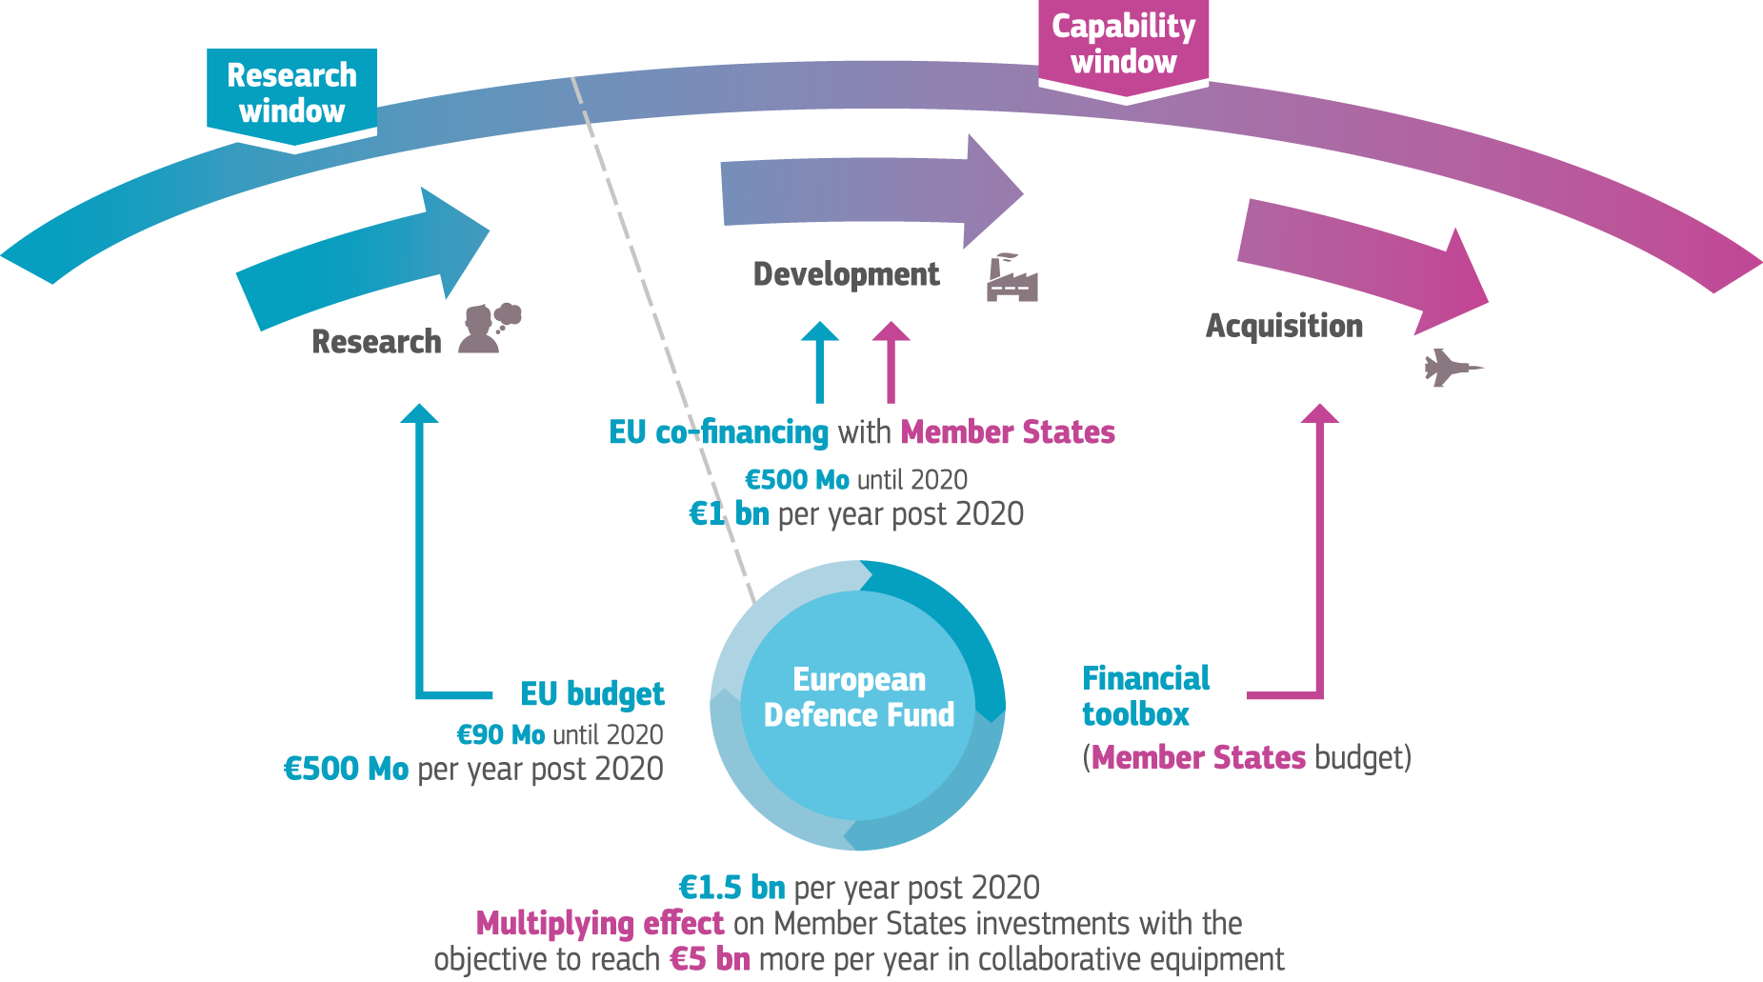

The research window is already beginning to finance collaborative research in innovative defence products and technologies at EU level. The first steps towards the future programme have already been taken with the launch of the Pilot Project and the launch of the Preparatory Action, with a total expected budget of EUR 90 million over three years[7]. The projects it finances, which may include projects developed in the framework of the Permanent Structured Cooperation (PESCO), take into account defence capability priorities agreed by the Member States within the EU. It will be fully funded by the EU budget through a dedicated EU programme under the next Multiannual Financial Framework (MFF). The estimated budget will be of around EUR 500 million per year. The proposal for this defence research programme will be made in the course of 2018 in order for it to be operational on 1 January 2021. The future defence research programme will benefit from a tailor made governance structure, reflecting the specificities of the defence sector. It will be designed in light of the experience gained through the Pilot Project, the Preparatory Action and the governance structures in Horizon 2020.

The capability window, which should aim to achieve a reference amount of EUR 5 billion per year in the medium-term, will support the joint development and the joint acquisition of key defence capabilities. These will respect the defence capability priorities agreed by Member States within the EU. While contributions for the capability window will mainly come from Member States, the EU budget will encourage defence cooperation by reducing the risk in earlier stages of the industrial development cycle. Such contributions, provided through the Defence Industrial Development Programme, will support the competitiveness of the European defence industry. They will leverage financing from Member States in support of the European defence industry launching and executing development projects in cooperation. The requirement of a joint financing commitment for the further development and procurement of the final product or technology by Member States will direct EU funding and investments towards viable projects in priority areas. A flexible Financial Toolbox will provide a range of options to address different needs of Member States in the launch of collaborative development programmes after the prototype phase as well as in view of joint acquisition.

**Figure 2: The governance of the European Defence Fund until 2020**

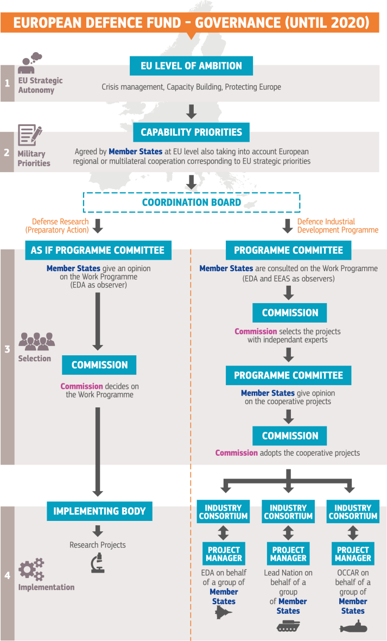

1. **Towards the Research Window of the Fund: Supporting research in defence products and technologies**

Defence research is essential to develop the future key capabilities, bridge technological gaps and thereby address emerging and future security threats facing Europe. It helps develop core technological know-how and skills.

The Commission will mobilise EU funds to leverage and complement national defence research programmes. The focus will be on collaborative defence research and technology development activities and stimulating cooperation amongst R&T actors across Europe, taking into account the defence capability priorities agreed by Member States within the EU. A two-step approach will be pursued: the initial Preparatory Action on Defence Research will lead to a more substantial EU defence research programme under the next MFF.

1. ***Preparatory Action on Defence Research***

The financing decision launching the Preparatory Action on Defence Research was adopted on 11 April.[8] Together with the Pilot Project, this is the first time that EU budget will support actions in defence R&T.

A budget of EUR 25 million has been agreed for 2017. The Commission has proposed a budget of EUR 40 million for 2018 and of EUR 25 million for 2019 (EUR 90 million overall). The Preparatory Action will target research areas[9] which are crucial to advance the development of key defence systems. Based on priorities set by the Member States, including through the EDA, these are a Defence Research Technology Demonstrator Project and a number of actions in the areas of Critical Defence Technologies, Future and Emerging Disruptive Technologies, Standardisation and Interoperability. Strategic Technology Foresight will also be funded.

The EDA is managing the implementation of the Preparatory Action's annual work programmes on behalf of the Commission, in accordance with the Delegation Agreement signed on 31 May. It has valuable expertise and experience with the organisation and management of research projects in the area of defence. In addition, the EDA has assisted Member States and the Commission in defining research topics and will support the exploitation of research results.

In the implementation of the Preparatory Action, the Commission will be assisted by a group of Member State experts and by an advisory group bringing together experts from industry, research and technology organisations, academia, the EDA and the EEAS.

Specific implementation modalities were developed in close consultation with Member States and defence industries to reflect the specificities of the defence research activities. EU support will mainly take the form of grants. The first calls for proposals are being published today. Proposals will be evaluated based on their excellence, their impact and their quality and efficiency of implementation. They will be reviewed in relation to ethical, legal, or societal aspects by a group of experts on defence ethical and legal issues.

The signature of first grant agreements is foreseen by the end of 2017. The Commission will review progress made in the implementation of the Preparatory Action on an annual basis.

**Achieved milestones:**

- Agreement with the European Parliament and the Council on the EUR 25 million for the Preparatory Action for 2017;

- Adoption of the Financing Decision launching the Preparatory Action;

- Agreement on the work programme and the conditions of participation (reflected in the calls for proposals and model grant agreements);

- Signature of the delegation agreement with the EDA;

- Publication of the first calls for proposals. The calls primarily focus on a technological demonstrator for unmanned systems in a naval environment and on force protection and soldier systems.

**Next steps:**

- Signature of first grant agreements – December 2017;

- Securing the budget for the years 2018 and 2019 to reach EUR 90 million overall in the period 2017-2019.

1. ***Towards a dedicated EU defence research programme***

While it is an essential first step, the Preparatory Action will remain limited in time and scope. Its purpose will be to demonstrate the added value of EU-funded defence R&T and to pave the way towards a dedicated EU defence research programme under the next MFF (post-2020). A broad consultation with all stakeholders, including the EU institutions, will accompany this transition. To support this dialogue, the Commission will also consult the expert group established in the context of the Preparatory Action on the key elements of the future defence research programme.

The future defence research programme will focus on targeted research activities supporting the development of defence-related products and innovative technologies. It should be capability-driven and focus on critical defence technologies as well as exploratory and disruptive research with the potential to strengthen the technological leadership of the European defence industry. Member States will identify, with the help of the EDA, the defence capability priorities and the R&T priorities. The Commission will take these into account in the future defence research programme. Projects will be selected with the assistance of experts against defined criteria such as excellence and impact, and typically require trans-national collaboration. The future programme should attract broad participation of different actors, including SMEs.

The precise relationship with the successor to Horizon 2020 will need to be determined. The financing of the defence research programme should be separate from and not affect the civilian research programme.

To meet the public expectations and reflect the high level of ambition, the future defence research programme needs an ambitious budget. In the European Defence Action Plan, the Commission indicated a reference amount of EUR 500 million per year. This would make the EU one of the biggest defence R&T investors in Europe and the first investor in collaborative defence research.

The experience with the management of the Pilot Project and the Preparatory Action will provide guidance on the future role for the EDA and the overall governance of the future programme in the context of the follow-up programme. While taking into account existing structures and expertise, various options will be considered for associating industry stakeholders in the preparation and implementation of the programme.

**Next steps**:

- Continued dialogue with Member States, the European Parliament, the Council, the EDA, the industry, R&T organisations and other interested parties in the preparation of the programme;

- Adoption of the proposal, accompanied by an impact assessment, in 2018 in view of the next MFF;

1. **Towards the Capability Window of the Fund: Promoting joint development and joint acquisition of key defence capabilities**

The economic case for joint development and procurement is strong but so are the challenges. Cooperative development and procurement programmes require common assessment of threats and needs as well as an effective partnership between participating Member States and industry. Joint investments, whether at the stage of development or procurement, also require a level of synchronisation of national defence planning and budget cycles. High upfront costs and long project timescales can discourage important investment decisions.

Some defence development projects crucial for providing key future capabilities have not proceeded despite the initial stages of R&T already been funded. It is therefore particularly important to bridge the gap between research and development, i.e. to ensure that the results of research are further developed into the capability needed. Indeed, this phase of the cycle entails important technical and financial risks that individual Member States may not be willing or able to take. The development and testing of prototypes in particular involves heavy upfront costs while the technological risks at that stage remain substantial. In collaborative programmes, these challenges are easier to overcome, often leading to the successful delivery of state of the art capabilities that are currently in use in the armed forces of Member States.

European collaboration in the field of missile technology is a prime example: investments like the Storm Shadow / SCALP cruise missiles or the Meteor and IRIS-T air-to-air missiles show that collaborative programmes can contribute significantly to achieving economies of scale, standardisation and interoperability.

The Meteor, which entered service with the Swedish Air Force in 2016, is considered as one of the most capable beyond visual range air-to-air missiles. It was developed to meet the needs of six Member States (the United Kingdom, Germany, Italy, France, Spain and Sweden) and will equip at least three European platforms.[10]

Projects like the Eurofighter Typhoon also show that European defence collaborative programmes can entail wider economic benefits. A study on the Typhoon programme[11] estimated that it supported some 100 000 jobs in the participating Member States, with a high proportion of highly-qualified workers. It generated important technology benefits and spin-offs, as well as skills that are highly transferrable to other sectors and even contributed to the introduction of modern business practices in the industry.

**The impact of the Capability Window on the competitiveness of the European defence industry:**

- Identification of strategic capability priorities notably through the Capability Development Plan combined with a multiannual funding scheme should encourage industry to invest in innovation.

- The capability window should facilitate political decisions to launch cooperative programmes, accelerate their execution and promote innovation in the European defence supply chains.

- The capability window should encourage the pooling of the demand that will ultimately lead to industrial joint undertakings and potential consolidation of the European industrial landscape.

- The capability window should encourage joint purchase that will enable the European defence industry to achieve economies of scale and therefore reinforce the global competitiveness of the European defence industry.

1. ***Promoting joint development through the European Defence Industrial Development Programme***

The capability window will be driven by Member States and their needs and resources. However, the EU can complement national financing and provide incentives to launch collaborative development projects. Today's proposal for a Regulation of the European Parliament and the Council to establish a European Defence Industrial Development Programme is an important step in that direction. The proposal foresees a budget of EUR 500 million for two years, with EUR 245 million for 2019 and 255 million for 2020.

The European Defence Industrial Development Programme will co-finance a part of the costs of development. An amount of EUR 500 million under the programme could therefore lead to a significant total investment of at least EUR 2.5 billion over the two years in the development phase of collaborative defence capabilities.

The European Defence Industrial Development Programme will support industry in the development phase for collective investments in cutting-edge products and technology. The Programme could also support the spin-in of commercial innovation into future defence projects, such as artificial intelligence, big data, cyber defence, robotics and super-computing.

The cooperative projects developed by the beneficiaries of the Programme will have to contribute to meeting the security and defence interests of the EU, notably in view of the capability priorities commonly agreed by Member States at EU level (through the Capability Development Plan), also taking into account European regional or multilateral cooperation corresponding to EU strategic priorities. Driven by the objective of increasing the competitiveness of our defence industries, they should help meet the level of ambition in security and defence as derived from the EU Global Strategy on Foreign and Security Policy in terms of crisis management and the protection of Europe.

The Programme will complement the research window by supporting actions which focus on post-research activities, based on common technical requirements. It will help the industry to launch collaborative development programmes or upgrading existing ones by actions supporting the definition of common technical requirements, feasibility studies and the development of prototypes and testing. It can also be used for EU-wide industrial and technological challenges and competitions to take advantage of the diversity of the European technological and industrial base. It should support innovative SMEs and facilitate their inclusion in European supply chains. It should reduce fragmentation, which can hinder economies of scale and cross-border use. Financial support may in particular take the form of grants or financial instruments. The Programme will only cover part of the development costs.

The Programme will initially cover the years 2019-2020. Only projects involving at least three companies from at least two Member States will be eligible. The collaborative projects can be managed by a project manager selected by the Member States co-financing the project. The Programme will cover different types of projects. It should benefit both large-scale companies and SMEs in the defence sector, ensuring inclusiveness in terms of undertakings and Member States. It will thus enhance cross-border cooperation among industry and contribute to the competitiveness of the whole defence industrial sector. For that reason, a proportion of the overall budget will benefit projects enabling the cross-border participation of SMEs.

A more substantial programme will be prepared under the next MFF taking into account the initial experience. The future programme may allow for a broader range of projects to be covered than under the current programme, given its limited scope and duration.

As regards governance, the Commission will be responsible for the overall execution of the programme. It may however entrust certain tasks to an implementing body. The EDA will have a key role to play in the identification of the capability priorities, as well as in harmonisation of technical requirements. It will participate as observer in the Programme Committee composed of Member State representatives as well as in an advisory group composed of representatives of industry and other experts in the defence sector. Furthermore, the EEAS will be involved in the programme including in the work of the Programme Committee in accordance with applicable rules. Committee The Programme Committee will provide an opinion on the annual work programme and the award of funding for selected cooperative actions to the Commission.

The programme ensures synergies with the capability pillar of the Permanent Structured Cooperation (PESCO). PESCO is one of the key instruments in the Treaty to help fulfilling the EU’s level of ambition in security and defence, enhance the EU’s operational ability and support greater cooperation and efficiency in defence capabilities development. Projects developed in the context of PESCO would ensure enhanced cooperation between undertakings in the different Member States on a continuous basis and directly contribute to the aims of the programme, which thus envisages an increased funding rate for such projects.

However, as the Programme targets a broader range of projects, a participation in PESCO will not be a pre-requisite for obtaining support under the programme. Other projects contributing to the development of commonly agreed capability priorities, including projects conducted under the EDA framework or based on regional cooperation in line with EU security and defence interests can also be considered for support.

**Next steps:**

- Discussions with Member States to start the preparation of pipelines of possible projects which could benefit from support under the European Defence Industrial Development Programme;

- A swift examination and adoption by the co-legislators. To achieve this, strong support of the European Parliament and the Council will be required. The Commission will therefore propose European Defence Industrial Development Programme among the legislative priorities to be given priority treatment by the three institutions. An agreement with the European Parliament and the Council by early 2018 would allow first project to be financed in 2019;

- Preparation of a more ambitious Defence Industrial Development Programme in the next Multiannual Financial Framework, accompanied by an impact assessment, with a reference amount of EUR 1 billion each year with the aim to enable a significant total yearly investment in collaborative defence capabilities in Europe.

1. ***Looking forward: paving the way for joint acquisition of capabilities***

The development and acquisition of defence capabilities are inherently linked, especially when it comes to financing. In order to benefit from support under the European Defence Industrial Development Programme, industry will have to demonstrate that Member States have committed to jointly finance the further development of the eligible action and procure the final product or technology in a coordinated way, including through joint procurement where applicable. Such commitment would ensure that a contribution from the EU budget is only provided to projects where on one hand, there is reasonable expectation that the development results in procurement and on the other hand, where this is done in a cooperative manner to optimise the investments and ensure synergies.

Procurement essentially remains in the hands of Member States. It is therefore necessary to explore further incentives to trigger more collaborative acquisition of defence equipment, with its advantages in terms of interoperability, economies of scale, supporting a viable European industrial base, lifecycle savings in terms of maintenance, logistic support, and training facilities and command structure. Such incentives could also facilitate multinational equipment and joint ownership solutions, which may be particularly suited for capabilities which are not in permanent use (e.g. strategic lift assets).

***Financial Toolbox***

While the role of the EU budget is necessarily limited as regards the acquisition of defence capabilities, the Commission can support Member States in many respects, notably by helping them deploy the most suitable and cost-saving financial arrangements for the joint acquisition of defence capabilities. At the moment, collaborative procurement projects are mostly negotiated and implemented on an ad-hoc basis by the Member States involved. Knowledge and best practice on possible financial arrangements are not being systematically recorded, standardised and shared to the benefit of all Member States. In addition, while Member States have a great deal of national knowledge and expertise on how to conduct national defence procurement, they experience a gap in terms of expertise and tools in the case of collaborative projects. Information and tools for optimal financial arrangements are not available in a single 'hub'. Each collaborative development and procurement project has its unique requirements and characteristics, and it would therefore not be appropriate to apply a one-size-fits-all approach. However, a number of challenges encountered by collaborative projects are recurrent and there would thus be merit for having a ready-made set of tools, as well as the expertise to advise on their use in the specific project context, available on demand. The Commission, in collaboration with Member States, has identified some of the most frequent challenges and possible ways to address them.

* A first challenge is lifting synergies and synchronising budget spending: collaboration among Member States can lead to synergies and economies of scale, but lifting such synergies is often hampered by the lack of synchronisation in the planning of budget contributions, which in turn can lead to delays in the availability of fiscal resources for collaborative projects. A possible way to address this challenge is the pooling of national resources for funding specific collaborative projects[12], which would allow for the necessary degree of budget coordination and synchronisation over long periods of time, and avoid the unavailability of funds in a given year.
* A second challenge consists in fair risk and cost sharing: the cost of development of capabilities may initially be 'restricted' to the (potentially small) number of participating Member States, despite the fact that it could subsequently create a benefit to others (e.g. 'off-the-shelf' procurement). It is possible to develop mechanisms whereby these Member States are 'compensated' via a development cost recovery mechanism, by other Member States taking part in the procurement of a capability. This includes the possibility of setting up project-related financial vehicles. If warranted, these vehicles could also be used for a project-related issuance of capital instruments (debt or equity) with a view to enable a more flexible structure and ensure full availability of the resources when they are needed.
* A third challenge is avoiding financing constraints in the supply chain: development of capabilities is carried out by different parts of the defence supply chain – big system providers acting as prime contractors but also SMEs and intermediate companies as sub-contractors. The latter may have difficulties accessing the necessary financing. In order to overcome these difficulties, well-targeted financial instruments, such as guarantees, could be used to cover loans to defence (sub)-contractors.
* Finally, further optimisation and added value of cooperation among Member States can be achieved by exploring alternative forms of ultimate ownership structures of the capabilities (e.g. joint ownership or leasing structures).

Together, the abovementioned instruments will form part of the European Defence Fund's Financial Toolbox. The Financial Toolbox will provide the different types of arrangements that Member States can use to address challenges for collaborative development and procurement from a financing perspective. The Financial Toolbox, the use of which is voluntary for Member States, will in particular provide a set of standardised and predefined financial tools that can be used flexibly by Member States in order to finance jointly the projects benefitting from the support of the EU budget in the prototype phase but not limited to them.

In the short term, an ad-hoc Committee will be established with Member States to develop ready-to-use, standardised instruments that will allow the Financial Toolbox instruments to be deployed in a rapid manner where Member States decide to use them. This might inter alia include elements such as standardised templates, draft term sheets, standard tools to set-up project-related financing vehicles (SPVs) or templates for necessary framework agreements. This ad-hoc committee will comprise representatives from both Defence and Finance/Economy Ministries, representatives from the EEAS, the EDA[13] and other relevant stakeholders. Existing structures, mechanisms, and experience gained by Member States from collaborative financing of defence projects will be used to the greatest possible extent to ensure best practices and avoid duplications. The Commission will support this work, draw on its expertise in using similar tools in other policy areas and help adapt those tools to the defence context.

The Commission will furthermore set up an internal Task Force to assist Member States, on demand, with the application of the Financial Toolbox in the case of specific collaborative procurement projects. For example, it will advise on the merit of using different forms of funding instruments for project-related financial vehicles, including up-front equity payments and bridge financing via the issuance of capital market instruments. In addition, the Task Force will be available as a single contact point with the ability to draw on Commission expertise in other areas of relevance to collaborative procurement projects, like for example compliance with EU competition and the defence procurement law or the statistical treatment in fiscal accounts. As such, the internal Task Force would offer a one-stop-shop in the areas of the Commission's expertise, providing advisory, administrative and, if warranted, also financial services on demand to those Member States that wish to undertake collaborative procurement projects.[14] In this way, the Commission can act as a trustworthy partner for Member States in establishing joint procurement in defence capabilities.

Looking further ahead, the benefits in establishing a permanent financial structure beyond the specific project context will also be explored. Depending on its design and financial profile, such a permanent structure could provide additional financial incentives for collaborative capability development and procurement among Member States, including its treatment in the overall fiscal framework[15]. Subject to the final shape of the possible future Permanent Structured Cooperation, and considering its inclusive character, the possibility to bring together key aspects of the Financial Toolbox with the PESCO framework will also be considered.

**Next steps:**

- Creation of an ad-hoc Committee with Member States and relevant stakeholders with the objective of developing a standardised initial set of instruments that could form part of the Financial Toolbox;

- Creation of an internal Commission Task Force to act as a one-stop-shop providing support to Member States on specific collaborative procurement projects, including the deployment of the Financial Toolbox and other advisory, financial and administrative services;

- Further examination of the possible establishment of a permanent financial structure beyond the project context to provide additional financial incentives for collaborative capability development.

1. **Supporting integrated European supply chains and competitive SMEs**

While capability development is normally fully financed with public means, the industry often carries an important part of the risk. This is a particular challenge for smaller suppliers that often have to adapt and regularly modernise their production capacity depending on the varying interest, while keeping at the edge of the innovation curve. These players are a crucial part of the defence supply chain and the challenges they face may affect the success of the development programmes. Also, such challenges may arise during the development stage but also during subsequent procurement.

The development of capabilities is carried out not only by big system providers acting as prime contractors but also by SMEs and mid-cap companies that often act as sub-contractors. Hence, there will often be a whole chain of interlinked contributing enterprises which are involved in the process. If one element in the chain faces individual funding constraints for making the necessary corporate investments or for obtaining sufficient working capital, then this might drive up the overall costs of development and/or the marginal cost of production. It might also cause delays in capability development or procurement.

At the same time, given the new technological challenges in the sector (from artificial intelligence to robotization), innovation in defence technologies often comes up from start-ups whose focus might not be primarily defence in some cases. Appropriate financial instruments, like venture capital or equity might help develop competitive European technologies critical for Europe’s security and strategic autonomy.

In order to tap into the potential of SMEs and smaller sub-contractors, all instruments of the European Defence Fund will be mobilised both in the research and capability window. Both the Preparatory Action and the future EU defence research programme will attract a broad participation of actors, including SMEs. The European Defence Industrial Development Programme will ensure that a proportion of the overall budget will benefit projects enabling the cross-border participation of SMEs. In that way, the Programme will support the inclusion of SMEs into European supply chains.

Although much work has been undertaken to support the cross-border market access of SMEs and sub-suppliers as well as to facilitate their integration in existing or newly established supply chains, more needs to done both at European and at national level. What is required is a range of measures to support cross border market access, including measures to:

* Reduce the fragmentation and improve the functioning of the Single Market in defence;
* Support under the European Structural and Investment Funds or centrally managed EU programmes;
* Further facilitate access to finance from the European Investment Bank, European Investment Fund and other players, including national promotional banks, that follow its lending policy with a particular focus on innovation through instruments like equity and venture capital; and to
* Support the development of regional clusters through the European Network of Defence-related Regions[16].

***Financial instruments to support SMEs and mid-caps***

The Defence Industrial Development Programme proposed by the Commission foresees the possibility of financial instruments to support SMEs and mid-caps in closing the gap between research and development. These financial instruments could be implemented with the EIB group (including the EIF for innovative SMEs and start-ups) or other relevant partners.

In order to help exploit new opportunities for different parts of the supply chain and in line with its internal limitations, the EIB group is already supporting investments in the area of security and defence, notably in three areas: i) RDI for dual-use technologies, including cybersecurity and vaccines, as far as these investments can be motivated by their commercialisation in civilian applications; ii) protection of physical infrastructures, such as surveillance, and admission control in the energy, transport and urban sectors; and iii) telecommunications and information infrastructure, including (fixed, mobile and satellite) broadband networks, data centres and computer systems. The European Investment Fund has recently developed agreements in the field of Venture Capital to support start-ups in security and defence fields. The EIB will further step up its contribution to the EU security and defence agenda. This includes, as a first step, increased support for dual-use technologies, increased financing of civil protection measures, such as strengthening physical, cyber and biodefence infrastructure, as well as the extension of support to investments which are ancillary to security and defence activities. In a second step, the Bank will in view of the necessary changes to its overarching policies develop a robust due diligence system to support investments in the security sector within the Union.

Where the access to finance might still be limited for certain defence-related activities in light of lending restrictions, the role National or Regional Promotional Banks could play to deploy relevant financial instruments and in that way improve the access of SMEs in the supply chains to obtain necessary funding will be explored further. A number of these Promotional Banks already can and do actively support projects in the national defence context. Examples of supported projects range from Public-Private-Partnership structures for military services to military capabilities such as armoured vehicles. The Commission will look into the best ways to deploy relevant financial instruments in the next MFF.

***Use of structural funds and smart specialisation***

The Union funding programmes, notably the European Structural and Investment Funds, can also play an important role in promoting integrated supply chains. As set out in the European Defence Action Plan, the Commission is working to promote funding opportunities offered by Structural Funds that may be used by Member States in the defence sector as long as they contribute to the objectives of the fund in question to:

(i) Co-fund productive investment projects, and

(ii) Support the modernisation of the defence supply chains.

Defence industries can contribute to the goals and objectives set in the European Structural and Investment Funds, such as promoting the development of regional economies, representing a high investment multiplier on skills, jobs, technological and economic development.

The European Regional and Development Fund (ERDF) may support investments for SMEs active in or related to the defence sector as long as they pursue the prevailing objective of strengthening the Union's economic, social and territorial cohesion, comply with the scope of support from the ERDF and contribute to the existing thematic objectives[17].

For example, investments into defence-related research and innovation activities for the development and uptake of new technologies are eligible for financing from the ERDF, particularly where they are linked to the implementation of smart specialization, if the prevailing objective of the investment is to contribute to the Union's economic, social and territorial cohesion.

***Further actions to support SMEs in the defence sector***

The Commission will be following up on the report from the Expert Group on Cross-Border Access for SMEs to defence and security contracts published on 30 November 2016. The Commission will be adopting recommendations, addressed to Member States and their contracting authorities, to support SMEs and sub-suppliers in a range of areas including:

* Concrete actions on how the procurement authorities could facilitate cross-border and SMEs' and mid-caps' participation in defence procurement procedures. Such measures could include providing early information about long-term plans and priorities, using pre-procurement advertising, designing public procurement procedures to facilitate cross-border and SMEs participation, training for suppliers and providers, etc.
* Industrial policy measures such as developing funding schemes taking into account the needs of defence SMEs, providing information on SMEs and their capacities, supporting development of defence clusters, building skills, supporting and carrying out R&T projects with support for SMEs involvement.

These recommendations are expected to be adopted by the end of 2017 and discussions with Member States have already begun. The recommendations will be followed-up with engagement with industry to develop the set of good practices across the supply chains to follow in order to have competitive businesses and the best possible products, while providing opportunities to sub-suppliers across Europe regardless of their location. The Commission count on active engagement of industry, and especially of prime contractors, in this process.

**Next steps:**

- Proportion of budget of the European Defence Industrial Development Programme earmarked for projects enabling the cross-border participation of SMEs;

- Consider the cross-border participation of SMEs and dedicated financial instruments in the context of preparing the proposals under the next MFF;

- The EIB group will step-up in the short-term its support for dual-use technologies, increased financing of civil protection measures, as well as the extension of support to investments which are ancillary to security and defence activities. In a second step, the Bank will in view of the necessary changes to its overarching policies develop a robust due diligence system to support investments in the security sector within the Union.

- Where the access to finance might still be limited for certain defence-related activities in light of lending restrictions, the role National or Regional Promotional Banks to deploy relevant financial instruments and in that way improve the access of SMEs in the supply chains will be explored in the context of the next MFF.

- Raise awareness of existing opportunities provided by EU funding programmes as well as National or Regional Promotional Banks;

- Develop with the industry a set of good practices across the supply chains.

**Conclusion**

The European Defence Fund is already starting to deliver.

The Preparatory Action on defence research is up and running, providing an estimated EUR 90 million over three years under the research window. Today's proposal for a European Defence Industrial Development Programme will add EUR 500 million until 2020 under the capability window, with the potential of generating overall investments of at least EUR 2.5 billion as of 2019.

In addition, the Commission is launching a number of financial tools that should quickly lead to collaborative projects between the Member States. The Commission stands ready to support Member States on specific collaborative procurement projects.

The Commission is playing its part. The European Parliament and Council should now adopt the proposal as a matter of priority. Member States should use 2018 to identify and prepare the pipeline of projects to be funded as a matter of urgency.

These proposals and actions are part of a step change towards closer defence cooperation in Europe that will be consolidated in the upcoming MFF post-2020 where the European Defence Fund will represent half of the collaborative defence projects in Europe.

In making these proposals, the Commission is contributing to the creation of a European Union that protects and that defends. An ambitious European Defence Fund will support the competitiveness of the European defence industry. It will be the engine powering the development of a European Security and Defence Union.

**ANNEX**

***Supporting defence cooperation through the Financial Toolbox***

The Commission will play an active role with respect to the Financial Toolbox. It will establish an ad hoc committee comprising Member States and relevant stakeholders with the aim of standardising the Financial Toolbox instruments, to the extent possible, to allow for their rapid deployment in each specific project context. Moreover, the Commission will set up a Task Force that will support Member States, upon demand, with the application of the Financial Toolbox in the case of specific collaborative procurement projects. The Commission will thus provide a concrete contribution in supporting Member States in carrying out collaborative procurement projects.

**Standardisation of the Financial Toolbox:**

The work to be carried out to standardise instruments in the Financial Toolbox would take into account existing practices, concepts and examples from national, multinational and international contexts. In order to avoid duplication, existing structures and mechanisms should be linked to the Financial Toolbox in the best possible way, while at the same time remaining open to different options for the framework that is used.

*Pooling of budget resources*

At its simplest, pooling would require Member States that decide to cooperate on a defence project to contribute an amount of funds to a national compartment (e.g. bank account) of the designated pooling mechanism. These funds could then be used for collectively funding specific collaborative projects with other Member State(s). There are already some examples of pooling in place or under development in the area of defence that provide an idea of the potential possibilities. Notably, the Organisation Conjointe de Coopération en matière d'Armement's (OCCAR), has in place a simple pooling mechanism, whereas the European Defence Agency (EDA) is currently in the process of establishing a Cooperative Financial Mechanism[18] (CFM), a form of pooling mechanism that inter alia would also allow for the possibility for the exchange of 'reimbursable advances' among Member States. The Commission will do further work, in particular to explore and assess to what extent the existing mechanisms will be combined with more sophisticated Financial Toolbox instruments.

*Cost recovery mechanism via a financial vehicle (SPV)*

The cost recovery would produce a form of 'quasi-revenues' that would flow back to the initial investees (i.e. Member States that invested in the development of a capability). If these are pooled in a special-purpose vehicle (SPV), the cash flow structure would be akin to the one of a project financing context. Two different funding structures could be considered for such an SPV: i) equity financing, whereby each Member State participating in the development to make an equal lump sum payment to the SPV to cover the cost of development, which would correspond to an equity participation in the SPV; or ii) bridge financing, whereby Member States participating in the development could also decide to finance part of the development cost by issuing capital market instruments (e.g. project bond), thereby reducing their upfront equity participation in the SPV. The Commission will do further work on the different institutional, financial and legal aspects required to implement such structures, including the set-up of project-related financing vehicles. The objective would be to facilitate their usage through standardisation and the exchange of experience and best practices.

*Guarantee on project-related funding of suppliers*

Guarantees could be used to cover loans to defence (sub)-contractors. One way to provide guarantees would be for Member States that will participate in the procurement to form a financing vehicle (e.g. SPV) and pool contributions, creating a guarantee fund. An alternative to pre-funding the guarantee fund would require Member States that will participate to provide over-guarantees to ensure a sufficient credit-enhancement. The Commission will do further work, in particular to explore options with regard to a more institutional cooperation with public financial institutions, such as promotional banks, concerning the implementation of financial instruments such as guarantees.

*Other possible tools*

Examples of joint ownership in the defence sector already exist, namely in the NATO context (e.g. Multinational Multi Role Tanker Transport Fleet and Strategic Airlift Capability). The experiences gathered to date could form a useful basis for the further development of the tools, to be included in the Financial Toolbox, which could support Member States in pursuing joint ownership. In addition, leasing arrangements could also be a potentially useful addition to the Financial Toolbox. One form of leasing could notably include leasing by Member State(s) from private sector and/or an enterprise collectively owned. Leasing from another Member State / third country could also be envisaged, in particular in cases where these countries are either specialised in a certain defence capability and / or have spare capacity. Another possibility could be for the EU (e.g. Commission or an Agency) to lease (where possible by the Treaty) capabilities (e.g. dual-use goods) from the private sector.

**Project-specific support in implementation of the Financial Toolbox:**

The Commission will set up an internal Task Force that will stand ready to assist Member States with the application of the Financial Toolbox. The Task Force will be able to provide concrete assistance and project-specific input. Examples of the types of support that the internal Task Force can be envisaged to provide are summarised below.

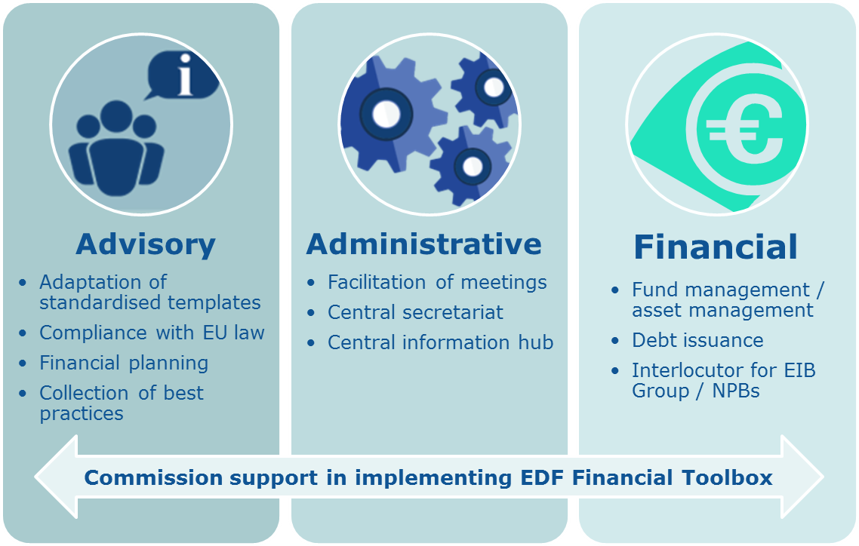

1. COM(2016)950.
2. See paragraph 12 of the European Council Conclusions of 15 December 2016.
3. See the reflection paper on the future of European defence, COM(2017)315.
4. European Council Conclusions of 15 December 2016 and Council Conclusions of 14 November 2016 on implementing the EUGS in the security and defence area.
5. See European Council Conclusions of 20 December 2013.
6. The current share of European defence equipment procurement devoted to collaborative projects is around 22.1%. 90% of these collaborative projects are European, amounting to an investment of EUR 5.1 billion.
7. C(2017)2262.
8. C(2017)2262.
9. These actions will be identified in the technology clusters of Autonomous platforms, C4ISR (Command, Control, Communications, Computers, Intelligence, Surveillance and Reconnaissance), Effects, Force Protection and Soldier Systems.
10. Eurofighter Typhoon, Dassault Rafale and Saab Gripen. Its integration is also foreseen on the Lockheed F-35 Lightning II.
11. Hartley, The industrial and economic benefits of Eurofighter Typhoon, University of York, York, 2008.
12. One example of a pooling mechanism is the EDA's Cooperative Financial Mechanism, the establishment of which establishment was approved by the EDA's Ministerial Steering Board on 18 May 2017. Negotiations with Member States on a Programme Arrangement will start soon.
13. Full use will in particular be made of the EDA's expertise from setting up the Cooperative Financial Mechanism.
14. It should be noted that the provision of certain services by the Commission, e.g. financial services, would require a mandate in line with the relevant case law of the European Court of Justice.
15. As mentioned in the Europea Defence Action Plan: "National capital contributions to the "capability window" will be treated as "one-offs" under the Stability and Growth Pact, which means that they will be discounted from the structural fiscal effort expected to be accomplished by Member States. The same treatment will apply to guarantees to the extent that they have an impact on deficit and/or debt."
16. <https://www.endr.eu/>
17. As defined in Regulation (EC) No 1301/2013.
18. On 18 May 2017, the EDA Steering Board adopted the Cooperative Financial Mechanism as an EDA Ad-Hoc CAT A programme. Negotiations with Member States on a Programme Arrangement will start soon and are expected to be concluded in the coming months.