

**I. Introduction**

As envisaged by the Treaty of Lisbon[1], the European Union established the EU Aid Volunteers (EUAV) initiative in 2014[2]. It aims to strengthen the EU’s ability to provide needs-based humanitarian aid and to strengthen the capacity and resilience of vulnerable or disaster-affected communities in non-EU countries. At the same time it allows European citizens to show solidarity with people in need by taking part in humanitarian action in these countries.

Article 27 of Regulation (EU) No 375/2014 requires the Commission to submit annual reports to the European Parliament and to the Council on the progress made in implementing the Regulation.

The initiative began operations in 2016 when the first volunteers were trained and deployed outside of the EU. This is the third annual report outlining the main activities and achievements in the implementation of the EUAV initiative[3].

The report is based on data that is collected and analysed in line with a framework for the monitoring of the implementation of actions under the initiative. The framework was established and agreed upon between the Commission and the Education, Audiovisual and Culture Agency (EACEA), which is responsible for managing most of the operations of the initiative.

**II. Objectives and priorities**

The activities were based on the 2016 annual work programme for implementing the EUAV initiative adopted by the Commission[4] in accordance with Article 21(3) of Regulation (EU) No 375/2014 and Article 84(2) of the Financial Regulation[5]. EUR 16 885 000was set aside in the budget to implement the initiative, which aimed to help:

* strengthen resilience and disaster risk managementin vulnerable, fragile or disaster-affected countries and forgotten crises;
* select, train and deploy volunteers;
* strengthen the capacitiesof organisations hosting volunteers in non-EU countries and provide technical assistance to organisations based in the EU Member States that send volunteers abroad;
* certify sending and hosting organisations;
* establish the EU Aid Volunteers platform and various communication activities;
* implement the training programme for candidate volunteers funded under the 2015 work programme.

**III. Actions implemented in 2016**

The actions presented in sections 1-5 below are delegated to and implemented by EACEA in cooperation with the Commission[6].

EACEA is responsible for the calls for proposals, calls for tender, contract management and implementing the corresponding budget appropriations in line with the annual work programmes adopted by the Commission. In terms of managing operations, the Commission remains directly responsible for establishing the partners and volunteers' network, the online platform and communications.

1. **Certification**

All organisations wishing to send or host volunteers under the EUAV initiative **must be certified**[7]**.** The certification of sending and hosting organisations began in 2015 and continued throughout 2016. It verifies that the high standards and efficient procedures of volunteer management that are established to protect and manage volunteers during their deployment under the EUAV initiative can be fully achieved by all participating organisations[8].

The objective of the call for applications, published in January 2015, was to compile a list of 100 certified sending and hosting organisations wishing to participate in the EUAV initiative. By the end of 2016, 82 organisations were certified - 23 sending organisations and 59 hosting organisations[9]. One application was rejected. The evaluation of a further nine applications submitted in 2016 will be finalised in 2017.

Applications for certification will continue to be accepted until 30 September, 2020. Therefore, the process is regularly monitored and improved based of the experience shared by stakeholders. As a follow up to dialogue with the participants in the EUAV initiative and their regular feedback, the process was simplified and the electronic forms for submitting applications were made more user-friendly, clear and available in three languages (English, French and Spanish).

1. **Technical assistance/Capacity building**

The EUAV initiative provides opportunities for capacity building for hosting organisations and technical assistance for sending organisations[10]. The objective is to strengthen the abilities of the organisations intending to participate in the initiative and to ensure they comply with the standards and procedures established for the EUAV initiative. A call for proposals (EACEA/27/2016) was published on 30 April 2016[11] providing a total budget of EUR 7 960 000 for the co-financing of projects for capacity building for hosting organisations and technical assistance for sending organisations in different areas such as:

* disaster risk management
* volunteer management
* ability to undergo certification
* tools and methods to assess needs
* building partnerships
* communication activities.

By 4 July 2016 (the deadline for applications), eight applications were submitted. Five projects (three for technical assistance and two for capacity building) with a total of 39 implementing partners were selected for co-funding with a total EU grant of EUR 2 845 689[12].

The technical assistance projects for EU-based organisations focus on strengthening and improving these organisations' procedures, volunteer management practices and ability to be certified. Partnership and alliance-building amongst organisations is a clear priority area, which organisations wish to develop.

Other areas which organisations intend to strengthen include the setting of standards governing the management of partnerships, needs assessments, programme management and the development of local volunteering. The projects that develop the skills and capabilities of organisations based in non-EU countries are also focused on building partnerships and forming alliances. By building close partnerships during the projects, partners may launch new joint projects under the EUAV initiative, particularly deployment activities. They will act as ambassadors within their respective networks and help to improve best practice according to EU standards.

*Case study: The project "More and Better EU Aid Volunteers" is headed by GVC (Italy) and is implemented by eight partner organisations from eight different countries: Spain, Portugal, Estonia, Cyprus, Latvia, Lithuania, Slovenia, Hungary and one associate from Italy.* *The project aims to strengthen capabilities of present and future sending organisations to undertake Humanitarian Aid activities, participate in the EU Aid Volunteers initiative, and understand and apply the standards and procedures required to become a sending organisation.*

*Case study: The EU Aid Volunteers Capacity Building project called "Reinforcement and Sustainability in Humanitarian Volunteering Management" (HVM) aims at strengthening partners from the Balkans, Caucasus and the Maghreb in different fields linked to humanitarian volunteering management.*

Together with 10 projects selected for funding in 2015 involving 88 partners, there are now in total 15 projects in total operating in 2016. 44 organisations (under technical assistance projects) and 85 organisations (under capacity building projects) are involved in these projects to strengthen their management and operational systems, and to work in partnership to implement best practices in humanitarian aid delivery and volunteer management.

From spring 2017, the first projects that started activities in 2015 will complete their activities. Projects are running according to their general overall work programmes with no significant delays reported.

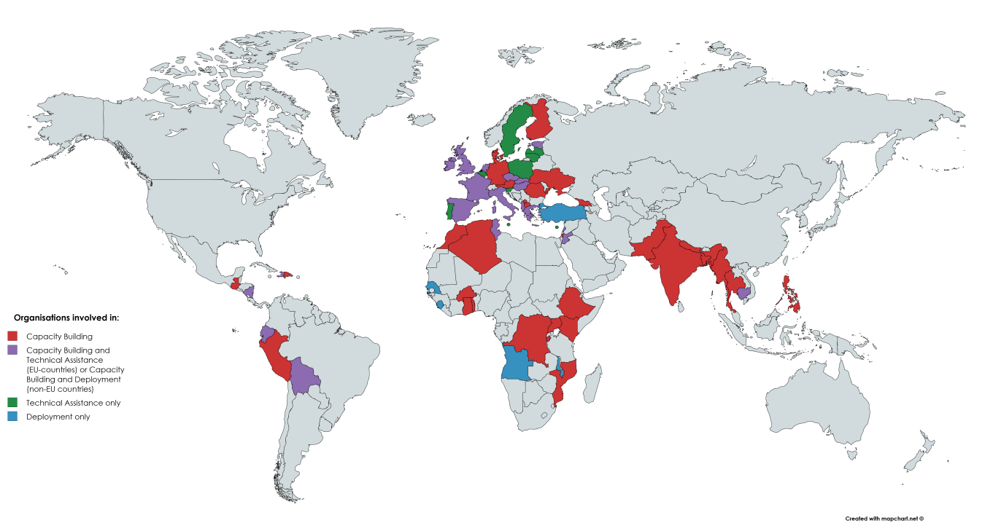

|  |  |
| --- | --- |
| Organisations involved in: | |
|  | Capacity Building |
|  | Capacity Building and Technical Assistance (EU countries) or Capacity Building and Deployment (non-EU countries) |
|  |
|  | Technical Assistance only |
|  | Deployment only |

1. **Deployment**

Deploying volunteers is one of the main activities under the EUAV initiative. The objective is to select, prepare and deploy junior and senior volunteers to contribute to strengthening the EU's capacity to provide needs-based humanitarian aid and to strengthen the ability and resilience of vulnerable and disaster-affected communities in non-EU countries.

Two deployment projects selected for funding under the 2015 call for proposals were operating in 2016. They were run by groups of sending and hosting organisations[13].Under these projects 44 volunteers were selected and trained, with the first deployments starting in December, 2016. EU aid volunteers are participating in projects in 13 countries outside of the EU: Angola, Bolivia, Cambodia, Ecuador, Haiti, Jordan, Lebanon, Malawi, Nicaragua, Senegal, Sierra Leone, Tunisia, and Turkey. These volunteers have different profiles and are working in various areas. For example, they support their hosting organisation in project management, food security and nutrition, communication, logistics, urban resilience, gender issues, and disaster risk management.

A call for proposals (EACEA/14/2016) was published on 17 March 2016[14], with a total budget of EUR 8 400 000 to co-finance projects that deploy EU aid volunteers, including apprenticeship placements for junior professionals and capacity building and/or technical assistance for organisations implementing the initiative. The call for proposals had two rounds with two deadlines (17 May and 1 September, 2016). Four projects involving 71 partners were selected for co-funding with a total EU grant of EUR 4 920 356[15]. Under these projects 162 volunteers will be deployed to non-EU countries in 2017 and 2018.

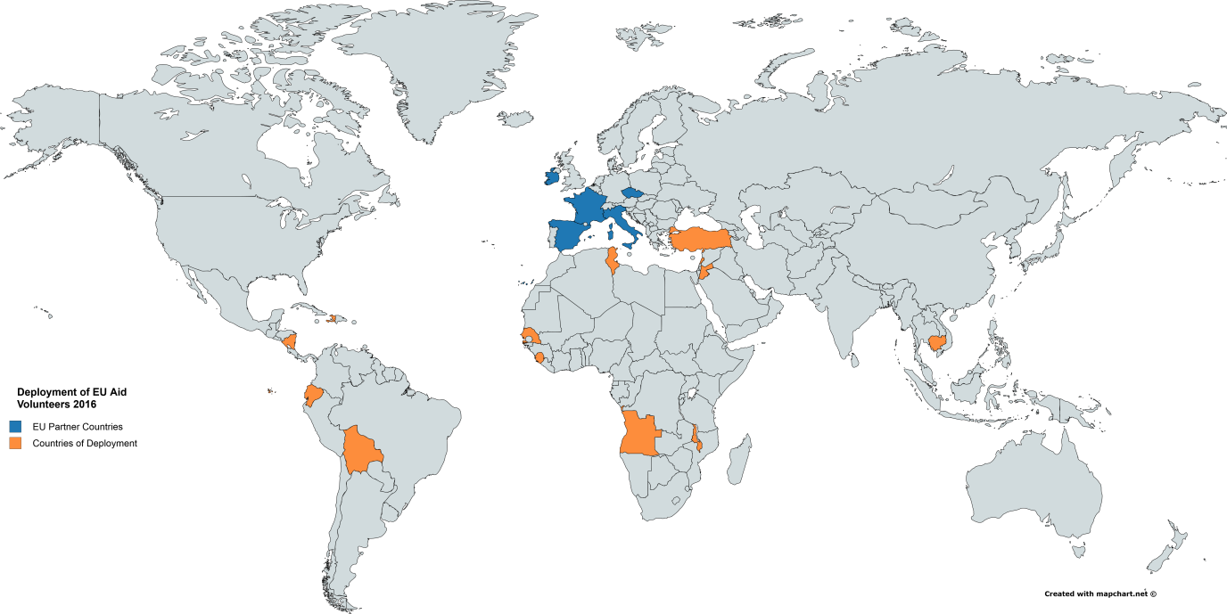

|  |  |
| --- | --- |
| Deployment of EU Aid Volunteers 2016 | |
|  | EU Partner countries |
|  | Countries of Deployment |

1. **External evaluators**

The 2016 annual work programme provides funding to support the management of calls for proposals for certification, deployment, technical assistance and capacity building. All eligible applications received are subject to independent external evaluation which helps with the decisions on whether to award or reject certification or to select projects for funding.

Each year a pool of experts with at least 35 % of it consisting of new evaluators is set up. Each evaluator is selected following an evaluation of their curriculum vitae which takes into consideration:

* the level and field of their studies
* professional experience in the humanitarian aid field
* prior work as evaluator
* languages spoken.

All experts in the pool are briefed on the programme, the evaluation process and the evaluation tools, and are guided through the process by an Expert Handbook. 68 applications for certification, deployment, capacity building, and technical assistance projects have been evaluated by 18 experts.

EACEA has an open call for expression of interest in order to establish a database of evaluators with a high level of expertise EACEA programmes. Such a database would help to speed up the creation of the annual expert pool.

1. **Training Programme**

In May 2016, a contract to provide training for EU aid volunteer candidates was signed with a consortium comprising ICF Consulting Services Ltd (ICF), MDF Training and Consultancy BV (MDF), with Punto.sud, Gesellschaft fur Organisation, Planung und Ausbildung mbH Consulting (GOPA), with B&S Europe, the Austrian Study Centre for Peace and Conflict Resolution (ASPR) and the Scuola Superiore Sant’Anna (SSSUP). 97 candidate volunteers were trained in four groups in October and November/December 2016, in Pisa. The number of candidate volunteers trained was higher than the planned number of volunteers to be deployed in order to deal with possible dropouts and candidate volunteers who were deemed unfit for deployment following the training assessment, and to ensure the successful and timely roll-out of deployment projects*.*

The EU Aid Volunteers training programme is based on a competence framework laid down in Delegated Regulation 1398/2014. It is being delivered through a combined learning approach based on:

* 20 hours of online learning as part of an introductory learning period;
* 9 to 12 days of face-to-face classroom modules comprised of mandatory and optional training modules;
* a scenario–based exercise in the field[16].

The training included mandatory modules 1-7 as well as optional modules 8, 9 and 12. Feedback from the volunteers trained was very positive with an evaluation score of 8.5 out of 10. Detailed feedback provided by volunteers and trainers on each training module will allow for the further refining of some of the modules, in order to continuously improve this important part of the EUAV initiative.

1. **Support Measures**

The amount committed in 2016 for support measures aimed at information and awareness raising among potential beneficiaries and the development of the EU Aid Volunteers platform was EUR 417 015*.*

Through these actions relevant participants were informed about opportunities to become involved in the initiative, and the initiative's platform and database, online volunteering scheme and partner/volunteer network for the EU Aid Volunteers initiative were further developed.

The Commission has continued to gather stakeholder input on the initiative: for example it held a round-table discussion on the application process in January 2016. The organisations involved provided feedback on the challenges they met when applying for certification or submitting proposals for deployment, capacity building and technical assistance. Suggestions were made on possible solutions and improvements for smooth and effective participation.

Furthermore, the Commission organised information events for organisations about the funding opportunities available under the EUAV initiative. Two 'Info Days' on the deployment call for proposals and the certification for sending and hosting organisations and on capacity building and technical assistance took place on 5 April and 1 June 2016 at DG ECHO's premises. Both events were web-streamed allowing those organisations not present to follow the presentations remotely and ask questions.

On 5 December 2016, the International Volunteer Day, the Commission organised an information session providing updates on the latest developments concerning the EU aid volunteers and encouraging organisations to get involved. Aside from gathering information organisations had the opportunity to network and to facilitate future partnerships.

The initiative's spread and outreach were broadened through its participation in various major events, such as the World Humanitarian Summit (Istanbul, May 2016), the European Youth Event at the European Parliament (Strasbourg, May 2016), the European Development Days (Brussels, June 2016), and the AidEx Conference and Exhibition (Brussels, November 2016). The Commission paid numerous visits to Member States, attended conferences and held bilateral meetings with organisations to inform and encourage potential partners to participate in the EUAV initiative.

Information products encouraging potential organisations and volunteers to become involved have been produced, and certain events, such as the training of candidate EU aid volunteers in Pisa, Italy, in November 2016, provided opportunities to gather volunteer testimonies and other communication materials.

The key tool enabling the work of the partners and volunteers network[17] is the EU Aid Volunteers platform[18]. It was developed by the Commission and was launched in the summer of 2016. Different features and tools have being gradually introduced, e.g. space for discussions, individual projects, vacancies, volunteer profiles, space for individual projects to interact, etc. The platform serves primarily as a working environment for selected projects, certified organisations and volunteers. However it also provides ample networking opportunities to the participants and those interested in taking part in the future. The up-coming features will include automatic notifications and satisfaction surveys.

**IV. Conclusions and way forward**

The implementation of the EU Aid Volunteers initiative in 2016 was marked by:

* the start of the first ten projects on capacity building and technical assistance and the first two projects that led to the first EU aid volunteers being deployed;
* the first vacancies for volunteers being published;
* the first training of volunteers and the training programme being implemented;
* the on-going certification process resulting in 82 sending and hosting organisations becoming certified;
* the launch of the EU Aid Volunteers platform.

Despite the slower than expected uptake of programme opportunities, organisations are becoming increasingly familiar and confident with the initiative and its uptake is improving with many organisations already implementing projects and planning further future activities.

In 2017 the initiative will continue to provide opportunities for more hosting and sending organisations to benefit from capacity building and technical assistance projects and more volunteers to be deployed in non-EU countries. Certifying sending and hosting organisations will continue on a rolling basis and the EU Aid Volunteers platform will be maintained and developed further. Moreover, the first online volunteering opportunities are expected to be published in summer 2017.

The EUAV initiative will be further promoted through communication campaigns. An active outreach campaign will aim to improve on the rate of participating organisations from 2016, and increase the number of projects funded. Networking will contribute to partnership building and increase the number of organisations involved in the initiative. An EU Aid Volunteers network workshop took place in February 2017, whereby EUAV participants had the opportunity to meet organisations, to interact, share experience, and build new partnerships.

An interim evaluation of the initiative by independent evaluators is currently underway as required by Regulation 375/2014.

In line with the work programme for 2017[19], one of the main objectives will be to contribute to strengthening resilience and disaster risk management in vulnerable, fragile or disaster affected countries and forgotten crises, including actions in the following stages of the disaster management cycle:

* disaster prevention
* preparedness
* disaster risk reduction
* recovery from natural and man-made disasters
* early warning.

Deploying EU aid volunteers in non-EU countries in order to support local communities to improve their resilience and capabilities to manage disasters will continue to demonstrate the Commission's strong political commitment on strengthening resilience in these countries. These activities will contribute to:

* building better prepared, inclusive, and stable societies
* improving services and opportunities
* mitigating risks
* reducing suffering and loss.

More information on the EU Aid Volunteers initiative can be found at the following address: <http://ec.europa.eu/echo/what/humanitarian-aid/eu-aid-volunteers_en>

1. Article 214 (5) of the Treaty on the Functioning of the European Union: "In order to establish a framework for joint contributions from young Europeans to the humanitarian aid operations of the Union, a European Voluntary Humanitarian Aid Corps shall be set up. The European Parliament and the Council, acting by means of regulations in accordance with the ordinary legislative procedure, shall determine the rules and procedures for the operation of the Corps.".
2. Regulation (EU) No 375/2014 of the European Parliament and of the Council of 3 April 2014 establishing the European Voluntary Humanitarian Aid Corps ("EU Aid Volunteers initiative") (OJ L 122, 24.4.2014, p. 1). Commission Delegated Regulation (EU) No 1398/2014 of 24 October 2014 laying down standards regarding candidate volunteers and EU Aid Volunteers (OJ L 373, 31.12.2014, p. 8). Commission Implementing Regulation (EU) No 1244/2014 of 20 November 2014 laying down rules for the implementation of Regulation (EU) No 375/2014 of the European Parliament and of the Council of 3 April 2014 establishing the European Voluntary Humanitarian Aid Corps ("EU Aid Volunteers initiative") (OJ L 334, 21.11.2014, p. 52).
3. Annual report on the implementation of the EU Aid Volunteers initiative in 2014, COM(2015)335 of 13.07.2015 and Annual report on the implementation of the EU Aid Volunteers initiative in 2015, COM(2016)436 of 30.06.2016
4. Commission Implementing Decision C(2015)9058 of 15.12.2015 concerning the adoption of the 2016 work programme and the financing for the implementation of the EU Aid Volunteers initiative
5. [Regulation (EU, EURATOM) No 966/2012](http://eur-lex.europa.eu/legal-content/EN/AUTO/?uri=celex:32012R0966) of the European Parliament and of the Council of 25 October 2012 on the financial rules applicable to the general budget of the Union and repealing Council Regulation (EC, Euratom) No 1605/2002. (OJ L 298, 26.10.2012)
6. The division of tasks between the Commission and EACEA is based on *Commission Decision C (2013)9189 of 18.12.2013 delegating powers to the Education, Audio-visual and Culture Executive Agency with view to performance of tasks linked to the implementation of Union programmes in the field of education, audio-visual and culture comprising, in particular, implementation of appropriations entered in the general budget of the Union and of the EDF allocations.*
7. Article 10 of Regulation (EU) No 375/2014; Articles 32 and 33 of Delegated Regulation (EU) No 1398/2014
8. <https://eacea.ec.europa.eu/sites/eacea-site/files/certification-call-announcement-012115.pdf>
9. [http://eacea.ec.europa.eu/eu-aid-volunteers/selection-results/selection-results-certification-mechanism-for-sending-and-hosting-organisations_en](http://eacea.ec.europa.eu/eu-aid-volunteers/selection-results/selection-results-certification-mechanism-for-sending-and-hosting-organisations_en%20) 
10. Article 10 and 15 of Regulation (EU) No 375/2014
11. OJ C 155, 30.4.2016, p. 6.
12. <https://eacea.ec.europa.eu/sites/eacea-site/files/selection_results_2016_0.pdf>
13. The full list of participating organisations per project: <https://eacea.ec.europa.eu/sites/eacea-site/files/deployment.pdf>
14. OJ C 101, 17.3.2016, p. 6.
15. <https://eacea.ec.europa.eu/sites/eacea-site/files/selection_results_euav_deployment_2016_2.pdf>
16. Annex II of Implementing Regulation (EU) No 1244/2014
17. Article 16 of Regulation (EU) No 375/2014
18. <https://webgate.ec.europa.eu/echo/eu-aid-volunteers_en>
19. Commission Implementing Decision C(2016)8989 of 6.1.2017 concerning the adoption of the 2017 work programme of the EU Aid Volunteers initiative