

REPORT FROM THE COMMISSION TO THE EUROPEAN PARLIAMENT AND THE COUNCIL

on Trade and Investment Barriers  
  
1 January 2016 - 31 December 2016

INTRODUCTION

As part of the Market Access Strategy ("MAS"), this seventh edition of the Trade and Investment Barriers Report ("TIBR") analyses the trade and investment barriers reported by business and Member States to the Commission through the Market Access Partnership ("MAP")[1].

This Partnership between the Commission, Member States and European business has already proven invaluable to gather information on trade barriers, and to jointly prioritize and define a common barrier removal strategy. Building on this experience and mindful of the rise in protectionism, the Commission in its ''Trade for All''[2] communication announced an ''enhanced partnership'' to reinforce the existing joint efforts and to extend them beyond the removal of obstacles to trade and investment to the implementation of Free Trade Agreements ("FTAs")[3].

In this context, this year's edition of the TIBR focusses on concrete barriers directly affecting EU economic operators in third countries. This approach marks a shift from the analyses of general protectionist trends examined in the previous edition[4], in order to focus on the most relevant barriers affecting EU exports to 51 third countries[5] as reported via the MAP and recorded in the trade barriers section of the Market Access Database ("MADB")[6]. This analysis of measures impacting EU businesses also allows drawing some conclusions that generally confirm the continued rise in protectionist trends observed in previous TIBRs and protectionism reports.

The first section of this report presents a numerical analysis, per country, per type of barrier and per sector, of the total stock of 372 active[7] trade and investment barriers registered in the MADB and of the 36 new barriers recorded in 2016.

The second part provides a more detailed analysis of the new barriers reported in 2016 (1 January – 31 December 2016), describing specific trends in various countries and sectors and assessing potentially affected trade flows.

The third section elaborates on the tools used in the MAS to address these barriers and provides an overview of the 20 barriers that were successfully resolved in 2016. Following a general analysis on potentially affected trade flows and main sectors that benefitted, some major success stories are also highlighted.

**I. OVERVIEW OF TRADE AND INVESTMENT BARRIERS**

This chapter provides a factual and numerical analysis of trade barriers in third countries and related trends, based on the trade barriers section of the MADB, which records all barriers for which actions have been taken in the framework of the MAP.

It is important to note that the MADB (and this report) do not provide a comprehensive overview of all trade hurdles faced by EU economic operators[8]. Companies may decide not to report certain barriers to the MAP because they hope to resolve them or circumvent their effects, or the barrier may not be prioritized in the MAP. Some companies may moreover not be aware of the possibility to tackle barriers through the MAP.

While the MADB and this report do not prejudge the (il)legality of the recorded measures, these barriers have all been identified as problematic for EU companies and prioritized for further action in the MAP as they might be discriminatory, disproportionate or trade-restrictive.

A. OVERALL STOCK OF TRADE AND INVESTMENT BARRIERS

At the time of the drafting of this report, 372 active trade and investment barriers were recorded in the MADB overall. This figure demonstrates the success of the MAP as a forum to identify trade barriers, but it also shows that a significant number of measures continue to restrict the opportunities of EU exporters and investors. The MADB allows distinguishing recorded trade barriers per third country, per type of measure and per sector. This report follows this breakdown.

1. Breakdown of all barriers per third country

Table 1 shows a graphic representation of the geographical distribution of these measures.

Despite the fact that pledges of G20 leaders to reject protectionism were once again repeated in 2016 at the G20 Summit held on 4-5 September 2016 in Hangzhou, the ten countries with the highest number of trade barriers still in place are all G20 economies. The highest stock of barriers has been observed in Russia with 33 measures recorded. 16 of these were applied directly at the border, 14 behind the border and 3 were trade-distorting subsidies. The countries with the second highest number of active barriers were Brazil, China and India, each with a stock of 23 measures currently in place. These were mainly behind the border measures (14 for Brazil, and 12 both for China and India) but also directly at the border (9 for Brazil, 10 for China and 11 for India). For China, the MADB also recorded one subsidy-related measure.

Other third countries with 10 or more trade and investment barriers registered include Indonesia (17), South Korea (17), Argentina (16), the United States (16), Turkey (15), Australia (13), Thailand (11), Vietnam (11), Chile (10) and Mexico (10).

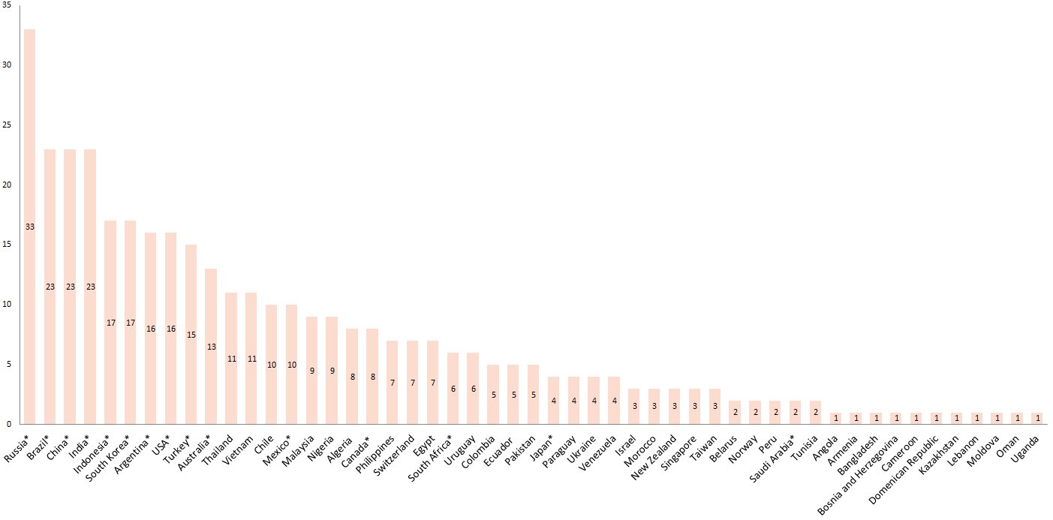

**Table 1: Geographical breakdown of trade and investment barriers in the MADB** (* - G20 countries)

2. Breakdown of all barriers per type of measure

The MADB also enables differentiating between the types of barriers. This is illustrated in Table 2.

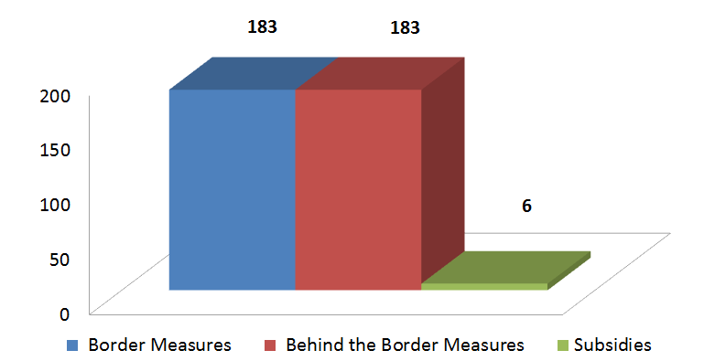

**Table 2: Breakdown of trade and investment barriers recorded in the MADB per type**

The chart reveals an equal number of barriers (183 each) in the areas of more traditional border measures on one hand and behind the border measures on the other hand. Border measures are restrictions that directly affect imports and exports, typically through tariff increases, quantitative restrictions, sanitary and phytosanitary (SPS) measures, import licensing or through outright trade bans. Russia (16), India (11), Argentina (11), China (10) and Turkey (10) are the countries that have most often resorted to these barriers.

The MADB recorded an equally high number of behind the border measures. These barriers include restrictions related to services, investments, government procurement, intellectual property rights or unjustified technical barriers to trade. Russia, Brazil (14 each), China (12) and India (12) have the highest number of such measures recorded.

The third main category of barriers registered is trade-distorting subsidies. Although subsidies are rather addressed via anti-subsidy investigations, Member States and businesses chose to report some subsidy schemes (six) in the framework of the MAP as well - underlining the increasing challenges posed by this unfair practice. Russia is responsible for half of the particularly trade-distortive registered subsidies (three), followed by China, South Korea and the United States (one each).

B. TRADE AND INVESTMENT BARRIERS REPORTED IN 2016

Considering its annual scope, the TIBR presents a good opportunity to take stock of the new barriers as well as the barrier removal activities of the MAP on an annual basis. Based on the data recorded in the MADB, 36 new barriers in 21 third countries[9] were registered in 2016. The number of new barriers in 2016 was therefore fairly consistent with the 39 new measures in 2015.

1. Breakdown of barriers reported in 2016 per third country

The geographical distribution of these new barriers is visualised in Table 3.

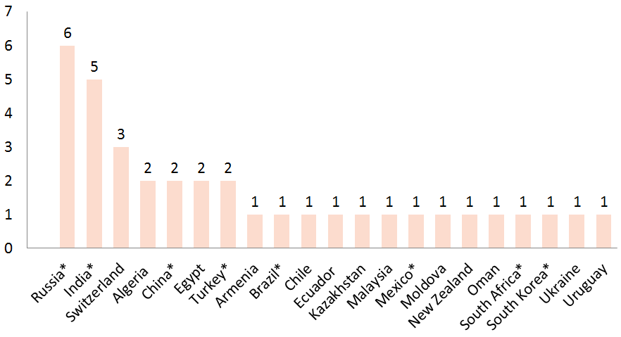

**Table 3: Geographical breakdown of trade and investment barriers reported in 2016 (**\* - G20 countries)

The highest occurrence of new barriers in 2016 was reported in the trade and investment relations with Russia (six) and India (five), which confirms the protectionist trends already identified in last year's edition of the TIBR. Switzerland also resorted to three new barriers, while two new barriers were reported in Algeria, China, Egypt and Turkey, respectively. The remaining 14 new barriers were recorded for other individual third countries.

2. Breakdown of barriers reported in 2016 per type of measure

Table 4 provides an overview of the three main types of measures recorded in 2016.

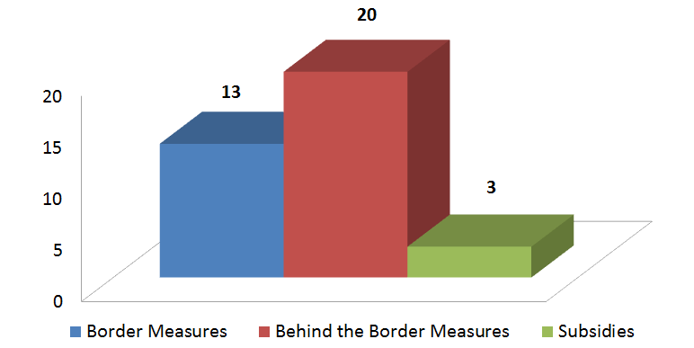

**Table 4: Breakdown of trade and investment barriers reported in 2016 per type**

The majority of the barriers registered in 2016 are measures behind the borders (20), indicating an increased reliance on internal measures affecting EU exports or investments, which are often more difficult to perceive and address. Most of the recorded restrictions were adopted in the area of trade in goods, including unjustified regulatory barriers, internal tax measures and intellectual property rights (17). In addition, a few new barriers were recorded with regard to trade in services (two) and investments (one).

While the number of new behind the border measures in 2016 overtook the traditional trade barriers faced by EU exporters at customs, the number of new border measures also remained significant (13). The majority of these restrictions hindered imports into third countries by way of increased tariffs, quotas, bans or burdensome licencing schemes (eight). In addition, a substantial amount of new SPS restrictions also emerged (four). The number of new recorded export restrictions by the EU's trading partners was more limited in 2016 (one).

The list of barriers reported in 2016 also contained new subsidy measures (three), either in the form of general subsidy schemes (two) or specifically linked to export performance (one).

3. Breakdown of barriers reported in 2016 per sector

Table 5 demonstrates that the number of new measures registered in 2016 affected 13 different sectors of economic activity.

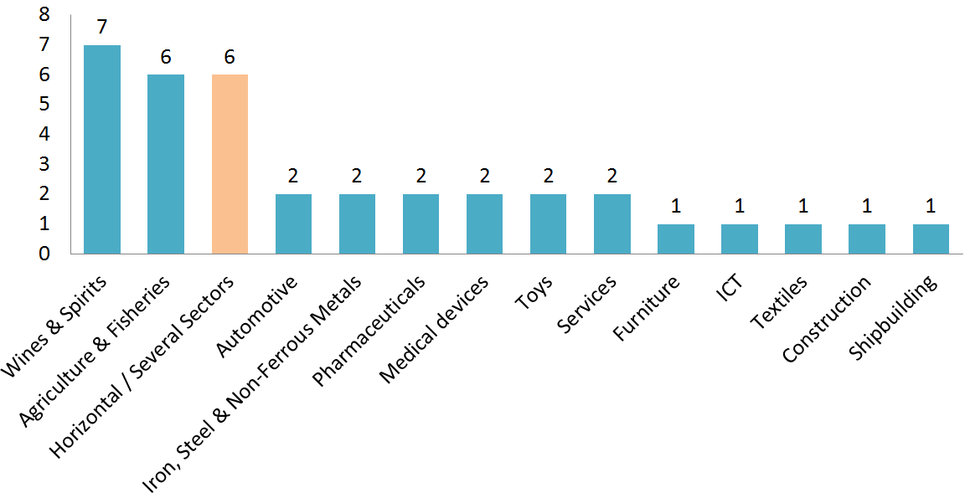

**Table 5: Sectorial breakdown of trade and investment barriers reported in 2016**

The highest number of new reported barriers was recorded for the wines and spirits sector (seven), followed by the agriculture and fisheries sector (six). For the automotive, pharmaceutical, services, medical devices, toys sectors and the iron, steel and non-ferrous metals sector two new barriers each were recorded. Individual barriers were also reported in the construction, furniture, ICT, shipbuilding and textiles sectors (one each). Finally, six horizontal barriers, affecting several sectors, were also recorded.

**II. MAIN TRADE AND INVESTMENT BARRIERS REPORTED IN 2016**

This chapter provides a deeper analysis of new barriers in the seven trade partners for which multiple new barriers were recorded in 2016: Russia, India, Switzerland, China, Algeria, Egypt and Turkey. It also estimates the potentially affected trade flows.

A. QUALITATIVE ANALYSIS OF THE NEW BARRIERS

1. Russia

In the midst of a major domestic economic crisis, Russia continued to resort to trade barriers in 2016 to protect its local industry, confirming trends observed in previous reports. Russia recorded the highest number of new barriers in 2016 (six), raising the stock of existing barriers for this country to 33, also ranking it highest in total number of trade barriers recorded.

*Trade-distorting subsidies* were among the main barriers reported for Russia, with two new such measures registered in 2016. One of the new subsidy measures was targeted at promoting the output of Russian industrial plants in the automotive and agricultural machinery sectors following the significant slowdown of local demand. In this context, the Government issued two decrees providing export subsidies from the federal budget to companies in these sectors operating in Russia.

The government also introduced specific restrictions for the participation of foreign companies in the framework of investment projects undertaken by state-owned enterprises (SOEs) or by private companies that are subsidised by the state. In the context of this measure, Russia also introduced a 15% price preference for Russian companies participating in tenders by SOEs.

Further, Russia adopted two new certification-related barriers concerning the cement and pharmaceutical sectors, aimed at protecting local manufacturing and encouraging further production localisation. For *cement*, it introduced mandatory certification requirements while not issuing certificates to importing companies (except for white cement), which has stopped EU cement exports to Russia since March 2016. Russia has also adopted ''Good Manufacturing Practice'' certificate requirements for the marketing and the renewal of marketing authorizations for *pharmaceuticals*, without ensuring sufficient capacities to carry out these procedures in Russia, leading to undue delays for the EU pharmaceutical industry.

Russia (together with Kazakhstan) has also notified a draft amendment to the *toy* safety regulation of the Eurasian Economic Union, planning to introduce requirements on psychological and educational safety, which is unprecedented in international practice and appears to bear no relation to actual toy safety objectives.

Finally, Russia rolled out a major border measure in the form of a *transit ban* on carriers via road and railway from the territory of Ukraine to the territory of Kazakhstan and Kyrgyzstan via Russia, regardless of their origin (i.e. including the EU). The restriction has led to a considerable increase of transport costs for certain EU exporters.

It is important to note that Russia also extended its longstanding restrictions for foreign companies to participate in government procurement to two additional sectors (foodstuff and radio-electronic products). For the purposes of this report, these issues have not been considered to be new barriers but rather as new aspects of longstanding restrictions on government procurement, which had already covered a long list of goods (textiles, medical devices, imported vehicles, light industry imports, machinery and equipment, pharmaceuticals, software).

The Commission has raised all new and existing barriers with Russia at all available fora, including at the 2016 WTO Trade Policy Review of Russia, at the relevant WTO Committees as well as via bilateral meetings and letters. Where Russia's policies were in breach of its WTO commitments, the EU also resorted to the WTO Dispute Settlement system. In 2016, WTO Panels have ruled in favour of the EU with regard to EU exports of pig meat products (confirmed by the Appellate Body on 23 February 2017) and to Russia's excessive tariffs for certain agricultural and manufacturing products (the reasonable period of time for Russia's compliance with the WTO ruling had not yet expired at the moment of drafting).

2. India

India resorted to five new barriers in 2016, bringing the overall barrier count to 23 and confirming protectionist tendencies identified in last year's TIBR. The majority of the new restrictions put in place were measures behind the border (four) targeting a wide range of sectors such as steel, medical devices, textiles as well as wines and spirits.

With regard to the *steel sector*, India introduced minimum import pricing, initially imposed in February 2016 on 173 steel products. The measure was last extended for two months in December 2016 for 19 steel products.[10] In addition, the list of products falling under the scope of the system of mandatory certification operated by the Bureau of Indian Standards (BIS) was extended in June 2016 to include additional 3 stainless steel products, on top of 35 steel products defined in the Quality Control order of 2012.

*Medical devices* in India are still regulated as "drugs" under the terms of India's Drug and Cosmetics Act and Rules, unnecessarily entailing stricter requirements. In this context, exports of "refurbished" medical devices (i.e. products that have been completely remanufactured and that, as a consequence, cannot be considered as second-hand equipment) are prohibited, limiting the export opportunities of EU producers.

On *textiles*, additional duties on the maximum retail price of certain articles have been doubled (from 30% to 60%). This increase, coupled with the related landing charges, imposes a heavy burden on EU apparel.

Furthermore, business opportunities of the *wines and spirits* sector in India are affected by unjustifiable regulatory divergences from international standards regarding labelling requirements and by internal taxation measures.

While partly positive developments were reported in 2016 for exports of *telecommunication equipment*, other burdensome requirements still remain, such as the obligation to re-export used electrical and electronic assemblies in case of repair, testing, research and development or project work. This leads to delays of imports that negatively affect both the repair of telecom networks and potential research cooperation projects.

While the negotiations for a broad-based FTA with India were brought to a de facto standstill in the summer of 2013 due to a mismatch of the level of ambitions and expectations, the Commission regularly raises these issues with the Indian authorities in all available multilateral and bilateral fora, such as the WTO Technical Barriers to Trade (TBT) Committee or in the EU-India Working Groups and Sub-Commission on Trade.

3. Switzerland

Three new barriers were raised in the MAP for Switzerland in 2016, raising the total stock of registered barriers to seven. Two of the new restrictions concern the *services sectors*: so far, EU businesses providing services had to register for Value-Added Tax (VAT) in Switzerland if their annual turnover in Switzerland reached a certain threshold. New legislation proposed in 2016 would change the reference from turnover in Switzerland to worldwide turnover. As a result, most EU businesses providing cross-border services in Switzerland would be required to register for and pay VAT. In addition, an EU based business would need a fiscal representative in Switzerland, creating further costs. The rules for low value consignments, which are exempt from VAT, will also be modified, rendering low value imports (notably through e-commerce) less attractive.

Moreover, a new registration requirement for artisan workers introduced in Canton Ticino requires a number of craft professions (e.g. carpenters, painters, gardeners) to register on the basis of professional (e.g. diploma and minimum years of practical experience) and personal requirements (e.g. no criminal record). The fulfilment of these requirements must be proven by the applicant, in the case of foreigners by way of certified documents by the competent authorities. This negatively affects the potential for European professionals to provide such services.

Switzerland also introduced a border measure by reclassifying tariffs for *seasoned meat,* significantly increasing these tariffs. Even though a decision has been taken in the meantime to reduce the tariff for seasoned meat "imported for the purpose of producing dry meat", importers will have to prove upon request that the meat has been imported for that purpose. As a result, part of EU exports will continue to be subject to the higher duties.

The EU has raised these barriers with Switzerland both locally at experts' level together with the Market Access Team as well as more formally in the context of the relevant Joint Committee meetings on customs, free movement of persons and agriculture.

4. China

As highlighted in previous TIBRs and in the MADB, China remains among the most trade-restrictive partners of the EU. EU companies face numerous longstanding barriers in China, including joint venture requirements, market entry restrictions, obligations for technology transfer and unjustifiable technical regulations. China's production also remains the key factor in the existing and growing global overcapacity in the steel sector, as well as a number of others, including not only the traditional energy-intensive sectors but increasingly high-tech industries as well. Chinese overcapacity in some cases exceeds the size of total EU production or the total EU market. This poses a risk of dumping at unfair prices and resulting major market disruptions in the EU.

Specifically for 2016, two new barriers (both regulatory measures behind the border) were reported to the MAP, in the furniture and medical devices sectors, respectively.

With regard to *furniture*, limits were introduced for the level of certain volatile organic compounds that are not in line with international standards and pose a considerable risk for EU companies of not being able to sell their products in China. The Commission raised these measures in its response to the relevant TBT notifications and on several other occasions in the WTO TBT Committee and at bilateral EU-China committee meetings.

For *medical devices* China updated its regulatory requirements in 2016 by publishing a second catalogue including 350 devices exempt from clinical trials. However, in order to be registered in China, the most innovative devices continue to be subject to a clinical trial to be conducted in China. The Commission regularly requests China to align its medical devices regulatory system with international standards and practices, including at the EU-China Medical Device Expert Roundtable, the EU-China Annual Regulatory Dialogue and Market Access Meeting and at the EU-China Food and Drug Administration High Level Meeting.

While addressing the new barriers recorded in 2016, the EU is of course also undertaking all necessary actions that can contribute to the removal of the 23 existing barriers recorded in the MADB. However, the prospects for the emergence of new barriers remain significant. For example, China is introducing horizontal security-related rules with significant economic impact on several sectors. China has also recently signalled upcoming legislation in important areas for EU economic operators, such as for New Energy Vehicles (NEV). In addition, China has indicated its intention to introduce unjustifiable food certification requirements affecting a large number of products, including drinks (alcoholic and non-alcoholic), confectionary, chocolates, biscuits, jams, compotes and other fruit preparations, milled products and grains, breakfast cereals as well as dry products such as noodles and pasta. These measures, if confirmed, will be addressed in the next edition of the TIBR.

5. Algeria

Algeria has not featured prominently in the reports of previous years but in the context of the worsening current account and trade balance and in its effort to increase local industrial production, the country put in place two major barriers in 2016 with wide-ranging effects for EU exporters in several sectors.

Following up on a 2015 legislation enabling potentially sweeping *quantitative restrictions,* an import licence scheme for four categories of products (vehicles, cement, rebar and steel wire rods) was introduced in 2016. Consequently, EU exporters were significantly affected in 2016. For example, only approximately 57 000 licenses were issued in 2016 for EU automobile exports, a significant drop compared to EU exports to this market in previous years (e.g. around 245 000 vehicles in 2012). Rebar steel, cement and steel wire rod products were also hard-hit by the measure.

Further, Algeria continued to resort to the *industrial localization policies* launched in the 2015 Finance Law, adopting a decree to create a horizontal consumer's credit for the purchase of products manufactured or assembled in Algeria as of 2016.

The EU has raised these issues with Algeria under the framework of the EU-Algeria Association Agreement but Algeria so far remains reluctant to amend its trade-restricting policies. This also contributes to the lack of progress in its WTO accession talks.

6. Egypt

While Egypt has not been a focus of previous reports, an increasing number of barriers affecting trade are being put in place. Most recently, in a cross-cutting measureencompassing 25 categories of goods*,* ranging from agricultural products, bikes, cosmetics and garments to ceramic tiles and furniture, the Egyptian Government introduced a *mandatory* *registration of companies willing to export their products to Egypt*. Among the documents required for the registration, the Decree includes a certificate that the producer and/or the trademark owner maintain a quality control system. All the documents to be provided have to be certified by a Chamber of Commerce, approved by an Egyptian embassy and translated by an accredited translation centre. The measure raises concerns as to its compatibility with the WTO and the EU-Egypt Association Agreement frameworks as well as creates a number of practical difficulties for companies (e.g. lack of transparency of the registration process, lack of appeal procedure, extensive delays).

The EU has raised its concerns in all available fora, including at the WTO TBT Committee, in the bilateral framework provided by the EU-Egypt Association Agreement, via the EU Delegation in Cairo as well as in a letter on a high political level.

In addition, Egypt is also preparing a draft *automotive* *tax* *incentive scheme* with the objective of forced localisation. The scheme would provide tax deductions for companies reaching a required local component percentage, a local production quantity and/or exportation threshold from Egypt.

7. Turkey

Over the past years Turkey has maintained several trade barriers which are contrary to its obligations under the EU-Turkey Customs Union, such as burdensome customs procedures or additional duties. In 2016, Turkey introduced two further trade-restrictive measures, raising the overall number of reported trade barriers to 15.

One of these new barriers consists in Turkey's application of *excessive certification requirements* for a large number of products (including machinery, electric motors and pumps) despite that there have not been any incidents of malfunctions or defects with these products. Consequently, a large number of EU companies have experienced problems with customs proceedings when exporting to Turkey.

Another significant new trade barrier is that Turkish authorities are implementing forced localisation measures in the *pharmaceutical* sector to boost domestic production in Turkey. The Turkish Ministry of Health has requested foreign manufacturers of several pharmaceutical products to produce them locally. In the absence of a 'sufficient' localisation commitment by foreign manufacturers, the products will be deleted from the list of items that can be reimbursed under the Turkish health insurance system. This implies that those products will be effectively excluded from the Turkish market. The measure is discriminatory against imports and will have serious implications for the ability of the EU pharmaceutical industry to export to and operate in Turkey, risking a significant loss of market share.

The EU's concerns about both new measures in various bilateral meetings have been raised with the Turkish Ministry of Economy, Ministry of Health and the Medicines and Medical Devices Agency. The Commission will continue to address these and other trade irritants, with the objective to deter further escalation of protectionist measures, increase market access for European companies as well as to improve the overall trading environment. Turkey's implementation of its existing obligations under the EU-Turkey Customs Union will also be taken into consideration in the context of the foreseen negotiations to modernise the Customs Union and to further extend its coverage.

B. TRADE FLOWS POTENTIALLY AFFECTED BY THE BARRIERS RECORDED IN 2016

Estimating the economic impact of specific market access barriers remains a challenging exercise, which requires close cooperation between the business community, the Member States and the Commission. One of the factors in prioritizing trade barriers in the MAP is the expected impact of any new measure reported.

While the Commission intends to focus more on collecting such information through the MAP in the future, available economic data for the registered barriers, although improving, remains partial. Therefore, this section analyses the *trade flows* *potentially affected* by the new barriers to trade in goods. This is based on bilateral EU export figures (and import figures in the case of export restrictions of third countries) for the relevant Harmonised System (HS) tariff codes. As the barriers that emerged in 2016 may already have limited EU exports that same year, the analysis is based on the average trade flows of the three consecutive previous years 2013-2015. While the exact effect of the trade barriers on these trade flows could not be measured[11], this at least gives an indication of the importance of the underlying exports potentially affected by the trade barriers.

This method was applied to 32 of the 36 new barriers recorded in 2016, excluding two services and one investment measure (for which no trade flow data are available) and one important horizontal measure for which no specifically affected sectors could be identified.

The outcome of this estimate shows that the new trade barriers recorded in 2016 potentially affected EU exports worth up to EUR 27.17 billion[12]. This exceeds total EU exports to trading partners such as South Africa[13], Algeria[14] or Ukraine[15] and corresponds to 1.6% of all EU exports globally in the same years.

It is estimated that - taken together - the measures introduced by Russia could have the highest impact on EU exports, potentially affecting trade flows up to EUR 12.26 billion. This is followed by the potential impact of the barriers put in place by Algeria (EUR 3.75 billion), China (EUR 3.7 billion), Turkey (EUR 2.69 billion), India (EUR 2.2 billion) and Egypt (EUR 1.72 billion).

This analysis also showed that the new measures introduced by Russia particularly targeted sectors in which EU exports to Russia were traditionally strong. For example, before the introduction of the unjustified certificate requirements on pharmaceuticals, EU medicines exports to Russia were worth EUR 6.1 billion per year and the subsidies for automobiles and agricultural machinery may affect trade flows in these sectors accounting for EUR 5.85 billion in EU exports to Russia per year.

Algeria's decision to introduce new quantitative restrictions and import licensing scheme on motor vehicles, cement, steel and steel wire rods could also have a significant impact on EU exporters, with previous exports for these sectors worth EUR 3.75 billion.

Other barriers with potential impact on notably high trade flows include the clinical trial obligations required by China for European medical devices, which could pose a risk for EUR 2.95 billion of EU exports; the burdensome customs procedures applied by Turkey to several products including machinery, electric motors and pumps, which could have an adverse impact on EU exports worth EUR 2.6 billion; and the Indian minimum import price barrier on steel, which could negatively affect EU exports worth EUR 1.36 billion. Moreover, the factory registration requirements in Egypt, which cover 25 categories of goods ranging from agricultural products, bikes, cosmetics and garments to ceramic tiles and furniture, could affect trade flows worth EUR 1.03 billion in EU exports.

The significant level of trade possibly affected by the imposition of new market access barriers reconfirms the importance of the EU's Market Access Strategy and the ''enhanced partnership'' to monitor and address trade-restrictive measures globally, and to prioritize and address them with the most appropriate tools.

**III. MAIN TRADE AND INVESTMENT BARRIERS RESOLVED IN 2016**

This chapter elaborates on the strategy the Commission followed to address trade and investment barriers in 2016 and the results obtained in terms of barriers resolved. The section then looks into some of the key success stories of 2016 in more details. Finally, it estimates the value of trade affected by these measures before their resolution.

A. EU STRATEGY TO ADDRESS TRADE AND INVESTMENT BARRIERS

The previous edition of the TIBR already elaborated on the main avenues used by the MAP to address the increasing number of barriers in third countries[16]. During the course of 2016, the MAP continued to rely on a similarly wide range of tools to resolve market access cases.

Under the *WTO framework*, the EU remains a strong supporter of the multilateral trade agenda and dispute settlement mechanism. The EU also maintained its active and constructive role in the WTO Committees (e.g. TBT[17], SPS[18], SCM[19], TRIMS[20], Import Licensing Procedures, Balance of Payments Restrictions), which provided useful opportunities in 2016 to express EU concerns about many of the measures described in previous chapters.

Where consultation mechanisms could not effectively solve barriers adversely affecting EU interests, the EU also resorted to the WTO Dispute Settlement system. In 2016, the EU launched two new cases, one related to China's duties and other restrictions on the export of raw materials (DS 509) and another relating to discriminatory treatment of EU exports of spirits to Colombia (DS 502). Also in 2016, two WTO Panels ruled in favour of the EU (in DS 475 regarding Russia's policies on the imports of pig products and in DS 485 on the Russian tariff treatment of certain agricultural and manufacturing products).

Further, the EU continued to pursue an *ambitious trade negotiating agenda*, another instrument to open markets and to resolve trade barriers. During the course of 2016, the Comprehensive Economic and Trade Agreement with Canada (CETA) and Ecuador's accession to the FTA with Colombia and Peru were signed, the FTA talks with Japan significantly advanced, the MERCOSUR FTA discussions resumed, the modernisation of the Mexico FTA started and new negotiations were launched with several countries such as Indonesia, the Philippines and Tunisia. Many market access barriers are addressed directly during negotiations. For example, as a result of the CETA signed with Canada in 2016, tariff elimination will be complemented by the removal of many significant behind the border barriers in various sectors such as wines and spirits.

In the context of the enhanced MAP and mindful of the increased protectionism, the Commission also decided to reinforce its partnership with Member States and business in order to further improve coordination efforts to eliminate barriers with third countries. Importantly, the Commission has also reinforced discussions with the MAP stakeholders on the trade barriers in place in countries for which FTA negotiations are contemplated or have started in order to determine the best strategy to address those barriers.

The *implementation and enforcement of trade agreements* also remains a key aspect of EU trade policy. Implementation structures established by FTAs significantly contribute to eliminating specific trade barriers. In 2016, this was for example the case for the EU-South Korea FTA, and the EU-Ukraine Deep and Comprehensive Free Trade Area (DCFTA), the latter of which commenced provisional application on 1 January 2016 (cf. section III.C. of this report). The Commission is also closely monitoring that commitments made under CETA are transposed into Canadian law and effectively implemented. CETA provides furthermore the necessary framework to discuss obstacles that may arise in areas such as SPS, TBT or investments. In the context of the ''enhanced partnership'' announced in the ''Trade for All'' strategy adopted in October 2015, the Commission will publish a targeted report on FTA implementation later this year.

B. OVERVIEW OF THE BARRIERS RESOLVED IN 2016

1. Breakdown of barriers resolved in 2016 per third country

Thanks to the combined efforts of all MAP stakeholders, 20 of the registered trade barriers applicable in 12 different third countries could fully or partially be resolved in 2016. These results obtained last year are broadly comparable with the 23 measures tackled in 2015.

Table 6 illustrates the third countries where barriers were most successfully tackled. South Korea was first in line with five trade barriers resolved in 2016, followed by China (three), Israel and Ukraine (two each). Also in Argentina, Botswana, Brazil, Egypt, India, Japan, Taiwan and Turkey, one of the registered barriers could in each case be resolved.

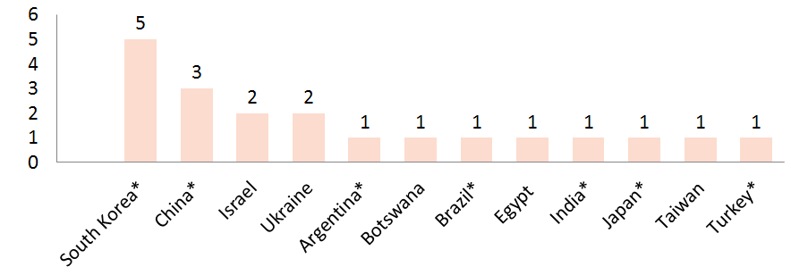

**Table 6: Geographical breakdown of trade and investment barriers resolved in 2016 (**\* - G20 countries)

It should, however, be repeated that as the MADB does not provide a comprehensive overview of all trade barriers encountered by EU exporters, it does not give a complete picture of all barriers resolved in 2016 either. In particular where FTA negotiations were ongoing, barriers and their removal were sometimes not registered. This will be followed up more closely in the MAP in the future in the context of the "enhanced partnership".

2. Breakdown of barriers resolved in 2016 per type of measure

Considering the increasing resort in 2016 to behind the border barriers (20) as opposed to border measures (13), it is useful to analyse how effective the EU was in tackling these different types of measures last year.

Table 7 shows that the MAS has equally contributed to the resolution of border (10) and behind the border (10) measures, demonstrating that its toolbox also remains effective when tackling measures that are often more difficult to perceive.

With regard to the 10 border measures successfully addressed, most related to SPS matters (seven), while the other resolved barriers constituted import bans or customs issues (three).

For the 10 behind the border measures, most positive outcomes were achieved in the area of regulatory or taxation measures for trade in goods (nine), while one services issue was also successfully resolved.

3. Breakdown of barriers resolved in 2016 per sector

Table 7 provides a snapshot of the main sectors of economic activity in which trade barriers were resolved in 2016: *Agriculture and fisheries* was the top sector with eight barriers (fully or partially) resolved, in particular relating to SPS matters (five). The *wines and spirits* industry also saw a considerable number of its barriers resolved (three), followed by the *automotive* and *cosmetics* sectors (two each). Additionally, individual barriers were resolved in the electronics, pharmaceutical and ICT sectors. Finally, two horizontal barriers were also solved - both in South Korea: one with respect to origin verification and another (solved temporarily) regarding tariff treatment of (re-imported) repaired goods (cf. also section III.C.1.).

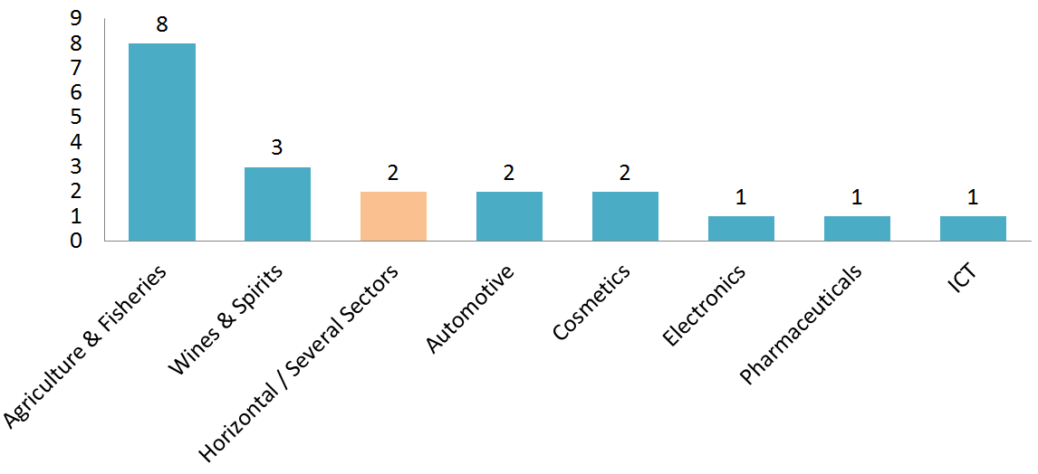

**Table 7: Sectorial breakdown of trade and investment barriers resolved in 2016 as recorded in MADB**

C. QUALITATIVE ANALYSIS OF BARRIERS RESOLVED IN 2016

This section provides a deeper analysis of the barriers resolved in the four trade partners for which the highest number of resolved barriers was recorded in 2016: South Korea, China, Israel and Ukraine.

1. South Korea

A particularly positive trend can be observed in South Korea, where only one new barrier was registered in 2016 while five barriers were eliminated. This underscores that the FTA implementation structure provides an effective vehicle to address trade barriers (cf. also section III.A).

While trade flows significantly improved in the *automotive sector* since the application of the FTA, certain market access issues have persisted in this sector and the Commission continued to raise these concerns in the FTA Automotive Working Group. In this framework, South Korea in 2016 agreed to amend its unique seat size and clearance requirements, as well as to harmonise certain regulations to international standards (e.g. 48 V issue under UNECE Regulation 100). The Commission will continue to raise the remaining barriers in the relevant FTA implementation bodies, as well as in possible amendments to the existing deal.

A barrier was also resolved for the *cosmetics* sector in 2016: after intervention of the EU with the South Korean counterparts, a discriminatory measure, obliging downtown duty-free shop operators in South Korea to reserve a minimum floor area for selling domestic products, was amended into a less discriminatory obligation to reserve a minimum floor area for selling the products of small and mid-sized enterprises.

In the field of trade in *agricultural* products, the trade-distortive aspects of a draft regulation containing unjustified technical requirements for raw milk cheese that would have negatively impacted EU business was softened following EU interventions.

More horizontally, South Korea has also amended its customs procedures with regard to the *verification of origin*. Until 2016, the Korea Customs Service continued to carry out its origin verification for EU goods in a manner equivalent to the direct origin verification method, i.e. by directly approaching importers. EU companies in various sectors complained about this approach, which was contrary to the indirect origin verification foreseen in the FTA. Following EU interventions, South Korea has accepted the indirect origin verification in line with the FTA, thus significantly improving the situation of EU exporters.

An additional longstanding horizontal issue concerns South Korea's tariff treatment of (re-imported) *repaired goods*. The EU-South Korea FTA has no provision exempting repaired goods from customs duties on re-entry to South Korea after repair in the EU. Following the Commission's frequent interventions, South Korea extended the current duty exemption in December 2016 until the end of 2018. Further to this temporary solution, the EU will also continue to seek a long-term resolution to this issue, including in the context of potential FTA amendments.

2. China

China remains among the countries that resort most to market access barriers both in terms of the overall stock of registered measures (23) and new ones that emerged in 2016 (two). However, 2016 also saw positive developments for three recorded trade barriers, showing that the EU barrier removal strategy can also work effectively vis-à-vis major economies.

Progress has been achieved on a major barrier in the *ICT* segment: China planned to adopt rules forcing companies that procure ICT goods for Chinese banks to use Chinese intellectual property and disclose key software codes, which are considered as business secrets. Following high level interventions of the Commission, China has decided to temporarily suspend the adoption of the measure, pending revision of the regulation. The Commission will continue to closely monitor this issue with the aim to achieve a full resolution of this issue on the ground.

Another positive development was recorded in the *cosmetics* industry, where a new legislation was expected to introduce burdensome requirements such as the prohibition of ''overstickering'' of the original label or the obligation to display the name and address of subcontractors on the packaging. Following EU interventions at all relevant multilateral and bilateral fora, China agreed to suspend the measure. As of 2016, this allowed EU cosmetics companies to continue their exports to China as before.

The *spirits* sector also registered a success: China used to maintain an unjustifiable SPS measure requiring very low levels on certain phthalates, which were stricter than the safety levels set under their own risk assessment. The issue was resolved in 2016, when China confirmed that it would revert to its previous practice in accordance with the outcome of its own risk assessment, ensuring that EU spirits exporters can continue their operations.

3. Israel

EU-Israel trade relations are based on the Association Agreement that entered into force in 2000. Israel has in general been supportive of facilitating trade and has not been a very active user of market access barriers vis-à-vis EU businesses, which in turn has contributed to a strong trade relationship. With two barriers effectively resolved in 2016, only three barriers remain active in the MADB overall.

One of the recently resolved barriers concerns *pharmaceutical* exports: Following direct contacts with the Israeli Ministry of Health, Israel now accepts to consider requests for pharmaceutical market authorisation from all EU Member States, including those that have joined the EU as of 2004. This has finally enabled companies in those Member States to export pharma products to Israel as well. The EU is hopeful that a similar barrier for medical devices can also be solved soon.

Since 2016 Israel has also resumed granting authorization to several EU Member States to export live *cattle*, therefore addressing this SPS concern.

4. Ukraine

The provisional application of the EU-Ukraine DCFTA since 1 January 2016 resulted in the continued improvement of trade relations. The total stock of active trade barriers in place in Ukraine has decreased from five to four, following the elimination of two barriers in 2016 and the adoption of one new barrier in 2016. With regard to the newly adopted measure, which consists of an export duty on metal scrap, it should be noted that following the intervention by the European Commission and a subsequent veto applied by the President of Ukraine on the initial proposal, the adopted measure was eventually shortened to one year and is expected to expire in September 2017. This should bring the overall barrier stock further down.

Ukraine has shown progress in eliminating barriers of concern for EU exporters, such as by repealing the longstanding SPS ban for *beef and veal* (although some import conditions are still not fully in line with EU standards) or the equally longstanding quarantine permit for import or transit of *vegetables*. It is nevertheless regrettable that the wood export ban adopted by Ukraine in 2015 is still in force despite the many commitments made by Ukraine to abandon the measure. Together with its partners in the enhanced MAP, the Commission will continue to monitor the implementation of the DCFTA in view of resolving barriers and preventing new ones from emerging.

D. TRADE FLOWS POTENTIALLY AFFECTED BY THE BARRIERS RESOLVED IN 2016

In the absence of sufficiently reliable economic data at this stage, the same methodology explained in section II.B was also used for the purpose of calculating the trade flows potentially affected for barriers resolved in 2016. While this methodology is less than perfect – as looking at trade flows of previous years for resolved barriers provides distorted figures due to the EU exports being depressed by the barrier that used to be still in place - it gives at least some (albeit potentially underestimated) indication of the importance of the trade flows that may benefit from the resolved barriers.

The methodology was used for 17 of the 20 barriers that were resolved in 2016, exceptions relating again to more horizontal cases (the issues of repaired goods and origin verification in South Korea) and to the ICT related issue in China described in the previous section. Although the economic value generated by the removal of these barriers is expected to be considerable, it remains too difficult to identify and measure relevant trade flows and hence these are not included in the analysis.

Nevertheless, based on this methodology, the resolution of trade barriers in 2016 could positively affect EU exports in the range of EUR 4.2 billion[21]. In any case, taking into account the limitations of the methodology, it will be useful for the future to follow the evolution of trade in these areas now that the barriers are resolved, in order to draw more precise conclusions on the impact of their resolution.[22]

Concerning the trade flows potentially affected with regard to specific barriers, EU exporters could have significantly better trade opportunities following the elimination of seven SPS-related barriers in 2016, accounting for EU exports of EUR 1.86 billion in total. For example, EU farmers could benefit from the removal of the SPS restriction formerly applied by Ukraine, which could affect current exports valued at EUR 602.62 million.

The resolution of the barriers in China related to cosmetics and spirits might also have a major impact, as EU exports in these sectors were worth EUR 678.6 million and EUR 398.39 million, respectively. The cosmetics sector could also benefit from the abolition of discriminatory treatment in Korea, which could provide a boost to the current level of EU exports valued at EUR 452.56 million.

**IV. CONCLUSION**

The focus of this year's report is to provide a comprehensive overview of trade and investment barriers directly affecting EU economic operators as reported and resolved via the Market Access Partnership between the Commission, Member States and business organisations. The Market Access Database, which registers these barriers, currently counts 372 active barriers reported for 51 countries across the globe. Large economies such as Russia, Brazil, China, India and Indonesia continue to be main users of such protectionist instruments.

Similar global trends were observed in the calendar year 2016, the reference period of this report. Within the total of 36 new barriers reported in 2016, Russia resorted to the highest number of new trade restrictions, closely followed by India, while China kept its position in the top 5 users of trade barriers as well. Several new measures were also reported regarding Switzerland, while Algeria, Egypt and Turkey were highlighted in particular as active users of localisation policies. In addition to certain horizontal measures, new barriers were registered for 13 sectors of economic activity, among which mainly the wines and spirits as well as the agriculture and fisheries sectors were featured, but also the automotive, pharmaceutical, services, medical devices, toys and iron, steel and non-ferrous metals sectors. The trade flows potentially affected by all new barriers registered in 2016 were estimated to reach up to EUR 27.17 billion, which exceeds total EU exports to partners such as South Africa, Algeria or Ukraine and corresponds to 1.6% of total EU exports.

On the positive side, the Market Access Partnership contributed to tackling 20 trade and investment barriers in 2016, in seven different sectors as well as horizontal barriers. The positive tendencies observed in particular in South Korea and Ukraine underscore the effectiveness of the implementation of Free Trade Agreements to resolve market access barriers and the Commission is committed to further strengthening and bundling efforts with its partners under the 'enhanced partnership' to ensure even more effective implementation of EU Free Trade Agreements. While the road ahead is admittedly long, some barriers were also tackled in China, which demonstrates that the EU barrier removal strategy can also work effectively vis-à-vis large economies with which no Free Trade Agreements are in place. The EU will also continue to rely on the WTO framework and its own ambitious trade negotiating agenda, which will remain key instruments for addressing barriers. All in all, the trade flows potentially affected by the barriers resolved in 2016 were in the range of EUR 4.2 billion.

In conclusion, the EU Market Access Strategy has proven very valuable in identifying and removing barriers, thus contributing to better export and investment opportunities for EU economic operators. In light of the globally increasing protectionism, the Commission will further intensify its efforts to ensure that all stakeholders join forces through the Market Access Partnership in order to trigger economic growth and productivity on the basis of open markets worldwide.

1. The Market Access Partnership was set up in 2007 to deepen the cooperation between the Commission, Member States and EU business both in Brussels and locally. It is based on monthly meetings of the Market Access Advisory Committee and sectorial Market Access Working Groups in Brussels and regular meetings of the Market Access Teams or Trade counsellors' meetings in third countries.
2. <http://trade.ec.europa.eu/doclib/docs/2015/october/tradoc_153846.pdf>
3. A new report on FTA implementation is foreseen for adoption towards the end of 2017.
4. A more general analysis of protectionist trends is still undertaken by the biannual WTO report on protectionist measures adopted by G20 countries. The last WTO trade monitoring report at the time of drafting this report (<https://www.wto.org/english/news_e/news16_e/trdev_09dec16_e.htm>) dated 9 December 2016.
5. Algeria, Angola, Argentina, Armenia, Australia, Bangladesh, Belarus, Bosnia and Herzegovina, Brazil, Cameroon, Canada, Chile, China, Colombia, Dominican Republic, Ecuador, Egypt, India, Indonesia, Israel, Japan, Kazakhstan, Lebanon, Malaysia, Mexico, Moldova, Morocco, New-Zealand, Nigeria, Norway, Oman, Pakistan, Paraguay, Peru, Philippines, Russian Federation, Saudi Arabia, Singapore, South Africa, South Korea, Switzerland, Taiwan, Thailand, Tunisia, Turkey, Uganda, Ukraine, Uruguay, USA, Venezuela and Vietnam.
6. The market access database (<http://madb.europa.eu/madb/indexPubli.htm>) gives information to companies exporting from the EU about import conditions in third country markets. This includes information on trade barriers, but also on tariffs and rules of origin, procedures and formalities for importing into third countries, sanitary and phytosanitary (SPS) measures, statistics, and on specific export-services provided to SMEs. Conversely, the EU's Export Helpdesk (<http://exporthelp.europa.eu/thdapp/index.htm>) also provides information on conditions for importing from trade partners into the EU (including applicable tariffs and requirements, preferential arrangements, and quotas and statistics).
7. "Active" barriers mean that the barriers are actively followed-up in the Market Access Partnership (as opposed to resolved barriers).
8. Cf. for example, the recent joint report of the International Trade Centre (ITC) and the Commission, "Navigating Non-tariff Measures: Insights From A Business Survey in the European Union", December 2016 (<http://trade.ec.europa.eu/doclib/docs/2016/december/tradoc_155181.pdf>), the overview of potentially trade restrictive measures described in the context of the previous TIBR (<http://trade.ec.europa.eu/doclib/docs/2016/may/tradoc_154568.pdf>; <http://trade.ec.europa.eu/doclib/docs/2016/june/tradoc_154665.pdf>) or previous protectionism reports.
9. Algeria, Armenia, Brazil, Chile, China, Ecuador, Egypt, India, Kazakhstan, Malaysia, Mexico, Moldova, New Zealand, Oman, Russia, South Africa, South Korea, Switzerland, Turkey, Ukraine and Uruguay.
10. On 6 February 2017, India's Ministry for Steel announced that the minimum import pricing would not be further extended. As a result, this barrier no longer exists and will, if confirmed, be considered as a resolved barrier for the 2017 TIBR.
11. Not all trade barriers constitute total trade bans, and some have more trade-restrictive effects than others.
12. Average EU exports in 2013-2015 served as the basis for the analysis.
13. EU total exports to South Africa in 2013-2015 averaged EUR 24.41 billion / year.
14. EU total exports to Algeria in 2013-2015 averaged EUR 22.67 billion / year.
15. EU total exports to Ukraine in 2013-2015 averaged EUR 18.31 billion / year.
16. TIBR 2016, pp. 17-23. <http://trade.ec.europa.eu/doclib/docs/2016/june/tradoc_154665.pdf>
17. WTO Committee on Technical Barriers to Trade
18. WTO Committee on Sanitary and Phytosanitary Measures
19. WTO Committee on Subsidies and Countervailing Measures
20. WTO Committee on Trade-Related Investment Measures
21. The basis for the analysis remains the average EU exports in 2013-2015 in the HS codes concerned.
22. While the Commission has developed a methodology to more precisely assess the impact of the resolved barriers, this methodology requires the observation of trade flows after the barrier was removed. The last such analysis was carried out in 2015 and concluded that the barriers removed in 2012 and 2013 within the MAS had resulted in EUR 2.4 billion of additional trade flows in the year 2014, the equivalent of a small FTA such as the one concluded with Colombia.