

REPORT FROM THE COMMISSION TO THE EUROPEAN PARLIAMENT AND THE COUNCIL

concerning the implementation and the results of the Pericles 2020 programme for the protection of the euro against counterfeiting in 2016

1. **General**

The ''Pericles 2020'' programme (hereafter ''the Programme") is an exchange, assistance and training programme for the protection of the euro against counterfeiting. It replaces the Pericles programme that was established in 2001 and ran during the period 2002-2013. The Programme was established by **Regulation (EU) No 331/2014 of the European Parliament and of the Council of 11 March 2014**[1]**. Its application was extended to the non-participating Member States by Council Regulation (EU) 2015/768 of 11 May 2015**[2]. Regulation (EU) No 331/2014 establishes the duration of the Programme until 31 December 2020. Article 13(3) of **the Regulation** requires the Commission to provide annual information on the results of the Programme to the European Parliament and to the Council. This third Annual Report responds to that requirement in relation to the year 2016.

1. **Implementation of the Programme and results of committed actions in 2016**

The annual budget for the implementation of the Programme for the year 2016 was set at EUR 1 038 500 and was financed from the budget line 01. 020400 of the general budget of the European Union for 2016. A total of EUR 1 029 353.87 was committed in 2016. The Programme is implemented through co-financed actions (grants) originating from the competent authorities of the Member States and through ''Commission actions'', organised directly by the Commission.

The implementation of the Programme reflected the commitment of Member States and the Commission to protect the euro against counterfeiting. Discussions of the multi-annual strategy at the meetings of the Euro Counterfeiting Experts Group (ECEG) made it possible to commit 99.12% of the overall budget in 2016. In order to make full and effective use of the available commitment credits, EUR 45 083.16 was transferred from grants to Commission actions. In 2016, the Programme funded 13 projects in total[3]. Altogether, 9 grants were succesfully awarded from applications originating from the competent authorities of the Member States. This is the same number as 2015. Furthermore, 4 Commission actions were funded, compared to 3 Commission actions in the previous year. 4 actions were implemented in 2016, while 9 actions are being/will be implemented in 2017 and later.

**Chart I and Chart II: Number of actions per Member State and Type of action financed (actions committed to in 2016, see annex I)[4]**

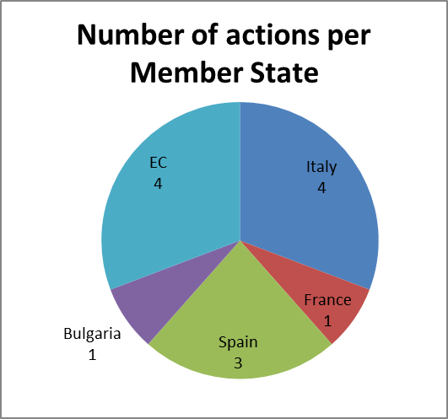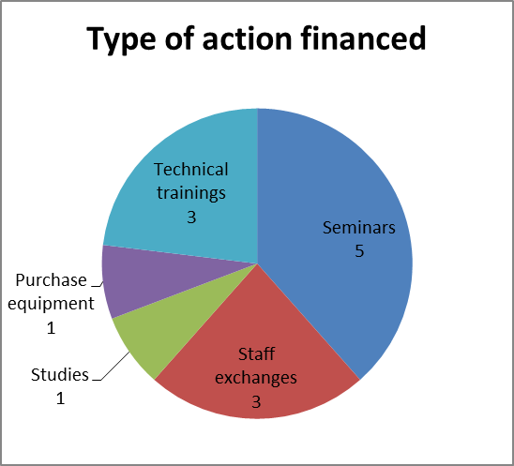

Applicants to the Programme in 2016 represent four Member States, namely Italy, France, Spain and Bulgaria. To a large extent, this reflects the fact that the countries most affected by euro counterfeiting are more frequent users of Pericles funds. In addition, a Bulgarian authority is a first-time applicant to the Programme.

The actions for which commitments were made in 2016 consist of 5 seminars/conferences, 3 technical trainings, 3 staff exchanges, 1 study and 1 purchase of equipment.

The actions take place[5] both inside and outside the EU depending on the specific needs to protect the euro against counterfeiting. Since its inception, the Programme has consolidated its regional approach by implementing actions involving particularly sensitive regions of the world. Of specific focus are Latin America (2 actions organised by Spain and 1 Commission action), and South-East Europe (2 actions organised by Italy and 1 action by Bulgaria).

Charts III and IV give a breakdown of the origin and professional background of participants to the Programme:

**Chart III and Chart IV: Origin of participants and Professional background of participants[6] (actions committed to in 2016, see annex I)[7]**

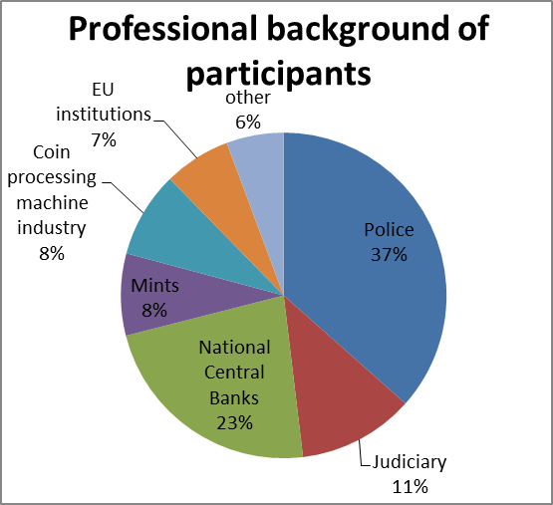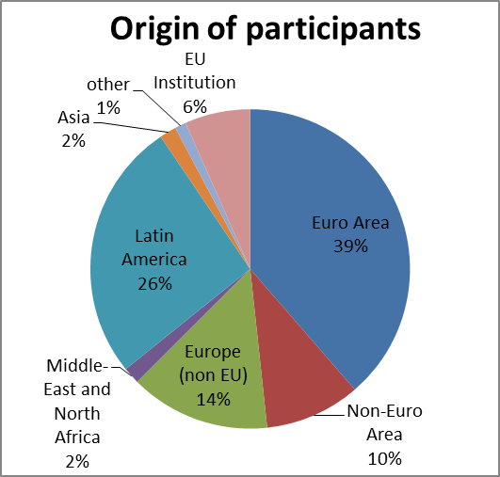

An estimated number of 528 experts participate in actions for which commitments were made in 2016[8].

In terms of origin, participants come from 60 countries. The majority of trainees (63%) are European participants: 39% come from the euro area Member States, while non-EU countries in Europe represents 14% and Non-Euro Area Member States 10%; 26% of trainees are from Latin America, a significant increase compared to the previous year[9] and now representing the second largest group of participants. Finally, 2% come from the Middle East and North Africa and 2% from Asia.

With respect to the professional background of participants, members from police forces represent 37% of the total. That prominent presence is due to the fact that police authorities represent the front line in the fight against euro counterfeiting, and police staff includes both investigators and technicians. Nevertheless, other categories of participants account for 63% of the total, a significant increase from 47% in the previous year. Particularly, the relative participation of central banks has increased significantly (23%)[10]. Furthermore, there is a continuing high participation of members of the judiciary (11%)[11], and a growing participation of mints (8%)[12]. Finally, the implementation of the Commission action ''euro coin authentication conference''results in a high participation of representatives from the coin processing machine (CPM) industry (8%), which affirms the private sector as a significant stakeholder in the fight against counterfeiting.

As a result, the implementation of the Programme meets the transnational and multidisciplinary dimensions of the Programme required under Regulation (EU) No 331/2014.

1. **Overview of actions committed to in 2016: highlights**[13]

The implementation of the Programme in 2016 demonstrates a continuing positive trend towards an increasing differentiation of the professional backgrounds of participants over the years. Indeed, for the first time, police authorities do not represent the absolute majority of participants in 2016. In particular, the significant growth in the involvement of the central banks as well as the growing participation of judiciary, mints and the CPM industry in actions is noteworthy. The 2016 commitments also reflect a further diversification of Member States' competent national authorities applying for the Programme; the Bulgarian National Bank is a first-time applicant for Pericles funds. Furthermore, taking into account the 2016 priorities of the Programme[14], the following highlights can be identified:

*Regional international cooperation*

The Programme has succeeded to maintain and further strengthen strong regional international cooperation in 2016:

* Three actions took/will take place in Latin America, bringing together experts from a large number of Latin American countries.
* Three actions took/will take place in South Eastern Europe, maintaining strong cooperation in this region.

*Internet/darknet*

Several actions committed in 2016 addressed the threat posed by the internet/darknet in the fight against counterfeiting, focussing on the effectiveness of investigation techniques and the need for a coordinated response to the threat:

* The co-funded 'Seminar: A new threat on euro counterfeiting - the Deep Web and cryptocurrencies', organised by the Italian National Central Office, will take place in Rome in April 2017.
* Furthermore, both the UCAMP[15]-organised conference 'A Community Strategy to Protect the Euro in the Mediterranean Area' as well as the BIBE[16]-organised conference 'Curso de Formación sobre Falsificación de Moneda para Expertos de Paises Iberoamericanos' treated this topic.

*Study on new security features*

* In 2016, the Programme has been able to co-finance the second phase of the study on 'Nano-Structured Photochromic Polymers for New Coin Security Features', as a continuation from the first phase previously financed under the 2014 budget of the Programme. Organised by Monnaie de Paris, the study aims to explore the development of new interactive materials that will enhance security features for future euro coins, thereby considerably reducing the risk of coin counterfeiting.

*Classification and/or authentication of euro coins and banknotes*

Several actions committed in 2016 focussed on issues related to the classification and/or authentication of euro coins and banknotes:

* A co-funded staff exchange on euro classification organised by the Bank of Spain.
* A Commission action addressing a Member State backlog in coin classification.
* A Commission action, organised in coordination with and in support of the European Technical and Scientific Centre (ETSC), providing training on the LICO database to be used by Member State CNAC's for the registration of Coin Processing Machines in conformity with Article 5(2) of Regulation (EU) No. 1210/2010[17].
* A conference on the authentication of euro coins, which will include the participation of representatives of the coin processing machine industry. This conference, organised as a Commission action in coordination with and in support of the European Technical and Scientific Centre (ETSC) has as a specific goal to raise awareness and share the main issues of concern to all stakeholders with regard to the authentication of euro coins and handling of euro coins unfit for circulation as per Regulation (EU) No 1210/2010[18]. It will provide an overview and way forward as to the main technical developments for coin processing machines, future challenges and market evolution.

1. **Implementation of actions in 2016 that were committed to under previous budgets of the Programme**

2016 saw the implementation of 9 actions that were committed to under previous budgets of the Programme[19]. Of those actions, 7 originated from the competent national authorities of Member States - namely France, Spain, Germany, Croatia and Italy - while 2 actions were initiated by the Commission. The actions consisted of 5 seminars, 3 staff exchanges and a study. Particular focus areas were South-Eastern Europe, China, Latin America and the Mediterranean region.

Of particular note is the 12th Euro South East conference that was held in October 2016 in Zagreb, Croatia. This conference continued the sequence of Euro South East Conferences which have been vital in reinforcing cooperation among competent national authorities in South-East Europe, containing several hotspots regarding the possible transit and production of counterfeit euros.

1. **Conclusion and way forward**

The Commission constantly disseminates the results of the actions supported under the Programme to the experts of the Euro Counterfeit Experts Group (ECEG). In 2016, 3 ECEG meetings took place.

The Programme shows a high degree of consistency and complementarity with other relevant programmes and actions at Union level because it is dedicated exclusively to and focuses on preventing and fighting a specific form of organised crime, namely euro counterfeiting. This is true for OLAF's Hercule III programme[20] which protects the financial interests of the Union, and the Programme shows a high degree of complementarity with, inter alia, DG HOME's Internal Security Fund - Police[21], which covers the prevention and combating of crime in general.

The ''Pericles 2020'' programme continues to be an important and effective tool in the fight against counterfeiting. This is underscored by the fact that the available budget for 2016 was fully committed. Furthermore, the following cases illustrate the contribution of the Programme to the protection of the euro against euro counterfeiting in 2016: in May 2016, a new regulation covering all aspects of euro-cash operations was adopted in Kosovo[22], after its representatives had participated in several Pericles 2020 actions[23]. In addition, Pericles 2020-trained law enforcement personnel participated in the dismantling of three illegal printshops in Colombia and in the arrest of 49 persons suspected of counterfeiting the euro in Peru in 2016[24].

The Programme forms the basis for the support of studies, maintaining and developing cooperation, and exchanging best practices among all actors involved in the fight against euro counterfeiting. Based on the results of the implementation of the Programme and the continuous analysis of emerging threats discussed in the ECEG, the priorities for 2017 are the following[25]:

* Supporting activities aimed at improving cooperation among those Member States which are particularly affected by the production or distribution of counterfeits.
* Fostering cooperation with authorities of those third countries where there is suspicion of or evidence for counterfeit euro production.
* Maintaining an efficient framework for the protection of the euro in South Eastern Europe.
* New developments: technical developments within the coin processing machines, the distribution of counterfeits and high quality components on the internet and the increasing interest in euro counterfeiting of criminals located in Third Countries.

1. Regulation (EU) No 331/2014 of the European Parliament and of the Council establishing an exchange, assistance and training programme for the protection of the euro against counterfeiting (the 'Pericles 2020' programme) (OJ L 103, 5.4.2014, p. 1). That Regulation repealed Council Decisions 2001/923/EC, 2006/75/EC, and 2006/849/EC.
2. Council Regulation (EU) 2015/768 of 11 May 2015 extending to the non-participating Member States the application of Regulation (EU) No 331/2014 of the European Parliament and of the Council establishing an exchange, assistance and training programme for the protection of the euro against counterfeiting (the ‘Pericles 2020’ programme) (OJ L 121, 14.5.2015, p. 1).
3. A comprehensive overview of Pericles actions committed to in 2016 can be found in Annex I.
4. All data concerns both actions implemented in 2016 and actions that are being/will be implemented beyond 2016.
5. Some actions are still being implemented in 2017.
6. The other category includes, inter alia, Interpol, staff from national ministries and representations, and staff of academic institutions.
7. All data concerns both actions implemented in 2016 and actions that are being/will be implemented beyond 2016.
8. 174 experts participated in actions implemented in 2016, and 354 experts are participating/will participate in actions being implemented beyond 2016.
9. This is an increase from 14% during 2015 Pericles implementation, COM/2016/419 final.
10. This is an increase from 19% during 2015 Pericles implementation, COM/2016/419 final.
11. This is an increase from 10% during 2015 Pericles implementation, COM/2016/419 final.
12. This is a 5-percentage point increase from the 2015 Pericles implementation, see COM/2016/419 final.
13. A comprehensive overview of Pericles actions committed to in 2016 can be found in Annex I.
14. The priorities are stated in the Annual Work Programme, which is annexed to Commission Decision C(2016) 316 of 27 January 2016 concerning the adoption of the work programme for 2016 of the Pericles 2020 programme.
15. Ufficio Centrale Antifrode dei Mezzi di Pagamento.
16. Brigada de Investigacion del Banco de Espana.
17. The LIst of COin processing machines IT tool is an IT tool developed by ECFIN for managing and monitoring the "Consolidated list of coin-processing machines successfully tested or declared to conform" according to Article 5(2) of Regulation (EU) No. 1210/2010. The IT tool will support The Designated National Authority of the Member States to implement the Regulation and allows them to submit the "Detection Test Report Summary" to the ETSC.
18. OJ L339, 22.12.2010.
19. A comprehensive overview of Pericles actions committed to under previous budgets of the Pericles 2020 programme but implemented in 2016 can be found in Annex II.
20. Regulation (EU) No 250/2014 of the European Parliament and of the Council of 26 February 2014 establishing a programme to promote activities in the field of the protection of the financial interests of the European Union (Hercule III programme) and repealing Decision No 804/2004/EC (OJ L 84, 20.3.2014, p. 6).
21. Regulation (EU) No 513/2014 of the European Parliament and of the Council of 16 April 2014 establishing, as part of the Internal Security Fund, the instrument for financial support for police cooperation, preventing and combating crime, and crisis management and repealing Council Decision 2007/125/JHA (OJ L 150, 20.5.2014, p. 93).
22. This designation is without prejudice to positions on status, and is in line with UNSCR 1244/1999 and the ICJ Opinion on the Kosovo declaration of independence.
23. Information received after consultations with the Kosovar authorities in the framework of the Pericles 2020 programme mid-term evaluation.
24. Information received from Europol, and the Brigada de Investigacion del Banco de Espana during the ECEG of 16 March 2017.
25. The priorities of the Programme for 2017 are an essential part of the Annual Work Programme, which is annexed to Commission Decision C(2016) 8778 final of 03 January 2017 concerning the adoption of the work programme for 2017 of the Pericles 2020 programme.