1. Introduction
The European Criminal Records Information System (ECRIS) became operational in April 2012. It is regulated by Council Framework Decision 2009/315/JHA of 26 February 2009 on the organisation and content of the exchange of information extracted from the criminal record between Member States (Framework Decision), and the Council Decision of 6 April 2009 on the establishment of the European Criminal Records Information System (ECRIS) in application of Article 11 of Framework Decision 2009/316/JHA.
Its purpose is to improve the security of citizens within the European Area of Freedom, Security and Justice, by enabling an efficient exchange between the Member States of information on previous criminal convictions handed down by criminal courts in the EU.
The present Report is the first statistical report of the Commission concerning the exchange through ECRIS of information extracted from the criminal records between the Member States, as foreseen in Art. 7 of Council Decision 2009/316/JHA.
1.1. General principles of the ECRIS system
ECRIS is based on a decentralised architecture, interconnecting the Member States and enabling them to exchange efficiently criminal records information.
- For the purposes of ECRIS, each Member State designates a Central Authority (one or more) as a single point of contact and entrusts it with all responsibilities under the ECRIS Framework Decision.
- Information is exchanged electronically between the Central Authorities of Member States, using a standardised format allowing for an efficient and immediately understandable communication in all EU languages and within short deadlines of 10 or 20 days.
- A Member State having convicted a citizen of another Member State is legally obliged to notify as soon as possible through ECRIS information related to the conviction to the Member State(s) of that person's nationality, including subsequent updates (notifications on new convictions and updates).
- The Member State of nationality thus maintains a central repository of all convictions handed down in the EU by criminal courts against its nationals. It is obliged to store and update all information received through ECRIS, and to provide full criminal records information through ECRIS replies to requests) when requested by another Member State (requests for information).
- The conviction information must be exchanged for the purpose of criminal proceedings and, if so permitted by national law, can be exchanged for other purposes, such as administrative procedures, employment, licences, etc.
- Although ECRIS is designed mostly to exchange information concerning EU nationals, it is also possible to exchange information on third country nationals and stateless persons (in the following: TCN) through this system. Supplementing legislation creating a central ECRIS-TCN system to support efficient exchanges through ECRIS on TCN was proposed by the Commission in the same package as this statistical report.
Under the Framework Decision, Member States were obliged to implement the system in legal and technical terms, interconnect electronically with each other, and start exchanges in line with the general principles described above, by 27 April 2012.
1.2. Legal foundations of ECRIS and its statistics
The general principles governing the exchange of information and the functioning of the system are regulated in Framework Decision 2009/315/JHA.
Council Decision 2009/316/JHA established a standardised format for the electronic exchange between the Member States of information extracted from national criminal records, in particular as regards information on the offence giving rise to the conviction, and information on the content of the conviction. It also established other general and technical means of implementation related to organising and facilitating the information exchange.
The Council has also adopted further detailed rules on operating the ECRIS system, including its Business Analysis, detailed Technical Specifications and statistical information.
In line with these arrangements, non–personal statistical data are automatically collected by the system in order to monitor the functioning and effectiveness of ECRIS, as well as the compliance of the Member States' exchanges with the ECRIS legal framework.
The ECRIS Detailed Technical Specifications currently list 225 indicators established for ECRIS monitoring. These statistics are generated automatically by the system at national level and sent by the Member States to the European Commission on a monthly basis.
Art. 7 of Council Decision 2009/316/JHA provides:
"The Commission services shall regularly publish a report concerning the exchange, through ECRIS, of information extracted from the criminal record based in particular on the statistics referred to in Article 6 (2). This report shall be published for the first time one year after submitting the report referred to in Article 13 (3) of the Framework Decision."
The report on the implementation of Council Framework Decision 2009/315/JHA mentioned above was adopted on 19 January 2016. The Commission decided to present its first statistical report in accordance with Article 7 in a package, along with a proposal for a Regulation establishing the European Criminal Records Information System for Third Country Nationals (ECRIS-TCN system), which will supplement the current ECRIS system.
The present report gives an overview on the use and practical implementation of ECRIS since its ‘go live’ from April 2012 to 31 December 2016, with an emphasis on the year 2016. Its purpose is to present the compliance of the Member States' exchanges with the ECRIS legal framework and to identify any issues regarding the efficiency of the system, with a view to remedying the situation.
While the statistics presenting a general overview cover the full five year period of operation of ECRIS, the comparative statistical data on all Member States, as well as the individual Member States' statistical tables in section 2 of the Annex only cover ECRIS exchanges in the years 2014-2016. The choice of the last three years of ECRIS operation for this analysis was motivated by the fact that in 2014 a substantial number of 25 interconnected Member States was achieved, and thus from that moment on the statistics can be considered to provide a representative overview of the actual situation.
The report is based on the statistics generated automatically by the system and sent to the Commission by the Member States. From the 225 statistical indicators established for ECRIS, a choice was made in order to publish only the most relevant and meaningful statistical information.
The Member States were also requested to communicate statistics on the number of convictions of nationals of other Member States (EU non-nationals) handed down on their territory, in order to be able to provide an overview of the implementation of the notification procedure.
The report includes conviction data received from 24 Member States. The Commission did not receive data from Bulgaria, Cyprus, Denmark and Slovenia.
2. Main findings
- All 28 Member States are active in ECRIS, but 24% of possible interconnections are missing
After five years of ECRIS operation, all 28 Member States are currently connected to ECRIS, with Slovenia and Portugal joining in January 2017. However, none of the Member States is exchanging information through ECRIS with all 27 other Member States. At the end of 2016, only 76% of the total number of possible interconnections was established. The ultimate goal - that each Member State is connected to and exchanges information through ECRIS with all the other Member States – is therefore yet to be achieved.
- The number of messages exchanged reached 2 million in 2016
From the 300.000 messages exchanged by all interconnected Member States by the end of 2012, the number reached nearly 2 million in 2016 with an average of 165.000 messages per month. Currently, yearly notifications on new convictions, requests and replies to requests amount roughly to 350.000 per category. The most active Member States in terms of total volume of these three types of messages sent in 2016 were: DE (24.9%), followed by UK (13.7%), IT (7.7%), PL (6.6%) and RO (5.5%).
- One reply in three reveals previous criminal convictions
Since the first year of ECRIS operation, 31% of requests for information on previous convictions of a person were replied to with information on previous criminal convictions. This means that in 31% of the requests the person concerned had already been convicted one or more times elsewhere in the Union. This proves the significant value of ECRIS as a tool for obtaining criminal records information. In 2016, over 105.000 replies contained information on previous criminal convictions.
- Stabilising trend for notifications
Since 2014, with 25 interconnected Member States, the number of notifications on new convictions has gradually stabilised to reach 330.000 notifications in 2016. This follows a period of initial significant growth, new Member States joining the network and creating more interconnections. The number is expected to still increase, independent of the conviction rate, as the interconnection rate moves towards 100%.
- Rapid increase in requests for information and replies
The number of requests for information and replies to these requests has increased rapidly during the last five years, reaching 364.000 requests and 350.000 replies in 2016. It is a positive sign of rising awareness in the Member States of the need to use ECRIS to request information for criminal proceedings, as well as for other purposes such as recruitment, in particular for positions involving direct and regular contact with children in line with Directive 2011/93/EU.
- Significant differences between the Member States' ECRIS activities and workload
Some Member States send considerably more requests for information than they receive. In 2016, this concerned DE, UK, AT and CZ. Other Member States are confronted with a significant workload replying to requests, while they send fewer requests themselves: PL, RO, SK, LT, IT, BG, LV, HU, HR, IE, EL, EE. The workload for some other Member States is produced mostly by sending a high number of notifications on new convictions to the Member States of the offender's nationality, while sending fewer requests themselves: IT, BE, ES, FR, CY.
- Not all convictions and updates are notified
The most active Member States in terms of volume of sent notifications on new convictions in 2016 were DE (29,7% of all such notifications sent), IT (19.0%), BE (13,6%), UK (9,9%), ES (9,0%) and FR (5,2%).
By contrast, some Member States do not send notifications on new convictions at all (EL) or send only few notifications in relation to their EU non-national population (BG, EE, HR, LT, LV, MT, RO in 2016; BG, EE, LV, HR, LT in 2015; BG, EE, HR, LT, LV, RO, SK in 2014). Failure to systematically and reliably notify convictions may result in offenders being able to escape their criminal past or to commit the same criminal offences again.
Updates of conviction information sent constituted on average 27% of all notifications in 2016. Some Member States did not send updates on previously sent notifications at all (BG, DK, EE, EL, LV, RO in 2016; BG, DK, FI, EL in 2015; DK, EE, FI, EL, HR, RO in 2014) or sent a low volume of such messages (HR, LT, LU in 2016; EE, HR, LT, LU, LV, RO in 2015; BG, HU, IE, LT, LU, LV, SK in 2014). Failure to update conviction information results in the processing of outdated and unrealiable conviction information by the Member State of nationality, including its dissemination.
- ECRIS not always used to request information on previous convictions
The Member States which sent the highest volume of requests in 2016 were: DE (38,6%), followed by UK (26,7%), CZ (10,1%), AT (6,9%), ES (3,7%) and FR (3,5%). However, some Member States did not send requests for information at all (EL) or sent a low number of requests (BG, CY, HU, IT, MT, SK in 2016; BG, HU, IT, SK in 2015; BG, EE, HR, HU, IT, SK in 2014). This leads to the situation where criminal courts might pass judgements without knowlegde of previous convictions in other Member States, contrary to the requirements set out in Framework Decision 2008/675/JHA. Insufficient information on previous convictions will also prevent the use of reliable conviction information for other purposes than criminal proceedings (such as pre-employment checks) and thus lead to diminished crime-prevention.
- Around 14.000 requests for information (3,9%) not responded to in 2016
In most of the Member States, the number of received replies was slightly lower than the number of sent requests for information, with an average difference around 3.9% in 2016. The Member States which did not reply to the highest percentage of requests received by them were: CY (66.1%), EL (34.9%), IT (20%) and LV (17.8%).
- Almost 13.000 requests (3,6%) not responded to within legal deadline in 2016
In 2016, almost 13.000 requests were not replied to within the legal deadline. This represents 3,6% of the total number of requests. The Member States having most problems to respect the deadlines are: EL (28,1% of requests received by EL not replied to within the deadline), FI (21,5%), EE (20,5%), RO (9,3%) and IT (5,28%).
- ECRIS increasingly used for other purposes than criminal proceedings
During the ECRIS operation period, on average 81% of all requests were made for the purpose of criminal proceedings and 19 % for other purposes than criminal proceedings. The amount of requests for other purposes increased up to 22% in 2016, reaching 79.000 requests. Requests from individual persons for information on their own criminal records account for the highest volume of requests for other purposes than criminal proceedings – 68% of all requests for other purposes and 15% of all requests made.
- Current ECRIS rarely used for TCN
On average, 90% of all requests concern EU nationals and around 10% concern third country nationals and stateless persons. The amount of requests for information on TCN reached over 33.000 in 2016. Supplementing the ECRIS system with a dedicated centralised system for TCN, as the Commission proposes as part of the package including this report, is expected to lead to a substantial increase in requests on TCN.

3. ECRIS exchanges in numbers
3.1. Connected Member States
A Member State is considered connected to ECRIS if it exchanges criminal records information with at least one connected partner. To date, all 28 Member States are connected to ECRIS and exchange criminal records information with at least one other Member State, with the last Member States (SI and PT) having joined in January 2017. For the history of connections to the ECRIS network – see the Annex, Section 1.1.
ECRIS is a decentralised system where all Member States should be interconnected with each other. The total possible number of interconnections in such a configuration is 756 (27*28). Although all Member States are now connected to ECRIS, none of them is exchanging information through ECRIS with all the other 27 Member States.
The following table shows for each Member State the number of interconnections in April 2017.
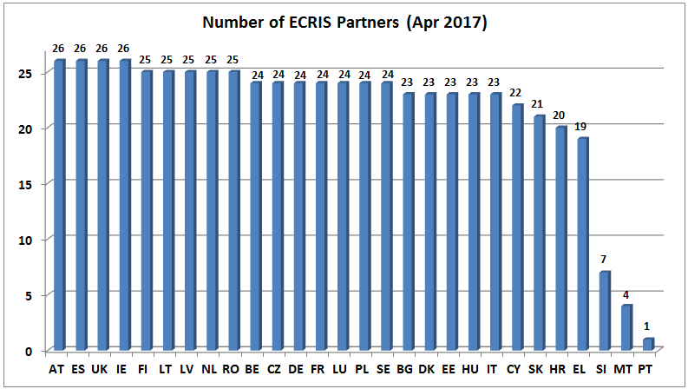
The ECRIS system started off with 173 interconnections in 2012 - out of 756 possible interconnections (with 28 MS live). At the end of 2016, the fifth year of operation of the system, 575 interconnections were established, representing 76% of the total number of possible interconnections and 88% of the operational interconnections (with SI and PT still not connected to ECRIS at that time). For the evolution of the number of interconnections over the years - see the Annex, section 1.1.
In 2017, four Member States (AT, ES, UK and IE) have reached the highest number of operational interconnections (26).
The ultimate goal - that each Member State is connected to and exchanges information through ECRIS with all the other Member States – is therefore yet to be achieved.
3.2. Total number of messages exchanged
The graph below illustrates the rapidly growing yearly volume of messages exchanged between the connected Member States since the ECRIS "go live" in April 2012 until 31 December 2016. When analysing the data concerning the year 2012, it needs to be borne in mind that there were only 8 months of activity in that year.
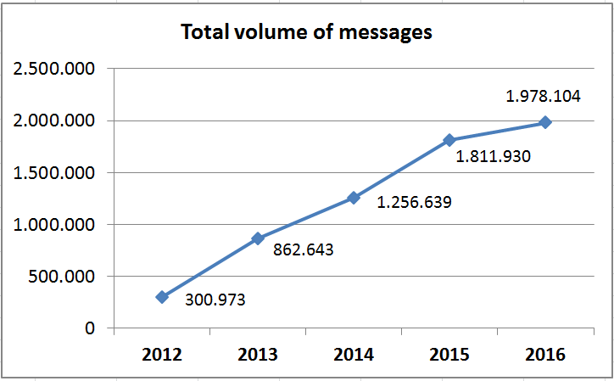
From the 300.000 messages exchanged by all interconnected Member States by the end of 2012, the number reached nearly 2 million in 2016 with an average of 165.000 messages per month. All types of messages are included in these volumes: notifications, updates, requests, replies, denials, other replies, exchanges of additional information, etc.
The graph below presents the trend of notifications, requests and replies to requests over the five years of ECRIS operation. Only notifications on new convictions were taken into consideration here, without updates. Replies include request replies, request denials and other replies.
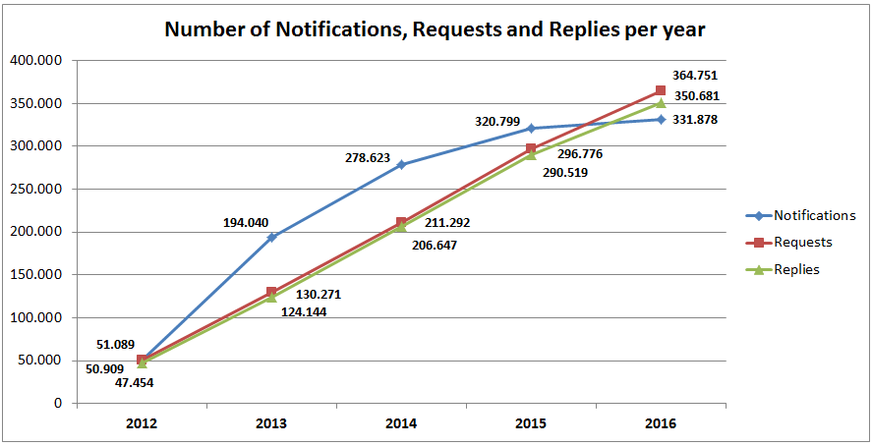
Currently, the notifications, requests and replies to requests roughly amount to 350.000 per year in each category.
Since 2014, with 25 Member States interconnected, the number of notifications on new convictions has been stabilising gradually, after an initial significant growth correlated with the joining of new Member States to the network and creating more interconnections. This number is expected to still increase, independent of the conviction rate, as the interconnections reach 100%.
In contrast, the number of requests for information and the related replies to requests, is increasing rapidly. This is a positive sign of rising awareness in the Member States of the need to use ECRIS to request information in the course of criminal proceedings in order to be able to take account of previous convictions, in line with Framework Decision 2008/675/JHA. Also, the increasing number of requests for information for other purposes than criminal proceedings (e.g. employment, especially for positions involving regular contact with children in line with the Directive 2011/93/EU) contributes to this positive trend.
3.3. Number of notifications, requests and replies per Member State
The graph below illustrates the number of sent notifications on new convictions, sent requests for information and sent replies for all interconnected Member States in 2016. For the years 2014 and 2015 - see the Annex, section 1.2.
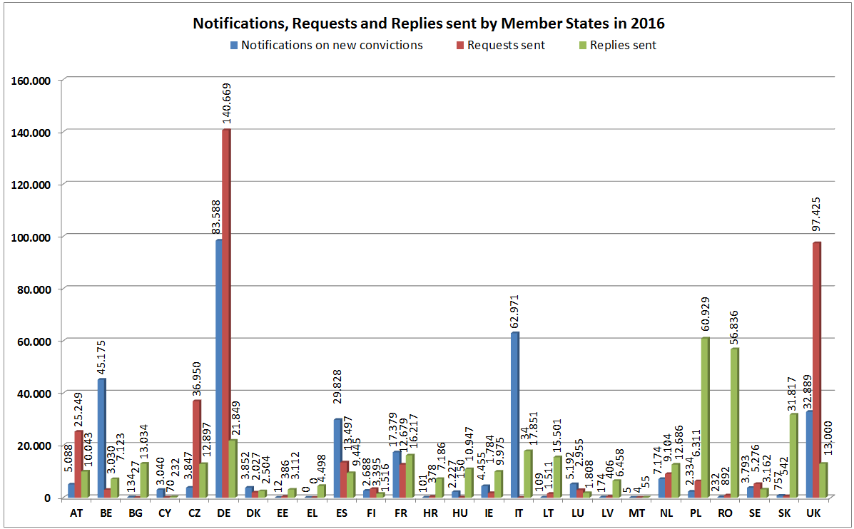
The most active Member States in terms of total volume of sending these three types of messages were:
- in 2016: DE (24.9%), followed by UK (13.7%), IT (7.7%), PL (6.6%) and RO (5.5%).
- in 2015: DE (25.6%), followed by UK (14.7%), IT (9.1%), PL (7.0%) and RO (5.6%).
- in 2014: DE (28.7%), followed by IT (10.9%), UK (9.7%), FR (8.3%) and PL (6.8%).
The figures demonstrate significant differences between the Member States' ECRIS activities and workload.
Some Member State request information considerably more times than they are requested to provide information: DE, UK, AT, and in 2016 also CZ. Others are confronted mostly with a significant workload of replying to requests, while they send fewer requests themselves: PL, RO, SK, LT, IT, BG, LV, HU, HR, IE, EL, EE. The workload for some other Member States is produced mostly by sending high volumes of notifications on new convictions to the Member States of the offender's nationality, while they send fewer requests themselves: IT, BE, ES, FR, CY.
3.4. Notifications
The graph below presents the volume of notifications issued by all interconnected Member States in 2016, broken down by notifications on new convictions and notifications updating previously sent notifications. For the years 2014 and 2015 - see the Annex, section 1.3.
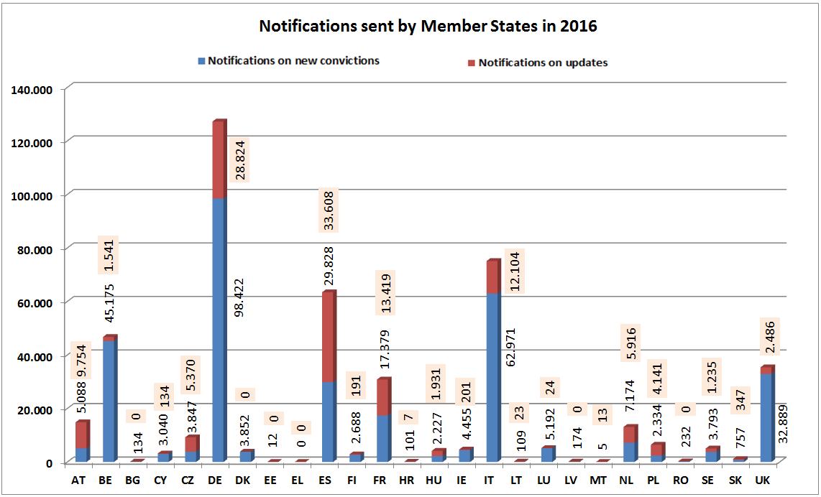
The volume of notifications sent varies considerably among the Member States, from nearly 100.000 (DE) to zero notifications on new convictions (EL) per year. There are mainly two factors to be taken into account in the analysis of these variations: the size of the country and the number of convictions of nationals of other Member States (further: EU non-national population). For detailed analysis of individual Member State statistics, please see the Annex, section 2.
The most active Member States in terms of sending notifications on new convictions were:
- in 2016: DE (29.7%), followed by IT (19.0%) , BE (13.6%), UK (9.9%), ES (9.0%) and FR (5.2%)
- in 2015: DE (28.7%), followed by IT (19.8%), BE (12.5%), UK (11.4%), FR (6.3%) and ES (5.9%)
- in 2014: DE (30.0%), followed by IT (20.8%), FR (11.2%), BE (8.4%), UK (7.9%) and ES (5.8%).
Taking into consideration all sent notifications, including updates, the above classification will look quite similar, however with ES advancing to the third position in 2016 and fourth position in 2014 and 2015.
Sent notifications on new convictions and notifications on updates accounted respectively for 73,2% to 26.8% on avarage in 2016. For the years 2014 and 2015 – see the Annex, section 1.3. This proportion differs significantly among the Member States, from updates being twice as high as notifications (e.g. AT, PL), through almost equal amounts for both of these categories of messages (e.g. ES, NL) to updates constituting a tiny part of all notifications (e.g. BE, UK). For DE, which sends the highest number of all notifications, the updates amount to about 22% of all its notifications sent.
Two problems were identified here on the basis of the detailed analysis of the statistical data.
Firstly, some Member States do not send notifications on new convictions at all (EL) or send a very low volume of such notifications in relation to their EU non-national population (BG, EE, HR, LT, LV, MT, RO in 2016; BG, EE, LV, HR, LT in 2015; BG, EE, HR, LT, LV, RO, SK in 2014). As a result, these non-notified convictions were not registered in the Member State(s) of nationality, and offenders might be able to escape the consequences of their criminal past.
Secondly, some Member States do not send updates on their previously sent notifications at all (BG, DK, EE, EL, LV, RO in 2016; BG, DK, FI, EL in 2015; DK, EE, FI, EL, HR, RO in 2014) or send a low volume of such messages (HR, LT, LU in 2016; EE, HR, LT, LU, LV, RO in 2015; BG, HU, IE, LT, LU, LV, SK in 2014). Failure to send updates by the convicting Member State results in the processing of not updated, unrealiable information by the Member State of nationality, including its dissemination.
3.5. Requests for information
The graph below compares the volume of requests for information sent by all interconnected Member States in 2016 with the volume of replies received to these requests. For the years 2014 and 2015 - see the Annex, section 1.4.
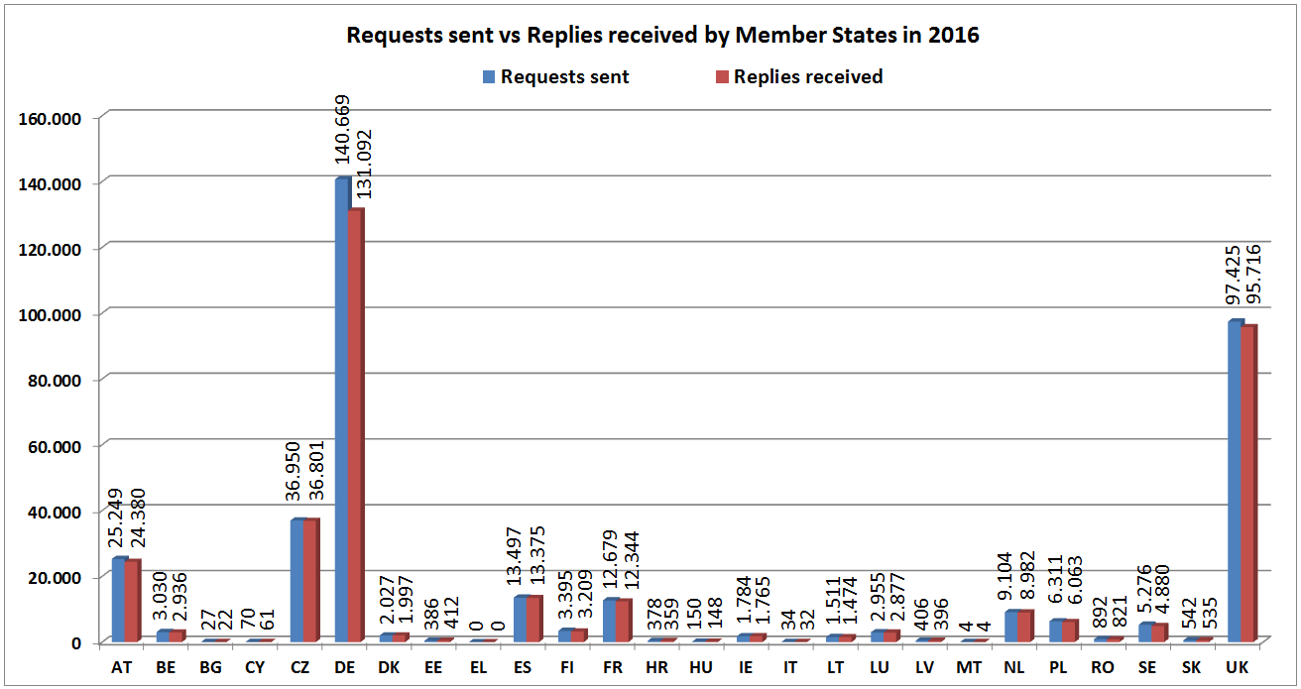
The volume of issued requests for information varies considerably among Member States, from 140.000 (DE) to zero requests (EL) per year. The main factor to be taken into account in the analysis of these variations is the number of nationals of other Member States residing in a given Member State.
The most active Member States in terms of issued requests were:
- in 2016: DE (38.6%), followed by UK (26.7%), CZ (10.1%), AT (6.9%), ES (3.7%) and FR (3.5%)
- in 2015: DE (40.0%), followed by UK (29.4%), AT (8.2%), FR (4.5%), ES (4.0%) and CZ (3.3%)
- in 2014: DE (45.3%), followed by UK (18.7%), AT (13.7%), FR (7.6%), CZ (4.1%) and NL (2.8%)
Some Member States do not send requests at all (EL) or send a low number of requests in relation to their EU non-national population (BG, CY, HU, IT, MT, EE, HR, LV, RO, SK in 2016; BG, HU, IT, EE, HR, LV, RO, CY, SK in 2015; BG, EE, HR, HU, IT, LV, CY, SK in 2014). This leads to the situation where criminal courts might pass judgements without knowledge of convictions handed down in other Member States, contrary to the requirements set out in Framework Decision 2008/675/JHA on taking account of previous convictions in the course of new criminal proceedings. In addition, the preventive effect of requesting criminal records certificates for other purposes than criminal proceedings, such as employment, will be diminished.
It can be also concluded from the above data that not all requests for information are responded to. In most of the cases, the number of received replies is slightly lower than the number of sent requests, with an average difference of around 3,9% in 2016. In case of the Member States most active in sending requests, 7% of DE requests (9.577), 4% of AT requests (869) and 2% of UK requests (1.709) in 2016 were never responded to.
3.6. Replies to requests
The graph below illustrates the volume of replies sent by all interconnected Member States in 2016 in comparison to the volume of corresponding requests for information received by them. For the years 2014 and 2015 - see the Annex, section 1.5.
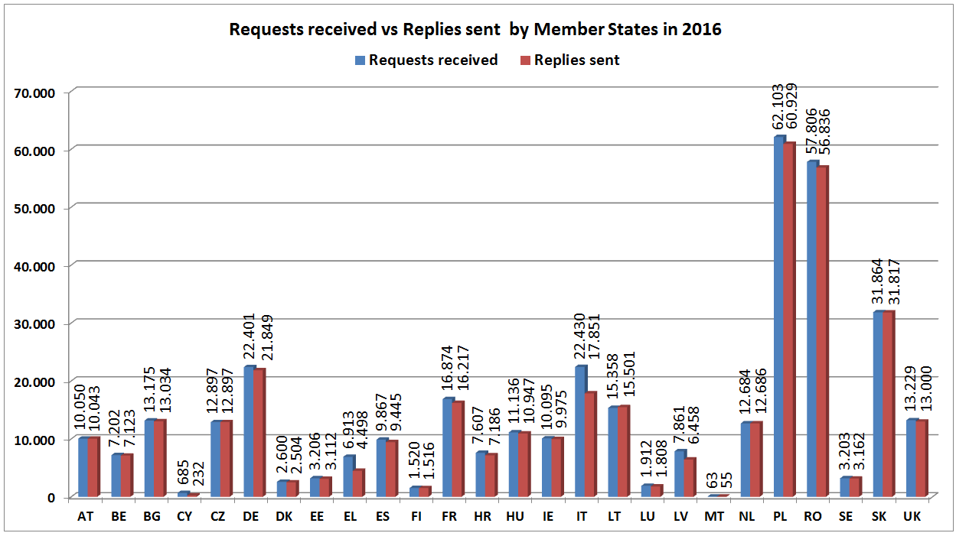
The volume of requests received and sent replies corresponding to them varies significantly among the Member States, from 62.000 (PL) to 63 requests (MT) per year. There are mainly two factors to be taken into account in the analysis of these variations: the overall population per Member State, and the number of its nationals residing in other Member States. For a detailed analysis of individual Member State statistics, please see the Annex, section 2.
The Member States which received the highest amount of requests for information, and, as a consequence, which responded to the highest amount of requests in absolute terms (not necessarily the highest in proportion to what they received) were:
- in 2016: PL (17.4% of all replies), followed by RO (16.2%), SK (9.1%), DE (6.2%), IT (5.1%) and FR (4.6%)
- in 2015: PL (18.9%), followed by RO (17.9%), DE (7.5%), IT (6.5%), LT (5.2%) and FR (4.9%)
- in 2014: PL (20.0%), followed by RO (13.0%), DE (9.9%), IT (8.5%), FR (5.2%) and LT (5.0%)
While all Member States respond to requests in general, not all requests for information are responded to. In most of the cases, the number of sent replies is slightly lower than the number of received requests for information, with on average around 3.9% in 2016.
In case of the Member States which received the highest amount of requests in 2016, IT did not respond to 20.4% of requests received by them (5,579), FR to 3.9% (657), DE to 2.5% (552), PL to 1.9% (1,174), RO to 1.7% (970) and SK to 0.1% (47).
In 2016, the Member States with the highest percentage of requests not replied to were: CY (66.1% of the requests received by them), EL (34.9%), IT (20,4%) and LV (17.8%).
3.7. Replies not meeting legal deadlines
Another issue is that some requests are not replied to within the legal deadlines. The table below presents an overview for all Member States of the volumes of replies not meeting the legal deadlines in 2016.

In 2016, around 13.000 requests were not replied to within the legal deadline. This represents 3,6% of the total number of requests. The Member States having most problems to respect the deadlines were: EL (28,1% of requests with expired deadline to reply), FI (21,5%), EE (20,5%), RO (9,3%) and IT (5,28%). In terms of replies sent after the legal deadline, 27,33% of LT replies were sent after the deadline (4,198), 21,33% of IE replies (2,153), 19,56% of CY replies (134), 6,12% of RO replies (3,535) and 4,92% of PL replies (3,056).
3.8. Requests for criminal proceedings and other purposes
The graphs below represent the proportion between the requests for criminal proceedings and for other purposes than criminal proceedings – from 2012 until 2016.

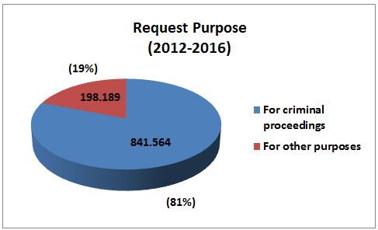

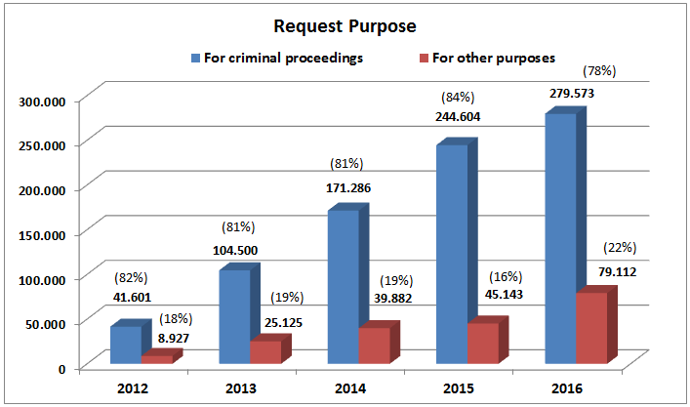
During the ECRIS operation period on average 81% of all requests were made for the purpose of criminal proceedings and 19 % for other purposes. The amount of requests for other purposes reached 79.000 in 2016.
In the years 2012- 2014 the percentage of requests for other purposes was stable. The increase up to 22% in 2016 was caused mainly by the increasing number of requests for the purposes of recruitment for professional or organised voluntary activities involving direct and regular contact with children, in implementation of Directive 2011/93/EU. Such requests represented nearly 8.000 requests in 2016 or 10% of all requests for other purposes. In comparison, the volume of these requests was negligible (7 requests) in 2012.
In 2016, most requests for other purposes than criminal proceedings were made by individual persons to obtain information on their own criminal records - 68% of all requests for other purposes and 15% of all requests made. The next highest number of requests related to requests from a competent administrative authority for non-criminal proceedings (14% of the requests for other purposes and 3,1% of all requests made), requests for recruitment in accordance with Directive 2011/93/EU (respectively: 9.9% and 2,2%) and requests for obtaining a permit to carry weapons (respectively: 3,5% and 0,8%).
Requests for the important purpose of obtaining a different nationality constituted only around 1,4% of all requests for other purposes and 0,3% of all requests.
For more details on the volumes of requests for various categories of purposes in the years 2014-2016 - see the Annex, section 1.6.
3.9. Requests concerning EU nationals and TCN
The graphs below represent the proportion between requests concerning EU nationals and TCN – per year and on average during the whole ECRIS operation period.

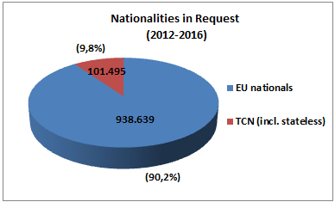
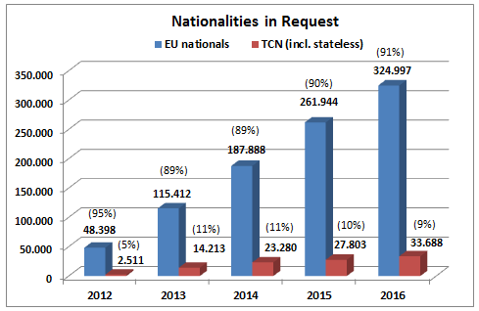

On average, 90% of all requests concern EU nationals and around 10% concern TCN. The share of requests for stateless persons is marginal (0,03%).
In the first year of ECRIS operation, the percentage of requests concerning TCN was very low (5%). In 2013 this percentage doubled and has since then remained steady. The number of requests for information on TCN reached over 33.000 in 2016.
Supplementing legislation proposed by the Commission together with this report will improve the ECRIS system with regard to TCN by introducing a dedicated centralised system allowing for efficient identification of the Member State(s) holding criminal records information on TCN. This measure is expected to lead to a considerable increase of requests on TCN.
3.10. Replies containing conviction information
In the graphs below information is given on the proportion of the replies to requests containing one or more convictions, replies with no convictions and other replies yearly, and on average during the ECRIS operation period.
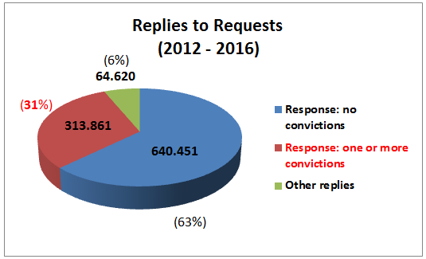
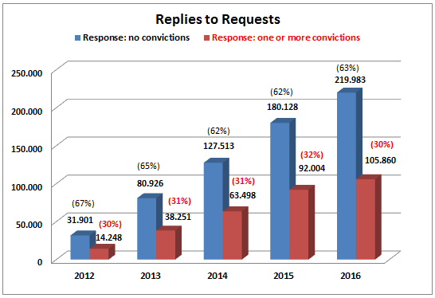
Since the first year of ECRIS operation, 31% of replies contained information on previous convictions. This means that in 31% of the cases the person concerned had been already convicted one or more times, proving the value of ECRIS as a tool for obtaining criminal records information. In 2016 this represented over 105.000 replies including conviction information. The replies with no conviction information constituted on average 63%, and other replies 6% over the last five years.

OJ L 93, 7.4.2009, p. 23.
OJ L 93, 7.4.2009, p. 33.
Art. 6(2) of Council Decision 2009/316/JHA foresees adoption of implementing measures for ECRIS by the Council, in particular the establishment of logging systems and procedures making it possible to monitor the functioning of ECRIS and the establishment of non-personal statistics relating to the exchange through ECRIS of information extracted from criminal records.
Report from the Commission to the European Parliament and the Council on the implementation of Council Framework Decision 2009/315/JHA of 26 February 2009 on the organisation and content of the exchange of information extracted from criminal record between Member States, COM (2016) 6 final.
COM(2017)344 final
Directive 2011/93/EU of the European Parliament and of the Council of 13 December 2011 on combating the sexual abuse and sexual exploitation of children and child pornography, and replacing Council Framework Decision 2004/68/JHA, OJ L 335, 17.12.2011, p. 1.
See Eurostat-statistics: http://ec.europa.eu/eurostat/statistics-explained/index.php/File:Non- national_population_by_group_of_citizenship,_1_January_2016_(%C2%B9).png
Council Framework Decision 2008/675/JHA on taking account of convictions in the Member States of European Union in the course of new criminal proceedings, OJ L 220, 15.8.2008, p. 32.
Other replies are for example replies with multiple persons found, with a person not being a national of the requested Member State, etc.
For the comparative table with the most active Member States in terms of volume of sending notifications, requests and replies (separately per category) – see the Annex, section 1.2.
See also a table in the Annex, section 1.7.
See footnote 9. See also the table in the Annex, section 1.8.

