1. ECRIS exchanges in numbers
1.1. Connected Member States
The table hereunder shows the history of the Member States' connection to the ECRIS network.
Month | Year | Live MS | # MS
2012
Apr | 2012 | AT CZ DE DK EE ES FR UK EL IE LT LV NL PL RO | 15
May | 2012 | FI | 16
Jun | 2012 | SK | 17
Jul | 2012 | BE and BG | 19
Oct | 2012 | HU | 20
2013
Feb | 2013 | IT | 21
Mar | 2013 | CY | 22
Jul | 2013 | HR | 23
Aug | 2013 | LU | 24
Sep | 2013 | SE | 25
2014
Apr | 2014 | SI (test only) | 25
2016
Feb | 2016 | MT | 26
2017
Jan | 2017 | SI and PT | 28

The graph below illustrates the evolution of the number of interconnections over the five years of ECRIS operation. The total possible number of interconnections is 756 (27*28).

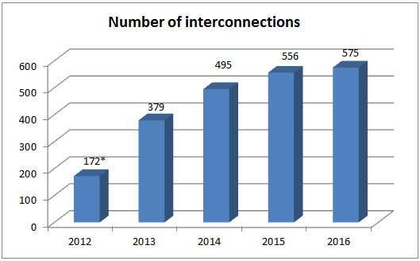
*only 8 months of ECRIS activity in 2012

The table below shows the evolution of the number of interconnections for each Member State over the years, with indication of the percentage of all possible interconnections (with 28 Member States live) and of the operational ones (with Member States interconnected at that time).

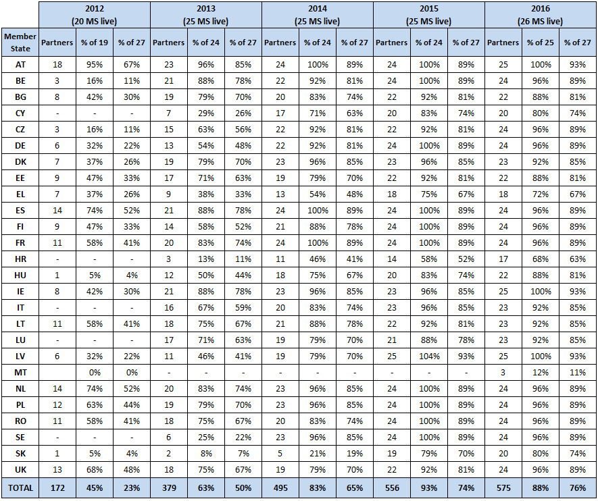

1.2. Number of notifications, requests and replies per Member State
The graphs below illustrate the volumes of notifications on new convictions sent, the requests for information sent and the replies sent for the interconnected Member States in 2014 and 2015.
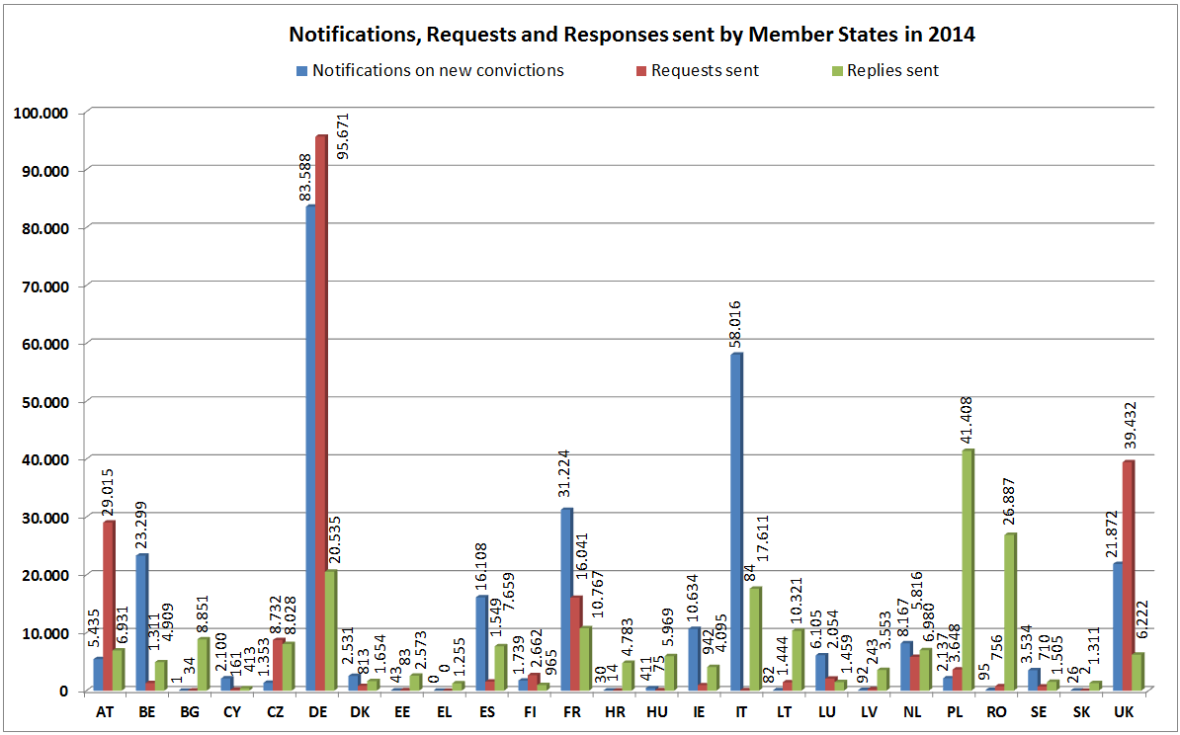

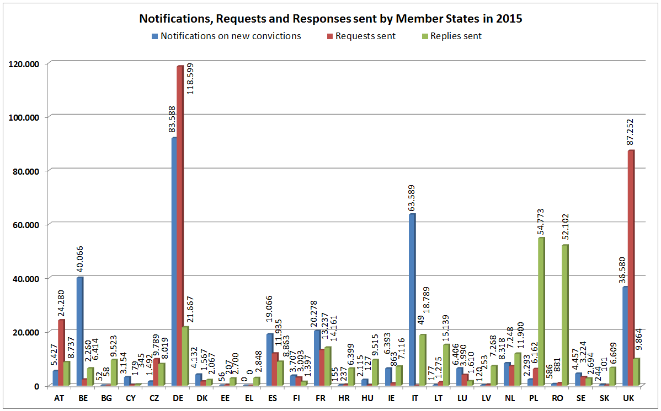

The table below gives an overview of the most active Member States in terms of volume of notifications on new convictions sent, requests and replies to requests, all together and per each category of messages - in the years 2014-2016.

2014 | 2015 | 2016
Most active Member States in terms of total volume of notifications, requests and replies sent
DE - 28,7% | DE - 25,6% | DE - 24,9%
IT - 10,9% | UK - 14,7% | UK - 13,7%
UK - 9,7% | IT - 9,1% | IT - 7,7%
FR - 8,3% | PL - 7,0% | PL - 6,6%
PL - 6,8% | RO - 5,6% | RO - 5,5%
Most active Member States in terms of notifications sent on new convictions
DE - 30,0% | DE - 28,7% | DE - 29,7%
IT - 20,8% | IT - 19,8% | IT - 19,0%
FR - 11,2% | BE - 12,5% | BE - 13,6%
BE - 8,4% | UK - 11,4% | UK - 9,9%
UK - 7,9% | FR - 6,3% | ES - 9,0%
Most active Member States in terms of issued requests
DE - 45,3% | DE - 40,0% | DE - 38,6%
UK - 18,7% | UK - 29,4% | UK - 26,7%
AT - 13,7% | AT - 8,2% | CZ - 10,1%
FR - 7,6% | FR - 4,5% | AT - 6,9%
CZ - 4,1% | ES - 4,0% | ES - 3,7%
Most active Member States in terms of amount of replies sent
PL - 20,0% | PL - 18,9% | PL - 17,4%
RO - 13,0% | RO - 17,9% | RO - 16,2%
DE - 9,9% | DE - 7,5% | SK - 9,1%
IT - 8,5% | IT - 6,5% | DE - 6,2%
FR - 5,2% | LT - 5,2% | IT - 5,1%

1.3. Notifications
The graphs below present the volume of notifications issued by the interconnected Member States in 2014 and 2015 sorted by new convictions and updates on previously sent notifications.
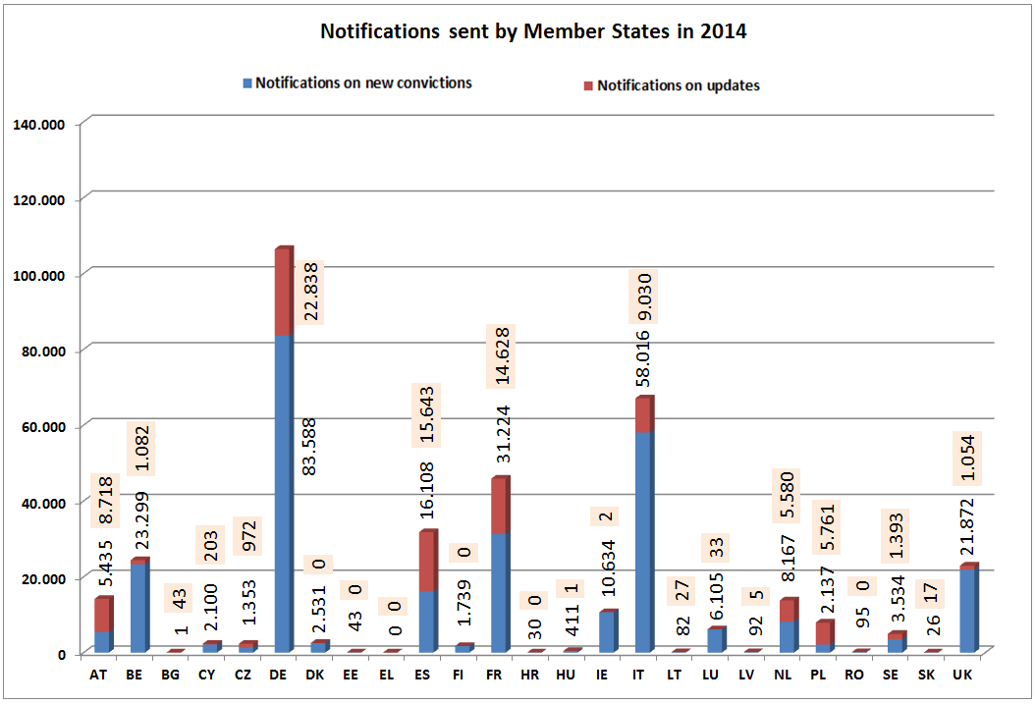

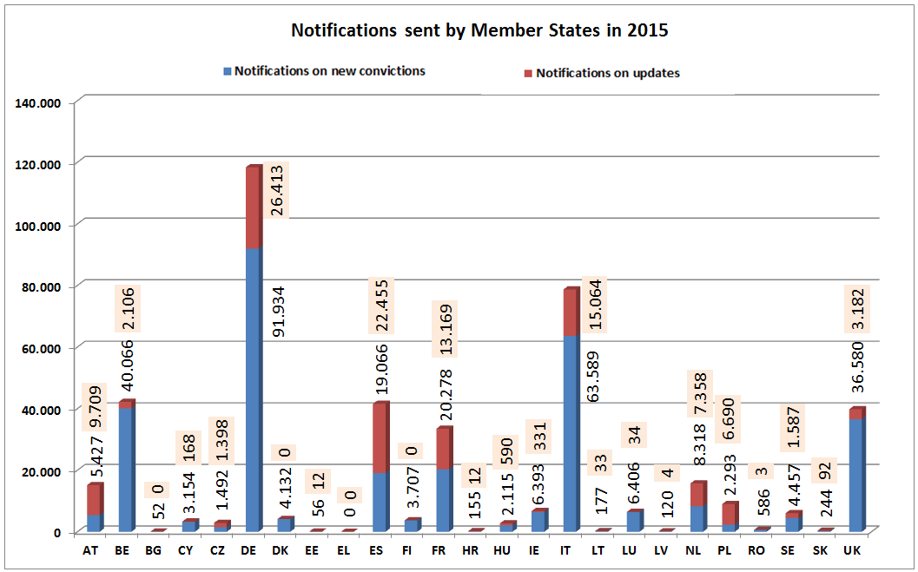

The table below presents the proportion of sent notifications on new convictions and updates during the whole ECRIS operation period.
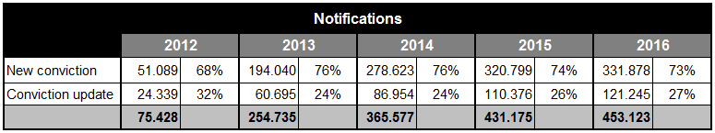
*only 8 months of ECRIS activity in 2012

1.4. Requests for information
The graphs below compare the volume of requests for information sent by all interconnected Member States in 2014 and 2015 to the volume of received replies to these requests.
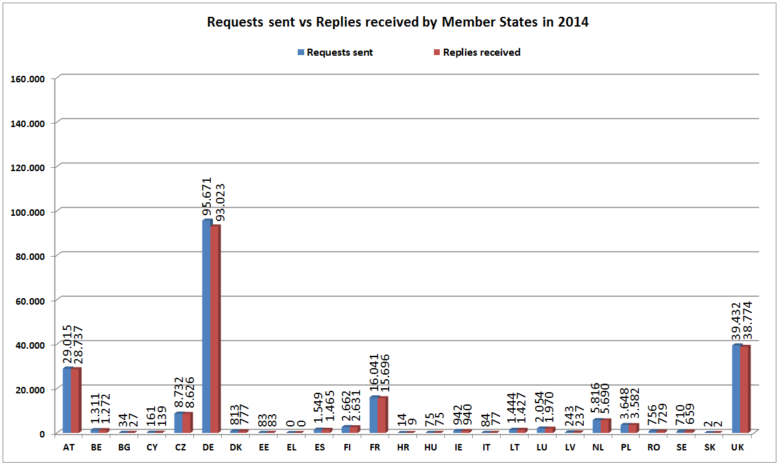

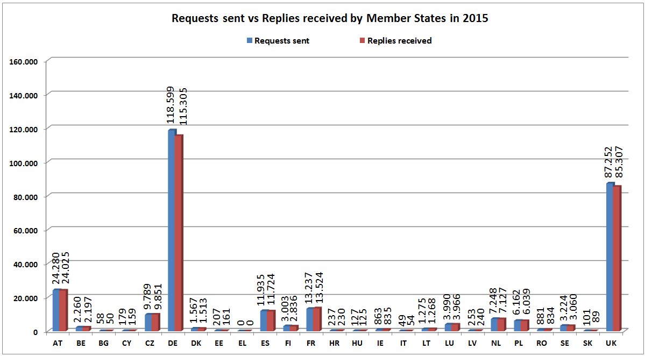

1.5. Replies to requests
The graphs below illustrate the volume of replies sent by all interconnected Member States in 2014 and 2015 in comparison with the volume of corresponding requests for information received by them.
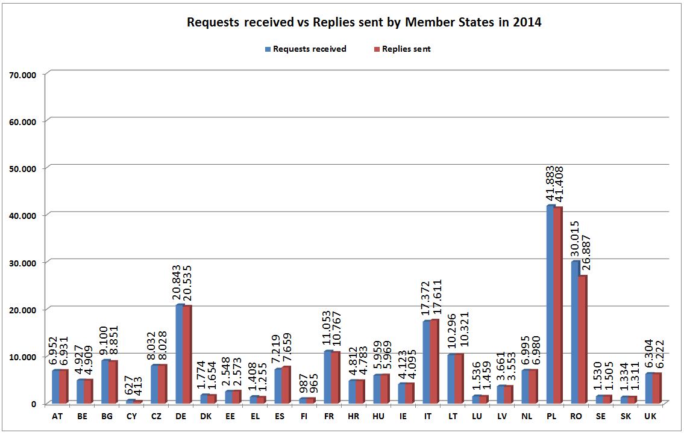
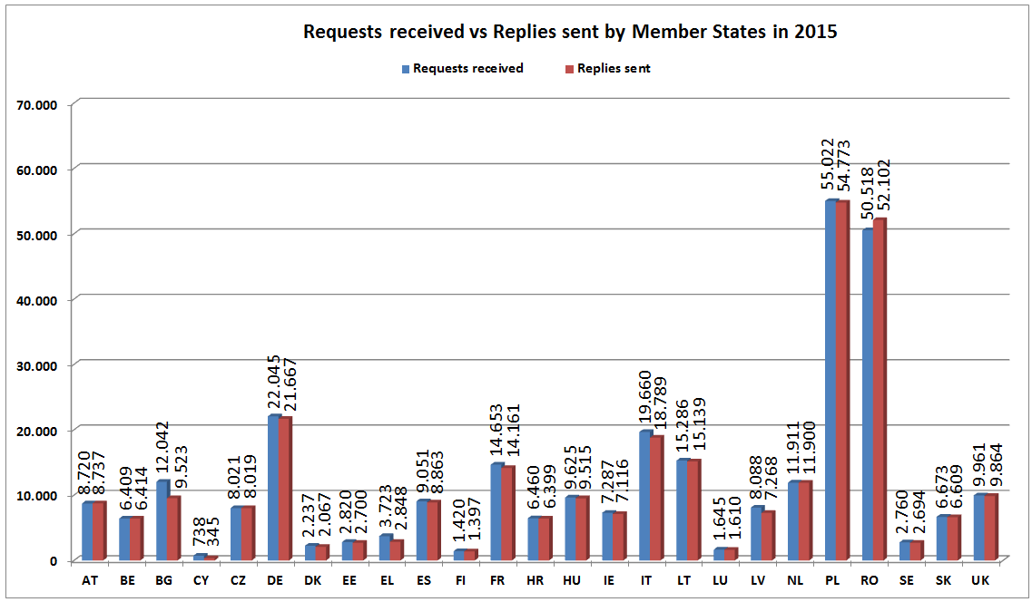

1.6. Requests for criminal proceedings and other purposes
The table below presents the proportion between number of requests for criminal proceedings and number of requests for other purposes than criminal proceedings sent per year during the whole ECRIS operation period.
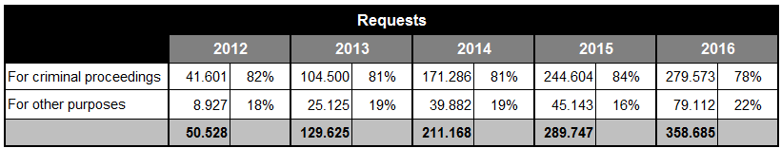

The table below details the volumes of requests per type of purpose for the requests sent for criminal proceedings and for other purposes than criminal proceedings.
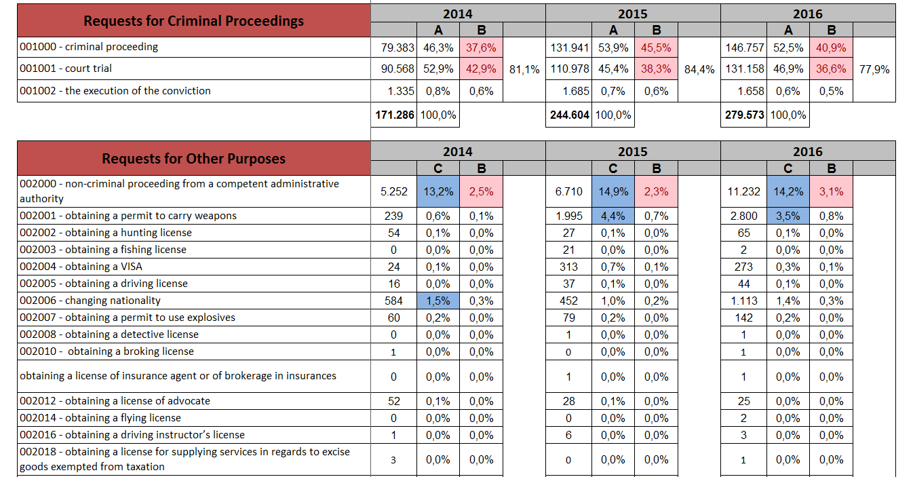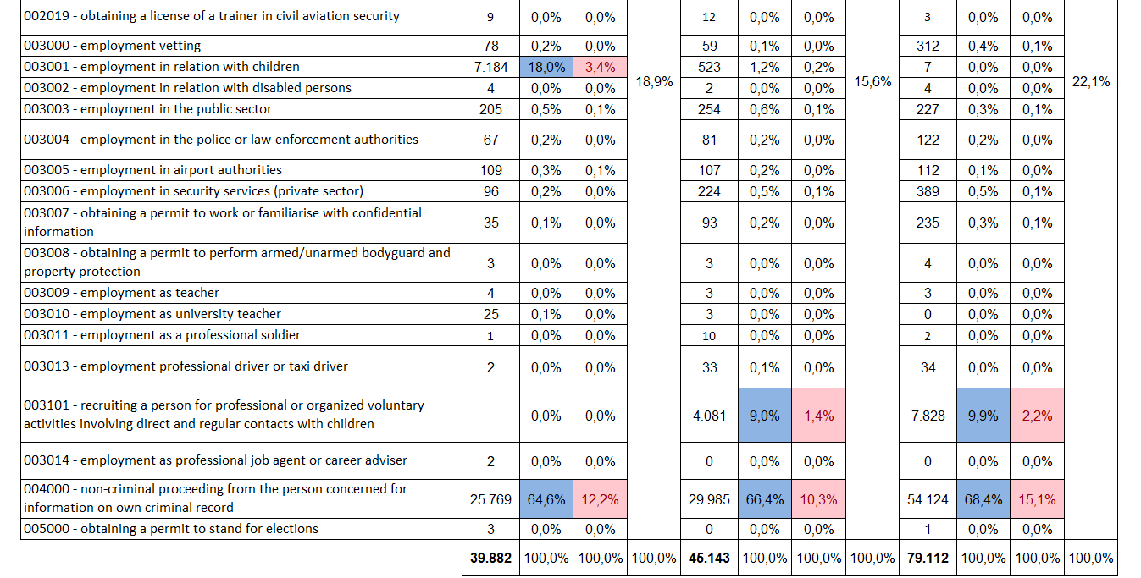
* The columns marked with A give percentage of certain type of requests out of the requests for the purpose of criminal proceedings. The columns marked with B give percentage of certain type of requests out of all requests issued. The columns marked with C give percentage of certain type of requests out of the requests for other purposes than criminal proceedings.

1.7. Requests concerning EU nationals and TCN
The table below represents the proportion of requests concerning EU nationals, Third Country Nationals and Stateless persons respectively per year during the whole ECRIS operation period.
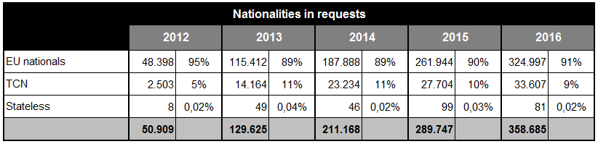

1.8. Replies containing conviction information
The table below shows the proportions of different types of replies sent per year during the ECRIS operation period.
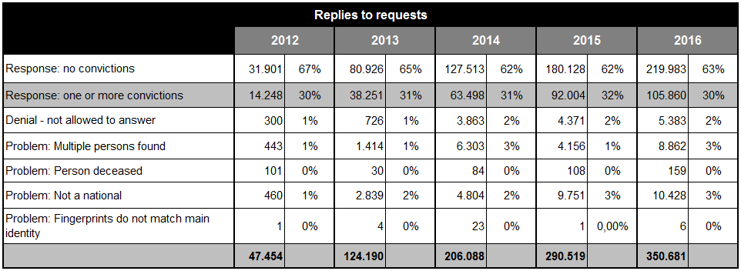

2. Individual Member States statistics
The tables below present, for each Member State, the number of convictions of nationals of other Member States (EU non-nationals) handed down on its territory versus the number of sent notifications; the number of sent requests; as well as the number of received requests versus the number of sent replies in the years 2014- 2016.
Portugal and Slovenia were not connected to ECRIS by the end of 2016, so there are no tables for these two Member States. The tables for Bulgaria, Cyprus and Denmark do not contain conviction data as these Member States have not provided the Commission with such data. For France the statistics for 2016 were not available yet.
The information on convictions of EU non-nationals is vital for evaluation whether all their convictions have been notified to the respective Member States of nationality.
In many Member States the volume of notifications on new convictions exceeds the volume of convictions of nationals of other Member States. At request, the concerned Member States informed the Commission about incorrect classification of updates as notifications on new convictions. In some cases, this disproportion was caused by sending a large backlog of old notifications in a certain year. The Netherlands sent data including not only convictions as defined in the Framework Decision 2009/315/JHA, but also other types of decisions in criminal proceedings registered in its criminal records. The conviction data communicated by these Member States cannot therefore serve for the purpose of analysis of the relation between the convictions and notifications.
