

Reflection Paper on the Future of EU finances

# 1. FINANCING EUROPEAN INTEGRATION: THE EVOLUTION OF EU FINANCES

**The EU budget helps to deliver on the things that matter for Europeans**. By pooling resources at European level, Member States can achieve more than they could by acting alone. Together with national budgets and a wide array of legislative and regulatory instruments, the EU budget supports shared objectives and helps to tackle common challenges.

From the first major common policy – agriculture – in the 1960s until today, the EU budget has changed progressively and in parallel with the building of the European Union.

In the 1980s and 1990s, Member States and the European Parliament broadened the scope of EU competences through changes in the Union's founding Treaties. Recognising the need to support the new Single Market, they increased the resources available under the structural funds to support economic, social and territorial cohesion. In parallel, the EU enhanced its role in areas such as transport, space, health, education and culture, consumer protection, environment, research, justice cooperation and foreign policy.

Areas financed by the EU budget (2014-2020)

In billion Euro

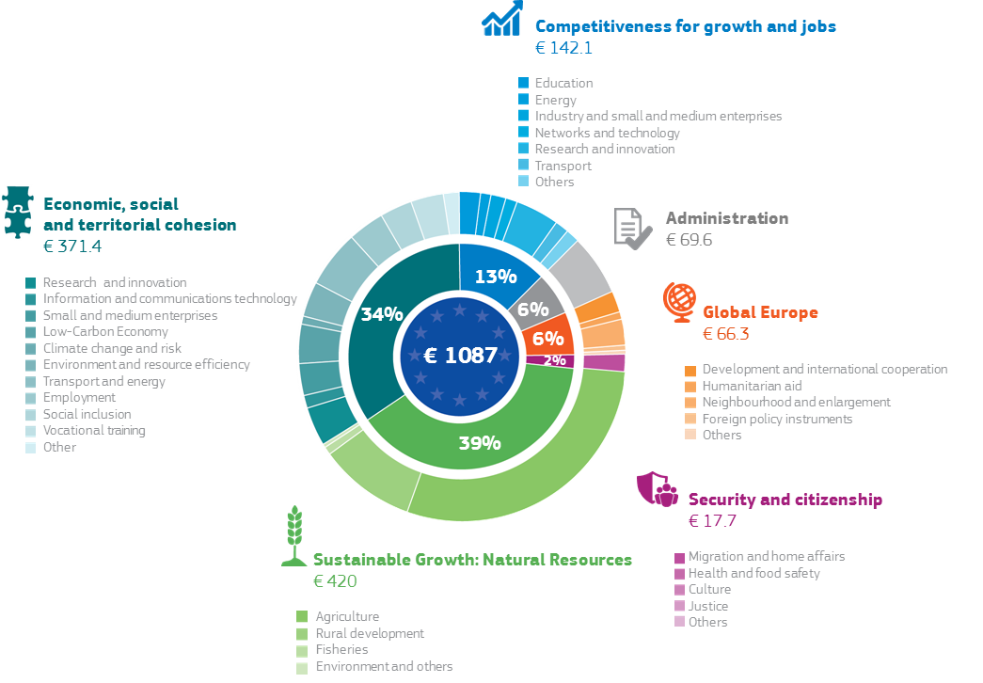

Note: Commitments; adjusted for 2018

Source: European Commission

Since 2000, the EU budget has been shaped by the arrival of 13 new Member States with diverse socioeconomic situations and by successive EU strategies to support jobs and growth. It has also accompanied the growing role of the Union in the international arena, as a leader in the fight against climate change and as the largest donor of humanitarian and development aid in the world.

Nevertheless, the EU budget has remained a small part of total public expenditure in the EU, accounting for less than 1% of EU income and only around 2% of EU public expenditure. This share has declined over time.

The EU budget compared to overall EU income and public spending

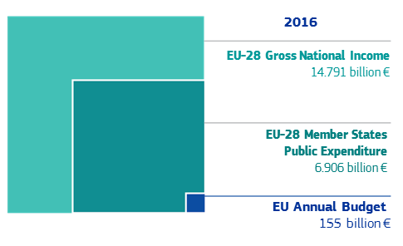

Source: European Commission

The size of the EU budget as percentage of gross national income

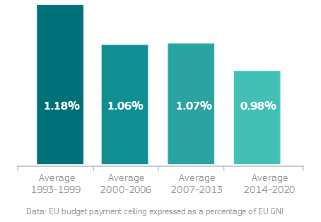

Source: European Commission

This decline has put increased pressure on the EU budget to be more efficient, to focus on the areas where its impact is greatest and to ensure that burdensome rules and procedures do not get in the way of results.

Over time, the composition of the EU budget has evolved. While the share of agricultural and cohesion spending has declined over time, combined it remains above 70% of the total. Spending has increasingly focused on areas such as research, Trans-European networks, and external action, and on programmes directly managed at European level.

Evolution of main policy areas in the EU budget

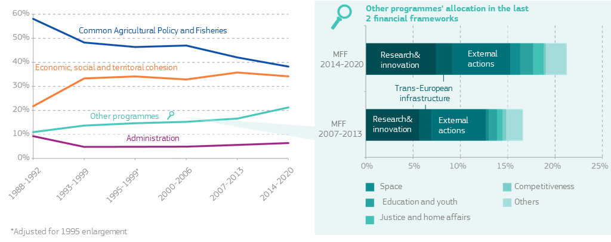

Source: European Commission

During the economic and financial crisis, the EU budget proved to be a powerful instrument to support investment. With national budgets in many Member States under severe strain, the EU budget and cohesion policy in particular emerged since 2008 as a major source of stable growth-supporting investment. In some Member States they even proved to be the main such source. The European Fund for Strategic Investments has also played a major role in catalysing private investments throughout Europe. This has shown how the EU budget can rapidly respond to emerging challenges and create substantial leverage[1].

Share of European Structural and Investment Funds in public investment 2015-2017

In %

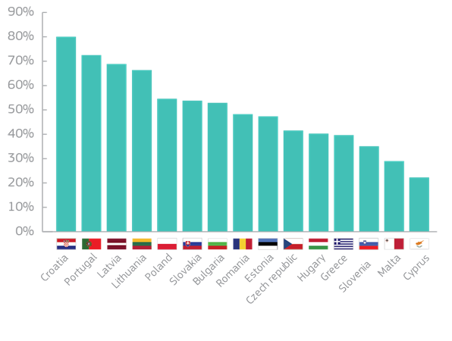

Source: European Commission

The EU budget has also underpinned the European response to the refugee crisis and to the threat of organised crime and terrorism. The funding devoted to security and migration was doubled to support for example the new European Border and Coast Guard and to help Member States receiving a significant inflow of refugees. Responding to these crises has tested the flexibility of the budget to the limit.

Looking ahead, the challenges to the Union are multiplying at the same time as the pressure on European and national budgets increases. Sluggish productivity and investment, demographic change and other long-term challenges such as migration, climate change, defence, cybersecurity and terrorism, are all areas where the EU budget is called upon to play a prominent role.

It is also time to look at the way in which the EU budget is financed. Just as the spending side of the budget has evolved, so too has the way in which the EU budget is financed. Unlike national budgets the Union is not able to borrow. Instead it relies on financing through 'own resources'. There are three main types of own resources today: contributions from Member States based on their income level measured by Gross National Income (GNI), contributions based on Value Added Tax (VAT), and customs duties collected at the external borders of the Union.

About 80% of the EU budget is financed from national contributions based on GNI and VAT. GNI contributions are generally considered as fair, because they are a good reflection of Member States’ relative "ability to pay". Custom revenues are considered to be genuine own resources as they are derived from the common trade policy whose revenue accrue to the EU budget.

The sources of financing of the EU budget

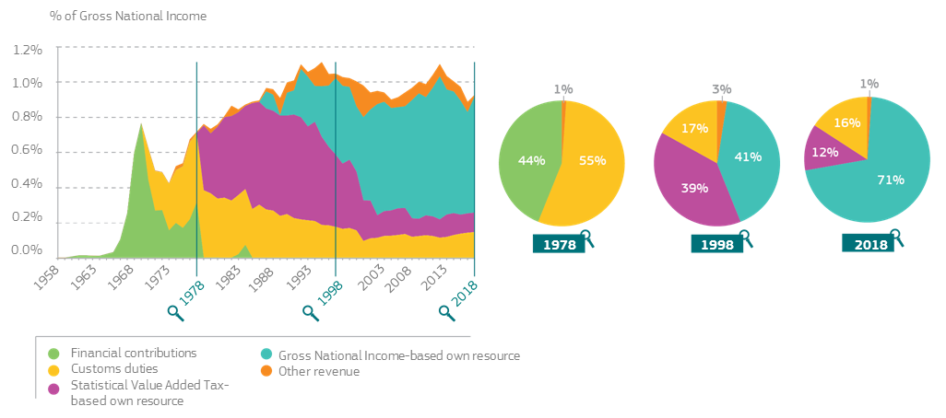

Source: European Commission

However, a number of adjustments and "rebates" have been introduced over time because some Member States considered their contributions to the EU budget to be excessive compared to what they get back from it. This has made the EU’s current financing system increasingly complex and opaque.

This system, mostly based on contributions from Member States, has also reinforced a false perception that the value of the EU budget to a Member State can be measured by the net balance of contributions made and funds received. This ignores the essence of a modernised EU budget: the value added that results from pooling resources and delivering results that uncoordinated national spending cannot. These broader economic gains are all too often ignored, as is the wider value of belonging to the largest economic area and trading power in the world.

If we want to improve the effectiveness of the EU budget, we should also look at how the revenues can contribute to EU priorities. The departure of the United Kingdom and the elimination of the associated rebates would already remove some obstacles to reform on the revenue side of the EU budget.

Finally, in order to respond to the different needs, the EU budget has been complemented by a number of new tools, institutions and instruments. Some of them are outside the EU budget and are not governed by the same rules. Additional funding is provided by the European Investment Bank or other bodies based on inter-governmental agreements, like the European Development Fund linked to the special partnership with Africa Caribbean Pacific countries. More recently, European Union Trust Funds and other facilities have been created to pool money from the EU budget, Member States and other donors to address external crises. This extended financial architecture has allowed the Union to mobilise additional funding but it has added to the complexity of EU finances. The chart below provides a broad illustration of all elements of EU financing beyond the EU budget itself. It also shows which elements fall under the democratic control of the European Parliament as well as the scrutiny of the European Court of Auditors.

EU finances: the whole picture

purely illustrative, the size of the circles does not correspond to actual volumes

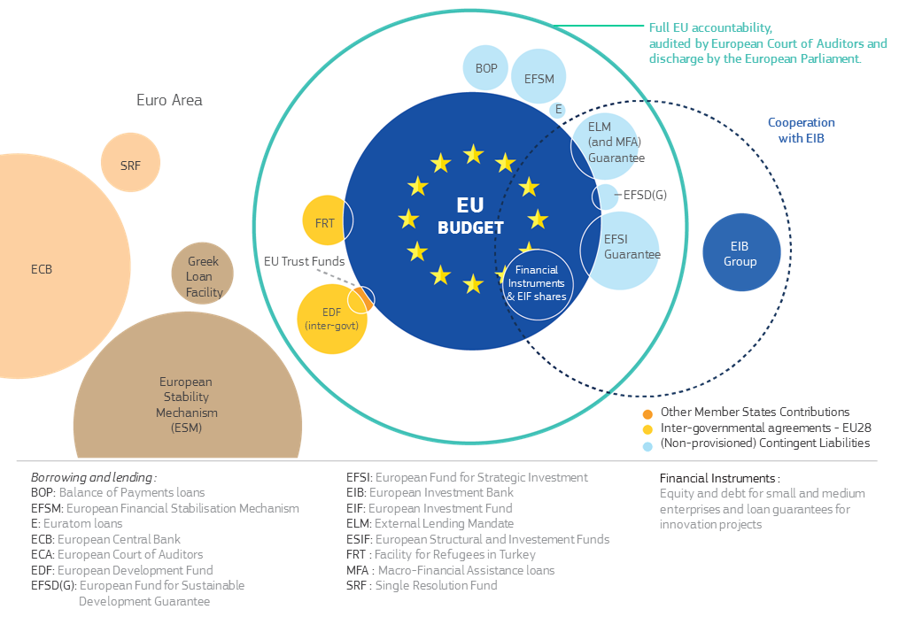

Source: European Commission

|  |
| --- |
| Box 1: The EU budget in a nutshell – for the period 2014-20   * represents around 1% of EU GNI, and 2% of total public spending; * is framed by Multiannual Financial Frameworks (MFF) of at least 5 years. The current framework (2014-2020) provides EUR 1087 billion; * is mostly funded by contributions from each Member State based on their relative income, together with customs duties collected at the external borders and a small part based on value added tax. There is no EU tax. The revenue system is agreed by all Member States and ratified by national Parliaments; * mobilises via cohesion policy EU-wide more than EUR 480 billion in investments, which should result, for example, in over 1 million enterprises receiving support, 42 million citizens having access to improved health services, 25 million will benefit from flood and fire prevention, nearly 17 million additional EU citizens connected to waste water facilities, 15 million additional households with broadband access, and more than 420,000 new jobs. Also 5 million Europeans will benefit from training and life-long learning programmes, and 6.6 million children will have access to new, modern schools and childcare. * is expected to trigger investments worth at least EUR 500 billion via the extended “Juncker Plan” (European Fund for Strategic Investments); * provides more than EUR 74 billion for the Horizon 2020 research and innovation programme that led – so far – in the past to 6 Nobel prizes, 4 Fields medals and discoveries with global impact (e.g. Ebola vaccine research, ground-breaking research on cancer and Alzheimer; aircraft with lower CO2 and noise emmisions); * provides over EUR 30 billion to support trans-European networks in the fields of transport, energy and communication via the Connecting Europe Facility; * supports a dynamic agricultural sector with around EUR 400 billion, supporting 7 million farmers; supports the modernisation of 380,000 farms with EUR 8.7 billion; rural development finances investments targeting biodiversity, improved energy efficiency, the setting up of businesses and the modernisation of production facilities; * finances the Galileo navigation system, which has to date launched 15 fully operational EU satellites into orbit; and Copernicus, Europe's earth observation programme; * mobilised more than EUR 17 billion between 2015 and 2017 to address the refugee crisis within and outside the EU; * finances the Erasmus programme promoting mobility of over 9 million people, especially students and youth across countries over the last 30 years; * provides more than EUR 8 billion to tackle youth unemployment via the Youth Employment Initiative and to date has supported 1.6 million young people; * aims at devoting 20% of total expenditure to actions against climate change; * provides around EUR 8 billion of humanitarian aid, making the EU a leadingdonor of humanitarian aid in the world. |

# 2. THE VALUE ADDED OF EUROPEAN FINANCES

The aim of the European Union is to promote peace, its values and the well-being of its peoples. The EU budget supports this, working together with national budgets and complementing other efforts at European and national level.

Any reflection about the future of the EU budget should therefore start with the most basic question of all – what should the EU budget be for? **European value** **added** must be at the core of that discussion. On the one hand, European value added is about achieving the objectives set out in the Treaty; on the other it is about a budget that provides for public goods of a European dimension or helps uphold our basic freedoms, the Single Market or the Economic and Monetary Union.

EU value added and funding from the EU budget

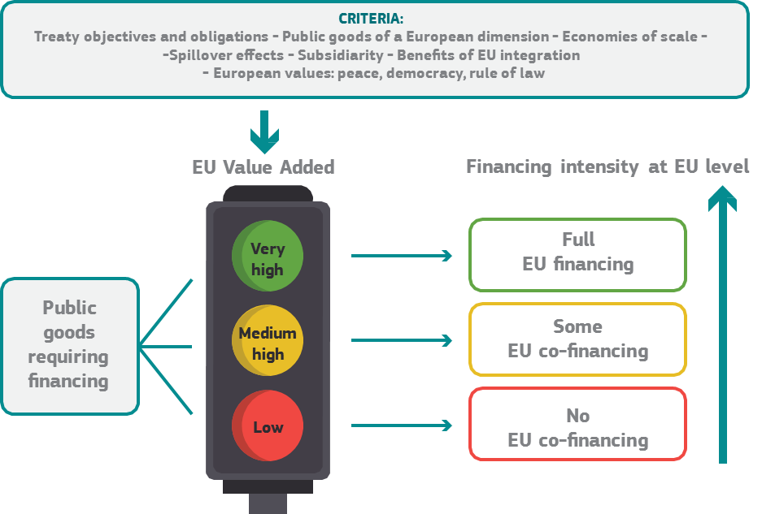

Source: European Commission

EU value added also fits with the principle of subsidiarity and proportionality. The EU should not take action unless it is more effective than action taken at national, regional or local level. EU action has to be additional or complementary to national or regional efforts, but should not fill in gaps left by shortcomings of national policies. Added value may also be in the form of avoided costs and indirect benefits.

The concerns and expectations of European citizens should be a major factor in shaping the new EU budget. In recent years, there have been increasing expectations on the Union to tackle challenges for which it has neither the powers, nor the financial resources. This expectation gap is central to this debate and is directly linked both to the size and the flexibility of the new budget.

European taxpayers expect a transparent EU budget that is easy to understand and gets the most back from every euro spent. The results achieved must be visible and measurable. Each policy and programme funded by the EU budget should spell out clearly what it intends to achieve, how it intends to go about it and report what the actual results have been. This would increase accountability and allow for an informed public discussion on how the EU budget is used. While some progress in this direction has already been made in the current financial framework, notably under cohesion policy, further steps are necessary across all instruments.

There is also a clear value added when action at European level goes further than national efforts could. This includes, for example:

* Cross-border programmes have transformed border areas helping to remove sources of conflict and create new economic opportunities.
* Similarly, transnational infrastructure, such as energy interconnectors (e.g. between Malta and Italy), digital networks, research infrastructure or tunnels (e.g. the Brenner Base railway tunnel in the Alps between Austria and Italy) benefit citizens and companies across the EU.
* Investments made under cohesion policy in one region or Member State contribute to macroeconomic stability and increases the growth potential of the Union as a whole.
* Similarly, control of the Southern or Eastern external borders clearly serves to protect the rest of Europe.
* Aid and investment in partner countries allows building more resilient societies.
* Open competition at EU level to fund science and innovation has increased excellence compared to national funding (eg. higher impact scientific publications, number and quality of patents) and attracted global talent.
* Other big projects and and key enabling technologies, such as Galileo, Copernicus, ITER[2] or high performance computing can only be financed by pooling resources at EU level because of their very high financing needs.

European finances can also provide value added in upholding common European values, such as democracy, freedom, the rule of law, fundamental rights, equality, solidarity, sustainability and peace. For instance, the Erasmus programme and the European Solidarity Corps promote mobility and allow students and workers to discover European cultures, learn new languages and skills and gain work experience abroad, and build bonds across Europe. The EU’s active role in its neighbourhood and beyond and in providing a perspective of EU membership have supported peace and projected stability. The cost of non-action in this area would be catastrophic if instability and war were to return to the region. Some achievements are more tangible and material than others, but all are equally important.

Finally, the value added of the EU budget also depends on its internal, strategic coherence. Duplications must be removed and instruments should complement each other and be consistent from a policy perspective.

# 3. TRENDS AND CHALLENGES

The White Paper on the Future of Europe and the previous recent reflection papers have shown that the EU at 27 will face a wide range of challenges in the period leading up to 2025 and beyond.

Among them are current trends that will remain relevant for decades to come, such as the digital revolution and globalisation, demographic change and social cohesion, economic convergence and climate change. At the same time, Europe's citizens are looking to the Union and national governments to deliver prosperity, stability and security in a fast-changing and uncertain world[3]. In a more volatile global environment, further unexpected challenges might emerge in the future.

If security, economic strength, sustainability, and solidarity should be the focal points of EU action in the face of these new challenges and ongoing trends, is the current EU budget equipped to respond? How does EU spending match up with these priorities? And what scope for improvement do we have?

## 3.1 Security and safety for the citizens of the Union

The instability of Europe's neighbourhood and new forms of terrorism pose significant challenges inside and outside our borders. The security of one Member State has become the security of all the EU. While many of the tools enhancing security of all citizens lie in the hands of the Member States, the EU also has a crucial role to play, whether by improving the control of external borders, strenghtening robust information networks, reinforcing the support provided by the agencies, or tackling the increased instability in our neighbourhood.

Security and safety threats concern also other areas, such as the protection of resilient food chains and mechanisms to respond to risks to public health (e.g. the mad cow disease or swine fever, water pollution and chemicals). Another example is the joint effort to combat global diseases (such as for example Ebola) that can have devastating effects on both third countries and European citizens. Another area is the response to natural or man-made disasters.

We must decide what role the EU budget could play supporting the EU´s action building the area of Freedom, Security and Justice and which role it could also play, inter alia, in implementing the Global Strategy[4] and developing a common defence policy to deal with new and existing threats, both physical and in cyberspace.

## 3.2 Economic strength, sustainability and solidarity

The EU budget should continue to make the European economy stronger and more resilient by promoting long-term competitiveness, sustainability and solidarity.

Sustainable development has long been at the heart of the European project. European societies today face many sustainability challenges from youth unemployment to ageing populations, climate change, pollution, sustainable energy and migration. The 2030 United Nations Agenda for Sustainable Development and the Sustainable Development Goals (SDGs) (see chart below) is an anchor of EU policy both internally and externally.

Sustainable Development Goals at the heart of the EU’s sustainability policy

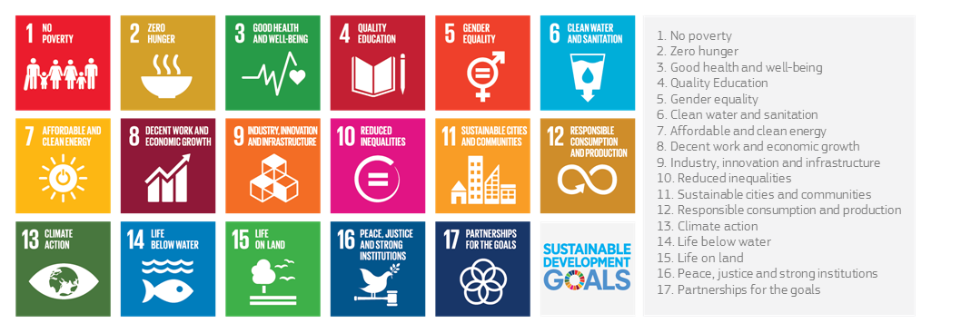

Source: United Nations

The economic, social and environmental dimensions at the heart of the SDGs have largely been incorporated into the EU budget and spending programmes. They have been mainstreamed into the Europe 2020 strategy to build around education and innovation ("smart"), low carbon emissions, climate resilience and environmental protection ("sustainable"), job creation and poverty reduction ("inclusive"). There is also a political commitment of devoting at least 20% of the EU budget 2014-2020 to climate action and to achieving 0.7% of GNI as Official Development Assistance within the framework of the 2030 agenda.

Nurturing competitiveness and averting a widening social divide is an important challenge for the Union and for the Euro area in particular. The aim must be to reduce economic and social divergences between and within Member States and to empower people to play their full role in society. EU expenditure on social matters, from labour market to poverty reduction, from social inclusion to education, currently represents only 0.3 % of total public social expenditure in the EU. While this share might be re-assessed in the future, there can be no mistaking that social support will remain primarily in the hands of Member States. The Reflection Paper on the social dimension of Europe has outlined areas where EU finances could make a stronger contribution in the future, depending on the path chosen for the EU's future social policy.

The benefits of globalisation are unequally distributed both between people and territories, notably between large metropolitan areas and declining industrial and rural areas. The Reflection Paper on Harnessing Globalisation indicates that it is necessary to accompany the economic transformation brought about by globalisation and technological change so that every citizen and every region can contribute to and benefit from the internal market and become more competitive and more resilient.

How does the current EU budget respond to these challenges?

The three basic functions of any public budget are investment in public goods, re-distribution and macro-economic stabilisation. The EU budget performs these functions albeit to differing degrees. For instance, it finances public goods through programmes managed directly at the European level, such as Horizon 2020 for research or instruments like the Connecting Europe Facility for infrastructure investment, and together with Member States and regions through the investment co-financed under cohesion policy.

It achieves a re-distribution (coupled with the financing and provision of public goods) through cohesion policy, which promotes economic convergence as well as social and territorial cohesion; and, through support for rural development and via the support to the income of farmers under the Common Agricultural Policy (CAP).

The stabilisation function is only covered indirectly. The EU budget has some stabilising effects for some Member States, notably due to its stability over seven years, which provides a constant level of investment independent of the economic cycle. At the same time, a Member State’s contributions are linked to economic performance, so that contributions to the budget will go down in a recession. However, the EU budget was not conceived to provide for macro-economic shock absorption.

An important question suggested by the Reflection Paper on deepening Economic and Monetary Union is whether establishing such a stabilisation function and means to further convergence should be considered, and further explored by the Commission.

Finally, the impact of investment depends on the environment in which it operates. This is why the discussion on the link between structural reforms and the EU budget has become so prominent recently. While this link has been already established for cohesion policy, it is worth reflecting on whether this is sufficient and whether the incentives could be improved.

### 3.2.1 Investment in public goods directly managed at the European level

In the 2014-2020 multiannual financial framework around 13% of the EU budget is supporting key priorities for sustainable growth through programmes or projects directly or indirectly managed at the European level.

The largest of these programmes is the **European Fund for Strategic Investments**, which was set up by President Juncker in November 2014 following the financial and economic crisis of 2008-2009 and the subsequent collapse in investment. It is well on the way to trigger the intended target of EUR 315 billion in investments. With the proposed extension it should trigger total investments of at least EUR 500 billion.

**Horizon 2020,** the main instrument for financing top-level research and innovation across the European Union (EUR 74.8 billion) attracts collaboration from 131 countries worldwide and finances 13,000 high-quality projects since 2014.

The **Connecting Europe Facility** (EUR 30.4 billion) is another example of EU investment in major infrastructure in transport, energy and communication technology in Europe. Projects include for example the improvement of the safety of the central rail line in Poland, while increasing its speed up to 200 km/h, thus improving overall European freight and passenger transport along the central Baltic-Adriatic transport corridor.

**Erasmus+** (EUR 14.8 billion) is the European programme for education, training and youth and sport with over 2 million participants by 2016.

The **COSME**[5] programme (EUR 2.3 billion) targets small and medium-sized enterprises by facilitating access to loan and equity financing as well as market access, providing loan financing of over 5.5 billion EUR to more than 140,000 companies. It addresses the specificities of the European venture capital market by investing in SMEs in their growth and expansion stage, reaching nearly half a billion EUR of equity investment in 2016.

The EU also finances a number of **large scale projects and infrastructure** that are too big to complete without public investment. A notable example is the EU's global Navigation Satellite System - **Galileo**, which provides services thanks to 15 fully operational EU satellites now in orbit and the EU's earth observation system, Copernicus, which is set to become one of the most important global providers of big data.

Many of these programmes have become EU trademarks, making the EU visible and recognisable in the daily lives of its citizens. Nevertheless, there are margins for improvements to further strengthen their performance and increase their impact, in particular by avoiding overlaps, combing instruments, and ensuring complementarity and simplification. Should the budgetary allocation for these programmes be reinforced? How can we ensure they are mutually reinforcing? How can overlaps between programmes intervening in the same areas be avoided, whether for large infrastructure or support to SMEs? Avenues to improve the use of financial instruments in this area, to simplify the relevant rules and to enhance flexibility are set out in section 4.2.

### 3.2.2 Economic, social, and territorial cohesion

While the benefits of globalisation are widely spread, the costs are often localised. Recent evidence suggests that many regions across Europe are much more likely than others to be exposed to sudden shocks due to their economic specialisation, labour costs, or education level of their workforce. At the same time, unemployment rates, particularly among the younger generations, remain too high; participation in the labour market is low in many parts of Europe; and the number of people at risk of poverty is unacceptably high.

These differences of economic and social perspectives may create socio-political tensions and require an appropriate EU response so that no person and no region are left behind.

Fostering lasting economic convergence and resilience is the main objective of **EU cohesion policy**, which together with national co-financing, will mobilise more than EUR 480 billion in the period 2014-2020.

The current generation of programmes have incorporated important reforms. They focus more funding on key European priorities, such as employment, social inclusion, skills, research and innovation, energy and resource efficiency. Programme objectives are set upfront. The overall economic, legal and institutional framework for investment has improved. Similarly, the policy has established a close link between the investment co-financed and the broader economic governance agenda and structural reforms.

Globalisation: is Europe prepared?

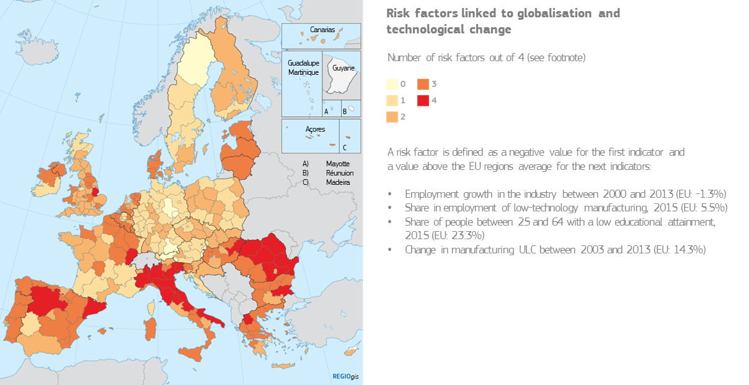

Source: European Commission

What does cohesion policy finance?

In billion EUR

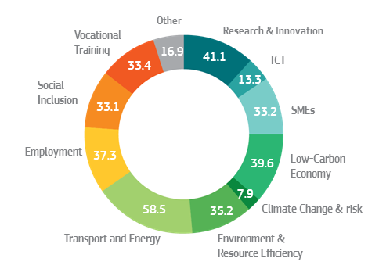

*Box 2 – Examples of results under cohesion policy 2007-13*

* Expenditure for social objectives: 9.4 million people secured employment, while 8.7 million citizens obtained qualifications
* All Member States and regions have developed smart specialisation strategies to better target their research and innovation efforts. The support has led to around 95 000 Research &Innovation projects and 42 000 new research positions created;
* Around 400 000 SMEs received support under cohesion policy and more than 1 million new jobs are being created as a result.
* A large part of the EU expenditure for climate change and environment protection is being spent through cohesion policy. For example, around 6 million people gained access to better water supply and 7 million to improved waste water treatment;
* Member States built or renovated 2600 km of railway lines and 2400 km of roads belonging to the Trans European Network, in addition to the secondary networks connecting remote areas to the rest of Europe.

While the overall results of cohesion policy are globally positive, there are a number of areas where reform is needed.

First, in recent years, cohesion policy has effectively compensated for declining national and regional investments as a result of the crisis. This has helped to prevent major disruptions, but the resulting higher co-financing rates by the EU budget have reduced the overall investment effort.

Second, while cohesion policy responded to the crisis by increasing the co-financing level and amending its programmes to better fit changing socio-economic needs, there is also a need to review how cohesion policy can better prepare and react to unexpected developments, crisis and societal changes.

Third, the link with the economic governance and the European Semester may need to be strengthened to ensure that the system is simpler, transparent, and provides positive incentives to implement concrete reforms to foster convergence.

Finally, the policy has become increasingly complex to manage, hampering implementation on the ground and creating delays. The layers of controls and bureaucratic complexity make it difficult for beneficiaries to access these funds and deliver projects quickly. Therefore, a much more radical approach to simplifying implementation and allowing for more agile and flexible programming is needed for the future.

### 3.2.3 Sustainable agriculture

Farmers provide a stable and high-quality food supply produced in a sustainable way at affordable prices for more than 500 million Europeans while respecting the requirements for animal health and welfare, environmental protection and food safety.

Ensuring the economic, social and environmental sustainability of agricultural and rural communities is the core objective of the Common Agricultural Policy (CAP). In the current framework 2014-2020 the CAP will mobilise around EUR 400 billion to finance market measures and direct payments for farmers and rural development programmes and to promote sustainable agriculture and healthy rural economies. Of this amount direct payments represent around 70%. This income support partially fills the gap between agricultural income and comparable income for other economic sectors. The most recent reform of this policy introduced major changes to the system of direct payments, targeted to address the particular needs of young farmers and smaller farms, specific sectors or regions in difficulties, and the environment.

Thanks to this policy, European citizens have access to safe, affordable and high quality food. Successive reforms of the common agricultural policy have made the European farm sector globally competitive, operating close to world market prices and showing a strong and improving export performance. Still, there are huge disparities in the development of the farming sector. In some rural areas there are no credible alternative sources of employment and income outside farming. However, some farmers now have access to other forms of non-farm income, e.g. from tourism and leisure activities, wind power, bio gas and solar power.

Agriculture covers nearly half of the surface of the EU. This makes farmers key for preserving natural resources (water, air, soil and biodiversity), implementing climate action and in shaping treasured landscapes. The CAP sets the necessary rules and incentives to ensure that agriculture and forestry contribute to solving the globally pressing environmental and climate problems and provide the public goods that citizens expect. Among these key tools are the agri-environment-climate measures of the CAP, which provides incentives farmers to adopt and adapt management policies and practices and undertake actions enhancing and preserving water bodies, soil, biodiversity and landscape amenities as well as mitigating and adapting to climate change. Still, there are growing demands to orient the Common Agricultural Policy further towards the provision of public goods related to the protection of the environment and climate action. This would require more targeted and regionally adapted support measures.

Agricultural trade balance shows a competitive sector

In million Euro

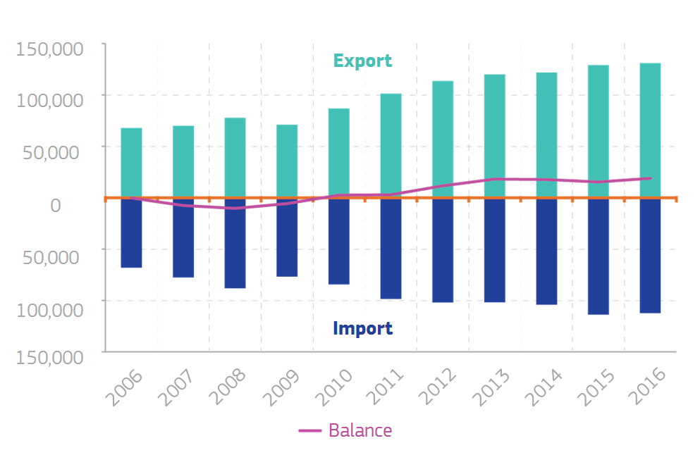

Source: European Commission

There is no consensus on the level of income support necessary when taking into account competitiveness within the sector. In some cases, these payments do not contribute to the structural development of the sector but tend to increase land prices that may hinder the entry of young farmers into the market.

Direct payments are still largely determined by historic entitlements and concentrated on large farms and land owners in richer Member States. On average, 20% of beneficiaries receive around 80% of the payments. However, that general picture masks huge differences from Member State to Member State. For instance, 92% of farmers in Romania and 97% in Malta operate small farms, while in Germany less than 9% of farms are small.

Who benefits from Common Agricultural Policy support?

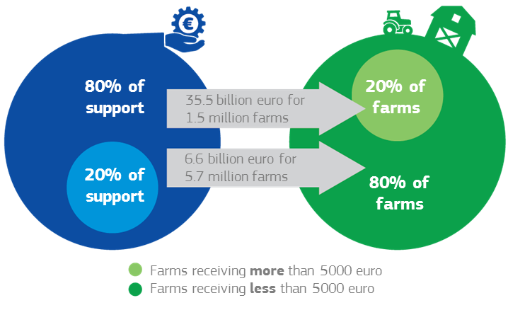

Source: European Commission

The majority of CAP payments are financed fully by the EU budget and thus providing a direct link between beneficiaries and the Union. The policy reaches farmers and citizens even in the most marginal areas of Europe, thereby providing significant knock-on effects for economic and social development, not to mention resilience in those areas. Apart from the rural development measures financed under the second pillar of the CAP, this is the only policy area managed together with the Member States without national co-financing.

Developments over recent years showed that the EU budget has had to provide recurrently ad-hoc emergency support to react to specific developments such as the fall in dairy prices or the Russian ban on imports of certain agricultural products. There is hence a need to explore the right balance of instruments in the future common agricultural policy between policy measures and financial envelopes, grants and financial instruments, risk-management tools and other market arrangements to cope with risk and unexpected adverse events in the agricultural sector.

*Box 3 – Examples of results under the Common Agricultural Policy*

* 70 % of EU agricultural land is covered by greening measures, supported by EUR 60 billion
* Around 47 million hectares or roughly 25% of European agricultural area was under management contract for agri-environment friendly practices targeting water, soil and biodiversity
* Creation and development of more than 200 000 rural businesses (145 000 young farmers receive support to set up business and 62000 micro enterprises)
* Support for more than 25 000 environmental infrastructure projects such as sewage system and improved waste management in remote and rural areas
* 2400 Local Action Groups received support to develop and implement development strategies for their local areas

### 3.3 Managing Migration

The EU’s external borders have increasingly been the scene of human tragedies to which the EU, together with its Member States, must take immediate action. At the same time, migration needs to be better managed in all its aspects; the EU should aim at providing its Member States with tools to do so in the medium as well as long term.

Migration management is a shared responsibility, not only among EU Member States, but also vis-à-vis non-EU countries of transit and origin of migrants. By combining both internal and external policies, the EU and the Member States are developing a comprehensive approach grounded in mutual trust and solidarity among EU Member States and institutions.

When it comes to managing migration flows, the current EU budget already supports Member States in in developing adequate reception and protection frameworks, addressing the root causes of migration and safeguarding the Schengen area. More than EUR 17 billion – 3.7% of the total EU budget – is allocated to these challenges over 2015-2017.

For example, the EU budget was used to create 'hotspots' in Greece and Italy reaching a total capacity of over 9000 places. In 2016, shelter was provided for over 35,000 people in Greece, from tents in the initial stage to containers fit for winter conditions and 417 safe spaces for unaccompanied minors. The newly established European Border and Coast Guard Agency helped to rescue 174,500 people in the Mediterranean in 2016.

## 3.4 External Challenges, Security, Humanitarian Aid and Development

In recent years, Europe has faced new external challenges linked to instability and fragility in its immediate neighbourhood and beyond. EU citizens are concerned about migration, terrorism and external security threats in general and want these issues to be tackled at the European level, including defence. They expect Europe to play a leading role in the world, to manage the effects of globalisation, to defend a rules-based order, good governance as well as democracy, the rule of law and human rights, and sustainable economic development and to project stability and security in particular in Europe’s immediate neighbourhood. Almost 9 in 10 Europeans think that it is important to support developing countries. 82% of Europeans consider that helping others is a win-win option that is clearly in the European interest. Europeans also see the clear value added of taking action at a European level in external affairs.

At the moment, EUR 96.5 billion support the EU’s external action, including the extra-budgetary 11th European Development Fund (EUR 30.5 billion) for EU's African, Pacific and Caribbean partners. The EU Budget then dedicates around 6% of the present MFF to external action, the largest financial envelopes being the Development Cooperation Instrument (EUR 19.7 billion), the European Neighbourhood Instrument (EUR 15.4 billion) and the Instrument for Pre-accession Assistance (EUR 11.7 billion). EUR 8 billion are programmed for Humanitarian Aid. This budget has been constantly mobilised and reinforced in the past years exhausting all available margins to tackle the multiplication of humanitarian and other emergencies around Europe, increasing the numbers of displaced people, the unprecedented humanitarian needs and the complexity of crises, which are set to continue.

The EU’s external action takes place in partner countries outside the Union but also protects citizens' interests and safety. As the world's largest development and humanitarian aid donor, including through its collective commitment to devote 0.7% of GNI to Official Development Assistance (ODA), the EU and its Member States play a key role in supporting others across the world. EU external action promotes stability around the EU borders and beyond, supports the eradication of poverty in developing countries and fosters co-operation on areas of EU interest. It also tackles the root causes of irregular migration and violent extremism. EU financing usually provides a core around which development financing from Member States gathers to increase the EU critical mass and the impact in partner countries through joint programming and joint implementation.

The new challenges for the EU’s external action as defined in the Global Strategy for the EU Foreign and Security Policy point to a need to examine the alignment of EU finances with these new priorities and the effectiveness of the various instruments in this area, including EU Delegations. This is particularly true regarding defence, and also EU external investment where there may be a need for the possibility to leverage significant private funds and reach substantial impacts with bearings on peace, stability and strong economic ties. The experience of recent years also suggests a stronger co-ordination between external and internal policies is needed, including the implementation of the Sustainable Development Goals (SDG) of the United Nations' 2030 Agenda and the Paris Climate Agreement, as well as the implementation of the Partnership Framework with third countries on migration.

# 4. OPTIONS FOR THE FUTURE OF EU FINANCES

The design of the future EU budget must be underpinned by a clear vision of Europe’s priorities and a determination to invest in the areas that will secure economic strength, sustainability, solidarity and security for the future.

The gap in EU finances arising from the United Kingdom’s withdrawal and from the financing needs of new priorities need to be clearly acknowledged. The new priorities have been accommodated under the current financial framework mainly by stretching the existing flexibilities to their limits.

In the future, migration management, internal and external security, external border control, the fight against terrorism and defence will need to be budgeted within a longer-term perspective alongside continuing investment to support stability and sustainable development in our partner countries. The size, structure and content of the future EU budget will have to correspond to the political ambition that the European Union sets itself for the future. Will the EU just carry on, do less, act at different speeds, pursue a radical re-design or do much more together?

Hard choices will need to be made. Can Europe deliver on its existing policies and new priorities with a shrinking budget? If not, where should cuts be made and ambitions scaled back? Or should the gap be bridged, either via increasing contributions from the 27 Member States, alternative sources of revenue, or a combination of the two, so that the EU 27 can do more together? Whatever the outcome, the level of political ambition must be aligned with the means to act.

**An EU budget enabled to deal with domestic and global challenges**

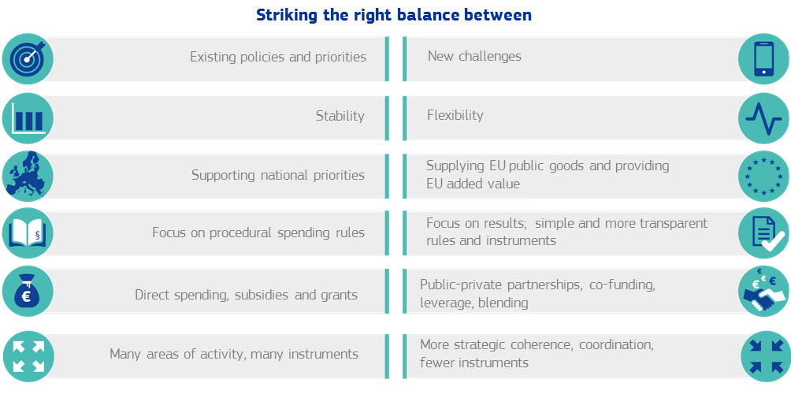

Source: European Commission

## 4.1 What should the future EU budget focus on

**4.1.1 Responding to current trends and new challenges**

The EU budget should continue dealing with current trends that will shape the EU in the coming years. There are also a number of new challenges in which the EU budget will need to do more than today. These include management of irregular migration and refugees, including integration, control of external borders, security, cybersecurity, fight against terrorism and common defence.

First, reducing economic and social divergences between and within Member States is crucial for a Union that aims for a highly competitive social market economy aiming at full employment and social progress. It is of vital importance for the Euro area, where divergences put at stake the sustainable development of Economic and Monetary Union in the medium term. The Reflection Papers on the Social Dimension of Europe and on Harnessing Globalisation have put forward a number of ideas for consideration. The overarching priority would be to invest in in people, from education and training, to health, equality and social inclusion. Also—building on the example of the Youth Guarantee—a Child Guarantee supported by EU funds would be an option. It is important for a social spending to reach those that most need it, in particular in regions with high social inequalities. Existing criteria for such targeting may need to be revisited with that aim in mind.

Second, while the bulk of financial resources for Europe’s defence will continue to come from national budgets, there is consensus on the need to move forward jointly, for example on research and development, on the competitiveness of Europe's industrial base and procurement where the EU budget should finance a European Defence Fund to improve value for money. It should also be able to increase its present assistance to partner countries in capacity building as well as its military/defence component, where more solidarity would be needed in the financing of operational activities, including for Common Security and Defence Policy military missions.

All in all, reflecting this new ambition in defence will entail a steady effort after 2020 from different sources. The EUR 1.5 billion per year of the EU budget contribution to the European Defence Fund, together with Member States' contributions to finance joint development projects, the Fund could generate a total investment in defence research and capability development of EUR 5.5 billion per year after 2020.

Third, the Commission in its reflection paper on deepening Economic and Monetary Union has highlighted the idea of providing incentives to support structural reform. Such incentives, which could take the form of financial rewards, would recognise the economic, financial or political cost of structural reform in the short term and help facilitate their successful implementation. They could either be reinforced under cohesion policy or established under a new, stand-alone fund open to all Member States. They should support European policies and actions in line with country-specific recommendations within the European Semester. Technical support for these efforts could also be financed from the EU budget. The Commission will assess these options carefully before considering concrete initiatives.

Upholding EU core values when developing and implementing EU policies is key[6]. There have been new suggestions in the public debate to link the disbursement of EU budget funds to the state of the rule of law in Member States. Respect for the rule of law is important for European citizens, but also for business initiative, innovation and investment, which will flourish most where the legal and institutional framework adheres fully to the common values of the Union. There is hence a clear relationship between the rule of law and an efficient implementation of the private and public investments supported by the EU budget.

Fourth, an important issue is whether the next EU budget should incorporate some form of stabilisation function. The Reflection Paper on the deepening of the Economic and Monetary Union suggested introducing a macroeconomic stabilisation function as soon as the next Multiannual Financial Framework. Its objective would be to protect against large shocks that hit different countries differently (so-called “asymmetric” shocks). It could take the form of a protection scheme for investments, a re-insurance for national unemployment schemes or a “rainy day” fund. There would be clear conditions to access such a function.

Such options could be financed from existing instruments or from a new instrument. It is debated as to whether such a stabilisation function should be linked with a new fiscal capacity focusing exclusively on the euro area or whether this function could be performed by the EU budget, given that, even at this point in time, the euro area represents already 85% of EU GDP. The reflection paper on deepening the EMU suggests, as one option, that the stabilisation function "should be developed in the EU framework and could be open to all Member States".

Introducing a Euro area fiscal stabilisation capacity would bring something qualitatively new to EU finances. For the longer term, the paper also opened a debate about a fully-fledged Euro area budget with much broader objectives, significantly higher resources and an own revenue stream.

Fifth, it is necessary to shift towards new, sustainable growth models that combine economic, social and environmental considerations in a holistic and integrated way. For the transition to happen successfully the investment needs are vast – the largest share of which will be for low-carbon energy infrastructure, both for generation, transmission and distribution. For instance, the share of renewable energy sources in electricity generation needs to almost double by 2030 in order for the EU to meet its energy and climate targets. The EU budget can have a catalysing effect to stimulate the necessary additional private or public investment.

Sixth, all existing instruments will need to be looked at. Though this paper looks in particular at the reform of the two biggest spending policies (agriculture and cohesion) no programme or instrument supported by the EU budget should be exempt from the EU value added test. We must consider whether all existing instruments are indispensable or whether there is scope for merging or closing programmes. Even more important is the need to ensure policy coherence among EU instruments to ensure that they all support EU objectives and facilitate reforms in Member States. For instance, in the area of SME financing the same beneficiaries may be eligible to receive support through several instruments covered under different programmes (COSME, Horizon 2020 and EFSI) or implemented by Member States through cohesion policy. This overlapping product offer has caused some confusion for financial intermediaries as to which scheme to apply. Rules and conditions applying in the same policy area should be aligned.

There is also evidence of competition and crowding out effects between EU programmes - for example in the case of infrastructure, where even if the loans and guarantees provided by the EFSI are intended to complement the CEF Debt Instrument, implementation suggests that the introduction of EFSI has slowed down the deployment of the CEF instrument and of cohesion policy funds.

Seventh, with a view to improving delivery of results, it may be necessary that for external policies, the number of instruments is reduced, but their flexibility increased. This could also facilitate internal re-allocation between regional or thematic priorities in case of the need to react to a crisis in the short term.

The incorporation of the European Development Fund (EDF) in the EU budget and the MFF has often been discussed also as an option to enhance the unity of the budget and its accountability. Such an option may also have drawbacks, as some of the present activities may not be supported by EU budget rules, for instance the African Peace Facility.

Where Member States move spending from national to EU budgets, this should not be viewed as a net increase in spending levels, but rather as a way of transferring existing spending from national budgets and the EU budget, where it should in principle achieve a higher value added. This means, for instance, that if the EDF were to be incorporated into the EU budget and MFF, the overall volume of the MFF would have to increase by the size of the fund.

Finally, the sound implementation of EU policies relies on a strong and efficient European civil service. Since 2013, the EU institutions are fulfilling their commitment to reduce their staffing level. This happened despite the addition of new responsibilities, for example in handling the refugee crisis or dealing with security threats, or in the EU Delegations abroad. The future EU budget should therefore make provision for a strong European civil service, attractive to talented young people from across the Union, and capable of delivering on the priorities that result from this reflection process. Decisions on future policies and instruments should take account of the impact on human resources.

A further reduction in staff levels could jeopardise the good functioning of the EU institutions. Similarly, previous reforms have reduced salaries, increased working time and pension age. There is clearly a declining interest of young people from Member States with relatively high per capita income to join the EU institutions. While working conditions may only be one factor in such decisions, the trend is clear.

**4.1.2 Reforming the common agricultural policy**

The common agricultural policy provides an important value added for Europeans and fulfils the objectives set by the Treaty. It was the EU’s first common policy and has evolved greatly over time through a number of reforms. In the current debate, different options for further reform are being considered to enhance its efficiency and fairness while achieving its unchanged objectives to ensure safe and healthy food, a competitive sector, a fair standard of living for the agricultural community and protection of our natural resources, our landscapes, the environment and for climate action. The impact of the policy goes beyond the stabilisation of farmer's income. However, many rural areas feel left behind. There is a growing call for the policy to focus further on the provision of public goods, such as safe and healthy food, nutrient management, response to climate change, protection of the environment and its contribution to the circular economy.

Work is ongoing as regards the modernisation and simplification of the CAP. Among the debated options is the suggestion to target direct payments more effectively to ensure income to all farmers across the EU, particularly for marginal areas and the poorest farms. Such an option could reduce direct payments for large farms.

One option to explore is the introduction of a degree of national co-financing for direct payments in order to sustain the overall levels of current support. Risk-management tools could be envisaged for dealing with crises. Any changes would need to preserve one of the key assets of the policy: the protection of a well-functioning internal market ensuring a level playing field for all producers across the EU.

Viable rural communities are necessary to ensure the sustainability of the vast majority of EU territory. In this context, there is margin for improvement and for enhancing synergies with other funds. Here a suggestion is to rationalise the action of the various structural funds in rural areas and eliminate overlaps.

There is room to further improve the performance of the policy by putting more emphasis on incentivising farmers to deliver environment and climate public goods and services. Farmers should be encouraged to invest in new technologies and environmental protection within the rural development policy through positive incentives on the basis of contracts. This would lighten the current administrative burden for all farmers.

**4.1.3 Reforming cohesion policy**

A number of different options could make cohesion policy more effective and maximise the impact of its investment.

First, cohesion policy could be made more flexible to face new challenges, for example through an unallocated capacity. Similarly, a more flexible Globalisation Adjustment Fund able to cover a wider range of economic and social measures could be made more efficient via a closer link with cohesion policy. It would also contribute to the overall flexibility of the EU budget.

Second, faster implementation of cohesion policy and a smoother transition between programming periods is required. A number of measures could be envisaged, such as stricter de-commitment rules, shorter procedures for closing programmes, and quicker and more flexible processes for appointing the management authorities and for programming.

Third, shortcomings in administrative capacity and poor institutional quality hamper competitiveness, limit effectiveness of investments and create a serious obstacle to growth. The EU budget should strengthen its administrative capacity building linked to the most important investment areas supported by EU funding. New approaches to building administrative capacities could be explored, for example through better coordination of available instruments and a closer involvement of the Commission. The lagging regions initiative under cohesion policy was an important pilot exercise and its successful elements may be further deployed.

Fourth, the levels of national co-financing for cohesion policy should be increased, in order to better calibrate them for different countries and regions and increase ownership and responsibility. The question should also be asked as to whether cohesion policy funding should be available to the more developed countries and regions.

Fifth, a single investment fund, or a single set of rules for existing funds, would ensure more coherent investment and simplify the life of beneficiaries. Coherence can also be improved via a single rule book for cohesion policy and other funding instruments with programmes or projects of the same type. This would ensure stronger complementarity, for example between cohesion policy and Horizon 2020 or the Connecting Europe Facility.

Sixth, the current system of allocation of the funds could be revised. New criteria could be added, for instance linked to the challenges Europe faces, from demographics, unemployment to social inclusion and migration, from innovation to climate change.

## 4.2 How should the future EU budget operate

After having decided what the budget should do, there are a number of factors which need to be taken into account in its design.

## *Box 4 - Principles for reform*

The design of the future EU budget should be driven by these key principles:

* **EU value added:** funding should be concentrated on the areas of highest value added, taking into account the different dimensions indicated in section 2 such as focus on results.
* **Accountability:** the debate on the future EU budget will follow a democratic and transparent process. The use of additional instruments outside the EU budget should be kept to a minimum, as they blur the understanding of the budget and put at risk democratic control, transparency and good management.
* **More flexibility within a stable framework:** The multiannual structure of the EU budget is an asset. Certainty and predictability are a prerequisite for long-term investment. However, experience has shown that more flexibility is essential to respond to crises and unforeseen events. This should be reflected in a more flexible structure and a larger share of the budget should be left unallocated.
* **Simplified rules:** citizens should not be discouraged from applying for EU funding as a result of excessive bureaucracy. Efforts to cut red-tape and further simplify the rules of implementation should therefore continue. Moving towards a **single set of rules** would help achieve this.

### 4.2.1 Stability and flexibility

There is a need to strike the right balance between the stability and the flexibility of financing.

One factor in this balance is **the duration** of the financial framework. Previous MFFs have almost always extended over 7 years; five years are today the minimum prescribed by the Treaty. Most Member States, regions and stakeholders are therefore accustomed to operating within this cycle. Reducing the current 7-year duration to 5 years would reduce the predictability of financing. This could be a problem in particular for investments that require more time. It would also imply that preparation for the next MFF would have to start at the very beginning of the previous one, further reducing the possibility to draw lessons for the future. Institutions may end up in a permanent "negotiating" mode.

However, on the positive side, a shorter duration would also bring more flexibility and make it easier to adjust to unforeseen developments. In addition, a 5-year timeframe would align with the mandates of the European Parliament and the Commission. This would strengthen the democratic debate on the EU’s spending priorities and put the EU budget more clearly at the centre of European politics.

Another option is an MFF of 5+5 years with an obligatory mid-term revision to adjust the framework to new priorities. However, such an option would require setting the MFF ceilings and legal bases for the full duration of up to 10 years in the first place. This may create a strong disincentive to agree on any wider changes at mid-term compared to the actual negotiation of a new MFF.

There are other ways to address the need for flexibility. The experience of recent years has demonstrated how the current structure is limited in how it can adapt to unexpected needs. One factor is that spending takes place strictly within certain categories and that a re-deployment of funds between budget headings is not easy. Another reason is the large number of different programmes and budget lines that have been created over time. The result has been a significant number of different instruments, often overlapping with each other.

The flexibility of EU finances is also constrained by the fact that around 80% of the MFF is pre-allocated to specific policy areas, Member States or spending envelopes for third countries. Existing mechanisms to shift funding quickly to new priorities or between years have allowed for some adaptability. However, the existing flexibility would not be enough to deal with known challenges and unexpected future developments of a similar order of magnitude in a volatile environment. One option could be to put aside a share, often called a non-programmed reserve, within each spending programme that remains unallocated and reserved for unexpected developments.

Moreover, a Crisis Reserve funded by unused money from previous years could provide additional firepower for exceptional circumstances and a improved Globalisation Adjustment Fund could also enhance flexibility. It could allow the Union to enhance support for structural change of areas hit by the impact of globalisation and technological change.

### 4.2.2 Financial instruments and the extended EU financial architecture

An important source of flexibility of EU finances comes from institutions and instruments that complement the EU budget, such as the European Investment Bank, the European Development Fund, European Union Trust Funds and other facilities.

Financial instruments such as guarantees, loans and equity can play an important role to allow the EU to "do more with less" and leverage the EU budget, particularly at a time of budgetary constraints. One important recent example is the European Fund for Strategic Investments.

Their successful use depends on a clear strategy and on a set of criteria to determine which tools are most appropriate for market needs, beneficiaries and desired objectives. Financial instruments are only appropriate for revenue-generating projects. Grants and subsidies will therefore continue to be needed for projects that do not generate revenues, for example for basic research, for some types of infrastructure programmes, or for people-based investments, such as Erasmus or Marie-Curie grants.

The number of EU-level financial instruments and rules applying to them is an obstacle to their efficient use. One option to address this could be their integration within a single Fund which would provide loans, guarantees and risk sharing instruments—blending with EU grants where appropriate—depending on the project and windows for the different policies (such as research, innovation, environment, SME support, infrastructure, including for energy efficiency) to cater for different objectives.

Europe can do more to provide conditions for companies to scale up. Financing mid-cap companies and SMEs beyond the start-up phase remains difficult and many entrepreneurs leave Europe in search for appropriate capital investment. To this end, a pan-European Venture Capital Fund-of-Funds of EUR 1.6 billion has been launched by the Commission in 2016 and will be operational during 2017. This approach could be expanded to provide stable funding in the scale up stage of development of projects or firms.

These new EU-level financial instruments and the loan, guarantee, and equity instruments managed by Member States under cohesion policy should be complementary. This complementarity between the different instruments should be ensured, through upstream coordination, same rules and clearer demarcation of interventions.

### 4.2.3 Simplification, focus on performance and efficient management of the EU budget

Well-designed rules are essential to ensure that EU funds are spent properly and taxpayer money is protected. Excessive bureaucracy can get in the way of results and discourage citizens and companies from taking full advantage of the EU budget.

Major steps have already been taken to simplify the EU budget but there is significant scope to go further by reducing the complexity of the rules. This is desirable in many areas of spending, in particular where the difficulty to comply with reporting and monitoring requirements leads to significant delays in project execution. The complexity of the rules leads to more errors and costs for final recipients and increases the risks of non-compliance. There is a clear need to merge programmes that pursue similar objectives, for instance across the areas of energy efficiency or of citizenship. Likewise, in the area of external policies, it could be appropriate to reduce the number of instruments and at the same time increase their flexibility, removing any artificial barriers between regional or thematic priorities.

One way forward may be a "single rule book" governing all processes and instruments or application of the same rules and conditions for the same type of project. This may help ensure radical simplification and cutting of red tape with higher visibility and promotion of better coherence across different EU investments. It may reduce the administrative burden for beneficiaries – they may not need to comply with different rules for the same types of investments depending on the source of funding. What genuinely matters for those being supported is the simplicity of rules and not the funding source.

Along this line, implementation of the budget should focus on maximising the performance of every euro spent in terms of economic growth and value added. Whereas significant progress has been made on this front, the current performance framework built by a multitude of different legal texts is complicated, making it more difficult to assess and communicate progress and achievements.

Moreover, there is a need to restore trust between the different institutions, moving towards proportionate controls that depend on volumes but also on the reliability of institutions and the efficiency of management and control systems. A clear move in this direction would also allow Member States (and the Commission too) to rationalise management systems and corresponding institutional arrangements – the multiplication of institutional systems specific to each fund is a luxury which may not be affordable. In Member States, in particular, substantial institutional efficiency gains and a reduction of administrative costs for programme management could be achieved. Making full use of the European Public Prosecutor's Office can contribute to the simplication and the efficiency of the protection of the EU budget.

## 4.3 Revenues to support EU policies

There is a close link between decisions about what the EU budget is used for and choices about how the EU budget is funded.

The reflection on the reform of the expenditure side of the EU budget should therefore be accompanied by a critical assessment of how the budget is financed—the own resources system—and how this system can be reformed to be more efficient and provide stronger support for policies. The current approach to financing is over-complicated, opaque and riddled with complex correction mechanisms. In the future, the system should be simple, fair and transparent.

The long-standing debate about the revenues financing the EU budget has centred on linking own resources more visibly to key EU policies, in particular the Single Market and sustainable growth, and on simplifying the system. In an ideal world, the EU’s own resources would, at the same time, arise from a key EU policy with a visible EU value added, be seen as equitable and finance a stable and significant share of the EU budget. The traditional own resource of customs duties can be seen as such a good example.

There are many possible sources of revenue which can be used to finance the EU budget (Chart 15 lists the ones most frequently referred to), although none could by itself fit all the criteria identified as necessary for an own resource: Some can bring in stable and significant revenues and lead to real reshaping of the revenue side. Others would bring in more modest revenues, but could be more politically relevant or acceptable, in particular when they would accompany priority policy objectives such as the decarbonisation of the European economy, the deepening of the single market and of Economic and Monetary Union or the financing of new priorities.

Ultimately, the best choice will depend on the main objectives of the future reform, and if there is a targeted volume of the EU budget which should be financed from new own resources.

**Revenue sources — a range of options**

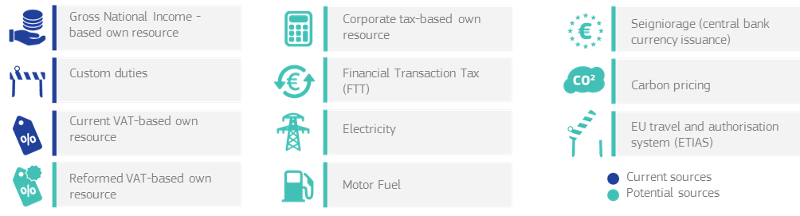

Contrary to what is often stated, new own resources would not necessarily increase the size of the EU budget. Decisions related to the expenditure level are made in the context of the multiannual financial framework, and the decision on whether or not to increase current spending levels will have to be taken depending on the outcome of the present reflection process. At unchanged spending levels, new own resources would automatically reduce the share of the GNI-based own resource, which acts as a residual and makes up any gap to cover EU expenditure, depending on the evolution of other own resources. The recent report by the high-level group on own resources jointly set up by the European Parliament, the Council and the Commission and chaired by Mario Monti[7] has provided a comprehensive analysis of these issues and assessed a number of possible sources of revenue in relation with the most relevant criteria (e.g. equity, efficiency, stability, transparency, focus on European value added, democratic accountability). Progress in tax co-ordination, particularly in the area of corporate taxation and the taxation of financial transactions would facilitate some forms of own resources. Based on the ongoing debate, a number of avenues of reform of the current system could be considered.

*Box 5 – Options for an "own resources" system*

- The current VAT-based own resource could be reformed and simplified. An extreme option would be to abolish it altogether.

- With the departure of the United Kingdom, the rebate that was introduced as a concession to that country in the past will become obsolete. The same is true for the rebates on the UK rebate. The other rebates will expire at the end of 2020. The elimination of rebates would open the door to substantial simplification of the revenue system. Ideally, in-depth reform of EU policies focusing on the highest value added should make any rebate unnecessary

- Any new own resource should be conceived not only to finance part of the EU budget, but also to accompany its core policies. As an example, common energy or environmental taxes could be applied to ensure a level playing field between companies and contribute to the global fight against climate change.

- In a similar manner, a percentage of the common corporate tax base or the financial transaction tax could be designed to reinforce the single market, mirror the benefits of the internal market for the largest companies and strengthen the fight against tax fraud and tax evasion.

- With the future deepening of Economic and Monetary Union, revenues from seignorage – the revenues arising from issuing currency – could in the longer term become the basis for an EU own resource.

- Money generated directly by EU policies and competences could be considered as revenues for the EU budget, such as, in the long term, revenues from auctions under the Emissions Trading System, emission premia for cars, also in the longer term the future European Travel Information and Authorisation System to be paid by persons entering the EU border, or any similar fees.

- In introducing own resources, attention should be paid to their transparency, simplicity, stability, their consistency with Union policy objectives, their impact on competitiveness and sustainable growth and their equitable breakdown among Member States.

Source: European Commission

**4.4 The way forward**

The options for the future EU finances that have been set out in this section are both varied and of different nature. They concern what the EU budget should be spent on; how the budget should be financed; how some key policies should be reformed; and how the budget itself should be structured and organised.

All of these interlocking aspects need to be considered together when looking at the possible scenarios for the future EU budget. This is set out in the next section.

# 5. POSSIBLE SCENARIOS FOR THE EU 27

The White Paper presents five illustrative scenarios with different implications for the EU finances in terms of budget size, structure and degree of change/modernisation. Combinations are possible and different design elements are compatible, as the options and scenarios are neither completely distinct nor mutually exclusive.

Some horizontal issues are valid for all scenarios:

The first one is ensuring that EU money is spent in the most efficient way: expenditure should focus on programmes with proven EU value added designed to deliver results with the minimum costs. Performance should be at the centre of the next generation of programmes.

Secondly, in order to respond to the unanimous call from Member States and beneficiaries of EU funding, simplification is the other common driver for modernising the EU budget in all scenarios. Overall coherence and complementarity between the different programmes and instruments should be ensured and overlaps should be prevented already at the design stage. To simplify implementation, the same rules should apply for the same type of interventions to the extent possible with a view to moving towards a single rule book.

The ongoing processes to modernise existing programmes and policies would continue, for instance, for the common agricultural policy, cohesion policy, the research programme and others. Weaker-performing programmes could be discontinued or integrated elsewhere.

Third, all scenarios require factoring in flexibility to respond to major unexpected developments and unforeseen needs. Special instruments in the EU budget proved crucial for dealing with the migration and security challenges in the current MFF. They may need to be streamlined and strengthened to provide more inbuilt flexibility within spending programmes.

Finally, rebates on contributions of Member States should be abolished in all scenarios. Likewise reporting on net balances would be dropped or the methodology significantly improved to better reflect reality and national treatment of contributions to the EU budget would be aligned.

In this logic, there are five basic options for the future of the EU finances:

* **Carrying on**: the EU27 continues on delivering its positive reform agenda;
* **Doing less together:** the EU27 is doing less together in all policy areas;
* **Some do more:** the EU27 allows groups of Member States to do more in specific areas;
* **Radical redesign:** the EU27 do more in some areas, while doing less elsewhere.
* **Doing much more together:** the EU27 decide to do more together across all policy areas.

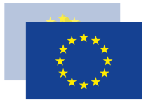

**1Carrying on**

**Scenario**

**General trend and volume**

* **Broadly stable**
* **Reflects current reform agenda of EU 27**
* **Lower relative shares of Cohesion and Agriculture to finance new priorities**
* **Higher use of financial instruments and guarantees**

**Expenditure**

* **Common agricultural policy** 
  + Better targeted support for farmers under special constraints (e.g. small farms, mountainous areas and sparsely populated regions) and risk management tools for all farms
  + Investment in rural development (particularly agri-environmental measures)
* **Economic, social and territorial cohesion**
  + Investment for all regions at a lower level
  + Higher levels of national co-financing and use of financial instruments
  + Stronger focus on social inclusion, employment, skills, innovation, climate change, energy and environmental transition
* **New priorities**
  + Internal/external security, migration and border control; defence (Research & Development, capabilities);
* **Structural reforms linked to the European Semester**
  + Positive incentives either through cohesion policy or through a dedicated fund

**Revenue**

* **Current system without rebates**
* **Other sources of revenue or fees finance the EU budget**

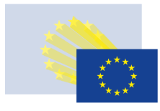

**General trend and volume**

* **Significantly reduced**
* **Focus on internal market functioning**
* **Amounts for Cohesion and Agriculture significantly reduced**
* **Much higher use of financial instruments and guarantees**

**Expenditure**

* **Common agricultural policy** 
  + Support only for farmers under special constraints (e.g. small farms, mountainous areas and sparsely populated regions)
  + Risk management tools for all farms
* **Economic, social and territorial cohesion**
  + Support only to cohesion countries and cross-border co-operation
  + Focus exclusively on social inclusion, employment, skills, innovation, climate change, energy and environmental transition
* **Single market programmes maintained** (Trans-European networks, customs, consumer protection, agencies)
* **No financing for new priorities** (security, border control, migration,defence)
* **Discontinue other programmes (**Erasmus, research and innovation, aid to the most deprived, health, culture, citizenship…)

**Revenue**

* **Current system without rebates**

**2Doing less together**

**Scenario**

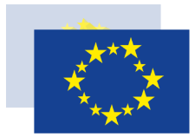

**3Some do more**

**Scenario**

**General trend and volume**

* **Broadly stable with a potential increase to cover the areas of joint action**
* **Higher use of financial instruments and guarantees**

**Expenditure**

* **As in Scenario 1**

**Additional budgets and innovative financing**

* **Enhanced cooperation expenditure included in the EU budget (like European Public Prosecutor's Office)**
* **Pooling of funding beyond the EU budget**
  + trust funds
  + assigned revenues
  + channeled through the EU budget but not subject to the constraints of the Multi-annual Financial Framework
* **Eurozone** 
  + Euro-zone macro-economic stabilisation (investment protection/unemployment re-insurance/rainy day fund)

**Revenue**

* **As in Scenario 1 + new policies financed only by participating Member States, either through current system or**
* **A new own resource (e.g. Financial Transaction Tax)**
  + A new stream of revenue outside the current financing system
  + or ad-hoc financial contributions



**4Radical redesign**

**General trend and volume**

* **Lower**
* **Share of Cohesion and Common Agricultural Policy reduced**
* **Focus on priorities with very high EU value added**
* **Much higher use of financial instruments and guarantees**

**Expenditure**

* **Common agricultural policy**
  + Reduced direct payments
  + Focus on farmers under special constraints (e.g. small farms, mountainous areas and sparsely populated regions)
  + Agri-environment-climate actions and risk management tools for all farms
* **Economic, social and territorial cohesion**
  + Support only to poorer regions and cross border co-operation
  + Focus exclusively on social inclusion, employment, skills, innovation, climate change, energy and environmental transition
* **New priorities**
  + Security and defence (joint financing of key capabilities, joint procurement)
  + Counter terrorism agency and migration management with border control and coast guard with joint equipment
* **Reinforcement of existing priorities**
  + Smart transport and energy grids, high-performance computing, world-class Research & Development, e-transport
  + External policies
* **Structural reforms linked to the European Semester**
  + Positive incentives either through cohesion policy or through a dedicated fund

**Revenue**

* **Simplification of current system: abolish all rebates, reform or abolish Value Added Tax-based own resource**
* **New Own Resources finance a share of the EU budget and contribute to achieving policy objectives (e.g. green tax, Financial Transaction Tax, Common Consolidated Corporate Tax Base)**
* **Other sources of revenue or fees finance the EU budget**

**Scenario**

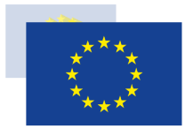

**5Doing much more together**

**Scenario**

**General trend and volume**

* **Significantly increased**
* **Significant additional financing of new priorities and external action**
* **Higher use of financial instruments and guarantees**
* **Increase of own resources ceiling**

**Expenditure**

* **Common agricultural policy—higher amount**
* **Economic, social and territorial cohesion as in scenario 1 plus:**
  + Reinforced social dimension (e.g. Child Guarantee)
  + Reinforced territorial cooperation dimension
  + Reinforced urban dimension
* **New priorities and high value added priorities as in scenario 4**
* **Structural reforms linked to the European Semester**
  + Positive incentives either through cohesion policy or through a dedicated fund
* **Common Security & Defence, common financing & procurement, EU budget complemented by an extra-budgetary fund**
* **Venture Capital Fund facility**
* **Fully-fledged Euro area budget and European Monetary Fund**
* **Reinforced external action; European Development Fund in the budget**

**Revenue**

* **In-depth reform beyond scenario 4**
* **New own resources finance a large share of the EU budget and contribute to achieving policy objectives**
* **Other sources of revenue or fees finance the EU budget**

# 6. CONCLUSIONS: FINANCING THE EU'S FUTURE

The EU budget, and indeed the European Union as a whole, will change after 2020. This is certain – the status quo is not an option for our Union. The EU budget will need to be simpler, more flexible, more streamlined and must enable more efficient spending.

How the budget changes – and what it is used for – depends on what future we want for our Union and on the level of ambition we chose to work together to shape that future.

This reflection paper has set out a series of options and scenarios regarding the future direction of the budget and how it could be used. It is intended to stimulate further debate about where the Union is going and what we want to achieve together.

This is the last of the 5 reflection papers following the White Paper on the Future of Europe. Taken together, the 6 documents have set out a range of ideas, concepts and possibilities for the future of the EU27.

The breadth and depth of debate and discussion that the White Paper and the reflection papers have stimulated so far show how important these issues are. This discussion should continue in the second half of 2017 with as broad a debate as possible to ensure that Europe as a whole reflects carefully on its future. President Juncker will take these ideas forward and give his personal views in his State of the Union speech in September.

When it comes to the future Multi-Annual Financial Framework, the Commission will examine all reactions and responses to the White Paper and the reflection papers. This will enable the Commission to present its proposals for the next multi-annual financial framework around the middle of 2018.

1. In September 2016, the Commission proposed a reinforcement and extension of the European Fund for Strategic Investments until 2020.
2. Galileo is the European global navigation satellite system, providing a range of positioning, navigation and timing services to users worldwide. Copernicus is the EU programme for earth observation and monitoring for the purposes of e.g. agriculture, climate analysis, civil protection and emergency management. International Thermonuclear Experimental Reactor (ITER) is the world’s largest scientific partnership that aims to demonstrate fusion is a viable and sustainable source of energy, with the EU being the biggest contributor in partnership also with Japan, China, India, South Korea, Russia and the United States.
3. See the Special Eurobarometer 461, Designing Europe’s Future, published 28 June 2017.
4. The Global Strategy for the EU Foreign and Security Policy, presented by the High Representative and Vice-President of the European Commission Federica Mogherini to the European Council in June 2016.
5. The EU programme for the Competitiveness of Enterprises and Small and Medium-sized Enterprises
6. The EU Justice Scoreboard monitors a number of factors related to the quality, independence and efficiency of national justice systems, such as the independence of judges.
7. <http://ec.europa.eu/budget/mff/hlgor/library/reports-communication/hlgor-report_20170104.pdf>