

Contents

Section I – Assessment of the state of the stocks 1

Section II – Economic performance of the EU fishing fleet 9

Section III – Implementation of the landing obligation 14

Section IV - Governance through regionalisation 20

Section V - Report on Member States' efforts during 2015 to achieve a sustainable balance between fishing capacity and fishing opportunities 22

# Section I – Assessment of the state of the stocks

Section I explains in detail the progress towards archieving maximum sustainable yield and the situation of the stocks.

1. **Progress Report**

The Commission has asked the Scientific, Technical and Economic Committee for Fisheries (STECF) to report on progress in achieving the maximum sustainable yield exploitation rate (FMSY) in line with the objectives of the Common Fisheries Policy. The exploitation rate relative to FMSY is calculated by the STECF, the International Council for the Exploration of the Sea (ICES) and the General Fisheries Commission for the Mediterranean (GFCM)

In line with recommended best practice, all historic data series have been updated. This means that some new methods have been introduced, new science taken into account, and new data added.

The main findings of the STECF technical report[1] are summarised here. Reference to the "North-East Atlantic" includes the waters of the Baltic Sea, North Sea, Irish Sea, Celtic Sea and adjacent waters. Some technical improvements have been incorporated into the method used by the STECF – these are documented in the report cited.

**1.1 Knowledge of the state of the stocks**

**1.1.1 North-East Atlantic**

New knowledge and new data have enabled an additional 10 stocks to be included in the evaluation since the previous exercise. However, estimates for three stocks could not be updated for 2015.

The number of stocks for which there is scientific advice about fishing mortality compared to the fishing mortality that would lead to the maximum sustainable yield has increased from 62 to 66 since 2003, but has generally remained stable (see Figure 1)

Figure 1 Numbers of fish stocks of EU interest in the North-East Atlantic where both annual fishing mortality (F) and the fishing mortality corresponding to maximum sustainable yield have been assessed.

**1.1.2. Mediterranean Sea and Black Sea**

Due to a lack of human resources, only some of the commercial stocks in these areas undergo an annual biological assessment. Although the number of assessments increased from 2003 to 2009 and remained roughly stable afterwards, significantly fewer stock assessments are available for 2015 data (Figure 2). This is due to a number of factors. Experts from key non-EU countries were unavailable for STECF meetings, so no assessments were possible in the Black Sea. Information on GFCM assessments in 2016 was not available at the time of the analysis (March 2017). The STECF was unable to provide acceptable assessments for new stocks. This, combined with new geographic stock definitions, resulted in some stocks previously considered as biologically discrete being merged into larger, single stock units. In turn, the overall number of stocks fell.

Figure 2 Numbers of fish stocks of fish of EU interest in the Mediterranean and Black Seas where both annual fishing mortality (F) and the fishing mortality corresponding to maximum sustainable yield have been assessed. * = value to be updated.

**1.2. Fishing compared to the maximum sustainable yield rate (FMSY)**

* + 1. **North-East Atlantic**

The number of stocks overfished or fished within FMSY by year in the North-East Atlantic is given in Figure 3, with the relative proportions shown in Figure 4. The average intensity of fishing compared to FMSY is illustrated in Figure 5. The figures show similar trends. The number and proportion of stocks fished in accordance with the CFP FMSY objective increased gradually, particularly in the period 2007-2013. The most recent estimates show that 39 of 66 assessed stocks were exploited within FMSY (equating to 59 %, up from 52 % in the previous year).

Figure 3. Numbers of assessed stocks in the North-East Atlantic, North Sea and Baltic Sea in EU waters and contiguous shared stocks, showing the number of stocks not overfished (fishing mortality is at or below *FMSY*) or overfished (fishing mortality is above *FMSY*)

Figure 4. Relative proportion of stocks assessed as not overfished (fishing mortality at or below *FMSY*) of the total assessed stocks in the North-East Atlantic, North Sea and Baltic Sea in EU waters and contiguous shared stocks

Figure 5. Average fishing mortality compared to *FMSY* values (=1 for F= *FMSY*) for stocks in the North-East Atlantic, including the Celtic Seas, North Sea and Baltic Sea. Based on Figure 3.18 and Table 3.9 of 2017-04 STECF 17-04. The solid line represents the average (median of model fit); the dotted lines show the range of uncertainty in the estimate of the average (95% confidence interval).

For 2017 the number of TACs established in accordance with the MSY advice increased again and now stands at 44 stocks, or 61 % of the overall volume fished in the North-East Atlantic, North Sea and Baltic Sea (see Tables 1 and 2, and Figures 6 and 7). Of the overall expected catches, about 20 % do not have MSY advice.

Figure 6. TACs with MSY advice by landed volume in North-East Atlantic, North Sea and Baltic

Table 1. TACs with MSY advice (volume)

|  |  |  |  |  |  |  |  |  |
| --- | --- | --- | --- | --- | --- | --- | --- | --- |
|  | **2010** | **2011** | **2012** | **2013** | **2014** | **2015** | **2016** | **2017** |
| % share of TACs in line with MSY advice (volume) | 50 | 44 | 45 | 49 | 48 | 51 | 55 | 61 |
| % share of TACs not in line with MSY advice (volume) | 22% | 24 | 23 | 21 | 22 | 20 | 20 | 19 |
| % share of TACs without MSY advice | 28 | 33 | 33 | 30 | 30 | 29 | 25 | 20 |

Figure 7. Number of TACs with MSY advice[2]

Table 2. Number of TACs with MSY advice

|  |  |  |  |  |  |  |  |  |  |  |  |  |  |
| --- | --- | --- | --- | --- | --- | --- | --- | --- | --- | --- | --- | --- | --- |
|  | **2005** | **2006** | **2007** | **2008** | **2009** | **2010** | **2011** | **2012** | **2013** | **2014** | **2015** | **2016** | **2017** |
| TACs with MSY advice | 34 | 23 | 32 | 33 | 35 | 39 | 35 | 38 | 41 | 46 | 62 | 72 | 75 |
| TACs set in accordance with or lower than advice | 2 | 2 | 2 | 4 | 5 | 11 | 13 | 20 | 25 | 27 | 32 | 36 | 44 |
| TACs set above advice | 32 | 21 | 30 | 29 | 30 | 28 | 22 | 18 | 16 | 19 | 30 | 36 | 31 |
| % of TACs in accordance with or lower than advice | 6 | 9 | 6 | 12 | 14 | 28 | 37 | 53 | 61 | 59 | 58 | 50 | 59 |

**1.2.2. Mediterranean and Black Seas**

Due to the incomplete assessment coverage of stocks in this area, no estimates are available for the number of stocks with respect to FMSY. However, trends in F compared to FMSY have been assessed (see Figure 8). They show that overfishing in the Mediterranean is very high (209 % of FMSY in 2014) and shows no sign of falling.

Figure 8. Average fishing mortality compared to *FMSY* values (=1 for F= *FMSY*) for stocks in the Mediterranean and Black Seas. Based on Figure 4.3 and Table 4.2 of STECF-17-04. The solid line represents the average (median of model fit); the dotted lines show the range of uncertainty in the estimate of the average (95% confidence interval).

**1.3 Trends in Biomass**

Fisheries directly affect fish stocks through catches. The fishing mortality (F) is a measure for fishing pressure, the proportion of fish in a year class that is taken by fisheries during one year. Fishing mortality is the only variable that can be directly controlled by fisheries management. Fisheries management cannot directly control stock size, but can only influence it through fishing mortality. Stock size is also subject to natural variability that can overwhelm the influence of fishing from one year to the next. MSY is therefore the long-term average stock size that can be expected when stocks are fished at FMSY The CFP objectives include rebuilding stocks above levels at which they can produce maximum sustainable yield. However, estimates of corresponding stock sizes are not currently available from scientific agencies. Instead, ICES reports on MSY Btrigger, which is considered the lower bound of spawning-stock biomass fluctuation around BMSY. It is therefore useful to report on trends in stock biomass. The STECF has provided information on biomass trends, which is reproduced here (in Figures 9 and 10 for the North-East Atlantic and Mediterranean respectively). The analysis shows a 35 % increase in average biomass in the North-East Atlantic between 2003 and 2015. By way of comparison, in 2014, 53% of stocks were classified as being within safe biological limits. In 2015 this figure rose to 68 %. By contrast, in the Mediterranean Sea average biomass declined by 20 % between 2003 and 2014.

Figure 9. Average spawning biomass compared to values in 2003 (B/B2003) for stocks in the North-East Atlantic. Based on Figure 3.19 and Table 3.10 of STECF-17-04. The solid line represents the average (median of model fit); the dashed lines show the range of uncertainty in the estimate of the average (95% confidence interval).

Figure 10. Average spawning biomass compared to values in 2003 (B/B2003) for stocks in the Mediterranean (the Black Sea is not included). Based on Figure 4.4 and Table 4.3 of STECF-17-04. The solid line represents the average (median of model fit); the dashed lines show the range of uncertainty in the estimate of the average (95% confidence interval).

# Section II – Economic performance of the EU fishing fleet

This section provides a detailed report about the economic performance of the EU fishing fleet is provided.

**Main economic trends**

According to the latest Annual Economic Report from the STECF, the economic performance of the EU fleet has improved significantly in recent years (see Figure 11). The EU fleet registered record net profits of EUR 770 million in 2014, a 50 % increase over the 2013 figure of EUR 500 million. **Preliminary data for 2015 confirm this upturn, and the economic forecasts for 2016 and 2017 remain upbeat**. Furthermore, the EU fleet’s gross value added, i.e. the fish-catching sector’s contribution to the economy through wages and gross profit, amounted to EUR 3.7 billion in 2014. This represented a substantial increase on previous years. Average salaries and labour productivity in the EU fleet have also risen in recent years. However, employment continues to decline, reflecting reductions in fleet capacity.

The overall improvement in the EU fleet’s profitability coincides with an increase in the number of fish stocks being fished at rates consistent with the objective of achieving MSY and an associated increase in the biomass of these stocks (see Figures 12 and 13). This upturn in performance is the result of increases in revenue and reduced or stable fishing costs. Fuel costs have undergone a significant fall, driven not only by relatively low fuel prices, but also by a downward trend in fuel consumption and fuel use intensity, as a result of the more efficient way in which many EU fleets operate.

Recent studies and scientific publications suggest that in the longer term, the EU fishing fleet could substantially improve its economic performance if the **biomass** of all exploited stocks recovered to MSY levels. They also suggest that the sooner fishing mortality rates are reduced to FMSY, the higher the EU fleet’s net profits will be. However, there are potential short-term economic consequences in achieving FMSY where stocks are currently fished at levels well above FMSY and therefore require ongoing reductions in fishing opportunities to meet the CFP objectives.

To add a note of caution, these papers and analyses should be understood as a series of scenarios or simulations, not forecasts. Key external factors such as environmental fluctuations, fuel and fish prices are held constant in these simulations, but can dramatically impact the results of the simulations. Furthermore, long-term projections are subject to considerable uncertainty and are dependent on the model’s assumptions.

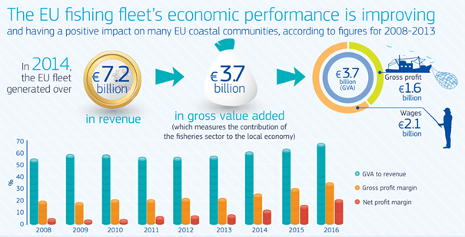

Figure 11. The EU fishing fleet's economic performance is improving

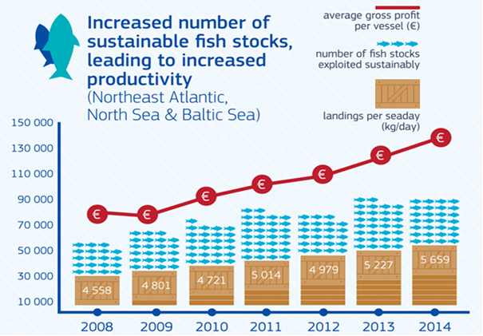

Figure 12. Contrast between number of stocks sished sustainably and the impact on landings and average profit.

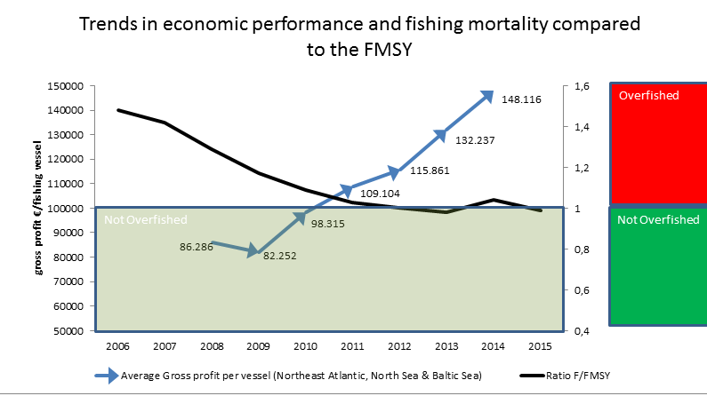

**Figure 13. Trends in economic performance and fishng mortality rates relative to FMSY.**

**Differences across fishing regions, fisheries and fleet categories**

Despite this overall economic progress at EU level, performance also varies considerably between regions, Member States and fisheries.

The overall performance of fleets operating in the North Sea and North-East Atlantic has been good, beating previous years. Factors that may have contributed to this improvement include recovery of certain stocks (e.g. plaice in the North Sea and Northern hake in the Atlantic) and higher average first-sale prices for some important species (e.g. sole, mackerel and hake). Notable examples of increased returns in the North Sea from fishing at MSY include the haddock, plaice and sole fisheries. Some of the UK fleets with the greatest dependency on haddock stocks have significantly boosted their profitability, with gross value added and net profits substantially increasing between 2008 and 2015, and the net profit margin exceeding 15 % in 2015. Likewise, the medium-sized and large Dutch beam trawlers of 24-40 metres in length have enjoyed high profitability, with a net profit margin of over 20 % in 2015, supported by the change to less fuel-intensive fishing methods. In the North-East Atlantic, recent trends for the Nephrops (ICES SubareaVII – Irish and Celtic Seas) and Northern hake fishery suggest better economic returns from fishing at MSY. In the former, the 24-40 m Irish demersal trawlers operating on a small profit margin in 2008 were recording a net profit margin above 15 % in 2015. In the latter, the Spanish demersal trawlers operating at a loss in 2008 were registering a 5 % net profit in 2015.

There are, however, examples of other fleets whose performance in these fisheries has not improved to the same extent.

Generally speaking, economic performance trends are better in the **North Sea, North-East Atlantic and Baltic fleets** than those fleets fishing in the **Mediterranean and Black seas fleets** (see Figures 14-18), although the latest economic data in the Baltic Sea suggests a poorer economic performance among certain fleets, putting a brake of the improvements the region has seen in previous years.

The economic performance of certain EU fleets in the Mediterranean and Black Sea continues to stagnate in areas where several stocks remain overfished.

The economic situation of certain **small-scale coastal fleets,** in particular in the Mediterranean basin, continues to show signs of slowing down, in contrast with the overall improvement in the EU large-scale and distant-water fleets.

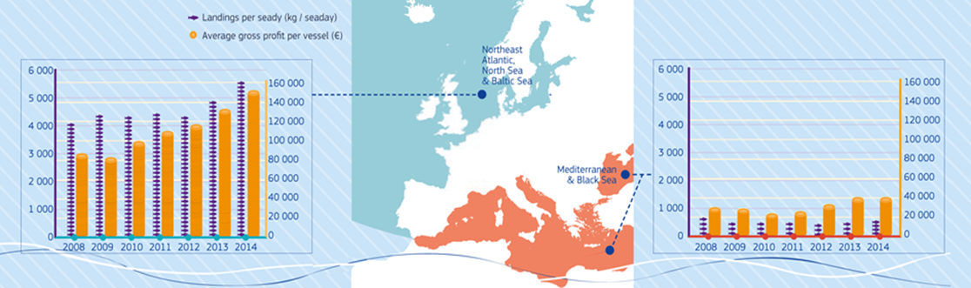

Figure 14. Landings per sea and average gross profit per vessel.

Figure 15. Trends in EU economic performance indictors 2008 – 2013: UK demersal trawlers 24-40 meters in length.

Figure 16. Trends in EU economic performance indictors 2008 – 2013: Irish demersal trawlers 24-40 meters in length.

Figure 17. Trends in EU economic performance indictors 2008 – 2013: Dutch beam trawlers 24-40 meters in length.

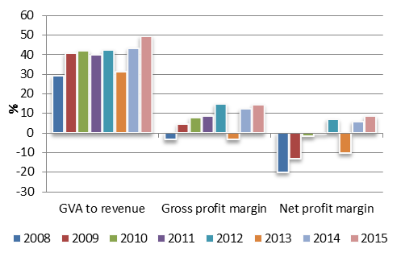

Figure 18. Trends in EU economic performance indictors 2008 – 2013: Spanish demersal trawlers 24-40 meters in length.

# Section III – Implementation of the landing obligation

**Introduction**

Based on the obligation to report on the implementation of the landing obligation in Regulation (EU) No 1380/2013[3], the Commission has obtained information from Member States and Advisory Councils information on:

* the steps taken by Member States and producer organisations to comply with the landing obligation;
* the steps taken by Member States regarding checks on compliance with the landing obligation;
* the socioeconomic impact of the landing obligation;
* the effect of the landing obligation on safety on board fishing vessels;
* the use of, and outlets for catches below the minimum conservation reference size (MCRS) of a species subject to the landing obligation;
* port infrastructures and vessel fittings responding to the landing obligation;
* the difficulties encountered in the implementation of the landing obligation and recommendations to address them, for each fishery concerned.

In 2016 the Commission issued a voluntary questionnaire with 34 questions on the landing obligation to help the Member States with their reports and increase comparability.

Reports were received from 22 Member States, three Advisory Councils (for the Mediterranean, South-Western waters AC and North-Western waters, the European Fisheries Control Agency (EFCA) and two local groups. The information in this Section is based on the Member States and Advisory Councils contributions on their experiences in implementing the landing obligation in 2016.

The individual reports from Member States highlight the wide range of measures used to promote compliance with the landing obligation. Overall, Member States have continued to make significant efforts to disseminate information to fishermen; these have included working through and in close cooperation with the Advisory Councils. A number of Member States have launched specific studies and pilot projects to test selective gears or avoidance strategies, to assess the impacts of the landing obligation on specific fisheries, or to provide data to support *de minimis* and high survivability exemptions under discard plans. Here, some difficulties have been reported with the registration of catches below minimum conservation reference size in the Electronic [catch] Reporting System (ERS) system and in paper logbooks. A few Member States have amended their national quota management systems. One Member State has reported using the inter-species quota flexibility; six report using the inter-annual flexibility mechanism.

Member States have also taken a range of steps to ensure controls on, and compliance with, the landing obligation. Most have provided specific training and dedicated workshops for inspectors on the control side of the landing obligation. In most of these cases EFCA has provided assistance. In addition, the majority of Member States have signalled a move towards a risk-based approach to control and monitoring. EFCA has demonstrated how the last-haul analysis can help assess compliance with the landing obligation provisions and provide information on catch composition across different fisheries. However, while there has been extensive dialogue between inspectors at regional level, and most Member State high-level groups have established cross-sectoral working groups on control, relatively few concrete measures have emerged. New control tools such as Close Circuit Television (CCTV) and other Remote Electronic Monitoring (REM) systems have been tested in many countries but there is little evidence of their being mandatory. By contrast, observer coverage has not increased; in fact, in several Member States there are indications that it has actually fallen. This is a worrying development and could ultimately affect future scientific advice.

Member States report that it is difficult as yet to assess the *socio-economic impacts* of the landing obligation, as it is still at an early stage of implementation. The majority of Member States indicate that problems so far have been minimal, but they expect more to arise as the phasing-in of the landing obligation progresses. In particular, difficulties with the handling and storage of unwanted catches on board and limited opportunities for disposing of them are highlighted as potential problems.

There is still no clear evidence of the landing obligation causing *safety issues on board fishing vessels*. No Member States have reported any incidents or accidents, although some continue to highlight potential issues of overloading and additional workload, leading to tiredness. Several Member States have provided funding under the European Maritime and Fisheries Fund (EMFF) to improve safety on board, although these funds are not directly related to the landing obligation.

*Landings of fish below MCRS* reported by Member States are low across the different regions. The comparisons between estimates from the available observer data and the last-haul analysis cast doubt on whether they reflect the quantities actually caught. Any unwanted catches landed have been used for fish meal, pet food or bait for pot fisheries. The limited volume of unwanted catches seems to have restricted the level of investment required to develop alternative uses for such catches in most Member States. However, several Member States have reported ongoing projects to look at other potential uses.

Funding under the EMFF to improve the *infrastructure of ports and modifications on board fishing vessels* to handle unwanted catches has been limited to date, reflecting the low levels of unwanted catches below MCRS that have been landed. Several Member States highlight specific actions taken, such as the provision of cold-storage facilities in fishery harbours and ports and modifications on board vessels to help fishermen with the storage of unwanted catches on landing and on board.

Overall, Member States indicate that *difficulties in implementing the landing obligation encountered* so far have been minimal. However, several highlight the most significant issue they face as being the industry’s reluctance to comply with the landing obligation, despite considerable awareness-raising efforts. They also report that fishermen seem slow to change behaviour. The issue of choke species remains the biggest challenge in implementing the landing obligation, although very few concrete choking scenarios have been reported. For 2016, only one Member State indicated that unintended catches had led to the premature closure of the herring fishery off the southwest coast of England.

In summary, Member States, EFCA and the Advisory Councils are working closely together to help implement the landing obligation smoothly, and no significant impacts on the industry have been reported so far. On the other hand, much of the information supplied remains largely qualitative; an increase in the level of quantitative information would provide a better means of assessing how the landing obligation is being implemented. There are other areas to be addressed in the lead-up to 2019: industry’s reluctance to embrace the change; the lack of accurate reporting of fish discarded under the exemptions in place; the low volumes of reported or landed catches below MCRS; and the difficulties experienced by Member States in monitoring such catches.

The CFP envisages the gradual phasing in of stocks which will be subject to the landing obligation, with full implementation by 2019. Based on the legal calendar and the state of play of phasing in the landing obligation we already have a number of fisheries in Europe where today all catches fall under the landing obligation, namely all fisheries in the Baltic Sea as well as all fisheries for pelagic and for industrial species in all EU waters. Furthermore looking at the regional situation in the North Sea 82% of all TACs are now under the landing obligation. In North Western Waters this figure amounts to 86% and in South Western waters it is 77%. Looking at the volume of demersal fish under the landing obligation this is 28% in the North Sea, 46% in North Western waters and 27% in South Western Waters. These figures bring to light that we are well on the way for North Western Waters demersal fisheries, and that a more concerted effort is needed for demersal fisheries in the North Sea and in South Western Waters order to ensure progress until 2019[4].

Based on the legal calendar and the state of play of phasing in the landing obligation we already have a number of fisheries in Europe where today all catches need to be landed, namely all fisheries in the Baltic Sea as well as all fisheries for pelagic and for industrial species in all EU waters. Furthermore looking at the regional situation in the North Sea 82 % of all TACs are now under the landing obligation. In North Western Waters this figure amounts to 86 %, in South Western waters it is 77 %. Looking at the volume of demersal fish under the landing obligation this is 28 % in the North Sea, 46% in North Western Waters, 27% in South Western Waters. These figures bring to light that we are well on the way for North Western Waters demersal fisheries, and that a more concerted effort is needed for demersal fisheries in the North Sea, in South Western Waters order to ensure progress until 2019.

In the Mediterranean Sea, where the landing obligation applies to species which are subject to minimum conservation reference sizes, 29 % of the total landings are currently under the landing obligation. Looking by fisheries, this figure amounts to 82 % for small pelagic species and 17 % for demersal species (including molluscs). This data indicates that most catches from small pelagic fisheries are subject to the landing obligation, whereas further work is needed to better integrate demersal fisheries in the landing obligation by 2019. As regards the Black Sea, the landing obligation covers all catches of the species subject to TAC since 2017 (i.e. sprat and turbot).

|  |  |  |  |
| --- | --- | --- | --- |
|  |  |  |  |
| **Volume under LO per seabasin** | |  |  |
|  | Total TAC 2017 | Volume of TAC under LO | % under LO |
| Total | 3,807,970 | 3,281,504 | 86% |
| Baltic Sea | 697,390 | 697,390 | 100% |
| North Sea | 1,537,721 | 1,257,929 | 82% |
| North Western Waters | 1,244,440 | 1,071,749 | 86% |
| South Western Waters | 328,419 | 254,435 | 77% |
| Black Sea | 11,561 | 11,561 | 100% |
|  |  |  |  |
| **Volume under LO per stock category** | |  |  |
|  | Total TAC 2017 | Volume of TAC under LO | % under LO |
| Total | 3,807,970 | 3,281,504 | 86% |
| Demersal species | 825,267 | 317,232 | 38% |
| Pelagic species | 2,279,34 | 2,279,34 | 100% |
| Industrial species | 696,799 | 696,799 | 100% |
| Deep-sea species | 18,431 | 0 | 0% |
|  |  |  |  |
| **Volume of demersal stocks under LO per seabasin** | |  |  |
|  | Total demersal TAC | Total demersal volume under LO (t) | % unnder LO |
| Total | 825,181 | 317,146 | 38% |
| North Sea | 387,830 | 108,368 | 28% |
| North Western Waters | 304,102 | 140,017 | 46% |
| South WesternWaters | 88,454 | 23,965 | 27% |
| Baltic Sea | 44,795 | 44,795 | 100% |
| Black Sea | 86,4 | 86,4 | 100% |
|  |  |  |  |

|  |  |  |  |  |  |
| --- | --- | --- | --- | --- | --- |
| **Breakdown of volume of pelagic stocks and fish for industrial purposes under LO** | | | | |  |
|  | Total pelagic volume under LO (t) | |  | |  |
| Total | 2,964,358 | |  | |  |
| North Sea | 1,149,561 | |  | |  |
| North Western Waters | 931,732 | |  | |  |
| South Western Waters | 230,470 | |  | |  |
| Baltic Sea | 652,595 | |  | |  |
| Black Sea | 11,475 | |  | |  |
| Of this: |  | |  | |  |
| Fish for industrial purposes | 696,799 | |  | |  |
| Pelagic species | 2,279,34 | |  | |  |
|  |  | |  | |  |
| **Mediterranean Sea: volume under LO (species with MCRS)** | | | |  | | |  |
|  | |  | |  | | |  |
|  | | Total reported landings (tonnes) | | Volume of landings under LO | | | % under LO |
| Small pelagic species | | 279.766 | | 230.249 | | | 82% |
| Demersal species | | 280.069 | | 15.403 | | | 5% |
| Molluscs | | 204.633 | | 24.774 | | | 12% |
| Others | | 180.763 | | 0 | | | 0% |
| **Total** | | **945.231** | | **270.426** | | | **29%** |
|  | |  | |  | | |  |
| Source: FIDES, reference year 2016 | | | |  | | |  |

**Support for implementing the landing obligation**

**Additional detailed information EMFF – Member States’ operational programmes for the landing obligation**

The total amount set aside by Member States in their operational programmes (OPs) specifically for landing obligation measures is EUR 408 809 677, or 7 % of total funding available under the EMFF. The EMFF articles of relevance for landing obligation measures are 26, 28, 37, 38, 39, 40(1), 42 and 43(2).

Figure 19 shows the percentage of measures programmed specifically for the landing obligation by each Member State within their OPs, compared to the total EMFF resources available to it.

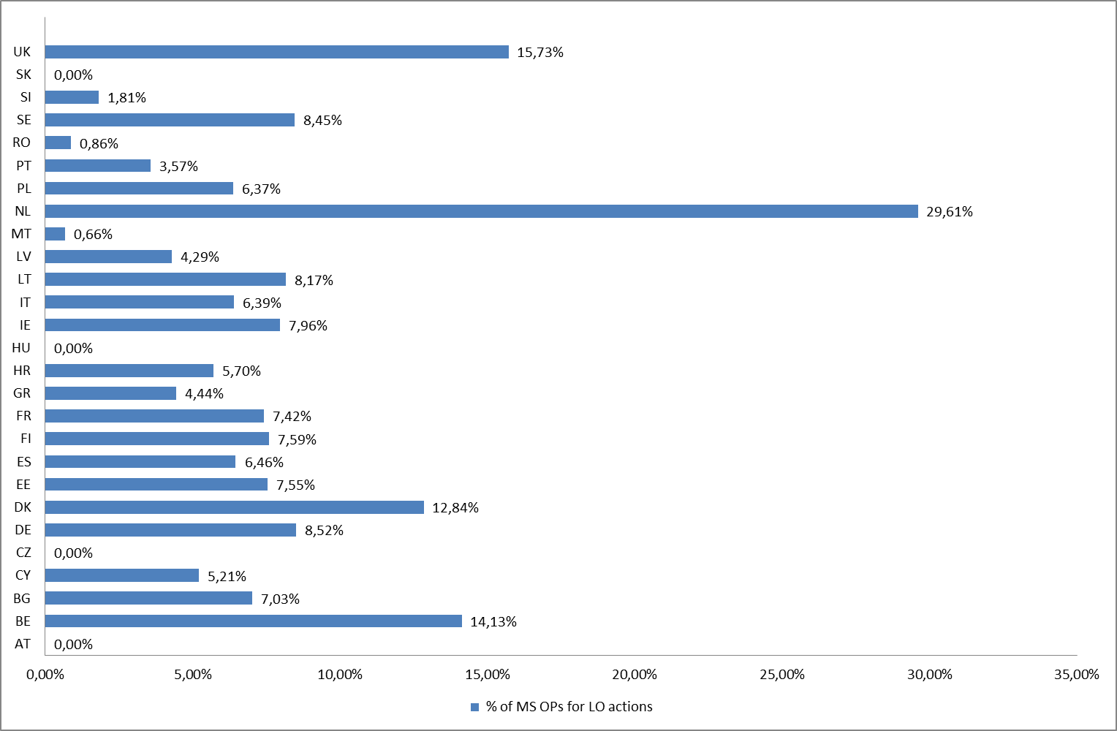

Figure 19. Measures programmed for the landing obligation by Member State.

**Additional information – Commission programmes on the landing obligation**

Aside from EMFF funding, the Commission invests in (research on) implementing the landing obligation. For example, the **DiscardLess** and **MINOUW** projects are financed from Horizon2020. These projects provide best-practice case studies on how to avoid discards through technological changes, tactical changes and the use of unwanted catches in the value chain. The scientific knowledge collected in this way could contribute to successful implementation of the landing obligation.

framework. This project provides best practice case studies for avoiding discards through technological changes, tactical changes and by using unwanted catches in the value chain. Scientific knowledge is in this way collected that could contribute to a successful implementation of the LO.

# Section IV - Governance through regionalisation

**Joint Recommendations under Article 11 of the CFP**

Joint recommendations under Article 11 of the CFP, received by the Commission:

|  |  |  |
| --- | --- | --- |
| Date | EU countries having direct management interest | Sea basin |
| 13/03/2015 | DE, DK, SE | North Sea |
| 13/03/2015 | DE, DK, SE | Baltic Sea |
| 10/06/2016 | DE, DK, SE | North Sea |
| 16/11/2016 | DE, DK, SE | North Sea |
| 30/11/2016 | DE, DK, SE, PL | Baltic Sea |
| 14/02/2017 | BE | North Sea |
| 28/02/2017 | BE, DE, DK, SE | North Sea |

* **Baltic Sea**

Commission Delegated Regulation (EU) 2017/117 of 5 September 2016 establishing fisheries conservation measures for the protection of the marine environment in the Baltic Sea and repealing Delegated Regulation (EU) 2015/1778.

* **North Sea**

Commission Delegated Regulation (EU) 2017/118 of 5 September 2016 establishing fisheries conservation measures for the protection of the marine environment in the North Sea.

**Discard Plans**

Since 2014 the Commission has adopted 15 discard plans to prepare for the implementation of the landing obligation:

1. Commission Delegated Regulation (EU) No 1392/2014 of 20 October 2014 establishing a discard plan for certain small pelagic fisheries in the **Mediterranean Sea**
2. Commission Delegated Regulation (EU) No 1393/2014 of 20 October 2014 establishing a discard plan for certain pelagic fisheries in **north-western waters**
3. Commission Delegated Regulation (EU) No 1394/2014 of 20 October 2014 establishing a discard plan for certain pelagic fisheries in **south-western waters**
4. Commission Delegated Regulation (EU) No 1395/2014 of 20 October 2014 establishing a discard plan for certain small pelagic fisheries and fisheries for industrial purposes in the **North Sea**
5. Commission Delegated Regulation (EU) No 1396/2014 of 20 October 2014 establishing a discard plan in the **Baltic Sea**
6. Commission Delegated Regulation (EU) 2015/2438 of 12 October 2015 establishing a discard plan for certain demersal fisheries in **north-western waters**
7. Commission Delegated Regulation (EU) 2015/2439 of 12 October 2015 establishing a discard plan for certain demersal fisheries in **south-western waters**
8. Commission Delegated Regulation (EU) 2015/2440 of 22 October 2015 establishing a discard plan for certain demersal fisheries in the **North Sea and in Union waters of ICES Division IIa**
9. Commission Delegated Regulation (EU) 2016/2250 of 4 October 2016 establishing a discard plan for certain demersal fisheries in the **North Sea and in Union waters of ICES Division IIa**
10. Commission Delegated Regulation (EU) 2016/2374 of 12 October 2016 establishing a discard plan for certain demersal fisheries in **South-Western waters**
11. Commission Delegated Regulation (EU) 2016/2375 of 12 October 2016 establishing a discard plan for certain demersal fisheries in **North-Western waters**
12. Commission Delegated Regulation (EU) 2016/2376 of 13 October 2016 establishing a discard plan for **mollusc bivalve Venus spp. in the Italian territorial waters**
13. Commission Delegated Regulation (EU) 2016/2377 of 14 October 2016 amending Delegated Regulation (EU) No 1394/2014 establishing a discard plan for certain pelagic fisheries in **South-Western waters**
14. Commission Delegated Regulation (EU) 2017/86 of 20 October 2016 establishing a discard plan for certain demersal fisheries in the **Mediterranean Sea**
15. Commission Delegated Regulation (EU) 2017/87 of 20 October 2016 establishing a discard plan for turbot fisheries in the **Black Sea**

# Section V - Report on Member States' efforts during 2015 to achieve a sustainable balance between fishing capacity and fishing opportunities

In accordance with the Common Fisheries Policy, Member States are required to prepare an annual report on the fishing capacity of their fleets in relation to fishing opportunities. If a Member State identifies a structural imbalance, it must submit an action plan for the segment(s) concerned, setting out adjustment targets, tools and a clear timeframe for its implementation. Member States must submit fleet reports in line with the Commission guidelines as a pre-condition under the EMFF[5].

The Commission draws on these national fleet reports[6] to draft a report on Member States’ efforts to achieve a sustainable balance between fishing capacity and fishing opportunities. The current report covers 2015 and also contains some updated data for 2016.

**The state of the fishing fleet capacity in the European Union**

The CFP stipulates that Member States must ensure that, from 2014, the fishing capacity of their fleet at no time exceeds the fishing ceilings in Annex II to Regulation (EU) No 1380/2013. There are 84 134 vessels in the EU fleet register. With overall capacity at 1 592 057 gross tonnes (GT) and 6 375 340 kilowatts (kW), the fishing capacity of the EU fleet is 25.50 % below the capacity ceilings for tonnage and 22.21 % below the power ceilings (see Figure 20). Fleet capacity is still decreasing; in the EU’s 23 coastal Member States there have been falls of 1.09 % in the number of vessels, 1.53% in kW and 2.16% in GT, continuing the trends seen in the past decade.

**Figure 20. Compliance with capacity ceilings in December 2016**. **Effective capacity as percentage of capacity ceiling by Member State (excluding outermost regions)**

In the period 2007-2016, Member States also used permanent cessation measures under the European Fisheries Fund to decommission vessels from their fleet and reduce capacity. Between 1 January 2007 and 31 December 2015, 4 378 vessels were decommissioned with public support. Public expenditure (certified payments) amounted to almost EUR 932 million, of which EUR 554 million came from the European Fisheries Fund. Vessels decommissioned with public support from the Fund cannot be replaced, thereby ensuring that overall fleet capacity has been reduced. A further 3 608 vessels (totalling 92 292.89 GT and 289 474.28 kW) were removed from the fleet without public aid, although capacity withdrawn in this way can be reintroduced.

In line with commitments set out in the CFP, all 23 coastal Member States submitted their reports to the Commission for 2015. The Scientific, Technical and Economic Committee for Fisheries (STECF) was asked by the Commission to provide an analysis of the balance between fleet capacity and fishing opportunities using a standard approach across all EU fleet segments and based on Data Collection Framework (DCF) information. All balance indicators provided and used in the STECF EWG 16-09 were calculated in accordance with the Commission Guidelines.

The overview of trends in the balance indicators shows progress in most fleet segments. However, the balance indicators for some segments may require further action to redress the situation. In such circumstances Member States are required under the CFP to prepare and include in their annual fleet report action plans for the segments with a structural imbalance[7]. This is closely linked to implementation of the EMFF, as permanent cessation measures under the EMFF are only possible for imbalanced fleet segments (and only until the end of 2017). Engine replacement and start-up support for young fishermen are only possible in balanced fleet segments.

In 2016, on the basis of biological, economic or technical indicators and/or supplementary information, fifteen Member States[8] identified a number of their fleet segments as not effectively balanced with their fishing opportunities, or showing latent signs of being imbalanced, and therefore requiring action plans under the Commission guidelines.

Another four Member States[9] concluded that they no longer had imbalanced fleet segments and thus did not submit any action plans. The remaining four coastal Member States[10] did not submit new action plans in 2016, despite the fact that they had identified imbalanced segments, because they were still implementing previous long-term action plans.

In the North-East Atlantic, fishing capacity in terms of GT and kW continues to decrease and there is a general improvement across all the balance indicators. However, according to the STECF analysis, some fleet segments in the North-East Atlantic remain out of balance with their fishing opportunities[11] and rely on stock considered at risk[12].

Overcapacity is considered a leading cause of overfishing in the Mediterranean Sea, given the general lack of catch controls and the reliance on effort to regulate fishing mortality. For example, around the Adriatic, Italy plans to reduce its fishing capacity by 8 % and Croatia by 5 to 20 %, depending on the fleet segment. Slovenia carried out a capacity reduction in 2013 of 38 % (in GT) and 20 % (in kW) compared to 2010[13].

More generally across the Mediterranean, in 2016 Member States presented a number of action plans to address imbalances or make the action plans submitted in 2015 more effective. They have established fishing protected areas and adopted 38 national management plans. The Commission is also working with them to introduce short-term national management measures. National management plans will have to be adapted to take account of these measures where relevant. They will also have to be aligned with the new CFP, especially where the landing obligation and the MSY objective are concerned.

The situation is similar in the Black Sea, where the majority of assessed stocks are overfished. While two stocks (turbot and sprat) are regulated under EU TACs and quotas, no management plan is currently in place.

**Outermost regions**

The fleets in the outermost regions of France, Portugal and Spain (with a total of 4 511 fishing vessels) are considered separately from the mainland fleets in Annex II of Regulation (EU) No 1380/2013. As of December 2016, the overall ceilings for the outermost regions decreased very slightly to 107 430 GT. For the EU’s outermost regions, which account for 5.4 % of the total EU fleet, from January 2015 to December 2016 fleet capacities decreased in total by 3.34 % in GT and by 0.46 % in kW (see Table 1). The fishing fleets in these regions are primarily composed of small-scale vessels targeting inshore and offshore resources. The STECF notes that lack of data (both economic and biological) makes it difficult to assess the extent to which these fleets are in balance or not.

**Conclusions**

From the STECF analysis and Member State reports, the following conclusions can be reached.

Member States are making huge efforts to balance their fleets’ fishing capacity and the available fishing opportunities.

Most Member States have identified fleet segments with structural overcapacity or showing potential signs of imbalance. In comparison with 2014, in 2015 the number of fleet segments for which Member States identified an imbalance with the available fishing opportunities increased. As a result, the action plans submitted in 2016 by most coastal Member States identified additional imbalanced fleet segments. In 2015 fifteen new action plans were submitted by Member States, 13 of which were revisions to action plans already submitted in 2014.

In concrete situations of segments with identified structural overcapacity, the Member States’ action plans to reduce the imbalance appear to be a transparent and effective means of pursuing a balance between fishing fleet capacity and fishing opportunities over time.

The STECF analysis shows that some of the indicators could not be calculated for all fleet segments due to a lack of biological and catch data or, in case of economic and technical indicators, due to clustering of segments to protect commercial confidentiality.

In spite of the above developments, in recent years the balance between fishing capacity and fishing opportunities has improved across the entire EU fleet. This is partly because, over the last decade, the EU fishing fleet’s capacity has been gradually cut. However, Member State reports and action plans reveal that further efforts are needed on fleet segments where structural overcapacity remains. The reduction in fleet capacity in recent years has helped improve the state of fish stocks generally and continues to move fisheries towards the MSY objectives in the CFP.

Table 1

|  |  |  |  |  |  |  |  |  |  |  |  |
| --- | --- | --- | --- | --- | --- | --- | --- | --- | --- | --- | --- |
| **Member States' fleet evolutions (vessels, tonnage and engine power) during 2015-2016** | | | | | | | | |  |  |  |
|  |  |  |  |  |  |  |  |  | | |  |
|  | N | GT | KW | N | GT | KW | Δ N(%) | Δ GT (%) | | | Δ KW (%) |
|  |  | 31/12/2015 |  |  | 01/12/2016 |  |  |  | | |  |
| MS | 41640 |  |  |  |  |  | Δ 2015-2016 |  | | |  |
| BE | 78 | 14,535 | 46,289 | 74 | 13,962 | 45,267 | -5.13% | -3.94% | | | -2.21% |
| BG | 1,989 | 6,541 | 58,043 | 1,930 | 6,598 | 58,984 | -2.97% | 0.87% | | | 1.62% |
| DK | 2,396 | 69,607 | 224,769 | 2,299 | 69,700 | 215,029 | -4.05% | 0.13% | | | -4.33% |
| DE | 1,465 | 64,221 | 141,679 | 1,427 | 63,930 | 140,171 | -2.59% | -0.45% | | | -1.06% |
| EE | 1,534 | 13,225 | 43,714 | 1,547 | 13,275 | 44,535 | 0.85% | 0.38% | | | 1.88% |
| IE | 2,157 | 63,466 | 192,441 | 2,136 | 63,498 | 193,866 | -0.97% | 0.05% | | | 0.74% |
| EL | 15,638 | 76,573 | 449,534 | 15,241 | 71,882 | 431,838 | -2.54% | -6.13% | | | -3.94% |
| ES | 9,481 | 353,356 | 812,550 | 9,388 | 339,949 | 794,304 | -0.98% | -3.79% | | | -2.25% |
| FR | 6,964 | 171,544 | 1,001,603 | 6,847 | 175,445 | 1,006,598 | -1.68% | 2.27% | | | 0.50% |
| IT | 12,414 | 162,749 | 1,003,301 | 12,311 | 157,527 | 986,471 | -0.83% | -3.21% | | | -1.68% |
| CY | 893 | 3,502 | 40,209 | 839 | 3,427 | 38,460 | -6.05% | -2.14% | | | -4.35% |
| LV | 688 | 24,671 | 43,114 | 681 | 28,715 | 47,638 | -1.02% | 16.39% | | | 10.49% |
| LT | 143 | 41,401 | 46,418 | 143 | 40,875 | 47,993 | 0.00% | -1.27% | | | 3.39% |
| MT | 1,005 | 7,106 | 73,106 | 917 | 6,211 | 67,165 | -8.76% | -12.59% | | | -8.13% |
| NL | 832 | 133,995 | 312,548 | 840 | 128,090 | 306,754 | 0.96% | -4.41% | | | -1.85% |
| PL | 874 | 26,293 | 76,256 | 875 | 35,718 | 86,937 | 0.11% | 35.84% | | | 14.01% |
| PT | 8,137 | 98,217 | 362,058 | 8,029 | 93,835 | 356,258 | -1.33% | -4.46% | | | -1.60% |
| RO | 152 | 870 | 6,146 | 158 | 1,118 | 6,041 | 3.95% | 28.53% | | | -1.71% |
| SI | 169 | 597 | 8,540 | 171 | 590 | 8,535 | 1.18% | -1.23% | | | -0.06% |
| FI | 2,839 | 15,613 | 160,475 | 3,024 | 15,549 | 165,748 | 6.52% | -0.41% | | | 3.29% |
| SE | 1,357 | 30,398 | 167,214 | 1,322 | 28,050 | 160,941 | -2.58% | -7.72% | | | -3.75% |
| UK | 6,320 | 196,304 | 789,992 | 6,256 | 184,312 | 769,237 | -1.01% | -6.11% | | | -2.63% |
| HR | 7,540 | 52,341 | 414,618 | 7,679 | 49,800 | 396,570 | 1.84% | -4.85% | | | -4.35% |
| Σ | 85,065 | 1,627,125 | 6,474,617 | 84,134 | 1,592,057 | 6,375,340 | -1.09% | -2.16% | | | -1.53% |

1. 2017-04_STECF 17-04: *Monitoring the performance of the Common Fisheries Policy (WP)*, Ispra, Italy, 27-31 March 2017, Publications Office of the European Union, Luxembourg, 2017.
2. Figures for 2005-2014 are taken from previous Communications
3. REGULATION (EU) No 1380/2013 OF THE EUROPEAN PARLIAMENT AND OF THE COUNCIL of 11 December 2013 on the Common Fisheries Policy, amending Council Regulations (EC) No 1954/2003 and (EC) No 1224/2009 and repealing Council Regulations (EC) No 2371/2002 and (EC) No 639/2004 and Council Decision 2004/585/EC
4. Table XY in the annex to this Communication
5. See Annex IV to Regulation (EU) No 508/2014 of the European Parliament and of the Council of 15 May 2014 on the European Maritime and Fisheries Fund and repealing Council Regulations (EC) No   2328/2003, (EC) No 861/2006, (EC) No 1198/2006 and (EC) No 791/2007 and Regulation (EU) No 1255/2011 of the European Parliament and of the Council, OJ L 149, 20.5.2014, p. 1.
6. See Annual Report, <http://s-antares.fish.cec.eu.int/front/index.cfm?method=FM_Reporting>.
7. Member States must submit annual reports (and action plans where relevant) to remain eligible for EU financial support under the new European Maritime and Fisheries Fund (EMFF).
8. Belgium, Bulgaria, Croatia, Cyprus, Denmark, France, Germany, Ireland, Italy, Malta, Portugal, Romania, Slovenia, Spain and the United Kingdom. The action plans are available at: <http://ec.europa.eu/fisheries/fleet/index.cfm?method=FM_Reporting.menu>.
9. Estonia, Finland, Greece and the Netherlands.
10. Latvia, Lithuania, Poland and Sweden.
11. The list of fleet segments not in balance also includes: 12-18 m and 18-24 m drift and fixed nets (mostly targeting sole); 12-18 m demersal trawls (targeting various Nephrop stocks); 24-40 m pelagic trawls (targeting Atlantic mackerel); and 18-24 m and 24-40 m beam trawls (targeting a mix of species). These segments account for 2.4 % (8.1 % of GT and 8.3 % of Kw) of all vessels in the North-East Atlantic. For an overview of the North-East Atlantic fleet, see Annex VI.
12. For the list of stocks at risk in this area, see annex V of Scientific, Technical and Economic Committee for Fisheries (STECF) Assessment of balance indicators for key fleet segments and review of national reports on Member States efforts to achieve balance between fleet capacity and fishing opportunities (STECF-16-18).); Publications Office of the European Union, Luxembourg; EUR 27758 EN; doi:10.2788/245471.
13. The ten fleet segments which account for the greatest share of catches of small pelagics in the Adriatic are all included in the relevant Member States’ action plans for the fleet segments with identified structural overcapacity. The plans detail how Member States intend to address this overcapacity.