

Commission staff working document

Table of Contents

1 Introduction 4

2 Smart Specialisation – regional partnerships for innovation, growth and jobs 6

2.1 The need for smart specialisation 6

2.1.1 Boosting investment in research and innovation 7

2.1.2 The diversity of performance of regional innovation systems across Europe 9

2.1.3 The position of the European institutions 11

2.1.4 Public consultation on smart specialisation 11

2.2 The RIS3 approach 12

2.2.1 The history of smart specialisation 12

2.2.2 A place-based policy approach 13

2.2.3 Addressing weaknesses in the delivery of regional innovation policy 14

2.3 Putting in place the right conditions for effective investments 16

2.3.1 RIS3 as an ex-ante conditionality 16

2.3.2 Incentives for reform through ex-ante conditionalities 17

2.3.3 RIS3 conditionality has helped address institutional weaknesses in innovation systems. 18

2.3.4 Changes induced by the RIS3 ex-ante conditionality 19

2.4 Early implementation and expected results 20

2.4.1 Expected results 20

2.4.2 Investment share in Research and Innovation (R&I) 20

2.4.3 Thematic priorities of regions – Eye@RIS3 21

2.4.4 Selection of operations and expenditure declared in ESI Funds 23

2.4.5 Evidence on implementation through analysis of calls for projects 24

2.4.6 The establishment of the S3Platform 25

2.4.7 Influence on national and regional systems 27

2.4.8 Overall assessment of achievements 33

3 Key challenges and next steps: boosting innovation-led growth 36

3.1 Further reform of research and innovation systems 36

3.1.1 The contribution of research and innovation to EU economy and productivity growth 36

3.1.2 The need for reform 37

3.1.3 Higher education and VET in smart specialisation 39

3.2 Increasing cooperation in innovation investment across regions 42

3.2.1 Rationale for transnational, interregional, cross-border cooperation 42

3.2.2 Addressing fragmentation and creating innovation investments in value chains 42

3.2.3 RIS3 in European Territorial Cooperation 45

3.2.4 Macro-regional strategies 45

3.2.5 European-level support for smart specialisation investment across borders 47

3.2.6 Thematic Smart Specialisation Platforms 49

3.2.7 RIS3 and the link to Digital Innovation Hubs and other innovation infrastructures 53

3.2.8 Maturity of mechanisms to support investment in innovation across borders: 54

3.3 Leveraging research and innovation in less developed and industrial transition regions 55

3.3.1 Tailoring through RIS3 leads to address specific bottlenecks in less developed regions 55

3.3.2 Mutual learning on design and implementation 57

3.4 Harnessing synergies and complementarities between EU policies and instruments 58

3.4.1 Mechanisms for synergies 61

3.4.2 Progress on synergies 62

3.4.3 Initiatives to promote synergies 63

# Introduction

Europe is experiencing a momentous period of change. Globalisation, automation, decarbonisation, emerging and digital technologies: all have an impact on jobs, industrial sectors, business models, the economy and the society as a whole. It is indispensable to help Europeans adapt to these profound changes and to help the EU economy to become more resilient. In its Reflection Paper on Harnessing Globalisation[1], the Commission highlighted the opportunities and challenges that Europe's citizens and regions are facing. This means anticipating and managing the modernisation of existing economic and societal structures bearing in mind that today, more than ever local issues have gone global and global issues have become local. To this end, Europe needs a long-term strategy, involving action at all levels, which triggers a fundamental shift in technology, economics and finance.

Thefuture challenge for EU regions is to be able to compete at the global level with other most advanced and emerging economic powers as they are more than ever part of a globalised world. Therefore, they need to find ways to become more resilient and competitive by taking concrete actions at EU, national and local levels while ensuring that the benefits of globalisation are shared.

Many European regions are well positioned to take advantage of the opportunities offered by globalisation. However, the Commission's reflection paper on globalisation[2] stressed that the competitiveness and innovation divide between some advanced EU regions and less strong regions is widening. Vulnerable regions can still be found across Europe in Southern or Central and Eastern Europe. Identify the potential of these regions and focusing on reinforcing their local strengths, narrowing development gaps, and boosting competitiveness can help strengthen resilience to globalisation. Special attention should also be paid to the resilience of rural areas, which are at risk of being left behind by globalisation and demographic change.

Innovation clusters that link up companies, universities, start-ups, investors and local governments must be further developed and linked up across Europe. The EU and their regions should invest more in the emerging industries and workers of the future, focusing on new and advanced manufacturing technologies and related industrial services to drive innovation. EU regions should position themselves in global value chains and help their businesses move up along the value-chainand further exploit their comparative advantages.

In order to do so, regions should further strengthen links between stakeholders and infrastructures across different European countries to exploit synergies. Interregional cooperation can play an essential role in this direction. Sharing costs between companies within value chains and sectors in an open innovation community would allow the development of new processes and provide the means to succeed in a comprehensive way. This would permit many industries, and in particular their SMEs, to develop processes that they would not be able to develop on their own because of a lack of resources.

In order to boost Europe’s competitiveness, it will also be necessary to find additional private investment across all sectors, provide better access to finance (especially for SMEs and start-ups that develop most of the innovations) and increase access to foreign markets towards boosting EU exports. Openness to foreign investment is also key for the EU and a major source of growth – as is to provide investment-friendly regulatory and business framework conditions as well as develop critical infrastructure (including for digitalisation, energy and transport).

Globalisation is a shared task between the EU and its Member States and regions. The table below – from the European Commission’s reflection paper on harnessing globalisation[3] – shows how each level can contribute to make this process successful.

**Graph 1: Contribution of each level of governance to harnessing globalisation**

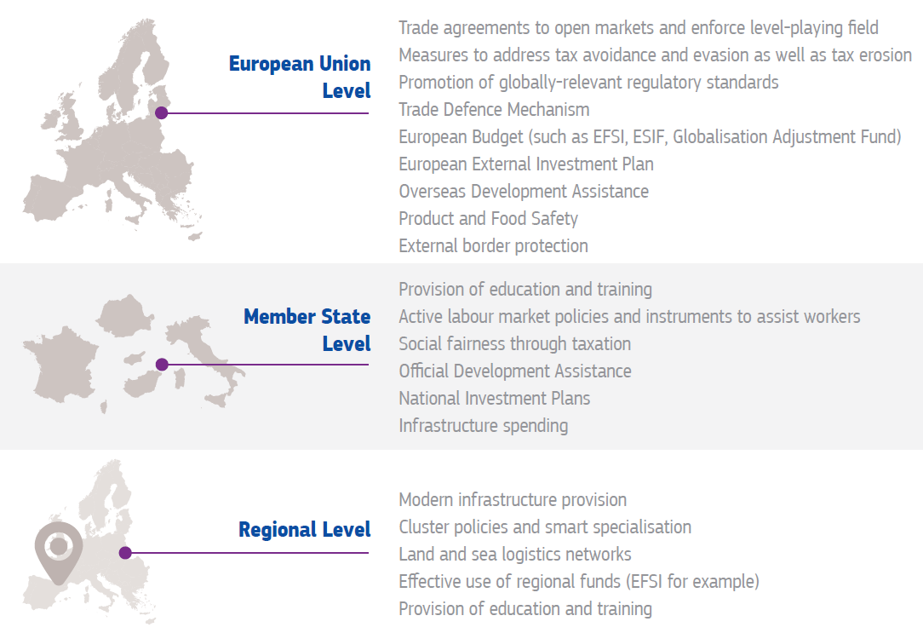

In conclusion, it is difficult to predict what globalisation will look like in ten years' time as technologies and their uses are changing rapidly. However, by strengthening cooperation between different levels of government, Europe can help its regions to move up global value chains, stimulate the private sector and target investment on key priorities and challenges, while preventing brain drain and rural flight.

This requires a concerted effort at EU, national and regional level to broaden the base for innovation, better target private and public resources and increase synergies. This entails not only better links within the Single Market and the European Research Area but also new opportunities for businesses to build on regional strengths to develop and grow within global value chains and markets and in this way to seize the opportunities created by globalisation.

In 2010 the Commission called on national and regional governments to develop smart specialisation strategies (RIS3) for research and innovation (R&I)[4] to encourage all European regions to discover their competitive advantage[5]. This new "smart specialisation" approach became the basis for research and innovation investment under the European Regional Development Fund (ERDF) for the programming period 2014-2020. The Council of the EU and the European Parliament have highlighted the need to further build on this approach[6].

The purpose of this staff working document is to provide a first overview of the evidence and draw lessons on R&I strategies for Smart Specialisation (RIS3) and their contribution to more efficient and effective national and R&I systems that support competitiveness and cohesion as well as broader research and industrial policy objectives, in the context of globalisation.

The document presents the smart specialisation approach and how it evolved from a theoretical concept to tool for the implementation of national and regional innovation policy in all European Union regions[7] irrespective of their economic development level, innovation performance, governance structure, research capabilities or business environment. It also examines how the prerequisites (ex-ante conditionalities) necessary for smart specialisation have been applied.

The staff working document assesses the current state of play as regards the design and implementation of smart specialisation strategies in the EU. It also shows how the smart specialisation approach is being applied in other parts of the world such as Australia and Latin America.

Finally, it examines the contribution of smart specialisation to the reform of European R&I systems and how, by adopting a tailored approach it has helped to build capacity in Europe's regions and facilitate investment across regions. It provides a state of play on the complementarities and synergies between EU instruments.

# Smart Specialisation – regional partnerships for innovation, growth and jobs

## The need for smart specialisation

Innovation is recognised as one of the main economic drivers for boosting jobs, growth and investment in the White Paper on the Future of Europe[8] and is essential for achieving the political priorities of the Juncker Commission[9]. Innovation is a precondition for "sustainable and job-creating growth"[10]. It leads to higher productivity and competitiveness while offering social and environmental benefits.[11]

### Boosting investment in research and innovation

Despite the fact that the target for Member States to invest 3% of their GDP on R&I is one of the priorities of Europe 2020 strategy[12], the aggregate share of R&I investments within the EU is still lower than in countries such the USA, Japan and South Korea. Within the EU,gross domestic expenditure on R&D as a percentage of GDP varies considerably from country to country with Sweden, Austria and Denmark spending a high percentage of their GDP on R&D and Eastern and Southern European countries lagging behind with lower expenditure.

**Graph 2: Gross domestic expenditure on R&D as % of GDP**

*Source: Eurostat 2017*

South Korea and Japan have an increasing performance lead over the EU. In particular their relative strength is in business R&D expenditures, innovation collaboration and procurement. The top R&D spending enterprises invest twice as much on R&D as top EU enterprises. Australia, Canada and the United States have a decreasing performance lead over the EU. However, Brazil, China, India, Russia and South Africa are catching up. In particular China increased its R&D expenditure and the number of Trademark and Design applications.

**Graph 3: Global performance (bars show countries' performance in 2016 relative to that of the EU in 2010)**

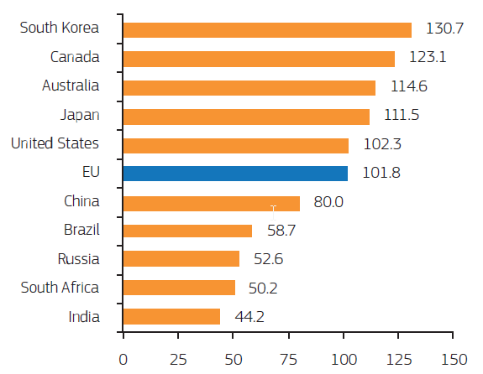

While the EU hosts a high number of high level PhDs, their research is weakly connected to the market. Their employment is almost equally shared between the public and private sector, whereas in competitor-countries the percentage of researchers employed within the private sector is higher.

**Graph 4: Researchers share in the business and public sectors in third countries compared to the EU.**

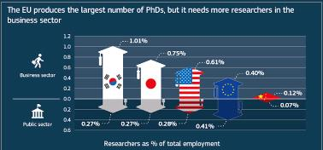

*Source: Science, Research and Innovation Performance of the EU 2016*

### The diversity of performance of regional innovation systems across Europe

Well performing innovation systems are found in Member States and regions which are better developed and are more competitive. There is a close correlation between R&D performance ("Regional Innovation Scoreboard") and economic performance ("EU Regional Competitiveness Index"). Without research and regional policies working closely together to encourage knowledge absorption, lagging regions and countries may never be able to converge to the technology frontier[13].

**Graph 5: EU regions performance in terms of innovation and competitiveness**

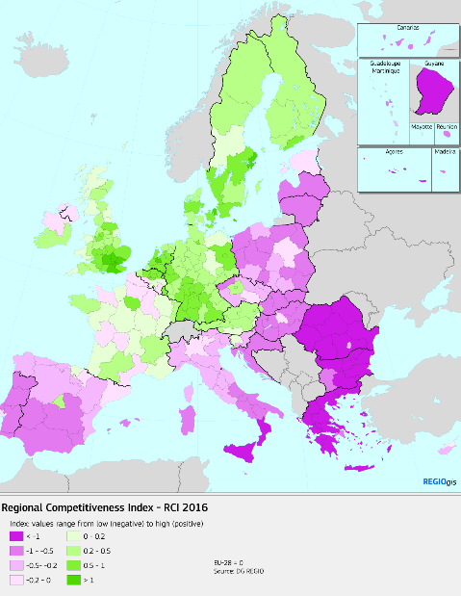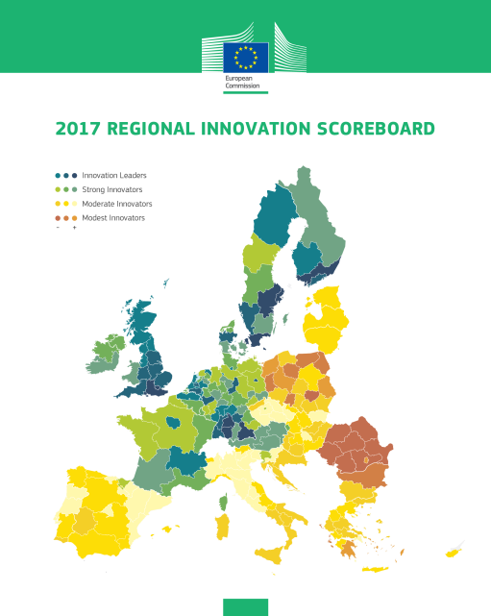

*Source: EU Regional Competitiveness Index, 2016 and Regional Innovation Scoreboard Report, 2017*

More than half of the total potential for productivity growth in developed countries comes from "catching up" innovation. Given the different level of economic development in which EU innovation actors operate, European policies need to take account of the differing situations in Member States and regions and, in particular, should target the needs of both developed and less developed economies.[14] Cohesion Policy therefore takes account of the specific needs of less developed[15] Member States and the need to support broad based innovation. This is in line with the recommendations of the 2017 Annual Growth Survey, which highlights the need to improve the interaction between research and business and to encourage reforms of weak research and innovation systems in Member States.[16]

As conditions differ from region to region, innovation needs to be embedded in local business knowledge that is often concentrated in clusters of related industries, but linked to high quality research across Europe to enable the swift diffusion and application of the knowledge created. By bringing together a broad range of businesses, researchers and public actors as part of a prioritisation and experimentation process and connecting them with new research ideas, smart specialisation can build on Europe's diversity of regional and local strengths.

The process of designing and implementing smart specialisation strategies ensures that public resources are targeted at areas which are likely to bring the best returns in terms of raising the level of innovation in all parts of Europe. This is achieved by addressing weaknesses in innovation systems and reinforcing the institutional capacity to bring research to market and trigger an uptake of innovation, notably in less-developed Member States.

### The position of the European institutions

The European Parliament expressed its support for smart specialisation in its resolution of 8 September 2016[17], and proposed to the European Commission and to Member States to implement further actions in order to make smart specialisation become more effective. It also noted in its Resolution of 6 July 2016 that synergies for innovation between Structural Funds and Horizon 2020 and other policies and instruments must be further enhanced in order to maximise the impact of investments. It further called for continued efforts to boost inter-regional collaboration and recalled the importance of innovation systems, institutions and the linkages to local and regional clusters in its report of 27 April 2016 on Cohesion Policy and smart specialisation strategies.[18]

The Council, in its conclusions of 24 June 2016, called for "a more R&I friendly, smart and simple Cohesion Policy and the European Structural and Investment Funds more generally", and recognised that "smart specialisation strategies could be powerful instruments for contributing to tackling societal challenges, and boosting innovation, investment and competitiveness, based on socio-economic and territorial specificities". It called on the European Commission "to give continued support to Member States and regions when developing and implementing smart specialisation strategies". The Council Conclusions of 4 December 2014 on the industrial competitiveness agenda[19] had also already recommended smart specialisation as an approach to prioritising investments and reiterated the importance of clusters and partnerships and the Presidency report of 16 November 2015 on mainstreaming competitiveness also acknowledged the contribution of clustering and smart specialisation strategies.[20]

In addition, the European Commission has launched many initiatives at EU level which identify smart specialisation as relevant for structural reforms[21] and for various policies such as energy[22], digital[23], industrial[24] policies and for the circular economy[25].

### Results of the public consultation on smart specialisation [26]

The importance of smart specialisation strategies is also highlighted by the replies of 237 respondents to the public consultation launched by the Commission in December 2016. 73 % of the respondents think it is ‘most and very important to implement European strategic priorities in focus areas in regions’, 70 % think it is ‘most and very important to have a bottom-up agenda for European growth & jobs’, 68 % think it is ‘most and very important that all types of regions can participate (advanced, research intensive regions and lagging regions)’ as well as alignment between complementary efforts in different countries and regions (64%).

The three most important objectives of RIS3 according to the respondents are:

* creating jobs and growth through place-based R&I investments (84%),
* enabling businesses and researchers to develop investment projects together (72%)
* the economic transformation of the region (e.g. towards new sectors) (68%).

The vast majority (94 %) of respondents to the public consultation think that it is important ‘to a great extent’ (74 %) or ‘to some extent’ (20 %) to put in place RIS3 strategies with priorities about which businesses, academia and public stakeholders have been consulted before funding is allocated.

Supporters and implementers of innovation alike observed a significant increase in the participation of clusters or business associations (75% and 66% respectively) and higher education institutions (68% and 76%) in the innovation ecosystem

In terms of the first early impact of smart specialisation strategies on the research and innovation infrastructure or support services, the greatest improvements in the support offered was observed for networking and cooperation (62% for finding partners within the country and 54% for partners abroad), for industrial research activities (55%) and experimental development/prototyping (49%) and for better access to researchers (53%) and R&I infrastructures and R& I service providers (55%). Important improvements have also been observed for technology transfer (47%) and digitization of enterprises and processes (42%) whereas no overall improvements were observed for the regulatory framework.

## The RIS3 approach

### The history of smart specialisation

Smart specialisation (RIS3) is an innovation policy approach that aims to boost national and regional innovation, contributing to growth and prosperity by helping and enabling Member States and regions to focus on their strengths. RIS3 brings together the research community, business, higher education, public authorities and civil society. These partners identify strengths in their region, and prioritise support based on where local potential and market opportunities lie (the "Entrepreneurial Discovery Process" - EDP). To help with this process, RIS3 seeks to improve governance at regional and national level, concentrate resources, build critical mass, and accelerate the uptake of new ideas.

The smart specialisation strategy concept was developed by the European Commission's high-level expert group "Knowledge for Growth" in 2005-2009[27], closely related to the concept of clusters[28], and was originally designed to tackle two main issues:

* The fragmentation of public research systems unable to compete independently on a global scale;
* The duplication of research work which leads to a scattering of resources across the European Research Area.

During the reform of cohesion policy for the period 2014-2020, the concept was extended in order to encourage regional economic transformation. It was also incorporated into EU regional policy as a key principle of investment in R&I.

In its 2010 Communication "Regional Policy Contributing to Smart Growth in Europe 2020"[29], the Commission called on national and regional governments to develop smart specialisation strategies (RIS3). Following its inclusion in the regulatory framework for Cohesion Policy 2014-2020 through the introduction of specific ex-ante conditionality, this new approach became the basis for research and innovation investment under the European Regional Development Fund.

Smart Specialisation strategies are defined in point (3) of Article 2 of the Regulation (EU) No 1303/2013[30] of the European Parliament and of the Council:

*"Smart Specialisation Strategy (S3)" means the national or regional innovation strategies which set priorities in order to build competitive advantage by developing and matching research and innovation own strengths to business needs in order to address emerging opportunities and market developments in a coherent manner, while avoiding duplication and fragmentation of efforts; a smart specialisation strategy may take the form of, or be included in, a national or regional research and innovation (R&I) strategic policy framework."*

### A place-based policy approach

Innovation still depends very much on location.[31] Smart specialisation has been implemented in high-performing[32], middle income[33],[34] and less-developed Member States or regions.[35],[36] Conceived within the reformed EU Cohesion Policy, smart specialisation is a place-based policy promoting investment in innovative activities in selected areas to achieve a smart, inclusive and sustainable growth in line with the EU's Europe 2020 growth strategy. Using local knowledge and learning reflects the overall justification for using a local and regional place-based development policy approach to cohesion policy, rather than employing a space-neutral or purely sectorial approach.[37]

The smart specialisation approach therefore identifies strategic areas for intervention, based both on the analysis of the strengths and potential of the regional economies and on a process of entrepreneurial discovery[38] with wide stakeholder involvement. It embraces a broad view of innovation that goes beyond research-oriented and technology-based activities, and requires a sound intervention strategy supported by effective monitoring mechanisms.

**Lessons learned from targeted RIS3 support in EU Member States and their regions**

In **Poland**, for instance, the Slaskie Region initiated its first innovation strategy for 2003-2013 on which it could rely, whereas Wielkopolskie, which never had strong specialisation, needed to start the entrepreneurial discovery process leading to the regional smart specialisation strategy, through comprehensive research and analysis of the existing conditions.

**Latvia** where smart specialisation was a new concept started with a comprehensive research on the sectors of the economy, related research capacity, business composition and advantages of the Member State. In close cooperation among the public sector, academia and business priority areas[39] were chosen and further developed though a continuous entrepreneurial discovery process combined with structural reforms of the research institutions and higher education institutions as well as by reviewing the tax regime for innovative companies.

In **Denmark** and **Sweden**, with highly developed innovation and business structures, the process approach was to detect systematically the inter-linkages and opportunities of the existing regional and national innovation and development strategies rather than to identify e.g. specific sectors as object for public intervention to promote smart specialisation.

**Finland**, as a leader in innovation, continues the smart specialisation approach in open, inclusive and participative method building on the existing advantages. An excellent example is Oulu Innovation Alliance that was created when the city faced a serious structural change caused by big ICT companies moving out of the city and thousands of jobs were lost. The aim of the alliance was to develop a Northern innovation ecosystem through cooperation between public sector, research and educational sector and companies that integrates top expertise and resources from selected fields. This approach helped Oulu to create 2000 new jobs, establish 300 new start-ups in the knowledge-intensive growth sectors, and develop new ICT sub-sectors that made the ICT sector in the region more flexible, agile and resilient to possible structural changes.

Each region, no matter the type or level of its socio-economic endowment, can in this way find its own way to sustainable and inclusive growth[40] taking into consideration EU strategic goals. For example, a carbon intensive region could focus on transforming experience and technology in traditional activities into greener economic activities that require similar competences and which are set to grow in the future in the context of EU policy priorities.

### Addressing weaknesses in the delivery of regional innovation policy

If properly designed through an interactive bottom-up process involving most of the innovation actors on a territory, smart specialisation can help address weaknesses in the delivery of innovation policy in Europe. These include the following:

Weaknesses in the delivery of regional innovation policy:

* **Lack of prioritisation and poor resource allocation** - The Entrepreneurial Discovery Process (EDP) is perhaps the most distinctive feature of the smart specialisation approach. Such a mechanism makes it possible: (i) to identify precisely (at the level of a single activity or system of activities) the market failures affecting the local economy and (ii) direct policy intervention exclusively towards those targets [41]. This is opposed to the previous situation (pre-RIS3), where it was not possible for public authorities to identify specific market failures and needs of the local economic system – meaning that the only option was to use horizontal measures (acting across activities, but with no differentiation between them[42].
* **Weak microeconomic governance** in the EU Member States and regions – evidence based policy and investment decision making which is informed by tacit knowledge of innovation actors is often not available in the public domain[43].
* **Barriers to the uptake of new ideas –** inflexible governance mechanisms[44] hamper the process of bringing new products and services into market.
* **Mismatch of EU research strengths and business needs** – the failure to exploit the wealth of knowledge existing in the EU to increase the competitiveness of EU businesses and accelerate the uptake of solutions to tackle societal challenges.
* **Lack of strategic alignment of investment pipelines** in industry and research, in both the private and public sector. This leads to scattered, fragmented and duplicated investments.
* **Lack of information flows** across business sectors, scientific disciplines and EU territories – increasing the degree of information asymmetry. **[45]**
* **Lack of interregional cooperation** between innovation actors across EU – failing to exploit the EU single market's potential to improve collaboration between innovation actors in related activities. **[46]**
* **Weaknesses in EU value chains** – opportunities for demonstration projects and for scaling up of initiatives are missed due to lack of economies of scale and scope[47].
* **Low leverage effect of EU funding** – a failure to attract private investors to realistic and bankable innovation initiatives.[48].

By addressing these issues in the delivery of support for innovation under the European Structural and Investment Funds (ESIF), smart specialisation can contribute to boosting overall growth and jobs, and help respond to globalisation. At a more specific regional level, smart specialisation can – by improving the prospects of specific regions and Member States for growth and economic transformation – also reduce disparities between the levels of development in the various regions and help the less-developed or lagging regions to progress.

It will also contribute to building specialisation in the Single Market as a whole, broadening innovation and contributing to industrial competitiveness goals. This applies to both well-established sectors such as agri-food, tourism, textile and those at the global technology frontiers in energy, environment, nano-tech, and health. Public administrations can use their purchasing power to play an important complementary role by encouraging transformative technological change and the uptake of innovation through their purchasing power.

Such activities offer regions the opportunity to diversify and develop new industrial activities by capitalising on emerging and key enabling technologies (KETs)[49], digital transformation[50], service innovation, resource-efficient solutions and other breakthrough innovations that cover all and new forms such as open and user-led, public sector, frugal and social innovation. In addition, the bio-economy and the transition to a circular economy offer great potential for growth.

## Putting in place the right conditions for effective investments

### RIS3 as an ex-ante conditionality

A key element of the RIS3 approach in during the 2014-2020 programming period was the requirement to define a national or regional RIS3 strategy for R&I before being allocated ERDF funding. This ex-ante conditionality was added to the regulatory framework to ensure that the effectiveness of EU investments within the regions was not undermined by the absence of evidence-based innovation priorities and the lack of appropriate institutional framework for R&I.

Two thematic ex-ante conditionalities (ExAC) were introduced in the area of research and innovation[51]:

**R&I: requiring a national or regional smart specialisation strategy that (ExAC 1.1)**

* is based on a SWOT or similar analysis to concentrate resources on a limited set of research and innovation priorities (ExAC 1.1.1);
* outlines measures to stimulate private research, technology and development (RTD) investment (ExAC 1.1.2);
* contains a monitoring and review system (ExAC 1.1.3);
* ensures that a Member State has adopted a framework outlining available budgetary resources for research and innovation (ExAC 1.1.4);

**R&I infrastructure: requiring a multi-annual plan for budgeting and prioritisation of investments (ExAC 1.2)**

The RIS3 ex-ante conditionality applied to most national or regional operational programmes (169 out of 205) and in all 28 Partnership Agreements. It was the most frequently applied ex-ante conditionality at regional level. At the time the programmes were adopted, only 20% of the programmes were considered as fulfilling ex-ante conditionality. 20 member states were required to develop action plans to fulfil this conditionality.

The following causes have been identified by the European Commission as responsible for a difficult fulfilment of ex-ante conditionality in the area of RIS3:

* A lack of political commitment to long-term strategies, and difficulties devising a bottom-up process of smart specialisation as a way to prioritise investments;
* The split of responsibilities between different vertical (national, regional, municipal) and horizontal (between ministers and departments) levels, resulting in the fragmentation of powers and failed coordination;
* A lack of effective, competent and adequately skilled staff in administration exacerbated by frequent legislative and institutional changes;
* Weak collaboration between the public and private sector and thus little commercialisation of public research;
* An absence of continuity in the entrepreneurial discovery process and a lack of key milestones, roadmaps, monitoring mechanism;
* Tenuous links between financed projects and RIS3 priority areas.

It is likely that all programmes will have fulfilled their ex-ante conditionalities by the reporting deadline of June 2017. The introduction of the RIS3 ex-ante conditionality[52] has therefore demonstrated the significant potential for the improvement of the governance of national and regional innovation systems in many Member States.

### Incentives for reform through ex-ante conditionalities

Ex-ante conditionalities (ExAC) have been important in terms of triggering reforms. They accounted for about 85% of the reform-triggering ExAC in in Member States that have joined the EU since 2004.

**Graph 6- Overview of reform triggering Thematic Ex-ante conditionalities**

|  |  |  |  |  |  |  |  |  |  |  |  |  |  |  |  |  |  |  |  |  |  |  |  |  |  |  |  |  |  |  |  |
| --- | --- | --- | --- | --- | --- | --- | --- | --- | --- | --- | --- | --- | --- | --- | --- | --- | --- | --- | --- | --- | --- | --- | --- | --- | --- | --- | --- | --- | --- | --- | --- |
|  | **1.1** | **1.2** | **2.1** | **2.2** | **3.1** | **4.1** | **4.2** | **4.3** | **5.1** | **6.1** | **6.2** | **7.1** | **7.2** | **7.3** | **7.4** | **8.1** | **8.2** | **8.3** | **8.4** | **8.5** | **8.6** | **9.1** | **9.2** | **9.3** | **10.1** | **10.2** | **10.3** | **10.4** | **11.1** |  | **Total** |
| **AT** | 0 | 0 | 0 | 0 | 0 | 0 | 0 | 0 | 0 | 0 | 0 | 0 | 0 | 0 | 0 | 0 | 0 | 0 | 0 | 0 | 0 | 0 | 0 | 0 | 0 | 0 | 0 | 0 | 0 |  | 0 |
| **BE** | 0 | 0 | 0 | 0 | 0 | 0 | 0 | 0 | 0 | 0 | 0 | 0 | 0 | 0 | 0 | 0 | 0 | 0 | 0 | 0 | 0 | 0 | 0 | 0 | 0 | 0 | 0 | 0 | 0 |  | 0 |
| **BG** | X | X | X | 0 | 0 | 0 | 0 | 0 | 0 | 0 | 0 | X | 0 | 0 | 0 | 0 | 0 | 0 | 0 | 0 | 0 | 0 | X | X | 0 | X | 0 | X | X |  | 9 |
| **CY** | X | X | X | X | X | 0 | 0 | 0 | X | X | X | 0 | 0 | 0 | 0 | 0 | 0 | 0 | 0 | 0 | X | X | 0 | 0 | 0 | 0 | X | X | 0 |  | 12 |
| **CZ** | X | 0 | X | X | X | 0 | 0 | 0 | X | X | X | X | X | X | 0 | X | X | X | 0 | 0 | 0 | 0 | X | X | 0 | X | X | X | X |  | 19 |
| **DE** | 0 | 0 | 0 | 0 | 0 | 0 | 0 | 0 | 0 | 0 | 0 | 0 | 0 | 0 | 0 | 0 | 0 | 0 | 0 | 0 | 0 | 0 | 0 | 0 | 0 | 0 | 0 | 0 | 0 |  | 0 |
| **DK** | 0 | 0 | 0 | 0 | 0 | 0 | 0 | 0 | 0 | 0 | 0 | 0 | 0 | 0 | 0 | 0 | 0 | 0 | 0 | 0 | 0 | 0 | 0 | 0 | 0 | 0 | 0 | 0 | 0 |  | 0 |
| **EE** | 0 | 0 | 0 | 0 | 0 | X | 0 | 0 | X | 0 | 0 | 0 | 0 | 0 | 0 | 0 | 0 | 0 | 0 | 0 | 0 | X | 0 | X | 0 | 0 | 0 | 0 | 0 |  | 4 |
| **EL** | X | X | X | X | 0 | X | 0 | 0 | 0 | X | X | X | X | 0 | 0 | X | X | X | 0 | X | 0 | X | X | X | X | X | 0 | X | X |  | 20 |
| **ES** | 0 | 0 | 0 | 0 | 0 | 0 | 0 | 0 | X | 0 | X | 0 | 0 | 0 | 0 | 0 | 0 | 0 | 0 | 0 | 0 | 0 | 0 | 0 | 0 | 0 | 0 | 0 | 0 |  | 2 |
| **FI** | 0 | 0 | 0 | 0 | 0 | 0 | 0 | 0 | 0 | 0 | 0 | 0 | 0 | 0 | 0 | 0 | 0 | 0 | 0 | 0 | 0 | 0 | 0 | 0 | 0 | 0 | 0 | 0 | 0 |  | 0 |
| **FR** | 0 | 0 | 0 | 0 | 0 | 0 | 0 | 0 | 0 | 0 | 0 | 0 | 0 | 0 | 0 | 0 | 0 | 0 | 0 | 0 | 0 | 0 | 0 | 0 | 0 | 0 | 0 | 0 | 0 |  | 0 |
| **HR** | X | 0 | X | X | X | 0 | 0 | 0 | X | X | X | X | X | X | 0 | X | 0 | X | 0 | 0 | X | X | 0 | X | 0 | X | X | X | X |  | 19 |
| **HU** | X | X | X | X | 0 | X | 0 | 0 | 0 | X | 0 | X | X | 0 | 0 | X | 0 | 0 | 0 | 0 | 0 | X | X | X | X | X | X | 0 | X |  | 16 |
| **IE** | 0 | 0 | 0 | 0 | 0 | 0 | 0 | 0 | 0 | 0 | 0 | 0 | 0 | 0 | 0 | 0 | 0 | 0 | 0 | 0 | 0 | 0 | 0 | 0 | 0 | 0 | 0 | 0 | 0 |  | 0 |
| **IT** | X | X | X | 0 | 0 | 0 | 0 | 0 | 0 | 0 | 0 | 0 | 0 | 0 | 0 | 0 | 0 | 0 | 0 | 0 | 0 | X | 0 | 0 | 0 | 0 | 0 | 0 | 0 |  | 4 |
| **LT** | X | 0 | 0 | X | 0 | X | 0 | 0 | 0 | 0 | 0 | 0 | 0 | 0 | X | 0 | 0 | 0 | 0 | 0 | 0 | X | X | X | X | X | X | X | 0 |  | 11 |
| **LU** | 0 | 0 | 0 | 0 | 0 | 0 | 0 | 0 | 0 | 0 | 0 | 0 | 0 | 0 | 0 | 0 | 0 | 0 | 0 | 0 | 0 | 0 | 0 | 0 | 0 | 0 | 0 | 0 | 0 |  | 0 |
| **LV** | X | 0 | 0 | 0 | 0 | 0 | 0 | 0 | X | X | X | X | X | X | 0 | 0 | 0 | 0 | 0 | 0 | 0 | X | 0 | X | X | 0 | 0 | 0 | X |  | 11 |
| **MT** | 0 | 0 | 0 | 0 | 0 | 0 | 0 | 0 | 0 | 0 | 0 | X | 0 | X | 0 | 0 | 0 | 0 | 0 | 0 | 0 | 0 | 0 | X | 0 | 0 | X | 0 | 0 |  | 4 |
| **NL** | 0 | 0 | 0 | 0 | 0 | X | 0 | 0 | 0 | 0 | 0 | 0 | 0 | 0 | 0 | 0 | 0 | 0 | 0 | 0 | 0 | 0 | 0 | 0 | 0 | 0 | 0 | 0 | 0 |  | 1 |
| **PL** | X | X | X | 0 | 0 | 0 | 0 | 0 | 0 | X | X | 0 | 0 | 0 | X | 0 | X | 0 | X | X | 0 | X | X | X | 0 | 0 | 0 | 0 | 0 |  | 12 |
| **PT** | 0 | 0 | 0 | 0 | 0 | 0 | 0 | 0 | 0 | 0 | 0 | 0 | 0 | 0 | 0 | 0 | 0 | 0 | 0 | 0 | 0 | 0 | 0 | 0 | 0 | 0 | 0 | 0 | X |  | 1 |
| **RO** | X | 0 | X | X | X | 0 | 0 | 0 | X | X | X | X | X | X | X | X | 0 | X | X | X | 0 | X | X | X | X | X | X | X | X |  | 23 |
| **SE** | 0 | 0 | 0 | 0 | 0 | 0 | 0 | 0 | 0 | 0 | 0 | 0 | 0 | 0 | 0 | 0 | 0 | 0 | 0 | 0 | 0 | 0 | 0 | 0 | 0 | 0 | 0 | 0 | 0 |  | 0 |
| **SK** | X | X | 0 | 0 | 0 | 0 | 0 | 0 | 0 | 0 | 0 | 0 | 0 | 0 | 0 | X | 0 | x | 0 | 0 | 0 | X | X | 0 | X | X | X | X | X |  | 11 |
| **SI** | X | 0 | X | X | 0 | X | 0 | X | 0 | X | 0 | X | X | X | 0 | 0 | 0 | 0 | X | 0 | 0 | 0 | 0 | 0 | 0 | 0 | 0 | 0 | X |  | 11 |
| **UK** | 0 | 0 | 0 | 0 | 0 | 0 | 0 | 0 | 0 | 0 | 0 | 0 | 0 | 0 | 0 | 0 | 0 | 0 | 0 | 0 | 0 | 0 | 0 | 0 | 0 | 0 | 0 | 0 | 0 |  | 0 |
| **Total** | 13 | 7 | 10 | 8 | 4 | 6 | 0 | 1 | 7 | 9 | 8 | 9 | 7 | 6 | 3 | 6 | 3 | 5 | 3 | 3 | 2 | 11 | 8 | 11 | 6 | 8 | 8 | 8 | 10 |  | 190 |
|  |  |  |  |  |  |  |  |  |  |  |  |  |  |  |  |  |  |  |  |  |  |  |  |  |  |  |  |  |  |  |  |
|  | Key to table: | | | |  |  |  |  |  |  |  |  |  |  |  |  |  |  |  |  |  |  |  |  |  |  |  |  |  |  |  |
|  | 0 | No reform triggering effect found | | | | | | | | | |  |  |  |  |  |  |  |  |  |  |  |  |  |  |  |  |  |  |  |  |
|  | X | Reform triggering effect found | | | | | | | | | |  |  |  |  |  |  |  |  |  |  |  |  |  |  |  |  |  |  |  |  |

Source: Study "Support of ESI Funds to the implementation of the Country Specific Recommendations and to structural reforms in Member States"

ExAC 1.1 (research and innovation) was characterised by a strong reform impact and high coherence with the European Semester (CSR/structural challenges). Evidence shows that the RIS3 ex-ante conditionality triggered reforms in all 13 Member States which joined the EU in 2004 or later and two belonging to the EU15 – IT and GR. [53] All these Member States had Member State specific recommendations in the European Semester process in the Member State Reports in the field of research and innovation in 2012-2015. In the majority of the Member States, the recommendations on research and innovation persisted for the whole period.

The occurrence of reform-triggering ExACs was substantially higher in the major (per capita) beneficiary Member States of the ESI Funds, which are also countries whose level of economic development is below 75% of the EU average.

In many cases, this conditionality helped to break down silos in multi-agent and multi-level governance and led to new dynamics in setting priorities and targets and creating the relevant policy instruments to achieve them. This mechanism, where public administrations listen directly to actors as part of a structured dialogue gives direct and unbiased feedback on existing or potential bottlenecks in national/regional R&I systems and skills and education needs.

### RIS3 conditionality has helped address institutional weaknesses in innovation systems.

The effectiveness of the EU investments under cohesion policy depends on the institutional capacities in the Member States through which these investments are channelled to the final beneficiaries. The organisation of the public sector and the institutional relationship and cultural norms governing the relationship between innovation actors is essential for economic performance. Characteristics such as trust, information sharing, common goal setting and mechanisms such as partnerships, clusters, stakeholder involvement and transparency and anti-corruption initiatives provide the basis for sustained economic cooperation. [54]

In this respect, the RIS3 ex-ante conditionality has helped in many regions to set an agenda for modern research and innovation institutions that can prioritise investments in research and innovation, in particular through its impact of the ex-ante conditionality is on the governance and on the behaviour of the stakeholders in the innovation systems while setting-up the RIS3.

The 6th Cohesion Report (European Commission 2014a)[55] summarises several channels through which poor governance limits the impact of cohesion policy on economic growth. In the first place, it can reduce expenditure if programmes fail to invest all the funding available. Secondly, it can lead to a less coherent or appropriate strategy for a country or region. Thirdly, it may lead to lower quality projects being selected for funding or to the best projects not applying for support at all. Fourthly, it may result in a lower leverage effect because the private sector is less willing to co-finance investment.

In 2013 Rodriguez Pose and Garcilazo (2013) used econometric tools to examine the impact of both the quality of government (measured by the European Quality of Government index) and EU Cohesion Policy expenditures on regional growth in the European Union in the period between 1996 and 2007[56]. They found that above a certain level of Cohesion Policy transfers, the quality of local government becomes a vital factor in determining the extent to which EU funds affect economic growth: the higher the quality of government, the greater the impact. In the regions with poor quality of government, greater level of cohesion expenditure can only lead to a marginal improvement of economic growth, unless the quality of government is significantly improved.

There is evidence that the capacity of a regional government in promoting public policies and minimising corruption is relevant for the effectiveness of strategies aimed at improving innovation. Regions with poor institutions can achieve significant gains in terms of innovative performance as a result of relatively small improvements in the quality of their governance systems. Good institutions, therefore, seem to be a significant pre-condition for the development of the innovative potential of regions and for making innovation strategies such as RIS3 work, especially in the periphery of Europe.[57]

### Changes induced by the RIS3 ex-ante conditionality

The ex-ante conditionality aims at improving performance of the innovation systems concerned through a partnership process requires behavioural changes of all partners and stakeholders involved. According to early evidence based on survey data,[58] the ex-ante conditionality on smart specialisation triggered the introduction of significant adaptations in the stakeholder involvement process (more than 60% of respondents).

Changes in the behaviour of administrations were achieved without imposing a unique model to be followed by all regions and Member States with substantial scope left for adaptation to local specificities. This resulted in clear differences in the way smart specialisation elements are articulated and implemented on the ground, revealing differences in the starting point of regions and Member States facing a new approach to innovation.

The majority of regions acknowledge that RIS3 has had a positive impact on their innovation policy governance, with better planning and impact orientation and more inter-departmental cooperation (e.g. among the research, education and industry ministries).[59]

As a result of the action plans a number of Member States needed to make changes to fulfil the preconditions (for example, the need to involve national and regional bodies). There was a clear difference between Member States with an already established structured strategy and Member States with a weaker strategic framework. Many Member States or regions with a strong tradition in innovation adapted existing strategies. In contrast, EU13 Member States developed their regional (e.g. Poland) and national strategies according to the guidelines of the European Commission. This suggests that the introduction of the RIS3 ex-ante conditionality has significant potential for the improvement of the governance of national and regional innovation systems in many Member States.

## Early implementation and expected results

### Expected results

During the negotiations on their programmes, EU Member States and regions have developed over 120 RIS3 strategies establishing priorities for research and innovation investments in the programming period 2014-20. Throughout this period an amount of more than EUR 40 billion (and more than EUR 65 billion including national co-financing) will be allocated to regions through the European Regional Development Fund (ERDF). Overall, support to research, innovation and entrepreneurship is expected to help 15 000 enterprises to introduce new products to market, to support 140 000 start-ups and to create 350 000 new jobs by the end of the programme period[60]. In addition, around EUR 2.5 billion is focussed on clusters and business networks and EUR 1.8 billion have been programmed under the European Social Fund (ESF) for strengthening human capital in research, technological development and innovation.

**Foreseen outputs for ERDF investment in Research and Innovation**

Number of new researchers in supported entities: 29,372 full time equivalents

Number of researchers working in improved research infrastructure facilities: 71,960 full time equivalents

Number of enterprises cooperating with research institutions: 71,252 enterprises

Private investment matching public support in innovation or R&D projects: 9,985,491,257 EUR.

Number of enterprises supported to introduce new to the market products: 15,385 enterprises

Number of enterprises supported to introduce new to the firm products: 26,938 enterprises

Number of enterprises participating in cross-border, transnational or interregional research projects: 5,177 enterprises

Number of research institutions participating in cross-border, transnational or interregional research projects: 1,117 research institutions

The long-term impact of implementation of smart specialisation strategies in terms of increased innovation, job creation and improved productivity will require a number of years and will be examined as part of the ongoing and ex-post evaluation of Cohesion Policy programmes.

### Investment share in Research and Innovation (R&I)[61]

The largest investments in research and innovation (R&I) in absolute terms are planned in Eastern and Southern Europe (ERDF, ESF), notably under the thematic objective (TO1) research and innovation. On average, 10.6% of ESIF are committed to R&I. As a share of total investments, planned investments in R&I are higher in Northern Europe.

Under TO1 the five largest planned investment categories are research and innovation processes in SMEs (including voucher schemes, process, design, service and social innovation) EUR 6.7 billion; Research and innovation infrastructure (public) EUR 6 billion; Technology transfer and university-enterprise cooperation primarily benefiting SMEs EUR 4.4 billion; Research and innovation activities in public research centres and centres of competence including networking EUR 4.2 billion and Research and innovation processes in large enterprises EUR 2.5 billion.

The Member States with the largest planned investments in absolute terms are Poland EUR 7.5 billion, followed by Spain 4.7 billion, Germany 3.8 billion, Italy 3.5 billion, Czech Republic 2.4 billion and Portugal 2.3 billion. The Member States with highest share of investment planned for TO1 are the Netherlands, with 32.1%, followed by Denmark (23.2%), Luxembourg (20.8%), Germany (20.6%) and Austria (19.8%).

**Graph 7: Planned investments under TO1**

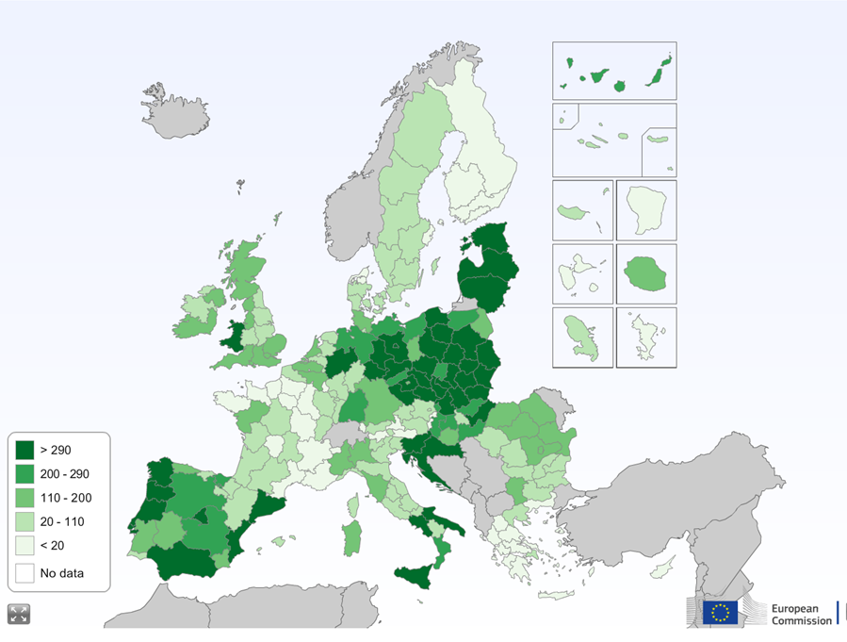

*Source: ESIF-viewer, visualising data for ERDF, ESF, CF and YEI,* [*http://RIS3platform.jrc.ec.europa.eu/esif-viewer*](http://s3platform.jrc.ec.europa.eu/esif-viewer)

### Thematic priorities of regions – Eye@RIS3

In RIS3 strategy documents, most regions and Member States have identified different combinations of broadly defined priorities. The RIS3 definition process identified a range of thematic priority areas for investments – e.g. health, climate, energy and industrial modernisation driven by key enabling technologies[62], transport, mobility, creative economy, bio-economy[63] and much more. The identified areas have been found at the intersection of economic sectors, expected to develop faster, thanks to their novelty, diversity and innovation, as well as new marketing and organizational solutions. This could nonetheless also involve revamping traditional sectors by mixing them with new economic areas or focusing on their particular elements from a new viewpoint based on a specific advantage.

**Examples of RIS3 priority-setting processes**

In **Poland**, the RIS3 finding process resulted in 20 national and 81 regional smart specializations, encompassing both traditional sectors (such as tourism, furniture or agriculture) and more innovative technologies and industrial processes (such as multifunctional materials, including nanoprocesses and nanoproducts).

In **Denmark**, some sectors appeared in several regions' identified areas of strength and opportunities (health e.g.), whereas other sectors appeared more region specific (e.g. blue economy). This identification process has enabled the Danish regions to adopt a more systematic approach to the entrepreneurial discovery process.

In the **UK** the smart specialization strategies depend on the unique circumstances of the different “Member States” (England, Scotland, Northern Ireland and Wales). Innovation policies are developed at national level in partnership with businesses and research institutions across the Member State, whereas other elements of smart specialisation can only best be delivered at the local level, such as strengthening of local innovation ‘ecosystem(s)’ and building local capabilities, supporting local supply chains to invest and collaborate, catalysing and leveraging the differing opportunities of social innovation; and branding and positioning places as credible centres of smart specialisation.

**Ireland**'s smart specialisation strategy provides indicative multi-annual plans for budgeting and prioritisation of investments linked to R&D, identifying 14 strategic areas where public investment in research should be concentrated. These strategic areas encompass the priorities both at national level and at regional level. A “mapping” exercise of the existing strengths evidenced regional specializations such as Medical Technology concentration in the West of Ireland, or Marine Renewable Energy in the West and North West.

**Estonia** has chosen surface coating technologies and nanotechnologies in new materials as one of the domains of the smart specialisation. For instance, a company, Skeleton Technologies, used an ERDF grant to develop a high-performing and competitive ultra-capacitor technology[64]. Combined with support under Horizon2020 and later financing by the European Investment Bank, the company became Europe's leading producer of ultra-capacitors.

**Graph 8: Ten most common categories of priorities**

*Source: Eye@RIS3 database,* [*http://RIS3platform.jrc.ec.europa.eu/map*](http://s3platform.jrc.ec.europa.eu/map)

The Eye@RIS3 tool of the Smart Specialisation Platform provides detailed maps of regions according to thematic priorities, as illustrated below for energy.

**Graph 9: Example Eye@RIS3 map of regions with energy related priority areas**

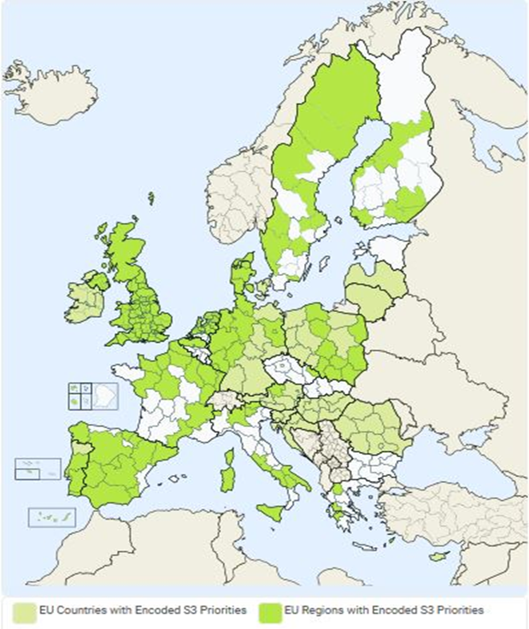

*Source: Eye@RIS3 database,* [*http://RIS3platform.jrc.ec.europa.eu/map*](http://s3platform.jrc.ec.europa.eu/map)

### Selection of operations and expenditure declared in ESI Funds

The European Regional Development Fund is the most important source of support for smart specialisation strategies in most regions.

By January 2017, the progress of implementation on the ground was picking up speed. The end-January indicator of project selection has reached 26% on average for all the European Regional Development Fund (ERDF) projects. When examining the thematic objectives (TO) that correspond to the eligible costs of projects selected, supports for smart specialisation (TO1 – EUR 16 billion) and for SMEs (TO3 – almost EUR 20 billion) are the most advanced fields approaching 40% of ERDF allocation.

**Under TO1 – strengthening research and innovation**: about one fifth of the EUR 16 billion eligible costs fall under the category of research and innovation processes in SMEs (cat.064). Together with technology transfer (cat. 062), activities in public research centres (cat.060), public infrastructure (cat.058), and processes in large enterprises (cat.002) about 75% of the overall eligible costs are covered. The eligible costs in selected projects are relatively evenly distributed across these four categories (in a range of EUR 1.9 billion to EUR 2.6 billion).

**Under TO3 – enhancing support for SMEs**: generic productive investment in SMEs (cat. 001) makes up almost half of the EUR 20 billion eligible cost in selected projects. Adding SME business development support (cat.064) and advanced support services to SMEs (cat.066) results in coverage of 80% of the expenditure of selected projects.

### Evidence on implementation through analysis of calls for projects[65]

An ongoing study by European Commission (JRC) analysing the calls for projects launched under the ERDF Thematic Objective 1 “Strengthening research, technological development and innovation” in 2014-2016 in five Member States (Poland, Italy, Portugal, Hungary, Lithuania and Slovenia) reveals that the smart specialisation (RIS3) approach is being translated into practice and is playing a pivotal role in the implementation of ERDF innovation-linked measures within national and regional Operational Programmes.[66] In most of the examined calls, RIS3 alignment is a binding eligibility condition for R&I funding.

**ERDF Operational Programs – Thematic Objective 1 (Research and Innovation): Number of RIS3-related calls (31 December 2016)**

|  |  |  |  |
| --- | --- | --- | --- |
| **Member State** | **Published calls (end-2016)** | **RIS3-related calls (eligibility condition)** | |
| Number | Number | % of total calls |
| Italy | 66 | 61 | 92 |
| Poland | 109 | 105 | 96 |
| Portugal | 54 | 54 | 100 |
| Hungary | 11 | 7 | 64 |
| Lithuania | 10 | 10 | 100 |
| Slovenia | 7 | 7 | 100 |
| **TOTAL** | **257** | **244** | **95** |

*Source: Adaptation from Gianelle, C., F. Guzzo, and K. Mieszkowski (2017), Smart Specialisation at work: Analysis of the calls launched under ERDF Operational Programmes, JRC Technical Report, forthcoming.*

Nearly all ERDF resources made available through the calls support project proposals falling exclusively within RIS3 priority areas.

**ERDF - Thematic Objective 1 (Research and Innovation): Funding allocated through RIS3-related calls (31 December 2016)**

|  |  |  |  |  |  |
| --- | --- | --- | --- | --- | --- |
| **Member State** | **ERDF resources** | | | **Overall ERDF funding for TO1 in each MS (2014-2020)** | **RIS3 related calls: % of TO1 resources** |
| **Total published calls (EUR)** | **RIS3-related calls (EUR)** | **% of RIS3 related calls** |
| Italy | 767,830,874 | 741,203,316 | 96.5 | 3,512,735,843 | 21.1 |
| Poland | 3,860,052,103 | 3,846,348,571 | 99.6 | 8,351,428,665 | 46.1 |
| Portugal | 1,253,320,000 | 1,253,320,000 | 100 | 2,328,812,052 | 53.8 |
| Hungary | 1,194,255,484 | 1,073,610,323 | 89.9 | 2,148,860,450 | 50.0 |
| Lithuania | 244,536,487 | 244,536,487 | 100 | 678,878,835 | 36.0 |
| Slovenia | 75,232,627 | 75,232,627 | 100 | 461,739,158 | 16.3 |
| **TOTAL** | **7,395,227,575** | **7,234,251,324** | **97.8** | **17,482,455,003** | **41.4** |

*Source: Gianelle, C., F. Guzzo, and K. Mieszkowski (2017), Smart Specialisation at work: Analysis of the calls launched under ERDF Operational Programmes, JRC Technical Report, forthcoming*.

The study also shows the existence of "spill-overs" of smart specialisation into other policy areas, in particular SMEs competitiveness, access and use of ICT, shift towards a low-carbon economy, and education and training. There exist calls embracing different policy instruments which support integrated project proposals falling within RIS3 priorities areas. The study shows that the most common category of beneficiaries is consortia of enterprises and research organisations. Together with three other categories - single (large, small and medium sized) enterprises - consortia of enterprises, and consortia of SMEs, they are generally the beneficiaries of calls aiming to support R&I projects.

### The establishment of the S3Platform

One of the main achievements of the smart specialisation approach has been the establishment of a community of practice for design and implementation of smart specialisation strategies. To assist Member States and regions in the process of developing, implementing and reviewing their smart specialisation strategies, the Commission set up the Smart Specialisation Platform (S3 Platform) in 2011. Its objective has been to provide information, methodologies, expertise and advice to national and regional authorities as well as to promote mutual learning and trans-national cooperation. It has around 200 members in total including 18 EU Member States and two non-EU countries, as well 170 EU and nine non-EU regions.

The S3 platform[67] has developed a number of tools[68] to encourage and support stakeholder interaction in RIS3, such as online matchmaking tools, peer review exchanges and learning workshops, giving interested parties a solid basis on which to interact with each other. It is clear, however, that an insufficient level of development of innovation environment is hampering the participation of some Member States and regions, especially from the EU-13[69], and limiting cooperation with more developed regions from the “old” Member States.

Smart specialisation cooperation actively involves a wide variety of stakeholders — national and regional authorities, universities, research institutions, business and civil society — and therefore brings significant opportunities to exploit synergies, facilitate the transfer of knowledge and capabilities and develop new ideas. A transnational perspective enables Member States and regions to evaluate their competitive position with regard to others, obtain the necessary research capacity or overcome a lack of critical mass.

**Graph 10: Registered Member States and regions in the RIS3 Platform**

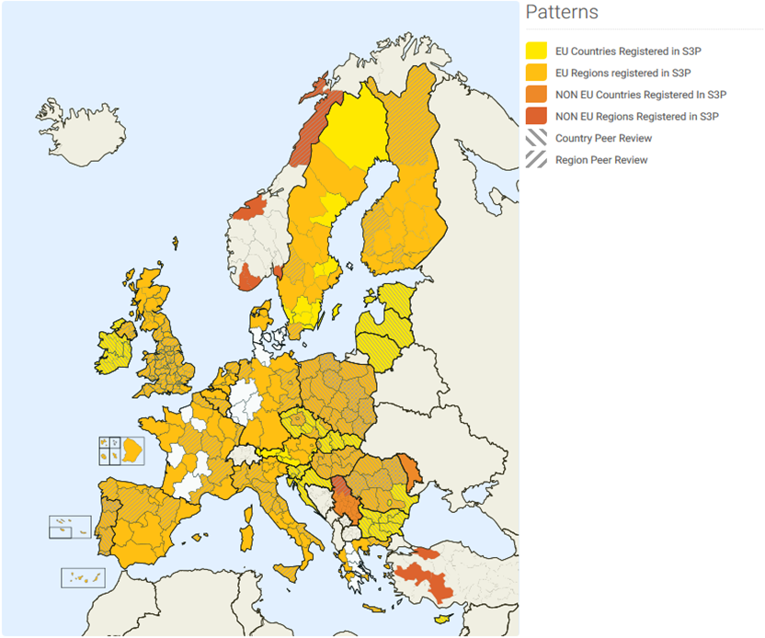

*Source: RIS3 Platform, available at* [*http://RIS3platform.jrc.ec.europa.eu/RIS3-platform-registered-regions*](http://s3platform.jrc.ec.europa.eu/s3-platform-registered-regions)

### Influence on national and regional systems

There is a range of evidence which shows how smart specialisation strategies have influenced national and regional innovation systems.

#### *Governance and institutional changes*

New practices in public administrations have emerged at national, regional and local level with regard to innovation policy-making. The RIS3 approach has brought about significant structural and institutional changes in regional governance, triggering or strengthening inter alia, interdepartmental cooperation, participative and inclusive governance, more transparent and efficient monitoring mechanism.

|  |
| --- |
| **Examples of how RIS3 has triggered structural change in some EU Member States:**  In the **Czech Republic**, the national authorities have given regions the opportunity to determine their own priorities by exploring their R&I strengths and weaknesses, growth potential and engaging with regional stakeholders. This should lead to the better allocation of financial resources. Although regions still do not hold formal legal responsibilities in R&I, they have designed their RIS3 strategies and manage them under the ESIF-funded Smart Accelerator project, depending on the readiness of regions.  In **Slovenia** Strategic Research and Innovation Partnerships (SRIPs), established during the RIS3 design phase, play a key role in transforming the governance structure. SRIPs are clusters that bring together companies, knowledge institutions, civil society organisations and notably, different government services. RIS3 initiated an unprecedented pooling of public and especially private research, technology, development and innovation capabilities in key priority areas. This is accompanied by comprehensive and well-coordinated government support addressing all relevant competitiveness dimensions and simultaneously emphasising forward-looking and disruptive types of innovation through the integration of science, engineering, design and art.  In **Sicily (Italy),** innovators have pointed out that most ideas have often failed to get off the ground because they did not pass funding eligibility thresholds. The regional authorities recognised the need for a different governance model. A new cross-departmental structure now coordinates the analysis, planning, guidance, and monitoring of RIS3. This is complemented by permanent thematic groupings that include international partners.  In **Lapland**, systemic RIS3 thinking has emerged (rather than a new governance structure): RIS3 implementation is followed up horizontally throughout all the layers of the planning and decision-making process in regional development.  **In East Macedonia and Thrace (Greece),** the entrepreneurial discovery process (EDP) required not only the introduction of participatory dialogue into research, technology, development and innovation policymaking, but also renewed efforts to build trust in the public sector. This transfer of  **‘entrepreneurial· knowledge’ into policy intervention** required that stakeholders who took part in the EDP were kept informed about policy outcome through:   * + EDP focus groups: a set of four sector-based events, aimed at generating innovative ideas through interaction between business, the public sector and research organisations within the RIS 3 priorities;   + Project Development Labs (PDL): a set of two events aimed at processing EDP ideas and moving them towards implementation, identifying funding opportunities and action plans for policy. During the second PDL in particular, policymakers presented to ‘Triple Helix’ actors the draft calls for proposals, which had been developed during the EDP focus groups. Stakeholders were able to comment on those and develop their own ideas further with the support of experts in R&D funds.   With the RIS3 experience, policymakers in this region were given responsibilities for R&I policies. These new powers pushed the managing authority of the ERDF operational programme to develop, together with the Joint Research Centre (JRC), skills in participatory leadership to pursue EDP in different sectors.  Through the EDP focus groups, the region set out in detail its priority areas and, building on this, analysed the administrative and legal aspects necessary to write effective calls for proposals. This involved interactions with the national government, the European Commission and experts in the field. Furthermore, throughout this process, stakeholders themselves noted that a better awareness of relevant actors (through updated databases and appropriate avenues for interaction) was necessary for conducting a proper EDP[70]. |

In the public consultation 92% of respondents replied that they think they should be more involved in the design and/or implementation of S3 challenging existing innovation governance structures. The respondents have been asked also which other organisation should be in their opinion more/better involved in the design or implementation of R&I support in their country / region. Most respondents see a need to involve enterprises (55% for medium-sized enterprises, 46%, for large and 43% for small and micro-enterprises) more **in the implementation or research and innovation support**. More involvement of SME intermediaries such as cluster organisations and Higher Education Institutions (43% each) is also seen as important.

A recent survey shows that the EU’s new cohesion policy has led many regions and Member States to change their behaviour with regard to collaboration on R&I policy[71]. The main barriers to collaboration seem to be inter-related and include lack of resources, insufficient political commitment, insufficient engagement of regional stakeholders and unclear objectives. One interpretation is that it is challenging to communicate clearly to stakeholders and politicians the outcomes of interventions, with the result that stakeholders are unwilling commit or mobilise resources. Innovation policy interventions quite often support activities that provide indirect and dynamic benefits that are not easily measured, divisible or attributable to individual actors or activities.

#### *The Entrepreneurial Discovery Process*

The Entrepreneurial Discovery Process (EDP) is an inclusive and interactive bottom-up process in which stakeholders from different environments — governance, firms, higher education institutions and civil society — gather on a regular basis to explore and select the domains of R&I in which regions are likely to excel, given their existing capabilities and productive assets. The EDP pursues the integration of entrepreneurial knowledge, fragmented and distributed over many sites and organisations, through the building of connections and partnerships.

Stakeholder interaction has proved conducive to opening up new market and technological opportunities, as well as informing governments’ policy and decision-making processes. The EDP approach facilitates the setting-up of public-private partnership and larger-scale projects. Thus, the smart specialisation concept has become an influential instrument for place-based innovation-driven growth.

|  |
| --- |
| **Examples of the Entrepreneurial Discovery Process in some EU Member States:**  A novel approach was introduced in **Calabria (Italy)** to encourage stakeholder engagement in the design and implementation phase of RIS3. Along with the establishment of thematic workshops, various tools (online consultations, technology foresights and global value chains analysis, etc.) were implemented to promote information gathering and public debate. Eight thematic platforms are about to be launched to maintain the momentum generated by the RIS3. They should promote industry-science cooperation, explore market opportunities, help select and monitor innovation areas, support regional firms’ outward orientation and global engagement and shape decision-making processes in general. A newly established RIS3 steering committee is responsible for taking decisions on the strategy’s revision and the exploration of new innovation areas. To ensure main stakeholders’ involvement, this committee is composed of representatives from the quadruple helix.  The emergence of a bottom-up approach to policymaking has led to a dramatic change in the approach to innovation in the **Pomorskie Region (Poland)**. Various tools such as co-working platforms and forums have been developed to engage stakeholders in a continuous and long-term exchange. The entire ecosystem is mobilised and academic establishments have started setting up partnerships with businesses. |

Almost all regional policymakers who recently took part in a survey judged the entrepreneurial discovery process to have been effective in identifying investment priorities for regional development. There is a high level of satisfaction with the EDP and its ability to engage stakeholders, increase trust among stakeholders and towards the public sector and to inform policymaking. The way in which the outcomes of the EDP have been embedded in the policy process varies between regions, with some considering it as mandatory and some seeing it as optional.

#### *Monitoring*

Through smart specialisation, European regions and Member States have designed a set of result-oriented policy actions, whose capacity to meet the strategic objectives need to be monitored closely. A substantial effort has been made to extend monitoring activities in order to integrate a range of strategic functions with the goal of better informing the decision-making process and keeping stakeholders engaged[72].

#### *Economic transformation, new technological and market opportunities*

The RIS3 logic has facilitated a reflection on the economic transformation of a wide range of regions. It promotes locally driven knowledge-based growth while breaking down silos between research and economic development.[73] In addition, a continuous entrepreneurial discovery process fosters cross-sectoral working practices and the emergence of clusters as a practical instrument for encouraging stakeholder commitment and collaboration. A shift towards a demand-oriented R&I policy approach is taking place, thus furthering private co-financing leverage.

|  |
| --- |
| **Examples of transformation processes in some EU Member States:**  RIS3 in **Saxony (Germany)** has triggered thinking about a much broader definition of innovation that goes beyond R&D, to encompass new emerging issues such as business models, design, market research, and social innovation. RIS3 has acted as catalyst for stakeholders' interaction to determine these new elements.  Among the seven specialisation areas selected by the **Languedoc-Roussillon (France)** region, the one dedicated to water technologies provides an example of the impact of the structuring effect of RIS3 on the regional ecosystem in a specific field. Regional stakeholders with the support of the competiveness cluster and the regional innovation agency aim to form a complementary chain in Water technologies and then reach a necessary critical mass. The role of the RIS3 framework was crucial in contributing to the faster development of six groups of integrated solutions in water technologies to better access to international markets.  In **Emilia Romagna (Italy**), RIS3 gave a new impetus to a more demand-oriented reshaping of regional research and innovation policies. The smart specialisation exercise is helping to address more effectively companies’ need for innovation through targeted support on research projects whose results can be used to create new products and processes that generate market value and enhance regional firms’ competitiveness.  In **Catalonia (Spain),** a clear shift from infrastructure/equipment towards innovation led projects can be seen. RIS3CAT communities are more company focused. Innovation Public Procurement schemes foster collaborations between public administrations, R&I agents and, in the case of public procurement, with companies. New instruments, such as CatLabs promote the participation of civil society in innovation.  In **Podkarpackie (Poland),** the development of an aviation and aeronautics cluster is helping the regional economy diversify from agri-food into high-tech industries and creates links with world class aviation businesses and research activities |

#### *Behavioural changes in universities and research centres*

Smart specialisation gives a leading role to universities[74] as actors in their local innovation ecosystems, connecting global and local knowledge domains, and arguably gives them far more prominence than it has been the case under previous structural funding programmes. Universities have started to play an increasingly important role in the design and implementation of regional RIS3, and a much broader role than merely generators of technological research and other ‘upstream’ activities. There remains though scope to better translate the presence of excellent universities and research centres into benefits for local businesses and the local economy.

|  |
| --- |
| **Examples of fostering behavioural changes in research institutions in some EU Member States:**  In **Catalonia (Spain),** the University of Girona set up the so called “Campus Sectorials” to **foster actors’ entrepreneurial readiness**. These are independent entities aimed at increasing the social and economic impact of the university by acting as bridges between the academy, the local productive sector, the institutions and society. The “Campus Sectorials” act as business-led knowledge brokers between researchers and the local private sector, launching an initial embodiment of EDP and preparing participation in it. Indeed, they have been critically engaged throughout the whole cycle.[75]  Smart specialisation has helped develop a more focused and strategic relationship between **Värmland's regional authority (Sweden)** and Karlstadt University. A renewed cooperation agreement has been put in place for **opening up the agenda of public research institutions**. It aims to develop excellence in teaching and research based on interaction with local private and public sector institutions, while increasing the international profile of the university and the region. Tangible results have already been achieved: in the first phase of Horizon 2020, Karlstadt University registered an impressive success rate of 32%, with most of the funded projects related to an RIS3 priority, a result the university explains partly by cooperation with regional institutions that give real life opportunities for scientific enquiry. Improving education in training is a more long term but just as important objective. The knowledge generated from the RIS3 areas is fed into degree curricula as well as its professional training courses. This is done through guest lectures, student placements, joint thesis supervision, as well as programme management, since each subject area is managed by council that includes an external representative. From the region's side, it hopes that the Smart Specialisation Academy can increase the long-term attractiveness of Värmland, both for university students and innovative companies that seek highly skilled employees and cutting-edge knowledge. |

The public consultation responses confirm that over the past 3 years thanks to the S3 the **interactions between the different stakeholders** in the innovation eco-systems (including universities and research centers) has improved significantly**.**

In more detail, the implementers of innovation noted a significant increase in cooperation with Higher Education Institutions (HEI) (76%), followed by more cooperation with clusters or business associations (66%) and consultancy firms (64%).

#### *Cooperation*

Outward-looking specialisation (RIS3) emphasises the identification of niches, clusters of related industries, cross-sectoral innovation, value chain linkages and the solving of societal challenges to find a region’s potential advantages in international markets, and to identify partners to help deliver new solutions and solve common challenges. This is the case not only for industry and academia, but also for regional policymakers who need to engage in interregional collaboration processes.[76]

|  |
| --- |
| **Building interregional strategic cooperation**[77]  The joint strategic process between **Galicia (Spain)** and **Norte (Portugal)** began in 2014 with the creation of the cross-border Work Group (Technical Secretariat) made up of representatives from the Galician Innovation Agency and the Northern Portuguese Regional Coordination and Development Commission. They set up the governance for the development of a joint strategy and carried out an analysis which identified the main areas for collaboration between the two entities. At the end of this strategic exercise, a shared vision for the future was reached that includes the alignment of R&I goals and the proposal of joint priorities, actions for support, as well as an evaluation system with indicators to follow up implementation. |

According to the public consultation results, 59 % of respondents have been directly involved or observed concrete, strategic interregional cooperation between their region and other regions that have similar or related S3 priorities. Moreover, a large majority (86 %) of the respondents confirmed that developing interregional cooperation in the framework of smart specialisation is important.

#### *International recognition of Smart Specialisation*

Smart specialisation is also now attracting the attention of countries outside Europe. Smart specialisation has therefore been recognised by international organisations such as OECD,[78] the World Bank[79] and the United Nations Economic Committee.[80] At the European level, the Proposal for a New European Consensus on Development (Our World, our Dignity, our Future)[81] and the External Investment Plan (EIP)[82], the Digital for Development (D4D) initiative, together with the support of further public sector's investments in R&I capacity in developing countries to unlock private sector investments will help to drive economic and social development internationally.

The regulation outlining pre-accession funding identifies smart specialisation as a thematic priority for helping enlargement Member States. In a recent Joint Staff working document for the Eastern Partnership[83], the European Commission and the representatives of the six partner member states agreed to having at least one partner government commit to starting a full-fledged RIS3 process in 2017 and formally adopting a new innovation strategy by 2020.

In the Western Balkans, Asia and Latin America, many countries have expressed their interest in learning from and exchanging knowledge with European counterparts that are successfully implementing smart specialisation strategies.[84],[85]

**Examples of smart specialisation strategies put in place outside the EU:**

**Australia, Smart Specialisation Strategy for the Hunter Region**: aims at boosting regional competitiveness and prioritising the region's unique strengths, namely in food and agri-business, mining activities, medical technologies, oil, gas and energy resources, defence, advanced manufacturing, and creative industries. The strategy is the first of its kind in the country and has already identified the necessary actions to deliver innovation-driven growth.

**Brazil, Project Regional Innovation System in Pernambuco**: EU-Brazil pilot project to design a RIS3 for the State of Pernambuco in economic sectors relating to clothing. The project aims to build endogenous capacity to develop local talents in the production of clothing.

**Chile, Strategic Decentralisation of Innovation in Chile**: decentralisation pilot plans are being implemented in the regions of Biobio, Antofagasta and Los Rios with the objective of creating incentives for business innovation. A total of 25 strategic specialisation programs have been implemented in 7 strategic sectors (mining, healthy food, sustainable tourism, sustainable construction, health technologies, fishing, and aquaculture and creative economy).

**Peru, Regional Agenda for Sustained Growth, Strategy of Smart Specialisation and Innovation in the Region of Piura**: aims at designing the specialisation agenda of Piura for the next 5 years in light of innovation policies done at the EU. The project is an initiative by the University of Piura and includes activities such as territorial diagnostic, strengths analysis, action plan and engagement of quadruple helix actors.

Exchanges with Latin America are an example of the positive results generated by the sharing of EU regional innovation programmes, mostly in the thematic areas of agri-food and energy. Argentina, Brazil, Chile, Colombia, Mexico, and Peru have established bilateral agreements with the EU to elaborate, implement, and manage urban and regional policies for innovation, which are mostly under implementation phases at the moment. This experience will be capitalised on under the European Union’s new International Urban Cooperation programme, 2016-2019, which, in the Latin American sphere, will mobilise policymakers and other regional actors to promote innovation, working closely with EU regional counterparts in a multi-stakeholder context where the business sector is expected to play a major part, thus generating new opportunities on both sides.[86]

**An example of international cooperation on smart specialisation: EU-Latin America cooperation**

The experience of EU regions in promoting regional innovation through Smart Specialisation Strategies (S3) is widely considered as an inspirational model for many countries and regions in Latin America. Many of the latter are seeking to diversify away from a longstanding dependence on primary products in order to create economies with greater focus on activities with more added value. Accordingly, countries such as Argentina, Brazil, Chile, Colombia, Mexico and Peru are seeking to create economies less dependent on exporting natural resources in favour of a knowledge-based development model where innovation is the key driver of structural change. Given the European experience in this field, cooperation with European Union institutions and the regions is a priority for many Latin American countries. A new framework for this cooperation was created in 2015 in the EU-La Comunidad de Estados Latinoamericanos y Caribeños (CELAC) Summit which called on both sides "to strengthen the capacity of the regional and urban authorities to promote economic development and innovation and social inclusion and cohesion"[87] .

The European Commission has played a key role in promoting this cooperation through the Directorate-General for Regional and Urban Policy and the Joint Research Centre (notably its S3 Platform). This ongoing work has led to the exchange of experiences and mutual learning between Latin American countries (notably, Brazil, Chile and Peru) and European regional authorities and specialised agencies. Themes for exchange have included the conception, implementation and management of regional innovation strategies, including cluster development and the promotion of innovation SMEs, and involving cross-border and global value chains.

### Overall assessment of achievements

Smart specialisation has contributed to the quality of investment in innovation and entrepreneurship under cohesion policy. In terms of key Commission priorities such as creating jobs, growth and investments, smart specialisation has been central in:

* Mobilising investments of EUR 65,8 billion, where EUR 43,7 billion is from the EU budget and the rest are national contributions;
* Supporting investments where the needs have been developed through a bottom-up process of priority selection;
* Creating an investment friendly environment through an intensive dialogue of innovation stakeholders in the local context;
* Addressing priorities of the Digital Single Market, Energy Union, the Circular Economy and the single market through technological and non-technological investments in innovation.

One of the main achievements of RIS3 approach has been the establishment of a community of practice[88] for the design and implementation of smart specialisation strategies. This has been made possible on the basis of the RIS3 'ex ante conditionality'.

The public survey results[89] indicate that for 59% of the respondents the S3 process had an important impact on the quality and range of R&I support to their work over the last three years. The respondents from North-Western EU countries perceived a bigger impact (65%) than those from Mediterranean countries (56%). The majority of respondents from Central and Eastern European countries noted an impact of S3 in the past three years (but it needs to be noted that 21 of the 25 respondents come from Poland, i.e. this trend might not be generalised yet).

The effort to concentrate resources on limited number of priorities has changed the perception and the mind-set of key innovation actors, including businesses and researchers, encouraging them to focus on their capacities and develop a tailored policy mix that is relevant for specific priorities rather than repeating support for generic capabilities and research infrastructure. It has involved more decentralisation in R&I policymaking and greater use of the public-private partnership approach.

Regional innovation actors have become better connected since national and regional authorities were required to involve businesses, researchers and civil society to identify the unique competitive advantages of a region – as also shown by the results of the public consultation (see Section 2.1.4). Innovation actors from different fields were often not connected at cross-sections of technological, sectoral, or geographical strengths.[90]

In addition, regions have become more outward-looking in their approach to research, innovation and enterprise. They are now more able to cooperate with others since their complementary strengths are now clear. This cooperation is making it easier to build critical mass and to make their RIS3 investments more cost-effective. This has encouraged a wider EU-level perspective to be considered.[91]

Regarding impact, there are now also more robust performance frameworks in place, with methodologies developed to capture the results and impacts of innovation-led development. New approaches to improve the implementation of RIS3 concepts include constant feedback loops of diagnostic monitoring (problem solving) and systematic learning-by-doing at project and policy level.

#### *Weaknesses and areas for improvement*

More efforts are still neededas regards **the choice of priorities** and keeping a structured interaction between researchers, businesses and civil society going. The choice and design of policy tools for implementation of the RIS3 - and the monitoring systems - still need attention in many regions to make them fit for delivering on the RIS3 priorities and objectives. There are also challenges in less-developed regions to build institutional and legal environment conducive to innovation and join international networks and value chains. The need to reinforce trans-border cooperation is one of the clearest challenges of all RIS3 work. Effective engagement of regions in interregional collaboration remains limited.

In addition, global challenges and new political priorities such as COP21, SDGs, the circular economy or bioeconomy create opportunities for new research, but also social and business model innovation and new value chains. These can build on local natural capital, such as unexploited biomass resources, using side-streams or wastes in the agri-food sector for bio-based products or producing textiles from wood cellulose. These opportunities have been identified and recognised by many EU regions.[92]

It is important to further **broaden the scope of actors and topics involved in the interactions at the local level.** These are still too focused on purely research and technology oriented debates and led by universities and research organisations rather than local business firms. Civil society organisations are underrepresented. If intermediaries such as clusters are absent, discussions should be encouraged directly between research actors and firms. There is a risk that, when the process is anchored at the political level or covers a large territory, it will tend towards political negotiation rather than towards open-ended processes of joint discovery.[93]

The process which led to fulfil the conditionality made it evident that some preconditions are necessary to put smart specialisation in place:[94]

* **Leadership** is necessary to embed design and implementation of smart specialisation in the overall policy making of the region. This requires a strong commitment to mobilise innovation actors around common vision of regional economic development. The vision making and facilitation of interactions should not finish once the strategy has been adopted. Interactions with a large variety of actors should be a process that continues throughout implementation and leads to concrete action i.e. investments or an adjusted policy mix.
* **An enabling public administration** at all government levels is crucial in order to harvest the knowledge and information generated through the process of interactions between innovation actors. The public sector needs to have the soft skills of collaboration, leadership, team working as well as the ability to translate received feedback into an effective policy mix that takes into account the local institutional, legal and political context.
* **Real and continuous interactive process** (so called Entrepreneurial Discovery) between businesses, universities, research centres, wider groups representing civil society that allows market forces and the private sector to discover and produce information about new activities.
* **Modern role of government** changing towards providing the right conditions to empower key actors to contribute to the strategic development of the region. Policy and investment decisions should therefore evolve through interactions with and between entrepreneurs (e.g. business people, researchers and social activists) and local citizens. In particular, the government needs to be much more engaged in helping design and develop the collaborative (investment) projects that represent the realisation of the entrepreneurial discovery process.
* **Openness to the external world** is essential in the global economy. Innovation networks call for a regional and innovation policy that goes beyond regional and national borders and which is not reluctant to be benchmarked and cooperate with others.
* **Transparent monitoring mechanisms - besides the legal obligations - should be** understood as a management tool for the strategy. Good monitoring system helps public authorities to properly implement and react promptly to inappropriate deviations.

However, in order to maximise the role of smart specialisation to contribute to Europe's innovation potential in the context of globalisation, it is necessary to examine the broader policy framework in which it operates. This issue is addressed in the next section.

# Key challenges and next steps: boosting innovation-led growth

In order to promote growth at regional level, target new sources of investment in innovative sectors and increase the competitiveness of European regions at a global level, the following four challenges need to be addressed:

* Further reform of the regional and innovation systems;
* Increase cooperation in innovation investment across regions;
* Leveraging research and innovation in less developed and industrial transition regions;
* Harnessing synergies and complementarities between EU policies and instruments.

## Further reform of research and innovation systems

### The contribution of research and innovation to EU economy and productivity growth

The importance of productivity as a key driver of sustained economic growth and consolidation of the recovery in Europe has been identified by several studies, such as 'The Future of Productivity’by the OECD.[95] Labour productivity in the EU is around 15 percent lower than in the United States and this gap has increased in recent years.

**Graph 11: The real labour productivity gap (GDP per hour worked) between EU Member States and the United States, 2014**

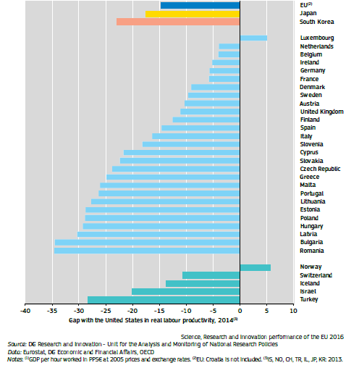

This labour productivity gap stems in particular from under-performing labour-intensive services[96] which highlights the important of both advanced technologies and service innovation.[97] While many factors drive multifactor productivity, for most advanced economies innovation and innovation-related investments in R&D, ICT and skills development are crucial. These processes are affected by different factors that can range from the functioning of the institutional set-up, the abundance and quality of the infrastructure network or the functioning of the markets that allow for an efficient allocation of resources to more productive activities.

### The need for reform

Structural reforms and better regulatory and institutional frameworks are essential to improve competitiveness and the sustainability of growth through increased productivity in all Member States. While it is always difficult to properly measure complex phenomena such as innovation, the relationship between private R&D investment, as a crude proxy of innovation capacity, and multifactor productivity growth shows a positive relationship.[98]

**Graph 12: Business R&D intensity, 1995 versus average annual growth in multifactor productivity, 1995-2007**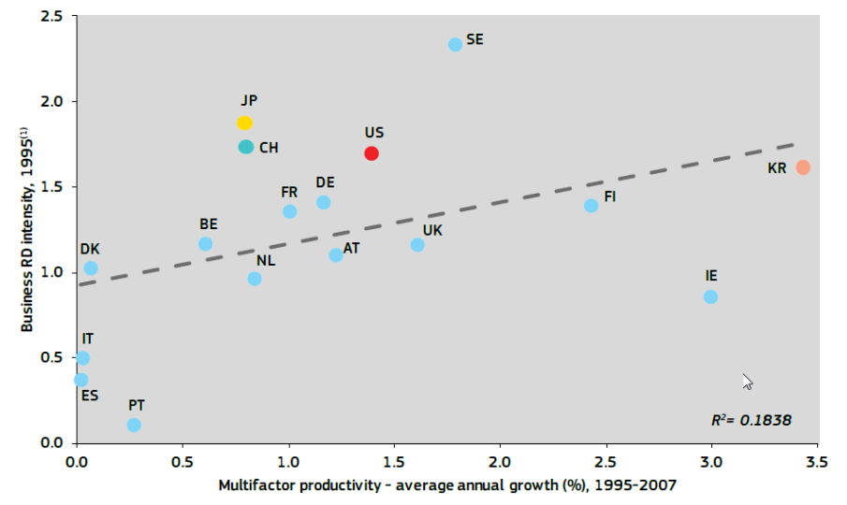

RIS3 aims at a better and smarter targeting of public investment in R&I through a focus on regional strengths and opportunities. An innovation strategy should focus on the barriers to innovation (regulation) and the needed support systems (investment in R&D, support for technology transfer and STEM education) that can spur more innovation in all three major sectors of an economy (for profit, non-profit and government).[99] Efficient implementation of these strategies, however, requires well-functioning regional and national R&I systems. In this respect, the European Semester process clearly shows that further progress needs to be made. While the situation differs from one Member State to another, three cross-cutting issues require particular attention: the quality of public research, public private cooperation and the business environment for R&I. RIS3 is an integral element of the Commission's analysis of R&I policies in the context of the European Semester and as a consequence is reflected in the European Semester Member State Reports and in some of the Country Specific Recommendations.

The overwhelming majority of public research in Europe is financed and governed through 27 national systems (and regional ones below) which vary considerably in scale and overall quality. According to the ERA Expert Group[100] there are systemic characteristics and consequences arising from the multi-centred and multi-level governance of research and innovation, such as:

* Barriers to researcher mobility inhibiting career opportunities;
* Difficulty in establishing cross-border academic-industrial partnerships;
* Duplication of funding between national/regional programmes dispersing resources,
* Lack of European perspective and transnational coherence in reforms undertaken at national level;
* Diminished attractiveness as a location for business R&D investment.

This leads to inadequate selection mechanisms and incentives to improve efficiency, effectiveness and learning capability. Such system-failures are at the level of governance of research, implying a lack of coordination and/or cooperation among innovation support institutions.[101]

The Horizon 2020 Policy Support Facility (PSF) further supports Member States in the design, implementation and evaluation of structural R&I policy reforms. Issues linked to the implementation of RIS3 have been explicitly addressed in the context of several PSF projects such as the Peer Reviews of Hungary and Bulgaria and they will be further examined by the PSF Mutual Learning Exercise (MLE) on "National practices in Widening Participation and Strengthening Synergies" which will be launched in autumn 2017. The MLE will include exchanges of national practice at the operational level in relation to how to best support national participation in EU Framework programmes and use ESIF and exploit synergies at the national level to build up a knowledge economy.

The Regional Innovation Monitor project[102], launched in 2010, monitors Research & Innovation policy in EU regions with special focus on industrial aspects. An online repository was regularly updated to provide an easy access and comparative overview of relevant regional support measures and strategies, policy documents and organisations. Standardised baseline regional profiles give user a quick overview of the socio-economic situation, research and innovation performance, innovation governance, policy trends and advanced manufacturing-related activities.

The tools of the European Observatory[103] for Clusters and Industrial Change – which is continuing the work of the previous European Cluster Observatory – can further help regions and Member States in setting evidence-based priorities. For instance, the Observatory provides an overview of regional strength for specialisation areas by providing a sectoral and cross-sectoral cluster mapping through its cluster mapping tool[104] and European Cluster Panorama, which reveal concentrations of economic activities for 51 traditional sectoral cluster categories and for 10 emerging industries that represent cross-sectoral cluster categories.

The **Observatory's Regional Ecosystem Scoreboard**[105] captures the quality of conditions in the regional ecosystem that can foster or hinder innovation and entrepreneurship through 60 indicators and composite indicators in six dimensions (namely entrepreneurial conditions, knowledge basis and skills, collaboration and internationalisation, access to finance, demand conditions and quality of governance). Its policy action dashboard identifies specific areas that might be most promising to address by policy action as a result of a regional bottleneck analysis. The six model demonstrator regions (namely Centre region in Portugal, Nord-Pas-de-Calais in France, Hamburg in Germany, Stockholm Digital Health Cluster in Sweden, West Region in Romania) that received advisory support services from the Observatory can also serve as showcases of modern cluster policy to inspire the RIS3 process of others.

### Higher education and VET in smart specialisation

Support to reforms can be increased through more emphasis on skills and education in RIS3 processes. This is the second most important element among respondents highlighted by stakeholders in the consultation. Education is a high priority, in particular for less developed regions.

However, a recent Fraunhofer survey[106] underlines that universities are perceived as focusing on their traditional remit of knowledge and talent providers as well as research organisers. Their role as entrepreneurial drivers of collaboration or platforms connecting the region to external knowledge sources is rather limited or, at least, rare except in the Nordic Member States and to a lesser extent, parts of the UK and Eastern Europe. Furthermore, the survey shows that universities' role as entrepreneurial drivers of collaborations is stronger where institutional settings are inclusive. The more the processes of consultation are anchored in the political hierarchy, the larger the average size of the territory they cover, the more dominant role they hold. It appears that the potential role of universities to build innovation capabilities in Southern, Central and South-Eastern Member States is weaker.

**Graph 13: Perceived role of universities in EDP:**

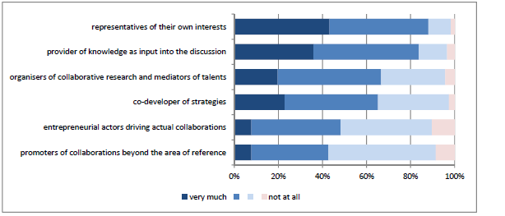

*Source: Fraunhofer Survey, DG REGIO.*

Traditionally innovation has been seen as a result of R&D activities carried out by highly qualified staff and thus a domain of higher education rather than vocational education and training (VET). However, there are at least three reasons why high quality VET is relevant to supporting innovation:

* Technological and process innovations can be absorbed by businesses provided that employees at all levels of the production chain have the required skills;
* Given that the majority of European companies (including small enterprises) are involved in global value chains, constant innovation and efficiency are a must to ensure competitiveness in a global context. That has implications for skills and work organisation practices; and
* Innovation cannot be limited to high tech industries – it also takes place in low-tech industries which account for a large share of employment in Europe.

Investment in training is also an investment in innovation, since many technical changes results from incremental innovations made by skilled workers and engineers on the factory floor.[107] However, the potential of VET to support or even drive competitiveness, innovation and growth policies has largely been neglected in education and training policies in many countries, in particular when compared with the role attributed to the higher education sector. Countries like Austria, Denmark, Germany and the Netherlands exemplify the importance of combined strategies where VET and higher education are seen as complementary and where one cannot be developed without the support of the other. Policy makers need to integrate the VET offer into comprehensive skills and knowledge-based economic development strategies, particularly at regional and local level. [108] This is related mainly to strategies to attract investments, to clusters, innovation, smart specialisation strategies and sustainable growth strategies.[109]

As defined in the ex-ante conditionality 10.4 on vocational education and training[110], countries should implement measures to foster excellence in VET which include, among others:

* Incorporating VET in economic strategies which connect skills supply and demand, based on systematic skills monitoring and anticipation;
* Building up VET providers' institutional autonomy and capacity to develop a strategic approach linked to local and regional economy and react to skills challenges;
* Promoting innovative forms of cooperation between VET providers and companies, authorities, technology centres and educational institutions, ranging from local partnerships to international networks; and
* Developing VET qualifications at higher than upper secondary level to respond to skills shortages.

Transversal competences like creativity, sense of initiative and entrepreneurship are vital for innovation to reach the market. Entrepreneurship skills and attitudes should therefore be fostered in students and researchers to develop their proactivity, flexibility, autonomy, the capacity to manage projects and achieve results. Furthermore, entrepreneurship programmes provide an excellent opportunity to connect the education systems to the local economy and gives incentives for students to remain in a region. Structural Funds (in particular the ESF and the ERDF) have an important role to play in supporting concrete projects aiming to enhance the entrepreneurial mind-sets, skills and attitudes.[111]

European initiatives such as the "Blueprint for Sectoral Cooperation on Skills"[112] and the Digital Skills and Jobs Coalition included in the New Skills Agenda for Europe[113], help in responding to the lack of synergies between quadruple helix actors and in developing concrete actions to satisfy short and medium-term skills needs to support innovation strategy within Member States.

Furthermore, smart specialisation cannot be isolated from social innovation. Promoting social innovation within European societies and, more specifically, in social policies, entails, the combination of skills, business cultures and public services to offer innovative responses (instead of focussing only on business products).[114]

## Increasing cooperation in innovation investment across regions

### Rationale for transnational, interregional, cross-border cooperation

Regions play an important role in creating the conditions to attract private sector investment in innovation and for businesses to seize opportunities in new, often global value chains. Interregional and macro-regional cooperation can help to exploit complementarities to build EU-wide value-chains and encourage the alignment of investment between the private and public sector.

There is a large untapped potential for more joint interregional actions with the corresponding national and regional policies as also illustrated by the Vanguard Initiative[115] and the strong support expressed in the recent public consultation. For instance, the BLUEMED initiative intends to promote joint actions of relevant research and innovation priorities within the maritime sector in order to maximise the leverage effects of the research investments from both private and public sectors.

"Scale, scope and spill-overs are important determinant of R&D and other innovation-related activities and the ability to realize economies of scale and scope and to capture spill-overs is strongly conditional to size."… "Gains from specialisation are central in R&D; even the ability to capture knowledge spill-overs generated by others depends as well on the existence of a sufficiently large nearby R&D sector" (D. Foray)[116].

Internationalisation can also help to solve mismatches between the functional system for innovation and regional/national innovation systems, when the former cross borders.[117] Promotion and facilitation of innovation across borders, connecting smart specialisation growth investments therefore has significant potential. Smart Specialisation based on transnational cooperation begins within a region/country by exploiting place-based expertise and industrial skills within the regional innovation eco-system. Regional innovation eco-systems could be further strengthened through transnational learning and training and collaboration.[118]

### Addressing fragmentation and creating innovation investments in value chains

Potential spill-overs and complementarities are underexploited because of the fragmented nature of national and regional innovation systems across the EU. At present, it is considered that there is no evidence of knowledge spill-overs beyond 200 kilometres from the agglomeration of origin[119]. The active engagement of Member States and regions is therefore essential in order to overcome this fragmentation.

There are **various instruments at EU level under the Horizon2020 and COSME** programmes which promote cooperation, such as Joint Technology Initiatives, contractual Public Private Partnerships (cPPPs), European Institute of Innovation & Technology (EIT) through its Knowledge and Innovation Communities[120] and their co-location (regional) centres across Europe, European Strategic Cluster Partnerships[121], cluster projects for new industrial value chains[122] and cluster excellence[123] as well as the Enterprise Europe Network, the European Sustainable Chemicals Support Service and other initiatives such as Joint Programming, European Innovation Partnerships, INTERREG, as well as the co-location centres established in different regions as part of the European Institute of Innovation & Technology. However, for pan-European projects there is a need for stronger links between mechanisms to combine funding sources in a predictable manner.

Fragmentation burdens the knowledge flows and the strategic alignment in the European research and innovation space. Smart specialisation can help reduce fragmentation through the organisation of open innovation process – the entrepreneurial discovery process - across borders, to promote cooperation to exploit knowledge spillovers and capitalise on complementarities. Smart specialisation provides a basis to develop co-investments in value chains in complementary assets and increasing technology spill-overs.[124]

Regions are encouraged to cooperate with the 3.7 billion EUR Biobased Industry Joint Undertaking (BBI JU)[125] and the Biobased Industry Consortium (BIC) to create synergies and exchange best practices to promote investments in Bioeconomy. For example, a Letter of Intent[126] has been signed between the BBI JU and 8 Polish regions aiming at more cooperation and awareness raising in the regions in synergy with their Regional Operational programmes and Smart Specialisation Strategies. The Central and Eastern European Bioregions Forum will carry out concrete initiatives and projects aiming at progressing with the sustainable bioeconomy development and increasing the participation of Central Europe in H2020 and BBI JU. More regions are encouraged to cooperate at all levels.[127]

The Strategic Energy Technology Plan in the area of low carbon technologies has created a European platform aiming to promote coordination, creation of synergies and the scaling-up of research and innovation activities at the national level. The objectives that have been set for several low carbon technologies to achieve cost-reduction and improve of performance targets[128] for the next 10-15 years can be inspirational for regions that want to adopt a similar or more ambitious level of commitment through enhanced cooperation. It can also offer its experience regarding the financial tools that could be applicable to transnational cooperation schemes, but also on ''opening up'' potential restrictions for realising such international partnerships.

Smart Specialisation encourages a bottom-up coordination of innovation investments by developing new mechanisms for strategic alignment and connecting investment decisions, and is mobilising resources for innovation all over Europe for common challenges and the creation of common futures.[129] Strengthening interregional linkages between regional ecosystems along smart specialisation priority areas is particularly important for less developed regions and Member States in Central and Eastern Europe, which have been highly dependent on foreign direct investment to drive productivity growth. Moreover, there is a need to increase the exposure of regional actors to international innovation networks to encourage knowledge diffusion.

|  |
| --- |
| **Cooperation on smart specialisation areas in Central Europe**  The Smart Specialisation Cooperation in Central Europe initiative, launched by DG REGIO in mid-2016, contributes to a long-term dialogue, enhanced cooperation and exchange of knowledge between actors of the knowledge triangle in Central Europe. The overall targets of the initiative are:  • to stimulate cooperation in RIS3 implementation,  • to coordinate RIS3s over borders,  • to build resilience in the CE region based on collaboration and  • to overcome the inward-looking approach.  The long-term objective is to accelerate the cohesion of Central Europe and link the macro region to the EU-wide innovation networks. The initiative is based on close cooperation with other European actors, like INTERREG CE and the EIT. Based on a comparative analysis of the national and regional smart specialisation strategies in CE countries that identified the common priorities, a networking event was organised in Zagreb in 2016 to agree on the areas with the highest potential for cooperation in the field of Smart Specialisation. So far 3 working parties were initiated: Slovenia leads the follow-up in Agro-food and Smart cities and Hungary leads in Industry 4.0.  As next steps, targeted thematic workshops are organised in the macro region in order to allow all players to collectively activate partnerships and encourage partner regions to focus on jointly-funded pilots actions leading to the elaboration of a pipeline of bankable investment projects and cooperation agreements. |

Regional innovation systems can create innovation potential but lack often the critical scale to impact the emergence of new value chains. New European value chains can emerge from better connecting investments across specialised clusters that belong to these regional and national innovation systems.

The innovation action for "**cluster facilitated projects for new industrial value chains"** **(INNOSUP-1)**[130] under Horizon 2020 is supporting cross-sectoral and cross-regional cooperation and innovation projects of SMEs through clusters with annual calls of an estimated total budget of around 130 million until 2020. This measure, which aims at triggering value chain innovation and fostering the development of emerging industries in Europe through a demonstrator approach, has two particular features:

* First, 75% of the budget of the supported projects must be reserved to support innovation in SMEs directly, e.g. through vouchers schemes.
* Second, applicants are required to outline in a 10-page concept note (for the first of two stages of the application process) how they intend to contribute to the implementation of smart specialisation strategies and complement support from the European Structural Investment Funds and other funds – thus demanding the creation of synergies in practice.

So far, 8 such cluster projects each with a budget of around EUR 4.5 million) have been launched that gather over 90 partners and cut across 25 industrial themes and sectors.[131] The first six INNO-SUP-1-2015 projects that started their activities in 2016 reported after their first 9 months to support already 802 SMEs in their innovation activities.

### RIS3 in European Territorial Cooperation

Smart specialisation can help regions to develop links and cooperation beyond regional and national borders to tackle common challenges. Such cooperation across borders is currently facilitated via the European Territorial Cooperation (ETC) programmes and through the four existing macro-regional strategies, which created partnerships between innovation actors around various themes: "Smart specialisation strategies have been used to drive a more effective innovation policy and push interregional cooperation in new value chains across borders."[132]

Territorial cooperation in cohesion policy is shaped mostly through three strands of programmes for cooperation: cross-border (Interreg A), transnational (in 15 programme zones: Interreg B) and interregional (Interreg Europe). The impact of Interreg projects on the innovation system can be significant because these are often explorative, beyond the traditional areas in the main programmes. A good example of the strategic impact of Interreg is "Bio-based Europe" which has developed now as an important technology centre for industrial biotech in Flanders and beyond. It was started with an Interreg A cooperation project between Flanders and Netherlands, alongside the Strategic Research Centre for Biotech in Flanders that is focussed on life sciences.

**Interreg Europe** has a capacity to accelerate policy learning regarding smart specialisation design and implementation via interregional policy learning. The present programme foresees four thematic pillars to support policy learning on implementation of ESIF under research and innovation, ICT, low carbon economy and SMEs. The first two calls resulted in 40 projects with 21 projects focussing on RIS3 (e.g. governance and clusters). There is a need to explore synergies among them and with the Thematic Platforms. The Policy Learning Platform of Interreg Europe will play a role in this. Interreg Europe is the only programme with EU-wide coverage. There is scope for developing synergies with Thematic Smart Specialisation Platforms, for example to support the networking of the regional authorities, but the budget is limited (and no more calls for the programme will be launched after 2017). The current rationale of Interreg Europe is focussed on policy learning to improve the ESIF Operational Programmes. So there is no direct support to co-investment, and business actors can only be involved indirectly (e.g. via intermediaries such as clusters).

### Macro-regional strategies

**A ‘macro-regional strategy’** is an integrated framework endorsed by the European Council to address common challenges faced by several Member States and third Member States located in the same geographical area, which thereby can benefit from strengthened cooperation contributing to the achievement of economic, social and territorial cohesion. So far the EU adopted four macro-regional strategies across Europe: the EU Strategy for the Baltic Sea Region, the EU Strategy for the Danube Region, the [EU Strategy for the Adriatic and Ionian Region](http://ec.europa.eu/regional_policy/en/policy/cooperation/macro-regional-strategies/adriatic-ionian/), the EU Strategy for the Alpine Region. These strategies rely on a coordinated approach and synergy effects through: optimal use of existing financial sources, better implementation of existing legislation, and better use of existing institutions. No extra money is involved.

|  |
| --- |
| **The example of the EU Strategy for the Baltic Sea Region**  The concept of smart specialisation is well embedded in the EU Strategy for the Baltic Sea Region (EUSBSR), in particular under the policy area 'Innovation' where smart specialisation strategies are one of the strategic policy instruments to foster cooperation beyond borders in the field of innovation. Macro-regional collaborations are good instruments to mobilise competences and align RIS3, as well as to create strategic platforms for developing joint RIS3 projects tackling common challenges. The BSR Stars[133] is a transnational programme and policy collaboration among 10 Member States (Denmark, Estonia, Finland, Germany, Latvia, Lithuania, Norway, Island, Poland, Sweden) that aims at strengthening competitiveness and economic growth in the Baltic Sea Region (BSR). This is to be achieved by fostering transnational linkages between specialised research and innovation nodes, clusters and SME networks leading to strategic innovation alliances to tackle common ‘grand challenges', such as health, energy, sustainable transports and digital business and services. One of the recent initiatives in the flagship — BSR Stars RIS3 is the INTERREG Baltic Sea Region project[134] which fosters a transnational approach towards RIS3 implementation. Partners (Denmark, Finland, Lithuania, Norway, Sweden) will develop integrated innovation support infrastructures, such as test and demonstration facilities and new innovation management tools to leverage complementary competences stemming from their RIS3. The project focuses on the bio and circular economy as a cross-sectoral priority field of RIS3 in the BSR. |

Another example is the **Danube Innovation Partnership** gathering stakeholders in the innovation value chain of the Danube region into a partnership that will design and implement actions to accelerate innovation and technology transfer.[135]

The feedback from potential applicants and other stakeholders shows that financing by the transnational cooperation programmes is in their view the most efficient way of ensuring that the implementation of smart specialisation strategies achieves the critical mass in the specific topics like e.g. blue growth or clean energy. It fosters going beyond the regional and national context of the strategies. Other financing means are not particularly designed to support this type of cooperation and pose many obstacles for working towards common goals.

Other important territorial strategies are the **Sea-Basin strategies**[136]. Smart specialisation helps to align the efforts for cooperation between sea-basin regions in Blue Growth areas. For example, the **macro-regional marine  research initiatives** in the Atlantic (Atlantic Ocean Research Alliance[137]), Mediterranean (**BLUEMED**[138]) and Baltic (**BONUS**[139]) will contribute to foster the sustainability of blue growth and the development of best strategies and smart specialisation by delivering a new knowledge base for appraising the socio-economic value of different marine ecosystem services, provide innovative tools for comprehensive planning and management of maritime activities and mitigate the trade-offs among different uses and blue economy sectors.

The **Urban Agenda for the EU**[140]**,** the Habitat III New Urban Agenda[141] and Sustainable Development Goal 11[142] also offers an important opportunity to reinforce European networks between cities sharing common challenges through using their specific agglomeration dynamics. Cities are actors of innovation and real life demonstrators of specific solutions they are best at to develop. This is in particular the case for the Horizon 2020 Smart and Sustainable Cities demonstration projects. Smart and Sustainable Cities therefore are important actors in smart specialisation strategies.

Cities face various challenges nowadays. For example, they can be leaders in linking circular economy and the bioeconomy. The **city of Amsterdam**[143] estimates that the better recycling of high value organic residue streams could generate 150 million EUR additional economic activity, create 1.200 jobs and save 600.000 MT of CO2. If Europe's 50 largest cities were to copy this vision, then the scaled-up impacts could be between 7.5 - 12 billion EUR in economic added value, and 60.000 - 100.000 new jobs, and CO2 emissions savings of 30 - 50 million MT[144]

### European-level support for smart specialisation investment across borders

The **Horizon 2020** regulation foresees the possibility to develop close interactions with the European Structural and Investment Funds, which specifically help to strengthen local, regional and national research and innovation capabilities, particularly in the context of smart specialisation strategies.[145]

As part of Horizon 2020 Widening measures, in several Member States (e.g. Poland), national competitions were held by relevant Ministries in order to identify the best proposals for the EU-wide competition – a first in the history of Framework Programmes. Equally, because of the link (Teaming in particular) with regions' Smart Specialisation Strategies for Research and Innovation, some Member States have taken the initiative to link the actions with their Operational Programmes in ESIF (e.g. Poland, Czech Republic).

The project **EU-Great**[146] provides guidelines and listed R&I initiatives that combine already different funding mechanisms. The reports were published in 2016 and include a map of large RDI initiatives with hands-on analysis and elaboration of concrete plans for investment. The project also focused on investigating the best approaches adopted and barriers encountered by stakeholders when combining funds from different public and private finance sources at European, national and regional level to co-finance large-scale RDI initiatives - specifically to translate successful research results and lab-scale prototypes into demonstrators, production pilot-lines, first market replications and commercialised products and services.

The project **RIS3-Online**[147] aims to develop an e-policy platform augmented with a toolbox of applications and online services, which will assist national and regional authorities in the EU in elaborating or revising their smart specialisation agenda, in terms of policies and strategy.

The project **SCREEN**[148] aims at the definition of a replicable systemic approach towards a transition to Circular Economy in EU regions within the context of the Smart Specialization Strategy, through the identification and implementation of operational synergies between R&I investments from H2020 and the European Structural and Investment Funds, thus contributing to novel future eco-innovative and horizontal business models across different value chains.

The project **CLUSTERNANOROAD[149]** is aimed at developing and implementing effective smart specialization strategies in the field of NMBP[150] aligned with cluster development, thus accelerating differentiation and structural change towards a knowledge-based economy for all European regions.

The **European Pilot Production Network (EPPN)** will cluster and coordinate pilot activities in the area of nanotechnology and advanced materials technology upscaling and pilot production. Horizon 2020, through its industrial leadership pillar, has invested more than EUR 150 million in Nanotechnology and Advanced Materials pilot lines that enable demonstration in an industrial environment. They support in particular SMEs in the access to and scale-up of new developments. There are currently more than 70 pilot lines across 30 different Member States and European Regions.

In addition, **a number of European mechanisms for interregional cooperation** exist that are supportive for the alignment of smart specialisation investment across borders:

* **Joint Programme Initiatives** are structured and strategic processes aiming at pooling national research efforts to tackle common European challenges in the area of R&D and to use public resources more effectively. Within JPIs' scope Member States agree, in a voluntary basis and in a partnership approach, on common visions and pathways to address major societal challenges. By committing to JPIs, Member States implement joint Strategic Research Agendas in key areas.
* **Contractual Public Private Partnerships** are bringing innovations to key industrial sectors. As broad, cross-sectorial initiatives, they are also ideally positioned to advance the breakthrough research required to address major societal challenges, economic growth and job creation. Their successful research results and their ability to attract higher industry involvement have led to an increase in the number of innovation activities such as demonstrations, pilot plants and prototyping.
* **European Innovation Partnerships** are a new approach to R&I in the EU. Activities are implemented in five areas ("Active & Healthy Ageing", "Agricultural Sustainability and Productivity", "Smart Cities and Communities", "Water", and "Raw Materials"). EIPs are challenge-driven, focusing on societal benefits and a rapid modernisation of the associated sectors and markets. EIPs act across the whole research and innovation chain, bringing together all relevant actors at EU, national and regional levels in order to step up research and development efforts, to coordinate investments in demonstration and pilots and to anticipate and fast-track any necessary regulation and standards.[151]
* **European Institute of Innovation & Technology (EIT)** is an independent EU body that aims to spur innovation and entrepreneurship through its Knowledge and Innovation Communities[152] (KICs), by bringing together leading universities, research labs and business. In doing so, the Institute reinforces Europe's innovation capacity by creating innovation ecosystems that can react in an effective way to relevant thematic challenges through the creation of innovative products, start-ups and a new generation of entrepreneurs.
* The **Cluster excellence programme** under COSME with an estimated budget of 8.25 million until 2020 aims to raise the cluster management capacities towards creating more world-class clusters across the EU. So far, 11 cluster excellence projects are being supported that bring together 57 cluster organisations that represent over 11,000 SMEs. They engage in twinning, capacity building and the development of strategic activities to professionalise the support services that cluster organisations offer to their SME members[153].
* **European Strategic Cluster Partnerships** - Going International (ESCPs-4i) [154] are transnational cluster partnerships that develop and implement joint internationalisation strategies to support SME in accessing global value chains. 15 Partnerships have so far been supported under COSME's Cluster Internationalisation Programme for SMEs (with another 9 non-funded Partnerships being set up as a result), which has an estimated budget of EUR 15.5 million until 2020. They gatherabout 150 cluster organisations across 23 European Member States, representing a potential to support the internationalisation of more than 17,000 European SMEs. Partnerships focus on industrial and cross-sectoral areas and target cooperation towards specific third markets.
* The **European Cluster Collaboration Platform**[155]represents the European tool to connect the cluster community within and beyond Europe andsupport international cluster cooperation. The Platform provides a mapping and profiling of over 600 cluster organisations currently registered (representing around 60,000 SMEs), a partners search tool, access to international cluster matchmaking events and up-to-date information on the cluster landscape in strategic third countries with a view to promote international cluster cooperation and facilitate the integration of European SMEs in global value chains. It also integrated the mapping of clusters from the European Cluster Observatory into its mapping tool.
* **Joint Technology Initiatives** are the means to effectively implement the Strategic Research Agendas of a certain number of European Technology Platforms. Where existent instruments are not sufficient to achieve the platform's objectives, the JTI enables necessary leadership and coordination mechanisms. Current JTI's are operating in thematic researches on health, transport, energy, ICTs and bio-based products.
* The **Startup Europe (SE) initiative** aims at reinforcing the links between people, business and associations who build and scale up the startup ecosystem. Under this objective several initiatives and networks have been promoted such as the **Web Investors Forum**, the **Accelerator Assembly or the Crowdfunding Network**, just to name a few. In order to further leveraging regional support for startups, the Startup Europe Regions Network(SERN)[156]was launched. This networks focuses in interconnecting EU start-ups to create a critical-mass within the regions and finally leverage private investments complementary to European and regional ones. SERN collaborate closer with the European Commission and the European Investment Bank (EIB).
* **Erasmus+** Key actions 2 and 3 are supporting innovation in VET and higher education. **Strategic partnerships** aim at supporting innovation in the sector as well as joint initiatives to promote cooperation, peer-learning, and the sharing of experience. **Knowledge Alliances** foster innovation in and through higher education together with businesses, and beyond, contributing to new approaches to teaching and learning, entrepreneurship in education, and the modernisation of higher education systems in Europe. **Sector Skills Alliances** aim to tackle skills gaps with regard to one or more occupational profiles in a specific sector. They do so by identifying existing or emerging sector specific labour market needs (demand side), and by enhancing the responsiveness of initial and continuing VET systems, at all levels, to the labour market needs (supply side)[157].
* The **European Sustainable Chemicals Support Service** launched in January 2016 provides advisory support services to a number of regional organisations interested in developing ambitious strategies with the aim to improve the investment readiness in their regions and to engage them more in sustainable chemicals production as well as to widen the scope of thematic areas tackled to include the use of Gaseous Industrial Effluents as a feedstock for the chemical industry.

### Thematic Smart Specialisation Platforms

The Commission has responded to the increasing interest of regions to work together by establishing three thematic smart specialisation platforms (TSSP) on energy, agri-food and industrial modernisation which have been created under the S3 Platform to facilitate cooperation and joint actions in the implementation of RIS3 areas across EU. The TSSPs emerged in the period 2015-16. The TSSP Industrial Modernisation and the TSSP Agri-Food were launched at the Smart Regions Conference of 1-2 June 2016 - the TSSP Energy was officially announced a year earlier. The initiation of the TSSPs by the European Commission was coupled with a call for expression of interest to organise partnerships of regions, cooperating in specific sub-domains. In less than a year, number of partnerships is approaching to 20 with around 100 regions joined one of the three Platforms.[158]

The focus on smart specialisation investment differentiates these partnerships from other forms of European interregional cooperation. They are not just another research network or another policy learning network but have a strong business investment orientation to achieve economic impact. The objective is thus not only to support policy learning across borders but to support EU regions that are committed to develop industrial investment projects on shared smart specialisation areas through strategic interregional cooperation.

**Graph 14: Regions involved in Thematic Smart Specialisation Platforms (May 2017)**

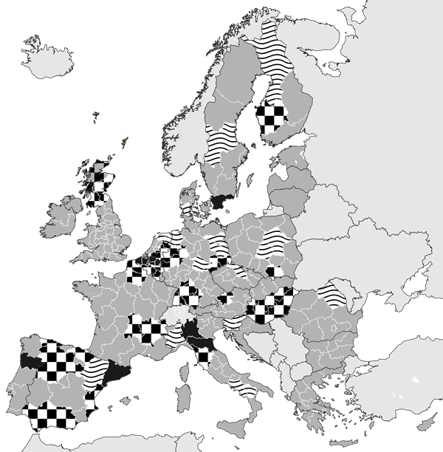

Regions that participate in 5 or more partnerships are indicated in full black colour, those that participate in 2-4 partnerships are indicated with a square patterns, while regions that participate in 1 partnership are indicated by horizontal wave lines.

*Source: European Commission, JRC*

|  |  |  |
| --- | --- | --- |
| **Overview of RIS3 Partnerships under the Thematic Smart Specialisation Platforms (May 2017)**  Following interregional partnerships have emerged in three Thematic Smart Specialisation Platforms (TSSP): lead-regions identify a thematic area in the broader domain of their RIS3 priority for which there is a need/advantage in setting-up cooperation together with participating regions on common topics, building European value chains based on complementarities and on investing in demonstrators and pilots. | | |
|  | Thematic Area | Participating regions (with lead regions being underlined) |
|  | **TSSP ENERGY** | |
| 1 | **Marine Renewable Energy** | Basque Country, Andalusia, Asturias, Navarra, (ES), Scotland (UK), Brittany, Normandy (FR), Dalarna, Skåne (SE), Emilia-Romagna, Lombardi (IT), Flanders (BE), Norte (PO), Ostrobothnia (FI), Southern Denmark (DK), Sogn og Fjordane (NO). |
| 2 | **Sustainable construction** | Andalusia, Navarra (ES), Norra Mellansverige y North Midsweden (SE), Lapland (FI), Gloucestershire County (UK), Gorenjska (SI), Rzeszow (PL), North-West Croatia(HR), Jämtland (SE), Lithuania (LT). |
| 3 | **Bioenergy** | Lapland, North Karelia, South Savo, East and North Finland (FI), Castilla y Leon, Extremadura, Asturias (ES), Western Macedonia (GR), Eastern Norway (NO), North East Romania (RU), Norrbotten, Jokkmokk (SE). |
| 4 | **Smart Grids** | Pomorskie (PO), Algarve (PT), Bretagne, Provence-Alpes-Côte d'Azur (FR), Northern Netherlands (NE), South Trans-Danubian (HU), Andalusia, Basque Region (ES), North Midsweden (SE), West Finland (FI). |
| 5 | **Solar** | Extremadura (ES), Andalusia (ES), Asturias (ES), Castile and Leon (ES), North Great Plain (Eszak-Alfold) (HU), Etela-Karjala (FI), GAP (TR), Ireland, Murcia (ES), Opolskie (PL), Podlaskie (PL), Sicilia (IT), Slaskie (PL), Slovenia, South-Estonia (ET), Manisa Subregion (TR), Valencia (ES), Veneto (IT) |
|  | **TSSP AGRI-FOOD** | |
| 6 | **High Technology Farming** | Tuscany, Lazio, Marche (IT), Galicia, Extremadura, Galicia (ES), Gelderland, Zuid Holland, (NL), Central Macedonia, West Macedonia (GR), Limburg (BE), East Sweden (SE), Auvergne-Rhone-Alpes (FR), Weser-Ems (DE). |
| 7 | **Traceability and Big Data** | Andalusia (ES), Sardinia, Basilicata, Emilia-Romagna, Friulli-Venezia-Giullia (IT), Northern Ireland (UK), Ribatejo (PO), Epiro (GR), Basque Country, Navarre (ES), South Savo and South Ostrobothnia (FI). |
| 8 | **Bio-economy Pilot** | [Randstad Region (NL)](http://s3vanguardinitiative.eu/partners/randstad-region) and Lombardy (IT), East-Netherlands, South-Netherlands, North-Netherlands (NL), Basilicata, [Emilia-Romagna (IT)](http://s3vanguardinitiative.eu/partners/emilia-romagna), [Scotland (UK)](http://s3vanguardinitiative.eu/partners/scotland), [Tampere, West Finland and Central Finland (FI)](http://s3vanguardinitiative.eu/partners/tampere-region), Flanders, [Wallonia (BE)](http://s3vanguardinitiative.eu/partners/wallonie), [North Rhine-Westphalia, Baden-Württemberg, Brandenburg (DE)](http://s3vanguardinitiative.eu/partners/nordrhein-westfalen), [Skåne, Värmland (SE)](http://s3vanguardinitiative.eu/partners/region-skane), Basque Country, Andalusia, [Navarra (ES)](http://s3vanguardinitiative.eu/partners/navarra), [Asturias (ES)](http://s3vanguardinitiative.eu/partners/asturias), Lodzkie and [Malopolska (PL)](http://s3vanguardinitiative.eu/partners/malopolska). |
| 9 | **Smart Electronic Systems** | Flanders (BE), Wallonia (BE), Eindhoven (NL), Lower Saxony (DE), North-Rhine Westphalia (DE), Lombardia, (IT), Közép-Dunántúl (HU), Navarra (ES), Galicia (ES), Asturias (ES), Auvergne-Rhône-Alpes (FR), Greece (all regions). |
|  | **TSSP INDUSTRIAL MODERNISATION** | |
| 10 | **Advanced manufacturing for energy applications** | Basque Country (ES), Scotland (UK), Asturias, Andalucía, Navarra (ES), Dalarna, Skane (SE), Emilia-Romagna, Lombardy (IT), Flanders (BE), Norte (PT), Ostrobothnia (SE) and Syddanmark (DK). |
| 11 | **Bio-economy – innovative use of non-food biomass** | Lombardy (IT), Randstad (NL), Flanders (BE), Värmland (SE), Scotland (UK), Asturias, Navarra (ES), North Rhine-Westphalia (DE), East Netherlands (NL). |
| 12 | **Efficient and Sustainable Manufacturing** | Lombardy (IT) and Catalonia (ES), Scotland (UK), Saxony (DE), Norte (PT), Basque Country (ES), Flanders (BE), Hauts-de-France (FR), Emilia Romagna (IT), Tampere (FI), Skane (SE), Baden Wurttemberg (DE). |
| 13 | **High Performance Production through 3D-Printing** | Flanders (BE), South Netherlands (NL) and Norte (PT). Asturias, Aragon, Catalonia, Andalusia (ES), Skåne, Orebrö Lan (SE), Tampere (FI), Baden-Wurttemberg, North Rhine-Westphalia, Thuringen, Saxony (DE), Wallonia (BE), Auvergne-Rhône-Alpes, Hauts-de-France (FR), Randstad (NL), Emilia-Romagna, Lombardy (IT), Upper Austria (AT) and Malopolska (PL). |
| 14 | **New Nano-Enabled Products** | Skåne (SE) and Tampere (Fi), Asturias, Navarra (ES), North Rhine-Westphalia, Baden-Württemberg (DE), Auvergne-Rhône-Alpes (FR), Emilia-Romagna (IT), South-Netherlands, East Netherlands (NL), Flanders, Wallonia (BE), Norte (PT). |
| 15 | **Innovative Textiles for creative industries** | Valencia (ES), North-East Romania (RO), Catalonia, Basque Member State (ES), Hauts-de-France (FR), Norte (PT), West-Flanders (BE). |
| 16 | **Industry 4.0 for SMEs / Production performance monitoring system** | Tuscany (IT), Castilla y Leon, Valencia, Catalonia (ES), Mazowiecke (PL), Hungary, Slovenia,and Estonia. |
| 17 | **Sport** | Lapland (FI), Flanders (BE), Kainuu (FI), South of Netherlands (NL), Upper Austria (AT), Valencia (ES). |
| 18 | **Medical Technologies** | Auvergne-Rhône-Alpes (FR), Lombardy (IT), Nord Rhine Westphalia (DE), Baden-Wurttemberg (DE), Copenhagen Region (DK), South of Netherlands (NL), Flanders (BE), Ile de France-Paris region (FR), Provence Alpes Côte d'Azur-Occitanie (FR), Catalonia (ES), Navarra (ES), Aragon (ES), Tuscany (IT) and East Netherlands (NL). |

The Smart Specialisation Platform for Industrial Modernisation (S3P-Industry Modernisation)[159] follows a dual approach to facilitate strategic interregional collaboration and industry involvement.It aims to generate interregional RIS3 partnerships of committed regional authorities as well as corresponding partnerships of cluster organisations (as specialised SME intermediaries) and technology centres. Moreover, a call for the expression of interest for European Strategic Cluster Partnerships for smart specialisation investments (ESCP-S3)[160] to facilitate the partnering has been launched. A call for proposals with a budget of 2.8 million EUR will be published under the COSME programme in the second half of 2017 dedicated to industrial modernisation.[161]

**Graph 15: The dual approach of the Smart Specialisation Platform for Industrial Modernisation**

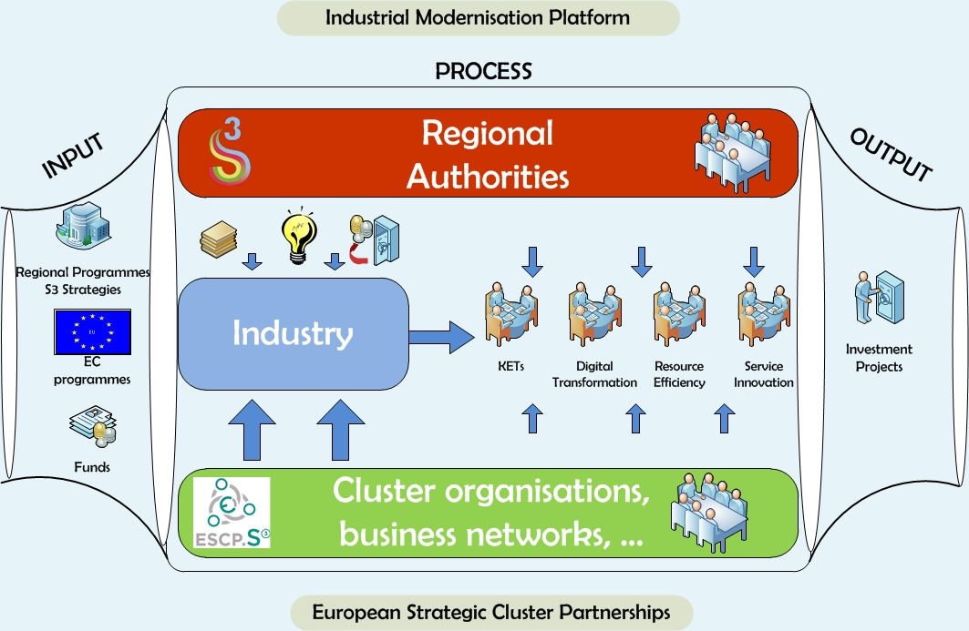

### RIS3 and the link to Digital Innovation Hubs and other innovation infrastructures

The European Commission launched on 19 April 2016 the first industry-related initiative of the Digital Single Market package: Digitising European Industry.[162] One of the main actions is to promote a pan-European network of regional digital innovation hubs. Digital innovation hubs are defined as ecosystems that consist of SMEs, large industries, start-ups, researchers, accelerators, and investors. One of the core elements of a digital innovation hub are competence centres that offer infrastructure and services for testing and demonstrating new digital solutions.[163] Digital Innovation Hubs should be differentiated towards the needs of local economies and positions in European value chains. A pan-European network of digital innovation hubs can also offer opportunities to give SMEs access to more specialised services across borders.

In order to maximize the impact on innovation and businesses, digital innovation hubs should foster synergies with other advanced technologies such as key enabling technologies (e.g. sustainable manufacturing technologies, advanced materials, industrial biotech, nanotech). Businesses should be guided to the right competence centre with the relevant expertise in digital, other advanced technologies or their combination corresponding to the innovation development needs of businesses.

The European Commission is conducting inventories of innovation infrastructures (digital innovation hubs, technology centres with expertise in key enabling technologies[164], pilot lines etc.), which will be connected with the Smart Specialisation Platform for Industrial Modernisation. As a result of these combined efforts the European Commission will be able to offer for the first time a comprehensive overview of a considerable part of innovation infrastructure that is available as shared infrastructure throughout the EU.

Further efforts are needed to open-up innovation infrastructures at pan-European level. R&I infrastructures relying on national/regional public support often work with own national/regional actors. Since these infrastructures are unevenly spread across Europe, the majority of European SMEs are not likely to find the knowledge and services they need for their specific innovation needs. On the other hand, some regions have state-of-the art testing facilities but these are underexploited due to the lack of demand from own regional actors. A comprehensive multi-level (EU, national, regional) approach is needed to ensure pan-European access for actors to R&I infrastructures. Finally, synergies with the Connecting Europe Facility (CEF) programme aiming at providing infrastructure deployment in transport, energy and digital sector should also be found.

### Maturity of mechanisms to support investment in innovation across borders:

Innovation policy has become more outward looking to co-develop solutions that go beyond the capacity of regional and national innovation systems.[165] Industrial leadership in Key Enabling Technologies (KETs) needs to develop full complementarities between lead-regions in KETs and lead-regions in specific application domains.[166] This includes identification of best practices and successful test-beds for regional upscaling to innovation and replicability of the model to other regions.

The Basque Country has a relevant track record in terms of regional public investments in industrial nanotechnology research as well as in participation in EU (Horizon 2020)-funded pilot projects. An example of synergies at project implementation level could be envisaged in the case of the PLATFORM Project[167]. The expertise needed to compete at European level for being a beneficiary of Horizon 2020 industrial leadership pillar funding has been possible thanks to the support received by the Basque Administration for knowledge generation through regional funds. Regional funds will also allow a consortium of Basque companies to scale up the PLATFORM pilot plant and produce nanomaterials to be incorporated in their production processes, contributing to take another step further in the long road that involves the incorporation of nanotechnologies in industrial processes.

The challenge is to cope with a growing complexity of interdependent actors and decisions operating at different levels and in different places. This is reflected in a multiplicity of financing sources, often based on different rules such as state aid, taxation, eligibility, different objectives (ESIF, Horizon 2020, national, private etc.) and different time-lines. The integration of EU support with private sector investment decisions is hampered by the fragmentation of programmes and calls.

The interregional investment projects for 'joint-demonstration' by the Vanguard Initiative (which are the most advanced demo-cases) have signalled bottlenecks at several levels and proposed a number of actions:

* Development of good **business plans**: specific knowledge for conversion of project ideas in structured projects, and development of business plans (including IPR issues) and financing plans (including public and private parts). Close-to-market piloting and demonstration will require an economic logic, especially for 'bankable' projects that aim at co-financing from EIB or other banks.
* Effective **financial engineering**: specific knowledge for combining funding sources and synchronisation of investments in decentralised cooperation. Already first explorations are underway (e.g. SCREEN project[168]).
* In many cases the **connection** **between existing pilot- and demonstration facilities**, to promote **mutual access** for companies from other regions, is the first step to take.
* In the context of the Investment Plan there is a need to create conditions for greater possibilities to exploit support from EU level financial instruments and EFSI for multi-actor and staged investment projects. Not only the instruments need to be tailored to the needs, but also the speed of delivery is a condition for success.
* Further experimentation with existing programmes for support to interregional co-investment can be the aggregation of Interred B (transnational cooperation) calls (based on the present experience of extending the geographical scope of the calls).

In conclusion, early results in implementation indicate a strong demand from regions. A vast majority (86%) of the respondents to the public consultation identified the need for the EU to “develop interregional cooperation regarding smart specialisation”. Furthermore, close to one fifth (18%) of the respondents highlighted that they face “difficulties to identify other regions with similar or related strategies”. However, there remains a need to simplify national and ESI fund procedures for programmes to better support interregional projects[169] and to facilitate collaboration with the existing broad range of platforms and initiatives at EU level.

## Leveraging research and innovation in less developed and industrial transition regions

Both the development process for smart specialization strategies and their content is determined by the level of development of the socio-economic structures, the innovation systems,[170] the business and entrepreneurial composition as well as of the institutional and administrative arrangements in the Member States and regions. These conditions vary substantially across the regions. The process towards the formation of smart specialisation strategies in regions and Member States with a weak innovation or entrepreneurial legacy was substantially different to the one in regions which have a history of excellence at European level on innovation and business competitiveness; the strategy development has followed different paths and methodology across regions, and it can be concluded there is no “one-size-fits-all” model.[171]

### Tailoring through RIS3 leads to address specific bottlenecks in less developed regions

Promoting innovation and competitiveness through RIS3 strategies is a significant challenge for low-income or low-growth regions with weak institutional structures. They require specific attention with regards to human capital, skills development and the role of higher education institutions and VET providers, as well as to natural capital. Both universities and providers of vocational training have a strategic role to play in these innovation ecosystems. More generally, innovation actors in less developed regions are often not very well connected to a wider research and innovation community and global value chains. This results in duplication of research efforts and barriers to cooperation.

Targeted support to overcome these bottlenecks can facilitate the implementation of RIS3. The policy action dashboard of the Regional Ecosystem Scoreboard of the European Cluster Observatory offers a tool that identifies bottlenecks that may be particularly promising to address by policy actions. [172]

The experience in Eastern Macedonia and Thrace[173] is an **example of providing targeted RIS3 support to lagging regions,** whichpointed to:

* A lack of trust and collaboration culture between stakeholders in the quadruple helix, but also inside each part of the helix (among firms, among public services, etc.). Building trust, collaboration culture, understanding and commitment towards RIS3 has proven very important.
* A number of Member State-specific and region-specific bottlenecks hampering RIS3 implementation (e.g. many companies having tax debts, and thus not eligible to receive ERDF funding; ambiguity regarding the legal power of regional governors to launch calls,...), which require tailored solutions
* Important spill-overs effects in terms of policy learning.

Outcomes to date of the ongoing project "Targeted RIS3 support to lagging regions" and of the finalised project on "Targeted RIS3 support to Eastern Macedonia and Thrace" indicate an increased understanding of RIS3 and the concept of entrepreneurial discovery, the importance of building continuously trust and a culture of collaboration through a focus on concrete results, the need for a good coordination between national and regional stakeholders, as well as for a focus on concrete results in the short term. Both projects also show that lagging regions can take a leading role in aspects related to RIS3, as shown by the leading role of Eastern Macedonia for Greece in implementing RIS3 for the whole of Greece, and by the RIS3 Monitoring Working Group, in which lagging regions jointly develop a hands-on approach to RIS3 monitoring, which will serve as a basis for other regions.

A majority of the lagging regions participating in the pilot programme have limited capacity to implement RIS3 activities that go beyond the use of ERDF funds. Under the EP preparatory action for targeted RIS3 support in Eastern Macedonia and Thrace, a RDI funding guide**[174]**, as well as a number of case studies for combined funding or projects have been elaborated to facilitate the use of different funds. An important condition for leveraging ERDF funds with other funds for RIS3 appears to be the existence of RIS3 teams at regional level dedicated to RIS3 implementation (and not only to ERDF implementation).

Benchmarking[175] can facilitate policy learning by helping regional policy makers to identify other similar regions as reference peers facing similar structural opportunities and constraints. More specifically, benchmarking with structurally similar regions facilitates the understanding of what policy practices could and should be transferred and replicated or rather avoided. It is also the first (necessary) step towards explaining varying growth paths of similar territories.

Policy practice can be substantially enhanced across regions by improving the flow of information and transfer of knowledge concerning actual objectives, strategies, plans, interventions and specific measures designed and implemented in different territories by different policy authorities. This is especially true in a context of scarcity of resources, like the one faced currently by most local and regional administrations in the European Union. Such constraints do not give much room for autonomously experimenting with different policy measures. This is why it is of utmost importance to draw the right lessons from other regions and share past experience.

### Mutual learning on design and implementation

Europe's diversity means that productivity gains from innovation can be reaped in many specialisation areas. Identifying and deploying this potential can be challenging, even in more developed regions. Support mechanisms and platforms for mutual learning were therefore instrumental in the design and implementation of RIS3 strategies through the TAIEX REGIO Peer-2-Peer[176] and S3 Platform[177]. TAIEX is designed to share expertise between [ERDF's and [Cohesion Fund](http://ec.europa.eu/regional_policy/index.cfm/en/funding/cohesion-fund/)'s Managing Authorities](http://ec.europa.eu/regional_policy/index.cfm/en/funding/erdf/). It helps public officials involved in the management of these funds to exchange knowledge, good practice and practical solutions to concrete problems thus improving their administrative capacity and ensuring better results for the EU investments.

This exchange can take the form of an "Expert Mission" (EU Member State experts can be sent to institutions in other Member States that have requested peer advice and exchange of experience on a specific topic), "Study Visits" (employees from a requesting institution can be sent on a working visit to other EU Member State institutions to learn from peers and exchange good practices) and "single or multi-country workshops". 12 events have already been organised by the Directorate General for Regional and Urban Policy of the European Commission for local and regional authorities of Romania, Lithuania, Poland, The Netherlands and Spain since September 2015. These included workshops, study visits and experts' missions from which a total of 225 stakeholders benefitted so far. In 2017, four more study visits are expected to take place in Romania, Poland, Latvia and Portugal.

The S3 Platform has provided an additional European added value to the process of strategy development by mapping the R&I diversity in EU regions, addressing European challenges and promoting policy learning. This has allowed regions to adopt best practice, benchmark their mechanisms against world-class standards and address their weaknesses.

In 2015, **Bulgaria** was the first Member State to take advantage of the Horizon 2020 Policy Support Facility to support wide-ranging reforms. The peer review provided external advice to the Bulgarian authorities in the process of evaluating their R&I system in the form of 10 policy messages, giving a significant push to the development of the smart specialisation strategy (referred to in Bulgaria as Innovation Strategy for Smart Specialisation ISSS or IRIS3). Latvia as well uses this support facility to ensure the completion of the reform of the funding system for public research that goes hand in hand with the implementation of the smart specialization strategy. Lithuania has successfully used peer-to peer opportunity to learn from the experience of the Netherlands in the identification and implementation of smart specialisation.

The need to spread excellence and widen participation has been supported at EU level through Teaming, Twinning, and ERA chairs. The Lagging Regions project[178] aims to provide targeted support to low-growth and low-income regions. Cohesion policy provides a broad range of levers to implement RIS3 in low growth and low income regions through support to capacity building, administrative reform, ex-ante conditionalities and strengthened monitoring and evaluation.[179] Finally, to support policy reforms at national level, the Horizon 2020 Policy Support Facility (PSF)[180] has also proved to be useful providing policy advice and facilitating exchanges of good practices and learning among participating countries.

## Harnessing synergies and complementarities between EU policies and instruments

The need for synergies and complementarities between EU funds for research and innovation has been increasingly highlighted at political level, including through Council Conclusions[181] and by the European Parliament[182]. To achieve smart, sustainable and inclusive growth, the "Common Strategic Framework"[183] stresses the importance of synergies and complementarities between EU funds. Excellence based policies that do not have a regional dimension need to be combined with national and regional innovation policies to strengthen the capacity of regional actors to participate in the European Research Area (ERA) and reinforce place-specific processes of market led innovation built on existing clusters and governance systems.

The "Common Strategic Framework" stresses the importance of synergies and complementarities between EU funds and RIS3 strategies provide a robust framework to develop synergies as they should include "up-stream actions" to prepare regional R&I players to participate in Horizon 2020 and "down-stream actions" to exploit and diffuse R&I results, stemming from Horizon 2020 and preceding programmes, into the market. Many of the identified smart specialisation priorities also allow matching with H2020 themes and thus offer opportunities for developing synergies, for example, in coordinated parallel actions that complement each other. Synergies can be envisaged also for other instruments funded under ESIF e.g. the Connecting Europe Facility that manages cross-national cooperation activities, where "down-stream" actions could maximise innovation absorption. Synergies can help in closing the innovation gap throughout the EU regions as reflected in the participation success rates in the Framework Programmes Horizon 2020.

ELI - Extreme Light Infrastructure (distributed) project[184] is an example of the upstream synergies located in Czech Republic, Hungary and Romania. It is supported by these Member States under their ESIF resources complementing the European Strategy Forum on Research Infrastructures, ESFRI. The European Spallation Source (ESS)[185] is also part of the ESFRI and receives support for the construction costs from ESIF. In the current programming period, around EUR 20 million of ESIF in Sweden will be allocated to this research infrastructure. Also some partner countries such as Estonia and Czech Republic are applying the new provision in the Cohesion Policy regulation (Article 70) that allows regions to spend part of their ERDF allocations (up to 15%) in other regions, even abroad, and thus invest their ESIF in the construction of the ESS.

FP7 TIGER and TIGER DEMO projects are examples of down-stream synergies. The projects paved the way to European Transport Corridors[186] through regional demonstration sites supported by ESIF. TIGER ‘Transit via innovative gateway concepts solving European intermodal rail needs’ is a 7th Framework Programme (FP7) project that supported the development of competitive European rail transport and of co-modal freight logistics chains. TIGER DEMO, the follow-up project, aimed at taking the pilots developed by the TIGER project forward into a full-scale demonstration for subsequent market uptake and commercial exploitation. The results of these pilots, after validation, are replicable in other EU ports and are ready for market exploitation. For example, the TIGER DEMO co-modal solutions for maritime traffic flows are implemented in several geographical sites in Europe e.g. the construction of the 'Genoa Fast Corridor' aiming to reduce congestion in the Genoa harbour, partially funded by the Liguria region via ESIF.

"Brückenbildung NRW" initiative in Germany is part of the "Smart Specialisation Strategy" of North-Rhine Westphalia to incentivise the transfer of FP7/H2020 research results to local firms for developing commercial solutions. F3Factory project under FP7 worked out solutions to enhance performance of production processes with regards to safety, cost effectiveness and energy efficiency. The results have been used by the ERDF funded MoBiDiK project.

MoBiDiK made a new biopharmaceutical production process work in a demonstration plant based on modular plug-and-produce chemical production technology. This helps meet the growing demand for specialised therapies, decrease production cost and leverage private funds. This succession of projects leading to an innovative product supports the smart specialisation priorities of North-Rhine Westphalia i.e., Machine and plant engineering and Life sciences.

Additionally, in some countries smart specialisation also helped regions in prioritising investments, setting a clear agenda for research and innovation, and in raising the quality of local governance. A good example for this is the Wrocław Research Centre EIT+ project in Poland supported by ERDF. It is a research and innovation infrastructure which combines an advanced technology park, thematic cluster and research and development institute. 11000 square metres of lab space funded from ERDF conducts applied research in the areas of nanotechnology, material technology, biotechnology, medicine, energy and climate looking for marketable technology solutions.

|  |
| --- |
| **Graph 16: Synergy building through upstream and downstream actions** |

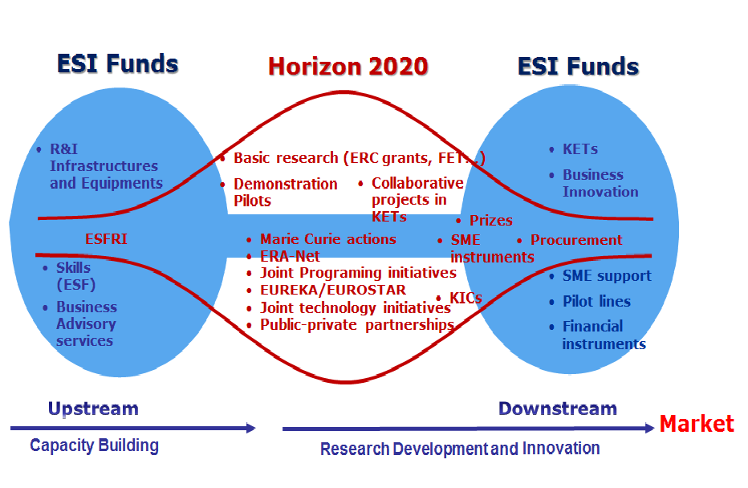

Complementarities are central for the emergence of novel technologies and the ‘functioning’ of existing ones. Automobiles, for example, require a network of gas or charging stations, a road infrastructure, traffic and safety regulations, repair shops, specialized suppliers and insurance services. Smart phones require a network of base- and switching stations, interconnectors to landlines and the internet, interoperability standards, different kinds of software, service providers etc. Complementarity at the sector or system level occurs, and if – combined – these components better contribute to fulfilling the societal function of the sector than each component on its own. Sector level complementarities can be viewed through the eyes of consumers or through the eyes of policy makers or regulatory authorities.[187]

Most projects with the potential to give rise to a new activity require simultaneous large-scale investments to be made in order to become profitable. All the necessary services and complementary activities have fixed costs and are unlikely to start unless the potential provider have enough positive expectations regarding the future of the smart specialisation strategy. Profitable new activities can fail to develop unless upstream and downstream investments are made simultaneously[188].

Building on a **better participation in Horizon2020** and on **stronger interaction with the Bio-based Industries Joint Undertaking (BBI JU)** would help to mobilize the political commitment for the broader uptake of the bioeconomy in the lagging regions involving all the sectors. An interesting example of a large scale investment funded by BBI Initiative in the CEE region is **BIOSKOH**[189] **flagship project**. The project will build an advanced biorefinery in eastern Slovakia. It has received funding from BBI during the 2015 call (with EUR 13.4 million of funding to the Slovak partner) and has started September 2016. This can serve as a point of reference for the regional stakeholders.

Another successful example in the Bioeconomy area is the EUR 17 million project (**FIRST2RUN**)[190] in Sardinia / Italy, that transformed an abandoned oil-refinery into a biorefinery that uses dry self-growing crops (cardoon) for the production of chemicals for food, feed and energy. This project created local jobs in an abandoned area where no plants can be easily grown. ESIF may further provide opportunities for complementary actions at local level and cross-border cooperation for exchange of knowledge.

Present cooperation models often reflect a linear innovation model and emphasise cooperation in research among peers within a specific technology domain. This constrains the innovation activities often to pre-commercial research cooperation among competitors and to technology-push strategies. The demand-pull model is gaining now more consideration, with a mission oriented research (pulled by societal challenges).[191] The creation of entrepreneurial opportunities as part of such approach will be crucial to achieve impact.

### Mechanisms for synergies

The new regulatory frameworks for Horizon 2020 and Cohesion Policy provide a number of instruments to reinforce synergies[192], including the possibility for the managing authorities of the ESIF programmes to allocate amounts from the operational programme to actions located outside the programme area but within the Union and for the benefit of the programme area (Article 70, Regulation (EU) No 1303/2013).

On the side of cohesion policy the mechanism for innovation related synergies is anchored in the RIS3 requirement. At the level of Partnership Agreements and operational programmes, Member States are required to demonstrate how various funding streams will be coordinated. Regulatory possibilities have been provided to combine Horizon 2020 and ESI funds in the same project, to perform successive and parallel projects[193] and the use of the simplified cost options and flat rates have been eased.[194] In addition, there are greater possibilities to spend ESI funds outside programme areas.[195] Finally, RIS3 strategies were required to build synergies and complementarities also with other ESI Funds (e.g; Interreg Europe), Horizon 2020 and other EU innovation funding programmes, such as COSME.

On the side of research and innovation policy, the purpose of fostering synergies between different EU funding programmes and policies to attain the Europe 2020 objectives of smart, sustainable and inclusive growth led to a stronger acknowledgement of the importance of Cohesion Policy investments in R&I, and a higher recognition of regional governments as innovation policy actors. It was also recognised that there is a need for involving all regions in the innovation cycle and each focusing on its own strengths. This shall contribute to the closing of the research and innovation divide within the European Union.

Articles 32 and 33 in the Regulation (EU) 1291/2013 establishing Horizon 2020 were included that provide for complementarity of Horizon 2020 with other Union funding programmes and policies and synergies with ESI funds. A special part for "Spreading excellence and widening participation" (with about EUR 0.8 billion) has been introduced to Horizon 2020 aiming to fully exploit the potential of Europe's talent pool and to ensure that the benefits of an innovation-led economy are both maximised and widely distributed across the Union. A practical guide[196]for decision-makers at regional level is available on how to effectively combine European structural funds with Horizon 2020 and the Bio-based Industries Joint Undertaking to deploy the European Bioeconomy.

Additional technical assistance is provided by the European Investment Advisory Hub[197] to further encourage the combination of the European Structural Investment Fund and the European Fund for Strategic Investments to maximise the mobilisation of private sector capital.

### Progress on synergies

Evidence from the programme negotiations and early implementation suggest that some progress on synergies has been made in particular at a strategic level, with a significant improvement in the information provided on coordination in the Partnership agreements and operational programmes. The situation at project level is more mixed. In spite of the changes to the regulatory framework, beneficiaries remain concerned that combination remains complex in practice.

In the context of Horizon 2020 calls for proposals which encourage synergies, further progress could be made to take synergies into account – but without undermining the excellence criterion of Horizon 2020 – where they are a valid aspect of the business plan and make the project more ambitious or increase its impact.

In the context of the Omnibus[198] regulation, the Commission has proposed a further simplification to facilitate joint funding.

In Teaming proposals of the Horizon 2020 Spreading Excellence and Widening Participation part, national/regional authorities or other private sources are required to commit financial resources, e.g. from ESIF, and proposals must clearly identify alignment and complementarity with the national or regional Smart Specialisation Strategies of the Member State or region from which the applicant is coming. In the other two Widening actions - Twinning and ERA Chairs - interactions with national/regional authorities and other stakeholders to coordinate actions and mobilise support, e.g. from ESIF, are desirable in the proposals, and the proposals are encouraged to identify alignment and complementarity with Smart Specialisation Strategies.

Actions such as those under the Spreading excellence and widening participation part of Horizon 2020 (Teaming in particular) have an important role of mobilising ESIF investments complementing in a synergetic way the establishment of Horizon 2020 validated centres of excellence in low R&I performing countries. These actions were introduced to respond to the persisting divide in terms of research and innovation performance of some Member States[199] with the aim to encourage structural changes through institution building and networking as well as bringing excellence to institutions.

While there are a number of good examples for the upstream and downstream synergies[200], many beneficiaries point to differences in the rules governing Horizon 2020 and Cohesion Policy expenditure, notably in relation to eligibility rules, procurement and state aid. Regarding governance of the two policy frameworks there is a need for better clarity of roles and responsibilities of the actors involved as well as coordination at all levels. More concrete support for implementation of synergies in practice is also needed.

There are encouraging initiatives proving that building functioning synergies succeed. For example, the 'Clean Sky 2' - the Joint Technology Initiative between the EC and the European aeronautics industry has developed a methodology to concretely implement synergies. The goal is to reinforce the R&I capacity and the European dimension of regions in aeronautics, as well as to identify complementary areas of technical cooperation and to have a leverage effect from the synergies between ESIF and Clean Sky 2 funding, thus ensuring a higher impact of the cumulative innovation investment.

This initiative mapped the RIS3 priority areas of the regions and signed with those of them who were interested in cooperation Memoranda of Understanding aiming to exchange knowledge and to jointly develop methods to complement and leverage Clean Sky technical content with further or parallel actions co-funded by ESIF. This approach has a high relevance for the 'widening' Member States and could certainly be adapted by other initiatives.

Synergies and complementarities between various EU support programmes and funding are an important issue in the other current EU programmes. The results of the public consultation show that there is significant improvement as regards complementarities and synergies, as out of the 44% of respondents that have received funding or other support from more than one EU fund or programme in the past 3 years, **60% of benefited from synergies or a combination of different funds**. 37% acknowledge that the different EU support or funding was mutually supportive and improved or expanded the impact of the activity. EU support or funding was not linked but complementary for 17% of respondents. Furthermore, 6% received funding from more than one fund or programme for the same activity. Yet, support or funding was not linked and not complementary, as very different actions were funded for 36% of respondents.

### Initiatives to promote synergies

**The Stairway to Excellence** (S2E) [201] pilot project aims to help closing the innovation gap between the EU regions through developing and exploiting the synergies between European Structural and Investment Funds (ESIF), Horizon 2020 and other EU funding programmes. The S2E national events held in the last two years provided an opportunity for establishing informed communication between stakeholders in participating Member States. This was recognised as a novelty in itself in many of the EU13 Member States where prior consultation of stakeholders consistently signalled the need of proper interaction between policy makers, research and business actors. The identified fields that need further improvement relate to quality of R&I governance, capacity building and the commercialisation of the research results.[202] Much more efforts should be put to better coordination of the current information channels, offices and platforms and exchange of information between Managing Authorities of the ESIF programmes, Horizon 2020 National Contact Points and other stakeholders. The project clearly recognized that the planning safety and exploiting opportunities provided by the continuous Entrepreneurial Discovery Process (EDP) must be guaranteed through a long-term vision and political commitment. Long-term strategic planning is crucial for reinforcing a shared vision of R&I policies, building up a consensus on the prioritisation while aligning activities and creating a more open, transparent and flexible working culture to maximise socio-economic impacts of these investments. This can facilitate strategic business involvement into the wider innovation ecosystems since a stable economic and political environment help business actors to plan investment decisions and long-term initiatives.

**The Seal of Excellence**[203] (SoE) initiative is a quality label awarded to proposals submitted for funding under the calls of the Horizon 2020 that succeeded a rigorous evaluation, but could not be funded under the available call budgets. Holders of the certificate can find alternative funding under the European Structural and Investment Funds or other sources for their outstanding project ideas. The Seal of Excellence offers an opportunity for regions and Member States (and any other interested actor) to benefit from the high-quality Horizon 2020 evaluation process. During its pilot phase in years 2015-2016, the Seal of Excellence was awarded to positively evaluated proposals under the SME Instrument Calls of Horizon 2020. The initiative has now been extended to cover Teaming actions under the Widening part of Horizon 2020 as well as Marie Skłodowska Curie actions. Preparatory work for extending the Seal to the Proof of Concept proposals of the European Research Council is in progress. The distribution of the SoE certificates reflects the participation in Horizon 2020 by the different Member States. National and regional authorities in Member States and regions with sufficient critical mass of awarded projects started designing appropriate funding schemes, those where the number of seals is not very high, have decided to use existing funding schemes and integrate there the 'seal' proposals (through a system of bonuses, etc.). An increasing number of such support schemes exist already or are about to be launched, both for 'Seal' SME Instrument Phase 1 and Phase 2 Seal proposals, at both national and /or regional level (for instance in CZ, CY, EL, ES, FR, HU, IT, NO, PL, SE, SI).

**Graph 17: Number of Seal of Excellence certificates awarded in Horizon 2020 SME Instrument (phase 1)**

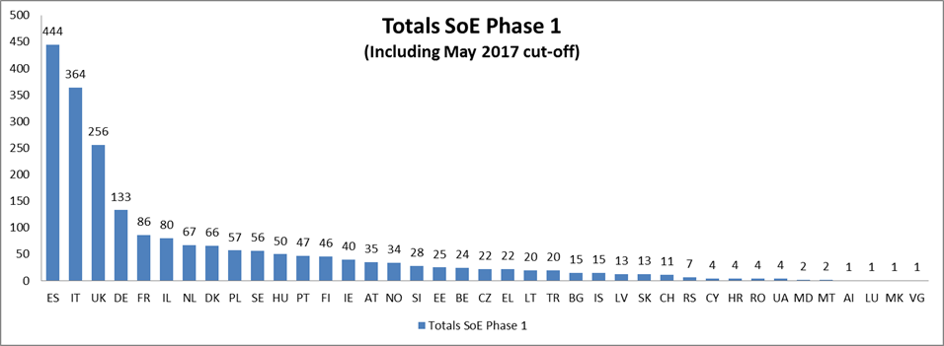

Source: European Commission

**Graph 18: Number of Seal of Excellence certificates awarded in Horizon 2020 SME Instrument (phase 1I)**

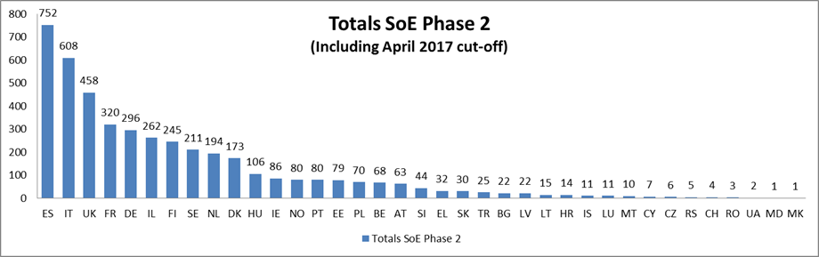

*Source: European Commission*

The European Commission since the beginning facilitates this work through the Seal of Excellence Community of Practice which has been established as a forum of discussion and exchange of information amongst funding bodies (more than 200 funding bodies currently members) interested in implementing the initiative which has been rapidly grown up with almost all Member States represented. To facilitate them in the handling of emerging questions when designing alternative funding schemes, the European Commission issued an 'Explanatory note of the Commission services on the application of State Aid Rules to national and regional funding schemes that offer alternative support to SME Instrument project proposals with a Horizon 2020 'Seal of Excellence''[204]. In order to tap into the full potential of the Seal of Excellence further steps need to be made towards simplification of procedures and alignment of rules between the two policy frameworks, Horizon 2020 and ESIF.

While the Commission is committing to make the synergies as operational and straightforward as possible, the national and regional authorities however have a central role to play in this transition towards greater synergies. Their active participation, for example, in the Seal of Excellence initiative is essential for success and their role in maximising the take-up of projects with Seals is crucial for significant impact.

A number of initiatives specifically seek to widen participation in Horizon 2020. These include, inter alia:

* A Horizon 2020 Policy Support Facility Mutual Learning Exercise on "Widening participation to the EU Framework Programmes and ensuring synergies between H2020 and European Structural Investment Funds" that shall facilitate the exchange of practice between the participating countries on how the Structural Funds and Horizon 2020 can act in closer synergy to boost Europe's knowledge base and productivity.
* Horizon 2020 has created the Start-up Regions of Europe[205] initiative to develop synergies and networking among regional start up ecosystems across Europe, linking developed ecosystem to developing ecosystems, in particular for eastern and south eastern regions of Europe.
* The European Institute of Innovation and Technology Regional Innovation Scheme[206] (EIT RIS) that aims to strengthen the capacity of regions’ innovation enablers and actors as well as the linkages among them, by working closely with the local knowledge triangle (research, education, business) actors and facilitating the collaboration, knowledge exchange and interaction among them.

The design process and the implementation of RIS3 and the above-mentioned initiatives have significantly increased awareness of the need for synergies and encouraged the development of concrete coordination mechanisms and stronger linkages at the strategic planning and implementing project level. However, challenges remain in order to streamline and simplify implementation as well as to create incentives for using the different funds in a combined manner. They include issues related to the strategic framework and programming, communication and bringing the relevant actors together, sharing of best practice and regularly monitoring and evaluation of synergies.[207] Nevertheless, the positive examples presented underline that efforts are beginning to demonstrate positive results in the regions.

1. European Commission's Reflection Paper on Harnessing Globalisation - COM(2017) 240 final.
2. Ibid.
3. Op cit.
4. COM(2010) 553 final "Regional Policy contributing to smart growth in Europe 2020.
5. Knowledge Economists Policy Brief n° 9 June 2009, Knowledge for Growth Expert Group, Smart Specialisation – The Concept Dominique Foray, Paul A. David and Bronwyn Hall.
6. Council Conclusions 2016 on A more R&I friendly, smart and simple Cohesion Policy and the European Structural and Investment Funds more generally, European Parliament resolution of 14 January 2014 on smart specialisation: networking excellence for a sound Cohesion Policy (2013/2094(INI)), European Parliament resolution of 13 September 2016 on Cohesion Policy and Research and Innovation Strategies for Smart Specialisation (RIS3) (2015/2278(INI))
7. "Regional Innovation Patterns and the EU Regional Policy Reform: Toward Smart Innovation Policies" - R Camagni, R Capello - Growth and change, 2013 http://onlinelibrary.wiley.com/doi/10.1111/grow.12012/full
8. COM 2017(2025) final
9. <https://ec.europa.eu/commission/priorities/jobs-growth-and-investment_en>
10. https://ec.europa.eu/commission/publications/president-junckers-political-guidelines_it
11. Oslo Manual, The Measurement of Scientific and Technological Activities <https://rio.jrc.ec.europa.eu/en/library/oslo-manual-third-edition>
12. <http://ec.europa.eu/europe2020/europe-2020-in-a-nutshell/priorities/smart-growth/index_en.htm>
13. Aghion, P. and Jaravel, X. 2015 The Economic Journal, "Knowledge Spillovers, Innovation and Growth" 125, p. 536
14. Aghion, "From Growth Theory To Growth Policy Design" (2012)
15. According to the EU Cohesion Policy, regions are classified under 3 groups according to their GDP : less developed regions (where GDP per inhabitant was less than 75 % of the EU-27 average); transition regions (where GDP per inhabitant was between 75 % and 90 % of the EU-27 average); and more developed regions (where GDP per inhabitant was more than 90 % of the EU-27 average).
16. COM (2016) 725 p.8
17. <http://www.europarl.europa.eu/sides/getDoc.do?pubRef=-//EP//TEXT+MOTION+P8-RC-2016-0851+0+DOC+XML+V0//EN>
18. <http://www.europarl.europa.eu/sides/getDoc.do?pubRef=-//EP//NONSGML+REPORT+A8-2016-0159+0+DOC+PDF+V0//EN>
19. <http://www.consilium.europa.eu/en/workarea/downloadAsset.aspx?id=40802190565>
20. <http://data.consilium.europa.eu/doc/document/ST-13989-2015-INIT/en/pdf>
21. COM(2013) 882 or COM(2012) 392
22. COM(2015) 572, COM(2016) 51
23. COM(2016) 180, COM(2016) 410
24. COM(2014) 14, COM(2012) 341, COM(2012) 537, COM(2013) 542
25. COM(2015) 614
26. <http://ec.europa.eu/regional_policy/en/newsroom/consultations/smart-specialisation>
27. "Knowledge Economists Policy Brief No 9" June 2009 <http://ec.europa.eu/invest-in-research/pdf/download_en/kfg_policy_brief_no9.pdf>
28. See, for instance, the Smart Guide to Cluster Policy (2016) available at <http://ec.europa.eu/DocsRoom/documents/16903/attachments/1/translations/en/renditions/pdf>, the expert group report on "The role of clusters in smart specialisation strategies" (2013) available at <https://ec.europa.eu/research/evaluations/pdf/archive/other_reports_studies_and_documents/clusters_smart_spec2013.pdf> and the 2008 Communication and Staff Working Document on clusters, COM(2008) 652 final/2 and SEC(2008) 2637.
29. COM(2010) 553 final.
30. Regulation (EU) No 1303/2013 of the European Parliament and of the Council of 17 December 2013
31. "Opportunity now: Europe's mission to innovate" European Commission" European Political Strategy Centre, 2016   
    <https://ec.europa.eu/epsc/publications/strategic-notes/opportunity-now-europe%E2%80%99s-mission-innovate_en>
32. "Smart Specialization as an innovation-driven strategy for economic diversification: Examples from Scandinavian regions" - Asheim, Bjørn, Grillitsch, Markus and Trippl, Michaela – Paper in Innovation studies (2016) -   
    <http://wp.circle.lu.se/upload/CIRCLE/workingpapers/201623_asheim_et_al.pdf>
33. "How to Improve Innovation Strategies for Smart Specialization in Poland" – World Bank (2014) [https://openknowledge.worldbank.org/bitstream/handle/10986/17839/865270WP0MIR0R00Box385176B00PUBLIC0.pdf](https://openknowledge.worldbank.org/bitstream/handle/10986/17839/865270WP0MIR0R00Box385176B00PUBLIC0.pdf%20)
34. "Smart specialization in Croatia" - World Bank (2015) - <https://openknowledge.worldbank.org/bitstream/handle/10986/22024/9781464804588.pdf;sequence=1>
35. "Smart Specialisation in less advanced regions: What are the key challenges" - Igo Rotaru, EURINT (2015) - <http://cse.uaic.ro/eurint/proceedings/index_htm_files/EURINT2015_ROT.pdf>
36. "Smart Specialisation: Creating Growth through Trans-national cooperation and Value Chains" - Mariussen Åge, Rakhmatullin Ruslan, Stanionyte Lina – JRC Policy Report (2016).
37. Philip McCann & Raquel Ortega-Argilés (2015) Smart Specialization, Regional Growth and Applications to European Union Cohesion Policy, Regional Studies <https://danube-inco.net/object/document/1517/attach/s3_mccann_ortega.pdf>
38. "Governing Smart Specialisation" - Dimitrios Kyriakou, Manuel Palazuelos Martínez, Inmaculada Periáñez-Forte, Alessandro Rainoldi – Regional Studies Association
39. "Mapping Innovation Priorities and Specialisation Patterns in Europe" - Jens Sörvik and Alexander Kleibrink – DG JRC Working Paper 2015.

    <http://s3platform.jrc.ec.europa.eu/-/mapping-innovation-priorities-and-specialisation-patterns-in-europe>
40. "Smart Specialisation. Opportunities and Challenges for Regional Innovation Policy", Dominique Foray, 2015
41. "Smart Specialisation: Opportunities and Challenges for Regional Innovation Policy" - Foray, D. (2015) – Regional Studies Association
42. "The goals of Smart Specialisation"- Dominique Foray and Xabier Goenaga – JRC Policy Brief (2013) - <http://s3platform.jrc.ec.europa.eu/-/the-goals-of-smart-specialisation>
43. "From smart specialisation to smart experimentation: Towards a new theoretical framework for EU regional policy "- Maximilian Benner - Zeitschrift für Wirtschaftsgeographie (2014) - <https://mpra.ub.uni-muenchen.de/51843/1/MPRA_paper_51843.pdf>
44. "Implementing Smart Specialisation Strategies: A Handbook" - Ed. Carlo Gianelle, Dimitris Kiriakou, Caroline Cohen, Marek Przeor Publication – European Commission (2016) - <http://s3platform.jrc.ec.europa.eu/s3-implementation-handbook>
45. "Smart Specialisation and Innovation in Rural Areas" - Artur da Rosa Pires, Martina Pertoldi, John Edwards and Fatime Barbara Hegyi – JRC Policy Brief (2014) - <http://s3platform.jrc.ec.europa.eu/-/smart-specialisation-and-innovation-in-rural-areas>
46. "Smart Specialisation: Creating Growth through Trans-national cooperation and Value Chains" Mariussen Åge; Rakhmatullin Ruslan; Stanionyte Lina – European Commission JRC Policy Report (2016).
47. "Regional Competitiveness and Smart Specialization in Europe: Place-based development in international economic networks " - M Thissen, F van Oort, D Diodato, A Ruijs (2013)
48. "The Regional and Urban Policy of the European Union: Cohesion, Results Orientation and Smart Specialisation", McCann (2015)
49. Jens Sörvik & Ruslan Rakhmatullin & Manuel Palazuelos-Martinez, 2013. "Preliminary report on KETs priorities declared by regions in the context of their work on Research and Innovation Strategies for Smart Specialisation (RIS3)," JRC Working Papers JRC84659, Joint Research Centre (Seville site). <https://ideas.repec.org/p/ipt/iptwpa/jrc84659.html>
50. Jens Sörvik & Alexander Kleibrink, 2014. "[the Digital Agenda Toolbox](https://ideas.repec.org/p/ipt/iptwpa/jrc88896.html)," [JRC Working Papers](https://ideas.repec.org/s/ipt/iptwpa.html) JRC88896, Joint Research Centre (Seville site). <https://ideas.repec.org/p/ipt/iptwpa/jrc88896.html>
51. [European Commission, Guidance on Ex ante Conditionalities for the European Structural and Investment Funds, PART II, February 2014](http://ec.europa.eu/regional_policy/sources/docgener/informat/2014/eac_guidance_esif_part2_en.pdf), pg. 4-13
52. Ex-ante conditionality 1.1 Research and innovation
53. Study "Support of ESI Funds to the implementation of the Country Specific Recommendations and to structural reforms in Member States"
54. See the Commission Staff Working Document SEC (2016) 318 final and the ex-post evaluation of Cohesion Policy Programmes 20017-2013 Financed by the ERDF and the CF, Work package 2 “Support to SMEs, Increasing research and innovation in SMEs and SME development”, Contract Nr. 2014CE16BAT002, Final report, <http://ec.europa.eu/regional_policy/sources/docgener/evaluation/pdf/expost2013/wp2_final_en.pdf>
55. http://ec.europa.eu/regional_policy/sources/docoffic/official/reports/cohesion6/6cr_en.pdf
56. http://ec.europa.eu/regional_policy/sources/docgener/work/2015_02_econ_assess.pdf
57. Andrés Rodríguez-Pose, Marco di Cataldo, Alessandro Rainoldi, The Role of Government Institutions for Smart Specialisation and Regional Development S3 Policy Brief Series No. 04/2014
58. Fraunhofer ISI, (2013), Smart specialisation approaches: A new policy paradigm on its way from concept to practice, Karlsruhe.
59. See summary of the public consultation on Smart Specialisation.
60. As planned in the national or regional operational programmes for 2014-20: <https://cohesiondata.ec.europa.eu/themes>.
61. Based on data from the ESIF viewer: <http://s3platform.jrc.ec.europa.eu/esif-viewer>
62. Study (launched by DG RTD. D1) Analysis of smart specialisation strategies in nanotechnologies, advanced manufacturing and process technologies, <http://bookshop.europa.eu/en/analysis-of-smart-specialisation-strategies-in-nanotechnologies-advanced-manufacturing-and-process-technologies-pbKI0115021/>
63. The European Bioeconomy Strategy, together with its Action Plan, is currently under review, with a view to being will be updated together with its Action Plan in the light of the Commission's announcement in the Circular Economy Package
64. A capacitor is a device used to store an electric charge, consisting of one or more pairs of conductors separated by an insulator.
65. Gianelle, C., F. Guzzo, and K. Mieszkowski (2017), Smart Specialisation at work: Analysis of the calls launched under ERDF Operational Programmes, DG JRC Technical Report, forthcoming.
66. Ibid
67. <http://s3platform.jrc.ec.europa.eu/>
68. <http://s3platform.jrc.ec.europa.eu/s3-tools>
69. "External dimensions of smart specialisation: Opportunities and challenges for trans-regional and transnational collaboration in the EU-13" - Slavo Radosevic and Katerina Ciampi Stancova – DG JRC Working Paper (2015) -   
    <http://s3platform.jrc.ec.europa.eu/documents/20182/114874/JRC96030_External_Dimensions_of_S3.pdf/>
70. Gdfgdf Boden et al. (2016)
71. (Sörvik et al., 2016).
72. Kleibrink, Gianelle and Doussineau (2016), “Monitoring Innovation and Territorial Development in Europe: Emergent Strategic Management”, *European Planning Studies* 24 (8): 1438–58.
73. ‘Targeted innovation policy and practice intelligence (TIP2E): concepts and implications for theory, policy and practice’ - Elias G. Carayannis, Dirk MeissnerAnastasia Edelkina - The Journal of Technology Transfer (2015) - <http://link.springer.com/article/10.1007/s10961-015-9433-8>.
74. "Universities and Smart Specialisation" - Louise Kempton, John Goddard, John Edwards, Fatime Barbara Hegyi and Susana Elena-Pérez – JRC Policy Brief (2013)   
    <http://s3platform.jrc.ec.europa.eu/-/universities-and-smart-specialisation>
75. Marinelli et al. (2016)
76. Jens Sörvik & Inger Midtkandal & Chiara Marzocchi & Elvira Uyarra, 2016. "How Outward Looking is Smart Specialisation? Results from a survey on inter-regional collaboration in Smart Specialisation Strategies (RIS3)," DG JRC Working Papers.

    Elvira Uyarra & Jens Sörvik & Inger Midtkandal, 2014. "Inter-regional Collaboration in Research and Innovation Strategies for Smart Specialisation (RIS3). DG JRC, S3 Working Paper Series no 6/2014," JRC Working Papers JRC91963, Joint Research Centre -   
    <http://s3platform.jrc.ec.europa.eu/documents/20182/114903/JRC91963_Interreg_Collaboration_RIS3_final.pdf/89b7b310-8378-4e03-bcd9-2680061d037e>.
77. <http://documentos.galiciainnovacion.es/RIS3T/RIS3T_en.pdf>
78. <http://www.oecd.org/sti/inno/smart-specialisation.pdf>
79. <https://www.innovationpolicyplatform.org/content/smart-specialization>
80. <http://www.unece.org/ceci/search.html?q=smart+specialisation&op=Search>
81. COM(2016) 740 final, 22.11.2016.
82. <https://eeas.europa.eu/headquarters/headquarters-homepage_en/9886/EU%20External%20investment%20plan>
83. Kleibrink, Alexander, Philippe Larédo, and Stefan Philipp. 2017. Promoting Innovation in Transition Countries: A Trajectory for Smart Specialisation. JRC Science for Policy Report. Seville: European Commission, Joint Research Centre.
84. "Smart Specialisation in Hunter Region" - Regional Development, Australia (2016) - <http://rdahunter.org.au/initiatives/smart-specialisation>
85. "Innovation and Regional Specialisation in Latin America " - Belén Barroeta, Javier Gómez Prieto, Jonatan Paton, Manuel Palazuelos, Marcelino Cabrera Giráldez – JRC Policy Brief (2017)
86. <http://ec.europa.eu/dgs/fpi/announcements/tenders/20160114_4_en.htm>.
87. <http://www.consilium.europa.eu/en/meetings/international-summit/2015/06/10-11/>
88. <http://s3platform.jrc.ec.europa.eu/>
89. Summary of the public consultation on smart specialisation
90. External dimensions of smart specialisations: Opportunities and challenges for trans-regional and transnational cooperation in EU13 - Slavo Radosevic and Katerina Ciampi Stancova – DG JRC Working paper (2015)   
    <http://s3platform.jrc.ec.europa.eu/-/external-dimesions-of-smart-specialisations-opportunities-and-challenges-for-trans-regional-and-transnational-cooperation-in-eu13>
91. Smart Specialisation in Europe: Looking Beyond Regional Borders - Nicola Bellini - SYMPHONYA Emerging Issues in Management (2015) -   
    <http://symphonya.unimib.it/article/viewFile/2015.1.03bellini/10686>
92. Committee of the Regions draft opinion: "Local and Regional dimension of Bioeconomy and the role of regions and cities"<http://cor.europa.eu/en/activities/opinions/pages/opinion-factsheet.aspx?OpinionNumber=CDR%2044/2017>
93. H.Kroll, "Policy Brief on Smart Specialisation", Fraunhofer Institute for Systems and Innovation Research (2016)
94. AMI-list expert reports during negotiation of operational programmes 2014-20
95. <http://www.oecd.org/economy/the-future-of-productivity.htm>
96. McKinsey Global Institute (2010) Beyond austerity: A path to economic growth and renewal in Europe
97. See also The Smart Guide to Service Innovation (2012), available at <http://ec.europa.eu/DocsRoom/documents/3955/attachments/1/translations/en/renditions/pdf>
98. "Science, Research and Innovation performance of the EU" (2016) <https://bookshop.europa.eu/en/science-research-and-innovation-performance-of-the-eu-pbKI0415512/>
99. James Manyika et al., “How to Compete and Grow: A Sector Guide to Policy” (McKinsey & Company, March 2010), http://www.mckinsey.com/insights/economic_studies/how_to_compete_and_grow.
100. ERA Expert Group, Challenging Europe’s Research: Rationales for the European Research Area (ERA) <http://www.eirma.org/sites/www.eirma.org/files/doc/documents/EU/ERA-consult/eg7-rationales.pdf>
101. ERA Expert Group, ibidem:
102. <https://ec.europa.eu/growth/tools-databases/regional-innovation-monitor/>
103. The European Cluster Observatory will be renamed the European Observatory for Clusters and Industrial Change in the second half of 2017. <http://ec.europa.eu/growth/smes/cluster/observatory/>
104. <http://ec.europa.eu/growth/smes/cluster/observatory/cluster-mapping-services/mapping-tool_en>
105. <http://ec.europa.eu/growth/smes/cluster/observatory/regional-ecosystem-scoreboard_en>
106. "Policy Brief on Smart Specialisation"- Henning Kroll (2016) Fraunhofer
107. Van Ark, B.; O’Mahony, M. and Timmer, M. (2008). The Productivity Gap between Europe and the United States: Trends and Causes. *Journal of Economic Perspectives*—Volume 22, Number 1—Winter 2008—Pages 25–44. Retrieved at: <http://www.indexmeasures.ca/dc2008/papers/vanark_productivity.pdf>
108. CEDEFOP (2012a), Sectoral perspectives on the benefits of vocational education and training. Retrieved at: <http://www.cedefop.europa.eu/EN/publications/19891.aspx>
109. SWD(2012) 375 final: Commission staff working document "Vocational education and training for better skills, growth and jobs"
110. Guidance on Ex ante Conditionalities for the European Structural and Investment Funds <http://ec.europa.eu/regional_policy/sources/docgener/informat/2014/eac_guidance_esif_part2_en.pdf>
111. European Commission/Directorate-General for Enterprise and Industry. (2012). *Building Entrepreneurial Mindsets and Skills in the EU*. GuideBook Seris. OPEU, Luxembourg
112. [Blueprint for sectoral cooperation on skills](http://ec.europa.eu/social/main.jsp?catId=1223&intPageId=4320&langId=en) (on Europa website) and [brochure](http://europa.eu/!gc96YU) (January 2017) [Digital Skills and Jobs Coalition](https://ec.europa.eu/digital-single-market/en/digital-skills-jobs-coalition) (on Europa website)
113. [Communication (2016) 381 "New Skills Agenda for Europe - Working together to strengthen human capital, employability and competitiveness](http://eur-lex.europa.eu/legal-content/EN/TXT/?uri=CELEX%3A52016DC0381) and [Staff Working Document (2016) 195 "Analytical underpinning for a New Skills Agenda for Europe"](http://eur-lex.europa.eu/legal-content/fi/TXT/?uri=CELEX:52016SC0195)
114. European Commission/DG REGIO (2013) Guide to Social Innovation. OPEU, Luxembourg.
115. <http://www.s3vanguardinitiative.eu/sites/default/files/docs/general/milan_declaration.pdf>
116. D. Foray, Smart specialisation and the New Industrial Policy agenda, Policy Brief N° 8, Innovation for Growth, 2011 - https://ec.europa.eu/research/innovation-union/pdf/expert-groups/i4g-reports/i4g_policy_brief_8_-_smart_specialisation.pdf
117. OECD, Cross-border science, technology and innovation governance arrangements, in Science, Technology and Innovation Outlook 2016
118. Mariussen Å; Rakhmatullin R; Stanionyte L. Smart Specialisation: *Creating Growth through Trans-national cooperation and Value Chains. Thematic Work on the Understanding of Transnational cooperation and Value Chains in the context of Smart Specialisation*. EUR 28049 EN. Luxembourg (Luxembourg): POEU; doi:10.2791/658931
119. "Why Regional Development matters for Europe's Economic Future", LSE, European Commission 2017.
120. There are currently six EIT Knowledge and Innovation Communities (KICs) in the following thematic areas: climate change adaptation and mitigation (EIT Climate-KIC), sustainable energy (EIT InnoEnergy), digitalisation (EIT Digital), healthy living and active ageing (EIT Health), raw materials (EIT RawMaterials) and food for future (EIT Food). Moreover, the EIT plans to launchtwo more innovation communities in 2018 in the thematic areas of added value manufacturing (EIT Manufacturing) and urban mobility (EIT UrbanMobility) <https://eit.europa.eu/collaborate/2018-call-for-kics>
121. <www.clustercollaboration.eu/eu-cluster-partnerships>
122. <https://ec.europa.eu/research/participants/portal/desktop/en/opportunities/h2020/topics/innosup-01-2016-2017.html> and <www.clustercollaboration.eu/eu-initiatives/emerging-industries-and-interregional-cooperation>
123. [www.clustercollaboration.eu/eu-initiative/cluster-excellence-calls](http://www.clustercollaboration.eu/eu-initiative/cluster-excellence-calls)
124. "Research and Development, Spillovers, Innovation Systems, and the Genesis of Regional Growth in Europe" - A Rodríguez-Pose, R Crescenzi (2010) - <http://rsa.tandfonline.com/doi/abs/10.1080/00343400701654186>
125. The BBI JU is leading the way in bio-waste, exploring new processing techniques that produce chemicals for bio-plastics or recover high value nutrients from urban bio-waste - <http://www.bbi-europe.eu/>
126. Signed at the European Bioeconomy Congress in Lodz, Poland (6 October 2016)
127. <http://biconsortium.eu/sites/biconsortium.eu/files/publications/Lodz_Press_Release_20161006.pdf>
128. <https://ec.europa.eu/energy/sites/ener/files/documents/set-plan_progress_2016.pdf>
129. <http://s3platform.jrc.ec.europa.eu/transnational-cooperation>
130. <https://ec.europa.eu/research/participants/portal/desktop/en/opportunities/h2020/topics/innosup-01-2016-2017.html> and <www.clustercollaboration.eu/eu-initiatives/emerging-industries-and-interregional-cooperation>
131. The focus areas of the first six INNOSUP-1-2015 and two INNOSUP-1-2016 cluster projects cover ICT, health, agri-food, bio, aerospace, advanced/process technologies, blue growth, mobility/automotive and creative industries.
132. Report from the Commission to the European Parliament, the Council, the European Economic and Social Committee and the Committee of the Regions on the implementation of EU macro-regional strategies , Brussels, 16.12.2016 <http://ec.europa.eu/regional_policy/sources/cooperate/macro_region_strategy/pdf/report_implem_macro_region_strategy_en.pdf>
133. BSR Stars project webpage: <http://projects.interreg-baltic.eu/projects/bsr-stars-s3-33.html>
134. Interreg Baltic Sea Region project webpage: <https://www.interreg-baltic.eu/about-projects.html>
135. <https://ec.europa.eu/jrc/en/research/crosscutting-activities/danube-strategy/innovation-partnership>
136. <https://ec.europa.eu/maritimeaffairs/policy/sea_basins_en>
137. <http://www.atlanticresource.org/aora/>
138. <http://www.bluemed-project.eu/>
139. <https://www.bonusportal.org/>
140. <http://ec.europa.eu/regional_policy/en/policy/themes/urban-development/agenda/>
141. <https://habitat3.org/the-new-urban-agenda>
142. <http://www.un.org/sustainabledevelopment/cities/>
143. Circular Amsterdam: a vision and action agenda for the city & metropolitan area", Circle Economy, Fabric TNO, Gemeente Amsterdam, 2016
144. European Commission, DG RTD.F.2 estimations (1/2017)
145. Regulation (EU) No 1291/2013 of the European Parliament and of the Council of 11 December 2013 establishing Horizon 2020
146. <http://eu-great-project.eu/>
147. <http://www.onlines3.eu/>
148. <http://cordis.europa.eu/project/rcn/205933_en.html>
149. <https://clusternanoroad.wordpress.com/>
150. Nanotechnologies, advanced Materials, Biotechnology and advanced manufacturing and Processing
151. <http://ec.europa.eu/research/innovation-union/index_en.cfm?pg=eip>
152. There are currently six KICs : EIT Climate-KIC, EIT InnoEnergy, EIT Digital, EIT RawMaterials, EITHealth and EIT Food.
153. <http://www.clustercollaboration.eu/eu-initiative/cluster-excellence-calls>
154. <http://www.clustercollaboration.eu/eu-cluster-partnerships>
155. <http://www.clustercollaboration.eu/>
156. http://startupeuropeclub.eu/sern/
157. <https://eacea.ec.europa.eu/erasmus-plus/actions/key-action-2-cooperation-for-innovation-and-exchange-good-practices/sector-skills-alliances_en>
158. <http://s3platform.jrc.ec.europa.eu/s3-thematic-platforms>
159. <http://s3platform.jrc.ec.europa.eu/industrial-modernisation>
160. These new partnerships (ESCP-S3) follow the example of the set up of partnerships for going international (ESCP-4i). For more information, see the call for the expression of interest for the partnering at <https://www.clustercollaboration.eu/open-calls/towards-european-strategic-cluster-partnerships-smart-specialisation>
161. http://ec.europa.eu/research/participants/portal/desktop/en/opportunities/cosme/index.html
162. <https://ec.europa.eu/digital-single-market/en/digitising-european-industry>
163. Such as Cyber-Physical-Systems (CPS), Internet of Things (IoT), digital design, simulation and analytics, advanced laser-based technologies, industrial robotics, 3D printing, etc
164. <https://ec.europa.eu/growth/tools-databases/kets-tools/kets-tc/map>
165. European Commission (2016), Open science, open innovation, open to the world: a vision for Europe
166. D. Foray, Smart Specialisation and new industrial policy
167. <http://www.platform-project.eu/>
168. Synergic Circular Economy across European Regions (SCREEN) project coordinated by the Lazio Region and financed under the H2020-EU.3.5.4. call (Enabling the transition towards a green economy and society through eco-innovation).
169. Regulation (EU) No. 1303/2013, Article 70(2)(b) of the Common Provisions Regulation (CPR) allows to implement ESI funds outside the programme area, but still within the European Union, provided that the total amount allocated to operations located outside the programme area does not exceed 15 % of the support from the ERDF. Nevertheless, this option has rarely been used by Managing Authorities.
170. "Templates of smart specialisation: Experiences of place-based regional development strategies in Germany and Austria" - Baier, Elisabeth; Kroll, Henning; Zenker, Andrea (2013) - <https://www.econstor.eu/bitstream/10419/74482/1/745637779.pdf>
171. "The Challenge of Smart Specialisation in less favoured Regions" - Henning Kroll – Fraunhofer Institute (2017) - <http://www.isi.fraunhofer.de/isiwAssets/docs/p/de/arbpap_unternehmen_region/2017/ap_r1_2017.pdf>
172. <http://ec.europa.eu/growth/smes/cluster/observatory/regional-ecosystem-scoreboard_en>
173. Mark Boden, Patrice dos Santos, Karel Haegeman, Elisabetta Marinelli and Susana Valero (2015) European Parliament Preparatory Action: "Actual and desired state of the economic potential in regions outside the Greek capital Athens" Final Report, EUR 27570, <http://s3platform.jrc.ec.europa.eu/documents/20182/143661/European+Parliament+Preparatory+Action+RIS3+in+REMTh+Final+Report/ecc81ce1-3542-4cd6-bb93-c2679e218b43>
174. RDI funding guide and case studies: <http://s3platform.jrc.ec.europa.eu/rdi-guide>
175. Navarro, Mikel, Juan José Gibaja, Susana Franco, Asier Murciego, Carlo Gianelle, Alexander Kleibrink, and Fatime Barbara Hegyi. 2014. “Regional Benchmarking in the Smart Specialisation Process: Identification of Reference Regions Based on Structural Similarity.” S3 Working Paper 03/2014. European Commission, Joint Research Centre. <https://ideas.repec.org/p/ipt/iptwpa/jrc89819.html>
176. <http://ec.europa.eu/regional_policy/en/policy/how/improving-investment/taiex-regio-peer-2-peer/>
177. <http://s3platform.jrc.ec.europa.eu/>
178. <http://s3platform.jrc.ec.europa.eu/ris3-in-lagging-regions>
179. COM(2015) 639 final - Investing in jobs and growth - maximising the contribution of European Structural and Investment Funds
180. See point 3.1.2.
181. Council Conclusions of 27 May 2016 on 'Research and innovation friendly regulation' and Conclusions adopted at GAC on 24 June on 'A more R&I friendly, smart and simple Cohesion Policy and the European Structural and Investment Funds more generally'
182. European Parliament resolution on Synergies between structural funds and Horizon 2020, adopted by the Commission on 4 July 2016
183. Regulation (EU) No 1303/2013, Common Strategic Framework, Annex I
184. <http://www.eli-laser.eu>
185. <https://europeanspallationsource.se>
186. <https://ec.europa.eu/transport/themes/infrastructure/ten-t-guidelines/corridors_en>
187. [Jochen Markard](http://www.sciencedirect.com/science/article/pii/S0040162516301172) and [Volker H. Hoffmann](http://www.sciencedirect.com/science/article/pii/S0040162516301172), Analysis of complementarities: Framework and examples from the energy transition, in [Technological Forecasting and Social Change](http://www.sciencedirect.com/science/journal/00401625), [Volume 111](http://www.sciencedirect.com/science/journal/00401625/111/supp/C), October 2016, Pages 63–75
188. Foray, ibid
189. <http://cordis.europa.eu/project/rcn/204326_en.html>
190. The project has received funding from the Bio Based Industries Joint Undertaking under the European Union’s Horizon 2020 research and innovation programme, <http://www.first2run.eu/>
191. See RTD: on 'Market Creating Innovation'
192. Regulation (EU) No 1303/2013: Articles 65(11), 70(2), 96(3)d and Common Strategic Framework, Annex 1; Regulation (EU) No 1290/2013, Article 37.
193. Enabling Synergies between European Structural Investment Funds, Horizon 2020 and other research, competitiveness-related Union programmes. Guidance for policy-makers and implementing bodies. <http://ec.europa.eu/regional_policy/sources/docgener/guides/synergy/synergies_en.pdf>
194. Regulation (EU) No 1303/2013, Articles 67 and 68
195. Regulation (EU) No 1303/2013, Article 70
196. <http://biconsortium.eu/sites/biconsortium.eu/files/downloads/Guidelines_BBI-ESIF-Final.pdf>
197. <www.eib.org/eiah>
198. To come into force on 1 January 2018
199. The Horizon 2020 Widening actions target the following countries: Member States - Bulgaria, Croatia, Cyprus, Czech Republic, Estonia, Hungary, Latvia, Lithuania, Luxembourg, Malta, Poland, Portugal, Romania, Slovakia and Slovenia, and Countries Associated to Horizon 2020 - Albania, Armenia, Bosnia and Herzegovina, Faroe Islands, Former Yugoslav Republic of Macedonia, Georgia, Moldova, Montenegro, Serbia, Tunisia, Turkey and Ukraine
200. <http://bookshop.europa.eu/en/eu-funds-working-together-for-jobs-growth-pbKI0116339/>
201. <http://s3platform.jrc.ec.europa.eu/stairway-to-excellence>
202. Stairway to Excellence – Briefs series – Issue #1 – December 2016
203. <https://ec.europa.eu/research/soe/index.cfm>
204. SWD(2017) 11 final - <https://ec.europa.eu/research/soe/pdf/swd2017-11_application_of_state_aid_rules_to_funding_schemes.pdf>
205. <http://startupregions.eu/>
206. <http://eit.europa.eu/activities/outreac/eit-regional-innovation-scheme-ris>
207. Final report (2017): 'Synergies between Framework Programmes for Research and Innovation and the European Structural and Investment Funds'