

# Introduction

The reform of EU audit legislation came into being to boost confidence in the integrity of financial statements. The legislation consists of an audit Directive[1] and an audit Regulation[2]. The Directive applies to all statutory audits; the Regulation contains specific requirements for the statutory audits of public-interest entities (PIEs)[3].

The Regulation aims both at enhancing audit quality and at promoting competition in the audit market. Article 27 serves as a means of effectively and regularly monitoring compliance with these aims. Article 27 deals with the monitoring of the following aspects of the EU market for the provision of statutory audit services[4] to PIEs: (a) market concentration levels; (b) risks to audit quality and measures to mitigate them; and (c) the performance of audit committees.

Under the Regulation each national authority responsible for audit oversight[5] (NCA) and the European Competition Network (ECN[6]) must draw up a report on developments in their market for the provision of statutory audit services to PIEs. The Commission then uses these reports to draw up a joint report covering the whole EU. The joint report is submitted to the Council, the European Central Bank, the European Systemic Risk Board and, where appropriate, to the European Parliament. This report is the first such joint report and will serve as a baseline for future reports.

The analysis in this report is based on the data that the Commission received from the NCAs and the ECN. It refers mostly to 2015 and was collected in 2016 based on a selection of market indicators. The Commission carried out the preparatory, consolidation and validation work in close cooperation with the Committee of European Auditing Oversight Bodies (CEAOB)[7].

The NCAs used different sources of information for their national reports. Sources such as the national public register and the transparency reports are public; others, such as surveys and questionnaires, are not. Unless otherwise specified, national reports are the main source of data in this report.

A number of limitations were encountered when consolidating national data at EU level. As the new EU audit rules became applicable only on 17 June 2016, the data in the national reports was gathered under the previous EU legal framework (Directive 2006/43/EC). The new audit rules have brought several changes, on issues such as access to and collection of data by the NCAs. The availability of data at national level has conditioned the level of detail provided by some Member States. This explains some of the missing information in the national reports.

In addition, data collection in many Member States covers different reference periods, as audit firms have diverse financial-year periods for reporting. This makes EU-wide data comparison and consolidation more challenging.

Also, data collection is subject to different practices in Member States. One example of this is the use of the individual ‘audit firm approach’ versus the ‘audit network approach’. Lastly, differences in the interpretation of indicators have also conditioned the level of detail provided by some Member States.

In view of these limitations, a cautious approach needs to be taken when analysing the data and drawing conclusions at EU level.

# Developments in the EU market for statutory audits of PIEs: Main Findings

## **PIE statutory audit market overview**

This section describes the state of the PIE statutory audit market before the entry into force of the audit reform. It helps provide a proper understanding of the market and facilitate future assessments in market monitoring reports.

Statutory audits of PIEs[8] such as listed companies, banks and insurance undertakings are subject to specific requirements under the Regulation. Member States can also designate other undertakings as PIEs because of the nature of their business, their size or the number of their employees. These are known as national PIEs[9].

An analysis of the PIE statutory audit market in the EU paints a very diverse picture in terms of the number of auditors and audit firms, and their turnover.

*PIEs*

Under the previous EU legal framework there were over 25 000 PIEs in the EU[10]. This number varies from a low of 64 in Latvia to a high of about 7 000 in Spain[11] (see Table 1).

National PIEs make up the highest percentage of PIEs in the EU[12]. In all, there are over 11 100 national PIEs in the EU. Some 15 Member States report having national PIEs. As Figure 1 shows, national PIEs account for more than half of all PIEs in eight Member States. Listed companies are second at EU level in percentage terms and have the highest share of PIEs in 15 Member States.

**Figure 1: PIEs per category in EU Member States**

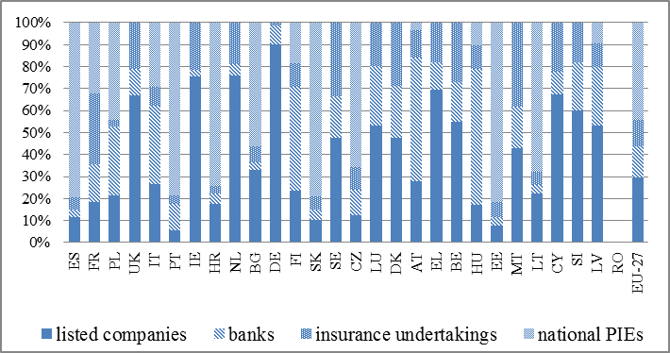

*Statutory auditors and audit firms in the EU*

Altogether, there are 250 047[13] individuals registered as statutory auditors in the EU. In 26 Member States[14] 26 % of registered statutory auditors are employed by or associated with an audit firm. These numbers vary widely across Member States[15] (see Table 1).

The UK, France, Ireland and Germany account for 64 % of all registered audit firms in the EU, with the largest number (over 6 000) in the UK. Six Member States (Bulgaria, Finland, Luxembourg, Malta, Slovenia and Greece) each have fewer than 100 registered audit firms.

About 5 %[16] of the total number of registered audit firms in the EU carry out statutory audits of PIEs. Less than one third of registered audit firms in each Member State audit PIEs, except in Greece (70 %), Bulgaria (55 %) and Slovakia (34 %). In the Netherlands, the UK, Denmark and Ireland the figure is below 2 %.

**Table 1: Overview of market structure in EU Member States**

|  |  |  |  |  |  |  |
| --- | --- | --- | --- | --- | --- | --- |
|  | **Number of registered statutory auditors (natural persons)** | **Number of registered statutory auditors employed by or associated as partners or otherwise with the audit firm** | **Number of registered audit firms** | **Number of registered audit firms auditing PIEs** | **Number of PIEs** | **Number of statutory audits of PIEs** |
| **Belgium** | 1 052 | 861 | 529 | 19 | 268 | 276 |
| **Bulgaria** | 704 | 243 | 93 | 51 | 782 | 1 021 |
| **Czech Republic** | 1 291 | 287 | 363 | 50 | 433 | 375 |
| **Denmark** | 3 591 | 3 093 | 1 568 | 9 | 354 | 354 |
| **Germany** | 17 342 | 10 067 | 2 992 | 73 | 677 | 1 040 |
| **Estonia** | 353 | 234 | 152 | 16 | 196 | 196 |
| **Ireland** | 9 997 | 9 997 | 5 272 | 11 | 1 005 | 1005 |
| **Greece** | 1 068 | 826 | 46 | 32 | 324 | 609 |
| **Spain** | 4 177 | 2 858 | 1 395 | 199 | 7 393 | 8 006 |
| **France** | 13 494 | N/A | 6 019 | 565 | 2 470 | 3 431 |
| **Croatia** | 976 | 532 | 228 | 75 | 794 | 794 |
| **Italy** | 15 3947 | 2 938 | 463 | 26 | 1 578 | 1 578 |
| **Cyprus** | 924 | 924 | 524 | 15 | 147 | 147 |
| **Latvia** | 169 | 150 | 136 | 15 | 64 | 64 |
| **Lithuania** | 370 | 265 | 171 | 13 | 156 | 170 |
| **Luxembourg** | 277 | 275 | 66 | 15 | 379 | 429 |
| **Hungary** | 4 965 | 2 070 | 1 807 | 68 | 245 | 245 |
| **Malta** | 1 276 | 587 | 66 | 10 | 168 | 168 |
| **Netherlands** | 1 791 | 1 791 | 365 | 7 | approx. 800 | 1 013 |
| **Austria** | 105 | N/A | 397 | 17 | 341 | 341 |
| **Poland** | 7 086 | 3 510 | 1 612 | 97 | 1 992 | 2 375 |
| **Portugal** | 1 378 | 802 | 229 | 58 | 1 189 | 1 192 |
| **Romania** | 4 632 | 1 358 | 969 | 124 | N/A | 552 |
| **Slovenia** | 188 | 133 | 54 | 17 | 88 | 88 |
| **Slovakia** | 791 | 445 | 233 | 80 | 572 | 908 |
| **Finland** | 1 543 | 905 | 80 | 15 | 578 | 578 |
| **Sweden** | 3 476 | 3 476 | 146 | 15 | 551 | 551 |
| **United Kingdom** | 13 084 | 13 084 | 6 331 | 50 | 1 741 | 1 748 |
| **EU Total** | **250 047** | **61 711** | **32 306** | **1 742** | **approx. 25 000** | **29 254** |

*Turnover and fees from statutory audits of PIEs*[17]

The total turnover of audit firms auditing PIEs in 25 EU Member States (data from Bulgaria, France and Spain is not available) is approximately EUR 31 billion[18]. However, the numbers per Member State show a disparity across the EU. In eight Member States the aggregated turnover of audit firms auditing PIEs is above EUR 1 billion, whereas in 11 Member States it is below EUR 100 million. The UK alone accounts for about half of all turnover of audit firms auditing PIEs in 25 Member States. Germany and the Netherlands[19] are the largest markets after the UK (see Figure 2).

Total fees from statutory audits amount to approximately EUR 11 billion[20] for the 27 EU Member States which provided data. The UK, Germany and France account for almost 60 % of this total. Some 13 Member States report fees below EUR 100 million.

**Figure 2: Turnover of audit firms auditing PIEs[21] and fees from statutory audits[22], per Member State**

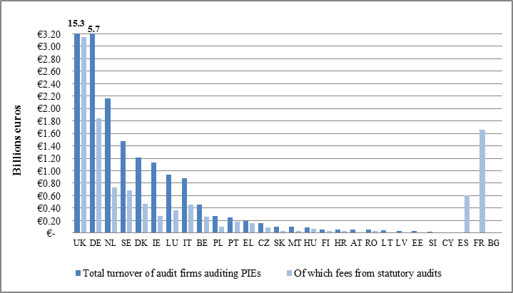

## **Market concentration level**

One of the Regulation’s main aims is to have a competitive market for statutory audit services in which there is a sufficient choice of statutory auditors or firms for PIEs. The requirement in Article 27 to assess the concentration levels in the market for statutory audits of PIEs highlights how important this aim is. This section therefore seeks to set a baseline for measuring progress in this area in future market monitoring reports.

Member States were asked to provide information on the market concentration for statutory audits of PIEs of 10 key audit players (‘10KAP’) [23]. To calculate turnover, 15 Member States[24] used the audit firm[25] approach[26], seven[27] used the audit network[28] approach[29] and two[30] used both approaches. The financial year differs from audit firm to audit firm and does not always match the 2015 calendar year, the reference period for this data collection[31]. Therefore, the data presented in this section is approximate.

Data on market shares is analysed using three different market concentration indicators calculated per Member State: the ‘Big Four’ (PwC, Deloitte, KPMG and EY), ‘CR4’ (the consolidated market share of the four biggest audit firms in each country), and ‘10KAP’. In particular, differences between the Big Four and CR4 have been analysed to assess the trends in these market concentration indicators in future reports.

*Concentration by statutory audits of PIEs and turnover (of the network or firm auditing PIEs)*

The Big Four have an average market share of almost 70 % in the number of statutory audits of PIEs (based on 28 Member States). For turnover, their market concentration is around 80 %[32] on average (based on 21 Member States). The Big Four hold a concentrated oligopoly[33] in 11[34] Member States for the number of statutory audits (see Figure 3), and in 15[35] Member States for turnover. As Figure 4 shows, the Big Four’s combined market share in turnover exceeds 90 % in six Member States[36]. CR4 beats the Big Four’s aggregated concentration ratio in seven Member States for the number of statutory audits of PIEs and in five Member States for turnover. Therefore, the Big Four are the four largest audit firms in most Member States.

**Figure 3: Audit firms’ market share in 2015 for statutory audits of PIEs**

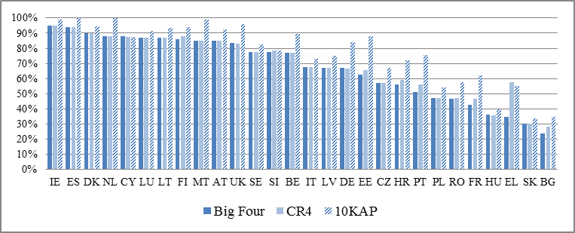

The aggregated market concentration of the six audit firms with the biggest shares (for turnover) is over half in the 21 Member States for which concentration levels on turnover could be calculated, and exceeds 90 % in 10 Member States. The combined market shares (for turnover) of the 10KAP at EU level total more than 90 % in 16 Member States[37] and less than 80 % in four Member States.

**Figure 4: Audit firms’ market share for turnover in 2015 (either audit firms or the network auditing PIEs) in 21 Member States**

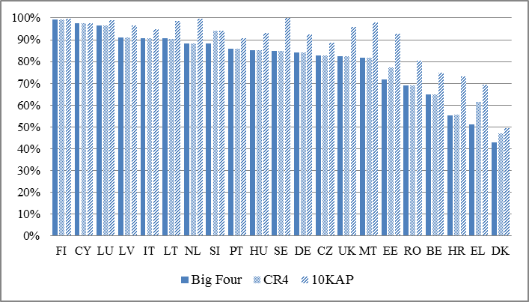

*Concentration by individual audit firm*

Figure 5 shows that the Big Four have a combined market share of around 70 % for the number of statutory audits of PIEs at EU level, while the concentration level of the 10KAP is close to 80 %.

**Figure 5: Market share of the 10KAP[38] for statutory audits of PIEs**

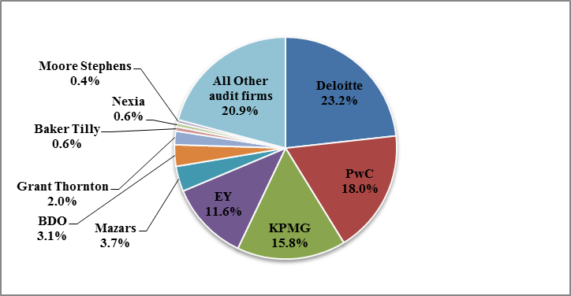

However, in terms of turnover[39] (either of the audit firm or of the network auditing PIEs) the Big Four cover over 80 % of the total EU audit market. Grant Thornton and BDO are the biggest audit firms after the Big Four.

*Concentration of audit firms by PIE category*

Concentration in the market for statutory audits of PIEs[40] is the highest for bank and insurance undertakings, where the market share for the Big Four is approximately 80 % (see Figure 6). Their market share in the listed companies category is close to 70 %. They have a lower market share for national PIEs (around 50 %).

**Figure 6: Average market concentration in different categories at EU level for statutory audits of PIEs**

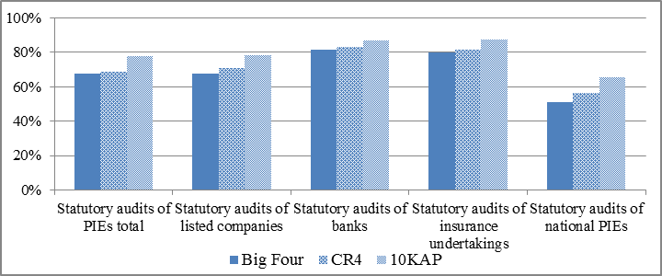

## **Risks arising from quality deficiencies of a statutory auditor or audit firm**

NCAs carry out quality assurance reviews to check the work of the statutory auditor or audit firm. Inspections are the main tool for audit supervisors to check whether the statutory auditor or audit firm have performed their engagement correctly and to identify any quality deficiencies. NCAs can use a wide range of powers and measures to correct and remedy these deficiencies. Under Article 27 of the Regulation, NCAs must assess the risks arising from high incidences of quality deficiencies and assess whether it is necessary to adopt measures to mitigate these risks. Given the confidential nature and the sensitivity of the information, data in this section is presented in an anonymised and aggregated format.

**Quality assurance reviews**

NCAs reported both on the quantitative and the qualitative aspects of quality assurance[41]. Most Member States reported for the 2015 calendar year (i.e. they reported the results of inspections carried out in 2014/15) but with different start and end dates. There were five Member States that presented data for an entire cycle of inspections (3 years), using the most recent data available in their respective markets.

Although this report focuses on PIE-related information, NCAs were also invited to provide information on non-PIEs. The purpose was to present a broader and more comprehensive picture of the situation at national level.

*Quantitative assessment*

A series of indicators were used to illustrate the situation:

- number of statutory audit engagements (files) inspected;

- number of audit firms inspected;

- number of audit firms for which firm-wide procedures were inspected;

- number of engagement/file reviews with at least one finding; and

- number of firm-wide reviews with at least one finding.

However, no common definition of ‘finding’[42] was agreed for this particular data collection. Instead, NCAs were asked to provide a definition or to indicate the categorisation followed.

**Figure 7:** **Quality assurance in the EU**

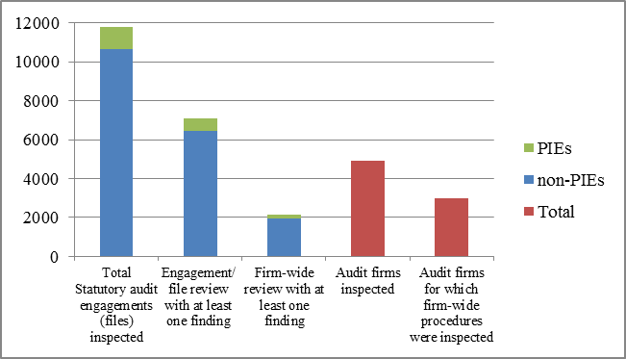

Since the number of non-PIEs is generally much higher than the number of PIEs, NCAs reported as expected a higher incidence of quality assurance in non-PIEs, both for the number of inspections and for findings. On average this equates to 90 % or so of the entire quality assurance review activity at EU level. However, in 12 Member States the percentage of PIE inspections ranges between 10 % and 50 % of the total number of inspections. Some 10 Member States report a similar range for the number of PIE findings. In two Member States more than 80 % of the total number of inspections and findings target PIEs. In the vast majority of cases the number of inspections and quality assurance reviews carried out is in line with and proportionate to the size of the national market.

*Qualitative assessment*

Three recurring issues were identified at EU level. They are:

(i) deficiencies in the internal quality control systems[43];

(ii) failure to document some aspects of the audit engagement; and

(iii) lack of sufficient audit evidence of having carried out a full audit assessment.

There are other, more diversified issues, limited to a few Member States. These issues reflect the specific structure of the different markets, such as: (i) findings on group audits in smaller Member States; (ii) issues linked to engagement quality control reviews in Member States with a stronger audit practice; and (iii) issues linked to training in Member States with less extensive audit inspection experience.

*The need to adopt measures to mitigate the risks*

The national reports also described the remedies and follow-up measures taken. The analysis shows that recommendations are the most common approach, followed by reprimands and follow-up measures where firms should confirm that they have taken the required steps. Only in a small number of serious cases were sanctions imposed.

## **Performance of audit committees**

The new audit rules have boosted the role and powers of the audit committees (ACs)[44]. The Regulation confers specific tasks on PIEs’ ACs. For instance, they play a direct role in the appointment of the statutory auditor or the audit firm, they oversee the statutory audit and they monitor the statutory auditor’s performance and independence.

Article 27(1)(c) of the Regulation provides for assessment of the ACs’ performance. This task has proven to be challenging given the timeline for the first national reports, the lack of experience of some NCAs and the changing legal framework. Despite giving an idea of the situation at national level, the national reports did not provide a clear picture as to whether and how NCAs engage with ACs.

At the end of 2016 the European Commission submitted additional specific questions to the NCAs to better understand the legal framework for ACs in the Member States[45]. The questions were meant to help understand how Member States, in particular NCAs, engage with ACs and how NCAs see to it that the ACs carry out their assigned tasks. This was not an attempt to lay down rules governing supervision, as the scope of supervision of ACs depends on each Member State.

The results show that ACs are subject to supervision in 15 Member States. Some 12 Member States reported that ACs are not subject to supervision and one Member State[46] did not provide information. As shown in Figure 8, practices vary widely among Member States as to which authority is responsible for supervision.

**Figure 8:** **Authority responsible for supervising ACs in Member States**

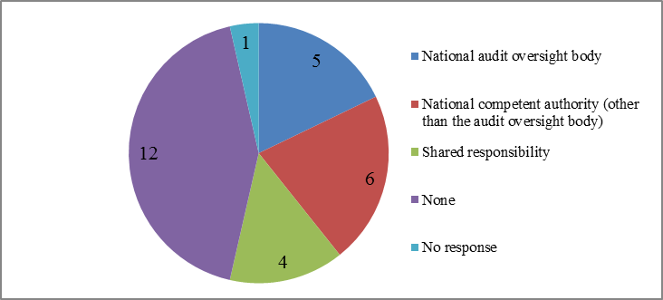

[Source: Questionnaire for NCAs on ACs]

The Regulation does not mention any specific task or power for NCAs vis-à-vis the ACs. This is left to the discretion of the Member States, which also have different corporate governance frameworks. The Commission enquired as to whether NCAs carry out activities with ACs other than supervision. In response the NCAs cited staging conferences and workshops, sharing best practice and guidance, holding meetings and discussions, sharing annual reports, processing applications from ACs, working with AC advisory groups and reporting (see Figure 9). In some cases the NCAs reported that they are involved in more than one activity with ACs.

**Figure 9: NCA activities with ACs (% of Member States which responded)**

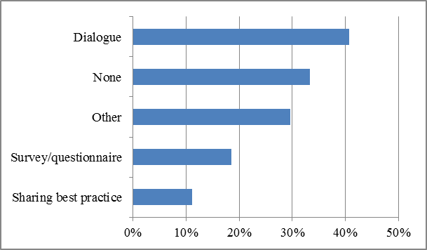

[Source: Questionnaire for NCAs on ACs]

# Contribution from the European Competition Network

Article 27 of the Regulation also states that the European Competition Network must draw up a report.

The Commission invited all national competition authorities to provide information about possible sector inquiries carried out in their jurisdictions and their enforcement record in the audit market (e.g. any antitrust investigations, assessments of notified mergers, investigations of complaints or State aid). The reference period was 2014-2015.

Of the 13 national contributions to the ECN report, only five reported on specific enforcement or reporting activities. Denmark provided information about the merger of EY and KPMG approved in 2014. Poland reported that its audit sector is highly concentrated in the hands of the Big Four and that there are high entry barriers. Romania reported on an ongoing investigation into the Romanian Financial Audit Chamber. The UK and Portugal gave information about their enforcement (UK) and reporting activities (Portugal and UK).

The Commission did not conduct any sector inquiries, antitrust investigations, assessments of notified mergers or investigations of state subsidies in the audit market during the relevant reference period.

# Conclusions

The new audit rules aim for better audit quality and a more competitive audit market for statutory audits of PIEs to enable capital markets to run smoothly. The available data shows a very diverse EU audit market in terms of size and structure and confirm that the market for statutory audits of PIEs remains relatively concentrated in most Member States, particularly in terms of turnover. In 15 of 21 Member States the Big Four hold more than 80 % of the market share for turnover. Banking and insurance undertakings are the PIE categories where the Big Four have the highest EU-wide market concentration (about 80 %). However, there is insufficient evidence to draw conclusions about the level and effectiveness of competition in the market. The Commission will continue monitoring trends in the consolidated concentration levels of the largest audit firms in Member States in future reports.

The information collected from the quality assurance systems is of great help in gauging the effectiveness of the new audit rules, both for investor protection and for public oversight. To ensure consistency and comparability, a common methodology and supervisory convergence in this area will become crucial. For instance, more work could be done to encourage further convergence around common indicators and the terminology for findings and deficiencies. No major risks have been identified. In any case, as data was collected under the powers given by the previous legal framework to NCAs, it is certainly too early to fully assess major risks.

Clearly, the next joint report should analyse whether the three most frequent issues identified in this report (deficiencies in the internal quality control systems, failure to document some aspects of the audit engagement, and lack of sufficient audit evidence) risk becoming structurally recurrent. In particular, the next report will need to evaluate what the potential consequences might be, not only for specific PIEs but also for the whole market.

The audit reform has boosted both the role and powers of the audit committees, as they are essential to giving the new audit rules real teeth. The analysis, however, shows that most NCAs have very little experience in monitoring the ACs’ activities and performance. To overcome this problem the NCAs should have appropriate tools to assess the ACs’ performance and receive the information they need to monitor how ACs are complying with the new rules. For their part, AC members should be made aware of their new responsibilities and more prominent role. At this stage, engaging with ACs and raising awareness is vital. This would not necessarily entail redefining or changing the national corporate governance frameworks or the supervisory remit of NCAs. Each national authority would be free to decide the best approach and the most appropriate tools to assess the ACs’ performance. Existing experience shows that cooperation and dialogue are useful and effective tools. Some NCAs have already started meeting ACs (and have even provided guidelines) to make them aware of the new framework and of their additional responsibilities. However, a great deal of work clearly remains to be done. The Commission could have a role to play in promoting this dialogue and in engaging with ACs directly to better understand their experience in implementing the audit reform.

This first Commission report will certainly act as the baseline scenario for future reports. Moreover, solutions will be needed to address some of the limitations outlined in the introductory section. Some of these limitations will be addressed as the new audit rules take effect. This is the case for access to and availability of data, as the new legal framework provides for new sources of information and tools for the NCAs and the Commission. However, further work will be required if there is to be progress on areas such as common terminology, convergence around reference periods and methodologies for data collection. To move forward on convergence, the Commission will work to review the current indicators in close cooperation with the NCAs, and especially with the CEAOB sub-group on market monitoring. This is particularly important in view of some of the provisions added by the new audit rules, such as the rotation periods, a ban on certain non-audit services, and a new role for the ACs. In future reports the Commission will be looking at these new rules as well, to measure the level of competition in the market on statutory audits of PIEs and to assess the full impact of the new regulatory framework.

The Commission will continue monitoring developments in the market for providing statutory audit services to PIEs in the EU. It stands ready to work with Member States to ensure that the requirements in Article 27 of the Regulation can be fulfilled as effectively as possible.

1. Directive 2006/43/EC of the European Parliament and of the Council of 17 May 2006 on statutory audits of annual accounts and consolidated accounts, amending Council Directives 78/660/EEC and 83/349/EEC and repealing Council Directive 84/253/EEC (consolidated version).
2. Regulation (EU) No 537/2014 of the European Parliament and of the Council of 16 April 2014 on specific requirements regarding statutory audit of public-interest entities and repealing Commission Decision 2005/909/EC.
3. Article 2, point (13) of the Directive defines PIEs as listed companies, credit institutions and insurance undertakings. Member States may also designate as national PIEs other undertakings that are of significant public relevance because of the nature of their business, their size or the number of their employees.
4. Article 2, point (1) of the Directive defines statutory audit as an audit of annual financial statements or consolidated financial statements.
5. Competent authorities designated under Article 20(1) of the Regulation.
6. The ECN is a network for cooperation between the Commission (specifically the Directorate-General for Competition) and national competition authorities.
7. A framework for cooperation between national audit oversight bodies at EU level set up by Article 30 of the Regulation.
8. As defined in Article 2, point (13) of the Directive.
9. As defined in Article 2, point (13)(d) of the Directive.
10. The reference year is 2015, except for: Bulgaria, Estonia and Spain (2014/2015); and Denmark and Germany (2016). Data for Romania is missing.
11. These numbers refer to the previous legislation in place in Spain (Royal Decree 1517/2011). The number of PIEs in many EU Member States may have changed with the new audit rules.
12. Data is missing for Romania.
13. Reference period year 2015, except for: Bulgaria and Estonia (2014/2015); Germany and Denmark (2016); and Greece (2014). Data is from 28 Member States.
14. Data from Austria and France is missing.
15. The number for Italy includes a large number of accountants who historically were registered as auditors as well. In addition, Ireland has a unique situation, as members of UK-regulated accountancy bodies are also registered in Ireland. Therefore, numbers for Ireland might be inflated due to this possible double counting. Similarly, some Irish regulated accountants may also be registered in the UK.
16. Based on data from 28 Member States.
17. To compare the figures among Member States, the data collected in national currencies has been converted into euros using the 2015 annual average exchange rates. See <http://appsso.eurostat.ec.europa.eu/nui/show.do?dataset=ert_bil_eur_a&lang=en>.
18. The financial year does not always match the 2015 calendar year, which is the reference period for this data collection. This is the case for: Bulgaria, Denmark and Estonia (2014/2015); the Czech Republic (2014); and Slovenia (2014-2016). The data from 25 Member States includes fees from statutory audits, assurance services and other non-audit services.
19. See previous footnote.
20. Reference period 2015, except for: Bulgaria, Denmark and Estonia (2014/2015); the Czech Republic (2014); and Slovenia (2014-2016). Data from Portugal includes fees from other assurance services. Data from Bulgaria is missing.
21. Data from Bulgaria, Spain and France is not available.
22. Data from Bulgaria is not available.
23. Based on the list identified by the European Audit Inspection Group (EAIG). Baker Tilly; BDO; EY; Deloitte; Grant Thornton; KPMG; Mazars; Moore Stephens; Nexia; PwC.
24. Denmark, Estonia, Greece, Finland, Ireland, Italy, Croatia, Hungary, Lithuania, Luxembourg, Latvia, Malta, the Netherlands, Romania and Slovakia.
25. As defined in Article 2, point (3) of the Directive.
26. Based on turnover of the individual audit firm in each country.
27. Belgium, Cyprus, France, Poland, Portugal, Sweden and Slovenia.
28. As defined in Article 2, point (7) of the Directive.
29. Based on the sum of turnovers of the individual firms that belong to the same network in each country.
30. Bulgaria and the Czech Republic.
31. This is the case with: Bulgaria and Estonia (2014-2015); the Czech Republic: 2014; Denmark: 2014-2015 and 2015; Slovenia: 2014-2015/2015/2015-2016; Germany: 31.03.2015; Latvia: 31.08.2015.
32. Average based on 21 Member States. Concentration ratios for turnover could not be calculated for seven Member States, due to a lack of full data (Austria and Spain) or partial data on turnover (Bulgaria, France, Ireland, Poland and Slovakia).
33. CR4 = 0% means perfect competition; 0%<CR4<50% ranges from perfect competition to oligopoly; 50%<CR4<80% means oligopoly; 80%<CR4<100% ranges from concentrated oligopoly to monopoly; CR4= 100% means highly concentrated oligopoly and even monopoly (if CR1=100%).
34. Austria, Cyprus, Denmark, Spain, Finland, Ireland, Lithuania, Luxembourg, Malta, the Netherlands and the UK.
35. Finland, Cyprus, Luxembourg, Latvia, Italy, Lithuania, the Netherlands, Slovenia, Portugal, Hungary, Sweden, Germany, the Czech Republic, the UK and Malta.
36. Cyprus, Finland, Italy, Lithuania, Luxembourg and Latvia.
37. In Finland and the Netherlands only 8 out of the 10 key players carried out statutory audits in the reference period; in Sweden, the figure was just seven.
38. Data for 2014/2015, based on the totals per Member State.
39. Data from 21 Member States (data from Austria, Bulgaria, Spain, France, Ireland, Poland and Slovakia is missing).
40. Data based on 28 Member States for statutory audits of PIEs. Data from Austria, Cyprus, Spain, Hungary, Luxembourg, Latvia and Poland is missing for statutory audits of listed companies, banks and insurance undertakings; data from Austria, Spain, Luxembourg, Latvia and Poland is missing for statutory audits of national PIEs.
41. One Member State did not report anything, as no quality assurance was carried out in 2015.
42. According to the International Forum of Independent Audit Regulators (IFIAR), inspection findings for PIE audits are deficiencies in audit procedures that indicate that the audit firm did not obtain sufficient appropriate audit evidence to support its opinion, but do not necessarily imply that those financial statements are also materially misstated.
43. Quality checks set up and carried out internally by the audit firm.
44. As described in Article 39 of the Directive.
45. In the survey the Commission understood supervision in the sense of whether NCAs had legal powers to:

    - obtain information, including whether audit committees exist and if they comply with their obligations (i.e. under Article 39 of the Directive or Article 16 of the Regulation); or

    - impose remedies or sanctions if audit committees do not comply with their obligations.
46. Romania.