

**1. The EU is open to and benefits from foreign direct investment…**

The EU welcomes foreign direct investment (FDI) because of the substantial benefits they bring for our economy and society at large. FDI is a source of growth and jobs. It links EU companies with global value chains that drive the modern economy. It boosts productivity and makes our companies more competitive by improving resource allocation, bringing in capital, technologies and expertise, increasing competition, stimulating innovation, and opening new markets for EU's exports. Furthermore, it supports the objectives of the Investment Plan for Europe, and other EU projects and programmes. Outward FDI generates similar gains as inward FDI, including for the implementation of the 2030 Agenda for Sustainable Development. For those reasons, the EU supports liberalisation of investments worldwide.

Indeed, the European Union has one of the world's most open investment regimes, and collectively EU Member States have the fewest restrictions in the world on foreign direct investment. This is expressly acknowledged in the OECD FDI Regulatory Restrictiveness Index which measures statutory barriers against foreign investment in over 60 countries worldwide and how they have changed over time (since 1997).

**OECD FDI Regulatory Restrictiveness Index (Section 1 – FDI restrictions de jure)**

***2015 - OECD FDI Regulatory Restrictiveness Index***

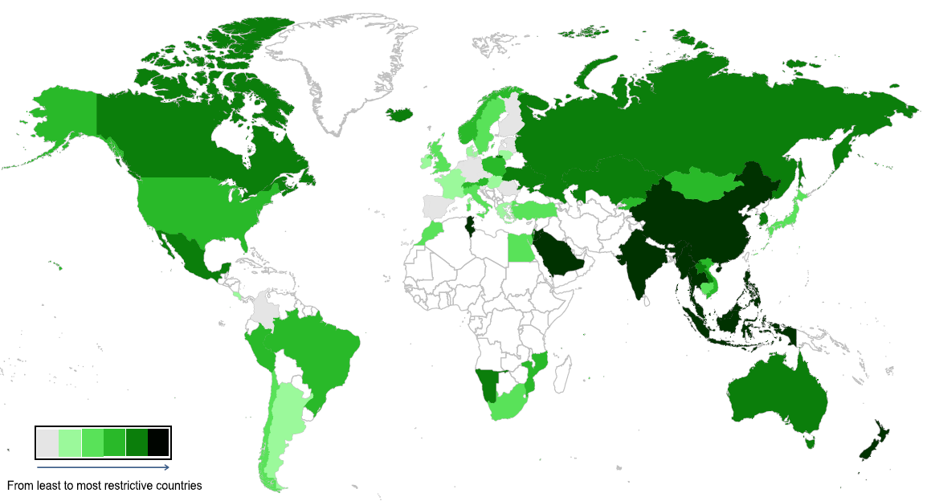

***OECD FDI Regulatory Restrictiveness Index – 2016***

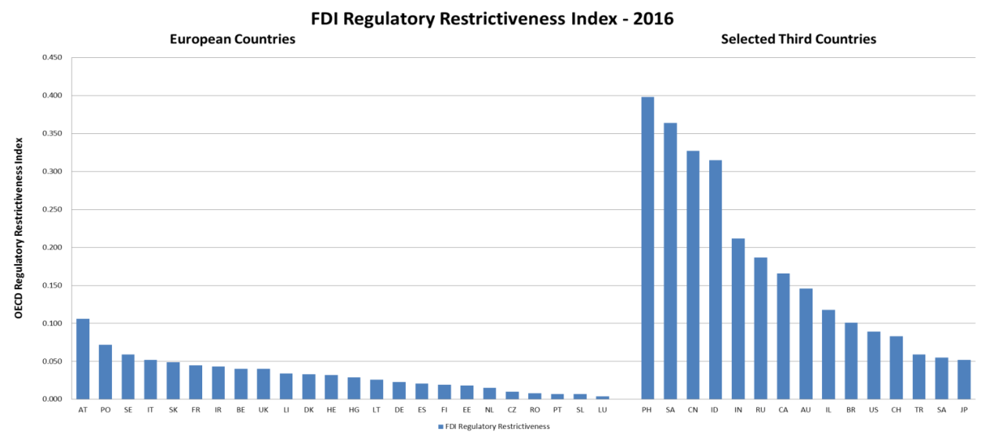

***Development of OECD FDI Regulatory Restrictiveness Index (1997-2016)1***

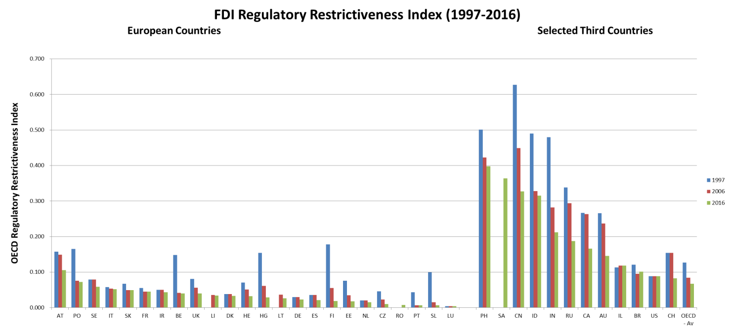

1 Lithuania, Latvia (1997), Romania and Serbia (1997&2006) left blank

This means that there are few obstacles for foreign investors to invest in the EU, and in particular to acquire EU companies. The OECD FDI Regulatory Restrictiveness Index also shows that major economic partners of the EU have more investment restrictions in place than is the case for the EU. Despite improvements over the period 1997-2016, China for instance remains among the countries with the highest restrictive index together with the Philippines and Saudi Arabia.

The EU is also the world's leading source and destination of FDI. At the end of 2015, the stock of inward FDI in the EU stood at over EUR 5.7 trillion while it reached EUR 5.1 trillion in the US and EUR 1.5 trillion in China, including Hong Kong. EU investors held EUR 6.9 trillion in FDI in third countries in the same year[1], with inflows of EUR 467 billion and outflows of EUR 537 billion in 2015[2]. The US is the largest investor in the EU, but its share of EU FDI stock fell from 51.3% in 1995 to 41.4% in 2015. The share of Japan also decreased over the same period, from 7.7% to 2.9%. At the same time, the shares of Brazilian and Chinese FDI have increased significantly from respectively 0.2 and 0.3 per cent in 1995 to 2.2 and 2 per cent in 2015[3],making these two countries the fifth and sixth largest foreign investors in the EU (see chart and table below).

**Share of the ten largest investors into the EU (share of EU inward FDI stocks) [4]**

|  |  |  |  |
| --- | --- | --- | --- |
| **Partner** | **1995** | **2005** | **2015** |
| United States | 51.3% | 47.7% | 41.4% |
| Switzerland | 19.7% | 13.3% | 10.8% |
| Canada | 3% | 4.2% | 3.8% |
| Japan | 7.7% | 4.3% | 2.9% |
| Brazil | 0.2% | 0.4% | 2.2% |
| China. incl. Hong Kong | 0.3% | 1% | 2% |
| Norway | 2.2% | 2.5% | 1.3% |
| Russia | 0.4% | 0.6% | 1.1% |
| Singapore | 0.4% | 1.6% | 1% |
| Israel | 0.1% | 0.3% | 0.8% |
| *Source*: EUROSTAT | | | |

While only 0.4 per cent of EU companies are controlled by non-EU investors, these companies are on average much larger than companies owned by EU investors. As a result, they represent about 13 per cent of total turnover, 11 per cent of value added and 6 per cent of total employment in the EU.[5]

The US is at the top of the list with 26 000 EU controlled companies located – in order of importance – in UK, Germany, the Netherlands, France and Italy. China, controlled around 4 000 companies in the EU.

Regarding the number of inward FDI transactions in the EU, estimates point to a range of between 2000 and 4000 per year.[6] In 2016 there were 1869 announced FDI transactions involving an extra-EU acquisition of a stake above 10% in an EU enterprise.[7]

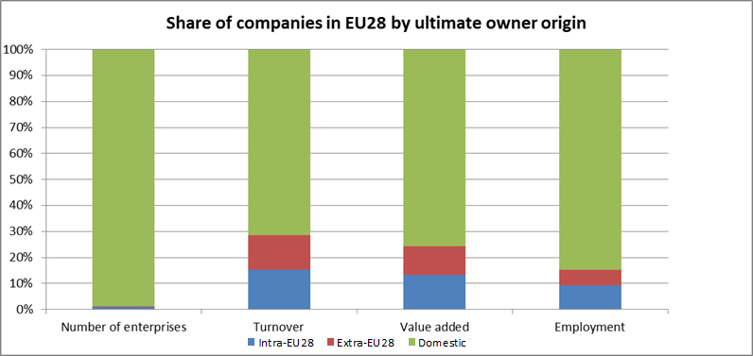

Regarding flows of cross-border investment, non-EU inward FDI increased sharply in 2015 to EUR 467 bn, recovering to the levels reached before the beginning of the financial crisis. The recent increase and recovery of non-EU FDI flows was largely due to the rapid pace of expansion of inward FDI by certain large non-EU economies.

|  |
| --- |
| **FDI net inflows in EU28, 2000-2015** |
|  |
| *Source*: Eurostat, *Notes*: Extra-EU refers to investments into the EU from third countries; *Selected non-EU includes BRICS countries, US and Japan. |

While both main types of inward FDI, Mergers and Acquisitions (M&As) and Greenfield investment, were recently on an upward trend, the post crisis increase in inward EU FDI flows continued to take the form mostly of M&As, while Greenfield investment remained more than six times lower than all other types of FDI.

|  |
| --- |
| **Greenfield investment as a share of total non-EU inward FDI** |
|  |
| *Source*: FDIMarkets; *Note*: Brownfield investment is calculated as a residual and includes all remaining components of FDI (for instance M&As, reinvested earnings and intracompany loans) |

Even though the EU continues to be traditionally a net exporter of capital with respect to total FDI, regarding gross M&As the value of inward flows has been higher than that of outward flows since 2012 which resulted in a positive net inward M&As balance for 5 consecutive years.

|  |
| --- |
| **Flows of Merger and Acquisition FDI transactions into the EU,** EUR mn |
|  |
| *Source*: Dealogic M&As ANALYTICS, FDI transactions for the acquisition of stakes above 10%. |

**2. … but the screening of foreign direct investment may be necessary in certain cases**

This being said, in exceptional cases, foreign investments are problematic when they pose a threat to security or public order. This point has been made by the European Parliament and certain Member States, who also raised concerns regarding industrial policy. In such circumstances, FDI may need to be assessed and/or conditioned or prohibited. This is the case where foreign investors – especially but not only when they are state owned or controlled, including through financing or other means of direction – may seek to acquire control of or influence in European undertakings whose activities have repercussions on critical technologies, infrastructure, inputs or sensitive information. Such acquisitions may allow the States in question to use these assets to the detriment not only of the EU's technological edge but also its security and public order.

The recent increase in non-EU FDI was driven by a sustained increase in investment in the high technology sectors both with respect to M&As and Greenfield investment.

Computers & Electronics is the most targeted sector by third countries acquirers in terms of total value of the stock of M&As which reached more than EUR 323 billion in the second quarter of 2017.[8]

In contrast, inward non-EU FDI in traditional manufacturing sectors slowed down recently again with respect to both components of FDI, M&As and Greenfield investment.

|  |  |
| --- | --- |
| **Non-EU FDI in high technology sectors and manufacturing** | |
| ***A. M&As*** | ***B. Greenfield investment*** |
|  |  |
| *Source*: FDIMarkets and DEALOGIC M&As ANALYTICS  *Note*s: *High technology* is defined here as aerospace, renewables, biotechnology, consumer electronics, electronic components, chemicals, engines/turbines, medical equipment, pharmaceuticals, semiconductors, software/IT services, space/defence; *indicates extrapolated figures; *Manufacturing* is defined as automotive, beverages, building/construction materials, business machines, ceramics, coal/gas/oil, consumer products, food, industrial machinery, metals, minerals, paper, plastics, rubber, textiles, wood products. | |

**3. Existing foreign direct investment screening mechanisms**

**Third countries**

Many EU partners have some type of investment screening mechanisms to screen inward FDI, including the Australia, Canada, China, Japan, Russia and the United States. The most common reason for screening foreign investment is national security. Some countries also refer to national "economic security" or "strategic sectors".

**EU Member States**

Within the EU, 12 Member States have national mechanisms to screen investment in place: Austria, Denmark, Germany, Finland, France, Latvia, Lithuania, Italy, Poland, Portugal, Spain, and the United Kingdom[9].

While the common purpose of these mechanisms is to allow the State to intervene in case of investments that may pose threats to their essential interests, they diverge in several aspects.

First, with regard to the scope, most of the Member States' screening mechanisms apply to both intra-EU and extra-EU investments, in some cases with slightly different rules applying to third country investment. Other mechanisms apply only to investments from third countries. The mechanisms applying only to third country investments normally include provisions to tackle possible circumvention of the screening, for example to counter the phenomenon of letter box companies

Second, with regard to the investments covered, the screening mechanisms normally set out qualitative criteria or quantitative thresholds, or a combination of both, to identify the investment to be screened. Qualitative criteria require for example acquisition of direct or indirect control over a company or assets. Quantitative criteria are usually thresholds referring to the percentage of shares or voting rights, which range from 5% to 50%.

Third, as to the sectors concerned, some screening mechanisms limit the screening to investments in specific sectors deemed to be strategic (e.g. telecommunications, transport, energy) or/and in certain companies or activities considered of strategic importance. Other mechanisms do not provide for such limitation or list sectors only for illustrative purposes.

Fourth, as regards grounds for screening, in some cases the screening is limited to the protection of essential interest of national security, especially related to the production of or trade in arms, munitions, military equipment, war material, etc. However, in most cases the screening goes beyond the defence sector and the grounds for screening extend to the protection of other public interests mainly related to public security and public policy.

Divergences exist in the design of the screening procedures. The screening mechanisms can take two main forms: - prior authorisation mechanisms which require investors to notify an investment covered before it is made and submit it to authorisation; - and ex-post- screening mechanisms which allow the State to carry out an ex-post control of investments already completed. Ex-post screening mechanisms normally also allow the investor to notify the investment voluntarily before it is completed in order to obtain clearance.

There are different deadlines for completion of the screening procedures in the national mechanisms, most of them providing for two to four months. Often, mechanisms providing for prior screening set out a system of tacit approval, whereby the investment is deemed to be approved if the decision is not taken within the prescribed time limit.

As regards the types of decisions, the authorities in charge of the screening may approve the investment, oppose it or approve it under certain conditions. Normally, the investors have the right to legal redress against the decision.

**EU level**

There is no EU-wide FDI screening mechanism. The EU merger control regime may in certain situations allow a review of FDI, in cases where they take the form of concentrations falling within the scope of the EU Merger Regulation, but exclusively based on the effect on competition in the EU market.

**4. The case for an EU framework**

**a) Status quo**

The absence of a comprehensive legal framework at EU level to screen FDI into the EU makes it difficult to monitor in detail FDI flows in the EU as well as FDI screening decisions taken by Member States that have a screening mechanism, and does not allow cooperation to take place at EU level on FDI that may affect the interests of several Member States or of the Union as a whole. This situation also creates heightened uncertainty for foreign investors that face different FDI screening regimes from different Member States. The status quo is therefore not an ideal option.

**b) More transparency**

Moretransparency on foreign investments in the EU is a pre-requisite for sound decision-making as well as enhanced exchange of information at EU level. This is why the Commission has decided to immediately:

* carry out further in-depth analysis of FDI flows into the EU, especially in strategic sectors (e.g. energy, space, transport) or assets (technologies and inputs linked to strategic sectors, critical infrastructures across sectors, sensitive data) that may raise security or public order concerns, in particular when the investor is owned or controlled by a third country, and
* set up a coordination group chaired by the Commission, and composed of representatives of Member States, to exchange information on FDI flows and FDI screenings and promote policy convergence on FDI screening policies.

**c) Legal framework**

This being said, in order to ensure a more effective coordination at EU level on FDI screenings and more legal certainty for Member States and for investors, a specific legal framework at EU level is necessary.

One option could have been to propose an FDI screening mechanism entirely operated at EU level. However, such system could be very difficult to operate in practice due to possible differences of views amongst Member States and also due to the fact that national security remains the sole responsibility of Member States. Such mechanism could therefore generate a disproportionate burden for foreign investors subject to screening, additional administrative burden, long deadlines for taking decisions and uncertainty.

The option of a framework for the screening of FDI at EU level enabling Member States to screen FDI based on Article 207 TFEU, setting common criteria and standards to do so, and providing for cooperation amongst Member States and with the Commission on FDI that affects the interest of several Member States or the Union is preferable.

It gives enough flexibility to Member States on whether to maintain or not FDI screening mechanisms, but also would ensure a minimum degree of harmonisation and cooperation at EU level, whilst enhancing the certainty and limiting the administrative burden for foreign investors.

This is why the proposal for such lighter Regulation establishing a framework for the screening of foreign direct investments at EU level is being made. The objective is to have an EU system that is politically acceptable to all Member States, adequately covers the concerns linked to certain FDI, stays within the limits of EU and international law, does not unduly deter foreign investments, and is efficient and credible.

**ANNEX[10]**

**DATA ON FDI IN THE EU**

**EU**

FDI Stocks

* *The EU is a net capital exporter worldwide in terms of foreign direct investment (FDI) stocks.*
* *Stakes of EU companies in non-EU countries (FDI outbound stocks) have increased in the last three years (since 2015) to a total of EUR 6.9 trillion. This compares to a total of EUR 5.7 trillion of non-EU countries stakes in the EU (FDI inbound stocks) also increasing over the last three years.*

FDI Flows

* *FDI flows to the EU increased sharply in 2015 to EUR 467bn, recovering to the levels reached before the beginning of the financial crisis.*
* *According to the OECD, FDI flows to the EU increased in 2016 by 22% against a global decrease of 7% (from USD 478 billion to USD 582 billion), reaching their highest level since the beginning of the financial crisis.*

|  |
| --- |
| **Figure 1, FDI net inflows in EU28, 2000-2015** |
|  |
| *Source*: Eurostat, Notes: Extra-EU refers to investments into the EU from third countries. *Selected non-EU countries: the BRICS countries, the US and Japan; |

Main components of the recovery of FDI Flows

* *The increase in non-EU FDI was largely due to the rapid pace of expansion of inward FDI by certain large non-EU economies (see Figure 1).*
* *It was as well driven by a sustained increase in investment in the high technology sectors both with respect to M&As and Greenfield investment.*
* *In contrast, inward non-EU FDI in traditional manufacturing sectors slowed down in recent years again with respect to both components of FDI, M&As and Greenfield investment (see Figure 2).*

|  |  |
| --- | --- |
| **Figure 2, Non-EU FDI in high technology sectors and manufacturing** | |
| ***A. M&As*** | ***B. Greenfield investment*** |
|  |  |
| *Source*: FDIMarkets and DEALOGIC M&As ANALYTICS  *Note*s: *High technology* is defined here as aerospace, renewables, biotechnology, consumer electronics, electronic components, chemicals, engines/turbines, medical equipment, pharmaceuticals, semiconductors, software/IT services, space/defence; *indicates extrapolated figures. | |

* *Non-EU inward FDI in high technology sectors increasingly took the form of M&As, while Greenfield investment is considered to have a more direct positive impact on international production growth and jobs as it is entails the creation of new production facilities/enterprises in the hosting economies.*

|  |
| --- |
| **Figure 3, High technology M&As and Greenfield investment, 2012-2016** |
|  |
| *Source*: FDIMarkets and DEALOGIC M&As ANALYTICS  *Note*: *High technology* is defined here as aerospace, renewables, biotechnology, consumer electronics, electronic components, chemicals, engines/turbines, medical equipment, pharmaceuticals, semiconductors, software/IT services, space/defence |

Gross flows of M&A / FDI Transactions

* *While EU continues to be traditionally a net exporter of capital, since 2012 the value of inward M&As has been higher than that of outward M&As which resulted in a positive net inward M&As balance for 5 consecutive years.*

|  |
| --- |
| **Figure 4, Flows of Merger and Acquisition FDI transactions into the EU,** EUR mn |
|  |
| *Source*: Dealogic M&As ANALYTICS, transactions for the acquisition of stakes above 10%. |

* *Some of the top 10 countries having the largest stock of inward FDI in the EU continued to expand rapidly their acquisitions in recent years (US, Japan, China including Hong Kong) which underpinned the rapid increase in inward M&As.*

|  |
| --- |
| **Figure 5, Gross M&A flows into the EU by selected large non-EU economies** |
|  |
| *Source*: Dealogic M&As ANALYTICS, transactions for the acquisition of stakes above 10%.  *Note*: *Selected non-EU economies: the BRICS countries, the US and Japan. |

* *In 2016 the largest acquiring countries in the EU have been US, followed by China (including Hong Kong) and Japan.*

|  |
| --- |
| **Figure 6, Ranking of the top 10 non-EU investment countries.**  **by value of their acquisition transactions in the EU in 2016** |
|  |
| *Source*: Dealogic M&As ANALYTICS, transactions for the acquisition of stakes above 10%. |

Sectoral composition of gross inward M&A / FDI Transactions

* *Computers & Electronics is the most targeted sector by third countries acquirers in terms of total value of the stock of M&As which reached more than EUR 323 billion in the second quarter of 2017.*

|  |
| --- |
| **Figure 7, Total stocks of inward M&As by General Industry Groups, Q2 2017** |
|  |
| *Source*: Dealogic M&As ANALYTICS, transactions for the acquisition of stakes above 10%. |

* *It was the most targeted sector as well in 2016 with a record value of gross M&As flows of EUR 65 billion. It also experienced the most rapid progression with value of deals increasing almost eightfold from EUR 2.25 billion in 1995 to more than EUR 65 billion in 2016. The value of deals in "Healthcare" reached more than EUR 30 billion in 2015, while telecommunications deals peaked in 2013 with a volume of deals worth EUR 26 billion* *and partially recovered in 2016 with a deal volume of more than EUR 15 billion ..*

|  |
| --- |
| **Table 8, Sectoral composition of inward M&As in 1995-2016,** EUR billion |
|  |
| *Source*: Dealogic M&As ANALYTICS, transactions for the acquisition of stakes above 10%. |

Number of inward M&A / FDI Transactions

* *Estimates point to a range for FDI transactions in the EU of between 2000 and 4000 per year[11]*
* *With respect to M&As the EU has become a net importer of capital as of 2009 with the value of inward transactions exceeding that of outward transactions.*
* *In 2016 there were 1869 announced FDI transactions involving an extra-EU acquisition of a stake above 10% in an EU enterprise*

|  |
| --- |
| **Figure 9, Number of extra-EU FDI transactions** |
|  |
| *Source*: DEALOGIC M&As Analytics, Announced deals, acquisitions of stakes above 10%. |

* *The UK was the most targeted Member State in 2016 as it was home to 629 deals or more than 35% of all extra-EU FDI transactions. It was followed by Germany (247 deals or 14% of EU total) and France (176 deals or 13% of EU total).*
* *Regarding the nationality of acquirers, the US had the largest share in the total extra-EU FDI transactions in 2016 (40%), followed by China (12%).*
* *More than 85% of these transactions (i.e. acquisition of a stake above 10%) were strategic acquisitions to gain control of the companies (i.e. stakes of more than 50%).*

Greenfield investment

* *Greenfield FDI shows as well a clear continuation of the increase trend in non-EU FDI sources (2012-2017);*
* *Similarly to M&As and total non-EU FDI, the rise in Greenfield investment into the EU was increasingly due to investment by selected large non-EU economies;*

|  |
| --- |
| **Figure 10, Non-EU Greenfield investment, 2012-2017** |
|  |
| *Source*: FDIMarkets; *Notes*: *Selected non-EU countries: the BRICS countries, the US and Japan; Extra-EU refers to investments into the EU from third countries. |

* *However, despite its increasing trend and its more direct positive impact on the hosting economies, Greenfield investment into the EU still remains well below the value of M&As and more than 6 times lower than brownfield investment.*

|  |
| --- |
| **Figure 11, Greenfield investment as a share of total non-EU inward FDI** |
|  |
| *Source*: FDIMarkets; *Note*: Brownfield investment is calculated as a residual and includes all remaining components of FDI (for instance M&As, reinvested earnings and intracompany loans) |

Foreign controlled enterprises[12]

* *Third-country foreign-controlled enterprises are small in number in the EU (0.4% of the total) but they have a significant economic impact due to their larger than average size in terms of added value, employment and turnover.*
* *The most recent reliable data available (end 2014*[13]*) shows that out of a grand total of around 22 million EU enterprises, only 1.2% were foreign-controlled of which 89 000 (around one third) have controlling owners from outside the EU (see 0.4% figure in above bullet).*
* *The US is at the top of the list with 26 000 EU controlled companies located – in order of importance – in UK, Germany, the Netherlands, France and Italy*.
* *China (including Hong Kong) controlled around 4 000 companies in the EU with a third of them located in Romania*.
* *Although third-country foreign-controlled enterprises are small in number in the EU they have a significant economic impact due to their larger than average size: in 2014, they accounted for 10% of value added 6% of employment and 13% of turnover in the non-financial business economy in the EU (see graph below).*





* *The weight of third-country foreign-controlled enterprises in selected strategic sectors is also higher along the four dimensions analyzed (number of companies, added value, employment and turnover)*.
* *A focus analysis on 16 selected strategic sectors moreover shows that the role played by companies controlled by third-country entities was even higher there*.

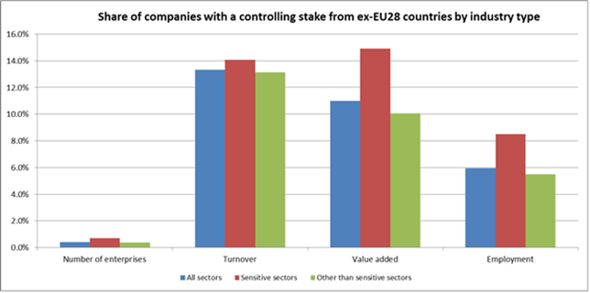

* *EU companies controlled by third country entities played an especially significant role in "Information service activities" (accounting for 40% of the total) and in "Manufacture of computer, electronic and optical products" (36% of the total)*.
* *2014 saw a net increase of around 4 000 of EU enterprises whose ultimate controlling company was located outside the EU (see table below) with China (including Hong Kong) in the lead.*

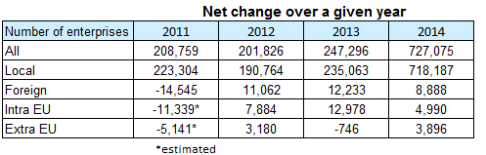

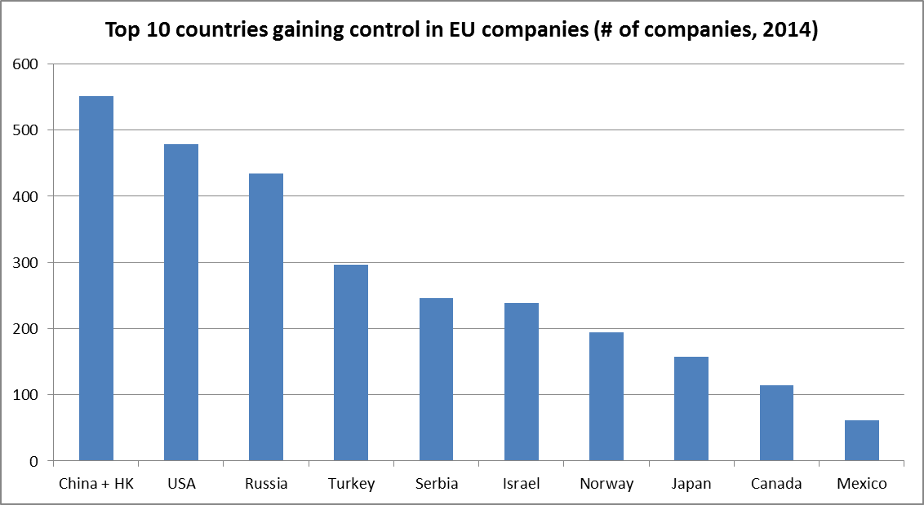

**World**

* *According to the OECD, in 2016 global FDI flows decreased by 7% to USD 1.6 trillion in comparison to 2015, but remains above levels recorded between 2009 and 2014 and comparable to 2008.*
* *FDI flows remained below their pre-crisis peak, representing 2.2% of global GDP compared to 3.6% in 2007.*

1. Eurostat, based on BPM 6 methodology and BD4, including investment through Special Purpose Entities.
2. Source: Eurostat
3. Source: Eurostat
4. Eurostat, data based on BPM 5 for 1995 and 2005, and BPM 6 for 2015.
5. Eurostat, FATS, 2014 figures.
6. Note that these figures are based on datasets that exhibit limitations in terms of coverage, period under analysis and details of information, so should be treated as rough estimates.
7. DEALOGIC M&As ANALYTICS.
8. DEALOGIC M&As ANALYTICS.
9. The description included in this paper of national screening mechanisms is based on the information currently available to the Commission services and their interpretation of the national legal frameworks.
10. Note that some graphs of this annex are also present in the body of the document. This repetition is necessary for the logic of the presentation of the annex.
11. Note that these figures are based on datasets that exhibit limitations in terms of coverage, period under analysis and details of information, so should be treated as rough estimates.
12. This section is based on EUROSTAT FATS, 2014.
13. 2015 data will be available in the first quarter of 2018