

EXPLANATORY MEMORANDUM

1. CONTEXT OF THE PROPOSAL

• Reasons for and objectives of the proposal

Democracy is one of the fundamental values on which the European Union is founded. To ensure the functioning of a representative democracy on the European level, the treaties determine that the citizens of the European Union are directly represented in the European Parliament.

The right to freedom of association and the right to freedom of expression are fundamental rights of every citizen of the Union.

Political parties fulfil an essential role in a representative democracy, creating a direct link between the citizens and the political system, thereby enhancing the legitimacy of the system. The same happens at European level: according to Article 10 of the Treaty on European Union, "*political parties at European level contribute to forming European political awareness and to expressing the will of citizens of the Union*". Article 12(2) of the Charter of Fundamental Rights of the European Union expresses the same principle.

Fostering political debate across Europe on European issues through vibrant European political parties is a long standing Commission objective.

In the run up to the 2014 European elections, the Commission issued a Recommendation[1], calling on European and national political parties, supported by the institutions and the Member States, to take a number of steps to strengthen the role of European political parties in contributing to forming European political awareness and to expressing the will of the citizens of the Union. One of these steps was the "Spitzenkandidat".

European political parties responded to the Commission's call and the 2014 European Parliament elections were fundamentally different from previous ones. For the first time, they established a link between the results of the elections and the choice of the current European Commission President, Jean-Claude Juncker. "Spitzenkandidaten" or candidates for President of the European Commission, with different political programmes allowed voters to make an informed choice between alternative political platforms for Europe, rather than on exclusively national political issues, thus ‘europeanising’ the elections.

Regulation No 1141/2014 of the European Parliament and of the Council of 22 October 2014 on the statute and funding of European political parties and European political foundations[2] was introduced to increase the visibility, recognition, effectiveness, transparency and accountability of European political parties and their affiliated political foundations.

Political parties and foundations satisfying a number of conditions were offered the opportunity to become European legal entities by registering at European level, and thereby enhancing access to European financial support. These conditions include representation in a sufficiently large number of EU Member States and respect, both in their programme and activities, of the values on which the EU is founded - respect for human dignity, freedom, democracy, equality, the rule of law and respect for human rights, including the rights of people belonging to minorities.

An independent Authority for European political parties and foundations ("the Authority") was created, for the purpose of registering, controlling and, if necessary, imposing sanctions on European political parties and foundation, including to consider cases where such entities allegedly fail to respect these fundamental European values. Where doubts arise about whether a party or foundation is observing this requirement in practice, the European Parliament, the Council or the Commission may lodge a request with the Authority for European political parties and European political foundations to verify the situation. Before coming to a decision on whether to de-register a party or foundation, the Authority must consult a Committee of independent eminent persons.

Nevertheless, the Commission’s report on the 2014 European elections[3] found that work remained to be done to increase the participation of citizens and the inclusivity of elections, enhance the European dimension of the political debate, reverse the trend of low turnouts, further enhance the democratic legitimacy of the EU decision-making process, highlight affiliations between national and European parties, and promote political accountability.

Moreover, despite the progress made with Regulation No 1141/2014, the existing rules have loopholes that need to be addressed.

The European Parliament, as well as a number of European political parties, have called for improvements and adjustments to these rules. The European Parliament services in charge of the administration of this Regulation have worked on a number of cases resulting from inappropriate use of funding.

In March 2017, Parliament held a plenary debate and issued an oral question inviting the Commission to respond both on the timing of any changes and on certain specific changes which concerned the level of co-financing, the possibility of multi-party membership of European Parliaments' Members, the number of members required for funding, the financing of referendum campaigns, the introduction of a financial capacity criterion and allowing the building of financial reserves.

In this debate, the Commission expressed its willingness to engage with the Parliament, along with the Council, in monitoring the early stages of implementing the new rules. On 15 June 2017, Parliament adopted a resolution[4] calling upon the Commission to propose a revision of the current legal framework as soon as possible to address its shortcomings, especially with respect to the level of co-financing requested, and of the possibility of multi-party membership of European Parliaments' Members.

Parliament and its political parties wrote to the Commission to restate their call for changes; a call elaborated in a comprehensive report provided to the Commission.

Given the above and based on the extensive input obtained from various stakeholders (see section 3), the Commission has therefore decided to propose a limited number of targeted amendments to this Regulation. These aim to close the loopholes, improve transparency, to ensure the appropriate allocation and expenditure of limited resources from the EU budget, and thereby to strengthen the genuine electoral representation of European citizens by European political parties. The amendments will ensure that the existing rules are not circumvented or its provisions misused.

The focused changes should be in place before the 2019 European elections. They will help address the challenges identified by the Commission in relation to the 2014 European elections, in particular in relation to the affiliations between national and European parties and increased political accountability.

• Specific issues addressed

In the first place, the current rules are prone to abuse regarding the issue of who can sponsor the registration of a European political party, because they allow the required level of representation (i.e. in seven Member States) to be met either (i) by support from member parties represented in regional parliaments, a national Parliament or the European Parliament; (ii) by support from individual members of such parliaments or (iii) by a mixture of the two.

In the first years after the introduction of funding for European political parties, most of the beneficiaries were alliances made up of national parties coming from the same political family. However, several European political parties created in recent years are composed mainly of individual politicians and/or strongly dominated by one or two national political parties. There are several cases of different members of a single national party sponsoring more than one European political party; in some extreme cases, a single member has sponsored more than one party.

The Authority has also been confronted with practical problems linked to the multiparty membership. It is often unclear how to avoid double counting for representation, how to deal with prior memberships, and how to make a connection between the representation and funding criteria - including the issue of a Member of the European Parliament counting for different European political parties as regards, on the one hand, registration and, on the other hand, funding.

The second issue of concern regards **proportionality of the EU funding** received to representation in the European Parliament. Currently, European political parties can apply for funding if they are represented in the European Parliament by at least one Member. A number of European political parties as well as the European Parliament's administration, have asked to increase the threshold of representation to three Members, to prevent the misuse of public funding via "one-man parties".

However, the practical impact of such a change would be minimal, as at present even the least represented European political parties eligible for funding currently have 3 Members[5] (see graph). More importantly such a change would raise serious legal concerns related to fundamental rights of freedom of association and equality of opportunities for parties presenting candidates for elections and would unduly limit the pluralistic nature of European politics.

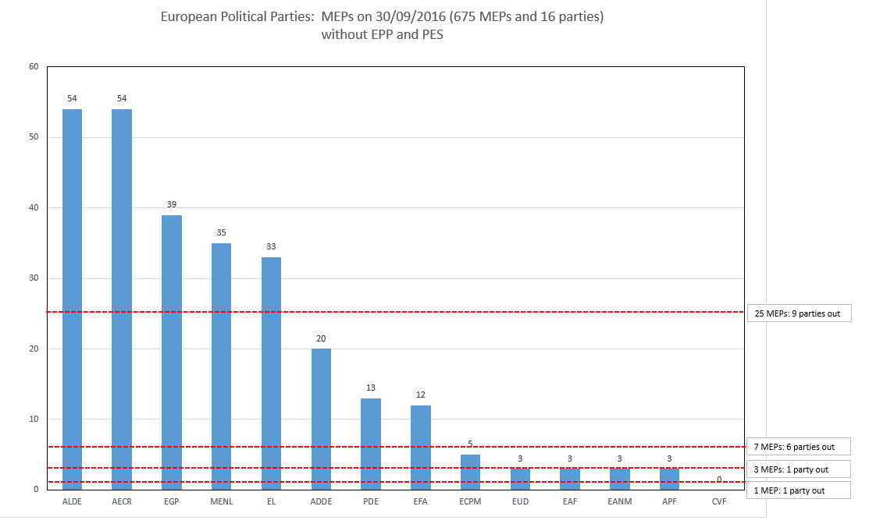

There is another way of addressing this concern by changing the distribution key for the funding of the eligible European political parties and the European political foundations. Currently, 15% of the total amount available is distributed equally to all parties which meet the one Member threshold, leaving 85% to be distributed in proportion to each party’s share of elected Members (the same distribution key is used for foundations). This leads to a rather unbalanced reflection of the electoral representation in Parliament. The tables below[6], provided by administration of the European Parliament, show the effect of changing the fixed portion of funding compared to the portion related to the level of representation in Parliament. Lowering the set aside amount to 5% could help restore a more proper balance and thus lead to a fairer and better reflection of electoral representation in Parliament.

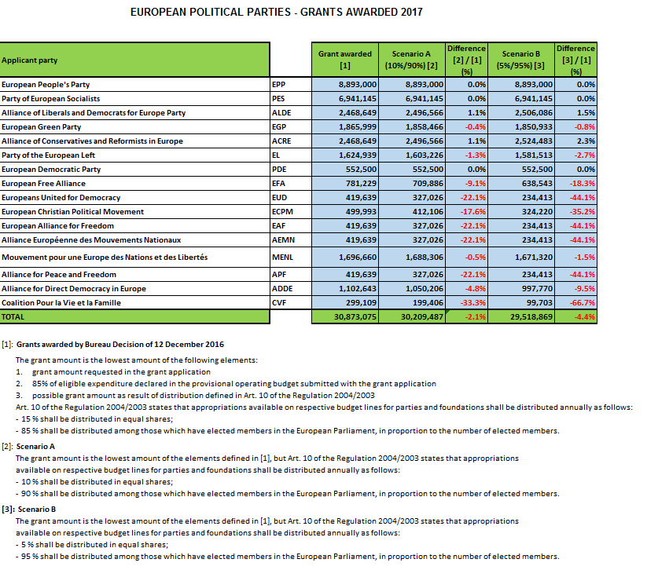



In the third place, next to abuse and proportionality issues, European political parties and – to a larger extent – the political foundations have difficulties meeting the current **co-financing threshold** of 15%. The European Parliament services have also been confronted by some dubious practices in this respect, such as some parties seeking to meet the letter of the co-financing requirement via circular financial flows. As regards financial capacity, in the financial year 2015, the Parliament's external auditor flagged concerns in 8 out of 28 reports. This indicates that the beneficiaries’ own resources are not sufficient.

In many cases, the shortfall in own resources from membership contributions and donations can only be balanced by the use of contributions in kind. In 2015 parties received contributions in kind amounting to €238,009 and foundations to €283,649. The objective evaluation of these contributions poses significant problems. In several cases, the Parliament's administration has been unable to verify this valuation in detail and ascertain whether the contributions were actually necessary for and directly related to the activity mentioned, and to determine whether the underlying activities were in the interest of the European party exclusively or possibly shared with a partner organisation.

Fourthly, there is a lack of clarity and transparency in the existing rules regarding the steps to be taken in cases where a party or foundation **ceases to comply with the registration criteria** or is found to have been registered on the basis of incorrect information.

Fifthly, based on the experience of Parliament's administration, there is a need to extend the scope of possible measures to **recover funds misspent** by parties and foundations.

• Consistency with other Union policies

In its 2017 Report on EU Citizenship Rights[7], the Commission recognised that the functioning of the EU is founded on representative democracy. This requires transparency and an accessible, accountable political culture, supported by an effective electoral system and an informed and engaged electorate. To that end, the Commission has committed to intensifying Citizens’ Dialogues and taking further action to explain its policies to citizens, as highlighted by Commission President Jean-Claude Juncker in his 2016 State of the Union address; to conducting, ahead of the 2019 elections, an EU-wide information and awareness-raising campaign on EU citizenship rights, including on electoral rights; to organising in 2018 a high-level event on democratic participation with a focus on encouraging best practices to increase the participation of young people and vulnerable and underrepresented groups; and to promoting best practices that help citizens vote and stand for EU elections, including practices that allow citizens to retain the right to vote when moving to another Member State, facilitate cross-border access to political news, and support turnout and broad democratic participation in the perspective of the 2019 European elections.[8] The current proposal is aligned to and complements these priorities and in addition to the issues set out in the previous section therefore includes some changes to enhance the transparency of the link between parties at Member State level and the European parties with which they are affiliated.

A number of initiatives are indirectly linked to this revision, in particular the Commission Recommendation[9] on enhancing the democratic and efficient conduct of the elections to the European Parliamentandthe reform of both the 1976 European Electoral Act and of the European Council decision on the composition of the European Parliament[10].

2. LEGAL BASIS, SUBSIDIARITY AND PROPORTIONALITY

• Legal basis

The proposal is based on Article 224 of the Treaty on the Functioning of the European Union, which states that "*the European Parliament and the Council, acting in accordance with the ordinary legislative procedure, shall lay down the regulations governing political parties at European level referred to in Article 10(4) of the Treaty on European Union and in particular the rules regarding their funding*" as well as on Article 106a of the Treaty establishing the European Atomic Energy Community[11].

• Subsidiarity

Since the existing Regulation provides for an EU-level system, including a specific European legal personality for parties and foundations and funding from the EU budget, any shortcomings in this system can only be remedied through EU legislation. Action by Member States alone is therefore not a relevant option.

The proposed focused changes therefore fully comply with the principle of subsidiarity. The EU level is the only one at which rules governing the statute and funding of European political parties and European political foundations can be laid down. In setting out possible reform measures, the Commission has been careful to reflect the principles contained in Protocol No. 2 to the Treaties.

• Proportionality

As explained in Section 5, the targeted measures proposed do not go beyond what is necessary to achieve the long-term objective of developing and strengthening European democracy and the legitimacy of the EU institutions, by seeking to make European political parties and European political foundations more effective and accountable democratic actors. In particular, The proposal therefore complies with the principle of proportionality.

• Choice of the instrument

Only a Regulation can amend an existing Regulation.

3. STAKEHOLDER CONSULTATIONS AND IMPACT ASSESSMENTS

• Stakeholder consultations and collection and use of expertise

In preparing the current proposal, the Commission has been in close dialogue and consultation with the relevant stakeholders. It has held several meetings with representatives of the political parties at European level, political groups in the European Parliament, Members of the European Parliament, services of the European Parliament, the Authority for European political parties and European political foundations as well as national experts.

A hearing was held on 12 July 2017 in the European Parliament's Committee on Constitutional Affairs[12]. The Committee members, together with the Director of the Authority, the Director-General for Finance of the European Parliament and a representative of the Commission debated the possible changes to the current Regulation. There was broad consensus that there is a need to close certain loopholes in the Regulation before the upcoming European Parliaments' elections. The focused changes would increase the level of transparency and help close the loopholes that allow the objectives of the current Regulation being circumvented or its provisions misused .

European political parties and foundations, the Parliament services as well as the Authority have also identified other potential shortcomings of the current Regulation, however these were considered less urgent.

Interested parties have provided input based on their experience and expertise with regard to the current rules governing the political parties and political foundations under both Regulation (EC) No 1141/2014 and the Financial Regulation.

• Impact assessment

The proposal is expected to improve the effectiveness with which Regulation 1141/2014 achieves its objectives by closing some of the existing loopholes. It is based on the extensive input obtained from various stakeholders as set out above and the analysis of a limited number of targeted solutions.

This proposal is not accompanied by a specific impact assessment as it is not expected to have wider significant economic, social and environmental impacts.

• Fundamental rights

Article 2 of the Treaty on European Union (TEU) provides that “*The Union is founded on the values of respect for human dignity, freedom, democracy, equality, the rule of law and respect for human rights, including the rights of persons belonging to minorities. These values are common to the Member States in a society in which pluralism, non-discrimination, tolerance, justice, solidarity and equality between women and men prevail.*”

Article 10(1) and (2) TEU provide that “*The functioning of the Union shall be founded on representative democracy*” and that “*Citizens are directly represented at Union level in the European Parliament*”. Subparagraph 4 of the same provision stipulates: “*political parties at European level contribute to forming European political awareness and to expressing the will of citizens of the Union*”. Articles 11 and 12 of the Charter of Fundamental Rights of the EU enshrine the right to freedom of expression and of association. In particular, Article 12 of the Charter of Fundamental Rights of the European Union reads that “*Everyone has the right to freedom of peaceful assembly and to freedom of association at all levels, in particular in political, trade union and civic matters, which implies the right of everyone to form and to join trade unions for the protection of his or her interests*. *Political parties at Union level contribute to expressing the political will of the citizens of the Union*”.

The amendments which are the subject of this proposal pursue the objectives of these provisions, and are thus compatible with and give effect to the fundamental rights guaranteed by Article 12 of the Charter.

4. BUDGETARY IMPLICATIONS

The EU funding provided to European political parties and European political foundations will continue to come from the budget of the European Parliament. No change to the amounts allocated is proposed by virtue of this proposal. The present proposal has no significant implications for the EU budget.

5. OTHER ELEMENTS

• Evaluation and reporting arrangements

The present proposal is for limited and focused reform of the existing Regulation which itself provides for a more comprehensive review. It is proposed to change the timetable for that review to allow it to be based on substantial evidence of the operation in practice of both the existing Regulation and the amendments proposed here.

• Detailed explanation of the specific provisions of the proposal

To further provide for a genuine European dimension to the European political parties and to increase transparency while ensuring that European funding is well spent, the Commission proposes a limited set of focused amendments to Regulation (EC) No 1141/2014, to address who can sponsor the registration of a political party, to have an allocation of funding which is more proportionate to the representativeness of European political parties in the European Parliament and to address difficulties faced by European political parties and foundations in meeting the co-financing threshold. Such changes will close the loopholes of the existing rules which make them prone to abuse.

To address the issue of "**multiparty membership**" several options were considered: (i) to prevent Members of the European Parliament from the same national party from sponsoring different European parties; (ii) to no longer allow regional parliamentarians to sponsor the registration and (iii) to allow for national parties sponsoring only. The last was considered the most effective option as it achieves the same objective as option (i) but in a manner which is more objective and fair, and easier to enforce.

The Commission therefore proposes to amend Article 3(1)b to allow only parties, and no longer individuals, to sponsor the creation of a European political party. This would make it harder for entities without substantial representation within Member States to be created as European level parties, and receive European funding once they meet the threshold of one Member of the European Parliament.

This change does not preclude European parties from allowing individual membership, only that such membership would no longer be relevant to the registration criteria. No change is therefore proposed to the definition of a political party or alliance.

To deal with European political parties' and foundations' difficulties in meeting the current **co-financing** threshold of 15%, it should be lowered enabling more of the public funding set aside for European parties and foundations to be directed appropriately, for example in election campaigns. It would also reduce incentives for questionable practices. Following the consideration of several options, the Commission decided to propose to lower the co-financing requirement foreseen in Article 17.4 to 10% for European political parties and 5% for European political foundations.

The level of **transparency** in European elections has always been a vital factor for the Commission. By making a clearer link between national and European political parties clarity and transparency can be enhanced. This is particularly important, as this proposal aims to allow sponsoring of European political parties by parties only. Citizens should be offered clear and relevant information upfront, including with regard to party affiliations, in order to understand the impact of their votes at the European party level. It is proposed to require an additional condition for a European political party to receive funding, by inserting a new Article 18.3a which would require it to report on the publication, on its member parties' websites, of its political programme and logo as well as and information on the gender representation among the candidates at the last elections to the European Parliament and its members of the European Parliament.

It is proposed to improve the **proportionality of EU funding** by linking it more clearly to the representation in Parliament, by amending the distribution key for financing foreseen in Article 19.1. It is proposed to lower the fixed amount to 5%, thereby increasing the share which is distributed in proportion to the members elected to Parliament. For the reasons set out above, the alternative option of increasing the threshold of representation needed to be eligible for funding was rejected.

When a European political party or foundation ceases to **comply with whichever of the registration criteria**, including in particular of representation and participation in European elections, or where registration was based on incorrect/misleading information, the Authority should be empowered to de-register them. The case law of the Court of Justice admits the possibility of retroactively withdrawing a favourable administrative act within a reasonable period and whilst respecting the legitimate expectations of a beneficiary of the measure, who has been led to rely on the lawfulness thereof. Changes made in Article 27 clarify this, to allow the Authority to enforce the rules more effectively.

To protect EU financial interests and the Union’s reputation, the authorising officer of the European Parliament must be able **to recover** **amounts unduly paid**, from individuals having committed illegal activities detrimental to the financial interests of the European Union for their own benefit, or for the benefit of other entities or individuals. The Commission therefore introduces changes to Article 30.

Finally, alongside transitional measures, the Commission proposes that the revision clause in the current Regulation should be adapted to allow for the evaluation report to be published in the first part of 2022 and thus also to assess the amendments proposed in the present Regulation.

2017/0219 (COD)

Proposal for a

REGULATION OF THE EUROPEAN PARLIAMENT AND OF THE COUNCIL

amending Regulation (EU, Euratom) No. 1141/2014 of the European Parliament and the Council of 22 October 2014 on the statute and funding of European political parties and European political foundations

THE EUROPEAN PARLIAMENT AND THE COUNCIL OF THE EUROPEAN UNION,

Having regard to the Treaty on the Functioning of the European Union, and in particular Article 224 thereof,

Having regard to the Treaty establishing the European Atomic Energy Community, and in particular Article 106a thereof,

Having regard to the proposal from the European Commission,

After transmission of the draft legislative act to the national Parliaments,

Having regard to the opinion of the European Economic and Social Committee[13],

Having regard to the opinion of the Committee of the Regions[14],

Having regard to the opinion of the Court of Auditors[15],

Acting in accordance with the ordinary legislative procedure,

Whereas:

(1) Regulation (EU, Euratom) No. 1141/2014 establishes a specific European legal status for European political parties and political foundations to benefit from and provides for their funding from the general budget of the European Union.

(2) A need has been identified to amend Regulation (EU, Euratom) No. 1141/2014 in order to better meet the objective of encouraging and assisting European political parties and their affiliated European political foundations in their endeavour to provide a strong link between European civil society and the Union institutions, in particular the European Parliament.

(3) It is necessary to better ensure a genuine transnational dimension of European political parties and political foundations as regards their acquisition of the specific European legal status through registration. Moreover, in order to strengthen the link between politics at national level and at Union level and to prevent the same national party from artificially creating several European political parties with similar or identical political tendencies, it should be excluded that members of the same national political party are taken into account in relation to different political alliances, for the purpose of the minimum representation requirements for those alliances to be registered as a European party. Therefore, only political parties and no longer individuals should be taken into account for the purpose of these minimum representation requirements.

(4) European political parties and foundations should be enabled to absorb a larger part of the appropriations dedicated to their funding in the general budget of the European Union. Therefore, the maximum share of financial contributions or grants from the general budget of the European Union in the annual reimbursable expenditure indicated in the budget of a European political party and in the eligible costs incurred by a European political foundation should be increased.

(5) For reasons of transparency and in order to strengthen the scrutiny and the democratic accountability of European political parties and the link between European civil society and the Union institutions, in particular the European Parliament, access to funding from the general budget of the European Union should be made conditional upon the publication by the member parties of the programme and logo of the European political party concerned, as well as information regarding the gender representation among the candidates at the last elections to the European Parliament and among the members of the European Parliament.

(6) To establish a more proportionate allocation of resources from the general budget of the European Union, objectively reflecting the genuine electoral support of a European political party, the funding of European political parties and, by extension, of their respective affiliated political foundations should be linked more closely to a demonstrable level of electoral support. Therefore, the rules on the distribution of funding should be adapted to take greater account of the share of elected members in the European Parliament of each European political party.

(7) Where a European political party or political foundation, due to a change in circumstances, no longer fulfils whichever of the conditions for registration, it should be removed from the Register.

(8) For reasons of legal certainty and transparency it should be explicitly provided that a European political party or political foundation can be removed from the Register, within a reasonable period, where the party or foundation has provided false or incomplete information on the basis of which a decision has been made to register that party or foundation.

(9) The protection of the EU financial interests should be strengthened by providing that, in cases of infringement, the effective recovery of funding from the general budget of the European Union would be ensured through a recovery of amounts unduly paid also from natural persons responsible for the infringement in question.

(10) In order to evaluate the implications of Regulation (EU, Euratom) No. 1141/2014 as amended by this Regulation on the basis of substantial evidence of its practical operation, the date of the proposed comprehensive review should be delayed.

(11) The new requirements regarding publicity of the programme and logo of European political parties and of information regarding gender representation should apply to the largest possible extent already to applications for funding for 2019, the year in which elections to the European Parliament will take place. Therefore, transitional arrangements should be provided for.

(12) Regulation (EU, Euratom) No. 1141/2014 should therefore be amended accordingly,

HAVE ADOPTED THIS REGULATION:

Article 1

Regulation (EU, Euratom) No. 1141/2014 of the European Parliament and the Council of 22 October 2014 on the statute and funding of European political parties and European political foundations is amended as follows:

(1) In Article 3(1)b, the first subparagraph is replaced by the following:

"its member parties must be represented by, in at least one quarter of the Member States, members of the European Parliament, of national Parliaments, of regional parliaments or of regional assemblies, or"

(2) Article 17(4), is replaced by the following:

"4. Financial contributions or grants from the general budget of the European Union shall not exceed 90 % of the annual reimbursable expenditure indicated in the budget of a European political party and 95 % of the eligible costs incurred by a European political foundation. European political parties may use any unused part of the Union contribution awarded to cover reimbursable expenditure within the financial year following its award. Amounts still unused after that financial year shall be recovered in accordance with the Financial Regulation."

(3) In Article 18

, the following paragraph 3a is inserted:

"3a. A European political party shall include in its application evidence demonstrating that its member parties have continuously published on their websites, during 12 months preceding the moment at which the applications is made, the political programme and logo of the European political party as well as information, in relation to each of the member parties of the European political party, on the gender representation among the candidates at the last elections to the European Parliament and among the Members of the European Parliament."

(4) Article 19(1) is replaced by the following:

"1. The respective appropriations available to those European political parties and European political foundations which have been awarded contributions or grants in accordance with Article 18 shall be distributed annually on the basis of the following distribution key:

— 5 % shall be distributed in equal shares among the beneficiary European political parties,

— 95 % shall be distributed in proportion to their share of elected members of the European Parliament among the beneficiary European political parties.

The same distribution key shall be used to award funding to European political foundations, on the basis of their affiliation with a European political party."

(5) Article 27 is amended as follows:

(a) Paragraph 1 (b) is replaced by the following:

"(b) where it is established, in accordance with the procedures set out in Article 10(2) to (5), that it no longer fulfils one or more of the conditions set out in Article 3(1) or in Article 3(2); or"

(b) In paragraph 1, the following subparagraph (ba) is inserted:

"(ba) where the party or foundation in question did not fulfil one or more of the conditions set out in Article 3(1) or Article 3(2) at the moment of its registration and where the party or foundation has provoked the decision to register it by means of false or incomplete information relating to those conditions; a decision removing the party or foundation from the Register shall be adopted within a reasonable period from the moment at which the Authority could have ascertained that the party or foundation in question did not fulfil the condition or conditions concerned;"

(c) The following paragraph 5a is inserted:

"5a. Where the Authority imposes a financial sanction in the situations referred to in paragraph 2 (a) (v) or (vi) it may, for the purpose of recovery pursuant to Article 30 (2), establish that a natural person who is a member of the administrative, management or supervisory body of the European political party or the European political foundation, or who has powers of representation, decision or control with regard to the European political party or the European political foundation is also responsible for the infringement in the following cases:

a. In the situation referred to in paragraph 2 (a) (v) where, in the judgment referred to in that provision, the natural person has been found also being responsible for the illegal activities in question;

b. In the situation referred to in paragraph 2 (a) (vi) where the natural person is also responsible for the conduct or inaccuracies in question."

(6) In Article 30(2), the following sentence is added:

"The Authorising Officer of the European Parliament shall also recover amounts unduly paid under contribution or grant agreement or decision from a natural person in respect of which a decision pursuant to Article 27 (5a) has been taken.".

(7) Article 38 is replaced by the following:

"Article 38

**Evaluation**

The European Parliament shall, after consultation of the Authority, publish five years after the moment at which this Regulation becomes applicable, a report on the application of this Regulation and on the activities funded. The report shall indicate, where appropriate, possible amendments to be made to the statute and funding systems.

No more than six months after the publication of the report by the European Parliament, the Commission shall present a report on the application of this Regulation accompanied, if appropriate, by a legislative proposal to amend this Regulation."

(8) The following Article 40a is inserted:

"Article 40a

**Transitional provision**

By the way of derogation from Article 18(3a) and as regards applications for funding for the financial year 2019, the Authorising Officer of the European Parliament shall, before deciding on an application on funding, request evidence from a European political party demonstrating that its member parties have continuously published on their websites, for a period beginning one month after the entry into force of Regulation (EU, EURATOM) No. XX/2018, the political programme and logo of the European political party as well as information, in relation to each of the member parties of the European political party, on the gender representation among the candidates at the last elections to the European Parliament and among the members of the European Parliament."

Article 2

This Regulation shall enter into force on the third day following that of its publication in the *Official Journal of the European Union*.

This Regulation shall be binding in its entirety and directly applicable in all Member States.

Done at Brussels,

For the European Parliament For the Council

The President The President

1. Recommendation of 12.3.2013 on enhancing the democratic and efficient conduct of the elections to the European Parliament C(2013)1303 final <http://eur-lex.europa.eu/legal-content/EN/ALL/?uri=OJ:L:2013:079:TOC>
2. OJ L 317 of 4.11.2017, pp 1-27.
3. Communication from the Commission to the European Parliament, the Council, the European Economic and Social Committee and the Committee of the Regions, Report on the 2014 European Parliament elections COM/2015/0206 final <http://eur-lex.europa.eu/legal-content/EN/TXT/?uri=COM:2015:0206:FIN>.
4. See <http://www.europarl.europa.eu/sides/getDoc.do?pubRef=-//EP//TEXT+TA+P8-TA-2017-0274+0+DOC+XML+V0//EN>
5. Alliance for Peace and Freedom (APF), Alliance européenne des Mouvements Nationaux (EANM), European Alliance for Freedom (EAF) and Europeans United for Democracy (EUD). The European Political Party Coalition pour la Vie et la Famille (CVF) has no MEP and is therefore not eligible for funding after 2017, the last year of application of the former rules from the 2004 Regulation.
6. Based on funding in 2017, under the rules of the 2004 Regulation, and thus not taking account of 2014 Regulation's requirement of minimum one Member of the European Parliament to receive funds.
7. COM(2017)30 final
8. These best practices will also address e-democracy tools, remote voting arrangements (e.g. e-voting) and cross-border access to political information, and will target improving on low voter turnout.
9. <http://ec.europa.eu/justice/citizen/document/files/c_2013_1303_en.pdf>.
10. European Council Decision of 28 June 2013 establishing the composition of the European Parliament http://eur-lex.europa.eu/legal-content/EN/TXT/?uri=uriserv:OJ.L_.2013.181.01.0057.01.ENG.
11. <https://europa.eu/european-union/sites/europaeu/files/docs/body/consolidated_version_of_the_treaty_establishing_the_european_atomic_energy_community_en.pdf>
12. The agenda, list of speakers and conclusions are available here: <http://www.europarl.europa.eu/sides/getDoc.do?pubRef=-//EP//NONSGML+COMPARL+AFCO-OJ-20170712-1+01+DOC+PDF+V0//EN>
13. OJ C , , p. .
14. OJ C , , p. .
15. OJ C , , p. .