TABLE OF CONTENTS

1. Introduction 3
2. Fund Management report 3
2.1. Development of the Fund in 2016 3
2.2. Situation of the Fund 4
2.2.1. Contributions as at 31 December 2016 4
2.2.2. The Fund’s holdings net of accrued interest at 31 December 2016 4
2.3. General and segmental analyses of the Fund 5
2.3.1. Liquidity analysis 5
2.3.2. General analysis of the results of the Fund 5
2.3.3. Analysis by segment 5
2.4. Benchmarking, performance and interest rate risk analysis 13
2.4.1. Benchmarking 13
2.4.2. Performance 15
2.4.3. Interest rate risk 15
3. Guarantee Fund Financial Statements as at 31 December 2016 16
3.1. General disclosures 21
3.2. Significant accounting policies 21
3.3. Financial Risk Management 27
3.4. Fair value of financial instruments 36
3.5. Bond portfolio 38
3.6. Cash and cash equivalents 39
3.7. Contributions 39
3.8. Other payables (in EUR) 40
3.9. Subsequent events 40

1. Introduction
According to the Article 7 of the Guarantee Fund Regulation, the assets of the Guarantee Fund (the "Fund") are managed by the EIB (the "Bank"). The agreement signed between the European Commission (the "Commission") and the Bank defines the principles governing the management of assets.
Under Article 8(2) of the Agreement, at the beginning of March of each year the Bank has to send the Commission an annual status report on the Fund and the management thereof and the financial statements of the Fund for the preceding year.
The management report on the Fund is presented in the section 2 of this Commission Staff Working Document (SWD). The financial statements audited by an external auditor are included in section 3.

2. Fund Management report

2.1. Development of the Fund in 2016
As at 31 December 2016 total assets (excluding accrued interest) of the Guarantee Fund (the “Fund”) amounted to EUR 2,490.7 million against EUR 2,328.1 million as at 31 December 2015, an increase of EUR 162.6 million.
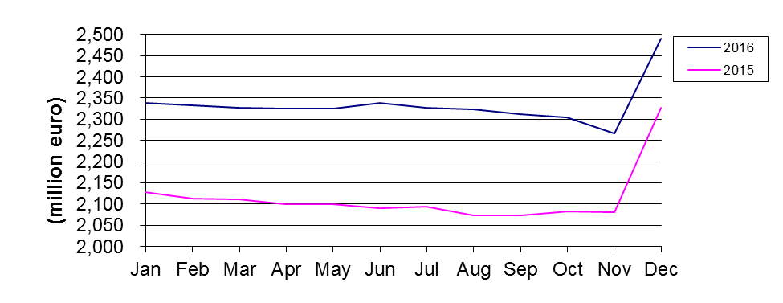
Fig.1: Development of total assets in 2016 and 2015

The net operating result amounted to EUR 29.85 million at 31 December 2016 compared with EUR 32.34 million at 31 December 2015 representing a decrease of 7.7%.

2.2. Situation of the Fund

2.2.1. Contributions as at 31 December 2016

2.2.1.1. Contributions paid in as at 31 December 2016
The net contributions paid into the Fund by the European Union budget increased by EUR 146.3 million or 13.1% from EUR 1,112.6 million at 31 December 2015 to EUR 1,258.8 million at 31 December 2016.
This is explained by the movements shown in the following table:
Contributions paid in (in EUR) | Situation at 31/12/2015 | Movements in 2016 | Situation at 31/12/2016
Provisioning | 3,748,326,975 | 257,121,792 | 4,005,448,767
Repayment of surplus | -1,775,870,000 | 0 | -1,775,870,000
Activation of guarantee calls | -682,903,987 | -110,828,866 | -793,732,853
Recovery of historic called amounts | 578,854,354 | 0 | 578,854,354
Repayment of Funds | -755,856,713 | 0 | -755,856,713
Balance | 1,112,550,629 | 146,292,926 | 1,258,843,555

2.2.1.2. Contributions payable and receivable as at 31 December 2016
As at 31 December 2016 the Fund has recorded EUR Nil (2015: EUR 22.1 million) as contributions payable (2015: three guarantee calls provisioning for three guarantee calls made by the European Investment Bank with regard to Syrian loan defaults). In addition, as at 31 December 2016 the Fund has recorded EUR 240.5 million (2015: EUR 257.1 million) as contributions to be paid in by the European Union.

2.2.2. The Fund’s holdings net of accrued interest at 31 December 2016
The Fund’s holdings at 31 December 2016 excluding accrued interest and contributions receivable totalled EUR 2,250.2 million as detailed below:
- EUR 151.5 million in the monetary portfolio (nominal value of interbank term deposits);
- EUR 45.4 million in the current accounts;
- EUR 2,053.3 million in the Available For Sale (AFS) (portfolio market value of fixed rate bonds, floating rate bonds, zero-coupon bonds and commercial papers, excluding accrued interest).
The Fund operates in one currency only, the Euro.

2.3. General and segmental analyses of the Fund

2.3.1. Liquidity analysis
The liquidity position of the Fund at 31 December 2016 is outlined in the table below. The liabilities shown in the column "maturity undefined" represent the Contributor's (i.e. European Union's) resources.
Liquidity position as at 31 December 2016 (in EUR million):

Maturity | less than 3 months | 3 months to 1 year | 1 to 10 years | maturity undefined | Total
Total assets | 520 | 25 | 1,961 | 0 | 2,506
Total net assets | 0 | 0 | 0 | -2,505 | -2,505
Total liabilities | -1 | 0 | 0 | 0 | -1
Total net assets and liabilities | -1 | 0 | 0 | -2,505 | -2,506
Net liquidity position | 519 | 25 | 1,961 | -2,505 | 0

2.3.2. General analysis of the results of the Fund
Overall, during the reporting period 1 January 2016 to 31 December 2016 the Fund achieved EUR 29.85 million in net revenue. The following table outlines the net revenue earned in 2016 and compares it with 2015:
In EUR million | From 1 January to  31 December 2016 |  | From 1 January to  31 December 2015
Interest income on cash & cash equivalents | 0.00 | 0.0% | 0.03 | 0.1%
Interest income on AFS assets | 14.39 | 48.2% | 24.23 | 74.9%
Realised gain on sale of AFS assets | 16.76 | 56.1% | 9.18 | 28.4%
Income from securities lending activity | 0.12 | 0.4% | 0.11 | 0.3%
Interest expense on cash & cash equivalents | -0.34 | -1.1% | -0.01 | 0.0%
Realised loss on sale of AFS assets | 0.00 | 0.0% | -0.15 | -0.5%
Commission and other charges | -1.08 | -3.6% | -1.05 | -3.2%
Total | 29.85 | 100.0% | 32.34 | 100.0%

2.3.3. Analysis by segment

2.3.3.1. Analysis of money market operations
Money-market investments (excluding accrued interest) amount to EUR 196.9 million at 31 December 2016, as compared to EUR 83.9 million the year before.
- Evolution of money-market rates in 2016
The market developments of the year 2016 were strongly influenced by central bank activity and heightened political risk caused by surprise events of Brexit, US presidential election results and Italy constitutional referendum. After the first hike of FED funds rate in December 2015, the FED continued its cycle in December 2016. ECB monetary policy remained accommodative.
During its March meeting, ECB extended its quantitative easing program by lowering the main refinancing rate to zero and the rate of the deposit facility to -0.40%. QE was expanded by additional EUR 20bn per month and extended to investment grade corporate bonds. On the credit side and in order to provide further incentives for banks to lend out, a new TLTRO II was launched with more favourable borrowing conditions relative to TLTRO.
Economic activity in the Eurozone was mixed in 2016 with generally week growth. After reaching its lows in February, the trend of oil price has turned and helped to evaporate deflation expectations. As a result, Eurozone inflation returned to positive area and approached 1% by year end.
The ECB announced in December an update of the asset purchase program, with timeframe extended by nine months (until December 2017) and the monthly volume of purchases reduced to EUR 60bn from EUR 80bn. The time extension combined with the decrease in the monthly purchases left some commentators pondering upon whether or not the ECB was in fact laying the ground for a gradual phase-out (tapering) of the quantitative easing, with potentially disruptive consequences for the EUR interest rates. ECB officials rushed to ensure the markets that the December’s revision of the QE should not be interpreted as tapering. The phase-out, if any, would be entirely driven by the flow of macroeconomic data, with particular regard to inflation, while the program itself could even be adjusted upwards if required to meet the ECB’s target of close to but below 2.0% inflation.

Money market rates and bond market yields were well supported by the ongoing quantitative easing and extended asset purchases of the ECB throughout 2016. However, in the 4th quarter of the year, in connection with mostly external factors including changing global economic policy mix favouring fiscal expansion and higher economic growth with increasing FED rate hike expectations, the bond market rally has been terminated with long tenors already selling off significantly. After the German 10 year bund has reached historical low of -0.20% in July, it moved to the area of 0,30-0,40% by year-end. In the meantime the short-end of the curve is further supported by central bank asset purchases, which resulted the German 2-year schatz to decrease further and reach its historical low around the end of the year below -0.80%. Thus yield curves became significantly steeper, the German 2/10 year segment steepened from 60 close to 120 basispoints.

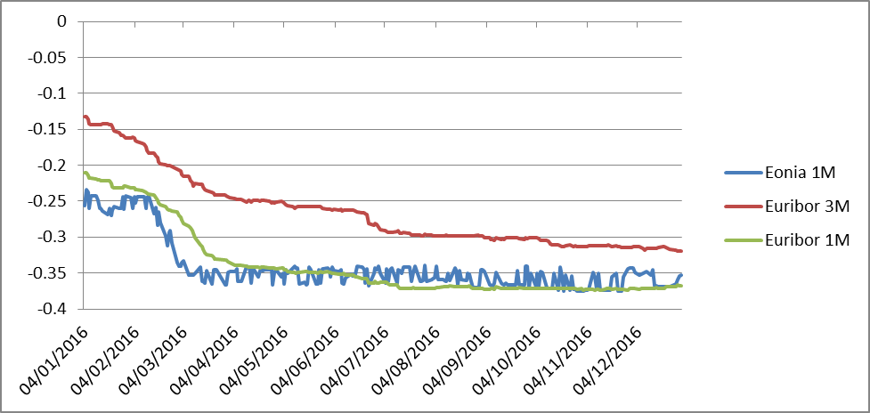

Fig. 2: Evolution of Money Market rates during 2016 (source Reuters)

- Profile of counterparties
In accordance with the agreement between the European Union and the EIB on the management of the Fund, all banks with which deposits are placed should have a minimum short-term credit rating of P-1 (Moody's or equivalent). The breakdown, including accrued interest, is as follows:
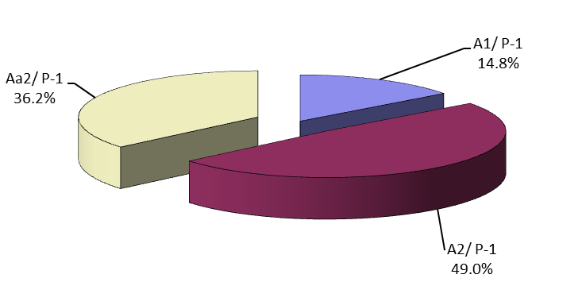
Fig. 3: Short term interbank investments by profile of counterparty at 31 December 2016

2.3.3.2. Analysis of bond portfolio results
The bond portfolio, seen as a long-term investment portfolio, is made up of euro-denominated securities initially acquired with the intention of holding them until maturity. In the Fund’s Financial Statements these securities are classified as Available for Sale (AFS) in line with the EC accounting rule 11. At 31 December 2016, the market value (excluding accrued interest) of securities with a residual period to maturity of less than three months amounted to EUR 82.1 million, between 3 months and one year EUR 25.2 million and between one and 10 years EUR 1,946.0 million.

The starting value of the securities in this portfolio is the acquisition cost. The difference between the entry price and the redemption value is the premium/discount spread, which is amortised over the remaining life of each of the securities using the effective interest rate method as specified in the EC accounting rules.

At 31 December 2016, the nominal value of the investment bond portfolio was EUR 1,944.8 million, against a clean market value of EUR 2,053.3 million.

The global (modified) duration of the bond portfolio increased over 2016 to reach 3.59 years at the end of the year. As of 31 December 2016, the clean market value of the investment bond portfolio came to EUR 2,053.3 million (2015: EUR 1,987.1 million) compared with a book value (including premiums/discounts) of EUR 2,017.8 million (2015: EUR 1,954.9 million), which gives an unrealised fair value result of EUR +35.5 million (2015: EUR +32.2 million).

The front end of the German government curve declined deeper into negative territory as ECB launched, continued the Public Sector Purchase Programme, lowered its deposit rate and extended the asset purchase program until end 2017. The long end of the yield curve has already started to rise in Q4 2016, due to normalizing inflation figures, but also following rising US rates.

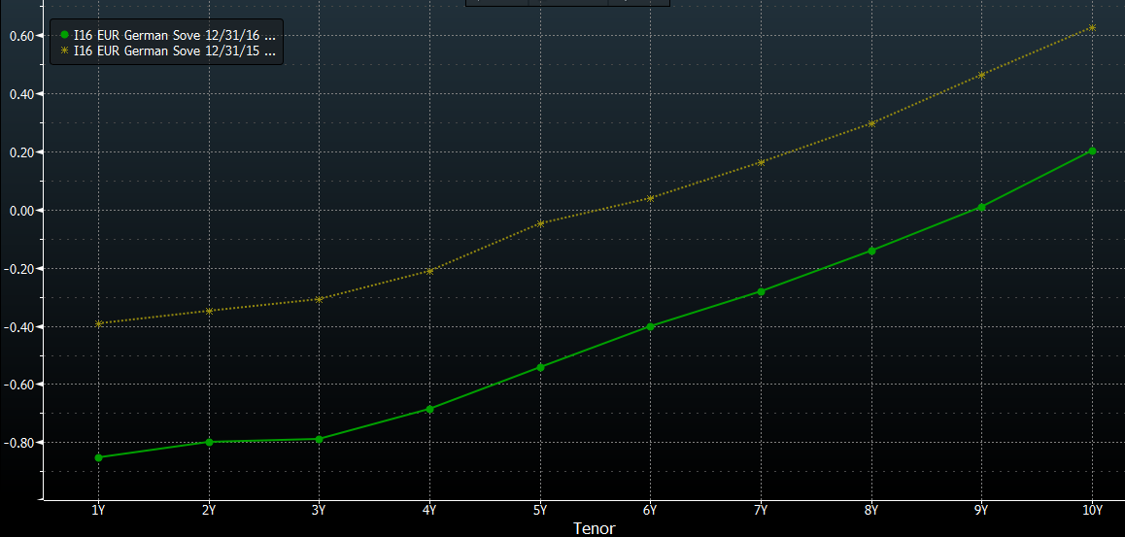

Fig. 4: Quasi parallel shift of the Euro sovereign yield curve during 2016 (source Bloomberg)

The decline of the yield curve had a positive impact on the Fund’s portfolio performance, which in terms of the absolute return amounted to 119 basis points.

In line with the 2016 approved investment strategy and in compliance with the guidelines, a total nominal amount of EUR 789.6 million was invested in four asset classes: SSA (EUR 400.2 million or 50.7%), covered bonds (EUR 176.7 million or 22.4%), corporate bonds (EUR 109.2 million or 13.8%) and financials (EUR 103.5 million or 13.1%) either on an outright or on a switch basis. The purchases were made both on the primary and on the secondary market. All of the transactions aimed to maximize the risk return profile of the portfolio while satisfying the liquidity constraints. The charts below outline the total 2016 investments per asset class as well as in terms of country distribution.
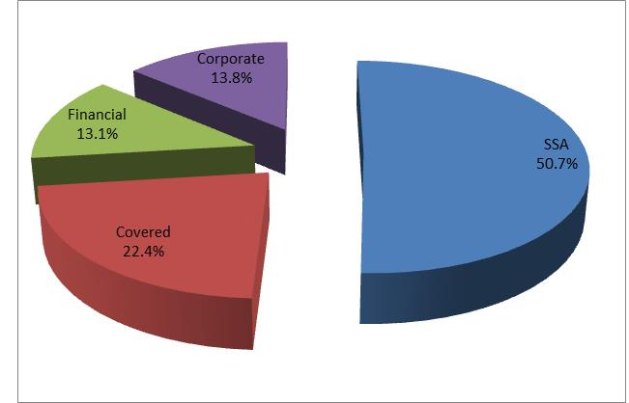
Fig. 5: 2016 Investments per asset class

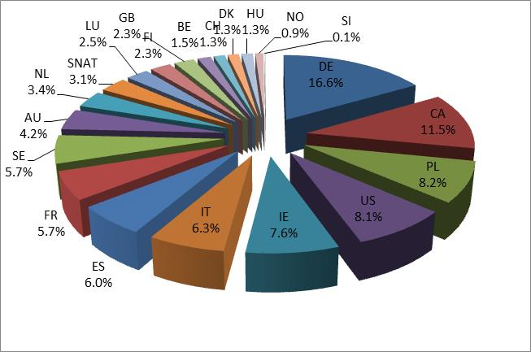

Fig. 6: 2016 Investments per country of exposure

The below chart displays the maturity and instrument format split of the 2016 investments. It can be inferred from the chart that the 5Y tenor, as most attractive spot on the yield curve in terms of risk and return consideration and supply dynamics of new issuances (but also in view of the overall Guarantee Fund portfolio duration management) has been favoured.

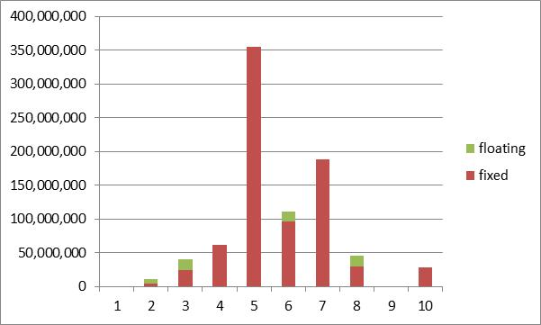

Fig. 7: 2016 Investments per maturity tenor and instrument type

- Breakdown of the investment portfolio between fixed rate and variable rate securities (nominal value)
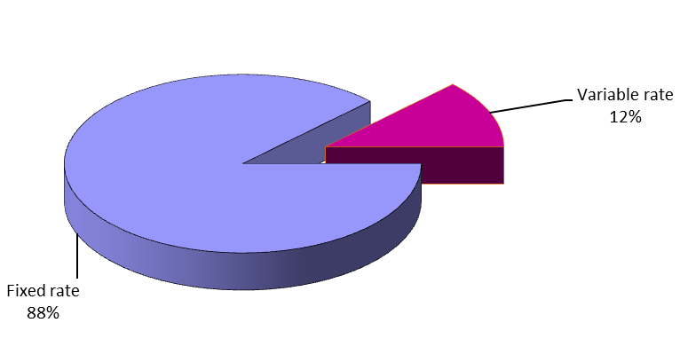
Fig. 8: Investment portfolio breakdown between fixed and variable rate securities at 31 December 2016

- Redemption profile of investment portfolio (nominal value)
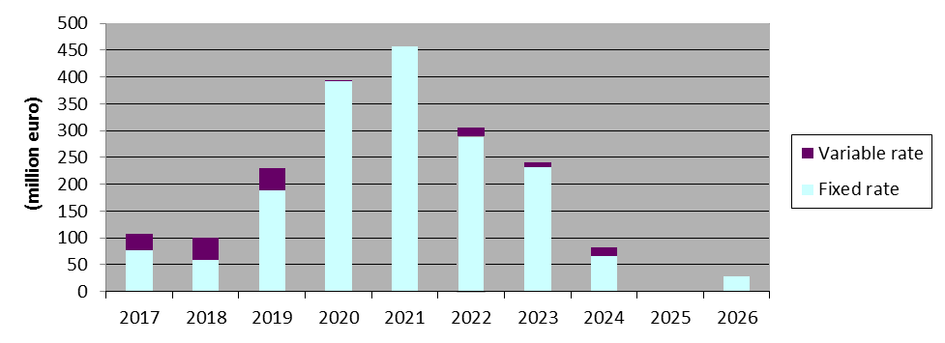
Fig.9: Investment portfolio: Redemption profile at 31 December 2016

The latest final maturity date for fixed rate securities is 7 December 2026.

Profile of issuers

All the securities held in the portfolio are in line with the management guidelines and meet the following criteria for:
Securities issued or guaranteed by Member States4: minimum rating Baa3;
Securities issued (or guaranteed) by a Supranational in which Member States are involved, other States, regional or local governments, public enterprises or institutions belonging to a government or controlled by the latter: minimum rating Aa2;
Covered Bonds or other legal bodies (including structured products): minimum rating Aaa;
Securities issued by other legal bodies (excluding CBs and structured products): minimum rating Aa2.

The profile of issuers by issuer type and long term rating⁵ of the investment portfolio (nominal amount) at 31 December 2016 is as follows:

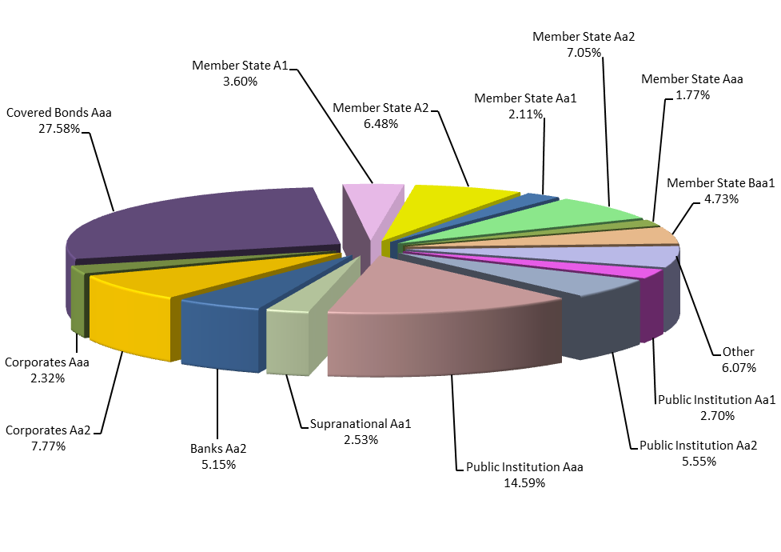
Fig.10: Investment portfolio: Profile of issuers at 31 December 2016⁶

2.4. Benchmarking, performance and interest rate risk analysis

2.4.1. Benchmarking
The performance of the Fund is monitored on a marked-to-market (MTM) basis against a composite index. This index is the result of the combination of the following sub-indices:
- Euribid 1M for money-market operations
- Euribid 3M for floating rate notes and fixed rate bond with less than one year to maturity
- IBOXX EUR Sovereign indices for fixed rate bonds issued by sovereign (or similar) issuers, split by maturity buckets
- IBOXX EUR Collateralized Covered indices for fixed rate bonds issued by non-sovereign issuers, split by maturity buckets
Index weightings are based on portfolio composition and are reviewed:
- at each end-month day: the dates which define the time buckets (up to 1y, from 1y to 3y, from 3y o 5y, from 5y to 7y and from 7y to 10y) are updated. As a consequence, the shifts between buckets due to the aging of existing positions are accounted only once per month at end-month, following the same procedure underlying the managing of the IBOXX’s indexes;
- during the month, whenever a change higher than ±5% in one of the asset-classes (with respect to the last benchmark’s adjustment) is observed. This change can be the result of:
- the impact of a contribution from the European Commission to the portfolio (external cash flows from the European Commission);
- the impact of a withdrawal from the portfolio to the European Commission (external cash flows to the European Commission);
- the impact of a transaction settled (sales and purchases);
- the impact of a redemption;
- the sum of the impacts of previous events accumulated from the last benchmark’s adjustment, taking also into consideration the changes in the clean values of the positions.

Bucket (years) | Performance Benchmark Sector | Instrument | Average Clean Market Value Composition of 2016
0-1 | 1 m | Money Market | 10.3%
0-1 | 3 m | FRN and Fixed Rate Bonds | 13.2%
1-3 | sovereign | Fixed  Rate  Bonds | 6.3%
1-3 | covered bonds | Fixed  Rate  Bonds | 5.1%
3-5 | sovereign | Fixed  Rate  Bonds | 21.3%
3-5 | covered bonds | Fixed  Rate  Bonds | 18.4%
5-7 | sovereign | Fixed  Rate  Bonds | 12.3%
5-7 | covered bonds | Fixed  Rate  Bonds | 9.1%
7-10 | sovereign | Fixed  Rate  Bonds | 3.3%
7-10 | covered bonds | Fixed  Rate  Bonds | 0.7%
Total |  |  | 100.00%

2.4.2. Performance
The performance of the Fund portfolio was monitored on a marked-to-market basis. During 2016, the portfolio delivered a 1.5563% MTM yearly return, outperforming its benchmark by +36.35 bps. The evolution of the portfolio return and excess return vis-à-vis its benchmark is presented in the following table:
 | Portfolio |  |  |  | Out-performance
 | Market Value (including accrued interest) | Monthly return (absolute return in %) | YTD return (absolute return in %) |  | Monthly  Excess Return compared to benchmark (in%) | YTD  Excess Return (in%)
31/01/2016 | 2,096,033,946 | 0.6614 | 0.6614 |  | 0.0453 | 0.0453
29/02/2016 | 2,346,683,034 | 0.3747 | 1.0385 |  | 0.1023 | 0.1484
31/03/2016 | 2,344,080,716 | 0.0291 | 1.0679 |  | -0.0381 | 0.1100
30/04/2016 | 2,341,402,523 | -0.1144 | 0.9523 |  | 0.0272 | 0.1374
31/05/2016 | 2,341,091,766 | 0.3182 | 1.2735 |  | -0.0189 | 0.1188
30/06/2016 | 2,352,164,085 | 0.4732 | 1.7527 |  | 0.0259 | 0.1455
31/07/2016 | 2,342,069,835 | 0.3473 | 2.1061 |  | 0.0965 | 0.2440
31/08/2016 | 2,339,135,475 | 0.0177 | 2.1241 |  | 0.0193 | 0.2638
30/09/2016 | 2,328,656,706 | 0.0802 | 2.2060 |  | -0.0071 | 0.2568
31/10/2016 | 2,316,828,306 | -0.5074 | 1.6875 |  | 0.0872 | 0.3443
30/11/2016 | 2,279,306,860 | -0.3279 | 1.3540 |  | 0.1162 | 0.4609
31/12/2016 | 2,265,816,160 | 0.1996 | 1.5563 |  | -0.0975 | 0.3635

2.4.3. Interest rate risk
The interest rate risk sensitivity of the MTM value of the portfolio mainly stems from its fixed rate exposure. A 1bp increase of interest rates reduces the value of the portfolio by EUR 813,908 of which EUR 809,729 is related to the fixed rate bond exposure. The global modified duration of the fund increased during 2016 and stood at 3.59 years as of 31 December 2016, compared to 3.21 years as of 31 December 2015.

GF Sub- Portfolios | Market Value (excluding accrued interest) | Modified Duration (Years) | Interest Rate Exposure (+/-1bp)
Floating Rate Notes | 155,579,358 | 0.168 | +/- 2,618
Fixed Rate Bonds | 1,867,673,111 | 4.300 | +/- 809,729
Money Market Instruments | 181,511,622 | 0.086 | +/- 1,561
Cash account | 45,431,504
Total GF | 2,250,195,595 | 3.592 | +/- 813,908

3. Guarantee Fund Financial Statements as at 31 December 2016

GUARANTEE FUND
FINANCIAL STATEMENTS
AS AT 31 DECEMBER 2016

- Balance sheet
- Statement of financial performance
- Statement of changes in net assets
- Cash flow statement
- Notes to the financial statements

Balance sheet
as at 31 December 2016
(in EUR)
ASSETS | Notes | 31.12.2016 | 31.12.2015
NON-CURRENT ASSETS
Available for Sale portfolio | 5
Bond portfolio – cost |  | 1,925,695,346.90 | 1,588,306,103.90
Bond portfolio – actuarial difference |  | -14,941,415.17 | -4,001,734.22
Bond portfolio – adjustment to fair value |  | 35,210,126.78 | 29,929,113.76
Total Available for Sale Portfolio |  | 1,945,964,058.51 | 1,614,233,483.44
TOTAL NON-CURRENT ASSETS |  | 1,945,964,058.51 | 1,614,233,483.44
CURRENT ASSETS
Available for Sale portfolio | 5
Bond portfolio – cost |  | 107,179,405.97 | 370,666,625.76
Bond portfolio – actuarial difference |  | -166,591.12 | -28,761.69
Bond portfolio – adjustment to fair value |  | 283,519.70 | 2,194,274.03
Bond portfolio – accrued interest |  | 15,390,711.64 | 14,960,434.80
Total Available for Sale portfolio |  | 122,687,046.19 | 387,792,572.90
Short-term receivables
Contributions receivable | 7 | 240,540,250.00 | 257,121,792.00
Total short-term receivables |  | 240,540,250.00 | 257,121,792.00
Cash and cash equivalents | 6
Current accounts |  | 45,431,503.50 | 49,145,562.99
Short-term deposits – nominal |  | 151,500,000.00 | 44,800,000.00
Short-term deposits - accrued interest |  | -69,805.06 | -2,301.19
Short-term deposits under settlement |  | 0.00 | -10,000,000.00
Total cash and cash equivalents |  | 196,861,698.44 | 83,943,261.80
TOTAL CURRENT ASSETS |  | 560,088,994.63 | 728,857,626.70
TOTAL ASSETS |  | 2,506,053,053.14 | 2,343,091,110.14
NET ASSETS AND LIABILITIES | Notes | 31.12.2016 | 31.12.2015
NET ASSETS
Contributions | 7
Net contributions paid in |  | 1,258,843,554.67 | 1,112,550,629.06
Contributions payable as guarantee call |  | 0.00 | -22,130,631.78
Contributions allocated but not yet paid in |  | 240,540,250.00 | 257,121,792.00
Reserves
Fair value reserve |  | 35,493,646.48 | 32,123,387.79
Accumulated surplus |  | 940,394,573.31 | 908,051,618.54
Economic result of the year |  | 29,849,553.53 | 32,342,954.77
TOTAL NET ASSETS |  | 2,505,121,577.99 | 2,320,059,750.38
LIABILITIES
CURRENT LIABILITIES
Guarantee call payable |  | 0.00 | 22,130,631.78
Other payables | 8 | 931,475.15 | 900,727.98
TOTAL CURRENT LIABILITIES |  | 931,475.15 | 23,031,359.76
TOTAL NET ASSETS AND LIABILITIES |  | 2,506,053,053.14 | 2,343,091,110.14
Statement of financial performance
For the year ended 31 December 2016
(in EUR)
 |  | From 01.01.2016  to 31.12.2016 | From 01.01.2015  to 31.12.2015
Expenses from operating activities |  | -1,074,112.12 | -1,045,413.10
Management fees |  | -891,975.15 | -861,227.98
Audit fees |  | -39,500.00 | -39,500.00
Bank fees |  | -142,636.97 | -144,685.12
Result from operating activities |  | -1,074,112.12 | -1,045,413.10
Financial revenue
Interest income |  | 14,387,844.82 | 24,252,802.28
Cash and cash equivalents |  | 831.14 | 26,254.60
Bond portfolio |  | 14,387,013.68 | 24,226,547.68
Realised gain on sale of Bond portfolio |  | 16,756,863.88 | 9,176,573.59
Income from securities lending activity |  | 119,696.45 | 115,809.80
Financial expenses
Interest expense |  | -340,739.50 | -8,633.64
Cash and cash equivalents |  | -340,739.50 | -8,633.64
Realised loss on sale of Bond portfolio |  | 0.00 | -148,184.16
Result from non-operating activities |  | 30,923,665.65 | 33,388,367.87
ECONOMIC RESULT OF THE YEAR |  | 29,849,553.53 | 32,342,954.77
Items directly recognised in net assets
Net change in fair value of Bond portfolio |  | 15,957,105.74 | -10,981,522.17
Net amount transferred to statement of financial performance |  | -12,586,847.05 | -12,996,945.49
NET RESULT RECOGNISED IN NET ASSETS |  | 3,370,258.69 | -23,978,467.66

Statement of changes in net assets
For the year ended 31 December 2016
(in EUR)

 |  | Contributions | Fair value reserve | Accumulated surplus | Economic result of the year | Total net assets
Balance as at 01.01.2015 |  | 1,150,514,734.55 | 56,101,855.45 | 878,284,248.11 | 29,767,370.43 | 2,114,668,208.54
Contributions from the European Commission allocated but not yet paid | 7 | 257,121,792.00 | 0.00 | 0.00 | 0.00 | 257,121,792.00
Contributions paid to the EIB as guarantee call | 7 | -60,164,571.55 | 0.00 | 0.00 | 0.00 | -60,164,571.55
Change of contributions payable as guarantee call | 7 | 69,834.28 | 0.00 | 0.00 | 0.00 | 69,834.28
Change of fair value reserve | 5 | 0.00 | -23,978,467.66 | 0.00 | 0.00 | -23,978,467.66
Allocation of the Economic result of the year 2014 |  | 0.00 | 0.00 | 29,767,370.43 | -29,767,370.43 | 0.00
Economic result of the year 2015 |  | 0.00 | 0.00 | 0.00 | 32,342,954.77 | 32,342,954.77
Balance as at 31.12.2015 |  | 1,347,541,789.28 | 32,123,387.79 | 908,051,618.54 | 32,342,954.77 | 2,320,059,750.38
Contributions from the European Commission allocated but not yet paid | 7 | 240,540,250.00 | 0.00 | 0.00 | 0.00 | 240,540,250.00
Contributions paid to the EIB as guarantee call | 7 | -110,828,866.39 | 0.00 | 0.00 | 0.00 | -110,828,866.39
Change of contributions payable as guarantee call | 7 | 22,130,631.78 | 0.00 | 0.00 | 0.00 | 22,130,631.78
Change of fair value reserve | 5 | 0.00 | 3,370,258.69 | 0.00 | 0.00 | 3,370,258.69
Allocation of the Economic result of the year 2015 |  | 0.00 | 0.00 | 32,342,954.77 | -32,342,954.77 | 0.00
Economic result of the year 2016 |  | 0.00 | 0.00 | 0.00 | 29,849,553.53 | 29,849,553.53
Balance as at 31.12.2016 |  | 1,499,383,804.67 | 35,493,646.48 | 940,394,573.31 | 29,849,553.53 | 2,505,121,577.99

Cash flow statement
For the year ended 31 December 2016
(in EUR)

 | Notes | From 01.01.2016  to 31.12.2016 | From 01.01.2015  to 31.12.2015
Operating activities
Treasury management fee paid during the year |  | -861,227.98 | -844,872.97
Bank fees / audit fees paid during the year |  | -182,136.97 | -184,185.12
Contributions paid as guarantee call |  | -110,828,866.39 | -60,164,571.55
Net cash flows used in operating activities |  | -111,872,231.34 | -61,193,629.64
Investing activities
Net interest received on cash and cash equivalents |  | -272,404.49 | 25,933.94
Purchase of investments - Bond portfolio | 5 | -991,735,364.00 | -1,054,379,125.37
Proceeds of investments - Bond portfolio |  | 930,234,324.63 | 877,556,734.34
Interest received - Bond portfolio |  | 29,390,127.26 | 29,483,128.69
Income from securities lending activity |  | 119,696.45 | 115,809.80
Net cash flows used in investing activities |  | -32,263,620.15 | -147,197,518.60
Financing activities
Contributions received from the European Commission | 7 | 257,121,792.00 | 144,409,518.00
Net cash flows from financing activities |  | 257,121,792.00 | 144,409,518.00
Net decrease in cash and cash equivalents |  | 112,985,940.51 | -63,981,630.24
Cash and cash equivalents at the beginning of the financial year |  | 83,945,562.99 | 147,927,193.23
Cash and cash equivalents at the end of the financial year |  | 196,931,503.50 | 83,945,562.99
Cash and cash equivalents are composed of
(excluding accrued interest):
Current accounts |  | 45,431,503.50 | 49,145,562.99
Short-term deposits |  | 151,500,000.00 | 44,800,000.00
Short-term deposits under settlement |  | 0.00 | -10,000,000.00
Total cash and cash equivalents |  | 196,931,503.50 | 83,945,562.99

Notes to the financial statements as at 31 December 2016

3.1. General disclosures
The rules and principles for the management of the Guarantee Fund (the “Fund”) are laid out in the Agreement between the European Commission (the “EC”) and the European Investment Bank (the “EIB”) dated 25 November 1994 and the subsequent amendments to the Agreement dated 23 September 1996, 8 May 2002, 5 June 2002, 25 February 2008 and 9 November 2010 (the “Convention”).
The main principles of the Fund, as extracted directly from the Convention, are as follows:
- The Fund will operate in one single currency being Euro (EUR). It will exclusively invest in this currency in order to avoid any exchange rate risk.
- The management of the Fund will be based upon the traditional rules of prudence relating to financial activities. Attention is given to control the risks and to ensure that the managed assets have a sufficient degree of liquidity and transferability while considering the Fund’s commitments.
The present financial statements cover the period from 1 January 2016 to 31 December 2016.
EIB’s management has authorized the financial statements for issue on 24 March 2017.

3.2. Significant accounting policies

3.2.1. Basis of preparation
The Fund’s financial statements have been prepared in accordance with the accounting rules adopted by the Accounting Officer of the European Commission, in particular “Accounting rule 11 – Financial assets and liabilities” dated December 2004 and updated in October 2006, December 2009 and December 20112.
The financial statements have been prepared on a going concern basis, which assumes that the Fund will be able to meet the mandatory payments of the guarantees.
According to articles 3, 5 and 6 of Council Regulation (EC, Euratom) No 480/2009 of 25 May 2009 if, as a result of the activation of guarantees following one or more defaults, resources in the Fund fall below the set target amount of 9% of total outstanding capital liabilities arising from each operation, plus any unpaid interest, then the European Commission transfers to the Fund the difference between the target amount and the value of the Fund’s net assets at the previous year-end balance sheet date.
The amounts in the financial statements are not rounded except in the section financial risk management where the amounts are rounded to the nearest thousand EUR.

3.2.2. Changes in accounting policies
The Fund has consistently applied to all periods the accounting policies set out in Note 2.4 presented in these financial statements.

3.2.3. Significant accounting judgments and estimates
The preparation of financial statements in conformity with the accounting rules adopted by the Accounting Officer of the European Commission requires the use of certain critical accounting estimates. It also requires the EIB Management to exercise its judgment in the process of applying the Fund’s accounting policies. The areas involving a higher degree of judgment or complexity, or areas where assumptions and estimates are significant to the financial statements are disclosed hereafter.
The most significant use of judgments and estimates are as follows:
Measurement of fair value of financial instruments
The fair value of financial assets and financial liabilities that are traded in active markets is based on quoted market prices or broker price quotations. Where the fair values of financial assets and financial liabilities recorded on the balance sheet cannot be derived from active markets, they are determined using a variety of valuation techniques that include the use of mathematical models. The input to these models is taken from observable markets where possible, but where this is not feasible, a degree of judgment is required in establishing fair values.
Impairment losses on financial instruments
The Fund reviews its financial instruments at each reporting date to assess whether an allowance for impairment should be recorded in the statement of financial performance. In particular, judgment by EIB Management is required in the estimation of the amount and timing of future cash flows when determining the level of allowance required.

3.2.4. Summary of significant accounting policies

3.2.4.1. Foreign currency translation
The Fund uses the Euro (EUR) for presenting its financial statements, which is also the functional currency.
Foreign currency transactions are translated at the exchange rate prevailing on the date of the transaction.
Monetary assets and liabilities denominated in currencies other than Euro are translated into Euro at the exchange rate prevailing at the balance sheet date. The gain or loss arising from such translation is recorded in the statement of financial performance.
Non-monetary items that are measured in terms of historical cost in a foreign currency are translated using the exchange rates at the dates of the initial transactions. Non-monetary items measured at fair value in a foreign currency are translated using the exchange rates at the date when the fair value was determined.
Exchange differences on non-monetary assets are a component of the change in their fair value. Depending on the classification of a non-monetary financial asset, exchange differences are either recognised in the statement of financial performance or within the reserves.
Exchange differences arising on the settlement of transactions at rates different from those at the date of the transaction, and unrealised foreign exchange differences on unsettled foreign currency monetary assets and liabilities, are recognised in the statement of financial performance.

3.2.4.2. Financial instruments
All financial assets are recognised in the balance sheet on trade date basis and measured according to their assigned category.

(a) Cash and cash equivalents
The Fund defines cash and cash equivalents as current accounts, commercial papers, treasury bills and short-term deposits with original maturity of three months or less.

(b) Bond portfolio
The bond portfolio is composed of Euro-denominated securities.
These securities are classified as Available for Sale (AFS) according to the accounting rules adopted by the Accounting Officer of the European Commission and consequently, are carried out at their fair value through net assets.
In accordance with the decision of the Accounting Officer of the Commission4 concerning the “Presentation of the Guarantee Fund for external actions and other Available for Sale portfolios” on 31 January 2013, the Available for Sale financial instruments of the Fund’s Portfolio are categorised following the current/non-current distinction of Article 8.3 of the Accounting rule 1 according to their remaining contractual maturity at the balance sheet date. Available for Sale investments with a remaining maturity of less than a year and accrued interest with due date less than a year are presented in the balance sheet as current assets, while Available for Sale investments with a remaining maturity of more than a year are presented in the balance sheet as non-current assets.
Unrealised gains or losses are reported in reserves until such a security is sold, collected or otherwise disposed of, or until such a security is determined to be impaired. Impairment losses identified are recognised in the statement of financial performance for the year.
On disposal of an Available for Sale security, the accumulated unrealised gain or loss included in net assets is transferred to the statement of financial performance for the year. Interest income on Available for Sale securities is included in “interest income”.
The determination of fair values of Available for Sale investments is generally based on quoted market rates in active markets.
These securities are initially measured at their acquisition cost, being their fair value at this moment. The difference between the entry price and the redemption value, i.e. the premium/discount spread, is amortised over the remaining life of each of the securities using the effective interest rate method as specified under Accounting rule 11.
Securities are considered impaired if there is objective evidence of impairment as a result of one or more events that occurred after the initial recognition of the security (a “loss event”) and that loss event has an impact on the estimated future cash flows of the security that can be reliably estimated.
Evidence of impairment is mainly about significant financial difficulties of the issuer, e.g. a breach of contract, a restructuring of the debt of the issuer or a high probability of bankruptcy. It is important to stress that the disappearance of an active market because the entity’s financial instruments are no longer publicly traded is not evidence of impairment. A downgrade of an entity’s credit rating is not, in itself, evidence of impairment, although it may be evidence of impairment when considered with other available information. A decline in the fair value of a financial asset below its cost or amortised cost is not necessarily evidence of impairment.
If in a subsequent period, the fair value of a debt instrument classified as Available for Sale increases and the increase can be objectively related to an event occurring after the impairment loss was recognised in the statement of financial performance, the impairment loss shall be reversed, with the amount of the reversal recognised in the statement of financial performance.

(c) Fair value of financial instruments
Fair value is the amount for which an asset could be exchanged, or a liability settled, between knowledgeable, willing parties in an arm’s length transaction.
When applicable, the EIB on behalf of the Fund measures the fair value of an instrument using the quoted price in an active market for that instrument. A market is regarded as active if transactions for the asset or liability take place with sufficient frequency and volume to provide pricing information on an on-going basis.
Where the fair values of financial assets and financial liabilities recorded on the balance sheet cannot be derived from active markets, they are determined using a variety of valuation techniques that include the use of mathematical models. The input to these models is taken from observable markets where possible, but where this is not feasible, a degree of judgement is required in establishing fair values. The chosen valuation technique incorporates all the factors that market participants would take into account in pricing a transaction.
The Fund measures fair values using the following fair value hierarchy that reflects the significance of the inputs used in making the measurements:
- Level 1: Quoted prices (unadjusted) in active markets for identical assets or liabilities;
- Level 2: Inputs other than quoted prices included within Level 1 that are observable for the asset or liability, either directly (i.e., as price) or indirectly (i.e., derived from prices);
- Level 3: Inputs for the asset or liability that are not based on observable market data (unobservable
inputs).
The Fund recognises transfers between levels of the fair value hierarchy as of the end of the reporting period during which the change has occurred.

(d) Impairment of financial assets
The EIB assesses at each balance sheet date whether there is any objective evidence that a financial asset or a group of financial assets is impaired. A financial asset or a group of financial assets is deemed to be impaired if, and only if, there is objective evidence of impairment as a result of one or more events that has occurred after the initial recognition of the asset (an incurred “loss event”) and that loss event has an impact on the estimated future cash flows of the financial asset or the group of financial assets that can be reliably estimated. Evidence of impairment may include indications that the borrower or a group of borrowers is experiencing significant financial difficulty, default or delinquency in interest or principal payments, the probability that they will enter bankruptcy or other financial reorganisation and where observable data indicate that there is a measurable decrease in the estimated future cash flows, such as changes in arrears or economic conditions that correlate with defaults.
For the Available for Sale financial assets, an objective evidence would include a significant or prolonged decline in the fair value of the investment below its cost. Where there is evidence of impairment, the cumulative loss (measured as the difference between the acquisition cost net of any principal repayment and amortisation and the current fair value, less any impairment loss on that investment previously recognised in the statement of financial performance) is removed from net assets and recognised in the statement of financial performance. Impairment losses on Available for Sale financial assets are reversed through the statement of financial performance.

3.2.4.3. Contributions
Contributions are increased by:
- Payment allocations made to the Fund by the general budget of the European Union;
- Guarantee recoveries received from EIB.

Contributions are decreased by:
- Payment allocations to be made from the Fund to the general budget of the European Union;
- Guarantee calls made by the EIB.

Contributions to be received5 from the general budget of the European Union, or to be paid back to the general budget of the European Union are recognized in the balance sheet on the date when they become due or owed according to articles 3, 4, 5 and 6 of the Council Regulation (EC, Euratom) No 480/2009 of 25 May 2009 establishing a Guarantee Fund for external actions (codified version). When it relates to articles 5 and 6 the contributions to be paid or received, based on the year end n-1 difference between the target amount and the value of the Fund’s net assets, are calculated and recorded at the beginning of the year n. When article 4 applies, the contribution to be paid back is calculated and recorded at the date of accession of the new Member State to the European Union.
Contributions to be paid to the EIB in the context of guarantee calls in line with the Recovery Agreement between the European Union and the EIB signed on 25 July 2014 in respect of loans and loan guarantees granted by the EIB for projects outside the European Union (“Recovery Agreement”) are derecognised from the balance sheet on the date when the guarantee call becomes due.
Guarantee recoveries paid from the EIB to the Fund in line with the Recovery Agreement are recognised in the balance sheet as contributions on the date when the guarantee recovery becomes due.

3.2.4.4. Interest income
Interest income covers interest earned on cash and cash equivalents and the Bond portfolio and is recorded in the statement of financial performance on an accrual basis.

3.2.4.5. Interest expense
Interest expense covers interest paid on cash and cash equivalents, due to negative interest rate, and is recorded in the statement of financial performance on an accrual basis.

3.2.4.6. Treasury management fees
According to the Convention, EIB shall receive a treasury management fee which is calculated on the basis of, in the case of securities, the average market value at the end of each month, and in the case of cash and money market deposits, the average nominal value at the end of each month.
Treasury management fees are recorded in the statement of financial performance on an accrual basis.

3.2.4.7. Securities Lending Activity
In April 2008 the Fund entered into an automatic securities lending program with Euroclear Bank SA/NV to lend assets from its Bond portfolio. Within this securities lending program all bonds from the Bond portfolio are eligible to be lent out.
Securities lent within the automatic securities lending program are not derecognized from the Fund’s balance sheet as the control of the contractual rights that comprises these securities is still held by the Fund itself.
Income from securities lending activity is recorded in the statement of financial performance on an accrual basis.

3.2.5. Taxation
The Protocol on the Privileges and Immunities of the European Union, appended to the treaty on the European Union and the treaty of the functioning of the European Union, stipulates that the assets, revenues and other property of the Institutions of the Union are exempt from all direct taxes.

3.3. Financial Risk Management
This note presents information about the Fund’s treasury portfolio exposure, its management and control of credit and financial risks, in particular the primary risks associated with its use of financial instruments. These are:
- credit risk – the risk of loss resulting from client or counterparty default and arising on credit exposure in all forms, including settlement risk;
- liquidity risk – the risk that an entity will encounter difficulty in meeting obligations associated with financial liabilities that are settled by delivering cash or another financial asset;
- market risk – exposure to observable market variables such as interest rates and foreign exchange rates.

3.3.1. Risk management organisation
The Risk Management function of EIB ensures that the treasury portfolio is managed in line with the agreed asset management guidelines, especially in respect of the eligible investments, the maximum maturity, the interest rate risk and the credit risk exposure of the Fund’s treasury portfolio. In this respect quarterly reporting is also delivered to the EC concerning the risk and the performance of the Fund’s treasury portfolio. The reporting makes reference to breaches, if any, of the limits set out in the asset management guidelines and includes a comparison of the valuations of the portfolio to a performance index taken as benchmark.

3.3.2. Credit Risk
Credit risk is the potential loss that could result from client or counterparty default and arising on credit exposure in all forms, including settlement.

3.3.2.1. Credit risk policy
The treasury portfolio’s agreed asset management guidelines and/or investment strategy define certain limits and restrictions in order to limit the exposure to credit risk of the treasury portfolio. The compliance with these limits is monitored by the Risk Management on a daily basis. Such limits and restrictions include eligibility criteria, absolute credit limits in nominal terms depending on issuer category, relative concentration limits depending on issuer category and concentration limits per issue.

3.3.2.2. Maximum exposure to credit risk without taking into account any collateral and other credit enhancements
The following table shows the maximum exposure to credit risk for the components of the balance sheet (in EUR):
Maximum exposure | 31.12.2016 | 31.12.2015
ASSETS
Available for Sale portfolio | 2,068,651,104.70 | 2,002,026,056.34
Contributions receivable | 240,540,250.00 | 257,121,792.00
Cash and cash equivalents | 196,861,698.44 | 93,943,261.80 | *
Total assets | 2,506,053,053.14 | 2,353,091,110.14
Total credit exposure | 2,506,053,053.14 | 2,353,091,110.14
* out of which EUR 10,000,000.00 is related to short-term deposits under settlement.

3.3.2.3. Credit risk on cash and cash equivalents

(a) Analysis of current accounts per profile of counterparties
The following table shows the breakdown of current account balances per maximum long-term counterparty rating (based on the external long term ratings assigned by Fitch, Standard & Poor’s and Moody’s) (in EUR):

Rating | 31.12.2016 | 31.12.2015
A1 | 45,424,684.55 | 49,123,538.63
Aa1 | 6,818.95 | 22,024.36
Total | 45,431,503.50 | 49,145,562.99

All counterparties are maximum rated P-1 short-term (based on the external short term ratings assigned by Fitch, Standard & Poor’s and Moody’s).
The Fund has two current accounts opened with BNP Paribas Fortis and one current account opened with Euroclear Bank as follows (in EUR):

Current accounts | 31.12.2016 | 31.12.2015
BNP Paribas Fortis transitory account | 32,777.03 | 33,884.70
BNP Paribas Fortis current account | 45,391,907.52 | 49,089,653.93
Euroclear Bank current account | 6,818.95 | 22,024.36
Total | 45,431,503.50 | 49,145,562.99

(b) Analysis of short term deposits per profile of counterparties
In accordance with the agreement between the European Commission and the EIB on the management of the Fund, all interbank investments should have a minimum issuer short-term rating from Moody’s or equivalent of P-1. The following table shows the breakdown of short term deposits (excluding short-term deposits under settlement) per maximum counterparty long term rating (based on the external long term ratings assigned by Fitch, Standard & Poor’s and Moody’s), the amounts presented include accrued interest (in EUR):

Rating | 31.12.2016 |  |  | 31.12.2015
Aa2 | 54,771,262.27 |  | 36.17% | 4,599,616.67 |  |  | 10.27%
A1 | 22,382,826.67 |  | 14.78% | 0.00 |  |  | 0.00%
A2 | 74,276,106.00 |  | 49.05% | 10,699,861.36 | * |  | 23.88%
Aa3 | 0.00 |  | 0.00% | 29,498,220.78 |  |  | 65.85%
Total | 151,430,194.94 |  | 100.00% | 44,797,698.81 |  |  | 100.00%
* out of which EUR 10,000,000.00 is related to short-term deposits under settlement.

3.3.2.4. Credit risk on Bond portfolio

(a) Risk concentration per issuance Credit risk on Bond portfolio
All the securities held in the portfolio are in line with the management guidelines and meet the following criteria for:
- Securities issued or guaranteed by Member States: minimum rating Baa3;
- Securities issued by a Supranational, other States or Public Company: minimum rating Aa2;
- Covered Bonds or other legal bodies (including structured products): minimum rating Aaa;
- Securities issued by Banks and Corporates: minimum rating Aa2.
The following table shows the breakdown of the Bond portfolio, at market value excluding accrued interest, per security type and rating (in EUR):
Issuer - Rating | 31.12.2016 |  | 31.12.2015
Banks Aa1 | 25,488,370.00 | 1.24% | 0.00 | 0.00%
Banks Aa2 | 107,722,271.70 | 5.25% | 60,018,950.00 | 3.02%
Banks Aa3 | 10,000,224.54 | 0.49% | 20,504,766.41 | 1.03%
Banks A1 | 0.00 | 0.00% | 25,196,381.01 | 1.27%
Banks A2 | 0.00 | 0.00% | 12,899,988.56 | 0.65%
Member State Aaa | 37,469,081.50 | 1.81% | 136,777,774.50 | 6.88%
Member State Aa1 | 42,684,937.50 | 2.08% | 0.00 | 0.00%
Member State Aa2 | 141,949,442.00 | 6.91% | 126,727,098.85 | 6.38%
Member State Aa3 | 23,067,766.00 | 1.12% | 11,008,800.00 | 0.55%
Member State A1 | 82,865,400.00 | 4.04% | 91,597,718.50 | 4.61%
Member State A2 | 137,947,264.70 | 6.72% | 65,179,156.00 | 3.28%
Member State A3 | 14,196,000.00 | 0.69% | 37,114,380.00 | 1.87%
Member State Ba1 | 0.00 | 0.00% | 16,519,200.00 | 0.83%
Member State Baa1 | 101,889,400.20 | 4.96% | 68,076,178.64 | 3.43%
Member State Baa3 | 10,990,025.00 | 0.54% | 0.00 | 0.00%
Covered Bonds Aaa | 547,963,464.77 | 26.69% | 589,361,477.88 | 29.66%
Corporates Aaa | 47,135,337.90 | 2.30% | 0.00 | 0.00%
Corporates Aa1 | 25,944,010.02 | 1.26% | 113,062,955.15 | 5.69%
Corporates Aa2 | 166,870,276.95 | 8.13% | 72,737,601.19 | 3.66%
Public Institution Aaa | 289,509,565.62 | 14.10% | 237,206,683.00 | 11.94%
Public Institution Aa1 | 54,812,301.06 | 2.67% | 27,587,948.20 | 1.39%
Public Institution Aa2 | 116,941,116.50 | 5.70% | 223,558,927.85 | 11.25%
Supranational Aaa | 5,009,300.00 | 0.24% | 5,035,408.00 | 0.25%
Supranational Aa1 | 53,165,821.50 | 2.59% | 37,421,371.00 | 1.88%
Non-EU Public Institution Aaa | 4,103,365.60 | 0.20% | 4,115,106.80 | 0.21%
Non-EU Public Institution Aa2 | 5,535,650.00 | 0.27% | 5,357,750.00 | 0.27%
Total | 2,053,260,393.06 | 100.00% | 1,987,065,621.54 | 100.00%

The above table presenting securities ratings is prepared according to the agreed asset management guidelines. In particular, security ratings of the Bond portfolio refer to the best rating given by Moody’s, Standard & Poor’s or Fitch.
In case of securities for which no security rating is available the rating of the issuer (or guarantor for guaranteed positions) has been taken into account.

(b) EU sovereign exposure
The following tables show the portfolio structure by exposure towards EU sovereign (either directly or indirectly) and exposure towards other entities as at 31 December 2016 and as at 31 December 2015 (in EUR):

At 31.12.2016 | Purchase price | Value at maturity | Carrying Value*)
EU sovereigns
Austria | 11,420,950.00 | 11,500,000.00 | 12,195,972.50
Belgium | 21,957,400.00 | 20,000,000.00 | 23,067,766.00
Finland | 29,445,625.00 | 29,500,000.00 | 30,488,965.00
France | 138,439,640.00 | 137,000,000.00 | 141,949,442.00
Germany | 15,552,150.00 | 15,000,000.00 | 15,777,238.00
Hungary | 11,006,900.00 | 10,000,000.00 | 10,990,025.00
Ireland | 78,532,800.00 | 65,000,000.00 | 77,787,050.00
Italy | 54,493,000.00 | 50,000,000.00 | 53,851,795.00
Latvia | 13,978,020.00 | 14,000,000.00 | 14,196,000.00
Luxembourg | 14,946,600.00 | 15,000,000.00 | 17,189,458.50
Netherlands | 4,500,000.00 | 4,500,000.00 | 4,502,385.00
Poland | 139,001,000.00 | 125,000,000.00 | 136,826,408.00
Slovakia | 4,927,650.00 | 5,000,000.00 | 5,078,350.00
Slovenia | 1,122,000.00 | 1,000,000.00 | 1,120,856.70
Spain | 48,079,264.91 | 42,000,000.00 | 48,037,605.20
EU Supranational | 15,764,050.00 | 15,000,000.00 | 16,327,653.50
Total EU sovereigns | 603,167,049.91 | 559,500,000.00 | 609,386,970.40
Total EU sovereigns | 1,429,707,702.96 | 1,385,250,000.00 | 1,443,873,422.66
TOTAL | 2,032,874,752.87 | 1,944,750,000.00 | 2,053,260,393.06
*) The carrying value represents the clean market value of the assets excluding accrued interest.
At 31.12.2015 | Purchase price | Value at maturity | Carrying Value*)
EU sovereigns
Austria | 11,420,950.00 | 11,500,000.00 | 11,916,827.00
Belgium | 32,115,400.00 | 30,000,000.00 | 32,506,600.00
Czech Republic | 11,042,900.00 | 11,000,000.00 | 11,008,800.00
Finland | 29,445,625.00 | 29,500,000.00 | 29,766,005.00
France | 92,849,815.00 | 92,000,000.00 | 94,220,498.85
Germany | 50,090,150.00 | 50,000,000.00 | 53,591,183.00
Ireland | 67,492,000.00 | 55,000,000.00 | 66,266,018.50
Italy | 45,171,585.00 | 46,500,000.00 | 48,070,658.80
Latvia | 13,978,020.00 | 14,000,000.00 | 14,032,060.00
Lithuania | 12,460,600.00 | 13,000,000.00 | 13,047,320.00
Luxembourg | 14,946,600.00 | 15,000,000.00 | 16,985,344.50
Netherlands | 4,500,000.00 | 4,500,000.00 | 4,506,615.00
Poland | 64,903,000.00 | 60,000,000.00 | 65,179,156.00
Portugal | 16,032,480.00 | 16,000,000.00 | 16,519,200.00
Slovakia | 24,688,950.00 | 25,000,000.00 | 25,331,700.00
Slovenia | 10,000,000.00 | 10,000,000.00 | 10,035,000.00
Spain | 20,003,715.44 | 20,000,000.00 | 20,005,519.84
Sweden | 19,920,000.00 | 20,000,000.00 | 20,011,800.00
EU Supranational | 35,794,950.00 | 35,000,000.00 | 37,421,371.00
Total EU sovereigns | 576,856,740.44 | 558,000,000.00 | 590,421,677.49
Others | 1,382,115,989.22 | 1,352,158,731.40 | 1,396,643,944.05
TOTAL | 1,958,972,729.66 | 1,910,158,731.40 | 1,987,065,621.54
*) The carrying value represents the clean market value of the assets excluding accrued interest.
In the tables above “EU sovereigns” refer to bonds issued or guaranteed by EU Member States and EU Supranationals while “others” refer to bonds issued by banks, covered bonds, bonds issued or guaranteed by non EU Supranationals or EU and non EU Public Institutions.

3.3.3. Liquidity Risk
Liquidity risk refers to an entity’s ability to meet obligations as they become due, without incurring unacceptable losses. It can be split into funding liquidity risk and market liquidity risk. Funding liquidity risk is the risk that an entity will not be able to meet efficiently both expected and unexpected current and future cash flow needs without affecting its daily operations or its financial condition. Market liquidity risk is the risk that an entity cannot easily offset or eliminate a position at the market price because of inadequate market depth or market disruption.

3.3.3.1. Liquidity risk management
The treasury portfolio’s agreed asset management guidelines and/or investment strategy define certain limits and restrictions in order to limit the exposure to funding liquidity risk of the treasury portfolio. The compliance with these limits is monitored by Risk Management on a daily basis. Such limits and restrictions include a target liquidity buffer.

3.3.3.2. Liquidity risk measurement
The table below provides an analysis of the non-derivative liabilities into relevant maturity groupings based on the remaining contractual maturities. The table is presented under the most prudent consideration of maturity dates where the earliest possible repayment date is shown.

Maturity profile  (at 31 December 2016) | Less than  1 year | 1 year to  5 years | More than  5 years | TOTAL
Other payables | 931,475.15 | 0.00 | 0.00 | 931,475.15
Total | 931,475.15 | 0.00 | 0.00 | 931,475.15
Maturity profile  (at 31 December 2015) | Less than  1 year | 1 year to  5 years | More than  5 years | TOTAL
Guarantee call payable | 22,130,631.78 | 0.00 | 0.00 | 22,130,631.78
Other payables | 900,727.98 | 0.00 | 0.00 | 900,727.98
Total | 23,031,359.76 | 0.00 | 0.00 | 23,031,359.76

3.3.4. Market Risk
Market risk represents the risk that changes in market prices and rates, such as interest rates and foreign exchange rates will affect an entity’s income or the value of its holdings in financial instruments.
The treasury portfolio’s agreed asset management guidelines and/or investment strategy define certain restrictions (such as concentration limits, modified duration and target combined spread duration) in order to fulfil diversification and to control to market risk of the treasury portfolio. The compliance with these limits is monitored by Risk Management on a daily basis.

3.3.4.1. Interest rate risk position
Interest rate risk arises from the volatility in the economic value of, or in the income derived from the treasury portfolio’s interest rate bearing positions due to adverse movements in interest rates. Exposure to interest rate risk occurs when there are differences in repricing and maturity characteristics of the different assets and liabilities.

Interest rate sensitivity analysis
The interest rate sensitivity of the treasury portfolios represents the amount of a potential change in the fair value of the portfolio and is computed on a deal by deal basis assuming that all interest rate curves rose by one percentage basis and 100 basis points or decrease by one percentage basis point and 100 basis points.
The following table shows the sensitivity to interest rate variations of the three Guarantee Fund (“GF”) treasury sub-portfolios GF-Short term (Short term deposits, commercial papers and zero coupon bonds), GF-FRN (Bond portfolio variable interest), GF-Long term (Bond portfolio fixed interest). It is presented on the same basis as the quarterly risk management reporting delivered to the EC concerning the risk and the performance of the Fund’s portfolio.

31 December 2016
GF sub-portfolios | Clean market value  in EUR'000 | Modified Duration (Years) | IR Exposure  (+/-1bp)  in EUR'000 | IR Exposure (100bp)  in EUR'000 | IR Exposure  (-100bp)  in EUR'000
GF - Short term | 181,508 | 0.09 | -/+ 2 | -155 | + 157
GF - FRN | 155,579 | 0.17 | -/+ 3 | -260 | + 264
GF - Long term | 1,867,673 | 4.30 | -/+ 810 | -78,598 | + 83,468
Current accounts | 45,432 | 0.00 | -/+ 0 | 0 | 0
TOTAL GF | 2,250,192 | 3.59 | -/+ 815 | -79,013 | + 83,889
31 December 2015
GF sub-portfolios | Clean market value  in EUR'000 | Modified Duration (Years) | IR Exposure  (+/-1bp)  in EUR'000 | IR Exposure (100bp)  in EUR'000 | IR Exposure  (-100bp)  in EUR'000
GF - Short term | 113,412 | 0.17 | -/+ 2 | -191 | + 193
GF - FRN | 236,045 | 0.17 | -/+ 4 | -398 | + 401
GF - Long term | 1,672,414 | 3.94 | -/+ 665 | -64,524 | + 68,473
Current accounts | 49,146 | 0.00 | -/+ 0 | 0 | 0
TOTAL GF | 2,071,017 | 3.21 | -/+ 671 | -65,113 | + 69,067

The clean market value of the GF-Short term sub-portfolio as reported above represents the sum of clean market values calculated for short term deposits, commercial papers and zero coupon bonds. Those clean market values are determined as follows:
- Short-term deposits: the sum of the nominal value and total interest at maturity for each position is discounted from the maturity date to the spot date, whereas the spot date equals the valuation date plus two business days. Finally, accrued interest at spot date is subtracted from the calculated market value of the position.
- Commercial papers: the nominal value of each position is discounted from the maturity date to the spot date, whereas the spot date equals the valuation date plus two business days;
- Zero coupon bonds: the nominal value of each position is multiplied with the observed spot/quote/price.
The clean market values of the GF-FRN and GF-Long term sub-portfolios as reported above represents the sum of the clean market values calculated for fixed and floating rate bonds. Those clean market values are determined as follows:
- Fixed rate bonds: the nominal value of each position is multiplied by its market quote as observed at valuation date.
- Floating rate bonds (FRNs): the nominal value of each position is multiplied by its market quote as observed at valuation date.

3.3.5. Foreign exchange risk exposure
Foreign exchange risk is the volatility in the economic value of, or in the income derived from, the Fund’s positions due to adverse movements of foreign exchange rates.
As all assets and liabilities of the Fund are denominated in Euro, the Fund is not exposed to foreign exchange risk.

3.4. Fair value of financial instruments

3.4.1. Accounting classifications and fair value

The following tables show the carrying amounts and fair values of financial assets and financial liabilities, including their levels in the fair value hierarchy. These do not include fair value information for financial assets and financial liabilities not carried at fair value if the carrying amount is a reasonable approximation of fair value.

At 31 December 2016 | Carrying amount |  |  |  |  | Fair value
in EUR
 | Available for Sale | Cash, loans and receivables | Other financial liabilities | Total |  | Level 1 | Level 2 | Level 3 | Total
Financial assets carried at fair value:
Bond portfolio | 2,068,651,104.70 | 0.00 | 0.00 | 2,068,651,104.70 |  | 2,058,650,880.16 | 10,000,224.54 | 0.00 | 2,068,651,104.70
Total | 2,068,651,104.70 | 0.00 | 0.00 | 2,068,651,104.70 |  | 2,058,650,880.16 | 10,000,224.54 | 0.00 | 2,068,651,104.70
Financial assets not carried at fair value:
Contributions receivable | 0.00 | 240,540,250.00 | 0.00 | 240,540,250.00
Current accounts | 0.00 | 45,431,503.50 | 0.00 | 45,431,503.50
Short-term deposits | 0.00 | 151,430,194.94 | 0.00 | 151,430,194.94
Total | 0.00 | 437,401,948.44 | 0.00 | 437,401,948.44
Total financial assets | 2,068,651,104.70 | 437,401,948.44 | 0.00 | 2,506,053,053.14
Financial liabilities not carried at fair value:
Other payables | 0.00 | 0.00 | -931,475.15 | -931,475.15
Total | 0.00 | 0.00 | -931,475.15 | -931,475.15
Total financial liabilities | 0.00 | 0.00 | -931,475.15 | -931,475.15

At 31 December 2015 | Carrying amount |  |  |  |  | Fair value
in EUR
 | Available for Sale | Cash, loans and receivables | Other financial liabilities | Total |  | Level 1 | Level 2 | Level 3 | Total
Financial assets carried at fair value:
Bond portfolio | 2,002,026,056.34 | 0.00 | 0.00 | 2,002,026,056.34 |  | 1,923,419,400.52 | 78,606,655.82 | 0.00 | 2,002,026,056.34
Total | 2,002,026,056.34 | 0.00 | 0.00 | 2,002,026,056.34 |  | 1,923,419,400.52 | 78,606,655.82 | 0.00 | 2,002,026,056.34
Financial assets not carried at fair value:
Contributions receivable | 0.00 | 257,121,792.00 | 0.00 | 257,121,792.00
Current accounts | 0.00 | 49,145,562.99 | 0.00 | 49,145,562.99
Short-term deposits (including amounts under settlement) | 0.00 | 34,797,698.81 | 0.00 | 34,797,698.81
Total | 0.00 | 341,065,053.80 | 0.00 | 341,065,053.80
Total financial assets | 2,002,026,056.34 | 341,065,053.80 | 0.00 | 2,343,091,110.14
Financial liabilities not carried at fair value:
Other payables | 0.00 | 0.00 | -900,727.98 | -900,727.98
Guarantee call payable | 0.00 | 0.00 | -22,130,631.78 | -22,130,631.78
Total | 0.00 | 0.00 | -23,031,359.76 | -23,031,359.76
Total financial liabilities | 0.00 | 0.00 | -23,031,359.76 | -23,031,359.76

3.4.2. Measurement of fair values

Assets for which carrying value approximates fair value

For financial assets and financial liabilities that are liquid or have a short term maturity (less than three months), it is assumed that the carrying amount approximates their fair value.

Assets and liabilities carried at fair value

Published price quotations in an active market are the first source for determining the fair value of a financial instrument.

For instruments without available market price, the fair value is estimated using a discounted cash flow model based on either directly or indirectly observable market data (discount curves and estimation curves) prevailing at the balance sheet date.

3.4.3. Transfers between level 1 and level 2
The table below shows the significant transfers between level 1 and level 2 of the fair value hierarchy (in EUR):
 | 31 December 2016 | 31 December 2015
Transfer out of level 2 into level 1 | 0.00 | 10,025,427.78

The transfers out of level 2 into level 1 correspond to securities for which quoted prices in active markets were available at the balance sheet date but not at the previous balance sheet date.

3.4.4. Level 3 fair value
As at 31 December 2016 and 31 December 2015 the Fund has no financial instruments classified under Level 3.

3.5. Bond portfolio
The following tables show the movements of the Bond portfolio (in EUR):
Balance as at 1 January 2015 | 1,845,410,324.55
Acquisitions | 1,054,379,125.37
Disposals and withdrawals (original acquisition cost) | -867,801,622.66
Change in carrying amount - actuarial difference | -6,314,190.15
Change in accrued interest | 330,886.89
Change in fair value | -23,978,467.66
Balance as amount at 31 December 2015 | 2,002,026,056.34
Balance as at 1 January 2016 | 2,002,026,056.34
Acquisitions | 991,735,364.00
Disposals and withdrawals (original acquisition cost) | -917,833,340.79
Change in carrying amount - actuarial difference | -11,077,510.38
Change in accrued interest | 430,276.84
Change in fair value | 3,370,258.69
Balance as at 31 December 2016 | 2,068,651,104.70

As at 31 December 2016 the nominal value of the investment portfolio was EUR 1,944.8 million (2015: EUR 1,910.2 million), against a market value of EUR 2,053.3 million (2015: EUR 1,987.1 million), excluding accrued interest.
Accrued interest as at 31 December 2016 amounting to EUR 15,390,711.64 (2015: EUR 14,960,434.80) is split between:
Fixed rate notes EUR 15,380,367.47 (2015: EUR 14,800,690.14);
Floating rate notes EUR 10,344.17 (2015: EUR 159,744.66).

As at 31 December 2016 the market value of securities lent within the automatic security lending agreement with Euroclear (excluding accrued interest) amounts to EUR 48,203,121.55 (2015: EUR 20,595,850.15).

3.6. Cash and cash equivalents
The following table shows the split of cash and cash equivalents (including accrued interest) (in EUR):

Description | 31.12.2016 | 31.12.2015
Current accounts | 45,431,503.50 | 49,145,562.99
Short-term deposits (including deposits under settlement) | 151,430,194.94 | 34,797,698.81
of which accrued interest | -69,805.06 | -2,301.19
Total | 196,861,698.44 | 83,943,261.80

3.7. Contributions
Contributions are increased by contributions from the general budget of the European Union and by the recoveries of previous interventions made by the Fund with regard to defaulted guaranteed loans. Contributions are either decreased by repayments to the general budget of the European Union or by interventions the Fund is paying with regard to defaulted guaranteed loans. Contributions to/from the budget of the European Union are recognised in the balance sheet on the date when they become due or owed according to articles 3, 4, 5 and 6 of the Council Regulation (EC, Euratom) No 480/2009 of 25 May 2009 establishing a Guarantee Fund for external actions.
The contribution allocated but not yet paid in as at 31 December 2015 amounting to EUR 257,121,792.00 was paid in cash during the reporting period. In 2016, the Fund has been allocated an additional contribution amount of EUR 240,540,250.00 which has not been paid as at 31 December 2016.
The following table shows the movements of the contributions during the reporting period (in EUR):
Balance as at 1 January 2015 | 1,150,514,734.55
Contributions from the European Commission allocated but not paid in | 257,121,792.00
Change of contributions payable as guarantee call | 69,834.28
Contributions paid to the EIB as guarantee call | -60,164,571.55
Balance as at 31 December 2015 | 1,347,541,789.28
Balance as at 1 January 2016 | 1,347,541,789.28
Contributions from the European Commission allocated but not paid in | 240,540,250.00
Change of contributions payable as guarantee call | 22,130,631.78
Contributions paid to the EIB as guarantee call | -110,828,866.39
Balance as at 31 December 2016 | 1,499,383,804.67

3.8. Other payables (in EUR)
Description | 31.12.2016 | 31.12.2015
Treasury management fees | 891,975.15 | 861,227.98
Audit fees | 39,500.00 | 39,500.00
Total | 931,475.15 | 900,727.98

Treasury management fees are payable to the EIB on an annual basis.

3.9. Subsequent events
There have been no material post-balance sheet events, which would require disclosure or adjustment to the 31 December 2016 financial statements.

The balance of total assets includes a contribution receivable of EUR 240.5 million which is due to be paid in 2017 (2015: EUR 257.1 million). In the chart presented in figure 1 contributions receivable are recognized as assets in December of the corresponding years.
This amount excludes short-term deposits under settlement.
The Available for Sale portfolio also includes the zero-coupon bonds and commercial papers with original maturities of more than three months.
This amount does not include the zero-coupon bonds and commercial papers.
The fixed rate portfolio includes the zero-coupon bonds and commercial papers.
4 Member States securities (including securities guaranteed by Member States) may be kept in an event of downgrade below the minimum requirements. This applies also to cases where the rating downgrade would trigger a lower limit.
5 Reported ratings are ratings of the respective issues. In the absence of all bond/issue ratings, the respective issuer ratings (in case of guaranteed positions the guarantor ratings) have been reported.
6 The “Other” category presented in figure 10 includes: Banks Aa1 (1.29%), Corporates Aa1 (1.28%), Member State Aa3 (1.03%), Member State A3 (0.72%), Banks Aa3 (0.51%), Member State Baa3 (0.51%), Non-EU Public Institutions Aa2 (0.26%), Supranational Aaa (0.26%), Non-EU Public Institutions Aaa (0.21%).
This is based on the revised standards IAS 32 and 39 as issued by the IASB in December 2003 and consequently, does not integrate the carved out provisions as set out in the version of IAS 39 endorsed by the European Commission on 19 November 2004.
2 This accounting rule is based on the following IPSAS standard: IPSAS 28 “Financial Instruments: Presentation”, IPSAS 29 “Financial Instruments: Recognition and Measurement” and IPSAS 30 “Disclosures”.
4 Decision of the Accounting Officer. Subject: Presentation of the Guarantee Fund for external actions and other available for sale portfolios (Ref. Ares (2013) 122752 – 31/01/2013).
5 The interinstitutional Agreement between the European Parliament, the Council and the Commission on budgetary discipline and sound financial management adopted on 25 November 2013 sets the multiannual financial framework of the European Union for the period 2014 to 2020.

