

Table of Contents

1 Introduction 4

1.1 Key concepts 5

1.1.1 Border region 5

1.1.2 Categorising of legal and administrative difficulties limiting interaction along EU land borders 7

1.2 Taking stock: The Cross-Border Review 2015-2017 8

1.2.1 Inventory and case studies 9

1.2.2 Public consultation 10

1.2.3 Workshops with stakeholders 10

2 Persisting difficulties and their impact 12

2.1 Legal and administrative barriers - and ways to overcome them 12

2.1.1 An issue in all EU land border regions 12

2.1.2 The nature and root-causes vary 13

2.1.3 Some policy areas are more concerned than others 14

2.1.4 Solutions exist - but take time, effort and commitment 16

2.1.5 The need for multi-level governance 18

2.2 The economic impacts - or: the cost of border obstacles 19

3 What happens and what should be done? 23

3.1 Deepening cooperation and exchanges 23

3.1.1 Establishing an on-line professional network on the Futurium platform 25

3.1.2 Implementing pilot projects to test new solutions 26

3.2 Improving the legislative process 26

3.2.1 Identifying cross-border aspects in impact assessments 27

3.2.2 Providing more expertise and advice 28

3.3 Enabling cross-border public administration 28

3.3.1 Using the advantages of eGovernment in a cross-border context 30

3.4 Providing reliable and understandable information and assistance 30

3.4.1 Better information through the "Single Digital Gateway" 31

3.4.2 SOLVIT for a more harmonious Single Market across borders 31

3.5 Supporting cross-border employment 32

3.5.1 Reinforced cooperation of employment services 36

3.6 Promoting border multi-lingualism 36

3.6.1 Promoting mobility across borders and language learning 39

3.7 Facilitating cross-border accessibility 39

3.7.1 Analysing existing cross-border rail connections and identifying missing links: 41

3.7.2 Encouraging better cross-border transport services 41

3.8 Promoting greater pooling of health care facilities 41

3.8.1 Mapping cross-border health cooperation in the EU 47

3.9 Considering the legal and financial framework for cross-border cooperation 47

3.9.1 Following the preparations of a "European Cross-Border Convention" 50

3.9.2 Looking at possible contributions from future funding programmes 50

3.10 Building evidence of cross-border interaction to inform decision-making 50

3.10.1 Implementing a pilot project on statistical evidence 52

3.10.2 Promoting border-related, territorial research 52

4 Annex 53

Overview of case studies 53

Commission staff working document

Boosting growth and cohesion in EU border regions

The European Union (EU) has 40 internal land border[1] regions, which represent 40% of the Union's territory and close to 30% of the EU population. However, border regions generally perform less well economically than other regions within a Member State. Access to public services such as hospitals and universities is generally lower in border regions. Individuals, businesses and public authorities in border regions face specific difficulties when navigating between different administrative and legal systems[2].

According to Article 174 of the Treaty on the Functioning of the European Union (TFEU), particular attention should be paid to border regions, when developing and pursuing actions leading to the strengthening of the Union’s economic, social and territorial cohesion.

In its Communication 'Boosting growth and cohesion in EU border regions', the Commission is proposing a set of actions to enhance the competitive and cohesive situation of border regions, notably by addressing some of the legal and administrative barriers currently hampering closer cooperation and interaction.

This Commission staff working document which accompanies the Communication shall provide further insight into the issue by

* Presenting key concepts and the elaboration process which started in 2015 ('cross-border review');
* Providing additional information on the legal and administrative difficulties faced by EU border regions and their societal impact; and by
* Underpinning the actions proposed by the Commission in the communication with further analysis and concrete examples.

These examples are highlighted in grey boxes throughout the document.

# Introduction

Since 1990, targeted cohesion policy funding through the Interreg programmes (also known as European Territorial Cooperation programmes) has strived to address the specificities of border regions including those with European Free Trade Association (EFTA) countries. Over more than 25 years, thousands of projects and initiatives have contributed to European integration in border regions. The work continues through the further investment of just under EUR 6 billion from the EU budget for the period 2014-2020.

**Interreg and barriers in border regions**

In the 2007-2013 funding period, Interreg cross-border cooperation programmes (EUR 5,574 bn EU budget) funded over 6,800 projects, with a particular focus on innovation and entrepreneurship, environment, transport, tourism and culture. The ex-post evaluation of Interreg (2016)[3] revealed that programmes also contributed to wider effects, notably in terms of alleviating specific barriers to cooperation (mainly cultural and distance barriers), and of better social integration. Interreg projects helped to reduce physical distance, cultural and mental barriers or language barriers.

Whilst some barriers (mainly administrative and legal barriers) continue to hamper further territorial cooperation and integration, the ex-post evaluation found that existing borders were less and less seen as a barrier. Similarly, whilst the ex-post evaluation did find that, to a small extent, technological barriers were reduced, it did not find evidence that economic or legal/institutional barriers were reduced. This being said, it is reasonable to consider that legal barriers (especially those related to health services, labour regulation, taxes, business development), and barriers linked to differences in administrative cultures and national legal frameworks, were difficult for the programmes alone to address (as they required decisions beyond programme and project management structures).

Both, programme evaluations and the Cross-Border Review process[4] conclude that persisting negative effects of administrative and legal difficulties cannot be addressed through financing and investments alone. For this reason, the Commission intends to define paths along which the EU, its Member States and regions can reduce the complexity, length and costs of cross-border interaction and promote the better alignment of services along borders, where appropriate. In doing so, the EU can harness the full potential of its internal land border regions and offer equal opportunities to border citizens, thus contributing to the creation of growth and jobs across the Union.

## Key concepts

### Border region

In the context of this staff working document and the Communication which it accompanies, a "land border region" is defined as a NUTS level 3 region[5] in the 28 EU Member States, Norway, Liechtenstein and Switzerland with a terrestrial border within a width of 25 km at each side of the national border.

Not in the scope are:

* Land border regions with non-EEA/EFTA countries including Andorra, Monaco and San Marino as well as the British Overseas Territory of Gibraltar, as they have a fragmented legal relationship to the Union;
* Maritime border regions, as natural (maritime) barriers create a territorial separation of the cross-border region and thus hampers more frequent exchanges[6].

Map 1 shows the geographical scope and location of EU land border regions.

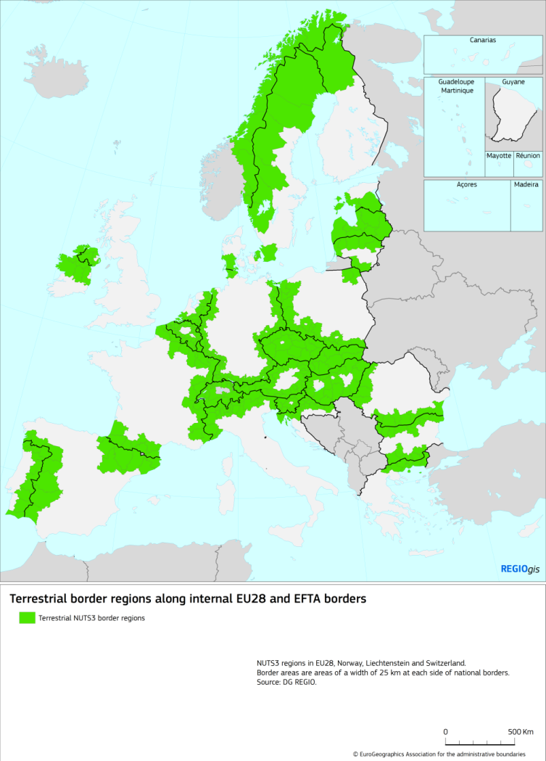Map 1: Terrestrial border regions along internal EU28 and EFTA borders.

### Categorising of legal and administrative difficulties limiting interaction along EU land borders

The difficulties faced by EU land border regions are usually caused by laws, rules or administrative practices which limit the unhampered flow of goods, services, capital and people and which obstruct the inherent potential of border regions when interacting across the border. The political, geo-physical, economic and socio-cultural dimensions of European borders create a variety of "closure effects" (obstacles[7] or barriers) and "opening effects" that always exist in parallel[8].

Closure effects, emerging from local, regional, national or EU legislation as well as from different administrative practices can be observed in **three general categories** (which are used in the context of this document):

* Legal barriers caused by the absence of Union legislation in policy fields where a Union competence exists or by shortcomings in a transposition of Union legislation into national law;
* Legal barriers caused by incoherent or inconsistent domestic laws of EU-Member States in policy fields where no or only a partial Union competence does exist;
* Administrative barriers caused by inadequate procedural and/or adverse behavioural aspects at the local, regional or national levels.

As figure 1 illustrates, legal and administrative barriers can have both, direct negative effects and potential adverse, secondary effects, leading to an overall limitation of cross-border integration and interaction.

Figure 1: Legal and administrative barriers and their impacts on cross-border integration.

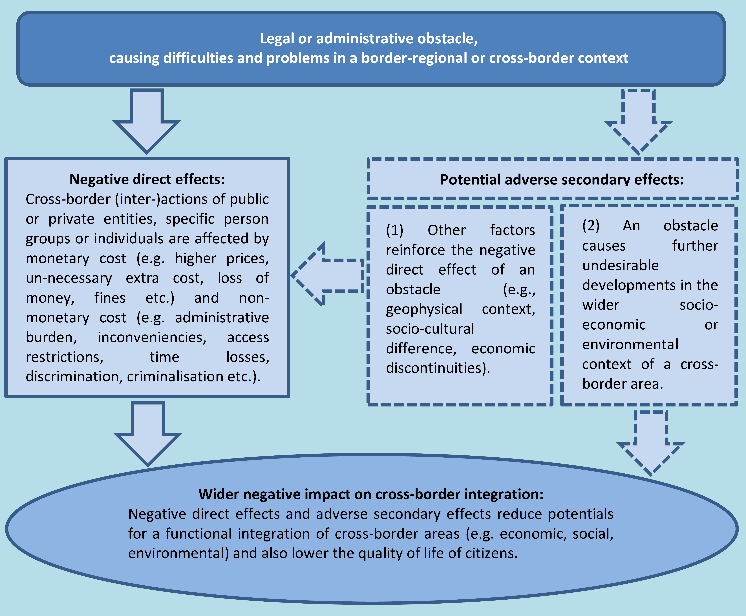

Source: Study 'Easing legal and administrative obstacles in EU border regions', Final Report, p. 47.

## Taking stock: The Cross-Border Review 2015-2017

The 'Cross-Border Review' process was carried out by the Commission between 2015 and 2017. It was organised along three pillars:

* The first pillar and the backbone of the exercise was a study providing an inventory of over 200 well-documented cases of legal and/or administrative barriers, illustrating the direct negative effects and potential adverse, secondary effects on border regions. A selection of these was taken further through case-studies describing how these obstacles were addressed on certain borders.
* The second pillar was an extensive on-line public consultation to which 623 replies from border citizens, public authorities, organisations and businesses were received.
* Accompanying this process was a series of workshops with stakeholders, which provided continuous feedback on the results of the review and also represented its third pillar[9].

### Inventory and case studies

As a basis for the review process, a first, Europe-wide[10] **inventory** of legal and administrative barriers[11] was established. Based on literature review and online research of sources published after 2010, the inventory of the Cross-Border Review identified 239 cases of legal and administrative obstacles. Due to limited information, it covers 37 out of the 40 land border regions. However, the number of obstacles identified for each of these 37 internal Union land borders is highly variable.

The inventory showed that a multitude of legal and administrative obstacles exists on all borders and in the timeframe covered by this study[12]. They all have an adverse effect on the life of border citizens or deter them from fully harnessing the potential of their place of residence or work. The obstacles described in the inventory differ in their nature, their causes and impact on the border regions.

Their documentation also varies, with North-Western and Northern Europe having many and well documented obstacles, while few obstacles are documented in Central and South-Eastern Europe. This difference between ‘existing’ and ‘documented’ obstacles may suggest a lower level of awareness of legal and administrative obstacles at some borders.

The observed barriers are clustered into the following eight wider policy areas: (1) Industry & Trade, (2) Labour Market & Education, (3) Social Security & Health, (4) Transport & Mobility, (5) Information & Society, (6) Environment, (7) Climate Change and (8) Policy Planning & Public Services.

As a next step, **15 case studies** were carried out, covering the five policy areas most affected (Labour Market & Education, Social Security & Health, Transport & Mobility, Industry & Trade and Policy Planning and provision of Public Services).

Each case study focused on a specific obstacle or exceptionally on a group of closely related obstacles[13]. An important objective for the case studies was to elaborate a tool that could provide interesting points of reference and/or lessons for a wider policy and practice audience beyond the illustrative spatial examples used to illustrate each case study. The research involved consultations with the Commission, regional and local stakeholders.

The case study on the mobility of cross-border workers, illustrated by the Danish-Swedish border (the Öresund region), was completed as pilot case to aid the process. In general the availability of Union level contextual information has been strong and backed up by consultations with key officials in the Commission and agencies. The level of information on cross-border legal and administrative obstacles has been variable and weak in relation to the impact of obstacles on cross-border cooperation. Documentation is often quite limited both at the Union and cross-border level. Despite the difficulty of identifying relevant actors, more than 200 people were consulted during the elaboration time, either individually or via focus groups.

The list of case studies is set out in the Annex.

### Public consultation

In 2015, the Commission launched a public consultation to gather the views of individuals and stakeholders on the border obstacles. The public consultation was open for three months and received **623 replies** from stakeholders from border citizens, businesses and public authorities[14]. By listening to their opinions, it aimed to identify the main obstacles encountered when interacting across borders, as well as the potential solutions. Half of the respondents to the consultations were private individuals (48%), followed by those responding on behalf of a public authority (23%), those on behalf of an organisation (13%) and those on behalf of a business/private company (7%). The remaining respondents were in the categories other (4%); self-employed individual (2%), academic/research institution (2%) and pan-European interest group (1%).

### Workshops with stakeholders

Accompanying the process was a series of workshops with stakeholders, organised by the Commission. The **four workshops**, which took place in Brussels between September 2015 and December 2016, provided continuous feedback on the results of the review and also represented its third pillar[15]:

* The first workshop served as a presentation of the work ahead and the expert consortium charged to produce the study, inventory and case-studies.
* The second workshop tried to identify a typology of obstacles and a methodology for potential solutions. Experts discussed concrete examples of legal or administrative border obstacles that were either recently solved or were to be solved in a short term, and drew conclusions on their characteristics.
* The third workshop focused on identifying the main conclusions from the case studies presented by the expert consortium and, based upon this, to draw recommendations that could relatively easily be transferred to different cross-border regions (hence, not too border specific).
* The fourth workshop focused on identifying possible solutions and suggestions to overcome legal and administrative obstacles in three specific areas: engaging citizens and stakeholders; better regulation and policy coordination; and the role of Interreg.

# Persisting difficulties and their impact

## Legal and administrative barriers - and ways to overcome them

The Cross-Border Review process revealed a rather large number of difficulties and barriers which hamper the development and interaction between land border regions. The results from all three pillars widely coincide:

### An issue in all EU land border regions

The inventory illustrates that around 64% of all obstacles (or 152 cases) affect **the entire length of land borders**. These are most often obstacles related to Member State legislation (67 cases) and also administrative obstacles (58 cases).

This is underpinned by the public perception: the public consultation[16] brought to light that legal and administrative barriers were perceived as **the most relevant obstacle** by 53% of respondents, with language barriers coming second with 38% (Figure 2).

Figure 2: Relevance and frequency of obstacles.

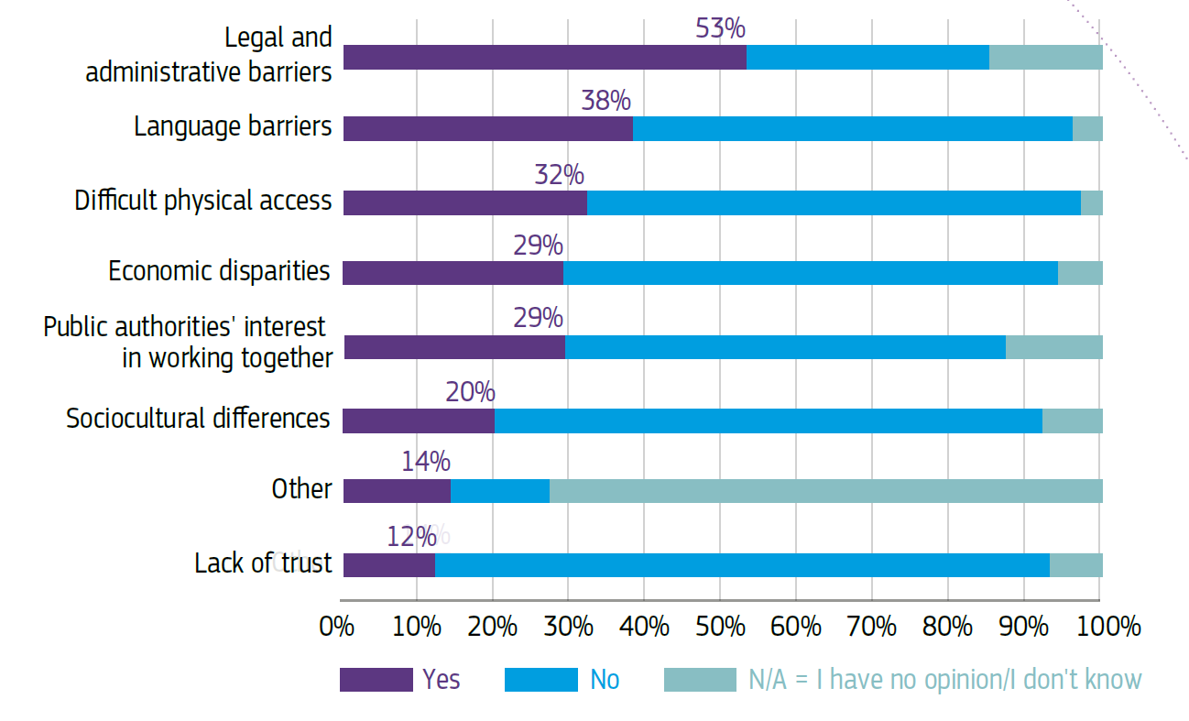

Source: Summary Report on the online public consultation "Overcoming obstacles in border regions", p. 12.

There is also a strong correlation between the **frequency of border crossing** and the obstacles perceived when interacting across the border. The more often a person crosses the border, the less likely he/she is to mention lack of trust as an obstacle. The same applies for language barriers and sociocultural differences. On the contrary, the more often a person crosses the border, the more likely he/she is to mention legal and administrative barriers as obstacles. One possible explanation is that the frequency of travel multiplies the opportunity to encounter such obstacles; in other words, obstacles of this nature are more strongly felt when mobility across the border is higher and more frequent.

**Language barriers** were viewed by 38% of respondents as a relevant problem in border regions, making it the second most mentioned type of obstacle. Language is a cross-cutting obstacle, transcending the defined categories of this public consultation. Various groups are affected, ranging from restricted interaction in everyday life, to hampered exchange of good practices between administrations.

### The nature and root-causes vary

In terms of their nature, the most numerous obstacles are those related to **national** legislation (104 cases), followed by **administrative** obstacles (99 cases). Obstacles related to the existence of **EU legislation** (or lack thereof) are much less frequent (36 cases). Depending on the nature of the obstacle, its removal or alleviation therefore requires action within and between Member States at different governance levels, or at the Union-level.

Figure 3: Legal and administrative barriers and their origins (239 cases in total).

**Two types** of source-problem-effect relationships were identified when assessing obstacles, which in turn impact their solutions: straightforward and complex. A 'straightforward' relationship means that there is a clear relational link between (1) a specific inadequate provision in a concrete piece of legislation or a certain inappropriate administrative practice, (2) the difficulties or hindrances this provision or practice is creating for cross-border interactions and (3) the negative direct effects or adverse secondary effects which emerge for specific corporate actors or larger person groups or individuals in the cross-border area. It is in principle quite easy to conceive and implement a solution for this kind of obstacle, if the concerned and competent stakeholders are willing to take action on the issue at stake. Once the source is eliminated, also the problems and the adverse effects will disappear.

For obstacles characterised by a 'complex' relationship, there are (1) various and more or less closely related legal or administrative aspects which together are creating (2) difficulties or hindrances for cross-border interactions that again (3) are leading to negative direct or indirect effects in the cross-border area. Because it is difficult to disentangle exactly which aspects are primarily causing a given problem and which aspects are additionally contributing to it, it is therefore also much more complicated to conceive and implement a solution that is able to fully eliminate the problem and the related adverse effects.

The inventory also attempted to appraise the **negative direct and secondary effects** of obstacles, as well as their wider impact on cross-border integration (sum of all negative direct effects and adverse secondary effects of an obstacle (see Figure 4 on page 15)[17].

A large majority of legal and administrative obstacles in the inventory has documented strong negative direct effects (182 cases), and 56 cases have moderate negative direct effects[18]. Negative secondary effects were strong in 77 cases and moderate in 86 cases. In sum, the wider negative impact of the border obstacles documented in the inventory is either high (143 cases) or moderate (93 cases). These negative impacts lower the intensity of cross-border interactions in virtually all dimensions of functional integration. Many of these obstacles have a wider relevance for the entire Union and/or for many other Union border regions, because very similar problems are observed at a large number of other internal Union borders.

### Some policy areas are more concerned than others

More than 90% of the legal and administrative obstacles documented in the inventory fall into the following **five policy areas**, in order of decreasing significance:

1. Labour Market & Education
2. Social Security & Health
3. Transport & Mobility
4. Industry & Trade
5. Policy Planning & provision of Public Services.

In terms of **public perception**, employment and labour market has also emerged as a major concern for respondents. Legal and administrative barriers make it more difficult to be employed on one side of the border, while living on the other. One of the most cited concerns is the lack of recognition of education and qualifications, followed by differences in social security, pension and taxation systems. For businesses, differences in technical standards and regulations for products as well as certain services act as de facto barriers for entry to specific markets across the border. Specific issues of a legal and administrative nature that came up most frequently, and posed problems to all categories of respondents, were the different taxation and social security systems, including health care and pension systems. In particular these were presented as major obstacles to workers' mobility.

Figure 4: Types of legal and administrative barriers by policy area (absolute figures).

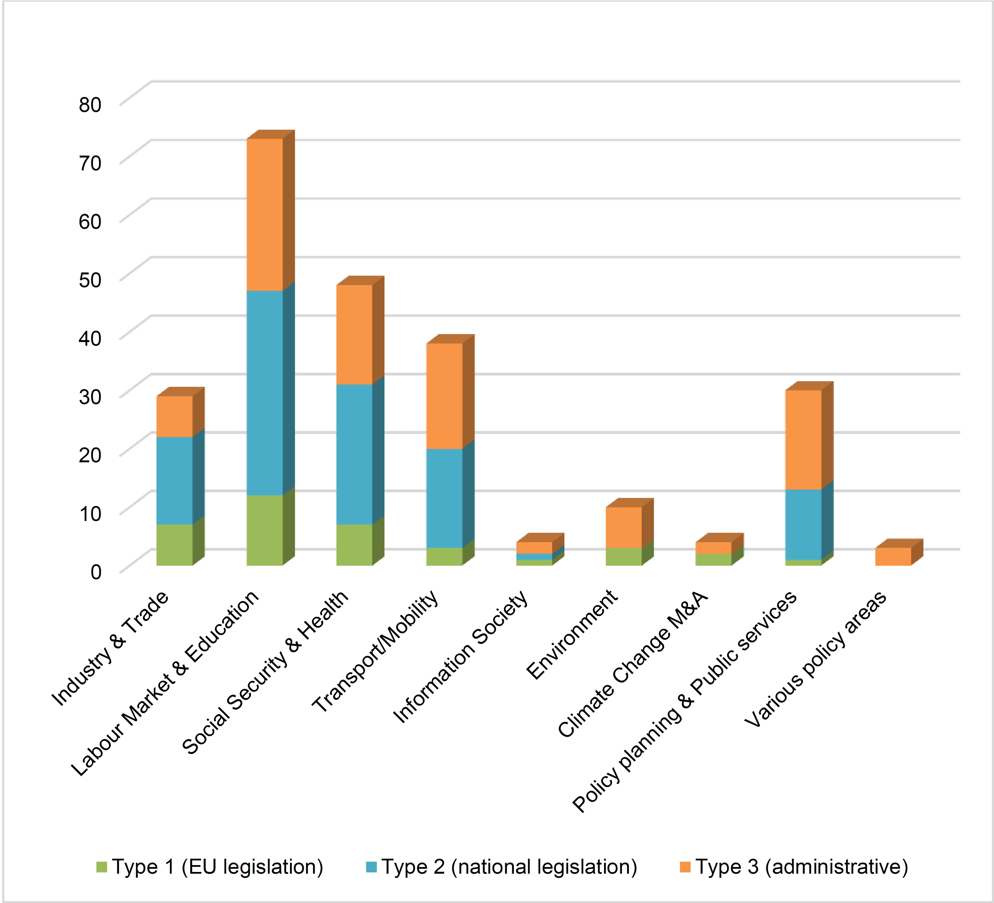

Source: Study 'Easing legal and administrative obstacles in EU border regions', Final Report, p. 35.

The public consultation confirmed that despite 25 years of Interreg funding for the development of cross-border cooperation, many obstacles in border regions go beyond its direct reach and pose a multitude of different challenges - across almost all parts of life of citizens. These are sometimes **multidimensional**, which means, for example, that the definition and origin of an obstacle differ in nature - for instance, in some cases inadequate cross-border transport systems (falling under the difficult physical accessibility category) are explained as originating in a lack of harmonisation of technical standards (coming under legal and administrative barriers). Language barriers and difficult physical access have been frequently mentioned as obstacles, which points to the persisting need to invest on cross-border mobility in border regions, as well as language and cultural learning. While lack of trust, as well as socio-cultural barriers, are perceived as relatively less relevant, they form nevertheless the backbone of cross-border cooperation.

### Solutions exist - but take time, effort and commitment

Where legal and administrative obstacles were successfully overcome, **two basic approaches** were observed: (a) better alignment or harmonisation of particular legal provisions and/or their implementation practices in neighbouring countries, and (b) better information and communication on cross-border issues. Better alignment aims at closing the gaps or removing the contradictions between counterpart regulations on either side of a border, while better information and communication is about coping with the gaps and contradictions as long as they exist.

In the public consultation, several possible solutions to legal and administrative barriers we reported - mostly about encouraging more convergence in regulatory frameworks, more flexibility and more information provision to individuals. A significant number of respondents pointed to differences in the implementation of EU rules (directives) as creating legal and administrative obstacles, and pleaded therefore for better coordination and harmonisation of the implementation of regulatory arrangements in border regions, for example through more targeted impact assessments, with a view to promoting greater convergence. At the same time respondents also asked for a greater flexibility in the general implementation of national/regional legislation in border regions, "freeing" it up from national legislation or adapting it to border regional conditions.

In practice, **several tools** exist to ease or solve legal and administrative obstacles, once they were identified in a systematic way and placed on the political agenda:

* Interstate agreements (bilateral or multilateral, at national or regional level) which can address obstacles either in a preventive manner or in order to solve existing ones,
* Informal cooperation, which is typically sector oriented (e.g. transport) or business related (e.g. chambers of commerce),
* Horizontal cooperation, (e.g. Euregions, Upper Rhine Conference, Greater Copenhagen and Skåne Committee and others),
* Cross-border legal entities and the European Grouping of Territorial Cooperation (EGTC)[19],
* 'Innovative' instruments such as the 'mutual recognition principle' as developed by the European Court of Justice (ECJ)[20] or *e*Government[21].

Although the border obstacles stem in most cases from incompatibilities between national legislations, their **local manifestation is place-specific**. A major implication of the territorial 'embeddedness' of cross-border obstacles is the key role that actors and institutions from the border regions can play in the definition, assessment and solution of obstacles relevant to their region. To this end a good cooperation climate, permanent information exchange and a comprehensive survey of obstacles are necessary. Removing or easing legal and administrative obstacles to cross-border interaction is therefore not primarily a matter of new or better legislation at Member State level but a matter of effective multi-level governance.

Table: Summary of the main characteristics of possible tools for easing (legal/administrative) obstacles[22].

|  |  |  |  |  |  |
| --- | --- | --- | --- | --- | --- |
| Tool | Simplicity and time for establishing | Flexibility (versatility) | ‘Binding-ness’ | Effective-ness (result potential) | Sustain-ability |
| State agreements | - - | + | + + | - | + |
| Informal cooperation | + | + | - | ++ | - |
| Horizontal cross-border cooperation | - | - | + | + | + |
| EGTC | + | - | - | + |  |
| Mutual c-b recognition | - - | + | + | + + | + |
| *e*Government measures |  | + | + + | - | + + |

Source: Study 'Easing legal and administrative obstacles in EU border regions', Conclusions and Recommendations paper, p. 18.

Legal and administrative obstacles are **recurrent phenomena**, which are difficult to be solved once and for all. Long-term/sustainable institutions (at national, regional and local levels) working systematically on identifying and resolving obstacles as well as preventing new ones from arising are key for addressing successfully these phenomena.

During the stakeholder workshops, it was emphasized that removing border obstacles is a **dynamic process**, as often a removed obstacle leads to increased cooperation and deepened integration, which in turn leads to the emergence of new obstacles. The approach of the Nordic Council of Ministers was considered a best practice, in which the inventory of obstacles is constantly updated and there is a work plan to eliminate at least 5-10 obstacles from the list each year.

Stakeholders also stressed that the **awareness-raising** of the benefits of cross-border cooperation, both to decision-makers and the general public, should be an overarching goal. This is often hampered by the lack of data on actual cross-border interactions, which could be addressed at the European level (Eurostat), in close collaboration with national statistical offices. Overall, effective multilevel governance was identified as a key to solving border obstacles, and for involving stakeholders at all levels; fora are needed to provide platforms for exchange. Information provision to individuals, businesses and public administrations through one-stop-shops could be a solution to the lack of information that has been identified as another common problem. Cross-border strategies were considered a potentially useful tool for a more coherent, long-term development of the border region, also by giving a clearer mandate to solve border obstacles to the actors involved. Harmonisation of legislation and better adapted impact assessments with a strong border dimension when developing new legislation were identified as crucial aspects. Finally, to better involve the general public in the process, the 'people' dimension when working with border obstacles has to be strengthened through people-to-people projects, language learning etc.

### The need for multi-level governance

Due to the multitude and diversity of obstacles and the large number of Union citizens potentially affected by them, the easing of legal and administrative obstacles remains a European issue. These obstacles also have a substantial direct effect on the further development of the **internal market**.

Since the majority of obstacles originate in differences between national legislation and administrative procedures/habits, the solutions are to be found at the level of **national and sub-national governments and administrations**. A coordinated support from both sides of the border is needed to improve the situation at the local level where the negative effects of obstacles are most strongly felt.

One of the conclusions from the stakeholder workshops is that especially Interreg programmes are important **platforms for engaging citizens and stakeholders**, and can also contribute to the funding of cross-border statistics and data to demonstrate the costs of cross-border obstacles. Overall, stakeholder emphasised the need for Interreg to focus more strongly on citizens and improving their lives, hence also take administrative and legal border obstacles better into account.

## The economic impacts - or: the cost of border obstacles

Reliable data on the prevalence, costs and other dimensions of cross-border obstacles as defined in 1.1 is hard to find. Academic research on the 'cost of non-Europe' has been undertaken since the *Cecchini Report* in April 1988[23], which estimated that the completion of the Single Market would increase the GDP of the European Community by around 4.5% and possibly up to 6.5%. More recent attempts to quantify the effect of border obstacles by Ilzkovitz et al*.*[24]*,* Boltho and Eichgreen[25], Campos et al.[26], Dunne[27] and Godel et al.[28], estimate the losses due to the absence of integration between 2.2% and 12% of the Union's GDP.

In the run-up to the Communication which this Staff Working Document accompanies, and in order to address the lack of quantitative data concerning border obstacles and their related costs, the Commission contracted an expert study, conducted by *Politecnico di Milano*, on the 'quantification of the effects of legal and administrative border obstacles in land border regions'[29]. More detailed analysis of this study can be found in the Annex. The study estimated that legal and administrative barriers had a high impact on land border regions, leading to an overall GDP loss of around 458 billion euros. In relative terms it corresponds to about 3 % of total Union GDP, or 8.8% of total GDP produced in land border regions. These values correspond to the extreme situation where all legal and administrative barriers would be removed. This scenario is of course neither attainable nor desirable. However, if only 20% of the existing obstacles were removed, border regions would gain 2% in GDP or around 91 billion EUR in GDP. The estimated impact on job creation is equally important, with potentially over 1 million jobs to be created.

Map 2 shows the percentage GDP loss in European land border regions. Major losses (dark brown) are incurred by areas located along borders in central EU+EFTA countries (borders between Netherlands and Belgium, France and Germany, France and Switzerland, Austria and Slovakia)[30].

Map 2: Percentage GDP loss in EU land border regions.



Source: Study "Quantification of the effects of legal and administrative border obstacles in land border regions", p. 11.

There is substantial economic research on the effect of borders on economic interaction (the so-called "border effect", illustrated in figure 5 below).

Figure 5: Basic pattern of socio-economic relations existing in border areas and non-border areas.

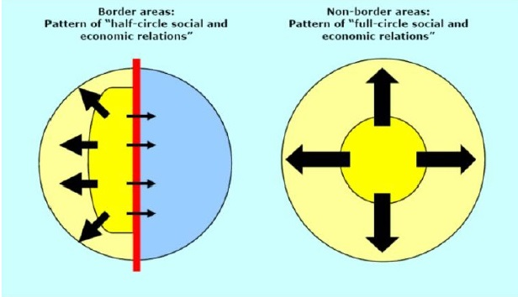

Gil-Pareja *et al* (2006) define the border effect as the negative impact of national borders on trade flows[31]. It can also be seen as how much less a given region trades with its neighbour region on the other side of the border, compared with how much it would trade if there were no borders. Several cases of border effect have been estimated in different geographical scopes. Due to lack of regionalised data, in few cases is it possible to estimate it at regional level. This is the case of the Spanish-Portuguese border, where according to Ferreira and Mourato, the border seems to be decreasing a region's trade by approximately 14 times[32]. Similarly, Gil-Pareja *et al* concluded that "*Basque Country trades between 12 and 16 times more with the rest of Spain than it does with any other country*". More frequently it is applied at national level. Vanagas found in 2013 that the average border effect for EU countries is approximately 7.5, and that harmonization through Union policies had a significant positive impact on trade among its Member States, especially for the most recent members[33]. On the French and German case, Helbe (2007) concludes that "*France trades about eight times more and Germany about three times more with itself than with other EU countries compared to the predictions*"[34]. The border effect is also noted outside the European context. The first major paper on border effect pointed out that trade amongst Canadian provinces was 22 times higher than with US states of similar size and distance[35].

The reasons behind the border effect are diverse. The complexity and costs of doing business across the border are part of them. Perceptions based on culture (reflected in consumer choices), business traditions and business cycles, is also part of the explanation. Ferreira and Mourato state that "*fear from the unknown, trading traditions and lack of business networks are some of the factors which lead potential business between actors on different sides of the border not to occur*"[36]. In a similar way Vanagas presented consumer preferences as one of the potential causes of border effect. In marketing literature this is presented as the domestic country bias in consumer preferences. Analysing the border effect causes in the specific case of the EU, Chen has highlighted technical barriers to trade (the complexity argument above) and informal trade barriers as "product specific information costs"[37]. The later occurs for example "*if it is more costly to obtain some information about the quality, or even the existence, of a foreign product as compared to a domestic product, we would expect this higher cost to reduce the quantities* *of foreign goods purchased*"[38].

# What happens and what should be done?

This chapter highlights areas identified in the Commission's preparatory work with stakeholders (study, consultation and workshops) as having great potentials to remove further hurdles. It outlines the role of the Commission in taking positive steps both in its own actions and in support of other key players.

Each section briefly describes the issues identified and uses examples and/or good practices to illustrate them. It also offers a brief insight into ongoing measures by the Commission or national institutions and finally, where possible, proposes new actions by the Commission or recommends actions for Member States and other stakeholders.

The implementation of the 10 actions listed below will be facilitated by the creation of a **"Border Focal Point"** within the Commission. The functions of the "Border Focal Point" will be (1) ensuring that key future actions by the Commission take due account of a cross-border regional dimension, (2) providing Member States and other key players with support to address legal and administrative border regional issues, notably relating to the transposition of EU directives or coordination requirements, (3) making sure that practical arrangements are in place for new actions as listed in the Communication, (4) sharing experiences and good practices effectively and widely among relevant stakeholders.

## 

## Deepening cooperation and exchanges

New initiatives by the Commission will not have the full desired positive impact in border regions if effective mechanisms for cross-border cooperation are not deepened. These mechanisms, whether institutionalised or not, need to reflect the multi-level government dimension of policy-making in the EU.

A number of such cooperation mechanisms already exist. At inter-governmental level, the Benelux Union and the Nordic Council of Ministers for example have established processes to identify and address bi-lateral border barriers.

The **Nordic Council of Ministers**, regrouping the governments of Denmark, Norway, Sweden, Finland and Iceland, as well as the Faroe Islands, Greenland, and *Åland* is the official organisation for Nordic intergovernmental co-operation. Since 2008 there has been a special body under this intergovernmental framework dealing with border obstacles - today known under the name the "Freedom of Movement Council". This body includes members from all the Nordic countries and autonomous regions, as well as the Secretary General and a representative from the Nordic Council (the inter-parliamentary organisation). The Freedom of Movement Council coordinates the Council of Ministers' work on border obstacles, and also maintains a database of obstacles. The information in the database is collected by the Nordic information services. Each member of the Freedom of Movement Council prioritises a handful of obstacles each year, making sure that it remains a priority until it is either resolved or that the relevant Government department concludes that it cannot be resolved. In 2015, ten of the 36 prioritised border obstacles were resolved (an additional two were written off because the relevant Government departments did not see any possibilities to ever resolve them). In 2016, seven prioritised obstacles were resolved. Hence, the institutionalised systematic cooperation and prioritisation work shows concrete results. Outside of this framework, Nordic governments also work on a purely bilateral basis to solve border obstacles.

The **Benelux Union** is a politico-economic union of three neighbouring states: Belgium, Netherlands and Luxembourg, which started as a customs union in 1944 and became an economic union in 1960. The Union is made up of several institutions, including the Benelux Parliament, the Secretariat-General, the Council of the Union, and the Committee of Ministers. The daily operations are managed by the Secretariat-General, while the executive authority rests with the Committee of Ministers, which meets quarterly. On 17 June 2008, a new Benelux Treaty was signed by which cooperation focuses on three key themes: the internal market & economic union, sustainable development and justice & home affairs. For instance, an expert group was recently set up to examine issues linked to the mutual recognition of diplomas and certificates – it is expected that the group will formulate recommendations to significantly improve cooperation on this topic which will result in easier and faster procedures.

At regional level, the Upper Rhine Conference and the Greater Copenhagen and Skåne Committee (previously known as the Öresund Committee) have developed effective ways to identify local obstacles and organise a response. At local level, the InfoBest network of information offices along the France-Germany border has had a real impact for commuters. Individuals can also effectively organise themselves to represent their common interests as can be seen from the *Groupement Transfrontalier Européen*, an association which represents over 30,000 French daily commuters on the border with Switzerland.

The **Upper Rhine Conference** is the institutional framework for cross-border cooperation in the Upper Rhine region between France, Germany and Switzerland. It originally derives from the 1975 Upper Rhine agreement and consists of several different bodies. The Steering Committee is the coordinating decision-making body and consists of a delegation from each participating country. Apart from this, twelve thematic working groups with have been established which consists of experts in the different fields, *e.g.* education and vocational training, transport, economic policy and regional planning.

The Commission encourages Member States and regions to take action in order to facilitate cross-border cooperation and to establish more systematic dialogues about border issues, taking also into account that cross-border cooperation between Member States can be an explicit requirement under the EU legislation. This is often the case for example in the EU environmental legislation (e.g. the Marine Strategy Framework  
  
Directive[39], the Water Framework Directive[40], the Noise Directive[41], the Waste Framework Directive[42], and the Ambient Air Quality Directive[43]) as cooperation is essential in order to face several environmental challenges. Furthermore, the "Action Plan for nature, people and the economy"[44] aimed at improving the implementation of the Birds[45] and Habitats[46] Directives includes a specific action to promote cooperation at biogeographical region level to address common challenges, including on cross-border issues.

The Commission calls upon Member States and regions to further develop regular dialogues on border issues. Essential European integration notions such as mutual recognition or alignment of rules and processes should receive more attention from Member States and regions. They are invited to take full advantage of existing opportunities to conclude agreements or conventions. For example, the four EU macro-regional strategies[47] could provide an appropriate framework for cross-border institution building, as the concerned Member States have already established cooperation structures within the most relevant sectors. Furthermore, where cooperation is an explicit requirement of EU legislation, as is the case for instance in many environmental legal acts, this should be used to full effect[48].

**The following two actions will be implemented to deepen cooperation and foster exchanges:**

### Establishing an on-line professional network on the Futurium platform

To support this process and to ensure that good practices are shared, the Commission will establish an EU-wide online professional network where legal and administrative border issues and solutions can be presented and discussed among border stakeholders. This network will use *Futurium* - an already existing online platform created by the Commission and will be moderated by the Commission via its Border Focal Point. The Commission will ensure the network is regularly fed with recent information and documentation and that good practices are well publicised and readily available via an extensive library. Relevant events will be publicised. Dialogues among stakeholders will be actively generated. The key objective of the network will be to create a strong community at European level in order to overcome a certain isolation mentioned by many stakeholders.

### Implementing pilot projects to test new solutions

In addition, the Commission will announce an open call for pilot projects before the end of 2017. It will target public authorities wishing to resolve one or more border-specific legal or administrative problem(s). Projects could for example be focused on improving compatibility of administrative systems, facilitating labour mobility through enhanced opportunities for qualification recognition or ensuring harmonisation of legal standards. These projects will serve as the basis for exploring innovative ways to address border issues. Up to 20 pilot projects will be selected for their high demonstration value and level of replicability. Their results will be summarised in a final compendium that will be widely distributed and used to foster greater awareness and capacity among key players. The call will be open to any public body willing to engage in identifying solutions to border issues within their area of competence. Up to 20 pilot projects will be selected for their high demonstration value and level of replicability.

## Improving the legislative process

For a considerable share of the border difficulties identified, root causes have been attributed to the existence side by side of different regulations in national legal and administrative systems. Even where there is a European legal framework, Member States sometimes have a degree of flexibility and discretion in the way they incorporate this legislation in their national systems. Often certain levels of standards stipulated in EU law are incorporated at varying degrees of stringency in various Member States. As a result, when two different systems meet along internal borders, this may create complexity - and sometimes even legal uncertainty - and generate additional costs.

Directive 2014/24/EU of the European Parliament and of the Council of 26 February 2014 on public procurement[49] contains 19 instances where minimum standards apply, for example a minimum number of days for certain applications or other actions, or a minimum of information to be included in an application or in a tender or other document. This creates 19 potential occasions where **cross-border public procurement** can be particularly difficult, as certain Member States will apply longer deadlines than others.

In its Better Regulation package adopted in 2015[50], the Commission has proposed measures to ensure that territorial aspects are factored into policy options. This happens mainly through the implementation of robust impact assessments of legislation that include territorial elements. The Better Regulation Package already establishes that impact assessments of legal or financial initiatives should consider not only socio-economic factors but also territorial ones[51].

When it comes to transposing, applying and implementing Union law, Member States should be encouraged and helped to take into account the specificities of internal land border regions, to coordinate and to exchange best practices in order to reduce the risk of obstacles specific for such regions. Member States should consider introducing a territorial dimension to the impact assessments foreseen in their legislative process. The Commission will support these efforts by facilitating coordination where requested and by sharing its methodological impact assessment tools.

Based at the University of Maastricht, the Institute for Transnational and Euregional Cross-Border Cooperation and Mobility (ITEM) carries out **cross-border impact assessments** of future national and EU legislation. The work is based on a work programme developed together with national, regional and local border stakeholders along the borders of the Netherlands with Germany and Belgium respectively[52].Each year, ITEM makes a selection of the most important subjects that are most suitable for research and in-depth analysis. This selection is made on the basis of input by ITEM’s stakeholders via a survey. This input is collected by means of a survey. The survey is only the first phase of the process. During the second phase, ITEM establishes a final shortlist of dossiers. The third phase consists of carrying out the essential research for the selected dossiers as conducted by various ITEM researchers and experts. The final phase comprises the publication and dissemination of the results and exchanges with stakeholders.

**To increase the awareness for border issues in legislative processes, the following two actions will be implemented:**

### Identifying cross-border aspects in impact assessments

The Commission will make further efforts to identify cross-border impacts whenever significant through the application of existing methods and tools. Via its Border Focal Point and the professional network described above, the Commission will seek greater involvement by border stakeholders in this process.

### Providing more expertise and advice

To support Member States with necessary coordination efforts during their national transposition process, the Commission's Border Focal Point will organise expertise and advice on cross-border regional aspects. This will build a.o. on the results of the pilot projects mentioned above and on existing good practices.

## Enabling cross-border public administration

EU Member States have different administrative cultures and systems. This diversity can be a constraint when different systems meet. Most administrative procedures tend to be of a national nature and cross-border procedures are less widespread. However, border stakeholders may well require non-domestic procedures on a regular basis. The lack of common approach or understanding, and the limited existence of mutually recognised documents can lead to lengthy and costly procedures, even for key life events.

For example, some public authorities have embraced *e*Government faster than others - this can lead to difficulties in border interaction especially when documents or forms are needed. Where *e*Government solutions are being implemented, these apply more to the domestic context than to a cross-border perspective.[53] Interoperability of public authorities' *e*Systems is still limited.

One good example of obstacles is the digitisation of public administration and its implications for cross-border commuters in the labour market at the Danish-German border. Digitisation of the public administration is highly advanced in Denmark where all communication with authorities has been digital by default since 2015. The majority of commuters in the **Danish-German border region** lives in Germany and work in Denmark and the digital administration can pose a challenge for these cross-border commuters. The main obstacles are the cultural aspect, procedures, accessibility and language. German citizens are not as used to, and comfortable with, using digital channels as Danish citizens are. The procedures for communication with the public administration and access to digital services are also quite rigid. In particular the timeframe causes problems for German commuters. In some cases the systems are also only available in Danish or English. These issues have been addressed by the Danish authorities in a recent report where they propose several improvements which will require in addition to the will, above all, expertise and resources, for example, to create advisory and information services that can meet the challenges[54].

In its *e*Government Action Plan 2016-2020[55], the Commission sets out a long-term vision for open, efficient and inclusive public administrations, providing borderless, personalised end-to-end digital public services. Although of a general nature, the plan proposes measures and tools which will be particularly relevant for border regions such as the once-only principle (i.e. information is supplied to public authorities only once regardless of country of origin)[56] and an automated translation tool for public authorities[57].

The Business Mobility benchmark in the *e*Government Benchmark Report[58] indicates that cross-border services are lagging behind services offered to country nationals. 25% of services required for foreign entrepreneurs to start their business in another country are available only on paper, meaning that there is no information - let alone a service - available online. In contrast, entrepreneurs starting a business in their own country face such issues in only 2% of the cases. Foreign start-ups are also less able to find and access information on services (33% vs 39%) and using services across border is only possible in 27% of the cases (compared to 46% of services in the national context). A possible solution for enabling entrepreneurs to access digital public services in other Union countries is the implementation of the so-called 'Points of Single Contact'[59].

In this respect the use of electronic identification mechanisms is very important. To facilitate cross-border online services, the *e*IDAS Regulation (EC) No 910/2014 on electronic identification and trust services was adopted in July 2014[60]. It ensures that people and businesses can use their own national electronic identification schemes (*e*ID) to access public services in other Union countries where *e*IDs are available. It also creates a European internal market for electronic signatures, electronic seals, time stamp, electronic delivery service and website authentication, by ensuring that they will work across borders and have the same legal status as traditional paper based processes.

Under the Connected European Facility (CEF), the Commission has deployed five Digital Service Infrastructures (DSIs) Building Blocks, namely *e*Signature, *e*ID, *e*Delivery, *e*Translation, *e*Invoicing, and also Cyber Security. The Building Blocks which are reusable across sectors are to support the interoperable delivery of cross-border services. Whenever Member States, regional and local administrations invest in digital public services, they should make use of these building blocks established under the CEF. The building blocks are expected to become de facto standards underpinning the delivery of digital public services across borders. The building blocks can be combined with each other and integrated in more complex services such as *e*Health, Electronic Exchange of Social Security Information (EESSI) and eProcurement.

The strong evidence that *e*Government can provide a robust answer to questions linked to cross-border public administration (e.g. data exchange between administrations) leads the European Commission to recommend that concrete steps are taken to actively promote existing digital solutions among border stakeholders and among administrations most concerned by cross-border data exchanges. To this end, the Commission will urge its ongoing and future *e*Government projects to engage the stakeholders of the border regions in order to deliver cross-border public services that meet the needs of individuals and businesses in border areas.

**To help enabling cross-border public administration, the following action is proposed:**

### Using the advantages of eGovernment in a cross-border context

Member States' and regional/local authorities need to **rise to the challenge of *e*Government** and take concrete steps that will make a difference to border citizens. The Commission will support this process by actively promoting existing e-solutions among border stakeholders and among public authorities most concerned by cross-border data exchanges. The Border Focal Point will establish stronger links with border regions' administrations in order to support this process. The on-line professional network to be established and moderated by the Commission will be used for this.

## Providing reliable and understandable information and assistance

Resolving border obstacles will take time and sustained effort. In the meantime, access to available and reliable information and problem-solving services on life or work on the other side of the border is vital. Europe-wide services such as Your Europe or SOLVIT are useful in this context even if they are not border specific. The Your Europe Advice service, started in November 1996, is a free advice service for the general public[61], managed by 65 legal experts from the European Citizens Action Service (ECAS) under contract with the European Commission. The service is available in all 24 official EU languages, and in all EU Member States. In its 20 years of existence, tailor-made advice has been provided in over 210,000 cases. Citizens access the service through the Your Europe website, where they can find information about various aspects of living, travelling or doing business within the EU. However, the advice provided covers only domains relating to EU law. Your Europe Advice typically answers about 24,000 enquiries per year in an average reply time of 3 to 4 working days[62]. Another closely related EU service is SOLVIT[63], a problem-solving network, dealing more specifically with cases of possible misapplication of EU law between companies or individuals and national administrations. In such cases, the requests are forwarded to SOLVIT[64].

Preparatory work for this Communication has highlighted concerns by individuals and businesses at the lack of reliable information services which can lead to legal uncertainty that hampers cross-border interaction or makes the implementation of cross-border projects longer and more costly.

Initially financed by Interreg, the **Infobest**[65] network of one-stop-shops in the Upper Rhine tri-lateral border region between France, Germany and Switzerland currently provides reliable information to individuals about all aspects of cross-border life, including employment and education and supports cross-border interface with the different public authorities. Infobest currently has four local focal points, covering the entire Upper Rhine region. Bi-lingual staff helps citizens and businesses get in touch with administrations "on the other side", to find the right contacts and to overcome potential language barriers.

**The following two actions are envisaged to provide more reliable and understandable information and assistance:**

### Better information through the "Single Digital Gateway"

The Commission has recently proposed the "**Single Digital Gateway**" (SDG)[66] draft regulation which once adopted will enable individuals and companies to have easier access, through a single digital entry point, to high quality information, online administrative procedures and assistance services. The SDG envisages the first application of the once-only principle at the EU level by enabling the exchange of evidence directly between competent authorities from different Member States for a set of key procedures. It will also encourage feedback from its users to constantly evolve to meet their needs and to collect information about single market barriers.

### SOLVIT for a more harmonious Single Market across borders

In its recently adopted Communication "Action plan on the reinforcement of SOLVIT: bringing the benefits of the Single Market to citizens and businesses"[67], the Commission commits to further reinforce SOLVIT with the Member States so that more individuals and businesses have their cross-border issues addressed.

## Supporting cross-border employment

Preparatory work has identified labour mobility as the single most important area directly affected by border obstacles, in particular with regards to cross-border workers. In 2015, the total number of Union-28 cross-border workers[68] active in another Union-28 country was around 1.3 million, making up 0.6% of all employed across the EU-28. Of these, 93% were working in an EU-15 Member State, with the remaining 7% working in EU-13 countries. Around 0.7 million (51%) were residing in an EU-15 Member State and around 0.6 million (49%) were residing in an EU-13 Member State. This shows that while cross border workers nearly all work in an EU-15 Member State, they reside roughly equally in EU-15 and EU-13 Member States. In 2014, the total number of EU-28 cross-border workers was around 1.2 million, thus showing an increase of 8% in 2015[69]. Higher shares of cross-border workers in relation to the overall domestic workforce were recorded in Slovakia for instance, where 5.6 % of workers cross the border for their job or in Estonia where the figure stands at 3.1%[70].

Labour mobility in border regions depends on a series of factors and policies beyond the concrete situation of the labour market (vacancies available, economic activity, employment rate, etc.) such as education and skills, transport and infrastructure, administrative procedures, language, cultural and socio-economic links, awareness of opportunities, access to specific information, etc.

A number of tools and coordination mechanisms exist at European level to facilitate cross-border work such as the European network of employment services (EURES), rules for the coordination of social security systems, the European Qualifications Framework which supports understanding and comparison of qualifications, the Europass Framework which enables individuals to communicate their skills and qualifications, the European classification of skills, competences, qualifications and occupations and the European Professional Card, an EU-wide digital procedure for the recognition of professional qualifications. In terms of financing, both the EU programme for Employment and Social Innovation (EaSI) and the European Social Fund provide support for labour mobility in border regions. The EURES axis of the EaSI programme supports cross-border partnerships that provide cross-border workers and their employers with information and placement services.

**EURES (European Employment Services)** is a cooperation network formed by public employment services. Trade unions and employers’ organisations also participate as partners. The objective of the EURES network is to facilitate the free movement of workers within the Union and EFTA countries[71]. Regulation (EU) No 2016/589 'on a European network of employment services (EURES), workers' access to mobility services and the further integration of labour markets' was adopted on 13 April 2016[72]. It provides for a sound basis to develop the EURES network expanding it to stakeholders outside the public employment services and improving the quantity and quality of services. The regulation gives particular attention to facilitating mobility in cross-border regions and to providing services to frontier workers. It also includes a definition of "frontier worker" and of "EURES cross-border partnerships", which are structures within the framework of EURES that address the specific needs for information and guidance to frontier workers as well as placement and recruitment services. Moreover, Article 27 establishes the support services to be provided in cross-border regions. Through the EURES axis of the Union programme for employment and social innovation (EaSI) on average EUR 4 million a year is devoted to support cross-border partnerships through calls for proposals.

In the context of EURES, several best practices have been identified such as the promotion of language training in the language of the neighbouring border region in schools, joint public employment services teams with case handlers from all the countries involved providing multilingual support to frontier workers, one-stop-shop solutions for information and guidance to frontier workers and their employers with dedicated staff that can guide customers to the right service and right information, in dual systems for vocational and education training, pupils following the theoretical part of the training in their home town and the practical part of the training across the border. This can be supported through framework agreements on cross-border dual vocational educational training between the relevant authorities and with the cooperation of employers.

Another example in the context of EURES is the joint monitoring of the cross-border labour market resulting in cooperation agreements between employment services to work together on hard to fill vacancies and provide tailor made services such as coaching for job seekers. The coaching prepares them to understand the requirements of the vacancy, the preferred way of presenting job applications and any useful information (administrative, cultural) that ensures good integration of the frontier worker in the working environment of the neighbouring country.

The Social Security and Labour Inspections of **Galicia and that of North Portugal**[73] have created a network supported by the local EURES cross-border partnership, which allows a faster resolution of obstacles to cross-border mobility of employers and workers. They have developed effective collaboration bridges between Social Security organisms and Labour Inspections in the cross-border region. The offer of the EURES partnership includes the posting of job offers from across the cross-border region, the counselling concerning labour, social and taxation regulations in both countries as well as training opportunities.

The reason for establishing the European Qualifications Framework (EQF) is that differences between education and training systems in the Union make it difficult to assess what someone holding a qualification from another country knows, understands and is capable of doing in learning or work contexts. To lift these obstacles the EQF helps to compare national qualifications frameworks or systems, ensuring that the learning outcomes of each qualification can be easily understood and compared.

The recently adopted revision of the EQF Recommendation ensures continuity as the referencing of national qualifications frameworks to the eight European referencing levels of the EQF remains at the heart of the EQF process. It seeks to further developing the EQF, making it more effective in facilitating understanding of national, international and third-country qualifications by employers, workers and learners. The aim is to contribute to a better use of available skills and qualifications for the benefit of individuals, the labour market and the economy.

Europass consists of a portfolio of five standard documents (Europass Curriculum Vitae, Europass Language Passport, Europass Mobility, Europass Certificate Supplement, Europass Diploma Supplement) used by people who wish to communicate their skills and qualifications in a clear and easy way. Europass is especially helpful when people move between countries to learn or work. The documents makes it easier for employers, education and training providers and guidance practitioners to understand the skills and qualifications from other Union Member States as information is presented in a consistent, standard layout in every country.

Europass has played an important role in supporting mobility within and between countries. Since 2005, Europass has had more than 127 million website visits; over 39 million document templates have been downloaded while more than 80 million Europass CVs have been created online. Public consultations have shown that the Europass framework is appreciated for its closeness to individuals as it has in particular become a well-known tool for supporting individuals to communicate their skills.

The European Skills/Competences, qualifications and Occupations (ESCO) project is part of Europe 2020 strategy. ESCO is a multilingual classification describing and categorising skills, competences and qualifications needed for thousands of occupations in all economic sectors. It is a common reference language that can be used by job seekers, employers, employment services, education and training providers and others in their professional and academic exchanges and introduces more transparency in occupations and qualification profiles across Europe.

To reduce language barriers the classification will be available in 26 languages and accessible by everyone through an online portal. One of the aims of ESCO is to allow employment services to exchange relevant labour market information across borders and facilitate communication between labour market and education and training on issues such as skills mismatching and better employability.

Cross-border commuting in the **Öresund** **Region** between Denmark and Sweden[74] is characterised by a set of interlinked obstacles which are part of the current programme to address all legal and administrative obstacles in the region. These include: taxation of pensions, unemployment benefit affiliation and restrictions on work placements across the border.

The case highlights in particular two good practice examples for handling these obstacles: (1) The role of cross-border organisations, such as the Freedom of Movement Council within the Nordic Council of Ministers, and the interregional cooperation through the Greater Copenhagen and Skåne Committee (previously known as the Öresund Committee) who identify obstacles and facilitate the process to resolve them. (2) Targeted and continuous information services, which can help improve cross-border commuters' knowledge.

However, the positive effects of those measures/tools have not achieved their full potential in border regions. Among the most commonly identified difficulties for labour mobility across the border are: completing an apprenticeship, having one's skills and competences fully recognised, accessing job vacancies, identifying workers, obtaining legal certainty on fiscal issues, obtaining professional insurance for medical staff, unduly complicated procedures to obtain professional certificates. Information provision, including to individuals and employers, as well as data collection for decision-making are other areas to be improved.

Another central topic revealed by the Cross-Border Review relates to social security, in particular for cross-border workers. The Union has a system of rules to coordinate social security systems in order to protect citizens’ social security rights in cross-border situations. These Union rules provide criteria to determine which system a mobile citizen is subject to. For instance, they ensure that an individual can only be insured in one country at any one time, that his or her insurance periods can be added up to insurance periods fulfilled in another country and that benefits can be paid in another Union country. These rules have existed since 1959 and have been regularly modernised to ensure that they are fit-for-purpose and respond to the social and economic reality in the Union. The Union has no power to harmonise national systems. Member States retain the prerogative to regulate who is to be insured under national provisions or which benefits are granted. As a result, differences remain in national social security systems, and are however frequently cited as placing a heavy burden on cross-border workers, putting them at a disadvantage because of *e.g.* difficulties in claiming benefits, leading to a high level of insecurity. Furthermore, cross-border workers underline a general lack of knowledge about the rules that apply. This is why coordination and cooperation on social security is crucial in a cross-border context.

**To further support cross-border employment and labour mobility, the following action is planned:**

### Reinforced cooperation of employment services

Member States and regional authorities are encouraged to reinforce cooperation between public employment services in border regions including joint cross-border employment services to improve access to information and to jobs in the cross-border labour market. Existing practices will be made more widely available to all using the proposed professional network mentioned above and cooperation among stakeholders will be actively promoted.

## Promoting border multi-lingualism

The wealth of cultures and traditions across Europe is a great asset. Multilingualism is a European integration goal. The ability to speak foreign languages is also increasingly important to boost employability, mobility and competitiveness, which is of particular relevance in border regions.

Yet, language has been highlighted as a source of difficulty by many during the public consultation carried out under the Cross-Border Review. The experience of border stakeholders often points to cases where the inflexible use of different languages on both sides of a border increases the administrative burden and hampers meaningful exchanges between public administrations and individuals.

The Commission is pursuing a strategy endorsed by the Council and based on the objective defined by the EU Heads of State and Government that all citizens should have the opportunity to learn two foreign languages from an early age[75]. In border regions one of these languages can ideally be the language of the neighbours. There are good examples of such strategies at regional level, for example the "France" strategy of the *Saarland* region in Germany[76].

The "**France-strategy**", adopted by the German *Bundesland of Saarland* in 2014, aims at making the region "multi-lingual" with one generation - by 2043. The regional government's ambitious plan is to make French its *lingua franca* in addition to German. With the strategy, the region actively promotes a bilingual approach at all levels of administration. It is supported by a curriculum including compulsory French, starting in preschool. As a result, more than half of all kindergartens in the area are already bilingual. Multi-lingualism is also considered an economic success factor for the future, ensuring better access to markets in the French-speaking community across 57 countries[77].

Language learning is also an over-arching priority of the European funding programme for education, training, youth and sport: Erasmus+[78]. The programme can support regional strategies for comprehensive language learning through the funding of mobility for purposes of learning, training or volunteering as well as innovation and good practices in the form of strategic partnerships between stakeholders in both the private and the public sectors. For example, the *Saarland* strategy mentioned above, has led to the implementation of a series of Erasmus+ financed learning mobility actions for preschool staff, facilitated through an exchange with the University of Lorraine in Metz/Nancy[79]. The region also benefits from a grant for a larger strategic partnership with Luxembourg and Wallonia in Belgium. The aim is to create a joint regional area for vocational education and training[80]. A youth partnership in the same border region has the objective to stimulate awareness for environmental challenges among the citizens of the future[81]. Other youth projects in border regions include trilingual approaches in the Basque region in France and Spain[82].

Language learning at an early stage is key to better integration and cross-cultural understanding, notably in border regions. For this reason, the region of **Lower Austria** launched an initiative for **bi-lingual kindergartens and schools** along its borders with Slovakia, Hungary and the Czech Republic. Financed from the respective Interreg programmes (2007-2013), the initiative promoted the neighbouring countries' languages in kindergartens and schools on the borders. For this purpose, a specific methodological-didactic concept was developed. Furthermore, excursions to kindergartens "on the other side" were held, thus providing the contacts and foundations for more intense cooperation. Through joint activities of kindergartens, the project enabled Slovak, Czech, Hungarian and Austrian children to get to know each other's language and customs and to gain intercultural competence. In addition, the parents' and the kindergarten teachers' knowledge about their neighbouring country was expanded which helped abolish mental barriers. The successful initiative is continued in the 2014-2020 programming period through Interreg.

In France and its border regions, good practices[83] that have been funded by Interreg programmes include the "*Trilingua*" project, putting in place an arrangement for German-language teaching in the *Moselle-Est* region.[84] Another one is the "*Sesam'GR*" project, providing training for youth to work in a cross-border context[85] and the "*Lycée Germano-Luxembourgeois*", hosting 267 pupils from the regions of Saarland, Rhineland-Palatinate, Lorraine and Luxembourg.[86] In the Upper Rhine region, among others a bilingual nursery,[87] and European campus (EUCOR), grouping together the five universities of Basel, Freiburg, Haute-Alsace, Karlsruhe and Strasbourg with approximately 15,000 scientists, 11,000 doctoral students and 115,000 overall students, promote language learning and multilingualism.[88] On the French-Spanish border, there are two such institutions, the primary school of Perthus[89] and the "*Campus Eurorégional*".[90]

**To promote multi-lingualism in border regions, the following action is foreseen:**

### Promoting mobility across borders and language learning

Member States, regions and municipalities are urged to use life-long learning opportunities to step up efforts to **promote bilingualism** in border regions. Existing good practices should be a source of inspiration and will be further promoted by the Commission. Existing funding instruments such as Erasmus+ or the Interreg cross-border cooperation programmes will be used to support this where appropriate.

## Facilitating cross-border accessibility

Transport is a key enabler of economic, social and cultural exchanges between regions across national borders. Especially public transport services will not only help tapping potentials for integration but also for enhancing the sustainability of cross-border connectivity. Lacking, insufficient or low-quality public transport services still are a reality for many individuals in border regions. This concerns three levels: 1) infrastructure connections, 2) service provision 3) services quality. Especially smaller scale railway connections are lacking or inoperative in a number of cases along internal Union borders; owing to a range of difficulties (e. g. diverging priorities and/or infrastructural standards, budgetary constraints or different legal/ procedural/organisational approaches).

Given the trans-national dimension of transport, specific legislation (e.g. on TEN-T, which specifically aims at bridging missing links and removing bottlenecks, particularly in cross-border sections[91] and which - with regard to the implementation of the core network - builds on a coordinated development of infrastructure, in particular in cross-border sections)[92] includes provisions for the Commission to stimulate and facilitate cooperation between Member States. This may serve as an example for other policy fields beyond transport.

TEN-T infrastructure cross-border projects seem to be particularly impacted by complex regulatory and administrative arrangements. A study[93] has been recently conducted to identify barriers in the regulatory and administrative procedures to effective and efficient planning and implementation of TEN-T core network projects.

Currently, the Commission is looking for ways of streamlining the implementation of the TEN-T core network projects. This will concern the organisation of different procedures as well as providing clarification where needed, while sticking to the objectives of the different EU policies. The need of simplifying the regulatory framework has been recalled in the recent Staff Working Document[94] accompanying the 'Mobility Package' adopted on 31 May 2017[95]. It underlines the fact that investment in transport infrastructure is largely dependent on regulatory framework and administrative procedures necessary for authorising infrastructure projects. These are key elements enabling swift project implementation, in particular in a cross-border context.

Co-funding of infrastructure projects has been made available in the framework of TEN-T policy. The 4th Railway Package (adopted in 2016) foresees the increased role of the **European Union Agency for Railways** in removing national technical and safety rules and thereby facilitating regional cross-border rail connections. It also establishes the legal basis for a common approach to the award of cross-border railway services, to become binding in 2019.

Uncertainties regarding the economic viability may also be an important obstacle - for public authorities, infrastructure managers and transport operators - to the provision of cross-border infrastructure and services. This, however, is also interrelated with other issues addressed in the Communication this Staff Working Documents accompanies. The award of public service contracts in the railway sector calls for a common approach on both sides of the border and is unlike public transport services in general, still subject to derogation. More attractive and up-to-date public transport service offers, both between regions across borders or services within cross-border conurbations, could also be boosted: e.g. enhanced cross-border connectivity, information and route planning as well as integrated ticketing.

To make cross-border transport services more attractive and abreast of new technological and societal developments, multi-modal travel information services shall therefore be stimulated: For example, the Delegated Regulation supplementing Directive 2010/40/EU of the European Parliament and of the Council with regard to the provision of EU-wide multimodal travel information services, intends to provide appropriate framework conditions enabling the co-operation of all the relevant stakeholders along the travel information value chain. It establishes the specifications necessary to ensure the accessibility, exchange and update of standardised travel and traffic data and distributed journey planning for the provision of multimodal travel information services in the EU.

In the tri-lateral border region between Germany, the Netherlands and Belgium (*Euroregio Meuse-Rhine*) public transport providers have developed a common platform with integrated, combined timetables, joint pricing and a modernised ticketing system. With 'euroticket' for 18 euros (for a day) all the bus and train lines in the Euroregio can be used. On the National days of Belgium, the Netherlands and Germany one ticket can be used by two persons.

However, the organisation and implementation of cross-border public transport services is a competence that lies at national, regional and local level. From market research to information provision and integrated ticketing, much still needs to be done. The European Commission supports a number of initiatives in this field through the Interreg cross-border cooperation programmes (see: KEEP database of projects[96]).

**The following two actions will be implemented to create favourable conditions for better cross-border mobility and accessibility:**

### Analysing existing cross-border rail connections and identifying missing links:

The Commission undertakes a study of missing rail links along internal EU borders. The study will be available and disseminated in 2018. The overall objective of this study is to conduct a comprehensive analysis of all cross-border rail transport connections, which assesses the current situation for all internal EU land border regions and identifies missing links that could be considered for investment in the future. As part of this study, an inventory of existing and missing cross-border rail connections is being established. Finally, policy recommendations for future developments as well as investment estimates will be presented. The results of the study and the associated recommendations will be widely publicised via the Border Focal Point. Relevant dialogues with transport stakeholders will be fostered.

### Encouraging better cross-border transport services

The organisation and implementation of cross-border public transport services is a competence that lies at national, regional and local level. Member States, regions and municipalities are therefore urged to step up their efforts to provide individuals with better quality, more integrated public transport services. The Border Focal Point will make good practices available and provide expert advice where possible.

## Promoting greater pooling of health care facilities

Encouraging cooperation between the Member States to improve complementarity of their health services in border regions is a priority for the EU[97]. This general mandate has been spelled out in the Cross-Border Healthcare Directive (2011/24/EU)[98], while Union rules on the coordination of social security systems (Regulation (EC) No 883/2004)[99] also enhance cooperation between Member States' authorities as regards healthcare. The Regulation (EC) No 883/2004 is based on the mandate to adopt measures in the field of social security necessary to provide freedom of movement for workers (Article 48 TFEU).

The Cross-Border Healthcare Directive establishes rules to facilitate access to safe and high quality cross-border healthcare and promotes cooperation in healthcare between Member States, which is of particular relevance for border regions. While there is no obligation for Member States to engage in cross-border collaboration, the Commission is entrusted with the mandate to *“encourage cooperation between Member States in the areas set out in Chapter IV of this Directive and […], in accordance with Article 168(2) TFEU, take, in close contact with the Member States, any useful initiative to facilitate and promote such a cooperation”* (Recital 51 of Directive 2011/24/EU). In accordance with Article 10(3) of that Directive the Commission *“shall encourage Member States, particularly neighbouring countries, to conclude agreements among themselves”*, and also, in particular, *"to cooperate in cross-border healthcare provision in border regions".* One way for the Commission to do so is *“by identifying major obstacles to collaboration between healthcare providers in border regions, and by making recommendations and disseminating information and best practices on how to overcome such obstacles”* (Recital 51 of that Directive).

Under Regulation (EC) No 883/2004, a person wishing to get planned healthcare in another Union Member State should apply to the competent institution for prior authorisation. Under the Cross-Border Healthcare Directive, if a patient is entitled to a given treatment in their home system then they may claim reimbursement for that treatment when they receive it in another Member State. They are entitled to be reimbursed up to the amount that their home system would have paid had that treatment been received at home.

These two legal instruments provide the Union's legal framework on patients' mobility and the coordination of social security rules when it comes to healthcare benefits in cross-border situations. However, they follow different structures and principles on providing reimbursement of cross-border healthcare. Therefore, in their practical implementation at national and regional levels, certain difficulties tend to arise from a cross-border regional context. These include e.g. different and complex procedures of prior authorisation of healthcare services and their payments/reimbursements; administrative burden for patients in dealing with cross-border consultations with specialists; incompatibilities in the use of technology and in the sharing of patients' data; lack of unified accessible information, which also includes a lack of information in the patients' language[100]. Thus, the limited accessibility from both sides of the border hampers the full use of the health care facility. Emergency and rescue services are also sometimes impeded in carrying out their cross-border interventions.

Apart from the inconvenience caused for the border patient, investing in health infrastructure risks becoming partially a lost investment, because of the limited accessibility from both sides of the border that hampers the full use of the health care facility.

For residents of the twin city of ***Valga-Valka***between Estonia and Latvia[101], the nearest hospital on the Latvian side is 50 km away, while the nearest hospital on the Estonian side is just 3 km away. However, access to hospital services in Estonia for Latvian residents remains unduly complicated. Obstacles include the lack of accessible information, cumbersome procedures for consultation with specialists and complex healthcare service payment procedures. There are as yet no agreements in place at either the national or municipality level to facilitate guaranteed medical assistance between the twin-towns, despite attempts to do so.

The two existing Union legal frameworks mentioned above do provide the opportunity for Member States to conclude bilateral agreement on patients' mobility and coordination of social security rules when it comes to healthcare benefits in cross-border situations, using tools from one or both legislation to get easier access to patients to cross-border healthcare. Examples of this already exist:

Starting as an Interreg project, the nowadays institutionalised agreement establishing **seven organised cross-border health care zones on the Franco-Belgian border**[102] has been used by more than 20,000 patients who have received health care closer to home in the neighbouring country. This is a good practice in dealing with the issue of different and complex procedures of healthcare service payments/reimbursements. In these areas (referred to as Zones Organisées d'Accès aux Soins Transfrontaliers- ZOAST) residents of six border territories can receive health care on both sides of the border in designated health care institutions without any administrative or financial barriers. Since 2008 emergency medical services on both sides of the border are working together to reduce response time. In late 2011 another framework agreement was signed between the French government and the regional government of Wallonia to accommodate mainly French people with disabilities in Walloon facilities. Many of the health care cooperation projects were supported by the Interreg programmes[103].

Map 3 shows the ZOAST along the Franco-Belgian border.

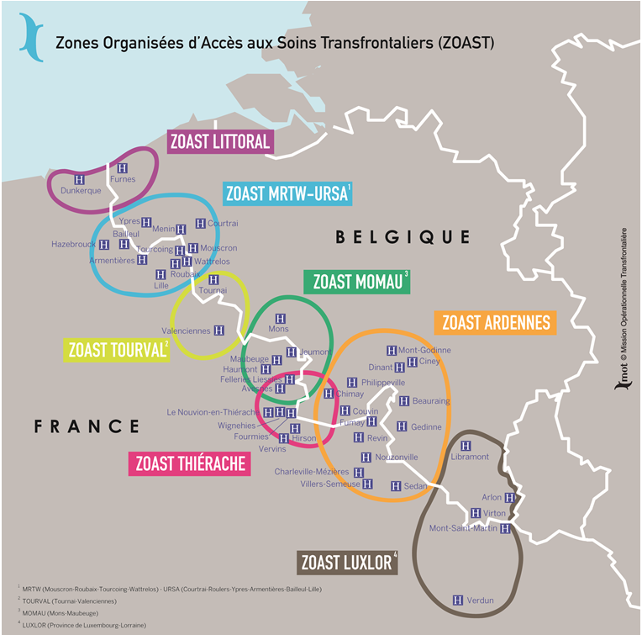

Map 3: Map of the ZOAST.

Another good practice of cross-border health cooperation is the European Regional Development Fund co-financed cross-border hospital in Cerdanya on the border between France and Spain:

The **Cerdanya hospital** forms part of a wider cross-border health care project seeking to ensure the availability of health care to the local population. It serves not only as a setting for the treatment of acute medical problems, but also as the core of a network of cross-border health services. Co-financed under Interreg by the European Regional Development Fund, the hospital has been equipped with 64 beds, 32 rooms, 3 operating rooms, 1 birthing room and additional multi-purpose facilities. Launched in September 2008, the cross-border hospital project is the result of a successful partnership between the European Grouping for Territorial Cooperation of the cross-border Hospital of Cerdanya and the Health Department of the Generalitat de Catalunya (Spain). The project led to the creation of a separate cross-border organisation for the construction and management of this establishment. The area of Cerdanya is inhabited by approximately 30,000 people, a number which rises to 150,000 during peak tourist periods[104]. In practical terms, the hospital resolved a number of secondary issues, such as the recognition of birth and death certificates on both sides of the border.

Other existing best practices co-financed under Interreg and the European Regional Development Fund, which could serve as models for emulation more broadly in the EU are the Integrated Approach to Improve Emergency Medical Assistance in Cross-Border between Italy and Slovenia (IntegrAid), the International Academy for Health Professionals (EEIG), also known as Sanicademia - a euroregional academy for health professionals of the Italian Regions of Friuli Venezia Giulia and the Veneto, and the Austrian Land, Carinthia - and the cooperation between the Children's Hospital in Helsinki University and Estonia.

A bilateral agreement between **Denmark and Germany**[105] has extended the use of the Danish reporting system at an operational level, as it was previously impossible to navigate between the two IT-systems. The incidence of malignant neoplasms in Denmark has risen during the last decades. However the treatment capacity in Denmark was limited when it came to radiotherapy. Before 2006, in Denmark only six hospitals were equipped with radiotherapy departments which caused long travelling times and waiting lists for Danish cancer patients. As the administrative region of Southern Denmark is adjacent to the German border, treatment in Germany can noticeably decrease travelling times. Against this background the cooperation between the German Malteser St. Franziskus hospital in Flensburg and the Region of Southern Denmark was started as a pilot programme in 1998. In 2001 a cooperation contract was signed which includes radiotherapy for diverse cancer for up to 300 Danish patients per year. Although the cooperation was planned to be an interim solution it is still ongoing, primarily due to the advantage of shorter travelling times for Danish patients. In 2007, the cooperation was extended via co-financing through Interreg towards the provision of chemotherapy for Danish patients and the development of a CB mammography screening was also planned. The incentives for the cooperation include the compensation of non-existing resources in Denmark, faster supply of radiotherapy for Danish cancer patients and reduction of the travelling time for Danish cancer patients, a competitive advantage for the Flensburg hospital, and financial incentives as the collaboration contributed to the expansion of the radio-therapy station in Flensburg due to enlarged group of patients.

**To further promote the pooling of health care facilities and to facilitate cross-border health care, the following action is envisaged:**

### Mapping cross-border health cooperation in the EU

A comprehensive **mapping of cross-border health cooperation** across the EU by the Commission will identify good practices and analyse future challenges[106]. It will be available in 2018 and shared with stakeholders via the Border Focal Point. The European Commission will during 2018 also organise a strategic event with health care and border stakeholders to highlight good practices of cross-border health cooperation and explore ways in which this can be further developed throughout the Union.

3.8.2 Report on cross-border Healthcare Directive

In 2018 the Commission will publish an implementation report on the operation of Cross-Border Healthcare Directive which will include elements linked to the situation in border regions.

## Considering the legal and financial framework for cross-border cooperation

The EU has introduced a number of legal and financial tools to facilitate cooperation across European borders.

In terms of funding, many EU-funded programmes make important contributions to cross-border cooperation. Interreg, also known as European Territorial Cooperation (ETC), is one of the two goals of the Union's Cohesion Policy and provides a framework for the implementation of joint actions and policy exchanges between national, regional and local actors from different Member States. In the current and fifth programming period stretching between 2014-2020, Interreg has a total budget of EUR 10.1 billion, of which EUR 6.6 billion are invested for 60 cross-border cooperation programmes along 38 internal Union borders[107].

Besides Interreg, LIFE, Horizon 2020[108], and EURES are important drivers of horizontal cooperation among border regions. For example, within the LIFE Programme (the Financial Instrument for the Environment and Climate Action) 2014-2020, the Integrated project (IP) 'PREPAIR'[109], which concerns air quality, a field where cross-border cooperation is particularly important, and which, among others, aims at strengthening the coordination and cooperation among regional authorities in Italy and Slovenia in this sector.

The Investment Plan for Europe will equally contribute to the development of border regions. The Plan's European Fund for Strategic Investments, recently re-enforced and extended,further incentivises the support for cross-border investment projects in view of their importance for Europe by defining such projects as additional *per se*. Also, as part of the second pillar of the Plan, the European Investment Advisory Hub[110] provides advice and technical assistance for investment projects, including specifically cross-border projects, while the European Investment Project Portal[111] helps projects meet potential investors. Finally, the Plan's third pillar dedicated to removing barriers to investment will help provide a more favourable environment for cross-border investment projects[112].

In terms of labour market policy, the European Social Fund (ESF) can support the transnational mobility of job seekers from 2014 onwards through financing for example language and orientation trainings, the costs of the transnational mobility itself (travel costs), their integration in the host country etc. Transnational mobility activities can be programmed under the specific investment priority (8)(vii), where they concern EURES (financing the activities of the EURES national networks), or under any different investment priority depending on the specific objective to which they contribute.

As far as legal instruments are concerned, Euroregions, Eurodistricts and EGTCs are good practices involving partners from both sides of the border to solve obstacles locally – and creating frameworks for improved cross-border cooperation. Often these local solutions are sector specific and rely mostly on better and more reliable information provision to citizens. Good examples include the INFOBEST offices on the French-German border, and the *'Groupement Transfrontalier Européen'*, an association of French commuters to Switzerland. The first Euroregion was set up in 1958 at the German-Dutch border. Due to the active promotion by the Council of Europe and the Commission, more than 160 Euroregional-type structures have been created between member regions and territories since then. Their legal set-up ranges from associations and foundations to EGTCs or other formalised agreements[113]. Eurodistricts are most often created in cross-border conurbations, like the Strasbourg-Orthenau Eurodistrict[114]. An EGTC is a legal instrument created on the basis of the Regulation (EU) No 1082/2006[115], and allows public entities from both sides of the border to come together under a new single entity with full legal personality[116].

The **Eurometropolis Lille - Kortrijk – Tournai**[117] is the largest cross-border metropole in Europe. The 3,500 km² large, bi-lingual region embraces the Lille metropolis, the southern and central parts of West Flanders, and Western Hainaut. The Eurometropolis was the first EGTC established in Europe, following a long tradition of cross-border cooperation. It brings together all French and Belgian government levels via 14 institutions, working together to erase the "border effect" and make day-to-day life easier for its 2.1 million inhabitants. Today, the EGTC acts as a hub for all cross-border information, activities and services, supporting their exploitation and development and sometimes even adapting them. Institutions, companies, artists, associations and clubs, various organisations, etc. are all invited to coordinate and pool their projects, allowing them to speak with one voice.

To create legal certainty and joint frameworks, the EGTC or the European Economic Interest Group (EEIG)[118] are important tools. However they are not necessarily always suitable to resolve legal and administrative obstacles. Despite their existence, implementing cross-border projects still remains a real challenge, as the time it took to successfully extend the tram line from Strasbourg (F) to Kehl (DE) illustrates[119].

A number of Member States are considering the merit of a new instrument which would make it possible, on a voluntary basis and agreed by the competent authorities in charge, for the rules of one Member State to apply in the neighbouring Member State for a specific project or action limited in time, located within a border region and initiated by local and/or regional public authorities.

From July 2016 to July 2017, the Working Group on Innovative Solutions to Cross-Border Obstacles, co-chaired by France and Luxembourg, with the support of the Transfrontier Operational Mission (*La MOT*) investigated the feasibility and design of a new legal tool, which was first presented under the Luxembourg Presidency in 2015[120]. The working group brought together Member States and partner countries, local and regional stakeholders as well as representatives of EU institutions to discuss a systematic approach to overcoming border obstacles. The aim of the process is to prepare a new tool, the so-called European Cross-Border Convention (ECBC).

The ECBC would be a voluntarily applicable, bottom-up legal tool, available to local and regional authorities and stakeholders to initiate a procedure for solving administrative and legal obstacles. In practice it would allow, after validation by the competent national authority (and if necessary transposition into national law) to apply the administrative or legal rules and provisions of another country in a defined area of application along the border. The ECBC would have the following advantages over existing tools: it would be quicker and more efficient compared to intergovernmental agreements, it would provide a higher administrative and legal certainty to stakeholders involved, compared to the bottom-up approach of many initiatives in cross-border areas. The tool would also limit the administrative burden to the Member States as existing mechanisms, structures and institutions could be integrated into the tool’s procedure. These existing mechanisms, structures and institutions could be used at every step of the procedure to facilitate the process of finding a solution. The instrument would not compete with existing instruments or solutions, and it goes beyond the scope of the EGTC Regulation, which specifies that the regulatory and policy-making powers of legal/regional authorities cannot be subject of an EGTC convention. The ECBC on the other hand would offer the concerned authorities a solution for the limited application of foreign rules and provisions in a domestic context.

**To further enhance the legal and financial framework for cross-border cooperation, the following two actions are envisaged:**

### Following the preparations of a "European Cross-Border Convention"

The Commission services closely follow the work undertaken by Member States as described above. Taking into account the evidence provided by the pilot projects mentioned above in section 3.1, the Commission will consider options to take this instrument forward.

### Looking at possible contributions from future funding programmes

Member States and the European institutions will engage early in a dialogue to explore how future funding programmes can make a more strategic contribution to the prevention and resolution of border obstacles and the development of cross-border public services.

## Building evidence of cross-border interaction to inform decision-making

Collecting data and evidence on border obstacles is the first necessary step towards resolving them but only limited resources are invested in collecting and analysing information on border difficulties and complexities. Excellent examples exist in France (see the *Mission Opérationnelle Transfrontalière*[121]) and in Hungary (see the Central European Service for Cross-Border Initiatives[122]). Regional observatories can be found for instance in the Upper Rhine or the Grande Region. More such types of initiatives are needed across Europe.

The **data portal for the Greater Region –** in and around Luxembourg – collects data from national and regional statistical offices to provide policy-makers with evidence of cross-border flows and territorial trends in an area characterised by high levels of interaction (e.g. 200,000 cross-border workers). Since 1995, a political "summit" brings together political leaders of all involved regions in Germany, France, Belgium and Luxembourg. The basis for joint decisions in the Greater Region is provided through statistical data from five statistical offices. The information is also publicly available[123].

Statistical and geospatial data describing cross-border flows and phenomena is not always sufficiently available or standardised to allow policy-makers to take informed decisions. Member States, under the coordination of the European Statistical Office should explore innovative data collection methodologies (e.g. geo-referencing or geocoding) ready for cross-border analysis such as grid-based data.

The European Commission has launched a one-year pilot project in 2017 with a group of 8 statistical offices to test the potential use of labour force survey data, administrative and census data, and mobile phone data[124].

The Commission also works with the Monitoring Committee of the European Observation Network for Territorial Development and Cohesion (ESPON) Interreg programme (part-financed by the European Regional Development Fund) to further promote territorial research linked to border regions.

The Commission is also building upon successful territorial research activities funded by the Seventh Framework Programme for Research and Technological Development (FP7) and Horizon 2020. Moreover, the Knowledge Centre on Territorial Policies (KC TP) set up by DG Joint Research Centre and DG Regional and Urban Policy develops meaningful and territorially relevant information and analytical tools.

Financed under the Seventh Framework Programme for Research and Technological Development (FP7), the **KTIECBR (Knowledge Transfer and Innovations in European Cross Border Regions)**[125] project focused on the cultural and cognitive differences between managers and customers (shoppers and tourists) from both sides in border regions between Finland and Sweden as well as on the special characteristics of tourism innovation and knowledge transfer between cross border small tourism businesses in two cross-border regions. There were perceived differences between customers and managers from Tornio-Haparanda (i.e. between customers and managers, self-identified as belonging to Finnish or Swedish culture). Surprisingly, customers' perceived differences were found to be similar to those of visitors (non-residents), which could indicate that cross-border regions could represent other mainland regions in Sweden and Finland. The project also concluded that a more fine-grained approach is needed for understanding and improving knowledge transfer between neighbouring national cultures in cross-border regions.

**The following two actions will be implemented to broaden the evidence base for better informed decision-making:**

### Implementing a pilot project on statistical evidence

The Commission is financing a one-year pilot project with statistical offices to test the potential use of labour force survey data, administrative and census data, and mobile phone data. This collaborative work with Member States should be pursued and re-enforced based on the outcome of the pilot project available in 2018. The Border Focal Point will ensure that the project results are widely disseminated and that identified good practices are made available to all border stakeholders via the online professional network to be set up.

### Promoting border-related, territorial research

The Commission is working with the European Observation Network for Territorial Development and Cohesion (ESPON) cooperation programme to further promote territorial research linked to border regions.

The Commission will continue to develop meaningful and territorially relevant information and analytical tools in the framework of the Knowledge Centre on Territorial Policies (KC TP). Based upon the support of two key analytical tools (namely: the Regional Economic model RHOMOLO and the LUISA Territorial Modelling Platform) the KC TP will contribute to increase the availability of indicators at high spatial and thematic granularity to evaluate and foster positive impacts of cross-border issues such as spill-overs, proximities, technological contaminations and labour market dynamics. The KC TP Territorial Dashboard will be the main instrument for the dissemination and analysis of territorial features. This work will be used by the Border Focal Point to promote informed decision-making in response to challenges faced by border communities.

# Annex

## Overview of case studies

| Case study number | Policy Area | Specific cross-border illustration |
| --- | --- | --- |
| 1 | Industry/trade: Exportation of goods and cross-border provision of commercial services, including e-commerce | Ireland - United Kingdom |
| 2 | Industry/trade: Border-regional business activities and cross-border development of entrepreneurship | Bulgaria - Greece |
| 3 | Labour market/education: Mobility of cross-border workers (commuter flows) | Denmark -  Sweden |
| 4 | Labour market/education: Mobility of trainees, students and teachers | Germany - The Netherlands |
| 5 | Labour market/education: Recognition of diploma or professional qualification certificates | Spain - Portugal |
| 6 | Belgium - Germany – France - Luxembourg (Grande Region) |
| 7 | Social security systems: Access to social insurance system (e.g. retirement pensions, disability insurance, survivor benefits, unemployment insurance etc.) | Belgium - Germany – France - Luxembourg (Grande Region) |
| 8 | Social security systems: Access to health care services (i.e. primary, secondary and tertiary care) and medical treatment | Estonia - Latvia |
| 9 | Social security systems: Access to health care services (i.e. primary, secondary and tertiary care) and medical treatment | Finland - Sweden |
| 10 | Transport: Scope and quality of regional/local and cross-border transport infrastructures and of related maintenance services (e.g. snow removal on roads and rail tracks etc.) | Germany - Poland |
| 11 | Transport: Public transport by bus, rail, light rail or metro (e.g. quality service offer, density of connections, harmonisation of tariffs & schedules etc.) | Germany - France |
| 12 | Transport: Scope and quality of regional/local and cross-border transport infrastructures and of related maintenance services (e.g. snow removal on roads and rail tracks etc.) | Austria - Slovenia |
| 13 | Policy planning/public services: Spatial planning and cross-border territorial development planning | Belgium - France |
| 14 | Policy planning/public services: Emergency and rescue services | Slovakia - Hungary |
| 15 | Policy planning/public services: Public security and crime prevention (police cooperation) | Germany - Poland |

1. For scope and definition see chapter 1.1.
2. ‘Territories with specific geographical features’, Working Paper No: 02/2009, European Commission, DG REGIO: p. 5: <http://ec.europa.eu/regional_policy/en/information/publications/working-papers/2009/territories-with-specific-geographical-features> .
3. European Commission, Ex-post evaluation 2007-2013 Work Package 11 Ex post evaluation of Cohesion Policy programmes 2007-2013, focusing on the European Regional Development Fund (ERDF) and the Cohesion Fund (CF) 11 ETC, 29 July 2016: <http://ec.europa.eu/regional_policy/en/information/publications/evaluations/2016/european-territorial-cooperation-work-package-11-ex-post-evaluation-of-cohesion-policy-programmes-2007-2013-focusing-on-the-european-regional-development-fund-erdf-and-the-cohesion-fund-cf> .
4. See chapter 2.
5. For statistical reasons, data and information is based on NUTS level 3 regions under the European Nomenclature of territorial units for statistics –<http://ec.europa.eu/eurostat/web/nuts> .
6. See e.g.: [http://www.espaces-transfrontaliers.org/en/resources/topics-of-cooperation/themes/theme/show/cross-border-maritime-cooperation /](http://www.espaces-transfrontaliers.org/en/resources/topics-of-cooperation/themes/theme/show/cross-border-maritime-cooperation%20/) .
7. The European Court of Justice ruling of 28 April 2009 Case C-518/06 noted in relation to the term 'obstacle' or 'restriction' that "*all measures which prohibit, impede or render less attractive the freedom of establishment or the freedom to provide services are restrictions to the relevant freedoms*".
8. This holistic perception of the "multidimensional reality" of European borders was developed in the context of the ESPON 2013 research project "GEOSPECS", Source: ESPON (2012): "GEOSPECS- European Perspective on Specific Types of Territories", Applied Research 2013/1/12, Final Scientific Report (Version 20/12/2012).
9. More information is accessible under: <http://ec.europa.eu/regional_policy/en/policy/cooperation/european-territorial/cross-border/review/> .
10. Previously established inventories remained limited in their geographical scope or lacked the necessary level of detail and documentation. In 2011, the Council of Europe (CoE) published the EDEN-database, which presents the outcome of a survey among CoE-member countries on existing border obstacles, as well as the subsequently elaborated "Manual on removing obstacles to cross-border cooperation" (Council of Europe (2011): Preparation of the conference on removing obstacles and promoting good practices on cross-border cooperation. Replies to the questionnaire. Strasbourg, 16 May 2011. Council of Europe (2012): Manual on removing obstacles to cross-border cooperation. Strasbourg, November 2012. EDEN-Database: http://cbc.isig.it/search-the-database/). While it contains valuable information, for a large number of countries the border-specific information on obstacles was rather general (i.e. lacking description of legal or administrative sources, of the wider policy background or of adverse effects) or even not existing at all. Regionally, good inventories exist in a number of border regions, such as the Öresund region, within the Nordic Council of Ministers, in border regions of the Netherlands, Germany and Belgium, and at the Franco-Belgian border.
11. The inventory is accessible here: <http://ec.europa.eu/regional_policy/en/policy/cooperation/european-territorial/cross-border/review> .
12. The study reviewed sources published between 2010 and 2015. Recent events in relation to the European refugee crisis and the linked re-introduction of border controls along some internal border sections in five Schengen states were not taken into account.
13. Although initially no specific policy area, and no specific cross-border region should have been represented more than once, the weighting of the examples of the inventory (more in Northern and Western Europe), led to the adoption of a more pragmatic approach.
14. It has to be noted that the amount of responses to the public consultation is below the threshold to be considered statistically significant. Therefore the conclusions drawn are largely qualitative.
15. Further information, participants' lists, videos and summaries of outcomes are available under the following webpage:   
    <http://ec.europa.eu/regional_policy/en/policy/cooperation/european-territorial/cross-border/review> .
16. For detailed results of the public consultation, see: European Commission, Directorate-General for Regional and Urban Policy: Overcoming obstacles in border regions. Summary report on the online public consultation 21 September 2015 - 21 December 2015. Luxemburg 2016:   
    <http://ec.europa.eu/regional_policy/en/newsroom/consultations/overcoming-obstacles-border-regions/> .
17. This is largely qualitative because the consulted sources rarely provide exact measurements or other quantitative data, and some adverse aspects are of an intangible and thus non-measurable nature (e.g. inadequate administrative action, lack of cooperation or coordination etc.).
18. The level of the impact of border obstacles on the border region (economically, socially, environmentally and for citizens living along the border) was categorised according to a simple scaling system (low/medium/high). For carrying out this assessment the following impact and scoring thereof was used: The primary impact, with four scores: 4=very strong, 3=strong, 2=moderate, 1=weak. The secondary impact, with four scores: 4=very strong, 3=strong, 2=moderate, 1=weak. The aggregated total impact, with a scaling at three levels (i.e. high, medium, low) which results from the previously achieved total score.
19. Introduced by Regulation (EC) No 1082/2006 of the European Parliament and of the Council of 5 July 2006 (OJ L 210, 31.7.2006, p. 19), as amended by Regulation (EU) No 1302/2013 of 17 December 2013 (OJ L 347, 20.12.2013, p. 303).
20. Beck, J. (2015),*Cross-Border Cooperation and the European Administrative Space – Prospects from the Principle of Mutual Recognition,* International Public Administration Review, 13(2), p. 9-36.
21. European Commission 'EU *e*Government Action Plan 2016-2020 - Accelerating the digital transformation of government', COM(2016) 179 of 19 April 2016: https://ec.europa.eu/digital-single-market/en/news/communication-eu-egovernment-action-plan-2016-2020-accelerating-digital-transformation  
    <http://eur-lex.europa.eu/legal-content/EN/TXT/?qid=1503566265012&uri=CELEX:52016DC0179> .
22. The summary in the table rates the tools described above in terms of five criteria, namely 'Simplicity and time for establishment': How easy can the tool be applied and how fast can it be established to become operational? 'Flexibility (versatility)': How flexible, changeable is the tool during its use and how easy can it be adapted to changing needs and circumstances? ‘Bindingness’ – How much are the actions and results of the application of the tool binding for the partners (and beyond)? 'Effectiveness (result potential)': To what extend is the tool expected to be effective/to produce positive results? 'Sustainability': To what extent is the tool expected to operate for a long term? For each criterion a simple and necessarily very general rating scale with four steps has been applied: ++ very high, + high, - low, -- very low.
23. Cecchini, P., *The European Challenge 1992: the benefits of a single market*, Aldershot: Wildwood House, 1988.
24. Ilzkovitz F., Dierx A., Kovacs V., Sousa N. (2007), 'Steps towards a Deeper Economic Integration: the Internal Market in the 21st Century', European Economics - Economic Paper 271, Directorate General Economic and Monetary Affairs (DG ECFIN), European Commission.
25. Boltho A. and Eichengreen B. (2008), *The Economic Impact of European Integration*, CEPR Discussion paper, n. 6820.
26. Campos N., Corricelli F. and Moretti L. (2014), 'Economic growth and political integration: synthetic counterfactual evidence from Europe', mimeo.
27. Dunne, J. (2015) (ed). 'Mapping the Cost of Non-Europe, 2014-19', European Added Value Unit, Directorate for Impact Assessment and European Added Value, Directorate-General for Parliamentary Research Services (EPRS): <http://www.europarl.europa.eu/thinktank/en/document.html?reference=IPOL-EAVA_ET%282014%29510983> .
28. Godel, M. I., Harms, A., Jones, S., and Mantovani, I. (2016). 'Reducing costs and barriers for businesses in the Single Market', European Parliament's Committee on Internal Market and Consumer Protection: <http://www.europarl.europa.eu/thinktank/en/document.html?reference=IPOL_STU(2016)578966> .
29. Study 'Quantification of the effects of legal and administrative border obstacles in land border regions', Expert contract number 2016CE160AT091, Final Report 28 April 2017.
30. Some NUTS level 3 regions belong to two or more land border regions. In these cases, the color prevailing is that of the land border regions that comes first in alphabetical order.
31. Gil-Pareja, S., Llorca-Vivero R., and Martínez-Serrano J., *The border effect in Spain: The Basque Country case*, Regional Studies Vol. 40, Issue 4, 2006.
32. Ferreira, R. and Mourato J., 'Border Effect in Interregional Iberian Trade', Journal of Economics and Business Research, Instituto Politécnico de Portalegre, Portugal, Year XVII, No. 1, 2011, pp. 35-50: <https://www.researchgate.net/publication/303494465_Border_Effect_in_Interregional_Iberian_Trade> .
33. Vanagas, M. (2013), 'Border Effects Among EU Countries: Do National Identity and Cultural Differences Matter?', Reinvention: an International Journal of Undergraduate Research, Volume 6, Issue 2: <https://www2.warwick.ac.uk/fac/cross_fac/iatl/reinvention/issues/volume6issue2/vanagas> .
34. Helble, M., 'Border Effect Estimates for France and Germany Combining International Trade and Intranational Transport Flows', Review of World Economics, October 2007, Volume 143, Issue 3, pp. 433-463: <https://link.springer.com/article/10.1007/s10290-007-0116-x> .
35. McCallum, J., 'National Borders Matter: Canada-U.S. Regional Trade Patterns', The American Economic Review, Vol. 85, No. 3 (Jun., 1995), pp. 615-623. The Results were later confirmed by Helliwell (1996); Hillberry (1998) Anderson and Smith (1999).
36. Ferreira, R. and Mourato J., *op. cit*. A similar argument is presented in Ferreira, R. (2016), "Iberian major Regions Interregional Trade across the Border", in Journal of Economics and Business Research XXII (2):2068-3537, December 2016, p. 28: <https://www.researchgate.net/publication/317000181_Iberian_major_Regions_Interregional_Trade_across_the_Border> .
37. Chen, N. 'Intra-national versus international trade in the European Union: why do national borders matter?', Journal of International Economics, Volume 63, Issue 1, May 2004, pp. 93-118: <http://www.sciencedirect.com/science/article/pii/S0022199603000424> .
38. Chen (2004), based on Rauch, J.E., 'Networks versus markets in international trade', Journal of International Economics, 48(1) (1999), pp. 7–35.
39. Directive 2008/56/EC of the European Parliament and of the Council of 17 June 2008 establishing a framework for community action in the field of marine environmental policy (Marine Strategy Framework Directive) (Text with EEA relevance) (OJ L 164, 25.6.2008, p. 19).
40. Directive 2000/60/EC of the European Parliament and of the Council of 23 October 2000 establishing a framework for Community action in the field of water policy (OJ L 327, 22.12.2000, p. 1).
41. Directive 2002/49/EC of the European Parliament and of the Council of 25 June 2002 relating to the assessment and management of environmental noise (OJ L 189, 18.7.2002, p. 12).
42. Directive 2008/98/EC of the European Parliament and of the Council of 19 November 2008 on waste and repealing certain Directives (Text with EEA relevance) (OJ L 312, 22.11.2008, p. 3).
43. Directive 2008/50/EC of the European Parliament and of the Council of 21 May 2008 on ambient air quality and cleaner air for Europe (OJ L 152, 11.6.2008, p. 1).
44. EU Action Plan for nature, people and the economy: <http://ec.europa.eu/environment/nature/legislation/fitness_check/action_plan/index_en.htm> .
45. Directive 2009/147/EC of the European Parliament and of the Council of 30 November 2009 on the conservation of wild birds (OJ L 20, 26.1.2010, p. 7).
46. Council Directive 92/43/EEC of 21 May 1992 on the conservation of natural habitats and of wild fauna and flora (OJ L 206, 22.7.1992, p. 7).
47. The EU Strategy for the Baltic Sea Region, The EU Strategy for the Danube Region, The EU Strategy for the Adriatic and Ionian Region and The EU Strategy for the Alpine Region.
48. Communication from the Commission to the European Parliament, the Council, the European Economic and Social Committee and the Committee of the Regions - The EU Environmental Implementation Review: Common challenges and how to combine efforts to deliver better results (COM(2017) 63 final of 3 February 2017).
49. OJ L 94, 28.3.2014, p. 65.
50. Communication from the Commission to the European Parliament, the Council, the European Economic and Social Committee and the Committee of the Regions 'Better regulation for better results - An EU agenda', COM(2015) 215 final of 19 May 2015.
51. Tool #29: Territorial Impacts of the toolbox complementing the Commission Staff Working Document Better Regulation Guidelines (SWD(2015) 111 of 19.5.2015).
52. Institute for Transnational and Euregional Cross-Border Cooperation and Mobility of Maastricht University: <https://www.maastrichtuniversity.nl/research/institute-transnational-and-euregional-cross-border-cooperation-and-mobility-item> .
53. European Commission 'EU *e*Government Report 2016' shows that online public services improved unevenly, Digital Single Market, News, Digibytes, 3 October 2016: <https://ec.europa.eu/digital-single-market/en/news/eu-egovernment-report-2016-shows-online-public-services-improved-unevenly> .
54. Digitalisierung der öffentlichen Verwaltung und ihre Folgen für die Grenzpendler auf dem Arbeitsmarkt im deutsch-dänischen Grenzland: <http://www.region.de/region/de/ueber_uns/publikationen/Publikationen_Arbeitsmarkt.php> .
55. European Commission 'EU *e*Government Action Plan 2016-2020 - Accelerating the digital transformation of government', COM(2016) 179 of 19 April 2016https://ec.europa.eu/digital-single-market/en/news/communication-eu-egovernment-action-plan-2016-2020-accelerating-digital-transformation:   
    <http://eur-lex.europa.eu/legal-content/EN/TXT/?qid=1503566265012&uri=CELEX:52016DC0179> .https://ec.europa.eu/digital-single-market/en/news/communication-eu-egovernment-action-plan-2016-2020-accelerating-digital-transformation
56. European Commission '*The “Once-Only” Principle (TOOP) Project launched in January 2017',* DigitalSingle Market, Project News and Results, 26/01/2017: <https://ec.europa.eu/digital-single-market/en/news/once-only-principle-toop-project-launched-january-2017> .
57. Machine translation for public administrations - MT@EC: <https://ec.europa.eu/info/resources-partners/machine-translation-public-administrations-mtec_en> .
58. See note 52.
59. Points of Single Contact: <http://ec.europa.eu/internal_market/eu-go/index_en.htm> .
60. Regulation (EU) No 910/2014 of the European Parliament and of the Council of 23 July 2014 on electronic identification and trust services for electronic transactions in the internal market and repealing Directive 1999/93/EC (OJ L 257, 28.8.2014, p. 73):   
    <http://eur-lex.europa.eu/legal-content/EN/TXT/?uri=uriserv%3AOJ.L_.2014.257.01.0073.01.ENG> .
61. Citizens of the EU, Norway, Iceland and Liechtenstein, or residing in an EU Member State.
62. Your Europe Advice: <http://europa.eu/youreurope/advice/> .
63. SOLVIT: <http://ec.europa.eu/solvit/index_en.htm> .
64. See note 62.
65. Infobest: <https://www.infobest.eu/> .
66. Proposal for a Regulation of the European Parliament and of the Council on establishing a single digital gateway to provide information, procedures, assistance and problem solving services and amending Regulation (EU) No 1024/2012 of 2 May 2017: <http://eur-lex.europa.eu/legal-content/EN/TXT/?uri=CELEX%3A52017PC0256> .
67. European Commission Communication COM/2017/0255, of 2 May 2017 Action plan on the reinforcement of SOLVIT: bringing the benefits of the Single Market to citizens and businesses: <http://eur-lex.europa.eu/legal-content/EN/TXT/?uri=CELEX:52017DC0255> .
68. Cross-border workersare defined as EU/EFTA citizens who live in one EU or EFTA country and work in another, regardless of their precise citizenship (provided they are EU-28/EFTA citizens). Cross-border workers, also called frontier workers, move across borders regularly on a daily or at least weekly basis.
69. Fries-Tersch, E. Tugran, T., Bradley, H., (2017), *The 2016 annual report on intra-EU labour mobility of the European Commission,* Second edition: <http://ec.europa.eu/social/main.jsp?catId=738&langId=en&pubId=7981&furtherPubs=yes> .
70. In absolute terms, the highest number of cross-border workers reside in France (364,000), Germany (229,000), Poland (138,000), Slovakia (132,000) and Belgium (100,000). Source: The 2015 Annual Report on Labour Mobility.
71. EURES: <https://ec.europa.eu/eures/main.jsp?catId=2547&acro=faq&lang=en> .
72. Regulation (EU) 2016/589 of the European Parliament and of the Council of 13 April 2016 on a European network of employment services (EURES), workers' access to mobility services and the further integration of labour markets, and amending Regulations (EU) No 492/2011 and (EU) No 1296/2013 (Text with EEA relevance) (OJ L 107, 22.4.2016, p. 1).
73. EURES Norte Portugal Galicia: <http://www.eures-norteportugal-galicia.org> .
74. Case study in policy area 2 (Labour Market and Education): <http://ec.europa.eu/regional_policy/en/policy/cooperation/european-territorial/cross-border/review> .
75. European Union – Council of the EU, Council conclusions on multilingualism and the development of language competences, May 2014:   
    <http://eur-lex.europa.eu/legal-content/EN/TXT/?uri=CELEX:52014XG0614(06)> .
76. School education Gateway, *'Border regions: learning the neighbour’s language'*, News, 7 September 2009:   
    <https://www.schooleducationgateway.eu/en/pub/latest/news/border-regions-learning-the-n.htm> .
77. France Saarland Strategy October 2016: <https://www.saarland.de/dokumente/ressort_finanzen/MFE_Frankreich_Startegie_LangDIn4S_UK_Lay2.pdf> .
78. European Commission, Erasmus+: <https://ec.europa.eu/programmes/erasmus-plus/> .
79. European Commission, Erasmus+, Project results: [http://ec.europa.eu/programmes/erasmus plus/projects/eplus-project-details-page/?nodeRef=workspace://SpacesStore/a45d9f22-00f1-4121-b67a-9fc3a653e54d](http://ec.europa.eu/programmes/erasmus%20plus/projects/eplus-project-details-page/?nodeRef=workspace://SpacesStore/a45d9f22-00f1-4121-b67a-9fc3a653e54d) .
80. European Commission, Erasmus+, Project results: <http://ec.europa.eu/programmes/erasmus-plus/projects/eplus-project-details-page/?nodeRef=workspace://SpacesStore/6b7b9d11-fcb6-40e4-bf27-68f534ef98f1> .
81. European Commission, Erasmus+, Project results: <http://ec.europa.eu/programmes/erasmus-plus/projects/eplus-project-details-page/?nodeRef=workspace://SpacesStore/6b444dbc-fd32-452c-afbf-908907da0356> .
82. European Commission, Erasmus+, Project results: <http://ec.europa.eu/programmes/erasmus-plus/projects/eplus-project-details-page/?nodeRef=workspace://SpacesStore/3acbf064-2949-425a-b30b-8034b2050a99> .
83. *Espaces Transfrontaliers, Education, formation, langues*:   
    <http://www.espaces-transfrontaliers.org/ressources/themes/themes/theme/show/education-formation-langues> and   
    <http://www.espaces-transfrontaliers.org/ressources/themes/education-formation-langues/education-formation-langues-3/> .
84. *Espace Transfrontaliers, Projects, Trilingua:*   
    <http://www.espaces-transfrontaliers.org/ressources/projets/projects/project/show/trilingua-reseau-dechange-dassistants-educatifslocuteurs-natifs-entre-les-ecoles-elementaires-e/> .
85. Projet SESAM’GR:   
    <http://www.moselle.fr/SiteCollectionDocuments/VivrelaMoselle/EducationJeunesse/SESAMGR_fiche.pdf> .
86. *Espace Transfrontaliers, Projects, Création d’un lycée germano-luxembourgeois:*<http://www.espaces-transfrontaliers.org/ressources/projets/projects/project/show/creation-dun-lycee-germano-luxembourgeois/> .
87. *Espace Transfrontaliers, Projects, La maison de la petite enfance transfrontalière:*<http://www.espaces-transfrontaliers.org/actualites/des-projets-transfrontaliers-au-service-de-la-population-locale/la-maison-de-la-petite-enfance-transfrontaliere-a-strasbourg-kehl/?print=y&cHash=7234bcf88a166bb1fad6768a53255626> .
88. http://www.interreg-rhin-sup.eu/projet/eucor-le-campus-europeen-structures-transfrontalieres/?cat=233-207 and <http://www.eucor-uni.org/fr> .
89. *Espace Transfrontaliers, Projects, Ecole Transfrontalière du Perthus:*<http://www.espaces-transfrontaliers.org/ressources/projets/projects/project/show/ecole-transfrontaliere-du-perthus/> .
90. Ehubaq: <http://www.ehubaq.eu/> .
91. Article 10(1)(c) of Regulation (EU) No 1315/2013 of the European Parliament and of the Council of 11 December 2013 on Union Guidelines for the development of the trans-European transport network (OJ L 348, 20.12.2013, p. 1).
92. Article 42(1)(c) of Regulation (EU) No 1315/2013.
93. Study on permitting and facilitating the preparation of TEN-T core network projects,˚MOVE/B3/2014-751, Final report including Annex 1 and the Annex on waterborne, December 2016: <https://ec.europa.eu/transport/sites/transport/files/2016-12-permitting-facilitating-ten-t.pdf> and: <http://ec.europa.eu/transport/sites/transport/files/2016-12-permitting-facilitating-ten-t-annexes-1-to-6.pdf> and: <http://ec.europa.eu/transport/sites/transport/files/2016-12-permitting-facilitating-ten-t-annex-on-waterborne.pdf> .
94. SWD(2017) 177 final of 31 May 2017.
95. Communication from the Commission to the European Parliament, the Council, the European Economic and Social Committee and the Committee of the Regions 'Europe on the move an agenda for a socially fair transition towards clean, competitive and connected mobility for all', COM(2017) 283 final of 31 May 2017:   
    <http://eur-lex.europa.eu/legal-content/en/TXT/?uri=CELEX:52017DC0283> .
96. <https://www.keep.eu/keep/> .
97. Besides provisions mentioned in the Treaty itself, one can highlight the Directive on the application of patients’ rights in cross-border healthcare (2011/24/EU) and the EU-Regulation on coordination of social security systems (883/2004), see complete references in footnotes 98 and 99.
98. Directive 2011/24/EU of the European Parliament and of the Council of 9 March 2011 on the application of patients' rights in cross-border healthcare (OJ L 88, 4.4.2011, p. 45).
99. Regulation (EC) 883/2004 of the European Parliament and of the Council of 29 April 2004 on the coordination of social security systems (OJ L 166, 30.4.2004, p. 1).
100. Gesundheit Österreich Forschungs- und Planungs GmbH, *Study on better cross-border Cooperation for high-cost Capital investments in health,* November 2016*,* e.g. pp. 97-108:   
     <https://ec.europa.eu/health//sites/health/files/cross_border_care/docs/hci_frep_en.pdf> .
101. Case study in policy area 3 (Social Security Systems), Obstacle N.82 in the inventory:   
     <http://ec.europa.eu/regional_policy/en/policy/cooperation/european-territorial/cross-border/review/> .
102. *Espace Transfrontaliers, La Communauté de santé transfrontalière:*<http://www.espaces-transfrontaliers.org/ressources/themes/sante/sante-4/> .
103. Expert Panel on Effective Ways of Investing in Health (EXPH) opinion on Cross-border Cooperation, 29 July 2015 p. 30:   
     <http://ec.europa.eu/health/expert_panel/sites/expertpanel/files/009_crossborder_cooperation_en.pdf> .
104. See footnote 101.
105. This cooperation exists between “The Malteser Hospital” in Flensburg (Germany) and the Region of Southern Denmark. The cooperation focuses on cost-intensive medical equipment necessary for radiotherapy, e.g. linear accelerators and the presence of radiotherapy stations.
106. See request for Specific Services No CHAFEA/2016/Health/22 for the implementation of Framework Contract No EAHC/2013/Health/01 – lot 2- health economics– Study on cross-border cooperation: capitalising on existing initiatives for cooperation in cross-border regions.
107. Interreg : European Territorial Co-operation:   
     <http://ec.europa.eu/regional_policy/en/policy/cooperation/european-territorial/> .
108. Horizon 2020, the biggest programme of the Union dedicated entirely to Research and Innovation (R&I), promotes advances in science with nearly EUR 80 billion of funding over 7 years (2014-2020): <https://ec.europa.eu/programmes/horizon2020/en/what-horizon-2020> .
109. PREPAIR - Po regions engaged to policies of air:   
     <http://ec.europa.eu/environment/life/project/Projects/index.cfm?fuseaction=search.dspPage&n_proj_id=6102> .
110. The European Investment Advisory Hub: <http://www.eib.org/eiah/> .
111. European Investment Project Portal (EIPP): <https://ec.europa.eu/eipp/desktop/en/index.html> .
112. Investment plan: <https://ec.europa.eu/commission/priorities/jobs-growth-and-investment/investment-plan_en> .
113. *Espaces Transfrontaliers, Eurorégions*:   
     <http://www.espaces-transfrontaliers.org/en/resources/territories/euroregions/> .
114. Eurodistrict: <http://www.eurodistrict.eu/fr> .
115. See complete reference in footnote 19.
116. EGTC Platform: <https://portal.cor.europa.eu/egtc/Pages/welcome.aspx> .
117. Eurometropolis: <http://www.eurometropolis.eu/> .
118. European Economic Interest Grouping (EEIG), introduced by the Council Regulation (EEC) No 2137/85 of 25 July 1985.
119. Strasbourg Eurométropole/   
     <http://www.strasbourg.eu/en/grands-projets/projets-deplacements-urbains/extension-tram-kehl> .
120. Input paper for the Informal Ministerial Meeting on Territorial Cohesion under the Luxembourg Presidency/ [http://www.amenagement-territoire.public.lu/fr/eu-presidency/Informal-Ministerial-Meetings-on-Territorial-Cohesion-and-Urban-Policy-_26-27-November-2015_-Luxembourg-City_.html#](http://www.amenagement-territoire.public.lu/fr/eu-presidency/Informal-Ministerial-Meetings-on-Territorial-Cohesion-and-Urban-Policy-_26-27-November-2015_-Luxembourg-City_.html%23%20) .
121. Mission Opérationnelle Transfrontalière: [www.espaces-transfrontaliers.org](http://www.espaces-transfrontaliers.org) .
122. Central European Service for Cross-Border Initiatives: [www.cesci-net.eu](http://www.cesci-net.eu) .
123. *Grande Région*: <http://www.grande-region.lu/portal/de/> .
124. European Commission, Study, 'Collecting solid evidence to assess the needs to be addressed by Interreg cross-border cooperation programmes', Study, Luxembourg, November 2016:   
     <http://ec.europa.eu/regional_policy/en/information/publications/studies/2016/collecting-solid-evidence-to-assess-the-needs-to-be-addressed-by-interreg-cross-border-cooperation-programmes> .
125. KTIECBR (Knowledge Transfer and Innovations in European Cross Border Regions): <http://cordis.europa.eu/result/rcn/59915_en.html> .