

**1. Introduction**

Financial integration lies at the heart of the Single Market and the Economic and Monetary Union and brings important economic benefits for the euro area and the EU as a whole. After a set-back due to the financial crisis, financial integration in the European Union has been increasing again since 2011.[1] EU investors have increased their cross-border asset holdings. Intra-EU debt and equity portfolio investments increased by EUR 2 trillion between 2006 and 2015. Price-based indicators of financial integration show that overall convergence nearly doubled over that period.[2] Against this background, and as the EU economy continues to recover, it is important to build on this momentum and move forward with the necessary steps to deepen financial integration in the EU.

The importance of Capital Markets Union and a stronger Internal Market was underlined by President Juncker in his State of the Union Address on 13 September 2017.[3] The European Council[4] and the European Parliament[5] have also repeatedly called for the completion of Capital Markets Union.

The **Single Market** in financial services promotes **jobs, growth and investment** in all EU Member States,by channelling savings more effectively to their most productive uses. If markets are truly integrated, savers and investors can obtain higher returns, while consumers and businesses can obtain better financing conditions - based on a more complete and competitive offering of financial instruments. In particular, financial integration can leverage even further the success of the **Investment Plan** **for Europe** in filling the EU's investment gap, while also facilitating the transition to a low-carbon, more resource-efficient economy.

Continued financial integration is also essential for strengthening **Economic and Monetary Union.** Deep and liquid markets increase the resilience towards adverse shocks and substantially facilitate private risk-sharing across borders, while at the same time reducing the need for public risk-sharing. To these ends, the Five Presidents' Report on Completing Europe's Economic and Monetary Union and the more recent Commission Reflection Paper on Deepening the Economic and Monetary Union have called for completing the Financial Union – comprising both a Banking Union and a Capital Markets Union – by 2019 so as to guarantee the integrity of the Euro and improve the functioning of the Euro area and the EU as a whole. All these benefits of integration are enhanced by the new opportunities presented by technological developments in the financial sector (FinTech). Indeed, FinTech is set to play a key role in shaping the future of the EU financial sector by facilitating access to financial services, improving operational efficiency and expanding choice. At the same time, technological development also raises issues around cyber-security and payment security that need to be adequately addressed.

Against this background, it is a priority for the Juncker Commission **to complete the Banking Union rapidly, and put in place all remaining building blocks for a Capital Markets Union by 2019**.

To make this happen, the EU must act as a priority to strengthen and integrate its supervisory framework. Strong and increasingly integrated financial supervision will play a key role in delivering the benefits and managing the challenges related to the further integration of EU financial markets, the development of financial technologies and the role of the financial sector in supporting sustainable economic development. In the Mid Term Review of the Capital Markets Union[6] the Commission therefore announced proposals for strengthened supervision as a first new priority to accelerate market integration.The legislative proposals accompanying this Communication contain these next steps which the EU must now deliver on quickly to reinforce its supervisory framework.

**2. More integrated supervision to foster Capital Markets Union and financial integration**

Progress in financial integration will require a more integrated **EU supervisory framework** for two main reasons.

* First, it is easier to conduct financial activities across border if those activities are regulated and supervised consistently across all Member States. Providers of financial products benefit from a level playing field across the Single Market and service providers may expand their product offerings and benefit from economies of scale. Users of financial products and services – consumers as well as businesses – may benefit from a wider choice without concerns about consumer protection or market integrity.
* Second, financial integration – for all its benefits – also expands the channels of contagion between Member States in the event of adverse shocks, as we experienced during the financial crisis. Inadequate supervision in one Member State can therefore also be a source of risk for financial market participants and consumers in other Member States. Furthermore, there is a risk that market participants actively exploit such differences in supervision in order to increase their own short-term profits.[7]

With the establishment of the European System of Financial Supervision in 2010-11 the EU supervisory framework has been substantially reinforced in response to the financial crisis. The European System of Financial Supervision includes both micro-prudential supervision, coordinated by the three European Supervisory Authorities, and macro-prudential supervision, co-ordinated by the European Systemic Risk Board. In November 2014, the Single Supervisory Mechanism became operational and is now responsible for the supervision of large and systemic banks in countries participating in the Banking Union. Resolution of banks in the Banking Union has been entrusted to another new European body, the Single Resolution Board. The progress made during the 10 years since the outbreak of the worst post-war financial crisis is significant. However, the EU supervisory framework is still work in progress and further reinforcement is required in the face of new challenges linked to the ongoing process of financial integration both within the EU and at global level. More specifically, the decision of the United Kingdom to leave the EU reinforces the case for more integrated supervision within the EU 27 and a reassessment of supervisory relations with third countries, so as to ensure proper management of all financial-sector risks.

The **banking sector** already benefits from consistent supervision by the Single Supervisory Mechanism within the Banking Union, in which 19 Member States participate. The geographical scope of Single Supervisory Mechanism supervision will extend, as additional Member States join the Banking Union. However, it is important that the Single Supervisory Mechanism operates within a consistent supervisory framework for the wider EU. This will ensure a level playing field between Member States participating in the Banking Union and non-participating Member States and will help smooth future transitions of non-participating Member States into the Banking Union. To this end, the role of the European Banking Authority in promoting supervisory convergence in the EU banking sector should be enhanced.

With a few exceptions, **EU capital markets** are supervised at national level. The Five Presidents' Report identified a Single European Capital Markets supervisor as a longer-term objective and the Reflection Paper on the Deepening of the Economic and Monetary Union announced that the first steps towards this objective should be taken in the context of this review of the European System of Financial Supervision. As the Capital Markets Union will bring about further financial integration, it is crucial to strengthen the capacity of the European Supervisory Authorities to ensure consistent supervision and uniform enforcement of the single rulebook. This will support well-functioning capital markets by reducing barriers to cross-border investment, simplifying the business environment and reducing compliance costs for firms operating on a cross-border basis resulting from divergent implementation of the rules. From an investor's perspective, consistent supervision and uniform enforcement of the rules contributes to enhancing investor protection and the building confidence in capital markets.

Moreover, direct supervision by the European Securities Markets Authority could significantly contribute to ensuring consistent supervision and represents first concrete steps towards a Single European Capital Markets Supervisor. In this context, the European Parliament has also emphasised that the legal and supervisory frameworks should play a fundamental role in avoiding excessive risk-taking and instability in financial markets, and underlined that a strong Capital Markets Union needs to be accompanied by strong EU-wide and national supervision.[8]

EU **insurance and pensions markets** enable EU citizens to mitigate risks, plan for their retirement and build up savings for their old age, but also have the potential to boost cross-border investment in a Capital Markets Union. While it appears appropriate to leave supervision under the recently-introduced Solvency II framework at the national level at the current stage, further convergence of supervisory practices must be ensured and intensified under the auspices of the European Insurance and Occupational Pensions Authority, so as to address any concerns and practical issues caused by the diverging application of rules by national supervisors.

As the EU strives to further integrate financial markets, **macroprudential oversight**, i.e. the monitoring of risks for the stability of the financial system as a whole, will be even more important. The European Systemic Risk Board, based on its broad membership, including national central banks, supervisors and European institutions, needs to play an even stronger role in the future, supported by an improved governance structure to ensure swifter procedures.

Importantly, **steps towards a reinforced supervision framework must apply to financial markets in all Member States**, so that all Member States can reap the benefits from more integrated financial markets while maintaining a level playing field across the entire EU.

Against this background, the Commission is proposing today **legislative measures to strengthen the European Supervisory Authorities and the European Systemic Risk Board.** The proposals build on the experience of more than six years of operation, and on the contributions of the European Parliament, Member States, the Council, a public consultation yielding more than 200 responses and an intense dialogue with all stakeholders concerned.

**3. Key elements of a strengthened supervisory framework**

***Intensified supervisory convergence***

Enhanced coordination powers will ensure convergence in the way national authorities supervise the financial sector and prepare the ground for further steps towards a single supervisor, notably as regards capital markets. The European Supervisory Authorities have already contributed to more **convergent and effective financial supervision with visible results**, for example via guidelines to national supervisors, mediating divergences of views between national supervisors or carrying out peer reviews of national authorities. However, improvements in this area are required to strengthen the capacity of the European Supervisory Authorities to ensure consistent supervision and uniform enforcement of the Single Rulebook. Today's proposals strengthen the role of the European Supervisory Authorities as regards the coordination of the activities of national authorities as follows:

* The **existing powers of the European Supervisory Authorities to ensure supervisory convergence will be strengthened**, for example through independent reviews of national authorities activities, a new role in setting EU-wide priorities for supervision and early intervention in cases of possible supervisory arbitrage.
* **The European Securities Markets Authority will receive transaction data directly from market participants,** so as to build significant market expertise, better use its supervisory powers and ensure a level playing field across the EU. Moreover, the European Securities Markets Authority will have a reinforced coordination role to establish itself as an investigatory hub for market abuse cases with a cross-border element.
* **The European Insurance and Occupational Pensions Authority will have a greater role in coordinating the authorisation of insurance and reinsurance companies' internal risk measurement models** so as to avoid the risk of divergent supervisory standards and outcomes.
* In parallel with these measures, the Commission proposes that the **European Supervisory Authorities' procedures to issue guidelines and recommendations will be enhanced to reflect the importance of these instruments.** This reflects a consistent demand from many stakeholders. To this end, the European Supervisory Authorities will be required to conduct cost-benefit analysis and the relevant stakeholder groups will have the right to seek action by the Commission if they consider that the instruments exceed the competences conferred on the European Supervisory Authorities by EU law.

***A solid basis for the governance and funding of the European Supervisory Authorities***

In order to fulfil their mandates and ensure supervisory convergence within the EU, the European Supervisory Authorities must be equipped with a solid governance structure. On the one hand, it is appropriate to maintain the important role of national authorities who will continue to set the overall direction and decide on regulatory matters. On the other hand, the European Supervisory Authorities should also have an independent Executive Board with full-time members that will ensure effective, impartial and EU-oriented decisions with regard to the coordination of supervisory practices.

**Proposed new governance**

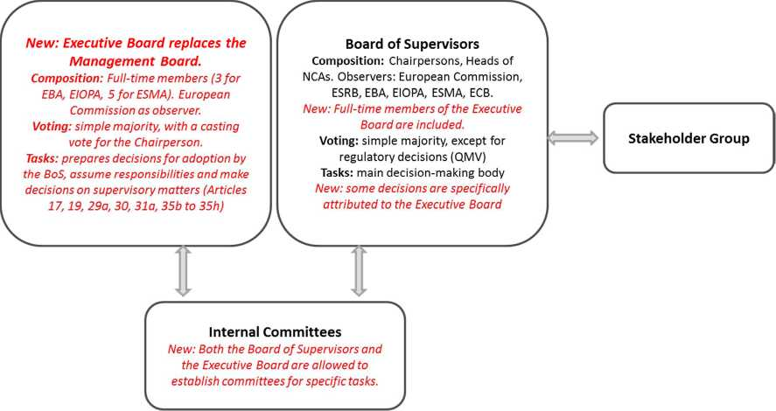

Moreover, today's proposals ensure that the Parliament and Council can endow the European Supervisory Authorities with the necessary budgetary means in light of their new tasks and responsibilities. While national experience shows that an element of public financing can be useful for the well-functioning of supervisory authorities and should thus be maintained, it is nevertheless appropriate to ensure more diversified sources of funding for the European Supervisory Authorities. Industry and market participants that benefit most directly from the supervisory convergence fostered by the European Supervisory Authorities should play a much more significant role in their financing. Contributions should be fair and proportionate to the benefit the industry and market participants concerned enjoy from the work of the European Supervisory Authorities.

**Changes to the funding of the European Supervisory Authorities**

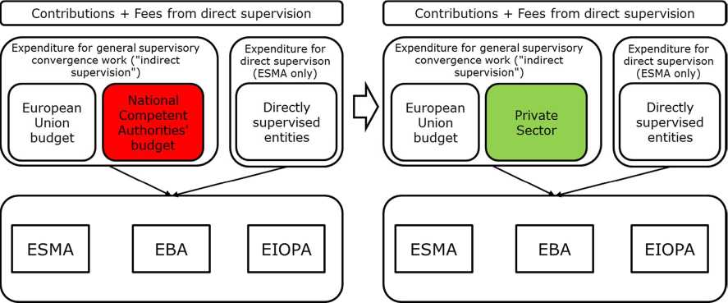

***Towards a Single European Capital Markets Supervisor***

Direct supervision at EU level is in many cases the most effective way of delivering supervisory convergence, thereby removing barriers to cross-border activities and the scope for regulatory arbitrage. However, at present, direct supervision by the European Securities Markets Authorityapplies to only a very limited number of market operators and activities, i.e. for credit rating agencies and trade repositories. The Commission has already recently proposed a more integrated EU supervisory mechanism for Central Counterparties,[9] and a strong role for the European Insurance and Occupational Pensions Authority in the authorisation of the recently proposed pan-European personal pension product.[10] Extending direct supervision to other areas can therefore make a significant contribution to Capital Markets Union. At the same time, the subsidiarity principle and the continued role of national authorities for example in the area of consumer protection must be taken into account.

On this basis, the Commission is **proposing to extend direct supervision to selected capital market sectors**. These areas have been selected based on the extent to which direct supervision can reduce cross-border barriers and promote further market integration, the efficiency gains that can be reaped by building specialised expertise at the EU level and/or the technical feasibility of direct supervision (considering for example the extent to which sectors are governed by directly applicable legislation, i.e. Regulations as opposed to Directives). The new areas proposed for direct supervision by the European Securities Markets Authority are presented in the table below in italics:

|  |  |  |  |
| --- | --- | --- | --- |
| **Area** | **Legislation** | **European Securities Markets Authority direct supervisory powers for EU entities** | **European Securities Markets Authority powers for third country entities** |
| ***Capital market entry*** | *Prospectuses* | *Approval of certain categories of prospectuses by EU issuers* | *Approval of all prospectuses drawn up under EU rules by third country issuers* |
| ***Capital market actors*** | *Harmonised collective investment funds (EuVECA, EuSEF and ELTIF)* | *Authorisation and supervision of funds which are regulated at the EU level* | *N/a* |
| **Capital market infrastructure** | Central Counterparties  (CCPs) | Supervisory powers in relation to CCPs (Commission proposal of June 2017) | Recognition and supervisory powers for third country CCPs (already existing; reinforced in Commission proposal of June) |
| **Capital market data & information** | Credit Rating Agencies (CRAs) | Registration and supervision of CRAs (already existing) | Endorsement of third country CRAs (already existing) |
| Trade Repositories (TRs) | Registration and supervision of trade repositories (already existing) | Recognition of third country TRs (already existing) |
| *Data reporting services providers* | *Registration and supervision of data reporting service providers* | *N/a* |
| *Benchmarks* | *Supervision of critical benchmarks* | *Endorsement and supervision of third country benchmarks* |

These proposals will be further complemented by the upcoming Commission legislative proposals to review the prudential treatment of investment firms. As part of this review, the Commission intends to propose to align the regulatory and supervisory treatment of certain large investment firms with the one applying to large credit institutions. Among other things, this will ensure that such firms established within the Member States participating in the Banking Union can become subject to supervision by the European Central Bank in its supervisory capacity, the Single Supervisory Mechanism.

***Making macro-prudential supervision more efficient***

The Commission is proposing targeted amendments to strengthen the efficiency of the European Systemic Risk Board, thereby reinforcing macro-prudential coordination and allowing the European Systemic Risk Board to better fulfil its mission. In particular, the Commission is proposing to confirm the existing arrangement that the European Systemic Risk Board is chaired by the President of the European Central Bank, while reinforcing the position of the Head of the Secretariat. Finally, the proposal modifies the organisation of the European Systemic Risk Board to reflect more recent changes in the EU institutional environment, most notably with regard to the creation of the Banking Union.

**4. Integrate sustainable finance considerations into financial supervision**

The EU must continue to strengthen its global leadership in making finance work towards the goals set by the United Nations 2030 Agenda for Sustainable Development, the Paris Agreement and the Sendai Framework for Disaster Risk Reduction. Given the scale of investments needed **to move the EU economy towards low-carbon, resource-efficient and risk-proofed investments and more sustainable growth** over the next decades, it is indispensable to mobilise and reorient private capital resources to more sustainable investments. This requires a comprehensive, deep rethinking of the current financial framework and a different risk-return approach of capital markets and investors.

The Commission will present in early 2018 an ambitious Action Plan on sustainable finance with regulatory measures.

The High Level Expert Group on sustainable finance established by the Commission pointed out in its interim report that environmental, social and governance risks – for example, unprecedented and growing climate-related risks – are not yet properly integrated into financial risk assessment processes, and that the present review of the European Supervisory Authorities provides an excellent opportunity to clarify and enhance their role in assessing environmental, social and governance risks in order to secure the long-term stability of Europe’s financial sector and benefits for a sustainable economy at large. Indeed, the European Supervisory Authorities can play an important role in creating a regulatory and supervisory framework that supports mobilising and orienting private capital flows towards sustainable investments while ensuring financial stability.

As a first step towards a more comprehensive strategy, the proposals accompanying this Communication specifically require the European Supervisory Authorities to take into account of to environmental, social and governance factors arising within the framework of their mandate. For example, this will enable the Authorities to monitor how financial institutions identify, report, and address environmental, social and governance risks, thereby enhancing financial viability and stability. The European Supervisory Authorities can also provide guidance on how sustainability considerations can be effectively embodied in relevant EU financial legislation, and promote coherent implementation of such rules upon adoption.

**5. Adapting the supervisory framework to harness the potential of FinTech**

FinTtech is set to play a key role in shaping the future of the EU financial sector by facilitating access to financial services, offering new ways of investment in firms, improving operational efficiency and expanding choice. Use of digital technologies is transforming the financial sector, producing consumer benefits, improving businesses' access to finance and offering vast opportunities for FinTech start-ups to scale-up. The pace of innovation in financial services has increased significantly in recent years. In developing the Financial Union, the opportunities of financial innovation have to be used to the fullest extent, but new risks also have to be managed.

The regulation and supervision underlying Banking Union and Capital Markets Union must be technology-neutral and proportionate, allowing for innovation and further technological developments and fostering an integrated market for digital financial services as part of the EU's Digital Single Market without constraints to economies of scale and scope.

As financial services become more technology and data dependent, regulators and supervisors must become familiar with these technologies in order to promote a consistent approach to both the benefits and potential risks, and to promote sound competition. .

Novel approaches present a challenge to supervisors as new technologies and alternative business models and services raise complex regulatory and supervisory questions. It is of great importance to enable supervisors to gain knowledge from working with innovative firms and learn about new technologies and business models. It is equally important that national regulators and supervisors across Member States coordinate their responses in order to avoid creating barriers to an integrated market for digital financial services.

Following its FinTech public consultation,[11] the Commission will present in early 2018 an EU Action Plan setting out what detailed actions must be taken to address these challenges and allow for an integrated market for digital financial services.

As a first step in that direction, the EU's integrated supervisory framework must be adjusted to take into account the new developments. The proposals accompanying this Communication will require the European Supervisory Authorities to take account of issues related to innovation and technological development while carrying out their tasks.

Another challenge taken into account in the proposals consists in national technological innovation instruments and tools such as innovation hubs or sandboxes set up by national supervisors. According to the proposal the European Supervisory Authorities would be tasked to promote supervisory convergence with specific attention being paid to innovation and technologies, through exchange of information and best practices, as well as guidelines and recommendations where appropriate. The Authorities will for example be invited to promote technology literacy within all national supervisory authorities alongside information-sharing on cyber threats, incidents and attacks.

Technology dependence also increases cybersecurity concerns. Security and operational integrity of financial services and their providers are changing rapidly and require a more co-ordinated response on the part of European regulation and supervision.

Through more coordinated approaches towards cybersecurity and resilience measure, the ESAs will also contribute to enhancing security and integrity of the European financial sector. The role of Information Sharing and Analysis Centres is particularly important in creating the necessary trust for sharing information about cybersecurity threats between financial services and public sector.

**6. Conclusion**

As Economic growth in Europe is getting on a steadier path, it is time to use the current window of opportunity in order for the EU to adjust its structures to make the Economic and Monetary Union more sustainable over the long run and boost the Single Market. Stronger financial integration is key in this context and will bring important benefits for the European Union, its citizens and businesses. Beyond the ongoing process of integration, the financial sector must adapt and adjust to changes linked to technological advances and its full role in order to ensure a more sustainable path for investments and economic development.

The quality and convergence of EU supervision will be key in delivering the benefits and managing the challenges in the context of these financial-sector relevant developments. The legislative proposals presented today alongside this Communication include concrete steps in order to accelerate supervisory convergence across all market segments and towards centralised and single supervision in capital markets. Moreover, they constitute first legislative steps to strengthen further the EU's leadership in the area of sustainable investment and finance and to manage the opportunities and challenges of FinTech.

The Commission invites the European Parliament and the Council to discuss and agree these proposals as a matter of priority, in order to ensure their entry into force before the end of the current legislative term in 2019. At the same time, the Commission will continue its close dialogue with all relevant stakeholders in this important area.

1. See the European Commission (2017), Staff Working Document, Economic Analysis accompanying the Communication on Capital Markets Union Mid-term Review, Chapter 1, p. 11; European Commission (2017), European Financial Integration and Stability Review, May, p. 18; European Central Bank (2017), Financial Integration in Europe, p. 3 (FINTEC indicators).
2. Source: ECB financial integration indicators.
3. https://ec.europa.eu/commission/state-union-2017_en.
4. Conclusions of the meeting of the European Council on 22-23 June 2017.
5. European Parliament Resolution of 9 July 2015 on Building a Capital Markets Union ([2015/2634(RSP)](http://www.europarl.europa.eu/oeil/popups/ficheprocedure.do?lang=en&reference=2015/2634%28RSP%29)), 9.07.2015.
6. Communication from the Commission on the mid-term review of the capital markets union action plan COM(2017) 292 final.
7. The risk of so-called "regulatory arbitrage" are of particular concern at this time, with the UK's decision to leave the EU inducing the financial sector to restructure its presence in the EU and to relocate certain activities.
8. European Parliament resolution of 9 July 2015 on Building a Capital Markets Union ([2015/2634(RSP)](http://www.europarl.europa.eu/oeil/popups/ficheprocedure.do?lang=en&reference=2015/2634%28RSP%29)), 9.07.2015
9. Proposal for a Regulation amending Regulation (EU) No 1095/2010 establishing a European Supervisory Authority (European Securities and Markets Authority) and amending Regulation (EU) No 648/2012 as regards the procedures and authorities involved for the authorisation of CCPs and requirements for the recognition of third-country CCPs COM/2017/0331 final
10. Proposal for a Regulation on a pan-European Personal Pension Product (PEPP) COM(2017) 343 final
11. https://ec.europa.eu/info/finance-consultations-2017-fintech_en