

***Introduction***

The Digital Single Market (DSM) is one of the 10 political priorities of the European Commission. The DSM strategy[1] aims to open up digital opportunities for people and businesses in a market of over 500 million EU consumers. Completing the Digital Single Market could contribute to EUR 415 billion per year to Europe's economy, create jobs and transform our public services. In the 18 months following the adoption of the DSM Strategy, the European Commission delivered the announced proposals. In the mid-term review of the strategy [2] it has updated its analysis and focused on the next series of challenges. Digital technologies are transforming our world and having an important impact on taxation systems. They help improving their management, offering solutions to reduce administrative burdens, facilitate collaboration between tax authorities, and address tax evasion. However, they transform business models, with intangibles playing an increasingly important role, putting pressure on Europe's taxation system.

The EU Digital Single Market needs a modern and stable tax framework for the digital economy to stimulate innovation, tackle market fragmentation and allow all players to tap into the new market dynamics under fair and balanced conditions. It is essential to ensure tax certainty for business investment and to prevent new tax loopholes emerging in the Single Market.

**In the field of taxation, policy makers are struggling to find solutions which would ensure fair and effective taxation** **as the digital transformation of the economy accelerates**. There are weaknesses in the international tax rules as they were originally designed for "brick and mortar" businesses and have now become outdated. The current tax rules no longer fit the modern context where businesses rely heavily on hard-to-value intangible assets, data and automation, which facilitate online trading across borders with no physical presence. These issues are not confined to the digital economy and potentially impact all businesses. As a result, some businesses are present in some countries where they offer services to consumers and conclude contracts with them, taking full advantage of the infrastructure and rule of law institutions available while they are not considered present for tax purposes. This free rider position tilts the playing field in their favour compared to established businesses.

**As a result, the growing challenge of ensuring that the digital economy is fairly taxed has still not been adequately addressed, primarily due to a lack of international consensus and the multidimensional nature of the challenge**. This is an unsustainable situation in an increasingly globalised and digitally connected world, where ever more activity is moving into the digital space. Failure to address these situations will lead to more opportunities for tax avoidance, less tax revenues for public budgets, impact on social fairness, including through erosion of the social budgets, and it will destabilise the level playing field for businesses. This puts at risk EU competitiveness, fair taxation and the sustainability of Member States' budgets. As Commission President Jean-Claude Juncker emphasised it in his 2017 State of the Union Address[3], the Commission calls for fair taxes for the digital industry. In the Informal ECOFIN in Tallinn[4], the Presidency supported by a large number of Member States called on the Commission to explore options and propose effective solutions, with a view to agree on a way forward for the EU by the end of the year.

**Since the start of its mandate, this Commission has taken action to ensure the principle that all businesses operating in the EU should pay their taxes where profits and value are generated.** This principle is essential for a fair and effective taxation in the Single Market, and it can only be enforced through common and coordinated measures. Divergent national approaches within the EU can fragment the Single Market, increase tax uncertainty, destabilise the level playing field and open new loopholes for tax abuse. As already identified in the Commission's report in May 2014[5], the international tax framework needs to be reformed so that it effectively captures the value created from the new business models – unfortunately, it has so far proved difficult to agree on the solutions at global level, as is evident from the OECD report in October 2015[6]. The time to act has now come. The Commission wants an ambitious EU agenda on the matter and a common EU approach to ensure that the digital economy is taxed effectively and in a way that ensures fairness and supports growth.

**This new agenda will complement the major strides that have already been made in improving the corporate tax framework in recent years, both at EU and international level.** Within the EU, Member States have agreed to a series of ambitious new rules to tackle aggressive tax planning and increase tax transparency, and have intensified their international stance on tax good governance through the External Strategy on Effective Taxation. In the area of State aid control, the Commission has carried out a general enquiry into the tax ruling practices of Member States and is investigating tax rulings and schemes that grant preferential tax treatment to some companies. The Commission has ordered the recovery of aid in several cases. In the area of Value-Added Tax (VAT), the Commission is also addressing head on the challenges posed by the digital economy with its proposal on e-commerce[7]. Negotiations are advancing on the Common Consolidated Corporate Tax Base (CCCTB)[8], which was re-launched by the Commission in 2016. Once agreed, the CCCTB will provide a competitive, fair and robust framework for taxing companies in the Single Market.

***Businesses are now more digitalised than ever before***

**We are acting in a borderless and globalised world. Increased consumption is accompanied by intensified trade and increasing trade volumes**. At the same time trade becomes more international. The growth of the digital economy is leading to a revolution in everyday life and business models, which are not only affecting traditional economic, political, governance, enforcement and business models but also tax and customs administration.

**Digitalisation has acted as a facilitator and accelerator of cross-border trade**. The evolution of business models means that companies operate in a fundamentally different manner today than at the time the international tax and customs rules were designed – for example, no physical presence is required to sell goods and services into a market, which means that it can be difficult to establish the tax base in the market jurisdiction or the origin of goods for customs purposes. From one click on the computer, one can order from all over the world. This translates into new market reach, overall lower prices and new opportunities. It is disrupting existing business models, and online platforms are more effectively reacting to demand. It is relevant that this not only results in an increase in trade but also in a fragmentation of trade, involving new parties that are not always familiar with tax and customs obligations, or perhaps can structure their business in such a way as to bypass these obligations.

**Digitalisation changes the nature of exchange by blurring the lines between goods and services, transforming products to their digital representation, such as e-books, or using the least material possible, for example 3D printing.** The economy is becoming increasingly digitalised so existing business models will need to adapt to this new reality as the new business models emerge. The main characteristics of these new business models are the ability to conduct activity remotely, volatility in the market (e.g. the rapid gaining and losing of market share), tendency towards monopoly or oligopoly, and network effects, to name just a few[9].

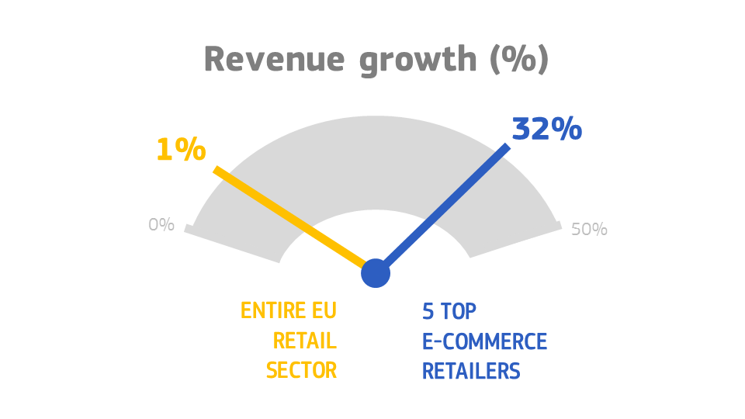**The digitalisation of the global economy is happening at a fast pace and large scale, permeating almost all areas of society.** Close to a third of the growth of the overall industrial output in Europe is already due to the uptake of digital technologies[10]. In 2006 only one technology company was among the top 20, accounting for only 7% of the market capitalisation. In 2017, 9 out of the top 20 companies by market capitalisation were technology companies, accounting for 54% of the total top 20 market capitalisation[11]. Between 2008 and 2016, revenue by the top 5 e-commerce retailers grew on average by 32% per year. During the same time period, revenue in the entire EU retail sector grew on average by 1% per year[12]. New advances will rapidly arise from a new generation of information technologies, such as internet of things, artificial intelligence, robotics and virtual reality. Digital solutions are increasingly used and open up new opportunities for people, businesses, investors and public administrations. It is essential that EU businesses grasp these opportunities to remain competitive, and that EU start-ups are able to scale up quickly, with full use of cloud computing, big data solutions, robotics and high speed broadband. The challenge ahead is for Europe to seize swiftly all these digital opportunities to ensure Europe's competitiveness, while ensuring fair taxation.

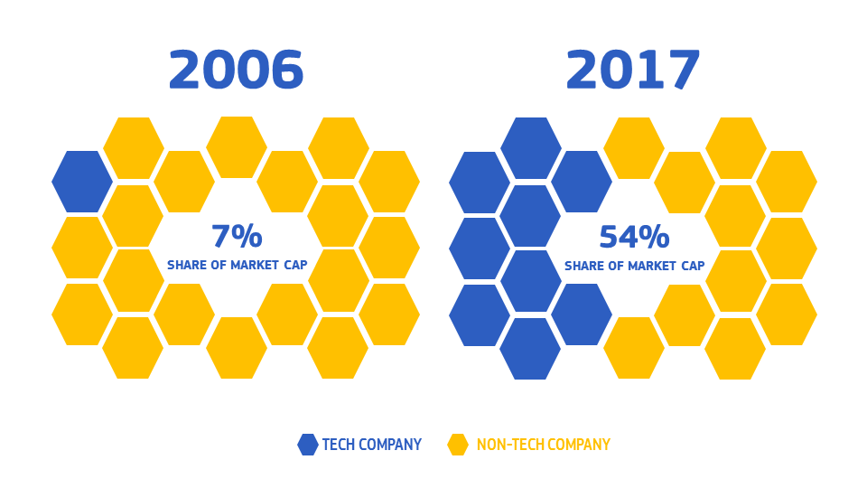**Digitalisation affects all businesses, but to varying degrees.** A challenge for tax policy is the diversity of business models enabled through technology and exploitation of large amounts of data. Customers are able to purchase goods and services from anywhere in the world via the internet rather than the local high street. New generations of consumers favour instant access over ownership. Asset-light digital platforms connect spare capacity and demand, and facilitate huge amounts of collaborative transactions, which are forecast to grow by 35% per year over the next decade[13]. Businesses of all kinds now derive much of their value from intangible assets, information and data. There is no single defining feature of new ways of doing business in the digital space and the different aspects are often combined together in a single business. This diversity requires work on the scoping of the various types of digital activities and services to be covered by any potential solution. A non-exhaustive list is presented below to highlight some of the new ways of doing business in the digital economy, which give rise to the issues of "Where to tax?" and "What to tax?". These new paradigms require new policy responses.

|  |
| --- |
| **Examples of new ways of doing business**   * **Online retailer model**, whereby online platforms sell goods or connect buyers and sellers in return for a transaction or placement fee or a commission. Examples of businesses include Amazon, Zalando, Alibaba. * **Social media model**, whereby network owners rely on advertising revenues by delivering targeted marketing messages to consumers. Examples of businesses include Facebook, Xing, Qzone. * **Subscription model**, whereby platforms charge subscription fee for continued access to a digital services (e.g. music or videos). Examples of businesses include Netflix, Spotify, iQiyi. * **Collaborative platform model**, whereby digital platforms connect spare capacity and demand, use reputational currency mechanisms to underpin consumption, and enable individuals to share “access” to assets rather than own them outright. Platforms charge a fixed or variable fee on each transaction. Examples of businesses include Airbnb, Blablacar, Didi Chuxing. |

**The EU needs a modern tax framework to seize digital opportunities, while also ensuring fair taxation.** A level playing field is a pre-condition for all businesses to be able to innovate, develop and grow to support higher levels of productivity, employment and prosperity. However, the level of digitalisation varies across sectors, particularly between high tech areas and more traditional ones, and between Member States and regions. There are also large disparities between large companies and SMEs. On average, domestic digitalised business models are subject to an effective tax rate of only 8.5%, less than half compared to traditional business models[14] (see graph below). This is mainly due to the characteristics of digitalised business models, which rely heavily on intangible assets and benefit from tax incentives. Cross border digitalised businesses benefit from a similarly low tax burden, even without accounting for aggressive cross-border tax planning that can bring down the tax burden to effectively zero[15].

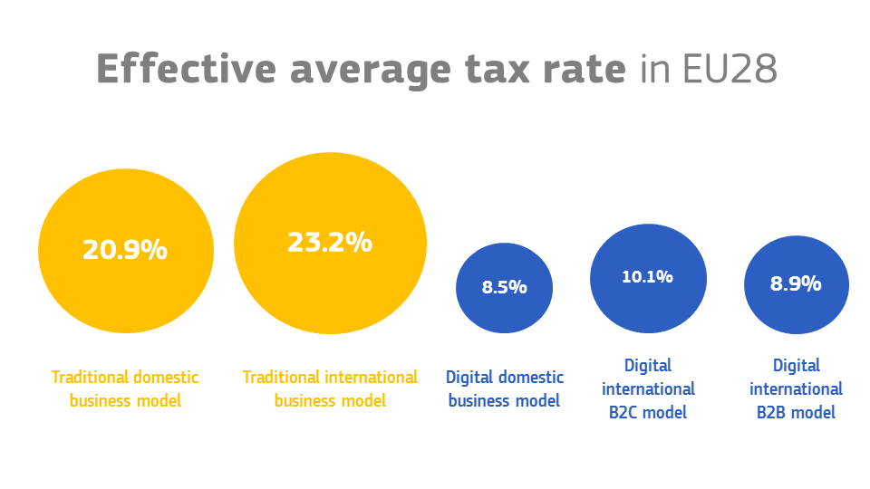

Source: Digital Tax Index, 2017, PWC and ZEW

***Critical challenges***

**The main challenge is to reform the international tax framework, which was first designed at the start of the twentieth century and is no longer fit for purpose.** This has worked well for traditional "brick and mortar" companies but as business activities have become more globalised and digitalised the old rules work less well.

**The underlying principle for corporation tax is that profits should be taxed where the value is created**. However, in a digitalised world, it is not always very clear what that value is, how to measure it, or where it is created.

The two main policy challenges that need to be addressed can be summarised as follows:

* **Where to tax? (nexus)** – how to establish and protect taxing rights in a country where businesses can provide services digitally with little or no physical presence despite having a commercial presence; and
* **What to tax? (value creation)** – how to attribute profit in new digitalised business models driven by intangible assets, data and knowledge.

These challenges need to be looked at together to find a meaningful solution for determining where economic activities are carried out and value is created for tax purposes. The issue of "Where to tax?" – how to establish taxing rights in a country where a business only has a digital presence and no physical presence – can be illustrated by the following theoretical example.

|  |
| --- |
| Theoretical example of a business which provides a social network that relies on advertising revenues by delivering targeted marketing messages to its users in the EU:  Users located in the EU have free access to a social network run by a business located outside of the EU. The business collects data on its users, for example information on their spending habits, tastes and preferences. Although the business mainly generates income from selling advertising space to other businesses to deliver targeted marketing messages via the network to its users in the EU, it may not have a taxable presence in the EU under the current international tax framework and therefore the business is not subject to corporate tax in the EU.  Theoretical example of a business that provides digital services to customers in the EU via an online platform:  Customers located in the EU pay subscription fees to access digital services (e.g. music or video) via an online platform run by a business located outside of the EU. Although the revenue generated from the subscription fees comes from customers in the EU, the platform provider does not have a taxable presence in the EU under the current international tax framework and therefore the business is not subject to corporate tax in the EU. |

**To address these challenges, it is crucial to create and sustain international momentum on this issue at political level**, which has been quite weak up to now because of the multitude of actors and a lack of consensus in the international debate. It remains that the ideal approach would be to find multilateral, international solutions to taxing the digital economy given the global nature of this challenge.

**The Commission considers that EU Member States should have a coordinated position to have a greater impact on the work at global level.** They should converge and promote an approach that would lead the work towards an ambitious outcome. The outcome should stabilise the tax bases of the individual Member States, and ensure fair competition and the flourishing of companies operating within the Single Market. In its international discussions, the EU should ensure that profits generated in the EU are effectively taxed by the EU Member States and redistributed fairly.

**An Important milestone will come early in 2018 when the OECD will present an interim report on the taxation of the digital economy to the G20.** It is essential that this report comes to appropriate and realistic conclusions on the way ahead and identifies genuine policy options to tackle the challenge.

**In parallel, the EU must examine all possible options so as to adopt new rules for taxing the digital economy within the Single Market.** It should also focus on EU solutions if progress at international level proves too slow.

***Objectives***

A comprehensive and modern approach to the taxation of the digital economy is needed to meet the goal of fairer and more efficient taxation, and to support EU growth and competitiveness through the Digital Single Market. This approach should be driven by the following objectives:

* **Fairness** – Ensuring that corporate profits are taxed where the value is created. It is necessary to maintain a level playing field and a system that is resilient against abuse so that all companies pay their fair share whether they are large or small, more or less digitalised, EU or non-EU based.
* **Competitiveness** – Creating the right tax environment for the scaling-up of start-ups and businesses to flourish in our Single Market. To improve the competitiveness of the EU, we need to remove existing obstacles and avoid creating new tax barriers to the emergence of new businesses that foster innovation and create jobs.
* **Integrity of the Single Market** – Converging towards a common solution that avoids unilateral measures that would destabilise the functioning of the Single Market. Uncoordinated national measures will lead to fragmentation of the Single Market, further distortions and tax obstacles that will prevent companies from growing and investing in the Single Market.
* **Sustainability** – Ensuring the corporation tax system is future-proofed and sustainable in the long-term. As traditional business models become increasingly digitalised, Member States' tax bases could gradually disappear if the tax rules are not adapted to capture new digitalised business models. If not remedied this will lead to the tax burden being increased elsewhere.

***The way ahead***

EU citizens and governments are increasingly concerned by the perceived imbalances in the levels of taxation of the new digitalised business models. Failure to agree on a meaningful solution in adequate time will exacerbate the pressure to act at national level and will undermine the Single Market.

**One solution is to embed the taxation of the digital economy in the general international corporate tax framework**. Fundamental reform of the international corporate tax framework currently applicable to the digital economy would ensure the consistency and coherence of tax rules worldwide, and ensure stability and certainty for businesses. The EU expects a high level of ambition as regards the interim report on the taxation of the digital economy that the OECD will present to the G20. It is essential that the report comes forward with meaningful policy options to address the issues at stake.

**In particular, new international rules specific to the challenges raised by digital economy are needed to determine where the value of businesses is created and how it should be attributed for tax purposes**. This would entail reform of international tax rules on permanent establishment, transfer pricing and profit attribution applicable to digital technologies.

The **permanent establishment rules** are used to determine the threshold of activity that needs to be carried out in a country in order for a business to be taxable in that country, and are largely based on physical presence. However, thanks to digital technologies, businesses are now able to have a significant economic presence in a market jurisdiction without necessarily having a substantial physical presence. Alternative indicators for significant economic presence are therefore required in order to establish and protect taxing rights in relation to the new digitalised business models.

Once the business is taxable in the country, the profits generated by this business still need to be determined and allocated to this country. The **transfer pricing rules** are used to attribute the profit of multinational groups to the different countries based on an analysis of the functions, assets and risks within the value chain of the group. However, these rules were developed for traditional business models and economic environment. The digital economy relies heavily on intangible assets, which are becoming more and more the value drivers within multinational groups and which are difficult to value. The challenge of identifying and valuing intangible assets as well as determining their contribution to value creation requires alternative methods for attributing profit that better capture value creation in the new business models, which should therefore be considered alongside changes to the permanent establishment rules. Furthermore, as profits can be shifted across countries through misuse of permanent establishment and transfer pricing rules, anti-abuse rules could be considered to enforce compliance and ensure that profits earned in the EU are taxed in the EU.

**At EU level, the Common Consolidated Corporate Tax Base proposal offers a basis to address these key challenges**. The Commission continues to believe that the CCCTB provides an EU framework for revised permanent establishment rules and for allocating the profit of large multinational groups using the formula apportionment approach based on assets, labour and sales that should better reflect where the value is created. There is scope within the current CCCTB proposal to examine further enhancements to ensure that it effectively captures digital activities. Discussions are already underway on this in the Council under the Estonian Presidency and in the European Parliament. The Commission stands ready to work with Member States in examining these options within the ongoing CCCTB negotiations, to find an ambitious and EU-law compatible approach for the Single Market.

**Arriving at a meaningful solution to capture and allocate the value created in the digital economy across countries can take time.** This is further complicated by the multidimensional nature of this challenge, to the constantly changing nature of the digital economy, and the diversity of the business models and the complexity of ecosystems in which they create value. However, the longer it takes to find a solution, the bigger the losses in tax revenues will be. Therefore, unilateral initiatives in the EU and internationally will continue to develop. Since 2016, countries such as India and Israel have already been testing alternative approaches to ensure effective taxation of the digital economy.

**Alongside the work on this longer-term strategy, there are also more immediate, supplementary and short-term measures that should be considered to protect the direct and indirect tax bases of Member States**. Different ideas have been presented in the EU and internationally to capture the digital activity in an alternative way to the international corporate tax framework, and to ensure equal treatment and a level playing field for all businesses.

|  |
| --- |
| **Some alternative options for shorter-term solutions**   * **Equalisation tax on turnover of digitalised companies** - A tax on all untaxed or insufficiently taxed income generated from all internet-based business activities, including business-to-business and business-to-consumer, creditable against the corporate income tax or as a separate tax. * **Withholding tax on digital transactions** - A standalone gross-basis final withholding tax on certain payments made to non-resident providers of goods and services ordered online. * **Levy on revenues generated from the provision of digital services or advertising activity** - A separate levy could be applied to all transactions concluded remotely with in-country customers where a non-resident entity has a significant economic presence. |

All short-term options have pros and cons, and further work is needed on the detailed approach to find a workable solution for the Single Market and the global economy as a whole. Questions about the compatibility of such approaches with the double-taxation treaties, State aid rules, fundamental freedoms, and international commitments under the free trade agreements and WTO rules would need to be examined. Yet something has to be done. The Commission remains convinced that the appropriate level of action is the EU. Only a coordinated EU approach will ensure that the solution is fit for the Digital Single Market and can deliver on our objectives of fairness, competitiveness and sustainability.

***Conclusion***

This Communication calls for a strong and ambitious EU position on taxing the digital economy, which should feed into ongoing international work on the issue. It also aims to provide a basis for further political discussions amongst Member States at the Tallinn Digital Summit of 29 September, so as to reach a common position in the international discussions.

The Commission will support the Estonian Presidency in its work on these issues with a view to stabilise by the end of the year Council conclusions setting out a coordinated EU approach. These conclusions would form the common basis that EU and its Member States would use to put forward proposals in the international discussions.

The EU expects meaningful progress in the global agenda and should push for this to be reflected in the OECD report to the G20 Finance Ministers at their meeting in April 2018. The Commission will contribute to a successful conclusion of the on-going global discussions at the G20.

In the absence of adequate global progress, EU solutions should be advanced within the Single Market and the Commission stands ready to present the appropriate legislative proposals. The Commission will continue to analyse the policy options and consult with relevant stakeholders and industry representatives on this important and pressing issue ahead of a possible proposal by spring 2018.

1. COM(2015) 192
2. COM(2017) 228
3. http://europa.eu/rapid/press-release_SPEECH-17-3165_en.htm
4. https://www.eu2017.ee/political-meetings/ECOFIN
5. See European Commission Expert Group on Taxation of the Digital Economy Report, May 2014.
6. See Addressing the Tax Challenges of the Digital Economy, OECD Base Erosion and Profit Shifting Project Action 1 Report, October 2015.
7. COM(2016)757
8. COM(2016)683 and COM(2016)685
9. See Addressing the Tax Challenges of the Digital Economy, OECD Base Erosion and Profit Shifting Project Action 1 Report, October 2015.
10. COM(2016) 180
11. Global Top 100 Companies by market capitalisation' PWC, 2017; Financial Times Global 500 database, 2006.
12. Bloomberg and Eurostat databases, accessed on 13 September 2017.
13. See Literature review on taxation, entrepreneurship and collaborative economy - final report by Dondena & IHS, study commissioned by the European Commission, forthcoming.
14. See Digital Tax Index, PWC and ZEW, 2017. Traditional business model: assets are assumed to be equally divided between buildings, machinery, inventory, financial assets and intangible assets. Digital business model is the average over three different models ('domestic', 'B2C', 'B2B'). The basic assumption for all three is that assets are equally divided between acquired intangibles, self-created intangibles, IT hardware, acquired software, self-created software. The B2C and B2B models use subsidiaries to organise their sales and marketing activities.
15. See 'The Impact of Tax-planning on Forward-looking Effective Tax Rates' by ZEW, Taxation paper 64, DG TAXUD, European Commission.