

Table of contents

**1.** **Budget procedure** 3

**1.1.** **Financial framework** 3

**1.2.** **Draft Budget (DB) 2016** 3

**1.3.** **The adoption of the 2016 Budget** 4

**1.4.** **The adoption of the Amending Budgets** 5

**2.** **Management of appropriations** 5

**2.1.** **Management of commitment appropriations** 5

*2.1.1.* *EAFRD rural development programmes* 5

*2.1.2.* *Technical assistance* 5

**2.2.** **Management of payment appropriations** 6

*2.2.1.* *EAFRD rural development programmes* 6

*2.2.2.* *Technical assistance* 7

**3.** **Implementation of the 2016 EAFRD budget** 7

**3.1.** **Implementation of commitment appropriations** 7

*3.1.1.* *EAFRD rural development programmes* 7

*3.1.2.* *Technical assistance* 8

**3.2.** **Implementation of payment appropriations** 9

*3.2.1.* *EAFRD rural development programmes* 9

*3.2.2.* *Technical assistance* 15

**3.3.** **Analysis of expenditure declared by axis and/or by measure** 15

**3.4.** **Implementation of EAFRD programmes** 18

*3.4.1.* *Programming period 2007-2013* 18

*3.4.2.* *Programming period 2014-2020* 18

**1. Budget procedure**

**1.1. Financial framework**

Rural development expenditure in 2016 is funded within two multiannual financial frameworks (MFFs): 2007-2013 and 2014-2020. The financial framework 2014-2020 is provided by Council Regulation (EU) No 1311/2013. The allocation for rural development and the allocation for market related expenditure and direct payments after the annual technical adjustment of the MFF are presented in table 1.

Table 1 – Financial framework 2014-2020

|  |  |  |  |  |  |  |  |
| --- | --- | --- | --- | --- | --- | --- | --- |
| **HEADING 2.** | In million EUR; current prices | | | | | | |
| **Sustainable growth: natural resources** | **2014** | **2015** | **2016** | **2017** | **2018** | **2019** | **2020** |
| **TOTAL** | **49 857** | **64 692** | **64 262** | **60 191** | **60 267** | **60 344** | **60 421** |
| of which : | | | | | | | |
| - Rural Development a), b), c), d), e) | 5 299 | 18 184 | 18 684 | 14 371 | 14 381 | 14 330 | 14 333 |
| - Market related expenditure and direct aids, a), b), c), d) | 43 778 | 44 190 | 43 950 | 44 146 | 44 162 | 44 241 | 44 263 |
|  |  |  |  |  |  |  |  |
| a) After net transfer of EUR 351.9 million between EAGF and EAFRD for the financial year 2014 (see note f for details) | | | | | | | |
| b) After net transfer of EUR 51.6 million between EAGF and EAFRD for the financial year 2015 (see note f for details) | | | | | | | |
| c) After net transfer of EUR 28 million between EAGF and EAFRD for the financial years 2014-2020 (see note f for details) | | | | | | | |
| d) After net transfer of EUR 3 577.2 million between EAGF and EAFRD for financial years 2015-2020 (see note f for details) | | | | | | | |
| e) After the reprogramming of the EAFRD allocation of year 2014 following the application of Article 19 of MFF Regulation (EU) No 1311/2013 a total amount of EUR 8 705 million deducted from 2014 commitments was equally distributed to 2015 and 2016 commitments | | | | | | | |
| f) The transfers into Rural Development (EAFRD) mentioned in notes a) to d) above involve: EUR 4 million transferred annually for the whole period 2014-2020 from the cotton sector (EL) on the basis of Article 66(1) of Regulation (EU) No 1307/2013, EUR 296.3 million set for the voluntary adjustment transferred for the financial year 2014 (UK) on the basis of Article 10b and 10c(2) of Regulation (EC) No 73/2009, EUR 51.6 million for unspent amounts transferred each year for financial years 2014 and 2015 (SE and DE) on the basis of Articles 136 and 136b of Regulation (EC) No 73/2009 and EUR 3577.2 million for the reduction of payments and the flexibility between pillars on the basis of Articles 7(2) and 14(1) of Regulation (EU) No 1307/2013 | | | | | | | |

**1.2. Draft Budget (DB) 2016**

The 2016 Draft Budget (DB) was adopted by the Commission and proposed to the Budgetary Authority on 24 June 2015.

The Draft Budget included EUR 3 268 million in payment appropriations for the European Agricultural Fund for Rural Development (EAFRD) for the 2007-2013 programming period. No commitment appropriations were requested for year 2016 as the 2007-2013 programming period ended at the end of 2013. For the programming period 2014-2020, the DB 2016 included EUR 18 672 million in commitment appropriations and EUR 8 594 million in payment appropriations.

Table 2

|  |  |  |
| --- | --- | --- |
| **Draft Budget 2016** | | |
| **Budget Item** | **Commitment appropriations** (in EUR) | **Payment appropriations** (in EUR) |
| **2007-2013** | | |
| 05.040501 (Rural development programmes) | - | 3 268 000 000 |
| 05.040502 (Operational technical assistance) | - | - |
| **2014-2020** | | |
| 05.046001 (Rural development programmes) | 18 650 559 495 | 8 574 000 000 |
| 05.046002 (Operational technical assistance) | 21 363 000 | 20 025 443 |

The Council adopted its position on the 2016 Draft Budget on 4 September 2015 and the European Parliament adopted its position on 28 October 2015. The Conciliation Committee had to be convened and the Committee agreed on a joint text within the 21-day time limit. The Council approved the joint text on 24 November 2015 and the European Parliament approved it on 25 November 2015,

The 2016 budget was finally adopted on 25 November 2015 decreasing EAFRD payment appropriations by EUR 120 million, of which EUR 33 million for the 2007-2013 programming period and EUR 87 million for the 2014-2020 period.

**1.3. The adoption of the 2016 Budget**

The 2016 Budget adopted on 25 November 2015 included for the EAFRD in chapter 05 04 an amount of EUR 3 235 million in payment appropriations for the programming period 2007-2013 and EUR 18 672 million in commitment appropriations and EUR 8 507 million in payment appropriations for the period 2014-2020.

Table 3

|  |  |  |  |
| --- | --- | --- | --- |
| **Adopted Budget 2016** | | | |
| **Budget Item** | **Commitment appropriations** (in EUR) | **Payment appropriations** (in EUR) | |
| **2007-2013** | | | |
| 05.040501 (Rural devevelopment programmes) | - | 3 235 000 000 | |
| 05.040502 (Operational technical assistance) | - | - | |
| **2014-2020** | | | |
| 05.046001 (Rural development programmes) | 18 650 559 495 | | 8 487 000 000 |
| 05.046002 (Operational technical assistance) | 21 363 000 | | 20 025 443 |

**1.4. The adoption of the Amending Budgets**

None of the Amending Budgets concerned the EAFRD.

**2. Management of appropriations**

**2.1. Management of commitment appropriations**

*2.1.1. EAFRD rural development programmes*

As regards commitment appropriations, the 2016 voted budget amounted to EUR 18 651 million, all related to the 2014-2020 programmes.

The Budget 2016 did not include any commitment appropriations for EAFRD 2007-2013 programmes.

Table 4

|  |  |  |
| --- | --- | --- |
| **Management of commitment appropriations in 2016 – EAFRD** | **Budget Item**  **05.040501**  **(amounts in EUR)** | **Budget Item**  **05.046001**  **(amounts in EUR)** |
| Appropriations at the beginning of 2016 | - | 18 650 559 495 |
| **Appropriations available in 2016** | **-** | **18 650 559 495** |
| Appropriations used in 2016[1] | - | 18 649 599 495 |

*2.1.2. Technical assistance*

Article 51(1) of Regulation (EU) No 1305/2013 provides that the EAFRD may use up to 0.25% of its annual allocation to finance technical assistance actions at the initiative of the Commission. In the 2016 budget, the initial amount available for this purpose was EUR 4.4 million for non-operational technical assistance and EUR 21.4 million for operational technical assistance.

**2.2. Management of payment appropriations**

*2.2.1. EAFRD rural development programmes*

For the rural development programmes 2014-2020, the payment appropriations of the voted budget 2016 amounted to EUR 8 487 million. The payment appropriations were reinforced with the transfer of EUR 1.0 million from the line of the completion of rural development financed by the EAGGF Guarantee Section (item 05.040114), where no appropriations were needed. On the other hand, the payment appropriations were reduced by two transfers totalling to EUR 32.1 million which were transferred to EAGGF-Guidance 2000-2006 in order to close one of the old programmes of Objective 1. Moreover, EUR 646.1 million was transferred to cover the urgent needs linked to the closure of EAFRD 2007-2013 programmes. Taking into account all transfers, the total amount of payment appropriations available in 2016 amounted to EUR 7 809.9 million. All appropriations of 2016 have been used during the year.

For the rural development programmes 2007-2013, payment appropriations of the voted budget 2016 amounted to EUR 3 235 million. In addition, the available assigned revenue, either carried over from 2015 or collected during the year, amounted to EUR 359.1 million. At the end of the year, the closure of the 64 programmes required additional payment appropriations. This was partially covered with a transfer from the EAFRD 2014-2020 programmes line (EUR 646.1 million), the technical assistance line (EUR 3.0 million) and the End-of-Year transfer (EUR 264.7 million). The total amount of payment appropriations available in 2016 was EUR 4 507.9 million. Of this amount, EUR 12.1 million of assigned revenue were automatically carried over to 2017.

Table 5

|  |  |
| --- | --- |
| **Management of payment appropriations in 2016** | |
| **(in EUR)** | |
|  | |
| **EAFRD (2014-2020)** | |
| **Budget Item - 05.046001** | |
| Appropriations at the beginning of 2016 | 8 487 000 000 |
| Transfer to EAGGF-Guidance — Objective 1 regions (2000 to 2006) | -5 124 931 |
| Transfer to EAGGF-Guidance — Objective 1 regions (2000 to 2006) | -26 940 235 |
| Transfer from EAGGF Guarantee Section 2000-2006 | 1 006 524 |
| Transfer to EAFRD 2007-2013 | -646 066 430 |
| **Appropriations available in 2016** | **7 809 874 928** |
| Appropriations used in 2016 | 7 809 874 920 |
|  |  |
| **EAFRD (2007-2013)** | |
| **Budget Item - 05.040501** | |
| Appropriations at the beginning of 2016 | 3 235 000 000 |
| Assigned revenue carried over from 2015 | 22 697 504 |
| Assigned revenue collected in 2016 | 336 400 606 |
| Transfer from EAFRD 2014-2020 | 646 066 430 |
| Transfer from TA line of EAFRD 2014-2020 | 3 000 000 |
| End-of-the year transfer | 264 739 750 |
| **Appropriations available in 2016** | **4 507 904 290** |
| Appropriations used in 2016 | 4 495 770 025 |

*2.2.2. Technical assistance*

As regards the EAFRD, total payment appropriations in the 2016 budget amounted to EUR 20.0 million. EUR 3.0 million were transferred to the EAFRD 2007-2013 programmes line in order to cover the closure of programmes EAFRD 2007-2013. The final payment appropriations was EUR 17.0 million. The total payments reached EUR 12.8 million.

**3. Implementation of the 2016 EAFRD budget**

**3.1. Implementation of commitment appropriations**

*3.1.1. EAFRD rural development programmes*

Of the total amount of commitment appropriations available in the 2016 budget for the EAFRD programmes 2014-2020 (EUR 18 650.6 million), EUR 18 649.6 million was committed. The minor amount not committed (EUR 0.96 million) was due to a modification of the allocation for the UK set out in Annex I to Regulation (EU) No 1305/2013[2] (see footnote 1).

Table 6 shows, per Member State, the allocation established by Regulation (EU) No 1305/2013 of 17/12/2013 as last amended by Commission Delegated Regulation (EU) 2016/142 of 02/12/20151 and the amounts committed in 2016.

Table 6

|  |  |  |
| --- | --- | --- |
| ***Regulation (EU) No 1305/2013 (as amended) vs. amounts committed by the end of 2016*** | | |
| **Budget item: 05.046001** | | *(in EUR)* |
| **MS** | **Regulation (EU) No 1305/2013** | **Amounts committed in 2016** |
| **2016 Allocation** |
|  | **(a)** | **(b)** |
| AT | 560 883 465 | 560 883 465 |
| BE | 109 821 794 | 109 821 794 |
| BG | 505 020 057 | 505 020 057 |
| CY | 28 345 126 | 28 345 126 |
| CZ | 503 130 504 | 503 130 504 |
| DE | 1 685 574 112 | 1 685 574 112 |
| DK | 136 397 742 | 136 397 742 |
| EE | 111 192 345 | 111 192 345 |
| ES | 1 780 403 445 | 1 780 403 445 |
| FI | 338 456 263 | 338 456 263 |
| FR | 2 363 567 980 | 2 363 567 980 |
| GR | 1 007 736 821 | 1 007 736 821 |
| HR | 448 426 250 | 448 426 250 |
| HU | 737 099 981 | 737 099 981 |
| IE | 469 724 442 | 469 724 442 |
| IT | 2 231 599 688 | 2 231 599 688 |
| LT | 230 431 887 | 230 431 887 |
| LU | 21 432 133 | 21 432 133 |
| LV | 153 066 059 | 153 066 059 |
| MT | 20 878 690 | 20 878 690 |
| NL | 118 496 585 | 118 496 585 |
| PL | 1 193 429 059 | 1 193 429 059 |
| PT | 578 913 888 | 578 913 888 |
| RO | 1 751 613 412 | 1 751 613 412 |
| SE | 378 153 207 | 378 153 207 |
| SI | 119 342 187 | 119 342 187 |
| SK | 215 603 053 | 215 603 053 |
| UK | 850 859 320 | 850 859 320 |
| **Total** | **18 649 599 495** | **18 649 599 495** |

*3.1.2. Technical assistance*

For the programming period 2014-2020, the amount of commitment appropriations for operational technical assistance in the budget 2016 was EUR 21.4 million. This line was reinforced by EUR 1.0 million transferred from the EAFRD 2014-2020 programmes line to cover the needs in relation to the contribution of the EAFRD to the European Solidarity Corps. Table 7 shows the consumption of the commitment appropriations available for technical assistance in 2016. The most important part relates to the Technical Advisory Platform for Financial Instruments and to the European Network for Rural Development.

Table 7

|  |  |
| --- | --- |
| ***Technical assistance – Implementation of commitment appropriations*** | |
| **Budget Item: 05.046002** | *(in EUR)* |
| **Description** | **Amount committed** |
| Technical Advisory Platform for Financial Instruments | 4 800 000 |
| European Network for Rural Development | 4 455 468 |
| Information technology* | 3 094 064 |
| Corporate Communication | 2 600 000 |
| European Innovation Partnership | 2 570 801 |
| European Evaluation Network | 1 845 650 |
| European Solidarity Corps | 1 300 000 |
| Audit and Controls | 1 269 555 |
| Protection of symbols | 57 093 |
| **Total** | **21 992 630** |

* Including BCO (Broadband Competence Offices)

**3.2. Implementation of payment appropriations**

*3.2.1. EAFRD rural development programmes*

For the programming period 2014-2020, almost all payment appropriations available after the transfers (EUR 7 810 million) were used, of which EUR 1 001 million for the pre-financing.

For the programming period 2007-2013, all payment appropriations available in the budget (EUR 3 235 million) were implemented. Additional payments of EUR 1 261 million were made with appropriations from EAFRD 2014-2020 programmes line, the operational technical assistance line, the assigned revenue and the End-of-Year transfer. At the end of 2016, the total amount paid for EAFRD programmes 2007-2013, including the closure of 64 programmes, was EUR 4 496 million.

Table 8 shows the breakdown of payments made in 2016 by declaration period:

Table 8

|  |  |  |
| --- | --- | --- |
| ***Payments 2016 for EAFRD rural development programmes (in million EUR)*** | ***2007-2013*** | ***2014-2020*** |
|  | Item 05.040501 | Item 05.046001 |
| Pre-financing 2014-2020 | 0.00 | 1 000.59 |
| Reimbursement of payment claims prior to Q4 2015 | 277.49 | 554.36 |
| Reimbursement of payment claims Q4 2015 | 1 547.84 | 1 346.31 |
| Reimbursement of payment claims Q1 2016 | 8.01 | 1 257.34 |
| Reimbursement of payment claims Q2 2016 | 0.00 | 2 038.53 |
| Reimbursement of payment claims Q3 2016 | 0.00 | 1 612.74 |
| Closure payments 2007-2013 | 2 662.43 | 0.00 |
| **Total 2016** | **4 495.77** | **7 809.87** |

The monthly consumption of payment appropriations during the year (January to December 2016) is shown in the graph below.

Graph 1

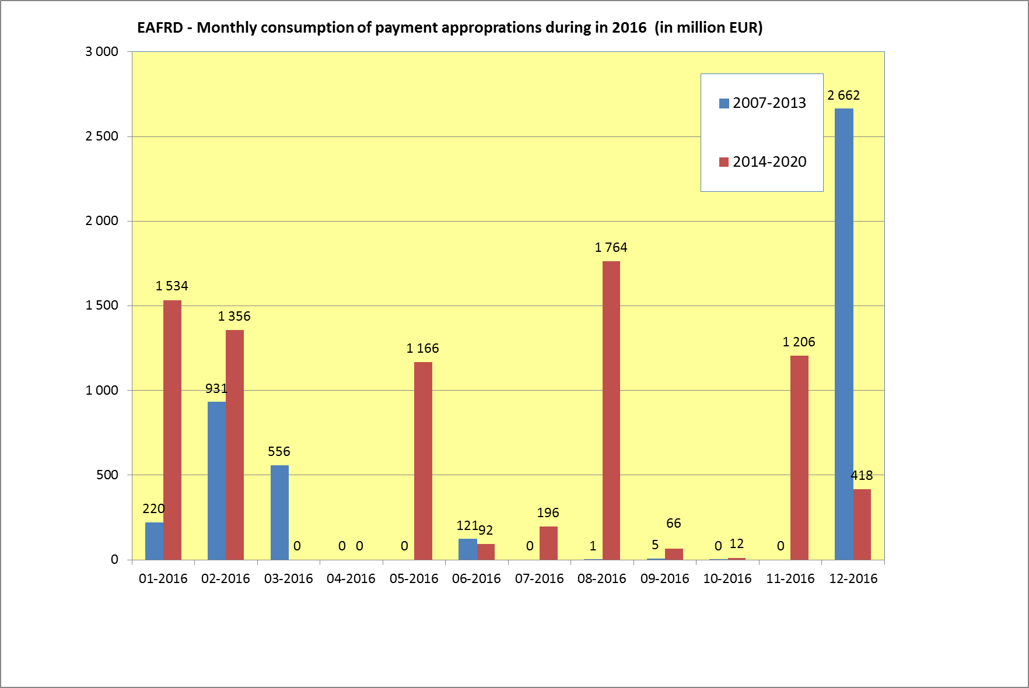

The breakdown per Member State and per declaration period of the amounts paid by the Commission in budget year 2016 is shown in tables 9a and 9b.

Table 9a

|  |  |  |  |  |  |
| --- | --- | --- | --- | --- | --- |
| **Payments effectively made between 01/01/2016 and 31/12/2016** | | | | | |
| **EAFRD 2007-2013 - Budget item 05.040501 *(in EUR)*** | | | | | |
| **MS** | **Prior to Q4 2015** | **Q4 2015** | **Positive payments, mainly following the judgements of Court of Justice** | **Closure** | **Total** |
| **AT** | 0 |  |  | 201 048 843 | **201 048 843** |
| **BE** | 0 |  |  | 11 915 307 | **11 915 307** |
| **BG** | 211 263 | 104 910 087 |  |  | **105 121 350** |
| **CY** | 0 |  |  | 8 138 265 | **8 138 265** |
| **CZ** | 0 |  | 584 299 | 138 417 270 | **139 001 569** |
| **DE** | 10 959 942 | 995 397 |  | 388 608 987 | **400 564 326** |
| **DK** | 7 243 066 |  |  | 20 963 291 | **28 206 357** |
| **EE** | 0 |  |  | 35 481 510 | **35 481 510** |
| **ES** | 49 444 612 | 254 214 733 | 28 301 | 138 757 741 | **442 445 387** |
| **FI** | 0 |  | 927 828 | 73 189 520 | **74 117 347** |
| **FR** | 24 430 594 | 34 997 367 | 4 746 784 |  | **64 174 744** |
| **GR** | 3 215 169 | 451 499 242 | 1 726 644 |  | **456 441 055** |
| **HU** | 0 |  |  | 100 146 037 | **100 146 037** |
| **IE** | 0 |  |  | 123 238 683 | **123 238 683** |
| **IT** | 123 857 373 | 215 437 259 |  | 117 416 941 | **456 711 574** |
| **LT** | 0 |  |  | 86 077 487 | **86 077 487** |
| **LU** | 0 |  |  | 4 310 828 | **4 310 828** |
| **LV** | 0 |  | 303 187 | 52 512 931 | **52 816 118** |
| **MT** | 1 310 503 | 560 059 |  | 2 656 238 | **4 526 801** |
| **NL** | 0 |  |  | 27 849 916 | **27 849 916** |
| **PL** | 0 |  |  | 654 646 405 | **654 646 405** |
| **PT** | 0 | 3 922 417 |  | 166 884 840 | **170 807 257** |
| **RO** | 54 175 098 | 481 300 950 |  |  | **535 476 048** |
| **SE** | 0 |  |  | 39 280 927 | **39 280 927** |
| **SI** | 0 |  |  | 42 697 633 | **42 697 633** |
| **SK** | 0 |  |  | 86 339 546 | **86 339 546** |
| **UK** | 2 637 812 |  |  | 141 550 893 | **144 188 705** |
| **Total** | **277 485 432** | **1 547 837 509** | **8 317 043** | **2 662 130 040** | **4 495 770 025** |

Table 9b

|  |  |  |  |  |  |  |  |
| --- | --- | --- | --- | --- | --- | --- | --- |
| **Payments effectively made between 01/01/2016 and 31/12/2016** | | | | | | | |
| **EAFRD 2014-2020 - Budget item 05.046001** | | | | | | | ***(in EUR)*** |
| **MS** | **Pre-financing** | **Prior to Q4 2015** | **Q4 2015** | **Q1 2016** | **Q2 2016** | **Q3 2016** | **Total** |
| **AT** | 39 375 520 |  | 3 265 091 | 17 539 570 | 339 778 144 | 33 993 775 | **433 952 101** |
| **BE** | 6 477 978 | 4 864 566 | 3 635 803 | 2 443 352 | 20 679 176 | 7 880 154 | **45 981 029** |
| **BG** | 23 667 170 |  |  | 84 793 197 | 15 018 210 | 29 248 636 | **152 727 213** |
| **CY** | 1 322 444 |  | 54 702 | 2 367 776 | 3 429 608 | 1 325 612 | **8 500 142** |
| **CZ** | 23 056 740 | 4 850 094 | 31 962 882 | 50 356 787 | 60 232 281 | 34 480 775 | **204 939 559** |
| **DE** | 93 607 201 | 17 663 132 | 218 875 742 | 165 939 180 | 148 021 290 | 97 342 001 | **741 448 545** |
| **DK** | 14 976 097 | 991 945 | 20 595 204 | 17 020 883 | 17 784 549 | 18 536 432 | **89 905 110** |
| **EE** | 8 233 416 | 4 138 495 | 6 567 382 | 48 892 142 | 13 093 427 | 15 209 984 | **96 134 846** |
| **ES** | 82 973 888 | 14 051 954 | 67 590 620 | 81 033 254 | 68 486 032 | 147 428 430 | **461 564 178** |
| **FI** | 23 804 083 | 48 031 959 | 106 332 534 | 5 276 183 | 57 387 698 | 110 154 555 | **350 987 012** |
| **FR** | 113 848 442 | 315 907 655 | 90 883 881 | 22 904 483 | 41 866 580 | 52 994 771 | **638 405 812** |
| **GR** | 47 182 918 |  |  | 8 494 055 | 26 664 899 | 192 679 994 | **275 021 867** |
| **HR** | 20 262 225 | 388 120 | 10 181 227 | 5 305 518 | 72 442 372 | 42 726 922 | **151 306 384** |
| **HU** | 34 306 645 |  |  |  | 196 249 540 | 12 218 585 | **242 774 769** |
| **IE** | 21 905 922 | 49 948 020 | 77 659 945 | 10 385 332 | 8 342 894 | 107 486 601 | **275 728 714** |
| **IT** | 104 443 808 | 11 074 939 | 40 546 961 | 64 506 841 | 174 280 211 | 129 139 789 | **523 992 549** |
| **LT** | 16 130 882 | 1 147 244 | 32 577 397 | 33 299 991 | 61 974 997 | 44 957 701 | **190 088 212** |
| **LU** | 1 005 746 | 13 645 | 3 306 700 | 867 396 |  | 2 168 098 | **7 361 586** |
| **LV** | 10 756 038 | 2 527 228 | 31 848 828 | 33 063 678 | 19 549 712 | 21 843 592 | **119 589 076** |
| **MT** | 973 269 |  |  |  | 565 944 | 23 513 | **1 562 726** |
| **NL** | 10 812 454 | 943 989 | 4 002 744 | 23 346 116 | 5 065 312 | 1 091 765 | **45 262 379** |
| **PL** | 88 961 088 |  |  | 73 652 412 | 238 330 817 | 50 868 806 | **451 813 122** |
| **PT** | 40 601 404 | 35 704 235 | 284 545 887 | 114 089 541 | 51 094 441 | 51 511 050 | **577 546 557** |
| **RO** | 81 279 964 |  |  | 56 984 320 | 231 935 189 | 235 097 590 | **605 297 063** |
| **SE** | 17 455 653 | 430 800 | 51 589 535 | 55 384 861 | 15 530 153 | 68 470 024 | **208 861 025** |
| **SI** | 8 378 498 | 1 163 339 | 22 175 367 | 26 250 286 | 26 101 394 | 1 570 151 | **85 639 035** |
| **SK** | 15 885 298 | 673 179 | 34 644 205 | 6 584 291 | 37 635 408 | 26 144 967 | **121 567 349** |
| **UK** | 48 906 195 | 39 849 997 | 203 467 861 | 246 560 880 | 86 990 969 | 76 141 057 | **701 916 960** |
| **Total** | **1 000 590 984** | **554 364 534** | **1 346 310 501** | **1 257 342 323** | **2 038 531 245** | **1 612 735 333** | **7 809 874 920** |

Tables 10a and 10b compare, for each Member State, the EAFRD payments made in 2016 with the payments in 2015. The total payments for EAFRD 2007-2013 programmes decreased by 31% (EUR 4.5 billion vs. 6.5 billion), reflecting that the eligibility for Union expenditure for the 2007-2013 programmes ended on 31 December 2015 and that hence the 2016 payments cover the reimbursements for Q4/2015 as well as the payments for the EAFRD programmes closed in 2016. At the same time the payments for EAFRD 2014-2020 programmes increased significantly (by 49%) compared to year 2015 (EUR 7.8 billion vs. EUR 5.3 billion).

Table 10a

|  |  |  |  |  |  |  |  |  |
| --- | --- | --- | --- | --- | --- | --- | --- | --- |
| **Payments made to Member States - Comparison 2016 vs 2015 - EAFRD 2007-2013** | | | | | | | ***(in EUR)*** | |
|
| **MS** | **2015** | | | **2016** | | | **Difference 2016 vs. 2015** | |
| **Interim payments** | **Closure** | **Total** | **Interim payments** | **Closure** | **Total** | **(in €)** | **(in %)** |
| **AT** | 0 | 0 | 0 | 0 | 201 048 843 | 201 048 843 | 201 048 843 | - |
| **BE** | 5 360 020 | 0 | 5 360 020 | 0 | 11 915 307 | 11 915 307 | 6 555 287 | 122.30% |
| **BG** | 404 510 426 | 0 | 404 510 426 | 105 121 350 |  | 105 121 350 | -299 389 076 | -74.01% |
| **CY** | 18 280 429 | 0 | 18 280 429 | 0 | 8 138 265 | 8 138 265 | -10 142 164 | -55.48% |
| **CZ** | 0 | 0 | 0 | 584 299 | 138 417 270 | 139 001 569 | 139 001 569 | - |
| **DE** | 287 887 731 | 0 | 287 887 731 | 11 955 339 | 388 608 987 | 400 564 326 | 112 676 595 | 39.14% |
| **DK** | 60 727 573 | 0 | 60 727 573 | 7 243 066 | 20 963 291 | 28 206 357 | -32 521 216 | -53.55% |
| **EE** | 0 | 0 | 0 | 0 | 35 481 510 | 35 481 510 | 35 481 510 | - |
| **ES** | 953 334 892 | 0 | 953 334 892 | 303 687 646 | 138 757 741 | 442 445 387 | -510 889 505 | -53.59% |
| **FI** | 0 | 0 | 0 | 927 828 | 73 189 520 | 74 117 347 | 74 117 347 | - |
| **FR** | 239 865 433 | 0 | 239 865 433 | 64 174 744 |  | 64 174 744 | -175 690 689 | -73.25% |
| **GR** | 379 109 303 | 0 | 379 109 303 | 456 441 055 |  | 456 441 055 | 77 331 752 | 20.40% |
| **HR** | 0 | 0 | 0 | 0 | 0 | 0 | 0 | - |
| **HU** | 382 092 959 | 0 | 382 092 959 | 0 | 100 146 037 | 100 146 037 | -281 946 922 | -73.79% |
| **IE** | 0 | 0 | 0 | 0 | 123 238 683 | 123 238 683 | 123 238 683 | - |
| **IT** | 1 143 347 348 | 0 | 1 143 347 348 | 339 294 632 | 117 416 941 | 456 711 574 | -686 635 774 | -60.05% |
| **LT** | 38 115 984 | 0 | 38 115 984 | 0 | 86 077 487 | 86 077 487 | 47 961 503 | 125.83% |
| **LU** | 0 | 0 | 0 | 0 | 4 310 828 | 4 310 828 | 4 310 828 | - |
| **LV** | 0 | 0 | 0 | 303 187 | 52 512 931 | 52 816 118 | 52 816 118 | - |
| **MT** | 8 590 730 | 0 | 8 590 730 | 1 870 562 | 2 656 238 | 4 526 801 | -4 063 929 | -47.31% |
| **NL** | 10 583 063 | 0 | 10 583 063 | 0 | 27 849 916 | 27 849 916 | 17 266 853 | 163.16% |
| **PL** | 1 170 599 020 | 0 | 1 170 599 020 | 0 | 654 646 405 | 654 646 405 | -515 952 615 | -44.08% |
| **PT** | 31 039 518 | 0 | 31 039 518 | 3 922 417 | 166 884 840 | 170 807 257 | 139 767 739 | 450.29% |
| **RO** | 1 257 624 319 | 0 | 1 257 624 319 | 535 476 048 |  | 535 476 048 | -722 148 271 | -57.42% |
| **SE** | 0 | 0 | 0 | 0 | 39 280 927 | 39 280 927 | 39 280 927 | - |
| **SI** | 0 | 0 | 0 | 0 | 42 697 633 | 42 697 633 | 42 697 633 | - |
| **SK** | 29 960 498 | 0 | 29 960 498 | 0 | 86 339 546 | 86 339 546 | 56 379 048 | 188.18% |
| **UK** | 43 269 312 | 0 | 43 269 312 | 2 637 812 | 141 550 893 | 144 188 705 | 100 919 393 | 233.24% |
| **Total** | **6 464 298 560** | **0** | **6 464 298 560** | **1 833 639 985** | **2 662 130 040** | **4 495 770 025** | **-1 968 528 535** | **-30.45%** |

Table 10b

|  |  |  |  |  |  |  |  |  |
| --- | --- | --- | --- | --- | --- | --- | --- | --- |
| **Payments made to Member States - Comparison 2016 vs 2015 - EAFRD 2014-2020** | | | | | | | ***(in EUR)*** |  |
|
| **MS** | **2015** | | | **2016** | | | **Difference 2016 vs. 2015** | |
| **Interim payments** | **Pre-financing** | **Total** | **Interim payments** | **Pre-financing** | **Total** | **(in €)** | **(in %)** |
| **AT** | 381 361 904 | 39 375 520 | 420 737 424 | 394 576 581 | 39 375 520 | 433 952 101 | 13 214 677 | 3.14% |
| **BE** | 60 955 847 | 12 955 955 | 73 911 803 | 39 503 051 | 6 477 978 | 45 981 029 | -27 930 774 | -37.79% |
| **BG** | 0 | 47 334 339 | 47 334 339 | 129 060 043 | 23 667 170 | 152 727 213 | 105 392 874 | 222.66% |
| **CY** | 0 | 3 967 331 | 3 967 331 | 7 177 699 | 1 322 444 | 8 500 142 | 4 532 811 | 114.25% |
| **CZ** | 187 621 864 | 46 113 480 | 233 735 344 | 181 882 819 | 23 056 740 | 204 939 559 | -28 795 785 | -12.32% |
| **DE** | 270 520 722 | 171 219 696 | 441 740 417 | 647 841 345 | 93 607 201 | 741 448 545 | 299 708 128 | 67.85% |
| **DK** | 1 704 161 | 6 294 007 | 7 998 168 | 74 929 013 | 14 976 097 | 89 905 110 | 81 906 942 | 1024.07% |
| **EE** | 31 042 916 | 16 466 831 | 47 509 747 | 87 901 431 | 8 233 416 | 96 134 846 | 48 625 099 | 102.35% |
| **ES** | 12 750 662 | 207 434 721 | 220 185 382 | 378 590 289 | 82 973 888 | 461 564 178 | 241 378 796 | 109.63% |
| **FI** | 382 518 728 | 24 011 173 | 406 529 902 | 327 182 929 | 23 804 083 | 350 987 012 | -55 542 890 | -13.66% |
| **FR** | 345 362 039 | 227 696 885 | 573 058 924 | 524 557 370 | 113 848 442 | 638 405 812 | 65 346 888 | 11.40% |
| **GR** | 0 | 141 548 754 | 141 548 754 | 227 838 949 | 47 182 918 | 275 021 867 | 133 473 113 | 94.29% |
| **HR** | 54 335 233 | 40 524 450 | 94 859 683 | 131 044 159 | 20 262 225 | 151 306 384 | 56 446 701 | 59.51% |
| **HU** | 0 | 68 613 290 | 68 613 290 | 208 468 125 | 34 306 645 | 242 774 769 | 174 161 479 | 253.83% |
| **IE** | 327 135 539 | 54 764 804 | 381 900 343 | 253 822 792 | 21 905 922 | 275 728 714 | -106 171 629 | -27.80% |
| **IT** | 7 578 868 | 208 887 615 | 216 466 483 | 419 548 741 | 104 443 808 | 523 992 549 | 307 526 066 | 142.07% |
| **LT** | 38 414 223 | 32 261 765 | 70 675 988 | 173 957 330 | 16 130 882 | 190 088 212 | 119 412 224 | 168.96% |
| **LU** | 12 209 640 | 2 011 492 | 14 221 132 | 6 355 840 | 1 005 746 | 7 361 586 | -6 859 546 | -48.23% |
| **LV** | 53 339 164 | 21 512 076 | 74 851 240 | 108 833 038 | 10 756 038 | 119 589 076 | 44 737 836 | 59.77% |
| **MT** | 0 | 1 946 538 | 1 946 538 | 589 457 | 973 269 | 1 562 726 | -383 812 | -19.72% |
| **NL** | 27 621 653 | 12 146 107 | 39 767 761 | 34 449 926 | 10 812 454 | 45 262 379 | 5 494 618 | 13.82% |
| **PL** | 174 360 865 | 85 982 808 | 260 343 673 | 362 852 034 | 88 961 088 | 451 813 122 | 191 469 449 | 73.54% |
| **PT** | 226 596 314 | 47 698 857 | 274 295 171 | 536 945 153 | 40 601 404 | 577 546 557 | 303 251 386 | 110.56% |
| **RO** | 0 | 243 839 892 | 243 839 892 | 524 017 099 | 81 279 964 | 605 297 063 | 361 457 171 | 148.24% |
| **SE** | 140 723 643 | 34 911 305 | 175 634 948 | 191 405 372 | 17 455 653 | 208 861 025 | 33 226 077 | 18.92% |
| **SI** | 29 933 496 | 16 756 996 | 46 690 492 | 77 260 537 | 8 378 498 | 85 639 035 | 38 948 543 | 83.42% |
| **SK** | 61 667 351 | 30 905 457 | 92 572 808 | 105 682 050 | 15 885 298 | 121 567 349 | 28 994 541 | 31.32% |
| **UK** | 479 188 117 | 98 067 330 | 577 255 447 | 653 010 765 | 48 906 195 | 701 916 960 | 124 661 513 | 21.60% |
| **Total** | **3 306 942 948** | **1 945 249 474** | **5 252 192 422** | **6 809 283 936** | **1 000 590 984** | **7 809 874 920** | **2 557 682 498** | **48.70%** |

*3.2.2. Technical assistance*

For the programming period 2014-2020, the amount for payment appropriations for technical assistance was EUR 20.0 million. A part of these appropriations (EUR 3.0 million) was transferred to cover payment needs in relation to rural development programmes under EAFRD 2007-2013.

Table 11 hereafter presents the payments grouped by main activities. The most important part relates to the European Network for Rural Development.

Table 11

|  |  |
| --- | --- |
| ***Technical assistance – Implementation of payment appropriations*** | |
| **Budget Item: 05.046002** | *(in EUR)* |
| **Description** | **Amount paid** |
| European Network for Rural Development | 3 807 289 |
| Information technology | 2 331 319 |
| Technical Advisory Platform for Financial Instruments | 2 198 479 |
| European Innovation Partnership | 2 159 784 |
| European Evaluation Network | 1 404 023 |
| Audit and Controls | 812 715 |
| Protection of symbols | 100 000 |
| Events | 214 |
| **Total** | **12 813 822** |

**3.3. Analysis of expenditure declared by axis and/or by measure**

Tables 12a and 12b show the payment claims declared by Member States and by axis/measure for rural development in 2016 (4th quarter of 2015 to 3rd quarter of 2016), the cumulative declared expenditure from the beginning of the programmes and also the financial plans of EAFRD programmes.

It should be noted that for EAFRD 2007-2013 the 4th quarter of 2015 was the last quarter for declaration of expenditure. In this quarter the expenditure concentrated in axis 1 (40.3%), followed by axis 2 with 23.3%, axis 3 with 20.8% and axis 4 with 12.8%. The cumulative declared expenditure from the beginning of the programmes (32.0%, 47.7%, 12.4% and 5.9% for axis 1 to 4 respectively) are very much in line with the programming per axis.

Axis 2 measures mainly involve annual payments (e.g. agro-environmental measures) whilst axis 1, 3 and, to a lesser extent, axis 4 mainly relate to multi-annual measures that require longer proceedings for their approval and implementation (e.g. investment projects).

The expenditure for EAFRD 2014-2020 in 2016 concentrated mainly in Measure 13 (Payments to areas facing natural or other specific constraints) and in Measure 10 (Agri-environment-climate).

Table 12a

|  |  |  |  |  |  |  |
| --- | --- | --- | --- | --- | --- | --- |
| **EAFRD declared expenditure 2016 (Q4 2015) & Total cumulative expenditure (Q4 2006 to Q4 2015)** | | | | | | |
| **compared with Financial Plans - EAFRD 2007-2013** | | | | | | |
|  | **Declared expenditure 2016 (Q4 2015)** | | **Cumulative declared expenditure (Q4 2006 to Q4 2015)** | | **Financial Plans 2007-2013** | |
| **EAFRD Axis / Measure** | **(million €)** | **(%)** | **(million €)** | **(%)** | **(million €)** | **(%)** |
| 111 Vocational training and information actions | 53.4 | 1.0% | 840.5 | 0.9% | 902.3 | 0.9% |
| 112 Setting up of young farmers | 348.9 | 6.9% | 3 271.4 | 3.5% | 3 310.8 | 3.5% |
| 113 Early retirement | 67.8 | 1.3% | 2 655.2 | 2.8% | 2 593.8 | 2.7% |
| 114 Use of advisory services | 3.7 | 0.1% | 133.3 | 0.1% | 139.4 | 0.1% |
| 115 Setting up of management, relief and .... | 1.2 | 0.0% | 31.7 | 0.0% | 33.8 | 0.0% |
| 121 Modernisation of agricultural holdings | 656.4 | 12.9% | 11 693.4 | 12.5% | 11 828.7 | 12.3% |
| 122 Improvement of the economic value of forest | 6.5 | 0.1% | 308.7 | 0.3% | 324.1 | 0.3% |
| 123 Adding value to agricultural and forestry... | 318.0 | 6.2% | 4 412.6 | 4.7% | 4 643.0 | 4.8% |
| 124 Cooperation for development of new products | 28.7 | 0.6% | 234.3 | 0.2% | 252.5 | 0.3% |
| 125 Infrastructure related to the development … | 477.4 | 9.4% | 4 317.6 | 4.6% | 4 366.9 | 4.6% |
| 126 Restoring agricultural production potential | 36.5 | 0.7% | 648.5 | 0.7% | 652.9 | 0.7% |
| 131 Meeting standards based on Community... | 0.1 | 0.0% | 62.1 | 0.1% | 64.1 | 0.1% |
| 132 Participation of farmers in food quality… | 3.0 | 0.1% | 91.3 | 0.1% | 99.4 | 0.1% |
| 133 Information and promotion activities | 11.8 | 0.2% | 128.4 | 0.1% | 131.3 | 0.1% |
| 141 Semi-subsistence farming | 27.5 | 0.5% | 771.6 | 0.8% | 792.2 | 0.8% |
| 142 Producer groups | 10.5 | 0.2% | 234.9 | 0.3% | 250.7 | 0.3% |
| 143 Direct Payment (BG + RO) | 0.0 | 0.0% | 9.5 | 0.0% | 15.7 | 0.0% |
| 144 Holdings undergoing restructuring | 0.1 | 0.0% | 180.8 | 0.2% | 190.0 | 0.2% |
| **Axis 1** | **2 051.6** | **40.3%** | **30 025.7** | **32.0%** | **30 591.8** | **31.9%** |
| 211 Natural handicap payments to farmers in ... | 181.1 | 3.6% | 7 391.1 | 7.9% | 7 128.0 | 7.4% |
| 212 Payments to farmers in areas with handicaps... | 87.9 | 1.7% | 7 681.4 | 8.2% | 8 062.5 | 8.4% |
| 213 Natura 2000 payments and payments linked .. | 13.3 | 0.3% | 267.5 | 0.3% | 272.6 | 0.3% |
| 214 Agri-environment payments | 464.2 | 9.1% | 23 619.4 | 25.2% | 23 845.5 | 24.9% |
| 215 Animal welfare payments | 106.3 | 2.1% | 1 006.2 | 1.1% | 1 040.6 | 1.1% |
| 216 Non-productive investments | 40.2 | 0.8% | 621.0 | 0.7% | 656.4 | 0.7% |
| 221 First afforestation of agricultural land | 41.8 | 0.8% | 1 585.5 | 1.7% | 1 584.4 | 1.7% |
| 222 First establishment of agroforestry systems... | 0.3 | 0.0% | 1.5 | 0.0% | 2.5 | 0.0% |
| 223 First afforestation of non-agricultural land | 7.6 | 0.1% | 168.2 | 0.2% | 176.1 | 0.2% |
| 224 Natura 2000 payments | 11.8 | 0.2% | 74.3 | 0.1% | 69.6 | 0.1% |
| 225 Forest-environment payments | 8.0 | 0.2% | 70.1 | 0.1% | 79.4 | 0.1% |
| 226 Restoring forestry potential and … | 148.8 | 2.9% | 1 542.1 | 1.6% | 1 603.3 | 1.7% |
| 227 Non-productive investments | 75.2 | 1.5% | 698.6 | 0.7% | 738.5 | 0.8% |
| **Axis 2** | **1 186.4** | **23.3%** | **44 727.1** | **47.7%** | **45 259.23** | **47.2%** |
| 311 Diversification into non-agricultural activities | 74.6 | 1.5% | 1 078.8 | 1.1% | 1 110.5 | 1.2% |
| 312 Business creation and development | 111.5 | 2.2% | 1 430.3 | 1.5% | 1 570.0 | 1.6% |
| 313 Encouragement of tourism activities | 96.1 | 1.9% | 887.9 | 0.9% | 1 112.0 | 1.2% |
| 321 Basic services for the economy and rural … | 522.1 | 10.3% | 3 683.0 | 3.9% | 3 745.6 | 3.9% |
| 322 Village renewal and development | 164.3 | 3.2% | 3 199.6 | 3.4% | 3 327.0 | 3.5% |
| 323 Conservation and upgrading of the rural.... | 85.8 | 1.7% | 1 154.9 | 1.2% | 1 194.2 | 1.2% |
| 331 Training and information | 2.7 | 0.1% | 92.2 | 0.1% | 96.4 | 0.1% |
| 341 Skills acquisition, animation and implement... | 4.3 | 0.1% | 100.4 | 0.1% | 101.0 | 0.1% |
| **Axis 3** | **1 061.3** | **20.8%** | **11 627.1** | **12.4%** | **12 256.8** | **12.8%** |
| 411 Implementing local development strategies... | 80.1 | 1.6% | 471.5 | 0.5% | 505.2 | 0.5% |
| 412 Implementing local development strategies... | 7.5 | 0.1% | 58.9 | 0.1% | 73.8 | 0.1% |
| 413 Implementing local development strategies.... | 456.4 | 9.0% | 3 977.0 | 4.2% | 4 059.9 | 4.2% |
| 421 Implementing cooperation projects | 39.1 | 0.8% | 170.8 | 0.2% | 189.9 | 0.2% |
| 431 Running the local action group, acquiring ... | 70.9 | 1.4% | 897.7 | 1.0% | 928.6 | 1.0% |
| **Axis 4** | **654.0** | **12.8%** | **5 575.9** | **5.9%** | **5 757.4** | **6.0%** |
| **511 Technical Assistance** | 139.6 | 2.7% | 1 440.7 | 1.5% | 1 531.1 | 1.6% |
| **611 BG RO Direct Payments** | 0.0 | 0.0% | 436.4 | 0.5% | 437.4 | 0.5% |
| **Grand total** | **5 092.8** | **100.0%** | **93 832.7** | **100.0%** | **95 833.8** | **100.0%** |

Table 12b

|  |  |  |  |  |  |  |  |
| --- | --- | --- | --- | --- | --- | --- | --- |
| **EAFRD declared expenditure 2016 (Q4 2015-Q3 2016) & Total cumulative expenditure (Q4 2014 to Q3 2016)** | | | | | | | |
| **compared with Financial Plans - EAFRD 2014-2020** | | | | | | | |
|  | | **Declared expenditure 2016 (Q4 2015 to Q3 2016)** | | **Cumulative declared expenditure (Q4 2014 to Q3 2016)** | | **Financial Plans 2014-2020** | |
| **EAFRD Measure** | | **(million €)** | **(%)** | **(million €)** | **(%)** | **(million €)** | **(%)** |
| Measure 01 | Knowledge transfer and information actions | 20.3 | 0.3% | 21.9 | 0.2% | 1 132.8 | 1.1% |
| Measure 02 | Advisory services, farm management and farm relief services | 10.7 | 0.2% | 11.4 | 0.1% | 865.9 | 0.9% |
| Measure 03 | Quality schemes for agricultural products and foodstuffs | 8.8 | 0.1% | 10.5 | 0.1% | 379.1 | 0.4% |
| Measure 04 | Investments in physical assets | 963.6 | 15.0% | 1 183.4 | 11.7% | 22 679.2 | 22.8% |
| Measure 05 | Restoring agricultural production potential damaged by natural disasters and catastrophic events and introduction of appropriate prevention actions | 38.0 | 0.6% | 53.1 | 0.5% | 906.2 | 0.9% |
| Measure 06 | Farm and business development | 344.7 | 5.4% | 416.0 | 4.1% | 7 399.6 | 7.4% |
| Measure 07 | Basic services and village renewal in rural areas | 117.4 | 1.8% | 120.3 | 1.2% | 6 664.3 | 6.7% |
| Measure 08 | Investments in forest area development and improvement of the viability of forests | 247.8 | 3.9% | 328.2 | 3.2% | 4 557.5 | 4.6% |
| Measure 09 | Setting-up of producer groups and organisations | 16.0 | 0.2% | 16.0 | 0.2% | 476.3 | 0.5% |
| Measure 10 | Agri-environment-climate | 1 734.3 | 27.1% | 3 098.0 | 30.5% | 16 365.7 | 16.5% |
| Measure 11 | Organic farming | 583.7 | 9.1% | 799.7 | 7.9% | 6 444.6 | 6.5% |
| Measure 12 | Natura 2000 and Water Framework Directive payments | 61.1 | 1.0% | 95.9 | 0.9% | 573.9 | 0.6% |
| Measure 13 | Payments to areas facing natural or other specific constraints | 1 704.5 | 26.6% | 3 217.7 | 31.7% | 16 059.2 | 16.2% |
| Measure 14 | Animal Welfare | 182.5 | 2.8% | 231.5 | 2.3% | 1 475.2 | 1.5% |
| Measure 15 | Forest environmental and climate services and forest conservation | 6.8 | 0.1% | 9.4 | 0.1% | 266.4 | 0.3% |
| Measure 16 | Co-operation | 20.7 | 0.3% | 21.9 | 0.2% | 1 762.6 | 1.8% |
| Measure 17 | Risk management | 10.4 | 0.2% | 15.6 | 0.2% | 1 715.9 | 1.7% |
| Measure 18 | Financing of complementary national direct payments for Croatia | 36.1 | 0.6% | 90.7 | 0.9% | 111.9 | 0.1% |
| Measure 19 | Support for LEADER local development — community-led local development (CLLD) | 116.8 | 1.8% | 125.7 | 1.2% | 6 900.4 | 6.9% |
| Measure 20 | Technical assistance Member States | 65.4 | 1.0% | 83.7 | 0.8% | 2 080.9 | 2.1% |
| Measure 113 | Early retirement | 117.0 | 1.8% | 197.7 | 1.9% | 529.2 | 0.5% |
| Measure 131 | Meeting standards based on Community legislation | 0.0 | 0.0% | 0.0 | 0.0% | 0.0 | 0.0% |
| Measure 341 | Skills acquisition, animation and implementation | 0.0 | 0.0% | 0.0 | 0.0% | 0.6 | 0.0% |
| **Grand total** |  | **6 406.6** | **100.0%** | **10 148.5** | **100.0%** | **99 347.5** | **100.0%** |

*Member States declare their expenditure quarterly. However, for year n, Q4 declarations are submitted in January of year n+1. Consequently, the corresponding reimbursements by the Commission to the Member States in year n go from Q4 of year n-1 until Q3 of year n.

**3.4. Implementation of EAFRD programmes**

*3.4.1. Programming period 2007-2013*

Graph 2 presents the absorption rate of rural development programmes 2007-2013 per Member State: payments from the beginning of the programming period till 31 December 2016, including closure payments for the programmes that have been already closed by this date, compared to the total 2007-2013 allocation.

Until the end of 2016 the application of the N+2 rule has resulted in decommitments amounting in total to EUR 1 722 million. This amount relates to years 2008-2013.

*3.4.2. Programming period 2014-2020*

Graph 3 presents the absorption rate of rural development programmes 2014-2020 per Member State: payments from the beginning of the programming period including payments made for the 4th quarter of 2016 that is reimbursed in financial year 2017 compared to the total 2014-2020 allocation.

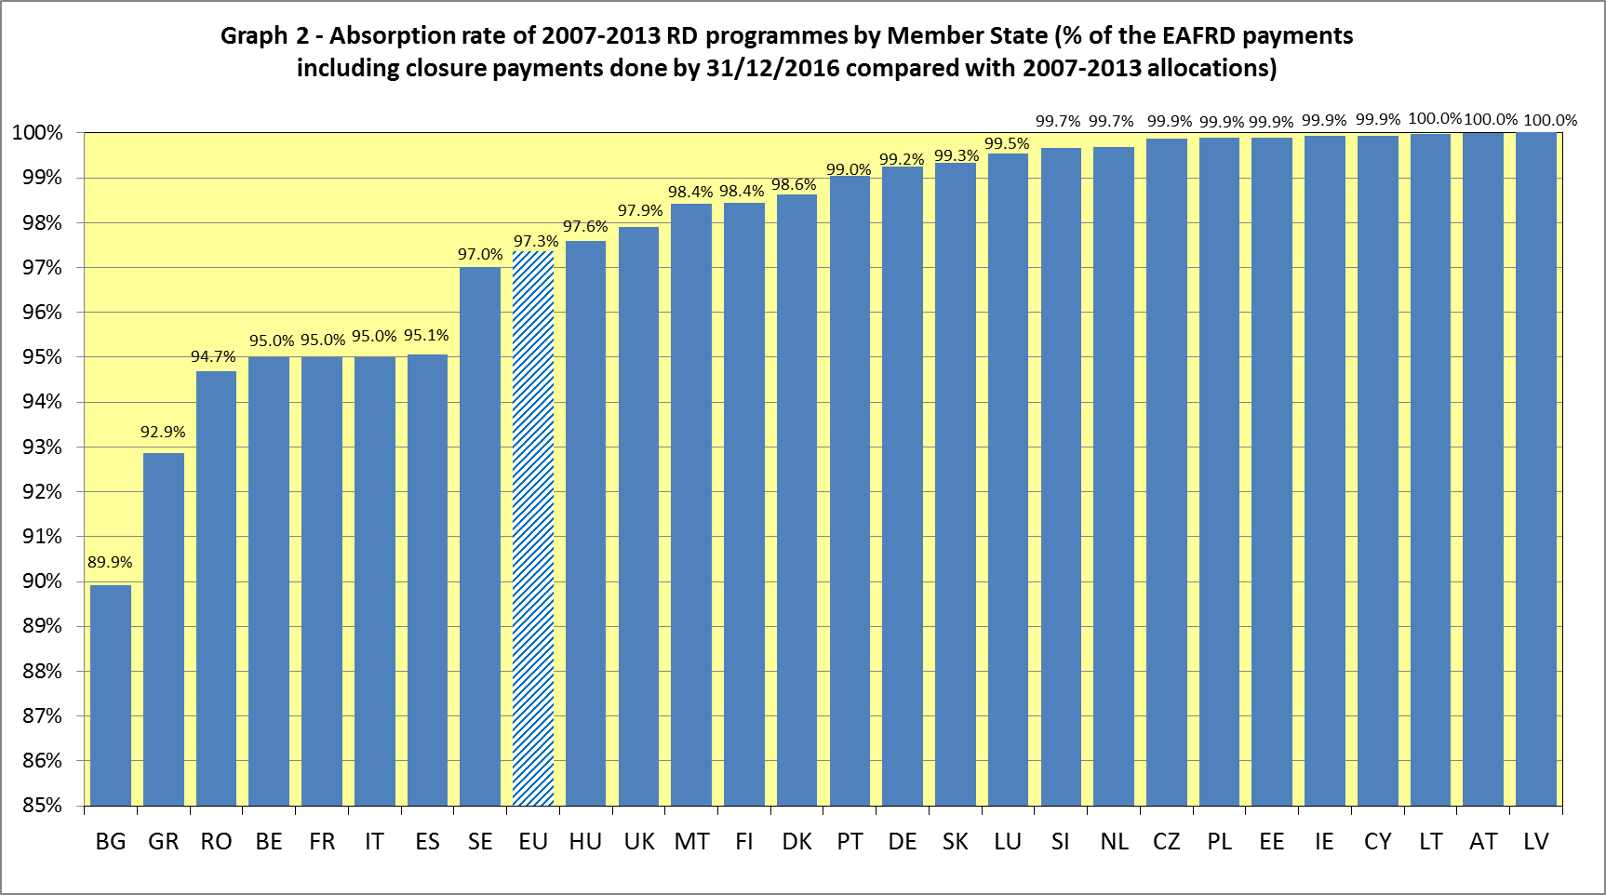

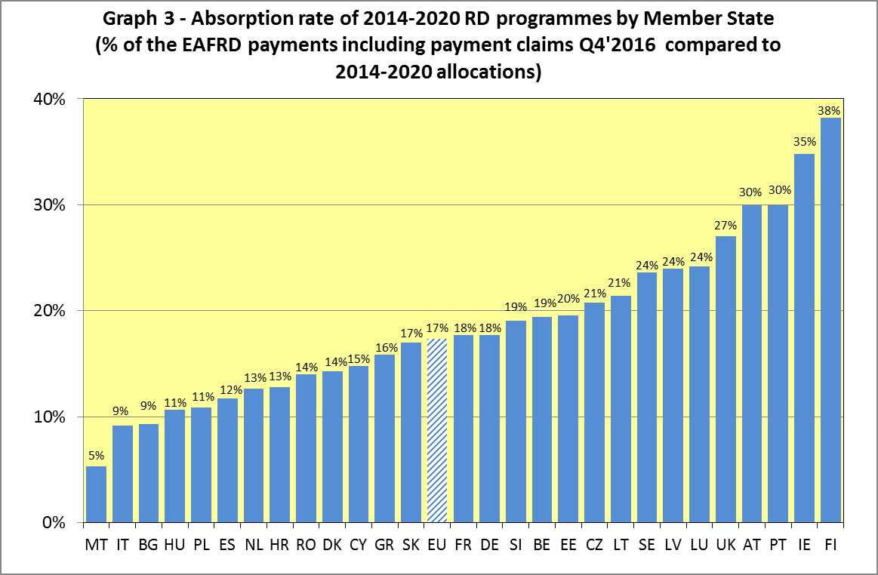

1. Following a UK High Court Consent Order of 12 December 2014, the commitments of the UK-Wales programme were reduced by EUR 4.2 million, affecting the years 2016-2020 which was added to the direct payments ceiling of the UK. The underexecution of EUR 960 000 is the annual impact of the overall decrease in year 2016.
2. COMMISSION DELEGATED REGULATION (EU) 2016/142 of 2 December 2015 amending Annex I to Regulation (EU) No 1305/2013 of the European Parliament and of the Council and Annex III to Regulation (EU) No 1307/2013 of the European Parliament and of the Council (OJ L28 of 4.2.2016, page 8)