

# Introduction

This report fulfils two requirements :

(1) It reports on how cohesion has evolved in EU regions over the recent past and assesses the impact on this of national policies, cohesion policy and other EU policies as required by the Treaty on the Functioning of the European Union[1]. The accompanying Staff Working Document (SWD) consists of 6 chapters: on economic development, social inclusion, sustainable development, improving institutions, national policies and cohesion, and the impact of cohesion policy. The impact of other EU policies is considered in the first four chapters.

(2) It reviews the measures linking the effectiveness of the European Structural and Investment (ESI) Funds to sound economic governance, as required by the Regulation on Common Provisions with regard to the Structural Funds[2]. This review is summarised in Section 9 below and set out in full in Section 5.3 of the SWD.

# regional disparities are narrowing again

After the double dip recession in 2008 and 2011, the EU economy is now growing again. The crisis seriously affected almost all Member States. It halted the long-term reduction in disparities in GDP per head between Member States. With the beginning of the recovery, however, these disparities have started to shrink again with growth everywhere, and higher rates in countries with lower levels of GDP per head.

The first signs of narrowing disparities are also evident at regional level across the EU. From 2008 onwards, regional disparities in employment and unemployment rates widened along with those in GDP per head. In 2014, disparities in employment started to narrow, followed by disparities in GDP per head in 2015. Nevertheless, many regions still have a GDP per head and an employment rate below pre-crisis levels.

Between 2000 and 2015, GDP per head in many less developed regions converged towards the EU average through faster productivity growth, but they lost employment. The manufacturing sector in these regions has for the most part performed well, which has helped firms to compete both inside the Single Market and globally. To ensure that their convergence continues, these regions will have to move up the value chain to activities with a higher skill, technology and innovation content, especially because globalisation and technological change[3] could quickly undermine their economic performance.

The regions with GDP per head well above the EU average have grown faster than the less developed ones through a combination of both productivity and employment growth. As most of the higher GDP per head regions contain a national capital or a large city, they benefit from agglomeration economies while a bigger labour market makes for a better matching of skills. The concentration of activities attracts specialised services and suppliers. Infrastructure investment in transport and ICT generates higher returns, while the spatial proximity of firms produces more innovation and knowledge spillovers. These benefits can be extended by improving links between large cities and their rural hinterland or between smaller cities, where the sharing of specialised services can give rise to economies of scale.

Several of the regions with a GDP per head close to the EU average, however, seem stuck in a ‘middle-income trap’. On average, GDP per head fell between 2000 and 2015 relative to the EU average in many of these regions (see Maps 1 and 2). Their manufacturing sector is smaller and weaker than in regions with both a lower and higher GDP per head. Their costs tend to be too high to compete with the former and their regional innovation systems not strong enough to compete with the latter. To improve their performance, multiple changes need to happen at the same time: a stronger export-orientation, a shift into new sectors and activities, a boost to research and innovation, an increase in education and training and an improvement in the business environment. Globalisation has caused substantial job losses in many of the regions, but the provision of training alone to workers laid-off does not ensure new job creation and the structural transformation needed.

# Employment has recovered, but unemployment is still above its pre-crisis level

In 2016, the employment rate of those aged 20-64 in the EU exceeded the pre-crisis level for the first time. At 71%, it is 1 percentage point higher than in 2008 but still well below the 75% target for 2020 set by the Europe 2020 strategy. The situation, however, varies markedly across the EU.

The unemployment rate across the EU has fallen from a high of 10.9% in 2013 to 8.6% in 2016 and 7.7% in 2017, still above the 7% it was in 2008. In some countries, the rate is lower than in 2008, but in others it is still at least 5 percentage points higher. Regional disparities in unemployment rates had not narrowed up to 2016, but they had largely ceased to widen. However, in particular people under 25 still face problems getting a job (see Map 3).

Although there was some move towards the Europe 2020 targets between 2010 and 2015, the rate of progress is not enough to achieve them by 2020. The more developed regions are closest to achieving them, but less developed regions made more progress towards them up to 2015. The transition regions (those in between) made almost no progress up to then and will be overtaken by the less developed regions by 2020 if the trends persist. Rural areas are furthest from meeting the EU targets, but they made more progress than the cities, towns and suburbs up to 2015.

|  |  |
| --- | --- |
| Map 1 Change in GDP per head index, 2000-2008 | Map 2 Change in GDP per head index, 2009-2015 |

Map 3 Population aged 15-24 not in employment, education or training, 2016

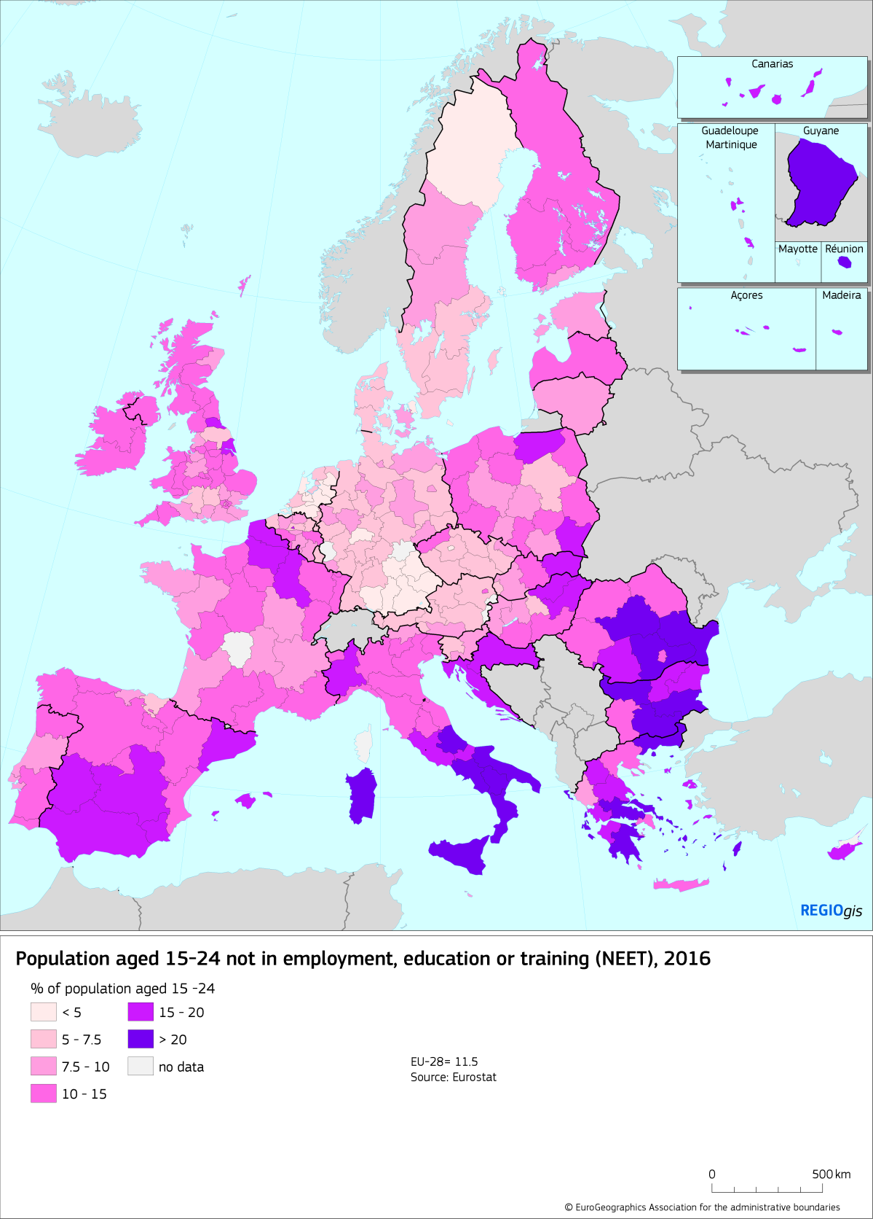

# Some regions have rapid population growth while others depopulate

For the first time, deaths outnumbered births in the EU in 2015, which strengthens the impact of migration and mobility on regional population. The big differences in unemployment and income across the EU encourage people to move to find better job opportunities and/or escape unemployment and poverty. Movements have predominantly been from the EU-13 to the EU-15 and within the EU-13 from rural regions to capital and other large cities. In several regions, this has led to rapid changes in population, which has put pressure on public infrastructure and services either to up or downscale them.

In the recent past, the EU has also seen a rapid increase in people applying for asylum, reaching 1.2 million first-time applications in both 2015 and 2016. Ensuring that all refugees or migrants legally residing in the EU are effectively integrated is important for cohesion and future prosperity. Improving their skills to help them find a job, helping them to set up a business, providing them with better access to finance and tackling discrimination are all key achieving this.

Map 4 Change in population in NUTS 3 regions, 2005-2015

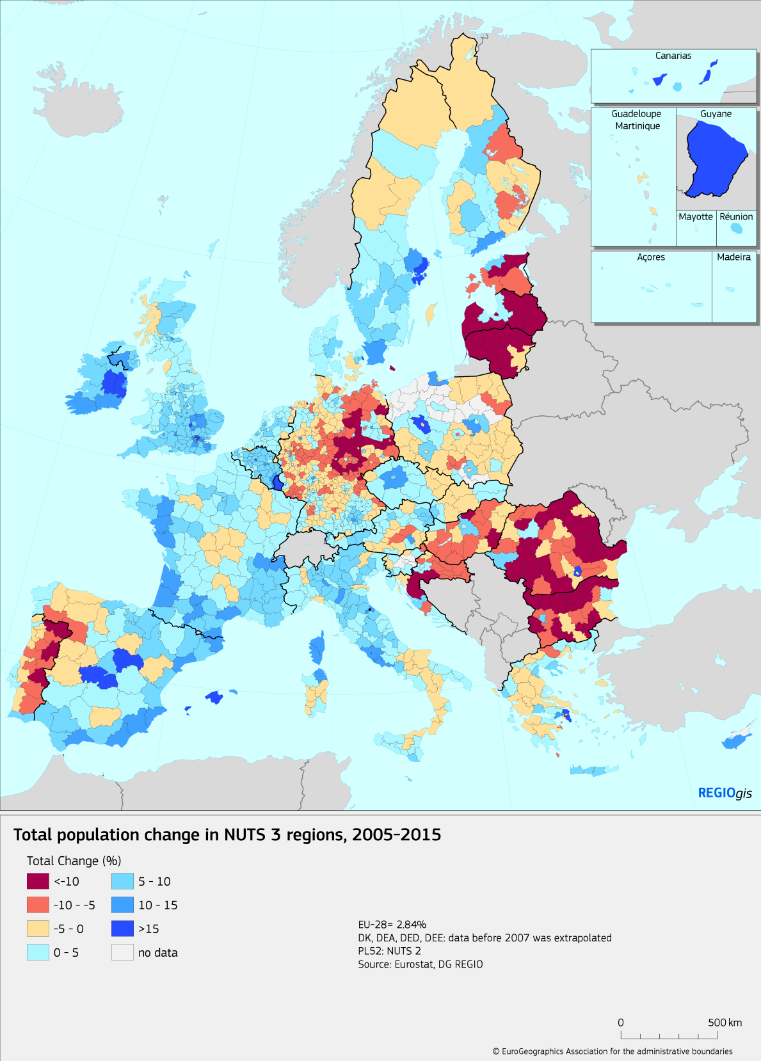

# Cities combine opportunities with challenges

Despite the growing concentration of jobs in cities, the share of low work intensity households is the highest in EU-15 cities. The risk of poverty or social exclusion in the EU has fallen back to its pre-crisis level. In the EU-13, it is even lower than before the crisis, but in the EU-15 it remains higher than before in cities, towns and suburbs. This highlights the fact that pockets of poverty[4] exist even in relatively well-off cities.

Cities are more efficient in terms of energy and land-use[5] and offer the possibility of a low-carbon lifestyle. At the same time, air pollution with all its damaging effects on human health remains a concern in many European cities.

Integrated strategies can make a big impact in cities. For example, improving urban transport can reduce congestion, make firms more productive and connect deprived neighbourhoods. Institutes of higher education can help to integrate migrants, promote innovation and provide skills missing in the local labour market. Nature based solutions, such as urban green spaces can improve quality of life, air quality and bio-diversity.

# Investments in innovation, skills and infrastructure are insufficient

Overall, innovation in the EU remains highly concentrated in a limited number of regions (see Map 5). In north-western Member States, good interregional connections, a highly skilled labour force and an attractive business environment have allowed neighbouring regions to benefit from their proximity to the regions concerned. In southern and eastern Member States, the innovation performance is weaker and regions close to centres of innovation — mainly the capitals — do not benefit from their proximity. This calls for policies that connect firms, research centres and specialised business services across regions. Investing more in skills could help to improve economic growth by narrowing the skills gap and help to reduce poverty, youth unemployment and social exclusion.

Public investment in the EU is still below its pre-crisis level with major gaps in some of the countries most affected by the crisis. More investment will be needed to complete the trans-European Transport network (TEN-T) and the connections to this. Basic broadband services are accessible to all households in the EU, but next generation access — which is much faster — is only available to 40% of rural residents compared to 90% of urban ones.

Map 5 Regional innovation performance, 2017

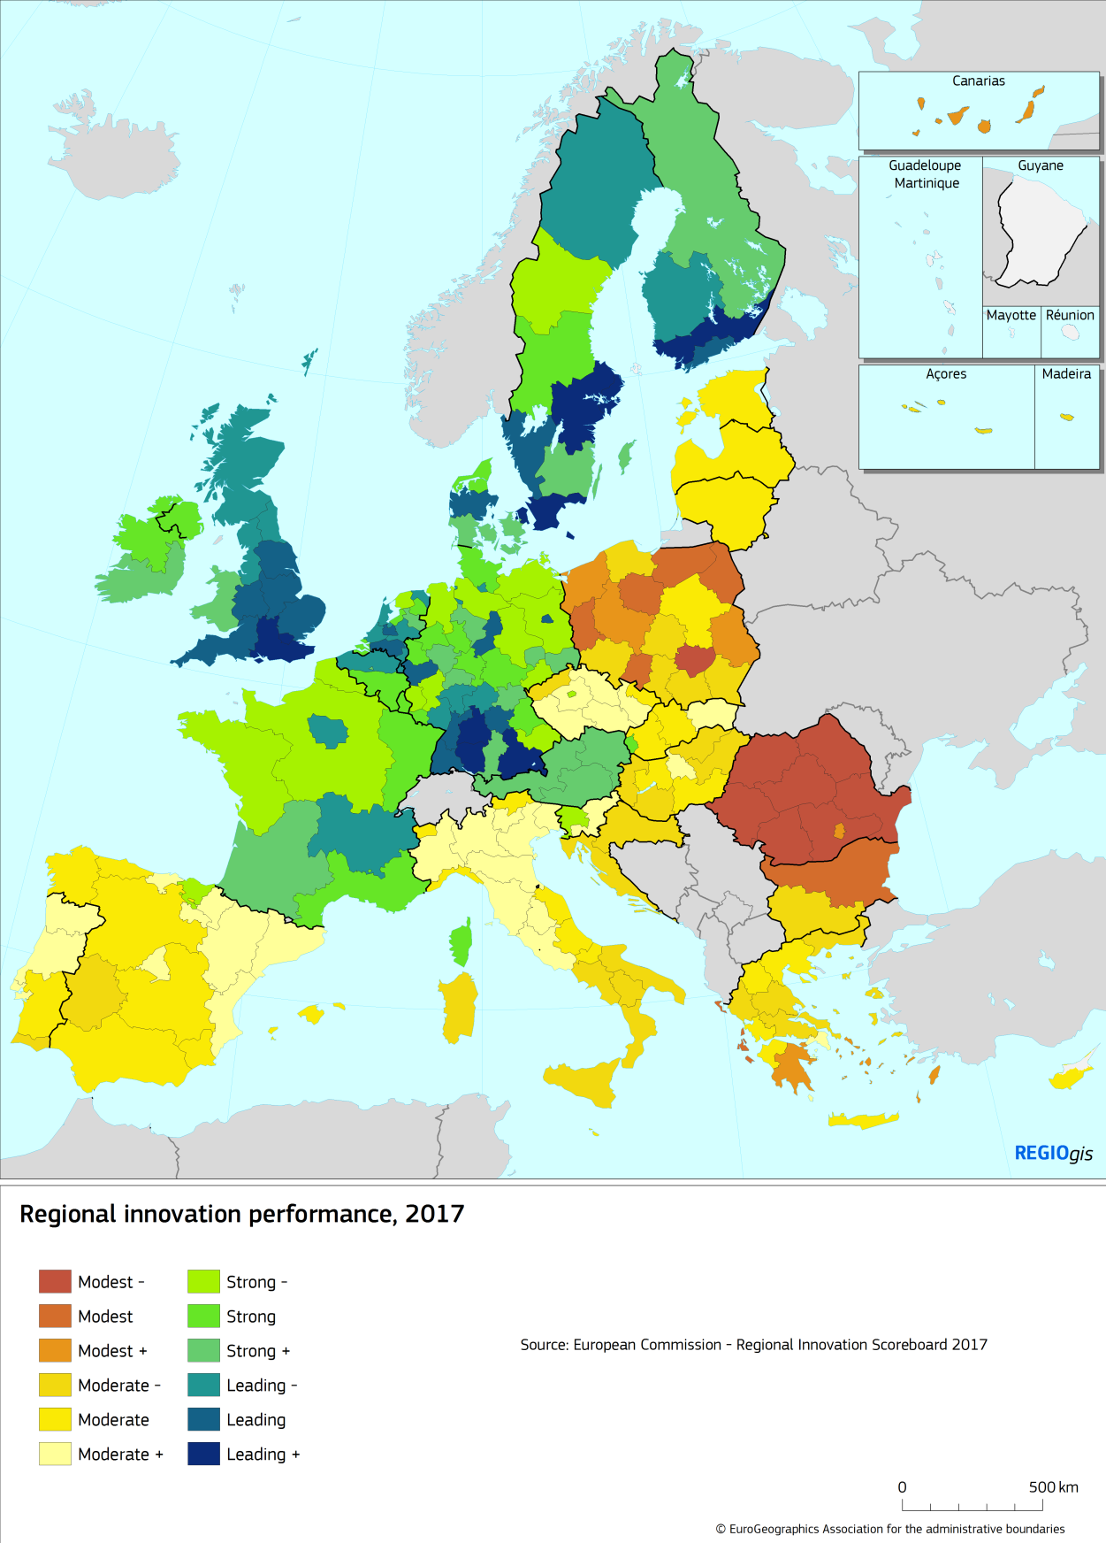

# More investments needed in energy efficiency, renewables and low-carbon transport to reduce greenhouse gas emissions

Substantial progress has been made in limiting energy consumption and greenhouse gas emissions. Most Member States have either reached or are close to reaching their national 2020 targets for greenhouse gas emissions and renewable energy. This in part has been facilitated by the crisis reducing economic activity. The current recovery may, therefore, put these achievements in jeopardy. Reaching the more ambitious EU targets of a 40% reduction of greenhouse gas emissions and 27% share of renewable energy by 2030 will require greater effort. The recent climate agreement (COP21) also commits governments to assessing every 5 years whether more ambitious targets are needed.

To reach the EU target for reducing greenhouse gas emissions, there is a need to shift towards more energy efficient and cleaner transport and to make more efficient use of existing transport infrastructure. Roads remain the predominant mode of transport for both passengers and freight and more needs to be done to increase the use of rail and waterways as well as public transport[6].

Climate change will have significant effects on many EU regions. It will give rise to changes in the environment which will often be costly to adapt to and which will necessitate substantial investment to make regions more resilient to the consequences.

The state of the environment in the EU has improved in recent years[7]. Nevertheless, key environmental objectives such as renewable energy, energy efficiency, air quality and in some Member States waste water treatment remain unfulfilled.

# Cooperating and overcoming obstacles across EU borders

The EU has always supported territorial cooperation which has played a crucial role both in mitigating the adverse effects of internal borders and in providing Europeans with innovative solutions as regards research, environmental issues, transport, education, energy, healthcare, security and training. Territorial cooperation can also help countries and regions to identify solutions to common problems including those linked to new global challenges.

Cooperation programmes have contributed to enlarging the knowledge-based economy across Europe by increasing R&D capacity and transfers of know-how between regions, stimulating investment in SMEs and diversifying local economies. They have improved accessibility across borders, the joint management of natural resources and environmental protection.

However, despite the elimination of many institutional and regulatory barriers, borders continue to represent obstacles to the movement of goods, services, people, capital and ideas. Removal of such barriers could boost economic growth and improve access to services in the regions concerned, but it would also help European economies to fully reap the benefits of integration[8].

# Improving the quality of government and implementing structural reforms would boost growth

Low quality of government hinders economic development and reduces the impact of public investment, including that co-financed by cohesion policy (see Chapter 4). Government efficiency differs between Member States. There are also significant disparities within a number of them (see Map 6). Improving institutions would amplify the impact of cohesion policy.

Structural reforms that improve competition, the business environment, education and skills[9], labour markets and social protection systems can have major benefits in terms of productivity and employment growth. This is particularly relevant for regions and countries where productivity has barely improved over the past decade[10]. Reforms requiring mainly regulatory and administrative changes with no investment, however, are currently not linked to cohesion policy.

According to the Doing Business report[11] there are marked differences between how business-friendly Member States are. The state of the business environment can also vary within countries due to differences in the efficiency of local authorities.

Open and transparent public procurement is essential to promote development and reward the most efficient firms. However, the use of open procedures, the intensity of competition and the speed of decision-making as well as the risk of corruption varies markedly between regions.

To boost economic development and the impact of cohesion policy in EU regions, the efficiency and transparency of public institutions as well as the effectiveness of justice systems need to be improved. Reforms are also needed to reduce regulatory obstacles and improve the functioning of the labour market.

Map 6 European Quality of Government Index, 2017

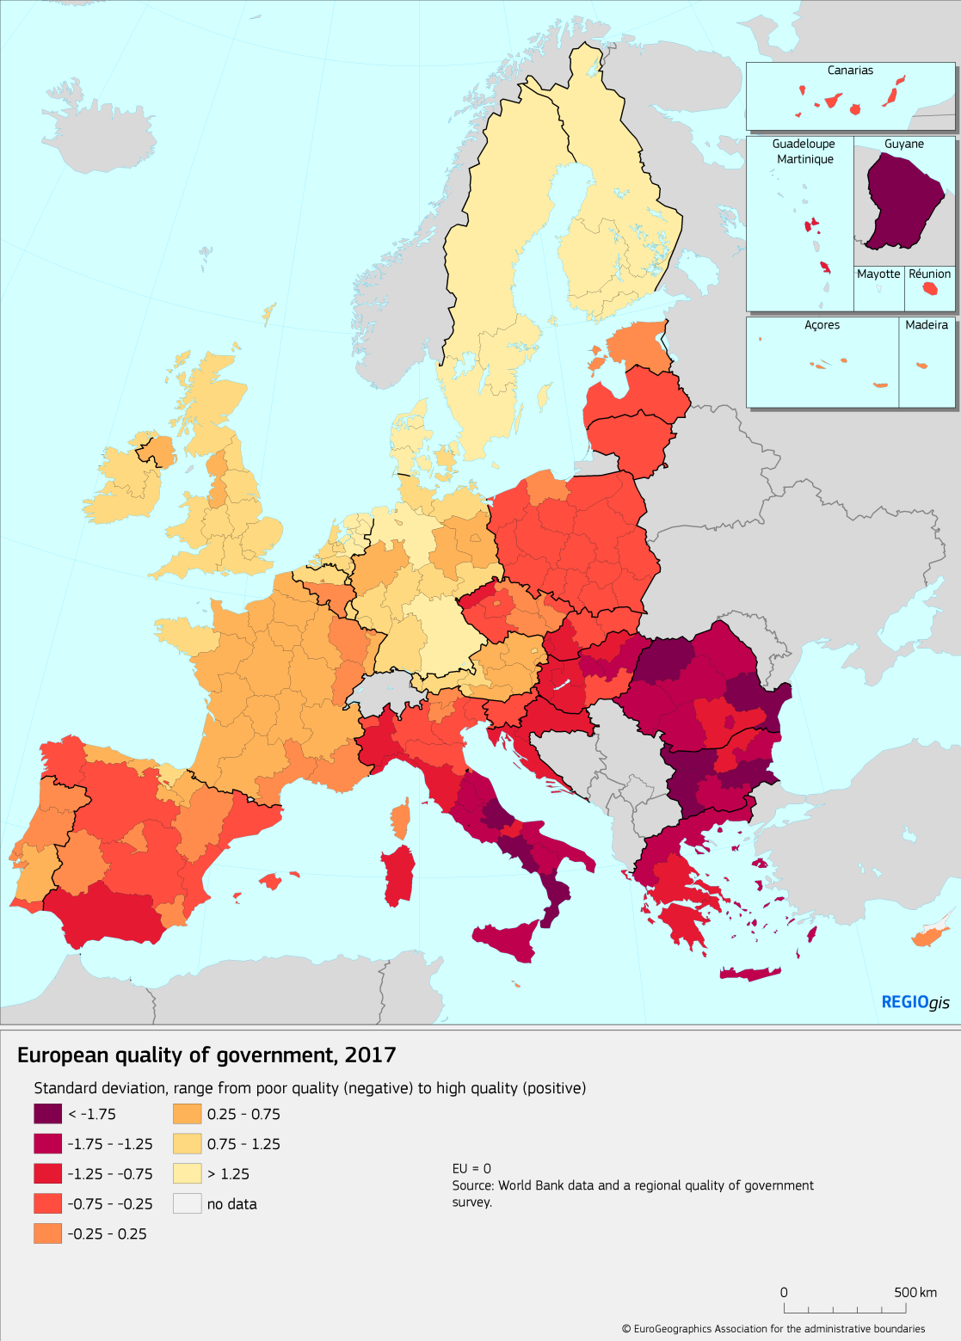

# National public investment has not yet fully recovered

The EU economy is gradually recovering from a protracted period of crisis which featured a significant reduction in investment in many Member States and regions. Total investment as a share of GDP fell and has hardly grown since.

As the EU economy has recovered, government debt in Member States has started to decline from a peak of 87%, but is still well above its level in 2007 of 58%. As a result of pressure on public finances, public investment in the EU fell from 3.4% of GDP in 2008 to 2.7% in 2016. In a number of Member States, the reduction in growth-friendly expenditure has been substantial. Since most of these Members States have a GDP per head below the EU average, the reduction could put at risk disparities across the EU narrowing in the future.

Public investment was at the core of the negotiations on the current legal framework of the ESI Funds. One of the major objectives was to improve the consistency between the Funds and European economic governance with the aim of ensuring that the effectiveness of expenditure financed by them is underpinned by sound economic policies.

For this reason, Article 23 of Regulation (EU) No 1303/2013 provides the Commission with (i) the power to request changes in programmes to address economic policy priorities recommended by the Council and (ii) the obligation to suspend the funds in cases of non-effective action by the Member State to address an excessive government deficit or excessive macroeconomic imbalance. The SWD assesses the application of this article and explains why a legislative proposal to modify it is at this stage not deemed necessary by the Commission (see Chapter 5).

# Cohesion policy’s key role in public investment reduced the impact of crisis

Cohesion policy is the EU’s main investment policy, providing funding equivalent to 8.5% of government capital investment in the EU, a figure which rises to 41 % for the EU-13 and to over 50 % for a number of countries (see Graph 1).

This investment adds value at the European level by contributing to:

* The **Treaty objective of reducing disparities**, notably in terms of income per head and living standards as well as social inclusion and employment opportunities.
* **European public goods** such as innovation and digital infrastructure, skills, addressing climate change, disaster risk reduction, energy and environmental transition, healthcare and social investment, public and smart transport.
* **Spillovers** benefits to non-cohesion countries from the increased trade generated and from cross-border, transnational and inter-regional programmes.

The strong EU added-value of cohesion policy was emphasised by many of the speakers at the Cohesion Forum in June 2017 who stressed that it helped less developed regions to catch up and all regions to invest in EU priorities and address new challenges.

The impact of Cohesion Policy on the EU economies is significant and the effects of investments build up over the long term. For the EU-12 countries (i.e. excluding Croatia), the QUEST model estimates that investment for the 2007-2013 period increased their GDP by 3% in 2015, and by a similar amount for the 2014-2020 period[12] in 2023.

Figure 1 Cohesion policy funding as an estimated share of public investment, 2015-2017



*Source: Eurostat and REGIO*

This has contributed to a significant convergence of GDP per head in these countries[13]. In the EU-12, this increased from 54% of the EU average in 2006 to 67% in 2015. Moreover, the 2007-13 programmes led directly to the creation of 1.2 million jobs in supported enterprises.

The non-cohesion countries also benefit from spillovers generated by investments in cohesion countries both directly (through selling investment goods) and indirectly (through higher income and therefore increased trade). By 2023, 2007-2013 programmes are estimated to add 0.12% to GDP in non-cohesion countries, a quarter of which is due to spillovers from spending in cohesion countries. This effect is particularly pronounced for Austria and Germany because of their close trading links.

The 2014-2020 programmes plan to support 1.1 million SMEs, leading directly to the creation of a further 420 000 new jobs[14]. The programmes plan to help more than 7.4 million unemployed people to find a job and to help another 2.2 million people within six months of completing training co-funded by the programmes. In addition, the programmes will help over 8.9 million people gain new qualifications.

Significant funding is being invested in the digital economy, where EUR 16 billion is earmarked for the development of e-government, ICT services and applications for SMEs, high speed broadband, smart grids and intelligent energy distribution systems, and large scale data centres. Such investment is expected to provide 14.5 million additional households with broadband access.

Cohesion policy is making a substantial investment in environmental protection and energy efficiency. An extra 17 million people are planned to be connected to wastewater treatment facilities, and 3.3 million more to smart grids, while 870 000 households will be helped to reduce their energy consumption.

Moreover, investment in transport will remove bottlenecks, reduce travel times and lead to more urban trams and metros. The programmes plan to renovate more than 4 600 km of TEN-T railway lines, construct 2 000 km of new TEN-T roads and construct or improve 750 km of tram and metro lines.

Cohesion policy is also making a substantial investment in social infrastructure. Some 6.8 million children will gain access to new or modernised schools and childcare facilities and 42 million people to improved healthcare services.

Territorial cooperation programmes are expected to see 240 000 people participate in cross-border mobility initiatives and 6 900 businesses and 1 400 research institutions in research projects.

Several measures to improve the quality of investments have been introduced for the 2014-2020 period:

* **Ex ante conditionalities**, which are preconditions attached to the programmes and which tackle the major systemic bottlenecks hindering effective public investment. These have led to the speeding up of ongoing reforms and the initiation of additional reforms. They have also strengthened the administrative capacity to implement EU rules relating to public procurement, state aid, environmental legislation and anti-discrimination[15].
* **Smart specialisation,** which is the most comprehensive decentralised, innovation and industrial policy in Europe today. It brings together the key players — the research community, business, higher education, public authorities and civil society — to target support in line with local potential and market opportunities. The goal is to achieve critical mass, innovation and a move up the value chain.
* A stronger **focus on results,** which means that programmes must set specific objectives, translated into clear result indicators with targets and benchmarks. Regular reports show whether the programmes are achieving their goals and key indicators can be tracked online on an open data platform to check their progress. There is also a performance reserve which can be released if pre-set targets are met.

The funding allocated to projects selected by the 2014-2020 programmes up to July 2017, amounts to 39% of the total available. Though this is similar to the previous period, implementation has been slow which suggests that simplification and capacity concerns need to be further addressed. It is still too early to monitor progress towards achieving targets which will only become apparent once more projects have been completed.

# Cohesion policy and the future of Europe

The White Paper on the Future of Europe[16] launched a debate on which direction the EU should take in the coming years. Together with its 5 reflection papers, it covers three main linked questions relating to cohesion policy:

1. Where should it invest?
2. What should the investment priorities be?
3. How should the policy be implemented?

These questions are summarised below in relation to the challenges identified in the present report. Two important agreements which cohesion policy needs to take account of are the COP21 agreement on climate change and the UN Sustainable Development Goals for 2030.

The Commission’s reflection paper on the future of EU[17] finances poses the question of whether cohesion policy should invest outside less developed regions and cross-border ones.

From its inception, cohesion policy has had a particular focus on less developed regions and territorial cooperation. It has also invested in other areas that are mentioned in the Treaty, such as areas undergoing industrial transition, rural areas and the outermost regions. It has invested too in areas of high unemployment and deprived urban areas. For the last two programming periods, Cohesion Policy has covered all regions.

The present report shows that the impact of globalisation, migration, poverty and a lack of innovation, climate change, energy transition and pollution is not limited to less developed regions.

Future funding for cross border cooperation should continue to focus on areas of particular EU value added and resolve cross-border problems, such as gaps and missing links in different policy fields, including transport. Finally, the pooling of joint public services in neighbouring border regions and institution-building needs could also be taken into account[18].

The reflection paper on EU finances states, more generally, that all EU funding needs to focus on areas where the highest EU value-added can be achieved. Social inclusion, employment, skills, research and innovation, climate change, energy and environmental transition are identified as the areas which cohesion policy needs to focus on. In addition, the reflection paper highlights other areas where cohesion policy has a positive impact, such as support for SMEs, healthcare and social infrastructure, transport and digital infrastructure. Last but not least, it underlines the need to address migration and globalisation.

Both the reflection paper and the present report argue that poor institutional quality reduces competitiveness, the impact of investment and economic growth. Improving the quality of government, implementing structural reforms and strengthening administrative capacity should be further emphasised. They stress that the link with economic governance and the European Semester may need to be strengthened to ensure that the system is simpler, transparent and provides positive incentives to implement concrete reforms to foster convergence. This may require new approaches, for example through better coordination of available instruments and closer involvement of the Commission. The lagging regions initiative[19] contained several successful elements which could be extended. The need to improve institutions is also demonstrated by calls to make the disbursement of EU funds conditional on legislation and institutions adhering to common EU values.

In addition to the issues raised above about the territorial coverage and investment priorities, the reflection paper considers a number of options to improve the implementation of cohesion policy:

* A single set of rules for existing funds, would ensure more coherent investment and make it easier for beneficiaries. Coherence could also be improved by a single rule book for cohesion policy and other funding instruments with programmes or projects of the same type. This should lead to stronger complementarity between cohesion policy and innovation or infrastructure funding.
* The system of allocation of the funds could be revised by adding criteria linked to the challenges the EU faces, from demographics and unemployment to social inclusion and migration, from innovation to climate change.
* The levels of national co-financing for cohesion policy could be increased to better align them for different countries and regions and to increase the sense of ownership in the policy.
* An unallocated proportion of funding could make cohesion policy more flexible and able to respond to new challenges more quickly.
* Faster implementation and a smoother transition between programming periods could be achieved by changes, such as stricter decommitment rules, shortening procedures for closing programmes and speeding up the processes for appointing the management authorities and for programming and making them more flexible.
* Complementarity between financial instruments could be enhanced. Upstream coordination, the same rules and clearer demarcation of interventions could ensure complementarity between the European Fund for Strategic Investment, the new pan-European Venture Capital Fund and the loan, guarantee and equity instruments managed by Member States under cohesion policy.
* Finally, the policy has become increasingly complex to manage. Therefore, a much more radical approach to simplifying implementation is needed.

Next, cohesion policy stakeholders and the general public will be invited to participate in the public consultation as part of the impact assessment. In May 2018, the Commission plans to adopt the proposal for the multi-annual financial framework, followed by the proposals for cohesion policy post 2020.

1. (Hereinafter referred to as 'the Treaty'), see Article 175.
2. Regulation (EU) No 1303/2013 of the European Parliament and of the Council of 17 December 2013 laying down common provisions on the European Regional Development Fund, the European Social Fund, the Cohesion Fund, the European Agricultural Fund for Rural Development and the European Maritime and Fisheries Fund and laying down general provisions on the European Regional Development Fund, the European Social Fund, the Cohesion Fund and the European Maritime and Fisheries Fund (…) (OJ L 347, 20.12.2013, p. 320), see Article 23.
3. European Commission 'Reflection Paper on Harnessing Globalisation' - COM(2017) 240 final, 10.5.2017.
4. European Commission 'Reflection Paper on the Social Dimension of Europe' - COM(2017) 206 final, 26.4.2017.
5. European Commission and UN-Habitat: The State of European cities report, 2016.
6. European Commission: ''Assessment of the progress made by Member States in 2014 towards the national energy efficiency targets for 2020' - COM(2017) 56 final, 1.2.2017.
7. European Environmental Agency: State of the Environment and Outlook, 2015.
8. Politecnico di Milano (2017) Quantification of the effects of legal and administrative border obstacles in land border regions.
9. European Commission 'A new skills agenda for Europe' - COM(2016) 381 final, 2.6.2016.
10. European Commission ‘Competitiveness in low-income and low-growth regions - The lagging regions report' - SWD(2017) 132 final, 10.4.2017.
11. World Bank. 2017. Doing Business 2017: Equal Opportunity for All.
12. This time for the EU-13, i.e. including Croatia.
13. In purchasing power standards. 2006 was chosen as the baseline year, since it was the year preceding the 2007-2013 programmes, as well as the year preceding the accession of Bulgaria and Romania. 2015 was the latest year for these data series at the time of publication.
14. The number of new jobs of this period is lower compared to last period because a) innovative, sustainable and high added value jobs are targeted and b) the number at the end of the period is typically considerably higher than the number estimated at the start of the period. See Communication 'Strengthening Innovation in Europe's Regions Strategies for resilient, inclusive and sustainable growth' - COM(2017) 376 final, 18.7.2017.
15. European Commission 'The Value Added of Ex ante Conditionalities in the European Structural and Investment Funds' - SWD(2017) 127 final, 31.3.2017.
16. European Commission 'White paper on the Future of Europe Reflections and scenarios for the EU-27 by 2025' - COM(2017) 2025 final, 1.3.2017.
17. European Commission 'Reflection paper on the future of EU finances' - COM(2017) 358 final, 28.6.2017.
18. European Commission 'Boosting growth and cohesion in EU border regions' - COM(2017) 534 final, 20.9.2017.
19. European Commission 'Competitiveness in low-income and low-growth regions: The lagging regions report' - SWD(2017) 132 final, 10.4.2017.