

**TABLE OF CONTENTS**

1. Introduction 3

2. Overview of the activities of the EGF in 2015 and 2016 4

3. Analysis of the activities of the EGF in 2015 and 2016 4

3.1. Applications received 4

3.1.1. Applications received by intervention criterion 5

3.1.2. Applications received by sector 5

3.1.3. Applications received by amount requested 7

3.1.4. Applications received by number of beneficiaries targeted for assistance 8

3.1.5. Applications received by number of targeted workers per sector 9

3.1.6. Applications received by amount requested per beneficiary 9

3.2. Contributions granted 10

3.2.1. Actions funded with EGF assistance 11

3.2.2. Complementarity with actions funded by the European Social Fund (ESF) 11

3.3. Applications rejected or withdrawn 13

3.4. Results achieved by the EGF 16

3.4.1. Summary of the results reported in 2015 and 2016 16

3.4.2. Qualitative assessment of the Final Reports submitted in 2015 and 2016 17

3.5. MFF Review – Regulation (EU) No 1309/2013 18

3.6. Financial execution 21

3.6.1. Funds contributed by the EGF 21

3.6.2. Technical assistance expenditure 21

3.6.3. Irregularities reported 23

3.6.4. Winding-up of financial contributions from the EGF 23

3.7. Technical assistance activities undertaken by the Commission 24

3.7.1. Information and publicity: Internet site 24

3.7.2. Meetings with the national authorities and EGF stakeholders 24

3.7.3. Creation of a knowledge base 24

3.7.4. EGF mid-term evaluation 2014 - 2020. 25

4. Cumulative data from 2007 till 2016 25

# 1. Introduction

The European Globalisation Adjustment Fund (EGF) is intended to provide support to workers made redundant as a result of major structural changes in world trade patterns due to globalisation and the negative effects of the global economic and financial crisis on employment.

The EGF, which was set up by Regulation (EC) No 1927/2006[1], was designed to reconcile the overall long-term benefits of open trade for growth and employment with the short-term adverse effects which globalisation may have, particularly on the employment of the most vulnerable and lowest-skilled workers.

To respond to the global economic and financial crisis, the rules governing the EGF were amended in 2009 first by Regulation (EC) No 546/2009[2] and, since January 2014, by Regulation (EU) No 1309/2013[3]. Under Regulation (EU) No 1309/2013, a financial and economic crisis criterion has been reintroduced for the EGF applications. Another important change is the inclusion of new categories of beneficiaries, such as temporary and agency workers, self-employed workers and – until the end of 2017 – young people not in employment, education or training (NEETs)[4].

The EGF co-finances active labour market policy measures taken by the Member States to help redundant workers to find new jobs. It supplements national labour market measures where sudden collective redundancy processes put the public employment services under extraordinary pressure and can therefore provide a more personalised and targeted approach to the most vulnerable redundant workers.

Article 19 of Regulation (EU) No 1309/2013 requires the Commission to present to the European Parliament and to the Council every two years a quantitative and qualitative report on the activities of the EGF in the previous two years. The reports must focus mainly on the results achieved by the EGF, including in particular information on:

* applications submitted;
* decisions adopted;
* actions funded, including their complementarity with actions funded by other Union instruments, in particular the European Social Fund (ESF);
* winding-up of financial contributions made.

The reports should also document requests refused owing to insufficient funds or ineligibility and examine actions completed in the reference period rather than following cases during their lifecycle. Each section of the report will thus examine different cases.

# 2. Overview of the activities of the EGF in 2015 and 2016

In 2015 and 2016, the Commission received 20 applications (12 in 2015, 8 in 2016) for contributions from the EGF[5]. The budgetary authority decided to mobilise the EGF in 17 cases, while three applications were withdrawn by the Member States[6]. With regard to those 17 applications, a total EGF amount of EUR 51 171 249 was requested by the Member States (EUR 35 400 623 in 2015, EUR 15 770 626 in 2016). Details of the applications received are given in section 3.1 and in Tables 1 and 2.

The budgetary authority took 25 decisions to mobilise the EGF (including ten applications received before 01/01/2015), totalling an amount of EUR 70 392 546[7] from the EGF's budget for 2015 and 2016. Details of the contributions granted in 2015 and 2016 are set out in section 3.2 and in Tables 3 and 4.

The Commission received 26 final reports on the implementation of EGF contributions in 2015 and 2016. The results are described in section 3.4 and Table 5. In 2015 and 2016, 34 EGF cases were wound up. Details of the wound up cases are set out in Table 3 of the Annex.

Technical assistance provided at the initiative of the Commission (Article 11 of Regulation (EU) No 1309/2013) is described in sections 3.6.2, 3.7 and Tables 6, 6.1.

The results of the mid-term evaluation of the EGF 2014-2020 are expected to be published in mid-2017 (see section 3.7.4).

In its Proposal for a Regulation of the European Parliament and of the Council on the financial rules applicable to the general budget of the Union and amending Regulation (EC) No 2012/2002, Regulations (EU) No 1296/2013, (EU) 1301/2013, (EU) No 1303/2013, EU No 1304/2013, (EU) No 1305/2013, (EU) No 1306/2013, (EU) No 1307/2013, (EU) No 1308/2013, (EU) No 1309/2013, (EU) No 1316/2013, (EU) No 223/2014,(EU) No 283/2014, (EU) No 652/2014 of the European Parliament and of the Council and Decision No 541/2014/EU of the European Parliament and of the Council[8], the Commission has included amendments to Regulation (EU) No 1309/2013 with regard to the extension of the derogation for NEETs (in force currently until 31.12.2017) and to the internal procedures so as to speed-up the decision making process. Those amendments are currently under discussion within the Multiannual Financial Framework (MFF) review process.

# 3. Analysis of the activities of the EGF in 2015 and 2016

## 3.1. Applications received

In 2015 and 2016, 20 applications from the following 11 Member States were received by the Commission: Belgium, Estonia, Finland, France, Germany, Greece, Ireland, Italy, the Netherlands, Spain and Sweden. For the first time Estonia applied for EGF funding, the 10 other Member States had already previously applied for EGF funding. Details of these applications are set out in Table 1.

The information in sections 3.1.1 to 3.1.6 will not take into account data regarding the withdrawn applications.

### 3.1.1. Applications received by intervention criterion

The 2015 and 2016 applications were covered by Regulation (EU) No 1309/2013, which provides for two intervention criteria:

1. Major structural change in world trade patterns due to globalisation.

Thirteen applications were submitted under the trade criterion out of which 3 were justified by exceptional circumstances.

1. The economic and financial crisis.

Four applications were submitted because of the repercussions of the global economic and financial crisis.

### 3.1.2. Applications received by sector

The 17 applications received and adopted were related to redundancies in 12 different sectors. The greatest number of applications received concerned the automotive sector (four applications) followed by computer programming, retail trade and computer, electronic and optical products (two applications each). A first application was submitted regarding redundancies in the sector manufacture of coke and refined petroleum products.

***Chart 1: Number of applications by sector (NACE Rev. 2) in 2015 – 2016\**** 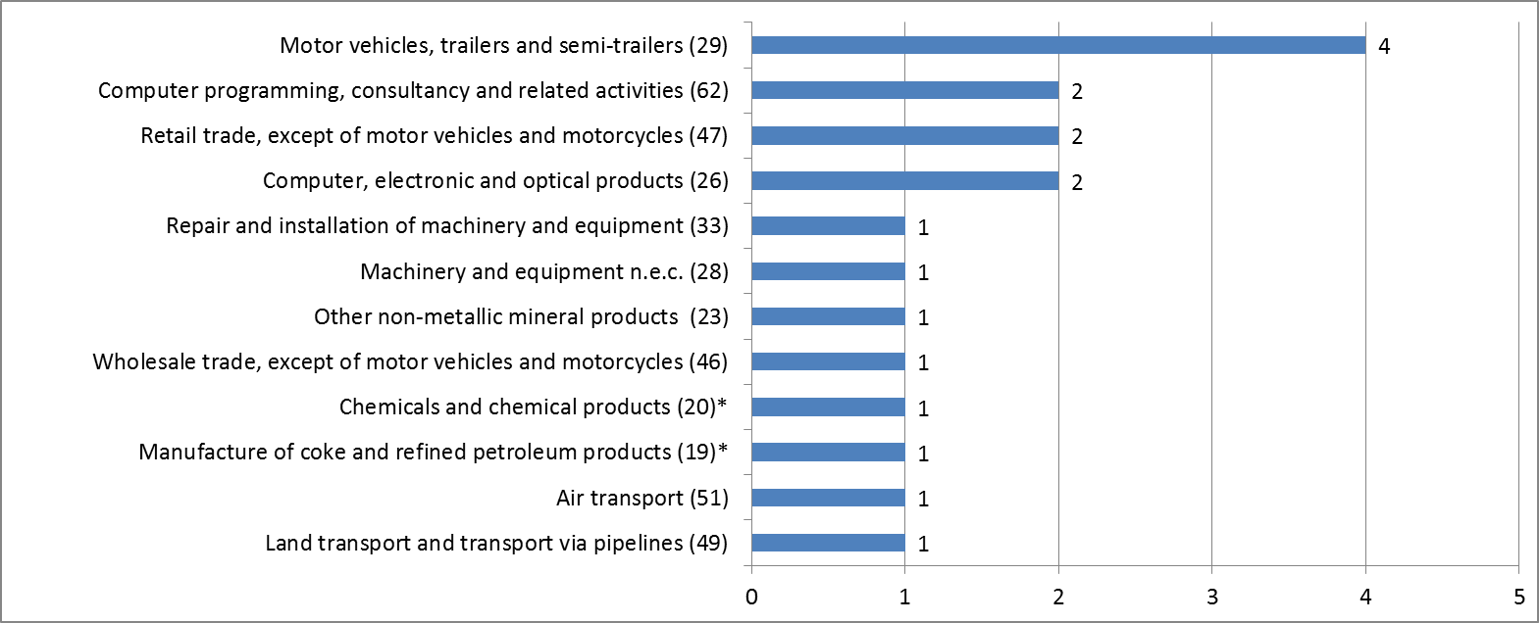

*\* EGF/2016/003 EE/Petroleum and chemicals case relates to two different sectors (19 and 20) therefore has been counted twice in the graph above*

***Table 1: Applications received in 2015 and 2016 by Member State***



### 3.1.3. Applications received by amount requested

Eleven Member States requested EUR 51 171 249 from the EGF over the period 2015 - 2016. Finland requested the highest amount (EUR 11 994 000 for four applications), followed by Belgium (EUR 9 188 149 for three applications) and Germany (EUR 6 958 623 for one application). The EGF contributions requested ranged from EUR 442 293 to EUR 6 958 623 with an average of EUR 3 010 073 per application and EUR 4 651 932 per Member State.

Each of the Member States which applied for EGF support must design a coordinated package of measures that best fits the targeted beneficiaries' profiles, and decide on the amount of assistance to request. Regulation (EU) No 1309/2013 sets out the maximum Commission co-funding rate at 60 %.

***Chart 2: Total EGF amounts requested per Member State in 2015 – 2016***

**Total EGF amount requested by 11 MS, 2015 – 2016: 51 171 249 €**

**Average EGF amount requested per MS, 2015 – 2016: 4 651 932 €**

### 3.1.4. Applications received by number of beneficiaries targeted for assistance

The total number of beneficiaries[9] targeted for EGF support was 19 354. The numbers of targeted beneficiaries per application ranged from 184 to 4 500 with six applications targeting more than 1 000 beneficiaries and three applications targeting less than 500 beneficiaries. On average, each of the 17 applications received in 2015 and 2016 targeted 1 138 beneficiaries.

Of the 19 354 targeted beneficiaries 18 303 were workers made redundant and 1 051 young people not in employment, education or training (NEETs). Belgium requested EGF support for the greatest number of workers (5 400), followed by Finland (3 962) and Germany (2 692). The average number of targeted workers per Member State was 1 664. The four applications in which NEETs were also targeted for support were submitted by Belgium (2 applications totalling 400 NEETs), Greece (543 NEETs) and Ireland (108 NEETs).

Chart 3 shows the distribution of targeted workers per Member State.

***Chart 3: Number of targeted workers per Member State in 2015 – 2016***

**Total number of targeted workers per MS, 2015 – 2016: 18 303**

**Average number of targeted workers per MS, 2015 – 2016: 1 664**

In most of the applications received the total number of workers targeted by the measures proposed for co-funding by the EGF represents in average 78 % of the total number of redundancies. This is because the Member State may decide to focus the EGF assistance only on specific groups of people such as the most vulnerable workers, those facing exceptional difficulties in remaining in the labour market and/or the most in need of assistance. The standard support available for redundant workers in Member States might be in some cases enough for a quick reintegration into employment or workers might choose the early retirement.

### 3.1.5. Applications received by number of targeted workers per sector

The 17 applications accepted during the period under review relate to 12 different sectors. The greatest number of workers was targeted in the sector motor vehicles, trailers and semi-trailers (7 942), followed by the computer programming, consultancy and related activities sector (2 641) and land transport and transport via pipelines (2 132).

***Chart 4: Number of targeted workers per sector (NACE Rev. 2) in 2015 – 2016\****

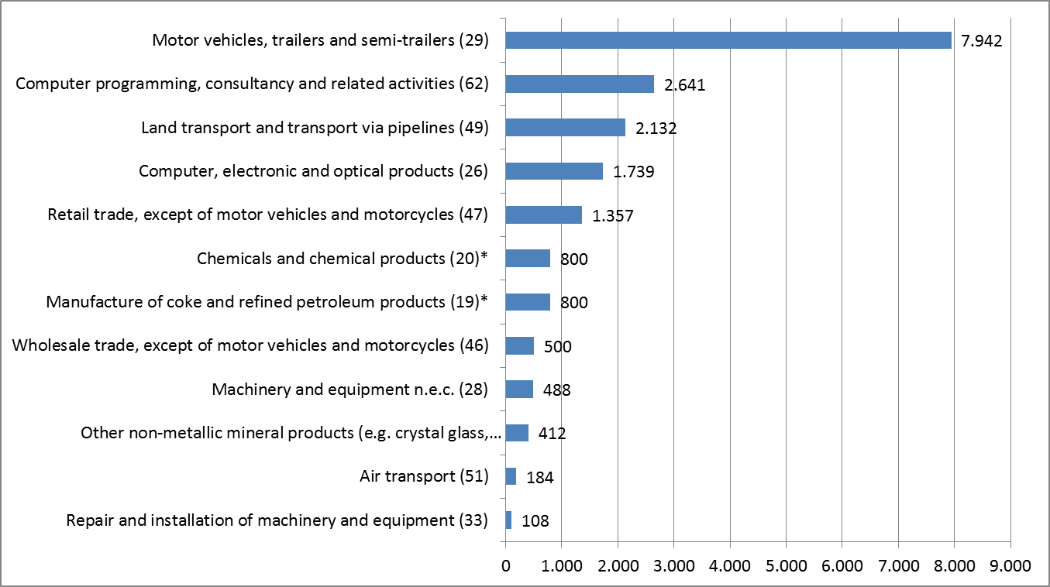

*\* EGF/2016/003 EE/Petroleum and chemicals case refers to two different sectors (19 and 20) therefore the 800 targeted workers of this case have been listed twice.*

### 3.1.6. Applications received by amount requested per beneficiary

Every Member State applying for EGF support must design a coordinated package of measures that best fits the targeted workers' profile and decide on the amount of assistance to request. The EGF Regulation does not limit the total amount requested. The amount requested per targeted beneficiary can therefore vary according to the severity of the lay-offs, the situation of the labour-market affected, the individual circumstances of the targeted beneficiaries, the measures already provided by the Member State, and the cost of providing the services in the Member State or region concerned.

This explains why the amounts of EGF support per beneficiary in 2015 and 2016 varied from EUR 1 393 to EUR 7 689 (see Table 1). On average, each of the Member States applying for EGF support in 2015 and 2016, requested EUR 2 644 per targeted beneficiary. The highest amount per beneficiary has been requested by Italy (EUR 7 689), followed by Greece (EUR 5 880) and Sweden (EUR 4 311).

***Chart 5:Highest EGF amount requested per beneficiary and per Member State in 2015 – 2016***

**Average EGF amount requested per beneficiary by 11 Member States, 2015 – 2016:  2 644 €**

## 3.2. Contributions granted

In 2015 and 2016, the budgetary authority took 25 decisions (including ten applications received before 01/01/2015) to mobilise the EGF funding. See Tables 3 and 4 for an overview of the contributions granted and a profile of the workers concerned[10]. The budgetary authority took 16 decisions in 2015 and 9 decisions in 2016. For the majority of the contributions granted (22) the co-funding rate was 60 %. The co-funding rate was 50 % for three cases to which Regulation (EC) No 1927/2006 applied[11] .

The 25 contributions granted targeted 25 353 beneficiaries (thereof 1 251 NEETs) in 11 Member States, with a total amount of EUR 70 392 546[12] granted from the EGF funding (average EUR 2 776 per targeted beneficiary).

### 3.2.1. Actions funded with EGF assistance

Under Article 7 of Regulation (EU) No 1309/2013, a financial contribution from the EGF may be made for active labour market measures that form part of a coordinated package of personalised services, designed to facilitate the reintegration of the targeted beneficiaries and, in particular, disadvantaged, older and young unemployed persons, into employment or self-employment. The measures approved for the 25 EGF contributions granted in 2015 and 2016 aimed to reintegrate 25 353 beneficiaries into the labour market. The measures consisted mainly of the following:

* intensive personalised job search assistance and case management;
* a variety of vocational training, higher education programmes, language training, upskilling and retraining measures;
* various temporary financial incentives/allowances for the duration of the active labour market measures;
* support measures up to the time when the workers actually went back into employment;
* some mentoring during the initial phase in the new job;
* other types of activities, such as entrepreneurship promotion/business creation, and
* one-off employment/hiring incentives.

When designing their support packages, Member States took into account the backgrounds, experiences and educational levels of the individual beneficiaries, their ability to be mobile and the current or expected job opportunities in the regions concerned.

### 3.2.2. Complementarity with actions funded by the European Social Fund (ESF)

The EGF is designed to increase employability and ensure the rapid integration of the targeted beneficiaries into employment through active labour market measures, thus complementing the ESF, which is the major EU instrument for promoting employment. Generally, the complementarity of the two funds lies in their ability to address these issues from two different time perspectives: the EGF generally provides for redundant workers or self-employed in response to a specific, large-scale mass redundancy which happened within a short period, whereas the ESF supports strategic, long-term goals (e.g. increasing human capital, managing change) through multiannual programmes, whose resources cannot normally be allocated to deal with crisis situations caused by mass redundancies. EGF and ESF measures are sometimes used to complement each other to provide both short-term and longer-term solutions. The decisive criterion is the potential of available instruments to help the targeted beneficiaries, and it is up to Member States to select – and to programme – the instruments and actions best suited to achieving the objectives pursued.

EGF provides an opportunity to ensure intense personalised measures that are tailored to the needs of individual redundant workers whereas ESF support is usually more generalised and targets the wider population (both in-work and out of work). Furthermore, the ESF has greater focus on supporting both labour demand and supply (skills, needs and aspirations of beneficiaries) in an integrated manner, while traditionally the EGF is more geared towards the supply side.

The content of the 'coordinated package of personalised services' to be co-funded by the EGF which for each case consists of specific personalised services and tailor-made assistance, should be balanced with other actions and complement them. The measures co-funded by the EGF can go well beyond standard courses and actions. Practice has shown that the EGF allows Member States to offer targeted beneficiaries better tailor-made and more in-depth assistance than would be possible without it, including measures to which they would not normally have access (e.g. second- or third-level education). The EGF allows Member States to pay particular attention to vulnerable people, such as lower-skilled or those with a migrant background, and to provide support with a better counsellor-beneficiary ratio and/or over a longer period of time than it would be possible without the EGF. This serves to increase the beneficiaries' prospects of improving their situation. By way of derogation until the end of 2017, the EGF Regulation (EU) No 1309/2013 allows Member States to extend the support to NEETs in regions of high youth unemployment. The aim is to support the implementation of the Youth Guarantee, which was endorsed by Council in April 2013[13].

As required by Article 9(5) of Regulation (EU) No 1309/2013, all Member States must put in place the necessary mechanisms to avoid any risk of double funding from EU financial instruments. In most Member States, the ESF Managing Authority is also responsible for the implementation of EGF cases, which ensures that displacement effects can be avoided. It also gives the possibility to seek for complementary between the different interventions. A particular responsibility is placed on Member States to ensure that what is funded through ESF Operational Programmes and the measures included in EGF cases do not result in displacement. Neither information provided by Member States in the Final Reports (on synergies in implementation between the various funds) nor the result of the mid-term evaluation (based on a limited number of cases with finalised implementation) gives evidence that there was an issue regarding the complementarity between the EGF and the ESF. At case level, the EGF commonly builds on existing national or ESF measures by topping them up or by offering different, additional measures.

In line with the principle of subsidiarity, the mix of EGF measures designed at Member State level is largely complementary to mainstream ESF provisions to support transitions back to employment. The decision whether to apply for ESF or EGF funding is made at Member States level, on the condition that the ESF operational programme agreed with the Commission is compatible with such ESF support. It's up to the Member State to manage the complementarity between the ESF and EGF in the best possible manner given the local conditions prevailing at the time.

However, there does not seem to be any evidence of an integrated approach to using EU funds at case level. The reason for this seems to be the long-term programming of the European Structural and Investment Funds (ESI Funds). The fact that the EGF operates outside the multiannual framework unavoidably influences the timeline of procedures and in some cases the ESF actions which are already programmed are first deployed in restructuring cases.

The conclusions of the mid-term evaluation show that the EGF has delivered significant European added value by its ability to support dismissed workers in a personalized manner through flexible provisions and focusing on the 'whole-person approach' in counselling.

## 3.3. Applications rejected or withdrawn

Of the 20 applications received in 2015 and 2016, none was rejected by the Commission and three were withdrawn by the Member States. The application EGF/2015/008 EL/Supermarket Larissa was withdrawn for technical reasons and introduced again in November 2015 in a revised form (EGF/2015/011 EL/Supermarket Larissa). The applications EGF/2016/006 FI/Helsinki-Uusimaa Education and EGF/2016/007 NL/Gelderland-Overijssel Social Work have been withdrawn due to a missing link between the dismissals and globalisation or the global financial and economic crisis. They have not been introduced again.

***Table 2: Withdrawn applications in 2015 and 2016***



***Table 3: Details of contributions granted in 2015 and 2016***

***(Date of Signature by BA in 2015 and 2016)***



***Table 4: EGF contributions granted in 2015 and 2016:***

***Profile of workers targeted (no NEETs included)***



## 3.4. Results achieved by the EGF

The main sources of information on the results achieved by the EGF are the final reports submitted by the Member States. These are supplemented by information shared by Member States in direct contacts with the Commission, during meetings and conferences and by audit works.

In 2015 and 2016, the Commission received 26 final reports[14] for EGF co-funded cases implemented by 12 Member States up to the middle of 2016[15].

The main results and data reported by these Member States in 2015 and 2016 are summarized in this section and in Table 5.

Overall, the Commission has received final reports for 121 EGF contributions (since 2008 when the results of the first EGF case became available until December 2016), representing 82 % of the total number of applications (147) received by the end of 2016.

Based on the information in the Member States' final reports, the Commission can conclude that the EGF adds value to what the Member States could otherwise do to help the targeted beneficiaries to find new jobs. The EGF allows Member States to provide better quality measures for more targeted beneficiaries and for longer than would be possible without EGF funding.

### 3.4.1. Summary of the results reported in 2015 and 2016

The 26 final reports received in 2015 and 2016 and presented by 12 Member States showed that at the end of the implementation period, 9 072workers, or 47 % of the 19 434beneficiaries who received EGF assistance, had found new jobs by the end of the EGF implementation period (7 601 as dependent employees, 1 471 as self-employed).

Approximately 3 % were still in education or training, 48 % were unemployed or inactive for various reasons and for 2 % of the beneficiaries the employment status was not available.

It is worth pointing out that the beneficiaries supported by EGF co-funded measures are usually among those facing the greatest difficulties on the labour market. The results in terms of reintegration into work are influenced by absorption capacities of local and regional labour markets in the aftermath of the global economic and financial crisis. The reintegration rate recorded at the end of the respective implementation periods merely provides a snapshot of the beneficiaries' employment situation at the moment the data were collected. It does not give any information on the type or quality of employment that has been found, which can change significantly in a short period of time. According to information received from several Member States, reintegration rates tend to rise in the months which follow the end of the measures and increase further in the medium term. Most of the EGF co-funded support has an additional positive impact on the longer run.

### 3.4.2. Qualitative assessment of the Final Reports submitted in 2015 and 2016

The support packages provided by the 12 Member States to the targeted beneficiaries include a wide range of personalised job search, outplacement and (re)qualification measures. The highest amounts were spent on 3 categories:

* Job search allowances[16]: EUR 48,8 million (41 % of the total amount of personalised services for the 26 reported cases)
* Individual case management: EUR 24,2 million (20 % of the total amount of personalised services for the 26 reported cases)
* Training and retraining: EUR 23, 3 million (19 % of the total amount of personalised services for the 26 reported cases).

The qualification and training programmes were tailored to the needs and wishes of the beneficiaries targeted while taking into account the requirements of the local or regional labour markets and the future potential of promising sectors.

During 2015-2017, the Commission carried out a mid-term evaluation of the EGF to assess how and to what extent the EGF is reaching its objectives. As the evaluation report has not yet been published, the results have to be regarded as being preliminary.

The evaluation covers all 29 EGF cases in which applications were received in 2014 and 2015[17]. The evaluation does not cover any cases that were submitted in the former programming period.

The EGF evaluation findings (both ex-post 2007-2013 and mid-term 2014-2020) show that EGF assistance helps beneficiaries (the redundant workers or the NEETs) build-up self-esteem, not only through intense guidance counselling, but also particularly through tailor-made training measures. The EGF often also enables beneficiaries to take part in these measures by offering assistance such as mobility allowances or by supporting childcare provision.

Even though evidence identified during the evaluation shows that the re-employment rates of EGF beneficiaries improved compared to the previous funding period (from 49 % to 56 %), these results have to be taken with caution, as the implementing period is now twice as long as before. Furthermore, evidence suggests that the re-integration rates are very case specific, for example depending on the specific economic situation in the area concerned. It is therefore not only difficult to compare re-integration rates over cases, but also to find other suitable comparators of similar measures.

The NEETs derogation was used in two cases (EGF/2014/001 EL/Nutriart and EGF/2014/006 IE/Andersen Ireland) for which the final reports have been received in the course of 2015 and 2016. Evidence shows that the help offered has been picked up to a large degree by the young people targeted, and the assistance they would otherwise not have received. However, EGF implementers have frequently questioned whether the EGF is the right mechanism for delivering this help. This suggests it might be of more benefit to the NEETs if any assistance granted was not tied to the occurrence of EGF-related redundancies in a respective region, but any kind of significant restructuring event.

Member States' institutional capacity and experience to provide assistance in restructuring events is a key to furthering the success of the EGF. However, in cases where Member States have little or no experience, they could benefit greatly from the EGF if mechanisms to deliver it are tested and put in place. Another crucial success factor is the degree to which beneficiaries or their representatives are involved from the very start in designing and implementing EGF assistance.

## 3.5. MFF Review – Regulation (EU) No 1309/2013

Regulation (EU) No 1309/2013 reintroduces the crisis criterion, so that an EGF application can be justified by the current or future economic and financial crisis. It also extends the scope of the EGF by making workers on temporary contracts and self-employed workers eligible for the support. To support the implementation of the Youth Guarantee, Regulation (EU) No 1309/2013 contains derogation, valid until the end of 2017, allowing for the inclusion of NEETs in regions eligible under the Youth Employment initiative (YEI).

Even though the EGF is not part of the Multi-Annual Financial Framework (MFF), it is covered by the Proposal for a Regulation of the European Parliament and of the Council on the financial rules applicable to the general budget of the Union and amending Regulation (EC) No 2012/2002, Regulations (EU) No 1296/2013, (EU) 1301/2013, (EU) No 1303/2013, EU No 1304/2013, (EU) No 1305/2013, (EU) No 1306/2013, (EU) No 1307/2013, (EU) No 1308/2013, (EU) No 1309/2013, (EU) No 1316/2013, (EU) No 223/2014,(EU) No 283/2014, (EU) No 652/2014 of the European Parliament and of the Council and Decision No 541/2014/EU of the European Parliament and of the Council [18].

The Commission proposed the extension of the derogation for NEETs in the EGF-Regulation, as well as some changes that would facilitate the budgetary procedure regarding the mobilisation of the EGF.

**Table 5: Final Reports received in 2015 and 2016**



*(*) The labour market status of the workers provided in this table reflects the situation at the end of the implementation period; however, in some cases, the data provided shows the situation a few months later*

*\*\*) 'inactive' can mean that people are not available for the labour market any longer for different personal reasons, such as start of pension.*



*(*) The labour market status of the workers provided in this table reflects the situation at the end of the implementation period; however, in some cases, the data provided shows the situation a few months later*

*(**) 'inactive' can mean that people are not available for the labour market any longer for different personal reasons, such as start of pension.*

## 3.6. Financial execution

### 3.6.1. Funds contributed by the EGF

In 2015 and 2016, the budgetary authority approved 25 contributions from the EGF totalling EUR 70 392 546[19] (see Table 2), out of which EUR 42 754 375 were mobilized in 2015, and EUR 27 638 171 in 2016.

For 2014 to 2020, Article 12 of Council Regulation (EU, Euratom) No 1311/2013 of 2 December 2013 laying down the multiannual financial framework for the year 2014-2020[20] establishes the maximum annual financial ceiling and allows the use of the EGF up to a maximum annual amount of EUR 150 million (2011 prices). This means that in 2015 commitment appropriations of EUR 162 365 000, and in 2016, commitment appropriations of EUR 165 612 000 were made available on the EGF reserve line[21]. The commitment appropriations for the contributions granted in both years were transferred from the EGF reserve to the EGF budget line following the adoption of each mobilisation by the budgetary authority.

In terms of payment appropriations, a total amount of EUR 105 923 969 was credited to the EGF budget line in 2015 and 2016. In 2015, the pre-financing[22] payments totalled to EUR 78 285 798[23] and in 2016 the amount of EUR 27 638 171 was paid for the adopted EGF mobilisations. Part of these came from recovered amounts following underspending reported by Member States at the closure stage.

### 3.6.2. Technical assistance expenditure

Under Article 11(1) of Regulation (EU) No 1309/2013, up to 0.5 % of the financial resources available for the year (EUR 811 825 in 2015 and EUR 828 060 in 2016) can be used for technical assistance at the initiative of the Commission for activities such as preparation, monitoring, information and creation of a knowledge base, administrative and technical support, and audit, control and evaluation activities necessary to implement the EGF Regulation.

The budgetary authority made available on the basis of the Commission proposals for 2015 and 2016 for technical assistance, respectively EUR 630 000 and EUR 380 000.

***Table 6: Technical assistance expenditure 2015***



***Table 6.1: Technical assistance expenditure 2016***



### 3.6.3. Irregularities reported

There were no irregularities reported to the Commission under either Regulation (EC) No 1927/2006 or Regulation (EU) No 1309/2013 in 2015 and 2016.

### 3.6.4. Winding-up of financial contributions from the EGF

The procedures for winding up EGF financial contributions are laid down in Article 18 of Regulation (EU) No 1309/2013. 34 cases, implemented between 2009 and 2015*,* were wound up in 2015 and 2016. Details of the cases are set out in Table 3 of the Annex.

An EGF case is wound up when the final report with all required information has been sent to the Commission, all outstanding reimbursements have been paid and no further action needs to be taken by the Member State or the Commission, apart from the obligation to keep available for the Commission and the Court of Auditors all supporting documents for three years (Article 21(5) of Regulation (EU) No 1309/2013).

The average budget implementation rate of the cases wound up was 57,6 %, with variations from 9 % to 100 % of budget absorption. The total amount of unspent funds reimbursed to the Commission for these 34 cases was EUR 60 573 926 (42,4 % of the EGF contributions granted for these 34 cases). The Commission continues to offer guidance to Member States to improve their implementation rate.

There are various reasons why Member States did not use the full amounts granted. While Member States are repeatedly encouraged to make realistic budget estimates for the coordinating package of personalised services, there can be a lack of accurate and informed planning. A too-high safety margin has been included in the initial calculations, which turned out to be unnecessary. The number of workers wishing to participate in the proposed measures has been overestimated in the planning phase. Some workers have opted for cheaper measures rather than more expensive ones or for short-term measures rather than long-term ones, or they have found new jobs sooner than initially estimated. Other reasons for low spending have been delays in starting up the measures and failure to fully use the available flexibility to reallocate funds between budget items while implementing the package of personalised services.

The budgeting of the measures and the forecasting of worker participation over the 24-month period are expected to improve with experience. The Commission is also seeing improvements in the timing of the arrival of the EGF funding in the affected area, the capacities of the various coordination and implementation structures and the quality of communication between the national and the regional/local levels. Member States are making better use of the possibility to review their budgets and reallocate expenditure between the various measures and/or implementing expenditure. The Commission now also invites Member States to review the budget during the application phase. Finally, the EU institutions are trying hard to speed up the procedures for decision-making and the payment for EGF funds, so that the time and funds provided can be used optimally. Regulation (EU) No 1309/2013 sets strict deadlines for the assessment of EGF applications and the budgetary procedure, so that funds become available sooner. Within the limit of the financial contribution, Member States can also re-budget and if the Commission agrees introduce new eligible measures during the course of implementation.

## 3.7. Technical assistance activities undertaken by the Commission

### 3.7.1. Information and publicity: Internet site

Under Article 12(2) of Regulation (EU) No 1309/2013, the Commission is required to set up and maintain an internet site, available in all Community languages, to provide information on the EGF, guidance on the submission of applications, as well as updated information on accepted and rejected applications, and highlighting the role of the budgetary authority.

The Commission's EGF internet site[24] was regularly updated with relevant information in 2015 and 2016.

### 3.7.2. Meetings with the national authorities and EGF stakeholders

The 15th, 16th, 17th and 18th meetings of the Expert group of contact persons of the European Globalisation Adjustment Fund, who are the Member States' correspondents for the EGF, were held in March and October 2015 and March and October 2016. Part of each meeting was devoted to the ongoing and planned EGF applications, the Share Fund Management Common System (SFC2014), the EGF mid-term evaluation 2014 - 2020, legal and auditing matters and a range of other agenda items.

Three networking seminars were organised in 2015 and in 2016. The topics of the seminars were the use of EGF technical assistance, the process of the EGF mid-term evaluation 2014 - 2020 and the role of the national authorities in that process and the motivation strategies for redundant workers. Furthermore the seminars were complemented by project visits which gave the opportunity to peer-type exchange of experience and to meet the beneficiaries. All three seminars were well attended by Member State representatives, stakeholders and EGF implementing bodies.

### 3.7.3. Creation of a knowledge base

In 2014, the Commission sought to simplify procedures further by including the EGF in the Commission and Member States' IT communication system, the Share Fund Management Common System (SFC2014). Since April 2015, Member States use this system to submit applications online through a guided application process. This should result in more correct and complete applications being submitted as the platform provides the opportunity for the Member States to share with the Commission data even before the official submission of an application. It makes the collection and processing of data easier and the reporting on EGF results faster. The improved procedure has contributed to reducing the time it takes from the moment an application is submitted by a Member State until the proposal submitted by the Commission to the European Parliament and the Council is adopted.

Since August 2016, also an EGF Final Report module became operational in SFC2014 and Member States have already started submitting the final reports for the programming period 2014 - 2020 through SFC2014. Further options in SFC2014 include the development of a reporting module (Infoview), the option for withdrawing an application and the possibility for the Commission to generate a draft Proposal for a Decision of the European Parliament and of the Council and Commission Implementing Decision (as regards the data in it) directly from SFC2014.

### 3.7.4. EGF mid-term evaluation 2014 - 2020.

In accordance with Article 20 of Regulation (EU) No 1309/2013, by 30 June 2017, the Commission is to carry out on its own initiative a mid-term evaluation of the EGF. In 2015 the Commission selected an external service provider in a call for tender procedure in the context of a framework contract. The contractor was tasked with conducting an evaluation study in the course of the year 2016 and providing a report offering answers to the evaluation questions in the form of findings, conclusions and recommendations. The report was also to be accompanied by annexes providing information on the individual cases (case reports).

The report draws on a mixture of qualitative and quantitative information and relies on a variety of sources of information to reach conclusions.

The final version of this report has been accepted by the Commission in December 2016.

The final results of the evaluation process will be published in the form of a Commission Staff Working Document (SWD) which is based on the report provided by the external consultants.

Regulation (EU) No 1309/2013 provides for evaluating the effectiveness and sustainability of the EGF. Furthermore the Better Regulation Guidelines adopted in 2015 added the efficiency, coherence, relevance, and EU-added value of the respective intervention. The conducted EGF mid-term evaluation was designed from the very beginning to cover all the aspects above and thus fully complies with the requirements of the Better Regulation Guidelines. Stakeholders were consulted widely during this process, through an internet-based open public consultation, targeted consultations, a networking seminar.

# 4. Cumulative data from 2007 till 2016

Every year, more data are available to identify trends in applications and to gain an overview of the direction of the fund's activities. The data in the following charts and Tables 1 and 2 in the Annex relate to 147 applications submitted by Member States from 2007 to 2016[25].

A total of EUR 592 894 194 has been requested so far for measures in favour of 140 545 targeted beneficiaries[26].

***Chart 6: Number of applications received in 2007 – 2016***[27]

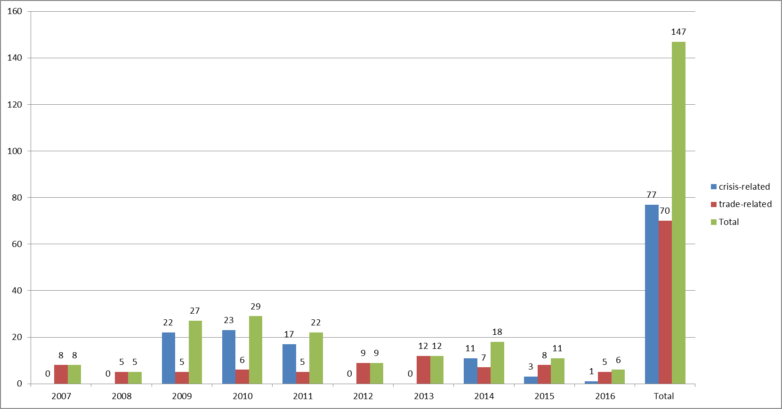

Regulation (EC) No 546/2009, with its inclusion of the crisis criterion, had a considerable impact on the number of applications received by the Commission: from 2009 (when the relevant amendment became applicable) to 31 December 2011, there was a significant rise in applications.

From 2007 to 2016, the Commission received 77 crisis-related applications and 70 trade-related applications. The total number of applications received each year is volatile with an average of about 15 applications per year.

As shown in Table 2 of the Annex, Spain is the Member State which has submitted the highest number of applications (21), followed by the Netherlands (17), Italy (13) and Belgium (12). By the end of 2016, seven[28] Member States had not yet applied for EGF support: Cyprus, Croatia, Hungary, Luxembourg, Latvia, Slovakia and the United Kingdom.

***Chart 7: EGF amounts requested per Member state in 2007 – 2016***

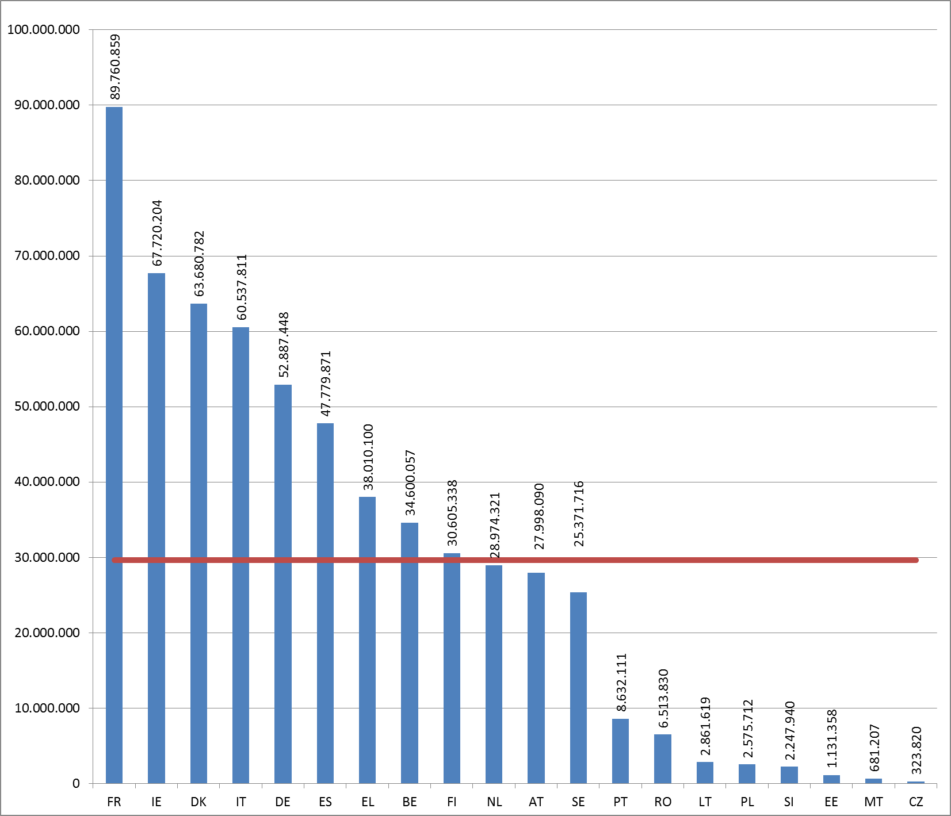

**Total EGF amount requested[29] per MS: 592 894 194 €**

**Average EGF amount requested per MS: 29 644 710 €**

A total amount of EUR 592 894 194 was requested from the EGF by 20 Member States from 2007 to 2016. France requested the highest amount of EGF co-funding (EUR 89 760 859 for 8 applications), followed by Ireland (EUR 67 720 204 for 10 applications), Denmark (EUR 63 680 782 for 10 applications) and Italy (EUR 60 537 811 for 13 applications).

Details of the applications per year and per Member State are set out in Table 2 of the Annex.

***Chart 8: Number of targeted workers per Member State in 2007 – 2016***

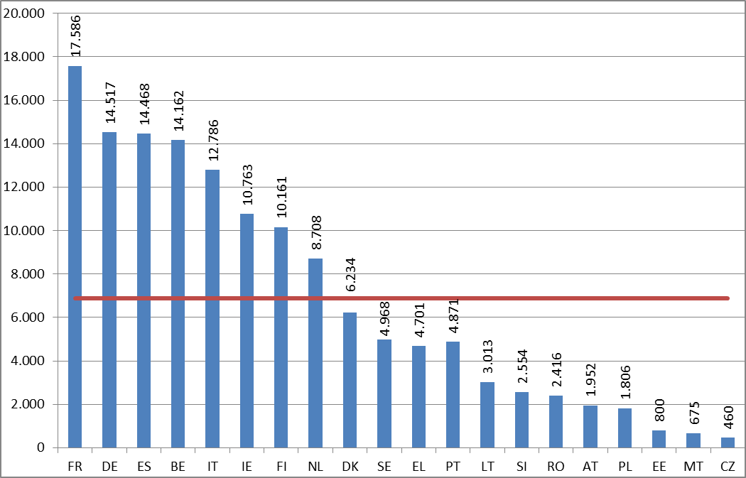

**Total number of targeted workers per MS: 137 601**

**Average** **number of targeted workers per MS: 6 880**

From 2007 to 2016, the applications received (excluding withdrawn or rejected applications) from the 20 Member States targeted 137 601 workers. Within the past 10 years, France requested support for the greatest number of workers (17 586), followed by Germany (14 517), Spain (14 468) and Belgium (14 162).

Nine applications submitted by three Member States over 2014 – 2016 period targeted 2 944 NEETs. Member States which applied for support for NEETs were: Belgium (2 applications - 400 NEETs), Greece (4 applications – 2 098 NEETs) and Ireland (3 applications - 446 NEETs).

Details of the applications per year and Member State are set out in Table 2 of the Annex.

***Chart 9: Number of applications by sector (NACE Rev. 2), 2007 – 2016\****

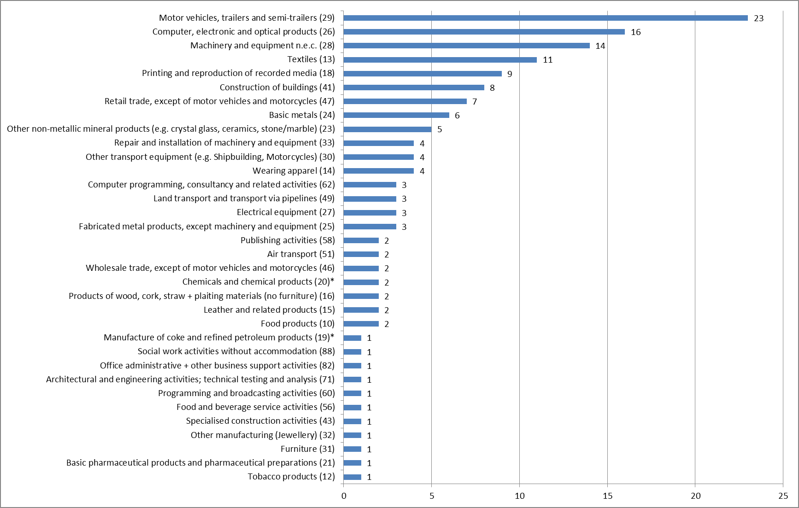

*\* EGF/2016/003 EE/Petroleum and chemicals case refers to two different sectors (19 and 20) and has therefore been counted twice.*

**Total number of sectors: 34**

From 2007 to 2016, the Commission received 147 EGF applications related to a broad range of sectors (34). The greatest number of applications was received for the sector motor vehicles, trailers and semi-trailers (23 applications), followed by computer, electronic and optical products (16 applications) and machinery and equipment n.e.c. (14 applications).

Details of the applications received by sector are set out in Table 1 of the Annex.

***Chart 10: Number of targeted workers per sector (NACE Rev. 2), 2007 – 2016\****

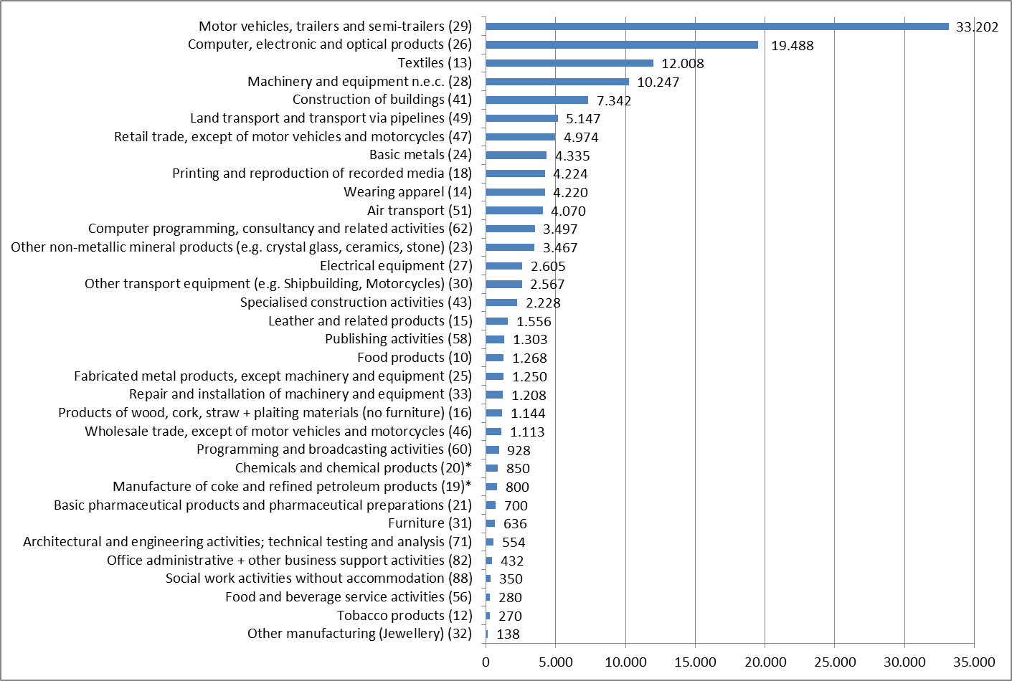

*\* EGF/2016/003 EE/Petroleum and chemicals case refers to two different sectors (19 and 20). Therefore the 800 targeted workers of this case have been listed twice.*

**Total number of targeted workers in 34 sectors: 137 601**

From 2007 to 2016, the Commission received EGF applications submitted by 20 Member States for 137 601 workers made redundant in 34 different sectors. The greatest number of workers was targeted in the sector motor vehicles, trailers and semi-trailers (33 202), followed by the computer, electronic and optical products sector (19 488) and textiles (12 008).

***Chart 11: Average EGF amount requested per beneficiary and per Member State in 2007 – 2016***

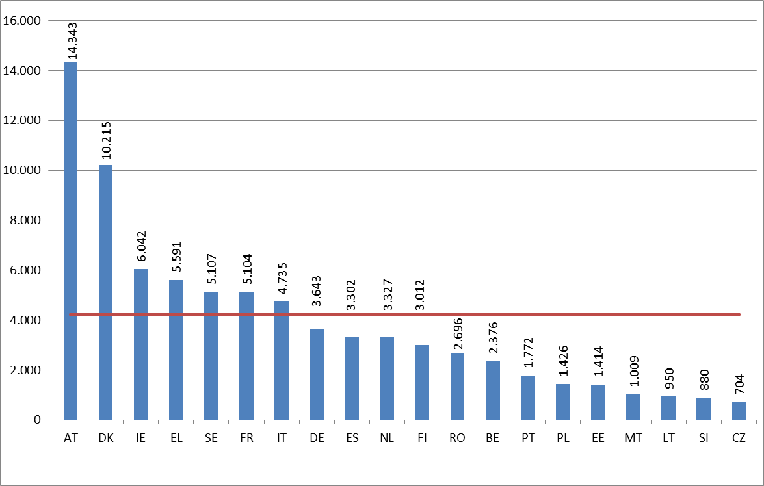

**Average EGF amount requested per beneficiary and per Member State: 4 229 €**

On average, each of the 20 Member States applying for EGF support from 2007 to 2016, requested EUR 4 219 per targeted beneficiary. The amount requested per targeted beneficiary can vary according to the severity of the lay-offs, the situation of the labour-market affected, the individual circumstances of the targeted beneficiaries, the measures already provided by the Member State, and the cost of providing the services in the Member State or region concerned. The highest amount per beneficiary was requested by Austria (EUR 14 343), followed by Denmark (EUR  10 215).

1. Regulation (EC) No 1927/2006 of the European Parliament and of the Council of 20 December 2006 on establishing the European Globalisation Adjustment Fund
2. Regulation (EC) No 546/2009 of the European Parliament and of the Council of 18 June 2009 amending Regulation (EC) No 1927/2006 on establishing the European Globalisation Adjustment Fund introduced a temporary derogation broadening the scope of the EGF to the global financial and economic crisis and increasing the EGF co-funding up to 65% of the total cost , which applied to all applications received from 1 May 2009 to 31 December 2011
3. Regulation (EU) No 1309/2013 of the European Parliament and of the Council of 17 December 2013 on the European Globalisation Adjustment Fund (2014-2020) and repealing Regulation (EC) No 1927/2006
4. The prolongation of this derogation until the end of the 2014-2020 programming period has been proposed by the Commission and is under discussion within the MFF review.
5. Applications received from the 1st of January 2015 until the 31st of December 2016.
6. Detailed information regarding the applications withdrawn is given in section 3.3.
7. This amount does not include technical assistance decisions
8. COM(2016) 605 final.
9. The term 'beneficiary' refers in this report to targeted workers and NEETs.
10. Table 2 lists the details of the contributions granted in 2015 and 2016 while the Table 1 lists details of the applications received in 2015 and 2016. The cases in each table may differ.
11. The three cases EGF/2013/007 BE/Hainaut Steel, EGF/2013/009 PL/Zachem and EGF/2013/011 and BE/Saint-Gobain Sekurit were received before 2014, therefore the old Regulation (EC) No 1927/2006 still applied.
12. This amount does not include technical assistance decisions.
13. Council Recommendation of 22 April 2013 on establishing a Youth Guarantee (OJ C 120 of 26.4.2013). The number of NEETs supported by the EGF must not exceed the number of targeted beneficiaries.
14. The results for the case EGF/2012/006 FI/Nokia Salo were presented in the previous Biennial report, since the final report was submitted in 2014 despite the deadline set for 2015.
15. Final reports are to be submitted six months after the end of implementation.
16. Since Regulation (EU) No 1309/2013 entered into force, allowances have been capped to a maximum of 35 % of all costs.
17. Note that these are different cases from the ones that are the subject of this biennial report. Whereas the present report covers the EGF activities in 2015 and 2016 and includes EGF cases still submitted under Regulation (EC) No 1927/2006, the mid-term evaluation covers all cases submitted under Regulation (EU) No 1309/2013.
18. COM(2016) 605 final
19. This amount does not include technical assistance decisions.
20. OJ L 347 of 20.12.2013
21. These amounts relate to the voted budget.
22. The EGF contribution is paid to the MS in a single instalment as a 100% pre-financing within 15 days of the approval by the Budgetary Authority of the EGF mobilising decision.
23. Including four decisions mobilised in 2014 and paid in 2015.
24. http;//ec.europa.eu/egf – available in all 23 EU languages, including Irish.
25. This figure rises to 166 if we take into account the 19 cases withdrawn or rejected. Withdrawn and rejected cases are not considered in the statistics.
26. Number of targeted beneficiaries estimated by the Member States.
27. In 2007, 2008, 2012 and 2013 trade was the only eligible criterion.
28. BG submitted EGF/2009/022 Kremikovtsi AD Basic metals application but it has been rejected.
29. BG requested EUR 1 082 337 which never were contributed as the application was rejected. The amount requested from BG is therefore not part of this total.