

Contents

4.2 Fostering the deployment of alternative fuels vehicles and vessels in the EU 34

4.3 Promoting the deployment of alternative fuels infrastructure in public transport services 37

4.4 Increasing the EU energy security supply 38

4.5 Contribution to the reduction of CO2 emissions from transport 38

4.6 Improvement of air quality 39

4.7 Strengthening EU competitiveness and jobs 41

5 Full Assessment of Member States' NPFs 43

5.1 Austria 43

5.1.1 Description of the MS 43

5.1.2 Summary of the National Policy Framework submitted 44

5.1.3 Assessment of targets and objectives (infrastructure) established 47

5.1.4 Deployment of alternative fuels vehicles and vessels 48

5.1.5 Assessment of the measures to implement Article 3 49

5.1.6 Assessment of the provided evidence whether the interests of regional and local authorities, as well as those of the stakeholders concerned has been considered 49

5.1.7 Assessment of MS cooperation and coordination with other Member States 50

5.1.8 Conclusions and possible recommendations 50

5.2 Belgium 51

5.2.1 Description of the MS 51

5.2.2 Summary of the National Policy Framework submitted 52

5.2.3 Assessment of targets and objectives (infrastructure) established 55

5.2.4 Deployment of alternative fuels vehicles and vessels 56

5.2.5 Assessment of the measures to implement Article 3 56

5.2.6 Assessment of the provided evidence whether the interests of regional and local authorities, as well as those of the stakeholders concerned has been considered 57

5.2.7 Assessment of MS cooperation and coordination with other Member States 57

5.2.8 Conclusions and possible recommendations 58

5.3 Bulgaria 59

5.3.1 Description of the MS 59

5.3.2 Summary of the National Policy Framework submitted 60

5.3.3 Assessment of targets and objectives (infrastructure) established 63

5.3.4 Deployment of alternative fuels vehicles and vessels 65

5.3.5 Assessment of the measures to implement Article 3 66

5.3.6 Assessment of the provided evidence whether the interests of regional and local authorities, as well as those of the stakeholders concerned has been considered 68

5.3.7 Assessment of MS cooperation and coordination with other Member States 68

5.3.8 Conclusions and possible recommendations 68

5.4 Cyprus 70

5.4.1 Description of the MS 70

5.4.2 Summary of the National Policy Framework submitted 70

5.4.3 Assessment of targets and objectives (infrastructure) established 73

5.4.4 Deployment of alternative fuels vehicles and vessels 74

5.4.5 Assessment of the measures to implement Article 3 75

5.4.6 Assessment of the provided evidence whether the interests of regional and local authorities, as well as those of the stakeholders concerned has been considered 75

5.4.7 Assessment of MS cooperation and coordination with other Member States 75

5.4.8 Conclusions and possible recommendations 76

5.5 Czech Republic 77

5.5.1 Description of the MS 77

5.5.2 Summary of the National Policy Framework submitted 78



## Fostering the deployment of alternative fuels vehicles and vessels in the EU

*Electric vehicles*

Electric vehicles seem to be a priority for most Member States, but the estimates for future deployment vary a lot across Member States, with estimated 2020 shares ranging between 0.1% and 9.2% of the vehicle stock in the different Member States, with Luxembourg having the highest estimated share in the future. The current attainment level for these estimates, calculated as the ratio between current status and 2020 estimate, ranges for the NPFs that provided EV estimates from 0.2% to 83%. The map in Figure 4-11 shows the 2020 estimated shares of electric vehicles according to the NPFs.

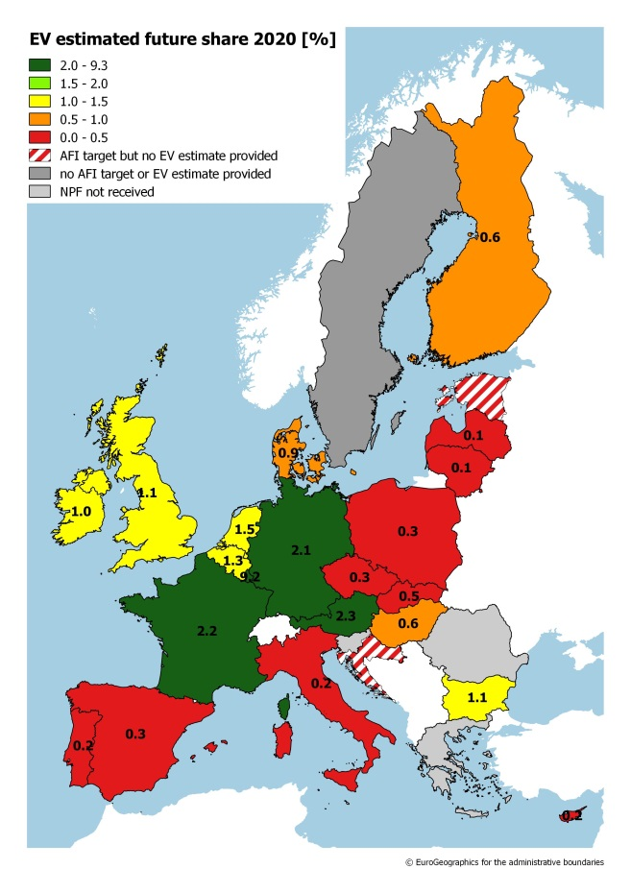

Figure 4-11: NPFs' 2020 estimated shares of electric vehicles

Support measures are an important enabler to ensure the achievement of NPF targets and objectives are reached. They are very diverse across the NPFs. Also their adoption status varies a lot. As a good example, France can be mentioned in the field of electro-mobility as it has defined a very comprehensive portfolio of support measures, most of them already in place with a high likelihood to impact market actors' decisions towards electro-mobility. In some Member States the adopted measures or the ones in process of adoption may not create the impact necessary to achieve the NPF targets and objectives. Ten NPFs (Denmark, Estonia, Finland, Croatia, Hungary, Lithuania, Luxembourg, Poland, Sweden, and Slovakia) have not considered any measures to also encourage and facilitate the deployment of recharging points not accessible to the public. The maps in Figure 4-12 provide an overview of support measures that aim at ensuring that the national targets and the objectives contained in the NPF are reached (left map: measures targeting the deployment of recharging points accessible to the public; right map: measures to encourage and facilitate the deployment of recharging points not accessible to the public).

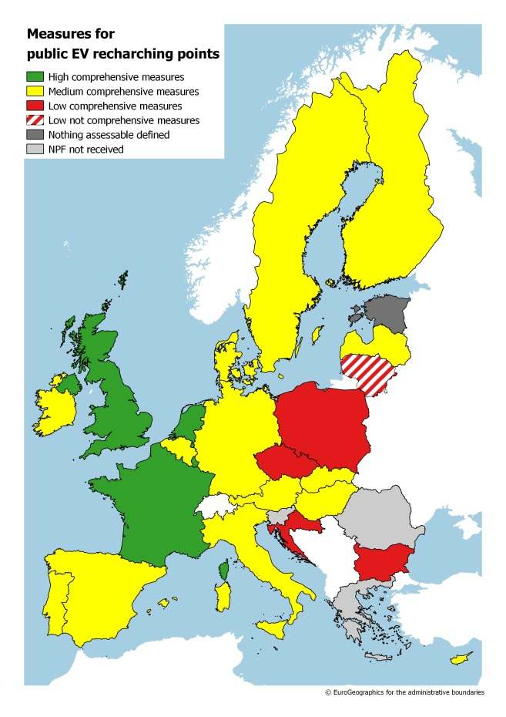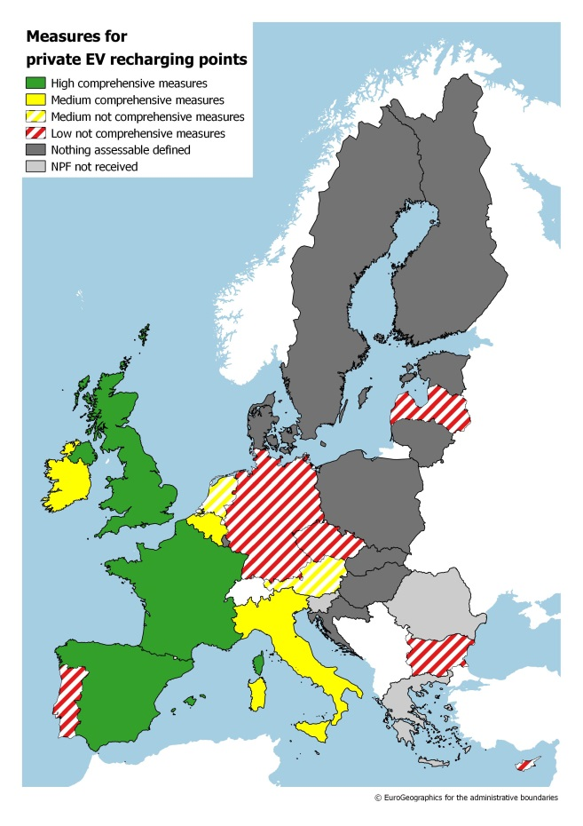

Figure 4-12: Support measures for recharging points (left map: measures targeting the deployment of recharging points accessible to the public; right map: measures to encourage and facilitate the deployment of recharging points not accessible to the public)

*Natural gas vehicles and vessels*

For CNG vehicles, the divergence across Member States is even more evident than in the case for electric vehicles. Many NPFs do not give any numbers for future estimates and for the ones that provide estimates, the future share varies between 0.05% and 3.3% in 2020, with Italy having the highest projected share. For some Member States, this effectively means a reduction in CNG vehicles on the road versus today. The current attainment level for the future CNG estimates, calculated as the ratio between current status and 2020 estimate, varies between 0.2% and 100%. The map in Figure 4-13 shows the NPFs' 2020 estimated shares of CNG vehicles (left map) and support measures for the deployment of CNG refuelling points accessible to the public. The score and comprehensiveness of the support measures are more or less consistent with the view that the Member States express vis-à-vis the viability of CNG vehicles.

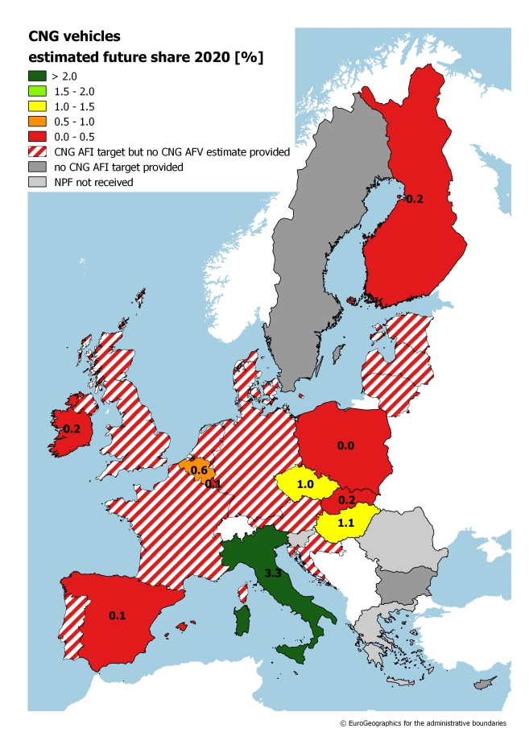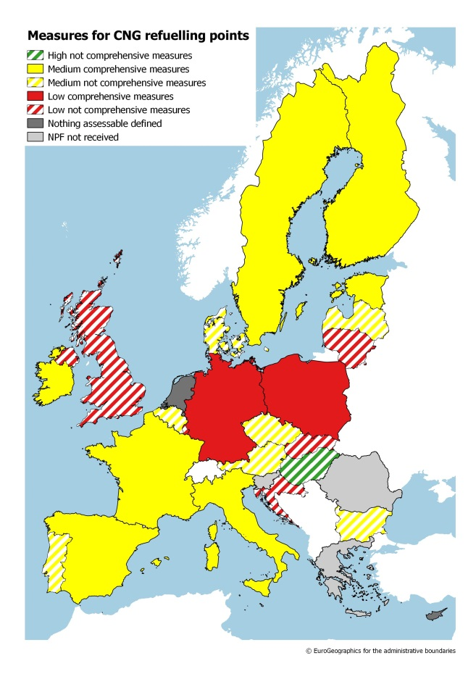

Figure 4-13: NPFs' 2020 estimated shares of CNG vehicles (left map); support measures for the deployment of CNG refuelling points accessible to the public

Only six of the NPFs contain estimates for LNG heavy-duty vehicles, and only Italy provides these for LNG vessels. Figure 4-14 shows the score and comprehensiveness of the support measures targeting the deployment of LNG refuelling points for heavy-duty vehicles.

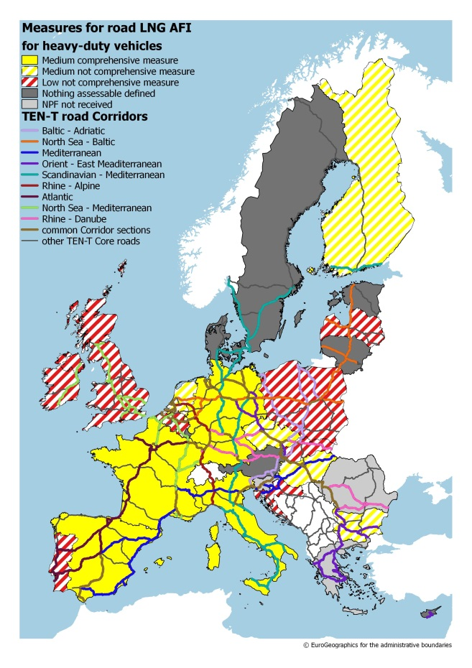

Figure 4-14: Support measures for the deployment of LNG refuelling points for heavy-duty vehicles

Figure 4-15 shows the score and comprehensiveness of the support measures targeting the deployment of LNG refuelling points in maritime ports (left map) and inland ports (right map).

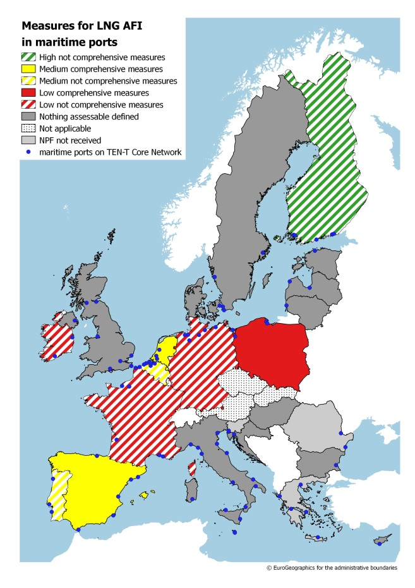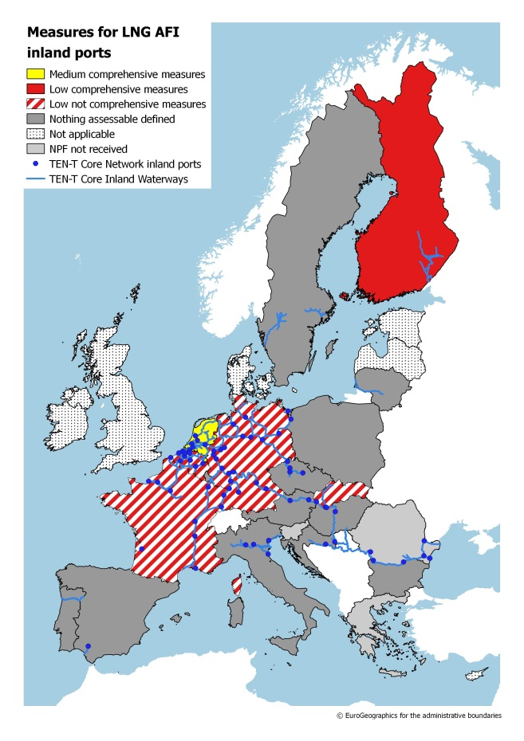

Figure 4-15: Support measures for the deployment of LNG refuelling points in maritime ports (left map) and inland ports (right map)

Many Member States did either define no measures or defined only measures with a likely low impact on the deployment of LNG refuelling points. This indicates, as also explicitly expressed in various NPFs, reliance on EU funds (for example Connecting Europe Facility (CEF)) for the deployment of an appropriate network of LNG refuelling both for heavy-duty vehicles and ships.

*Hydrogen vehicles*

Deployment of hydrogen vehicles will be linked to the availability of refuelling points. Only Bulgaria, Spain, Hungary and Netherlands provide numbers for future estimates and for those the future share will be less than 0.1% in 2025, with Italy having the highest projected share of 3.3%.

## Promoting the deployment of alternative fuels infrastructure in public transport services

Most of the NPFs contain the definition of measures that can promote the deployment of alternative fuels infrastructure in public transport services. Depending on the Member States, they target different fuels, for example covering electricity, natural gas, hydrogen, and biofuels. They also target different modes, for example, rail, buses, taxis, and car sharing. The support measures promoting the deployment of alternative fuels infrastructure in public transport services contained in the Dutch, French, and UK NPF can be considered as good examples. Two Member States (Cyprus, Lithuania) did not consider any measures to promote the deployment of alternative fuels infrastructure in public transport services. Figure 4-16 shows the results of the assessment for the support measures that can promote the deployment of alternative fuels infrastructure in public transport services.

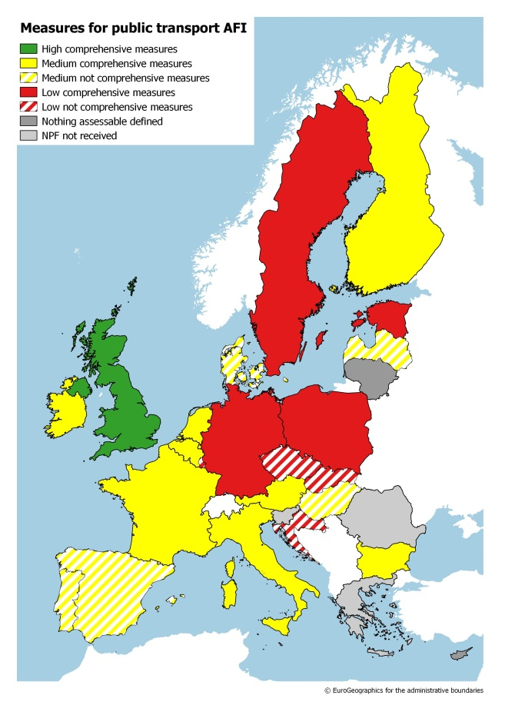

Figure 4-16: Support measures that can promote the deployment of alternative fuels infrastructure in public transport services

## Increasing the EU energy security supply

The analysis of the NPFs reveals that, by 2020, 0.4% of fossil oil-based fuels could be displaced by alternative fuels relative to a scenario without NPFs. By 2030, this number would increase to 1.4%. MS with ambitious NPFs can reduce their fossil oil use much more. For instance, a reduction of 13% could be achieved in Austria by 2030 relative to a scenario without NPF.

## Contribution to the reduction of CO2 emissions from transport

Given the overall low ambition level of the AFI targets and corresponding AF vehicle/vessel (AFV) estimates contained in the NPFs, the contribution of the NPFs to the 2030 energy and climate policy objectives is low. Several NPFs do not provide AFV estimates beyond 2020. As a consequence of the NPFs, CO2 emissions from transport could be reduced by 0.4% by 2020 and 1.4% by 2030 compared to a scenario without NPFs. Action is needed to put the contribution of alternative fuels back on track for a meaningful impact on GHG emissions reductions from transport and minimising the EU's dependence on oil. MS with ambitious medium to long-term plans can serve as a proxy for showing what is possible. For Austria, for example, the CO2 emissions improvements caused by its NPF could lead to a 13% transport CO2 emissions reduction by 2030 relative to a scenario without NPF.

## Improvement of air quality

The low level of ambition of the NPFs also leads to rather small impacts in terms of air quality (see Figures 4-17 to 4-20). For NOx emissions from transport, the reduction caused by the NPFs would be around 0.37% by 2020 and 1.5% by 2030 compared to a scenario without NPFs. For PM2.5, the emissions would reduce by 0.44% by 2020 and 1.9% by 2030. For the most ambitious MS (Austria and Ireland), the reduction can lead to up to a 0.8% improvement in NO2 concentrations and a 0.26% improvement in PM2.5 concentrations by 2020 in certain areas, relative to a scenario without NPF. For 2030, this improvement can reach up to a 5.8% reduction in NO2 concentrations and a 2.1% reduction in PM2.5 concentrations in these MS. It can be positively noted that urban and suburban agglomerations, currently at highest risk to violate EU air quality targets, benefit over proportionally from air quality improvements as a result of the NPFs.

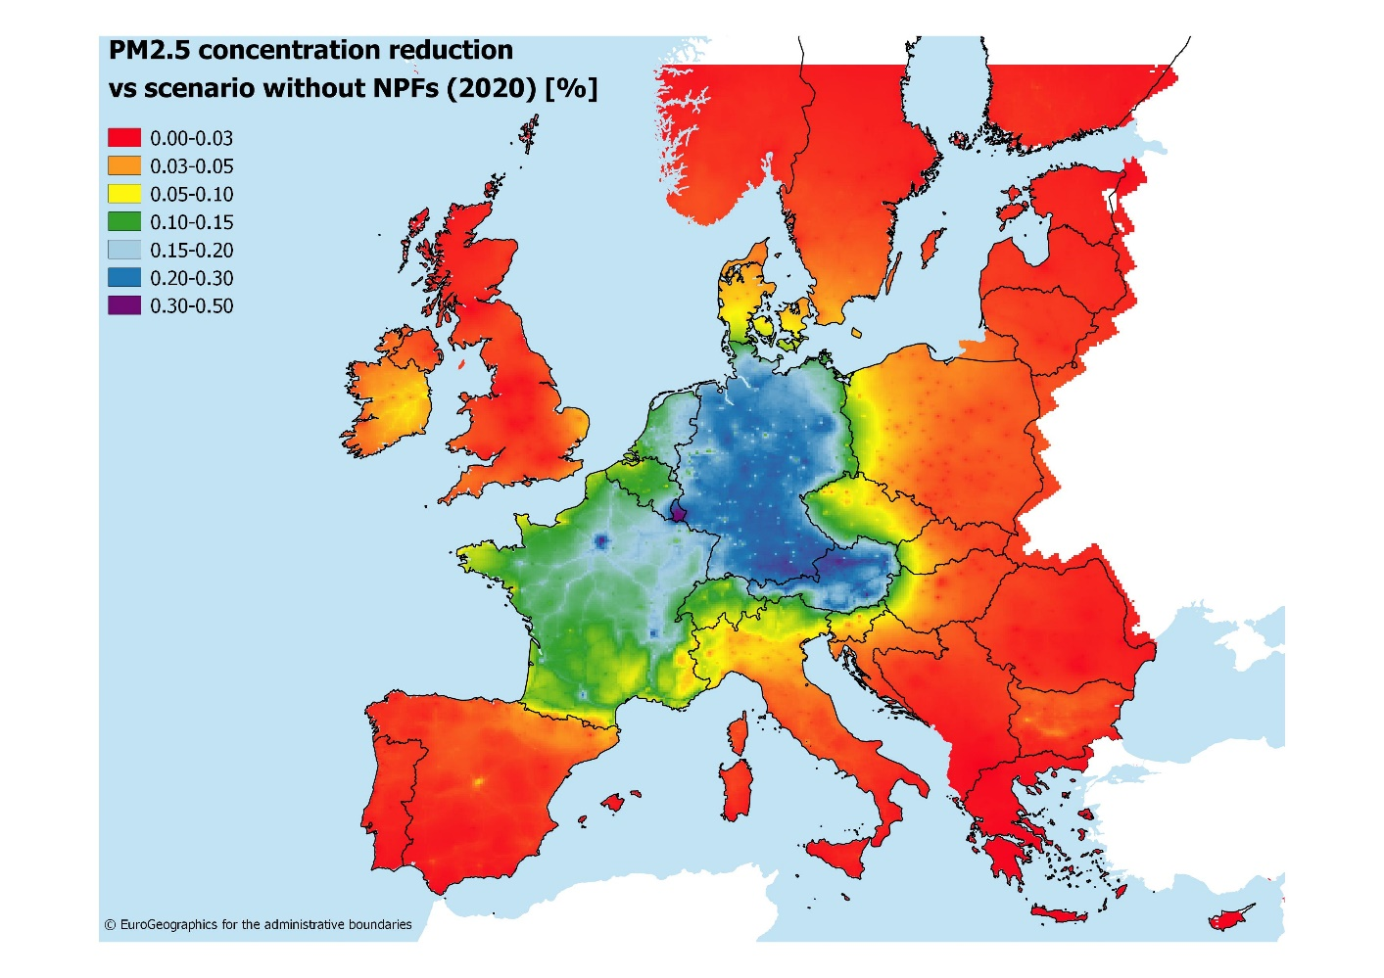

Figure 4-17: Reduction in PM2.5 concentrations versus a scenario without NPFs in the EU (2020)

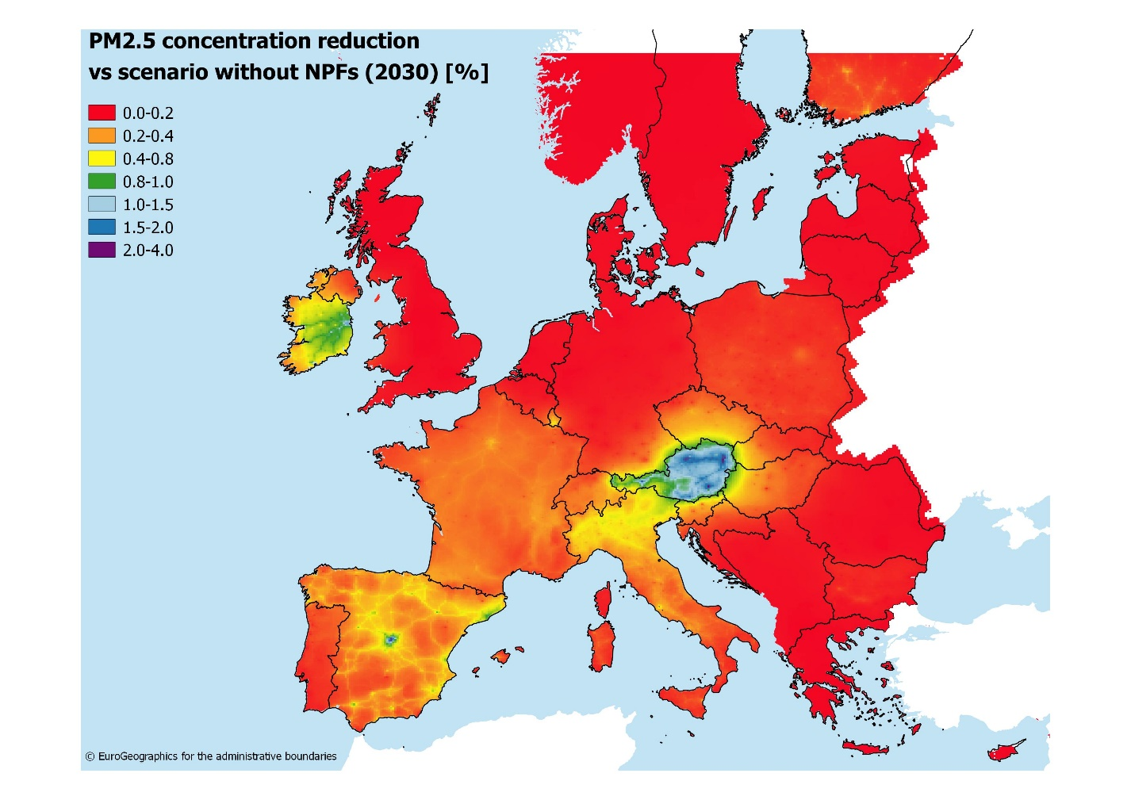

Figure 4-18: Reduction in PM2.5 concentrations versus a scenario without NPFs in the EU (2030)

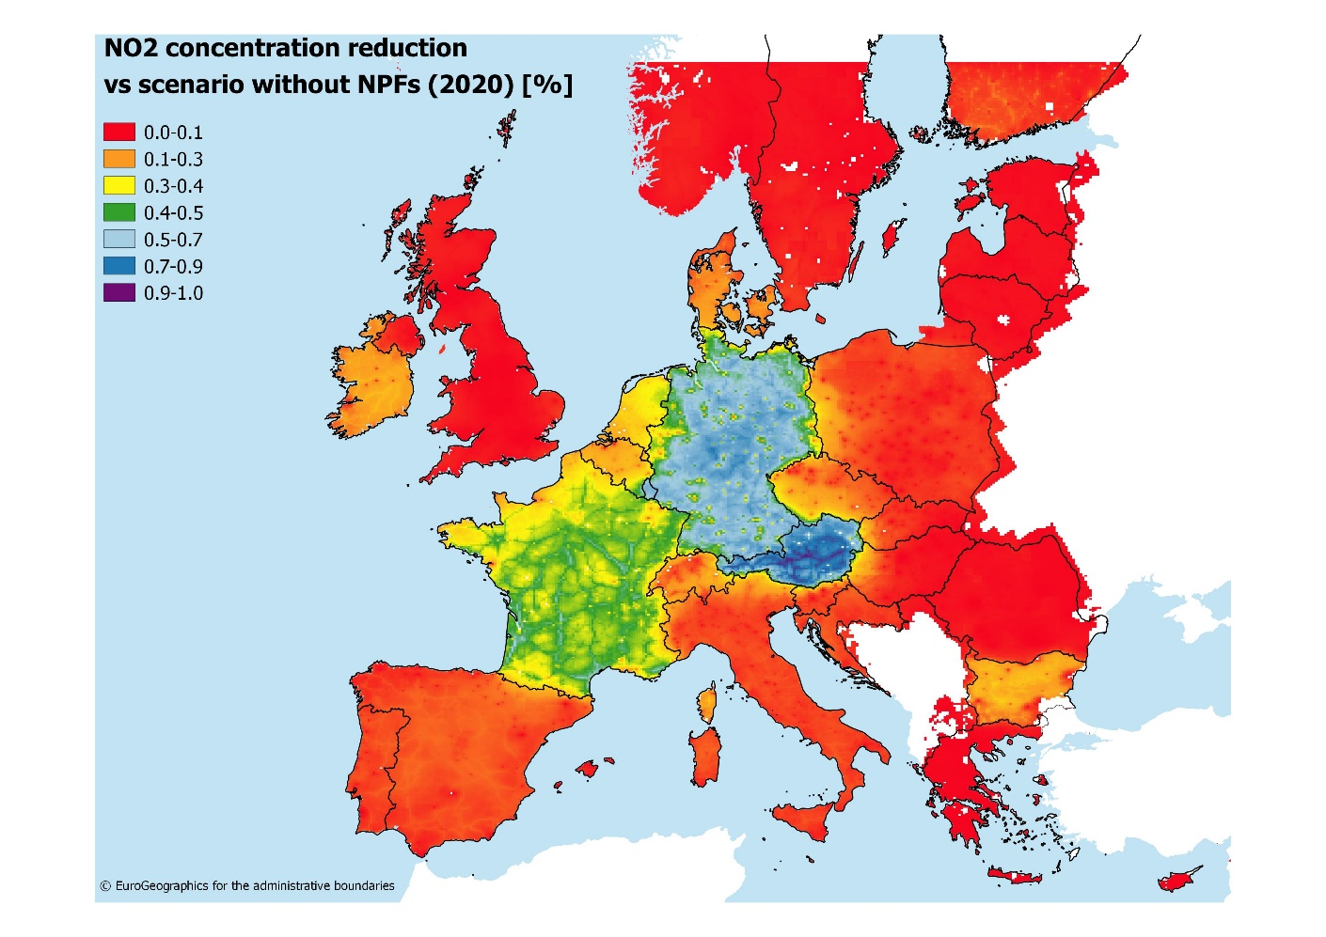

**Figure 4-19: Reduction in NO2 concentrations versus a scenario without NPFs in the EU (2020)**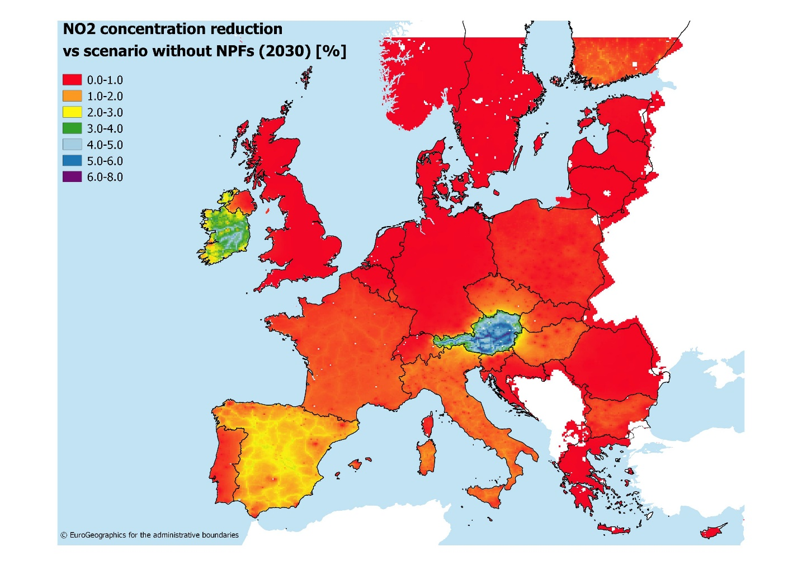

**Figure 4-20: Reduction in NO2 concentrations versus a scenario without NPFs in the EU (2030)**

## Strengthening EU competitiveness and jobs

Effects of AFI infrastructure build-up were calculated using the model described in Section **Error! Reference source not found.**. The model was run using AFI-build-up targets for the different road transport AFI types (recharging points, CNG, LNG and H2 refuelling points). Table 4-4 shows the EU-wide value added and labour demand that can be achieved by fulfilling the 2020 NPF targets for publicly accessible recharging points and CNG refuelling points as well as the 2025 targets for LNG and H2 refuelling points announced in the NPFs. Total value-added up to 2025 sums up to 2.5 billion EUR with annual effects ranging from 135 to 475 million EUR. The economic effect is strongest for the period up to 2020, as this is the target year for recharging point and CNG infrastructure build-up. From 2021 to 2025, the ongoing installation of LNG and H2 creates a smaller economic benefit.

Table 4-4: Gross Value Added (GVA) and Employment Effects of Implementing the AFI targets for 2020 and 2025

|  |  |  |  |  |  |  |  |  |  |  |
| --- | --- | --- | --- | --- | --- | --- | --- | --- | --- | --- |
|  | 2017 | 2018 | 2019 | 2020 | 2021 | 2022 | 2023 | 2024 | 2025 | Total |
| GVA (Mio EUR) | 429 | 444 | 459 | 474 | 135 | 139 | 143 | 147 | 151 | 2,519 |
| Employment (person-years) | 7,745 | 8,048 | 8,341 | 8,641 | 2,625 | 2,705 | 2,784 | 2,863 | 2,943 | 46,693 |

The total effect on labour demand amounts to roughly 47,000 person-years until 2025, again with higher effects of around 8,000 person-years annually up to 2020 and then lower numbers of less than 3,000 person-years until 2025. This shows that the question to what extent AFI build-up can contribute to a sustained growth in employment depends to a large extent on the future build-up of infrastructure beyond 2020/2025. A calculation of the impacts of the further 2030 AFI targets announced by some Member States in their NPFs shows that even with only few Member States continuing to invest, a level of around 5,000 person-years can be maintained throughout 2030. Additional employment effects could be triggered by the substantial deployment of private recharging points (not accessible to the public) that several NPFs refer to. In conclusion, a consistent EU-wide build-up of infrastructure could trigger a sustained positive employment effect, and could contribute to translating the temporary extra labour demand resulting from NPF plans into permanent jobs. Moreover, respective qualification of workforce, which is more likely to occur in the presence of longer-term targets, can support the maintenance or increase of domestic shares in AFI production and installation. This again can have a positive impact on the EU sector's competitiveness.

# Full Assessment of Member States' NPFs

Each Member State NPF assessment contains at the end a one-to-two page summary with the main results of the assessment. Each summary contains a tabular overview of the current status of AF vehicles/vessels and their corresponding infrastructure, the future estimates for AF vehicles/vessels as well as the corresponding future targets for AF infrastructure. It also contains an assessment of the sufficiency of the defined targets and a qualitative assessment of the defined support measures.

*Tabular overview explanations*

|  |  |  |  |  |  |  |  |  |  |  |  |
| --- | --- | --- | --- | --- | --- | --- | --- | --- | --- | --- | --- |
|  | **AF Vehicles / Vessels** | | | | **Publicly accessible AF Infrastructure** | | | | | **Measures** | |
| Fuel / Vehicles or Vessels / targets year | Current situation | Future Estimate | Future share (%) | Estimate reached (%) | Current situation | Target | Target attain-ment (%) | Sufficiency (Index) | | Score | Compre-hensive-ness |
| Current | Future |
| Electricity / vehicles / 2020 | Number of registered AF vehicles retrieved from EAFO in March 2017 (unless otherwise stated), AF vessels always from NPF | Estimate of future AF vehicles or vessel (according to NPF) | Future share in percent: calculated by dividing the future estimate (previous column) by total number of vehicles/vessels in Member State | Attainment of estimate (in percent): calculated by dividing the current situation (2016) by future estimate | Number of publicly accessible recharging/refuelling points available, retrieved from EAFO in March 2017 (unless otherwise stated), port infrastructure always from NPF | Target of publicly accessible recharging/refuelling points (according to NPF) | Attainment of target (in percent): calculated by dividing the current situation (March 2017) by future target | Number of EV per publicly accessible recharging point | | H-High, M-Medium, L-Low score. X-nothing assessable defined For details see SWD | c-comprehensive, n-not-comprehensive. For details see SWD |
| CNG / vehicles / 2020 | Number of CNG vehicles per publicly accessible CNG refuelling point | |
| LNG / heavy-duty vehicles / 2025 | Assessment of coverage (distance for road modes)  OK – sufficient  (OK) – seems sufficient, not all information provided in the NPF  i- insufficient  X – nothing defined/considered | |
| LNG / seagoing ships / 2025 |
| LNG / inland waterway vessels / 2030 |
| H2 / vehicles / 2025 |
| Other fuels |

## Austria

### Description of the MS

*Length of the road TEN-T Core Network*

The length of the road TEN-T Core Network in Austria is 1,084 km and the length of motorways is 1,719 km. The length of the total road network in Austria is 35,356 km.

The following lengths of the TEN-T Road Corridors are present in Austria: 15% (559 km) of the Baltic - Adriatic Corridor, 3% (142 km) of the Orient / East Mediterranean Corridor, 2% (110 km) of the Scandinavian - Mediterranean Corridor and 11% (485 km) of the Rhine - Danube Corridor.

Through the TEN-T Road Corridors, Austria is connected with the following Member States:  
- Czech Republic (through the Baltic - Adriatic and the Orient / East Mediterranean Corridor),   
- Slovakia (through the Baltic - Adriatic and the Rhine - Danube Corridor),   
- Slovenia (through the Baltic - Adriatic Corridor),   
- Italy (through the Baltic - Adriatic and the Scandinavian - Mediterranean Corridor),  
- Germany (through the Scandinavian - Mediterranean and the Rhine - Danube Corridor) and   
- Hungary (through the Orient / East Mediterranean and the Rhine - Danube Corridor)

*Number of registered road vehicles*

In July 2016, according to the Austrian NPF, Austria had 4,793,759 registered passenger cars. In 2015, it had 6,503,883 registered road vehicles of all types (motorcycles, passenger cars, microbuses and buses, goods vehicles, tractor units, trailers and semi-trailers and special vehicles). The present situation of few AFV on Austrian roads, with for example less than 0.2% of electric passenger cars, is regarded by Austria as insufficient and in need of improvement.

*Number of main agglomerations*

* 6 cities > 50,000 inhabitants (source – Eurostat)

*Number of ports in the TEN-T Core Network*

* 2 inland ports in the TEN-T Core Network
* 2 inland ports in the TEN-T Comprehensive Network
* No maritime ports

Through the TEN-T inland waterways network, Austria is connected with Germany and Slovakia through the Rhine - Danube Corridor.

*Number of airports in the TEN-T Core Network*

* 1 airport in the TEN-T Core Network (Vienna/Schwechat)
* 6 airports in the TEN-T Comprehensive Network

### Summary of the National Policy Framework submitted

*Short description of the measures*

The majority of measures in the Austrian NPF is already existing and future extension is proposed. They cover a wide variety of types, addressing many deployment barriers. The number of proposed measures is high and is covering various fuels and modes. The Austrian NPF puts a lot of emphasis on electric vehicles. The measures are presented in a well-structured and logical manner. They are often very limited in time and budget, although extension is foreseen for most of them. This could be perceived by market actors as a lack of predictability in terms of stability of support measures.

*Table with the national targets and objectives established for the deployment of alternative fuels infrastructure at the horizon 2020, 2025 and 2030*

Table 5.1-1. The national targets and objectives regarding alternative fuels infrastructure

|  |  |  |  |  |  |  |  |  |
| --- | --- | --- | --- | --- | --- | --- | --- | --- |
| **Fuel** | **Current (EAFO March 2017)** | | **2020** | | **2025** | | **2030** | |
| **AFV** | **AFI** | **AFV** | **AFI** | **AFV** | **AFI** | **AFV** | **AFI** |
| **Electricity for vehicles** | 13,338 | 2,486 | 64,000 – 175,000 | 3,500 – 4,700 |  |  | 930,000 – 1,700,000 |  |
| **Electricity for stationary airplanes** |  | 42 |  | 42 |  | 42 |  | 42 |
| **CNG for vehicles** | 6,165 | 173 |  | 171 |  | 171 |  | 171 |
| **LNG for road** |  |  |  |  |  | 1-2 |  |  |
| **LNG for inland ports** |  |  |  |  |  | 1-2 |  |  |
| **H2 for road** | 20 | 3 |  | 5 |  | 3-5 |  |  |

Legend: AFV = Number of Alternative Fuels Vehicles, AFI = Number of Alternative Fuels Recharging/Refuelling Points, *excluding L-category vehicles

*Checklist to assess whether all requirements to be addressed in the NPF are fulfilled*

The checklist shows that all the requirements of the Directive are covered.

Table 5.1-2. Checklist results



### Assessment of targets and objectives (infrastructure) established

*Infrastructure sufficiency for recharging points (number and distance, 2020 and 2025)*

Table 5.1-3. Index of AFI sufficiency

|  |  |  |  |  |
| --- | --- | --- | --- | --- |
| **Fuel** | **Index of AFI sufficiency, IS** | | | |
| Current | 2020 | 2025 | 2030 |
| **Electricity for vehicles** | 5.37 | 18.3-37.3 | - | - |
| **CNG for vehicles** | 35.64 | - | - | - |

*Legend: Index of AFI sufficiency, IS =Number of AFV / Number of AF Recharging/Refuelling points*

Table 5.1-3 shows the values of the sufficiency index IS = Number of AFV / Number of AF Recharging/Refuelling points. Regarding the electric vehicles, for the current situation, with 5.37, the index passes the assessment threshold of 10 AFV per recharging point. For 2020, depending of the scenario, the range of values 18-37 of the index suggests that the targeted number of recharging points in the Austrian NPF may be insufficient. The Austrian NPF objectives for 2020 contain a network of 500-700 high power recharging points and 3,000-4,000 normal power recharging points.

According to the visual assessment of spatial distribution of recharging points presented in the provided map and checking the routes of the TEN-T Core Network, it seems that the distance requirement of one recharging point at least every 60 km is fulfilled, already today. The Austrian NPF assumes that there will be one private recharging point available per EV. It also declares that the recharging infrastructure development beyond 2020 will depend on market needs.

*Designation of the urban/suburban agglomerations selected to be equipped with electric recharging points*

The Austrian NPF states that because of the current good coverage for recharging points in Austria no urban/suburban agglomerations were designated for the targets. Nevertheless, the Annex contains a map with the current recharging points and it is visible that the 6 urban agglomerations with more than 50,000 inhabitants, Wien, Graz, Linz, Salzburg, Innsbruck, and Klagenfurt are currently well covered with publicly accessible recharging points.

*Electricity supply at airports for use by stationary airplanes*

Austria's airport in the TEN-T Core Network, Vienna Schwechat, has according to the NPF, 42 fixed ground power units and several mobile ground power units. Other Austrian airports have mobile ground power units. As a minimum target, the Austrian NPF states that is aims at preserving the existing infrastructure.

*Shore-side electricity supply for inland waterways vessels and seagoing ships in maritime and inland ports of the TEN-T Core Network and in other ports (2025)*

The NPF mentions that Austria has a basic network of shore-side electricity supply, without giving specific details. Future analysis will be performed under the "Aktionsprogramm Donau des bmvit[1] bis 2022".

*Infrastructure sufficiency for CNG refuelling points (number and distance, 2020 and 2025)*

Table 5.1-3 shows that the currently available number of CNG refuelling points is sufficient to pass the threshold value of one CNG refuelling point per 600 vehicles. The NPF is sceptical about future potential for CNG and foresees no further increase of CNG refuelling points except in Tirol. The currently available 171 public CNG refuelling points in Austria could probably support up to approximately 100,000 CNG cars on Austrian roads.

According to the visual assessment of spatial distribution of CNG refuelling points presented in the provided map and checking the routes of the TEN-T Core Network, it seems that the distance requirement of one CNG refuelling point at least every 150 km is fulfilled, already today.

*Designation of the urban/suburban agglomerations selected to be equipped with CNG refuelling points (2020)*

The Austrian NPF states that because of the current good coverage for CNG refuelling points in Austria no urban/suburban agglomerations were designated for the targets. Nevertheless, the Annex contains a map with the current CNG refuelling points and it is visible that the 6 urban agglomerations with more than 50,000 inhabitants, Wien, Graz, Linz, Salzburg, Innsbruck, and Klagenfurt are currently well covered with publicly accessible CNG refuelling points.

*Road LNG refuelling points along the TEN-T Core Network (2025)*

At country level, a target of 1-2 LNG refuelling points is foreseen, depending on market demand. Dual use LNG refuelling for vessels and heavy-duty trucks are proposed. The NPF mentions for the locations the port of Linz or Enns-Ennsdorf (TEN-T Core Network) and possibly the port of Vienna (TEN-T Core Network). If both LNG refuelling points were realised this would guarantee that the maximum distance requirement for LNG refuelling points along the TEN-T Core Network would be fulfilled on Austrian territory.

*LNG refuelling points in maritime ports along the TEN-T Core Network (2025)*

Not applicable since Austria has no maritime ports.

*LNG refuelling points in inland ports along the TEN-T Core Network (2030)*

A target of 1-2 LNG refuelling points at Austrian inland ports is foreseen, depending on market demand. Dual use LNG refuelling for vessels and heavy-duty trucks are proposed. The NPF mentions for the locations the port of Linz or Enns-Ennsdorf (TEN-T Core Network) and possibly the port of Vienna (TEN-T Core Network).

*Hydrogen refuelling points on networks determined by Member States having decided to include hydrogen refuelling points accessible to the public in their National Policy Framework (2025)*

A target of 5 hydrogen refuelling points is established for 2020. Currently, 3 hydrogen refuelling points are already in operation in Vienna, Linz and Innsbruck. For the future deployment, coordination will be sought with neighbouring countries to ensure besides appropriate coverage of urban/suburban agglomerations also an appropriate hydrogen infrastructure along the TEN-T Corridors.

### Deployment of alternative fuels vehicles and vessels

A main focus of the Austrian NPF is on electric vehicles. It estimates a share of roughly 1.3% - 3.7% electric vehicles on the road in 2020. Until 2030, this share is estimated to increase to levels between 20 and 35%. For any of the other alternative fuels or transport modes the Austrian NPF does not specify any future estimates for alternative fuels and vessels. Altogether, it can be concluded that the Austrian NPF is based on the assumption that electric vehicles will gain in importance while other alternative fuels and vessels remain niche products until the 2020 time-frame.

### Assessment of the measures to implement Article 3

The Austrian NPF contains a big portfolio of measures. Most of the measures are already in effect, and their prolongation is considered. According to the assessment methodology, a medium overall assessment score is derived for electric and CNG vehicles as well as alternative fuels in public transport services. For many EV targeted support measures, the eligibility is linked to the use of 100% renewable electricity, a useful provision for ensuring zero WtW emissions. Bicycle and electric bicycle deployment are also supported. For the other fuels and modes, the assessment score is low. In some cases, the lack of concrete information (for example budget ceiling) makes it difficult to assess the scope according to the same methodology.

*Assessment of the measures that can ensure national targets and objectives*

The measures of this category cover: AFI and AFV, several fuel types, modes of transport, financial and nonfinancial support. The totality of these measures can indeed address many of the deployment barriers and as a consequence the portfolio of all measures can be considered quite comprehensive. Since many of the measures are already existing and receive a medium score at least for electric vehicles, it can be derived that the Austrian NPF seems to have defined appropriate measures in order to attain the defined targets and objectives of the NPF. A large amount of support measures are only approved for one year at a time or a budget appropriation that is likely to be depleted within a given year. Although extension is foreseen for most of them, this could be perceived by market actors as a lack of predictability in terms of stability of support measures.

From the alternative fuel and mode of transport clustering analysis, it resulted that most measures presented address electric vehicles, which is one important focus of the Austrian NPF. A 2016 change in the rules for company car tax treatment triggered in 2016 a surge in battery electric vehicle registrations, which were mainly registered as company cars.

*Assessment of the measures that can promote alternative fuels infrastructure in public transport services*

The Austrian NPF contains several measures in this category, covering AFI and AFV, all fuel types and two modes of transport (road and rail). The measures for public road transport are already in effect and prolongation is considered. They were assessed as having a medium score.

*Assessment of the measures that can promote the deployment of private electro-mobility infrastructure*

The Austrian NPF contains measures in this category, amongst others financially supporting the investment costs of building privately accessible recharging points. The measures for the promotion of deployment of private electro-mobility infrastructure are already in effect in several of the Austrian Bundesländer and prolongation is considered. They were assessed as having a medium score.

### Assessment of the provided evidence whether the interests of regional and local authorities, as well as those of the stakeholders concerned has been considered

The Austrian NPF has been established respecting the interests of regional and local authorities, as well as those of the stakeholders concerned. The NPF explicitly mentions stakeholder consultation, workshops, and a public consultation that were carried out during its drafting. A coordination committee on "Clean energy in transport" will be set-up in order to ensure follow-up of the implementation actions, future coordination among authorities and advice from stakeholders.

### Assessment of MS cooperation and coordination with other Member States

Austria has cooperated with other member states through different fora. The NPF mentions a spring 2016 coordination meeting with Germany, the Czech Republic, Slovakia, Slovenia, Italy and Croatia; Austrian participation in the STF; and its participation in the Government support group on alternative fuels (led by NL, and DE).

### Conclusions and possible recommendations

*Tabular overview*



The Austrian NPF fully addresses the requirements of Article 3. It contains an extensive discussion of the current state and future scenarios for alternative fuels in the transport sector. For all fuels and modes, it establishes targets as required by Article 3 of the Directive.

The Austrian NPF puts a lot of emphasis on electric vehicles and contains, with more than 1.3% share by 2020, high estimates for the future deployment of EV, when compared with its current EV shares (0.3%). Austria has already today a relatively dense network of public recharging points. Eligibility for several support measures for EV is contingent on 100% renewable electricity contracts. This ensures zero emission electro-mobility also under a well-to-wheel perspective. Austria, already today, has a significant number of electric buses, some powered via overhead lines. Bicycles and electric bikes as well as their infrastructure also receive support. Regarding electricity supply for stationary airplanes, the Austrian NPF commits to maintaining the current infrastructure. For shore-side electricity the NPF mentions ongoing studies to study the possible extension of the basic existing network.

Today, the spatial distribution of recharging points and especially fast recharging infrastructure seems to appropriately cover the needs of electric vehicles in terms of distance requirements in Austria. For the future, the targeted ratio of only one public recharging point per 18-37 electric vehicles estimated for 2020 could evolve to become a barrier for the further market deployment of electric vehicles. This could also lead to market fragmentation within the EU. It will be important to closely monitor this development and correct infrastructure targets in line with the market developments.

Austria currently has a sufficient network of CNG refuelling points. However, the Austrian NPF displays a sceptical view on the future prospects of CNG vehicles and does not foresee additional investments in CNG refuelling infrastructure.

Depending on market demand, 1-2 dual use LNG refuelling points for vessels and heavy-duty trucks are proposed in the NPF. If both LNG refuelling points were realised, this would guarantee that the maximum distance requirement for LNG refuelling points along the TEN-T Core Network would be fulfilled on Austrian territory.

The Austrian NPF considers hydrogen for transport and targets a slight increase of hydrogen refuelling points.

The Austrian NPF contains a very comprehensive list of measures, most already in place and their prolongation foreseen. Most of them can be considered having a medium impact on market actor's decisions. Longer periods for their validity could provide certainty for market actors and hence increase the likelihood that the national targets and objectives of the NPF can be reached. The NPF contains a comprehensive list of support measures that can promote the deployment of alternative fuels infrastructure in public transport services.

The consideration of the interests of regional and local authorities, as well as stakeholders during the drafting of the Austrian NPF can be considered exemplary. Further coordination is planned in order to ensure follow-up of the implementation actions, collaboration among authorities and advice from stakeholders.

Austria is actively involved in coordinating its plans on alternative fuels infrastructure with other Member States as well as collaborating with them in this field.

## Belgium

### Description of the MS

*Length of the road TEN-T Core Network*

The length of the road TEN-T Core Network in Belgium is 828 km and the length of motorways is 1,763 km. The length of the total road network in Belgium is 16,341 km.

The following lengths of the TEN-T Road Corridors are present in Belgium: 5% (214 km) of the North Sea - Baltic Corridor, 18% (253 km) of the Rhine - Alpine Corridor and 12% (508 km) of the North Sea - Mediterranean Corridor.

Through the TEN-T Road Corridors, Belgium is connected with the following Member States:  
- Germany (through the North Sea - Baltic and the Rhine - Alpine Corridor)  
- Netherlands (through the North Sea - Baltic and the North Sea - Mediterranean Corridor)  
- Luxembourg (through the North Sea - Mediterranean Corridor)  
- France (through the North Sea - Mediterranean Corridor)

*Number of registered road vehicles*

At the end of 2015, according to the Belgian NPF, Belgium had 5,661,742 registered passenger cars. In 2015, it had 6,396,720 registered road vehicles of all types (motorcycles, passenger cars, microbuses and buses, goods vehicles, tractor units, trailers and semi-trailers and special vehicles). The present situation of few AFV on Belgian roads, with approximately 0.16% AFV in the passenger car fleet, is regarded by Belgium as insufficient and in need of improvement.

*Number of main agglomerations*

* 11 cities > 50,000 inhabitants (source – Eurostat)

*Number of ports in the TEN-T Core Network*

* 8 inland ports in the TEN-T Core Network
* 10 inland ports in the TEN-T Comprehensive Network
* 4 maritime ports in the TEN-T Core Network
* no maritime ports in the TEN-T Comprehensive Network

Through the TEN-T inland waterways network, Belgium is connected with France through the North Sea - Mediterranean Corridor, and with the Netherlands through the North Sea - Baltic and the North - Sea Mediterranean Corridor.

*Number of airports in the TEN-T Core Network*

* 2 airports in the TEN-T Core Network (Brussels, Liège)
* 2 airports in the TEN-T Comprehensive Network

### Summary of the National Policy Framework submitted

*Short description of the measures*

The measures listed in the Belgium NPF differ for the three different regions (Flemish Region, Walloon Region, and Brussels Capital Region). A number of measures are defined at the federal level and apply for all three regions. The majority of measures in the Belgian NPF is already existing and foreseen to stay in place. They cover a wide variety of types, addressing many deployment barriers. The number of proposed measures is high and is covering various fuels and modes. The Flemish Region provides significant subsidies for the purchase of electric vehicles; the Walloon Region has defined few measures, and the Brussels-Capital Region emphasises the role of public transport. The measures are presented in a well-structured and logical manner. The level of support varies greatly across the three regions. This could lead to very different deployment levels of alternative fuels throughout Belgium.

*Table with the national targets and objectives established for the deployment of alternative fuels infrastructure at the horizon 2020, 2025 and 2030*

Table 5.2-1. The national targets and objectives regarding alternative fuels infrastructure

|  |  |  |  |  |  |  |  |  |
| --- | --- | --- | --- | --- | --- | --- | --- | --- |
| **Fuel** | **Current (EAFO March 2017)** | | **2020** | | **2025** | | **2030** | |
| **AFV** | **AFI** | **AFV** | **AFI** | **AFV** | **AFI** | **AFV** | **AFI** |
| **Electricity for vehicles** | 21,102 | 1,715 | 86,641 | 8,324 |  |  |  |  |
| **SSE for sea-going vessels** |  | 9 |  | 11 |  | 12 |  | 14 |
| **SSE for inland shipping** |  | 329 |  | 513 |  | 595 |  |  |
| **Electricity for stationary airplanes** |  | Present |  |  |  |  |  |  |
| **CNG for vehicles** | 4,285 | 58 | 42,581 | 333 |  |  |  |  |
| **LNG for road** |  | 2 |  | 2-14 |  |  |  |  |
| **LNG for maritime ports** |  | 3 |  | >=4 |  | >=4 |  | >=4 |
| **LNG for inland ports** |  | 0 |  | 2 |  |  |  | 3 |
| **H2 for road** | 21 | 3 |  | 22 |  |  |  |  |

Legend: AFV = Number of Alternative Fuels Vehicles, AFI = Number of Alternative Fuels Recharging/Refuelling Points, SSE = Shore-side electricity

*Checklist to assess whether all requirements to be addressed in the NPF are fulfilled*

The checklist shows that all the requirements of the Directive are covered.

Table 5.2-2. Checklist results



### Assessment of targets and objectives (infrastructure) established

*Infrastructure sufficiency for recharging points (number and distance, 2020 and 2025)*

Table 5.2-3. Index of AFI sufficiency

|  |  |  |  |  |
| --- | --- | --- | --- | --- |
| **Fuel** | **Index of AFI sufficiency, IS** | | | |
| Current | 2020 | 2025 | 2030 |
| **Electricity for vehicles** | 12.30 | 10.40 | - | - |
| **CNG for vehicles** | 61.40 | 127.90 | - | - |

*Legend: Index of AFI sufficiency, IS =Number of AFV / Number of AF Recharging/Refuelling points*

Table 5.2-3 shows the values of the sufficiency index IS = Number of AFV / Number of AF Recharging/Refuelling points. Regarding the electric vehicles, for the current situation, according to the Belgian NPF, with 12.3, the index does not reach the assessment threshold of 10 AFV per recharging point. For 2020, the value 10.4 of the index suggests that the targeted number of recharging points in the Belgian NPF may be insufficient. This even more so as in 2020 the sufficiency threshold would largely be missed in the Walloon region (14.4) and Brussels Capital region (13.2). The Belgian NPF objectives for 2020 contain a network of 8,324 recharging points accessible to the public.

According to the visual assessment of spatial distribution of recharging points presented in the provided maps, the distance calculations shown for the Walloon region, and checking the routes of the TEN-T Core Network, it seems that the distance requirement of one recharging point at least every 60 km will be fulfilled. The Belgian NPF does not contain targets for recharging infrastructure development beyond 2020.

*Designation of the urban/suburban agglomerations selected to be equipped with electric recharging points*

The Belgian NPF contains maps with information on planned recharging point deployment. According to this information, it can be assumed that the urban/suburban agglomerations in Belgium will be well covered with publicly accessible recharging points, although the ratio between estimated EV and targeted recharging points may give rise to concerns (see previous sub-section).

*Electricity supply at airports for use by stationary airplanes*

Belgium's two airports in the TEN-T Core Network, Brussels and Liège, have according to the NPF, fixed ground power units and mobile ground power units. No plans are foreseen to increase these numbers.

*Shore-side electricity supply for inland waterways vessels and seagoing ships in maritime and inland ports of the TEN-T Core Network and in other ports (2025)*

The NPF mentions that Belgium already has a network of shore-side electricity supply. A further increase of shore-side electricity is planned in most of the ports of the TEN-T Core Network.

*Infrastructure sufficiency for CNG refuelling points (number and distance, 2020 and 2025)*

Table 5.2-3 shows that the currently available number of CNG refuelling points is sufficient to pass the threshold value of one CNG refuelling point per 600 vehicles. The NPF foresees a further increase of CNG refuelling points. The 2020 CNG infrastructure target clearly passes the sufficiency threshold value for the estimated CNG vehicles on Belgian roads in the same year.

According to the visual assessment of spatial distribution of CNG refuelling points presented in the provided map and checking the routes of the TEN-T Core Network, it seems that the distance requirement of one CNG refuelling point at least every 150 km is fulfilled, already today, except for the A4 motorway which is part of the North Sea / Mediterranean Corridor. However, the number of planned CNG refuelling points gives confidence that the distance requirement should be met probably before 2025.

*Designation of the urban/suburban agglomerations selected to be equipped with CNG refuelling points (2020)*

Although the Belgian NPF does not explicitly identify urban/suburban agglomerations for CNG infrastructure coverage, it can be assumed that the deployment of the targeted CNG refuelling points should ensure appropriate coverage.

*Road LNG refuelling points along the TEN-T Core Network (2025)*

At country level, a target of 14 LNG refuelling points is mentioned as the result of a sector survey. Only the location of two of the LNG refuelling points is indicated, the ports of Antwerp and Oostende. These two LNG refuelling points could ensure that the maximum distance requirement for LNG refuelling points along the TEN-T Core Network would be fulfilled on Belgian territory.

*LNG refuelling points in maritime ports along the TEN-T Core Network (2025)*

LNG refuelling is foreseen for all Belgian maritime ports of the TEN-T Core Network by 2025. Truck-to-Ship bunkering is already available today in several ports.

*LNG refuelling points in inland ports along the TEN-T Core Network (2030)*

LNG refuelling points are planned for several Belgian inland ports. Currently, nothing is planned for the ports of Liege and Namur.

*Hydrogen refuelling points on networks determined by Member States having decided to include hydrogen refuelling points accessible to the public in their National Policy Framework (2025)*

A target of 22 hydrogen refuelling points is established for 2020, the majority (20) are foreseen in the Flemish Region. Currently, one public hydrogen refuelling point is in operation at Zaventem near Brussels. For the future deployment, coordination will be sought with the Benelux countries to ensure besides appropriate coverage of urban/suburban agglomerations also an appropriate hydrogen infrastructure along the TEN-T Corridors.

### Deployment of alternative fuels vehicles and vessels

A main focus of the Belgian NPF is on electric and CNG cars. It estimates a share of roughly 1.5% electric cars and 0.8% CNG cars on the road in 2020. The Belgian NPF does not contain any estimates beyond 2020. For any of the other alternative fuels or transport modes the Belgian NPF does not specify any future estimates for alternative fuels and vessels.

### Assessment of the measures to implement Article 3

The Belgian NPF contains a portfolio of different measures. Most of the measures are already in effect. They vary a lot by region. The Walloon Region has identified only few support measures. For the entirety of the Belgian NPF, according to the assessment methodology, a medium overall assessment score is derived for electric and CNG vehicles as well as alternative fuels in public transport services. For the Brussels-Capital Region, electric bicycle deployment is also supported. For the other fuels and modes, the assessment score is low. In some cases, the lack of concrete information (for example budget ceiling) makes it difficult to assess the scope according to the same methodology.

*Assessment of the measures that can ensure national targets and objectives*

The measures of this category cover: AFI and AFV, several fuel types, modes of transport, financial and nonfinancial support. The totality of these measures can indeed address many of the deployment barriers and, as a consequence, the portfolio of all measures can be considered quite comprehensive. Since many of the measures already exist and receive a medium score at least for electric and CNG vehicles, it can be derived that the Belgian NPF seems to have defined appropriate measures in order to attain the defined targets and objectives of the NPF. The different levels of support in the three Belgian regions could lead to a certain market fragmentation within the country.

From the alternative fuel and mode of transport clustering analysis, it resulted that most measures presented address electric vehicles, which is one important focus of the Belgian NPF. The new market share of EV in Belgium more than doubled from 2015 (0.76%) to 2016 (1.74%). This can possibly be attributed to the zero-emission purchase premium that was introduced in the Flemish region in 2016.

*Assessment of the measures that can promote alternative fuels infrastructure in public transport services*

The Belgian NPF contains a very comprehensive set of measures in this category, covering mainly electric AFI and AFV. The measures cover buses, car sharing, park & ride, and electric taxis. Most measures for public road transport are already in effect. They were assessed as having a medium score.

*Assessment of the measures that can promote the deployment of private electro-mobility infrastructure*

The Belgian NPF contains measures in this category, amongst others financially supporting the investment costs of building privately accessible recharging points. Several of the measures for the promotion of deployment of private electro-mobility infrastructure are already in effect. In the Brussels-Capital Region, there is an obligation to foresee public and private recharging point installations at parking areas. The region considers widening the scope of this measure. The totality of measures that can promote the deployment of private electro-mobility infrastructure were assessed as having a medium score.

### Assessment of the provided evidence whether the interests of regional and local authorities, as well as those of the stakeholders concerned has been considered

The Belgian NPF has been established respecting the interests of regional and local authorities, as well as those of the stakeholders concerned. The NPF explicitly mentions an interdepartmental transversal government working group that coordinated the drafting of the NPF. A National Steering Group on electric vehicles, since 2011, involves stakeholders to make recommendations regarding the introduction of electro-mobility in Belgium. From 2010 to 2014, eight sessions were held in the context of the Belgian Platform for Electric Vehicles and Alternative Fuels to discuss about alternative fuels in Belgium.

### Assessment of MS cooperation and coordination with other Member States

Belgium has cooperated with other Member States through the Benelux regional cooperation. Other neighbouring Member States, such as France or Germany are not explicitly mentioned.

### Conclusions and possible recommendations

*Tabular overview*



* - 2020

The Belgian NPF fully addresses the requirements of Article 3. It contains tables of the current state and future estimates for alternative fuels vehicles in the transport sector. For all fuels and modes, it establishes targets as required by Article 3 of the Directive.

The Belgian NPF puts a lot of emphasis on electric cars. It contains high estimates for the future deployment of EV with an estimated roughly 1.3% electric vehicles on the road in 2020. Today, the spatial distribution of recharging points seems to appropriately cover the needs of electric vehicles in terms of distance requirements in Belgium. For the future, the targeted ratio of less than one public recharging point per 10 electric vehicles estimated for 2020 could evolve to become a barrier for the further market deployment of electric vehicles, especially in the Walloon and Brussels-Capital Region. This could also lead to market fragmentation within the EU. It will be important to closely monitor this development and correct infrastructure targets in line with the market developments. Belgium has also defined ambitious targets for electric buses, especially in the Brussels-Capital Region. Other initiatives for electrifying public transport, such as taxi fleets and carpooling are presented in the Belgian NPF. Electric bikes as well as their infrastructure also receive support. The Belgian NPF contains targets for further increasing shore-side electricity in its ports but no plans to increase the electricity supply for stationary airplanes.

The Belgian NPF sees a growing role for CNG cars. It contains modest estimates for the further evolution of CNG cars, with an estimated share of 0.6% on the road in 2020. Belgium has today a sufficient network of public recharging and CNG refuelling points.

LNG refuelling is planned for all maritime ports in the TEN-T Core Network and several inland ports. Furthermore, at least 2 LNG refuelling points for heavy-duty vehicles are targeted in the ports of Antwerp and Oostende. According to the results of a sector survey, that is mentioned in the NPF, these targets could be significantly exceeded. Altogether, the planned LNG refuelling points could guarantee that the maximum distance requirement for LNG refuelling points along the TEN-T Core Network would be fulfilled on Belgian territory.

The Belgian NPF displays a strong commitment towards hydrogen. The deployment of 19 publicly accessible hydrogen refuelling points in addition to the three existing is planned.

The Belgian NPF contains a comprehensive list of measures, most already in place and foreseen to stay. Most of them can be considered having a medium impact on market actor's decisions, especially for electric and CNG cars as well as electrification of public transport. The measures listed in the Belgian NPF differ for the three different regions (Flemish Region, Walloon Region, and Brussels Capital Region). A number of measures are defined at the federal level and apply for all three regions. The level of support varies greatly across the three regions. This could lead to a certain market fragmentation within the country.

The consideration of the interests of regional and local authorities, as well as stakeholders during the drafting of the Belgian NPF is evident throughout the text of the NPF.

Belgium is actively involved in coordinating its plans on alternative fuels infrastructure with the Benelux countries and is collaborating with them in this field. It may be advisable to extend this cooperation effort also towards other neighbouring countries such as France and Germany.

## Bulgaria

### Description of the MS

*Length of the road TEN-T Core Network*

The length of the road TEN-T Core Network in Bulgaria is 1,507 km and the length of motorways is 605 km. The length of the total road network in Bulgaria is 7,615 km.

The length of the TEN-T Road Corridors present in Bulgaria is 18% (960 km) of the Orient / East Mediterranean Corridor.

Through the TEN-T Road Corridors, Bulgaria is connected with Romania and Greece through the Orient / East Mediterranean Corridor.

*Number of registered road vehicles*

In 2016, Bulgaria had 3,661,849 registered passenger cars in traffic use, out of which, 3,013,863 registered passenger cars. Presently around 6% AFV are driving on Bulgarian roads, out of which 0.08% of passenger cars are electric.

*Number of main agglomerations*

* Bulgaria has 18 cities > 50,000 inhabitants (source – Eurostat)

*Number of ports in the TEN-T Core Network*

* 2 inland ports in the TEN-T Core Network
* 4 inland ports in the TEN-T Comprehensive Network
* 1 maritime port in the TEN-T Core Network
* 1 maritime port in the TEN-T Comprehensive Network

Through the TEN-T inland waterways network, Bulgaria is connected with Romania through the Rhine-Danube Corridor.

*Number of airports in the TEN-T Core Network*

* 1 airport in the TEN-T Core Network (Sofia)
* 4 airports in the TEN-T Comprehensive Network (Burgas, Gorna Orjahovitsa, Plovdiv and Varna)

### Summary of the National Policy Framework submitted

*Short description of the measures*

The Bulgarian long-term goal (after 2030) is to deploy electro-mobility, to use natural gas widely as standard fuel and to start deployment of hydrogen for transport. Accordingly, Bulgaria has put in place a corresponding legislative framework to support the use of alternative fuels. The majority of measures described in the Bulgarian NPF are legislative, regulatory, or administrative measures, necessary for the transposition of the Directive. Bulgaria makes use of European financial instruments (JESSICA and Regional Development Fund), as well as EC Regional Policy Operational Programmes and cross-border cooperation via the INTERREG programme in order to achieve conditions comparable to those MS that are more advanced in the deployment of alternative fuels and their infrastructure. Bulgarian organisations participates in many EU funded RD&D actions.

The NPF describes, in a well-structured and logical manner, a large number of possible measures to enhance the deployment of electro-mobility, hydrogen and natural gas vehicles and infrastructure. However, many of these measures will only be considered after stakeholder consultation, impact assessments, and cost-benefit analyses.

*Table with the national targets and objectives established for the deployment of alternative fuels infrastructure at the horizon 2020, 2025 and 2030*

Table 5.3-1. The national targets and objectives regarding alternative fuels infrastructure

|  |  |  |  |  |  |  |  |  |
| --- | --- | --- | --- | --- | --- | --- | --- | --- |
| **Fuel** | **Current (EAFO March 2017)** | | **2020** | | **2025** | | **2030** | |
| **AFV** | **AFI** | **AFV** | **AFI** | **AFV** | **AFI** | **AFV** | **AFI** |
| **Electricity for vehicles** | 58 (EAFO) 2,337 (NPF) | 22 (EAFO) 43 (NPF) | 35,000 | 2,500 | 70,000 | 6,000 | 130,000 | 9,000 |
| **Shore-side electricity supply** |  | 31 |  |  |  |  |  |  |
| **Electricity for stationary airplanes** |  | 1 airport |  |  |  |  |  |  |
| **CNG for vehicles** | 80,875 | 105 |  |  |  |  |  |  |
| **LNG for road** | 3 | 1 |  | 2 |  |  |  | 4 |
| **LNG for inland ports** | 0 | 1 |  |  |  |  |  | 2 |
| **LNG for maritime ports** |  |  |  |  |  | 1 |  |  |
| **LPG** | 140,409 | 2,900 |  |  |  |  |  |  |
| **H2 for road** | 0 | 0 | 50 | 4 | 400 | 10 | 900 | 50 |

Legend: AFV = Number of Alternative Fuels Vehicles, AFI = Number of Alternative Fuels Recharging/Refuelling Points,

*Checklist to assess whether all requirements to be addressed in the NPF are fulfilled*

The checklist shows that the requirements of the Directive are only partly covered.

Regarding the deployment of an appropriate network of electric recharging points the Bulgarian NPF does not contain any designation of urban/suburban agglomerations to be equipped with recharging points. Moreover it is not clear if measures are defined to promote the development of private recharging infrastructure in Bulgaria.

The Bulgarian NPF does not contain any designation of urban/suburban agglomerations to be equipped with CNG refuelling points. In the Bulgarian NPF, the number of refuelling points for CNG and for LNG to be put in place along the TEN-T Core Network is not defined. The NPF just mentions that priority will be given for the construction of NG refuelling points along the TEN-T Corridors. Moreover, the NPF does not contain targets for LNG refuelling points at maritime and inland ports.

Table 5.3-2. Checklist results



### Assessment of targets and objectives (infrastructure) established

*Infrastructure sufficiency for recharging points (number and distance, 2020 and 2025)*

Table 5.3-3. Index of AFI sufficiency

|  |  |  |  |  |
| --- | --- | --- | --- | --- |
| **Fuel** | **Index of AFI sufficiency, IS** | | | |
| Current | 2020 | 2025 | 2030 |
| **Electricity for vehicles** | 2.64 | 14.00 | 12.00 | 14.00 |
| **CNG for vehicles** | 770.24 |  |  |  |

*Legend: Index of AFI sufficiency, IS =Number of AFV / Number of AF Recharging/Refuelling points*

Table 5.3-3 shows the values of the sufficiency index IS = Number of AFV / Number of AF Recharging/Refuelling points. The Bulgarian NPF provides targets for the recharging network in 2020, 2025 and 2030. For 2020, the value 14 of the index is above the threshold of 10 AFV per recharging point and suggests that the targeted number of recharging points may be insufficient and this situation will be maintained in 2025 and 2030.

According to the visual assessment of spatial distribution of recharging points available at the Bulcharge platform ([www.bulcharge.com](http://www.bulcharge.com)) and checking the routes of the TEN-T Core Network, the distance requirement of one recharging point at least every 60 km is not fulfilled. The NPF considers that it is necessary to plan the potential places for installing recharging points adopting a rule that ensures points to be located at a distance no more than 100 km from another along the major roads. Hence, there is the risk that the distance between recharging points may be too large, possibly leading to range anxiety for BEV drivers.

*Designation of the urban/suburban agglomerations selected to be equipped with electric recharging points*

The Bulgarian NPF does not contain any designation of urban/suburban agglomerations to be equipped with recharging points.

*Electricity supply at airports for use by stationary airplanes*

Sofia's airport in the TEN-T Core Network provides power supply and pre-conditioned air from stationary facilities installed at the aprons of Terminal 2. Terminal 1 supplies electricity from Mobile Ground Power Units but without pre-conditioned air. Other airports in the TEN-T Comprehensive Network (Burgas, Gorna Orjahovitsa, Plovdiv, Varna) neither provide fixed electrical ground power nor pre-conditioned air system. At present, no analysis has been made at national level to assess the necessity and economic justification of stationary facilities.

*Shore-side electricity supply for inland waterways vessels and seagoing ships in maritime and inland ports of the TEN-T Core Network and in other ports (2025)*

In Bulgaria, shore-side electricity supply is a technical service provided at public ports by the port operators. The capability to provide this service is part of the "certificate of fitness for operation" issued to the port.

The Bulgarian maritime ports and port terminals where ships are supplied with electricity have even geographical distribution. There are 7 maritime ports and port terminals (of national and regional importance) that provide shore-side electricity; among them Burgas port at the TEN-T Core Network and Varna at the Comprehensive Network.

There are 13 inland ports and port terminals (of national and regional importance) in which shore-side electricity supply is available. Ruse and Vidin of the TEN-T Core Network and the 4 ports and terminals of the TEN-T Comprehensive Network provide shore-side electricity.

The Bulgarian NPF acknowledges that "seeing that many of the Bulgarian ports have installations for the supply of shore-side electricity, the needs for modernisation of such installation should be investigated with regard to the possibilities for simultaneous supply of all vessels in the ports and the required power both total and at each point depending on the needs, the type and the size of the ships visiting the ports. As a result of this study the priorities for repair and construction of points should be identified, and the construction of the required equipment should be effected in compliance with the relevant standards. These technical requirements and standards should be reflected in the Bulgarian legislation". Accordingly the installations for shore-side supply of electricity to maritime transport, deployed or renewed after 18 November 2017, must comply with the technical specifications stipulated in Article 4(6) of the Directive.

*Infrastructure sufficiency for CNG refuelling points (number and distance, 2020 and 2025)*

The Bulgarian NPF does not contain targets for CNG refuelling points. The currently available 110 public CNG refuelling points leads to a sufficiency index value of 770 and does not meet the sufficiency threshold of at least one refuelling point per 600 CNG vehicles.

According to the visual assessment of spatial distribution of CNG refuelling points presented in the map at <http://cngeurope.com/countries/bulgaria/>, it seems that the distance requirement of one CNG refuelling point at least every 150 km is fulfilled in most parts of the country, however not across the entire Bulgarian territory and not along the TEN-T Core Network.

The NPF recognises that the number of CNG refuelling points is insufficient along the TEN-T Corridors on the territory of Bulgaria and establishes as priority building infrastructure for CNG and LNG along the transport corridors of the TEN-T Network in Bulgaria by 2020.

*Designation of the urban/suburban agglomerations selected to be equipped with CNG refuelling points (2020)*

The Bulgarian NPF does not contain any designation of urban/suburban agglomerations to be equipped with CNG refuelling points. The distribution of the CNG refuelling points is relatively evenly through Bulgaria, with lower level of density in North-western Bulgaria and the Rila-Rhodope region. The NPF declares that in the period 2020-2025 emphasis should be placed on building CNG infrastructure in those areas.

*Road LNG refuelling points along the TEN-T Core Network (2025)*

There is one LNG refuelling point in the Port of Ruse terminal, which was recently opened in the frame of the LNG Masterplan Rhine-Main-Danube (<http://www.lngmasterplan.eu/>). The LNG terminal, part of a pilot project, is equipped with a truck refuelling point and a pontoon to be used for future refuelling of inland vessels as well as combined LNG/CNG refuelling points for trucks. Other terminals will be built in Sofia and Plovdiv over the next 3 years.

The NPF declares that "it is imperative to study the regional and national demand for liquefied natural gas for the needs of road transport before proceeding with the construction of refuelling points". It does not contain targets for LNG refuelling points along the TEN-T Core Network. However the Bulgarian NPF affirms that, during the period 2020 to 2025, a greater focus will be placed on developing the CNG/LNG infrastructure on the motorway network (including TEN-T) and that in the period 2025-2030 the activities should be aimed at increasing the density of the distribution network for LNG and at promoting new technologies in the field of transport with alternative fuels.

*LNG refuelling points in maritime ports along the TEN-T Core Network (2025)*

At present, no LNG refuelling infrastructure is in place on the premises of the Bulgarian maritime ports. In the NPF it is just affirmed that "the required LNG refuelling points is Bulgarian maritime ports are to be built by 31 December 2025". The NPF sets as priority the port of Burgas in the TEN-T Core and possibly Varna in the Comprehensive Network, however the decision on locations and deadlines for construction still depends on a study of the market needs and cost-benefit analysis to be prepared.

*LNG refuelling points in inland ports along the TEN-T Core Network (2030)*

At present no LNG refuelling infrastructure is in place on the premises of Bulgarian inland ports. Within the LNG Masterplan Rhine-Main-Danube (<http://www.lngmasterplan.eu/>) a terminal has been built in the Port of Ruse, although it is not yet operative. The Bulgarian NPF just declares that "the required LNG refuelling points in Bulgarian inland ports are to be built by 31 December 2030". The NPF sets as priority the ports of Ruse and Vidin in the TEN-T Core and possibly Lom, Oryahavo, Silistra, Svishtov in the Comprehensive Network. However, the decision on locations and deadlines for construction still depends on a study of the market needs and a cost-benefit analysis to be prepared.

*Hydrogen refuelling points on networks determined by Member States having decided to include hydrogen refuelling points accessible to the public in their National Policy Framework (2025)*

Bulgaria considers hydrogen as a way of integrating renewable energy sources in transport and has included hydrogen in its NPF. Three potential applications have been identified: fuel cell fork-lift trucks, water transport, and road transport.

Bulgaria will explore the possibilities to establish a national network of hydrogen refuelling points based on various mobility scenarios. The aim is to develop a strategy that is the most adequate to the Bulgarian economic conditions. The building of the first hydrogen refuelling point at the port of Burgas is at initial stage, other locations (Sofia, Stara, Zagora, Ruse) will be considered in the long term. The forecast of the Bulgarian Academy of Science is at least one point in operation and one point under construction after 2020 and four refuelling points in operation by 2030. The Bulgarian Electric Vehicle Industrial Cluster (<http://www.emic-bg.org>) considers a more optimistic scenario with four points by 2020, ten by 2025 and 50 by 2030. The NPF declares that the required infrastructure will be established in Bulgaria with a targeted distance between hydrogen refuelling points of about 200 km.

There are plans to establish at the port of Burgas a hub for cruise ships and to introduce fuel cell powered ships in the nature conservation areas in the region. An association has been formed for the implementation of this plan by Delphin Varna Shipping, Municipality Burgas, Institute of Electrochemistry and Energy Systems — Bulgarian Academy of Science, Institute for Regional Strategies – Burgas. Furthermore, there is the idea of constructing a hydrogen maritime ferry line linking Constanţa (Romania) with Varna and Burgas in Bulgaria and with Istanbul (Turkey).

### Deployment of alternative fuels vehicles and vessels

The key principle underlying the Bulgarian NPF is the technological neutrality in the sense that the public sector should not support only one type of alternative fuels. The implementation of the national policy will be done, on the other hand, with those technologies that are at the threshold of commercial use and for which the active policy of the state would bring the greatest added value (according to the NPF: electro-mobility and natural gas) as well as with technologies that are currently at the stage of testing/pilot projects but which could still benefit from the governmental support in the short run at least until the stage of semi-commercial use (hydrogen/fuel cell) is reached. In the Bulgarian NPF estimates for deployment of alternative fuels vehicles are only provided for electric and for hydrogen fuel cell cars.

The NPF considers that: "development of electro-mobility in Bulgaria should not be perceived in terms of electricity quickly replacing conventional transport fuels. Rather it is to be seen as an evolutionary process in which various fuels, including alternative ones, will be used in different market segments, complementing rather than competing with one another". Attention should currently focus on hybrid vehicles (that could provide sufficient range, leveraging the existing conventional fuels distribution network), also taking into account that the price of such vehicles is lower than those powered solely by electricity or hydrogen. Accordingly, Bulgaria estimates a share of 1% electric vehicles in 2020, 2% in 2025 and 4.3% in 2030, consisting of PHEV with an electric range of at least 40 km. For hydrogen vehicles, the ambition level is lower (estimate of 400 vehicles in 2025 that will represent 0.01% and 900 vehicles in 2030 accounting for a 0.028%).

The NPF declares that: "at present the natural gas vehicle market in Bulgaria is relatively well developed but the trends for its future are unfavourable". With more than 2% CNG vehicles on its roads, Bulgaria is among the Member States with the highest share of natural gas vehicles. Nevertheless, the NPF states that, in practice, the CNG market is in standstill and there is no new demand due to both the lack of offer of CNG models and the disadvantageous price of CNG compared to LPG fuel.

Although no targets have been set for LNG heavy-duty vehicles, the Bulgarian NPF says that in the period 2020-2025 it would be necessary to support investments in a fleet of HDV and buses running on LNG.

LPG is broadly used in Bulgaria in road transport with currently a 3.74% share of LPG fuelled cars of the total number of cars. The NPF does not contain any future projections of the market development for LPG vehicles nor infrastructure.

### Assessment of the measures to implement Article 3

The Bulgarian NPF contains a total of 29 measures; however, many are just targeting transposition provisions of the Directive outside the scope of Article 3 or are very vaguely defined. 25 measures are in effect and 4 under consideration. This, according to the assessment methodology, leads to low overall assessment scores for most of the fuels, modes and measure types addressed. In some cases, the lack of concrete information (for example budget) makes it difficult to assess the scope according to the same methodology.

*Assessment of the measures that can ensure national targets and objectives*

Support measures in support to the deployment of AFV, contained in the Bulgarian NPF, comprise tax incentives for electric and for CNG vehicles. Also free parking in" blue zones" for electric vehicles is granted in several Bulgarian cities. However these measures do not significantly influence the AFV total cost of ownership and there is risk that these measures might not be sufficient to ensure attainment of the targets and objectives of the NPF.

Lower excises duties than for petrol or diesel are applied to CNG and LPG, and biofuels are exempt from excise duties. There is at present a considerable number of CNG and LPG propelled vehicles on the Bulgarian roads. However, from the data presented in the NPF it does not seem that, in the future, these measures will have a sustained impact on the market of those AFV or increase the use of biofuels.

From the Bulgarian NPF it is not clear whether measures to encourage and facilitate the deployment of recharging points not accessible to the public (private electro-mobility infrastructure) are in place or will be taken in the future. In the NPF, it is proposed to encourage the installation of recharging infrastructure through direct investment, fiscal incentives and administrative facilitation measures. The scope and content of such measures (result of the correspondent impact assessment and cost-benefit analysis) it is not yet specified.

To support achievement of its targets and objectives Bulgaria relies on European Commission policies for regional development, in particular the Operational Programmes "Environment", "Rural Development", "Competitiveness and Innovation", and "Science and Education for Smart Growth", Structural Funds, the European financial instrument JESSICA. Moreover, Bulgarian organisations participate in many EU funded RD&D actions.

Bulgaria plans to co-finance projects for building infrastructure for compressed and liquefied natural gas along the transport corridors of TEN-T Network making use of Cohesion Funds, in particular through the Connecting Europe Facility as well as through funds under cross-border cooperation programmes (INTERREG) with other Member States. The achievement of Bulgarian targets is therefore linked to the availability of European funds to finance CEF, Regional development and RD&D programmes.

*Assessment of the measures that can promote alternative fuels infrastructure in public transport services*

The Bulgarian NPF contains 6 measures in this category, covering AFI and AFV, all fuel types and mainly road transport. Two measures relate to public procurement: e.g. pilot projects for the use of electric buses in the city of Sofia and the use of Jessica funds for urban transport and infrastructure. Similarly, funds from the EU Regional Policy Bulgarian Operational Programmes "Environment" and "Regions in Growth" could be used in projects to respectively reduce pollution of public transport and to build refuelling and recharging infrastructure that would serve public transport services. Due to their low status (projects under consideration) and due to a lack of financial information, these measures were assessed as having a low score.

In addition, Bulgaria has put in place two regulatory measures concerning public transport: the most relevant is the Energy from Renewable Sources Act and the National Action Plan for Energy Sources that lays down the commitments and responsibilities for municipalities that should consider biofuel and energy from renewable sources in transport services within their area of responsibility. The second one refers to the requirement of electric (PHEV and BEV) taxis to be painted in green.

*Assessment of the measures that can promote the deployment of private electro-mobility infrastructure*

From the Bulgarian NPF it is unclear if measures are defined to encourage and facilitate the deployment of recharging points not accessible to the public (private electro-mobility infrastructure). The NPF just mentions a project that envisages the construction of recharging infrastructure and the provision of electric vehicles for shared use by occupants of residential building with an indicative budget of approximately 150 k€ per location; although it is not clear whether the budget comes from public, private or public-private shared funds.

### Assessment of the provided evidence whether the interests of regional and local authorities, as well as those of the stakeholders concerned has been considered

The Bulgarian NPF does not explicitly mention consultation with regional and local authorities. It seems that the interests of the stakeholders concerned have been taken into account, at least for the deployment of electric vehicles and recharging infrastructure for which the proposals of the Electric Vehicles Industrial Cluster and the Bulgarian Electric Vehicles Association are presented in the NPF. The Bulgarian NPF recognises the need of involving industrial associations and municipalities for deployment of hydrogen vehicles and refuelling infrastructure and the benefit of public-private partnerships to help creating a market and demand of CNG.

### Assessment of MS cooperation and coordination with other Member States

Bulgaria cooperates with Romania through the INTERREG V-A cross border cooperation programme (2014-2020), which finances activities under different priority axes. One requirement for eligibility of proposals is that it must contribute to the development of refuelling infrastructure for alternative fuels.

Coordination is mentioned in the Bulgarian NPF in the case of the planning of a hydrogen maritime ferry line linking Constanta (Romania) with Varna and Burgas in Bulgaria and with Istanbul (Turkey). Regarding NG refuelling points, cooperation is foreseen with candidate countries (Serbia) and along the TEN-T through the Connecting Europe Facility. It can be concluded that for these fuels Bulgaria shows intentions to cooperate with the neighbouring countries to ensure EU-wide circulation.

### Conclusions and possible recommendations

*Tabular overview*



The Bulgarian NPF addresses only part of the requirements of Article 3 of the Directive. It contains an extensive discussion of the current state and future scenarios for alternative fuels in the transport sector. However, the NPF does not contain any designation of urban/suburban agglomerations to be equipped with recharging points and with CNG refuelling points. In the Bulgarian NPF, the number of refuelling points for CNG and for LNG to be put in place along the TEN-T Core Network is not defined. Bulgaria intends to develop an alternative fuels infrastructure network that it is considerate of the Bulgarian economic conditions with lower initial investments and minimised risks in the first years.

The Bulgarian NPF recognises that electrification of the propulsion of vehicles could contribute to the development of environmentally friendly road transport in Bulgaria however in a long term perspective. Bulgaria expects a rather rapid deployment of electric vehicles, mainly PHEV. It estimates the share of EV in Bulgaria to be roughly 1% by 2020. For electric recharging infrastructure, the current situation, with 22 publicly accessible recharging points, is sufficient. The Bulgarian targets for the recharging network in 2020, 2025 and 2030 might not be enough if the estimates for electric vehicles in Bulgaria are met. It may be important to closely monitor this development and correct infrastructure targets in line with the market developments. The NPF does not contain concrete targets to increase the availability of electricity supply for stationary airplanes. For shore-side electricity it focuses on plans for modernising the existing infrastructure.

Bulgaria has already today a relatively dense network of CNG refuelling points in parts of the country and the NPF foresees that this will further grow to cover the complete Bulgarian territory and the Bulgarian part of the TEN-T Corridors. The Bulgarian NPF does not contain future estimates for the number of CNG vehicles.

It has a target of 4 LNG refuelling points for heavy-duty vehicles, which is insufficient to ensure appropriate coverage of the TEN-T Core Network on Bulgarian territory.

The Bulgarian NPF contains some targets for LNG bunkering infrastructure for inland and seagoing vessels. Building of the bunkering infrastructure is to a certain extent dependent on the availability of European funds.

Bulgaria considers hydrogen technologies as a way of integrating renewable energy sources in transport and has included hydrogen in its NPF. The NPF estimates the share of hydrogen vehicles to be around 0.01% by 2025 in Bulgaria.

The Bulgarian NPF is based on a well-defined legislative framework and on investment support that to some extent relies on European Union co-funding instruments and Cohesion Funds. The NPF contains large number of possible initiatives with support measures to enhance the deployment of electro-mobility, hydrogen and natural gas vehicles and alternative fuels infrastructure, also for public transport. All these measures, if implemented, could help overcome deployment barriers. Since most of these measures are still only under consideration, there is a certain risk that the national targets and objectives of the NPF may not be reached.

The Republic of Bulgaria, in its NPF, declares interest to cooperate with the neighbouring countries to ensure EU-wide circulation of vehicles and vessels, especially for natural gas. It may be advisable to extend this cooperation also for the other fuels and modes.

## Cyprus

### Description of the MS

*Length of the road TEN-T Core Network*

The length of the road TEN-T Core Network in Cyprus is 156 km and the length of motorways is 257 km. The length of the total road network in Cyprus is 4,767 km.

The length of the TEN-T Road Corridors present in Cyprus is 3% (138 km) of the Orient / East Mediterranean Corridor.

*Number of registered road vehicles*

In 2015, Cyprus had 472,692 registered passenger cars and 653,774 registered road vehicles of all types. Presently only very few (< 0.05%) AFV are driving on Cypriot roads.

*Number of main agglomerations*

* 2 cities > 50,000 inhabitants - Nicosia, Limassol (source – Eurostat)

*Number of ports in the TEN-T Core Network*

* No inland ports in the TEN-T Core Network
* No inland ports in the TEN-T Comprehensive Network
* 1 maritime port in the TEN-T Core Network (Limassol)
* 1 maritime port in the TEN-T Comprehensive Network (Larnaca)

*Number of airports in the TEN-T Core Network*

* 1 airport in the TEN-T Core Network (Larnaca)
* 1 airport in the TEN-T Comprehensive Network (Paphos)

### Summary of the National Policy Framework submitted

*Short description of the measures*

The NPF mentions that, for the future development and further penetration of alternative fuels in transport, a study entitled “Technical Assistance in order to assess and formulate recommendations for the promotion and penetration of alternative fuels in the transport sector” conducted by the German organisation Deutsche Gesellschaft für Internationale Zusammenarbeit (GIZ) GmbH is currently being carried out. The results of this study will be used to identify the most efficient scenario for promoting the use of alternative fuels in transport, initially by 2020 and by 2030 at a later stage, taking account of the impact on other sectors, such as electricity, and on environment. New plans, measures and programmes for other alternative fuels and necessary infrastructure on the basis of the results of the study will be decided at a later stage.

The NPF contains the description of 16 support measures. The Cyprus NPF has as main objective the introduction of electricity in road transport, the set of corresponding measures being assessed as comprehensive with a medium score.

*Table with the national targets and objectives established for the deployment of alternative fuels infrastructure at the horizon 2020, 2025 and 2030*

Table 5.4-1. The national targets and objectives regarding alternative fuels infrastructure

|  |  |  |  |  |  |  |  |  |
| --- | --- | --- | --- | --- | --- | --- | --- | --- |
| **Fuel** | **Current (EAFO March 2017)** | | **2020** | | **2025** | | **2030** | |
| **AFV** | **AFI** | **AFV** | **AFI** | **AFV** | **AFI** | **AFV** | **AFI** |
| **Electricity for vehicles** | 75 | 36 (EAFO) 32 (NPF) | 100-2000 | 100 |  | >100 |  | **>**100 |
| **CNG for vehicles** |  | 0 |  |  |  |  |  |  |
| **LNG for road** |  | 0 |  |  |  |  |  |  |
| **LNG for inland ports** | NA | NA | NA | NA | NA | NA | NA | NA |
| **LNG for maritime ports** |  | 0 |  |  |  |  |  |  |
| **H2 for road** |  | 0 |  |  |  |  |  |  |
| **LPG**  **for road** | 64 (NPF) |  |  | >20 |  |  |  |  |

*Legend: AFV = Number of Alternative Fuels Vehicles, AFI = Number of Public Alternative Fuels Recharging/Refuelling Points. Besides electricity, not enough data are provided concerning the other alternative fuels current or future vehicle and infrastructure situation. The NPF mentions that plans, measures and programmes for these alternative fuels will be decided based on the results of studies that are still ongoing.*

The NPF mentions the current use of fuels in Cyprus being: 57% petrol, 41.5% diesel and 1.5% biodiesel.

*Checklist to assess whether all requirements to be addressed in the NPF are fulfilled*

The checklist shows that the requirements of the Directive are to a large extent not covered.

Table 5.4-2. Checklist results



### Assessment of targets and objectives (infrastructure) established

*Infrastructure sufficiency for recharging points (number and distance, 2020 and 2025)*

Table 5.4-3. Index of AFI sufficiency

|  |  |  |  |  |
| --- | --- | --- | --- | --- |
| **Fuel** | **Index of AFI sufficiency, IS** | | | |
| Current | 2020 | 2025 | 2030 |
| **Electricity for vehicles** | 2.08 | 1 - 20 |  |  |
| **CNG for vehicles** |  |  |  |  |

*Legend: Index of AFI sufficiency, IS =Number of AFV / Number of AF Recharging/Refuelling points.*

The current sufficiency index IS for electricity infrastructure is 2.08 meeting the assessment threshold by a large margin but the value of the index for 2020 depends on the scenario for the number of electric vehicles. The large range of provided values makes the assessment difficult. The exact spatial distribution is not presented in the NPF but details are provided regarding the number and maximum distance in between the planned recharging points along the road segments of the TEN-T Core and Comprehensive Network for 2020. The distance requirement of one recharging point at least every 60 km is fulfilled since the declared maximum distances between points are lower than 55 km.

*Designation of the urban/suburban agglomerations selected to be equipped with electric recharging points*

On this matter, the Cypriot NPF contains sufficient information. Four municipalities with more than 50,000 inhabitants (Nicosia, Strovolos, Limassol and Larnaca), 7 municipalities with more than 2,000 inhabitants and 3 communities with more than 250 inhabitants are designated in the NPF for equipment with electric recharging points (25 normal power and 2 high power).

*Electricity supply at airports for use by stationary airplanes*

The NPF mentions the Department of Civil Aviation intends to examine the possibility of installing electricity supply for stationary airplanes at the airports of Larnaca and Paphos in the end of 2017. Cost-benefit studies and the views of the managing company Hermes Airports Ltd. and the Concessions Coordination Committee will be considered.

*Shore-side electricity supply for inland waterways vessels and seagoing ships in maritime and inland ports of the TEN-T Core Network and in other ports (2025)*

The NPF states this matter is currently under assessment by the Cyprus Ports Authority that participates in the Elemed project, which relates to a study on the provision of shore-side electricity for ships moored in Cypriot ports that are part of the TEN-T Core Network.

*Infrastructure sufficiency for CNG refuelling points (number and distance, 2020 and 2025)*

Currently, natural gas (LNG and CNG) is not used in the Cypriot transport sector, since there is no natural gas (NG) market in Cyprus due to its geographical isolation, the small market size and the lack of interconnections with other NG networks.

The degree of sufficiency for CNG AFI is not possible to be calculated due to the lack of data provided in the NPF[2].

*Designation of the urban/suburban agglomerations selected to be equipped with CNG refuelling points (2020)*

The Cyprus NPF does not offer information about this issue.

*Road LNG refuelling points along the TEN-T Core Network (2025)*

The Cyprus NPF does not provide targets for road LNG refuelling points by 2025[3].

*LNG refuelling points in maritime ports along the TEN-T Core Network (2025)*

The Cyprus NPF does not provide targets for LNG refuelling points in maritime ports by 2025[4].

*LNG refuelling points in inland ports along the TEN-T Core Network (2030)*

Not applicable since Cyprus has no inland ports along the TEN-T Core Network.

*Hydrogen refuelling points on networks determined by Member States having decided to include hydrogen refuelling points accessible to the public in their National Policy Framework (2025)*

The Cyprus NPF states that, at the present stage, there has been no decision on the use of hydrogen in transport.

### Deployment of alternative fuels vehicles and vessels

The Cyprus NPF doesn’t indicate future estimates for alternative fuels vehicles and vessels, except a very wide range of values concerning electric vehicles in 2020. These estimates represent a quite modest future share of electric vehicles in 2020, in the interval 0.02% and 0.32%.

The NPF provides the current number of LPG vehicles stating that the legislative framework for the implementation of LPG use in vehicles has been completed and more than 20 applications for planning authorisation for LPG refuelling points have been submitted. According to the NPF, the use of LPG as road transport fuel will be possible from 2017 onwards.

### Assessment of the measures to implement Article 3

The Cyprus NPF has presented a medium number (16) of support measures, most of them being vaguely defined. The lack of concrete information (for example budget ceiling) for the 8 assessable ones makes their assessment difficult. The majority of measures have the status ‘under consideration’ and therefore receive a low assessment score.

*Assessment of the measures that can ensure national targets and objectives*

The Cyprus NPF contains 15 measures ensuring national targets and objectives. Eight of them are of regulatory or administrative type and 7 are of financial or nonfinancial type being eligible for assessment. All these 7 assessable measures regard the electricity for road transport, 6 having a low assessment score due to their status and lack of information about effectiveness and only one having a medium assessment score. Overall, this cluster is considered comprehensive and having a medium assessment score.

The NPF states also that the energy policy regulates the blending shares of biofuel in conventional fuels (especially diesel), a threshold of at least 2.4% energy content being mentioned.

The vehicle registration tax and the annual circulation tax currently in place in Cyprus are based on CO2 emissions which could also contribute to the deployment of AFV in the country.

*Assessment of the measures that can promote alternative fuels infrastructure in public transport services*

The Cyprus NPF does not offer clear information in this area, but it states that different policy measures, including measures related to public transport, may be examined on the basis of the results of the on-going studies mentioned above.

*Assessment of the measures that can promote the deployment of private electro-mobility infrastructure*

The NPF presents one legislative type measure about the mandatory installation of an electricity supply system with an output of up to 3.7 KW in each parking space, for new buildings or buildings undergoing large-scale renovation, with at least two residential units, for potential future recharging of electric vehicles. This measure received the status ‘under consideration’ and it will be carried out in consultation with the competent building authorities and all interested and affected parties, decisions on the action to be taken will be made by the end of 2018.

### Assessment of the provided evidence whether the interests of regional and local authorities, as well as those of the stakeholders concerned has been considered

The NPF mentions different ministries and entities will work on defining the future measures. In the case of electricity supply at the airports, the Cyprus NPF states the views of the managing company Hermes Airports Ltd. and the Concessions Coordination Committee will be considered. The introduction of policy measures in the local plans of large cities will be examined.

### Assessment of MS cooperation and coordination with other Member States

In the frame of the European POSEIDON-MED ΙΙ LNG Bunkering project, Cyprus cooperates with Greece and Italy. Within this project, a study will be carried out regarding the future deployment and placement of LNG refuelling infrastructure at Cypriot ports.

### Conclusions and possible recommendations

*Tabular overview*



From the Cyprus NPF, it is transparent that alternative fuels are at an early deployment stage in Cyprus. The Cyprus NPF addresses only a small part of the requirements of Article 3 of the Directive, mainly electro-mobility. For the future development and further penetration of alternative fuels in transport, a study entitled ‘Technical Assistance in order to assess and formulate recommendations for the promotion and penetration of alternative fuels in the transport sector’ has been commissioned. The purpose of the ongoing study is to present a comprehensive proposal regarding future penetration scenarios for various alternative fuels in the transport sector in Cyprus, as well as promotion policies and measures, taking account of the specific characteristics of Cyprus, to achieve the climate and energy targets related to the transport sector.

In the case of electricity for road transport, which constitutes the focus of the Cyprus NPF, the requirements of the Directive were fulfilled and details were given about the targeted recharging infrastructure for 2020 in terms of number and placement. Even though the future estimates of electric vehicle stock are rather modest, being situated in the range of 0.02% to 0.32% of the future vehicle stock, the proposed set of measures can support reaching the declared objectives since it was evaluated as being comprehensive and having a medium assessment score. In the case of electricity supply at airports and shore-side supply in its maritime ports, the Cypriot authorities are currently examining the situation and studies are carried out. The decision of setting targets and support measures are foreseen for the future.

Besides electro-mobility, the national strategy for the other alternative fuels is briefly or inadequately treated in the Cyprus NPF, being dependent on the results of currently on-going studies. For CNG and LNG fuels, the NPF contains neither future estimates for vehicles nor targets for refuelling infrastructure. The lack of ambition for natural gas can be partially explained by the small market size in Cyprus and the lack of interconnections with other natural gas networks. However, the Cypriot NPF declares intentions to foster LNG use in maritime transport, also in cooperation with Greece and Italy

The Cyprus NPF does not contain any targets for hydrogen in transport.

The Cyprus NPF contains a medium size portfolio of support measures, many being currently discussed and planned and receiving in consequence the status ‘under consideration’. The majority of the proposed measures necessary to ensure national targets concern electricity for road transport, this cluster that contains 7 assessable measures received a medium assessment score. The use of alternative fuels for public transport activity is too vaguely addressed and additional concrete details would have been desirable.

Regarding the cooperation with other Member States, the NPF states that Cyprus cooperates with Greece and Italy in the frame of the EU funded POSEIDON-MED ΙΙ LNG project. A study regarding the future deployment and placement of LNG refuelling infrastructure at Cypriot ports will be carried out within this project.

## Czech Republic

### Description of the MS

*Length of the road TEN-T Core Network*

The length of the road TEN-T Core Network in the Czech Republic is 1,017 km and the length of motorways is 776 km. The length of the total road network in the Czech Republic is 55,762 km.

The following lengths of TEN-T Road Corridors are present in the Czech Republic: 6% (230 km) of the Baltic - Adriatic Corridor, 9% (473 km) of the Orient/East - Mediterranean Corridor and 11 % (495 km) of the Rhine - Danube Corridor.

Through the TEN-T Road Corridors, the Czech Republic is connected with the following Member States:  
- Austria (through the Baltic - Adriatic and the Orient/East - Mediterranean Corridor)  
- Poland (through the Baltic - Adriatic Corridor)  
- Germany (through the Orient/East Mediterranean Corridor and the Rhine - Danube Corridor)  
- Slovakia (through the Orient/East Mediterranean Corridor and the Rhine - Danube Corridor)

*Number of registered road vehicles*

At the end of 2014, according to the Czech NPF, the Czech Republic had 4,893,562 registered passenger cars and 6,996,674 registered road vehicles of all types (motorcycles, passenger cars, microbuses and buses, goods vehicles, tractor units, trailers and semi-trailers and special vehicles). The present situation of less than 0.2% of AFV is regarded by the Czech Republic as insufficient and in need of improvement.

*Number of main agglomerations*

* 131 towns > 10,000 inhabitants (source – Czech NPF)
* 69 towns > 20,000 inhabitants (other sources - Czech statistical office)
* 18 cities > 50,000 inhabitants (source – Eurostat)

*Number of ports in the TEN-T Core Network*

* 4 inland ports in the TEN-T Core Network
* 4 inland ports in the TEN-T Comprehensive Network
* No maritime ports

Through the TEN-T inland waterways network, the Czech Republic is connected with Germany through the Orient/East - Mediterranean Corridor.

*Number of airports in the TEN-T Core Network*

* 2 airports in the TEN-T Core Network (Ostrava/Mošnov and Václav Havel Prague)
* 1 airport in the TEN-T Comprehensive Network (Brno/Tuřany)

### Summary of the National Policy Framework submitted

*Short description of the measures*

The majority of measures in the Czech NPF are proposed for the future. Many of them are legislative, regulatory, or administrative measures, necessary for the transposition of the Directive. The number of proposed measures is high and is covering almost all areas, the future measures being presented in a well-structured and logical manner. However, while many measures are considered and several could have a tangible impact on the deployment of alternative fuels and its infrastructure, only few are in effect or adopted.

*Table with the national targets and objectives established for the deployment of alternative fuels infrastructure at the horizon 2020, 2025 and 2030*

Table 5.5-1. The national targets and objectives regarding alternative fuels infrastructure

|  |  |  |  |  |  |  |  |  |
| --- | --- | --- | --- | --- | --- | --- | --- | --- |
| **Fuel** | **Current (EAFO March 2017)** | | **2020** | | **2025** | | **2030** | |
| **AFV** | **AFI** | **AFV** | **AFI** | **AFV** | **AFI** | **AFV** | **AFI** |
| **Electricity for vehicles** | 1,386 | 451 | 17,000 | 1,300 | 100,000 |  | 250,000 |  |
| **CNG for vehicles** | 10,227 | 108 | 50,000 | 200 | 130,000 | 300 | 200,000 | 340 |
| **LNG for road** |  |  | 180 | 1-2 | 500 | 5 | 1300 | 14 |
| **LNG for inland ports** |  |  |  |  |  |  |  |  |
| **H2 for road** |  | 1 |  |  |  | 3-5 |  |  |

Legend: AFV = Number of Alternative Fuels Vehicles, AFI = Number of Alternative Fuels Recharging/Refuelling Points,

*Checklist to assess whether all requirements to be addressed in the NPF are fulfilled*

The checklist shows that the majority of the requirements of the Directive are covered. The Czech NPF does not contain targets for LNG refuelling at inland ports.

Table 5.5-2. Checklist results



1. BMVIT = Austrian Ministry for Transport, Innovation and Technology
2. Directive 2009/73/EC, with which the Laws on the Regulation of the Natural Gas Market of 2004 to 2012 are harmonised, provides that Cyprus may derogate from specific articles, since it may qualify either as an isolated or an emergent market. This may explain the absence of data for current and future situation of using NG in transport.
3. The Cyprus Council of Ministers decided on the 22nd of June 2016 to approve NG introduction in liquefied form (LNG) as soon as possible. Pursuant to the above Decision, the Public Natural Gas Company (DEFA) was given a mandate and proceeded to prepare a study which analyses the options for LNG maritime transport and storage/processing/regasification in an on-shore or off-shore unit, as well as for its land transport and distribution. The study will also include a schedule for the detailed planning of the infrastructure that will be initially required for liquefied NG to be used for electricity production immediately following its introduction, as a first stage. On the basis of the results of this study, a new proposal will be submitted to the Council of Ministers for decision making.
4. The Cyprus Ports Authority participates in the ‘Poseidon Med II’ European project, which was submitted under CEF-MOS, to prepare and carry out a study regarding the placement and future deployment of LNG refuelling infrastructure at Cypriot ports. The decisions on installation of LNG refuelling points at maritime ports along the Core TEN-T Network will be made after the completion of this study.