

Contents

1 Methodology for the assessment of NPFs 3

1.1 Qualitative assessment methodology 3

1.2 Quantitative assessment methodology 5

1.2.1 Infrastructure sufficiency assessment method 5

1.2.2 Measure assessment method 5

2 Methodology for the assessment of EU-wide impacts from all NPFs 9

2.1 Method to assess a minimum infrastructure across the EU 9

2.2 Method to assess the fostering of deployment of alternative fuels vehicles and vessels 9

2.3 Method to assess the promotion of the deployment of alternative fuels infrastructure in public transport services 10

2.4 Method to assess the support to EU climate and energy objectives 10

2.5 Method to assess air quality improvements 11

2.6 Method to assess the strengthening of the EU's competitiveness and jobs 12

3 Overview of targets, objectives and level of attainment from all NPFs 15

4 Overall Contribution of NPFs to EU policy targets 22

4.1 Ensuring the build-up of a minimum alternative fuels infrastructure in the EU 22

# Methodology for the assessment of NPFs

The methodology for the assessment of the National Policy Frameworks (NPFs) is organised in two work streams, a qualitative assessment that checks if the NPF covers all elements as regulated by the Directive and a quantitative assessment that evaluates if a given Member State (MS), through its targets and existing or planned measures, sufficiently supports the aim of the Directive to achieve a minimum level of alternative fuels infrastructure across the EU and cross-border continuity. The following sub-sections explain the methods employed.

## Qualitative assessment methodology

The qualitative assessment of the NPFs covers the completeness of the NPFs vis-à-vis the requirements of the Directive. For this purpose, a checklist was used (see table 1-1). The checklist summarizes the information if the NPF of a given Member State covers all elements as requested in article 3 of the Directive.

Table 1-1: NPF Checklist



## Quantitative assessment methodology

The quantitative assessment of the NPFs analyses if the NPF of a given Member State has established infrastructure targets that meet minimum requirements in terms of coverage and/or their relation to estimated future alternative fuelled vehicles. It also analyses if the existing or planned support actions or measures seem sufficient and are coherent with the vehicle estimates and infrastructure targets.

### Infrastructure sufficiency assessment method

The requirements, as documented in the table below, were used to assess the sufficiency of the infrastructure targets as established in the NPF.

Table 1-2: Infrastructure sufficiency requirements

|  |  |  |
| --- | --- | --- |
| **Mandatory?** | **Fuels** | **Objectives / Distance requirement** |
| Yes | Electricity for vehicles | One recharging point per estimated ten electric vehicles (and for information purposes: at least every 60 km[1] on TEN-T Core Network) |
| Yes | CNG | At least every 150 km on TEN-T Core Network and one CNG refuelling point per estimated 600 CNG vehicles[2] |
| Yes | LNG for vehicles | At least every 400 km on TEN-T Core Network |
| Yes | LNG for maritime vessels | Coverage of maritime ports with mobile or fix installations to enable the circulation on TEN-T Core Network |
| Yes | LNG for inland waterway vessels | Coverage of inland ports with mobile or fix installations to enable the circulation on the TEN-T Core Network |
| No | Hydrogen | At least every 300 km on TEN-T Core Network |

In this assessment step, it is also captured if and how a Member State has undertaken the designation of densely populated areas to be equipped with public recharging/refuelling points.

### Measure assessment method

A key aspect of the Directive is that the Member States are asked to plan and adopt measures to support the achievement of the targets and objectives of their NPF. The Directive explicitly refers to measures targeting three different aspects:

* measures necessary to ensure that the national targets and the objectives contained in the NPF are reached,
* measures that can promote the deployment of alternative fuels infrastructure in public transport services,
* measures to encourage and facilitate the deployment of recharging points not accessible to the public.

The measures, defined by a Member State in its NPF, are assessed in terms of their adoption status, scope, and comprehensiveness[3]. For the adoption status, the following four categories are differentiated: existing, adopted but not yet in effect, in process of adoption, and under consideration. The scope of the measures consists of two dimensions: coverage and effect. Coverage is an indicator of the number or share of vehicles or refuelling/recharging points eligible to benefit from the measure. Effect is an indicator of how much a measure could influence the purchase or investment decision for a given alternative fuelled vehicle or refuelling/recharging point. In the analysis, each measure is assigned one of the following scores: low, medium or high. Financial and nonfinancial measures are considered in the assessment. The overall measure comprehensiveness is assessed by fuel and mode. Comprehensiveness indicates by how much the totality of measures for a given fuel and mode addresses various deployment barriers. The score for comprehensiveness is binary: comprehensive/not comprehensive.

Measures are assessed individually by fuel and mode. For a given fuel/mode pair and aim (support to attainment of targets, public transport, non-public recharging points), they are clustered and receive an overall score that can be low, medium or high.

1. **Assessing Single Measures**

The individual measures are assessed in terms of status and scope.

Measure status can take three values:

* Low (L): measure is under consideration,
* Medium (M): measure is adopted or in process of adoption,
* High (H): measure is in effect.

Measure scope is evaluated against two dimensions, i.e. coverage (maximum eligible number or share of infrastructure items or vehicles) and effect (quantification of the impact, e.g., change in cost versus no-measure case), as can be seen in the table below.

Table 1-3: Criteria for Determining the Scope of a Measure

|  |  |  |
| --- | --- | --- |
|  | Alternative Fuels Infrastructure | Alternative Fuels Vehicles |
| Coverage | Max number of recharging/refuelling points eligible | Max number/share of vehicles eligible |
| Effect (Financial Measures) | Investment Cost Difference versus no-measure case | TCO (=Total Cost of Ownership) or Cost Difference versus no-measure case |
| Effect (Nonfinancial Measures) | Qualitative | Qualitative |

Coverage can be assessed for all measure types alike, whereas effect is defined in quantitative terms for financial measures only and needs to be assessed qualitatively for nonfinancial measures. All measures are assessed against both dimensions, coverage and effect, assigning them to one of the categories low/medium/high for each dimension. For coverage, category thresholds are defined based on the maximum number of refuelling/recharging points or vehicles eligible relative to the number of points or vehicles that need to be added to reach the Member States’ NPF targets. The thresholds for coverage have been defined as follows: number of refuelling/recharging points or number of vehicles (as share) in scope for measure (<10% low, 10% – 50% medium, >50% high). For the effect, for financial measures, thresholds are based on the % investment cost, TCO or purchase price decrease brought about by the measure (versus absence of measure). The corresponding threshold values for the likely impact on deployment or development decisions by market actors have been defined as follows: impact on TCO difference versus conventional benchmark vehicle or for infrastructure investment cost (<10% low, 10% - 50% medium, > 50% high). For nonfinancial measures, the effect is judged qualitatively.

Then, for each measure where evaluations could be derived for status, coverage and effect, its expected overall impact is assessed based on the three scores, as shown in the table below. Following the precautionary principle, the overall measure impact is determined by the lowest evaluation the measure has received regarding its three attributes status, coverage and effect. For example, if the measure has a high coverage and effect but is only under consideration (thus low adoption status), the overall measure assessment will be ‘low’ because it cannot be guaranteed that it will ever come into effect. Likewise, if its status is high (measure in effect) but the measure covers only few infrastructure items or has a low effect, its overall assessment will also be ‘low’. Overall measure assessment will be ‘high’ only if all three attributes are evaluated as ‘high’.

Table 1-4: Assessment of Expected Overall Measure Impact

|  |  |  |  |  |
| --- | --- | --- | --- | --- |
| Measure | Status | Scope | | Overall Measure Assessment |
| Coverage | Effect |
| MF1,1,1 | H | H | H | H |
| MF1,2,1 | L | any | any | L |
| MF2,1,1 | M | H or M | H or M | M |
| … |  |  |  |  |

Figure 1-1 presents the flowchart for the assessment of a measure. The measures are clustered by

* type (indexed by i),
  + Measures necessary to ensure that the national targets and the objectives contained in the NPF are reached (Art. 3 (1) 3rd indent), labelled M1,
  + Measures that can promote the deployment of alternative fuels infrastructure in public transport services (Art. 3 (1) 4th indent), labelled M2,
  + Measures that can promote the deployment of private electro-mobility infrastructure (Art. 4 (3)), labelled M3,
* alternative fuel (indexed by j),
* and mode of transport (indexed by k).

The measures Mi,j,k are classified as financial (MF) and nonfinancial (MNF) measures. Each measure receives three scores: S1 for status, S2 for coverage and S3 for effect. While for financial measures, the scope assessments, i.e. scores S2 and S3, are obtained on the basis of quantitative indicators, for nonfinancial measures, only score S2 can be obtained quantitatively. For nonfinancial measures, the score S3 for effect is based on qualitative indicators. The measure scores S1, S2 and S3 can only be determined correctly where a complete set of information is available. As explained above, the overall measure score SO is the minimum value of the three scores.

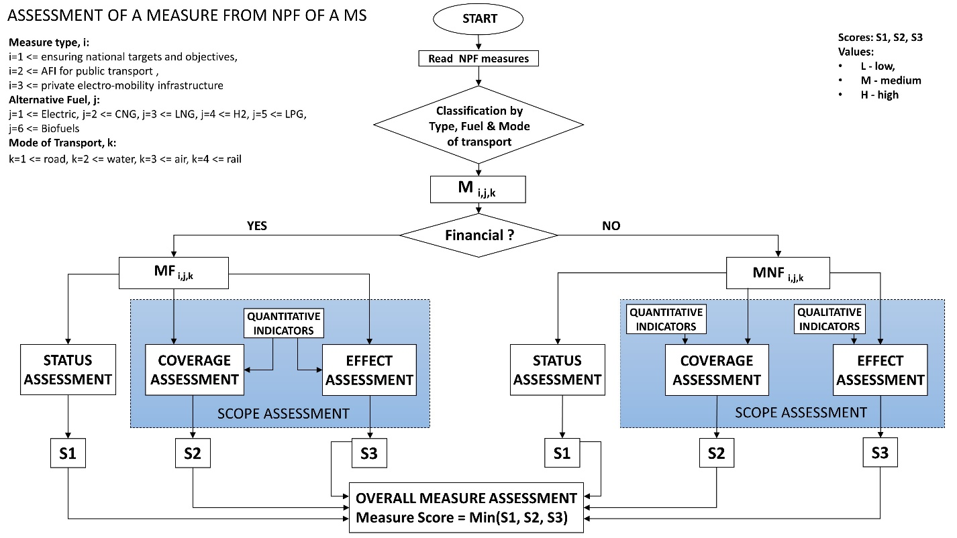

Figure 1-1: Workflow of overall measure assessment

1. **Overall Measure Score and Comprehensiveness**

For each cluster, the maximum score of all individual overall measure scores (SO) is taken as the cluster score. As a consequence, if a Member State has defined for a given fuel/mode and aim cluster one measure with a high adoption status, high coverage, and high effect, the total score for the cluster would also be high. Comprehensiveness indicates by how much the totality of measures for a given fuel and mode addresses various deployment barriers. It will take into account whether both infrastructure and vehicles are addressed or just one of them, what part of the vehicle population is addressed (e.g. for cars, whether private cars, company cars, commercial cars or several groups are subject to measures), and if financial as well as nonfinancial incentives are provided for within a cluster. The score for comprehensiveness is binary: comprehensive/not comprehensive. The comprehensiveness assessment is independent of the measure score. It is possible that a Member State defines a very comprehensive package of measures addressing a cluster but the total score for all measures could be low.

# Methodology for the assessment of EU-wide impacts from all NPFs

Possible impacts of all NPFs combined on the following EU-wide goals are assessed: (i) achieving a minimum level of refuelling and recharging infrastructure across the EU including cross-border continuity and enabling market uptake of alternative fuels transport systems; (ii) support to the achievement of EU climate and energy objectives; (iii) improvement of air quality; (iv) strengthening the EU's competitiveness and jobs in the alternative fuels infrastructure sector.

To this end, the targets and objectives from the different Member States' NPFs were used as input to models and calculation tools in order to derive the estimated impacts. The following sub-sections provide an overview on the models and calculation tools employed. Annex B provides more details.

## Method to assess a minimum infrastructure across the EU

The aim of this evaluation step is to verify if there remain any gaps in the EU-wide availability of refuelling and recharging infrastructure. The analysis builds upon the infrastructure sufficiency assessment derived from the Member States’ NPFs. The results of this analysis are displayed through summary tables for infrastructure sufficiency, results of the measure assessment and selected maps for specific fuels/modes.

The EU-wide analysis is carried out in four steps:

* identifying potential within-country gaps, based on a summary of Member State analysis,
* identifying potential cross-border gaps along the TEN-T network, based on the information provided in the NPFs and the minimum requirements given in Table 1-2 for the mandatory fuels infrastructure,
* calculation of a normalised difference index in order to describe differences in infrastructure density between Member States (see Box 2-1),
* summarising information on countries which have chosen to provide hydrogen infrastructure in order to identify potential coherent areas with hydrogen availability.

**Box 2-1: Calculation of normalised difference index to describe differences in infrastructure density between Member States**

A quantitative description of differences of Member States’ recharging or refuelling infrastructure density is given by a normalized difference index (NDI), calculated as:

NDI = |I1-I2| / (I1+I2),

where I = Number of AFI / Number of km of road network for a country (here countries 1 and 2).

The index takes values between “0” in case of the same density of infrastructure in two countries and “1” in case one of the countries has no infrastructure. A threshold NDI value can be defined to identify important discontinuities in infrastructure density, e.g. NDI=0.2 which indicates that one state has a 1.5 times higher infrastructure density than its neighbour country.

## Method to assess the fostering of deployment of alternative fuels vehicles and vessels

The estimates from the individual NPFs are combined in an EU-wide view. The individual estimates are normalised and expressed as the share of alternative fuels vehicles/vessels per total stock in each Member State. Maps are generated to check how coherent or divergent the estimates are at Union level.

## Method to assess the promotion of the deployment of alternative fuels infrastructure in public transport services

The information on the promotion of the deployment of alternative fuels infrastructure in public transport services from the individual NPFs is combined in an EU-wide view. The various priorities of the Member States' NPFs are listed. Coherence or divergence of promotion measures at Union level is qualitatively assessed.

## Method to assess the support to EU climate and energy objectives

The future alternative fuels vehicle/vessel estimates and infrastructure targets from the NPF of each Member State are used as exogenous projected fleet shares in fleet impact calculation tools. Their impacts in terms of CO2, other pollutant emissions, final energy mix for road transport, and reduction of fossil oil use are calculated versus an update of the EU Reference scenario 2016 without NPFs (so-called "scenario without NPFs")[4].

For road transport the JRC fleet impact model DIONE[5] is used. It is a European Commission owned road transport fleet projection tool and has been used amongst others to support scenario work for the Communication on a European Strategy for low-emission mobility[6]. It allows analysing scenarios of future road vehicle stock, activity, energy consumption and CO2 as well as air pollutant emissions up to 2050. DIONE was developed for assessing transport and energy (policy) options, such as fleet emission targets, vehicle technology transitions, alternative fuels mixes, scrappage schemes, etc. It builds on a detailed and flexible representation of vehicle types, their activities and efficiencies. DIONE can be employed to run scenarios varying in vehicle stock, new registrations, survival rates, activity, efficiency, fuel pathways for Well-to-Wheel (WtW) energy consumption and emissions, biofuel admixture shares, and driving patterns.

Scenarios can be run for any single EU Member State (plus some extra neighbouring countries) and pre-defined groupings such as EU28, EU15 and EU12, but it is also possible to define custom scenarios for any region, city, country or other entity of interest.

DIONE baseline is calibrated on the scenario without NPFs , developed with the PRIMES-TREMOVE transport model by ICCS-E3MLab. Fuel consumption and emission calculation for internal combustion engine vehicles is based on the COPERT[7] road transport emission inventory software. For alternative fuels vehicles, an energy and emission calculation methodology has been developed which takes account of vehicle characteristics, trip lengths and speed distributions. For both energy consumption and greenhouse gas (GHG) emissions, DIONE can provide real world Tank-to-Wheel (TtW) results up to the year 2050 as well as Well-to-Wheel (WtW) results up to 2030. Well-to-Tank (WtT) emissions for fuels are aligned to the JRC-EUCAR-CONCAWE WtT data[8]. For light-duty vehicles' CO2 emissions, type approval or real world values can be calculated. In this assessment only direct transport emissions, i.e. TtW results were considered.

For waterborne transport and stationary airplanes, emission reductions and energy impacts were taken from the NPFs if the Member State provided these data. If not, emission and energy use factors were used to calculate the respective impacts. For stationary airplanes, the factors were derived based on calculations using emission and energy factors from ICAO[9] (International Civil Aviation Organization). For shore-side electricity, factors were derived based on calculations from a study commissioned by DG Environment[10]. For LNG for ships, factors were derived based on calculations from a study commissioned by DG MOVE[11].

The following key performance indicators are calculated and summarised for the snapshots 2020, 2025, and 2030: CO2 reduction and reduction of fossil oil use versus the scenario without NPFs. As not all Member States provide estimates and targets for all snapshot years, some of the estimate/target numbers had to be inter- or extrapolated. As a general rule, if an NPF does not contain estimates beyond a given year, it was assumed that the AF vehicle or vessel number stays constant beyond that year.

## Method to assess air quality improvements

The results on air pollutant emissions from the previous assessment step are used as input to subsequent calculations with the SHERPA (Screening for High Emission Reduction Potential on Air) model[12] in order to assess air quality impacts. The results are displayed as difference maps of main pollutants versus a reference scenario without NPFs.

The SHERPA tool has been developed by the JRC with the aim of supporting national, regional and local authorities in the design and assessment of their air quality plans. It particularly helps identifying the most efficient administrative scale for potential actions in a multi-level governance decision context. SHERPA allows for a rapid exploration of potential air quality improvements resulting from national/regional/local emission reduction measures.

The tool is based on simplified relationships between emissions and concentration levels, which can be used to answer the following questions:

• What is the potential for local action in my region?

• What are the priority activities, sectors and pollutants on which to take action?

• At which scale (national, regional, local, etc.) should I act to be more efficient?

The SHERPA tool is currently distributed with default EU-wide data for emissions and source-receptor relationships at 7x7 km2 spatial resolution. Current data refer to 2010, and are related to a specific EU-wide air quality model and emission inventory.

SHERPA is used to evaluate the impact of the NPFs on air quality. As the current spatial resolution of the SHERPA model is 7x7 km2, the focus is on the impact of NPFs on urban/regional background (i.e. not hot-spot) concentrations of PM10, PM2.5, and NO2 in various areas in Europe.

## Method to assess the strengthening of the EU's competitiveness and jobs

A computational model was developed for calculating the value creation and employment effects resulting from AFI build-up as described in the NPFs. It outputs Member States' domestic as well as the EU-wide effects resulting from infrastructure production and installation. Types of infrastructure covered by the model include electricity recharging points and CNG, LNG and H2 refuelling points for road transport.

**Calculating the Gross Value Added (GVA) through AFI build-up**

Figure 2-1 shows a model flowchart for the calculation of the domestic economic effects of recharging point build-up in a Member State. For each infrastructure type and Member State, AFI build-up targets are derived in a first step, calculated as the target number of recharging or refuelling points minus present number as given in the NPF. Summed over Member States, the number of total planned AFI installations of each type in the EU results. For the different types of infrastructure, target years are given by the Directive. AFI build-up is assumed to be linear up to the target year (e.g., 2020 for recharging points), with no further growth assumed in later years.

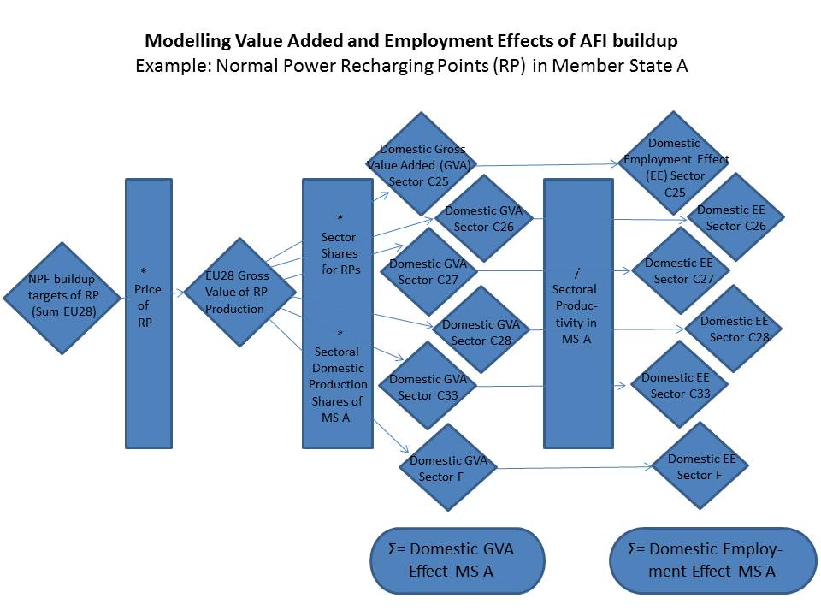

Figure 2-1: Flowchart of Added Value and Employment Calculation

Annual numbers of new AFI installed are multiplied by their net market prices to derive the Gross Value of Production (GVP). As the market price of a technology includes all value added along the value chain, it is a reasonable proxy for the calculation of gross value of production added.

In a next step, the share of each Member State in the production and installation of AFI needs to be determined, and imports from outside the EU need to be deducted. As the share of imported preliminary products differs among economic sectors, the GVP is sub-split. This is done by assigning the different technological components of an AFI installation (and thus their costs) to different economic sectors, on the basis of data on the composition and prices of the different AFI types. Price information was taken from recent studies and industry sources[13]. AFI GVP is assigned to the following sectors (in line with Eurostat NACE Rev. 2):

Table 2-1: Economic Sectors Considered

|  |  |  |  |  |  |  |
| --- | --- | --- | --- | --- | --- | --- |
| Sector | Fabricated metal products, except machinery and equipment | Computer, electronic and optical products | Electrical equipment | Machinery and equipment n.e.c. | Repair and installation services of machinery and equipment | Constructions and construction works |
| Eurostat Sector Number | C25 | C26 | C27 | C28 | C33 | F |

For each of these sectors, the sectoral GVP is multiplied by the sectoral domestic production share, yielding the sectoral domestic GVA for each of the six sectors for the AFI type and Member State under consideration. By default, the sectoral domestic share in AFI production in each Member State is assumed to be equal to the Member State's present sectoral share of production value within the EU, which is derived from Eurostat data[14]. The model allows reallocating domestic production shares as well as import shares from outside the EU for scenario analysis.

The national GVA effect resulting in the sectors C25, C26, C27 and C28 from the production is allocated completely (adjusted by preliminary imports) to the producing country. The costs of installing a recharging or refuelling point, occurring in sectors C33 and F, is divided into a GVA effect in the producing country and the country that installs the infrastructure.

Summing over the sectors, the Member States' domestic GVA effect from the particular infrastructure type results. For each Member State, total sectoral GVA effect includes the domestic effect of own AFI installation and the Member States exports of preliminary products for AFI installation to other EU countries. The sum over all AFI types per Member State is the total national GVA effect from the EU-wide implementation of AFI targets as envisaged in the NPFs, and the sum over all Member States yields the EU-wide effect. AFI maintenance costs are included via a multiplier representing annual costs as percentage of total investment per facility.

**Calculating the employment effect of AFI build-up**

As shown in Figure 2-1, the employment effect of building a given type of infrastructure in each Member State is derived from domestic GVA per sector, dividing it by productivity. This yields the amount of person-years required to build the AFI envisaged in the NPF, which is assumed to translate into employment.

As labour productivity varies for each Member State and sector, this calculation is done on sectoral level. Data on the number of persons employed in the production of AFI is not available, thus productivities in the sectors contributing to AFI build-up (see Table 2-1) were used. These were derived by dividing each Member State's sectoral gross value added by the number of employed persons, both taken from Eurostat[15].

The domestic employment effect is derived by aggregating over all sectors, and the EU-wide effect by then aggregating over all Member States.

**Sensitivities and scenario analysis**

The model allows for running scenarios on a wide number of parameters. These include, for example:

* The allocation of AFI production and installation, intra-EU and international,
* Technology costs and sectoral shares,
* Technology types, e.g. normal vs. high power, number of points per recharging or refuelling point, etc.,
* The time frame of AFI build-up, and
* Labour productivity.

# Overview of targets, objectives and level of attainment from all NPFs

This section provides an overview of the targets and objectives, the measure scores and comprehensiveness in the Member States' NPFs as well as the current level of attainment per Member State. By adoption date of this Staff Working Document, 26 Member States had notified their NPFs to the Commission[16]. However, the cut-off date for NPFs to be included in the technical analysis of this Staff Working Document was 1 October 2017. By that time 24 Member States had notified[17]. The analysis in this Staff Working Document concentrates hence on the NPFs submitted by the cut-off date.

The Commission started infringement procedures against the Member States that did not sent their NPF to the Commission and against one Member State, the NPF of which did not contain any targets for alternative fuels infrastructure.

Figure 3-1 gives a high-level overview on the compliance of the NPFs with the requirements of the Directive.

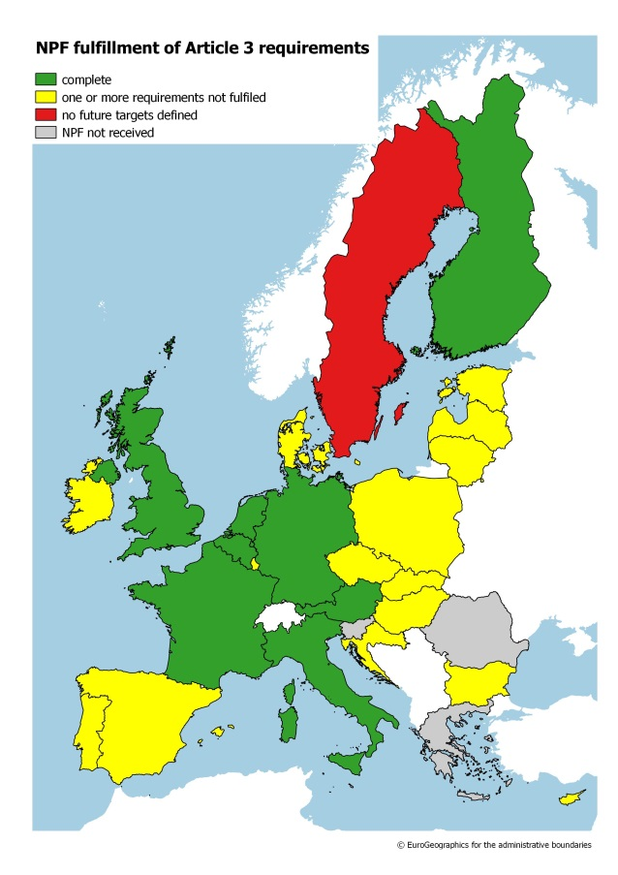

Figure 3-1: Compliance of NPFs with requirements of the Directive

Besides the two Member States[18] that have not sent their NPF to the Commission, 16 Member States[19] have not defined alternative fuels infrastructure targets for all mandatory fuels/modes or do not meet all requirements of article 3 of the Directive and the Commission will consider the option to start infringement procedures also against these Member States.

From the analysis of the NPFs it becomes evident that they are not coherent at Union level. The NPFs are diverging in view of prioritising different alternative fuels. They feature very different ambition levels across Member States both in terms of projected future development of alternative fuels and their corresponding infrastructure. In general, the future estimates and targets are much lower than what was used as a basis for the proposed Directive. Even with low ambition, very few NPFs define sufficient corresponding targets for alternative fuels infrastructure. The adoption status and likely impact of support measures seems too low as to ensure that the national targets and objectives contained in the NPFs are reached. All this can lead to an emerging market fragmentation at EU level and even within certain Member States.

Table 3-1 gives an overview of the infrastructure targets sufficiency and level of attainment. Two NPFs[20] do not contain targets for publicly accessible recharging points, four[21] do not contain targets for CNG refuelling points, and six[22] do not contain targets for LNG refuelling points for heavy-duty vehicles along the road TEN-T Core Network. Four[23] NPFs do not contain targets for LNG refuelling points at maritime ports and three[24] do not contain targets for LNG refuelling points at inland ports.

Table 3-1: Overview of infrastructure targets sufficiency and level of attainment[25]



Table 3-2 provides an overview of vehicle/vessel future estimates and the current status of attainment.

Table 3-2: Overview of vehicle/vessel future estimates and current status[26] 

Table 3-3 gives an overview of the measure scores and their comprehensiveness.

Table 3-3: Overview of measure scores and comprehensiveness



# Overall Contribution of NPFs to EU policy targets

This section describes the results of the analysis for important EU policy targets. It covers the aspects that are directly targeted by the scope of the Directive (alternative fuels infrastructure and vehicles/vessels) as well as other targets to which the Directive contributes as one initiative among other policies in place.

## Ensuring the build-up of a minimum alternative fuels infrastructure in the EU

*Recharging points*

Figure 4-1 summarises the information for the targeted publicly accessible recharging points and EV estimates per NPF as well as the current attainment level. Almost all NPFs define targets for publicly accessible recharging points. However, only seven NPFs (Cyprus, Denmark, Hungary, Italy, Latvia, Netherlands and Portugal) define a target that would ensure at least one publicly accessible recharging point per 10 electric vehicles for 2020. For the Member States that provide future EV estimates, the ratio of electric vehicles per publicly accessible recharging point ranges from 5 (in Latvia) to 32 in the different NPFs. The planned targets, which are ambiguously defined in some cases, also fall significantly short of the originally proposed targets that were used for the impact assessment of the proposed Directive. The current attainment level for the 2020 targets of publicly accessible recharging points, calculated as the ratio between current and targeted recharging points ranges from 1% to 88%.

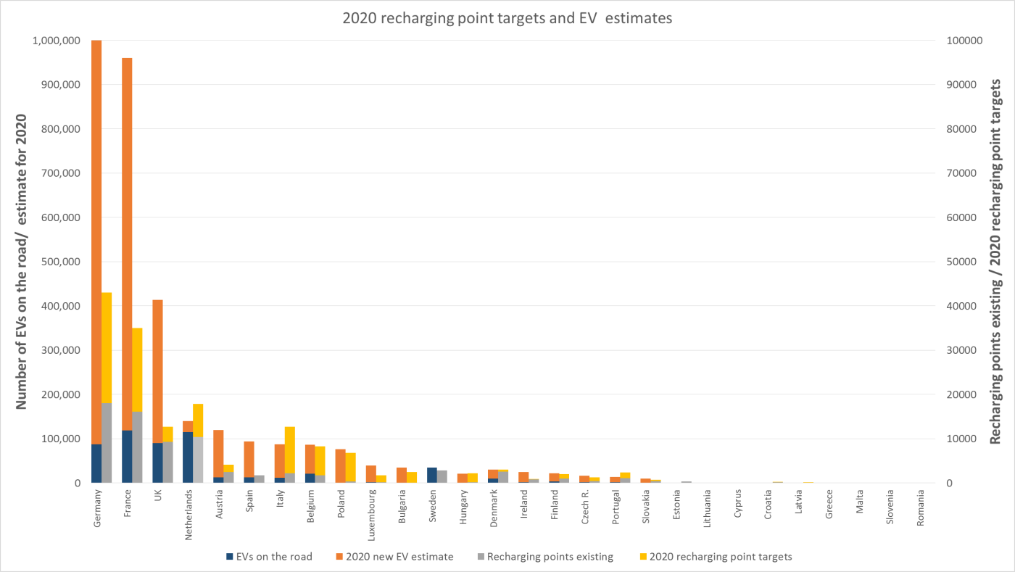

Figure 4-1: NPFs' 2020 recharging point targets and EV estimates, level of attainment[27]

The maps in Figure 4-2 show how the ratio of publicly accessible recharging points deteriorates in almost all Member States from today until 2020, when the targets for recharging points and EV estimates materialise.

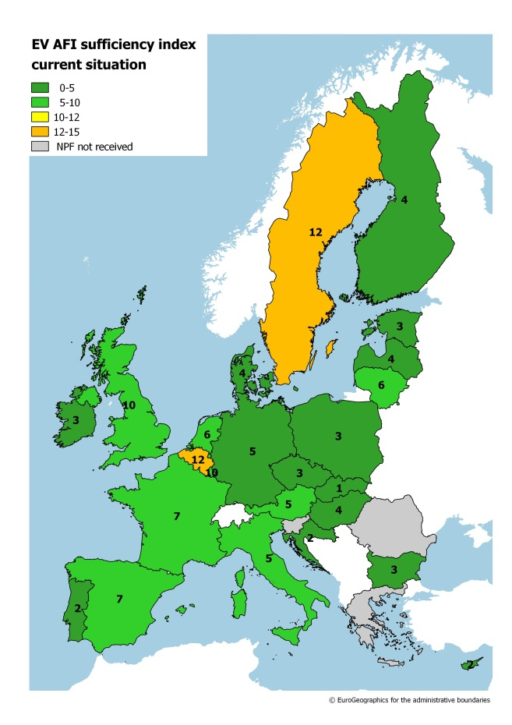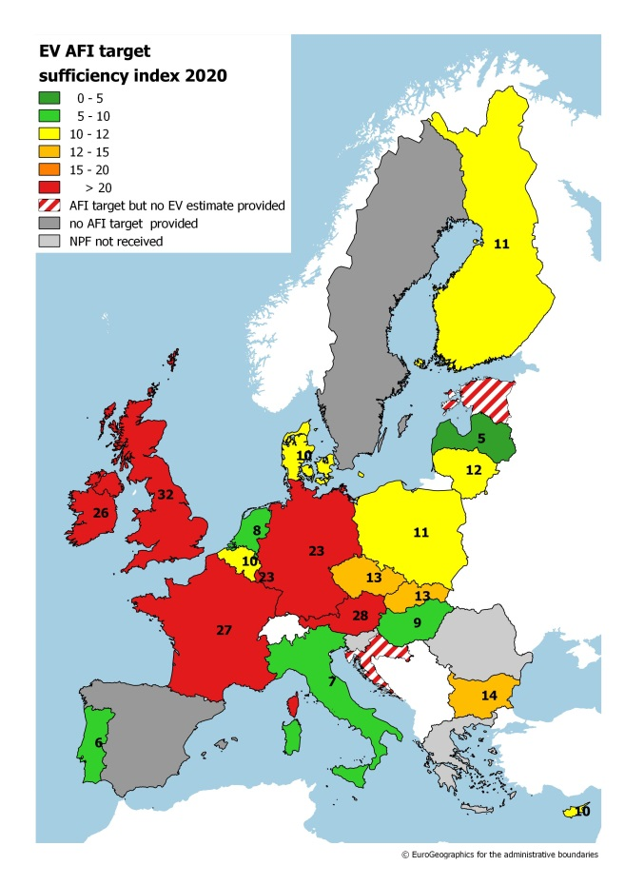

Figure 4-2: Overview of recharging point sufficiency index per Member State, current (left) and 2020 (right).

Coverage of the TEN-T network largely seems to be progressing well, the distance targets being usually met. Some portions of the road TEN-T Core Network will remain without appropriate recharging infrastructure, according to the NPFs. The map in Figure 4-3 shows the assessment results for TEN-T Core Network coverage with recharging points by 2025.

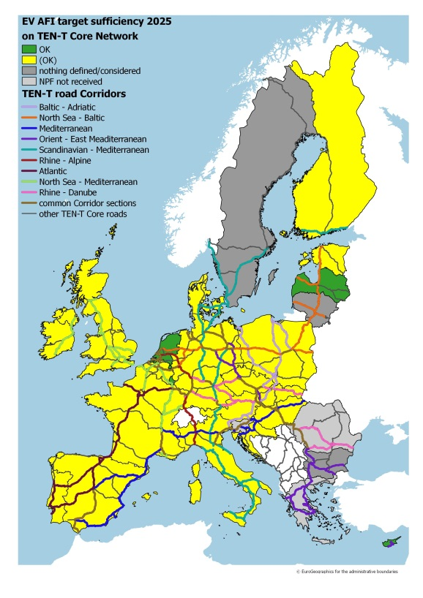

Figure 4-3: Overview of recharging point sufficiency to ensure appropriate coverage of the TEN-T Core Network by 2025.

From the analysis of the NPFs recharging point targets, it becomes evident that they are not coherent at Union level. The NPFs are diverging in their ambition levels vis-à-vis the deployment of recharging points accessible to the public. Table 4-1 shows the normalised difference index for the density of recharging point targets using the total road network of an MS. The table reveals big differences between neighbouring Member States regarding their density of recharging point targets. If the normalised difference index is also interpreted as an indicator for cross-border continuity in the sense that the level of infrastructure density varies a lot across borders, the following cross-border continuity issues can be identified: Austria/Czech Republic, Belgium/France, Czech Republic/Germany, Germany/Denmark, Germany/Netherlands, Germany/Poland, Spain/France, Spain/Portugal, France/Luxembourg, Croatia/Hungary, Lithuania/Latvia, Lithuania/Poland, Netherlands/UK. Because of the lacking Greek and Romanian NPF, no normalised difference index can be calculated for Bulgaria.

Table 4-1: Normalised difference index for recharging point targets (2020)[28].



*CNG refuelling points*

Some NPFs (Germany, Luxembourg, and Netherlands) express a pessimistic view on the viability of CNG for road, while others (Belgium, Czech Republic, Hungary, and Italy) consider this as a priority. Several Member States, especially the ones that currently have a rather high number of CNG refuelling points in comparison to CNG vehicles on the road, state that they have no plans to support a further increase of CNG refuelling infrastructure. The 2020 planned ratio of CNG vehicles to refuelling points ranges from 1,000 to 100, the target attainment level as of today, calculated by dividing the number of currently available CNG refuelling points by future targets, varies between 0 and 100%. Figure 4-4 provides an overview of the 2020 targeted CNG refuelling points accessible to the public and CNG vehicle estimates per NPF as well as the current level of target achievement.

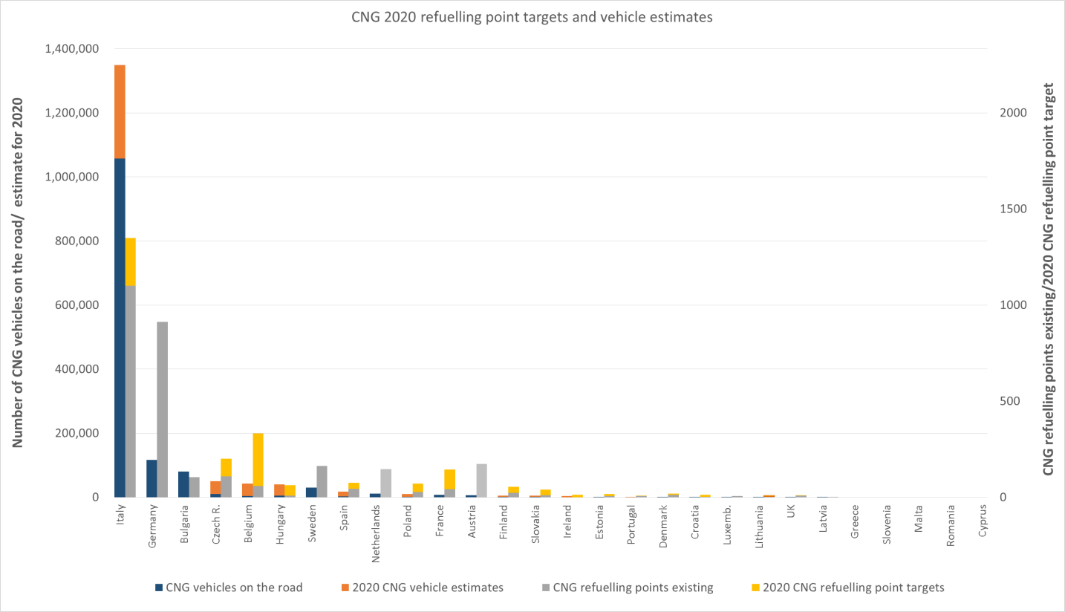

Figure 4-4: NPFs' 2020 CNG refuelling point targets and CNG vehicle estimates, level of attainment[29]

The maps in Figure 4-5 show the sufficiency index for the current situation and for the 2020 targeted CNG refuelling infrastructure accessible to the public. A ratio of at least one publicly accessible CNG refuelling point per 600 CNG vehicles in a given Member State is considered sufficient. 14 Member States (Austria, Bulgaria, Cyprus, Germany, Denmark, Estonia, France, Croatia, Lithuania, Latvia, Netherlands, Portugal, Sweden, and UK) did not provide any CNG vehicle estimates for the future. For these, the sufficiency index could not be calculated. Out of these thirteen Member States, three (Bulgaria, Cyprus, and Sweden) did not provide any targets for CNG refuelling points accessible to the public.

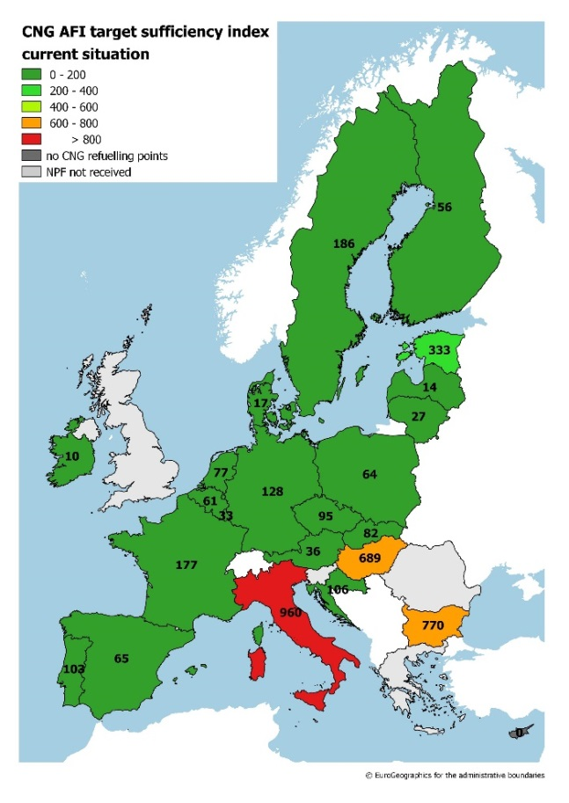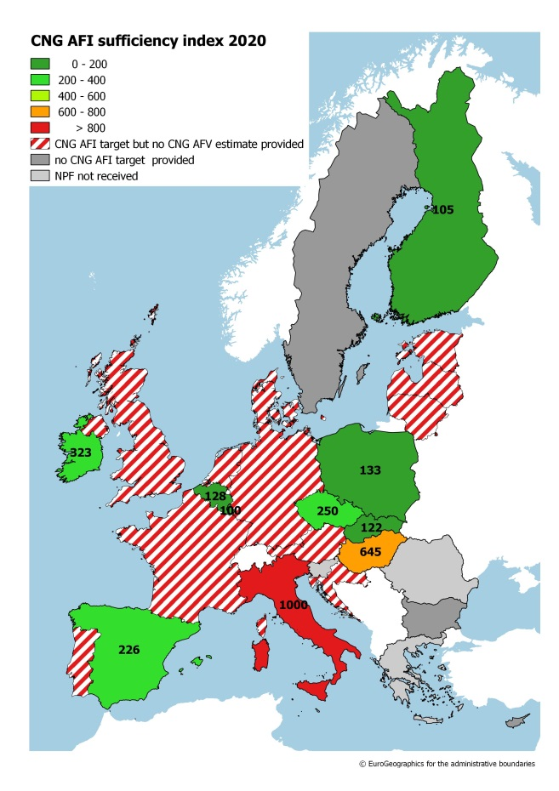

Figure 4-5: Overview of CNG refuelling point sufficiency index per Member State, current (left) and 2020 (right).

Table 4-2 shows the normalised difference index for the density of CNG refuelling point targets using the total road network of an MS. The table reveals big differences between neighbouring Member States regarding their density of CNG refuelling point targets. If the normalised difference index is also interpreted as an indicator for cross-border continuity in the sense that the level of infrastructure density varies a lot across borders, the following cross-border continuity issues can be identified: Belgium/Germany, Belgium/France, Belgium/Luxembourg, Czech Republic/Poland, Germany/Denmark, Germany/France, Germany/Luxembourg, Germany/Poland, France/Italy, Poland/Slovakia. Because of the lacking Greek and Romanian NPF, no normalised difference index can be calculated for Bulgaria.

Table 4-2: Normalised difference index for CNG refuelling point targets (2020)[30].



*LNG*

LNG for heavy-duty vehicles is covered by 19 NPFs and initial steps to ensure adequate TEN-T coverage are taken. However, according to the NPFs, appropriate coverage of the road TEN-T Core Network with LNG refuelling points is not guaranteed. Several Member States mention the need of further technical developments of LNG heavy-duty vehicles (e.g. longer driving ranges). Moreover, several Member States plan to review their LNG refuelling infrastructure targets after performing further market and cost-benefit analyses.

According to the NPF, a total of 379 LNG refuelling points will be deployed across Europe. The map in Figure 4-6 shows the results of the assessment for the sufficiency of LNG refuelling points along the road TEN-T Core Network. The picture is very much dominated by the lack of or insufficient[31] LNG refuelling targets for heavy-duty trucks in Bulgaria, Cyprus, Denmark, Croatia, Ireland, Italy, Latvia, Portugal and Sweden. This leads to insufficient coverage of the road TEN-T network crossing these countries and consequently cross-border issues with all their neighbouring Member States.

Table 4-3 shows the normalised difference index for the density of LNG refuelling point targets using the road TEN-T Core Network of an MS. Because of the lacking Greek and Romanian NPFs, no normalised difference index can be calculated for Bulgaria. The table reveals big differences between neighbouring Member States regarding their density of LNG refuelling point targets along the road TEN-T Core Network. If the normalised difference index is also interpreted as an indicator for cross-border continuity in the sense that the level of infrastructure density varies a lot across borders, the following cross-border continuity issues can be identified: Austria/Hungary, Austria/Italy, Belgium/Germany, Czech Republic/Germany, Germany/France, Germany/Luxembourg, Germany/the Netherlands, Finland/Sweden, Croatia/Hungary, Hungary/Slovakia, Latvia/Lithuania, and Latvia/Estonia.

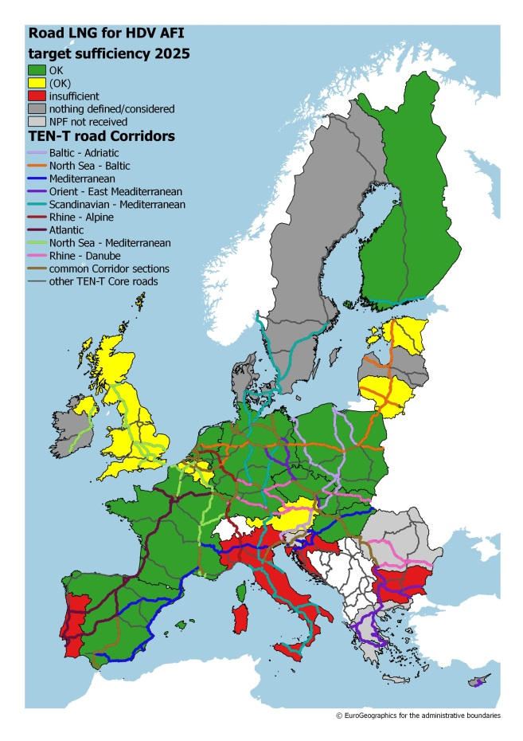

Figure 4-6: Results of the assessment for the sufficiency of LNG refuelling points along the road TEN-T Core Network.

Table 4-3: Normalised difference index for LNG refuelling point targets along the road TEN-T Core Network (2025)[32].



Based on the targets provided in the NPFs, it is evident that some portions of the road TEN-T Core Network will remain without LNG refuelling infrastructure. In particular, attention should be paid to the Southern part of the Atlantic Corridor and LNG cross-border continuity Spain/Portugal, the Southern part of the Scandinavian Mediterranean Corridor, the central and Eastern part of the Mediterranean Corridor, the entire Orient-East-Mediterranean Corridor, and the Baltic part of the North-Sea Baltic Corridor.

The maps in Figure 4-7 show the results of the assessment for the sufficiency of LNG refuelling points in TEN-T Core Network maritime ports (left map) and LNG refuelling points in TEN-T Core Network inland ports (right map). The plans to deploy LNG in maritime and inland ports vary between high ambition (Finland, Hungary, Italy) and no consideration, leaving a number of ports without any solution for LNG refuelling. For most of the inland waterway corridors the coverage of LNG refuelling will likely be inadequate according to the targets of the NPFs.

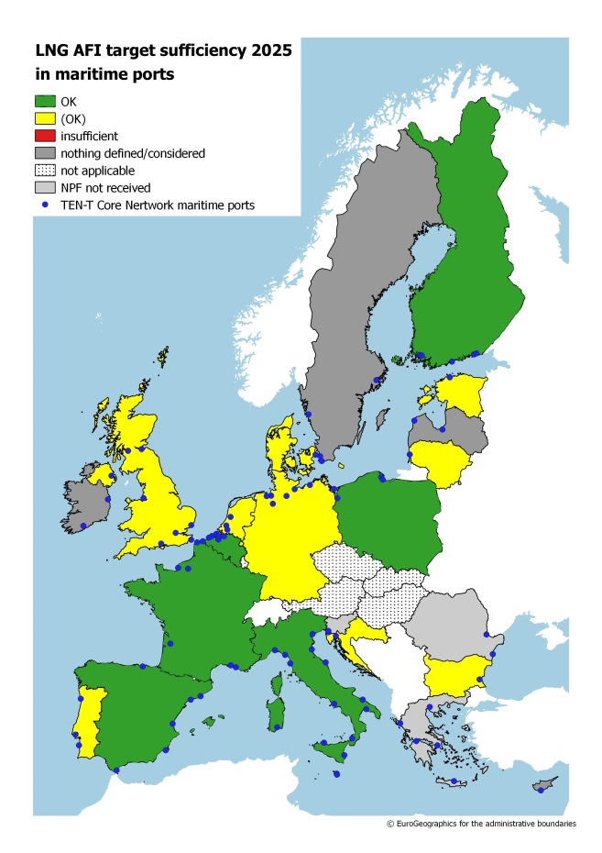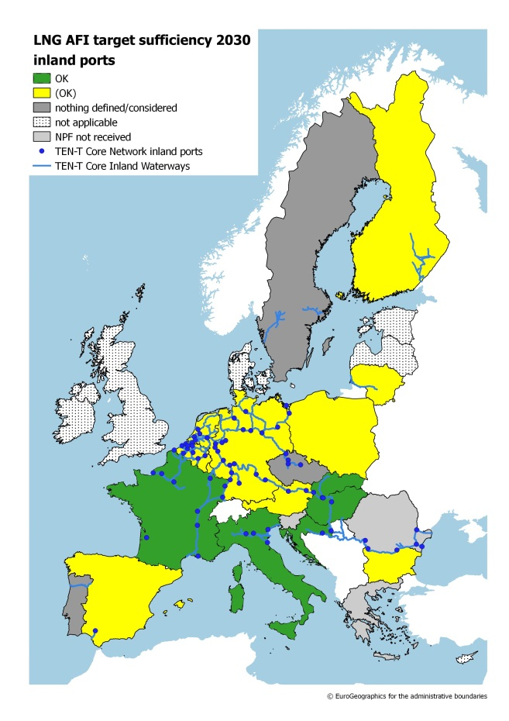

Figure 4-7: Results of the assessment for the sufficiency of LNG refuelling points in TEN-T Core Network maritime ports (left map) and LNG refuelling points in TEN-T Core Network inland ports (right map).

Some NPFs aim at exploiting synergies between CNG, LNG and road and waterborne transport.

*Electricity for stationary airplanes and shore-side electricity*

Shore-side electricity and electricity supply for stationary airplanes are scarcely covered in the various NPFs and very few NPF contain any targets or measures for an increase of these alternative fuel sources.

*Hydrogen*

Hydrogen is included in 14 NPFs[33] (Austria, Belgium, Bulgaria, Czech Republic, Germany, Estonia, Spain, Finland, France, Hungary, Italy, Netherlands, Sweden, and UK) and some Member States, for example Germany, have defined ambitious targets for hydrogen infrastructure. The map in Figure 4-8 shows the targets for hydrogen refuelling points across Member States by 2025 and Figure 4-9 gives an overview of the 2025 hydrogen refuelling point targets per NPF and current level of target achievement. First steps towards deployment of hydrogen vehicles and refuelling infrastructure are taking place, however it can be noted that while in central Europe hydrogen refuelling infrastructure will be deployed this will not be the case in North Eastern Europe.

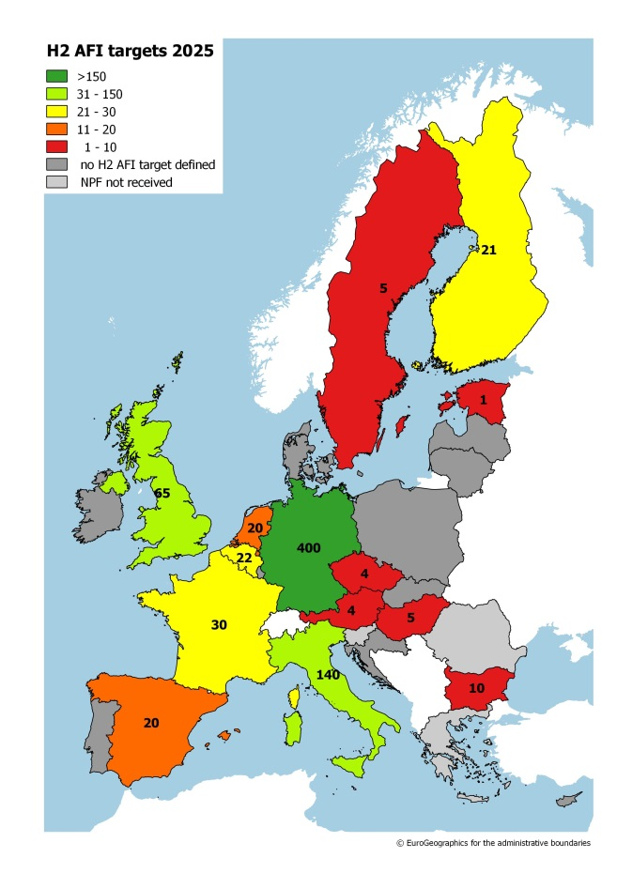

Figure 4-8: NPF targets for hydrogen refuelling points for 2025

Figure 4-10 shows the maximum distance between hydrogen refuelling points that would be achieved, when they are evenly distributed on the road TEN-T Core Network within each Member State, if the 2025 targets of the NPFs are achieved. For most of the Member States that have defined targets for hydrogen refuelling the maximum distance would be, by a large margin, below 300 km.

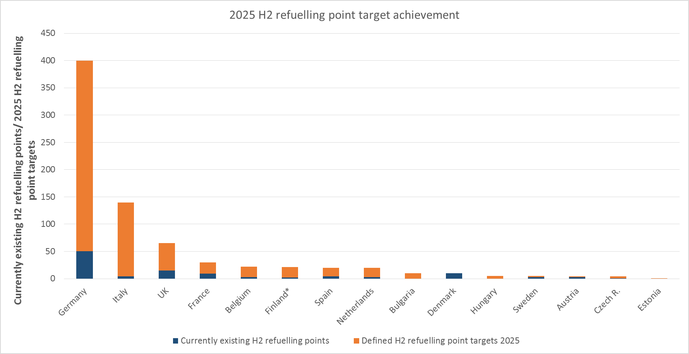

Figure 4-9: NPFs' 2025 hydrogen refuelling point targets, level of attainment[34]

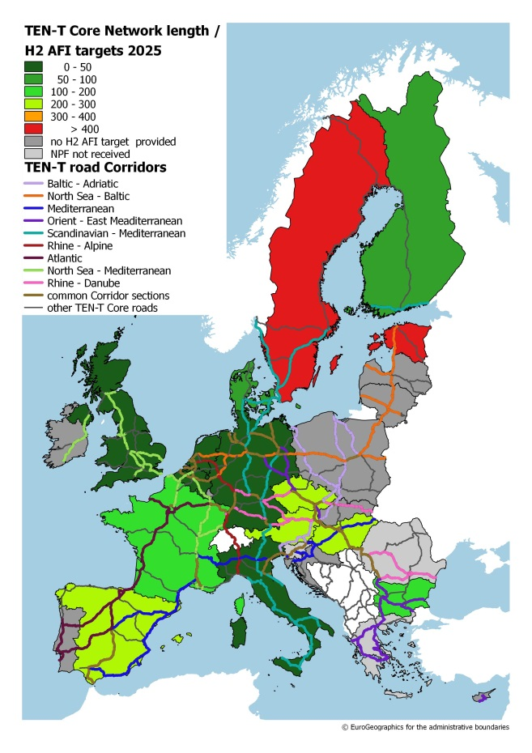

Figure 4-10: Maximum distance of hydrogen refuelling points for 2025 when evenly distributed on road TEN-T Core Network within Member States (according to NPF targets)

1. This value is derived from field test data from various EU countries and it can be reasonably assumed that it would remove range anxiety concerns. See for more details: JRC (2015) Individual mobility: From conventional to electric cars. Available at: <http://publications.jrc.ec.europa.eu/repository/bitstream/JRC97690/eur_27468_en_online_v3.pdf>
2. Current average ratio in Member States between conventional vehicles and gasoline/diesel refuelling point is 600 to one (one fuel station typically has several refuelling points).
3. Here, only the measures that target one of the three above described aspects are assessed.
4. The scenario without NPFs builds on the Baseline scenario of the Impact Assessment accompanying the Proposal for a Directive amending Directive 1999/62/EC on the charging of heavy goods vehicles for the use of certain infrastructures (SWD (2017) 180), and thus on the EU Reference scenario 2016, but excludes the incentives for alternative fuels provided at the Member State level. It has been developed with the PRIMES-TREMOVE model (i.e. the same model used for the EU Reference scenario 2016) by ICCS-E3MLab.
5. For more information see: Thiel, C., Drossinos, Y., Krause, J., Harrison, G., Gkatzoflias, D. and A.V. Donati (2016), Modelling electro-mobility: an integrated modelling platform for assessing European policies. Transport Research Procedia, DOI: <http://10.1016/j.trpro.2016.05.341>; Harrison, G., J. Krause, & C. Thiel (2016), Transitions and impacts of passenger car powertrain technologies in European member states. Transport Research Procedia, DOI: <http://10.1016/j.trpro.2016.05.418>
6. Communication on "A European Strategy for Low-Emission Mobility" [COM(2016)501] and accompanying Commission Staff Working Document [SWD(2016)244]
7. For more information see: <http://emisia.com/products/copert>
8. For more information see: <http://iet.jrc.ec.europa.eu/about-jec/downloads>
9. The following factors were used: gate/position primarily used for short haul flights: yearly avoidance through the use of ground power and air climate units (replacing airplane's auxiliary power units(APU)): fuel -350t, CO2 -1080t, NOx -3.1t, PM10 -0.11t, HC -0.1t, CO -1.4t each per year and gate/position; for long haul flights: fuel -986t, CO2 -3037t, NOx -7.9t, PM10 -0.13t, HC -0.5t, CO -0.7t each per year and gate/position; for unspecified gate/position use the average of the values was taken. Basic energy/emission factors for APU use were taken from ICAO, Doc 9889 (2011), page 3-A1-24.
10. The following factors for yearly fuel use/emission changes were used: for berths primarily used for small ships: electricity used: 1255MWh, MGO (marine gasoil) avoided: 285t, CO2 -653t, NOx -14.8t, PM -0.35t, VOC -0.49t; for medium ships: electricity used: 3482MWh, MGO avoided: 791t, CO2 -1811t, NOx -41.1t, PM -0.96t, VOC -1.36t; for large ships: electricity used: 8971MWh, MGO avoided: 2038t, CO2 -4665t, NOx -105.9t, PM -2.48t, VOC -3.49t. All calculated from European Commission – DG ENV (2005). Service Contract on Ship Emissions: Assignment, Abatement and Market-based Instruments - Task 2a – Shore-Side Electricity.
11. The following factors for yearly fuel use/emission changes were used: for ferries: LNG: 38000m3, MGO avoided: 18037t, CO2 -14348t, NOx -859t, SO2 -177t, PM10 -12.6t, CH4 +786t; for cruise ships: LNG: 90824m3, MGO avoided: 43110t, CO2 -34293t, NOx -2052t, SO2 -424t, PM10 -30.1t, CH4 +1879t; for cargo ships: LNG: 10,000m3, MGO avoided: 4747t, CO2 -3776t, NOx -226t, SO2 -47t, PM10 -3.3t, CH4 +207t. All calculated from European Commission – DG MOVE (2015). Study on the Completion of an EU Framework on LNG-fuelled Ships and its Relevant Fuel Provision Infrastructure - Lot 3 - Analysis of the LNG market development in the EU.
12. For more details see: <http://aqm.jrc.ec.europa.eu/sherpa.aspx>
13. Steer Davies Gleave (2016), Clean Power for Transport Infrastructure Deployment. Final Report, Study on behalf of European Commission, DGMOVE/2015 VIGIENo 495; Ludwig-Bölkow-Systemtechnik (2016), Vergleich von CNG und LNG zum Einsatz in Lkw im Fernverkehr, Abschlussbericht; Information from the German National Platform Electromobility (NPE) and e-mobil BW, Germany.
14. Total imports and EU-internal imports for each Member State are available from Eurostat at <http://appsso.eurostat.ec.europa.eu/nui/show.do?wai=true&dataset=nama_10_exi>, input-output tables for all member states based on <http://ec.europa.eu/eurostat/de/web/esa-supply-use-input-tables/data/workbooks>.
15. Annual enterprise statistics for special aggregates, http://ec.europa.eu/eurostat/data/database.
16. Austria, Belgium, Bulgaria, Croatia, Cyprus, Czech Republic, Denmark, Estonia, Finland, France, Germany, Greece, Hungary, Ireland, Italy, Latvia, Lithuania, Luxembourg, Netherlands, Poland, Portugal, Slovakia, Slovenia, Spain, Sweden and United Kingdom.
17. Slovenia and Greece notified after the cut-off date.
18. ,Malta and Romania.
19. Bulgaria, Cyprus, Czech Republic, Denmark, Estonia, Spain, Croatia, Hungary, Ireland, Lithuania, Luxembourg, Latvia, Poland, Portugal, Sweden, and Slovakia.
20. Spain and Sweden.
21. Bulgaria, Latvia, Portugal, and Sweden.
22. Cyprus, Denmark, Ireland, Lithuania, Latvia, and Sweden.
23. Cyprus, Denmark, Ireland, and Sweden.
24. Czech Republic, Portugal, and Sweden.
25. Level of attainment is expressed as current status divided by future target (in %).
26. Future estimate expressed as share of AFV per total (current) stock; "estimate reached" expressed as current number of AFV divided by future estimate (both in %).
27. Member states ordered by their estimated number of EV for 2020 (from high to low). When the right column (recharging points) is at least as high as the left column (EVs), the ratio of publicly accessible recharging points per EV is at least one to ten. No data available for the member states that did not notify their NPF to the Commission by 1st October 2017 (Greece, Malta, Romania, Slovenia).
28. Only for member states with a joint border or major ferry connections between one another. “0” means maximum coherence of targets, “1” means minimum coherence of targets.
29. Member states ordered by their estimated number of CNG vehicles for 2020 (from high to low). When the right column (refuelling points) is at least as high as the left column (CNG vehicles), the ratio of publicly accessible refuelling points per CNG vehicle is at least one to 600. No data available for the member states that did not notify their NPF to the Commission by 1st October 2017 (Greece, Malta, Romania, Slovenia).
30. Only for member states with a joint border or major ferry connections between one another. “0” means maximum coherence of targets, “1” means minimum coherence of targets.
31. In view of guaranteeing a maximum distance of at least 400 km between LNG refuelling points on the TEN-T Core Network
32. Only for member states with a joint border or major ferry connections between one another. “0” means maximum coherence of targets, “1“ means minimum coherence of targets.
33. The Danish NPF discusses hydrogen but does not commit to infrastructure targets for hydrogen.
34. Member states ordered by their targeted number of hydrogen refuelling points for 2025 (from high to low). No data available for the member states that did not include hydrogen targets in their NPF (Cyprus, Estonia, Ireland, Lithuania, Luxembourg, Latvia, Poland, Portugal, Slovakia) and the ones that did not notify their NPF to the Commission by 1st October 2017 (Greece, Malta, Romania, Slovenia).