

Contents

18.4.2. The potential territorial impact in relation to the R&D employment indicator 159

18.4.3. The potential territorial impact in relation to the patent applications indicator 161

18.5. Results of the TIA quick check: Potential territorial impact based on societal aspects 163

18.5.1. The potential territorial impact in relation to the number of people exposed to noise indicator 163

18.6. Results of the TIA quick check: Potential territorial impact based on governance aspects 164

18.6.1. The potential territorial impact in relation to the government effectiveness indicator 164

18.7. Conclusions and policy implications 166

18.7.1. Findings based on the results of the TIA Quick check 166

18.7.2. Findings and recommendations from the expert discussion 167

18.8. Territorial impact assessment workshop agenda 168

18.9. Description of the indicators used and regional sensitivity 169

Figure 18.3: Workshop findings: Expert judgement: Effect of the modification of the Clean Vehicles Directive



Source: Territorial impact assessment expert workshop, Brussels, 11 May 2017

The indicator picturing the sensitivity of a region according to the R&D climate is measured by the indicator “Total intramural R&D expenditure all sectors as a percentage of the GDP”. It is assumed that regions with a greater share of enterprises engaged in product and/or process innovation activities are considered to be more sensitive to directives influencing innovation.

The following map shows the potential territorial impact of the revision of the CVD based on the R&D climate indicator. It combines the expert judgement of a weakly advantageous effect with the given sensitivity of regions. The effect is distributed quite equally: most of the regions would gain a minor positive impact.

Map 18.10: Result of the expert judgement: R&D Climate (R&D expenditure) affected by the revision of the Clean Vehicles Directive – expert judgement: weak advantageous effect

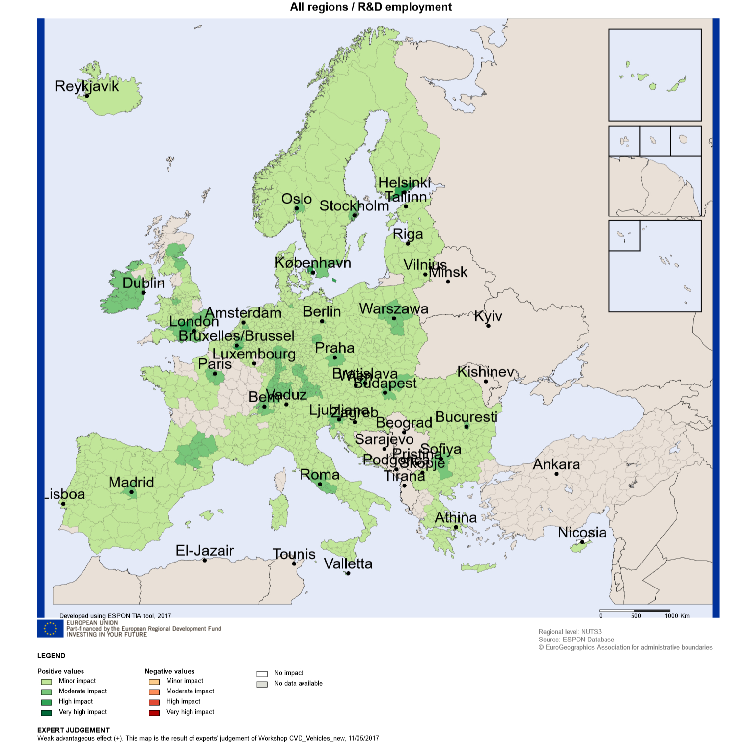

Source: Territorial impact assessment expert workshop, Brussels, 11 May 2017

# 



### The potential territorial impact in relation to the R&D employment indicator

Another indicator that the experts considered relevant in the analysis of the potential territorial impacts from the revision of CVD is the R&D employment. Eleven experts judged the effect of the modification of the CVD on R&D employment as weakly advantageous, 2 as strongly advantageous.[1]

Figure 18.4: Workshop findings: Expert judgement: Effect of the modification of the Clean Vehicles Directive



Source: Territorial impact assessment expert workshop, Brussels, 11 May 2017

The indicator picturing the sensitivity of a region according to R&D related employment is measuring “employment in technology and knowledge-intensive sectors”.

The following map shows the potential territorial impact of the revision of the CVD based on the R&D employment indicator. It combines the expert judgement of a weakly advantageous effect with the given sensitivity of regions.

The map shows the possibility of a “catching-up” effect of mainly Southern and Eastern European regions.

Map 18.11: Result of the expert judgement: R&D Employment affected by the revision of the Clean Vehicles Directive – expert judgement: weak advantageous effect

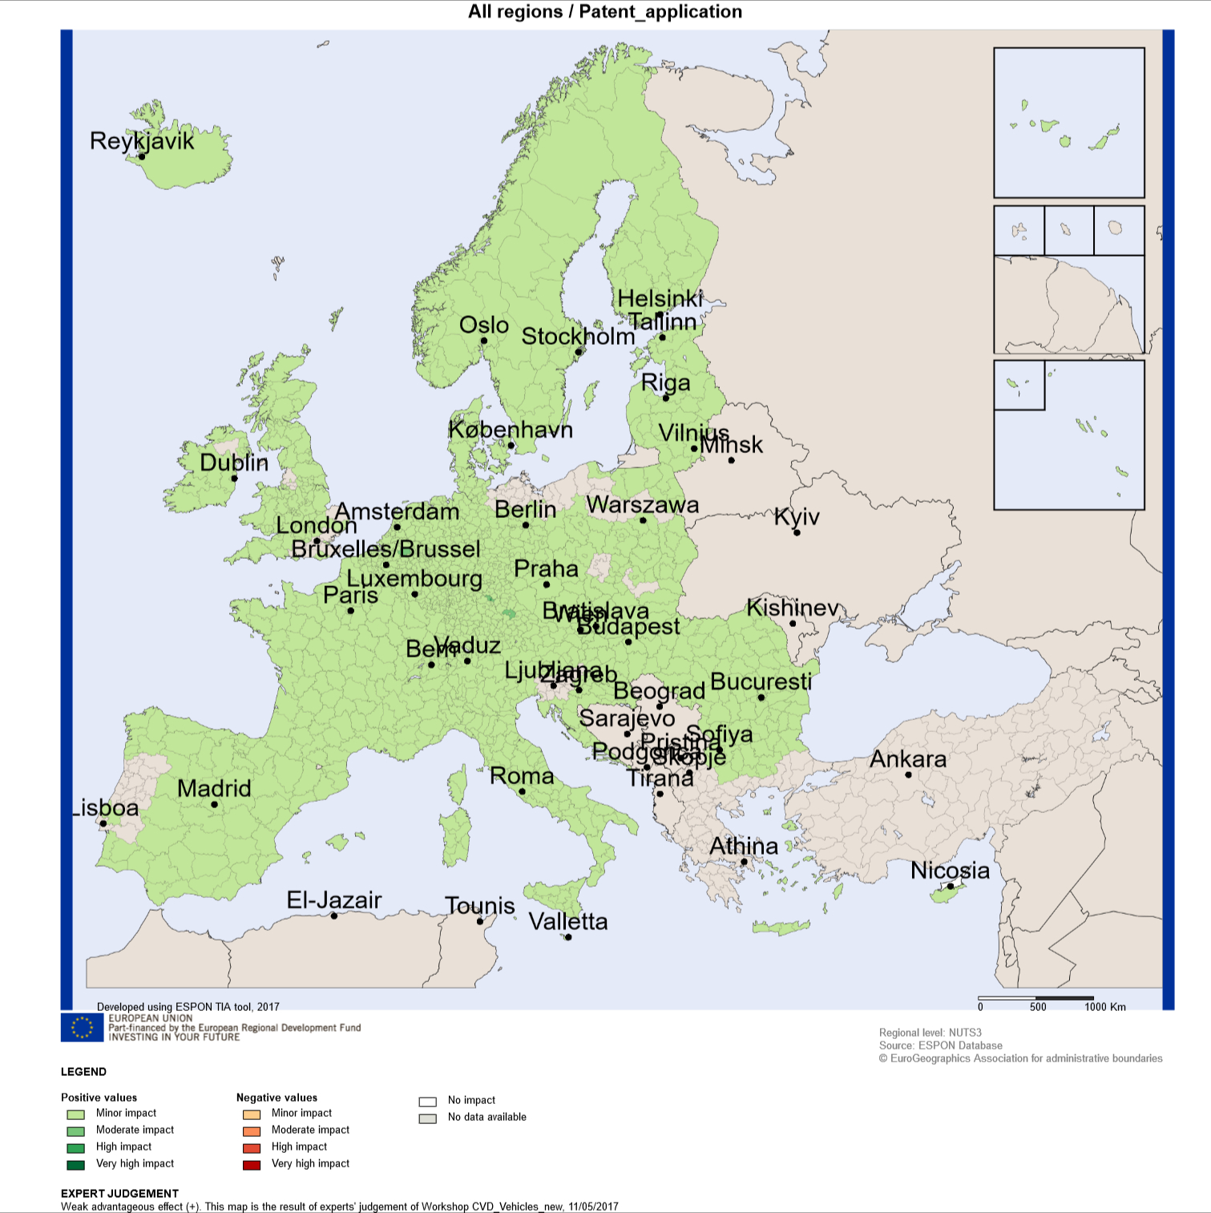

Source: Territorial impact assessment expert workshop, Brussels, 11 May 2017

### The potential territorial impact in relation to the patent applications indicator

Another indicator that the experts considered relevant in the analysis of the potential territorial impacts from the revision of CVD is the number of patent applications. However the judgement of the experts was quite diverse. A majority of 8 experts judged the effect as weakly advantageous, 5 as neutral an 1 even as weakly disadvantageous.[2]

Figure 18.5: Workshop findings: Expert judgement: Effect of the modification of the Clean Vehicles Directive



Source: Territorial impact assessment expert workshop, Brussels, 11 May 2017

The indicator picturing the sensitivity of a region according to patent applications is measuring“total patent applications to the EPO per million inhabitants”. It is assumed that regions with higher levels of patent applications are expected to have a higher capability of inventing new technology. Therefore they are considered to be more sensitive to directives influencing the levels of patent applications.

The following map shows the potential territorial impact of the revision of the CVD based on the R&D climate. It combines the expert judgement of a weakly advantageous effect with the given sensitivity of regions. The effect is distributed quite equally: More of 99% of the regions would gain a minor positive impact.

Map 18.12: Result of the expert judgement: Patent applications/mio inhabitants affected by the revision of the Clean Vehicles Directive – expert judgement: weak advantageous effect

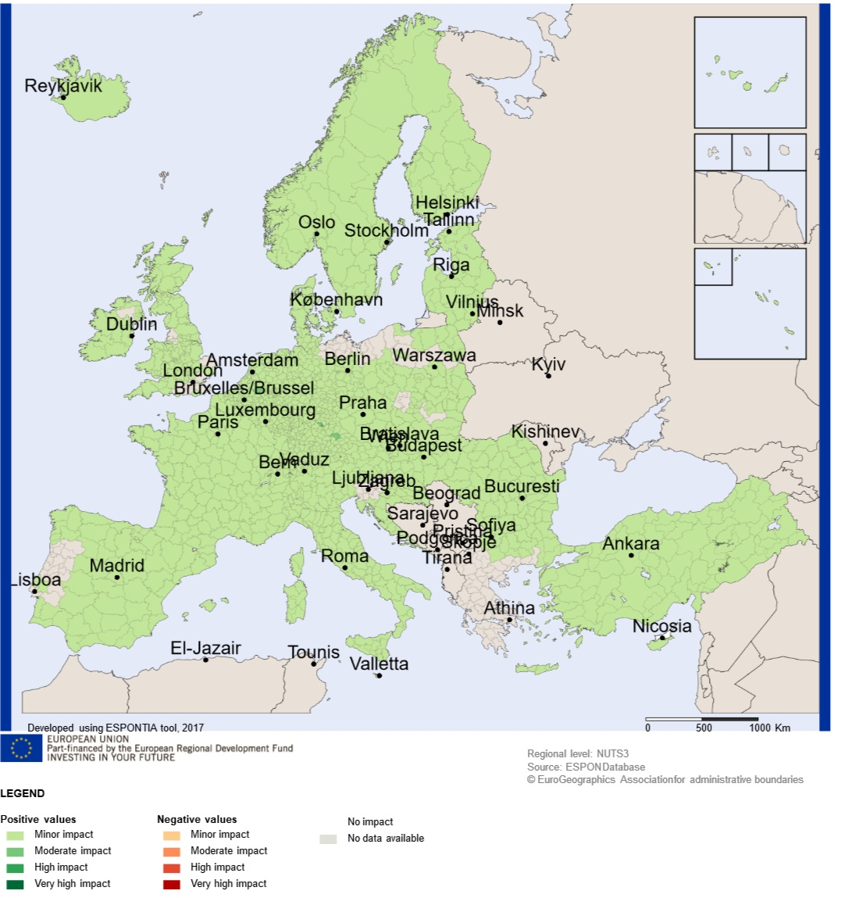

Source: Territorial impact assessment expert workshop, Brussels, 11 May 2017

## Results of the TIA quick check: Potential territorial impact based on societal aspects

### The potential territorial impact in relation to the number of people exposed to noise indicator

The experts assumed that the modification of the CVD will reduce noise caused by transport. Consequently eight experts voted for a strongly advantageous effect, six for a weakly advantageous effect. Four did not see a relevant effect of the CVD on people exposed to noise.

Figure 18.6: Workshop findings: Expert judgement: Effect of the modification of the Clean Vehicles Directive



Source: Territorial impact assessment expert workshop, Brussels, 11 May 2017

The indicator picturing the sensitivity of a region according to the exposure to noise is measured by a proxy-indicator referring to land use that is usually generating noise (area of Corine Landcover level 2 classes 12 (“Industrial, commercial and transport units”) and 13 (“Mine, dump and construction sites”). Based on the fact that only 4 out of the 22 experts did not vote this indicator was considered as very relevant a relevant As this indicator is covering different sources of noise and does not reflect on transport noise directly no further analysis and mapping seems to be useful. Results of the TIA quick check: Potential territorial impact based on governance aspects

## Results of the TIA quick check: Potential territorial impact based on governance aspects

### The potential territorial impact in relation to the government effectiveness indicator

The experts consider that an efficient and correct implementation of the revised Clean Vehicles Directive could contribute to establish better guidance to regions on how to improve procurement. Especially regions with an existing high potential to manage such challenges will gain a positive effect on government effectiveness. Nevertheless, there is the possibility that procurement procedures following the new requirements of the CVD could be more complicated and increase the procurement costs and administration. The question of governance design is of central relevance.

This ambiguous effect is mirrored in the expert judgement. 7 experts judged the effect of the modification of the CVD as weakly advantageous, whereas 3 judged them as weakly and 1 as strongly disadvantageous. Six experts judged the effects as unclear or neutral.[3]

Figure 18.7: Workshop findings: Expert judgement: Effect of the modification of the Clean Vehicles Directive



Source: Territorial impact assessment expert workshop, Brussels, 11 May 2017

The sensitivity of government effectiveness is measured by the indicator being part of the Regional Competiveness Index. Regions with low government effectiveness will benefit more from the implementation of new standards of administration than regions that already have high standards of their administration.

The following map shows the potential territorial impact of the modification of the CVD on government effectiveness combining the expert judgement of the weakly advantageous effect with the corresponding sensitivity. Eastern European regions in Latvia, Lithuania, Poland, Romania and Bulgaria as well as Italian and Greek regions and some Spanish regions could gain a moderately to highly positive impact on government effectiveness. Most of the other regions would gain a minor positive impact**.**

Map 18.13: Result of the expert judgement: Government effectiveness affected by the revision of the Clean Vehicles Directive – expert judgement: weak advantageous effect

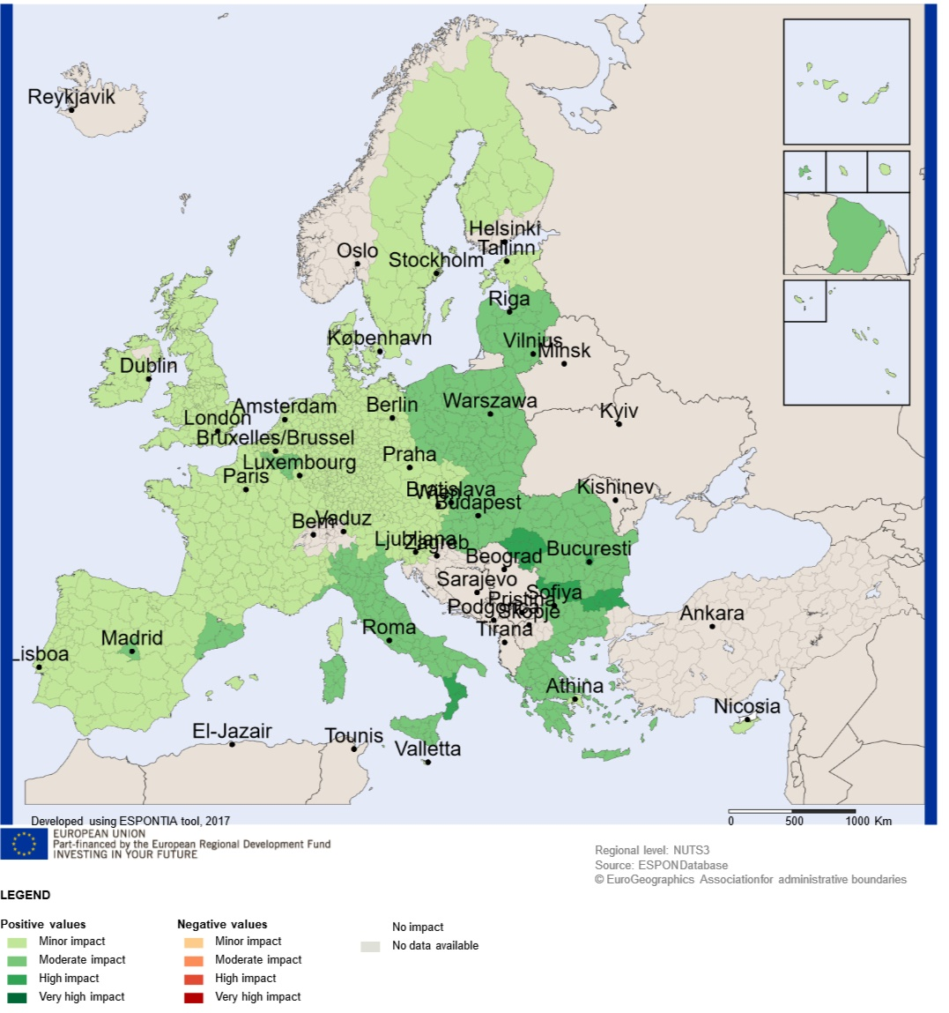

Source: Territorial impact assessment expert workshop, Brussels, 11 May 2017

## Conclusions and policy implications

### Findings based on the results of the TIA Quick check

The experts judged the effects of the revision of Directive 2009/33/EC on Clean and Energy-efficient Road Transport Vehicles – Clean Vehicles Directive predominantly positively. Three main observations can be made:

* Several effects are distributed quite equally throughout the European regions, when considering the impact on CO2 emissions, PM10 emissions or R&D climate. Concerning these aspects no strong regional distinction would be expected.
* However, there is a clear sign that for some environmental effects especially urban regions will benefit more the other regions. This can be observed by the effects on the air pollutants NOX and – to a slighter extent – PM10.
* A correct and efficient implementation of the revised Clean Vehicles Directive is expected that could contribute to establish better procurement procedures. This could support especially Eastern European regions in Latvia, Lithuania, Poland, Romania and Bulgaria as well as Italian and Greek regions and some Spanish regions to catch up in government effectiveness.

Based on the results of the TIA-tool no special effect could be detected for outermost regions.

### Findings and recommendations from the expert discussion

Based on the impact maps showing the potential territorial impact from the revision of the Clean Vehicles Directive by linking the results of the expert judgements on the effects with the sensitivity of the regions towards these effects the experts discussed on conclusions and policy implications.

Discussion about the scope of the CVD

In order to find the optimal scope of the revision of the CVD the experts deem important that following aspects should be considered:

* A clear and simple definition helps to understand the CVD better and supports its acceptance and implementation
* Very ambitious goals run the risk of non-implementation, whereas unambitious goals would cause no effects.
* A very strict regulation could also lead to a counter effect: E-mobility could get the touch of forcing and forbidding which could lead to a negative image of e-mobility in the population.
* When leasing is not covered by the revised CVD there is the danger that public authorities opt for leasing instead of buying vehicles in order to avoid the application of the CVD

Flexibility

Experts consider that wealthy regions with efficient administrations could better deal with a more strict regulation than poorer regions with less efficient administration. In addition experts expressed concerns that the poorer regions could not afford to pay more for clean vehicles. Therefore flexibility would be required. This flexibility could include e.g.:

* A minimum framework for all and a guidance for those who would like to go a step further
* A differentiation along the current status of the vehicle fleet. For an older fleet even a lower standard would be a great step forward. Here, however, impacts on complexity of the final approach would need to be considered as well.
* Transition time to public authorities to replace old fleet to meet new standards
* Transition time for producers of busses and other heavy vehicles to adjust their production
* Consider the starting point of each region. Regions in Eastern and South Europe will probably need more time, effort and money to implement reviewed CVD. Support from European Structural and Investment Funds could play a key role here.
* Consider that in remote and sparsely populated areas where the distances are longer electric vehicles will not be adequate since they will need more often recharge
* Flexibility when setting the national goals

However, great flexibility of the directive in technical terms would be a barrier for developing a European wide market for clean vehicles.

Implementation of the Clean Vehicles Directive

Experts consider that in order to implement a good practice in public procurement, a directive setting up rules should be accompanied by supporting measures. An enabling framework would be useful. The Commission faces some limitations here, as procurement legislation and practise have national and regional specifications. Support points established by the MS to integrate national, regional and local administrations could help.

Adequate financing would be also required via the EU Structural Funds to provide the necessary infrastructure such as recharging stations etc. Special consideration should be given to islands since the uptake of electric vehicles by local authorities is more difficult since in many cases there is no connection to the mainland Europe grid.

The idea that the Public Procurement Partnership under the Urban Agenda of the EU should follow the Directive as one of the Actions was also considered

## Territorial impact assessment workshop agenda

Territorial impact assessment expert workshop

**Revision of Directive 2009/33/EC on Clean and Energy-efficient Road Transport Vehicles – Clean Vehicles Directive (CVD)**

Brussels, 11 May 2017

|  |  |
| --- | --- |
| 09:30 – 10:00 | **Registration and Welcome Coffee** |
| 10:00 – 10:10 | **Welcome and introduction into the Territorial Impact Assessment**  Eleftherios StavropoulosUnit Inclusive Growth, Urban and Territorial Development, DG REGIO |
| 10:10-10:20 | **Tour de table – Getting to know the experts** |
| 10:20 – 10:45 | **Presentation of the Revision of Directive 2009/33/EC on Clean and Energy-efficient Road Transport Vehicles – Clean Vehicles Directive (CVD) Main issues – Policy Options**  Axel Volkery, DG MOVE |
| 10:45 – 11:00 | **ESPON TIA Quick Scan tool**  Erich Dallhammer, Austrian Institute for Regional Studies and Spatial Planning |
| 11.00 – 12:30 | Interactive discussion on potential benefits of **Revision of CVD** with respect to the development of different territories of the EU  § Discussing cause/effect chains  § Defining the types of regions affected and estimating the intensity of the regional exposure |
| 12:30 – 13:30 | Lunch Break |
| 13:30 – 14:30 | Interactive discussion on potential benefits of **Revision of CVD** with respect to the development to the development of different territories of the EU  § Discussion on the findings, results and hypothesis |
| 14:30 – 15:30 | **Policy recommendations** |
| 15:30 – 15:45 | **Summing up the results, feedback, discussion on options for further improvements** |

## Description of the indicators used and regional sensitivity

Following the interactive discussion among experts, the following indicators were selected and introduced into the ESPON TIA Quick Check model:

Emissions of CO2 per capita (tonnes)

|  |  |
| --- | --- |
| Definition of sensitivity | Regions with higher Emissions of CO2 per capita (tonnes) are considered to be more sensitive to directives aimed at its reduction. |
| Description | Spatial distribution of CO2 (Carbon dioxide) emissions in tonnes/year per capita |
| Source | JRC, GAINS model |
| Reference year | 2020 |
| Original Indicator  Spatial Reference | NUTS2, 2013 |

Emissions of NOx per capita (tonnes)

|  |  |
| --- | --- |
| Definition of sensitivity | Regions with higher Emissions of NOx per capita (tonnes) are considered to be more sensitive to directives aimed at its reduction. |
| Description | Spatial distribution of NOx (Nitrogen oxides) emissions in kilotonnes/year per capita |
| Source | JRC, GAINS model |
| Reference year | 2020 |
| Original Indicator  Spatial Reference | NUTS2, 2013 |

##### Air pollutants (PM10)

|  |  |
| --- | --- |
| Definition of sensitivity | Regions showing greater concentration of air pollution are expected to benefit more from directives aimed at its reduction. |
| Description | particular matter (PM10) |
| Source | 5th Cohesion Report |
| Reference year | 2009 |
| Original Indicator  Spatial Reference | NUTS3, 2010 |

R&D Climate (R&D expenditure)

|  |  |
| --- | --- |
| Definition of sensitivity | Regions with greater share of enterprises engaged in product and/or process innovation activities are considered to be more sensitive to directives influencing innovation. |
| Description | Total intramural R&D expenditure (GERD), all sectors as a percentage of the GDP |
| Source | EUROSTAT |
| Reference year | 2011 |
| Original Indicator  Spatial Reference | NUTS3, 2013 |

R&D Employment

|  |  |
| --- | --- |
| Definition of sensitivity | Regions with a greater share of employment in technology and knowledge intensive sectors are considered to be more sensitive to directives influencing innovation. |
| Description | Employment in technology and knowledge-intensive sectors |
| Source | EUROSTAT, LFS |
| Reference year | 2012 |
| Original Indicator  Spatial Reference | NUTS3, 2010 |

Patent applications/mio inhabitants

|  |  |
| --- | --- |
| Definition of sensitivity | Regions with higher levels of patent applications are expected to have a higher capability of inventing new technology. Therefore they are considered to be more sensitive to directives influencing the levels of patent application. |
| Description | Total patent applications to the EPO per million inhabitants |
| Source | EUROSTAT |
| Reference year | 2012 |
| Original Indicator  Spatial Reference | NUTS3, 2013 |

Number of people exposed to noise

|  |  |
| --- | --- |
| Definition of sensitivity | Exposure to noise is largely dependent on the proximity to transport units. Regions with a higher share of these areas are likely to be more hit by the impacts changing the levels of noise. Therefore they are expected to benefit more from directives. |
| Description | Area of Corine Landcover level 2 classes 12 (“Industrial, commercial and transport units”) and 13 (“Mine, dump and construction sites”) per inhabitant |
| Source | ESPON on CLC; OIR calculation |
| Reference year | 2006 |
| Original Indicator  Spatial Reference | NUTS3, 2010 |

Government effectiveness

|  |  |
| --- | --- |
| Definition of sensitivity | Regions with a low Regional Competiveness Index will benefit more from an improvement of the government effectiveness by implementing new standards of administration than regions that have already high standards of their administration. |
| Description | EU Regional Competiveness Index 2013 |
| Source | DG Regio project on QoG |
| Reference year | 2009 |
| Original Indicator  Spatial Reference | NUTS3, 2010 |

Definition of additional indicators

During the TIA quick check it is possible to identify additional fields of exposure, which are affected by the policy proposal and which are not provided by the tool as standard. Whereas the exposure caused by the policy proposal could be judged by the experts during the workshop, a valid indicator for describing the sensitivity of regions needs to be defined in advance. The TIA quick check offers the possibility to upload new indicators. It provides a template, where for each NUTS 3 regions the values of the indicator can be to be filled in.

For the new indicator it has to be defined, whether the exposure field needs to be evaluated as being either harmful (“cost”) or favourable (“benefit”) for the regions welfare. Then the tool will automatically transform the experts rating into numbers for further calculation (= normalisation).

Normalisation of indicators

The normalisation follows a linear procedure. Normalised values range from 0.75 up to 1.25. Basically, normalized sensitivity indicators represent coefficients that can increase (if greater than 1) or decrease (if lower than 1) each policy proposal’s impact on a specific field.

Methodology for normalisation of regional sensitivity values

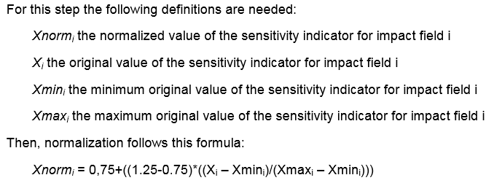

Source: ESPON TIA Quick Check Moderator’s Guide and Methodological Backgro

1. 6 out of the 22 experts did not consider this indicator as relevant
2. Based on the fact that 7 out of the 22 experts did not vote for this indicator it was considered the least relevant
3. 5 out of the 22 experts did not consider this indicator as relevant