

Contents

18.3.1. The potential territorial impact in relation to the emissions of NOx indicator 150

18.3.2. The potential territorial impact in relation to the pollutants in air (PM10) indicator 153

18.4. Results of the TIA quick check: Potential territorial impact considering economic aspects 156

18.4.1. The potential territorial impact in relation to the R&D climate indicator 156

Map 18.5: Result of the expert judgement: Emissions of CO2 per capita (tonnes)affected by the revision of the Clean Vehicles Directive – expert judgement: weakly advantageous effect

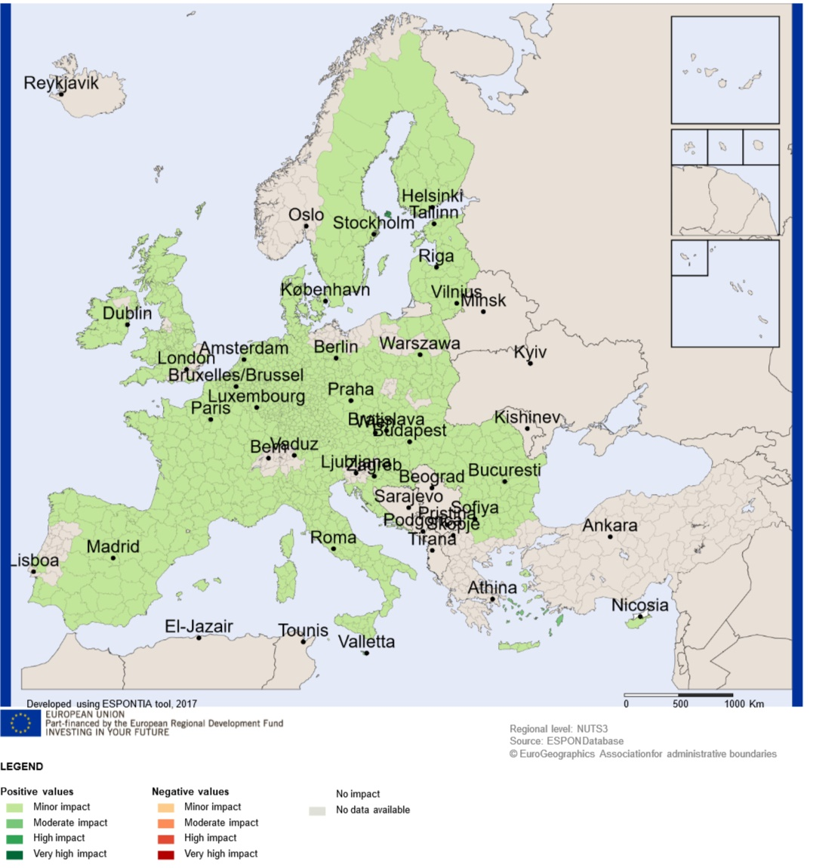

Source: Territorial impact assessment expert workshop, Brussels, 11 May 2017

### The potential territorial impact in relation to the emissions of NOx indicator

The experts saw a clearly positive effect of the revision of the Clean Vehicles Directive on the NOX emissions. Eight experts judged the effect strongly advantageous, six judged it as weakly advantageous.[1]

Figure 18.1: Workshop findings: Expert judgement: Effect of the modification of the Clean Vehicles Directive



Source: Territorial impact assessment expert workshop, Brussels, 11 May 2017

The indicator picturing the sensitivity of a region according to emissions of NOx is measured the indicator “tons of NOx per capita”. It is assumed that regions with higher Emissions of NOx per capita (tonnes) are more sensitive to directives aimed at its reduction.

The following map shows the potential territorial impact of the revision of the CVD on NOx emissions. It combines the expert judgement of a strongly advantageous effect with the given sensitivity of regions.

82% of the regions would gain a highly positive impact, 3 % even a very highly positive impact. Most of the regions are located in the environs of a great urban agglomeration as e.g. in the South of Finland, South of Copenhagen, South of Madrid, in the South of Portugal near Lisbon and North of Prague. Regions with just a moderate impact are located in more rural areas like in Romania, at the French Mediterranean coast, in the South of Italy and in the South-East of England.

In case of the expert judgement of a weakly advantageous effect the impact on the regions would respectively be lower. In this case more than 96% of the regions would just face a minor positive impact. Regions located in the environs of a great urban agglomeration, as mentioned above, would gain higher impacts.

Map 18.6 Result of the expert judgement: Emissions of NOx per capita (tonnes)affected by the revision of the Clean Vehicles Directive – expert judgement: strong advantageous effect

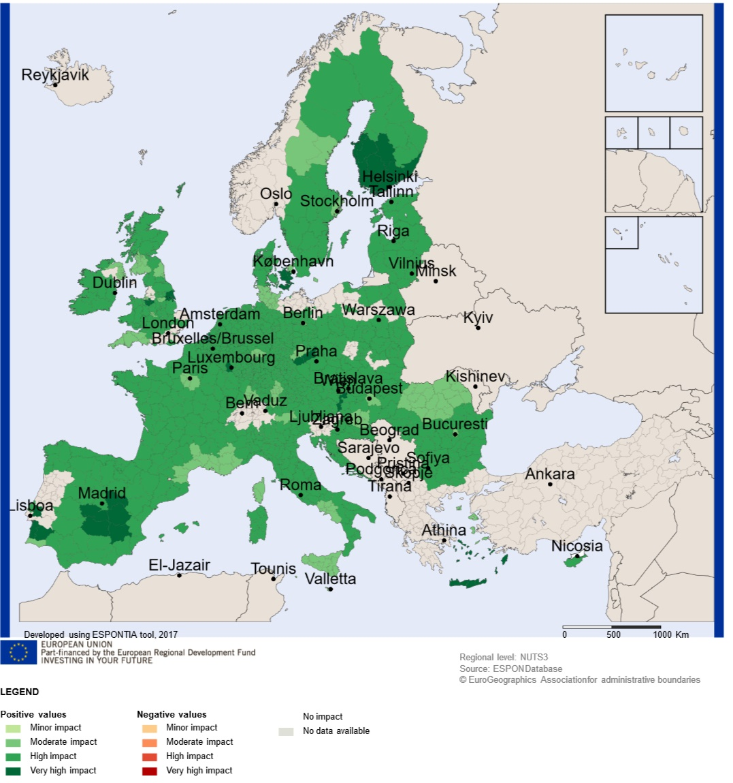

Source: Territorial impact assessment expert workshop, Brussels, 11 May 2017

Map 18.7: Result of the expert judgement: Emissions of NOx per capita (tonnes)affected by the revision of the Clean Vehicles Directive – expert judgement: strong advantageous effect

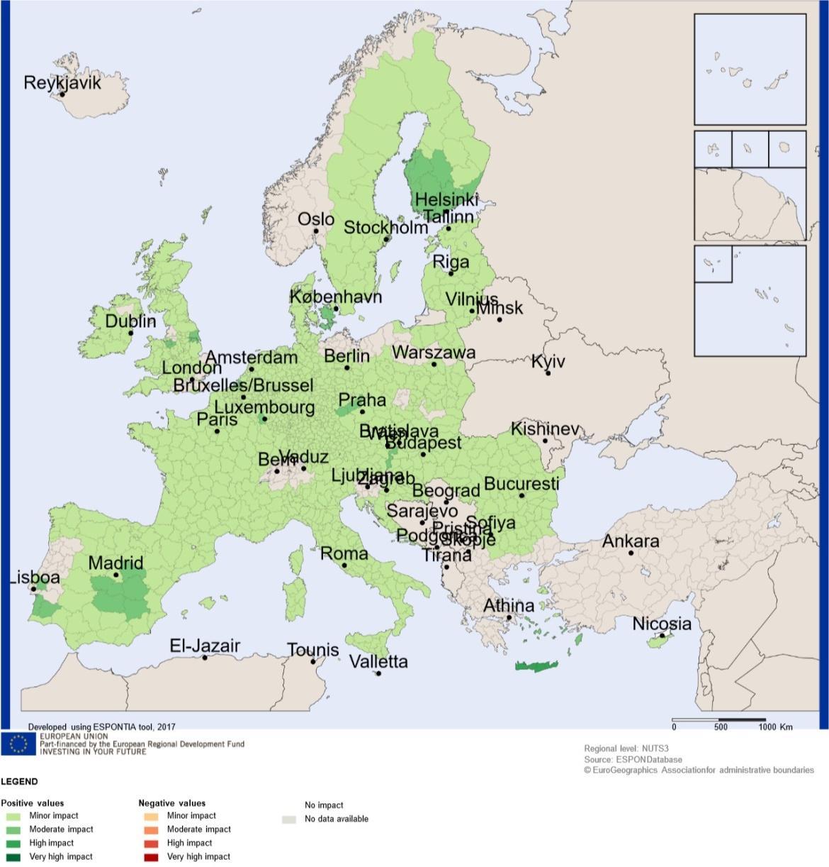

Source: Territorial impact assessment expert workshop, Brussels, 11 May 2017

### The potential territorial impact in relation to the pollutants in air (PM10) indicator

The experts concluded that there is certainly a positive effect of the revision of the Clean Vehicles Directive on pollutants in air. Eight experts out of 17 judged the effect strongly advantageous, nine experts judged it as weakly advantageous.[2]

Figure 18.2: Workshop findings: Expert judgement: Effect of the modification of the Clean Vehicles Directive



Source: Territorial impact assessment expert workshop, Brussels, 11 May 2017

The indicator picturing the sensitivity of a region according to pollutants in air is measured the indicator “concentration of air pollution PM10”. It is assumed that regions showing greater concentration of air pollution are expected to benefit more from directives aimed at its reduction.

The following map shows the potential territorial impact of the revision of the CVD when considering PM10 emissions. It combines the expert judgement of a weakly advantageous effect with the given sensitivity of regions. About 95 % of the regions would gain a minor positive impact. Several urban regions would get a moderate or even a high positive impact, as e.g. Rome, Helsinki, Lisboan, Stockholm, Budapest, Bucharest, Vienna, Copenhagen, Berlin, Hamburg, Bremen, Poznan, Warsaw etc.

In case of the expert judgement of a strongly advantageous effect the impact on the regions would be respectively higher. About 70 % of the regions would gain a moderately positive impact, 25 % a highly and 5 % a very highly positive impact. The focus on urban and metropolitan regions is even more pronounced.

Map 18.8: Result of the expert judgement: Pollutants in air (PM10) affected by the revision of the Clean Vehicles Directive – expert judgement: weak advantageous effect

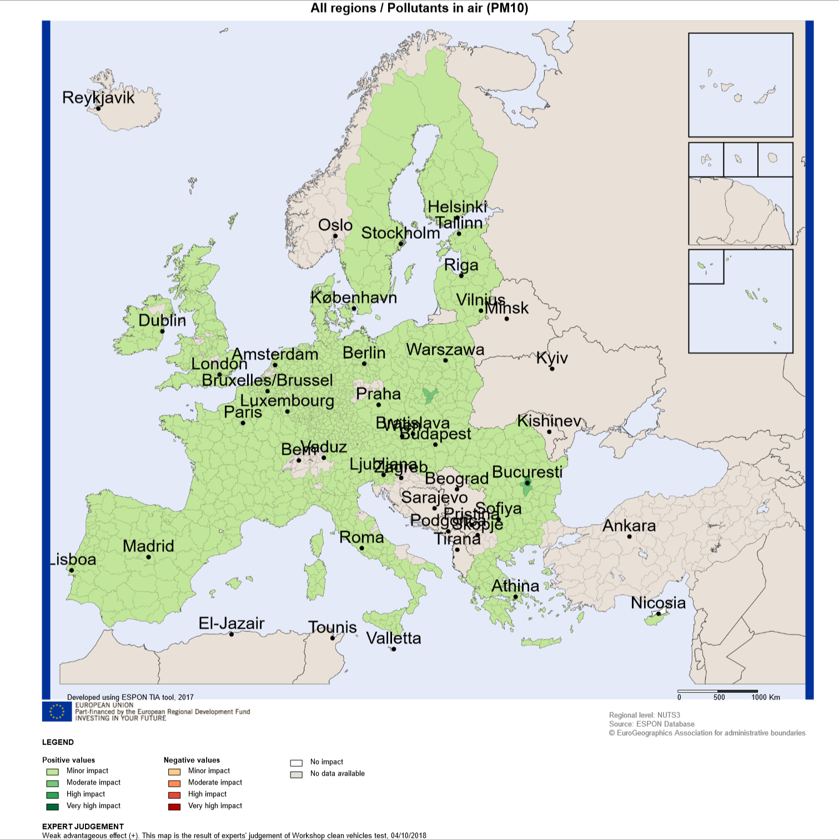

Source: Territorial impact assessment expert workshop, Brussels, 11 May 2017

Map 18.9: Result of the expert judgement: Pollutants in air (PM10) affected by the revision of the Clean Vehicles Directive – expert judgement: strong advantageous effect

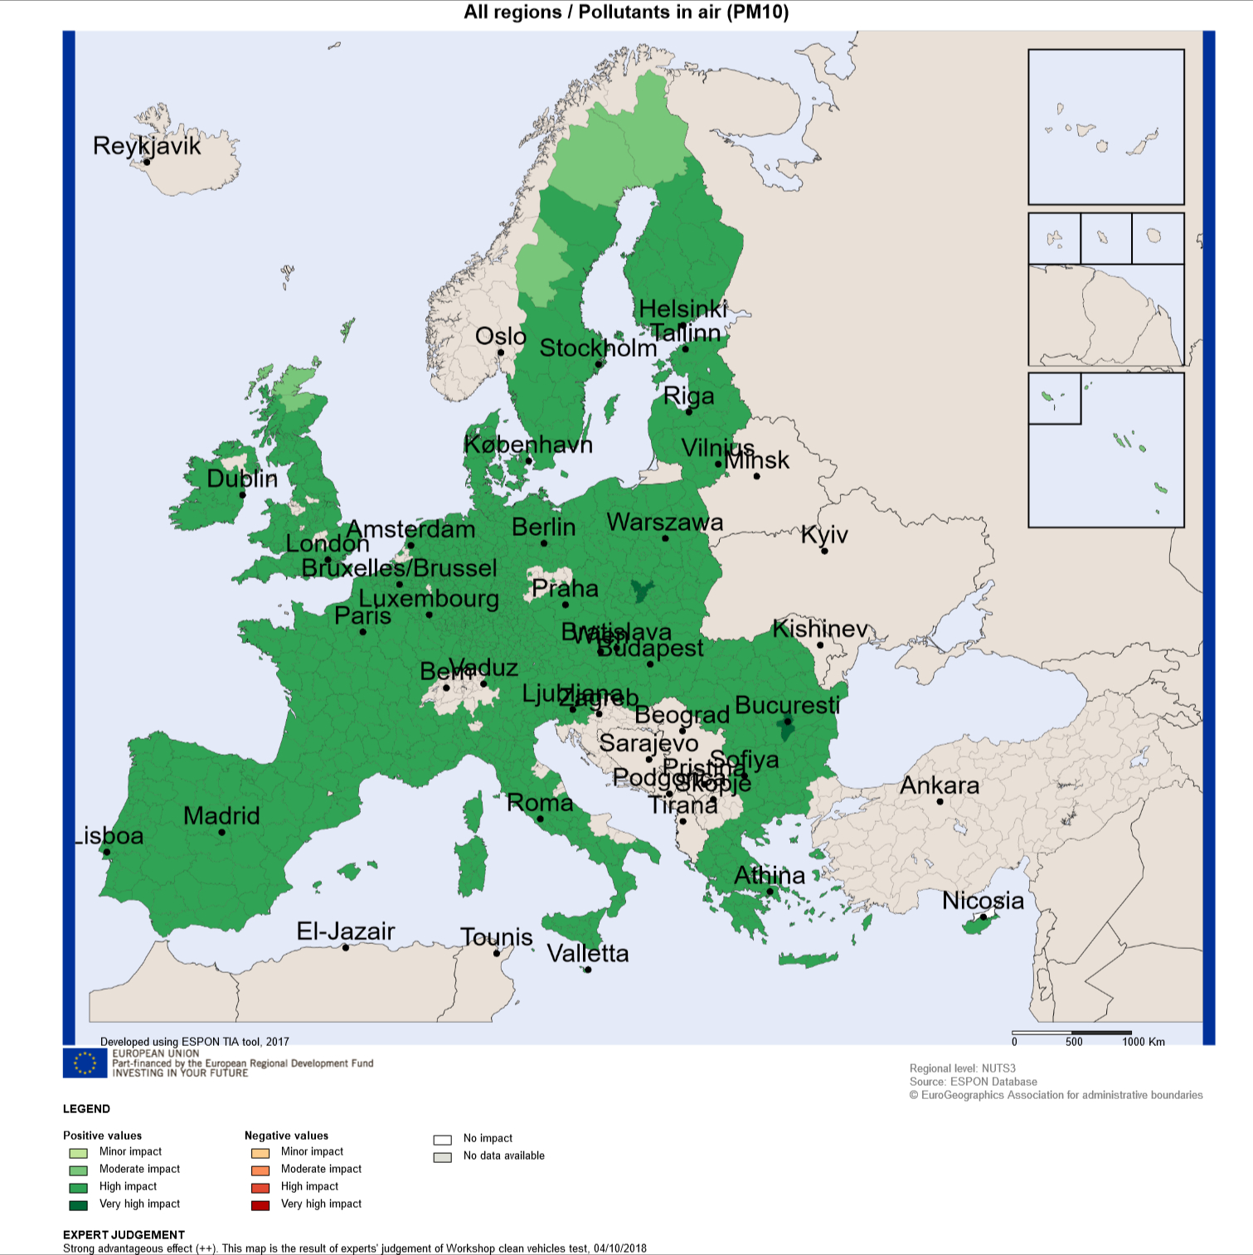

Source: Territorial impact assessment expert workshop, Brussels, 11 May 2017

## Results of the TIA quick check: Potential territorial impact considering economic aspects

### The potential territorial impact in relation to the R&D climate indicator

The experts assumed that the modification of the CVD will cause a greater demand of clean vehicles by public authorities, which can push innovation especially in heavy transport and busses. Consequently, the R&D climate would be stimulated and R&D expenditures will increase: Four experts voted for a strongly advantageous effect, eleven for a weakly advantageous effect. [3]

1. 6 out of the 22 experts did not consider this indicator as relevant
2. 5 out of the 22 experts did not consider this indicator as relevant
3. 5 out of the 22 experts did not consider this indicator as relevant