

Table of Contents

**Glossary - acronyms and definitions** 9

1 introduction 10

1.1 Policy context 10

1.2 Legal context 14

1.3 Evaluation of the implementation 15

2 WHAT IS THE PROBLEM AND WHY IS IT A PROBLEM? 17

2.1 What is the nature of the problem? What is the size of the problem? 17

2.1.1 Problem 1: Insufficient uptake of the most efficient vehicles, including low and zero emission vehicles, to meet Paris Agreement commitments and to improve air quality, notably in urban areas 19

2.1.2 Problem 2: Consumers miss out on possible fuel savings 20

2.1.3 Problem 3: Risk of losing the EU's competitive advantage due to insufficient innovation in low- emission automotive technologies over the long term 21

2.2 What are the main drivers? 23

2.2.1 Driver 1: Consumers value upfront costs over lifetime costs 23

2.2.2 Driver 2: Consumers' concerns regarding zero emission vehicles (ZEV) 25

2.2.3 Driver 3: EU standards do not provide enough incentive for further efficiency improvements and for the deployment of low and zero emission vehicles for the period beyond 2021, leading to uncertainty over future policy 26

2.2.4 Driver 4: Effectiveness of standards is reduced by growing 'emissions gap' 27

2.2.5 Driver 5: Road transport activity is increasing 27

2.3 Who is affected and how? 28

3 WHY SHOULD THE EU ACT? 28

3.1 The EU's right to act 28

3.2 What would happen without EU action? 29

3.3 Analysis of subsidiarity and added value of EU action 29

4 OBJECTIVES 31

5 WHAT ARE THE VARIOUS OPTIONS TO ACHIEVE THE OBJECTIVES? 32

5.1 Emission targets (level, timing and metric) 33

5.1.1 CO2 emission target level (TL) 34

5.1.1.1 CO2 target level for passenger cars (TLC) 34

5.1.1.2 CO2 target level for vans (TLV) 35

5.1.2 Timing of the CO2 targets (TT) 36

5.1.3 Metric for expressing the targets 37

5.2 Distribution of effort (DOE) 38

5.3 ZEV/ LEV incentives 41

5.3.1 Context 41

5.3.2 Policy options 47

5.3.2.1 LEV definition (LEVD) 47

5.3.2.2 Type and level of incentive (LEVT) 48

5.4 Elements for cost-effective implementation 50

5.4.1 Eco-innovations (ECO) 50

5.4.2 Pooling (POOL) 54

5.4.3 Trading (TRADE) 54

5.4.4 Banking and borrowing (BB) 55

5.4.5 Exemptions and derogations 56

5.4.5.1 'De minimis' exemptions' and 'small volume' derogations 57

5.4.5.2 Niche derogations for car manufacturers (NIC) 58

5.5 Governance 59

5.5.1 Real-world emissions (RWG) 60

5.5.2 Market surveillance (conformity of production, in service conformity) (MSU) 63

6 WHAT ARE THE ECONOMIC/EMPLOYMENT, ENVIRONMENTAL AND SOCIAL IMPACTS OF THE DIFFERENT POLICY OPTIONS AND WHO WILL BE AFFECTED? 66

6.1 General methodological considerations 66

6.2 Consistency with previous analytical work 68

6.3 Emission targets: metric, level and timing 69

6.3.1 Metric for expressing the targets 69

6.3.1.1 Option TM_WTW: metric for setting the targets based on Well-to-Wheel approach 69

6.3.1.2 Option TM_EMB: metric for setting the targets based on embedded emissions 70

6.3.1.3 Option TM_MIL: metric for setting the targets based on mileage weighting 72

6.3.2 Target levels for cars (TLC) and vans (TLV) 73

6.3.2.1 Introduction 73

6.3.2.2 Economic impacts (including employment) 75

6.3.2.3 Social Impacts 99

6.3.2.4 Environmental impacts 101

6.3.3 Timing of the targets (TT) 109

6.3.3.1 Option TT 1: The new fleet-wide targets start to apply in 2030. 109

6.3.3.2 Option TT 2: New fleet-wide targets start to apply in 2025, and stricter fleet-wide targets start to apply in 2030. 110

6.3.3.3 Option TT 3: New fleet-wide targets are defined for each of the years until 2030. 110

6.4 Distribution of effort (DOE) 111

6.4.1.1 Methodology and introduction 111

6.5 ZEV/ LEV incentives 117

6.5.1 Introduction and methodological considerations 117

6.5.2 Passenger cars: assessment of options with additional incentives for low-emission vehicles 118

6.5.2.1 Economic impacts 119

6.5.2.2 Social Impacts 128

6.5.2.3 Environmental impacts 129

6.5.3 Vans: assessment of options with additional incentives for low-emission vehicles 131

6.5.3.1 Economic impacts 132

6.5.3.2 Social Impacts 134

6.5.3.3 Environmental impacts 135

6.5.4 Macroeconomic impacts, including employment, of setting LEV incentives for cars and vans 137

6.5.4.1 Introduction and methodological considerations 137

6.6 Elements supporting cost-effective implementation 142

6.6.1 Eco-innovations (ECO) 142

6.6.1.1 Future review and possible adjustment of the cap on the eco-innovation savings (Option ECO 1) 142

6.6.1.2 Extend the scope of the eco-innovation regime to include mobile air-conditioning (MAC) systems including a future review and possible adjustment of the cap on the eco-innovation savings (Option ECO 2) 143

6.6.2 Pooling (POOL) 143

6.6.2.1 Change nothing (Option POOL 0) 143

6.6.2.2 An empowerment for the Commission to specify the conditions for open pool arrangements (Option POOL 1) 144

6.6.3 Trading (TRADE) 144

6.6.3.1 Change nothing (Option TRADE 0) 144

6.6.3.2 Introduce trading as an additional modality for reaching the CO2 targets and/or LEV mandates (Option TRADE 1) 144

6.6.4 Banking and borrowing (BB) 145

6.6.4.1 Change nothing (Option BB 0) 145

6.6.4.2 Banking only (Option BB1) 146

6.6.4.3 Banking and borrowing (Option BB 2) 147

6.6.5 Niche derogations for car manufacturers (NIC) 147

6.6.5.1 Change nothing (Option NIC 0) 147

6.6.5.2 Set new derogation targets for niche manufacturers (Option NIC 1) 148

6.6.5.3 Remove the niche derogation (Option NIC 2) 149

6.7 Governance 150

6.7.1 Real-world emissions (RWG) 150

6.7.1.1 Change nothing (Option RWG 0) 150

6.7.1.2 Option RWG 1: Collection, publication, and monitoring of real world fuel consumption data 150

6.7.2 Market surveillance (conformity of production, in service conformity) (MSU) 151

6.7.2.1 Option MSU 0 – no change 151

6.7.2.2 Option MSU 1: Obligation to report deviations and the introduction of a correction mechanism 152

7 Comparison of options 153

7.1 Emission targets 156

7.1.1 Emission target - Metric 156

7.1.2 Emission targets – timing 156

7.1.3 Emission targets – level for cars 157

7.1.4 Emission targets – level for vans 159

7.2 Distribution of efforts (cars and vans) 159

7.3 ZEV / LEV incentives 160

7.3.1 ZEV / LEV incentives for cars 160

7.3.2 ZEV/LEV incentives for vans 163

7.4 Elements supporting cost-effective implementation 164

7.4.1 Eco-innovations 164

7.4.2 Pooling 164

7.4.3 Trading 164

7.4.4 Banking and borrowing 164

7.4.5 Niche derogations for car manufacturers 165

7.4.6 Simplification (REFIT aspects) 165

7.5 Governance: real-world emissions – market surveillance 165

8 How would impacts be monitored and evaluated? 167

8.1 Indicators 167

8.2 Operational objectives 168

**List of figures**

Figure 1: Overview of interlinkages between this initiative and other climate, energy and transport related initiatives at EU level 12

Figure 2: Drivers, problems and objectives 18

Figure 3: GHG emissions from cars and vans (1990-2015) 19

Figure 4: Historical fleet CO2 emissions performance and current standards (gCO2/km normalized to NEDC) for passenger cars (ICCT, 2017) 22

Figure 5: EU-wide fleet target level trajectories for new cars under the different TLC options 35

Figure 6: EU-wide fleet target level trajectories for new vans under the different TLV options 36

Figure 7: Battery costs (USD/kWh) and battery energy density (Wh/L) 42

Figure 8: Evolution of Li-ion battery costs (USD/kWh) 43

Figure 9: Projected trend of greenhouse gas emissions from road transport between 2005 and 2030 under the baseline 68

Figure 10: Passenger car fleet powertrain composition (new cars) in 2025 and 2030 under different TLC options 74

Figure 11: Van fleet powertrain composition (new vans) in 2025 and 2030 under different TLV options 75

Figure 12: Net economic savings over the vehicle lifetime from a societal perspective in 2025 and 2030 (EUR/car) 78

Figure 13: TCO-15 years (vehicle lifetime) (net savings in EUR/car in 2025 and 2030) 79

Figure 14: TCO-first user (5 years) (net savings in EUR/car in 2025 and 2030) 80

Figure 15: Final energy demand (ktoe) for passenger cars over the period 2020-2040 under different TLC options 81

Figure 16: Share (%) of different fuel types in the final energy demand for cars (entire fleet) under different TLC options - 2025 and 2030 82

Figure 17: Net economic savings over the vehicle lifetime from a societal perspective in 2025 and 2030 (EUR/van) 86

Figure 18: TCO-15 years (vehicle lifetime) in 2025 and 2030 (net savings in EUR/van) 87

Figure 19: TCO-first user (5 years) in 2025 and 2030 (net savings in EUR/van) 88

Figure 20: Final energy demand (ktoe) for vans over the period 2020-2040 under different TLV options 89

Figure 21: Share (%) of different fuel types in the final energy demand for vans (entire fleet) under different TLV options –2025 and 2030 90

Figure 22: TCO-second user (years 6-10) (EUR/car) – 2025 and 2030 100

Figure 23: TCO-second user (years 6-10) (EUR/van) – 2025 and 2030 101

Figure 24: (Tailpipe) CO2 emissions of passenger cars in EU-28 - % reduction compared to 2005 102

Figure 25: Cumulative (tailpipe) 2020-2040 CO2 emissions of cars for EU-28 – emission reduction from the baseline (kt) 103

Figure 26: (Tailpipe) CO2 emissions of vans in EU-28 - % reduction compared to 2005 105

Figure 27: Cumulative (tailpipe) 2020-2040 CO2 emissions of vans for EU-28 – emission reduction from the baseline (kt) 105

Figure 28: Evolution of GHG emissions between 2005 (100%) and 2030 under the *EUCO30* scenario and under the baseline and different policy options for the CO2 target levels for new cars and vans considered in this impact assessment 107

Figure 29: Additional manufacturing costs (EUR/car) for categories of passenger car manufacturers under different options DOE and with the EU-wide fleet CO2 target levels as in option TLC30 114

Figure 30: Additional manufacturing costs relative to vehicle price (% of car price) for categories of passenger car manufacturers under different options DOE and with the EU-wide fleet CO2 target levels as in option TLC30 114

Figure 31: Additional manufacturing costs (EUR/van) for categories of van manufacturers under different options DOE and with the EU-wide fleet CO2 target levels as in option TLV40 115

Figure 32: Additional manufacturing costs relative to vehicle price (% of van price) for categories of van manufacturers under different options DOE and with the EU-wide fleet CO2 target levels as in option TLV40 115

Figure 33: TCO-15 years (vehicle lifetime) (net savings in EUR/car for 2025 and 2030) for different LEV incentive options 121

Figure 34: Illustration of the impacts of option LEVT_CRED2 (net savings, TCO-15 years) in case the LEV benchmark is not exactly met (with the CO2 target of option TLC30 and the benchmark of option LEV%_A) 124

Figure 35: Illustration of the impacts of option LEVT_CRED1 (net savings, TCO-15 years) in case the LEV benchmark is not exactly met (with the CO2 target of option TLC30 and the benchmark of option LEV%_A) 125

Figure 36: TCO-second user (years 6-10) (EUR/car) in 2025 and 2030 for different LEVD/LEVT options 129

Figure 37: TCO- 15 years (EUR/van) in 2025 and 2030 for different LEVD/LEVT options 133

Figure 38: TCO-second user (years 6-10) (EUR/van) in 2025 and 2030 for different LEVD/LEVT options 135

**Glossary - acronyms and definitions**

ACEA Federation of European Car Manufacturers

BEV Battery Electric Vehicle

CNG Compressed Natural Gas

CO2 Carbon dioxide

EMIS Emission Measurements In the automotive Sector (Committee of the European Parliament)

ESR Effort Sharing Regulation

ETS EU Emission Trading System

EV Electric Vehicle: covers BEV, FCEV and PHEV

FCEV Fuel Cell Electric Vehicle

FCM Fuel Consumption Measurement

GDP Gross Domestic Product

GHG Greenhouse gas(es)

HDV Heavy-Duty Vehicles, i.e. lorries, buses and coaches (vehicles of more than 3.5 tons)

HEV Hybrid Electric Vehicle (not including PHEV)

ICEV Internal Combustion Engine Vehicle

IEA International Energy Agency

LCA Life-Cycle Assessment

LCV Light Commercial Vehicle(s): van(s)

LDV Light-Duty Vehicle(s), i.e. passenger cars and vans

LPG Liquified Petroleum Gas

LNG Liquefied Natural Gas

MAC Mobile Air Conditioning

NEDC New European Driving Cycle

NGO Non-Governmental Organisation

NOx Nitrogen oxides (nitric oxide (NO) and nitrogen dioxide (NO2))

O&M Operation and Maintenance

OECD Organisation for Economic Co-operation and Development

OBD On-Board Diagnostics

PHEV Plug-in Hybrid Electric Vehicle

PM Particulate matter

REEV Range Extended Electric Vehicle (sub-group of PHEV)

SAM Scientific Advice Mechanism

TLC CO2 Target Level for passenger Cars (policy option)

TLV CO2 Target Level for Vans (policy option)

TTW emissions "Tank-to-wheel" emissions: emissions from the vehicle tailpipe that occur during the drive cycle of vehicles.

WLTP Worldwide Harmonised Light Vehicles Test Procedure

WTT emissions "Well-to-tank" emissions: emission occurring during fuel (incl. electricity, hydrogen) production and transport

WTW emissions "Well-to-wheel" emissions: sum of TTW and WTT emissions

# introduction

## Policy context

In his **State of the Union Address 2017**[1] President Juncker put it very clearly: while the car industry is a key sector for Europe making world-class products, EU manufacturers will need to invest in the clean cars of the future in order to maintain their strong position. In addition, President Juncker stated "I want Europe to be the leader when it comes to the fight against climate change" and announced that "the Commission will shortly present proposals to reduce the carbon emissions of our transport sector".

The **automotive industry is crucial for Europe's prosperity**, providing jobs for 12 million people in manufacturing, sales, maintenance and transport and accounting for 4% of the EU's GDP[2], including in sectors such as steel, aluminium, plastics, chemicals, textiles and ICT. The EU is among the world's biggest producers of motor vehicles and demonstrates technological leadership in this sector.

EU industry, in general, and the automotive sector, in particular, are currently facing **major transformations**. Digitalization and automation are transforming traditional manufacturing proceses. Innovation in electrified power trains, autonomous driving and connected vehicles constitute major challenges which may fundamentally transform the sector.

Furthermore, following the **Paris Agreement**[3], the world has committed to move towards a low-carbon economy. Many countries are now implementing policies for low-carbon transport, including vehicle standards, often in combination with measures to improve air quality. These developments represent an opportunity for the EU automotive sector to continue to innovate and adapt in order to ensure it remains a technological leader.

The EU 2030 framework for climate and energy includes a target of an at least 40% cut in domestic EU greenhouse gas (GHG) emissions compared to 1990 levels. The emission reductions in the Emissions Trading System (ETS) and non-ETS sectors amount to at least 43% and 30% by 2030 compared to 2005, respectively. The Commission has recently proposed 2030 GHG emission reduction targets for Member States under the Effort Sharing Regulation[4] (covering the non-ETS sectors, including road transport) as well as a revised Energy Efficiency Directive[5]. CO2 standards for light-duty vehicles will help to meet the overall goals set out therein.

In addition to that, daily experience on traffic jams, the crisis over diesel cars emissions and the adoption of policy measures at local level to discorage car use in urban areas, have contributed to making EU consumers more aware of the impact of road transport on health and air quality.

**These developments take place globally** since nowadays automotive industries are increasingly integrated in global value chains. Global automotive markets are expanding faster than ever before, notably in emerging markets such as India and China. The latter, in particular, is taking full advantage of the changing automotive landscape and according to a recent report by the International International Energy Agency , in 2016 it became the country with the highest share of electric vehicles.

In addition, EU sales of passenger cars relative to global sales have decreased from 34% before the crisis (2008/2009) to 20% today. This means that EU industry will have to consider not only increasing exporting volumes but also adapting to changing demands which will require more focus on innovation to retain competitiveness.

Until now, the ambitious emission reduction standards in place in Europe have represented a fundamental tool to push for innovation and investments in low carbon technologies. **But today, the EU is no longer the clear leader in this race, with the US, Japan, South Korea and China moving ahead very quickly.**

As highlighted in the recently adopted **Renewed Industrial Policy Strategy**[6],a modern and competitive automotive industry is key for the EU economy. However, for the sector to maintain its technological leadership and thrive in global markets, it will have to accelerate the transition towards more sustainable technologies and new business models. Only this will ensure that Europe will have the most competitive, innovative and sustainable industry of the 2030 and beyond.

The Commission's Communication **'Europe on the Move**: **An agenda for a socially fair transition towards clean, competitive and connected mobility for all'**[7] makes clear that we want to make sure that the best low-emission, connected and automated mobility solutions, equipment and vehicles will be developed, offered and manufactured in Europe and that we have in place the most modern infrastructure to support them. The Communication identifies that profound changes in how we enjoy mobility are underway and that the EU must be a leader in shaping this change at a global level, building on the key progress already made.

This Communication builds on the earlier Commission's European Strategy for Low-Emission mobility[8], published in July 2016, which set out an overall vision built on three pillars: (i) moving towards zero-emission vehicles; (ii) low emission alternative energy for transport; (iii) efficiency of the transport system.

The figure below presents an overview of the interlinkages between the various initiatives of the mobility package proposed by the Commission as well as other related EU climate, energy and transport related initiatives.

By pursuing an **integrated approach** looking both at the **demand and supply** **side** and by establishing an enabling environment and a clear vision and robust regulatory framework, the EU can create an environment that provides EU industry with the certainty and clarity needed to innovate and remain competitive for the future.

Figure 1: Overview of interlinkages between this initiative and other climate, energy and transport related initiatives at EU level

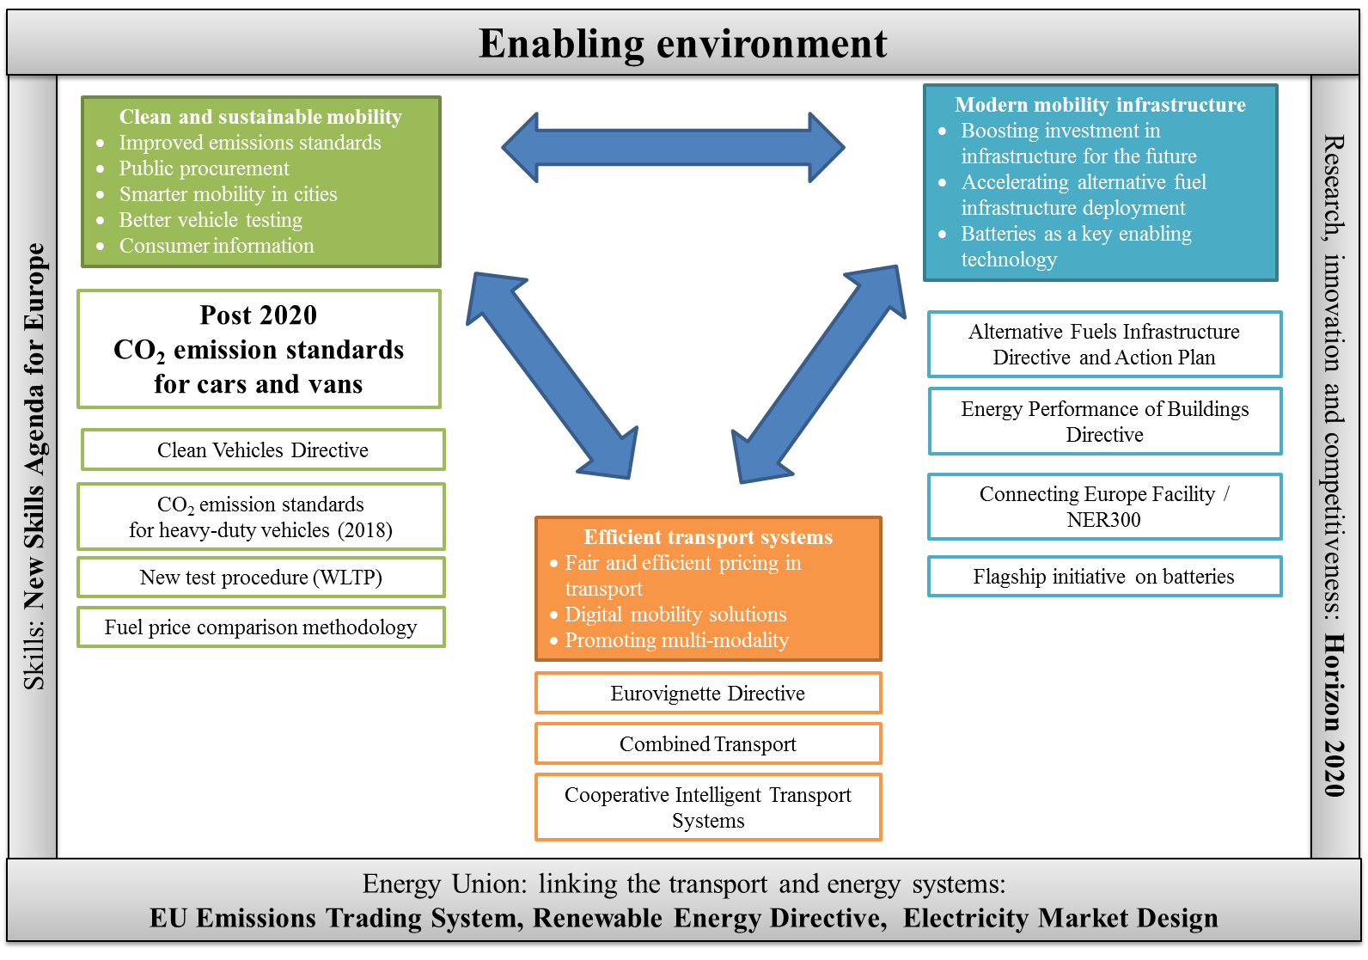

This builds on policies proposed or already implemented at national, regional and city level in the EU. Many Member States have set objectives to increase the share of zero and low emission vehicles, including both battery electric vehicles and plug-in hybrids, by 2020[9].

However, while some **Member States** have made good progress in achieving their objectives, the majority of Member States has made rather slow progress[10]. Even if the objectives were to be reached, the share of electric vehicles would remain low in the EU in relation to total vehicle registrations. Furthermore, three Member States, representing 35% of total new car registrations in the EU in 2016, have announced plans to phase out CO2 emitting cars (see Table 1).

At the same time, many **cities** in the EU have implemented regulations which limit the access of certain vehicles to urban areas. Most restrictions are within the scope of so-called Low Emission Zones which either limit the city entry of the most polluting vehicles or, in some cases, impose higher fees for such vehicles if they enter the zone. Recently some cities have even announced plans to ban diesel and/or petrol cars (see Table 1).

Table 1: Overview of announcements at national and city level to encourage the use of zero- and low-emission vehicles

|  |  |
| --- | --- |
| **Geographical coverage** | **Announcements** |
| ***Member States*** | |
| France | End the sale of new CO2 emitting cars by 2040[11] |
| Netherlands | End the sale of new CO2 emitting cars by 2030[12] |
| United Kingdom | End the sale of all new conventional petrol and diesel cars and vans by 2040[13] |
| ***Cities*** | |
| Paris (France) | Ban of diesel cars from 2024 and petrol cars from 2030[14] |
| Madrid (Spain) and Athens (Greece) | Ban of diesel cars from 2025[15] |
| Oxford (UK) | Ban of all non-electric vehicles in the city centre by 2035[16] |

A policy framework that further stimulates the accelerated uptake of zero- and low-emission vehicles would complement the on-going efforts to address air quality problems and would be well aligned with on-going action at city, regional, and national level. Zero-emission vehicles do not only reduce CO2 emissions from road transport but deliver also in terms of air pollutant and noise emission free transport.

## Legal context

The EU has in place two Regulations setting CO2 targets for new passenger cars and vans, respectively, which are based upon Article 192 of the TFEU (Environment chapter):

* **Regulation (EC) No 443/2009** setting a fleet-wide average target for new passenger cars of 130 g CO2/km from 2015 and 95g CO2/km from 2021, and
* **Regulation (EU) No 510/2011** setting a fleet-wide average target for new light commercial vehicles of 175 g CO2/km from 2017 and 147 gCO2/km from 2020.

These regulations have been amended in 2014 through Regulation (EU) No 333/2014 and Regulation (EU) No 254/2014 in order to define the modalities for implementing the 2020/2021 targets.

Both Regulations request the Commission to carry out a review by the end of 2015, and to report on it to the Council and the European Parliament, accompanied, if appropriate, by a proposal to amend the Regulations for the period beyond 2020.

The abovementioned emission targets have been set on the basis of the New European Driving Cycle (NEDC) test cycle. From 1 September 2017 on, a new regulatory test procedure, the World Harmonised Light Vehicles Test Procedure (WLTP)[17], developed in the context of the UNECE, has been introduced under the type approval legislation for determining the emissions of CO2 and the new targets will need to take this into account. Furthermore, consumer information on the fuel consumption and CO2 emission of new passenger cars under Directive 1999/94/EC should be based on WLTP as of 1 January 2019[18].

## Evaluation of the implementation

An extensive evaluation of the existing Regulations was carried out as part of REFIT. This was completed in April 2015 and the final report of the consultants has been published[19].

The evaluation report assessed the Regulations against the objectives set in the original legislation, which included providing for a high level of environmental protection in the EU and contributing to reaching the EU's climate change targets, reducing oil consumption and thus improving the EU’s energy security of supply, fostering innovation and the competitiveness of the European automotive industry and encouraging research into fuel efficiency technologies.

It concluded that the Regulations were still relevant, broadly coherent, and had generated significant emissions savings, while being more cost effective than originally anticipated for meeting the targets set. They also generated significant EU added value that could not have been achieved to the same extent through national measures. As regards impacts on competitiveness and innovation, the impacts of the Regulations were found to be generally positive.

Box 1 summarises the key outcomes in relation to the main evaluation criteria.

|  |
| --- |
| **Box 1: Key conclusions of the report on the evaluation of Regulations (EC) No 443/2009 and (EU) No 510/2011 ('the Regulations')**  ***Relevance***   * The Regulations are still valid and will remain so for the period beyond 2020, as:   + all sectors need to contribute to the fight against climate change,   + the CO2 performance of new vehicles needs to improve at a faster rate,   + road transport needs to use less oil (to improve the security of energy supply), and   + CO2 reductions must be delivered cost-effectively without undermining either sustainable mobility or the competitiveness of the automotive industry.   ***Effectiveness***   * The Regulations have been more successful in reducing CO2 than previous voluntary agreements with industry (annual improvement rate of 3.4-4.8 gCO2/km versus 1.1-1.9 gCO2/km). * The passenger car CO2 Regulation is likely to have accounted for 65-85% of the reductions in tailpipe emissions achieved following its introduction. For light commercial vehicles (LCVs), the Regulation had an important role in speeding up emissions reductions. * Impacts on competitiveness and innovation appear generally positive with no signs of competitive distortion. * The evaluation report highlighted the following weaknesses:   + The NEDC test cycle does not adequately reflect real-world emissions and there is an increasing discrepancy between test cycle and real-world emissions performance which has eroded the benefits of the Regulations.   + The Regulations do not consider emissions due to the production of fuels or associated with vehicle production and disposal.   + Some design elements (modalities) of the Regulations are likely to have had an impact on the efficiency of the Regulations. In particular, the use of mass as the utility parameter penalises the mass reduction as an emissions abatement option.   ***Efficiency***   * The Regulations have generated net economic benefits to society. * Costs to manufacturers have been much lower than originally anticipated as emissions abatement technologies have, in general, proved less costly than expected. For passenger cars, the ex-post average unit costs for meeting the target of 130gCO2/km are estimated at €183 per car, while estimates prior to the introduction of the Regulation ranged from €430-984 per car. For LCVs the ex-post estimate to meet the 175gCO2/km was €115 per vehicle, compared with an ex ante estimate of €1,037 per vehicle. * Lifetime fuel expenditure savings exceed upfront manufacturing costs, but have been lower than anticipated, primarily because of the increasing divergence between test cycle and real world emissions performance.   ***Coherence***   * The Regulations are largely coherent internally and with each other. * Modalities potentially weakening the Regulations, albeit with limited impacts, are the derogation for niche manufacturers, super-credits and the phase-in period (cars).   ***EU added value***   * The harmonisation of the market is the most crucial aspect of EU added-value and it is unlikely that uncoordinated action would have been as efficient. The Regulations ensure common requirements, thus minimising costs for manufacturers, and provide regulatory certainty. |

The evaluation report included some recommendations that would ensure the Regulations remain relevant, coherent, effective and efficient, including:

* With respect to relevance, a potential additional need to be considered for the post 2020 legislation is that road transport needs to use less energy. Hence, energy efficiency would become a more important metric as the LDV fleet moves to a more diverse mix of powertrains
* Concerning effectiveness, the most significant weakness identified was the current (NEDC) test cycle causing an increasing discrepancy between real-world and test cycle emissions, which has eroded a significant portion of the originally expected benefits of the Regulations. This will be largely addressed by the development of WLTP. In addition, sufficient checks are recommended to ensure that the new test does not in future years become subject to the same problems experienced with the NEDC.
* While the lack of consideration of the lifecycle and embedded emissions of vehicles was seen as a relatively minor issue, it was expected to become more significant as the proportion of electric vehicles increases.
* As regards additional incentives to develop low CO2 emission vehicles, it should be considered whether such mechanism is needed and, if so, to choose one that does not potentially weaken the target.
* A need to look at how to improve the ex-ante assessment of costs to manufacturers as the costs assumed prior to the introduction of the current Regulations were much higher than has been the case in reality.

These recommendations are addressed when presenting the policy options in Section 5.

# WHAT IS THE PROBLEM AND WHY IS IT A PROBLEM?

Figure 1 sets out the drivers, problems and objectives that are relevant for the revision of CO2 standards for cars and vans.

While the revision will clearly contribute to all three policy objectives, it should also be clear that it does not aim to address all of the problems and drivers mentioned to the same extent. For this, complementary proposals and flanking measures will be taken, some of are scheduled to be part of the same package of mobility related initiatives. This concerns in particular the EU Action Plan on the Alternative Fuels Infrastructure Directive (limited infrastructure), the proposal for a revised Clean Vehicles Directive 2009/33/EC, as well as the proposal for a revised Directive on road charging ("Eurovignette").

The Commission is also preparing a proposal for setting CO2 standards for heavy-duty vehicles, which would further help to tackle CO2 emissions in the road transport sector.

Beside this, there are a number of areas where complementary Member State or local action would help to tackle the drivers and problems, e.g. through tax measures (in order to help lowering upfront costs, especially for zero- and low-emission vehicles), and measures promoting modal shift (i.e. lowering road transport activity.

A key driver to be addressed by this impact assessment is the lack of stringency of the existing CO2 standards for the period beyond 2021 and the related uncertainty over future standards. Other drivers are addressed to a different degree in the policy options set out in Section 5. Clarifying the policy framework beyond 2021 will help reducing manufacturers' uncertainty over costs and future investment decisions as well as tackling certain market failures. Creating a market demand for more efficient vehicles will also help to reduce upfront costs. In addition, the 'emissions gap' will be addressed.

By contrast, limited infrastructure and increasing transport activity are not directly tackled by the options considered in this impact assessment.

## What is the nature of the problem? What is the size of the problem?

An overview of the problems and drivers is presented in Figure 2.

Figure 2: Drivers, problems and objectives

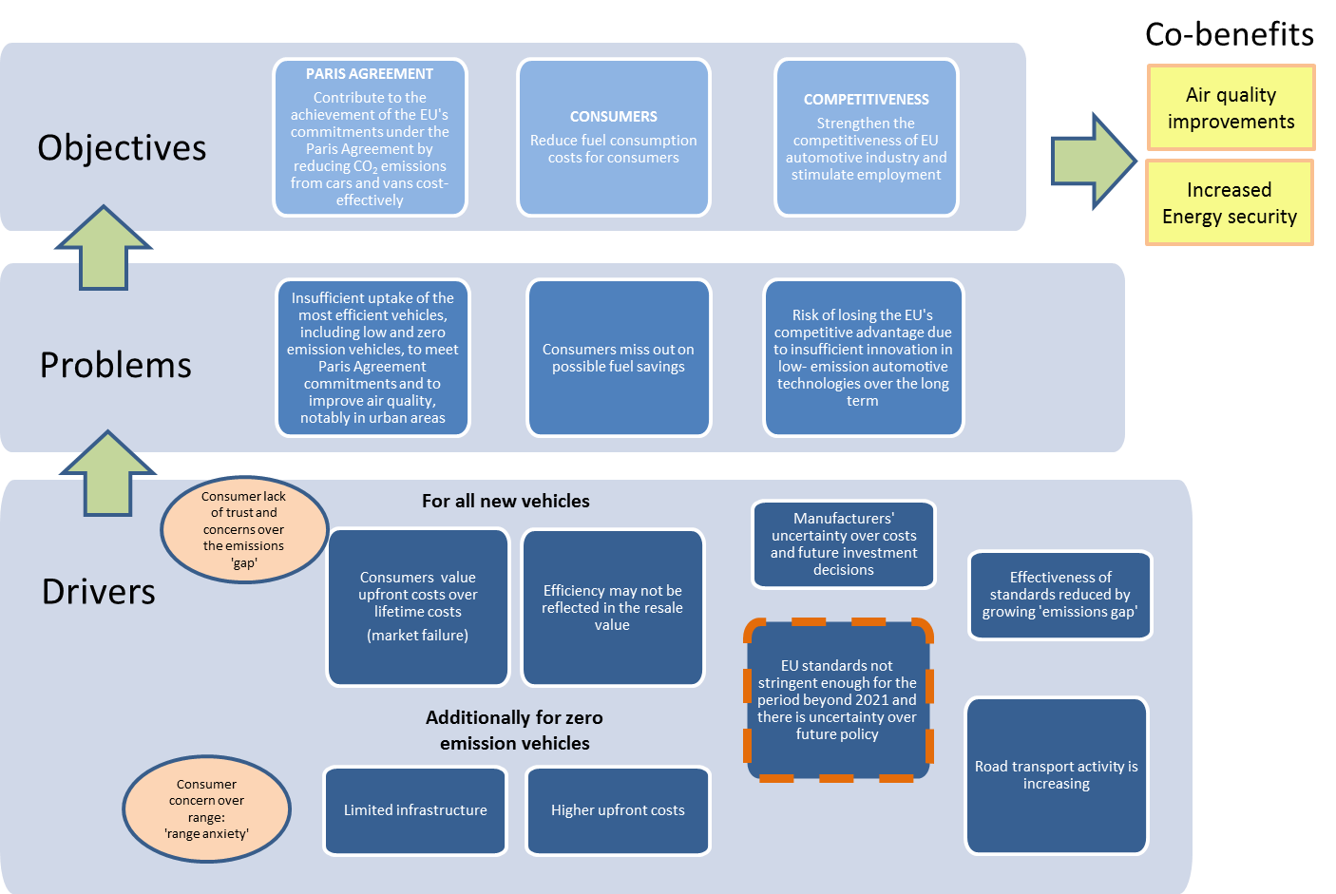

### Problem 1: Insufficient uptake of the most efficient vehicles, including low and zero emission vehicles, to meet Paris Agreement commitments and to improve air quality, notably in urban areas

The evaluation of the CO2 Regulations showed that the CO2 standards have stimulated the uptake of more efficient vehicle technologies, but it also highlighted that the CO2 performance of new vehicles needs to improve at a faster rate in order to achieve the Union's climate goals of at least 40% emissions reduction, as committed under the Paris Agreement, in a cost-effective way. As confirmed in the European Strategy for Low-Emission Mobility, greenhouse gas emissions from transport will need to be at least 60% lower than in 1990 and be firmly on the path towards zero.[20] With current trends in new vehicles' CO2 emissions, this cannot be achieved. More specifically, the uptake of LEV and ZEV is still very slow. In 2016, battery electric vehicles (BEV) and plug-in hybrid electric vehicles (PHEV) represented only 1.1% of the new EU car fleet (for BEV the share was only 0.41%).[21]

Road transport was responsible for 22%[22] of EU GHG emissions in 2015 with a steady increase since 1990 when the share was 13%. GHG emissions from cars and vans accounted for 73% of road transport emissions in 2015; this share has remained more or less constant since 1990.

Figure 3 shows that CO2 emissions from cars and light commercial vehicles in 2015 were still 19% higher than in 1990, despite the decrease observed between 2007 and 2013. While the increase in the share of transport emissions of EU GHG emission may be due to the emissions reduction in other sectors, the evolution of GHG emissions from cars and vans shows a steady increase since 1990 with the exception of the period between 2007 and 2013 when emissions were reduced.

**Figure 3: GHG emissions from cars and vans (1990-2015)[23]**

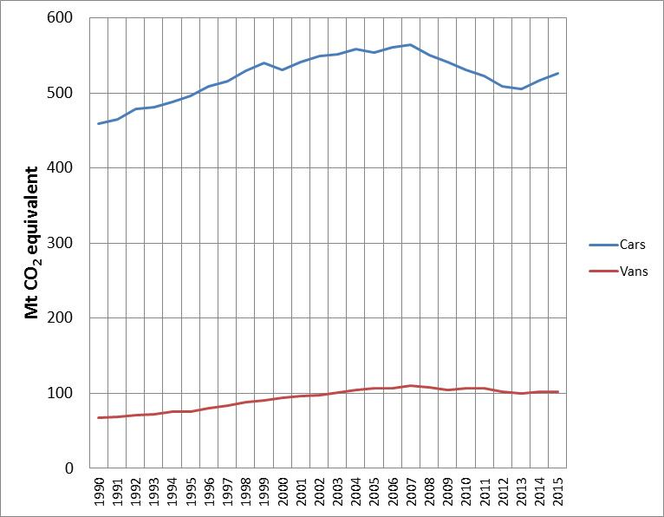

While the transport sector has considerably reduced its emissions of air pollutants in the EU over the last decades, it is the largest contributor to NOx emissions (46% in total NOx emissions in the EU in 2014). Of the total emitted NOx from road transport, around 80% comes from diesel powered vehicles. In addition, the transport sector makes an important contribution to the concentration of particulate matter in the atmosphere (13% for PM10 and 15% for PM2.5).[24]

EU air quality legislation[25] sets limit and target values for the concentration of a range of harmful air pollutants in ambient air in order to limit the exposure of citizens. Today, the limit values for NO2 are being exceeded in over 130 cities across 23 Member States and the Commission has initiated legal action against 12 Member States.

The public debate on the announcement of possible "diesel bans" in some major cities has significantly affected the share of diesel vehicles in new car registrations. For instance, in March 2017 a 5-year low in new diesel car registrations was recorded in France, Germany, Spain, and the UK. These Member States represent together almost 60% of new car registrations in the EU.[26]

In the EU as a whole the share of diesel in new car registrations decreased from a peak of 53% in 2014 to 49% in 2016. At the same time the share of new petrol cars increased from 44% in 2014 to 47%. [27]

While urban access restrictions contribute to a shift from diesel to petrol with benefits in terms of lower air pollutant emissions, so far they have not triggered a significant increase in low- and zero-emission vehicles. Although new registrations of battery electric and plug-in hybrid vehicles increased by 46% by July 2017 compared to the same period in 2016, their share in total car registrations in the EU remains low at 1.2% of which 46% were battery electric vehicles[28].

A policy framework that further stimulates the accelerated uptake of zero- and low-emission vehicles would therefore complement the on-going efforts to address air quality problems and would be well aligned with on-going action at urban, regional, and national level. Zero-emission vehicles do not only deliver benefits in terms of air pollutant and noise emission free transport but also contribute to the reduction of CO2 emissions from road transport.

### Problem 2: Consumers miss out on possible fuel savings

In understanding potential fuel savings for consumers, including initial and subsequent vehicle purchasers it is important to understand that the current average lifetime of a car is around 15 years[29] with several ownership changes. Consumers have benefitted from net savings over a vehicle's lifetime, although relatively few consumers consider fuel consumption when purchasing a new car[30].

So far the increases in the purchase prices of more efficient vehicles, as a result of the CO2 standards, have been significantly lower than the fuel savings over the vehicle's lifetime.

According to the evaluation of the CO2 Regulations the additional purchase cost of a new car in 2013 was €183 higher compared with a 2006 vehicle due to measures to meet the CO2 standards. At the same time (discounted) fuel savings, as a result of the CO2 standards, were €1,336 for petrol cars and €981 for diesel cars over the vehicle's lifetime. Lifetime fuel expenditure savings have been lower than anticipated, primarily because of the increasing divergence between test cycle and real world emissions performance. However, even if this gap were to be reduced significantly by the introduction of the WLTP test cycle and additional governance measures (see section 5.5), there remains an important unused cost savings potential. If this potential were to be exploited through more stringent CO2 standards, consumers could benefit from even higher fuel savings. The savings are however spread differently across the vehicle's lifetime.

An analysis of second hand car and van markets and implications for the cost effectiveness and social equity of light-duty vehicles CO2 regulations[31] shows that subsequent owners of a vehicle, who on average belong to lower income groups, proportionally benefit more from fuels saving than first vehicle owners. The initial cost for the more efficient vehicle is borne by the first owner. This depends however strongly on the initial price premium for the more efficient vehicle.

### Problem 3: Risk of losing the EU's competitive advantage due to insufficient innovation in low- emission automotive technologies over the long term

The EU automotive sector is crucial to the EU economy, including in terms of the number of direct and indirect jobs it provides. It faces global competition in terms of sales to other markets and, increasingly, from non-EU manufacturers within the EU market. The import of motor vehicles to the EU has increased from 2.5 million vehicles in 2010 to 3.4 million motor vehicles in 2016, worth € 45.7 billion.[32]

The competitiveness of industry is also related to its capacity to innovate. Looking at the relationship between the regulatory standards and industrial innovation, the Evaluation study found that EU fuel efficiency standards for new cars and vans have proven to be a strong driver for innovation and efficiency in automotive technology.[33] These targets allowed the EU manufacturers to have a first mover competitive advantage which has been especially important as the EU automotive industry exported more than 6 million vehicles in 2016, worth €135 billion.[34]

However, as shown in Figure 4, different fuel standards have progressively been implemented around the world, in countries including China, USA, South Korea, Mexico, Brazil and India. These international targets, moving over time towards the levels set in the EU, and coupled with the commitments made on climate change targets under the 2015 Paris Agreement, demonstrate the international demand for efficient vehicles.

**Figure 4: Historical fleet CO2 emissions performance and current standards (gCO2/km normalized to NEDC) for passenger cars[35] (ICCT, 2017)**

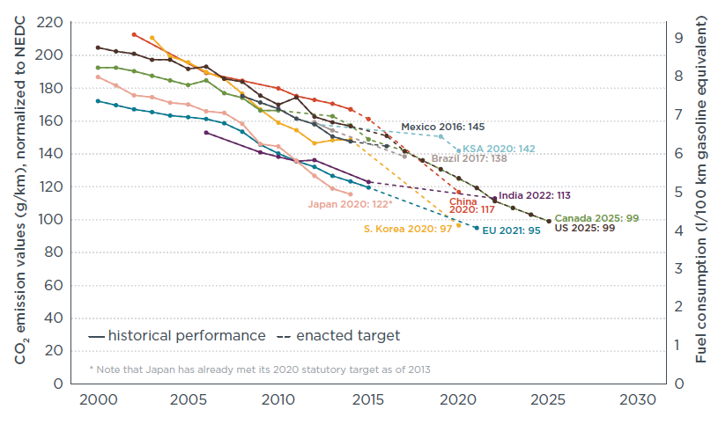

Major non-EU car markets have considered or are about to introduce more ambitious policies including measures to reduce pollutant emissions. In particular, in view of increasing the deployment of zero- and low emission vehicles, ambitious policies have been developed or recently adopted in car markets that are of particular importance for the EU car industry. In the US, the Californian "ZEV" standards to support the market deployment of battery electric, plug-in hybrid, and fuel cell vehicles have also been adopted by nine other States (29% of all new cars sold in the U.S. are sold in these 10 States) (see Box 2 for more details).[36] Eight US States have signed a memorandum of understanding committing to coordinated action to ensure that by 2025 at least 3.3 million pure battery electric vehicles, plug-in hybrid electric vehicles and hydrogen fuel cell electric vehicles are on their roads.[37]

In China, new mandatory "new energy vehicle" (NEV) requirements will apply to car manufacturers as from 2019 covering battery electric, plug-in hybrid, and fuel cell vehicles (see Box 3 for more details).[38] The requirements are applicable to all manufacturers with an annual production or import volume of 30,000 or more conventional fuel passenger cars.

Over the last decade China has become the key car market with 24 million new car registrations, meaning that every third new vehicle is now being sold in China. European car manufacturers have been successful in reaching out to this new market. More than 20% of new passenger cars sold in China were from European car manufacturers/joint ventures operating in China. One third of global sales by German manufacturers, i.e. around 15 million vehicles, took place in China: 39% for the VW Group and 22% for the BMW Group and Mercedes Benz Cars[39]. Similarly, China is the most important car market for the PSA Group with more than 600,000 vehicles sold[40].

A recent analysis of seven global automotive lead markets concludes that China is now in the "pole position" and will dominate the increasing market for electrified powertrains for the foreseeable future due to the importance of the Chinese market and a favourable regulatory framework.[41]

While Japan alone accounts for 40% of EV related patents, the EU automotive industry is the global leader in automotive patents in general.[42] At the same time patents data show that parts of the European car industry have a strong technological potential in LEV/ZEV which are however not sufficiently reflected in new products offered on the European market.[43]

This indicates that the EU industry risks losing its technological leadership and lagging behind these global trends.

## What are the main drivers?

### Driver 1: Consumers value upfront costs over lifetime costs

There are a number of market failures and barriers[44] which cause end-users to not necessarily purchase the most efficient new vehicles available on the market, even where this would be their optimal choice from an economic perspective, i.e. when the fuel economy benefit outweighs the additional costs for a more efficient vehicle.

When purchasing a new car, end-users tend to undervalue future fuel savings as a result of which it may not appear attractive to pay more for a more efficient vehicle. This is for instance empirically evidenced by the results of the evaluation of the CO2 Regulations, which show that fuel savings are significantly higher than the additional purchase cost of a new car (see Section 1.3). Despite existing fuel taxes, these clear financial benefits were apparently not reaped by the market, but required specific regulation to tap into such economic benefits.

Furthermore, even if the new vehicle purchasers do take account of fuel savings, it would only be rational for them to consider fuel savings for the period in which they intend to own the vehicle. As vehicles have an average lifetime of about 15 years with 4 owners, only a part of the reductions would be experienced by the initial purchaser.

In addition, a wide range of factors and elements other than fuel economy may dominate the purchase decision of a new car. Purchasers of new cars have skewed preferences away from fuel economy and towards factors such as comfort and power.[45] Another reason for the apparently economically suboptimal uptake of more efficient vehicles therefore lies on the production side. In a highly competitive automotive market, manufacturers may be hesitant to invest heavily in more efficient powertrains, knowing that competitors may have different commercial strategies (focusing on other vehicle attributes such as higher engine capacity, more comfort, etc.) that could be commercially more successful. This is in particular the case if consumers pay little attention to total cost of ownership. A regulatory framework on CO2 emissions for all new vehicles takes away the competitive risk that a manufacturer would be facing when focusing innovation efforts on fuel efficiency, while others do not.

Different purchase dynamics may apply for leased vehicles which have a share of around 30% of new registrations in the EU, with most of them being company cars. Leasing could in principle increase the attractiveness of lower CO2 vehicles, on the one hand by enabling instant payback on fuel saving ‘investments’, and on the other by helping operators optimise vehicle choice by enabling them to better take into account the costs and benefits associated with lower CO2 vehicles in the context of CO2-based national vehicle taxation schemes. However, the extent to which these factors affect the uptake of lower CO2 vehicles in practice could not be quantified due to a current lack of evidence.[46]

### Driver 2: Consumers' concerns regarding zero emission vehicles (ZEV)

Beyond the issue of undervaluing future benefits from fuel savings, the limited market uptake of ZEV is strongly influenced by additional factors. ZEV (battery EV and fuel cell EV) are still faced with much higher upfront costs[47] as compared to conventional vehicles.[48]

Consumers are also concerned about other issues regarding ZEV. As demonstrated in research[49], a major barrier is consumer resistance to new technologies that are considered alien or unproved. As other barriers perceived by the consumers, the study mentioned battery range, charging infrastructure, reliability, safety. Furthermore, the perceived limited comfort and style were seen as limiting the attractiveness of available ZEV models.

A key barrier is 'range anxiety', i.e. the perception that the battery capacity is limited and recharging infrastructure is insufficient to ensure recharging 'on time' and at the necessary recharging speed in particular for long-distance trips. This is underlined by the fact that the electric range for the most sold battery electric vehicles in the EU is currently between 150 and 250 km.

Despite important progress and sufficient coverage in most Member States given the low uptake of ZEV so far, the infrastructure for recharging ZEV is insufficient in many Member States in particular in view of the expected uptake of ZEVs by 2020 and beyond[50]. The Commission's Communication, 'Europe on the Move: An agenda for a socially fair transition towards clean, competitive and connected mobility for all' underlines that the deployment of a network of recharging points covering evenly the whole EU road network, is a key enabling condition for zero-emission mobility. The Action Plan on the Alternative Fuels Infrastructure Directive sets out concrete measures for achieving necessary deployment rates[51]. Experience from other regions shows that with an increase in the number of electric vehicles sold investments in the necessary infrastructure increases as well. Besides, reinforced support for research and development of batteries will be provided by Horizon 2020 in the context of the new working programme 2018-2020.

Another concern among consumers is linked to the resale value of ZEV given expected further technical improvements in particular on the battery's performance (range, lifetime, costs).[52]

At the same, the market for ZEV is developing rapidly. New technologies and business models may help to overcome some of the barriers discussed above. For example, new ZEV in the compact car segment are offered in Europe with ranges of up to 380 km[53]. Some ZEV are offered with a lease contract for the battery[54] which lowers upfront costs and can address possible consumer concerns related to the battery technology.

In this context, it should be noted that consumer research in the US and Germany showed that a large share of prospective new vehicle buyers (29% in the US, 44% in Germany) would consider purchasing a battery electric vehicle (BEV) or a plug-in hybrid electric vehicle (PHEV), which indicates a substantial latent demand for such vehicles. However, it was also found that half of all consumers are not yet familiar with electric vehicles. The researchers conclude that there is an opportunity for manufacturers to quickly increase the number of potential buyers by offering more tailored EVs and deploying new business models[55]. A JRC study covering six EU Member States[56] concluded in 2012 that on average around 40% of the car drivers surveyed would consider buying an electric car when changing their current vehicle[57].

### Driver 3: EU standards do not provide enough incentive for further efficiency improvements and for the deployment of low and zero emission vehicles for the period beyond 2021, leading to uncertainty over future policy

The current Regulations for cars and vans set targets of 95 g CO2/km for 2021 and 147 g CO2/km for 2020 respectively. In the absence of new legislation, these targets will remain at their present levels. As the current targets can be largely met by improving conventional vehicles, they do not provide sufficient incentive to invest in and in particular market alternative powertrains, in particular ZEV.

As a consequence there is insufficient uptake of LEVs and ZEVs in the EU as a result of which the necessary GHG emission reductions in the road transport sector cannot be achieved. Given persisting market failures (see Driver 1) under these conditions manufacturers are not likely to develop, produce and offer more efficient vehicles for the EU market at sufficient scale. The EU automotive industry therefore risks losing leadership in low-emission technologies for road transport.

As long as the automotive industry, including manufacturers and suppliers, does not know what will happen to targets beyond 2020/2021 and whether any additional requirements will be put in place, they do not have the regulatory certainty required to invest with confidence for the EU market. Without clarity on the long-term regulatory framework companies cannot take long-term investment decisions in order to meet future market demands and optimise compliance costs.

### Driver 4: Effectiveness of standards is reduced by growing 'emissions gap'

There is evidence of an increasing divergence between average test and real world CO2 emissions. Recent studies estimate the divergence is up to around 40%[58]. A number of factors have been identified to explain the divergence including the deployment of CO2 reducing technologies delivering more savings under test conditions than on the road, the optimisation of the test procedure as well as the increased deployment of energy using devices which are not taken into account when a vehicle is tested for its certified CO2 emissions. For example, air conditioning systems are not included when a vehicle is tested for its certified CO2 emissions but are widely installed and used, thus leading to higher real world emissions.

This increasing divergence means that the actual CO2 savings achieved are considerably less than those suggested by the test performance. Since manufacturers' compliance with their specific emissions target is assessed on the basis of the CO2 emissions as certified during the official test cycle, the 'emissions gap' undermines the effectiveness of the CO2 performance standards. In addition, the 'emissions gap' has undermined consumers' trust in the potential CO2/fuel savings of new vehicles which in turn may have affected consumers' willingness to buy the most efficient vehicles.

### Driver 5: Road transport activity is increasing

EU transport activity is expected to continue growing under current trends and adopted policies, albeit at a slower pace than in the past[59]. Despite profound shifts in mobility being underway, such as shared mobility services and easier shifts between modes, passenger traffic growth is still projected to increase 23% by 2030 (1% per year) and 42% by 2050 (0.9% per year) relative to 2010. Road transport would maintain its dominant role within the EU. Passenger cars and vans would still contribute 70% of passenger traffic by 2030 and about two thirds by 2050, despite growing at lower pace relative to other modes due to slowdown in car ownership increase.

While this increased activity is reflective of economic growth, it brings with it negative impacts in terms of GHG emissions and air quality impacts, if no additional measures are taken. It remains to be seen to what extent other developments such as autonomous driving may affect road transport activity.

## Who is affected and how?

The users of vehicles, both individuals and businesses, are affected because they face the cost of the energy required to propel the vehicles. Reducing the vehicle's CO2 emissions will reduce the energy required and result in a cost saving to the user. The use of technology to reduce in-use GHG emissions has a cost which is expected to be passed on to the vehicle purchaser.

Citizens, especially those living in urban areas with high concentrations of pollutants, will benefit from better air quality and less associated health problems due to reduced air pollutant emissions, in particular when the uptake of zero-emission vehicles increases.

CO2 standards require vehicle manufacturers to reduce CO2 emissions as a result of which they will have to introduce technical CO2 reduction measures. In the short-term, this is likely to result in increased production costs and could affect the structure of their product portfolios. However, demand for low- and zero-emission CO2 vehicles is expected to increase throughout the world as climate change and air quality policies develop and other countries introduce similar or even more ambitious standards, manufacturers have an opportunity to gain first mover advantage and the potential to sell advanced low CO2 vehicles in other markets.

Suppliers of components and materials from which vehicles are constructed will be affected by changing demands on them. Component suppliers have a key role in researching and developing technologies and marketing them to vehicle manufacturers. Requirements leading to the uptake of additional technologies or materials (e.g. aluminium, plastics, advanced construction materials) may create extra business activity for them. While often overlooked, EU employment in the component supply industry is as large as in the vehicle manufacturing industry.

Suppliers of fuels are affected by reduced energy demand leading to less utilisation of existing infrastructure. If demand shifts to vehicles supplied with alternative energy sources, this may potentially increase the need for other types of infrastructure and create new business opportunities and challenges for electricity supply companies and network operators.

There may also be impacts for example in the need for or type of vehicle servicing. There will also be lower maintenance requirements for battery electric vehicles.

The production and maintenance of vehicles with an electrified powertrain will pose important challenges to the workforce in the automotive sector including manufacturers and component suppliers as well as repair and maintenance businesses. The workforce will need additional and/or different skills to deal with new components and manufacturing processes.

Other users of fuel and oil-related products (e.g. chemical industry, heating) are expected to benefit from lower prices if demand from the transport sector decreases. Sectors other than transport that emit GHGs will avoid demands to further reduce emissions to compensate for increased transport emissions. In so far as these sectors are exposed to competition, this will be important for their competitiveness.

# WHY SHOULD THE EU ACT?

## The EU's right to act

The Environment chapter of the Treaty, in particular Article 191 and Article 192 of TFEU, give the EU the right to act in order to guarantee a high level of environmental protection. As mentioned in Section 1.1, based on Article 192 TFEU, the EU has already acted in the area of vehicle emissions, including adopting Regulations (EC) 443/2009 and (EU) 510/2011 which set limits for CO2 emissions from cars and vans, and with implementing legislation on monitoring and reporting of data (Commission Regulation (EU) No 1014/2010 (cars) and Commission Implementing Regulation 2012/293/EU (vans)).

## What would happen without EU action?

EU fuel efficiency standards for new cars and vans have proven to be a strong driver for innovation and efficiency in automotive technology. These targets allowed EU manufacturers to have a first mover advantage and to increase exports globally. Without further action in this field, it will be difficult for the EU automotive sector to retain its leading role in global markets as developing innovation and cutting-edge technologies is the only way to maintain and strengthen European competitiveness.

With all major markets with the exception of China and India projected to stall in the future, it will be important for the EU to maintain or increase the share of high-quality and high-technology vehicles on third markets, notably in those markets that are likely to grow fast. (source GEAR 2030)

Besides, without further EU action in this field it is likely there would be little additional substantial CO2 reduction from new light-duty vehicles. There may be certain expectations that in view of the current CO2 requirements and expected regulatory action in this field in third countries to which European vehicles are exported, the fuel efficiency improvement of vehicles may continue somewhat beyond this rate. However, as seen in the EU in the period between 1995 and 2006 for cars, in the absence of the mandatory CO2 standard this progress is likely to be offset at least to some degree by the increase in power, size or comfort of new cars.

Some reduction in emissions from the overall fleet of light-duty vehicles would still be expected beyond 2021 due to the continuing renewal of the existing fleet with newer cars and vans meeting the 2020/21 CO2 standards. However, transport activity would continue to increase and the overall CO2 reductions would not be sufficient to reach the targets set by the European Council in the 2030 Climate and Energy Package or contribute sufficiently to the goals of the Paris Agreement.

## Analysis of subsidiarity and added value of EU action

EU action is justified in view of both the cross-border impact of climate change and the need to safeguard single markets in vehicles.

Without EU level action there would be a risk of a range of national schemes to reduce light duty vehicle CO2 emissions. If this were to happen it would result in differing ambition levels and design parameters which would require a range of technology options and vehicle configurations, diminishing economies of scale.

Since manufacturers hold differing shares of the vehicle market in different Member States they would therefore be differentially impacted by various national legislations potentially causing competitive distortions. There is even a risk that national legislation might be tailored to suit local industry.

This poor coordination of requirements between countries, even if all Member States were to establish regulatory requirements for new vehicle CO2 emissions, would raise compliance costs for manufacturers as well as weaken the incentive to design fuel efficient cars and LCVs because of the fragmentation of the European market. It is unlikely that Member States acting individually would set targets in an equally consistent manner as shown by the widely differing tax treatment of new cars across the EU. This means that greater benefits will be achieved for the same cost from coordinated EU action than would be achieved from differing levels of Member State action.

With action only at Member State level we would not benefit from the lower costs which would arise as a result of the economies of scale that an EU wide policy delivers. The EU light vehicle market is currently around 16 million vehicles per year. The largest Member State market is around 3 million vehicles per year. On their own, individual Member States would represent too small a market to achieve the same level of results and therefore an EU wide approach is needed to drive industry level changes.

The additional costs which would arise from the lack of common standards and common technical solutions or vehicle configurations would be incurred by both component suppliers and vehicle manufacturers. However, they ultimately would be passed on to consumers who would face higher vehicle costs for the same level of greenhouse gas reduction without coordinated EU action.

The automotive industry requires as much regulatory certainty as possible if it is to make the large capital investments necessary to maximise the fuel economy of new vehicles, and even more so for shifting to new primary energy sources. Standards provide this certainty over a long planning horizon and they could not be implemented with the same effectiveness and certainty at Member State level.

# OBJECTIVES

**General policy objective**

The general policy objective is to contribute to the achievement of the EU's commitments under the Paris Agreement (based on Article 192 TFEU) and to strengthen the competitiveness of EU automotive industry.

**Specific objectives**

1. Contribute to the achievement of the EU's commitments under the **Paris Agreement** by reducing CO2 emissions from cars and vans cost-effectively;
2. Reduce fuel consumption costs for **consumers**;
3. Strengthen the **competitiveness** of EU automotive industry and stimulate employment.

These three specific objectives are on equal footing.

The first one concerns the climate objective of the **Paris Agreement**. Further efforts are necessary for all Member States to meet their 2030 targets under the Effort Sharing Regulation. With road transport causing one third of non-ETS emissions and emissions increasing in the last few years, reducing CO2 emissions from cars and vans is of key importance.

Implementing the Paris Agreement requires the decarbonisation of the economy including of road transport. The Low-Emission Mobility Strategy has confirmed the ambition of reducing GHG emissions from transport by at least 60% by 2050, as initially set out in the 2011 Low-Carbon Economy Roadmap and Transport White Paper.

This cannot happen without a very high deployment of zero- and low-emission vehicles. Analysis has shown that by 2050, electrically chargeable vehicles need to represent about 68-72% of all light duty vehicles on the roads. This requires a significantly increasing uptake of zero- and low-emission vehicles already in 2030 as the new vehicles of 2030 will remain on the road until the mid-2040s.

The second specific objective is related to the **consumer** angle of the CO2 standards, aiming to create benefits for car and van users through the sales of more efficient vehicles.

The third specific objective relates to innovation, **competitiveness** (including fair competition amongst EU manufacturers) and employment. While the EU automotive sector has been very successful in advanced internal combustion engine vehicles world-wide, it will need to adapt to the ongoing global transitions in the area of mobility and transport in order to maintain its technological leadership.

By providing a clear regulatory signal and predictability for industry to develop and invest in zero- and low-emission vehicles and fuel-efficient technologies, this initiative aims to foster innovation and strengthen EU industry's competitiveness in a fast changing global automotive landscape, without distorting the competition between EU manufacturers.

In addition to the three abovementioned specific objectives, the revision of the CO2 standards for cars and vans are expected to lead to **two main co-benefits**: improvements in air quality and increased energy security.

# WHAT ARE THE VARIOUS OPTIONS TO ACHIEVE THE OBJECTIVES?

This Section describes the options identified to address the problems listed in Section 3 and to achieve the objectives defined in Section 4. It sets out the rationale for their selection, as well as the reasons for discarding certain options upfront, taking into account the evaluation study, the public consultation, additional stakeholder input; as well as several internal and external study reports. The options cover a number of elements, some of which are already part of the current Regulations. The options are grouped into five categories:

1. CO2 emission targets (level, timing, metric);
2. the distribution of effort amongst manufacturers;
3. incentives for low- and zero-emission vehicles;
4. elements for cost-effective implementation;
5. governance related issues

The following tables show how the policy options, grouped into the five key policy areas, relate to the problems and objectives

Table 2: Policy options and problems

|  |  |  |  |
| --- | --- | --- | --- |
| Key policy areas | **Problem 1:** Insufficient uptake of the most efficient vehicles, including low and zero emission vehicles, to meet Paris Agreement commitments and to improve air quality, notably in urban areas | **Problem 2:**  Consumers miss out on possible fuel savings (market failures) | **Problem 3:**  Risk of losing the EU's competitive advantage due to insufficient innovation in low- emission automotive technologies over the long term |
| Emission targets | ✓ | ✓ | ✓ |
| Distribution of effort |  |  | ✓ |
| ZEV/ LEV incentives | ✓ | ✓ | ✓ |
| Elements for cost-effective implementation |  |  | ✓ |
| Governance | ✓ | ✓ |  |

**Table 3: Policy options and objectives**

|  |  |  |  |
| --- | --- | --- | --- |
| Key policy areas | **PARIS AGREEMENT:** Contribute to the achievement of the EU's commitments under the Paris Agreement Reduce by reducing CO2 emissions from cars and vans cost-effectively | **CONSUMERS:** Reduce fuel consumption costs for consumers | **COMPETITIVENESS:** Strengthen the competitiveness of EU automotive industry and stimulate employment |
| Emission targets | ✓ | ✓ | ✓ |
| Distribution of effort |  |  | ✓ |
| ZEV/ LEV incentives | ✓ | ✓ | ✓ |
| Elements for cost-effective implementation | ✓ |  | ✓ |
| Governance | ✓ | ✓ |  |

## Emission targets (level, timing and metric)

The currently applicable Regulations (EC) No 443/2009 ("Cars Regulation") and (EU) No 510/2011 ("Vans Regulation") set a fleet-wide target of 95 g CO2/km (from 2021, with a phase-in from 2020) and 147 g CO2/km (from 2020), respectively, for the emissions of newly registered vehicles. These targets are based on the NEDC test procedure. Compared to the targets set previously, they represent an average annual reduction of 5.1% for cars (from the 2015 target of 130 g CO2/km) and of 5.6% for vans (from the 2017 target of 175 g CO2/km).

The introduction of the new test procedure WLTP, in September 2017[60], is expected to bring the tailpipe CO2 emissions from cars and vans determined during type approval closer to the real world emissions. The WLTP will be fully applicable to all new cars and vans from September 2019 (see also Section 5.5).

WLTP is likely to result in increased CO2 emissions for most vehicles but the increase will not be evenly distributed between different manufacturers. Due to this non-linear relationship between the CO2 emission test results from the NEDC and WLTP test-procedures, it is impossible to determine one single factor to correlate NEDC into WLTP CO2 emission values. A correlation procedure[61] will therefore be performed at the level of individual manufacturer. Based on the correlation procedures and the methodology adopted for translating the individual manufacturer targets from NEDC to WLTP values, WLTP-based manufacturer targets will apply from 2021 onwards. Those targets will be confirmed by the Commission and published in October 2022.[62]

More information on the transition from NEDC to WLTP is given in Annex 5.

### CO2 emission target level (TL)

The likely increase in WLTP CO2 emission values (compared to NEDC) has been taken into account for the purposes of the analytical work underlying this impact assessment (see Annex 4.6).

Since the exact specific WLTP emission target values for 2021 can only be determined in 2022 (as described above), the new emission targets should be defined not as absolute values but in relative terms. The starting point for this are the 2021 EU-wide fleet average WLTP emission targets (i.e. the weighted average of the manufacturers' specific emissions targets for 2021). The new targets can be expressed either as a percentage reduction of those 2021 EU-wide fleet targets or as an average annual reduction rate over a given period.

The options in this section for the new EU-wide fleet average target levels ("TLC" for cars and "TLV" for vans) are defining the target trajectory over the period 2021-2030, without prejudging the target years. Options as regards the timing of the targets are set out in Section 5.1.2.

#### CO2 target level for passenger cars (TLC)

* Option TLC0: Change nothing (baseline)

This option represents the status quo, meaning that the CO2 target level set in the current Regulation is maintained after 2021 (WLTP equivalent of 95 g CO2/km as EU-wide fleet average).

* The other options for defining the EU-wide fleet CO2 target level for passenger cars are summarised in the below table.

|  |  |  |
| --- | --- | --- |
| Option | Decrease of WLTP CO2 target level (2021-2030) | Average annual reduction rate of WLTP CO2 target level (2021-2030) |
| TLC10 | 10% | 1.2% |
| TLC20 | 20% | 2.4% |
| TLC25 | 25% | 3.2% |
| TLC30 | 30% | 3.9% |
| TLC40 | 40% | 5.5% |
| TLC_EP40 | 40% | 5.5%  (8.0% for 2021-2025 and  3.5% for 2025-2030) |
| TLC_EP50 | 50% | 7.4% |

Option TLC_EP40 differs from option TLC40 by defining a non-linear target trajectory. This covers the strictest end of the 2025 target range referred to in the Statement by the Commission in 2014 in the context of the negotiations on the Cars Regulation[63]. This also holds true for option TLC_EP50, which defines a 2030 target that is 50% lower than the 2021 target.

Figure 5: EU-wide fleet target level trajectories for new cars under the different TLC options[64]

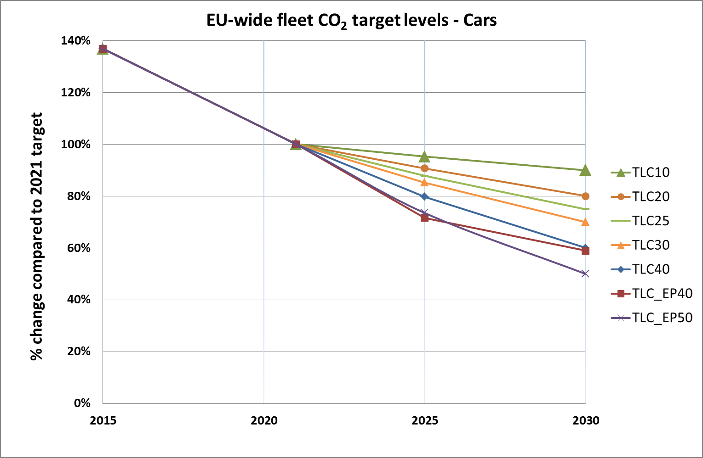

#### CO2 target level for vans (TLV)

* Option TLV 0: Change nothing (baseline)

This option represents the status quo, meaning that the CO2 target level set in the current Regulation is maintained after 2021 (WLTP equivalent of 147 g CO2/km NEDC as EU-wide fleet average).

* The other options for defining the EU-wide fleet CO2 target level for light commercial vehicles are summarised in the below table.

|  |  |  |
| --- | --- | --- |
| Option | Decrease of WLTP CO2 target level (2021-2030) | Average annual reduction rate of WLTP CO2 target level (2021-2030) |
| TLV10 | 10% | 1.2% |
| TLV20 | 20% | 2.4% |
| TLV25 | 25% | 3.1% |
| TLV30 | 30% | 3.9% |
| TLV40 | 40% | 5.5% |
| TLV_EP40 | 36% | 4.4%  (8.1% for 2021-2025 and  2.2% for 2025-2030) |
| TLV_EP50 | 50% | 7.4% (8.1% for 2021-2025 and  6.9% for 2025-2030) |

Options TLV_EP40 and TLV_EP50 are defining a non-linear target trajectory, covering the strictest end of the 2025 target range referred to in the Statement by the Commission in 2014 in the context of the negotiations on the Vans Regulation[65]. For 2025, both options cover a WLTP target equivalent to 105 g CO2/km NEDC, while in 2030 the targets are 36%, respectively 50%, lower than the 2021 targets.

Figure 6: EU-wide fleet target level trajectories for new vans under the different TLV options[66]

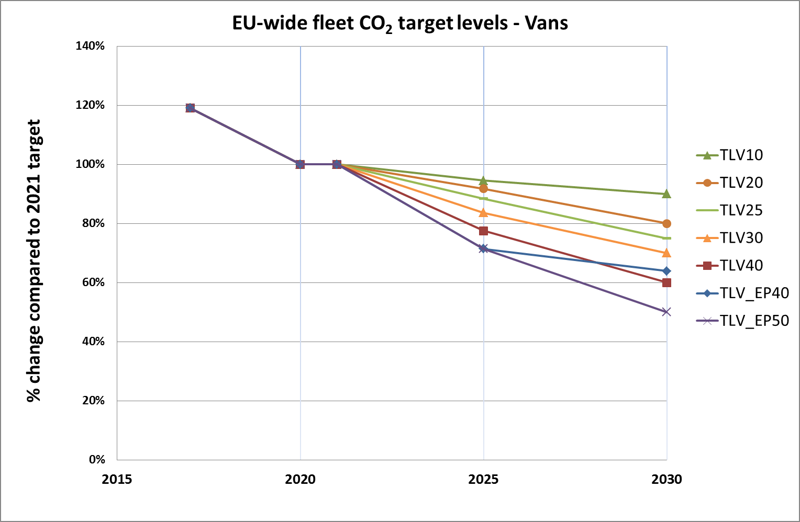

### Timing of the CO2 targets (TT)

The following options will be considered for defining the year(s) for which new targets are set. These options apply both for passenger cars (in relation to options TLC) and for light commercial vehicles (in relation to options TLV).

* Option TT 1: The new EU-wide fleet CO2 targets start to apply in 2030.

This means that the (WLTP equivalent of the) CO2 target levels set in the Cars and Vans Regulations would continue to apply until the year 2029.

* Option TT 2: New EU-wide fleet CO2 targets start to apply in 2025 and will continue to apply until 2029, and stricter EU-wide fleet CO2 targets start to apply from 2030 on.

Under this option, the new EU-wide fleet targets for 2025 and 2030 are calculated according to the annual average reduction rates set out in Section 5.1.1.

* Option TT 3: New EU-wide fleet CO2 targets are defined for each of the years 2022-2030.

Under this option, new annual EU-wide fleet CO2 targets are calculated according to the annual average reduction rates set out in Section 5.1.1

These options include a mid-term review to assess the effectiveness of the policy.

### Metric for expressing the targets

The CO2 targets set in the Cars and Vans Regulations relate to the tailpipe emissions of newly registered vehicles, applying the so-called Tank-to-Wheel approach (TTW). The targets are expressed in g CO2 /km and apply for the sales-weighted average emissions of the EU-wide fleet. For calculating the average, each newly registered vehicle is counted equally.

Using a TTW metric allows focusing on vehicle efficiency, which has proven to be an effective way of triggering the uptake of vehicle technology and starting a shift towards alternative powertrains. However, the overall GHG emission impact of using (new) vehicles is also affected by the type of fuel/energy used to propel the vehicle, as different energy types differ in the amount of CO2 emissions generated during their production, the so-called Well-To-Tank (WTT) emissions. The sum of the TTW emissions and the WTT emissions is referred to as the Well-To-Wheels (WTW) emissions.

Furthermore, there are also CO2 emissions associated with vehicle manufacturing (including the mining, processing and manufacturing of materials and components), maintenance and disposal. These are referred to as "embedded" CO2 emissions. For determining those emissions, information is needed concerning the different phases of a vehicle's life cycle and tools such as life-cycle assessment (LCA) are often used for this purpose.

The g CO2/km metric allows comparing the emission performance of vehicles on a unit distance basis, but this does not reflect the total emissions of a vehicle over its lifetime. Vehicles with a higher lifetime mileage may contribute more to total CO2 emissions compared to vehicles that are used less intensively, even where the latter perform worse against the g CO2/km targets.

The evaluation study noted that the effectiveness of the Cars and Vans Regulations might have been reduced because some of the emission reductions achieved in terms of tailpipe CO2 emissions may have been accompanied by increased emissions elsewhere.

During the public consultation, some stakeholders also suggested to switch to other metric types to express the targets, in particular by using one of the approaches mentioned hereafter.

*Well-to-Wheel (WTW) based metric*

In the public consultation, stakeholders representing the fuels industry as well as some component suppliers suggested a change from the TTW metric to a WTW based metric, which takes into consideration the sum of the TTW and WTT emissions in the CO2 target levels. By contrast, consumer organisations, car manufacturers and stakeholders from the power sector did not support such a change. Public authorities had mixed views.

*Metric taking into account embedded emissions*

In the public consultation, most car manufacturers were against changing to this approach, whereas other stakeholder groups had diverging views.

*Metric based on mileage weighting*

During the public consultation, the question whether average mileage by fuel and vehicle segment should be taken into account when establishing targets received very mixed replies from stakeholders. A number of environmental and transport NGOs, some research institutions, and all respondents from the petroleum sector were in favour of doing so. By contrast, one NGO and the majority of car manufacturers were against this option. Most consumer organisations were neutral on the issue, whereas public authorities expressed split views.

In the light of the above and the views expressed during the public consultation, the following options will be considered for defining the metric of the EU-wide fleet CO2 targets. These options apply both for passenger cars and for light commercial vehicles.

* Option TM_TTW: change nothing, TTW approach

This option maintains the current metric for setting the targets, i.e. targets expressed in g CO2/km based on a TTW approach and applying for the sales-weighted average EU-wide fleet emissions.

* Option TM_WTW: WTW approach

Under this option, the target would be expressed in g CO2/km based on a WTW approach and would apply for the sales-weighted average EU-wide fleet emissions.

* Option TM_EMB: metric covering embedded emissions

Under this option, the target would be expressed in g CO2/km covering both WTW and embedded emissions and it would apply for the sales-weighted average EU-wide fleet emissions.

* Option TM_MIL: metric based on mileage weighting

Under this option, the target would be set in relation to the mileage-weighted average EU-wide fleet emissions. It could either be expressed in g CO2/km or in different units reflecting the difference in lifetime mileage between vehicle groups.

## Distribution of effort (DOE)

The Cars and Vans Regulations use a limit value line to define the specific emission targets for individual manufacturers, starting from the EU-wide fleet targets. This linear curve defines the relation between the CO2 emissions and a "utility parameter" (currently: vehicle mass in running order[67]).

On this line, the EU-wide fleet target value corresponds with the average mass of the new vehicles in the fleet (M0). The slope of the line is the key factor in distributing the EU-wide fleet target as it determines to what extent vehicles (manufacturers) with a higher/lower (average) mass will be allowed/required to have higher/lower CO2 emissions than the EU-wide fleet average. The steeper the slope, the larger the difference in specific emission targets between manufacturers with "heavy" and "light" vehicles.

In order to avoid that the EU-wide fleet targets would be altered due to an autonomous change in the average mass of the fleet, the M0 values are readjusted every three years to align them with the average mass of the new fleet of the previous years.

The choice of slope of the limit value line is merely a decision on how to share efforts amongst manufacturers and does not affect the overall emission target for the EU fleet of new vehicles.

Other approaches (e.g. using another or no utility parameter, changing the slope of the line, using a non-linear curve) are possible for distributing the effort required from each manufacturer in meeting the EU-wide fleet target. The Cars and Vans Regulations explicitly request the Commission to review this modality[68].

Most car manufacturers and consumer organisations responding to the online consultation were in favour of using a utility parameter to distribute the effort between different manufacturers. A relatively large number of stakeholders across different stakeholder groups were neutral on this question, and only a small number of stakeholders (from different groups) were against the use of a utility parameter. Views diverged on which utility parameter to use. All consumer organisations, some environmental and transport NGOs as well as stakeholders from the petroleum sector supported footprint[69], while most car manufacturers supported mass as utility parameter. Only two stakeholders referred explicitly to another parameter (loading capacity, in the case of light commercial vehicles).

The Association of European automobile manufacturers suggested a slightly different approach for cars and vans. While maintaining a single linear curve for cars with a mass-based utility parameter (*i.c.* WLTP test mass[70]), for vans they proposed to switch to a curve consisting of two linear parts with different slopes, arguing that this would better take account of the large variety in design of light commercial vehicles.

In view of this, the following options are being considered:

* Option DOE 0: Change nothing

Under this option the linear limit value curves as defined in the current Regulations are maintained. The utility parameter applied is the mass in running order and the slope of the curves is 0.0333 (cars) and 0.096 (vans). The adjustment of the M0 value takes place every three years.

* Option DOE 1: mass based limit value curve with a slope representing an equal reduction effort for all manufacturers

Under this option, the manufacturer specific emission targets would be derived from the EU-wide fleet target according to a limit value line with the mass of the vehicles as the utility parameter.

The slope of the limit value line would be determined so that it results in an equal reduction effort for all manufacturers – starting from 2021 - according to the given utility value[71]. Two variants will also be considered as part of the assessment, one using the WLTP test mass as utility parameter (instead of mass in running order) and one using a combination of two different slopes for vans (taking account of the vehicle characteristics within the lighter and heavier segments).

* Option DOE 2: footprint based limit value curve with a slope representing an equal reduction effort for all manufacturers

Under this option, the specific emission targets would be derived from the EU-wide fleet target according to a limit value line using the vehicle footprint (i.e. wheelbase multiplied by track width) as the utility parameter. The approach for defining the slope would be the same as under option DOE 1, but using footprint data instead of mass data.

For options DOE 1 and DOE 2, other sub-options (with different slopes) had initially been considered, but were not withheld as they would either lead to unwanted effects (in case of higher slopes) or are very close to the other options explored (esp. DOE 4 in case of lower slope).

* Option DOE 3: same target for all manufacturers ("uniform target")

Under this option, the EU-wide fleet target would apply for each individual manufacturer and no utility parameter would be applied[72]. As the specific emission targets under the current Regulations vary according to the average mass of the new vehicles registered by a manufacturer, the (percentage) emission reductions required to meet the future targets would be larger for manufacturers having a higher average vehicle mass than for those having lighter vehicles.

* Option DOE 4: equal reduction percentage for all manufacturers

As in option DOE 3, no utility parameter would apply in this case. The same emission reduction percentage would be required for each manufacturer, taking its specific emissions target in 2021 as the starting point. Therefore, the future specific emission targets (in g/km) would differ amongst manufacturers, depending on their 2021 WLTP target[73].

Under options DOE 3 and DOE 4, the future manufacturer specific emissions targets would not be affected by future changes in the average value of the utility parameter for that manufacturer's new vehicles (mass or footprint).

## ZEV/ LEV incentives

### Context

The transition to low- and zero-emission mobility is subject to a number of policy discussions. At the informal meeting of the Environment and Transport Ministers in Amsterdam in April 2016, Member States supported this transition and underlined the opportunities it creates[74].

The May 2017 Communication, 'Europe on the Move: An agenda for a socially fair transition towards clean, competitive and connected mobility for all'[75] confirms that EU-wide carbon dioxide emissions standards are a strong driver for innovation and efficiency and will contribute to strengthening competitiveness and pave the way for zero and low-emission vehicles in a technology-neutral way. It also stated that options under review include specific targets for low and/or zero-emission vehicles.

The Communication builds on the earlier Commission's European Strategy for Low-Emission mobility[76], published in July 2016, in which the Commission highlighted the important role of zero- and low-emission vehicles in delivering CO2 reductions, particularly in view of the longer-term decarbonisation objectives. Furthermore, the Commission stressed that accelerating the ongoing shift to low-emission mobility will offer major opportunities for the European automotive and other sectors to drive global standards and export their products. Fostering a domestic lead market for such vehicles is relevant from a competitive perspective, in order to create (1) economies of scale to drive down costs and (2) a competitive edge for European manufacturers and component suppliers.

The battery is a major cost component of a BEV with battery costs making up to 55% in the price of a mass manufactured BEV in 2016[77]. According to external studies, a broad range of EV support policies applied worldwide[78] is expected to contribute to a drastic reduction in cost of electric vehicles over the next decade as battery manufacturing gets cheaper[79]. Those cost reductions are however highly reliant on mass manufacturing. Analysts argue that policy is therefore critical in this respect and fuel economy regulations will play an important role in driving the scale-up in EV manufacturing over the next 5-7 years[80].

Figure 7 summarises information available up to 2016 on the costs and volumetric energy densities of batteries currently being researched, as well as the ranges of cost reductions that can be expected from the three main families of battery technologies: conventional lithium ion; advanced lithium ion, using an intermetallic anode (i.e. silicon alloy-composite); and technologies going beyond lithium ion (lithium metal, including lithium sulphur and lithium air)[81]. Figure 8 illustrates the evolution of Li-ion battery costs (in USD/kWh) in the past decade (showing a decrease of around 70% since 2010) and a forecast of their further evolution towards 2030, based on expected demand[82], [83].

Figure 7: Battery costs (USD/kWh) and battery energy density (Wh/L)

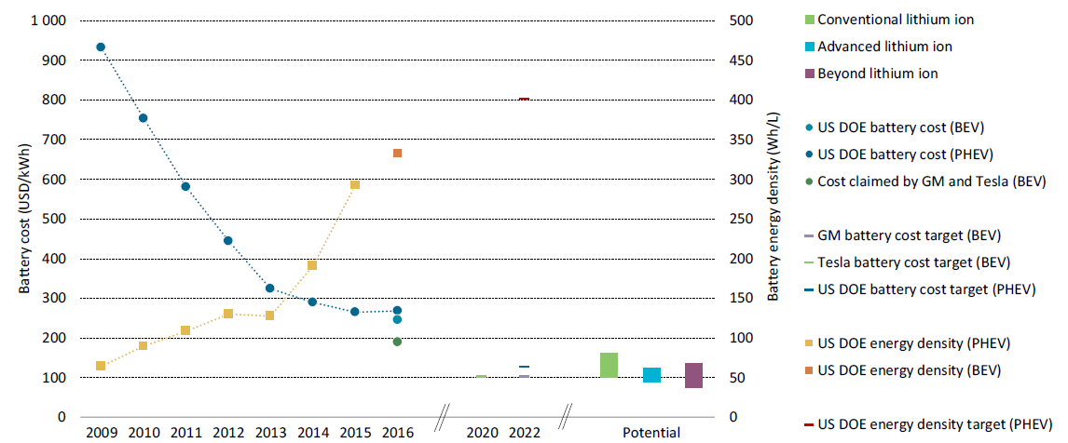

Source: OECD/IEA (2017) Global EV Outlook 2017

**Figure 8: Evolution of Li-ion battery costs (USD/kWh)**

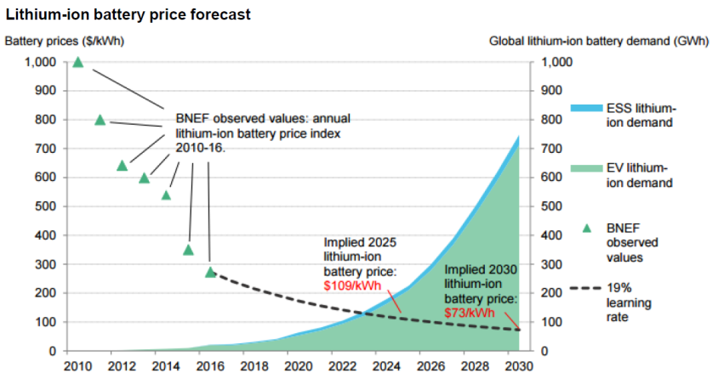

Source: Bloomberg New Energy Finance (2017)

In addition, the narrowing cost gap between electric cars and ICEV may put pressure on governments to gradually revise their support measures, phasing out incentives in cases where BEVs and PHEVs actually rival ICEV costs. According to a report by OECD/IEA, other regulatory instruments (such as including fuel economy regulations and local measures, such as differentiated access to urban areas) will remain important in supporting the electric car uptake needed to meet the targets characterising a low-emission future[84].

Regulatory incentives might thus be needed to help overcome the barriers to the market uptake of ZEVs and LEVs.

The vehicles incentivised should have a significant potential contribution to reducing the CO2 emissions of the new car and van fleet. The types of vehicle most relevant in this respect are the following:

* Battery electric vehicles (BEV) and fuel cell electric vehicles (FCEV), both having zero tailpipe CO2 emissions and a limited market uptake so far.
* Plug-in hybrid electric vehicles (PHEV) with sufficiently low tailpipe CO2 emissions.

In their replies to the public consultation, a majority of stakeholders across all stakeholder groups was in favour of some mechanism to encourage the deployment of LEV/ZEV, except for consumer organisations which were mostly neutral on whether and how LEVs/ZEVs should be incentivised. Environmental and transport NGOs were mostly in favour of a flexible mandate, differentiating between LEV and ZEV and allowing trading among manufacturers. European car manufacturers argued for considering broader policy issues such as grid management, infrastructure and taxation policy.

The European Automobile Manufacturers Association (ACEA) is opposed to sales mandates for LEV/ZEV as it considers the market uptake to be mainly driven by public incentives, in particular fiscal measures, which would give car manufacturers limited control to meet such mandates.[85] They also refer to experience in markets with existing mandates where customers are not willing to buy LEV/ZEV. Car manufacturers also point to the need to increase the number of publically available charging points which does not fall under their responsibility.

At the same time, over the past few years, several major car manufacturers have been announcing their global ambitions for the sales of electric cars, which would result in a strongly increasing deployment of those vehicles in the following years. Table 4 summarises a number of those announcements.

Table 4: List of manufacturer's announcements on electric car ambition (adapted from 'Global EV outlook 2017' (OECD/IEA, 2017)[86])

|  |  |
| --- | --- |
| **Manfacturer** | **Announcement** |
| BMW | 0.1 million electric car sales in 2017 and 15-25% of the BMW group’s sales by 2025[87] |
| Chevrolet (GM) | 30 thousand annual electric car sales by 2017 |
| Chinese manufacturers* | 4.52 million annual electric car sales by 2020 equivalent to around 20% of total expected production and sales in China. |
| Daimler | 0.1 million annual electric car sales by 2020; 15-25% of total sales (Mercedes and Smart) with electric powertrain by 2025[88] |
| Ford | 13 new EV models by 2020 |
| Honda | 66% of the 2030 sales to be electrified vehicles (including hybrids, PHEVs, BEVs and FCEVs) |
| Renault-Nissan | 1.5 million cumulative sales of electric cars by 2020; aspirational target of more than 20% of total sales to be equpped with electric powertrain by 2022[89] |
| Tesla | 0.5 million annual electric car sales by 2018  1 million annual electric car sales by 2020 |
| Volkswagen | 2-3 million annual electric car sales by 2025; 20-25% of VW Group's global sales to be "battery electric vehicles" by 2025[90] |
| Volvo | 1 million cumulative electric car sales by 2025  all new models will have an electric motor, including fully electric cars, plug-in hybrids and mild hybrids from 2019[91] |

*Note: Chinese manufacturers include BYD, BJEV-BAIC Changzhou factory, BJEV-BAIC Qingdao factory, JAC Motors, SAIC Motor, Great Wall Motor, GEELY Auto Yiwu factory, GEELY Auto Hangzhou factory, GEELY Auto Nanchong factory, Chery New Energy, Changan Automobile, GAC Group, Jiangling Motors, Lifan Auto, MIN AN Auto, Wanxiang Group, YUDO Auto, Chongqing Sokon Industrial Group, ZTE, National Electric Vehicle, LeSEE, NextEV, Chehejia, SINGULATO Motors, Ai Chi Yi Wei and WM Motor.

Despite this willingness by manufacturers to strongly expand their offer of EVs, the IEA[92] argues that at this stage of the electric car market deployment, policy support remains "indispensable for lowering barriers to adoption". In this context the IEA notes that mandates in combination with targets provide a clear signal to manufacturers and customers.

As a follow-up to the EMIS Inquiry Committee, the European Parliament[93] in April 2017 called on the Commission to fully engage in and implement a low-emission mobility strategy and "to come forward with a draft regulation on CO2 standards for the car fleets coming onto the market from 2025 onwards, with the inclusion of Zero-Emission Vehicles (ZEV) and Ultra-Low Emission Vehicles (ULEV) mandates that impose a stepwise increasing share of zero- and ultra-low-emission vehicles in the total fleet with the aim of phasing out new CO2-emitting cars by 2035".

A regulatory instrument to enhance the uptake of LEV has been established since the early 1990s in California with the "ZEV Regulation", which requires manufacturers to market a certain percent of vehicles with (near-)zero tailpipe emissions (see Box 2)[94]. Similar mandates also apply in nine other States of the US[95]. In September 2017, China adopted new energy vehicle (NEV) mandates (see Box 3) for the sales of electric cars, which, combined with government and local incentives for customers, manufacturers and the development of infrastructure, have seen a very strong growth in the past few years. Most recently, Quebec has adopted a ZEV mandate[96]. In the light of this policy context, the Impact Assessment is considering several options described below.

**Box 2: California's ZEV programme[97]**

California introduced a ZEV mandate already in 1990. It required manufacturers to progressively increase the sales volume of BEVs to 2% of new vehicle sales by 1998 and 10% by 2003. Given the early stage of development of electric vehicles at the time, the initial ZEV mandate turned out to be too ambitious and was subject to a number of modifications since then.[98] The current ZEV Regulation requires vehicle manufacturers with an annual production of more than 4,500 vehicles to bring to and operate in California a certain percent of "ZEVs" (i.e. BEV, FCEV and PHEV; up to 2017, ZEV credits may also be obtained for "partial" ZEV (PZEV), such as clean hybrids and clean gasoline vehicles) . The ZEV Regulation has become incrementally more stringent and will continue to do so until 2025. From 2018 they include a minimum ZEV floor requirement for large manufacturers (i.e. annual production of more than 60,000 vehicles) above which manufacturers may use credits to meet their total ZEV requirement.

The Californian "ZEV" standards have in the meantime been adopted by nine other States in the U.S. (29% of all new cars sold in the U.S. are sold in these 10 States).[99] However, in 2016 the actual share of BEV, PHEV and FCEV in new car sales was only around 3% in California and less than 1% in the U.S. as a whole.[100] In its recent Midterm Review CARB notes that costs for batteries (as well as other component costs) have fallen "dramatically" (largely due to reduced material costs, manufacturing improvements, and higher manufacturing volumes). Moreover, the number of PHEV and BEV models offered on the market is expected to increase from 25 today to more than 70 models over the next 5 model years. Since 2012 car manufacturers had been over-complying with the ZEV standards and accumulated ZEV credits in view of meeting future ZEV requirements.

**Box 3: China's NEV mandate**

In 2010 China introduced its new energy vehicle (NEV) programme setting a target of 1 million electric vehicles (including both light- and heavy-duty vehicles) by 2015. With the support of public incentives, sales of electric vehicles grew significantly in China in recent years with cumulative sales reaching nearly 1 million in 2016[101]. On 28 September 2017, the Chinese Ministry of Industry and Information Technology (MIIT) published the final rule on passenger car fuel economy standards with an integrated mandate for NEVs which covers battery electric (BEV), plug-in hybrid (PHEV) and fuel cell vehicles (FCEV).[102]

The legislation sets mandatory NEV requirements as from 2019: 10% in 2019 and 12% in 2020; requirements for 2021 and beyond are yet to be determined by MIIT. The requirements are applicable to all manufacturers with annual production or import volume of 30,000 or more conventional-fuelled passenger cars. In order to meet the requirements, manufacturers can generate new energy vehicle scores by producing or importing NEVs. A company’s actual NEV score is calculated by summing up the products of annual manufacturing or import volume of each NEV and the per-vehicle NEV score. The per-vehicle score depends mainly on the electric range for BEV, whereas for PHEV and FCEV other factors are taken into account such as electric consumption. The highest score of 5 can be reached by BEV, whereas PHEV can reach a maximum score of 2. NEV requirements are therefore not equivalent to the market share of NEVs in China in 2019 and 2020. For instance, e.g. for meeting 10% NEV requirement in 2019 with BEVs only, a manufacturer would need a BEV share of 2% only. A company generates NEV credits if its actual NEV score is higher than its NEV requirement. It will face a NEV score deficit if its actual NEV score is below the target. If a manufacturer cannot reach its NEV target in 2019, it can still meet its NEV requirement in 2020. A positive NEV quota can be traded between manufacturers but cannot be carried over to following year(s) after 2019, except from 2019 to 2020. Manufacturers are allowed to use NEV credits towards compliance with existing fuel economy standards.

### Policy options

* Option LEV 0: Change nothing

This option assumes that, apart from the fleet-wide CO2 emission targets, the legislation will not include provisions, which would specifically aim to increase the number of ZEV or LEV registered. The assessment of this option will therefore be based on the assessment of the TLC and TLV options

For the other policy options for incentivising ZEV/LEV, three key elements are considered: (i) the definition of a low-emission vehicle, as this determines the scope of the incentive, and (ii) the type of incentive and (iii) the level of the LEV incentive.

In addition, elements related to the implementation of the incentive need to be considered, such as compliance assessment (incl. the link with the CO2 target), differentiation between OEMs and between different types of LEV.

#### LEV definition (LEVD)

In order to identify which vehicles would qualify for the LEV incentive, it is necessary to define what constitutes a LEV. This requires consideration of the metric and threshold to be used.

An option initially considered was to use the zero emission range of a vehicle (in km) for defining a LEV. However, this approach was not considered further, as the link of this metric with CO2 emissions is less outspoken, and only limited data is available to decide on an appropriate WLTP value. This view is also supported by the majority of stakeholders from different stakeholder groups which clearly preferred the use of CO2 emission performance as the criterion for defining LEV, with proposed thresholds ranging from 15g CO2/km to 50g CO2/km.

Therefore, as regards the CO2 emission threshold, only the options for defining a LEV according to its tailpipe CO2 emissions will be further considered, as summarised in Table 5.

**Table 5: Options considered for the LEV definition (LEVD)**

|  |  |
| --- | --- |
| Option | LEV definition |
| LEVD_ZEV | only vehicles with CO2 emissions of zero qualify as a LEV (LEV = ZEV) |
| LEVD_25 (for cars)  LEVD_40 (for vans) | LEV are all vehicles with CO2 emissions of less than or equal to 25 g CO2/km (for cars) or 40 g CO2/km (for vans) |
| LEVD_50 | LEV are all vehicles with CO2 emissions of less than 50 g CO2/km (with counting of LEV on the basis of their CO2 emissions) |

The higher threshold for vans under option LEVD_40 compared to cars (LEVD_25), is explained by their larger average mass compared to cars and by the uncertainty over the feasibility of bringing a sufficient number of PHEV vans with emissions below 25 g CO2/km to the market.

For option LEVD_50, the 50 g CO2/km threshold is the same one as set in Article 5 of the Cars and Vans Regulations for vehicles to be eligible for generating super-credits. With the change from NEDC to WLTP, type approval emissions from PHEV with emissions around 50 g CO2/km are not expected to change significantly (see Annex 4.6).

However, covering such a broad range of vehicles without any further distinction would not take account of the expected improvement in battery efficiency and the corresponding decrease of CO2 emissions from PHEV. Furthermore, the actual performance of PHEV on the road is strongly influenced by the type and duration of trips undertaken, external conditions (temperature) and consumer behaviour (charging, use of electric equipment).

Therefore, a distinction is proposed under this option between ZEV and other LEV, by counting each LEV in relation to its CO2 emissions. While each ZEV would thus count as one vehicle, all other LEV would count as less than one vehicle, according to the following formula: $1-\frac{CO2 emissions of the LEV}{50}$.

In this way, the incentive is targeted towards vehicles having near-zero emissions, which avoids over-incentivising PHEVs with a short electric range.

#### Type and level of incentive (LEVT)

Additional regulatory tools for incentivising the uptake of ZEV/LEV currently used are mostly based on a ZEV/LEV sales mandate (e.g. California) and/or a crediting system, through increasing the weighting of a ZEV/LEV in the calculation of average emissions or providing emission credits based on the sales share of qualified vehicles.

Under the current Cars and Vans Regulations, a "super-credit" modality has been established to incentivise manufacturers to produce vehicles emitting less than 50 g CO2/km. During a limited number of years, such vehicles may be counted as more than one vehicle for the purpose of calculating the average specific emissions of a manufacturer.

For cars, super-credits applied between 2012 and 2015 in relation to the 130 g CO2/km target and will again apply (with lower multipliers) between 2020 and 2022 in relation to the 95 g CO2/km target (with a cap of 7.5 g CO2/km per manufacturer over the three years). For vans, super-credits only apply between 2014 and 2017 in relation to the 175 g/km target (for a maximum of 25,000 vans over that period).

However, as already highlighted in the impact assessment underlying the 2012 proposals for amending the Cars and Vans Regulations[103], a super-credit system has significant drawbacks as it reduces the stringency of the CO2 target and thus the effectiveness of the Regulations in reducing CO2 emissions. The increase of CO2 emissions depends *inter alia* on the multiplier used and the number of eligible vehicles. For example, with a multiplier of 3.5 (which was applicable in the Cars Regulation in 2012-2013 and in the Vans Regulation in 2014-2015), CO2 emissions could increase by 3% to 15% depending on the proportion of vehicles qualifying for super-credits.

The evaluation study confirmed that super-credits could potentially weaken the targets, but noted that this had not yet materialised (in 2015) in view of the very low uptake of vehicles emitting less than 50 g CO2/km and as all major manufacturers were meeting their targets at that time even without taking super-credits into account.

However, as the share of vehicles with low emissions is expected to increase over time, maintaining the super-credit modality, as included in the Cars and Vans Regulations, would bear a high risk of weakening the CO2 target.

This analysis is confirmed in recent studies[104],[105] which highlight the substantial environmental cost of electric vehicle multipliers or super-credits, in particular as the share of low-emission vehicles in the fleet starts to increase. Super-credits are seen as a counterproductive long-term vehicle policy. As an example, it is calculated that with an electric vehicle penetration at 28% of new vehicle sales in Europe, the regulation would lose 41% of its intended CO2 benefits when allowing super credits. Furthermore, as CO2 targets get stricter, super-credits could even discourage the further deployment of LEVs after 2020 due to the multiple counting. Maintaining even a small multiplier of 1.33 (the lowest value used in the current Cars Regulation) could cause the market uptake of LEV to be reduced by 6-7% by 2030.

Finally, by applying a multiplier from the first LEV registered on, the current super-credits system fails to send a clear signal to manufacturers and authorities about the expected share of LEV in the fleet.

The main drawbacks of the super-credit system could be mitigated or overcome by redesigning it into a crediting system, which would incentivise the uptake of LEV beyond a given level and would avoid undermining the CO2 target levels.

In view of the above, the following three options are considered:

* Option LEVT_MAND: LEV mandate

Under this option, each manufacturer's new vehicle fleet would have to include at least a given share of LEV.

* Option LEVT_CRED1: LEV crediting system with one-way adjustment of the CO2 target

This option builds on and improves the current super-credits system. The LEV incentive would take the form of a crediting system in connection with a manufacturer's specific CO2 target. A benchmark would be defined for the share of LEV in the new fleet in a given year. The specific CO2 target of a manufacturer exceeding this LEV benchmark would be adjusted as follows: each LEV registration above the benchmark would be rewarded on a 1%/1% ratio, meaning that a manufacturer registering 1% more LEV than the benchmark would get a 1% less stringent CO2 target. The CO2 target adjustment would be limited to 5% in order to avoid it to be weakened too much. Assessing compliance would be done only against the CO2 target. Not meeting the LEV benchmark would have no consequences for this compliance assessment.

* Option LEVT_CRED2: LEV crediting system with two-way adjustment of the CO2 target

This option only differs from option LEVT_CRED1 in that a manufacturer not meeting the LEV benchmark level would have to comply with a stricter specific CO2 target. Again, each LEV registration below the benchmark would be counted at a 1%/1% ratio, meaning that a manufacturer registering 1% less LEV than the benchmark would get a 1% more stringent CO2 target. The CO2 target adjustment would also be limited to 5%. Not meeting the LEV benchmark would therefore be reflected in the compliance assessment through a more stringent CO2 target.

As regards the percentage of the new vehicle fleet serving as the LEV mandate (LEVT_MAND) or benchmark (options LEVT_CRED), three options are considered for cars, labelled LEV%_A, LEV%_B and LEV%_C, and two options for vans, labelled LEV%_A and LEV%_B. The values chosen for the LEV mandate/benchmark are incremental compared to the LEV shares in the new vehicle fleet under option LEV0, while taking account of recent announcements by vehicle manufacturers as regards their expected LEV share. This is further explained in Section 0.

The assessment will be based on applying the same LEV mandate/benchmark for all manufacturers. The option of differentiating between OEMs has been not been withheld.

## Elements for cost-effective implementation

### Eco-innovations (ECO)

Article 12 of the Cars and Vans Regulations provides manufacturers with the possibility to take into account CO2 reductions achieved by innovative technologies whose CO2 reducing effect cannot be demonstrated through the official test procedure. Vehicle manufacturers and component suppliers may apply for the Commission's approval of a technology as an eco-innovation, if it fulfils the following basic conditions:

* The supplier or manufacturer must be accountable for the CO2 savings achieved;
* The technologies must make a verified contribution to CO2 reduction;
* The technologies must not be covered by the standard test cycle CO2 measurement or by mandatory provisions covered by the so-called Union's integrated approach to reach 10 g CO2/km (Article 1 and Article 12(2)(c) of the Cars Regulation[106], see below for more information).

Where an approved eco-innovation technology is fitted to a manufacturer's vehicles, the average specific emissions of that manufacturer may be reduced by the CO2 savings from applying that technology, up to a maximum of 7 g CO2/km per year.

The Commission is empowered to adopt detailed provisions on the application procedure, including on the implementation of the criteria listed above. So far, the Commission has adopted more than 20 decisions approving eco-innovations for use in cars, for instance LED lighting systems and more efficient alternators. No applications have yet been submitted with regard to vans.

Both the previous impact assessment[107] and the evaluation study concerning the Cars and Vans Regulations concluded that eco-innovations are effective and efficient as they help to reduce CO2 emissions at a lower cost than alternative options. While it could be argued that the stringency of the targets as measured on the official test procedure would be reduced by this modality, this effect is balanced by the delivery of ‘off cycle’ emission reductions which cannot be measured on the test procedure and by setting a cap on the contribution of those reductions to the target achievement.

During the public consultation, a very large majority of stakeholders across all stakeholder groups was in favour of taking account of CO2 emission reductions arising from eco-innovations. Moreover, the evaluation study concluded that there is evidence supporting that the introduction of the Regulations has had a positive impact on innovation through encouraging higher R&D, and the development and deployment of fuel efficient technologies in the market. A phase-out of the eco-innovation modality will therefore not be considered as an option.

The evaluation study as well as stakeholders have however raised the issue of the administrative burden linked to the application and certification of savings as an issue and have suggested that the eco-innovation regime could be simplified in order to ensure a wider up-take of eco-innovations in the EU fleet.

Under the Cars and Vans Regulations (Article 12), the Commission is empowered to adopt detailed provisions on the application process, through which it may address any issues related to the administrative burden for industry and/or authorities. The Implementing Regulations [108] set out the requirements for applications as well as for the certification by type approval authorities of the CO2 savings from the approved technologies.

A revision of the Implementing Regulations is currently underway, with a view of adapting it to the new test procedure WLTP, but also to introduce a number of simplifications without changing the robustness of the assessment of the applications or the certification of the savings. The revision includes consideration of the US approach of determining off-cycle technologies with pre-defined CO2 savings as well as the possibility for amending existing approval decision upon request by stakeholders or at the Commission's initiative.

In view of this, it can be concluded that the current concept of eco-innovations is both efficient in that approved innovations will reduce CO2 emissions and cost-effective in that their cost should be lower than alternative options, while not causing any significant adverse effects with regard to the stringency of the targets.

Moreover, the current design of the provisions provides the Commission with the necessary powers to address effectively the concerns raised by stakeholders and identified in the relevant studies with regard to the administrative burden.

Against that background, it is considered that the current design of the eco-innovation modality is fit for purpose and can be maintained for the period 2022 to 2030. However, two issues require further consideration: the cap for the CO2 savings and the current exclusion of mobile air-conditioning systems from being eligible as eco-innovations. Manufacturers have in the context of the introduction of the WLTP requested an increase in the 7 g CO2/km cap. Manufacturers as well as component suppliers have also called for including mobile air-conditioning systems in the eco-innovation regime, pending any further regulation of such systems under the type approval legislation.

*Cap for the CO2 savings*

The current eco-innovation regime includes a cap of 7 g CO2/km for the CO2 savings that may be taken into account for compliance purposes. The cap applies regardless of the target level and vehicle category concerned. Until now, the up-take of eco-innovations has been limited (less than 1 g CO2/km in average savings for the manufacturer with the highest number of eco-innovations). It is however expected that the amount of eco-innovation credits used by manufacturers will increase significantly towards the target years 2020-2021.

The 7 g CO2/km cap has been set by reference to the emissions tested on the NEDC, while the EU-wide fleet CO2 targets for the period 2022 to 2030 are to be based on the emissions measured on the new WLTP type approval test. By setting a cap on the eco-innovation savings, a balance is ensured between incentives given to efficiency improvements demonstrated on the official test procedure and those given for the development of more efficient and new technologies that are not covered by that test. That balance also takes into account the fact that the target level is set on the basis of the test procedure emissions only.

The majority of technologies that have already been approved as eco-innovations will continue to fall outside also the WLTP test and will thus still be eligible as eco-innovations. There is however still uncertainty with regard to the level of the savings that can be expected from those technologies within the new testing framework as well as for the potential for other off-cycle technologies.

Against that background, and in order to ensure a smooth transition from the NEDC to the WLTP testing conditions, it is proposed to maintain the cap at the level of 7 g CO2/km pending the availability of more information with regard to the level of eco-innovation savings under the new WLTP test procedure.

In order to be able to take into account the experience that will be gained from the implementation of that procedure in the next couple of years, it is appropriate to consider an option providing the Commission with an empowerment to review the level of the cap so as to ensure that incentives given to eco-innovations remain balanced and effective over time.

*Mobile air-conditioning systems (MAC systems)*

Under the Cars and Vans Regulations, measures that are covered by the so-called "integrated approach" as defined in the 2007 Commission Communication on A Competitive Automotive Regulatory Framework for the 21st Century[109] are not eligible as eco-innovations[110]. This includes, inter alia, MAC systems.

All measures related to this "integrated approach", with the exception of MAC systems, are subject to mandatory measures. This concerns tyre pressure monitoring systems, tyre rolling resistance limits, gear shift indicators, fuel efficiency standards for vans and the use of biofuels. Mandatory measures addressing the efficiency of MAC systems have not yet been introduced and the WLTP test procedure, developed in the context of the UNECE, will not cover such systems in a foreseeable future.

Different studies[111] have pointed to the absence of measures addressing the efficiency of MAC systems as a draw-back, considering that MAC systems are one of the most important energy consumers on board vehicles, representing an average increase in fuel consumption in the order of 9%[112]. Furthermore, these systems are becoming standard equipment in new vehicles. The share of new cars equipped with MAC has risen from around 10% in 1993 to 85 % in 2011[113].

Against that background, it is appropriate to consider the option of incentivising more energy efficient MAC systems within the context of eco-innovations. More efficient MAC could reduce the overall fuel consumption by at least 1 or 2%[114].

It should also be noted that the US has introduced an off-cycle regime, according to which manufacturers that provide efficiency improvements in MAC systems can generate CO2-efficiency credits. The credits generated by the use of efficient MAC systems represented an equivalent of around 1.9 g CO2 /km in 2014 and in 2015.

It is therefore proposed to consider the option of extending the scope of the eco-innovation regime to include MAC systems.

In view of the above, the following options are considered:

* Option ECO 0: Change nothing
* Option ECO 1: Future review and possible adjustment of the cap on the eco-innovation savings

This option would maintain the current provisions of Article 12 of the Cars and Vans Regulations but would introduce an empowerment for the Commission to review and, where found appropriate following an assessment, adjust the 7 g CO2/km cap set on the eco-innovation savings.

* Option ECO 2: Extend the scope of the eco-innovation regime to include MAC systems

This option would also maintain the provisions of Article 12 of the Cars and Vans Regulations including the empowerment to adjust the cap as described in ECO1 but would remove the exclusion of MAC systems from being eligible as eco-innovations. The design of the methodology for determining the efficiency of MAC systems would result from an application by a manufacturer or supplier which would have to be assessed and approved by the Commission.

### Pooling (POOL)

The current Regulations (Article 7) offer individual manufacturers the possibility to form a "pool" for the purposes of meeting their emission targets. Such agreement enables a group of manufacturers to be counted as one entity for the purpose of compliance with the joint target. This allows manufacturers to decide on the most efficient way of complying with the targets. All manufacturers covered by the scope of the Regulations, which have not been granted a derogation (see section 5.4.5), could be part of a pool.

Pooling has been extensively used under the current Regulations. In 2015, pooling was used by 49 car manufacturers, responsible for 81% of all new car registrations in that year and by 25 van manufacturers, responsible for 70% of all new van registrations in that year. Forming a pool has prevented several manufacturers from exceeding their individual specific emissions target (in 2015 this was the case for 23 car manufacturers and 4 van manufacturers, which were member of a pool)[115].

The vast majority of pools have been formed by manufacturers belonging to the same group of connected undertakings. Independent manufacturers may also form pools, however, until now this possibility has been rarely used. A pool formed by independent manufacturers would, in accordance with competition rules, have to be open to the participation of any other manufacturer requesting to participate. This reduces somewhat the utility of such, so called "open", pools with regard to compliance planning.

In order to enhance pooling as an instrument for all manufacturers to reduce compliance costs, the conditions under which open pools may be formed by independent manufacturers and under which conditions another manufacturer may request to join an existing open pool could to be clarified. An option is therefore introduced whereby the Commission is empowered to complement the existing provision by developing specific criteria for the open pool arrangements, in particular with a view to address any relevant competition aspects.

In view of the above, the following options should be considered:

* Option POOL 0 – change nothing – current pooling regime
* Option POOL 1 – an empowerment for the Commission to specify the conditions for open pools arrangements

### Trading (TRADE)

Trading has been suggested as a complement to pooling in order to provide additional flexibility for manufacturers in meeting the targets. Trading would allow individual manufacturers (or pools) to trade credits depending on their performance. This means that when a manufacturer (pool) overachieves its specific CO2 emissions and/or LEV mandate, this would result in credits that could be sold to another manufacturer (pool), which would otherwise not meet its target.

The main distinction compared to pooling is that trading would not require an upfront decision by manufacturers on how to ensure compliance with the target. The decision to trade could take place only at the time the provisional performance of the manufacturer (pool) is known.

Just as for pooling, trading would support the meeting of the CO2 targets or a LEV mandate or a combination of both.

In the case of a LEV mandate (LEVT_MAND), different design options are possible, mainly in relation to how any LEV generating credits are being accounted for in relation to the CO2 targets[116].

Under a LEV crediting system (options LEVT_CRED), a separation between LEV credits and CO2 emission credits would not be necessary. For example, a manufacturer that does not achieve the LEV benchmark would have to meet a more stringent CO2 target. If that leads to non-compliance with the CO2 target, the manufacturer would have to buy credits from a manufacturer overachieving on its CO2 target.

In light of the above the following options are considered:

* Option TRADE 0: Change nothing – no trading
* Option TRADE 1: Introduce trading as an additional modality for reaching the CO2 targets and/or LEV mandates

Under this option, individual manufacturers (or pools) (which do not benefit from a derogation) would be allowed to exchange CO2 and/or LEV credits on an 'ad hoc' basis. This would require the establishment of a register to ensure full transparency and accountability of all transactions among manufacturers.

Trading would be allowed for cars and for vans separately (not amongst them).

### Banking and borrowing (BB)

Banking and borrowing are mechanisms used in different regulatory environments setting policy targets for individual actors with the aim of increasing flexibility and therefore lowering the cost of compliance. The rationale is that the overall desired outcome should be achieved by a certain time, while acknowledging that the optimal route to that point may differ between actors.

For the LDV CO2 legislation, banking would mean that when in a given year the average specific CO2 emissions of a manufacturer (pool) are below its specific emissions target, the manufacturer (pool) can carry over the difference between its emissions and its target as CO2 credits for future compliance purposes. In case its average specific CO2 emissions exceed the specific emissions target in one of the following years, the manufacturer (pool) can offset these excess emissions with the ‘banked’ CO2 credits from preceding year(s).

Borrowing would mean that, in a given year, a manufacturer (pool) could comply with its CO2 target by 'borrowing' CO2 credits, which have to ‘paid back’ in subsequent years.

In order to ensure that the EU-wide fleet CO2 target set for a certain date is actually met, banking and borrowing needs to be limited. For the definition of such a limit, the timeline for the new CO2 emissions target(s) (options TT, see Section 5.1.2) is critical.

If new targets are only set in discrete years (e.g. 2025 and/or 2030), it would be necessary to define a target trajectory against which emissions in the intermediate years would be compared for the purpose of granting credits. This would avoid that too many credits are accumulated before 2025, respectively 2030, which otherwise would allow a manufacturer (pool) to significantly exceed the target and hence undermine the intended CO2 emission reductions for that time period. In case of annual CO2 targets, these would, by definition, provide for such a trajectory.

However, even if a trajectory is set, there may still be a risk of too many credits being accumulated over time. In order to prevent this, banking could be limited to certain time periods (e.g. 2025-2030) or even to one year (e.g. 2025, when overachieving the applicable target or the trajectory). In the latter case, credits could only be used for compliance with the 2030 target. Finally, the use of banked credits could be limited to the year 2030 and no credits could be used after that year (assuming that a target will remain in place in subsequent years).

*Links with the LEV incentives*

In case of option LEVT_MAND, the above considerations would equally be valid in relation to the LEV mandate.

However, the situation is different in case of a LEV crediting system (options LEVT_CRED) where compliance assessment is based on the CO2 target only and therefore already makes a link between the LEV benchmark and the CO2 target. Hence, under that option, banking would only be necessary in relation to the CO2 target.

In light of the above-mentioned considerations, the following options are considered:

* Option BB 0: Change nothing

Under this option, no banking or borrowing would be allowed.

* Option BB 1: Banking only

Under this option, banking of CO2 and/or LEV credits would be allowed, but no borrowing.

* Option BB 2: Banking and borrowing:

Under this option, both the banking and borrowing of CO2 and/or LEV credits would be allowed.

### Exemptions and derogations

The Cars and Vans Regulations acknowledge that CO2 targets should be determined differently for smaller manufacturers as compared to larger ones, taking account of their capability to meet such standards. The Regulations therefore contain the following derogations:

* A *de minimis* exemption (cars and vans), which was introduced in the legislation in 2014 for manufacturers responsible for less than 1,000 newly registered vehicles per year. This exempts small manufacturers, in many cases SMEs, from meeting a specific CO2 emissions target and hence from applying for a derogation, thus reducing administrative burden;
* Small volume derogations (cars and vans): manufacturers (or a group of connected undertakings) responsible for between 1,000 and 10,000 cars registered per year or between 1,000 and 22,000 vans registered per year can apply to the Commission for an individual target consistent with their reduction potential;
* Niche derogations (cars only): manufacturers (or a group of connected undertakings) responsible for between 10,000 and 300,000 cars registered per year can apply for an individual target in 2021, corresponding with a 45% reduction from their 2007 average emissions.

#### 'De minimis' exemptions' and 'small volume' derogations

*De minimis* exemptions reduce compliance and administrative costs for small manufacturers which are in many cases SMEs. Since they are exempt from meeting a specific CO2 target they have no compliance costs for adapting their vehicles to meet CO2 standards. The evaluation study estimated that the exemption reduces the administrative burden for the eligible manufacturers by around € 25,000 per manufacturer. It also facilitates the market entry of new manufacturers whilst having no significant impacts on the CO2 reductions of the overall EU vehicles fleet. During the public consultation, small car manufacturers underlined the importance of this exemption, with no other stakeholders questioning it.

The evaluation study also identified the small volume derogations as a potential weakness, but also confirmed that its impacts in this respect had been relatively small. Most stakeholders also supported this derogation regime, although some environmental NGOs and public authorities were opposed.

In 2015/2016, 23 car manufacturers benefitted from this derogation, 18 of which had less than 1,000 registrations and could thus have benefitted from the *de minimis* exemption (many small manufacturers continue to apply for derogations since EU derogations are required to avoid penalties when selling vehicles on the Swiss market). Without a derogation (or exemption) all of these car manufacturers would have exceeded their specific emissions target.

Six van manufacturers (or pools) applied for this derogation in 2015/2016, three of which had less than 1,000 vans registered in these years and were thus eligible for the *de minimis* exemption [117]. Four other manufacturers, which were eligible for the derogation, did not apply for it as they met their 'default' (Annex I) target.

In considering possible options, it does not appear appropriate to completely exempt this group of manufacturers from meeting any CO2 targets in view of the emission reduction potential in this segment, including the introduction of alternative powertrains. On the other hand, applying the same targets as for large volume manufacturers, based on the limit value curve, would mean that the reduction effort imposed on the small volume manufacturers would be significantly higher compared to large volume manufacturers taking account of their capability to meet emission standards (e.g. smaller fleet, fewer models).

The options of complete exemption or applying the same targets as for large volume manufacturers are therefore not considered further.

While some manufacturers applying for the derogation have pointed to the administrative burden of the application procedure as an issue, it should be noted that the Commission is empowered to define the detailed provisions on the application procedure and assessment criteria. These concerns can effectively be addressed through a simplification of the current applicable rules which are defined under comitology[118].

In view of the above, the impact assessment does not consider specific options to change the existing regime of *de minimis* exemptions and small volume manufacturers.

#### Niche derogations for car manufacturers (NIC)

The Cars Regulation allows a 'niche' car manufacturer to meet a fixed emission reduction percentage set in relation to its emissions in 2007 (25% reduction by 2015 and 45% by 2021) instead of the 'default' emission target according to the limit value curve (Annex I to the Regulation). It should be noted that the percentage emission reduction between the 2015 and 2021 'niche' derogation targets is the same as the one between the fleet-wide targets set in the Regulation for those years (130 g/km and 95 g/km, respectively).

In 2015/2016, eight manufacturers or pools were eligible for a niche derogation but only five have applied to the Commission. Four out of the eight[119] were below their 'default' (Annex I) specific emissions target in one or both years and so strictly speaking did not need a derogation to comply with the Regulation.

It results from the evaluation study that this derogation potentially weakens the delivery of CO2 emissions reductions. If all of the eligible manufacturers would apply for the derogation, the number of cars covered could then increase by up to five times[120].

During the public consultation, car manufacturers supported the continuation of this derogation regime but a majority of environmental and transport NGOs as well as all consumer organisations were against it.

Taking into account those considerations, the following options will be considered:

* Option NIC 0: Change nothing

This would mean maintaining the current provisions of the Cars Regulation. As a result, the 'niche' manufacturers would have to continue to comply after 2021 with the current derogation target, i.e. 45% reduction from their 2007 average emissions.

* Option NIC 1: Set new derogation targets for 'niche' manufacturers

Under this option, new "niche" targets would be defined for the period post-2021 on the basis of the overall CO2 reduction targets defined for the EU-wide fleet (TLC, see Section 5.1.1). The starting point for the 'niche' manufacturers would be their specific emission target for 2021. This approach would be in line with the reduction pathway set in the current Regulations between 2015 and 2021.

* Option NIC 2: Remove the 'niche' derogation

Under this option, no 'niche' derogations would be foreseen. This would mean that the 'niche' manufacturers would be covered by the same rules as the larger manufacturers as regards the target levels (see Section 5.1.1.1), distribution of effort (see Section 5.2) and LEV/ZEV incentives (see Section 5.3.2).

## Governance

The CO2 emission targets for LDVs are set and enforced using as reference a standardised type approval test, taking place in a laboratory. This approach is used worldwide and allows for comparability, reproducibility, verifiability and planning certainty. The effectiveness of the targets in reducing CO2 emissions in reality depends on the one hand on the representativeness of the test procedure with respect to average real-world driving, and on the other hand on the extent to which the vehicles placed on the market conform to the reference vehicles tested at type approval.

As highlighted in the evaluation report and in the opinion of the Scientific Advice Mechanism[121], it is widely accepted that the currently used NEDC laboratory test is no longer representative of today's driving conditions and vehicle technologies. Evidence taken from a number of sources indicates a growing divergence over the past years, up to around 40%, between the certified emissions and the emissions of vehicles driven on European roads[122].

Factors which have contributed to this divergence include: the deployment of CO2 reducing technologies delivering more savings under test conditions than on the road; exploitation of flexibilities in the test procedure; growing deployment of untested energy consuming devices; driver independent circumstances like weather, road conditions or trip types; driving style and driving modes[123].

During the public consultation there was very strong support across all stakeholder groups for the Commission to explore the potential to further reduce the divergence between the test cycle and real world emissions. Only representatives of car manufacturers and one component supplier were against this. All stakeholder groups, except for car manufacturers, supported establishing additional driving tests to give values closer to real driving emissions.

Application of the WLTP, which is mandatory in the EU for all new car types from September 2017 and for all new cars and vans from September 2019, will result in more realistic CO2 values.

However, the longer-term effectiveness of the shift to WLTP in closing the gap will depend on the extent to which it will remain representative of real-world driving circumstances and on the degree to which it is enforced, including via market surveillance instruments.

The following sections set out the options considered in relation to these two governance aspects.

### Real-world emissions (RWG)

The effectiveness of technologies applied to reduce the CO2 emissions of vehicles is affected by the actual driving conditions. This effectiveness can therefore not be fully captured by a laboratory emissions test procedure, in particular given the rapid evolution of these technologies.

Therefore, it is generally accepted that the emissions determined through a test procedure differ from the actual emissions achieved in the real world[124]. As such, this is not problematic for designing CO2 targets relying on type approval values, as long as the expected divergence between the test procedure and the real world emissions can be estimated correctly (see Annex 6). However, for the CO2 targets to fulfil their objective, it is important that any remaining divergence under the test procedure does not increase over time.

This consideration also applies with regard to consumer information. Type approval values of CO2 and fuel consumption are used by consumers to compare different vehicles' performance in terms of fuel efficiency. In order avoid that consumers are misled with regard to the performance of vehicles, information on how type approval values compare to real world values should be readily available. Easy access to real world fuel and energy consumption data should contribute to achieve that and would also be an important step towards increased transparency and rebuilding consumer trust in the automotive industry as well as in the type approval system.

The following two options are considered with a view to address both the need to verify and ensure the representativeness of the new test procedure and to provide consumers with robust real world data on vehicle CO2 emissions and fuel consumption:

* Option RWG 0: Change nothing

This option assumes that the new test procedure WLTP, its periodic revision and the (proposed) revision of the type approval testing[125] would be sufficient to ensure the representativeness of the test procedure over time, with a limited and stable divergence with respect to average real-world emissions. It also assumes that the CO2 and fuel consumption data resulting from the WLTP test would be sufficient in terms of consumer information.

* Option RWG 1: Collection, publication, and monitoring of real world fuel consumption data

This option considers two main complementary sources: firstly, the collection by manufacturers of real world fuel and energy consumption data from new vehicles and their publication on-line or by other easily accessible means. Secondly, the monitoring and assessment by the Commission of the manufacturer data and, if appropriate, from national sources, such as from periodic technical inspections, with a view to continuously evaluate the representativeness of the WLTP.

The implementation of these measures would require an empowerment for the Commission to determine the conditions for the collection and publication of the data, inter alia taking into account relevant data protection requirements. This empowerment would enable the development of a methodology to access, monitor and evaluate on a regular basis the average real world CO2 emissions of the new vehicle fleet (and/or sub-fleets thereof) and determine how that evolves in comparison to the corresponding type approval values. The findings based on that evaluation would be an essential element to be considered in a review of the WLTP test procedure and, where necessary, of the CO2 emission standards.

These measures require the availability of relevant data on real world fuel and energy consumption which are described below.

*Standardized 'fuel consumption measurement device'*

The Commission is currently preparing an amendment, in the context of the type approval legislation, of the WLTP Regulation 2017/1151 to lay down an obligation for manufacturers to fit a standardized 'fuel consumption measurement device' in the new vehicles.

This measure is not covered as an option in this impact assessment as it concerns an obligation under type approval legislation through a comitology act. It should however be noted that the cost for cars to be equipped with standardised, accurate and accessible on-board fuel-consumption measurement devices is estimated to be very low - in the order of 1 euro per vehicle[126]. - and they already exist in today's vehicles[127],[128],, but the information is not accessible Moreover, this enabling technology has already been mandated in California[129] as of 2019.

The data resulting from such fuel consumption measurements would provide a robust basis to verify the representativeness of the WLTP type approval emission values and monitor the gap. It would also provide consumers with reference real world data on the basis of which they can assess how their own fuel economy compares to the average real world fuel consumption. In addition, it would enable simplified on-road fuel consumption measurements on a large number of vehicles.

An empowerment would be required for the Commission to develop the necessary provisions for the collection of the data as well as for the conditions for access and publication. This approach is in line with the recommendation of the European Parliament (following the work of its EMIS Committee)[130], the opinion of the Scientific Advice Mechanism[131], as well as the technical assessment by the Commission's Joint Research Centre (see Annex 6).

*Other data sources*

In the absence of standardised on-board fuel sensors, real-world fuel consumption data can be gathered via self-reporting platforms or fleet operators[132],[133] even though such data are subject to inherent bias. The gap can also be estimated using a simulation software like the Green Driving Tool developed by the Commission's Joint Research Centre[134],[135].

CO2 measurements are also performed at type-approval (ex-ante) as part of the Real Driving Emissions (RDE) procedure for pollutant emissions introduced gradually as of 2017[136]. Their measurement is necessary to validate the procedure itself. However, there is no evidence to date for the degree of representativeness of these data with respect to corresponding ex-post average real-world driving emissions, and there is a risk of bias and inconsistency across the tested vehicle types (see Annex 6).

***Other option considered: elaboration of an ex-ante CO2 real-driving emissions procedure, including the determination of a not-to-exceed limit***

In their response to the public consultation, some environmental and transport NGOs and car drivers associations suggested to develop a dedicated new RDE test protocol for CO2 emissions using Portable Measurement Equipment Systems (PEMS). In addition, binding not-to-exceed limits for CO2 emissions would be introduced. These not-to-exceed limits would be based on the difference between the emissions measured during the WLTP test cycle and the new RDE procedure for CO2 emissions. This would add another level of compliance checking, in a similar way as for air pollutant emissions.

The feasibility of such an approach is highly uncertain due in particular to the high variability in the CO2 emissions under real world conditions. RDE CO2 test results are strongly influenced by external factors, such as temperature, humidity, and driving behaviour. Consequently, the test results cannot offer the precision needed for regulatory purposes, such as target setting, compliance checking or for imposing financial penalties. In a laboratory test – such as the WLTP – such external factors can be controlled and the test values can as a consequence ensure the necessary legal certainty and precision[137].

Custom-tailored test protocols of individual manufacturers (or groups) may provide more realistic fuel consumption and CO2 emission values than a laboratory test. They can provide useful information to consumers. However, such protocols rely on test data from a limited number of vehicle models and selected drivers, and make use of monitored real world emissions of these specific fleets. As a consequence, these test protocols are not exposed to the same variability or uncertainties as compared to a more generic protocol that would have to apply in an equivalent way and with similar accuracy to any vehicle on the EU market.

In view of the above, the elaboration of an EU-wide ex-ante CO2 real-driving emissions procedure at type-approval, including the determination of a not-to-exceed limit for the purpose of target setting and compliance checking does not appear feasible and is therefore discarded from further analysis.

### Market surveillance (conformity of production, in service conformity) (MSU)

As recommended by the European Parliament following the work of its EMIS Committee[138] and stressed by several consumer organisations and environmental NGOs[139], it is necessary to put in place the means to detect irregularities in the CO2 and fuel consumption data.

Recent test campaigns performed by independent laboratories, have provided indications of CO2 emission values deviating significantly from the values determined at type approval[140]. Such deviations may undermine the achievement of the reduction objectives, distort competition among manufacturers and undermine consumer confidence in the type approval fuel consumption data.

Type approval tests are performed on a vehicle, which is representative of a certain vehicle family. The CO2 emissions of each vehicle produced that the manufacturer attributes to that family must conform to the emissions of the approved type. The manufacturer certifies this in a certificate of conformity which is issued as a condition for placing a vehicle on the market.

Each year, Member States report the CO2 emission values recorded in the certificates of conformity of the newly registered vehicles to the Commission. On that basis, the Commission determines the annual average specific emissions of a manufacturer for the purpose of checking compliance with the specific CO2 emissions target.

For the CO2 reduction objectives to be achieved, it is essential that the CO2 emissions of the vehicles placed on the market conform to the type approved values.

Under the type approval legislation, the conformity of the CO2 emissions is currently verified only at the stage of production. Some vehicles are selected from the production line by the manufacturer and tested to verify that the CO2 emissions are in line with those of the approved type. If this is not the case, the manufacturer has to take measures to bring the vehicles to be produced into conformity or perform a new type approval test.

A procedure for verifying the CO2 emissions of vehicles on the road, i.e. a so called in-service conformity test, is not yet in place. However, a proposal for setting up such a procedure is under discussion by the co-legislators[141]. In case in-service tests would not be retained in type approval legislation following the on-going co-decision process, an empowerment for the Commission to set up an independent testing of vehicles in use could be considered as part of this proposal.

In view of this, the following options are considered to ensure that the emissions of vehicles placed on the market continue to adequately reflect the CO2 emissions determined at type approval, to minimise the risk of deviations occurring and, if they occur, to ensure that the consequences for the CO2 reduction objectives can be adequately addressed.

* Option MSU 0: Change nothing

This option would mean that the CO2 monitoring provisions set out in the Cars and Vans Regulations[142] and the associated implementing legislation continue to apply. This allows the Commission to amend the CO2 monitoring data reported by Member States where manufacturers have found and notified errors in that data[143]. The verification by a manufacturer is voluntary and there is no explicit obligation placed on either manufacturers or Member States to report to the Commission deviations found from the type approved CO2 emission values.

* Option MSU 1: Obligation to report deviations and the introduction of a correction mechanism

Under this option, an obligation would be introduced in the legislation requiring Member States and manufacturers to systematically inform the Commission of any findings resulting from conformity of production tests or, where applicable, from in-service conformity tests, and inform of deviations from the type approved CO2 emissions affecting the monitored CO2 data.

The monitoring data for a manufacturer would be corrected in those cases where serious deviations from the type approval values have been detected which cannot be technically or otherwise justified. The empowerment would allow the Commission to define the way in which deviations may be detected and how these should be reported to the Commission as well as taken into account for the compliance checking. This could build on measures defined within the framework of the type approval legislation, or as an independent testing procedure to be defined under the CO2 regulations.

# WHAT ARE THE ECONOMIC/EMPLOYMENT, ENVIRONMENTAL AND SOCIAL IMPACTS OF THE DIFFERENT POLICY OPTIONS AND WHO WILL BE AFFECTED?

## General methodological considerations

The quantification of the impacts, in particular as regards the target levels, distribution of effort and LEV incentives - see Sections 6.3.2, 6.4 and 0 - relies on a suite of models and a dedicated set of cost curves covering a broad range of up-to-date technologies for reducing CO2 emissions from cars and vans.

These cost curves, which show the CO2 reduction potential and costs for over 80 technologies, were determined as part of a study[144] on which car manufacturers, suppliers and other stakeholders provided input and were extensively consulted. The technologies considered include those that are currently already utilised in vehicles in the marketplace, as well as those expected to be available in the near future, and also options that have been proposed or are under development that could feasibly be introduced to the marketplace in the 2020-2030 period. Starting from a detailed assessment of these technologies, a total of 252 cost-curves on a WLTP basis was generated for different combinations of powertrain type (conventional, PHEV, BEV, FCEV), vehicle segment (four size classes for cars and three for vans) and year (2015, 2020, 2025 and 2030).

In the preparation of the cost curves, which represent a cost-optimal combination of technologies to be fitted in the vehicles to reach specific CO2 reduction levels, the possibility (or impossibility) to combine technologies has been duly taken into account, as has their pre-existing market penetration in the vehicles fleet, and overlaps in the CO2 saving potential of technologies when combined into packages.

In addition, for the purpose of analysing the sensitivity of cost assumptions apart from the "medium" costs, a number of cost-curves were developed illustrating the impact of low and high technology cost estimates. These different cost estimates were calculated using a methodological approach developed and refined in consultation with stakeholders and a statistical model to assess the uncertainty in the future cost projections. The "medium" cost case represents the most likely scenario resulting from significant future technology deployment to meet post-2020 CO2 targets. The projected future costs of BEV, PHEV and FCEV powertrains take into account economies of scale and potential rates of learning on the cost reduction of key components (i.e. notably batteries and fuel cells) in different market deployment scenarios. These costs have also been reviewed in the light of the more rapid than expected reductions in battery costs.

The PRIMES-TREMOVE model is used to project the evolution of the road transport sector. This model was consistently used for climate, energy and transport initiatives in the past, including for the 2016 Commission initiatives concerning the Effort Sharing Regulation (ESR), the Energy Efficiency Directive (EED), the Low-Emission Mobility Strategy, the Eurovignette Directive, as well as impact assessment on the Clean Vehicles Directive which was conducted in parallel. In addition, macro-economic models (GEM-E3, E3ME) and the DIONE model developed by the JRC have been used. All analytical models used are described in detail in Annex 4.

The baseline used for this impact assessment builds on the "Reference Scenario 2016" (*Ref2016*)[145], which was used as the baseline for the ESR and EED proposals and the Low-Emission Mobility Strategy. In this scenario the market uptake of advanced technologies is estimated to remain rather low, not allowing for economies of scale, i.e. costs for these advanced technologies staying high.

The baseline includes a few policy measures adopted after the cut-off date of *Ref2016* (end of 2014). Furthermore, some further differentiation in the model assumptions was needed in view of new information from specific studies, in particular:

1. Updated cost curves were used, as explained above. The new costs are lower than the costs used as assumptions in *Ref2016* and other previous analytical work performed with the PRIMES-TREMOVE model.
2. Based on a recent JRC study[146] and other publications, a higher gap between emissions measured during NEDC testing and those in real driving conditions has been applied, on average about 37% for cars and 33% for vans[147].
3. The transition from the NEDC to the WLTP test cycle has been factored in by converting NEDC to WLTP emission values, using conversion factors derived by the JRC for this purpose (see Annex 4.5). For conventionally fuelled vehicles, these conversion factors are 1.21 for cars and 1.30 for vans, with specific values depending on the segments and powertrains.

Finally, the latest set of data from monitoring the implementation of the Cars and Vans Regulations (2015) has been used to properly reflect the current fleet composition and the turn-over rate for cars.

The baseline assumes that the EU-wide CO2 standards for the new passenger cars and vans fleets remain at the same level as in the current Regulations after 2020/2021 (i.e. 95 g CO2 /km for cars and 147 g CO2/km for vans). This would lead to a reduction of CO2 emissions in the period between 2020 and 2030 due to the renewal of the fleet and the reduction of the technology costs over time, which triggers the uptake of more efficient vehicles. However, in absence of new targets, the CO2 emissions reductions remain limited. Figure 9 shows that the GHG emissions from road transport are expected to decrease by 17% in 2030 with respect to 2005.

Figure 9: Projected trend of greenhouse gas emissions from road transport between 2005 and 2030 under the baseline

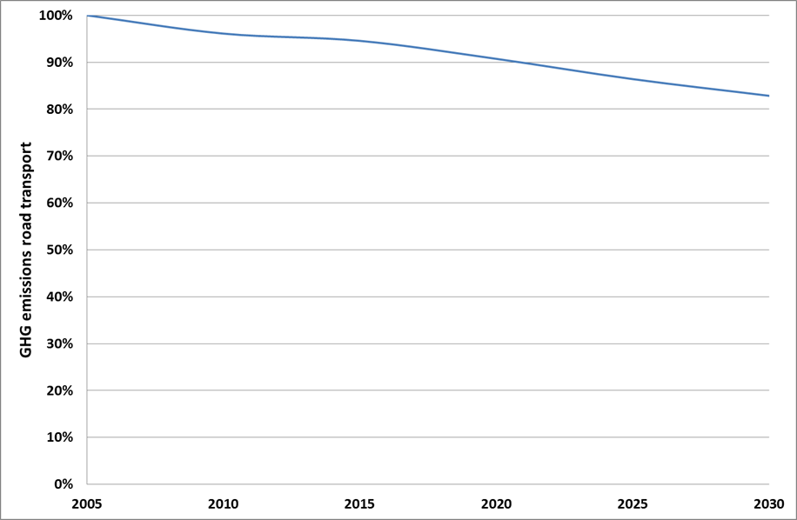

In particular, CO2 emissions from passenger cars and vans reduce by 26% and 17% respectively between 2005 and 2030. In a context of projected growing activity, these reductions are achieved due to the penetration in the fleet of more efficient vehicles. The monitored type-approval CO2 values of new passenger cars and vans decrease respectively by 14% and 11% between 2020 and 2030.

The resulting composition of the new passenger car and van fleet in 2025 and 2030 is shown in Section 6.3.2.1 in Table 6 (TLC0) and Table 7 (TLV0). The uptake of LEV remains limited, especially when considering that by 2050 the fleet share of these vehicles should be around 68-72% in view of the longer term emission reduction objectives.

A detailed description of the baseline projections is presented in Annex 4.

## Consistency with previous analytical work

A comparison was performed between different options for the CO2 targets for new cars and vans considered for the period after 2020 in this impact assessment and under the "*EUCO30*" scenario[148], which is underlying several Commission climate, energy and transport policy proposals adopted in 2016. This scenario achieves the EU-wide 2030 targets regarding greenhouse gas emissions in the ESR sectors (a 30% reduction compared to 2005), and regarding final energy demand (27% renewable energy and 30% energy efficiency). The results are shown in Section 6.3.2.4.3 and in Annex 4.

## Emission targets: metric, level and timing

### Metric for expressing the targets

#### Option TM_WTW: metric for setting the targets based on Well-to-Wheel approach

The two main arguments most frequently used by stakeholders calling for a change from the current tank-to-wheel (TTW) to a well-to-wheel (WTW) metric mainly relate to the following aspects:

1. the need to account for the well-to-tank (WTT) emissions of electricity generation in comparison with those from fossil fuels, in particular in a context where the power sector is not yet fully decarbonised;
2. the need to acknowledge the role of low-carbon fuels like bio-ethanol, bio-methane or synthetic fuels produced from renewable electricity when setting reduction targets for CO2 emissions from cars and vans in order to incentivise the use of those fuels.

As regards the first argument, it needs to be remembered that greenhouse gas emissions from the power and refinery sectors in the EU are already covered by the EU emissions trading system (ETS). Furthermore, the power sector is also affected by measures to attain the Renewable Energy target.

With respect to the second argument, the Commission's 2016 RED-II proposal[149] sets mandates on the fuels sector for 2030. This means that EU policy is already in place for incentivising the deployment of renewable electricity and low-carbon fuels across all sectors, including transport.

Thus, moving to a WTW metric would *de facto* constitute double regulation for the fuels sector as well as the power sector. In the medium term, the impact of this double regulation on the emissions from those sectors in combination with other EU ETS sectors would likely be negligible as the total emissions of the EU ETS sectors are covered by a cap that declines every year. In fact, power sector emissions are reducing at a faster rate than that of any other sector***.*** According to the projections based on the Reference Scenario 2016, about 65% of electricity generated in the EU in 2030 will be carbon free[150].

Projections taking into account newly proposed policies[151] show a carbon free share of more than 70%, and overall project a decrease of GHG intensity in the power sector of around 40% between 2015 and 2030. With the continuation of the linear reduction factor in the ETS beyond 2030, further reductions of the greenhouse gas intensity of the power sector will be realised. The WTW emissions of electric vehicles in particular can therefore be expected to reduce over time.

As the WTW emissions are not a property of the vehicle alone, it would be hard if not impossible to establish metrics which are accurate, fair and cost-effective. In fact, conventional powertrains are sufficiently flexible to use different fuel types within certain specifications and therefore it is not possible to determine ex-ante for a given new vehicle on which fuels it will actually run or to which extent these would be low-carbon fuels. PHEV and BEV will run on any form of electricity, no matter how it is produced, with PHEV also capable of running on liquid fuels. Hence, uncertain ex-ante assumptions would have to be used to account for the potential use of low-carbon fuels in the metric expressing the CO2 emission performance.

Alternatively, some fuel producers propose to use an ex-post crediting approach for based on actual fuel use and the respective GHG emission factors. While it is theoretically possible to establish WTT factors for the many different fuels used in vehicles[152], there are numerous practical barriers to overcome to actually agree on such figures, which also vary geographically as well as over time. Lessons can be learned from the discussions regarding the monitoring requirements for upstream emissions in the context of the Fuel Quality Directive 98/70/EC (FQD), where stakeholder concerns about large administrative burden contributed to the political decision not to insist on detailed monitoring of emissions from well to tank and instead to discontinue regulating CO2 in the FQD after 2020. Similarly, as in the implementation of the Renewables Directive the issues of indirect land use change (ILUC) and the sustainability of imported low-emission fuels would have to be addressed. For the WTW based CO2 targets, the exact same issues would have to be faced, but in addition a discussion would be needed regarding electricity.

Even in the case of an ex-post crediting system, highly uncertain ex-ante assumptions would have to be made about the availability of such credits when setting new CO2 targets for cars in order to maintain a sufficient level of incentives for accelerating the adoption of efficient and clean technologies in cars and vans.

As the actual emission reduction potential, the market availability and the penetration rate of low-emission fuels falls outside the direct control of the automotive industry, ACEA advocates maintaining the current tank-to-wheel metric.

Additional information on WTW emissions can be found in Annex 8.1.

#### Option TM_EMB: metric for setting the targets based on embedded emissions

Apart from the WTW emissions, which cover the use phase of the vehicle and the production of the fuels used, there are also "embedded" CO2 emissions associated with vehicle manufacturing (including the mining, processing and manufacturing of materials and components), maintenance and disposal.

It is estimated that those embedded emissions currently cause around 16% of the total lifetime CO2 emissions of EU cars[153]*.* Additional information on embedded emissions can be found in Annex 8.1.

The evaluation study concluded that the further uptake of technologies improving the fuel efficiency of conventional (internal combustion engine) vehicles would have a limited impact on production emissions, and that the tailpipe CO2 emission savings achieved through such measures would outweigh by far any additional production emissions.

Nevertheless, it was also noted that the relative importance of embedded emissions may increase in the long-term, in particular when the proportion of vehicles using alternative powertrains is increasing.

A number of recent studies highlighted the potential emissions associated with the production of batteries for electric vehicles. However, the emission factors calculated vary significantly depending on the type of battery in terms of materials and energy density and the source of energy used for its production[154]. Furthermore, it is anticipated that the significance of batteries in the overall carbon footprint of electric vehicles could decrease very significantly due a number of factors, including the anticipated increase in gravimetric energy density reducing the materials use per kWh, the reduced GHG intensity of the power sector (see above) and materials used in battery manufacture, improved recycling processes, and an extension of the battery lifetime. Improved overall vehicle efficiencies would also contribute to this by reducing the size of the battery needed for a given electric range. All of this would cause the GHG emissions from the lifecycle of a BEV to drop by 40% between 2020 and 2030, in particular, if combined with establishing a strong battery manufacturing base within the EU in the near future.

Another study[155] highlighted the technical complexity of the issue, and the high administrative burden of covering embedded emissions in a meaningful way. In addition, trade policy issues might be raised as in the case of the emissions from fuels produced from Canadian tar sands during the implementation of the FQD. Such highly complex and detailed emission reporting would need to rely on life-cycle assessment (LCA) reporting by manufacturers which would have to cover all relevant downstream emissions from a huge number of suppliers of materials and car parts within the EU and from third countries. Developing a meaningful and robust methodology with guidelines and tools would be lengthy and costly.

Using a pre-described LCA approach that is sufficiently meaningful and providing the right incentives for reducing the embedded emissions would not only be extremely complex in terms of methodological approach, but would also be very difficult to enforce.

If such a LCA methodology could not be established, fixed default values for including embedded emissions in the metric would have to be used. However, this would have very limited added value as it would just give incentives for reducing the amount of materials used, but not take account of the differences between the emissions related to various materials.

In response to the public consultation, most car manufacturers were against covering embedded emissions in the metric, while other stakeholder groups had diverging views. The steel industry mentioned that the eco-innovation scheme should be complemented with an LCA credit option.

For the reasons above, including embedded emissions in the metric in a meaningful way is not deemed feasible with an effort proportionate to the expected benefits due to the technical complexity of the issue and the prohibitively high cost of data collection at the level of granularity required.

In the coming years, voluntary reporting on embedded emissions of the most relevant segments along the supply chain and testing various methodological approaches could offer further insights to manufacturers on the overall carbon footprint of car manufacturing. This could be combined with regularly monitoring the progress made with reducing the embedded emissions through dedicated studies.

#### Option TM_MIL: metric for setting the targets based on mileage weighting

Information on vehicle lifetime mileage was gathered in the context of two studies on behalf of the Commission. A first one[156] investigated differences in lifetime mileage between vehicle categories. A follow-up study[157] gathered additional data and analysed the total mileages of vehicles of different ages with the aim of describing how annual mileage varies and accumulates during the vehicle lifetime.

It was found that diesel cars on average run higher mileages than petrol cars, but no size-related differences in mileage were identified for vans.

Introducing mileage-weighting when calculating the fleet-wide average emissions, by weighting the CO2 emissions of each type of car by the distance typically travelled over its lifetime, would impose a proportionately more stringent target on larger and heavier vehicles. According to the findings of the study, this would in turn slightly reduce by 1.6-1.8% the overall fleet-wide cost of achieving the same CO2 reduction.

A main challenge encountered during these studies was to find appropriately detailed data at Member State level and important data gaps remain in this respect.

A more recent study[158], building on the aforementioned data, concluded that accounting for different lifetime mileages would have a relatively limited impact on the effectiveness, costs and competitiveness. Furthermore, it was highlighted that establishing robust and broadly agreeable mileage numbers for different vehicle types and categories depending on the utility value or other characteristics would be very complicated.

In light of the above, there are a number of uncertainties around the feasibility of establishing a robust mileage database to implement this option.

### Target levels for cars (TLC) and vans (TLV)

#### Introduction

As regards the CO2 emission performance of new passenger cars, due to the continuous overall improvement of car technologies some autonomous improvement is expected to occur under the baseline. On average, WLTP CO2 emissions in 2030 are estimated to be 14% lower than in 2021. For vans, a similar effect is seen, bringing down emission by 10% in 2030 compared to 2020. In fact, the improvements already captured in the baselines TLC0 and TLV0 are very similar to the results of the options TLC10 and TLV10. Therefore, there is no need to consider the latter options further.

Table 6 and Figure 10 show the impact of the remaining six target options on the composition of the EU-wide fleet for passenger cars in 2025 and 2030.

At moderate target levels up to TLC30, the change in composition of the fleet will be rather gradual compared to the baseline. For instance, with a 30 % target the share of gasoline and diesel cars in 2030 will still make up almost three quarters of the total fleet, compared to slightly more than 80% in the baseline. Only at the higher target levels, the change would be more rapid. In the most ambitious scenario, the gasoline and diesel car share would decline to a little more than 55%.

It should be noted that for option TLC20 the new fleet composition results in an over-achievement of the CO2 target constraint. This is because for all policy options, the introduction of the CO2 target constraint is assessed in the context of the broader policy on low-emission mobility, i.e. in conjunction with enhanced availability of recharging infrastructure and better user acceptance of advanced powertrains as higher mileage of EVs reduces range anxiety. These factors result in an enhanced up take of more advanced power trains. In combination with cost-beneficial improvements of ICEVs, this leads to a situation that the 20% target is somewhat overachieved. This effect is also illustrated in the results regarding final energy demand (section 6.3.2.2.1.4) and CO2 emission trends over time (section 6.3.2.4.1), where the TLC20 results are somewhat optimistic, when comparing the different policy options.

Table 6: Passenger car fleet powertrain composition (new cars) in 2025 and 2030 under different TLC options

|  |  |  |  |  |  |  |  |  |  |  |
| --- | --- | --- | --- | --- | --- | --- | --- | --- | --- | --- |
| **2025** | Gasoline | | Diesel | | CNG | LPG | PHEV | BEV | FCEV | Other |
| ICEV | HEV | ICEV | HEV |
| TLC0 | 27.3% | 13.6% | 36.3% | 9.8% | 1.7% | 3.3% | 4.8% | 2.4% | 0.4% | 0.3% |
| TLC20 | 25.2% | 13.8% | 33.9% | 9.6% | 1.7% | 3.5% | 6.6% | 4.1% | 1.1% | 0.5% |
| TLC25 | 24.9% | 13.8% | 33.6% | 9.7% | 1.7% | 3.5% | 6.9% | 4.3% | 1.1% | 0.6% |
| TLC30 | 24.6% | 13.8% | 33.2% | 9.8% | 1.6% | 3.6% | 7.2% | 4.4% | 1.2% | 0.6% |
| TLC40 | 22.4% | 14.1% | 31.6% | 9.8% | 1.6% | 3.8% | 9.1% | 5.4% | 1.5% | 0.7% |
| TLC_EP40 | 20.1% | 14.1% | 30.0% | 10.5% | 1.5% | 4.3% | 10.7% | 6.3% | 1.7% | 0.9% |
| TLC_EP50 | 19.4% | 14.3% | 29.3% | 10.3% | 1.5% | 4.1% | 11.6% | 6.7% | 1.9% | 0.9% |

|  |  |  |  |  |  |  |  |  |  |  |
| --- | --- | --- | --- | --- | --- | --- | --- | --- | --- | --- |
| **2030** | Gasoline | | Diesel | | CNG | LPG | PHEV | BEV | FCEV | Other |
| ICEV | HEV | ICEV | HEV |
| TLC0 | 23.8% | 15.2% | 33.5% | 10.3% | 1.8% | 3.8% | 6.7% | 3.9% | 0.7% | 0.3% |
| TLC20 | 21.0% | 15.6% | 29.9% | 9.9% | 1.8% | 3.9% | 9.3% | 6.4% | 1.7% | 0.6% |
| TLC25 | 20.4% | 15.4% | 29.1% | 10.0% | 1.8% | 4.0% | 10.0% | 6.7% | 1.8% | 0.7% |
| TLC30 | 19.9% | 15.3% | 28.4% | 10.1% | 1.8% | 4.1% | 10.8% | 7.1% | 1.9% | 0.7% |
| TLC40 | 16.7% | 14.6% | 24.4% | 9.6% | 1.6% | 4.2% | 15.7% | 9.7% | 2.6% | 1.0% |
| TLC_EP40 | 15.7% | 14.4% | 22.9% | 9.5% | 1.5% | 4.1% | 17.4% | 10.7% | 2.8% | 1.1% |
| TLC_EP50 | 13.3% | 12.8% | 20.1% | 9.1% | 1.4% | 3.9% | 22.1% | 13.0% | 3.3% | 1.0% |

Figure 10: Passenger car fleet powertrain composition (new cars) in 2025 and 2030 under different TLC options

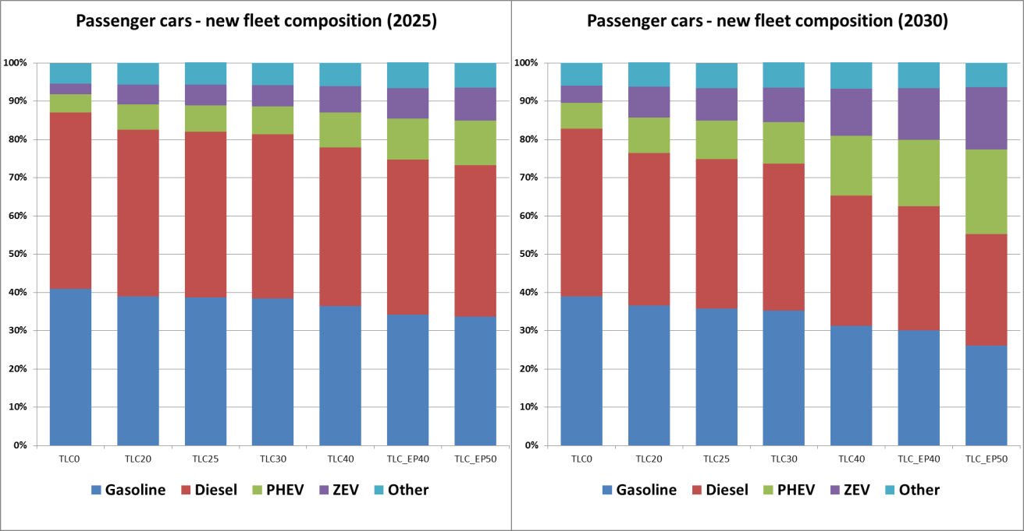

Table 7 and Figure 11 show the impact of different target level options on the composition of the EU-wide fleet of new vans in 2025 and 2030. This shows that for vans the change would be a little less pronounced than for cars. Under the 30% target, in 2030 almost four fifths of the vans would still be equipped with a more efficient combustion engine. At the highest level of ambition considered, this share would fall to a little less than 55%.

Table 7: Van fleet powertrain composition (new vans) in 2025 and 2030 under different TLV options

|  |  |  |  |  |  |  |  |  |  |
| --- | --- | --- | --- | --- | --- | --- | --- | --- | --- |
| **2025** | Gasoline | | Diesel | | CNG | LPG | PHEV | BEV | FCEV |
| ICEV | HEV | ICEV | HEV |
| TLV0 | 2.2% | 1.5% | 57.3% | 32.2% | 0.2% | 0.1% | 4.7% | 1.7% | 0.1% |
| TLV20 | 2.1% | 1.7% | 53.4% | 31.9% | 0.2% | 0.1% | 8.1% | 2.0% | 0.5% |
| TLV25 | 2.1% | 1.7% | 53.7% | 30.7% | 0.2% | 0.1% | 8.8% | 2.2% | 0.5% |
| TLV30 | 2.1% | 2.0% | 54.4% | 31.0% | 0.2% | 0.2% | 7.7% | 2.2% | 0.4% |
| TLV40 | 1.9% | 2.0% | 49.3% | 30.0% | 0.2% | 0.2% | 12.8% | 3.0% | 0.7% |
| TLV_EP40 | 1.8% | 1.3% | 47.6% | 29.1% | 0.1% | 0.3% | 15.5% | 3.5% | 0.8% |
| TLV_EP50 | 1.7% | 1.3% | 44.1% | 27.5% | 0.1% | 0.3% | 19.9% | 4.1% | 1.0% |

|  |  |  |  |  |  |  |  |  |  |
| --- | --- | --- | --- | --- | --- | --- | --- | --- | --- |
| **2030** | Gasoline | | Diesel | | CNG | LPG | PHEV | BEV | FCEV |
| ICEV | HEV | ICEV | HEV |
| TLV0 | 2.0% | 1.5% | 53.2% | 32.1% | 0.2% | 0.2% | 7.9% | 2.7% | 0.2% |
| TLV20 | 1.9% | 1.5% | 48.6% | 30.1% | 0.2% | 0.2% | 14.0% | 2.7% | 0.8% |
| TLV25 | 1.9% | 1.4% | 47.5% | 30.0% | 0.2% | 0.2% | 15.0% | 2.9% | 0.9% |
| TLV30 | 1.8% | 1.4% | 45.6% | 29.3% | 0.2% | 0.2% | 17.3% | 3.2% | 1.0% |
| TLV40 | 1.6% | 1.2% | 40.4% | 26.0% | 0.2% | 0.3% | 24.8% | 4.2% | 1.3% |
| TLV_EP40 | 1.6% | 1.2% | 41.7% | 24.9% | 0.2% | 0.3% | 24.6% | 4.2% | 1.3% |
| TLV_EP50 | 1.3% | 1.0% | 32.5% | 19.9% | 0.1% | 0.2% | 37.6% | 5.6% | 1.9% |

Figure 11: Van fleet powertrain composition (new vans) in 2025 and 2030 under different TLV options

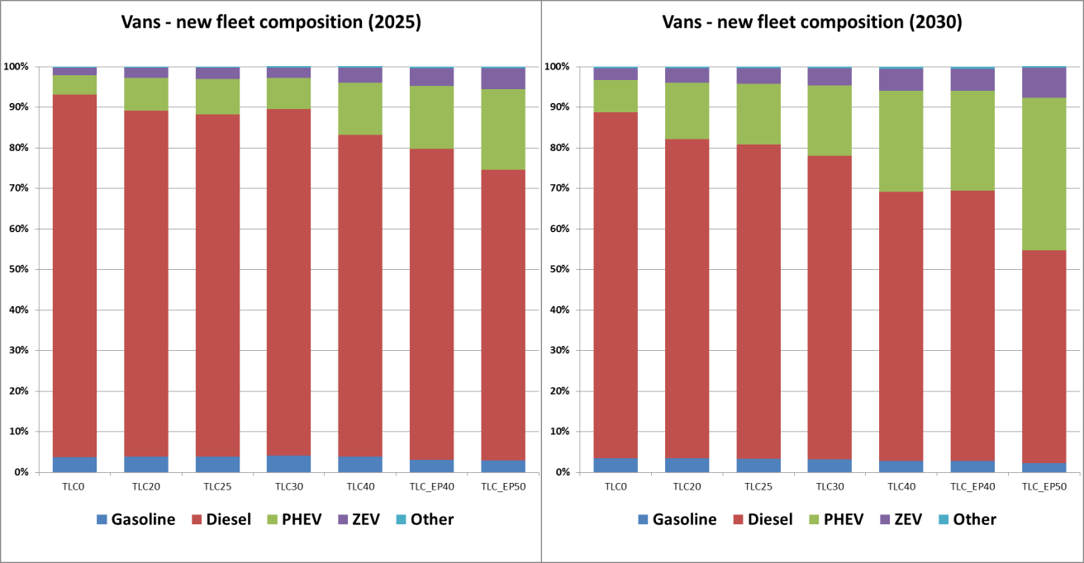

#### Economic impacts (including employment)

In this section the following impacts are considered:

1. Net economic savings from different perspectives
2. Energy system impacts
3. Macro-economic impacts, including employment

*Net economic savings taking different perspectives*

The direct economic impacts of the abovementioned options have been assessed by considering the changes (compared to the baseline) in capital costs, fuel costs[159], and operating and maintenance (O&M) costs for an "average" new vehicle (car or van), registered in 2025 or in 2030.

An "average" new vehicle of a given year is defined by averaging the contributions of the different segments of small, medium, large vehicles and powertrains by weighting them according to their market penetration as estimated. The PRIMES-TREMOVE model projects the new fleet composition in a given year as a result of the need to comply with the requirements of the new policy. Therefore, the different policy options lead to different projected fleet compositions, characterised by different shares of powertrain types (diesel, gasoline, battery electric, plug-in hybrids, etc.) in the different market segments. The net savings for an "average" vehicle are calculated by averaging the costs and savings of the different powertrain types and segments, using the projected shares as weights. Since these shares change among the different scenarios, and they change for the new vehicles of 2025 and those of 2030, the cost indicators are used to represent the economic impacts for the new fleet of 2025 and 2030.

For this analysis, the following indicators have been used:

* Net economic savings over the vehicle lifetime from a societal perspective

This parameter reflects the change in costs over the lifetime of 15 years of an "average" new vehicle without considering taxes and using a discount rate of 4%.

* Net savings from an end-user perspective, using two different indicators:
  + Total Cost of Ownership (TCO) over the vehicle lifetime (TCO-15 years)

This parameter reflects the change in costs over the lifetime of 15 years of an "average" new vehicle. In this case, given the end-user perspective, taxes are included and a discount rate of 11% for cars or 9.5% for vans[160] is used.

* + TCO for the first user, i.e. net savings during the first five years after registration (TCO-first user):

This parameter reflects the change in costs, during the first five years of use, i.e. the average time the first buyer is using the vehicle. Again, taxes are included and a discount rate of 11% for cars or 9.5% for vans is used. The calculation also takes account of the residual value of the vehicle and the technology added with depreciation.

###### Sensitivities

As explained in Section 6.1, apart from the cost curves based on the "Medium" technology cost estimates, a number of other cost-curves were developed as part of a sensitivity analysis. While the overall economic analysis of the policy options (TLC and TLV) relies on the use of the Medium costs, some sensitivities were run to investigate the effect on the net costs (savings) in case technology costs would decrease faster than anticipated under the Medium cost case. This additional assessment also allows looking into a situation where costs evolve differently for different powertrain types. This is particularly relevant for EV in view of the importance of the battery cell costs and the higher uncertainty over how these costs will evolve in the future very much depending on market penetration.

Two other sensitivities explored are related to the future oil price and to the evolution of the share of diesel cars in the fleet.

*Energy system impacts*

In view of the close link between the LDV CO2 standards and energy use in the transport and fuel sectors, the energy system impacts have been analysed, considering the final energy demand, the final energy demand by energy source and the impact on the electricity system.

*Macro-economic impacts*

The broader macro-economic impacts of the different TL options have been analysed for the LDV sector (passenger cars and vans) as a whole. Therefore, the results are presented for cars and vans together in Section 6.3.2.2.3.

While the below Sections provide an overview of the main findings of the assessment and some illustrative tables and figures, the detailed results of the calculations of the net savings and their components are given in Annex 8.

##### Passenger cars (TLC)

###### Net economic savings over the vehicle lifetime from a societal perspective

Table 8 and Figure 12 show the net savings (EUR per vehicle, expressed as the difference with the baseline) over the vehicle lifetime from a societal perspective for an average new passenger car registered in 2025 and in 2030 under the different TLC options. The net savings observed are the result of differences in capital costs, fuel cost savings and O&M costs.

Capital costs – which in this case are equal to manufacturing costs - increase with stricter fleet-wide CO2 target levels as reducing CO2 emissions will require additional more expensive technologies to be implemented. For a car registered in 2025, the average additional capital cost ranges from 115 EUR (TLC20) to 1,411 EUR (TLC_EP40). In 2030, it ranges from 419 EUR (TLC20) to 2,752 EUR (TLC_EP50) per car.

At the same time, stricter targets will lower fuel costs as the fuel efficiency of the cars improves and more alternative powertrains are deployed, both measures reducing the amount of fuel consumed. Fuel cost savings per car range from 354 EUR (TLC20) to 1,394 EUR (TLC_EP40) in 2025 and from 1,159 EUR (TLC20) to 2,558 EUR (TLC_EP50) in 2030.

O&M costs show little variation between the different options, as they depend on the insurance and maintenance costs for the different segments and powertrains which compose the PRIMES-TREMOVE optimised fleet.

Both in 2025 and in 2030, net savings occur for options TLC20, TLC25, TLC30 and TLC40, ranging from 78 EUR (TLC40) to 152 EUR (TLC30) per car in 2025 and from 565 EUR (TLC40) to 902 EUR (TLC25) per car in 2030. Option TLC_EP40 results in net savings in 2030 (512 EUR per car), but not in 2025 (net costs of 42 EUR per car) while under option TLC_EP50 net savings are just below zero in both 2025 and 2030.

As can be seen from Table 8 and Figure 12, the highest net savings can be realised with options TLC25 and TLC30 in both 2025 and 2030.

Table 8: Net economic savings over the vehicle lifetime from a societal perspective in 2025 and 2030 (EUR/car)

|  |  |  |  |  |  |  |
| --- | --- | --- | --- | --- | --- | --- |
| **2025 (EUR/car)** | TLC20 | TLC25 | TLC30 | TLC40 | TLC_EP40 | TLC_EP50 |
| Capital cost [1] | 115 | 229 | 380 | 747 | 1,411 | 1,193 |
| O&M cost [2] | 139 | 139 | 130 | 96 | 25 | 22 |
| Fuel cost savings [3] | 354 | 514 | 661 | 922 | 1,394 | 1,198 |
| *Net savings  [3]-[1]-[2]* | *100* | *147* | *152* | *78* | *-42* | *-17* |

|  |  |  |  |  |  |  |
| --- | --- | --- | --- | --- | --- | --- |
| **2030 (EUR/car**) | TLC20 | TLC25 | TLC30 | TLC40 | TLC_EP40 | TLC_EP50 |
| Capital cost [1] | 419 | 679 | 1,020 | 1,812 | 1,861 | 2,752 |
| O&M cost [2] | -62 | -62 | -96 | -157 | -168 | -192 |
| Fuel cost savings [3] | 1,159 | 1,520 | 1,802 | 2,220 | 2,214 | 2,558 |
| *Net savings  [3]-[1]-[2]* | *802* | *902* | *878* | *565* | *521* | *-2* |

Figure 12: Net economic savings over the vehicle lifetime from a societal perspective in 2025 and 2030 (EUR/car)

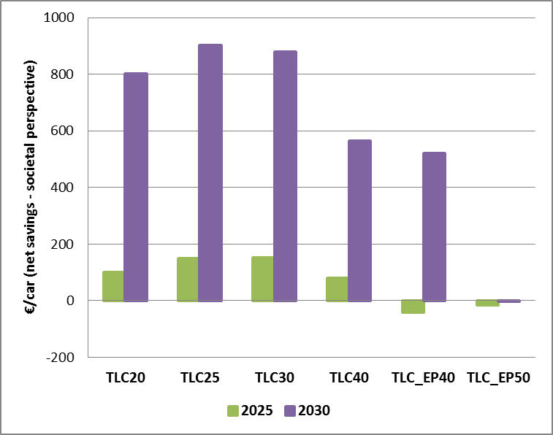

###### In principle, in order to estimate the net economic savings over the vehicle lifetime from a societal perspective, one should include also the external benefits (or avoided external costs). For the options assessed here, the most important effect concerns additional benefits in terms of avoided CO2 costs over the lifetime of a vehicle as compared to a baseline vehicle.

###### Table 10 gives an overview of the estimated additional avoided CO2 costs for cars in 2030 for the different options assessed[161]. It shows that these external benefits increase as the CO2 target gets stricter.

Table 10: Avoided CO2 cost (EUR/car) over a car's lifetime

|  |  |  |  |  |  |  |
| --- | --- | --- | --- | --- | --- | --- |
| (EUR/car) | TLC20 | TLC25 | TLC30 | TLC40 | TLC_EP40 | TLC_EP50 |
| Avoided CO2 cost | 303 | 375 | 451 | 593 | 609 | 728 |

###### TCO-15 years (vehicle lifetime)

Figure 13 shows the TCO over 15 years (EUR per car) of an average new passenger car registered in 2025 and in 2030 under the different TLC options (expressed as the difference with the baseline).

It shows that in both years and under all options considered there are net savings for the end-users over 15 years. The savings per car in 2025 range from 253 EUR (TLC_EP40) to 436 EUR (TLC30) and they increase in 2030, ranging from 389 EUR (TLC_EP50) to 1,374 EUR (TLC25).

The highest net savings for the total cost of ownership over 15 years can be realised with a CO2 target as in options TLC25 or TLC30.

Figure 13: TCO-15 years (vehicle lifetime) (net savings in EUR/car in 2025 and 2030)

###### 

###### TCO-first user (5 years)

Figure 14 shows the net savings (EUR per car) from a first end-user perspective for an average new passenger car registered in 2025 and in 2030 under the different TLC options (expressed as the difference with the baseline).

The trends seen are very similar to those found for the analysis from a societal perspective (see above).

Capital costs increase as the fleet-wide CO2 target levels get stricter and range from 90 EUR (TLC20) to 1,104 EUR (TLC_EP40) for the average car registered in 2025. In 2030, they range from 328 EUR (TLC20) to 2,154 EUR (TLC_EP50) per car.

At the same time, stricter targets will lower fuel costs and fuel cost savings per car range from 348 EUR (TLC20) to 1,286 EUR (TLC_EP40) in 2025 and from 1,025 EUR (TLC20) to 2,354 EUR (TLC_EP50) in 2030.

O&M costs show little variation between the different options and are generally positive in 2025 and negative (i.e. lower than under the baseline) in 2030.

For the first user, both in 2025 and in 2030, net savings occur under all options considered, ranging from 171 EUR (TLC_EP40) to 263 EUR (TLC30) per car in 2025 and from 282 EUR (TLC_EP50) to 818 EUR (TLC30) per car in 2030.

The results of the following two sensitivities are given in Annex 8.2:

###### sensitivity regarding the effect of varying cost assumptions;

###### sensitivity regarding the effect of a varying international oil price.

Figure 14: TCO-first user (5 years) (net savings in EUR/car in 2025 and 2030)

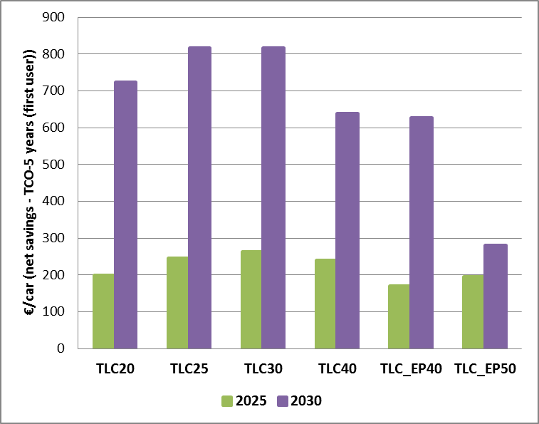

###### Energy system impacts

Figure 15 shows the impact of the different TLC options on the final energy demand for passenger cars over the period 2020-2040.

Under the baseline (TLC 0), the final energy demand for passenger cars is 170,300 ktoe in 2020 and it decreases over time as cars being subject to the CO2 targets set in the current Cars Regulation enter the fleet. In 2030, the final energy demand for passenger cars is 13% lower than in 2020, and the effect of the current targets continues afterwards, i.e. in 2040 final energy demand is 16% lower than in 2020).

Under the different policy options regarding the CO2 target level, the final energy demand for cars reduces further, and the effects of more stringent CO2 targets become more outspoken from 2030 on as more and more cars which are subject to those targets enter the fleet.

The EU-wide fleet targets for CO2 also affect the composition of the car fleet in terms of the powertrains used and hence have an impact on the demand per type of energy source in the transport sector.

Figure 16 shows the share of different fuel types used in the entire passenger car fleet (i.e. not only the newly registered cars) in 2025 and 2030. Diesel and gasoline by far remain the main fuels used in 2025 and 2030. Even for the most ambitious target level, there is only a gradual shift away from fossil to alternative fuels, in particular electricity and hydrogen. The shift is more outspoken in 2030 and for the options with more stringent CO2 targets. For the other fuel types (biogasoline, biodiesel, gaseous fuel), there are very limited changes amongst the different options considered.

Figure 15: Final energy demand (ktoe) for passenger cars over the period 2020-2040 under different TLC options

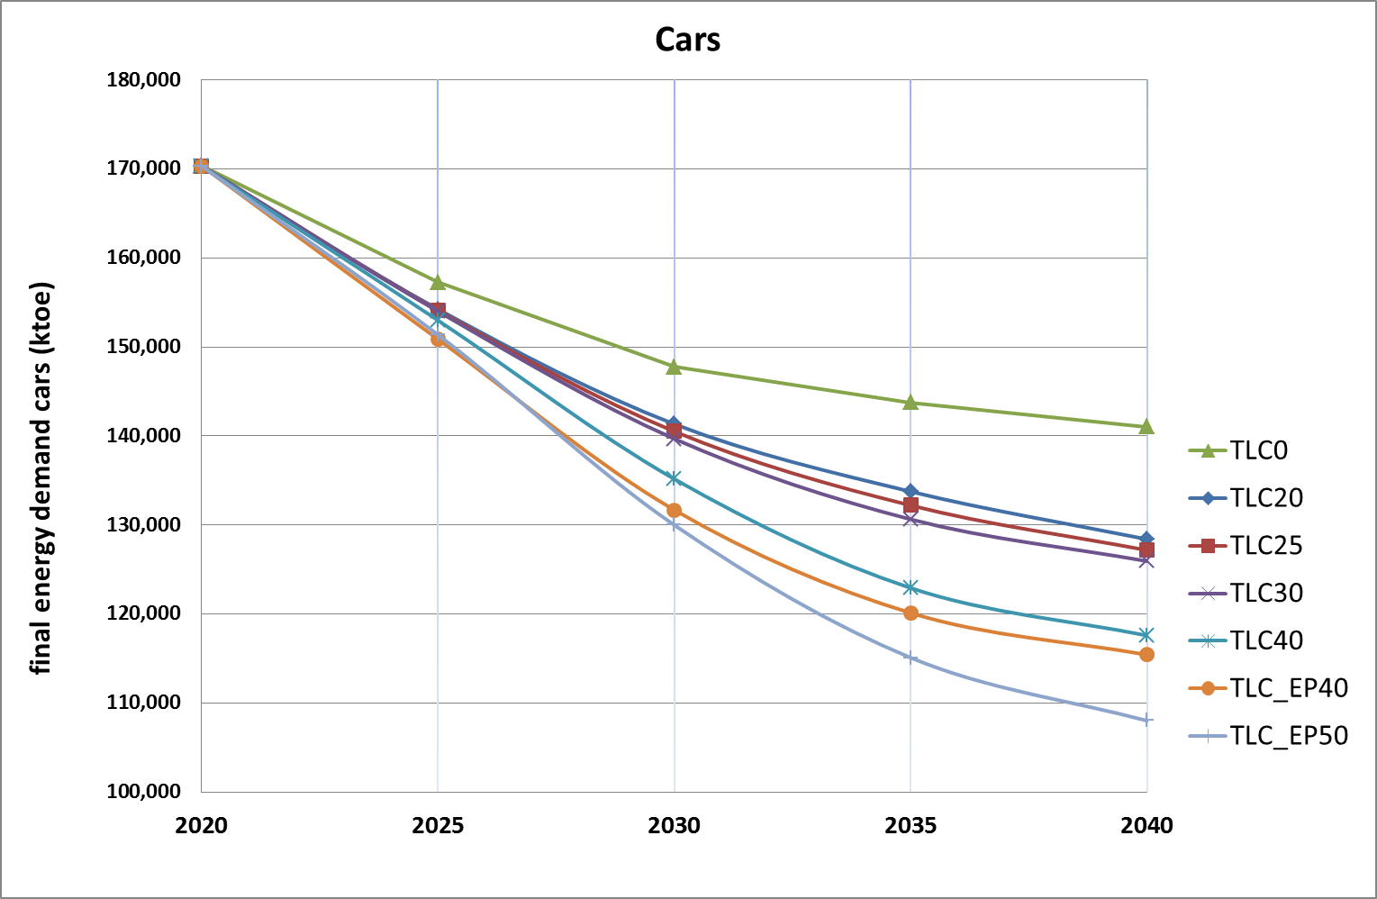

Figure 16: Share (%) of different fuel types in the final energy demand for cars (entire fleet) under different TLC options - 2025 and 2030

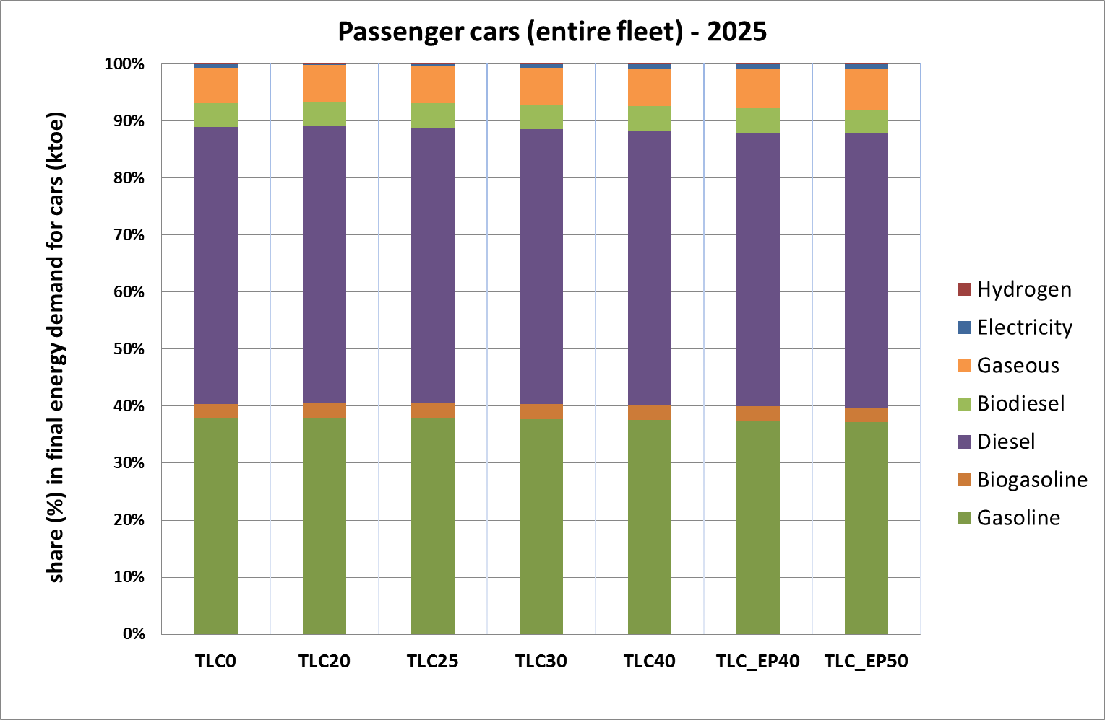

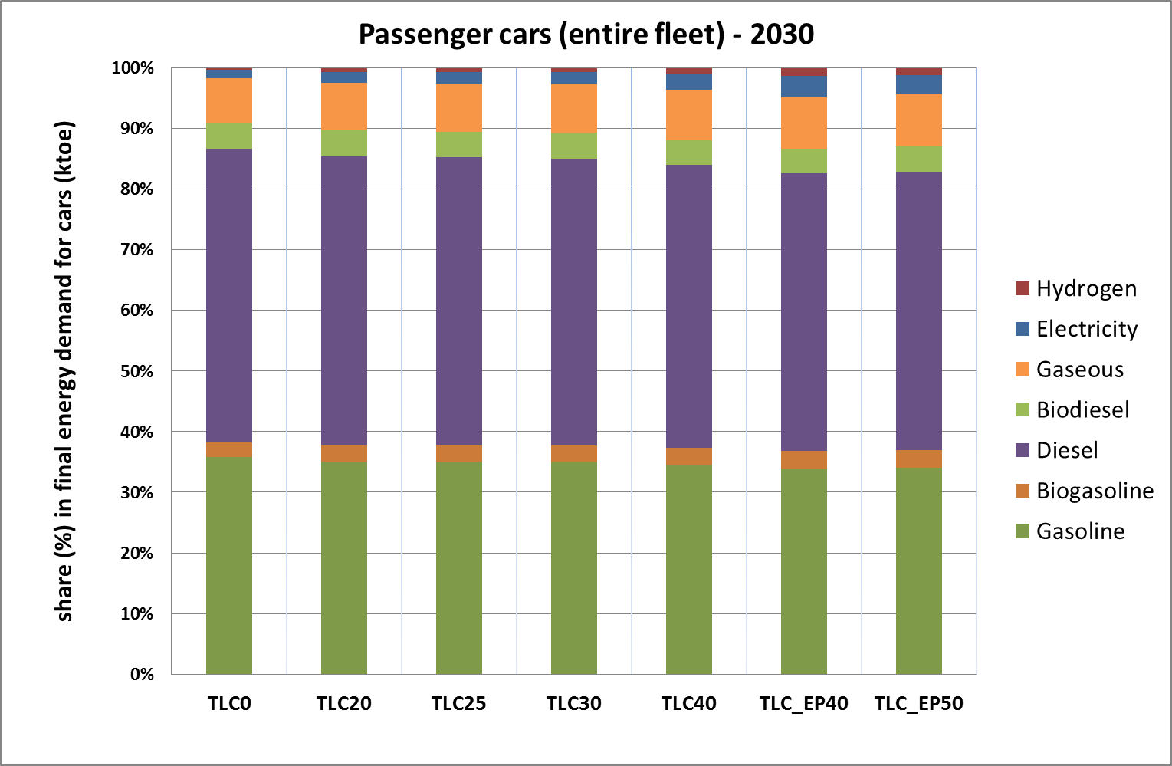

*Electricity consumption*

Table 9 shows the share of the total EU-28 electricity consumption used by cars and vans (together) in 2025 and 2030 for different CO2 target level options. It illustrates that, even with the strictest targets considered, the share of electricity used by light-duty vehicles up to 2030 is not more than a few percent.

**Table 9: Electricity consumption by cars and vans with respect to total electricity consumption (EU-28) under different options for the EU-wide CO2 target levels**

|  |  |  |  |
| --- | --- | --- | --- |
| Options for the EU-wide CO2 target level | | Share of cars and vans in total electricity consumption | |
| cars | vans | **2025** | **2030** |
| TLC20 | TLV20 | 0.5% | 1.2% |
| TLC30 | TLV25 | 0.5% | 1.3% |
| TLC40 | TLV40 | 0.5% | 1.7% |
| TLC_EP50 | TLV_EP50 | 0.6% | 2.2% |

*Diesel and gasoline demand*

Table 10 shows the cumulative savings of diesel and gasoline in the period 2020 to 2040 with respect to the baseline for different scenarios. Considering the combination of options TLC30 and TLV40, the cumulative savings between 2020 and 2040 are equivalent to around 150 billion euros at current oil prices

**Table 10: Cumulative diesel and gasoline savings (Mboe) over the period 2020 to 2040 under different policy options with respect to the baseline**

|  |  |  |  |
| --- | --- | --- | --- |
| **cars** | **(Mboe)** | **vans** | **(Mboe)** |
| TLC20 | 1,881 | TLV20 | 485 |
| TLC30 | 2,136 | TLV25 | 505 |
| TLC40 | 2,864 | TLV40 | 719 |
| TLC_EP40 | 3,283 | TLV_EP40 | 753 |
| TLC_EP50 | 3,658 | TLV_EP50 | 933 |

*Sensitivity – effect of decreasing share of diesel cars*

In view of recent developments following the diesel emission scandal and the persistent air quality issues in a number of cities across the EU, the share of diesel cars in the fleet of newly sold cars has declined in a number of EU Member States[162].In order to assess the potential effects, two sensitivities were designed with lower diesel car fleet shares, as shown in Table 11.

**Table 11: Share of diesel cars (incl. diesel hybrids) in the new car fleet under the two "Low Diesel" sensitivities - % reduction compared to the baseline**

|  |  |  |  |
| --- | --- | --- | --- |
| **Scenario** | **Car segment** | **2025** | **2030** |
| Diesel_1 | Small | 20% | 40% |
| Medium | 15% | 30% |
| Large | 15% | 30% |
| Diesel_2 | Small | 40% | 80% |
| Medium | 30% | 60% |
| Large | 30% | 60% |

The resulting fleet composition under these two sensitivities is shown in Table 12, compared with the fleet composition in case of TLC25 and TLC30. It makes clear that diesel cars are largely substituted by gasoline cars with rather limited increases in PHEV, BEV and other (gaseous fuel) cars.

**Table 12: Passenger car fleet composition in 2025 and 2030 under the "Low Diesel" sensitivities compared to options TLC25 and TLC30**

|  |  |  |  |  |  |  |
| --- | --- | --- | --- | --- | --- | --- |
| **2025** | **diesel** | **gasoline** | **PHEV** | **BEV** | **FCEV** | **other** |
| TLC25 | 43% | 39% | 7% | 4% | 1% | 6% |
| TLC30 | 43% | 38% | 7% | 4% | 1% | 6% |
| Diesel_1 | 37% | 43% | 8% | 5% | 1% | 6% |
| Diesel_2 | 29% | 49% | 8% | 5% | 1% | 7% |

|  |  |  |  |  |  |  |
| --- | --- | --- | --- | --- | --- | --- |
| **2030** | **diesel** | **gasoline** | **PHEV** | **BEV** | **FCEV** | **other** |

|  |  |  |  |  |  |  |
| --- | --- | --- | --- | --- | --- | --- |
| TLC25 | 39% | 36% | 10% | 7% | 2% | 6% |

|  |  |  |  |  |  |  |
| --- | --- | --- | --- | --- | --- | --- |
| TLC30 | 39% | 35% | 11% | 7% | 2% | 7% |
| Diesel_1 | 28% | 43% | 12% | 7% | 2% | 7% |
| Diesel_2 | 13% | 55% | 13% | 8% | 2% | 9% |

Table 13 shows the resulting tailpipe CO2 emission reductions for cars between 2025 and 2040, taking 2005 as the reference year, under the "Low Diesel" scenarios in conjunction with the EU-wide fleet CO2 target of option TLC30. It shows that the impact of the declining diesel share is limited. CO2 is reduced only slightly less than under option TLC30 when using the initial fleet composition. This is due to the modelled gap between test cycle and real-world emissions, which is slightly lower for diesel cars compared to gasoline cars. Therefore, a declining share of diesel cars leads to a small overall increase in the gap between type approval and real world emissions, hence a lower emissions reduction.

**Table 13: (Tailpipe) CO2 emissions of passenger cars in EU-28 - % reduction compared to 2005**

|  |  |  |  |  |
| --- | --- | --- | --- | --- |
|  | **2025** | **2030** | **2035** | **2040** |
| TLC30 | 22.0% | 31.0% | 41.3% | 51.5% |
| Diesel_1 | 21.9% | 30.5% | 40.8% | 50.6% |
| Diesel_2 | 21.9% | 30.1% | 40.1% | 49.2% |

In terms of economic impacts, the three tables below show that net savings from a societal perspective, vehicle lifetime perspective and first-user perspective decrease as diesel shares are declining. This is mainly due to a decrease in the fuel savings when the market shares of diesel car decrease. However, from any of the three perspectives there will still be significant net savings, especially when approaching 2030.

**Table 14: Net economic savings from a societal perspective (EUR/car)**

|  |  |  |  |
| --- | --- | --- | --- |
|  | **TLC30** | **Diesel_1 (TLC30)** | **Diesel_2 (TLC30)** |
| 2025 | 154 | 77 | 34 |
| 2030 | 876 | 808 | 805 |
|  | **TLC25** | **Diesel_1 (TLC25)** | **Diesel_2 (TLC25)** |
| 2025 | 147 | 25 | -47 |
| 2030 | 902 | 758 | 749 |

###### **Table 15: TCO– lifetime (15 years) – net savings in EUR/car**

|  |  |  |  |
| --- | --- | --- | --- |
|  | **TLC30** | **Diesel_1 (TLC30)** | **Diesel_2 (TLC30)** |
| 2025 | 438 | 251 | 51 |
| 2030 | 1,359 | 1,133 | 908 |
|  | **TLC25** | **Diesel_1 (TLC25)** | **Diesel_2 (TLC25)** |
| 2025 | 413 | 170 | -19 |
| 2030 | 1,374 | 1,038 | 739 |

###### **Table 16: TCO- first user (5 years) – net savings in EUR/car**

|  |  |  |  |
| --- | --- | --- | --- |
|  | **TLC30** | **Diesel_1 (TLC30)** | **Diesel_2 (TLC30)** |
| 2025 | 263 | 149 | 23 |
| 2030 | 818 | 673 | 505 |

##### Light commercial vehicles (TLV)

###### Net economic savings over the vehicle lifetime from a societal perspective

Table 17 and Figure 17 show the net savings over the vehicle lifetime from a societal perspective for an average new van registered in 2025 and in 2030 under the different TLV options (expressed as the difference with the baseline).

Capital costs – which in this case equal manufacturing costs - increase with stricter EU-wide fleet CO2 target levels as reducing CO2 emissions will require additional more expensive technologies to be implemented. For a new van registered in 2025, the average additional capital cost ranges from 232 EUR (TLV20) to 1,469 EUR (TLV_EP50). In 2030 (when stricter targets apply), it ranges from 426 EUR (TLV20) to 2,439 EUR (TLV_EP50) per van.

At the same time, stricter targets will lower fuel costs and fuel cost savings per van range from 1,002 EUR (TLV20) to 2,529 EUR (TLV_EP40) in 2025 and from 2,063 EUR (TLV20) to 4,261 EUR (TLV_EP50) in 2030.

O&M costs show little variation between the different options, apart from TLV_EP50, where these costs are significantly lowered in 2030.

Both in 2025 and in 2030, net savings occur under all options, ranging from 810 (TLV20) to 1,369 EUR (TLV_EP40) per van in 2025 and from 1,687 EUR (TLV20) to 2,386 EUR (TLV40) per van in 2030.

Overall, net savings for vans are significantly higher than for cars under options with similar emission target reduction percentages due to the much higher fuel cost savings achieved as vans start reducing from a significantly higher CO2 efficiency standard. Importantly, the highest benefits occur at target levels of 30% and 40% in 2030. This could help improving the competitiveness of many SMEs.

**Table 17: Net economic savings over the vehicle lifetime from a societal perspective in 2025 and 2030 (EUR/van)**

|  |  |  |  |  |  |  |
| --- | --- | --- | --- | --- | --- | --- |
| 2025 | TLV20 | TLV25 | TLV30 | TLV40 | TLV_EP40 | TLV_EP50 |
| Capital cost [1] | 232 | 355 | 393 | 877 | 1,251 | 1,469 |
| O&M cost [2] | -40 | -52 | -58 | -106 | -91 | -119 |
| Fuel cost savings [3] | 1,002 | 1,265 | 1,685 | 2,061 | 2,529 | 2,316 |
| *Net savings [3-1-2]* | *810* | *962* | *1,350* | *1,290* | *1,369* | *967* |

|  |  |  |  |  |  |  |
| --- | --- | --- | --- | --- | --- | --- |
| 2030 | TLV20 | TLV25 | TLV30 | TLV40 | TLV_EP40 | TLV_EP50 |
| Capital cost [1] | 426 | 620 | 891 | 1,582 | 1,415 | 2,439 |
| O&M cost [2] | -50 | -55 | -75 | -142 | -141 | -239 |
| Fuel cost savings [3] | 2,063 | 2,600 | 3,064 | 3,827 | 3,341 | 4,261 |
| *Net savings [3-1-2]* | *1,687* | *2,036* | *2,247* | *2,386* | *2,067* | *2,060* |

###### **Figure 17: Net economic savings over the vehicle lifetime from a societal perspective in 2025 and 2030 (EUR/van)**

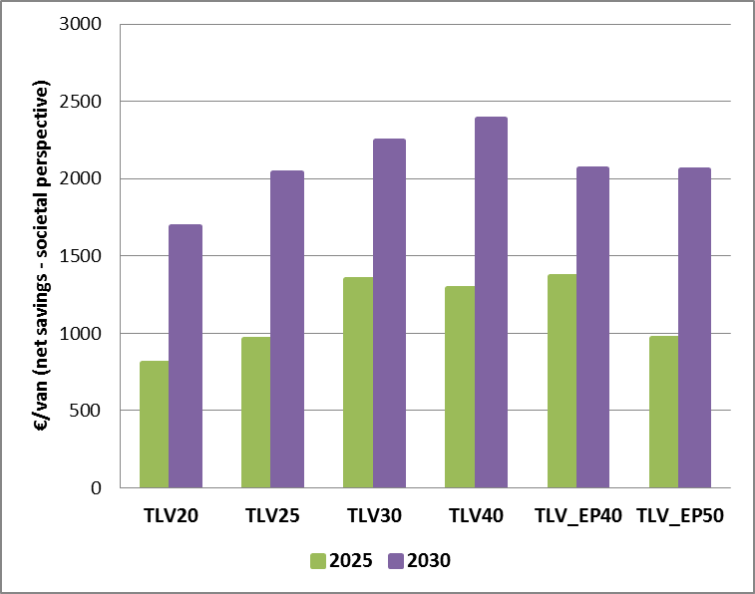

###### In principle, in order to estimate the net economic savings over the vehicle lifetime from a societal perspective, one should include also the external benefits (or avoided external costs). For the options assessed here, the most important effect concerns additional benefits in terms of avoided CO2 costs over the lifetime of a vehicle as compared to a baseline vehicle.

###### Table 18 gives an overview of the estimated additional avoided CO2 costs for vans in 2030 for the different options assessed[163]. It shows that these external benefits increase as the CO2 target gets stricter.

Table 18: Avoided CO2 costs over a van's lifetime

|  |  |  |  |  |  |  |
| --- | --- | --- | --- | --- | --- | --- |
| (EUR/van) | TLV20 | TLV25 | TLV30 | TLV40 | TLV_EP40 | TLV_EP50 |
| Avoided CO2 cost | 521 | 649 | 774 | 1,000 | 898 | 1,212 |

###### TCO-15 years (vehicle lifetime)

Figure 18 shows the net savings in the total cost of ownership of an average new van registered in 2025 and in 2030 under the different options expressed as the difference with the baseline.

It shows that under all options considered there are net savings for the end-users over 15 years. The savings per van range from 1,382 EUR (TLV20) to 2,521 EUR (TLV_EP40) in 2025 and further increase in 2030, ranging from 2,765 EUR (TLV20) to about 4,400 EUR (TLV_EP50 and TLV40). The highest benefits occur at 30%, 40% and even 50% target reduction levels.

**Figure 18: TCO-15 years (vehicle lifetime) in 2025 and 2030 (net savings in EUR/van)**

###### 

###### TCO-first user (5 years)

Figure 19 shows the net savings from a first end-user perspective for an average new van registered in 2025 and in 2030 under the different TLV options (expressed as the difference with the baseline).

The trends are very similar to those found for the analysis from a societal perspective (see section 6.3.2.2.2.1). Capital costs increase as the fleet-wide CO2 target levels get stricter and range from 144 EUR (TLV20) to 913 EUR (TLV_EP50) for an average van registered in 2025. In 2030, they range from 265 EUR (TLV20) to 1,516 EUR (TLV_EP50) per van.

At the same time, stricter targets will lower fuel costs for the end-user and fuel cost savings per van range from 1,016 EUR (TLV20) to 2,614 EUR (TLV_EP40) in 2025 and from 2,026 EUR (TLV20) to 4,412 EUR (TLV_EP50) in 2030.

O&M costs show relatively little variation between the different options and are always negative (i.e. lower than under the baseline).

As a result, both in 2025 and in 2030, the first user benefits from significant net savings under all options considered, ranging from 889 EUR (TLV20) to 1,702 EUR (TLV_EP40) per van in 2025 and from 1,783 EUR (TLV20) to 3,000 EUR (TLV_EP50) per van in 2030. The highest net benefits will be achieved at the higher end of the reduction targets.

###### **Figure 19: TCO-first user (5 years) in 2025 and 2030 (net savings in EUR/van)**

###### 

Light commercial vehicles are predominantly used by businesses, particularly SMEs. The total cost of ownership is therefore of particular importance for these companies. The above calculations show that SMEs could benefit from significant net savings both over the first five years of ownership as well as over the entire vehicle's lifetime.

The results of the following two sensitivities are given in Annex 8:

###### sensitivity regarding the effect of varying cost assumptions;

###### sensitivity regarding the effect of a varying international oil price.

*Energy system impacts*

Figure 20 shows the impact of the different van CO2 target level options on the final energy demand for vans over the period 2020-2040.

Under the baseline (TLV 0), the final energy demand for vans is 35,700 ktoe in 2020 and it decreases over time as new vans, which are subject to the CO2 target set in the current Vans Regulation, enter the fleet. In 2030, the final energy demand for vans is estimated to be 6% lower than in 2020, but the effect of the current CO2 target decreases afterwards. In 2040 final energy demand is 8% lower than in 2020.

Under the different TLV policy options, the final energy demand for vans is significantly lower compared to the baseline. The effects of more stringent CO2 targets becomes even more pronounced from 2030 onward as more and more new vans which are subject to those targets enter the fleet.

Figure 20: Final energy demand (ktoe) for vans over the period 2020-2040 under different TLV options

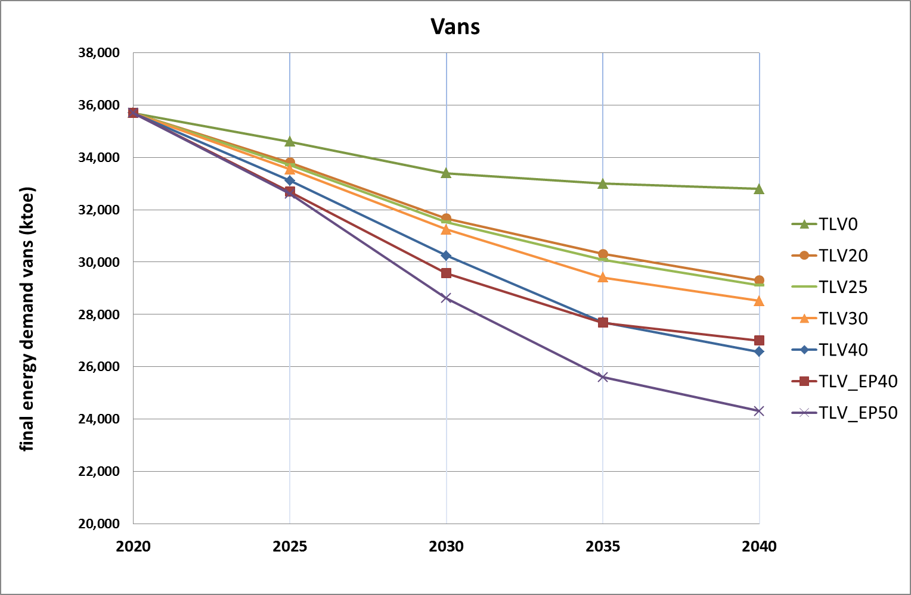

The EU-wide fleet targets for CO2 also affect the composition of the new van fleet in terms of the powertrains used and hence have an impact on the demand per type of energy source.

Figure 21 shows the share of different fuel types used in the entire van fleet, i.e. not only the newly registered vans, in 2025 and 2030. This indicates that diesel remains by far the main fuel used for vans in 2025 and 2030, there is quite a limited shift away from fossil to alternative fuels, in particular electricity. The shift is slightly more significant in 2030 and for more stringent CO2 targets. For the other fuel types gasoline, bio-gasoline, biodiesel, and gaseous fuels, there are very limited changes amongst the different options considered. It illustrates that because of the limited overall turnover rate of vans even high sales targets will only lead to gradual changes in the demand for different fuels in 2025 and 2030.

The share of cars and vans in the total EU-28 electricity consumption is shown in Table 9 (Section 6.3.2.2.1.4).

**Figure 21: Share (%) of different fuel types in the final energy demand for vans (entire fleet) under different TLV options –2025 and 2030**

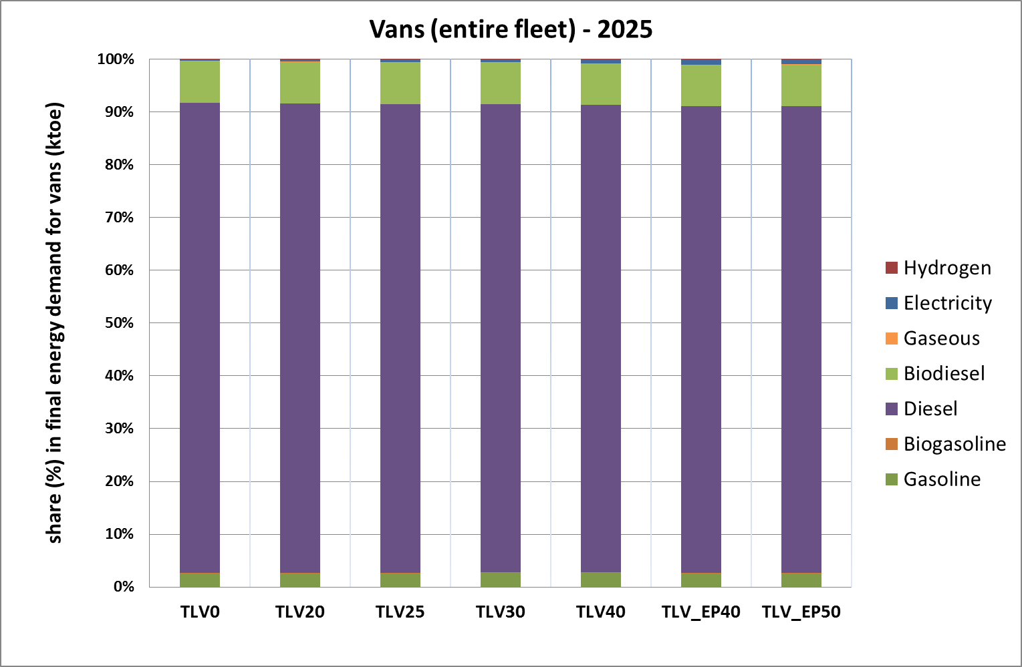

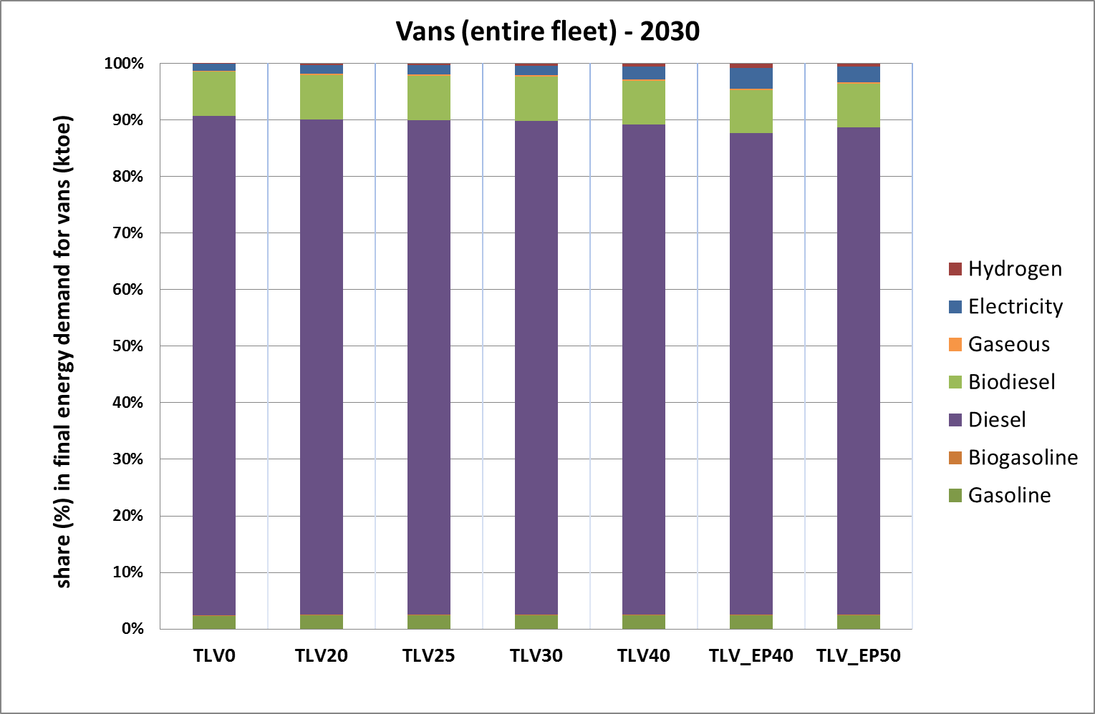

##### Macro economic impacts, including employment

###### Introduction and methodological considerations

The E3ME and GEM-E3 models are used to assess macroeconomic and sectoral economic impacts (see Annex 4 for a detailed description). In particular, these models are used to quantify the impacts of the different CO2 targets for light-duty vehicles on the wider economy, i.e. GDP, sectoral output and employment.

Table 19 shows the options for the target levels which were considered in the scenarios modelled by E3ME and GEM-E3. The macro-economic impacts of a combination TL25 (combining TLC25 and TLV25) would be very similar to those of the modelled scenario TL30c/25v.

Table 19: Scenarios modelled with E3ME and GEM-E3 for assessing the macro-economic impacts of the TLC and TLV options

|  |  |  |
| --- | --- | --- |
| **E3ME and GEM-E3  scenario** | **Cars target level option** | **Vans target level option** |
| Baseline (TL0) | TLC0 | TLV0 |
| TL20 | TLC20 | TLV20 |
| TL30c/25v | TLC30 | TLV25 |
| TL40 | TLC40 | TLV40 |

All the modelled scenarios estimate changes due to the new CO2 target levels in order to isolate the macroeconomic effects of this specific policy. In all scenarios, government revenue neutrality is imposed. The implementation of the new CO2 targets reduces petrol and diesel consumption, which are commodities upon which taxes are levied in all Member States. This is compensated, in all scenarios, by a proportional increase of VAT rates. As an example, in the scenario TLC30c/25v modelled through E3ME, it is projected that fuel duty revenues in the EU28 decrease by around 6,000 million euros in 2030, corresponding to a 5% decrease with respect to the baseline. The fuel duty revenue loss represents around 0.04% of the EU28 GDP. To ensure revenue neutrality, VAT total revenues increase by around 0.3% in 2030.

###### GDP impacts

*E3ME modelling results for GDP*

Table 20 shows the projected GDP impact for the EU-28 for the three scenarios compared against the baseline. The results shown are based on the assumption that the battery cells used in electric vehicles are imported from third countries. Further analysis regarding the impacts of the production of battery cells in the EU is presented in Section 6.5.4.

Table 20: GDP impacts in the baseline (million euros) and percentage change from the baseline under the policy scenarios – battery cells imported (E3ME results)

|  |  |  |  |  |
| --- | --- | --- | --- | --- |
| **Scenario** | **2025** | **2030** | **2035** | **2040** |
| Baseline (M€) | 16,018,660 | 17,087,725 | 18,381,955 | 19,892,587 |
| TL20 | 0.00% | 0.01% | 0.02% | 0.03% |
| TL30c/25v | 0.00% | 0.02% | 0.03% | 0.05% |
| TL40 | -0.01% | 0.02% | 0.05% | 0.07% |

The results show compared to the baseline a very small positive impact of the three policy scenarios on EU-28 GDP from 2030 onwards. It is projected that with tighter CO2 targets for LDV slightly increased consumer expenditure as well as increased infrastructure investment would be triggered. Together with a reduction in imports of petroleum products, this would result in an overall small positive impact on GDP.

At the sectoral level, there would be an expansion of the automotive supply chain, with a production increase in sectors such as rubber and plastics, metals and electrical and machinery equipment. This reflects the impact of increased demand for batteries and electric motors.

The automotive sector itself would see a decrease in value added due to the decreasing use of combustion engines in cars. Similarly, the power and hydrogen supply sectors would increase production reflecting increased demand for electricity and hydrogen to power EVs, while the petroleum refining sector would see losses. With higher target levels, these effects would become slightly more pronounced.

Table 21 shows the main impacts on the output within the most affected sectors in 2030 for the different scenarios. The other sectors overall see smaller but positive impacts due to the projected increased overall economic output.

Table 21: Impacts on the output within the most affected sectors in 2030 (million euros) and percentage change from the baseline – battery cells imported (E3ME results)

|  |  |  |  |  |
| --- | --- | --- | --- | --- |
| **Sector** | **Baseline (M€)** | **TL20** | **TL30c/25v** | **TL40** |
| Petroleum refining | 410,422 | -0.9% | -1.1% | -1.7% |
| Automotive | 1,076,972 | 0.0% | -0.1% | -0.5% |
| Rubber and plastics | 317,932 | 0.3% | 0.4% | 0.4% |
| Metals | 1,044,999 | 0.3% | 0.3% | 0.4% |
| Electrical equipment | 1,091,185 | 0.7% | 0.9% | 1.7% |
| Electricity, gas, water, etc | 1,124,221 | 0.2% | 0.3% | 0.5% |

*GEM-E3 modelling results for GDP*

GEM-E3 is a general equilibrium model. It therefore assumes that the economy is in perfect equilibrium, with no spare capacity that, if used, would boost economic output. Capital resources are fully employed in the economy. This has consequences when introducing policy changes, with GEM-E3 typically seeing crowding out effects of investments. A policy intervention to increase investments in a particular sector, for instance road transport therefore limits capital availability for other sectors.

The model was run using two variants: a "self-financing" variant where businesses and households finance their investments in more efficient vehicles by spending less on other items; a "loan-based" variant where businesses and households receive a 10-year loan (2% real interest rate) that is fully paid back within this period to purchase more efficient vehicles.

Table 22 shows the GDP impact of scenario TL30c/25v, for the two financing schemes, in terms of percentage changes with respect to the baseline. In the self-financing variant, the crowding out effect is dominant and the impact is marginally negative.

The loan-based variant presents a slightly positive effect that diminishes over time as the investment and expenditure for new advanced vehicles is reduced and loans start to be paid back. In this case, in the short term, the slightly positive impacts are mostly driven by the additional investments. The possibility for firms and households to finance their purchases through loans stimulates demand without crowding out other investments. Over time, as the stock of more efficient vehicles builds up, the impact from fuel savings becomes gradually more important.

Table 22: GDP impacts in the baseline (million euros) and percentage change from the baseline under scenario TL30c/25v comparing the self-financing and loan-based variants – battery cells manufactured in the EU (GEM-E3 results)

|  |  |  |  |  |
| --- | --- | --- | --- | --- |
|  | 2025 | 2030 | 2035 | 2040 |
| TL0 (Baseline) | 15,564,081 | 16,654,923 | 17,941,843 | 19,388,241 |
| TL30c/25v self-financing | -0.014% | -0.014% | -0.024% | -0.040% |
| TL30c/25v loan-based | 0.016% | 0.053% | 0.066% | 0.041% |

The GDP impacts for the other scenarios assessed are similar. Table 23 presents the GDP impact for the scenarios TL20, TL30c/25v and TL40 in terms of changes with respect to the baseline, in the loan-based variant. The positive impact tends to be slightly higher for the scenarios with tighter CO2 target, where higher expenditures for more efficient vehicles, financed by loans, increase GDP.

Table 23: GDP impacts in the baseline (million euros) and percentage change from the baseline under the policy scenarios - loan-based variant – battery cells manufactured in the EU (GEM-E3 results)

|  |  |  |  |  |
| --- | --- | --- | --- | --- |
|  | 2025 | 2030 | 2035 | 2040 |
| TL0 (Baseline) | 15,564,081 | 16,654,923 | 17,941,843 | 19,388,241 |
| TL20 loan-based | 0.015% | 0.045% | 0.044% | 0.021% |
| TL30c/25v loan-based | 0.016% | 0.053% | 0.066% | 0.041% |
| TL40 loan-based | 0.021% | 0.110% | 0.169% | 0.108% |

Vehicles manufacturing, electrical equipment manufacturing[164], fossil fuels production and power generation are the most impacted sectors. Table 24 shows the sectoral results in percentage changes with respect to the baseline. Starting from quite a low baseline, the increases in manufacturing of electric vehicles are expected to be quite significant ranging between 40-50% at 20%, 50-60% at 30%, and 90-165% at the 40% CO2 target levels. Still, as already seen earlier in the change of the composition of the overall fleet, the impact on the manufacturing of conventional vehicles would be limited at 20 % and 30% CO2 target levels. Even at 40% CO2 target, production would still be reduced by less than 6 % in 2030. Similarly, fossil fuel production is only slightly affected up to 2040, while at the same time production of electrical equipment and electricity would increase slightly.

Table 24: EU-28 production by sector in the baseline (million euros) and percentage change from the baseline under the policy scenarios (GEM-E3 results)

|  |  |  |  |  |
| --- | --- | --- | --- | --- |
| **Sectors** | **Scenario** | **2025** | **2030** | **2040** |
| Manufacturing of electric vehicles | TL0 (Baseline) | 24,424 | 52,785 | 88,590 |
| TL20 | 47.2% | 40.9% | 49.6% |
| TL30c/25v | 49.8% | 57.4% | 53.7% |
| TL40 | 93.1% | 165.9% | 94.2% |
| Manufacturing of conventional vehicles | TL0 (Baseline) | 845,066 | 893,707 | 1,025,884 |
| TL20 | -0.8% | -1.3% | -2.4% |
| TL30c/25v | -0.9% | -1.9% | -2.4% |
| TL40 | -1.6% | -5.6% | -4.2% |
| Electrical equipment (including batteries) | TL0 (Baseline) | 923,368 | 950,849 | 1,019,439 |
| TL20 | 0.3% | 0.4% | 0.7% |
| TL30c/25v | 0.3% | 0.6% | 0.7% |
| TL40 | 0.6% | 1.8% | 1.3% |
| Fossil Fuels | TL0 (Baseline) | 589,878 | 579,307 | 582,956 |
| TL20 | -0.2% | -0.4% | -0.8% |
| TL30c/25v | -0.2% | -0.5% | -1.0% |
| TL40 | -0.3% | -1.3% | -1.9% |
| Electricity | TL0 (Baseline) | 1,054,960 | 1,134,433 | 1,287,253 |
| TL20 | 0.2% | 0.4% | 1.1% |
| TL30c/25v | 0.2% | 0.5% | 1.2% |
| TL40 | 0.3% | 1.2% | 2.3% |
| Other Sectors | TL0 (Baseline) | 25,608,768 | 27,055,166 | 30,723,227 |
| TL20 | 0.02% | 0.03% | 0.00% |
| TL30c/25v | 0.02% | 0.04% | 0.01% |
| TL40 | 0.02% | 0.05% | 0.02% |

###### Employment

*E3ME modelling results on employment*

As shown in Table 25, with stricter CO2 target levels resulting in an increase in economic output, there is also an increase of the number of jobs across the EU-28 compared to the baseline, be it overall in limited numbers. The number of additional jobs also increases over time. The main drivers behind the GDP impacts also explain the employment impacts. The first table shows the results under the assumption that battery cells used in electric vehicles are imported in the EU from third countries, while for the second table it is assumed Europe develops its own battery sector. As can be seen, the impacts are more positive

Table 25: Total employment impacts (E3ME) in terms of number of jobs in (000s) and changes to the baseline (000s jobs)

|  |  |  |  |
| --- | --- | --- | --- |
| **Battery cells imported from third countries** | 2030 | 2035 | 2040 |
| Baseline | 230,207 | 225,871 | 223,148 |
| TL20 | 20 | 71 | 122 |
| TL30c/25v | 20 | 103 | 149 |
| TL40 | 86 | 189 | 213 |

|  |  |  |  |
| --- | --- | --- | --- |
| **Battery cells manufactured in the EU** | 2030 | 2035 | 2040 |
| Baseline | 230,233 | 225,905 | 223,181 |
| TL20 | 31 | 111 | 122 |
| TL30c/25v | 71 | 133 | 239 |
| TL40 | 88 | 197 | 334 |

In the different options assessed, the market uptake of battery and plugin hybrid electric vehicles increases with respect to the baseline, but the conventional powertrains remains the large majority of the fleet, as shown in Table 6. While manufacturing battery electric vehicles has a lower labour intensity than conventional vehicles, the labour intensity of manufacturing of plug-in hybrid electric vehicles is higher. As a consequence of the changes in the powertrain shares in the fleet, the impact on employment remains positive.

At sectoral level, similar conclusions as for the impacts on the output can be drawn. The overall impacts are small. Positive impacts are mainly seen in the sectors supplying to the automotive sector as well as in the power sector. Other sectors enjoy some positive second order effects, e.g. as a result of overall increased consumer expenditure. As shown in Table 26, for these sectors combined, the TL30c/25v scenario results in 22,000 additional jobs in 2030, while 4,000 jobs are lost in the petroleum refining and the automotive sectors.

Table 26: Employment impacts, broken down by sector - 2030 (E3ME model)

|  |  |  |  |  |  |  |  |
| --- | --- | --- | --- | --- | --- | --- | --- |
|  | Baseline | TL20 | TL30c/25v | TL40 | TL20 | TL30c/25v | TL40 |
|  | Number of jobs (000s) | Number of jobs (000s)  change from baseline | | | % change from baseline | | |
| Petroleum refining | 151 | 0 | -1 | -1 | -0.2% | -0.3% | -0.5% |
| Automotive | 2,454 | 0 | -3 | -12 | 0.0% | -0.1% | -0.5% |
| Rubber and plastics | 1,776 | 5 | 5 | 7 | 0.3% | 0.3% | 0.4% |
| Metals | 4,288 | 5 | 5 | 5 | 0.1% | 0.1% | 0.1% |
| Electrical equipment | 2,451 | 5 | 7 | 12 | 0.2% | 0.3% | 0.5% |
| Electricity, gas, water, etc | 2,852 | 2 | 2 | 5 | 0.1% | 0.1% | 0.2% |
| Other sectors | 200,427 | 3 | 3 | 69 | 0.0% | 0.0% | 0.0% |
| ***Total*** | ***230,209*** | ***20*** | ***18*** | ***86*** | ***0.01%*** | ***0.01%*** | ***0.04%*** |

*GEM-E3 modelling results on employment*

Total employment increases slightly with respect to the baseline in the policy scenarios. Higher levels of ambition for the CO2 target would lead to a higher increase in the number of jobs. The table below shows economy-wide results, based on the assumption that the batteries used in electric vehicles would be manufactured in the EU.

Table 27: Employment impacts under the Baseline (000s jobs) and policy scenarios (% change from Baseline) under the loan based financing variant – battery cells manufactured in the EU (GEM-E3)

|  |  |  |  |  |
| --- | --- | --- | --- | --- |
| **Scenario** | **2025** | **2030** | **2035** | **2040** |
| TL0 (Baseline) | 218,609 | 216,367 | 214,265 | 212,852 |
| TL20 loan-based | 0.01% | 0.01% | 0.02% | 0.01% |
| TL30c/25v loan-based | 0.01% | 0.02% | 0.02% | 0.02% |
| TL40 loan-based | 0.01% | 0.04% | 0.05% | 0.04% |

In the case where batteries are manufactured exclusively outside the EU, it was estimated for the TL30c/25v scenario that the number of jobs would slightly decrease by around 0.016% with respect to the baseline. Even if this scenario remains unlikely, it confirms the importance of additional measures to ensure battery production within the EU.

The sectoral breakdown of the employment impact, in Table 28, shows that the new jobs are mainly created in three sectors: advanced vehicles manufacturing, batteries production, and electrical equipment.

Table 28: Employment impacts, broken down by sector under the Baseline (000s jobs) and policy scenarios (% change from Baseline) under the loan based financing variant – battery cells manufactured in the EU (GEM-E3 model)

|  |  |  |  |  |
| --- | --- | --- | --- | --- |
| **Sectors** | **Scenario** | **2025** | **2030** | **2040** |
| Manufacturing of electric vehicles | Baseline | 75 | 147 | 206 |
| TL20 | 47.1% | 38.3% | 48.6% |
| TL30c/25v | 49.8% | 55.6% | 51.1% |
| TL40 | 93.8% | 159.8% | 85.6% |
| Manufacturing of conventional vehicles | Baseline | 3,340 | 3,174 | 2,998 |
| TL20 | -0.9% | -1.4% | -2.5% |
| TL30c/25v | -0.9% | -2.0% | -2.5% |
| TL40 | -1.6% | -5.8% | -4.3% |
| Electrical equipment goods (including batteries) | Baseline | 4,002 | 3,740 | 3,337 |
| TL20 | 0.3% | 0.4% | 0.7% |
| TL30c/25v | 0.3% | 0.6% | 0.7% |
| TL40 | 0.5% | 1.7% | 1.2% |
| Fossil Fuels | Baseline | 697 | 632 | 519 |
| TL20 | -0.1% | -0.1% | -0.2% |
| TL30c/25v | -0.1% | -0.2% | -0.2% |
| TL40 | -0.1% | -0.5% | -0.6% |
| Electricity | Baseline | 2,351 | 2,528 | 2,660 |
| TL20 | 0.2% | 0.4% | 1.1% |
| TL30c/25v | 0.2% | 0.5% | 1.2% |
| TL40 | 0.3% | 1.2% | 2.3% |
| Other Sectors | Baseline | 208,144 | 206,146 | 203,132 |
| TL20 | 0.00% | 0.00% | -0.02% |
| TL30c/25v | 0.00% | -0.01% | -0.02% |
| TL40 | -0.01% | -0.03% | -0.03% |

*Other studies*

External studies assessing the possible impacts of an accelerated uptake of low- and zero-emission vehicles conclude that this would lead to an increase in overall employment. A series of macroeconomic studies – both for the EU-28 as a whole[165] and for some individual Member States[166] – show positive impacts on the wider economy, including growth in GDP and employment.

Positive impacts are also confirmed at the level of car manufacturing even for scenarios with significantly higher shares of electrified powertrains as high as 100%.

However, the overall employment impacts will be influenced by the actual technology mix and how other transformative processes such as digitalisation or new business models, e.g. car sharing, will affect the automotive sector.

A literature review[167] of recent studies on employment impacts of a higher share of electrified powertrains confirms that the majority of studies conclude with positive impacts on employment. However, the review points out that the positive impacts on employment rely *inter alia* on the assumption that the EU would retain its technological leadership also in the area of electrified powertrains.

A more detailed summary of the external studies on employment and qualifications is presented in Annex 7.

*Broader impacts on employment and qualification of workers*

A higher share of electronic components will require different and additional skills compared to the skills needed for the development, manufacturing and maintaining of conventional powertrains ('reskilling'). At the components level, the assembly of electric engines is technically more complex compared to a conventional engine combined with a more important role for electronics and digitalisation. This will require better qualified people ('upskilling'). The consequences for employment and qualification will be different for each actor in the automotive supply chain. It is expected that some parts of the value chain will shift from manufacturers to other parts of the supply chain and vice versa.

A stakeholder meeting organised during the preparation of this impact assessment[168] was dedicated to better understand the potential social impacts of the transition to electrified powertrains. It brought together key results of recent studies as well as stakeholder views on how the uptake of low- and zero-emission vehicles may affect employment and skills (see Annex 2). It showed positive effects on total employment in the automotive sector and for the economy as a whole by 2030 also when penetration rates as high as 40% BEV or FCEV and 30% PHEV were assumed.[169] However, the magnitude of the impacts on employment in particular in car manufacturing will depend on the scale and speed of other on-going transformative processes in the automotive industry, e.g. digitalisation, new business models such as car sharing will affect the sector.[170]

The adaptive capacity to cope with these changes varies across the automotive value chain both for companies and employees. SMEs that are highly specialised in certain elements of conventional powertrains may need more time to identify and develop new business opportunities. Unqualified or low qualified workers may have more difficulties in acquiring the new skills and qualifications needed. Similarly, regions with industry clusters built around conventional powertrains or with a strong refining industry may be more negatively affected.

However, the challenges and opportunities in particular for SMEs will be influenced by the speed of the transition to low- and zero-emission vehicles. While the policy options considered will require different transition speeds, all of them would only lead to a gradual transition and not disruptive technological change. In all scenarios by 2030, conventional powertrains, either as stand-alone or as hybrid technologies, will still be fitted in the majority of new vehicles and therefore continue to play a key role. This will provide also highly specialised SMEs and their employees with flexibility to adjust to new technologies and enter new markets while still benefitting from their strengths in incumbent technologies.

Independently from the uptake of alternative powertrains, the automotive industry – as all other sectors – will be faced with fundamental changes in labour markets. Demographic changes will significantly reduce the labour force potential until 2030 and beyond. According to the 2015 Ageing Report[171], total labour supply in the EU28 is projected to almost stabilise between 2013 and 2023, while it is expected to decline by 8.2% between 2023 and 2060, equivalent to roughly 19 million people. As a result, the automotive sector may be faced with a shortage of qualified employees. Against these labour market issues in the EU it was suggested that less labour intensive technologies such as BEVs could indeed improve the EU's competitiveness[172].

A number of measures have been identified on how to allow the workforce to adapt to the new qualification needs and to make the transition socially fair[173]. Possible actions include industrial collaboration, building new value chains, creating social dialogue, supporting the employability and retraining of workers / lifelong learning, stimulating entrepreneurship and creating new job opportunities in the circular economy.

For this reason, as part of the High Level Group for the automotive industry GEAR 2030[174] a "Human Capital" Project Team was established to “identify the impact on employment in the EU, prepare approaches for mitigating possible negative consequences and develop a strategy for ensuring that the necessary skills will be available in 2030” for the EU automotive industry. The Project Team assessed the landscape of existing initiatives across the EU, looked at what trends will impact the sector up to 2030. Specifically, it investigated the skills and human capital needs and concluded with specific recommendations on EU and Member State actions on developing digital skills and supporting (re-)qualification programmes.

In addition, the Commission's Blueprint-initiative[175] launched in May 2017 includes the automotive sector as one of the sectors targeted. It offers the possibility for project applications to bring together key stakeholders from the social partners to identify qualification / skills challenges combined with the roll-out of tailored strategies at national/regional level to address these challenges.

#### Social Impacts

A first element considered as regards social impacts is whether and to what extent the EU-wide CO2 fleet targets affect different population groups differentiated according to income groups.

A study[176] looking at the dynamics of the used car market and the distribution of costs and benefits of the EU legislation on CO2 emission standards for LDV confirmed that used vehicles are far more important for lower income groups and showed that used vehicles tend to be older among lower income groups.

The study identified a correlation between the fuel efficiency of a vehicle and its purchase price on the used vehicle market. Reduced CO2 emissions were found to have a positive effect on the value of a passenger car on the second hand market of around 22 EUR per gram CO2 per km. This means that the lower the CO2 emissions of a used car, the higher the price an owner can ask for when selling its used car. This price premium is passed on between subsequent car owners and increases with the sequence of owners. There is progressive pricing of fuel efficiency with increasing vehicle age.

Due to the socio-economic properties of the used vehicle market, this in turn causes a redistribution of the benefits of fuel efficiency measures towards the lower income groups and, consequently, towards regions where a larger share of the population belongs to those income groups.

In view of this, the quantitative assessment of the options for the fleet-wide CO2 targets for new vehicles looked also at the total cost of ownership for the second users. This parameter reflects the difference between a policy scenario and the baseline in the capital costs, O&M costs and fuel cost savings, during the sixth to tenth year of use of a vehicle registered in 2025 or 2030.

As for the TCO for the first user (see Section 6.3.2.2.2.3), taxes are included and a discount rate of 11% for cars or 9.5% for vans is used and the calculation takes account of the residual value of the vehicle (and the technology added) with depreciation

##### TCO for second user - passenger cars (TLC)

The results of the analysis of the TCO for the second user are summarised in Figure 22. Compared to the first user, the second user will benefit from higher net savings under all options and in both years. The highest net savings are found under options TLC40 and TLC_EP40.

Figure 22: TCO-second user (years 6-10) (EUR/car) – 2025 and 2030

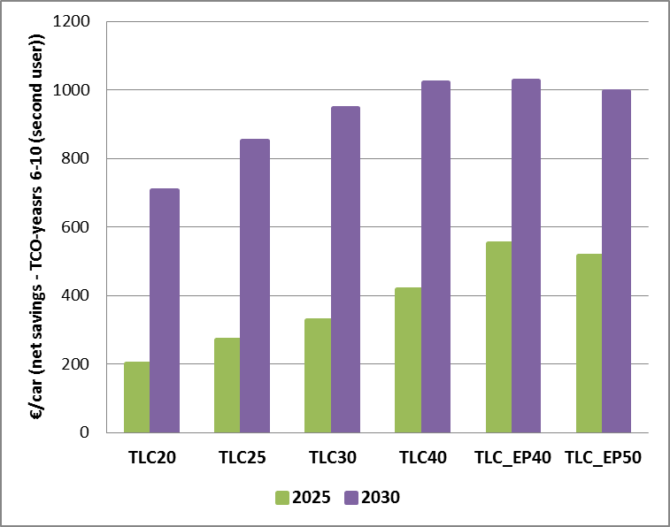

The results of the sensitivity regarding the effect of varying cost assumptions are given in Annex 8.

##### TCO for second user - vans (TLV)

Figure 23 shows the net savings from a second end-user perspective for an average new van registered in 2025 and in 2030 under the different options (expressed as the difference with the baseline).

There are net savings for the second user under all options, and the highest savings are achieved under option TLV_EP40 in 2025 and under options TLV40 and TVL_EP50 in 2030. However, the second user savings for vans are lower than for the first user (see Section 6.3.2.2.2).

###### **Figure 23: TCO-second user (years 6-10) (EUR/van) – 2025 and 2030**

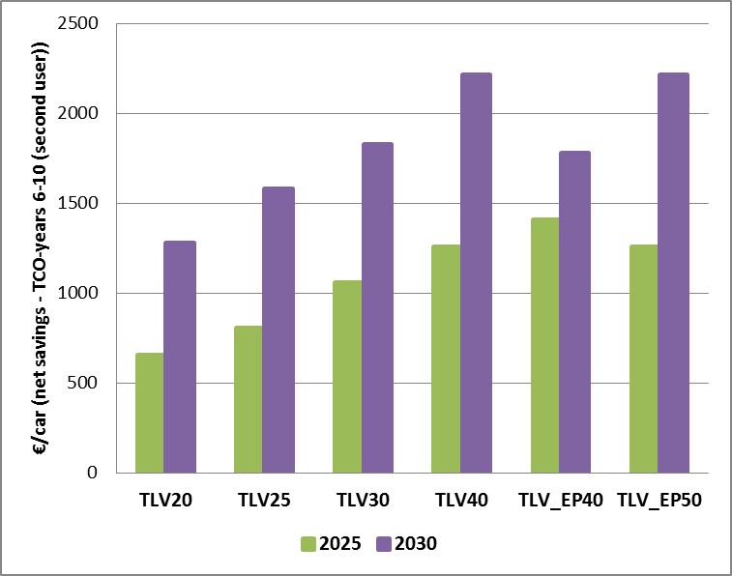

The results of the sensitivity regarding the effect of varying cost assumptions are given in Annex 8.

#### Environmental impacts

The main environmental impact of EU-wide CO2 targets for the new LDV fleet concern the tailpipe CO2 emissions within the sector. The full effect of setting new CO2 targets for newly registered vehicles in the period 2021-2030 will only be realised over time as a larger share of the overall vehicle stock becomes subject to the new targets due to fleet renewal. Therefore, the environmental impacts up to 2040 are shown in this section.

Furthermore, next to 2020, also 2005 is considered as a reference year where this is relevant to put the emission reductions observed in the sector in a broader policy perspective[177].

Well-to-wheel CO2 emissions have also been assessed[178]. However, due to the interactions with the EU ETS, care must be taken when interpreting these figures in a causal fashion. While indicative of a part of upstream emissions as traditionally defined in LCAs, they should not be interpreted as the impact on CO2 emissions of the vehicle standards alone. Furthermore, the assessment looked at possible changes in the embedded CO2 emissions (related to the manufacturing of the vehicle and its components) triggered by the targets.

A change in fuel consumption or mix will not only affect greenhouse gas emissions, but also those of air pollutants (esp. NOx and particulate matter). These co-benefits of the policy options have also been quantified and assessed.

##### Passenger cars (TLC)

*CO2 emissions (tailpipe)*

Under the baseline (TLC 0), tailpipe CO2 emissions from cars in the EU-28 are reduced by 26% between 2005 (543 Mt) and 2030 (402 Mt). A stronger reduction is observed since 2015, when the first CO2 targets for new cars took effect and the reduction is slowing down after 2030 as no new targets are set beyond 2021.

Figure 24 shows the evolution of the emissions between 2025 and 2040 under the baseline and the TLC policy options comparing them to the 2005 emissions.

Across the options considered, the additional reductions in 2030 on top of the baseline range from 4 percentage points (TLC20) to 11.4 percentage points (TLC_EP50). In 2040, the range is from 19.1 percentage point (TLC20) to 30.3 percentage points (TLC_EP50).

**Figure 24: (Tailpipe) CO2 emissions of passenger cars in EU-28 - % reduction compared to 2005**

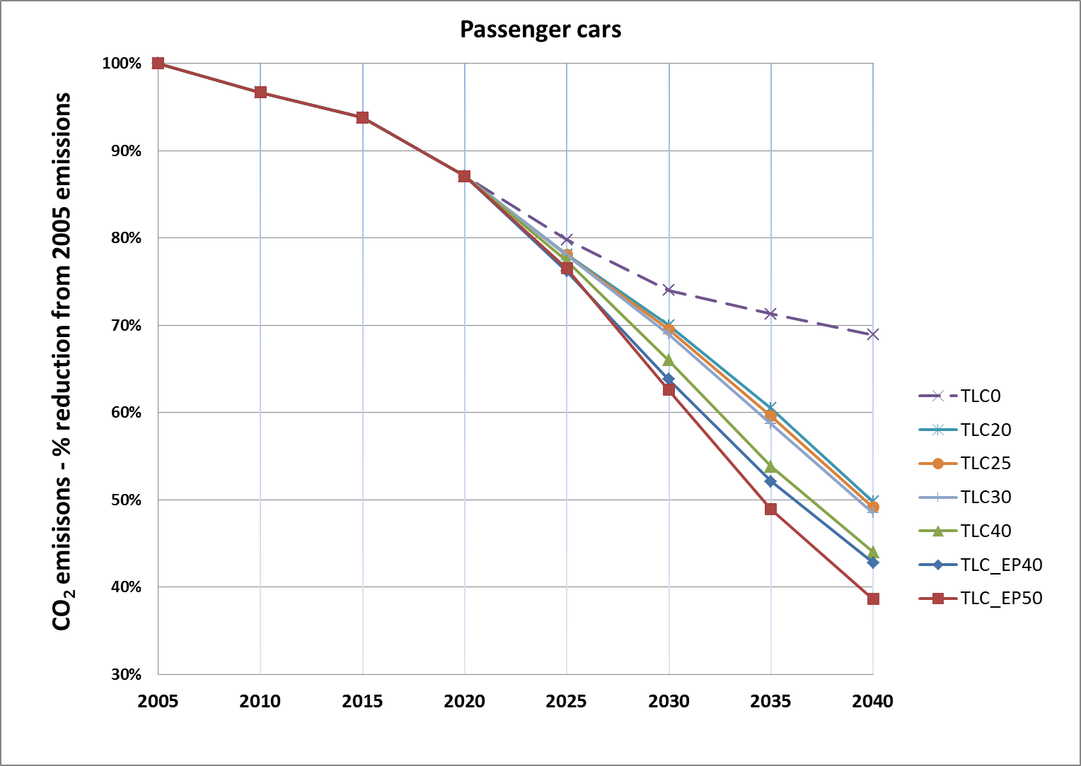

Figure 25 shows the reduction of the cumulative CO2 emissions over the period 2020-2040 (compared to the baseline) for the different scenarios. For cars, these emission reductions range from about 700 Mt (TLC20) up to nearly 1,500 Mt (TLC_EP50).

Figure 25: Cumulative (tailpipe) 2020-2040 CO2 emissions of cars for EU-28 – emission reduction from the baseline (kt)

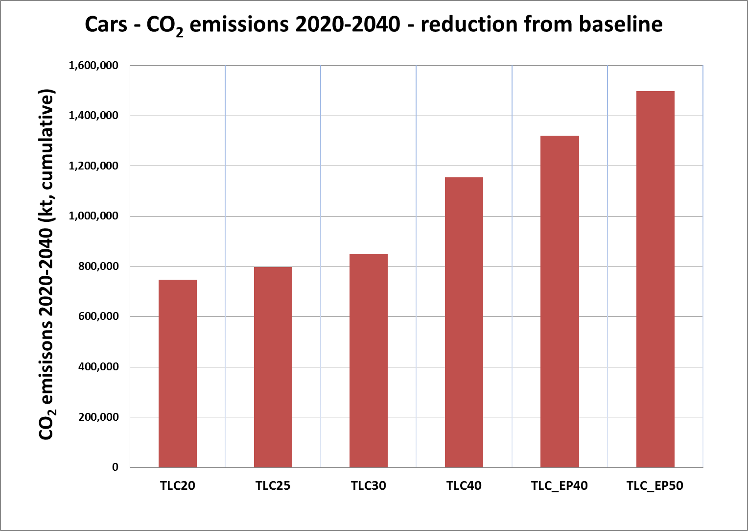

*CO2 emissions (WTW)*

When considering the well-to-wheel CO2 emissions, the trends are very similar, with slightly lower emission reductions. Under the baseline, emissions reduce by 24.8% between 2005 (658 Mt) and 2030 (495 Mt).

Across the options considered, the additional reductions in 2030 on top of the baseline range from 3.6 percentage points (TLC20) to 10.2 percentage points (TLC_EP50). In 2040, the range is from 17.8 percentage points (TLC20) to 28.9 percentage points (TLC_EP50).

*Air pollutant emissions*

Due to the change in fleet composition under the different policy options concerning the fleet-wide CO2 target, also the emissions of air pollutants are affected. Under the baseline and TLC options, compared to 2020, emissions of nitrogen oxides and particulate matter (PM2.5) from cars are reduced as shown in the tables below.

Table 29: NOx emissions of passenger cars in EU-28 - % reduction compared to 2020

|  |  |  |
| --- | --- | --- |
| **NOx emissions** | **2025** | **2030** |
| **TLC 0** | 27% | 36% |
| **TLC20** | 28% | 38% |
| **TLC25** | 28% | 39% |
| **TLC30** | 28% | 39% |
| **TLC40** | 29% | 42% |
| **TLC_EP40** | 29% | 43% |
| **TLC_EP50** | 29% | 44% |

Table 30: PM2.5 emissions of passenger cars in EU-28 - % reduction compared to 2020

|  |  |  |
| --- | --- | --- |
| **PM2.5 emissions** | **2025** | **2030** |
| **TLC 0** | 27% | 31% |
| **TLC20** | 22% | 33% |
| **TLC25** | 22% | 34% |
| **TLC30** | 22% | 35% |
| **TLC40** | 22% | 42% |
| **TLC_EP40** | 22% | 39% |
| **TLC_EP50** | 22% | 41% |

##### Vans (TLV)

*CO2 emissions (tailpipe)*

Under the baseline (TLV 0), tailpipe CO2 emissions from vans in the EU-28 are reduced by 17.4% between 2005 (113 Mt) and 2030 (94 Mt). The reduction is slowing down after 2030 as no new van targets are set beyond 2020.

Figure 26 shows the evolution of the emissions between 2025 and 2040 under the baseline and the TLV policy options compared to 2005. Across the options considered, the additional reductions in 2030 on top of the baseline range from 4.8 percentage points (TLV20) to 14.1 percentage points (TLV_EP50). In 2040, the range is from 25.6 percentage points (TLV20) to 38.0 percentage points (TLV_EP50).

**Figure 26: (Tailpipe) CO2 emissions of vans in EU-28 - % reduction compared to 2005**

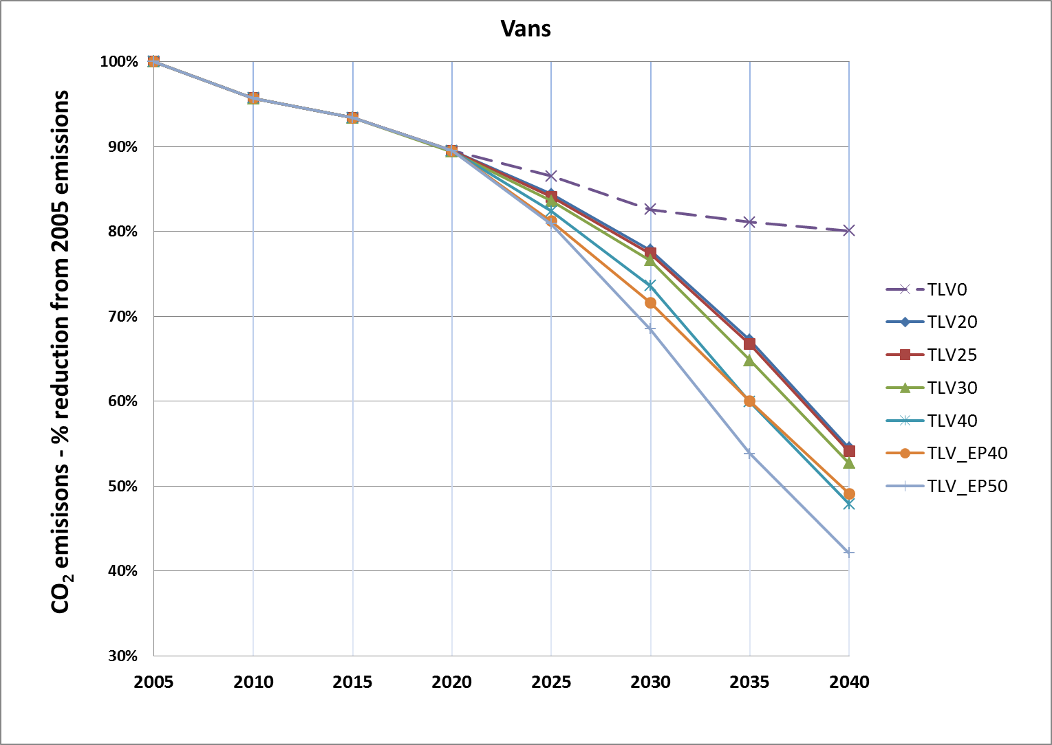

Figure 27 shows the reduction of the cumulative CO2 emissions over the period 2020-2040 (compared to the baseline) for the different scenarios. For vans, these emission reductions range from about 200 Mt (TLV20) up to nearly 400 Mt (TLV_EP50).

Figure 27: Cumulative (tailpipe) 2020-2040 CO2 emissions of vans for EU-28 – emission reduction from the baseline (kt)

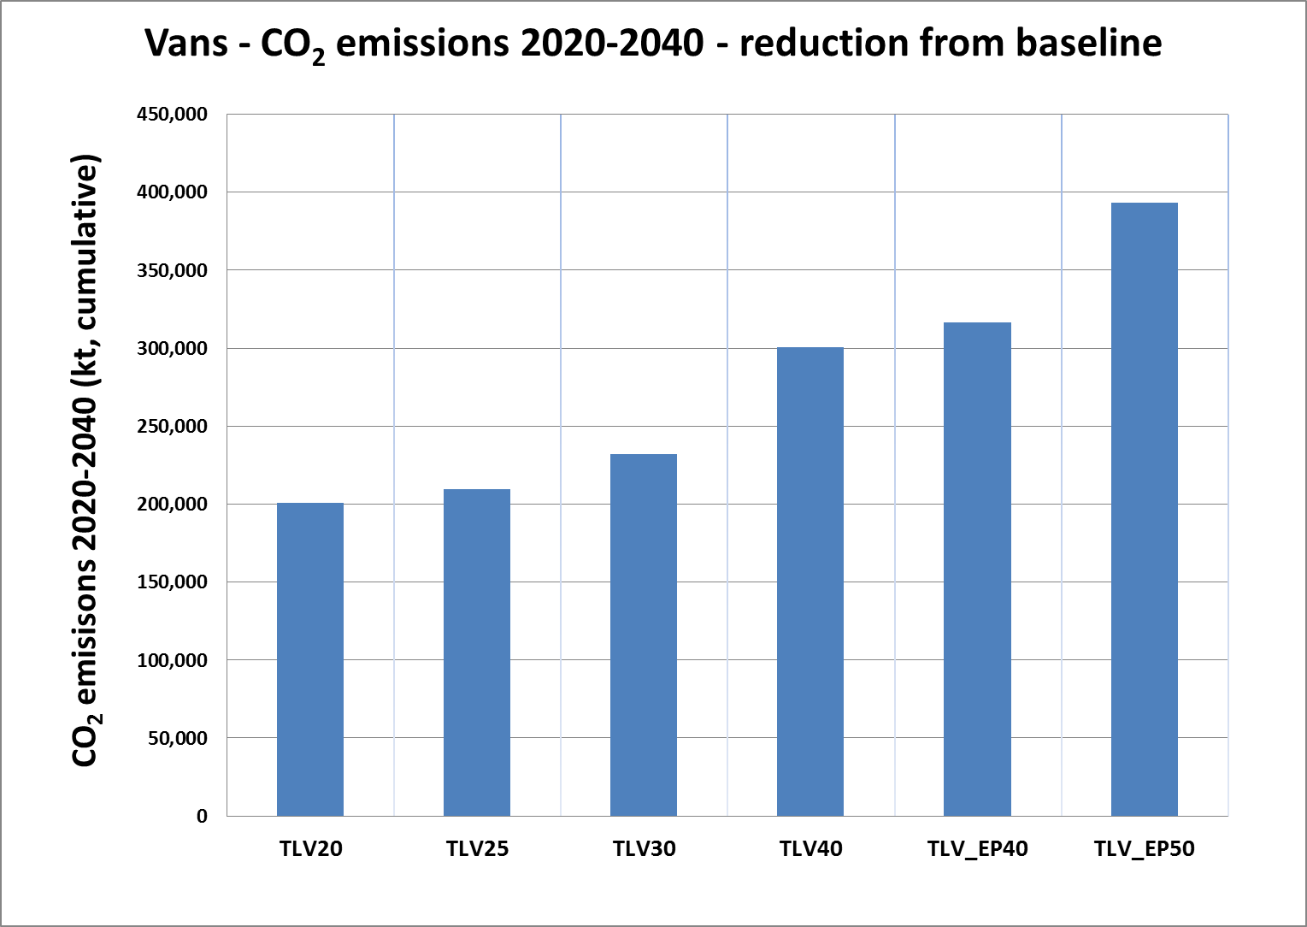

*CO2 emissions (WTW)*

When considering the well-to-wheel CO2 emissions, the trends are very similar, with slightly lower emission reductions. Under the baseline, emissions reduce by 16% between 2005 (137 Mt) and 2030 (114 Mt).

Across the options considered, the additional reductions in 2030 on top of the baseline range from 4.4 percentage points (TLV20) to 12.3 percentage points (TLV_EP50). In 2040, the range is from 23.2 percentage points (TLV20) to 33.8 percentage points (TLV_EP50).

*Air pollutant emissions*

Due to the change in fleet composition under the different policy options concerning the fleet-wide CO2 target, also the emissions of air pollutants are affected. Under the baseline and TLV options, compared to 2020, emissions of nitrogen oxides and particulate matter (PM2.5) from vans are reduced as shown in the tables below.

###### **Table 31: NOx emissions of vans in EU-28 - % reduction compared to 2020**

|  |  |  |
| --- | --- | --- |
| **NOx emissions** | **2025** | **2030** |
| TLV 0 | 22% | 31% |
| TLV20 | 23% | 33% |
| TLV25 | 23% | 33% |
| TLV40 | 24% | 36% |
| TLV_EP40 | 25% | 37% |
| TLV_EP50 | 25% | 41% |

###### **Table 32: PM2.5 emissions of vans in EU-28 - % reduction compared to 2020**

|  |  |  |
| --- | --- | --- |
| ***PM2.5* emissions** | **2025** | **2030** |
| TLV 0 | 19% | 32% |
| TLV20 | 20% | 33% |
| TLV25 | 20% | 33% |
| TLV40 | 21% | 36% |
| TLV_EP40 | 22% | 38% |
| TLV_EP50 | 22% | 41% |

##### Contribution to the ESR targets

As already mentioned in Section 6.1, CO2 emissions from road transport contribute significantly to the emissions from the sectors not covered under the EU ETS. While the EU is on track to meet its 2020 target for these sectors (i.e. 10% reduction by 2020 with respect to 2005) further efforts are necessary to meet the 30% reduction target by 2030. Maintaining the current CO2 emission standards for cars and vans would not be sufficient for meeting the EU's 2030 target under the Effort Sharing Regulation, as confirmed by the EU Reference Scenario 2016[179].

The analytical work underpinning the Effort Sharing Regulation and the Energy Efficiency Directive proposals built on the so-called *EUCO30* scenario, under which all 2030 climate and energy targets are met through the implementation of additional policies to the ones assumed under the EU Reference scenario 2016. For the road transport sector, these additional policies included more ambitious CO2 emission standards for new cars and vans.

Under the *EUCO30* scenario, emissions from road transport are projected to reduce by 25% in 2030 with respect to 2005. Figure **28** depicts projected GHG emissions in the road transport sector for the *EUCO30* scenario and for several of the options considered in this Impact Assessment regarding the EU-wide fleet CO2 targets for cars (TLC) and for vans (TLV).

It shows a significant difference between the emission reduction in road transport in the *EUCO30* scenario and in the baseline used for this Impact assessment. When setting stricter CO2 targets for new cars and vans for the period after 2020/2021, this difference gets significantly smaller. However, the options assessed do not close the gap completely, so that further measures to reduce GHG emissions in the road transport sector remain relevant, including for example EU policies setting CO2 emissions performance standards for trucks.

Figure 28: Evolution of GHG emissions between 2005 (100%) and 2030 under the *EUCO30* scenario and under the baseline and different policy options for the CO2 target levels for new cars and vans considered in this impact assessment

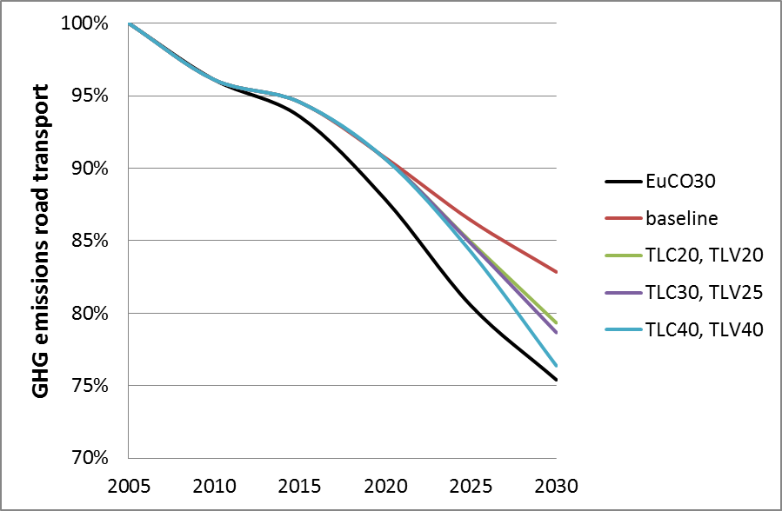

An analysis has also been carried out to assess the contribution of the new CO2 standards for cars and vans to the Member States targets set in the Effort Sharing Regulation (ESR)[180], which are determined on the basis of the relative GDP per capita.

The analysis is performed by grouping Member States in two groups depending on their 2030 ESR targets. The first group consists of Member States with an ESR reduction target below 20% and the second group are Member States with a target between -20% and -40%. For each group, the weighted average[181] of the 2030 ESR emissions reduction targets was calculated for the purpose of this analysis. Table 33 compares these values with the weighted average[182] of the emissions reductions for light-duty vehicles between 2005 and 2030 under two different options for the EU-wide fleet CO2 standards[183].

This shows that the new targets will result in more CO2 emission reductions in Member States with more ambitious reduction targets under the ESR. This general trend can be explained by lower income Member States having higher GDP growth and hence faster transport activity growth. These countries have also a larger second hand market.

Table 33: Comparison of the average of the emission reductions required under the Effort Sharing Regulation (ESR) and emission reductions for light-duty vehicles under different policy options

|  |  |  |  |
| --- | --- | --- | --- |
| Member State groups | Weighted average of the ESR emission reduction targets | CO2 reductions from light-duty vehicles | |
| TLC30 / TLV25 | TLC30 / TLV40 |
| ESR target < 20% | 9% | 9% | 10% |
| ESR target ≥ 20% | 35% | 33% | 34% |

An additional comparison was performed with the "*EUCO30*" scenario to assess whether the options considered for the automotive sector in this impact assessment are coherent with the broader 2030 energy and climate policy framework.Table 34 shows the emissions from the ESR sectors under the *EUCO30* scenario and in a scenario TLC30c/25v+ where the EU-wide fleet CO2 targets for new cars and vans are set as in options TLC30 and TLV25 (referred to as TL30c/25v), while assuming also other transport related policies (as in *EUCO30*)[184].

Table 34: Comparison of CO2 emissions under the *EUCO30* scenario and the TL30c25v+ scenario

|  | **2005** | **2030** | |
| --- | --- | --- | --- |
|  | *EUCO30* | TL30c/25v*+* |
| ESR emissions [Mt CO2] | 2,848 | 1,985 | 1,999 |
| % change from 2005 |  | -30.3% | -29.8% |

In *EUCO30*, ESR emissions fall by 30.3% in 2030 compared to 2005 levels, which is in line with the 30% target. In the TL30c/25v+ scenario, the reduction is 29.8%. From this assessment, it could be concluded that the new policy scenarios and *EUCO30* are consistent in the GHG savings they deliver in the non-ETS sectors. This assessment also confirms that any remaining gap identified for transport emissions is expected to be closed further as additional CO2 reduction policies are being developed in the transport sector, such as emission standards for heavy-duty vehicles. Additional details on this analysis are presented in Annex 4.

### Timing of the targets (TT)

#### Option TT 1: The new fleet-wide targets start to apply in 2030.

Under this option the new targets start to apply in 2030. Even if the 2030 targets can be expected to create some anticipation by manufacturers, the absence of more ambitious CO2 targets prior to 2030 is very likely to cause a number of CO2 reducing technologies or LEV/ZEV to be introduced only close to the date of application of the new targets, in particular for those technologies with high manufacturing costs.

*Environmental impacts*

The expected delayed introduction of fuel-efficient technologies and LEV/ZEV will lead to higher CO2 and air pollutant emissions in the intermediate period. Furthermore, given the average lifetime of new vehicles, the vehicle stock in 2030 will continue to have higher CO2 and air pollutant emissions. As a consequence, in this option, the contribution of road transport to the 2030 climate and energy targets risks being more limited.

For example, with EU-wide CO2 targets as under options TLC30 and TLV25, in the worst case whereby no emission reduction happens by 2025 due to the fact that no new target is set for 2025, the cumulative total CO2 emissions from light duty vehicles in the period 2020-2030 would be around 81 million tons higher than in a scenario with an interim target in 2025, stimulating an earlier uptake of more efficient vehicles. This is equivalent to around 16% of total annual CO2 emissions in 2030 in the baseline. Even if some reduction efforts were to be anticipated, this indicates that under this option cumulative CO2 emissions in the period 2020-2030 would be higher.

*Economic impacts*

As the new targets start to apply only in 2030, there is a limited incentive for manufacturers to increase and improve their product range of LEV/ZEV at a higher pace than that needed to meet earlier new targets, as is reflected in the currently low market share of these vehicles among new registrations.

This option would provide industry with more lead time to invest and develop new technologies. However, delaying the introduction of more efficient technologies, and LEV/ZEV in particular, could have a negative impact on the technology cost reduction through economies of scale.[185] At the same time, applying the new target in 2030 only may provide a weaker signal to potential investors to invest in alternative powertrains and infrastructure. Given the regulatory developments in other regions in the world, Europe would risk to lose out as lead market (see section 2.1.3). European manufacturers would not benefit from a first mover advantage with negative effects on their international competitiveness.

*Social impacts*

Due to the delay in bringing more efficient vehicles on the market, consumers would lose out on fuel cost savings. Moreover, the delay could provide for more time to prepare for the new skills required for the production of low- and zero-emission vehicles ('reskilling' and 'upskilling', see section 6.3.2.2.3.3).

#### Option TT 2: New fleet-wide targets start to apply in 2025, and stricter fleet-wide targets start to apply in 2030.

*Environmental impacts*

Since targets are set in 2025 and 2030, this option provides for early action well ahead of 2030. Thus, cumulative emission reductions are expected to be higher. *Economic impacts*

Setting CO2 targets also in 2025 would provide a clear and early signal for the automotive sector to increase the market share of LEV/ZEV in the EU from the early 2020s on. At the same time, it would leave sufficient flexibility to manufacturers to phase in gradually more efficient technologies and hence give sufficient lead time for the automotive supply chain to adapt through a step by step approach. However, this would be less the case where a higher average annual reduction of the target level is foreseen in the earlier period 2021-2025 compared to the later period 2025-2030 such as illustrated by the EP_40 options.

*Social impacts*

Consumers would benefit from fuel cost savings from the early 2020s on due to an earlier introduction of more efficient vehicles (compared to option TT 1). While the transition to LEV/ZEV would need to commence earlier, there would still be time to prepare for the new skills requirements.

#### Option TT 3: New fleet-wide targets are defined for each of the years until 2030.

*Environmental impacts*

This option would ensure CO2 emission reductions follow an annual path, like installations under the emissions trading system, and therefore would provide greater certainty for the expected CO2 and air pollutant emission reductions to be effectively delivered. It would also ensure timely and continuous market uptake of LEVs/ZEVs.

*Economic impacts*

Annual targets could be perceived as very prescriptive in imposing a rigid annual emission reduction pathway on manufacturers. Managing year-to-year market fluctuations, for example, due to changes in customer demand would be almost impossible without additional flexibility for compliance between years. It would be challenging for manufacturers to plan the modernisation of models and introduction of new technologies in their fleet against annual emissions targets. In addition, setting annual targets in the first years after 2021 may create a risk of limiting lead time for manufacturers to appropriately plan and implement their strategies for meeting the new targets. Overall, this could make delivery of the targets rather costly.

*Social impacts*

Consumers would benefit from fuel cost savings as early as possible.

*Link with Banking / Borrowing*

As explained in section 5.4.4., the timing of the targets affects how banking and borrowing could be implemented. If no annual targets are set (options TT1 and TT2), a target trajectory for banking and borrowing would need to be defined. This would avoid that too many credits are accumulated up to 2025 and/or 2030. There is also the risk that a manufacturer or pool could significantly exceed the target and hence undermine the intended CO2 emission reductions for that time period.

## Distribution of effort (DOE)

#### Methodology and introduction

In order to assess the impact of using a utility based or other distribution function for defining the CO2 target of individual manufacturers, the JRC developed an additional model (DIONE). For this, a limited number of manufacturer categories were defined taking into account key common features (see below).

Starting from the segment/powertrain shares resulting from the PRIMES-TREMOVE model, the impacts per manufacturer category were analysed, taking account of their fleet characteristics in terms of utility and share of different powertrains and segments.

For a given CO2 target in a given year and applying one of the DOE options, the average manufacturing cost increase against the baseline per vehicle is calculated for each manufacturer category.

*Manufacturer categorisation*

As it is not possible to accurately predict the evolution of the average vehicle mass or footprint for actual manufacturers over time, the results of this assessment are rather presented for a limited number of "stylised" manufacturers, each representative of manufacturers with similar specific characteristics. The criteria used for defining the manufacturer categories are the fleet composition in terms of market segments for small, medium, and large cars and the readiness to increase the uptake of low-emission vehicles. The resulting passenger car and LCV manufacturer categories are presented in the tables below[186].

Table 35: Categories of passenger car manufacturers considered for the assessment of the DOE options

| **Category** | **Predominant segment[187]** | **Expected LEV uptake level[188]** |
| --- | --- | --- |
| Manufacturer of smaller cars | Small | Low |
| Advanced technology average car manufacturer | Medium | Early market leader |
| Average car manufacturer | Medium | Average/Low |
| Advanced technology manufacturer of larger cars | Large | Early market leader |

**Table 36: Categories of LCV manufacturers considered for the assessment of the DOE options**

|  |  |  |
| --- | --- | --- |
| **Category** | **Predominant segment[189]** | **Expected LEV uptake level** |
| Manufacturer of larger LCVs with EVs | Large | EV model sales |
| Manufacturer of larger LCVs | Large | No EV sales |
| Manufacturer of smaller LCVs | Small | Variable |

###### Assessment of the variants to option DOE1 (mass based limit value curve with equal reduction efforts for all manufacturers)

As regards option DOE 1, the quantitative assessment was only possible for the case where the utility parameter is 'mass in running order', as no data is yet available on the WLTP test mass of the different vehicles and manufacturers. Similarly, it was not possible to quantify the effect of using different slopes for different categories of vans (i.e. steeper slope for heavier vans).

Overall, the impacts on the results of shifting to WLTP test mass as the utility parameter can be expected to be limited, as it can be assumed that the average 'mass in running order' and the average 'WLTP test mass' correlate quite closely, and this correlation would not differ between different manufacturers or pools. Thus, shifting from 'mass in running order' to 'WLTP test mass' as the utility parameter would not significantly affect the relative position of individual manufacturers or pools on the limit value curve. Possibly, in the case of cars, larger (heavier) vehicles might have relatively more optional features, which would mean that their ''WLTP test mass' would increase more compared to smaller (lighter) cars. If so, under an "equal reduction effort" approach, the limit value curve would tend to become less steep (lower slope), making the targets less strict for lighter cars, while tightening them for heavier cars.

As regards the two-slope approach, which was suggested for vans by industry stakeholders, particular care needs to be taken in designing the limit value curve in such a way that it ensures that the EU-wide fleet average CO2 target is maintained. While a linear limit value curve means that the EU-wide fleet average CO2 target corresponds with the sales-weighted average mass of the fleet, this is no longer the case for a two-slope approach. Instead, this will require the CO2 target of a vehicle with a mass equal to the sales-weighted average mass of the fleet to be stricter than the EU-wide fleet CO2 target. In other words, the overall impact of the two-slope approach compared to the single-slope approach with the same EU-wide fleet target level, would be that the target is slightly relaxed for both the lightest and the heaviest vehicles, while becoming stricter for the middle category (i.e. vans with a mass close to the fleet-wide average mass). In absolute terms, the overall impacts will depend on the target level, but can generally be expected to be rather limited assuming that the two slopes will not be very different.

##### Economic Impacts

###### Average manufacturing costs

The analysis found that, for a given EU-wide fleet CO2 target, the average manufacturing costs per vehicle relative to the baseline change only marginally across the different DOE options considered.

This was expected as the utility function is merely intended to distribute the effort across the different manufacturers, while not modifying the overall effectiveness and efficiency of the EU-wide fleet CO2 target level.

For example, when applying the CO2 target for passenger cars of option TLC30 (see Section 6.3.2), the increase in total manufacturing costs across the options DOE 0 to DOE 4 ranges from 380 to 399 EUR per vehicle in 2025 and from 1020 to 1051 EUR per vehicle in 2030.

Similarly, for vans, with the fleet-wide CO2 target of option TLV25, the manufacturing cost increase across the options DOE 0 to DOE 4 only ranges from 354 to 378 EUR per vehicle in 2025 and from 619 to 670 EUR per vehicle in 2030.

In view of these limited economic impacts at the EU-wide fleet level, the further assessment will focus on the impacts on manufacturing costs at manufacturer category level, which in turn will affect the vehicle pricing and competitive position.

###### Impacts on competition between manufacturers

This analysis has looked at how manufacturing costs of different types of manufacturers may change across the DOE options. In addition, since certain vehicle segments (e.g. smaller budget vehicles) are more price sensitive, and, therefore, the same absolute price increase could cause more significant impacts for them, the analysis also considered the cost increase relative to the average price of the vehicles.

*Passenger cars*

The two figures below show the main results of the analysis for passenger cars in case of an EU-wide fleet CO2 target in 2025 and 2030 under option TLC30. Figure 29 shows the cost increase per vehicle (EUR/car), while in Figure 30 these costs are related to the vehicle price (cost increase in % of car price).

While results are presented here in relation to only one EU-wide fleet target level options, it should be added that the trends found for other target level options were very similar (the detailed results for TLC25 are shown in Annex 8). The findings mentioned below can thus be equally applied in relation to all TLC options.

Figure 29: Additional manufacturing costs (EUR/car) for categories of passenger car manufacturers under different options DOE and with the EU-wide fleet CO2 target levels as in option TLC30

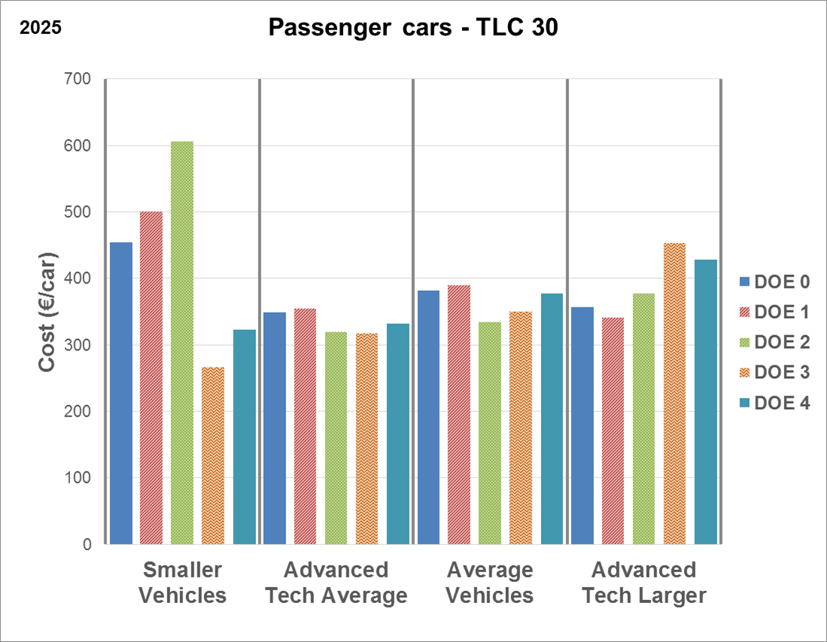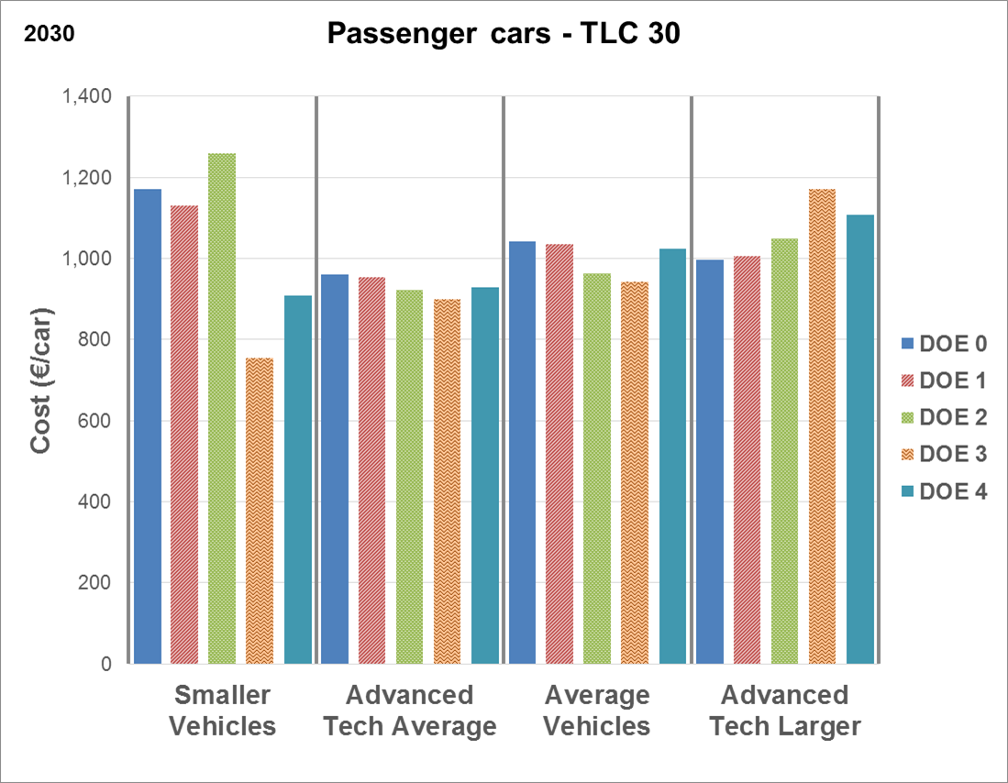

**Figure 30: Additional manufacturing costs relative to vehicle price (% of car price) for categories of passenger car manufacturers under different options DOE and with the EU-wide fleet CO2 target levels as in option TLC30**

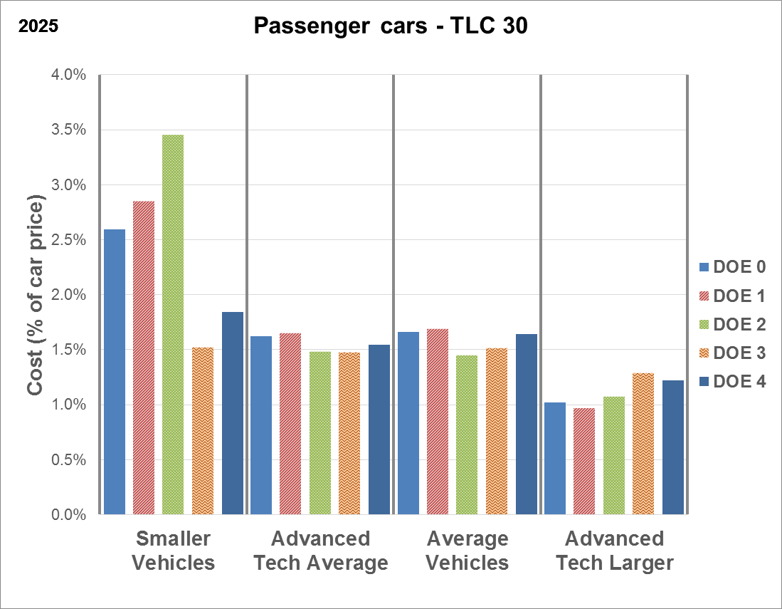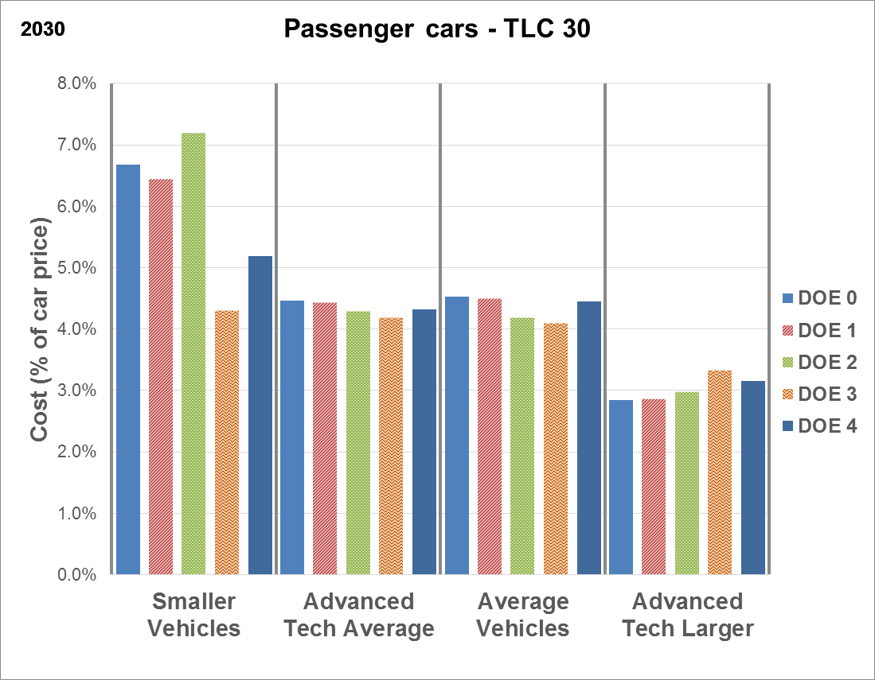

Overall, these figures show that for three out of the four categories of car manufacturers the DOE options do not significantly affect the manufacturing costs (not more than 100 EUR/car in 2025 or 200 EUR/car in 2030).

However, manufacturers of smaller cars face far higher additional manufacturing costs under options DOE 0, DOE 1 and, most of all, DOE 2 (footprint based limit value curve) compared to the other options, which are not using a limit value curve. When looking at the relative cost impacts, this effect is even more visible. The opposite effect is seen for the "advanced technology manufacturer of large cars", albeit less outspoken.

Amongst the options considered, the most homogeneous distribution of absolute efforts between manufacturer categories is achieved through a uniform reduction of the target level (DOE 4). However, both this option and option DOE 3 (uniform target) have the drawback of being less flexible in accounting for changes in the utility properties of a manufacturer's fleet as the specific emission targets for individual manufacturers are fixed and do not vary depending on those properties. Therefore, distributing the efforts without taking into account the utility properties may interfere with a manufacturer's strategic choices by limiting future segmentation shifts. This would be particularly challenging for manufacturers producing a less diversified fleet of mainly larger or mainly smaller vehicle models. Finally, for option DOE 4 it also would need to be established how to deal with new entrants.

*Vans*

The two figures below show the main results for vans with EU-wide fleet CO2 targets in 2025 and 2030 as under option TLV40. Figure 31 shows the absolute manufacturing cost increase (EUR/van), while in Figure 32 these costs are related to the vehicle price (cost increase in % of van price).

Again, the trends found for other target level options were very similar (the detailed results for TLV25 are shown in Annex 8). The findings mentioned below can thus be equally applied in relation to all TLV options.

Figure 31: Additional manufacturing costs (EUR/van) for categories of van manufacturers under different options DOE and with the EU-wide fleet CO2 target levels as in option TLV40

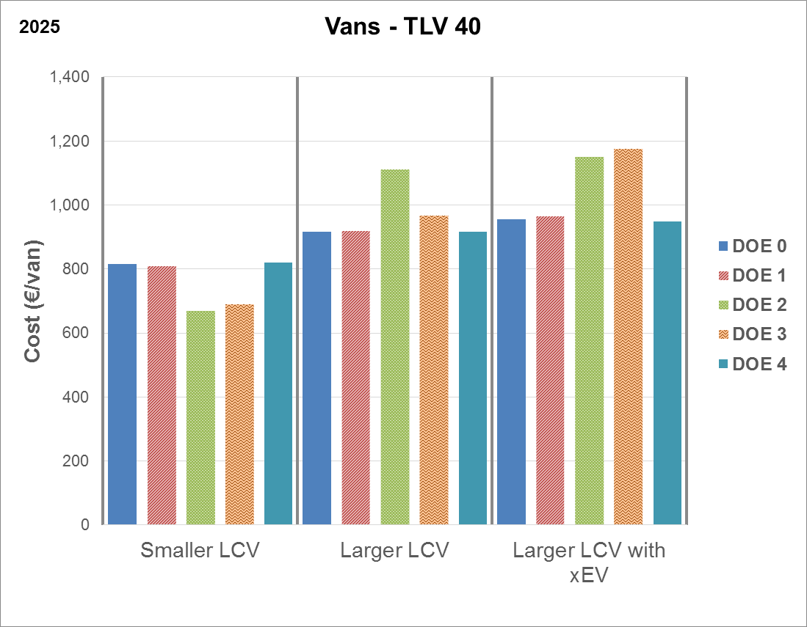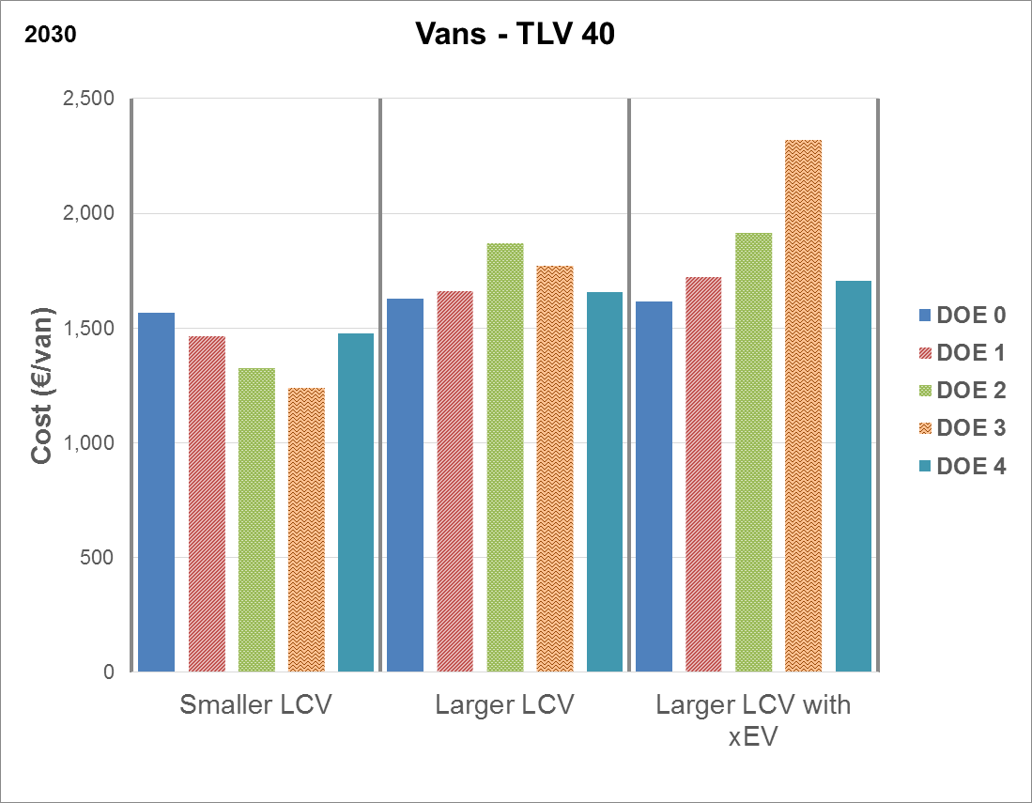

**Figure 32: Additional manufacturing costs relative to vehicle price (% of van price) for categories of van manufacturers under different options DOE and with the EU-wide fleet CO2 target levels as in option TLV40**

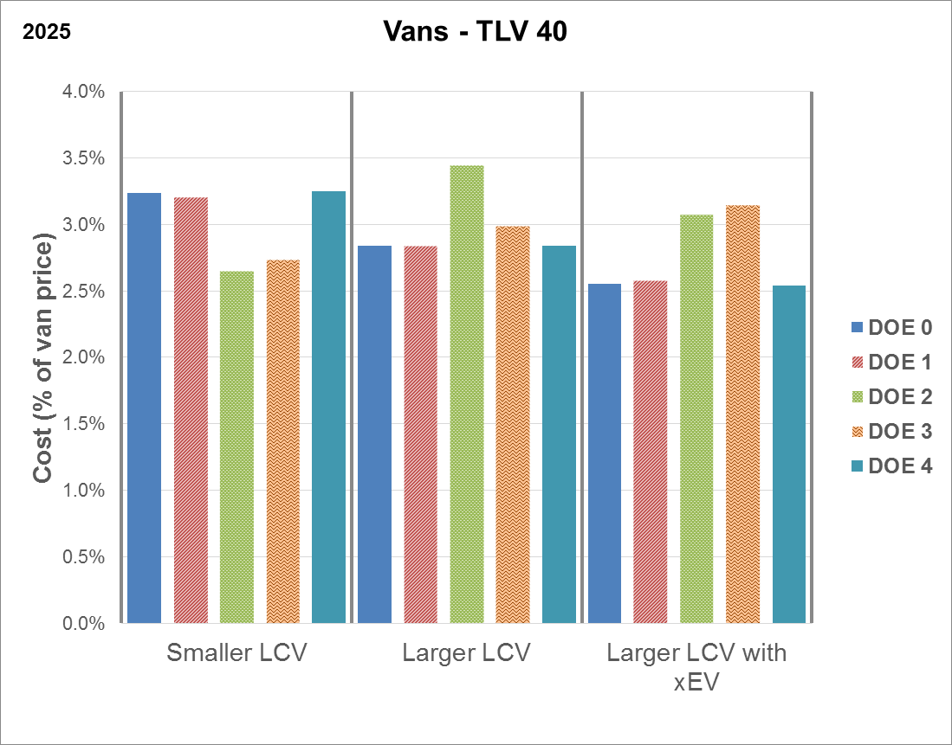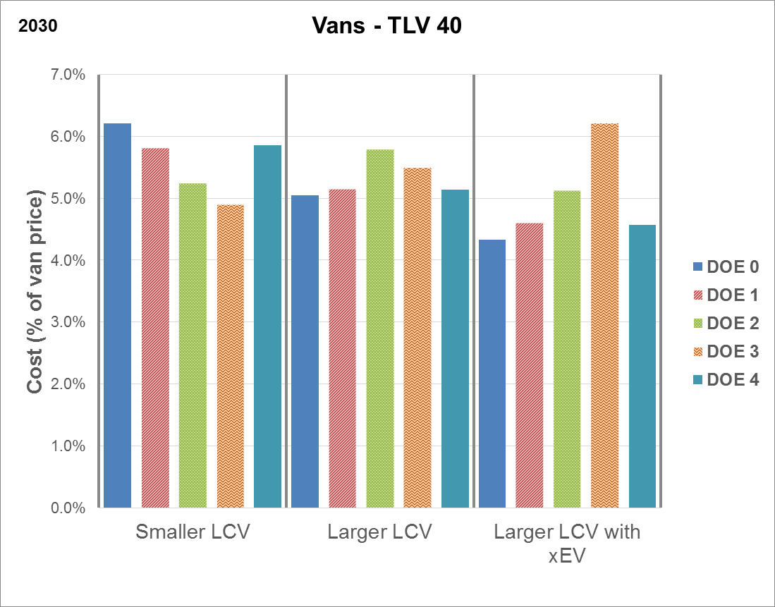

The figures show that differences in absolute additional manufacturing costs (EUR/van) among the DOE options considered are rather limited (i.e. not more than 100 EUR/van in 2025 or 200 EUR/van in 2030).

The largest distributional impacts are seen for options DOE 2 (footprint) and DOE 3 (uniform target), where costs are significantly lower for manufacturers of smaller vans compared to the other two categories.

Only very small differences are found between options DOE 0, DOE 1 and DOE 4. In these cases, the distribution of efforts across manufacturer groups is quite homogeneous, with slightly higher costs (esp. in relative terms) for manufacturers of smaller vans and slightly higher ones for "larger LCV with xEV".

As the differences in vehicle price across the manufacturer categories are more limited than for cars, the effects are very similar when considering the cost increase relative to those prices.

As regards options DOE 3 and DOE 4, the same considerations regarding the lack of flexibility for manufacturers as regards future segmentation shifts apply as for cars.

*Other considerations (for cars and vans)*

From an administrative point of view, maintaining a mass based limit value curve for distributing the EU-wide fleet target is the simplest option.

As regards the slopes of the limit value curves, maintaining the values currently established in the Cars and Vans Regulation would be questionable as those slopes were specifically linked to the targets set for 2020/2021. With the switch to WLTP and the new targets to be set for post-2020, there seems to be no sound basis for simply maintaining them.

##### Social Impacts

Overall, given the limited impact on the overall costs and on the composition of the fleet, the different options considered for the distribution of effort are not expected to have significant social impacts.

There could be impacts in terms of social equity in case the distribution of effort would lead to a higher (relative) price increase for smaller or medium sized vehicles compared to premium models. However, there is no evidence available of a direct relationship between income groups and the size of vehicles purchased.

##### Environmental impacts

As the DOE options do not affect the overall CO2 target level, they are not expected to have an impact on the overall TTW CO2 emissions from cars and vans.

The only conceivable effect would be related to changes in the fleet composition induced by the DOE mechanism applied. Vehicles with different powertrains may be impacted differently by these options, e.g. due to differences in utility (mass or footprint), where such parameter is used for the limit value curve. For example, electric vehicles tend to be heavier than ICEV, and diesel cars tend to be heavier than petrol cars, and using a mass based DOE approach would thus tend to favour the market uptake of those types of vehicles, which in turn may impact the environmental performance of the fleet.

## ZEV/ LEV incentives

### Introduction and methodological considerations

As a manufacturer's CO2 targets apply for its fleet-wide sales-weighted average emissions, the share of LEV within the fleet directly affects the emission reductions needed for the other vehicle types. Therefore, the impacts of the options concerning the LEV incentives cannot be considered in isolation from those regarding the EU-wide fleet CO2 target. This is why in this Section the impacts are shown for the different LEVD/LEVT options in combination with the TLC/TLV options. In order to keep the number of combinations manageable, only some of the TLC/TLV options were selected, reflecting a range of fleet-wide CO2 target levels.

It has been assumed that the LEV incentive level set would be met by all manufacturers[190], both in case of a binding LEV target (option LEVT_MAND) and in case of a benchmark used in a crediting system (options LEVT_CRED). However, for option LEVT_CRED, it was also assessed how the impacts would change in case the LEV benchmark would not be reached or would be overachieved.

As described in Section 5.3.1, targeted LEV incentives would provide a clear pathway for the automotive sector and public authorities towards the development of an EU market for these vehicles, thus fostering the required investments in vehicle technology and refuelling and recharging infrastructure. Starting from a rather low base, the accelerated uptake of LEV is expected to yield significant economies of scale, hence bringing down vehicle costs and making LEV more attractive for consumers. Analysts project that the faster the market grows, the faster costs could come down (see references in Section 5.3.1).

Therefore, the methodological approach reflects that costs are correlated with deployment rates, and with additional enabling policies such as the provision of electric charging infrastructure (reducing range anxiety and enhancing consumer acceptance) and measures supporting the development of an industrial battery value chain.

These effects have been captured in particular through the assumptions on the evolution of the battery costs, which are projected to decrease at a faster rate when regulatory LEV incentives are provided, thanks to the economies of scale and enhanced learning rates.

As a consequence, the following technology cost assumptions were used for the analysis of the options in this Section (see also Section 6.3.2):

* "Medium": Medium costs for all technologies – this was used for option LEV0;
* "VLxEV": Very Low costs for EV, i.e. based on battery pack costs of around 100 EUR/kWh in 2025 and 65 EUR/kWh in 2030 and Medium costs for ICEV – this was used for options LEV%_A, LEV%_B and LEV%_C (see below).

The assessment below does not include the cost of the flanking measures to support the higher uptake of more efficient vehicles, in particular zero- and low-emission vehicles. Information on the costs for the alternative fuels infrastructure can be found in the Communication 'Towards the broadest use of alternative fuels - an Action Plan on Alternative Fuels Infrastructure'[191]. The costs for EU-wide demand side measures (Clean Vehicles Directive, Eurovignette Directive) can be found in the respective Impact Assessment reports[192].

### Passenger cars: assessment of options with additional incentives for low-emission vehicles

In order to accelerate the sales of the most advanced low emission vehicles in the EU, additional incentives can be set. As part of an industrial policy an additional strong market signal could be sent to consumers and manufacturers. This would increase uptake and allow industry and consumers to reap economies of scale.

Table 37 shows in the first column (option LEV0) that without an additional market signal the share of LEV in the new passenger car fleet would only be determined by the EU-wide CO2 target. For example, in 2025, the ZEV share would range between 5% and 7 % increasing with the CO2 target level as already highlighted in Section 6.3.2.

It should be noted that a low emission vehicle is defined differently across the three options LEVD_ZEV, LEVD_25 and LEVD_50, i.e. the LEV shares cannot be directly compared between those three options because of the different coverage of vehicle types[193].

Table 37 also shows the different LEV mandate or benchmark levels for the years 2025 and 2030. For example, for zero emission vehicles (ZEV) sales would be raised to 10%, 15% or 20% in 2025, and to 15%, 20% or 25% in 2030.

It can be seen that LEV mandate or benchmark levels were selected as an incremental increase in the order of around 5% from the LEV0 fleet shares, which broadly mirrors the recent announcements by many EU manufacturers as regards their expected LEV uptake for the coming decade (see Table 4 in Section 5.3.1).

**Table 37: Overview of the share (%) of LEV in the new car fleet in 2025 and 2030 when no LEV incentive is applied (LEV0) and with three different LEV mandates/benchmarks in 2025 and 2030 for different combinations of LEV definitions (LEVD) and CO2 target levels (TLC)**

|  |  |  |  |  |  |  |  |  |
| --- | --- | --- | --- | --- | --- | --- | --- | --- |
| ***LEVD_ZEV*** | **2025** | | | | **2030** | | | |
| **LEV0** | **LEV%_A** | **LEV%_B** | **LEV%_C** | **LEV0** | **LEV%_A** | **LEV%_B** | **LEV%_C** |
| TLC20 | 5% | 10% | 15% | 20% | 8% | 15% | 20% | 25% |
| TLC25 | 5% | 8.5% |
| TLC30 | 5.5% | 9% |
| TLC40 | 7% | 12% |

|  |  |  |  |  |  |  |  |  |
| --- | --- | --- | --- | --- | --- | --- | --- | --- |
| ***LEVD_25*** | **2025** | | | | **2030** | | | |
| **LEV0** | **LEV%_A** | **LEV%_B** | **LEV%_C** | **LEV0** | **LEV%_A** | **LEV%_B** | **LEV%_C** |
| TLC20 | 8% | 15% | 20% | 25% | 12% | 25% | 30% | 35% |
| TLC25 | 8% | 12.5% |
| TLC30 | 8.5% | 13% |
| TLC40 | 12% | 20.5% |

|  |  |  |  |  |  |  |  |  |
| --- | --- | --- | --- | --- | --- | --- | --- | --- |
| ***LEVD_50*** | **2025** | | | | **2030** | | | |
| **LEV0** | **LEV%_A** | **LEV%_B** | **LEV%_C** | **LEV0** | **LEV%_A** | **LEV%_B** | **LEV%_C** |
| TLC20 | 7% | 15% | 20% | 25% | 10.5% | 25% | 30% | 35% |
| TLC25 | 7% | 11% |
| TLC30 | 7% | 12% |
| TLC40 | 10% | 17.5% |

Furthermore, in order to reach these higher sales levels, as explained in Section 5.3.2.2, three different LEV incentive policy instruments are being considered:

1. binding mandate (LEVT_MAND);
2. crediting system with a one-way CO2 target adjustment (LEVT_CRED1);
3. crediting system with a two-way adjustment (LEVT_CRED2).

#### Economic impacts

For the assessment of the economic impacts of the LEV incentives options, the same indicators are used as for assessing the options regarding the EU-wide CO2 target levels (TLC) (see Section 6.3.2.2).

Below, the net savings achieved under the different LEV incentives options are summarised for the indicator "TCO-15 years". The results for the other indicators regarding net economic savings from a societal perspective and net economic savings over the first five years were very similar.

The detailed results for all options and indicators as well as the results of a sensitivity analysis varying the cost assumptions for the battery are provided in Annex 8.

*TCO-15 years (vehicle lifetime)*

Figure 33 shows the net economic savings, taking into account capital costs, O&M costs and fuel costs, over the lifetime of an "average" passenger car registered in 2025 or in 2030 for the different LEV incentive options as regards the definition (LEVD) and target/benchmark level (LEV%), in combination with four different options for the EU-wide CO2 target level (TLC20, TLC25, TLC30 and TLC40). The net savings are calculated as the difference with the baseline.

The key general trends observed can be summarised as follows.

Firstly, all options considered bring net economic savings over the vehicle lifetime. Depending on the option, net savings per car are up to about 1,000 EUR in 2025 and up to about 2,400 EUR in 2030, and they increase with increasingly strong CO2 target levels.

Both the fuel savings and the capital costs are key factors as regards the net savings achieved. The capital costs of LEV, and in particular of ZEV, are mainly determined by the cost of batteries and, as explained above, these are set to decrease with the introduction of additional LEV incentives creating economies of scale.

Secondly, in 2030 net economic savings are highest for the options with the lower LEV incentive compared to the other options, i.e. higher LEV incentives and LEV0.

In some cases, the higher LEV incentives have lower net economic savings than the option LEV0 without an additional incentive, e.g. in 2030 for TLC20 combined with LEVD_25 or LEVD_50 and for TLC25 combined with LEVD_50.

More generally, for TLC20 the potential net savings in case of a LEV mandate or crediting system are much lower, or slightly negative. This is not surprising: in order to reach the lowest CO2 target combined with a LEV mandate or crediting system, higher PHEV and BEV uptake would substitute for the wide deployment of the least costly less advanced ICEV technologies.

The results for 2025 are largely similar as for 2030.

Figure 33: TCO-15 years (vehicle lifetime) (net savings in EUR/car for 2025 and 2030) for different LEV incentive options



In terms of the policy instrument chosen to reach the higher sales levels, the first option, i.e. the binding mandate, will deliver if combined with a strong enough compliance system. However, this situation could be different in the case of the crediting system which, in principle, leaves more flexibility to car manufacturers tailored to their own sales and innovation strategy.

Compared to a crediting system, a binding mandate reduces the flexibility for manufacturers to react to changes in relative costs between LEV/ZEV and conventional technologies. If e.g. battery costs decrease faster than expected, a crediting system offers stronger incentives to invest further in LEV/ZEVs and increase further the competitiveness of the European automotive industry in this technology. A pure binding mandate does not offer these flexibilities and scores therefore lower in terms of efficiency and proportionality.

Under the two crediting options, LEVT_CRED1 and LEVT_CRED2, the LEV benchmark would be non-binding, which means that it may be over- or underachieved by individual manufacturers or pools, and this will affect their fleet-wide CO2 target as explained in Section 5.3.2.2.

The economic impacts of these options will depend on the extent to which the LEV share of different manufacturers will be above or below the LEV benchmark in 2025 and 2030.

As the strategic choices that will be made by individual manufacturers are not known in advance, numerous variants could be designed in terms of LEV share and, consequently, the corresponding CO2 target.

In order to understand the overall bandwidth and the potential trade-offs, a "low LEV" case, where the average LEV fleet share is **below** the LEV benchmark, and a "high LEV" case, where the average LEV fleet share is **above** the LEV benchmark, will be further analysed.

The figures below are examples with the aim of illustrating how the economic impacts of options LEVT_CRED1 and LEVT_CRED2 could evolve in case the LEV benchmark set is not met at the level of the EU-wide fleet.

Figure 34 illustrates the effects on net savings for TCO-15 years which could be expected in case of a **two-way** adjustment of the CO2 target level (option LEVT_CRED2). It shows the situation for 2030 with a CO2 target as under option TLC30 and the lower benchmark of option LEV%_A[194].

Under this option, net savings will tend to evolve between the situation where the LEV benchmark is exactly met (point A) and the "end points" for the "low LEV" case (point B) or "high LEV" case (point C). In this case, the tightening or relaxation of the CO2 target will be limited to a maximum of 5%, which determines the two end points of the possible range.

In case the overall LEV fleet share is below the LEV benchmark, net savings will evolve towards point B as the EU-wide fleet CO2 target becomes up to 5% stricter, while the market penetration of LEV decreases and would become too low to create economies of scale. As a result of this, battery costs would be higher than in case the LEV benchmark is met.

In case the manufacturer reaches an overall LEV share in the fleet that is higher than the LEV benchmark, the net savings will evolve towards point C with increasing LEV fleet shares as the EU-wide fleet CO2 target becomes up to 5% less strict, but the market uptake of LEV increases.

Figure 35 illustrates the expected impacts on net savings (TCO-15 years) in case of option LEVT_CRED1 (**one-way** adjustment of the CO2 target level).

Under this option, the situation is the same as for LEVT_CRED2 in case the overall LEV share in the fleet is higher than the LEV benchmark (point C).

However, in case the overall LEV fleet share is below the LEV benchmark, net savings will evolve towards point B, as the initial CO2 target level is not tightened. As for LEVT_CRED2, battery costs would be higher than in case the LEV benchmark is met.

As can be seen, for the situation shown, the net savings would always tend to decrease in case the LEV benchmark is not met.

Furthermore, under option LEVT_CRED1, the one-way adjustment mechanism weakens the signal provided to the market as regards the uptake of LEV. Indeed, as there would be no consequences for manufacturers in not achieving the LEV benchmark, the LEV benchmark would become fully voluntary.

**Figure 34: Illustration of the impacts of option LEVT_CRED2 (net savings, TCO-15 years) in case the LEV benchmark is not exactly met (with the CO2 target of option TLC30 and the benchmark of option LEV%_A)**

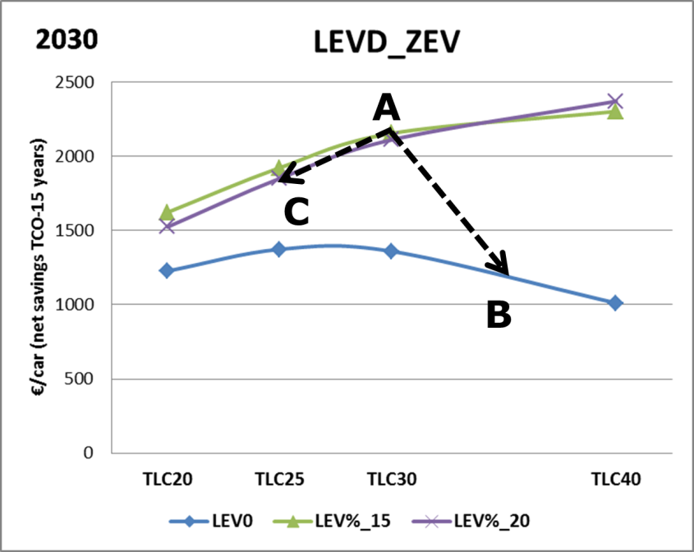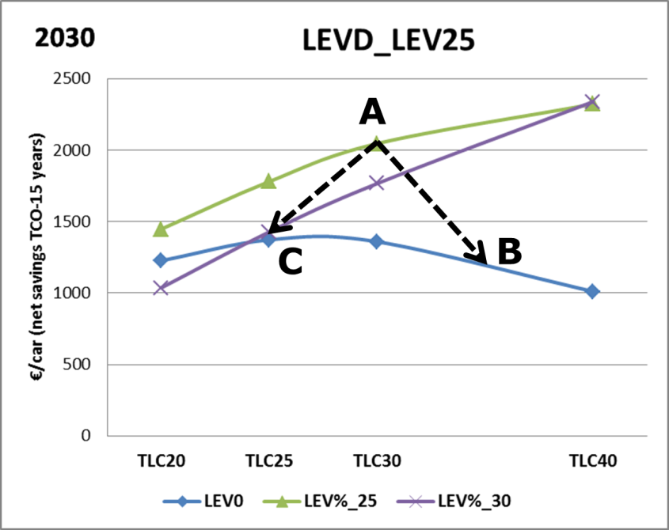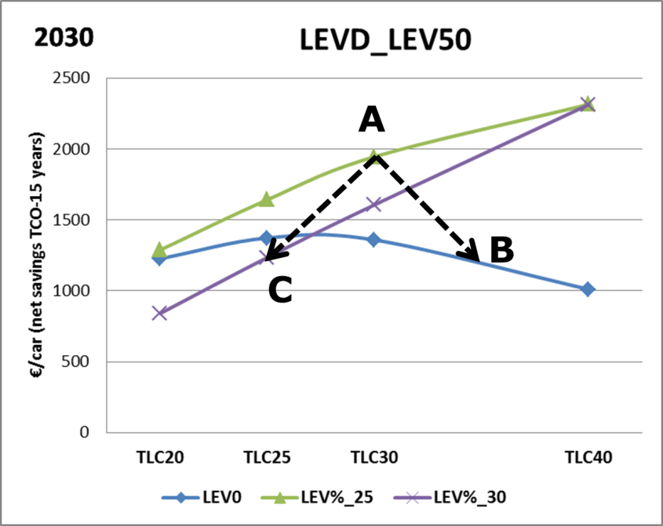

Figure 35: Illustration of the impacts of option LEVT_CRED1 (net savings, TCO-15 years) in case the LEV benchmark is not exactly met (with the CO2 target of option TLC30 and the benchmark of option LEV%_A)

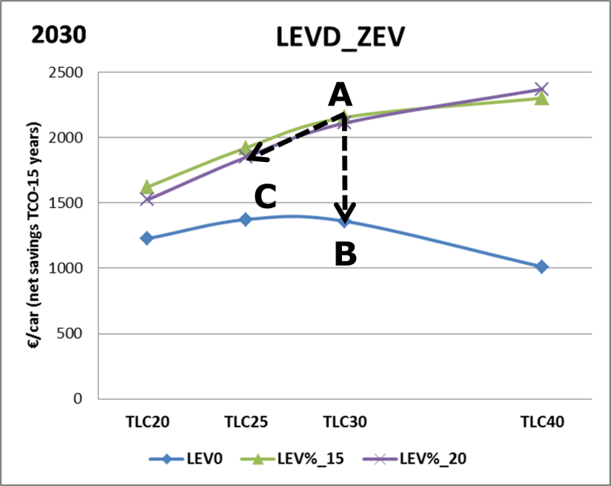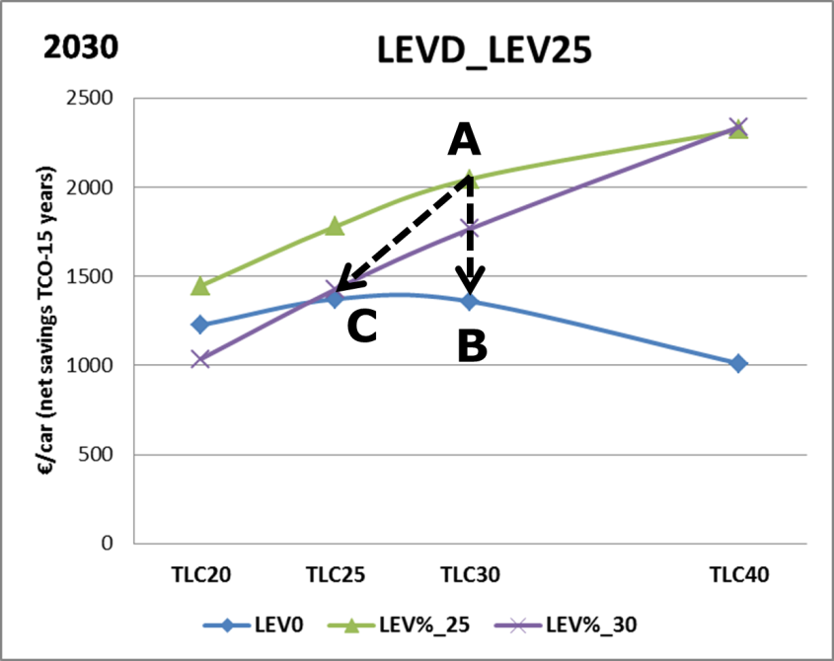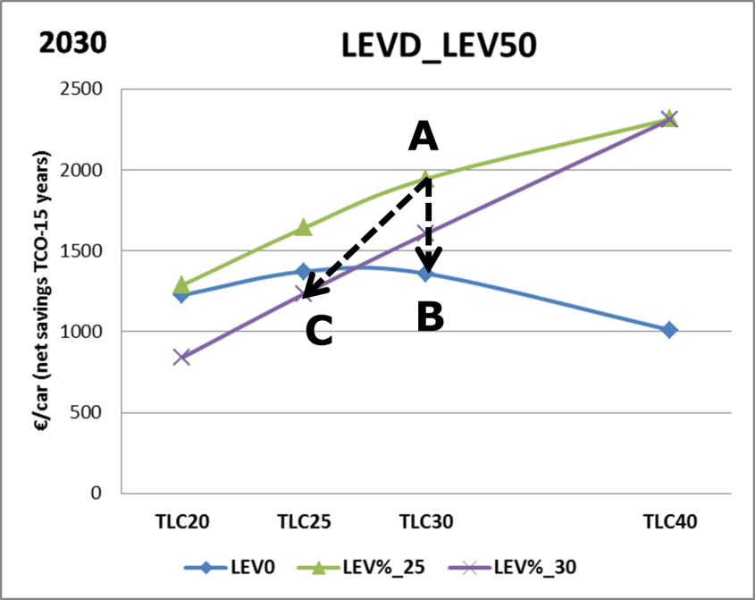

*Interaction between the LEV/ZEV crediting system and the CO2 fleet-wide reduction level*

The CO2 fleet-wide reduction level and the level of the ZEV/LEV benchmark in the case of the crediting system will also have an impact on the efficiency of the conventional vehicles. Setting a LEV incentive increases the market uptake of LEV. As a consequence, in order to comply with the CO2 fleet-wide target, lower efforts are required to improve the efficiency of the conventional vehicles.

Table 38 shows the changes in percentages of the emissions of an average conventional car in 2030 compared with the average baseline conventional vehicle in 2020/2021 when combining the CO2 fleet target of 25% or 30% reduction with a LEV mandate or with a LEV crediting system.

It shows that the efforts required for conventional vehicles would be significantly lower in case of a crediting system with a 5% overachievement of the LEV benchmark. As a matter of fact, CO2 emissions of the average conventional vehicle could be relaxed and become 2 to 12% higher in case of a 25% reduction target. For a 30% reduction target, the range of changes in emissions would be from -5 to +5%.

In the other case of 5% underachievement of the LEV benchmark, manufacturers would have to significantly reduce CO2 emissions from their conventional vehicles as indicated in Table 38: average emissions would be 12% or 18 % lower than for the baseline vehicle, in case of a 25% and a 30% reduction target, respectively. This would give quite a strong signal to manufacturers to reach the LEV benchmark and would have to be considered when designing the trade-off between the level of underachievement and the corresponding adjustment of the CO2 target.

In a situation with a LEV mandate, CO2 emissions of the average conventional vehicle are between 3 and 7% and between 8 and 13% lower than for the baseline vehicle, in case of a 25% and a 30% reduction target, respectively.

So, in a number of the options below there would be no incentive left for the technological advancement of internal combustion engines after 2020/21. This will have to be taken into consideration as part of the wider industrial policy when designing the trade-off between the percentage of over achievement and the credit in terms of lowering the CO2 target.

**Table 38: Emissions of an average conventional car in 2030 - expressed as % difference compared with a baseline conventional car in 2020/2021 - under options TLC25 and TLC30 in case of a LEV mandate (LEV%_A) and in case of a crediting system, with 5% overachievement of the LEV benchmark**

|  |  |  |
| --- | --- | --- |
| **LEVD_ZEV** | **TLC25** | **TLC30** |
| LEVT_MAND | -7% | -13% |
| LEVT_CRED with 5% overachievement of the benchmark | +2% | -5% |
| LEVT_CRED with 5% underachievement of the benchmark | -12% | -18% |

|  |  |  |
| --- | --- | --- |
| **LEVD_25** | **TLC25** | **TLC30** |
| LEVT_MAND | -4% | -10% |
| LEVT_CRED with 5% overachievement of the benchmark | +9% | +2% |
| LEVT_CRED with 5% underachievement of the benchmark | -12% | -18% |

|  |  |  |
| --- | --- | --- |
| **LEVD_50** | **TLC25** | **TLC30** |
| LEVT_MAND | -3% | -8% |
| LEVT_CRED with 5% overachievement of the benchmark | +12% | +5% |
| LEVT_CRED with 5% underachievement of the benchmark | -12% | -18% |

*Macroeconomic assessment, including employment*

The assessment of the macro-economic impacts of the options regarding LEV/ZEV incentives is done at the level of the light-duty vehicles as a whole and this is presented in Section 6.5.4.

*Energy system impacts*

The final energy demand from passenger cars in 2030 shows limited variation amongst the different options considered for the LEV incentives (including LEV0).

The increased market penetration of electrically chargeable vehicles (BEV, PHEV) leads to higher shares of electricity in the final energy demand for transport. Nevertheless, as illustrated in Table 39, these effects remain rather limited across the range of options considered.

Table 39: Electricity share in the final energy demand for passenger cars

|  |  |  |  |  |
| --- | --- | --- | --- | --- |
| **Option for EU-wide fleet CO2 target level** | **LEV0** | | **Other LEV options  (various LEVT, LEVD, LEV%)** | |
| **2025** | **2030** | **2025** | **2030** |
| TLC20 | 0.7% | 1.8% | Up to 1.6% | Up to 4% |
| TLC25 | 0.7% | 1.9% | Up to 1.6% | Up to 4% |
| TLC30 | 0.7% | 2.0% | Up to 1.6% | Up to 4% |
| TLC40 | 0.7% | 2.6% | Up to 1.8% | Up to 4.5% |

The share of cars and vans in the total EU-28 electricity consumption is shown in Table 9 (Section 6.3.2.2.1.4).

*Administrative burden*

The different options considered as regards the ZEV/LEV incentives would not create significant additional administrative costs.

In case of a binding mandate (LEVT_MAND), an additional dedicated regime would need to be established to allow verifying whether individual manufacturers comply with the mandatory LEV share.

In contrast, under a crediting system (LEVT_CRED), compliance checking would only be against the CO2 target.

#### Social Impacts

As for the assessment of the options regarding the EU-wide CO2 targets (TLC), the TCO (net savings) for the second user was used as an indicator for quantifying the social impacts of the LEV incentives options.

The figures below show the results for an "average" passenger car newly registered in 2025 or 2030.

The general findings are similar to those discussed in relation to the economic impacts (see Section 6.5.2.1). However, the differences between the various scenarios in the absolute net savings per car tend to be lower when looking at the TCO for the second user compared to the vehicle lifetime (TCO-15 years).

**Figure 36: TCO-second user (years 6-10) (EUR/car) in 2025 and 2030 for different LEVD/LEVT options**



#### Environmental impacts

*CO2 emissions (tailpipe)*

The different options for the LEV incentives show variations in the tailpipe CO2 emission levels as shown in the table below. The emissions are mainly determined by the EU-wide fleet CO2 target, but also the fleet composition has an effect due to the differences in the gap between test and real word emissions.

Table 40: CO2 emission reductions (%) between 2005 and 2030 (passenger cars)

|  |  |  |
| --- | --- | --- |
| **Option for EU-wide fleet  CO2 target level** | **LEV0** | **Other LEV options  (various LEVT, LEVD, LEV%)** |
| TLC20 | 30% | 32.2% - 32.4% |
| TLC25 | 30.5% | 32.2% - 32.4% |
| TLC30 | 31% | 32.2% - 32.4% |
| TLC40 | 33.6% | 34.4% - 34.6% |

*Impacts of options LEVT_CRED in case the LEV benchmark is not met or overachieved*

As explained in Section 5.3.2.2, in case of a LEV crediting system, the EU-wide fleet CO2 target may vary depending on whether the LEV benchmark is under- or overachieved. The adjustment of the CO2 target is however limited to a maximum of 5%. Therefore, the "end points" for the LEVT_CRED options as regards the environmental impact in terms of CO2 tailpipe emissions would be similar as for the TLC options with a CO2 target that is 5% higher, respectively 5% lower (only in case of LEVT_CRED2) than in the corresponding LEVT_MAND option[195]. These impacts can be derived from the results shown in Section 6.3.2.4.1.

*Air pollutant emissions*

The LEV incentives options lead to somewhat lower air pollutant emissions, in particular due to the higher market shares of ZEV. As shown in Table 41 and Table 42, emission reductions of NOx and PM2.5 over the period 2020-2030 show rather limited variation among the different LEV incentive options considered.

Table 41: NOx emission reductions (%) between 2020 and 2030 (passenger cars)

|  |  |  |
| --- | --- | --- |
| **Option for EU-wide fleet  CO2 target level** | **LEV0** | **Other LEV options  (various LEVT, LEVD, LEV%)** |
| TLC20 | 38% | 42% - 46% |
| TLC25 | 38.5% | 42% – 46% |
| TLC30 | 39% | 42% – 46% |
| TLC40 | 42% | 44% - 46% |

**Table 42: PM2.5 emission reductions (%) between 2020 and 2030 (passenger cars)**

|  |  |  |
| --- | --- | --- |
| **Option for EU-wide fleet  CO2 target level** | **LEV0** | **Other LEV options  (various LEVT, LEVD, LEV%)** |
| TLC20 | 34% | 38% - 42% |
| TLC25 | 34.5% | 38% - 43% |
| TLC30 | 35% | 38% - 43% |
| TLC40 | 38% | 40% - 43% |

### Vans: assessment of options with additional incentives for low-emission vehicles

Similarly to passenger cars (Section 6.5.2), additional incentives were considered in order to accelerate the sales of low emission vans.

Table 43 shows in the first column (option LEV0) the share of LEV in the new van fleet, which without an additional market signal would only be determined by the EU-wide CO2 target. For example, in 2025, the ZEV share would range between 2.5% and 3.5 % increasing with the CO2 target level as already highlighted in Section 6.3.2.

It should be noted that a low emission van is defined differently across the three options LEVD_ZEV, LEVD_40 and LEVD_50, so the LEV shares cannot be directly compared between those three options because of the different coverage of vehicle types.

Table 43 also shows two different LEV mandate or benchmark levels, (options LEV%_A and LEV%_B) for the years 2025 and 2030. For example, for zero emission vehicles (ZEV) sales would be raised to 10% or 15% in 2025, and to 15% or 20% in 2030.

**Table 43: Overview of the share (%) of LEV in the new van fleet in 2025 and 2030 when no LEV incentive is applied (LEV0) and of two LEV mandates/benchmarks in 2025 and 2030 for different combinations of LEV definitions (LEVD) and CO2 target levels (TLV)**

|  |  |  |  |  |  |  |
| --- | --- | --- | --- | --- | --- | --- |
| ***LEVD_ZEV*** | **2025** | | | **2030** | | |
| **LEV0** | **LEV%_A** | **LEV%_B** | **LEV0** | **LEV%_A** | **LEV%_B** |
| TLV20 | 2.5% | 10% | 15% | 3.5% | 15% | 20% |
| TLV25 | 2.7% | 3.7% |
| TLV40 | 3.5% | 5.5% |

|  |  |  |  |  |  |  |
| --- | --- | --- | --- | --- | --- | --- |
| ***LEVD_40*** | **2025** | | | **2030** | | |
| **LEV0** | **LEV%_A** | **LEV%_B** | **LEV0** | **LEV%_A** | **LEV%_B** |
| TLV20 | 10.5% | 15% | 20% | 17.5% | 25% | 30% |
| TLV25 | 11.5% | 18.5% |
| TLV40 | 16.5% | 20% | 25% | 30% | 35% | 40% |

|  |  |  |  |  |  |  |
| --- | --- | --- | --- | --- | --- | --- |
| ***LEVD_50*** | **2025** | | | **2030** | | |
| **LEV0** | **LEV%_A** | **LEV%_B** | **LEV0** | **LEV%_A** | **LEV%_B** |
| TLV20 | 4.5% | 15% | 20% | 7.5% | 25% | 30% |
| TLV25 | 5% | 8% |
| TLV40 | 7.5% | 12.5% |

In order to reach these higher sales levels, as explained in Section 5.3.2.2, three different LEV incentive policy instruments are being considered:

1. binding mandate (LEVT_MAND);
2. crediting system with a one-way CO2 target adjustment (LEVT_CRED1);
3. crediting system with a two-way adjustment (LEVT_CRED2).

#### Economic impacts

For the assessment of the economic impacts of the LEV incentives options, the same indicators are used as for the assessing the options regarding the EU-wide CO2 target levels (TLV) (see Section 6.3.2.2.2).

Below, the net savings achieved under the different LEV incentives options are summarised for the indicator TCO-15 years. The results for the other indicators (net economic savings from a societal perspective and net economic savings over the first five years) were very similar.

The detailed results for all options and indicators are provided in Annex 8.

*TCO-15 years (vehicle lifetime)*

Figure 37 shows the net economic savings taking into account capital costs, O&M costs and fuel costs over the lifetime of an "average" van in 2025 and 2030 for the different LEV incentive options as regards the definition (LEVD) and target/benchmark level (LEV%), in combination with three different options for the EU-wide CO2 target level (TLV20, TLV25 and TLV40). The net savings are calculated as the difference with the baseline.

The key general trends observed can be summarised as follows.

Firstly, and very different from the results for passenger cars, both for 2025 and for 2030 in all cases with one exception the option where no incentives are set (LEV0) shows the highest net economic savings compared to the options with additional incentives for ZEV/LEV. Furthermore, the net savings are higher for the lower levels of the LEV mandate/benchmark (option LEV%_A).

Still, all options considered with only one exception bring net economic savings over the vehicle lifetime. Depending on the option, net savings are up to about 2,500 EUR for a 2025 new van and up to about 4,500 EUR for a 2030 new van.

Both fuel savings and capital costs are key factors as regards the net savings achieved. The capital costs of LEV, and in particular of ZEV, are mainly determined by the cost of batteries and, as explained above, these are set to decrease with the introduction of LEV incentives creating economies of scale.

Secondly, with rising CO2 fleet-wide targets from TLV20, TLV25 to TLV40 also the net economic savings increase.

Figure 37: TCO- 15 years (EUR/van) in 2025 and 2030 for different LEVD/LEVT options



*Impacts of options LEVT_CRED (1 and 2) in case the LEV benchmark is not exactly met*

Under the two crediting system options LEVT_CRED1 and LEV_CRED2, the LEV benchmark would be non-binding, which means that it may be over- or underachieved by individual manufacturers (or pools), which would affect the fleet-wide CO2 target as explained in Section 5.3.2.2. Thus, the economic impacts of this option will depend on the extent to which the LEV share of different manufacturers is higher or lower than the LEV benchmark in 2025 or 2030.

As the strategic choices that would be made by individual van manufacturers in this respect are not known, for the purpose of the analysis numerous variants could be designed in terms of LEV share and, consequently, CO2 target.

However, since the economic analysis above showed that the option without an additional LEV incentive is economically superior compared to the ones with a crediting system, van manufacturers would most likely not voluntarily increase sales of low emission vans to reach or even overachieve the benchmark. This means that given the underlying economics setting a voluntary LEV benchmark would most likely not create the necessary incentivising effect.

*Energy system impacts*

The final energy demand from vans in 2030 shows limited variation amongst the different options considered for the LEV incentives (including LEV0).

The increased market penetration of electrically chargeable vehicles (BEV, PHEV) leads to higher shares of electricity in the final energy demand for transport. Nevertheless, as illustrated in the table below, these effects remain rather limited with respect to the total energy demand of vans across the range of options considered.

Table 44: Electricity share in the final energy demand of vans

|  |  |  |  |  |
| --- | --- | --- | --- | --- |
| Option for CO2 target level | LEV0 | | Other LEV options (various LEVT, LEVD, LEV%) | |
|  | 2025 | 2030 | 2025 | 2030 |
| TLV20 | 0.4% | 1.5% | 1% - 1.4% | 2.5% - 4.7% |
| TLV25 | 0.5% | 1.6% | 0.9% -1.8% | 2.5% - 4.7% |
| TLV40 | 0.7% | 2.3% | 1.1% -2.3% | 2.9% - 6.1% |

*Light Duty Vehicle Electricity consumption*

Table 45 shows the share of the total EU-28 electricity consumption used by cars and vans in 2025 and 2030 for selected policy options. It illustrates that, even with the highest LEV mandates/benchmarks considered, the share of electricity used by LDV up to 2030 is not more than a few percent of total electricity consumption.

**Table 45: Electricity consumption by cars and vans with respect to total electricity consumption (EU-28) under different options for the EU-wide CO2 target and LEV incentives**

|  |  |  |  |
| --- | --- | --- | --- |
| Options | | Share of cars and vans in total electricity consumption | |
| cars | vans | **2025** | **2030** |
| TLC30, LEV%_B | TLV25, LEV%_B | 1.0% | 2.5% |
| TLC40, LEV%_B | TLV40, LEV%_B | 1.4% | 3.0% |

#### Social Impacts

As for the assessment of the options regarding the EU-wide CO2 targets (TLV, see Section 0) the TCO (net savings) for the second user of vans will be used as an indicator for quantifying the social impacts of the LEV incentives options.

The figure below shows the results for an "average" van newly registered in 2025 or 2030.

The general findings are similar to those discussed in relation to the economic impacts (see Section 6.5.3.1). However, the differences between the various scenarios in the absolute net savings per car tend to be smaller when looking at the TCO for the second user compared to the vehicle lifetime (TCO-15 years).

Figure 38: TCO-second user (years 6-10) (EUR/van) in 2025 and 2030 for different LEVD/LEVT options



#### Environmental impacts

*CO2 emissions (tailpipe) of vans*

The different options for the LEV incentives show variations in the tailpipe CO2 emission levels as shown in the table below. The emissions are mainly determined by the EU-wide fleet CO2 target, but also the fleet composition has an effect due to the differences in the gap between test and real word emissions.

Table 46: CO2 emission reduction (%) between 2005 and 2030 (vans)

|  |  |  |
| --- | --- | --- |
| **Option for EU-wide fleet  CO2 target level** | **LEV0** | **Other LEV options  (various LEVT, LEVD, LEV%)** |
| TLV20 | 22.2% | 26.1%-26.7% |
| TLV25 | 22.6% | 26.3% -26.7 % |
| TLV40 | 26.4% | 27.4% - 31.3% |

*Impacts of options LEVT_CRED in case the LEV benchmark is not exactly met*

As explained in Section 5.3.2.2, for options LEVT_CRED1 and LEV_CRED2, the EU-wide fleet CO2 target may vary depending on whether the LEV benchmark is under- or overachieved.

The adjustment of the CO2 target is however always limited to a maximum of 5%. Therefore, the "end points" for the LEVT_CRED options in terms of CO2 tailpipe emissions would be similar as for the TLV options with a CO2 target that is 5% higher (for LEVT_CRED2 only), respectively 5% lower than in the corresponding LEVT_MAND option[196]. These impacts can be derived from the results shown in Section 6.3.2.4.1.

*Air pollutant emissions*

The LEV incentives options lead to somewhat lower air pollutant emissions, in particular due to the higher market shares of ZEV. As shown in the tables below, emission reductions of NOx and PM2.5 over the period 2020-2030 show limited variation among the different LEV incentive options considered.

Table 47: NOx emission reduction (%) between 2020 and 2030 (vans)

|  |  |  |
| --- | --- | --- |
| **Option for EU-wide fleet  CO2 target level** | **LEV0** | **Other LEV options (various LEVT, LEVD, LEV%)** |
| TLV20 | 33% | 37% - 43% |
| TLV25 | 33% | 36% – 43% |
| TLV40 | 36% | 38% - 45% |

**Table 48: PM2.5 emission reduction (%) between 2020 and 2030 (vans)**

|  |  |  |
| --- | --- | --- |
| **Option for EU-wide fleet  CO2 target level** | **LEV0** | **Other LEV options (various LEVT, LEVD, LEV%)** |
| TLV20 | 33% | 36%-42% |
| TLV25 | 33% | 36% - 42% |
| TLV40 | 36% | 38% - 45% |

### Macroeconomic impacts, including employment, of setting LEV incentives for cars and vans

#### Introduction and methodological considerations

The E3ME model was used to assess the macro-economic and sectoral economic impacts of the policy options regarding LEV incentives. A detailed description of this model is provided in Annex 4.

In the policy scenarios different incentives for LEV were considered in addition to the EU-wide fleet CO2 target. The analysis was done for the scenario TL30c/25v, combining options TLC30 (cars) and TLV25 (vans)[197]. As regards the LEV definition, the options LEVD_25 (cars) and LEVD_40 (vans) were chosen for this analysis. As regards the LEV mandate/benchmark level, two options (LEV%_A and LEV%_B, see Section 5.3.2.2) were modelled. The scenarios modelled are summarised in Table 49.

Table 49: Overview of scenarios modelled with E3ME for assessing the macro-economic impacts of various options regarding LEV incentives

|  |  |  |  |
| --- | --- | --- | --- |
| **E3ME scenario** | **Option for EU-wide fleet CO2 target level** | **Option for LEV incentive definition  and level** | |
| Cars | Vans |
| **TL0 (Baseline)** | TLC0 and TLV0 | - | - |
| **LEV_1** | TLC30 and TLV25 | LEVD_25, LEV%_A | LEVD_40,  LEV%_A |
| **LEV_2** | LEVD_25,  LEV%_B | LEVD_40,  LEV%_B |

All the modelled scenarios assume that only the transport sector undergoes changes due to the new CO2 target level and the LEV incentives. Compared to the baseline, the other sectors do not undertake higher efforts to decrease GHG emissions or increase energy savings. In this way, it is possible to isolate the macro-economic effects of the specific policy.

In all scenarios, government revenue neutrality is assumed. The implementation of the new CO2 targets reduces petrol and diesel consumption, which are commodities upon which taxes are levied in all Member States. This is compensated, in all scenarios, by a proportional increase of VAT rates, and hence, VAT revenues.

##### GDP impacts

Table 50 shows the projected GDP impact for the EU28 for the scenarios LEV_1 and LEV_2, and for the scenario TL30c/25v (see Section 6.3.2.2.3.1), which has the same EU-wide fleet CO2 targets, but does not foresee additional LEV incentives compared with the baseline. The results shown are based on the assumption that the battery cells used in electric vehicles are imported in the EU from third countries.

E3ME projects small positive GDP impacts for the LEV scenarios assessed, slightly more positive for the scenario with the lower mandate/benchmark levels (LEV_1). Setting LEV incentives also drives marginal improvements with respect to the scenario TL30c/25v starting from 2030 onwards.

Table 50: Impact on GDP (EU-28) of different options regarding the LEV incentives – battery cells imported (E3ME model)

|  |  |  |  |  |
| --- | --- | --- | --- | --- |
|  | **2025** | **2030** | **2035** | **2040** |
| TL0 (Baseline) | 16,018,660 | 17,087,725 | 18,381,955 | 19,892,587 |
| TL30c/25v | 0.00% | 0.02% | 0.03% | 0.05% |
| LEV_1 | 0.00% | 0.03% | 0.04% | 0.06% |
| LEV_2 | -0.01% | 0.02% | 0.04% | 0.06% |

As under the LEV policy options increases also the market penetration of electrically rechargeable vehicles compared to the TL30c/25v scenario, it is relevant to consider the impact of battery cells being manufactured either inside or outside the EU.

Table 51 presents the results under the assumption that the battery cells used in electric vehicles are manufactured in the EU. It shows that the GDP increase is higher in the LEV policy options. In this case, the higher LEV mandates/benchmarks (LEV_2) lead to slightly higher positive impacts.

Table 51: Impact on GDP (EU-28) of different options regarding the LEV incentives - battery cells manufactured in EU (E3ME model)

|  |  |  |  |  |
| --- | --- | --- | --- | --- |
|  | 2025 | 2030 | 2035 | 2040 |
| TL0 (baseline) | 16,022,952 | 17,094,332 | 18,391,086 | 19,901,703 |
| LEV_1 | 0.00% | 0.04% | 0.05% | 0.05% |
| LEV_2 | 0.00% | 0.04% | 0.06% | 0.06% |

Interestingly, the pattern of GDP impacts of the different LEV incentive options is quite similar to those estimated for the different CO2 targets (see Section 6.3.2.2.3.2).

On the positive side, there is an expansion of the automotive supply chain translated into increases in production in sectors such as rubber and plastics, metals and electrical and machinery equipment sectors reflecting the impact of increased demand from the automotive sectors for batteries and electric motors, while the automotive sector itself sees a small decrease in value added due to the decreased use of combustion engines in its cars. Similarly the power and hydrogen supply sectors see production increase, reflecting increased demand for electricity and hydrogen to power EVs, while the petroleum refining sector sees lower production.

Table 52 shows the main impacts on output by the most affected sectors in 2030 for the scenarios with the conservative assumption that all battery cells are imported from outside the EU. The other sectors see smaller but positive impacts due to the projected increased overall economic output.

Table 52: Impact on 2030 output (M€ in baseline and % change from baseline for other scenarios) for the most affected sectors (EU-28) of different options regarding the LEV incentives - battery cells imported (E3ME model)

|  |  |  |  |  |
| --- | --- | --- | --- | --- |
|  | **TL0 (M€)** | **TL30c/25v** | **LEV_1** | **LEV_2** |
| Petroleum refining | 410,422 | -1.1% | -1.3% | -1.2% |
| Automotive | 1,076,972 | -0.1% | -0.6% | -0.9% |
| Rubber and plastics | 317,932 | 0.4% | 0.4% | 0.4% |
| Metals | 1,044,999 | 0.3% | 0.3% | 0.2% |
| Electrical equipment | 1,091,185 | 0.9% | 0.5% | 0.7% |
| Machinery equipment | 581,955 | 0.2% | 0.3% | 0.3% |
| Electricity, gas, water, etc. | 1,124,221 | 0.3% | 0.6% | 0.7% |

In case that the battery cells are manufactured in the EU, the electrical equipment sector output would show an increase of 0.6% and 0.9% with respect to the baseline in LEV_1 and LEV_2, respectively.

##### Employment

As shown in Table 53, the scenarios assessed show small positive changes in the number of jobs across the EU-28 compared to the baseline.

**Table 53: Impact in terms of total employment (in thousands of jobs, EU-28, and % change to the baseline) of different LEV incentive options - battery cells imported (E3ME model)**

|  |  |  |  |
| --- | --- | --- | --- |
| **N of jobs (000s)** | **2030** | **2035** | **2040** |
| Baseline | 230,207 | 225,871 | 223,148 |
| TL30c/25v | 0.01% | 0.05% | 0.07% |
| LEV_1 | 0.01% | 0.03% | 0.05% |
| LEV_2 | < 0.01% | 0.02% | 0.02% |

The results shown are based on the assumption that battery cells used in electric vehicles are imported in the EU from third countries and thus results would be more positive if the EU were to develop its own battery sector.

At sectoral level, similar conclusions as for the impacts on the output can be drawn. The small positive employment impacts mainly occur in sectors supplying the automotive sector as well as the power sector, while the petroleum refining and automotive sectors itself see a small negative effect. It can be noted that all the effects are slightly higher for LEV_2 with respect to LEV_1.

Table 54 shows the employment impact breakdown by sector, in the year 2030, under the conservative assumption that all battery cells are produced outside of the EU.

Table 54: Impact in terms of employment in the most affected sectors (in thousands of jobs, EU-28) of different LEV incentive options - battery cells imported (E3ME model)

|  |  |  |  |  |  |
| --- | --- | --- | --- | --- | --- |
| 2030 | **Baseline** (number of jobs, 000s) | Change from baseline (%) | | Change from baseline (number of jobs, 000s) | |
|  |  | **LEV_1** | **LEV_2** | **LEV_1** | **LEV_2** |
| Petroleum refining | 151 | -0.4% | -0.3% | - 0.6 | - 0.5 |
| Automotive | 2,454 | -0.5% | -0.8% | - 12.3 | - 19.6 |
| Rubber and plastics | 1,776 | 0.4% | 0.4% | 7.1 | 7.1 |
| Metals | 4,288 | 0.1% | 0.1% | 4.3 | 4.3 |
| Electrical equipment | 2,451 | 0.2% | 0.3% | 4.9 | 7.4 |
| Machinery equipment | 2,506 | 0.1% | 0.1% | 2.5 | 2.5 |
| Electricity, gas, water, etc. | 2,852 | 0.3% | 0.4% | 8.6 | 11.4 |
| Other sectors | 213,731 | 0.0% | 0.0% | 15 | 20 |

As mentioned in Section 6.3.2.2.3.3, external studies assessing the possible impacts of an accelerated uptake of low- and zero-emission vehicles also estimate an increase in overall employment.

By contrast, a study assessing the impact of a much more drastic and abrupt policy change compared to all the options analysed in this IA, i.e. a complete ban of conventional powertrains by 2030 in Germany[198] unsurprisingly concludes that jobs in SMEs are particularly at risk due to difficulties in developing alternative technologies within such a short time period. Clearly, the capacity of companies to develop new technologies and to invest in new factories strongly depends on the length of the transition time. It is therefore important to underline that the policy options considered in this impact assessment are based on an incremental technology transition instead of a rapid and very disruptive change within a short period of time. This recognises the challenges linked to the transition to new technologies for companies and the workforce.

A more detailed summary of the external studies regarding employment and qualifications is presented in Annex 7.

## Elements supporting cost-effective implementation

### Eco-innovations (ECO)

#### Future review and possible adjustment of the cap on the eco-innovation savings (Option ECO 1)

*Environmental impacts*

The cap set is intended to limit to a certain extent the eco-innovation savings that manufacturers may use to achieve their CO2 targets as those CO2 targets are primarily intended to stimulate the uptake of more efficient 'on-cycle' technologies, whose effect can be demonstrated in the type approval test. Without such a cap, there is a risk that the uptake of those 'on-cycle' technologies would be reduced. While off-cycle technologies contribute to improving vehicle efficiency, the highest potential for such improvements still lies in the technologies whose effect is visible in the type approval test. The cap should therefore be set so that an appropriate balance can be struck between the incentives given to on- and off-cycle technologies respectively.

For setting the cap at the appropriate level, account needs to be taken of the implementation of the WLTP and the uncertainties linked to the determination of the savings of the eligible technologies. To address this uncertainty, more data will need to become available. This includes inter alia data on the savings potential of new off-cycle technologies such as mobile air-conditioning equipment.

*Economic impacts*

The 7 g CO2/km cap would allow the continuation of the current regime under WLTP test conditions. A number of studies[199] as well as the previous impact assessments undertaken in preparation of the existing Regulations[200] concluded that the eco-innovation regime would promote the development and market deployment of eco-innovative technologies that are less costly than some improvements of which the effect can be demonstrated in the test procedure.

The level of the cap may have an impact on the choice of measures taken to reduce emissions by the manufacturer. However, under the current eco-innovation regime the 7 g CO2/km cap is far from reached, so it does not appear that maintaining this cap would constrain the uptake of more cost-effective efficiency improvements. It is however appropriate to have the possibility to further assess and, where necessary, adjust the cap allowing for the uptake of a cost-efficient mix of off-cycle and on-cycle technologies over time.

*Administrative burden*

There would not be any additional administrative burden resulting from this option.

*Social impacts*

There are no direct or otherwise relevant social impacts of this option.

#### Extend the scope of the eco-innovation regime to include mobile air-conditioning (MAC) systems including a future review and possible adjustment of the cap on the eco-innovation savings (Option ECO 2)

*Environmental impacts*

In recent years, MAC systems have become standard equipment in practically all vehicle segments. Those systems are among the most important energy consumers on board of light-duty vehicles[201]. Making MAC systems eligible as eco-innovations would create an incentive to improve their efficiency.

While more CO2 savings from eco-innovations would become available to manufacturers to achieve their targets, it is expected that the environmental impact would be neutral in case it can be ensured that real world CO2 reductions are achieved by more efficient MAC devices.

*Economic impacts*

Efficiency improvements of MAC systems are expected to be a cost-effective option for manufacturers to reduce emissions and this would benefit consumers through improved fuel consumption of the vehicles.

*Administrative burden*

Inclusion of MAC systems into the eco-innovation regime would extend the scope of that regime to technologies that were not previously eligible as eco-innovations. This does not in itself increase the administrative burden of the eco-innovation regime in itself, i.e. the administrative burden of preparing the applications for the applicants and the assessment by the European Commission for preparing the Decision remains the same. It should however be noted that the procedure for application and the certification of the CO2 savings from eco-innovations is being simplified as part of the current implementation work with the intention of reducing the administrative burden for the applicants and for national type approval authorities.

*Stimulus to innovation*

By making MAC systems eligible as eco-innovations, incentives will be given to both component suppliers and vehicle manufacturers to invest in further research and development, thus enhancing innovation in this technology field.

*Social impacts*

A better understanding of the influence of MAC systems on the overall CO2 performance of the vehicles would also be achieved thus providing more representative environmental and fuel consumption data to the benefit of consumers.

### Pooling (POOL)

#### Change nothing (Option POOL 0)

*Environmental impacts*

The evaluation study concluded that the pooling provisions have contributed beneficially to most of the current Regulations' objectives.

*Economic impacts*

The evaluation study showed that pooling contributed beneficially in terms of cost-effectiveness, and competitive neutrality. Pooling facilitates compliance for those manufacturers that produce a rather limited range of vehicles, thus helping to preserve the diversity of the fleet.

*Administrative burden*

There would not be any additional administrative burden resulting from this option as the existing procedures are well established and fairly straightforward for manufacturers to apply.

*Social impacts*

The option does not present any significant social impacts.

#### An empowerment for the Commission to specify the conditions for open pool arrangements (Option POOL 1)

*Environmental impacts*

In view of the limited number of independent manufacturers that would be eligible to form an open pool, it is considered that any negative environmental impact would remain very small under this option.

*Economic impact*

Enhancing the possibility for independent manufacturers to pool by increasing legal certainty and improving compliance planning would contribute further to the cost-effectiveness implementation of the legislation. Furthermore, this option would improve the competitive neutrality of pooling by placing independent manufacturers in a position equivalent to those of connected undertakings.

*Administrative burden*

The administrative burden would decrease for manufacturers as the specified conditions would clarify the applicable rules and simplify the process of arranging open pools.

*Social impacts*

The option does not present any significant social impacts.

### Trading (TRADE)

#### Change nothing (Option TRADE 0)

As this option implies a continuation of the current pooling regime, the impacts would be similar as described in Section 6.6.2.1

#### Introduce trading as an additional modality for reaching the CO2 targets and/or LEV mandates (Option TRADE 1)

*Environmental impacts*

Trading as a complementary modality to pooling should not negatively affect the achievement of the EU-wide fleet CO2 targets. Some risks associated with the trading of credits are rather linked to banking and borrowing (see section 6.6.3).

A trading mechanism may affect the level of investment in new technologies by each specific manufacturer (or pool). Without a trading mechanism each manufacturer or pool would have to have a certain number of energy-efficient vehicles and/or LEVs/ZEVs in its fleet in order to comply with the set targets. By contrast, under a trading mechanism without a limit on the amount of credits to be traded per manufacturer or pool, a manufacturer or pool could decide to invest less in new technologies and instead buy credits from other manufacturers to fulfil the CO2 target. Investments in energy-efficient vehicles and/or LEV/ZEV may be limited to only some specialised manufacturers or pools and hence possibly limit the number of manufacturers taking up innovative technologies.

*Economic impacts*

Trading can reduce overall compliance costs for manufacturers by providing for additional flexibility in meeting the targets. This in turn creates a potential additional revenue stream.

Compared to pooling, additional flexibility is achieved as trading does not require an upfront decision. In the case of pooling, before the end of every year manufacturers have to notify pools for the purpose of target compliance. Trading could take place after manufacturers are informed about the provisional calculations of their target compliance. This would allow manufacturers to trade the exact amount of credits needed to meet their target before the confirmation of the final compliance data.

A manufacturer or pool that over-complies with its target and has therefore invested in more efficient vehicles can sell credits and generate additional revenue to recover its additional investment costs, at least partially. At the same time, for another manufacturer or pool it may be cheaper to buy credits than putting additional investments in new technologies or paying penalties.

However, these benefits depend on the liquidity in the market and the willingness of manufacturers and pools to trade. Given the relatively small number of manufacturers, in particular when a pool would act as one trading entity, a few manufacturers may dominate the market. This may limit the potential economic benefits of trading.

*Administrative burden*

The introduction of trading would increase the administrative burden compared to the existing flexibilities. Trading would require both manufacturers and the Commission to monitor all transactions, e.g. in the form of a register. While the number of market participants would be limited, it could increase the time needed for compliance checking as well as finalisation of annual performance data.

In the case of pools engaging in trading, changes to the pool composition over time would have to be considered when determining the available credits.

*Social impacts*

If trading leads to lower overall compliance costs, this may increase the net economic savings and benefits for consumers.

### Banking and borrowing (BB)

#### Change nothing (Option BB 0)

*Environmental impacts*

The absence of banking and borrowing does not affect the effectiveness of the regulations in reducing emissions in any significant way.

*Economic impacts*

Requiring compliance within the defined target year(s) - without relying on past or future emission surpluses – creates certainty and predictability when to achieve the CO2 target levels set. However, it limits flexibility for manufacturers or pools to comply with the targets and may therefore increase compliance costs.

*Social impacts*

There are no direct or otherwise relevant social impacts of this option.

#### Banking only (Option BB1)

*Environmental impacts*

The accumulation and carry-over of credits can undermine the effectiveness of the targets. This was experienced for example under the ZEV programme in California (see Box 2 in Section 5.3.1). A recent study[202] concluded that banked credits accumulated by manufacturers over time put at risk that the number of ZEVs to be put on the market would actually be met. In case of a too low LEV target and higher than expected supply of LEV/ZEVs, banking can even result in a shift back towards conventional ICEV[203].

To avoid such negative impacts that would weaken the CO2 targets, the level of credits banked could be capped and credits could be set to expire after a fixed time limit. In addition, there could be rules on the maximum carry over from one compliance period to another.

*Economic impacts*

Allowing the banking of credits offers manufacturers greater flexibility and can therefore reduce their compliance costs, thus increasing the overall cost-effectiveness of the policy. Banking rewards early movers and helps to alleviate efforts at a later stage, which may be generally more expensive or require a more advanced shift in the powertrain composition of their fleet. It would also allow for dealing with unexpected annual fluctuations in a manufacturer's fleet.

*Administrative burden*

Administrative costs would increase as the emissions monitoring system would need to be extended to keep track of the available and used credits. In order to ensure full transparency each manufacturer's or pool's credit balance would have to be published every year. In case the composition of a pool changes during a banking period, it would be necessary to establish the correct reallocation of the credits banked as a pool to each manufacturer in the pool.

The 2012 impact assessment[204] supporting the Commission's proposals for amending the Cars and Vans Regulations also highlighted this additional administrative complication.

*Social impacts*

There are no direct or otherwise relevant social impacts of this option.

#### Banking and borrowing (Option BB 2)

*Environmental impacts*

Overall, similar considerations apply as for option BB1, but there are some additional environmental impacts and risks when allowing borrowing. These relate in particular to manufacturers not being able to balance out a negative amount of credits at the end of the scheme's duration. [205] As for banking, negative impacts could be limited by defining a maximum amount of credits that can be borrowed. In addition, borrowing could be limited to one compliance period in order to avoid that targets are not complied with.

*Economic impacts*

Banking and borrowing would give additional flexibility to manufacturers as compared to Option BB 1 in that it anticipates future credits. However, the same caveats as discussed for Option BB 1 apply, including as regards the additional administrative burden.

Banking and borrowing could be of particular interest for manufacturers with a less diversified fleet which are more likely to be negatively affected by annual variations in their fleet CO2 performance. These are however predominantly small volume manufacturers which may in any case benefit from derogations. Large volume manufacturers have generally a more diverse fleet without strong annual fluctuations.

A particular issue as regards borrowing could arise in case a manufacturer that has been borrowing credits to be used in future compliance periods would go out of business. This would create serious problems of liability for compensating the credit deficit for that period.

*Social impacts*

There are no direct or otherwise relevant social impacts of this option.

### Niche derogations for car manufacturers (NIC)

#### Change nothing (Option NIC 0)

*Environmental impacts*

The main concerns identified around the current system of niche derogations are the risks of reduced effectiveness of the targets. Currently only one-third of the eligible manufacturers makes use of niche derogations, covering only one fifth of the sales of all manufacturers eligible for these derogations.[206] The environmental impact of the derogation has therefore been limited so far.

However, if all eligible manufacturers would use niche derogations, the negative impact on the CO2 reductions achieved under the Regulation would increase significantly and would reduce the effectiveness of the Regulation.

Furthermore, under this option, no further efficiency improvement would be required for those eligible manufacturers for the period post-2021.

*Economic Impacts*

The niche derogation regime has some drawbacks in terms of competitive neutrality.

Niche manufacturers are competing with those that are not eligible for the derogation in the same market segments. However, most of the niche manufacturers currently present on the EU market are major global manufacturers but with relatively small sales in the EU. This may result in a distortion of the market and may provide new entrants in the EU market with a competitive advantage[207].

Furthermore, very few of the potentially eligible manufacturers have so far made use of the derogations and most of them have emission levels similar to their 'fleet-wide target under the non-derogated regime. For those, there are limited economic benefits from seeking a niche derogation.

In addition, the use of the year 2007 to set manufacturer specific emissions baseline has distorting effects and penalizes early action. The higher its 2007 emissions, the larger the benefit for a manufacturer of making used of the niche derogation. Hence, most of the manufacturers which have applied for a niche derogation had emissions in 2007 above the fleet-wide average.

*Social impacts*

There are no direct or otherwise relevant social impacts of maintaining the niche derogations.

#### Set new derogation targets for niche manufacturers (Option NIC 1)

*Environmental impacts*

By setting new targets for niche manufacturers during the period 2022-2030, based on the same reduction percentage as for the overall EU-wide fleet target (taking the 2021 targets defined for each niche manufacturer individually as the starting point), emissions from those manufacturers will be further reduced in line with those of the fleet.

As the target levels get stricter, the absolute difference (in g CO2/km) between the niche targets and the 'default' specific emission targets (without derogation) will get smaller. As a result, the impact of the derogation on the overall emission reduction will become more limited.

On the other hand, a tightening of the specific emission targets may cause more niche manufacturers to apply for this derogation. This would risk reducing the effectiveness of the legislation, as indicated in the analysis of option NIC 0.

*Economic impacts*

The same risks with regard to market distortion between niche and other manufacturers apply as indicated for option NIC 0.

*Social impacts*

There are no direct or otherwise relevant social impacts of this option.

#### Remove the niche derogation (Option NIC 2)

*Environmental impacts*

Removing the niche derogation would make all car manufacturers responsible for more than 10,000 registrations per year subject to the EU-wide fleet target, taking into account the approach applied regarding the distribution of effort, see Section 5.2.

This option would remove the risk of a weakening of future targets by a more extensive use of this type of derogation. It would also lead to additional emission reduction from the potentially eligible manufacturers compared to option NIC 1[208].

*Economic impacts*

This option would contribute to remove the market distorting effects of the niche derogation and ensure a more level playing field among manufacturers.

Furthermore, half of the currently eligible eight niche manufacturers do not currently need the derogation and could comply with the "default" regime. For the remaining half, removing the possibility of a niche derogations may increase the cost of compliance. This could to some extent be compensated through the use of other current flexibilities such as pooling or eco-innovations. Half of the eligible manufacturers are members of pools as they belong to a group of connected manufacturers and all of them are connected to major manufacturer groups on the global market.

*Administrative burden*

Removing the niche derogation for car manufacturers would simplify the architecture of the Regulations and streamline the approach taken for cars and vans. It would reduce the number of derogation applications to be dealt with, which would slightly lower the overall administrative costs of the Regulation.

*Social impacts*

There are no direct or otherwise relevant social impacts of niche derogations.

## Governance

### Real-world emissions (RWG)

#### Change nothing (Option RWG 0)

A number of sources from the US[209],[210] indicate that the combination of a laboratory based test procedure and market surveillance instruments can be to a certain extent sufficient to ensure a limited, constant and stable gap, i.e. of around 20% in that specific jurisdiction. It can be then accounted for when assessing the impact of specific target levels.

The introduction of the new WLTP test procedure as of September 2017 and of a revised type approval framework is expected to reduce significantly the gap currently observed in the EU. Although the new system has been carefully designed to this end, it is anticipated that a certain gap will remain as underlined in the opinion of the Scientific Advisory Mechanism[211].

The lead time required to address any remaining gap solely by extensive changes of the reference test procedure developed in the context of UNECE is expected to be long with respect of the timeframe of the proposed legislation.

#### Option RWG 1: Collection, publication, and monitoring of real world fuel consumption data

*Environmental impact*

A robust and regular monitoring and publication framework for real-world fuel consumption data will allow the verification of the assumptions made regarding the divergence between the test procedure values and the average real world emissions (see Section 6.1). Significant divergences can in turn trigger a review of the testing framework and where appropriate the CO2 emission standards themselves. This policy option is therefore expected to have an important positive environmental impact.

The publication of real world fuel consumption data would contribute to raising public awareness of fuel economy measures and promote the market up-take of CO2 reducing technologies. A co-benefit would therefore be secured through the resulting market effect and competition among manufacturers for vehicles and technologies delivering significant fuel savings on the road.

The environmental effectiveness of this policy option would be linked to the quality of the available data.

*Economic impact*

The economic impact of this option is mainly associated to the administrative burden to establish and operate a monitoring mechanism which will strongly depend on its actual design. The real-world fuel consumption data can be sourced or estimated by different means.

If the standardised 'fuel consumption measurement device' becomes mandatory in new cars through type approval, the Commission could propose to retrieve such data for example by means of reporting or publication obligations for manufacturers, periodic or ad-hoc inspections, remote sensing or a combination thereof. This would be subject to a dedicated analysis and assessment to underpin new regulatory provisions on this issue.

Alternatively, *ad hoc* periodic test campaigns covering representative fleet samples could be carried out. In this case, the Commission would carry out internal and external specific studies.

*Administrative burden*

The administrative costs would depend on the set-up of the data retrieval and processing system. For example in case of Commission studies based on *ad hoc* periodic test campaigns, the administrative costs would be limited to the costs for carrying out the studies and to process, analyse and report the data.

*Social impact*

The impact is expected to be positive for consumers as this option will provide consumers with information on real world emissions and fuel consumption and allow them to assess how those values compare to the fuel consumption of their own vehicles.

### Market surveillance (conformity of production, in service conformity) (MSU)

#### Option MSU 0 – no change

*Environmental impact*

The verification by manufacturers of the correctness of the monitoring data provided by Member States is an essential step in ensuring legal certainty for the manufacturers in the process of determining compliance with their specific CO2 emission targets.

However, while the current approach may lead to the identification (and subsequent remediation) of unjustified deviations from the type approved CO2 emissions of vehicles placed on the road, it is nevertheless mainly dependent on information provided by the manufacturers.

This creates a risk that divergences in the CO2 data used for assessing compliance may go undetected. Where this happens it may reduce the effectiveness of the Regulations in ensuring that the reductions foreseen are actually achieved.

*Economic impact*

The verification by manufacturers of the CO2 data is currently optional. In case of no verification by the manufacturer, the data is considered correct. Should the Commission be informed of errors, it may however proceed with further checks in conjunction with measures taken by Member States and may also to abstain from confirming a manufacturer's performance in meeting its targets as long as the data is not confirmed to be correct (this is the case with the Volkswagen pool data for 2014 and 2015).

*Administrative burden*

The administrative costs would depend on the set-up of the data retrieval and processing system. For example in case of Commission studies based on *ad hoc* periodic test campaigns, the administrative costs would be limited to the costs for carrying out the studies and to process, analyse and report the data.

*Social impacts*

The lack of an effective independent verification of the CO2 data may result in deviations going undetected. This may in turn lead to less representative data on CO2 emissions and fuel consumption being available to consumers.

#### Option MSU 1: Obligation to report deviations and the introduction of a correction mechanism

This option assumes a mechanism is in place to systematically and formally detect deviations from the type approval values as part of the conformity of production tests (type approval legislation on emissions testing) or during verification tests of vehicles in-service (to be established, e.g. as part of the type approval framework).

*Environmental impacts*

Obligations placed on national authorities to systematically report deviations to the Commission, and on the Commission to correct the CO2 data should contribute to ensuring reliable and representative CO2 data. This would contribute to improving the effectiveness of the Regulation by ensuring that the CO2 reductions foreseen are actually achieved.

*Economic impacts*

The new requirement national authorities to report to the Commission any deviations found, regardless of whether they are detected as part of a formal type approval procedure or on the basis of independent verifications would allow the Commission to take further steps in ensuring that such deviations are penalised and remediated. This would avoid that such deviations undermine the CO2 reduction objectives and hence the effectiveness of the regulations. It would also prevent the distorting effect such deviations may have on the competition among different manufacturers.

The reporting requirement combined with the possibility for the Commission to correct the average specific CO2 emissions of a manufacturer in the case of serious and unjustified deviations from the type approval values would serve as a strong deterrent from placing vehicles on the market with deviating CO2 and fuel consumption values. It could be expected that the mere possibility of being subject to such corrections would in itself reduce the risk for such deviations occurring systematically.

*Administrative burden*

The new reporting obligation would incur an administrative burden primarily on type approval authorities. They would have to make available to the Commission in a systematic manner any deviations found together with a report on the remedial measures imposed.

However, it can be assumed that this data has already to be documented and reported for the purpose of the type approval legislation. For manufacturers the administrative burden could slightly increase as there would be a stronger incentive to actively verify the monitoring data than is currently the case. It would require further assessment of the data by the Commission as well as follow-up of in terms of correction of the CO2 data set.

*Social impacts*

An effective independent verification and correction regime should contribute to ensuring that consumers have access to reliable CO2 and fuel consumption data.

# Comparison of options

The options considered are compared against the following criteria:

* **Effectiveness:** the extent to which different options would achieve the objectives;
* **Efficiency:** the benefits versus the costs; efficiency concerns "the extent to which objectives can be achieved for a given level of resource/at least cost".
* The **coherence** of each option with the overarching objectives of EU policies: ;
* The compliance of the options with the **proportionality principle**

Table 55 summarizes the assessment of each option against these criteria, following the 5 categories of issues considered in the Impact Assessment.

The effectiveness of the policy options considers the extent to which the set objectives are achieved. As presented in Section 4, the objectives considered are the following.

*General policy objective*

The general policy objective is to contribute to the achievement of the EU's commitments under the Paris Agreement (based on Article 192 TFEU) and to strengthen the competitiveness of EU automotive industry.

*Specific objectives*

1. Contribute to the achievement of the EU's commitments under the **Paris Agreement** by reducing CO2 emissions from cars and vans cost-effectively;
2. Reduce fuel consumption costs for **consumers**;
3. Strengthen the **competitiveness** of EU automotive industry and stimulate employment.

**While CO2 emission standards for cars and vans for the period post 2020 are a key element to achieve the above objectives, they cannot deliver on them on their own. A number of other complementary policy measures – both on the supply and demand side – have already been or need to be put in place at EU, national, and regional/city level. These include investment in the necessary refuelling/recharging infrastructure, investment in research, development and innovation for battery technologies (both current and next generation), policies supporting deployment through public procurement (Clean Vehicles Directive), policies supporting the internalisation of external costs linked to emissions (Eurovignette Directive), national incentive schemes and local level actions (see Section 1.1 for more details).**

While for most of the issues a preferred option has been identified, as mentioned below, in the cases of the target levels and the LEV/ZEV incentives, trade-offs between the various options are described.

Table 55: Summary of key impacts expected

| **Key impacts expected** | | | | |
| --- | --- | --- | --- | --- |
| ***🗶🗶*** | ***🗶*** | ***O*** | ***✓*** | ***✓✓*** |
| Strongly negative | Weakly negative | No or negligible impact | Weakly positive | Strongly positive |

| ***1. EMISSION TARGETS*** | | | | | | | | |
| --- | --- | --- | --- | --- | --- | --- | --- | --- |
| **METRIC** | | | | | | | | |
| ***Options considered*** | ***Effectiveness*** | | ***Efficiency*** | | | ***Coherence*** | | ***Proportionality – added value*** |
| Tank-to-Wheel (no change) | ✓ | | ✓ | | | ✓✓ | | ✓✓ |
| Well-to-Wheel | ✓ | | ✓ | | | 🗶🗶 | | 🗶🗶 |
| Embedded emissions | ✓ | | ✓ | | | 🗶🗶 | | 🗶🗶 |
| Mileage weighting | ✓ | | ✓ | | | ✓✓ | | 🗶🗶 |
| **TIMING** | | | | | | | | |
| New CO2 targets apply in 2030 | ✓ | | 🗶 | | | 🗶 | | ✓✓ |
| New CO2 targets apply in 2025 and in 2030 | ✓✓ | | ✓✓ | | | ✓✓ | | ✓✓ |
| New CO2 targets defined for each year 2022-2030 | ✓✓ | | ✓ | | | ✓✓ | | 🗶 |
| **CO2 TARGET LEVEL FOR CARS** | | | | | | | | |
| TLC20 | ✓ | | ✓ | | | O | | ✓✓ |
| TLC25 | ✓✓ | | ✓✓ | | | ✓✓ | | ✓✓ |
| TLC30 | ✓✓ | | ✓✓ | | | ✓✓ | | ✓✓ |
| TLC40 | ✓✓ | | ✓ | | | ✓ | | ✓ |
| TLC_EP40 | ✓✓ | | ✓ | | | ✓ | | ✓ |
| TLC_EP50 | ✓✓ | | 🗶 | | | O | | 🗶 |
| **CO2 TARGET LEVEL FOR VANS** | | | | | | | | |
| TLV20 | ✓ | | ✓ | | | O | | ✓✓ |
| TLV25 | ✓ | | ✓ | | | ✓ | | ✓✓ |
| TLV30 | ✓ | | ✓✓ | | | ✓✓ | | ✓✓ |
| TLV40 | ✓✓ | | ✓✓ | | | ✓✓ | | ✓✓ |
| TLV_EP40 | ✓✓ | | ✓ | | | ✓ | | ✓ |
| TLV_EP50 | ✓✓ | | ✓ | | | ✓ | | ✓ |
| ***2. DISTRIBUTION OF EFFORTS (cars and vans)*** | | | | | | | | |
| No change: mass, current slope (DOE0) | O | | ✓ | | | 🗶 | | ✓ |
| Mass, equal reduction effort for all (DOE1) | O | | ✓ | | | O | | ✓ |
| Footprint, equal reduction effort for all (DOE2) | 🗶 | | ✓ | | | O | | O |
| No utility parameter, uniform target for all (DOE3) | ✓ | | O | | | O | | 🗶 |
| No utility parameter, equal % reduction for all (DOE4) | ✓ | | O | | | O | | 🗶 |
| ***3. ZEV / LEV INCENTIVES*** | | | | | | | | |
| **TYPE OF ZEV / LEV INCENTIVE – CARS** | | | | | | | | |
| No incentive | | 🗶 | | O | | O | | O |
| Mandate | | ✓✓ | | ✓ | | ✓ | | 🗶 |
| Crediting system (two way adjustment) | | ✓✓ | | ✓✓ | | ✓ | | ✓ |
| Crediting system (one way adjustment) | | 🗶 | | ✓ | | O | | ✓ |
| ***Options considered*** | ***Effectiveness*** | | ***Efficiency*** | | ***Coherence*** | | ***Proportionality – added value*** | |
| **TYPE OF ZEV / LEV INCENTIVE - VANS** | | | | | | | | |
| No incentive | | 🗶 | | O | | O | | O |
| Mandate | | ✓✓ | | 🗶 | | ✓ | | 🗶 |
| Crediting system (two way adjustment) | | ✓✓ | | 🗶 | | ✓ | | ✓ |
| Crediting system (one way adjustment) | | 🗶 | | 🗶 | | O | | ✓ |
| ***4. ELEMENTS FOR COST-EFFECTIVE IMPLEMENTATION*** | | | | | | | | |
| **ECO-INNOVATION** | | | | | | | | |
| Future review and possible cap adjustment | ✓ | | ✓ | | ✓ | | ✓ | |
| Extend scope to mobile air conditioning systems, incl. future review and cap adjustment | ✓✓ | | ✓✓ | | ✓✓ | | ✓ | |
| **POOLING** | | | | | | | | |
| Enhanced pooling | O | | ✓ | | ✓ | | ✓ | |
| **TRADING** | | | | | | | | |
| Trading | O | | ✓ | | ✓ | | O | |
| **BANKING AND BORROWING** | | | | | | | | |
| Banking | O | | ✓ | | O | | O | |
| Banking and borrowing | 🗶 | | ✓ | | O | | O | |
| **NICHE DEROGATION** | | | | | | | | |
| New derogation target for niche manufacturers | ✓ | | O | | ✓ | | ✓ | |
| Remove derogation for niche manufacturers | ✓✓ | | O | | ✓✓ | | O | |
| ***5. GOVERNANCE*** | | | | | | | | |
| ***REAL-WORLD EMISSIONS*** | | | | | | | | |
| Collection, publication and monitoring of real world fuel consumption data | ✓✓ | | ✓ | | ✓ | | ✓ | |
| ***MARKET SURVEILLANCE*** | | | | | | | | |
| Obligation to report deviations and correction mechanism | ✓✓ | | ✓ | | ✓ | | ✓ | |

## Emission targets

### Emission target - Metric

As described in Section 6 of this IA, the main distinction in the impacts of the different options for the metric of the CO2 target lies in their coherence with other policies and in the additional complexity and administrative burden they might cause, compared to their added value.

The Tank-to-Wheel (TTW) approach, by focusing on reducing tailpipe CO2 emissions from the light duty vehicle sector, is considered fully coherent with the other instruments contributing to the EU's climate and energy policy, including the EU ETS, the Effort Sharing Regulation, the fuels policy, including the proposal for a revised Renewable Energy Directive (RED II), as well as policy initiatives taken in the transport sector. The risk of double regulation will be minimised.

The same applies for the option of enhancing the TTW approach through mileage weighting. However, this would require establishing weighing factors for different vehicle categories and monitoring mileage over time, which would be costly and highly burdensome given the expected limited benefits in additional CO2 emission reductions achieved.

As explained in Chapter 6, both a Well-to-Wheel (WTW) and embedded emissions metric would lead to double regulation, interfering with the EU ETS and/or EU fuels policy. Furthermore, a switch to a WTW or embedded emissions metric would lead to confusion in terms of responsibilities and liabilities, making vehicle manufacturers accountable for emissions occurring outside their sector. Such approaches also risks creating additional burden, in particular in terms of monitoring and reporting obligations.

The choice of the metric for the CO2 targets would in principle not affect the effectiveness of the policy, in particular with regards to the achievement of the specific objective to reduce CO2 emissions. However, different metrics may have different impacts on the sources and sectors of CO2 emissions associated with vehicles, i.e. the vehicle itself during use, the fuel/electricity sector, or vehicle manufacturing.

Similarly, the options considered could in principle all be equally efficient as the costs and benefits will be largely determined by the target level and by how the efforts are distributed across the sectors concerned. However, they clearly differ in terms of the associated administrative costs.

**The preferred option for the emission target metric is thus to maintain the Tank-to-Wheel (TTW) approach with targets set in g CO2/km for the sales-weighted average of the fleet.**

### Emission targets – timing

The option with new targets applying in 2025 and in 2030 scores very high on all criteria. Setting CO2 targets also in 2025 would provide a clear and early signal for the automotive sector to increase the market share of LEV/ZEV in the EU from the early 2020s on. It would incentivize the European automotive sector to swiftly upscale their investments in key technologies as batteries and benefit early on from the economies of scale and learning. As other jurisdictions – like China and California – are going forward with strong incentives for LEV/ZEV, there is a risk that – without a 2025 target – European automotive industry may fall behind and foreign competitors gain a cost advantage.

At the same time, it would leave sufficient flexibility to manufacturers to phase in more efficient technologies and hence give sufficient lead time for the automotive supply chain to adapt.

It is in particular effective in achieving the first specific objective by reducing CO2 emissions early. As a result, cumulative emission reductions are expected to be higher as described in Section 6. This option is also coherent with the broader climate and energy policy by ensuring that the cars/vans policy will contribute delivering on time on the annual objectives set in the broader context of the proposed effort sharing decision for 2030, while leaving flexibility for manufacturers as regards the trajectory to follow in the intermediate years.

Postponing the new CO2 targets for cars and vans until 2030 causes the policy to be less effective in reducing CO2 emissions. Given the long fleet renewal time, the introduction of more efficient vehicles only around 2030 would result in higher overall emissions from road transport emissions for many years thereafter.

This option is also less effective against the second specific objective as consumers would miss out on significant fuel savings in the period up to 2030. This would also increase the costs of the policy and in turn negatively influence its efficiency.

All of this makes this option not fully coherent with the broader climate and energy policy as the cars and vans CO2 targets are one of the key elements contributing to achieving the 2030 climate and energy objectives.

The option of setting annual targets, while being highly effective in reducing CO2 emissions and in steering the market uptake of more LEV and ZEV, would leave manufacturers very little flexibility during any year of the period. Compared to the limited added value it may bring, such an annual compliance requirement seems overly restrictive.

**The preferred option is thus to set new CO2 targets for cars and vans applying from 2025 and stricter targets applying from 2030 on.**

### Emission targets – level for cars

The options considered cover a range of target level trajectories up to 2030. As described in Section 6 of this IA, the stricter the target levels set, the higher their effectiveness in achieving the specific objective of reducing CO2 emissions. The additional reductions in 2030 compared to 2005 on top of the baseline range from 4 percentage points (TLC20) to 11.4 percentage points (TLC_EP50). In 2040, the range is from 19.1 percentage point (TLC20) to 30.3 percentage points (TLC_EP50).

The co-benefits in terms of reduced air pollution also increase with the stringency of the target, leading to additional reductions of NOx and PM2.5 emissions by 2030 from 2020 compared to the baseline ranging from 2 percentage points (TLC20) to 8 percentage points for NOx and 10 percentage points for PM2.5 (TLC_EP50).

Stricter targets will also increase the market uptake of LEV and ZEV accelerating innovation and reaching economies of scale. However, the change in the fleet composition will be rather gradual compared to the baseline. For instance, for a 30% reduction target, the share of gasoline and diesel cars in 2030 will still be almost three quarters of the total new feet compared to slightly more than 80% in the baseline. Only at the higher target levels, the change would be more rapid. For the most ambitious option considered, the gasoline and diesel car share would decline to a little more than 55%.

All options considered deliver benefits for consumers. The 'total cost of ownership' reflects the change in costs from an end-user perspective of an 'average new car'. As the fleet-wide target levels get higher, the capital costs increase as well as the fuel cost savings. Highest net savings for the total cost of ownership can be realised with a reduction target of 25% or 30%. For these options, the net savings for a 2030 'average new car' are about 1,400 EUR considering a lifetime of 15 years and around 800 EUR for the first user during the first 5 years after registration of the vehicle.

The net savings for the second user increase with the stringency of the targets and are higher than those for the first users, benefiting the lower income groups of consumers. The net savings for the second user are higher for a 30% reduction target than for the 25% option.

As regards the macro-economic impacts, the results show a very small positive impact for the policy scenarios compared to the baseline in terms of EU-28 GDP. It is projected that higher CO2 targets trigger increased consumer expenditure as well as increased infrastructure investment. This combined impact, as well as a reduction in imports of petroleum products, would result in an overall positive impact on GDP and reduce the import dependency of the EU economy.

On the one hand, at the sectoral level, there would be an expansion of the automotive supply chain, which would translate into a production increase in sectors such as rubber and plastics, metals and electrical and machinery equipment. This reflects the impact of increased demand from the automotive sectors for batteries and electric motors.

On the other hand, the automotive sector itself would see a small decrease in value added due to the decreasing use of combustion engines in cars. Similarly, the power and hydrogen supply sectors would increase production reflecting increased demand for electricity and hydrogen to power electric vehicles, while the petroleum refining sector would see a lower production. With more stringent target levels, these effects would become slightly more pronounced.

With more ambitious CO2 target levels resulting in an increase in economic output, there is also a marginal increase in the number of jobs across the EU-28 compared to the baseline. The number of additional jobs also increases slightly over time. The main drivers behind the GDP impacts also explain the employment impacts. The exact magnitude of the employment impacts will depend among others whether the battery production will take place in the EU or whether batteries will be imported from Asia. Additional enabling measures for EU investments into battery production would amplify the positive employment effects.

Shifts in sectoral economic activity will also affect the skills and qualifications required in the automotive sector. Given the gradual shift to electrified powertrains and the expected relatively high share of plug-in hybrid vehicles until 2030, there will be sufficient time for re-skilling and up-skilling.

In light of the analysis carried out, the target level of 20% scores less positively on effectiveness than 25% and 30% in particular in view of the CO2 emission reduction and the lower deployment of ZEV/LEV and fuel efficient technologies. Higher target levels of 40% and above score less positively with regards to the net savings for consumers over 15 years and over the first 5 years. However, they lead to higher market uptake of ZEV/LEV and more net savings for the second owners.

Looking at the efficiency of the options from a societal perspective, the analysis shows that the highest net savings[212] can be realised at target levels of 25% and 30% in both years 2025 and 2030. However, when considering the CO2 external costs, the 30% scenario provides higher benefits than 25%. The 50% scenario delivers no net savings, as the highest target levels lead to significantly higher manufacturing costs. The 40% and 50% also scores lower with regards to proportionality in view of the higher manufacturing costs.

In terms of coherence, a key consideration is related to the way the car CO2 targets would deliver a cost-effective contribution to reducing emissions of the sectors covered by the Effort Sharing Regulation by 2030. In this respect, higher targets enhance the capabilities of Member States in meeting their target under the Effort Sharing Regulation, taking into account also that other sectors covered by this Regulation, such as agriculture and freight transport have a lower than average cost–effective emission reduction potential. However, the highest targets would score less positively against the coherence criteria in view of the increased manufacturing costs.

### Emission targets – level for vans

Regarding the effectiveness and proportionality of the emission targets for vans, similar considerations apply as for cars. The higher the target levels set, the higher their effectiveness in achieving the specific objective of reducing CO2 emissions and the co-benefits in terms of air quality. Higher targets will also increase the market uptake of LEV and ZEV accelerating innovation and reaching economies of scale. Similar conclusions can also be drawn up as regards the macro-economic impacts including on employment.

As regards the benefits for consumers, the highest net savings over 15 years and 5 years and for the second user occur in the case of the 40% reduction level.

In terms of efficiency, the highest net savings from a societal perspective are found for options TLV40 followed by TLV30.

In terms of coherence with the overall climate and energy policies, TLV30 and TLV40 are both scoring somewhat better than the other options given the emission reductions and societal net savings delivered.

## Distribution of efforts (cars and vans)

The key specific objective considered to assess the effectiveness is to ensure a fair distribution of effort among the manufacturers, thus avoiding that competition is distorted, without undermining the overall emission reduction potential.

As described in Section 6, for cars, the first three options, which are based on a limit value curve, are comparatively less effective as they tend to lead to higher costs for manufacturers of smaller vehicles, both in absolute and in relative terms. This is especially the case for the footprint-based option.

For vans, the options based on footprint and with a uniform target result in significantly higher manufacturing cost increases for manufacturers of larger vehicles.

Another important element for the analysis is the consideration of the proportionality with regards to the flexibility left for manufacturers in adapting their future fleet composition depending on consumer demand. For both cars and vans, the options DOE3 and DOE4 without a utility parameter leave less room for changes in the fleet composition, and may cause greater challenges for manufacturers producing a less diversified fleet of mainly larger or mainly smaller vehicle models.

As regards the proportionality, maintaining a mass based approach compared to footprint would be the simplest option from an administrative point of view. Changing the utility parameter would also create uncertainty for the future.

As regards the efficiency, as explained in Section 6.4, the overall cost is hardly affected by the approach chosen to distribute the EU-wide fleet target across manufacturers. However, the absence of a utility parameter would reduce the flexibility of manufacturers, creating risks to increase the costs of the policy.

As regards internal coherence, the approach of keeping the slopes of the limit value curve as currently established in the Cars and Vans Regulation could be questioned. These slopes were specifically linked to the currently applicable targets for 2020/2021. With the switch to WLTP and the new targets to be set for post-2020, there seems to be no sound basis for simply maintaining them. For the other options considered, no other issues regarding the internal or external coherence were noted.

**The preferred option for distributing the EU-wide fleet targets across individual manufacturers from 2025 on, is to use a limit value curve, with the manufacturer specific targets depending on the average WLTP test mass of the vehicles. The slope of the curve should ensure an equivalent reduction effort amongst manufacturers.**

## ZEV / LEV incentives

### ZEV / LEV incentives for cars

The automotive industry is crucial for Europe's prosperity and the EU is among the world's biggest producers of motor vehicles and demonstrates technological leadership in this sector.

However, competition is increasing and the global automotive sector is changing rapidly with a higher number of market players from outside the EU, new innovations in electrified powertrains, autonomous driving and connected vehicles.

In order to retain its global competitiveness and access to markets, the EU needs to react proactively with an ambitious but realistic and cost-effective regulatory framework. This will support technological development and influence regulatory development outside the EU. This is particular important in the area of zero- and low-emission vehicles.

In terms of future market growth for electric vehicles, analysts expect that the global stock could increase from around 2 million electric vehicles in 2016 to between 9 and 20 million by 2020 and could reach between 40 and 70 million electric vehicles by 2025.

These forecasts are also reflected in recent announcements by major EU car manufacturers intending to significantly increase the share of electrified powertrains in their portfolio to as much as 25% in 2025 for some of the largest manufacturers.

In 2016 China was by far the largest electric car market in the world with more than twice as many registrations as the US or the EU and with very dynamic growth rates. While the Chinese electric car market grew by more than 60% in 2016, the EU market grew by 6% only. In 2016, Chinese car manufacturers increased their share in global electric vehicles production from 40% in 2015 to 43%.

This strong position of the Chinese market and manufacturers is expected to continue. In order to even further strengthen its competitive edge, China adopted in 2017 mandatory quotas for "new energy" vehicles for all domestic and foreign car manufacturers that produce for and/or import to the Chinese market. In the US, California and nine other States have successfully established a regulatory instrument to enhance the uptake of LEV since the early 1990s.

In the light of this policy context, the Impact Assessment is considering several options to introduce incentives for zero- and low-emission vehicles.

* The first option is a binding mandate under which each manufacturer would have to include at least a specific share of LEV in its new vehicle fleet.
* The second option is a more flexible crediting system with a two-way CO2 target adjustment, building on and improving the current super-credits system. A manufacturer exceeding a certain benchmark of LEV/ZEV in its fleet would be allowed to meet a less strict CO2 target, hence relaxing the need for efficiency improvements in internal combustion engines. However, a manufacturer whose sales share of LEV/ZEV fleet is below the benchmark would have to meet a stricter fleet-wide CO2 target, which limits the risk of undermining the overall CO2 fleet-wide target. Section 6 carries out an analysis on the effects of the over and under-achievement of the ZEV/LEV benchmark on the efficiency improvement for conventional vehicles.
* The third option is a crediting system with a one-way CO2 target adjustment where the CO2 target will be relaxed if the benchmark is overachieved. Not meeting the benchmark would have no consequences, i.e. the benchmark would become voluntary.

For the LEV/ZEV mandate or benchmark levels, a range from 10 to 25% in 2025 and 15 to 35% in 2030 has been looked at, depending on the scope of the vehicles considered, only ZEV or including LEV. The selected ranges broadly mirror the recent announcements by many EU manufacturers as regards their expected LEV uptake for the coming decade.

Starting from a rather low base, the accelerated uptake of LEV is expected to yield significant economies of scale, hence bringing down vehicle costs and making LEV more attractive for consumers and stimulating investments in infrastructure. Analysts project that the faster the market will grow the faster vehicle costs could come down.

*Design of incentives for low- and zero-emission vehicles*

A binding mandate and a crediting system with a two-way CO2 target adjustment score the highest with respect to effectiveness and coherence as they provide a clear regulatory signal for industry to invest in LEV. This would create a larger internal market leading to economies of scale, bringing the technology costs down at a faster pace, to the benefit of consumers, industrial competitiveness and triggering investments in the necessary infrastructure.

A clear regulatory signal on the future market size for LEV/ZEV will reduce the risk for all market participants – be it car manufacturers, providers of charging infrastructure, or consumers – and allow a faster uptake. A well-chosen regulatory signal on the future market size – that is in line with the expectations of the car manufacturers – will make all market participants more confident to invest into LEV/ZEV technologies and contribute to solve the "chicken-and-egg" problem between vehicle manufacturers and providers of charging infrastructure. Private and public providers of charging infrastructure will have a more credible signal on the future charging demand and can invest with less risk.

A crediting system with a one-way CO2 target adjustment would not create a clear signal leaving market participants less certain about the future size of the LEV/ZEV market and therefore investment risks increase. In addition, this creates a higher risk of undermining the environmental integrity of the regulatory system.

As regards efficiency, the analysis in Section 6 shows that the introduction of LEV incentives leads to higher net economic savings from a societal perspective, with the mandate providing the highest net economic savings compared to a crediting system.

However, compared to a crediting system, a binding mandate reduces the flexibility for manufacturers to react to changes in relative costs between LEV/ZEV and conventional technologies. If e.g. battery costs decrease faster than expected, a crediting system offers stronger incentives to invest further in LEV/ZEVs and increase further the competitiveness of the European automotive industry in this technology. A pure binding mandate does not offer these flexibilities and scores therefore lower in terms of efficiency and proportionality.

While having the advantage of being more flexible, the effectiveness and efficiency of a crediting system will eventually depend on the level of the benchmark. In particular, if the benchmark value is set below the level that the market expects for the future LEV/ZEV market share, this may have negative and perverse effects on the overall effectiveness. Take e.g. the case that the benchmark would be set at a very low level that would be over-achieved in any case. Such a benchmark would provide no additional incentives for the deployment of ZEV/LEV and may even allow every manufacturer to generate such a high amount of credits with no further need to improve the efficiency of conventional engines. There would neither be incentives for innovation in low-emission nor in conventional technologies.

Section 6 has analysed different levels for the ZEV/LEV benchmark – based on the modelled LEV shares for the future and broadly mirroring the recent announcements made by several major European manufacturers. Three benchmark level options–have been analysed for ZEV only and for ZEV and LEV together:

Table 56: Overview of ZEV/LEV benchmark level options

|  |  |  |  |  |
| --- | --- | --- | --- | --- |
|  | ***ZEV only*** | | ***ZEV and LEV together*** | |
| **2025** | **2030** | **2025** | **2030** |
| Levels of the benchmarks | 10% | 15% | 15% | 25% |
| 15% | 20% | 20% | 30% |
| 20% | 25% | 25% | 35% |

The difference between the levels of benchmark is notable in terms of effectiveness and efficiency:

* A higher LEV incentive level determines a stronger market signal, incentivises more investment on LEV and increases their market uptake, hence is more effective.
* As shown in Section 6, a LEV incentive increases the net savings up to a certain level. The higher-level benchmark values, while being more effective, show moderately lower net savings than the lower-level benchmarks.

*Interaction between the LEV/ZEV crediting system and the CO2 fleet-wide reduction level*

The CO2 fleet-wide reduction level and the level of the ZEV/LEV benchmark in the case of the crediting system will also have an impact on the efficiency of the conventional vehicles. Setting a more ambitious LEV incentive increases the market uptake of LEV. As a consequence, in order to comply with the CO2 fleet-wide target, lower efforts are required to improve the efficiency of the conventional vehicles. This means that there would be less innovation incentives for the conventional engines.

**This will have to be taken into consideration as part of the wider industrial policy when deciding the trade-off between the level of the CO2 fleet-wide target and the parameters of the LEV/ZEV incentives i.e. (1) level of the LEV/ZEV benchmark, (2) the ratio between the over/underachievement of the LEV/ZEV benchmark and the credits for the adjustment of the CO2 fleet-wide target, and (3) the limits to the adjustment itself of the CO2 fleet-wide target.**

A balanced approach is needed to provide for an effective set of incentives that yields high benefits for consumers, competitiveness, and the environment.

*Targeting low- or only zero-emission vehicles?*

As regards the definition of the vehicles covered by the incentives, a definition based on LEV would incentivize a higher uptake of plug-in hybrid vehicles compared to a pure ZEV benchmark. Further hybridisation is an important stepping stone allowing a smooth transition towards electrified powertrains. Furthermore, the higher labour intensity of the production of plug-in hybrid vehicles compared to conventional vehicles and ZEV would keep employment in the car manufacturing sector.

*Conclusions*

**The preferred option as regards the LEV/ZEV incentive mechanism for cars is a crediting system.**

A well-designed crediting system can provide a strong and credible signal for the development of zero- and low-emission vehicles while maintaining some improvement of the efficiency of the conventional engines beyond the 2020/2021 baseline. It will support the competitiveness of the EU automotive industry across all technologies and to ensure that significant benefits for consumers and environment will be achieved.

Market participants – car manufacturers, infrastructure providers, and consumers – will invest with more confidence when there is more certainty about the future market size for LEV/ZEV. A strong and stable home market for LEV/ZEV will be a key support for the competitiveness of the European industry. It will allow the European industry to benefit from a fast learning curve and economies of scale. Such a strong and large home market will be particularly important in view of the regulatory incentives set in other key export markets (e.g. China, California).

### ZEV/LEV incentives for vans

The results for vans are quite different than for passenger cars in terms of overall efficiency. Section 6 shows that for vans the option without specific ZEV/LEV incentives provides higher net economic savings than the other options. For the other assessment criteria, the same scoring applies as for cars.

**The preferred option is thus not to establish an additional ZEV/LEV incentive mechanism for vans.**

## Elements supporting cost-effective implementation

### Eco-innovations

Both options to further develop the eco-innovation scheme score positively on all criteria. The main distinction is in the effectiveness of the options.

Extending the scope to mobile air conditioning (MAC) systems – in addition to a future review and possible cap adjustments – would further increase the effectiveness of the policy since MAC systems have become standard equipment in practically all vehicles. They have a significant cost efficient CO2 emission reduction potential but have so far not been taken into account for reaching the CO2 target. Thus potential efficiency improvements have been neglected. The extension to MAC would provide an important incentive to improve the efficiency of this widely used technology. In addition, it would increase the technology options available to manufacturers to cost-effectively reduce CO2 emissions, and thereby improve the overall efficiency of the policy.

**The preferred option is thus to maintain the eco-innovation provisions, while extending the scope to mobile air conditioning and allowing for a revision of the 7 g/km cap.**

### Pooling

Enhanced pooling would increase the efficiency of the policy in that independent manufacturers would benefit from legal certainty on the possibility to form a pool. This would help independent manufacturers to reach their specific emissions target at lower costs. In terms of coherence it is assessed positively with respect to the single market because it ensures a level playing field among all manufacturers.

**The preferred option is thus to maintain the pooling provisions, while clarifying how manufacturers may form open pools.**

### Trading

Trading – in addition to pooling – could slightly positively affect the policy in terms of efficiency. By providing additional flexibility to manufacturers it could reduce overall compliance costs and generate an additional potential revenue stream for progressive manufacturers. In terms of coherence it is also assessed positively because it ensures a level playing field among all manufacturers. However, where it has been introduced it had very limited take-up but setting it up and running it would still add a significant administrative burden.

**The preferred option is thus not to introduce the possibility for trading of CO2 credits.**

### Banking and borrowing

Banking only as well as banking and borrowing could potentially increase the efficiency by providing more flexibility and hence reducing overall compliance costs for manufacturers.

However, allowing for borrowing creates the risk that manufacturers may not be able to balance out a negative amount of credits. It also raises concerns of liability and environmental integrity in case a manufacturer that has been borrowing credits to be used in future compliance periods would stop its activities.

Both options also add some additional administrative burden especially by the necessity to adding quite complex design elements.

**The preferred option is thus not to introduce the possibility for banking or borrowing of CO2 credits.**

### Niche derogations for car manufacturers

Comparing the two options on derogations for niche manufacturers shows that removing the derogation scheme would have strong positive effects on effectiveness and coherence. It would help to better achieve the specific policy objectives because it would incentivise lower average specific emissions of the new car fleet of niche manufacturers instead of possibly weakening future targets by more extensive use of this type of derogation.

Coherence would be improved by removing a possibly market distorting element in the current Regulation. However, a new derogation target for niche manufacturers scores better with regards to proportionality as it would allow niche manufacturers to continue benefitting from a derogation and hence reduce their compliance costs.

**The preferred option is thus to remove the possibility for car manufacturers to be granted a "niche" derogation.**

### Simplification (REFIT aspects)

Compared to the current Regulations, the abovementioned preferred policy options, including on the ZEV/LEV incentives mechanism, are not expected to significantly affect the administrative costs caused by the legislation. In addition, they are not increasing the complexity of the legal framework.

In line with the findings of the Evaluation study, no changes in the compliance regime or in the level of the excess emissions premium are foreseen.

Under the preferred options, a number of existing flexibilities, such as super-credits and the 'niche' derogation, would be removed. The regulatory system will continue to provide for flexibilities to meet the regulatory requirements. These are intended to lower the compliance cost and most of them are offered to the regulated entities on a voluntary basis.

Next to the ZEV/LEV incentives, where a crediting system would allow compliance checking to be limited to the CO2 emissions target, the main new elements considered are the governance related aspects. The preferred options for these elements are aimed to tackle the main weakness of the current Regulations identified by the Evaluation study and to follow-up on the call for closing the real-world gap from the Scientific Advice Mechanism and the European Parliament. The details of how these mechanisms will operate in practice will have to be elaborated later, and care should be taken at that stage to limit any administrative burden or complexity.

## Governance: real-world emissions – market surveillance

The collection, publication and monitoring of real world fuel consumption data as well as an obligation to report deviations linked to a correction mechanisms would strongly increase the effectiveness of the regulatory framework.

Real world fuel consumption data would allow the verification of the assumptions made on the gap between test procedure values and the average real world emissions. In case significant divergences are reported, corrective actions could be taken to ensure the overall integrity and robustness of the regulatory framework. In addition, the publication of real world fuel consumption data would strongly improve transparency for consumers and may influence car purchase decisions towards more efficient vehicles.

The obligation to report deviations detected through improved market surveillance would complement real world data reporting by ensuring that CO2 emissions of vehicles, as type-approved, are correct or that these are swiftly corrected in case of deviations. Since type-approved CO2 emission values are used for assessing CO2 target compliance introducing such a verification and correction procedure is critical to ensure that the CO2 emission reductions objectives are actually achieved.

Both options would help consumers to benefit from higher fuel cost savings and they would be coherent with the overall objectives of EU policies in other areas such as vehicle type-approval and consumer protection.

**The preferred option is thus to establish an empowerment for the Commission to allow (i) the collection, publication and monitoring of real world fuel consumption data and creating an obligation to report deviations linked to a correction mechanisms and (ii) to correct reported CO2 emission values in case of deviations detected through improved market surveillance.**

# How would impacts be monitored and evaluated?

The actual impacts of the legislation will be monitored and evaluated against a set of indicators tailored to the specific policy objectives to be achieved with the legislation. A mid-term review of the legislation would allow the Commission to assess the effectiveness of the legislation and, where appropriate, propose changes.

Under the existing Cars and Vans Regulations on CO2 emission standards, an annual reporting and monitoring procedure has been established. In order to assess the compliance of manufacturers with their annual specific emissions targets, Member States report every year data for all newly registered cars and vans to the Commission. In addition to the type-approved CO2 emission and mass values, a number of other relevant data entries are monitored, including fuel type and CO2 emission savings from eco-innovations.

The Commission, supported by the European Environment Agency (EEA), publishes every year the monitoring data of the preceding calendar year including manufacturer specific CO2 performance calculations. Manufacturers have the opportunity to notify errors in the provisional data, as submitted by Member States. This well-established monitoring system constitutes an important basis for monitoring the impacts of the legislation.

The legislation will be based on this well-established monitoring and compliance framework. No essential elements are changed in the current framework that would add complexity. It will therefore neither increase administrative costs for manufacturers and competent national authorities nor enforcement costs for the Commission. A crediting system would be integrated in the existing compliance mechanism by merely adding another step in the methodology for calculating the performance of individual manufacturers/pools. No additional monitoring or reporting is required.

Additional administrative costs are linked to the new governance framework, i.e. the collection, publication and monitoring of real world fuel consumption data as well as the obligation to report deviations and use these for correcting the emissions data. However, in light of the importance to ensure transparency to consumers and representativeness of monitored CO2 emission values, these costs appear well justified.

## Indicators

For the specific policy objectives the following core monitoring indicators have been identified:

* Contribute to the achievement of the EU's commitments under the **Paris Agreement** by reducing CO2 emissions from cars and vans cost-effectively:
  + The EU-wide fleet average CO2 emissions measured at type approval will be monitored annually on the basis of the monitoring data against the target level set in the legislation.
  + The gap between the type-approved CO2 emissions data and real world CO2 emissions data will be monitored through the collection and publication of real world fuel consumption data as well as reporting of deviations from the type approved CO2 emissions and corrections to the CO2 emissions data as initially reported by Member States and corrected by manufacturers.
  + Cars and vans GHG emissions will be monitored through Member States' annual GHG emissions inventories.
  + The costs of technologies used in the vehicles and the fuel savings will be monitored on the basis of data to be collected from manufacturers, suppliers and experts.
  + The number and share of newly registered zero/low emission vehicles will be monitored through the annual monitoring data submitted by Member States against the benchmarks set in the legislation .
* Reduce fuel consumption costs for **consumers**:
  + Development in fuel cost savings will be monitored through the EU-wide fleet average emissions as well as the collection of real world fuel consumption data and in-service conformity checks, if available.
  + The number of zero/low-emission vehicle models available on the market and development of purchase costs over time will be monitored through publicly available databases.
* Strengthen the **competitiveness** of EU automotive industry and stimulate employment:
  + The level of innovation will be measured in terms of new patents by European car manufacturers related to zero/low-emission vehicles and fuel-efficient technologies through publicly available patents databases. Data will be compared to past performance, both in terms of absolute numbers and relative share against main competitors form other world regions.
  + In addition to innovation activity, the competitiveness of the automotive sector will be monitored in terms of global market share of European car manufacturers in terms of new vehicle sales on the basis of publicly available data including from car manufacturer associations.
  + The level of employment will be monitored on the basis of publicly available Eurostat statistics on sectoral employment data for the EU.

The methodology for an evaluation of the legislation will put particular emphasis in ensuring that causality between the observed outcomes, based on the above indicators, and the legislation can be established. In this context, methodological elements will include the establishment of a robust baseline/counterfactual scenario and the use of regression analysis/empirical research.

## Operational objectives

Based on the policy options, the following operational objectives have been identified:

|  |  |
| --- | --- |
| **Operational objectives** | **Indicators** |
| Reach a specific CO2 emissions target level by the target year(s) | Compliance of manufacturers with their specific emissions target in the target year(s) |
| Achieve a certain level of deployment of zero/low emission vehicles in a specific year | Share of zero/low emission vehicles in that year |
|  |  |
| Achieve actual CO2 emissions reductions without an increase in the "emissions gap" | Divergence between real-world emissions and type-approved/reported CO2 emissions data  Deviation between in-service conformity results and type-approved/reported CO2 emissions data |

1. President Jean-Claude Juncker's State of the Union Address 2017, <http://europa.eu/rapid/press-release_SPEECH-17-3165_en.htm>
2. <https://ec.europa.eu/growth/sectors/automotive_en>
3. <http://unfccc.int/paris_agreement/items/9485.php>
4. Proposal for a Regulation on binding annual greenhouse gas emission reductions by Member States from 2021 to 2030 for a resilient Energy Union and to meet commitments under the Paris Agreement and amending Regulation No 525/2013 of the European Parliament and the Council on a mechanism for monitoring and reporting greenhouse gas emissions and other information relevant to climate change, COM(2016) 482 final
5. Proposal for a Directive of the European Parliament and of the Council amending Directive 2012/27/EU on energy efficiency, COM(2016) 761 final – In this, the Commission has proposed an energy efficiency target of 30% for 2030.
6. COM(2017) 479 final
7. COM(2017) 283 final
8. COM(2016) 501 final
9. Germany aims to become lead market for electric mobility and has set an objective of 1 million electric vehicles on the road by 2020; France aims for 2.4 million electric vehicles on the road by 2023; Poland aims to have 1 million electric vehicles on the road by 2025.
10. Commission Staff Working Document (2017), Detailed Assessment of National Policy Frameworks under Directive 2014/94/EU. Greece, Malta, Romania, Slovenia, and the UK had not submitted their NPF by the cut-off date of 1 August 2017; data may include electric buses, LDVs and HDVs
11. Ministère de la Transition écologique et solidaire (2017): Plan Climat, https://www.ecologique-solidaire.gouv.fr/sites/default/files/2017.07.06 - Plan Climat.pdf
12. Coalition agreement of the new Dutch government, <https://nltimes.nl/2017/10/10/new-dutch-governments-plans-coming-years>
13. UK Department for Environment Food & Rural Affairs (2017): UK plan for tackling roadside nitrogen dioxide concentrations, An overview, July 2017, <https://www.gov.uk/government/uploads/system/uploads/attachment_data/file/633269/air-quality-plan-overview.pdf>
14. Mairie de Paris (2017): Fin des véhicules diesel et essence: réaction de la Ville de Paris, Communiqué de presse, 12/10/2017, <https://presse.paris.fr/wp-content/uploads/2017/10/Fin-des-v%C3%A9hicules-diesel-et-essence-r%C3%A9action-de-la-Ville-de-Paris.pdf>
15. BBC (2017): Four major cities move to ban diesel vehicles by 2025, http://www.bbc.com/news/science-environment-38170794
16. Reuters (2017): Oxford to become first UK city to ban petrol and diesel cars from center, <http://www.reuters.com/article/us-britain-autos-oxford/oxford-to-become-first-uk-city-to-ban-petrol-and-diesel-cars-from-center-idUSKBN1CH1IQ?utm_source=34553&utm_medium=partner>
17. Commission Regulation (EU) 2017/1151 of 1 June 2017
18. Commission Recommendation (EU) 2017/948 of 31 May 2017 on the use of fuel consumption and CO2 emission values type-approved and measured in accordance with the World Harmonised Light Vehicles Test Procedure when making information available for consumers pursuant to Directive 1999/94/EC
19. Ricardo-AEA and TEPR (2015), Evaluation of Regulations 443/2009 and 510/2011 on the reduction of CO2 emissions from light-duty vehicles, available at: <https://ec.europa.eu/clima/sites/clima/files/transport/vehicles/docs/evaluation_ldv_co2_regs_en.pdf>
20. COM(2016) 501 final
21. Final CO2 monitoring data for 2015 (cars), <http://www.eea.europa.eu/data-and-maps/data/co2-cars-emission-11>
22. This share does not cover the emissions from international shipping, which are not part of the 2020 and 2030 climate and energy targets.
23. EEA GHG data viewer (http://www.eea.europa.eu/data-and-maps/data/data-viewers/greenhouse-gases-viewer), extracted on 01/09/2017
24. EEA (2016): Air quality in Europe - 2016 report. EEA Report No 28/2016,
25. Directive 2008/50/EC of the European Parliament and of the Council of 21 May 2008 on ambient air quality and cleaner air for Europe, OJ L 152, 11.6.2008, p. 1.
26. ICCT (2017): Cities driving diesel out of the European car market, <http://www.theicct.org/blogs/staff/cities-driving-diesel-out-european-car-market>
27. Monitoring of CO2 emissions from passenger cars – Regulation 443/2009: https://www.eea.europa.eu/data-and-maps/data/co2-cars-emission-12/#parentfieldname-title
28. European Alternative Fuels Observatory, http://www.eafo.eu/eu#eu_pev_mark_shr_graph_anchor
29. Ricardo-AEA (2015): Improvements to the definition of lifetime mileage of light duty vehicles, (<https://ec.europa.eu/clima/sites/clima/files/transport/vehicles/docs/ldv_mileage_improvement_en.pdf>). Cars in the European Union are on average 9.7 years old: <http://www.acea.be/statistics/tag/category/average-vehicle-age>
30. Eurobarometer survey on climate change in 2017 shows that fewer than one in ten citizens (9%) have bought a new car partly for its low fuel consumption, down from 13% in 2015. (<https://ec.europa.eu/clima/news/eu-citizens-increasingly-concerned-about-climate-change-and-see-economic-benefits-taking-action_en>)
31. TM Leuven (2016): Data gathering and analysis to improve the understanding of 2nd hand car and LDV markets and implications for the cost effectiveness and social equity of LDV CO2 regulations. Final Report, <https://ec.europa.eu/clima/sites/clima/files/transport/vehicles/docs/2nd_hand_cars_en.pdf>
32. ACEA (2017): Imports of Motor Vehicles, <http://www.acea.be/statistics/tag/category/imports-of-motor-vehicles> (accessed 23 June 2017)
33. Ricardo-AEA and TEPR (2015), Evaluation of Regulations 443/2009 and 510/2011 on the reduction of CO2 emissions from light-duty vehicles
34. ACEA (2017): Exports of Motor Vehicles, <http://www.acea.be/statistics/tag/category/exports-of-motor-vehicles> (accessed 23 June 2017)
35. ICCT (2017): 2017 Global update light-duty vehicle greenhouse gas and fuel economy standards, <http://www.theicct.org/sites/default/files/publications/2017-Global-LDV-Standards-Update_ICCT-Report_23062017_vF.pdf>, p. 10
36. CARB (2017): California’s Advanced Clean Cars Midterm Review - Summary Report for the Technical Analysis of the Light Duty Vehicle Standards, <https://www.arb.ca.gov/msprog/acc/mtr/acc_mtr_summaryreport.pdf>
37. <https://www.zevstates.us/>
38. <http://www.miit.gov.cn/n1146295/n1146557/n1146624/c5824932/content.html>
39. EY (2017): Der Pkw-Absatzmarkt China 2009 bis 2016, <http://www.ey.com/Publication/vwLUAssets/ey-auto-absatzmarkt-china-2017/$FILE/ey-auto-absatzmarkt-china-2017.pdf>
40. PSA Group (2017): Chine et Asie du Sud-Est, https://www.groupe-psa.com/fr/groupe-automobile/presence-internationale/chine-asie-sud-est/
41. Roland Berger, Forschungsgesellschaft Kraftfahrwesen mbH Aachen (2017): Study E-mobility Index Q2 2017, June 2017, <https://www.fka.de/consulting/studien/e-mobility-index-2017-q2-e.pdf> (accessed 18/06/2017)
42. ACEA (2017): Decarbonisation of transport – impact on jobs. Stakeholder Meeting organised by the European Commission, DG CLIMA, 26 June 2017, Brussels.
43. Falck, O. et al. (2017): "Auswirkungen eines Zulassungsverbots für Personenkraftwagen und leichte Nutzfahrzeuge mit Verbrennungsmotoren" ifo Institut, <http://www.cesifo-group.de/portal/page/portal/DocBase_Service/studien/Studie-2017-Falck-etal-Zulassungsverbot-Verbrennungsmotoren.pdf>
44. See e.g.: 'Mind the Gap, Quantifying Principle-Agent Problems in Energy Efficiency', IEA, <https://www.iea.org/publications/freepublications/publication/mind_the_gap.pdf>'; 'Market failures and barriers as a basis for clean energy policies', Marilyn A Brown, Energy Policy volume 29, issue 14, Nov 2001, pp 1197-1207; Greene, David (2010) Why the market for new passenger cars generally undervalues fuel economy, OECD/ITF Joint Transport Research Centre Discussion Paper, No. 2010-6 (<http://dx.doi.org/10.1787/5kmjp68qtm6f-en>)
45. CAP HPI Consulting (2016): A study into the fitment and pricing of optional extras onto new motor vehicles in the UK and their resale in the used market. <https://ec.europa.eu/clima/sites/clima/files/transport/vehicles/docs/uk_automotive_study_en.pdf>
46. Ricardo Energy & Environment (2016): Consideration of light duty vehicle leasing in relation to the cost effectiveness of LDV CO2 regulation. (<https://ec.europa.eu/clima/sites/clima/files/transport/vehicles/docs/ldv_leasing_en.pdf>): "In France and the UK, leased vehicles across most segments and fuel types have significantly lower CO2 emissions ratings than the average new vehicle. However, it is not clear how non-leased company cars perform in comparison and so it is difficult to draw conclusions. "
47. ICCT (2016): Electric vehicles: Literature review of technology costs and carbon emissions, Working Paper 2016-14, <http://www.theicct.org/sites/default/files/publications/ICCT_LitRvw_EV-tech-costs_201607.pdf>
48. Some studies have suggested that convergence of total cost of ownership for some ZEV may occur by 2020, see, for example Element Energy (2016): Low carbon cars in the 2020s. Consumer impacts and EU policy implications, <http://www.beuc.eu/publications/beuc-x-2016-121_low_carbon_cars_in_the_2020s-report.pdf> (04/05/2017)
49. Egbue, O.l Long, S. (2012): Barriers to wide spread adoption of electric vehicles: An analysis of consumer attitudes and perceptions, Energy Policy, Vol. 48, p. 717–729, <http://dx.doi.org/10.1016/j.enpol.2012.06.009>
50. Commission Staff Working Document (2017), Detailed Assessment of National Policy Frameworks under Directive 2014/94/EU.
51. Communication from the Commission to the European Parliament, the Council, the European Economic and Social Committee and the Committee of the Regions. Towards the broadest use of alternative fuels – an Action Plan on Alternative Fuels Infrastructure under Article 10(6) of Directive 2014/94/EU, including the assessment of national policy frameworks unde rARticle 10(2) of Directive 2014/94/EU.
52. European Environment Agency (2016): Electric vehicles in Europe, EEA Report No 20/2016
53. The new Opel Ampera-e has an electric range of 380 km (WLTP) and 520 km (NEDC), source: <http://media.opel.com/media/intl/en/opel/vehicles/ampera-e/2017.detail.html/content/Pages/presskits/intl/en/2017/opel/04-21-ampera-e-new-way-of-driving.html>
54. Renault offers the new ZOE with a lease contract for the battery, source: <https://fr.renault.be/vehicules/vehicules-electriques/zoe.html>.
55. McKinsey&Company (2017) Electrifying insights: How automakers can drive electrified vehicle sales and profitability (<http://www.mckinsey.com/industries/automotive-and-assembly/our-insights/electrifying-insights-how-automakers-can-drive-electrified-vehicle-sales-and-profitability>)
56. France, Germany, Italy, Poland, Spain, United Kingdom
57. Thiel, C., Alemanno, A., Scarcella, G, Zubaryeva, A., Pasaoglu, K. (2012): Attitude of European car drivers towards electric vehicles: a survey, <http://publications.jrc.ec.europa.eu/repository/handle/JRC76867>
58. Scientific Advice Mechanism (SAM) (2016): Closing the gap between light-duty vehicle real-world CO2 emissions and laboratory testing, High Level Group of Scientific Advisors, Scientific Opinion 01, Brussels, 11 November 2016; Zacharof, N., Fontaras, G., Ciuffo, B., Tsiakmakis, S. et al. (2016) Review of in use factors affecting the fuel consumption and CO2 emissions of passenger cars (EUR 27819 EN; doi:10.2790/140640)
59. Impact Assessment accompanying the Proposal for a Directive of the European Parliament and of the Council amending Directive 1999/62/EC on the charging of heavy goods vehicles for the use of certain infrastructures and Proposal for a Council Directive amending Directive 1999/62/EC on the charging of heavy goods vehicles for the use of certain infrastructures, as regards certain provisions on vehicle taxation, Commission Staff Working Document, SWD(2017) 180 final.
60. Commission Regulation (EU) 2017/1151 of 1 June 2017 supplementing Regulation (EC) No 715/2007
61. Commission Implementing Regulation (EU) 2017/1153; Commission Implementing Regulation (EU) 2017/1152
62. Commission Delegated Regulation (EU) 2017/1502 of 2 June 2017 amending Annexes I and II to Regulation (EC) No 443/2009, OJ L 221, 26.8.2017, p. 4 and Commission Delegated Regulation (EU) 2017/1499 of 2 June 2017 amending Annexes I and II to Regulation (EU) No 510/2011, OJ L 219, 25.8.2017, p. 1
63. "In carrying out its impact assessment of a 2025 target the Commission will consider the appropriateness of a range of ambition levels/rates of reduction, coherent with the long term climate goals of the EU and the emission reduction trajectory referred to in recital 7 of Regulation (EU) No. xxx/2013. This assessment will cover the range of ambition sought by the European Parliament for a 2025 target in the range of 68g to 78g CO2/km, equivalent to 4-6% reduction per year in relation to the 2020 target." (<http://register.consilium.europa.eu/doc/srv?l=EN&f=ST%206642%202014%20ADD%201%20REV%201>)
64. The figure shows the evolution over time, relative to the target of 95 g CO2/km NEDC, which applies in 2021 (100%). The future targets will be set in g CO2/km WLTP.
65. "In carrying out its impact assessment of a 2025 target, the Commission will consider the appropriateness of a range of ambition levels/rates of reduction, coherent with the long term climate goals of the EU and the necessary emission reduction trajectory. This assessment will cover the range of ambition sought by the European Parliament for a 2025 target in the range of 105 g to 120 g CO2/km, equivalent to 3-4 % reduction per year in relation to the average 2012 emissions from new light commercial vehicles." (<http://register.consilium.europa.eu/doc/srv?l=EN&f=ST%205584%202014%20ADD%201>) The average 2012 emissions from new light commercial vehicles were 180 g CO2/km.
66. The figure shows the evolution over time, relative to the target of 147 gCO2/km NEDC which applies in 2020-2021 (100%). The future targets will be set in g CO2/km WLTP.
67. This is defined as "mass of the vehicle, with its fuel tank(s) filled to at least 90 % of its or their capacity/ies, including the mass of the driver, of the fuel and liquids, fitted with the standard equipment in accordance with the manufacturer’s specifications and, when they are fitted, the mass of the bodywork, the cabin, the coupling and the spare wheel(s) as well as the tools" (Article 2(4)) of Commission Regulation (EU) No 1230/2012 of 12 December 2012 implementing Regulation (EC) No 661/2009 of the European Parliament and of the Council with regard to type-approval requirements for masses and dimensions of motor vehicles and their trailers and amending Directive 2007/46/EC of the European Parliament and of the Council)
68. In particular, the Commission is requested to review whether "a utility parameter is still needed and whether mass or footprint is the more sustainable utility parameter, in order to establish the CO2 emissions targets for new passenger cars for the period beyond 2020."
69. In this context, the "footprint" of a vehicle is defined as the product of its wheelbase and track width, measured in m².
70. The WLTP test mass includes the mass in running order as well as the mass of optional equipment fitted to individual vehicles and the vehicle. By contrast, NEDC tests are based on the reference mass. The WLTP test mass is expected to better reflect the actual mass of the vehicles put on the road. While the test mass is not yet monitored or reported, this will be the case once the WLTP is being implemented (from 2018 onwards). See also TNO (2016): NEDC – WLTP comparative testing, TNO 2016 R11285, <http://publications.tno.nl/publication/34622355/ZCzWY2/TNO-2016-R11285.pdf>
71. The limit value line is constructed by firstly plotting the (WLTP equivalent of the) CO2 emission values for the reference year for all vehicles registered in that year as a function of their mass. The slope of the line representing the sales-weighted least squares fit of the plotted points is the "reference slope". For a given target year, the ratio between the average EU-wide fleet emissions in the reference year and the EU-wide fleet target level in that year is determined. Multiplying the reference slope by that ratio gives the slope of the new limit value curve for the given year and target level. This line reflects an equal reduction effort for all manufacturers according to the given utility value.
72. Another way of looking at this is that the slope of the limit value function becomes zero (flat limit value curve).
73. Those WLTP targets will be derived from the NEDC targets, which will differ between manufacturers according to the limit value curves defined in the current Regulations (Commission Delegated Regulations (EU) 2017/1502 and (EU) 2017/1499).
74. Informal meeting of the Environment and Transport Ministers, 14-15 April 2016 – Information note of the Presidency (<http://data.consilium.europa.eu/doc/document/ST-10203-2016-INIT/en/pdf>)
75. COM(2017) 283 final
76. https://ec.europa.eu/transparency/regdoc/rep/1/2016/EN/1-2016-501-EN-F1-1.PDF
77. N. Soulopoulos, (2017) When Will Electric Vehicles be Cheaper than Conventional Vehicles? (Bloomberg New Energy Finance) - <https://data.bloomberglp.com/bnef/sites/14/2017/06/BNEF_2017_04_12_EV-Price-Parity-Report.pdf>
78. OECD/IEA (2017) Global EV Outlook 2017 (<https://www.iea.org/publications/freepublications/publication/GlobalEVOutlook2017.pdf>)
79. ICCT project that 2015 and 2030 PHEVs will achieve about a 50% cost reduction, BEVs 60% and FCEVs 70% ('Electric Vehicles: Literature review of technology costs and carbon emissions', 2016, <http://www.theicct.org/lit-review-ev-tech-costs-co2-emissions-2016>).   
    Bloomberg estimates that battery costs are reducing by 19% per cumulative doubling of manufactured capacity, which means that battery cell prices could more than halve between 2015 and 2025. (When Will Electric Vehicles be Cheaper than Conventional Vehicles? (N. Soulopoulos, Bloomberg New Energy Finance, 2017) <https://data.bloomberglp.com/bnef/sites/14/2017/06/BNEF_2017_04_12_EV-Price-Parity-Report.pdf>
80. N. Soulopoulos, (2017) When Will Electric Vehicles be Cheaper than Conventional Vehicles? (Bloomberg New Energy Finance)
81. OECD/IEA (2017) Global EV Outlook 2017
82. Bloomberg New Energy Finance (2017) (presentation by Michael Liebreich at the Bloomberg New Energy Finance Global Summit, New York, April 2017) (<https://about.bnef.com/blog/liebreich-state-industry-keynote-bnef-global-summit-2017/>)
83. Bloomberg New Energy Finance (2017): "Global Trends in Clean Energy and Electric Mobility" (presentation by Michael Liebreich, Berlin, 10 May 2017) (<https://www.agora-energiewende.de/fileadmin/Projekte/2017/VAs_sonstige/Clean_Energy_Electric_Mobility/Liebreich_Global_Trends_Event_10052017.pdf> )
84. Global EV Outlook 2017 (OECD/IEA, 2017) (<https://www.iea.org/publications/freepublications/publication/global-ev-outlook-2017.html>
85. ACEA (2017) Decarbonisation of transport – impact on jobs, stakeholder meeting, Brussels, 26 June 2017
86. OECD/IEA (2017), 'Global EV outlook 2017' (Table 2)
87. <https://www.press.bmwgroup.com/global/article/detail/T0273122EN/bmw-group-announces-next-step-in-electrification-strategy?language=en>
88. <http://www.manager-magazin.de/unternehmen/autoindustrie/daimler-mehr-als-eine-milliarde-euro-pro-jahr-fuer-elektroautos-a-1117695.html>
89. <http://www.france24.com/en/20170915-renault-nissan-launch-12-zero-emission-models>
90. <https://www.volkswagen-media-services.com/en/detailpage/-/detail/New-Group-strategy-adopted-Volkswagen-Group-to-become-a-world-leading-provider-of-sustainable-mobility/view/3681833/7a5bbec13158edd433c6630f5ac445da>
91. Volvo Car Group (2017): Volvo Cars to go all electric, (<https://www.media.volvocars.com/global/en-gb/media/pressreleases/210058/volvo-cars-to-go-all-electric>)
92. OECD/IEA (2017), 'Global EV outlook 2017'
93. European Parliament Recommendation of 4 April 2017 to the Council and the Commission following the inquiry into emission measurements in the automotive sector (<http://www.europarl.europa.eu/sides/getDoc.do?pubRef=-//EP//NONSGML+TA+P8-TA-2017-0100+0+DOC+PDF+V0//EN>)
94. <https://www.arb.ca.gov/msprog/zevprog/zevprog.htm>
95. Connecticut, Maine, Maryland, Massachusetts, New Jersey, New York, Oregon, Rhode Island and Vermont.
96. The mandated new ZEV market shares, which are modelled after California’s approach, are 3.4% in 2018, 6.9% in 2020 and 15.5% in 2025.
97. <https://www.arb.ca.gov/msprog/zevprog/zevprog.htm>
98. Vergis, S. and Mehta, V. (2012): Technology innovation and policy: a case study of the California ZEV mandate, in: Nillsson, M., Hillman, K., Ricken, A., Magnusson, T.: Paving the road to sustainable transport: governance and innovation in low-carbon vehicles. Abingdon: Routledge
99. CARB (2017): California’s Advanced Clean Cars Midterm Review - Summary Report for the Technical Analysis of the Light Duty Vehicle Standards, <https://www.arb.ca.gov/msprog/acc/mtr/acc_mtr_summaryreport.pdf>
100. Reuters (2017): Zero-emission vehicle sales in the U.S., [http://fingfx.thomsonreuters.com/gfx/rngs/california-electriccars/010021FJ3JD/index.html](http://fingfx.thomsonreuters.com/gfx/rngs/CALIFORNIA-ELECTRICCARS/010021FJ3JD/index.html)
101. EIU (2017): China's new NEV rules, <http://www.eiu.com/industry/article/1185390902/chinas-new-nev-rules/2017-05-03>
102. <http://www.miit.gov.cn/n1146295/n1146557/n1146624/c5824932/content.html>
103. SWD (2012)213final
104. Element Energy (2016) Towards a European Market for Electro-Mobility (report for Transport & Environment) - <https://www.transportenvironment.org/sites/te/files/Towards%20a%20European%20Market%20for%20Electro-Mobility%20report%20by%20Element%20Energy.pdf>
105. N. Lutsey (2017) Integrating electric vehicles within U.S. and European efficiency regulations (ICCT Working Paper 2017-07) (<http://www.theicct.org/sites/default/files/publications/Integrating-EVs-US-EU_ICCT_Working-Paper_22062017_vF.pdf>)
106. This criterion also applies in relation to vans.
107. SWD(2012) 213 final
108. Implementing Regulations (EU) No 725/2011 and (EU) No 427/2014.
109. COM(2007) 22 final. The measures listed under the "integrated approach" should represent an additional 10 g CO2/km reduction with a view to bringing the EU fleet average emissions to a level of 120g CO2 /km.
110. Article 1 and Article 12(2)(c) of the Cars and Vans Regulations
111. Ricardo-AEA and TEPR (2015), Evaluation of Regulations 443/2009 and 510/2011 on the reduction of CO2 emissions from light-duty vehicles; CE Delft and TNO (2017) Assessment of the Modalities for LDV CO2 Regulations beyond 2020, report for the European Commission (DG CLIMA)
112. JRC (2016): Review of in use factors affecting the fuel consumption and CO2 emissions of passenger cars, <https://ec.europa.eu/jrc/en/publication/eur-scientific-and-technical-research-reports/review-use-factors-affecting-fuel-consumption-and-co2-emissions-passenger-cars>
113. Hill, N., Walker, E., Beevor, J., James, K. (2011), ‘2011 Guidelines to Defra/DECC’s GHG Conversion Factors for Company Reporting, Defra PB13625, UK.
114. JRC (2016): Review of in use factors affecting the fuel consumption and CO2 emissions of passenger cars, <https://ec.europa.eu/jrc/en/publication/eur-scientific-and-technical-research-reports/review-use-factors-affecting-fuel-consumption-and-co2-emissions-passenger-cars>
115. See Commission Implementing Decision (EU) 2016/2319 of 16 December 2016 confirming or amending the provisional calculation of the average specific emission of CO2 and specific emissions targets for manufacturers of passenger cars for the calendar year 2015 pursuant to Regulation (EC) No 443/2009, OJ L 345, 20.12.2016, p. 74; Commission Implementing Decision (EU) 2016/2320 of 16 December 2016 confirming or amending the provisional calculation of the average specific emissions of CO2 and specific emissions targets for manufacturers of new light commercial vehicles for the calendar year 2015 pursuant to Regulation (EU) No 510/2011, OJ L 345, 20.12.2016, p. 96
116. Element Energy (2016): "Towards a European Market for Electro-Mobility" (report for Transport & Environment)
117. The three manufacturers with more than 1,000 van registrations were Jaguar Land Rover (18460 vans in 2015 and 7435 in 2016), Mitsubishi (pool) (16,167 vans in 2015 – and 17,431 in 2016), and Piaggio & C SPA (2,621 vans in 2015 and 2,966 in 2016),
118. Commission Regulation (EU) No 63/2011 and Commission delegated Regulation (EU) No 114/2013.
119. Volvo Corporation, Mitsubishi Motors Pool, Honda Motor Europe Pool (2015 and 2016) and, Tata Jaguar Land Rover Pool (2016 only)
120. The evaluation study referred to the situation in 2013, where manufacturers that applied for the niche derogation had registered a total of 439,000 new cars.
121. Scientific Advice Mechanism (SAM): Closing the gap between light-duty vehicle real-world CO2 emissions and laboratory testing. High Level Group of Scientific Advisors, Scientific Opinion No. 1/2016, <https://ec.europa.eu/research/sam/pdf/sam_co2_emissions_report.pdf#view=fit&pagemode=none>
122. ICCT (2016): From laboratory to road – a 2016 update of official and 'real-world' fuel consumption and CO2 value for passenger cars in Europe, <http://www.theicct.org/sites/default/files/publications/ICCT_LaboratoryToRoad_2016.pdf>
123. JRC (2016): Review of in use factors affecting the fuel consumption and CO2 emissions of passenger cars, <https://ec.europa.eu/jrc/en/publication/eur-scientific-and-technical-research-reports/review-use-factors-affecting-fuel-consumption-and-co2-emissions-passenger-cars>
124. CARB 2015, Staff Report: Technical Status and Proposed Revisions to On-Board Diagnostic System Requirements and Associated Enforcement Provisions for Passenger Cars, Light-Duty Trucks, and Medium-Duty Vehicles and Engines (OBD II) (<https://www.arb.ca.gov/regact/2015/obdii2015/obdii2015isor.pdf>)
125. European Commission, 2016: Proposal for a Regulation of the European Parliament and of the Council on the approval and market surveillance of motor vehicles and their trailers, and of systems, components and separate technical units intended for such vehicles, COM(2016) 031 final
126. CARB (2015) Staff Report: Technical Status and Proposed Revisions to On-Board Diagnostic System Requirements and Associated Enforcement Provisions for Passenger Cars, Light-Duty Trucks, and Medium-Duty Vehicles and Engines (OBD II), <https://www.arb.ca.gov/regact/2015/obdii2015/obdii2015isor.pdf>
127. TNO (2010) Effects of a gear-shift indicator and a fuel economy meter on fuel consumption  
     <https://circabc.europa.eu/webdav/CircaBC/GROW/wltp/Library/WLTP/consumption_meter/121018_legislation/FCM%20-%20GSI%20efficiency%20(TNO).pdf>
128. TNO (2013) Fuel consumption meter requirements for light-duty vehicles – Final report  
     <https://publications.europa.eu/en/publication-detail/-/publication/ffa5ab82-0bc2-472f-af0c-9d0d82a6b91f>
129. CARB (2016) OBD II regulation, section 1968.2 of title 13, California Code of Regulations, as approved by OAL on July 25, 2016. <https://www.arb.ca.gov/msprog/obdprog/section1968_2_clean2016.pdf>
130. European Parliament recommendation of 4 April 2017 to the Council and the Commission following the inquiry into emission measurements in the automotive sector (2016/2908(RSP)) (<http://www.europarl.europa.eu/sides/getDoc.do?type=TA&reference=P8-TA-2017-0100&language=EN&ring=B8-2017-0177>)
131. Scientific Advice Mechanism (SAM)(2016) Closing the gap between light-duty vehicle real-world CO2 emissions and laboratory testing. High Level Group of Scientific Advisors, Scientific Opinion No. 1/2016, <https://ec.europa.eu/research/sam/pdf/sam_co2_emissions_report.pdf#view=fit&pagemode=none>
132. Tietge U. et al (2016), From Laboratory To Road - A 2016 Update Of Official And ‘Real-World’ Fuel Consumption And CO2 Values For Passenger Cars In Europe (ICCT)
133. Greene D.L. et al (2015), How Do Motorists' Own Fuel Economy Estimates, How Do Motorists' Own Fuel Economy Estimates Compare with Official Government Ratings? A Statistical Analysis, Baker Reports
134. <https://green-driving.jrc.ec.europa.eu>
135. Zacharof N-G, Fontaras G., Ciuffo B., Tsiakmakis S., Anagnostopoulos K., Marotta A., Pavlovic J. (2016). Review of in use factors affecting the fuel consumption and CO2 emissions of passenger cars. JRC100150.
136. Commission Regulation (EU) 2017/1154,   
     <http://eur-lex.europa.eu/legal-content/EN/TXT/?uri=CELEX:32017R1154>
137. Scientific Advice Mechanism (SAM): Closing the gap between light-duty vehicle real-world CO2 emissions and laboratory testing. High Level Group of Scientific Advisors, Scientific Opinion No. 1/2016, <https://ec.europa.eu/research/sam/pdf/sam_co2_emissions_report.pdf#view=fit&pagemode=none>
138. European Parliament recommendation of 4 April 2017 to the Council and the Commission following the inquiry into emission measurements in the automotive sector (2016/2908(RSP))
139. BEUC (2016): Urgent need for better oversight of cars – A consumer view on the Commission proposal on type approval and market surveillance, <http://www.beuc.eu/publications/beuc-x-2016-052_smacca_beuc_typeapproval_marketsurveillance_positionpaper_final.pdf>;   
     ICCT (2017): Market surveillance of vehicle emissions: Best-practice examples with respect to the European Commission's proposed type-approval framework regulation, <http://www.theicct.org/sites/default/files/publications/PV-in-use-surveillance_ICCT-position-brief_13072017_vF.pdf>
140. Ministère de l'Environnement, de l'Énergie et de la Mer (2016): Rapport final de la commission indépendante mise en place par la Ministre Ségolène Royal après la révélation de l’affaire Volkswagen, <http://www.ladocumentationfrancaise.fr/var/storage/rapports-publics/164000480.pdf>;   
     TNO (2016): NEDC – WLTP comparative testing, TNO 2016 R11285, <http://publications.tno.nl/publication/34622355/ZCzWY2/TNO-2016-R11285.pdf>
141. European Commission (2016): Proposal for a Regulation of the European Parliament and of the Council on the approval and market surveillance of motor vehicles and their trailers, and of systems, components and separate technical units intended for such vehicles, COM(2016)031 final.
142. Article 8 of the Cars and Vans Regulations
143. See Article 8(5) of Regulation (EC) No 443/2009 and Article 8(6) of Regulation (EU) No 510/2011
144. Ricardo Energy and Environment (2016) Improving understanding of technology and costs for CO2 reductions from cars and LCVs in the period to 2030 and development of cost curves (report for the European Commission, DG CLIMA)
145. European Commission (2016) EU Reference Scenario 2016 - Energy, transport and GHG emissions : trends to 2050 (<https://publications.europa.eu/en/publication-detail/-/publication/aed45f8e-63e3-47fb-9440-a0a14370f243>)
146. Zacharof N-G, Fontaras G., Ciuffo B., Tsiakmakis S., Anagnostopoulos K., Marotta A., Pavlovic J. (2016) Review of in use factors affecting the fuel consumption and CO2 emissions of passenger cars. JRC100150.
147. Taking into account the correlation factors applied between WLTP and NEDC, the average remaining gap between the WLTP emissions and the real driving emissions is about 13% for cars and about 3% for vans (specific values depend on the segments and powertrains).
148. The *EUCO30* scenario is a key input to several Commission documents adopted in 2016: Impact Assessment underpinning the Proposal for the Effort Sharing Regulation, Staff Working Document accompanying the Communication on the low-emission mobility strategy, Impact Assessment accompanying the proposal for recast of the Directive on the promotion of energy from renewable sources, Impact Assessment accompanying the proposal for a revised Energy Efficiency Directive. (<https://ec.europa.eu/energy/sites/ener/files/documents/20170125_-_technical_report_on_euco_scenarios_primes_corrected.pdf>)
149. COM (2016) 767 final
150. [https://ec.europa.eu/energy/sites/ener/files/documents/20160713%20draft_publication_ref2016_v13.pdf](https://ec.europa.eu/energy/sites/ener/files/documents/20160713%20draft_publication_REF2016_v13.pdf)
151. <https://ec.europa.eu/energy/sites/ener/files/documents/20170125_-_technical_report_on_euco_scenarios_primes_corrected.pdf>
152. See e.g. the reports published by the JEC research collaboration between the Commission's Joint Research Centre , EUCAR (European Council for Automotive R&D) and CONCAWE (the Oil Companies’ European Organisation for Environment, Health and Safety) - <http://iet.jrc.ec.europa.eu/about-jec/downloads>
153. Ricardo-AEA and TEPR (2015), Evaluation of Regulations 443/2009 and 510/2011 on the reduction of CO2 emissions from light-duty vehicles, <https://ec.europa.eu/clima/sites/clima/files/transport/vehicles/docs/evaluation_ldv_co2_regs_en.pdf>; TNO (2015): Energie- en milieu-aspecten van elektrische personenvoertuigen, TNO 2015 R10386, <http://publications.tno.nl/publication/34616575/gS20vf/TNO-2015-R10386.pdf>; EEA (2016) Electric vehicles in Europe, <https://www.eea.europa.eu/publications/electric-vehicles-in-europe>; studyCE Delft and TNO (2017) Assessment of the Modalities for LDV CO2 Regulations beyond 2020, report for the European Commission (DG CLIMA)
154. For example: M. Romare & L. Dahllöf IVL) (2017) The Life Cycle Energy Consumption and Greenhouse Gas Emissions from Lithium-Ion Batteries; L. A.-W. Ellingsen et al. (2017) Identifying key assumptions and differences in life cycle assessment studies of lithium-ion traction batteries with focus on greenhouse gas emissions (Transportation Research Part D 55 (2017) 82–90); H.C. Kim et al. (2016) Cradle-to-Gate Emissions from a Commercial Electric Vehicle Li-Ion Battery: A Comparative Analysis (Environ. Sci. Technol. 2016, 50, 7715−7722)
155. CE Delft and TNO (2017) Assessment of the Modalities for LDV CO2 Regulations beyond 2020, report for the European Commission (DG CLIMA)
156. Data gathering and analysis to assess the impact of mileage on the cost effectiveness of the LDV CO2 Regulations. (Ricardo-AEA, report for the European Commission (2014))
157. Improvements to the definition of lifetime mileage of light duty vehicles (Ricardo-AEA, report for the European Commission (2015))
158. CE Delft and TNO (2017) Assessment of the Modalities for LDV CO2 Regulations beyond 2020, report for the European Commission (DG CLIMA)
159. The fuel costs are calculated taking into account the cost of electricity consumed in the electrically rechargeable vehicles. Both for the baseline and the different policy options the electricity prices as projected in the Reference Scenario 2016 are used.
160. [https://ec.europa.eu/energy/sites/ener/files/documents/20160713%20draft_publication_ref2016_v13.pdf](https://ec.europa.eu/energy/sites/ener/files/documents/20160713%20draft_publication_REF2016_v13.pdf)
161. The avoided CO2 cost is based on the Update of the External Costs of Transport, with a value of 70 €/tonCO2 for external costs of climate change, averaged over the period 2030-2045 (<https://ec.europa.eu/transport/sites/transport/files/themes/sustainable/studies/doc/2014-handbook-external-costs-transport.pdf>)
162. ICCT (2017): Cities driving diesel out of the European car market, <http://www.theicct.org/blogs/staff/cities-driving-diesel-out-european-car-market>
163. The avoided CO2 cost is based on the Update of the External Costs of Transport, with a value of 70 €/tonCO2 for external costs of climate change, averaged over the period 2030-2045 (<https://ec.europa.eu/transport/sites/transport/files/themes/sustainable/studies/doc/2014-handbook-external-costs-transport.pdf>)
164. In the present version of GEM-E3 the manufacturing of batteries is not represented as a separate sector but it is assumed to be part of the electrical equipment sector.
165. Fuelling Europe’s Future, <https://www.camecon.com/how/our-work/fuelling-europes-future/>
166. Fuelling France / En route pour un transport durable, 2015, <https://www.camecon.com/how/our-work/en-route-pour-un-transport-durable/>; Fuelling Britain's Future (FBF), 2015, <https://www.camecon.com/how/our-work/fuelling-britains-future/>; Low Carbon Mobility in Germany: Challenges and Economic Opportunities, 2017, <https://europeanclimate.org/low-carbon-mobility-in-germany-challenges-and-economic-opportunities./>
167. FTI Consulting (2017): The impact of Electrically Chargeable Vehicles on the EU economy, A literature review and assessment. Study prepared for ACEA: <http://www.fticonsulting.com/~/media/Files/emea--files/insights/reports/impact-electrically-chargeable-vehicles-eu-economy.pdf>
168. Stakeholder meeting "Revision of the Regulations on CO2 emissions from light-duty vehicles (post-2020) – Impact on jobs and skills in the automotive sector", Brussels, 26 June 2017.
169. Fraunhofer IAO (2012): Elektromobilität und Beschäftigung – Wirkungen der Elektrifizierung des Antriebsstrangs auf Beschäftigung und Standortumgebung (ELAB), <http://www.muse.iao.fraunhofer.de/content/dam/iao/muse/de/documents/AbgeschlosseneProjekte/elab-abschlussbericht.pdf> . The study does not consider how much the workforce is affected along the value chain, e.g. component suppliers, not does it look at labour structures. These issues are assessed in a follow-up study "ELAB2". Results were not available yet at the time of writing.
170. Deloitte: The Future of the Automotive Value Chain – 2025 and beyond, <https://www2.deloitte.com/de/de/pages/consumer-industrial-products/articles/automotiv-value-chain-2025.html>
171. European Commission (2014): The 2015 Ageing Report: Underlying Assumptions and Projection Methodologies, <http://ec.europa.eu/economy_finance/publications/european_economy/2014/pdf/ee8_en.pdf>
172. FTI Consulting (2017): The impact of Electrically Chargeable Vehicles on the EU economy, A literature review and assessment. Study prepared for ACEA: <http://www.fticonsulting.com/~/media/Files/emea--files/insights/reports/impact-electrically-chargeable-vehicles-eu-economy.pdf>
173. InudstriAll (2017): Structural change in the automotive industry – How to deal with the social consequences? Presentation by Guido Nelissen, Brussels, 26 June 2017.
174. <http://ec.europa.eu/growth/tools-databases/newsroom/cf/itemdetail.cfm?item_id=8640>
175. <http://ec.europa.eu/growth/tools-databases/newsroom/cf/itemdetail.cfm?item_id=8848>
176. Transport & Mobility Leven (2016) - Data gathering and analysis to improve the understanding of 2nd hand car and LDV markets and implications for the cost effectiveness and social equity of LDV CO2 regulations (report for the European Commission, DG CLIMA)
177. 2005 is the reference year for the emission reduction objectives established under the Effort Sharing Decision and the Commission's 2016 Proposal for an Effort Sharing Regulation
178. In PRIMES-TREMOVE, WTW emissions are defined as upstream emissions, due to fuel and electricity production, on EU territory only. These emissions change as the vehicle mix changes.
179. <https://ec.europa.eu/energy/en/data-analysis/energy-modelling>
180. COM(2016) 482 final
181. Weighted average, according to the 2005 emissions for the non-ETS sectors under the Effort Sharing Decision
182. Weighted average, according to the 2005 emissions for light-duty vehicles
183. The table illustrates that the results are not significantly impacted by the target levels, so similar conclusions would apply for other target level combinations.
184. These policies concern eco-driving, Cooperative Intelligent Transport Systems (C-ITS), internalisation of transport externalities, road infrastructure charges for Heavy Goods Vehicles, and the targets set in the Commission's 2016 proposal for a revision of the Renewable Energy Directive for the shares of renewable energy sources used in transport..
185. For instance, based on patent data for combustion engines and alternative technologies for the period 1995-2015, the German automotive industry is among the leading automotive nation in the period 2010-2015. However, this technological potential is not transformed into new products. One reason for industry to rather wait than investing in further development and marketing of these products are the higher costs and the expected economies of scale It is therefore necessary to stimulate the market diffusion of these new technologies. See Falck, O. et al. (2017): "Auswirkungen eines Zulassungsverbots für Personenkraftwagen und leichte Nutzfahrzeuge mit Verbrennungsmotoren" ifo Institut, <http://www.cesifo-group.de/portal/page/portal/DocBase_Service/studien/Studie-2017-Falck-etal-Zulassungsverbot-Verbrennungsmotoren.pdf>
186. Small volume manufacturers (with < 10,000 passenger car registrations or <20,000 LCV registrations) and manufacturers below the *de minimis* threshold (<1,000 vehicles registered) are not considered in this quantitative analysis.
187. "Small": >75% A/B segment vehicles; "Large": >10% large or >50% upper medium+large vehicles; "Medium": other.
188. "Early market leader": higher deployment/market share of EVs and/or hybrids; "Low": little/no deployment of EVs and hybrids.
189. "Small": <50% large LCV or >15% small LCV or car-based sales; "Large" = other
190. As PRIMES-TREMOVE does not model the fleet of individual manufacturers, the situation where the LEV level is "met by all manufacturers" in the model context means that the share of LEV in the EU-wide new vehicle fleet equals the LEV target/benchmark.
191. Communication from the Commission to the European Parliament, the Council, the European Economic and Social Committee and the Committee of the Regions. Towards the broadest use of alternative fuels – an Action Plan on Alternative Fuels Infrastructure under Article 10(6) of Directive 2014/94/EU, including the assessment of national policy frameworks unde rARticle 10(2) of Directive 2014/94/EU.
192. <http://ec.europa.eu/transparency/regdoc/?fuseaction=ia>
193. For option LEVD_50, the shares shown in Table 37 do not represent the actual market share of LEV because of the counting of LEV on the basis of their CO2 emissions, as explained in Section 5.3.2.1 (Table 5)
194. This means a LEV benchmark of 15% in case of LEVD_ZEV and 25% in case of LEVD_25 and LEVD_50 (green lines in the figures)
195. "corresponding" in the sense that the CO2 target would be the same in case the LEV benchmark is exactly met
196. "corresponding" in the sense that the CO2 target would be the same in case the LEV benchmark is exactly met
197. Macro-economic impacts would be very similar when combining options TLC25 (cars) and TLV25 (vans).
198. Falck, O. et al. (2017): "Auswirkungen eines Zulassungsverbots für Personenkraftwagen und leichte Nutzfahrzeuge mit Verbrennungsmotoren" ifo institut, <http://www.cesifo-group.de/portal/page/portal/DocBase_Service/studien/Studie-2017-Falck-etal-Zulassungsverbot-Verbrennungsmotoren.pdf>
199. Ricardo-AEA and TEPR (2015), Evaluation of Regulations 443/2009 and 510/2011 on the reduction of CO2 emissions from light-duty vehicles, CE Delft and TNO (2017) Assessment of the Modalities for LDV CO2 Regulations beyond 2020, report for the European Commission (DG CLIMA)
200. SWD(2012) 213 final
201. Martin F. Weilenmann, Robert Alvarez, Mario Keller, (2010) Fuel Consumption and CO2/Pollutant Emissions of Mobile Air Conditioning at Fleet Level – New Data and Model Comparison, (Environmental Science and Technology, 2010, 44).
202. Shulock, C. (2016): Manufacturer Sales Under the Zero Emission Vehicle Regulation (Prepared for Natural Resources Defense Council), <https://www.nrdc.org/sites/default/files/media-uploads/nrdc_commissioned_zev_report_july_2016_0.pdf>
203. Element Energy (2016): "Towards a European Market for Electro-Mobility"
204. European Commission (2012) - Commission Staff Working Document - Impact Assessment accompanying the documents "Proposal for a regulation of the European Parliament and of the Council amending Regulation (EC) No 443/2009 to define the modalities for reaching the 2020 target to reduce CO2 emissions from new passenger cars" and "Proposal for a regulation of the European Parliament and of the Council amending Regulation (EU) No 510/2011 to define the modalities for reaching the 2020 target to reduce CO2 emissions from new light commercial vehicles" (SWD (2012)213 final) (<http://eur-lex.europa.eu/resource.html?uri=cellar:70f46993-3c49-4b61-ba2f-77319c424cbd.0001.02/DOC_1&format=PDF>)
205. CE Delft and TNO (2017) Assessment of the Modalities for LDV CO2 Regulations beyond 2020, report for the European Commission (DG CLIMA)
206. Ricardo-AEA and TEPR, 2015: "Evaluation of Regulation 443/2009 and 510/2011 on the reduction of CO2 emissions from light-duty vehicles" (report for the European Commission, DG CLIMA)
207. CE Delft and TNO (2017) Assessment of the Modalities for LDV CO2 Regulations beyond 2020, report for the European Commission (DG CLIMA)
208. According to the 2015 and 2016 emissions monitoring data, 4 manufacturers out of the 5 having derogations would have missed their "default" specific emission target in those years.
209. Midterm Evaluation of Light-Duty Vehicle Greenhouse Gas Emission Standards and Corporate Average Fuel Economy Standards for Model Years 2022-2025, EPA, CARB, NHTSA 2016
210. Greene D.L. et al, How Do Motorists' Own Fuel Economy Estimates, How Do Motorists' Own Fuel Economy Estimates Compare with Official Government Ratings? A Statistical Analysis, Baker Reports 2015
211. <https://ec.europa.eu/research/sam/pdf/sam_co2_emissions_report.pdf>
212. The net savings observed are the result of differences in capital/manufacturing costs, fuel cost savings and operational & maintenance costs.