TABLE OF CONTENTS

FOREWORD 2
KEY MESSAGES 3
1. OVERVIEW OF LABOUR MARKET AND SOCIAL TRENDS AND CHALLENGES IN THE EUROPEAN UNION 11
1.1 Labour market trends 11
1.2 Social trends 15
2. SNAPSHOTS FROM THE SOCIAL SCOREBOARD 19
2.1 The scoreboard explained 19
2.2 Evidence from the social scoreboard 21
3. EMPLOYMENT AND SOCIAL REFORMS – MEMBER STATES PERFORMANCE AND ACTION 27
3.1 Guideline 5: Boosting demand for labour 27
3.1.1 Key indicators 28
3.1.2 Policy response 38
3.2 Guideline 6: Enhancing labour supply, skills and competences 43
3.2.1 Key indicators 43
3.2.2 Policy response 61
3.3 Guideline 7: Enhancing the functioning of labour markets 79
3.3.1 Key indicators 79
3.3.2 Policy response 90
3.4 Fostering social inclusion, combatting poverty and promoting equal opportunities 99
3.4.1 Key indicators 99
3.4.2 Policy response 113
ANNEXES 118

FOREWORD
The Joint Employment Report (JER) is mandated by Article 148 of the Treaty on the Functioning of the European Union (TFEU). It is part of the Autumn package, which includes the Annual Growth Survey launching the European Semester cycle. The Joint Employment Report provides an annual overview of key employment and social developments in Europe as well as Member States' reform actions, in line with the Guidelines for the Employment Policies of the Member States. The reporting on these reforms follows the structure of the Guidelines: boosting demand for labour (Guideline 5), enhancing labour supply, skills and competences (Guideline 6), enhancing the functioning of labour markets (Guideline 7), and fostering social inclusion, combatting poverty and promoting equal opportunities (Guideline 8).
In addition, the Joint Employment Report 2018 monitors Member States' performance in relation to the European Pillar of Social Rights. The Pillar, signed as an inter-institutional Proclamation by the European Parliament, the Council and the Commission on 17 November 2017, identifies principles and rights in three areas: i) equal opportunities and access to the labour market, ii) fair working conditions, and iii) social protection and inclusion. Monitoring of progress in these areas is underpinned, in particular, by a detailed analysis of the Social Scoreboard accompanying the Pillar.
The Joint Employment Report is structured as follows: an introductory chapter (Chapter 1) reports on main labour market and social trends in the European Union to set the scene. Chapter 2 presents the main results from the analysis of the social scoreboard associated to the European Pillar of Social Rights. Chapter 3 provides a detailed cross-country description of key indicators (including from the social scoreboard) and policies implemented by Member States to address the Guidelines for Employment Policies.

KEY MESSAGES
The following key messages emerge from the analysis in the Report:
The economic expansion, which now has reached all Member States, is accompanied by steady improvements in the labour market and social situation. On average for the EU, 11 out of the 14 social scoreboard indicators, monitoring progress on the European Pillar of Social Rights, recorded an improvement over the last year. Of the remaining three, two remained broadly unchanged and only one (impact of social transfers on poverty reduction) slightly deteriorated, though with very differentiated patterns at country level. Overall, this evidence points to ongoing progress with respect to the Pillar's three chapters, supported by the strong recovery and by recent reform efforts. Still, challenges on specific principles of the Pillar are identified for a majority of Member States, as highlighted in the body of the report. These will also be subject of an in-depth analysis in the European Semester Country Reports.
Job creation has picked up and employment continues to expand at a firm pace. In the second quarter of 2017 some 235.4 million persons were in employment in the EU (156 million in the euro area), the highest level ever recorded. Employment exceeds its pre-crisis peak in 2008 by 1.7%. Compared to the lowest level in mid-2013, 11 million more people are now in employment in the EU. At the current pace, and with an employment rate of 72.2% in the second quarter of 2017, the Europe2020 target of 75% for the employment rate may be within reach.
The main labour market indicators have strengthened across the board. The unemployment rate has continued the decline observed since mid-2013. In August 2017, it decreased to 7.6 % in the EU (and 9.1% in the euro area), the lowest level in the EU since December 2008 (February 2009 in the euro area), approaching its low of 6.8 % in March 2008. Youth unemployment and long-term unemployment also continued to decline at a steady pace. Activity rates, which never fell throughout the crisis, keep increasing in almost all Member States.
While all Member States show improvements, very substantial differences can be observed. The unemployment rate ranges from 3.1 % in the Czech Republic and 3.8% in Germany to 17.3 % in Spain and 21.6 % in Greece (Q2-2017). The employment rate ranges from 57.7 % in Greece and 62.1 % in Italy to 79.3 % in Germany and 82 % in Sweden (Q2-2017). In many Member States, employment rates have still some way to go to recover from the crisis and notably also to attain the Europe 2020 national targets.
Underutilisation of the labour force is falling but remains sizeable even in countries where unemployment is low. During the recovery the total number of hours worked has increased at a significantly slower rate than employment levels. Importantly, hours worked per employed person are holding stable about 3% below the pre-crisis level. Furthermore, (involuntary) part-time remains high, though full-time employment has increased in 2016. While the recovery is boosting the creation of both permanent and temporary jobs, the share of fixed-term employees remains stable (at around 14%) in the EU. The combination of high shares of fixed-term contracts and low transition rates towards permanent jobs points to labour market segmentation in a number of Member States. Self-employment increased only marginally (by 0.3%) in 2016, with a faster increase among self-employed without employees.
Despite the improvements in the labour market, wage growth remains subdued in most countries. The overall modest wage dynamics can be explained by the remaining slack in the labour market, weak productivity growth and low inflation expectations. In addition, in the period 2014 to 2016, real wage growth lagged behind productivity growth. This is a long-term trend: in the EU, from 2000 to 2016, real productivity per person employed grew by 14.3%, while real compensation per employee grew by 10.2%.
Several Member States have taken steps to enhance the predictability of the wage setting system, with the involvement of social partners. They have made changes to improve the responsiveness of the wage setting system to economic conditions. Also the processes governing minimum wage developments have been part of this development. It is important that wages are set in a predictable way providing for a decent standard of living, respecting the autonomy of the social partners. Minimum wages, in particular, should be adjusted through a transparent system, with the double aim of preventing in-work poverty whilst safeguarding access to employment and incentives to seek work. Medium-term responsiveness to productivity developments is important in this context.
In line with the labour market upturn there is a general improvement in the financial situation of households. Household disposable income continued to rise at a steady pace. It has now reached the 2009 peak for the EU. Higher job creation and resulting increases in labour incomes were the main contributors to the observed increase. Improvements can be seen in nearly all Member States. However, in a number of Member States household disposable income has not yet reached the pre-crisis levels.
Increasing labour market participation, employment rates, and productivity is an imperative in view of demographic change. Ongoing ageing of our societies implies more pressure on younger generations – those same generations who experience also a more difficult access to stable, quality jobs – in order to guarantee sufficient revenues to the pension systems and ensure their sustainability. At the same time, it makes longer working lives a necessity and puts pressure on pension benefits in the future. In broader terms, it risks affecting the "social contract" across generations, potentially creating a generational divide and putting intergenerational fairness into question. Increasing employment rates, participation and productivity to contain these impacts is therefore vital at the current juncture.
Recent gains in employment have not been evenly distributed among different population groups. The gap in employment rates between low-skilled and high-skilled workers is large (31 pps), underlining the need to invest in skills to better respond to changing labour market needs. Significant differences remain in the returns on education and training across Member States, showing the potential benefits of further reforms. The employment rate of young people, although recovering, is almost 4 percentage points below the pre-crisis level. Similarly, the employment rate of migrants (non-EU born) has been recovering more slowly than for other groups, and has not yet returned to pre-crisis level. In addition, people with a disability are less likely to be employed than those without disability, although their situation has improved. On the positive side, the employment rates of women and older workers continue to increase, but significant challenges remain for both groups.
While the employment rate of women reached another record high, they continue to be underrepresented in the labour market and face a significant pay differential. Women tend to outperform men in terms of educational attainment, but their employment rate is still 11 pps below that of men, even if it has consistently increased. Again, this varies considerably across the EU. The employment gap is especially high for mothers and women with caring responsibilities. This is compounded by financial disincentives faced by women when entering the labour market or wanting to work more. A strong albeit narrowing gender gap in pay persists in the EU, with the average gross hourly earnings of male employees about 16 % higher than those of female employees in 2015. This gap is largely due to an underrepresentation of women in well-paid sectors and occupations, including management and supervisory positions, reflecting to some extent discrimination in the labour market. At the same time, women are more likely to take time off work to take care of dependent family members or relatives.
In addition, more part-time work combined with shorter and more discontinuous careers often translates into lower pensions for women. This indicates that a comprehensive integration of work-life balance considerations into policy making is needed. Some Member States are taking further action to ensure access to affordable and quality childcare and other care services, leave and flexible working time arrangements, and reduce existing disincentives to work in tax and benefit systems (notably for second earners). These actions, jointly with the implementation of anti-discrimination practices, play a key role towards equal treatment of women. In turn, they support upward social mobility, foster equal opportunities and reduce inequality and poverty, with benefits extending across generations, in line with the objectives of the Social Pillar.
Older workers are staying increasingly longer in the labour market. Their employment rate has increased after the crisis for all age-groups 55+ (but with large variations across Member States), and continues rising. The last wave of pension reforms, which increased retirement age in most Member States, and the availability of more flexible working arrangements, are some of the drivers of this trend. However, the availability of appropriate work-life balance policies and the support to age management, including the modernisation of working environments, is crucial to accompany this process. In this respect, some countries are promoting longer working lives by allowing more flexible transitions into retirement and combining pension with income from work.
Tackling youth and long-term unemployment remains a priority. While steadily declining, the youth unemployment rate is still 17 % (Q2-2017) and is a key challenge in a number of countries. The same goes for the share of those not in employment, education or training (NEET). Long-term unemployment remains very high in some Member States and accounts for almost 50% of total unemployment. A high duration of unemployment implies a depreciation of skills, low attachment to the labour market and ultimately a high risk of poverty and social exclusion. Moreover, it risks turning cyclical unemployment into structural, with negative consequences on potential growth. Actions taken by Member States in line with the Council Recommendation of February 2016 on the integration of long-term unemployment and with the Youth Guarantee can be key drivers for improvement.
Guaranteeing access to quality and inclusive education, and improving investment in national education systems and skills are key in enabling people to become engaged and active citizens, and in facilitating transitions into and within the labour market. If progress continues at the current pace, Europe is on track towards reaching the 2020 targets on both early school leaving and tertiary education attainment. Member States are taking action to modernise their education systems, notably with a view to prevent early school leaving and tackle low proficiency in basic skills, especially by closing the educational gap of disadvantaged learners. Specific measures are being introduced, in some cases, to encourage the integration of migrants into education. Improving the labour market relevance of higher education is also high in the agendas. In line with the New Skills Agenda for Europe, National Coalitions for Digital Skills and Jobs have been launched in numerous Member States in order to foster investment in digital skills. With frequent support of social partners and other stakeholders, Member States are improving the quality of vocational education and training, apprenticeships and mechanisms for validation of skills acquired outside the formal system.
Good labour market functioning, the creation of quality jobs, promotion of entrepreneurship and higher participation in the labour market can be supported by properly combining flexibility and security, on the job and during transitions. Promoting job creation on permanent contracts, ensuring that temporary contracts represent stepping stones and not dead-ends, easing transitions across jobs and enabling entrepreneurs to scale up are key purposes. Member States are taking steps to achieve a balanced policy response in this domain, notably by making the legislative framework for dismissals clearer and more predictable, and by recognizing the need for effective social protection systems adapted to more diverse needs and circumstances, especially as a response to new forms of work. Still, the degree of coverage and adequacy of unemployment and other benefits and services differs considerably across Member States. In this context, effective active labour market policies enabling smooth transitions across jobs appear very important for dealing with the challenges posed by globalisation and digital change.
Along with the economic and labour market recovery, the proportion of people at-risk-of poverty or social exclusion continued to decrease in 2016 and has reached its 2008 level. The reduction is mostly due to a fall in the share of low work intensity households and in lower material deprivation rates, while the (monetary) at-risk-of-poverty rate has stabilised. While declining, the total number of people at risk of poverty or social exclusion remains at a very high level – 118 million people or 23.5% of the total population in 2016, which is far off-track in reaching the Europe 2020 poverty and social exclusion target.
Income inequality has slightly decreased in the EU, after increasing in the aftermath of the crisis. The richest 20% of the population had a disposable income that was around five times higher than that of the poorest 20% in 2016, with large disparities across countries (and an increase in inequality in some). The persistence of relatively large income inequalities, often linked to inequal opportunities in access to education, training and social protection, and reflecting poor labour market outcomes, raises concerns in terms of fairness, social inclusion and sustainable growth.
Member States continue to modernise social protection systems, by improving coverage and adequacy of benefits and services, notably for non-standard workers, and actively encourage labour market participation. In line with the European Pillar of Social Rights principles, some Member States extended eligibility for social security schemes (including parental leave, unemployment and sickness benefits) to self-employed and free-lance workers, previously not covered. Nationwide minimum income support measures were introduced for the first time in two countries, Greece and Italy. Actions are also being taken to strengthen the activation of benefits recipients, for instance by making participation into active labour market policies compulsory and/or by improving individualised services. In this regard, it is important to ensure the effective access of all workers including self-employed to social protection schemes, and improve the coordination between employment and social services, including through the creation of one-stop-shops, in order better to target those in need and support, with quality services, their (re)integration in the labour market.
Tax and benefit systems play an important role in reducing the impact on poverty and inequality, but the measured impact of social transfers (excluding pensions) on the risk of poverty was still slightly declining in 2016. This development, which does not yet take into account latest reforms to enhance social safety, hides different developments at country level. In particular, it may reflect changes in benefits adequacy and coverage, lack of indexation (in a context of generally increasing incomes), as well as changes in the composition of households (and related characteristics of those at risk of poverty). To tackle inequalities and reduce poverty, including by breaking their transmission across generations, Member States can take further action in different areas, including by improving the design of tax and benefits systems, fostering equal opportunies in education and training, ensuring access to quality healthcare, and promoting gender equality amongst others.
Safeguarding pension adequacy, whilst ensuring the financial sustainability of social security systems, remains a priority. Most recent reforms often feature measures to improve adequacy, notably of lower pensions. In particular, a number of countries took measures to raise minimum pensions or reduce the tax burden on lower pension incomes. Strengthening supplementary pensions and other forms of retirement savings could also play a positive role to improve adequacy in some Member States. In the context of demographic change, pension reforms that may lead to earlier exit from the labour market, thus endangering the sustainability and adequacy of pensions, should be avoided. In this respect and in the light of the persisting pension gap between men and women and the increased risk of poverty for elderly women, measures to ensure the alignement of the retirement age for both genders are essential in some Member States.
Equal and timely access to quality health and long term care, as well as effective health promotion and disease prevention, are key to foster a healthy and active population and achieve economic prosperity. In a number of Member States healthcare reforms have been implemented to encourage the provision of and access to effective primary health care services; to enshrine promotion of good health and prevention of diseases in primary care; to streamline and increase the sustainability of specialist and hospital care; and to improve the access to affordable medicines used in a cost-effective way, in line with Member States' competence. Some Member States are also taking steps to improve the efficiency and quality of long-term care services. This should promote social inclusion and reduce obstacles to labour market participation for family carers, especially women.
A well-functioning social dialogue is key for achieving social fairness while ensuring economic performance. Social dialogue plays a central role in reinforcing social rights and enhancing sustainable and inclusive growth. The degree and impact of social partners' involvement in the design and implementation of relevant reforms varies considerably among EU countries. This is largely due to a diversity of practices and institutional settings in the different Member States, and to varying social partners' capacities and contributions. Whereas there is no single model that serves as a reference, it is important that social partners are actively involved at all stages of policy-making and implementation, in line with the European Pillar of Social Rights.

1. OVERVIEW OF LABOUR MARKET AND SOCIAL TRENDS AND CHALLENGES IN THE EUROPEAN UNION

This section presents an overview of labour market and social trends and challenges in the European Union, providing a detailed analytical account of major employment and social policy areas.

1.1 Labour market trends

European Union labour market conditions significantly improved in 2016 and the first half of 2017, with substantial progress towards the Europe 2020 strategy employment rate target. The employment rate (20-64) recorded the largest increase after the crisis, by 1 percentage point to 71.1% in 2016. It continued rising in the first half of 2017, to 72.2% in Q2-2017, the highest level ever reached in the EU. At the same time, the number of people in employment amounted to 235.4 million in Q2-2017, 3.5 million jobs more than one year before. If the employment rate continues increasing at the current pace, the Europe 2020 strategy employment target of 75% would be broadly within reach. The situation improved substantially also in the euro area, where the employment rate attained its highest level at 70.9% in Q2-2017. The employment recovery is supported by a steady increase in labour market participation, with the activity rate (15-64) having achieved a record level at 73.4% in Q2-2017 (73% in the euro area).
The continuous increase in employment translated into a continuous drop in the unemployment rate (15-74), which reached 7.7% in Q2-2017 (9.2% in the euro area), slowly approaching the pre-crisis level. This is all the more positive considering that more people who were previously inactive joined the labour market and increased the size of the labour force (including more job-seekers).
Youth and long-term unemployment have been decreasing quickly. While still high (particularly so in some Member States), the youth unemployment rate dropped by almost 2 pps year-on-year, to 17% in Q2-2017 (19.1% in the euro area). It is now about 7 pps below the peak of 23.9% reached in Q1-2013. The long-term unemployment rate (i.e. unemployed for more than 12 months as a share of the active population) followed a similar trend, declining by 0.6 pps year-on-year to 3.4% in Q2-2017 (4.7% in the euro area). The share of long-term unemployment among total unemployment is also falling but remains high at 45.6% (49.7% in the euro area) and surpasses 50% in some Member States. Moreover, the very long-term unemployment rate (i.e. considering those unemployed for more than 24 months) is only declining slowly, which increases the risk that it becomes entrenched.

Figure 1: Unemployment and long-term unemployment rates and share in the EU
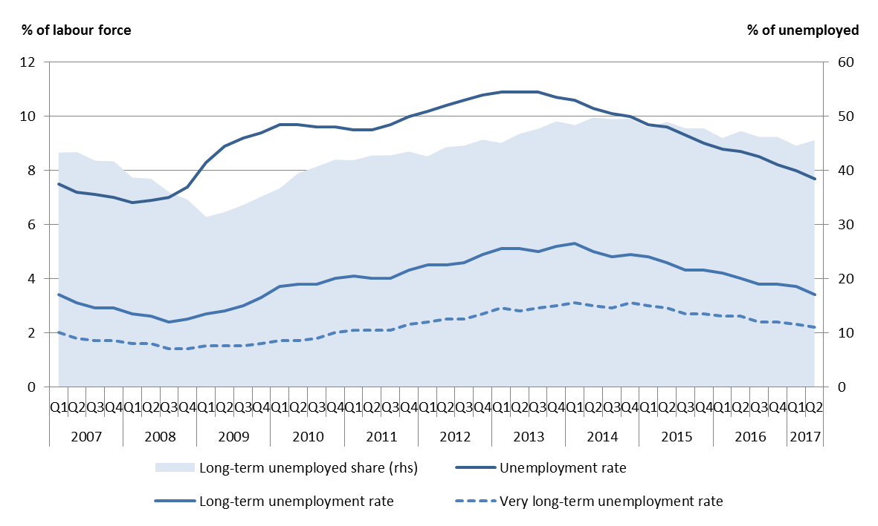
Source: Eurostat, LFS.

The recovery in employment and the decline in unemployment have been surprisingly strong given the steady but moderate GDP growth. This trend emerged clearly during the last two years, both in the EU and the euro area. However, subdued growth in hours worked per employed person points to some remaining slack in the labour market as they remain about 3% below the pre-crisis level in the EU (Figure 2) and about 4% in the euro area. Increases in part-time work and, to a smaller extent, reductions in the hours of full-time workers have contributed to this development. Nonetheless, over 2016 full-time employment grew faster than part-time (as shown later in this section).
Figure 2: Growth in real GDP, employment and hours worked per employed person in the EU (cumulative change – index 2008 = 100)
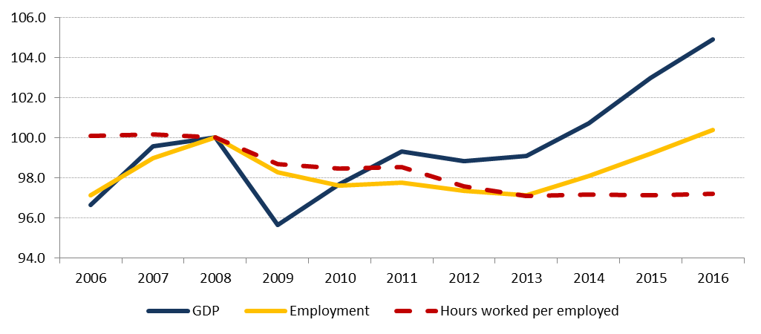
Source: Eurostat, National accounts (DG EMPL calculations).

Employment growth has been stronger among older workers. As shown in Figure 3, the largest increase in employment figures in the EU, by 4.6% in 2016, was recorded by older workers (aged 55-64). This adds up to a continuously rising employment rate for this group in the post-crisis period, from 45.5% in 2008 to 55.3% in 2016, and a corresponding rise in the activity rate (to 59.1% in 2016). This trend reflects ongoing reforms of national pension systems, with a view to improve their sustainability and increase labour supply in a context of demographic change (including increasing life expectancy). As in 2015, employment growth was comparatively lower among young (15-24) and prime age (25-54) workers, though quicker for the former group (1.3% vs 0.8%). In view of a stable activity rate (at 41.5% both in 2015 and 2016), steady job creation among young people contributed to the decrease in youth unemployment. Employment growth was comparable across genders, as already in 2015. Employment of both men and women increased by 1.4% over 2016. This means that whereas employment rates increased for both groups (by 1 pp to respectively 76.9% and 65.3%) the gender employment gap remained unaffected.
While rising across all education levels, employment increased the most among higher-educated workers. Indeed, the number of people with higher education in employment increased by 3.1% in 2016 (age group 25-64). Medium- (i.e. with upper secondary education) and low-skilled (with lower secondary education or below) workers recorded a comparatively lower increase by 0.4% and 0.9% respectively. Detailed trends by Member States are provided in the following sections of the report.

Figure 3: Employment rates and employment growth across different groups in the EU
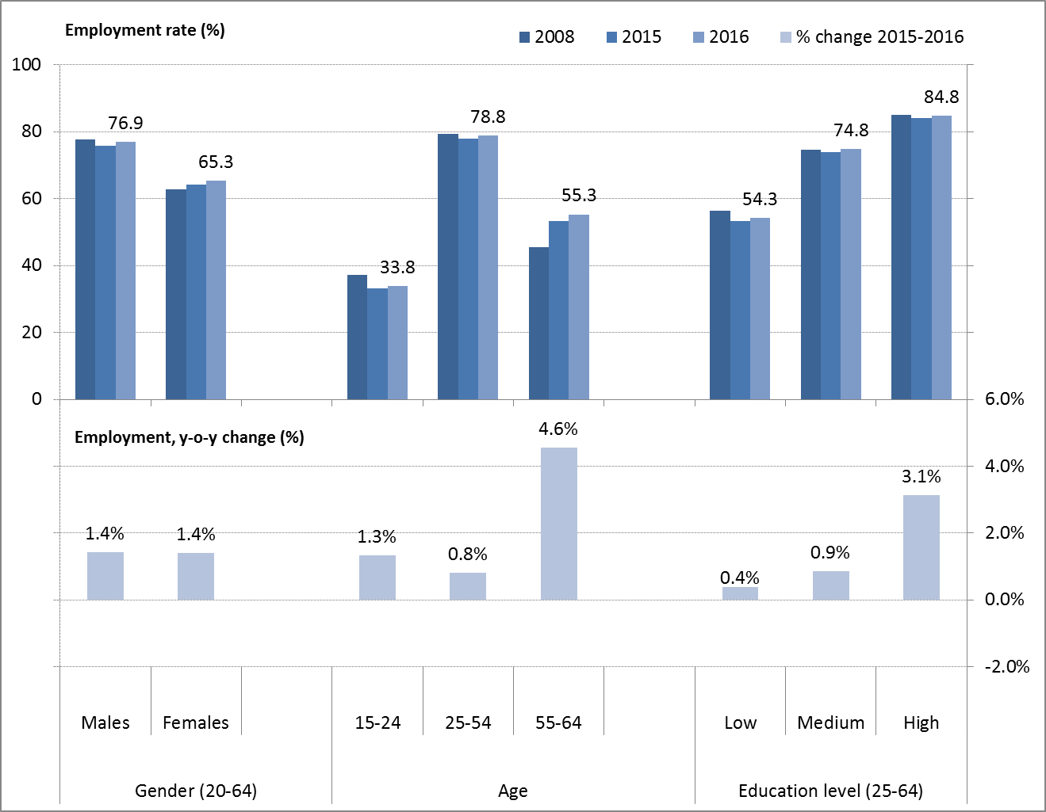
Source: Eurostat, LFS.

The recovery is boosting both permanent and temporary jobs, with increasingly full-time work schedules. In absolute terms, the increase in the number of employees on permanent contracts in 2016 exceeded that of employees on temporary contracts (2.7 million vs. 0.6 million), though in percentage terms the increase was larger for the latter. The share of temporary employees over total employees remained stable at 14.2% (more details in Section 3.3.1). Self-employment increased only marginally (by 0.3%) in 2016, with a faster increase among self-employed without employees (more details in Section 3.1.1). As mentioned earlier in the chapter, since the onset of the crisis the number of part-time workers has increased substantially (by around 11% compared to 2008), while full-time employment has dropped (by 2%). Nonetheless, this trend might be on the verge of changing, as in 2016 proportionally more full-time than part-time jobs were created (the same had occurred only once since 2008, in 2014). In addition, the share of involuntary part-time has decreased in 2016, from 29.1% to 27.7%. In line with the trend of recent years, most job creation occurred in services (+1.7%). Industry and construction also showed good growth (both with +1%). In construction, employment growth showed a positive sign for the first year since 2008 – though compared to that year, there are still 18% fewer people employed in the sector. Jobs in agriculture continued to fall, following a long-term trend, by 4% in 2016.

1.2 Social trends

Improved labour market conditions have brought general improvements in the financial situation of households. The real Gross Disposable Household Income (GDHI), which measures household market income adjusted for taxes and social transfers, increased for a third consecutive year in 2016 and has reached the previous peak of 2009. Quarterly data indicate a stable increase of around 2% on yearly basis in 2016. Growth continued in the first quarter of 2017, though at a slower pace. Recent growth is driven by higher incomes from work, with compensation of the self-employed and especially employees increasing at a firm pace. This mostly reflects higher employment rates, and to a lesser extent wage increases. Increases in social benefits also raised the disposable income of households, but their contribution to overall GDHI growth has decreased in the second half of 2016. Property incomes and other income contributions have remained stable in the past years, while higher social contributions and taxes had a negative contribution to GDHI growth.
The improved income situation of households has reduced the number of people at risk of poverty or social exclusion (AROPE). This indicator continued to improve for a fourth consecutive year in 2016, dropping to 23.5% (from 23.8% one year earlier), and is now approaching its lowest level of 23.3% in 2009. Still, progress towards achieving the Europe 2020 strategy headline target – of lifting at least 20 million people out of poverty compared to 2008 – remains insufficient. Around 118 million people were at risk of poverty or social exclusion in 2016, i.e. about 700,000 more than in 2008. The risk was more prevalent among certain groups: children (aged 0-17, 26.4%), young people (aged 18-24, 30.5%) as well as people with at most lower secondary level education (34.9%) and people with disabilities (aged 16+, 29.9%). Two-thirds of the unemployed were also at risk of poverty or social exclusion in 2016. Non-EU born people tend to face higher risks of poverty or social exclusion (39.1% in 2015). Conversely, elderly people (age 65+) remain relatively better protected (with a slight deterioration, from 17.4% in 2015 to 18.3% in 2016).

Figure 4: Sub-indicators of ‘people at risk of poverty or social exclusion", 2005-2016
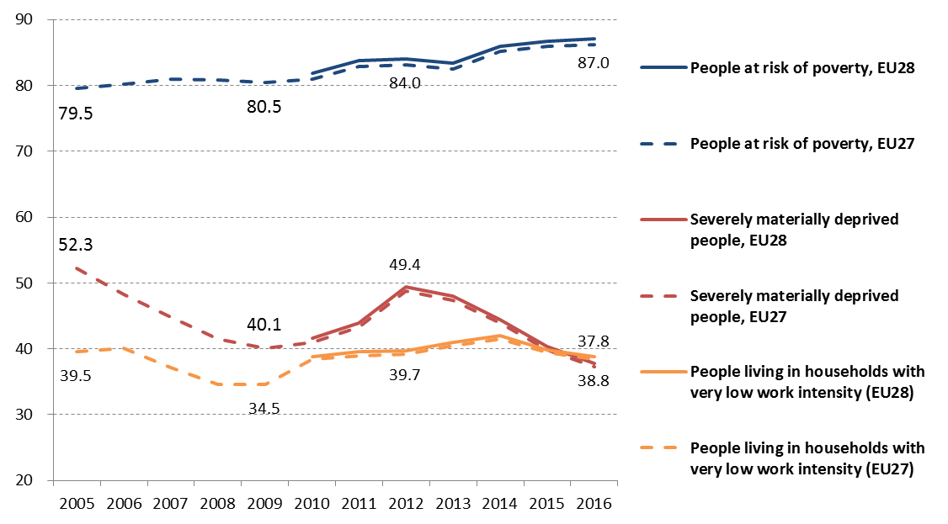
Source: Eurostat, SILC. Note: EU27 in this graph equals EU minus Croatia (only available since 2010).

Looking at sub-components of the AROPE, monetary poverty remains the most relevant challenge. The number of people at risk of poverty (AROP) rose for several years following the crisis, driven by the weak economic and labour market situation until mid-2014, reaching a peak of 87 million in 2016. However, as a share of the population, the number of people at risk of poverty has stabilised in 2015 and 2016 (17.3% in both years), thanks to the recovery and improving labour market conditions. Still, it remains above the pre-crisis level of 16.4% in 2009. Flash estimates for income year 2016 suggest that monetary poverty further stabilised in most Member States.
The number of people suffering from severe material deprivation (SMD) has been declining since 2013, and in 2016 reached the lowest level ever recorded (37.8 million). This figure amounts to 7.5% of the EU population (from 8.1% in 2015). Its decrease, reflecting a fall in absolute poverty, is the main driver behind the reduced number of people at risk of poverty or social exclusion. The improved labour market situation led to a decrease in the share of people living in (quasi) jobless households. This share amounted to 10.4% (or 38.8 million) in 2016, declining from the 2014 peak of 11.2%. However, over a longer time horizon, it remains elevated compared to 2008 (9.2%).
In-work poverty risk has remained on an increasing trend (started with the crisis), affecting 9.6% of the working age population in 2016. This value remains above its lowest level of 8.3% in 2010, and correspnds to over 32 million workers at risk of poverty. Although crucial in bringing down the risk of poverty, employment alone is not always sufficient to lift people out of poverty. Increases in non-standard forms of employment and employment polarisation may impact future results for this indicator.
Income inequality started slowly declining in 2016, after having increased in the aftermath of the crisis. The income quintile share ratio (i.e. the ratio of total income received by the 20% of the population with the highest income to that received by the 20 % of the population with the lowest income) slightly receded from 5.2 in 2015 to 5.1 in 2016, after increasing from 4.9 in 2009. This modest development reflects the improved economic and labour market conditions. Nonetheless, the average EU indicator on income inequality hides considerable variation across countries (see Section 3.4).

2. SNAPSHOTS FROM THE SOCIAL SCOREBOARD
The European Pillar of Social Rights, signed as an inter-institutional Proclamation by the European Parliament, the Council and the Commission on 17 November 2017, sets out a number of key principles and rights to support fair and well-functioning labour markets and welfare systems. It is designed as a compass for a renewed process of convergence among Member States towards better working and living conditions.
The European Pillar of Social Rights is accompanied by a new social scoreboard to monitor performances and track trends across the Member States. This edition of the Joint Employment Report presents the results from the social scoreboard, which replaces the scoreboard of key employment and social indicators agreed in 2013. The new scoreboard provides a number of Headline Indicators to screen the employment and social performance of Member States along three broad dimensions, identified in the context of the Pillar: (i) equal opportunities and access to the labour market, (ii) dynamic labour markets and fair working conditions, and (iii) public support / social protection and inclusion. This analysis is placed in the broader reform context presented in Chapter 3.

2.1 The scoreboard explained
The social scoreboard will be a central tool for monitoring convergence towards better working and living conditions. It notably consists of the following 14 headline indicators that assess employment and social trends at large :
- Equal opportunities and access to the labour market:
  - Share of early leavers from education and training, age 18-24
  - Gender gap in employment rate, age 20-64
  - Income inequality measured as quintile share ratio - S80/S20
  - At-risk-of-poverty or social exclusion rate (AROPE)
  - Young people neither in employment nor in education or training (NEET rate), age 15-24
- Dynamic labour markets and fair working conditions:
  - Employment rate, age 20-64
  - Unemployment rate, age 15-74
  - Participants in active labour market policies per 100 persons wanting to work
  - Gross disposable income of households in real terms, per capita
  - Compensation of employees per hour worked, in euro
- Public support / Social protection and inclusion:
- Impact of social transfers (other than pensions) on poverty reduction
- Children aged less than 3 years in formal childcare
- Self-reported unmet need for medical care
- Share of population with basic overall digital skills or above.
The common methodology used to analyse the Scoreboard has been agreed by the Employment Committee and the Social Protection Committee (see Annex 3 for details). It evaluates the situation and developments in Member States by looking at levels and yearly changes of each of the headline indicators included in the social scoreboard. Levels and changes are classified according to their distance from the respective (unweighted) EU averages. Member States' performances on levels and changes are then combined (by using a predefined matrix) so that each Member State is assigned to one out of seven categories ("best performers", "better than average", "good but to monitor", "on average/neutral", "weak but improving", "to watch" and "critical situations"). On this basis, Table 1 provides a summary of the readings of the scoreboard according to the latest figures available for each indicator.
A careful and non-mechanical reading of the table is warranted. To this purpose, a detailed analysis of the fourteen indicators, including longer-term trends and additional indicators, when relevant, is presented in Chapter 3. In addition, the forthcoming country reports will provide an in-depth analysis of all "critical situations" and additional socio-economic background to better qualify country-specific challenges in the context of the European Semester. This will provide an analytical basis for the subsequent Commission proposals for Country Specific Recommendations where appropriate.

2.2 Evidence from the social scoreboard
Action is required to achieve convergence in 'societal progress' along the dimensions identified by the Social Pillar. The analysis of headline indicators shows for 17 Member States at least one "critical situation". Across the 14 domains assessed, 50 "critical situations" are identified, corresponding to almost 13% of the total number of assessments. Counting the three more problematic classifications, "critical situation", "to watch" and "weak but improving" brings the global count to 129 i.e. about one-third of all assessments.
Looking at the three broad dimensions covered by the scoreboard, problematic flags appear more frequently in the area of "public support/social protection and inclusion", with an average of 11.8 cases (of which 4.5 "critical situations") per indicator. Impact of social transfers in poverty reduction appears the most difficult , with indicators flashing for 13 Member States (of which 5 in the bottom category).
The dimensions of "Equal opportunities and access to the labour market" and "dynamic labour markets and fair working conditions" follow, with for both an average of about 9 and 8.8 cases flagging per indicator (respectively 4 and 3 "critical situations" each). In the first domain, the most flagged indicator is the gender employment gap (10 times). In the latter, compensation of employees per hour worked appears as the indicators with most numerous challenges (13 flags).
The Scoreboard depicts an improving labour market and social situation for the EU as a whole. On average for the EU, 11 out of the 14 headline indicators recorded an improvement over the last available year (i.e. 2016 or 2015 depending on data availability), confiming the steady improvement in labour markets and social situation which has accompanied the economic recovery. In particular, on the unemployment rate, 11 Member States can now be categorised as best perfomers or better than average, and only one country is in a critical situation. Twelve Member States also flag as best perfomers or better than average in terms of the employment rate and 12 Member States when considering the share of people at risk of poverty of social exclusion. Nevertheless, two indicators (gender employment gap and compensation of employees per hour worked) remained broadly unchanged and one of them (impact of social transfers on poverty reduction) slightly deteriorated.
The situation of Member States remains scattered and the severity of challenges varies widely across Member States. Most Member States are flagged at least once with a challenge on headline indicators, except for Denmark, Germany, France, the Netherlands, Sweden and the United Kingdom. Greece, Romania, Italy and Bulgaria report "critical", "to watch", or "weak but improving" situations on ten or more indicators. In that group, Greece and Romania present by far the largest number of "critical situations" (i.e. indicators which are much worse than average, and either not improving sufficiently fast or deteriorating further). In the case of Greece, critical situations are spread across all the three areas (yet, a good performance is recorded on early school leaving). For Romania, they are mostly concentrated in the "equal opportunities and access to labour market" and "public support / social protection and exclusion" areas. In terms of overall count, Cyprus (9 challenges), Spain and Croatia (8 challenges each), Latvia, Lithuania and Portugal (7 challenges each) follow. By contrast, Denmark is a best performer or better than average in all 14 headline indicators, followed by Sweden (12 indicators), Austria (10 indicators) and the Netherlands (9 indicators).
When looking at equal opportunities and access to the labour market, the situation improved over the last year in terms of early leavers from education and training, the risk of poverty and social exclusion and NEETs in the EU. However, it remained broadly stable in terms of gender employment gap and income inequality (as measured by the income quintile share ratio). When looking by indicator:
- Spain, Malta, Portugal and Romania face a critical situation when it comes to early leavers from education and training compared to Croatia, Lithuania and Slovenia as the best performers;
- Greece, Italy, Malta and Romania score critical on the gender employment gap, compared to Latvia, Lithuania and Sweden as best performers;
- Bulgaria, Greece, Spain and Lithuania face a critical situation in terms of income inequality compared to the good performance of the Czech Republic, Slovenia, Slovakia and Finland;
- The situation as concerns the risk of poverty or social exclusion is critical in Bulgaria, Greece and Romania, compared to the Czech Republic, Denmark, the Netherlands and Finland as best performers;
- Bulgaria, Greece, Croatia, Cyprus and Romania face a critical situation when looking at NEETs while Denmark, Luxembourg, the Netherlands and Sweden perform the best.
Turning to dynamic labour markets and fair working conditions in the EU, the situation improved over the last year in terms of employment and unemployment rates, participation in active labour market policies (ALMPs) and gross disposable household income (GDHI) per capita growth, while it was fairly stable in terms of compensation per employee. When looking by indicator:
- Greece, Croatia and Italy still face a critical situation when it comes to their employment rate, compared to Denmark, Germany, the Netherlands, Sweden and the UK as the best performers;
- Greece scores critical on the unemployment rate, compared to the Czech Republic and Germany as best performers;
- Bulgaria, Estonia, Croatia, Romania and Slovenia face a critical situation in terms of participation to ALMPs, compared to the performance of Belgium, Denmark, France, Hungary and Sweden;
- The growth in per capita GDHI is seen as a critical situation in Greece and Cyprus, compared to Poland and Romania as best performers;
- Bulgaria, Hungary and Poland face a critical situation when looking at compensation per employee, while Belgium, Denmark, France, Luxembourg and the Netherlands perform the best.
As regards public support and social protection and inclusion, the situation improved over the last year in terms of childcare availability, self-reported unmet need for medical care and digital skills but it worsened in terms of the impact of social transfers on poverty reduction. When looking by indicator:
- Bulgaria, Greece, Italy, Lithuania and Romania still face a critical situation when it comes to the ability of their social transfers to reduce poverty. This compares to Denmark, Austria, Finland and Sweden as the best performers;
- The Czech Republic, Poland and Slovakia score critical on the availability of formal childcare, compared to Belgium, Denmark, Luxembourg, Portugal and Sweden as best performers;
- Estonia, Greece, Italy, Poland and Romania face a critical situation in terms of self-reported unmet need for medical care (no "best performers" identified through the methodology);
- Bulgaria and Romania face a critical situation when looking at levels of digital skills, while Denmark, Luxembourg, the Netherlands and Finland perform the best.

Table 1. Summary of the headline indicators in the social scoreboard

Note: At 31 October 2017, participation in ALMPs not available for EL, IT, MT, UK (LU not reported for data verification issue); GDHI per capita growth not available for HR, LU and MT; income quintile ratio, at-risk-of-poverty or social exclusion rate, and impact of social transfers on poverty reduction not available for IE.

Box 1. Benchmarking - state of play

The Communication of 26 April 2017 establishing a European Pillar of Social Rights notes that "benchmarking and exchange of best practices will be conducted for a number of areas, such as employment protection legislation, unemployment benefits, minimum wages, minimum income and skills". The Commission started in 2015, following the Five Presidents' Report and in cooperation with Member States, benchmarking exercises in some of the areas mentioned in the Social Pillar Communication. The purpose of benchmarking is to support structural reforms and upward convergence towards best performers. In comparison with other cross-examination exercises, where the focus is mainly on comparing general outcomes, these benchmarking exercises focus notably also on policy levers (i.e. on specific policy parameters that can lead to better outcomes).
The Employment Committee (EMCO) and the Social Protection Committee (SPC) have agreed on a common approach relying on a three-step approach: (1) identification of key challenges and a set of high level outcome indicators relevant for the policy area under consideration; (2) performance indicators which allow for benchmarking the performance; (3) the identification of policy levers, which are accompanied by general principles for policy guidance and, when available, by specific indicators. At this stage the aim is to allow for comparisons of Member States for each policy lever, rather than setting reference values.
Discussions in the Employment Committee on a pilot on Unemployment Benefits and Active Labour Market Policies started in 2016 and an agreement was found in 2017. This notably concerns three outcome indicators (unemployment rate, long-term unemployment and at-risk-of-poverty rate of the unemployed), two performance indicators (share of people wanting to work participating in regular activation measures and coverage of unemployed with unemployment duration shorter than 12 months by unemployment benefits); and three policy lever indicators, notably in the domain of unemployment benefits (replacement rate, eligibility conditions and benefit duration). The analysis of unemployment benefits presented in Chapter 3.3 draws on the results of the benchmarking exercise. Work is still ongoing as regards policy levers on activation policies.
A benchmarking exercise for minimum income schemes is also being developed jointly with Member States in the Social Protection Committee. The state of play of this exercise is presented in Chapter 3.4. Work is also progressing on benchmarking skills, with a focus as concerns policy levers on adult learning.
Within the context of the European Pillar of Social Rights, the Commission intends to pursue a further reflection on benchmarking together with Member States. It aims at identifying Pillar principles for which benchmarking can provide a positive contribution towards mutual learning and upward convergence.

3. EMPLOYMENT AND SOCIAL REFORMS – MEMBER STATES PERFORMANCE AND ACTION
This section presents an overview of recent key employment and social indicators and measures taken by the Member States in priority areas identified by the EU employment guidelines, as adopted by the Council in 2015. For each guideline, recent developments on a selection of key indicators are presented, as well as policy measures taken by Member States. As concerns the latter, the section draws on Member States’ National Reform Programmes 2017 and European Commission sources. If not specified otherwise, only policy measures implemented after June 2016 are presented in the report. An in-depth analysis of recent labour market developments can be found in the Labour Market and Wage Developments 2017 report and the Employment and Social Developments in Europe Review 2017.

3.1 Guideline 5: Boosting demand for labour
This section looks at the implementation of the employment guideline no. 5, which recommends Member States to create conditions promoting labour demand and job creation. It first presents an overview of unemployment and employment rates by Member State, complementing the analysis at EU level made in Chapter 1, so as to highlight the relevance of the job creation challenge across countries. It then looks at self-employment dynamics, as a proxy for entrepreneurship and as a source of employment growth per se. It finally investigates key macroeconomic determinants of hiring decisions, namely wage and tax wedge developments. Section 3.1.2 reports on policy measures implemented by Member States in these areas to promote labour demand, including hiring subsidies.

3.1.1 Key indicators
In almost half of the Member States the unemployment rate decreased markedly in 2016, by more than 1 percentage point. A quicker-than-average drop occurred notably in some Member States suffering from very high unemployment rates – especially Spain, Croatia and Cyprus (by 2 pps or more) but also Greece and Portugal – pointing to a convergence towards lower unemployment levels. However, differences remain big. As evident from Figure 5 (which looks jointly at levels and changes according to the agreed methodology for assessing headline indicators of the social scoreboard), the dispersion of unemployment rates remained sizeable in 2016, with values ranging from around 4% in the Czech Republic and Germany ("best performers") to 23.6% in Greece ("critical situation"). Although the unemployment rate decreased by 1.3 pps in Greece, the overall level remains very high. Moreover, unemployment rates also remain high in Italy, with no significant improvements in 2016 (decreasing by only 0.2 pps). Among Member States with lower than average unemployment rates, Estonia and Austria recorded a slight increase in 2016. In spite of the steady decrease since 2013, in most Member States the unemployment rate was still higher in 2016 than in 2008 (Figure 6). The only exceptions are Germany, Hungary, Malta, Poland, the United Kingdom and the Czech Republic.
Figure 5: Unemployment rate (15-74) and yearly change (Social Scoreboard headline indicator)
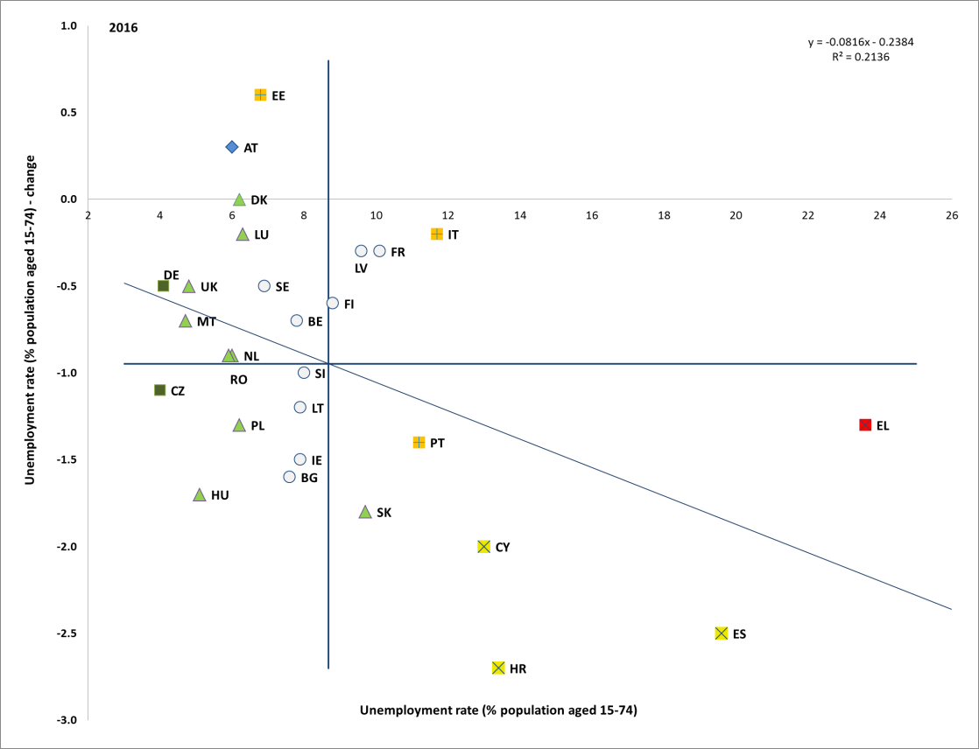
Source: Eurostat, LFS (DG EMPL calculations). Period: 2016 levels and yearly changes with respect to 2015. Note: Axes are centred on the unweighted EU average. The legend is presented in the Annex.

Figure 6: Unemployment rate (15-74), multiannual comparison
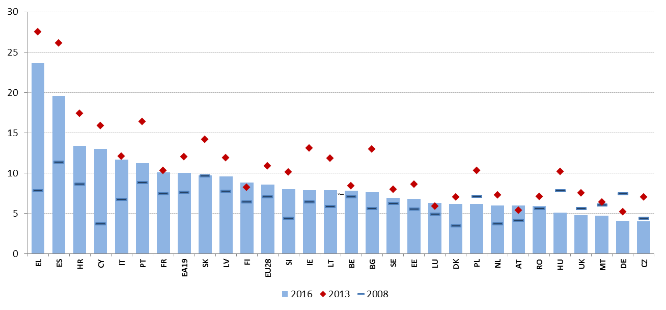
Source: Eurostat, LFS.

The employment rate has increased in 27 out of 28 Member States, though significant disparities remain. Only Luxembourg has recorded a slight decrease over the last year. As shown in Figure 7, employment rates are only partially converging. This is reflected in the moderately negative slope of the regression line that links changes with levels in employment rates. This suggests that Member States characterised by lower employment rates are growing somewhat faster than average, and vice versa – but the situation remains scattered. Employment rates (age group 20-64) diverge widely, ranging from 56.2% in Greece to 81.2% in Sweden. At the lower end, the employment rate remains much below the EU average (below 65%) in Greece, Croatia, Italy (flagged as "critical situations"), and Spain (flagged as "weak but improving" in view of a significant improvement). It is marginally higher in Romania, Belgium and Bulgaria, though increasing at a slower than average pace. Conversely, the Netherlands, Denmark, United Kingdom, Germany and Sweden are flagged as "best performers" with employment rates of 77% or higher. An expansion of employment is, according to the European Commission Autumn 2017 economic forecast, expected over 2017 and 2018 in almost all Member States.

Figure 7: Employment rate (20-64) and yearly change (Social Scoreboard headline indicator)
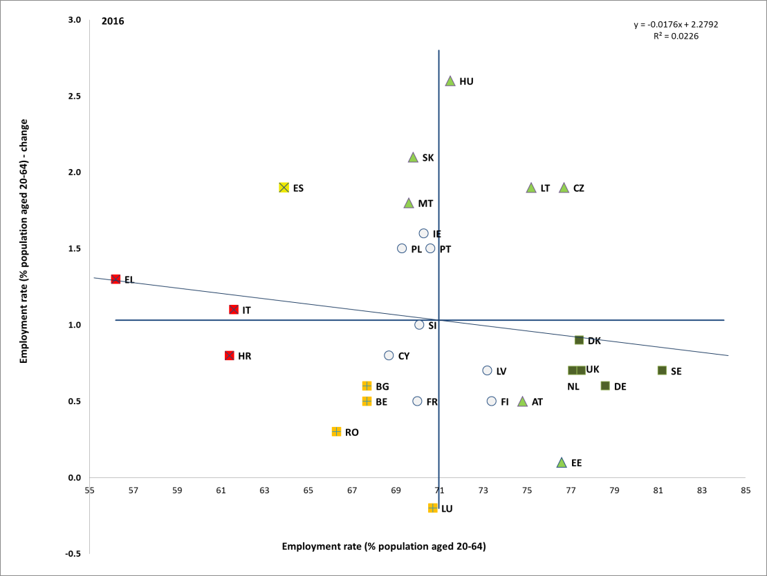
Source: Eurostat, LFS (DG EMPL calculations). Period: 2016 levels and yearly changes with respect to 2015. Note: Axes are centred on the unweighted EU average. The legend is presented in the Annex.

Average employment rates in the EU have been constantly rising since 2013 and are now above pre-crisis levels, but disparities are still high. In 2016 more than half of the Member States, 17 countries, are still below the 2008 levels (Figure 8). This is particularly evident in those countries more affected by the crisis – notably Greece (-10.1 pps), Cyprus (-7.7 pps), Spain (-4.6 pps) and Croatia (-3.5 pps). Reassuringly, the recovery has contributed to employment growth in almost all Member States compared to 2013. The largest increases in employment rates since 2008 took place in Hungary (+8.5 pps) and Lithuania (+5.3 pps).

Figure 8: Employment rate (20-64), multiannual comparison
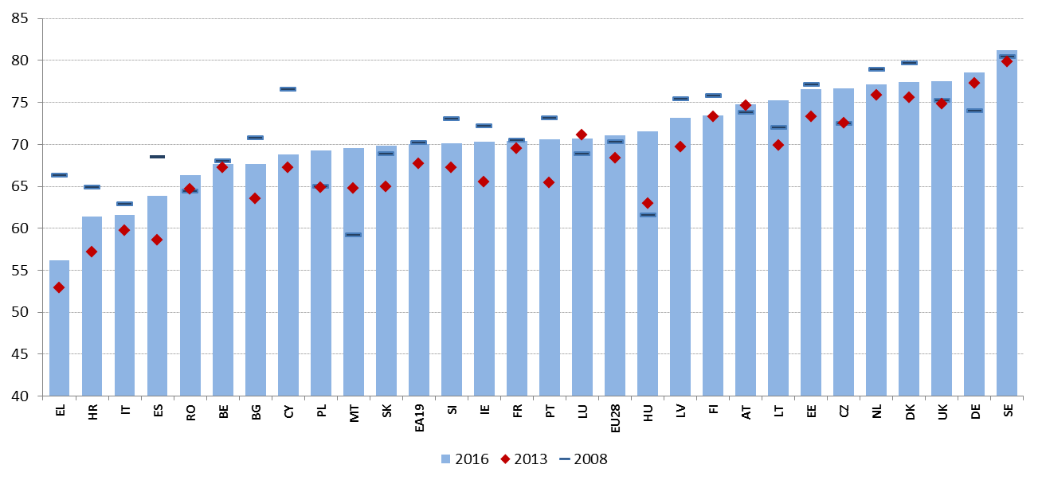
Source: Eurostat, LFS.

In a context of sustained employment growth, trends in self-employment tend to be more stable. The average self-employment rate decreased in 2016 to 14.0%, the lowest rate since 2008, as total employment grew faster (+1.5%) than self-employment (+0.3%). However, if the primary sector (agriculture, forestry and fishing), which is affected by a structural decline, is excluded, the number of self-employed grew almost as fast as total employment (by 1.3%). Self-employment by people with a migrant background continued its steady rise: the rate for people with a non-EU citizenship rose to 12.2% in 2016, from 11.9% in 2015 (it was only 10.0% in 2010). Moreover, demographic developments have led to a strong increase in the number of self-employed of 65 years and older. In 2016, their number amounted to 8% of the total number of self-employed (6% in 2006).
In absolute terms, self-employment rose in 2016 in a majority of Member States. Sectoral developments played a role, with decreases mainly concentrated in Member States with an above-average share of self-employed in the primary sector (Croatia, Romania, Slovenia, Bulgaria, Portugal, Finland and Poland). Decreases were also recorded in Cyprus, Germany, Belgium, Sweden and Italy, while self-employment went up in all other Member States (by 5% or more in Luxembourg, Slovakia and the United Kingdom). The male self-employment rate continued its steady decrease (to 17.5% in 2016; it stood above 18% up to 2014), while the female self-employment rate has remained constant at around 9.9% since 2012.
Self-employment without employees (so-called own-account workers) remained widespread. In 2016, the number of own-account workers outside the primary sector rose by 1.8% (and stood 9% higher than in 2008), while the number of employers (self-employed with employees) outside the primary sector rose only by 0.3% (and stood 10% lower than in 2008). Self-employment without employees can hide situations of "bogus" self-employment in some circumstances; this issue will be further discussed in Section 3.3 along with labour market segmentation.
Wage growth remains subdued in the EU, despite continued improvements in the labour market. Real wages adjusted for the change in consumer prices increased in almost all Member States and grew overall by 1.3% in the EU. Growth was lower in the euro area, where, in the low-inflation environment of 2015 and 2016, real wages grew by slightly less than 1% in both years. Modest wage growth, coupled with a slight slowdown in productivity growth, translated into a moderate pick-up in unit labour cost dynamics. Compensation of employees varies widely across Europe, ranging from EUR 4.6 per hour worked in Bulgaria to EUR 43.3 in Luxembourg. Moreover, Figure 9 shows that Europe is broadly split in two groups of low-wage and high-wage countries, with only Cyprus, Slovenia, Italy and Spain being close to EU average. On the low end, in particular Bulgaria, Poland and Hungary stand out, as well as Romania which recorded a large increase in the last year. Some signs of convergence can be identified, even if the correlation between the absolute level of wages and the change in compensations does not seem strong.

Figure 9: Compensation of employees per hour worked and yearly change (Social Scoreboard headline indicator)
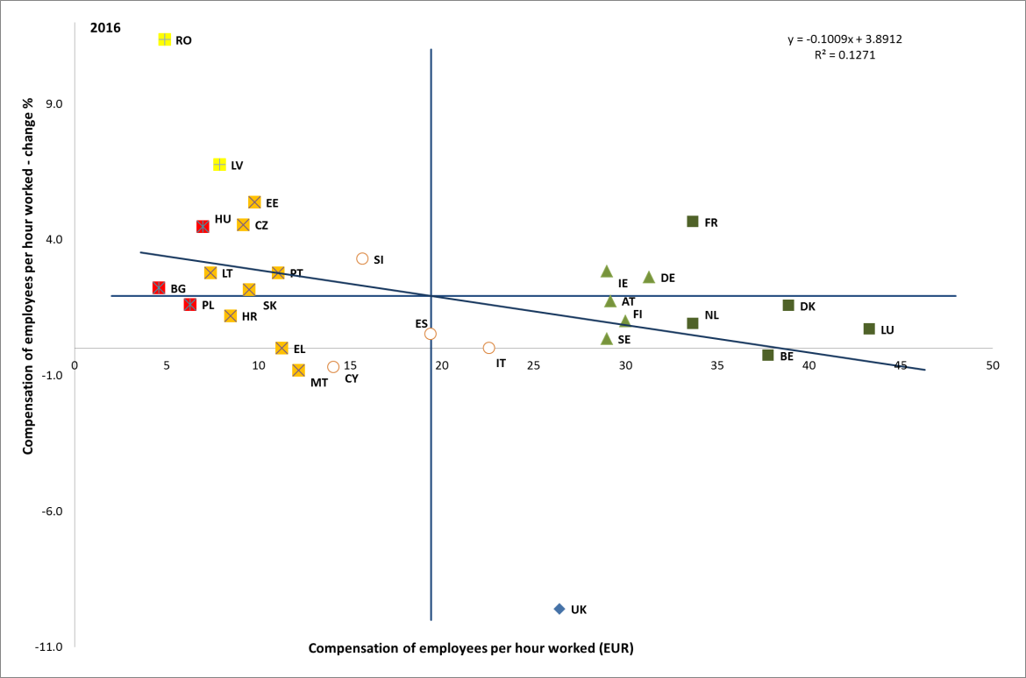
Source: Eurostat, National accounts. Period: 2016 levels and yearly changes with respect to 2015. Note: Axes are centred on the unweighted EU average. The legend is presented in the Annex.

In the period 2011 to 2016, real wage growth lagged behind average productivity growth in the majority of Member States (18 out of 28). In six countries (Belgium, Cyprus, Finland, Croatia, Greece, Portugal) real wage growth was negative over the period 2014-2016. Also over the longer term, on average real wage developments have been trailing behind productivity (see Figure 10).
Figure 10: Wage and productivity developments, 2000-2016 average % changes
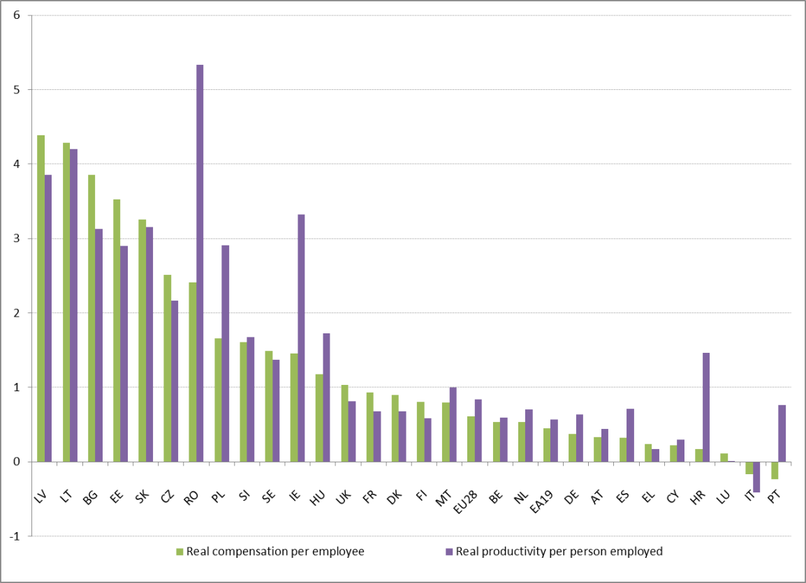
Source: Eurostat, National Accounts (DG EMPL calculations).

Cost competitiveness developments were supportive of rebalancing in the euro area, but progress has slowed down. In the euro area, following prolonged fiscal and wage restraint, by 2015 most Member States turned to a current account surplus position. In the context of the subdued wage growth in the euro area, nominal unit labour costs have grown slightly faster in countries characterised by large and persistent current account surpluses than in net debtor countries. However, the difference narrowed somewhat in 2016, slowing down the rebalancing.
In most Member States, wage growth in 2016 was slower or equal than predicted by the historical relationship with unemployment, notably with wages lagging behind the drop of unemployment. Countries where wage growth remained furthest below the historical relationship include Belgium, Bulgaria, Finland, Slovakia and Sweden. The Phillips curve – the (normally negative) relationship between wage growth and unemployment – confirms that wages have reacted slowly to the recovery, especially in the euro area. Figure 11 compares the annual change in nominal compensation per employee with the so-called unemployment gap, i.e. the difference between the actual unemployment rate and its trend. Since the start of the crisis, the curve has been flatter than previously, implying a weaker reaction of wages to falls in unemployment. Moreover, the growth rate of compensations has over the last three years been below the trend expected in the light of labour market improvement.
The modest wage dynamics can be explained by weak productivity developments, low inflation expectations, the effect of some labour market reforms and the remaining slack in the labour market. In particular, the current unemployment rate may not adequately capture the effective state of resource utilisation in the labour market. In addition to those effectively looking for a job (i.e. the unemployed), discouraged workers and underemployed part-time workers may exert additional downward pressures on wages. The decline in inflation expectations and the productivity slowdown may also affect wage negotiations, keeping wage growth down, thus undermining the sustainability of the recovery. The negotiated wages also give a clear picture of how wage pressures have not materialised, especially in the euro area: the yearly percentage change in the first quarter of 2017 was 1.5%, about 0.5 pps lower than its pace at the early stage of the recovery.

Figure 11: Phillips curve for the euro area 2000-2016
Source: DG ECFIN AMECO database and Eurostat, LFS

The tax burden on labour is broadly stable in Europe, but with significant differences across Member States. In 2016, reductions in the tax wedge for single workers earning the average wage were most significant in Austria (-2.4 pps), Belgium (-1.4 pps) and Italy (-1.2 pps), while it increased markedly in the Netherlands (1.3 pps), Greece (1.0 pps) and Poland (0.9 pps). As evident from Figure 12, the tax wedge ranges from less than 30% in Ireland and Malta to around 50% in Belgium, Germany, Hungary, Italy, France and Austria. A similar dispersion can be observed for lower income workers (defined as those earning 67% of the average wage), though different country patterns emerge as concerns the progressivity of tax rates. Between 2013 and 2016 the non-weighted average tax wedge decreased by 0.5 pps (and by 0.8 pps for low income workers), with large reductions in some of the countries experiencing the highest rates (Belgium, Austria, as well as Italy and France, but limited to low income workers), and also in Romania and Denmark. On the contrary, there were significant increases in Luxembourg and, limited to low wages, Portugal.

Figure 12: Tax wedge on labour, level in 2016 and change 2013/2016
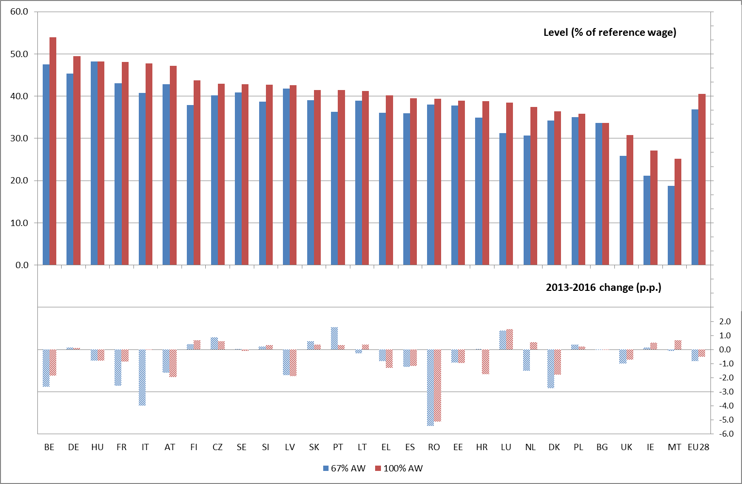
Source: Tax and benefits database, European Commission/OECD. Note: data are for single earner households (no children). No recent data available for Cyprus.

3.1.2 Policy response
Member States continued to resort to employment subsidies to support labour demand and job creation. Most measures in this area are targeted to specific groups facing labour market integration problems (e.g. youth, older people, long-term unemployed, refugees, etc.) and consist of financial incentives (or tax/social security contribution rebates) to employers for hiring targeted workers. Over the reference period (from the second half of 2016 onwards), targeted hiring subsidies were introduced by several Member States (more details to be found in section 3.2). A few countries also introduced (or plan to introduce) hiring subsidies for a wider public, i.e. without or with looser eligibility conditions, usually with the aim of promoting open-ended employment. Italy introduced, limited to the Southern regions, a reduction of social security contributions for employers hiring on a permanent basis (or through professional apprenticeship) people younger than 25 or unemployed from at least six months. France extended by six months (to the first semester 2017, now phasing out) the EUR 4 000 premium granted for the hire by a small or medium enterprise of an employee paid up to 1.3 times the minimum wage; close to 1.6 million workers benefitted from the premium. In Austria, the introduction of an employment bonus aimed at creating new jobs by reducing the wage costs for employers opening additional positions is currently under study. In other cases, hiring subsidies are targeted to several disadvantaged groups. For instance, Portugal set up financial incentives to permanent hiring, in the form of partial exemptions of social security contributions for certain vulnerable groups (young people, long-term unemployed, older people). Moreover, a hiring support measure, targeted to the same groups, provides incentives to convert fixed-term contracts into permanent ones. The European Social Fund (ESF) contributes to this measure, as well as to a recent initiative aimed at promoting the transition from traineeships into permanent contracts. Cyprus introduced employment subsidies for hiring people who belong to vulnerable groups, including GMI recipient and persons with disabilities. In Hungary, the ESF contributes to enhancing the employment potential of social enterprises through incentives and subsidies for job creation.
Some Member States are taking action to promote entrepreneurship and start-ups. For instance, Hungary is supporting young people under the age of 30 and registered job seekers over the age of 30 to become entrepreneurs in the frame of the Youth Guarantee Scheme. In Romania, the Start-up nation scheme, supported by the ESF, aims at promoting the development of new SMEs. In Finland, as of 2018, it will be possible to receive the unemployment benefit as start-up grants and while working as a part-time entrepreneur. Moreover, discussions are ongoing on how to make easier for the unemployed to set up companies. Steps have also been taken in many Member States to make sure that self-employed enjoy adequate social rights (see section 3.3 on labour market segmentation).
Several Member States reduced labour costs by cutting the tax wedge, often targeting the lowest incomes. In recent months, the tax wedge was tackled in many countries, especially for low income earners, through reforms focused on personal income taxation, often by increasing tax allowances (i.e. the tax-free amount of income). For instance, in Germany the Federal Government updated the income tax rate to reduce the fiscal drag and increase the Basic Personal Allowance, Child Tax Credit, Child Benefit and Child Supplement. In Estonia, the Parliament adopted the new tax-reform plan entering into force in 2018, which includes an increase in basic income tax allowance per month to EUR 500 per month (up from EUR 180 in 2017). Lithuania amended the Law on Personal Income Tax, increasing the basic and additional tax-exempt amount of income. Hungary increased family tax allowances for earners with two children. The United Kingdom increased the personal allowance to £11,500 (approximately EUR 13,100) per year and the threshold for the higher rate from £43,000 to £45,000 (EUR 51,400). France further decreased income tax for lower and middle incomes. In Belgium, the second phase of the Brussels tax reform, with additional reductions in personal income tax and a shift from taxation on labour to real estate, entered into force on 1 January 2017. In Latvia, a major tax reform includes the replacement of a flat 23% personal income tax rate with a progressive system. Cyprus abolished the “special contribution” – a progressive tax on the gross monthly incomes emoluments of all employees, self-employed and pensioners. Slovenia amended the Personal Income Tax Act to reduce the personal income tax burden.
Many Member States also intervened on the tax wedge through reductions in social security contributions. In France, employers' contributions were cut, partially counterbalanced by increases on the employees’ side. In other countries, reductions in social security contributions were rather aimed at supporting the employment of specific target groups, such as the young and older workers (Belgium and Italy), the disabled (Malta), new hires on permanent contracts (Italy) or new hires by the self-employed (Sweden). Hungary decreased the social contribution tax, with an impact on tax wedge for low-wage earners. At the same time, several countries (Greece, Lithuania, Latvia, Croatia) introduced or increased social security contributions for the self-employed or for those employed under atypical work arrangements. Finally, as of 2018 Latvia will generally increase social contributions for both employers and employees to finance health care.
Building on major reforms over the past years, some Member States are introducing further changes in their wage setting systems. Belgium completed, after consultation with social partners, the revision of the 1996 Law on wage setting, establishing an automatic correction mechanism, introducing a safety margin and strengthening the legal basis of the wage norm, so as to prevent loss of cost competitiveness. The federal government also announced in July 2017 its intention to simplify and promote the participation of employees in the benefits of their enterprises. Croatia made the process of collective bargaining more effective on the conclusion of collective agreements binding for the government, ensuring equal access to negotiating committees, enhancing financial management of funds from the state budget and ensuring the sustainability of the payroll system. Portugal temporarily suspended the automatic expiry of collective agreements, for a period of 18 months until July 2018, due to the low number of new signed collective agreements. Moreover, following the publication of the green paper on labour relations, and as part of the tripartite agreement with social partners, the government is planning measures to foster collective bargaining. In Slovenia, public sector trade unions and the government continued negotiations on how to loosen several temporary austerity measures enacted by the Fiscal Balance Act of 2012, on issues such as remuneration for job performance linked to increased work load, wage increase for promotion, reimbursement for annual leave and termination of the employment contract of persons fulfilling pensionable conditions. In France, a new reform of the Labour Law was adopted following consultation with social partners, further expanding the perimeter where company-level agreements prevail, while defining where branch-level agreements should remain decisive.
Some Member States adjusted their minimum wages or took steps to make minimum wage setting frameworks more predictable, with the involvement of social partners. In Bulgaria, the government has tabled a draft minimum wage setting mechanism with three scenarios and an impact analysis component, pending agreement with the social partners. The government plans to incrementally increase the minimum wage from its current level of EUR 230 per month to EUR 305 in 2020. Romania has set the level of minimum wages until 2020 in its government programme. The minimum wage has more than doubled since 2010 and is set increase from EUR 315 per month to EUR 380 in 2020. In Ireland, the minimum wage was increased from EUR 9.15 per hour in 2016 to EUR 9.25 in 2017 based on recommendations from the Low Pay Commission, which also assesses the social impact of minimum wage adjustments. The Irish Government recently announced a further increase of the minimum wage up to EUR 9.55 per hour from January 2018. Latvia established a minimum wage increase to EUR 430 per month, up from EUR 380, as of 1 January 2018. Poland increased the monthly minimum wage to 2000 PLN and introduced minimum hourly remuneration for those working on civil law contract (13 PLN per hour, i.e. around EUR 3). In Portugal, following a tripartite agreement with social partners, the Government increased the statutory minimum wage on 1 January 2017 from EUR 530 to EUR 557 a month. The increase was accompanied by a temporary reduction in employer's social security contribution for workers receiving the minimum wage. The UK government aims at increasing the national minimum wage for those over 25 up to 60% of median earnings by 2020 (around £9 per hour, approximately EUR 10.3). The annual uprating in April 2017 moved the national living wage to £7.50 per hour (EUR 8.6) and the national minimum wage will also increase for young workers and apprentices. In Germany, the Federal Government followed the recommendation of the permanent Minimum Wage Commission of the social partners, increasing the general minimum wage from EUR 8.50 to 8.84 per hour as from 1 January 2017.

3.2 Guideline 6: Enhancing labour supply, skills and competences
This section looks at the implementation of the employment guideline no. 6, which recommends to Member States to create conditions to promote labour supply, skills and competences. It presents indicators about the impact of the education and training system on the employability of the workforce (basic skills proficiency, participation in lifelong learning, and school-to-work transitions for different types of curricula) before going through labour market outcomes for various groups underrepresented in the labour market (e.g. young people, older workers, people with a migrant background and women). Section 3.2.2 reports on policy measures of Member States in these areas and measures targeted at those disadvantaged groups.

3.2.1 Key indicators
In 2016, the early school leaving rate (ESL) further decreased in the EU. It stood at 10.7%, down 0.3 pps from 2015. Seventeen Member States recorded rates below the EU target value of 10%. At the same time, the rate was close to 20% in Malta, Spain and Romania (which together with Portugal are flagged as "critical situations"), while it was below 5% in Croatia, Lithuania and Slovenia ("best performers"). In the past year the ESL rate remained stable in the large majority of Member States (as shown in Figure 13), decreased the most in Luxembourg (by 3.5 pps) and Greece (1.4 pps), but showed a substantial increase in Cyprus (by 2.8 pps, although for the level is still below the EU average). There is no evidence of convergence across Member States in 2016, as evidenced by the almost horizontal regression line which relates yearly changes to levels in the ESL rate. Compared to 2008 (Figure 14), however, the ESL rate declined across almost all Member States, by 4 pps on average; it dropped the most in Portugal, Spain, Greece and Luxemburg, while it went up in Hungary, the Czech Republic, Slovakia, and Romania. The difference in the early school leaving rate between men and women in 2016 has shrunk to 3 pps from 3.9 pps in 2008, with women being less likely to leave school early than men.
Figure 13: Early leavers from education and training (% of population aged 18-24) and yearly change (Social Scoreboard headline indicator)
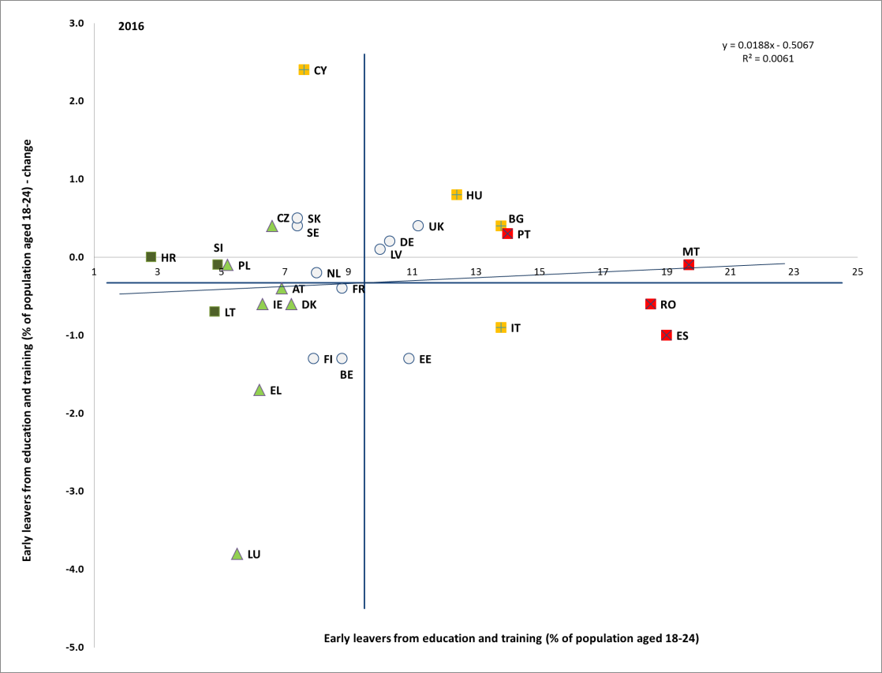
Source: Eurostat. Period: 2016 levels and yearly changes with respect to 2015. Note: Axes are centred on the unweighted EU average. The legend is presented in the Annex.

Figure 14: Early leavers from education and training, 2008-2016
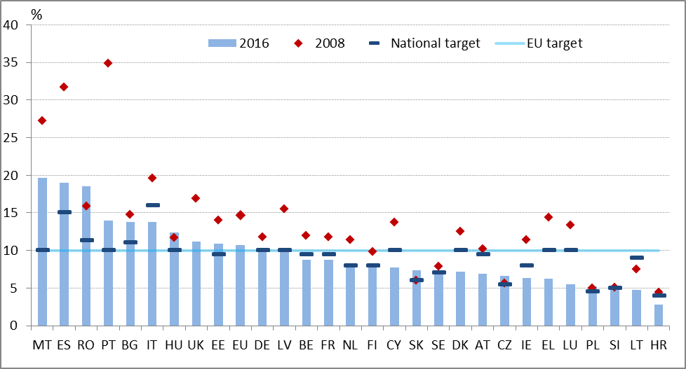
Source: Eurostat (LFS). Online data code: edat_lfse_14.

The long-term decline of early school leaving in Europe is a positive trend that largely stems from structural reforms in education and training systems and targeted policy measures. Yet, in the aftermath of the crisis, it may in part be related to the persistent difficult access to the labour market of countries with high levels of youth unemployment, where young people have decided to remain longer in education. Moreover, early school leaving is strongly linked to social disadvantage and low education backgrounds of parents. Pupils with a migrant background, particularly foreign-born pupils, have higher drop-out rates. Pupils with disabilities are also more disadvantaged with a 10.3 pps gap compared to pupils without disabilities in 2015.
An important indicator of the quality of initial education and training systems is the proficiency of students in basic competences such as reading, mathematics and science. The OECD's Programme for International Student Assessment (PISA) 2015 survey of basic competences gained in primary and lower-secondary education shows that 19.7% of European students, at the age of 15, were low achievers in reading, 22.2% in maths and 20.6% in science. Compared with the previous survey of 2012, performance has deteriorated across all domains on average in the EU and in most EU countries, although a large variation among Member States in the acquisition of basic skills persists. This means that EU countries are further away from the goal to reduce underachievement in reading, maths and science to below 15% by 2020.
A disadvantaged socio-economic background is the most significant factor associated with low educational achievement. There is also an overlap between low achieving students and students with special educational needs and/or with a migrant background. The EU average proportion of low achievers in science within the bottom socio-economic quartile of the 2015 PISA student population is around 34%, 26 pps more than in the top socio-economic quartile (Figure 15). Member States with substantial shares of students with a migrant background have generally higher-than-average shares of low-achievers in basic skills, and students' performance is usually strongly correlated with their socio-economic status. Additionally, as has been previously discussed in the 2017 Joint Employment Report, the recent migration surge into the EU has highlighted the role of education and training systems in helping many thousands of incoming young people to develop their full potential and foster their integration in European societies.

Figure 15: Low achievers in science at the age of 15 by economic, social and cultural status (ESCS) in PISA 2015

Source: European Commission (2016), PISA 2015: EU performance and initial conclusions regarding education policies in Europe.

The EU rate of tertiary education attainment among those aged 30-34 has been constantly and visibly increasing for more than a decade. The rate currently stands at 39.1%, up 0.4 pps in the past year alone. Eighteen Member States have attainment rates above the Europe 2020 headline target of 40%. Since 2008, the EU average tertiary attainment rate rose by 8 pps (Figure 16). Despite significant progress over the years, Member States lagging behind still have around half the attainment rate of the leading countries.
Considerable differences in tertiary education attainment persist between genders, with women performing better than men in all Member States but Germany and an EU average difference in tertiary attainment between men and women of nearly 10 pps. Parental background still influences tertiary attainment with about 5 pps lower average attainment for people born abroad, although the opposite is observed in Denmark, Ireland, Luxembourg, Latvia, and the United Kingdom. Furthermore, the young people who migrated in the middle or at the end of their compulsory school age face greater difficulties than those who migrated at a younger age, and they require non-traditional pathways to access higher education that recognise the skills they might have picked up outside traditional upper secondary education. People with disabilities also have consistently lower tertiary education attainment, with a gap of 13.6 pps in 2015.

Figure 16: Tertiary education attainment among those aged 30-34, 2008-2016
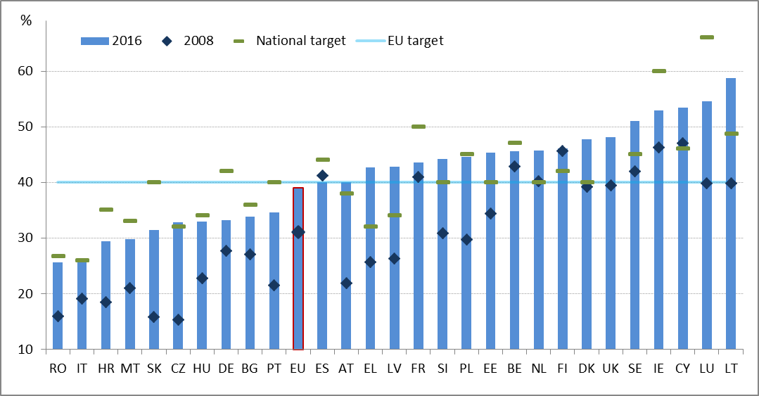
Source: Eurostat (LFS). Online data code edat_lfse_03.

The labour-market relevance of education is a crucial determinant of young people's ability to find work and contribute effectively to economic growth. On average, the employment rate of recent graduates from higher education (aged 20-34) is 82.8% in the EU, whereas for those with upper secondary education the employment rate is 72.6% (reaching 75% for those with vocational pathway). The gap is greater in Member States with lower overall youth employment rates.
The gap in employment and/or unemployment rates across skills levels to a certain extent provides an indication of a skills mismatch, as an equivalent match of labour supply and demand by level of education would imply identic employment rates across skill groups. In 2016, the highest dispersion of employment rates by education levels (less than upper secondary, upper and post-secondary, and tertiary education) was observed in Bulgaria, the Czech Republic, Croatia, Lithuania, Poland, Slovenia and Slovakia.
Despite relatively good labour market outcomes of Vocational Education and Training (VET), the number of students enrolling in initial VET in the EU has in most countries been steadily falling since 2013. The overall number of initial VET students at the upper-secondary level in the EU dropped since 2013 by around 500 000 (4.7 %), to 10.3 million in 2015. The United Kingdom registered the most notable fall in absolute numbers of initial VET student population – by almost 200 000. At the same time, enrolment in general education stayed at the same level. Therefore, the share of VET students in the total student population enrolled at upper secondary level has decreased from 48.9 % in 2013 to 47.3 % in 2015.
VET students who enter the labour market directly after attaining their upper-secondary level qualification enjoy in most countries relatively high employment rates. This is evident in countries having well-functioning VET systems, including strong permeability and school-to-work transition systems, such as Malta, the United Kingdom, Germany, the Netherlands, Sweden, Austria and Denmark (except for health and welfare VET graduates). However in other countries, VET graduates from some fields seem to be under-performing (particularly in the field of business, administration and law) as, for example, in Hungary, Lithuania, Slovenia, Poland, France, Bulgaria and Romania. In Italy and Greece, within the generally not very well performing labour market, there are particularly large differences in employment rates depending on field of study.
Besides employability, expected wages is another important factor indicating the attractiveness of different educational pathways. The wage premium for those with a medium-level vocational qualification as compared to those with medium level general qualification varies from 60% in Germany to a wage penalty of around -25% in the Czech Republic (though it is a special case since the majority of VET graduates continue into higher education). Overall in the EU, young people with a vocational qualification earn around 25% more than those with only a low level of education (ISCED 0-2), 17% more than those with a medium level qualification with a general orientation, and 40% less compared to those with a high level of education.
One of the key characteristics of VET systems that facilitate a smooth transition to and success on the labour market is the integration of work-based learning in VET programmes. According to the 2016 Education and Training Monitor, in 2015, there were around 2.8 million students enrolled in combined work- and school-based programmes (who spend at least 25% of the programme duration learning in a real work environment in a company) in the EU. However, the availability of programmes with a substantial element of work-based learning is still limited in most EU countries and the situation is not improving. Between 2013 and 2015, there was little change in the prevalence of combined work- and school-based programmes in the EU. In a number of countries the share of students attending such programmes fell – for example in the United Kingdom, Austria, France, Luxembourg and Finland. A noticeable increase was observed only in Slovakia and Hungary, in the latter case potentially due to changes in the classification of certain programmes as including a sufficient amount of work-based learning.
The overall rate of adult participation in learning in the EU has changed little since 2013 (Figure 17). In all countries, the majority of adult learning is of a non-formal nature, usually work-related and provided as well as financed by employers or individuals themselves. Such learning often targets those employees who already have the highest levels of skills and are performing the most complex jobs, while for the rest of employees, opportunities to access training are often much more limited. The fact that most learning is of a non-formal nature also implies that it is often of only short duration and aims to develop company-specific skills. This results in a situation where most adult learning is not able to help adults develop skills that are more transferable across companies including the basic skills – literacy, numeracy or ICT.

Figure 17: Participation in adult learning by different types of learning (2016)
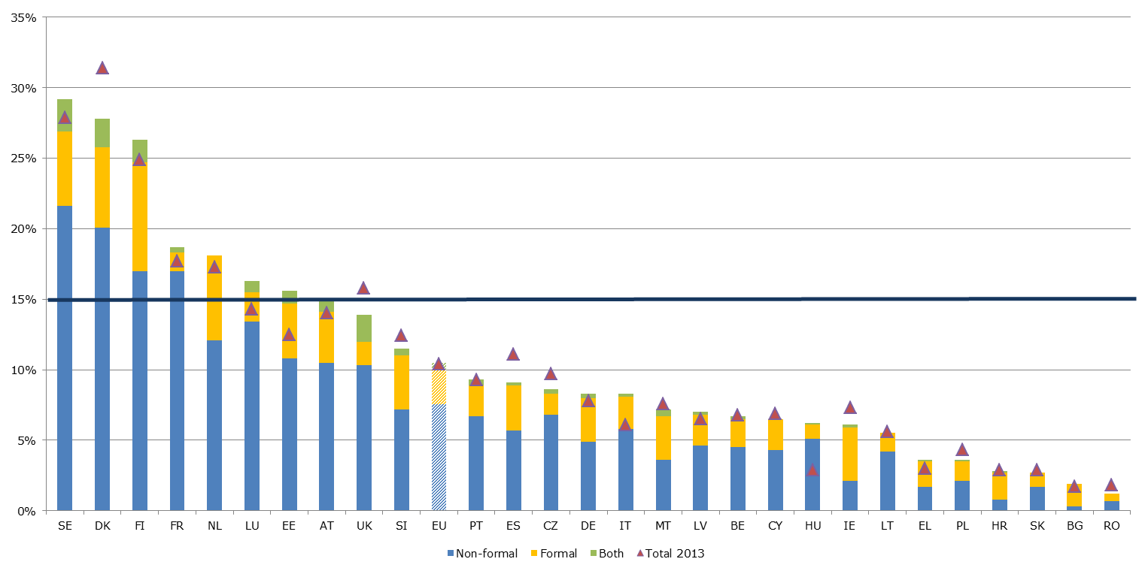
Source: Eurostat (EU-LFS, special extraction, 2016). Note: the indicator captures the participation rate in formal and non-formal education and training (last four weeks) of 25 to 64 year-olds. Data category “both” indicates the share of persons who participated during the reference period of 4 weeks in both formal and non-formal learning activities. Data in HR, HU and LV for those participating in “both” forms of learning is unreliable and in CY, LT, SK, BG and RO is unavailable.

The level of digital skills is increasing, although very slowly, leaving parts of the population unable to benefit from the digital transformation. This has an impact on innovation, productivity and eventually growth. In 2016, 44% of the EU population aged 16 to 74 did not have the basic digital skills to meet current needs, while 19% had none at all (in 2015, the figures stood at 45% and 21% respectively). The variation across Member States is substantial, with ten Member States (Portugal, Poland, Slovenia, Croatia, Lithuania, Italy, Greece, Cyprus, Bulgaria and Romania) where at least one quarter of the population had no digital skills in 2016. The level is particularly low in Bulgaria and Romania ("critical situations") whilst in Finland, the Netherlands, Denmark, and Luxembourg ("best performers") it is much higher than average. There is evidence of divergence on this indicator across the EU – as the level of digital skills is improving comparatively faster, on average, in best performing countries.

Figure 18: Share of population with basic overall digital skills or above and yearly change (Social Scoreboard headline indicator)
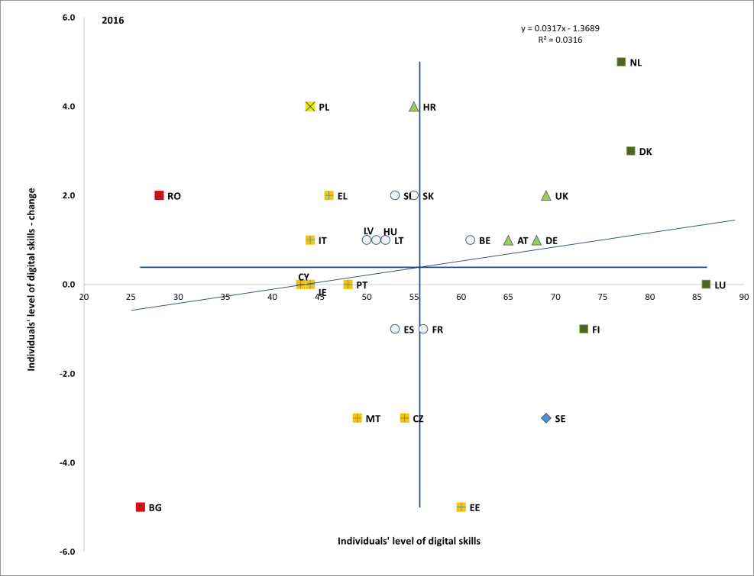
Source: Eurostat. Period: 2016 levels and yearly changes with respect to 2015. Note: Axes are centred on the unweighted EU average. The legend is presented in the Annex.

The labour market situation of young people continues to improve, in line with the strengthening of the economy. In the EU, the youth unemployment rate decreased by 5 pps from a peak of 23.7% in 2013 to 18.7% in 2016, and further to 17% in Q2-2017. However, it is still 1.4 pps above the level observed in Q2-2008. The dispersion of youth unemployment is high, with some Member States recording levels close to or above 40% (Italy, Spain, Greece), but it is decreasing over time (see Figure 19). Young women experience lower unemployment rates than men (17.9% versus 19.4% in 2016). This may be related to better educational achievements, but also to lower activity rates. In spite of improving labour market prospects, young people are more often employed under non-standard and atypical forms of employment, including temporary jobs, involuntary part-time work and lower wage jobs (in 2016, 43.8% of young workers – and more than 70% in Slovenia, Spain and Poland – work under a temporary contract, compared to 13.1% of workers aged 25-49); as shown in section 3.4, these contracts not always evolve towards more stable patterns.

Figure 19: Youth unemployment rate (15-24), multiannual comparison
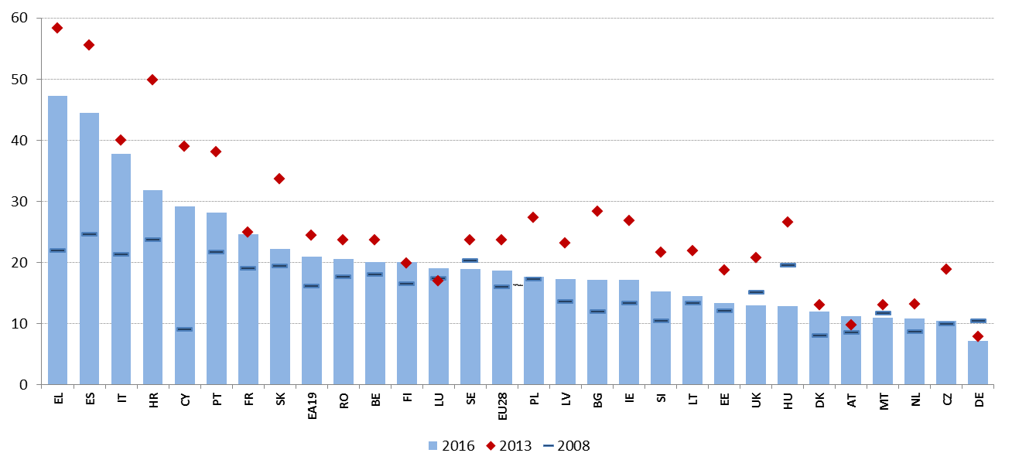
Source: Eurostat, LFS.

In addition to those working or seeking a job, a considerable part of the young people aged 15-24 in the EU are economically inactive. In total in the EU, in 2016 more than 6 million people aged 15-24 were neither in employment, education or training (NEET). This amounts to 11.5% of population in that age class, down from a peak of 13.2% in 2012 but still above 2008 level (10.9%). This reduction was mainly due to unemployed NEETs moving into work. As shown in Figure 20, NEET rates above 15% are still recorded in several countries (Bulgaria, Romania, Croatia, Cyprus and Greece, all flagged as "critical situations") and Italy, where the level dropped by 1.5 pps in 2016 ("weak but improving"). Conversely, the Netherlands, Luxembourg, Denmark and Sweden are "best performers". The number of NEETs is increasing in Germany, Austria, Lithuania, Latvia and, more worryingly, in Cyprus (starting from an already high rate). Fast reductions can be observed in Belgium, Malta, Estonia and Slovenia. The negative slope of the regression line relating yearly changes to levels suggests ongoing convergence across Member States. In the EU, NEETs are equally divided between unemployed and inactive, but with substantial differences among Member States (with the highest share of inactive in Bulgaria and Romania and the highest share of unemployed in Croatia and Spain). Having only a low-level education is the main risk factor for being NEET. Among female NEETs, inactivity is more frequent than unemployment, while the opposite holds for men.

Figure 20: NEET rate (15-24) and yearly change (Social Scoreboard headline indicator)
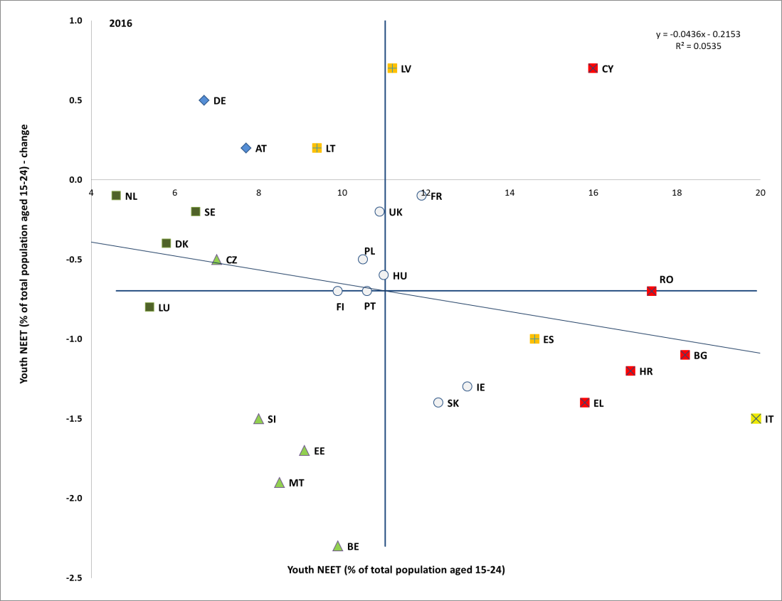
Source: Eurostat. Period: 2016 levels and yearly changes with respect to 2015. Note: Axes are centred on the unweighted EU average. The legend is presented in the Annex.

The employment rate of older workers has grown substantially over the last decade. Older workers have weathered the crisis relatively better than other age groups. In fact, as already shown in Chapter 1, age group 55-64 is the main driver of the overall increase in employment rate over the last ten years. In 2016, the employment rate of people aged 55-64 was 55.3%, 2 pps higher than in the previous year, and the steady increase is projected to continue against the background of demographic change. Employment rates of older workers vary widely across Member States, ranging from 75.5% in Sweden to 36.3% in Greece. The employment rate of women aged 55-64 is also catching up, and stood at 48.9% in 2016. The gender gap in the duration of working lives is declining but still significant, with women participating in the labour market on average 4.9 years less than men (33.1 vs 38.0 years in 2016). This average is the result of major variations across Member States and is driven by multiple factors, such as insufficient access to care services as well as lower pensionable ages for women in some Member States, reflecting into shorter duration of working life (see Figure 21). Finally, older workers are more likely to have part-time contracts than prime age workers, but they are less likely to work part-time than younger workers. Similarly, they are more likely to have permanent jobs (only 5.3 % of older workers aged 55-64 had temporary contracts).
Figure 21: Average duration of working life, 2016
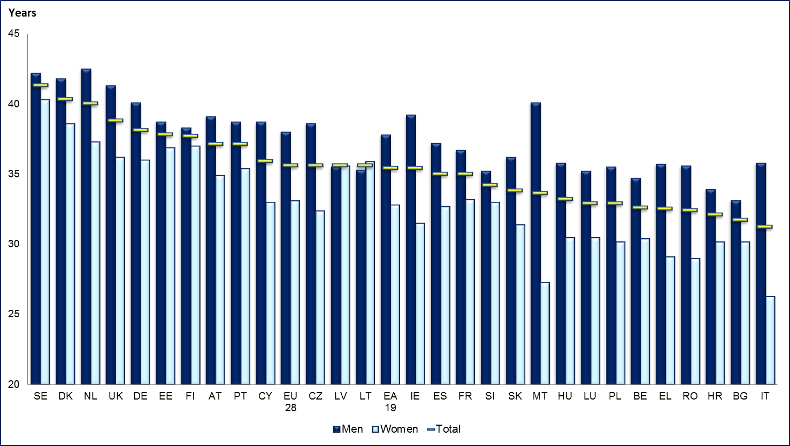
Source, Eurostat, LFS.

In all Member States, women are underrepresented in the labour market. The Social Scoreboard headline indicator in the area of gender equality in the labour market is the gender employment gap, which is the difference between the employment rates for men and women. In 2016, the gender employment gap amounted to 11.6 percentage points for the EU, with a 76.9% employment rate for men and 65.3% for women (Figure 22). The gap is particularly high for non-EU born and Roma women. Overall, it remained stable compared to 2015, as shown in Chapter 1. However, in a longer-term perspective, it is substantially lower than in 2008, when the gender employment gap was 15.0 percentage points. This long-term improvement was mainly driven by an increase in the female employment rate. Still, in 2016 six Member States had a female employment rate below 60%, together with a high employment gender gap (highest values recorded for Malta, Italy, Greece and Romania, flagged as "critical situations"). The gap is also increasing in a number of Member States, significantly faster than average in Finland, Belgium, Cyprus and Greece (in these countries, employment rate increased for both genders, but faster for men than for women). Lithuania, Latvia and Sweden are assessed as "best performers". The positive slope of the regression line relating changes to levels of gender employment gap in Figure 22 suggests that, on average, Member States' performances are slightly diverging as regards this indicator.

Figure 22: Gender employment gap and yearly change (Social Scoreboard headline indicator)
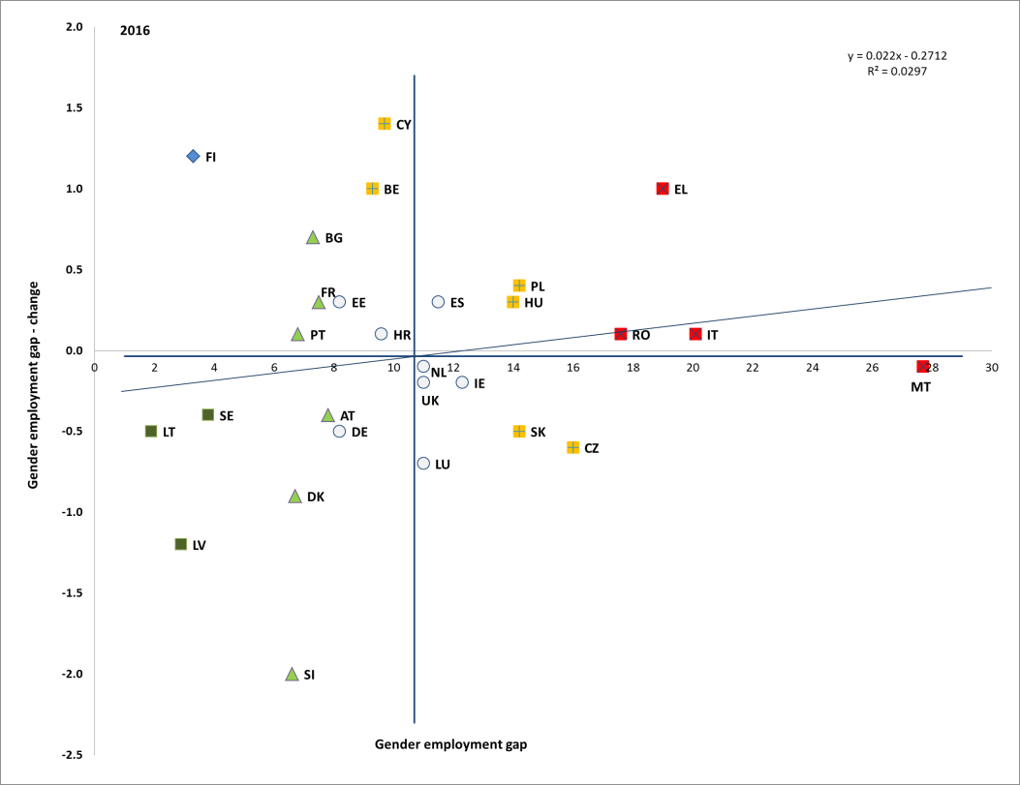
Source: Eurostat, LFS. Period: 2016 levels and yearly changes with respect to 2015. Note: Axes are centred on the unweighted EU average. The legend is presented in the Annex.

Unequal participation in the labour market by gender is also reflected by the large gender gap in part-time employment, which amounted to 23.0 pps in 2016 in the EU (slightly down from 23.2 pps in 2015). There is large variation between countries. While the gap is low in most Central and Eastern European Member States, it exceeds 30 percentage points in four Member States, reaching a high of 52.7 percentage points in the Netherlands (Figure 23). Moreover, 23.5% of female part-time employment was involuntary in 2016.
Figure 23: Part-time rates and gender gap, 2016
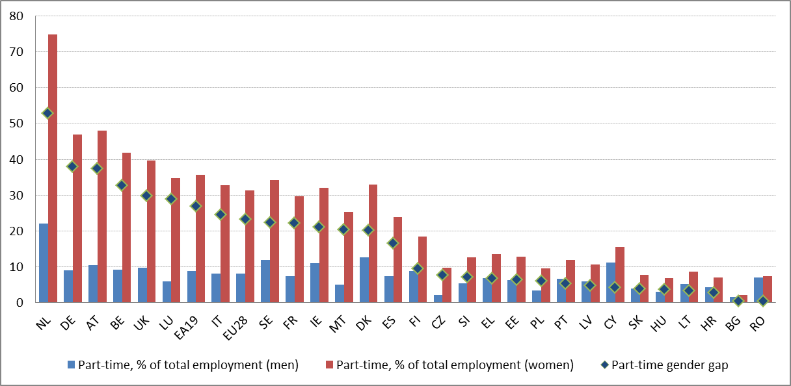
Source: Eurostat, LFS.

Gender gaps in employment are particularly acute for those with caring responsibilities, with women still more likely than men to carry these responsibilities. On average, the employment rate of women with at least one child under the age of 6 is 9 pps less than the employment rate of women without children (with a stronger effect for low-skilled mothers as well as single parents), and in some countries this difference is over 30 pps (Slovakia, the Czech Republic, Hungary). Conversely, parenthood has the opposite effect on the employment rates of men, as fathers are more likely to be employed (Figure 24). Women are also more likely than men to assume long-term care responsibilities. More than 19% of the EU potential female workforce in 2016 was inactive because of looking after children or incapacitated adults. This figure exceeded 28% in the Czech Republic, Estonia, Ireland, Hungary, Slovakia, and the United Kingdom. Female employment rates appear to be higher than average in countries with well-designed gender-balanced work-life balance measures (notably Sweden and Denmark).

Figure 24: Employment impact of parenthood for men and women (age 20-49) in 2016
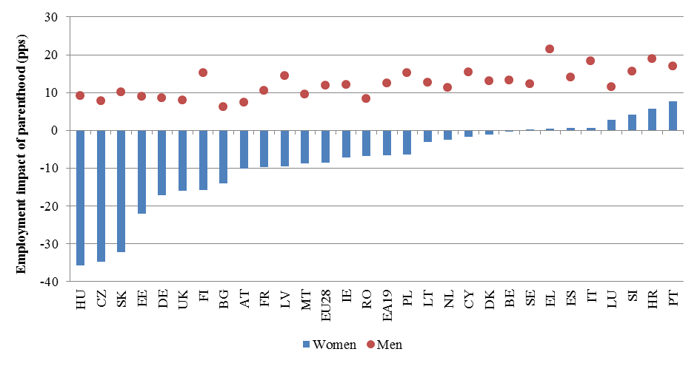
Source: Eurostat. Note: the employment impact of parenthood is measured as the difference of the employment rate of women (men) with at least one child under the age of 6 and the employment rate of women (men) with no children.

The lack of available, accessible and quality formal care services, especially for children, is one of the factors hampering women's participation in the labour market. As shown by the Social Scoreboard headline indicator on participation in early childhood education and care, in 2015 only 30.5% of children aged 0-3 years old were cared for in formal education and care services, up from 28.5% in 2014 and 28.0% in 2008. There is a large variation across Member States: while in Denmark and Sweden more than 60% of the children were in formal childcare, this share was below 10% in Slovakia, the Czech Republic and Poland ("critical situations"), as well as in Bulgaria, Romania and Lithuania. Along with Denmark and Sweden, Luxembourg, Belgium and Portugal are assessed as "best performers". This variation is to some extent related to differences in family leave arrangements across countries. Member States' performances on this indicator are actually diverging, as shown by the positive slope of the regression line relating yearly changes to levels – best performing countries are improving faster.

Figure 25: Children in formal childcare 0-3 and yearly change (Social Scoreboard headline indicator)
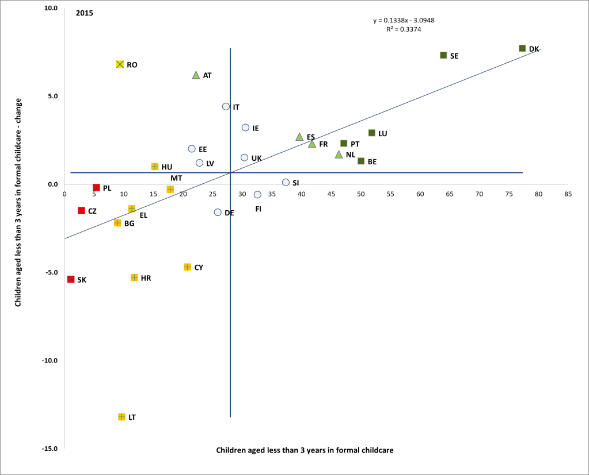
Source: Eurostat, LFS. Period: 2015 levels and yearly changes with respect to 2014. Note: Axes are centred on the unweighted EU average. The legend is presented in the Annex.

Moreover, the sufficient provision of formal accessible, high-quality and sustainable long-term care services remains a challenge in several Member States. Their underdevelopment can be a major impediment for women to stay in employment, as informal care is often the only option for many families. It is estimated that the number of dependent elderly will rise by 12 million (from 40 to 52 between 2013-2060).
In addition to lower full-time equivalent employment rates, women also tend to suffer from a significant pay gap. This gap stood at 16.3% in 2015 in the EU, slowly declining compared to 2014 (16.7%). There are, however, large variations across Member States, with pay gaps ranging from 26.9% in Estonia to 5.5% in Italy and Luxemburg. Over the last two years with available data, the highest increase was registered in Portugal (+4.5 pps), while fast reductions were recorded in Hungary (-4.4 pps) and Estonia (-2.9 pps) and Spain (-2.9 pps). Potential reasons behind the gender pay gap include differences in work experience, working time, type of job or sector of employment, due to some extent to discrimination in the labour market. This also risks to translate into a gender gap in pensions, which stood at 38.3% in 2015.

Figure 26: Unadjusted gender pay gap in 2013 and 2015
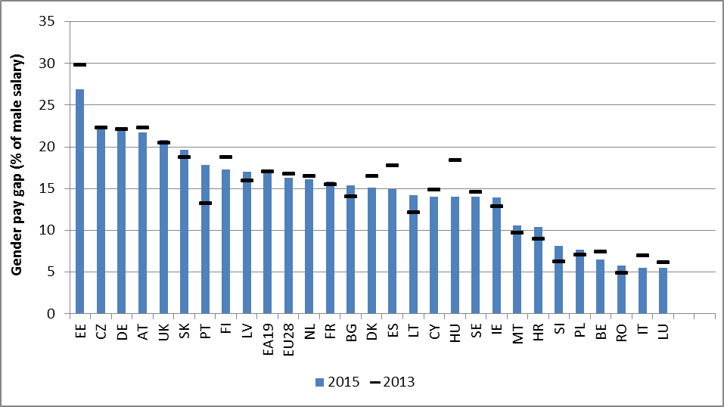
Source: Eurostat.
Note: the unadjusted Gender Pay Gap (GPG) is measured as the difference between average gross hourly earnings of male paid employees and of female paid employees as a percentage of average gross hourly earnings of male paid employees. No data available for Greece. For Croatia, Malta and Ireland, 2014 figures instead of 2015.

The labour market potential of migrants is strongly underutilised. Whereas non-EU born people make up an increasing share of population in the EU (6.6% in 2014, 6.9% in 2016), they are less likely to participate in the labour market than native born. The integration challenge has increased with the impact of the economic crisis and with the recent increased inflows of refugees, whose labour market integration is more difficult than other groups. While in 2008 non-EU born people experienced activity rates and employment rates respectively 1.0 pps and 4.6 pps lower than native born, by 2016 these gaps had widened to 4.8 pps and 10.6 pps (age class 20-64). In seven EU countries (Belgium, Finland, the Netherlands, Sweden, France, Austria and Denmark) the employment gaps exceeds 15 pps. Inactivity of non-EU born women is particularly high, 9.1 pps below that of native born women.
Figure 27: Employment rate by country of birth, age 20-64, 2016
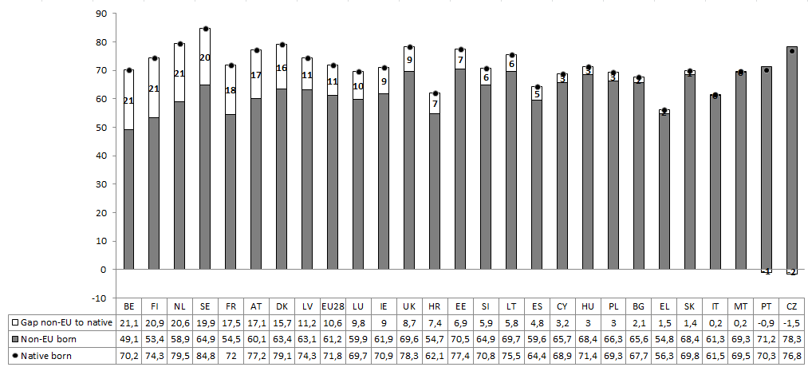 Source: Eurostat [lfsa_ergacob]. Note: For DE there is no breakdown available for non-EU born (the gap between host country nationals and third country nationals is 26.5 pps, the sixth highest in the EU).

Labour market outcomes differ markedly by reason of migration. The employment rate of non-EU born people is higher for those arrived for study or employment reasons (71% in 2014, even higher than for natives) and lower for those arrived for family reasons and for refugees. While the lower employment rates of migrants are partly driven by a higher share of persons with low level of education, a rising level of education does not translate into better employment outcomes and there is a significant under-use of migrants' skills and qualifications. Social challenges have a tendency of being passed over generations. This risk is particularly relevant in view of the high and increasing share of people with a migrant background among young people in some Member States.
As labour markets recover, persons with disabilities risk being left behind. A high gap persists in the employment (and activity) rates between people with and without disabilities, amounting to 25.7 percentage points (47.4% versus 73.1%) in 2015. This gap is increasing (it was 22.9 pps in 2012), as those without disabilities have higher chances to return to work. In particular, in Ireland and Malta it was more than 40 pps and in 7 countries it was higher than 30 pps. The lowest gaps were observed in Italy (13.8 pps) and Slovenia (16 pps).

3.2.2 Policy response
Policy work has led to the identification of key aspects to improve the inclusiveness, relevance and quality of education, notably to tackle early school leaving. In May 2017, two Commission Communications outlined how EU action can support Member States and education providers in meeting these objectives. In addition, the 2015 Council Conclusions on reducing early school leaving and promoting success in school invited Member States to develop and implement comprehensive strategies against early school leaving (ESL), along with a number of specific measures. Several Member States are taking action in this area. In 2016, the Flemish community in Belgium approved a discussion paper on a policy related to study entitlement, truancy and school drop-out that will replace the current action plans. In the French-speaking community in Belgium, reducing ESL is a major element of the ongoing school reform which focuses on improving equity, effectiveness and efficiency. Bulgaria is implementing an inter-institutional cooperation mechanism to improve school enrolment and retention, with local teams deployed on the ground to identify out-of-school children or students at risk of dropout, improve the information exchange between relevant institutions, and improve data collection. In Estonia, career counselling and increasing the attractiveness of VET to tackle drop-out is being pursued. France has taken steps to ensure that young adults aged 16-25 who left school without a certificate or a qualification have the right to return to education or training. In November 2016, Hungary adopted an action plan to reduce ESL and introduced mandatory data collection on pupils’ school progress. Romania is developing an early warning mechanism and is planning ESF-funded second chance programmes and after-school activities.
Across the EU, policies to effectively tackle low proficiency in basic skills are increasingly combined with efforts to promote inclusive education. The aim is reducing the impact of socio-economic status on students' performance, closing the educational gap of disadvantaged learners and fostering excellence in education. In Portugal, local administrations and school clusters cooperate in the implementation of the National plan to Promote Success in School, the Government’s flagship initiative to prevent school failure and reduce grade repetition. In 2017, Ireland set for the first time specific targets for literacy and numeracy within disadvantaged schools; it also set a relatively ambitious target to maintain the proportion of low-achievers below 10%, while increasing the proportion of top performers by 2025. The Czech Republic is implementing ESF-funded projects, which focus on supporting nursery, primary and secondary schools by introducing and implementing individual inclusion. In Sweden, the government boosted resources to tackle inequalities and announced a long-term investment plan (2017-2025) to support municipalities and independent school providers in offering high quality education to newly arrived students. In Germany, the federal government and states joined forces to increase the quality of teacher training as well as to raise mobility of teacher students and teachers. Finally, Bulgaria is devoting more attention to inclusive education and the Netherlands plan additional investments to increase equity in education.
Roma inclusion in education is a challenge, due to several factors, including school segregation, non-inclusive teaching and barriers induced by severe poverty. Enforcement of legislative changes remains important. Bulgaria introduced a ban on the formation of separate classes based on ethnicity. The measures currently in place for Roma students include scholarships and extracurricular activities, additional Bulgarian language classes and activities with parents. In the Czech Republic, a new reform package on individual support measures for children with special educational needs - including for socioeconomic reasons - entered into force in September 2016. In 2017, Hungary amended its Equal Treatment and Public Education Act to ensure prohibition of segregation. Also, schools with a high drop-out rate will be selected in 2017 to receive training and development support to implement differentiated teaching methods. In Romania, segregation in pre-university systems was prohibited and projects targeting Roma students and communities were prioritised under ESF. In February 2017, Slovakia approved revised Action Plans in support of the implementation of the National Strategy for Roma Integration up to 2020, with the goal of reducing the differences between the education level of Roma and the population average, by improving education of children from marginalised communities. Greece launched a programme for the integration and education of Roma children, co-funded by EU structural and investment funds.
Member States are developing policies to encourage the integration of migrants into education. In Belgium, all communities have increased the capacity of reception classes, number of language teachers and support budgets for new migrant pupils. Denmark slightly increased the number of reception classes and increased the maximum number of refugees per class from 12 to 15; it also allowed the integration of foreign-born young people into compulsory schooling up to the age of 25. In Finland a new training module combining language and vocational studies was created in mid-2017, engaging adult education institutions and broadening the scope and reach of available training. In Sweden, a Tuition for Immigrants course is offered to newly arrived adults with vocational education or other studies. Greece has opened first reception structures for the education of children of asylum seekers which operate in after-school hours, but aims to integrate children eventually into mainstream education. Cyprus is rolling out an action plan also covering the teaching of Greek as a second language, measures for reception, transition and inclusion of migrants, teacher training and anti-discrimination. In addition, to respond to the influx of refugees and facilitate their integration (as well as for other third-country nationals in need), the European Commission developed the EU Skills Profile Tool for Third Country Nationals in 2017 to help them make their skills and qualifications visible across different Member States.
Policies to raise tertiary education attainment focus on access and participation, as well as on reducing drop-out rates. As underlined in the Commission Communication on a renewed EU agenda for higher education, this can be achieved by providing students from disadvantaged backgrounds with more transparent information on educational opportunities and outcomes, tailored guidance and financial support. The Czech Republic increased grants to students in need as well as the number of profession-oriented programmes to promote a stronger social diversity of tertiary education students. In 2017, Estonia revised its funding system in higher education to incentivise completion of studies in nominal time. Sweden launched an inquiry into the governance and financing of higher education, in view of increasing the participation of students from disadvantaged backgrounds. Croatia is using ESF to provide support to students from disadvantaged backgrounds.
Improving the relevance of higher education is also crucial. To achieve this purpose, key aspects are a greater variety of study modes (part-time, distance, etc.), the increased use of skills projections and graduate employment data in strategic planning, the involvement of employers in curriculum design, and further developing higher vocational education and professional higher education. Bulgaria is implementing performance-based funding and focusing efforts on increasing participation in science, technology, engineering and mathematics (STEM) related fields. In Malta, several initiatives aim to increase the number of graduates in science-related subjects. The Flemish community in Belgium has developed a STEM action plan involving all educational levels and the French-speaking community in Belgium is focusing on dual learning in sectors where skill shortages are identified or expected. ESF-funded scholarships for students in STEM are provided in Croatia. Estonia set up a forecasting tool to anticipate labour market and skills needs, with recommendations for forward planning in education and training. In 2017, Poland introduced a national system of graduate tracking to address the need for better information on labour market outcomes. Cyprus, Portugal, Slovakia and Sweden have recently taken measures to strengthen quality assurance in higher education.
Member States continue to work towards more transparency of skills and qualifications. Twenty-four Member States have already finalised the process of referencing their national qualifications levels to the European Qualifications Framework (EQF), signalling commitment to its overall objective of transparency and comparability. Romania and Slovakia have presented their initial referencing reports, while Finland and Spain are planning to reference in 2017-2018. Another milestone – i.e. putting EQF levels on certificates and diplomas – has been met by 16 Member States (Belgium, the Czech Republic, Denmark, Germany, Estonia, France, Ireland, Italy, Latvia, Lithuania, Hungary, Malta, the Netherlands, Portugal, Slovenia and the United Kingdom) and a further increase is expected by the end of 2017.
The need to develop digital skills is increasingly high on Member States' agendas. In line with one of the key actions of the New Skills Agenda for Europe – the Digital Skills and Jobs Coalition – National Coalitions for Digital Skills and Jobs seeking to facilitate high-impact actions at local level have been launched in 17 Member States and more are under development. Concrete measures to boost digital skills planned / adopted by Member States include the introduction of basic digital training from primary level and reinforcing digital training throughout school curricula (Austria, Germany), stepping up training on coding (Poland, Belgium, Romania, Sweden), digital skills training for teachers (Austria, Bulgaria, Germany), the increase of STEM places in higher education (Austria, Poland), certification of European Computer Driving Licence (ECDL) on a voluntary basis to secondary students (Cyprus), and one-off initiatives, such as the IT Academy in Slovakia.
To promote the responsiveness of vocational education and training programmes to labour market needs the EU supports a wide range of policy initiatives. In October 2017 the Commission adopted a proposal for a Council Recommendation on a European Framework for Quality and Effective Apprenticeships. The Framework sets out 14 criteria to define quality and effective apprenticeships, ensuring both the development of job-related skills and the personal development of apprentices. To increase the numbers of vocational learners benefitting from longer work placements abroad, the ErasmusPro activity has been introduced in Erasmus+ to become operational as of October 2017. Towards supporting the work-based learning, the European Alliance for Apprenticeships was launched in 2013 as a multi-stakeholder platform at EU level. It is aimed at improving the quality, supply and image of apprenticeships, as well as more recently also mobility. The Commission also supports the European Pact for Youth initiated by CSR Europe (the European Business Network for Corporate Social Responsibility), bringing together business and their stakeholders to work for employment for young people through the creation of apprenticeships, traineeships, internships and entry-level jobs. The attractiveness and labour market relevance of initial VET programmes could still be improved. In 2015, Member States agreed to further strengthen key competences in VET curricula and provide more effective opportunities to acquire or develop those skills.
Employment challenges of low-skilled adults requires policy attention, particularly in the context of evolving skills needs linked to technological change. To address the persistent employment gap and low rates of participation in adult learning by low-skilled and low-qualified adults (who are also more likely to be older, live in rural areas and face other disadvantages), the European Union at the end of 2016 adopted a recommendation on Upskilling Pathways: New Opportunities for Adults, to provide the low-skilled and low-qualified adults with support in enhancing their skills and progressing towards higher qualifications (see Box 2).
Box 2. Upskilling Pathways: new opportunities for adults

The "Upskilling Pathways Recommendation", adopted by the Council in December 2016, calls on Member States to develop a linked series of targeted interventions, establishing a 'pathway' of support to low skilled / low qualified adults, of which there were 63 million in the EU in 2016.

It aims at supporting these adults to enhance their literacy, numeracy and digital skills and/or to acquire a broader set of skills by progressing towards higher qualifications. Each beneficiary would be offered:
- a skills assessment, to identify existing skills and upskilling needs
- an offer of education / training designed around this assessment, and
- opportunities to have the skills so acquired validated and recognised.
These three steps will be accompanied by outreach, guidance and support measures.

The overall policy objectives of the initiative are to:
- improve the employment opportunities and overall life chances of adults with low levels of skills (e.g. adults without upper secondary education) in Europe;
- contribute towards up- / re-skilling the whole workforce; and
- enhance social inclusion and cohesion for adults struggling with basic skills.

Implementation by Member States can be supported by funding from ESF, Erasmus+ and other sources. By mid-2018, Member States should outline the measures they will take to implement this Recommendation, including to which groups of low-skilled adults they will give priority.

In the field of adult education, some Member states undertook measures to encourage more active participation in adult learning, especially towards improving basic skills. Bulgaria introduced a measure for better providing of competences for basic educational level for illiterate or poorly literate persons over 16 years old. Croatia has announced a plan to ensure that the educational activities contribute to better employability of unemployed persons in areas with the greatest shortage of skilled workers. Cyprus introduced changes in financial support to enterprises that invest in life-long learning to encourage more participation of adults with lower educational attainment in adult education. Portugal has presented a comprehensive programme (the 'Qualifica' programme) aimed at providing adults with qualifications based on skills acquired by experience and complementing them with further modular training.
Member States have taken steps to facilitate social dialogue on the issues of vocational education and training. In Spain, the Government recently set up national discussion tables with the social partners to discuss a range of issues on employment, among which the quality of vocational training. In Greece, pilot tenders will be launched in 2017 for a series of business community-led partnerships for vocational education and training, involving sectoral and local employer representative bodies and social partners. In Latvia, the social partners, especially employers, have been involved in many aspects of the VET reforms. In 2016, secondary legislation to create sectoral expert councils and procedures for updating curricula was passed amending to the Vocational Education Law adopted in 2015. Moreover, in the frame of the implementation plan 2016-2020 of the Adult Education Governance Model, the Adult Education Governing Board was established that involves ministries, social partners, municipalities, adult education association and other stakeholders. The Board, taking into account the labour market situation, reviews and approves priorities for the adult education and ensures regular assessment of adult education results (including supply and demand of education programmes).
Validation of skills acquired outside of the formal education and training system is particularly relevant. It is particularly so for people with lower qualifications, unemployed or at risk of unemployment, migrants, and for those seeking to change their career paths. Although national approaches vary, validation arrangements are planned or in place in all Member States. National mechanisms to coordinate validation arrangements across sectors of education, labour market and the third sector have been established by 15 Member States (Belgium, Denmark, France, Greece, Ireland, Italy, Latvia, Malta, the Netherlands, Poland, Portugal, Romania, Spain and Sweden).
National Skills Strategies can play an important role in addressing the fragmentation of skills polices in many countries and providing coherence between the various strands of policy, the various financial resources supporting skills and all the actors concerned. They can provide a strategic assessment of a country's skills system, identify the main skills challenges and lead to an action plan to address these. With the technical help of the OECD, the Commission is supporting the development of skills strategies in Italy, Portugal, and Slovenia (and previously in Spain). The Netherlands and Austria also embarked on National Skills Strategy projects using national funding alone.
Knowing what skills are and will be needed in future can help Member States adjust their policies to better address any skills imbalances on their labour markets. The need to align skills to the labour market needs has already triggered a number of actions across Member States. To attract more ICT workers and entrepreneurs, Estonia has modified the Aliens Act by inter alia changing the requirement of permanent residence in Estonia and exempting major investors, ICT workers and start-up entrepreneurs from the immigration quota. France is opening 500 new specific training pathways in line with the identified future labour market needs (such as ICT, green economy) or in recruiting sectors (industry, security, catering, etc.) adjusted to local / regional profiles. Ireland has launched the National Skills Council and nine regional skills fora to help anticipate and respond to the rapidly changing skills needs across all sectors. In Hungary the ESF co-financed projects help unemployed acquire the skills and work experience necessary for occupations experiencing labour shortages.
Member States are stepping up efforts to expand and develop their career guidance services. In Cyprus free career counselling services are offered to young soldiers and a project financed by the European Social Fund and the Youth Employment Initiative is under way to expand the outreach of counselling services to those not in education, employment or training (NEETs). In Malta, starting from the academic year 2017-2018, career guidance programmes will be launched in all state colleges to encourage post-secondary education or employment.
Young people’s labour market situation has improved significantly, also thanks to structural reforms supported by the Youth Guarantee. Youth Guarantee schemes are consolidating, though additional efforts are needed in most countries to increase their coverage and impact, as well as ensure sustainable implementation. In 2015 alone, 5.5 million young people entered Youth Guarantee schemes and 3.5 million took up an offer of employment, apprenticeship, traineeship or continued education. Almost half of all NEETs aged 15-24 were enrolled in the Youth Guarantee in 2015.
Reaching out to young people, encouraging them to register with Public Employment Services and receive adequate support is an important priority, in particular in Member States with high rates of inactive and non-registered NEETs. In Spain, a Royal Decree-law was adopted in December 2016 that simplifies and promotes young job-seekers’ registration to the Youth Guarantee National System. Portugal presented in June 2017 a new national strategy for NEET outreach and registration which aims at registering at least 30 000 more NEETs and enlarging the national network of Youth Guarantee partners. Romania is launching new outreach measures to increase the number of young NEETs registered with the PES by 200 000 via preventive identification, an information and awareness campaign, support networks, and intervention teams involving the PES, social assistants and education advisers. The Bulgarian authorities are initiating new outreach measures targeting the activation and integration into employment of unregistered NEETs under the age of 29.
Better supporting young people facing multiple barriers remains a challenge in this context. In France, the "Garantie jeunes" launched in October 2013 as an experiment has been extended in 2017 to all NEETs aged between 16 and 25 at risk of social exclusion and with an income lower than the minimum income. It provides an intensified path to the labour market, combining intensive counselling measures and work experience. In Slovakia, the National project “Restart for young jobseekers - Creation of jobs for young long term unemployed” launched in July 2017 aims at motivating young jobseekers to find employment through 30 hours of counselling combined with a financial incentive for those who find employment.
A smooth coordination among employment, education and youth policies is essential to better support young people’s transition from education and unemployment to work. New partnerships are being set up. In Cyprus, the Career Counselling and Education Services in Secondary Education will be enhanced to offer more targeted guidance and counselling services to young people aged 15 to 24. In addition, the Youth Board of Cyprus’ Youth Information Centres offer specialised studying and career counselling services to students as well as young NEETs. In Lithuania, a pilot mentoring programme has been implemented nationwide in 2016, whereby the PES cooperates with a network of psychologists and academic training institutions to better support youth (as well as long term unemployed and older workers).
Member States are investing in re-skilling and up-skilling young people to enhance their employability. In Slovakia, a national project is investing EUR 30.9 million to support the employability of young jobseekers through retraining, strengthening of key competences, or training and education for the labour market on their own initiative. In Spain, since February 2017 an example of good practice is represented by a digital skills training programme offering training oriented to the digital industry and new business models. In Sweden, the measure 'Start Studying Support' (Studiestartsstödet) adopted in July 2017 is expected to make approx. 15,000-20,000 low-skilled people with serious educational needs (including newly arrived migrants with limited education) engage in studies at primary and secondary level each year.
In a still challenging macro-economic context, a large number of Member States are supporting labour market demand for young people through wage and recruitment subsidies. They are often funded with support from the European Social Fund and the Youth Employment Initiative. Such schemes are usually targeted at young people further from the labour market (e.g. long-term unemployed, low qualified or without any work experience) to avoid deadweight and substitution effects. Besides, a strong training component and follow-up of beneficiaries contribute to maximising their impact. In Belgium, the federal government announced in July 2017 a reduction of employers' social security contributions for the recruitment of young people from 18 to 21 years old. In Cyprus, the Scheme for Job Placement of Young Unemployed Graduates in place since November 2016 supports 6 months job placements in enterprises/organisations to young unemployed graduates with limited work experience. 1 in 3 participants were employed 4 months after their participation. In June 2017, Estonia amended the “My First Job” scheme to broaden support to youth aged 16-29, making conditions more flexible and increasing possibilities for training. Within this scheme, employers receive a compensation for work-related training to a value of up to 2,500 euros. In Italy, the 2017 budget law introduced three new types of social security reductions for hiring young people under open ended contracts or through professional apprenticeships. In Portugal, a combined support to the recruitment of a young person and older worker ("Contrato-Geracao") is being developed to provide support to companies that hire simultaneously a young unemployed person (or a young person looking for a first job) and a long-term unemployed older person.
Member States continued to adapt their traineeship legislation to the Quality Framework for Traineeships. These traineeship reforms have helped better prepare young people for labour market needs and build relevant skills, but have also helped strengthen business community engagement. In Poland social partners have agreed in June 2017 on a national quality framework for traineeships. The Romanian authorities have adopted in July 2017 an update to the apprenticeship and traineeship law to make it more attractive for employers (increasing incentives for them and align the levels of the subsidies in national budget with those from the ESF, thus better integrating the budgets).

Box 3. Making full use of the European Social Fund (ESF) and the Youth Employment Initiative
With a budget of 86.4 billion EUR for 2014-2020, the European Social Fund (ESF) is one the key EU instruments to address the challenges identified in the country-specific recommendations (CSRs). The operational programmes adopted in 2014 and 2015 have been designed in a way that ensures close their alignment with the CSRs. Moreover, the Regulations provide for the possibility to re-programme to align with emerging challenges.
A key policy priority for the ESF 2014-20 is youth employment, tackled through both the ESF own resources (6.3 billion EUR) and the Youth Employment Initiative (3.2 billion EUR of YEI resources with a ESF matching allocation of 3.2 billion EUR). The YEI has as targets young people who are not in employment, education or training (NEET) in the regions with the highest youth unemployment rates in 2012. The initiative is progressing well. By the end of 2016, about 8 million participants had benefitted from European funding supported projects – notably job placements, apprenticeships, traineeships, self-employment measures and continued education and training. 39% of beneficiaries are under 25 years old.
In the majority of Member States the YEI is seen as a key tool for the coverage and design of the respective employment policies. In many Member States, the YEI funds the vast majority of Youth Guarantee measures.
The EUR 1.2 billion budget increase of the YEI for 2017-2020 approved by the Council and European Parliament should help Member States continue to support unemployed and inactive young people.
The ESF is also a tool for Member States to implement the European Pillar of Social Rights. Interventions under ESF that support the Pillar amount to EUR 27.5 billion for labour market access and EUR 21.2 billion for social inclusion. Each year some 15 million European citizens benefit directly from participating in ESF co-funded projects.

In order to support female employment, Member States adopted gender-balanced policies supporting workers in reconciling their professional and caring responsibilities. Giving both parents adequate leave entitlements and supporting a better sharing of caring responsibilities between women and men can enable women to re-enter employment faster and limit the negative impacts of their caring burden on their career progressions. In 2017, the Czech Republic and Cyprus both introduced a new entitlement to paternity leave (respectively 1 and 2 weeks) and Portugal extended the leave period from 20 to 25 days, 15 of which are mandatory (previously 10). Luxembourg adopted in 2016 a reform of its parental leave system to make it more flexible and better compensated. Germany and Austria recently introduced a financial bonus in case both parents take part of the parental leave. In 2017, specific measures to cover self-employed parents were introduced in Denmark and Italy. Spain expanded in January 2017 the right to paternity leave (for birth, adoption or foster care of a child) from two to four weeks for employed fathers. Croatia has recently increased the maximum allowance for the second half of the year-long maternity leave for both employed and unemployed parents. Slovakia increased the maternity benefit from 70 to 75% of the daily assessment base and extended the list of social services to include childcare facility for children less than three years. In the Netherlands, the Flexible Working Act entered into force in 2016, instating the right for employees to request a permanent or temporary change in working hours, a change in the scheduling of working hours, and a change in place of work.
Women are also most often those caring for dependent and elderly relatives. Introducing or strengthening carers' leave entitlements, as the Czech Republic did in July 2017, can enable women to reconcile their caring and professional responsibilities. In addition to family-related leaves, flexible working arrangements have strong positive impacts female employment. In 2016-2017 Belgium, the Czech Republic and Italy introduced measures to facilitate more flexibility with regard to the organisation of work and Romania has launched a public consultation on a proposal on teleworking. Furthermore, several Member States improved the financial support for carers. In Romania, the government approved the financial centralization of the salary costs of personal assistants for severely disabled. In Malta, carers' pensions and carers' allowances were reformed and increased. The amounts were raised also in Hungary and the Czech Republic. Estonia plans to change the Gender Equality Act to give the Labour Inspectorate the task of monitoring gender equality in the private sector more closely, including by collecting gender-disaggregated wage data, by offering training on how to address the gender pay gap and disseminating wage gap information.
Enhancing access to formal childcare services is an effective tool to tackle obstacles to female employment. The Czech Republic set a right of all children to attend pre-school preparatory classes, introducing a compulsory year of preschool education and subsequently guaranteeing places in kindergartens and strengthening support for children with special education needs. Moreover, an ESF-piloted project is ongoing for micro-nurseries for children from 6 months to 4 years of age. The United Kingdom is now fully implementing the Childcare Act 2016, which provided for an additional 15 hours of free childcare for certain working parents of 3 and 4 year old children in England, on top of the existing universal provision of 15 hours of free childcare for that same age group. Luxembourg launched an ambitious reform in 2016 to improve access and quality in early childhood education and care. In Slovakia, investments in infrastructures are planned to increase the capacity of childcare. In April 2017, the Finnish government proposed to extend free/low-cost childcare to a wider group of low and middle income families. In 2017, some Member States also introduced measures to develop services for children in disadvantaged settlements (Hungary) and job-seekers' children (France).
Some Member States also introduced targeted measures in order to encourage women to re-enter the labour market while their child is still very young. For instance, in June 2017 Bulgaria adopted a measure to grant to mothers with children under 1 year of age who return to employment 50% of the childcare benefit on top of their salary. Similarly in Romania, the employment insertion stimulus for parents who benefited of a child raising leave increased in April 2017. Other Member States have developed schemes targeted to women who have already taken lengthy career breaks. It is the case of the 'Returnships' scheme for which the United Kingdom Spring 2017 budget allocated £5 million (around EUR 5.6 million). Luxembourg passed a law to strengthen the principle of equal pay for women and men and supported awareness raising campaigns and actions to eliminate barriers to female employment. In order to tackle the negative consequences of women's underrepresentation in the labour market, Sweden is about to submit a proposal to promote more gender equality in pensions. The Estonian Government has approved a draft act that will modify the parental leave and parental benefits scheme by introducing an additional month for fathers, extending the period during which parental benefit can be claimed and raising the employment-related income threshold during parental leave. In Malta, free childcare is provided when both parents are in employment or in education.
Several Member States took action to promote labour market integration of older workers. Germany adopted a law on facilitating the transition of older workers into retirement (‘Flexi-Rente’), aiming at making the transition into retirement more flexible. In particular, the reform promotes the combination of early retirement and part-time work by reducing pension deductions in the event of extra income. It also incentivises employment above retirement age by enabling employees to acquire additional pension entitlements and releasing employers from the obligation to pay unemployment insurance contributions. Greece launched in February 2017 two new programmes of hiring subsidies for the age group over 50. Cyprus established a scheme providing incentives for the employment of unemployed people over 50 years old, aiming at encouraging employers to hire unemployed people over 50 years old interested in full time employment. In the Netherlands, a draft bill, in the frame of the action plan 'Perspective for 50+'foresees, a compensation for employers (no-risk premium) in case older workers (over 56 years old) which have been unemployed for more than 1 year and receive an unemployment benefit fall ill. In Austria, the employment campaign "20.000" aims at facilitating the employment of older people and to reduce long-term unemployment. The full roll out for the project is planned for January 2018 and should lead, in the medium term, to 20.000 additional non-profit jobs. Moreover, the Social Security Amendment Act allows persons working beyond the pensionable age to accrue a higher old-age pension. This measure concerns mainly female pensioners, which experience a higher risk of poverty than men. In Slovenia, the action plan "Older and the Labour Market in Slovenia" includes 49 measures to be deployed in 2017-18, including support for the employers in the implementation of promoting programmes health and safety at work, incentives for employer for investments in human capital and training of workers, incentives for workers to stay longer in employment, increased activation of older workers through ALMPs.
In response to the increased number of asylum seekers, Member States are adapting their integration policies of third country nationals. Measures focus on improving language skills and participation in the labour market. In France the law on the rights of foreign nationals established an individualised integration pathway based on personalised reception, renewed civic training and reinforced language training. In Finland, the national Action Plan on Integration and the Government Integration Programme aim at speeding up access to training paths and employment. Moreover, a fast-track employment of immigrants' trial was launched applying the social impact bond model. The aim of the project is to try out new employment and training models for accelerating employment of immigrants and combining training and work in a flexible way. In Austria, the June 2017 integration law makes the participation of beneficiaries of international protection in language and culture/value courses compulsory, with a duty to sign an integration declaration. Moreover, an obligatory labour market integration year is going to be implemented (managed by PES) for all recognised refugees and asylum seekers with a high likelihood of being granted asylum and who are unemployed. In the Czech Republic, under the new ’State Integration Programme’ that came into force in January 2016, beneficiaries of international protection receive assistance in the field of housing, employment, health and education including enhancement of language skills. In Germany, since the introduction of the new Integration Law of 2016, participation in integration courses can be made compulsory for asylum seekers who do not work. Germany also introduced a new type of job-oriented language course, following the successful completion of an integration course and catering to refugees who are already working or participating in labour market activation or vocational training measures. In Denmark, a Tripartite agreement focused on early intervention, individual skills assessment and job-oriented measures. Asylum seekers are screened during the application phase and allocated to the municipality that best accommodates their individual job opportunities. In addition, refugees are to acquire work experience within one month after arrival.
Many measures adopted by Member States go beyond recently arrived refugees and also apply to other migrants or people with a migrant background. For instance, Finland is preparing for a more efficient identification of immigrants’ skills and guidance to an appropriate training and employment path. In Austria, the Recognition and Assessment Act, entered into force as of 12 July 2016, promotes the labour market integration of individuals who have acquired qualifications abroad and defines special procedures for persons granted asylum or subsidiary protection without documentation of completed education or training. Sweden recently made significant efforts to cater to the growing demand for evaluations of foreign qualifications, also by increasing funding for the Swedish Council for Higher Education, the public agency responsible for the recognition of foreign qualifications. Sweden also invested significant funds to increase the availability of bridging programmes that enable migrants with foreign credentials in law, medicine, nursing, dentistry, teaching and pharmaceuticals to complete the training required to practice their occupation. Moreover, in the frame of the reform of the 'New Start Jobs' scheme, the subsidy was increased for newly arrived migrants and refugees. Estonia promoted the immigration of ICT workers, start-up entrepreneurs and major entrepreneurs, changing the requirements for their permanent residence. Malta provides courses for non-natives speakers with literacy needs, aiming at increasing the employability of migrants. Slovenia established a Government Office for the Support and Integration of Migrants, which coordinates the work and tasks of other national authorities, non-governmental and other organisations. The Office’s main tasks are the accommodation of, and support to, different categories of migrants.
Beyond measures aimed mostly at integrating the newly-arrived, several Member States have made efforts to tackle discrimination. In France, the Law for equality and citizenship promulgated end January 2017, improves the overall regime of protection against discrimination and notably includes the right to French language training as part of continuous training. In Sweden, the amended Swedish Discrimination Act, which entered into force in January 2017, provides for new active measures on non-discrimination in the areas of employment and education, a requirement of an annual salary report and an obligation for employers to have guidelines and routines for the prevention of harassment (including sexual harassment) and retaliatory measures. Spain established several working groups to monitor activities related to awareness raising of racism, xenophobia and other forms of intolerance of different professional groups involved in the fight against discrimination (e.g. police, judges, prosecutors, other professionals of the administration, etc.). In Estonia, ‘sensitivity trainings’ on discrimination were piloted for law enforcement agencies, judges, prosecutors, and victim support specialists. Finland launched a two-year inter-ministerial initiative "TRUST – Good Relations in Finland" in early 2016 to promote non-discrimination of asylum seekers at regional and local level. In the field of education, Portugal provided schools with an intercultural school kit containing online educational material for teachers.
Member States are actively seeking to support the integration of persons with disabilities into the labour market. In Belgium, the Federal government has put in place pathways to encourage labour market reintegration into suitable jobs for workers who can no longer carry out the agreed work and regions are introducing reductions in social security contributions for employers employing persons with disabilities. The Brussels Capital Region introduced the quota obligation (2.5%) for hiring people with disabilities in local administrations. Germany has revised the assessment basis for the means-test for disabled benefits and increased the work subsidy for disabled workers, to benefit some 300,000 severely disabled persons in sheltered workplaces. Bulgaria is working on reforming the system for assessment of remaining working capacity of working age people with disabilities. Estonia adopted a Labour Market Programme for 2017-2020, which offers active measures to prevent unemployment, in particular for people with health concerns. Cyprus put in place employment subsidies for vulnerable groups, including people with disabilities and with chronic diseases. Latvia amended the Social Services and Social Assistance Law to improve the provision of professional rehabilitation for people with disabilities. Hungary is implementing the ESF project on increasing the rehabilitation potential of organisations employing people with disabilities. Austria has reduced the take up of disability pensions and increased the number of older workers by gradually increasing the disability retirement age to 60 years, together with supporting measures such as a legal right to vocational rehabilitation. In Ireland, the Make Work Pay Interdepartmental Group identified key disincentives to work for people with disabilities and issued recommendations to the Government, which should announce actions and potential legislation before the end of 2017. Portugal introduced a new social benefit for the inclusion of people with disabilities to encourage them to continue working or to look for a job (currently, people with disabilities are not entitled to receive disability benefits if they receive any form of remuneration). Moreover, a pilot project funded by the ESF will focus on supporting independent life for people with disabilities.

3.3 Guideline 7: Enhancing the functioning of labour markets
This section looks at the implementation of the employment guideline no. 7, which recommends Member States to enhance the functioning of the labour market, including by ensuring sustainable transitions from unemployment into employment and between jobs, and preventing labour market segmentation. It starts by shortly introducing key indicators pointing at challenges in this area, notably long-term unemployment and segmentation between permanent and temporary jobs. It then looks at relevant policies, notably at how proper labour legislation, well-designed unemployment benefits and effective activation strategies can improve labour market functioning. In doing so, it presents results from a benchmarking exercise on unemployment benefits and active labour market policies as agreed with Member States. It then illustrates the degree of coverage of public employment services and activation measures, which are crucial to foster labour market integration of the unemployed and to improve labour market matching. Section 3.3.2 finally reports on policy measures from Member States in these areas.

3.3.1 Key indicators
The continuing labour market recovery contributed to reducing long-term unemployment across Member States. However, not all of them have benefitted equally from this improvement. As shown in Figure 28, the long-term unemployment rate in 2016 was higher than in the pre-crisis period (2008) in almost all Member States, with a few notable exceptions (e.g. Sweden, the Czech Republic, Germany, Malta and Hungary). Over the last three years most Member States have improved significantly, with a drop by 3 percentage points or more in countries such as Croatia, Ireland, Portugal, Slovakia and Spain. However, some countries with a comparatively high long-term unemployment rate (i.e. higher than the EU average) did not experience any significant improvement, or even deteriorated over the period (Belgium, France, Cyprus and Italy). The long-term unemployment challenge still appears pressing in 2016 in Greece and Spain (the respective rates amounting to 17% and 9.5%) followed by Italy, Croatia, Portugal, Slovakia and Cyprus (hovering around 6%). By contrast, the lowest rates were found in Sweden, the United Kingdom and Denmark (below 1.5% of the labour force). In 10 Member States the long-term unemployed account for more than 50% of total unemployment, with peaks of 72% in Greece and 60% in Slovakia.
Figure 28: Long-term unemployment as a percentage of active population
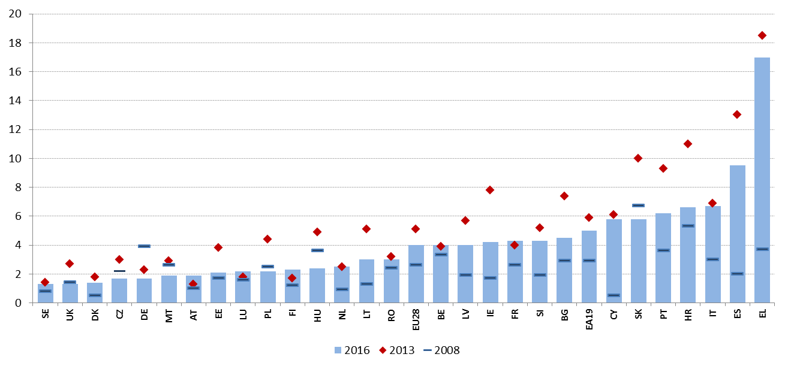
Source: Eurostat, LFS.
Labour market segmentation remains stable over time, and continues to affect a number of Member States. Duality between permanent and atypical jobs, with limited possibilities to move from the latter to the former, is a threat against well-functioning and fair labour markets. The situation in this respect is almost unchanged compared to the 2017 Joint Employment Report, with countries such as Poland, Spain, Croatia and Portugal showing a percentage of temporary contracts (age group 20-64) close or above 20% and other nine countries between 10% and 15% (the Netherlands, Slovenia, Cyprus, France, Sweden, Finland, Denmark, Italy and Germany). In Poland and Spain the picture is complemented by particularly low transition rates towards permanent contracts, a situation common to France, where however the share of temporary contracts is comparatively lower (but still above the EU average). This suggests that temporary contracts may represent "dead ends" rather than "stepping stones" towards permanent jobs. In a multiannual perspective, the percentage of temporary contracts changed only slightly over time since the onset of the crisis (the EU average hovered around 14% since 2008), remaining also stable in most Member States. However it increased significantly in Malta, Luxembourg, Slovakia, Cyprus, Denmark, the Netherlands and Croatia. In Spain, it dropped significantly at the beginning of the crisis (due to termination of fixed-term contracts), but increased subsequently after, along with the recovery.
Figure 29: Share of temporary workers over total employees 20-64 (2016) and transition rate from temporary to permanent jobs (2015).
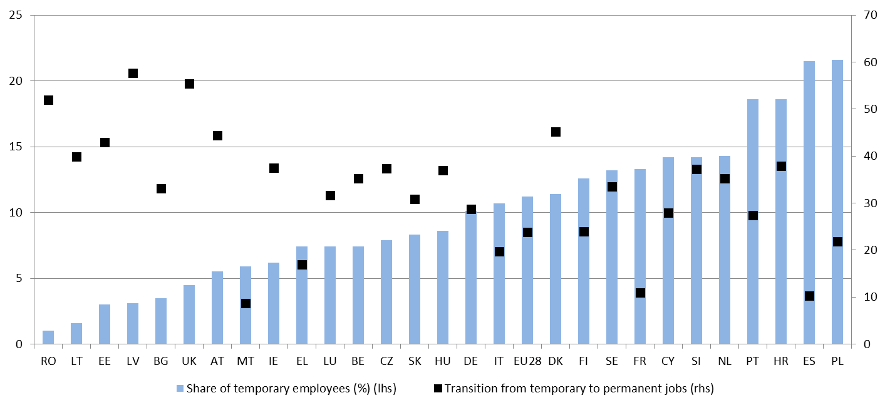
Source: Eurostat, LFS, SILC.

Countries with a high share of self-employment may also be more exposed to labour market segmentation. This can occur if self-employment masks economically dependent employment relationships (so-called 'bogus' self-employment), and/or when social security systems are not adapted to adequately cover the self-employed. While the degree of autonomy of self-employed workers cannot be measured with available statistics, a part of self-employment without employees (as a share of total employment) may be associated with potentially unstable jobs, thus signalling the need for further assessment. The ranking according to this indicator in 2016 shows Greece (22.2%), Romania and Italy (15.4%) on top, while Sweden, Germany and Denmark recorded the lowest values (close or below 5%). Looking at dynamics over time since 2008, the share of own-account workers increased significantly in some countries, notably the Netherlands (by 3.1 pps), Latvia (by 2.2 pps) and the United Kingdom (by 2.0 pps). On the contrary, it decreased most in Portugal (by -4 pps) and Croatia (by -5.1 pps).

Figure 30: Self-employed without employees as percentage of total employment
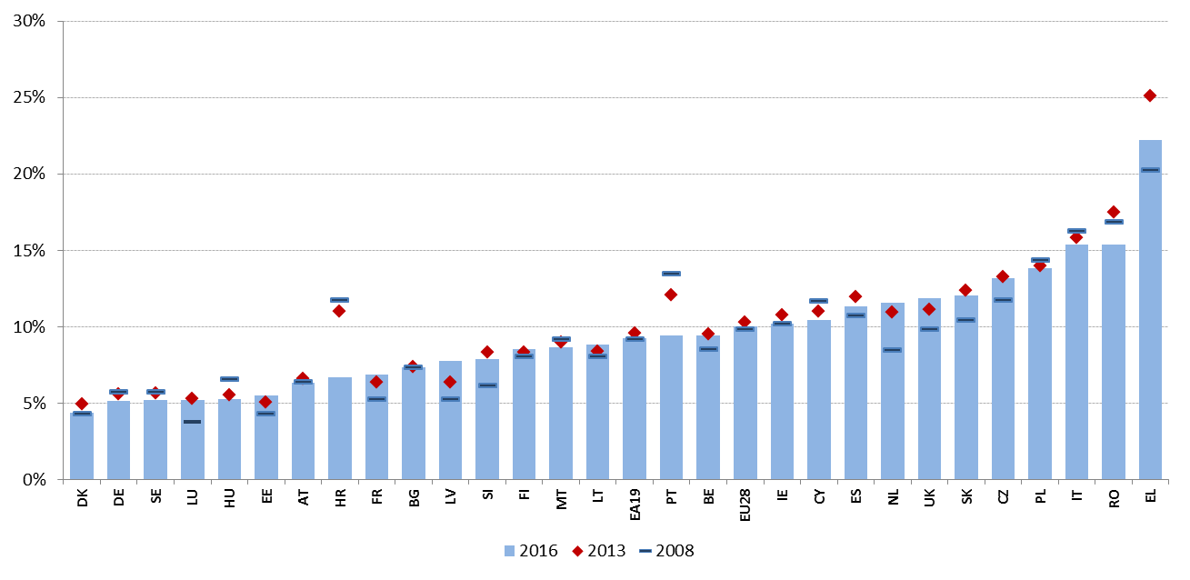
Source: Eurostat, LFS.

Well-designed unemployment benefit systems, characterised by appropriate levels and broad coverage combined with effective activation strategies, support and increase transitions back into employment. The comparative analysis of specific design features of unemployment benefit systems and their interplay with the provision of activation and support measures can provide useful insight regarding their performance. The following analysis draws from the benchmarking exercise conducted during 2016-17 in the Employment Committee, following the approach outlined in Chapter 2. While the challenges related to high unemployment (notably, long-term) across Member States have been identified in previous sections of the report, this section will focus specifically on the performance of the unemployment benefits system and on specific policy levers, using agreed indicators.
On average, around one third of short-term unemployed are covered by unemployment benefits in the EU. This share slightly decreased in the aftermath of the crisis (from 34.4% in 2008 to 32.4% in 2016), with significant differences across countries. These differences depend on policy design (notably on eligibility conditions, maximum duration and overlaps with other social protection schemes) as well as cyclical developments. On the one hand, coverage has more than doubled in Italy (from 7.3% to 15.1%), and has also increased significantly (by more than 10 pps) in Latvia, Estonia and the Czech Republic. On the other hand, it fell in Hungary (-10 pps), Luxembourg (-10 pps), Cyprus (-9 pps) and the United Kingdom (-8 pps). Significant decreases were also recorded in Member States with the lowest coverage, notably Romania, Poland, Malta and Croatia. The latter four countries all present a coverage rate below 15% in 2016. On the opposite, in Finland, Belgium, Austria and Germany more than 50% of short-term unemployed were covered, with a peak of 66% in the latter.

Figure 31: Coverage of unemployment benefits for the short-term unemployed
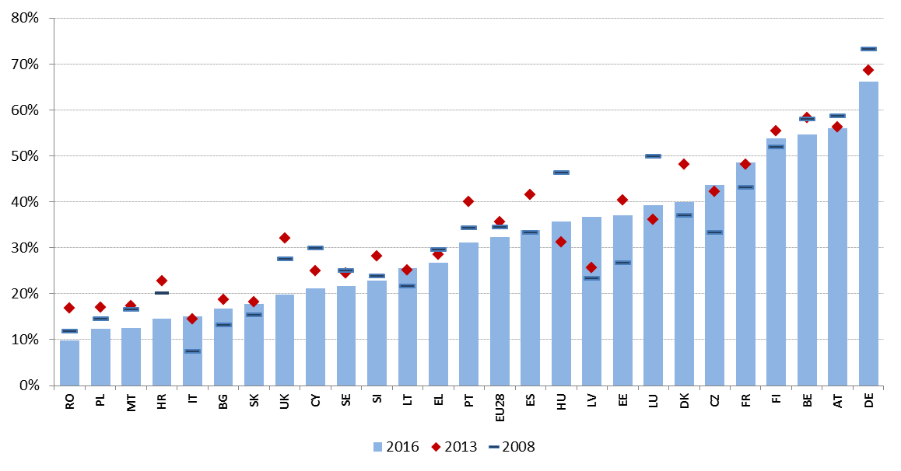
Source: computation on Eurostat, LFS data. Note: IE and NL not available.

In all Member States, entitlement to unemployment insurance benefits depends on previous work records and/or contributions paid. Stricter eligibility conditions translate into fewer unemployed people being entitled to benefits, and thus a lower coverage rate. In order to be entitled, unemployed people are generally required to have a minimum work record over a given period of time and, as a consequence, individuals with short employment spells and less continuous work histories often enjoy a lower coverage or no coverage at all. Looking at Figure 32, the number of weeks required to access unemployment benefits varies between 20 or less in Malta (where at least 50 weekly contributions must have been paid since the person first started work), France and Italy, to more than 100 in Slovakia, with one year (52 weeks) being the most common value. Another key parameter is the ratio between the contribution period and a longer 'reference' period, which in several countries allows taking into account periods of non-employment in the computation. The most frequent value across Member States is 0.5 (that is, beneficiaries should have contributed for at least half of the reference period). Shorter entitlement periods allow easier access to unemployment benefits for workers with discontinuous careers, although they might in turn promote unnecessary turnover of workers (i.e. churning).
Figure 32: Length of the required qualifying period, 2016
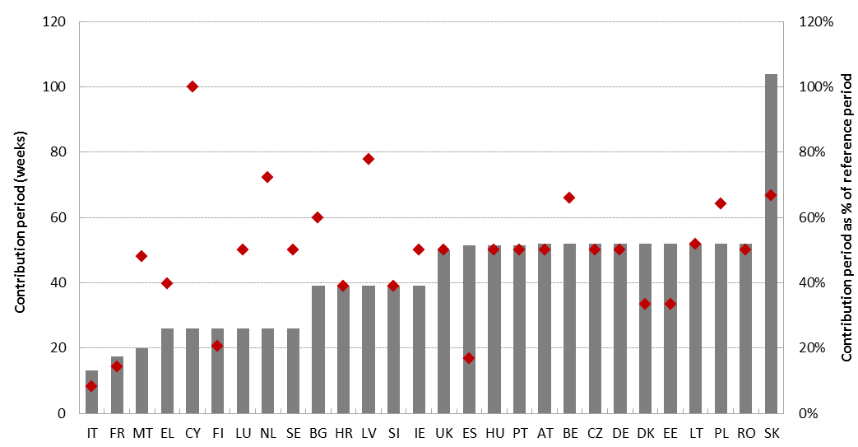
Source: MISSOC database, and national legislation. Red diamonds indicate the ratio between contribution and reference period. In Malta, at least 50 weekly contributions must have been paid since the person first started work; in Ireland, at least 104 weekly contributions must have been paid since the person first started work.

The duration of unemployment benefits is generally lower than the contribution period, with some exceptions. Benefit duration can be either fixed or increasing with the length of the contribution record. Moreover, after rights to unemployment benefits have exhausted, many EU countries have alternative second tier benefit. Figure 33 shows the maximum duration of benefits after one year of contribution. While in most Member States the duration is shorter than the contribution period (with half period, i.e. 26 weeks, being the most frequent outcome), in four cases it equals the contribution period (i.e. in France, the Netherlands, Greece and Luxembourg) and three cases it is higher (71 weeks in Finland, 104 in Denmark, indefinite in Belgium, though the benefits decrease with time to a floor level). At the opposite side of the scale, benefits last three months or less in Slovenia, Croatia, Malta and Hungary.

Figure 33: Maximum duration of benefits with a 1-year work record, 1st January 2017
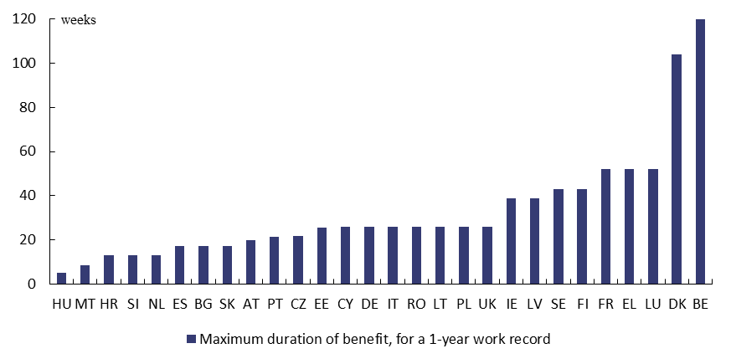
Source: MISSOC database (January 2017) and national legislation. Note: in BE there is no limit on the duration of benefits. For Member States in which duration also depends on age, the chart shows the duration for the youngest age group, corresponding to the shortest possible one. In SK, the duration shown (4 months) refers to people employed under a fixed-term contract (otherwise it is 6 months). In PL, duration varies depending on the level of the unemployment rate of the region relative to the national average.

There is a great variation in the level and adequacy of unemployment benefits across Member States. Net replacement rates provide an indication of the adequacy of the income replacement function of unemployment insurance benefits. Their level depends on a number of factors, including the previous level of earnings from work, seniority, duration of the unemployment spell, age and household composition (in particular when the interaction with the tax system and with other benefits is taken into account). Looking at the case of a low-wage worker with a short work history (1 year), the values of the net replacement rate, after one month of unemployment, range from 20% of previous (net) earnings to 90% (Figure 34). At the lower end there are Member States where the benefit is already terminated at the second month of unemployment (Hungary) or where the individual with a work career of one year is not eligible for unemployment insurance (Slovakia). These are followed by Member States providing a flat-rate benefit which is unrelated (or only weakly related) to the level of previous earnings (Romania, Bulgaria, Greece, the United Kingdom, Malta). The comparison with the net replacement rates at the 12th month of the unemployment spell shows the effect of either the expiration of the benefits (with individuals falling into other schemes, such as unemployment or social assistance), or the possible reduction in benefit generosity.
Figure 34: Net replacement rate of unemployment benefits at 67% of the average wage, at the 2nd and 12th month of unemployment (January 2016)
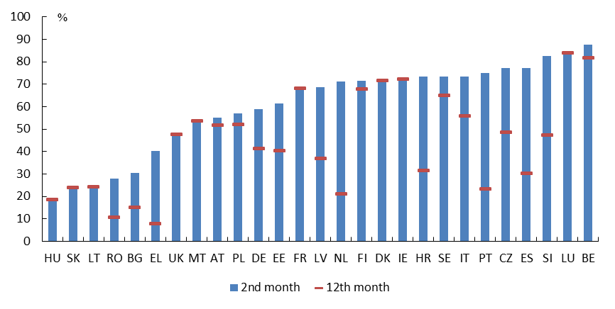
Source: European Commission based on OECD Tax-Benefit Models.

Figure 35: Indicator of strictness of job-search and availability requirements, 2014

Source: OECD.
Member States adopt different strategies to ensure activation of unemployment benefit recipients. Concretely, this amounts to making the continued receipt of benefits conditional on a set of requirements of job search and availability to work, ensuring that people receiving unemployment benefits remain engaged and do not become inactive. Figure 35 shows summary indicators of job-search and availability requirements for unemployment benefits recipients, as calculated by OECD, in the domains of: i) availability for work also during participation in ALMPs, and suitable work criteria (i.e. under what circumstances a job offer may be refused without sanctions); ii) monitoring of job-search activities (frequency of job-search, documentation to be provided); iii) sanctions (for voluntary unemployment, refusal of job offers, failure to participate in counselling sessions or AMLPs). Estimated job-search and availability conditions and related sanctions appear to be the strictest in Malta, Croatia, Estonia, Portugal, Luxembourg and Slovenia, while they are the least strict in Cyprus and Hungary. The relative importance of sub-components varies considerably across countries. Importantly, this indicator does not measure the level of enforcement.
High unemployment duration increases the risk for jobless people to disengage from the labour market, gradually losing skills and employability. In order to prevent this situation from occurring, an early targeting of the unemployed through effective active labour market policies (ALMPs) may help their quick (re)integration in the labour market.
Figure 36: Participants in ALMPs (per 100 persons wanting to work) and yearly change (Social Scoreboard headline indicator)
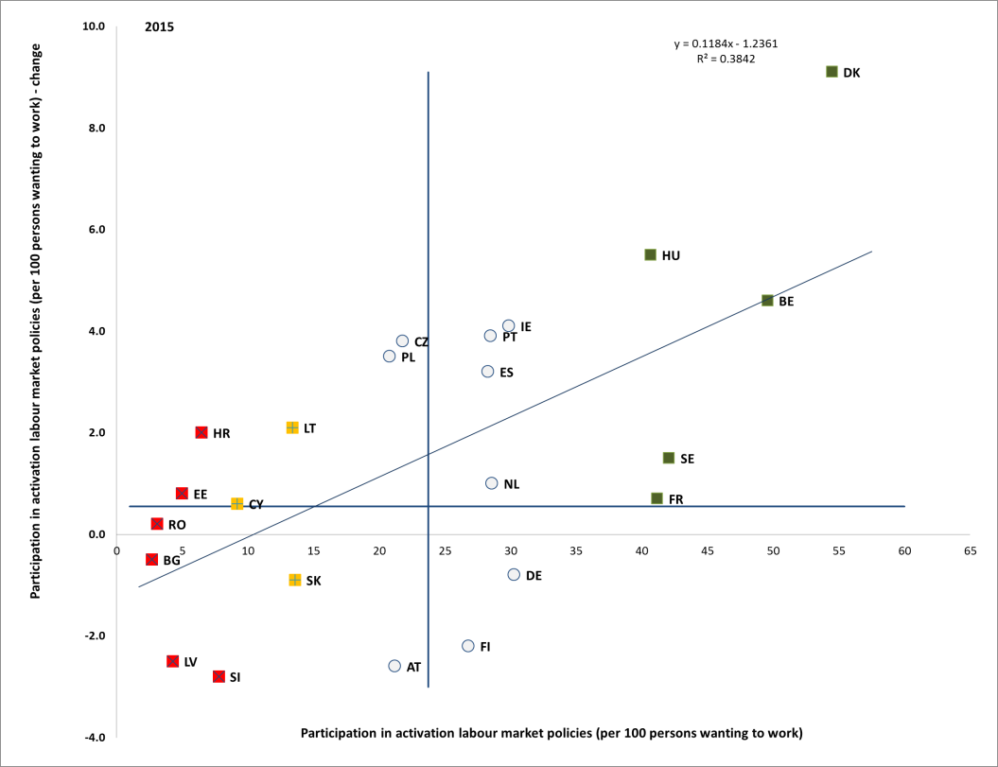
Source: Eurostat, LMP database and LFS. Period: 2015 levels and yearly changes with respect to 2014. Note: Axes are centred on the unweighted EU average. The legend is presented in the Annex. No data available for EL, IT, MT, UK. LU excluded due to data verification issues.

Participation in ALMPs follows very distinct patterns across Member States. On the one hand, in a large group of Member States (Bulgaria, Romania, Latvia, Estonia, Croatia, Slovenia and Cyprus) the participation rate per 100 persons wanting to work (i.e. either unemployed or available to work but not actively seeking for it) was below 10% in 2015, showing only a modest improvement or even deterioration over the latest year. With the exception of Cyprus, those Member States are flagged as "critical situations". On the other hand, another sizable group of countries recorded participation rates well above the average, and in all cases beyond 40%: France, Hungary, Sweden, Belgium and Denmark ("best performers"). For these countries the participation rate has increased (to a different degree) over the latest year. This development adds up to a picture of increasing divergence across countries, as highlighted by the positively sloped regression line which relates yearly changes to levels. In any case, this indicator should be interpreted with caution, as it only measures participation to (and not effectiveness of) labour market policies, and for a number of countries it presents statistical reliability issues, related to the data collection process. In a multiannual perspective, evidence for most Member States shows a decline of the indicator during the crisis (notably due to the cyclical increase of unemployment after 2008) followed by an improvement along with the recovery.
Registration with Public Employment Services, in most cases, is a pre-requisite for the participation into ALMPs schemes. Registered unemployed may have access to profiling, counselling and individualised services, including job search support and referral to specific activation and/or training schemes. However, as shown in the Joint Employment Report 2017, there remain large discrepancies in registration rates across Member States. These differences depend on various factors such as the capacity of Public Employment Services, the quality of the services offered, the obligations and sanctioning mechanisms related to unemployment benefits and other income assistance schemes.
Beyond formal registration requirements, Public Employment Services are a key tools for job search. Evidence shows also in this case a large variation. In Member States such as the Czech Republic, Slovakia, Lithuania, Austria and Germany, the share of unemployed people who declare using Public Employment Services to search for a job approaches 80%. A share of 30% of less can be observed instead in Romania, Italy and Spain. This might also reflect different quality of the services offered, notably as concerns job matching with employers. On average, since the onset of the crisis, less unemployed people have been using the services by PES in Europe. On the contrary, the use of private employment agencies and alternative job search methods, like direct applications to employers or publishing/replying to advertisements (including on the internet) has been on the rise (not shown in the graph). However, an opposite trend can be observed in a few Member States where the utilisation of Public Employment Services has actually increased in recent years, notably Latvia, Cyprus, Estonia, Greece, Slovenia and Lithuania.
Figure 37: Share of unemployed people using public employment services for job search
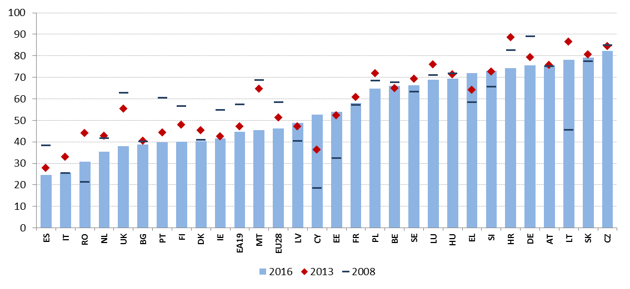
Source: Eurostat, LFS.

3.3.2 Policy response
Reforms continue in the field of labour law, with a view to supporting dynamic labour markets and reducing segmentation. Recently adopted or planned measures in this area often aim at reducing labour market segmentation and promoting hiring on permanent contracts, notably by setting more stringent regulation on fixed-term and atypical workers, and increasing flexibility as concerns hiring and firing of permanent workers. For instance, to encourage recruitment of new employees, Belgium announced making the notice period in the first six months of employment more progressive, reducing it to one week in the first 3 months and increasing it to 5 weeks as of the sixth month (federal measure). The Czech Republic tightened regulation of temporary work agencies, by introducing more stringent criteria for the establishment of an agency and higher penalties in case of breach of obligations. Greece has replaced the system of ex-ante administrative approval in case of collective dismissals (giving the minister of labour a veto power) with a notification procedure to guarantee the respect of the information and consultation requirements of workers. In France, the law of 9 August 2016, specifying circumstances for individual dismissals for economic reasons and introducing more flexibility in working conditions at company level, entered progressively into force with most measures starting in January 2017. A further broad-ranging reform was adopted by the government in September 2017, notably introducing compulsory thresholds and ceilings for compensation of abusive dismissals, while increasing severance pay in case of economically justified dismissals. In addition, it introduced the possibility of commonly agreed collective resignation procedures (rupture conventionnelle collective) and further facilitated agreements on working conditions. In June 2017, Lithuania introduced a broad reform to its Labour Code, touching upon several aspects of employment protection legislation: clarifying reasons for termination of employment, reducing the notice period, setting new rules for defining severance payment (the standard now being 2 months), reducing the maximum duration of fixed-term contracts from 5 to 2 years (with exceptions), and introducing flexible working hours. It also introduced a number of atypical contracts, including temporary work agency and project work contracts, whose impact on labour market segmentation would need to be monitored. The legislation was extensively discussed with the social partners. Poland is also planning to replace its current labour code, highly complex, many time modified and not reflecting fully the current economic model (it dates back 1974), with the aim to promote more employment on permanent contracts. Social partners are actually involved in drafting. Austria has repealed the exceptional rule according to which employees older than 50 cannot be dismissed after having been working 2 years in the same company. The aim is to increase the employment of older workers by eliminating this barrier.
Few Member States have taken action to promote a swift resolution of labour disputes. This is aimed to improve the predictability of the outcomes and reduce associated costs for both employers and employees. In particular, Estonia adopted a legislative act regulating the activity of individual Labour Disputes Commissions (introduced in 1996). The new Act aims at strengthening the position of these commissions, by making their work more flexible, allowing for written procedures including approval compromise positions to solve labour disputes. In France, gradual measures were taken to reform the rules applied to litigation on individual dismissals (prud'hommes) to strengthen concertation and speed up procedures, also by reducing uncertainties on the compensation of employees in case of unlawful dismissals. In November 2016, two decrees introduced an indicative seniority-based benchmark and in September 2017 new compulsory ceilings and thresholds were introduced, facilitating the resolution of litigation at the conciliation stage, hence speeding up procedures.
Improving the working conditions of self-employed workers, ensuring they enjoy adequate social rights, and preventing the exploitation of atypical forms of work is high on the agenda of several Member States. Denmark amended the rules for childbirth leave for self-employed business owners, so that they may work in their business for up to 25% of normal working hours and simultaneously receive childbirth benefits corresponding to 75%, thus keeping their business running. Italy adopted in May 2017 a "Jobs Act on non-entrepreneurial self-employment and smart working", extending protection for self-employed, notably as concerns maternity leave, parental leave, illness, unemployment benefits, and the deduction from taxable labour income of expenditures linked to vocational training. In France, the law of 9 August 2016 introduced, starting from 1st January 2018, the principle of social liability of collaborative platforms towards independent workers using them as intermediary. Platforms will participate in work accidents insurance coverage and finance the contribution to vocational training, while workers will enjoy full rights to demonstrate, set up or participate to trade unions. In Latvia, taxi drivers and persons working for start-ups receiving state subsidies are now considered as employees and thus enjoy stronger social rights and stricter requirements for social security contributions. Portugal has amended its labour procedural law extending special actions for recognising the existence of bogus self-employment ("falsos recibos verdes") to other typologies such as bogus traineeships, volunteer work and other types of undeclared work. In Spain a reform of the Law on Autonomous Workers was adopted in summer 2017, with new measures aiming at improving the situation of self-employed (for instance by reducing their social security contributions, making pension payments compatible with developing a freelance work, and promoting access to training opportunities). Slovenia adopted measures to prevent work on the basis of civil law contracts in cases when standard employee contracts should be concluded, notably strengthening inspectorates' powers and related sanctions. It also proposed to shift the burden of proof to the employer in the event of a dispute on the reasons for a short term contract, introducing higher fines for violations (including for workers). Finland has drafted a law proposal to limit the use of zero-hours contracts to situations where the employer can justify that the demand for labour varies.
In some Member States, reducing the high incidence of temporary workers in the public sector could contribute to tackling overall labour market segmentation. Spain, following recommendations by an ad-hoc expert group, is taking measures in this area. In particular, in April 2017 an agreement with the social partners was reached to run recruitment competitions for 250,000 permanent public sector posts over three years. Similar measures have also been announced by Portugal. In Cyprus, a new law on fixed-term contracts in the public service was adopted in 2016, establishing limits to the duration of contracts (as a rule it must not exceed 12 months, but the term is renewable) and specifying cases when administrations are allowed to use fixed-term contracts.
At the same time, several Member States are taking measures to increase internal flexibility, notably by increasing the adaptability of working hours and working conditions. In March 2017, Belgium adopted a law on flexible work aiming to facilitate flexibility for employers and employees alike and simplify the combination of work and private life. Working time can now be set on an annual basis, the use of overtime has been relaxed, the formalities for part-time work have been simplified and a legal framework for occasional telework has also been created. Moreover, social partners now have the option of further adapting working hours at sectoral level. The Czech Republic has introduced amendments to the Labour Code to increase the flexibility of working arrangements, notably by introducing more flexibility in scheduling/entitlements to working hours and leaves, changing 'teleworking'-related provisions and strengthening reconciliation tools such as 'homeworking'. Lithuania, in the context of the Labour code reform mentioned above, has introduced the possibility of flexible working schedules and teleworking. In Romania, the Ministry of Labour has published for consultation a proposal on teleworking, aiming to make working arrangements more flexible and to regulate a previously not used form of work. The consultation is open until the end of July. Finland drafted a law proposal to make its working time legislation more specific as concerns flexi-time and worked hours bank, and to extend the amount of overtime allowed.
In Italy, the above mentioned "Jobs Act on non-entrepreneurial self-employment and smart working" aims at promoting a more flexible arrangement of subordinate work in order to increase productivity and facilitate work-life balance (e.g. by regulating the possibility to work outside firms' premises, using IT tools, with the right to the same pay of employees working within firms' premises and doing the same job).
Some Member States are reinforcing labour inspectorates and taking additional measures to tackle undeclared work. For instance, in Greece, a three-year (2017-2019) action plan to tackle undeclared work is being implemented, envisaging a wide range of measures including, among others, a review of fines, new risk-analysis rules for targeted inspections, upgraded design of inspections and training of inspectors, and public awareness campaigns. In Cyprus, modifications to the Social Insurance Law have been recently submitted to the parliament for adoption, including the increase of the amount of fines and the introduction of an electronic declaration of commencement of employment. Moreover, a review of the system of labour inspections will be promoted. Labour inspectorates are also being strengthened in Portugal, notably by recruiting additional staff and reinforcing procedures for better coordination and sharing of data between labour inspection authority, tax authority and social security services. Romania has modified its legislation on undeclared work, broadened the definition of undeclared work and introduced more measures that bring to light the disguised employment.
Public Employment Services (PES) are further strengthening their efforts in terms of institutional reform and performance improvement. These efforts are also supported by the "Benchlearning" method introduced in 2015 in the European Network of Public Employment Services (PES Network). Recent reforms are reflected in the decreasing numbers of jobseekers and the increasing number of vacancies notified to Public Employment Services (also linked, to some extent, to improved macroeconomic conditions). As shown in Section 3.3.1, as the unemployment rates fell, most PES have seen the number of registered job-seeking clients decrease. The improvement of the labour market conditions has however neither led to a corresponding reduction in PES expenditure nor to a significant decrease in human resources. At the same time more PES seem to be using specialised counsellors to work with specific sub-groups of jobseekers (young people, LTU and older workers). Cyprus is currently preparing for additional recruitment of PES counsellors to be better able to address more effectively and efficiently the implementation of the Youth Guarantee and the recommendation on the long term unemployed. Public Employment Services are also investing in better service delivery. In Greece, under the project of re-engineering the Greek PES, a new profiling methodology for jobseekers was adopted and the introduction of a performance management system is planned in the near future.
Public Employment Services continue to strengthen cooperation with employers based on a deeper understanding of the labour market, a more labour demand oriented service package and qualitative assistance of employers. Even if comprehensive employer engagement strategies are still rare, different approaches as to employer segmentation and organisation of employer services have been developed. Most PES have a central coordination level of employer services as well as they do provide services for employers at regional and local level. Employers can be segmented by different categories, for example by sector, size, regional/national importance and those which are considered to need more help such as start-up companies or businesses that are facing difficulties. Furthermore, some PES conclude co-operation agreements with specific employers. Better employer services will also require awareness of specialised human resources needs as competence requirements of employer advisors differ from those of traditional PES advisors. This necessitates new approaches to staff training.
The level of support provided to long-term unemployed still varies greatly among Member States. In some Member States such as Finland, Denmark and Austria the assistance to the long-term unemployed builds on the experience of many years and social partners are closely involved. However, in most other Member States more integrated types of services in the form of single points of contact as well as more personalised services are still far from being in place while the involvement of employers is also rather weak. However, in 2017 both Italy and Cyprus initiated deep reforms of policies, practices and infrastructure in order to improve the level of support to the long-term unemployed.
Various types of incentives and subsidies are being used to promote recruitment and activation of the long-term unemployed. Since 2017 targeted hiring incentives have been introduced in Belgium (Flanders) and Bulgaria. In Sweden the employment subsidies levels have been reviewed to make the scheme more effective. To activate the long-term unemployed, Belgium (Brussels region) adopted a scheme called ‘Activa générique’ i.e. a scheme offering an allowance to long-term unemployed while in Slovakia similar schemes are being piloted. In Denmark temporary work incentives for long-term unemployed have been introduced based on a tax-free "job premium". In Romania, employment subsidies have been extended to long term unemployed.
Other types of activation incentives are being put in place through measures supporting internal geographic mobility. For instance, in Romania new subsidies are offered to those who take a new job 50 km away from their place of residence. In Bulgaria funding for childcare, rental and internet subscription will be provided to unemployed people who start a job more than 50 km away from their place of residence (up to 400 unemployed people are targeted). In the Czech Republic, support to regional mobility is granted by the Labour Office to the job seekers registered for more than 5 months, which covers commuting costs and removal to a new job outside of the job seeker's region. Finland is also planning to improve collaboration between regions and authorities to facilitate movement of labour to high growth areas.
Emphasis on provision of more individualised services is increasing. In Spain, a large programme (Programa de Acción Conjunta para la Mejora de la Atención de Personas Parados de Larga Duración) has been put in place to strengthen the capacity of the Public Employment Services in providing individualised support to the long-term unemployed. Portugal has amended legislation to cater for more personalised services, and is developing one-stop shops for employment ("Balcão Único do Emprego"), bringing together services provided by public employment services and social services (expected by beginning 2018). In the Netherlands the budget has been substantially increased to allow for more personalised job search support while in Finland extra funding has been provided to increase frequency of the support. Whereas in Belgium (Wallonia) more personalised services are now offered via the newly introduced "insertion contract", Italy is experimenting with vouchers for unemployed that can be used to obtain more tailored and intensive job search support. Finally, to offer more integrated services via single points of contact 8 new centres have been established in Bulgaria in 2017 bringing the total number to 73.
Training programmes targeting the unemployed are gaining momentum. In 2017, Croatia started rolling out trainings targeting almost 10 000 unemployed persons with special focus on long-term unemployed and France extended the massive 2016 training plan for unemployed to 2017. It also expanded it with 200 000 additional places on top of the 500 000 added in 2016, while a new Investment plan of EUR14 bn aims at training 1 million low-qualified jobseekers and 1 million early school-leavers between 2018 and 2020. Lithuania and Hungary re-designed their ALMPs to reduce the use of public works in favour of work-based learning and practice. Finally, Greece launched a programme of training and certification for 23 000 unemployed in sectors with growth potential and included an optional training component in the new generation of its public works scheme.
Strengthening the activation of benefit recipients is a priority in several Member States. This concerns both unemployment and social assistance benefits, such as minimum income schemes. In Finland, a major reform of the unemployment benefit system took place with the aim to accelerate reintegration into employment. As of 2017, participation in active labour market policies is a condition for receiving unemployment benefits, and jobseekers face stricter conditions about rejection of job offers. Moreover, the basic (non-earnings related) unemployment benefit can be used as mobility and wage subsidies to activate jobseekers. There are also plans as of 2018 to introduce further financial sanctions for jobseekers failing to demonstrate their job-search or participation in activation measures. In Belgium, since September 2016 every new beneficiary of the social insertion income is obliged to sign a personalised social integration project with the social welfare centres (e.g. the scheme "impulsion insertion" in Wallonia). The "project" defines the rights and obligation of both parties, with the aim to stimulate sustainable professional integration. In Cyprus, the implementation of activation measures targeted at Guaranteed Minimum Income beneficiaries (e.g. training and development, participation in public benefit programmes) started in 2016 and will be further developed in 2017. In Slovenia a draft act (to be adopted by parliament) will introduce the obligation for a dismissed worker to report to the Employment Service already during the notice period (with some exceptions), to avoid a cut in unemployment benefits in the first three months of unemployment.
Recent reforms in the field of unemployment benefits systems aimed at their rationalisation and sustainability, often the introduction of stricter eligibility conditions and/or lower benefit levels. However, some Member States are also taking (or planning) action to increase benefits amount and duration. In the context of the above-mentioned reform, Finland reduced the duration of the earnings-related unemployment benefit from 500 to 400 days (or 400 to 300 days in the case of a career shorter than 3 years), except for older long-term unemployed people. In France, a new 3-year Convention on Unemployment Benefits (2017-2020) was adopted in May 2017, in agreement with social partners, aiming at tackling the system deficit and reducing incentives to hire on very short-term contracts (notably through a new method to calculate rights, removing calculation bias favourable to short-term contracts). A further reform is planned, aiming at granting access to independent workers and increasing checks on job search. Latvia has increased its minimum contribution period for being eligible from 9 months (out of 12) to 12 (out of 16). In Lithuania, the new version of the Law on Unemployment Social Insurance (part of the package together with the labour code) expands the coverage and adequacy of unemployment benefits, notably by increasing the period of payment from 6 to 9 months (not depending on the tenure). In Denmark, the comprehensive reform adopted in 2015 came into force in 2017. Among other measures, it involves a simplification of the system, further digitalisation and higher benefits to newly graduates with children. A main element in the reform is the possibility of prolonging the unemployment benefit period from two years up to three years if taking on short-term work.
Well-functioning social dialogue is crucial in promoting a social market economy that balances economic performance with social fairness. It plays a central role in reinforcing social rights and enhancing sustainable and inclusive growth, as highlighted by the European Pillar of Social Rights. Listening to social partners' advice and involving them in reform discussions early on, can significantly facilitate implementation in later stages. The degree and impact of social partners' involvement in the design and implementation of relevant reforms varies considerably among EU countries. This is largely due to a diversity of social dialogue practices and institutional settings in the different Member States and to varying social partner's capacities and contributions. Whereas there is no single existing national social dialogue system that serves as the standard reference, an effective and well-functioning social dialogue should be fostered in order to promote welfare in the EU. This can only be achieved by promoting social partners' capacity by respecting their autonomy and strengthening their roles in the design and implementation of reforms and policies and by actively involving social partners at all stages of policy-making and implementation. Positive examples of social partners' involvement in the design and implementation of policies can be found across this report, notably in Chapter 3.1 (concerning wage setting systems), Chapter 3.2 (concerning vocational training systems) and Chapter 3.3 (labour law reforms).

3.4 Fostering social inclusion, combatting poverty and promoting equal opportunities
This section looks at the implementation of the employment guideline no. 8, which recommends to Member States to modernise their social protection systems, in order to combat poverty and social exclusion. It first presents an overview of the social situation in Member States by key indicators, including disposable income, poverty and social inclusion, and access to healthcare. Section 3.4.2 reports on policy measures from Member States in the areas of social protection systems, including unemployment benefits, housing policies, childcare, long-term care, healthcare, pensions and inclusion of people with disabilities.

3.4.1 Key indicators
In 2015, gross disposable household income (GDHI) per capita increased in a large majority of Member States. Still, in several Member States its level has not recovered from the crisis: this is evident in particular in Greece and Cyprus ("critical situations"), where disposable income per capita was respectively about 32% and 23% lower in 2015 than in 2008, followed by Italy, Spain, Portugal, Slovenia, and – to a lesser extent – Austria. In all these countries, the growth rate in 2015 lagged behind the EU average or was even negative. On the contrary, in a number of Central and Eastern European Countries GDHI per capita was higher in 2015 than in 2008 (Romania, by 32.9%; Poland, by 17.0%; Bulgaria, by 12.0%; Lithuania, by 7.0%). In all these countries (plus Estonia and Latvia) disposable income per capita continued increasing faster than the EU average, reflecting their ongoing convergence with the rest of the EU. In particular, Romania and Poland are flagged as "best performers".
Figure 38: Real GDHI per capita, index 2008 = 100 and yearly change (Social Scoreboard headline indicator)
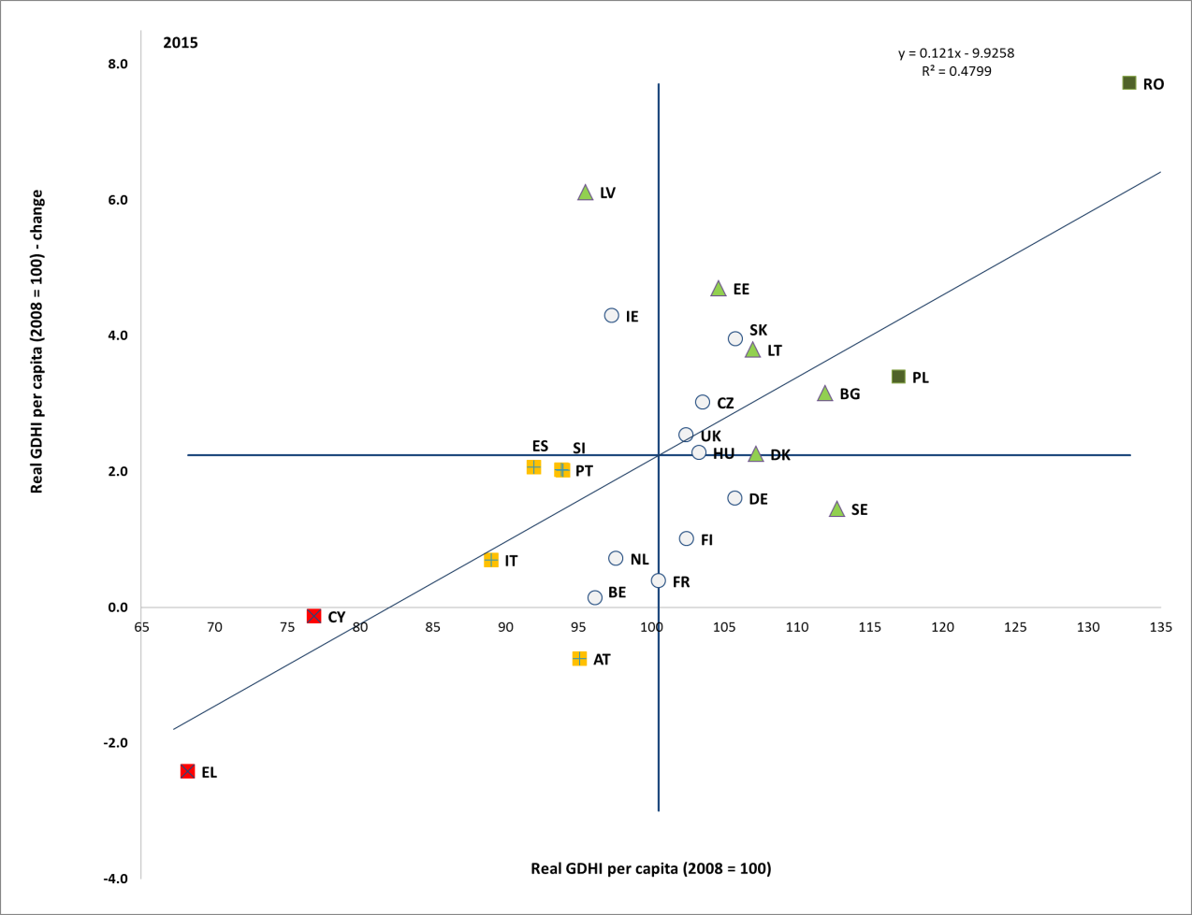
Source: Eurostat, National Accounts [nasq_10_nf_tr and namq_10_gdp], DG EMPL calculations. Period: 2015 levels and yearly changes with respect to 2014. Note: Axes are centred on the unweighted EU average. The legend is presented in the Annex. Data for 2016 only available for 18 MS at 31 October 2017.

Income inequality started falling on average, but in several Member States the post-crisis increases have not been reversed. In 2016 for the EU as a whole, the richest 20% of households received an income share that was 5.1 times that of the poorest 20% (Figure 39). However, the average value masks considerable variation across countries, with ratios of 6.5 or above for Bulgaria, Lithuania, Greece and Spain ("critical situations") and Romania ("weak but improving"), almost twice as high as values for the Czech Republic, Slovakia, Finland and Slovenia ("best performers"). Inequality intensified most in Bulgaria and Luxembourg, while the most significant declines were registered in Romania, Lithuania and Estonia. In 2016, a moderate convergent pattern in income inequality across Member States appeared, with faster decreases being more likely to be seen, on average, in countries with higher levels. In a longer term perspective, the income quintile share ratio remains significantly higher than in 2009 for more than a third of Member States. This is true in particular for Bulgaria, Greece, Italy, Hungary, Luxembourg, Romania, Spain, Lithuania and Estonia. Significant decreases have however been observed in Latvia (where inequality still remains high) and in Denmark.

Figure 39: Income quintile share ratio and yearly change (Social Scoreboard headline indicator)
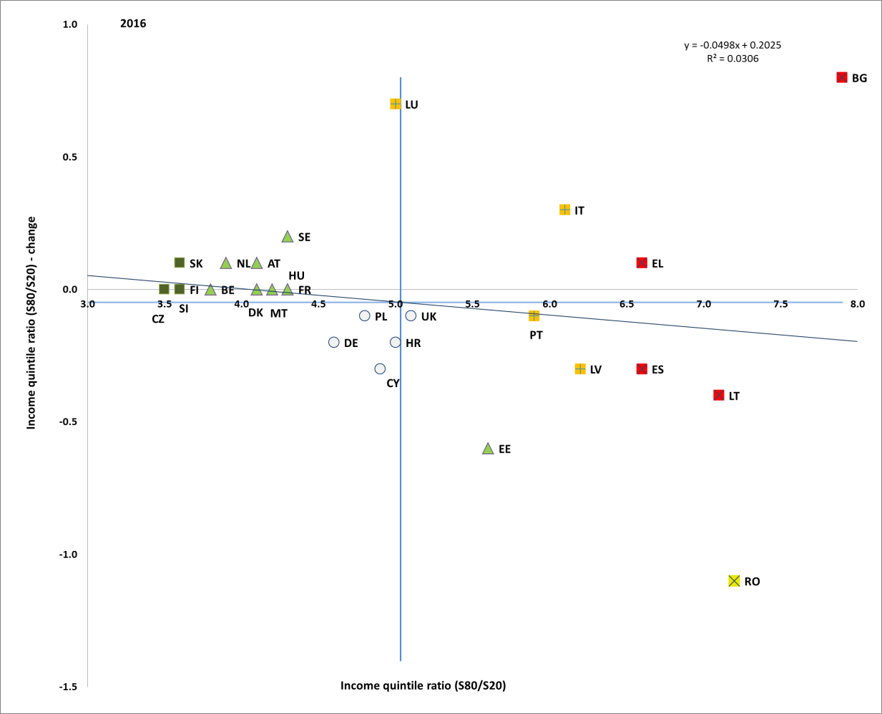
Source: Eurostat, SILC. Period: 2016 levels and yearly changes with respect to 2015. Note: Axes are centred on the unweighted EU average. The legend is presented in the Annex.

The share of people at risk of poverty or social exclusion has decreased in most Member States in 2016. There are however, considerable differences in the proportion of population at risk of poverty or social exclusion across Member States (Figure 40). More than one third of the population in Bulgaria, Romania and Greece ("critical situations") was considered at risk, with a marked increase in 2016 for Romania. This share was also significantly higher than the EU average in Italy, Lithuania, Latvia, Spain, Croatia and Cyprus. In the first two countries further increases were recorded in 2016; on the contrary, Latvia experienced the strongest decrease (by around 2.5 percentage points). On the other end of the scale, the Czech Republic, Finland, Denmark and the Netherlands ("best performers") had the lowest proportion of their population at risk of poverty or social exclusion, below 17%. Among countries with low risk of poverty or social exclusion, a significant increase was recorded in Luxembourg. In a longer term perspective, a noticeable decrease compared to 2009 is observed in Latvia, Poland, Bulgaria and Romania, while in Greece, Italy, Cyprus and Spain, the risk of poverty or social exclusion is visibly higher.

Figure 40: At-risk-of-poverty or social exclusion rate (AROPE) and yearly change (Social Scoreboard headline indicator)
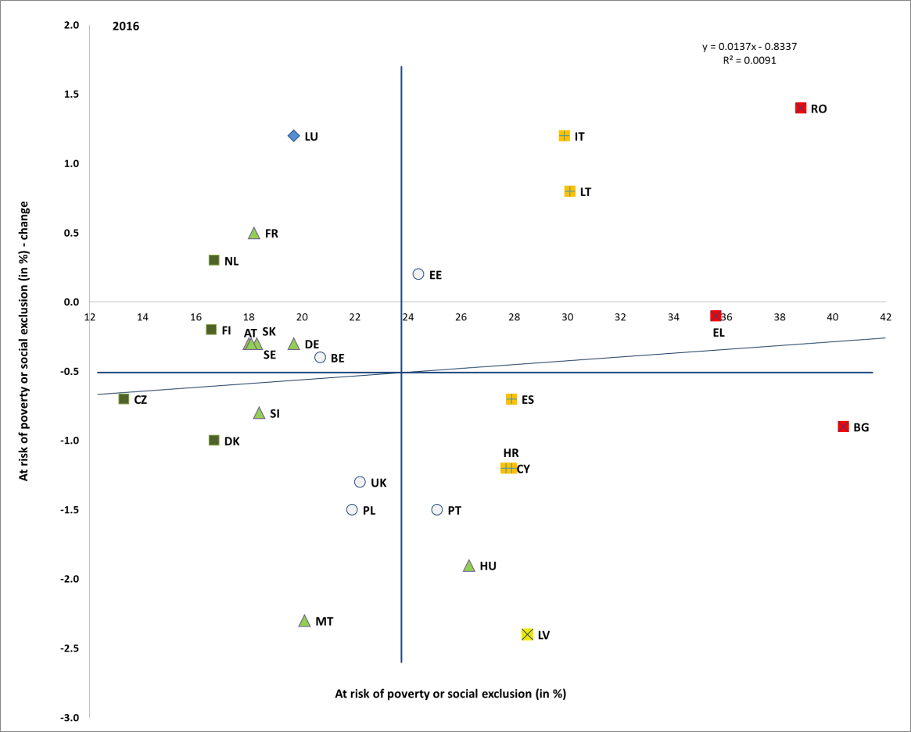
Source: Eurostat, SILC. Period: 2016 levels and yearly changes with respect to 2015. Note: Axes are centred on the unweighted EU average. The legend is presented in the Annex.

After increasing in previous years, the proportion of the EU population at risk of monetary poverty has stabilized in 2015 and 2016. At Member State level, the ratio decreased or remained stable in 17 Member States (Figure 41). Among the remaining countries, the biggest increases (by around 1 pp or more) were observed in Luxembourg, the Netherlands (both still with comparatively low poverty risks), Italy and Bulgaria. Looking at levels, the Member States with the highest proportion of population at risk are Romania, Bulgaria and Spain (22% or more). Conversely, the Czech Republic, Finland and Denmark reported the lowest rates (below 12%). Compared to 2009, the risk of monetary poverty in 2016 was still higher in 21 Member States, with lower levels observed only in Latvia, Finland, the United Kingdom, Denmark and Austria. Croatia in 2016 also had a lower risk of monetary poverty compared to the situation in 2010.
Figure 41: Sub-indicators of ‘people at risk of poverty or social exclusion'
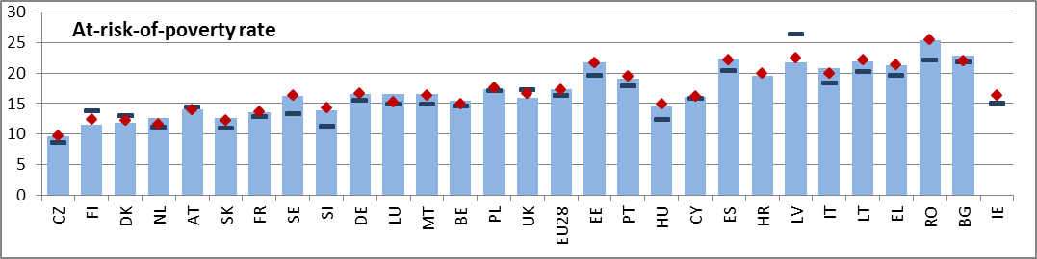
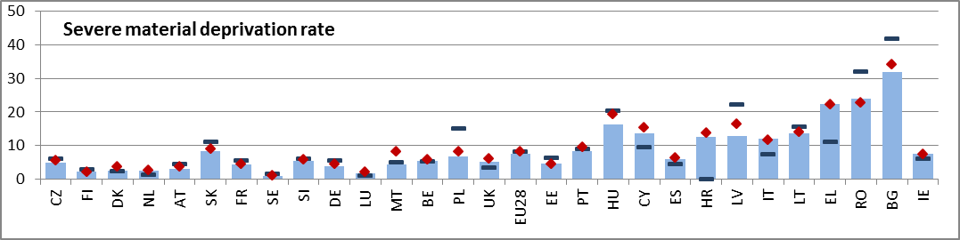
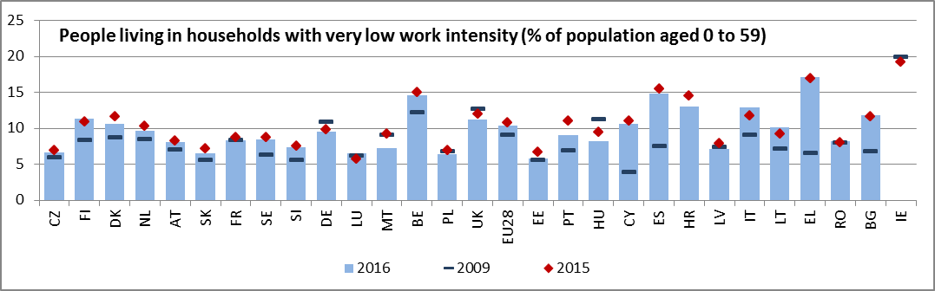
Note: Indicators are ranked by AROPE in 2016. IE not available for 2016. EU27 values used for 2009 (data for HR not available).

In 2016, severe material deprivation declined for a fourth consecutive year, indicating improving living standards in the majority of the Member States. The situation has improved or remained stable for all but four Member States (Romania, Italy, Estonia and Greece). Still, around one third of the population in Bulgaria, and more than a fifth of the population in Romania and Greece suffered from severe material deprivation. In contrast, this share was less than 3% for six countries (Sweden, Luxembourg, Finland, the Netherlands, Denmark and Austria). Compared to the situation before the crisis, changes since 2009 in severe material deprivation show that by 2016 the situation has improved in 17 Member States. However, in Greece the indicator stands 11.4 pps higher, and in Cyprus and Italy it is more than 4 pps higher.
The labour market recovery has also contributed to reducing or levelling out the number of people living in (quasi-jobless) households in most Member States. In 2016, the share of people living in low work intensity households decreased or remained stable in 19 Member States. The biggest decreases (by 1 percentage point or more) were observed in Malta, Portugal, Croatia, Hungary and Denmark. The rate of (quasi) joblessness remains particularly high in Greece (17.2%), Spain (14.9%), Belgium (14.6%) and Croatia (13.0%); with the exception of Belgium, these Member States also present higher than average unemployment rates. By comparison, the data for Estonia, Poland, Slovakia and Luxembourg shows the lowest rates in the EU. In a long-term perspective, most Member States still present higher values than in 2009, sign that the impact of the crisis has not been completely reversed. Notable exceptions are Germany, Poland, Malta, Hungary and the United Kingdom.
The risk of poverty or social exclusion remains particularly high for children. In 2016, the risk for children (age 0-17) stood at 26.4%, down from 27.1% in 2015. This is notably higher than for working age individuals (age 18-64, at 24.2% in 2016 compared to 24.7% in 2015). Child poverty risk is particular high in Romania (49.2%), Bulgaria (45.6%) and Greece (37.5%), while Finland and Denmark report the lowest levels, below 15%. In contrast to the situation with children, the risk of poverty or social exclusion among the elderly (65+) remains low, although increasing in 2016 (18.3% compared to 17.3% one year before). Overall, this group has been relatively sheltered from the negative impact of the crisis (it remains largely below the 2009 level of 21.8%). Again, significant variations can be observed across the Member States, with at risk rates among the elderly varying from 9.2% (in Denmark) to 45.9% (in Bulgaria).
At the European level, people with disabilities have a considerably higher risk of poverty or social exclusion. The relative gap was 10.1 pps in 2016 (29.9% versus 19.8%), up from 9.4 in 2015. The biggest gaps were in Lithuania (20.9 pps), Latvia (20.8 pps) and Estonia (20.4 pps). On the contrary, an almost null gap was registered in Greece, while 4 countries had a gap below 6 pps (France, Spain, Romania and Slovakia). The degree of disability (severe versus moderate) increases significantly the risk of poverty or social exclusion.
Box 4. Benchmarking Minimum Income

Upon initiative of the Commission, the Social Protection Committee has started an exercise on benchmarking minimum incomes, focusing on the working age population with working abilities not in employment and not eligible or having exhausted entitlements to social insurance benefits. The approach follows the three-step approach presented in Box 1.
It starts with the identification of key outcome indicators, namely the relative median poverty risk gap, the material and social deprivation rate and the at-risk-of-poverty rate of the population living in (quasi-) jobless households. Performance relates to the impact of social transfers (excluding pensions) on poverty, the persistent at risk of poverty rate and the coverage rate of social benefits (excluding pensions) for those at-risk of poverty in (quasi-) jobless households.
These outcome and performance indicators have been linked to policy levers (and related general principles agreed) of: 1) the adequacy of benefits, 2) eligibility criteria ensuring coverage of benefits and 3) the activation elements to incentivise take up of work. A twofold policy lever indicator was identified for the adequacy of minimum income benefits: it relates to both the income of a minimum income beneficiary as a share of the poverty threshold (smoothed over three years) and as a share of the income of a low wage earner (the latter also providing an indication of the activation dimension of minimum income benefits).
These policy lever indicators are strongly correlated to the outcome and performance indicators, and in particular with the relative median poverty risk gap and with material and social deprivation. The adequacy indicator related to the poverty threshold generally lies in a range from around 50% and 80% and the one related to the income of a low wage earner from around 40 % and 70 % (Figure 42).
When considering this framework it is important to take into account the specificities of national contexts including complementarities between different policy areas (e.g. in kind services and other benefits, taxation, public services and public administration, territorial dimension, the activation elements of the existing schemes and the role of social partners). In addition, further work is needed as regards the dimensions of eligibility and activation, as well as to explore the possibilities to further take into account the impact of in kind benefits, as appropriate indicators are still lacking in this respect.

Figure 42. Net income of minimum income recipients as % of poverty line (smoothed over three years) and as a percentage of the income of a low wage earner (2014)
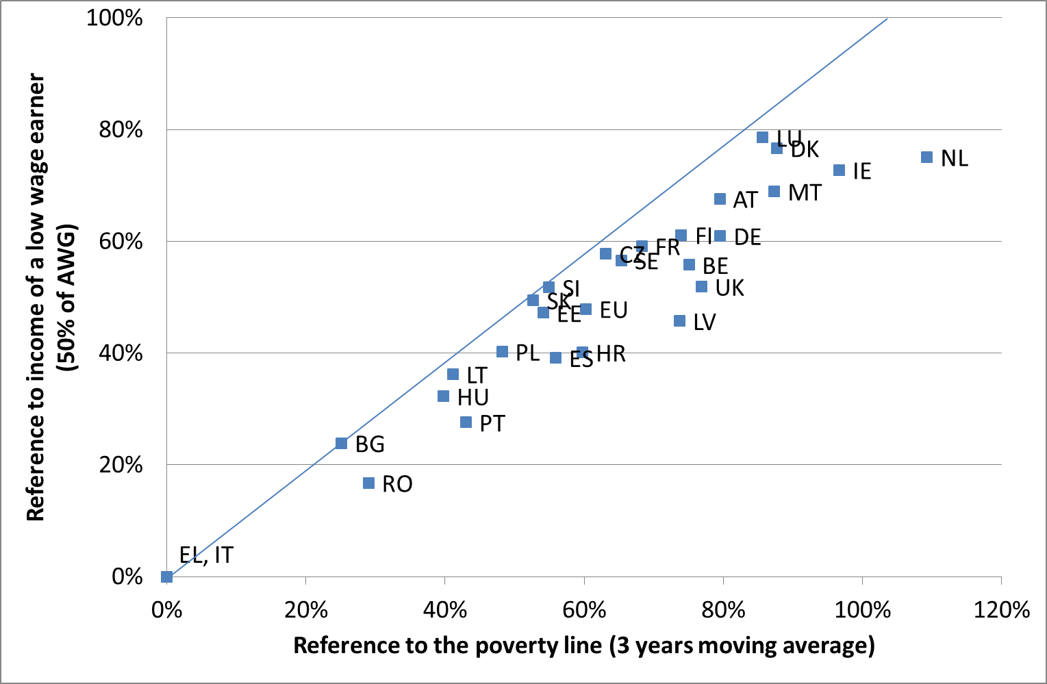

Note: income refers to one person households; EU unweighted average for covered countries (excluding Cyprus); the poverty line refers to the at-risk of poverty concept and is set at 60% of the national median equivalised disposable income (with reference year being income reference year rather than EU-SILC survey wave year of 2015). Low wage earner defined as 50% of the average wage. Source: OECD tax-benefit indicators and EUROSTAT EU-SILC data. Assumption of housing costs of 11.3% of the average wage (estimated from EU-SILC).

In spite of an overall improving income situation of households, the depth of poverty of the active age population continued to increase in a number of Member States. The relative median poverty gap increased for the EU 28 Member States over the last years, reaching 24.8% in 2015 and stabilising in 2016. It ranges from close to 15% (in Malta, France, the Netherlands, and Cyprus) to 30% or more (in Bulgaria, Greece, Spain and Romania). The poverty gap is also often higher in thee Member States that have higher at risk of poverty and social exclusion rates.
The trend towards an increase of in-work poverty did not reverse, though recent changes were fairly mixed across the Member States. The in-work at-risk-of-poverty rate varied greatly across the EU: the lowest values were recorded in Finland (3.1%) and the Czech Republic (3.8%), while the highest ones in Spain (13.1%), Greece (14%) and Romania (18.6%). This variation reflects different labour market features, including different prevalence of part-time and/or temporary workers, wage levels, and work intensity in the households (reflecting overall labour market conditions). It increased notably in Bulgaria (by 3.8 pps), France, the Netherlands and Austria (by 0.5 pps). On the other hand, the strongest reduction was in Lithuania (-1.5pps), Latvia (-0.9 pps) and Cyprus (by 0.8 pps).
Those who earn their living from non-standard employment or self-employment are exposed to significantly higher poverty risk in most EU countries. In 2015, the self-employed in the EU faced a poverty risk on average three times higher than that of salaried workers and even six times higher in Slovakia, Finland and Romania. On average, in the EU around 16% of temporary and part-time workers were income poor in 2016, compared to only 6% of employees with a permanent contract.
Self-employed and non-standard workers also endure greater economic uncertainty with limited access to social protection. The self-employed do not have access to unemployment protection in ten countries, mandatory sickness protection in eight countries, and protection against accidents at work and occupational injury in thirteen countries. This translates into more than half of self-employed without potential access to unemployment benefits and more than a third without potential access to sickness benefits. Non-standard workers usually have the same statutory access to most social benefit schemes as those on standard contracts, though often this does not hold for certain categories of workers (e.g. casual and seasonal workers, on-call workers, and those on temporary agency contracts, civil law contracts or zero-hour contracts). Moreover, due to discontinuous contribution periods or insufficient number of working hours, non-standard workers often encounter difficulties in fulfilling the eligibility conditions for receiving benefits from insurance-based schemes. As a result, more than a third of temporary workers do not have potential access to unemployment benefits. Despite major changes in the labour market, social protection systems are still largely based on the notion of "standard employment", assuming a long-term, full-time relationship between a worker and a single employer. The rise of new forms of work can pose further challenges to social protection systems.
Access to affordable, high-quality accommodation has been improving since 2008 in a large majority of the Member States. In Slovakia, the Czech Republic, Finland or Romania, less than 10% of the population lived in households that faced housing deprivation in 2016. In ten other Member States the rate was below 15% (the EU average stood at 15.5% in 2016). Still, housing deprivation remains a significant challenge in several Member States. Around 25% of the population or above in Portugal and Cyprus or Slovenia reported problems related to housing.
Housing-related expenditure accounted for a significant share of household disposable income in a number of Member States. The housing cost overburden rate was the highest in Greece with 40.5% of the population living in a household where the total housing costs (net of housing allowances) represent more than 40% of the total disposable household income. This was considerably higher than in any other EU Member States, as Bulgaria at around 20% and Romania, Germany and Denmark at around 15% had the next-highest ratios. By contrast, less than 5% of the population in Finland, Estonia, Ireland, Cyprus and Malta were living in a household with a housing cost overburden. In most countries, the housing cost overburden was significantly higher for tenants paying a market rent (27.9% EU average), than for owners with a mortgage or loan (5.4% EU average).
The poverty reducing impact of social transfers has slightly weakened. The impact of social transfers on monetary poverty ranges from a reduction of below 20% in Romania, Bulgaria or Greece ("critical situations" together with Italy and Lithuania) to levels close or higher than 50% in Finland, Denmark, Austria and Sweden ("best performers"). Overall, the indicator has slightly deteriorated in the EU, from 33.7% in 2015 to 33% in 2016. Nonetheless, this decrease masks a substantial variation among Member States. The impact of social transfers weakened by more than 4 percentage points in some Members States with low or average performance (Bulgaria, Croatia, Slovakia and Luxembourg), but also in the Netherlands, where the overall impact remains significantly above average. On the contrary, it has improved by 2 percentage points or above in Latvia, Estonia and Finland. The weakening of the poverty reducing effects of social transfers is a part of a longer term trend (since 2008) in Slovakia, the Czech Republic, Hungary, Sweden, the Netherlands and France. However, the situation has visibly improved in the last ten years in the United Kingdom and Cyprus. These variations may reflect different patterns at country level, notably changes in benefits adequacy and coverage, lack of indexation (in a context of generally increasing incomes and, consequently, rising poverty thresholds), as well as changes in the composition of households (notably in terms of work intensity) and related characteristics of those at risk of poverty. Observed figures (which refer to 2015 incomes) do not reflect the effects of recent reforms enhancing social safety nets in a number of Member States.

Figure 43: Impact of social transfers (other than pensions) on poverty reduction and yearly change (Social Scoreboard headline indicator)
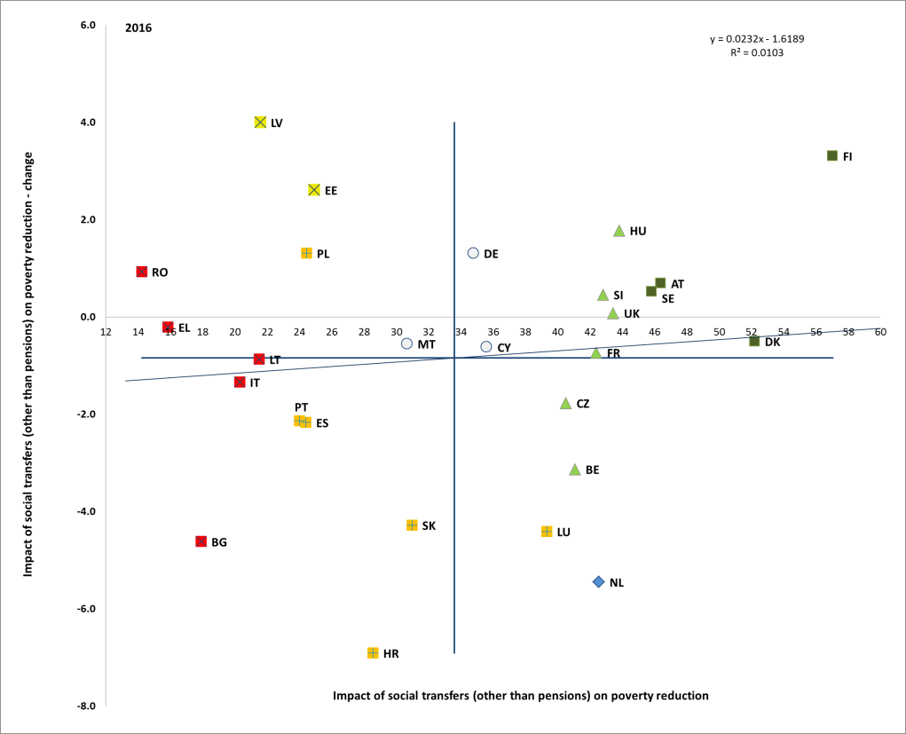
Source: Eurostat, SILC. Period: 2016 levels and yearly changes with respect to 2015. Note: Axes are centred on the unweighted EU average. The legend is presented in the Annex.

Expenditure on social protection conceals considerable variation across the Member States. In 2014, social protection expenditure as a percentage of GDP was 30% or more in France (32.2%), Denmark (31.6%) and Finland (31.1%), and below 20% in Estonia (14.9%), Lithuania, Romania (both at 14.4), and Latvia (14.3%). These variations reflect differences in the living standards, but are also are indicative of the variety of national social protection systems and of the social, economic and institutional arrangements in each Member State. As a percentage of GDP social protection expenditure slightly declined on average in 2014, while expenditure level growth was mostly driven by spending on old-age pensions and on health.
The aggregate replacement ratio of pensions continued its recent improvement in 2016. It reached 0.58 in the EU, reflecting the overall resilience of current pension incomes in most Member States. Significant differences between Member States remain, though, as the ratio ranged from 80% in Luxembourg and more than 65% in France, Italy, Spain, Hungary and Romania to 45% or less in Croatia, Ireland, Latvia, Estonia, Lithuania or Cyprus.
In some Member States, costs and waiting time remain important barriers for the accessibility of healthcare. Nonetheless, the proportion of the EU population facing self-reported unmet needs for medical care due to either too high costs, too long waiting time or travelling distance, on average decreased in 2015, according to the corresponding survey-based indicator (Figure 44). The share of the population impacted still exceeded 6% in Greece, Romania, Italy (mostly due to cost), Estonia and Poland (mostly due to waiting time) and Latvia. While the indicator in Latvia is high yet improving, a "critical situation" is flagged in the other above-mentioned countries, as the share of people reporting unmet healthcare needs is not decreasing. This share exhibited notable increases in Estonia (specialist medical care), Greece and Italy. The situation of Finland is to be watched, as this share is increasing more than on average. While a number of "better than average" countries are flagged, no "best performers" are identified through the methodology for this indicator. There are some signs of divergence in the share of the population reporting unmet needs for healthcare, as it is increasing in some countries where it was already high and decreasing in some countries where it was relatively low (see Figure 44, where the regression line shows a weak positive correlation between level and changes of unmet needs). In many countries the average values of unmet needs for medical care remain stable. Comparing to the situation in 2008 similar divergent patterns are observed. There is a substantial improvement observed in Bulgaria and Lithuania, with in addition positive changes in Romania, Latvia, Cyprus, Sweden and Germany. At the same time, this share increased over the long term in a number of Member States, such as: Estonia, Greece (both to a rather high level), Finland, Portugal, the United Kingdom, and Belgium (although within rather low levels).
Figure 44: Self-reported unmet needs for medical care (Social Scoreboard headline indicator)
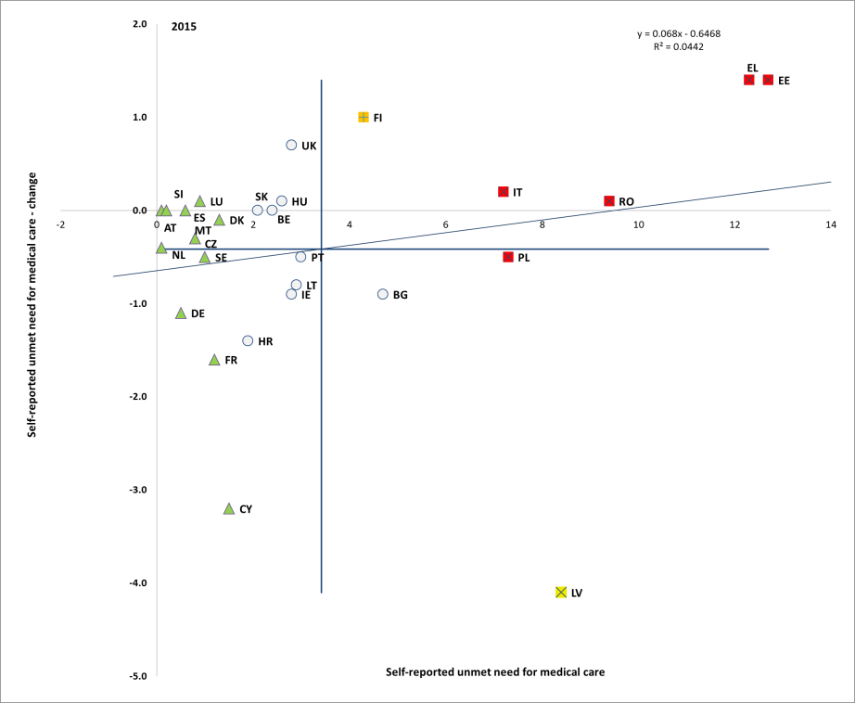
Source: Eurostat, SILC. Period: 2015 levels and yearly changes with respect to 2014. Note: Axes are centred on the unweighted EU average. The legend is presented in the Annex.

The unmet healthcare needs specifically affect low income households. On average in the EU, 5.5% of people in the bottom income quintile reported an unmet need for medical care in 2015, against 1.4% in top quintile. This share is particularly high in Greece, Italy and Latvia (above 15%), although Latvia reduced this share by one third compared to the previous year. The income quintile gap has shrunk, on average in the EU, in 2015.
Healthcare is financed through different schemes, while the relative importance of each scheme varies among Member States. In 2014, out-of-pocket payments, i.e. household expenditure for health (including medical goods) not reimbursed by any scheme or paid as cost-sharing with an organised scheme, measured as a share of current health expenditure is above 30% in Bulgaria, Cyprus, Latvia, Greece and Lithuania (Figure 45).

Figure 45: Healthcare expenditure by financing source, 2014
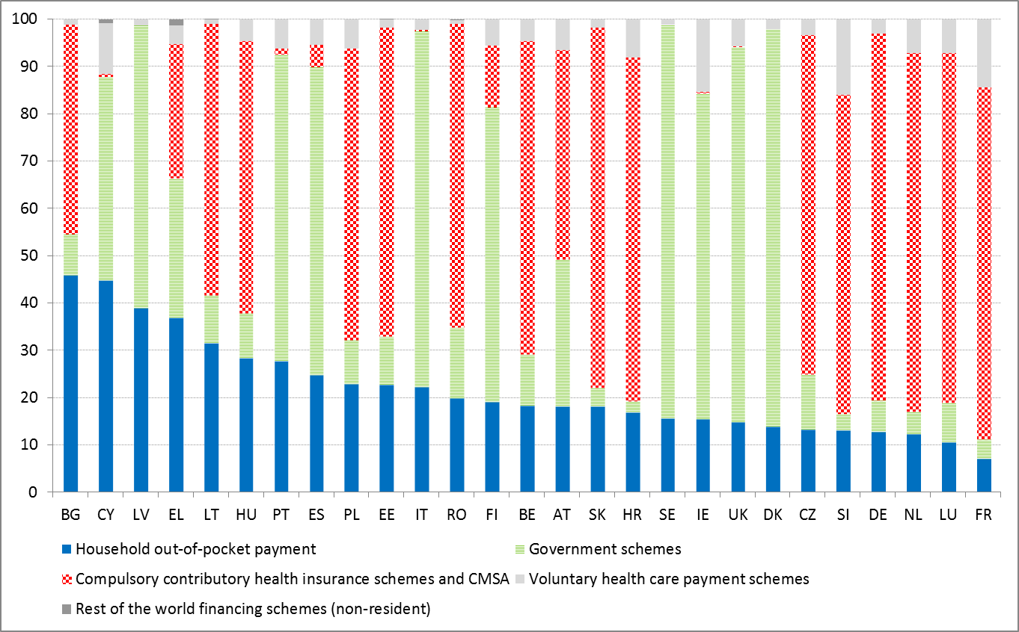
Source: Eurostat [hlth_sha11_hf]. Notes: Data are collected according to Commission Regulation (EC) 2015/359 as regards statistics on healthcare expenditure and financing (System of Health Accounts 2011 manual). Data for 2015 not available for all MS at 31 October 2017.

3.4.2 Policy response
Modernisation of systems goes hand in hand with improvements in the coverage, design and adequacy of benefits. Romania adopted in 2016 a reform aiming at substantial increase in the adequacy and coverage of benefits, as well as activation for Guaranteed Minimum Income beneficiaries (to enter into force in April 2018). In Greece, a nationwide Guaranteed Minimum Income scheme was launched, providing for eligible people/families financial assistance, improved access to social services and goods, and activation measures. The scheme is expected to cover around 7% of the Greek population. In Slovenia, following the assessment of the previous reform (that increased minimum income, introduced one-stop-shops, enhanced simplification and shifted focus towards employment activation), a new project was prepared for 2017-2022 in view of providing a wider range of tailor-made services and additional linkages between social and employment programmes. In Italy, the enabling law adopted in March 2017 introduces for the first time a structural income support measure (Reddito di inclusione) with stable funding addressed to people in poverty. The measure combines income support with activation measures and with a reinforcement of services. In France, while the former reform (Revenue de solidarité active) had addressed potential welfare inactivity traps, a new reform (Prime d'activité) aimed in 2016 at better coordination and simplification of the existing benefits and enhanced access in particularly for young people. Measures in the field of unemployment benefits and extension of social protection schemes to self-employed and atypical workers are discussed in Section 3.3.
Reforms to the delivery of social services aim at improving access and quality, and respond to the increase in the complexity of clients' needs. In 2016, Slovakia adopted an ambitious action plan on long-term unemployment to provide tailor-made services, while Romania has put together integrated social teams to work with the most excluded groups. In Estonia, the implementation of the Social Welfare Act and measures of the Action Plan 2016-2020 to the Welfare Development Plan 2016-2023, aiming at ensuring the provision and accessibility of high-quality social services, is ongoing. Greece is rolling out a network of local community centres serving as one-stop-shops for social services.
A number of Member States have undertaken reforms in the field of access to housing. Romania adopted a national strategy aimed at addressing barriers for persons with disabilities and targeting the protection and promotion of rights of these persons. Ireland adopted an integrated system for housing support which allows, on the one hand, all social housing to be accessed through local authorities and, on the other hand, recipients to take up full-time employment while retaining the housing support they receive. Malta adopted a new rent subsidy measure allowing the Housing Authority to extend the criteria that is expected to double the number of families eligible. Sweden increased the income limit for disadvantaged households receiving housing allowance for families with children. The Czech Republic and Lithuania plan the adoption of new measures to provide access to adequate social housing for vulnerable people. Greece is preparing a new means-tested housing benefit system.
Substantial measures aimed at increasing access to health services, whilst maintaining the quality and sustainability of the system, have been introduced and implemented. The efforts to shift the focus of care to primary healthcare, ensuring coordinated operations with other parts of the health system, are taking place in almost all Member States, and in particular in Malta, Bulgaria, Poland, Estonia and Austria. In addition to primary care development, increased funding has been allocated to raise the accessibility of certain healthcare services in Sweden. Waiting times have been reduced in Latvia and Malta, and some parts of the ambulatory care system in Romania were reorganised. Promotion of good health is increasingly recognised as a means to prevent avoidable diseases and related treatment, to reduce health inequalities caused by social determinants, and to enhance the sustainability of health systems. Several Member States are taking action in this area: for instance, Romania is investing in cancer screening, France plans to increase the number of obligatory vaccinations and the price of tobacco, and Lithuania will ban as of 2018 the advertising of alcohol products, increase the legal age for alcohol consumption to 20 years and restrict sales hours. Furthermore, some steps have been taken to reinforce the provision of outpatient care in Bulgaria where the low public coverage of outpatient medical services makes it difficult for some people to access to healthcare. In Cyprus, a major reform was adopted in June 2017 to entitle until 2020 universal access to healthcare, reduce out-of-pocket payments, and to ensure hospital autonomy under a national hospitals agency. The Portuguese health system has undergone significant reforms during 2016 and 2017 that have strengthened its capacity to keep on ensuring universal health coverage. In Austria, a new system of payment for the hospital ambulatory area has been introduced in order to relieve pressure from the stationary care and foster day clinic and ambulatory services within hospitals. Reforms to combat the insufficient availability of healthcare workforce are underway in Poland and Latvia. Romania and Hungary have made steps in increasing wages for health care workers. In addition, support measures aimed at attracting medical practitioners and nurses to work in peri-urban or rural areas are to be launched in Latvia, Poland, Portugal and Romania. Measures have been introduced to reduce waiting times for healthcare services through the development of an IT system in Italy, Portugal, Slovenia and Malta. In addition, reforms aimed at reducing the pharmaceutical expenditure and ensure accessibility and the cost- effective use of medicines, such as centralization of procurement, uptake of generics and development of Health Technology Assessment bodies are underway in Portugal, Spain, Italy and Slovakia. Finally, plans to enhance accountability and transparency mechanisms the health system have started in Romania and Latvia.
Ensuring access to affordable and good quality long-term care is essential to address ageing and subsequent increases in the number of dependent elderly people and long-term care needs. Reforms in Member States mainly focus on improving the long-term care systems' organisation, integration, financing and quality. Luxembourg is preparing a reform of long-term care insurance which revises the procedures and tools for assessing and determining dependency, and establishes transparent and efficient quality control policy. Slovenia continues to prepare a reinforcement of care integration, organisation and financing. Likewise, Latvia is planning to improve social services support system by improving their financing, defining staff qualifications and establishing levels of assistance. After numerous cutbacks in this area in previous years, more investment in support to local authorities is planned in the United Kingdom to spend on adult social care services. In Germany, a new definition of needs was followed by the introduction of a new assessment tool in 2017. Some reforms aim at improving the situation of informal carers, including enhanced financial support. In Romania, the government approved the financial centralization of the salary costs of personal assistants for severely disabled. In Malta, carers' pensions and carers' allowances were reformed and increased. The amounts were raised also in the Czech Republic. In Austria, the clawback of nursing costs of people in long-term care was abolished, which could be a step towards more universal and affordable provision of services.
The recent wave of pension reforms often features measures to safeguard the adequacy of pensions. They complement the former reform steps focusing on later retirement and the sustainability of pension systems. In particular, a number of countries have adopted measures aimed to safeguard lower pensions. Latvia and Austria have introduced additional safeguards for pensioners with long careers, while Bulgaria, Malta, Romania and Slovenia (for pensioners who fulfil the full retirement conditions) have raised minimum pensions. Latvia, Malta and Romania have raised the threshold under which tax is not paid, which should in particular benefit recipients of lower pensions. Lithuania has introduced a more favourable indexation mechanism. Several countries have also adopted measures focused on the retirement age. Germany and Austria have sought to promote longer working lives by allowing more flexible transition into retirement and combining pension with income from work. In other Member States some reforms, however, go in the opposite direction. Most notably, Poland has reversed earlier reforms by reintroducing lower pensionable ages for men and women (65 and 60 years respectively), in spite of the considerable impact which (the projected) demographic ageing is likely to have, while Finland has introduced a one-off measure of easier access to early retirement for the very long-term unemployed over the age of 60.
Reforms to disability benefits and caring provisions complement employment policies for persons with disabilities. Estonia has increased the provision of childcare for children with disabilities from 57-80 hours to 270 hours per year. Malta has reformed and increased disability pensions by introducing a three-tier payment system linked to the degree of disability. It also put in place the reform of the Carers' Pension and the Carers' Allowance, thus increasing allowances to carers and making carers' pension payable without the need for means-testing. In Romania there was a financial centralisation of salaries for caregivers for people with severe disabilities to provide them from the central level instead of the local ones as the local budgets were often not able to cover them. Bulgaria has increased the allowance for children with disabilities.

ANNEXES
Annex 1. Social scoreboard headline indicators, levels
Source: Eurostat.
* indicates indicators previously included in the scoreboard of key employment and social indicators.
Note: EUnw and EAnw refer to the non-weighted averages for EU and the euro area.
Flags – b: break in time series; e: estimated; p: provisional; u: low reliability.

Annex 1 (continued). Social scoreboard headline indicators, levels
Source: Eurostat.
* indicates indicators previously included in the scoreboard of key employment and social indicators.
Note: EUnw and EAnw refer to the non-weighted averages for EU and the euro area. Real GDHI per capita is measured using 'unadjusted income' (i.e. without including social transfers in kind) and without correction for purchasing power standards.
Flags – b: break in time series; e: estimated; p: provisional; u: low reliability.

Annex 1 (continued). Social scoreboard headline indicators, levels
Source: Eurostat.
* indicates indicators previously included in the scoreboard of key employment and social indicators.
Note: EUnw and EAnw refer to the non-weighted averages for EU and the euro area.
Flags – b: break in time series; e: estimated; p: provisional; u: low reliability.

Annex 2. Social scoreboard headline indicators, changes and distance to EU
Source: Eurostat.
* indicates indicators previously included in the scoreboard of key employment and social indicators.
Note: EUnw and EAnw refer to the non-weighted averages for EU and the euro area. At 31th October 2017, statistical significance estimates for changes and differences to the EU average of SILC-based indicators are not yet available.
Flags – b: break in time series; e: estimated; p: provisional; u: low reliability.

Annex 2 (continued). Social scoreboard headline indicators, changes and distance to EU

Source: Eurostat.
* indicates indicators previously included in the scoreboard of key employment and social indicators.
Flags – b: break in time series; e: estimated; p: provisional; u: low reliability.
Note: real GDHI per capita is measured using 'unadjusted income' (i.e. without including social transfers in kind) and without correction for purchasing power standards.
Note: EUnw and EAnw refer to the non-weighted averages for EU and the euro area. At 31th October 2017, statistical significance estimates for changes and differences to the EU average of SILC-based indicators are not yet available.

Annex 2 (continued). Social scoreboard headline indicators, changes and distance to EU

Source: Eurostat.
* indicates indicators previously included in the scoreboard of key employment and social indicators.
Flags – b: break in time series; e: estimated; p: provisional; u: low reliability
Note: EUnw and EAnw refer to the non-weighted averages for EU and the euro area. At 31th October 2017, statistical significance estimates for changes and differences to the EU average of SILC-based indicators are not yet available.

Annex 3. Methodological note on the identification of trends and levels in the scoreboard
In mid-2015 the European Commission, the Employment Committee and the Social Protection Committee agreed on a methodology for assessing Member States' performance on the scoreboard of key employment and social indicators. As part of the agreement, the methodology aimed at providing, for each indicator, a measure of the relative standing of each MS within the distribution of the indicator values (scores) of the EU. The methodology is applied jointly to year-levels (levels) as well as to one-year changes (changes), thus enabling a holistic assessment of MS performance.
For the 2018 Joint Employment Report, the Commission in agreement with Member States, has decided to apply the methodology to the new social scoreboard accompanying the European Pillar of Social Rights.
In detail, for each indicator, levels and changes are converted to standard scores (also known as z-scores), which allow to apply the same metric to all the indicators. This is achieved by standardising raw values of both levels and changes according to the formula:
$${z-score for MS}_{X}= \frac{\left[{MS}_{X} indicator -average \left(MS indicator\right)\right]}{standard deviation (MS indicator)}$$
Then the distributions of scores (separately for levels and changes) are analised, and the observations that significantly deviate from the average level/change are detected.
This approach enables expressing for each Member State its raw indicator value in terms of how many standard deviations it deviates from the (unweighted) average. Then the performance of each MS is assessed and classified on the basis of the resulting z-scores against a set of pre-defined thresholds, set as standard deviation multiples.
The most important issue within this approach is setting cut-off points. Given that no parametric assumption can be made about the distribution of the observed raw values for the employment indicators, it is common to use a “rule of thumb” in selecting the thresholds. According to the analysis of the key indicators used in the scoreboard, it was agreed to consider:
- Any score below -1 as a very good performance
- Any score between -1 and -0.5 as a good performance
- Any score between -0.5 and 0.5 as a neutral performance
- Any score between 0.5 and 1 as a bad performance
- Any score higher than 1 as a very bad performance

Table 2: Z-scores threshold values
 | z-scores threshold values
 | -1.0 | - 0.5 | 0 | 0.5 | 1.0
 | (lower than) | (lower than) | (between) | (Higher than) | (Higher than)
 | Assessment
Levels | Very Low | Low | On average | High | Very High
Changes | Much lower than average | Lower than average | On average | Higher than average | Much higher than average
By combining the evaluation of levels and changes it is then possible to classify the overall performance of a country according to each indicator within one of the following seven categories. The colour coding is reflected in the respective figures in the body of the report.
The tables below provide the classification based on z-scores for those indicators for which a low value is assessed as a good performance (e.g. unemployment rate, AROPE, etc).
Best performers | scoring less than -1.0 in levels and less than 1.0 in changes | Member States with levels much better than the EU average and with the situation improving or not deteriorating much faster than the EU average
Better than average | scoring between -1.0 and -0.5 in levels and less than 1 in changes or scoring between -0.5 and 0.5 in levels and less than -1.0 in changes | Member States with levels better than the EU average and with the situation improving or not deteriorating much faster than the EU average
Good but to monitor | scoring less than -0.5 in levels and more than 1 in changes, and presenting a change higher than zero | Member States with levels better or much better than the EU average but with the situation deteriorating much faster than the EU average
On average / neutral | scoring between -0.5 and 0.5 in levels and between -1.0 and 1.0 in changes | Member States with levels on average and with the situation not improving nor deteriorating much faster than the EU average
Weak but improving | scoring more than 0.5 in levels and less than -1.0 in changes | Member States with levels worse or much worse than the EU average but with the situation improving much faster than the EU average
To watch | scoring between 0.5 and 1.0 in levels and more than -1.0 in changes or scoring between -0.5 and 0.5 in levels and more than 1.0 in changes | This category groups two different cases: i) Member States with levels worse than the EU average and with the situation deteriorating or not improving sufficiently fast; ii) Member States with levels in line with the EU average but with the situation deteriorating much faster than the EU average
Critical situations | scoring more than 1.0 in levels and more than -1.0 in changes | Member States with levels much worse than the EU average and with the situation deteriorating or not improving sufficiently fast

The tables below provide the classification based on z-scores for those indicators for which a high value is assessed as a good performance (e.g. employment rate, participation into childcare, etc).
Best performers | scoring more than 1.0 in levels and more than -1.0 in changes | Member States with levels much better than the EU average and with the situation improving or not deteriorating much faster than the EU average
Better than average | scoring between 1.0 and 0.5 in levels and more than -1.0 in changes or scoring between -0.5 and 0.5 in levels and more than 1.0 in changes | Member States with levels better than the EU average and with the situation improving or not deteriorating much faster than the EU average
Good but to monitor | scoring more than 0.5 in levels and less than -1.0 in changes, and presenting a change lower than zero | Member States with levels better or much better than the EU average but with the situation deteriorating much faster than the EU average
On average / neutral | scoring between -0.5 and 0.5 in levels and between -1.0 and 1.0 in changes | Member States with levels on average and with the situation not improving nor deteriorating much faster than the EU average
Weak but improving | scoring less than -0.5 in levels and more than 1.0 in changes | Member States with levels worse or much worse than the EU average but with the situation improving much faster than the EU average
To watch | scoring between -0.5 and -1.0 in levels and less than 1.0 in changes or scoring between -0.5 and 0.5 in levels and less than -1.0 in changes | This category groups two different cases: i) Member States with levels worse than the EU average and with the situation deteriorating or not improving sufficiently fast; ii) Member States with levels in line with the EU average but with the situation deteriorating much faster than the EU average
Critical situations | scoring less than 1.0 in levels and less than 1.0 in changes | Member States with levels much worse than the EU average and with the situation deteriorating or not improving sufficiently fast

Cut-off points summary table
 |  | Very low | Low | On average | High | Very high
Early leavers from education and training  (% of poulation aged 18-24) | Levels | less than 5.1% | less than 7.3% | between 7.3% and 11.7% | more than 11.7% | more than 13.9%
 | Changes | less than -1.4pps | less than -0.9pps | between -0.9pps and 0.2pps | more than 0.2pps | more than 0.7pps
Gender employment gap (pps) | Levels | less than 4.9pps | less than 7.8pps | between 7.8pps and 13.6pps | more than 13.6pps | more than 16.4pps
Gender employment gap (pps) | Changes | less than -0.8pps | less than -0.4pps | between -0.4pps and 0.3pps | more than 0.3pps | more than 0.7pps
Income quintile ratio (S80/S20) | Levels | less than 3.8 | less than 4.4 | between 4.4 and 5.7 | more than 5.7 | more than 6.3
Income quintile ratio (S80/S20) | Changes | less than -0.4 | less than -0.2 | between -0.2 and 0.1 | more than 0.1 | more than 0.3
At risk of poverty or social exclusion (%) | Levels | less than 16.7% | less than 20.2% | between 20.2% and 27.3% | more than 27.3% | more than 30.8%
At risk of poverty or social exclusion (%) | Changes | less than -1.5pps | less than -1.0pps | between -1.0pps and 0.0pps | more than 0.0pps | more than 0.5pps
Youth NEET (% of total population aged 15-24) | Levels | less than 6.9% | less than 9.0% | between 9.0% and 13.1% | more than 13.1% | more than 15.2%
Youth NEET (% of total population aged 15-24) | Changes | less than -1.5pps | less than -1.1pps | between -1.1pps and -0.3pps | more than -0.3pps | more than 0.1pps
Employment rate (% population aged 20-64) | Levels | less than 65.2% | less than 68.1% | between 68.1% and 73.8% | more than 73.8% | more than 76.7%
Employment rate (% population aged 20-64) | Changes | less than 0.4pps | less than 0.7pps | between 0.7pps and 1.4pps | more than 1.4pps | more than 1.7pps
Unemployment rate (% population aged 15-74) | Levels | less than 4.2% | less than 6.4% | between 6.4% and 10.9% | more than 10.9% | more than 13.1%
Unemployment rate (% population aged 15-74) | Changes | less than -1.7pps | less than -1.3pps | between -1.3pps and -0.6pps | more than -0.6pps | more than -0.2pps
Participation in activation labour market policies (per 100 persons wanting to work) | Levels | less than 8.2% | less than 16.0% | between 16.0% and 31.5% | more than 31.5% | more than 39.3%
 | Changes | less than -4.9pps | less than -2.2pps | between -2.2pps and 3.3pps | more than 3.3pps | more than 6.pps
Real GDHI per capita (2008 = 100) | Levels | less than 94.8 | less than 98.5 | between 98.5% and 105.9 | more than 105.9 | more than 109.5
Real GDHI per capita (2008 = 100) | Changes | less than 0.8pps | less than 1.1pps | between 1.1pps and 1.8pps | more than 1.8pps | more than 2.1pps
Compensation of employees per hour worked (EUR) | Levels | less than 7.8 € | less than 13.9 € | between 13.9 € and 25.9 € | more than 25.9 € | more than 32.0 €
Compensation of employees per hour worked (EUR) | Changes | less than -0.5pps | less than -0.1pps | between -0.1pps and 0.6pps | more than 0.6pps | more than 0.9pps
Impact of social transfers (other than pensions) on poverty reduction (%) | Levels | less than 21.9% | less than 27.7% | between 27.7% and 39.5% | more than 39.5% | more than 45.3%
 | Changes | less than -3.5pps | less than -2.2pps | between -2.2pps and .5pps | more than 0.5pps | more than 1.8pps
Children aged less than 3 years in formal childcare (%) | Levels | less than 8.9% | less than 18.5% | between 18.5% and 37.5% | more than 37.5% | more than 47.0%
Children aged less than 3 years in formal childcare (%) | Changes | less than -3.7pps | less than -1.5pps | between -1.5pps and 2.8pps | more than 2.8pps | more than 5.0pps
Self-reported unmet need for medical care (%) | Levels | less than 0.2% | less than 1.6% | between 1.6% and 4.4% | more than 4.4% | more than 5.8%
Self-reported unmet need for medical care (%) | Changes | less than -2.pps | less than -1.5pps | between -1.5pps and -0.4pps | more than -0.4pps | more than 0.2pps
Individuals who have basic or above basic overall digital skills (% of population aged 16-74) | Levels | less than 41.6% | less than 48.6% | between 48.6% and 62.6% | more than 62.6% | more than 69.6%
 | Changes | less than -2.1pps | less than -0.9pps | between -0.9pps and 1.6pps | more than 1.6pps | more than 2.9pps

Annex 4: Summary overview of the ‘employment trends to watch’ and number of Member States with deterioration or improvement as identified by the Employment Performance Monitor 2017 (EPM), endorsed by the EPSCO Council in October 2017.
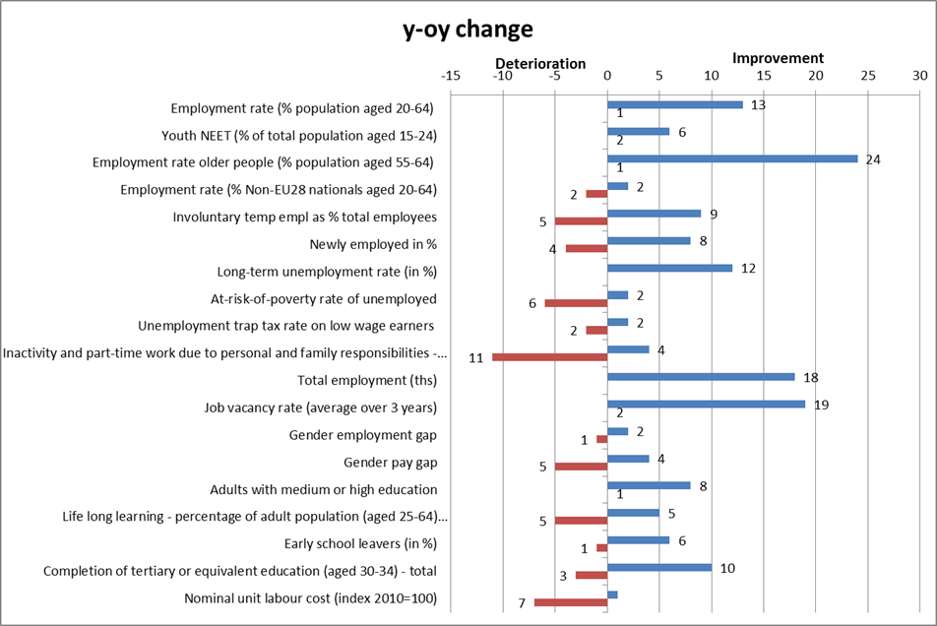
Note: 2015-2016 changes, except 2014-2015 for at-risk-of poverty rate of unemployed, unemployment trap and gender pay gap.

Annex 5: Summary overview of the ‘social trends to watch’ and number of Member States with deterioration or improvement as identified by the Social Protection Performance Monitor 2017, endorsed by the EPSCO Council in October 2017.
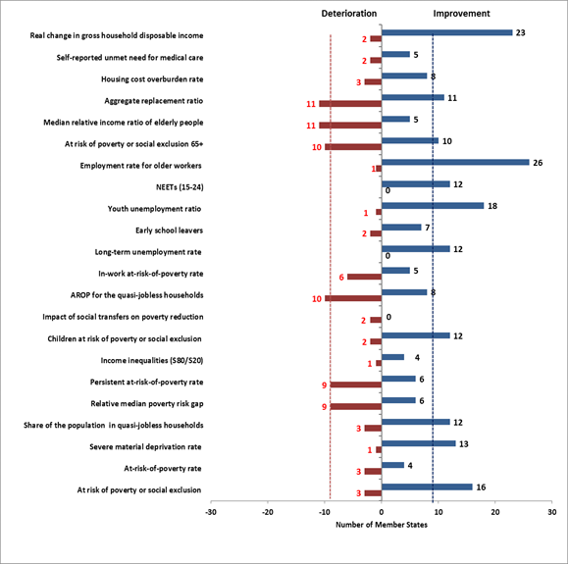
Note: for EU-SILC based indicators the changes generally actually refer to 2013-2014 for income and household work intensity indicators, and to 2014-2015 for unmet need for medical care. Changes in gross household disposable income refer to 2014-2015. LFS-based indicators (LTU rate, early school leavers, youth unemployment ratio, NEETS (15-24), ER (55-64)) and SMD figures (not yet final for 2016 for several MS) refer to the period 2015-2016.

Together with the draft Joint Employment Report the Commission has adopted a proposal for revised Employment Guidelines (COM(2017) 677).
Seasonally adjusted quarterly figures [lfsi_emp_q] are used throughout this section.
For details, see Employment and Social Developments in Europe, Annual Review 2017 (p. 22) and Labour Market and Wage Developments in Europe, Annual Review 2017 (pp. 10 and 19).
Nonetheless, the employment rate of low-skilled workers has increased more than proportionally (by 1.1 pps) in view of the decline of the population aged 25-64 with lower secondary education or below.
Employment and Social Developments in Europe, Annual Review 2017, p. 39.
For more details, see Employment and Social Developments in Europe, Quarterly Review - October 2017, pp. 33-34.
Individuals who are at risk of poverty (AROP) and/or suffering from severe material deprivation and/or living in households with zero or very low work intensity.
The average number of people at risk of poverty or social exclusion for EU-28 in 2008 is based on an estimation by Eurostat, as figures for Croatia are only available from 2010 on.
People are considered at-risk of poverty (AROP) if their equivalised disposable income is below 60% of the national equivalised median income.
The figure is computed based on 2015 incomes, with the exception of United Kingdom (survey year) and Ireland (income of 12 months preceding the survey). NB: data for Ireland not available at 31 October 2017.
Severe Material Deprivation (SMD) is defined as the enforced inability to pay for at least four of the deprivation items: (1) pay rent/mortgage/ utility bills on time; (2) keep home adequately warm; (3) meet unexpected expenses; (4) eat meat, fish or a protein equivalent every second day; (5) one week holiday away from home; (6) own a car; (7) a washing machine; (8) a colour TV; (9) a telephone.
People aged 0-59 living in households where the adults (excluding dependent children) worked less than 20 % of their total work-time potential in the previous 12 months.
SWD(2017) 200 final, accompanying the Communication COM(2017) 250 final of 26 April 2017.
Headline indicators which were also included in the old scoreboard are marked with an asterisk in Annex 1.
All but a few of these indicators are part of the existing assessment frameworks and tools jointly agreed with the Employment Committee and the Social Protection Committee, i.e. the Joint Assessment Framework (JAF) and the dashboards included in the Employment Performance Monitor (EPM) and the Social Protection Performance Monitor (SPPM). The Employment Committee and the Social Protection Committee (and their Indicator Sub-Groups) have discussed the practical implementation of the Scoreboard, following its adoption in April 2017. In this context, the Committees have agreed the use of headline indicators in the 2018 Joint Employment Report, and to assess Member States' performance through the commonly agreed methodology applied in previous Joint Employment Reports.
As part of the discussions with the Employment Committee and the Social Protection Committee on the full Social Scoreboard, (a number of) Member States have expressed a preference for finding for indicators 8 and 10 two alternative indicators.
As demanded by the Committees, this indicator is measured using 'unadjusted income' (i.e. without including social transfers in kind) and dropping reference to the use of purchasing power standards (PPS) units.
This is measured as the difference, among total population, between the share of people at risk of poverty rate before and after social transfers.
With the exception of the Gross Disposable Household Income, which is measured as an index number (2008=100, thus reflecting a change compared to pre-crisis) and changes in the latest year.
COM(2017) 250 final.
COM(2015) 600 final.
The guidelines have been fully reflected for the first time in the 2016 National Reform Programmes.
Including LABREF database, available at http://ec.europa.eu/social/main.jsp?catId=1143&intPageId=3193.
European Commission (2017). Labour Market and Wage Developments in Europe. Annual review 2017. Luxembourg: Publications Office of the European Union.
European Commission (2017). Employment and Social Developments in Europe. Annual Review 2017. Luxembourg: Publications Office of the European Union.
When looking at social scoreboard figures according to the common methodology, the report uses the concept of convergence in levels, or "beta-convergence". This refers to the situation where indicators in worse-performing countries improve faster than in best performing ones. It can be assessed by looking at the slope of the regression line in the scatterplot of levels against changes.
See Chapter 2 and Annex 2 for details.
Analysis in the Labour Market and Wage Developments report 2017 (p. 11) shows that dispersion of unemployment rates is decreasing since 2014.
Labour Market and Wage Developments report 2017 (p. 44).
Labour productivity per hour worked grew by only 0.6% in 2016, both in the EU and in the euro area.
The annual variation for the United Kingdom is strongly affected by the considerable changes in the EUR to GBP exchange rate.
Labour Market and Wage Developments report 2017 (p. 45).
Labour Market and Wage Developments report 2017 (p. 49).
Labour Market and Wage Developments report 2017 (p. 16).
The tax wedge on labour is composed of personal income taxes plus employers' and employees' social security contributions. Contributions to occupational and private pension schemes, as well as targeted tax reliefs, are not included in the calculation. For instance, in the case of France the impact of the CICE (Crédit d'impôt pour la compétitivité et l'emploi) is not accounted by the indicator.
Tax and benefits database, European Commission/OECD.
Detailed information on recent trends including on different income groups can be found in: Tax Policies in the European Union – 2017 Survey, European Commission, DG TAXUD.
The average exchange rate for 2017 up to 31 October is used here and in similar cases throughout the report.
In particular, non-EU born young (18-24) faced in 2016 an early school leaving rate around 19.4%, almost double than the native-born (9.8%).
Based on EU-SILC data.
In the PISA survey, students are considered as having a migrant background if they are either foreign-born (first-generation) or natives whose parents are both foreign-born (second-generation).
Education and Training Monitor 2017, p. 38, Figure 15.
According to 2015 PISA, the share of low performers in EU Member States was 39.1% among foreign-born pupils and 29.5% among natives with foreign-born parents, much higher than the 18.9% recorded for pupils without a migrant background.
European Commission, Education and Training Monitor, available at: http://ec.europa.eu/education/policy/strategic-framework/et-monitor_en.
Based on EU-SILC data.
Low level of education includes qualifications at ISCED levels 0-2; medium level at ISCED levels 3-4 and high level at ISCED levels 5-8.
Though, in some countries (such as in Finland and Bulgaria) those with VET qualification are only able to secure salaries that are similar to people who even do not possess a medium-level qualification, while in others those with VET qualification receive only slightly lower wages compared to those who graduate from higher education (such as in Denmark or Italy).
The Digital Economy and Society Index, European Commission.
Eurofound (2016) 'Exploring the Diversity of NEETs', Publications Office of the European Union, Luxembourg.
Ageing Report 2015.
The reference indicator is the unadjusted gender pay gap (i.e. not adjusted according to individual characteristics that may explain part of the earnings difference), which should give an overall picture of gender inequalities in terms of pay. Research shows that most of the gender pay gap persists even when differences in educational attainment, occupational choice, working hours and other observable attributes are taken into account (e.g. http://ec.europa.eu/justice/gender-equality/files/gender_pay_gap/2016_factors_gpg_en.pdf).
European Commission, 2017 Report on equality between women and men in the EU.
See Employment and Social Developments in Europe, Annual Review 2016, chapter 3.
Migrants for family reasons are the biggest share among non-EU born people (52% in 2014). Their employment rate was 53% in 2014, even lower than refugees (56%).
The share of non-EU born (aged 25-54) with high level of education increased from 25.4% to 30.9% from 2010 to 2016, see [edat_lfs_9912].
The gap in the employment rate among non-EU born and native-born is the most pronounced among those with tertiary education, highlighting that migrants face lower returns on their education compared to natives (see also Employment and Social Developments in Europe 2015). In 2016, 35% of non-EU born with high education worked in low- or medium-skilled occupations compared to 21% among native-born. The rate of over-qualification among non-EU born was higher than 50% in countries such as EL, IT, CY and ES.
The share of people with a migrant background is about or somewhat above 20% in countries such as France and Germany, and above 30% among the children below 6 years.
Figures on employment of people with disabilities do not fully show how limited their participation in the labour market is; they need to be looked at together with activity rates which are also disproportionately low. In 2015, the activity gap (20-64 age group) between people with and without disabilities in the EU amounted to 22.4 pps (59.5% versus 81.9%).
COM(2017) 247 final on "A renewed EU agenda for higher education" and COM(2017)248 final on "School development and excellent teaching for a great start in life". The latter identifies three main school policy challenges which virtually all Member States are facing: 1) weaknesses in reading, mathematics and science skills; 2) the excessive impact of socio-economic background on educational achievement; 3) insufficient digital competences. It then indicates where EU and Member States' action is needed: to develop better and more inclusive schools; to support teachers and school leaders; and to make the governance of school education systems more effective, equitable and efficient.
http://data.consilium.europa.eu/doc/document/ST-14441-2015-INIT/en/pdf
COM(2017)247 final.
Notably, in 2016, the European Commission launched a new initiative to showcase excellence and quality of VET in Europe as well as to raise awareness of opportunities vocational training provides for both young and adults. In its first edition, the European Vocational Skills Week was able to mobilise 800 000 stakeholders in Europe with the aim to improve the image and attractiveness of VET.
OJ C 484/1, 24.12.2016. http://eur-lex.europa.eu/legal-content/EN/TXT/?uri=OJ:JOC_2016_484_R_0001
Council Recommendation of 10 March 2014 on a Quality Framework for Traineeships, 2014/C 88/01.
Additional detailed analysis on labour market segmentation and its determinants can be found in Part 2 of European Commission (2017), Labour Market and Wage Developments in Europe. Annual Review 2017. Luxembourg: Publications Office of the European Union, 2017.
Those who have been unemployed for less than one year.
See: Venn (2012), “Eligibility Criteria for Unemployment Benefits: Quantitative Indicators for OECD and EU Countries”, OECD Social, Employment and Migration Working Papers, No. 131, OECD Publishing, Paris, and Langenbucher, K. (2015), “How demanding are eligibility criteria for unemployment benefits, quantitative indicators for OECD and EU countries”, OECD Social, Employment and Migration Working Papers, No. 166, OECD Publishing, Paris.
The indicators are based on aggregation of a number of items, with score on a scale from 1 (least strict) to 5 (most strict).
Also known as "El Khomri law". A detailed description of the law is provided in the 2017 JER.
The first 2-year-cycle of the Benchlearning exercise, which consists of a self-assessment as well as an external peer and expert review of each PES, was finished in 2016. Each PES received customised recommendations on how to improve their organisational capacity as well as their service provision. Based on these, PES initiated change processes on which they reported back to the network one year after the assessment had taken place. Furthermore the assessment results are used to develop and steer the network’s mutual learning programme. In 2017 the second cycle of benchlearning was launched. This cycle will focus on how the PES are implementing and managing their change processes.
GDHI is measured using 'unadjusted income' (i.e. without including social transfers in kind), in real terms. Data not available for HR, LU and MT. At 31st October 2017, data for 2016 were only available for 18 Member States.
In this chapter, for SILC-based indicators, 2009 is used as a reference year for pre-crisis – as it encompasses 2008 incomes.
See Chapter 1.2 for definitions of at-risk-of-poverty or social exclusion and its sub-components.
In addition, Ireland presented a high share of people living in low-work intensity households (19.2%) in 2015.
Based on EU-SILC 2015 data, 36.1% of people with severe disabilities (aged 16+) were at risk of poverty or social exclusion (compared to 27.4% of people with moderate disabilities) in the EU. The situation did not change significantly over the last years. Bulgaria had the highest risk of poverty or social exclusion for people with severe disabilities (59.9%), followed by Latvia (53.3%) and Lithuania (51.3%).
The relative median at-risk-of-poverty gap is calculated as the difference between the median equivalised total net income of persons below the at-risk-of-poverty threshold and the at-risk-of-poverty threshold, expressed as a percentage of the at-risk-of-poverty threshold (cut-off point: 60% of median equivalised income).
This topic is partly addressed also in Section 3.3.
European Social Policy Network (2017), Access to social protection for people working on non-standard contracts and as self-employed in Europe – a study of national policies, report prepared for the European Commission.
Percentage of the population living in a household where total housing costs (net of housing allowances) represent more than 40% of the total disposable household income (net of housing allowances).
Ratio of the median individual gross pensions of 65-74 relative to the median individual gross earnings of 50-59.
Self-reported unmet needs for medical care concern a person's own assessment of whether he or she needed examination or treatment for a specific type of health care, but did not have it or did not seek it because of the following three reasons: ‘Financial reasons’, ‘Waiting list’ and ‘Too far to travel’. The problems that people report in obtaining care when they are ill often reflect significant barriers to care.
With specific reference to Greece, the dramatic reduction of salaries and the surge in unemployment in a fragmented health insurance system with weak redistribution caused a considerable drop in coverage and eligibility for public healthcare. While there is evidence of overconsumption of healthcare services before the crisis in Greece (as reflected by the high level of out-of-pocket payments), this became no longer affordable with the crisis. Universal coverage was introduced by subsequent reforms in 2014 and in 2016. The impact of these reforms on unmet needs is not yet captured by available data.
Out-of-pocket spending refers to direct payments for goods and services from the household primary income or savings, where the payment is made by the user at the time of the purchased of goods or the use of the services either without any reimbursement or as cost-sharing with an organised scheme.
The access to social services and activation measures are supported by the European Social Fund (ESF).
Diagnosis-related group based payment system.
Both normality and T-shaped distribution tests were carried out resulting in the rejection of any distributional hypothesis.
In case of normality, chosen cut-off points roughly corresponds to 15 %, 30%, 50%, 70% and 85% of cumulative distribution.
The latter condition prevents a Member State presenting "low" or "very low" level to be flagged as "deteriorating" when showing a change "much higher than average", but still decreasing.
The latter condition prevents a Member State presenting "high" or "very high" level to be flagged as "deteriorating" when showing a change "much lower than average", but still increasing.

