

|  |
| --- |
| *The alert mechanism report (AMR) is the starting point of the annual cycle of the macroeconomic imbalance procedure (MIP), which aims to identify and address imbalances that hinder the smooth functioning of the economies of Member States or the economy of the EU and may jeopardise the proper functioning of the economic and monetary union.*  *The AMR uses a scoreboard of selected indicators, plus a wider set of auxiliary indicators and additional relevant information, to screen Member States for potential economic imbalances in need of policy action. The AMR identifies Member States for which analysis in an in-depth review (IDR) is needed to assess how macroeconomic risks in the Member States are accumulating or winding down, and to conclude whether imbalances or excessive imbalances exist. Taking into account discussions with the European Parliament and within the Council and the Eurogroup on the AMR, the Commission will then prepare IDRs for the Member States. Following established practice, an IDR is in any event prepared for Member States for which imbalances were identified in the previous round of IDRs. IDR findings will feed into the country-specific recommendations (CSRs) under the European semester of economic policy coordination. The IDRs are expected to be published in February 2018 as part of the country reports, ahead of the European semester package of CSRs.* |

# 1. Executive Summary

**This report initiates the seventh annual round of the macroeconomic imbalance procedure (MIP).**[1] The procedure aims to identify imbalances that hinder the smooth functioning of Member State economies and to spur appropriate policy responses. The implementation of the MIP is embedded in the European semester of economic policy coordination so as to ensure consistency with the analyses and recommendations made under other economic surveillance tools. The annual growth survey (AGS), which is adopted at the same time as this report, takes stock of the economic and social situation in Europe and sets out broad policy priorities for the EU as a whole for the coming year.

**The report identifies Member States for which in-depth reviews (IDRs) should be undertaken to assess whether they are affected by imbalances in need of policy action.**[2] The alert mechanism report (AMR) is a screening device for economic imbalances, published at the start of each annual cycle of economic policy coordination. In particular, it is based on an economic reading of a scoreboard of indicators with indicative thresholds, alongside a set of auxiliary indicators.

**The AMR emphasises euro-area considerations.** In line with proposals contained in the 22 June 2015 Report *ʽCompleting Europeʼs Economic and Monetary Unionʼ* by Jean-Claude Juncker, Donald Tusk, Jeroen Dijsselbloem, Mario Draghi and Martin Schulz, and the 21 October 2015 Commission Communication ʽ*On Steps Towards Completing Economic and Monetary Union*ʼ, the AMR also includes an analysis of the euro-area wide implications of countriesʼ imbalances and examines the extent to which a coordinated approach to policy responses is needed in light of interdependencies within the euro area. The role of interdependencies and systemic implications of imbalances is recognised in MIP legislation, which defines imbalances with reference to "macroeconomic developments which are adversely affecting, or have the potential adversely to affect, the proper functioning of the economy of a Member State or of the economic and monetary union, or of the Union as a whole".[3]

**The assessment in this report is set against the backdrop of an economic recovery that is becoming broader and more robust.** The European Commission services' autumn 2017 economic forecast estimates real GDP growth in the EU and the euro area to be 2.3% and 2.2% in 2017 respectively with positive growth in all EU countries, against the backdrop of a surge in world trade and a strengthening of domestic demand in the euro area. For 2018, the autumn forecast projects GDP expansion to remain at 2.1% in both the EU and the euro area, before edging down to 1.9% in 2019 as the recovery matures. Inflation in 2017 picked up from historically low levels but, at 1.6% by 2019, it is projected to remain below the ECB target over the forecast period; core inflation remained persistently more muted, having been below 1% in the past three years. The labour market continues to improve with unemployment rates declining and employment rates increasing, yet wage growth remains subdued even in countries with tight labour markets, which entrenches the low inflation environment, and there are wide differences between and within Member States in their labour market situation. Credit growth has resumed, while sovereign and corporate bond spreads have narrowed.

**While the recovery is facilitating the correction of macroeconomic imbalances, a number of challenges may cloud the economic backdrop going forward.** Uncertainties for the economic and policy outlook persist, mainly linked to the prospects for US fiscal and monetary policy, the rebalancing in China and emerging economies with high corporate debt, geopolitical tensions, and growing protectionist sentiments. Although broadening and consolidating, the recovery is still characterised by total factor productivity growth that remains below pre-crisis rates. Reform activity has slowed recently compared with crisis and immediate post-crisis years. Should reform efforts not continue on pace, the conditions for a durable pick-up in potential growth, as well as for expanding the room to tackle imbalances on a sustainable basis, could be undermined. As inflation gradually approaches the ECB target, the deleveraging process will be facilitated by higher nominal growth. At the same time, overcoming low inflation would open the case for monetary policy normalisation.

**The horizontal analysis presented in the AMR leads to a number of conclusions:**

* **The rebalancing needs to continue.** Although large and unsustainable current account deficits were corrected in almost every Member State before 2016, prudent external positions in net debtor countries need to be kept for the reduction of large stocks of net international investment positions (NIIPs). At the same time, large current account surpluses persist in some net-creditor countries in the euro area, and forecast downward corrections remain limited.
* **Net international investment positions remain deeply negative in some cases, against the backdrop of competitiveness developments that appear less supportive of rebalancing.** Large negative NIIP positions are recorded incountries that exhibited persistent large current account deficits in the pre-crisis period. Their improved current account positions have in most cases created the conditions for a gradual reduction in the stock of net foreign liabilities, but current accounts in balance or surplus need to be sustained in order to maintain a reduction of liabilities to prudent levels at a satisfactory pace. Competitiveness gains helped that purpose in past years, but developments in relative unit labour costs between net-debtor and net-creditor countries have started being less supportive of rebalancing more recently.
* **Private debt deleveraging is ongoing but has lost some pace recently.** Borrowing is edging up, and reductions in debt-to-GDP ratios have increasingly relied upon resuming nominal growth. At the same time, deleveraging is uneven and not always proportionate to needs. Deleveraging has been faster in the corporate than in the household sector in most Member States, underpinning low investment in some countries. Government debt dynamics have only recently embarked on a declining path in most high-debt countries.
* **Profitability in the banking sector is improving, as are stock market valuations**. Yet compressed interest rate margins, outdated business models, and large non-performing loans (NPLs) stocks in some countries remain challenges.
* **House prices are accelerating in most Member States.** Valuations are generally still below peak levels after the downward post-crisis adjustment, but in some cases available indicators point to overvaluation. Pockets of possible overheating are present and price dynamics are accelerating in a growing number of countries. Accelerations in household credit are also becoming broad based.
* **Labour markets are generally improving and tightening in most countries, while wage growth remains subdued.** The reduction in unemployment has coincided with reduceddispersion of unemployment rates across the EU, even if joblessness still high in some countries. Activity rates have generally been on the rise over the last decade, but in some countries, and for some groups, labour market participation remains low. Social distress is receding but remains high in some countries with the legacy of protracted joblessness and reduced earnings for vulnerable groups against the backdrop of generally subdued wage dynamics. While disposable household income has increased it has not yet reached its 2008 levels in real terms in some Member States. In a few countries, tight labour markets are associated with an accelerated pace of unit labour cost growth.

**Euro-area rebalancing continues to deserve careful consideration.** The euro-area current account surplus has stopped growing: it peaked at 3.3% of GDP in 2016 and is forecast to edge down to 3% this year and to remain around that level by 2019.[4] Nonetheless, the euro-area surplus remains the largest at worldwide level and is above levels consistent with economic fundamentals. The reduction of persistently large stocks of net external liabilities requires maintaining prudent external balances in net-debtor countries. At the same time, progress with the adjustment of large surpluses in net-creditor countries would help deleveraging at euro-area level to remain compatible with a sustained recovery.

**Overall, although they have begun to receede, risks remain, mainly originating from the same sources identified in the AMR 2017.** Progress in terms of external rebalancing is limited, with large surpluses remaining persistent and competitiveness developments becoming less supportive of rebalancing. The reduction of private and government debt is ongoing, increasingly as a result of resuming nominal growth, but remains uneven. Corporate deleveraging is often associated with subdued investment, and uncertainty remains on the extent to which deleveraging could rely on stronger potential growth looking forward. The banking sector situation has improved in several dimensions but challenges also remain. Signs of overheating in labour costs and housing prices are becoming more visible in a growing number of countries.

**More detailed and encompassing analyses for Member States flagged by the AMR will be performed in the IDRs**. As in recent annual cycles, IDRs will be embedded in the country reports, which provide the Commission services' analysis of the economic and social challenges in the EU Member States. This analysis then informs the European Semester country-specific recommendations (CSRs). To prepare the IDRs, the Commission will base its analysis on a rich set of data and relevant information. As established by the legislation, the IDRs will be crucial to provide the basis for the Commission to conclude whether imbalances or excessive imbalances exist, and subsequently to prepare the policy recommendations for each Member State.[5] Countries for which imbalances or excessive imbalances have been identified are, and will continue to be, subject to specific monitoring to ensure the continuous surveillance of the policies undertaken under the MIP.

**IDRs are warranted for the Member States identified with imbalances or excessive imbalances in the previous round of the MIP.** In line with established prudential practice, an IDR is needed to assess whether existing imbalances are unwinding, persisting or aggravating, while paying due attention to policies implemented by the relevant countries. Thus, the AMR calls for the preparation of IDRs for the 12 Member States identified with imbalances in light of the findings of the 2016 IDRs.[6] The countries concerned are **Bulgaria, Croatia, Cyprus, France, Germany, Ireland, Italy, the Netherlands, Portugal, Slovenia, Spain** and **Sweden**.

**On the basis of the economic reading of the scoreboard, the Commission does not deem it necessary to prepare IDRs for Member States not currently identified with imbalances.** The economic reading of the scoreboard concludes that there are no major overall additional risks compared to last year for Finland, which exited MIP surveillance in 2017. A similar conclusion is found at this stage for the countries that exited MIP surveillance in 2016 (Belgium, Hungary, Romania and the United Kingdom) and for countries not recently examined in IDRs. However, recent house prices dynamics in a number of countries (Austria, Belgium, Denmark, Finland, Hungary, Luxembourg and United Kingdom) warrant close analysis in the respective country reports even if no IDR seems necessary at this stage as risks seem limited in scope. The same holds for incipient dynamics in labour costs in some Member States (Estonia, Hungary, Latvia, Lithuania and Romania). In the case of Greece, the surveillance of imbalances and the monitoring of corrective measures continue to take place in the context of the stability support programme. Overall, the AMR therefore calls for the preparation of IDRs for 12 Member States compared to 13 in the previous cycle.

# 2. Imbalances, Risks and Adjustment: main developments across countries

**The AMR builds on an economic reading of the MIP scoreboard of indicators**, **which provides a filtering device for detecting prima-facie evidence of possible risks and vulnerabilities deserving further investigation through an IDR**. The scoreboard includes a range of 14 indicators and indicative thresholds regarding areas, such as external positions, competitiveness, private debt, housing markets, the banking sector, and employment. It relies on actual data of good statistical quality to ensure data stability and cross-country consistency. Hence, the scoreboard used for this report reflects data up to 2016. More recent data, in addition to a set of auxiliary indicators, are nevertheless taken into account in the reading of the indicators. Scoreboard values are not read mechanistically, but subject to an economic reading that enables country-specific issues and contextual considerations to be taken into account.[7]

**The scoreboard indicators highlight the persistence of imbalances and vulnerabilities related to high debt levels.** Values in excess of the threshold in the AMR scoreboard continue to be frequent when it comes to government debt, net international investment positions, and private debt (Graph 1).[8] The number of Member States with outcomes beyond the thresholds for those three indicators in 2016 is 16, 15 and 12 respectively. This is close to the outcomes of previous annual rounds, and confirms the long-lasting nature of these stock imbalances. Consistent with the ongoing job-rich recovery, the number of countries with outcomes beyond the unemployment rate threshold between 2014 and 2016 has fallen from 12 to 9, and more numerous reductions concern the youth and long-term unemployment indicators in light of their stronger sensitivity to the labour market situation. Conversely, house prices are accelerating and the scoreboard displays a growing number of Member States crossing the threshold, up to 10 from 6 in 2015 and 5 in 2014. The scoreboard indicates that currently 4 of the 5 Member States exceeding the thresholds on the current account indicator are as a result of surpluses. The number of Member States with unit labour cost pressures above the threshold has so far remained relatively stable at 3 or 4 in the past three years. Three Member States surpass the thresholds for the real effective exchange rate: in 1 case because of impaired competitiveness, in 2 cases because the real exchange rate falls below the lower threshold. The number of Member States recording export markets shares in excess of the threshold has fallen markedly with resuming export demand for EU countries.

*Graph 1:* Number of countries recording scoreboard variables beyond threshold

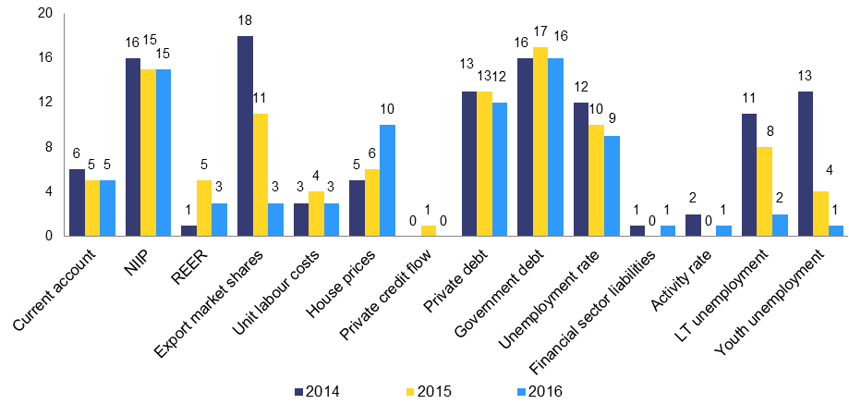

*Source:* Eurostat.

*Note:* the number of countries recording scoreboard variables beyond threshold is based on the vintage of the scoreboard published with the respective annual AMR. Possible ex-post data revisions may imply a difference in the number of countries beyond threshold computed using the latest figures for the scoreboard variables compared with that reported in the graph above.

*Graph 2:***Current account balances, 2016**

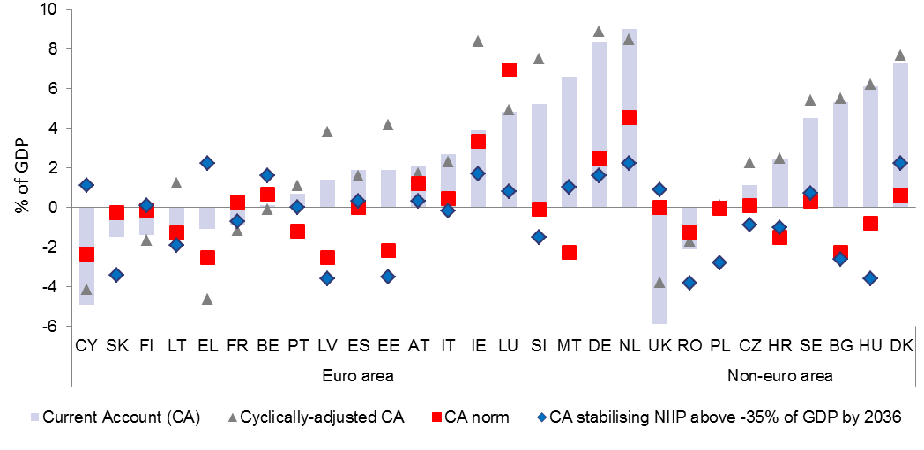

*Source:* Commission services calculations.

*Note:* cyclically-adjusted balances are calculated using the output gap estimates underlying the European Commission autumn 2017 forecast; the cyclically-adjusted balance for Malta in 2016 is not visible in the graph and is equal to 13.3% of GDP in 2016. For the computation of current account norms see footnote 9. The current account stabilising the net international investment position is defined as follows: the current account balance needed to bring the NIIP to -35% in 20 years; for countries whose NIIP in 2016 is already at or above -35% of GDP, it is the balance needed to preserve the NIIP at its 2016 level.[9]

*Graph 3:* Evolution of current account balances



*Source:* Eurostat.

**Current account deficits are very limited in number while large surpluses persist.** Most of the large current account deficits had already narrowed significantly before 2016 and turned into surpluses or balanced positions on the back of regained competitiveness and subdued domestic demand (Graphs 2 and 3). Recent trade balance developments have benefited from a reduction of commodities prices, the upswing in trade in the EU and the acceleration of world trade since mid-2016, while the income balance of net-debtor countries has benefited from falling interest rates implying lower remunerations on net financial liabilities.

* Only the United Kingdom now has a current account deficit beyond the scoreboard threshold. The other Member States with current account deficits in 2016 (Belgium, Greece, France, Cyprus, Latvia, Lithuania, Poland, Romania, Slovakia and Finland) stayed well below the scoreboard threshold. Cyclical factors have been declining in importance for these outcomes, as output gaps are closing (Graph 2). Some further marginal improvements were recorded even in 2016 still, while countries such as Croatia and Ireland recorded falls in their surpluses down from exceptionally high levels recorded in 2015 (Graph 3).
* In Cyprus and Greece, the 2016 current account balances are still insufficient to support a reduction of the large NIIPs to prudent levels at a satisfactory pace. Conversely, Portugal and Spain had current account outturns somewhat in excess of what is needed to converge towards an NIIP of -35% of GDP over the next two decades, with those margins being larger for Croatia and Ireland.
* At the same time, large current account surpluses persist. Despite recent marginal falls, the surpluses in Denmark, Germany and the Netherlands continue to exceed the threshold as they have done for several years. Malta crossed the threshold in 2016, which is reflecting also the offshore centre effect. The surplus would have been slightly higher in Germany and lower in Denmark if it were not for cyclical effects. Germany, Denmark and the Netherlands are currently recording surpluses well above what can be explained by economic fundamentals (including, for instance, ageing and relative per-capita income).[10]
* More generally, apart from Luxembourg, all of the recent surpluses of the various Member States both inside and outside the euro area appear to be above fundamentals, sometimes by large margins. The Commission autumn 2017 forecast suggests only limited changes to these patterns this year and next.

*Graph 4***: Net international investment positions and their dynamics**



*Source:* Eurostat (BPM6, ESA10), Commission services calculations.

*Note:* Data for Bulgaria are available only as of 2010 and for Cyprus as of 2008.

**Net international investment positions (NIIPs) have improved in almost all Member States recently but remain deeply negative in a number of them.** Improvements in 2016 were at times strong and recorded in net-debtor and net-creditor countries alike, even if somewhat sharper in the latter than in the former. This reflected the rising current account and capital balances and higher GDP growth. Valuation effects varied widely across countries, with no clear link with starting NIIP positions, but sometimes contributing to the reduction of largely negative NIIP balances. Developments in the first half of 2017 do not reveal major changes to these patterns.

* Despite recent improvements, in 2016, more than half of the EU Member States recorded NIIPs beyond the MIP scoreboard threshold. Some values continue exceeding -100% of GDP (Ireland, Greece, Cyprus and Portugal); in Spain and Croatia they are more than -70% of GDP; whereas nine other countries have still to converge to the threshold of -35% of GDP, including Bulgaria, Hungary, Latvia, Poland, Romania and Slovakia.
* 2016 were marked by clear improvements in the most negative NIIPs, which often contrasted with deteriorations in earlier years. Cyprus and Ireland stand out for the marked gains in 2016 but also in Portugal and Spain the patterns changed visibly as improvements in in 2016 followed years of more or less continued deterioration. Greece continues to be an exception as its position kept worsening, however at a lower pace than before. The changes in patterns were more mixed in countries with less negative NIIPs, and, in general, the corrections were more moderate. While they have even lost speed in cases such as Hungary, they always remained in the direction of improving NIIPs.
* The net-creditor countries kept further increasing their large positive NIIPs in 2016 on the back of large surpluses and valuations gains that frequently came out stronger than before. In particular, the Netherlands ended 2016 with a positive NIIP of almost 70% of GDP, while Denmark and Germany edged up to 55% of GDP, in all cases reaching their maximum value in a decade. The recent current account outturns are visibly in excess of the levels needed to preserve the NIIP-to-GDP ratios at their 2016 levels. Malta and Luxembourg were the only net-creditor countries with falls in their NIIPs in 2016, which in any case remained in clear positive territory. Also, most of the countries with a relatively balanced NIIP improved their positions in 2016 and in some cases clearly more than before. The United Kingdom ended 2016 with a balanced NIIP mainly thanks to valuation effects linked to the depreciation of sterling after years of negative readings.
* Risks and vulnerabilities linked to net negative positions may depend also on their composition. In this respect, the often large net-debtor countries, notably Cyprus, Greece, Portugal and Spain, have levels of net external debt that account for most of their NIIPs, which might make them vulnerable to changes in financing conditions, especially if and when roll-over needs are high. Conversely, in other debtors, foreign direct investment, which might be a more stable source of funding account for a large share of the negative NIIP as it is the case in the Estonia, Latvia and Lithuania, Bulgaria, Poland, Romania and Slovakia.

*Graph 5****:* Growth in unit labour cost and decomposition of factors, 2016**

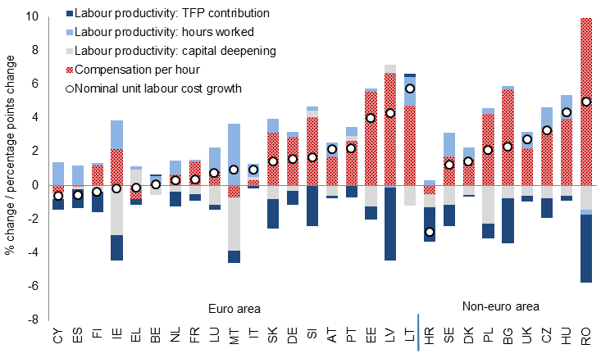

*Source:* AMECO and Eurostat. Commission services calculations

*Note:* The decomposition is based on the standard breakdown of unit labour cost growth into nominal hourly compensation and labour productivity, the latter being further broken down into the contribution of hours worked, total factor productivity and capital accumulation using a standard growth accounting framework.

**Developments in cost competitiveness are becoming less supportive of rebalancing.** Competitiveness gains in net-debtor countries are often moderating or fading out, while net-creditor countries have recorded little changes in their competitiveness positions. Against a backdrop of relatively sluggish labour productivity growth and subdued wage dynamics in a majority of countries, unit labour cost (ULC) developments in 2016 appear more detached from stock or flow external positions compared with previous years (Graph 5). Overall, the reduced dispersion in cost competitiveness developments is little supportive of a more symmetric rebalancing within the euro area (see Graph 6 and Box 2).

* In 2016, some of the net-debtors countries saw unit labour cost dynamics flattening or turning positive after years of reduction (e.g., Greece, Ireland, Spain, Portugal, Slovenia), reflecting decelerating productivity growth and wage growth becoming less negative or positive. Countries like Estonia, Latvia and Lithuania continued recording fast growth of unit labour costs driven by strong wage growth in a context of tightening labour markets and against moderate productivity advancements. At the same time, other countries have been recently recording an acceleration in unit labour costs, including into 2017, notably Romania but also Bulgaria, the Czech Republic and Hungary (Graph 6). In some of these countries, wage acceleration comes after significant adjustments on the aftermath of the 2008-2009 crisis, which temporarily halted the long-term wage convergence. Weak labour productivity has often gone hand in hand with moderate total factor productivity growth.[11]
* The growth in unit labour costs in a number of net-creditor countries (Denmark, Germany, Luxembourg, the Netherlands and Sweden) remained overall moderate in 2016, having cooled somewhat in Germany against the backdrop of subdued wage dynamics, despite the tightening labour market.
* Low inflation has contributed to maintaining price competitiveness, as measured by the real effective exchange rate (REER), relatively stable over recent years (Graph 7). The euro started appreciating in 2016 after the depreciation of 2015, implying nominal effective appreciations in euro-area countries on a broad basis, feeding also through the most recent REER dynamics. Despite this recent appreciation, REER positions still signal an improvement in price competitiveness compared with the pre-crisis period in most net-debtor countries. Deterioration in competitiveness compared with the pre-crisis period has been taking place for some years only in Estonia, Latvia and Lithuania, and more recently in Bulgaria and the Czech Republic, in light of sustained inflation rates. Among all EU countries, only the United Kingdom, Poland and Germany are recording improved price competitiveness positions compared with those of the year 2000.

*Graph 6:* **Unit labour cost growth**



*Source:* AMECO; 2017 data come from the Commission services autumn 2017 forecast

*Graph 7:* **Real effective exchange rates, 42 trading partners, HICP deflator**



*Source:* AMECO

*Note:* Data for Slovakia are off-scale, with the indexes reading 153, 173, 170 and 171 in 2007, 2013, 2015 and 2016 respectively.

**Most EU countries have recorded recent gains in export market shares.** Those gains reflect somewhat strongerintra-EU trade growth than extra-EU trade, and a fall in the prices of commodities leading to an increased weight of non-commodities exports in total exports, in recent years. The largest gains in export market share were recorded by Ireland, Luxembourg and Romania, while the losses were the highest for Greece, Finland and Sweden. Large EU economies generally recorded no changes in market shares. No systematic difference appears between net-creditor and net-debtor countries concerning market share dynamics in recent years, except for 2016, where net-debtor countries fared somewhat better.

*Graph 8*: **Change in export market shares, cumulative change over 2011-2016**

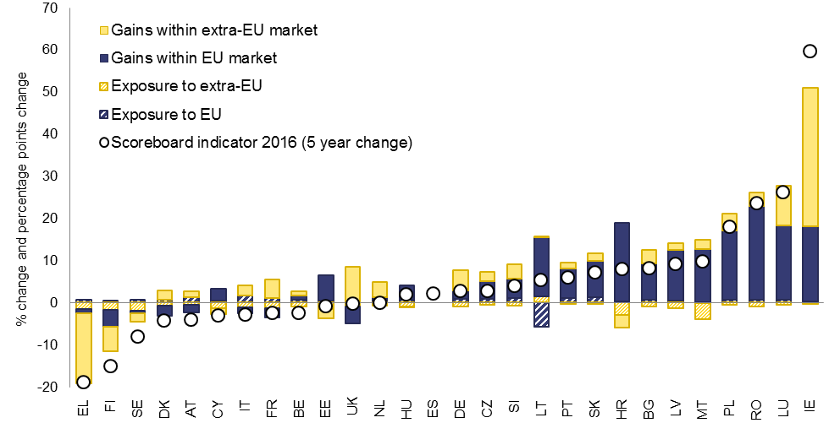

*Source:* Eurostat, Commission services calculations.

*Note:* The decomposition rests on the shift-share methodology. Shaded bars represent the contribution to market share dynamics stemming from changes in the exposure to a given market; solid bars measure the contribution to market share dynamics coming from market share changes within a given market. Calculations use BPM6 data except for Finland where exports to EU are derived from national accounts; data partly unavailable for Spain.

|  |  |  |  |  |  |  |  |  |  |  |  |  |
| --- | --- | --- | --- | --- | --- | --- | --- | --- | --- | --- | --- | --- |
| ***Box 1: The euro area dimension of macroeconomic imbalances***  **Euro-area-wide implications of macroeconomic imbalances deserve careful consideration.** In line with proposals contained in the 22 June 2015 Report ʽCompleting Europeʼs Economic and Monetary Unionʼ by Jean-Claude Juncker, Donald Tusk, Jeroen Dijsselbloem, Mario Draghi and Martin Schulz, and the 21 October 2015 Commission Communication ʽOn steps towards completing Economic and Monetary Unionʼ, starting from 2016, the AMR contains a systematic analysis of the euro-area wide implications of countriesʼ imbalances, and whether a coordinated approach to policy responses is required in light of interdependencies.  **The large euro-area current account surplus has stabilised.** The euro-area current account surplus edged up marginally to a peak of 3.3% of GDP in 2016 after 3.2% of GDP in 2015, and the Commission autumn 2017 forecast foresees it staying at around 3% until 2019, mainly linked to the euro-area cycle recovering relative to that of trading partners and the petering out of gains in terms of trade.[12] At unchanged policies, the level of the current account surplus of the euro area is expected to remain the largest worldwide. This level is assessed to be above what can be explained by economic fundamentals (e.g., including ageing, relative per-capita income), as empirical estimates of the euro-area current account norm indicate a small surplus of slightly above 1% of GDP in 2016.[13] Looking forward, the large current euro-area account surplus could be among the factors contributing to the maintenance of upward pressure on the external value of the euro.  **The persistence of the euro area surplus reflects the correction of current accounts previously in deficit coupled with the persistence of large surpluses.** The combined large surpluses of Germany and the Netherlands account for almost 90% of the current *level* of the aggregate euro-area surplus (Graph B.1.1). The sharp improvement in the euro-area current account position in the years after the crisis coincided with an abrupt adjustment of large external deficits following a reversal in private cross-border financial flows (Graph B.1.2). The subsequent growth in the euro-area surplus coincided with sustained improvements in current account balances in net-debtor countries and surpluses in net-creditor countries growing further. Since 2011, the *dynamics* in the current account positions of Italy and Germany account for about 2/3 of the increase in the euro-area surplus. The reduction in the euro-area surplus foreseen for 2017 largely comes from a reduction in the German surplus.  **The dynamics of the euro-area surplus is linked to domestic demand lagging behind that of economic activity and sustained export demand.** Net exports corresponds to the difference between aggregate income and spending, which has been widening since 2009 until 2016, the first year where real aggregate demand dynamics outpaced that of GDP since the crisis (see Graph B.1.3). The evolution of the surplus reflects subdued demand dynamics in net-debtor countries and external positions of net-creditor countries that increased further from already largely positive values. Persistently weak demand was reflected in an output gap figure for the euro area that has stayed in negative territory since 2009, and which is forecast to turn positive in 2018 according to the Commission autumn 2017 forecast. This protracted economic slack underpins inflation figures which remains below the target of monetary authorities. The evolution of the euro-area surplus is also linked to the dynamics of euro-area exports, building on supportive global demand for European goods and services and on an improved competitive position. While benefits from the 2015 depreciation of the euro are gradually producing effects of the trade balance, those from the recent appreciation of the euro are hardly visible.   |  |  | | --- | --- | | **Graph B.1.1: Current account balances of the euro area and of selected Member States** | **Graph B.1.2: Euro area net borrowing/lending per sector** | |  |  | | Source: AMECO | Source: Eurostat |   **The growing external position of the euro area is linked to a widespread deleveraging process.** At the euro-area aggregate level, debt remains elevated for households, corporations and governments, with remarkable differences across countries. The deleveraging process started after the outbreak of the crisis and led to increased net savings for the euro area as a whole (Graph B.1.2). Active deleveraging by the private sector started early on, when the crisis broke out around 2009, while public finances contributed to cushion their impact on incomes. Net lending figures for the household sector are currently twice as large as compared with the pre-crisis period. Corporations, which normally record net borrowing needs, have been posting a positive net lending position since 2013 and presently account for the biggest share of the overall net lending position of the euro area, reflecting subdued investment despite ample room for internal financing. While this aggregated figure masks relevant differences across countries, it reflects positive net lending positions in almost all euro-area countries, with the highest figures in terms of GDP being in Greece, the Netherlands and Spain; only in Luxembourg, France and Estonia corporations were net borrowers in 2016. Government deleveraging started in 2011, with net lending positions becoming less negative following the implementation of policies to tighten budgets, accounting for a relevant share of the increase of the overall net lending position of the euro area.   |  |  | | --- | --- | | **Graph B.1.3: Euro area output, domestic demand, net exports and core inflation** | **Graph B.1.4: Euro area unemployment wage growth and rebalancing of unit labour costs[14]** | |  |  | | Source: AMECO | Source: AMECO |   **Rebalancing in the euro area needs to continue.** Countries that have corrected large deficits are still characterised by large negative net international investment positions coupled with large stocks of private or government debt that represent vulnerabilities. Winding down large stocks of debt requires maintaining current account balances in balance or in surplus, which implies also a continued process of internal deleveraging. The relative competitiveness gains of net-debtor countries that started in 2012 are gradually vanishing, while productivity growth has stalled (Graph B.1.4).  **While stronger demand and steady growth would continue help the deleveraging and the rebalancing, greater productivity and competitiveness gains would support a durable correction of imbalances.** In light of the interconnection among euro-area economies, an appropriate combination of macroeconomic policies across Member States is warranted, as it would support the correction of imbalances and the recovery. Supportive demand conditions in euro-area net-creditor countries and in countries outside the euro area would be crucial to this end for net-debtor countries. In this respect, the recent recovery in nominal growth has contributed to an acceleration of the pace of reduction in the stock of net foreign liabilities as a share of GDP. Structural improvement in productivity and competitiveness, in particular in net-debtor countries, would need to be maintained to support sustained adjustment and help ease the debt burden. |

**Private sector debt ratios have generally receded from their post-crisis peaks, but over‑indebtedness continues to affect several countries.** Twelve Member States exceeded the scoreboard threshold for private debt in 2016, the same set of countries as in last year's AMR, with the exception of Malta, which is now below the threshold. Private debt ratios are highest in Cyprus, Luxembourg, Ireland and the Netherlands, although figures are influenced by the large presence of multinational or offshore sectors. Denmark, Sweden, Belgium, Portugal and the United Kingdom have the next highest scoreboard indicator value, with stocks of private debt in excess of 160% of GDP.

**The relative contribution of households and firms to high private debt levels varies across Member States.** In the case of Luxembourg, Ireland and, to a lesser extent, Belgium, it is mainly the high debt ratios of non-financial corporations (NFCs) that stand out from a cross-country comparison. Conversely, large stocks of private debt are driven by the household sector in Denmark and the United Kingdom. Cyprus, the Netherlands and Portugal experience comparatively high debt levels in both the corporate and household sectors. Overall, debt stock differences across countries are to a large extent explained by differences in fundamental factors justifying the accumulation of debt, including prospects for growth and investment, constraints to private savings, and financial development. At the same time, risks posed by high debt should be assessed against the backdrop of a country's growth potential, the resilience of its financial sector and the currency denomination of those liabilities, while also taking into account the value, liquidity, volatility and distribution of the underlying assets.

**The pace of private debt reduction has been uneven across countries and is not always commensurate with deleveraging needs.** The level of debt in the non-financial private sector increased significantly in the run-up to the financial crisis and has only marginally decreased since then in most cases. In the five countries with the highest NFC debt ratios (Luxembourg, Cyprus, Ireland, Belgium and the Netherlands), deleveraging has stalled or reversed over the past two years, while in France it has yet to start (Graph 9). In contrast, in Sweden, Portugal, Bulgaria and Spain, which also show high debt ratios, NFC deleveraging continued at a quick pace. In some countries not burdened by high debt levels, such as Latvia, Hungary and Slovenia, NFC deleveraging has been rapid and has accelerated over the past two years. Household leverage ratios declined over the past two years in the three Member States where households are most indebted (Denmark, Cyprus and the Netherlands), as well as other high debt countries such as Portugal, Spain and Greece (Graph 10). Household deleveraging has instead stalled in the UK and relatively high debt ratios in Sweden and Finland kept growing further.

*Graph 9*: **Pace of deleveraging of non-financial corporations**

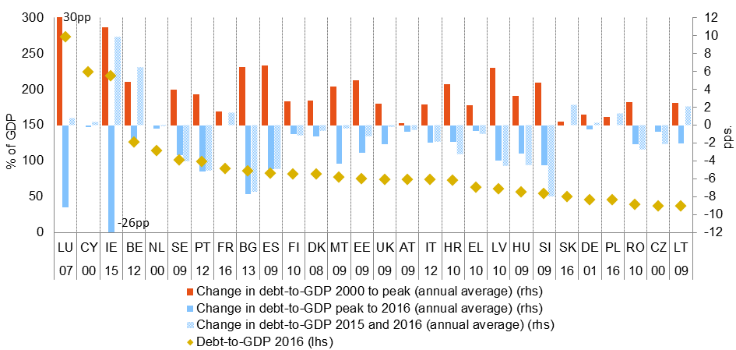

*Source:* Eurostat, Commission services calculations.

*Note:* Numbers below the country codes indicate the peak year. The increase to peak was calculated based on an initial year other than 2000 for the case of LU (2001), PL (2002), MT (2003) and LV (2003). Based on consolidated debt data.

*Graph 10*: **Pace of household deleveraging**

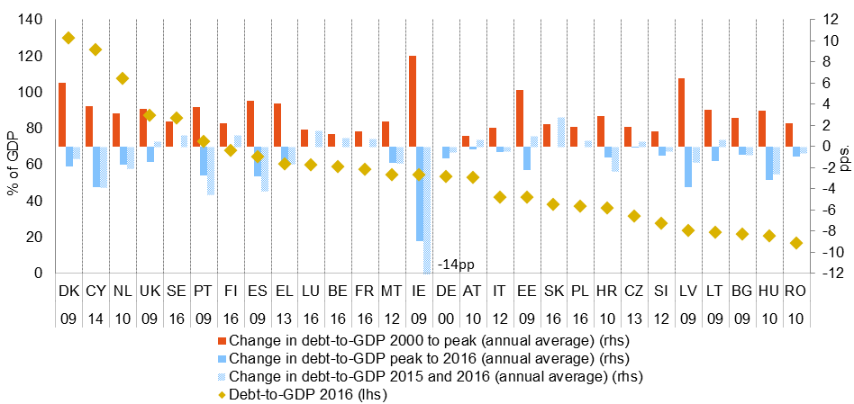

*Source:* Eurostat, Commission services calculations.

*Note:* Numbers below the country codes indicate the peak year. The increase to peak was calculated based on an initial year other than 2000 for the case of LU (2002), PL (2003), MT(2004) and LV (2004). Based on consolidated debt data.

**Credit flows are picking up more strongly in the household sector than in the corporate sector, implying different deleveraging modes and investment dynamics.** Overall, private sector credit flows remain comparatively modest, and no Member State exceeded the scoreboard threshold in 2016. Over recent years, in light of resuming growth, household deleveraging has become increasingly driven by reductions in the debt-to-GDP ratio via stronger GDP growth ("passive deleveraging"), while "active" household deleveraging through negative net credit flows was only observed in some of the countries most affected by the economic and financial crisis i.e., in Cyprus, Ireland, Portugal, Spain and Greece (Graph 11a). Households have actually been leveraging up in twelve Member States over the past year, including in countries with high debt levels such as the United Kingdom, Sweden and Finland. The pick-up in credit flows has generally been weaker for firms, implying that the corporate sector is currently deleveraging in more than two thirds of Member States, with dynamics broadly split into active and passive modes (Graph 11b). Active deleveraging by firms tends in turn to be associated with subdued investment (Graph 12), which underscores the importance of the debt overhang for the poor investment record of NFCs in the post-crisis period.

|  |  |
| --- | --- |
| *Graph 11a****:* Decomposition of the change in household debt-to-GDP (2017 Q1)** | *Graph 11b****:* Decomposition of the change in NFC debt-to-GDP (2017 Q1)** |

*Sources:* Eurostat, Commission services calculations.

*Notes:* the graphs present a breakdown of the evolution of the debt-to-GDP ratios into four components: credit flows, real GDP growth, inflation and other changes. Active deleveraging involves net repayment of debt (negative net credit flows), usually leading to a nominal contraction of the sectorʼs balance sheet and having, ceteris paribus, adverse effects on economic activity and asset markets. Passive deleveraging, on the other hand, consists in positive net credit flows being outweighed by higher nominal GDP growth, leading to a gradual decrease in debt/GDP. Active leveraging takes place when positive net credit flows outweigh nominal GDP growth. Data on NFCs for CY refers to 2016 Q3.

*Graph 12****:* Changes in the NFC investment and net lending/borrowing ratios in the years following a debt peak**



*Source:* Eurostat, Commission services' calculations.

*Note:* The country sample is restricted to those countries for which data is available and whose NFC debt-to-GDP ratio peaked before 2016.

**The EU banking sector continues to face challenges linked to low levels of profitability and large stocks of non-performing loans (NPLs) in some countries.** The growth in financial sector liabilities is accelerating in most Member States, but generally remains well below the scoreboard threshold.[15] Most Member States witnessed some improvements in bank profitability, capital ratios, stocks of NPLs and credit flows over the past year. Bank valuations, in particular, recovered significantly from mid-2016 to mid-2017, related to expectations of higher interest rates and steeper yield curves. Profitability, however, remains under pressure in light of the low-interest rate environment and outdated business practices. In some Member States, a combination of low profitability, capital ratios on the low side of the cross-country distribution and high levels of NPLs can be found. This is the case, in particular, in Greece, Cyprus, Italy and Portugal (Graphs 13 and 14).

|  |  |
| --- | --- |
| *Graph 13****:* Bank profitability and capital ratios** | *Graph 14****:* Non-performing loans** |

*Sources:* ECB, Commission services calculations.

*Notes:* Data on gross non-performing debt instruments for 2008 is unavailable for CZ, HR, SE and SI. In Graph 13, the 2015 Q1 data point refers to 2014 Q4 in the case of BG and to 2016 Q1 in the case of CZ.

**The stock of NPLs continues to decline across the EU, but remains elevated in several Member States.** The NPLs ratio is declining in all Member States with relatively high shares of NPLs, with the exception of Greece. This decline in the NPL ratio has started, however, only very recently in Portugal and Italy (Graph 14). Notwithstanding a declining trend, NPLs remain elevated in a number of countries. In particular, Greece and Cyprus continue to experience NPLs in excess of 30% of total loans, while Italy and Portugal display NPL ratios close to 14%. Bulgaria, Ireland, Croatia, Slovenia have NPL stocks in the vicinity of 10% of total loans.

**A broad-based increase in real house prices is ongoing in the EU, representing a recovery from previous downturns but also potentially leading to widening overvaluations in some cases.** Real house prices increased in 25 Member States in 2016, with indicator values exceeding the scoreboard threshold in Bulgaria, the Czech Republic, Ireland, Latvia, Hungary, Austria, Portugal, Romania, Slovakia and Sweden. This represents four more countries than last year and a different composition, with only Ireland, Hungary and Sweden having exceeded the threshold in both years.[16] Greece, Italy and Finland represent the only instances of declines in real house prices, which, in the case of the former two countries, have continued into 2017 and are contributing to the current negative valuation gap (Graph 15). In several other Member States, the increase in real house prices added further pressure to already overvalued housing markets. Tensions are particularly visible in Sweden and, to a lesser extent, in the United Kingdom, Luxembourg and Austria, where the strong increase in real house prices in 2016 came on top of an estimated overvaluation gap. In the case of Austria and the United Kingdom, quarterly data shows, however, that house price dynamics decelerated in 2017. In Sweden and the United Kingdom, but also in Denmark, overvalued house prices coexist with large household debt levels. In some cases, strong price dynamics are in evidence in countries that show only small (under)valuation gaps. This is the case in Hungary, Bulgaria, Latvia, the Czech Republic and Slovakia, where real house price growth has continued into 2017 and where overvaluation risks may be building up. In the Netherlands, relatively sustained house price dynamics take place in a context of high household debt. In some Member States, sustained dynamics in house prices are coupled with those of mortgage lending, suggesting credit-induced risks of a heating up. This is notably the case in Slovakia and Romania, where mortgage growth exceeded 10% in 2016, albeit in a context of low household debt levels. In all, buoyant house price growth in a number of EU countries deserve continued monitoring in light of the possible accumulation of pockets of macro-financial risks and for its implications in terms of resource allocation and housing affordability.

*Graph 15****:* House prices changes and valuation gaps in 2016**

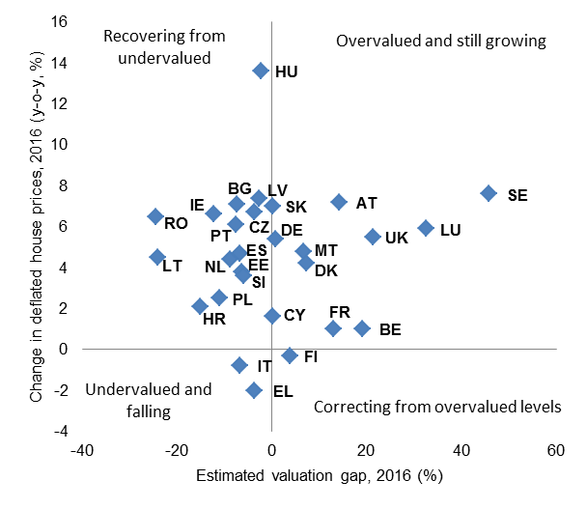

*Source:* Eurostat, ECB, BIS, OECD and Commission services calculations.

*Note:* the overvaluation gap was estimated as an average of three metrics: the deviations in the price-to-income and the price-to-rent ratios from their long-run averages, and the results from a fundamentals model of valuation gaps.

**Government debt ratios have now peaked in nearly all Member States, but debt levels remain elevated in most countries.** Scoreboard values exceeded the threshold in 16 Member States in 2016, down from 17 countries recorded in the AMR 2017. For nine of these Member States government debt in excess of 60% of GDP combines with private sector indebtedness beyond the threshold, suggesting economy-wide deleveraging needs. Government debt-to-GDP ratios have generally embarked into downward trajectories among the Member States with the highest levels of government debt, with France and Italy being exceptions. However, the deleveraging pace is often modest: among the ten Member States with the highest levels of government debt, only Greece, Cyprus and Austria are expected to achieve a reduction of at least 10 percentage points in the debt ratio between year-end 2016 and 2019. Among Member States with lower debt levels, debt ratios are projected to grow in Romania and Luxembourg. Overall, government sector deleveraging is taking place in light of the gradual improvement in budgetary positions over the past years and recently resuming growth. This allows for incipient reductions in the government debt-to-GDP ratio despite mild budgetary loosening in a number of countries.

|  |
| --- |
| ***Box 2:* Employment and social developments**  Labour markets in the EU have continued to improve during 2016 and the first half of 2017, with unemployment rates declining further and with disparities across the EU decreasing from elevated levels. The job-rich recovery contributed to an improving social situation on the back of a decline in the share of people at risk of poverty or social exclusion, due to a reduction in low work intensity households and severe material deprivation, while the (monetary) at-risk-of-poverty rate has stabilised. Social distress remains a concern in many Member States, with possible negative effects on potential GDP growth and implications for the correction of macroeconomic imbalances that deserve consideration. The newly proclaimed European Pillar of Social Rights can work as a compass to address these challenges and promote upward social convergence in the EU.  In 2016, the *unemployment rate* decreased further, but was still high or even very high in several EU countries. From 2015 to 2016, it increased in only two countries, Austria and Estonia, though starting from low levels. Improvements have been the strongest in countries among those with the highest level of unemployment (reductions of 2 percentage points or more in Croatia, Cyprus, and Spain). Still, nine Member States (Greece, Spain, France, Croatia, Italy, Cyprus, Latvia, Portugal and Slovakia) exceeded the scoreboard indicator threshold of an average of 10% over the past 3 years; down from 12 in the last two AMRs. In addition, in 2016 unemployment rates were still higher than in 2008 in about two thirds of Member States. At 8.6% and 10% in the EU and the euro area respectively, unemployment rates were about around 2 percentage points below the respective peaks reached in 2013, but still 1.6 and 2.4 percentage points higher than 2008 figures. Unemployment rates continued steadily decreasing in the first half of 2017, down to 7.7% and 9.1% by mid 2017 in the EU and the euro area respectively.  *Employment and employment rates* went up in almost all Member States, continuing the positive developments of the last years. The employment rate (20-64 years old) reached 71.1% in 2016 for the EU as a whole, surpassing the pre-crisis peak of 70.3% recorded in 2008. The employment rate kept increasing in the second quarter of 2017 up to a record 72.2%. In absolute terms, in 2016 the number of persons employed declined only in Romania and Latvia.  *Activity rates* increased nearly everywhere in the EU. Only two countries registered a declining activity rate over the last three years: the decrease in Cyprus came just at level of the scoreboard threshold of -0.2, while that in Spain (-0.1) was even below it. On aggregate, in 2016 for the EU and the euro-area activity rates were at 72.9% and 72.9% respectively, i.e., 2.6 and 2.1 percentage points above their 2007 levels. The increasing trend is mostly due to increasing labour market participation by older workers and women.  *Long-term unemployment* improved with some delay after the start of the recovery, but by 2016, improvements could already be seen in almost all Member States. Only two countries recorded rates that are at least 0.5 percentage points higher than three years ago – the threshold in the scoreboard: in Austria, it increased to 1.9%, and in Finland by 2.3%. The highest rates of long-term unemployment were observed in Greece (17%) and Spain (9.5%).  The *youth unemployment* *rate* fell in all EU countries in the three years to 2016, except in Luxembourg (where the increase of 2.2 percentage points slightly exceeds the scoreboard threshold of 2 percentage points) and, to a lesser extent, in Austria and Finland. Falls of 10 percentage points or more over the same period were recorded in countries among those with the highest rates (including Greece, Hungary, Spain, and Croatia) as well as in Bulgaria and Slovakia. The youth unemployment rate is still above 30% in Croatia, Greece, Italy and Spain, while the share of young people not in employment, education or training is still above 15% in Bulgaria, Croatia, Cyprus, Greece, Italy and Romania.  The social situation is still a source of concern in various EU countries. The share of people at risk of poverty or social exclusion (AROPE) has decreased in around half of the EU countries, and often by low margins, between 2015 and 2016.[17] In 2016, almost one quarter of the EU population was at risk of poverty or social exclusion. Rates varied considerably from around 40% in Bulgaria and Romania, followed by Greece at over 35%, to around 13% in the Czech Republic and 17% in Denmark, Finland and the Netherlands. Luxembourg and Romania recorded some of the strongest increases in AROPE rates between 2015 and 2016, whereas Hungary, Latvia and Malta showed the most marked reductions. At the same time, disposable household income has increased it has not yet reached its 2008 levels in real terms in many Member States.  The overall AROPE developments reflect different evolutions of its different components. The share of people at risk of poverty (AROP) while declining in most Member States in 2016 had increased in most of the EU countries in recent years: the largest increases in AROP over a three-year period were recorded in Estonia, Latvia, the Netherlands and Romania, while a significant decrease was recorded in Greece, albeit from an above-average reading. In contrast, severe material deprivation has declined over the past three years and also in 2016 alone in almost all EU Member States: it declined over 10 percentage points over a three-year period in Bulgaria, Hungary and Latvia. Finally, whereas the recovery has brought a decline in the share of people (under 60) living in households with very low work intensity in most EU countries, most notably in Hungary, Portugal, Latvia and Estonia, there are still countries where share increased in 2016, notably Lithuania, Finland, Greece and Romania. |

**Overall, risks and vulnerabilities stemming from legacy issues and/or recent trends are present in a number of Member States.** The degree of severity and the urgency in bringing forth adequate policy responses vary significantly across Member States, depending on the nature of the vulnerabilities or trends, as well as their confinement to one or several sectors of the economy:

* A number of Member States are affected by *multiple and interconnected stock vulnerabilities*. This is the case for countries that were hit most severely by boom‑bust credit cycles – frequently associated with liquidity and solvency issues in their banking sectors – and the sharpest reversals of current account positions. In the case of Cyprus, Greece[18] and Portugal, elevated private indebtedness combines with high levels of public debt, large negative net international investment positions and remaining issues within the banking system. These countries still confront the issue of addressing significant deleveraging needs in the context of limited fiscal space, high (though receding) levels of unemployment and modest nominal growth. In Bulgaria, Croatia, Ireland, Slovenia and Spain, vulnerabilities are also multiple, interconnected and, with the possible exception of Bulgaria, carry an important stock imbalance dimension. However, faster progress in addressing them has been achieved than in the countries previously mentioned.
* In a few Member States, vulnerabilities are driven mainly by *large stocks of general government debt* and concerns relating to *potential output growth* and *competitiveness*. This is particularly the case for Italy, where vulnerabilities are also linked to the banking sector, in particular the large stock of NPLs. Belgium and France also face a high general government debt and potential growth issues, but are not confronted with similar potential risks stemming from vulnerable banks.
* Some Member States are characterised by *large and persistent current account surpluses* that while reflecting their strong competitiveness reflect also, to a varying degree, subdued private consumption and investment. This is the case notably for Denmark, Germany, the Netherlands and also Sweden. In the case of Germany, this is combined with deleveraging trends in all sectors of the economy, even though debt levels are not comparatively high. The large and persistent surpluses may imply forgone growth and domestic investment opportunities. In addition, the shortfalls in aggregate demand bear consequences for the rest of the euro area in a context of still slack in activity and below-target inflation.
* In some Member States, *developments in price or cost variables show potential signs of overheating, particularly as regards the housing market or the labour market*. In Sweden, as well as in Austria, Denmark, Luxembourg, the Netherlands and the United Kingdom, price pressures relate mainly to the housing sector in combination with significant levels of household debt. In Estonia, Hungary, Latvia, Lithuania and Romania, unit labour costs continue to grow at a relatively strong pace while price competitiveness is edging down. In these countries, especially Romania and also Hungary, accelerating unit labour costs are recorded against the background of pro-cyclical fiscal policies that could exacerbate possible overheating pressures.

**Overall, IDRs are warranted for 12 Member States: Bulgaria, Croatia, Cyprus, France, Germany, Ireland, Italy, the Netherlands, Portugal, Slovenia, Spain and Sweden.** All of these countries were subject to an IDR in the previous cycle, during which IDRs were prepared for 13 countries overall. While the set of Member States undergoing an IDR is slightly reduced compared with last year, new possible risks are building up in a number of countries for which no IDR is warranted at this stage and thereby developments will continue to be monitored, as indicated in Section 3. Relative to the AMR 2017, further progress has been made in addressing external imbalances among net-debtor countries, and labour markets and growth conditions have continued to generally improve. Progress in tackling and preventing the emergence of imbalances related to internal dynamics and sectorial debt stocks has been more mixed. Given that internal and external stock imbalances only adjust slowly, they remain a source of risks and vulnerabilities in many Member States, weighing also on investment prospects and the economic recovery. Without the strengthening of long-term growth drivers such as investment, productivity and employment levels, improving cyclical conditions may prove insufficient to bring current stock imbalances to prudent levels. At the same time, the upswing in cyclical conditions is contributing to building up localised price, cost and housing market pressures, which warrant close monitoring in some countries.

# 3. Imbalances, Risks and Adjustment: country-specific commentaries

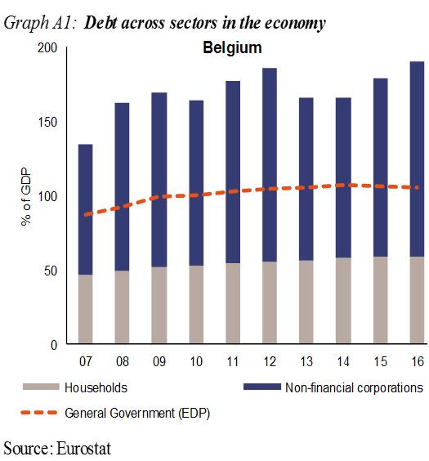**Belgium:** In the previous round of the MIP, *no macroeconomic imbalances were identified* in Belgium. In the updated scoreboard, a number of indicators are beyond the indicative threshold, namely private debt and government debt.

External sustainability is underpinned by a very favourable net international investment position and a current account position close to balance. On the back of gains in 2016, cumulated losses in export market shares have been substantially reduced. Nominal unit labour cost developments have been subdued but are expected to pick up going forward. Private debt remains relatively high, in particular for non-financial corporates, though widespread intra-group lending inflates debt figures. Risks related to household debt originate predominantly from the housing market. Real house prices have been relatively flat in recent years, meaning that no correction has taken place for the fast increase prior to 2008. Government debt is expected to slowly decline from high levels and continues to represent a major challenge for the long-term sustainability of public finances; government consumption is stagnant as a result of the ongoing consolidation of public finances. Job creation remains strong and long-term unemployment as well as the high and persistent youth unemployment have been decreasing.

*Overall, the economic reading highlights issues relating to public indebtedness, though the risks linked to them remain contained. Therefore, the Commission will at this stage not carry out further in-depth analysis in the context of the MIP.*

**Bulgaria:** In February 2017, the Commission concluded that Bulgaria was *experiencing excessive macroeconomic imbalances*, in particular involving pockets of vulnerabilities in the financial sector coupled with a high corporate indebtedness in a context of incomplete labour market adjustment. In the updated scoreboard, a number of indicators are beyond the indicative threshold, namely net international investment position (NIIP) and real house price growth.

The negative NIIP remains beyond the threshold but has continued to improve as the current account has moved into a sizeable surplus. Reflecting catching-up dynamics, most of the NIIP relates to net foreign direct investment liabilities, which mitigates external risks. Improvements in the external position are supported by the gains in export market shares recorded over the last few years. Private indebtedness remains a concern, in particular for non-financial corporates where the level of non-performing loans remains high despite the on-going deleveraging process. Real house prices increased strongly in 2016 and warrant close monitoring. Early steps are underway to help address the vulnerabilities in the financial sector. Yet, and despite the favourable macroeconomic environment, the functioning of the sector is still hampered by lingering concerns over weak governance, asset quality and supervision. The recovery of the labour market continues, with unemployment projected to fall over the forecast horizon. Still, persistent structural issues, such as the high share of long-term unemployed as well as skills and qualification mismatches, lead to underutilisation of human capital and weigh on employment. Meanwhile, wage and labour costs are set to accelerate looking forward, notably due to supply shortages in some sectors and to plans to further increase the minimum wage over 2018-2020.

*Overall, the economic reading points to remaining vulnerabilities in the economy, including in the financial sector. Therefore, the Commission finds it useful, also taking into account the identification of an excessive imbalance in February, to examine further the persistence of macroeconomic risks and to monitor progress in the unwinding of excessive imbalances.*

**Czech Republic:** In the previous round of the MIP, *no macroeconomic imbalances* were identified in the Czech Republic. In the updated scoreboard, real house price growth is beyond the indicative threshold.

The current account balance has been on an improving trend and now shows a small surplus. The net international investment position has continued to strengthen, partly due to the defence of the exchange rate floor vis-à-vis the euro, a policy which, however, ended in April 2017. Export market shares showed gains. Nominal unit labour costs increased, largely driven by strong wage growth that is projected to accelerate further in the context of a tightening labour market. Real house price growth accelerated further and now is now beyond the threshold, which warrants attention. The feedback spiral between house prices and mortgage volumes accelerated. The private sector debt level slightly increased in 2016, but remains within the threshold. The largely foreign-owned banking sector remains stable, despite the growth of financial sector liabilities accelerating significantly in 2016. Unemployment has continued falling and is very low.

*Overall, the economic reading highlights issues relating to possible internal risks although still contained. Therefore, the Commission will at this stage not carry out further in-depth analysis in the context of the MIP.*

**Denmark:** In the previous round of the MIP, *no macroeconomic imbalances* were identified in Denmark. In the updated scoreboard, a number of indicators remain beyond the indicative threshold, namely the current account balance and the private sector debt.

The current account balance continues to show large surpluses, reflecting strong corporate savings and household deleveraging. The current account surpluses have led to a large positive net international investment position, which in turn generates positive net income on foreign investments. Cumulated losses in export market shares have been reduced while cost competitiveness indicators have been stable. Household debt, although decreasing, remains among the highest in the EU. The high level reflects a specific mortgage bank funding model, a favourable tax treatment and low incentives for paying down mortgage debt, as well as an advanced pension and welfare system. However, supported by continued low funding costs and improving labour market conditions, house prices continue to recover, particularly in the main urban areas, which warrants attention. Nonetheless, the banking sector remains sound. The labour market is gradually improving, and unemployment is low and reducing.

*Overall, the economic reading highlights issues related to the current account, the private debt and the housing sector but risks appear contained. Therefore, the Commission will at this stage not carry out further in-depth analysis in the context of the MIP.*

**Germany:** In February 2017, the Commission concluded that Germany was experiencing *macroeconomic imbalances*, in particular related to in its large current account surplus reflecting excess savings and subdued investment. In the updated scoreboard, a number of indicators are beyond the indicative threshold, namely the current account balance and government debt.

The current account surplus was broadly stable in 2016. With steady domestic demand growth, the current account surplus is expected to continue narrowing, but to remain at a high level and sustain further increases in the net international investment position. The positive impact from terms-of-trade is dissipating. Export growth weakened amid slowing world trade, which sustained export market shares. Despite low private sector debt, private sector deleveraging trends continue with excess savings and subdued investment, which is then reflected in the high current account surplus. Corporate investment is restrained despite improving liquidity. Real house prices growth has been accelerating. However, credit growth has been subdued despite low interest rates and accelerating house prices. Wage growth is moderate, but so is per capita household consumption keeping the household saving rate at an elevated level. Government debt continued to decrease towards the threshold with budget surpluses forecast over the forecast horizon. The public investment backlog remains. Overall unemployment, as well as youth and long-term unemployment, have further decreased and remain very low.

*Overall, the economic reading highlights issues relating to the very large and only gradually decreasing external surplus and strong reliance on external demand underlining the need for continued rebalancing. Therefore, the Commission finds it useful, also taking into account the identification of an imbalance in February, to examine further the persistence of imbalances or their unwinding.*

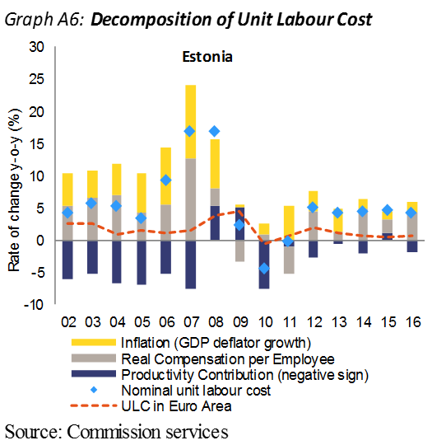

**Estonia:** In the previous round of the MIP, *no macroeconomic imbalances* were identified in Estonia. In the updated scoreboard, a number of indicators are beyond the indicative thresholds, namely the negative net international investment position (NIIP), and unit labour costs.

The negative NIIP is beyond but getting close to the threshold, but more than half of the external liabilities consist of FDI. The current account has shown small surpluses since 2014, which are expected to be sustained over the forecast horizon. Despite some gains in 2016, in cumulated terms, export market shares have been stable. The strong growth in nominal unit labour costs, and the appreciating real effective exchange rate, mainly reflects wage growth in a tightening labour market. Going forward, with investment flows and export markets rebounding this year and next year, productivity is set to increase and unit labour cost growth to slow down. House price growth moderated in 2016 after having grown beyond the threshold in earlier years. Private sector debt is stable and the government debt remained the lowest in the EU. Long-term and youth unemployment indicators have further improved, as activity rates reached historically high levels.

*Overall, the economic reading highlights issues related to cost competitiveness in a tightening labour market but risks are contained. Therefore, the Commission will at this stage not carry out further in-depth analysis in the context of the MIP.*

**Ireland:** In February 2017, the Commission concluded that Ireland was *experiencing macroeconomic imbalances*, in particular involving vulnerabilities from large stocks of public and private debt and net external liabilities, despite improvements in flow variables. In the updated scoreboard, a number of indicators remain beyond the indicative threshold, namely the net international investment position (NIIP), the real effective exchange rate (REER), private debt, government debt as well as real house prices.

The current account shows a substantial surplus while the NIIP has worsened strongly mainly driven by factors disconnected from the domestic economy. Overall, the underlying current account and external position remain difficult to assess due to the size and impact of the activities of multinational enterprises. Strong productivity growth in past years has contributed to improved cost competitiveness. On the back of the strong recovery, the ratios of private and government debt to GDP are falling but remain high. Households have continued to deleverage actively while the situation of domestic non-financial companies is more difficult to interpret given the weight of multinationals on total corporate debt. The government deficit is moving close to balance over the forecast horizon. The non-performing loans ratio has been declining over the last years, but remains elevated, with implications for the entire economy. Banks are well capitalised and their profitability, albeit still subdued, is improving gradually. Real house prices are increasing at a fast pace, mainly driven by supply constraints, from still likely undervalued levels, but warrant attention. Ireland is nearing full-employment, unemployment falling and full-time jobs growing at the fastest pace since 1999. Long‑term and youth unemployment have also declined substantially.

*Overall, the economic reading highlights issues relating to the assessment of external sustainability, the financial sector vulnerabilities, private and public debt. Therefore, the Commission finds it useful, also taking into account the identification of an imbalance in February, to examine further the persistence of imbalances or their unwinding.*

**Spain**: In February 2017, the Commission concluded that Spain was experiencing *macroeconomic imbalances*, in particular relating to the high levels of private, public and external indebtedness in a context of high unemployment. In the updated scoreboard, a number of indicators are above the indicative threshold, namely the net international investment position (NIIP), as well as private and government debt ratios, and the unemployment rate.

External rebalancing has continued. The NIIP has improved but remains very high, and it will take time before it reaches prudent levels. The current account is expected to remain in moderate surplus despite the strength of final demand, partly due to structural improvements in export performance. Unit labour cost growth has been subdued but low productivity growth makes competitiveness gains hinge upon cost advantages. Deleveraging needs remain, but private sector debt has continued to decline throughout 2016, especially for corporations. The pace of debt reduction has slowed as new credit has started flowing again, supporting a strong rebound in investment. The government debt ratio is high and only slowly decreasing, driven mainly by strong growth. Unemployment has been declining rapidly, but it remains very high, especially among youth and long-term unemployed. Job creation is characterised by a high proportion of temporary contracts.

*Overall, the economic reading highlights issues relating to external sustainability, private and public debt, and labour market adjustment, in the context of weak productivity growth. Therefore, the Commission finds it useful, also taking into account the identification of imbalances in February and their cross-border relevance, to examine further the persistence of imbalances or their unwinding.*

**France:** In February 2017, the Commission concluded that France was experiencing *excessive macroeconomic imbalances*, in particular involving high public debt and weak competitiveness, in a context of low productivity growth. In the updated scoreboard, a number of indicators are beyond the indicative threshold, namely government debt, private sector debt and the unemployment rate.

The current account continues to show a moderate deficit which is projected to be stable. Export market shares have stabilised over the recent past. Competitiveness indicators have improved as nominal unit labour costs have decelerated markedly, due to moderate wage dynamics and measures to reduce the cost of labour. However, labour productivity growth remains low which prevents a faster recovery of cost-competitiveness. Private sector debt is beyond the threshold with corporate debt increasing and house prices remaining at quite high levels compared to disposable income. Government debt is stabilising at high levels and remains a major source of vulnerability reducing the room for fiscal manoeuvre available to respond to future shocks. Unemployment is falling from the peak reached in 2015, while long-term unemployment stabilised.

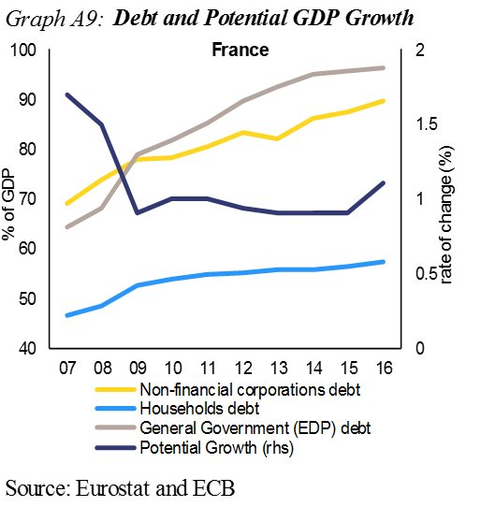*Overall, the economic reading highlights issues relating to high public indebtedness and weak competitiveness, in the context of low productivity growth. Therefore the Commission finds it useful, also taking into account the identification of an excessive imbalance in February, to examine further the persistence of macroeconomic risks and to monitor progress in the unwinding of excessive imbalances.*

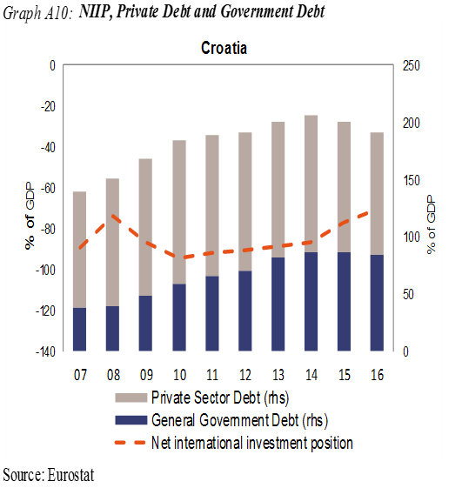**Croatia:** In February 2017, the Commission concluded that Croatia was experiencing *excessive macroeconomic imbalances*, in particular involving risks from high levels of public, corporate and external debt, all largely denominated in foreign currency, in a context of low potential growth. In the updated scoreboard, a number of indicators are beyond the indicative threshold, namely the net international investment position (NIIP), the government debt and the unemployment rate.

The NIIP is decreasing but remains at high levels, with persistent currency-related risks. The current account shows a sizeable surplus and has been positive since 2013. While initially driven by contracting domestic demand, it is now increasingly based on strong growth of exports, boosted by improved cost competitiveness. Gains in export market shares accelerated in 2016. Private sector debt decreased further amid weak credit flows but its level is still high. Continued strong economic growth should support the deleveraging process, relieving pressure on credit growth looking forward. Although decreasing, a large share of loans to non-financial corporations remain non-performing. The government debt ratio declined further in 2016 and is projected to continue declining, also on account of contained deficits. The unemployment rate is falling, but its reduction is to a large extent driven by a rapidly shrinking labour force. Risks to the economic outlook are related to developments in the on-going restructuring of the large conglomerate Agrokor.

*Overall, the economic reading highlights issues as regards the high debt and currency exposures in all sectors and also the labour market performance. Therefore, the Commission finds it useful, also taking into account the identification of an excessive imbalance in February, to examine further the persistence of macroeconomic risks and to monitor progress in the unwinding of excessive imbalances.*

**Italy**: In February 2017, the Commission concluded that Italy was experiencing *excessive macroeconomic imbalances*, in particular involving risks from high public debt and protracted weak productivity dynamics in a context of high non-performing loans (NPLs) and unemployment. In the updated scoreboard, a number of indicators are beyond the indicative threshold, namely government debt and the unemployment rate.

The current account surplus further increased in 2016, helped by exports, where moderate gains in export market shares has brought the indicator within the indicative threshold, but also reflecting continued weak domestic demand, as evidenced by the historically low fixed investment to GDP ratio. However, cost competitiveness continues to suffer from subdued labour productivity growth, despite contained wage growth, while non-cost factors such as innovation and the firm size also weigh on export performance. A sluggish economic recovery, low inflation and broadly expansionary fiscal policy over the recent years are delaying the reduction of the very high government debt ratio. Potential growth prospects are muted, especially in the light of adverse demographics and low productivity growth, also due to the legacy of long-lasting capital misallocation, associated with high NPL levels, and the low level of investment. Despite recent public interventions to resolve the weakest banks, continuing low profitability and the high stock of NPLs make the banking system vulnerable to shocks and hamper banks’ capability to raise further capital and support the economic recovery. Labour market conditions are gradually improving, but the unemployment rate remains high, far above pre-crisis levels, in particular for the young people and the long-term unemployed. The overall participation rate is rising but remains below the euro-area average.

*Overall, the economic reading highlights issues relating to high public indebtedness and high unemployment in a context of weak productivity growth and a still vulnerable banking system. Therefore the Commission finds it useful, also taking into account the identification of excessive imbalances in February, to examine further the persistence of macroeconomic risks and to monitor progress in the unwinding of the excessive imbalances.*

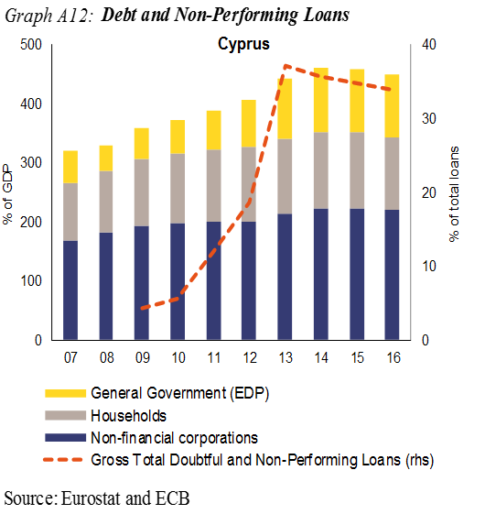**Cyprus:** In February 2017, the Commission concluded that Cyprus was experiencing *excessive macroeconomic imbalances*, in particular involving large stocks of private, public, and external debt and the high share of NPLs in the banking system. In the updated scoreboard, a number of indicators remain beyond the indicative threshold, namely the net international investment position (NIIP), the real effective exchange rate (REER), private sector debt, government debt as well as the unemployment rate and the change in labour activity rate.

The current account deficit widened substantially in 2016 and the negative NIIP remains substantial. Cumulated losses in export market shares have been reduced by gains in 2016. Cost competitiveness improved, with a significant depreciation of the REER, reflecting the negative inflation experienced until 2016, and contained wages compensating for the low productivity growth. Looking forward, further gains may prove to be a challenge as these factors fade away. The level of private indebtedness is amongst the highest in the EU, both for households and corporates, while the deleveraging process is slow. In particular, household savings are negative. The deflationary environment until the end of 2016, has reduced the scope for passive deleveraging, a trend that is to be reversed as inflation is forecast to pick up. Real house prices have been stable and may have passed their through. The very high level of non-performing loans hampers the restauration of a healthy flow of credit to the economy, which is required for supporting potential growth in the medium term. The very high government debt-to-GDP ratio is expected to have peaked in 2016. Unemployment is declining but remains high, notably regarding long-term and youth unemployment.

*Overall, the economic reading highlights issues relating to external sustainability, public and private debt, vulnerabilities in the financial sector and labour market adjustment. Therefore, the Commission finds it useful, also taking into account the identification of an excessive imbalance in February, to examine further the persistence of macroeconomic risks and to monitor progress in the unwinding of excessive imbalances.*

**Latvia:** In the previous round of the MIP, *no macroeconomic imbalances* were identified in Latvia. In the updated scoreboard, a number of indicators are above the indicative threshold, namely the net international investment position (NIIP), unit labour costs, real house prices and the unemployment rate.

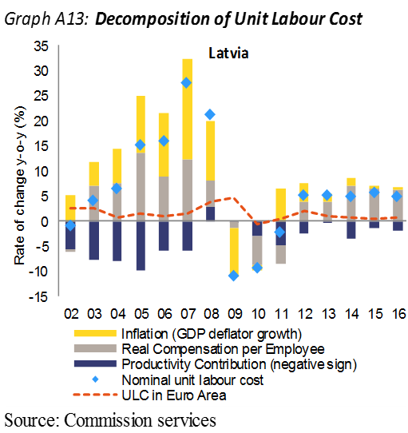The current account turned to a surplus in 2016 but is expected to return to a deficit looking forward. The high negative NIIP, mainly reflecting government debt and FDI, continues to improve gradually. Export market shares have stabilised over the recent past. However, cost competitiveness indicators points to a continued weakening. The REER has been appreciating. Unit labour costs have grown strongly, primarily driven by steady wage growth, which looking forward is expected to continue in the context of a shrinking labour force and a tight labour market, even if labour productivity is forecasted to pick up somewhat. Real house price growth grew strongly in 2016, which warrants attention. Private debt deleveraging continues and credit growth remains subdued. Public debt remains low and stable. Unemployment continues to adjust downwards.

*Overall, the economic reading highlights issues relating to domestic demand pressures and cost competitiveness, but risks appear contained. Overall, the Commission will at this stage not carry out further in-depth analysis in the context of the MIP.*

**Lithuania**: In previous rounds of the MIP, *no macroeconomic imbalances* were identified in Lithuania. In the updated scoreboard a number of indicators are beyond the indicative threshold, namely the net international investment position (NIIP), unit labour costs (ULC), 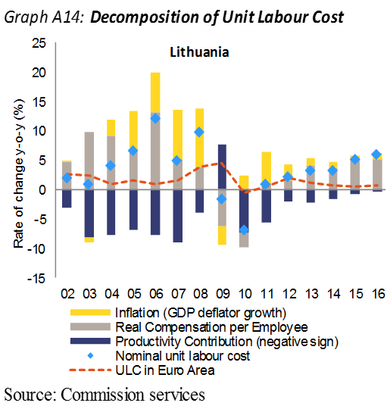and the real effective exchange rate (REER).

The current account has been shrinking in 2015-2016 bringing the indicator towards balance. The NIIP, mainly reflecting government debt and FDI, is on an improving trend. There have been gains in export market shares in 2016. However, there have been losses in cost competitiveness. The REER has been appreciating in recent years and unit labour cost growth has been strong, which is expected to decelerate somewhat in the coming years with an expected increase in productivity. Public and private debt levels continue to be relatively low and stable. Real house prices have been increasing but from a low level. Unemployment is decreasing and is now within the threshold.

*Overall, the economic reading highlights issues relating to cost competitiveness, but risks remain contained. Therefore, the Commission will at this stage not carry out further in-depth analysis in the context of the MIP*

**Luxembourg:** In the previous round of the MIP, *no macroeconomic imbalances* were identified in Luxembourg. In the updated scoreboard, a number of indicators are beyond the indicative threshold, namely private sector debt as well as the increase in the youth unemployment rate.

The external position continues to show broadly stable current account surpluses and a positive NIIP where changes are to a large extent reflecting the country's position as an international financial centre rather than the activity of the domestic economy. Cumulated gains in export market have been large, favoured by the recent stability in cost competitiveness as underpinned by the subdued evolution in unit labour cost. For many consecutive years, real house prices have continued to grow at a relatively high rate and warrant close attention. House price growth is underpinned by the dynamic labour market combined with the sizeable net migration flows and favourable financing conditions while supply remains relatively constraint. Housing affordability keeps on deteriorating in view of constantly increasing house prices. While corporate indebtedness is mostly related to cross-border intracompany loans, the level of households' debt, which is mostly mortgage debt, has steadily increased reflecting the increasing house prices. Risks for the country financial stability are however mitigated by the solidity of the banking sector. Public debt remains very low. In a context of strong growth conditions the labour market is tightening and unemployment declining.

*Overall, the economic reading points mainly to some contained risks related to constantly increasing housing prices and households debt. Therefore, the Commission will at this stage not carry out further in-depth analysis in the context of the MIP.*

**Hungary:** In the previous round of the MIP, *no macroeconomic imbalances* *were identified* for Hungary. In the updated scoreboard, a number of indicators are beyond the indicative threshold, namely the net international investment position (NIIP), government debt, real house prices and the annual change in total financial sector liabilities.

The current account remains in a surplus position that has implied a sustained improvement in 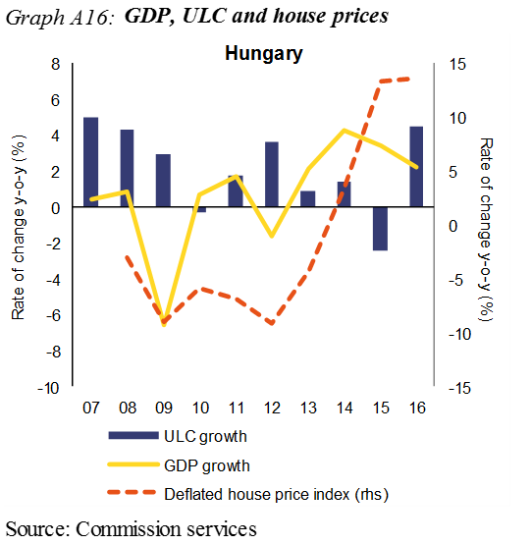the negative NIIP. There have been gains in export market shares, supported by a growing car industry. However, cost competitiveness has deteriorated as reflected in dynamic growth in unit labour costs. Private debt continues to decrease. In the corporate sector the pace of deleveraging has slowed down as economic growth strengthens and corporate lending has started to recover. There are signs of emerging capacity constraints and price pressures in the economy, which warrant attention. Real house prices, in particular, have continued to increase rapidly, albeit from undervalued levels. However, the still high share of non‑performing mortgage loans could benefit from a recovery in the housing market through their improved marketability. Government debt is only slowly declining. The banking sector has improved its profitability and its shock-absorbing capacity. The increase in financial sector liabilities is linked to a large one-off transaction by a special purpose entity with no effect on domestic credit. Unemployment decreased further in 2016 and the labour market keeps tightening.

*Overall, the economic reading highlights issues relating to the housing market and labour market, although risks appear contained. The Commission will at this stage not carry out further in-depth analysis in the context of the MIP.*

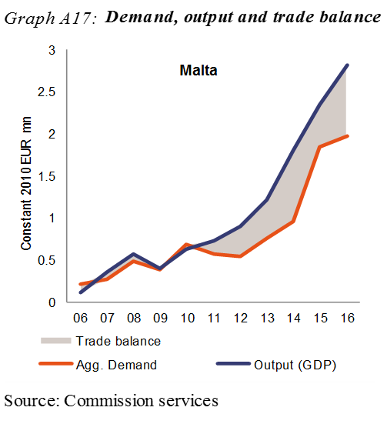

**Malta:** In the previous round of the MIP, *no macroeconomic imbalances* were identified in Malta. In the updated scoreboard, the current account balance is beyond the indicative threshold.

Despite rapid domestic demand growth the high current account surplus increased further in 2016 and the indicator is now beyond the threshold. The net international investment position is strongly positive. Cost competitiveness developments have been favourable. Unit labour cost growth has been contained due to both moderate wage developments and relatively strong labour productivity growth. REER developments have been stable. The private sector debt ratio was stable in 2016 but further passive deleveraging is underpinned by strong growth. However, corporate sector leverage remains high. The growth rate of credit to households has been roughly stable. The government debt-to-GDP ratio has been on a firm downward trend and is now within the threshold. The buoyant economic environment and some bottlenecks in channelling domestic savings to investments have contributed to a revival of the housing market. House prices have been growing steadily, which warrants attention. Asset quality in the domestic banking sector is improving and the available capital buffers appear sufficient to absorb immediate risks that could emerge from the housing market. Strong employment growth continued to be accompanied by falling unemployment.

*Overall, the economic reading points to a strong dynamism in the current account balance and the housing market in a context of strong growth but the risks appear contained. Therefore, the Commission will at this stage not carry out further in-depth analysis in the context of the MIP.*

**The Netherlands:** In February 2017, the Commission concluded that the Netherlands was experiencing *macroeconomic imbalances*, in particular involving the high level of household debt and the large and persistent current account surplus. In the updated scoreboard a number of indicators are beyond the indicative threshold, namely the current account, private sector debt and government debt.

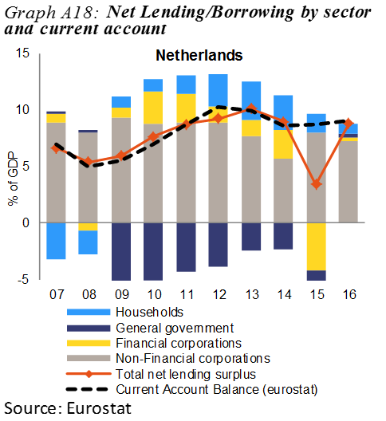The current account surplus remains well above the indicative threshold. The surplus reflects excess savings of non-financial corporations, in particular by multinational enterprises, in a context of low investment and contained corporate profit distribution. The aggregate impact from other sectors remains contained. Improving household investment has largely offset the current account impact by recent changes in the fiscal balance. The NIIP is positive and further increasing. Cost competitiveness indicators have been favourable, which also reflects subdued wage growth. Private debt is high. This concerns in particular the high level of household debt, compared to household disposable income. Household indebtedness continues to be fuelled by a favourable tax treatment of (debt-financed) home-ownership and low mortgage interest rates. Household deleveraging has been ongoing for several years, although mostly passively with the recent housing market activity and rising house prices driving up nominal debt levels. The government debt ratio is falling towards the threshold. The government debt ratio is on a declining trend and will move below the 60% threshold.

*Overall, the economic reading highlights issues relating to the persistent net savings and investment imbalances and the high private debt level. Therefore, the Commission finds it useful, also taking into account the identification of an imbalance in March, to examine further the persistence of imbalances or their unwinding.*

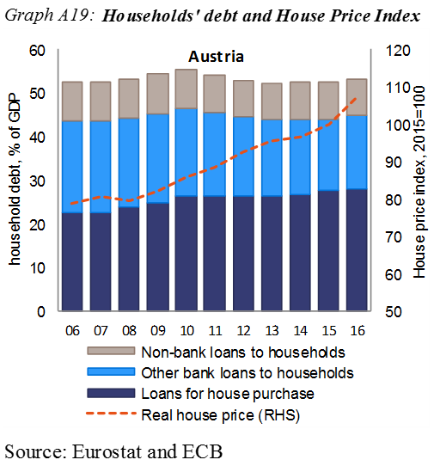**Austria:** In the previous round of the MIP, *no macroeconomic imbalances were identified* in Austria. In the updated scoreboard, a number of indicators are beyond the indicative threshold, namely real house prices, government debt as well as the change in long-term unemployment.

The current account surplus stabilised at a moderate level in 2016, while the net international investment position remained close to balance. Export market shares have also stabilised over the recent past, supported by cost competitiveness, as the real effective exchange rate remained broadly unchanged and unit labour costs decelerated due to limited wage growth. Real house prices, which have been on the rise since 2009, grew significantly in 2016 but have since moderated. Although the price increase does not appear credit-driven, the issue warrants close monitoring. Private sector debt, which stands within but close to the threshold, was little changed in terms of GDP. Government debt is projected to have entered a declining trend, also thanks to the divestment of impaired assets from nationalised financial institutions. The banking sector situation has improved notably in 2016, as banks further reduced their non-performing loans and their capital ratios are slowly catching up with EU peers. The unemployment rate is likely to have peaked in 2016, and is expected to slowly decline thanks to strong employment growth. Long-term and youth unemployment have slightly increased but remain at relatively low levels.

*Overall, the economic reading highlights issues relating to the housing and the banking sector, but risks appear contained. Therefore, the Commission will at this stage not carry out further in-depth analysis in the context of the MIP.*

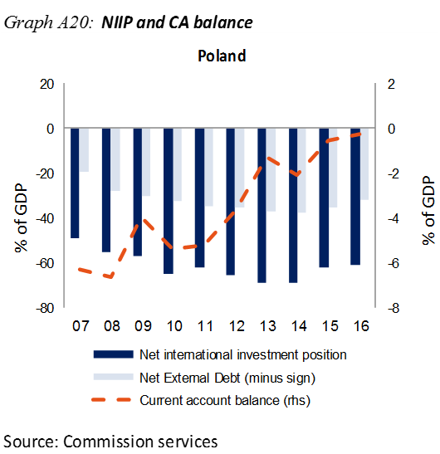

**Poland:** In the previous round of the MIP, *no macroeconomic imbalances were identified* in Poland. In the updated scoreboard, the net international investment position (NIIP) is beyond the indicative threshold.

The current account deficit has continued to narrow towards balance. The NIIP, which remains highly negative, improved minimally in 2016. External vulnerabilities are contained, given that foreign direct investments account for a major part of foreign liabilities, while net foreign debt has continued to gradually decline. In 2016, the gains in export market shares accelerated while cost competitiveness indicators strengthened. Both private sector and government debt increased in 2016, while still remaining at a relatively low level. Poland's banking sector is relatively well capitalized, liquid and profitable, although the sizable stock of foreign-currency denominated loans increases its vulnerability. Labour market performance continued to be strong and improved with a further decline in the unemployment rate and associated progress in poverty indicators.

*Overall, the economic reading highlights issues in the external investment position, but overall risks remain limited. Therefore, the Commission will at this stage not carry out an in-depth analysis in the context of the MIP.*

**Portugal:** In February 2017, the Commission concluded that Portugal was experiencing *excessive macroeconomic imbalances*, in particular involving the large stock of external liabilities, public and private debt, banking sector vulnerabilities and the labour market adjustment process in the context of low productivity growth. In the updated scoreboard, a number of indicators are beyond the indicative threshold, namely the net international investment position (NIIP), government debt, private debt, unemployment, and real house prices.

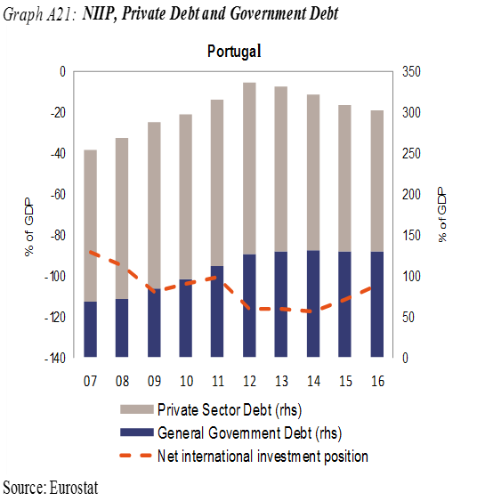The current account has retained a small surplus over the past years contributing to a gradual reduction in the negative NIIP. The pace of adjustment however remains insufficient to induce a more sustainable external position. Having improved in previous years, price competitiveness deteriorated moderately in 2016 but export performance remained strong. Both public and private debts remain very high, imposing a high interest burden while the share of investment in the economy is very low. While the private sector is deleveraging at a relatively fast pace the government debt ratio has been rather stable over the past years but is expected to drop gradually going forward. The high, albeit decreasing, level of non-performing loans, low profitability and low capital ratios highlight vulnerabilities of the banking sector. The labour market is undergoing a substantial improvement but there are still challenges related to skills and segmentation. In addition, weak productivity dynamics are limiting the country's growth potential.

*Overall, the economic reading highlights issues relating to imbalances in stock variables and their pace of adjustment, in particular external debt, public and private debt, banking sector vulnerability and weak productivity growth along with some labour market rigidities. Therefore the Commission finds it useful, also taking into account the identification of an excessive imbalance in February, to examine further the persistence of macroeconomic risks and to monitor progress in the unwinding of excessive imbalances.*

**Romania:** In the previous round of the MIP, *no macroeconomic imbalances were identified* in Romania. In the updated scoreboard, a number of indicators are beyond the indicative threshold, namely the net international investment position (NIIP) and real house prices.

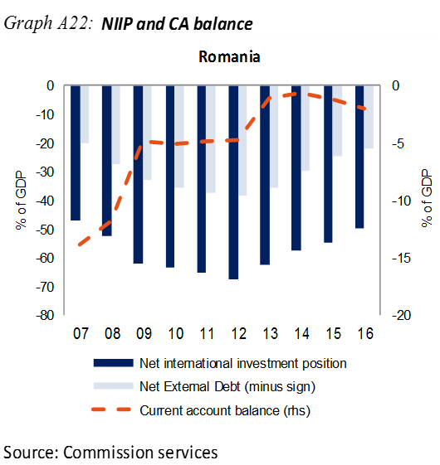The current account deficit deteriorated in 2016 on the back of strong private consumption, but strong GDP growth allowed for an improvement of the negative NIIP, in particular by reducing net external debt. Reflecting catching-up dynamics, most of the NIIP relates to net foreign direct investment liabilities, which mitigates external risks. Export market share growth remains strong, with substantial gains in 2016 despite a deterioration in cost competitiveness. Wage growth is set to remain substantial in the medium term and this could put additional pressure on cost competitiveness. Private sector debt is moderate and decreasing. The correction of real house prices reversed in 2015 and prices further accelerated in 2016. The banking sector remains well capitalized and liquid. Non-performing loans appear to be on a firm downward trend and do not seem to pose a risk to financial stability, despite still relatively high levels. Public debt declined slightly in 2016 and remains relatively low. However, the fiscal deficit is set to remain high in the medium term, with a negative impact on the publicdebt dynamics. The unemployment rate declined in 2016 reflecting a tightening of the labour market, while the activity rate decreased somewhat despite the strong economic growth.

*Overall, the economic reading highlights issues related to the external position and to the sustainability of the fiscal policy, but macroeconomic risks appear contained. The Commission will, at this stage, not carry out further in-depth analysis in the context of the MIP*.

**Slovenia:** In February 2017, the Commission concluded that *Slovenia was* *experiencing macroeconomic imbalances*, in particular involving fiscal risks and vulnerabilities stemming from the banking sector and corporate indebtedness. In the updated scoreboard, a number of indicators are beyond the indicative threshold, namely the net international investment position (NIIIP) and government debt.

The large current account surplus increased further in 2016, as investment remained weak. As a consequence, the negative NIIP has improved substantially and is now very close to the threshold. Export market shares increased in 2016, supported by minimal unit labour costs growth and the very modest real effective exchange rate appreciation. Private debt decreased further, notably in the corporate sector, while deleveraging pressures are coming to an end. However, investment remains low. The banking sector has stabilised and bank profitability is recovering while the share of non-performing loans continues its downward trend with further reductions expected. Public debt remains high, but decreased in 2016. Projected ageing costs continue to pose risks to fiscal medium and long-term sustainability. The labour market improved further owing to the continued growth of GDP and exports. However, labour productivity remains low.

*Overall, the economic reading highlights issues relating to the long-term fiscal sustainability and banking sector performance. Therefore, the Commission finds it useful, also taking into account the identification of an imbalance in February 2017, to examine further the persistence of imbalances or their unwinding.*

**Slovakia**: In the previous round of the MIP, *no macroeconomic imbalances were identified* in Slovakia. In the updated scoreboard, a number of indicators are beyond the indicative threshold, namely the net international investment position (NIIP), real house prices and unemployment.

The current account balance turned slightly negative in 2016, after having improved for several years. The NIIP remains strongly negative and in excess of the indicative threshold. However, the associated risks remain limited as much of the foreign liabilities relates to foreign direct investment, especially in the expanding automotive industry, while net external debt levels remain comparatively low. Nominal unit labour costs continued to grow at modest rates, boosting competitiveness and facilitating a marked increase in export market shares. Growth in property prices, although it was preceded by years of price moderation, accelerated in 2016, fuelled by strong growth in credit for house purchases that also contributed to the upward-trending private sector debt ratio. The public debt ratio continued to decrease in 2016, from an already moderate level. The largely foreign-owned banking sector remained resilient and well-capitalised. Further declines in unemployment have been accompanied by increases in the participation rate, as employment prospects for previously inactive persons have risen. However, the unemployment situation regarding youth people and disadvantaged groups, while improving, remains a challenge.

*Overall, the economic reading points to issues related to developments in the housing markets, but with limited risks, while structural* *unemployment remains a challenge. Therefore, the Commission will at this stage not carry out further in-depth analysis in the context of the MIP.*

**Finland**: In February 2017, the Commission concluded that Finland was *no longer experiencing macroeconomic imbalances*. In the updated scoreboard, a number of indicators are beyond the indicative threshold, namely export market shares, private sector debt and government debt, as well as the increase in long-term unemployment.

The current account deficit worsened somewhat in 2016 due to increased domestic demand, but is expected to improve in the coming years. After a few years in which the net international investment position had deteriorated somewhat on the back of valuation effects, it improved in 2016. Cumulated Export market shares losses have slowed down in 2016, supported by the recent gradual improvement in cost competitiveness indicators: nominal unit labour costs declined slightly as productivity growth increased. Non-cost competitiveness however remains a key issue. The private sector debt-to-GDP ratio came down slightly in 2016, but remains high. Credit growth to the private sector has recently slowed down, although favourable credit conditions, low interest rates and improved economic outlook could accelerate private credit growth going forward, which may limit deleveraging. The financial sector remains well capitalised, limiting risks to financial stability, while mortgage and housing market indicators point to reduced risks to household sector debt. The government's fiscal policy and the improved economic outlook should help reduce the public debt ratio, which stabilised in 2016. Employment gradually expanded and the unemployment rate decreased in 2016 following increasing economic activity. Youth unemployment has recently begun to decrease, and long-term unemployment has stabilised in 2016.

*Overall, the economic reading highlights challenges related to competitiveness and private sector debt but points to improving trends and limited risks. Overall, the Commission will at this stage not carry out further in-depth analysis in the context of the MIP.*

**Sweden:** In February 2017, the Commission concluded that Sweden *was experiencing macroeconomic imbalances*, in particular involving persistent house price growth from already overvalued levels, coupled with a continued rise in household debt. In the updated scoreboard, a number of indicators stand above the indicative threshold, namely export market shares, private sector debt and house price growth.

The current account surplus remains high but somewhat below the threshold, primarily reflecting high private savings. The net international investment position has continued to improve and is now significantly positive. Cumulated export market share losses remain beyond the threshold, but the medium-term trend shows a gradual improvement amid slowing world trade. These losses were driven by weak external demand rather than by competitiveness issues, as unit labour cost growth remained contained. Private sector debt is broadly stable at a high level, and risks mainly relate to household debt. Household debt is growing continuously, implying risks for macroeconomic stability in view of growing house prices. House prices and household indebtedness have notably been pushed up through favourable tax treatment of (debt-financed) home-ownership, low mortgage interest rates and specific features of the Swedish mortgage market. On the supply side, constraints on new construction remain a problem, although residential investment continues to grow rapidly. In spite of the exposure to household debt, bank risks currently appear contained as asset quality and profitability remain high. Unemployment is on a slowly declining trend, aided by the improvement of growth conditions.

*Overall, the economic reading highlights continued concerns relating to high private debt and developments in the housing sector. Therefore, the Commission finds it useful, also taking into account the identification of an imbalance in February, to examine further the persistence of imbalances or their unwinding.*



**United Kingdom**: In the previous round of the MIP, *no macroeconomic imbalances were identified* in the United Kingdom. In the updated scoreboard, a number of indicators are beyond the indicative threshold, namely the current account deficit, private sector debt and government debt.

The 2016 sterling depreciation significantly improved the United Kingdom’s net international investment position, leaving it close to balance. However, while price-competitiveness, as measured by the real effective exchange rate, has increased markedly due to sterling’s depreciation, to date the net trade response to weaker sterling has been disappointing. The substantial current account deficit persisted in 2016, exposing the United Kingdom to sizeable external financing needs. After several years of gradual deleveraging, the private sector debt-to-GDP ratio has ticked up, and remains high. In particular, household debt continues to warrant close monitoring. Real house prices continued to rise from already high levels, though house price growth is expected to moderate going forward. Public debt was close to stable in 2016 but the high public debt-to-GDP ratio remains a concern. Strong employment growth continued to be accompanied by falling unemployment, although labour productivity remains weak.

*Overall, the economic reading highlights some issues relating to private debt, the housing market and the external side of the economy. These issues appear to pose limited risks to stability in the short term. Overall, the Commission will at this stage not carry out further in-depth analysis in the context of the MIP.*



 

1. This report is accompanied by a *statistical annex* which contains a wealth of statistics which have contributed to inform this report.
2. See Article 5 of EU Regulation (EU) No 1176/2011.
3. Regulation (EU) No 1176/2011 of the European Parliament and the Council of 16 November 2011 on the prevention and correction of macroeconomic imbalances.
4. National accounts-based figures.
5. Regulation (EU) No 1176/2011 (OJ L 306, 23.11.2011, p. 25).
6. See ʽ2016 European Semester: Assessment of progress on structural reforms, prevention and correction of macroeconomic imbalances, and results of in-depth reviews under Regulation (EU) No 1176/2011ʼ - COM(2016) 95 final/2 -, 7.4.2016.
7. A mechanistic reading of the scoreboard is ruled out by the MIP regulation (Regulation (EU) 1176/2011). On the rationale underlying the construction of the AMR scoreboard and its reading see ʽ*The Macroeconomic Imbalance Procedure. Rationale, Process, Application: A Compendium*ʼ (European Commission, 2016).
8. The detailed scoreboard indicators, together with the respective indicative thresholds, are displayed in Table 1.1 in annex.
9. The calculations for NIIP-stabilising current accounts rest on the following assumptions: nominal GDP projections stem from the European Commission autumn 2017 forecast (up to 2019) and from the Commission methodology for 10-year ahead projections; valuation effects are conventionally assumed to be zero in the projection period; capital account balances are assumed to remain constant as a percentage of GDP at the median value between 2016 and the projections to 2019.
10. A broadly similar assessment is presented in IMF, External Sector Report, 2017. See also footnote 13.
11. In a few countries, like Poland and Romania strong increases in the amount of capital per worker (so-called capital deepening) lifted labour productivity and dampened unit labour costs, while the opposite happened in Latvia, Greece, Portugal and Slovenia.
12. National accounts-based figure for the period 2017-2019; the national accounts-based figures and the figures in balance of payments statistics for 2015 and 2016 coincide.
13. The benchmark is derived from reduced-form regressions capturing the main determinants of the saving-investment balance, including fundamental determinants (e.g. demography, resources), policy factors and global financial conditions. The methodology is akin to that followed by IMF External Balance Assessment (Phillips, S. et al., 2013, ʽThe External Balance Assessment (EBA) Methodologyʼ, IMF Working Paper, 13/272). The main differences consist of a larger sample used in the estimation, a slightly different empirical specification (different interactions for the variable capturing ageing effects and an additional variable capturing the share of manufacturing in value added), and some differences in the definition of norms (predictions based on a smaller set of fundamentals, notably excluding the NIIP and global risk aversion variables, and policy variables set at world average). IMF estimates of the current account norm for the euro area point to a small surplus in the order of 2.7% of GDP (staff assessment).
14. Surplus countries are defined as follows: Belgium, Germany, Luxemburg, the Netherlands, Austria, Finland; deficit countries are the remaining EA19 countries. All surplus countries recorded a current account position balanced or in surplus over the 1999-2012 period (the only exceptions being Germany and Austria before 2002 and Finland after 2010, while all deficit countries recorded a deficit between 2000 and 2012).
15. Hungary constitutes an exception, although the rapid growth in financial sector liabilities observed in 2016 is attributable to a particular transaction with limited macroeconomic impact.
16. In November 2016, the European Systemic Risk Board (ESRB) issued country-specific warnings on medium-term vulnerabilities in the residential real estate sector to eight EU Member States (Austria, Belgium, Denmark, Finland, Luxembourg, the Netherlands, Sweden and the United Kingdom).
17. The indicator At Risk of Poverty or Social Exclusion (AROPE) corresponds to the share of persons who are vulnerable according to at least one of three social indicators: (1) At risk-of-poverty (AROP) are persons with disposable income (adjusted for household composition) below 60% of the national median; (2) Severe material deprivation (SMD) covers indicators related to a lack of resources, namely the share of people experiencing at least 4 out of 9 deprivations items; (3) People living in households with very low work intensity are those aged 0-59 living in households in which adults (aged 18-59) work less than 20% of their total work potential during the past year.
18. In the case of Greece, the surveillance of imbalances and the monitoring of corrective measures takes place in the context of the programme of financial assistance rather than under the macroeconomic imbalances procedure.