

Table of Contents

List of acronyms and abbreviations 3

1. INTRODUCTION 5

2. EU ETS INFRASTRUCTURE 7

2.1. Coverage of activities, installations and aircraft operators 7

2.2. Union Registry and the European Union Transaction Log (EUTL) 9

3. FUNCTIONING OF THE CARBON MARKET IN 2016 10

3.1. Supply: allowances put in circulation 10

3.1.1. Cap 10

3.1.2. Issued allowances 12

3.1.3. International credits 21

3.2. Demand: allowances taken out of circulation 23

3.3. Balancing supply and demand 23

4. AVIATION 27

5. MARKET OVERSIGHT 29

5.1. The legal nature and fiscal treatment of emission allowances 30

6. MONITORING, REPORTING AND VERIFICATION OF EMISSIONS 31

7. OVERVIEW OF ADMINISTRATIVE ARRANGEMENTS 34

8. COMPLIANCE AND ENFORCEMENT 35

9. CONCLUSIONS AND OUTLOOK 37

ANNEX 38

# List of acronyms and abbreviations

AVR Accreditation and Verification Regulation

CA Competent Authority

CCS Carbon Capture and Storage

CDM Clean Development Mechanism

CERs Certified Emission Reductions

CORSIA Carbon Offsetting and Reduction Scheme for International Aviation

EA European Cooperation for Accreditation

EEA European Economic Area

EEX European Energy Exchange

EIB European Investment Bank

ERUs Emission Reduction Units

EU ETS European Union Emissions Trading System

EUTL European Union Transaction Log

GHG Greenhouse Gas

ICAO International Civil Aviation Organization

ICE ICE Future Europe

JI Joint Implementation

MAR Market Abuse Regulation

MiFID2 Directive on Markets in Financial Instruments

MRR Monitoring and Reporting Regulation

MRV Monitoring, Reporting, and Verification

MRVA Monitoring, Reporting, Verification and Accreditation

MSR Market Stability Reserve

NAB National Accreditation Body

NER New Entrants Reserve

PFCs Perfluorocarbons

RES Renewable Energy Sources

TNAC Total Number of Allowances in Circulation

# INTRODUCTION

The EU Emissions Trading System (EU ETS) has been the cornerstone of the EU's strategy for reducing greenhouse gas (GHG) emissions from industry and the power sector since 2005. It contributes significantly to the achievement of the EU's target of cutting GHG emissions by 20% from 1990 levels by 2020. While the EU is on track to surpass this target[1], cutting GHG emissions by at least 40% by 2030 – as foreseen in the EU's 2030 climate and energy policy framework – would require continued progress[2]. The 2030 domestic target will be delivered collectively by the EU, with reductions in both the ETS and the non-ETS sectors. However, a well-functioning, reformed EU ETS will constitute the main mechanism to achieve this target, by facilitating a decrease of 43% of GHG emissions compared to 2005 levels in the sectors covered by the system.

To enable the EU ETS to accomplish this goal, in July 2015 the Commission presented a legislative proposal[3] to reform the EU ETS for its fourth trading period (2021- 2030). A political agreement was reached on the proposal in early November 2017 following an extensive process of trilogues[4].

This Report on the functioning of the European carbon market is presented in accordance with the requirements of Articles 10(5) and 21(2) of Directive 2003/87/EC[5] (EU ETS Directive). As stipulated by the Directive, the objective of the report is to provide a regular snapshot of developments in the European carbon market on an annual basis.

**Table 1: Carbon market reports published in previous years[6]**

|  |  |  |
| --- | --- | --- |
| **Reference** | **Period covered** | **Political context** |
| COM(2012) 652 | 2008-2011 | Assess the need for regulatory action in view of a growing surplus in emission allowances |
| COM(2015) 576 | 2013-2014 | 1st State of the Energy Union report |
| COM(2017) 48 | 2015 | 2nd State of the Energy Union report |

The present report covers the year 2016, but also presents certain initiatives proposed or agreed in 2017. Compared to the previous report, it contains a new chapter on indirect carbon cost compensation schemes, as well as information on the Market Stability Reserve surplus indicator published for the first time in May 2017. Unless otherwise indicated, data used for this report were the ones publicly available and at the disposal of the Commission by 30 June 2017.

General and descriptive information on different aspects of the EU ETS is included in boxes throughout the report.

# EU ETS INFRASTRUCTURE

# Coverage of activities, installations and aircraft operators

The EU ETS operates in the 31 countries of the European Economic Area (EEA). It limits emissions from nearly 11,000 power plants and manufacturing installations as well as slightly over 500 aircraft operators flying between EEA's airports. It covers around 45% of the EU's GHG emissions.

As of Phase 3 (2013-2020)*, the sectors with stationary installations regulated by the EU ETS are energy intensive industries, including power stations and other combustion plants with >20MW thermal rated input (except hazardous or municipal waste installations), oil refineries, coke ovens, iron and steel, cement clinker, glass, lime, bricks, ceramics, pulp, paper and board, aluminium, petrochemicals, ammonia, nitric, adipic, glyoxal and glyoxylic acid production, CO2 capture, transport in pipelines and geological storage of CO2.

The aviation scope of the EU ETS was limited to flights within the EEA until the end of 2016, pending the adoption of a global approach by the International Civil Aviation Organization (ICAO). In October 2016, the ICAO agreed on a resolution on the Carbon Offsetting and Reduction Scheme for International Aviation (CORSIA), to start in 2021. In light of this outcome, the Commission proposed to continue the intra-EEA approach beyond 2016 (see Section 4).

The EU ETS covers carbon dioxide (CO2) emissions, nitrous oxide (N2O) emissions from all nitric, adipic, glyoxylic acid and glyoxal production, and perfluorocarbons (PFC) emissions from aluminium production. Even though participation in the EU ETS is mandatory, in some sectors only installations above a certain size are included. Moreover, participating countries can exclude small installations from the system if measures are in place that will cut their emissions by an amount equivalent to the amount of emissions which would have been cut had the installations been included in the EU ETS. Participating countries may also add more sectors and GHGs to the EU ETS.

* Information on Phases 1 and 2 of the EU ETS can be found here: https://ec.europa.eu/clima/policies/ets/pre2013_en

According to the Article 21 reports submitted by participating countries[7] in 2017, there were a total of 10 790 permitted installations in 2016 compared to approximately 10 950 in 2015 and approximately 11 200 the year before.

As was the case in previous years, the fuels combusted within the EU ETS in 2016 remained overwhelmingly fossil. However, 29 countries also reported biomass use (compared to 27 in 2015) in connection with 2 079 installations (19% of all installations). Only two countries (LI and MT) did not report any use of biomass[8]. Emissions from biomass in 2016 amounted to approximately 141 million tonnes CO2 (8% of EU ETS reported emissions), compared to approximately 125 million tonnes CO2 in 2015 (some 7% of EU ETS reported emissions). The same two countries as last year (DE and SE) reported a small use of biofuel for three aircraft operators (compared to four in 2015).[9]

Within the installation categories based on annual emissions[10], the data for 2016 shows that, as in previous years, approximately 72% of installations are category A, nearly 21% are category B and slightly over 7% are category C. Over 6 202 installations were reported as 'installations with low emissions' (57.5% of the total).

EU ETS installations involving combustion activities can be found in all participating countries, while oil refining, steel production, cement, lime, glass, ceramics and pulp and paper production can be found in the majority of them. Regarding EU ETS activities additionally listed for non-CO2 emissions, permits are reported as issued for primary aluminium and perfluorocarbons (PFCs) in 13 countries (DE, ES, FR, GR, IS, IT, NL, NO, RO, SE, SI, SK, UK), while for nitric acid production and N2O permits are reported as issued in 21 countries (the exceptions being CY, DK, EE, IE, IS, LI, LU, LV, MT, and SI). The other N2O sectors – adipic acid production and glyoxal and glyoxylic acid production are reported in three (DE, FR, IT) and two (DE, FR) countries, respectively. The same two countries (FR and NO) as last year declared CO2 capture and storage activities.

Eight countries (DE, ES, FR, HR, IS, IT, SI, UK) have made use of the possibility to exclude small emitters from the EU ETS in line with Article 27 of the EU ETS Directive. As in 2015, emissions excluded for 2016 amounted to about 4 million tonnes CO2 (some 0.22% of total verified emissions).

According to Article 21 submissions in 2017, so far seven countries (BE, DK, FR, HR, HU, LI, LT) have taken advantage of the provision offered by Article 13 of Commission Regulation (EU) No 601/2012 ("the Monitoring and Reporting Regulation") to allow use of simplified monitoring plans in low risk cases for stationary installations. Only Denmark has joined since 2015. In the case of aircraft operators with low emissions, four countries have reported use of this provision (BE, FI, IS and PL), with Belgium joining since 2015.

Regarding the coverage of aircraft operators, 503 aircraft operators in 2016 were reported to have a monitoring plan (compared to 524 reported for 2015, and 611 for 2014). This suggests that the number of aircraft operators within the EU ETS is stabilising. Nearly 60% (300) of the reported operators were commercial while the other 40% (203) were non-commercial.[11] A total of 249 (nearly 50%) qualified as small emitters (compared to 274 (52%) in 2015 and 329 (54%) in 2014).

# Union Registry and the European Union Transaction Log (EUTL)

The Union Registry and the European Union Transaction Log (EUTL) track the ownership of general and aviation allowances and the transactions involving them by recording the amounts owned on its accounts and the transactions between accounts. They are operated and maintained by the Commission, whereas national registry administrators in the 31 participating countries remain the point of contact for the representatives of around 15 000 accounts (companies or natural persons).

While the Union Registry holds accounts for stationary installations and for aircraft operators, the EUTL automatically checks, records and authorises all transactions between accounts, thus ensuring that all transfers comply with EU ETS rules. They thus offer European emitters, traders and the 31 national authorities the means to carry out their EU ETS activities: allocating free allowances to the stationary and aviation operators, recording emissions, allowing emitters, professional traders and physical persons to execute completed trades by transferring allowances between accounts, and allowing emitters to cover their emissions by surrendering allowances.

*Decision No 406/2009/EC of the European Parliament and of the Council of 23 April 2009 on the effort of Member States to reduce their greenhouse gas emissions to meet the Community’s greenhouse gas emission reduction commitments up to 2020, OJ L 140, 5.6.2009, p. 136.

In 2016, the Union Registry continued to provide reliable services to European emitters (stationary installations and aviation operators), traders, and national authorities.

Several technical and usability improvements were introduced in the registry. The enhancements concern features of user handling, accounts, and transactions, as well as the authentication system, which was substantially improved and became EU Login.

In the summer of 2017, the Commission launched a survey on the user interface of the Union Registry, asking users to provide their views on the current functioning of the interface. The goal was to further improve the user experience of the registry.

# FUNCTIONING OF THE CARBON MARKET IN 2016

This chapter provides information on the supply and demand side of the EU ETS. The supply side section includes information on the cap, free allocation, the NER300 programme, auctioning, the derogation from full auctioning for the power sector, as well as the use of international credits. As a new element, this year's report also contains a chapter on indirect carbon cost compensation schemes.

On the demand side, information is provided on the number of verified emissions and on the methods of balancing the supply and demand of allowances, such as the Market Stability Reserve (MSR).

## Supply: allowances put in circulation

### Cap

The cap is the absolute quantity of GHGs which may be emitted in the system to ensure the emission reduction target is met and that it corresponds to the number of allowances put in circulation over a trading period. In Phase 3, a common EU-wide cap is applied, replacing the previous system of national caps.

The 2013 cap for emissions from stationary installations was set at 2 084 301 856 allowances. This cap decreases each year by a linear reduction factor of 1.74% of the average total quantity of allowances issued annually in 2008-2012, thus ensuring that the number of allowances that can be used by stationary installations will be 21% lower in 2020 than in 2005.

The aviation sector cap was originally set at 210 349 264 aviation allowances per year, which is 5% below the average annual level of aviation emissions in 2004-2006. It increased by 116 524 aviation allowances on 1 January 2014 to accommodate Croatia joining the EU ETS. This cap was meant to reflect the 2008 legislation* which included aviation in the EU ETS and stated that all flights from, to and within the EEA would be included in the EU ETS. However, the scope of the EU ETS was temporarily limited to flights within the EEA between 2013 and 2016 to support the development of a global measure by the ICAO. Therefore, the number of aviation allowances put into circulation in 2013-2016 has been significantly lower than the original cap. In light of the progress on the global measure in October 2016, the Commission has proposed to continue the current approach beyond 2016 (see section 4).

* Directive 2008/101/EC of the European Parliament and of the Council of 19 November 2008,amending Directive 2003/87/EC so as to include aviation activities in the scheme for greenhouse gas emission allowance trading within the Community

Table 2 shows the figures for the cap for stationary installations and the number of aviation allowances put annually into circulation[12] for each year during Phase 3 of the EU ETS.

**Table 2: EU ETS cap 2013-2020**

|  |  |  |
| --- | --- | --- |
| **Year** | **Annual cap *(installations)*** | **Annual aviation allowances put into circulation[13]** |
| 2013 | 2 084 301 856 | 32 455 312 |
| 2014 | 2 046 037 610 | 41 681 025 |
| 2015 | 2 007 773 364 | 48 543 026 |
| 2016 | 1 969 509 118 | 38 034 475 |
| 2017 | 1 931 244 873 | 37 833 819[14] |
| 2018 | 1 892 980 627 |  |
| 2019 | 1 854 716 381 |  |
| 2020 | 1 816 452 135 |  |

### Issued allowances

#### Free allocation

Although in Phase 3 auctioning is the default method for allocating emission allowances to companies participating in the EU ETS, a significant amount of allowances continue to be allocated for free until 2020 and beyond. The following principles apply:

* Electricity production no longer receives any free allowances;
* Allowances are distributed for free according to EU-wide harmonised rules;
* Free allocation is based on performance benchmarks to strengthen the incentives for GHG emission reductions and reward the most efficient installations;
* An EU-wide New Entrants' Reserve (NER) has been established, equivalent to 5% of the total amount of allowances for Phase 3.

Free allocation is provided to industrial installations to address the potential risk of carbon leakage (a situation where companies transfer production to third countries with laxer constraints on GHG emissions for reasons of costs related to EU climate policies, which may lead potentially to an increase in their total emissions). The sectors and sub-sectors deemed to be exposed to a significant risk of carbon leakage are placed on a carbon leakage list*, which currently covers the period 2015-2019.

* The current carbon leakage list can be found here: http://eur-lex.europa.eu/legal-content/EN/ALL/?uri=CELEX:32014D0746

Over Phase 3, 39% of the total quantity of allowances available will be allocated for free to industry and electricity-generating installations for the heat they produce. This share will be further increased due to allocations to new entrants until 2020. It is not possible to determine how much of the NER will be used in future years. However, the Commission's 2015 Impact Assessment[15] indicated that in line with trends, it was expected that no more than 2% of the cap would additionally be allocated for free from NER. Therefore, over Phase 3, the free allocation is expected to be around 41% of the total amount. Further, some 2% of the total cap is used to fund the deployment of innovative low-carbon technologies via the NER300 programme[16]. Therefore, the auction share in Phase 3 amounts to 57%.

New installations and installations significantly increasing capacity are eligible for additional free allocation from the NER in Phase 3. The initial NER, after deducting 300 million allowances for the NER300 programme, held 480.2 million allowances. 139.9 million allowances have been reserved for 654 installations for the entirety of Phase 3[17]. The remaining NER, which amounts to 340.3 million allowances, can be distributed in the future. However, it is expected that a significant number of these allowances will remain unallocated.

Until June 2017, allocation has been reduced by around 301.9 million allowances due to installations that have closed or reduced their production or their production capacity compared to the one initially used to calculate Phase 3 allocation.

Table 3: The number of allowances (in millions) allocated to the industry for free in from 2013 to 2017[18]

|  |  |  |  |  |  |
| --- | --- | --- | --- | --- | --- |
|  | **2013** | **2014** | **2015** | **2016** | **2017** |
| **Free allocation[19]  (EU28+EEA EFTA states)** | 903.0 | 874.8 | 847.6 | 821.3 | 796.2 |
| **Allocation from the new entrants reserve (greenfield investments and capacity increases)** | 11.2 | 14.6 | 17.3 | 18.3 | 17.6 |
| **Free allowances remaining unallocated due to closures or changes in production or production capacity** | 40.2 | 58.6 | 69.9 | 65.5 | 67.5 |

As the demand for free allocation exceeded the amount available, the allocation for all installations under the EU ETS has been reduced by the same percentage through the application of a "cross-sectoral correction factor" (in accordance with the ETS Directive). The correction factor was calculated as a reduction in free allocation of approximately 6% in 2013, increasing annually until reaching approximately 18% in 2020.

On 28 April 2016, the European Court of Justice[20] invalidated as of 1 March 2017 the cross-sectoral correction factor values established in Commission Decision 2013/448/EU (see Appendix 5 to the Annex). Consequently, the Commission revised the values set in that Decision[21] on 24 January 2017 to bring them in conformity with the judgment of the Court of Justice.

#### NER 300 programme

The NER300 is a large-scale funding programme for innovative low-carbon energy demonstration projects. It is aimed at demonstrating environmentally safe carbon capture and storage (CCS) and innovative renewable energy (RES) technologies on a commercial scale within the EU.

The NER 300 is funded from the monetisation of 300 million emission allowances from the NER set up for Phase 3 of the EU ETS. The funds from the monetisation were awarded to projects selected through two rounds of calls for proposals in December 2012 and July 2014.

As a result of the two calls for proposals, 38 RES projects and 1 CCS project were awarded in total, covering 20 EU Member States and amounting to €2.1 billion. Of them, four are already operational: bioenergy project BEST in Italy, bioenergy project Verbiostraw in Germany, Windpark Blaiken in Sweden, and, as of 1 July 2017, the Veja Mate offshore wind farm in the German North Sea.

Thirteen projects in total have so far reached their final investment decision, while four projects have been cancelled. The Commission proposed re-investing the unspent funds from the cancelled projects, which amount to at least € 436 million, in existing financial instruments, i.e. the InnovFin Energy Demo Projects (EDP) and the Connecting Europe Facility debt instrument, both managed by the European Investment Bank (EIB). To this end, in May 2017 Member States approved in the Climate Change Committee a relevant amendment[22] to the NER 300 Decision[23].

**Table 4: NER 300 projects awarded under the first and second calls for proposals[24]**

|  |  |  |
| --- | --- | --- |
|  | **1st Call for proposals** | **2nd Call for proposals** |
| **Projects in planning** | 1 | 17 |
| **Projects final investment decision reached** | 11 | 2 |
| **Projects in operation** | 4 | 0 |
| **Projects withdrawn** | 4 | 0 |
| ***Total*** | *20* | *19* |

The publication of further NER 300 calls for proposals is not foreseen. The Commission is now focusing on the implementation[25] of the projects selected for funding, and the swift re-investment of unspent funds.

#### Compensation of indirect carbon costs

As explained in section 3.1.2.1, energy-intensive industries deemed to be exposed to risk of carbon leakage are eligible for free allowances to cover their direct carbon costs. In addition, EU Member States may grant state aid to compensate some electro-intensive industries for indirect carbon costs, i.e. increases in electricity prices, passed through by power generators due to the EU ETS.

To ensure harmonized application of indirect carbon cost compensation across Member States, and minimize competition distortions in the internal market, the Commission has adopted the EU ETS State Aid Guidelines* for the period 2013-2020. The Guidelines determine, inter alia, eligible sectors and maximum amounts for compensation of indirect carbon costs. The state aid granted for this purpose is partial and declining over time**, therefore retaining the incentives for electricity efficiency and the transition to ‘green’ electricity, in line with the EU ETS objectives.

* Guidelines on certain State aid measures in the context of the greenhouse gas emission allowances trading scheme post 2012,OJ C158, 05.06.2012, p.4

** The maximum share of eligible costs declines from 85% for the period 2013-2015, to 75 % for the period 2019-2020.

To date, the Commission has approved 10 state aid schemes for compensation of indirect carbon costs. Table 5 presents a summary of the indirect carbon costs compensation schemes approved since 2013.

**Table 5:** **Indirect carbon cost compensation schemes approved within the framework of the 2012 ETS Guidelines**[26]

|  |  |  |  |
| --- | --- | --- | --- |
| **Member State** | **Approved ceiling of the indirect carbon cost compensation schemes /*(annual average approved ceiling)* in millions** | **Duration of the scheme** | **Member States' auction revenue 2016 (excluding aviation allowances) in millions** |
| UK | £ 113[27]/ *(13 - 50)* | 2013 - 2020 | € 419 |
| DE | € 756[28]/ *( 203 - 350)* | 2013 - 2020 | € 846 |
| BE | € 113[29]/ *( 38)* | 2013 - 2020 | € 107 |
| NL | € 156[30]/(*78)* | 2013 - 2020 | € 142 |
| EL | € 160[31]/*(40)* | 2013 - 2020 | € 147 |
| LT | € 13.1 / *(1-3)* | 2014 - 2020 | € 21 |
| SK | € 250/ *(35)* | 2014 - 2020 | € 65 |
| FR | € 364/ *(61)* | 2015 - 2020 | € 231 |
| FI | € 149/ *(30)* | 2016 - 2020 | € 71 |
| ES | € 5/ (*1-3)* | 2013 - 2015 | € 365 |
| € 106 */(6-25)* | 2016 -2020 |

* + - 1. *Auctioning of allowances*

As of Phase 3 of the EU ETS, auctioning via the primary market is the default mode for allocating allowances. More than half of the allowances are to be auctioned during this phase, with the proportion continually growing throughout the trading period. Auctions are governed by the Auctioning Regulation* which specifies the timing, administration and other aspects of how auctions should take place to ensure an open, transparent, harmonised and non-discriminatory process.

* Commission Regulation (EU) No 1031/2010 of 12 November 2010 on the timing, administration and other aspects of auctioning of greenhouse gas emission allowances pursuant to Directive 2003/87/EC of the European Parliament and of the Council establishing a scheme for greenhouse gas emission allowances trading within the Community, OJ L 302, 18.11.2010, p.1.

The auctions over the reporting period took place through the following auction platforms:

* European Energy Exchange AG ('EEX'), auctioning as the common auction platform for 25 Member States participating in a joint procurement procedure, and for Poland which opted-out from the joint procurement procedure but has not appointed its own auction platform yet. As of 5 September 2016, EEX is conducting auctions as the second common auction platform appointed on 13 July 2016;
* EEX, auctioning for Germany as an 'opt-out' auction platform;
* ICE Future Europe ('ICE'), auctioning for the UK as an 'opt-out' auction platform.

Iceland, Liechtenstein and Norway have not started to auction allowances yet.

In 2016, EEX, auctioning on behalf of 27 Member States (25 Member States cooperating on a common auction platform, Germany, and Poland) auctioned 89% of the total auctioned amount, while ICE auctioned 11% of the total amount on behalf of the UK.

On 4 May 2017, auction number 1000 performed across platforms under the Auctioning Regulation was held. The number of auctions reached 1036 by 30 June 2017.

Table 6 provides an overview of the volumes of allowances auctioned by EEX and ICE up to 30 June 2017, including the early auctions[32] of general allowances. The volumes of general allowances have been determined taking into account Decision 1359/2013/EU to backload 900 million allowances from 2014, 2015 and 2016. The volumes of aviation allowances have been determined taking into account the temporary derogations for the aviation sector set out in Decision No 377/2013/EU and Regulation (EU) No 421/2014.

Table 6: Total volume of Phase 3 allowances auctioned in 2012-2017

|  |  |  |
| --- | --- | --- |
| Year | General allowances | Aviation allowances |
| 2012 | 89 701 500 | 2 500 000 |
| 2013 | 808 146 500 | 0 |
| 2014 | 528 399 500 | 9 278 000 |
| 2015 | 632 725 500 | 16 390 500 |
| 2016 | 715 289 500 | 5 997 500 |
| 2017 (up to 1 April)[33] | 241 935 000 | 0 |

The auctions were generally conducted smoothly and the auction clearing prices were generally in line with the secondary market prices, without the occurrence of significant problems or incidents. Due to the transition between the transitional auction platform and its successor common auction platform, no auctions for the 25 participating Member States were conducted for about a week in August 2016.

The auction on 25 May 2016 conducted by EEX for Poland and the one on 14 December 2016 conducted by ICE for the UK were cancelled in line with the provisions of the Auctioning Regulation. In the case of the Polish auction this was due to the reserve price not being met, while for the UK one the total bid volume fell short of the auctioned volume. With these, a total of five auctions have been cancelled out of the more than a thousand held under the Auctioning Regulation since late 2012. An overview of the auction clearing prices, number of participants and cover ratio for general allowances auctions from 2013 to 30 June 2017 is provided in Appendix 2 to the Annex.

The auction platforms publish detailed results of each auction on dedicated websites. Further information on the performance of the auctions, including on the participation, cover ratio and prices, can be found in the Member States' reports published by the Commission[34].

The total revenues generated from the auctions between 2012 and 30 June 2017 exceeded €18.4 billion (in 2016 alone, the generated total revenues were €3.79 billion). The EU ETS Directive provides that at least 50% of auction revenues, including all revenues generated from allowances distributed for the purposes of solidarity and growth, should be used by Member States for climate and energy related purposes. In 2016, the auctioning of ETS allowances generated EUR 3.79 billion of revenues for the Member States. According to the information submitted to the Commission, Member States spent or planned to spend approximately 80% of these revenues for specified climate and energy related purposes in 2016[35], however there are variations among them[36].

#### Derogation from full auctioning for the power sector

A derogation from the general rule of auctioning has been provided in Article 10c of the EU ETS Directive to support investments in the modernisation of the electricity sector in certain EU Member States. Eight out of ten eligible Member States* make use of this derogation and allocate to electricity generators a number of allowances for free provided corresponding investments are carried out.

The free allowances under Article 10c are deducted from the quantity that the respective Member State would otherwise auction. Depending on the national rules for the implementation of the derogation, electricity generators can receive free allowances of an equivalent value to the investments they carry out from their National Investment Plans, or to payments made into a national fund through which such investments are financed.

*Bulgaria, Cyprus, Czech Republic, Estonia, Hungary, Latvia, Lithuania, Malta, Poland and Romania are eligible for the derogation. Malta and Latvia decided not to make use of it.

The number of allowances allocated for free to electricity generators in 2016 is indicated in Table 1, Appendix 1 to the Annex, while the maximum number of allowances per year is indicated in Table 2 of Appendix 1.

The total value of reported investment support during the years 2009 to 2016 is around € 11 billion. About 80% of this was dedicated to upgrading and retrofitting infrastructure, while the rest of the investments were in clean technologies or diversification of supply. Some examples of investments include the reduction of energy consumption for electricity production in Lithuania, the replacement of insulation on existing steam distribution lines in the Czech Republic, and the construction of a cogeneration unit fuelled mainly by natural gas in Bulgaria.

Any allowances which are not given for free are auctioned. Figure 1 shows the number of allowances that have been requested by the eligible Member States during the years 2013-2016.

**Figure 1: Allowances allocated for free pursuant to Article 10c**

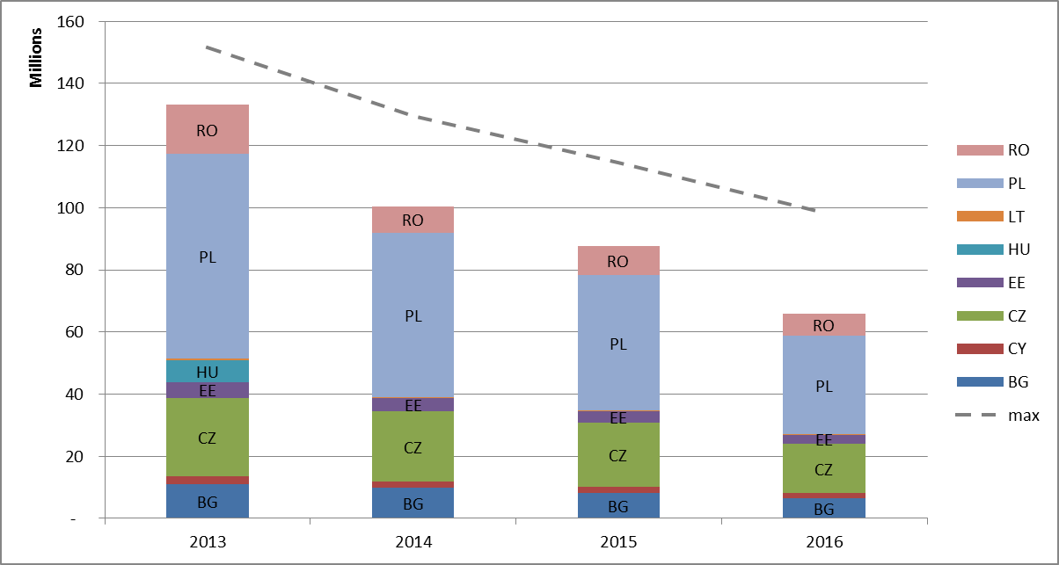

Figure 2 shows, for 10c allowances, the extent to which they have been allocated, auctioned or remain unused. For example, 82 million unused allowances have been deducted from Poland's share of allowances auctioned between 2013 and 2016, but have not yet been given for free or added to the auctions.

**Figure 2: Distribution of allowances (allocated, auctioned, unused remaining)**

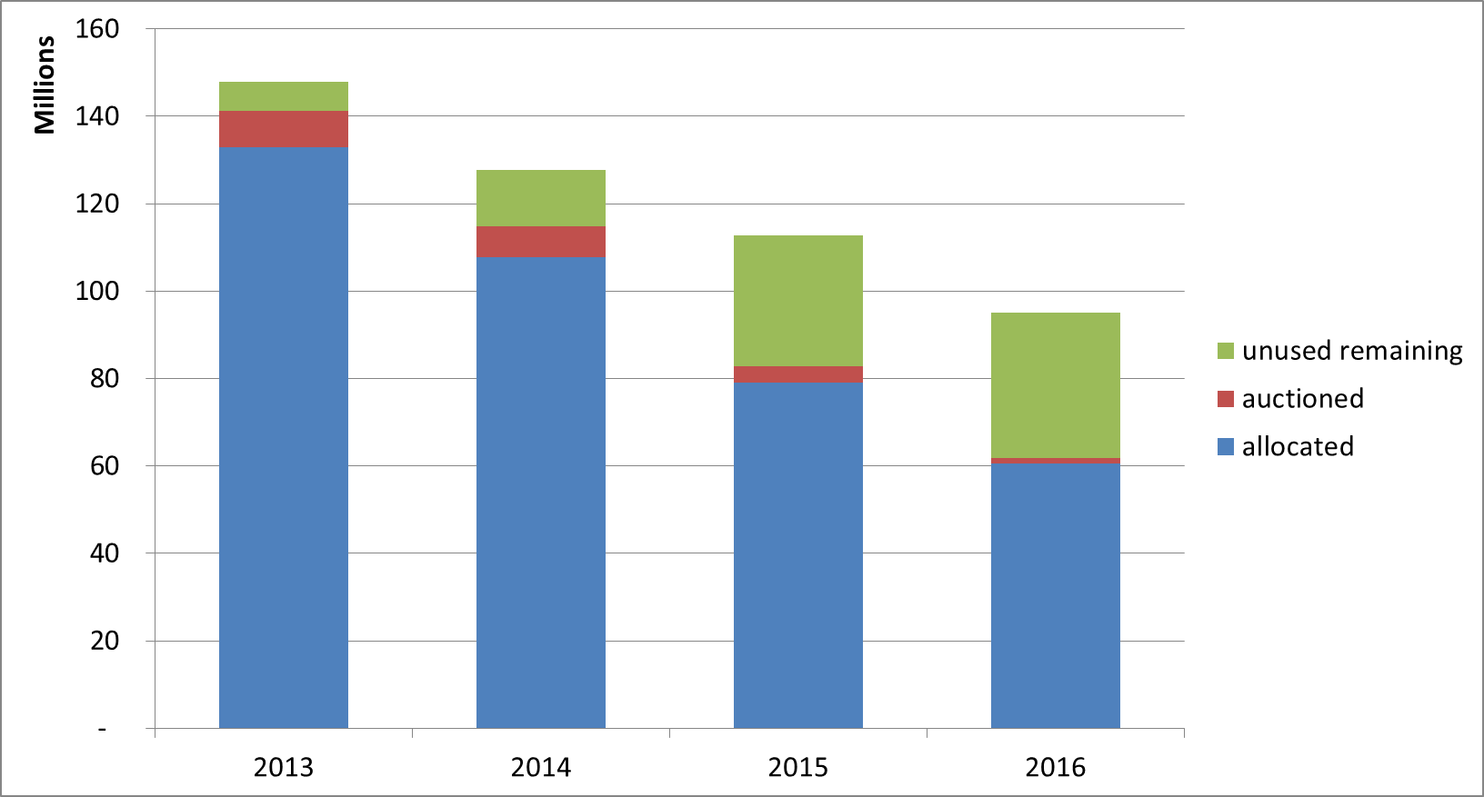

|  |  |
| --- | --- |
|  | Allocated allowances |
|  | Auctioned allowances |
|  | Unused remaining allowances |

Table 7 shows the number of unused allowances deducted for the years until 2016 which have been auctioned in the period 2013-2016, as well as the number of remaining unused allowances.

**Table 7: Treatment of unused 10c allowances 2013-2016**

|  |  |  |
| --- | --- | --- |
| **Member State** | **Number of unused 10c allowances**  **auctioned (in million)** | **Number of remaining unused allowances[37] (in million)** |
| **BG** | 6,9 | 0,0 |
| **CY** | 0,0 | 0,0 |
| **CZ** | 0,1 | 0,2 |
| **EE** | 0,2 | 0,3 |
| **HU** | 0 | 0,9 |
| **LT** | 0,3 | 0,6 |
| **PL** | 0,0 | 82,8 |
| **RO** | 8,8 | 6,6 |
| **Total** | 16,3 | 90,5 |

### International credits

Participants in the EU ETS can use international credits from the Kyoto Protocol's Clean Development Mechanism (CDM) and Joint Implementation (JI) towards fulfilling part of their EU ETS obligations until 2020*. These credits are financial instruments that represent a tonne of CO2 removed or reduced from the atmosphere as a result of an emissions reduction project. In phase 3 credits are no longer surrendered directly, but instead may be exchanged for allowances at any time during the calendar year.

A number of qualitative standards apply to the use of credits by EU ETS participants: credits are not accepted from nuclear, afforestation and reforestation projects, and new projects registered after 2012 must be in least developed countries. There are also maximum levels of credits that can be used by stationary installations and aircraft operators**.

* CDM and JI projects generate Kyoto carbon credits: Certified Emission Reductions (CERs) and Emission Reduction Units (ERUs) respectively. Commission Regulation (EU) No 389/2013 stipulates that ERUs issued by third countries which do not have legally binding quantified emission targets from 2013 to 2020 as set out within the Doha amendment to the Kyoto Protocol or that have not deposited an instrument of ratification relating to the amendment, should only be held in the Union Registry if they have been certified to relate to emission reductions verified as having taken place before 2013.  
**Commission Regulation (EU) No 1123/2013 of 8 November 2013 on determining international credit entitlements pursuant to Directive 2003/87/EC of the European Parliament and of the Council, OJ L 299, 9.11.2013, p. 32

Although the exact quantity of international credit entitlements over Phases 2 and 3 (2008-2020) will partially depend on the quantity of future verified emissions, market analysts estimate that it will amount to approximately 1.6 billion credits. As of 30 June 2017, the total number of international credits used or exchanged amounts to 1.48 billion, accounting for over 90% of the estimate for the allowed maximum.

Figure 3 illustrates the international credits exchange. For a full overview, see Appendix 3 to the Annex.

**Figure 3: Summary of international credits exchange until 30 June 2017**

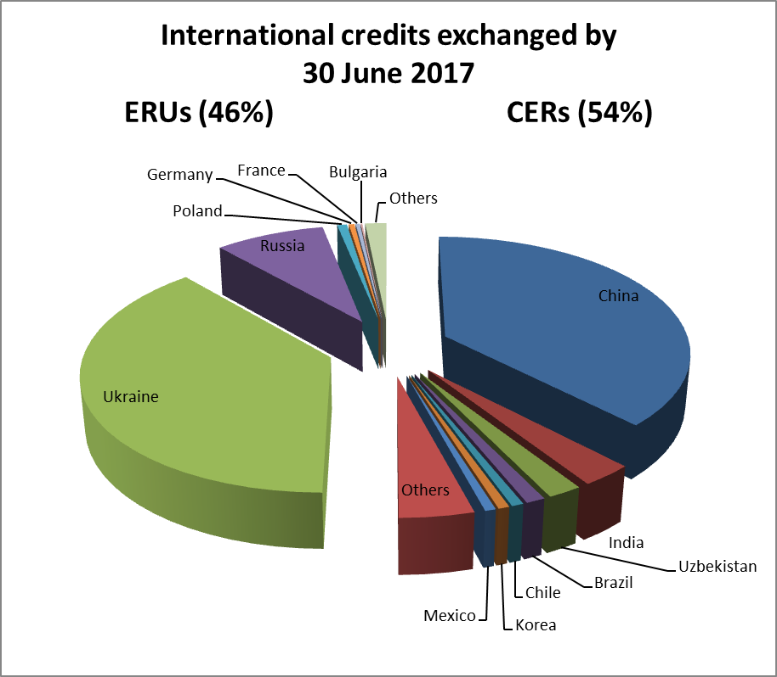

## Demand: allowances taken out of circulation

In 2016, emissions of GHGs from installations participating in the EU ETS are estimated to have decreased by 2.9% compared to 2015 based on the information recorded in the Union Registry. This marks a decreasing trend in emissions since the start of Phase 3 of the system in 2013.

Table 8: Verified emissions (in million tonnes CO2 equivalents)

|  |  |  |  |  |  |  |
| --- | --- | --- | --- | --- | --- | --- |
| **Year** | **2011** | **2012** | **2013** | **2014** | **2015** | **2016** |
| **Verified total emissions** | 1904 | 1867 | 1908 | 1814 | 1803 | 1750 |
| **Change to year x-1** | -1.8% | -2% | 2.2% | -4.9% | -0.6% | -2.9% |
| **Verified emissions from power sector** | 1.185 | 1.181 | 1.128 | 1.039 | 1.031 | 982 |
| **Change to year x-1** |  | -0,3% | -4,4% | -7,9% | -0,8% | -4,8% |
| **Verified emissions from industrial installations** | 720 | 686 | 780 | 775 | 772 | 768 |
| **Change to year x-1** |  | -4,6% | 13,7% | -0,7% | -0,4% | -0,5% |
| **Real GDP growth rate EU28** | 1.7% | -0.5% | 0.2% | 1.7% | 2.2% | 1.9% |

GDP data as reported on: <http://epp.eurostat.ec.europa.eu/tgm/table.do?tab=table&init=1&plugin=1&language=en&pcode=tec00115>

(accessed in July 2017). Verified aviation emissions are reported separately in section 4.

As the table demonstrates, combustion activities have been the main driver in the verified emission reductions.

The number of allowances cancelled on a voluntary basis amounts to 63 573 allowances in 2016. In total, voluntary cancellations of 267 933 allowances have been recorded so far.

## Balancing supply and demand

At the start of Phase 3, the EU ETS was characterised by a large imbalance between the supply and demand of allowances, resulting in a surplus of around 2.1 billion in 2013. The surplus was reduced slightly in 2014 and then fell significantly to 1.78 billion allowances in 2015 and to 1.69 billion allowances in 2016. This reflects the impact of a further reduction of the supply of allowances in 2016, the final year of the back-loading measure, by 200 million. As emissions declined by around 2,9% in 2016, lower demand partly balanced the impact of the reduction in supply on the surplus.

To address the structural imbalance between the supply and demand of allowances, the creation of a Market Stability Reserve (MSR) was agreed in 2015 to render the auction supply of emission allowances more flexible. Ultimately, the back-loaded allowances will be transferred to the reserve, which will be operational as of January 2019.

A key notion for the functioning of the MSR is the total number of allowances in circulation (TNAC). Allowances will be added to the reserve, if the TNAC is above a predefined upper threshold (833 million allowances) and will be released from the reserve, if the number is below a predefined lower threshold (below 400 million allowances)*. Thus, the MSR absorbs or releases allowances if the circulating ones are outside of a predefined range. Back-loaded and so-called unallocated** allowances will also be absorbed by the reserve.

*Or where measures are adopted under Article 29a of the EU ETS Directive

**Unallocated allowances are allowances not allocated pursuant to Article 10a(7) of the EU ETS Directive, i.e. allowances remaining in the new entrants' reserve, and resulting from the application of Article 10a(19) and (20), i.e. allowances foreseen for free allocation to installations but remaining unallocated because of (partial) cessation of operations or significant capacity reductions. De facto "unallocated" allowances stemming from the application of the relevant carbon leakage factor to sectors not included in the carbon leakage list during the current period, as well as any allowances that are not allocated under Article 10c of the ETS Directive, are not foreseen to be placed in the Market Stability Reserve under Article 1(3) of Decision (EU) 2015/1814. Such allowances are therefore not covered (please refer to p. 225 of the Impact Assessment (SWD(2015) 135 final) accompanying the ETS revision proposal.

The total number of allowances in circulation relevant for determining feeds and releases in the MSR is calculated by the following formula:

TNAC = Supply – (Demand[38] + allowances in the MSR)

The supply of emission allowances consists of the allowances banked from Phase 2 of the EU ETS (2008-2012), auctioned allowances, allowances allocated for free and the allowances in the New Entrants Reserve (NER); while the demand is determined by the emissions of the installations and the cancelled allowances. For more details, see Table 1 in Appendix 4 to the Annex.

The starting point for determining the TNAC is the total number of allowances remaining after Phase 2 which were not surrendered or cancelled.[39] This 'banking total' of 1 749 540 826 allowances[40] thus represents the exact number of ETS allowances in circulation at the start of the third trading period of the EU ETS.

The carbon market report allows for the consolidation of the figures for supply and demand which are published according to the timeline of reporting obligations stemming from the EU ETS Directive and its implementing provisions. This timeline, relevant data and scope are outlined in Table 2, Appendix 4 to the Annex. Figure 4 shows the composition of supply and demand in 2016. The relevant data have also been published as part of the communication on the total number of allowances in circulation (TNAC) for the purposes of the MSR[41] **.**

**Figure 4: Composition of cumulative supply and demand until the end of 2016**

**Supply** (cumulative, millions) **Demand** (cumulative, millions)

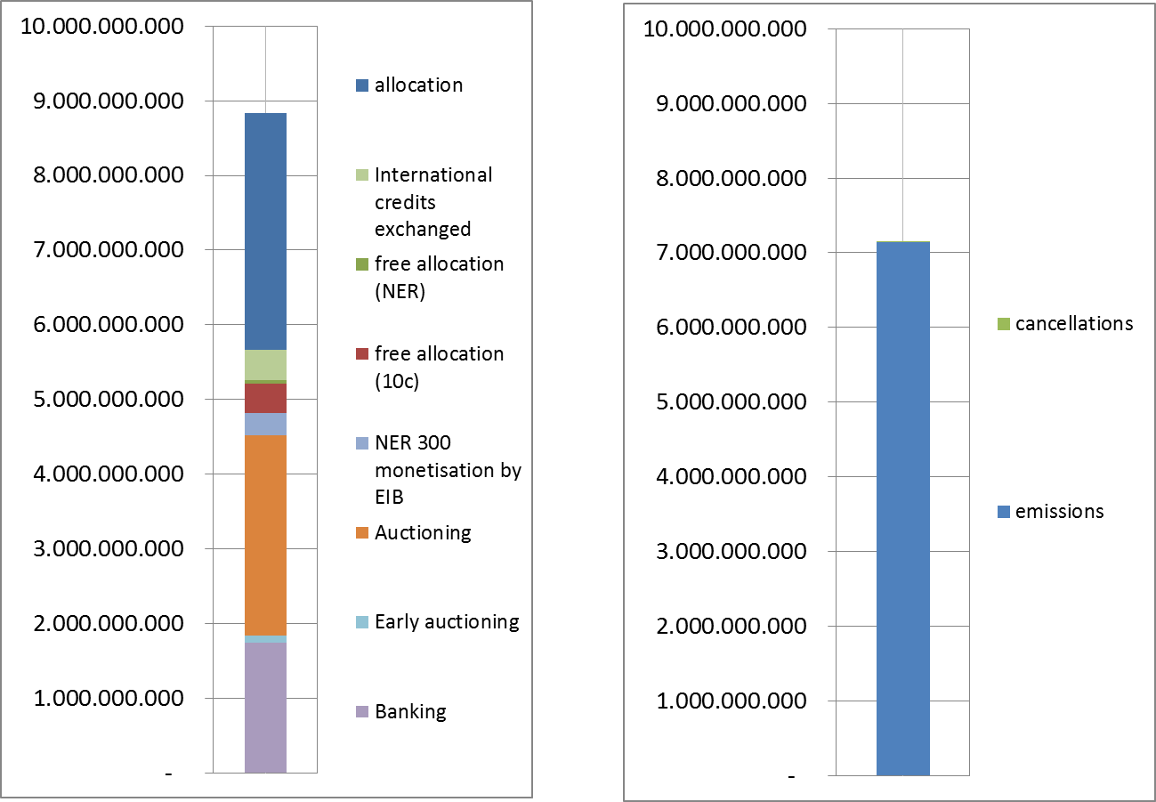

|  |  |  |  |  |
| --- | --- | --- | --- | --- |
|  | Free allocation |  |  | Cancellations |
|  | International credits exchanged |  |  | Verified emissions |
|  | Free allocation (NER) |  |  |  |
|  | Free allocation (10c) |  |  |  |
|  | NER 300 monetisation by EIB |  |  |  |
|  | Auctioning |  |  |  |
|  | Early auctioning |  |  |  |
|  | Banking |  |  |  |

As the MSR becomes operational in 2019, the Commission will regularly publish each year by mid-May the TNAC for the preceding year. In May 2017, the TNAC was published for the first time, corresponding to 1 693 904 897 allowances[42].

Figure 5[43] presents the development of the cumulative supply and demand figures for the EU ETS until the end of 2016. In 2013, supply was over 2 billion allowances, while demand was lower at around 1,9 billion allowances. In 2014, both the total supply and demand decreased to around 1.8 billion allowances. In 2015, supply decreased further to 1.5 billion allowances, while demand reduced marginally. In subsequent years, while emissions remained stable or reduced, the supply of allowances was reduced to a greater extent as a result of the back-loading measure.

As a result, the surplus grew in 2013 to over 2 billion allowances, remained stable in 2014 and subsequently fell in 2015 to around 1.8 billion allowances. In 2016, emissions were reduced compared to 2015 but demand was still higher than supply. The TNAC published in May 2017 is thus at the lowest level since the start of the current trading period.

**Figure 5: Development of supply and demand in 2013-2016**

|  |  |
| --- | --- |
|  |  |

|  |  |
| --- | --- |
|  |  |
|  |  |

|  |  |
| --- | --- |
|  | demand |
|  | supply |
|  | banking total from phase 2 |
| cid:image002.png@01D20D9B.50F5BE60 | surplus |

|  |  |
| --- | --- |
|  |  |
|  |  |

# AVIATION

The aviation sector has been part of the EU ETS since 2012. The original legislation covered all flights in and out of the European Economic Area (EEA). However, the EU decided to limit the obligations for 2012-2016 to flights within the EEA, in order to support the development of a global measure by the ICAO for reducing aviation emissions.

In October 2016, the ICAO Assembly agreed on a resolution on the Carbon Offsetting and Reduction Scheme for International Aviation (CORSIA), to start in 2021. CORSIA is conceived as a carbon offsetting scheme with the objective of stabilising emissions from international aviation at 2020 levels.

EU Member States have signalled[44] their intention to join the ICAO global scheme[45] from the start provided that certain conditions are met. Pending the application of the global measure, the Commission has proposed[46] to continue the same EU ETS approach for aviation beyond 2016, namely to keep the geographic scope as intra-EEA. The proposal also maintains the same exemptions and the same approach towards allocation for airlines, to which the linear reduction factor will apply as from 2021, and foresees a new review to consider ways for the implementation of CORSIA in EU law through a revision of the EU ETS Directive. A political agreement on the proposal was reached in October 2017.

As regards developments in aviation emissions within the EU ETS, in 2016, verified emissions continued to grow and amounted to 61 million tonnes of CO2, an increase of 7.9% compared to 2015.

The free allocation amounted to slightly over 32.0 million allowances in 2016[47]. The amount of allowances auctioned between January and December 2016 was approximately 6.0 million.

In 2017, pending the adoption of the legislative proposal on the EU ETS for aviation, allowances were issued in line with the intra-EEA scope. The adjusted free allocation amounted to slightly over 32.0 million allowances in 2017[48]. In addition, nearly 1.1 million free allowances were allocated from the special reserve for new entrants and fast growing operators. This is the first of four annual issuances, corresponding to the 2013-2020 period. The amount of allowances to be auctioned during 2017 will be proportional to the total number of allowances issued. Table 9 shows a summary of verified emissions, free allocation, and auction volumes for the aviation sector since the start of Phase 3 of the EU ETS.

**Table 9: Verified emissions and allocation to the aviation sector**

|  |  |  |  |  |  |
| --- | --- | --- | --- | --- | --- |
| **Year** | **2013** | **2014** | **2015** | **2016** | **2017** |
| **Verified emissions (in million tonnes CO2 equivalents)** | 53 495 902 | 54 822 754 | 57 085 143 | 61 124 583 |  |
| **Change of verified emissions to year x-1** |  | 1 326 852 | 2 262 389 | 4 039 440 |  |
| **Free allocation  (EU28+EEA EFTA states)** | 32 455 312 | 32 403 025 | 32 152 526 | 32 036 975 | 32 018 239 |
| **Free allocation from special reserve for new entrants and fast growing operators** | 0 | 0 | 0 | 0 | 1 085 080 |
| **Volumes of allowances auctioned** | 0 | 9 278 000 | 16 390 500 | 5 997 500 | 4 730 500[49] |

The volumes of aviation allowances auctioned over the period 2013-2015 reflect the 2013 co-legislator's decision to "stop the clock"[50] and limit climate obligations only to flights within the EEA, in order to support the development of a global measure by the ICAO. Compliance for the aviation sector was postponed and no aviation allowances were auctioned in 2012 and 2013. The 2012 volumes were thus auctioned in 2014, while compliance took place in 2015 for aviation emissions from 2013 and 2014.

# MARKET OVERSIGHT

A significant part of daily transactions in emission allowances is in the form of derivatives (futures, forwards, options, swaps), which are already subject to EU financial markets regulation. This is being replaced by the new Financial Market Directive (MiFID2* package), which will be applicable as of January 2018.

Under this new directive, emission allowances will be classified as financial instruments. This means that rules applicable to traditional financial markets (those including carbon derivatives trade on leading platforms or over-the-counter (OTC)) will also apply to the spot segment of the secondary carbon market, putting emission allowances on an equal footing with the derivatives market in terms of transparency, investor protection and integrity.

Moreover, by virtue of cross-references to MiFID2 definitions of financial instruments, other pieces of financial market legislation will apply. This is in particular the case for the Market Abuse Regulation (MAR)**, which will cover transactions and conduct involving emission allowances, on both primary and secondary markets. Similarly, a cross-reference to MiFID2 in the Anti-Money Laundering Directive*** will trigger a mandatory application of customer due diligence checks by MiFID-licensed carbon traders to their clients in the secondary spot market in emission allowances. ****

* Directive 2014/65/EU of the European Parliament and of the Council of 15 May 2014 on markets in financial instruments and amending Directive 2002/92/EC and Directive 2011/61/EU

** Regulation (EU) No 596/2014 of the European Parliament and of the Council of 16 April 2014 on market abuse (market abuse regulation) and repealing Directive 2003/6/EC of the European Parliament and of the Council and Commission Directives 2003/124/EC, 2003/125/EC and 2004/72/EC

*** Directive (EU) 2015/849 of the European Parliament and of the Council of 20 May 2015 on the prevention of the use of the financial system for the purposes of money laundering or terrorist financing, amending Regulation (EU) No 648/2012 of the European Parliament and of the Council, and repealing Directive 2005/60/EC of the European Parliament and of the Council and Commission Directive 2006/70/EC

****Due diligence checks are already mandatory in the primary market and in the secondary market in emission allowances' derivatives.

MiFID2 and MAR, both adopted in 2014, envisage certain adaptations of the general regime to carbon market specificities (see Carbon Market Report 2015).

Several measures regulating detailed aspects of the provisions under MiFID2[51] and MAR[52] were adopted in 2016 and 2017.

## The legal nature and fiscal treatment of emission allowances

The legal and fiscal treatment of emission allowances varies across countries, since these two aspects are not defined in the ETS Directive. Countries are instead obliged to report annually on their national regimes related to the legal nature and fiscal treatment of allowances as part of their Article 21 reports. However, despite non-harmonisation, a mature and very liquid market has developed over the last decade. The current regulatory framework provides the necessary legal underpinnings for a transparent and liquid carbon market, whilst ensuring the market's stability and integrity.

The national treatment of allowances varies, ranging from financial instruments and intangible assets to property rights and commodities. According to Article 21 submissions in 2017, at least four participating countries have implemented or envisage changes to national legislation, mostly amendments regarding the implementation of MiDIF2.

As regards the fiscal treatment of allowances only three countries report that value added tax (VAT) applies to the issuance of emission allowances. In contrast, VAT is due on transaction of emission allowances on the secondary market in most participating countries (all except CY, EE, IS, LI). The majority of countries report that they apply the reverse-charge mechanism[53] on domestic transactions involving emission allowances. Emission allowances for corporations can additionally be taxed (e.g. via the application of a corporate tax or a corporate income tax). Fifteen countries reported that there was no such taxation.

As mentioned in the previous carbon market report, the Commission is currently conducting a study on the legal nature of EU ETS allowances.

In a recent preliminary ruling[54] of 8 March 2017, the Court of Justice refrained from defining the nature of allowances (see Appendix 5 to the Annex.)

# MONITORING, REPORTING AND VERIFICATION OF EMISSIONS

The monitoring, reporting and verification (MRV) of GHG emissions must be robust, transparent, consistent and accurate for the EU ETS to operate effectively. It is supplemented by a sound accreditation system to assure adequate quality of third-party verifiers. MRV requirements are harmonised in the Monitoring and Reporting Regulation (MRR) and the Accreditation and Verification Regulation (AVR).

The monitoring system in the EU ETS is designed as a 'building block' approach which allows a high degree of flexibility for operators to ensure cost-efficiency, while at the same time to achieve a high reliability of the monitored emissions data. For this purpose, several monitoring methods ('calculation-based' or 'measurement-based', as well as by exception 'fall-back approaches') are allowed. Methods may be combined for individual parts of an installation. For aircraft operators, only calculation-based approaches are feasible, with fuel consumption being the central parameter to be determined for the flights covered by the EU ETS. The requirement for installations and aircraft operators to have a monitoring plan approved by the competent authority on the basis of the MRR prevents arbitrary selection of monitoring methods and temporal variations.

With the AVR for Phase 3 and beyond an EU-wide harmonised approach towards the accreditation of verifiers has been introduced. Verifiers who are a legal person or a legal entity must be accredited by a National Accreditation Body (NAB) in order to carry out verifications in compliance with the AVR. The new uniform accreditation system provides the advantage of allowing verifiers to operate with mutual recognition across all participating countries, thereby taking full advantage of the internal market and helping to ensure sufficient availability overall.

**6.1 General Developments**

The Commission continues to seek improvements in the guidance and templates that it makes available to facilitate consistent implementation of MRR[55] and AVR[56] requirements. In this regard, new guidance on EU ETS inspection has been drafted to help coordinate countries' response to a recommendation from the European Court of Auditors for them to implement a more coherent and effective EU ETS implementation control frameworks inclusive of inspections.

The Commission also continues to encourage improvements in countries' implementation of the EU ETS MRVA. Where relevant, guidance has been clarified and training events arranged to address some of the main issues identified in the Action Plans produced to assist each country[57].

It is recognised that the efficiency of the compliance system has improved since the MRR allowed countries to make electronic reporting mandatory. Most participating countries report the use of templates or systems based on the minimum requirements set by the Commission. Fourteen Member States have reported in 2017 that they use some form of automated IT system for EU ETS reporting (compared to 13 in 2016 and 10 in 2015).

As mentioned in the previous carbon market report, the Commission launched DECLARE ETS MRVA in May 2016 – a web-based system developed to support obligations related to EU ETS monitoring plans, annual emission reports, verification reports and improvement reports by participating countries.

**6.2 Monitoring applied**

According to the Article 21 reports submitted in 2017, most installations use the calculation-based methodology[58]. Only 150 installations (less than 1.5%) in 23 countries were reported to use continuous emissions measurement systems, most frequently in Germany and the Czech Republic. There is one more country than last year, but one less installation overall.

Only 11 countries reported the use of the fall-back approach by 36 installations, covering approximately 5.1 million tonnes CO2e (compared to 6.6 million tonnes CO2e the year before). The Netherlands reports a reduction in the number of installations applying fall-back methodology (9 compared to 12 last year) and a halving of the affected emissions. Two installations (one in the UK and one in NL) are responsible for over half of the overall emissions reported in relation to fall-back methodology.

The minimum tier defaults[59] of the MRR are met by the vast majority of installations. Only 105 category C installations (compared to 113 in the previous year and 118 the year before), that is 13% (compared to 14% last year) were reported to deviate for at least one parameter from the requirement to apply the highest tiers for the major source streams. These deviations are only allowed where the operator demonstrates that the highest tier is technically not feasible or incurs unreasonable costs. Once these conditions no longer apply, the operator has to improve their monitoring system accordingly. In the 2013 reporting period, 137 category C installations (16% of the total) were reported as not meeting highest tiers in one way or another. Therefore, a steady improvement in category C installation highest tier compliance can be seen in each year of Phase 3 of the EU ETS.

In a similar way, reports from 22 participating countries (the same as in the previous two years) indicate that overall 22% of category B installations are permitted with some form of deviation from the MRR default requirements, compared to 26% in the previous year and 28% in the year before that, again demonstrating a steady improvement in highest tier compliance.

**6.3 Accredited verification**

The total number of verifiers is not reported in Article 21 reports, but a reasonable estimate based on the number accredited for combustion (the primary scope of accreditation) is that there were at least 130 different accredited verifiers overall concerning 2016 verifications. Article 21 submissions in 2017 indicate that there were 47 individual verifiers accredited for 2016 concerning aviation. The European cooperation for Accreditation (EA) provides a central link to relevant National Accreditation Bodies (NABs) and their lists of EU ETS accredited verifiers[60].

The mutual recognition of verifiers among participating countries is working successfully: most countries (29, all except FR and LV) reported that at least one foreign verifier is active in their territory.

Compliance of verifiers with the AVR is found to be high. Only Poland reported a suspension and Sweden a withdrawal of accreditation in 2016 (of one verifier in each case). This compares to no reported suspensions or withdrawals concerning 2015 and one suspension and one withdrawal for 2014. Only Poland reported a reduction made in the scope of one verifier's accreditation in 2016, compared to four countries reporting such reductions for five verifiers in 2015 and three countries for six verifiers in 2014.

Fewer countries reported complaints received about verifiers this year (eight compared to nine last year). The overall number of complaints is also 17% lower. 96% of the complaints received are reported resolved (the same as last year). Nine countries reported identification of verifier non-conformities as part of the information exchange process between NABs and competent authorities (compared to eleven last year).

# OVERVIEW OF ADMINISTRATIVE ARRANGEMENTS

Countries participating in the EU ETS use different approaches regarding the competent authorities in charge of its implementation. In some countries several local authorities are involved, while in others the approach is much more centralised. Article 21 reports provide a high level overview of the organisational structure of each participating country.

No significant changes have been observed in the administrative arrangements of participating countries since the last reporting period. According to Article 21 submissions in 2017, there were, on average, 5 competent authorities involved in EU ETS implementation per country.[61] With regard to the coordination between authorities, different tools and methods were reported, such as legislative instruments for central management of monitoring plans or emission reports (in 12 countries), provision of binding instructions and guidance by a central competent authority to local authorities (in 10 countries), regular working groups or meetings between authorities (in 15 countries), and the use of a joint IT platform (in 13 countries), among others. Seven countries (CY, EE, HU, IT, IS, LI, LU) indicated that none of the above are in place.

On administrative fees charged in relation to permitting and approved monitoring plans, 14 countries reported in 2017 that they do not charge any fees to installation operators (CY, DE, EE, FR, GR, IE, LI, LT, LU, LV, MT, NL, SE, SK), compared to 16 last year. Aircraft operators do not pay fees in 15 countries (BE, CY, CZ, DE, EE, ES, GR, LI, LT, LU, LV, MT, NL, SE, SK), compared to 16 the year before. Charges vary significantly according to country and the particular service involved. For example, the fees for permit and monitoring plan approval for installations vary from € 5 to € 7621, and for aviation the fees for monitoring plan approval range from € 5 to € 2400.

Overall, participating countries' systems are largely effective as aligned to their administrative organisation. Communication between local authorities and the sharing of best practices among Competent Authorities, including via the activities of the EU ETS Compliance Forum, should continue to be reinforced and encouraged. In this regard, the 7th EU ETS Compliance Conference[62] was held in 2016, as well as two separate Compliance Forum related training events. This annual conference helps to ensure widest awareness of Compliance Forum activities in particular concerning its five Task Forces on Monitoring and Reporting, Accreditation and Verification, Aviation, Electronic-reporting and Carbon Capture and Storage.

# COMPLIANCE AND ENFORCEMENT

The EU ETS Directive provides for an excess emissions penalty in the form of €100 (indexed) for each tonne of CO2 emitted for which no allowance has been surrendered in due time. Other penalties applicable to infringements in implementation of EU ETS are according to national provisions set by the concerned country.

The EU ETS has a very high compliance rate: each year around 99% of the emissions are covered by the required number of allowances on time. 2016 was not an exception. Less than 1% of the installations reporting emissions for 2016 did not surrender allowances covering all their emissions by the deadline of 30 April 2017. These installations were typically small and accounted for approximately 0.4% of EU ETS emissions. In the aviation sector the level of compliance was also very high: aircraft operators responsible for more than 99 % of EU ETS aviation emissions complied.

The competent authorities continue to carry out different compliance checks on the annual emissions reports. According to Article 21 submissions in 2017, all participating countries check annual emission reports for completeness (100% of reports except FR 77%, SE 3% and UK 62%). The reports further indicate that on average countries check over 75% of reports for consistency against monitoring plans (all countries) and about 75% against allocation data (all countries except FI, MT and NO). Twenty five countries reported that they also carry out cross-checks against other data. Only three (LV, SI, SK) suggest an absence of a detailed check of emission reports by the competent authorities.

Based on Article 21 submissions in 2017, competent authorities in 16 countries (BE, BG, DK, ES, FI, FR, EL, HR, IT, LU, NL, NO, PL, SE, SK, UK) carried out conservative estimates regarding missing data in the case of 125 installations in 2016. However, 68 of these were reported by the UK for emissions in years prior to 2016, based on operator notifications of newly discovered historic errors. Discounting the UK data from the totals for 2016, conservative estimates were reported by 15 countries for 57 installations (approximately 0.5% of installations overall), compared to 45 installations (0.4%) for 2015 and 37 (0.3%) for 2014. The reported quantity of affected 2016 emissions was 1.9 million tonnes CO2 (compared to 8.3 million tonnes last year and 9.1 million the year before that), approximately 0.1% of overall emissions (compared to nearly 0.5% in the previous two years). The most common reasons given for making conservative estimates were the absence of an emission report by 31 March or emission reports that were not fully in line with MRR/AVR requirements.

Conservative estimates regarding missing data for aviation were reported by only four countries concerning 18 aircraft operators (approximately 3.5% of the total), all of which were very small emitters (in total under 0.2% of aviation emissions). This compares to 103 aircraft operators (nearly 20%) reported by eight countries last year.

Competent authority checks also remain important to supplement the verifier’s work. For 2016, all participating countries confirmed that they carry out further checks in the case of installations. Most countries reported a similar approach regarding aircraft operators (except HU, LV and SI). However, only 17 countries reported that they carried out any site inspections at installations in 2016 (AT[63], CY, CZ, DE, ES, FI, FR, GR, HR, HU, IE, IS, LT, LV, NL, NO, UK).

For 2016, the application of excess emissions penalty was reported for only 14 installations by four countries (BG 1, PL 1, RO 6 and UK 6). For aviation, excess emission penalties were reported for 48 aircraft operators (BE 1, DE 4, ES 4 and UK 39).

Ten countries confirmed issue of penalties (in addition to excess emissions penalties) in the 2016 reporting period. No imprisonments were reported, but fines or formal notices concerning 56 installations and 8 aircraft operators were noted amounting to a total financial value of €1 573 389. Approximately one sixth of this was attributed to the discovery by the competent authority and trade associations of 19 installations found to be operating without a permit in the UK. These operators are now permitted and make up most of the increased number of installations reported by the UK.

The most common offences reported for 2016 were operation without a permit (21 cases), failure to report capacity changes (14 cases), failure to submit verified annual emission reports by the due deadline (9 cases), failure to comply with permit conditions (6 cases) and failure to hold a duly approved monitoring plan (5 cases). Other cases included the annual emission report being non-compliant with the requirements of the MRR, failure to surrender a sufficient number of allowances by 30 April and failure to submit improvement reports.

# CONCLUSIONS AND OUTLOOK

In 2016, the EU ETS has remained the EU's flagship tool for tackling climate change in a cost-effective way. The system delivered emission reductions of 2.9% from participating installations, marking a decreasing trend in emissions since the start of Phase 3 in 2013, while the surplus of allowances in the carbon market fell to its lowest level since the start of the current trading period. In this regard, the first publication of the Market Stability Reserve surplus indicator in May 2017 prepares the ground for the starting of operation in 2019 of the Market Stability Reserve, the EU ETS’s structural solution for stabilising the European carbon market in the midterm.

Important progress has also been made in the field of aviation. Following ICAO's 2016 resolution on curbing global aviation emissions, the Commission has taken steps towards continuing current measures for aviation in the EU ETS in view of the global scheme coming into effect and planning for its prompt implementation.

Moreover, in the fourth year of phase 3 the EU ETS architecture has proven to remain robust. The compliance rate has remained consistently very high for both stationary installations and aviation operators and the administrative organisation in participating countries has proven to be effective.

The 1000th auction in May 2017 marked a symbolic milestone in the smooth functioning of the infrastructure bringing allowances to the market.

After more than 2 years of negotiations on the proposal for reforming the EU ETS for its fourth trading period, a landmark agreement has been reached in November 2017 which demonstrates that the European Union is turning its Paris commitment into concrete action. The revised and substantially strengthened EU ETS will be a major part of the EU contribution to the implementation of the Paris agreement towards a global low-carbon transition.

The Commission will continue to monitor the European carbon market and provide the next report in late 2018.

ANNEX

**Appendix 1**

**Table 1: Number of free allowances requested for modernising the electricity sector**

|  |  |  |  |  |
| --- | --- | --- | --- | --- |
|  | **Number of free allowances requested by Member State pursuant to Article 10c** | | | |
| **MS** | **2013** | **2014** | **2015** | **2016** |
| **BG** | 11 009 416 | 9 779 243 | 8 259 680 | 6 593 238 |
| **CY** | 2 519 077 | 2 195 195 | 1 907 302 | 1 583 420 |
| **CZ** | 25 285 353 | 22 383 398 | 20 623 005 | 15 831 329 |
| **EE** | 5 135 166 | 4 401 568 | 3 667 975 | 2 934 380 |
| **HU** | 7 047 255[64] | n.a. | n.a. | n.a. |
| **LT** | 322 449 | 297 113 | 269 475 | 237 230 |
| **PL** | 65 992 703 | 52 920 889 | 43 594 320 | 31 621 148 |
| **RO** | 15 748 011 | 8 591 461 | 9 210 797 | 7 189 961 |
| **Total** | 133 059 430 | 100 568 867 | 87 532 554 | 65 990 706 |

**Table 2: Maximum number of free allowances per year under the derogation from full auctioning for the power sector**

|  |  |  |  |  |  |  |  |
| --- | --- | --- | --- | --- | --- | --- | --- |
| **Maximum number of allowances per year** | | | | | | | |
| **2013** | **2014** | **2015** | **2016** | **2017** | **2018** | **2019** | **Total** |
| 13 542 000 | 11 607 428 | 9 672 857 | 7 738 286 | 5 803 714 | 3 869 143 | 1 934 571 | 54 167 999 |
| 2 519 077 | 2 195 195 | 1 907 302 | 1 583 420 | 1 259 538 | 935 657 | 575 789 | 10 975 978 |
| 26 916 667 | 23 071 429 | 19 226 191 | 15 380 953 | 11 535 714 | 7 690 476 | 3 845 238 | 107 666 668 |
| 5 288 827 | 4 533 280 | 3 777 733 | 3 022 187 | 2 266 640 | 1 511 093 | 755 547 | 21 155 307 |
| 7 047 255 | 0 | 0 | 0 | 0 | 0 | 0 | 7 047 255 |
| 582 373 | 536 615 | 486 698 | 428 460 | 361 903 | 287 027 | 170 552 | 2 853 628 |
| 77 816 756 | 72 258 416 | 66 700 076 | 60 030 069 | 52 248 393 | 43 355 049 | 32 238 370 | 404 647 129 |
| 17 852 479 | 15 302 125 | 12 751 771 | 10 201 417 | 7 651 063 | 5 100 708 | 2 550 354 | 71 409 917 |
| 151 565 434 | 129 504 488 | 114 522 628 | 98 384 792 | 81 126 965 | 62 749 153 | 42 070 421 | 679 923 881 |

**Appendix 2**

**Figure 1: Overview of general allowances auctions from 2013 to 30 June 2017**

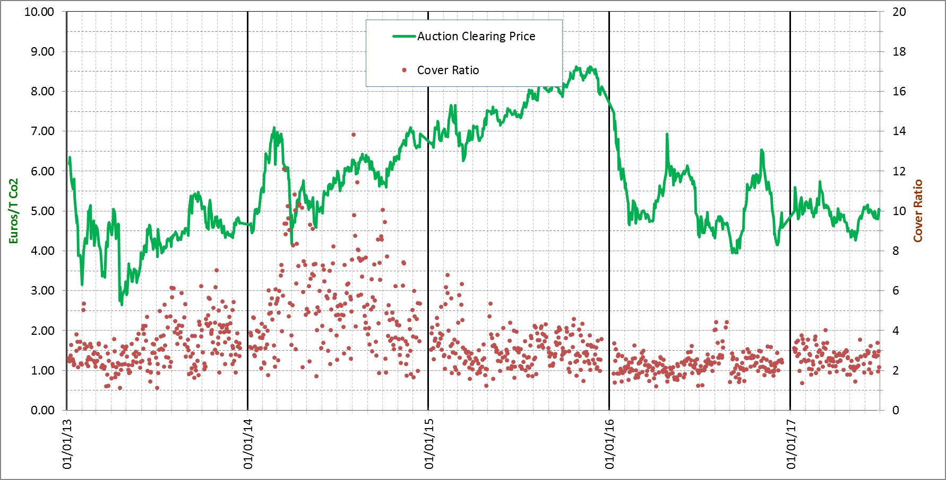

**___** Auction Clearing Price

**.** Cover Rate

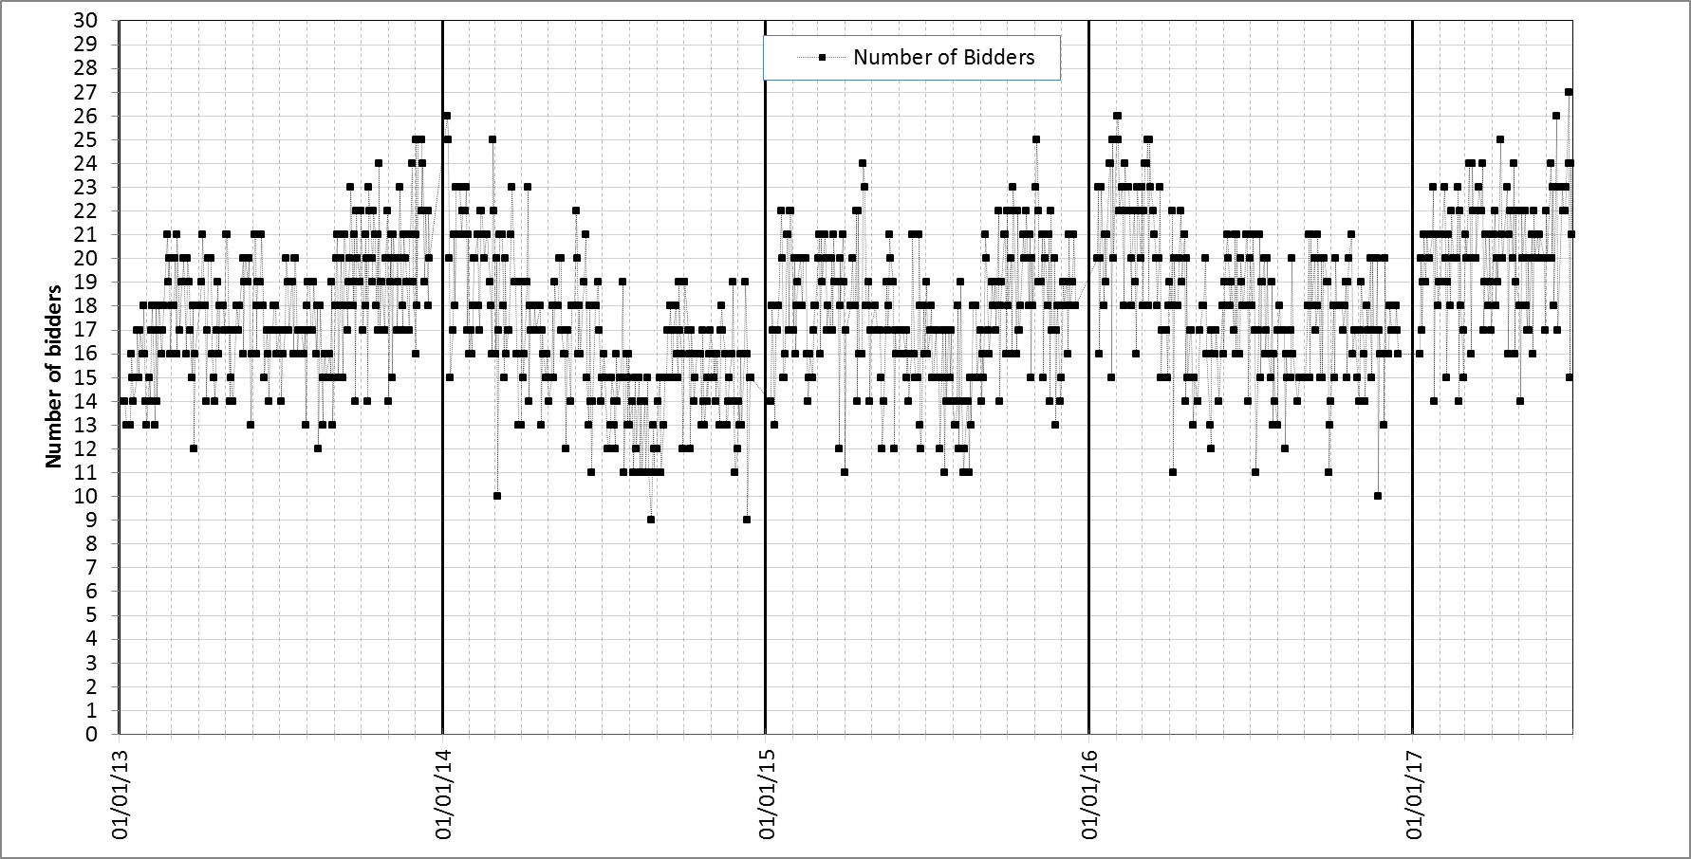

**Appendix 3**

**Table 1: Summary of international credits exchange until 30 June 2017**

|  |  |  |  |  |  |  |  |  |  |
| --- | --- | --- | --- | --- | --- | --- | --- | --- | --- |
| **International credits exchanged by 30 June 2017** | **million** | **percentages** |  | | |  |  |  | |
| **CERs** | **231,08** | **54,61%** |  | | |  |  |  | |
| China | 164,30 | 71,10% |  | | |  |  |  | |
| India | 13,13 | 5,68% |  | | |  |  |  | |
| Uzbekistan | 8,04 | 3,47% |  | | |  |  |  | |
| Brazil | 4,59 | 1,98% |  | | |  |  |  | |
| Chile | 3,11 | 1,34% |  | | |  |  |  | |
| Korea | 2,92 | 1,26% |  | | |  |  |  | |
| Mexico | 2,75 | 1,19% |  | | |  |  |  | |
| Others | 19,25 | 8,33% | **Track 1** | | **Track 2** | | | | |
| **ERUs** | **192,07** | **45,39%** | **million** | **percentages of ERUs** | **million** | | | | **percentages of ERUs** |
| Ukraine | 147,69 | 76,89% | 145,95 | 78,32% | 1,74 | | | | 0,91% |
| Russia | 32,06 | 16,69% | 32,06 | 17,20% | 0,00 | | | | 0,00% |
| Poland | 2,82 | 1,46% | 3,02 | 1,62% | 0,00 | | | | 0,00% |
| Germany | 1,65 | 0,85% | 1,66 | 0,89% | 0,00 | | | | 0,00% |
| France | 1,24 | 0,64% | 1,24 | 0,67% | 0,00 | | | | 0,00% |
| Bulgaria | 0,49 | 0,25% | 0,49 | 0,26% | 0,00 | | | | 0,00% |
| Others | 6,21 | 3,23% | 1,76 | 0,94% | 4,35 | | | | 2,26% |
| **Total** | **423,16** | **100%** | **186,18** | **96,83%** | **6,09** | | | | **3,17%** |

**Appendix 4**

Table 1: ETS supply and demand elements

|  |  |  |  |
| --- | --- | --- | --- |
| **Element** | **Supply or demand?** | **Publication** | **Update and uncertainties** |
| **Banking total phase 2** | Supply | Carbon market report | No update is foreseen as phase 2 ended. Final figure. |
| **Early phase 3 auctions** | Supply | DG Climate website, EEX and ICE websites | Not part of phase 2 banking total. Final figures. |
| **Allowances for NER 300** | Supply | EIB website | 300 million allowances were monetised in 2012-2014. Final figures. |
| **Aviation auctions** | Supply | DG Climate website, EEX and ICE websites | No – adjustments are reflected in the volumes for the following year.  2013 and 2014 auctions took place in 2015. |
| **Phase 3 auctions** | Supply | DG Climate website, EEX and ICE websites | No - the figure is not subject to revision. However, allowances (e.g. due to delays to start of auctioning for certain Member States, e.g. those for EEA-EFTA) withheld from auctions can be auctioned in subsequent years. |
| **Free allocation (NIMs)** | Supply | EUTL, tables | These figures are updated throughout the year.  - Member State may provide late submissions for previous years or actual allocation can be lower than the amount initially foreseen.  The EUTL provides an accurate state of play of actual allocation. |
| **Free allocation (NER)** | Supply | EUTL, tables |
| **Free allocation**  **(aviation)** | Supply | EUTL, MS publication of allocation tables |
| **Free allocation**  **(Article 10c)** | Supply | EUTL, status table |
| **Emissions (stationary installations)** | Demand | EUTL, compliance data | Compliance data made public on 1 May shows emissions and surrendered allowances for installations that are in compliance (i.e. those installations reporting for all years concerned). |
| **Emissions (aviation)** | Demand |  | Compliance for aviation operators for both 2013 and 2014 took place in 2015. |
| **Allowances cancelled** | Demand |  | Carbon market report |

Table 2: Timeline for data publication

|  |  |  |
| --- | --- | --- |
| **Timing** | **Data** | **Scope** |
| 1 January – 30 April year x | Updates to free allocation to power (Article 10c) | Year x-1 |
| 1 April year x | Verified emissions  Free allocation (Article 10a(5) – NIMs) | Year x-1 |
| 1 May year x | Compliance deadline: verified emissions and surrendered allowances | Year x-1 |
| May/October year x | International credits exchanged |  |
| Last quarter of year x | Carbon Market report | Year x-1 |
| January/July year x | Status of new entrants' reserve - NER table |  |
| Not published at EU level | Free allocation to aviation published at Member States level |  |

**Appendix 5**

**Table 1: Preliminary rulings of the Court of Justice of the EU relevant to the functioning of the EU ETS in the period July 2016 to June 2017**

|  |  |  |  |  |  |
| --- | --- | --- | --- | --- | --- |
| **Case reference** | **Legislation Concerned** | **Parties** | **Case summary** | **Date** | **Judgement summary** |
| Case C-461/15 | Decision 2011/278/EU | E. ON Kraftwerke/DE | Extent of obligation to provide information for the free allocation of emission allowances, having regard to changes made to the operation of one power station | 08.09.2016 | The competent authority can define 'relevant information' to be reported concerning capacity, activity level and operation of an installation. Information can be regarded as relevant, no matter whether there could be a change in the operator's allocation. |
| Case C-460/15 | Regulation EU 601/2012 | Schaefer Kalk GmbH & Co. KG/DE | Legality of the exclusion of CO2 used in the production of precipitated calcium carbonate in Article 49(1) and point 10 of Annex IV | 19.01.2017 | In the context of CO2 transferred outside a lime producing installation and bound in a stable way in the production of precipitated calcium carbonate, Art. 49 and point 10. B of Annex IV are contrary to Art. 3(d) of the ETS Directive, because they irrefutably presume that there is a release of CO2 in the atmosphere. |
| Case C-457/15 | Directive 2003/87/EC | Vattenfall Europe Generation AG/ DE | When does the emission trading obligation arise for the inclusion of combustion of fuels in installations with a total rated thermal input > 20 MW in Annex I? | 28.07.2016 | Inclusion of ‘Activities for the combustion of fuels in installations with a total rated thermal input > 20 MW’ in Annex I starts on the date of the first emissions of GHGs produced by the installation (even before producing electricity). |
| Case C-456/15;  Joined Cases C-191/14, C-192/14, C-295/14, C-389/14 and C-391/14 to C-393/14 | Decision 2013/448/EU | Borealis Polyolefine GmbH/ AT Federal Minister for Agriculture, Forestry, Environment and Water Management | Validity of method for calculating the uniform cross-sectoral correction factor (CSCF) | 14.07.2016; 28.04.2016 | Article 4 and Annex II of Decision 2013/448/EU are invalid. Emissions data coming from new activities in existing installations should not have been taken into account, only installations newly covered by the EU ETS as of 2013. CSCF will be invalid as of 01.03.2017. |
| Case C-321/15 | Directive 2003/87/EC | ArcelorMittal Rodange et Schifflange SA/ LU | Question on the surrender of wrongly allocated allowances and whether allowances can be considered as property | 08.03.2017 | Member States are entitled to claim back wrongly allocated allowances without compensation. The question of the legal status of allowances is not essential to deliver a judgment in the case at stake. |
| Case C-272/15 | Decision 377/2013/EU, Directive 2008/101/EC | Swiss International Air Lines AG/ UK Secretary of State for Energy and Climate Change, Environment Agency | Does Decision 377/2013/EU infringe the EU principle of equal treatment by establishing a moratorium on the surrender of emission allowances for flights between EEA states and non-EEA states, but not for flights between EEA states and CH? | 12.12.2016 | The fact that the moratorium on extra-EEA flights does not apply to flights from and to Swiss airports does not infringe on the principle of equal treatment, which does not apply vis-à-vis third countries. |
| Case C-180/15;  Case C-506/14 | Decision 2011/278/EU,  Decision 2013/448/EU | Borealis AB and others/ SE Environmental Protection Agency;  Yara Suomi Oy and others/ FI Ministry of Employment and the Economy | Validity of the method for calculating the uniform cross-sectoral correction factor (CSCF) and of the method for determining the product benchmark for hot metal | 08.09.2016;  26.10.2016 | Invalidation of the CSCF as of March 2017 (see cases C-191/14 and others).  The methodology for calculating the hot metal benchmark is judged valid. The Court stressed the principle of non-double counting of emissions. |
| Case C-203/12 | Directive 2003/87/EC | Billerud Karlsborg Aktiebolag/ SE Environmental Protection Agency | Must an operator who has not surrendered enough emission allowances by 30 April pay a penalty regardless of the cause of the omission, even if the operator had a sufficient number of allowances on 30 April? | 17.10.2016 | Penalties according to the ETS Directive apply even if the operator who did not surrender its allowances on time had enough allowances available to cover its emissions for the past year on 30 April. |

1. In 2015, EU GHG emissions were already 22% below 1990 levels.
2. According to national projections, emissions will further decrease until 2020, but additional policies will need to be implemented to achieve the 2030 target.
3. COM (2015) 337, <http://eur-lex.europa.eu/legal-content/EN/TXT/?uri=CELEX:52015PC0337>
4. Trilogues are informal tripartite meetings attended by representatives of the European Parliament, the Council of the EU and the Commission.
5. Directive 2003/87/EC of the European Parliament and of the Council of 13 October 2003 establishing a scheme for greenhouse gas emission allowance trading within the Community and amending Council Directive 96/61/EC, OJ L 275, 25.10.2003, p. 32.
6. Reports published in previous years can be found here: https://ec.europa.eu/clima/policies/ets_en#tab-0-1
7. For the reference to Article 21 reports, "participating countries" or simply "countries" include the 28 EU Member States plus EEA countries (Iceland, Norway and Liechtenstein).
8. Biomass emissions are zero-rated in the EU ETS, i.e. emissions have to be reported but no allowances have to be surrendered for them.
9. Article 21 reported emissions concerning use of biofuel amounted to less than 0.04% of the overall emissions of the aircraft operator involved.
10. See Commission Regulation (EU) No 601/2012 of 21 June 2012 on the monitoring and reporting of GHG emissions pursuant to Directive 2003/87/EC of the European Parliament and of the Council, OJ L 181, 12.7.2012, p. 30, where category C installations emit more than 500 000 tonnes CO2e per year, category B installations emit between 500000 and 50000 tonnes CO2e per year, and category A installations emit less than 50000 tonnes CO2e per year. Furthermore, 'installations with low emissions' are a sub-set within category A installations which emit less than 25000 tonnes CO2e per year.
11. An example of a commercial aircraft operator would be a passenger airline providing services to the general public. An example of a non-commercial aircraft operator would be a privately owned aircraft.
12. The number of aviation allowances put into circulation since 2013 is the result of a bottom-up approach starting from free allocation (determined on the basis of activity-based benchmarks for operators' activity within the EEA). The number of allowances auctioned is then derived based on the fact that free allocation (including a special reserve for later distribution to fast-growing aircraft operators and new entrants) should be 85% of the total and auctioning should be 15%.
13. The number of aviation allowances put into circulation for 2017, 2018, 2019 and 2020 will depend on the outcome of the Commission's legislative proposal (see section 4).
14. The included auctioning numbers are from August 2017 (see section 4).
15. SWD(2015) 135 final, https://ec.europa.eu/clima/sites/clima/files/ets/revision/docs/impact_assessment_en.pdf
16. NER300 is a funding programme for innovative low-carbon energy demonstration projects funded from the monetisation of 300 million emission allowances from the NER (see section 3.1.2.2.).
17. The numbers presented are from July 2017: https://ec.europa.eu/clima/sites/clima/files/ets/allowances/docs/170711_status_table_ner.pdf
18. The figures include notifications received until July 2017 and may be subject to large changes due to later notifications by Member States.
19. Initial amount, before application of the reductions mentioned below in the table.
20. Judgment of the Court of Justice of 28 April 2016 in Joined Cases C-191/14, C-192/14, C-295/14, C-389/14 and C-391/14 to C-393/14 Borealis Polyolefine GmbH and Others v Bundesminister für Land- und Forstwirtschaft, Umwelt und Wasserwirtschaft and Others, EU:C:2016:311.
21. Commission Decision 2017/126/EU, OJ L 19, 25.1.2017, p. 93.
22. https://ec.europa.eu/clima/sites/clima/files/lowcarbon/ner300/docs/2017_draft_amendment_post_ccc_en.pdf
23. Commission Decision 2010/670/EU, OJ L 290, 6.11.2010, p. 39
24. In line with Commission Decision 2010/670/EU, projects awarded under the first call must reach final investment decision by the end of 2016, while projects awarded under the second call must do so by the end of June 2018.
25. An interactive map following project implementation can be found here: https://setis.ec.europa.eu/NER300
26. The non-confidential versions of all decisions can be found on the website of DG Competition: <http://ec.europa.eu/competition/elojade/isef/index.cfm?clear=1&policy_area_id=3>
27. Estimated budget is for 2013-2015
28. Estimated budget is for 2013-2015
29. Maximum estimated total budget dependent on estimates of carbon price
30. Estimated budget for 2014-2015
31. Estimated budget for 2015-2018
32. Early auctions of allowances of Phase 3 were performed in 2012 in view of the widespread commercial practice in the electricity sector of selling power on a forward basis and purchasing the required inputs (including allowances) when they sell their output.
33. In addition, between 1 April and 30 June 2017, 244 388 000 general allowances were auctioned. In accordance with the 2017 published auction calendars, another 452 064 000 general allowances are foreseen to be auctioned between July and December 2017.
34. Such reports are available at the Commission’s dedicated website at <http://ec.europa.eu/clima/policies/ets/auctioning/documentation_en.htm>
35. Please see Article 10(3) of the EU ETS Directive.
36. An analysis of the use of auction revenues by Member States is available here: https://ec.europa.eu/clima/sites/clima/files/ets/auctioning/docs/auction_revenues_report_2017_en.pdf
37. Includes volumes from the 2017 auction calendar.
38. This also includes cancelled allowances.
39. These allowances were replaced by Phase 3 allowances at the end of the second trading period. No other allowances from before the third trading period contribute to the total number of allowances in circulation. For the explanation on banking of the emission allowances see: https://ec.europa.eu/clima/policies/ets/registry_en#tab-0-2
40. This number does not include early auctions of Phase 3 allowances taking place in 2012 but does reflect the use of international credits before the start of Phase 3. The total amount of international credits used since 2008 is listed in section 3.1.3.
41. C(2017) 3228 final, https://ec.europa.eu/clima/sites/clima/files/ets/reform/docs/c_2017_3228_en.pdf
42. C(2017) 3228 final, https://ec.europa.eu/clima/sites/clima/files/ets/reform/docs/c_2017_3228_en.pdf
43. These figures related to 2013 -2016, are based on the most recent data related to these years, as can be derived from the EUTL. This means that they can include recent data relating to 2013, 2014, 2015 and 2016.
44. https://ec.europa.eu/transport/modes/air/news/2016-09-09-bratislava-declaration_en
45. The ICAO Assembly Resolution on CORSIA can be found here: https://www.icao.int/Meetings/a39/Documents/Resolutions/a39_res_prov_en.pdf
46. COM(2017)054 final, http://eur-lex.europa.eu/legal-content/EN/TXT/?uri=COM:2017:0054:FIN
47. Data from June 2017
48. Data from June 2017
49. Information from August 2017, https://ec.europa.eu/clima/news/2017-auction-calendars-aviation-allowances-published_en
50. Decision No 377/2013/EU of the European Parliament and of the Council of 24 April 2013 derogating temporarily from Directive 2003/87/EC establishing a scheme for greenhouse gas emission allowance trading within the Community Text with EEA relevance, OJ L 113, 25.4.2013, p. 1.
51. https://ec.europa.eu/info/law/markets-financial-instruments-mifid-ii-directive-2014-65-eu/amending-and-supplementary-acts/implementing-and-delegated-acts_en
52. https://ec.europa.eu/info/law/market-abuse-regulation-eu-no-596-2014/amending-and-supplementary-acts/implementing-and-delegated-acts_en
53. The reverse charge mechanism moves the responsibility for the payment of the VAT transaction from the seller to the buyer of a good or service and constitutes an effective safeguard against VAT fraud.
54. Judgment of the Court of Justice of 8 March 2017 in Case C-321/15 ArcelorMittal Rodange et Schifflange SA v État du Grand-duché de Luxembourg, EU:C:2017:179.
55. Commission Regulation (EU) No 601/2012 of 21 June 2012 on the monitoring and reporting of greenhouse gas emissions pursuant to Directive 2003/87/EC of the European Parliament and of the Council, OJ L 181, 12.7.2012, p. 30.
56. Commission Regulation (EU) No 600/2012 of 21 June 2012 on the verification of greenhouse gas emission reports and tonne-kilometre reports and the accreditation of verifiers pursuant to Directive 2003/87/EC of the European Parliament and of the Council, OJ L 181, 12.7.2012, p. 1.
57. These action plans are specific to each Member State. However, an example of a commonly identified issue would be the correct classification of reported misstatements, non-conformities, and non-compliances in verification reports. MRR and AVR templates and guidance documents can be found here: https://ec.europa.eu/clima/policies/ets/monitoring_en#tab-0-1
58. The main reason for this is that the measurement-based methodology involves the deployment of significant resources and know-how for the continuous measurement of the concentration of relevant GHGs, which a lot of smaller operators do not have.
59. Commission Regulation (EU) No 601/2012 requires all operators to meet certain minimum tiers, with larger emission sources required to meet higher tiers (involving more reliable data quality), while for cost-efficiency reasons less strict requirements apply for smaller sources.
60. EA list of access points to NABs accrediting verifiers for EU ETS: <http://www.european-accreditation.org/information/national-accreditation-bodies-having-been-successfully-peer-evaluated-by-ea>
61. In some cases countries may be reporting a multiple number of regional/local authorities as one competent authority.
62. The conference proceedings can be found here: https://ec.europa.eu/clima/events/articles/0114_en
63. As part of Industrial Emissions Directive (IED) inspections
64. HU made use of the Article 10c derogation only in 2013.