The Future of Food and Farming

Contents
1. A new context 3
2. towards a new delivery model and a simpler CAP 9
3. a smarter, modern and sustainable CAP 11
3.1. Using research and innovation to better link what we know to what we grow 12
3.2. Fostering a smart and resilient agricultural sector 14
3.2.1. A fair income support to help farmers to make a living 14
3.2.2. Investing to improve farmers' market reward 16
3.2.3. Risk Management 17
3.3. Bolstering environmental care and climate action and contributing to the achievement of EU environmental and climate objectives 18
3.4. Strengthening the socio-economic fabric of rural areas 20
3.4.1. Growth and jobs in rural areas 20
3.4.2. Attracting new farmers 22
3.5. Addressing citizens' concerns regarding sustainable agricultural production, including health, nutrition, food waste and animal welfare 23
4. The global dimension of the CAP 25
4.1. Trade 25
4.2. Migration 26

A new context
The EU's farm sector and rural areas are major players in terms of the Union's well-being and its future. EU agriculture is one of the world's leading producers of food, and guarantees food security for over 500 million European citizens. The EU's farmers are also the first stewards of the natural environment, as they care for the natural resources of soil, water, air and biodiversity on 48% of the EU's land (foresters a further 36%) and provide essential carbon sinks and the supply of renewable resources for industry and energy. They also depend directly on these natural resources. Large numbers of jobs depend on farming, either within the sector itself (which provides regular work for 22 million persons) or within the wider food sector (farming, food processing and related retail and services together provide around 44 million jobs). The EU's rural areas as a whole are home to 55% of its citizens while serving as major bases for employment, recreation and tourism.
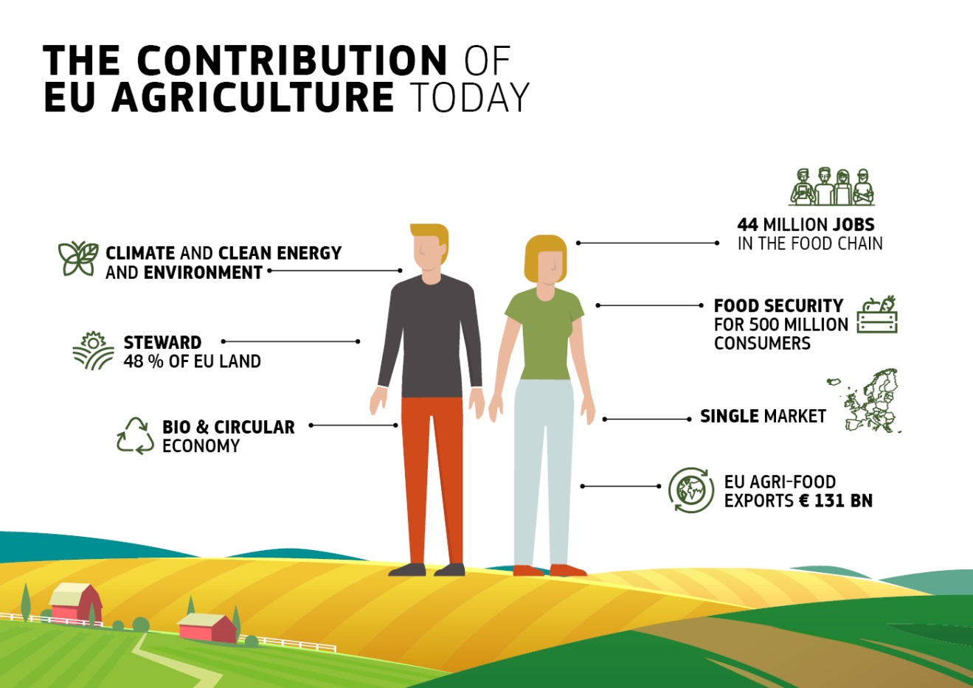Figure 1
None of these benefits can however be taken for granted. Unlike most other economic sectors, farming is strongly affected by the weather; it is also frequently tested by volatile prices, natural disasters, pests and diseases – with the result that, every year, at least 20% of farmers lose more than 30% of their income compared with the average of the last three years. At the same time pressure on natural resources is still clearly present partly as a result of some farming activities. Climate change threatens to make all of the above-mentioned problems weigh more heavily. The Common Agricultural Policy (CAP) should therefore lead a transition towards a more sustainable agriculture.
The CAP enabled the development of the most integrated single market. It is thanks to the CAP that the EU farm sector is able to respond to citizens' demands regarding food security, safety, quality and sustainability. However, at the same time the sector faces the challenges of low profitability - due inter alia to the EU's high production standards, the high costs of production factors and the fragmented structure of the primary sector. The sector now competes at world market prices in most sectors, leads the field in terms of food product diversity and quality and achieves the globe's highest agri-food exports (worth EUR 131 billion in 2016)
Solid performance but further work to be done
Direct payments currently shore up the resilience of 7 million farms, covering 90% of farmed land. While they make up around 46% of the income of the EU farming community, the proportion is much higher in many regions and sectors. They thereby provide relative income stability to farmers facing significant price and production volatility - which helps to keep the EU's vital high-quality food production base spread around the Union. Their impact is supplemented by market instruments. Areas with Natural Constraints are also the object of specific support.
Rural development policy makes a substantial contribution to the farm economy and vital rural livelihoods in various ways. It supports investments; knowledge-building; supply chain organisation; environmental protection and climate action. Rural development programmes in 2014-2020 build on this and widens provision for innovation and risk management. The creation of the European Innovation Partnership for Agricultural Productivity and Sustainability (EIP-AGRI) gave an impetus to knowledge creation and sharing. However, important efforts still need to be done to facilitate the access of farmers to knowledge.
There are lessons to be learned from the public consultation carried out in the first half of 2017 on "modernising and simplifying the CAP" which confirmed a widespread consensus that the current CAP tools successfully addresses current challenges to some extent only. This covers also environmental and climate challenges, where a majority of farmers and other stakeholders consider that the CAP should do more. At the same time, the excess of bureaucracy has been highlighted as a key obstacle preventing the current policy from successfully delivering on its objectives.
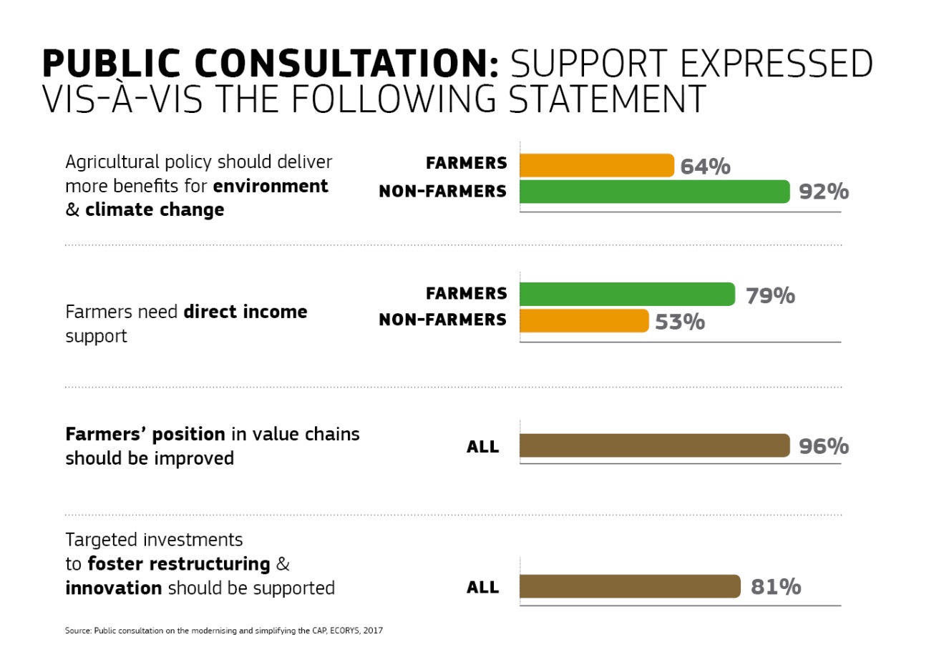
Figure 2
Land-based measures are pivotal to achieving the environmental and climate-related goals of the EU, and farmers are the primary economic agents in delivering these important societal goals. In this context, we need to look at direct payments in order to ensure that a large portion of the EU's actively farmed area is managed with practices beneficial for the environment. The current area-based Rural Development payments build on this foundation. Partly thanks to the CAP, organic farming expanded significantly, to cover 6% of UAA in 2015 compared to 2% in 2000.
The implementation of “greening” is qualified as sometimes less ambitious than intended, and is identified in the public consultation as the most burdensome and complex element of the CAP which limits its effectiveness. Climate change has in the meantime become an even more urgent priority, with important costs to be faced by the farming community in the future.
This view has also been highlighted by the REFIT Platform, which has put the focus on the excessive administrative burden of the current greening measures, the control and audit system and the growing overlaps between pillar I and II. As indicated by the REFIT Platform, there is a need to reduce the regulatory burden of the CAP and improve its value for money while ensuring the achievement of the objectives and increase its integration with other policy areas.
A first report on the implementation of the current common monitoring and evaluation framework of the CAP, including first results on the performance, will be presented to the European Parliament and the Council in 2018. The Impact Assessment that will underpin the Commission proposal for the post-2020 Common Agricultural Policy will take into account all available evidence on the performance of the policy so far (including results of evaluations and input from the REFIT Platform) and will use this information when analysing specific solutions for the future.

A future- proof CAP
While addressing the CAP Treaty objectives, the CAP has kept evolving, increasing the EU added value. It has also substantially increased its emphasis on the environment, climate and the wider rural context in which farming operates. This enabled the sector to increase its productivity by nearly 9% since 2005 while cutting greenhouse gas (GHG) emissions by 24% since 1990 and reducing fertiliser use with a positive impact on water quality. However, in the absence of stronger and more ambitious policy support it is unlikely that EU agricultural emissions will continue to decrease at the same pace. The CAP must continue stepping up its response to these challenges and it also shall play an essential role in realising the Juncker priorities in full coherence with other policies, especially:
- boosting quality employment, growth and investment;
- harnessing the potential of the Energy Union, the circular economy and the bio-economy while bolstering environmental care and fighting and adapting to climate change;
- bringing research and innovation out of the labs and onto the fields and markets;
- fully connecting farmers and the countryside to the digital economy; and
- contributing to the European Commission's agenda on migration.
At the same time, the EU is strongly committed to action on the COP21 Paris Agreement and the United Nations Sustainable Development Goals (SDGs). Notably, the CAP underpins the policies spelled out in the 2030 Climate and Energy framework, which calls upon the farming sector to contribute to the economy-wide emission reduction target of -40% by 2030 and EU Adaptation strategy. European farming also needs to step up its contribution towards the EU environmental objectives. These commitments cannot be met without farmers, foresters and other rural actors who manage over half of the EU's land, are key users and custodians of the related natural resources and provide large carbon sinks as well as renewable resources for industry and energy. This is why a modernised CAP should enhance its EU added value by reflecting a higher level of environmental and climate ambition, and address citizens' concerns regarding sustainable agricultural production.
The Cork 2.0 Declaration of 2016, A Better Life in Rural Areas, gave voice to ambitious aspirations for the future success of the EU's agriculture and countryside and the contributions they could make to society as a whole. It presents an agenda for reforming the CAP to improve its delivery and bring it up to date to the current day challenges In particular there is a need to invest in skills, public services, infrastructure and capacity building in order to generate vibrant rural communities.
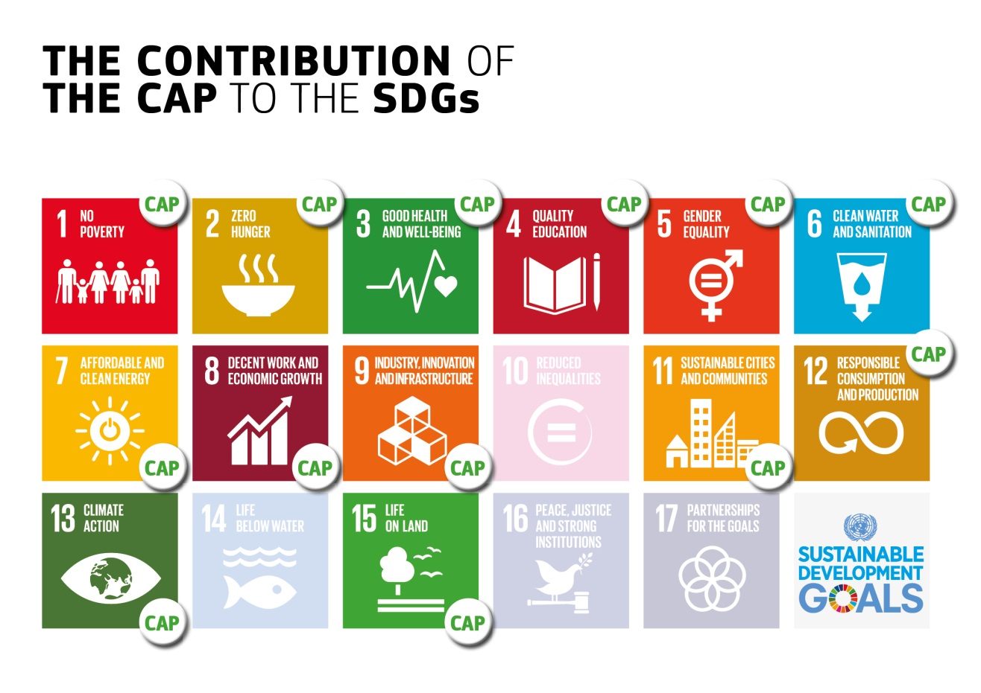
Figure 3
The public consultation underlined the importance of the three dimensions of sustainability (economic, environmental and social) and linked them to a broader need to modernise and simplify the policy.
The Commission's White Paper on the Future of Europe of 1 March 2017 set in motion a wide-ranging debate on tomorrow's EU, calling on the Union and its Member States to interact better with citizens, be more accountable to them and deliver faster and better on what has been collectively agreed, such as the European Pillar of Social Rights. The Commission's Reflection paper on the Future of EU Finances of 28 June 2017 stimulates further this debate, setting out options and scenarios for the future direction of the EU budget, including among other options a degree of co-financing of the CAP and its implications. As recalled in the Reflection Paper, the EU budget should continue dealing with current trends that will shape the EU in the coming years. There are also a number of new challenges in which the EU budget will need to do more than today. In this context, all existing instruments including the CAP will need to be looked at. Hence, this Communication does neither pre-empt the outcome of this debate nor the proposals for the next multiannual financial framework (MFF).
The Reflection Paper on the future of EU finances called for a shift towards new, sustainable growth that combine economic, social and environmental considerations in a holistic and integrated way and stronger focus on the provision of public goods.
This is the backdrop against which the CAP must take the next steps in its evolution – modernising and simplifying, and working hand in hand with other EU policies – to meet a wide range of pressing challenges and bring out the very best from the Union's farm sector and rural areas, with a greater focus on high standards and actual results, and to support farmers in anticipating and dealing with future relevant challenges and developments.

towards a new delivery model and a simpler CAP
The CAP needs to evolve in various ways and sharpen its responses to the challenges and opportunities as they manifest themselves at EU, national, regional, local and farm levels. This also includes for the CAP to streamline its governance and improve its delivery on the EU objectives, and to significantly decrease bureaucracy and administrative burden.
The current CAP delivery system relies on detailed requirements at EU level, and features tight controls, penalties and audit arrangements. These rules are often very prescriptive, down to farm level. In the Union's highly diversified farming and climatic environment, however, neither top-down nor one-size-fits-all approaches are suitable to delivering the desired results and EU added value.
In the delivery model of the future CAP, the Union should set the basic policy parameters (objectives of the CAP, broad types of intervention, basic requirements), while Member States should bear greater responsibility and be more accountable as to how they meet the objectives and achieve agreed targets. The CAP objectives would fulfil the EU Treaty obligations but also the already agreed objectives and targets on for instance the environment, climate change (COP 21), and a number of the SDGs. When preparing CAP strategic plans, the Member States will take into account their planning tools adopted emanating from EU environmental and climate legislation and policies. At the same time, Member States would be accountable for providing credible performance monitoring and reporting, underpinning the assurance of the budget.
Greater subsidiarity would make it possible to better take into account local conditions and needs, against such objectives and targets. Member States would be in charge of tailoring CAP interventions to maximise their contribution to EU objectives. While maintaining current governance structures – that must continue to ensure an effective monitoring and enforcement of the attainment of all policy objectives - the Member States would also have a greater say in designing the compliance and control framework applicable to beneficiaries (including controls and penalties).
To enhance EU added value and to preserve a functioning agricultural internal market Member States would take their decisions not in isolation, but in the framework of a structured process that would materialise in establishing a CAP strategic plan, which would cover interventions in both pillar I and pillar II, thus ensuring policy coherence across the future CAP and with other policies. The delivery model will thus continue to ensure a level playing field, preserving the common nature and the two pillars of the policy. The Commission would assess and approve such plans with a view to maximising the contribution of the CAP towards the EU priorities and objectives and the achievement of Member States' climate and energy targets. This is important to ensure the maintenance of a common approach to the delivery of environment and climate objectives across Member States. Increased ambition is the only viable policy option in this regard.
The planning process should be shaped in a much simpler way, remaining clearly below the levels of complexity exemplified by the current rural development programming. This means in particular that prescriptive compliance elements such as measures' details and eligibility rules at the level of EU legislation should be eliminated. Such simplification would also favour integrated and innovative approaches and render the policy framework more adaptive and innovation friendly.
This means the CAP and the Member States plans should focus above all on the objectives and expected results while leaving sufficient room for Member States and regions to address their specificities. In line with the logic of the Commission's "budget focused on results" approach, a future delivery system should thus be more result-driven, boost subsidiarity by giving Member States a much greater role in rolling out CAP schemes, pursue agreed realistic and adequate targets, and help reducing the EU-related administrative burden for beneficiaries. In such a context simplified cost options and modern technologies offer huge opportunities to reduce this burden, in particular as regards controls. Both farmers and citizens should be enabled to benefit from such advances with a less prescriptive framework.
In this way, as proclaimed by the Cork 2.0 Declaration, the architecture of the CAP as a whole would provide for targeting interventions to well-defined economic, social and environmental objectives while reflecting the needs and aspirations of the territories concerned.
Another crucial function of the Commission would of course consist in supervising the delivery on results and the respect of basic EU rules and international commitments in the framework of a well-designed audit and assurance system. To this end the assurance process would need to be adapted to the requirements of a result-driven policy design including the development and application of solid and measurable indicators and of a credible performance monitoring and reporting.

a smarter, modern and sustainable CAP
European citizens should continue to have access to safe, high quality, affordable, nutritious and diverse food. The way this food is produced and marketed should adapt to citizens' expectation, in particular concerning the impact on their health, the environment and the climate. To ensure this in a context of growing world population, increased environmental pressure and climate change, the CAP has to continue evolving, maintaining its market orientation and its support to the EU family farm model across all the regions of the Union. Similarly, the CAP needs to support and be compatible with efforts that address the root causes of migration towards the EU.
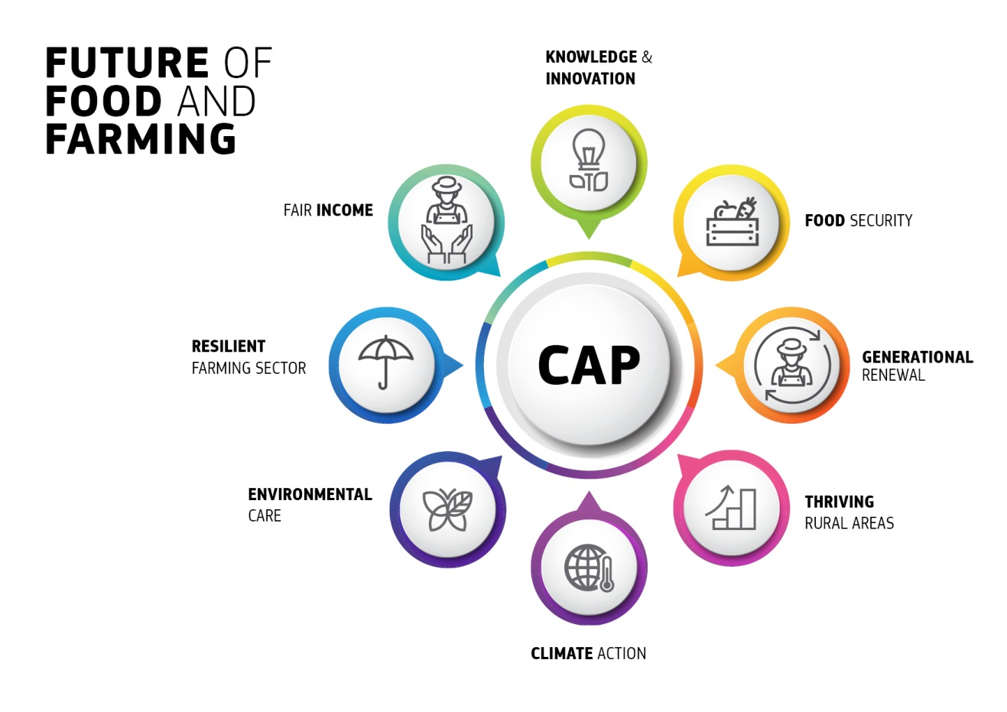Figure 4
Fulfilling these goals will be made possible by building on what the CAP has already achieved through its policy objectives, in a new economic, climate, environmental, social, technological, industrial and political context. The section below sets out the main objectives of the future CAP:
- to foster a smart and resilient agricultural sector;
- to bolster environmental care and climate action and to contribute to the environmental and climate objectives of the EU;
- to strengthening the socio-economic fabric of rural areas.

To fulfil these objectives the agricultural sector and the EU rural areas will need to be better linked to human capital development and research and support for innovation will need to be stepped up.
The future CAP will also need to continue to address societal expectations regarding sustainable food production, in particular concerning food safety, food quality, environmental and animal welfare standards.

Using research and innovation to better link what we know to what we grow
Innovations in various fields (agronomy such as nature based solutions, breeding, vertical farming, zootechnics, biological, technological, digital, organisational and product related) are within reach and can serve the multi-functionality of EU agricultural and food systems. Research and innovation are part of the foundation of progress concerning all the challenges which confront the EU's farm sector and rural areas: economic, environmental and social. The needs and contributions of rural areas should be clearly reflected on the research agenda of the European Union and the future CAP will need to enhance even more synergies with the Research and Innovation Policy in fostering innovation.
Technological development and digitisation make possible big leaps in resource efficiency enhancing an environment and climate smart agriculture, which reduces the environment-/climate impact of farming, increase resilience and soil health and decrease costs for farmers. However, the uptake of new technologies in farming remains below expectations and unevenly spread throughout the EU, and there is a particular need to address small and medium-sized farms' access to technology.
Not only technology but also access to sound, relevant and new knowledge is very patchy around the Union. This impedes the performance of certain CAP instruments as well as the farm sector's overall competitiveness and development potential. By contrast, the CAP's capacity to increase the flow of knowledge between partners from different parts of the EU offers strong added value as it will save costs, increase the impact of EU funding and speed up innovation in the different parts of the EU.
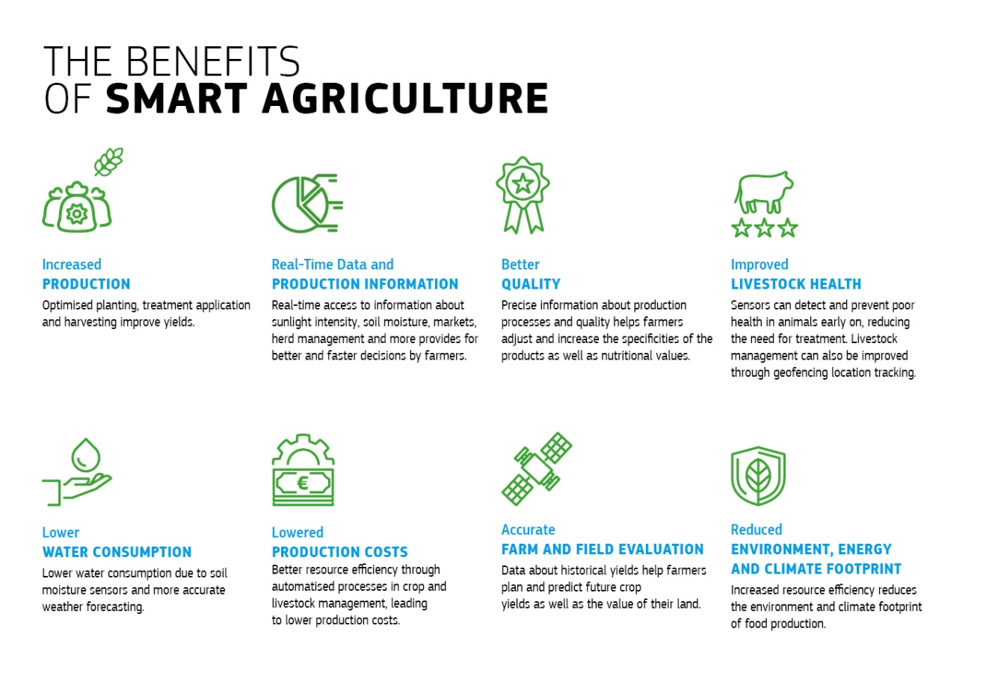
Figure 5
Support for knowledge, innovation and technology will be crucial to future-proofing the CAP. Schemes that aim at enhancing economic, social or environmental performance as well as climate change adaptation and mitigation will be linked to the advisory services providing knowledge, advice, skills and innovation.
The European Innovation Partnership for Agricultural Productivity and Sustainability (EIP-AGRI) and the European Innovation Partnership on Water have proven their value in mobilising the agricultural sector for innovation. It has funded multi-participant pilot projects and is networking across Europe to make new knowledge generally available. Its success depends on the combined performance of advisors, agricultural training and educational systems, researchers and farmer organisations often referred to as the Agricultural Knowledge and Innovation System (AKIS) – which operates very differently from one Member States to another. The role of the farm advisor stands out as particularly important. A modern CAP should support the strengthening of farm advisory services within the AKIS systems. This should become a condition for the approval of CAP Strategic Plans. This should be facilitated by strengthening the support for peer-to-peer exchange, networking and cooperation amongst farmers including through Producer Organisations ("POs"), as these can be important vehicles of knowledge sharing, innovation as well as cost savings for the farmers on a very regular basis.

Fostering a smart and resilient agricultural sector

A fair income support to help farmers to make a living
As emphasised in the Reflection paper on the future of EU finances, direct payments partially fill the gap between agricultural income and income in other economic sectors. They provide an important income safety net, ensuring there is agricultural activity in all parts of the Union including in areas with natural constraints (which also receive income payments under Rural Development Policy) with the various economic, environmental and social associated benefits, including the delivery of public goods. Therefore, direct payments remain an essential part of the CAP in line with its EU Treaty obligations.
Figure 6

Although the role of direct payments in stabilising farm income is generally welcomed, the fact that 20% of farmers receive 80% of the payments sometimes prompts accusations of "unfairness". These numbers are a reflection of a system where payments are linked to land which is concentrated among a minority of farmers. Half of CAP beneficiaries are very small farms and most of the payments go to medium-size professional family farms, however a more balanced distribution of support should be promoted. Direct payments will fulfil their mission more effectively and efficiently if they are simplified and better targeted. Any change would however have to preserve one of the key assets of the policy: the protection of the well-functioning internal market the CAP has created over the years.
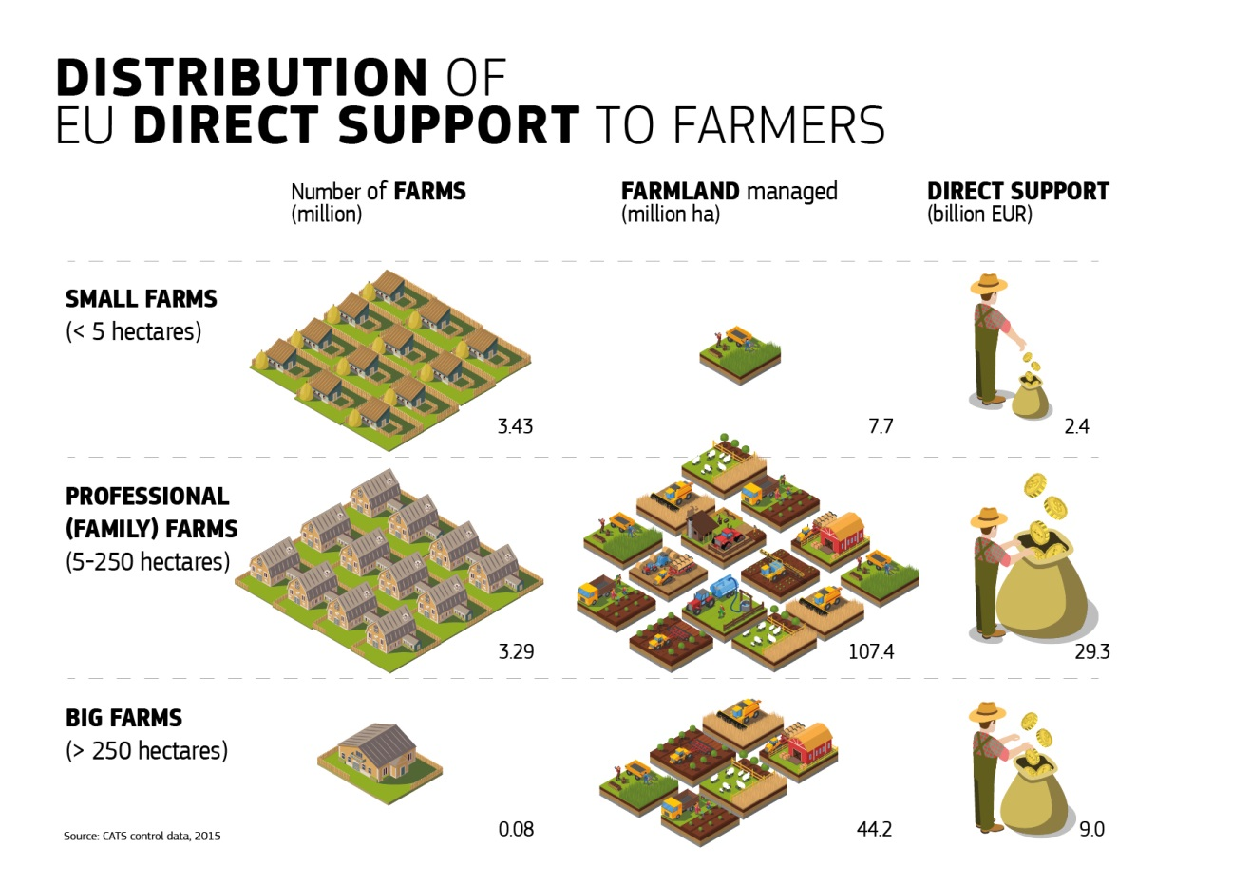
Figure 7
To target direct payments more effectively to ensure income to all farmers across the EU, as evoked in the above-mentioned Reflection paper, without being exhaustive the following possibilities in order to ensure a fair and better targeted support of farmers' income should be further explored:
- A compulsory capping of direct payments taking into account labour to avoid negative effects on jobs;
- Degressive payments could be introduced as well, as a way of reducing the support for larger farms;
- Enhanced focus on a redistributive payment in order to be able to provide support in a targeted manner e.g. to small-medium sized farms;
- Ensure support is targeted to genuine farmers, focussing on those who are actively farming in order to earn their living.
At the same time, the CAP needs to play its role in following the principles of "Equality between its Members, big or small, East or West, North or South", which were recalled by President Juncker in his State of the Union address of 2017. In this sense, it should reduce differences between Member States in CAP support. Even if the wide diversity of relative costs of labour and land as well as the different agronomic potentials across the EU should be acknowledged, all EU farmers face similar challenges.

Investing to improve farmers' market reward
The CAP should play a larger role in helping farmers make more money from the market. There is a clear need to boost investments into farm restructuring, modernisation, innovation, diversification and uptake of new technologies and digital-based opportunities such as precision agriculture, the use of big data, and clean energy in order to improve individual farm sustainability, competitiveness and resilience, including against the negative impacts of climate change. The position of farmers in the food chain is an important factor, and will also be addressed by the scheduled proposal to improve the EU food supply chain. Additional reflections are needed on the role and effective functioning for agricultural producer organisations. Recognised producer organisations can be a useful tool to enable farmers to strengthen their bargaining position in the value chain and to cooperate to reduce costs and to improve their competitiveness to improve market reward. As producer organisations are particularly relevant for small farmers, it is important that they are organised so they offer opportunities for them. Emerging sustainable rural value chains in areas such as bio-based industries, bio-energy and circular economy, as well as ecotourism offer opportunities for farmers and rural businesses to diversify their businesses, hedge risks and provide additional income: the policy should increasingly focus on supporting such efforts.
The performance of investment support under the CAP should also be improved through better integration of business advice and promotion of collective investments and mechanisms to get effective synergies with research and innovation. The current investment gap in agriculture needs to be addressed, also through more use of innovative financial instruments that take into account the specificities of farming as well as more integrated projects that link various EU instruments (EFSI, ESIF). Further work with the European Investment Bank (EIB) may point the way.

Risk Management
In the context of a greater market orientation of the CAP, more market exposure led to higher risks of price volatility and an increasing pressure on incomes. Risks also stem from climate change, the associated increased frequency and severity of extreme events and more frequent sanitary and phytosanitary crises affecting the EU livestock and agronomic assets. While farmers, as entrepreneurs, are ultimately responsible for designing their own on-farm strategies, it is important to set up a robust framework for the farming sector to successfully prevent or deal with risks and crises, with the objective of enhancing its resilience and, at the same time, providing the right incentives to crowd-in private initiatives.
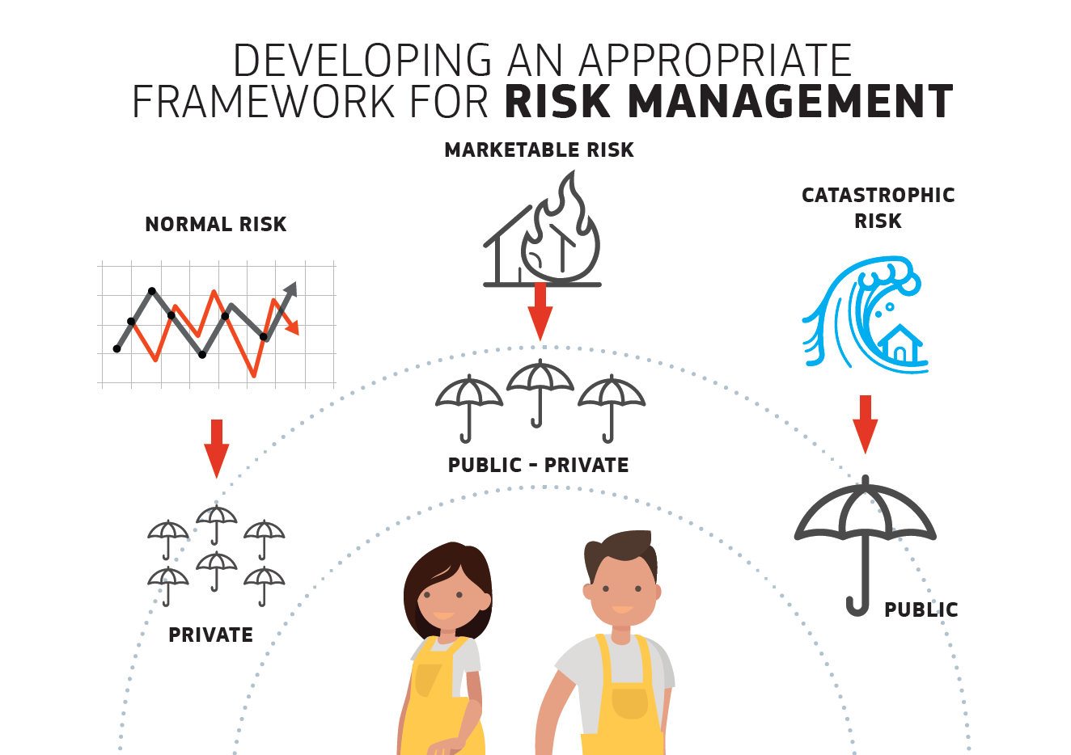
Figure 8
The CAP already offers a layered set of tools helping farmers to prevent and manage risks, from direct payments and market intervention to post-crises compensations and the present second pillar measures in particular an Income Stabilisation Tool (IST) and insurance support. For example sector specific stabilisation tools with a 20% trigger level for income loss can be effective. It is important to consider whether to further adjust its design to improve its functioning. Furthermore, it should be explored how existing possibilities as regards risk management can be better exploited, for instance by the use of indexes to calculate farm income losses, reducing red tape and costs.
The understanding and consideration by the farming community of risk management instruments in general and agricultural insurance in particular can be improved. There is an opportunity to increase knowledge of the benefits of those systems through rural development training, knowledge transfer initiatives and the inclusion in the farm advisory service.
In the short run, a permanent EU-level platform on risk management will be set up, providing a forum for farmers, public authorities and stakeholders to exchange experiences and best practices, with the objectives of improving implementation of the current tools and informing future policy developments.
At the same time, it is worthwhile exploring how to further develop an integrated and coherent approach to risk prevention, management and resilience, which combines, in a complementary way, EU-level interventions with Member States' strategies and private sector instruments which address income stability as well as climate risks. A flexible approach, in this context, is a necessary condition to allow tailored solutions for the different types of regional and sectoral needs of farmers and to support their market orientation.
New avenues should however be explored. Financial instruments stimulating the inflow of private capital can help to overcome temporary cash flow shortages. Other complementary measures to the current risk management toolkit, such as support for re-insurance of mutual funds or incentives for precautionary savings, may also be envisaged.
Beyond the CAP toolbox, certain actions at Member State level could help provided that they are compatible with state aid rules. This concerns for instance provisions in taxation policy that currently discourage farmers to make from savings in good years to cope with bad years.

Bolstering environmental care and climate action and contributing to the achievement of EU environmental and climate objectives
Climate change and constraints on natural resources will continue affecting farming and driving food security challenges. The EU 2030 Climate and Energy targets set ambitious goals.As all sectors, agriculture should make a fair contribution to these targets, as outlined in the Commission proposals on Effort Sharing and Land-Use, Land Use Change and Forestry (LULUCF). At the same time, agriculture is one of the sectors most vulnerable to climate change. Water scarcity, changing precipitation patterns, overall temperature increases and variation, increased intensity and frequency of climate-related extremes, presence and persistence of (new) pests and diseases, and fire risks are already challenging current agricultural and forestry practices and production. However, farmers and foresters are not only users of natural resources, but also, indispensable managers of ecosystems, habitats and landscapes. Any new CAP should reflect higher ambition and focus more on results as regards resource efficiency, environmental care and climate action.
The future CAP should make the best use of research results, ensure that knowledge is shared and implemented and support proliferation of modern technologies to maximise the contribution of agriculture to the EU and global objectives. Climate-smart farming supported by training, advice and innovation is one part of the answer; but this requires an agricultural policy with strong commitment to deliver public goods and ecosystems services related to soil, water, biodiversity, air quality, climate action and the provision of landscape amenities. It is also important that the contribution of the CAP to these objectives is strategic and measurable.
The current green architecture of the CAP, that primarily relies on the complementary implementation of three distinct policy instruments – cross compliance, green direct payments and voluntary agri-environmental and climate measures will be replaced and all operations integrated into a more targeted, more ambitious yet flexible approach. The new delivery model will allow Member States to devise a mixture of mandatory and voluntary measures in Pillar I and Pillar II to meet the environmental and climate objectives defined at EU level. Member States will need to define quantified targets which will ensure that the agreed environmental and climate objectives defined at EU level are achieved. Member States will have the flexibility to formulate strategic plans allowing for addressing climate and environmental needs at local level. It should be explored how an obligatory EU-wide requirement to have a nutrient management plan and incentives for precision agriculture, forming part of any Member State CAP strategic plan, could improve results. The Commission will explore inter alia how to cater for measures that yield high EU environmental added value, such as conservation of permanent pastures, maintenance and creation landscape features, agriculture in areas with natural constraints, organic farming, as well as individual or collective schemes aimed at soil health, biodiversity and /river basin stewardship.
The granting of income support to farmers will be conditioned to their undertaking of environmental and climate practices, which will become the baseline for more ambitious voluntary practices. The new conditionality will rely on the implementation of a streamlined set of environmental and climate conditions, providing environmental and climate public goods. These practices would be further defined by Member States in order to better take account of their specific situation, climate risks and needs, while ensuring that these practices adequately contribute to the objectives agreed at EU level. Member States would have to ensure that the agreed targets are met and monitor performance in a robust and credible way. Additional environmental / climate benefits will be achieved through voluntary entry level schemes and more ambitious agro-environment-climate schemes that will allow Member States/Regions to target their specific concerns.
Such approach will lead to simplification - one layer of requirements for direct payments, a single set of management and control rules and a reduction of administrative burden to the Member State and the farmer. Greater subsidiarity will remove "the one size fit all" approach and ensure a clear environmental link for actions taken. However, to ensure coherence with the overarching EU objectives, all actions and targets put forward by the Member State will be approved by the Commission within an EU framework agreed as part of the CAP strategic plan.
The overall performance of the new green architecture should encourage the promotion of co-operative/collective approaches, involving Farmers and Stakeholders in a result-oriented delivery of environmental and climate public goods and developing schemes that integrate the provision of knowledge and environmental investments.

Strengthening the socio-economic fabric of rural areas

Growth and jobs in rural areas
Many rural areas in the EU suffer from structural problems, such as a lack of attractive employment opportunities, skill shortages, underinvestment in connectivity and basic services and a significant youth drain. In a Union of equals the potential and aspirations of rural citizens and communities must be better addressed in EU policies. The CAP, and in particular Rural Development Policy, has an important role to play to promote rural jobs and growth as well as to preserve the environmental quality of rural areas.
Joint EU and national investment in infrastructure, natural and human capital development is paramount to support sustainable, quality employment in rural areas. The rural communities should have better access to public services, health care, vocational training, programmes to develop new skills notably in the digital sector, quality education, and connectivity.
The CAP is one of several EU policies that contribute to prosperous rural areas and it must improve its complementarity with other EU policies such as Cohesion Policy - which also provides substantial EU funding in rural areas - and the Connecting Europe Facility as well as national funds and strategies. Improved coordination between these policies would result in simpler delivery mechanisms and less red tape for administrations and citizens.
New rural value chains such as clean energy, the emerging bio-economy, the circular economy, and ecotourism can offer good growth and job potential for rural areas. By-products from agri-food and forestry could find new value as inputs for bio-energy and bio-based industries, while manure can turn into biogas and fertiliser thus supporting both the energy transition and the wider nutrient recycling. This also contributes to the substitution of more polluting and non-renewable resources and materials, and to a reduction of food losses and waste. Sustainable agriculture and forestry are both strategic sectors to develop this potential.
Growth of the bio-economy in a sustainable business model should therefore become a priority for the CAP strategic plans, and support the EU circular economy strategy and the development of new business models which will benefit farmers and foresters whilst creating new jobs. This would also boost the CAP's potential to contribute to the Energy Union and the EU Industrial Policy by promoting clean and efficient energy production, including sustainable biomass mobilization in respect of the core principles of the EU circular economy strategy. The EFSI and other financial instruments should leverage additional support from Rural Development programmes in order to provide low cost and longer term loans for entrepreneurs that are willing to invest in rural areas.
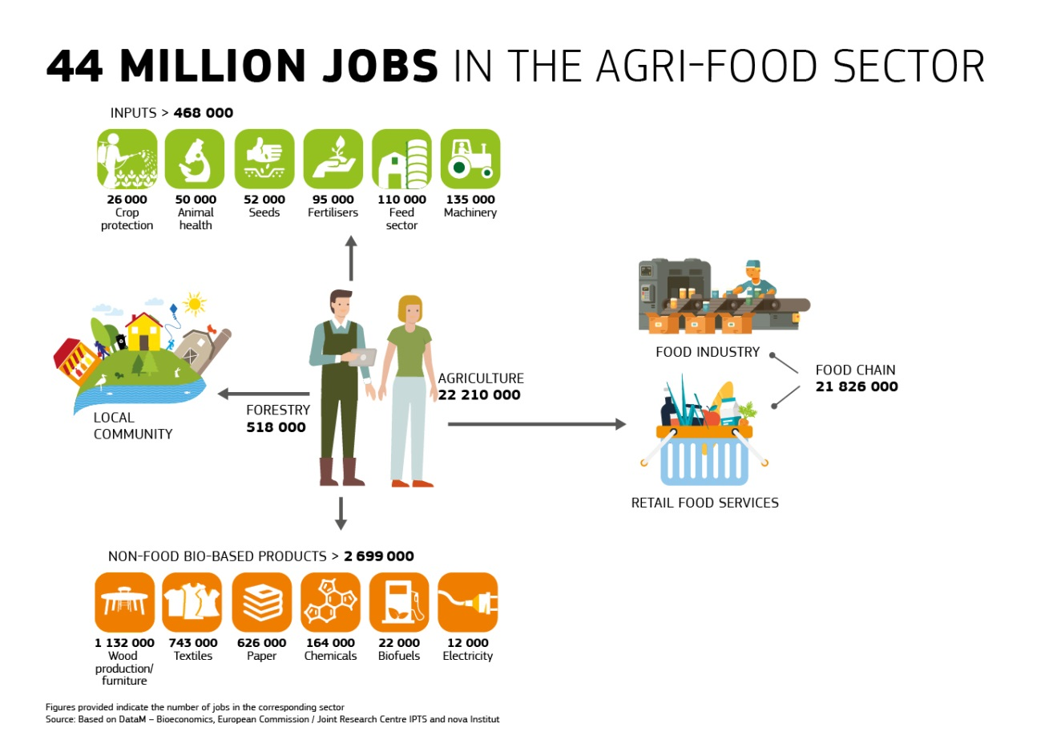
Figure 9
One priority for this future joint work across policy areas is development of "Smart Villages" throughout the Union. This emerging concept, currently developing through a number of initiatives and pilots, will help local communities address issues of inadequate broadband connectivity, employment opportunities and service provision in a clear and comprehensive manner. The Commission is committed to reinforcing support for rural communities and local authorities that wish to develop Smart Villages through capacity building, investments, innovation support, networking as well as through the provision of innovative financing tools for improving skills, services and infrastructure.
Continued joint EU and national investment in human capital development in rural areas is needed to support sustainable and quality employment and to help people living in these areas fulfil their potential, and their community's potential by helping them acquire new skills, and have improved access to quality key services, including access to quality education.
The bottom-up, locally led approach LEADER has proven to be an effective means to local capacity building and to promoting social inclusion, poverty reduction and job creation in the local economy. There is a need for better synergy and coordination with municipal authorities and local agencies to fully mobilise rural potential.
Through its rural development policy, the CAP is the "rural champion" of the Union. However, while all macro and sectorial policies have a potential impact on rural communities and many EU funds the capacity to promote rural prosperity, this capacity for rural regeneration is not always maximised. The Commission is therefore committed to promoting a "rural proofing" mechanism, which systematically reviews relevant policies through a "rural lens", considering possible impacts on rural communities.

Attracting new farmers
A prosperous agricultural sector can develop only if a real change of generation takes place: our aging agricultural community needs new blood to make the sector more dynamic and open to on-going technological transformations. However, young farmers and other new entrants face considerable obstacles to starting up farming activity, among them economic ones such as high land prices but also societal ones such as the perception of farming as an unattractive or old fashioned occupation, sometimes with inappropriate social protection.
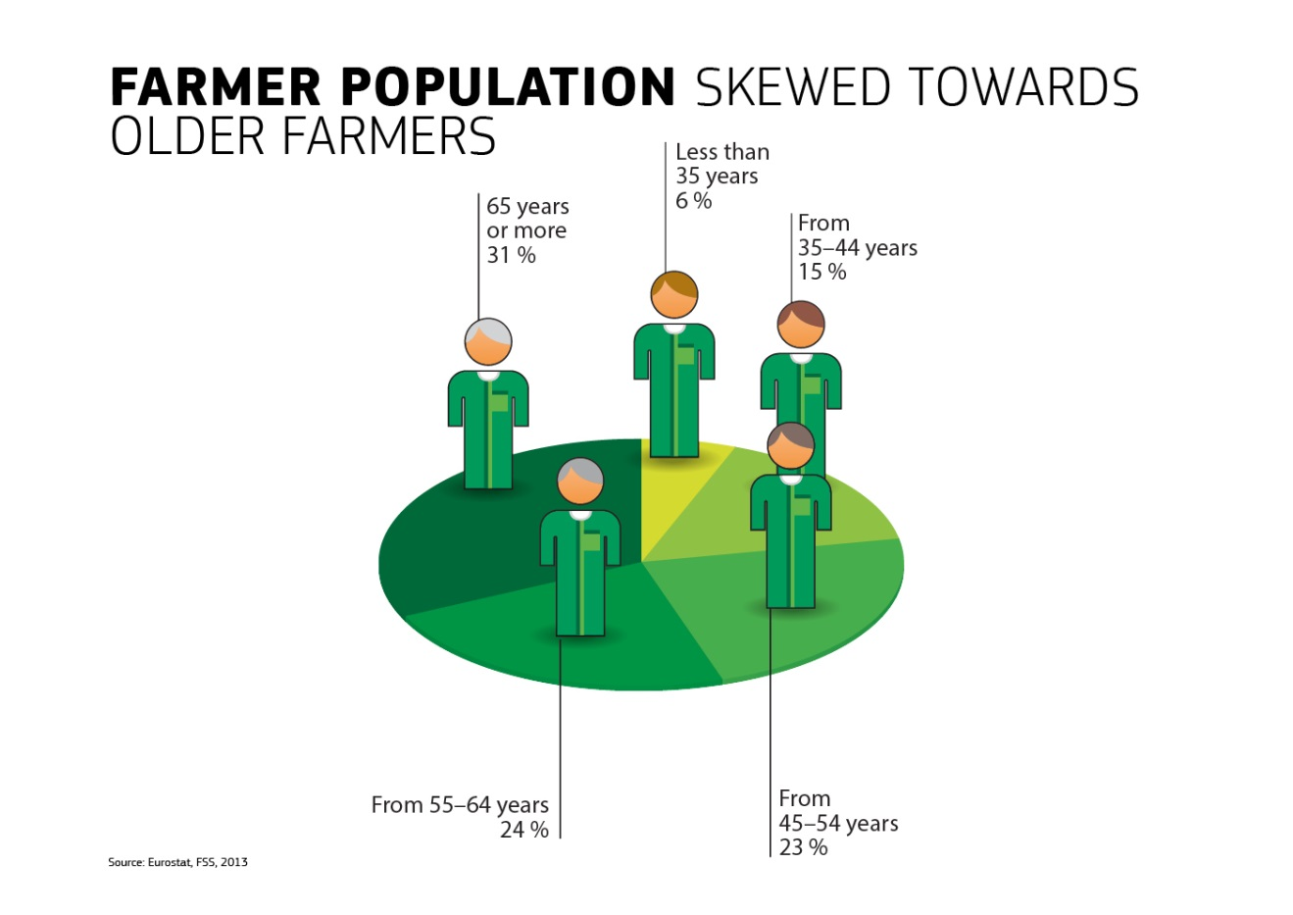Figure 10
Generational renewal should become a priority in a new policy framework, but it must be recognised that Member States are in the best position to stimulate generational renewal using their powers on land regulations, taxation, inheritance law or territorial planning. Taking this into account, there is a need to improve the consistency between EU and national actions. The CAP should give flexibility to Member States to develop tailor made schemes that reflect the specific needs of their young farmers. The new delivery system will facilitate Member States' actions to assist young farmers. The CAP strategic plans could include support for skills development, knowledge, innovation, business development and investment support. Producer Organisations can play a valuable role here. To increase learning opportunities abroad for young people living in rural areas, Erasmus exchange possibilities for young farmers should be bolstered.
Setting up in agriculture implies high risk with large capital requirements and uncertain income. The CAP should help mitigate this risk in the first years after launching a farming business by providing an EU-wide system of support to the first installation with necessary support in a simpler and better targeted way: this could be achieved with a simplified top-up payment for new entrants (tailored by Member States according to the specific needs) and/or the reinforcement or extension of current lump-sum payments.
Access to financial instruments to support farm investments and working capital should be facilitated and better adapted to the investment needs and higher risk profiles of new entrants. Support to the new generation of farmers could be combined with the appropriate incentives to facilitate the exit of the older generation and increase land mobility. Furthermore, there is a growing need to support actions that stimulate the transfer of knowledge among generations (through partnerships and other new business models) and facilitate succession planning (i.e. advisory services, mentoring and the preparation of “farm succession plans”).

Addressing citizens' concerns regarding sustainable agricultural production, including health, nutrition, food waste and animal welfare
The CAP is one of the EU policies responding to societal expectations regarding food, in particular concerning food safety, food quality, environmental and animal welfare standards. Farmers are the real gatekeepers of food production systems; as such the contribution they can give to a sustainable food chain is crucial.
Citizens are also increasingly valuing access to a wide variety of food that carries broader benefits for society, such as organic produce, products with geographical indications (GIs), local specialities and innovative food. In synergy with other EU policies, the CAP must continue to respond to these concerns, for instance by modernising organic rules, continuing to make GIs more attractive to farmers and consumers and easier to manage, or supporting the objectives of the Sustainable Use of Pesticides directive. The CAP should become more apt at addressing critical health issues such as those related to antimicrobial resistance (AMR) caused by inappropriate use of antibiotics. In line with an ambitious and encompassing approach with regard to human and animal health - as embodied by the "One Health" concept – it should also promote the use of new technologies, research and innovation to reduce risks to public health.
Identically the CAP can help farmers to improve the application of EU rules on animal welfare and to further increase standards through voluntary initiatives aimed at promoting the market value of animal welfare both within and outside the EU.
The CAP should continue to support production with specific and valuable characteristics through Rural Development as well as to promote and improve its international recognition. The CAP also has a role to play in promoting healthier nutrition, helping to reduce the problem of obesity and malnutrition, making nutritious valuable products such as fruits and vegetables easily available for EU citizens. A good example is the Schools schemes, under which free fruit, vegetable and dairy products are subsidised in schools and by using these schemes to promote class room activities related to healthy eating. Campaigns to promote healthy dietary practices and increasing the consumption of fruit and vegetables should be a focal point in the CAP promotion activities.
Consumers' food choices depend on a number of factors going far beyond the remits of the CAP. The most important role for the policy is therefore to help farmers anticipate developments in dietary habits and adjust their production according to market signals and consumers' demands. Strengthening the knowledge triangle in agriculture and forging better links to relevant initiatives such as the European Institute for Innovation and Technology's Food Partnership and the EU Food 2030 research strategy will also help maximise the contribution of the CAP to future-proofing our food system. .
Finally, the CAP can help to reduce food waste and food losses by stimulating better production and processing practices (e.g. promoting new technologies that extend the shelf life of perishable products or better matching supply and demand through increased transparency) and by supporting initiatives that transform traditional produce-use-discard consumption patterns into a circular bio-economy.

The global dimension of the CAP
The CAP is a policy for the EU but it obviously has global implications and linkages. Close attention must be paid to these when decisions are taken about the policy's future. The linkages between the CAP and Sustainable Development Goals are presented in figure 3. The EU is committed to support partner countries achieving the same goals through external policies and instruments. Therefore it will seek coherent action among its policies in line with the 2030 Agenda, and with its commitment to enhance policy coherence for sustainable development. The latter requires taking into account the objectives of development cooperation in policies which are likely to affect developing countries.
To this regard, the CAP is and will continue to be coherent with the EU development policy, which recognises the important role sustainable agriculture plays for poverty eradication and sustainable development in developing countries and promotes also the development of agricultural markets and inclusive value chains which benefit the poor and encourage the agro-industry to generate jobs.

Trade
Thanks to the efforts of the EU's agricultural and food processing sector, with support of EU trade agreements and the CAP (including its promotion policy) the EU is the world largest agri-food exporter. Further liberalisation of trade and increased participation in global value chains will allow the EU agri-food sector to develop exports even further, responding to growing middle-class demand worldwide, as well as dietary changes. For citizens, further growth in international trade will improve the accessibility, variety and affordability of food.
Maintaining the market-orientation of the EU agri-food sector and the compatibility of CAP measures with international trade law will also allow the EU to retain its leading role in international bodies such as the World Trade Organisation (WTO), promoting open trade and advocating strict disciplines on trade-distorting forms of support.
At the same time, it cannot be ignored that specific agricultural sectors cannot withstand full trade liberalisation and unfettered competition with imports. We therefore need to continue to duly recognise and reflect the sensitivity of the products in question in trade negotiations and explore ways how to address the geographical imbalances of advantages and disadvantages that affect the farm sector within the Union as a result of EU trade agreements.
Currently, the EU faces export restrictions from many important agri-food markets of third countries due to unjustified sanitary and phytosanitary (SPS) barriers. The EU will continue seeking a fair and balanced relationship with our trading partners and, where appropriate, promoting the EU SPS 'Single Entity' concept. The high standards of the EU will in no case be compromised. Furthermore, the EU, through its different cooperation and technical assistance tools, should foster increased cooperation with EU partner countries and regions, in particular when facing new and emerging animal health and phytosanitary threats.

Migration
The future CAP must play a larger role in implementing the outcome of the Valetta Summit, addressing the root causes of migration.
Knowledge and know-how gained from CAP-supported projects should be used to develop employment opportunities and revenue-generating activities in regions of origin and transit of migrants, including through the EU External Investment Plan Pilot projects for training young farmers - with the involvement of European farmers' organisations. Furthermore, EU-Africa Union exchange schemes are avenues to explore. Cooperation on agricultural research and innovation must be deepened through the relevant EU policies and instruments. The Commission is also committed to enhancing strategic policy cooperation and dialogue with the Africa Union on issues related to agriculture and rural development so as to help the region develop its agri-food economy.
Within the EU, agriculture offers oportunities for seasonal workers.
Moreover, through its rural development arm, the CAP can play a role in helping to settle and integrate legal migrants, refugees in particular, into rural communities. Experience shows that Community-Led Local Development/LEADER is particularly apt for this.

Covering predominantly rural and intermediate areas (OECD definition).
See https://ec.europa.eu/agriculture/trade-analysis/statistics_en
Ecorys et al. (2016) Mapping and analysis of the implementation of the CAP, p 76-94
See Evaluation study of the implementation of the European Innovation Partnership (EIP), November 2016: https://ec.europa.eu/agriculture/external-studies/2016-eip_en
See https://ec.europa.eu/agriculture/consultations/cap-modernising/2017_en
European Commission staff working document: Review of greening after one year https://ec.europa.eu/agriculture/sites/agriculture/files/direct-support/pdf/2016-staff-working-document-greening_en.pdf; also Report from the Commission to the European Parliament and the Council on the implementation of the ecological focus area obligation under the green direct payment scheme (COM/2017/0152 final) of 29.3.2017
See Ecampa2 study (2016) with the most updated assessment of greenhouse gas mitigation policy options for EU agriculture:http://publications.jrc.ec.europa.eu/repository/bitstream/JRC101396/jrc101396_ecampa2_final_report.pdf
REFIT Platform Opinions on "Cross Compliance", "Greening", "Overlaps between pillar I and II", "Control and Audit", "Rural Development support" and "EU legislation on the Farm subsidies reform". Available at: https://ec.europa.eu/info/law/law-making-process/overview-law-making-process/evaluating-and-improving-existing-laws/reducing-burdens-and-simplifying-law/refit-platform/refit-platform-recommendations_en
Such as the Management Plans and Prioritised Action Frameworks for Natura 2000, River Basin Management Plan, Air Quality and Air Pollution Programmes, Biodiversity Strategies.
Commission Work Programme 2018 – An agenda for a more united, stronger and more democratic Europe, COM(2017)650 final of 24.10.2017.
In this context, the European Commission has recently published guidance on how to protect agricultural land (Interpretative Communication on the Acquisition of Farmland and EU law, 2017/C 350/05 of 18.10.2017).
Directive 2009/128/EC of the European Parliament and of the Council of 21 October 2009 establishing a framework for Community action to achieve the sustainable use of pesticides.
See also https://ec.europa.eu/health/amr/sites/amr/files/amr_action_plan_2017_en.pdf
Cf. art. 208 TFEU
The new European Consensus on Development signed on 07/06/2017, and available on https://ec.europa.eu/europeaid/sites/devco/files/european-consensus-on-development-final-20170626_en.pdf
See http://www.consilium.europa.eu/en/meetings/international-summit/2015/11/11-12/#

