

# Introduction

## Context

The Industrial Emissions Directive[1] (IED) is the primary EU legal instrument to regulate industrial emissions and aims to achieve significant benefits to the environment and human health, in particular through the mandatory application of Best Available Techniques (BAT). Sectors within the scope of the IED account for a considerable share of overall pollution (emissions to air and water and waste generation) in Europe. It is estimated[2] that they account for around 23% by mass of emissions to air. For emissions to water the situation is less clear, but it is estimated to represent 20 to 40% of emissions of heavy metals and 30 to 60% of pollutants other than nutrients and organic carbon.

The 7th Environment Action Programme[3] expects that the uptake by industry of BAT under the IED will deliver improved resource-use patterns and reduced emissions for the EU's major industrial installations, thus making a significant contribution to stimulating the development of innovative techniques, greening the economy and reducing costs for industry in the longer term.

The IED is a product of better regulation efforts in that it merged, streamlined and simplified several pieces of legislation. It is an integrated instrument and its permitting provisions replace old systems of multiple permits. One chapter covers the framework for permitting and BAT, while others contain special rules for key sectors, in particular large combustion plants, waste (co-)incineration plants and installations using organic solvents.

BAT Reference documents (BREFs) are prepared by the European Integrated Pollution Prevention and Control Bureau (EIPPCB) of the European Commission's Joint Research Centre. This exemplary process involves full participation of all stakeholders in an evidence-based process in line with Better Regulation. BREFs contain BAT conclusions that are given legal force by the adoption of Commission Implementing Decisions containing them. BAT conclusions provide the BAT framework for each sector which must be taken into account by Competent Authorities when issuing permits.

The IED requires the Commission to report to Council and Parliament first on the initial phase of implementation and after that triennially. This report summarises Member State reports covering the initial phase of implementation (2013) and outlines other associated work that has been carried out, reviews the Commission's current related activities and looks ahead to the future.

As the first Commission report under the IED, this also covers the final reports from Member States under the predecessor legislation.

# Reporting by Member States on predecessor legislation

The reports from the Member States on the predecessor legislation have been assessed and their summaries published on CIRCABC[4].

## Integrated Pollution Prevention and Control Directive (IPPCD)

Final reports under the IPPCD[5] were submitted by Member States for its last reporting period covering the years 2012-2013. All Member States responded to most of the questionnaire, providing sufficient data to assess and comment on the implementation of the Directive. Member States reported a total of 51 528 IPPC installations in operation at the end of 2013. Their main reported activity is shown in the figure below (this only covers EU27 as Croatia became a Member State in mid-2013).

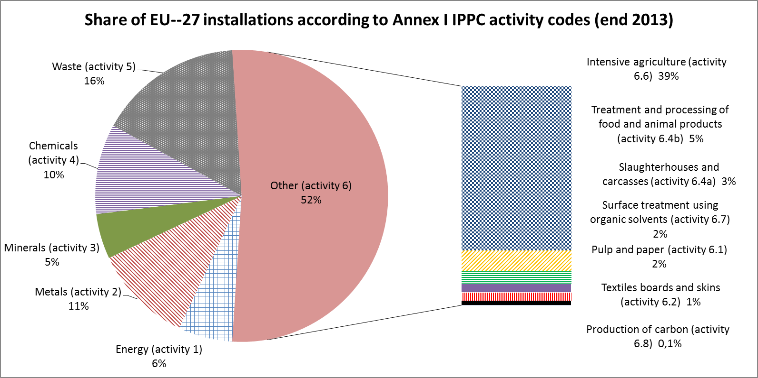

The majority of Member States reported no major change in implementation of the IPPCD since the previous reporting period. Changes reported mostly related to transposition and implementation of the IED. Some Member States also reported difficulties due to the coordination of permitting procedures when more than one Competent Authority was involved in the permitting process.

## Large Combustion Plants Directive (LCPD)

A substantial share of total SO2, NOX and dust emissions to air as well as of other pollutants such as mercury originate from Large Combustion Plants (LCPs). Prior to the IED, LCPs were subject to specific legislation, the LCPD[6]. The IED repealed the LCPD and set stricter Emission Limit Values (ELVs).

The LCPD enabled the Commission to request LCP emissions data annually. Since the 2013 reporting year, Member States have reported annual emissions data to a database managed by the European Environment Agency[7]. The Commission continues to seek opportunities to streamline and simplify reporting requirements. One illustration is pre-population of the LCP database with identifiers for those plants used for the European Pollutant Release and Transfer Register[8] and linking with the previously submitted data for the plant. The last reporting year available is 2015. The annual plant-by-plant data includes emissions of SO2, NOX and dust, plus the total energy input, related to the net calorific value, broken down by fuel type. From the 2016 reporting year, LCP reporting under the LCPD is replaced with reporting under the IED requiring more detailed information.

## Waste Incineration Directive (WID)

Final reports under the WID[9] were submitted by Member States for its last reporting period covering the years 2012-2013. Overall no major problems were identified with its operation.

## Solvent Emissions Directive (SED)

Final reports under the SED[10] were submitted by Member States for its last reporting period covering the years 2012-2013. Around 50 000 installations are covered although there is some uncertainty on the exact number. Overall, no major problems were identified with its operation, although some problems were identified related to the reporting of monitoring data from operators.

## Conclusions regarding the legacy legislation

No major compliance issues with the legacy legislation have come to light. Nevertheless, a few issues mentioned in relation to the IPPCD may warrant further investigation. Despite improvements, the level of information reported remained incomplete, in particular numerical data related to the number of inspections (e.g. total number of installations visited, number of visits including emission measurements). This might partly be due to the wording of the questions, which seems to have been understood differently by Member States.

Several Member States reported insufficient staff to deal with tasks related to the IPPCD implementation, in addition to financial constraints on the hiring and training of Competent Authority staff. This could be linked to the work transitioning from IPPCD to IED, therefore, it is possible that the workload for Competent Authorities would now be more manageable.

Some difficulties were reported in relation to the interpretation of definitions, raising questions whether installations would fall outside the scope of the IPPCD after either having shut down a part of the process (partial closure of the installation) or having permanently reduced their production capacity.

One important issue that required improvement was the degree of BAT uptake. This was addressed through introducing the obligation to update permits in line with BAT conclusions in the IED.

# IED Implementation

## Transposition status of IED

The Commission has received all Member States' national transposing legislation, and has assessed the completeness of transposition.

The Commission has also assessed the conformity with the IED of the transposition measures adopted by all Member States. Where ambiguous or erroneous transposition has been identified, the Commission engaged in bilateral dialogues with the Member States concerned. To date twenty one such dialogues were launched.

## Member State reporting

Commission Implementing Decision 2012/795/EU[11] ('the Decision') sets out the details that Member States are required to report to the Commission on the implementation of the IED. Annex I of that Decision sets out the requirements to be transmitted to the Commission by September 2014, while Annex II defines the information required by September 2017.

The Decision sets an objective for electronic reporting by Member States. To facilitate this, the Commission has contracted work on the necessary electronic reporting tools. In view of various challenges encountered, there is a delay in the execution of these projects and consequently, reporting under Module 2 of Annex II of the Decision is delayed by one year from 30 September 2017 to 30 September 2018. For Modules 1, 3 and 4 reporting is delayed until February 2018.

Member States have submitted information required by Annex I of the Decision. These returns have been assessed and a summary report has been published[12]. While all Member States except Finland responded, the level of detail varied greatly. Some responses only made reference to transposing legislation while others were detailed and comprehensive. Overall, some useful information was provided on the processes and steps taken towards actual implementation of the IED. These include information on the criteria used for checking non-compliance, the different approaches to ensuring that BAT conclusions are used in setting permit conditions and details of environmental inspection plans.

Much more information is expected to be gathered in the next reporting period (covering the period 2014-2016) as BAT conclusions are being adopted sector by sector and Member States will be in a position to provide further details on practical implementation issues.

The Commission has now started reflections on the reporting requirements for the period beyond 2016. This will take into account the change to electronic reporting and lessons learned so far. Member States have been asked for their initial views on the future reporting requirements and the Commission expects to propose a new reporting Decision soon taking into account the approach outlined in the communication on the fitness check of environmental reporting[13] and maximising synergies with the E-PRTR.

## BREFs

All plants within the scope of Chapter II of the IED are obliged by its requirements to apply BAT. BREFs are at the heart of ensuring that BAT can be identified in an optimal way at EU level. They provide a level playing field and save Member States from having to carry out their own assessments of BAT to meet their obligations under the IED. There are currently 31 BREFs and two reference documents covering the activities in Annex I of the IED. So far 13 of these BREFs have been updated under the IED.

The format of the BREFs was established under the IPPCD. In addition to an extension of the sectors covered, the main change from the IPPCD to the IED was a formalisation of the information exchange between the Commission and stakeholders to identify BAT (also referred to as the 'Sevilla process'). BAT conclusions are the key element of BREFs as they describe BAT and contain binding Associated Emission Levels (BAT-AELs) linked with its use. These are adopted through committee procedure after which the Commission adopts them as implementing decisions. BAT conclusions are the reference for Competent Authorities setting permit conditions for installations covered by the IED. They provide information to decision makers about relevant techniques that are economically viable and technically available to industry in order to improve their environmental performance.

The chart below provides an overview of the cumulative number of BAT conclusions adopted since the coming into effect of the IED and the approximate cumulative number of installations that will be affected by these. BAT conclusions adopted to date cover more than half of the IED installations.

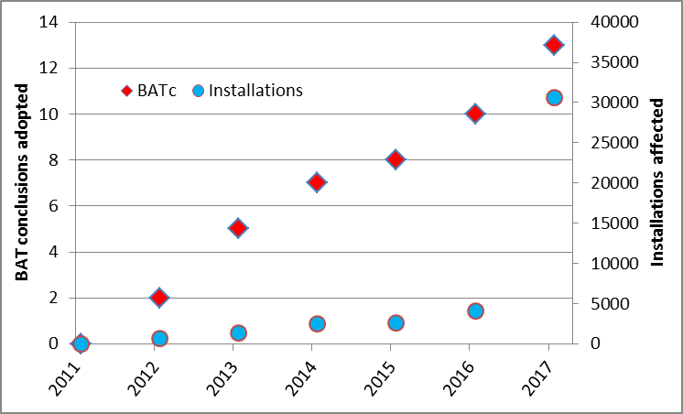

The paragraphs below provide a brief overview of the main BREF-related issues.

### Overview of process and participation

The binding status of BAT-AELs contained in BAT conclusions has meant that the information exchange process to generate BREFs has become more focussed on the collection and evaluation of information aimed at determining the environmental performance levels achieved by existing plants. The exchange of technical information for each BREF takes place in a Technical Working Group (TWG), comprising Member States, industries concerned, environmental NGOs and the Commission. The TWG is led and mediated by the EIPPCB. The procedures to be followed and other elements of the process are described in detail in a Commission Implementing Decision[14] adopted under the IED.

### Confidentiality

Issues of confidentiality can arise during the BREF process. In principle, EU rules on transparency in environmental matters[15], based on the Aarhus Convention[16] create a strong right of access to environmental information. However, information provided by industry on a voluntary basis may have commercial sensitivity. In accordance with the obligation of professional secrecy, which also follows from Article 339 of the TFEU[17], aggregation or anonymisation of some information may be necessary, provided it is not directly linked to emissions to the environment, in which case an overriding public interest in disclosure and transparency is deemed to exist. Member States' Competent Authorities, which are bound by professional secrecy rules, should have access to such information where this concerns installations in their territory.

### Better Regulation

The 'Sevilla process' underpinning the development of BREFs is a unique, inclusive, fact-based technical process. Data is gathered through extensive questionnaires and then validated and checked with all stakeholders. Documents are circulated, commented and peer-reviewed by TWG participants in full transparency. Mark-ups show when changes have been introduced. Final conclusions are agreed by consensus in the TWG. Where diverging opinions exist, these are also reported in the final BREF in accordance with the criteria specified in the guidance on the information exchange process. The Commission believes that this collaborative approach, while not necessarily feasible in all other areas, is an excellent example of Better Regulation in practice.

### Key Environmental Issues

BREF reviews focus on the areas where the greatest benefit will be achieved, the so-called "Key Environmental Issues" (KEIs). This ensures the best environmental outcome for the efforts put into the process. The Commission has proposed criteria for the identification of KEIS[18] that were endorsed by the IED Article 13 Forum. These are: the environmental relevance of the pollution; the significance of the activity; the potential to identify new techniques to significantly improve the situation; and the potential to define BAT-AELs significantly improving environmental protection compared to the current situation.

The EIPPCB has used these criteria to prepare subsequent BREF reviews. The Commission has launched a service contract to further develop the methodology and implement it for a number of upcoming BREF reviews. This will produce KEI background documents as input to the BREF review Kick-off Meetings and provide a solid basis for TWG decisions on KEIs.

### Assessing the information exchange process

The information exchange process is at the heart of BREF production and review. It generates the solid evidence base for decision-making. In the case of the most extensive BREF review to date (on Large Combustion Plants), the working group comprised 289 members, 580 plant level questionnaires were completed, 24 site visits took place, 225 reports and case studies were considered and 8 510 comments on the first draft were addressed.

In view of the desire to enhance its functioning, the Commission, jointly with the German environment ministry, organised a workshop of the IED Article 13 Forum in Berlin in 2014 focused on the IED information exchange process. The workshop was well-attended and conclusions from it have been published[19]. The workshop reaffirmed the high EU added value and efficiency of the IED. It also suggested some practical improvements that are now being implemented in BREF reviews e.g. enhanced use of webinars to facilitate the participation of TWG members.

## Compliance promotion and implementation support

The Commission aims to support Member States in ensuring effective application of the IED. In pursuit of this it carries out the following activities:

### Workshops with Member States and stakeholders

It is useful to organise meetings with Member States and other relevant stakeholders to review IED implementation including the development of BREFs and BAT conclusions. These have the merit of identifying early on areas where problems are encountered as well as agreeing common future approaches.

Workshops are held as appropriate, either only with Member States focussed on legal implementation or also with stakeholders when wider issues are discussed. After the Berlin workshop with all Forum members, the second workshop in Copenhagen in 2016 was limited to Member States representatives. The Commission plans to continue this fruitful practice in 2017 with a Member State workshop in Belgium.

The main messages from the Copenhagen workshop were that participants considered it a useful opportunity to benchmark their national activities and invited the Commission to review existing experience with regard to the derogation procedure under Article 15(4) of the IED. The presentations and a summary of the workshop have been published[20].

Furthermore, more technical workshops with participation of experts from Member States and stakeholders are regularly set-up to gather views on ongoing projects and studies. Specific workshops are also planned in 2017 on Emerging Techniques (with Belgium and Sweden) and BAT contribution to water policy (with Germany).

### Frequently Asked Questions

An important task for the Commission is to assist Member States with the implementation of the IED. One tool used for this are frequently asked questions (FAQs), which are available on the Commission's website[21].

The Commission is working to expand and update these as appropriate including on a number of specific FAQs whose importance was identified during the Copenhagen workshop. In particular, these address topics such as the use of BAT-AEL ranges; when BAT conclusions have to be complied with; and which BAT conclusions trigger permit reconsideration.

### Supporting networks of national Competent Authorities

The main responsibility for effective implementation of the requirements of the IED rests on national Competent Authorities. Their tasks include issuing permits, assessing appropriate ELVs and other conditions, considering derogation requests and in general ensuring that installations are correctly operated. The Commission supports these authorities so as to ensure comparable, harmonised approaches at national level in line with the legislation.

The Commission supports the work of the European Union Network for the Implementation and Enforcement of Environmental Law (IMPEL) which runs a number of projects in the field of industrial emissions[22]. In particular these relate to: Supporting IED implementation [IED Baseline Report](https://www.impel.eu/projects/ied-baseline-report/); [Experience of Derogations from IED BAT-AEL’s](https://www.impel.eu/projects/proposals-derogations-best-available-techniques-associated-emission-levels-bat-aels/). The Commission engages with Member State experts within the project meetings and values this knowledge-sharing.

### Enforcement

The approach taken to enforcement under the IED is considered to be very advanced. This is because it creates strong rights for citizens to have access to relevant information and to participate in the permitting process. This empowers citizens, and NGOs, to ensure that permits are appropriately granted and their conditions respected. It is clear that the Commission could not actively check all 50 000 permits, but local residents have a vested interest in ensuring that they are appropriate and enforced.

The primary responsibility for dealing with breaches lies with the Competent Authorities. This is the first level of enforcement and it is the relevant Competent Authority that a concerned citizen or NGO should approach. The permit review process is also important to provide periodic opportunities for neighbours or other affected parties to raise any concerns they may have and for these to be considered as part of the permit review.

The IED creates rights for affected parties to challenge permit conditions and push for non-routine environmental inspections. This approach potentially marshals thousands of individuals to oversee the operation of the legislation. The Commission considers that national administrative or judicial bodies are primarily responsible for verifying specific situations of non-compliance and have the appropriate means to address these if the concerns are found justified. The Commission would mainly intervene in the event of systemic failings, or where breaches have a very significant environmental impact.

## LCP transitional arrangements

The IED has brought LCP provisions into a simplified and consistent framework. To facilitate the transition to these, the IED contains two main types of flexibility deviating from the overall requirements:

* **Transitional National Plans (TNPs)** – TNPs are established at Member State level. Plants included in a Member State's TNP are subject to an overall emissions ceiling (declining linearly between 2016 and mid 2020). During this time the affected plants must nevertheless respect the LCPD ELVs. This flexibility provides more time (until mid-2020) for all the affected plants to comply with the ELVs of the IED and also flexibility as to how the necessary upgrading investments are made to comply. As a result, it is expected that compliance costs and other challenges will have been reduced. This option has been used by 15 Member States.
* **Limited life time derogations** – This flexibility takes account of situations where plants are nearing the end of their life time and so it would be uneconomic to retrofit them to comply with IED ELVs. It allows an existing plant to continue to operate for a limited number of operating hours (not more than 17 500 hours) without additional investments until the end of 2023 while complying with the LCPD ELVs. When the limited life time derogation ends, the plant must be shut down or be upgraded to meet the conditions for a new plant. Limited life time derogations are used by 24 Member States. An extremely limited possibility allowed the limit to be 32 000 hours where a plant met a set of four criteria laid out in the IED.

From 2017, Member States will annually report plant-by-plant data allowing the Commission to monitor the correct use of these provisions. The final lists of LCPs using the various flexibilities are published on CIRCABC[23].

## Innovation

IED Article 27 requires Member States to encourage the development and application of emerging techniques and for the Commission to establish guidance to assist Member States in this. To this end, an "emerging techniques" section is contained in all BREFs.

The setting of ELVs on the basis of BAT and its generalisation across a whole industrial sector will mean that a larger scale market is created for the relevant BAT. This should lead to lower costs and enable the benefits to be achieved more cost effectively.

Business opportunities also arise for companies providing emission reduction techniques as they will be able to sell into larger markets if their techniques provide BAT performance. Since BAT is increasingly being used at a global scale, these opportunities exist worldwide.

Synergies with other programmes such as LIFE[24] projects may be possible. Efforts are being made to check that relevant LIFE projects promote advanced techniques and to ensure that successful demonstrations feed back into the BREF review process.

The Commission is interested in gaining a deeper understanding of all these effects and therefore plans to continue work in this field, in particular through testing an innovation observatory.

## Expansion of knowledge base

The Commission continues to develop its knowledge of the environmental impacts of the industrial sectors covered by the IED. This helps to support understanding of the areas to focus on and enhances assessment of the legislation. To do this, the Commission seeks as wide a range of sources of information as possible. In particular information comes from:

### Member State reporting

A key source of knowledge on the impacts of the IED comes directly from Member States through their formal implementation reports submitted to the Commission. This report is based on Member State reports submitted in 2014.

### Supporting analysis

The Commission continues to carry out in-depth assessments of sectors covered by the IED and the application and impacts of BAT in those sectors. It has completed a number of analyses in recent years to improve its knowledge base. These reports have been published at the 'Studies' tab on the CIRCABC IED site[25].

Analysis confirms the substantial share of industry in many types of air and water pollutant emissions. It also shows that there has been an evolution of emission control technologies over time, with a number of techniques progressing from 'emerging' status to proven BAT.

In its preparatory work for the Commission to develop the National Emissions Ceilings Directive, an approach was developed using the precursor emissions of PM2.5 (i.e. primary PM2.5, SO2, NOX, NH3 and VOC) to develop a measure of PM-equivalent impacts on premature mortality from fine particulate matter at the EU scale[26]. The Commission has prepared a preliminary assessment of trends in industrial emissions, based upon reporting under E-PRTR and upon PM-equivalent figures. The graph below shows the trend in emissions for the whole of the E-PRTR installations as well as only for LCPs. While this only considers one environmental aspect (emissions to air) and only a sub-set of its impacts, it nevertheless shows a promising trend[27].

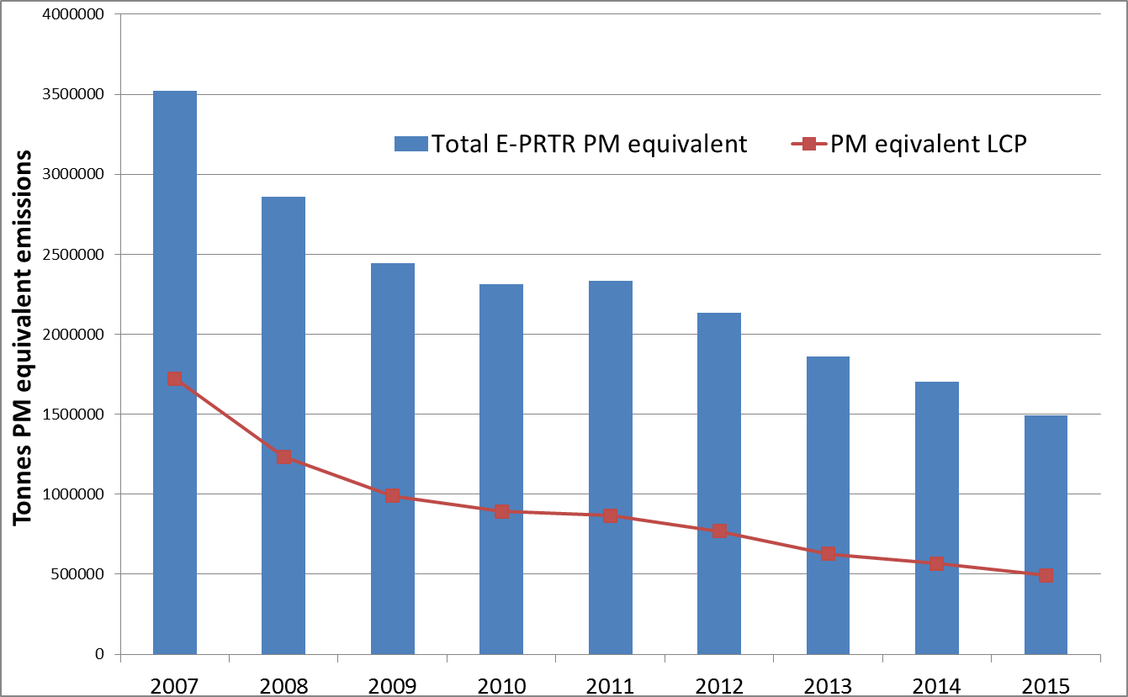

With regard to assessing the overall emission reductions from individual BAT conclusions, it has proved much harder to reach definitive conclusions. The Commission continues to carry out analytical work in this field and a workshop with stakeholders was held in 2016. Nonetheless, it is clear that assessments at EU level can only be rather general while Member States can, and do, carry out their own more detailed assessments.

## International application of BAT

In the international context, the IED, BREFs and BAT conclusions are considered an EU contribution to the global process initiated at the 2002 World Summit on Sustainable Development. This enables non-European countries to also benefit from this ambitious work. For example, some countries translate EU BREFs for their own use.

The more widely that BAT concepts are used in environmental control, the greater the resource and evidence base for making decisions and identifying BAT and the consequent market forces that will develop for the production, deployment and improvement of BAT. A wider international uptake of BAT-like approaches will also lead to more harmonised competitive conditions. Countries spend significant resources in implementing, reviewing and updating information on advanced industrial practices and technology for preventing and controlling pollution so it is desirable to ensure a cross-fertilisation of knowledge and practices.

In view of this, one strand of the Commission's work relating to the IED has been to support organisations in other parts of the world using, or interested in, BAT and to share information and experience with them. The Commission has supported work ongoing in Israel, Russia and South Korea as they seek to develop industrial permitting regimes broadly based on the EU BAT and BREF approaches. The Commission has also supported the Energy Community[28] in its steps to implement the environmental goals of the IED for Large Combustion Plants.

With a view to wider outreach, the Commission also supports an OECD project[29] in this field and supports use of the BAT concept in multilateral environmental agreements (e.g. the Minamata Convention).

# Conclusions

This report provides the first Commission overview of IED implementation and its ongoing activities. The Commission draws a number of conclusions from the information provided:

* The IED is a good example of better regulation. It merged and simplified 7 pieces of EU legislation and created a rather unique, highly transparent and collaborative process for preparing BREFs;
* While it is too early to see the practical results of the change to the IED, progress is encouraging;
* Trends in industrial emissions appear promising;
* The Commission's focus in the next 4 years is on finalising BAT conclusions for all industrial sectors, monitoring the use of LCP flexibilities and pro-actively supporting Member States with implementation.

In addition to continuing with the activities described in this report, the Commission considers it appropriate to reflect how the work on IED implementation should evolve in the longer term and at what point it would be appropriate to take stock of achievements and to consider the scope for improvement. By 2020, the Commission will have received further reports from Member States and most BAT conclusions will have been adopted. Furthermore, most of the LCP transitional arrangements will be close to their final deadlines. This would appear an appropriate time to consider the launch of a full evaluation of the IED.

1. Directive 2010/75/EU on industrial emissions (integrated pollution prevention and control);OJ L 349, 19.12.2012, p. 57–65
2. 'Contribution of industry to pollutant emissions to air and water'; AMEC; September 2014; ISBN 978-92-79-39499-7
3. Decision No 1386/2013/EU of 20 November 2013 on a General Union Environment Action Programme to 2020 ‘Living well, within the limits of our planet’;OJ L 354, 28.12.2013, p. 171–200
4. CIRCABC>[env](https://circabc.europa.eu/faces/jsp/extension/wai/navigation/container.jsp?FormBanner:_idcl=navigationTitle&FormBanner_SUBMIT=1&org.apache.myfaces.trinidad.faces.STATE=DUMMY&id=d4470620-1d93-41c6-86b0-9b2e667211ae&javax.faces.ViewState=aoN9mQBYiy7Agzlsip4bddH7fMhKOgooFx0Djj7v4C1WkV48zoWlz8tSV4DtIH2CP4k4zWKg%2BB3zoCYl%2FMzNMnJhMt4p07U8ihTgn5yaLAZIm%2FhBQpEA3yDOeL51uCbpSYMagWiaj5jRuCbwjM0RD%2FKOZDFPDhalgYZj6g%3D%3D)ironment>IED>Library>[Studies](https://circabc.europa.eu/faces/jsp/extension/wai/navigation/container.jsp?FormPrincipal:_idcl=navigationLibrary&FormPrincipal_SUBMIT=1&org.apache.myfaces.trinidad.faces.STATE=DUMMY&id=36379180-c0a6-4b66-9019-64a5a0229116&javax.faces.ViewState=aoN9mQBYiy7Agzlsip4bddH7fMhKOgooFx0Djj7v4C1WkV48zoWlz8tSV4DtIH2CP4k4zWKg%2BB3zoCYl%2FMzNMnJhMt4p07U8ihTgn5yaLAZIm%2FhBQpEA3yDOeL51uCbpSYMagWiaj5jRuCbwjM0RD%2FKOZDFPDhalgYZj6g%3D%3D)> [Article 73 review reports](https://circabc.europa.eu/faces/jsp/extension/wai/navigation/container.jsp?FormPrincipal:_idcl=navigationLibrary&FormPrincipal_SUBMIT=1&org.apache.myfaces.trinidad.faces.STATE=DUMMY&id=7569595f-693c-4328-8cb2-a5bbcc7779b0&javax.faces.ViewState=aoN9mQBYiy7Agzlsip4bddH7fMhKOgooFx0Djj7v4C1WkV48zoWlz8tSV4DtIH2CP4k4zWKg%2BB3zoCYl%2FMzNMnJhMt4p07U8ihTgn5yaLAZIm%2FhBQpEA3yDOeL51uCbpSYMagWiaj5jRuCbwjM0RD%2FKOZDFPDhalgYZj6g%3D%3D)>Final reports
5. Directive 2008/1/ECconcerning integrated pollution prevention and control
6. Directive 2001/80/EC on the limitation of emissions of certain pollutants into the air from large combustion plants
7. See: [http://www.eea.europa.eu/data-and-maps/data/lcp](http://www.eea.europa.eu/data-and-maps/data/lcp-1-now)
8. Regulation (EC) No 166/2006 of the European Parliament and of the Council of 18 January 2006 concerning the establishment of a European Pollutant Release and Transfer Register and amending Council Directives 91/689/EEC and 96/61/EC
9. Directive 2000/76/EC on the incineration of waste
10. Directive 1999/13/EC on the limitation of emissions of volatile organic compounds due to the use of organic solvents in certain activities and installations
11. Commission Implementing Decision of 12 December 2012 establishing the type, format and frequency of information to be made available by the Member States for the purposes of reporting on the implementation of Directive 2010/75/EU of the European Parliament and of the Council on industrial emissions; OJ L 349, 19.12.2012 p.57
12. See footnote 2
13. Actions to Streamline Environmental Reporting; COM(2017) 312
14. Commission implementing decision 2012/119/EU laying down rules concerning guidance on the collection of data and on the drawing up of BAT reference documents and on their quality assurance referred to in Directive 2010/75/EU of the European Parliament and of the Council on industrial emissions; *OJ L 63, 2.3.2012, p. 1–39*
15. Regulation (EC) N° 1367/2006 on the application of the provisions of the Aarhus Convention on Access to Information, Public Participation in Decision-making and Access to Justice in Environmental Matters to Community institutions and bodies, OJ L 264, 25.9.2006, p. 13
16. UNECE convention on Access to Information, Public Participation in Decision-making and Access to Justice in Environmental Matters of 25 June 1998 and approved by the Community on 17 February 2005
17. Treaty on the Functioning of the European Union; OJ C 326, 26.10.2012, p. 47–390
18. CIRCABC>Environment>IED>Library>ied_art_13_forum>8th Forum meeting 19 October 2015>Presentations>[5.1 Key environmental issues.pdf](https://circabc.europa.eu/sd/a/22f919af-daee-4fc2-b84f-dc66ba2ba952/5.1%20Key%20environmental%20issues.pdf)
19. CIRCABC>Environment>IED>Library>[Berlin workshop on IED information exchange (Oct 2014)](https://circabc.europa.eu/faces/jsp/extension/wai/navigation/container.jsp?FormPrincipal:_idcl=navigationLibrary&FormPrincipal_SUBMIT=1&org.apache.myfaces.trinidad.faces.STATE=DUMMY&id=ffd91761-bf83-43f0-958e-5d6dbbddf05a&javax.faces.ViewState=aoN9mQBYiy7Agzlsip4bddH7fMhKOgooFx0Djj7v4C1WkV48zoWlz8tSV4DtIH2CIJl3QNfUcPbzoCYl%2FMzNMnJhMt4p07U8ihTgn5yaLAZIm%2FhBQpEA3yDOeL51uCbpSYMagWiaj5j8Bar09aDHu%2FV%2FSIGJAyTPE%2B6qlg%3D%3D)
20. CIRCABC>env>ied>Library> [Copenhagen workshop on Putting the IED into practice (13-14 April 2016)](https://circabc.europa.eu/faces/jsp/extension/wai/navigation/container.jsp?FormPrincipal:_idcl=navigationLibrary&FormPrincipal_SUBMIT=1&org.apache.myfaces.trinidad.faces.STATE=DUMMY&id=17812ed5-a85e-4a54-8332-cd9f8ebbc929&javax.faces.ViewState=aoN9mQBYiy7Agzlsip4bddH7fMhKOgooFx0Djj7v4C1WkV48zoWlz8tSV4DtIH2Cagg%2FTfdgdoPzoCYl%2FMzNMnJhMt4p07U8ihTgn5yaLAZIm%2FhBQpEA3yDOeL51uCbpSYMagWiaj5gZpGv9g5dwvr0KI2UUU5y3A6oeVw%3D%3D)
21. http://ec.europa.eu/environment/industry/stationary/ied/faq.htm
22. https://www.impel.eu/topics/industry-air/
23. EUROPA > European Commission>CIRCABC> env > ied > Library > [IED Derogations_Lists](https://circabc.europa.eu/faces/jsp/extension/wai/navigation/container.jsp?FormPrincipal:_idcl=navigationLibrary&FormPrincipal_SUBMIT=1&org.apache.myfaces.trinidad.faces.STATE=DUMMY&id=02b3249f-1773-4cbb-b499-95d9e26ae522&javax.faces.ViewState=ec4hGUj%2F4TwlvThLuDLkOAoNx0aNP7z3f1MsTN8eIv1EXshAoAirfcQBMyu6MZfH5td86zZENsfs1ND41L%2BEkjuHFzGbdlaJnjYNC8riWtmX%2FYiFxCi1rnqHtqla81uqTtftFFOTzp2lkEHrnK5yRSW%2F%2BAM%3D) and EUROPA > [European Commission](http://ec.europa.eu/index_en.htm)>[CIRCABC](https://circabc.europa.eu/faces/jsp/extension/wai/navigation/container.jsp?FormBanner:_idcl=FormBanner:circabchomelink&FormBanner_SUBMIT=1&javax.faces.ViewState=RdIVx3BAE5KSx%2BA1N4rDI5XgkjGsBOx8r912ZkUPGBE3X9gdZ3bRefMnxVzi7%2Ff3HERGTkPRWhJkq398IBSPq6qduo2F2S6Ji3Ob1c67FArdGWTCaLGRr%2FboAAHH06Vc%2BseRpUBboTcDTEajC3OLFZgzsO4%3D)> [env](https://circabc.europa.eu/faces/jsp/extension/wai/navigation/container.jsp?FormBanner:_idcl=navigationTitle&FormBanner_SUBMIT=1&org.apache.myfaces.trinidad.faces.STATE=DUMMY&id=d4470620-1d93-41c6-86b0-9b2e667211ae&javax.faces.ViewState=RdIVx3BAE5KSx%2BA1N4rDI5XgkjGsBOx8r912ZkUPGBE3X9gdZ3bReWMa2Kp2lTFiHERGTkPRWhJkq398IBSPq6qduo2F2S6Ji3Ob1c67FArdGWTCaLGRr%2FboAAHH06VcLneJGF5Fcu%2FOXMan5tM%2BmiXbxSg%3D)> [ied](https://circabc.europa.eu/faces/jsp/extension/wai/navigation/container.jsp?FormBanner:_idcl=navigationTitle&FormBanner_SUBMIT=1&org.apache.myfaces.trinidad.faces.STATE=DUMMY&id=06f33a94-9829-4eee-b187-21bb783a0fbf&javax.faces.ViewState=RdIVx3BAE5KSx%2BA1N4rDI5XgkjGsBOx8r912ZkUPGBE3X9gdZ3bReWMa2Kp2lTFiHERGTkPRWhJkq398IBSPq6qduo2F2S6Ji3Ob1c67FArdGWTCaLGRr%2FboAAHH06VcLneJGF5Fcu%2FOXMan5tM%2BmiXbxSg%3D) > Library > [TNPs](https://circabc.europa.eu/faces/jsp/extension/wai/navigation/container.jsp?FormPrincipal:_idcl=navigationLibrary&FormPrincipal_SUBMIT=1&org.apache.myfaces.trinidad.faces.STATE=DUMMY&id=9b35bc6d-fe26-4f5b-a97d-3a4d05145d5b&javax.faces.ViewState=ec4hGUj%2F4TwlvThLuDLkOAoNx0aNP7z3f1MsTN8eIv1EXshAoAirfbFVxl6SxavF6PLkPwh7sRp8bgZNhBnLzTYQ5yIM6BZCc8S64ssp339%2BpzZX2zxUb%2Bj6xb291FdzFM6RExHtMgE5hiXhAgpgARmG76JTpAfpzAL%2BEQ%3D%3D)
24. LIFE is the EU’s financial instrument supporting environmental, nature conservation and climate action projects throughout the EU. <http://ec.europa.eu/environment/life/>
25. EUROPA > [European Commission](http://ec.europa.eu/index_en.htm)>[CIRCABC](https://circabc.europa.eu/faces/jsp/extension/wai/navigation/container.jsp?FormBanner:_idcl=FormBanner:circabchomelink&FormBanner_SUBMIT=1&javax.faces.ViewState=RdIVx3BAE5KSx%2BA1N4rDI5XgkjGsBOx8r912ZkUPGBE3X9gdZ3bRefMnxVzi7%2Ff3HERGTkPRWhJkq398IBSPq6qduo2F2S6Ji3Ob1c67FArdGWTCaLGRr%2FboAAHH06Vc%2BseRpUBboTcDTEajC3OLFZgzsO4%3D)> [env](https://circabc.europa.eu/faces/jsp/extension/wai/navigation/container.jsp?FormBanner:_idcl=navigationTitle&FormBanner_SUBMIT=1&org.apache.myfaces.trinidad.faces.STATE=DUMMY&id=d4470620-1d93-41c6-86b0-9b2e667211ae&javax.faces.ViewState=RdIVx3BAE5KSx%2BA1N4rDI5XgkjGsBOx8r912ZkUPGBE3X9gdZ3bReWMa2Kp2lTFiHERGTkPRWhJkq398IBSPq6qduo2F2S6Ji3Ob1c67FArdGWTCaLGRr%2FboAAHH06VcLneJGF5Fcu%2FOXMan5tM%2BmiXbxSg%3D)> [ied](https://circabc.europa.eu/faces/jsp/extension/wai/navigation/container.jsp?FormBanner:_idcl=navigationTitle&FormBanner_SUBMIT=1&org.apache.myfaces.trinidad.faces.STATE=DUMMY&id=06f33a94-9829-4eee-b187-21bb783a0fbf&javax.faces.ViewState=RdIVx3BAE5KSx%2BA1N4rDI5XgkjGsBOx8r912ZkUPGBE3X9gdZ3bReWMa2Kp2lTFiHERGTkPRWhJkq398IBSPq6qduo2F2S6Ji3Ob1c67FArdGWTCaLGRr%2FboAAHH06VcLneJGF5Fcu%2FOXMan5tM%2BmiXbxSg%3D)>Library> [studies](https://circabc.europa.eu/faces/jsp/extension/wai/navigation/container.jsp?FormPrincipal:_idcl=navigationLibrary&FormPrincipal_SUBMIT=1&org.apache.myfaces.trinidad.faces.STATE=DUMMY&id=36379180-c0a6-4b66-9019-64a5a0229116&javax.faces.ViewState=tVqJi%2B5wyAJGhqyzk%2FYPUSOtsMDN%2FGQKM7Y34eNPE6Oye0HVqf9jXBJEMY5285GTG8aYJ6BW4xW1j0rOhc6%2Bkkivr99frRLg29y5g1z0xxT6VjAVvEC%2BKvyn5oFQ3sbSfLA3Rv%2FB783vGfGK3t%2FkG32Lya8%3D)
26. <http://ec.europa.eu/environment/air/pdf/TSAP-15.pdf>
27. The emissions shown are total figures and have not been normalised to account for changes in production. The Commission intends to carry out further work to develop better indicators of progress in this area
28. https://www.energy-community.org/
29. <http://www.oecd.org/chemicalsafety/risk-management/best-available-techniques.htm>