Introduction
In 2016, the Commission continued to deliver on its strong commitment to increased transparency and accountability. One of the means by which it seeks to do that, is to foster the effective exercise of the right to access documents held by the EU institutions. This right is enshrined in Article 42 of the Charter of Fundamental Rights of the EU, Article 15(3) of the Treaty on the Functioning of the EU and Regulation (EC) No 1049/2001 regarding public access to European Parliament, Council and Commission documents.

Broader Transparency Agenda
The Commission has taken several important steps to increase the transparency of its law-making and policy implementation processes, including in its contacts with stakeholders and lobbyists.
In 2016, the Commission continued to deliver on its Better Regulation Agenda, which aims at getting the European Union work better and more transparently, with a strong focus on acting in a simpler way and only where it matters for citizens. The Commission's Regulatory Fitness and Performance (REFIT) programme has continued to ensure that EU legislation delivers results for citizens and businesses effectively, efficiently and at minimum cost. In January 2016, the REFIT Platform was officially launched, which allows national authorities, citizens and other stakeholders to get involved in improving EU legislation in a transparent manner.
In April 2016, following a Commission proposal, the European Parliament, the Council and the Commission adopted the Inter-institutional Agreement on Better Law-making. The Agreement further bolsters transparency through a series of measures enhancing the openness of the EU decision-making process.
Since the adoption of Decisions C(2014) 9048 and 9051 in November 2014, information on more than 11,000 bilateral meetings of Commissioners, Cabinet Members and Directors-General with interest representatives has been made publicly available on the Europa website. As a general rule, these meetings may only take place with interest representatives registered in the Transparency Register. The Transparency Register has continued to grow steadily and currently contains over 11,000 entries, having attracted over 3,500 new registrants since January 2016.
In May 2016, the Commission adopted new rules on expert groups, reinforcing the transparency requirements and introducing synergies with the Transparency Register.
In September 2016, taking into account the results of the public consultation on the future of Transparency Register, the Commission adopted a proposal for an Inter-institutional Agreement on a mandatory Transparency Register, which is an important step towards a common and mandatory transparency regime at the EU level. The Commission has invited the European Parliament and the Council to start the negotiations with a view to establishing such a Register, covering all three institutions, as swiftly as possible.
Addressing public demands for more transparency about possible instances of ‘revolving doors’, the Commission published, in December 2016, its second annual Communication providing information about the senior officials who left the Commission for new jobs, by detailing their previous duties, their new activities outside the Commission, and the respective decision of the Appointing Authority. The transparency is also ensured on all decisions authorising post-office activities to former Commissioners, through a dedicated Europa webpage.

Access to documents
Within the broader transparency agenda, the right of access to documents features as a prominent part of the Commission's approach to transparency. In addition to providing access to documents in its possession under Regulation 1049/2001, the Commission also proactively published, in a user friendly way, a wide range of information and documents, both in its various public registers and on its webpages.
This report is drawn up pursuant to Article 17(1) of Regulation 1049/2001. It provides the overview of how the Commission applied the access-to-documents rules in 2016. The report is based on statistical data which are summarised in Annex. The statistics reflect the number of applications received in 2016 and the replies provided to them. They do not reflect the number of documents requested or (partially) disclosed, which were far more numerous. Whereas applicants may ask for access to a single document, they more frequently request access to a multitude of documents, or even to entire files concerning a specific subject or procedure. The statistics show the importance of the right of access to documents as part of the Commission's overall transparency policy. The requested documents were fully or partially disclosed in 81.3% of cases at the initial stage, and wider or even full access was granted in 52% of cases reviewed at the confirmatory stage.
- Registers and Internet Sites
In 2016, 18,523 new documents were added to the register of Commission documents (see Annex – Table 1), falling within the C, COM, JOIN, OJ, PV, SEC or SWD category. No sensitive documents falling within those categories were created or received by the Commission in 2016.
In 2016, the Access to Documents website on Europa recorded a slight increase in the number of visits (19,191 in comparison to 18,939 in 2015), whereas the number of visitors and the pages viewed remained constant (see Annex – Table 2).

2. Cooperation with other Institutions subject to The Regulation
In 2016, the European Parliament, Council and Commission continued to hold regular technical meetings, at administrative level, in order to share experience, develop best practices and ensure a consistent application of Regulation 1049/2001.

3. Analysis of the Applications for Access
3.1. The number of applications
In 2016, the number of initial applications decreased by almost 10% (6,077 compared to 6,752 in 2015). The number of initial replies based on Regulation 1049/2001, on the other hand, increased by more than 2% (from 5,819 in 2015 to 5,944 in 2016 – the highest number of replies in the last five years).
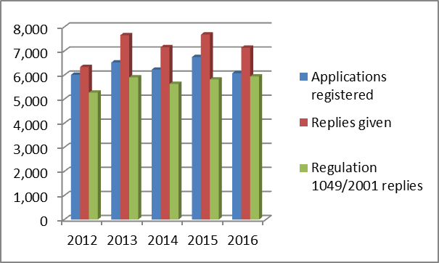
The remaining 1,193 replies were provided outside the scope of Regulation 1049/2001, or confirmed that the documents requested were not in the possession of the Commission (see Annex – Table 3).
As regards confirmatory applications requesting a review, by the Commission, of initial replies fully or partially refusing access, their number increased by 4% (295 in 2016 in comparison to 284 in 2015), continuing the steadily upward trend since 2012. On the other hand, the number of confirmatory replies based on Regulation 1049/2001 slightly decreased, from 230 in 2015 to 219 in 2016, as some of the requests appeared to be information requests.
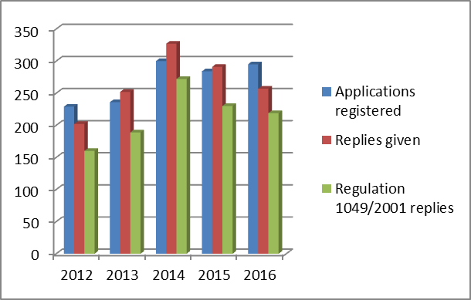
In other cases, several requests from one single applicant were regrouped and dealt with by a single reply (see Annex – Table 5).

3.2. Proportion of applications per Commission DG/Service (Annex – Table 10)
The Secretariat-General (SG) received the highest proportion of initial applications (8.6% in comparison to 8.7% in 2015), whilst DG SANTE occupied the second rank, with a decrease from 9,2% in 2015 to 8% in 2016. Initial applications for documents held by DG GROW decreased from 8,6% to 7.6% in 2016, putting it in third place.
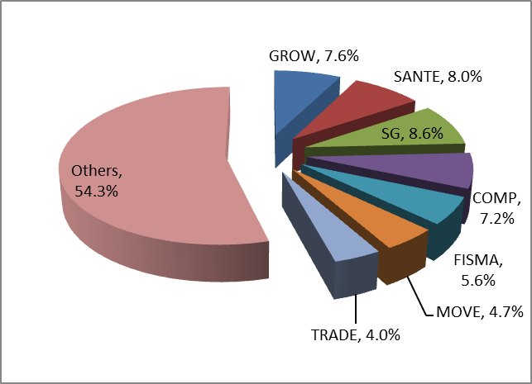
DG COMP (7.2%) and DG FISMA (5.6%) were the only other DGs having received more than 5% of all initial applications each. The remaining Commission departments each account for 4% or less of all initial applications.

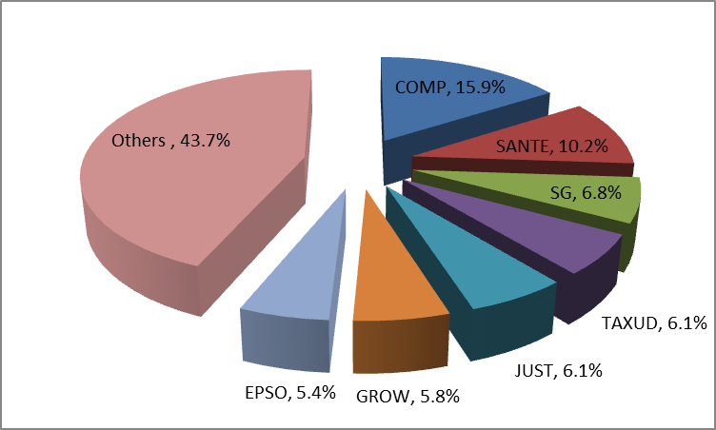
As regards confirmatory applications received by the Secretariat-General, the highest proportion related to initial replies provided by DG COMP (15.9% in 2016, compared to 16.2% in 2015). It was followed by DG SANTE (10.2%, compared to 7% in 2015) and SG (6.8%, compared to 10.2% in 2015).

DGs JUST and TAXUD (both 6.1% in 2016, compared to respectively 7.4% and 6.3% in 2015) shared the fourth place. The initial replies of two other Commission departments formed the subject of more than 5% of all confirmatory applications (DG GROW and EPSO). The remaining Commission departments accounted for less than 5% of confirmatory applications each.
3.3. The social and occupational profile of applicants (Annex – Table 8)
Most initial applications in 2016 continued to originate from citizens. These accounted for almost 40% of all applications (38.3% compared to 24.7% in 2015). The academic institutions and think tanks were the second most active category, accounting for 16% of initial applications (in comparison with 21.3% in 2015).
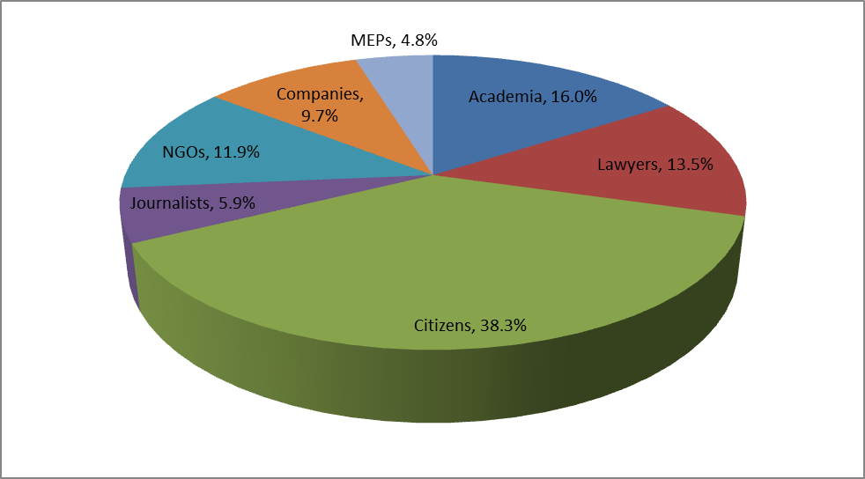
The third place was occupied by legal professionals (13.5%, compared to 12.7% in 2015), followed by civil society (NGOs) (11.9%, compared to 15.2% in 2015), companies (9.7%, compared to 2% in 2015) and journalists (5.9% in 2016, compared to 7.1% in 2015).
Most confirmatory applications in 2016 originated from citizens. These accounted for more than 30% of all applications (30.2%, compared to 24.3% in 2015). The legal professionals, with 26.4% of all applications (in comparison to 27.8% in 2015) were the second most active category of applicants.
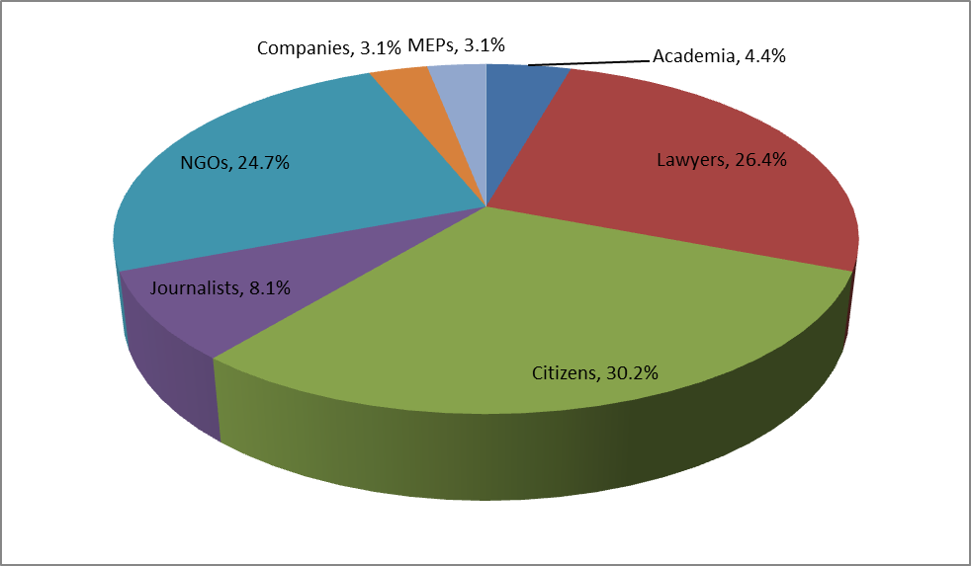
They were followed closely by civil society (NGOs), accounting for 24.7% of applications (24.6% in 2015). Journalists occupied the fourth place at 8.1% (13% in 2015), and academic institutions and think tanks came in fifth at 4.4% of applications (5.6% in 2015).
3.4. The geographical origin of applicants (Annex – Table 9)
Regarding the geographical breakdown of initial applications, the largest proportion continued to originate from the applicants within Belgium (27.2%, compared to 26.8% in 2015), followed by Germany (12.6%, compared to 11.7% in 2015) and the United Kingdom (a significant increase, from 7.6% in 2015 to 10% in 2016). France, Spain, Italy and the Netherlands followed, representing more than 5% of all applications each. The applications originating from within the remaining 21 Member States accounted for less than 2% per Member State.
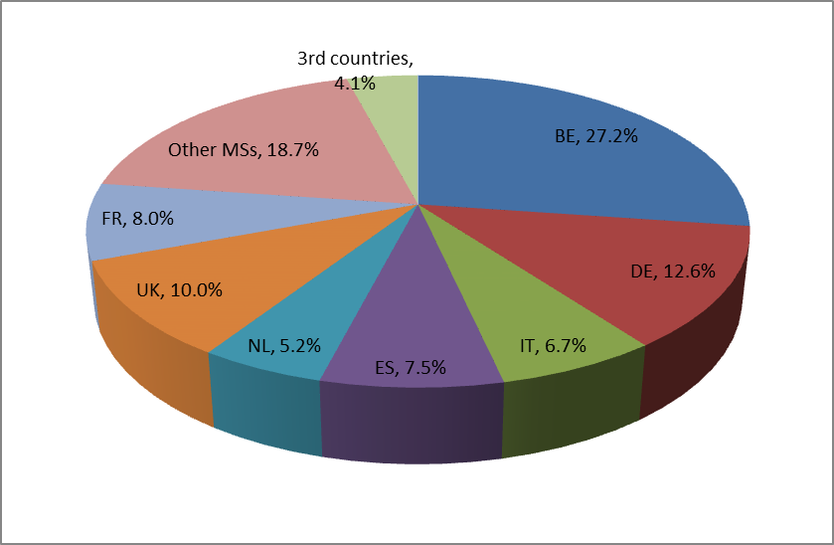
The right of access to documents also continued to be exercised by the applicants residing or having registered office in third countries, as their initial applications accounted for 4.1% of all initial applications (4.4% in 2015).

Regarding the geographical breakdown of confirmatory applications, the largest proportion by far originated from applicants within Belgium (33.2%, compared to 30.3% in 2015), followed by Germany (13.2%, compared to 15.1% in 2015). Italy (9.8%), Spain (8.8%), the Netherlands (6.4%), the UK (5.8%) and France (5.1%) were the only other Member States wherein more than 5% of applications originated.
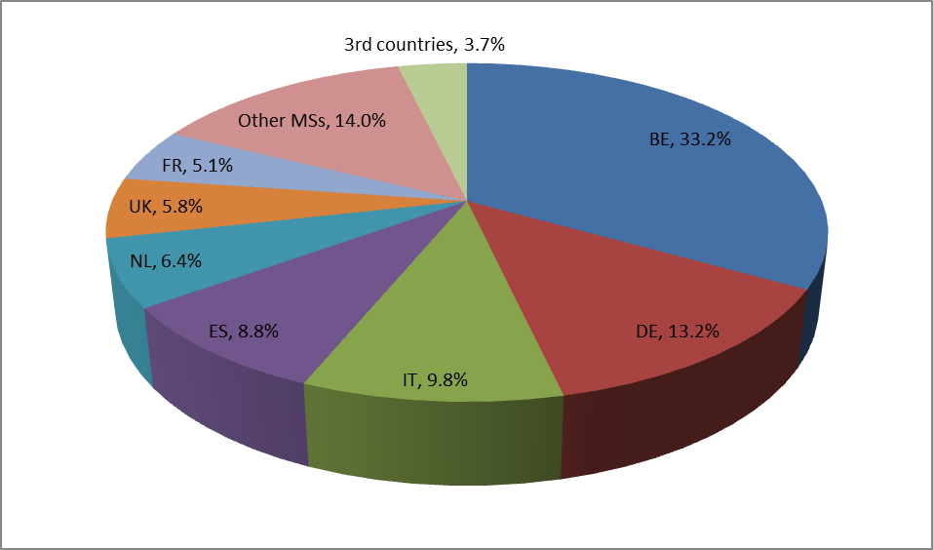
Applications originating from within the remaining 21 Member States accounted for 2%, or less, each. Finally, applications from applicants residing or having their registered office in third countries accounted for 3.7% of all applications (compared to 2,5% in 2015).

4. Application of Exceptions to the Right of Access
4.1. Types of access provided
In 2016, full or partial access to documents was given in more than 80% of cases at the initial stage (81.3% in comparison to 84.7% in 2015). Full access continued to be given in almost 61% of all cases. This constitutes a decrease in comparison with the previous year (68.8%), continuing the downward trend since 2012, which can partly be accounted for by a stricter application of the Commission's data protection policy.
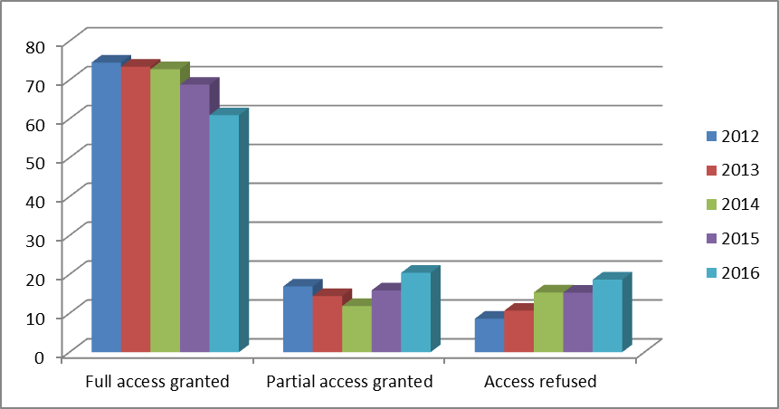
For the same reason, the percentage of partially positive replies increased significantly, by 30% (20.4% in 2016 compared to 15.9% in 2015). 18.7% of applications were fully rejected (compared to 15.3% in 2015) – see Annex (Table 4).
In 2016, every second initial reply challenged by a confirmatory application was (fully or partially) reversed at confirmatory stage (a significant increase from 41.3% in 2015 to 52% in 2016). In 47% of cases, wider (though not full) access was granted than at initial level (a considerable increase compared to 31.7% in 2015). At confirmatory level, the initial full refusal was confirmed only in 48% of cases (compared to 58.7% in 2015).
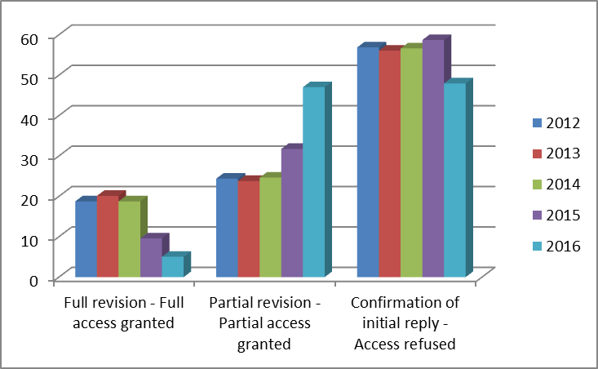
On the other hand, the number of confirmatory applications giving rise to a fully positive reply was lower (5%) than in 2015 (9.6%) – see Annex (Table 6).

4.2. Invoked exceptions to the right of access (Annex – Table 7)
The protection of privacy and the integrity of the individual continued to be the main ground for (full or partial) refusal of access at the initial stage, remaining constant at almost 30%. The second most invoked exception was the protection of the decision-making process of the institution (a slight increase, from 20,3% in 2015 to 21,7% in 2016). The exception aimed at protecting the purpose of inspections, investigations and audits, occupying the third place, was invoked considerably less frequently than in 2015 (16.2% in 2016 compared to 20.9% in 2015).
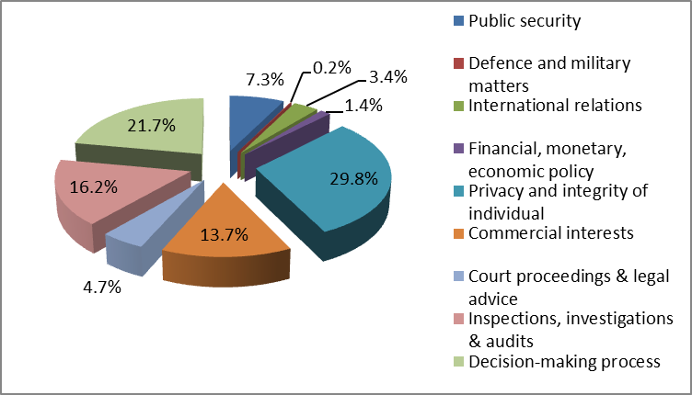
The relative use of the exception protecting commercial interests slightly decreased (13.7% in 2016, compared to 14.7% in 2015), but remained in the fourth place. The most significant increase concerned the exception protecting the public interest as regards public security (7.3% in 2016, compared to 2.4% in 2015).
At confirmatory stage, the most frequently invoked, main ground for confirming a (full or partial) refusal of access was the protection of privacy and the integrity of the individual, representing a 45% increase in comparison to the previous year (28.3% in 2016, in comparison to 15.6% in 2015). In the second place was the exception protecting the decision-making process (22.3%, compared to 16.4% in 2015). The exception protecting the purpose of inspections, investigations and audits was invoked considerably less frequently (20.3% in 2016, compared to 37.7% in 2015), putting it in the third place.
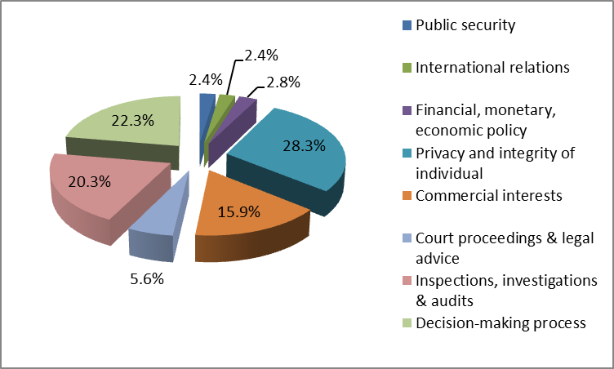
The fourth and the fifth rank were occupied, respectively, by the exceptions protecting commercial interests (15.9%, compared to 13.1% in 2015), and court proceedings and legal advice (5.6%, compared to 4.9% in 2015).

5. Complaints to the European Ombudsman
In 2016, the Ombudsman closed 21 complaints against the Commission's handling of requests for access to documents. Six of these were closed with further or critical remarks. For comparison, in 2015 the Ombudsman closed 23 complaints, six of which with a critical remark.
In 2016, the Ombudsman opened 12 new inquiries where access to documents was either the main or a subsidiary part of the complaint (a slight increase in comparison to 2015, when 11 new inquiries were opened).

6. Judicial Review
In 2016, the EU Courts have delivered important new case law that will influence the Commission practice under Regulation 1049/2001.
6.1. The Court of Justice
The Court of Justice handed down three judgments on appeal where the Commission was a party to the proceedings.
In the Internationaler Hilfsfonds case, regarding access to the file concerning a contract for humanitarian help, it confirmed the order of the General Court dismissing the appellant’s application brought against the Commission.
In its SeaHandling judgment, the Court of Justice confirmed the existence of a general presumption that disclosure of documents in the administrative file of a State aid investigation undermines, in principle, the protection of the purpose of investigation activities. It also ruled that a possible interest in obtaining a document for the purpose of court proceedings cannot constitute an overriding public interest in disclosure. Furthermore, it explained that, in case of a delayed reply, the applicant can file a complaint with the Ombudsman or initiate an action for damages in order to enforce its right of access and its right to a fair hearing.
In its Stichting Greenpeace Nederland judgment, the Court of Justice established that the notion of ‘emissions into the environment’ under Regulation 1367/2006 is not limited to actual emissions, but includes also the foreseeable emissions into the environment under normal or realistic conditions of use of a product or substance. The Court further specified that information which ‘relates to emissions into the environment’ is information which concerns or relates to such emissions and not information with a direct or indirect link to emissions into the environment.
6.2. The General Court
The General Court handed down 12 judgments related to the right of access to documents where the Commission was a party to the proceedings. In two cases, the General Court ruled that the action for the annulment of the Commission decision was inadmissible. One case did not result in a judgment.
In six cases, the General Court dismissed the applicant's action for annulment of the Commission's confirmatory decision on access to documents, by confirming the Commission's position. In three cases, the General Court partially annulled the Commission decision.
On the subject of personal data, the General Court ruled that the Commission cannot redact the applicant's own personal data, if it is clear that the latter is in favour of their disclosure. It also clarified that the institution does not have to assess the absence of prejudice to the data subject's legitimate interests if the applicant did not provide any express and legitimate justification or any convincing argument in order to demonstrate the necessity for those personal data to be transferred.
As regards commercial interests, the General Court recalled the general presumption of non-disclosure of bids submitted by tenderers in public procurement procedures, as their disclosure would undermine the commercial interests of the successful tenderer and the fair competition among tenderers.
Concerning the purpose of investigations, the General Court confirmed the general presumption of non-accessibility of OLAF's investigative documents for on-going and, in certain cases, closed investigations. It also stated that the occurrence of unauthorised leaks of confidential information does not, in itself, justify the disclosure of these documents under Regulation 1049/2001. The General Court also held that, even if the applicant is in possession of (parts of) the documents requested, the Commission may not refuse the handling of his/her application under Regulation 1049/2001.
The General Court furthermore re-confirmed the existence of a general presumption of non-disclosure of documents forming part of the file of an infringement procedure during its pre-litigation stage, as their disclosure would, in principle, undermine the protection of the purpose of investigations.
As regards documents having a relevant link with a pending judicial dispute at EU level, or with national proceedings likely to give rise to a preliminary ruling, the General Court ruled that such documents may be protected from disclosure. The aim is to ensure observance of the principles of equality of arms and the sound administration of justice and, by that same token, the protection of court proceedings.
Furthermore, the General Court confirmed that for the purposes of applying the exception relating to the protection of legal advice, the timing and (formal or informal) way in which that advice was given are irrelevant. It also acknowledged that the protection of legal advice encompasses the position of the Commission’s Legal Service in its defence of the Commission position before the Court of Justice, on an equal footing with the other parties. Finally, the General Court held that the mere fact that the legal advice was drawn up in the context of a legislative process is not, in itself, sufficient to establish an overriding public interest.
As regards the protection of the decision-making process, the General Court established that the Commission is entitled to presume, without carrying out a specific and individual examination of the documents drawn up in the context of preparing an impact assessment, that the disclosure of each of those documents would, in principle, seriously undermine its decision-making process for developing a policy proposal.
The General Court also recognised the importance of the EU staff having the possibility of expressing their views independently. It confirmed that the disclosure of their opinions for internal use, as part of deliberations and preliminary consultations, could seriously compromise the Commission's decision-making process, as it would deter staff from expressing their opinion independently and without being unduly influenced by the prospect of wide disclosure exposing the institution of which they are part.
In another judgment, the General Court clarified that the reality of the external pressure to which the decision-making process would be exposed has to be established with certainty and that evidence has to be adduced in order to show that there was a reasonably foreseeable risk that the process would be substantially affected owing to that external pressure.
In 2016, the General Court did not hand down any judgments related to the right of access to documents on appeal against a decision of the Civil Service Tribunal where the Commission was a party to the proceedings.
6.3. New Court cases
In 2016, 19 new cases were brought before the General Court against Commission decisions under Regulation 1049/2001. In addition, four new appeals were brought before the Court of Justice against a judgment of the General Court where the Commission was a party to the proceedings.

7. Conclusions
In 2016, the Commission continued to deliver on its commitment to increase transparency, both under Regulation 1049/2001 and in the framework of its broader transparency agenda.
This was reflected, inter alia, in its progressive implementation of the Better Regulation Agenda; by its systematic publication of information on the meetings of its political leaders and senior officials with stakeholders; by its proposal for an Inter-institutional Agreement on a mandatory Transparency Register; and by its policy regarding the ‘revolving doors’.
The Commission also continued to pro-actively publish, in a user-friendly way, a wide range of information and documents on its various, legislative and non-legislative activities.
The right to access documents upon request, as provided for in the Charter of Fundamental Rights of the EU, the Treaties and Regulation 1049/2001, continued to be an important instrument through which the Commission delivers on its transparency commitment.
In 2016, the Commission received more than 6,000 initial applications for access to documents, and close to 300 confirmatory applications. This demonstrates that EU citizens and other beneficiaries are making active use of their right to access documents held by the Commission.
The Commission remains by far the institution handling the largest number of access-to-documents requests. The high disclosure rate of documents following numerous access requests has resulted in a large number of documents being made available. This was done in addition to the documentation and information proactively published in 2016 by the Commission, or already publicly available on the Commission's numerous webpages and in its various public registers.

? Beneficiaries of the right of access to documents are EU citizens and persons residing or having their registered office in a Member State. In addition, citizens and legal persons of third countries not residing or having their registered office in a Member State also enjoy that right.
Official Journal L 145, 31.5.2001, p. 43 (hereinafter referred to as ‘Regulation 1049/2001).
Commission Decision of 25.11.2014 on the publication of information on meetings held between Directors-General of the Commission and organisations or self-employed individuals (C(2014) 9048), and Commission Decision of 25.11.2014 on the publication of information on meetings held between Members of the Commission and organisations or self-employed individuals (C(2014) 9051).
The ‘no registration, no meeting’ rule is set out in the Communication from the President to the Commission: The Working Methods of the European Commission 2014-2019 (C(2014) 9004), p. 9.
The data are based on figures extracted on 1 February 2017.
Commission Decision C(2016) 3301 of 30.5.2016 establishing horizontal rules on the creation and operation of Commission expert groups.
Communication to the Commission on the publication of information concerning occupational activities of senior officials after leaving the service (Article 16(3) and (4) of the Staff Regulations), C(2016) 8928, available at: http://ec.europa.eu/civil_service/docs/2016_annual_report_en.pdf.
https://ec.europa.eu/info/about-european-union/principles-and-values/ethics-and-integrity/ethics-and-integrity-eu-commissioners/former-european-commissioners-authorised-occupations_en
Unless otherwise indicated, the statistics presented in this Report are based on figures extracted from the Commission IT applications on 3 May 2017. Percentages in the narrative part of the Report are rounded to the closest decimal.
In case of applications encompassing hundreds (or, in certain cases, even thousands) of documents, where a fair solution is reached with the applicants, the applications are usually dealt with in successive stages, each covering a number of documents that can be dealt with within the deadlines set out in Regulation 1049/2001.
A similar number as in 2015 (18,945).
C: Autonomous acts of the Commission; COM: Commission legislative proposals and other documents communicated to other institutions, with their preparatory papers; JOIN: Commission and High Representative Joint Acts; OJ: Agendas of Commission meetings; PV: Minutes of Commission meetings; SEC: Commission documents which cannot be classified in any of the other series; SWD: Commission staff working documents.
For the purposes of Regulation 1049/2001, sensitive documents are documents classified as ‘top secret’, ‘secret’ or ‘confidential’ (see Article 9(1) of Regulation 1049/2001).
Access to documents: http://ec.europa.eu/transparency/access_documents/index_en.htm.
In their application, the applicants can (but are not required to) indicate their social/occupational profile (i.e. choose one of the seven given categories). For statistical purposes, the profile of ‘citizens‘ covers the applicants who indicated their profile as ‘citizens’ together with the applicants who did not indicate their social/economical profile (i.e. did not choose any of the seven categories).
The statistics concern the Ombudsman cases for all Commission departments except OLAF.
The six cases with further/critical remark: 2012/0803/TN (+ 2013/369/TN), 2014/0852/LP, 2014/1871/JN, 2014/2063/PMC, and 2015/437/OMB. Three cases were closed with suggestions for improvement and 12 cases were closed without any further action.
The statistics, provided in the 2015 Annual report, referred only to the cases resulting from confirmatory applications and handled centrally by the Secretariat-General (16 complaints, two of which closed with a critical remark). Other Commission departments handled additional seven complaints, four of which were closed with a critical remark).
Order of the Court of 21 January 2016 in Internationaler Hilfsfonds eV v Commission, C-103/15 P.
Judgment of 14 July 2016 in Sea Handling SpA, in liquidation, formerly Sea Handling SpA v Commission, C-271/15 P.
Judgment of 23 November 2016 in Commission v Stichting Greenpeace Nederland and PAN Europe, C-673/13 P.
Regulation (EC) No 1367/2006 of the European Parliament and of the Council of 6 September 2006 on the application of the provisions of the Aarhus Convention on Access to Information, Public Participation in Decision-making and Access to Justice in Environmental Matters to Community institutions and bodies (Official Journal L 264 of 25.9.2006, p. 13–19).
Orders of the General Court in (1) PITEE v Commission, T-674/15 (under appeal), and (2) Anikó Pint v Commission, T-660/16 (under appeal).
Order of the General Court in TMG Landelijke Media BV and Menzo Willems v Commission, T-189/15, EU:T:2016:22.
IMG v Commission, T-110/15; Philip Morris Ltd v Commission, T-796/14 and T-800/14; Herbert Smith Freehills v Commission, T-755/14; Syndial SpA v Commission, T-581/15; and Secolux v Commission, T-363/14.
Judgments in PAN Europe v Commission, T-51/15; Philip Morris Ltd v Commission, T-18/15; and Strack v Commission, T-221/08.
Judgment of 26 April 2016 in Strack v Commission, T-221/08, and judgment of 21 September 2016 in Secolux v Commission, T-363/14.
Judgment of 26 May 2016 in IMG v Commission, T-110/15, and judgment of 26 April 2016 in Strack v Commission, T-221/08.
Judgment of 25 May 2016 in Syndial SpA v Commission, T-581/15.
Judgments of 15 September 2016 in Philip Morris Ltd v Commission, T-18/15, T-796/14 and T-800/14.
Judgments of 15 September 2016 in Herbert Smith Freehills v Commission, T-755/14, and in Philip Morris v Commission, T-796/14 and T-800/14.
Judgment of 13 November 2015 in ClientEarth v Commission, T-424/14 and T-425/14 (under appeal).
Judgment of 15 September 2016 in Philip Morris Ltd. v Commission, T-18/15.
Judgment of 20 September 2016 in Pesticide Action Network Europe (PAN Europe) v European Commission, T-51/15.
Steven Verschuur v Commission, T-877/16; Falcon Technologies Int. LLC v Commission, T-875/16; Access Info Europe v Commission, T-852/16 and T-851/16; Anikó Pint v Commission, T-660/16; Malte v Commission, T-653/16 and T-653/16R; ClientEarth v Commission, T-644/16; Verein Deutsche Sprache e.V. v Commission, T-468/16; Fabio De Masi v Commission, T-423/16, T-341/16 and T-11/16; MS v Commission, T-314/16; CEE Bankwatch Network v Commission, T-307/16; Pagkyprios organismos ageladotrofon (POA) Dimosia Ltd v Commission, T-74/16; European Environmental Bureau (EEB) v Commission, T-38/16; Association Justice & Environment, z.s. v Commission, T-727/15; PITEE v Commission, T-674/15; Stichting Greenpeace Nederland and Pesticide Action Network Europe (PAN Europe) v Commission, T-545/11RENV.
ClientEarth v Commission, C-57/16 P; Syndial v Commission, C-410/16 P; PITEE v Commission, C-464/16 P; and Pint v Commission, C-625/16 P.

