

1. **INTRODUCTION**

**In his 2017 State of the Union address and accompanying Letter of Intent, President Juncker mentioned the possible creation of the post of a European Minister of Economy and Finance.**[1]In his words, “*the Commissioner for economic and financial affairs – ideally also a Vice-President – should assume the role of Economy and Finance Minister. He or she should also preside the Eurogroup.*” This Communication follows up on that announcement. It builds on the debate shaped by the Reflection Paper on the deepening of the Economic and Monetary Union[2] and develops a practical way forward. It also builds on the ideas of the Five Presidents’ Report,[3] ideas expressed by the European Parliament[4] and those of the Euro Summit in October 2011, where Heads of State and Government already discussed the possibility of a full-time Eurogroup President.[5]

**The current architecture of the Economic and Monetary Union is intrinsically complex.** Compared to monetary policy, which is unified for euro area Member States and easily identified by citizens, economic policy is essentially managed by individual Member States and coordination efforts at EU and euro area level are conducted by many actors. The relevant institutions have evolved incrementally over time and combine EU institutions and some intergovernmental bodies.   
These bodies have their own chairpersons or Presidents, have developed their own accountability systems and work under various and sometimes overlapping legal frameworks. This has led to complex decision-making processes, which have often been criticised for not being sufficiently understandable and efficient. It also means that EU policies and instruments require a lot of coordination between actors to be applied in a fully coherent way.

**As highlighted in the Five Presidents’ Report, effective governance and further strengthening democratic accountability are essential parts towards completing the Economic and Monetary Union.** The creation of a European Minister of Economy and Finance would be a further important step in this direction. By combining existing functions at EU level and bringing together closely linked policy instruments, the Minister would help to create new synergies and thus improve the overall coherence and effectiveness of EU economic policy-making. Acting within the EU legal framework, the Minister would also contribute to strengthening the transparency of EU policy-making,   
accountability towards the European Parliament and the interaction with national authorities, without impinging on national competences or on matters best dealt with at national level.

**The Commission has in recent years gradually elevated the coordination of economic matters within the College.** Under the Juncker Commission, the role of the Vice-Presidents, including on matters dealing with the euro, the European Semester of economic policy coordination and social dialogue, has been further strengthened to play even more of a coordinating function. This allows   
a holistic vision of a wide range of topics related to several policy portfolios and their respective services.

**The current governance of the Economic and Monetary Union is complex**

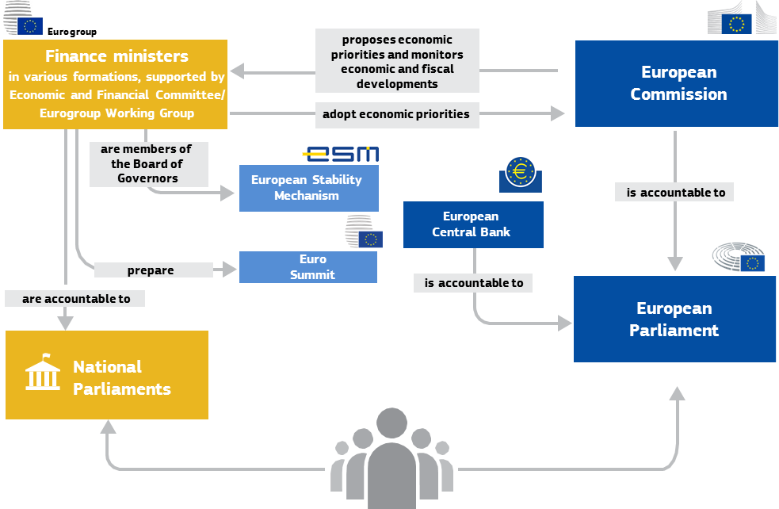

*Source: European Commission*

**With this Communication, the Commission sets out how a future European Minister of Economy and Finance could play a role in the governance architecture of the Economic and Monetary Union.** In so doing, the Communication details the key functions of a European Minister of Economy and Finance, outlines the institutional setting in which the Minister would operate and sets out a potential timeline for the setting up of this new position. In particular, the Communication describes the added value of an ultimate merger of the function of Commission Vice-President in charge of the Economic and Monetary Union with that of President of the Eurogroup, and it highlights that this could already be achieved under the existing Union Treaties.

**Possible responsibilities of the European Minister of Economy and Finance in a steady state**

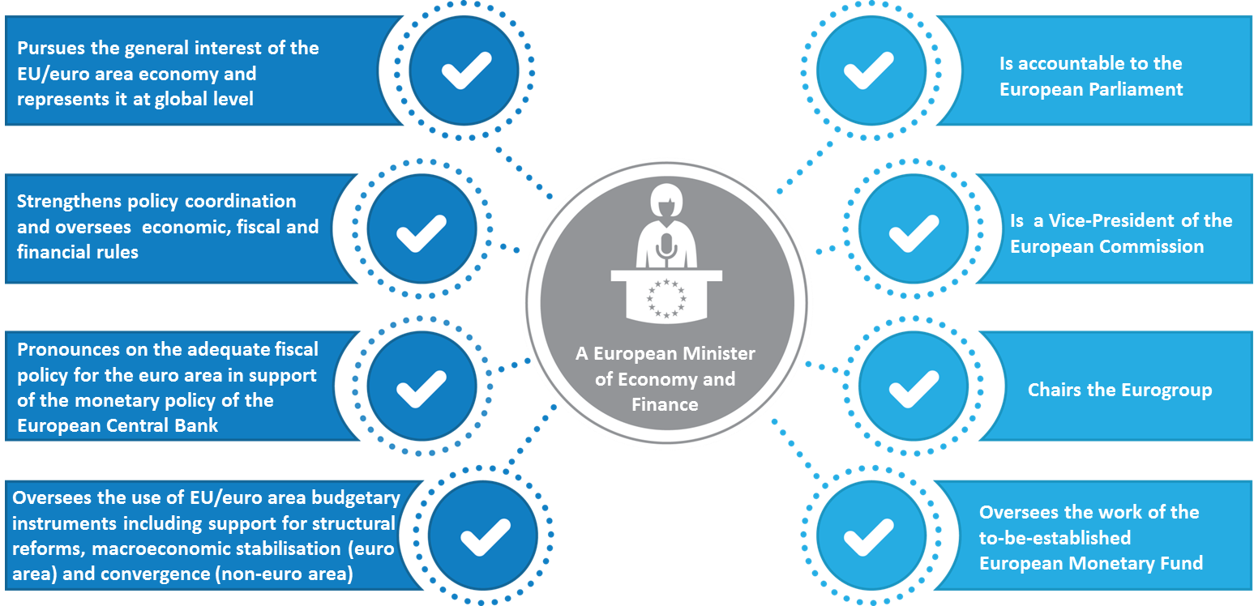

*Source: European Commission*

1. **FUNCTIONS OF A EUROPEAN MINISTER OF ECONOMY AND FINANCE: ENSURING COHERENCE AND EFFICIENCY**

The possible key functions of a European Minister of Economy and Finance in their final state are set out below. Bringing together these functions would help strengthen the overall coherence and efficiency of EU economic policy-making.

*Pursuing the general interest of the EU and euro area economy and representing it at global level*

**Today, the common interest of the EU and the euro area is still not sufficiently represented in the public debate and decision-making across Europe.** While monetary policy is centralised at euro area level, budgetary, tax and sectoral policies are all decentralised, reflecting national competences and circumstances, without spontaneously or necessarily reflecting shared priorities. The issuance of a recommendation on the economic policy of the euro area as part of the European Semester has improved the coordination of euro area policies in recent years. However, its implementation relies on the Member States’ collective willingness and the coordination of policies requires constant steer and monitoring at EU level.

**At the same time, the euro has established itself as a leading world currency, but its global representation is still very much fragmented.** Since its launch, the euro has become the second most used currency around the world. However, in international financial institutions, such as the International Monetary Fund, the euro area is not represented as a single entity. The external economic representation of the EU and of the euro area is currently divided, with different roles assigned to the Commission, the European Central Bank, the President of the Eurogroup and the EU Council Presidency. This fragmented representation often means that the euro area punches well below its political and economic weight across the world.

**A European Minister of Economy and Finance could help to promote better the general interest of the Union and the euro area economy, both internally and at global level.** With the post of the Minister, a key interlocutor would be established at EU level in the areas of economic, fiscal and financial policies vis-à-vis the EU institutions and bodies, the Member States and the general public. The Minister would also naturally assume the function of external representation of the euro.[6]

*Strengthening policy coordination and overseeing economic, fiscal and financial rules*

**Economic policy coordination in the EU has been significantly bolstered as a consequence of the economic and financial crisis.** The European Semester has been continuously improved to foster reforms and their implementation. The recently created Structural Reform Support Service of the Commission provides technical support to Member States to help them with these efforts. This has been supported by further initiatives at EU level, including on tackling youth unemployment, the fight against tax evasion and recently, the proclamation of the European Pillar of Social Rights. The EU has also made decisive steps towards a Capital Markets Union and the completion of the Banking Union, which need to be continued. However, the implementation of reforms in the Member States is still uneven. There are also missed opportunities in terms of improved coordination and learning from each other, and there is a constant need to align national and EU priorities in the light of changing circumstances.

**A European Minister of Economy and Finance could help further strengthen economic policy coordination and ensure consistency across policy areas, building on the work already done by the Commission together with the Member States.** Working in close bilateral and multilateral dialogue with national authorities and the European Parliament, the Minister could promote the coordination and implementation of reforms in the Member States. As structural reforms can have positive spill-over effects, the Minister would also bring added value in looking at the optimal reform agenda for the EU and the euro area as a whole.[7]

*Pronouncing on the adequate fiscal policy for the euro area in support of the monetary policy of the European Central Bank*

**Together with monetary policy, fiscal policy plays a key role in stabilising the macroeconomic environment, while also serving the broader goals of fiscal sustainability and redistribution.**[8]The Commission regularly provides recommendations to the Council on Member States’ fiscal policies, taking into account the flexibility enshrined in the existing set of EU fiscal rules.[9] In recent years, the Commission and the Council have also put a greater focus on the aggregate fiscal stance of the euro area, considering the general interest of and collective responsibility for the euro area as a whole.[10] However, the successful implementation of an appropriate aggregate fiscal stance for the euro area requires the individual and collective willingness of the Member States to follow through.

**A European Minister of Economy and Finance could help in the identification and pursuit of an adequate fiscal policy for the euro area as a whole.** As a member of the Commission, the Minister would coordinate the surveillance of Member States’ fiscal policies, ensuring fiscal sustainability and applying the Stability and Growth Pact with the economic reading that the rules foresee. Part of this task would also be toassess the appropriateness of the fiscal stance of the euro area, thereby contributing to finding a balance between the fiscal interests of the Member States and the best solution for the euro area as a whole. Another task would be to promote the quality and best composition of public finances and the functioning of national fiscal frameworks with a view to maximising their impact on jobs and growth. In so doing, the Minister would build on the views of the European Fiscal Board[11] and be a key interlocutor for national fiscal councils.

*Overseeing the use of EU and euro area budgetary instruments including instruments in support of reforms, macroeconomic stabilisation and convergence*

**The EU budget and other EU and euro area budgetary instruments already play a strategic role in supporting Member States to foster convergence, long-term growth, investment and financial stability.** About half of the EU funding is currently channelled to concrete projects through the five European Structural and Investment Funds. The link between these funds and the priorities of the European Semester has been strengthened over the years with a view to supporting shared priorities. The actions supported by the EU budget are complemented by a number of European and euro area tools and bodies, such as the European Investment Bank and the European Stability Mechanism. However, the crisis has shown that the architecture and scope of EU public finances do not yet fully capture the specific needs of the euro area. Whereas the EU and euro area have increased their lending firepower in recent years, the potential for macroeconomic stabilisation and supporting convergence is still limited.[12] Looking forward, the Commission proposes today a number of new budgetary instruments for a stable euro area within the Union framework.[13]

**The European Minister of Economy and Finance would coordinate the use of relevant EU and euro area budgetary instruments and maximise their impact in support of shared priorities.** The Minister would endeavour to make sure that these instruments are used coherently and effectively and would constantly seek synergies in their implementation, in close cooperation with the Commissioners responsible and public authorities at all levels. Coordinating the Commission’s work on the Investment Plan for Europe would be a particularly important task.[14] In that function, the Minister would also be in charge of the Commission’s relations with the European Investment Bank.

1. **INSTITUTIONAL ASPECTS: DEMOCRATIC ACCOUNTABILITY AND LEGITIMACY**

**The new position of a European Minister of Economy and Finance can contribute to further streamlining the EU governance framework and strengthening the European dimension to economic policy making.** As a matter of fact, the envisaged “double-hatting” – member of the Commission and President of the Eurogroup – is already possible within the current Treaties. Article 2 of Protocol No 14 on the Eurogroup, annexed to the Treaties, mentions that *“the Ministers of the Member States whose currency is the euro shall elect a president for two and a half years, by a majority of those Member States.*”[15] The Minister would not create a new supranational bureaucratic layer, nor would the Minister impinge on national competences. By combining existing functions and available expertise at EU level, the Minister would help create synergies and thus contribute to a more efficient governance framework.

*The Minister as Vice-President of the Commission*

**Given the Commission’s institutional role as promoter of the general interest, a Vice-President of the Commission could take over the role as European Minister of Economy and Finance.**This would allow for the creation of a visibly mandated and unified representative of the economic and fiscal interests of the whole EU and the euro area, which also serves as a key point of reference inside and outside the Commission.

**The Minister could steer and coordinate the work of several policy portfolios** and services across the Commission. He/she would represent the Commission in the meetings of the European Central Bank’s Governing Council, without the right to vote, as it is foreseen in Article 284(1) of the Treaty on the Functioning of the European Union. He/she would also be responsible for EU-level social dialogue and interaction with key stakeholders.

*The Minister as Chair of the Eurogroup*

**The European Minister of Economy and Finance could be elected as President of the Eurogroup, with a view to taking into account the interests of the euro area as a whole.** The Eurogroup has until now been chaired by a finance minister of a euro area Member State. As President of the Eurogroup, the Ministerwould present and seek consensus on the broad policy direction and the overall strategy for the euro area, by helping to balance and align the points of views of national ministers with the shared priorities pursued at euro area and EU level. The Minister would also ensure the coherent preparation of Euro Summit meetings.

|  |
| --- |
| ***The role of the Eurogroup and its President over time***  *The Eurogroup is an informal body where the finance ministers of the euro area Member States discuss matters under their shared responsibilities related to the euro. Its main task is to ensure close coordination of economic policies among euro area Member States, in full respect of the powers attributed to the Council under Article 121 TFEU.*  *The European Council endorsed the creation of the Eurogroup on 13 December 1997.[16] In a resolution on economic policy coordination, the Council concluded that “the Ministers of the States participating in the euro area may meet informally among themselves to discuss issues connected with their shared specific responsibilities for the single currency.” The Eurogroup held its first meeting on 4 June 1998. In its early years, the Eurogroup was chaired by the rotating Council Presidency, except where the Council Presidency was held by a non-euro area Member State, in which case the chair was held by the next euro area country that would hold the Council Presidency.*  *On 10 September 2004, the Eurogroup decided to have a permanent President, appointed for a period of two years. At an informal ECOFIN meeting in Scheveningen, in the Netherlands, Jean-Claude Juncker was elected as the first permanent President of the Eurogroup.*  *Protocol 14 on the Eurogroup entered into force with the Lisbon Treaty on 1 December 2009.  It stipulates that Ministers of Member States whose currency is the euro shall meet informally to discuss matters related to the specific responsibilities they share with regard to the single currency and shall elect a President for two and a half years by a simple majority of votes.*  *Since October 2008, regular meetings of the euro area Heads of State or Government had taken place. At their meeting on 26 October 2011, Heads of State or Government agreed that a decision on whether the President of the Eurogroup is to be elected “among its members or be a full-time President based in Brussels will be taken at the time of the expiry of the mandate of the current incumbent.” It was also agreed that the Eurogroup Working Group would prepare Eurogroup meetings, drawing on the expertise provided by the Commission. It was furthermore clarified that the Eurogroup Working Group would be chaired by a full-time Brussels-based President elected,  in principle, at the same time as the chair of the Economic and Financial Committee, for a period of two years, which may be extended. [17]* |

**The Eurogroup could agree to elect the Minister as its President for the whole duration of the Commission’s mandate.** This would be compatible with the Minister’s duties as a member of the Commission, representing the general interest, and would not require a Treaty revision.[18]

**The European Minister would be supported in the preparation of Eurogroup meetings by   
the permanent Chairman of the Economic and Financial Committee/Eurogroup Working Group** and a Secretariat building on all available expertise, making sure that no additional structures are created or duplicated.[19]

*The Minister overseeing the work of the European Monetary Fund*

**The President of the Eurogroup currently chairs the Board of Governors of the European Stability Mechanism.** The latter was put in place during the crisis on an intergovernmental basis as a way to provide support to those Member States facing financial distress. Building on the European Stability Mechanism, the Commission proposes today to integrate the European Monetary Fund into the Union legal framework.[20]

**As President of the Eurogroup, the Minister would then also chair the Board of Governors of the European Monetary Fund**. In so doing, the Minister would exercise a neutral role, taking into account the interests of the shareholders of the European Monetary Fund in a balanced manner.

*Accountability towards the European Parliament*

**The Commission is accountable towards the European Parliament.** Members of the Commission also actively engage with the European Parliament on economic and fiscal matters, notably through the Economic Dialogues set out in the “Six-Pack” and “Two-Pack” legislation.[21] The Eurogroup and the European Stability Mechanism engage with the European Parliament on a voluntary basis.

**The Minister would be accountable towards the European Parliament on all issues related to its functions and would also be available for dialogues with national Parliaments.** As a member of the College of Commissioners, the Minister would be subject to a hearing by the European Parliament. After a vote of consent, the Minister would be appointed as part of the Commission College.   
The Minister would continue to have regular dialogues with the European Parliament and with national Parliaments. Furthermore, in line with the existing process for examining the Draft Budgetary Plans of euro area Member States, national Parliaments could request the Minister to present the Commission opinion on the respective Draft Budgetary Plan to them.

1. **CONCLUSIONS**

The Commission considers that the position of a European Minister of Economy and Finance would be an important institutional step for a more coherent, effective and accountable economic governance of the European Union.

It calls on the European Parliament and the Council, as well as on the Member States, to reflect on the ideas expressed in this Communication, with a view to building a common understanding in the context of the discussion on the deepening of the Economic and Monetary Union foreseen in the Leader’s Agenda.

Within the existing Treaties, such a position could be created sequentially, according to the following timeline:

* The function of the Minister as Vice-President of the Commission could be established as part of the appointment of the next Commission as from November 2019.
* The Eurogroup could agree to elect the Minister as its President for two consecutive mandates, thus agreeing on an alignment of its mandate with the mandate of the Commission.

1. President Jean-Claude Juncker’s State of the Union Address 2017, 13 September 2017.
2. COM(2017) 291, 31 May 2017.
3. Completing Europe’s Economic and Monetary Union, Report by Jean-Claude Juncker, in close cooperation with Donald Tusk, Jeroen Dijsselbloem, Mario Draghi and Martin Schulz, 22 June 2015.
4. In its resolution of 16 February 2017 on possible evolutions of and adjustments to the current institutional set-up of the European Union, the European Parliament called for “an executive authority [of the Union] to be concentrated in the Commission in the role of an EU Finance Minister”.
5. During the Euro Summit on 26 October 2011, Heads of State or Government of the Euro Area agreed on ten measures to improve the governance of the euro area, where it was agreed that a decision on whether the President of the Eurogroup “*should be elected among Members of the Eurogroup or be a full-time President based in Brussels will be taken at the time of the expiry of the mandate of the current incumbent*”.
6. See also COM(2015) 602 final of 21 October 2015 on a roadmap for moving towards a more consistent external representation of the euro area in international fora and COM(2015) 603 final of 21 October 2015 on a Commission proposal for a Council Decision laying down measures in view of progressively establishing unified representation of the euro area in the International Monetary Fund.
7. COM(2017) 825 and COM(2017) 826 of 6 December 2017.
8. Also the G20 Leaders’ declaration of 8 July 2017 underlined the need to use fiscal policy – next to monetary and structural policies – individually and collectively to achieve the goal of strong, sustainable, balanced and inclusive growth, while enhancing economic and financial resilience.
9. COM(2015) 12 final, 13 January 2015.
10. The “fiscal stance” is usually understood as the orientation given to fiscal policy by governments’ discretionary decisions on tax and expenditure. It determines the role that fiscal policy plays in the economic cycle. If well designed, notably in combination with reforms and support to investment as well as the help of a future fiscal stabilisation function, a more active fiscal policy can contribute to a faster reduction in unemployment in the short run, but also to lift the medium-term (potential) growth in the euro area. See also COM(2016) 727 final, 16 November 2016.
11. The board is an independent advisory body to the Commission on fiscal matters with the purpose of achieving a more informed public debate and better coordination of national fiscal policies.
12. See also Commission Reflection Paper on EU public finances, COM(2017) 358, 28 June 2017.
13. COM(2017) 822 of 6 December 2017.
14. The Investment Plan for Europe was launched by the Commission together with the European Investment Bank with a view to stimulating private investment in the EU economy and to tackling investment barriers, and significant first results have been achieved with EUR 251 billion of investments mobilised so far.
15. Eurogroup ministers would only need to change their working methods, which are agreed informally,   
    by simple majority. These working methods currently foresee that candidates for the office of President must hold the position of national minister of finance.
16. European Council, Presidency conclusions, Luxembourg, 12-13 December 1997.
17. In May 2013, France and Germany also presented their joint paper “*Together for a stronger Europe of Stability and Growth*”. It proposed to strengthen the governance of the euro area “*after the next European elections. […] This could include:[…] a full-time President for the Eurogroup*”.
18. The Commission participates in the work of the Eurogroup, as is foreseen in Protocol No 14 to the Treaties. Article 17(1) TEU lays down the mission of the Commission to promote the common interest of the Union, which it does in all its activities. It is thus Union primary law that makes it clear that there is no incompatibility between the tasks of a Member of the Commission and involvement in the work of the Eurogroup.
19. The work of the Eurogroup is prepared by the Eurogroup Working Group (EWG). The EWG and   
    the Economic and Financial Committee (EFC) are chaired by a permanent chairperson since 2012. Hosted in   
    the Council, the EFC/EWG Chair is assisted by a secretariat whose staff is mainly supplied by and based in the Commission. This organisation has allowed synergies and proven to be efficient. It could be further developed with the creation of the European Minister for Economy and Finance.
20. COM(2017) 827 of 6 December 2017.
21. Regulations (EU) n° 1173/2011, 1174/2011, 1175/2011, 1176/2011, 1177/2011, 472/2013 and 473/2013.