

1. **INTRODUCTION**

It is almost sixteen years since the first euro coins and notes entered our daily lives. The currency is now used every day by 340 million Europeans in 19 euro area Member States. It is the second most used currency worldwide. Sixty other countries and territories around the world, home to 175 million people, have chosen to use the euro as their currency or to peg their own currency to it.

The financial and economic crisis that hit Europe in 2008, the consequences of which are still felt to this day, did not start in the euro area but it laid bare some of its institutional weaknesses. As an emergency response to the immediate challenges, several instruments were adopted. They provided new financial firewalls, assisted the countries most affected and stepped up policy coordination at EU level. They strengthened the fiscal and financial rules in order to prevent the crisis from escalating further. Monetary policy action by the European Central Bank has also proved decisive.

After years of low or no growth, **determined efforts at all levels have started to pay off**. Europe is now experiencing a robust recovery. All Member States are now growing and overall EU growth has stood at around 2% on average for several years in a row.[1] The economic sentiment is at its highest in the EU and the euro area since 2000. Unemployment is at its lowest since late 2008. Popular support for the euro is at its highest in the euro area since the introduction of the euro notes and coins in 2002.[2] However, as the current Commission said when taking office, the crisis is not over as long as unemployment remains so high, with 14.3 million people still without a job in the euro area in October 2017.

Important lessons needed to be drawn from the crisis years. The relevant issues were already clearly identified in the **Five Presidents' Report of June 2015**.[3] Since then, a lot has been done to "deepen" the Economic and Monetary Union by "doing". The European Semester of economic policy coordination has been strengthened with clearer guidance for the euro area as a whole and a stronger focus on social aspects. Economic governance has been improved, with the creation of a European Fiscal Board and National Productivity Boards. Technical assistance to Member States was boosted with the creation of the Structural Reform Support Service. Important steps towards completing   
the Banking Union[4] and Capital Markets Union[5] have been taken, notably by advancing in parallel on risk-reduction and risk-sharing measures in the banking sector. To increase ownership at all levels,   
the dialogue with national and European political actors and social partners has also intensified.

As a result, the euro area architecture is more robust than ever before but this does not mean that it is complete. **The Reflection Paper on the deepening of the Economic and Monetary Union**,[6] as well as the Reflection Paper on the future of EU finances[7] presented by the Commission as part of the follow-up to the **White Paper on the Future of Europe**,[8] recall the state of play and outline   
a possible way forward to 2025.

Europe is now visibly regaining its strength. Both economically and politically, there is a **window of opportunity** and positive developments are further encouragements to act. There should be no complacency: one should always fix the roof when the sun is shining.

In his State of the Union address on 13 September 2017,[9] President Juncker set out his views for **a More United, Stronger and More Democratic Union** and made it clear that the completion of Europe's Economic and Monetary Union is an essential part of the roadmap leading to the meeting of Leaders in Sibiu, called by President Tusk for 9 May 2019, where important decisions on the future of Europe should take place.

This is also reflected in the **Leaders' Agenda**,[10] with EU Leaders planning a Euro Summit   
on 15 December 2017 to discuss a timeline for decisions on Economic and Monetary Union and   
the Banking Union, and a dedicated meeting planned on 28-29 June 2018 with a view to reaching concrete decisions.

**Europe's Economic and Monetary Union today**

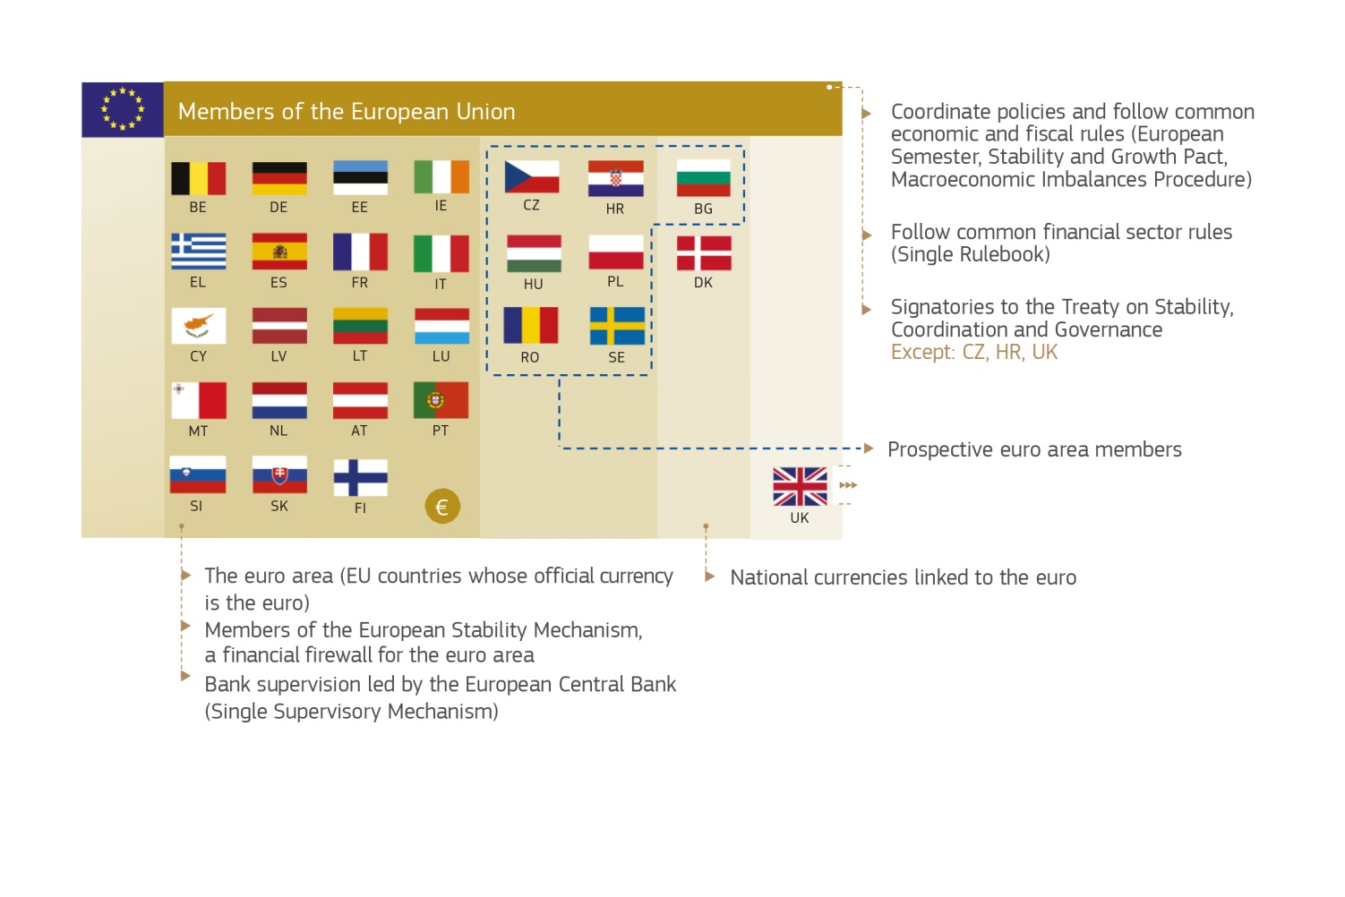

*Source: European Commission*

The call for unity, efficiency and democratic accountability of the State of the Union address is particularly relevant for the completion of the Economic and Monetary Union:

* **Unity**: The euro is the single currency of the EU and what is conceived for the euro area should also be conceived for and with those Member States that are expected to join the euro in the future. With the exception of the United Kingdom and Denmark, **all non-euro Member States are legally committed to joining the euro eventually**.[11] Moreover, with the United Kingdom's departure, euro area economies will represent about 85% of the EU's total Gross Domestic Product. The EU's political and economic integration, of which the single market is the core, means that the futures of both euro and non-euro Member States are already intertwined, and a strong and stable euro area is key to its members as well as to the EU as a whole. This is why the proposals in this package address the needs and interests of both euro and non-euro Member States, as inter-dependent parts of the Economic and Monetary Union.

* **Efficiency**: A stronger Economic and Monetary Union requires **stronger governance** and **a more efficient use of available resources**. The current system still reflects a patchwork of decisions taken to face an unprecedented crisis. This has sometimes led to a multiplication of instruments and an increased sophistication of rules, which is a source of complexity and creates risks of duplications. Greater synergies, streamlined procedures and the integration of intergovernmental arrangements within the **EU legal framework** would strengthen governance and decision-making. It is also for efficiency reasons that all the changes proposed by the Commission as part of today's package can be implemented within the framework of the current EU Treaties.
* **Democratic accountability**: Completing the Economic and Monetary Union also means greater **political responsibility** and **transparency** about who decides what at the different levels.   
  This requires bringing the European dimension of decision-making closer to citizens and more to the forefront of national debates, as well as making sure that both national Parliaments and the European Parliament have sufficient powers of oversight on the management of the EU's economic governance. This should also lead to greater ownership of collective decisions and openness on the way they are taken and communicated.

In recent years, many views have been expressed on the completion of the Economic and Monetary Union. Opinions may differ but there is a **broad consensus** on the need to make further progress. There have also been very significant contributions from the European Parliament[12] and important discussions in the Eurogroup.[13]

This Communication gives a summary of the rationale and content of the initiatives presented   
today by the Commission. It then recalls how this package is embedded in a broader **roadmap   
to deepen Europe's Economic and Monetary Union** **by 2025** and provides a timeline for action in the next 18 months.

1. **TODAY'S INITIATIVES**

As announced in the 2017 State of the Union address and the accompanying Letter of Intent, today's initiatives set out further steps towards completing the Economic and Monetary Union.

**An overview of today's package**

*Today, the Commission is presenting the following proposals and initiatives:*

* *A proposal for the establishment of a European Monetary Fund anchored in the Union legal framework;*
* *A proposal to integrate the substance of the Treaty on Stability, Coordination and Governance into the Union legal framework, taking into account the appropriate flexibility built into the Stability and Growth Pact and identified by the Commission since January 2015;*
* *A Communication on new budgetary instruments for a stable euro area within the Union framework;*
* *For the period 2018-2020, (1) targeted changes in the Common Provisions Regulation to mobilise EU funds in support of national reforms and (2) a proposal to strengthen the Structural Reform Support Programme;*
* *A Communication on a European Minister of Economy and Finance.*

*A proposal for the establishment of a European Monetary Fund*

This proposal builds on the well-established structure of the European Stability Mechanism by creating a **European Monetary Fund** anchored within the EU's legal framework. This was already announced in the Five Presidents' Report and has also been called for by the European Parliament, which stressed the need for the European Monetary Fund to be equipped with adequate lending and borrowing capacities and a clearly defined mandate.[14]

The European Stability Mechanism was set up in October 2012 at the height of the crisis. The pressure of events at the time led to an intergovernmental solution being found. However, it was already clear then that this could also be achieved within the framework of the EU Treaties, as indicated, for instance, in the Commission's Blueprint for a Deep and Genuine Economic and Monetary Union.[15]

Over the years, the European Stability Mechanism has proven decisive in helping to preserve the financial stability of the euro area. It has done so by providing additional financial support to euro area Member States in distress. Its transformation into a European Monetary Fund will further strengthen its **institutional anchoring**. It will help to create new synergies within the EU framework, notably in terms of transparency, legal review and efficiency of the EU's financial resources and thus offering better support to Member States. It will also help improve further the cooperation with the Commission and accountability to the European Parliament. This will be done without affecting the way in which national governments are held to account by their own national Parliaments and preserving the commitments of the existing European Stability Mechanism.

The initiative takes the form of a proposal for a Council Regulation, which is subject to the consent of the European Parliament, under Article 352 of the Treaty on the Functioning of the EU. Article 352 allows for the integration of the European Stability Mechanism into the Union framework, as this action is necessary for the **financial stability of the euro area**[16]and the Treaties have not provided any other legal basis for the EU to reach this precise objective.[17] Paragraph 2 of that Article explicitly foresees a role for national Parliaments. Historically, several significant decisions paving the way towards the establishment of the Economic and Monetary Union have been based on the equivalent   
of Article 352. For instance, decisions on the European Monetary Cooperation Fund, the European Currency Unit and the first balance of payment mechanisms were taken under Article 235 of   
the Treaty on the European Economic Community, the predecessor to Article 352.

The proposal is complemented by a draft of what could become an **intergovernmental agreement**   
for euro area Member States to agree among themselves on the transfer of funds from the European Stability Mechanism to the European Monetary Fund. This also foresees that the Fund would succeed to and replace the ESM, including in its legal position, with all its rights and obligations.

Under today's proposal, the European Monetary Fund will be established as a **unique legal entity under Union law**. It will succeed the European Stability Mechanism, with its current financial and institutional structures essentially preserved. This means that the European Monetary Fund will continue to provide financial stability support to Member States in need, to raise funds by issuing capital market instruments and to engage in money market transactions. The membership will not change and the participation of additional Member States will remain possible, once they join the euro.

Given that the European Monetary Fund would become a Union body, some targeted adjustments are necessary to the current structure of the European Stability Mechanism. These are explained in the explanatory memorandum to the Regulation. They include an **endorsement by the Council** of discretionary decisions taken by the European Monetary Fund.[18]

In addition, today’s proposal adds a limited number of new features.

First, the European Monetary Fund will be able to provide the **common backstop to the Single Resolution Fund**. This is an essential component of the second pillar of the Banking Union-   
the Single Resolution Mechanism.[19]

When the Single Resolution Mechanism was adopted in 2013, Member States also agreed to develop a **backstop to the Single Resolution Fund**. This was meant as a last resort to be activated if the Single Resolution Fund's immediately available resources proved to be insufficient for capital or liquidity purposes. Member States also agreed that it should be fiscally neutral over the medium term so that any potential deployment of the backstop would be recovered from the banking sector in the euro area.

New EU rules on banking supervision and resolution developed in the aftermath of the crisis have significantly reduced the likelihood and potential impact of bank failures. However, a common fiscal backstop continues to be needed to enhance the financial capacity of the Single Resolution Fund. Such a backstop would instil confidence in the banking system by underpinning the credibility of actions taken by the Single Resolution Board. In turn, this would actually reduce the likelihood of a situation in which a backstop would need to be called on.

There is now wide consensus that the European Stability Mechanism – the future European Monetary Fund – is best placed to provide such a backstop in the form of a credit line or guarantees to the Single Resolution Fund. This is reflected in today's proposal which also sets out appropriate decision-making processes to ensure that the backstop can be deployed quickly, if needed. Special arrangements are also proposed to cater for the legitimate interests of non-euro Member States having joined the Banking Union.

Second, in terms of **governance**, the proposal includes the possibility for faster decision-making in specific urgent situations. It is proposed to keep unanimity voting for all major decisions with financial impact (e.g. capital calls). However, reinforced qualified majority, in which 85% of the votes are required, is proposed for specific decisions on stability support, disbursements and the deployment   
of the backstop.

Third, as regards the **management of financial assistance programmes**, the proposal foresees a more direct involvement of the EMF, alongside the European Commission.

Fourth, the proposal refers to the possibility for the European Monetary Fund to develop **new financial instruments**. Over time, such instruments could supplement or support other EU financial instruments and programmes. Such synergies could prove particularly useful if the European Monetary Fund were to play a role in support to a possible stabilisation function in the future.

With these changes, the European Monetary Fund will establish itself as a robust crisis management body within the Union framework, working in **full synergy with other EU institutions**. The Council and the Commission will retain their competences and responsibilities in terms of economic and fiscal surveillance and policy coordination, as set out in the EU Treaties.

**Practical cooperation** can also be stepped up to serve Member States better, engage with market participants and avoid the duplication of activities. Further cooperation could be sought in the light of further progress towards the strengthening of Economic and Monetary Union.

*A proposal to integrate the substance of the Treaty on Stability, Coordination and Governance into the Union legal framework, taking into account the appropriate flexibility built into the Stability and Growth Pact and identified by the Commission since January 2015*

The **Treaty on Stability, Coordination and Governance in the Economic and Monetary Union** is an intergovernmental Treaty signed by 25 EU Member States.[20] It complements the EU fiscal framework, including the Stability and Growth Pact.

Today's proposal implements its Article 16 in which all the contracting parties legally committed to taking steps to incorporate the substance of that Treaty into Union law within five years after its entry into force, which corresponds to 1 January 2018.[21] It should be recalled that at the time of the negotiation of the Treaty, notably the European Parliament and the Commission insisted on its incorporation under EU law within a defined timeframe, which Member States accepted in Article16.

As with the European Stability Mechanism, the decision to establish the Treaty on Stability, Coordination and Governance in the Economic and Monetary Union as an intergovernmental Treaty in 2012 must be seen in the context of the circumstances at the time. However, both the commitment taken under Article 16 and the fact that subsequent legislation (known as the "two-pack") has already incorporated many of its elements under EU law, show that the intention of finding Union solutions has been present from the beginning. Bringing the substance of the Treaty on Stability, Coordination and Governance under EU law has also been repeatedly called for by the European Parliament,[22] arguing that, to be effectively legitimate and democratic, the governance of a genuine Economic and Monetary Union must be placed within the institutional framework of the Union.

Today's initiative takes the form of a proposal for a Council Directive, which requires consultation of the European Parliament, under Article 126(14)(2) of the Treaty on the Functioning of the EU. This is the only available legal basis in the Treaty. The Commission will take due account of the views of the European Parliament in the process. The proposal applies to all euro area Member States and includes “opt-in” provisions for non-euro Member States.

The proposed Directive integrates the essence of Article 3 of the Treaty on Stability, Coordination and Governance, which forms part of the so-called **Fiscal Compact**. This Article requests that a balanced budget rule in structural terms should be applied, along with a correction mechanism in case of significant deviation. As reported by the Commission earlier this year,[23] the provisions under this Article have already been enacted into national laws.

Integrating the Fiscal Compact into Union law will **simplify the legal framework** and allow for **continuous and** **improved monitoring** as part of the overall EU economic governance framework.   
In particular, this will complement and strengthen the existing fiscal frameworks, which aim to achieve convergence to prudent levels of public debt. At the same time, the proposal takes into account the appropriate flexibility built into the Stability and Growth Pact and identified by the Commission since January 2015.[24] The provisions are therefore fully in line with existing rules defined in primary and secondary legislation.

The proposal also stresses the value and maintains the practice of inter-parliamentary meetings held annually by the European Parliament, as well as the voting arrangements among contracting parties listed in the Treaty on Stability, Coordination and Governance.

*A Communication on new budgetary instruments for a stable euro area within the Union framework*

In his State of the Union address, President Juncker stressed that there was no need for parallel structures: “*we do not need a budget for the euro area but a strong euro area budget line within the EU budget”*. The **Reflection Papers on the deepening of the Economic and Monetary Union** and   
on the **future of EU finances** described the common challenges for the modernisation of EU public finances in general and for the particular needs of the euro area. Today's Communication sets out a vision of how certain budgetary functions that are essential for the euro area and the EU as   
a whole can be developed within the framework of the EU public finances of today and tomorrow.

The Communication recalls what can be achieved within the current financial framework of the EU and presents several ideas and options, some of which pave the way for the **upcoming proposals for the post-2020 Multiannual Financial Framework.**

The Communication discusses four specific functions that are essential for the deepening of the Economic and Monetary Union. It proposes concrete next steps for each of them:

* **Support to structural reforms** through: 1) a reform delivery tool to support reform commitment packages agreed with Member States and 2) technical support at the request of Member States;
* **A dedicated convergence facility for Member States on their way to joining the euro**;
* **A backstop for the Banking Union**, through the European Stability Mechanism/European Monetary Fund, as explained above;
* **A stabilisation function**, bringing together different EU and euro area level funds and financial instruments, to be used to maintain investment levels in the event of large asymmetric shocks.

For the period 2018-2020, the Commission intends to develop some of these ideas and to test them in practice to support structural reforms and capacity building. To that end, the following initiatives are presented alongside this package:

* **A proposal to amend the Common Provisions Regulation**, as explained below, in order to extend the possibilities to use the performance reserve built into the existing European Structural and Investment Funds.
* **A proposal to strengthen the Structural Reform Support Programme**, as explained below, to boost technical support available for all Member States and to create a dedicated work stream to support non-euro Member States in their convergence process.

The other proposals mentioned here will follow in the context of the post-2020 Multiannual Financial Framework, for which detailed proposals will be presented in **May 2018**. The Commission will take full account of the feedback received by then.

*Targeted changes to the Common Provisions Regulation*

With a view to preparing for the new reform delivery tool mentioned above, the Commission proposes to test a new tool of budgetary support in a pilot phase for the period 2018-2020. This proposal takes the form of targeted amendments to the Common Provisions Regulation.[25] Its aim is to offer additional flexibility in the use by Member States of **the performance reserve of the European Structural and Investment Funds**. It will be up to each Member State to decide whether it intends to allocate parts of its performance reserve to this new scheme.

The aim of this tool will be to support the implementation of national reforms, which will be identified through the European Semester of economic policy coordination and built into the National Reform Programmes presented by the Member States. Once the reform commitments of a Member State are agreed, with clearly defined targets and milestones, the Commission will monitor and evaluate their implementation before the disbursement of support.

The proposal does not modify the overall level of expenditure for the European Structural and Investment Funds in the current Multiannual Financial Framework. The lessons learned from the initiative will inform the proposals for the post-2020 period.

*A proposal to strengthen the Structural Reform Support Programme*

Following the Five President's Report, the Commission established the **Structural Reform Support Service** in late 2015. The aim of this Service is to provide technical support to Member States in order to assist in the design and implementation of specific reforms or to reinforce their overall reform capacity. The programme has proven particularly successful in helping Member States to design reforms for the modernisation of the public administration and the business environment. It has now become clear that the demand for this type of technical assistance by far exceeds the funding that had initially been made availablethrough the **Structural Reform Support Programme**.[26]

At the same time, as stated by President Juncker in his State of the Union address, there is a clear need to think ahead and support non-euro Member States in preparing for their euro accession when they so desire. One of the lessons learned from the crisis is that achieving convergence and building robust economic structures is crucial for the prosperity of the Union and, in particular, for the smooth functioning of the single currency.

**Dedicated technical support to non-euro Member States** can prove useful to contribute to the process of real convergence. This is notably true in areas such as public financial management, public administration, the financial sector, and labour and product markets.

For these two reasons, the Commission is today presenting **an amendment to the Structural Reform Support Programme Regulation**.[27] Its objective is to double the funding available for technical assistance activities by 2020, thus bringing it to EUR 300 million for the period 2017-2020. Lessons learned will inform the proposals for the post-2020 period.

*A Communication on a European Minister of Economy and Finance*

In his State of the Union address, President Juncker backed the idea of a **European Minister of Economy and Finance.** In keeping with the logic that form follows function, the Minister will be instrumental in strengthening the coherence, efficiency, transparency and democratic accountability of EU economic governance. It is also important to note that the merging of the function of a responsible Commissioner, possibly a Vice-President of the Commission, with that of the President of the Eurogroup is already possible under the current EU Treaties.[28]

The current architecture of the Economic and Monetary Union is intrinsically complex. Competences, functions and instruments are carried out by different bodies, within various and sometimes overlapping legal frameworks. This is sub-optimal for EU citizens and decision-makers alike,   
as it hampers the ability to articulate and stand up for the common economic interest of the EU and   
of the euro area in particular. This need has been increasingly felt over the years as the euro has become a leading international currency and several dimensions of the Economic and Monetary Union are being strengthened. This is also one of the reasons behind the fact that this Commission has strengthened its internal coordination capacities by assigning new horizontal roles to its Vice-Presidents to coordinate several economic, financial and social policy portfolios.

Today's Communication looks to the future and sets outs how certain existing functions could be combined under a European Minister in order to pursue the general interest of the EU and euro area economy, to strengthen policy coordination and to deliver an improved policy mix at all levels.   
The European Minister would also oversee the use of EU and euro area budgetary instruments and seek to maximise their impact in support of shared priorities.

The Communication also spells out the potential institutional setting in which the Minister would operate. The Minister would strengthen the European dimension of economic policy-making and ensure strong parliamentary scrutiny at EU level, without calling into question national competences. By combining existing functions and available expertise at EU level, the Minister would contribute to a more efficient governance framework, which should complement and facilitate the exercise of national competences, also in their interaction at EU level.

The establishment of such a position could be pursued sequentially. The role of the Minister as Vice-President of the Commission could be established as part of **the appointment of the next Commission as from November 2019**. For him or her to chair the Eurogroup, the latter could informally agree to elect the Minister as its President for **two consecutive mandates**, thus agreeing on the alignment of its mandate with the mandate of the Commission.

1. **A ROADMAP FOR DEEPENING THE ECONOMIC AND MONETARY UNION**

Moving from general principles to practical implementation requires a determined sense of direction and appropriate sequencing. Following the Five Presidents’ Report, the Reflection Paper on the deepening of the Economic and Monetary Union set out a roadmap for the completion of the Economic and Monetary Union by 2025, which remains relevant.

Today’s package is part of this broader agenda. It adds to steps already taken and still to come. Overall, progress is needed in four complementary areas: **1) Financial Union; 2) Fiscal Union;   
3) Economic Union and 4) democratic accountability and strengthened governance.**

To take the first steps, it is important to know the direction and to see the path ahead. As a way to structure the work ahead, this Communication identifies the initiatives to be discussed and agreed by the EU co-legislator over the next eighteen months. This roadmap is also presented in an appendix and the main elements are recalled below. It also sets out a possible path to 2025.

*Financial Union*

The establishment of the Banking Union and the Capital Markets Union have considerably reduced remaining risks in the EU financial sector, changed its fundamentals and contributed to its solidity and resilience. However, remaining parts of this work need to be completed swiftly.

The **Commission Communication on completing the Banking Union**,published in October 2017,[29] includes a pragmatic path for a swift agreement on outstanding issues. This specific roadmap is also reproduced in an appendix. This includes first and foremost the completion of the **risk-reduction** agenda to strengthen further the resilience of EU banks. A number of initiatives currently under negotiation in the European Parliament and the Council, notably the Commission's banking package from November 2016[30], as well as the proposal on business insolvency and restructuring, need to be **agreed in 2018**. Determined progress is also necessary in the context of ongoing national and European work with regard to **non-performing loans**, which remain a challenge in parts of the banking sector.[31] In parallel, the proposal for a **European Deposit Insurance Scheme**[32] should be agreed upon by the co-legislators by the **end of 2018**. The proposal for a common **backstop to the Single Resolution Fund** should be politically agreed by **mid-2018**, with a view to its quick operationalisation by **2019**.

At the same time, all actors – EU Institutions, Member States, supervisory authorities and market operators across Europe – should step up their work to make the **Capital Markets Union** a reality   
so that deep and well-integrated capital markets can play their role as shock-absorbers and efficient channels for private risk-sharing, while at the same time improving access to finance, in particular   
for start-ups and companies.

The Commission is supportive of the current work in the European Systemic Risk Board on **European Sovereign Bond-backed Securities** and will present an enabling framework for such securities   
**in spring 2018**.

*Fiscal Union*

As part of theEuropean Semester of economic policy coordination, the Commission will continue to work towards **responsible fiscal policy** at national level, by supporting the establishment of sound fiscal frameworks and paying appropriate attention to debt levels.

Policy guidance will continue to take account of what makes economic and budgetary sense both for the countries concerned and for the euro area as a whole, at the particular juncture of the economic cycle. The Commission will continue to apply the rules of the Stability and Growth Pact by making use of its inbuilt flexibility in support of reforms and investment. It will also continue to put the focus on the **priorities of the euro area** as a whole, notably in terms of the aggregate fiscal stance, in line with the annual Recommendation for the economic policy of the euro area.[33]

Beyond these aspects, as explained above, **the post-2020 Multiannual Financial Framework** will be a key opportunity to modernise the Union public finances and find new synergies in order to support national reform and investment efforts, as well as to cushion large asymmetric shocks. The Commission intends to make a proposal for the creation of a **stabilisation function in May 2018**, to be fully developed over time, as part of the proposals for the post-2020 Multiannual Financial Framework.

Finally, the need to capture the diversity of economic circumstances, which was particularly pronounced during the crisis years, has brought more sophisticated but also more complex fiscal rules at EU level over time. At times, this can play against national ownership of reforms and effective implementation. Stronger economic, fiscal and financial integration, together with market discipline, should pave the way for a **review of the EU fiscal rules** in the longer term, with the aim of a substantial simplification by 2025.

*Economic Union*

The notions of convergence and integration are at the heart of the Economic Union. To achieve sustainable prosperity, Member States need to continue to focus on the necessary reforms to modernise their economies, make them more resilient to possible shocks and improve their growth prospects. Reform priorities are discussed and monitored on an annual basis in the context of the **European Semester of economic policy coordination**.

Going forward, the Union framework should continue to **support a process of reforms for real convergence** across the EU, both within the euro area and for countries on their way to joining the euro. As explained above, the Commission will start with pilot actions for the period 2018-2020 and will present dedicated proposals to support agreed reforms in **May 2018** **in view of the post-2020 Multiannual Financial Framework**. This should be agreed before the next European Parliament elections.

In addition, the proposal to **strengthen the budget of the Structural Reform Support Programme for the next two years** will need to be adopted by the European Parliament and Council in 2018. Among other tasks, a dedicated work stream will be developed to provide tailor-made assistance to countries that plan to adopt the euro over a defined time horizon. Looking beyond 2020, the Commission intends to propose a **continuation of the Structural Reform Support Programme**. This will also include a **dedicated convergence facility** for non-euro Member States.

Finally, further strengthening of **coordination of national economic policies** is important for convergence. The annual process of policy coordination will continue to be linked with a **more multi-annual approach** to reforms initiated by national governments. In so doing, it will also be important to keep a strong social dimension to all activities. The principles and rights of the **European Pillar of Social Rights**, which was proclaimed in Gothenburg on 17 November 2017, will provide a compass for renewed convergence towards better working and living conditions.[34] Moreover, ongoing work in the Council and in the Eurogroup on the **benchmarking of policies** and the identification of **convergence standards** should be reinforced during the next 18 months.

*Democratic accountability and strengthened governance*

As explained above, the **integration of both the European Stability Mechanism and the Treaty on Stability, Coordination and Governance under the Union framework by mid-2019** will be useful steps to strengthen institutional efficiency, transparency and accountability.

The European Parliament and national Parliaments should be equipped with sufficient powers of oversight. The Commission has developed an effective regular **dialogue with the European Parliament** on EU and euro area economic policy matters in recent years. In the light of today's proposals, these practices could be formalised by the two institutions by the **end of 2018**.

Moreover, the establishment of a **European Minister of Economy and Finance** could be considered as part of the appointment of the next Commission as from **November 2019**,with the Eurogroup electing the Minister as its President for two consecutive mandates. In parallel, stronger internal coordination on Economic and Monetary Union matters should be mirrored by a **more unified external representation of the euro area**, as proposed by the Commission in 2015.[35]

1. **CONCLUSIONS**

The package presented today constitutes further important steps for the deepening of Europe's Economic and Monetary Union, which is also an essential element on the way to a **More United, Stronger and More Democratic Union.** Building on the Leaders' Agenda, concrete decisions are expected in the coming months. In the view of the Commission, a roadmap should be agreed upon, which should include the following steps over the next 18 months:

***By mid-2018****:*

* adoption of the necessary **legal acts** **to complete the Banking Union**, including the 2016 November **risk-reduction package** to strengthen the resilience of EU banks. In parallel, work on proposals relating to the Capital Markets Union needs to continue.
* agreement on a **common backstop for the Single Resolution Fund** with a view to its quick operationalisation by 2019.
* adoption of the amending proposal to double the activities of the **Structural Reform Support Programme** by 2020.
* adoption of the targeted changes to the **Common Provisions Regulation** in support of the implementation of national reforms.

***By the end of 2018****:*

* adoption of the proposal on the **European Deposit Insurance Scheme**.
* formalisation of **dialogue practices between the European Parliament and the Commission**.

***By mid-2019****:*

* adoption of the proposals leading to (1) **the establishment of a European Monetary Fund**,   
  **(2) the incorporation of the Treaty on Stability, Coordination and Governance into Union law** and (3) **the establishment of unified representation of the euro area in the International Monetary Fund**.
* a common understanding on the role of a **European Minister of Economy and Finance** in the context of the next Commission, with the Eurogroup agreeing to elect the Minister as its President for two consecutive mandates.
* conclusion of the discussions on pending proposals to **improve the functioning of the euro area** and adopt in the context of the **next Multiannual Financial Framework**: (1) **proposals for** **structural reform support**,(2) a **dedicated convergence facility for non-euro Member States,** (3) a **stabilisation function**.
* finalisation of all pending legislative initiatives for the **Capital Markets Union**, including the review of the European Supervisory Authorities, all changes to the European Markets Infrastructure Regulation and the Pan-European Pension Product.

While progressing on all these fronts, it will be important to have a clear sense of direction for the period 2019-2024, with a view to **deepening Europe's Economic and Monetary Union by 2025**. The roadmap in appendix 1 recalls the main steps that would still be necessary beyond 2019, building on the Reflection Paper on the deepening of the Economic and Monetary Union. These steps should be part of the common understanding to be reached by mid-2018.

**Appendix 1: A roadmap for deepening Europe's Economic and Monetary Union**

*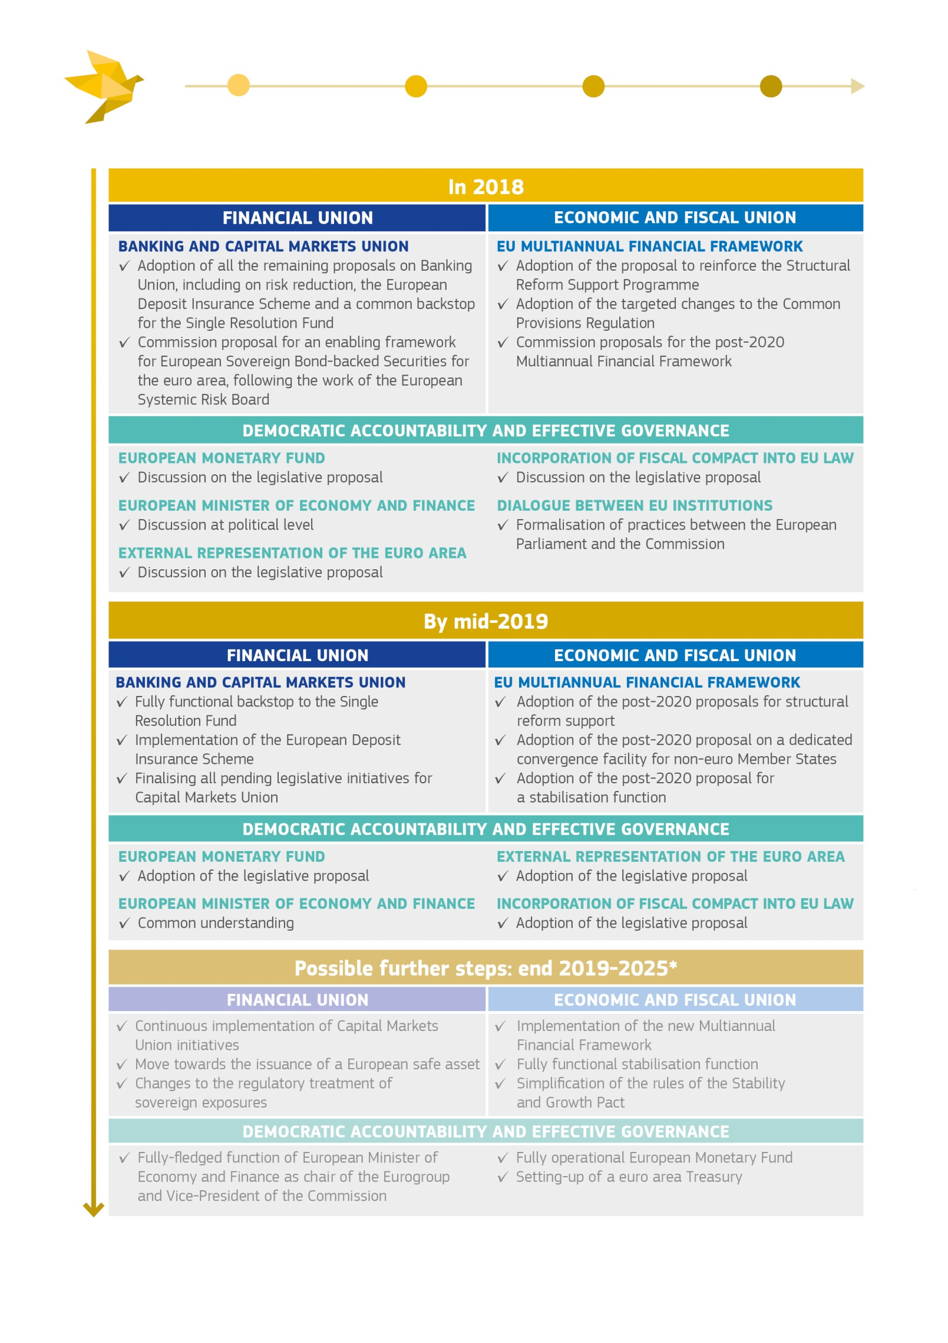   
* For more details, see the Reflection Paper on the deepening of the Economic and Monetary Union of 31 May 2017  
Source: European Commission*

**Appendix 2: Roadmap on completing the Banking Union by 2018 – abstract from the Commission Communication of 11 October 2017**

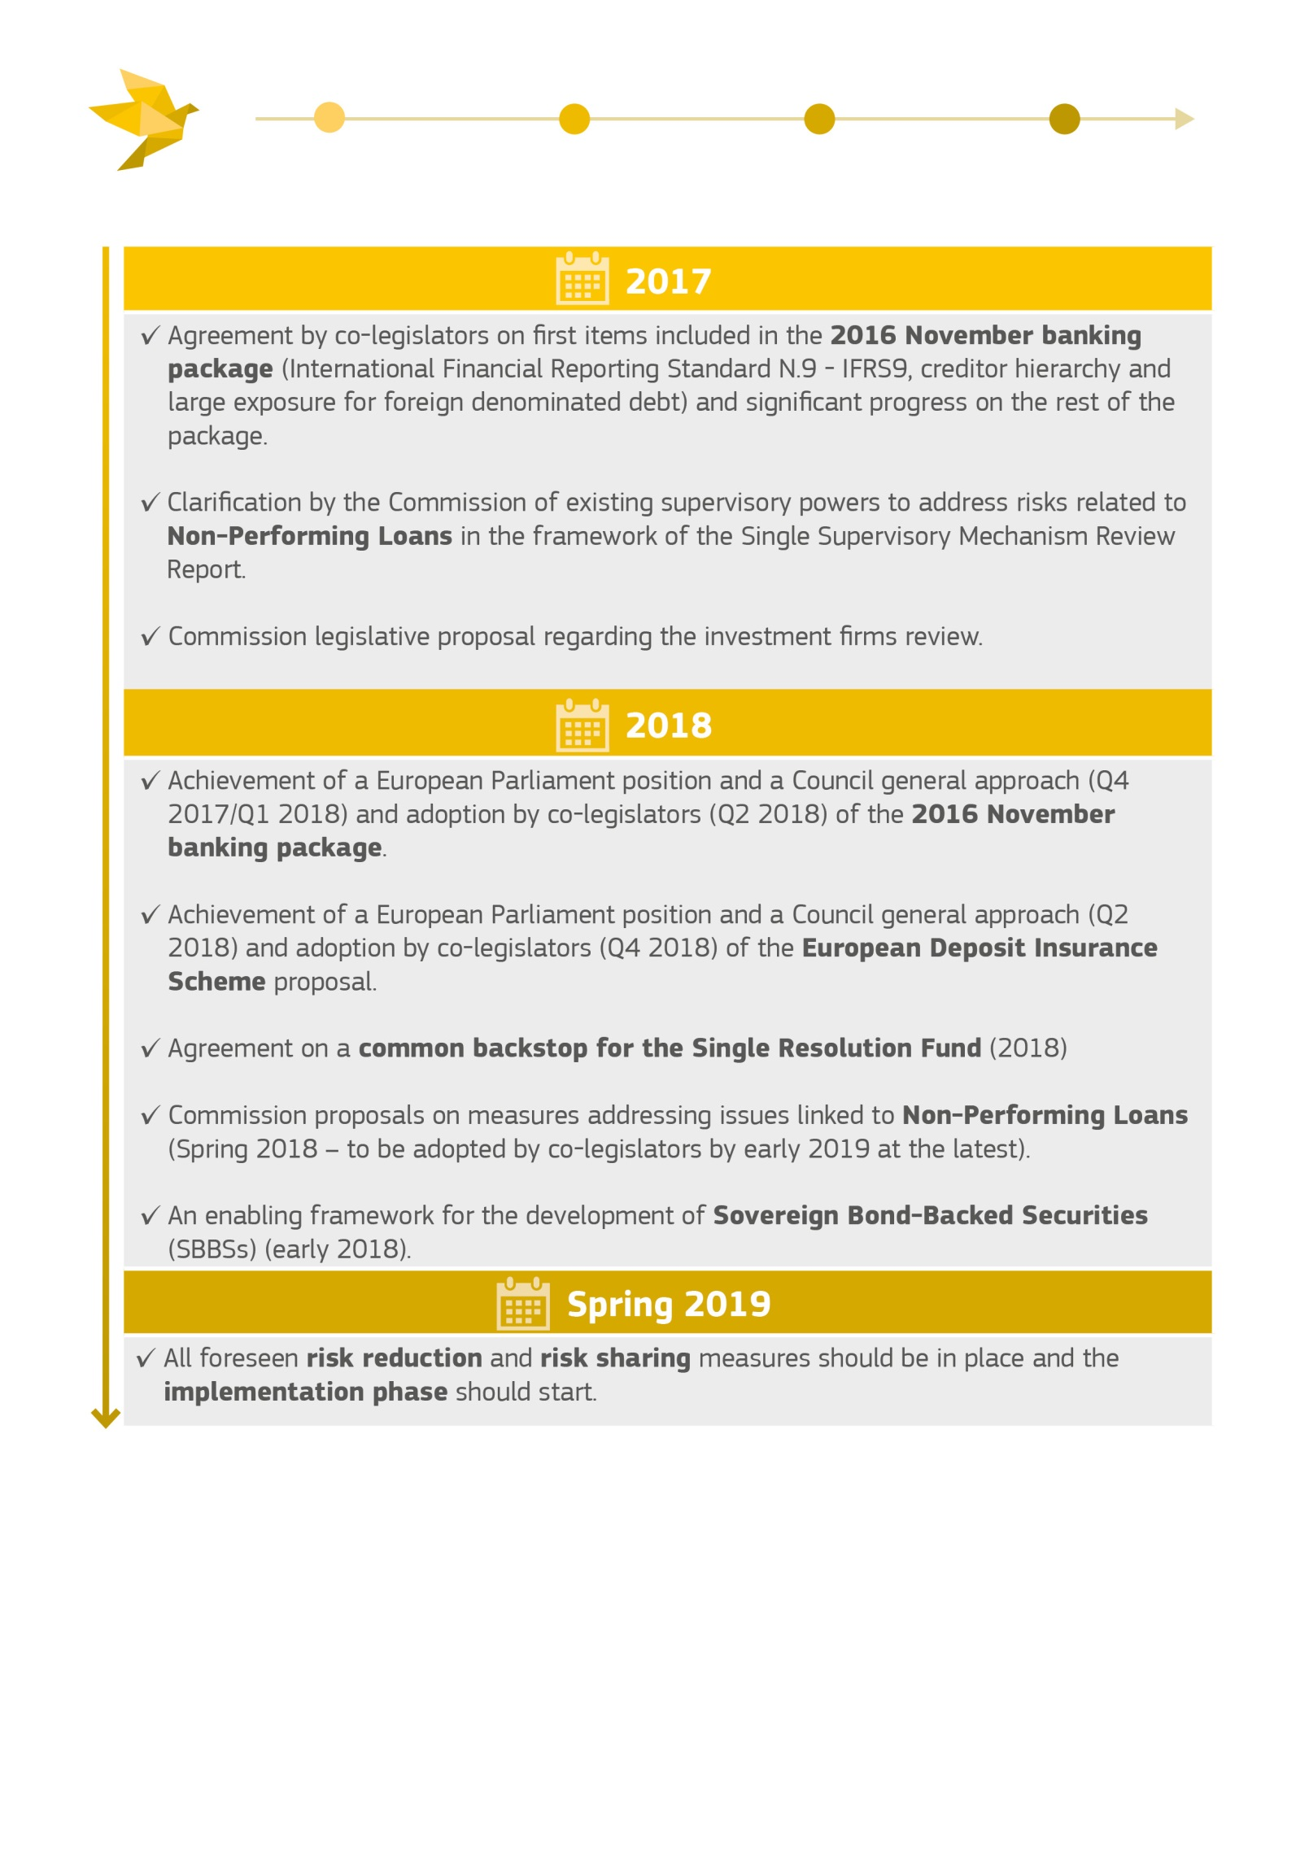

*Source: European Commission*

1. European Economic Forecast Autumn 2017, Institutional Paper 63.
2. Flash Eurobarometer 458, 4 December 2017.
3. “Completing Europe's Economic and Monetary Union”, Report by Jean-Claude Juncker, in close cooperation with Donald Tusk, Jeroen Dijsselbloem, Mario Draghi and Martin Schulz, 22 June 2015.
4. See in particular COM(2017) 592 final, 11 October 2017.
5. COM(2017) 292 final, 8 June 2017.
6. COM(2017) 291, 31 May 2017.
7. COM(2017) 358, 28 June 2017.
8. COM(2017) 2025, 1 March 2017.
9. President Jean-Claude Juncker’s State of the Union Address 2017, 13 September 2017.
10. Leaders’ Agenda: Building our future together, endorsed by the European Council on 20 October 2017.
11. Among the non-euro Member States,Denmark and Bulgaria have pegged their currency to   
    the euro since the introduction of the latter in 1999. Unlike Denmark, Bulgaria does not participate in   
    the Exchange Rate Mechanism II, but the lev is pegged to the euro through a currency board arrangement.
12. See, in particular, the European Parliament resolutions of 16 February 2017 on i) budgetary capacity for   
    the euro area (2015/2344(INI)), ii) possible evolutions of and adjustments to the current institutional set-up of the European Union (2014/2248(INI)) and iii) improving the functioning of the European Union building on the potential of the Lisbon Treaty (2014/2249(INI)).
13. See, in particular, Eurogroup of 6 November 2017 on “Fiscal capacity and fiscal rules for the Economic and Monetary Union”, Eurogroup of 9 October 2017 on “Deepening Economic and Monetary Union – The role of the European Stability Mechanism” and Eurogroup of 10 July 2017 on “Follow-up on deepening of the Economic and Monetary Union”.
14. European Parliament's resolution of 16 February 2017 on a budgetary capacity for the euro area (2015/2344(INI)).
15. COM(2012)777 “Blueprint for a Deep and Genuine Economic and Monetary Union”, 28 November 2012.
16. The necessity of having a body such as the European Stability Mechanism to safeguard the stability of the euro area is based on factual elements and confirmed by Article 136(3) Treaty on the Functioning of the EU,   
    as well as the second recital of the European Stability Mechanism Treaty, which refer to the current ESM as "a stability mechanism to be activated if indispensable to safeguard the stability of the euro area as a whole".
17. The European Court of Justice has already considered the possibility that Article 352 could be used   
    to establish a Union body in charge of providing financial support to ensure stability of the euro area.   
    See “Pringle case”- judgment of 27 November 2012, Case C-370/12, EU:C:2012:756, paragraph 67.   
    As indicated in footnote 15, the 2012 Commission Blueprint also mentioned the possible use of Article 352.
18. This will ensure compliance with the “Meroni doctrine”. The Meroni doctrine, which arose from Cases H-9/56 and H-10/56 (Meroni v High Authority [1957/1958] ECR 133), relates to the extent to which EU Institutions may delegate their tasks to regulatory agencies. In the context of today's proposal, it should be borne in mind that the endorsement by the Council of discretionary decisions taken by the Boards of the European Monetary Fund will be simplified by the fact that the composition of its Board of Governors is the same as that of the Eurogroup.
19. Regulation (EU) No 806/2014. The Single Resolution Board (SRB) is the resolution authority for large and systemic banks in the euro area, operational since January 2016. The Single Resolution Fund (SRF) is financed via contributions from the euro area banking sector. It may be used to finance resolution costs, provided that all conditions of the regulatory framework are met, including the bail-in of 8% of total liabilities of the bank concerned.
20. Austria, Belgium, Bulgaria, Cyprus, Germany, Denmark, Estonia, Spain, France, Greece, Hungary, Italy, Ireland, Lithuania, Luxembourg, Latvia, Malta, Netherlands, Portugal, Poland, Romania, Sweden, Finland, Slovenia and Slovakia.
21. Article 16 of the Treaty on Stability, Coordination and Governance in the Economic and Monetary Union states that "*within five years, at most, of the date of entry into force of this Treaty, on the basis of an assessment of the experience with its implementation, the necessary steps shall be taken, in accordance with the Treaty on the European Union and the Treaty on the Functioning of the European Union, with the aim of incorporating the substance of this Treaty into the legal framework of the European Union.*"
22. European Parliament resolution of 12 December 2013 on constitutional problems of a multitier governance in the European Union (P7_TA(2013)0598) and resolution of 24 June 2015 on the review of the economic governance framework: stocktaking and challenges (P8_TA(2015)0238).
23. COM(2017) 1201 final, 22 February 2017.
24. COM(2015) 12, 13 January 2015.
25. Regulation (EU) No 1303/2013 laying down common provisions on the European Regional Development Fund, the European Social Fund, the Cohesion Fund, the European Agricultural Fund for Rural Development and the European Maritime and Fisheries Fund and laying down general provisions on the European Regional Development Fund, the European Social Fund, the Cohesion Fund and the European Maritime and Fisheries Fund and repealing Council Regulation (EC) No 1083/2006 (OJ L 347, 20.12.2013, p. 320–469).
26. The Structural Support Programme (SRSP) was established in May 2017 to support financially the activities of the Structural Reform Support Service.
27. Regulation (EU) No 2017/825 on the establishment of the Structural Reform Support Programme for the period 2017 to 2020 and amending Regulations (EU) No 1303/2013 and (EU) No 1305/2013 (OJ L 19.05.2017, p. 129).
28. Article 2 of Protocol No 14 on the Euro Group, annexed to the Treaty on the European Union and to the Treaty on the Functioning of the European Union, establishes the rules for electing the President of the Eurogroup. There is no incompatibility between this role and that of a member of the Commission.
29. COM(2017) 592 final, 11 October 2017.
30. Commission proposals of 23 November 2016 amending the following pieces of legislation: Regulation No 575/2013, Directive 2013/36/EU, Directive 2014/59/EU and Council implementing regulation 2015/81 of 19 December 2014.
31. See for example ECOFIN conclusions on non-performing loans in the Banking Sector (doc. 9854/17).
32. COM(2015) 586 final, 24 November 2015.
33. See for instance COM(2016) 726 final, 16 November 2016 and COM(2017) 770 final, 22 November 2017.
34. The adoption of the Pillar was complemented by the establishment of a Social Scoreboard, which will be integrated in the 2018 European Semester and serve as a reference framework for the monitoring of employment and social performance.
35. COM(2015) 603 final, 21 October 2015.