

1. INTRODUCTION

This Staff Working Document contains qualitative and quantitative information on the application of the Directive 2011/16/EU (the Directive or DAC) since its entry into force on 1 January 2013. It looks at the key provisions of the Directive, in particular exchange of information (EOI) it its various forms: on request, spontaneously and in automatic manner; and at other ways to cooperate.

This report has been written by the Commission services on the basis of information and data gathered through questionnaires and statistics from Member States about their efforts in applying the Directive, as well as on the practical experiences when cooperating with other Member States.

As regards statistical data, Member States replies rely on their national databases and registering systems, if any, which may differ considerably among them, resulting in information not having the same level of detail. This is especially true for the quantification of the accrued tax benefit thanks to administrative cooperation which has not been reported by the majority of Member States due to the difficulties underlined by the Member States to obtain the figures.

The difficulty in evaluating the appropriate share of added revenues due to administrative cooperation activities is the main reason given by Member States for not being able to give statistical data on accrued tax benefit. Normally the tax authorities use several international and national sources and tools to get all necessary details of a certain taxpayer under tax audit, and administrative cooperation within EU is only one of many sources for information.

2. APPLICATION OF ADMINISTRATIVE COOPERATION IN 2013-MID 2017

A consolidated version of DAC[1] contains 31 articles and several annexes. It is divided into chapters: the first chapter concerns general provisions, and deals with subject matter, scope, definitions and organisations; the second chapter covers exchange of information; the third chapter is about other forms of administrative cooperation; the fourth chapter sets out the "rules of the game" i.e. the conditions governing administrative cooperation; the fifth chapter is about the relations with the Commission; the sixth is about relations with third countries; finally, chapter seven lists general and final provisions.

The Directive aims to ensure a strong legal basis for administrative cooperation within the Union leading to a higher degree of transparency: wide in scope, it provides for a comprehensive framework for administrative cooperation, while improving the timeline for the exchange of information on request and spontaneously. Its operation enhances the automatic exchange of information, allowing for a broad use of the information exchanged and ensuring a level playing field between the Member States, due to the most favoured nation clause foreseen in Article 19.

By implementing the legal provisions of the Directive, effective exchange of information is accomplished despite the differences in domestic legislations, such as the different statute of limitation for carrying out tax audits. To support the cooperation foreseen in the Directive, innovative standardised forms for the exchanges and a secure channel of communication were developed.

3. THE SUBJECT AND THE SCOPE OF ADMINISTRATIVE COOPERATION (ARTICLES 1-2)

Member States have applied the Directive first and foremost by exchanging tax information with each other. Information is to be exchanged when foreseeably relevant[2].

In the exchange of information on request Member States have applied the principle of foreseeable relevance with no major problem, even if bilateral contacts have been required sometimes to get a confirmation that the requested information was relevant to assess the taxpayer's tax obligation in the requesting Member State.

On the other hand, in the framework of spontaneous exchange of information the principle of foreseeable relevance was applied in a very restrictive manner by Member States, with specific reference to the cross-border tax rulings and advance pricing agreements and few, if any, were exchanged. The LuxLeaks scandal raised awareness on the inappropriate application of the Directive and, as further explained later in this report, the Commission intervened proposing the mandatory automatic exchange of cross-border tax rulings and advance pricing agreements with lead to the final adoption of the Directive 2015/2376/EU (DAC 3).

Contrary to fears that it might hinder mutual assistance in criminal matters there is evidence of improvements in interaction between administrative cooperation and criminal matters. For example, information gathered from exchanges may be used for other purposes such as in criminal investigations of tax crimes.

4. ORGANISATION (ARTICLE 4)

The Directive reinforced the efficiency of cooperation by underlining the importance of decentralised organisation in the Member States.

All Member States have designated a competent authority, typically their tax administration, for the purposes of the Directive. They have also designated a central liaison office (CLO) within their competent authorities who have principal responsibility for contacts with other Member States. In most cases, Member States have in addition designated liaison departments who are entitled to directly exchange information. Several have designated individual officials as authorised to exchange information.

The number of staff members dedicated to administrative cooperation in the field of direct taxation differed in 2013-2014 widely between Member States, being in total from 1 responsible person in the central liaison office and going up to 84 persons (4 at CLO level, 80 in other departments or units). Most usually the number was between 2 and 24 staff members. During 2015-2016 CLO was acting as a coordination office with supervision of the overall application of the Directive in 20 Member States, and as an operational unit in 8 Member States. Member States have reported that relatively few staff is dedicated to administrative cooperation. Most tax administrations report having between 1 to 5 staff in the CLOs.

5. EXCHANGE OF INFORMATION ON REQUEST (ARTICLES 5-6-7 AND 17-18)

Exchange of information on request (EOIR) is the core function of administrative cooperation and takes place in steps, as defined in Articles 5, 6 and 7 of the Directive. The competent authority of a Member State sends a request for information to another to get information that is foreseeably relevant to the administration and enforcement of the domestic laws of the requesting Member State. The requested authority acknowledges receipt of the request and performs all the activities needed to gather such information, finally, once the information has become available, the requested Member State replies to the requesting authority.

Since 2013, overall Member States have sent each other nearly 35,000 requests for information. The charts below show the percentage of requests sent and received per Member State.

Picture 1: Percentage of requests **sent** per Member State (NB: the percentages are rounded to one decimal)

Picture 2: Percentage of requests **received** per Member State(NB: the percentages are rounded to one decimal)

Member States reported that the requests are formulated in a clear way and therefore the quality of the requests is in general very good. In very few cases they have notified deficiencies and/or requested additional background information from the requesting Member State as foreseen by Art.7(4), mainly to request additional information needed for the proper identification of the concerned taxpayer.

The main types of information which are generally requested from each other Member State in case of **natural persons** are: residency status, banking information, business transactions, tax returns, general tax information and payments.

The main types of information which are generally requested concerning **legal persons and other arrangements** are: ownership information, tax returns, business transactions, banking information, transfer pricing and existence of human and material resources (i.e. to assess the existance of a permanent establishement). [3]

The obligation to provide information even if held by banks or other financial institutions contained in Article 18 led to a greater tax transparency and can be regarded as one of the most important achievements of the Directive. Member States have been exchanging banking information over the period under examination and did not report any particular problem in the practice of the exchanges, apart from some delays due to the existing domestic procedures to obtain the information from the bank or other financial institutions. The number of requests related to banking information was not collected.

Since 2013, overall Member States have received around 31,000 full replies[4], out of which more than half were given within the six months deadline. Within that deadline Member States have also provided partial replies to the pending requests, but the related figures are not readily available.

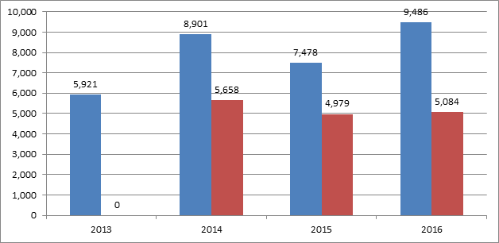

Picture 3: Total number of full replies received (blue) and number of those replies received within 6 months (red) NB: in 2013 the number of replies received within 6 months was not collected from Member States.

Member States reported that some delays in replying within the relevant time frame were due to the complexity of the case, the difficulties encountered to obtain the information from the taxpayer and/or an ongoing investigation. In such a case, as per Art. 7(5), they informed the requesting Member State of the reasons and the expected date of the reply. Member States usually send reminders regarding the pending request until a reply is received.

Member States reported that in very few circumstances they agreed bilaterally on a different time limit than the standard of 2 months and 6 months according to Art. 7(2). This has occurred especially in complex cases often involving also a request for information held by banks. There the process includes first a request from one Member State to another Member State, which then has to contact the bank in its country and inquire for certain information needed in another Member State for tax purposes.

Member States are in general satisfied with the overall quality and the completeness of the information received. They praised as well the efforts made in order to comply with given deadlines and to send information or a status report on the measures taken. However, Member States consider the requirement to acknowledge receipt of a request as per Article7(3) burdensome and have suggested some automation to ease the process.

Member States reported that in some instances they have been unable to respond and, in line with Art. 7(6), have informed the requesting Member State of the reason, being most frequently the taxpayer not known, unattainable or not existing anymore, the domestic legal framework constraints in the requested Member State and the expiration of the statute of limitation.

Since 2013, there have been only 31 explicit refusals to reply to a request for information for one of the circumstances listed in Article 17.

The Commission services acknowledge the efforts made by the Member States to comply with the time limits established by the Directive but would encourage them to continue exchanging good quality information and to improve the timeliness of the replies.

6. AUTOMATIC EXCHANGE OF INFORMATION (ARTICLE 8)

Automatic exchange of information (AEOI) in administrative cooperation means sending predefined tax data regularly without prior request from one Member State to the Member State where a taxpayer is resident. The aim is to provide structured and more detailed tax information about the activities of specific and identified taxpayers who are resident in a given Member State but who have reportable income and capital in another Member State.

In line with the provisions of Article 8(1) of the Directive Member States sent bilaterally information - **already available and retrievable** - in an automated manner for taxable periods 2014 and 2015 on the five categories of income and capital: income from employment (IE), director’s fees (DF), life insurance products (LIP), pensions (PEN), ownership of and income from immovable property (IP). Sending the information on each category was given in the Directive a step-by-step approach, where the first exchanges took place in 2015 regarding taxable period of 2014. The target was for all Member States to exchange information under at least three of the five categories regarding taxable periods as from 1 January 2017.

Before 1 January 2019, the Commission shall submit a report that provides an overview of AEOI. If appropriate, the Commission shall propose to the Council to consider further steps to strengthen the efficiency of AEOI, such as: the obligation for Member States to communicate all five categories of income and capital, to include other categories and items, and to review the conditions laid down in Article 8(1), such as the availability of information.

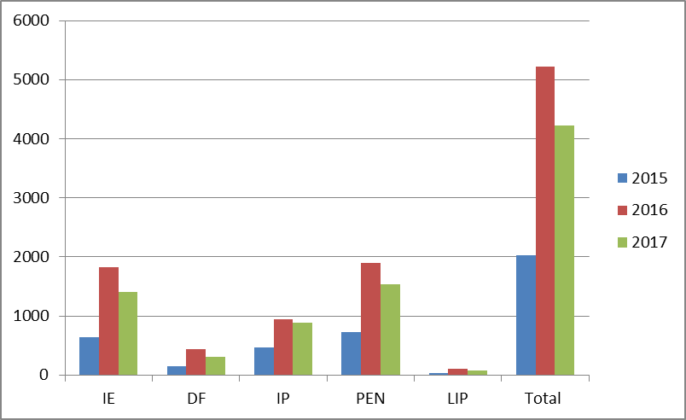

Picture 4: Total number of messages sent between 2015-2017, by income/capital category (NB: one message may contain thousands of records). In 2017 number of messages sent is tracked until end of August only.

Systematic and automatic communication of predefined information is just the first step of a long processing. The receiving Member State matches the data received with a taxpayer in the national database, and if the matching is successfully performed, the information received is finally usable. Therefore, the quality of data must be ensured in order for the receiving Member State to correctly and efficiently identify the relevant taxpayer in the national database and use the data received. The more accurate the provided information is, containing for example the correct tax identification number (TIN) and full name, the lesser the need for manual intervention for matching at the receiving Member State. The more incomplete the information is the more details have to be reviewed, such as name, address, birth date. The identification process can still be automated to an extent, but poor information which requires manual matching means more work for the receiving administration. Non-matching should not exist in the long run as the quality of information should improve thanks to the bilateral feedback, by the efforts of the sending Member State.

Matching: an example of income from employment

The charts below show how identifying the taxpayer in the residence country has progressed during the first two years in one Member State in relation to employment income information.

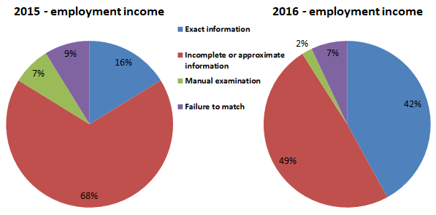

Picture 5: An example of division of taxpayer identification methods actually used on AEOI data, where exact information and incomplete information have been done in an automated manner.

The increase of automated matching from 84 % to 91 % with exact information and incomplete information in the example of employment income can be explained by the fact that most Member States have started the exchanges with this income type as it has most typically been available for AEOI. Thus, for this income type there has already been a possibility for enhancement in the national collection of the data. Improvement of the quality of the data sent has simplified matching in the receiving Member State.

On the contrary to the matching progress related to employment income, the matching for life insurance products and directors' fees did not progress as much, because the data flows were modest during 2015 and only a bit more extensive in 2016. The low amount of data exchanged may mean that the data was not available in majority of the Member States, or that the efforts for retrieving the data were still under work in the Member States.

During the first two years of AEOI activities, Member States have reported that they generally see Article 8 working well for the enhancement of tax data flow to the residence country. Some have expressed wishes for an extension of the scope of mandatory AEOI, and some consider the AEOI provision on a general level as one of the best achievements of the Directive.

The scope of mandatory AEOI has been expanded three times through amendments to the Directive. Thereby, AEOI of financial account data, namely dividends, interests, other capital income, gross proceeds as well as the account balance, started in September 2017 (DAC2), AEOI of advance cross-border tax rulings and advance pricing agreements (APA) by July 2017 (DAC3), and Country by Country on reporting of multinational enterprises in 2018 (DAC4). The AEOI on advance cross-border tax rulings will provide the Member States with details on arrangements made between tax authorities and taxpayers in the EU that may have an impact on their tax base. It is based on the use of a central depository administered by the Commission where all Member States can access the information uploaded by any other Member State. Thus, it is a different procedure from the standard AEOI that concerns "bulk" data on income and assets exchanged via secured channels bilaterally between Member States.

7. SPONTANEOUS EXCHANGE OF INFORMATION (ARTICLES 9-10)

Categories covered by spontaneous exchange of information (SEOI) include information which may be relevant for another Member State's administration and enforcement of the domestic tax laws for avoiding double taxation or double non taxation, and for preventing profit shifting. Furthermore, Member States may inform each other of any information of which they are aware and which they consider may be useful for the tax authorities of other Member States.

Since 2013 all Member States have sent information spontaneously : overall around 70,000 SEOI exchanges have taken place between Member States. In the below chart the number of SEOI in 2014 reflects a special project carried out between two Member States.

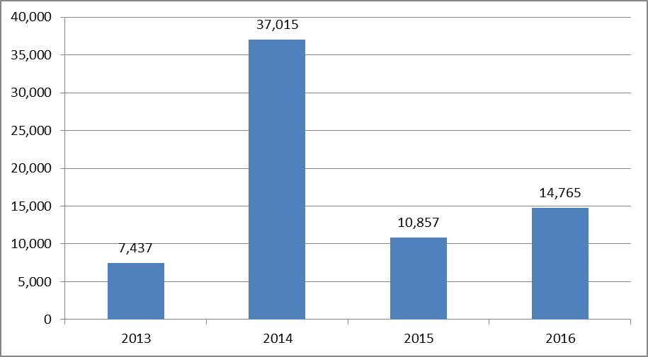

Picture 6: Total number of SEOI **sent** per year

No evidence is available to assess the timeliness of information sent, i.e. whether information was sent at the latest one month after it became available. Awareness in the Member States is raised through internal guidance on administrative cooperation on tax matters, training to tax auditors and internal time limits to report the information to the competent authority in charge of sending the spontaneous information.

Information exchanged spontaneously usually covered: employment (dependent work) details not covered in AEOI, payments, business transactions, other incomes and in the recent years cross-border tax rulings and advance pricing arrangements (APAs). However, the items listed above cannot be considered exhaustive because not all Member States keep records of the type of information exchanged spontaneously.

Generally, all information provided spontaneously should be effective as it is selected by tax officials relying on their own practical experience and expertise in tax collection. Member States rated spontaneous exchange of information as most effective in the following fields: employment, business transactions, payments, independent activities and general tax information. Since the Commission proposed for DAC3, it is noteworthy that the spontaneous exchange of tax rulings and APAs increased with special reference to Luxembourg and the Netherlands as sending Member States and Germany, France and the Netherlands as receiving Member States.

It was evident that the objective of ensuring that all Member States receive sufficient information on tax rulings and APAs could not be achieved through non-coordinated action implemented by each Member State individually on the basis of SEOI. Nor did the Model Instruction issued in 2013 following a Code of Conduct recommendation in 2012 lead to the exchanges of rulings. The exchange of information on cross-border tax rulings that may affect the tax bases of more than one Member State required a common and compulsory approach through an action at Union level (DAC3), ensuring tax transparency and effective cooperation between tax administrations in fighting tax avoidance. Picture 7 highlights the effects of this action.

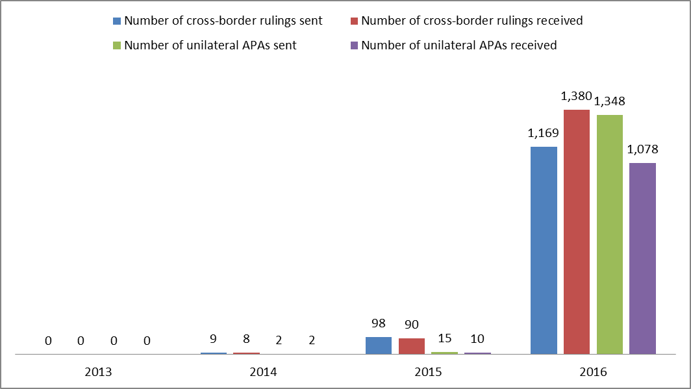

Picture 7: Total number of cross-border rulings and APAs sent/received per year

8. PRESENCE AND PARTICIPATION IN ADMINISTRATIVE ENQUIRIES (ARTICLE 11)

This particular form of cooperation is designed to support the effective monitoring of procedures in cross-border transactions and the correct assessment and collection of taxes due for cross border activities. In a single market where taxpayers can operate without borders, tax authorities need to "cross" the borders as well. In addition to being present, officials may gather information by interviewing individuals and examining documents if allowed under the laws of the Member State which they are visiting. The national legislation differs significantly with regard to allowing visiting officials to interview individuals and examine records. Only in just over half of the Member States (15) are such actions allowed. [5]

Since the entry into force of the Directive, Member States (Austria, Belgium, Cyprus, Germany, Denmark, Estonia, Finland, Hungary, Ireland, Italy, Latvia, Netherlands and Sweden) have increased the use of this provision mainly with neighbouring countries: 32 in 2013, 32 in 2014, 87 in 2015 and 62 in 2016. The tool is used mainly in relation to tax residence, the existence of a permanent establishment, transfer pricing, and letterbox companies. The Fiscalis 2020 Programme finances the presence of officials in other countries' offices and their participation in administrative enquiries.

9. SIMULTANEOUS CONTROLS (Article 12)

The tax situation of one or more persons or related parties liable to tax established in several Member States is often of common or complementary interest. In those cases, Member States may agree to conduct simultaneous tax controls, in their own territory, of one or more taxpayers of common or complementary interest to them. After controls are concluded, Member States exchange the information they have collected. The meetings of tax officials involved in simultaneous controls are financed by the Fiscalis 2020 Programme.

Member States acknowledge the effectiveness of this instrument and are generally satisfied with its functioning. Since the entry into force of the Directive, all Member States except Bulgaria and Romania have either initiated or taken part to simultaneous controls. Overall a total number of 119 simultaneous controls have been initiated by the Member States although more than two Member States may be involved in a simultaneous control. The controls mainly relate to transfer pricing issues.

Member States claim some obstacles in including these initiatives in established annual audit planning programmes, due also to the difficulty in convincing management of the value in investing in audits that may apparently show a benefit only for the Member States initiating the control.

Action 19 of the 2012 Action Plan to strengthen the fight against tax fraud and tax evasion[6] stressed the link between promoting the use of simultaneous controls and the presence of foreign officials as well as the possibility of having joint audits[7] in the future.

In addition, in 2016 the Fiscalis Project Group on joint audits[8] concluded that: "a joint audit gives the widest extent of administrative cooperation and may result in: agreed facts, agreed outcomes, a common approach, a common understanding, greater certainty for taxpayers and administrations, leading to correct taxation. The project group recognised that there will be operational issues and challenges to resolve, but as a starting point a joint audit function cannot work effectively without a legal framework to support it."

10. ADMINISTRATIVE NOTIFICATION (ARTICLE 13)

The Directive lays down procedures for Member States to request another Member State to issue a notification of any instrument and decision concerning the application in its own territory of legislation on taxes covered by the Directive, as for instance notice of assessment to taxpayers.

Since the entry into force of the Directive all Member States have received requests for notification. Overall 1,137 requests for notification have been sent: 223 in 2013, 233 in 2014, 258 in 2015 and 423 in 2016.

Notification works well and smoothly in practice with the exception of very few cases where the taxpayer could not be traced or the company was dissolved. Some complaints have come from taxpayers who received notifications, including documents, in other languages. Currently an excel file is being used for this purpose and some Member States ask for a dedicated e-Form to be integrated in the current IT tool.

11. FEEDBACK (ARTICLE 14)

The feedback requested after an exchange of information on request or spontaneously has to be given as soon as possible and no later than three months after the outcome of the use of the information is known.

Feedback is considered a motivating factor for tax auditors providing a reply to a request for information or identifying situations of interest for another Member State. Feedback could therefore enhance the quality of information provided.

Member States consider feedback provided on the results achieved with spontaneous information received as particularly important. It enables to identify what types of spontaneous exchanges might have fiscal impact in other Member States and, therefore, to make a better estimation of the information that could be relevant and a better use of the resources available.

The bilateral feedback on AEOI under Article 8(1) is mandatory for the Member States and shall be sent once a year in accordance with practical arrangements agreed upon bilaterally. Feedback concerning possible technical errors that would prevent the receiving Member State to use the information is the most important way to improve the national collection methods of tax data. In discussions with Member States it has been identified that there is a need to develop national feedback processes, not only within tax administrations but also between tax administrations and their national reporters, such as banks, employers and pension companies. Feedback is one of the key tools for improving the overall quality of AEOI data in the long run.

12. SHARING OF BEST PRACTICES AND EXPERIENCES (ARTICLE 15)

According to the Directive, Member States, together with the Commission, have to examine and evaluate administrative cooperation and share their experience, in order to improve administrative cooperation and develop it further. This provision is especially important at present: Member States and Commission are facing new challenges in implementing this new legal base and in meeting the need of adapting the existing systems and finding practical solutions that can be shared by all Member States.

The main forum where the Commission and Member States meet to discuss common issues and identify best practices related to the practical implementation of the Directive is the Expert Group on Administrative cooperation in the field of direct taxation (EG ACDT)[9].

Furthermore, specific workshops and project groups financed by the Fiscalis Programme have been set up in order to gather experts from the Member States on specific topics with the aim of having a better cooperation among themselves and with the Commission, and/or to develop concrete outputs[10].

13. DISCLOSURE OF INFORMATION AND DATA PROTECTION (ARTICLES 16 AND 25)

Effective administrative cooperation is based on reciprocity and confidentiality between competent authorities. The Article on the disclosure of information and documents is more detailed than in the Mutual Assistance Directive ("MAD") of 1977, and the intention was to propose a broad approach for the disclosure while at the same time it was aimed to protect both the Member State and taxpayers' interests. As a general rule Member States have to keep secret the information exchanged, use it only for the purposes specified in the Directive and ensure data exchanged are protected. Since the entry into force of the Directive, there is no evidence of any breach of **secrecy** and/or **data protection** provisions.

The received data may be used to assess and recover taxes mentioned in the Directive, but also to assess and **enforce other taxes and duties, or compulsory social security contributions**. Some Member States have reported having used the information for these secondary purposes.

Half of the Member States have used information received from other Member States in connection with judicial and administrative proceedings related to **infringement of tax law** and proceedings that may involve penalties. The frequency of this kind of use has however been quite low if it is considered on an annual basis; in 2016 usually for 1 to 5 cases per Member State, although one Member State reported as many as 20 to 50 cases.

If the Member State that sends the information allows so nationally, information may be used for **other purposes**. Permission has been asked for the use of information that was usually related to anti-money laundering, other economic or financial crimes, other criminal cases, for other public authorities (e.g. statistical purposes) and bookkeeping crime procedures. Member States have granted the permission whenever national legislation allows use for similar purposes in domestic cases. Normally, granting permission requires a case-by-case analysis.

Member States may transmit information received from another Member State to a **third Member State**. In 2013, only one Member State reported having done so, whereas, in 2016, 7 Member States transmitted information likely to be useful to a third Member State.

14. STANDARD FORMS AND COMPUTERISED FORMATS, PRACTICAL ARRANGEMENTS (ARTICLES 20-21)

Electronic standard forms for the practical implementation of administrative cooperation were developed together with Member States in order to make the exchanges more efficient and user-friendly. The forms were structured in a way that all necessary information to identify the taxpayer and to process the exchange has to be provided, including the tax purpose for which the information is sought. The eFDT application (*electronic forms in direct taxation*) containing the forms was deployed nationally and frequent updates have been provided since implementation on 1 January 2013. The Commission is currently working on a central web application for the exchange of the electronic forms. Member States are very satisfied with the use of the electronic standard forms.

For AEOI under Art. 8(1), the standard computerized format was based on data exchange format of Directive 2003/48/EC on taxation of savings income in the form of interest payments. The Commission and the Member States constructed the format to cover several details about the first five categories needed in each Member State for tax purposes. For AEOI on foreign financial account data under Art. 8(3a), or other tax transparency related AEOI under Art. 8a and 8aa, the exchange format is based on a global standard developed at OECD.

The exchange of information is performed in a secure way by using the Common Communication Network secure system, the CCN-mail. In case of request for notification or in case there are voluminous documents to be sent together with a reply Member States may use regular mail.

15. RELATIONS WITH THIRD COUNTRIES (ARTICLE 19)

Article 19 of the Directive enhances the cooperation by introducing an obligation for a Member State to provide to any other Member State the widest cooperation it maintains with a third country. Since 2013 no exchanges took place under this provision.

1. The Directive 2011/16/EU and consequential amendments adopted between 2014 and 2016
2. The foreseeable relevance means that the Member States shall exchange information concerning particular cases and identified taxpayers, and they cannot carry out “**fishing expeditions".**
3. The items listed above cannot be considered complete because not all Member States keep records of the type of information exchanged.
4. The difference between the total number of requests sent and total number of replies received may be explained by (i) a different counting methods between Member States for statistical purposes, (ii) replies falling under different statistical period and (iii) increase of requests due to the introduction of the electronic forms which was not always supported by an increase of the human resources available to deal with the cases.
5. The allowance may depend on the taxpayer's acceptance or on an agreement between the requesting authority and the requested authority upon reciprocity.
6. Communication from the Commission to the European Parliament and the Council: An Action Plan to strengthen the fight against tax fraud and tax evasion. COM/2012/0722 final.
7. The OECD describes a joint audit as two or more countries joining together to form a single audit team to examine an issue(s) / transaction(s) of one or more related taxable persons (both legal entities and individuals) with cross-border business activities, perhaps including cross-border transactions involving related affiliated companies organized in the participating countries, and in which the countries have a common or complementary interest; where the taxpayer jointly makes presentations and shares information with the countries, and the team includes Competent Authority representatives from each country - *Joint Audit Report, OECD, FTA September 2010*
8. Group's details in the Register of Commission Expert Groups: F2020 FPG/049 - Project group on Joint Audits.
9. http://ec.europa.eu/transparency/regexpert/index.cfm?do=groupDetail.groupDetail&groupID=1711&NewSearch=1&NewSearch=1
10. Some examples of output: administrative practices in place within each country as regards administrative cooperation in the field of taxation, bilateral feedback, risk management guidelines on the use of AEOI data and yearly assessment questionnaire.