

## **Introduction**

Plastic is an important and ubiquitous material in our economy and daily lives. It has multiple functions that help tackle a number of the challenges facing our society. Light and innovative materials in cars or planes save fuel and cut CO2emissions. High-performance insulation materials help us save on energy bills. In packaging, plastics help ensure food safety and reduce food waste. Combined with 3D printing, bio-compatible plastic materials can save human lives by enabling medical innovation.

However, too often the way plastics are currently produced, used and discarded fails to capture the economic benefits of a more 'circular' approach and harms the environment. There is an urgent need to tackle the environmental problems that today cast a long shadow over the production, use and consumption of plastics. The million tonnes of plastic litter that end up in the oceans every year are one of their most visible and alarming signs of these problems, causing growing public concern.

Rethinking and improving the functioning of such a complex value chain requires efforts and greater cooperation by all its key players, from plastics producers to recyclers, retailers and consumers. It also calls for innovation and a shared vision to drive investment in the right direction. The plastics industry is very important to the European economy, and increasing its sustainability can bring new opportunities for innovation, competitiveness and job creation, in line with the objectives pursued by the renewed EU Industrial Policy Strategy.[1]

In December 2015, the Commission adopted an EU Action Plan for a circular economy.[2] There, it identified plastics as a key priority and committed itself to ‘prepare a strategy addressing the challenges posed by plastics throughout the value chain and taking into account their entire life-cycle’. In 2017, the Commission confirmed it would focus on plastics production and use and work towards the goal of ensuring that all plastic packaging is recyclable by 2030.[3]

The EU is best placed to lead the transition to the plastics of the future. This strategy lays the foundations to a new plastics economy, where the design and production of plastics and plastic products fully respect reuse, repair and recycling needs and more sustainable materials are developed and promoted. This will deliver greater added value and prosperity in Europe and boost innovation. It will curb plastic pollution and its adverse impact on our lives and the environment. By pursuing these aims, the strategy will also help achieve the priority set by this Commission for an Energy Union with a modern, low-carbon, resource and energy-efficient economy and will make a tangible contribution to reaching the 2030 Sustainable Development Goals and the Paris Agreement.

The strategy presents key commitments for action at EU level. Yet the private sector, together with national and regional authorities, cities and citizens, will also need to mobilise. Similarly, international engagement will be necessary to drive change outside Europe’s borders. With decisive and concerted efforts, Europe can turn challenges into opportunities and set the example for resolute action at global level.

## **Plastics today: Key challenges**

Over the past 50 years, the role and importance of plastics in our economy has consistently grown. **Global production of plastics has increased twentyfold since the 1960s**, reaching 322 million tonnes in 2015. It is expected to double again over the next 20 years.

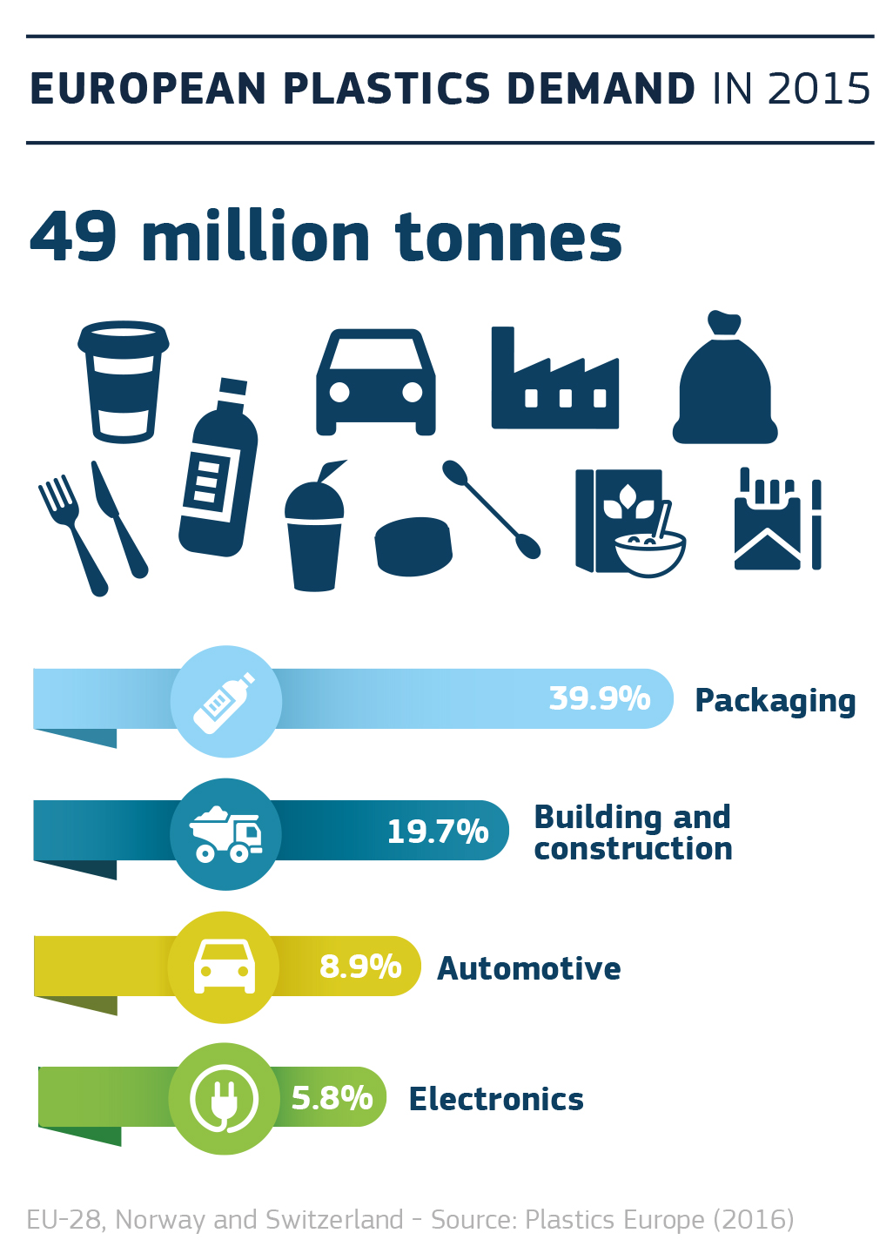

In the EU, **the** **plastics sector employs 1.5 million people[4]** and generated a turnover of EUR 340 billion in 2015. Although plastics production in the EU has been stable in recent years, the EU’s share of the global market is falling as production grows in other parts of the world.

In the EU, the potential for recycling plastic waste remains largely unexploited. **Reuse and recycling of end-of-life plastics is very low**, particularly in comparison with other materials such as paper, glass or metals.

**Around 25.8 million tonnes of plastic waste are generated in Europe every year.[5]** Less than 30% of such waste is collected for recycling. Of this amount, a significant share leaves the EU[6] to be treated in third countries, where different environmental standards may apply.

At the same time, **landfilling and incineration rates of plastic waste remain high** − 31 % and 39 %, respectively − and while landfill has decreased over the past decade, incineration has grown. According to estimates, 95 % of the value of plastic packaging material, i.e. between EUR 70 and 105 billion annually, is lost to the economy after a very short first-use cycle.[7]

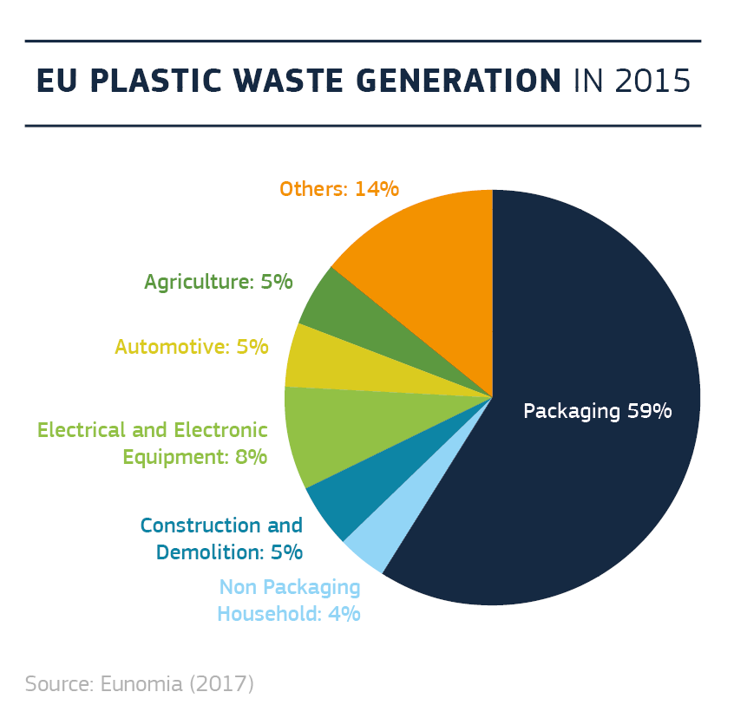

**Demand for recycled plastics today accounts for only around 6 % of plastics demand in Europe**. In recent years, the EU plastic recycling sector has suffered from low commodity prices and uncertainties about market outlets.Investments in new plastic recycling capacity have been held back by the sector’s prospects of low profitability.

It was estimated that **plastics production and the incineration of plastic waste give rise globally to approximately 400 million tonnes of CO2a year**.[8] Using more recycled plastics can reduce dependence on the extraction of fossil fuels for plastics production and curb CO2 emissions.[9] According to estimates,[10] the potential annual energy savings that could be achieved from recycling all global plastic waste is equivalent to 3.5 billion barrels of oil per year.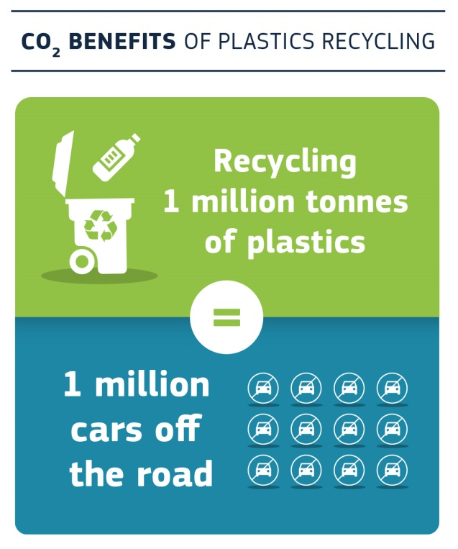

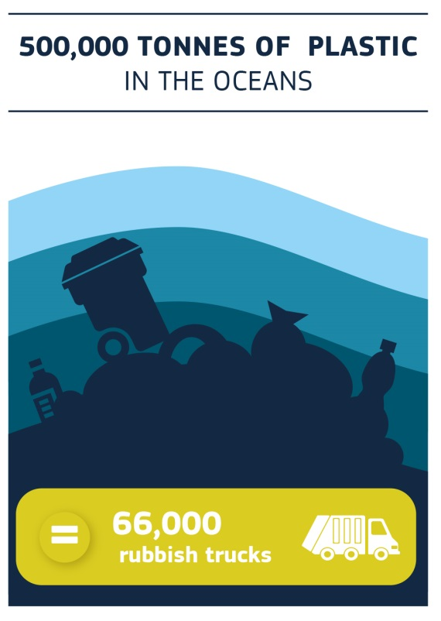Alternative types of feedstock (e.g. bio-based plastics or plastics produced from carbon dioxide or methane), offering the same functionalities of traditional plastics with potentially lower environmental impacts, are also being developed, but at the moment represent a very small share of the market. Increasing the uptake of alternatives that according to solid evidence are more sustainable can also help decrease our dependency on fossil fuels.

Very large quantities of plastic waste leak into the environment from sources both on land and at sea, generating significant economic and environmental damage. **Globally, 5 to 13 million tonnes of plastics — 1.5 to 4 % of global plastics production — end up in the oceans every year.[11]** It is estimated that plastic accounts for over 80 % of marine litter. Plastic debris is then transported by marine currents, sometimes over very long distances. It can be washed up on land,[12] degrade into microplastics or form dense areas of marine litter trapped in ocean gyres. UNEP estimates that damage to marine environments is at least USD 8 billion per year globally.

**In the EU, 150 000 to 500 000 tonnes[13] of plastic waste enter the oceans every year**. This represents a small proportion of global marine litter. Yet, plastic waste from European sources ends up in particularly vulnerable marine areas, such as the Mediterranean Sea and parts of the Arctic Ocean. Recent studies show plastics accumulate in the Mediterranean at a density comparable to the areas of highest plastic accumulation in the oceans. Plastic pollution also affects areas of the European Exclusive Economic Zone, in the outermost regions along the Caribbean Sea, the Indian, Pacific and Atlantic Oceans. In addition to harming the environment, marine litter causes economic damage to activities such as tourism, fisheries and shipping. For instance, the cost of litter to EU fisheries was estimated at about 1 % of total revenues from catches by the EU fleet.[14]

This phenomenon is exacerbated by the **increasing amount of plastic waste generated each year**, and is also fuelled by the growing consumption of ‘single-use’ plastics, i.e. packaging or other consumer products that are thrown away after one brief use, are rarely recycled and prone to being littered. These include small packaging, bags, disposable cups, lids, straws and cutlery, for which plastic is widely used due to its lightness, low cost, and practical features.

New sources of plastic leakage are also on the rise, posing additional potential threats to both the environment and human health. **Microplastics**, tiny fragments of plastic below 5mm in size, accumulate in the sea, where their small size makes it easy for marine life to ingest them. They can also enter the food chain. Recent studies also found microplastics in the air, drinking water and foods like salt or honey, with yet unknown impacts on human health.

In total, it is estimated that between **75 000 and 300 000 tonnes of microplastics are released into the environment each year in the EU**.[15] While a large amount of microplastics result from the fragmentation of larger pieces of plastic waste, significant quantities also enter the environment directly, making it more challenging to track and prevent them.

In addition, the **increasing market shares of plastics with biodegradable properties** bring new opportunities as well as risks. In the absence of clear labelling or marking for consumers, and without adequate waste collection and treatment, it could aggravate plastics leakage and create problems for mechanical recycling. On the other hand, biodegradable plastics can certainly have a role in some applications and the innovation efforts in this field are welcomed.

As plastic value chains are increasingly cross-border, problems and opportunities associated with plastics should be seen in light of **international developments,** including China's recent decision to restrict imports of certain types of plastic waste. There is a growing awareness of the global nature of these challenges, as shown by international initiatives on marine litter, like the UN Global Partnership on Marine Litter[16] and the action plans put forward by the G7 and G20.[17] Plastic pollution was also identified as one of the main pressures on healthy oceans at the international ‘Our Ocean Conference’, hosted by the EU in October 2017. A resolution on marine litter and microplastics was adopted at the United Nation Environment Assembly in December 2017.[18]

## **Turning challenges into opportunities: A vision for a circular plastics economy**

Moving decisively towards a more prosperous and sustainable plastics economy could deliver considerable benefits. To reap these, Europe needs a strategic vision, setting out what a ‘circular’ plastics economy could look like in the decades ahead. This vision needs to promote investment in innovative solutions and turn today’s challenges into opportunities. While the EU will propose concrete measures to achieve this vision, making it a reality will require action from all players in the plastic value chain, from plastic producers and designers, through brands and retailers, to recyclers. Similarly, civil society, the scientific community, businesses and local authorities will have a decisive role to play in making a difference, working together with regional and national governments to bring about positive change.

**‘A vision for Europe’s new plastics economy’**

**A smart, innovative and sustainable plastics industry, where design and production fully respects the needs of reuse, repair, and recycling, brings growth and jobs to Europe and helps cut EU's greenhouse gas emissions and dependence on imported fossil fuels.**

* Plastics and products containing plastics are designed to allow for greater durability, reuse and high-quality recycling. By 2030, all plastics packaging placed on the EU market is either reusable or can be recycled in a cost-effective manner.
* Changes in production and design enable higher plastics recycling rates for all key applications. By 2030, more than half of plastics waste generated in Europe is recycled. Separate collection of plastics waste reaches very high levels. Recycling of plastics packaging waste achieves levels comparable with those of other packaging materials.
* EU plastics recycling capacity is significantly extended and modernised. By 2030, sorting and recycling capacity has increased fourfold since 2015, leading to the creation of 200 000 new jobs, spread all across Europe.[19]
* Thanks to improved separate collection and investment in innovation, skills and capacity upscaling, export of poorly sorted plastics waste has been phased out. Recycled plastics have become an increasingly valuable feedstock for industries, both at home and abroad.
* The plastics value chain is far more integrated, and the chemical industry works closely with plastics recyclers to help them find wider and higher value applications for their output. Substances hampering recycling processes have been replaced or phased out.
* The market for recycled and innovative plastics is successfully established, with clear growth perspectives as more products incorporate some recycled content. Demand for recycled plastics in Europe has grown four-fold, providing a stable flow of revenues for the recycling sector and job security for its growing workforce.
* More plastic recycling helps reduce Europe’s dependence on imported fossil fuel and cut CO2emissions, in line with commitments under the Paris Agreement.
* Innovative materials and alternative feedstocks for plastic production are developed and used where evidence clearly shows that they are more sustainable compared to the non-renewable alternatives. This supports efforts on decarbonisation and creating additional opportunities for growth.
* Europe confirms its leadership in sorting and recycling equipment and technologies. Exports rise in lockstep with global demand for more sustainable ways of processing end-of-life plastics.

**In Europe, citizens, government and industry support more sustainable and safer consumption and production patterns for plastics. This provides a fertile ground for social innovation and entrepreneurship, creating a wealth of opportunities for all Europeans.**

* Plastic waste generation is decoupled from growth. Citizens are aware of the need to avoid waste, and make choices accordingly. Consumers, as key players, are incentivised, made aware of key benefits and thus enabled to contribute actively to the transition. Better design, new business models and innovative products emerge that offer more sustainable consumption patterns.
* Many entrepreneurs see the need for more resolute action on plastics waste prevention as a business opportunity. Increasingly, new companies emerge that provide circular solutions, such as reverse logistics for packaging or alternatives to disposable plastics, and they benefit from the development of digitisation.
* The leakage of plastics into the environment decreases drastically. Effective waste collection systems, combined with a drop in waste generation and with increased consumer awareness, avoid litter and ensure that waste is handled appropriately. Marine litter from sea-based sources such as ships, fishing and aquaculture are significantly reduced. Cleaner beaches and seas foster activities such as tourism and fisheries, and preserve fragile ecosystems. All major European cities are much cleaner.
* Innovative solutions are developed to prevent microplastics from reaching the seas. Their origin, routes of travel, and effects on human health are better understood, and industry and public authorities are working together to prevent them from ending up in our oceans and our air, drinking water or on our plates.
* The EU is taking a leading role in a global dynamic, with countries engaging and cooperating to halt the flow of plastics into the oceans and taking remedial action against plastics waste already accumulated. Best practices are disseminated widely, scientific knowledge improves, citizens mobilise, and innovators and scientists develop solutions that can be applied worldwide.

## **The way forward: turning vision into reality**

To move towards that vision, this strategy proposes an ambitious set of EU measures.[20] These will be put forward in line with the Better Regulation principles. In particular, any measure likely to have significant socioeconomic impact will be accompanied by an impact assessment. Recognising the importance and need of common efforts, the strategy also identifies key actions for national and regional authorities and industry.[21]

**4.1 Improving the economics and quality of plastics recycling**

Stepping up the recycling of plastics can bring significant environmental and economic benefits. Higher levels of plastic recycling, comparable with those of other materials, will only be achieved by improving the way plastics and plastics articles are produced and designed. It will also require increased cooperation across the value chain: from industry, plastics manufacturers and converters to public and private waste management companies. Specifically, key players should work together to:

* improve design and support innovation to make plastics and plastic products easier to recycle;
* expand and improve the separate collection of plastic waste, to ensure quality inputs to the recycling industry;
* expand and modernise the EU’s sorting and recycling capacity;
* create viable markets for recycled and renewable plastics.

Over the past months, the Commission facilitated a cross-industry dialogue and now calls on the industries involved[22] to swiftly come forward with an ambitious and concrete set of voluntary commitments to back this strategy and its vision for 2030.

To support these developments, the Commission has already proposed new rules on waste management.[23]These include clearer obligations for national authorities to step up separate collection, targets to encourage investment in recycling capacity and avoid infrastructural overcapacity for processing mixed waste (e.g. incineration), and more closely harmonised rules on the use of extended producer responsibility. The Commission has consistently called on the co-legislators to swiftly agree on these new rules. Once adopted and implemented, this new European legislation should do much to improve the current situation, driving public and private investment in the right direction. However, additional and more targeted action is needed to complement waste laws and remove barriers that are specific to the plastics sector.

*Design for recyclability*

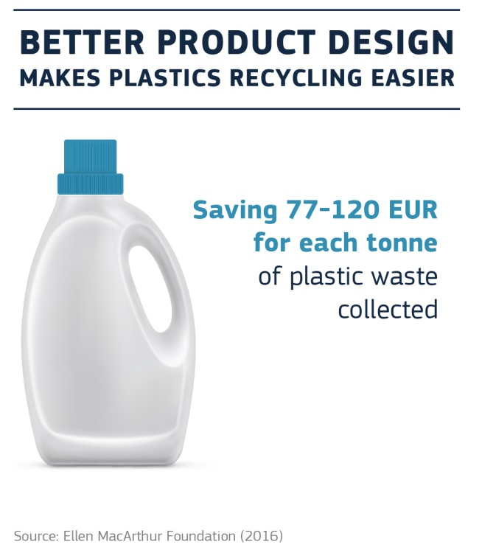Today, producers of plastic articles and packaging have little or no incentive to take into account the needs of recycling or reuse when they design their products. Plastics are made from a range of polymers and are highly customised, with specific additives to meet each manufacturer’s functional and/or aesthetic requirements. This diversity can complicate the recycling process, make it more costly, and affect the quality and value of recycled plastic. Specific design choices, some of which are driven by marketing considerations (e.g. the use of very dark colours) can also negatively affect the value of recyclates.

Plastics packaging is a priority area when it comes to design for recyclability. Today it accounts for about 60 % of post-consumer plastic waste[24] in the EU, and product design is one of the keys to improve recycling levels. It has been calculated that design improvements could halve the cost of recycling plastic packaging waste.[25]

In 2015, the Commission already proposed that by 2025 at least 55 % of all plastics packaging in the EU should be recycled. If greater levels of high-quality recycling are to be reached, design issues must be addressed far more systematically.

To support improved design while preserving the internal market, EU action is essential. The Commission will work on a revision of the essential requirements for placing packaging on the market.[26] The objective will be to ensure that, by 2030, all plastics packaging placed on the EU market is reusable or easily recycled.[27] In this context, the Commission will also look into ways of maximising the impact of new rules on Extended Producers Responsibility (EPR), and support the development of economic incentives to reward the most sustainable design choices. It will also assess the potential for setting a new recycling target for plastic packaging, similar to those put forward in 2015 for other packaging materials.

Construction and the automotive, furniture and electronics sectors are also important applications for plastics use and are a significant source of plastics waste that could be recycled. For these applications, lack of information regarding the possible presence of chemicals of concern (e.g. flame retardants) creates a significant obstacle to achieving higher recycling rates. As part of its work on the interface between chemicals, waste and product policies, the Commission is proposing to accelerate work in order to identify possible ways to make chemicals easier to trace in recycled streams. The aim will be to make it simpler to process or remove these substances during recycling, thus ensuring a high level of health and environmental protection.

The Commission also remains committed to developing, where appropriate, product requirements under the Ecodesign Directive that take account of circular economy aspects, including recyclability.[28] This will make it easier to recycle plastics used in a wide variety of electrical appliances and electronic goods. The Commission has already proposed mandatory product design and marking requirements to make it easier and safer to dismantle, reuse and recycle electronic displays (e.g. flat computer or television screens). It has also developed criteria to improve recyclability of plastics in its Ecolabel and Green Public Procurement criteria (e.g. marking large plastic parts to facilitate sorting, designing plastic packaging for recyclability, and designing items for easy disassembly in furniture and computers).

*Boosting demand for recycled plastics*

Weak demand for recycled plastics is another major obstacle to transforming the plastics value chain. In the EU, uptake of recycled plastics in new products is low and often remains limited to low-value or niche applications. Uncertainties concerning market outlets and profitability are holding back the investment necessary to scale up and modernise EU plastics recycling capacity and boost innovation. Recent developments in international trade, restricting key export routes for plastics waste collected for recycling,[29] make it more urgent to develop a European market for recycled plastics.

One of the reasons for the low use of recycled plastics is the misgivings of many product brands and manufacturers, who fear that recycled plastics will not meet their needs for a reliable, high-volume supply of materials with constant quality specifications. Plastics are often recycled by small and predominately regional facilities, and more scale and standardisation would support smoother market operation. With this in mind, the Commission is committed to working with the European Committee for Standardisation and the industry to develop quality standards for sorted plastic waste and recycled plastics.

A greater integration of recycling activities into the plastics value chain is essential and could be facilitated by plastics producers in the chemical sector. Their experience and technological expertise could help reach higher quality standards (e.g. for food grade applications) and aggregate offer for recycled feedstock.

The chemical composition of recycled plastics and their suitability for the intended uses can also act as a barrier in some instances. Incidental contamination[30] or lack of information about the possible presence of chemicals of concern is a problem for various streams of plastics waste. These uncertainties can also discourage demand for recycled plastics in a number of new products with specific safety requirements. The Commission’s work on the interface between chemicals, waste and product policy is set to address some of these issues and will therefore contribute directly to increased uptake of recycled plastics. The EU will also finance research and innovation projects on better identification of contaminants and on decontamination of plastic waste through Horizon 2020*.*

As regards the use of recycled plastics in food-contact applications (e.g. beverage bottles), the objective is to prioritise high food safety standards, while also providing a clear and reliable framework for investment and innovation in circular economy solutions. With this in mind, the Commission is committed to swiftly finalise the authorisation procedures for over a hundred safe recycling processes. In cooperation with the European Food Safety Agency, the Commission will also assess whether safe use of other recycled plastic materials[31] could be envisaged, for instance through better characterisation of contaminants.

Volumes and quality alone, however, do not fully explain the small market share held by recycled plastics today. Resistance to change among product manufacturers and a lack of knowledge of the additional benefits of closed-loop recycled plastics have also emerged as barriers to the higher uptake of recycled content.

Europe has examples of successful commercial partnerships between producers and plastics recyclers (e.g. in the automotive sectors), showing that quantity and quality issues can be overcome if the necessary investments are made. To help tackle these barriers, and before considering regulatory action, the Commission is launching an EU-wide pledging campaign to ensure that by 2025, ten million tonnes of recycled plastics find their way into new products on the EU market. To achieve swift, tangible results, this exercise is addressed to both private and public actors, inviting them to come forward with substantive pledges by June 2018. The details are presented in Annex III.

To further support the integration of recycled plastics in the market, the Commission will also explore more targeted sectoral interventions. For instance, certain applications in the construction and automotive sectors show good potential for uptake of recycled content[32] (e.g. insulation materials, pipes, outdoor furniture or dashboards). In the context of ongoing and upcoming evaluations of EU rules on construction products and on end-of-life vehicles, the Commission will look into specific ways of promoting this. In the context of future work on the Packaging and Packaging Waste Directive, thought will also be given to using economic instruments to reward the use of recycled content in the packaging sector. Finally, the Commission will work on integrating recycled content in Green Public Procurement criteria.

National governments can also achieve a great deal through economic incentives and public procurement. The French system ‘ORPLAST’[33] or Italy’s new rules on public procurement are two good examples of what could be done at national level. Similarly, local authorities can support the objective of this strategy when purchasing work, goods or services.

*Better and more harmonised separate collection and sorting*

More and better plastic recycling is also held back by insufficient volumes and quality of separate collection and sorting. The latter is also essential to avoid introducing contaminants in the recycling streams and retain high safety standards for recycled materials. National, regional and local authorities, in cooperation with waste management operators, have a key role to play in raising public awareness and ensure high-quality separate collection. Financial resources collected through the Extended Producer Responsibility schemes can do much to boost such efforts. Similarly, deposits systems can contribute to achieving very high levels of recycling.

Reducing fragmentation and disparities in collection and sorting systems could significantly improve the economics of plastics recycling, saving around a hundred euros per tonne collected.[34] To encourage more standardised and effective practices across the EU, the Commission will issue new guidance on separate collection and sorting of waste. More importantly, the Commission strongly supports the European Parliament and the Council in their current effort to amend waste rules to ensure better implementation of existing obligations on separate collection of plastics.

**4.2 Curbing plastic waste and littering**

Growing plastic waste generation and its leakage into our environment must be tackled if we are to achieve a truly circular lifecycle for plastics. Today, littering and leakage of plastic waste harm the environment, cause economic damage to activities such as tourism, fisheries and shipping, and may affect human health through the food chain.

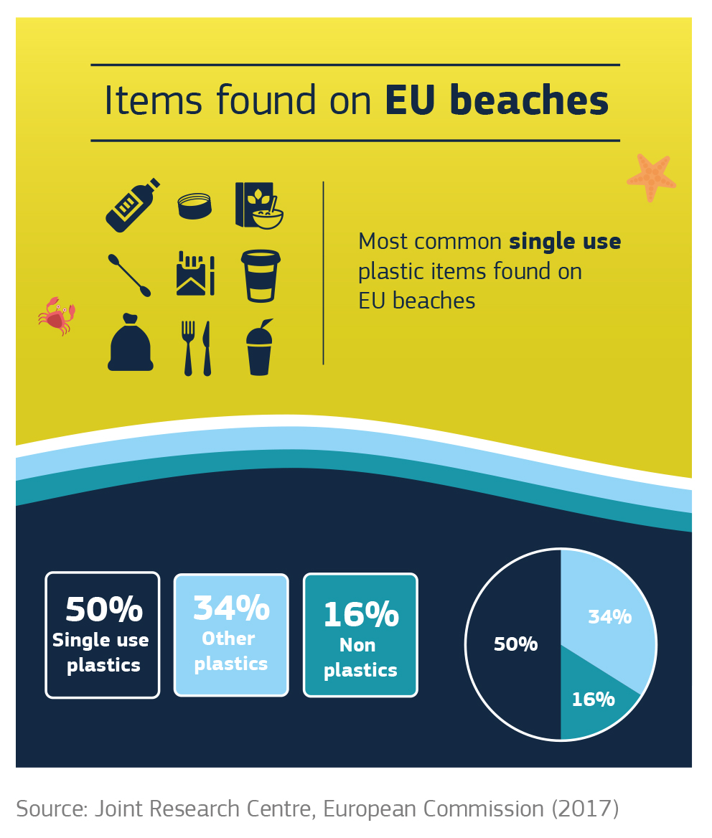

*Preventing plastic waste in our environment*

Growing use of plastics for a wide range of short-lived applications gives rise to large quantities of plastic waste. Single-use plastics items are a major source of plastic leakage into the environment, as they can be difficult to recycle, are often used away from home and littered. They are among the items most commonly found on beaches, and represent an estimated 50% of marine litter.[35]

Increasing on-the-go consumption of food and drink is fuelling the growth of ‘single-use plastics’ and the problem is therefore expected to grow. Where waste management is sub-optimal, even plastic waste that has been collected can find its way into the environment. More recycling of plastics used in agriculture (such as plastic mulching films or greenhouses) can contribute to reduce leakages in the environment. To achieve this, Extended Producer Responsibility schemes have proven effective in several countries.

Marine litter from sea-based sources is also significant. Fishing gear abandoned at sea can have particularly harmful impacts through entanglement of marine animals.

Curbing plastic waste and pollution is a complex problem, given its diffuse nature and the link with social trends and individual behaviour. There is no clear incentive for consumers and producers to switch to solutions that would generate less waste or litter.

The EU has already taken steps by setting requirements for Member States to adopt measures to cut the consumption of plastic bags[36] and to monitor and reduce marine litter.[37] EU funding is also being deployed to understand and combat the rise of marine litter,[38] supporting global, national and regional action. EU rules supporting higher recycling rates and better waste collection systems are also important in helping to prevent leakage. In addition, through its upcoming legislative proposal for a revision of the Drinking Water Directive, the Commission will promote access to tap water for EU citizens, therefore reducing packaging needs for bottled water. The criteria for the Ecolabel and Green Public Procurement also promote reusable items and packaging.[39]

Additional measures at EU and national levels can be developed to reduce the unnecessary generation of plastic waste, especially waste from single-use items or over-packaging, and to encourage the reuse of packaging. Analytical work, including the launch of a public consultation, has already started to determine the scope of a legislative initiative on single-use plastics at EU level to be tabled by this Commission, following the approach used for light-weight plastic bags and examining relevant evidence from behavioural science.[40] Furthermore, the Commission will explore the feasibility of introducing measures of a fiscal nature at the EU level.[41] Finally, the Commission will also look into the issue of over-packaging as part of the future review of the essential requirements for packaging.

Extended Producer Responsibility schemes at national level can also help finance action to curb plastic litter. Targeted deposit schemes can help reduce littering and boost recycling, and have already helped several countries achieve high collection rates for beverage containers.[42]

Awareness campaigns, measures to prevent littering and projects to clean up beaches can be set up by public authorities and receive support from EU funds, for instance through the European Solidarity Corps. On 30 May 2017, the Commission presented a proposal to extend and reinforce the European Solidarity Corps, with a budget of €341.5 million for the years 2018-2020.[43] This means that in the near future there will be even more opportunities for young people across the EU to actively engage and support the objective of this strategy.

To reduce discharges of waste by ships, the Commission is presenting together with this strategy a legislative proposal on port reception facilities.[44] This presents measures to ensure that waste generated on ships or gathered at sea is delivered on land and adequately managed. Building on this, the Commission will also develop targeted measures for reducing the loss or abandonment of fishing gear at sea. Possible options to be examined include deposit schemes, Extended Producers Responsibility schemes and recycling targets. The Commission will also further study the contribution of aquaculture to marine litter and examine a range of measures to minimise plastic loss from aquaculture.[45] Finally, it will continue its work to improve understanding and measurement of marine litter, an essential but often neglected way to support effective prevention and recovery measures.

As a complement to these preventive measures, action to retrieve some of the plastics floating in the oceans and innovative technologies for retrieval are supported by EU funds.[46][47] Finally, as developed in section 4.4, international action will remain key to tackling the most significant sources of plastics litter in the oceans, i.e. insufficient waste management infrastructure in developing countries and emerging economies.

*Establishing a clear regulatory framework for plastics with biodegradable properties*

In response to the high level of plastic leakage into our environment and its harmful effects, solutions have been sought to design biodegradable and compostable plastics. Targeted applications, such as using compostable plastic bags to collect organic waste separately, have shown positive results; and standards exist or are being developed for specific applications.

However, most currently available plastics labelled as biodegradable generally degrade under specific conditions which may not always be easy to find in the natural environment, and can thus still cause harm to ecosystems. Biodegradation in the marine environment is particularly challenging. In addition, plastics that are labelled 'compostable' are not necessarily suitable for home composting. If compostable and conventional plastics are mixed in the recycling process, it may affect the quality of the resulting recyclates. For consumer applications, the existence of a well-functioning separate collection system for organic waste is essential.

It is important to ensure that consumers are provided with clear and correct information, and to make sure that biodegradable plastics are not put forward as a solution to littering. This can be achieved by clarifying which plastics can be labelled 'compostable' or 'biodegradable' and how they should be handled after use. Applications with clear environmental benefits should be identified and in those cases the Commission will consider measures to stimulate innovation and drive market developments in the right direction. To allow adequate sorting and avoid false environmental claims, the Commission will propose harmonised rules for defining and labelling compostable and biodegradable plastics. It will also develop lifecycle assessment to identify the conditions under which the use of biodegradable or compostable plastics is beneficial, and the criteria for such applications.

Finally, some alternative materials claiming biodegradability properties, such as 'oxo-degradable plastics', have been found to offer no proven environmental advantage over conventional plastics, while their rapid fragmentation into microplastics cause concerns. Therefore, the Commission has started work with the intention to restrict the use of oxo-plastics in the EU.[48]

*The rising problem of microplastics*

Microplastics are intentionally added to certain product categories (such as cosmetics, detergents, paints), dispersed during the production, transport and use of plastic pellets, or generated through wear and tear of products such as tyres, paints and synthetic clothes.

Microplastics intentionally added to products represent a relatively small proportion of all those in the sea. However, since they are relatively easy to prevent and in response to public concern, several countries have already taken action to restrict their use,[49] while the cosmetic industry has also taken voluntary action. Bans are under consideration or planned in several Member States and this may lead to fragmentation in the single market. In line with the REACH procedures for restricting substances that pose a risk to the environment or health, the Commission has therefore started the process to restrict the use of intentionally added microplastics, by requesting the European Chemicals Agency to review the scientific basis for taking regulatory action at EU level.[50]

More research is needed to improve our understanding of the sources and impacts of microplastics, including their effects on the environment and health, and to develop innovative solutions to prevent their dissemination (see section 4.3). This can include ways to improve the capture of microplastics in waste water treatment plants, as well as targeted measures for each source. A Cross Industry Agreement[51] for the prevention of microplastic release into the aquatic environment during the washing of synthetic textiles is set to develop first proposals on test methods in 2018. For its part, the Commission will consider measures such as labelling and specific requirements for tyres, better information and minimum requirements on the release of microfibers from textiles, as well as measures to reduce plastic pellet losses. Extended producer responsibility schemes can also be envisaged, where relevant, to cover the cost of remedial action. Microplastics also need to be monitored in drinking water, where their impact on human health is still unknown.

**4.3 Driving innovation and investment towards circular solutions**

Achieving the objectives laid out in this strategy will require major investments in both infrastructure and innovation. Meeting ambitious goals on plastics recycling alone will require an estimated additional investment of between EUR 8.4 and 16.6 billion.[52] Therefore, creating an enabling framework for investment and innovation is central to implementing this strategy.

Innovation is a key enabler for the transformation of the plastics value chain: it can help reduce the costs of existing solutions, provide new ones and amplify potential benefits beyond Europe’s borders. While the EU can play an enabling role, European businesses need to invest in the future and affirm their leadership in the modernisation of the plastics value chain.

Innovative solutions for advanced sorting, chemical recycling and improved polymer design can have a powerful effect. For instance, scaling up new technological solutions such as digital watermarking could allow much better sorting and traceability of materials, with few retrofitting costs. Research and innovation can also make a difference in preventing plastic waste and microplastics pollution. The Commission is particularly attentive to innovation on materials that fully biodegrade in seawater and freshwater and are harmless for the environment and ecosystems. New approaches − developing innovative business models, reverse logistics or designing for sustainability, for instance − can do much to help minimise plastic waste at source, while achieving further economic, environmental and social benefits. Finally, further scientific research is needed to gauge the potential health impacts of microplastics and develop better monitoring tools.

Alternative feedstocks, including bio-based feedstocks and gaseous effluents (e.g. carbon dioxide or methane) can also be developed to avoid using fossil resources. Currently, these feedstocks represent a small but growing share of the market.[53] Their cost can be an obstacle to wider use; in the case of bio-based plastics it is also important to ensure that they result in genuine environmental benefits compared to the non-renewable alternatives. To that effect, the Commission has started work on understanding the lifecycle impacts of alternative feedstock used in plastics production, including biomass. Based on the available scientific information, the Commission will look into the opportunities to support the development of alternative feedstocks in plastic production.

EU research funding will support all these efforts. So far, Horizon 2020 has provided over EUR 250 million to finance R&D in areas of direct relevance to the strategy. About half has been used to help develop alternative feedstocks. This has been complemented by support under the EU cohesion policy, in the context of smart specialisation strategies.[54] A large number of these strategies include plastics-related innovation priorities.

In the run-up to 2020, an additional EUR 100 millionwill be devoted to financing priority measures, including developing smarter and more recyclable plastics materials, making recycling processes more efficient, and tracing and removing hazardous substances and contaminants from recycled plastics. Finally, the Commission will develop a Strategic Research and Innovation Agenda on plastics to provide guidance for future research and innovation funding after 2020.

To meet the objectives of this strategy, the scale of private and public investment must significantly increase, not only as regards innovation. At present, private investment in sorting and recycling plants is held back by uncertainties about profitability (given low oil prices, lack of outlets, etc.). For instance, only about two-thirds of the plastics recycling businesses in France today are profitable.[55] As the situation in other EU countries shows,[56] it is important to modernise and scale up recycling plants if plastic recycling is to be economically viable. Many of the measures proposed in section 4.1 are specifically designed to boost investors’ confidence.

Public authorities need to invest in extended and improved separate collection. Well-designed Extended Producer Responsibility (EPR) schemes can play a key role to provide the necessary funding. In some countries with very high recycling rates, for example, most separate collection and treatment costs for packaging waste are financed through contributions paid by the producers.

In addition to being a source of financing, EPR can provide economic incentives for businesses to develop more sustainable plastic products. If well designed and implemented across Europe, EPR systems could help improve the efficiency of the recycling process, encourage design for recycling, reduce waste and littering and promote greater dialogue between producers, local authorities and recyclers. In its proposed review of waste legislation, the Commission aims to promote this model and make it more effective through minimum common requirements, based on existing best practice. To ensure EPR schemes run smoothly and support investment in recycling, the Commission will provide guidanceon how to ensure effective modulation of fees paid by the producers, in particular for packaging*.* For instance, ‘*eco-modulation*’ of such fees can produce results only if it provides a meaningful financial reward in return for more sustainable product design choices.

The principle of extended producer responsibility could possibly also be applied to create a private-led fund for financing investment in innovative solutions and new technologies aimed at reducing the environmental impact of primary plastic production. This could, for instance, support the uptake of recycled plastics. By mid-2019, the Commission, in cooperation with stakeholders, will analyse the potential design features of such fund, including as regards technological and material neutrality and complementarity with existing instruments, and will closely examine its technical, economic and legal feasibility.

Member States’ decisions on taxation and public procurement will also play a vital role in supporting transition and steering investments.[57] In its proposed waste review, the Commission has emphasised the use of economic instruments to prioritise waste prevention and recycling at national level. Internalising the environmental costs of landfilling and incineration through high or gradually rising fees or taxes could improve the economics of plastic recycling.

European Structural and Investment Funds, in particular cohesion policy funds, also make a key contribution to developing EU recycling capacity, including the recycling of plastics. From 2014 to 2020, over EUR 5.5 billion has been allocated for improving waste management. This is expected notably to result in an increase of 5.8 million tonnes per year in waste recycling capacity.[58] The European Fund for Strategic Investment (EFSI) can also play an important part, for instance by supporting greater integration of the value chain and projects for closed-loop plastics recycling. The recently launched ‘*Circular Economy Finance Support Platform*’ will help raise awareness among investors and facilitate access to finance for circular economy projects.

**4.4 Harnessing global action**

Opportunities and challenges linked to plastics are increasingly global and addressing them will significantly contribute to achieving the 2030 Sustainable Development Goals. Outside Europe, plastics consumption per capita is growing quickly, most notably in Asia.[59] Plastics value chains are developed across entire continents and plastic waste is traded internationally: in the EU about half the plastic waste collected is sent abroad, where uncertainty remains over its treatment. More than 85 % of the exported plastic waste is currently shipped to China,[60] a situation that will soon change following China’s decision to ban the import of certain types of plastic waste,[61] thus creating opportunities for EU recyclers.

Adequate plastic waste prevention, collection and recycling systems are needed in many parts of the world. Marine litter from one country can end up on the beaches of another, and fragments of plastic from all over the globe accumulate over time in the oceans and seas, carried by marine currents. International cooperation is crucial to tackle this issue. Oceans and seas are a global good and common heritage, and if the current trend is not reversed this could have legacy effect for future generations through degradation of marine ecosystems and threats to human health. Establishing sound waste prevention and management systems, particularly in emerging economies, is essential to keep plastics out of the sea. Many initiatives have been launched at international fora (such as G7 and G20, the United Nations, and in the context of the MARPOL Convention[62]) and regional sea conventions; actions against marine litter are also included in the International Ocean Governance Agenda for the future of our oceans.[63]

The EU will continue to support international action, promote best practices worldwide, and use its external funding instruments to support improved waste prevention and management around the world. In particular, the Commission will continue to make use of policy dialogues on environment and industry and dialogues under free trade agreements, and to actively cooperate in Regional Sea Conventions.[64] It will also take an active part in the working group established by the United Nations Environment Assembly in December 2017 to work on international responses for combating plastic marine litter and microplastics. In 2018, the Commission will launch a dedicated project to reduce plastic waste and marine litter in East and South-East Asia, where the problem is growing fast.[65] It will also examine possible ways to take action to reduce plastic pollution in the Mediterranean, in support of the Barcelona Convention, and in major world river basins, as a vast proportion of waste plastic is carried by rivers before it reaches the seas. Finally, the Commission will facilitate the cooperation of the outermost regions of the EU[66] with their neighbours along the Caribbean Sea, the Indian, Pacific and Atlantic Oceans across different fields, including in waste management and recycling.

Going forward, there are also significant prospects for developing an innovative circular plastics industry worldwide. The EU already has the world’s highest rate of plastic recycling. With its objectives on improved recyclability of packaging and increased recycling rates, it is well placed to lead new developments by supporting, in particular, investment in modern recycling technologies, new materials better suited to recycling, and solutions to curb marine litter.

Measures that increase the trust of operators and public authorities are needed to better integrate plastics recycling globally, and thus create a circular value chain across borders. For instance, the Commission will promote the development of international standards to boost industry confidence in the quality of recyclable or recycled plastics. It will also be important to ensure that any plastics sent abroad for recycling are handled and processed under conditions similar to those applicable in the EU under rules on waste shipments,[67] supporting action on waste management under the Basel Convention, and developing an EU certification scheme for recycling plants. A global industry effort is also needed to promote widespread use of recyclable and recycled plastics.

**5. Conclusions**

Challenges linked to the production, consumption and end-of-life of plastics can be turned into an opportunity for the EU and the competitiveness of the European industry. Tackling them through an ambitious strategic vision, covering the entire value chain, can spur growth, jobs and innovation. It can also reaffirm European leadership in global solutions and help us make the transition towards a low-carbon and circular economy, while providing citizens with a cleaner, safer environment.

This strategy proposes concrete actions designed to make the vision for a more circular plastics economy a reality. The Commission will focus on making decisive progress within its current mandate, while preparing the ground for longer-term action. It will be essential for other key actors to also play their part. The Commission therefore calls on the European Parliament and Council to endorse this strategy and its objectives, and calls on national and regional authorities, cities, the entire plastics value chain, and all relevant stakeholders, to commit to resolute and concrete action.

1. COM(2017) 479.
2. COM(2015) 614.
3. Commission Work Programme 2018 - COM(2017) 650.
4. This includes raw material producers and product manufacturers.
5. Source: Plastics Europe.
6. Source: Eurostat.
7. Ellen MacArthur Foundation, *The new plastics economy,* 2016(<https://www.ellenmacarthurfoundation.org/assets/downloads/EllenMacArthurFoundation_TheNewPlasticsEconomy_Pages.pdf> ).
8. Ibid. Data refer to 2012.
9. According to estimates, recycling one ton of plastic saves around 2 tCO2 (see <http://presse.ademe.fr/wp-content/uploads/2017/05/FEDEREC_ACV-du-Recyclage-en-France-VF.pdf> ).Recycling 15 million tons of plastics per year by 2030 (equivalent to about half of the projected plastic waste generation) would save CO2 emissions equivalent to taking 15 million cars off the road.
10. A. Rahimi, J. M. García, *Chemical recycling of waste plastics for new materials production*, Nat. Chem. Rev. 1, 0046, 2017.
11. Jambeck et al, *Plastic waste inputs from land into the ocean*, Science, February 2015.
12. Including on uninhabited land, for example see <http://www.pnas.org/content/114/23/6052.abstract>
13. <http://ec.europa.eu/environment/marine/good-environmental-status/descriptor-10/pdf/MSFD%20Measures%20to%20Combat%20Marine%20Litter.pdf>
14. Joint Research Centre, *Harm Caused by Marine Litter*, 2016.
15. Source: Eunomia.
16. <https://www.unep.org/gpa/what-we-do/global-partnership-marine-litter>
17. [https://www.g7germany.de/Content/EN/_Anlagen/G7/  2015-06-08-g7-abschluss-eng_en.html](https://www.g7germany.de/Content/EN/_Anlagen/G7/2015-06-08-g7-abschluss-eng_en.html) and [https://www.g20.org/Content/DE/_Anlagen/G7_  G20  /2017-g20-marine-litter-en.html?nn=2186554](https://www.g20.org/Content/DE/_Anlagen/G7_G20/2017-g20-marine-litter-en.html?nn=2186554)
18. UNEP/EA.3/L.20 see: <https://papersmart.unon.org/resolution/uploads/k1709154.docx>
19. This data corresponds to building about 500 new sorting and recycling plants (source: Plastics Recyclers Europe).
20. All the EU measures are listed in Annex I.
21. These are listed in Annex II.
22. This dialogue was conducted with Plastics Europe, European Plastics Converters (EuPC) and Plastics Recyclers Europe.
23. COM (2015) 593, COM (2015) 594, COM (2015) 595, COM (2015) 596.
24. Source: Plastics Europe.
25. Ellen MacArthur Foundation, *The New Plastics Economy: Catalysing action*, January 2017.
26. Directive 94/62/EC on Packaging and Packaging Waste.
27. i.e. it can be recycled cost-effectively.
28. Directive 2009/125/EC; this Directive covers all energy-related products.
29. In particular China's recent announcements of its decision to ban import of certain types of plastic waste – see section 4.4.
30. Contamination of recycled streams can originate from multiple sources (e.g. impurities, the use-phase, misuse, degradation, improper separation of materials, legacy substances or cross contamination during waste collection). Such incidental contaminants can affect the quality and safety of recyclates.
31. i.e. plastics other than PET or plastics not originating from closed-loop reuse applications.
32. Contrary to other applications, such as packaging, aesthetic requirements are less relevant and health and environmental exposure is usually lower. In addition, the European Committee for Standardisation has already developed assessment standards to identify hazardous substances which could be embedded in recycled materials.
33. <https://appelsaprojets.ademe.fr/aap/ORPLAST2017-68>
34. Ellen MacArthur Foundation, *The New Plastics Economy: Catalysing action*, January 2017.
35. Joint Research Centre, *Top Marine Beach Litter Items in Europe* , 2017.
36. Directive 2015/720/EU amending Directive 94/62/EC as regards the consumption of lightweight plastic carrier bags.
37. Directive 2008/56/EC establishing a framework for community action in the field of marine environmental policy.
38. For instance, in the Arctic Region, the "Circular Ocean" INTERREG project is testing new opportunities for reusing old fishing nets, including a material to remove pollutants from water (<http://www.circularocean.eu/>). In the Baltic Sea Region, the BLASTIC project maps potential litter sources in urban areas and monitors litter levels in the aquatic environment (<https://www.blastic.eu/>). Both projects are supported by the European Regional Development Fund.
39. For example, the Ecolabel criteria for tourism and the Green Public Procurement criteria for food and catering restrict the use of single-use plastics in catering.
40. The Joint Research Center conducts in-house behavioural research in various policy areas, helping to better understand both the drivers of behaviour and the relative effectiveness of alternative solutions.
41. The modalities of such a potential fee would have to be decided on the basis of the assessment of its contribution towards meeting the strategy goals. On top of that, in the context of the preparation of the post-2020 Multiannual Financial Framework, it could be considered as one of potential options to generate revenues for the EU budget.
42. The five best performing Member States with deposit schemes for PET bottles (Germany, Denmark, Finland, the Netherlands and Estonia) reached an average collection rate for PET of 94% in 2014.
43. <http://eur-lex.europa.eu/legal-content/EN/TXT/?uri=COM:2017:262:FIN>
44. COM (2018) 33 on port reception facilities for the delivery of waste from ships and repealing Directive 2000/59/EC and amending Directive 2009/16/EC and Directive 2010/65/EU.
45. Including the possible adoption of a Best Available Technique reference document for aquaculture installations.
46. See for example the call under Horizon 2020 to develop and scale up innovative processes to clear the sea of litter and pollutants: <http://ec.europa.eu/research/participants/portal/desktop/en/opportunities/h2020/topics/bg-07-2017.html>
47. <https://ec.europa.eu/easme/en/information-day-blue-growth-calls-under-emff>
48. In line with REACH procedures for restricting substances that pose a risk to the environment or health, the Commision has requested the European Chemicals Agency to review the scientific basis for taking regulatory action at EU level.
49. Bans on the use of microplastics in specific personal care products have been put in place in the United States and Canada; several EU Member States have also notified the Commission of draft laws to ban microplastics in certain cosmetics. The Council has called on the Commission to take measures on microplastics, especially from cosmetics and detergents.
50. On that basis, the Agency must initiate the restriction process within 12 months, if the conditions are met.
51. The Agreement is signed by five industry associations: AISE, CIRFS, EOG, EURATEX and FESI.
52. Deloitte, Increased EU Plastics Recycling Targets: Environmental, Economic and Social Impact Assessment, 2015.
53. Today, bio-based plastics represent between 0.5 and 1% of EU annual plastic consumption.
54. National and regional innovation strategies, developed through a bottom-up process engaging industry and stakeholders to identify areas of regional competitiveness. The Commission also supports interregional partnerships for smart specialisation areas.
55. French Environment and Energy Management Agency, *Analyse de la chaîne de valeur du recyclage des plastiques en France*, March 2015.
56. Ibid.
57. The Commission has a well-defined state aid framework to support such measures. See 2014/C 200/01, Communication from the Commission: Guidelines on State aid for environmental protection and energy 2014-2020.
58. <https://cohesiondata.ec.europa.eu>
59. Per capita plastic consumption has reached around 100 kg per year in Western Europe and North America; in Asia it is currently above 20 kg per year, a figure expected to grow rapidly.
60. Global Waste Management Outlook 2015.
61. WTO Notification G/TBT/N/CHN/1211 of 18 July 2017 and G/TBT/N/CHN/1233 of 15 November 2017, covering a range of waste types, including certain types of plastic waste.
62. The International Convention for the Prevention of Pollution from Ships (MARPOL convention) regulates the discharge of garbage from ships.
63. JOIN(2016)49
64. The EU is a member of the OSPAR (North East Atlantic), HELCOM (Baltic) and Barcelona Conventions (Mediterranean) and provides support to the Bucharest Convention (Black Sea).
65. In the context of the Partnership instrument.
66. The nine Outermost Regions of the European Union consist of six French overseas territories (French Guiana, Guadeloupe, Martinique, Mayotte, Réunion and Saint Martin), two Portuguese autonomous regions (the Azores and Madeira) and one Spanish autonomous community (the Canary Islands).
67. Regulation (EC) 1013/2006 on waste shipments.