

**1. Deployments**

The European Border Coast Guard Agency continues to support frontline Member States, with deployments in Greece, Italy, Bulgaria, and Spain as well as in the Western Balkans, with approximately 1500 members of the European Border and Coast Guard teams. The map presents the situation in week 13-17 November 2017.

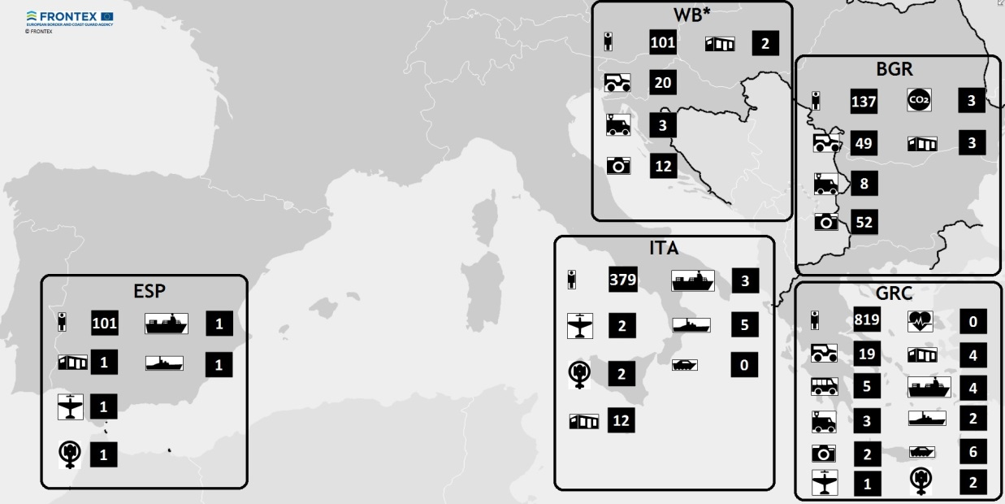

* Western Balkans

Between 1 January and 31 October 2017, the Member States contributed over 489 000 man-days.

|  |  |  |  |  |  |
| --- | --- | --- | --- | --- | --- |
| **Human Resource deployments in Greece, Italy, Bulgaria, Spain and the Western Balkans from 01.01.2017 until 31.10.2017** | | | | | |
| **MS/SAC** | **EBGT Deployment man-days (excl. Int. Deployments)** | **Crew/technical staff, coordinating staff & interpreters deployment man-days (excl. Int. Deployments)** | **Internal deployment man-days** | **Western Balkan deployments** | **Total** |
| Austria | 6,484 | 366 |  | 3,713 | 10,563 |
| Belgium | 979 |  |  | 174 | 1,153 |
| Bulgaria | 10,881 | 1,037 | 7,512 | 117 | 19,547 |
| Croatia | 1,739 | 1,353 |  | 29 | 3,121 |
| Cyprus | 444 |  |  |  | 444 |
| Czech Rep. | 6,190 | 228 |  | 162 | 6,580 |
| Denmark | 2,082 | 1,722 |  |  | 3,804 |
| Estonia | 2,754 | 462 |  | 203 | 4,582 |
| Finland | 891 | 3,204 |  | 487 | 4,582 |
| France | 14,208 | 5,124 |  | 87 | 19,419 |
| Germany | 24,842 | 8,092 |  | 1,499 | 34,433 |
| Greece | 9,504 | 2 | 131,354 | 218 | 141,078 |
| Hungary | 1,657 |  |  | 44 | 1,701 |
| Iceland |  | 775 |  |  | 775 |
| Italy | 1,545 | 5,678 | 32,485 | 174 | 39,882 |
| Latvia | 2,914 | 4,465 |  | 303 | 7,682 |
| Lithuania | 3,859 | 758 |  | 234 | 4,851 |
| Luxembourg | 802 | 971 |  |  | 1,773 |
| Malta | 168 | 12,911 |  | 56 | 13,079 |
| Netherlands | 13,151 | 9,075 |  | 205 | 22,431 |
| Norway | 917 | 13,183 |  |  | 14,100 |
| Poland | 11,052 | 1,122 |  | 590 | 12,764 |
| Portugal | 6,849 | 24,100 |  | 461 | 31,410 |
| Romania | 15,907 | 8,535 |  | 1,287 | 25,729 |
| Slovakia | 1,858 |  |  | 145 | 2,003 |
| Slovenia | 1,240 |  |  | 594 | 1,834 |
| Spain | 8,012 | 18,726 | 15,136 | 338 | 42,212 |
| Sweden | 1,949 | 3,590 |  | 57 | 5,596 |
| Switzerland | 760 |  |  | 200 | 960 |
| United Kingdom* | 3,035 | 9,326 |  |  | 12,361 |
| Total | 156,673 | 134,805 | 186,487 | 11,321 | 489,286 |

* Not formally EBGT contributor

**2. Rapid Reaction Capabilities, including the mandatory pooling of resources**

By 9 November 2017, the total number of "nominated" border guards available for deployments form Rapid Reaction Pool will be 1 110, representing 74% of the Pool.

|  |  |  |  |  |  |  |  |  |  |  |  |  |  |  |  |  |  |  |  |  |  |  |  |  |  |  |  |  |  |
| --- | --- | --- | --- | --- | --- | --- | --- | --- | --- | --- | --- | --- | --- | --- | --- | --- | --- | --- | --- | --- | --- | --- | --- | --- | --- | --- | --- | --- | --- |
| Member States | Austria | Belgium | Bulgaria | Croatia | Cyprus | Czech Republic | Denmark | Estonia | Finland | France | Germany | Greece | Hungary | Iceland | Italy | Latvia | Lithuania | Luxembourg | Malta | Netherlands | Norway | Poland | Portugal | Romania | Slovakia | Slovenia | Spain | Sweden | Switzerland |
| Number of border guards nominated in Opera | 47 | 89 | 40 | 97 | 0 | 132 | 29 | 168 | 57 | 378 | 65 | 58 | 65 | 0 | 131 | 30 | 53 | 7 | 14 | 81 | 12 | 275 | 5 | 196 | 4 | 8 | 0 | 63 | 46 |
| Number available for mandatory deployment under the RRP | 34 | 30 | 40 | 65 | 0 | 20 | 29 | 18 | 30 | 170 | 65 | 50 | 65 | 0 | 125 | 30 | 39 | 7 | 6 | 50 | 12 | 100 | 5 | 75 | 4 | 8 | 0 | 17 | 16 |
| Contributions under Annex I of the EBCG Regulation | 34 | 30 | 40 | 65 | 8 | 20 | 29 | 18 | 30 | 170 | 225 | 50 | 65 | 2 | 125 | 30 | 39 | 8 | 6 | 50 | 20 | 100 | 47 | 75 | 35 | 35 | 111 | 17 | 16 |

Under the **Rapid Reaction Equipment Pool**, considerable gaps remain for most types of equipment and the current contributions continue to be ensured by only 14 Member States:

|  |  |  |  |  |
| --- | --- | --- | --- | --- |
| Type of equipment | No. of asset-months  Requested by Management Board Decision | No. of asset-months offered by MS/SAC | Gap | Contributing MS |
| Buses | 36 | 5 | 31 | Bulgaria, Czech Republic, Finland, Croatia, Hungary, Latvia, Netherlands, Slovenia, Portugal, Italy, Austria, Poland, Germany |
| Coastal Patrol Boat | 67 | 24 | 43 |
| Coastal Patrol Vessel | 33 | 13 | 20 |
| Fixed wing aircraft | 19 | 3 | 16 |
| Helicopter | 20 | 3 | 17 |
| Offshore Patrol Vessel | 28 | 13 | 15 |
| Patrol car | 167 | 442 | -275[1] |
| Thermo vision vehicles | 55 | 33 | 22 |

**3. Vulnerability Assessments**

With the conclusion of 6 simulation exercises by December 2017, the Agency will complete the first cycle of the vulnerability assessments.

|  |  |
| --- | --- |
| **Types of Agency feedback** | **No. of Member States concerned** |
| Member States addressed with recommendations containing measures including specific timelines for implementation | 21 |
| Member States addressed with recommendations to take the vulnerabilities into account at national level (without any specific measures) | 6 |
| Member States with no recommendations | 2 |
| **TOTAL** | **29** |

In total, the Agency recommended 33 measures in 21 Member States addressing vulnerabilities in different areas.

|  |  |  |
| --- | --- | --- |
| **Vulnerabilities** | **Recommended measures** | **No. of Member States** |
| **Border checks** | * Adapt procedures for database consultations for systematic checks * Establish an estimated number of undetected cases of document fraud/clandestine entries and perform targeted checks | 20 |
| **Contingency planning** | * Develop and/or update the contingency plan, test the plan | 6 |
| **Registration and accommodation capacity** | * Increase accommodation capacity * Establish a detailed inventory of EURODAC fingerprinting devices | 4 |
| **Staffing for border control** | * Increase the effective number of staff | 2 |
| **Border surveillance** | * Establish a log of reaction times after detection | 1 |

**4. Pooling of resources and building the Agency's own capacities in view of providing operational support**

|  |  |  |  |  |  |
| --- | --- | --- | --- | --- | --- |
|  | **Fixed wing aircraft** | **Coastal patrol vessels** | **Coastal patrol boats** | **Thermo vision vehicles / surveillance vehicles** | **Total budget** |
| Internal Security Fund Specific actions 2015 | 6 items: Poland (2), Spain (1), France (1), Malta (1), Italy (1) | 6 items: Greece (2), Spain (1),  Italy (2), France (1) | Finland (1) | 11 items: Greece (1), Latvia (2),  Spain (2), Portugal (2), Bulgaria (1),  Romania (1), Lithuania (1), Austria (1) | EUR 132 million |
| Internal Security Fund Specific actions 2015 |  | 5 items: Greece, Italy, Portugal, Lithuania,  Romania | 20 items: Germany (1), Finland (3),  Greece (3), Latvia (3), Italy (3),  Portugal (3), Romania (3) | 11 items: Greece (1), Latvia (2),  Spain (2), Portugal (2), Bulgaria (1),  Romania (1), Lithuania (1), Austria (1) | EUR 86 million |

1. The negative value illustrates that the resources agreed are more than the resources needed.