

**1. INTRODUCTION**

Since the adoption of the European Agenda on Migration in May 2015,[1] EU action to address the many challenges of the refugee and migration crisis has been framed by a comprehensive approach. In September 2017, with a mid-term review of the Agenda, the Commission made an overall assessment of the progress made in responding to the crisis and in rolling out the actions foreseen by the Agenda.[2] The European Council in its meeting of October 2017 noted the results achieved on all fronts, and called for this work to be consolidated.[3]

The European Commission has carried forward work on all the different parts of the European Agenda of Migration. To monitor progress and allow for an evidence-based assessment of the delivery on the commitments taken by EU institutions and Member States, including in European Council conclusions, the Commission has presented regular progress reports on the implementation of the EU-Turkey Statement, on relocation and resettlement, on the operationalisation of the European Border and Coast Guard and on the progress made in the Partnership Framework with third countries.[4]

Each and every workstream contributes to the overall effectiveness of the EU response. As announced in the mid-term review, this consolidated report reflects and reinforces the comprehensive approach by bringing together the different strands. Together with the information provided in the Annexes, it presents the most important developments since the last reports of 6 September[5] and identifies key actions requiring follow-up by the relevant actors, notably in the run-up to the next European Council in December.

**2. SITUATION ALONG THE MAIN MIGRATORY ROUTES**

***Eastern Mediterranean route***

On the Eastern Mediterranean route, migratory movements remain limited compared to the period before the activation of the EU-Turkey Statement in March 2016. However, there has been an increase in arrivals in the ***Greek islands*** since the early summer of 2017, consistent with seasonal trends. Migratory pressure has increased further from mid-August, with 198 irregular crossings per day on average in September and October, compared to 99 in the same period in 2016.[6] The top nationalities of migrants arriving in the Greek islands since the start of 2017 are Syrian (39%), Iraqi (17%), Afghani (10%) and Pakistani (6%).[7]

There have also been some signs of migrants seeking to leave Turkey by routes other than the Aegean Sea. While the number of detections of irregular land border crossings from Turkey into Bulgaria remains low, there has been a recent increase in irregular crossings from Turkey into Greece via the land border (29 detections as a daily average between 4 September and 9 November, compared to 20 over the previous six months). The main nationalities of arrivals in 2017 to the Greek mainland are so far Turkish (37%), Syrian (27%), Pakistani (15%) and Iraqi (12%). In contrast, arrivals over the summer from Turkey to Romania over the Black Sea currently seem to have ceased.[8] There have also been limited, yet regular, arrivals from Turkey to Italy (3 676 so far in 2017). A number of arrivals to Cyprus from Turkey in 2017 have also been recorded (917 so far in 2017).

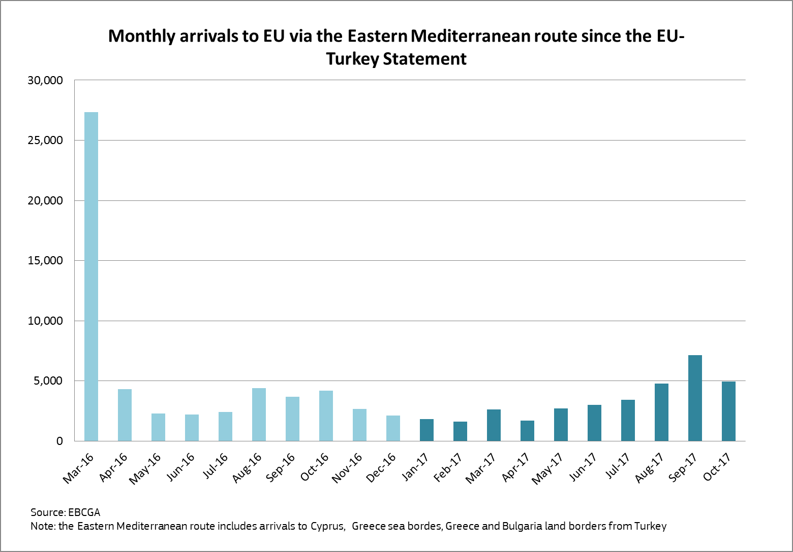

***Western Balkan route***

Although the number of detections of irregular migrants at the entry points of the Western Balkan route has stabilised at a low level, some Member States at the end of the route report that a significant number of migrants and asylum seekers continue to reach their territory. The fact that a significant proportion of these have no previous Eurodac registration reinforces the conclusion that a number of irregular migrants succeed in progressing undetected. Cooperation between these Member States, Europol and the European Border and Coast Guard Agency is essential to tackle this issue. Continued vigilance is necessary, including by making full use of the bi-weekly videoconferences chaired by the Commission.

***Central Mediterranean route***

The Central Mediterranean route continues to account for the largest number of people crossing by sea. The overall migratory situation has stabilised in the past months, with reduced departures from Libya on the route since mid-July. Whilst the number of arrivals in Italy was noticeably higher in early summer, overall arrivals continue the decreasing trend reported in September, and have now fallen by 30% compared to 2016 – but remain high at a total of over 114 000 for the year so far. The top three nationalities of all migrants arriving are: Nigerian (15 %); Guinean (8%); and Ivorian (8%). In addition, a significant increase of departures from Tunisia towards Italy has been registered, with a sevenfold increase in 2017 compared to 2016, albeit with numbers much lower than from Libya.[9] Outward flows from Niger towards Libya and Europe of migrants from Western African countries of origin continue their decreasing trend, but some rerouting towards Algeria continues.

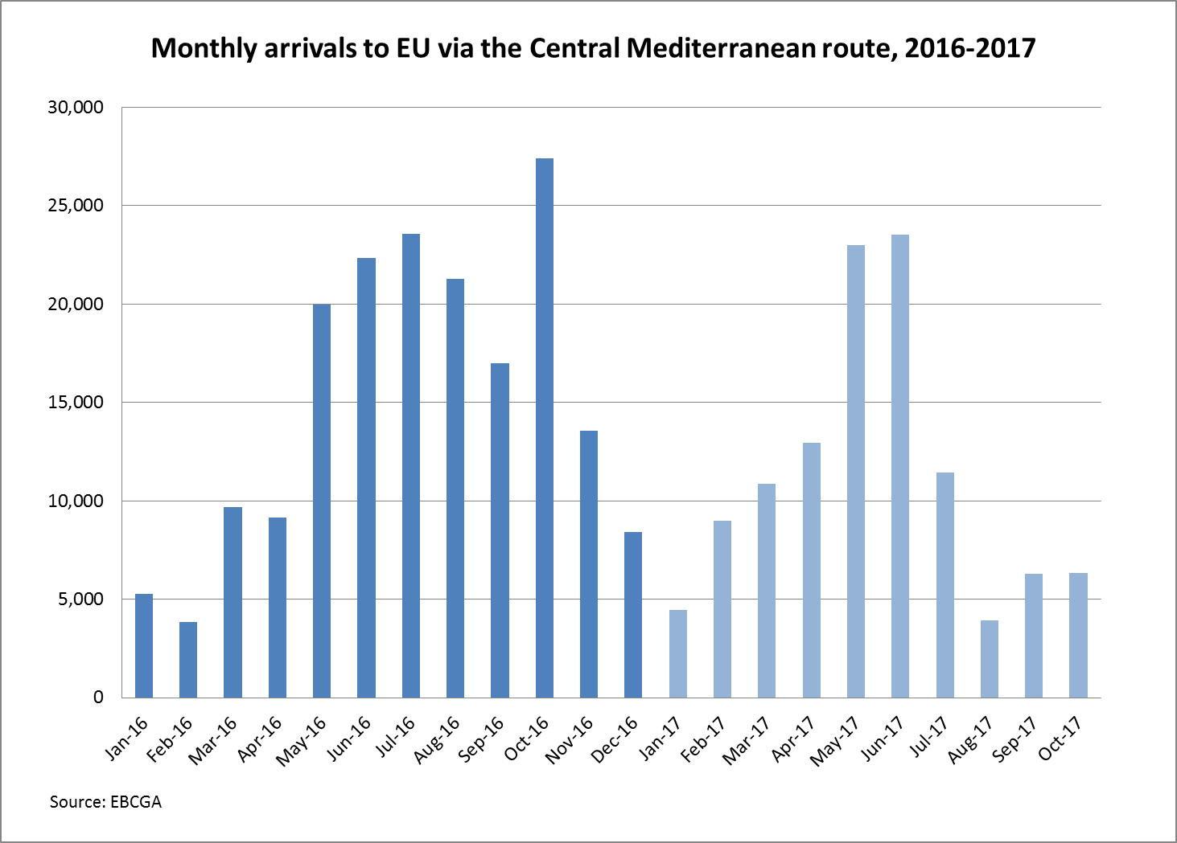

At sea, the number of ***lives lost and missing persons*** is estimated to be 2 750 so far in 2017, compared to 4 581 in 2016.[10] More than 285 100 migrants had been rescued by EU operations in support to the Italian Coast Guard.[11] In addition, the Libyan Coast Guard has estimated that it had rescued more than 18 400 persons this year in Libyan territorial waters (up to 6 October), helped by the return of vessels after the training of crew members.[12] The EU Trust Fund for Africa[13] also supports work by the International Organisation for Migration and the authorities of Niger to carry out search and rescue missions in the desert: in 2017, over 1 100 migrants have been brought to safety after being abandoned by smugglers.

***Western Mediterranean route***

An upward trend in irregular flows was recorded in the course of 2017 on the Western Mediterranean/Atlantic route, with the total number of arrivals to Spain amounting to 22 031, which is almost 94% higher than that in the same period in 2016. In 2017, until the end of August the three main countries of origin of the migrants were Morocco (21 %), Côte d’Ivoire (18 %), and Guinea (14 %).

***Asylum application trends***

By the end of September 2017, 535 609 asylum application had been made in the EU and associated states, compared to 1 010 839 in the same period of last year.[14] In the first half of 2017, 275 710 positive first instance decisions were issued,[15] compared to 293 315 decision made in the same period of last year.

**3. EU OPERATIONAL SUPPORT ALONG THE ROUTES**

The cornerstone of the EU's support remains the ***hotspot approach***, in place since 2015. The Commission has assessed the operation of the hotspots in Greece and Italy so far and in close cooperation with the Agencies, it has brought together best practices on the implementation of the hotspot approach.[16]

The deployment of Europol guest officers has been instrumental in identifying risk profiles and fighting smugglers' networks and they will continue to perform second-line security checks in Greek and Italian hotspots.

Another important priority of the EU's work is to focus on the needs of ***children*** in the migration process.[17] The best practices on the implementation of the hotspots approach identify specific measures to be taken to help children and other vulnerable groups. The 11th European Forum on the rights of the child on 7-8 November provided an opportunity to explore the need to find alternatives to detention for children in the context of migration.

***Eastern Mediterranean route***

Support from the European Border and Coast Guard Agency, the European Asylum Support Office and Europol has been critical in operationalising the hotspots in Greece, as well as the deployment of twelve vessels in naval operations. Work to have a more precise picture of the number and needs of migrants, including in the hotspots, is under way. The Greek government is expected to complete a first summary of this work by the end of November.

***Reception places*** available in hotspots, however,are still insufficient, despite the arrangements foreseen under the National Programme of the Asylum, Migration and Integration Fund. The increasing pressure caused by recent high numbers of arrivals may add further pressure. Improving the availability[18] and quality of reception places, including by better addressing the specific needs of vulnerable groups, remains an urgent priority. Immediate action by the Greek authorities is needed to further address the shortcomings of reception facilities on the islands and prepare for winter conditions. The Commission stands ready to provide the appropriate support.

The EU also continues to provide substantial ***financial support*** to Greece in the face of the challenges of the crisis. Over EUR 440 million has now been provided from the Emergency Support Instrument within the EU to support the work of 15 humanitarian partners. This instrument has been able to ensure that sufficient reception places are available on the mainland, modulating availability according to need up to a total of 40 000, as well as to contribute to the creation of capacity on the islands. The current priority of this work is for the Greek authorities to shift as many refugees as possible from camps to rented accommodation. A multi-purpose cash programme[19] has also been put in place. The main objective of the rental accommodation and cash programme is to provide dignified conditions for those in need. As of 7 November, 19 447 accommodation places have been created – though the number of refugees hosted in the urban rental accommodation scheme fluctuates, the current figure is 15 458 refugees. On a monthly basis, an average of 32 500 refugees receive cash support.

Discussions are under way with the Greek authorities on the adoption of a financial plan for 2018, where essential needs, activities and respective sources of funding will be identified. Further steps have been taken to ensure more sustainable support by shifting from emergency funding to using money allocated under the national programmes for Greece. For example, funding under these programmes is being used to support the provision of services such as catering, accommodation, and cleaning in the hotspots, as well as services in shelters for unaccompanied minors. These programmes already fund agreed priorities, including reception services on the islands and shelters for unaccompanied minors. EU support (approximately EUR 27 million so far) for the Assisted Voluntary Returns and Reintegration Programme implemented by the International Organisation for Migration has also been crucial to alleviate some of the pressure: more than 4 800 people have returned to their country of origin through this scheme in 2017.

In Greece, European Asylum Support Office teams provide support to Greek authorities with the identification and registration of potential applicants for international protection, and inform migrants about the international protection system in Greece as well as the relocation procedure. In addition, ***experts*** provide advice on nationality assessment and possible exclusion issues, and contribute to the detection of possible document fraud. As of 9 November, through the European Asylum Support Office, 18 experts from Member States are deployed to support the relocation process, and one expert in support of the Greek Reception and Identification Service. The European Border and Coast Guard Agency as of 8 November deploys 21 experts at the border between Greece and the former Yugoslav Republic of Macedonia.

Significant financial support has also been provided to ***Bulgaria*** to address migration challenges. The emergency assistance grants awarded to Bulgariain autumn 2016 have recently been extended by a year, to allow for full implementation. The European Border and Coast Guard Agency continues to assist Bulgaria in controlling its land borders, also in view of preventing secondary movements. The current deployment includes 143 officers, as well as a wide range of equipment. Under the national programme of the Asylum, Migration and Integration Fund (2014-2020), Bulgaria has EUR 4.5 million allocated to cover return measures including Assisted Voluntary Return, and emergency support has also helped the assisted voluntary return of 800 people (until 10 November 2017).

***The*** ***EU-Turkey Statement***

The implementation of the EU-Turkey Statement has continued to play a key role in ensuring that the migration challenge in the Eastern Mediterranean is addressed effectively and jointly by the EU and Turkey. It continues to deliver concrete results in reducing irregular and dangerous crossings and in saving lives in the Aegean Sea. In addition, through the Facility for Refugees in Turkey, the Statement delivers practical support to Syrian refugees and host communities in Turkey, as well as ensuring resettlement of Syrians from Turkey to Europe. The full and sustained implementation of the Statement requires continuous efforts and political determination from all sides.

The Commission and EU agencies continue their targeted work to implement the Statement (see Annex 2), including through significant support to the Greek Asylum Service.[20] However, the shortcomings identified in the previous reports persist.[21] In particular, the pace of *returns* to Turkey under the Statement remains very slow, with only 1 969 returns since March 2016.[22] Of these, only 439 were the result of a second instance negative judicial decision on an asylum application. Ensuring effective returns once legal proceedings are complete is a core part of the Statement so this depends heavily on the resources provided for all relevant stages of the Greek asylum system. In spite of the ruling of the Greek Council of State published on 22 September 2017, which rejected the appeals of two Syrians and thereby concluded that Turkey is a safe country for the return of migrants under the Statement, subject to individual assessment, the number of decisions by the Appeal Committees has not increased substantially, and consequently returns remain low, also due to the number of subsequent administrative appeals. The result is that pressure on facilities and operations in the Greek islands remains high and continues to increase: as of 9 November, an estimated 15 169 migrants are present on the islands.

*Resettlement* from Turkey under the Statement continues, and it is essential that a high pace is maintained. Since 4 April 2016, 11 354 people have been resettled from Turkey.[23] As for the *Voluntary Humanitarian Admissions Scheme*, the Commission and Turkey finalised the Standard Operating Procedures, which now need to be endorsed by the Member States. A swift decision on its activation would boost the implementation of the Statement, providing Syrians with a safe and legal alternative to irregular migration to the EU.

Operational dialogue on migration with the Turkish authorities continues, specifically on returns and information-sharing, as well as on resettlement. As regards the implementation of the *Visa Liberalisation Roadmap*, the Commission continues to encourage Turkey's efforts to complete the delivery of all the outstanding benchmarks of the Roadmap as soon as possible.

Another key element of the Statement is support through the *Facility for Refugees in Turkey*, focussed on delivering direct impact on the ground (see Annex 3). The EU is on track to contract the full amount of EUR 3 billion by the end of 2017. Contracts have already been signed for 55 projects for an amount of EUR 1.78 billion.[24] For all these contracts, effective implementation is underway. The total amount disbursed has reached EUR 908 million. Projects bringing education to almost half a million Syrian children and healthcare to some two million persons are now under way. A significant landmark was reached in September 2017, with one million of the most vulnerable refugees now receiving monthly electronic cash transfers to cover their everyday needs.

***Jordan and Lebanon***

The EU is also providing support to other countries facing pressures following the Syrian crisis and to help manage the huge challenge of the continued refugee crisis. Jordan and Lebanon continue to support livelihoods of refugees alongside their host communities. Both Jordan and Lebanon have recently taken important steps to open up education to all refugee children. The EU Regional Trust Fund in Response to the Syrian Crisis has so far allocated EUR 290 million to projects in Lebanon (EUR 152.3 million contracted) and EUR 141 million to projects in Jordan (EUR 96.5 million contracted). The EU will continue to prioritise actions to provide protection and assistance to the most vulnerable. The need for substantial international financial support will continue.

|  |
| --- |
| ***Key future actions***   * To improve the situation on the Greek islands, the Greek authorities should urgently increase the rate of return to Turkey of those persons who are not entitled to remain in Greece, in full compliance with EU and international rules. This applies also to returns of Syrians further to the recent ruling of the Council of State; * Improve reception conditions and capacity on the islands; * Agree quickly on the Voluntary Humanitarian Admission Scheme and its activation, in line with the conditions set out by the EU-Turkey Statement; * Complete contracting of the remaining humanitarian programmes under the Facility for Refugees in Turkey by the end of the year; * Continue monitoring trends and fight against smuggling on the Western Balkan route, including through cooperation between Member States and relevant agencies; * Member States to continue support to the relevant EU Agencies, and Agencies to ensure sustainability of ongoing operations; * Ensure sufficient financing to support Jordan and Lebanon in hosting substantial numbers of refugees, also with a view to the Brussels Conference on the Syria Crisis and the Region, to be held in the Spring of 2018. |

***Central Mediterranean route***

The October European Council conclusions[25] underlined the common interest in addressing the Central Mediterranean route and highlighted a number of priority actions. This included effective action on returns, resettlement and humane conditions for migrants. The EU's operational response in the Central Mediterranean to save lives, fight smuggling and support protection, community stabilisation and capacity building have further expanded, in close cooperation with the Italian authorities.[26] Under the North of Africa Window of the EU Trust Fund for Africa, the entire amount available of EUR 264.58 million has been committed, of which EUR 131.1 million is contracted and EUR 57 million has been disbursed (for 11 programmes).

In ***Italy***, the Commission has worked on new ways to bring support in line with the Action Plan of 4 July[27] and of the exchange of letters between President Juncker and the Prime Minister Gentiloni of August 2017. As a short term action, the Commission immediately expressed its readiness to mobilise up to EUR 35 million funding of emergency assistance under the Internal Security Fund (Borders) to support the Italian a number of priority actions identified by the Italian Ministry of Interior, centred on the hotspots, to improve the efficiency of procedures and cater for the needs of those arriving in the country.[28] If necessary, as a next step, the Commission stands ready to mobilise up to a further EUR 100 million in emergency funding under the Asylum, Migration and Integration Fund. This should help Italy make further progress on the internal aspects of the Action Plan, including the acceleration of asylum and return procedures and substantially increased detention capacities.

A fifth hotspot (the "Centre for first Aid, Assistance and Identification") opened on 30 September 2017 in Messina, with a capacity of 250 places, but overall reception capacity in the hotspots remains too limited.[29] In Italy, the European Asylum Support Office is present in more than 45 locations inside and outside hotspot areas. Experts carry out information provision, and provide support with regard to the registration of applicants for international protection in view of the relocation procedure. On 9 November, 53 Member State experts, 55 cultural mediators, and 18 agency staff were deployed in Italy by the European Asylum Support Office.

Maritime surveillance operations have continued. There are currently eight assets deployed for Joint Operation Triton and five naval units for Operation Sophia. As a result of these actions, 119 suspected smugglers and traffickers have been apprehended and more than 497 assets neutralised.

The EU's dedicated efforts to support the ***Libyan Coast Guard*** have continued. At sea and in Member States' facilities, Operation Sophia has now completed an initial training package for a total of 142 personnel including 39 personnel for patrol boat crews and has also provided trainers' training.[30] Following a thorough vetting process, 66 Libyan personnel recently started training in Taranto. Further modules are anticipated to take place in the coming weeks in Spain, Greece and Italy. Key recent developments have been the recent return of Coast Guard vessels and the setting up of a monitoring system. The aim of the monitoring system is to assess the capacity building and adjust the training requirements, support Libyans to take ownership of securing their territorial waters, and to enhance protection of and respect for human rights. An initial report on monitoring activities is scheduled at the beginning of 2018. The Seahorse Programme has also recently completed its latest training, focused on increasing the capabilities of the Libyan Coast Guard with a view to longer-term work to establish the Seahorse Mediterranean Network.

While the initiatives at sea continue delivering important results, an enhanced focus has been put on the actions on land in order to improve the often appalling ***conditions faced by migrants*** in Libya and provide alternatives for stranded migrants and victims of trafficking in human beings. Under the EUR 90 million programme adopted in April under the Trust Fund, specific action on the protection of migrants in Libya has started. The United Nations High Commissioner for Refugees and the International Organisation for Migration have worked to enhance support to migrants in detention centres and at disembarkation points. Almost 4 000 migrants are provided with medical assistance and basic support, and monitoring of protection status in detention centres is being improved. The United Nations High Commissioner for Refugees and the International Organisation for Migration have also provided support to more than 2 000 Libyan displaced families. Medical help and assistance is being delivered to more than 14 000 migrants in detention centres, in the aftermath of the clashes between militias in Sabratha. In this way, the Trust Fund is directly contributing to the immediate needs of migrants.

Infrastructure works are being planned to help create employment for Libyans and migrants, and support is provided to develop small businesses and promote community security and stability. Special attention is being given also to children, with work on school rehabilitation, non-formal education for Libyans and migrants, training teachers and providing support to transitional care institutions for unaccompanied and separated children. Child-friendly spaces will be supported or established, including in existing structures and community centres. The programme also works on the wider economic sectors, starting with small infrastructure works, and capacity-building on local governance. The challenging environment in Libya remains an obstacle to faster delivery of EU support but the Commission is actively working with its partners on the ground to minimise delays.

The ***EU Border Assistance Mission*** in Libya will establish a light presence in Tripoli before the end of November. This will be followed by a gradual and phased build-up of staff by spring 2018, allowing greater routine engagement with the Libyan authorities responsible for border management, law enforcement and criminal justice, including the civilian and coastal police. It is also participating in the planning for an Italian-led fact-finding mission to the South of Libya this autumn, which fully involves Libyan border guard authorities and focuses on border management and migration issues.

A new effort is under way at the ***southern land border***. A EUR 46.3 million programme adopted in July will be contracted in November. Anti-smuggling activity is flanked by the provision of economic alternatives to smuggling – this is a key objective of the community stabilisation component under the EUR 90 million programme adopted in April.[31]

The EU continues to work actively with the International Organisation for Migration through the joint initiative on Migrant Protection and Reintegration. These programmes include support for ***assisted voluntary return*** and reintegration assistance along the Central Mediterranean route. In 2017, over 10 000 migrants stranded in Libya have so far been helped to return to their countries of origin, notably Nigeria, Senegal, Guinea, Mali, and The Gambia, When migrants stranded in Niger, Mali and Mauretania are included, the total is over 15 000. In addition, work is being stepped up with Libya's neighbours to help more migrants return home from Libya or refugees to be resettled by the international community, with assistance of the United Nations High Commissioner for Refugees. The EU delegations in the respective countries of origin and transit have enabled contacts to step up consular support, thus facilitating more returns.

The EU remains committed to an inclusive ***political transition*** in line with the July 2017 Council conclusions,[32] as a prerequisite for solid and sustainable results on the management of migratory movements in and through Libya. This will support the steps being taken to put in place a permanent EU presence, as called for by the European Council, which is essential for an effective response.

Departures of migrants from ***Egypt*** continue to be very few. An agreement on the financing of the EUR 60 million programme to address economic drivers of irregular migration, improve employability and increase resilience of migration-affected communities has recently been signed. It is expected that the migration dialogue with Egypt will be launched in December.

Action is being developed in cooperation with the Italian authorities to respond to the increase in arrivals from ***Tunisia*** – both in terms of limiting arrivals and increasing returns. Contacts with ***Algeria*** have continued, with the EU offering to step up dialogue and cooperation both in bilateral and regional formats.

The European Council put particular emphasis on a commitment to ensure sufficient and targeted funding to the ***North Africa window*** ***of the EU Trust Fund for Africa***.

An immediate funding gap of EUR 110 million has been identified specifically for the continuation of the "Mixed Migration programme" now under way. The extended programme will work with the United Nations High Commissioner for Refugees and the International Organisation for Migration to undertake critical work on assisted voluntary return and reintegration; on improved conditions for migrants in detention centres; and on community stabilisation and support to municipalities in areas such as new employment opportunities and support to key services.. Given the critical importance of the work in North Africa to the EU's overall policy, further programmes both in Libya and in other North African countries will need to follow in the course of 2018. These needs will not be able to be met without additional contributions from Member States to the Trust Fund. The European Council will evaluate progress on this commitment in December 2017.

***Western Mediterranean route[33]***

As a result of the increased arrivals observed on this route, there has been an intensification of contacts with Morocco. At a dedicated meeting of G6 Interior Ministers in October[34], the Commission expressed its readiness to provide further assistance on migration management.

|  |
| --- |
| ***Key future actions***   * Member States to increase contributions to the North of Africa window of the Trust Fund to meet the immediate needs of a further EUR 110 million for Libya. Further key programmes to be developed for 2018; * Establish permanent EU presence in Libya as soon as security conditions allow; * Continue engagement with African countries of origin and transit under the Partnership Framework, including on the southern Libyan border, stepping up work with Libya's neighbours to increase returns and resettlements; * Monitor migration flows from Tunisia and assess the necessity of possible actions and support; * Monitor developments on the Western Mediterranean route, and prepare possible support. |

**4. ACTION AGAINST MIGRANT SMUGGLING**

Significant efforts have been made in order to break the business model of smugglers on all major migration routes to Europe. In the Western Balkans, the Europol-supported Joint Operations Office in Vienna has enabled Member States to conduct a number of actions, leading to 185 arrests since its work started. In October, the Europol European Migrant Smuggling Centre coordinated a Joint Action Day with Member States and neighbouring countries in the Western Balkans: this resulted in the detection of more than 760 irregular migrants and the arrest of 24 suspected smugglers.

Tackling smuggling is a core part of the Partnership Framework approach. EU support to the strong commitment of the Nigerien government has resulted in a decrease of the number of irregular migrants transiting through Agadez from 340 per day on average in 2016 to 40 to 50 per day in 2017. An EU Trust Fund for Africa pilot project is now under way to strengthen the operational and judicial capabilities of the Nigerien police (Joint Investigation Team). In the first half of 2017, 101 persons were arrested and brought to court; 66 vehicles and 8 motorcycles were seized and placed under seal (in addition, 79 persons were arrested for crimes related to human trafficking).. The model will be expanded to other countries, as called for by the European Council in October 2017. In parallel, to provide alternative income sources to smuggling, the EU is providing income support to local communities in northern Niger.[35]

The EU will host a high-level International Conference on security and development in the Sahel in Brussels. The purpose of the conference is to focus on the stability and stabilisation of the peripheral, cross-border and fragile zones of the Sahel. Following the EU's support to the G5 Sahel Joint Force (EUR 50 million through the African Peace Facility)[36] the EU will help to mobilise international support to the Joint Force, in support of the fight against terrorism, drug, migrant smuggling and trafficking in human beings. In addition, the EU is expanding its training and advice activities to enhance the capacities of the local security forces.[37] The civilian Common Security and Defence Policy Mission "EUCAP Sahel Niger" continues to increase its field visits in the different regions to implement projects, deliver training, identify further needs of the law enforcement authorities, and contribute to the mapping of irregular migration flows. It conducted a second visit to Madama, an important hub for trafficking in human beings, in September 2017. The mission will be further strengthened, with an increased focus on the support to the fight against migrants smuggling and trafficking in human beings, of drugs and weapons, as well as further support to the Nigerien Security and Defence Forces and a further development of decentralised activities countrywide.

Cooperation is essential to tackling smuggling and address trafficking in human beings. The migrant smuggling Information Clearing House at Europol was set up in September. It already involves Operation Sophia and five Member States (seconded national experts from Germany, Greece, Italy, Spain, and the United Kingdom), and is set to receive support by others.[38] The European Border and Coast Guard Agency and Interpol are aiming to link up through liaison officers by the end of November. Specific efforts are under way to help EU Consular Officers to address smuggling through visa fraud.[39] The use of EU Cooperation platforms on migrant smuggling to more effectively target interventions in high priority locations have already been launched in Nigeria and Pakistan.[40] Widening this approach to include other locations will be framed by an Operational Action Plan on Facilitation of Illegal Immigration to be adopted by Member States under the policy cycle on organised crime by the end of November.

|  |
| --- |
| ***Key future actions***   * Enhance information sharing within the EU, between Member States, EU Agencies, CSDP missions and operations and extend operational joint investigation teams, with key West African partners; * Support the rollout of the G5 Sahel Joint Force. |

**5. ADDRESSING THE ROOT CAUSES OF IRREGULAR MIGRATION**

With its three windows for the Sahel and Lake Chad, the Horn of Africa and North Africa, the ***EU Trust Fund for Africa***[41] has brought a new focus on migration. 117 programmes have been approved for a total of almost EUR 2 billion, with contracts signed for just over EUR 1.3 billion.[42] Though European Council identified the North Africa window as the most urgent priority, pushing forward work on the other windows of the Trust Fund is also of critical importance.

In the Horn of Africa, Trust Fund projects now under way will create over 44 000 jobs across Ethiopia, Kenya and Somalia, and directly finance a further 30 000 jobs in South Sudan. Projects are supporting the delivery of basic social services to over 1.6 million beneficiaries. In West Africa and the Sahel, work under way targets the creation of 114 000 jobs, and supporting almost 10 000 micro, small and medium enterprises. Most of these actions include support to returning migrants, to provide them with reintegration opportunities.

For ***Asia***, a special measure of EUR 196 million was adopted by the Commission in September to address challenges posed by protracted forced displacement and migration in Asia and the Middle East. Benefitting Afghanistan, Pakistan, Iran, Iraq and Bangladesh,[43] the measure will complement the EU migration dialogues with all five target countries. Key objectives are to strengthen resilience and self-reliance, including for local and host communities, to support sustainable livelihoods, enhance protection of their rights and ensure sustainable reintegration.

Furthermore, long-term investment projects contributing to addressing the root causes will also soon be able to benefit from the ***External Investment******Plan,*** including its European Fund for Sustainable Development, which entered into force on 28 September 2017. The Plan aims at fostering innovative financial partnerships in Africa and the Neighbourhood to promote inclusive growth, job creation and sustainable development. Work to operationalise the Fund swiftly is ongoing , and a decision defining five dedicated investment windows[44] will be taken by the Commission ahead of the Eastern Partnership and African Union-EU Summits, paving the way for the first call for expressions of interest before the end of the year.[45]

Addressing the long-term challenge of migration needs a truly global approach. The ***Global Compact on Migration*** is currently mid-way in the two-year process. The consultative phase concluding in December 2017 will be a first step towards endorsement of the Compact at an intergovernmental conference in 2018. The informal thematic discussion phase for the ***Global Compact on Refugees*** is due to be completed in November 2017. The UNHCR High Commissioner's Dialogue on protection Challenges, taking place in Geneva on 12 December, will be dedicated to assessing progress made and identifying lessons learned during the preparatory work and to laying the groundwork for the Global Compact on Refugees.

This work will underpin the importance of migration in the context of the ***EU-African Union summit*** at the end of November. This summit will build on the Valletta follow-up, with a balanced relationship essential to addressing root causes, providing development assistance, fighting smuggling and trafficking and promoting legal migration and effective readmission and reintegration.

|  |
| --- |
| ***Key future actions***   * Agreement in December on new round of projects under the Sahel and Lake Chad and Horn of Africa windows of the EU Trust Fund for Africa; * EU-African Union Summit to foster the partnership approach towards a joint management of migration with African countries; * First call of proposals under the External Investment Plan by the end of 2017. |

**6. RETURN AND READMISSION**

As reflected in last month's European Council conclusions, improving the rate of return of those who have no right to stay is part of the European Agenda on Migration. It is a challenge which needs the commitment of all: the ***Member States***, who are responsible for taking individual return decisions and whose work to implement the Recommendation and the Renewed Action Plan[46] on Returns is essential to ensure that those who receive return decisions are effectively returned; the European Border and Coast Guard Agency which now has a specific mandate to support this work; and the third countries which need to fulfil their obligations on readmission.

As announced in September's mid-term review of the delivery of the European Agenda on Migration, the Commission will be reporting regularly on the progress being made. This report provides the first opportunity to do so, and the Commission intends to develop further its monitoring and feedback in this field.

One important aspect of this is the need for timely and good quality data. To this end, the full support of Member States for the Irregular Migration Management Application (IRMA) is essential if it is to meet its potential to give a reliable and regular overview of the state of play on return. In addition, Eurostat will start to increase the frequency of data collection on returns, from annually to quarterly, to allow more timely monitoring.

The European Council in its conclusions of October 2017 put particular emphasis on the work of the ***European Border and Coast Guard Agency***. The Agency will decide at the end of November on the next operational steps to build up its support to Member States in the field of return. As well as providing training and spreading best practice,[47] the Agency will conduct more pro-active work on returns from Member States to enable it to serve as the focal point for operational efforts on return. Member States' full support and commitment to the Agency's Return Implementation Framework is crucial to its success. On this basis, operational plans should be developed by the end of the first quarter of 2018.

***Support by the Agency to return operations[48]***

|  |  |
| --- | --- |
| Total number of return operations coordinated | 279[49]: Of these, 54% were monitored with the physical presence of a monitor (compared to 41% in the same period in 2016). Within the reporting period the Agency deployed 70 monitors from the pool of forced-return monitors for 70 operations. |
| Total number of persons returned with support of the Agency | 11 698 |
| Top five third-countries of return | 1.     Albania: 87 operations, 3416 returnees  2.     Tunisia: 47 operations, 1187 returnees  3.     Kosovo[50]: 46 operations, 1597 returnees  4.     Serbia:  36 operations, 1508 returnees  5.     former Yugoslav Republic of Macedonia: 26 operations,  962 returnees |
| Top five destinations for return operations, excluding Western Balkan Countries | 1. Tunisia: 47 operations, 1187 returnees  2. Georgia: 16 operations, 502 returnees  3. Afghanistan: 16 operations, 237 returnees  4. Nigeria: 14 operations, 522 returnees  5. Armenia: 9 operations, 168 returnees |
| Top 10 Member States based on participation in return operations (regardless of the number of returnees)[51] | 1. Germany: 103 operations  2. Italy: 51 operations  3. France: 39 operations  4. Austria: 29 operations  5. Sweden: 10 operations  6. Spain: 8 operations  7. Belgium: 8 operations  8. Greece: 7 operations  9. Iceland: 6 operations  10. Finland: 6 operations |

Further progress has been made since the summer on establishing a more structured practical cooperation on return with a number of ***third countries***. The Standard Operating Procedures agreed with Bangladesh in September were endorsed by the Council on 25 September 2017 and Member States now have a clear frame to work consistently with a country which is the fifth largest source of migrants so far this year. The Commission is in the process of taking forward similar arrangements with a number of key African partners. For these arrangements to have a practical effect, Member States need to make full use of the good practices and operational agreements agreed. A new round of negotiations on the readmission agreement with Tunisia, in parallel with the negotiation of the visa facilitation agreement, will be held on 28 November.

While with some key countries progress has been recorded, others continue to present difficulties. Enhanced engagement with Nigeria, Côte d'Ivoire, Senegal and Mali, where no progress has been made on migration management and readmission, will be further pursued, In all cases, the mobilisation of incentives and leverages at the EU and national levels will continue to be actively explored and applied as needed.

|  |
| --- |
| ***Key future actions***   * European Border and Coast Guard Agency will present at the next Management Board the next steps towards an Integrated Return Management System; * Member States to collect and provide data on returns to enable a better assessment of the effectiveness of returns at EU level; * Eurostat to issue data on returns on a quarterly instead of an annual basis; * Member States to apply in practice the arrangements established with third countries to facilitate returns; the Commission to monitor application of these arrangements; * Finalise as soon as possible operational agreements with key countries of origin, including the negotiations on the readmission agreement with Nigeria and Tunisia. |

**7. RELOCATION, RESETTLEMENT AND OTHER LEGAL PATHWAYS**

The ***relocation*** of eligible applicants by Member States has continued to be a valuable way to help those in clear need of international protection and to alleviate pressure on the asylum systems of Italy and Greece. As of 9 November, 31 503 people have been relocated (10 265 from Italy and 21 238 from Greece), of which 3 807 since the last Relocation and Resettlement Report[52]. Cyprus, Estonia, Croatia and Lithuania have continued showing support for relocation by pledging after 26 September. Member States should finalise the relocation of remaining eligible applicants as a matter of urgency.

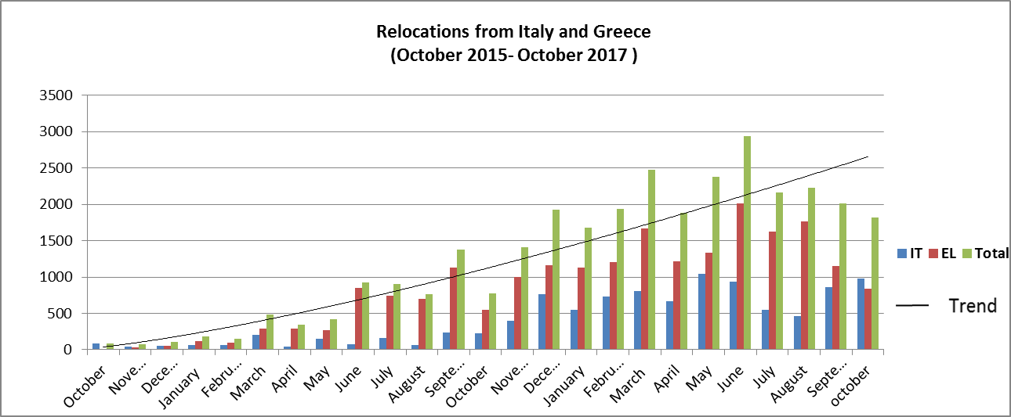

In total 758 applicants remain to be relocated from Greece (of which 369 to Ireland). Whereas for Greece current pledges are sufficient, Member States should finalise the relocation of remaining eligible applicants as a matter of urgency. In particular, Ireland should find accommodation and transfer already notified cases from Greece while Germany and Switzerland should reply to relocation requests sent by Greece. All other Member States with cases already matched and notified should accelerate the transfers from Greece.

3 110 applicants remain to be relocated from Italy. However, Italy has continued registering remaining eligible candidates and should finalise this exercise as soon as possible to stabilise this number. Germany, Switzerland, France and Austria should accelerate replies to relocation requests from Italy and all Member States should accelerate transfers from Italy of cases already matched and notified. Member States should also urgently reply to the 190 pending requests for unaccompanied minors submitted by Italy and provide at least 200 additional places for the relocation of eligible unaccompanied minors in the pipeline but who cannot be assigned yet to any Member State due to the unavailability of pledges.

In its regular Relocation and Resettlement Reports, the Commission repeatedly reminded all Member States of their ***legal obligations*** under the Council Decisions and called on those Member States that have yet to pledge and relocate from Greece and Italy, to do so immediately. Regrettably, despite repeated calls, Hungary and Poland have still not relocated a single person and the Czech Republic has relocated only a few and has not pledged for over a year. The Commission therefore decided on 14 June 2017 to initiate infringement procedures against these three Member States. Following their replies to the letters of formal notice, the Commission decided on 26 July 2017 to adopt, as the next step, reasoned opinions. The ruling of the Court of Justice of the EU of 6 September 2017 confirmed the validity of the second Council Decision of relocation and the Commission expected the three Member States to take action. Unfortunately, the Czech Republic, Hungary and Poland did not so far take any measure to address the grievances included in the reasoned opinion; those infringement procedures therefore remain ongoing.

While the current schemes are coming to an end, the EU should continue to show solidarity with Italy and Greece. Member States are therefore encouraged to continue to relocate from Italy and Greece beyond the current schemes. The Commission stands ready to provide financial support to those Member States sustaining their relocation efforts. The assistance provided by EU agencies to Italy and Greece will also continue and, when needed, be further enhanced.

The European Asylum Support Office has played a crucial role in the implementation of the relocation scheme since its start in September 2015, including by deploying Member State experts, developing tools in support of specific steps in the relocation procedure, as well as by implementing a relocation communication package, and continued support by Member States to the European Asylum Support Office is key.

***Resettlement*** allows the EU and it Member States to both fulfil the imperative to help those in need of international protection, and to reduce the incentives for irregular migration. Of the 22 504 resettlements agreed in 2015[53], over 81% have been completed. As of 10 November 2017, 18 366 people have been resettled to 20 Member States and four Associated States,[54] mostly from Turkey, Jordan and Lebanon. Since a number of countries with large quota have already fulfilled their resettlement commitment or are very close to fulfilling them, efforts continue to be mainly directed at resettlements under the EU-Turkey Statement. The total number of people resettled under both EU resettlement schemes since their launch is 25 739.

Following the Commission's Recommendation which calls on Member States to offer at least 50 000 resettlement places[55] by 31 October 2017, 16 Member States have pledged for a total of more than 34 400 resettlement places. The Commission welcomes the pledges received from Belgium, Bulgaria, Croatia, Cyprus, Finland, France, Ireland, Italy, Lithuania, Luxembourg, Portugal, Romania, Slovenia, Spain, Sweden and the United Kingdom. Several other Member States announced their pledges to be made shortly and some others who had pledged already may increase their pledges. The Commission encourages Member States to submit further pledges as soon as possible, in particular those that have not done so, in order to reach at least the 50 000 target and enable the EU to start planning concrete resettlement processes, including the evacuation from Libya in cooperation with the United Nations High Commission for Refugees.

Announced in the mid-term review of September, progress has already been made on the ***legal migration*** pilot projects with third countries. Most Member States have welcomed the concept, and several are ready to take this forward.[56]

|  |
| --- |
| ***Key future actions***   * Italy to finalise the registration of eligible applicants for relocation; * Member States to finalise the relocation of remaining eligible applicants from Italy and Greece as a matter of urgency, with a special focus on additional places to relocate eligible unaccompanied minors in Italy; the Commission stands ready to continue its support to those Member States who continue to relocate from Italy and Greece beyond the current schemes; * Member States to submit pledges to reach the target of at least 50 000 places for resettlement; * Commission and United Nations High Commission for Refugees to finalise project to evacuate refugees from Libya with a view to resettlement; * Together with interested Member States, define the scope of the pilot projects on legal migration, and identify third countries that could participate. |

**8. CONTINUED REINFORCEMENT OF EXTERNAL BORDER MANAGEMENT**

One year after its launch, the ***European Border and Coast Guard Agency*** is currently supporting Member States through joint operations across the main migratory routes in the Eastern, Central and Western Mediterranean and the Western Balkans, with the deployment of more than 1 500 border guard officers and other staff. Due to the increase of arrivals to Spain, Operation Indalo, which normally runs during the summer peaks only, was extended until the end of 2017. Another area of support is the preparation of vulnerability assessments and related recommendations for Member States.

However, the gaps for the ongoing Joint Operations in support of the Member States under pressure persist. Pledges continue to be too short in length and insufficiently matched to specifications, as well as falling short in scale. The only area where no gaps are expected until mid-November is the Joint Operation Poseidon.

While further progress has been achieved on putting in place the permanent capacity for rapid reaction, by 9 November 2017, 26 Member States had nominated their border guards, amounting to 74% of the required pool composition (1 110 out of 1 500 officers). No further progress has been made on the Rapid Reaction Equipment Pool since September[57] and considerable gaps remain for most types of equipment - only 14 Member States are contributing and no new pledges have been received since April. In order to support the equipment made at the disposal of the Agency, in August 2017 the Commission allocated a further EUR 76 million under the Specific Actions[58] of the Internal Security Fund for the purchase of maritime assets by Member States. This complements EUR 132 million allocated for this purpose in 2015. Member States should now step up their efforts to implement these projects so as to make these assets available to the Agency. . In addition, the Agency adopted a strategy for the acquisition of its own assets in the period 2017-2020 and is now developing a long term strategy for the period until 2027.

A key area of the Agency's work is the development of vulnerability assessments to identify possible shortcomings in Member States' border controls. The next step must be for Member States to implement the recommendations addressed in July 2017, and that the Agency puts in place an effective monitoring mechanism to ensure implementation of the action plans submitted by the Member States in September 2017. The Agency is about to complete the assessments following simulation exercises.[59] This process can also lead to additional recommendations. The common methodology for vulnerability assessments is expected to be revised at the next meeting of the Management Board on 22-23 November 2017. In addition, steps are under way to start the roll-out of liaison officers[60] to Member States and this process should be completed by the Agency by February 2018.

Cooperation with third countries is essential to the Agency’s work. Negotiations with Serbia and the former Yugoslav Republic of Macedonia towards the completion of the status agreements are ongoing. On 16 October 2017, the Council gave the green light to negotiate similar agreements with Albania, Montenegro and Bosnia and Herzegovina.

The development of the ***European Integrated Border Management strategy*** to draw together the work at national and EU level was the subject of a dedicated meeting with European Parliament and the Member States on 17 October 2017. This will feed into further work on setting the key elements of the common Integrated Border Management Strategy for the EU as a whole.[61]

|  |
| --- |
| ***Key future actions***   * Completion by Member States of obligations to contribute to the rapid reaction pools set up by the European Border and Coast Guard Agency; * Timely implementation by Member States of the recommendations made on the basis of vulnerability assessment and their effective monitoring by the European Border and Coast Guard Agency; * Member States to take full advantage of all possible support provided by the Agency. |

**9. CONCLUSION AND NEXT STEPS**

This report brings together the different workstreams being driven forward under the European Agenda of Migration. It illustrates the comprehensive nature of the work and the imperative to maintain the intensity of the EU's efforts across the board. The Commission will maintain the approach of a single wide-ranging report in the future, highlighting the issues requiring particular focus.

This report identifies key operational actions which are necessary to ensure the effectiveness of the EU response to the current migration challenge. They require the immediate attention and sustained commitment of the Member States, the EU institutions and EU agencies. They also contribute to preparing the ground for the convergence towards an agreement on the reform of the Common European Asylum System. In this regard, the December European Council will be an opportunity to take stock of progress made and to identify a way forward in line with the Leaders' Agenda endorsed by the October European Council.

1. COM(2015) 240 final of 13.5.2015.
2. COM(2017) 558 final of 27.9.2017.
3. European Council conclusions of 19.10.2017, EUCO 14/17 document CO EUR 17, CONCL 5.
4. Seven reports were produced on the implementation of the EU-Turkey Statement, fifteen on relocation and resettlement, five on the operationalisation of the European Border and Coast Guard and five on the progress made under the Partnership Framework.
5. Longer term trends and comparisons are also provided.
6. This compares to an average of 1 700 arrivals per day during the months preceding the EU-Turkey Statement.
7. Top nationalities for the period since 1 August: Syrian (40%) Iraqi (22%) Afghani (12%) Turkish (8%).
8. The number of apprehensions by Turkish Coast Guard suggests that the deployment of extra surveillance assets in the Black Sea in the second half of August, combined with the worsening weather conditions, may have contributed to this.
9. Around 98% of the migrants departing from Tunisia are Tunisians, a total of 5 749 in 2017 so far.
10. Source: IOM's Missing migrants project (https://missingmigrants.iom.int/region/mediterranean).
11. Year to 5 November.
12. These vessels had previously been detained by Italy.
13. The EU emergency Trust Fund for stability and addressing root causes of irregular migration and displaced persons in Africa (the "EU Trust Fund for Africa"); Commission Decision C(2015)7293 final.
14. Latest available data from the European Asylum Support Office.
15. Source: Eurostat. Last update: 26 October 2017.
16. SWD(2017) 372 of 14.11.2017.
17. Communication on the Protection of Children in Migration, COM(2017) 211 final of 12.4.2017.
18. The total number of migrants currently hosted in the Greek islands is close to 15 000, more than double the reception capacity of 7 000.
19. The cash programme in Greece provides refugees and migrants with humanitarian needs with a fixed monthly amount to cover food and non-food needs.
20. 107 national experts from Member States are deployed to EASO to support the implementation of the EU-TR Statement in Greece.
21. See COM(2017) 470 final of 6.9.2017.
22. Since 20 March 2016, there have been 1 380 returns to Turkey under the EU-Turkey Statement and 589 returns under the Greece-Turkey bilateral protocol.
23. So far, 15 EU Member States resettled Syrian refugees from Turkey, namely Austria, Belgium, Estonia, Finland, France, Germany, Italy, Latvia, Lithuania, Luxembourg, Malta – with its first resettlement operation under the EU-Turkey Statement – the Netherlands, Portugal, Spain, and Sweden. Additionally, Norway has so far resettled 814 Syrians from Turkey since 4 April 2016. In October, Croatia has conducted its first verification mission in Turkey and is expected to resettle in the coming weeks.
24. Two major contracts to extend the Emergency Social Safety Net as well as the Conditional Cash Transfer for Education project will be signed in December 2017.
25. European Council conclusions of 19.10.2017, EUCO 14/17 document CO EUR 17, CONCL 5.
26. Most recently through an operational workshop in November to improve the effectiveness of return.
27. SEC(2017) 339 of 4.7.2017.
28. Under Italy's National Programmes under the Asylum, Migration and Integration Fund and Internal Security Fund for 2014-2020, Italy received a total of EUR 634 million. Since 2014, the European Commission has awarded emergency assistance amounting to a total of EUR 149.1 million to Italy.
29. On best practices for hotspots, see page 4.
30. Operation Sophia initiated a second package of shore-based training as of late January 2017 in Greece and Malta resulting in the training of an additional 40 personnel.
31. At the same time, Common Security and Defence Policy operations have continued capacity building in partner countries: the EU Border Assistance Mission in Libya is supporting the development of a new integrated border management strategy.
32. Council conclusions on Libya of 17.7.2017 (doc. 11155/17).
33. Three assets are currently deployed in the Joint Operation in the Western Mediterranean.
34. Sevilla (Spain), 16 October 2017.
35. Similarly, in Sudan, a Better Migration Management Programme is under way to link national and regional policies: this has led to the setting up of specialised human trafficking Prosecution Offices.
36. Announcement made by the HR/VP at the EU-G5 Sahel Ministerial Meeting in Bamako, 5 June 2017.
37. The mission also participates, together with the European Migration Liaison Officer, the European Border and Coast Guard Agency Liaison Officer and the International Organisation for Migration in a platform of exchange of information on irregular migration.
38. Under the EMPACT (European multidisciplinary platform against criminal threats) Operational Action Plan 2018 against facilitation of irregular immigration.
39. The first EU/Schengen Consular Anti visa-fraud Workshop is scheduled to take place on 30 November-1 December in Moscow.
40. The second formal meeting of the Pakistan EU Cooperation platform on migrant smuggling is scheduled in Islamabad on 23 November.
41. Commission Decision C(2015) 7293 final; The EU emergency Trust Fund for stability and addressing root causes of irregular migration and displaced persons in Africa (the EU Trust Fund for Africa).
42. Recent Member State contributions include: Estonia, Austria, the Czech Republic and Italy have paid additional contributions; Croatia, Latvia and Italy have sent contribution certificates, and Bulgaria and other donors are working on formalising their pledge.
43. In parallel, the EU is actively engaged in addressing the humanitarian needs of Rohingya and their host communities in both Bangladesh and Myanmar. At the international Pledging Conference in Geneva on 23 October 2017, the EU committed an additional EUR 30 million, bringing its total support for this crisis to EUR 51 million for 2017. Humanitarian assistance is focusing on nutrition, fighting the outbreak of disease, and sexual and gender based violence, as well as emergency education.
44. Sustainable energy and sustainable connectivity; Micro, Small and Medium Enterprises financing; Sustainable agriculture, rural entrepreneurs and agroindustry; Sustainable cities; Digitalisation for sustainable development.
45. The first meeting of the EFSD Strategic Board took place also on 28 September, the joint meeting of the operational boards for the two geographical platforms, Neighbourhood and Africa, took place on 7 November to discuss in detail the five sectoral windows of intervention.
46. Communication on a more effective return policy in the EU – A renewed Action Plan, COM(2017) 200 final of 2.3.2017.
47. Most recently, through support to a workshop organised in Italy on increasing the effectiveness of return policy (6 November).
48. Reporting period 01/01/2017-15/10/2017.
49. Of which 153 to countries other than Western Balkans.
50. This designation is without prejudice to positions on status, and is in line with UNSCR 1244/1999 and the ICJ Opinion on the Kosovo declaration of independence.
51. Figures include joint return operations, national return operations, and collecting return operations.
52. COM(2017) 465 final of 6.9.2017.
53. Council conclusions ("on resettling through multilateral and national schemes 20 000 persons in clear need of international protection") of 20.7.2015, document 11130/15.
54. Belgium, the Czech Republic, Denmark, Germany, Estonia, France, Iceland, Ireland, Italy, Latvia, Liechtenstein, Lithuania, Luxembourg, Malta, the Netherlands, Norway, Austria, Portugal, Romania, Spain, Finland, Sweden, Switzerland and the United Kingdom.
55. Commission Recommendation of 27.9.2017 on enhancing legal pathways for persons in need of international protection; C(2017) 6504.
56. A meeting between interested Member States and the Commission has been scheduled for 29 November 2017.
57. COM(2017) 467 final of 6.9.2017.
58. The Specific Actions are a dedicated top-up funding scheme under the Internal Security Fund to co-finance Member States' equipment which, once purchased, must be registered in the Agency's technical equipment pool and made available at the request of the Agency for deployments at any section of external borders, especially in case of rapid border interventions.
59. For Bulgaria, Greece, Italy and Croatia, this process will be completed by end November, with France and Spain to follow in December
60. Article 12 of the Regulation on the European Border and Coast Guard (Regulation (EU) 2016/1624 of 14 September 2016 (OJ L 251/1 of 16.9.2016). Liaison officers will be deployed largely to clusters of Member States.
61. Article 4 of the Regulation on the European Border and Coast Guard.