

**Table of Contents**

1. Introduction 3

1.1. Context 3

2. What is the problem and why is it a problem? 4

2.1. Specific problems related to the current DWD identified in the Evaluation 5

2.1.1. Regulatory failure - Outdated parameters 5

2.1.2. Regulatory failure - Outdated approach 6

2.1.3. Obstacle to internal market - Materials and products in contact with drinking water 7

2.1.4. Information failure 7

2.2. Part of the population has no access to drinking water- problem identified in the ECI 9

2.3. Ranking of the problems 10

3. Why should the EU Act 11

3.1. Right to act 11

3.2. Subsidiarity 11

4. What should be achieved 13

4.1. General policy objective 13

4.2. Specific objectives 13

5. What are the various options to achieve the objectives 13

5.0. Baseline scenario – How would the problem evolve? 14

5.0.1. Baseline assumptions 14

5.0.2. Expected baseline impacts on health 15

5.0.3. Expected baseline impacts on affordability of drinking water for EU citizens 16

5.1. Set of options to achieve Objective 1: Updating the list of parameters 18

5.2. Set of options to achieve Objective 2: Simplifying the approach 18

5.3. Option to achieve Objective 3: Removing obstacles to the internal market 19

5.4. Set of options to achieve Objective 4: Ensuring transparency and information to the consumer 20

5.5. Set of options to achieve Objective 5: Improving access to drinking water 21

5.6. Synopsis sets of options 22

5.6.1. Options not further pursued 24

6. Analysis of impacts 25

6.1. Health Impacts 25

6.1.1. Acute Health risks 25

6.1.2. Chronic health risks 26

6.1.3. Associated health benefits in monetary terms 27

6.2. Economic Impacts 27

6.2.1. Economic situation/baseline 27

6.2.2. Comparison of economic impacts of each option 28

6.2.3. Impacts on SMEs and on innovation 28

6.2.4. Macro-economic impacts 30

6.2.5. Impact on employment 30

6.3. Social Impacts 31

6.3.1. Affordability and social inclusion 32

6.4. Environmental impacts 33

6.4.1. Water Pollution 33

6.4.2. Resource efficiency 34

6.4.3. Energy 35

6.4.4. Bottled water 35

6.5. Administrative Burden Reduction Impacts 36

7. Comparison of options 37

7.1. Health Protection versus Costs 37

7.2. Ranking overall 38

7.3. Who will be affected? 40

7.4. Presentation of possible policy packages 40

8. Monitoring and evaluation 47

9. Annexes 49

9.1. Annex 1 Procedural information concerning the process to prepare the Impact Assessment report and related amendment 50

9.2. Annex 2 Synopsis report on the stakeholder consultation 54

9.3. Annex 3 Who will be affected by the preferred policy packages and how? 68

9.4 Annex 4 Development of the analytical model for the assessment of the options, underlying assumptions of the options and impacts assessed through application 79

9.5. Annex 5 Monitoring 128

9.6. Annex 6 Glossary 132

1. Introduction

The revision of the Drinking Water Directive (DWD)[1] is included in the Regulatory Fitness and Performance Programme ([REFIT](https://ec.europa.eu/info/law/law-making-process/overview-law-making-process/evaluating-and-improving-existing-laws/reducing-burdens-and-simplifying-law/refit-making-eu-law-simpler-and-less-costly_en)). The preceding REFIT evaluation[2] contributed to identifying the strengths and weaknesses of the Directive. This Impact Assessment report builds on the evaluation results. It analyses several options aimed at updating and simplifying the Directive in order to ensure that its objectives can be reached in a more effective and efficient way. Furthermore, the revision is also one of the follow-up actions to the first successful European Citizens' Initiative *Right2Water*.[3]

1.1. Context

Safe drinking water is essential for public health and well-being. Defects in quality and quantity cause high social and economic costs. The DWD is the main piece of EU legislation in this regard. The DWD regulates the quality of water intended for human consumption. Its overall objective is to protect human health by ensuring that drinking water at the consumer tap is wholesome and clean. Drinking water in the EU stems from around 11 000 large water supplies[4] and 85 000 small supplies serving around 80 % and 20 % of the population, respectively.

EU legislation on drinking water has existed for about four decades.[5] The original Directive[6] was replaced in 1998 by the current DWD. The DWD provides a general framework and sets concrete minimum quality standards in the form of maximum parametric values. The Directive lists a total of 48 parameters that must be monitored regularly. If the standards are exceeded (non-compliance), remedial measures are required. The selection of those is left to the Member States' discretion. The DWD also requires that Member States ensure the provision of appropriate information to consumers.

While the DWD regulates water quality at the consumer's tap, the EU Water Framework Directive (WFD)[7] regulates the abstraction of drinking water and the protection of water bodies intended for this purpose. Article 7 of the WFD requires Member States to identify bodies of water for the abstraction of drinking water and to protect them, so that the treatment regime will result in drinking water which meets the DWD requirements.

2. What is the problem and why is it a problem?

The EU has already achieved significant results through its efforts to ensure the provision of high drinking water quality. Before the changes to the DWD introduced in 1998, drinking water compliance with the majority of the parametric values was just over 90 %. In 1998, compliance rates rose on average to around 95 %[8], but varied between Member States. Recent data shows that compliance continued to increase, from 97 % in 2005 to over 99 % for most parameters, and compliance became more homogenous across the EU. The latest Implementation report[9] based on around 30 million analyses shows sustained high compliance.

The reporting results and the REFIT Evaluation confirmed that the Directive is well implemented in the Member States, and is generally achieving its objective of protecting human health from the adverse effects of contamination. The evaluation and the results of stakeholder consultations confirmed that the DWD is a relevant tool to ensure that the quality of the water consumed in the EU is good, and that it fulfils its basic purpose to enable the enforcement of drinking water monitoring and the restoration of quality to the required level in the event of non-compliance. However, the evaluation was subject to several limitations[10], most importantly that, although the compliance rates are high, it is difficult to establish whether the existing parameters adequately reflect all possible (including emerging) health risks. Stakeholders also argued that it is difficult to quantify the impact of the DWD on drinking water quality in comparison with other influences that might have led to improvements in drinking water quality.

The evaluation concluded that the following four areas leave room for improvement and represent weaknesses of the current DWD[11]: (1) the list of drinking water parameters and values has not been revised in the past 19 years, and could be partly not relevant anymore and not fully take account of changed or emerging pressures according to the latest scientific knowledge, (2) risk-based elements are not sufficiently considered in the DWD, (3) provisions related to materials in contact with drinking water constitute a burden and lead to non-recognition of such materials on the internal market, and (4) the availability of information to consumers is uneven, sometimes inadequate and insufficiently transparent.

The results of the public consultation[12], and of targeted stakeholder consultations[13], confirmed the finding that, despite the generally good outcomes of the DWD implementation, some aspects of the Directive are in clear need of improvement.

The four areas of improvement outlined above represent the main problems to be tackled. Additionally, the ECI 'Right2Water' identified as a distinct problem the fact that part of the population has no access to drinking water[14]. Since the adoption of UN Agenda 2030, this problem is subject to EU Member States' obligation to implement Sustainable Development Goal (SDG) 6.[15] Figure 1 depicts how these areas of improvement or problems are related to underlying drivers and what consequences they entail.

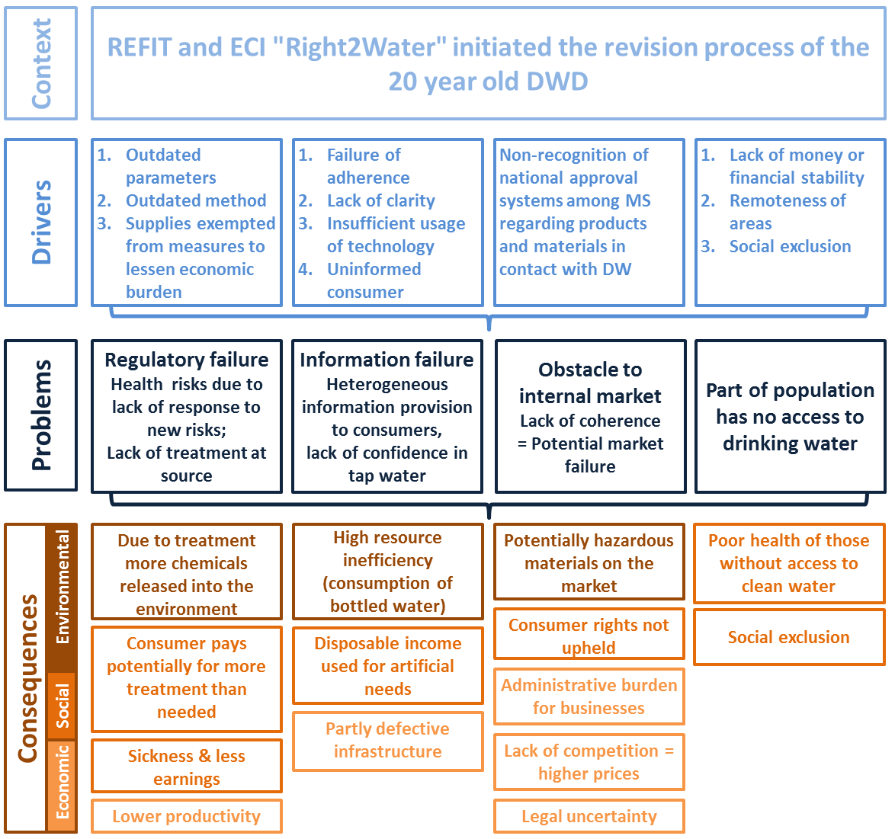

Figure 1: Drivers, problems and consequences

2.1. Specific problems related to the current DWD identified in the Evaluation

2.1.1. Regulatory failure - Outdated parameters

The list of parameters and values has not been revised in the past 19 years. The evaluation found, correspondingly, that although compliance with the existing parametric values is high, some are not relevant anymore[16], and they do not fully take account of changed or emerging pressures according to the latest scientific knowledge.[17], [18] The results of stakeholder consultations confirm that there is general agreement among Member States and industry experts that the parameter list is insufficient. This could mean that health risks are higher than currently accounted for.

2.1.2. Regulatory failure - Outdated approach

The DWD method to regularly monitor water quality at the consumer's tap is not optimal as it is not comprehensive enough. This was underlined by some stakeholders, who raised the issue of risks to health from, e.g. legionella, which are currently not monitored. The DWD does neither require systematic preventive safety planning nor systematic risk assessments. Instead, the current DWD requires monitoring at regular intervals independent of the level of risk. Such an approach is outdated. Although the practice on the ground may in many, or the majority of the cases, be adequate, emerging risks might bypass the matrix of the current parameter list which constitutes a too uniform and generic monitoring approach. Furthermore, current requirements do not address the microbiologically-related challenges, such as legionella and somatic coliphages. Under these circumstances an EU level playing field is not ensured. The current approach also does not promote cost-effective source control measures, even though the prevention of water pollution at source generally has a very high cost-benefit ratio in comparison to water treatment.[19] Therefore, the current approach has led to more treatment than needed, leading in turn to higher costs for consumers. Moreover, the current fixed monitoring approach is burdensome and was therefore not always properly applied.

An alternative method for monitoring called the "risk-based approach" (RBA)is already implemented to a certain extent in a few Member States such as Hungary, the Netherlands, and the UK. As the water supply sector is rather conservative and the RBA still considered a new concept, it has not been taken up as much as one would expect given its expected benefits. Prior to the revision of Annexes II and III of the DWD in 2015, the application of the RBA was under the current end-of-pipe approach of the DWD only possible to a very small extent in EU Member States. Now the RBA can be taken up by Member States in their legislation on a voluntary basis since 2015[20] and meetings with Member States showed that overall the RBA has been very positively received and the majority will take up this voluntary approach in their transposition of the Annexes. However, even with this revision of Annexes II and III, the RBA remains restricted to the monitoring Annexes and hence is not fully integrated into the Directive, limiting its potential.

2.1.3. Obstacle to internal market - Materials and products in contact with drinking water

A third problem identified and often raised by various stakeholders[21] concerns materials in contact with drinking water. Inappropriate materials can contaminate drinking water. An obstacle to the internal market arises from the non-recognition of national product approvals between different Member States causing high administrative burden. The evaluation of the DWD concluded that Article 10, which imposes that Member States take all necessary measures to ensure that materials in contact with drinking water do not reduce the protection of human health, does not work well. The provision represents a problem of legal uncertainty as interpretations diverge between Member States and provide too much flexibility, and therefore constitutes a long-term challenge to the provision of clean and healthy drinking water in the EU.

One international manufacturer with a strong presence in Europe selling products in contact with drinking water in 47 countries has to deal with more than national 1300 approvals and more than 40 quality marks, and has to spend annually between EUR 1.8 and 3.6 million to keep the approval process alive, including double and tripling tests because of cross-border non-acceptance of existing test results and certificates, additional costs and delayed market introductions.

This example is representative for all manufacturers in the EU and therefore gives a good indication of the (cross-border) dimension of the problem.

**Box:** Product Approval

Many materials in contact with drinking water are construction products that can be harmonised under internal market legislation, in particular under the Construction Products Regulation[22] (CPR), but standardisation efforts have so far been unsuccessful due to the complexity of the materials and products, unclear mandates and low priority attached to developing them.[23]

Most affected by this are the manufacturers of such materials. As demonstrated in the representative example on product approval for manufacturers, the costs incurred by businesses through the inefficiency of Article 10 lead to clear obstacles for manufacturers in the internal market. More evidence is provided by a specific study.[24]

2.1.4. Information failure

A fourth problem identified in the evaluation of the DWD is the very heterogeneous level of (mostly passive) information made available to consumers. The open public consultation showed that only 58 % of the EU citizens feel that they are well informed on issues relating to drinking water. This is mainly due to the vague and passive DWD wording, which provides that 'Member States shall take the measures necessary to ensure that adequate and up-to-date information […] is available…' This has led to significantly different information practices among Member States and also among water suppliers. This lack of information can lead to consumers turning away from tap water.

Preferring bottled over tap water has many underlying reasons, among others this preference can be explained by cultural habits, convenience, access as well as clever and attractive marketing promoting the purchase of bottled water. Although tap water is highly regulated to ensure its quality, many consumers fear pollution (63 % of the Americans in a recent Gallup study) and consequently choose bottled water instead of tap water as argued by Business Insider (2017) "16 facts that show why bottled water is one of the biggest scams of the century".

Box: Consumers' choice for bottled water and the link to confidence in tap water

The confidence in tap water is rather low: only 19 % of the respondents to the public consultation[25] agreed that the quality of tap water is acceptable at EU level. Many consumers do not trust tap water and rely partly or exclusively on more expensive bottled water. To be able to make an assessment of the options that are suggested to address this low confidence, this Impact Assessment uses the purchase of bottled water in the EU as a simplified indicator to estimate the level of non-confidence[26]. The 2015 average is 106 l of bottled water/ capita/ year, up to 170 to 180 l/ capita/ year in some Member States including Germany, Italy and Malta.

Poor knowledge about tap water contributes to the low confidence shown by citizens, and to their failing to participate more actively in water management decisions, as well as to scrutinize the efficiency and quality of supply services as well as water and energy savings. The evaluation also found that the current reporting provisions providing outdated compliant values are of no avail and do not tap the potential of modern information technology and data management for swift und multiple use of information. Providing adequate information to consumers is an issue also identified as important by the European Court of the Auditors.[27]

#### 2.1.4.1 Lack of awareness of leakages

Another issue identified that is outside the scope of evaluation by the Commission was that the public lacks awareness of water leakages that can lead, to a certain extent, to health problems[28] but are mainly indicators for a general underinvestment in maintenance and renewal of the drinking water infrastructure[29], [30]. This underlying driver of lack of investment can be strongly seen in the elevated leakage rate of treated water during its distribution: 23 % of treated water is lost in public water supplies in Member States[31], with large differences between Member States.[32], [33]

In Herford, Germany (64 000 citizens) in Summer 2015: Caused by two pipe bursts following a settlement close to an aerator/exhauster surface water could enter into the drinking water pipes during heavy rain events. It took several weeks to find the cause and to solve the problem. In addition further disinfection plants were installed.

**Box**: Health problems caused by leakages

2.2. Part of the population has no access to drinking water - problem identified in the ECI

The current DWD does not include any provision on access to water or an obligation to supply drinking water to every citizen. The ECI 'Right2Water' supported by more than 1.8 million signatories, invited the Commission *inter alia* "*to propose legislation implementing the human right to water and sanitation, and promoting the provision of water* […] *for all*" to ensure that all inhabitants enjoy the right to water. The Commission replied officially to the European Citizens’ Initiative ‘Right2Water’ via a Communication[34] recalling the principle of neutrality in relation to national decisions governing the ownership regime for water undertakings. Whilst the Union cannot regulate this system of ownership nor the means chosen by Member States for the provision of drinking water services, the Commission invited "*the Member States, acting within their competences, to take account of the concerns raised by citizens through this initiative and encourages them to step up their own efforts to guarantee the provision of safe, clean and affordable drinking water and sanitation to all*." (p. 13). The human right to water corresponds to SDG 6 in the UN Agenda 2030, which also concerns the availability of water and sanitation for all. Furthermore, lack of access to water is also a problem from a health perspective. It is in this general context that this problem and possible options will be assessed in this Impact Assessment. This additional issue was not in the scope of the evaluation of the Directive.

In the ECI it is argued that there are "*still around 2 million people in Europe that do not have proper access to water or sanitation*"[35]. Based on Eurostat data this Impact Assessment estimates that currently 23 million people or 4.5 % of the total EU population are not connected to Public Water Supply (PWS) systems for a variety of reasons: on the one hand many temporarily or sporadically used dwellings, secondary residences and holiday homes are not connected because there is no need. On the other hand homeless people, Roma and nomadic communities often have no possibility to be connected to the system. Consequently, it can be said that the underlying drivers of this problem are diverse, ranging from no need, over the remoteness of some areas to social exclusion and poverty. Connection rates to PWS systems in Member States range from 57 % (Romania) to 100 % (Belgium, the Netherlands).

"**Does the human right to water help the poor and people that are not connected to a system?**

We are arguing for more public spending to extend water and sanitation services to the poor. The human right to water obliges governments to ensure that everybody has (clean, safe, affordable, accessible) water and sanitation. That is contrary to a market-based approach that demands that people pay first for access to the service. You cannot ask the poor to pay upfront for connection to a water system. Putting the human right first helps the poor, a market for water doesn’t."

(ECI Right2Water: <http://water.tttp.eu/node/45/>)

**Box:** ECI Right2Water

The continuous support to the topic was visible in the open public consultation for which supporters of legislation implementing the right to safe water and sanitation, among others, submitted 186 times the same text to the survey and provided 41 position papers with the same text to substantiate their position.

2.3. Ranking of the problems

In terms of the Directive's main objective of health protection the outdated parameter list combined with the outdated end-of-pipe approach to monitoring are certainly the most urgent problems. These two issues are closely interlinked and need to be viewed together when thinking about solutions. Key is the anticipation of emerging issues such as new types of pollutants (e.g. pesticides, pharmaceuticals) that are more and more frequently found in raw water sources used for the production of drinking water. The other identified problems – lack of transparency and lack of information, lack of harmonisation of the materials in contact with drinking water, limited access to drinking water for some parts of the population – have an important but more indirect impact on citizens' health. These issues are however crucial in terms of efficient governance and cost effectiveness of the sector, especially from a long-term and resource efficient perspective.

3. Why should the EU Act

3.1. Right to act

The proposed legislation is not a new intervention. It is based on Article 192(1) TFEU. This provision was the legal basis of the current DWD, and will serve as a legal basis for the revised measure. The EU has shared competence with Member States to regulate environment and health in the field of water. This means that the EU can only legislate as far as the Treaties allow it, and with due consideration for the principles of necessity, subsidiarity and proportionality.[36]

3.2. Subsidiarity

The current DWD was designed in accordance with the principle of subsidiarity, and recognised the natural and socio-economic differences between the regions of the EU. The Directive sets EU minimum standards and the legal frame, but leaving most decisions on monitoring, analysis and remedial measures to be taken at a local, regional or national level. Concrete actions (remedial actions, actual monitoring programmes, etc.) are left to the Member States.

Concerning more specifically aspects related to access to water, the revision was originally triggered by the ECI 'Right2Water', supported by more than 1.8 million signatories. In its reply to the initiative, the Commission underlined the importance of the human rights dimension of access to safe drinking water, whilst respecting as outlined above the subsidiarity principle and the EU's neutrality in regard to national, regional and local levels concerning provision of water services[37]. Action at EU level was also demanded by the European Parliament in its response to the initiative.[38] Moreover, the EU's commitment to the UN Sustainable Development Goals (SDGs)[39] requires the Commission to consider new approaches to drinking water. However, any considerations on access to water will have to respect the Treaty principles of subsidiarity and neutrality, according to which the Treaties in no way prejudice Member States' rules governing the system of property ownership of water undertakings, and other legislations in this regard such as the Concessions Directive[40] and Services Directive[41], which excludes the application of the cross-border freedom to provide services for water distribution and supply. In addition, the provision of water services is generally the responsibility of local authorities, which are the closest to the citizens and their concerns.[42]

With water catchment areas[43] and groundwater reservoirs being cross-boundary, an EU-wide approach is utterly important to ensure that all EU citizens benefit from the same level of health protection. Also, the REFIT evaluation confirmed the added value of the drinking water legislation at EU level, achieving significant harmonisation of water quality over time across Europe. In stakeholder consultations on the evaluation and the quality of drinking water, Member States and businesses have called upon the EU to set and maintain up-to-date EU-wide common drinking water quality standards. Most Member States, particularly smaller ones that do not always have the resources and specific expertise, expect the EU to continue to set the essential chemical and microbiological parameters and values. Moreover, many stakeholders see EU measures as best placed to address emerging health hazards from water. Establishing EU harmonised approaches for materials and products in contact with drinking water can contribute to improving the functioning of the internal market, whereas national approaches currently create obstacles to the internal market. Finally, the lack of transparency on prices and leakage affecting consumers is also to be addressed at EU level, to ensure a similar level of protection of consumers across the Union.

In light of the above, it is clear that the objectives of the DWD and of the different options considered in this Impact Assessment, namely protection of human health and of the environment, removal of obstacles to the internal market, improving and promoting access to water and sustainable management of water distribution, cannot be sufficiently achieved by Member States on their own, but can rather, because of the scale of the actions to be taken, be better achieved at Union level. There is, therefore, a clear demand and justification for action at EU level.

4. What should be achieved

4.1. General policy objective

The general objective of the revised initiative is to contribute in the most effective and efficient way to the protection of human health from the adverse effects of any contamination of water intended for human consumption by ensuring the continued high quality of drinking water in the long term in a cost effective way. The aim is also to modernise and simplify the current legislation - where this is feasible and without impairing the overall objective of the protection of health - and to move from an 'end of pipe' to a more preventive and integrated approach. By also using the possibilities offered by new technologies, the initiative also aims to lower the administrative burden for small supplies and to increase transparency for EU citizens.

4.2. Specific objectives

Five specific objectives were defined in response to the problems identified in section 2, taking into account the need to meet the principal health objective and to avoid excessive costs and excessive impacts on affordability (Annex 4).

1. Update the parameter list in line with technical and scientific progress;
2. Simplify the approach and target the focus of monitoring and treatment to those contaminants that present health risks;
3. Remove obstacles to the internal market in relation to materials and products in contact with drinking water;
4. Increase transparency on water related topics that can be of interest to the consumer and increase the availability of, and improve the access to, up-to-date information on drinking water;
5. Improve the access to drinking water.

5. What are the various options to achieve the objectives

This section screens the possible options for meeting the objectives outlined above. The choice of possible options has been done through an iterative process. At the very beginning of the process, two far-reaching options were discussed, namely repealing and discontinuing the DWD, or replacing it by a Drinking Water Regulation. A regulation would have the advantage that the same parameters and values would apply to all EU citizens. The repeal option could refer to the voluntary but comprehensive WHO Drinking Water Guidelines. However, the evaluation, further supported by the 2015 comitology process to amend Annexes II and III[44] of the DWD as a first step towards a risk-based approach, as well as the various stakeholder consultations (Annex 2), suggested that these options should be discarded upfront. The evaluation firmly underlined that the DWD is a relevant legislative tool that works well. The amended Annexes II and III already pave the way towards a more risk-based approach which intrinsically gives Member States and suppliers more flexibility to address risks that matter. This approach is well-suited to an EU Directive, setting the frame for all, but leaving specific measures up to the local level.

A specific stakeholder consultation on possible policy options was held including a stakeholder conference on 8 December 2015.[45] The options considered in this document were broadly supported, while other options, e.g. on a Safe Drinking Water Label or on Responsible Service Operators were rejected because judged unrealistic.

5.0. Baseline scenario – How would the problem evolve?

5.0.1. Baseline assumptions

The baseline scenario assumes that the current DWD with its amended annexes will continue to be applied. The baseline considers certain changes that will take place in Europe between today and 2050. The changes are linked to climate change, general socio-economic developments, the uptake of innovative technologies, or migration linked in particular to war or changes in the political situations of countries that are geographically or economically connected to the EU. Some of these changes will affect directly or indirectly the functioning of the 'drinking water system' (Annex 3).

The main changes that are expected in key parameters and variables affecting the drinking water system between now, 2030 and 2050[46] concern inter alia changes in population and behaviour, in the quality of raw water resources, in emission of emerging substances by the domestic sector, in an increase of nitrogen losses, in the management of drinking water services, and in better monitoring and data management.[47]

Potential change in consumer behaviour regarding the purchase of drinking water is based on expert knowledge. This entails, the effects of the various options can be (slightly) under- or overestimated. Quality of raw water resources depends on the effectiveness of other water legislation such as the WFD, for which the assessment of the river basin management plans is yet to be conducted. Emerging substances in the domestic sector are accounted for, but as the name indicates it remains to be seen which substances emerge and how hazardous they are to human health and which treatments are existent or to be developed to tackle these. Other uncertainties related to the development of technologies regarding monitoring and data management in drinking water services. With fast developing technologies in nearly all sectors, it can only be assumed in the model how these account for costs in 2050.

**Box**: Inherent uncertainties in the assessment of future health and cost implications

Potential change in consumer behaviour regarding the purchase of drinking water is based on expert knowledge. This entails that, the effects of the various options can be (slightly) under- or overestimated. Quality of raw water resources depends on the effectiveness of other water legislation such as the WFD, for which the assessment of the river basin management plans is yet to be conducted. Emerging substances in the domestic sector are accounted for, but as the name indicates it remains to be seen which substances emerge and how hazardous they are to human health and which treatments are existent or to be developed to tackle these. Other uncertainties related to the development of technologies regarding monitoring and data management in drinking water services. With fast developing technologies in nearly all sectors, it can only be assumed in the model how these account for costs in 2050.

**Box**: Inherent uncertainties in the assessment of future health and cost implications

An important assumption for the baseline concerns the RBA. This assumes that changes in the management of drinking water services will take place independently of the implementation of the DWD. It is assumed that the number of water suppliers implementing a RBA will continue to increase, but at an uneven manner across the EU. This is triggered by the revision of Annexes II and III of the DWD, and also promoted by the WHO and other national and water suppliers’ initiatives. It is expected that in 2050 74 % (2015: 47 %) of the EU population will receive drinking water from suppliers that have implemented the RBA. Data and assumptions for the current situation and the projections until 2050 are listed in Annex 4.

Another important assumption for the baseline concerns the very slow development of the internal market for products in contact with drinking water and the stagnation on standardisation work. Due to the sensitive health issue some Member States insist on having their own high level approval systems, whereas many others refrain from establishing such systems at all. Apart from a four-Member State initiative, no significant progress towards a fully-functioning mutual recognition system has been made.

Therefore, the baseline does not assume that positive developments on mutual recognition via product passports or in other sectors will spill over onto these products, but assumes that the current status quo in the baseline in 2030 and in 2050 will remain as it is now.

5.0.2. Expected baseline impacts on health

The Evaluation already pointed at the difficulties for establishing direct causal and statistical relations between drinking water quality and risks to human health. This is particularly difficult for emerging pollutants. Therefore, health issues in this Impact Assessment have been addressed through a specifically developed indicator named ‘Population Potentially at Health Risk’ (PPHR).

*What is PPHR?*

This indicator serves as an estimate of the share of the population that could potentially suffer from health problems because of the presence of contaminants in drinking water.[48] In summary, five levels of risk have been defined (no risk, marginal, low, medium, high) depending on the quality of the water consumed. Different assumptions have been made regarding the quality of the water depending on whether the RBA is applied or not, the origin of the water (bottled/ tap water), and whether or not there is a connection to the public water system. The quality of the water was estimated on the basis of the possible contamination by substances included in the DWD or outside its current scope (emerging pollutants). For the baseline and for each option having a health impact, the indicator PPHR was calculated.

This calculation was then verified by available data on causal sickness cases attributed to: Cryptosporidiosis, Campylobacteriosis, E.coli, Giardosis, Shigellasis, Legionella - which are typically present in unsafe drinking water. This verification has shown a good correlation between the PPHR and data on diseases due to unsafe drinking water (Annex 4).

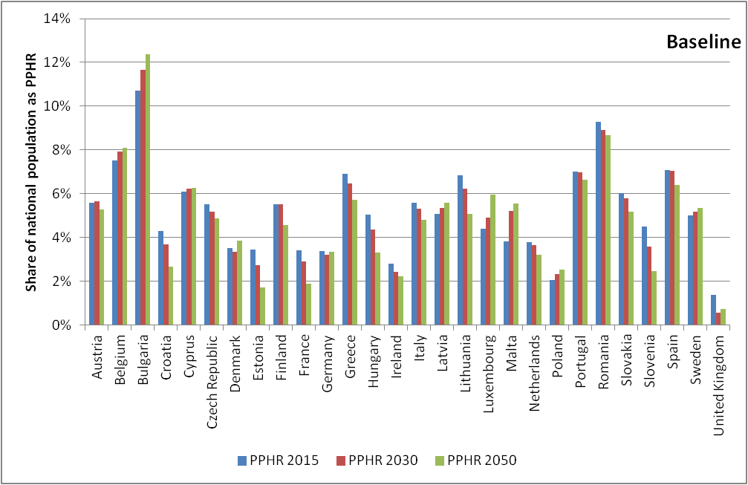

Figure 2: Expected trend in the Population Potentially at Health Risk (in relative terms, % of the absolute national population, 2015, 2030 and 2050)

According to the PPHR indicator, it is estimated that in 2015 **22.7 million people** were potentially at health risk due to non-safe drinking water, equivalent to 4 % of the EU population. In 2015 the societal cost of the estimated 17 000 cases of getting sick from drinking tap water in Europe was equal to EUR 220 million or EUR 0.43 per EU citizen and EUR 9.6 per person at risk (Annex 4).[49] Using the PPHR for the baseline calculation, the number of people potentially at health risk is expected to decrease by 2050, but the number of people potentially at risk will remain significant. Overall, **20 million people** will potentially be at health risk due to drinking water quality problems, equivalent to **3.8 % of** **the** EU28 population in 2050. In absolute terms, the large majority of Member States will see their situation (marginally) improve. The highest potential risk is likely to be observed in, among others, Bulgaria, Greece, and Lithuania.

5.0.3. Expected baseline impacts on affordability of drinking water for EU citizens

The evaluation of the DWD has assessed the cost-effectiveness of drinking water policy.[50] In different Member States there are different approaches on how water is paid for, for instance via tariffs or taxes. In general it is assumed in this Impact Assessment that water operators transfer all costs to the consumer and that only those consumers that are connected to the PWS in each Member State pay for the costs. In 2015, the average annual cost per household was estimated at EUR 229[51], which represents an EU average of 0.73 % of the disposable income.[52], [53] Figure 3 shows for each Member State how much of the income of a household is spent on water services. This is assessed by comparing the share of spending on water services to average incomes (green bars) and to the incomes of the lowest income group of the Member State (violet bars). For instance, in Romania drinking water is assumed to require a share of 1.8 % of the disposable income, which is more than twice as high as the EU average. Bulgaria, Latvia and Lithuania also experience comparatively high figures with over 1.2 % of their disposable income being spent on drinking water, whereas in Finland, Malta and the United Kingdom the figure is only around 0.5 %. The impact on the lowest quintile of the population is in comparison to the impact on all income groups higher and averages at 1.01 % for the EU (Figure 3). Looking at individual Member States, in 2015 for Romania the spending of disposable income on drinking water is as high as 7.4 % for the lowest income group. In Bulgaria, Hungary and Lithuania, the level is above 2.0 % for the lowest income group. Under the baseline scenario, the average EU household spending is forecast to decrease to EUR 228 by 2050.

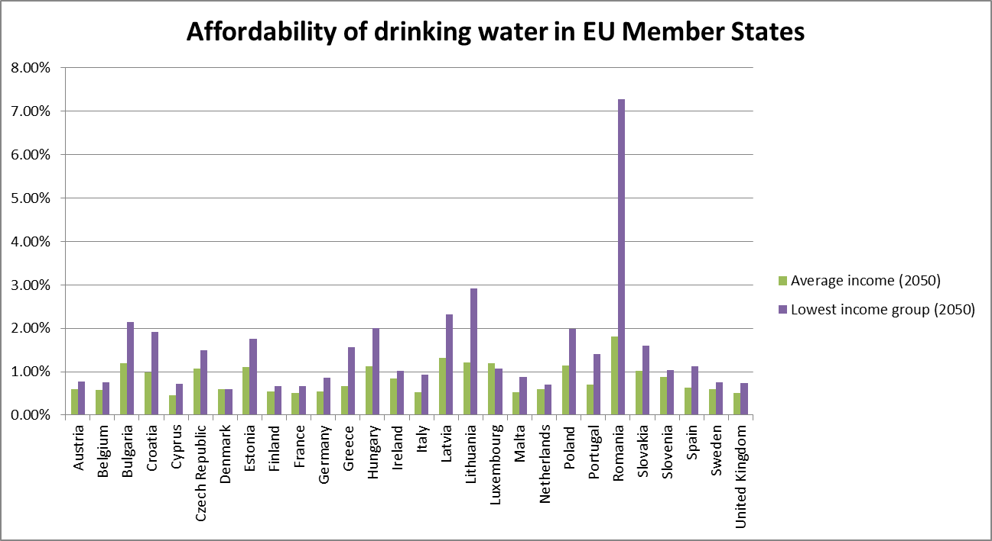

Figure 3: Affordability of drinking water

The assessment found that costs to the consumer in the baseline scenario remain stable. The cost-effectiveness in achieving the objectives of the current DWD will slightly improve in the longer-term as a result of the progressive application of the RBA. As stated in the problem definition, the Commission is bound by the principle of neutrality when it comes to water pricing. Detailed cost estimations and a cost breakdown can be found in Annex 4.

The baseline scenario includes further an assessment of people currently without access to water services. The EU average population connected to a PWS[54] (currently 95.5 %) is expected to increase by 18.5 million people (mainly due to increase in population size). The expected average connection rate in 2050 will be 95.9 %.

5.1. Set of options to achieve Objective 1: Updating the list of parameters

The evaluation and the stakeholder consultations identified the need to amend the list of parameters of Annex I in line with latest scientific and technical developments and evidence. There were in particular suggestions from the public consultation that substances used in consumer products, pharmaceuticals and endocrine disrupting substances should be included. For a detailed review, a cooperation project with the WHO Regional Office for Europe was launched in December 2015 with the aim to integrate the most recent scientific knowledge and to support the revision of Annex I of the DWD. The objective of the project was to provide policy-relevant, science-based, advice to inform the revision of the parameters and the limit values in the DWD, as the DWD standards should generally be based on the WHO Guidelines (see Recital 4 of the Directive) that are amended every two to three years. The project was concluded in summer 2017. Table 11, in Annex 4, illustrates the results of this work. For each parameter a fact sheet that justifies the proposed changes is being developed.[55]

Three options with different levels of ambition are presented to address this objective. Option 1.1 is a simple update of the existing list of parameters on the basis of the latest WHO updates. Option 1.2 extends further than option 1.1 the list of parameters, in particular through additional microbiological reference parameters, perfluorinated compounds or endocrine disrupting compounds. These additional parameters or stricter requirements under option 1.2 are based on the precautionary principle, and may be stricter than what is recommended by the WHO. This option 1.2 assumes the use of advanced treatment for instance with activated carbon adsorption. Option 1.3 reduces the list of parameters (Annex 4).

5.2. Set of options to achieve Objective 2: Simplifying the approach

As identified in the problem definition, the current DWD method, based on a rigid one-size-fits-all monitoring approach, is not sufficiently comprehensive on the one hand, nor sufficiently flexible on the other. Preventive safety planning and risk-based elements are so far under-exploited, leaving room for (new) hazardous substances to remain undetected. A new concept introduced in 2004 by the World Health Organization (WHO), the risk-based approach (RBA), would address these issues. The RBA is efficient, both from a health- and a cost perspective. The current approach in comparison to the RBA is especially for microbiological challenges not sufficient ("too little" and "too late") and the RBA presents an opportunity to move from an end-of-pipe approach to a holistic and modern management of water supply. The RBA is a comprehensive approach, from abstraction area to distribution. These options therefore cover the introduction of a mandatory RBA which offers opportunities for simplification to concentrate time and resources on risks that matter, on cost-effective source measures, and to avoid effort (including analyses) on non-relevant issues without compromising a very high level of health protection.[56], [57] Upholding very high levels of health protection will also be ensured through keeping a core list of parameters that always need to be monitored. Nevertheless, the overall reduction of the level and frequency of required analyses and the treatment can be adapted to real risks identified by the RBA and thereby reduce administrative burden for national authorities and save resources for water suppliers.

Under the RBA, Member States and/or water suppliers are required to conduct preventive risk assessments, based on minimum requirements set at EU level, encompassing a hazard assessment of the abstraction area, a supply risk assessment, and also a risk assessment of the domestic distribution system. The RBA needs to be transposed and integrated in Member States' national legislations, whilst leaving some degree of flexibility on how the RBA is implemented and who is responsible to conduct it. The baseline already considers a voluntary take-up of the RBA, which was triggered especially through the amendments of Annex II and III in 2015. As noted above, this objective is therefore not counteracting a negative development, but rather supporting and accelerating a positive one. Additionally, these options lead to stronger coherence with the WFD, which under Article 7 requires the protection of water bodies used for drinking water abstraction, in order to ultimately reduce the level of purification treatment needed for the production of drinking water.[58]

The difference to the baseline is that the RBA is mandatory and provides for uniform risk assessment across all Member States. Option 2.1 entails a compulsory RBA for large water suppliers (LWS). Option 2.2 goes further and entails a compulsory RBA for large and small water suppliers (SWS). Option 2.2, however, takes into account that a suitable time frame is needed for its implementation for small suppliers.

5.3. Option to achieve Objective 3: Removing obstacles to the internal market

This foresees replacing the ambiguous Article 10 provisions (see chapter 2.1.3.) by concrete provisions related to the wider domestic distribution risk assessment. In addition, the development of product requirements and standards should be launched, for instance under the Construction Products Regulation[59], to overcome the non-functioning mutual recognition and stagnant standardisation work so far in that area. Position papers by business associations and industry representatives have shown strong support for harmonization and standardisation in this context. In the IA study, an option assuming full mutual recognition ensuring market access for such products that are not subject to EU harmonisation was considered. This option was not taken over in this Impact Assessment, against the background that (1) the baseline with Article 10 did not ensure a fully-functioning mutual recognition system and (2) a related 4 Member States initiative[60] to recognise their approval schemes was, despite some technical progress, not yet successful after 10 years of cooperation. Due to the sensitive health issue, also simpler mutual recognition options introducing product passports to guarantee that any product lawfully sold in one EU Member State can be sold in another one, even if the product does not fully comply with the technical rules of the other Member State, have also been discarded as they are not perceived as acceptable by Member States. Consequently, option 3 entails the removal of an obstacle to the internal market facilitating the development of harmonized standards for products in contact with drinking water outside the scope of Drinking Water Directive.

5.4. Set of options to achieve Objective 4: Ensuring transparency and information to the consumer

These options are derived from the results of the open public consultation which showed that the overwhelming majority of citizens wishes more up-to-date information on their tap water and that their level of confidence in safety of water supply is relatively low. In addition, options under this objective aim at raising consumers' awareness and civil society's influence to address consumer concerns in the water sector. As consumers pay through their water bills for the water supply infrastructure, awareness of leakages and the state of the infrastructure can trigger citizens to pressure their water supplier or political parties to take action. Obliging water operators to provide information to their consumers on water leakages entails that they will have to regularly check their water supply systems and thereby acquire better knowledge about it. This is already practice in some Member States (see Box)[61], [62], showing that an approach via information sharing and transparency requirements can be successful.

Option 4.1 entails simplified automatic electronic reporting, combined with a very substantial reduction of the data to be reported, to the Commission. This option identifies simplification possibilities, for instance with the use of on-line database (e.g. Eionet), which the Commission and the European Environmental Agency (EEA) could consult, in line with the REFIT principles, and the results of the Fitness Check of Monitoring and Reporting[63]. There would not be direct reporting to the Commission as Member States would simply need, with for instance the help of the EEA, to update their databases. In addition, the actual information to be included in the dataset would be reduced, by limiting it to cases of exceedances of parametric values.

Option 4.2 requires basic online information on water quality to consumers, and option 4.3 advanced online (and/or via water invoices) access to a wider range of information for example on sources used, water quantity, water price, waste water treatment and components of water pricing, overall performance of the system in terms of efficiency, leakage rates and actions taken to improve the infrastructure, energy use, or additional advice.[64] For both options (4.2 and 4.3) the size of the water supplier would be taken into account when it comes to frequency and level of detail of information requirements, in order to avoid overburdening small water suppliers. Both options will also trigger the market penetration with better digital solutions and smart metering technologies. Transparency of water prices contributes to the implementation of the principle of cost recovery (Article 9 WFD), and considers the right of the individual to obtain adequate information (Annex 4).

In the UK and in Denmark both governments use the relation between consumers' awareness and investment needs on the side of the water operator to reduce water leakages in the system. For instance, in the UK, the national regulator Ofwat uses 'naming and shaming' practices to pressure water suppliers to reduce leakage rate. In Denmark heightening the consumer's awareness of leakages is used to increase the consumers' acceptance of higher bills as the revenue is used for addressing infrastructure problems.

**Box**: Dealing with leakages through information provision.

5.5. Set of options to achieve Objective 5: Improving access to drinking water

The current DWD has no provisions on the obligation of supply or access to water. Choices on those are currently fully left to the Member States. Any options to achieve Objective 5 must respect the principle of neutrality and the Treaty as noted above. Options under Objective 5 therefore suggest approaches to improve access to water, whilst leaving the specificities of measures to the Member States.

The possibility to include provisions on access to drinking water has been explored in line with the outcome of the ECI 'Right2Water' and the adoption of Agenda 2030, which includes Sustainable Development Goal 6.

To assess the problem to the widest extent possible, this Impact Assessment has taken as a starting point the share of the population not connected to the PWS (baseline 4.1 % or 23 million people[65]). By doing this, it may have overestimated the extent of the problem to be solved, but this conservative assumption allows a very credible assessment of the maximal possible costs at the higher end of probability. No detailed data is available to analyse exactly the make-up of non-connected people.

On the basis of those conservative assumptions, two options for addressing the lack of access to water for parts of the population are considered in this Impact Assessment. Both options aim to promote access to drinking water and to support Member States' commitment to implement the SDGs.

Option 5.1 envisages full connection of all EU citizens to the PWS systems and to extend the PWS everywhere as an EU level obligation. The means used by Member States to implement this option would be entirely left to national decision (in-house, public system, public-private partnership, procurement, etc.).

Option 5.2 concerns a set of various measures to improve access to water including, (a) the provision of access to water to non-connected citizens with self-supply systems[66] or alternative solutions, (b) other appropriate measures to provide access to more specific groups such as remote, vulnerable or marginalised groups, (c) promotional measures to encourage the use of tap water, and (d), other measures to promote access to water for instance in public places. This option would consequently entail an obligation addressed at Member States to provide access to vulnerable and marginalised groups. Given the heterogeneous nature of non-access issues, it is foreseen that although Member States would have to meet the objective of providing non-connected citizens with solutions, it would be up to them to decide which approaches and technologies would be best suited to their national situations. For the purposes of this assessment, calculations have been based on the conservative assumption that half of the non-connected citizens would be provided with individual solutions. It was not possible, in the context of this Impact Assessment, to exactly assess the potential impacts of other measures because of the lack of data on the causes of non-connection, but also because it is not possible to anticipate all potential measures to improve access to water of the Member States and because the conditions in different areas are too heterogeneous.

Overall, the assumption underlying option 5.2 is considered as very representative for assessing the total potential cost of possible measures (specific measures targeting more specific groups, such as remote, vulnerable or marginalised group, or promotional measures to encourage use of tap water) taken under this heading.

5.6. Synopsis sets of options

The different options described in the above Sections are summarised in Table 1, already indicating some preliminary effects. Following the initial assessment potential options beyond the baseline were maintained. These are options BL (Baseline), Option 1.1, 1.2, 2.1, 2.2, 3, 4.1, 4.2, 4.3, and 5.2. Options 1.3 and 5.1 are discarded from further analyses as discussed in the following section. Detailed descriptions of the assumptions can be found in Annex 4. Annex 4 also contains tables where all assumptions of these options are listed.

|  |  |
| --- | --- |
| Option | Short name |
| BL | Baseline |
| 1.1 | Updated Parameter List |
| 1.2 | Extended Parameter List |
| 2.1 | RBA Mandatory for large water suppliers |
| 2.2 | RBA Mandatory for large and small water suppliers |
| 3 | Harmonization of contact materials' standards |
| 4.1 | Simplified reporting |
| 4.2 | Basic online information to consumers |
| 4.3 | SMART information |
| 5.2 | Alternative self-supply systems and/or measures to improve access to water |

Table 1: Numbering and abbreviations of retained options

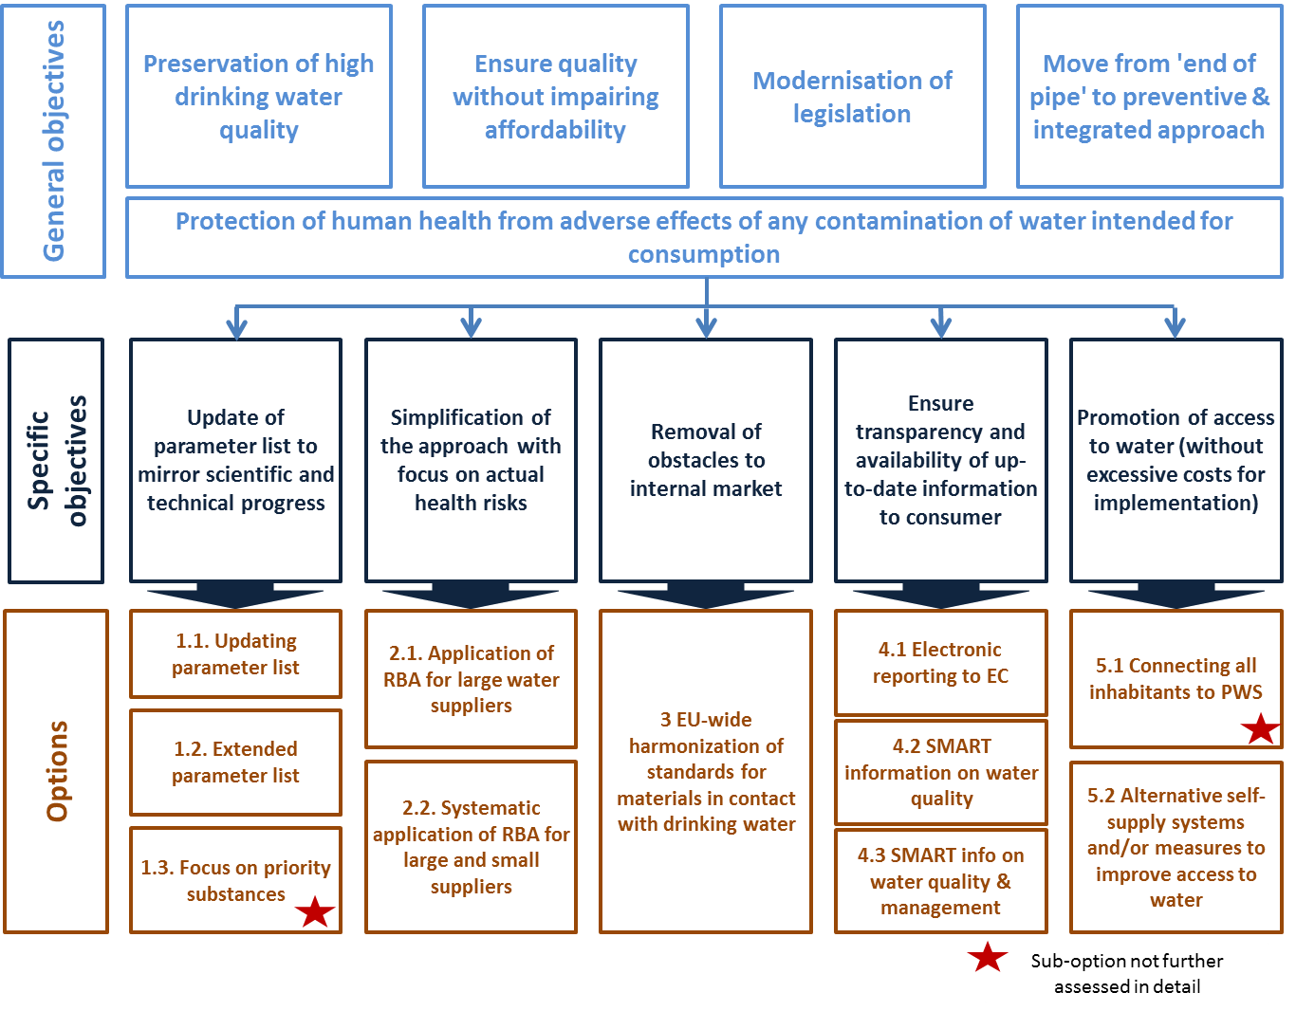

Figure 4: Objectives and options

5.6.1. Options not further pursued

Under the objective of protection of human health and the aim of doing so cost-effectively, two options of two different set of options can already at this point be discarded from further analysis.

A short analysis of Option 1.3 of the set of options to achieve the objective of improving the current parameter list shows that this option does not comply with the overarching aim of achieving a high level of protection of human health. Quantitative assessments show that this option only very marginally supports the reduction of people at health risk but far below achievable rates in comparison to Options 1.1 and 1.2. Furthermore, water suppliers and Member States strongly opposed a reduction of parameters during stakeholder consultations. Consequently, Option 1.3 is discarded from all further analysis.

Option 5.1 of the set of options with the objective of improving access to water is discarded for a variety of reasons: first of all, a compulsory connection for millions of citizens including those who do not need nor demand it (e.g. remote secondary residences, remote residencies with own sources) does not make sense. Furthermore, it would be technically impossible to connect all non-connected parts of the population to the PWS because of the remoteness of the area or other technical problems making the connection not feasible. Alternative locally based solutions are more effective than a systematic connection to PWS (see Option 5.2).

Secondly, from an economic point of view, and as also stated by the ECI and the Commission's response to it (see Box), affordability is a very important aspect when considering how to improve access to water. An affordability analysis shows that household costs would substantially increase in many Member States – with some of them being the host to large numbers of vulnerable and marginalised parts of the population[67].

"**Affordability** is also a key element because it relates to effective access to water services for all. **The EU has no role in the setting of water prices, which are determined at national level.** EU water-related environmental legislation does, however, establish some basic principles for water pricing policies in the Member States. The Water Framework Directive requires Member States to ensure that the price charged to water consumers reflects the true costs of water use. This encourages the sustainable use of limited water resources. EU water policy is based on the principle that affordability of water services is critical. National authorities are competent for taking concrete support measures safeguarding disadvantaged people and tackling water-poverty issues (e.g. through support for low-income households or through the establishment of public service obligations)".

**Box**: Communication from Commission on ECI Right2Water, March 2014

With an EU average increase of the household costs by EUR 21.40 per year, Option 5.1 would be financially particularly demanding for the lowest income groups. In general, the assessment shows that in Member States in which the PWS connection rate is rather low, the impact on household costs would be substantial (Figure 5). For instance, in Romania Option 5.1 would entail an increase in household costs of EUR 94 per year, and in Lithuania and Latvia an increase of above EUR 66 per household per year. The adoption of Option 5.1 alone would already mean that the share of disposable income spent on drinking water increases from 0.73 % (baseline 2050) to 0.77 % and to 1.06 % for the average income groups and for the lowest income groups respectively.

On the basis of these reasons, Option 5.1 is therefore discarded from further analysis.

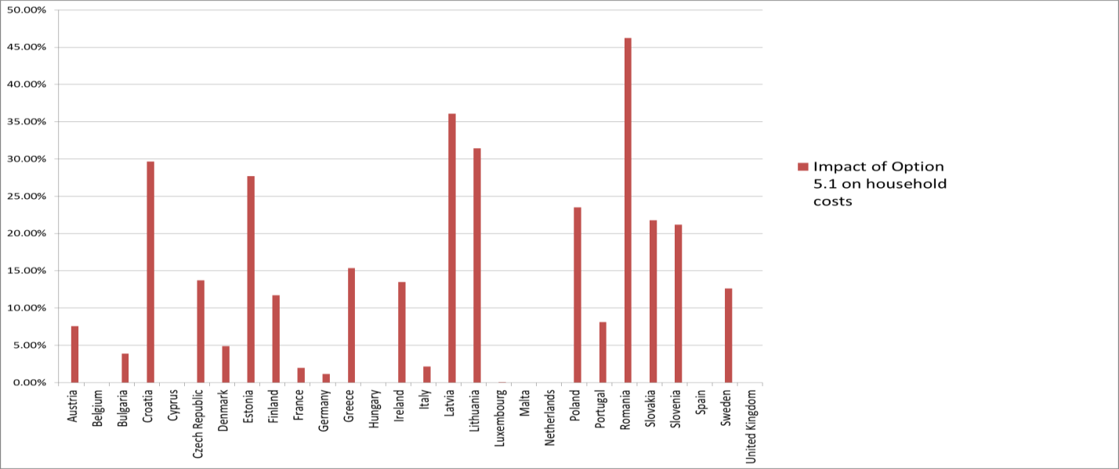

Figure 5: Impact of Option 5.1 on household costs - in percentage change

6. Analysis of impacts

This analysis of impacts is based on the methodology for Impact Assessments provided in the Commissions' Toolbox for Better Regulation. As a first step, all the possible impacts have been screened[68], and several of them have been identified for a more detailed analysis. Table 13 in Annex 4 presents a synopsis of the impact categories that have been screened along with the outcome of this screening process.

6.1. Health Impacts

6.1.1. Acute Health risks

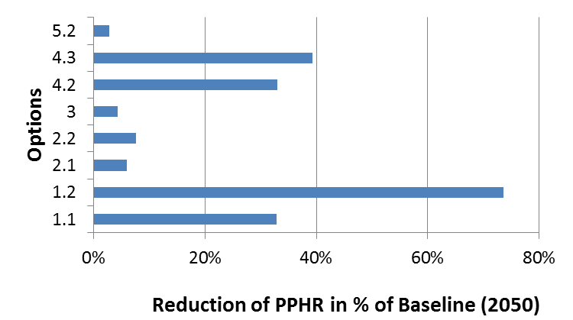

Figure 6: Difference of the PPHR as comparison to the baseline (% in 2050)

To recall, the share of the population that potentially suffers today (2015) from health problems due to non-safe drinking water, according to the PPHR methodology, is estimated at 22.7 million inhabitants (or 4 % of the EU28 population (Section 5.0.2). Considering the baseline scenario, the PPHR in 2050 is estimated at 20 million inhabitants (3.8 % of EU28 population), thus the health situation with no policy change would improve, but only slightly.

Figure 6 presents the PPHR under the different options in 2050 in comparison to the baseline. It represents directly the difference between each individual option in percentage of the baseline situation. Furthermore, it shows that the highest reduction of health risks occurs through option 1.2 'Extended parameter list', which reduces the PPHR by 73.5 % to 5.3 million inhabitants (1 % of EU28 population).

This can be explained by the high number of substances that would be monitored and treated under this option, which consequently leads to a significant improvement in drinking water quality. The second most effective option to limit negative health impacts on populations is option 4.3, followed by 4.2 and 1.1, with a reduction in the number of inhabitants accessing polluted drinking water to almost 8 million at the EU28 scale by 2050 as compared to the baseline (reduction of 39 % compared to the baseline). All other options contribute significantly less to reducing negative impacts on human health.

6.1.2. Chronic health risks

In addition to the potential short or mid-term health risks related to drinking water expressed by the PPHR, which considers in its methodology low, medium and high levels of risk, each option will also influence some possible chronic long-term health effects due to changes in water quality (e.g. through carcinogenic substances). The assessment of these non-acute risks is, however, both hard to measure and, if measurable, hard to causally relate back to the consumption of drinking water.

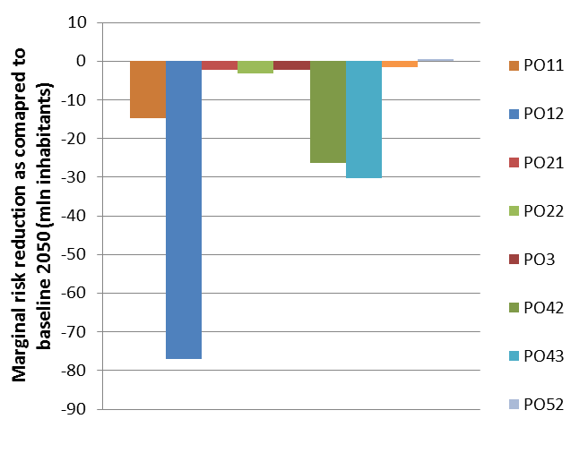

Figure 7: Difference in population facing a marginal health risk with baseline in 2050 (millions of inhabitants (0-line = 131 mn))

Nevertheless, a variation of the PPHR data allows approximating such chronic long-term health effects. The methodology allows identifying the population potentially facing not a high, medium and low risk, but just a marginal risk related to drinking water. This population is probably not facing health problems in the short or mid-term (e.g. becoming sick), but this share of the population could suffer from chronic effects of drinking water that is not completely safe.

For 2015 the population potentially facing a long-term health risk related to drinking water (i.e. the marginal risk indicator) is estimated to be 105 million of the EU inhabitants. In 2050, this population would increase up to 131 million inhabitants. Compared to the baseline scenario, Figure 7 shows how the options would impact long-term health effects.

Comparing the information in Figure 6 with Figure 7 allows seeing that concerning long-term health effects variations, options are not ranked in the exact same order as for PPHR (corresponding to short and mid-term health risks).[69] However, the options with the highest reduction of health risks remain ranked in the same order. Option 1.2 is still the most effective. It leads to the highest reduction of potential long-term health problems for the population.

Option 1.1 would be less effective. This can be explained by the fact that the extended parameter list provides in the long-term a better protection against chronic effects than just an updated list. Option 4.2 and option 4.3 rank significantly better than option 1.1. Thus, appropriate consumer information leads to a more effective reduction of potential long-term effects as compared to their impacts on short- and mid-term risks, and also relatively to options other than 1.2.

6.1.3. Associated health benefits in monetary terms

Based on the 2008-2012 average number of illness cases, the actual number of reported people falling sick as a result of contaminated drinking water is 31 500 per year. Based on these figures, the hospital and/ or general healthcare costs and the cost due to loss of production or productivity have been assessed, as well as the impact of the options.

Option 1.2 (to recall: PPHR reduction of 15 million people at risk) will have an annual healthcare benefit of EUR 153 million, making it the option with the highest benefits, followed by Option 4.3 of EUR 92 million, Option 4.2 of EUR 80 million, and Option 1.1 of EUR 69 million in 2050. All other options have significantly lower impacts (Annex 4). Due to methodological challenges, no monetary benefits arising from the reduction of chronic illnesses are assumed, although they could be considerable.

6.2. Economic Impacts

6.2.1. Economic situation/baseline

The Evaluation estimated the **total annual cost** for supplying drinking water in the EU in 2015 at roughly EUR 46.3 billion of which 18 % (EUR 8.3 billion) can be attributed to the implementation of the DWD. The Impact Assessment has re-calculated these total annual costs[70] that will increase from EUR 46.3 (2015) over EUR 47.1 (2030) to EUR 47.9 (2050) billion (Annex 4).[71] The baseline for bottled water consumption assumes a decrease in bottled water consumption from 106 litres/ person/ year in 2015 to 100 litres/ person/ year in 2050[72] (approximately – 6%).

In the EU water supply sector, **employment** is relatively stable. For 2015 it has been estimated that there are 413 000 people working in the water supply industry. Within the baseline scenario the number of people employed by the water supply sector is forecasted to slowly decrease to 409 000 in 2030 and 404 000 in 2050, in line with the forecasted total market value of the sector. The main reason for this minor decrease in employment is efficiency gains. There is a large difference between the number of employees per 10 000 inhabitants in the Member States[73] (for example high: Bulgaria, Hungary and Slovakia, low: The Netherlands, Germany and Austria).

6.2.2. Comparison of economic impacts of each option

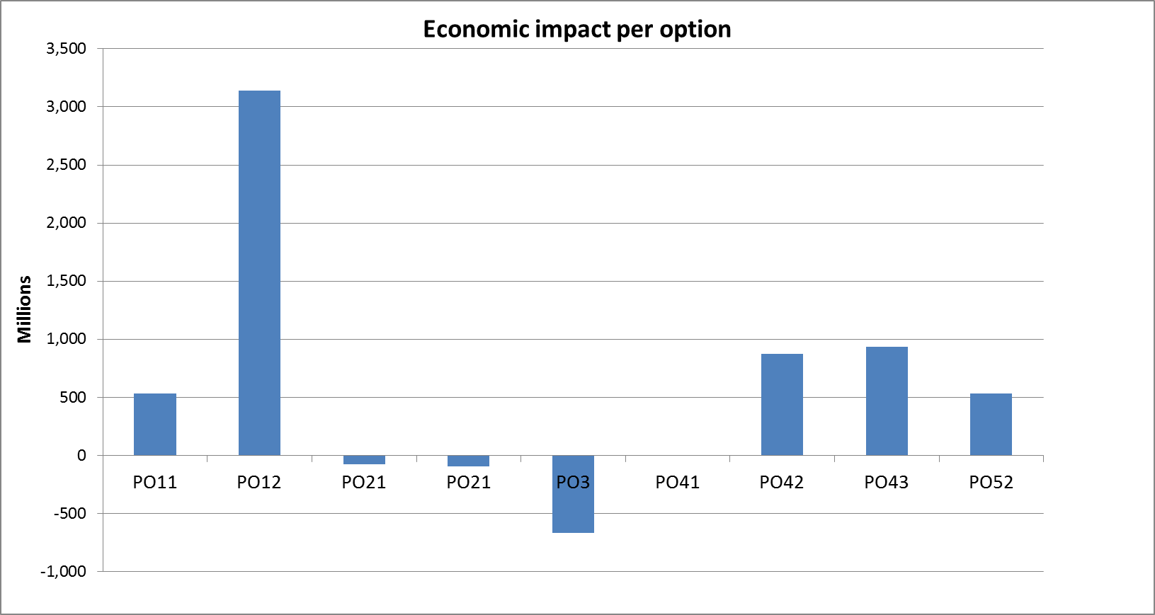

Figure 8: Economic impact on compared to baseline per Option[74]

The economic impact assessment of each of the options was done by calculating the set-up cost (which were then amortized on the expected life time of each investment) and the increase in operating cost at EU28 level (Annex 4). In summary, as shown in Figure 8, Option 1.2 will lead to the largest increase of annual costs[75] of EUR 3.1 billion. Option 3, Options 2.1 and 2.2 lead to some savings. The cost of Option 4.1 is with EUR 0.2 million much lower. (For pure set-up cost for each option see Table 2 below).

6.2.3. Impacts on SMEs and on innovation

It needs to be emphasized that water is not a commercial good, but a natural and regenerative resource. Thus all economic users of this source benefit from it.

The economic effects of the options on small and medium sized companies (SMEs) on innovation and on the sector’s competitiveness have been assessed. As water suppliers have a monopoly position, they can pass costs on to the consumers – even if in several Member States water regulators are in place to control the water prices, take no market risks and are eventually overall economically not affected. The financial sources of the water sector are Taxes, Tariffs, Transfers, the '3Ts' referred to by the OECD[76].

The most important economic sectors that depend on the PWS are notably the food industry and the tourism sector. The quality of water supplied by public systems can be an important feature for these companies. Although no statistics are available on the shares of SMEs in the Member States, it can be assumed that SMEs have a greater reliance on public water systems. It is assumed that the effects of the options will be similar for all sizes of enterprises.

In terms of possible impacts on trade, small increases of imported testing equipment, appliances for treatment or services stand opposed to important export opportunities for EU firms which successfully developed new treatment technologies for example in membrane filtration and disinfection[77].

It is expected that Option 1.1 and in particular Option 1.2 will be innovation-friendly and increase R&D expenditures on new water treatment technologies of facilities specialised in developing new treatment technologies. This type of research is carried out at EU or global level and increases in employment will be small, typically not more than a few hundred jobs. However, for those technologies that can be successfully applied, the potential for exports to other countries will be important and thus secondary employment effects can rise to 500 to 1 000 jobs.

**Handling the pesticide metaldehyde under the risk-based approach in the UK**: The water operator Anglian Water found the pesticide metaldehyde in its treated drinking water and failed to meet the DWD limit value for the indicated pesticide threshold. Treating for metaldehyde would have costed 612.4M, entailing a 21% increase in consumer bills. As an alternative to treating the water, Anglian Water used financial incentives to address the cost barriers to farmers to use an alternative to metaldehyde. This alternative costs the consumer 16.6M, which is only 3 % of treating the water.

Box: Cost savings through RBA

With particularly Options 2 referring to source protection and to measures at the source, this option is unlikely to have a negative effect on SMEs and other companies using water, except if they are affected by new measures established to reduce specific water pollution, or to contract consulting services. As the RBA demands more effective management and open potentials for tailoring treatments to local threats, Options 2 are assumed to be innovation-friendly.

Option 3 is expected to have a positive impact on manufacturers of materials in contact with drinking water, including their material suppliers. Among these manufacturers are many SMEs, and the whole installation sector is dominated by SMEs. It is assumed that the cost for certifications and approvals, which constitute up to 1-2 % of the turnover of companies, will be reduced significantly if product approvals are harmonised, and SMEs are expected to have somewhat higher benefits.[78] Option 3 will have a positive impact on intra-EU trade, as current barriers to trade through national approval systems will disappear. Furthermore, Option 3 will reduce barriers to innovation and accelerate access to markets, as the slow and complicated approvals so far discouraged companies to develop new products and to approach new markets.[79]

Options 4.2 and 4.3 are assumed to be innovation-friendly as new information platforms and systems will need to be developed. Both options will also lead to a small positive economic impact for those SMEs involved in setting-up of new IT systems needed for these options (service companies involved in communication, web design, and the development of smart apps). In general, better information will lead to better functioning of the markets as consumers will make better informed decisions.

Option 5.2 will offer some small opportunities for SMEs involved in installing new connections, or in developing self-supply systems. Option 5.2 can be seen as innovation-friendly as alternative and possibly low-cost water supply systems would be demanded.

6.2.4. Macro-economic impacts

The value added of the whole water supply sector is 0.7 % of the EU28 economy.[80] Thus, relatively small changes in this sector are not expected to have a significant macro-economic impact. Most important would be the macro-economic impacts of Option 1.2, as in 2050 these efforts sum up to an additional EUR 3.1 billion or on average EUR 14.90 per household per year. A further important impact will be on the industry supplying materials and products in contact with drinking water. It is expected that through Option 3 some Member States will gain a competitive advantage as their industry complies already with the rules of the system.

The bottled water industry may experience some challenges through the decrease in bottled water consumption, incited by Option 4.3 and 5.2. Moreover, the European Federation of Bottled Water (EFBW) highlighted always that bottled water is supplementary to tap water, and not in competition.

One aspect, which is easily overlooked, is that knowledge on water safety planning under Option 2 can be exported to third countries. This will mainly be beneficial for companies active in advisory/ implementation work and directed not only to underdeveloped, but also to more developed countries that already have a high level of drinking water quality.

6.2.5. Impact on employment[81]

Each option will impact employment in the water sector to a different extent. Figure 9 shows the effects of the options on employment, compared to the 2050 baseline. The employment impacts displayed in Figure 9 show that mainly option 1.2 will boost employment. The figures differ strongly per Member State. Each option will impact employment in the water sector to a different extent. The figures differ strongly per Member State. Options that incite a move from bottled water consumption to tap water are heavily based on assumptions regarding changes in consumer behaviour. Consequently, a quantification of impacts on individual industries, including whether a tangible change in consumer behaviour might cause negative impacts on e.g. the consumer packaged goods industry, was perceived as highly hypothetical and therefore with a limited added value to this Impact Assessment.

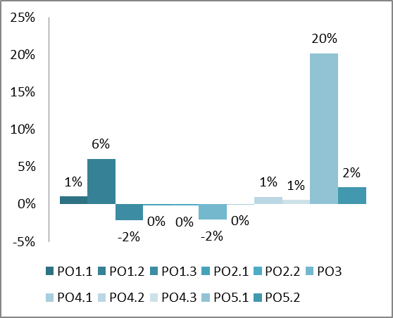

Figure 9: Employment changes due to options in 2050 compared to the 2050 baseline

6.3. Social Impacts

The main social impacts of the suggested options concern information to consumers, consumers’ trust in drinking water quality, behavioural changes like shifting from bottled water consumption to tap water consumption, cost and affordability of drinking water, and social inclusion.

Option 4.2 and 4.3 are the options which are providing the most significant improvements in terms of **information** provided to consumers. These options will bring a significant increase of information on water quality across EU28 as compared to the baseline. In some Member States (Belgium, France, Portugal, UK) the information level is on average already relatively high. The most significant increase will be in countries with the lowest level of information in the baseline scenario, such as Latvia, Lithuania, Ireland, Hungary, Poland and Romania.[82] Although the social impact for the citizens are evident, stakeholder consultations showed that these options were not well received by some public and private water operators arguing that these options are conflicting with complex water services governance systems established by the national administrations, for example in relation to water pricing. Moreover, some associations raised doubts on the real possibilities for citizens to participate in water supply decision-making.

The confidence people have in tap water quality is one main driver of tap water consumption compared to **bottled water consumption**. Studies have shown that consumer decisions to purchase bottled water are predominantly driven by sensorial information regarding taste and odour, and the associated health risk concerns. Thus, the level of confidence among consumers is mostly linked to the perception on the water quality and to the access of information on water quality. Increased awareness and enhanced transparency through options 4.2 and 4.3 is expected to bring about higher trust in the overall quality of the drinking water and of drinking water services. The decrease of bottled water is expected to be proportional to the level of information provided. Together with the general trend in decrease of bottled water consumption, option 4.3 is expected to result in a reduction of the share of bottled water consumption by 17 % in 2050 as compared to baseline 2015. The consumption per capita/year would decrease from 106 litre/ capita in the baseline scenario to 88 litres/ capita as the EU28 average, saving on average EUR 2.90 per household[83] per year.

Options 2.1 and 2.2 in conjunction with options 4.2 and 4.3 would **induce behavioural changes** and not only influence consumers, but also water suppliers' behaviour to improve water quality. Empowered citizens would follow and participate more actively in the water management decisions, creating a sense of ownership among the local community and provide incentives for protecting and improving their water supply. The local community can then facilitate the identification, the access and the management of the risks and hazards in the area, and balance the importance of safe water supply against other competing needs, such as housing and education. The impact would be more significant under option 2.2 as it would include all water suppliers, not only the large ones as is the case in option 2.1.

6.3.1. Affordability and social inclusion

In general the impact of the options on affordability of water services for the average EU households are very low, and affordability figures continue to range between 0.85 - 1.1 % of the disposable household income. The 'expensive' option 1.2 has a comparatively strong impact on the consumers' disposable income as it increases household cost on EU average by EUR 14.90 per year.

The social inclusion impact is mainly related to option 5.2 on the improvement of access to safe drinking water. Expanding the current objective of the Directive to demand from Member States the provision of alternative self-supply systems or access to water in publicly accessible places or other relevant measures to improve access to water would have significant positive social impacts, as a larger number of people would get access to safe drinking water, especially vulnerable and marginalised parts of the population. As a consequence of better social inclusion and better health of the population, benefits include productive days gained per year for the working population and time-savings (working days gained).

Option 5.2 using conservative assumptions (see section 5.5) would increase costs on average in the EU by EUR 2.5 per household/per year and has consequently a much lower impact on affordability than the discarded option 5.1 whilst still achieving a considerable improvement with regards to access to drinking water.

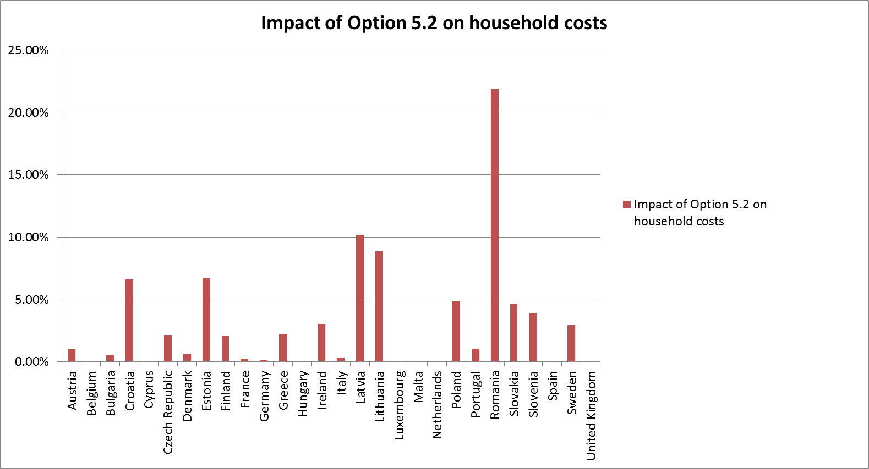

Figure 10: Affordability of drinking water if Option 5.2 is implemented

On household level it is assumed that especially option 4.3 but also option 5.2 will lead to a decrease in the consumption of bottled water. Option 4.3 would lead to a decrease due to an assumed change in behaviour which will take place based on the availability of information on tap water. Options 5.2 would decrease the need for buying bottled water, as citizens would have the possibility to drink tap water instead. Savings are assumed to be EUR 2.90 (4.3) and EUR 0.40 (5.2) per household per year.[84]

6.4. Environmental impacts

6.4.1. Water Pollution

The main environmental impacts from the suggested options include: the quality of water resources, reduction of **pollution** at source for water resources abstracted, improvement of water resources where waste water is discharged (following lower levels of pollutants in drinking water), energy consumption, environmental externalities of consumption of bottled water, which also contribute to reducing the amount of riverine and marine litter, resource efficiency; and biodiversity.

Drinking water is influenced by the quality of fresh water bodies: simultaneously the requirements for high drinking water quality are also drivers that influence the protection and thus the quality of fresh water bodies. Due to these interactions, impacts are difficult to attribute. It is assumed that in the baseline 2050 fresh water bodies' quality will keep on improving notably because of the effective implementation of the existing water related directives. It is assumed that the chemical status of surface and ground water bodies will improve by 10 percentage points by 2050 for all water bodies, and by 20 points where an RBA has been implemented.

Options addressing objective 1 will lead to reductions of pollutants in drinking water. More relevant pollutants will be monitored, which would allow suitable interventions and thus to remove potential risks for the environment. Option 1.2 would have a more significant environmental impact than option 1.1 since it would cover also emerging substances. Option 1.2 has thus the potential for the largest reduction in pollution loads.

Options addressing objective 2 will have through their integrated risk reduction a positive environmental impact, as risk assessments have the influence and the possibility to improve water quality across all options. It will have in particular a potential to enforce measures at source. The level of contribution depends on the individual cases. It includes the prevention of industrial and pharmaceutical pollution, and different characteristics of the farming such as the crop rotations, intensity of cultivation, integration or not of livestock production as well as type of livestock production, addressing fertilizers, tillage, irrigation, green manuring and liming, reducing monoculture. All these characteristics have a bearing on the quality of water bodies in the area, and changes in these characteristics due to options 2.1 and 2.2 might therefore significantly reduce the level of harmful environmental impact.

The positive effect of implementing measures addressing option 3 will lead to less 'toxic/harmful' contact materials itself, both for metallic and plastic materials, and also reduce the leaching of contaminants into the water cycle. Also, options addressing objective 4 will have a small but positive environmental impact, as consumers will have better information on water quality, and might require further stricter and precautionary measures to limit risks to a minimum. With regard to option 5.2, it will open up additional catchments and require additional measures at source, which might have positive local impacts on fresh water quality through reduced pollution loads. The biggest impacts would be in areas with currently low connection rates to PWS. The most affected countries are Romania, Lithuania and Latvia.

Reducing the amounts of pollutants in drinking water by unlisted and emerging substances would have a positive environmental impact on water bodies, water ecosystems and organisms. The benefits on the status of aquatic ecosystems and related ecosystems will thus also have a positive effect on **biodiversity**, as well as on the recreational value of ecosystems. The increased measures at source following options 2.1 and 2.2 will to a large extent include changing agricultural practices that have a significant impact on water bodies, soil quality as well as biodiversity. When farmers are adapting their practices to reduce pollution at source, this can have positive impacts on biodiversity/ landscape in the areas where changes in farm practices take place.

6.4.2. Resource efficiency

Option 4.3 provides consumers and suppliers with strong incentives to improve water and **resource efficiency**. Smart information will empower the consumers to hold suppliers accountable for managing leakage rates at acceptable levels. This will lead to early leakage detection, fixing and decreased water use, and will contribute to reduce leakages from water supply networks, that currently remain on EU average at 23 %[85]. Measures addressing leakage problems in distribution systems would in general reduce water consumption as well as lead to energy savings. Due to its technical complexity, for example to consider unavoidable losses[86], it was not possible to estimate the impacts of the options on potential leakage rate reductions. Regardless, reduced water consumption would have a significant environmental impact on water ecosystem and related ecosystem services, especially in already water stressed areas.

6.4.3. Energy

Drinking water supply by water pipes is in comparison to all other transport modes very energy-efficient.The energy needed for distribution to provide each citizen with about 50 000 l/ year equals the energy needed to produce three litres of bottled water. The total energy consumption relates to the energy consumed in the process for producing drinking water, which varies greatly due to differences in the size of the water systems, pumping requirements between geographic locations, and raw water characteristics and quality. The overall greenhouse gas (GHG) emissions of the EU drinking water supply are roughly 6 million tonnes CO2 eq.[87]. Reduced energy consumption will also bring associated reduction in GHG emissions. Energy consumption for treatment represents 50 % of total energy consumption for the EU drinking water supply, followed by abstraction, whereas distribution represents on average only 5 %[88]. Thus options that reduce the need for treatment, by for instance applying measures at source, would result in energy savings. Options 2.1 and 2.2 will thus have a positive energy impact. Option 1.2 that will require an increased treatment estimated by +30 % will thus have a negative energy impact. Also option 5.2 will require more treatment for alternative supplies and source measures, which will increase their energy demand by 50 % (estimates). Overall, estimates[89] show that 30 % energy savings could be achieved from improving water efficiency, to which in particular options 2.1, 2.2, 4.2 and 4.3 contribute, which will very likely overcompensate additional energy consumption induced by options 1.2 and 5.2.

6.4.4. Bottled water

This Impact Assessment has also analysed the bottled water consumption in EU28, as this is related to social but also environmental effects. Through better availability of information to consumers an improvement in confidence in drinking water would be achieved, which in turn would lead to a reduction of use of bottled water. Reduced consumption of bottled water would result in a reduction of the associated use of resources, energy consumption, emissions and waste generation from the production and transport of plastic and glass bottles.[90]

Options 4.2 and 4.3 would therefore lead to improvements in resource efficiency. An average EU citizen currently consumes 106 litres of bottled water per year, in some Member States like Germany, Malta, Italy up to 170 l. Option 4.3 for which a reduction against the baseline from 100 to 88 litres per year is estimated by 2050[91], would already reduce GHG emissions by 1.2 million tonnes CO2 eq. This represents 20 % of the total energy demand of the whole EU drinking water supply (Calculation/ Assumptions in Annex 4). Thus options, such as option 4.3, that contribute to reduce bottled water consumption have a significant positive energy and **climate change impact**.

Stakeholders were however vocal about using the bottled water as an indicator for consumer confidence in tap water and pointed out that that the reduction potential of a few litres per consumer and year is low, whereas the bottled water industry is important for local employment and for diversified choice of drinking water.

6.5. Administrative Burden Reduction Impacts

The evaluation did not identify provisions that cause high administrative burden. The tasks done by health authorities that relate mainly to monitoring and surveillance are marginal in comparison to the work of water operators. No substantial changes to these costs are expected to occur except for options 2.2 and 4.1 (Annex 4). Positive economic aspects related to administrative burden-reduction will mostly be achieved through adoption of option 4.1. This option identified the simplification - by very substantially limiting reporting to the Commission to useful information and data - and automation potential of the reporting. A reduction of reporting requirements to the most important data on exceedances and significant incidents is assumed to significantly reduce administrative burden for Member States and the Commission. The set-up cost amount to EUR 2.9 million in comparison to the baseline 2050 and relate mainly to developing the software and linking of systems. After these initial investments, annual savings on reporting provisions are estimated at EUR 0.35 million, visible in the reduction of the operating costs for reporting. Whether the simplified reporting can be at the same time interlinked with the European electronic reporting tool under Water Information System for Europe (WISE), or a new reporting tool in the follow-up of the Fitness Check of Monitoring and Reporting[92], remains to be seen.

For options 2.1 and 2.2 the main challenge for administrations and national authorities will be the change of approach to set up risk assessment systems. This is expected to lead to set-up investment costs of EUR 6.25 million in comparison to baseline 2050[93]. More knowledge and other resources are needed for these options, as the risk-based approach requires a different way of thinking and of administrative procedures than current approach via fixed monitoring intervals. Thus, the first years will require learning, training and guidance. This will probably initially be considered as a new burden by those who have to implement these changes. In the beginning, difficulties are expected in monitoring the effectiveness. All this will be in particular an issue for countries with a significant share of small water supplies and SMEs involved. Therefore, option 2.2 foresees sufficient time to putting the RBA in place. Experience with the RBA has shown that over the years this new system will reduce unnecessary administrative burden and analyses significantly. On the longer run, administrative burden reduction can be expected by the reduction of the number of parameters to be monitored and reported.

The challenges faced by Option 3 are more of a regulatory nature. It is interesting to note that most of the administrative costs are spent on conformity assessment procedures and testing (75 %) concerning materials and products in contact with drinking water. Smaller cost components include the design of products, their production processes (15 %) and the awareness raising effort for companies (15 %). The annual burden reduction potential for manufacturers has been estimated at EUR 669 million, assuming that in the future materials in contact with drinking water are fully recognised within an internal market without obstacles.

7. Comparison of options

7.1. Health Protection versus Costs

As the objective of the DWD is the protection against adverse health effects from drinking water, the main question to be answered in this Impact Assessment is how effective the different options contribute hereto, and how efficient they are. In terms of potential health impacts, the best health impact, **largest reduction in PPHR** by 2050 is obtained with **option 1.2** (full list of parameters) followed by **Option 4.3** (smart-information on water quality and water services performances).[94]

In terms of costs, **option 1.2 is the most expensive one**. On the opposite side of the spectrum, **option 3, options 2.1 and 2.2 lead to some (although limited for these two last) benefits** (cost savings) as compared to the baseline scenario.

|  |  |  |  |  |  |
| --- | --- | --- | --- | --- | --- |
| Option | Change in PPHR as compared to baseline (millions of inhabitants) | Total set-up costs in addition to baseline 2050 in million EUR | | Operating costs in addition to baseline 2050 in million EUR | Change in household costs to the consumer |
| 1.1 | -6,6 | | 1 965 | 437 | + 2.60 |
| 1.2 | -14,7 | | 5 895 | 2 842 | + 14.90 |
| 2.1 | -1.2 | | 22 | -76 | - 0.35 |
| 2.2 | -1,5 | | 25 | - 96 | - 0.40 |
| 3 | -0.9 | | 0 | - 669 | - 3.20 |
| 4.1 | 0 | | 2.9 | - 0.352 | + 0.001 |
| 4.2 | -6,6 | | 4.2 | 876 | + 4.20 |
| 4.3 | -7,9 | | 5.6 | 933 | + 4.50 |
| 5.2 | -0,6 | | 1 411 | 60 | + 2.50 |

Table 2: Changes in PPHR, changes in costs and costs per additional person protected for the different Options

7.2. Ranking overall

Table 4 provides a ranking of the options in comparison. The assessment of the ranking is based on the findings and analysis described in Sections 5 and 6, as well as in Annex 4. The ranking is based on quantitative and qualitative factors derived from the analysis. The scale outlined in Table 3 shows how "+" and "-" are attributed to positive and negative impact expectations. As each category in Table 4 has different indicators, Annex 4 (Section 8) can be consulted for an overview of ranges and cut-off points for each quantified category.

|  |  |  |  |  |  |  |  |  |
| --- | --- | --- | --- | --- | --- | --- | --- | --- |
| Very large negative impact | Large negative impact | Medium negative impact | Small negative impact | No impact | Small positive impact | Medium positive impact | Large positive impact | Very large positive impact |
| **- - - -** | **- - -** | **- -** | **-** | **+/-** | **+** | **++** | **+++** | **++++** |

Table 3: Legend for Table 5

The "overall ranking" of each option is determined through the accumulation of "+" and "-". In the accumulation positive impacts for the reduction of the PPHR have twice the weight as other positive/negative impacts to acknowledge the Directive's overarching aim of protecting human health. As the aim is to address all four/ five areas of improvement that were uncovered in the Evaluation of the Directive, options are always chosen in comparison to other options in their set. Through this, it will be ensured that all areas of improvement are covered through the amended Directive.

As the revision of the DWD is part of the REFIT programme, option 4.1, which entails simplifications of reporting requirements to the Commission, is part of all combinations. As it does not have significant effects on many of the categories outlined in the table, it was chosen – also for readability purposes – to not include option 4.1 in the table.

It should be noted that in the table below options addressing the same objective are being compared. Since the revision of the Directive aims at addressing all above identified and outlined problems, it is now important to identify from each set of options the best one to build an efficient policy package that address all current issues.

|  |  |  |  |  |  |  |  |  |
| --- | --- | --- | --- | --- | --- | --- | --- | --- |
|  | **Option 1.1** | **Option 1.2** | **Option 2.1** | **Option 2.2** | **Option 3** | **Option 4.2**[95] | **Option 4.3** | **Option 5.2** |
| **HEALTH IMPACT**[96] | | | | | | | | | |
| Reduction of PPHR at short/mid-term | **++**  (- 33 %) | **++++**  (- 74 %) | **+**  (- 6 %) | **+**  (- 8 %) | **+**  (- 4.2 %) | **++**  (- 33 %) | **++**  (- 39 %) | **+**  (- 2.8 %) |
| Reduction of PPHR at long term | **+**  (-3 %) | **++++**  (-15 %) | **+/-**  (0 %) | **+**  (-1 %) | **+/-**  (0 %) | **++**  (- 5 %) | **++**  (- 6 %) | **+/-**  (0 %) |
| **ECONOMIC IMPACT** | | | | | | | | | |
| Increase/ decrease in annualised set-up and operating costs (€million)[97] | **-**  (+ 535) | **- - - -**  (+ 3 137) | **+**  (- 74) | **+**  (- 93) | **++**  (- 669) | **- -**  (+ 876) | **- -**  (+ 934) | **-**  (+ 530) |
| Impact on SMEs and R&D | **+** | **++** | **+** | **+** | **+** | **+** | **++** | **++** |
| Internal market impact | **+** | **++** | **+** | **+** | **+++** | **+/-** | **+/-** | **++** |
| Change in employment | **+**  (+ 4 112) | **++**  (+ 24 353) | **+/-**  (- 674) | **+/-**  (- 883) | **-**  (- 8 525) | **+**  (+ 3 889) | **+**  (+ 2 128) | **+**  (+ 8 926) |
| Change in health cost | **++**  (- 68) | **++++**  (- 152) | **+**  (- 14) | **+**  (- 17) | **+**  (- 14) | **++**  (- 80) | **+++**  (- 91) | **+**  (- 9) |
| **SOCIAL IMPACT** | | | | | | | | | |
| Change in costs per household (€/ year) | **-**  (+ 2.60) | **- - -**  (+ 14.90) | **+**  (- 0.35) | **+**  (- 0.40) | **-**  (- 3.20) | **-**  (+ 4.20) | **-**  (+ 4.50) | **-**  (+ 2.5) |
| Increase in confidence in water quality | **+** | **+** | **+** | **++** | **+++** | **++** | **++++** | **+** |
| **ENVIRONMENTAL IMPACT** | | | | | | | | | |
| Improvement of water quality | **+** | **++** | **++** | **+++** | **++** | **++** | **++** | **++** |
| More treatment of pollution at source | **+** | **++** | **++** | **+++** | **+/-** | **+** | **+** | **+** |
| Energy savings | **-** | **- -** | **++** | **+++** | **+/-** | **-** | **-** | **- -** |
| **OVERALL RANKING** | | | | | | | | | |
| **Points[98]** | 14 +  3 - | 31 +  9 - | 14 +  0 - | 20 +  0 - | 14 +  2 - | 17 +  4 - | 21 +  4 - | 12 +  4 - |
| **Accumulated result** | **11** | **22** | **14** | **20** | **12** | **13** | **17** | **8** |

Table 4: Ranking of options

7.3. Who will be affected?

The analysed options of amending an existing Directive affect citizens, water operators and authorities in a rather moderate way (see Annex 3 for more details). The main impacts of the options for an EU citizen will be for EU citizens through the reduction of the probability of being at risk (PPHR) combined with a reduction of potential chronical effects; and with regard to the affordability of drinking water. Water suppliers could be most affected by costs for monitoring and additional treatment, and through the requirements to develop and apply a risk-based approach even though mid-term financial benefits are expected. Manufacturers of products and materials in contact with drinking water will be affected through changes in product standards and approvals. Public authorities will also be challenged on how to control the risk-based approach and apply the principles of transparency.

7.4. Presentation of possible policy packages

The Impact Assessment has identified five problem areas, defined five corresponding objectives with each objective having a set of options. The ranking of the options along a variety of categories can be found in section 5.

To cover as effectively and efficiently as possible all four identified problem areas of the Evaluation of the Directive, three 'feasible' packages of options have been developed with each package containing options from all four objectives. The packages have, however, different levels of ambition in terms of health outcomes. For these packages, and in line with the main objective of the Directive, the reduction of health risks has been given high priority. For the ambitious packages only the very positive ranked options 1.2, 2.2, 3 and 4.3 were chosen from Table 4.

In order to analyse only 'feasible' packages, options with excessive costs and limited impacts on health protection were not selected for the analysed policy packages.

In summary, the three packages, combining different options were further investigated, are:

* Package 1 (less ambitious) = 1.1 + 2.1 + 3 + 4.1 + 4.2
* Package 2 (medium) = 1.2 + 2.2 + 3 + 4.1 + 4.3
* Package 3 (advanced) = 1.2 + 2.2 + 3 + 4.1 + 4.3 + 5.2

The modelling assumptions are included in Annex 4. Figure 11 shows the health impacts of the remaining options plus the three combinations.

It is assumed that the options cannot just be added up to each other, as also already noted in Section 2 the problems and consequently also the options addressing them interact/synergize and should not be seen in isolation. Synergetic effects of combinations of options are assumed to deliver higher health benefits whilst reducing the overall costs.

Consequently, "packaged" options are assumed to be less expensive than individual options. The synergy effects have been considered by including specific assumptions for the calculations at Member State and EU level (Annex 4). The main synergetic effect occurs under the simultaneous adoption of options from set 1, 2 and 4.

For the ambitious policy packages this means: whereas option 1.2 ensures that a vast number of substances is covered in general, option 2.2 allows the individual water supplier to opt out for individual parameters, if it is clear that these are not to be found in the supplier's catchment area. Consequently, the large positive health effects of 1.2 are not endangered, but costs can be reduced as the water supplier will only need to apply a tailored treatment to the specific substances found in the specific catchment area.

Furthermore, option 2.2's holistic approach will lead to more treatment at source and preventive measures, which entails overall cleaner raw water, which needs less treatment. Consequently, fewer substances will be found in the water, only a shorter list of substances needs to be monitored and treated for, and costs can therefore be reduced. This positive interplay is supported by option 4.3 that entails an enabling framework to empower the consumer. An empowered consumer is expected to pressure the water supplier for efficient management whilst maintaining highest standards of the water quality. This will also entail a reduction of leakages, which means that less treated water is lost – and therefore overall less water needs to be treated.

As can be seen in Table 5 individual options such as 1.2 achieve significant health benefits by reducing the PPHR to 1.01 % - however, the option does so whilst costing more than EUR 3 000 million. Assuming that the synergetic effect of combining option 1.2 with 2.2 and 4.3 achieves reductions in, for instance, treatment needs by about 10 % to 15 %, policy packages that contain both will have significantly lower costs than only option 1.2 alone.

|  |  |  |
| --- | --- | --- |
| **Comparison individual options and packages** | **Remaining PPHR in 2050**  **under individual options** | **Costs (annualised set-up and operating cost) in comparison to baseline 2050 (€/million)** |
| Baseline 2050 | 3.81% | 0 |
| Option 1.1 | 2.56% | 535 |
| Option 1.2 | 1.01% | 3 137 |
| Option 2.1 | 3.59% | -74 |
| Option 2.2 | 3.52% | -93 |
| Option 3 | 3.65% | -669 |
| Option 4.1 | 3.81% | 0.23 |
| Option 4.2 | 2.56% | 876 |
| Option 4.3 | 2.32% | 934 |
| Option 5.2 | 3.71% | 530 |
| PP 1 (1.1+2.1+3+4.1+4.2) | 1.60% | 253 |
| PP 2 (1.2+2.2+3+4.1+4.3) | 0.90% | 1 647 |
| PP 3 (1.2+2.2+3+4.1+4.3+5.2) | 0.79% | 2 177 |

Table 5: Individual options and packages in comparison

**Assessment of policy packages**

Figure 11 shows that package 1 would reduce by 2050 the PPHR by 58 % or a reduction of 11.6 million people at risk, package 2 by 76 % or 15.3 million and package 3 by 79 % or 15.9 million. The cost of drinking bottled water to consumers will decrease by respectively EUR 336 million (package 1) and EUR 610 million (package 2 and 3).

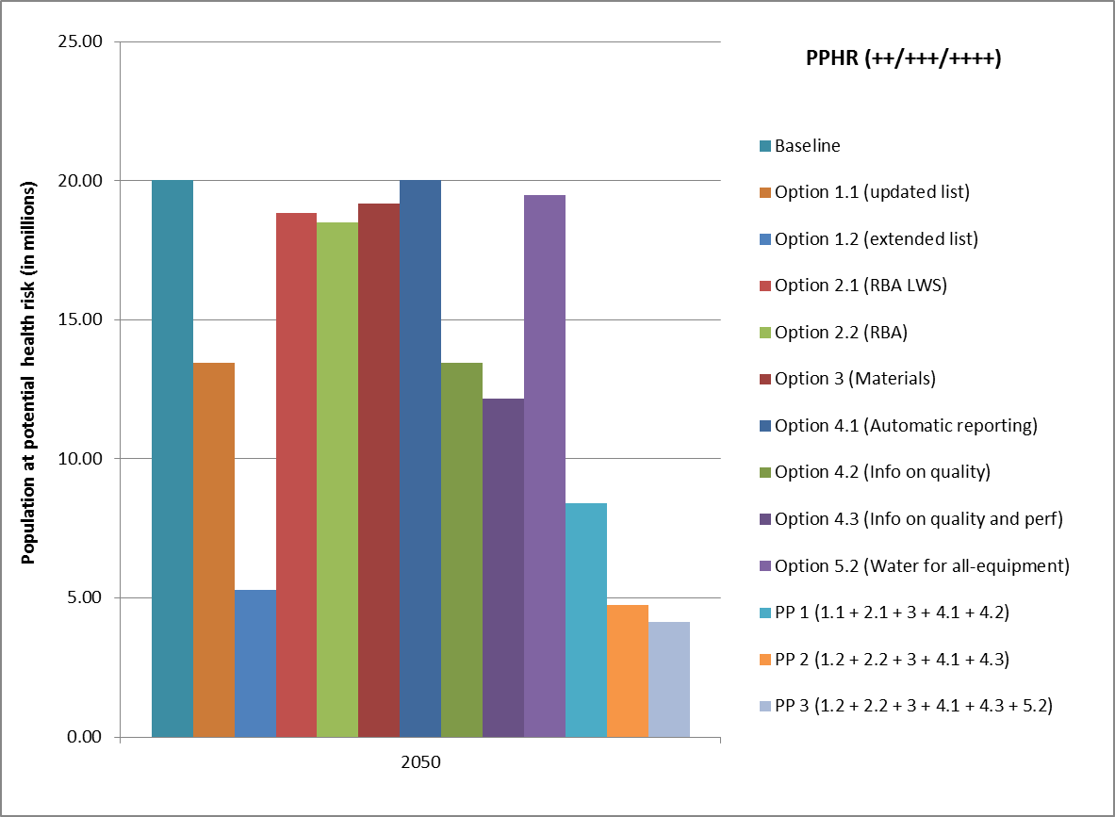

Figure 11: Health impacts (PPHR) for selected options and for their combination into Policy Packages 1, 2 and 3

As previously indicated, the current costs for supplying drinking water in the EU in 2015 amount to EUR 46.3 billion (see Section 5.0) and are assumed to be 47.9 billion in baseline 2050. In comparison to baseline 2050, the assessments of the **costs of the three policy packages** show that they will lead to an increase in annual costs[99] of EUR 0.3 billon (PP1), EUR 1.6 billion (PP2) and EUR 2.2 billion (PP3) respectively, see Figure 12. For 2050 the pure total set-up costs in comparison to baseline 2050 would amount to EUR 2 billion (PP1), EUR 5.9 billion (PP2) and EUR 7.3 billion (PP3) (Table 6).

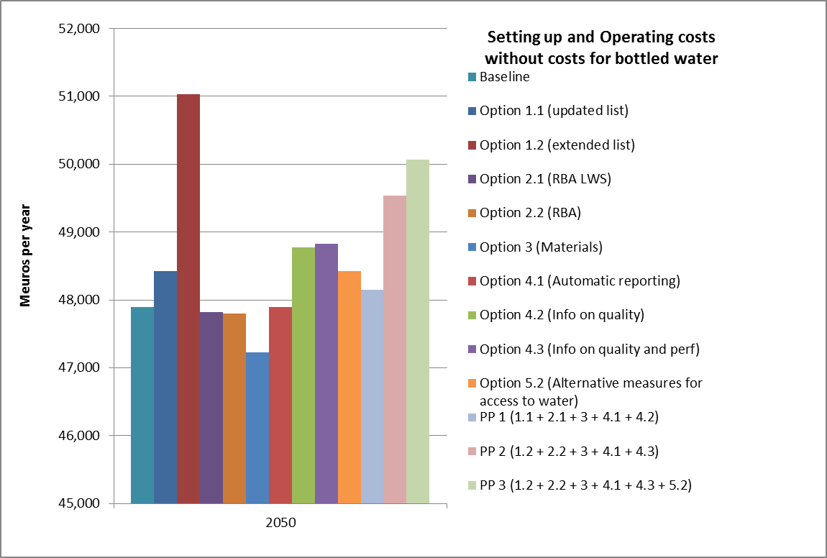

Figure 12: Annualised set-up and operating costs of the policy packages 1, 2 and 3 (in million EUR)

The combination of the PPHR and cost indicators helps assessing the **cost-effectiveness of each policy package,** as illustrated in the figure below, which compares the cost-effectiveness ratio of the three policy packages as compared to the ratio of individual options.

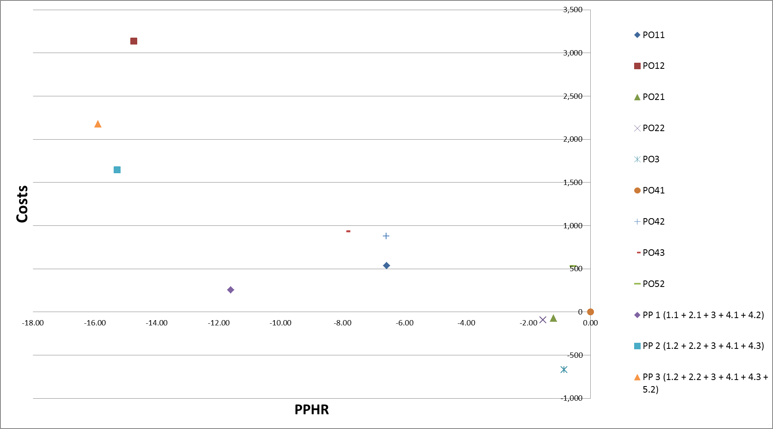

Figure 13: Cost effectiveness of options and packages in comparison

Overall, while **package 3 delivers the highest effectiveness** in terms of reduction of the indicator PPHR, package 2 is more cost-effective than package 3. Package 1 involves fewer costs but has a more limited effect on the main objective of public health.

With regard to affordability, policy package 1 will increase the total cost per household (baseline: EU28 average 2050: EUR 228) by ca. EUR 1.20 euro per year (+ 0.5 %). For policy package 1 an increase can be observed for instance in Finland from EUR 263 per year in the baseline 2050 to EUR 264.80 per year. At the same time in some Member States, such as in Croatia the costs per household could slightly decrease from EUR 149.80 per year in the baseline to EUR 149.30 per year. Policy package 2 will increase the total cost per household on EU average by EUR 7.90 per year (+ 3.4 %). This would mean for instance for Finland an increase to EUR 272 per year and for Croatia to EUR 154 per year. Policy package 3 will increase the total cost per household by EUR 10.40 per year (+ 4.5 %), which would be an increase for Finland to EUR 277 per year and for Croatia to EUR 164 per year. An overview of the household cost changes in comparison to baseline 2050 is provided in Figure 14. As is visible in this figure, some Member States are assumed to not be impacted by option 5.2, which results in the economic impact of PP2 and PP3 being the same for them.

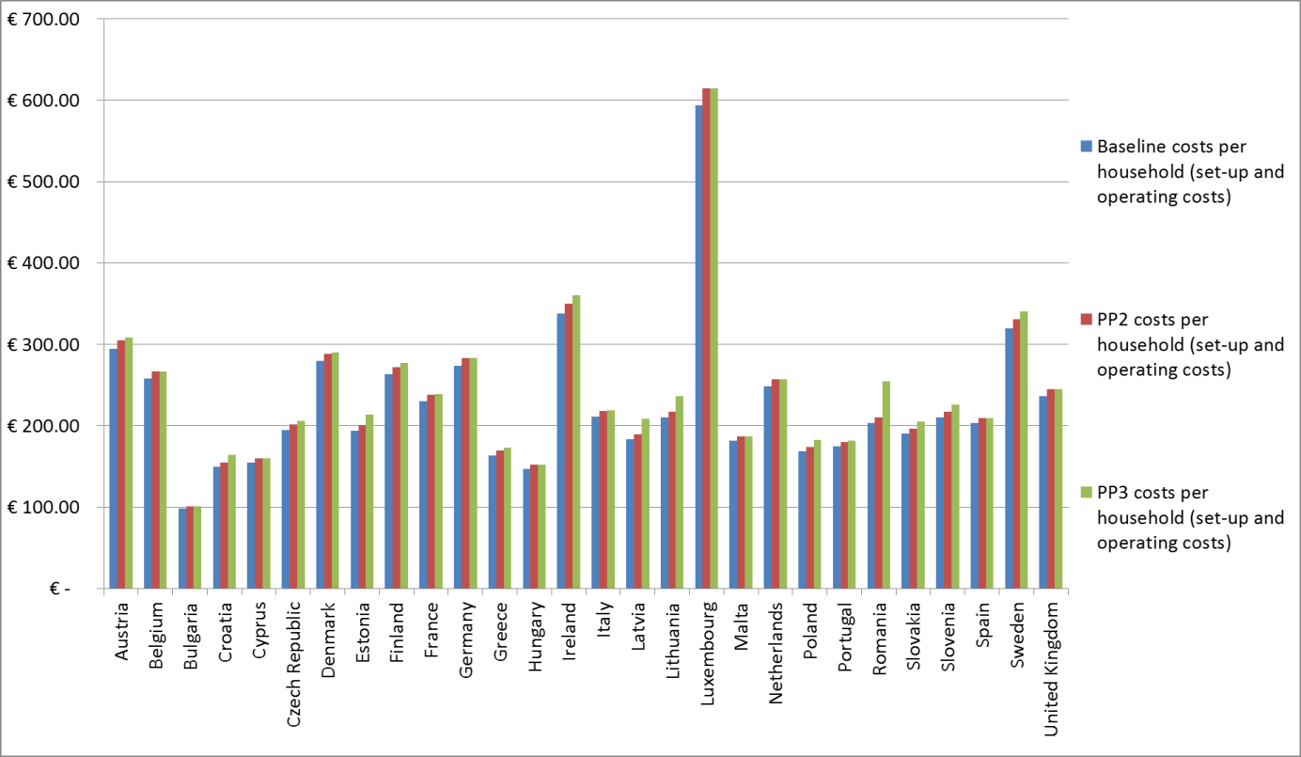

Figure 14: Household costs per policy package in comparison to baseline 2050

Employment is expected to decrease by 1 233 persons as compared to the 2050 baseline for package 1 and it is expected to increase by 17 038 persons with package 2 and 25 964 for package 3.

The Table 6 below compares the three policy packages with regard to effectiveness, efficiency, coherence, and proportionality.

|  |  |  |  |  |
| --- | --- | --- | --- | --- |
| **Policy Package** | **Effectiveness** | **Efficiency** | **Coherence** | **Proportionality** |
| **Policy package 1 (1.1+2.1+3+4.1+4.2)** | Indicator PPHR reduced by 11,61 million inhabitants as compared to baseline by 2050 | Total set-up cost in 2050: 2 billion  Water tariffs as % of disposable income = 0,73 %  Employment: - 1 233 | Increased coherence with WFD (as a result of RBA) | EUR 25.9 /additional person protected from health risk |
| **Policy package 2 (1.2+2.2+3+4.1+4.3)** | Indicator PPHR reduced by 15.3 million inhabitants as compared to baseline by 2050 | Total set-up cost in 2050: EUR 5.9 billion  Water tariffs as % of disposable income = 0,75 %  Employment:  + 17 038  Expected larger impact on management efficiency of water suppliers  Little positive social and environmental impacts due to inclusion of 2.2 and 4.3 | Increased coherence with WFD (as a result of RBA)  + expected benefits in terms of resource efficiency of water suppliers as a result of SMART information to customers on wider range of management issues | EUR 104.6 /additional person protected from health risk |
| **Policy Package 3 (1.2+2.2+3+4.1+4.3+5.2)** | Indicator PPHR reduced by 15.9 million inhabitants as compared to baseline by 2050 | Total set-up cost in 2050: EUR 7.3 billion  Water tariffs as % of disposable income = 0,76 %  Employment:  + 25 964  Expected larger impact on management efficiency of water suppliers  Positive Social and environmental impacts significantly improved, especially through inclusion of 5.2 | Increased coherence with WFD (as a result of RBA)  + expected benefits in terms of resource efficiency of water suppliers as a result of SMART information to customers on wider range of management issues | EUR 138.4 /additional person protected from health risk |

Table 6: Summary the assessment of the three Policy Packages

**Conclusion**

On the basis of the above assessment, all policy packages are a balanced and coherent choice for political decision to be made. Policy packages 2 and 3 are more effective with regard to health protection, and are, from the health and environmental viewpoint, the preferred packages in comparison to package 1. Both packages 2 and 3 correspond best to the general objective to contribute in the most possible effective and efficient way to protect human health. Improvements can be expected on the quality of the water distributed by small suppliers which will contribute to the reduction of human health risks. The suggested packages will preserve high drinking water quality in the long-term.

The small increase of costs for both packages, as outlined above, is legitimate and outweighed by the health benefits. Additionally, both packages 2 and 3 also contribute to the modernisation and simplification the current legislation - where this is feasible and without impairing the overall objective of protection of health - by moving from an 'end of pipe' to a more preventive and integrated approach.

These two more favourable packages provide concrete answers to the ECI 'Right2Water' notably through option 4.3 (smart information) while better connecting the drinking water approach to the concept of circular economy (for example through increased confidence in tap water and transparency on leakage rates).

Package 3 provides an additional answer to meeting the objectives of SDG 6 on access to water through the inclusion of option 5.2. It is expected that option 5.2, which entails a set of measures to improve access to water, would substantially improve the situation for non-connected EU citizens.

The related additional set-up costs (about EUR 1 411 million) is most probably overestimated as - in absence of more accurate data - it is based on the assumption that half of the non-connected citizens would be provided with individual treatment systems (see section 5.5).

Both policy packages have a positive impact on the environment as bottled water consumption is assumed to decrease through the increase of consumer confidence in tap water, which will be stimulated by providing better access to up-to-date information for all consumers. Furthermore, the mandatory use of the risk-based approach for large and small water supplies leads to less need for treatment, which entail energy savings and a reduction of chemicals released into the environment. Moreover, it is expected that the risk-based approach improves the treatment of pollution at the source and better application of the polluter-pays principle.

Taking into account all findings of this impact assessment as well as the ECI Right2Water, which was one of the triggering factors for the revision of the directive, a cleverly problem-oriented version of policy package 3 is the most favourable package. Instead of assuming that half the non-connected population would be provided with self-supply systems, package 3 is adapted to the needs of individual Member States. This would mean a general obligation to improve access should be introduced, but a margin of discretion should be left to the Member States to decide how to best improve access to water taking specific local situations into account. A number of effective measures could be expected to work across all Member States, these include: providing information on possibilities for connection and points of access, setting up street fountains, encouraging the use of drinking water in public buildings such as schools, and in restaurants, and, in addition, ensuring access to water for a particular category of the population (vulnerable and marginalised groups). Implementing such measures and leaving margin of discretion for the Member States to react to their national needs would be substantially less costly than the initially assumed package including self-supplies solutions.

Finally, the implementation of option 4.1 (significantly limit reporting to the Commission) in combination with the options 2 (risk-based approach) will also contribute to reduce administrative burden by limiting the reporting obligations only to relevant information and by limiting monitoring efforts only on parameters making sense.

8. Monitoring and evaluation

It is crucial to monitor the measures to ensure that the general and specific objectives are achieved in an effective and efficient manner. It needs to be ensured that the enforcement of the DWD can be monitored, and that in case of non-compliance the measures are enforceable.

The current Directive had established a reporting system focusing on water quality data. This reporting of compliance and non-compliance information has reached its limits over the years. Most compliance data reached 100 %, and as the data processing and reporting was slow, reports were outdated when they were published. Thus, this information had limited significance as an environmental indicator but also as an instrument to measure the effectiveness and efficiency of the Directive. Therefore, a different monitoring and evaluation system should be established. The amended Directive should be subject to an evaluation no later than 12 years after transposition and its Annexes should be regularly reviewed in light of scientific and technical progress.

As it is difficult to measure the success of a 'safety' instrument that shall protect human health from the adverse effect of drinking water contamination, and as also the data collected by the European Centre of Disease Prevention and Control (ECDC) could not be directly linked to drinking water, a workable solution, with a mix of measurable output indicators combined with some success indicators, will be proposed. It is suggested to have a number of different success indicators, to be used for future evaluations, developed in cooperation with the European Environmental Agency, taking account of the INSPIRE Directive and of the findings of the Fitness Check on Environmental Monitoring and Reporting (Annex 5):

• The number of 'incidents' and cases of exceedances of the limit values in the European Union. In the new reporting system, Member States will be asked to report on these incidents and on the solutions provided in a more effective manner;

• The number of Union citizens with access to water intended for human consumption;

• Long-term health impacts due to the quality of the drinking water – this will require additional epidemiologic studies in conjunction with specialised organisation like the WHO.

• The new transparency and minimum information to be available online, for example the level of leakages in the networks, to allow for a systematic analysis of implementation levels and achievements.

The Commission will remain in close contact with the Member States and with the relevant stakeholders to monitor implementation and drinking water quality. The Drinking Water Expert Group represents an excellent forum for the exchange of information with the Member States and key stakeholders.

9. Annexes

Annex 1 Procedural information concerning the process to prepare the Impact Assessment report and related amendment

Annex 2 Stakeholder consultation report – Synopsis report

Annex 3 Who will be affected and how

Annex 4 Development of the analytical model for the assessment of the options: description of the options, underlying assumptions and impacts assessed through application of methodology

Annex 5 Monitoring Table

Annex 6 Glossary

9.1. Annex 1 Procedural information concerning the process to prepare the Impact Assessment report and related amendment

1. Chronology

Decide Planning: 2017/ENV/014 - Revision of the Drinking Water Directive

|  |  |  |
| --- | --- | --- |
| 2014 | March | Public Consultation on Drinking Water announced in the Commissions Reply to the ECI Right2Water |
| 2014 | April | Inter-service Steering Group set up (incl. DG SG, GROW, SANTE, REGIO, RTD, JRC, CLIMA) , first ISG Meeting 30/04/2014 |
| 2014 | June | Public Consultation performed from 23/06/2014 until 23/09/2014 (EUSurvey), Results published afterwards |
| 2014 | September | Stakeholder Dialogue on Transparency and Benchmarking launched, two dialogues performed in September 2014 and October 2015 |
| 2014 | December | Inclusion of the DWD Evaluation in the Commission Work Programme 2015 A New Start, COM(2014) 910 final of 16/12/2014 Annex 3 Refit |
| 2015 | January | Evaluation Study kicked off |
| 2015ff |  | Inter-Service Group Meetings carried out on 08/01/2015, 10/04/2015, 08/10/2015, 11/12/2015, 04/04/2016, 20/06/2016, 10/10/2016, 17/05/2017 (The overall consultation strategy was agreed by an Inter Service Group (ISG) that met 8 times so far and that was kept up to date. The Commission internal ISG was also consulted on options, indicators, methodology and main impacts, options were discussed at an ISG meeting on 20/06/2016 and their impacts on 10/10/2016. The ISG was consulted and discussed the draft final Commissions' Impact Assessment on 17/05/2017. A summary of the minutes is provided as a separate document). |
| 2015 | May | Stakeholder Consultation Conference organised on 26/05/2015 |
| 2015 | June | Drinking Water Roadmap published |
| 2015 | December | Impact Assessment Stakeholder Conference on 08/12/2015 |
| 2016 | January | Seminar on Drinking Water Protection performed on 21/01/2016 |
| 2016 | July | Evaluation Study finalised and published: [http://www.safe2drink.eu/](http://www.safe2drink.eu/dwd-evaluation/) |
| 2016 | September | Stakeholder Consultation on Annex I Parameters 22/09/2016 |
| 2016 | October | Drinking Water Revision included in Commission Work Programme 2017, COM(2016)710 final |
| 2016 | December | Evaluation SWD (2016) 428 published on 01/12/2016 |
| 2017 | February | Inception Impact Assessment Published, 4 week Feedback Mechanism until 28/03/2017 |
| 2017 | March | Impact Assessment Study published : <http://www.safe2drink.eu/> |
| 2017 | March | Expert Group Meeting 27/03/2017 |
| 2017 | June | Regulatory Scrutiny Board |

The main information sources for this Impact Assessment are the preceding REFIT Evaluation and external expertise by a study supporting the revision of the EU Drinking Water Directive, published in March 2017[100].

**Quality of the information collected:** The evidence of information was high. The Impact Assessment builds on recent evaluation that provided in particular detailed economic data. Their comprehensiveness and completeness, their accuracy, and their reliability were considered good. The methodology to forecast impacts was found robust. A model validation and sensitivity analysis has been carried out. The indicator "PPHR" has been compared with causal sick cases and could be correlated to ECDC information. The modelling assumptions were based on expert judgments, often validated by water practitioners. The choice of options was intensively discussed at a specific stakeholder conference, and adapted accordingly. Information on the data collection and on the stakeholder conference is available at the project website "www.safe2drink.eu". Moreover, information from a further external study on materials in contact with Drinking Water[101] and interim information from the cooperation project with WHO[102] reviewing the parameters was considered.

**Usefulness of the information collected**. The information collection was valuable. The data collected and modelled for the Impact Assessment are a useful basis for decision making. They overcome the limited relevance of compliance data collected under the current reporting system of the DWD. This finding that the compliance reporting was not very significant will be considered in the in the decision-making process of the Commission and in the amended Directive to make it useful for different purposes: e.g. future evaluations, infringement proceedings against Member States; enforcement action at regional/local level. Possible new indicators are listed in the monitoring Annex 6.

2. Consultation of the Regulatory Scrutiny Board

The Regulatory Scrutiny Board of the European Commission assessed a draft version of the present Impact Assessment report and issued a positive opinion with reservations on the 23rd of June 2017. The Regulatory Scrutiny Board made the following comments:

1. The scope of the impact assessment is unclear. It fails to explain to what extent it would address a number of identified problems through a revision of the DWD or rather through other policy measures (e.g. access to drinking water for all; materials in contact with drinking water; underinvestment in water infrastructure in general and water leakages in particular).
2. The report does not clearly explain the planned process of selecting the list of parameters and their limit values, including the integration of the most recent scientific knowledge.
3. Further considerations and adjustment requirements: (1) Clarify the scope of the impact assessment and corresponding policy actions; (2) Selection of parameters and risk-based approach, (3) Clarify the cost estimates, (4) Elaborate the comparison of options; and (5) Clarify monitoring arrangements.

3. Follow-up

Following the Board's recommendations for improvement, the document has been further amended, in the present version, as follows:

1. Clarifications on the scope of the impact assessment

Regarding access to water: it has been clarified that considerations on access to water have to respect the Treaty principles of neutrality and subsidiarity, within the remit of the EU's competence. The Impact Assessment was further aligned with the Communication replying to the ECI initiative (COM (2014)177). The costs and affordability of both options 5.1 and 5.2 have been analysed, and option 5.1 concerning the full connection to the PWS systems for all has been eventually discarded from further analysis in particular as in some Member States affordability would be at stake. It has been clarified in the conclusions that Policy Packages 2 and 3 are both valid choices. It has been clarified that option 5.2 is only one way to improve access to water, but that flexibility should be left to Member States so that alternative measures can also be envisaged that are assumed to be significantly less costly. Imposing the general obligation on Member States to improve access to water through a variety of alternative measures seems appropriate but was difficult to assess in detail due to limited data.

Regarding materials in contact with drinking water: The problem of obstacles to the internal market and how it would evolve has been clarified. It was made clearer that the current set-up does not ensure a fully-functioning mutual recognition system. This is now better reflected in the description of the baseline. This status quo would not change significantly in the future if the flexible Article 10 would be kept in the Directive without being complemented by the adoption of a harmonised standard. It is also explained why some options proposed in the Impact Assessment study have not been taken over in this Impact Assessment. It is also better clarified that the DWD is not the right instrument to propose product standardisation that is more suitably addressed under internal market legislation. Option 3 is however maintained and it was clarified that it concerns the removal of an obstacle to the internal market. Therefore, in its impact analysis the benefits of harmonised standards have been considered.

Regarding underinvestment in water infrastructure in general and water leakages in particular, the intervention logic has been amended, as discussed during the hearing on 23 June 2017. Water leakages are addressed under option 4.3 and the role of providing information on water quality and water management is explained more thoroughly.

1. Selection of Parameters

The report clarifies further how the process to review the parameters and the development of the risk-based approach has been performed. As the parametric standards set in Annex I are, according to Recital 16 of that Directive, generally based on the World Health Organization (WHO) Guidelines for drinking-water, their adaptation to scientific progress follows the recommendations of a cooperation project with the WHO Regional Office for Europe. The objective of the project was to provide policy-relevant advice to enable science-based input to inform the revision of Annex I of the Directive. The WHO also promotes the risk-based approach, thus also providing evidence for the option on the risk-based approach and for making it mandatory within the EU. In addition, the extended list under option 1.2 is based on the precautionary principle, thereby sometimes leading to stricter values than proposed by the WHO. The Impact Assessment report clarifies further that the risk-based approach is a cost-effective solution that does not entail risks to human health.

1. Further considerations:

The cost calculations have been made more precise. Detailed cost estimates on policy packages as well as individual options have been added. Costs are displayed as set-up costs, operating costs, and changes in household costs to consumers. Standard tables with a cost and benefit assessment of policy packages according to the Better Regulation Guidelines have been added to the Annex.

The presentation comparing the options has been improved. The main table in section 7 on the ranking and consequent comparison of options has been adapted and amended. A simpler ranking system now allows a clear ranking of the options and allows for a straight-forward deduction of the most suitable options.

Section 8 and Annex 5 on monitoring has been revised and aligned with the Better Regulation Guidelines on future Evaluation: success indicators e.g. on monitoring results in cases of exceedances of the parametric values and remedial actions taken, or on information on occurrence of incidents, have been included to address the Board's concerns.

9.2. Annex 2 Synopsis report on the stakeholder consultation

##### 1. Introduction

For the revision of the Drinking Water Directive (Council Directive 98/93/EC) several consultation activities in accordance with the Better Regulation Guidelines[103] took place. The start of the consultation activities was marked by an open public consultation on the quality of drinking water in June 2014.

In the consultations input from a wide range of stakeholders was sought with a focus on the main objective of the DWD, namely the provision of high quality drinking water to EU citizens. The focus in the consultations was on (1) the scope of the Directive, (2) the actual content of the Directive, namely the approach to monitoring and the parameter list, (3) new topics such as materials and products in contact with drinking water, as well as (4) improved contact with consumers when it comes to drinking water e.g. through information provision. During the various consultation activities, stakeholders also had the opportunity to submit their views on concrete options that were developed for the IA.

In line with the Better Regulation Guidelines[104] and under consideration of the circumstances, the Evaluation and the Impact Assessment of the Directive were done back to back. Through the open public consultation and follow-up consultation activities it was ensured that all stakeholders were consulted and kept informed about the revision process. In this regard the broad open public consultation proved very valuable as during the process of preparing, conducting and evaluating the survey, the main stakeholder groups were identified. Consequently, key associations acting as multipliers served to ensure the systemic information distribution and the continuous consultation of all relevant stakeholders. The input and the feedback from the various stakeholders fed into the decision-making process for the revision of the DWD.

In this document an analysis of the contributions of the stakeholders is summarised. Some suggestions by stakeholders were, after careful consideration, regarded as being out of scope for the DWD but will potentially be addressed by other means. These included for example: water supply affordability, encouragement of water safety, better education etc... Nevertheless, all topics raised in the consultation activities were considered to be highly valuable for informing the revision of the DWD.

##### 2. Stakeholder groups consulted for the revision

In line with the assessment of relevant stakeholders that need to be considered for the revision of the DWD, the following ones were consulted:

* Water Associations
* Member States in a targeted consultation since 2015 and regularly through the Expert Group
* Industrial associations from various sectors that are related in their activities to drinking water, or that identify themselves as being concerned by a revision of the DWD
* Non-governmental organizations related in their activities to consumer protection, nature, environmental protection, human rights etc.
* Citizens of the European Union
* Interest groups such as scientists, professional and experts in the field, academics etc.
* Other EU institutions (EEA, EFSA, EESC…)

All of the above mentioned stakeholders provided significant input that supported the revision activities conducted by the Commission services. Particularly relevant was also the support by the WHO as well as contacts with those supporting the Right2Water initiative.

##### 3. Approach to consultation and inclusion of other information sources

The revision process of the DWD was triggered by the ECI Right2Water[105]. It considered the REFIT approach by the European Commission. A further important source was the "safe2drink.eu" project that supported the Commission with the analysis of consultations.

For the open public consultation 5908 answers and 138 opinions were received as well position papers from key stakeholders.[106] Roughly 88 % of the responses came from citizens and the remaining 12 % were submitted by stakeholders such as institutions or experts in the field. In addition to citizens' answers to the online survey, 80 EU citizens sent detailed emails in response to the consultation. Responses came from all EU countries; however some MS were over-represented (Germany, Austria, Portugal, Cyprus and Ireland when compared to their respective population share). Other MS such as Poland, Denmark, the UK, Sweden and Estonia were underrepresented. This imbalance was corrected in the analyses of the answers.

Apart from the open public consultation, which lasted from June 2014 until September 2014, several other consultation activities were carried out to ensure that all relevant stakeholders can contribute to the revision:

In September 2014 and in October 2015 Stakeholder Dialogue on Transparency and Benchmarking launched, two dialogues were performed[107].

A targeted public stakeholder consultation conference reaching a wide range of stakeholders including national and regional authorities, representatives of industry and business associations, as well as companies and experts was organised in May 2015 for the REFIT Evaluation. A specific internet-based Consultation page[108] was created and stakeholders had more than three months to submit their input and feedback. Important documents were further publicly available in a specific folder on the Commission's data repository CIRCABC[109].

A further Stakeholder Conference on the review and on possible options took place as a public hearing in December 2015 for which a background document[110] was distributed beforehand. At the conference, a specific questionnaire/ evaluation form[111] was handed out and electronically issued, and all presentations and minutes including participants list were made publicly available.[112] This conference also targeted a wide range of stakeholders.

In the beginning of 2016, Member States were contacted digitally for their input and had time until May 2016[113] to respond. In total 15 responses to the questionnaire and 16 position papers were registered, simultaneously a seminar on drinking water protection was held in January 2016.

The Commission co-organised with WHO a large stakeholder consultation on the drinking water parameters on 23 September 2016 in Brussels. This conference aimed at collecting input to adapt the drinking water standards to scientific and technical progress. Draft versions of the report were made available before and are publicly accessible[114]. At the conference the underlying rationale and preliminary findings of the project, including possible proposals for the revision of Annex I of the Directive, were presented and discussed. In addition to the feedback received during the consultation, all Member States and stakeholders were invited to submit written feedback on the draft background papers presented at the consultation. Updates were presented to the Drinking Water Expert Group in March 2017. All relevant feedback was considered during the preparation of the WHO report. A detailed annotated log of the feedback including comments on individual parameters is provided in Appendix 2 of the final WHO report.

After the publication of the Inception Impact Assessment on the new portal on the Better Regulation Website on 28/02/2017 stakeholders had the opportunity to provide feedback until 28/03/2017. The feedback mechanism registered 32 replies. These replies came again from a wide range of stakeholders, including citizens, business associations and industry representatives' as well environmental organisations and local authorities.

In March 2017 the Commission published the supporting Impact Assessment Study. After its publication stakeholders had the opportunity to provide their feedback from March until end of April 2017 to DG Environment.

##### 4. Summary results of stakeholder consultations

In the following chapter the analyses of the stakeholder consultations are summarised. To present a complete picture of the input, feedback and ideas that were received, the summary is structured according to topics[115]. Divergent opinions from stakeholder groups as well as interdependencies, consistencies or contradictions among groups are pointed out where deemed necessary. Generally it can be said that the DWD is considered to be a relevant part of the EU legislative framework to ensure the protection of the consumer. Nevertheless, considering the age of the DWD, the aim of revising the DWD is in general supported by all relevant stakeholders.

Firstly, some key examples from the report on the open public consultation are presented. The consultation clearly supported the update and revision of drinking water parameters. The responses highlighted the following threats of pollution from agriculture, from industrial sources, and from human consumption and inadequate waste water treatment. Additionally, the consultation also asked about further aspects and possible policy options. The responses support harmonised materials in contact with drinking water, incentives to save water, and to cover the entire supply chain. A strong message from the consultation, especially mentioned by EU citizens, was the wish for more up-to-date online information.

*Overview of the main topics addressed by stakeholders in the consultation activities*

**Quality of drinking water and current monitoring activities**

The main threats to the quality of drinking water were seen in 'pollution from agriculture' (especially from MS: DE, CZ, UK-Scotland) and from 'industrial sources', a bit less but also perceived as very threatening is 'pollution through exploitation and exploration of hydrocarbons'. Stakeholders and experts perceive a higher threat to quality of drinking water than citizens as is visible from the open public consultation.

Stakeholders agreed that the current DWD is not effective enough regarding the protection of human health from certain microbiological substances such as legionella. For monitoring and transparency provisions a variety of approaches were suggested. Some MS and water suppliers/associations (BE, CZ, FR, NO and UK; EurEau, WHP, United Utilities, Dwr Cymru Welsh Water, CC Water) favour a risk-based approach. From those who have responded to the stakeholder consultations only the Baden-Württemberg municipalities (DE) support the current approach in scope and frequency.

Furthermore, alignment and consistency among EU legislations (i.e. the WFD, the Groundwater Directive, and the Construction Products Regulation) is crucial to avoid unnecessary administrative burden, also with regard to monitoring and reporting requirements. If there is insufficient harmonization between standards, water supply companies are forced to use more treatment than actually needed.

**Risk-based approach**

Risk-based approaches, for example implemented by water safety plans are considered to deliver key complementary elements for the provision of safe drinking water. Many stakeholders argued that guidelines on details of risk management should be developed. Regarding a change in the monitoring method, the inclusion of all stakeholders is indispensable: for example also communication with consumers appears to be very important in the context of risk management, as consumers might otherwise perceive flexibility as less safety in their drinking water. When developing and implementing water safety plans, better cooperation with authorities working with the Water Framework Directive (WFD) and better interaction with its implementation will be a crucial element for protecting drinking water from source to tap.

**Parameters and emerging substances**

In all consultation activities the need for revising and extending the list of parameters in the DWD were mentioned by the entire range of stakeholders. From a Member States perspective, some were clearly in favour of an extended list (e.g. Denmark, Malta, Cyprus and Luxembourg), whereas others do not want to see a price hike arising out of a too broad extension (e.g. GR, ES, HR). Only a couple of stakeholders, namely Baden-Württemberg municipalities (DE) and Vienna Water (AT) argue that the status quo is sufficient. From those who have responded to the stakeholder consultations French and English farmers opposed the unnecessary stringent regulations and changes to the DWD. A focus and support for closer monitoring was seen by a large majority of stakeholders for endocrine disruptors (87 %), pharmaceuticals (85 %), substances used in consumer products (87 %) and faecal matter, pathogenic germs, parasites and viruses (81 %). This strongly supportive feedback for the revision of the parameter list was used as the basis for the establishment of a cooperation project with the WHO.

On emerging substances, some stakeholders mainly from water suppliers but as well from Member States authorities suggested that the DWD should not regulate these substances, but define firstly approaches on how to deal with them. However, many stakeholders also invoked the need for keeping the Precautionary Principle as the leading principle in this regard.

**Materials and products in contact with drinking water**

Early on in the consultation activities the topic of materials and products in contact with drinking water was raised. Generally stakeholders from business associations as well as from consumer associations and from authorities argued in favour of the harmonization of materials and products in contact with drinking water. From Germany a proactive campaign for this topic was visible in the 51 individually submitted but content-wise same answers to the survey of the open public consultation.

On materials and products in contact with drinking water a common methodology should be developed, as indeed the current situation prevailing appears unsatisfactory[116] as was stated by business associations. According to the business associations this would lessen the burden on companies and strengthen consumer and health protection. Further considerations should be based on the results of the ongoing assessment within the study commissioned by the Commission.

**Access to and content of information for the consumer**

About 58.5 % of the EU citizens that responded to the open public consultation see themselves as being generally well-informed; however, this varies strongly depending on their origin MS[117]. Almost all stakeholders mentioned either via responding to the survey or through other forms of feedback (i.e. direct emails) their wish for more up-to-date online information on the quality of drinking water.

Regarding the content, information on how analyses are performed and on parameter values is wished for in general. Stakeholders do not have a convergent view on the depth and width of information they wish for, but do agree that online publication is an adequate way. Some water suppliers and other business associations are against the supply of too much information. Generally the use of new technologies for the distribution of information seems to be supported by stakeholders from MS, institutions, expert backgrounds etc.

This triggered the decision-making process of including the provision of smart information as a option in the Impact Assessment.

**Consumer confidence in drinking water**

All stakeholders agreed that efforts are required to boost consumer confidence in drinking water quality. Upon the question of a ‘water quality label’, such a label may not be compared with existing energy consumption labels, as indeed for drinking water limit values are established – making the term ‘safe drinking water’ operational in numerical values. Positive experience with a drinking water App has been reported from Portugal.

**Access to drinking water**

Although most citizens that replied to the open public consultation believe that they themselves have good access to drinking water, this is not the case for all, in particular for the poorer segment of the population (‘bottom 40 %’). Access to drinking water could be addressed in an approach similar to the one already existing on waste water, i.e. an obligation for Member States to provide their citizens with safe drinking water. With the idea of providing access to drinking water initially brought forward by the ECI Right2Water[118], also during the process of the consultations especially citizens stressed the importance for having access to water as a human right.[119] The results of the open public consultation have shown that supporters of the ECI Right2Water submitted 186 times the same text to the survey and provided 41 position papers with the same text to cement their position.

The access to water is generally seen by stakeholders across the line as important, however, many wish for national approaches to this, also under the consideration that some MS already have legislation in this regard in place. In this context, the scope of the DWD was often discussed. Many stakeholders, both institutions and citizens, stated that right to water issues should be considered exclusively under the human right approach, that water should be regarded as a public good, not as a commodity, and all taxes for the water services should work on the principle of cost-recovery (EPHA (INT), UGT (ES)), Unite the Union (UK), EPSU (INT), United Services Union (DE), Irish Coalition against Water Charges, Stakeholders (SK), CA (UK), EFFAT (INT)).

*Further topics raised in the consultations*

Recurrently, in different consultation activities, the following topics were raised. These were also consequently explicitly or implicitly addressed or taken up in the IA:

* Business associations from the bottled water industry were surprised about the link between the circular economy and the DWD and stress that no discrimination against a healthy product such as bottled water should be attempted and that further the environmental impact of bottled water is scientifically unfounded.
* Regarding the improvement of efficiency, benchmarking is considered an important element of efficient water management. However such benchmarking should be done at national / regional level and not EU-wide (argument mainly made by Member States).
* On reporting for small water supply zones no consensus among stakeholders is visible: whereas some do not want to impose reporting obligations, others see an urgent need to do so. The administrative burden for small water supplies has to be considered: Small supplies should not directly report, but the data could be assembled at regional or national level before being reported to the Commission. New technologies and approaches would need to be used, along the lines already established for bathing water and waste water data.

*Responses from National Parliaments*

The French National Parliament submitted a position paper in the time frame of the open public consultation. The French Parliament regretted that the questionnaire did not explicitly ask a question about the right to water and sanitation.

*The main comments on the Impact Assessment Study by stakeholders were:*

* Public operators have questions on transparency and SMART information – they mainly fear comparisons of costs as they could not reflect those associated with their public mission;
* Bottled water industry contested that consumption of bottled water is used as an indicator for confidence in tap water**.**
* Stakeholders representing the industry as well as Member States call for the harmonization of materials and products in contact with drinking water (Article 10 in the existing legislation). The lack of harmonization is perceived as an obstacle to the internal market.
* Some stakeholders have misunderstood the meaning of the theoretical health indicator used for modelling in the IA.

##### 5. Conclusion

Stakeholders from Member States and industry showed support for the existence of the DWD and agreed that, although not necessarily quantifiably, the DWD supported and still supports the improvement of the drinking water quality in the EU. Most stakeholders from all backgrounds support in general the revision of the DWD especially regarding parameters and new monitoring approaches under the provision that costs and benefits are considered throughout the revision process. Stakeholders from agriculture however argued against strengthening parameters related to agriculture like nitrate and pesticides.

Closer unity among stakeholders can be found on the topic of expanding the list of parameters. Except for a few exemptions, many are in favour for including more substances in the list, as well as revising the thresholds provided for the already included substances. This clear support was taken up by the Commission services and throughout the revision phase. A project cooperation with the WHO ensured that the developed parameter list relies on highest scientific standards without losing sight of underlying EU approaches to risks, such as the Precautionary Principle.

Stakeholders representing the industry as well as Member States have called for the harmonization of materials and products in contact with drinking water (Article 10 in the existing legislation). The lack of harmonization is perceived as an obstacle to the internal market. This topic was consequently discussed and approached together with DG GROW under the Regulation for Construction Products.

All of the topics raised by the stakeholders were considered throughout the Evaluation and the Impact Assessment and informed thereby the decision-making process of the Commission service. Through the manifold consultation activities that took place over the revision phase, it was possible to re-discuss topics with stakeholders, clarify positions and to reach consensus on many items.

**Appendix 1 to Annex 2: Highlights of the Public Stakeholder Consultation**

Firstly, some key examples from the report on the open public consultation are presented. The Figures below give examples of how Impact Assessment related questions on the problem definition and on improvement options were considered already at an early stage of the consultation process. Thus, the consultation covered all elements supporting a systematic evaluation and impact assessment in accordance with the 'better regulation' principle.

The consultation clearly supported the update and revision of drinking water parameters, see figure below. This led to a further Impact Assessment option and the work is supported by a cooperation project with the WHO (Option 1).

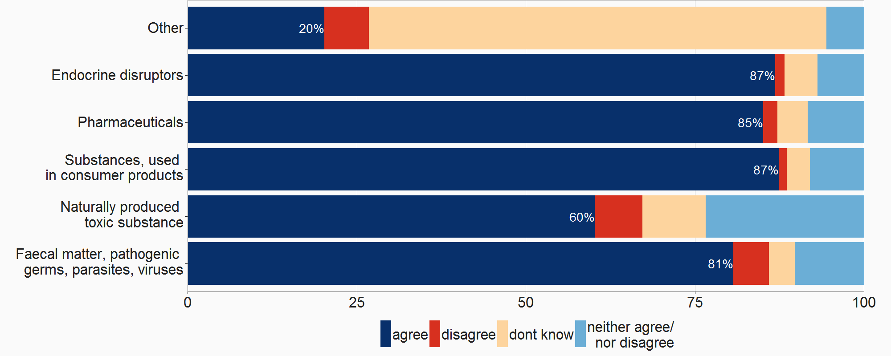

Figure 15: Results open public consultation: focus for parameters

With regard to the problem definition, the responses highlighted the following threats; see figure below. These problems and how they will evolve have been assessed in the problem definition and the baseline scenario.

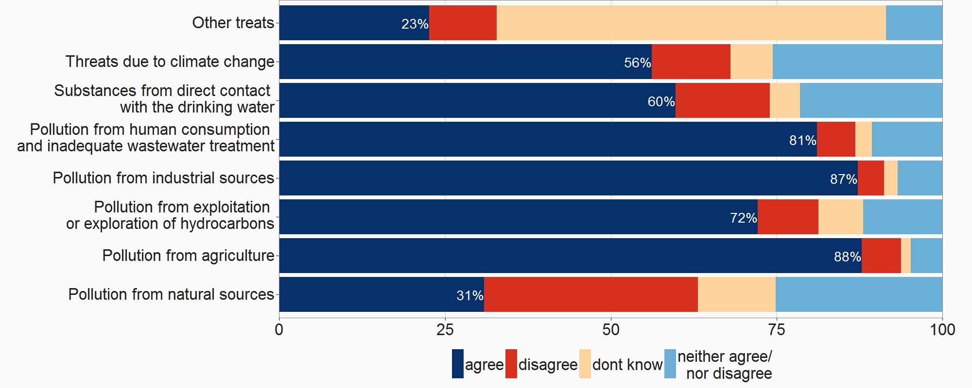

Figure 16: Results open public consultation: Threats to be considered

Additionally, the consultation also asked about further aspects and possible policy options; see figure below. The conclusions are taken up by the Commission Services. The option with the highest rate on materials in contact with drinking water is for example followed by a specific option and by further standardisation activities on construction products by DG GROW (Option 3).

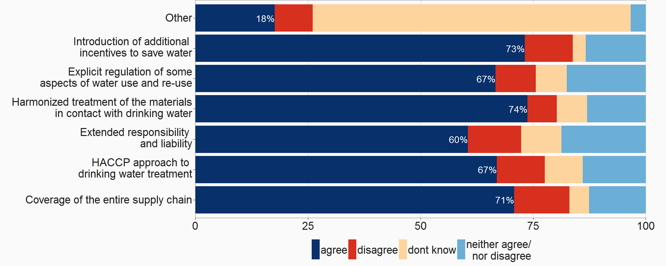

Figure 17: Results open public consultation: Suggested options[120]

A strong message from the consultation, especially mentioned by EU citizens, was the wish for more up-to-date online information. This request has been considered and further developed into a option ensuring smart information to drinking water consumers, see figure below (Option 4).

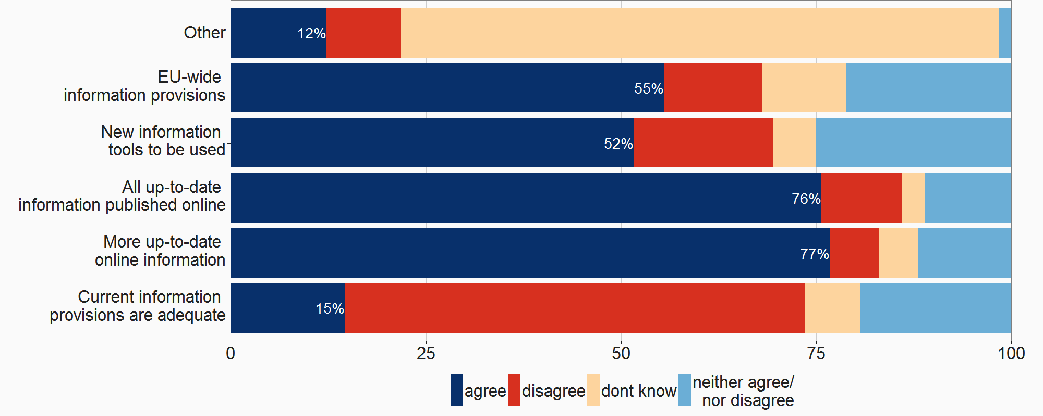

Figure 18: Results open public consultation: Demand for information

**Appendix 2 to Annex 2: Synopsis report on the stakeholder consultation**

*Concerns raised by stakeholders*

|  |  |  |
| --- | --- | --- |
| **Who[121]** | **Concern** | **Argument** |
| BDEW, UBA, EurEau, AquaPublica, CEEP, NL | Access to water | * Access to water should not be in the scope of the DWD * It should be regulated at Member State level, * Implementation can be costly (although it should be covered on EU level) * Cannot be solved through provision of SMART information |
| Vewin, NL, Northern Ireland, UBA, National Farmers Union | Parameter list | * Some values already too precautionary without being based on scientific evidence * MS already set stricter standards than the ones in the Annexes * Flexibility needs to be ensured for cases of emergency * Many want to see WHO list first before making a statement |
| Suez, EurEau, AquaPublica, Poland, NL, VKU, National Farmers Union, BDEW | Option 4.2 and 4.3 | * Benchmarking is out of scope of DWD * Details of options are unclear. Some information can be provided such as quality, frequency, sources, quantities of abstraction; an incident etc., but is the consumer capable of using this information to interfere with management decisions? * Oversimplified that more information leads to high management efficiency * 4.3 generally goes too far * Too much information might lead to uncertainty among consumers * Information should be more tailored to audience (i.e. differentiate professionals and consumers). |
| BDEW, Aqua-Publica, CEEP, Vewin, VKU, Sweden's' local authorities, Vivaqua | Risk-based approach | * Unclear how the risk-based approach should look like * Unclear how RBA affects pollution at source * Subsidiarity and flexibility need to be considered * Argument does not reflect sufficiently positive impact on environment * Shifts responsibility too much to local suppliers |
| FIEB-VIWF, European & French Federation of bottled waters, Natural Hydration Council | Indicator of bottled water | * Using bottled water as an indicator is inappropriate * Bottled water is not as bad for the environment as always said, * This industry provides loads of local jobs, * Limiting the choice of consumption for drinking water is detrimental to efforts to make people drink enough. |
| Aquapublica, CEEP, NL, Vewin | PPHR | * Underlying assumptions are arguable, at times unreliable and sometimes inaccurate |

*Supportive points raised by stakeholders*

|  |  |  |
| --- | --- | --- |
| **Who** | **Support** | **Argument** |
| BDEW, UBA, CCE, Auqapublica, CEEP, Vewin, NL, German Health Ministry, Northern Ireland, European Consumer representation in standardization, PlasticsEurope, and many others | Option 3: Harmonisation of materials and products in contact with drinking water | * Supportive because mutual recognition is important for internal market functioning * Wish for harmonisation of regulatory frameworks across Member States, * 4MS approach should be taken into consideration, * Harmonization will lead to equal levels of consumer protection across the Member States |
| ENDWARE, RIWA, UBA, CCEE, CEEP, Carbon disclosure project, etc. | General harmonization with other legislation | * Almost all stakeholders support that the amended/new DWD is to be more harmonized with the WFD, its daughter directives and other EU (environmental but also other) legislations |
| CEEP, VKU, Sweden, Health care without harm, IDEXX | Updated parameter list in line with scientific and technological standards | * Precautionary Principle should be leading (also when considering WHO's list) * New list should include endocrine disruptors, pharmaceuticals, legionella * New list should be simplified (Sweden) * Adaptation to new scientific & technological standards is highly supported |
| ENDWARE, SUEZ, UBA, Sweden, EurEau, CCE | Inclusion of mandatory risk-based approach | * Good approach, (as long as flexible enough for Member States) * Supports the sharing of information among different authorities that govern water, which is highly important * Works well with a good parameter list * Responsibilities under RBA should be clear |
| AquaFed, Suez, Veolia, Carbon disclosure project | Provision of transparency & information | * General support for more transparency and information to consumers, * Support for the use of IT tools for the distribution of SMART information to consumers |
| Individual citizens, CEE, Nalco, SUEZ, Veolia | Inclusion of  access to water | * Access to water should be embedded in DWD * For the poorest, ad-hoc solutions such as social tariffs should be found * It is a human right and the EU should stand up to its commitments. * 5.2 is acceptable as long as MS have flexibility of how to do it |
| Suez, Danfoss, Danish Environment technology Association | Addressing leakages | * Sustainable management of drinking water should be more targeted (could be done via 4.3) * Support a recital on link between protection of drinking water resource and potential to reduce water leakage |

9.3. Annex 3 Who will be affected by the preferred policy packages and how?

The following annex presents the main impacts for citizens/consumers, supplier/water industry/operators, and public authorities. Impacts on SMEs have been analysed in detail in chapter 5.2.5. The preferred Policy Packages 2 and 3 will have an impact on all considered stakeholders.

*Citizens/consumers*

The main impacts of the preferred policy combination for an EU citizen will be the reduction of the chance of being at risk (PPHR); this and additional costs and benefits concerning the average EU citizen are pointed out below:

* Health benefits/ (costs) associated with that: In total it is expected that through the ambitious packages the population at health risk would be reduced by 15.3 (PP2) or even 15.9 (PP3) million inhabitants by 2050 (reducing the risk for 76 % (PP2) or 79 % (PP3) of the EU population); Most positively affected from PP2/3 regarding the health benefits are Bulgaria, Luxembourg, Malta, Greece and Spain.
* Increase of household cost and affordability of water services: The total cost per household will increase for PP2 by EUR 7.90 or for PP3 by EUR 10.40 per year. For the individual and average EU citizen drinking water will constitute 0.75 % (PP2) or 0.76 % (PP3) of the disposable income. For the lowest income group drinking water will constitute 1.05 % (PP2) and 1.06 % (PP3) of the disposable income.
* Employment will increase by 17 038 persons through the impacts of PP2 and by 25 964 for PP3, mainly to be seen in the UK, France and Germany.
* Through the access to better information, an increase in confidence in drinking water is expected, leading to a decrease in purchases of bottled water. With the implementation of PP2/3, (costs)/ savings from bottled water purchase will be achieved as consumers will develop more confidence in drinking water. The overall decrease in costs for bottled water is expected to be EUR 610 million.
* EU citizens will benefit in the long-term from resource efficiency/ use of water, an impact that is arises through the application of Option 1.2 and Option 2.2 in PP2/3.
* PP3 would positively impact non-connected citizens through providing some of them with access to drinking water.

*Suppliers/operators*

Water suppliers will be most affected by costs for monitoring and additional treatment (Option 1.2 as contained in PP2/3). Overall it is expected that PP2 leads to set-up costs of EUR 5 923 million and PP3 to EUR 7 337 million. Total annual treatment costs increase for PP2 by EUR 1 651 million and for PP3 by EUR 1 660 million. However, the application of the RBA (Option 2) and the hazard assessment of abstraction areas will in the longer term avoid unnecessary monitoring and treatment. These changes in monitoring and treatment activities are assumed to lead to the need of finding new ways of management in water companies as well as the need for more training. As option 4.3 requires the suppliers to provide substantially more information to the consumers, water suppliers have to improve the way they use modern technology and work on the establishment of a clear communication channels with their customers. PP2/3 is also anticipated to have a positive impact on innovation (new monitoring, new data management).

Especially option 3 will have a positive impact for suppliers of materials and products in contact with drinking water as tendering will become significantly easier and cross-MS trade will increase. However, certification and testing institutes in the same Member States can be expected to lose business as new materials would have to be tested only once to be accepted throughout the EU, which can then also be done in other Member States.

*Public authorities*

From the perspective of authorities, an important challenge will be the shift to the RBA for health authorities. The introduction of the risk-based approach will require additional time and effort for setting-up the new approach, as the assessment of hazards can be demanding and requires a different skill set than the existent one. This also entails that more human resources will be needed to follow up on the new approach and on compliance. Another impact relates to the reduction of administrative burden through simplified reporting (Option 4.3). However, there will also be a need to widen existent expertise on health and water to support the implementation of ption 4.3 and to monitor the effects.

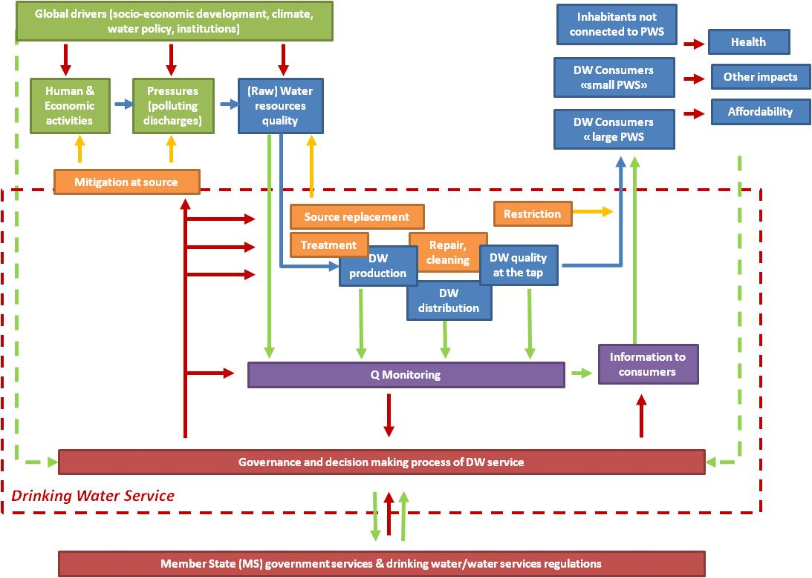

Figure 19: Scheme of the drinking water system

Also public authorities will feel the impact of option 3 as it will be easier to implement as there no longer the need for separate standardization procedures to be established by each MS.

Figure 19 above provides further background on the drinking water scheme, who is involved, and who is affected.

Cost – benefit assessment of policy packages

**Title: Proposal for a Directive of the European Parliament and of the Council amending Council Directive 98/83/EC on the quality of water intended for human consumption (IA)**

**Summary of costs and benefits**

|  |  |
| --- | --- |
| **PP2/PP3** | **PP3** |

|  |  |  |  |  |  |  |  |
| --- | --- | --- | --- | --- | --- | --- | --- |
| ***I. Overview of Regulatory Costs – Preferred Option(s)[122]*** | | | | | | | |
|  | | **Consumers** | | **Businesses=Water operators[123]** | | **Administrations** | |
| **Set-up costs** | **Recurrent**  **(increase/decrease in baseline 2050 household costs)** | **Set-up costs** | **Annual operating costs** | **Set-up costs** | **Annual operating costs[124]** |
| **1.2 Extended Parameter List** | Direct costs[125] |  | EUR + 14.90/year | EUR 5 895 million | EUR 2 842 million |  |  |
| Indirect costs |  |  |  |  |  |  |
| **2.2 RBA Mandatory for all water suppliers** | Direct costs | No set-up costs | EUR - 0.40/year | EUR 25 million | EUR -96 million | EUR 6.25 million[126] |  |
| Indirect costs |  |  |  |  |  |  |
| **3 Harmonisation of materials; standards** | Direct costs | No set-up costs | EUR – 3.20/year | No set-up costs expected | *EUR – 669 million Costs reduction for product manufacturers passed on to consumers*[127]. |  |  |
| Indirect costs |  |  |  |  |  |  |
| **4.1 Automatic reporting** | Direct costs |  |  |  |  | EUR 2.9 million | EUR - 0.352 million |
| **4.3 Advanced access to information** | Direct costs | No set-up costs | EUR + 4.50/year  Savings through less purchases of bottled water:  EUR – 2.90/year | EUR 5.6 million (in comparison to baseline 2050) | EUR 933 million  The decrease of bottled water consumption is included in the household costs. The changes in bottled water consumption will nevertheless remain minor compared to the market.  The packaging industry will not be significantly negatively affected by better tap water quality. |  |  |
| Indirect costs |  |  |  |  |  |  |
| **PP2 (combined for measures 1.2, 2.2, 3& 4.3)[128]** | Direct costs | No set-up costs | EUR + 7.90/year | EUR 1 349 million (operating costs)  EUR 5 925 million | | EUR - 0.352 million | |
| **5.2 Alternative self-supply systems and access in public places** | Direct costs | No set-up costs | EUR + 2.50/year  Savings through less purchases of bottled water:  EUR – 0.40/year | EUR 1 411 million | EUR 60 million |  |  |
| Indirect costs |  |  |  |  |  |  |
| **PP3 (combined for measures 1.2, 2.2, 3, 4.3 & 5.2)** | Direct costs | No set-up costs | EUR + 10.40/year | EUR 1 408 million (operating costs)  EUR 7 354 million | | EUR - 0.352 million | |

|  |  |  |
| --- | --- | --- |
| ***II. Overview of Benefits (total for all provisions) – Preferred Option (between PP2 and PP3)*** | | |
| ***Description*** | ***Amount*** | ***Comments*** |
| ***Direct benefits*** | | |
| Administrative cost reduction | **EUR 669M/year** in costs savings due to reduction of administrative burden. Additional marginal savings could be expected from the proposed simplification of reporting obligation for Member States |  |
| Compliance cost reduction | **EUR 96M/year** in cost savings compared to the baseline – due to a decrease in the number of tests. The annualised cost saving includes theamortised set up costs.  Differentiation of set-up costs and operating costs: see glossary |  |
| Compliance cost reduction | **EUR 0.40/year** per household in cost savings due to overall decrease in water supply costs being passed on to consumers (due to option 2.2) |  |
| FTE increase | Overall 6,4 **% increase in employment** from all options under PP3 (4,2 % under PP2) | Costs for employment were included in the costs figures and is therefore represented in all figures. |
| N/A | Unquantified (but small) benefit to IT providers of option 4.3 |  |
| N/A | Unquantified benefit for companies involved in the creation of additional PWS (due to measure 5.2) |  |
| N/A | Significant increase in water quality (PP2) and access (PP3) | The reduction of bottled water purchases is included in the assessment of the household costs. Under both preferred policy packages a decrease of purchases of bottled water is assumed and this is also reflected in the household costs. |
| ***Indirect benefits*** | | |
| Avoided health impacts | **EUR 285M/year** in cost savings from reduced healthcare costs due to a decrease of illnesses related to contaminated water |  |
| FTE increase | Increase in employment of between 500-1000 FTEs due to innovation driven by option 1.2 |  |

|  |  |  |
| --- | --- | --- |
| ***REFIT Cost Savings – Preferred Option(s)*** | | |
| ***Description*** | ***Amount*** | ***Comments*** |
| Administrative cost reduction | **EUR 669M/year** in costs savings due to reduction of administrative burden |  |
| Compliance cost reduction | **EUR 96M/year** in cost savings compared to the baseline – due to a decrease in the number of tests. The annualised cost saving includes theamortised set up costs.  In operating costs a saving of EUR 96 million is assumed |  |

**Glossary to cost benefit table**

|  |  |  |
| --- | --- | --- |
| **Item** | **Component (depending on option)** | **Life-span/ time frame of costs** |
| **Set-up costs** | Risk-based approach implementation | 10 years |
| Equipment for non-equipped citizens | 3 years |
| Automatic reporting development | 5 years |
| SMART information provision system development | 5 years |
| Distribution network extension | 30 years |
| New monitoring and treatment equipment | 20 years |
| **Operating costs** | Monitoring or analysis | Annual costs borne by water operators (and then transferred to consumer) |
| RBA audit |
| Treatment |
| Distribution |
| Additional preventative actions |
| Information provision |
| Reporting |
| Other operating costs |
| **Household costs** (1 household equals 2.4 persons) | Operating costs | Yearly costs borne by consumers |
| Annualised set-up costs |
| Only counting population connected to the public water supply system |

9.4 Annex 4 Development of the analytical model for the assessment of the options, underlying assumptions of the options and impacts assessed through application

This Annex describes the methodology that was developed and used to assess the status quo and the different options. Among experts, it was agreed upon that there is a need to develop a new indicator, the so-called 'People at Potential Health Risk' (PPHR) indicator. The PPHR was developed together with a consortium of consultancies led by Acteon. Throughout the stakeholder consultation activities, the indicator has been presented to, and was discussed with experts in the field, and feedback has been included whenever possible. The development of this indicator, the baseline for its comparison to natural developments until 2030 and 2050 and how the indicator was consequently used for the assessment of the options is explained in the subsequent sections.

1. The need for a new indicator

There is general recognition regarding the importance of safe drinking water for human health. At EU level no data is available regarding how many people turn sick after drinking contaminated water, but outbreaks occur frequently. Several cases collected for the Evaluation[129] confirm that people have to be treated for diarrhoea, vomiting or fevers after drinking tap water. A recent WHO assessment for the pan-European region[130] estimates that diarrhoeal diseases still cause 14 deaths per day due to inadequate water, sanitation and hygiene. Renewed momentum is therefore needed to address these challenges (Figure 20).

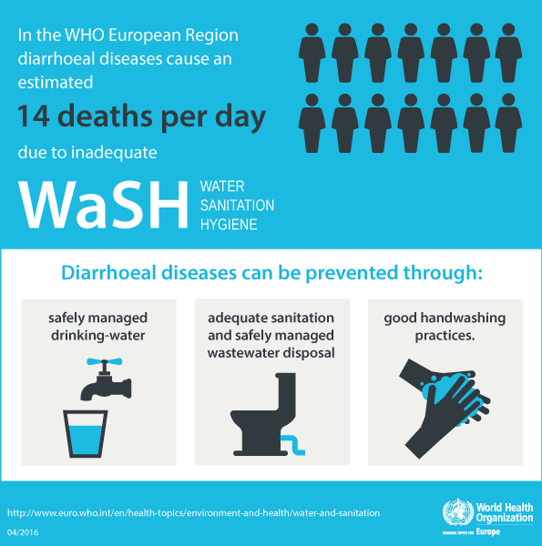

Figure 20: Infographic WHO - 14 deaths per day due to inadequate water, sanitation and hygiene

As no data is available to directly link EU drinking water quality with EU human health effects, a specific **health indicator 'Population Potentially at Health Risk' (or PPHR)** has been developed to estimate the overall impacts on today’s population potentially at health risk. According to this methodology, it is estimated that **22.7 million inhabitants (or 4 % of the EU28 population) are potentially at health risk today because of potential contamination in water resources and drinking water**. This theoretical health indicator is used as a benchmark to assess health impacts next to economic, environmental and social impacts, and to assess whether there are possible options to tackle this EU health issue.

##### 1.2. The PPHR indicator

The PPHR indicator (combining the low, medium and high risk categories) and the population marginally at health risk were estimated on the basis of assumptions for the shares of the population exposed to different risk factors among which: being connected to a PWS or not, drinking bottled-water or not, being supplied by a water operator applying RBA or not, having access to water potentially contaminated by different types of pollutants, etc.. Depending on their exposure to different risk factors, the percentage of the population under each risk category (marginal, low, medium and high) was estimated as summarized in Figure 21.

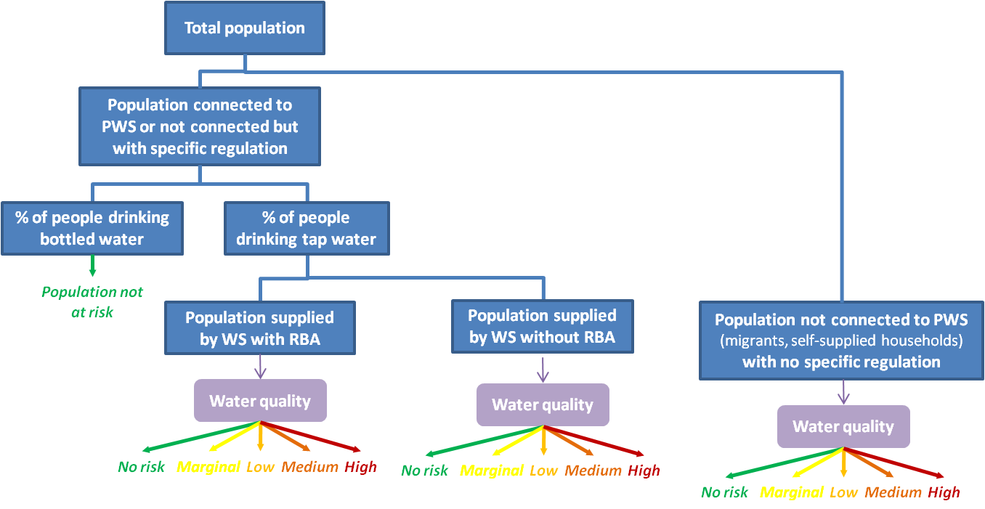

Figure 21: Underlying scheme for the development of the PPHR

To develop the PPHR, available data on population, connection rates to public water supplies, assumptions on the type and level of contaminants in water resources were used, as well as data of reported illness cases that could be due to the consumption of drinking tap water collected by the European Centre for Disease Prevention and Control (ECDC). Through this the **health indicator 'Population Potentially at Health Risk' (or PPHR)** was defined to capture the part of the population that has access to drinking water that might contain substances that can potentially cause health problems. The indicator PPHR was developed to aggregate the overall impact of these different elements on today’s population potentially at health risk. The information refers to Annex 2 of the IA Study[131].

The above introduced PPHR analytical model explained how to best estimate the number of EU citizens currently at risk. To complement that model and make a link between the population at risk and societal cost related to being sick (or not sick, thus leading to health benefits) is needed.[132]

##### 1.3 Assumptions on today’s situation with regards to basic parameters used to estimate PPHR

The following data points were used to constitute the basis for PPHR analytical model:

* 508 223 624 inhabitants (EU 28)
* With 95 % connected to PWS
* Each inhabitant drinks on average 106 litres of bottled water per person and per year – with 3 845 litres of tap water being used per person and per year
* It is assumed that 47 % of (large) PWS are applying already a RBA.
* It is assumed that current tap water quality is affected by contamination as follows:
* 7 % contaminated by substances listed in the current DWD Annex, with concentration above the WHO parametric values, i.e. not complying with the current DWD standards
* 11 % contaminated by substances listed in the current DWD Annex, with concentration below the WHO parametric values but, above “precautionary” limit values
* 4 % contaminated by substances from the new list under option 1.1 (see Annex 5, 2.1) among water distributed by water suppliers who apply an RBA; and 8 % among water distributed by water suppliers who do not apply a RBA
* 7 % contaminated by supplementary substances from the new list under option 1.2 (Table 11, Annex 5)
* It is assumed that raw water (used for self-water supply in particular) is affected by contamination as follows:
* 9 % contaminated by substances listed in the current DWD Annex, with concentration above the WHO parametric values, i.e. not compliant with the current DWD standards
* 11 % contaminated by substances listed in the current DWD Annex, substances with concentration below the WHO parametric values but above “precautionary” limit values
* 10 % contaminated by substances from the new list under option 1.1
* 11 % contaminated by supplementary substances from the new list under option 1.2 (Table 11, Annex 5).

##### 1.4. Cost estimation related to cases of illness due to consumption of drinking tap water

To analyse the societal cost of cases of illness related to the consumption of drinking tap water we follow the four-step methodology depicted below:

Figure 22: Four step methodology

The European Centre for Disease Prevention and Control (ECDC) collects information from each MS regarding the yearly number of reported illness cases. This information is taken up for the years 2008-2012 in the Evaluation of the EU Drinking Water Directive study (Annex C). From this table one can observe that there are, on average, 17.000 reported cases of illness per MS that could be due to the consumption of drinking tap water. Furthermore, 86 % of all cases are related to a case of Campylobacteriosis and most of the reported cases stem from the UK (32 %).[133] However, generally not all cases of illness are reported. An ill person does not always report to a general practitioner (in most cases since there is no need of urgency as he/ she is only ill for a short(er) period of time). As such, there is a need to estimate and include the number of unreported cases of illness.[134] The well documented case of an outbreak of Giardiosis in Norway has been used to roughly estimate the number of unreported cases versus the number of reported cases (COWI, 2009). From this specific Giardiosis outbreak we are able to determine that on average there are 2.5 cases of unreported illness (who are also much less longer sick) for each reported case. In this study this result is used as a proxy for the six main types of water related illnesses.

Not all cases of illness taken up in the ECDC are due to consumption of drinking tap water. The ECDC reports the sickness of a person, but (logically) no information is known as to the cause of falling ill and as such not reported on. Based on an extensive literature study, combined with expert judgement (in case literature is not conclusive), the causal attributed share of becoming ill due to drinking tap water is estimated.

The third step in our approach is to include the number of days a person falls ill in the case he/ she obtained a parasite/ virus/ other through the consumption of drinking tap water. This step is closely related to step two.[135] The final step in assessing the current societal cost related to the consumption of drinking tap water is related to the (financial) societal impact of being sick, mainly related to a combination of healthcare cost (on average EUR 203 per day) and loss of productivity cost (on average EUR 93 per day (if you are part of the working population)).

##### 1.5. Causal attributable share and duration of cases of illness related to tap water

***1.5.1. Cryptosporidium and drinking tap water***

An infection of Cryptospridium has an incubation period of 7 to 10 days and the symptoms are in general diarrhoea. Infected people who have a well-functioning immunity system are on average sick for 2 to 3 weeks (it ranges from 4 days to over 4 weeks). In case an infected person does not have a well-functioning immunity system (aids-, transplant-, cancer patients etc.) the infection can last up to months, become a chronic disease and even be fatal. Mortality is in general very low (<0.01 %), in case an infected person does not have a well-functioning immunity system chances are up to 50 %. Small children are also a group that is more affected by this type of waterborne infection.

One can be infected by Cryptosporidium through various ways. When infected the cause is often unclear. As such it is very difficult to show the contribution of drinking tap water to the reported number of Crypto cases. One can however make estimations using the QMRA approach. Sources of infection, related to drinking water consumption, are recreational water bodies, swimming pools, drinking water sources (river- and groundwater) after flooding, intense rainfall, meltwater and food. Small (private) water supplies can also be a source of the infection.

There are several studies that use the QMRA method to empirically show the chance of being infected with crypto through drinking water: A Chinese study estimated that the chance per 100.000 people is 8.31 x 10-6 (range 0.34-30.93 x 10-6) DALY per person per year. The findings of this study are higher than what is reported by the WHO and lower than the risk according to the US EPA.[136] In the UK, a country that has a strong focus on monitoring crypto, the risk of being infected is estimated at 50 % from swimming pools and 20 % from tap water. On the other end of the spectrum, the Netherlands, no cases of crypto infection related to consumption of drinking water are known, meaning that the method of water treatment and/ or quality of intake are important factors and determine the number of infections. For the EU 20% as upper limit is used.

***1.5.2. Campylobacteriosis and drinking tap water***

Campylobacteriosis is known to be caused by: private water sources and rivers (especially after floods) and in many cases it is carried by animals. Other contaminants are food, especially beef, chicken, various birds and shellfish, but also raw milk and vegetables.

The incubation period is somewhere between 1 to 7 days, 3 on average. When infected the patient will have diarrhoea for up to 7 days, and in 15 % of the cases the sickness lasts even longer. The chance of infection through drinking water is roughly 5-10 % and is mainly related to small(er) water supplies.

***1.5.3. E.coli and drinking tap water[137]***

There is a common misconception regarding E.coli in drinking water, as E.coli is in itself not leading to any infections. E.coli is however an indicator parameter for a range of infections closely related to the E.coli bacteria, namely shigatoxic producing E.coli (STEC), verotoxic producing E. Coli (VTEC) and enterohemorrargic E.coli (EHEC). An infection of these three types of E.coli is almost always related to food consumption (raw vegetables such as tomato, cucumber, but also meat).

An infection of a type of E.coli bacteria is in most known cases not caused directly through the consumption of drinking water, but to some extent indirectly through the cleaning of food. For this study chances of infection are estimated to be in the range of 0-5% for Europe. The incubation period of E.coli is between 1 and 14 days, roughly 3-4. A patient is on average 4 days sick when infected.

***1.5.4. Giardiosis and drinking tap water***

Giardiosis is an intestine infection caused by G.Lamblia. When infected, the main symptoms are weight loss and diarrhoea. Overall the duration of the infection is two to three weeks, although in some cases it is reported to be longer and even chronic. In case a person is also infected by aids, underfed or elderly the infection can be fatal.

One can be infected through drinking tap water, swimming pools, spas, open water bodies and in some cases also through food consumption. Overall infection is caused more often by open water when compared to groundwater sources. According to an American study 80 % of the infections are caused by untreated water.[138] Based on expert judgment, it is estimated that the chance of being infected by consumption of drinking water is between 50 and 80 %.

***1.5.5. Shigellosis and drinking tap water***

In general Shigellosis patients are infected through consumption of drinking water and food that is washed by infected water. Based on expert judgment the attributability of drinking tap water to the number of Shigellosis cases is between 70 and 80 %. Patients infected by Shigellosis are having diarrhoea after an incubation period of 1-7 days and it lasts between 4-7 days. In select cases, it has been reported that the duration extends to several weeks. Normally being infected with Shigellosis is only fatal for the young, sick and elderly.

***1.5.6. Legionella and drinking tap water [139]***

There is one way for being infected by Legionella, namely through inhaling of aerosols (in water vapour). Legionella causes a lung infection. Locations of infection are the shower, hot tubs, saunas, and air condition systems. The consumption of drinking water does not cause Legionella. Legionella becomes dangerous if it can multiply, which happens if water stands still for a longer period of time and reaches a temperature between 25 and 55 degrees. Mortality rates are relative high compared to other discussed infections, namely 2-10 % (although often elderly people). The value of a life is set at EUR 3.4 million. Although the number of mortal Legionella cases is low, it accounts for the highest social cost.

The incubation period of a Legionella infection is 2 to10 days and an infected patient is sick from 2 days up to several weeks. Based on a discussion with RIVM we estimate the attributability of drinking water (water vapour, i.e. showering) to be 60 to 80 % of the reasons for infection.

| Case | Min | Max | Days sick | Additional sick days |
| --- | --- | --- | --- | --- |
| Cryptosporidiosis | 0% | 20% | 36 | 4 |
| Campylobacteriosis | 0% | 5% | 5 | 2 |
| E.coli | 0% | 5% | 9 | 2 |
| Giardosis | 50% | 80% | 14 | 2 |
| Shigellasis | 70% | 80% | 7 | 4 |
| Legionella | 60% | 80% | 10 | 2 |

Table 7: Overview of attributability and duration of sickness

##### 1.6. Cost of being sick

The societal cost of being sick consist of two main components, namely the hospital and/ or general healthcare costs and the cost due to loss of production or productivity. The cost of being taken up in a hospital for an infectious disease (most similar to above causes of illness) has been estimated to cost EUR 2 676 for five days.[140] However, not all people who fall sick need hospital treatment and for the analysis the assumption that half of the cases need to be treated in the hospital is used. This assumption and the simplification[141] for the different MS healthcare systems show that on average direct costs of falling ill are EUR 203. Next to healthcare costs society has cost when one falls sick if s/he is part of the working group (65 % of the population when taking EU28 2015 average)[142]. The costs of falling sick consist of salary for a replacement employee and loss of productivity.[143] On average the costs have been estimated at EUR 93.[144]

*1.6.1. Total number of cases and societal cost of being sick*

The table below is a culmination of the approach set out in the first section of this chapter and provides a rough indication of the current societal cost related to drinking tap water per MS. In 2015 the societal cost of drinking tap water in Europe is equal to EUR 220 million or EUR 0.43 per EU citizen and EUR 9.6 per person at risk.[145] These figures are a rough estimation of the current societal cost of consuming tap water; this value should be interpreted as the lower boundary. In this analysis possible (unknown) long term health impacts of water consumption are not taken into account.

| Member State | Societal cost for being sick due to tap water | Total min  (x mln) | Total max  (x mln) | Causal days sick** | Cost per PPHR *** |
| --- | --- | --- | --- | --- | --- |
| Austria | € 386 | € 2,4 | € 3,3 | 3.055 | € 6,9 |
| Belgium | € 353 | € 5,3 | € 7,3 | 23.681 | € 8,6 |
| Bulgaria | € 139 | € 3,5 | € 4,5 | 34.468 | € 5,8 |
| Croatia* | € 139 | € 2,1 | € 2,1 | 20.681 | € 11,5 |
| Cyprus | € 244 | € 0,2 | € 0,3 | 107 | € 5,5 |
| Czech R. | € 252 | € 3,0 | € 4,5 | 8.758 | € 7,8 |
| Denmark | € 372 | € 1,6 | € 2,3 | 2.301 | € 11,4 |
| Estonia | € 227 | € 0,6 | € 0,8 | 3.706 | € 17,5 |
| Finland | € 330 | € 1,6 | € 2,2 | 2.875 | € 7,4 |
| France | € 319 | € 17,7 | € 23,4 | 12.584 | € 10,3 |
| Germany | € 375 | € 27,4 | € 39,7 | 82.822 | € 14,5 |
| Greece | € 216 | € 2,7 | € 3,6 | 772 | € 4,8 |
| Hungary | € 202 | € 2,5 | € 3,5 | 3.655 | € 7,1 |
| Ireland | € 400 | € 1,4 | € 2,2 | 4.086 | € 17,1 |
| Italy | € 287 | € 14,9 | € 19,8 | 1.549 | € 5,8 |
| Latvia | € 190 | € 0,5 | € 0,7 | 720 | € 7,0 |
| Lithuania | € 224 | € 0,8 | € 1,1 | 1.083 | € 5,3 |
| Luxembourg | € 406 | € 0,2 | € 0,3 | 377 | € 10,5 |
| Malta | € 257 | € 0,1 | € 0,2 | 131 | € 9,4 |
| Netherlands | € 390 | € 5,4 | € 7,1 | 8.097 | € 11,1 |
| Poland | € 202 | € 11,1 | € 14,7 | 28.085 | € 18,8 |
| Portugal | € 233 | € 2,5 | € 3,4 | 251 | € 4,6 |
| Romania | € 165 | € 5,4 | € 7,0 | 8.096 | € 3,8 |
| Slovakia | € 229 | € 2,1 | € 2,8 | 8.856 | € 8,5 |
| Slovenia | € 246 | € 0,6 | € 0,8 | 1.009 | € 8,5 |
| Spain | € 272 | € 12,3 | € 16,5 | 13.583 | € 5,0 |
| Sweden | € 367 | € 5,3 | € 7,3 | 25.139 | € 15,0 |
| UK | € 325 | € 24,6 | € 36,6 | 107.380 | € 41,2 |
| **EU total** |  | € 157,9 | € 218,5 | 407.906 |  |
| **EU average** | € 298 | € 5,6 | € 7,8 | 14.568 | € 9,6 |

Table 8: Societal cost of being sick (short-term)

* The EDCD database did not include information on Croatia. Croatia has been set at 60 % of Bulgaria to best assess total EU28 sick costs (due to differences in population). The societal cost per sick case is set equal for Bulgaria.

** **0.08 % of the EU will on a yearly basis become 1 day sick due to drinking tap water**. For these figures the average of column 2 and 3 in Table 8 has been taken.

*** The difference per MS corrects for the difference in actual sick cases (ECDC) and PPHR.

##### 1.7. Linking PPHR and causal attributed reported sick cases

The PPHR approach calculated the number of people at risk for the baseline (2015, 2030 and 2050) and for each of the options. Similar to the number of drinking water related sickness cases (based on the ECDC reported cases database) we found that there are considerable differences across MS for both the PPHR and number of sick cases. These section analyses to what extent a link exists between the PPHR approach and number of causal attributable sick cases at MS level.

On average 23 million people are annually at risk per MS, or roughly 5 % of the EU population. A consumer is most at risk in Bulgaria (>10 %) and least at risk in the UK (<2 %), (Figure 23).

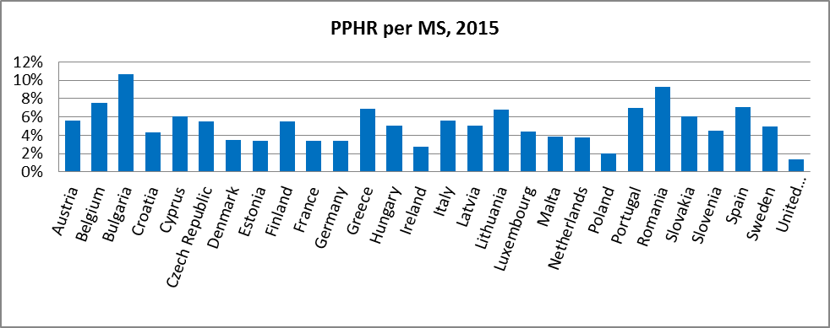

Figure 23: Population potentially at risk of being sick by MS, % annually

In order to compare the PPHR and number of causal sick cases we first took the chance of being at risk and chance of falling sick per MS and secondly calculated the share compared to the EU total chance of being at risk and causal sick chance summed over all MS. To graphically best depict what MS have a good correlation versus MS where the correlation is weaker we took the difference of the scaled result.

One should interpret the below figure in the following manner:

- If all MS have a value close to 2.8 % 🡪 there is a very strong correlation between the PPHR approach and the actual number of reported sick cases.

- If many MS are far away from the average of 2.8 % 🡪 there is a weak correlation and the PPHR approach or the ECDC information do not report the actual number of people at risk.[146]

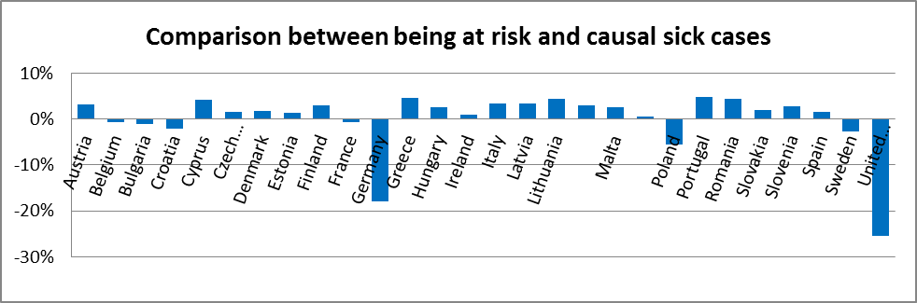

Figure 24: Linkage between being at risk and getting sick

The above figure shows that there is a relative strong link between both approaches for most MS. It also shows that the approach is relatively unreliable for Cyprus, Germany, Greece, Poland, Portugal, Romania and the United Kingdom. The expected main reason for inconsistencies in correlation between both approaches is related to the level of reporting on number of sick cases to the ECDC database by MS. Experts who often work with this database have informed us that the UK is very actively monitoring and reporting sick cases compared to some other MS. In light of this qualitative background we can conclude that for some MS the PPHR might be an underestimation and for others an overestimation. We conclude that it would be best to fall back to calculating PPHR costs at EU level compared to an approach where we link PPHR results to the number of reported sick cases for that MS.

2. Underlying assumptions for analytical model and options

##### 2.1. Assumptions made for the quantification of impacts

This Annex serves as an explanatory guide regarding the assumptions and quantifications that were made for the Impact Assessments of the different options. All assumptions were based on the same baseline scenario which is presented in tabular form below (Table 9). These assumptions were used for the consequent assessment of the options. Cost figures build on the cost estimations in the Evaluation and its underlying study. An EU 'household' corresponds on Eurostat figures to 2.4 persons.

Monitoring costs, in the baseline scenario, are expected to decrease from 2015 to 2030 and 2050 as a result of the voluntary application of the risk-based approach. Treatments costs are expected to decrease by 2030 and then to increase again by 2050 because of the combination of two trends: firstly, reduced unitary treatment costs through the risk-based approach and preventive measures that secondly, do not compensate for the increase in population.

|  |  |  |
| --- | --- | --- |
| Characteristics of demography and pressures on water resources | Current situation (2015) | Projections (2050) |
| Demography | 508.2 millions of inhabitants (Eurostat) | 525.5 millions of inhabitants, - decreasing in some MS (Eurostat) |
| Distribution of population between urban / rural areas | 43 % in urban areas; 35 % in intermediate areas; 22 % in rural areas (Eurostat) | 47 % in urban areas; 38 % in intermediate areas; 15 % in rural areas (UN trends) |
| Population above 65 | 19 % (Eurostat) | 28 % (Eurostat) |
| Pharmaceuticals products consumption expenditure | 9 030 PPS (Eurostat) | 14 204 PPS (increase proportional to the number of inhabitants above 65) |
| N losses to surface and ground water | 13.9 kg N/ha (Eurostat) | 18.1 kg N/ha (Wolf et al., 2015) |
| Surface water bodies subject to point source pollution | 37.5 % (Waterbase, EEA) - with large disparities between MS | 37.5 % (stable, as decoupling of industrial emissions and economic growth) |
| Percentage of PWS water coming from groundwater sources | 58 % (Eurostat) | 58 % (stable) |
| Average consumption of drinking water per person (tap + bottles) | 3 950 litres per year and per person (Eurostat, Unesda) | 3 950 l/y/p (stable) |
| Large water suppliers (among population connected to PWS) | 80 % of the EU28 population (Eurostat) | 86 % of the EU28 population (increase proportional to the population in urban and intermediate areas) |
| Risk-based approach  % of the MS population | Small supplies 0 %,  Large supplies 0->90 % | Small supplies 25-75 %  Large supplies 50-90 % |

Table 9: Assumptions for the baseline scenario

|  |  |  |  |  |  |
| --- | --- | --- | --- | --- | --- |
| Member state | **Population** | **Population connected to PWS** | **Population connected or covered by specific regulation** | average consumption of tap water per person (drinking water in l/cap/day) | LEAKAGE  PWS |
| **Austria** | 8.551.081 | 95,10% | 95,1% | 137 | 14% |
| **Belgium** | 11.336.943 | 100,00% | 100,0% | 100 | 50% |
| **Bulgaria** | 7.199.931 | 99,16% | 99,2% | 191 | 57% |
| **Croatia** | 4.244.995 | 85,50% | 85,5% | 182 | 44% |
| **Cyprus** | 873003 | 100,00% | 100,0% | 105 | 8% |
| **Czech Republic** | 10.536.043 | 93,28% | 93,3% | 90 | 23% |
| **Denmark** | 5.649.584 | 97,00% | 97,0% | 99 | 14% |
| **Estonia** | 1.311.505 | 81,44% | 81,4% | 70 | 17% |
| **Finland** | 5.478.486 | 91,50% | 91,5% | 117 | 22% |
| **France** | 66.175.754 | 99,00% | 99,0% | 128 | 30% |
| **Germany** | 80.709.056 | 99,30% | 99,3% | 122 | 12% |
| **Greece** | 10.977.945 | 94,00% | 94,0% | 177 | 26% |
| **Hungary** | 9.863.193 | 100,00% | 100,0% | 92 | 25% |
| **Ireland** | 4.602.854 | 85,00% | 85,0% | 150 | 44% |
| **Italy** | 60.944.960 | 99,00% | 99,0% | 243 | 39% |
| **Latvia** | 1.985.887 | 76,00% | 76,0% | 77 | 28% |
| **Lithuania** | 2.901.039 | 76,00% | 76,0% | 61 | 19% |
| **Luxembourg** | 562.848 | 99,90% | 99,9% | 115 | 19% |
| **Malta** | 426.144 | 100,00% | 100,0% | 50 | 26% |
| **Netherlands** | 16.876.904 | 100,00% | 100,0% | 128 | 12% |
| **Poland** | 38.499.953 | 87,64% | 87,6% | 98 | 24% |
| **Portugal** | 10.367.550 | 96,90% | 96,9% | 132 | 23% |
| **Romania** | 19.909.323 | 57,16% | 57,2% | 74 | 17% |
| **Slovakia** | 5.416.851 | 86,84% | 86,8% | 83 | 28% |
| **Slovenia** | 2.066.511 | 85,50% | 85,5% | 122 | 29% |
| **Spain** | 46.390.269 | 100,00% | 100,0% | 130 | 30% |
| **Sweden** | 9.721.642 | 86,00% | 86,0% | 148 | 19% |
| **United Kingdom** | 64.643.370 | 100,00% | 100,0% | 150 | 14% |
| **EU total** | 508.223.624 | 95% |  | 3.371 |  |
| **EU average** | 18.150.844 | 95% |  | 120 | 23% |

Table 10: Population, Connection, Consumption Data, Leakage Rates

##### 2.2. Social-economic baseline impacts - water costs in a household-spending

The baseline scenario starting with 2015 income levels has made predictions on income levels in 2050. This analysis shows that, in the baseline, the cost of water for households decreases from EUR 229 to EUR 228 in the 2050 forecast with no visible change with regards to affordability. This is a result of a cost reduction expected in the baseline and of the disposable income estimation increasing faster than the estimated increase in cost of water from drinking water providers. However, due to the large uncertainties in these predictions for 2050, it is unlikely that drinking water becomes dramatically more affordable towards 2050 in the baseline. Figure 25 below shows the comparison of water costs with household incomes per Member State.

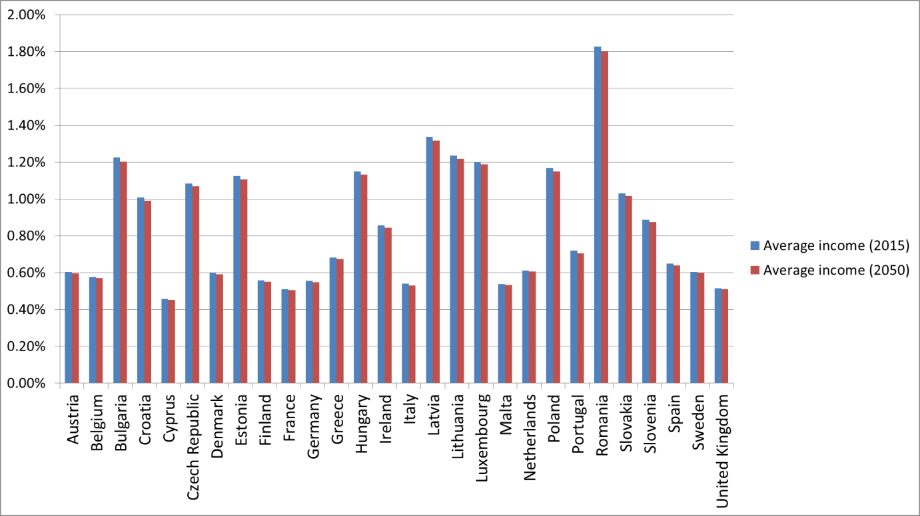

Figure 25: Comparison of water costs with household incomes (2015 and 2050 baseline)

3. Detailed description of the options

The following section describes the different options that were discussed to address the problems and the objectives pointed out in this Impact Assessment. First each option and the underlying assumptions are explained in detail. These assumptions are based on expert discussions. Second, in tabular form an initial screening of all options across a wide range of categories is provided. Third, the in-depth assessment of the health and economic impacts of the options is described. For the in-depth assessment the above outlined PPHR indicator was used as well as the baseline assumptions.

In the following sub-section the five overarching objectives are explained in detail and the underlying assumptions are provided.

##### 3.1. Objective 1: Updated list of parameters

The DWD defines minimum requirements for the quality of drinking water by regulating 48 microbiological and chemical parameters in its Annex I. The parameters have to be reviewed based on technical progress every five years, but the reviews have not led to a revision in the set of parameters so far. The ex-post Evaluation and the stakeholder consultations identified the need to amend the list of parameters of Annex I in line with latest scientific and technical developments and evidence. There were in particular suggestions from the public consultation that substances used in consumer products, pharmaceuticals and endocrine disrupting substances should be included. A number of European projects from Framework programmes (such as HEALTHY Water –FP6, RAMADA – FP6, ECHAIN-FP6, ChemFree Water – FP6, BIOTREAT-FP7, MAQUA-FP7, AQUAVALENS-FP7, HI-WATE- FP6, ARSENIC reduction – FP6, and others) shows the need to address this challenge. For a detailed review, a cooperation project is conducted by the WHO to update the parameters and the limit values in the DWD, as the DWD standards should be generally based on the WHO Guidelines. The project suggests a list of substances to remove and to add to the DWD list. This project will provide for each parameter a fact sheet that justifies the proposed changes.[147]

Table 11 below shows the extended parameter list (resulting from the WHO cooperation project as well as reliance on precautionary principle) with new parameters displayed in bold, which have been used to back up the assumptions of option 1.2.

|  |  |  |
| --- | --- | --- |
| Parameter | Parametric value | Unit |
| ***Clostridium perfringens* spores** | 0 | Number/100 ml |
| **Coliform bacteria** | 0 | Number/100 ml |
| Enterococci | 0 | Number/100 ml |
| *Escherichia coli (E. coli)* | 0 | Number/100 ml |
| **Heterotrophic plate counts (HPC) 22o** | No abnormal change |  |
| **Somatic coliphages** | 0 | Number/100 ml |
| **Legionella** | <1000 | Number/l |
| **Turbidity** | <1 | NTU |
| Acrylamide | 0,10 | μg/l |
| Antimony | 5,0 | μg/l |
| Arsenic | 10 | μg/l |
| Benzene | 1,0 | μg/l |
| Benzo(a)pyrene | 0,010 | μg/l |
| **Beta Estradiol (50-28-2)** | 0,001 | μg/l |
| **Bisphenol A** | 0,01 | μg/l |
| Boron | 1,0 | mg/l |
| Bromate | 10 | μg/l |
| Cadmium | 5,0 | μg/l |
| **Chlorate** | 0,35 | mg/l |
| **Chlorite** | 0.35 | mg/l |
| **Chromium** | 50/25 | μg/l |
| Copper | 2,0 | mg/l |
| Cyanide | 50 | μg/l |
| 1,2-dichloroethane | 3,0 | μg/l |
| Epichlorohydrin | 0,10 | μg/l |
| Fluoride | 1,5 | mg/l |
| **Haloacetic acids (HAAs)** | 80 | μg/l |
| **Lead** | 10/5 | μg/l |
| Mercury | 1,0 | μg/l |
| **Microcystin-LR** | 1,0 | μg/l |
| Nickel | 20 | μg/l |
| Nitrate | 50 | mg/l |
| Nitrite | 0,50 | mg/l |
| **Nonyl phenol** | 0,3 | μg/l |
| Pesticides | 0,10 | μg/l |
| Pesticides — Total | 0,50 | μg/l |
| **PFAS** | 0,10 | μg/l |
| **PFASs - Total** | 0,50 | μg/l |
| Polycyclic aromatic hydrocarbons | 0,10 | μg/l |
| Selenium | 10 | μg/l |
| Tetrachloroethene and Trichloroethene | 10 | μg/l |
| Trihalomethanes — Total | 100 | μg/l |
| **Uranium** | 30 | μg/l |
| Vinyl chloride | 0,50 | μg/l |

Table 11: Parameter list

Objective 1 of updating the list of parameters is addressed by three options with different levels of ambition.

*3.1.1 Option 1.1: Updated list of parameters*

This Option would solve the problem raised above by amending Annex I of the Directive. Annex I would be updated according to scientific progress and following the recommendations of the WHO. This update would lead to the removal of some substances that are outdated (i.e. that do not represent a source of contamination with potential health effects anymore), and the addition of some newly identified priority substances. Parametric values for those new substances would be set according to the WHO guidelines. It has to be noted that several global WHO standards are slightly less strict than the current DWD standards. Hence, a few EU-specific standards based on a different risk assessment or on the precautionary principle (for instance for pesticides) would stay unchanged. The aim is to maintain both the level of health protection and ambition as well as to keep the number of substances to be monitored stable.

3.1.1.1 Assumptions for option 1.1

• Parameters: around 48 parameters to monitor and to comply with in drinking water, defined as an update of the current list in Annex I according to scientific and technical progress.

• This option would require some investments to equip monitoring labs and treatments facilities for making water potable, with new technologies machines in order to be able to monitor and treat the new substances added to Annex I list.

• This option would require the application of more treatments on water during the potabilization process as compared to baseline (+5 % in annual treatment costs).

• It would lead to a change in the drinking water quality as some more parameters will be monitored and taken into consideration:

- We assumed that contamination by substances in this new list above defined parametric values would be reduced as compared to baseline because those substances would now be regulatory monitored and treated. The contamination rates would be equal to those under the current DWD list non-compliance rates during the previous period. We also assumed that water suppliers which apply a RBA would even more reduce this contamination, consistently with the assumptions in baseline (i.e. that contamination rates are twice lower would be reduced by the factor 2 for water suppliers which apply RBA as compared to those which do not apply RBA.

- We assumed that contamination of raw water used for individual supply would be similar as in baseline.

*3.1.2. Option 1.2: Extended list of parameters*

This option will consist of an update of the parameters in Annex I following scientific and technical progress, plus the addition of relevant potentially harmful substances on the basis of the precautionary principle, i.e. in particular through additional microbiological reference parameters, perfluorinated compounds or endocrine disrupting compounds (EDCs). This list would therefore be broader than the list under option 1.1. Parametric values would be set either by reference to the WHO guidelines, or by keeping the same value as in the existing DWD if that one is already stricter that the WHO value, or by setting a stricter value for the most harmful contaminants with regard to the precautionary principle. As this list of parameters includes a wider spectrum of potentially harmful substances that could be found in drinking water, the need for a precautionary treatment by far-reaching adsorption and filtering technologies, i.e. by activated carbon has been assumed.

3.1.3. Assumptions for option 1.2

• Parameters: more than 48 parameters to monitor and to comply with in for drinking water, defined as the whole list of substances representing a potential harm for human health and with parametric values settled according to the precautionary principle.

• This option would require some investments to equip monitoring labs and potabilization plants with new technologies modern machines in order to be able to monitor and treat the new substances added to Annex I list. Investments needed are considered to be 33 times higher than in Option 1.1.

• This sub-option would require an increased monitoring effort during the drinking water production process as compared to baseline (+15 % in annual monitoring costs).

• This option would require the application of more treatments on water during the potabilization process as compared to baseline (+30 % in annual treatment costs).

• It would lead to a change in the drinking water quality as some more parameters will be monitored and taken into consideration:

- We assumed that contamination by these substances would be on average at a lower concentration in drinking water as compared to the baseline. Overall, the compliance rates with current DWD parametric values would remain similar to the baseline: as a result, contamination rates above precautionary limit values are assumed to be equal to the non-compliance rates assessing assessed during the previous DWD reporting period.

- We assumed that the contamination by substances from the list under option 1.1 above defined parametric values would be reduced as compared to baseline as these substances would be regulatory monitored and treated. The new contamination rates would be equal previous compliance rates. We also assumed that water suppliers which apply a RBA would even more further reduce this contamination, consistently in line with the assumptions in baseline (i.e. that contamination rates are twice lower by a factor of 2 for water suppliers which apply RBA as compared to those which do not apply RBA.

- We assumed that the contamination of drinking water by the supplementary substances that are above defined parametric values would be reduced as compared to baseline and to option 1.1. Contamination rates are assumed to be equal to ¾ of contaminations rates in baseline for both, water suppliers applying RBA and those not applying RBA.

• We assumed that contamination of raw water used for individual supply would be similar as in baseline.

3.1.4. *Option 1.3: Reduced list of parameters*

This Option is designed with the main aim of simplifying the requirements in terms of quality standards for drinking water. The list of parameters would contain only the most potentially harmful parameters. In conjunction with option 2 (risk-based approach) and the principle of subsidiarity, Member States will be responsible to set regulations, if any, for other substances. A first screening has shown that this sub-option leads to a worse situation than the baseline in terms of achieving the health objective. As noted previously, this option will not be analysed and not be considered in the overall assessment.

3.1.5. Assumptions Option 1.3

• Parameters: less than 48 parameters to monitor and to comply with in for drinking water, corresponding to the current list in Annex I with only the most potentially harmful substances kept.

• This option would lead to a reduced monitoring effort during the drinking water production process as compared to baseline (-15 % in annual monitoring costs).

• This option would lead to the application of less treatments on water during the potabilization process as compared to baseline (-10 % in annual treatment costs).

• It would lead to a change in the drinking water quality as only a few parameters will be monitored and taken into consideration:

- We assumed that contamination substances from the current Directive remains stable as compared to 2015, which means it, would be higher than in baseline where for which an improvement has been assumed.

• We assumed that contamination of raw water used for individual supply would be similar as in baseline.

This Option has been excluded from further analysis in the IA, as it obviously leads to a worse situation than today in terms of achieving the set health objective.

##### 3.2. Objective 2: Risk-Based Approach

As identified in the problem definition (Section 1.2.1.2), the current DWD method is not sufficiently comprehensive. Preventive safety planning and risk-based elements, concepts introduced in 2004 by the WHO, are so far only under-considered. This option therefore covers the introduction of a risk-based approach (RBA) offering opportunities to concentrate time and resources on risks that matter and on cost-effective source measures, and to avoid analyses and efforts on non-relevant issues.[148] It should be underlined that considerable progress at the European level have been shown as an outcome of several European scientific projects (e.g. in particular TECHNAU-FP6) where decision support framework for the integration of risk management in drinking water supply successfully advanced comprising risk tolerability in drinking water as a basis for decisions on risk reduction measures.

The RBA presents an opportunity to move from an end-of-pipe approach to a holistic and modern management of water supply, from abstraction area to distribution. Under the RBA, Member States and/or water suppliers are required to conduct preventive risk assessments, based on minimum requirements set at EU level, encompassing a hazard assessment of the abstraction area, a supply risk assessment, and also a risk assessment of the domestic distribution system. The hazard assessment should identify hazards that might threaten the safety of a water supply and the quality or acceptability of drinking water. It should take existing monitoring data collected under the Groundwater Directive 2006/118/EC, the Priority Substances Directive 2008/105/EC, or the Water Framework Directive 2000/60/EC into account, but also be flexible to identify emerging hazards, e.g. microplastics.The RBA needs to be transposed and integrated in Member States' national legislations, whilst leaving some degree of flexibility on how the RBA is implemented and who is responsible to conduct it. It has to be noted that the baseline already considers a voluntary take-up of risk assessment. As outlined above, this Option is therefore not counteracting a negative development, but rather supporting and accelerating a positive one. The difference between the baseline and Option 2 is the mandatory and uniform character of the risk based approach across all Member States.

The RBA triggers changes on several levels as depicted in Table 12:

|  |  |
| --- | --- |
| **Changes that can be triggered through adoption of RBA[149]** | |
| **Level** | **Expected changes** |
| Institutional changes | * Increased communication and collaboration among stakeholders * Increased knowledge and understanding of the water supply system among water supplier’s staff and other stakeholders * Increased training (increased knowledge, discipline and ownership among staff for their specific roles). |
| Operational changes | * Improved system infrastructure (through system infrastructure assessments, water quality assessment and monitoring plans) * Implementation of improved procedures for operations and monitoring. |
| Financial changes | * Cost savings through identification and implementation of more efficient procedures * Cost recovery: higher willingness to pay because of increased consumer satisfaction * Increased donor support and investment (better foundation for more efficient and targeted investment in drinking water systems). |

Table 12: Change triggered through RBA – holistic approach

*3.2.1. Option: 2.1: compulsory RBA for large water suppliers*

The current DWD provides the possibility to exclude very small supplies[150] from its scope and distinguishes between large and small water supplies[151] in terms of reporting requirements. Option 2.1 would apply in a proportionate way to large water suppliers having the obligation to apply a RBA as described above. This option will enable large water companies and communities to learn more about sources of pollution of their drinking water sources, monitor the right parameters and target measures to reduce pollution at source.

*3.2.2.*. Main assumptions for option 2.1

• RBA application: We assumed that 98 % of large water suppliers would indeed apply a RBA and have implemented it by 2050. Concerning small water suppliers, voluntary application of RBA would be similar as in baseline. In total, it would result in 86 % of the population connected to PWS concerned by a RBA in 2050 (vs. 74 % in baseline). Cost of mandatory RBA implementation (per person supplied and per year) is assumed to be higher (by 10 %) than for the 'voluntary' RBA considered in baseline as the regulation would impose a stricter process of development, implementation, updating of the risk assessments performed

• Parameters: As currently and as in baseline, a list of parameters to monitor and to comply with will be annexed to the DWD - and with (as currently) the possibility for water suppliers which apply a RBA (so in theory all large water suppliers at least) to deviate from this list in terms of monitoring and/or treatment. For this option, as more water suppliers would apply an RBA as compared to baseline, we can assume that more water suppliers would monitor less (and sometimes more) parameters.

• Monitoring and treatment efforts (and thus unitary costs) are impacted by the application of an RBA. Assumptions on those impacts are common with baseline and are described in details in the regarding section. It is important to stress that monitoring obligations shift from a pure monitoring of the quality of drinking water supplied to consumers to monitoring the wider water resources, including the quality of raw water in catchments.

• The obligation to apply RBA would have consequences on the drinking water quality. Although the impacts of an RBA application on supplied drinking water’s contamination by all categories of substances considered are similar than in baseline regarding to contamination percentages, more water (and more persons) would be concerned by the lower rates defined for water suppliers applying RBA. As a result, drinking water quality would be globally improved (those concerned by a difference in contamination if an RBA is applied).

• The obligation to apply RBA would also have consequences on the quality of raw water used for individual supply by the persons not connected to PWS. Indeed, a higher number of water suppliers applying RBA would lead to more actions addressing contamination at source implemented – with ancillary benefits for those persons with self-supplies/self-abstractions in water bodies benefiting from these actions.

*3.2.3*. *Option 2.2: compulsory RBA for large and small water suppliers*

In this option, in addition to the option 2.1, smaller water suppliers would also be obliged to develop and implement the RBA. The RBA would need to be proportionate to the size of the water supply and to possible hazards that could deteriorate water quality, following WHO processes and guidelines, including a simplified process for small communes/communities managing their own water supplies. In practice, this means that smaller water suppliers may benefit from more time to apply the RBA.

*3.2.4*. Main assumptions for option 2.2

• RBA application: We assumed that 98 % of large water suppliers would indeed apply an RBA and have implemented a WSP by 2050, and 95 % of small water suppliers. In total, it would result in 95 % of the population that is connected to PWS to benefit those concerned by an RBA in 2050 (vs. 74 % in baseline). Cost of mandatory RBA implementation (per person supplied and per year) is assumed to be higher (by 10 %) than for the 'voluntary' RBA considered in baseline as the regulation would impose a stricter process of implementation and of WSP writing.

• Parameters: As currently and as in baseline, a list of parameters to monitor and to comply with will be annexed to the DWD - and with (as currently) the possibility for water suppliers which apply an RBA to derogate from this list in terms of monitoring and/ or treatment. In this option as more water suppliers would apply an RBA as compared to baseline, we can assume that more water suppliers would monitor less (and sometimes more) parameters.

• Monitoring and treatment efforts (and thus unitary costs) are impacted by the application of an RBA. Assumptions on those impacts are common with baseline and are described in detail in the corresponding section.

• The obligation to apply RBA would have consequences on the drinking water quality. Although the impacts of an RBA application on supplied drinking water’s contamination by all categories of substances considered are similar than in baseline regarding to the contamination percentage, more water (and more persons) would be concerned by the lower rates defined for water suppliers applying an RBA. As a result, drinking water quality would be globally improved (those concerned by a difference in contamination if an RBA is applied).

• The obligation to apply an RBA would also have consequences on the quality of raw water used for individual supply by the persons not connected to PWS. Indeed, a higher number of water suppliers applying RBA would lead to a higher implementation of more actions addressing contamination at source implemented.

##### 3.3. Objective 3: Materials and products in contact with drinking water - harmonisation of the system

This option emerges from the evaluation, as described under the problem definition section[152]. The effectiveness analysis concluded that Article 10 on materials and products in contact with drinking water leaves too much room for Member States to determine what 'necessary measures' for such materials are, which made the provision ineffective. The ambiguity of the Article tolerated national approval systems for materials and products in contact with drinking water, which do not recognise test and approval results from other Member States. The nationally required multiple testing and approval can be seen as an obstacle to the internal market. Thus, Article 10 represents a long-term challenge to the provision of clean and safe drinking water in the EU, and options need to assess how best to replace this Article.

Most materials and products in contact with drinking water are construction products that can be harmonised under the Construction Products Regulation, but standardisation efforts, already going on for quite some time, were so far not successful.

This option foresees the development of product requirements and standards to overcome non-functioning mutual recognition and the stagnant standardisation work so far in area. This would be done by replacing Article 10 in the DWD by concrete provisions related to the wider domestic distribution risk assessment, and the development of product requirements and standards would be done under internal market legislation, namely the Construction Products Regulation.

*3.3.1. Option 3: Removal of an obstacle to the internal market and harmonisation of standards on materials and products in contact with drinking water*

Under this option, it is assumed that product requirements and standards will be developed, and that materials and products which come in contact with drinking water will have to comply with them. The main efforts needed are non-legislative measures. Standardisation mandates are issued by the Commission. Thus, there is a gap in product standardisation that needs to be filled, as these standards on what and how to test cannot include the test results required. Such results, quality requirements or transitional measures need to be fixed within the DWD. The DWD will then trigger a more speedy development of product standards, to ensure that in the longer-term product standards and the Directive act in concert. This option foresees that standardisation work would require input on environmental and health-related aspects of standards, and therefore, this option's potential will be assessed in this Impact Assessment, and not under the Construction Product Regulation, while ensuring full consistency with the CPR legislation and that entire policy area.

*3.3.2.* Main assumptions: option 3

• The harmonisation of standards on materials and products in contact with drinking water would have consequences on drinking water quality:

- We assumed that contamination by substances from the list proposed under option 1.2 (Table 11 above) would be reduced as compared to baseline as those pollutants partly come from materials and products used during the drinking water production process - this reduction is assumed to be of 5 % as compared to contamination in baseline.

- We assumed that contamination of drinking water by substances from the current DWD list is similar as in baseline as those pollutants are assumed to not be coming from materials and products in contact with drinking water.

• This option would also lead to an improvement of organoleptic characteristics of drinking water (such as odour and taste of water). Thus, we assumed that those among population supplied by PWS but drinking bottled- water would partly switch to tap water for their consumption. This reduction of bottled water consumption is assumed to 10 % (vs. 4 % in baseline).

##### 3.4. Objective 4: Information on drinking water to consumers

This objective is derived from the evaluation of the open public consultation which shows that the overwhelming majority of citizens wishes more up-to-date information on drinking water and that their level of confidence in safety of water supply is relatively low. Currently, there is a very heterogeneous level of active and passive information to consumers. This is mainly due to the imprecise DWD wording, which provides that "Member States shall take the measures necessary to ensure that adequate and up-to-date information […] is available". This lack of information can cause late responses to incidents and lead to citizens consuming contaminated or not wholesome water.

Therefore, the options addressing this objective look into smarter reporting and ways to better inform consumers by tapping the potential of modern information technology and data management. This objective is supported by water-information technology clusters[153].

In broader terms this option also relates to the public perception of tap water and lack of confidence in tap water. The **confidence in tap** **water** is rather low: only 19 % of the respondents of the public consultation[154] agreed that the water quality is acceptable at EU level. Many customers do not trust tap water and rely partially or exclusively on more expensive bottled water for drinking. This Impact Assessment uses therefore the consumption of bottled water as an indicator to estimate the confidence or non-confidence. The 2015 average is 106 l/ capita/ year of bottled water purchased in the EU, up to 170 to 180 l/capita/year for Member States like such as Germany, Italy and Malta.

This option aims at increasing the consumers' confidence in tap water via the best technological and organisational/managerial solutions already suggested by some of European innovations of water-information technology nexus groups and clusters[155]

*3.4.1. Option 4.1 simplified automatic electronic reporting to the Commission*

Option 4.1 entails simplified automatic electronic reporting, combined with a very substantial reduction of the data to be reported to the Commission. This option identifies simplification possibilities, in line with the REFIT principles, and the results of the Fitness Check of Monitoring and Reporting[156]. As shown in the REFIT evaluation the compliance level for most parameters is already very high which questions the added value of reporting on all data. Today Member States are reporting on all parameters every 3 years to the Commission and the Commission then publishes synthesis reports, which are often outdated. Under this option Member States would no longer be required to provide complete national reports on all substances every three years, but will rather only report on zones where exceedances of the limit values have happened as well as on critical water supply zones. In other terms, Member States would only report useful information to the Commission based on a risk-based approach, to limiting reporting obligations to information with a real added value, and all routine information showing regular and high level of compliance for several parameters would not be reported to the Commission anymore.

In addition, it assumes that automatic reporting will allow a reduction of the reporting costs per Member State. It will replace the current three-yearly reporting to the Commission by a system ensuring that the information can be used by Member States to control water supplies, but can also be accessible to the European Environmental Agency and the European Commission. Results of the fitness check on environmental monitoring and reporting and its follow-up will allow identifying concrete actions towards a streamlined, low-burden, high-effects monitoring and reporting in the context of environmental legislation[157], but examples of such systems already exist (SIIF under the Urban Waste Water Treatment Directive, Eionet, etc.).

The data thereby available would not only be used for compliance checking purposes but also as indicators for any future evaluations of the Directive, in accordance with the Better Regulation guidelines.

It is important to note that this option in itself does not address the problem of heterogeneous information to consumers and does not respond to the objective of improving information provided to consumers. This is why in the different policy packages it has been included in addition to options 4.2 or 4.3.

*3.4.2.* Main assumptions: option 4.1

• The implementation of an automatized reporting process would need the development of national informatics systems gathering information from water suppliers on drinking water quality and water services characteristics. This represents a small **investment** corresponding to some time of work of some dedicated persons across MS.

• Once the automatized reporting system implemented, the process dedicated to the production of the report that needs to be sent to EC each year would be simplify - and thus the corresponding **annual costs** would be reduced (by 15 % as an assumption)[158]. Note that these tasks could be supported by the EEA.

• The accessible information used for this reporting will be limited to relevant information for policy monitoring and to risk based approach monitoring, but not on compliance data with all parametric values.

As the overall cost of the reporting of a few million Euro a factor 1000 lower that the costs of all other options, the costs of this option cannot be displayed in most of the figures comparing options.

*3.4.3. Option 4.2 Basic online information to consumers*

Option 4.2 requires basic online information on water quality to consumers. In order to improve information diffusion and quality provided to citizens, this option proposes to set specific requirements for water suppliers to actively provide and updated, timely, transparent, understandable, local and useful information to consumers using electronic/web systems. Under this option, Member States would need to ensure that all water suppliers provide updated information (whose details would need to be defined in an Annex to the DWD), and facilitate its electronic access via Internet servers, phone applications or portals. The content of the information and frequency of updates will be gradual and proportionate to the size of suppliers to avoid excessive burden on small suppliers.

The information that shall be provided will address in particular: water sources used, monitoring (frequency, location), and results of monitoring in terms of drinking water quality. The quality information includes the concentrations of most relevant microbiological, chemical and indicator parameters, minerals, anions/cations, water hardness information on odour, taste, with an explanation of implications for human health, remedial actions taken, incidents and interruption of services (and how long they last) and measures taken to restore the service, timeliness and adequacy of responses to problems. Updated information would have to be available online on water services website and/or water authorities' websites as a means to limit administrative cost increases.

*3.4.4.* Main assumptions: option 4.2

• Same investment and same cost reduction for reporting are assumed for in this sub-option as in for option 4.1, as a consequence of an automatized reporting process.

• Even if the smart information on water quality would theoretically be provided to all persons connected to PWS, we assumed that in fact only 95 % of them would have access to this smart- information.

• The implementation of a system that allows the collection of data from water suppliers, the organization of a national database and the development of websites and applications would require an initial investment corresponding to sometime of work by some persons dedicated to this task in each MS and in the European Commission / EEA. Once this system is developed, the provision of smart- information would be more costly than the current annual cost of providing information and supported by water suppliers (assumingly 4.75 times higher than the current unitary cost per person connected to PWS and per year) .

• As a consequence of the possibility of consumers to give feedback on water quality and to participate to in consultations on water quality and water services decisions, the population would have the “power” to influence drinking water suppliers so they will improve drinking water quality by applying more treatments. We assumed that treatments would be increased by 10 % as compared to baseline.

• As more treatments would be applied, drinking water quality would be improved:

- We assumed that contamination substances currently regulated, would be on average at lower concentrations in drinking water. Globally compliance rates with current parametric values would remain similar as in baseline, but more drinking water will contain substances at concentration below precautionary limit values - and as a result contamination rates above precautionary limit values would be reduced by 10 % as compared to baseline.

- We assumed that contamination of raw water used for individual supply would be of similar quality than in baseline.

• This option would also lead to an improvement of trust in drinking water quality and thus we assumed that those among population supplied by PWS but drinking bottled-water would partly switch to tap water for their consumption. This reduction of bottled water consumption is assumed to 10 % by 2050 (vs. 4 % in baseline).

*3.4.5. Option 4.3. Advanced access to a wider range of information*

Option 4.3 requires advanced online (and/or via water invoices) access to a wider range of information like on sources used, water quantity, water price, waste water treatment and components of water pricing, overall performance of the system in terms of efficiency, leakage rates, energy use, or additional advice.[159] Transparency of water prices contributes to the implementation of the principle of cost recovery (Article 9 WFD), and gives consideration to the right of the individual to obtain adequate information. Option 4.3 assumes that an informed population would have some “power” to influence locally water policies and water suppliers' decisions. Water suppliers in turn would then apply more advanced treatments, more measures addressing pollution at source and more measures to ensure effective management and proper governance. Therefore, it is assumed that drinking water quality improves as well as the management of the water supply. Sharing this information is expected to lead to a change in consumer behaviour that will in turn make the water companies more efficient.

This option will require water service operators to provide information on the management of the drinking water systems in terms of: water sources used, water quantity, water price and components of water pricing, types of treatment, overall performance of the system in terms of efficiency, leakage rates, energy use, etc., impacts of measures previously taken for improving performance, measures and actions proposed for improving performance (e.g. proposed investments for leakage rate reductions), additional tips and advice on how to reduce consumption can be provided depending on local conditions. The information would have to be accessible in a timely manner (and regularly updated) via innovative information systems to all drinking water consumers. Some of this information may also be available on water invoices for instance, following the model in Annex II of the Proposal for a Directive of the European Parliament and of the Council on common rules for the internal market in electricity[160].

Access to this information will help consumers to influence water suppliers to become more efficient in terms of water and energy savings technologies, leakage reductions, to apply modern and online monitoring which can lead to better water quality, and to adopt more cost-effective measures to address pollution at source instead of treating polluted water. Information requirements on leakages would trigger specific actions in case of high levels of drinking water losses in the network. Information on quality and price would support citizens to possibly change their behaviour (bottled water consumption).

Information systems including online monitoring systems would allow for timely information on exceeding parameters or identifying outbreaks, which would permit suitable interventions and therefore removing potential risks for the environment.

To consider national and regional distinctions, the methodology on pricing, on performance criteria, and on public participation in decision making cannot be set at EU level, but should be up to the Member States to allow appropriate solutions close to the consumers and comparisons at national or regional level.

*3.4.6*. Main assumptions: option 4.3

• Same investment and same cost reduction for reporting would happen in this sub-option as in Option 4.1 as a consequence of an automatized reporting process.

• Even if the smart- information on water quality would theoretically be provided to all persons connected to PWS, we assumed that in fact only 95 % of them would have access to this smart-information.

• The implementation of a system that allows the collection of data from water suppliers, the organization of a national database and the development of websites and applications would require an initial investment (higher than for option 4.2) corresponding to sometime of work by some persons dedicated to this task in each MS and in the European Commission / EEA. Once this system developed, the provision of smart-information would be more costly than the current annual cost of providing information and supported by water suppliers (9.5 times higher than the current unitary cost per person connected to PWS and per year).

• As a consequence of the possibility of consumers to give their feedback on water quality and to participate to public consultations on water quality and water services decisions, population would have the “power” to influence drinking water suppliers so they will improve drinking water quality by applying more treatments. We assumed that treatments would be increased by 10 % as compared to baseline (as in option 4.2).

• And as more treatments would be applied, drinking water quality would be improved as in option 4.2:

- We assumed that contamination substances currently regulated would be on average at lower concentrations in drinking water. Globally compliance rates with current parametric values would remain similar as in baseline, but more drinking water will contain substances at concentration below precautionary limit values - and as a result contamination rates above precautionary limit values would be reduced by 10 % as compared to baseline.

- We assumed that contamination by new substances would be reduced as compared to baseline (by 15 %).

- We assumed that contamination of drinking water by supplementary substances is similar as in baseline.

• In addition to more treatments, citizens would also have the “power” to make water suppliers implement more measures addressing pollution at source instead of treatment. We assumed that additional 5 % additional percent of treatments would be replaced by measures at source as compared to baseline.

• And as a consequence, we assumed that contamination of raw water used for individual supply would be improved as compared to baseline:

- We assumed that contamination current and new substances would be reduced as compared to baseline (by 10 %).

- We assumed that contamination by new substances would be reduced as compared to baseline (by 15 %).

- We assumed that contamination of drinking water by supplementary substances is similar as in baseline.

• This option would also lead to an improvement of trust in drinking water quality and thus we assumed that those among population supplied by PWS but drinking bottled-water would partly switch to tap water for their consumption. This reduction of bottled water consumption is assumed to 15 % by 2050 (vs. 4 % in baseline).

Further assumptions on bottled water:

• Life-cycle assessments (LCA) where the environmental impact of a product is assessed in stages from cradle to grave have shown that the environmental impact of bottled water is 90 to more than 1000 times higher than that of tap water, depending mainly on how far the water is transported. An average EU citizen currently consumes 106 litres of bottled water per year. On average, it takes 7 litres of water and 162g of oil to make the plastic for each one litre plastic bottle, generating 100g of CO2. The results from different analyses vary from 173 to 250g of CO2 eq per litre of water bottled in a plastic bottle, which is up to 6 000 times more than the ecological footprint of a litre of tap water.

• Option 4.3 which estimates a reduction against the baseline from 100 to 88 litres per year would already reduce GHG emissions by 1.2 million tonnes CO2 eq, which represents 20 % of the total energy demand of the whole EU drinking water supply.

##### 3.5. Objective 5: Access to safe drinking water for all

The current DWD is focused only on the quality of the drinking water, but has no provisions on the supply or access to water. Any decision on supply of and access to water is currently fully left to the Member States. It can however be noted that a similar approach requiring the provision of waste water collecting systems exists in EU water legislation. The Urban Waste Water Treatment Directive 91/271/EEC imposes all agglomerations are provided with collection systems and treatment in settlement areas with more than 2 000 or population equivalent. With regard to access to drinking water, some Member States such as Belgium, France, Ireland, Italy, Spain and the UK established regulations proposing specific measures in the water sector in favour of specific vulnerable and marginalised groups such as travellers, Roma and others, minorities (indigenous peoples, first peoples, etc.), illegal immigrants, and the homeless[161], or that Slovenia has amended in 2016 its constitution to make access to drinkable water a fundamental right for all citizens, but effects of such provisions could not be could not be quantitatively considered.

This option concerns the quantitative access to drinking water despite the differing objectives of this option compared to other options, no details are available whether those who do not have access to water as consequence suffer from health impacts. Nevertheless, it has been assessed, for consistency purpose, in the same way as the other options.

This option has been developed as a follow-up to the ECI Right2Water and in line with the implementation of the UN Sustainable Development Goals (in particular SDG 6).

As clear criteria regarding what "access" to safe and clean drinking water supply exactly means are not available, this Impact Assessment has analysed how many EU inhabitants are not connected to Public Water Supply (PWS) systems, for example because they live in very remote areas or for other reasons (e.g. homeless, migrants, nomadic communities). Based on Eurostat data it was estimated that currently 23 million people or 4.5 % of the total EU population are not connected to PWS systems.[162]

This option aims at exploring two solutions that would ensure access to drinking water to all EU28 citizens: extending PWS everywhere (which is a rather theoretical option as technical impossibilities would exist), or providing individual supply systems to citizens not connected to PWS and that are not equipped yet, ensuring the monitoring and treatment of this raw water used for self-supply, plus access to drinking water in publicly accessible places like schools or restaurants.

*3.5.1***.** *Option 5.1 – Full connection to Public Water Supply systems*

This option would address the issues described above by amending the current DWD with the obligation to provide drinking water through PWS networks to all citizens. This would expand the scope of the DWD, requiring water supply, in addition to compliance with drinking water quality standards, in all small communities and for any person living in the EU (including Roma populations and migrants). This option guarantees safe drinking water quality for all.

*3.5.2*.Main assumptions: Option 5.1

• We assumed that 100 % of the population in all MS would be connected to PWS by 2030 - even though this assumption is purely theoretical due to technical infeasibilities (see sensitivity analysis). Investments would be necessary to extend the drinking water networks (abstraction points, pipes, treatment plants, etc.), and the unitary cost to connect one person has been assumed higher for rural population than for urban population, and even higher for rural population beyond a connection rate of 95 % than for other rural population .

• As a consequence of the increase of the population connected to PWS, all operating costs of water services would be proportionally higher as compared to baseline (monitoring, treatments, measures at source, information, reporting…).

• Those people that do not have access to wholesome drinking water today and so drink bottled-water would get suitable tap water instead; the average consumption of bottled-water would decrease. This decrease would be marginal as compared to baseline at EU28 scale because of the already high average rate of connection to PWS (99 l/ pers/ year vs. 100 l/ pers/ year in baseline).

*3.5.3*.*Option 5.2 – Providing people not connected to Public Water Supply systems with alternative self-supply systems and/or alternative measures for access to water*

Option 5.2 concerns a set of various measures to improve access to water including, (a) the provision of access to water to non-connected citizens with self-supply systems or alternative solutions, (b) other appropriate measures to provide access to more specific groups such as remote, vulnerable or marginalised groups, (c) promotional measures to encourage the use of tap water, and (d), other measures to promote access to water for instance in public places.

To guarantee access to safe drinking water in this way, the DWD would include a new obligation that would have to be swiftly transposed in national laws and then fully implemented in EU28 by 2030. Such obligation can be fulfilled through a variety of different technical, informational, and promotional approaches. The technical solutions can comprise improved wells, local disinfection plants, better pumping, storing and local distribution systems, filtering devices, etc. that allow small communities or households to have drinking water provisions close to their premises. Concrete arrangements and implementation would be left to the Member States. Such an option should be supplemented by guidance, regional programmes, funding, subsidies etc... This option distinguishes two groups for domestic and public places:

All those that are not connected and not equipped with self-supply systems and would need to install systems for the first time.

Those who are already equipped with some kind of self-supply systems (wells or cisterns for example), would require controls and upgrades (e.g. by implementing measures at source to improve fresh water quality or by distributing UV treatment devices, etc.) to ensure a quality of water close to PWS drinking water quality.

*3.5.4*.Main assumptions: option 5.2[163]

• We assumed that 50 % of the population not connected to PWS network would be equipped with individual supply systems, as compared to only 50 % today and in baseline - even though this assumption is theoretical. This would require some investments that would be supported either by population concerned either by water suppliers or MS, either both.

- Monitoring: We assumed that raw water used for self-supply will have its quality analysed once a year (taking water samples from wells or from cisterns) - with costs supported by population concerned and/or water suppliers and MS.

• Treatments and measures at source: When raw water used by people not connected to PWS is unsuitable for human consumption (according to the parameters of the current Annex I that would remain unchanged), additional treatments (e.g. with UV treatment devices for cisterns) and measures for addressing pollution at source will have to be implemented. The share between treatments and measures at source is assumed to be half-half for each - with corresponding unitary costs taken into consideration.

- As a consequence of treatments and measures at source applied on fresh water used for self-supply, raw water quality will change. We assumed that contamination of raw water would be reduced (but only in areas where water is used for self-supply) - until reaching approximately the same rate of compliance with current annex I standards than drinking water from PWS in 2015.

- Drinking water in PWS networks will remain with a similar quality as in baseline.

- Those people that do not have access to wholesome drinking water today and so drink bottled-water would get suitable tap water instead, the average consumption of bottled-water would decrease. This decrease would be marginal as compared to baseline at EU28 scale because of the already high average rate of connection to PWS (98 l/ pers/ year vs. 100 l/ pers/ year in baseline).

4. Initial screening of the impact of the options

This table provides an overview of the assumed impact of the various options across a wide range of categories covering social, economic and environmental aspects.

|  |  |  |
| --- | --- | --- |
| Impact category | Further assessment  (yes/no) | Justification |
| *Economic* |  |  |
| Growth and investment | No | The options will hardly affect the economic growth and investment in MS. Only two options (providing SMART information to consumers and “harmonisation of materials”) will contribute to relatively small improvement in the conditions for investment and the proper functioning of markets. These will be discussed in the context of SMEs. |
| Sectorial competitiveness | Yes | Given that some options will have an effect on the cost of production (primarily water companies but also enterprises using drinking water as input), and others will lead to (technical) innovations, impacts are further investigated, although the effects will apply quite similarly across the EU. With regard to option 3, companies and in particular SMEs involved in supplying materials and products based in Member States that have an approval system will have a competitive advantage, as they are used to the rules of the system, while SMEs in other Member States will have to update their processes. On the other hand, certification and testing institutes in the same Member States can be expected to lose business as new materials would have to be tested only once to be accepted throughout the EU, which can then also be done in other Member States. |
| Facilitating SMEs growth | Yes | This impact category is linked to the previous one and consequences for SME growth as a result of (new) products to be developed or better quality inputs (drinking water) available, also justifies further analysis. |
| Achievement of the Single Market | Yes | One option (harmonisation of materials) is expected to have a positive impact on the free movement of goods (materials and products in contact with drinking water). This can also lead to an increase in consumer choice (and reduced prices) as enterprises producing for this market do not need to obtain approval for exporting to individual MS. |
| Increased innovation and research | Yes | The options which involve new technologies to detect and treat (new) substances will have a positive impact on innovation and research. The innovation friendliness of the DWD revision was confirmed by an DG RTD Initiative on Integration of the Innovation Principle into New EU Policy Initiatives: Application of R&I Tool for Better Regulation, analysed at Workshop on "Drinking Water Directive revision and Research and Innovation" on23 June 2017. |
| Technological development and digital economy | Yes | Some impact is to be expected from options to provide ‘SMART’ information to consumers. |
| Increased international trade and investment | No | Although an impact on the international trade of ‘materials and products in contact with drinking water’ can be expected from the option ‘harmonisation of materials’, this impact will be very small, and difficult to quantify as trade statistics are not available at this level of detail. |
| Competition | No | As none of the following questions in the ‘competition checklist’ is answered in the affirmative, further analysis is not needed for this impact category. Do proposed options have any of the following effects: i) Limit the number or range of suppliers; ii) Limit the ability of suppliers to compete; iii) Reduce the incentive of suppliers to compete; and iv) Limit the choices and information available to customers? |
| Energy independence | No | As impact of the options on energy use will be negligible, this category will not be further assessed. |
| Deeper and fairer economic monetary union | No | There will be no effect on the monetary union: therefore this category will not be further assessed. |
|  |  |  |
| *Social* |  |  |
| Employment | Yes | Each option will lead to an increase or decrease of employment in the sector and/ or suppliers to the sector. This category will be assessed further. |
| Working conditions | No |  |
| Income distribution and social inclusion | Yes | Option ‘Access to safe drinking water for all’ would have a positive effect on social inclusion for vulnerable groups such as populations in rural, peri-urban areas or temporary settlements which currently have intermittent drinking water provision and quality. |
| Health and safety | Yes | As the objective of the Directive is directly related to the likelihood of health risk, this category will be further investigated. Not only to grasp the quantitative result of the options in terms of the number of people affected or the probability of health risk, but also the financial and economic consequences of these impacts. |
|  |  |  |
| Social protection |  |  |
| Education | No | No impact identified |
| Security | No | No impact identified |
| Governance and good administration | No | No impact identified |
| Preserving the cultural heritage/ multi-linguism | No | No impact identified |
| Crime. Terrorism and security | No | No impact identified |
| Social protection, health and education systems | No | No impact identified |
| Cultural heritage | No | No impact identified |
|  |  |  |
| *Environmental* |  |  |
| Fighting climate change | Yes (minor) | A number of options can have a minor indirect impact on climate change. This is mainly seen through a marginal effect on energy consumption and the expected decrease in the production of bottled water. This is further investigated in the environmental and social impact sections. |
| Fostering the efficient use of resources | Yes | In the option SMART information to consumers, consumers and suppliers will be provided with incentives for implementing voluntary measures resource efficiency. Resource efficiency is in this context mainly related to water efficiency and related to energy savings as a result of more efficient water management, and an expected decrease in the production of bottled water |
| Preserving the quality of natural resources/ fighting pollution | Yes | Positive impacts will derive from several options through the improvement of water resources where waste water is discharged (following lower levels of pollutants in drinking water), and reducing pollution at source for water resources abstracted, and will lead to better environmental status in water bodies. This is mainly a result of option ‘Updated list of parameters’ and ‘Risk Based Assessment’. Decrease in littering and plastic pollution of water and marine environment through reduced use of plastic bottles. |
| Protecting biodiversity, flora, fauna and landscapes | Yes | Reducing the amounts of pollutants in drinking water and introducing more treatment at source to reduce pollution will have a positive impact. It is mainly addressed in option ‘Risk Based Assessment’. |
| Reducing and managing waste | No | Some options might have a marginal impact on reducing waste, in the case of reduced levels of bottled water consumption. This is however not further explored in the report. |
| Minimizing environmental risks | Yes | Several of the options will lead to reducing the amounts of pollutants in drinking water by unlisted and emerging substances and reducing pollution at source for water resources abstracted which will lead to reduced environmental risks. This is mainly addressed through policy option ‘Updated list of parameters’ ‘harmonisation of materials’ and ‘Risk Based Assessment’. |
| Protecting animal welfare | No | No impact identified |
|  |  |  |
| *Other* |  |  |
| Economic and social cohesion | No | Option ‘Access to safe drinking water for all’ would have a positive effect on social inclusion for vulnerable groups such as populations in rural, peri-urban areas or temporary settlement which currently have intermittent drinking water provision and quality. |
| Impact on developing countries | No | No impact identified |
| Sustainable development |  | All suggested options will bring certain environmental benefits that are aligned with sustainable development. Options 4.3 and in particular 5.2 would have positive impact on implementation of SDG 6 Impacts such as limiting the amounts of pollutants in drinking water, suppressing pollution at source and improving resource efficiency will all contribute to the improvement of the status of water bodies, biodiversity, and support the achievement of the objectives of the WFD. |
| Fundamental rights | Yes | The option ‘Access to safe drinking water for all’ would expand DWD to include a right to safe drinking water and sanitation to all citizens, which is recognized by the UN as a human right. |
| Territorial Impacts | No | After discussions within the Commission, it was decided not to conduct a Territorial Impact Assessment using one of the methodologies provided in the Better Regulation toolbox.  The Evaluation and the reporting results show a very good and even water quality in all Member States. There are no indications that specific regions have specific differences, and therefore the initial screening suggested that no specific screening tool on regional or territorial impact needs to be applied. It can be noted that here are significant differences in raw water depending on the origin, sources, on hardness, etc., but no significant differences after treatment. The latest Synthesis report[164], Table 1 Compliance rates at national level in the Member States (2011-2013), shows for all compliance rates above 99% and thus no territorial differences.  The following analysis has been carried out related to Policy Objective 5 This objective comes up against some regional differences, as access to water is a problem in some remote and rural areas. However, it can by identified in which Member States they are by the assessment of connection rates, which are with over 95 5 % of the overall EU population very high, but low for example in of Romania. As to tackle this problem, option 5.2 foresees rather an enabling framework and no stringent legal requirements; the territorial impacts will be limited. It has to be noted that cohesion policy funding exactly in these regions is also intended to contribute to a solution to this problem. Due to these considerations, and that overall territorial differences are very low, no specific territorial impact assessment has been performed. |

Table 13: Initial screening of the impact of the options

5. Health benefits of options compared to the baseline

The above sections described the approach to estimate the cost of being sick due to drinking tap water and to what extend the result of this analysis can be linked to the PPHR outcome for the 2015 baseline. These sections showed that, on average, the chance of being at risk is 5 %, current costs to society is at least EUR 220 million and the chance of falling 1 day ill due to drinking tap water is 0,08 %. For the 2015 baseline there are 23 million people at risk. This means that the cost for every person at risk is on average EUR 9.6.

The resulting PPHR of each option for 2030 and 2050 can be multiplied with the above cost to show how that option offsets the increase in societal costs. This offset should be interpreted as the minimum health benefits (or cost) of a option. The table below shows the expected societal health cost of being sick due to drinking tap water for the 2030 and 2050 baseline –and the result for each option in 2030 and 2050.[165]

| Theme | 2030 | 2050 |
| --- | --- | --- |
| **Baseline (expected total cost)** | € 194 | € 188 |
| Option 1.1 | € -46 | € -68 |
| Option 1.2 | € -117 | € -152 |
| Option 1.3 | € 56 | € 81 |
| Option 2.1 | € -13 | € -14 |
| Option 2.2 | € -17 | € -17 |
| Option 3 | € -7 | € -14 |
| Option 4.1 | € - | € -5 |
| Option 4.2 | € -64 | € -80 |
| Option 4.3 | € -73 | € -91 |
| Option 5.1 | € -19 | € -27 |
| Option 5.2 | € 0 | € -9 |

Table 14: Comparison of costs of being sick between baseline and options

*\* Negative values indicate that there are positive health benefits compared to the 2030 or respective 2050 baseline. From this overview it becomes apparent that option 1.2 has the largest short-term positive impact on society (due to less hospitalization cost and less loss of production capacity).*

6. Economic impacts per individual option in comparison to baseline

In this sub-section first the direct economic impacts of the options on the (operations of) the drinking water providers will first be analysed. They will be distinguished into setting-up costs and (annual) operational costs. The outcome of this assessment will be used to assess further effects in terms of costs (of inputs, capital, labour, impact on the annual household bill and other), and to quantify other indirect effects.

##### 6.1. Baseline Scenario:

Specific assessments were made for estimating the specific costs linked to the drinking water sector, and thus to the DWD. It is important to remark that operating costs of water services are only very marginally impacted by the DWD.[166]

|  |  |  |  |
| --- | --- | --- | --- |
| Costs (M€) | Costs 2015 | Costs 2030 | Costs 2050 |
| Cost of monitoring (M€/yr) | 1 574 | 1 560 | 1 481 |
| Cost of treatments (M€/yr) | 8 327 | 8 103 | 8 190 |
| Cost of measures at source (M€/yr) | 0[167] | 46 | 54 |
| Cost of information and reporting (M€/yr) | 4 | 5 | 5 |
| Other costs impacted (M€/yr) | 0 | 0 | 0 |
| Total operating costs (M€/yr) | 46 261 | 47 085 | 47 892 |
| Setting-up costs (M€) | 0,0 | 5,6 | 19,6 |
| Setting-up costs (M€/yr) | 0,0 | 0,6 | 2,0 |
| Cost of bottled water purchase (M€/yr) | 5 371 | 5 345 | 5 254 |

Table 15: Expected trends over time of the implementation costs of the current DWD (2015, 2030 and 2050), in million EUR

In this sub-section the cost figures and the resulting direct economic impact compared to the baseline scenario for each option and sub-option are presented. For the expected impacts on annualized operation cost for each Member State, we refer to the Impact Assessment Study.

##### 6.2. Individual assessment of the economic impacts per option

In the following the economic impacts of each option are summarised, including assessments of the impacts of individual options.

6.2.1. For Objective 1 new sampling systems, associated equipment, and additional treatment, especially where it concerns pharmaceutical or emerging substances are required. In the baseline the annual treatment costs are about EUR 8.3 billion in 2015. They decrease to EUR 8.1 billion in 2030 (mainly caused by the take-up of RBA) and increase slightly towards 2050.

For option 1.1, the setting-up cost for monitoring and treatment are estimated at EUR 2 billion, and annual costs[168] at EUR 535 million. This corresponds to an annual change per household of **an addition EUR 2.60**.

For option 1.2, the setting-up cost for monitoring and treatment are estimated at EUR 6 billion, and the annual costs at EUR 3 137 million. This corresponds to an annual change per household of **an addition EUR 14.90**.

6.2.2. Objective 2 relates to development and implementation of a risk-based approach and Water Safety Plans, assumed with six-monthly/biannual audits and triannual updates. For large water suppliers, the costs of implementation, auditing, updating is estimated at respectively EUR 0.028, EUR 0.001 and EUR 0.003 per persons served and savings on monitoring costs are expected to be 5 %. For small water supply companies, the costs will be about half of this, and no saving in monitoring costs are expected (WHO, 2008).

For option 2.1, the setting-up costs of RBA for large suppliers are estimated at EUR 22 million, and annual savings at - EUR 74 million. This corresponds to an annual reduction per household of EUR **0.35**.

For option 2.2, the setting-up costs of RBA for large and small suppliers are estimated at EUR 25 million, and annual savings at - EUR 93 million. This corresponds to an annual reduction per household of EUR **0.40**.

In summary, options 2.1 and 2.2 are expected to result in significant (mainly treatment related) savings.

6.2.3. Objective 3 concerns the harmonisation of standards for materials in contact with drinking water. A Panteia study (2016) estimated the current cost to approve/certify products and materials in contact with drinking water at EUR 1.208 million per year (2.8 % of the turnover for Article 10 products). In addition, the study estimated the yearly cost savings through harmonisation at EUR 669 million. This available figure is considered in the calculations, although the approval costs and therefore the saving potential may be slightly overestimated.[169] Due to limited information, the impacts of option 3 are only assessed at EU level. Nevertheless, it is assumed that on household level savings of EUR 3.2 can be expected.

6.2.4. Objective 4 is related to information requirements. The main economic impact of option 4 is the following:

For option 4.1, setting-up costs of a reporting system are estimated at EUR 2.9 million, and annual costs at EUR 0.23 million. Costs per household are negligible.

For option 4.2, the setting-up of simple quality information systems are estimated at EUR 4.2 million, and annual costs at EUR 876 million. This corresponds to an annual change per household of **an additional EUR 4.20**.

For option 4.3, the advanced access setting-up costs are estimated at EUR 5.6 million, and annual costs of EUR 934 million. This corresponds to an annual change per household of **an additional EUR 4.50**.

Options 4.2 and 4.3 might further create awareness on the quality of tap water and affect the level of bottled drinking water consumption. A reduction in bottled water consumption is assumed by option 4.2 to be 3 % by 2030 and 10 % by 2050, leading to savings of EUR 336 million. Taking into account savings through the reduction of bottled water consumption, option 4.2 will lead to an increase in costs of EUR 540 million by 2050. A reduction in bottled water consumption is assumed by option 4.3 to be 5 % by 2030 and 15 % by 2050, leading to savings of EUR 610 million. Overall option 4.3 will lead to an increase in cost of EUR 325 million by 2050.

6.2.5. Option 5: option 5.1 aims at connecting 100 % of all households in all Member States to a PWS system. Setting-up costs are estimated at **EUR 82 billion,** and annual costs compared to the baseline at EUR 4 678 million. This corresponds to an annual change per household of an additional EUR 21.40. This EU average cost ranges for different Member States between EUR 0 to EUR 93 per household, making this option by far the most expensive one. For details on the cost distribution, see the Maps below.

Option 5.2 aims at connecting all citizens to at least a minimum level of water quality through alternative supplies. For option 5.2, setting-up costs for such self-supplies are estimated at EUR 1 411 million, and annual costs compared to the baseline at EUR 530 million. This corresponds to an annual change per household of an additional EUR 2.50.



Map: Annual costs distribution by Member States in Options 5.1 and 5.2 in comparison to baseline

7. Assumptions made for the assessment of the synergies of the options

The following section provides a comprehensive overview of the synergies of the options and how the combinations lead to different assumptions.

The main underlying assumptions regarding synergies are first of all that the inclusion of one option firstly brings all costs and benefits that it would have as a stand-alone option into the calculation. This can entail consequently higher costs, but also the strong reduction pollution in surface water or very high confidence in tap water for consumers within the package. Additionally to this accumulation of positive and negative quantifications, it was assessed that some of the options interact (see Figure 29 to 29 below). For instance, when water suppliers have to implement the risk-based approach it is assumed that higher costs arise for measures at the source but simultaneously treatment can be reduced by 10 to 15 %. This reduces therefore high treatment cost that arise primarily from option 1.2 that alone increases treatment by 30 %. Additionally, it is assumed that highly informed consumers (option 4.3) can influence water suppliers or national authorities to treat water more effectively. Consequently, a reduction in treatment costs of 1 to 15 % can be expected.

Figure 26: Assumptions for PP2

Figure 27: Assumptions for PP2



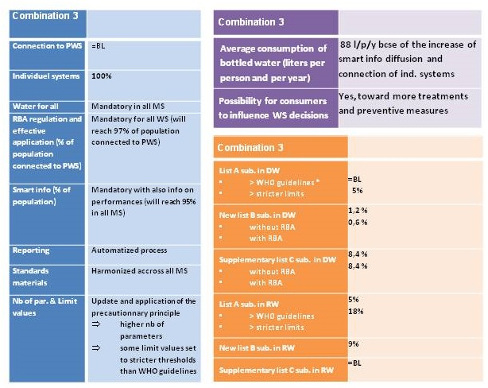

Figure 28: Assumptions for PP3



Figure 29: Cost assumptions for PP2



Figure 30: Cost assumptions for PP3

##### Table 16: General assumptions for the different options

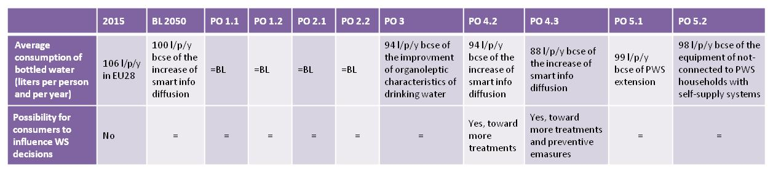

Table 17: Assumptions regarding the consumer for the different options

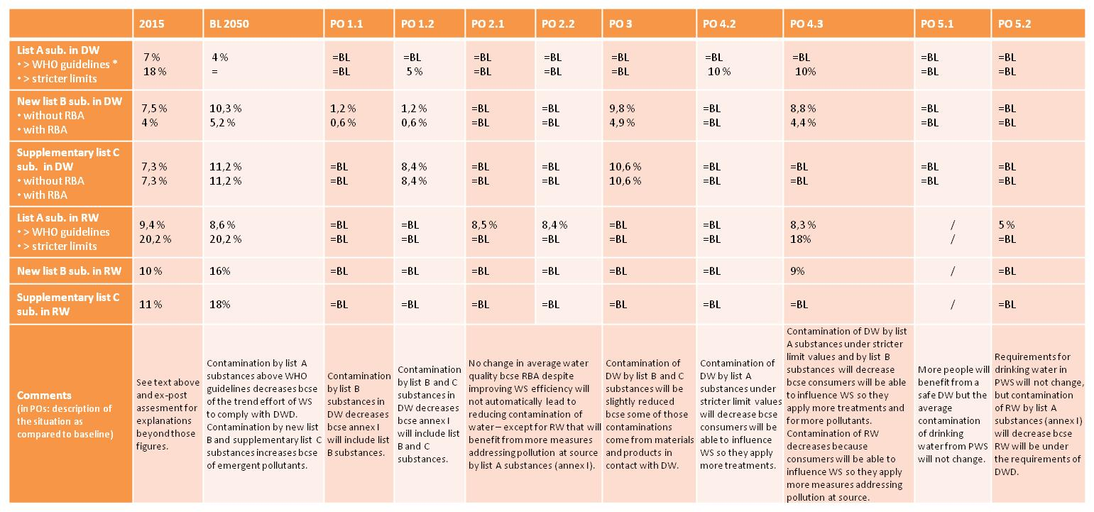

Table 18: Assumptions regarding the hazardous substances in drinking water for the different options

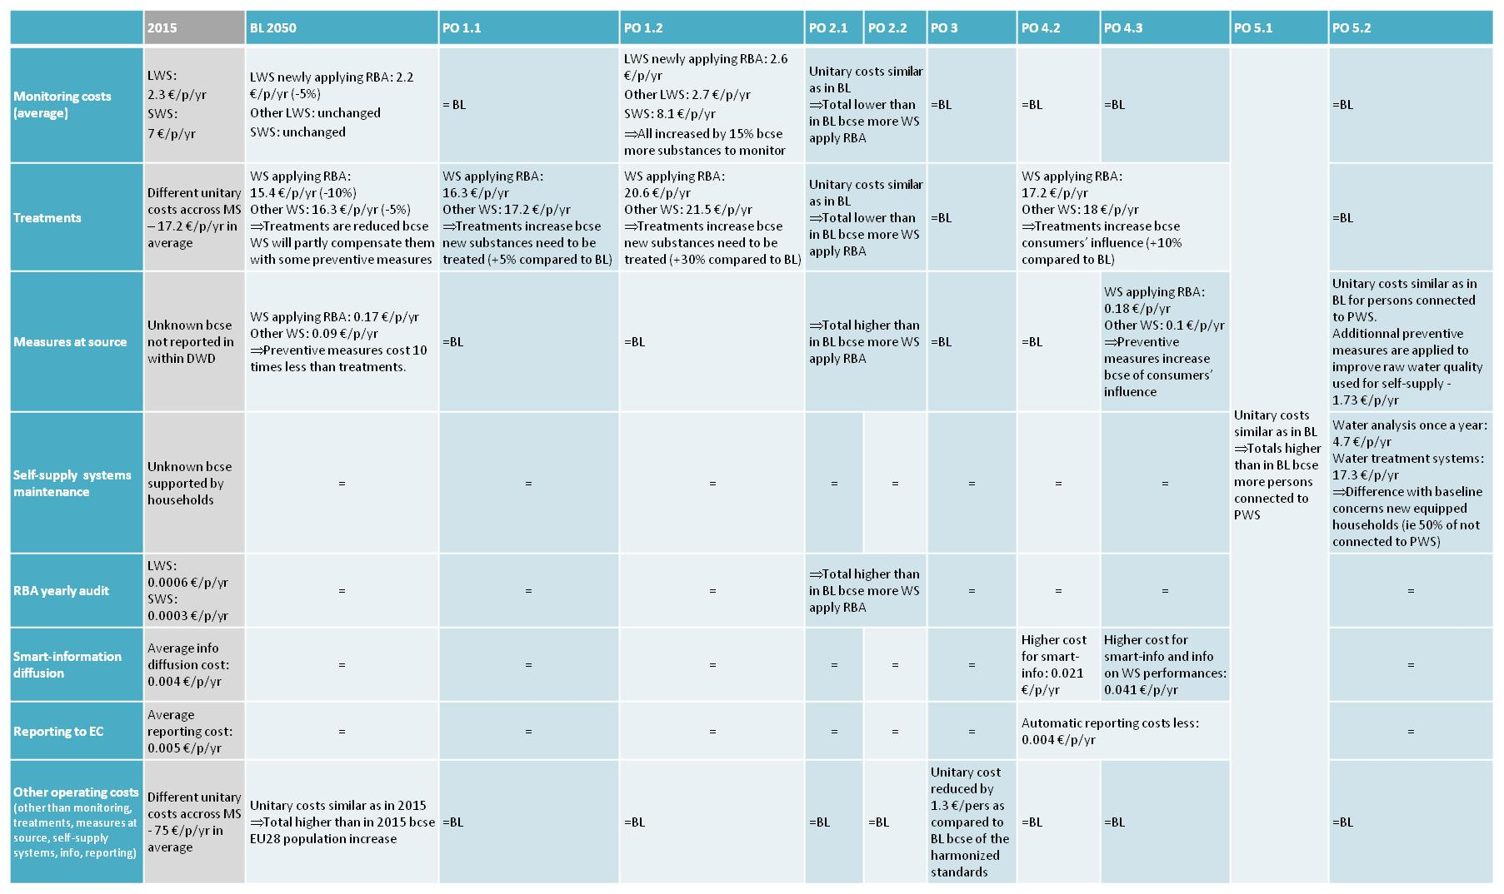

Table 19: Cost assumptions for the different options

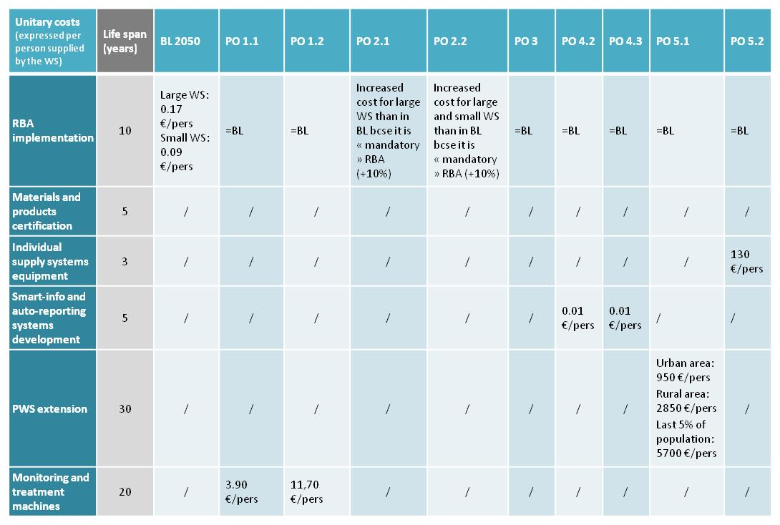

Table 20: Unitary cost assumptions for the different options

8. Ranking of options – underlying ranges

The below table provides the ranges and cut-off points used to establish Table 4 in Section 7.2 "Ranking of the options". As Table 4 "Ranking of the options" contains a variety of categories, it was deemed necessary to show the various cut-off points and ranges that were established for each quantified category.

|  |  |  |  |  |  |  |  |  |  |
| --- | --- | --- | --- | --- | --- | --- | --- | --- | --- |
| **Category** | Very large negative impact | Large negative impact | Medium negative impact | Small negative impact | No impact | Small positive impact | Medium positive impact | Large positive impact | Very large positive impact |
|  | **- - - -** | **- - -** | **- -** | **-** | **-/+** | **+** | **++** | **+++** | **++++** |
|  | **HEALTH IMPACT** | | | | | | | |  |
| Reduction of PPHR at short/mid-term[170] | **/** | **/** | **/** | **/** | 0% | -1% - -20% | -21% - -40% | -41% - -60% | < -61% |
| Reduction of PPHR at long term[171] | **/** | **/** | **/** | **/** | 0% | -1% - -4% | -5% - -9% | -10% - -14% | < -15% |
|  | **ECONOMIC IMPACT** | | | | | | | |  |
| Increase/ decrease in annualised costs (€million) | > +2401 | +1201 – +2400 | +601 – +1200 | +1 – +600 | 0 | -1 - -600 | -601 - -1200 | -1201 –  -2400 | < -2401 |
| Change in employment | < -60001 | -40001 –  -60000 | -20001 –  -40000 | -1001 –  -20000 | -1000>  0  <1000 | 1001 – 20000 | 20001 – 40000 | 40001 – 60000 | > 60001 |
| Change in health cost | / | / | / | / | 0 | -1 - -40 | -41 - -80 | -81 - -120 | < -121 |
|  | **SOCIAL IMPACT** | | | | | | | |  |
| Change in costs per household (€/ year) | > +15.00 | +10.1 - +15 | +5.1 - +10 | +0.1 - +5 | 0 | -0.1 – -5 | -5.1 – -10 | -10.1 - -15 | < -15.00 |

## 9.5. Annex 5 Monitoring

Indicators per specific objective:

|  |  |  |  |  |  |
| --- | --- | --- | --- | --- | --- |
| ***Parameters fit for purpose*** | | | | | |
| Indicator | Unit of measurement | Source of data | Frequency of measurement | Baseline | Full  Implementation |
| Parameters and Values transposed | Number per Member State | Transposition Check, communicated legislation | Once, updates every 6 years | 48 | All |
| Additional Parameters set up by Member States | Number per Member State | Transposition Check, communicated legislation | Once, updates every 6 years |  |  |
| Cases of exceedances of the parametric values set in Annex and remedial action taken | List with parameters and numbers per water supplier and Member State | Monitoring results collected and kept in a data set | Every 3 years | First results | Exceedances decrease |
| Occurrence of incidents including causes and remedial action taken | Number, cause, significance | Data set | Annually | First submissions | Occurrences decrease |
| Long-term health impacts due to the quality of the drinking water | Suitable health indicators | Epidemiologic studies in conjunction with specialised organisation like the WHO | Evaluation related, every 12 years or occasionally |  | Health impacts decrease |
| **Risk –based Approach** | | | | | |
| Number of supplies with supply risk assessments | Rate in % of water suppliers | Data set | Every 6 years | Currently EU  ~96 000 water supplies |  |
| Abstraction hazard assessments | Numbers | Data set | Every 6 years |  |  |
| Number of cases and related parameters where suppliers could reduce monitoring according to the RBA | Lists with parameters and numbers of 'allowances' | Data set | Every 6 years | Not available |  |
| **Materials in contact with Drinking Water and distribution** | | | | | |
| Number of EN standards with test and performance criteria established for products in contact with drinking water | Number | Commission or CEN information | Permanent/Annual |  |  |
| Domestic distribution risk assessments | Number of control and management measures performed | Data set | Every 3 years | Not available |  |
| Effective actions to avoid non-compliance and the risk from reoccurring for lead and legionella | Number of effective action taken | Data set | Every 3 years |  |  |
| **Information to Consumers** | | | | | |
| Water supplier websites with quality information | Number per Member State, %, up-to-dateness | Websites | Permanent/Annual | Currently EU  ~96 000 large water supplies | 100% |
| Price of drinking water per litre, daily or annual volume consumed, trends of consumption | Euro/litre; litre/day and person, m3/year and person or household | Water suppliers, authorities, or from consumers that receive regularly and in the most appropriate form, websites | Permanent/Annual | Currently EU average annual cost per household EUR 229; 120 l/day and person |  |
| Overall performance including leakage rates and amount of investment | Rate in % and amount in million Euro per very large supplier | Very large water suppliers, Websites | Permanent/Annual | Currently EU leakage average ~23 % |  |
| **Access to Drinking Water** | | | | | |
| Share of population that has access to drinking water | % per Member State | Data set | Regularly updated every 6 years |  | All |
| Share of population connected to public drinking water supplies | % per Member State | Eurostat | Regularly updated | 95.5 % |  |
| "Percentage of population using basic safe water" UN Indicator under development for SDG 6.1 Access to clean and affordable Drinking Water | % per Member State | UN, Eurostat | 2030 |  | All |

## 9.6. Annex 6 Glossary

EC European Commission

EU European Union

DWD Drinking Water Directive

PPHR The indicator Population Potentially at Health Risk refers to the part of the population that is supplied with, or has access to, a drinking water that could contain pollutants that might potentially cause health problems. In the context of the assessment of the baseline scenario and of the different options, the population supplied with drinking water that complies with the current Drinking Water Quality Standards can be part of the PPHR, in situation where pollutants of emerging concern and/or compounds not currently covered by Annex II of the DWD but that represent a health risk, are present in the drinking water. People supplied with such water are considered as potentially at health risk (for Details: see Annex 4).

MS Member State of the European Union

PO Policy Options

PWS The Public Water Supply is the water supplied by operators that are engaged in collecting, purifying and distributing water through public networks (source: see Eurostat[172]). It is complemented by “self and other water supply” in the Eurostat typology dealing with the different types of (drinking) water supply.

RBA Risk Based Approach/Assessment (following the definition of the WHO)

SDG Sustainable Development Goals

WFD Water Framework Directive

WHO World Health Organisation

WSP A Water Safety Plan (see also dedicated boxes in Chapter 6) is, according to the WHO definition, a plan that ensures the safety of drinking water through the application of a comprehensive risk assessment (aimed at identifying all/the main sources of pollution or pollution risk) and a risk management approach that encompasses all components of the water supply system from water resources in the catchment to the delivery to the final consumer. A WSP is a part of Water Safety Framework, which contains of step by step activities and measures prepared by the distribution network operator in order to permanently and effectively ensure the wholesomeness, compliance and cleanliness of drinking water. The WSP is based on the identification of risks and hazardous occurrences, risk assessment, taking preventive measures in order to prevent or manage these risks, checking the effectiveness of drinking water preparation and monitoring compliance with the regulatory requirements relevant to drinking water.

WSZ A Water Supply Zone is a geographically defined area within which water intended for human consumption comes from one or more sources and within which water quality may be considered as being approximately uniform (source: DWD).

*Large water supplies* (LWS) are those supplying more than 1, 000 m³ drinking water per day as an average or serving more than 5 ,000 persons (source: DWD)

*Small water supplies* (SWS) are those supplying less than 1, 000 m³ drinking water per day. Small water supply zones can be subdivided into two categories: category 1 supplying less than 100m³/day; and category 2 supplying between 100m³ to 1 000m³/day. Individual supply providing less than 10 m³ a day as an average or serving fewer than 50 persons, unless the water is supplied as part of a commercial or public activity, are considered as a separate category exempted from the provisions of the DWD.

Water Supplier A water supplier is a company (private or public) in charge of drinking water supply for general domestic water use in an agreed geographic area. This company can also be responsible for sewerage management and wastewater treatment. In most MS, the company operates under the delegation of a public authority (municipality in general). A Water operator is a synonym of Water Supplier. Water supply companies/ or water operators are part of what is defined as the water industry. They can supply water via PWS to different water supply zones (see above), or there can be several large and/or small water supply companies supplying water to one water supply zone.

WWAP World Water Assessment Program

1. Council Directive 98/83/EC of 3 November 1998 on the quality of water intended for human consumption,

   OJ L 330, 5.12.1998, p. 32.
2. The Commission published on 1 December 2016 a Staff Working Document on the REFIT Evaluation of

   the Drinking Water Directive 98/83/EC, SWD(2016) 428 final.
3. http://ec.europa.eu/citizens-initiative/public/initiatives/successful/details/2012/000003
4. A water supply is an area of uniform water defined for monitoring purposes, often corresponding to one

   supplier. Small water supplies are those supplying less than 1 000 cubic meters per day or serving less than 5 000 people. Very small supplies with less than 10 cubic meters per day or serving less than 50 people are exempted from the Directive.
5. COUNCIL DIRECTIVE 75/440/EEC concerning the quality required of surface water intended for the

   abstraction of drinking water in the Member States (repealed by the Water Framework Directive.).
6. Council Directive 80/778/EEC of 15 July 1980 relating to the quality of water intended for human con-

   sumption, OJ L 229, 30.8.1980, p. 11–29.
7. Directive 2000/60/EC of the European Parliament and of the Council of 23 October 2000 establishing a framework for Community action in the field of water policy (OJ L 327, 22.12.2000, p. 1).
8. Triannual reports prepared since 1993-1995, data electronically available since 2005 until 2013.
9. Report COM(2016) 666 final of 20 October 2016,

   <http://ec.europa.eu/environment/water/water-drink/reporting_en.html>
10. For details see chapter 4.2 of the Evaluation SWD, see Footnote 2.
11. For detailed information please refer to the evaluation SWD (see Footnote 3 above of this Impact Assessment).
12. Public consultation organised in response to the European Citizens' Initiative (ECI) 'Right2Water '<http://ec.europa.eu/citizens-initiative/public/initiatives/successful/details/2012/000003>
13. See details in Annex 2
14. The Directive does not regulate access to drinking water.
15. Communication COM(2016) 739 final, Next steps for a sustainable European future - European action for sustainability {SWD(2016) 390 final}
16. i.e. Benzene, Benzo(a)pyrene, 1,2-dichloroethane, Polycyclic aromatic hydrocarbons PAHs;
17. i.e. Legionella, chlorate, chlorite, endocrine disrupting chemicals, per- and polyfluoroalkyl substances like PFOA and PFOS.
18. See also for Agricultural Pressures: SWD(2017) 153 final on Agriculture and Sustainable Water Management in the EU; Pressures from emerging substances: Roadmap for the Commission's initiative on a strategic approach to pharmaceuticals in the environment: <http://ec.europa.eu/info/law/better-regulation/initiatives/ares-2017-2210630_en>;
19. See evaluation SWD, Footnote 3, page 30;
20. In 2015 the revised Annexes were introduced, containing the monitoring frequencies and analytical methods.
21. 74 % of respondents of the public consultation identified the need for a harmonized regulation of the

    materials in contact with drinking waters (the highest score);
22. Regulation (EU) No 305/2011 of the European Parliament and of the Council of 9 March 2011 laying down

    harmonised conditions for the marketing of construction products and repealing Council Directive 89/106/EEC (OJ L 88, 4.4.2011, p. 5);
23. Due to the link to the CPR, and the circumstance that product standardisation already started under the CPR, the implementation of this objective under the CPR is assumed. As the materials impact drinking water quality, this Impact Assessment was found to be the better place to analyse them rather than in the CPR REFIT. Moreover, an assessment of the current situation is needed due to stakeholder pressure and the intent to replace the non-functioning Article 10 with more concrete provisions;
24. Study report – Product and Materials in contact with Drinking Water:

    <https://circabc.europa.eu/w/browse/0b93e708-5e20-4c35-8fbd-8554a87e7cb5>.
25. See Figure 12 of the Consultation Report:

    <https://circabc.europa.eu/sd/a/0070b535-5a6c-4ee4-84ba-6f6eb1682556/Public%20Consultation%20Report.pdf>, the confidence in water quality is higher where the consumers live (73%).
26. This is a proxy which has some limitations as bottled water consumption is also related to other reasons than the absence of confidence in the drinking water, such as personal preferences.
27. Special report of the European Court of Auditors SR 12/2017: "*Implementing the Drinking Water Directive: water quality and access to it improved in Bulgaria, Hungary and Romania, but investment needs remains substantial*".
28. The WHO points out, that leakages often arise when water pressure is low, which is also a moment when hazardous substances or microbes can enter the pipes, making leakages a health issue: "A non-revenue water programme would address issues such as intermittent supply and low water pressure, both of which are contributing factors to contamination of drinking-water in the distribution system." (Source: <http://apps.who.int/iris/bitstream/10665/44584/1/9789241548151_eng.pdf> ; <http://apps.who.int/iris/bitstream/10665/181592/1/Effective-approaches-drinking-water-quality-surveillance-Oslo-report.pdf>). This is also supported by other (new) scientific findings. University of Sheffield (2015), Leaky pipes can allow contaminants into our drinking water: <https://www.sheffield.ac.uk/news/nr/leaky-water-pipes-contaminants-drinking-water-1.470248> LeChevallier et al. (2003) The potential for health risks from intrusion of contaminants into the distribution system from pressure transients: <http://jwh.iwaponline.com/content/1/1/3> Teunis et al. (2010). Enteric Virus Infection Risk from Intrusion of Sewage into a Drinking Water Distribution Network: <http://pubs.acs.org/doi/abs/10.1021/es101266k>;
29. "High quality of urban water services in OECD countries is threatened by a massive investment backlog impending the upgrading, renewal and maintenance of water-related infrastructure." (This includes urban waste water and floods), OECD (2016), Water Governance in Cities;
30. EU Commission Guidance Document on Leakage Management, (2015,), p. 5;
31. Eurostat, 2015, referred to in the Impact Assessment Study adding up to 6.5 billion m3;
32. Based on Eurostat, 2015, details per Member State see Annex 5 Table 7;
33. Additionally, from a resource efficiency point of view, high levels of leakage are unacceptable in times of

    climate change and water scarcity. The annually lost 6.5 billion m3 at EU level amount to the consumption demand of entire Member States such as France and Germany together (Annex 5, Table 10);

    An underlying driver of this problem, namely the need for 'substantial' investments in the field of water supply has been highlighted in the Special Report of the European Court of the Auditors SR 12/2017. Particularly when EU funds are mobilised water losses are considered an issue.
34. COM(2014)177 final.
35. Water is a human right: <http://water.tttp.eu/node/45/>.

    According to the World Water Assessment Programme (WWAP) referred to in the European Parliament's Resolution in reply to the ECI, in the EU28 more than 1 million people still lack access to a safe and clean drinking water supply. (European Parliament Report in the follow-up to the ECI 'Right2Water', Sept 2015, Resolution Nr 17 (2014/2239(INI)).
36. Consolidated Version of the Treaty on the European Union [2008] OJ C115/13, Art 5 (3) and (4);
37. As stated in the Commission's Communication on the topic: "…the decision on how best to operate water services is firmly in the hands of the public authorities in the Member States. The provision of water services is generally the responsibility of local authorities, which are the closest to the citizens and their concerns … The Commission is committed to ensuring that the human rights dimension of access to safe drinking water and sanitation, which must be of high quality available, physically accessible, and affordable, will continue to guide its future action". COM(2014)177 final.
38. Para. 10: "Calls on the Commission, in line with the primary objective of the Right2Water ECI, to come forward with legislative proposals, and, if appropriate, a revision of the WFD, that would recognise universal access and the human right to water; advocates, moreover, that universal access to safe drinking water and sanitation be recognised in the Charter of Fundamental Rights of the European Union" ([European Parliament resolution of 8 Sept. 2015 on the follow-up of the ECI 'Right2Water'](http://www.europarl.europa.eu/sides/getDoc.do?pubRef=-//EP//TEXT+TA+P8-TA-2015-0294+0+DOC+XML+V0//EN));
39. [The Sustainable Development Goals, European Commission (2017)](https://ec.europa.eu/europeaid/policies/sustainable-development-goals_en);
40. Directive 2014/23/EU of the European Parliament and of the Council of 26 February 2014 on the award of concession contracts;
41. Directive 2006/123/EC of the European Parliament and of the Council of 12 December 2006 on services in the internal market;
42. Public authorities are entirely free to perform the relevant tasks directly, by their own means, or to confer them on legally distinct, completely public, "in-house" entities. They may also decide to outsource water services, partially or entirely, to private or mixed management. When doing so, public authorities are fully entitled to establish clear obligations for private operators to ensure that services provided within their geographic area of competence meet prescribed standards. The EU, for its part, takes care that key Treaty principles − such as transparency and equal treatment − are observed. At the same time, Treaty rules require it to remain neutral in relation to national decisions governing the ownership regime for water undertakings (Commission Communication on Right2Water, March 2014);
43. For instance: Danube, Rhine, Elbe, Maas etc.
44. Commission Directive (EU) 2015/1787 of 6 October 2015 amending Annexes II and III to Council

    Directive 98/83/EC on the quality of water intended for human consumption;
45. Documentation on: <https://circabc.europa.eu/w/browse/3fccab4b-812d-46be-8efe-1f866cf556c5>;
46. The comparison of the 2015 to 2030 and 2050 was chosen as it is in general helpful to have future reference points for the assessment of options. Moreover, an earlier comparison, i.e. five years in the future, is not sensible as the drinking water sector is impacted by long-time changes and drivers. For instance, changes in demographics (e.g. urbanization) have an effect on the future of the drinking water sector. Furthermore, water supplies are planned to last rather centuries than decades. At the same time an even later point in time than 2050 would make the assumptions less robust;
47. These main uncertainties could have some impacts on the costs and benefits of the options but these uncertainties will not change the main lessons learnt from the analysis in terms of policy packages;
48. The PPHR was developed with a consortium of experts to be able to make a reasonable link between the different options suggested in this IA and their impact on health and to ensure that these options can be compared on their health impacts. The methodology used of creating the proxy of the indicator PPHR was discussed with stakeholders who made remarks about the lack of scientific soundness of the theoretical indicator but agreed that for the underlying modelling purpose, for which it was developed, it is indeed valuable;
49. The societal cost, in the short-run, is ranging between EUR 160 and EUR 239 million.
50. Staff Working Document REFIT Evaluation DWD, SWD(2016) 428 final, and evaluation study on:

    <https://circabc.europa.eu/w/browse/15386e9d-964e-4274-88ad-5be171c12bd2>;
51. For the purpose of later assessing the costs of the options and policy packages, the calculated household costs reflect the sum of total annual operating and annualised set-up costs divided by the PWS-connected population (a household constitutes at EU average 2.4 persons based on Eurostat data). It is assumed that all costs for drinking water are borne by those citizens that are connected to the PWS in the given Member State. Any assessment of costs is based on assumptions. They do not necessarily depict the real situation in the individual Member State;
52. The disposable income of private households is the balance of primary income (operating surplus/mixed

    income plus compensation of employees plus property income received minus property income paid) and the redistribution of income in cash;
53. A poverty line for water has been set at a threshold of 3 % for the lowest three income deciles. (OECD, 2009, Managing Water for All: an OECD perspective on pricing and financing).
54. See problem definition chapter 1.3.2.
55. The cooperation with the WHO is of importance as the parameters and threshold values of the existing Directive were based on its assessment. Nevertheless, with the EU following the Precautionary Principle and for some parameter stricter assessment values (e.g. 1 in 1 million sick cases instead of 1 in 100 000 cases) the suggested list by the WHO will be thoroughly assessed and adjusted to stricter EU standards. The WHO is aware of the EU's stricter approach regarding parameters and will take it into account;
56. See WHO Publication on the Water Safety Plan/Risk-Based Approach:

    <http://www.euro.who.int/en/health-topics/environment-and-health/water-and-sanitation/publications>;
57. RBA Benefits, https://gsd.spc.int/sopac/docs/MR0714_dwsp%20advocacy.pdf.
58. W. Bracket et al. (2016). Towards the review of the European Union Water Framework Directive: Recommendations for more efficient assessment and management of chemical contamination in European surface water resources. Science of the Total Environment 576, p. 720 – 737, see p. 12;
59. [Regulation (EU) No 305/2011 of the European Parliament and of the Council of 9 March 2011 laying down harmonised conditions for the marketing of construction products and repealing Council Directive 89/106/EEC](http://eur-lex.europa.eu/legal-content/EN/TXT/?uri=celex%3A32011R0305);
60. 4 MS Initiative: https://www.umweltbundesamt.de/en/node/13888.
61. Ofwat investigating leakage failure: [http://www.ofwat.gov.uk/ib-0811-ofwat-investigating-leakage-failures](http://www.ofwat.gov.uk/ib-0811-ofwat-investigating-leakage-failures/): "As companies ask their customers to conserve water and use it wisely, customers have a right to expect that their water company meets its commitments and obligations. These failures send a poor signal about how companies value water".
62. State of green, Danish Water Forum: <https://stateofgreen.com/files/download/9809>:

    "Awareness and understanding of the value of water is very weak in many countries and often the price for water does not cover the actual investment and operational costs. Political focus and priority from government institutions is required in order to make consumers aware of the value of a stable supply of clean and safe tap water".
63. European Commission (2017) Monitoring and reporting of environment legislation: <http://ec.europa.eu/environment/legal/reporting/fc_overview_en.htm>
64. Further details on the information are included in Annex 5, description option 4. Taking into consideration national and regional distinctions, the methodology on pricing, on performance criteria, and on public participation in decision making cannot be set at EU level, but should be up to the Member States to allow for appropriate solutions close to the consumers and comparisons at national or regional level. Also details whether information should be provided on the water bill, and/or together with information on sewerage, will be left to Member States;
65. There is a difference between "people without access to drinking water" (around 2 million people according to the ECI) and "people not connected to public water supplies (PWS)" (estimated around 23 million). However, people that are part of the second category may have access to drinking water via other means (private wells for instance).
66. Self-supply systems for the provision of drinking water does not refer to a specific technology but rather to "incremental improvements", improved wells, local disinfection plants, local distribution systems, filtering devices, etc. that allow small communities or households to have drinking water provisions close to their premises. This approach seems to be generally a good approach to achieve SDG 6.1 (Olschewski (2016).
67. It is estimated that 80 % of all Roma live in Bulgaria, Croatia, the Czech Republic, Greece, Hungary, Portugal, Romania, Slovakia and Spain (FRA report – Second European Union Minorities and Discrimination Survey, 2016).
68. In Particular IA Tools #16-31, see <http://ec.europa.eu/smart-regulation/guidelines/toc_tool_en.htm>.
69. For a more detailed assessment at Member State level, we refer to the IA study: <https://circabc.europa.eu/w/browse/52c9bdf7-9fbb-46da-aefe-1deea6311508>
70. These figures contain the annual operating and the annualised set-up costs.
71. All cost figures also contain employment.
72. Based on the current trend of a slow decrease in bottled water consumption - Unesda data, see also IA study pp. 37.
73. Study on the potential of the EU water industry sector (2010).
74. The economic impact includes here annual operating costs and annualised set-up costs and is therefore comparable to the indicated baseline figures.
75. Annual costs contain operating costs and annualised set-up costs.
76. OECD – Managing Water for all, <https://www.oecd.org/env/42350563.pdf>;
77. EPEC Market Potential Report: https://ec.europa.eu/environment/ecoap/sites/ecoap_stayconnected/files/etv-files/files/documents/EPEC_study/etv_final_report_market_annex1.pdf.
78. Aqua Europa, 2015;
79. This option was also strongly supported by various industries that pressed in general for a harmonisation of the market, i.e. "PlasticsEurope recommends that Article 10 of the DWD empowers the Commission to enact binding provisions on the safety of materials in contact with drinking water. These legally binding measures would have the effect to ensure that all European citizens benefit from the same level of human health protection. Also, they would progressively lead to the development of a EU-wide harmonized list of substances allowed in the production of materials and products in contact with drinking water." (PlasticsEurope via Feedback mechanism);
80. Eurostat, 2012.
81. Ecorys (2016), based on Eurostat (2010) Note that the employment impact has been calculated as impact on water providers, although they should be seen as employment effects in the sum of all sectors as an increase in total cost for water will increase the employment for all sectors active in the water supply industry.
82. More details are provided in the Impact Assessment Study
83. Bottled water purchases were calculated on the basis of 10 cents per litre of bottled water uniformly across Member States. Assumingly this figure might be significantly higher in some countries.
84. These estimates are very conservative as the price for one bottle of water was set at 10 cents uniformly across all EU Member States.
85. See for example CIS Guidance Document Best Practices: <https://circabc.europa.eu/sd/a/1ddfba34-e1ce-4888-b031-6c559cb28e47/Good%20Practices%20on%20Leakage%20Management%20-%20Main%20Report_Final.pdf>
86. Unavoidable losses of treated water are those underground losses that are rather little in quantity but that would cost so much to be located and to be repaired that it would be less costly to keep the leakage instead of fixing it (American Water Works Association).
87. The water sector uses 29 kWh per year for the drinking water supply of one person. Source: dvgw Wirt

    schafts- und Verlagsgesellschaft Gas und Wasser mbH, Profile of the German Water Sector 2015http://www.dvgw.de/fileadmin/dvgw/wasser/organisation/branchenbild_engl_2015_langfassung.pdf. The energy intensity is however quite diverse across Europe, calculation with 0,395 kg CO2/kWh
88. Rachel Young (2014) Watts in a Drop of Water: Savings at the Water-Energy Nexus, An ACEEE

    White Paper and European Benchmarking Cooperation (2013) Public report of the International water benchmark: Learning from International Best Practices.
89. Rachel Young’s report, see above
90. These assumptions were contested by stakeholders from the bottled water industry who argued that their industry is essential for regional/ local employments, that their water needs less treatment and that the industry's efforts to protect the environment are often overlooked.
91. The bottled water industry argues that there is no direct link between more information and a decrease in the consumption of bottled water.
92. <http://ec.europa.eu/environment/legal/reporting/fc_overview_en.htm>
93. Estimates in are based on recent assumptions from Member States authorities: one-off administration time 5 hours for small, 20 hours for large supplies. Administrative costs do not include licensing/approval costs that are imposed on operators. One-off EU costs estimated at EUR 6.25 Million. No reduction in operational costs for authorities through option 2.2 assumed.
94. For a graphical overview see Figure 11 and Figure 13.
95. For readability purposes option 4.1 is not displayed in detail in this overview, nevertheless as pointed out previously it would have a significant impact especially on administrative burden. For more quantitative details on administrative burden reduction, see Section 6.5 and Annex 5.
96. % change in total PPHR to baseline 2050 and % change in marginal risk population to baseline 2050
97. Increase and decrease contain changes of annual operating costs and annualised set-up costs in comparison to baseline 2050.
98. As the protection of human health is the main objective of the Directive, impacts on health are counted with a factor 2 in the accumulation of points to determine the ranking result.
99. "Annual costs" include annual operating costs and annualised set-up costs.
100. <https://circabc.europa.eu/w/browse/96b5e7a3-81c3-46ed-b9fb-0204514028e4>
101. https://circabc.europa.eu/w/browse/0b93e708-5e20-4c35-8fbd-8554a87e7cb5
102. Folder: https://circabc.europa.eu/w/browse/b6bb0d99-8c88-4b9d-9a14-68a0f2695e6d
103. Notably toolboxes 10 and 50 on the 12-week internet-based public consultation and on the complement approaches and tools in order to engage all relevant stakeholders and to target potential information gaps, which was done by subsequent targeted stakeholder consultations.
104. <http://ec.europa.eu/smart-regulation/guidelines/ug_chap7_en.htm>
105. <http://www.right2water.eu/node/37/view>
106. [Consultation Report](https://circabc.europa.eu/sd/a/0070b535-5a6c-4ee4-84ba-6f6eb1682556/Public%20Consultation%20Report.pdf)

     https://circabc.europa.eu/sd/a/0070b535-5a6c-4ee4-84ba-6f6eb1682556/Public%20Consultation%20Report.pdf
107. Summary Report: <https://circabc.europa.eu/w/browse/4fa04ec0-2b16-409a-b5b1-edbb6ffd6287>
108. [www.safe2drink.eu](http://www.safe2drink.eu) including a specific functional mailbox [safe2drink@ecorys.com](mailto:safe2drink@ecorys.com)
109. <https://circabc.europa.eu/w/browse/3fccab4b-812d-46be-8efe-1f866cf556c5>
110. <https://circabc.europa.eu/sd/a/ec261386-9b0c-4fd0-9037-3db85070517b/DWD_stakeholder%20workshop_background%20document_final.pdf>
111. <http://www.safe2drink.eu/dwd_stakeholder-workshop_evaluation-form/>
112. <http://www.safe2drink.eu/wp-content/uploads/2016/02/Meeting-report-8-12-2015.pdf>
113. <https://circabc.europa.eu/sd/a/52c8b4f5-7df5-43fb-a573-f00967a2e4f4/Item%208%20Review%20Draft%20Policy%20options%20for%20revision.pdf> (see slides 15/16)
114. https://circabc.europa.eu/w/browse/b6bb0d99-8c88-4b9d-9a14-68a0f2695e6d
115. As also pointed out in the analysis of the open public consultation survey, many respondents did not specify their institution or sector, and therefore a structure according to topics rather than stakeholder groups was preferred.
116. Article 10 “Quality assurance of treatment, equipment and materials Member States shall take all measures necessary to ensure that no substances or materials for new installations used in the preparation or distribution of water intended for human consumption or impurities associated with such substances or materials for new installations remain in water intended for human consumption in concentrations higher than is necessary for the purpose of their use and do not, either directly or indirectly, reduce the protection of human health provided for in this Directive; . . . . .”
117. The range of satisfaction with the level of information about the drinking water quality by countries varies significantly from 18 % Luxembourg to as high as 85 % for Austria (see Public Consultation report by Ecorys, p. 29)
118. Right2Water European Citizens' Initiative with more than 1.6 million signatures.
119. <https://ec.europa.eu/info/law/better-regulation/initiatives/ares-2017-1061434/feedback_en>
120. HAACP
121. These tables provide just a short and distilled indicative overview of the stakeholders' various opinions. Many of the stakeholders have very detailed ideas of what is acceptable and what is not.
122. Costs of preferred option(s) as compared to the baseline. The baseline 2050 assumes yearly operating costs of EUR 47.9 bn and annualised set-up costs of EUR 1.9 million. All figures provided in the table are additional costs or savings compared to the Baseline 2050.
123. Businesses in this case are Water Operators. They can be public or private or a mixture of both. It is assumed that all costs that are incurred by water operators will be borne by the consumers through transfers to the water tariffs or taxes. Therefore, column 1 and 2 of this table look at the same costs but from two sides: consumers (cost displayed as costs per household) and water operators (costs for all EU operators).
124. The tasks done by the administrations (mostly health authorities) relate mainly to surveillance and monitoring controls. The costs are marginal in comparison to the work of water operators. Annual recurrent costs are estimated at EUR 42.6 million per year (40h per large supply, 8h per small supply). No substantial changes to these costs are expected to occur through any of the proposed options except for options 2.2 and 4.1.
125. For details on cost components please see the attached glossary.
126. Additional administrative costs for the RBA introduction were not quantified in the draft IA. Estimate in this table based on recent assumptions from Member States authorities: one-off administration time 5 hours for small, 20 hours for large supplies. Administrative costs do not include licensing/approval costs that are imposed on operators. One off EU costs estimated to 6.25 Million. No reduction in operational costs for authorities through option 2.2 assumed.
127. Businesses in this field are in contrast to the other fields manufacturers of products/materials in contact with drinking water such as water pipes, taps, seals, etc. A specific study related to Option 3 on the testing and approval of products in contact with drinking water looked into internal and external costs. It estimates that industry has around 60 Million per year external costs for approvals procedures which could be saved through harmonization. The overall and internal costs are however much higher, as these includes savings related to product design and pre-testing etc. In the IA the overall annual savings was estimated at EUR 669 Million per year
128. Synergies are expected from combinations of the individual options
129. See Annex C Evaluation Study: <https://circabc.europa.eu/sd/a/14e7ac5a-df84-42b8-9b6c-32ca8bfafe55/DWD-evaluation-report-2-Annexes.pdf>
130. The WHO pan-European Region comprises 53 countries including less developed countries from

     Albania to Uzbekistan; therefore the figures in the infographic are disproportionate and cannot be transferred to the EU.
131. In: <https://circabc.europa.eu/w/browse/52c9bdf7-9fbb-46da-aefe-1deea6311508>
132. Even though there is strong monitoring and control some EU citizens will still get sick when consuming drinking water. Being sick has both direct and indirect cost for society.
133. From discussion with experts we found that the UK scores very well when it comes to reporting this type of information to the ECDC. The 32% of reported cases might as such be an overestimation – or an underestimation for other MS;
134. Note that we do not take underreporting in MS into account the numbers from the ECDC should be seen as minimum number of actual cases of illness;
135. See the analysis below, where for all six drinking water related sickness the approach findings are shown.
136. The burden of drinking water associated cryptosporidiosis in China; the large contribution of the immuno -deficient population identified by quantitative microbial risk assessment QMRA. Water Research volume 46 issue 13 September 2013 Shumin Xiao et. al.
137. According to the WHO, RIVM and the LCI guidelines for shigatoxic producing E.coli;
138. Robertson LJ, Forberg T, Gjerde BK. Giardia cysts in sewage influent in Bergen, Norway 15-23 months after an extensive waterborne outbreak of giardiasis. *J Appl Microbiol*. 2008 Apr. 104(4):1147-52. [[Medline]](http://reference.medscape.com/medline/abstract/17976168). Ryu H, Alum A, Mena KD, Abbaszadegan M. Assessment of the risk of infection by Cryptosporidium and Giardia in non-potable reclaimed water. *Water Sci Technol*. 2007. 55(1-2):283-90. [[Medline]](http://reference.medscape.com/medline/abstract/17305151);
139. www.dewatergroep.be and RIVM.
140. <http://www.zorgwijzer.nl/zorgverzekering-2014/wat-kost-een-verblijf-en-behandeling-in-het-ziekenhuis>;
141. Simplification entailed that for the calculation the cost of different MS healthcare systems were assumed on the basis of income per capita differences;
142. <http://ec.europa.eu/eurostat/statistics-explained/index.php/File:Population_age_structure_by_major_age_groups,_2005_and_2015_(%25_of_the_total_population)_YB16.png>.
143. <http://www.mkbservicedesk.nl/10218/zieke-werknemer-kost-200-tot-400-euro.htm>;
144. We excluded cost of salary to the person who is sick, because this is rather a transfer. Values are EU weighted averages;
145. The societal cost, in the short-run, is ranging between €160 and €239 million.
146. We note that we are aware that not all MS report equally to the ECDC database and we assume that option 1 (all MS near the 2,8% average) is an unlikely outcome of the analysis. This section is therefore more of a check and results are not impacting the overall analysis.
147. Folder WHO Project: <https://circabc.europa.eu/w/browse/b6bb0d99-8c88-4b9d-9a14-68a0f2695e6d>
148. See WHO Publication on the Water Safety Plan/Risk-Based Approach:

     <http://www.euro.who.int/en/health-topics/environment-and-health/water-and-sanitation/publications>
149. Identified by CDC, A conceptual framework to evaluate the Impacts of water safety plans. Centers for disease control and prevention, Atlanta. 2011. http://www.cdc.gov/nceh/ehs/gwash/Publications/WSP_Evaluation_Framework.pdf;
150. Very small supplies with less than 10 cubic meters per day or serving less than 50 people are exempted from the Directive, Article 3.2 (b).
151. EU: Around 11 000 large supplies and 85 000 small supplies serving respectively around 80 % and 20 % of the population. For further details, see Evaluation SWD.
152. See Section 2.1.3
153. ICT4water cluster - <http://www.ict4water.eu/>
154. See Figure 12 of the Consultation Report: <https://circabc.europa.eu/sd/a/0070b535-5a6c-4ee4-84ba-6f6eb1682556/Public%20Consultation%20Report.pdf>
155. ICT4water cluster - <http://www.ict4water.eu/> provides a solid background of innovative solutions in addressing information about drinking water. This cluster has been created as a follow up of a number of European projects, such as FREEWAT, INCOVER, KINDRA, DAIAD, POWER (H2020), Proteus, Smart-Plant(H2020), etc.
156. European Commission (2017) Monitoring and reporting of environment legislation: <http://ec.europa.eu/environment/legal/reporting/fc_overview_en.htm>
157. http://ec.europa.eu/environment/legal/reporting/fc_overview_en.htm
158. This assumption was based on an estimate by the authors of this report, which relies on a collective expertise.
159. Further details on the information are included in Annex 4, description option 4. Taking into consideration national and regional distinctions, the methodology on pricing, on performance criteria, and on public participation in decision making cannot be set at EU level, but should be up to the Member States to allow for appropriate solutions close to the consumers and comparisons at national or regional level. Also details whether information should be provided on the water bill, and/or together with information on sewerage, will be left to Member States.
160. COM(2016) 864 final
161. A study by the European Union Agency for Fundamental Rights found that "every third Roma lives in

     housing without tap water" (FRA, 2016, p. 9). The need to provide Roma and other nomadic communities with access to water has been stressed by the European Commission's Communication on the EU Framework for National Roma Integration Strategies urging the Member States to change the status quo (COM(2011)173 final). The European Council has also issued a recommendation demanding "Access to housing: (d) ensuring access to public utilities (such as water, electricity and gas) and infrastructure for housing in compliance with national legal requirements" for Roma (Council Recommendation on effective Roma integration measures in the member states, 2013, p. 7).
162. See also Problem Definition, Section 2.2
163. These assumptions were used for modelling the impacts of fully equipping half of all non-connected people.
164. Synthesis Report COM(2016) 666 final, <http://ec.europa.eu/environment/water/water-drink/pdf/reports/EN.pdf>
165. The expected decrease in population at risk for 2030 and 2050, and the associated lower health cost, are mainly due to the autonomous increase of implementing RBA and thus an increase in water quality.
166. See also efficiency analysis in the Evaluation SWD.
167. Measures at source are considered to be ‘0’ in 2015 because no data was available. This has

     insignificant effect on our analysis, as the costs in the impacts assessment will focus on the difference with baseline 2050 and not 2015.
168. "Annual costs" include annual operating costs and annualised set-up costs.
169. See page 64 'Materials Study': <https://circabc.europa.eu/w/browse/0b93e708-5e20-4c35-8fbd-8554a87e7cb5>
170. % change in total PPHR to Baseline
171. % change in marginal risk population to Baseline
172. http://ec.europa.eu/eurostat/statistics-explained/index.php/Water_statistics