

Contents

Annex 1. Procedural Information Concerning the Process to Prepare the Evaluation 3

Annex 2. Stakeholder Consultation Results 6

Annex 3. Analytical models used in preparing the evaluation 44

Annex 4. List of sectorial objectives and their related key performance indicators (KPIs) 47

Annex 5. CEF intervention Logic 50

Annex 6. The CEF DI Portfolio including the legacy instruments for 3 Sectors 51

Annex 7. EU funding of infrastructures in the 2007-2013 Multiannual Financial Framework 52

Annex 8: The role of INEA 57

Annex 9: Predecessor programme for transport 60

Annex 10: Predecessor programmes for energy: Relevance of legacy projects for CEF 66

Annex 11: Predecessor programme for telecommunication 70

Annex 12: List of synergy actions 71

Annex 13: CEF Calls 2014-2016 actual EU support per sector and country 72

# Annex 1. Procedural Information Concerning the Process to Prepare the Evaluation

**Lead DGs**: Directorate-General for Mobility and Transport (DG MOVE), Directorate-General for Energy (DG ENER) and Directorate-General for Communications networks, Content and Technology (DG CNECT).

**Agenda Planning number:** 2017/MOVE+/003 Mid-term evaluation of the Connecting Europe Facility (CEF).

The requirement for the interim evaluation of the Connecting Europe Facility (CEF) derives from Article 27(1) of Regulation 1316/2013/EC establishing the Connecting Europe Facility (CEF). This stipulates that "no later than 31 December 2017, the Commission, in cooperation with the Member States and beneficiaries concerned, shall prepare an evaluation report to be presented by the Commission to the European Parliament and the Council".

The results of the evaluation will be used for the implementation of the remaining part of the programme, and to decide on the renewal, modification or suspension of the measures. In line with Art.5 (3) of the CEF Regulation, following the evaluation referred to in Article 27(1), the European Parliament and the Council may, upon a proposal by the Commission, transfer appropriations between the transport, telecommunications and energy sectors of the allocation set out in Art. 5(1) of the CEF Regulation. In this context, the evaluation will provide input and guidance to the mid-term review of the overall MFF 2014-2020 and assist in preparing the next MFF.

An evaluation roadmap, summarising the design, purpose and scope of the Connecting Europe Facility (CEF) interim evaluation, was published in May 2016[1].

The Commission responsible DGs set out an evaluation methodology, timeline and scope, in line with EU Better Regulation Guidelines and have assigned a contract (under a Framework contract of DG BUDG) with an external consultant (PricewaterhouseCoopers) to prepare a study providing input for the evaluation. The study was planned for a period of 13 months until September 2017. The study has been guided by the Terms of Reference published by the Commission on 23 May 2016.

DG MOVE as lead-service in liaison with the other CEF DGs (ENER and CNECT) set up an Inter-Service Group (ISG) gathering representatives of different Directorates-General (DG) of the Commission was set up in early 2016 and held five meetings prior to submission of the Staff Working Document to the Regulatory Scrutiny Board in May 2017.

The evaluation is composed by an overarching part addressing the progress towards the overall objectives of the CEF Programme ("horizontal part"), and three sectorial parts addressing the progress towards the objectives specific to the sectors of transport, energy, and telecommunications ("sectorial parts"). Overall, the evaluation takes stock of the progress of the implementation of the CEF programme (in terms of budgetary years 2014, 2015, 2016 and the 1st semester of 2017) and addresses the forms of financial assistance under the CEF (grants, financial instruments and procurements) and accompanying measures such as programme support actions. Furthermore, an assessment on the relative merits and achievements of financial assistance and accompanying measures has been done, identifying in which areas/circumstances they could be improved.

A series of internal seminars with the external contractor were also organised between December 2016 and May 2017 during which the emerging interim evaluation results were presented and discussed horizontally as well as at each of the sectorial levels.

**Regulatory Scrutiny Board**

The initial draft of the evaluation was submitted to the Regulatory Scrutiny Board on 12 June 2017. Scrutiny took place at the Board meeting of 5 July 2017. Subsequently, a negative opinion was issued by the board on 7 July 2017. A revised draft, taking the Board's comments into account was submitted to the RSB on 13 October 2017. A positive opinion from the Board on the revised draft was received on 31 October 2017.

In line with the letter from the Board Chair accompanying the positive opinion, the following paragraphs detail the changes that were made to the document in response to both Board opinions.

* Timing

The timing of this evaluation in relation with the ex-post evaluation of TEN-T has been further explained under Chapter 4 "Methodology".

* Legacy Projects

The text has been modified to indicate that the requirement of Article 27 to take evaluation results concerning the long term impact of predecessor measures into account could not be met because this data is not yet available. However, additional data on the implementation on the 2007-2013 programmes and on the importance of the legacy projects has been added in a new section of Chapter 2 "Background to the initiative" entitled "Predecessor Programmes under the MFF 2007-2013" as well in the annexes. The text now also indicates that the mid-term evaluation of predecessor measures was taken into account in the IA carried out in 2011.

* Synergies

Section 6.3.2.2. "Exploiting sectorial synergies" has been redrafted accordingly to better explain the critical factors that have made it difficult to co-finance actions covering several sectors and thus to achieve synergies at project level. Examples of potential project level synergies are provided as well as obstacles that have weakened potential demand for such synergies.

The section on "The relevance of a common programme" in Section 6.1.1 "Relevance for EU priorities and sectorial needs" was also modified accordingly, outlining the basis for the common programme.

* Role of the CEF in relation to other EU funding programmes

Section 6.2 on "Coherence" has been significantly modified strengthening the assessment with ESIF and Horizon 2020 as well as providing a redrafting of the coherence of CEF with EFSI.

* Merits of direct management versus shared management

A box on the advantages of direct management for CEF was added in Section 6.4.2. "Implementing and Managing CEF efficiently".

* Role of INEA

An annex presenting the role of INEA has also been added.

It is important to note that there is as a separate legal obligation for an evaluation of INEA (responsible for the implementation of CEF, H2020 and transport legacy programme), which has to be carried out after 3 years of INEA's establishment. The evaluation of INEA will be carried out this year.

* Overall conclusions of the report / intermediate findings

Chapter 7 "Conclusions" has been entirely redrafted and better aligns with the intermediate findings.

* Financial instruments

The sections relevant to financial instruments have been reworked. Firstly, the Financial instruments section of Chapter 5 "Implementation state of play" has been modified to provide a clearer summary of the current situation. Secondly, Section 6.2 on "Coherence" now contains a redrafting of the coherence of CEF with EFSI. Thirdly, a box outlining how to increase the effectiveness of financial instruments has been added to Section 6.3.2.1 "Ensuring and accelerating investment."

* Views of stakeholders / beneficiaries of the CEF

Regarding the question on the evidence base, all streams of evidence mentioned in the study are taken into account in the SWD. The possible bias of many stakeholders being beneficiaries of the CEF has been evidenced.

* Summary information

Figures presenting an overview per sector and type of project have been added in Chapter 5 "Implementation state of play". Additional information on funding per Member State per sector has been added in a new Annex 13.

# Annex 2. Stakeholder Consultation Results

|  |
| --- |
| **Stakeholder box: The stakeholder consultation on the CEF Mid-Term Evaluation**   * 332 complete responses collected out of which 24% are not beneficiaries * 14 position papers * Disaggregated analysis of questionnaire responses (according to stakeholder type and number of replies) * Qualitative analysis of the position papers * Key stakeholder views (used in evaluation findings) |

The stakeholder consultation relies on three pillars:

* An online **Open Public Consultation** targeting both the general public ("general survey") and CEF stakeholders ("technical survey"); in addition 14 position papers were received to a dedicated functional mailbox.
* A **stakeholder survey** including (i) interviews specific to the case studies, (ii) sectorial interviews aiming at looking at relevance, complementarity of CEF operations as well as testing some hypotheses drawn for the cases studies, and (iii) complementary thematic focus groups, that will focus on specific evaluation topics/questions that are horizontal or derived from the sectorial evaluations. In order to select the interviewees, PwC has undertaken a mapping of the relevant stakeholders by sector;
* A round of **interviews with key high-level/institutional stakeholders**, mainly covering horizontal topics such as relevance and coherence of the programme, the efficiency of the programme’s management and implementation as well as the EU added-value.

**1. Overview of respondents**

The objective of the consultation activities was two-fold: 1) to assess the **opinion** and the **perception** of the general public on the CEF Programme, ensuring transparency and accountability, and 2) to collect more precise opinions from involved stakeholders. Indeed, this consultation of the key stakeholders allowed interested parties to provide feedback and to contribute suggestions. In this respect, the results of the open public consultation cannot be statistically representative but cover the various aspects of the programme and therefore the different topics evaluated.

This open public consultation has been conducted through an online questionnaire consisting primarily of multiple-choice, with some open-ended questions. As mentioned above, two questionnaires were available on the consultation webpage:

* A **general survey** for the respondents with no direct role in the Programme: academics, think tanks, NGO, the General Public, Industry business, public authorities, private sector bodies and professionals, etc. This survey contains core questions and focuses on general topics and the non-internal aspects of the CEF Programme.
* A **technical survey** for the others respondents who are involved in the programme at CEF design, management or implementation of the programme or are among its beneficiaries. This survey is more specific, and also covers internal aspects of the Programme.

These two surveys covered all the evaluation criteria (relevance, coherence, effectiveness, efficiency, and EU added value) and were adapted to the level of information of the respondents and their interest in the programme.

The stakeholders consultation was officially launched on the 28/11/2016. The two surveys were available online during a period of thirteen weeks (instead of the usual twelve weeks, to take into account the Christmas break), ending on the 27/02/2017.

In total, 148 individual stakeholders responded to the general survey, and 184 to the technical/stakeholder’s survey. In addition, **132 interviews with key high-level/institutional stakeholders** were conducted.

**Figure 1** **Number of respondents per survey by origin**

*Source: PwC, based on OPC data as transmitted by the European Commission.*

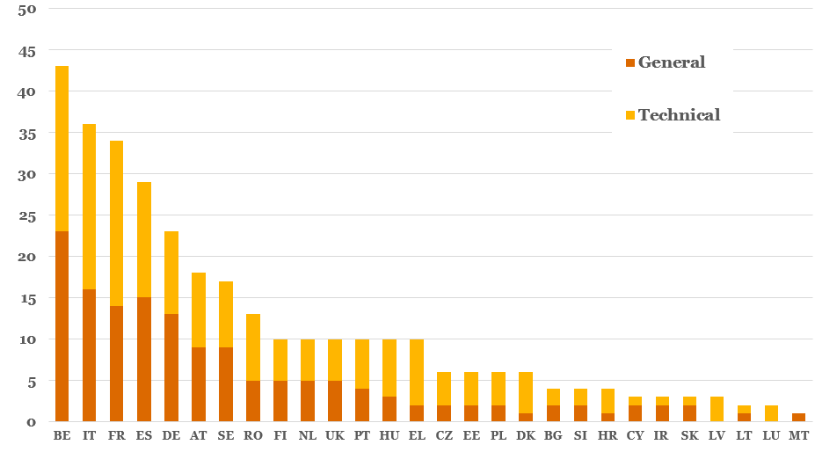

The relative share of respondents from the three CEF sectors reflects the correlative allocations of budget, transport being the largest and telecom the smallest. This observation is confirmed by the data in Figure 1, which shows the number of respondents by geographic origin. The majority of respondents come from Belgium, Italy, France, Spain and Germany. Figure 2 shows the number of respondents classified by sector and type of survey.

**Figure 2 Number of respondents by sector**

*Source: PwC, based on the OPC data as transmitted by the European Commission.*

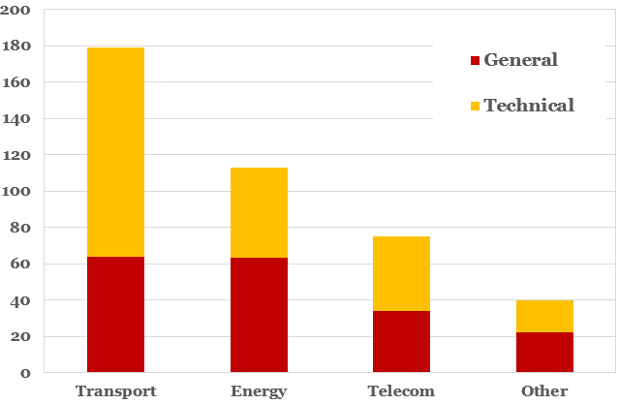

Finally, if they were not responding in their private capacity, the survey also asked respondents to identify themselves according to the type of institution with which they are associated. The results of this question are presented in Figure 3.

Figure 3 Number of respondents by type of institution

*Source: PwC, based on the OPC data as transmitted by the European Commission.*

Figure 4 Geographical distribution of the surveys' responses

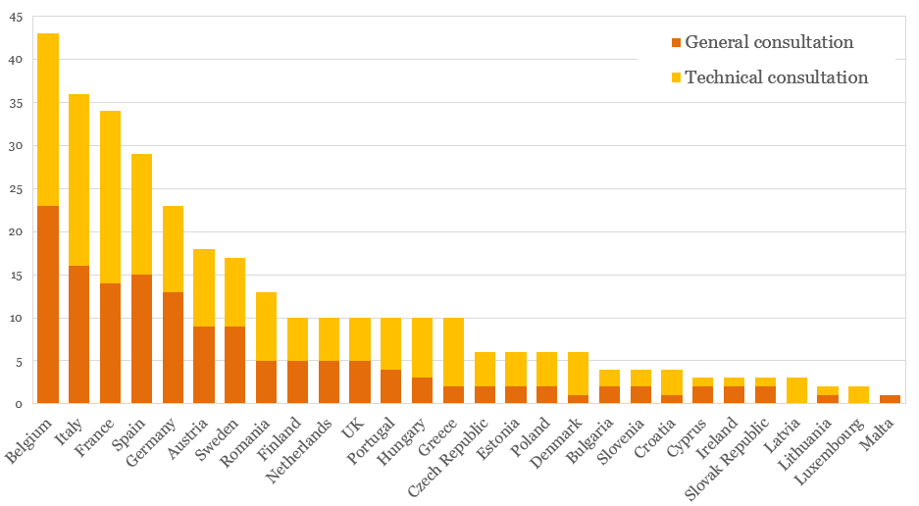

*Source: PwC, based on the OPC data as transmitted by the European Commission. The word" consultation" in the graph refers to the word "survey"*

Interviews with key stakeholders were conducted at the strategic and institutional level for the CEF Programme and in the EU. These interviews allow covering high level and horizontal topics regarding the relevance of the programme, the coherence, the efficiency of the programme’s management and implementation or the EU added value.

The selected interviewees belonged to the following categories of stakeholders (not exhaustive list):

* Institutional CEF stakeholders and the management and implementation bodies: INEA, EIB;
* DGs MOVE, ENER, CNECT ECFIN, CLIMA, ENV, RTD and REGIO;
* The European Parliament - Committees responsible for the 3 sectors;
* Economic and Social Committee and the Committee of the Regions;
* Core investors in the transaction signed under CEF FIs, as well as institutional investors other than the afore-mentioned investors;
* EFSI representatives at the European Commission (EC) and the EIB;
* European Groupings of Territorial Cooperation.

The questionnaires and interview’s orientations were tailored to each stakeholder before the corresponding meeting. The interviews were aligned with the professional expertise or knowledge of the interviewee, in order to retrieve the most accurate and relevant information. Many subsequent exchanges between the evaluators and stakeholders have been pursued after the meeting themselves. These exchanges supplied the evaluator with data and quantification backing the stakeholders’ statements, specifying as to their position or just by providing additional legal or descriptive documents.

**Figure 5** **Number of interviews by sector**

Figure 5 shows the breakdown of these interviews by sector. The breakdown is relatively well balanced among the sectors, showing a modest preference in line with the relative allocation of budget among the sectors, with transport receiving the greatest number of interviews and telecom the fewest.

An effort was also made to include a certain amount of geographic balance among stakeholders.

Figure 6 shows the geographical location of the interviewed stakeholders across Europe. Of course, because the CEF Programme is a central managed EC instrument, there was a large number of stakeholders involved with design and implementation of the Programme from the EU institutions, and particularly from the European Commission.

**Figure 6** **Number of interviews by origin and by sector**

This point is made quite clearly in Figure 7, which shows the number of stakeholder interviews by category and origin. Please note the dominance of strategic stakeholders from the EC group.

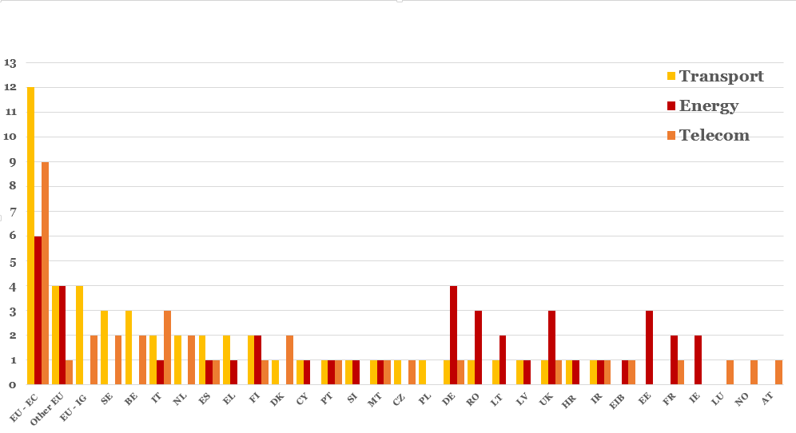

**Figure 7** **Number of interviews by category and by origin**

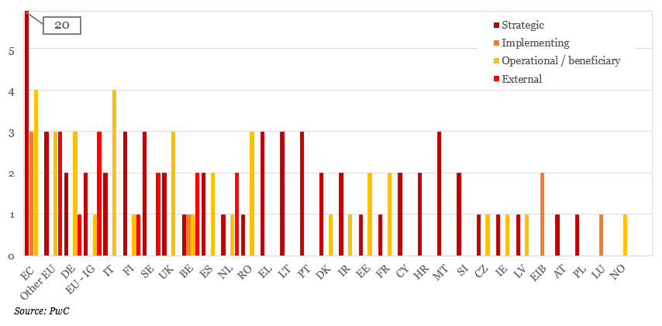

Interviews were also conducted with key stakeholders at the horizontal level, covering all three sectors of the CEF programme. Table 1 summarises the interviews conducted at the horizontal level, by institution.

Table 1 Horizontal consultations by institution

|  |  |
| --- | --- |
| Consulted institution | Interviews performed |
| CEF Strategy and implementing DGs | 2 |
| Other concerned DGs: DG CLIMA, DG ENV, DG REGIO, DG BUDG, DG ECFIN | 5 |
| European Economic and Social Committee | 1 |
| **Consulted institution** | **Interviews performed** |
| INEA | 2 |
| Committee of the Regions | 1 |
| EIB | 1 |
| European Parliament | 1 |
| External policy experts | 2 |
| European Fund for Strategic Investments | 1 |
| **Total of high level consultations** | **16** |

Figure 8 Transport Interview Categories

Figure 9 Energy Interview Categories

**Figure 10 Telecommunication Interview Categories**

**2. Relevance**

When asked about the relevance of the general objectives of the CEF Programme to the goal of developing Trans-European Networks in transport, energy, and telecommunications, the majority of respondents to the general and technical surveys, as well as participants in targeted interviews from all three sectors, agree that the objectives are relevant.







For question GB2 on the general survey, on average 41% responded that each objective was “very important” to the goal of developing Trans-European Networks, while 35% responded “important”. For the equivalent questions on the technical survey, including TB2, on average 49% of respondents said that each objective was “very important” and 32% said “important”.

Developing the infrastructures in the three sectors is the objective considered most relevant by the respondents in the technical survey (with 87% considering it "very important" and 10 "important"), whereas in the general survey this objectives – despite among the most important – was second to CEF Programme’s contribution to the EU’s climate action goals.

70% of respondents to the general survey said that reducing greenhouse gas emissions and increase energy efficiency and the use of renewable energy was “very important.” This notably strong result was driven by the transport and energy sectors. Among respondents who reported working in the telecom sector, only 35% responded that climate action was “very important” to developing the Trans-European Networks. This result can be explained by the limited relevance of telecom sector actions to climate action goals.

***Relevance of CEF actions to EU climate policy***

“To be compatible with EU climate objectives, CEF should strictly refuse to finance fossil fuel based infrastructure (gas, coal and oil) and therefore only support renewable energy based infrastructure.”

**Friends of the Earth Europe, Ireland**

**General Survey**

A similar result emerged from the targeted stakeholder interviews, where the vast majority of respondents agreed that CEF contributes to EU climate action goals, while just a handful of interview subjects in each sector said the contrary. With regard to the expert interviews, 17 out of 30 energy experts that were asked on how CEF is in line with the climate objectives felt that adjustments might be needed in CEF with a view to the 2030 targets.

Furthermore, 77% of respondents to the technical survey (TB2) and 80% of respondents to the general survey (GB3) said that developing projects that combine infrastructures for transportation, energy and ICT was either “very important” or “important". Reduction in disparities of social and economic development in Europe was also considered as a "very important" objective by the respondents to the general survey, whereas in the technical survey relevance in improving the competitiveness of the three sectors was rated higher.

Regarding CEF instruments and activities, financing of projects and studies through non-repayable grants was considered by the respondents to the general survey (GB3) as the most important; with 80% of them responding that it is either "very important" or "important". Direct purchase of services via procurement – which is in any case an activity very limited in CEF – was considered "very important" or "important" only by 29% of respondents.



For most respondents of the technical survey, CEF is fully or to a large extent aligned with other EU policy objectives and initiatives in the fields of transport (73% of respondents), energy (78%) and telecommunications (68%).

The technical survey also included a series of questions on the relevance of the sectorial objectives for the contribution to the EU policy objectives. In the transport sector (TB3a), the priorities of removing bottlenecks and of bridging missing links were considered by the largest majority of respondents (93% and 90% respectively) to be fully or to a large extent conducive to the contribution to the EU policies' objectives. Improving the safety on the networks was considered to contribute to the objectives to a relatively lesser extent. In the energy sector (TB3b), the priority considered to be most conducive to the contribution of EU policies objectives was the enhancement of Union's energy supply (94% fully or to a large extent). In the case of the Telecommunications sector (3B3c), 89% of respondents considered that CEF contributes fully or to a large extent to EU policies by improving the daily life of citizens, businesses and public administrations. Overall, specific objectives of the telecommunications sector were considered to contribute to a less extent to the general objectives, as compared to the other sectors, with the lowest score given to the extent to which CEF programme enhances access to broadband networks. This is consistent with the limited budget allocation for broadband infrastructure projects.







A subsequent question, TB4, asked about the extent to which individual aspects of the program are determining to the ability of CEF to address its stated objectives. This included a discussion of the different forms of financial support under the programme. Figure 11 shows the results for non-repayable grants, as well as the two kinds of FIs under CEF, loans and equity. The difference in the perceived relevance of non-repayable grants as compared to loans and equity is remarkable and relatively consistent across sectors. Financial instruments were considered less relevant, consistently across sectors; equity instruments were rated "very important" only by about 10% of respondents in each sector, although in the telecommunications a higher share of respondents rated them as "important".

**Figure 11 Perceived importance of form of financial support by sector**

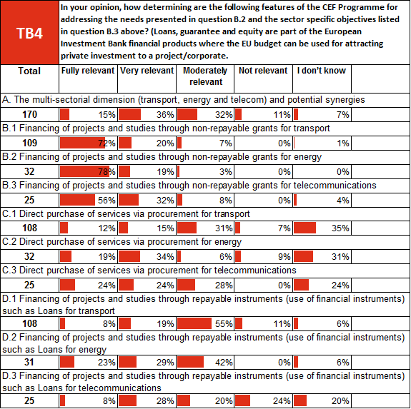





**3. Coherence**

***Coherence of the single programme approach***

“While the common management of the three sectors may be worth pursuing, mechanisms to promote “synergies” between sectors do not appear to have been appropriately implemented.”

**French Ministry of Transport**

“I agree to the extent that large infrastructure projects have similar challenges, but the sectors face different types of difficulties. In my opinion, telecommunication has the least amount of physical intervention and should be looked separately.”

**Project promoter, energy sector**

One of the key issues in the internal coherence of the CEF Programme is the degree to which the single programme approach is well-suited to the three sectors involved. The OPC addressed this issue via multiple questions, the response to which paint a nuanced picture.



On the one hand, respondents to the general survey expressed support for the main justifications for the single programme approach. For example, 65% of respondents the technical survey below (TC1) and 77% of respondents to the general survey (GC1) either “strongly agree” or “agree” with the statement that the transport, energy, and telecommunications sectors face common challenges.



On the general survey (GC2), 34% preferred three individual funding instruments while 47% said one instrument for all three sectors was preferable.



Respondents to the general survey were on the whole more negative when asked to describe the complementarity of CEF with the four funding instruments mentioned (GC3). In fact, for ERDF, CF and Horizon 2020, the number who responded that the complementarity was “excellent” or “good” was just 20%.





Both surveys asked directly whether it was preferable to have one funding instrument for the three sectors, or three separate instruments. 53% of respondents to the technical survey (TC2) said that they preferred individual funding instruments per sector while 34% said one instrument for all three.





In terms of the coherence of the CEF Programme with other EU initiatives and wider EU policy, the input from stakeholders was mixed. On the one hand, strong majorities in all three sectors indicated that the CEF Programme is aligned to and complementary with other EU policy objectives and initiatives in their sector (TC4).





When asked about the complementarity with ERDF, CF, EFSI and Horizon 2020 (TC5), the number of respondents to the OPC technical survey who responded either that they were “fully” or “to a large extent” complimentary did not in any case exceed 40%. The responses were not systematically affected by either the sector the respondent works in, nor by their self-reported level of familiarity with the Programme.



In the transport sector, 72% of respondents said CEF was coherent “fully” or “to a large degree.” In the energy sector, the total is 76%, while in telecom it is 70%.

Figure 12 Perceived coherence of CEF with EU policy and initiatives by knowledge of CEF

Responses to this question varied somewhat according to the self-reported level of familiarity with the CEF Programme. As shown in Figure 12, those who report knowing the Programme “fully” were substantially more likely to say that it was “fully” aligned to and complimentary with other EU policies and initiatives in the sector than those who said they only know the Programme “to some extent.” This effect was persistent across sectors.

Interview participants were also overwhelmingly positive in their assessment of the coherence of CEF with other EU initiatives, with some 50 subjects from all three sectors speaking positively on this aspect compared to just eight who spoke negatively.

On the other hand, when asked about CEF’s complementarity with specific EU funding instruments, assessments became markedly less positive in both quantitative and qualitative feedback.

Figure 13 Perceived impact of EFSI set-up by sector

***Complementarity with EFSI***

“CEF is meant for major EU added value projects on TEN-T network, whereas once this money was transferred to EFSI, there was no guarantee that it will even be used for funding the EU priorities, let alone projects on TEN-T network.”

**Estonian Ministry of Economic Affairs**

The technical survey contained a specific question about the impact of the creation of EFSI in 2015. Here results were relatively evenly split, with 30% saying the impact was “very positive” or “quite positive,” 31% saying “quite negative” or “very negative,” and 39% responding “I don’t know.” While the positive responses to this question were quite consistent across sectors, respondents working in the transport sector were far more likely to say that the creation of ESIF had a negative impact, whereas respondents from the energy and telecom sectors were more likely to say they didn’t know.

These results were complimented with a number of comments, the majority of which were critical of the impact of transferring the budget from the CEF Programme, which has a targeted focus, to EFSI, which supports a much broader range of investment projects.

**4. Effectiveness**

The CEF programme’s effectiveness in developing projects enabling synergies across the transport, energy, and telecommunications sectors, is higher than originally anticipated. 50 respondents (36%) to the technical survey expected this to be achieved “fully,” or “to a large extent.”

Figure 14 Perceived effectiveness of CEF

It emerged from several interviews with project promoters that grants are necessary as "*there is no consumer underwriting for the (higher than usual) risks associated with the development phase of such cross border projects; if a project was unable to make a positive final investment decision, then costs incurred up to that point would not be met by consumers through transmission tariffs. This could be a deterrent to investment and therefore access to CEF Study Grant co-funding has been particularly important in stimulating development*." (one gas project promoter). Several representatives of national authorities emphasised in the interviews also the fact that small countries with dispersed population and/or more isolated location cannot build a business case or recuperate via tariffs some of the investments necessary. Here grants for works and/or agreements between neighbouring countries on the sharing of costs are necessary in order to make them happen at all.



















**B.6. Efficiency related question**







Here there seems to be a piece missing…

Several representatives of project promoters and national authorities stated that there was so far a preference to use long standing lending arrangements with the EIB or other financial institutions rather than the new CEF offer as "*borrowing at company level" or "arrangements through the parent company" were "more attractive than seeking funding at project level*". Several experts interviewed also emphasised the fact that using a financial instrument instead of a grant results in capital costs implying a higher tariff – which is obviously more difficult to impose in countries with smaller population size.

**5. Efficiency**

***Efficiency of INEA***

"INEA has already demonstrated its ability to operate efficiently and effectively, this is greatly appreciated¨

**Transport Beneficiary, UK**

**OPC Technical Survey**

Stakeholders appear to have a uniform appreciation for the role that INEA plays in ensuring the efficiency and well-functioning of the CEF Programme. 34% of respondents to the OPC technical survey said that the application and selection process managed by INEA was handled very efficiently, and another 42% said it was handled “somewhat efficiently.” This finding was reinforced by a number of comments left in the OPC, as well as by the feedback from targeted stakeholder consultations with beneficiaries from all three sectors, which were universally positive from the 41 interview subjects who provided an opinion.

The majority of stakeholders generally agree that INEA has enabled a major simplification of the processes and procedures, particularly in the energy and telecommunications sector which did not use its forerunner the TEN-T Executive Agency. The resulting grant agreements are more conjoint, which reduces the need for subsequent budgetary amendments.

Stakeholders consider the agency to have a strong relationship with DG MOVE, DG CNECT and DG ENER, with a team like approach between them. The agency is considered to work smoothly, as it has been able to conclude grant agreements in the set deadline of 9 months in 99% of cases, with most delays coming from the beneficiaries' side. Stakeholders agree that the costs associated with INEA are minimal providing for an efficient implementation of the CEF programme. Some shortcomings have been observed however in relation to communication and dissemination of information to the general public about INEA's work.

Figure 15: Perceived efficiency of INEA by knowledge of CEF

It is worth noting that the response to this question varies systematically according to the self-reported level of familiarity with the CEF Programme, with those who believe they know it best having a more positive assessment of INEA’s performance than those that know it less well. As shown in Figure 16, nearly 50% of those who said they know the CEF Programme “fully” said that INEA managed the application and selection process “very efficiently,” compared to just over 20% of those who only know CEF “to some extent.”

***Efficiency of calls for proposal***

"The period during which the calls are open (less than 4 months) is too short, in particular for projects with partners from different Member States¨

**Local Authority, France**

**OPC Technical Survey**

“With the tight schedule of past calls it is very challenging for the SESAR Deployment Manager and implementing partners to identify and prepare multi-stakeholder proposals that could bring more added value." Transport Beneficiary, Spain

**Transport Beneficiary, Spain**

**OPC Technical Survey**

A related issue is the timing of calls for proposals. 26% of respondents to the OPC technical survey (TF2) reported that the frequency and duration of calls was handled very efficiently, and 45% said “somewhat efficiently.”

In general, the operational aspects of the CEF are perceived by stakeholders as well structured so as to deliver the objectives of the Programme. However, while the assessment of the frequency and duration of the calls was on the whole very positive, there were a number of suggestions made for how their handling could be improved. In general, the timing and lasting of the calls is sometimes seen as limiting the efficiency of the Programme. A minority of sectorial beneficiaries indicated during the targeted stakeholder interviews the desire for calls to be announced further in advance, so that they could improve the organisation of their interventions, and would also wish for the calls to be held open longer. Furthermore, some stakeholders gave the opinion that Member States could generally be more engaged at various stages of the process and further opportunities for discussion should be promoted.

The administrative cost of the implementation is seen as worthwhile and proportionate to the results achieved. Beneficiaries and operational stakeholders pointed to a need to reduce administrative burden of submitting proposals for smaller projects: in general, in relation to smaller projects, certain stakeholders are of the opinion that the administrative cost of the implementation should be more proportionate to the size of the project. This was particularly true for the Telecom sector where the average grant size was just EUR 1 million. During targeted interviews, Telecom stakeholders indicated that removing the requirement for all grant proposals to be approved by their MS administration could be a way to reduce the administrative burden.

***Efficiency of application process***

"The technical nature of CEF is such that it is necessary to have the support of a specialised consultant to submit an application”

**Regional Authority, France**

**OPC Technical Survey**

This aspect was underscored in the technical surveys (TF1 and TF2). 42% of respondents assessed the administrative burden was efficient “to some extent” in the transport sector. The telecom sector received a similar assessment, with 37% of respondents assessing the process as efficient “to some extent.” The energy sector was deemed “not at all efficient” by a broad part of the interviewees (32%), and only 26% estimated that the process was efficient “to some extent.” Overall, the scores for this question are quite low.

The use of e-communication tools to manage the current programme goes that far that, as one interviewed project promoter in the field of energy put it – "the only paper-based procedure is the grant agreement". Even though it was not possible to arrive at a meaningful quantification of the cost savings for the involved authorities in MS, there is enough evidence and statements from experts (several national authorities and one TSO representative), confirming that the new procedural set up for CEF as of 2013 reduced the regulatory burden for MS.

Some stakeholders (as indicated above, 5 submissions to the technical survey of the 7 that rated the administrative cost performance of CEF energy as very poor and that submitted free comments on this issue) referred to the CBCA process as burdensome and/or prolonging the application process (e.g. ENTSO-E in their position paper). Also experts interviewed on this issue referred only to the CBCA as being burdensome in terms of compliance, no other issue was raised in this context. However it is very interesting to add that out of the eleven experts that discussed this question at greater detail only two felt that the CBCA requirements are disproportionate. All the others argued that "*while the CBCA requirements are burdensome, the CBCA is also the best tool in the PCI process to oblige MS to go beyond national thinking*" (a national authority). Another expert with a more horizontal perspective on CEF described "*administrative costs are high, but for a good purpose*". Around a quarter of those interviewed on the issue also felt that there are no concerns as regards the administrative burden for project promoters.

Whilst the present evaluation does not contain a quantitative assessment of the costs of complying with the CBCA criteria[2], one can qualitatively discuss the obligations in particular with a view to proportionality: indeed the requirement to have a decision on CBCA when applying for CEF effectively results in a prolongation of the application process and in increased administrative costs related to provision of proof and documents, but there is an element of proportionality in that a CBCA is only necessary for applications for grants for work, not for grants for studies where the amounts at stake are significantly smaller.

**6. EU Added-Value**

Respondents to the general survey perceived that the programme will promote transnational cooperation and promote greater investments in the three sectors. The expected added value was perceived to be lower with regards to the reduction of cross-border network connections within sectors. Other expected impacts mentioned in the open replies concern the removal of national bottlenecks which hinder the deployment of a TEN-T (goods and passengers), close the financing funding gap for “non-bankable” projects, or bankable at very long terms, which need to be carried out as they are of high added value for the region, hinterland, corridor, as well as to contribute to standardisation and cybersecurity.



The perceived Added Value of the programme was rated as either substantially or somewhat higher by half of the respondents (GD2), with 40% rating it as similar to national or regional programmes. Private individuals rated the highest the added value of CEF, with 60% saying that it his substantially or somewhat higher value and 38% similar. This was also the case in the technical survey (TD2), where private individuals rated the added value of the programme as either substantially or somewhat higher. Regional and local authorities had similar views (36% similar, 57% somewhat/substantially higher), one also found it of lower value. For the majority of civil society organisations the added value was similar, and for one fourth of them higher, a few also responded that the programme has somewhat lower added value. A few national ministries and infrastructure managers also responded that they perceived a lower added value than regional or national programmes.



In the technical survey, 89% of industry representatives rated CEF added value as either substantially or somewhat higher, with the remaining considering it similar. Infrastructure managers or operators showed similar trends of replies, with the majority (52% and 60% respectively) rating it at substantially higher, 17% and 20% somewhat higher and 13% and 15% similar. Regional/local authorities perceived high added value in the programme: 71% rated it either substantially or somewhat higher and 8% similar. 54% national ministries considered the programme added value substantially or somewhat higher to national/regional ones and 19% similar, although 8% responded that it is lower.



The capacity of CEF to foster development of cross-border projects was confirmed by the stakeholders in the technical survey, a large majority of which (88-94%) responded that this is the case fully or to a large extent, for the three sectors.



The respondents to the technical survey indicated that one area where they perceived an added value of the CEF Programme was by accelerating the investment in Trans-European Networks (TD1). As shown in Figure 14 78% of respondents working in the transport sector and 85% from the energy sector report that they expect the CEF Programme to accelerate investment either “fully” or “to a large extent.” Respondents working in the telecom sector were slightly less positive in their expectations, with 63% expecting investment to be accelerated “fully” or “to a large extent.” These responses were augmented with a number of positive comments on the contribution of CEF to accelerating investment.

***Investment Acceleration***

“The use of CEF programme for mature projects is a concrete tool to accelerate investments at an advanced stage, and a way to compensate and socialize at the European level the costs incurred by those Member States that promote infrastructure projects and support investments having European impact and relevance.”

**Energy infrastructure Operator, Italy**



Figure 16: Perceived acceleration of investment by sector

Other positive points on EU added value were brought forward by stakeholders through the interviews. In the transport sector, it was highlighted that direct interaction between project promoters and INEA resulted in better quality projects, and was a capacity building experience. For Energy, CEF is seen to accelerate implementation of interconnection projects and reduce costs for end users. For Telecom, the Programme is viewed as having a positive impact on the interoperability of digital services.

Several experts interviewed on the question of EU added value stated that the CEF – with its unique focus on supranational priorities provides funding for which there would otherwise not necessarily be alternatives in national budgets. Interview partners in particular from Eastern Member States also often described the projects funded under security of supply as a common EU effort where all Member States share in solidarity the costs resulting from the synchronization with the Western grid (e.g. for Baltic States).

In addition most of the targeted stakeholders (24 over 30 or 80%) rated the overall added-value of CEF as a somewhat higher or substantially higher because is:

* More fast and efficient instrument comparing to the national/regional programmes for trans-European infrastructure networks and Smart and sustainable Economic growth;
* A strong catalyst to bring together project promoters, National Regulatory Authorities and Government ministry representatives to solve issues to enable cross-border infrastructure projects to be realised;
* A support for cross-border projects whose commercial viability is not immediately perceived or demonstrated.

**7. Forward-looking questions**





**8. Position papers**

Through the evaluation process, the possibility was given to stakeholders and non-stakeholders to submit a formal opinion as an organisation. First, OPC respondents were allowed to submit their position papers through the questionnaire. Second, a few targeted stakeholders chose to release a formal opinion as an organisation instead of an individual and anonymised interview.

14 position papers were submitted in total, including:

**Multi-sector**

* Province of Limburg, Belgium
* Tirol – Süd-Tirol Regional political leadership
* Region of Venlo, the Netherlands
* Europa forum
* Finnish, Swedish and Norwegian regional offices around the Gulf of Bothnia
* Joint Letter from 10 Environmental associations[3]
* Ministry of Economy, Estonia

**Transport**

* Deutsche Bahn
* European Federation of Inland Ports
* Finnish Port Association

**Energy**

* Gas Infrastructure Europe
* The European Network of Transmission System Operators for Electricity

**Telecom**

* CZ NIC
* European coordination of organizations for an EMF exposure regulation

The 14 position papers received are broadly positive in their assessment of the design, rationale and objectives of the CEF Programme, including its added value to the EU. However, they also put forward a number of recommendations and areas for improvement.

One frequent theme was the need tom move away from the heavy reliance on grants. Many respondents greater use of alternative forms of financing such as blending, while acknowledging that grants remain necessary for the less bankable projects. Another frequent theme is the positive assessment of the achievements of central management and the single programme approach. Position papers generally posited that central management as one of the current success factors of CEF. Some of these papers also touched on the concept that projects of high EU added value may have been excluded from support via the CEF Programme due to the timing of calls, as well as the narrowness of eligibility and selection criteria.

|  |  |  |  |
| --- | --- | --- | --- |
| Respondent | Arguments supporting CEF achievements | Recommendations and potential improvements | |
| **Respondents active in multiple sectors** | | |
| Procinvie Linburg | Supporting projects targeted specifically at strengthening the robustness of multimodal transport networks and nodes and reducing cross-border bottlenecks | CEF should include new roads and waterways in the core network/in the extended TEN-T, as well as improving the quality of border crossings by rail, in order to strengthen further multimodal transport networks with trimodal nodes (road, rail, waterway) | |
| Tirol – Süd-Tirol | “The CEF provides a strong basis for creating an efficient and sustainable transport system that connects all countries and regions of Europe. The achievements are great in the Tirol regions. Despites the stakeholders’ effort to diversify funding, grants remain a needed source of funding.” | “Greening the transport system is not an option – it is an obligation. The successful introduction of cleaner transportation solutions on a large scale remains critical to the success of The European Union goals for reducing both the dependence on fossil fuels and their negative externalities.” | |
| Regio Venlo | “As a central and core Region, Venlo is mostly concerned about multimodality and interoperability, which are objectives of the CEF programme.” | Budget should be raised, as well as more open to national initiatives which foster interoperability. | |
| Europa forum | “CEF is an important and relevant tool. Its extension in the Core Network Corridor Scandinavian-Mediterranean (Scan-Med) would consolidate the engagement of the EU and its role as a key player in the development of the Artic region. It promotes territorial cohesion and growth, strengthening the relevance of EU on local and regional level.” | “CEF is an important and relevant tool. Its extension in the Core Network Corridor Scandinavian-Mediterranean (Scan-Med) would consolidate the engagement of the EU and its role as a key player in the development of the Artic region. It promotes territorial cohesion and growth, strengthening the relevance of EU on local and regional level.” | |
| Finnish, Swedish and Norwegian regional offices around the Gulf of Bothnia | “The CEF programme strongly stimulates the cross-border cooperation between the EU Member States and regions” | “An extension of the corridors should be implemented in the next CEF Regulation. The current nine Core Network Corridors of the CEF are not covering the whole Union; leaving out important parts of Northern Europe, i.e. almost the whole of Finland and Sweden. The absence of the TEN-T Core Network Corridors in the North, and thus the lack of a coordinated approach to financing transport infrastructure, endangers the timely implementation of the TEN-T Core Network. | |
| **Respondent** | **Arguments supporting CEF achievements** | **Recommendations and potential improvements** | |
| Joint Letter – Environmental associations | “Despites the climate objectives the CEF regulation set, the programme is still investing in fossil-fuel infrastructure and distributed most of its energy funding to gas infrastructure actions.” | “Due to a changing context (both climatic and technological), it is a foremost importune that CEF refocuses its funding respecting 4 criteria:  - Stop public support to fossil fuel based infrastructure;  - Align the investment criteria with the changing character of a modern, sustainable infrastructure;  - Put energy efficiency and renewable energies first;  Include demand-side measures into the portfolio.” | |
| Ministry of Economy, Estonia | “CEF has been an important instrument for connecting more peripheral regions closer to the center of Europe. Trans-European networks and the existing missing links on this is of considerable EU added value. Consequently, the financing of similar network related projects from an EU central instrument in the future is important.  Central management of the program has also proven useful as projects are chosen based on the same process, priorities and criteria across EU which favours projects of the highest EU added value.” | “CEF’s manages should note that the rules for synergy calls must not be too stringent  Grant must remain a preferred funding vehicle when the project’s bankability is limited.  Transferring CEF funds to EFSI has so far not brought additionality nor complementarity in the transport sector.” | |
| **Respondents active in the transport sector** | | | |
| Deutsche Bahn | “The CEF Programme is of a foremost importance in achieving the EU 2020 goals, and its specific objectives are overall well defined.  The design of CEF makes the programme flexible enough to reallocate funding on emerging or new priorities (compared to other programmes of this size and targets).” | “If grants remain necessary, the need to diversify the financing schemes is prioritary.  Application procedures could be simplified.  Last, the programme should be more open to transport-related technology projects that are not eligible at the moment.” | |
| European Federation of Inland Ports | “CEF has been effective in delivering European transport priorities thus far. In 2015, EUR 12.8 billion of grants were allocated to 263 projects.” | “In all the CEF calls, high quality projects were rejected due to insufficient EU budget.  Financial contribution given to inland port sector is rather low compared to the other transport modes.” | |
| **Respondent** | **Arguments supporting CEF achievements** | **Recommendations and potential improvements** | |
| Finnish Port Association | “CEF is needed as ports face an increased amount of issues:  - New trends in the Industry;  - National austerity;  - Energy prices volatility;  - Climate change.” | “In all CEF calls, a high number of high-quality projects were rejected due to insufficient EU budget.  Transport requires:  - More budget;  - Better blending;  -Better definition and implementation of the EU Added-Value;  - Improving the CEF budget’s distribution over time.” | |
| **Respondents active in the Energy Sector** | | | |
| Gas Infrastructure Europe | “CEF is calibrated to the needs of the EU, as many European regions really need upgraded and extended Transport, Energy and Telecommunication infrastructure. To this extend, CEF as a programme reinforces the integration of the single market. “ | “In the current CEF, it is very difficult to identify areas where the 10% top-up rate can be applied. Only exceptional actions are advised to ask for this top-up.  The CEF support instruments should be accessible for small capital projects if they meet the setout criteria.  Last, more feedback could be provided to CEF promoters, such as descriptions or examples, that might help the promoter to submit successful applications.” | |
| ENTSO-E | “Grants for works under CEF could be a concrete tool to speed up projects of common interest in the electricity field and represent an opportunity to socialise at European Level the costs borne by the countries that are promoting projects having benefits for several European countries.” | “CEF’s application to the infrastructure electricity PCI is limited by too strict and unclear eligibility criteria.” | |
| **Respondents active in the Telecom sector** | | |
| CZ NIC | Recognition of CEF Telecom in encouraging cross-border cooperation.  CZ NIC believes the lump-sum functioning of WIFI4EU will bring more simplification and concrete achievements. | In the future, CEF Telecom should support smaller projects with funding based on the lump-sum principle.  Work programmes should not impose public procurements processes as many SMEs and innovative bodies are excluded by the criteria. | |
| European coordination of organizations for an EMF exposure regulation | “Great caution should be warranted with regard to the proposed widespread rollout of wireless technologies to meet internet connectivity requirements.” | “Precautionary regulation of the EMF exposure and required alternatives that are more environmentally friendly, biologically tested.  Proper assessment of the potential health and environmental consequences of their widespread use is urgently required.” | |
|  | | |

# 

# Annex 3. Analytical models used in preparing the evaluation

The interim evaluation of the Connecting Europe Facility Programme has been carried out with the support of an external consultant (PricewaterhouseCoopers) by lead DGs teams and dedicated Inter-Service Group also comprising other Commission services. The interim evaluation started in 2016 and has been by the Terms of Reference published by the Commission on 23 May 2016.

**C.1. General overview of models and methods used in external assessments**

The three Commission DGs responsible for CEF (Directorate General for Mobility and Transport - DG MOVE, Directorate General for Energy - DG ENER and Directorate General for Communications Networks, Content & Technology – DG CNECT) set out an evaluation scope (presented in introduction), timeline and methodology, as defined in the roadmap adopted in 2016.

The evaluation started in December 2015 and was foreseen to be finalised by 31 December 2017. In November 2016 the 3 DGs decided to shorten the general timetable by a 3 months to ensure the conclusions of the evaluation can feed into the preparation of the next MFF-related proposals.

In addition, the Commission signed a contract with an external consultant (PriceWaterhouseCoopers) to prepare a study providing input for the present evaluation.

**The evaluation has been carried out based on different sources, namely literature review and desk research, an extensive stakeholder consultation, including interviews, a sectorial target consultation and the open public consultation and the analysis of case studies.**

**1. Data collection, selection and analysis**

The review of relevant CEF literature and documentation covers the legal basis and organisation of CEF, both at programme and at sectorial level. The information gathered through the desk research feeds into the case studies selection, the portfolio analysis and the conclusions at the CEF Programme and sectorial level. More specifically, it informed on the relevant quantitative and qualitative indicators to be taken into account when forming conclusions on the evaluation questions.

The analysis of available sources in relation to the CEF Programme was conducted at programme, sectorial and project levels. This was complemented by desk research on data not directly linked to the CEF Programme, but which was taken into account throughout the evaluation process as they could nonetheless be relevant (i.e. policy documents on other EU interventions that could considered for assessing the complementarity with CEF, like EFSI, ESIF, H2020, etc.).

**1.1. Collected and processed data**

The information collected as part of the mid-term evaluation mainly includes 1) the data sets covering grants, CEF Debt Instrument (CEF DI) and procurement, 2) all the documentation collected as part of the desk research, the sampling and case studies

**2. Literature review and desk research**

The review of relevant CEF literature and documentation represented an important data source, particularly for the early stages of the project. Information on the legal basis and organisation of the CEF were key inputs to both the context and intervention logic. It was also used in refining the evaluation questions in order to more accurately match the objectives and scope of the evaluation.

In the later stages of the evaluation, the desk research was also an important source of qualitative and quantitative indicators to be taken into account when forming conclusions on the evaluation questions. The documentation had been either provided by 3 leading DGs or other stakeholders, or collected by the evaluation team through desk research.

Analysis of available sources in relation to the CEF Programme, and is conducted at three levels:

* Programme level;
* Sectorial level; and
* Project level.

This was complemented by desk research on data not directly related to the CEF Programme, but which is taken into account in the evaluation process and are relevant for the CEF (as an example, policy documents on other EU interventions that could considered for assessing the complementarity with CEF, etc.).

*2.1. Desk research at programme level*

The following list of documents and data sources on CEF as a Programme were used and enriched during the whole evaluation process. It includes, but cannot be restricted to:

* Regulation establishing the Connecting Europe Facility (EU) No 1316/2013 and amendment on the Annex 1;
* Policy and strategy documents;
* Impact assessment of the CEF;
* Adopted CEF Programmes;
* Calls for proposals launched, project selection decisions;
* Forthcoming calls for proposals for energy/transport - indicative budget allocations, priorities for financing, project financing decisions;
* Grant agreements signed;
* Pipeline of projects and budget committed for the CEF financial instruments; and
* Programme support actions implemented.

In regards to the horizontal dimension of the analysis to be considered at this level, the following documentation was considered:

* Studies and evaluation reports on the implementation of the EU structural funds;
* Data in relation to the Project Bond Initiative;
* Policy documents for evaluating the general and specific objectives of the CEF Programme include: ‘Europe 2020 Strategy’, ‘Jobs, growth and investment’, internal market policy, climate and energy policy’, ‘Digital Single Market’, regional policy, environmental policy.

*2.2. Desk research at sectorial level*

In addition to programme level documents, the desk research phase incorporated the review of other relevant documents at sectorial level. An indicative list of relevant documents could include:

*Transport*

* TEN-T Corridor work plans and Coordinators progress reports;
* Nine core network corridor studies including list of projects and TENtec compliance maps;
* Study on the Cost of non-completion of the TEN-T;
* Biennial report on the implementation of the TEN-T Guidelines (when available);
* Ex-post evaluation of the TEN-T 2007-2013;
* European Court of Auditor performance Audit reports in the field of TEN-T;
* Action plan “Making the best use of new financing schemes for European transport infrastructure projects” (2015);
* Opportunities for the transport sector under the Investment, Commission Plan Non-paper to Ministries for 8 October 2015 Transport Council;
* Evaluation of Marco Polo programme.

*Energy*

* TEN-E framework reports;
* Report – “The structuring and financing of energy infrastructure projects, financing gaps and recommendations regarding the new TEN-E financial instrument”;
* Reports from the Commission to the European Parliament and the Council on the implementation of the European Energy Programme for Recovery;
* ACER consolidated report on PCI monitoring (2015 and 2016-expected);
* Evaluation of predecessor programmes (interim evaluation of TEN-E programme 2007-2013 and EEPR implementation reports).

*Telecom*

* Study “The feasibility and scenarios for the long-term sustainability of the Large Scale Pilots”, including “ex-ant” evaluation;
* Studies on Digital Service Infrastructures;
* Relevant policy documents : Digital Agenda Scoreboard index, Digital Single Market,   
  e-Government Action, Cost Reduction Directive;
* Study on National Broadband plans in the EU.

**4. Portfolio analysis**

Financial and project data for all actions supported by or benefitting from the CEF Programme between 2014 and the end of 2016 were collected to populate a database for use in a portfolio analysis. For FIs, the latest approved pipeline of projects under CEF DI were considered. This was used for descriptive analysis and to identify and to identify issues that could merit further investigation as case studies where identified.

# Annex 4. List of sectorial objectives and their related key performance indicators (KPIs)

| CEF Transport specific sectorial objectives | |
| --- | --- |
| *(a) removing bottlenecks, enhancing rail interoperability, bridging missing links and, in particular, improving cross- border sections* | *The achievement of this objective shall be measured by the number of new or improved cross-border connections;*   1. *the number of kilometres of railway line adapted to the European nominal gauge standard and fitted with ERTMS* 2. *the number of removed bottlenecks and sections of increased capacity on transport routes for all modes which have received funding from the CEF* 3. *the length of the inland waterway network by class in the Union* 4. *the length of the railway network in the Union upgraded following the requirements set out in Article 39(2) of Regulation (EU) No 1315/2013* |
| *(b) ensuring sustainable and efficient transport systems in the long run, with a view to preparing for expected future transport flows, as well as enabling all modes of transport to be decarbonised through transition to innovative low- carbon and energy-efficient transport technologies, while optimising safety* | *The achievement of this objective shall be measured by:*   1. *(i) the number of supply points for alternative fuels for vehicles using the TEN-T core network for road transport in the Union* 2. *(ii) the number of inland and maritime ports of the TEN-T core network equipped with supply points for alternative fuels in the Union* 3. *(iii) the reduction in casualties on the road network in the Union* |
| *(c) optimising the integration and interconnection of transport modes and enhancing the interoperability of transport services, while ensuring the accessibility of transport infrastructures* | *The achievement of this objective shall be measured by:*   1. *the number of multimodal logistic platforms, including inland and maritime ports and airports, connected to the railway network* 2. *the number of improved rail-road terminals, and the number of improved or new connections between ports through motorways of the sea* 3. *the number of kilometres of inland waterways fitted with RIS* 4. *the level of deployment of the SESAR system, VTMIS and ITS for the road sector* |

The budgetary resources as defined for the CEF transport envelope, excluding those allocated to programme support actions are divided among these three objectives, respecting the following percentages: 80%, 5% and 15%.

The Commission has the possibility to amend these percentages through the adoption of a delegated act, should the allocation of funds diverge by more than 5 percentage points from these values.

|  | |
| --- | --- |
| CEF Energy specific sectorial objectives | |
| *(a)* increasing competitiveness by promoting the further integration of the internal energy market and the interoperability of electricity and gas networks across borders | *The achievement of this objective shall be measured* ***ex post*** *by:*   1. *the number of projects effectively interconnecting MS' networks and removing internal constraints* 2. *the reduction or elimination of MS' energy isolation* 3. *the percentage of electricity cross-border transmission power in relation to installed electricity generation capacity in the relevant MS* 4. *price convergence in the gas and/or electricity markets of the MS concerned* 5. *the percentage of the highest peak demand of the two MS concerned covered by reversible flow interconnections for gas* |
| *(b)* enhancing Union security of energy supply | *The achievement of this objective shall be measured* ***ex post*** *by:*   1. *the number of projects allowing diversification of supply sources, supplying counterparts and routes* 2. *the number of projects increasing storage capacity* 3. *system resilience, taking into account the number of supply disruptions and their duration* 4. *the amount of avoided curtailment of renewable energy* 5. *the connection of isolated markets to more diversified supply sources* 6. *the optimal use of energy infrastructure assets* |
| *(c)* contributing to sustainable development and protection of the environment, inter alia by the integration of energy from renewable sources into the transmission network, and by the development of smart energy networks and carbon dioxide networks | *The achievement of this objective shall be measured* ***ex post*** *by:*   1. *the amount of renewable electricity transmitted from generation to major consumption centres and storage sites* 2. *the amount of avoided curtailment of renewable energy* 3. *the number of deployed smart grid projects which benefited from the CEF and the demand response enabled by them* 4. *the amount of CO 2 emissions prevented by the projects which benefited from the CEF* |

|  | |
| --- | --- |
| CEF Telecommunication specific sectorial objectives | |
| *(a) economic growth and support to the completion and functioning of the internal market in support of the competitiveness of the European economy, including small and medium-sized enterprises (SMEs)* | *The following operational priorities shall contribute to the achievement of the objectives:*   1. *interoperability, connectivity, sustainable deployment, operation and upgrading of trans-European digital service infrastructures, as well as coordination at European level* 2. *efficient flow of private and public investments to stimulate the deployment and modernisation of broadband networks with a view to contributing to achieving the broadband targets of the Digital Agenda for Europe* |
| *(b) improvements in daily life for citizens, businesses and public authorities at every level through the promotion of broadband networks, interconnection and interoperability of national, regional and local broadband networks, as well as non-discriminatory access to such networks and digital inclusion* |

|  | |
| --- | --- |
| CEF general objectives | |
| *(a) contributing to smart, sustainable and inclusive growth, in line with the Europe 2020 Strategy, by developing modern and high-performing trans-European networks which take into account expected future traffic flows, thus benefiting the entire Union in terms of improving competitiveness on the global market and economic, social and territorial cohesion in the internal market and creating an environment more conducive to private, public or public- private investment through a combination of financial instruments and Union direct support where projects could benefit from such a combination of instruments and by appropriately exploiting synergies across the sectors* | *The achievement of this objective shall be measured by the volume of private, public or public-private partnership investment in projects of common interest, and in particular the volume of private investment in projects of common interest achieved through the financial instruments under this Regulation. Special focus shall be placed on the efficient use of public investment* |
| *(b) enabling the Union to achieve its sustainable development targets, including a minimum 20 % reduction of greenhouse gas emissions compared to 1990 levels and a 20 % increase in energy efficiency, and raising the share of renewable energy to 20 % by 2020, thus contributing to the Union's mid-term and long-term objectives in terms of decarbonisation, while ensuring greater solidarity among Member States* |  |

# Annex 5. CEF intervention Logic

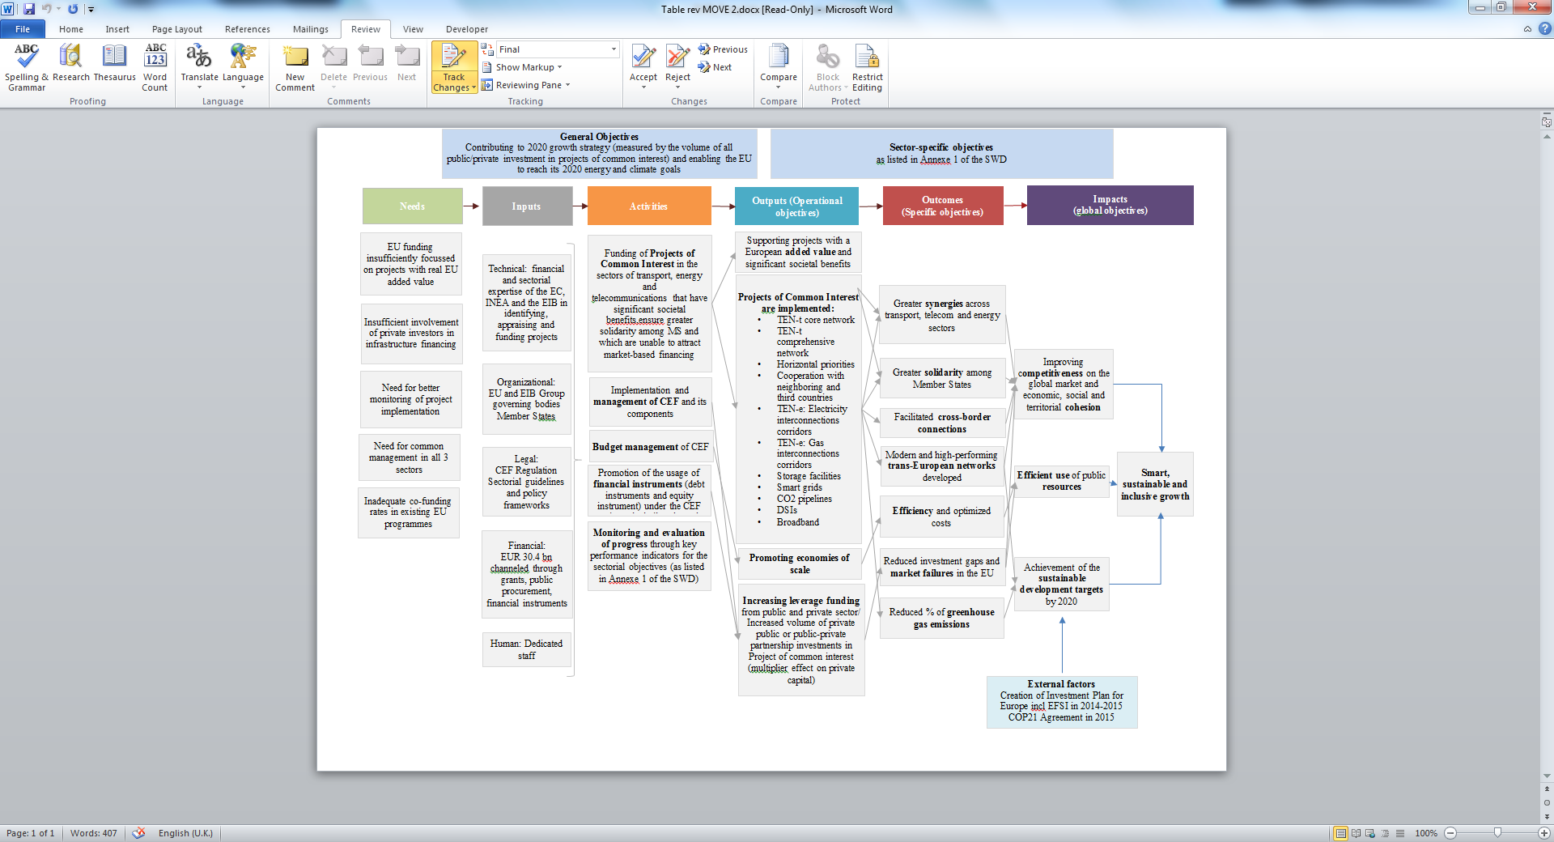

# Annex 6. The CEF DI Portfolio including the legacy instruments for 3 Sectors

|  |  |  |  |  |
| --- | --- | --- | --- | --- |
| **CEF DI Project** | **Sector** | **Country** | **CEF DI product** | **Project Costs (EUR m)** |
| AUTOBAHN A-5 PPP TEN | Transport | Germany | Loan Guarantee Instrument for Trans-European Transport (LGTT) | 628.4 |
| EIX TRANSVERSAL C-25 PPP | Transport | Spain | LGTT | 815.3 |
| LGV SUD EUROPE ATLANTIQUE | Transport | France | LGTT | 7,851 |
| OFFSHORE TRANSMISSION NETWORK- ROUND 1 (Greater Gabbard) | Energy | UK | Project Bond Credit Enhancement (PBCE) | 424.9 |
| A11 BRUGGE PPP | Transport | Belgium | PBCE | 657.5 |
| N25 NEW ROSS BYPASS PPP | Transport | Ireland | PBCE | 169 |
| AXIONE TELECOM INFRASTRUCTURE | Broadband | France | PBCE | 189.1 |
| AUTOBAHN A-7 PPP TEN | Transport | Germany | PBCE | 772.6 |
| CALAIS PORT 2015 | Transport | France | PBCE | 862.5 |
| PASSANTE AUTOSTRADALE DI MESTRE | Transport | Italy | PBCE | 990 |
| AUTOBAHN A8 AUGSBURG ULM PPP TEN | Transport | Germany | Senior Debt Credit Enhancement (SDCE) | 505 |
|  |  |  |  | **13,865.3** |
| Green Shipping Guarantee | Transport | EU | CEF Debt | Depending on the disbursement to the final recipients, estimated at 3,000 |
| Project for port development under signature*/ | Transport |  | CEF Debt | Estimated at 129 |

# Annex 7. EU funding of infrastructures in the 2007-2013 Multiannual Financial Framework

|  |  |  |  |  |  |  |
| --- | --- | --- | --- | --- | --- | --- |
| Sector | Source/Programme | Objectives | Priorities/Eligibility criteria | Budget 2007-2013  (EUR million) | Forms and methods of financing | Monitoring and evaluation |
| Energy  (electricity and gas networks) | TEN-E Programme | Developing energy projects that contribute to the working of the single market, particularly of crossborder nature | Project of common interest and projects of European interest as identified in the TEN-E guidelines | 155 | Grants:  - for studies (up to 50% co-financing)  - for works (up to 10%)  Interest rate rebate (never used) | Member States undertake the technical monitoring and financial control of projects in close cooperation with the Commission  Evaluation responsibilities shared by the Commission and Member States |
| European Energy Programme for Recovery (EEPR) | Investing in modernising Europe's energy infrastructure in response to the economic crisis in Europe | TEN-E projects as specified in the EEPR Regulation[4] | 2 365[5]  (2009-2010) | Grants for works and project preparation:  - up to 50% | Commission in charge of the evaluation of the progMember States may be requested to evaluate specific projects; Commission to report to other institutions |
| Cohesion Fund and ERDF | Increasing and improving the quality of investment in energy sector physical capital in order to improve conditions for growth and employment, speed up the convergence of the least-developed Member States and regions | Projects improving security of supply; gas and electricity interconnections in cases of identified market failure | 1607  (Funds allocated within financial perspective 2007-2013) | Grant for works – up to 85% co-financing (but reduced in case of projects generating revenues) | Monitoring by Member States  Commission in charge of the evaluation of the programme |
|  | European Neighbourhood and Partnership Instrument (ENPI) / Neighbourhood Investment Facility | Converging energy markets, Enhancing energy security, Supporting sustainable energy development, | Various | c.a. 25 | Grants | Shared responsibilities by the Commission and Member States |
| Transport | TEN-T Programme | Support TEN-T development | Projects of common interest,  of which list of 30 Priority Projects | 8 043 | Grants:  - for studies (up to 50% co-financing)  - for priority projects: works (up to 20%); up to 30% for cross-border sections;  - for other projects of common interest: works: up to 10%.  - ERTMS: up to 50% for both track-side and mobile equipemnt.  - traffic management systems: up to 20% of eligible costs of works.  Interest rate rebate (never used) | Monitoring and evaluation is mainly undertaken by the TEN-T Executive Agency |
| *of which LGTT | Encourage PPPs financed through user-pay mechanisms | The LGTT provides additional guarantees against traffic risk that facilitate and accelerate private sector investment in TEN-T projects. | 500 | TEN-T programme and EIB Action for growth initiative to cover risk. Capital contribution of **EUR** 1 billion (50% EU, 50% EIB) with estimated leverage of 25. |  |
| *of which Marguerite Fund | Support TEN-T, energy and renewables development | Priorities: TEN-T, and other transport projects;  climate change, meet energy targets, renewables  Eligibility: transport & energy projects > **EUR** 200million  Renewables > **EUR** 50million | 80  (1500 target of total capital invested with other investors) | Sponsors |  |
| Cohesion Fund and ERDF | Support transport infrastructure development in order to strengthen the economic and social cohesion of the Union | Finances action on:  - TEN-T, especially Priority Projects of European interest | 43 000 |  |  |
| Marco Polo | Encourage modal shift | Ease road congestion and pollution / Companies with viable projects to shift freight from road to greener modes | 450 | Result oriented support (grant not loan)  Commission DG MOVE and EACI |  |
| Telecom |  |  |  |  |  |  |
| CIP ICT PSP | Stimulating smart sustainable and inclusive growth | Areas of public interest, including health and ageing, inclusion, energy efficiency, sustainable mobility, culture preservation and learning as well as efficient public administrations | 730 | Grants for consortia implementing: pilot projects, thematic networks, best practice networks. | Annual implementation reports, interim and final evaluations. |
| Cohesion Fund and ERDF | Telephone infrastructures (including broadband networks) |  | 2 300 | Grants |  |
|  | ICT technologies, digital services and other measures |  | 10 280 | Grants |  |
| Framework Programme7  Information and Communication Technologies | Competitiveness of European industry, strengthening scientific and technology base, global leadership in ICT, product, service and process innovation and creativity, ICT benefits for Europe's citizens, businesses, industry and governments, reducing digital divide and social exclusion. | Productivity and innovation, modernisation of public services, advances in science and technology  ICT Technology Pillars  Integration of Technologies:  Applications Research:  ICT for content, creativity and personal development  ICT supporting businesses and industry  ICT for trust and confidence | 9700  of which 270 contributed to RSFF | Mainly Grants for consortia implementing r&D projects  (from Cooperation programme,  And ICT eInfrastructures (capacities programme) | Continuous and systematic monitoring, interim evaluation, final evaluation two years after completion of the Programme. |
| Risk Sharing Finance Facility (RSFF) | Improve access to debt financing for private companies or public institutions promoting activities in the field of RDI | Support to a wide range of RDI activities, including research, experimental and pre-competitive development, feasibility studies and pilots.  Projects to be financed by the EIB need to be technically, economically, financially and environmentally feasible according to the EIB's project evaluation criteria. | 310 | Corporate debt financing,  Project financing,  Mezzanine financing,  Risk sharing lines of credit,  Guarantees. | Monitoring and evaluation together with FP7. |

# Annex 8: The role of INEA

The Innovation and Networks Executive Agency (INEA) manages the implementation of grants and certain programme support actions for the CEF programme in all three CEF sectors - by delivering the full project lifecycle grant management process as illustrated in the diagram below:.

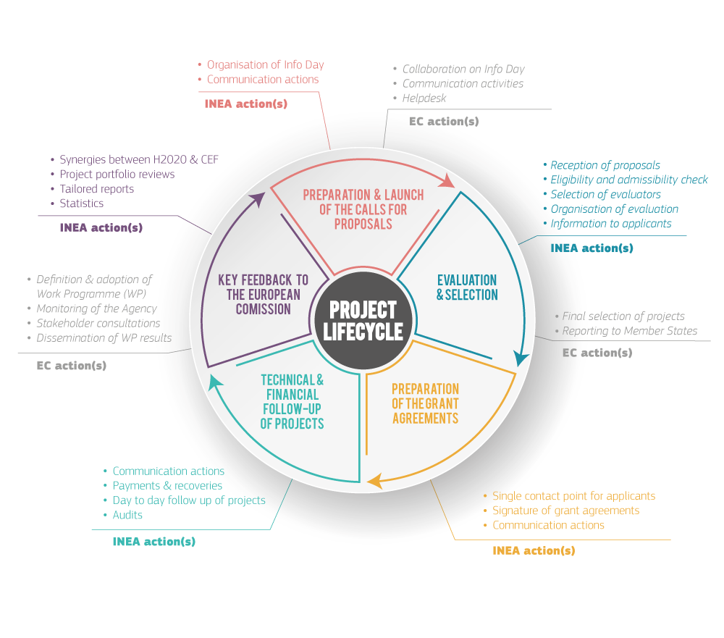

**Benefits, Simplifications and Synergies introduced by INEA**

Enabling and strengthening efficiency, simplifications and synergies between the three CEF sectors is a key priority for INEA. Actions that are shared across sectors enable cost savings or results to be optimised through the sharing of expertise and best practices, as well as the pooling of financial, technical or human resources. This also benefits the simplification and harmonisation of working methods, enhancing INEA's effectiveness in managing the programme.

**Shared governance and resources**

INEA's Steering Committee made up of representatives from the Parent DGs and other associated services (DG REGIO, DG ENV, EIB) ensures synergies between the CEF sectors for strategy and governance of the Agency's work related to the programme.

Joint Commission coordination meetings encourage synergies for all three CEF sectors in procedures and working methods. INEA reports on or raises cross-sector issues to be examined.

CEF implementation costs are optimised via economies of scale - with consolidated functions in the Agency for programme support and horizontal services (Communication, Reporting, Evaluation, Financial Engineering, Human Resources, Logistics, Legal Services, ICT, Audit, Accounting, etc.).

Integrated tools and services can be provided to the different CEF parent DGs, from the technical and financial implementation of the entire project cycle to programme reporting and reviews.

**Programme/project management, including support to beneficiaries**

INEA's website provides a single point of access to all CEF funding opportunities and project information – acting as a one stop shop for all CEF sectors with streamlined communication and easy access to information. This ensures the provision of high quality information in relation to Calls for Proposals, maintains a high transparency in the allocation of EU funds in all three CEF sectors, and promotes project results and achievements for increased visibility of EU actions and promotion of the CEF programme as a whole.

INEA has developed efficient common, harmonised and optimised evaluation procedures and expert management, user friendly and transparent call documentation, customised IT tools for 'e-submission' to support applicants - and call reporting across the three CEF sectors.

INEA provides guidance and technical support in project management and financial engineering to beneficiaries. This includes dissemination of best practice and innovative solutions to the relevant stakeholder communities.

The Agency works in close partnership with all beneficiaries across the programme, ensuring close monitoring of progress and sound financial management of projects (milestones, deliverables, regular reporting, ad hoc reporting, on-site visits,..). A permanent dialogue is also ensured via workshops and working groups as well as a variety of communication channels.

A single IT tool was developed to support beneficiaries common to several CEF sectors from submission of their application to progress monitoring. This tool also ensures the provision of a full and shared data access for the CEF programme for INEA and the Commission parent DGs, as well as providing the necessary data for individual and harmonised project factsheets to be published on INEA's website.

Streamlined and harmonised procedures across the three CEF sectors have resulted in short payment times and fast response rates.

INEA has harmonised services for Geographical Information Services (GIS) (production of maps and GIS tools) to support the evaluation of proposals, project implementation and decision making processes, as well as use for communication purposes (website + publications) to enhance visibility of the geographical allocation of EU funds and implementation of the networks.

INEA outlines its strategy and communication actions in a Multi-Annual Communication Strategy in line with the priorities of the Commission. One of the 3 pillars of the strategy – Innovating - focuses on synergies and economies of scale for communication activities. This is achieved for example via the website, social media channels, and joint publications (e.g. the forthcoming CEF Implementation Brochure for all 3 CEF sectors). Best practices and experience are also shared between the sectors.

**Support to the European Commission**

Feedback on programme implementation as input to policy making: combining the CEF sectors in the Agency has created an enabling environment that allows a common understanding of the political priorities of the programmes and their implementation through projects, and the transfer of know-how back to the Commission.

INEA's expertise and experience allows an effective support to the CEF parent DGs in discussions with Member States, stakeholders (workshops, committees, conferences, exhibitions etc.).

INEA provides an invaluable contribution to ensuring the alignment of EU funding with the policy priorities, and for support to the drafting on new work programmes.

INEA contributes to maximising the use of EU funds using the complementarity between the different sources – and the Agency's overview helps reduce the risk of double funding.

# Annex 9: Predecessor programme for transport

**Implementation of the TEN-T Programme 2007-2013 (state-of-play: 11/09/2017)**

**1. Calls for Proposals 2007-2013**

TEN-T Calls for Proposals have been launched under 15 different Work Programmes. As a result of these Calls, 717 proposals have been selected by the TEN-T Selection Committee awarding an EU contribution of €9,736.7 million. Out of these proposals, 18 have been cancelled before the adoption of the individual Decision, while for some others the amount of the EU contribution was reduced. As a result, the Programme portfolio consists of 699 projects.

**Table 2. Results of TEN-T Calls for Proposals 2007-2013**

|  |  |  |  |
| --- | --- | --- | --- |
|  | **Selection Decision** | **Individual Decision** | **Reduction (%)** |
| Number of projects | 717 | 699 | 2.51% |
| TEN-T funding | 9,736.7 | 9,490.5 | 2.53% |

There are two different types of individual Decisions used in the TEN-T Programme. They are referred to as Annual type Decision and MAP type Decisions and should not be confused with the different Work Programmes[6]. The following table gives a quick overview of the two types and their main characteristics.

**Table 3. Different types of individual Decisions**

|  |  |  |  |
| --- | --- | --- | --- |
| **Decision Type** | **Number of projects** | **Initial TEN-T funding** | **Characteristics** |
| Annual Decision | 487 | 1,855.4 | At the start of the project, 100% of the EU contribution is committed through one single instalment and 50% pre-financing paid. |
| MAP Decision | 212 | 7,635.0 | The EU contribution is committed through annual instalments depending on the progress of the project as reported in the annual Action Status Report (ASR). The pre-financing payments normally correspond to 50% of the annual instalment. |
| **Total** | **699** | **9,490.5** |  |

The recourse to MAP Decisions has allowed the TEN-T Programme to be less dependent on the actual commitment and payments appropriations allocated in the yearly budget as it is not necessary to commit 100% of the initial EU contribution at the beginning of the project. This has allowed the selection of big, politically important projects through the 2007 MAP Call giving them long-time financial security on EU support (e.g. Brenner Base, Lyon-Turin, …).

**2. Implementation of TEN-T projects**

*2.1. Evolution of the TEN-T Programme*

Figure 1 below shows the evolution of the portfolio of the TEN-T Programme 2007-2013 until September 2017. Out of the total number of 699 projects, 45 had to be cancelled while 587 are already officially closed, leaving 67 ongoing.

**Figure 17. Evolution of the TEN-T project portfolio**

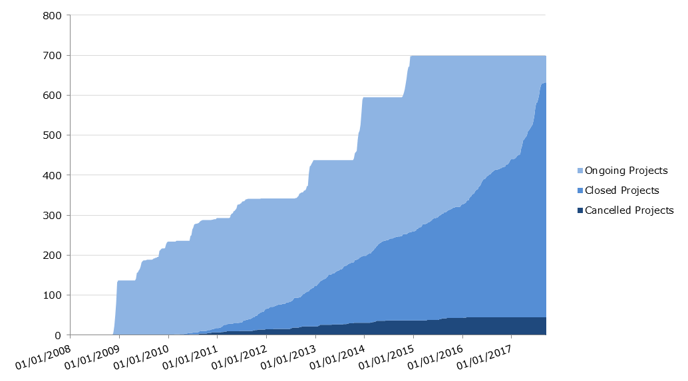

*2.2. Mid-term review and re-injection of funds*

An important milestone in the management of the Programme was the mid-term review organised jointly by DG MOVE and the Agency in 2010[7]. The review was based on the 'use-it-or-lose-it' principle consisting in applying funding reductions to projects with low performance and re-injecting the unused funds into new calls for proposals, so that TEN-T funds are optimally used through their re-investment in the Programme. This principle has since been applied every year after the annual ASR (Action Status Report) exercise.

In general, the financial crisis has significantly impacted the speed and scope of the implementation of TEN-T projects. In combination with strict implementation deadlines (e.g. 31/12/2015 for projects selected under the 2007 MAP Call), it was therefore necessary to update the implementation plans of many projects (including the corresponding funding reductions) and, subsequently, re-inject the unused funding to new projects.

The figure below shows the evolution of the EU funding of the entire project portfolio after cancellations, amendments or completion of projects. The black line indicates the total commitment appropriation available for grants (see Annex for details).

**Figure 18. Evolution of TEN-T funding (€ million)**

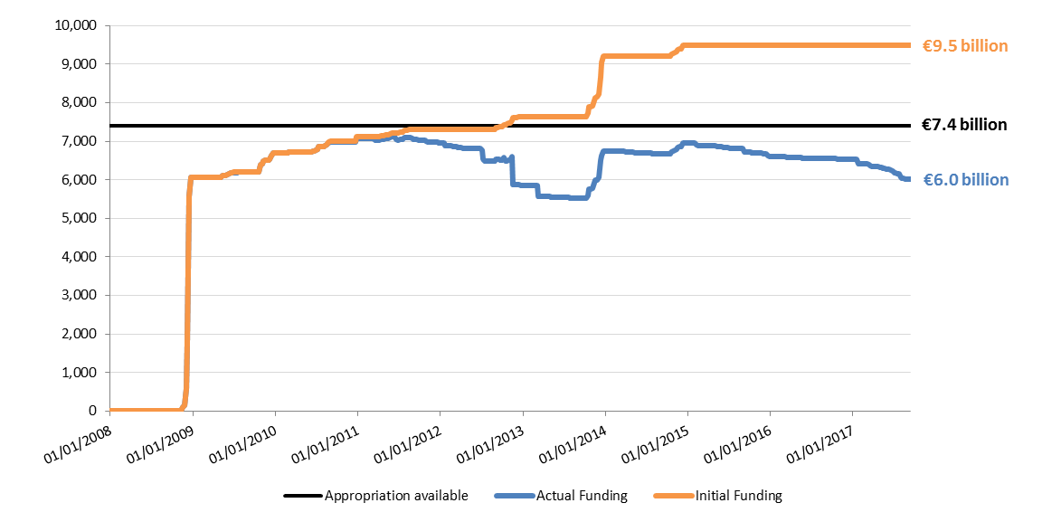

The choice of re-injection of unused funds into the Programme has proven its clear added value. As only part of the total EU support is committed at the beginning of the MAP Decision projects, it was made possible through amendments of the funding Decisions to reduce the EU contribution of underperforming projects and to return the uncommitted funds to the Programme (this has been termed 'legal decommitment'). NB. In case of cancellations or partial completion of projects however, it might also be necessary to recover part of the pre-financing. Table 3 shows how all funding reductions have been recuperated financially.

**Table 4. Financial recuperation of actual funding reductions (€ million)**

|  |  |  |  |  |  |  |  |
| --- | --- | --- | --- | --- | --- | --- | --- |
| **Decision Type** | **Number of projects** | **Initial TEN-T funding** | **Actual TEN-T funding** | **Actual funding reduction** | **out of which:  Legal decommitment** | **out of which:  Decommitment** | **out of which:  Recovery order** |
| Annual | 487 | 1,855.4 | 1,261.2 | 594.2 | 0.0 | 404.5 | 189.7 |
| MAP | 212 | 7,635.0 | 4,746.4 | 2,888.6 | 2,263.6 | 529.0 | 96.0 |
| **Total** | **699** | **9,490.5** | **6,007.6** | **3,482.8** | **2,263.6** | **933.5** | **285.7** |

Therefore, out of a total amount of initial funding Decisions of €9,490.5 million an amount of €2.3 billion was released and re-injected to the Programme. The decommitted amount was lost to the Programme and returned to the general budget of the Commission while the cashed recovery orders became available as new commitment credits (C4 – assigned revenue) and used for either the TEN-T Programme or, as of 2014, for the CEF Transport Programme.

*2.3. Programme Execution*

2.3.1 Absorption analysis

The total commitment appropriations available under the TEN-T Programme 2007-2013 for Calls for Proposals amounted to **€7,405.5 million** (see section below on Financial Overview). The execution can be measured in different terms:

* Consumption through individual commitments

One of the key performance indicators of INEA is to ensure 100% budget execution in every given year. As from the handover in 2008, INEA has achieved this target year after year and the commitment appropriations from 2007 until 2012 have been successfully individualised[8]. However, an amount of around €180 million of the 2013 commitment appropriation was not individualised due to mainly a relatively unsuccessful TEN-T Call for Proposals 2013 for which an initial amount of €350 million (+€70 million flexibility) was foreseen but only €285 million were individualised.

|  |
| --- |
| **Commitment execution:**  The execution in terms of individual commitments reached almost **98%**. |

* Consumption through EU contribution considered eligible through cost claims

As outlined above, a total of 45 projects had to be cancelled while 587 are already officially closed, leaving 67 projects ongoing.

Cancelled projects:

|  |  |  |  |  |  |  |
| --- | --- | --- | --- | --- | --- | --- |
| **Decision Type** | **Number of projects** | **Actual TEN-T Funding (€ million)** | **Initial TEN-T Funding (€ million)** | **% of absorption** | **Total commitment  (€ million)** | **% of absorption** |
| Annual | 31 | 0.0 | 126.9 | 0.0% | 126.9 | 0.0% |
| MAP | 14 | 0.0 | 396.2 | 0.0% | 27.9 | 0.0% |
| **Total** | 45 | 0.0 | 523.1 | 0.0% | 154.8 | 0.0% |

Closed projects:

|  |  |  |  |  |  |  |
| --- | --- | --- | --- | --- | --- | --- |
| **Decision Type** | **Number of projects** | **Actual TEN-T Funding (€ million)** | **Initial TEN-T Funding (€ million)** | **% of absorption** | **Total commitment  (€ million)** | **% of absorption** |
| Annual | 423 | 1,080.5 | 1,527.8 | 70.7% | 1,529.2 | 70.7% |
| MAP | 164 | 2,680.6 | 4,090.3 | 65.5% | 3,199.3 | 83.8% |
| **Total** | 587 | 3,761.1 | 5,618.1 | 66.9% | 4,728.5 | 79.5% |

In total, closed projects absorbed €3,761.1 million of TEN-T Funding in contrast to an amount allocated in the initial TEN-T Decisions of €5,618.1 (i.e. 67%). However, the total commitment appropriation used for these projects was €4,728.5 which is lower than the amount initially allocated due to the recourse to MAP Decision. These commitments have been absorbed through cost claims at 79.5%.

Ongoing projects:

For the remaining ongoing projects, the final payment claim has in most cases been received and the final TEN-T funding can therefore relatively precisely be estimated. Assuming no reduction of the declared costs, the estimated TEN-T Funding for the ongoing projects is €1,800 million. However, on the basis of historical data, we must assume the detection of ineligible costs. The resulting forecasted TEN-T funding for ongoing projects is €1,746 million, corresponding to absorption rates of 52.1% of the initially allocated TEN-T funding and 74.6% of the committed appropriation.

|  |  |  |  |  |  |  |
| --- | --- | --- | --- | --- | --- | --- |
| **Decision Type** | **Number of projects** | **Forecasted TEN-T Funding (€ million)** | **Initial TEN-T Funding (€ million)** | **% of absorption** | **Total commitment  (€ million)** | **% of absorption** |
| Annual | 33 | 122.4 | 200.7 | 61.0% | 200.7 | 61.0% |
| MAP | 34 | 1,623.5 | 3,148.5 | 51.6% | 2,141.0 | 75.8% |
| **Total** | 67 | 1,745.9 | 3,349.2 | 52.1% | 2,341.7 | 74.6% |

The total amount of forecasted TEN-T funding for the 699 adopted TEN-T Decision is therefore €5,508 million corresponding to 76.2% of the individualised commitment appropriation and 74.4% of the total commitment appropriation available.

|  |
| --- |
| **Programme execution:**  Within the current framework, the final absorption of the TEN-T budget available for grants is forecasted to be around 74.4%. |

**Figure 19. Overview of TEN-T budget absorption (€ million)**

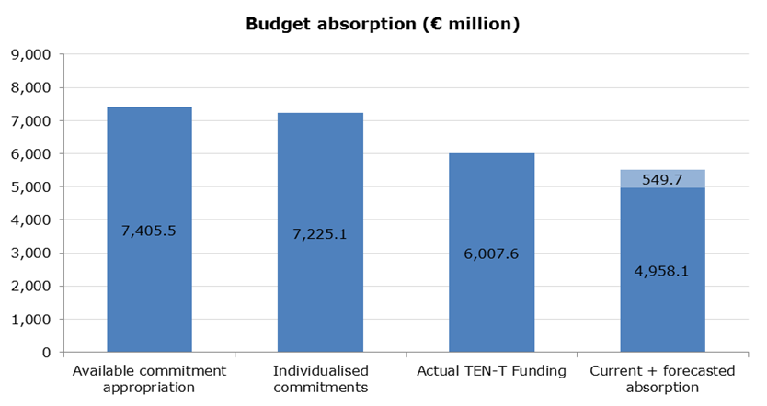

**Financial Overview**

The total operational commitments available for the TEN-T Programme amounted to €7,945.7 million, shared between DG MOVE, DG ECFIN and INEA according to the table below:

|  |  |  |  |
| --- | --- | --- | --- |
| **Fund Management Centre** | **C1 - Appropriation** | **C4/C5 - Appropriation** | **Total** |
| DG MOVE (SESAR) | 350.0 |  | 350.0 |
| DG ECFIN (Marguerite) | 80.0 |  | 80.0 |
| INEA | 7,386.2 | 129.5 | 7,515.7 |
| **Total** | **7,816.2** | **129.5** | **7,945.7** |

Some parts of this budget were not used for grants selected under Calls for Proposals:

* Support to the Marguerite Fund (€80 million)
* Support to financial instruments (almost 6% of the total budget)

|  |  |
| --- | --- |
|  | **Amount** |
| LGTT | 250.0 |
| LGTT (accrued interest) | 6.9 |
| Project Bonds | 200.0 |
| EPEC | 3.0 |
| **Total** | **459.9** |

* A small amount (€0.3 million) was also used for administrative expenditure under the TEN-T Calls for Proposals 2012 and 2013.

🡪 The remaining amount of **€7,405.5 million** was available for projects under Calls for Proposals.

# Annex 10: Predecessor programmes for energy: Relevance of legacy projects for CEF

Following the legislation adopted in 1996 and 2003 respectively, the main EU instruments on trans-European energy networks (TEN-E) were adopted in 2006 and 2007. These were Decision 1364/2006/EC laying down guidelines for TEN-E and repealing Decision No 391/1996/EC and Decision No 1229/2003/EC, followed by Regulation 680/2007/EC (“TEN Financial Regulation”). Through this Decision, based on Article 156 of the Treaty on the European Community (now Article 172 of the Treaty on the Functioning of the European Union), the European Community promoted the interconnection, interoperability and development of trans-European energy networks and access to such networks in accordance with Community law in force. The aim was encouraging the effective operation and development of the internal energy market, facilitating the development and reducing the isolation of the less-favoured and island regions of the Community, reinforcing the security of energy supplies, contributing to sustainable development and protection of the environment, inter alia by involving renewable energies and reducing the environmental risks associated with the transportation and transmission of energy.

This Decision defined the nature and scope of Community action to establish guidelines for trans-European energy networks, covering the objectives, priorities and broad lines of action by the Community in respect of trans-European energy networks. These guidelines ranked a total of 342 priority projects/axis in three categories, with the aim to create a more favourable context for development of those networks[9]:

* Projects of Common Interest – which related to the electricity and gas networks meeting the objectives and priorities laid down in the Decision (the list in Annex II made reference to the specific objectives and the Member States involved; the list in Annex III laid down 286 projects – 164 in the electricity sector and 122 in the gas sector – with no specifications defined when it came to actions improving the functioning of the interconnected electricity networks within the internal market, as well as actions improving the functioning of the interconnected gas networks within the internal market); they had to display potential economic viability (assessed by means of a cost-benefit analysis in terms of the environment, the security of supply and territorial cohesion);
* Priority Projects – selected from among the projects of common interest and had to have a significant impact on the proper functioning of the internal market, on the security of supply and/or the use of renewable energy sources (the reference list in Annex I laid down 15 axis – 9 in the electricity sector and 6 in the gas sector);
* Projects of European Interest – priority projects of a cross-border nature or which had a significant impact on cross-border transmission capacity (the reference list in Annex I laid down 41 Projects of European Interest – 31 in the electricity sector and 10 in the gas sector). They had priority for the granting of Community funding under the TEN-E budget and particular attention was given to their funding under other Community budgets.

Under the TEN-E programme 2007–2013, only actions related to one or more of the projects identified in the TEN-E Guidelines received EU financial aid. The evaluation has been based on the following award criteria:

* Maturity of project
* Stimulating effect of EU intervention on public and private finance
* Soundness of financial package
* Socio-economic effects
* Environmental consequences
* Need to overcome financial obstacles
* The degree of contribution to the continuity and interoperability of the network, as well as optimisation of its capacity
* The degree of contribution to the improvement of service quality, safety and security

Between 2007 and 2013, a total number of 111 projects were co-financed under 128 TEN-E Grant Decisions for a total budget of €143 million. To date, 17 projects are still ongoing.

In 2013, after 6 years of implementation, the TEN-E regulation was fundamentally revised and replaced by Regulation 347/2013 on guidelines for trans-European energy infrastructure (“TEN-E Guidelines”). Under this regulation, a revolutionarily new approach was established, aimed at identifying Projects of Common Interest in 12 energy infrastructure priority corridors and areas. The new concept of project of common interest covers lines, pipelines, facilities, equipment or installations falling under the energy infrastructure categories and is defined by certain criteria: it is necessary for at least one of the energy infrastructure priority corridors and areas; the potential overall benefits of the project outweigh its costs, including in the longer term; and the project has to either involve at least two Member States by directly crossing the border of two or more Member States, be located on the territory of one Member State and have a significant cross-border impact or cross the border of at least one Member State and a European Economic Area country.

Out of the 111 projects co-financed under the TEN-E programme 2007-2013, 37 projects became PCIs on the first Union list of Projects of Common Interest published on 14 October 2013: 21 electricity projects (20 transmission lines and 1 smart grids project) and 16 projects in the gas sector (13 high-pressure pipelines, 2 LNG terminals and 1 underground storage). Of those, 15 PCIs (corresponding to 18 actions) were selected to receive also grants for studies or works under the 2014-2016 CEF calls for proposals (see table 1 below).

As an ad-hoc instrument under the 2007-2013 Multiannual Financial Framework, the European Energy Programme for Recovery (EEPR) was adopted in 2009 with the specific aim to make energy supplies more reliable and help reduce greenhouse emissions, while simultaneously boosting Europe's economic recovery after the gas crisis in Ukraine. Under this programme, grants for works were awarded to selected, highly strategic projects covering three broad fields: gas and electricity infrastructure projects, offshore wind projects and carbon capture and storage projects. Most of the budget available was allocated to 59 promoters and 61 projects in the following sub-programmes: gas infrastructure (€1363 million, contributing to 8 projects having acquired PCI status on the first Union list of 2013); electricity infrastructure (€904 million, contributing to 2 PCIs); offshore wind energy (€565 million); and carbon capture and storage (€1000 million). Among those 10 PCIs only one was selected to receive a grant also under the 2014-2016 CEF calls for proposals (see table 2 below).

Table 1: PCI supported under TEN-E (2007-2013) and continuity of funding under CEF



Table 2: PCI supported under EEPR and continuity of funding under CEF



# Annex 11: Predecessor programme for telecommunication

CIP

The Competitive and Innovation Programme – Policy Support Programme (CIP-PSP) provided the perfect instrument to launch large scale pilot (LSP) to develop and validate solution with MS government. Several LSPs were launched, STORK (on eID), PEPPOL (eProcurement), epSOS (on eHealth), SPOCS (Services Directive), eCODEX (on eJustice), eCALL (on transport emergency call) and eventually eSENS (on the convergence of the building blocks). The issue of sustainability of the developed services emerged quickly: it was clear that, although the approach was always federated, central component still existed and would need EU financial and political support[10]. The CEF programme was designed specifically for that purpose and to enable the operation of key cross border infrastructures. Because of its centralised approach, the ISA programme could not support the deployment of the services as needed. CEF enables to deploy and operate the central infrastructure and to support MS stakeholders to hock the own infrastructure to it. This creates immediately cross border services for the policy identified in the regulation.

# Annex 12: List of synergy actions



# Annex 13: CEF Calls 2014-2016 actual EU support per sector and country

***CEF Transport: actual EU support per envelope and country***

|  |  |  |  |
| --- | --- | --- | --- |
| **Country** | **General Envelope Actual EU Support** | **Cohesion Envelope Actual EU Support** | **Total Actual EU Support** |
| AT | €758.8M | €0.4M* | €759.3M |
| BE | €482.9M | €0.0M | €482.9M |
| BG | €0.6M | €405.7M | €406.3M |
| CY | €10.2M | €45.0M | €55.2M |
| CZ | €2.2M | €1,115.1M | €1,117.3M |
| DE | €2,107.1M | €0.0M | €2,107.1M |
| DK | €670.7M | €0.0M | €670.7M |
| EE | €16.2M | €191.9M | €208.1M |
| EL | €51.4M | €577.3M | €628.6M |
| ES | €976.5M | €0.0M | €976.5M |
| FI | €126.6M | €0.0M | €126.6M |
| FR | €1,997.3M | €0.0M | €1,997.3M |
| HR | €2.3M | €422.2M | €424.4M |
| HU | €9.2M | €1,072.3M | €1,081.5M |
| IE | €91.6M | €0.0M | €91.6M |
| IT | €1,423.7M | €0.0M | €1,423.7M |
| LT | €25.0M | €367.6M | €392.6M |
| LU | €71.6M | €0.0M | €71.6M |
| LV | €11.6M | €255.2M | €266.8M |
| MT | €3.6M | €41.7M | €45.3M |
| NL | €356.9M | €0.0M | €356.9M |
| PL | €16.8M | €4,136.3M | €4,153.1M |
| PT | €169.6M | €508.0M | €677.6M |
| RO | €3.5M | €1,225.5M | €1,229.1M |
| SE | €195.2M | €0.0M | €195.2M |
| SI | €34.7M | €174.7M | €209.4M |
| SK | €0.4M | €704.2M | €704.7M |
| UK | €348.6M | €0.4M | €349.0M |
|  |  |  |  |
| BA | €0.1M | €0.1M | €0.1M |
| EEIG | €13.5M | €8.5M | €22.0M |
| IL | €7.0M | €0.0M | €7.0M |
| IO | €75.1M | €7.4M | €82.5M |
| MK | €0.1M | €0.0M | €0.1M |
| NO | €9.2M | €0.0M | €9.2M |
| RS | €11.5M | €0.2M | €11.7M |
| **Total** | **€10,1B** | **€11,3B** | **€21,3B** |

Under countries, IO refers to International Organisations and EEIG to European Economic Interest Grouping

Please note that this data may differ from the national cohesion envelope in terms of budget allocation. This is explained because some of the Cohesion member States supported non cohesion countries i.e. UK and AT, international organisations or EIEEIGs

The actual EU support includes reduction of funding due to amendments, terminations and closures

|  |  |
| --- | --- |
|  | **Actual  EU Support** |
| *AT* | €0.01M |
| *BG* | €69.1M |
| *CY* | €15.8M |
| *CZ* | €5.0M |
| *DE* | €50.1M |
| *DK* | €7.2M |
| *EE* | €166.4M |
| *EL* | €9.3M |
| *ES* | €6.3M |
| *FI* | €94.1M |
| *FR* | €17.9M |
| *HR* | €128.2M |
| *HU* | €2.5M |
| *IE* | €110.4M |
| *LT* | €112.7M |
| *LV* | €128.7M |
| *MT* | €0.4M |
| *PL* | €271.7M |
| *PT* | €1.0M |
| *RO* | €180.8M |
| *SI* | €27.5M |
| *SK* | €59.7M |
| *UK* | €73.5M |
|  |  |
| *CH* | €14.0M |
| *NO* | €26.4M |
| *TR* | €10.3M |
| ***Total*** | **€1.6B** |

***CEF Energy: actual EU support per country*** ***CEF Telecom: actual EU support per country***

|  |  |
| --- | --- |
| **Country** | **Actual  EU Support** |
| AT | €5.5M |
| BE | €3.3M |
| BG | €1.5M |
| CY | €4.1M |
| CZ | €2.9M |
| DE | €8.9M |
| DK | €6.2M |
| EE | €2.3M |
| EL | €5.4M |
| ES | €8.4M |
| FI | €4.7M |
| FR | €5.9M |
| HR | €3.9M |
| HU | €2.6M |
| IE | €4.9M |
| IT | €8.7M |
| LT | €3.3M |
| LU | €3.6M |
| LV | €1.8M |
| MT | €2.2M |
| NL | €7.6M |
| PL | €3.9M |
| PT | €4.8M |
| RO | €3.5M |
| SE | €1.9M |
| SI | €2.7M |
| SK | €1.8M |
| UK | €8.2M |
|  |  |
| IS | €1.4M |
| NO | €2.2M |
| RS | €0.03M |
| **Total** | **€128.3M** |

***CEF Synergy: actual EU support per country***

|  |  |
| --- | --- |
| **Country** | **Actual  EU Support** |
| AT | €4.2M |
| BE | €0.9M |
| CY | €2.6M |
| DE | €1.0M |
| EL | €1.7M |
| HR | €1.0M |
| MT | €0.6M |
| NL | €6.5M |
| PL | €1.0M |
| SE | €1.8M |
| UK | €0.2M |
| **Total** | **€22.1M** |

1. See: <http://ec.europa.eu/smart-regulation/roadmaps/docs/2017_move_003_mid_term_evaluation_connecting_europe_facility_en.pdf>
2. The evidence that was collected as part of the underlying study did not allow for a full quantification of CBCA.
3. Including: Bankwatch Network, Climate Action Network Europe, European Environmental Bureau, Energy Watch Group, E3G, Food & Water, Europe, Friends of the Earth Europe, Green Budget Europe, Justice and Environment - European Network of Environmental Law Organizations, transport & Environment
4. [Regulation (EC) No 663/2009 of the European Parliament and of the Council of 13 July 2009 establishing a programme to aid economic recovery by granting Community financial assistance to projects in the field of energy](http://eur-lex.europa.eu/LexUriServ/LexUriServ.do?uri=CELEX:32009R0663:EN:NOT)
5. The total budget of the EEPR programme i.e. EUR 3.980 billion was divided into three sectors: gas and electricity infrastructure projects (EUR 2.365 billion); offshore wind energy projects (EUR 0.565 billion) and carbon capture and storage projects (EUR 1.05 billion)
6. In fact, there are Annual Decisions for projects selected under the MAP Call and there are MAP Decisions for projects selected under an Annual Call.
7. Review of the MAP 2007 project portfolio: <http://inea.ec.europa.eu/en/ten-t/ten-t_projects/mid-term_review/2007-2013_map_project_portfolio_review.htm>
8. For SESAR, selected under the 2007 MAP Call, INEA has made a commitment of €200 million and following the handover, DG MOVE has committed the remaining €150 million. The project has ended on 31/12/2016 and DG MOVE expects an absorption of around €320 million (however, the final payment claim was not yet submitted).
9. Complete list of projects: Annex I, II and III of the Decision 1364/2006/EC
10. CIP ICT PSP Second Interim Evaluation. Final report (2011). http://ec.europa.eu/information_society/activities/ict_psp/documents/cip_ict_psp_final_second_interim_evaluation-final_report_2011.pdf