

**ANNEX 3 - European Border and Coast Guard**

**1. Deployments**

The European Border Coast Guard Agency continues to support frontline Member States, with deployments in Greece, Italy, Bulgaria and Spain as well as in the Western Balkans, with approximately 1350 members of the European Border and Coast Guard teams. The map presents the situation in week 5-9 March 2018.

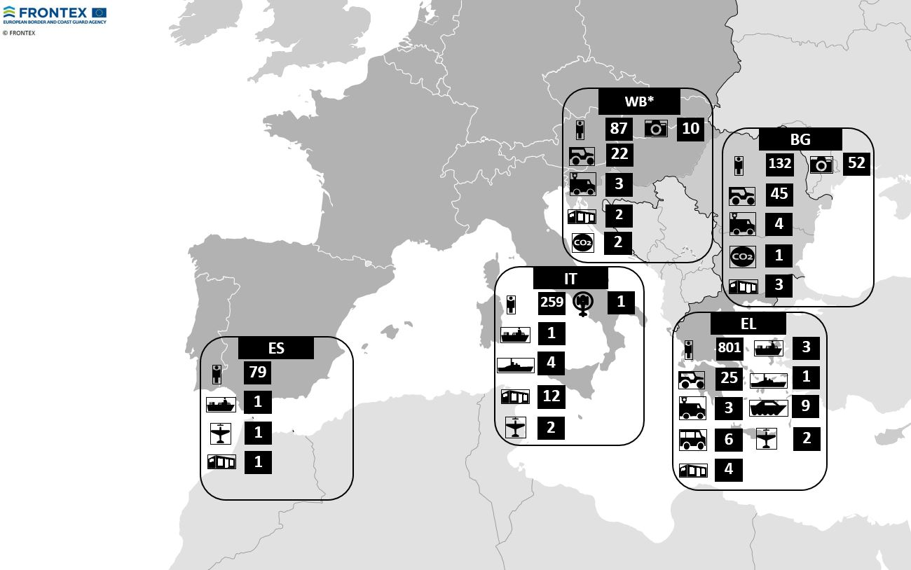

* Western Balkans

Between 1 January and 31 December 2017, the Member States contributed over 597,000 man-days.

| **MS/ SAC[1]** | **EBCGT[2] Deployment man-days (excl. internal deployments)** | **Crew/technical staff, coordinating staff & interpreters deployment man-days (excl. internal deployments)** | **Internal deployment man-days** | **Western Balkan deployments** | **Total** |
| --- | --- | --- | --- | --- | --- |
| Austria | 6,677 | 366 |  | 5,220 | 12,263 |
| Belgium | 1,179 |  |  | 174 | 1,353 |
| Bulgaria | 11,598 | 2,662 | 9,696 | 203 | 24,159 |
| Croatia | 2,009 | 2,162 |  | 150 | 4,321 |
| Cyprus | 431 |  |  | 29 | 460 |
| Czech Rep. | 4,231 | 228 |  | 1,558 | 6,017 |
| Denmark | 3,186 | 2,166 |  |  | 5,352 |
| Estonia | 3,761 | 997 |  | 442 | 5,200 |
| Finland | 923 | 4,472 |  | 571 | 5,966 |
| France | 17,658 | 6,085 |  | 472 | 24,215 |
| Germany | 28,502 | 10,724 |  | 6,268 | 45,494 |
| Greece | 599 | 61 | 172,279 | 283 | 173,222 |
| Hungary | 1,681 |  |  | 522 | 2,203 |
| Iceland |  | 956 |  |  | 956 |
| Italy | 1,597 | 7,566 | 41,854 | 460 | 51,477 |
| Latvia | 3,068 | 6,408 |  | 1,218 | 10,694 |
| Lithuania | 4,317 | 813 |  | 639 | 5,769 |
| Luxembourg | 949 | 1,217 |  | 57 | 2,223 |
| Malta |  | 19,419 |  | 456 | 19,875 |
| Netherlands | 18,417 | 14,191 |  | 478 | 33,086 |
| Norway | 1,065 | 15,916 |  | 29 | 17,010 |
| Poland | 11,658 | 1,335 |  | 2,887 | 15,880 |
| Portugal | 5,635 | 27,421 |  | 2,443 | 35,499 |
| Romania | 13,515 | 10,341 |  | 6,916 | 30,772 |
| Slovakia | 1,976 |  |  | 174 | 2,150 |
| Slovenia | 853 |  |  | 1,658 | 2,511 |
| Spain | 7,318 | 6,062 | 19,487 | 3,091 | 35,958 |
| Sweden | 2,139 | 3,713 |  | 282 | 6,134 |
| Switzerland | 506 |  |  | 493 | 999 |
| United Kingdom* | 3,884 | 12,613 |  |  | 16,497 |
| **Total** | **159,332** | **157,894** | **243,316** | **37,173** | **597,715** |

* Not formally EBCGT contributor

However, serious gaps in pledges in human and technical resources were identified for 2018 operational activities. These considerable shortages risk to severely limit the implementation of the activities planned for 2018 at the land, sea and air borders.

|  |  |  |  |  |
| --- | --- | --- | --- | --- |
| **Land Borders** | | | | |
|  | *Requested Man-days* | *Agreed*  *Man-days* | *Gaps*  *Man-days* | *Gap %*  *Man-days* |
| **Human resources** (different EBCGT profiles) | 124470 | 61295 | 63179 | **51%** |
|  | *Requested*  *Asset - Days* | *Agreed*  *Asset - Days* | *Gaps*  *Asset-Days* | *Gap %*  *Asset-days* |
| Patrol car | 28632 | 12139 | 16493 | **58%** |
| Thermo vision vehicles | 3159 | 1510 | 1649 | **52%** |
| Transportation vehicle | 786 | 0 | 786 | **100%** |
| CO2 Detectors | 1405 | 1830 | 0 | **0%** |
| Heartbeat detector | 338 | 0 | 338 | **100%** |
| Mobile laboratory | 169 | 0 | 169 | **100%** |
| **Total** | **34489** | **15479** | **19435** | **56%** |
| **Sea Borders** | | | | |
|  | *Requested Man-days* | *Agreed*  *Man-days* | *Gaps*  *Man-days* | *Gap %*  *Man-days* |
| **Human resources** (different EBCGT profiles) | **124775** | **103746** | **19002** | **15%** |
|  | *Requested*  *Asset - Days* | *Agreed*  *Asset - Days* | *Gaps*  *Asset-Days* | *Gap %*  *Asset-days* |
| Offshore Patrol Vessels | 1711 | 868 | 843 | **49%** |
| Coastal Patrol Vessels | 2201 | 522 | 1679 | **76%** |
| Coastal Patrol Boats | 4103 | 2016 | 2087 | **51%** |
| Fixed wing aircraft | 1220 | 876 | 344 | **28%** |
| Helicopter | 1432 | 786 | 646 | **45%** |
| Thermo vision vehicles | 856 | 1014 | 0 | **0%** |
| Patrol car | 4725 | 765 | 3960 | **84%** |
| Transportation vehicle | 2376 | 2376 | 0 | **0%** |
| **Total** | **18624** | **9223** | **9215** | **49%** |
| **Air Borders** | | | | |
|  | *Requested Man-days* | *Agreed*  *Man-days* | *Gaps*  *Man-days* | *Gap %*  *Man-days* |
| **Human resources** (different EBCGT profiles) | **12751** | **9524** | **3227** | **25%** |

**2. Rapid Reaction Capabilities, including the mandatory pooling of resources**

By 5 March 2018, the total number of "nominated" border guards available for deployments from the Rapid Reaction Pool will be 1481, representing 99% of the Pool.

|  |  |  |  |  |  |  |  |  |  |  |  |  |  |  |  |  |  |  |  |  |  |  |  |  |  |  |  |  |  |
| --- | --- | --- | --- | --- | --- | --- | --- | --- | --- | --- | --- | --- | --- | --- | --- | --- | --- | --- | --- | --- | --- | --- | --- | --- | --- | --- | --- | --- | --- |
| Member States | Austria | Belgium | Bulgaria | Croatia | Cyprus | Czech Republic | Denmark | Estonia | Finland | France | Germany | Greece | Hungary | Iceland | Italy | Latvia | Lithuania | Luxembourg | Malta | Netherlands | Norway | Poland | Portugal | Romania | Slovakia | Slovenia | Spain | Sweden | Switzerland |
| Number of border guards nominated in Opera | 52 | 83 | 40 | 97 | 0 | 137 | 28 | 171 | 57 | 397 | 370 | 87 | 65 | 0 | 130 | 30 | 52 | 8 | 14 | 93 | 12 | 280 | 68 | 196 | 60 | 35 | 146 | 62 | 46 |
| Number available for mandatory deployment under the RRP | 34 | 30 | 40 | 65 | 0 | 20 | 28 | 18 | 30 | 170 | 225 | 50 | 65 | 0 | 125 | 30 | 39 | 8 | 6 | 50 | 12 | 100 | 47 | 75 | 35 | 35 | 111 | 17 | 16 |
| Contributions under Annex I of the EBCG Regulation | 34 | 30 | 40 | 65 | 8 | 20 | 29 | 18 | 30 | 170 | 225 | 50 | 65 | 2 | 125 | 30 | 39 | 8 | 6 | 50 | 20 | 100 | 47 | 75 | 35 | 35 | 111 | 17 | 16 |

Under the **Rapid Reaction Equipment Pool**, while some improvements were made, considerable gaps remain for most types of equipment and the current contributions continue to be ensured by only 14 Member States/Associated States:

|  |  |  |  |  |
| --- | --- | --- | --- | --- |
| Type of equipment | No. of asset-months  Requested by Management Board Decision | No. of asset-months offered by MS/SAC | Gap | Contributing States |
| Buses | 36 | 5 | 31 | Bulgaria, Czech Republic, Finland, Croatia, Hungary, Latvia, Netherlands, Slovenia, Portugal, Italy, Austria, Poland, Germany, Switzerland |
| Coastal Patrol Boat | 67 | 24 | 43 |
| Coastal Patrol Vessel | 33 | 14 | 19 |
| Fixed wing aircraft | 19 | 5 | 14 |
| Helicopter | 20 | 3 | 17 |
| Offshore Patrol Vessel | 28 | 24 | 4 |
| Patrol car | 167 | 453 | 0 |
| Heart Beat detector | 6 | 0 | 6 |
| Thermo vision vehicles | 55 | 35 | 20 |
| CO2 Detector | 54 | 0 | 54 |  |
| Mobile Laboratory | 3 | 0 | 3 |  |

**3. Vulnerability Assessments**

By 5 March 2018, following the 2017 assesments, the Agency recommended 37 measures in 21 Member States addressing vulnerabilities in different areas. Several additional recommendations may be still issued.

|  |  |  |
| --- | --- | --- |
| **Vulnerabilities** | **Recommended measures** | **No. of Member States** |
| **Border checks** | * Adapt procedures for database consultations for systematic checks * Establish an estimated number of undetected cases of document fraud/clandestine entries and perform targeted checks | 20 |
| **Contingency planning** | * Develop and/or update the contingency plan, test the plan | 7 |
| **Registration and accommodation capacity** | * Increase accommodation capacity * Establish a detailed inventory of EURODAC fingerprinting devices | 5 |
| **Staffing for border control** | * Increase the effective number of staff | 2 |
| **Border surveillance** | * Establish a log of reaction times after detection | 3 |

1. Member States/ Schengen associated countries.
2. European Border and Coast Guard Team.