

**SYNOPSIS REPORT ON THE STAKEHOLDER CONSULTATION ON THE EUROPEAN LABOUR AUTHORITY**

In his 2017 State of the European Union address, the European Commission's President Jean-Claude Juncker proposed that a European Labour Authority (ELA) be established to strengthen cooperation between labour market authorities at all levels and better manage cross-border situations. In line with the Commission's Work Programme, the Commission is scheduled to present a proposal in the first semester of 2018.

This report analyses and summarises the replies to the open public consultation (OPC) and the targeted consultation of stakeholders on the establishment of an ELA.

Description of consultation activities carried out:

A 6-week internet-based OPC was launched by the European Commission on 27 November 2017 in order to explore the views of the citizens and stakeholders on the establishment of a European Labour Authority (ELA). Alongside, the Commission had launched a targeted consultation to stakeholders that had begun on 6 November 2017 with a view to collect views and positions from practitioners, including Member States, public authorities and social partners. The consultation process was concluded on 7 January 2018.

An additional targeted stakeholder consultation in the transport sector was launched on 12 January 2018 and closed on 2 February 2018.

**1. Overview of the consultation process**

*Open public consultation*

A total of 8,809 replies to the web-based OPC were received. While there were only 389 unique replies, a campaign led by the European Trade Union Confederation (ETUC) resulted in 8,420 identical replies in favour of the establishment of ELA. These responses were excluded from the OPC analysis as they would have otherwise skewed the results towards the answers predefined by the campaign. The opinion brought forward by the campaign is taken into account in the analysis of the open-ended questions.

The majority of respondents overall (77%) were located in Austria and Germany. Among the 389 respondents who submitted a non-campaign reply, the highest number of unique replies came from the United Kingdom (61), followed by Belgium and Germany (both 24).

Most respondents indicated being in employment. Among non-campaign respondents, 49% had either current or past mobility experience compared to 26% of campaign respondents.

Few responses were received on behalf of organisations, based on what could be established from the data. Social partners more frequently took part in the OPC than other types of organisation.

*Targeted Consultation*

Position papers submitted by organisations taking part in the consultation, including in the transport sector, as well as the minutes of stakeholder hearings on the ELA were reviewed and analysed.

**2. Analysis of the consultation responses**

***2.1.*** Challenges as regards EU labour mobility

The European Commission bases its proposals for a ELA on two challenges as regards EU labour mobility:

* Inadequate cooperation between national enforcement authorities
* Incomplete or sparse information on labour mobility rights and obligations

*Results from the open public consultation*

About two thirds of respondents agree or strongly agree that the existing cooperation between national authorities is not enough for an effective employment and social security policy implementation in the EU involving cross-border situations (0).

**Q1. Please indicate the extent to which you agree or disagree that existing cooperation between national authorities is insufficient to ensure the effective implementation of EU employment and social security rules in cross-border situations**



*Source: ICF based on responses to the OPC for the establishment of a European Labour Authority and of a European Social Security Number. Answers of respondents from the Campaign are excluded.*

A clear majority of OPC respondents agreed that the issues listed by the Commission were as many challenges to effective cooperation between national authorities on EU cross-border mobility.

**Q2. Please indicate the extent to which you agree or disagree that the elements presented in the figure below constitute challenges to effective cooperation between national authorities on EU cross-border mobility:**

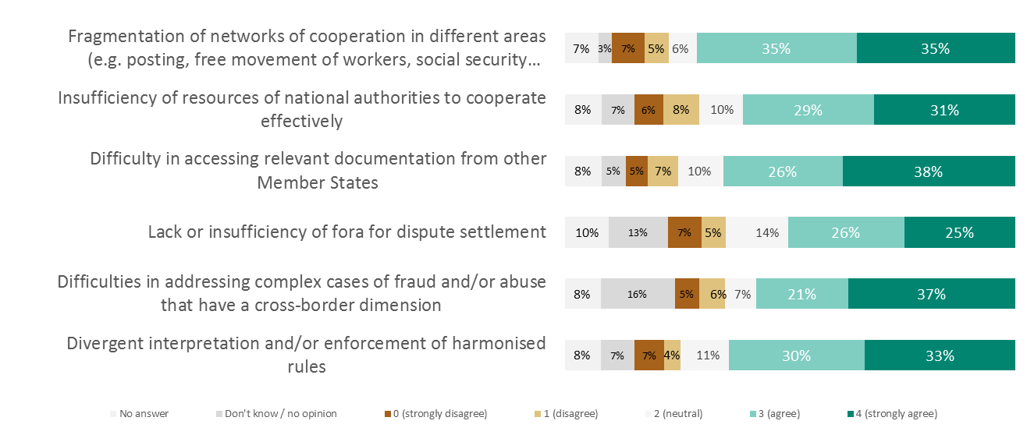

*Source: ICF based on responses to the OPC for the establishment of a European Labour Authority. Answers of respondents from the Campaign are excluded. Percentages are calculated on the total number of responses (N=389).*

A number of respondents raised concerns about the lack of common EU standards for cross-border cooperation on employment and social security matters and the administrative costs that this brings about. This is also combined with the lack of information, unclear communication and lack of transparency as well as unclear rules.

The sample sizes were too small to detect statistically differences in responses by organisation type, country, or labour status. This was mostly due to the high number of nonresponses for these categorical variables.

*Results from the targeted consultation*

Most of the responding stakeholders agreed with the analysis presented in the note on ELA of the most significant challenges linked to improving cooperation at EU level on cross-border employment and social security matters[1].

The challenge most frequently mentioned by the various contributors relates to the effectiveness of information exchange. Most EMCO members, EPSCO as well as certain members within the ECPW (EE, ES, FR, LV, PL) and MISSOC (AT, IT) highlighted inefficiencies in terms of information exchange and access to information by relevant Member State authorities as a major cause of social security fraud and abuses and a major challenge to overcome.

Along with issues around information exchange, many of the abovementioned stakeholders highlighted that differences in administrative capacity between the Member States act as a barrier to effective cooperation. This was especially the case among MISSOC members overall.

A number of stakeholders (French government; AC: BE member; EFBWW; ECPW: ES FR, IT, LV, PL members; PES Network; SLIC; UDW; ETUC and affiliates) highlighted that issues around cooperation and coordination between Member State authorities are primarily caused by specific and complex national administrative landscapes and the lack of streamlined procedures, often with implications for institutional capacity. In its common position, the PES Network added that challenges on cross-border mobility and social security coordination remain as systems in the EU are not harmonised arguing that the ELA could address issues around capacity building which prevents effective cross-border cooperation. The UDW highlighted the fragmentation of efforts to address cross-border mobiilty issues, with many different tools for cooperation existing on EU level; in addition, there are many different bilateral agreements between Member States.

Weak or absent mechanisms for joint cross-border investigation and for dispute settlement was also a challenge mentioned by certain stakeholders, albeit less frequently. This view was shared among the European Parliament's Employment and Social Affairs Committee, the UDW, PES Network, the ILO and the Nordic-Baltic-Polish EU Information Group. Social partners overall also highlighted the absence of a dispute resolution forum as a challenge for resolving litigation on cross border cases. While employer organisations such as Business Europe were overall sceptical of the idea of giving the ELA a dispute resolution function due to potential interference with the ECJ, trade unions such as ETUC were more in favour of the idea so long as the ELA provided out-of-court solutions.

**2.2. Incomplete or sparse information on labour mobility rights and obligations**

*Results of the open public consultation*

A vast majority of the respondents agreed that insufficient access to information and transparency on cross-border mobility rules is a problem for individuals and businesses.

**Q3. Please indicate the extent to which you agree or disagree that insufficient access to information and transparency on cross-border mobility rules is a problem for individuals and businesses:**

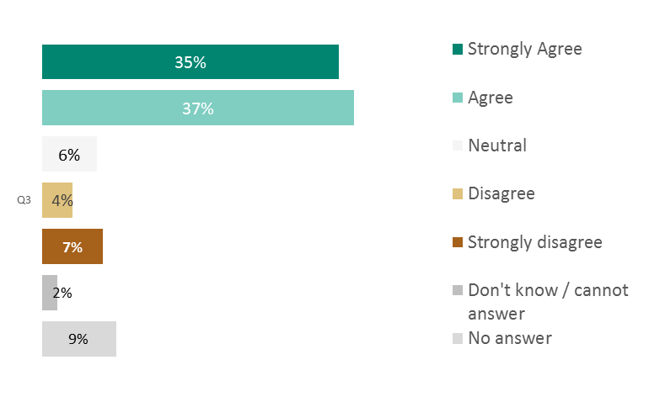

*Source: ICF based on responses to the OPC for the establishment of a European Labour Authority. Answers of respondents from the Campaign are excluded. Percentages are calculated on the total number of responses (N=389).*

Again, a clear majority of OPC respondents agreed with the challenges identified by the Commission to fair and easy access to information and transparency of labour mobility rules.

**Q4. Please indicate the extent to which you agree or disagree that the elements presented in the table constitute challenges to fair and easy access to information and transparency of labour mobility rules:**

***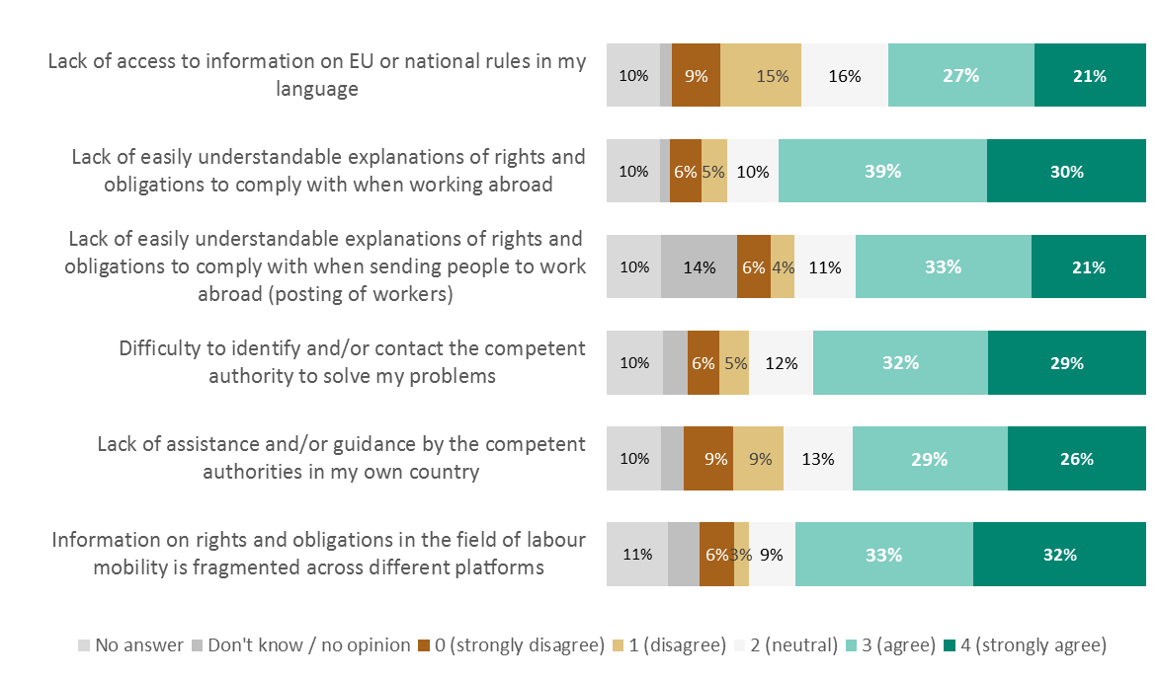****Source: ICF based on responses to the OPC for the establishment of a European Labour Authority. Answers of respondents from the Campaign are excluded. Percentages are calculated on the total number of responses (N=389).*

*Note: percentages labels below 5% have been omitted from the figure to improve readability.*

Among the respondents who provided additional comments[2] the most frequent cause mentioned was institutions' limited administrative capacity to deal with mobility, while the most frequently cited solutions were the creation of a one-stop shop or a better communication channel where straightforward clear information is accessible to all.

The sample sizes were too small to detect statistically differences in responses by organisation type, country, or labour status. This was mostly due to the high number of nonresponses for these categorical variables.

*Responses of the targeted consultation*

A few contributions explicitly mentioned incomplete or sparse information concerning labour mobility rights and obligations as a challenge to cross-border mobility. A number of issues were raised, such as: circumvention of the law caused by unclear or insufficient information (French EMCO member), technicality of the legislation causing confusion in enforcement (HR and IT MISSOC members), lack of awareness to seek the right information (Swedish PES), and need for clarification on EU rules on the posting of workers (employer organisations overall).

**3. Policy options in relation to tasks carried out by a European Labour Authority**

*Results of the open public consultation*

All the potential functions for the ELA proposed in the OPC received strong support overall, in particular supporting information exchange for businesses, individuals and between national authorities.

**Q5. Please indicate the extent to which you agree or disagree that following functions could be usefully carried out by a permanent EU body dealing with labour mobility and social security in cross-border situations:**

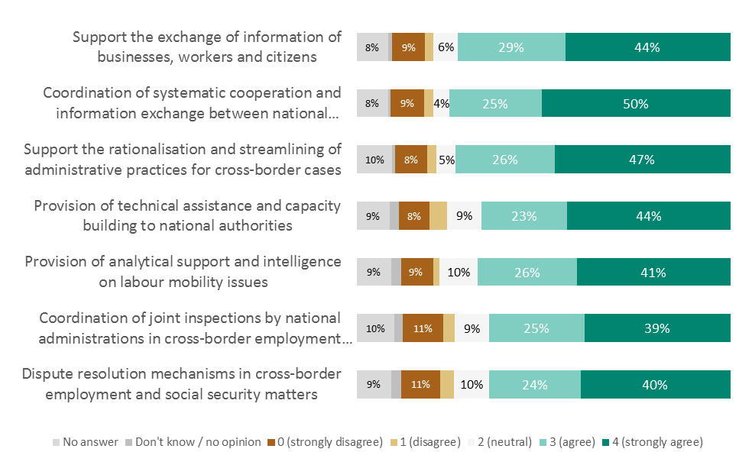

*Source: ICF based on responses to the OPC for the establishment of a European Labour Authority. Answers of respondents from the Campaign are excluded. Percentages are calculated on the total number of responses (N=389).*

*Note: percentages labels below 5% have been omitted from the figure to improve readability.*

Among the OPC respondents who further commented[3], a frequent observation was that an ELA would clearly improve data collection and communication with added value in terms of law enforcement, dispute resolution, social dumping prevention and support for national authorities to post workers. A few respondents were concerned about data privacy and expressed scepticism about the need for a central EU body.

The sample sizes were too small to detect statistically differences in responses by organisation type, country, or labour status. This was mostly due to the high number of nonresponses for these categorical variables.

*Results of the targeted consultations*

Stakeholders were asked what exactly a newly created ELA could do to support cross-border institutional cooperation to fight fraud and abuse and to improve the availability of information to individuals and organisations concerned with labour mobility[4].

The most recurrent views were that the ELA should be above all a platform for information exchange between other institutions and structures. Sharing this position, the PES Network added that that the ELA could offer digital solutions to help with data collection, exchange and analysis. EMCO members argued that this could be achieved through synergies between the ELA and existing EU instruments. Among the social partners, ETUC and the UEAPME shared the view that the ELA should act as a.

In this context, a number of stakeholders held the view that the ELA would create value in acting as a "liaison" plarform or a support service for national enforcement authorities providing intelligence and other resources especially to remedy capacity issues (AC; MISSSOC: HR, IT members; UDW; ETUC; UAEPME; EFBWW, Austrian Chamber of Labour).

In addition to the potential intelligence gathering function that the ELA could have, several EU agencies have expressed an interest in complementing the work of the ELA based on their own specialisms. For Cedefop, the ELA could provide expertise relating to the cross-border challenges that emerge from the digital economy and work towards improving the cross-border recognition of qualifications, access to training for all EU workers and the forecasting of skills needs. The ETF argued that its expertise on third country qualification systems and skills recognition could potentially complement the work of the ELA. EU-OSHA also offered to complement the work of the ELA while Eurofound argued that the ELA could be granted powers to request critical data from national labour inspectorates for further investigation which would result in up-to-date information on frequency and types of labour mobility and incidence of abuse.

A smaller share of the respondents to the targeted consultation showed themselves in favour of an ELA with advanced functions, with greater responsibility for inspections and enforcement activities (AC: AT, BE, RO members; ECPW: FR member; MISSOC: PT member, Austrian Chamber of Labour). The ILO noted that while the EU has made progress in cross-border cooperation on labour inspections thanks to the SLIC and the UDW, this should be further intensified through the creation of an ELA. For civil society organisations overall, the ELA should support cross-border labour inspections beyond the scope of bilateral agreement while respecting national specificities in this area (e.g. in countries where labour inspections involve social partners).

There is clear support among stakeholders for establishing the ELA as a single EU information portal available in all European languages to individuals and organisations alike: e.g. a "one-stop-shop" dealing with all information requests on mobility and redirecting to other EU mobility online services (AC: AT and BE members; ECPW: DE, FR, IT, RO members; FMW; UDW; ETUC; UEAPME; REIF, Austrian Chamber of Labour). Cedefop highlighted the need to offer citizens easy access to information on the conditions for, and opportunities of, mobility. This includes the portability of workers’ rights from one country to another, pension rights but also understanding of labour market needs and job opportunities in other countries. Eurofound argued that the ELA could aim to make EURES a real job matching portal directly accessible by employers and jobseekers and bring together a wide array of information sources on national labour market developments, industrial relations systems, wages and working conditions. The PES Network suggested that the ELA could provide an online tool allowing EU workers to check their social security status anywhere and anytime which may, in turn, decrease non-legal employment and abuse cases. Similarly, the EFBWW proposed a multilingual website and helpline where all forms of cross-border fraud and abuse of social protection can be reported immediately. For Eurodiaconia, the ELA should ensure the setting up of services offering guidance and support to those EU mobile citizens lacking information about their social rights as such services are currently often provided solely by humanitarian organisations to EU mobile citizens who struggle to receive any kind of help in registering to the local employment agency and social security system.

Conversely, several members within the MISSOC expressed the view that a unified EU information portal for both workers and companies could be realised without the need for an ELA – instead, this could be done through the effective cooperation of relevant DGs (CZ member) or by improving the visibility and availability of the EURES portal (IT and PT members). The UK PES highlighted that bringing together information into an ELA portal to meet the needs of citizens and businesses engaging in cross-border activities could undermine the Single Digital Gateway SDG’s objective of being a one-stop-shop for digital information and procedures.

**4. Potential impacts**

*Results of the open public consultation*

About three-quarters the respondents agreed with the envisaged impacts resulting from improved cooperation among the Member States on cross-border employment and social security matters.

**Q6. Please indicate the extent to which you agree or disagree that improving cooperation between Member States' authorities on EU employment and social security rules in cross-border situations would have the following impacts?**

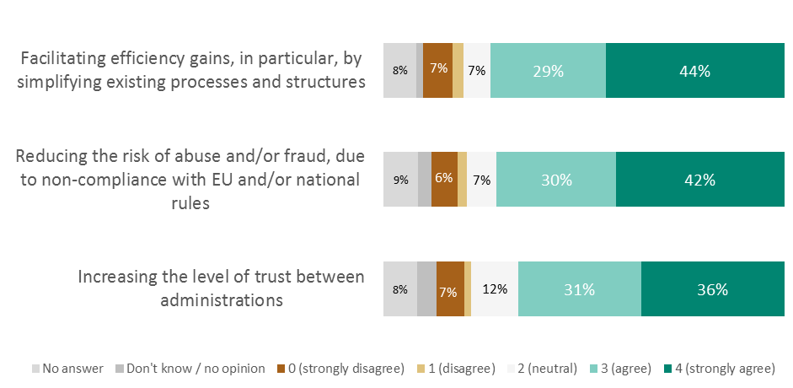

*Source: ICF based on responses to the OPC for the establishment of a European Labour Authority. Answers of respondents from the Campaign are excluded. Percentages are calculated on the total number of responses (N=389).*

*Note: percentages labels below 5% have been omitted from the figure to improve readability.*

Most of the respondents who further commented to their reply were confident that improved cooperation between Member States would improve data collection and exchange, with some respondents expecting to see positive results on employment with better work opporutnities for all. Certain other respondents expressed reservations regarding the centralisation of personal information on the grounds of data privacy.

The majority of respondents also agreed that improved cooperation among the Member States would lead to a series of improvements (as those listed in the OPC) (0).The results suggest that agreement is highest with regard to raising awareness among individuals and businesses of EU rules and rights.

**Q7. Please indicate the extent to which you agree or disagree that improving access to information and transparency for individuals and businesses on EU employment and social security rules in cross-border situations would have the following impacts?**

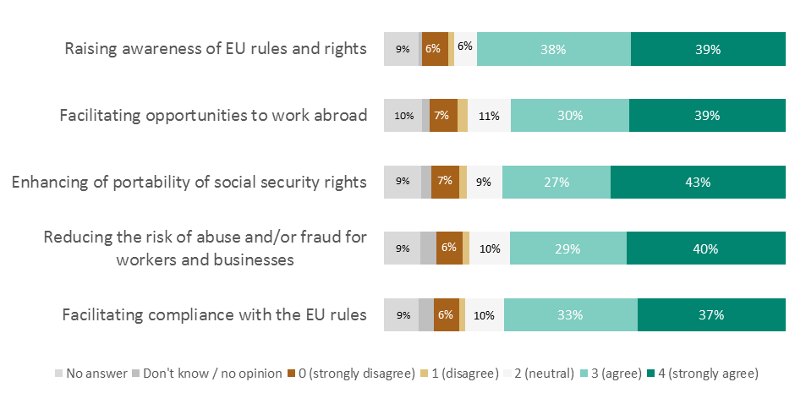

*Source: ICF based on responses to the OPC for the establishment of a European Labour Authority. Answers of respondents from the Campaign are excluded. Percentages are calculated on the total number of responses (N=389).*

*Note: percentages labels below 5% have been omitted from the figure to improve readability.*

None of the respondents who further commented on their reply[5] mentioned negative impacts. Rather, they proposed ideas regarding the possible functions of the ELA (e.g. include seconded national experts proving technical support and advice, introduce a centralised complaints system etc.).

The sample sizes were too small to detect statistically differences in responses by organisation type, country, or labour status. This was mostly due to the high number of nonresponses for these categorical variables.

*Results of the targeted consultations*

The responding organisations were asked to share views on how the ELA could provide added value in improving procedures to address issues around social security coordination among the Member States and labour mobility[6].

Overall, many of the stakeholders thought that the primary role of the ELA should be limited to facilitating the exchange of information among the relevant Member State authorities (such as labour inspectorates, etc.) to maximise its added value. This view was shared by the Finnish and Swedish governments, EPSCO and EMCO members, the latter highlighting that the establishment of the ELA should not result in additional reporting requirements on the Member States

Going beyond the added value the ELA could create by facilitating cross-border information exchange, a number of stakeholders pointed out the potential efficiency gains the ELA could generate e.g. by increasing the level of trust and cooperation between national administrations and stakeholders, or by creating synergies with other existing instruments. The proposals made in this regard include streamlining procedures for decision on cross-border cases (ECPW: ES, IT members); fostering intelligent collaboration with national authorities, social partners and SOLVIT contact points (ECPW: FR member; EFBWW); focusing interventions on fewer areas of higher relevance or where EU instruments are lacking (EMCO).

For certain stakeholders, improved information exchange and efficient administrative coordination through the ELA will bring added value in terms of raising awareness of EU rules and rights, with positive consequences for law enforcement. EU-OSHA suggested that the ELA could support an enlarged Senior Labour Inspectors’ Committee (SLIC) which will improve enforcement by the Member States of Community law on health and safety at work while Eurofound suggested that the ELA could extend its remit to cover cross-border issues linked to the information and consultation of workers in multinational companies or arising from the digital economy and other new forms of work. The ETUC suggested that the added value of ELA could come from the establishment of an early warning system or alert mechanism to record and act upon infringement cases. Several stakeholders suggested that the ELA would generate value by acting as a forum for the exchange of good practices and lessons learned (AC BE member; ECPW EL member; EFBWW).

For a select number of stakeholders, giving the ELA sufficient scope for action will generate considerable added value in terms of reducing the risk of social security fraud and abuse in cross-border situations. This primarily means that the ELA should be responsible for the coordination of joint investigations or cross-border inspections and for acting as a dispute resolution forum on cross-border cases (views shared by the French government; the European Parliament; EPSCO: BE, FR, SE; EMCO ES, EL members; EFBWW, Austrian Chamber of Labour).

A considerable number of stakeholders were concerned about the risk of duplication or overlaps resulting from the co-existence of the ELA and other EU-level bodies involved in the area of cross-border mobility (view shared by AC: BE, NL, CZ, PL, LT, HU, DE, LV, IT members; PES Network BE, CZ, DE, IE, PL, SE; MISSOC; UDW; SLIC; ILO; Business Europe). Many of these respondents agreed that increasing administrative complexity through the creation of a new ELA would cancel out any of its added value.

**3. Delivery options**

*Results of the open public consultation*

Respondents to the OPC were asked what, in their view, the relationship between the ELA and other EU agencies, notably those in the employment domain should be (Question 8 of the OPC). Most of the responses were related to the role that the ELA should have, with many respondents agreeing tha the ELA should have a coordinating role to improve on existing EU tools and EU networks rather than a new body with broader scope substituting already existing organisations. A small number of respondents asked for the establishment of a centralised EU body incorporating existing EU tools and networks.

The sample sizes were too small to detect statistically differences in responses by organisation type, country, or labour status. This was mostly due to the high number of nonresponses for these categorical variables.

*Results of the targeted consultations*

Regarding options for establishing the ELA, the views of the organisations taking part in the targeted consultation[7] were relatively similar to those expressed by the majority of OPC respondents in that if a new authority was to be created, its role should be limited to coordinating the work of Member State bodies and existing EU-level bodies or mechanisms dealing with cross-border mobility. Stimulating the exchange of information and operational cross-border action among competent national authorities should be the priority. As such, most the responding stakeholders believe that creation of a new ELA should not imply a transfer of competences away from the Member States.

Another recurring view shared by the different stakeholders is that no organisational structure can be determined if the scope and objectives of the ELA are not clearly defined as this would risk resulting in increased administrative complexity.

Thus, the most preferred option for a number of stakeholders is stronger cooperation between existing relevant EU bodies to address cross-border challenges without increasing their capacity or changing the way they are governed (a so-called "status quo"). Member State governments overall favoured improving existing EU level structures and mechanisms dealing with cross-border labour mobility rather than creating a new EU body as subsidiarity needs to be respected. A considerable number of EMCO members (CZ, HU, IT, LU, NL, SE) pointed out that there should not be any transfer of regulatory or legal competencies to ELA away from Member State authorities, and that the need for an ELA would first need to be assessed against the performance and objectives of current EU instruments. Similarly, many members within the AC (BE, CZ, DE, HU, LT, LV, NL, PL) and the PES Network (BE, CZ, DE, FI, HR, IE, SE, UK) argued that a new body may increase complexity and the risk of duplication and that synergies between existing organisations and national labour inspectorates should instead be further enhanced without having an ELA. The same view was shared by Business Europe, the Estonian ECPW member and the Czech MISSOC member.

Many other stakeholders suggested that a new EU-level network to improve the coordination of existing EU labour mobility bodies and of national authorities could be created. This option would require no change in the structure of existing bodies, but would however introduce a new governance arrangement. In such a case, overlaps and duplication of effort should be avoided. The overall EMCO position was that the ELA should build on existing networks and tools so that no additional reporting requirements or costs are passed on to the Member States, with the Finnish member adding that the ELA could exist as a supporting network and not a physical agency. EPSCO and the PES Network shared the view that having the ELA as a network focused on solving concrete problems especially given the lack of clarification of what the ELA's relationship with existing instruments such as EESSI or IMI would be. While sharing these views, many other stakeholders argued that the ELA should only have a supportive rather than an authoritative role so as to safeguard the competencies of Member State authorities (UDW; SLIC; ECPW: LV, PL, PT, SE members; MISSOC CZ and LV members; FMW SE member; PEARLE; REIF, Nordic-Baltic-Polish EU Information Group).

A select number of stakeholders showed themselves more favourable to the creation of a new agency or authority, some highlighting that the proposed mandate of the ELA would still need to be further clarified (FMW, MISSOC). Other stakeholders proposed a strong governance structure for the ELA to the extent that is possible in respect of the principle of subsidiarity (ECPW: ES, FR, IT, RO members; ETUC; civil society organisations). In this respect, the ECPW and ETUC argued that representatives from the competent Member State authorities as well as social partners should hold key positions in the governance of the ELA.

In addition, the responding EU agencies (Cedefop, Eurofound, EU-OSHA, ETF) all suggested that the governance of the ELA could partly integrate their own specific mandates or competencies in the areas of employment and mobility. The French government also argued that this could potentially increase the visibility of the activities undertaken by these various agencies.

Lastly, it should be noted that several organisations who had contributed to the targeted consultation did not express an opinion on what would be the most appropriate structure for the ELA – this relates to the general view that the objectives and scope of the ELA would first need to be clarified to discuss the proposed options for establishing it.

**5. Conclusions**

Support for the ELA very strong among respondents to the OPC whereas views were more mixed among the stakeholders taking part in the targeted consultations.

The majority of respondents across the OPC and the targeted consultation agreed with the Commission's analysis of the challenges to cooperation and communication between Member State authorities on cross-border employment and social protection cases.

Plans for establishing an ELA were rather well received overall. The general view was that the ELA should focus on improving cooperation among national authorities by facilitating the exchange of information, intelligence and good practice.

The general opinion is that the establishment of the ELA should not result in a transfer of competencies away from the Member States, and should not create administrative complexity and duplication.

Many of the stakeholders taking part in the targeted consultation believed that the mandate and objectives of the ELA need to be further clarified before deciding on its governance arrangements. Some among them suggested that an assessment of existing structures and instruments (e.g. EESSI, EURES, IMI, SOVLIT, UDW) would be needed before deciding on whether to establish the ELA.

The general opinion with Member States' administrations is that the establishment of the ELA should not result in a transfer of competencies away from the Member States, and should not create administrative complexity or duplication.

1. Question 1: "Do you share the above analysis of the most significant challenges linked to improving cooperation at EU level on cross-border employment and social security matters?"
2. “Please explain” question after Question 4
3. Please explain” question after Question 5
4. Question 2: "Drawing on existing structures, tools and legislation, how could the Authority effectively support cooperation at an operational level among Member States for the smooth handling of procedures and to become more effective in fighting cross-border fraud and abuse? Do you see the need to review any existing structures or tools to better achieve these goals?"
5. “Please explain” question after Question 7.
6. Question 4: How could the Authority provide added value in enhancing and extending current procedures and fora for addressing differences in the social security coordination and labour mobility areas?
7. Question 5: Which organisational structure would you consider to best enable the Authority to efficiently carry out its tasks?