

**1. Introduction**

In his **State of the Union Address** on 9 September 2015, President Juncker proposed the establishment of a European Pillar of Social Rights[1], which would take account of the changing realities of Europe's societies and developments in the world of work.

Following a broad public consultation in 2016, which involved citizens, social partners, civil society, Member States and EU Institutions,[2] the European Pillar of Social Rights was jointly proclaimed by the European Parliament, the Council and the Commission on   
17 November 2017 at the **Gothenburg Social Summit** for Fair Jobs and Growth.[3]

The European Pillar of Social Rights is designed as **a compass for a renewed process of upward convergence** towards better working and living conditions in the European Union.   
It sets out twenty essential principles and rights in the areas of equal opportunities and access to the labour market; fair working conditions; and social protection and inclusion.

The European Council of 14 December 2017 endorsed the conclusions of the Social Summit and underlined that **the European Pillar of Social Rights should be implemented at both Union and Member State level**, with due regard to their respective competences. It also invited the Commission to propose appropriate monitoring.[4] This Communication responds to that request and outlines a way forward.

**2. Taking forward the European Pillar of Social Rights**

The establishment of the European Pillar of Social Rights is part of the broader debate about the **future of Europe**, which was launched by the Commission's White Paper of   
1 March 2017.[5] The question of how to strengthen and modernise the European social model in the face of fundamental changes – such as new technologies, globalisation and demographic ageing – is one of the key questions put forward by the White Paper, as well as in the Commission's Reflection Papers on the social dimension of Europe[6] and on harnessing globalisation.[7]

At their **Summit in Rome** to mark the 60th anniversary of the EU, Leaders reiterated their commitment to a social Europe.[8] In this broader debate, the European Pillar of Social Rights is both **a milestone** in building and consolidating social Europe, and a reference point **on the road to Sibiu**, where EU Leaders will meet in May 2019 to draw conclusions on the EU's future, ahead of the next European Parliament elections.

Delivering on the European Pillar of Social Rights has always been conceived as a **shared political commitment and responsibility**. EU Institutions, Member States, public authorities, social partners and civil society organisations at all levels have a crucial role to play, in line with their competences.

At EU level, the Commission is fully committed to **mainstreaming the priorities of the European Pillar of Social Rights in all EU policies**. It has already started to make use of existing tools and processes to that effect, and it has also presented several dedicated initiatives within the framework of EU competences, some of which remain to be adopted by the EU co-legislators.

The Commission is also committed to **supporting Member States, social partners and civil society organisations in the implementation of the European Pillar of Social Rights** at national, regional and local level. A staff working document published alongside this Communication recalls the legal framework, the respective roles of the national and EU levels, as well as the action already taken on each of the principles of the European Pillar of Social Rights.[9]

Monitoring the implementation of the European Pillar of Social Rights is essential for ensuring tangible progress on the ground. With this Communication, the Commission proposes, as a complement to initiatives already taken and still to come at EU level, to **strengthen the monitoring of implementation of the European Pillar of Social Rights in the European Semester of policy coordination**. This can be done:

* by reflecting the priorities of the European Pillar of Social Rights   
  in the analysis of measures taken and progress made at national level;
* by providing technical assistance, supporting benchmarking and promoting   
  the exchange of good practices among Member States and stakeholders;
* and by screening employment and social performances on the basis of the new Social Scoreboard, thus supporting the broader process of upward convergence.

**3. Implementing the Pillar at EU level**

**Social priorities have been at the core of this Commission's agenda since it took office in 2014.** The content and ambition of the European Pillar of Social Rights build on a large number of initiatives in the employment and social field that have been rolled out by this Commission in recent years, notably[10]:

* the promotion of a **New Start for Social Dialogue**, which reflects the Commission's commitment to work closely with social partners at all levels;
* the proposal for a **European Accessibility Act**, which aims to improve the functioning of the internal market for accessible products and services by removing barriers created by divergent legislation and thus facilitate the work of companies and bring benefits for disabled and older people in the EU;
* a proposal for a Directive to improve **transparency and predictability of working conditions**, which improves the information of workers about their rights and, at the same time, establishes new minimum requirements to improve working conditions;
* the revision of the **Posting of Workers Directive**, which anchors the principle of "equal pay for equal work at the same place", thus establishing a level playing field and preventing unfair competition within the internal market;
* new proposed legislation to modernise the **coordination of social security systems,** which, in particular, helps ensure that workers who make use of their right to free movement do not lose their social security rights;
* a proposal for a Directive on **Work-Life Balance for Parents and Carers** to modernise the existing legal framework by introducing paternity and carers' leave, strengthening parental leave and extending the right to request flexible working arrangements;
* the Action Plan to tackle the **gender pay gap** 2017-2019 which includes a set of activities to address its root causes; the review of the various pieces of legislation in the field of **occupational safety and health**, which updates and complements the provisions that protect workers against work-related health risks, including exposure to carcinogens;
* various actions to ensure timely access to affordable, preventive and curative **health care** of good quality including the European Reference Networks which, since last November, provide people with rare diseases with access to diagnosis and treatment across the EU.
* the strengthening and roll-out of the **Youth Guarantee** to help young people to get quickly into employment, education or training;
* the launch of a broad set of initiatives under the **New Skills Agenda**, which seeks to equip more people with better skills;
* various initiatives to promote access to high-quality and inclusive education, training and lifelong learning, as part of the move towards a **European Education Area**;
* In the field of **education and training**, the Commission aims at more ambitious targets for the share of low achievers and early-school leavers, and is considering new ones as regards digital competences and entrepreneurship[11].

Among the 22 legal acts proposed since November 2014 in the employment and social field, 10 have been adopted and 12 remain to be agreed by the Council and/or the European Parliament. As reflected in the Joint Declaration between the European Parliament, the Council and the Commission, the priority for the coming months will be to **conclude on pending legislative files** and **to focus on delivery and implementation** of the new initiatives on the ground.

**In addition, the Commission has mainstreamed social priorities across the board,** fully acknowledging the social dimension of everything it does. This includes:

* the **European Semester** of policy coordination, where the Commission has put greater focus on social priorities and put them on a par with economic objectives at the core of the annual cycle of economic governance, with this year's cycle also reflecting for the first time the priorities of the European Pillar of Social Rights;[12]
* under **Cohesion Policy**, social priorities are widely supported by the European Structural and Investments Funds in areas such as access to the labour market, social inclusion and education. Other **funding programmes and instruments** like the European Globalisation Adjustment Fund and the Fund for European Aid to the Most Deprived support people affected by the restructuring of companies or at risk of severe material deprivation;
* the **Investment Plan for Europe** ("Juncker Plan"): social infrastructure and equipment as well as strategic investments in social enterprises can be financially supported by the European Fund for Strategic Investments;[13]
* under **the Energy Union**, the package proposed by the Commission on "Clean energy for all Europeans" puts a major focus on the consumer and steps up efforts to ensure that the clean energy transition is socially fair and no one is left behind. In addition, the package sets out a new approach to protecting vulnerable consumers, which also includes helping Member States reduce the costs of energy for consumers by supporting energy efficiency investments. This has also led to the creation of a European Energy Poverty Observatory;
* under the **Digital Single Market**, the Commission set out connectivity objectives for 2025 to help make high capacity broadband available to society as a whole, paying particular attention to areas lagging behind such as rural and remote areas, with a strong focus in parallel on developing digital skills. It also seeks to promote free Wi-Fi connection for citizens and visitors in public spaces through its WiFi4EU initiative.   
  In addition, the proposed European Electronic Communications Code contains provisions to ensure the affordability of electronic communications (including broadband) as part of a universal service;
* in the field of **transport policy**, the mobility package 'Europe on the Move' is a wide-ranging  set of initiatives that will *inter alia* ensure proper working conditions. Moreover, the EU is currently revising passenger rights legislations to ensure that persons with reduced mobility have the same access to transport services as all other passengers;
* the Commission proposed a revision of the Directive on the **quality of drinking water**, which will improve access for all people, especially for vulnerable and marginalised groups;
* under the **taxation agenda**, the Commission has put forward a number of initiatives aimed at restoring the fairness of the EU tax system by ensuring that all companies pay their fair share of taxes where profits are generated;[14]
* via its **trade policy**, the EU promotes core fundamental labour standards agreed at international level: freedom of association, the right to collective bargaining, non-discrimination, the fight against child labour and forced labour, labour inspection, health and safety and work and decent work conditions. Social issues are also key aspects of the sustainability impact assessments carried out for all trade agreements along with economic, human rights and environmental impacts;
* the new **European Solidarity Corps** is enabling young people, with a particular focus on less privileged young persons, to take part in solidarity activities and help address societal needs across Europe, which also allows them to develop their own competences and skills;
* in the event of Stability Support Programmes, the practice has been established since the case of Greece in 2015 to make sure that these are accompanied by a **social impact assessment**.

Moreover, convergence towards better socio-economic outcomes, social resilience and fairness, as promoted by the European Pillar of Social Rights, is an essential part of the efforts to strengthen and complete the **Economic and Monetary Union**, as recalled in the Five Presidents Report of June 2015[15] and subsequent Commission proposals.[16]

Graph 1 below gives an overview of the various ways in which the Commission has been **mainstreaming social priorities across the board**:

**Graph 1. Key initiatives under this Commission in the employment and social field**

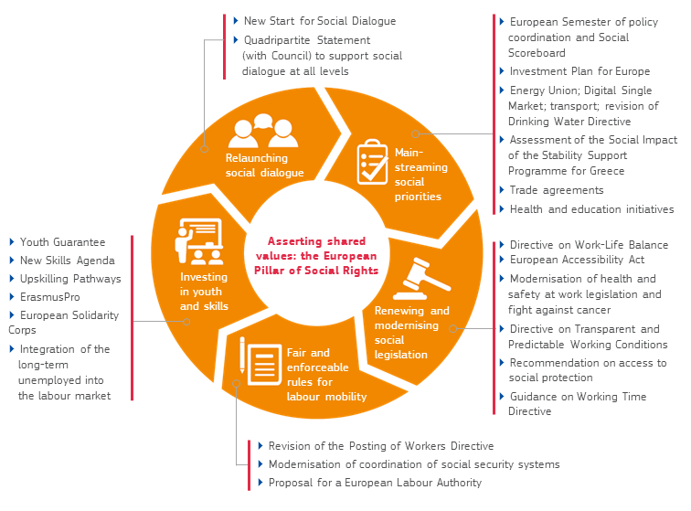

In this context, the establishment of the Pillar has been a **key driver to update and complement EU legislation, wherever necessary.** In addition to what has been done so far, the Commission is presenting another set of initiatives alongside today's Communication, as summarised in box 1.

**Box 1. The new "Social Fairness Package" presented on 13 March 2018**

The present Communication is accompanied by a new **Social Fairness Package**, adopted by the Commission on 13 March 2018.

First, the Commission is proposing to establish a **European Labour Authority**, complementing previous initiatives to improve the rules for the posting of workers and the coordination of social security systems. Free movement is one of the most cherished freedoms of the internal market, benefitting individuals, economies and societies as a whole. Today, an extensive body of EU legislation is in place to ensure fair mobility but what matters is that these rules are effectively applied on the ground. In this context, the role and added value of the Authority will be to:

(a) facilitate access for individuals and employers to information on their rights and obligations as well as to relevant services;

(b) support cooperation between Member States in the cross-border enforcement of relevant Union law, including facilitating joint inspections;

(c) mediate and facilitate a solution in cases of cross-border disputes between national authorities or labour market disruptions.

To assist with the preparation and establishment of the Authority, the Commission is also setting up an advisory group, bringing together key stakeholders.

Second, the Commission is proposing a **Council Recommendation on access to social protection for workers and self-employed**, which builds on a consultation of EU Social Partners and aims to encourage Member States to ensure that everyone who works can contribute and have adequate access to social protection, such as unemployment or sickness benefits. Today, about 60% of people work on full-time, permanent contracts. However, an increasing share of people work on other types of contracts, including part-time or temporary contracts, or are self-employed. This trend may give rise to inequalities and social risks if these workers do not have sufficient access to social protection. The Commission examined the option of proposing a Directive to address this issue but, given the diversity of situations and limitations of the legal framework to take action at EU level, it considers that a Council Recommendation is the appropriate way forward to steer progress at national level, ensure a level-playing field, and support upward convergence.

Finally, the Commission is working on developing a **European Social Security Number**, which is meant as a digital identifier to make existing systems interoperable. Millions of tourists and persons who travel, live and work in another EU country could prove easily that they are covered at home, and get quicker and easier access to the benefits to which they are entitled, knowing that their personal data will be fully protected. This would facilitate the portability of rights across borders, allow for real-time identification and verification of coverage, and also reduce risks of errors and fraud resulting from the use of paper documents. It would simplify the work of administrations at all levels. This initiative is part of the 2018 Commission Work Programme: in line with Better Regulation principles, the Commission is engaging with Member States and stakeholders and will come forward with an initiative later this year.

**For the further implementation of the Pillar at EU level, the Commission will continue to make full use of all existing tools at its disposal.** The use of these tools will vary, depending on the policy area and the principles of the Pillar and reflecting the nature and extent of competences at EU level.They include updating and complementing existing legislation, as set out above, improving the enforcement of EU law in the Member States, and supporting social dialogue across the EU, in addition to monitoring progress under the European Semester.

This also applies to **relevant financial support through EU funds**, notably the European Structural and Investment Funds, Erasmus+ and other relevant programmes. In its recent Communication on "A new, modern Multiannual Financial Framework for a European Union that delivers efficiently on its priorities post-2020"[17], the Commission calls for the EU budget to deliver on the promises made by Leaders at the Gothenburg Social Summit and further develop the social dimension of the Union, including through the full implementation of the European Pillar of Social Rights.[18] The Commission underlined that adequate resources will be required to improve employment opportunities and address skills challenges, including those linked to digitisation. Detailed proposals for the post-2020 EU Multiannual Financial Framework will follow in spring 2018.

**4. Implementing the Pillar at national level**

**Most of the competences and tools required to deliver on the European Pillar of Social Rights are in the hands of local, regional and national authorities, social partners as well as civil society.** While the EU has an important role to play in supporting Member States, the responsibility for implementing the Pillar lies - to a very large extent - with the Member States, at various levels of government and administration. Moreover, social partners at all levels have a crucial role to play in implementing the Pillar in accordance with their autonomy in negotiating and concluding agreements.[19] Respect for the diversity of national industrial relations systems as well as the autonomy of social partners is explicitly recognised by the TFEU. Over the years the Commission has invited Member States to give social partners a greater role in the employment and social field, as their involvement is instrumental for the ownership of reforms. Non-governmental organisations, notably when they provide social services, are also of critical importance to mobilise and deliver on the Pillar.

**By expressing essential principles and rights, the European Pillar of Social Rights serves as a guide towards efficient outcomesin the employment and social field.** There are no one-size-fit-all solutions and the Pillar captures the diversity of national situations.Although Member States often face common challenges and share similar problems, the solutions they need to develop are bound to vary. This is due to the diversity of their national systems, traditions, different starting points and their specific socio-economic situations.

**The current economic context provides a window of opportunity to promote inclusive growth, to modernise the EU social market economy and to invest in people, in line with the European Pillar of Social Rights.** The EU's economy is continuing its expansion at a robust pace.[20] More than 9 million additional jobs have been created since the start of the autumn of 2014, when this Commission started its mandate.[21] The unemployment rate is steadily decreasing and at its lowest level since 2008. The number of people employed has reached 236.3 million in the EU, the highest level ever recorded. However, there are still 18 million people unemployed in the EU, household income is still below the 2008 level in a number of Member States and many social challenges remain, particularly when considering the pace and scope of ongoing developments – from digitisation to ageing. There are also still large disparities in situations among and within Member States.

**Priorities will necessarily vary and the European Semester is an opportunity for Member States to make progress with and report on the delivery of the Pillar.** The Country Reports published recently in the context of the 2018 European Semester cycle[22] outline the nature and extent of challenges at national level to work towards better working and living conditions, fairer and better-functioning labour markets, improved education and training systems to equip people with appropriate and relevant skills, and social welfare systems that are both sustainable and adequate. The National Reform Programmes, expected from Member States in April, will set out renewed priorities and further concrete actions at national level. These programmes will be the basis for Country-Specific Recommendations that the Commission will propose later in spring 2018. In parallel, the Commission will continue to work with Member States to ensure that available EU funding is well used in support of structural reforms or to invest in people, in line with the priorities identified in the Country Reports and Country-Specific Recommendations.

**5. Monitoring the implementation of the Pillar**

**The European Semester of policy coordination provides an appropriate tool for monitoring** **progress in key areas covered by the European Pillar of Social Rights**.   
The European Semester is based on in-depth analysis, specific to the situation of each country: it acknowledges the diversity of challenges and the need to prioritise in the light of different starting points and available means across countries. The European Semester is also the way to structure collective efforts over time: it builds on in-depth dialogue and reporting throughout the year, which is transparent and open to all actors, and it is used in particular to structure peer reviews and benchmarking among Member States. Building on the progress achieved in recent years to strengthen the social dimension of the European Semester, the Commission has started to fine-tune existing tools and working methods to reflect the European Pillar of Social Rights since it was proclaimed. This does not require fundamental changes or the creation of new instruments, or additional administrative burden on the side of Member States.

**A more thematic follow-up will also be required to cover the depth of the various principles of the Pillar and to review effective follow-up and take-up on the ground.** Regular EU publications – such as the annual Joint Employment Report and the Report on Employment and Social Developments – will be used to study specific issues in-depth. EU agencies active in the field[23] will also be tasked with developing in-depth reporting for the principles falling more squarely within their responsibilities. In turn, EU-level social partners and civil society organisations may decide to focus more deeply on certain principles of particular interest to them.

**As part of the European Semester, three new elements will be added** to help monitor the implementation of the European Pillar of Social Rights:

* **Mainstreaming the priorities of the Pillar in the European Semester while selecting themes for detailed reporting on an annual basis**: the principles and rights enshrined in the Pillar will be taken into account throughout the European Semester in monitoring, comparing and assessing the progress made. At the same time, some specific themes pertaining to the Pillar will be highlighted for a detailed assessment every year. This applies notably to the Annual Growth Survey (issued in November), which sets out economic and social priorities at EU level, and the Country Reports (issued in February/March), which form the basis for further country-specific guidance. The choice of themes will be made in consultation with all actors, and notably the relevant committees representing the Member States.
* **Providing technical assistance, promoting benchmarking and exchanging good practices**: the European Semester offers a forum for dialogue with stakeholders, exchanging experience and strengthening mutual learning among Member States,  
  with a view to supporting upward convergence towards the best performers. The bodies that deal with employment and social policy issues under the European Semester, such as the Employment Committee and the Social Protection Committee, have already started work on the benchmarking of policy convergence. In addition, in its Communication on "Further steps towards completing Europe's Economic and Monetary Union: a Roadmap"[24], the Commission suggested that ongoing work in the Council and in the Eurogroup on the benchmarking of policies should be reinforced. Moreover, in addition to the financial support provided through the European Structural and Investment Funds, the Commission's Structural Reform Support Service has stepped up its offer of tailor-made support for institutional, administrative and policy reforms.[25]
* **Assessing and monitoring performances with the help of the new Social Scoreboard:** together with its proposal for the Pillar, the Commission presented a new Social Scoreboard. Its role is to help screen the performances of Member States in the employment and social field along the various dimensions of the Pillar. It was used,   
  for the first time, to help inform and deepen the analysis in the 2018 Joint Employment Report and the indicators were used to back up the analysis of the 2018 Country Reports. While they do not exhaust the discussion on the monitoring on the Pillar, they shed useful light on the situation on the ground, allowing for comparisons over time and across countries. The Scoreboard and its statistical underpinnings will be further developed with the support of Member States.

**Box 2. The new EU Social Scoreboard[26]**

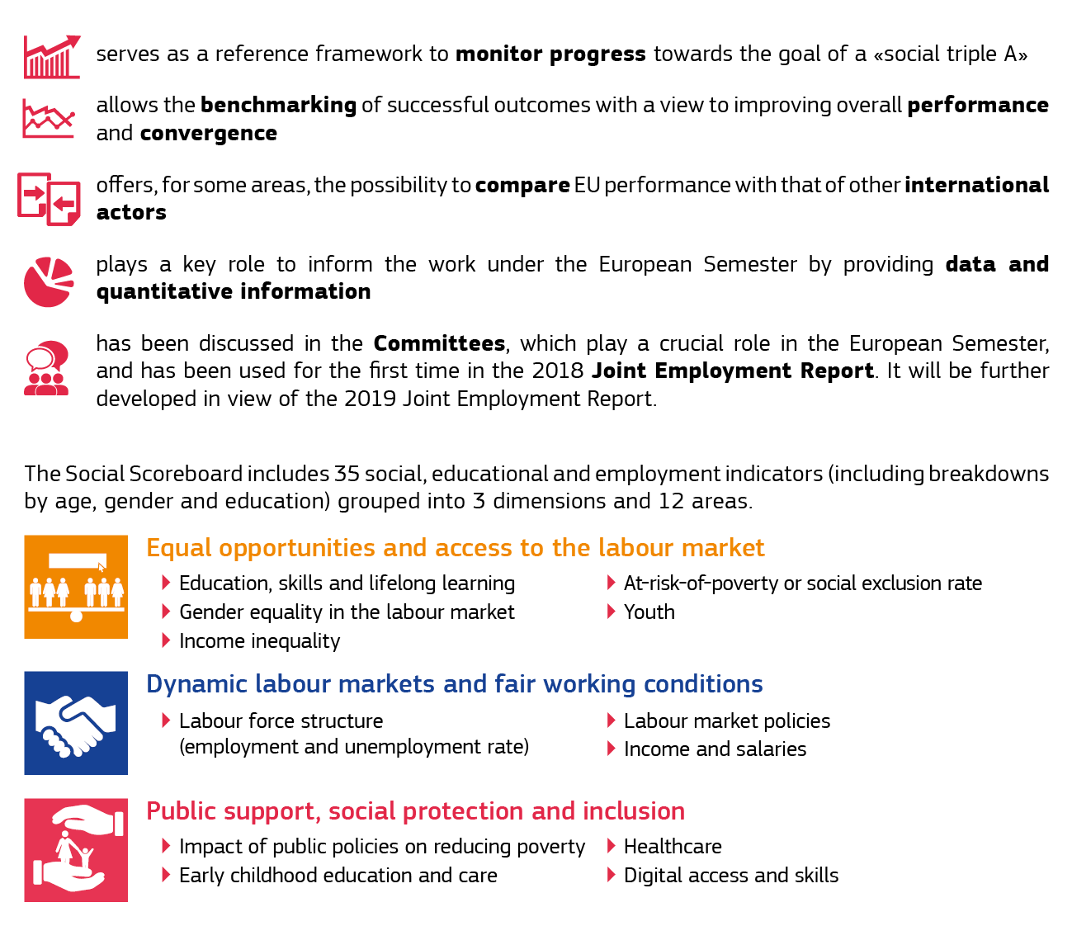

**6. Conclusions**

For decades, the European Union has helped deliver increasing prosperity and social fairness. Today, Europe is one of the most attractive places to live in the world. However, the economic and social crisis of the last decade has had a far-reaching impact on our social fabric, which questioned the essence of our social market economy.

As Europe has turned the page of the crisis, it is time to look to the future, to match the speed of changing realities and to tackle the broader socio-economic challenges confronting Europe, so as to renew and sustain our economic and social models.

By making clear what Europe stands for, the European Pillar of Social Rights expresses principles and rights that are essential for social progress for the benefit of citizens and societies alike, and which provides a compass for further action.

The commitments taken by EU Leaders at the Gothenburg Social Summit are part of a broader agenda to build the future of the European Union at 27. Delivering on the European Pillar of Social Rights and making it a reality for all Europeans is a shared responsibility. Governments, social partners and non-governmental organisations, local, regional and European Institutions are ready and committed to contribute to this endeavour.

1. <https://ec.europa.eu/commission/priorities/deeper-and-fairer-economic-and-monetary-union/european-pillar-social-rights/european-pillar-social-rights-20-principles_en>
2. On 8 March 2016, the Commission presented a first outline of the European Pillar of Social Rights and launched a public consultation. The Commission received more than 16,500 online replies and nearly 200 position papers. The consultation culminated in a concluding Conference "Going Forward Together" on   
   23 January 2017. As part of the consultation, the European Parliament adopted a Resolution on the Pillar on   
   19 January 2017 (2016/2095(INI). The European Economic and Social Committee adopted an opinion on   
   25 January 2017 (SOC/542-01902-00-01-ac). The Committee of the Regions adopted an Opinion on 11 October 2016 (CDR 2868/2016).
3. <http://www.socialsummit17.se/>
4. The European Council of 14 December 2017 underlined the following: "*The Social Summit in Gothenburg recalled the need to put people first, to further develop the social dimension of the Union based on a shared commitment and established competences, and to promote convergence through efforts at all levels, including  
    by social partners. As a first step the following should be taken forward: implementing the European Pillar of Social Rights at Union and Member State level, with due regard to their respective competences;   
   the Commission is invited to propose appropriate monitoring (…)."* 
5. COM(2017) 2025.
6. COM(2017) 206.
7. COM(2017)240.
8. In the Rome Declaration, on 25 March 2017, EU Leaders declared: "*In these times of change, and aware of the concerns of our citizens, we commit to the Rome Agenda, and pledge to work towards: … A social Europe: a Union which, based on sustainable growth, promotes economic and social progress as well as cohesion and convergence, while upholding the integrity of the internal market; a Union taking into account the diversity of national systems and the key role of social partners; a Union which promotes equality between women and men as well as rights and equal opportunities for all; a Union which fights unemployment, discrimination, social exclusion and poverty; a Union where young people receive the best education and training and can study and find jobs across the continent; a Union which preserves our cultural heritage and promotes cultural diversity.*"
9. SWD (2018) 67..
10. [https://ec.europa.eu/commission/sites/betapolitical/files/social_dimension_of_europe_  
    overview_of_initiatives_en.pdf](https://ec.europa.eu/commission/sites/betapolitical/files/social_dimension_of_europe_overview_of_initiatives_en.pdf)
11. COM (2017) 673 final.
12. Cf. 2018 Annual Growth Survey (COM(2017) 690 final) and the Communication on the assessment of progress on structural reforms, prevention and correction of macroeconomic imbalances, and results of in-depth reviews (COM(2018) 120).
13. The EFSI already supported such projects for an expected total investment value of over EUR 10.5 billion. In the EFSI infrastructure and innovation window, 18 social infrastructure projects have already been approved and are expected to mobilise a total of over EUR 6 billion in investments. These include the construction, expansion or refurbishment of schools and universities, clinics and hospitals, and affordable social housing in the community. In the EFSI small and medium-sized enterprises window, the total expected investment mobilised in the social sector amounts to EUR 4.5 billion. Recently, the EFSI doubled the firepower of the European Programme for Employment and Social Innovation for microfinance and social entrepreneurship.
14. Examples are the Anti-Tax Avoidance Directive, the Directive on the automatic exchange of information on tax rulings and advance pricing arrangements, the Directive on country-by-country reporting concerning multinationals and the proposal to re-launch the Common Consolidated Corporate Tax Base.
15. [https://ec.europa.eu/commission/publications/five-presidents-report-completing-europes-  
    economic-and-monetary-union_en](https://ec.europa.eu/commission/publications/five-presidents-report-completing-europes-economic-and-monetary-union_en)
16. On 6 December 2017 the Commission presented a Communication on "Further Steps Towards Completing Europe's Economic and Monetary Union: A Roadmap" (COM(2017)821).
17. COM(2018) 98 final.
18. The Commission stressed in the Communication: "*The next Multiannual Financial Framework should better align available financing with our political priorities. It should build on what works well today while also anticipating the challenges of tomorrow. In line with the Rome Declaration, the budget should enable a Europe that is safe and secure. A Europe that is prosperous and sustainable. A Europe that is social. And a Europe that is stronger on the global scene.*" The Commission also underlined: "*The EU budget will need to deliver on the promises made by Leaders at the Gothenburg Social Summit. This means further developing the social dimension of the Union, including through the full implementation of the European Pillar of Social Rights, and supporting young people and the mobility of European citizens*".
19. A recent example for social partner action is the Autonomous Framework Agreement they agreed on 8 March 2017 on Active Ageing and the Inter-generational Approach. An example for a Social Partners Agreement, which has been implemented in EU law is the Council Directive (EU) 2018/131 of 23 January 2018 implementing the Agreement concluded by the European Community Shipowners' Associations (ECSA) and the European Transport Workers' Federation (ETF) to amend Directive 2009/13/EC in accordance with the amendments of 2014 to the Maritime Labour Convention, 2006, as approved by the International Labour Conference on 11 June 2014.
20. See the Winter 2018 Economic Forecast of the European Commission:

    <https://ec.europa.eu/info/business-economy-euro/economic-performance-and-forecasts/economic-forecasts/winter-2018-economic-forecast_en> and the Quarterly Report on Economic and Social Developments: <http://ec.europa.eu/social/main.jsp?catId=738&langId=en&pubId=8063>.
21. The majority of these newly created jobs can be considered as of "good quality": 78% of the newly created jobs since 2014 Q3 are permanent and 88% of them are full-time.
22. Communication on the assessment of progress on structural reforms, prevention and correction of macroeconomic imbalances, and results of in-depth reviews (COM(2018) 120)).
23. The European Centre for the Development of Vocational Training (Cedefop); the European Foundation for the improvement of living and working conditions (Eurofound); the European Agency for Safety and Heath at Work (EU-OSHA); the European Training Foundation (ETF).
24. COM(2017) 821 final.
25. Since 2015, the SRSS has been implementing close to 500 projects of technical support. Examples of such projects in the social field include: (i) supporting the implementation of a guaranteed minimum income; (ii) supporting the design and implementing of integration policies for migrants and refugees; (iii) improving disability assessment systems and the services for people with disabilities; (iv) improving the design and implementation of active labour market policies; (v) supportive the reform of special education.
26. For more information on the Social Scoreboard, see:

    [https://composite-indicators.jrc.ec.europa.eu/social-scoreboard/#](https://composite-indicators.jrc.ec.europa.eu/social-scoreboard/)