

**1. Introduction**

**On 22-23 March 2018, the European Council will hold a debate on the taxation of the digital economy.** The Commission Communication on A Fair and Efficient Tax System in the European Union for the Digital Single Market, published in September 2017[1], set out the key issues and objectives with regard to taxation of the digital economy. The Commission is now bringing forward proposals to establish a modern, fair and efficient standard for the digital economy. This responds to calls from the European Council and the Ecofin Council which stressed the "need for an effective and fair taxation system fit for the digital era" and looked forward to Commission proposals by early 2018[2].

**The digital economy is transforming the way we interact, consume and do business. The digital transformation brings many benefits to society.** To fully seize its potential, the Commission has made the Digital Single Market one of its top priorities[3]. Achieving a Digital Single Market will ensure that the European Union maintains its position as a world leader in the digital economy, providing new opportunities for innovation and helping European companies to grow globally. It could contribute €415 billion to the European economy, boosting jobs, growth, competition, investment and innovation. Assuming that the appropriate policy and legislative framework is put in place on time, the value of the data economy in the EU will increase to €739 billion by 2020, representing 4% of overall EU GDP[4]. With digitalisation, cross-border opportunities for even the smallest companies will increase.

We have entered an era where users of digital services are increasingly part of the value creation process, consciously or not. Users are providing data, sharing knowledge and content, and enabling wide and diverse networks. All this generates huge value in today's economy, which is only set to grow in the future. The intensive nature of user activity in the digital economy is shown by the diagram below.

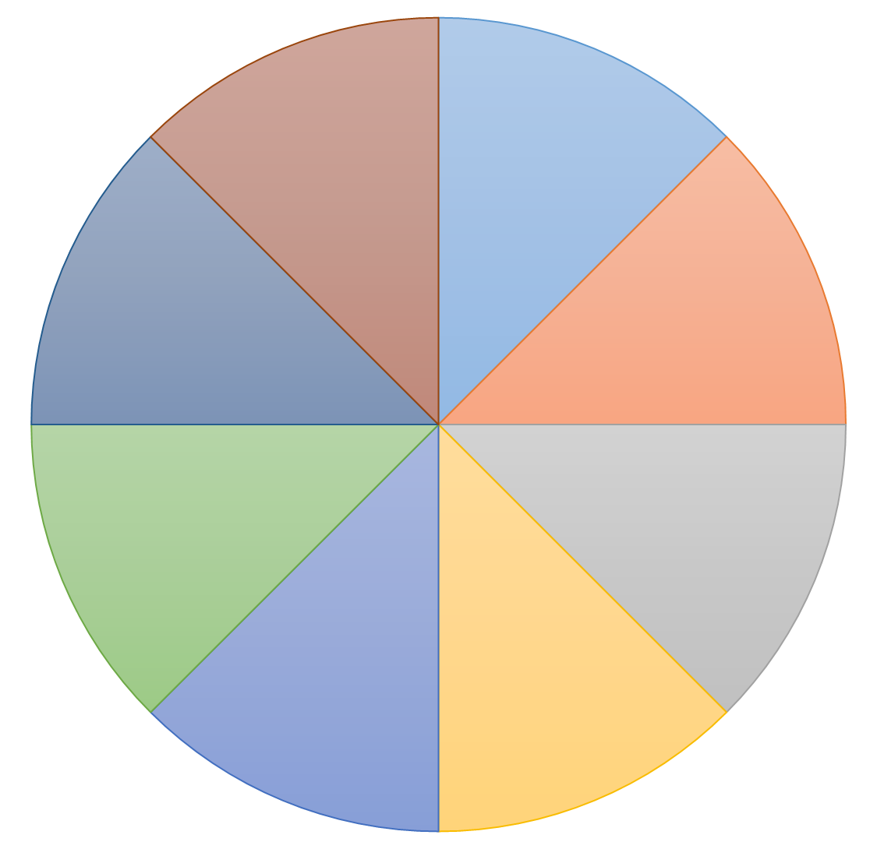

*This is what happens on an*

***EU Internet Day***

*More than…*

***20 billion***

*Emails sent*

***650 million***

*internet searches*

***500 000***

*blog posts*

*written*

***150 million***

*social media*

*posts*

***800 million***

*videos watched*

*online*

***40 million***

*photos uploaded*

***40 million***

*Voice over IP*

*Calls*

***400 million***

*gigabyte internet*

*traffic*



**Digital companies are growing far faster than the economy at large, and the largest digital companies have huge user and consumer bases within the EU.** For example, 42% of Europeans are users of Facebook. Although in the digital economy the majority of websites are local (accessed only from one country), the lion's share of the traffic is captured by the much smaller number of global websites. In the last 7 years average annual revenue growth for the top digital firms was around 14%, compared to around 3% for IT & telecoms and 0.2% for other multinationals[5]. This is a positive sign of the sector's dynamism and potential.

**14%**

**Digital firms**

**3%**

**IT and telecoms**

**0.2%**

**Other multinationals**

**Average annual revenue growth**

**Fair and effective taxation is essential to support the Digital Single Market to deliver on its potential.** It is important to provide an updated tax environment in which digital activities are recognised at their right worth and in which digitally oriented companies can grow benefiting from a predictable and fair business environment. Taxation plays a vital role in the EU economic and social model. A fair and efficient tax system provides revenue for public services, while at the same time supporting economic growth and the competitiveness of EU businesses. Faced with rising inequalities and perceptions of a lack of social justice, EU citizens are calling for Member States and the Commission to take action to improve the fairness of tax systems. All taxpayers must pay their fair share, to ensure the level playing field between businesses that is central to the success of the Single Market, and also to protect the European Social Model on which citizens depend.

**From the start of its mandate, this Commission made it a priority to improve the fairness and efficiency of EU tax systems[6].** The EU has played a leading role in the global revolution in tax transparency[7], adopted binding rules to close loopholes facilitating tax avoidance[8], taken action on non-cooperative jurisdictions[9] and adopted an updated VAT framework fit for the modern world[10]. Under State aid rules, the Commission has taken action against preferential tax treatment to companies engaging in tax planning practices. Furthermore, the Commission has proposed a new competitive, fair and robust framework for taxing companies in the Single Market[11]. The Commission has also proposed measures to promote further transparency, by requiring multinational companies to publish the tax they pay in the EU (public Country by Country Reporting)[12]. It calls on the European Parliament and the Council to show further determination on this important proposal to facilitate its swift adoption.

However, some challenges still remain. In particular, the rapid transformation of the global economy through digitalisation is putting new pressures on corporate tax systems at EU level and internationally. New business models should support entrepreneurship while ensuring a level playing field. All levels of policymaking must ensure that the regulatory environment is simple and supportive to entrepreneurs, especially SMEs. As highlighted in the Commission’s reflection paper on harnessing globalisation[13] presented in May 2017, this does not mean protectionism, deregulation or a race to the bottom, but smart regulation. Governments must ensure that tax policy remains relevant in light of digitalisation and new business models, and that companies pay their taxes where economic activities are located. The proposals presented today by the Commission are a balanced and proportionate response to these challenges.

**2. Adapting the corporate tax system to the 21st century: the challenges ahead**

**2.1 Outdated corporate tax rules**

**Companies engaged in digital activities, like all other companies, must share the tax burden** needed to finance the public services on which they rely. Yet this is not the case at this moment. Companies with a significant digital presence in a Member State are able to benefit from its public services and market infrastructure, such as the judicial system and high level of connectivity in a Member State, but do not pay tax there unless they have a significant physical presence as well. Companies with preponderantly digital activities have a reduced need to be physically present when operating abroad: only 50% of the affiliates of digital multinationals are foreign-based, compared to 80% for traditional multinationals[14].

**It is an internationally agreed principle that profits should be taxed where value is created[15].** However, the current international tax rules were designed for 'brick and mortar' businesses. They are largely based on physical presence and were not designed to cope with business models driven primarily by intangible assets, data and knowledge. They do not take into account business models in which companies can supply digital services in a country without being physically present there. Today's rules also fail to recognise the new ways in which profits are created in the digital world. For example, they struggle to capture the value created through intangible assets, such as patents and algorithms, which can easily be moved to low or no-tax jurisdictions. In addition, they do not acknowledge the role of users in generating value for digital companies by providing data and content or as the building blocks of the networks that are central to many digital business models. All of this means that there is a disconnect between where the value is created, and where taxes are paid.

**As a result, companies with digital business models pay less than half the tax rate of businesses with traditional business models,** with an effective average tax rate of 9.5% compared to 23.2%[16]. This happens partly due to the outdated tax system, partly due to built-in incentives by governments for digital companies in order to support the growth of this future-oriented sector. In certain cases, through aggressive tax planning strategies, the tax burden can be brought down even further. This creates an imbalanced system, which disadvantages traditional companies. It also creates an imbalance between purely domestic digital companies and those that are active across different jurisdictions. It calls into question the sustainability of Member States' tax bases and runs the risk of other businesses and taxpayers carrying a higher tax burden as a result, at the expense of social fairness.

**Effective average tax rate** in the EU 28

Traditional international business model

Digital international business model

**The problems arising from these outdated tax rules are well recognised by the public and businesses.** In the Commission's recent public consultation, almost three quarters of respondents agreed that current international taxation rules allow digital companies to benefit from certain favourable tax regimes and push down their tax contributions. A total of 82% of respondents believed that something should be done about the current international tax rules in relation to the digital economy[17].

**2.2 The need for an international solution**

**The digital economy transcends borders and there is growing international recognition of the need for a new tax framework that is up-to-date with digital business models.** The Commission strongly believes that the solution must ultimately be a global one. This is in line with the need to better harness globalisation with proper global governance and global rules. The Commission is working closely with the Organisation for Economic Co-operation and Development (OECD) to support the development of an international solution. However, progress at international level is challenging, due to the complex nature of the problem and the wide variety of issues that need to be addressed.

**Therefore, in parallel to international discussions, and following on from its September Communication, the Commission is now proposing solutions at EU level.** This will give further impetus to international discussions by providing a clear example of how the principles under discussion at international level can be transformed into a modern, fair and efficient corporate taxation framework adapted to the digital era. By being a first mover in proposing an overarching response to fix the issue and mitigate the immediate risks, the EU and its Member States will be at the forefront in shaping a global solution.

**3. Sustainable taxation in the digital age: a Comprehensive Solution within the corporate tax system**

**The EU Digital Single Market needs a stable tax framework that is up-to-date with digital business models.** This should stimulate innovation by providing a stable environment for businesses to invest in. It should also allow all players to tap into the new market dynamics under fair and balanced conditions. The tax framework should ensure tax certainty for business investment and prevent distortions of competition or new tax loopholes emerging in the Single Market. It should also ensure sustainable tax revenues for Member States.

For these reasons, the Commission is proposing a comprehensive solution to the challenge of taxing the digital economy. This includes three main elements.

**3.1 A new Directive on corporate taxation of a significant digital presence**

The first element of the comprehensive solution is a Directive laying down rules relating to the corporate taxation of a significant digital presence. **This Directive provides a solution within the existing corporate tax system**, addressing the problems of 'where to tax' and 'what to tax' in the digital economy.

The Directive proposes that businesses would have to pay tax in Member States where they have a **significant digital presence**, even if they do not have a physical presence there. This would be defined according to revenues received from the supply of digital services, number of online users or number of business contracts for digital services. These thresholds would ensure that significant levels of digital activity are taken into account when assessing where a company should be taxed, while avoiding disproportionate burdens on SMEs.

The Directive also establishes **new rules for attributing profits** to digital businesses. The Directive proposes to build on the current transfer pricing principles and sets out that the attribution of profits to a digital business should reflect the particular ways in which digital activities lead to value creation, through use of criteria such as data and users.

**3.2 Integrating the principles within the CCCTB proposal**

The second important element in the comprehensive solution proposed by the Commission is to **integrate the provisions in the proposed Directive into the proposals for a Common Consolidated Corporate Tax Base (CCCTB).** The Commission stands ready to work with Member States to examine how this can be achieved.The amendments proposed by the European Parliament in the reports on the Common Corporate Tax Base and CCCTB are a good base for further work[18].

**Combining the new Directive on digital presence with amendments to the CCCTB** will ensure both that Member States' corporate tax systems and the proposed common consolidated tax base at EU level will have rules which address the challenge of taxation of the digital economy.

**3.3 Extending the solution to the global level**

**Any solution proposed at EU level must also take into account the global dimension.** These proposals are the Commission's contribution to shaping the consensus-based solution that the OECD intends to seek by 2020. They provide an example of how the principles being discussed at international level can be operationalised.

**The EU solution should be extended wherever possible to relationships with third countries, in order to ensure a level playing field between EU and non-EU businesses**. This should be done through Member States' double taxation treaties. Therefore, alongside the proposed Directive, the Commission is also putting forward a Recommendation to Member States to adapt their double taxation treaties with non-EU jurisdictions along the lines of the proposed Directive.

**The Commission stands ready to assist Member States in taking a common approach to negotiating changes in their double taxation treaties with non-EU jurisdictions**. The Commission is prepared to assist the Council in identifying priority jurisdictions for negotiations and, if the Council so decides, to conduct exploratory talks with non-EU jurisdictions on the process for agreeing changes to their double taxation treaties with Member States. This would prevent a wide variety of different approaches that could undermine the level playing field and create new loopholes in the tax system.

**Building Blocks for Fair Taxation in the Digital Economy**

Opt-in

**Taxation of a significant digital presence**

**Taxation of Digital Services**

**CCCTB**

**A Global solution adjusting the OECD framework**

**All businesses**

Businesses active in the Single Market

Businesses with worldwide consolidated turnover > EUR 750 million

Businesses with annual digital revenue in the EU of > EUR 50 million

Opt-in

**4. Managing the immediate risk of fragmentation: an interim measure taxing certain digital service revenues**

**Agreeing and implementing a structural solution will take time,** in particular to extend the principles to double taxation treaties with non-EU jurisdictions. However, **Member States are under increasing political pressure to act now** on taxing the digital economy, to safeguard revenues and ensure a level playing field. An increasing number of Member States are already taking unilateral action. Unilateral indirect taxation measures have been planned or implemented in 10 Member States. Other national tax authorities see a risk that the current situation could provoke further uncoordinated measures[19].

**A multiplicity of different approaches to the taxation of the digital economy risks further fragmenting the EU Single Market,** creating additional barriers and legal uncertainty for companies and distorting competition in the Single Market. It may also result in the creation of new loopholes that could facilitate tax avoidance. All of this would be damaging for EU competitiveness and tax fairness. In addition, uncoordinated national measures reduce the chances of converging towards a common comprehensive EU approach.

For this reason, **it is also necessary to find an interim solution at EU level**. This should prevent the fragmentation of the Single Market and improve fairness, while allowing Member States to safeguard their revenues and creating a catalyst for a movement towards a more comprehensive solution. **The interim measure should only apply until a comprehensive solution has been agreed at the international level.**

The Commission is therefore proposing an interim Digital Services Tax at EU level. The proposed measure **has a very specific scope. It focuses on activities where there is a large gap between the value created and Member States' ability to tax it** – where user participation and user contributions play a central role in value creation. The proposed Digital Services Tax would be applied at a rate of 3% on gross annual revenues in the EU derived from specific digital services, due in the Member State(s) where the users involved are located. It is estimated that the Digital Service Tax would raise around EUR 5 billion annually in revenues within the EU, improving the sustainability of EU and national public finances[20].

**The Digital Services Tax would apply to revenues from two main types of digital services. The common feature of such services is that they are heavily reliant on the exploitation of user participation or data obtained about users as a way to generate revenues.** Since such services are typically provided remotely, the provider of the services does not have to be physically established in the jurisdiction where the users are and therefore where value is created. Hence, this new tax aims at giving taxing rights to these jurisdictions.It would cover services consisting in the placement of advertising on digital interfaces. It would also cover intermediary digital interfaces or marketplaces whose main purpose is to facilitate the direct interaction between users (such as peer-to-peer sales apps or sites). Thresholds would apply to ensure that **it does not negatively impact on small or emerging businesses.** The Directive also proposes to establish a One Stop Shop to simplify the process for businesses.

In designing the interim measure, the Commission has taken into account the elements identified in the OECD interim report[21] presented to the G20 Finance Ministers, as well as existing Member State practices.

**5. Conclusion**

Digitalisation is bringing about a rapid and radical transformation in the global economy. In order to fully seize the opportunities offered by digitalisation, and also to face up to the challenges it poses to Member States' tax systems, it is vital that we take action to make our corporate tax system fit for the digital age.

The proposals put forward today by the Commission provide a comprehensive structural solution to the question of taxation of the digital economy within the EU, and support Member States in extending this to non-EU jurisdictions. They also provide a simple interim solution to address the current risks of fragmentation of the Single Market and prevent further divergence, while the comprehensive solution is being agreed and implemented.

The Commission therefore calls on Member States to swiftly agree on the proposals presented today so that businesses, administrations, citizens and the European economy can benefit from a uniform and modern tax framework for the digital economy. These proposals should be the common basis that the EU and its Member States would use to feed the international ongoing work on taxing the digital economy and to contribute to a successful conclusion of such work.

1. COM(2017) 547 final.
2. European Council meeting (19 October 2017) – Conclusions (doc. EUCO 14/17); and

   Council conclusions (5 December 2017) – Responding to the challenges of taxation of profits of the digital economy (FISC 346 ECOFIN 1092).
3. <https://ec.europa.eu/digital-single-market/en/policies/shaping-digital-single-market>
4. <https://ec.europa.eu/digital-single-market/en/policies/building-european-data-economy>
5. SWD(2018) 81 final.
6. See Annex for summary of taxation initiatives.
7. Council Directive (EU) 2015/2376; Council Directive (EU) 2016/881; Council Directive (EU) 2016/2258; COM(2016) 198 final and COM(2017) 335 final.
8. Council Directive (EU) 2016/1164 and Council Directive (EU) 2017/952.
9. <http://www.consilium.europa.eu/en/press/press-releases/2017/12/05/taxation-council-publishes-an-eu-list-of-non-cooperative-jurisdictions/>

   <http://www.consilium.europa.eu/en/press/press-releases/2018/01/23/taxation-eight-jurisdictions-removed-from-eu-list/>
10. Directive on VAT on e-commerce, proposal adopted by the Commission on 1.12.2016 (COM(2016) 757 final) and adopted by the Council on 5.12.2017. (COUNCIL DIRECTIVE (EU) 2017/2455).
11. COM(2016) 685 final and COM(2016) 683 final.
12. COM/2016/0198 final.
13. <https://ec.europa.eu/commission/sites/beta-political/files/reflection-paper-globalisation_en.pdf>
14. According to the methodology in [chapter IV of UNCTAD's World Investment Report 2017](http://unctad.org/en/PublicationChapters/wir2017ch4_en.pdf) (pages 174-175).
15. OECD/G20 Base Erosion and Profit Shifting Project (2013).
16. SWD(2018) 81 final.
17. Annex 2 of the Impact Assessment accompanying the proposals (SWD(2018) 81 final) presents a detailed summary of the results.
18. European Parliament legislative resolution of 15 March 2018 on the proposal for a Council directive on a Common Corporate Tax Base (COM(2016)0685 – C8-0472/2016 – 2016/0337(CNS)); and

    European Parliament legislative resolution of 15 March 2018 on the proposal for a Council directive on a Common Consolidated Corporate Tax Base (CCCTB) (COM(2016)0683 – C8-0471/2016 – 2016/0336(CNS)).
19. 15 out of 21 Member states that have replied to the Commission's consultation were of the opinion that the current situation could push some Member states towards adopting unilateral measures.
20. Part of the proceeds could be dedicated as revenue for the EU budget, for example, in the context of the own resources decision for the period of the next multiannual financial framework.
21. OECD (2018), Tax Challenges Arising from Digitalisation – Interim Report 2018: Inclusive Framework on BEPS, OECD Publishing, Paris. <http://dx.doi.org/10.1787/9789264293083-en>