

**Table of contents**

Annex 11: Additional data on "free" digital services 2

1. Detailed problem description 2

2. Additional data 6

3. Stakeholder views 16

Annex 12: Additional data on information requirements 27

Annex 13: Additional data on rules on the right to withdraw 29

Annex 14 JRC Technical Report: "An analysis of the influence of remedies and sanctions on consumers' exposure to unfair commercial practices and shopping problems" 31

Acknowledgements 2

Executive summary 3

1 Introduction 4

2 Estimation approach 5

2.1 Influence of penalties intensity on remedies implementation 5

3 Data 7

4 Results and interpretation 9

5 Further extensions 12

List of figures 13

List of tables 14

# Annex 11: Additional data on "free" digital services

## 1. Detailed problem description

The EU is one of the largest e-commerce markets in the world and the percentage of consumers aged between 16 and 74 that have ordered goods or services over the internet has grown year‑on-year from 30% in 2007 to 55% in 2016.[1] Furthermore, the 2015 DSM consumer survey revealed that 93% of EU28 online respondents had used "free" digital services at least once in the previous year (2014)[2] and 75% of the 91 respondents in the public consultation reported having used "free" digital services over the last 3 years (2015-2017).

However, the existing EU consumer law does not yet offer adequate protection in all digital transactions. In its current form, the CRD applies to contracts for the supply of digital content[3], regardless of whether the consumer pays a price in money (paid digital content) or provides personal data ("free" digital content), as explained in the CRD Guidance Document.[4] Digital content includes, for example, computer programs, applications, games, music, videos or texts, irrespective of whether they are accessed through downloading or streaming from a tangible medium or through any other means*.*[5]If a contract for the supply of digital content is concluded the CRD provides consumers with EU‑level rights to pre‑contractual information and to withdraw from the contract. The CRD does not apply if a contract is not formed, for instance in case a consumer merely accesses a website, uses a search engine or downloads digital content from a website without providing anything in return.[6]

In its current form, the CRD fails to offer adequate protection for contracts that do not concern a specific piece of digital content, but which involve digital services of a certain duration. Digital services include, for example, accessing, creating, processing, storing or sharing of data in digital form, such as subscription contracts to content platforms (e.g. iTunes, GooglePlay), cloud storage (e.g. Dropbox, iCloud), webmail (e.g. Hotmail, Gmail) and social media (Facebook, Instagram). The CRD only applies to digital service contracts supplied against the payment of a price in money (paid digital service), but it is silent on the applicable rights for contracts where the consumer provides personal data ("free" digital service).

It is challenging to justify the existence of this legal gap of consumer protection given the similarities between digital content and digital service contracts, as well as the substantive interchangeability of paid digital services and "free" digital services.

The CRD Report found that it is often difficult to distinguish between what qualifies as "free" digital content or a "free" digital service in practice.[7] As only one of these categories is currently covered by the CRD, there is significant legal uncertainty about the applicable rules and the legal protection afforded to the consumers that entered into such contracts differs dramatically.

These problems will be magnified by the upcoming Digital Content Directive (DCD), which, once adopted, will provide contractual remedies for consumers in case there has been a failure to supply or a lack of conformity with the digital content or digital services, as well as a right to terminate long term contracts after 12 months. In situations where the consumer provides personal data for "free" digital content and "free" digital services, the remedies provided for in the DCD would apply in parallel with the new General Data Protection Regulation[8], which will be applicable as from 25 May 2018.

The interplay between the CRD, the DCD and the GDPR can be illustrated as follows:

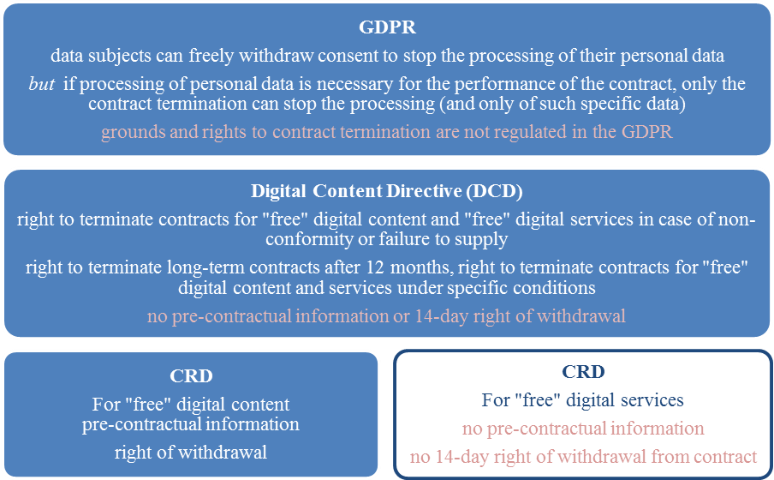

A detailed overview of the DCD and GDPR is included in subsection 2 of this Annex.

Next to the problems that will emerge with the CRD once the DCD comes into force, the current situation already poses unnecessary costs for traders due to diverging national rules and an unclear legal framework. Replies to the targeted consultations indicate that the rules on pre-contractual information and/or the right of withdrawal apply also to "free" digital services in at least three Member States.[9] Latvia and Portugal have extended both the pre-contractual information requirements and the right of withdrawal to "free" digital services, whereas France applied only the pre-contractual information requirements to online marketplaces by the means of the Digital Republic Bill[10], which requires online marketplaces to provide consumers with fair, clear and transparent information, including on general conditions of use of the proposed intermediation service.

As a result of the fragmentation of national consumer laws, a trader wishing to sell cross‑border to the consumers of another Member State will have to incur legal and other compliance costs in order to make sure he is complying with the consumer protection rules of the Member State of the consumer, as required under the Rome I Regulation.[11] These barriers impede the provision of and the access to digital services for traders and consumers, and ultimately hinder the completion of the DSM.

The relevance of such barriers was confirmed in the public consultation, where around 60% of business associations[12] reported that companies incur costs to some or significant extent when trading cross-border due to a need to adapt to current different national laws related to pre‑contractual information or right of withdrawal.[13] 7 out of 10 responding business associations consider these costs to be unreasonable. Moreover, in the SME panel consultation, 10 out of 58 respondents[14] reported being discouraged from entering other EU markets due to these costs, while 28 respondents did not consider these costs to have significant impact on their decision-making. SMEs offering "free" digital services report costs when trading cross-border due to (1) replying to complaints and enquiries from consumers that did not get information about the service before concluding the contract (3 of 14 responding companies), (2) would like to cancel the service (6 of 15) and (3) due to complying with rules other countries' national legislation on pre-contractual information and right of withdrawal (6 of 15)[15]. In the SME test panel SMEs gave estimates regarding one-off costs between zero and EUR 48 000 (up to 16% in terms of turnover). Estimates for annual costs ranged from zero to EUR 20 000 (up to 6.67% in terms of turnover). The two responding large enterprises stated zero and EUR 299 respectively, both one-off and annual costs.[16]

These costs are likely to increase in the future, as the targeted consultation points to ongoing discussions in a number of Member States about introducing new rules concerning the provision of personal data under the notion of "payment of a price", as laid down in the CRD in relation to the definition of service contracts.

Furthermore, the current situation leads to a unfair competition between traders. Depending on whether they supply the exact same digital service against personal data or against payment of a price, traders are subject to different rules. Similarly, traders that supply digital content for "free" have to comply with the CRD rules, unlike traders that supply digital services for "free". Furthermore, these divergences create difficulties for compliance with consumer law if the business model combines elements of "free" and paid digital services. For example, the so-called "freemium" model enables consumers to use an app without payment (e.g. play a game) but subsequently have the ability to buy paid elements through "in-app" purchases.[17]

The lack of protection for "free" digital services also leads to tangible detriment for consumers. The CRD study found that 48% of the surveyed consumers experienced difficulties with unsubscribing from such services. Similarly, in the public consultation almost 70% of individuals indicated that the lack of pre-contractual information and the right of withdrawal is problematic and can create harm for consumers when using "free" digital services cross-border[18]. In particular, 23 out of 67 individuals reported having experienced detriment in the last three years when using "free" digital services due to the lack of pre-contractual information (33%), while 13 reported such harm due to the lack of a right of withdrawal (17%).[19]

The IA for the DCD proposal estimated that almost 1 in 3 consumers across the EU (36%) had experienced at least one problem in the previous 12 months with contracts for digital products, including contracts for "free" digital services (such as cloud storage with which 30% reported problems) [20]. In the public consultation, almost 100% of the respondent consumer associations agreed that consumers suffer harm when using "free" digital services due to the lack of pre‑contractual information and the right of withdrawal, whereas over 2/3 of them consider that this lack of rights discourages consumers from acquiring such services[21].In contrast, over 50% of business associations[22] and traders[23] replying to the public consultation rather disagreed that consumers suffer detriment when using "free" digital services due to lack of rights. In the CPC/CPN/CMEG targeted consultation, Member State authorities did not provide considerable evidence of consumers suffering harm when using "free" services; however, some of the responding Member States underlined that this lack of evidence could be due to the consumers' lower expectations about digital services that are offered for "free" and due to difficulties in assessing to whom a complaint can be addressed.

Finally, in reply to the public consultation, no less than 48% of individuals[24] reported that they would use "free" digital services even more often, if they had the right to pre‑contractual information and to withdraw. This view is confirmed by more than 80% of the consumer associations[25] and more than 30% of MS authorities.[26]

## 2. Additional data

**Table 1: From the 2015 DSM consumer survey:**

Overall, 93% of EU28 online respondents (sample N =22,848, 2015 data) had used at least one of the concerned four online services during the past year (2014).

**Figure 1: Paid versus free usage of online services over the past year, by market**

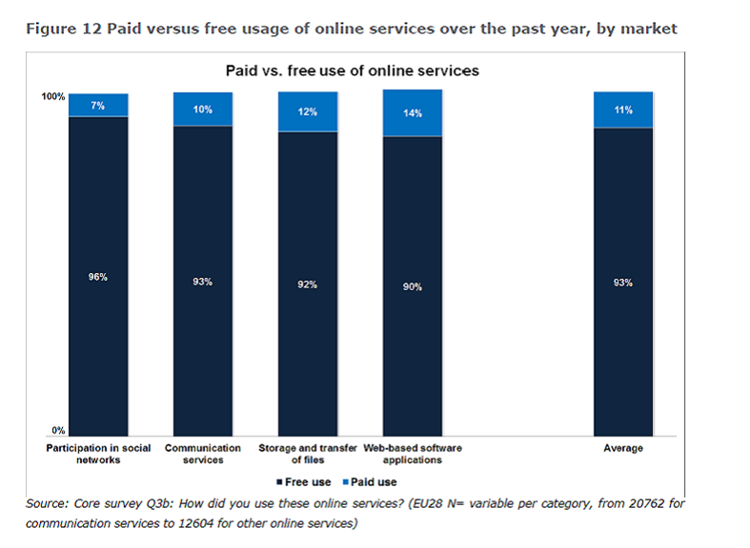

**Figure 2: Usage frequency of online services over the past year, by market**

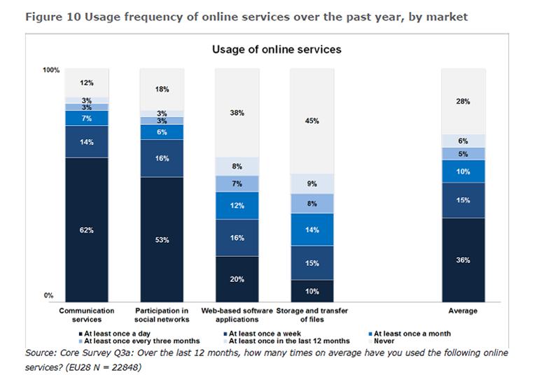

**I) Economic Study on Consumer Digital Content Products:**

***NOTE: The data for the market analysis section are based on the DSM consumer survey***

**A) Market analysis**

The market analysis of seven types of digital content and services (music, games, film and TV content, e-books/audiobooks, cloud storage, software/apps and streaming of sports events) showed that the vast majority of consumers who access these types of digital content and services online do not pay a price. The incidence of 'free' business models is predominant both for digital content (e.g. a download of a specific music track) and digital services (e.g. a subscription for online music streaming). 90 to 92% of consumers who access software & apps or store digital content do it without paying with money; 77% of consumers who stream events do it without paying with money; and more than 50% of consumers who download music, film and television content, games and digital books do it without paying with money.[27]

In particular:

-Music (p. 68): Free downloading is still the most common channel to access digital music formats in Europe; more than half (58%) of EU consumers who accessed music online reported downloading music for free. Free streaming of music is also widespread; 44% of EU consumers who accessed music online reported free streaming of music. The study estimates that only between 13% and 25% of European consumers accessing music online pay for music in digital format.

-Film and TV content: (p. 85) Free streaming and free downloading are the most common channels to access digital film and television content formats in Europe; 53 and 49% respectively of European consumers who accessed films and TV series online reported downloading or streaming films and TV series for free. Only 14%of European consumers who accessed film and television content online pay for downloading videos and 18%pay for streaming videos.

-Games: (p. 99) Free download of games is the preferred mode of access in Europe among users of digital games. 66% of EU consumers who accessed games online downloaded games for free and 32% reported streaming games for free. Only 21% reported paying for downloading and 11% paying for streaming a game online.

-E-books and audiobooks (p. 107):

65% of EU consumers that accessed e-books online downloaded them for free;

26% of EU consumers that accessed e-books online streamed them for free;

Only 28% of EU consumers that accessed e-books online paid to download them, and 12%paid to stream them.

-Software-apps: (p.123):

Free downloading is still the most common channel to access software and apps in Europe. Between 90 and 91% of EU consumers that bought or accessed software and apps online reported downloading software and apps for free, while only between 21 and 23% of them pay for software and apps in digital format.

P.130: Concerning antivirus software, a survey found that in Western Europe, 26% of users pay for antivirus programs (the 74% others choose a free solution)[28] which is in line with the estimated figures for software and apps market based on the DSM consumer survey. Users tend to think that free solutions provide sufficient security.

- Storage: (p.133)

92% of European internet users who use storage services access these services for free

Overall, the storage of digital content has been experiencing high growth in recent years, but most of the consumers access these services for free. As such, in terms of sales, online web services that provide server space for individuals to store data, photos, videos and other files, generate little revenues directly from consumers.

p.136: Based on the DSM consumer survey, 92% of EU consumers who access storage of digital content online do so for free. Only 12 % of those who accessed digital content storage online reported paying for this service. This trend is confirmed by Eurostat's annual model questionnaires on ICT (Information and Communication Technologies) reporting that only one in ten cloud users paid for internet storage space to save or share their files.

- Sport events: (p.141)

77% of EU consumers who stream sports events do so without paying with money.

**B) Consumer Survey**

A consumer survey was conducted by Ipsos MediaCT in 15 sample countries. 1 000 consumers in each of the 15 Member States were asked about the type of problems they encountered when purchasing or otherwise accessing digital content.

Problems with free digital content/services:

On average across all content types, almost 1 in 3 online users of digital content have experienced at least one problem with the digital content or service they used during the 12-month period preceding the survey. It is estimated that at least 70 million consumers[29] across the EU have experienced one or the other problem with just the four types of digital content covered by the study.

Although the incidence of reported problems was higher among consumers who paid for digital content or services, the percentage of consumers reporting problems with "free" digital content or services was also very significant. In particular 49% of consumers who accessed digital content/services reported facing a problem with digital content/ services they paid for. At the same time 36% of consumers who accessed digital content/services reported facing a problem with digital content/ services which they accessed without paying a price.[30]

The problems consumers faced with 'free' digital content or services related to three areas: quality, access and terms and conditions.

Quality-related problems included issues such as:

* damage to computers, mobile phones or other devices caused by the digital content;
* digital content not working properly and/or of poor quality compared to what was promised by the supplier;
* the digital content being incompatible with hardware/software, when information suggested it would be compatible;
* poor levels of quality compared to what one would normally expect from similar digital content;
* not receiving updates for the content as promised by the supplier; and
* receiving different/older versions of the content, rather than the one promised by the supplier.

The incidence of quality-related problems with 'free" digital content or services was significant: 20% of consumers who accessed music online had "quality related problems" with music they accessed without paying (p. 224), 22% of consumers who accessed games online had "quality related problems" with games they accessed without paying (p. 225), 18% of consumers who accessed antivirus software online had "quality related problems" with free antivirus (p. 225) and 16% of consumers who accessed cloud storage had "quality related problems" with free cloud storage (p. 226)

Access-related problems included issues such as:

* difficulties downloading or accessing the digital content because of unclear or incomplete instructions;
* unexpected interruptions (e.g. crashes, unannounced maintenance) which prevented full use / access;
* inability to access the content or digital service in one or more countries where the supplier had promised that access would be available;
* not being able to access or retrieve data (e.g. photos) after ending contracts;
* more limited access to a service or content than had been expected given the information received from the supplier; and
* not being able to download or access the digital content because of poor internet connections.

The incidence of quality-related problems with 'free" digital content or services was significant: 25% of consumers who accessed music online had "access-related problems" with free music (p. 231), 27% of consumers who accessed games online had "quality related problems" with free games (p. 232), 19% of consumers who accessed antivirus online had "quality related problems" with free antivirus and 18% of consumers who accessed cloud storage online had "quality related problems" with free cloud storage.

Problems related to terms & conditions of digital content products and services include issues such as:

* terms and conditions being too long and not being read;
* consumers not understanding their rights because the terms and conditions were unclear;
* terms and conditions excluding the supplier from most or all of any responsibility for problems arising with the digital service or content;
* terms and conditions giving the provider the right to remove or amend services or content without providing notice;
* terms and conditions entitling the supplier to close accounts without giving consumers the opportunity to retrieve their data; and
* long term subscriptions that bind consumers to digital content or services (of more than one year) and cannot be terminated before the expiration of the term.

The incidence of T&C-related problems with 'free" digital content or services was even higher than the other categories: 24% of consumers who accessed music online had "T&C related problems" with free music (p. 238), 27% of consumers who accessed games online had "T&C related problems" with free games, 24% of consumers who accessed antivirus online had "T&C related problems" with free antivirus and 25% of consumers who accessed cloud storage online had "T&C related problems" with free cloud storage.

Costs Resulting From Problems With Free Digital Content/Services: (p.310 -321)

Although consumers had accessed digital content or services without paying money, they reported costs as a result of the problems they encountered. In particular, the net cost incurred by consumers averaged EUR 5.79 per consumer for ‘free’ music, EUR 6.42 for "free" games, EUR 8.80 for "free" antivirus and EUR 5.59 for "free" cloud storage. Although these costs were significantly lower than the ones reported as a result of problems with paid digital content/services (EUR 12.19, EUR 14.28, EUR 20.49 and EUR 32.99 respectively) it is important to note that consumers incur costs as a result of a problem also when no money was paid in exchange for the digital content or service. The costs reported by consumers included, among others:

* Cost of telephone calls, postage or stationery
* Travel costs
* Costs of any legal matters or for legal advice
* Costs of getting any other type of expert advice or assistance
* Costs of any knock-on / consequential damage or inconvenience caused to you or any of your possessions as a result of the problem
* Cost of lost earnings by not being able to work while taking time to resolve the problem

**II) Flash Eurobarometer 411 “Cross-border access to online content” (2015)**

This survey was carried out by TNS Political & Social network in the 28 Member States of the European Union between 7 and 15 January 2015. Some 26,586 respondents from different social and demographic groups were interviewed via telephone

**-** Key Findings

**Access to the Internet**

* 82% of respondents use the Internet. The countries with the highest proportion of Internet users are located in northern and western areas of the EU.
* 69% of respondents use the Internet daily or almost daily.
* Respondents are most likely to access the Internet from a personal computer (desktop computer, laptop or netbook) (90%), a mobile device (tablet, mobile phone or e-reader) (73%) or a home entertainment device (Smart TV or game console) (21%).

**Access to digital content online**

* Respondents are most likely to have accessed or downloaded music (60%) and audio-visual content (59%), followed by video games (37%), sports (35%) and e-books (27%) in the last twelve months.
* Music and audio-visual content are the most likely to be downloaded or streamed on a daily or weekly basis.

- Incidence of "free" digital content or services

* Audio-visual content, p. 23-24

The large majority (80%) of consumers who accessed or downloaded audio-visual content online did so without paying a price, while 15% pay per item and 20% pay for an online subscription.

In all Member States, the majority of respondents who had accessed or downloaded audio-visual content said the content was free; in fact in 27 Member States at least two thirds did so.

* Sports contentp. 32

The large majority (82%) of consumers who accessed or downloaded sports content online did so without paying a price, while 19% paid in some way (paying a subscription was more common than paying per item, 14% vs. 7% respectively).

* Music p. 36:

In all Member States at least half of all Internet users say they have accessed or downloaded music at least once in the last 12 months, with those in Romania (79%), Cyprus (74%), and Greece and Slovenia (both 73%) the most likely to do so.

p.40: The large majority (77%) of consumers who accessed or downloaded music are most likely to have done so for free (77%), while 19% paid per item and 12% paid a subscription. Overall, 29% paid in some way to access or download music.

* Digital booksp. 44

Just over a quarter of Internet users have downloaded or accessed an e-book at least once in the past 12 months (27%), although most had done so less than once a month (11%). Few (2%) accessed or downloaded e-books daily or almost daily, while 5% did so at least once a week and 9% at least once a month.

p.47: Compared with the other kinds of content discussed, e-books are more likely to be paid for in some way (46%), generally per item rather than by subscription (39% vs. 8%). In spite of this, the majority (64%) still access or download e-books free of charge.

* Video games p. 51

More than one-third of Internet users have accessed or downloaded a video game online in the past 12 months (37%), although once again access is not as frequent as for other content types, such as sports or audio-visual. Almost one in ten (9%) say they access video games online every day or almost every day, while 9% do so at least once a week and 8% at least once a month. Just over one in ten (11%) access video games less than once a month.

p.54: Just over one-third of those who access video games online say they have paid in some way (34%): payment per item (20%) or the purchase of items related to the video game (16%) are both more common than payment by subscription (8%).

Just over three-quarters (76%) have accessed or downloaded the content they wanted free of charge.

|  |
| --- |
| - *Consumers who access paid digital content/services often also access "free" content/services and vice versa*  Data from Flash EB 411:  -p. 26: 16% of respondents who have accessed free audio-visual content online have also paid for this type of content (16%). And 43% of those who paid for audio-visual content have also accessed free audio-visual content.  -p. 34: 6% of the respondents who accessed free sports content also paid for this type of content. And 27% of those who paid for sports in some way shows that 27% also accessed free sports content  -p.42: Just over one in ten of those who accessed free music online also paid for music (11%). And 28% of those who paid for music in some way also accessed free music online.  -p.49: 22% of respondents accessing free e-books online have also paid for eBooks. And 30% of those who paid for e-books in some way also accessed free eBooks  -p.56: 18% of respondents who accessed free video games also paid for video games. And 40% of those who paid for video games in some way also accessed free games online. |
| *Also, business models often combine elements of "free" and "paid" models, e.g. when consumers start playing a game without payment but subsequently start buying elements related to the game.*  Data from Economic Study on Consumer Digital Content Products:  -Freemium is currently one of the predominant business models especially for video games, software and applications.  p. 100-101: In this model, software, media, games or web services are provided free of charge, but money (i.e. a premium) is charged for proprietary features and functionality (e.g. virtual goods, time reduction).  The freemium model has become a widely-adopted pricing strategy in the industry. Two types of freemium games have emerged in the process: (1) “pay-to-entertain” games, whereby premium content is purely decorative and serves as a way for consumers to individualise the game according to their preferences; and (2) “pay-to-progress” / “pay-to-win” games, whereby additional content is functional and allows premium consumers to progress faster in the game (e.g. by enhancing the performance of their in-game character);  Trialware is also a predominant business model especially for software and cloud storage.  P.130: Trialware (for software in general): users can try out software during a trial period and when it is over they need to pay a licence fee to continue to access the software. According to Kaspersky Labs, Trialware is commonly used as a pricing model for antivirus software. Many computers and laptops are sold with a pre-installed trial version of an antivirus program. It is estimated that about 60% of respondents use these programs, but that only 13% purchase the licence one the trial period is over.[31].  For cloud storage (p.137):  The main types of pricing models are:  14 to 30 days free trials followed by paid subscription based on storage capacity;  Free service limiting storage capacity to 2 and 15 Gigabytes (GB)[32] and paid subscription fee for larger storage capacity. |

|  |
| --- |
| **Examples of consumer problems due to lack of protection in contracts for "free" digital services**  The absence of rights to pre-contractual information when subscribing to "free" digital services has the potential to lead to consumer detriment. For instance, a consumer who has not been informed about the duration of his contract for "free" email services might one day discover that he can no longer access his email account because the contract has lapsed. Hence, his time and effort invested in that service could be lost together with previous communication and contacts.  A Commission study on terms and conditions found contractual rights of the supplier to remove or amend content without notice, or to close accounts without giving users the opportunity to retrieve data, as one of the major problems encountered by consumers. This is more likely to happen to consumers entering into contracts for "free" digital services due to the lack of pre contractual information obligations for the traders. This is also in line with the results of the Economic Study on Consumer Digital Content Products, whose consumer survey showed that the most often cited type of problem  Another example of consumer detriment can be inferred from a concrete case regarding terms and conditions used in "free" digital services. In 2017, the Italian Competition Authority (ICA) fined WhatsApp EUR 3 million for having forced its users to share their personal data with Facebook. In particular, the ICA found that: *WhatsApp de facto forced the users of its service WhatsApp Messenger to accept in full the new Terms of Use, and specifically a requirement to share their personal data with Facebook, by inducing them to believe that without granting such consent they would not have been able to use the service anymore.* Furthermore, the ICA assessed as illicit some contractual clauses included in WhatsApp Messenger’s “Terms of Use”, such as the possibility for the trader to unilaterally interrupt the service without reason or advance notice[33]. Clearly this is a case of use of unfair terms, in breach of the UCTD, that are not binding on consumers. However, enforcing this right in a dispute with a trader may require time and resources. Therefore, ideally the consumers should refrain from engaging with traders who impose unfair contract terms. In this context, they obviously need to understand the terms and conditions. However, many consumers do not read the T&Cs in particular because they are too voluminous and difficult to read, this is why pre-contractual information is essential for consumers even when they conclude contracts for "free" digital services, since such information has to be provided upfront to the consumer and in an easily and comprehensible manner.  In addition, in the framework of the Economic study on the consumer digital content products, it was found that roughly three per cent of all users said the digital content caused damage to their computer, mobile phone or other device: this might occur due to lack or improper information about the functionality and operability of the digital content or service, and is more likely to happen when using digital free services for which consumers do not have a EU wide right to be informed about the characteristics of the free digital service they subscribe for.  Consumer detriment can also occur in social media. Here, consumers are usually not informed when they subscribe about main functions of the service, such as how social media operators intend to use their "likes" (endorsements) of posts, brands and products for their own commercial purposes. "Likes" are often re used by operators to be displayed together with new ad posts from the brand that the consumer has endorsed, but the consumer is usually not made aware of this. In this way, a consumer's endorsements may be presented to his or her friends on the social media out of the context of the original "like". This may lead the consumer's friends to believe that the friend has endorsed posts, brands or products that the consumer has not really endorsed. Such situation can be embarrassing for the first consumer. It can also lead his or her friends to buy products they would not have bought if they had not been misled by the re-used endorsement.  Recent research also found that consumers experience detriment due to a refusal of the right to withdraw from dating services[34]. |

|  |
| --- |
| **Relevant provisions of the Digital Content Directive (DCD) and the General Data Protection Regulation**  The DCD will provide contractual remedies for consumers in case there has been a failure to supply or a lack of conformity with the digital content or digital services, such as getting a new copy of the content, a reduction of the price or the termination of the contract against a refund; the proposal also gives consumers the possibility to terminate long term contracts after 12 months. In situations where the consumer provides personal data to the supplier to access digital content or services, the remedies provided for in the DCD apply in parallel with the rules on the lawful processing of personal data under EU data protection legislation. As regards non‑personal data, the Proposal aims to introduce similar rules to ensure that the supplier shall also refrain from the use of such data and that the consumer shall be entitled to retrieve the data. (Non-paper of the Commission services on the relationship between the Proposal for a Directive on certain aspects concerning contracts for the supply of Digital content and EU Data protection. WK 680/2016 INIT).  The European Commission put forward its EU Data Protection Reform in January 2012. The reform consists of two instruments published in the EU Official Journal on 4 May 2016: [Regulation (EU) 2016/679](http://eur-lex.europa.eu/legal-content/EN/TXT/?uri=uriserv:OJ.L_.2016.119.01.0001.01.ENG&toc=OJ:L:2016:119:TOC) of the European Parliament and of the Council of 27 April 2016 on the protection of natural persons with regard to the processing of personal data and on the free movement of such data, and repealing Directive 95/46/EC (General Data Protection Regulation), and [Directive (EU) 2016/680](http://eur-lex.europa.eu/legal-content/EN/TXT/?uri=uriserv:OJ.L_.2016.119.01.0089.01.ENG&toc=OJ:L:2016:119:TOC) of the European Parliament and of the Council of 27 April 2016 on the protection of natural persons with regard to the processing of personal data by competent authorities for the purposes of the prevention, investigation, detection or prosecution of criminal offences or the execution of criminal penalties, and on the free movement of such data, and repealing Council Framework Decision 2008/977/JHA. The Regulation will replace the Data Protection directive 95/46/EC, and will be applicable as from 25 May 2018; it includes, inter alia, the right to receive information on the collected data in concise and transparent form, and in clear and plain language; the right to access collected personal data, and obtain the rectification of inaccurate personal data without undue delay, and the possibility to "be forgotten", namely to have personal data erased if they are no longer needed for the purposes for which they were collected; the GDPR also includes a right to data portability.  The EU data protection law provides an exhaustive list of legal grounds for processing personal data. Processing can be based, for instance, on the consent of the data subject or where it is necessary for the performance of the contract:  1) Article 6(1)(a) GDPR allows for processing of personal data where the data subject (the consumer) has given consent to the processing of his or her personal data for one or more specific purposes. In the event that the legal basis for processing consumer' personal data is the consent, such consent should be clearly distinguished and separate from the agreement necessary for the conclusion of a contract.[35]  The consumer can at any time terminate such processing of his personal data by specific withdrawal of consent (Art. 7(3) GDPR), which shall not affect the lawfulness of processing based on consent before its withdrawal. However, the GDPR does not provide for the consequences of such withdrawal of consent on the contract that may exist between the data controller and the data subject, such as a contract for the supply of digital content or services. For instance, when a consumer opens a social media account, his name and e-mail address may be necessary for the supplier to create and maintain the user's account. The consumer may at the same time give his consent for the supplier to use this personal data also for other reasons, e.g. for direct marketing purposes. If the consumer withdraws his consent, the supplier will only still be able to process the personal data as far as this is necessary for the performance of the contract, i.e. for giving the consumer access to his account. Therefore, in the event of withdrawal of consent the contract for the supply of digital content or services would not be automatically terminated, and such situations would be subject to interpretation under national general contract law rules.  2) Personal data can also be processed where its processing is necessary for the performance of a contract pursuant to Article 6(1)(b) GDPR. In such cases the GDPR does not provide for a general right of the data subject to terminate the processing of personal data as long as the contract remains in force. The consumer can of course terminate the contract based on what the applicable legislation and the contract itself lays down for its termination. If the consumer withdraws from or otherwise terminates the contract, the trader can no longer process such data, since the contract as legal basis for processing of the personal data will no longer exist. |

## 3. Stakeholder views

In the public consultation almost 70% of individuals (58 out of 87) indicated that the lack of pre-contractual information and the right of withdrawal is problematic and can create harm for consumers when using "free" digital services cross-border.[36] This was also strongly confirmed by 27 respondent consumer associations in the same consultation, where almost 100% of them strongly/tend to agree that consumers suffer harm when using "free" digital services, due to lack of pre‑contractual information and right of withdrawal.[37] 19 of 27 MS authorities (70,4%) and 16 of 26 MS authorities (61,5%) strongly/tend to agree that consumers suffer harm when using "free" digital services, due to lack of pre‑contractual information and right of withdrawal. Business associations were not supportive, while companies expressed mixed views: 32 out of 62 and 32 out of 57 responding business associations strongly/tend to disagree that consumers suffer detriment due to respectively lack of pre-contractual information and withdrawal right. 18 out of 54 and 18 out of 53 responding companies strongly/tend to disagree that consumers suffer detriment due to respectively lack of pre-contractual information and withdrawal right (respectively 16 and 17 (tend/strongly) agree).

In the OPC 48% of individuals (42 and 43 respectively), over 80% (22) of consumer associations and over 40% (11 and 13 respectively) of national authorities reported that "free" digital services would be used more often if consumers had the right to pre‑contractual information and to withdraw from such contracts.

In the public consultation 7 out of 10 of responding business associations considered the current costs due to diverging national requirements as unreasonable.[38] In the SME test panel, SMEs gave estimates regarding current one-off cost between zero and EUR 48 000 (up to 16% in terms of turnover). In the same consultation, estimates for annual regular/running costs due to diverging national requirements ranged from zero to EUR 20 000 (up to 6.67% in terms of turnover).

67% of companies (12 out of 18) and 42% of business associations (19 out 45) agree with the extension of the pre-contractual information requirements, while around 38% of companies (7 out of 18) are in favour of the extension of the right of withdrawal; When asked about the key reasons for introducing pre-contractual information obligations for such services, overall the majority of respondents 82.1% of individuals, 93.8% of consumer organisations, 94.1% of MS authorities, 38.9% of traders, 26.9% of business associations highlighted the better protection of consumers of digital services with similar functionalities. Similarly, 75.9% of individuals, all responding consumer organisations, 81.3% of MS authorities, 35.3% of traders and 19.6% of business associations considered the same benefit for the introduction of the right of withdrawal.

**Public Consultation:**

**Question 36** (291 responses) "In your view, is it problematic that consumers do not have the right to be informed (before acquiring the service) about the main features of "free" online services (e.g. on functionality and interoperability with hardware and software)?: Yes, it discourages consumers from acquiring such online services

**Figure 3: lack of pre-contractual information about "free" digital services is problematic**

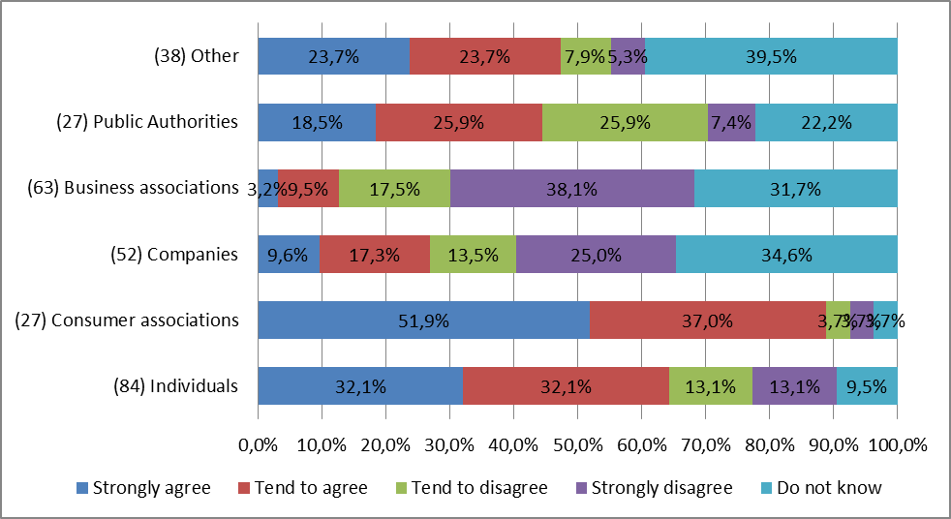

**Question 39** (194 responses) "Based on your professional experience, would consumers use "free" online services more often if they had the right to be informed (before acquiring the service) about the main features of the service (e.g. on functionality and interoperability with hardware and software)?"

**Figure 4: consumer use of "free" digital services to increase if given pre-contractual information**

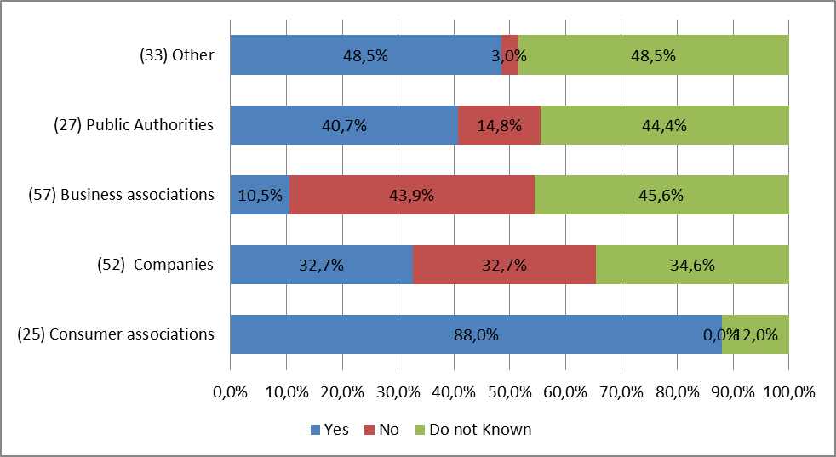

**Question 40** (285 responses) "In your view, is it problematic that consumers do not have the right to cancel "free" online services within 14 days?: Yes, it discourages consumers from acquiring such online services"

**Figure 5: lack of right of withdrawal for "free" digital services is problematic**

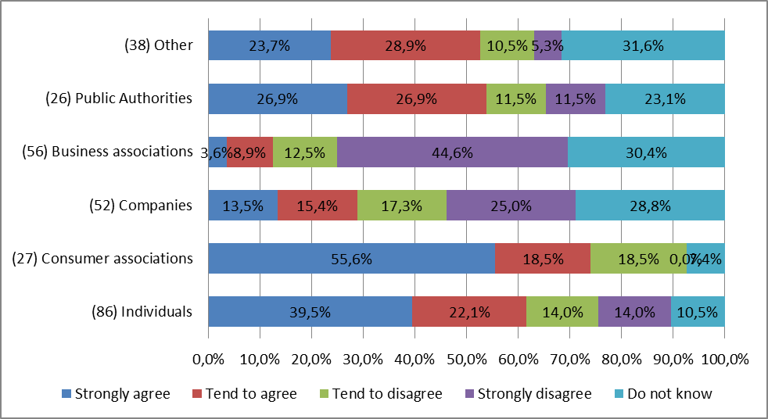

**Question 43** (201 responses) "Based on your professional experience, would consumers use "free" online services more often if they had the right to cancel the service within 14 days after acquiring it."

**Figure 6: consumer use of "free" digital services to increase if given right of withdrawal** 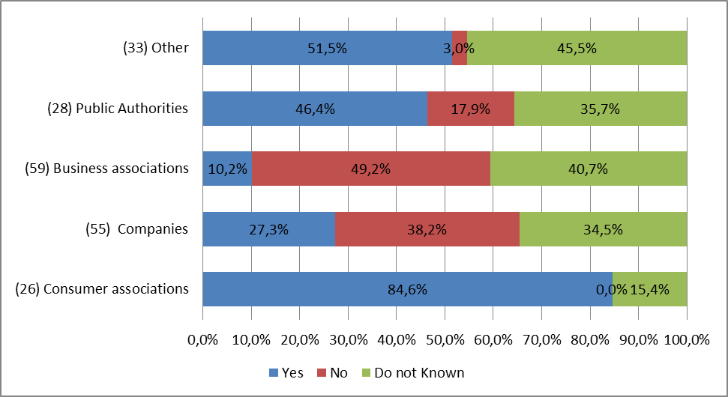

**Question 81** (134 responses) "In your opinion, should consumers benefit from the rights listed below when using "free" online services?: The right to pre-contractual information (e.g. about functionality and interoperability of the service with hardware and software)".

**Figure 7: should consumers have pre-contractual information about "free" digital services**

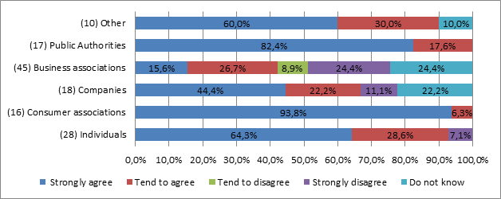

**Question 81** (134 responses) "In your opinion, should consumers benefit from the rights listed below when using "free" online services?: The 14-day right of withdrawal (possibility to cancel the contract)".

**Figure 8: should consumers have the right of withdrawal for "free" digital services**

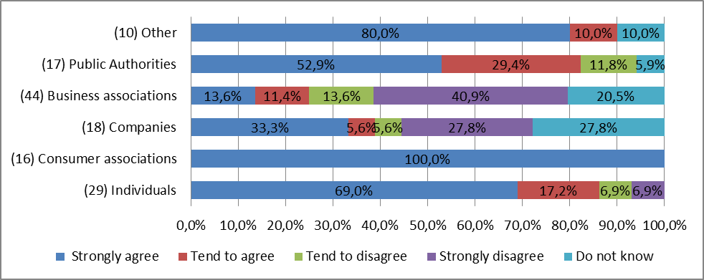

**Question 81** (44 responses) "In your opinion, should consumers benefit from the rights listed below when using "free" online services?: Other".

**Figure 9: should consumers have other rights for "free" digital services**

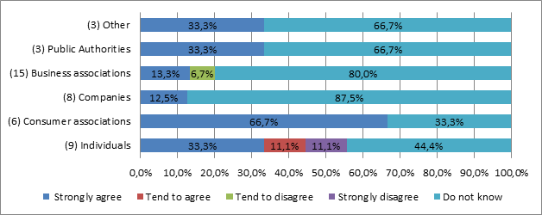

**Question 83** (129 responses) "Why would it be important that consumers have a right to pre-contractual information for "free" online services?: To achieve a more level playing field between digital traders using different business models (services provided with or without payment of money)".

**Figure 10: impact of pre-contractual information for a more level playing field**

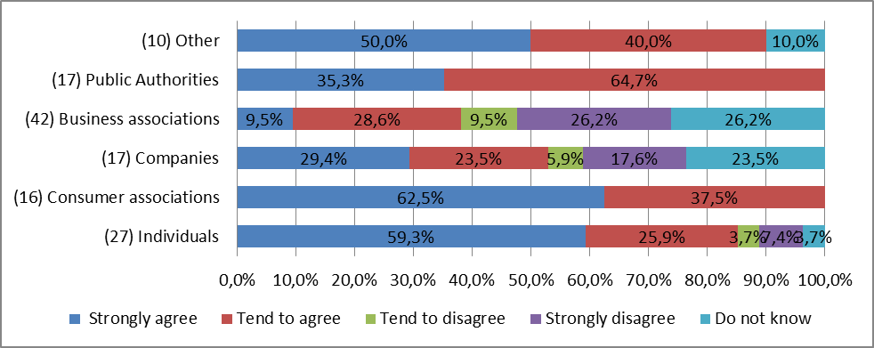

**Question 83** (130 responses) "Why would it be important that consumers have a right to pre-contractual information for "free" online services?: To better protect the consumers of services with similar functionalities".

**Figure 11: impact of pre-contractual information on consumer protection for services with similar functionalities**

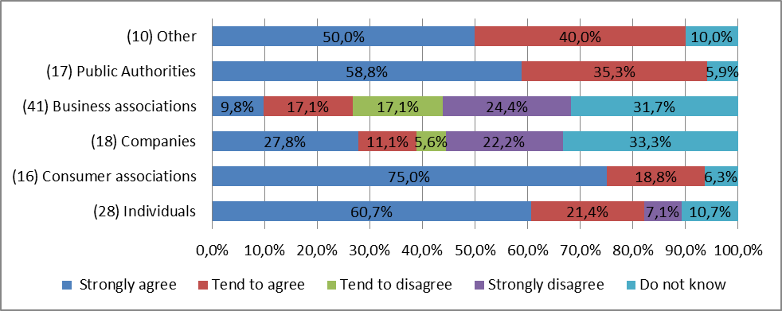

**Question 83** (131 responses) "Why would it be important that consumers have a right to pre-contractual information for "free" online services?: To ensure better synergies between EU consumer protection and the new EU personal data protection rules".

**Figure 12: impact of pre-contractual information for better synergies with EU consumer protection and data protection rules**

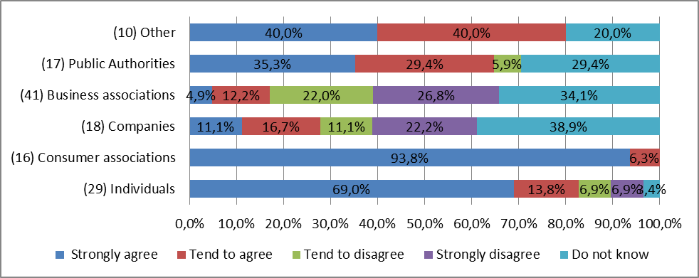

**Question 85** (128 responses) "Why would it be important that consumers have a possibility to withdraw from contracts for "free" online services?: To achieve a more level playing field between digital traders using different business models (services provided with or without payment of money)".

**Figure 13: impact of right of withdrawal on a more level playing field**

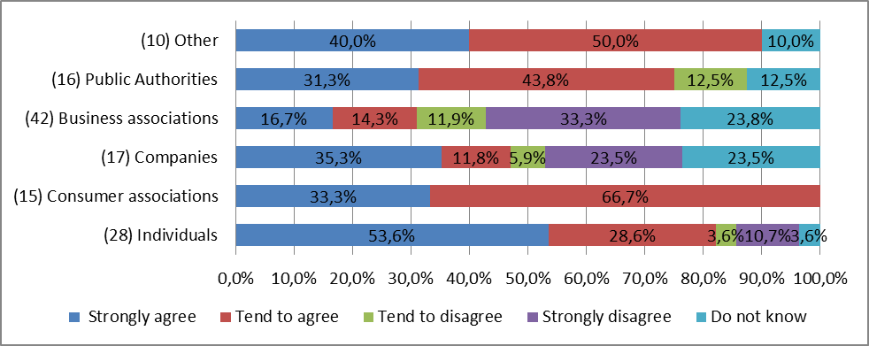

**Question 85** (128 responses) "Why would it be important that consumers have a possibility to withdraw from contracts for "free" online services?: To better protect the consumers of services with similar functionalities".

**Figure 14: impact of right of withdrawal on consumer protection for services with similar functionalities**

**Question 85** (127 responses) "Why would it be important that consumers have a possibility to withdraw from contracts for "free" online services?: To ensure better synergies between EU consumer protection and the new EU personal data protection rules".

**Figure 15: impact of right of withdrawal for better synergies with EU consumer protection and data protection rules**

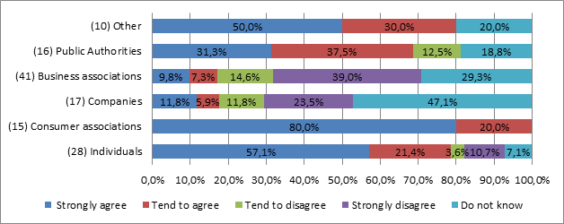

**Question 36 in the public consultation**: In your view, is it problematic that consumers do not have the right to be informed (before acquiring the service) about the main features of "free" online services (e.g. on functionality and interoperability with hardware and software)?

[ID142] Yes, it creates harm for consumers including when they use services cross-border

68% of individuals (58 out of 85 respondents) strongly/tend to agree that lack of pre-contractual information is problematic and creates harm when using "free" digital services cross-border; similar percentage applies for lack of a withdrawal right: 66% of individuals (57 out of 86 respondents) strongly/tend to agree this being problematic.

[ID143] Yes, it discourages consumers from acquiring such online services

24 out of 27 responding consumer authorities strongly/tend to agree that lack of pre-contractual information discourage consumers from acquiring "free" digital services.

**Question 40 in the public consultation**: In your view, is it problematic that consumers do not have the right to cancel "free" online services within 14 days?

[ ID210] Yes, it creates harm for consumers including when they use services cross-border.

66% of individuals (57 out of 86 respondents) strongly/tend to agree.

[ID211] Yes, it discourages consumers from acquiring such online services

20 out of 27 responding consumer authorities strongly/tend to agree that lack of right of withdrawal discourage consumers from acquiring "free" digital services.

**SME panel consultation**

**Question 3 in section C.3 of the SME panel consultation:** How much staff time or other resources does your enterprise need, when entering another EU country's market, for complying with national rules of the other Member State requiring you to give pre- contractual information to consumers and/or enabling them to withdraw from their "free" online service contracts shortly after having concluded the contact (e.g. within 14 days)?

One-off costs: Please estimate the one-off resources you need to invest in order to enter a new EU market, on average per Member State (e.g. checking compliance with national rules and adjusting business practices as a result (e.g. update your website), costs of legal/technical advice).

Regular costs: Please estimate the resources you need to invest on a regular basis to comply with different national rules, on average per country (e.g. handling consumer complaints/ enquiries, monitoring national rules).

Note: Please indicate staff time in working days, whereby 1 working day = 8 hours of staff time. Please do not consider staff time for translation. If no staff time is involved, indicate ‘0’

**Summary of responses:**

Costs have been obtained by converting full time equivalents using the standard cost model and the second highest ISCO level (ISCO 2 professionals), adding pecuniary costs estimates:

One-off costs [ID2651 ID2652] pre-contractual information + right of withdrawal

|  |  |  |
| --- | --- | --- |
| **Size class** | **Range of estimated annual costs in Euro (median/mode)** | **Number of responses** |
| **Micro** | 0 - 48 000 (0/0) | 21 |
| **Small** | 0 – 7 500 (1 146/0) | 6 |
| **Medium** | N/A* | 2 |
| **Large** | N/A | 0 |
| SMEs | 0 - 48 000 (0/0) | 29 |

Note: (*) 2 estimates were received in this category (EUR 0 and 299 respectively

Annual regular/running costs [ID2661 ID2662] pre-contractual information + right of withdrawal

|  |  |  |
| --- | --- | --- |
| **Size class** | **Range of estimated resources in Euro (median/mode)** | **Number of responses** |
| **Micro** | 0 – 20 000 (0/0) | 21 |
| **Small** | 0 – 5 782 (1 250/0) | 6 |
| **Medium** | N/A* | 2 |
| **Large** | N/A | 0 |
| SMEs | 0 – 20 000 (0/0) | 29 |

Note**:** (*) 2 estimates were received in this category (EUR 0 and 299 respectively)

**Question 5 in section C.3 of the SME panel consultation:** ID275] If a new EU rule was introduced requiring you to give pre-contractual information to consumers about "free" online service contracts, would this have an impact on your enterprise's decision to enter other EU markets?

48,3% of SMEs operating online (B2C) consider that future costs from pre-contractual information requirements would not have an impact on their decision to enter other EU markets (28 out of 58 respondents).

**Question 8 in section C.3 of the SME panel consultation:** [ID298] If a new EU rule was introduced to extend the right of withdrawal to "free" online services in all Member States (i.e. consumers would be able to cancel, for any reason, such "free" contracts within 14 days), would this have an impact on your enterprise's decision to enter other EU markets?

44.7% of SMEs operating online (B2C) consider that future costs from a right of withdrawal would not have an impact on their decision to enter other EU markets (21 out of 47 respondents).

**Question 1b. in the SME panel consultation**: What are your enterprise's estimated losses related to the previously mentioned obligations?:

- Obligation to accept the return of goods bought online which consumers have used more than what they could have done in a brick and mortar shop (e.g. to check the size), thus requiring you to calculate the diminished value of the used good, to resell it as second-hand good and/or to dispose of it as waste.

- Obligation to reimburse the consumer without having the possibility to inspect the returned goods as soon as the consumer has supplied evidence of having sent them back (e.g. goods were never returned back)

**Summary of responses:**

Costs have been obtained by converting full time equivalents using the standard cost model and the second highest ISCO level (ISCO 2 professionals), adding pecuniary costs estimates:

[ID1811 ID1812] **Obligation to accept the return of goods bought online:**

|  |  |  |
| --- | --- | --- |
| **size class** | **Range of estimated annual losses in Euro (median/mode)** | **Number of responses** |
| **Micro** | 0 – 13 500 (50/0) | 22 |
| **Small** | 0 – 12 000 (550/0) | 6 |
| **Medium** | 0 – 1 000 (0/0) | 3 |
| **Large** | N/A* | 2 |
| **SMEs** | 0-13 500 (100/0) | 31 |

Note**:** (*) Less than three estimates were received in this category

[ID1821 ID1822] **Obligation to reimburse the consumer:**

|  |  |  |
| --- | --- | --- |
| **size class** | **Range of estimated annual losses in Euro (median/mode)** | **Number of responses** |
| **Micro** | 0 – 10 000 (0/0) | 22 |
| **Small** | 0 – 4 000 (50/0) | 4 |
| **Medium** | 0 – 10 000 (0/0) | 5 |
| **Large** | N/A* | 1 |
| **SMEs** | 0 - 10 000 (0/0) | 31 |

Note**:** (*) Less than three estimates were received in this category

# Annex 12: Additional data on information requirements

**Figure 1: Consumers' views of the redundancy of UCPD information requirements (behavioural experiment)[39]**

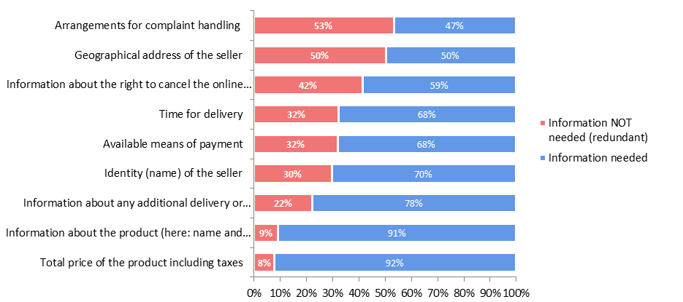

**Figure 2: Consumers' views on the importance of information presented in advertisement (respondents considering information as (important’ or ‘very important’))[40].**

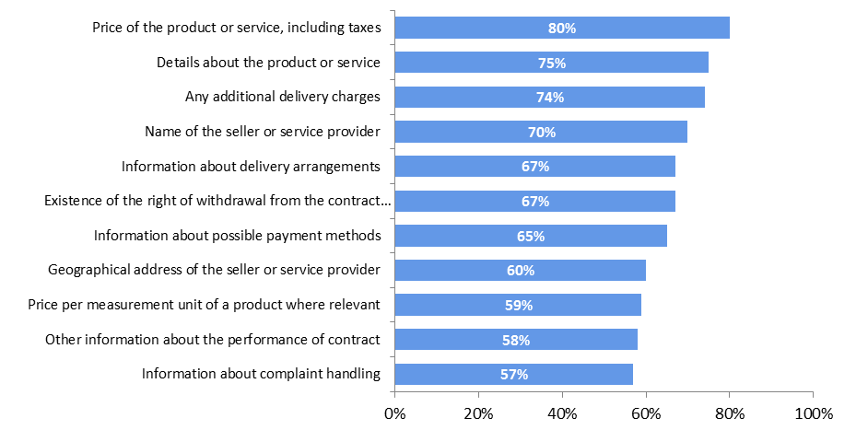

**Question 162 in the public consultation**: Currently, traders are required to provide the following information to consumers at the advertising stage and at the stage before the actual purchase. Do you agree that the following information is necessary already at the advertising stage even though the consumer will also receive this information at a later stage?:

Most of the responding business associations considered that these two information elements are not needed at the advertising stage (35 out of 51 regarding the geographical address of the trader and 42 out of 51 respondents regarding the complaint handling). Most of the responding public authorities (11 out of 18) agreed that information about the complaint handling is not needed at the advertising stage. In contrast, a majority of them (13 out of 18) considered the geographical address of the trader as necessary also at the advertising stage. Almost all consumer associations replied in the public consultation that both information elements are required at the advertising stage (16 out of 16 for the geographical address, 15 out of 16 for the complaint handling). 9 of 15 SMEs agreed that information about the geographical address is necessary already at advertising stage but only 2 considered necessary the information about the complaint handling.

**Question 103 in the public consultation**: Under the Consumer Rights Directive, the fax number and the email address – both if available - are listed as information that must be provided to the consumer before conclusion of the contract ("pre-contractual information obligation"). In view of technological developments, which of the following communication means are for you most relevant when communicating with consumers/traders?:

No business association and only three consumer associations and two public authorities considered fax as a relevant means of communication. In contrast, web-based means of communication were considered by all these stakeholder categories nearly as relevant as e-mail communications. Specifically, the following number of respondents considered these means of communication as relevant: consumer associations – 15 email and 13 web-based; business associations – 40 email and 30 web-based; public authorities – 14 email and 10 web-based. As regards companies, among the 8 responding large companies all considered as relevant web-based tools, 7 chose email, 4 - social media whereas no one chose fax. Among the 15 SME respondents, 14 chose email, 7 – web-based tools, 2 – social media, and 6 – fax.

# Annex 13: Additional data on rules on the right to withdraw

**Question 1 in section C.1 of the SME panel consultation**: Over the last two years, has your enterprise faced unnecessary and/or disproportionate burdens due to the following obligations related to the right of withdrawal (right for the consumer to cancel the contract within 14 days)? 1) Obligation to accept the return of goods bought online which consumers have used more than what they could have done in a brick and mortar shop (e.g. to check the size), thus requiring you to calculate the diminished value of the used good, to resell it as second-hand good and/or to dispose of it as waste); 2) Obligation to reimburse the consumer without having the possibility to inspect the returned goods as soon as the consumer has supplied evidence of having sent them back.

Significant share of respondents selling to consumers online replied that they face disproportionate burden. In particular, the majority of SMEs selling to consumers online replied that they never faced disproportionate burden related to the legal obligation to accept the return of "unduly tested goods" (52%, i.e. 51 out of 99 respondents) or to reimburse the consumer without having the possibility to inspect the returned goods (60%, i.e. 58 out of 97 respondents). Few respondents have 'often' faced disproportionate burden, 4% (4 out of 99 respondents) for used goods, and 5% (5 out of 97 respondents) for early reimbursement.

**Question 148 in the public consultation**: Do you consider that traders face unnecessary and/or disproportionate burden due to the following obligations related to the right of withdrawal? 1) Obligation to accept the return of goods bought online which consumers have used more than what they could have done in a brick and mortar shop (thus requiring the trader to calculate the diminished value of the used good, to resell it as second-hand goods and/or to dispose of it as waste); 2) Obligation to reimburse the consumer without having the possibility to inspect the returned goods as soon as the consumer has supplied evidence of having sent them back.

Only 16 out of 30 consumer associations replied to these questions. 7 of them acknowledged that the right of withdrawal for unduly tested goods creates disproportionate/unnecessary burden for traders to 'a large' or 'some extent' and 6 replied the same in relation to the early reimbursement obligation. As regards public authorities, 10 out of the 16 agreed that traders may experience burden to 'a large' or 'some extent' for both the return of "unduly tested goods" and "early reimbursement".

In the public consultation, out of the 94 online companies replying to the questions on the right of withdrawal for unduly tested goods, 58% (55 respondents) replied "do not know" to whether they had experienced significant problems to accept the return of such goods. Out of the 91 online companies replying to whether they had experienced significant problems due to the "early reimbursement", 57% (52 respondents) replied "do not know". Around 35% of them[41] declared having experienced significant problems at least 'once'[42]. This is also true for small or micro enterprises operating online: around 34-37% of them[43] replied they had experienced significant problems at least 'once'.

In the public consultation 10 out of the 16 responding authorities[44] agree that traders may experience burden to 'a large' or 'some extent' for both the return of "unduly tested goods" and "early reimbursement".

However, very few respondents provided quantitative data/estimates. As regards the share of returned used goods, 12 respondents (businesses selling online, two individuals and a national business association) indicated that 20% of goods are "unduly tested" in proportion to all returned goods (median value). At the same time, one should underline that most consumer associations (14 out of the 15 respondents), Member States authorities (12 out of the 16 respondents) and 'others' category (5 out of the 8 respondents) consider the right of withdrawal for "unduly tested goods" and the right to early reimbursement are 'rather'[45] or 'very important'.[46]

Two out of the six submissions received by various stakeholders in the framework of the Refit Platform of the European Commission referred to the CRD rules on the exercise of the right of withdrawal for goods use more than allowed. In particular, the Danish Business Forum pointed to the need to investigate on the CRD rules in question to make it sure that the Directive does not impose unnecessary or disproportionate burdens on businesses, whereas the Detailhandel Nederland considers further clarification on these rules necessary. Overall, the Government group shared the conclusions of the Commission in the CRD Evaluation and whilst one Member State opposed to restricting the right of withdrawal of the consumer, the other contributing Member States supported the Commission's initiative to introduce possible targeted amendments to the rules on the right of withdrawal, if the burden on traders is proved to be disproportionate. In particular, in the opinion issued on 23 November 2017 the REFIT Platform welcomed the initiative by the Commission to analyse possible targeted legislative changes in view of the findings from the CRD evaluation. [47]

# Annex 14 JRC Technical Report: "An analysis of the influence of remedies and sanctions on consumers' exposure to unfair commercial practices and shopping problems"

An analysis of the influence of remedies and sanctions on consumers' exposure to unfair commercial practices and shopping problems

Canzian, G., Ferrara, A., Ferraresi, M.

2017

This publication is a Technical report by the Joint Research Centre (JRC), the European Commission’s science and knowledge service. It aims to provide evidence-based scientific support to the European policymaking process. The scientific output expressed does not imply a policy position of the European Commission. Neither the European Commission nor any person acting on behalf of the Commission is responsible for the use that might be made of this publication.

**Contact information**

Name: Giulia Canzian

Address:  via E. Fermi 2749 - Ispra (VA), I-21027, Italy

Email: giulia.canzian@ec.europa.eu

Tel.: +39 0332 785791

**JRC Science Hub**

https://ec.europa.eu/jrc

JRC109500

Ispra : European Commission, 2017

© European Union, 2017

Reuse is authorised provided the source is acknowledged. The reuse policy of European Commission documents is regulated by Decision 2011/833/EU (OJ L 330, 14.12.2011, p. 39).

For any use or reproduction pf photos or other material that is not under the EU copyright, permission must be sought directly from the copyright holders.

How to cite this report: Canzian, G., Ferrara, A. and Ferraresi, M., *An analysis of the influence of remedies and sanctions on consumers’ exposure to unfair commercial practices and shopping problems*, European Commission, Ispra, 2017, JRC109500.

All images © European Union 2017

Contents

Acknowledgements 1

Executive summary 2

1 Introduction 3

2 Estimation approach 4

2.1 Influence of penalties intensity on remedies implementation 5

3 Data 6

4 Results and interpretation 8

5 Further extensions 11

List of figures 12

List of tables 13

Acknowledgements

The authors would like to thank colleagues from DG JUST who provided insights and expertise that improved this report. We are also grateful to CC-ME team for their comments on an earlier version of the manuscript. Any errors are our own.

Authors

Giulia Canzian, Antonella Ferrara and Massimiliano Ferraresi

Executive summary

This technical note reports about the relationship between consumers’ behaviour and the implementation of the Unfair Commercial Practices Directive (2005/29/EC), aimed at contrasting illegal processes that can harm consumers’ rights and to ease cross-border trading for SMEs and businesses in general.

In particular, it assesses to what extent the implementation by a country of either contractual or extra-contractual remedies is associated to a lower probability – for a consumer – to experience an unfair commercial practice, and how these remedies influence the perception of consumers, measured by several outcomes.

The results presented in the report show a broad range of correlation patterns between the main treatment variable and the outcome of interest. Some particular features of the data do not allow establishing causal relationships between the implementation of remedies and the results of interest.

The results indicate that consumers living in countries where remedies are in place experience a lower probability of both reporting a UCP and experiencing any kind of problem while shopping, when compared to consumers living in other countries without remedies. Moreover, the deterrent effect of remedies is associated with the value of a measure addressing the level of monitoring exerted by Public Administrations on compliance with consumers’ legislation; and with the severity of penalties for UCPD infringements envisaged by countries.

Eventually, consumers living in countries where remedies are in place display also a higher likelihood of receiving a satisfying assistance once they complain after having suffered a problem while shopping.

1. Introduction

Consumers’ protection is at the forefront of European Commission interests. In the last decades a number of initiative has been put in place to ensure fair terms of trade for consumers, and among these, it is worth remembering the Unfair Commercial Practice (UCP hereinafter) directive (2005/29/EC).

The analysis presented in this report is related to the implementation of the UCP directive on consumers’ behaviour. In particular, it assesses to what extent the implementation by a country of either contractual or extra-contractual remedies is associated to a lower probability – for a consumer – to experience an unfair commercial practice, and how these remedies influence the perception of consumers, measured by several outcomes.

1. Estimation approach

The UCP directive was adopted to promote consumers’ rights protection and to ease cross-border trading for SMEs and businesses in general. In this light, the adoption of either contractual or extra-contractual remedies following the Directive was aimed at lowering the likelihood for consumers to encounter episodes of UCP, while shopping.

For this reason the analysis focuses on three outcomes: the probability of experiencing a UCP; the probability of experiencing any kind of problem when shopping; and the probability of receiving a satisfying assistance after complaining for shopping problems. The outcomes are all expressed in binary (0-1) terms.

The evaluation of how the implementation of remedies is associated to these outcomes is done by means of a Linear Probability Model (LPM). In this framework, the LPM returns estimated coefficients similar to that obtained by using either a logistic or a probabilistic model, but with the main advantage of the coefficients to be interpreted as percentage changes. In particular, the results of the LPM represent the differential in the likelihood of a particular outcome to occur in countries where remedies are in place with respect to countries that do not foresee them.

While the results of the LPM offer a broad range of correlation patterns, they cannot be interpreted as establishing causal relationships between the implementation of remedies and the outcome of interest. Indeed, in this setting, the available data were not enough to tackle all the endogeneity sources that prevent a causal interpretation of the model performed.

Nonetheless, a robust regression analysis has been performed by introducing control variables to account for possible confounding factors related to individual characteristics.

The baseline model is given by the following equation:

$y_{ic}=α+β_{1}{Remedies}_{c}+β_{2}{PM}_{c}+β_{3}{{Remedies}_{c}*PM}_{c}+γX_{i}+ε_{ic}$ (1)

where $y_{ic}$ is one of the outcome variables considered for individual *i* and country *c*; ${Remedies}_{c}$ is the main treatment variable that takes the value of one if the country envisages remedies for breaches in consumers’ law – either contractual or extra-contractual – and 0 otherwise. ${PM}_{c}$ takes into account countries’ specific legislative framework, capturing the extent to which retailers in the country believe Public Authorities are effectively monitoring consumer legislation compliance. $X_{i}$ is a vector of controls that gives reason to possible differences in reporting to the survey related to age, gender, the employment status, the intensity of internet usage, the living area, the mother tongue language (whether it is a European language or not), the number of spoken languages, the degree of financial difficulties experienced, the numerical skills and the degree of self-reported vulnerability with respect to contract terms and offers.

The coefficient of interest is computed deriving equation (1) with respect to the *Remedies* variable, which yields the following expression:

$$\frac{∂y_{ic}}{∂{Remedies}_{c}}=β_{1}+β_{3}* {PM}_{C}$$

thus, the influence of remedies is the result of the linear combination of the two estimated coefficients, $β_{1}$ and $β_{3}$, computed for different levels of Public Monitoring. In particular, the combination is evaluated at minimum, mean, median and maximum values of PM.

2.1 Influence of penalties intensity on remedies implementation

European countries envisage the possibility of applying penalties for breaches in consumer protection legislation. The level of penalties is highly heterogeneous across countries. In order to control for possible contemporaneous effects of remedies and penalties[48] implementation, a different specification of the previous model has been considered:

$y_{ic}=α+β_{1}{Remedies}_{c}+β_{2}{Penalties}_{c}+β_{3}{{Remedies}_{c}*{Penalties}_{c}+ β_{4}PM}_{c}+γX_{i}+ε_{ic}$ (2)

where ${Penalties}_{c}$ is a categorical variable taking on values ranging from 0 to 3, according to the intensity of sanctions.

As before, the coefficient of interest is computed deriving equation (2) with respect to the *Remedies* variable, which yields the following expression:

$$\frac{∂y}{∂Remedies}=β_{1}+β_{3}* Penalties$$

The influence of remedies is then evaluated for each level taken by the $Penalties$ variable.

1. Data

The analysis is mainly based on individual consumer data collected in 2017 by the survey on Consumers’ attitudes towards cross-border trade and consumer protection (SCA hereinafter)[49]. On the other hand, the information about the implementation of remedies and penalties in each EU country has been provided by DG JUST.03.

As already mentioned, the study focuses on three main outcomes. All of them have been defined on the basis of the information contained in the SCA.

The “probability of experiencing a UCP in domestic countries” is a dummy variable taking the value of one if the consumer has experienced at least one UCP in the last 12 months among those listed in the submitted question (Q13). To focus on domestic UCPs, only answers to the option “Yes, with retailers or service providers located in our (domestic) country” have been considered.

As for the “probability of experiencing a problem” outcome, the variable is based on the question “In the past 12 months, have you experienced any problems when buying or using any goods where you thought you had a legitimate cause for complaint?” (Q9), and it takes the value of one when consumers declare either to have experienced the problem and to have taken action to solve it or to have experienced a problem but to have not taken any action to solve it; 0 otherwise.

The “probability of receiving a satisfying assistance from retailers after having experienced a problem” is referred to the question “In general, how satisfied or dissatisfied were you with the way your complaints were dealt with by the retailer or service provider?” (Q11). The question targets a subsample of the respondents, namely those who declared to have suffered a problem and to have tried to solve it directly referring to the retailer. It takes the value of one if the result of the complaint very satisfied or fairly satisfied the consumer and 0 otherwise.

The country level variable accounting for consumer legislation compliance is derived from the 2016 edition of the survey on Retailers’ attitude towards cross-border trade and consumer protection[50]. It is given by the fraction of retailers that strongly agree or agree with the statement “the Public Authorities actively monitor and insure compliance with consumer legislation in your sector”.

As already mentioned, a number of additional control variables have been introduced. The age of the consumer when the interview took place can have had an impact on both the willingness to respond to the questionnaire and to the likelihood of reporting UCP experienced. Indeed, it can be argued that the younger, being in general more educated and more keen to ensure their rights are met, are more likely to detect and report UCPs. In order to control for this, an “age” variable has been introduced that recodes consumers’ age into 3 main categories: those aged between 18 and 34; those aged between 34 and 54 and those older than 55 years.

Following the same line of reasoning, there could be differences in the likelihood of reporting problems or in the evaluation of the assistance received between men and women. These possible differences are accounted through a dummy variable taking value 1 if the consumer is a female and 0 if he is a male.

Being unemployed or being a white collar could entail different shopping behaviours, and, eventually, different assessment of UCPs or the assistance received. For this reason, regressions are made robust controlling for the employment status of the respondent. In particular, it has been described according to 7 categories: i) self-employed; ii) white collar; iii) blue collar; iv) unemployed; v) seeking a job; vi) student; vii) retired.

The likelihood to report UCPs could be related to the understanding of the terms of sale by the consumer. An individual whose mother tongue is the one of the country where she lives, will have a better understanding of the terms of sale and would have less probability to experience and report a UCP. The analysis controls for this through a dummy variable equals to 1 when the consumer’s mother tongue is an official language of the home country and 0 otherwise. Apart from the mother tongue language, consumers can consider the terms of sale to be so complex that they feel vulnerable when making the purchase: it can be argued that the more vulnerable they feel, the more likely they will experience and report a UCP. In order to account for this effect, the model has been enriched with a variable capturing consumers’ self-reported degree of vulnerability. The latter is coded into three categories capturing the degree of vulnerability, namely “Very vulnerable”, “Somewhat vulnerable” and “Not vulnerable”.

The degree of vulnerability could be influenced by several factors. In principle, the higher the problem solving ability of a consumer, the lower would be the likelihood for him to be exposed to UCPs. The SCA offers two variables to be used in the analysis as proxies for the problem solving ability of the consumers. First, the survey accounts for the number of spoken languages by the consumer (cardinal variable taking values from 1 up to 4); secondly, it evaluates the numerical skills of the respondent through a short numerical test, and it categorised them into a variable whose values range from 1 (“High skills”) to 3 (“Low”).

Another factor that might affect consumers’ purchasing behaviour and experiences is the intensity of internet usage. Given the multidimensional role of the web, worldwide tool to spread out information and huge marketplace, it influences both the awareness of the consumers on their rights and also the number of commercial transactions they could perform. This is a categorical variable, coded into five levels of intensity of the use of internet: daily, weekly, monthly, hardly ever, never.

The financial position of the consumers matter in determining number and entity of their transactions and the effort put to enforce their rights. In order to account for this, the variable “Degree of financial difficulties” has been introduced. This variable, originally coded into four categories (very difficult, fairly difficult, fairly easy, very easy), has been recoded into a dummy variable equal to 1 if the degree of financial difficulties was fairly easy or easy and 0 otherwise.

Along with this more personally related aspects, a variable accounting for the degree of urbanization of the living are has been included. The variable “living area” distinguishes three categories: rural area, small town, large town.

1. Results and interpretation

When looking at the influence of remedies implementation on the likelihood of experiencing UCP, consumers in countries where remedies are in place experience a 3.99% lower probability of experiencing a UCP with respect to consumers living in other countries (Table 1). Table 2 and figure 1 show that the influence of remedies implementation is associated with the level of Public Monitoring. That is to say, the deterrent effect of remedies on the likelihood of experiencing UCP changes accordingly to the value of the Public Monitoring. In particular, for the minimum level of Public Monitoring, there is no deterrent effect of remedies on the probability of experiencing UCP (the coefficient is positive and statistically significant), while the effects become negative and significant for any levels of Public Monitoring equal or higher than its median value.

Table 1. Baseline coefficient of the “remedies” variable on the likelihood of experiencing at least one UCP in the domestic country. Percentage value.

|  |  |
| --- | --- |
| Baseline coefficient of the remedies variable |  |
| Remedies | -3.99481*** |
|  | (0.008647) |

**Source:** own calculations- LPM regression, robust standard errors in parenthesis.

*** p<0.01, ** p<0.05, * p<0.1

Table 2. Baseline coefficient of the “remedies” variable at different levels (minimum, median, maximum) of “Public Monitoring on Consumer Legislation”. Percentage values.

|  |  |
| --- | --- |
| *Baseline coefficient of the remedies variable for different values of PM* |  |
| Remedies - PM (min level) | 15.07004*** |
|  | (0.02064) |
| Remedies - PM (median level) | -5.57152*** |
|  | (0.008515) |
| Remedies - PM (max level) | -21.4358*** |
|  | (0.017308) |

**Source:** own calculations- LPM regression, robust standard errors in parenthesis.

*** p<0.01, ** p<0.05, * p<0.1

Figure 1. Baseline coefficient of the “remedies” variable at different levels of “Public Monitoring on Consumer Legislation”.

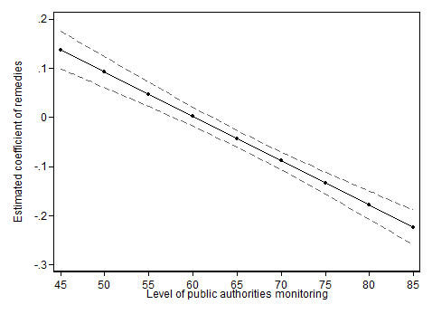

Similar results come up assessing the likelihood of experiencing a problem when shopping. For consumers living in countries where remedies are implemented, the probability of experiencing a problem while shopping is 3.15% lower with respect to those living in other countries (Table 3).

Table 3. Baseline coefficient of the “remedies” variable on the likelihood of experiencing a problem while shopping in the domestic country. Percentage value; standard errors in parenthesis

|  |  |
| --- | --- |
| Baseline coefficient of the remedies variable |  |
| Remedies | -3.15081*** |
|  | (0.0079546) |

**Source:** own calculations- LPM regression, robust standard errors in parenthesis.

*** p<0.01, ** p<0.05, * p<0.1

Table 4 and figure 2 confirm the findings on the influence of the level of PM presented in table 1 and figure 1.

Table 4. Baseline coefficient of the “remedies” variable on the likelihood of experiencing a problem while shopping in the domestic country, at different values of “Public Monitoring on Consumer Legislation”. Percentage values.

|  |  |
| --- | --- |
| *Baseline coefficient of the remedies variable for different values of PM* |  |
| Remedies - PM (min level) | 8.25197*** |
|  | (0.0183917) |
| Remedies - PM (median level) | -4.0984*** |
|  | (0.007857) |
| Remedies - PM (max level) | -13.59039*** |
|  | (0.0153349) |

**Source:** own calculations- LPM regression, robust standard errors in parenthesis.

*** p<0.01, ** p<0.05, * p<0.1

Figure 2. Baseline coefficient of the “remedies” variable at different levels of “Public Monitoring on Consumer Legislation”.



On average, where remedies are implemented consumers complaining with retailers after encountering a problem have a higher probability (8.7%, statistically significant at 5%) of receiving a satisfying assistance, compared to countries without remedies.

Eventually, regressions estimates presented in table 5, show that in countries foreseeing higher penalties for UCPD infringements, the introduction of remedies is associated with a decrease of the probability to encounter a UCP that is roughly 3 times larger than in countries with medium or lower penalties.

Table 5. Baseline coefficient of the “remedies” variable for each sanction category. Percentage values.

|  |  |
| --- | --- |
| *Baseline coefficient of for each sanction category* |  |
| Remedies - Low sanctions | -11.92734*** |
|  | (0.0186859) |
| Remedies - Medium sanctions | -9.29867*** |
|  | (0.0180855) |
| Remedies - High sanctions | -29.35719*** |
|  | (0.0279084) |

**Source:** own calculations- LPM regression, robust standard errors in parenthesis.

*** p<0.01, ** p<0.05, * p<0.1

1. Further extensions

As already mentioned in the previous sections, the results of the analysis cannot be interpreted as establishing causal relationships.

A causal interpretation of the results would only be possible by tackling the endogeneity issues. The latter mainly concerns the fact that remedies may have been implemented in those countries that most needed them.

In this specific problem, setting the endogeneity issue can be addressed in three main ways: panel setting, difference-in-differences strategy and synthetic control approach.

The panel framework, exploiting the longitudinal dimension of country level data, allows controlling for country time invariant characteristics by introducing country fixed effects. Even though it could have been possible to collect annual information for all the countries, the same would have not been feasible for the dependent variable since it is constructed from a survey whose methodology has changed throughout time.

The endogeneity problem can also be tackled exploiting the time dimension of the implementation of remedies. In particular, it is possible to compare a pre-existing situation to the one realized after the implementation of remedies, for the countries that implemented remedies and for the countries that did not (differences-in-differences strategy). The implementation of this strategy relies on the common pre-intervention trend assumption for the outcomes of interest (common trend assumption). As a consequence any deviation of the outcome of those implementing remedies from this trend can be imputed to the intervention itself, and can be interpreted as its net effect.

Clearly, researchers would need information on the outcome variable of interest in pre-intervention periods in order to carry out such an analysis. Unfortunately, the survey from which data have been taken has changed several times in the last years, and this poses not only comparability concerns regarding both the outcome variables and the individual variables that can be used as control in the regressions, but also it reduces the time-span for which it is possible to test the common trend assumption.

A different approach is the synthetic control method. The idea on which the method is based is to evaluate the impact of a treatment implemented at the country level using a set of countries – the so-called donor pool – to build a synthetic unit similar as much as possible to the treated one. Longitudinal data concerning both the reference country and the donor pool are needed. In particular, information referred to a moment prior to the intervention is used to build the weighted average of control units that best reproduces the characteristics of the treated country over time. The comparison between the treated unit and the synthetic outcome trends after the implementation of the policy, informs about its net impact. The condition for the method to work is to have sufficient pre- and post-intervention time points for all the countries involved.

In this context the synthetic control method was not feasible. Indeed, most of the countries decided to adopt remedies for breaches in consumers’ law only in recent years (around 2014), thus there is no long enough post-treatment information to run the analysis. The only country for which the implementation of the synthetic was feasible is Luxemburg, since remedies were adopted in 2011. However, Luxemburg is a relatively small and peculiar country, thus any conclusion that could have been drawn from the analysis would have been hardly applicable to the rest of Europe.

Finally, an instrumental variable approach could have been implemented. However, the identification of a valid instrument satisfying the exclusion restriction assumption requires long and in-depth analyses.

List of figures

Figure 1. Baseline coefficient of the “remedies” variable at different levels of “Public Monitoring on Consumer Legislation”. 9

Figure 2. Baseline coefficient of the “remedies” variable at different levels of “Public Monitoring on Consumer Legislation”. 10

List of tables

Table 1. Baseline coefficient of the “remedies” variable on the likelihood of experiencing at least one UCP in the domestic country. Percentage value. 8

Table 2. Baseline coefficient of the “remedies” variable at different levels (minimum, median, maximum) of “Public Monitoring on Consumer Legislation”. Percentage values. 8

Table 3. Baseline coefficient of the “remedies” variable on the likelihood of experiencing a problem while shopping in the domestic country. Percentage value; standard errors in parenthesis 9

Table 4. Baseline coefficient of the “remedies” variable on the likelihood of experiencing a problem while shopping in the domestic country, at different values of “Public Monitoring on Consumer Legislation”. Percentage values. 9

Table 5. Baseline coefficient of the “remedies” variable for each sanction category. Percentage values. 10

**HOW TO OBTAIN EU PUBLICATIONS**

**Free publications:**

• one copy:  
via EU Bookshop (<http://bookshop.europa.eu>);

• more than one copy or posters/maps:  
from the European Union’s representations (<http://ec.europa.eu/represent_en.htm>);   
from the delegations in non-EU countries (<http://eeas.europa.eu/delegations/index_en.htm>);   
by contacting the Europe Direct service (<http://europa.eu/europedirect/index_en.htm>) or  
calling 00 800 6 7 8 9 10 11 (freephone number from anywhere in the EU) (*).  
  
[(*)](http://europa.eu.int/citizensrights/signpost/about/index_en.htm#note1#note1) The information given is free, as are most calls (though some operators, phone boxes or hotels may charge you).

**Priced publications:**

• via EU Bookshop (<http://bookshop.europa.eu>).

***Europe Direct is a service to help you find answers***   
***to your questions about the European Union.***

**Freephone number** (*)**:**

**00 800 6 7 8 9 10 11**

[(*)](http://europa.eu.int/citizensrights/signpost/about/index_en.htm#note1#note1) The information given is free, as are most calls (though some operators, phone boxes or hotels may charge you).

More information on the European Union is available on the internet (<http://europa.eu>).

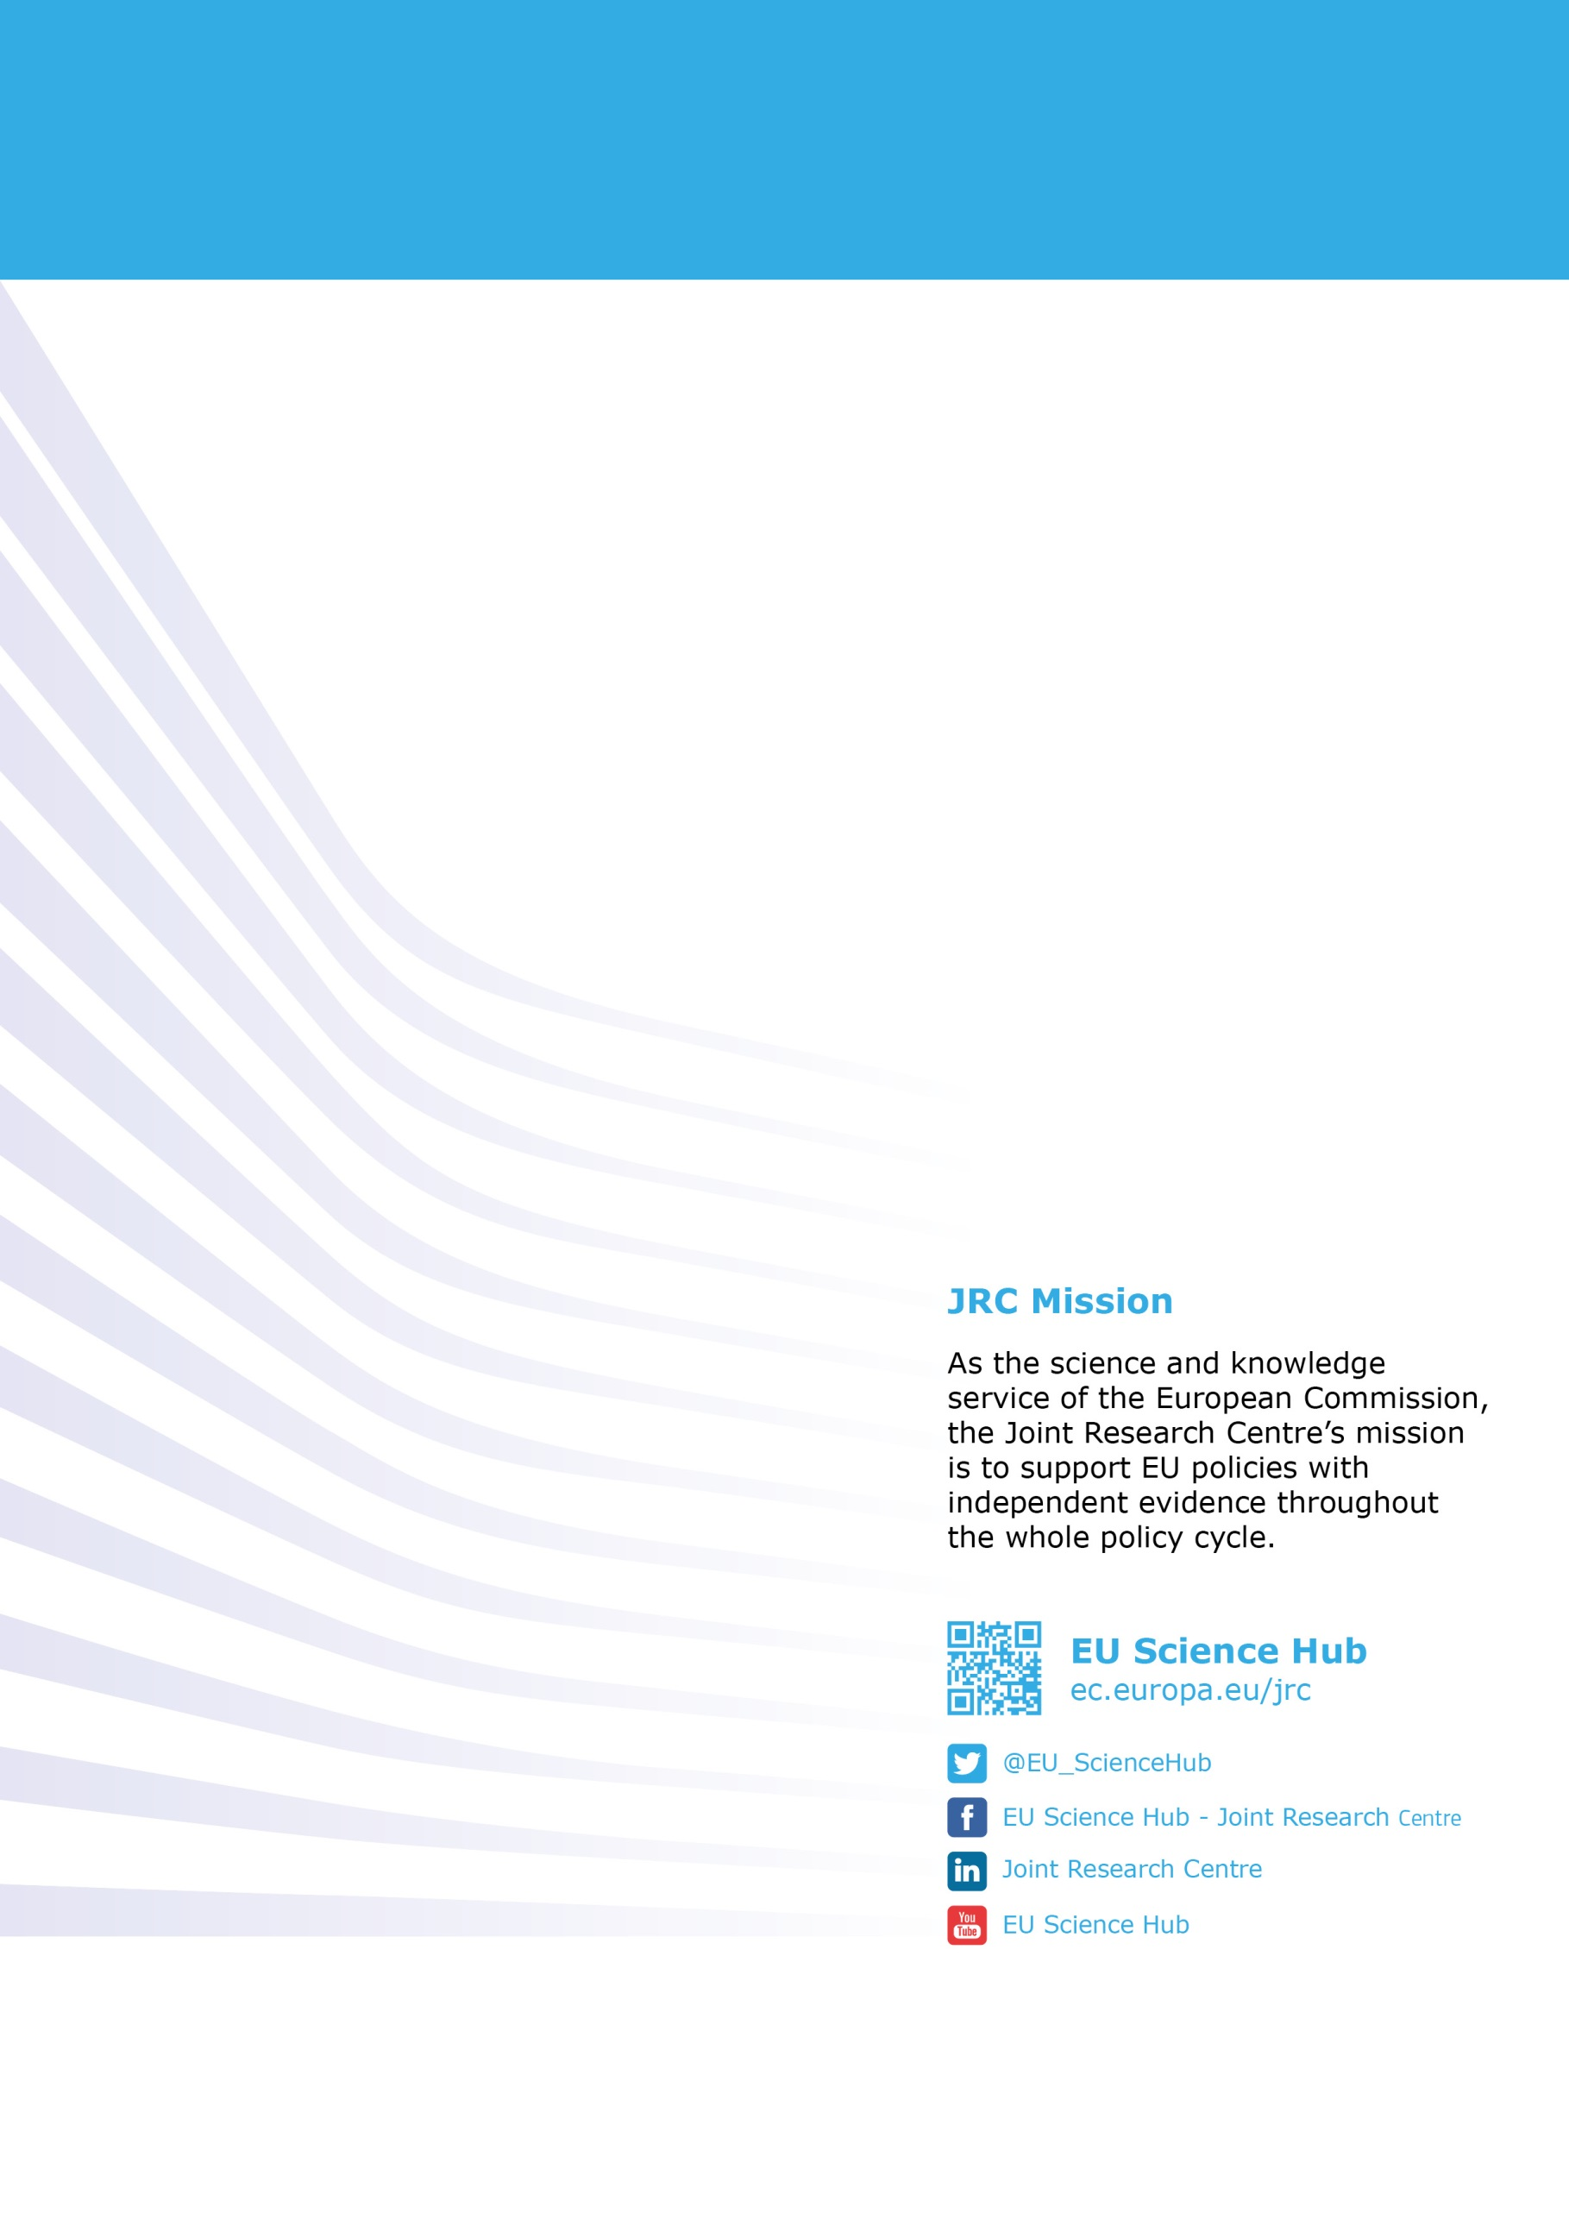

XX-NA-xxxxx-EN-N

doi:xx.xxxx/xxxx

ISBN xxx-xx-xx-xxxxx-x

1. See 2016 Eurostat Community Survey on ICT usage in households and by individuals, available at: <http://ec.europa.eu/eurostat/statistics-explained/index.php/E-commerce_statistics_for_individuals>
2. These were a) Communication services (e.g. Hotmail, Gmail, Whatsapp, Viber, Skype), b) Participation in social networks (e.g. Facebook, Twitter, Instagram), 3) Storage and transfer of files (e.g. Dropbox, iCloud) and 4) Web-based software applications (e.g. Google Docs) (see subsection 2 in this Annex).
3. 'Digital content' means data produced and supplied in digital form.
4. Section 2.3 and 12.1 of DG Justice Guidance Document on the CRD.
5. Recital 19 CRD.
6. See page 64 of the DG Justice Guidance Document on the CRD.
7. CRD Report, p. 9.
8. Regulation (EU) 2016/679 on the protection of natural persons with regard to the processing of personal data and on the free movement of such data (GDPR).
9. LV, PT and FR replies to the CPC/CPN/CMEG survey.
10. [*Loi pour une République numérique*](https://www.legifrance.gouv.fr/affichTexte.do?cidTexte=JORFTEXT000033202746&categorieLien=id) of 7 October 2016, Article 49, available at <https://www.legifrance.gouv.fr/affichTexte.do?cidTexte=JORFTEXT000033202746&dateTexte=20161212#LEGISCTA000033205027>
11. Regulation (EC) No 593/2008 of the European Parliament and of the Council on the law applicable to contractual obligations. Article 6(2) of Rome I states that the choice of law made by the parties to the contract may not have the result of depriving the consumer of the protection afforded to him by such provisions that cannot be derogated from by contract by virtue of the law which, in the absence of choice, would have been applicable on the basis of paragraph 1 (this law, under certain conditions, is the law of the country where the consumer has his residence). The Regulation hence allows contracting parties to choose which law applies to their contract and determines which law applies in the absence of choice. A trader who "directs his activities" to consumers in another country may either apply the consumer's national law or choose another law (in practice almost always the trader's national law). In this latter case, however, the trader must also respect the mandatory consumer contract law rules of the consumer's country to the extent that those rules provide a higher level of consumer protection. When the trader does not direct his activities to consumers in a specific Member State but agrees to enter into a contract at the consumer’s own initiative, consumers do not benefit from the more protective rules of their national law.
12. 10 out of 17 for both pre-contractual information and the right of withdrawal.
13. A precise quantification of the costs faced by traders was not possible due to the low level of responses.
14. SMEs operating online in business to consumer transactions; figures are similar when considering the overall respondents: 57 out of the 113 respondents consider that current costs due to legal fragmentation do not have an impact on their decision to enter other EU markets, while for 16 respondents these costs represent an obstacle.
15. SME panel: "*Does your enterprise incur costs when trading cross-border due to the following?*" The responses to these questions included five "not applicable to my enterprise" responses.
16. Question was: One-off costs: Please estimate the one-off resources you need to invest in order to enter a new EU market, on average per Member State (e.g. checking compliance with national rules and adjusting business practices as a result (e.g. update your website), costs of legal/technical advice). Regular costs: Please estimate the resources you need to invest on a regular basis to comply with different national rules, on average per country (e.g. handling consumer complaints/ enquiries, monitoring national rules). Note: Please indicate staff time in working days, whereby 1 working day = 8 hours of staff time. Please do not consider staff time for translation. If no staff time is involved, indicate ‘0’
17. Economic Study on Consumers Digital Content Products, p. 100.
18. 68% of individuals (58 out of 85 respondents) strongly/tend to agree that lack of pre-contractual information is problematic and creates harm when using "free" digital services cross-border; similar percentage applies for lack of a withdrawal right: 66% of individuals (57 out of 86 respondents) strongly/tend to agree this being problematic.
19. Specific examples of potential consumer problems due to lack of protection in contracts for "free" digital services are also included in subsection 2 of this Annex.
20. Consumer survey conducted in 2015 in 15 sample countries within the framework of the Economic Study on Consumer Digital Content Product. See DCD IA, p. 15 and the Economic Study on Consumer Digital Content Products, p. 222.
21. 24 out of 27 and 20 out of 27 responding consumer authorities strongly/tend to agree that respectively lack of pre-contractual information and right of withdrawal discourage consumers from acquiring "free" digital services.
22. 32 out of 62 and 32 out of 57 responding business associations strongly/tend to disagree that consumers suffer detriment due to respectively lack of pre-contractual information and withdrawal right.
23. 18 out of 54 and 18 out of 53 responding companies strongly/tend to disagree that consumers suffer detriment due to respectively lack of pre-contractual information and withdrawal right.
24. 42 out of 88 responding individuals indicated they would use more "free" digitals services if they had a right to be informed, while 43 out of 89 respondents think this would happen if a right to withdraw from the contract was granted.
25. 22 out of 25 responding **consumer associations** indicated that **consumers would use "free" digital services more often** if they had pre‑contractual information, while 22 out of 26 of them consider this would happen if a right to cancel the contract within 14 days was granted.
26. 11 out of 27 responding MS authorities consider that consumers would use more "free digital services" if a right to be informed was granted, while 13 out of 28 consider this would happen if a right to withdraw from the contract was granted.
27. This is supported by results from the consumer survey undertaken as part of this study, where on average, 67% of consumers using intangible music content did so for free (in comparison to 39% who paid), 62% of those using intangible games content did so for free, and 62% of those using anti-virus software did so for free. The one exception was cloud storage, with an equal split between consumers paying and accessing for free, amongst those using cloud storage.
28. Kaspersky Lab. 2012. Perception and knowledge of IT threats: the consumer’s point of view. <https://www.kaspersky.com/downloads/pdf/kaspersky-lab_ok-consumer-survey-report_eng_final.pdf>
29. There exists potential overlap in consumers between product categories, therefore the estimate is derived from ‘games – intangible medium’, which is the maximum number of consumers affected in one category. It is likely the number will exceed 70 million - however it is not possible to deduce the precise number from the information available.
30. Annex 3 p. 214 Table 60.
31. Kaspersky Lab. 2012. Perception and knowledge of IT threats: the consumer’s point of view. <https://www.kaspersky.com/downloads/pdf/kaspersky-lab_ok-consumer-survey-report_eng_final.pdf>
32. NetworkComputing, 2013. 8 Great Cloud Storage Services. Available: <http://www.networkcomputing.com/cloud-infrastructure/8-great-cloud-storage-services/d/d-id/1109155>?
33. <http://www.agcm.it/en/newsroom/press-releases/2380-whatsapp-fined-for-3-million-euro-for-having-forced-its-users-to-share-their-personal-data-with-facebook.html>
34. <https://ssl.marktwaechter.de/pressemeldung/online-dating-abzocke-fakes-und-schlechter-datenschutz>
35. "When assessing whether consent is freely given, one shall take into account as one out of several aspects whether consent is a condition for the performance of a contract (Article 7(4) Regulation (EU) 2016/679). In that regard, consent is presumed not to be freely given if the performance of a contract, including the provision of a service, is dependent on the consent despite such consent not being necessary for such performance". Non-paper of the Commission services on the relationship between the Proposal for a Directive on certain aspects concerning contracts for the supply of Digital content and EU Data protection, 2015/0287 (COD).
36. Question 36: 68% of individuals (58 out of 85 respondents) strongly/tend to agree that lack of pre-contractual information is problematic and creates harm when using "free" digital services cross-border; similar percentage applies for lack of a withdrawal right: 66% of individuals (57 out of 86 respondents) strongly/tend to agree this being problematic.
37. Questions 36 and 40 in the public consultation. Please see figures 3-6.
38. Question 92 of the public consultation. The only responding company also considered these costs unreasonable.
39. Behavioural experiment for the Fitness Check. For details see Fitness Check report, p. 65 – 67.
40. Consumer survey for the Fitness Check, question: ‘*When you see an online advertisement or advertisement on a poster for a good or a service, how important is it for you to receive the following information already in the advertisement? Note that you will receive all the same and even more information about the product and contract terms when actually visiting the (online) shop concerned*’. For details see Fitness Check report, p. 65 – 67.
41. 34 out of the 94 respondents for the unduly tested goods, and 31 out of the 91 respondents for early reimbursement.
42. Respectively 34% (32 companies) 'often' or 'a few times' for used goods, and 32% (29 companies) 'often' or 'a few times' for early reimbursement. Only two companies experienced such problems 'once'.
43. 24 out of the 64 responding SMEs for the unduly tested goods and 21 out of the 62 responding SMEs for early reimbursement.
44. Authorities from the following countries: Germany, Romania, United Kingdom, Czech Republic, Netherlands, Luxembourg, Norway, Finland, Cyprus, Italy, Hungary, Austria, Portugal, Latvia.
45. For 2 consumer associations, 7 MS authorities, 1 of 'other' category right of withdrawal for unduly tested goods is rather important, while 'early reimbursement' is rather important for 1 consumer associations, 8 MS authorities, and 2 of 'other' category.
46. For 12 consumer associations, 5 MS authorities, 4 of 'other' category Row for unduly tested goods is very important, while 'early reimbursement' is very important for 13 consumer associations, 4 MS authorities, and 4 of 'other' category.
47.
48. Please note that remedies and penalties are two different legal provisions.
49. See the report “Consumers' attitudes towards cross-border trade and consumer protection 2016” (<http://ec.europa.eu/consumers/consumer_evidence/consumer_scoreboards/survey_consumers_retailers/index_en.htm>) for a detailed description of the Survey and the survey methodology implemented.
50. <http://ec.europa.eu/consumers/consumer_evidence/consumer_scoreboards/survey_consumers_retailers/index_en.htm>