

**Table of contents**

Annex 1: Procedural information concerning the process to prepare the IA report and the related initiative. 2

Annex 2: Stakeholder consultation 7

1. Key outline of the consultation strategy 7

2. Summary of the main results from the consultations 7

3. Use of the results of the consultations 13

4. Overview of the consultation activities 13

Annex 3. Who is affected by the initiative and how? 18

Annex 4. Analytical methods used in preparing the IA 24

Annex 5. Results of the Fitness Check, the CRD Evaluation and the Assessment of the Recommendation on collective redress. 28

Annex 6. Mechanisms to enforce EU consumer law 36

Annex 7. Additional data regarding penalties 38

1. Detailed problem description 38

2. Stakeholder views 45

3. Additional data 50

Annex 8: Additional data on redress for victims of unfair commercial practices 55

1. Detailed problem description 55

2. Additional data 60

3. Stakeholder views 74

Annex 9: Additional data on the Injunctions Directive 77

1. Detailed problem description 77

2. Legal mapping of the national transposition of the ID 83

3. Outtakes from the qualified entities survey conducted for the Study supporting the Fitness Check of EU consumer and marketing law 86

4. Outtakes from the survey conducted for the Study supporting the assessment of the implementation of the 2013 Commission Recommendation on collective redress 90

5. Outtakes from the ID survey conducted for this Impact Assessment 92

3. Stakeholder views 99

Annex 10: Additional data on transparency of online marketplaces 109

1. Detailed problem description 109

2. Additional data 117

# Annex 1: Procedural information concerning the process to prepare the IA report and the related initiative.

**Lead DG:** European Commission Directorate-General Justice and Consumers, DG JUST

The **IIA on targeted revision of EU consumer law directives**[1]was published on 30 June 2017 and the **IIA** **on the revision of the Injunctions Directive**[2] on 31 October 2017, along with the corresponding consultation strategies.[3] The IIAs set out the context, scope and aim of the exercise. They presented the intervention logic and questions to be addressed.

The Inter-service Steering Group (ISSG) that had been set up in October 2015 for the Fitness Check continued supporting DG JUST for this IA. In addition to the Secretariat General and Legal Service, 10 Directorates-General were invited and designated their representatives to the ISSG: ECFIN, GROW, CNECT, ENV, ENER, MOVE, FISMA, EMPL, COMP, TRADE. The ISSG was consulted on the draft IIAs and consultation strategies, draft questionnaire of the public consultation and the drafts of this IA report. The ISSG met five times to discuss the preparatory documents and the draft IA report.

**Consultation of the Regulatory Scrutiny Board**

The meeting of the Regulatory Scrutiny Board (RSB) took place on 10 January 2018. It issued a negative opinion with comments on 12 January. Following a thorough revision of the initial draft IA, the RSB issued a positive opinion with further comments on 9 February 2018. The comments of the RSB have been addressed as follows:

*Opinion of 12 January 2018:*

(1) Chapter 1 (Introduction) and Chapter 2 (Problem definition) were revised by adding more detailed information on the conclusions of the Fitness Check of consumer and marketing law, the CRD evaluation and the Report on the implementation of the Recommendation on Collective Redress. Specifically, it was explained in detail how the concrete conclusions of these evaluations were followed up by this initiative. Furthermore, these two Chapters were extended with information explaining the links and synergies between this initiative and the broader policy context, such as the recently accomplished review of the CPC and the evaluation of the Recommendation on collective redress in the context of ensuring better compliance with consumer law, and with the Commission's pending work on fairness in platform-to-business (P2B) relations, the Digital Content Directive and GDPR in the context of the proposals of initiative aimed at modernisation of consumer protection rules. Analysis of the interplay with these instruments was also added in the "Coherence" sections of different options in Chapter 6 (Impacts of policy options). Furthermore, more details were provided regarding the relation between the initiative covered by this IA and the other follow-up actions to the recent above-mentioned evaluations, such as awareness raising activities and provision of additional guidance documents on consumer law directives. To improve readability, additional figures were added, i.e. a complete intervention logic including also options has been inserted in Chapter 6 and an overview of the directives and their respective amendments has been inserted in Chapter 7.3.

(2) The entire report was reviewed to present stakeholders' views in different consultations by category of respondent, i.e. the results were presented separately for respondents from public authorities, consumer associations, business associations, individual businesses and consumers. In this way, the stakeholder opinions on problems, their drivers and consequences as well as on impacts of the solutions are explained in a more granular way and the possible dissenting opinions were made readily visible. The consultation results were also presented separately for SME respondents and large companies when there were differences in their opinions.

(3) Chapter 5 (What are the available policy options) was revised describing further details of the policy options, in particular regarding penalties for breaches of consumer law, remedies, injunctions and collective redress. Where a relevant detail of the option could not be established at that stage, such as the exact % rate for turnover-based fines for breaches of consumer legislation, Chapter 5 additionally explained the parameters that would be used when deciding on such details at a later stage of the decision-making process and Chapter 6 (Impacts of policy options) included an explanation what the different variants of such a detail entails in terms of impacts.

Furthermore, Chapter 5 and Chapter 6 were significantly restructured. As regards main Problem 1 (still many traders do not comply with EU consumer law), the revised report presented several Options (political choices) consisting of measures to improve the rules on penalties, injunctions, consumer remedies and collective redress. These options implied less or more intervention that would achieve, to a lesser or greater extent, the first objective of this initiative to improve compliance with consumer law. They ranged from intervention only tackling public and private enforcement, to intervention additionally improving also consumer redress and, finally, a full scale intervention addressing also consumer collective redress. The revised Chapter 6 assessed the impacts of these options consisting of different measures.

As regards main problem 2 (Ineffective consumer protection rules and unnecessary costs for compliant traders), the revised report included additional options of promoting self- and co-regulation in the areas of transparency of online marketplaces and "free" digital services and explained why no viable alternative options (besides baseline scenario) could be presented to address overlapping and outdated consumer information requirements and imbalances in the right of withdrawal.

Sections concerning "social impacts" in Chapter 6 were extended with information about impacts on vulnerable consumers. The "cost" sections in Chapter 6 were enriched with further available data (such as regarding "free" digital services") and with explanation of the applicable costs (such as costs arising to enforcement authorities in relation to turnover-based fines). Chapter 7 (Comparison of the options) was extended with additional data on stakeholder views per category and comparative table of options was provided regarding the area of modernisation and burden reduction.

Further Changes were made also in Chapters 3, 8 and 9 as well as in annexes.

*Opinion of 9 February 2018:*

(1) Chapters 3, 5 and 6 were revised to better demonstrate the need for legislative action at EU level on collective redress. Section 3.2 “Subsidiarity: Necessity of EU action” was complemented with reference to (1) the 2012 Resolution on “Towards a Coherent European Approach to Collective Redress”, where the European Parliament highlighted the need for a horizontal EU approach on collective redress, with particular focus on infringements of consumers' rights, and (2) the 2017 Recommendation following the inquiry into emission measurements in the automotive sector, where the European Parliament called on the Commission to put forward a legislative proposal for a harmonised collective redress system for EU consumers. In Section 5.1.6 “Option 3: Improving enforcement and individual and collective consumer redress”, information was added about the number of Member States (21) that strongly supported the addition of mechanisms for redress to the ID in the ID survey. Descriptions of the degree of legal change required in Member States were further developed in Sections 6.1.1. (impacts of option 1: Improving enforcement to stop and deter infringements) and 6.1.3 (impacts of option 3: Improving enforcement and individual and collective consumer redress).

(2) A new Chapter 8.3 was added to address potential risks, unintended consequences and trade-offs associated with the preferred package options.

(3) Chapter 6 was updated to better explain why self-and co-regulation have been discarded as approaches for online marketplaces and “free” digital services. Section 2.1 “Options to address lack of transparency and legal certainty for B2C transactions on online marketplaces”, “Option 0: Promoting self and co-regulation” was further developed by adding information about experience from previous initiatives to ensure increased transparency in the online environment through self-regulation. Chapter 6.2.2 “Options to address lack of transparency, consumer protection and legal certainty for "free" digital services”, “Option 0: Promoting self and co-regulation” was similarly updated.

(4) Efforts were made to make the report more reader-friendly and the language less technical. The report was streamlined, in particular Chapters 5 (“What are the available policy options?”), 6 (“What are the impacts of the policy options?”) and 7 (“Comparison of the options”).

**Timeline:**

|  |  |
| --- | --- |
| **Date** | **Event/Step** |
| 25 October 2016 | Publication of the [CWP 2017](http://ec.europa.eu/atwork/key-documents/index_en.htm) (which includes follow-up to the Fitness Check as one of the REFIT items) |
| 23 May 2017 | Fitness Check adopted + Reports forwarded to Council |
| 29 May 2017 | Presentation by Commissioner at the COMPET Council + Press release: publication of results from Fitness Check and CRD evaluation |
| 1 June 2017 | Political validation by CSSR Jourova & 1st VP Timmermans of Agenda Planning Fiche *[Substantive rules]* |
| 2 June 2017 | Draft online public consultation (OPC) questionnaire sent to CAB;  IIA, consultation strategy and questionnaire sent to ISSG *[Substantive rules]* |
| 6 June 2017 | 5th meeting of the Stakeholder Consultation Group |
| 8 June 2017 | 1st ISSG meeting – Discussion of draft IIA, consultation strategy and OPC questionnaire *[Substantive rules]* |
| 22 June 2017 | Approval by CAB of 1st VP to launch the initiative (IIA+ OPC) *[Substantive rules]* |
| 26 June 2017 | Revised documents forwarded to ISSG (IIA, questionnaire, consultation strategy, web page) for information |
| 30 June 2017 | Publication of IIA *[Substantive rules]* |
| 28 July 2017 | Deadline for feedback on the IIA: 12 replies received from stakeholders |
| 30 June - 8 October 2017 | Public consultation *[Substantive rules]*  *(14 weeks in EN, shorter for other languages which were added as translations became available from DGT)* |
| 19 July - 15 September 2017 | Targeted consultations with MS through DG JUST networks (CPN, CPC, ECCG, CMEG) *[Substantive rules]* |
| 19 July - 18 September 2017 | Targeted consultations with traders (1) offering "free" digital services and (2) offering goods or services through online marketplaces |
| 27 July- 25 September 2017 | SME panel consultation *[Substantive rules]* |
| 4 September 2017 | 6th Meeting of the Stakeholder Consultation Group |
| 14 September 2017 | 2nd ISSG meeting: discuss feedback to the IIA and status of consultation activities + first discussion on the draft IA *[substantive rules]* |
| 25 September | End of the SME panel consultation *[Substantive rules]* |
| 27 September 2017 | End of targeted consultations *[Substantive rules]* |
| 2 October 2017 | 7th meeting of the Stakeholder Consultation Group (*self-regulatory initiative on pre-contractual information and T&Cs)* |
| 9 October 2017 | End of the Public Consultation *[Substantive rules]* |
| 12 October 2017  (DDL: 19 October) | Consulting the ISSG on the IIA, Consultation Strategy and Targeted Questionnaires *[Injunctions]* |
| 17 October 2017 | 3rd ISSG meeting *[Injunctions]* |
| 24 October 2017 | Publication of the [CWP 201](http://ec.europa.eu/atwork/key-documents/index_en.htm)8 |
| 30-31 October 2017 | Injunctions:   * Publicationof the IIA * Publicationof Public Consultation Strategy * Sending Consultation questionnaires to stakeholder networks (deadline for replies 16 November) |
| September – November 2017 | Drafting IA [covering both Substantive rules and Injunctions] |
| 6November 2017 | 8th Meeting of the REFIT Stakeholder Consultation Group (*self-regulatory initiative on pre-contractual information and T&Cs)* |
| 9 November 2017 | Technical meeting with RSB |
| 15 November 2017 | Draft IA sent to ISSG for second discussion. |
| 16 November 2017 | Close of targeted consultation for injunctions |
| 17 November 2017 | 4th ISSG meeting to discuss the draft IA |
| 29 November 2017 | Draft IA (including input from consultation on injunctions) sent to ISSG |
| 30 November 2017 | Presentation of the Consumer Manifesto and "Consumer Breakfast" at the margins of the COMPET Council |
| 1 December 2017 (am) | 5th ISSG meeting; sending draft minutes for comments |
| 1 December 2017 17h00 | Deadline for written comments from all ISSG members |
| 4-7 December 2017 | Finalising the draft IA and the ISSG meeting minutes |
| 8 December 2017 | Submission of the draft IA to the RSB |
| December 2017 – January 2018 | Drafting the legislative proposal |
| 12 December 2017 | 9th Meeting of the REFIT Stakeholder Consultation Group *(update on Legislative Proposals & self-regulatory initiative on pre-contractual information and T&Cs)* |
| 25 January 2018 | Publication of the Report on the implementation of the 2013 Commission Recommendation on Collective Redress (Collective Redress Report) |
| 10 January 2018 | RSB meeting |
| 12 January 2018 | RSB opinion |
| 29 January 2018 | Re-submission of the revised IA to the RSB |
| 9 February 2018 | 6th ISSG meeting: First discussion of draft legislative Proposals |
| 9 February 2018 | RSB opinion |
| 5 March 2018 | Inter-service consultation |
| 11 April 2018 | Adoption of legislative proposals |

# Annex 2: Stakeholder consultation

## 1. Key outline of the consultation strategy

This IA was supported, as outlined in the consultation strategies[4], by the following consultation activities: feedback on the Inception IAs; a public consultation (hereinafter OPC for online public consultation); a targeted SME panel consultation; targeted consultations with Member States (MS) and other stakeholders including through surveys for DG JUST networks; structured discussions in meetings with Member State authorities and experts; consultation with consumer and business stakeholders via the REFIT Stakeholder Consultation Group.

The objective of the consultations was to collect qualitative and quantitative evidence on all key elements of the IAs, from relevant stakeholder groups (consumers, consumer associations, businesses, business associations, Member States authorities, legal practitioners) and the general public. It was challenging to reach specific type of businesses, such as online marketplaces and free digital service providers. The consultations were publicised via Twitter, Facebook, emails to existing networks, via regular meetings (see the expert groups and networks described further below) and speeches delivered by the Commissioner and high-level Commission officials.

The IA also builds on the consultation activities that were carried out in the context of the Fitness Check and CRD evaluation[5]. Regarding the Injunctions Directive, the IA builds on the extensive consultation work already carried out for the Fitness Check and on the 2017 call for evidence on collective redress in addition to the targeted consultations of relevant networks of legal practitioners, consumer associations and business associations which replaced the public consultation due to the highly technical nature of the envisaged amendments.

## 2. Summary of the main results from the consultations

In the following summary, "**consumer associations"** means national and EU-level consumer associations, "**business associations"** includes national and EU-level business associations,   
"**MS authorities"** includes national consumer enforcement authorities, European Consumer Centres, government authorities (ministries) in charge of consumer policy, national public enforcement authorities in a specific area. Other stakeholders include other public bodies/institutions including few ministries, employers' associations, NGOs, regional associations and other categories of respondents in the OPC.

**Transparency on online marketplaces:** Stakeholders' replies to the OPC, CPC/CPN/CMEG and ECCG consultation, indicate that consumers experience problems due to lack of transparency. Over half of business associations in the public consultation agreed that consumer face situations of lack of transparency on online marketplaces[6], but many either see no harm or indicate not knowing whether consumers suffer harm due to certain problems connected to transparency.[7] In the same consultation, companies expressed mixed views on whether consumers face situations of lack of transparency and sceptical views whether they experience consumer harm: with almost half or over half indicating no consumer harm. Diverging rules on information obligations exist amongst Member States, as confirmed by MS authorities and consumer associations. In addition, respondentsto the targeted consultation with online marketplacesshowed diverging views on the applicable legislation. In the OPC, the SME panel and the targeted consultation with online marketplaces, majority of different stakeholder groups agree that consumers buying on online marketplaces throughout the EU should be informed about: Whether they buy from the online marketplace itself or from someone else; whether the contracting party declares to be a trader or not and whether EU consumer rights apply to their transaction. Business associations expressed mixed views[8] on the last point (applicability of EU consumer rights).   
Stakeholder largely agreed also that such transparency would have the following benefits for the consumers: to know whom to contact in case of a problem; to understand who is responsible for the performance of the contract; to understand if consumer protection rules apply in case of a problem and to increase consumer trust. As for views on business costs: Some online marketplaces[9], including larger ones, stated that, due to the varying national requirements, they incur compliance costs to some extent. This is confirmed by companies and business associations in general.[10] Some large online marketplaces[11] took the view that harmonised information obligations would lead to some costs reductions whilst others did not know. Two out of the four online marketplaces found that costs of complying with possible new information requirements would be reasonable, one disagreed and one did not know. Five business associations found also that such potential costs would be reasonable for online marketplaces, three disagreed and the majority did not know.

**"Free" digital services: extension of 1) the right to pre-contractual information and 2) the right of withdrawal (RoW) under the CRD**: Replies from most stakeholder groups to the OPC, CPC/CPN/CMEG and ECCG survey, show that consumers using "free" digital services suffer harm, including when using these services cross-border, due to the lack of these rights, and this to a certain extent discourages them from using such services. In the OPC, more than half of business associations did not agree that consumer suffer harm cross-border, and companies expressed mixed views with similar shares agreeing and disagreeing.[12] The majority of stakeholders agreed that the lack of these rights disrupts the level playing field for businesses, companies and business associations were divided on this. The majority of stakeholders in the OPC supported extending these rights to "free" digital services; however traders expressed mixed views regarding RoW with only seven out of 18 being in favour of this, while business associations were not supportive (24 out of 44 disagree and 11 agree, rest do not know) as some stressed that overlaps with existing legislation (in particular GDPR) should be avoided and therefore advised against extending the CRD to RoW (while agreeing to extension regarding pre-contractual information). This IA, in particular in the sections on problem definition and on options, takes this aspect into account with the conclusion that the proposed rules would complement and enhance rather than overlap with the GDPR. Regarding pre‑contractual information, business associations showed more support (OPC: 19 out of 45 agree and 15 disagree, rest do not know). In the same consultation, 12 of 18 companies agree with the extension of the pre-contractual information requirement. The other categories of stakeholders were supportive regarding the extension of both rights. A European business association claimed that the CRD scope should not be extended to gratuitous contracts for digital services, where consumers do not provide their personal data; this was also supported by a Member State.[13] This IA addressed this by clarifying that the rules should be applicable when there is a contractual agreement between the "free" service provider and the consumer.

As for business costs, 10 out of 17 business associations stated that companies incur costs due to diverging national rules on 1) and 2) for "free" digital services and for 7 out of 10 these costs are not reasonable. As for potential future costs due to the proposed measure, over 40%[14] SMEs replying to this question in the SME panel stated that such costs would not have significant impact on their decision to enter other EU markets. Nine out of 12 business associations, in the public consultation, do not consider these costs reasonable.

**UCPD remedies**: Based on replies to the OPC, a majority of stakeholders agree that differences between national rules on UCPD remedies cause harm to consumers. Half of the companies (28) agree as well, however only 14% (10) of the business associations agrees. A majority also think that these differences cause costs for traders engaging in cross-border trade. However, only 39% (29) of business associations agree with this. There is general support (including by SMEs) for introducing an EU-wide right to claim remedies from the trader. However a few MS[15] and over 60% (30) of business associations disagree. A majority (except business associations) also agreed that such a right would increase consumer trust, lead to better compliance and a more level playing field for compliant traders. 52% (65) of respondents in the public consultation said that it should be decided at EU level which remedies should be made available, and 38% (48) of respondents said that the choice of remedies should be left to Member States: 13 consumer associations supported defining UCPD remedies on EU level, while 3 said it should be left to the Member States; Seven MS authorities would prefer the EU to define the types of remedies and eight would leave this to the Member States; 6 business associations supported harmonising the type of remedies on EU level, while 20 supported leaving this to the national level. As for the type of remedies, an EU-wide right to terminate the contract and get a refund would have added value, according to most MS authorities,[16] followed by a right to compensation for damages. The same rights in the same order were also favoured in the public consultation, where 73% (83) of respondents to this question chose the right to contract termination and 65% (74) selected the right to receive compensation for damage.[17]

Nine of 15 MS authorities think the costs of administrative and judicial enforcement would increase to some extent due to possible new EU-wide rights to UCPD remedies, 3 think it would increase to a significant extent. As for business costs, ten of the 12 cross-border traders replying to this specific question reported facing costs (to significant or some extent) due to a need to adapt to current diverging national rules and two did not know. 18 of 34 business associations also indicated that companies face such costs to some or significant extent. Furthermore, eight of 19 companies said that these costs are a reason for them not to sell to other Member States (six said this is not the case and five did not know). More than half of companies and 40% of business associations considered that compliance costs due to a possible new EU-wide right to remedies would not be reasonable. 23% (45) of SMEs selling to consumers stated that costs related to national rules discourage them from entering other EU markets and25% (51) of SMEs stated that a new EU-wide right to remedies would encourage them to enter other EU markets. However, a majority stated that these current or potential new costs (would) have no impact on their decision to enter other EU-markets.

**Penalties for consumer law breaches**: National consumer protection authorities reported on the maximum fines available under national law for the breaches of consumer law, the criteria applied in the imposition of the fines, the level of fines actually imposed in the past year and the fines that could be imposed in hypothetical cases. The replies to the survey show significant divergences on all of these points. For instance, the maximum absolute fine for the infringement ranges from EUR 8 688 in Lithuania to EUR 5 million in Italy. A minority of countries use turnover based fines. Very few respondents indicated that the cross-border nature of the infringement is taken into account in the assessment of the fine. The results of the hypothetical case studies also show major differences in the level of the fine that could be applied for one and the same infringement in different countries. For instance, the estimated fine for a large company for the breach of the UCPD ranges from EUR 3 900 to EUR 600 000. The majority of consumer associations think that current penalties are not sufficiently proportionate, effective and dissuasive. SMEs express mixed views on this[18] with only between 20% and 25%of respondents considering the current level of fines as proportionate. Majority of stakeholders agree that differences in the nature and level of penalties for the same or similar breaches of EU consumer laws lead to insufficient compliance and insufficient deterrence especially for breaches that took place in more than one Member State. Over 40%[19] of SMEs agree as well, large companies are divided (five agree and five disagree, six do not know) and business associations do not agree (with only 17% and 23% agreeing to insufficient compliance and deterrence respectively).

13 of 17 MS authorities and all 16 consumer organisations supported the idea that fines should be available as penalties for breaches of consumer law in all Member States and that there should be common criteria in all Member States for imposing fines. Amongst business organisations, these ideas were supported, respectively, by 15 (31%) and 20 (44%) respondents. Furthermore, 8 of 15 SMEs as well as four of six large companies supported introducing common criteria and five of the 15 SMEs and three of the six large companies also agreed that fines should be available as penalties in all Member States.

14 of 16 consumer associations are in favour of a turnover-based fine and seven of 15 MS authorities favour setting the maximum fine as a percentage of the trader's turnover or as an absolute amount or a percentage of the trader's turnover whichever is higher. Most business associations and companies did not agree with any of the proposed EU-level measures; however seven of 15 SMEs and one large company would agree to a maximum fine expressed as an absolute amount. In the SME panel consultation, highest share of SMEs (49%) considered that the most proportionate, effective and dissuasive way of setting the maximum level of fines is by expressing it as a percentage of the trader's turnover.[20]

A majority of consumer associations and MS authorities agreed that stronger EU rules on penalties would lead to greater consumer trust and more effective enforcement of consumer protection rules. Between 62% and 73% of SMEs agreed also that stronger rules on penalties would have a positive impact on the compliance by traders with consumer protection rules, on levelling the playing field between traders[21] and on consumer trust.

**Reducing burden for businesses regarding the right of withdrawal**: in the OPC, around 35%[22] of online companies reported significant problems due to their current obligation to accept the return of "used" goods and to reimburse consumers without having the possibility to inspect the returned goods, while majority said they did not know. Over 90% of business associations[23] indicated that traders face disproportionate/unnecessary burden due these obligations. In the SME panel, the majority of respondents declared never facing disproportionate burden. However, when looking at the smallest companies (self-employed, micro, small) selling to consumers online, close to half report disproportionate burdens. According to a majority of other stakeholders (consumer associations, MS authorities, citizens and others), these consumer rights are important. However, seven of 16 consumer associations and 10 of 16 MS authorities also acknowledged that traders may face burden due to these rights.

As for the concrete problems, a clear majority of both online companies and of business associations indicated that traders face costs and practical difficulties with the following: determining the diminished value, recovering this diminished value from the consumer, reselling the goods as second-hand goods and disposing these goods as waste. Most of them also said that charging the costs for diminished value is difficult also from a customer relations' viewpoint.[24]

**Amending information requirements**: In the public consultation, a majority of citizens, of consumer associations and of other categories considered the information about the trader's geographical address and complaint handling mechanisms to be necessary in the advertising stage, even though consumers will receive the same information at a later stage. Most MS authorities agreed that the geographical address is necessary at the advertising stage, but not the complaint handling. Companies were divided in their views regarding the geographical address and did not regard the complaint handling as necessary information at advertising stage. Business associations disagreed regarding both and considered that the removal of these requirements at advertising stage would result in some or significant savings for companies.

**Modernisation of rules on the means of communication with the consumer**: In the public consultation email and web-based contact form were regarded as relevant by most respondents (126 and 93 respectively). 44 respondents considered social media account as relevant and 15 respondents (companies, citizens, consumer associations, government authorities) considered fax as relevant.

**Revision of Injunctions Directive:** Stakeholders, except for business associations which overall disagreed, showed overall support for the improvements proposed to enhance the effectiveness of the injunction procedure, including the extension of the ID's scope to all EU law relevant for the protection of the collective interests of consumers, the designation of independent public bodies and consumer associations as qualified entities subject to reputability criteria, a facilitated access to justice for qualified entities, under objective criteria, maximum time limits for all procedural steps, and the power for courts/authorities to require the trader to provide information and to publicise the outcomes of the procedure. There were mixed views on the possible role of business associations as qualified entities, with 38% of stakeholders agreeing and 38% disagreeing (48.8% of Member States' authorities, 21.4% of consumer associations and 55.6% of business associations). Stakeholders also agreed that a final injunction decision could be relied on as proof of the breach of EU law for follow-on redress actions, including in the form of collective redress actions. 65% of all respondents agreed that qualified entities should be able to seek injunctions and consumer redress within a single procedure. All stakeholders strongly support the introduction of effective, proportionate and dissuasive penalties for traders who do not comply with the outcomes of the procedure. A majority of stakeholders indicated that the proposed elements would have a positive impact on increasing the deterrence of non-compliance and reducing consumer detriment. 86.8% of Member States' authorities and 84.6% of consumer associations considered in particular that there would be a positive impact on the procedural efficienciesdue to the collective resolution of mass claims, whereas business associations overall disagreed (54.5% stating that there would be no impact and 36.4% considering that there would be a significant negative impact). A majority of business associations also considered that the initiative could increase the insurance premiums for coverage against claims in mass harm situations, in particular if it would address collective redress (90.9% of respondents).

In their feedback to the IIA, responding business representatives and public authorities favour focusing on the enforcement of substantive EU consumer law and possibly on improvements of the injunction procedure as such. These respondents are however overall opposed to the introduction at EU level of redress opportunities for consumers in mass harm situations, referring mainly to the risk of abusive litigation, additional costs and burdens as well as undue interference with existing national mechanisms. On the other hand, consumer associations, academic/research institutions and citizens expressed overall support for a single procedure at EU level enabling qualified entities representing the collective interests of consumers to simultaneously ask the courts and/or administrative authorities to stop the breach of any EU law relevant for the protection of the collective interests of consumers and ensure redress for the victims, which is seen as filling a current gap in consumer protection. A majority of respondents concur that any action at EU level should respect the legal traditions of EU Member States and provide safeguards against possible risks of abuse. Several elements should be clearly regulated, including the criteria for the designation of the qualified entities to ensure independence and absence of any conflict of interest, the funding, and the information of affected consumers.

**Other issues**: Some business and consumer associations enquired about the envisaged legislative technique and expressed concerns about possible opening up of the substantial law directives for other amendments than the ones suggested in the IA. The Commission explained that it aims to introduce only targeted amendments and not a complete revision of the directives as the current rules are generally fit for purpose.

Companies and business associations regarded self-regulation as an appropriate tool to improve compliance: in the public consultation over 90% of them agreed that EU and MS should stimulate self-regulation. In the same question, these groups expressed more sceptical (sometimes mixed) views on other (incl. legislative) ways to improve compliance. 21 of 29 MS authorities and nine of 27 consumer associations also indicated that self-regulation could contribute to better compliance. However, these latter groups showed stronger support (over 85%) for legislative interventions (for UCPD remedies and stronger penalties) and for providing more resources to enforcement authorities (over 90%). Some MS advised against maximum harmonisation arguing that it leaves too little margin of manoeuvre for the MS and could lead to a lower level of consumer protection and to a rigidity of the legal framework that is less responsive to new market practices.

Some traders, business associations and a few national ministries/governments called for further reduction of burdens for businesses related to issues such as off-premises contracts under the CRD and the right to withdraw from contracts concluded on online auction platforms, contracts for heating oil, e-vignette and architecture contracts. Some of these stakeholders argued that other than aiming to reduce burdens no new regulation is needed. BEUC suggests updating the UCPD blacklist to include 1) banning marketing of unhealthy food to children and 2) certain organised resale practices to improve EU law regarding secondary ticket selling.

## 3. Use of the results of the consultations

The results from the consultation activities have been incorporated throughout the IA from problem definition to possible options and their impacts. For example, results of the OPC and several of the targeted consultations were used in section 2 (problem definition), results from the ID survey and CPC/CPN/CMEG survey were taken into account in the section on options, results from SME panel, OPC, ID survey, ECCG survey were used in section 6 on Impacts of the policy options and results specifically from the SME panel were taken into account in the subsection dedicated to expected impacts on SMEs. The Annexes on each topic (Annexes 7 – 13) contain further data from the consultations.

## 4. Overview of the consultation activities[25]

**4.1 Feedback on the inception IAs (IIA)**

**IIA on targeted revision of EU consumer law directives**[26] (30 June to 28 July 2017): 12 submissions received via the online feedback option directly on the webpage where the initiative was published: several **European and national business associations**[27], an **EU-level consumer association** (BEUC), a **public authority** (the Austrian Federal Ministry for Science, Research and Economy), an **NGO** (National Energy Ombudsmen Network (NEON)) and a **company** (anonymous, Netherlands).

**IIA on the revision of the Injunctions Directive[28]** (31 October to 28 November 2017): The IIA was publicised via Twitter and in stakeholder meetings. 23 feedbacks[29] received from: **European and national business associations** (Law Society of England & Wales, ECTAA, German industry association BDI, German Insurance Association, EMOTA, Austrian Federal Economic Chamber, BusinessEurope, EuroCommerce, AGFW e.V. from Germany, European Justice Forum from Belgium, China Chamber of international Commerce EU Office) **consumer associations** (BEUC, DECO), **public authority** (Austrian Federal Ministry of Science, Research and Economy), **academic/research institutions** (Universities of Oxford and KU Leuven and an anonymous institution from Italy), **NGOs** (NEON, Better Finance), **company** (anonymous, Czech Republic), the **Financial Services User Group** (FSUG)[30], three **citizens** (from Ireland, USA, Germany).

**4.2 Public consultation**[31]

The **public consultation** (30 June to 8 October 2017) collected views from all stakeholder groups on all topics of this IA except injunctions.[32] It fully respected the general rules on consultation set out in COM(2002) 704. The consultation was publicised by regular tweets on the Commission services' Twitter account and in meetings with stakeholders.

In total, 414 responses were received via the online questionnaire on EUsurvey[33]. Of these, 94 were from individual **citizens**, 133 from **companies**, 80 from European-level and national **business associations**, 30 from European-level and national **consumer associations**, 31 from **Member state (MS) authorities[34]** (national consumer enforcement authorities, European Consumer Centre, government authorities (ministries) in charge of consumer policy, national public enforcement authorities in a specific area) and 46 from other public bodies/institutions, professional consultancies/law firms, regional associations and others). A number of respondents also submitted position papers, either via the EUsurvey tool or by email.[35] Responses were received from 26 EU Member states (no response received from Ireland and Lithuania) and 5 replies came from USA and Norway. The highest number of responses with 165 (40%) came from Germany, in particular 103 of the responding 133 companies (77%) are established in Germany. The second highest share were from Belgium (46, most of which from EU-level associations), followed by UK (40).

Out of the 133 companies, 5% are self-employed, 35% are micro companies (1-9 employees), 26% are small companies (10-49 employees), 11% are medium-sized (50-249 employees) and 23% are large companies (more than 249 employees).

The questionnaire consisted of two parts: (1) a short part collected views on problems stakeholders face today in the areas under assessment. At the end of the short part, respondents could choose to continue to a (2) full questionnaire with more detailed questions, including on possible options for the interventions and their costs and benefits. 244 respondents continued to the full questionnaire, of which 35 individual citizens, 20 consumer associations, 94 companies, 56 business associations, 22 MS authorities and 17 other type of respondents. However many respondents did not answer all the questions and "sub-questions", e.g. out of 94 companies that continued to the full questionnaire, only between 15-20 gave a actual responses (including "do not know") to most of the subsequent questions. Furthermore, across all topics, the level of replies on the quantification/estimation of (both current and potential future) costs and benefits was very low.

Among the replies a campaign involving around 70 respondents could be identified: the German association representing small and medium-sized heating oil retailers, UNITI, appears to have called on its members to participate in the consultation with suggested responses. The participants, retailers and mostly SMEs on the German heating oil market, followed the same line (almost verbatim) in their replies: They describe their concern about the application of the CRD right of withdrawal to distance selling of heating oil as confirmed by the German Federal Supreme Court[36] and its impact on SMEs. They call for action in order to exempt the distance sale of heating oil from the scope of the CRD right of withdrawal.

**4.3 Targeted consultations with specific stakeholders**

The **targeted SME panel consultation** (27 July to 2 October 2017) aimed to gather SMEs' views as well as quantification of costs and benefits of the options in the following topics of the IA: transparency of online marketplaces, free digital services, UCPD remedies, penalties, simplification of rules on right of withdrawal. In total, 291[37] responses were received from 18 Member States, 247 of which confirmed selling to consumers. 133 sell to consumers online, 84 sell to consumers through online marketplaces and 23 offer consumers "free" online services. 137 sell to other EU countries. The main activity of 47% is the sale of goods, 31% is providing services, 16% manufacturing, and 2% each for online marketplace, digital content and other. As for the size of the companies: 61% are self-employed & micro companies, 24% are small, 11% are medium, 2% are large and 2% did not indicate their size.

The highest share of responses came for Poland with 79 of the 291 (27%) responses, followed by Italy (36) and Portugal (31).

In some cases, depending on the topic, only a specific group of the replies to a question were taken into account, for example replies from companies selling to consumers online, or the replies by the few large companies and those that gave no indication of size were excluded. However, in most cases there was no significant difference in the percentage of different views with or without the few large companies.

SME panel consultations help gather qualitative information from SMEs and allow Commission departments to reach out to SMEs in a targeted way. To that end, the Commission prepares a dedicated questionnaire. The Enterprise Europe Network (EEN) assists the Commission in carrying out SME panel consultations. Thanks to the good geographic coverage and the high density of EEN network partners, this method of consulting provides substantial results.

The EEN partner's role in carrying out an SME panel consultation is to select the relevant companies from their region, to contact them, and to assist them in replying to a questionnaire. The EEN partners collect the SMEs replies, translate them into English and report them back to the Commission. EEN partner organisations are responsible for selecting companies best suited to respond to a given consultation. The selection requires expertise, bringing in fluency in EU policies and drawing on individual relationships with businesses. EEN partner's understanding of the topic of consultation, the ability to establish the relevance of the consultation for individual companies and the ability to convince those companies to respond are essential drivers for collecting replies. The pool of consulted companies varies for each SME panel. Companies are selected depending on the subject of the consultation. The degree of how actively EEN partners solicit a business' participation is left to the EEN member organisations and usually reflects their broader commercial relationship. The level of assistance provided to companies varies on case-by-case basis.

SME panel consultations are not economic surveys. There is no guarantee for minimum number of replies. The results are usually not statistically representative. SME panel consultations do not ensure an even geographical balance among the respondents. Despite these limitations, they are unique in the way they rapidly provide direct inputs from SMEs into European policy-making processes. The minimum duration of the consultation period is set at 8-10 weeks.

**Targeted questionnaire for Member States authorities:** Consumer Protection Co-operation Network (CPC, national consumer law enforcement authorities),[38] Consumer Policy Network (CPN, national ministries),[39] and Consumer Market Expert Group (CMEG, experts nominated by Member States to advise the Commission on matters related to the Consumer Scoreboards, market and behavioural studies). [40] 36 responses were received, from 25 EU Member States and Norway.

**Targeted questionnaire for members of the European Consumer Consultative Group,** ECCG[41]:10 ECCG members replied (AT, BE, HR, DK, FR, DE, LU, NO, PT, SV).

The two latter consultations ran from 19 July to 1 October 2017 and were intended to shed light on technical issues, such as relevant national legislation and complaint handling regarding the following topics: penalties, UCPD remedies, transparency of online marketplaces, free digital services. The questionnaires were disseminated by emails to the CPC, CPN and CMEG authorities and to the ECCG members respectively and members were reminded during the regular network meetings.

**Targeted consultations** **with online traders**: offering goods or services through online marketplaces on one hand, and offering "free digital services" on the other. These targeted online consultations served to obtain detailed data from these types of businesses. They ran from 19 July until 2 October 2017 (period of consultation was extended several times). The consultations were disseminated by email to 166 online businesses and business associations encouraging them to share the links to these targeted questionnaires with other relevant traders that the Commission has not identified through its networks. Despite repeated dissemination and communication efforts (via twitter, Facebook, meetings with stakeholder), only seven responses were received to the **consultation of online marketplaces**: five companies (one of which is not an online markeplace), and a national business association replied via the EUsurvey tool. Additionally, an EU-level association representing online platforms companies submitted a position paper outside the survey tool. Only two responses were received to the **consultation on "free" digital services**: one from an association whose members offer digital games via EUsurvey, and one from a large internet company by email.

**ID survey (Targeted consultation on the revision of the Injunctions Directive):** Targeted consultation (in the form of a web survey) of the following networks took place **in November 2017**: Qualified entities as listed in the Official Journal of the EU, under article 4 of the Injunctions Directive; CPN; CPC; ECCG; CMEG; European Consumer Centres (ECCs); European Judicial Network (EJN); Group of contact persons on national justice systems (Commission expert group); Financial Service Users Group (FSUG); Expert Group on the Implementation of Directive 2008/48/EC on Consumer Credit (CCD); European Network of Councils for the Judiciary (ENCJ); Network of the Presidents of the Supreme Judicial Courts (NPSJC); Association of the Councils of State and Supreme Administrative Jurisdictions of the EU (ACA-Europe); Council of Bars and Law Societies of Europe (CCBE); Enterprise Europe Network (EEN); several business networks and associations (Cooperatives Europe, Cecop Cicopa Europe, European Small Business Alliance (ESBA), European Association of Development Agencies (EURADA), EUROCHAMBRES, EuroCommerce, European Association of Craft, Small and Medium-sized Enterprises (UEAPME), BusinessEurope, European Confederation of Young Entrepreneurs (YES), Zentralverband des Deutschen Handwerks (ZDH), European Confederation of Junior Enterprises (JADE), European Council of the Liberal Professions (CEPLIS), European Family Businesses European Start-up Network); and REFIT Stakeholder Consultation Group. **90 replies were received in total**: 48 MS authorities (nation consumer protection authorities, European consumer centres, national ministries, national competition authorities), 21 business associations (nation and EU-wide), 16 consumer associations (nation and EU-wide), 5 Other (chamber of commerce, legal practitioners); from 25 Member States (no replies from FR, HR[42]), from ten EU-wide organisations and from three "Other" countries: Iceland, Norway and USA.

**4.4 Consultations via meetings with DG JUST networks, expert groups**

**Meetings of the Refit Stakeholder expert group (the Group)**: For this IA the Commission services continued to consult the Group established in 2016 for the Fitness Check of consumer and marketing law. The Group consists of EU level and national organisations representing consumers and/or civil society and EU level and national business organisations representing retailers, service providers and manufacturers, including SMEs. Member organisations were selected through a call for application in 2016 requiring applicants to be registered in the Commission's Transparency Register.[43] The Group is registered as a DG JUST expert group in the Register of Commission expert groups and other similar entities (‘the Register of expert groups’).[44] At the meetings of 6 June, 4 September, 2 October, 6 November, 12 December 2017 and 29 January 2018, the proposed follow-up actions to the Fitness Check and the CRD evaluation were discussed. Following discussions during the meeting of 6 June, the Commission took into account the comments received on the draft questionnaire for the public consultation, notably it redrafted some questions in a less complex manner and added explanations to specific terminology as suggested by the Members. Following the announcement, at the meeting of 2 October 2017, of the planned revision of the Injunctions Directive, members informed that they would respond to the relevant targeted consultation and IIA.

**Regular meetings with the CPC network:** At the meetings of 15 June and 19 October 2017, the members discussed the updates presented by the Commission on the work done for this IA. For more information on CPC see: <https://ec.europa.eu/info/consumers/consumer-protection-cooperation-regulation_en>

**Regular meetings with the ECCG**: At the meetings of 14 June and 12 October, the members discussed the updates presented by the Commission on the work done for this IA. For more information on ECCG see: <http://ec.europa.eu/transparency/regexpert/index.cfm?do=groupDetail.groupDetail&groupID=849&NewSearch=1&NewSearch=1> .

**Regular meetings with the CPN**: At the meeting of 24 January 2018, the members discussed the updates presented by the Commission on the work done for this IA. For more information on CPN see: <http://ec.europa.eu/transparency/regexpert/index.cfm?do=groupDetail.groupDetail&groupID=861&NewSearch=1&NewSearch=1>

# Annex 3. Who is affected by the initiative and how?

The preferred Option would affect the following stakeholders: consumers, traders (including SMEs), representative organisations (including 'qualified entities' under the ID), national authorities (courts, administrative authorities, sector-specific regulators, ministries) and the network of the European Consumers Centres.

|  |  |  |
| --- | --- | --- |
| ***I. Overview of Benefits (total for all provisions) – Preferred Option*** | | |
| ***Description*** | ***Amount*** | ***Comments*** | |
| ***Direct benefits*** | | | |
| **Improve compliance with EU consumer law** | The preferred package of Options will increase deterrence, which ultimately will result in higher compliance rates among traders. | This package focuses on outstanding drivers of the lack of compliance that have not already been addressed by other initiatives. | |
| The preferred package of Options will support the effective functioning of the revised CPC Regulation. | By strengthening penalties, providing direct civil law consequences for breaches of EU consumer law and by strengthening injunctions procedure by redress effect this package will increase deterrence and also provide an incentive for infringing traders to offer voluntary commitments to settle infringement cases, including in the context of coordinated CPC enforcement actions. | |
| Probability for consumers to encounter unfair commercial practices from domestic retailers is 4 percentage points lower in MS with links between remedies and breaches of the UCPD. Similarly, in MS with links between remedies and breaches of the UCPD the probability of experiencing a problem with the product/service purchased is lower (by 3.2 percentage points).  The effect of remedies linked to UCPD breaches on the likelihood to have experienced a UCP is strongly amplified in countries imposing a high level of sanctions and in countries with the highest level of public monitoring of compliance with consumer legislation. | This indicates that ensuring remedies for victims of unfair commercial practices improves compliance with EU consumer law by traders | |
| Likelihood of consumers to get satisfactory outcome when complaining is influenced by UCPD remedies: 8.7 percentage points difference in satisfied consumers between MS with links to UCPD remedies and other MS. | This indicates that ensuring remedies for victims of unfair commercial practices helps consumers solve problems when their rights have not been respected. | |
| 53% of the respondents to the ID survey predicted an increase of deterrence, 56% - a reduction of consumer detriment, 53% - procedural efficiencies. | With improved collective injunctive relief and redress, there will be an increase of compliance with EU consumer law, particularly for businesses that are sensitive to reputational damage from collective actions. | |
| **Modernise consumer protection rules and eliminate unnecessary costs for compliant traders** | Following pre-contractual information on online marketplaces, 72% of consumers correctly remembered who their contractual partner is. | Providing for more transparency on online marketplaces will reduce consumer detriment and increase consumer trust | |
| Instead of differing and unclear requirements in Member States, transparency obligations for online marketplaces will be harmonised. | This brings simplification for cross-border transactions in the internal market. | |
|  | In reply to the public consultation, around 80% of consumer associations reported that consumers would use "free" digital services even more often, if they had the right to pre‑contractual information and to withdraw. | Ensuring consumer protection in "free" digital services will reduce consumer detriment and increase consumer trust, also leading to possible uptake of the volume of transactions. | |
|  | 60% of business associations replying to the public consultation stated that companies incur unnecessary costs due to diverging rules on information requirements and right of withdrawal for "free" digital services | Extending the scope of the CRD to "free" digital services would reduce current unnecessary costs of compliant traders linked to the need to check and comply with possible national mandatory rules on pre‑contractual information and right of withdrawal for these services. | |
| ***Indirect benefits*** | | | |
| **Improve compliance with EU consumer law** | The preferred package of Options will contribute to greater awareness about consumer rights among consumers and traders, for example by leading to more media attention about consumer rights infringements through collective injunction and redress initiatives. This package will thus complement other specific awareness raising measures. | The Fitness Check showed that lack of awareness is an important impediment to well-functioning consumer protection. In addition to this package, the Commission is working to improve awareness about consumer law through training activities for traders, awareness raising campaigns for consumers and developing further guidance on the application of EU consumer law | |
| If UCPD remedies were applied in all 28 MS, reduction in consumer detriment in the 14 MS that do not have links to UCPD remedies today is estimated at Euro 560 million per year (this is a conservative estimate that doesn't take into account the synergetic effect between remedies, sanctions and active public enforcement). | Conservative estimate since likely synergies between remedies and sanctions are not taken into account. As shown by the results of the regression analyses, effects of UCPD remedies increase strongly when combined with high levels of sanctions. | |
| Positive impacts on vulnerable consumers of introducing rights to UCPD remedies and of improving collective injunctive relief and redress. | The number of vulnerable consumers experiencing unfair commercial practices increases more than the numbers for other consumer becoming victims of such practices. Vulnerable consumers are more reluctant to bring individual redress actions, so effects of introducing rights to UCPD remedies will be strengthened by also introducing collective injunctive relief and redress. | |
| Positive environmental impacts of introducing rights to UCPD remedies and of improving collective injunctive relief and redress | Ensuring consumers rights to UCPD remedies is likely to deter more traders from presenting misleading environmental claims.  Misleading environmental claims are particularly likely to create mass harm situations. | |
| **Modernise consumer protection rules and eliminate unnecessary costs for compliant traders** |  | Greater transparency will ensure that consumers are better informed about differences between consumer rights and rights in pure consumer-to-consumer contracts. | |
|  |  | Extending the scope of the CRD to "free" digitals services would ensure a clear and consistent legal framework at EU level, at the same time facilitating fairer competition for businesses. | |

|  |  |  |  |  |  |  |  |  |  |  |  |  |  |  |  |
| --- | --- | --- | --- | --- | --- | --- | --- | --- | --- | --- | --- | --- | --- | --- | --- |
| ***II. Overview of Costs – Preferred Option[45]*** | | | | | | | | | | | | | | | |
| Objective/Policy option | | Consumers/qualified entities representing consumers | | | | | | | | Traders | | | | Courts/authorities | |
| One-off | | | | | | | Recurrent | One-off | | | Recurrent (per year) | One-off | Recurrent |
| **Improve compliance with EU consumer law** | Direct costs | Initial familiarisation costs | | | | | | | n/a | 0 – EUR 572 484 (average EUR 12 293, median EUR 638) [46] for SMEs  0 – EUR 5 000 (average EUR 1 703, median EUR 108) for large enterprises  EUR 2.276 billion are the EU-estimated costs for the retail trade industry in the EU[47] | | | 0 – EUR 190 497 (average: EUR 8 484, median: EUR 655) [48] for SMEs  0 – EUR 15 000 (average EUR 5 000, median 0) for large enterprises.  EUR 2.336 billion are the EU-estimated costs for the retail trade industry in the EU[49] | Initial implementation costs | Enforcement costs |
| Indirect costs | n/a | | | | | | | n/a | n/a | | | n/a | n/a | n/a |
| **Modernise consumer protection rules and eliminate unnecessary costs for compliant traders** | Introducing transparency obligations for online marketplaces | | Direct costs | |  | | |  | | 0 – EUR 48 000 (average EUR 2 179, median EUR 50) for SMEs[50]  n./a. for large enterprises[51]  EUR 178 million are the EU-estimated costs for the retail trade industry in the EU[52] | | | 0 – EUR 84 301 (average EUR 3 887, median 0) for SMEs[53]  n./a. for large enterprises  Zero EUR are the EU-estimated costs for the retail trade industry in the EU[54] |  |  |
| Indirect costs | | n/a | | | n/a | | n/a | | | n/a | n/a | n/a |
|  | Extending rules on free digital services | | | Direct costs | |  |  | | | | Pre-contractual information:  0 – EUR 48 000 (average EUR 2 956, median 0) for SMEs  n./a. for large enterprises  Zero EUR are the EU-estimated costs for the retail trade industry in the EU[55]  Right of withdrawal:  0 – EUR 48 000 (average EUR 3 382, median 0) for SMEs.  n./a. for large enterprises  Zero EUR are the EU-estimated costs for the retail trade industry in the EU[56] | Pre-contractual information:  0 – EUR 168 602 (average EUR 8 367, median EUR 33) for SMEs[57]  n./a. for large enterprises  EUR 117 million are the EU-estimated costs for the retail trade industry in the EU[58]  Right of withdrawal:  0 – EUR 168 602 (average EUR 9 119, median EUR 50) for SMEs.  n./a. for large enterprises  EUR 178 million are the EU-estimated costs for the retail trade industry in the EU[59] | |  |  |
|  | Indirect costs | | n/a | n/a | | | | n/a | n/a | | n/a | n/a |

# Annex 4. Analytical methods used in preparing the IA

***1. Analysis of correlation between remedies and breaches of the UCPD***

The correlation between remedies and breaches of the UCPD was analysed through a multivariate approach[60]. The regression model, which was run on micro data from the EU wide consumer survey carried out in the framework of the 2017 Consumer Conditions Scoreboard[61], was aimed at observing the relation between the probability of consumers having experienced at least one unfair commercial practice (UCP) and the fact that they live in a EU country where remedies for breaches of the UCPD are foreseen[62]. In addition, the model includes a set of control variables at both micro level (socio-demographic characteristics of the persons interviewed) and at country level (the effectiveness of public monitoring of compliance with consumer legislation[63]). The model results shows that, all other things being equal, the probability of encountering a UCP in EU countries foreseeing remedies linked to breaches of the UCPD is 4 percentage points lower than in the other Member States.

By combining results from the regression model described above with other sources of statistical information, it was possible to estimate the reduction in consumer detriment (in euro) corresponding to a situation where all EU Member States would provide remedies linked to breaches of the UCPD. This estimate should be considered as indicative only, both because it is based on an analytical approach that evidences correlation, not causation; and because it does not rely on a General Equilibrium Model (meaning that indirect and loop effects of the foreseen policy measured are not taken into account).

Using PROB_GDP (=0.4%) the overall consumer detriment (from all kind of consumer problems) as percentage of the EU Gross Domestic Product[64] and:

* UCP_RED (=7.39%) the relative difference[65] in the probability of encountering a UCP between EU countries with links between remedies and breaches of the UCPD and Member States without such links (as estimated by the regression model described in point 6.3.2 of the main document for this IA)
* UCP_SHARE (=0.144), the share of UCP-related complaints in all complaints, as estimated from the Commission harmonized database on consumer complaints[66]
* DETR_RATIO (=1.812), the average ratio between the post-redress financial detriment due to one consumer problem related to a UCP and the detriment due to one general consumer problem, as estimated based on data from the Commission study on "Measuring consumer detriment in the European Union"[67],

the expected reduction in percentage point of GDP (UCP_GDP) from establishing a linkage between remedies and breaches of the UCPD can be estimated as:

UCP_GDP = PROB_GDP*UCP_RED*UCP_SHARE* DETR_RATIO

In numerical terms:

UCP_GDP = 0.4%*0.0739*0.144*1.812=0.00774%[68]

In addition, considering that the overall GDP in 2016 for the countries currently not foreseeing links between remedies and breaches of the UCPD was equal to 7,232,891.3 million Euro, the economic benefit – in terms of reduction in detriment – for the EU consumers associated with the extension of the remedies linked to UCPD breaches to all Member States can be estimated to represent

EURO_DETR=7,233,598.3*(0.00774/100)=560[69] million Euro.

An augmented version of the regression model described above allowed for the estimation of the relation between the probability for a consumer to have experienced at least one UCP and the fact that they are living in a EU country where links between remedies and breaches of the UCPD are foreseen, conditional to the maximum level of sanctions imposed for UCPD breaches in the country. For this purpose, a variable grouping Member States in 3 categories (low, medium and high sanctions), based on the maximum level of fines imposed (see below table 1) was added to the equation regression:

**Table 1: Highest monetary fines actually imposed for UCPD breaches**

|  |  |  |
| --- | --- | --- |
| **Country** | **Monetary fine, euro** | **Category** |
| Bulgaria | 25,000 | low |
| Czech Republic | 76,701 | medium |
| Denmark | 135,000 | medium |
| France | 500,000 | medium |
| Italy | 5,000,000 | high |
| Latvia | 50,000 | low |
| Lithuania | 34,754 | low |
| Malta | 195,000 | medium |
| Netherlands | 300,000 | medium |
| Poland | 6,708,619 | high |
| Portugal | 25,000 | low |
| Romania | 11,000 | low |
| Slovenia | 3,000 | low |
| Sweden | 200,000 | medium |

Source: CPC/CPN/CMEG survey (question 40)

Results from this analysis[70] show that the effect of remedies linked to UCPD breaches on the likelihood to have experienced a UCP is strongly amplified in countries imposing a high level of sanctions. Similar results were found when considering the probability of experiencing any problems when buying or using goods or services as the dependant variable in the regression model.

A slightly modified regression model showed that the marginal effect of remedies is amplified in countries having the highest level of public monitoring of compliance with consumer legislation.

Detailed results of the regression models can be found in the JRC technical report: "An analysis of the influence of remedies and sanctions on consumers' exposure to unfair commercial practices and shopping problems"[71]

**2. Platforms contractual identification behavioural experiment**

The experiment investigated the effect of information on contractual entities on product choices. The design mirrors the logic of the study on informational characteristics. The respondents were presented with two of the possible mobile phones and asked which phone they preferred basing their evaluation on three attributes of the contractual information and price. The three attributes were (i) information content about the contractual entity; (ii) information presentation in terms of visual prominence about the contractual entity, and (iii) price of the mobile phone. The following table shows the levels for each attribute.

The sample for the experiment consisted of 1,600 subjects in 4 EU MS (Germany, Poland, Spain and UK). The sample for each discrete choice experiment, 400 subjects in each target country, was representative of the population that purchased a good or service online during the last year, as quotas by sex and age were applied to these samples, based on the last available Eurostat’s data from the 2016 survey on ICT.

**Discrete choice model methodological note**

The parameter estimates are standard logic, therefore the regression coefficients represent the change in the logit for each unit change in the predictor. However, in contrast to traditional Conjoint Analysis that relies on Conjoint Measurement, which is not a behavioural theory (of choice), Discrete choice experiments (DCEs) are based on a long-standing, well-tested theory of choice behaviour that can take inter-linked behaviours into account.

Specifically, RUT proposes that there is a latent construct called “utility” existing in a person’s head that cannot be observed by researchers. That is, a person has a “utility” for each choice alternative, but these utilities cannot be “seen” by researchers, which is why they are termed “latent”. RUT assumes that the latent utilities can be summarized by two components, a systematic (explainable) component and a random (unexplainable) component. Systematic components comprise attributes explaining differences in choice alternatives and covariates explaining differences in individuals’ choices. Random components comprise all unidentified factors that impact choices. Psychologists further assume that individuals are imperfect measurement devices; so, random components also can include factors reflecting variability and differences in choices associated with individuals and not choice options per se. More formally, the basic axiom of RUT is:

Uin = Vin + ein, (1)

where Uin is the latent, unobservable utility that individual n associates with choice alternative i, Vin is the systematic, explainable component of utility that individual n associates with alternative i, and in is the random component associated with individual n and option i. Because there is a random component, utilities (or “preferences”) are inherently stochastic as viewed by researchers. So, researchers can predict the probability that individual n will choose alternative i, but not the exact alternative that individual n will choose.

|  |  |  |
| --- | --- | --- |
| **Experiment:** Impact of the identity of the contracting parties involved in the transactions enabled or facilitated by the platform. | Information content **(IC)** | * **IC1:** No information on contractual identity * **IC2:** Information on the contractual entity being a trader or non-trader * **IC3:** Information on the contractual entity being a person or a company and its implications on the consumer’s right |
| Information presentation **(IP)** | * **IP1:** Low salience (as a text included in the description of the good) * **IP2:** High salience (as a highlighted text out of the description of the good) |
| Price (P) | * **A1:** The good has a lower price * **A2:** The good has a higher price |

# Annex 5. Results of the Fitness Check, the CRD Evaluation and the Assessment of the Recommendation on collective redress.

The results of the Fitness Check of 6 consumer and marketing law directives[72] and the evaluation of the CRD were published on 29 May 2017.[73]

The Fitness Check concluded that the substantive provisions of the respective Directives remain overall fit for purpose if they are applied and enforced effectively. Specifically, the substantive rules laid down in the Directives are capable of addressing most existing consumer problems. However, the findings also point to some problems. The general objective of ensuring a high level of consumer protection is not fully achieved, as infringements of consumer rights remains relatively widespread. The main obstacle to ensuring a high level of consumer protection is that the rules are insufficiently enforced. This is coupled with: (i) limited awareness among consumers of their rights; and (ii) shortcomings over redress opportunities, which makes it difficult for consumers to seek redress.[74]

The findings of the Fitness Check per evaluation criteria can be summarised as follows:

* Effectiveness: The objective of ensuring a high level of consumer protection has so far not been fully met. This is because many traders do not respect EU consumer and marketing rules.[75] There has not been significant progress on traders’ compliance with consumer protection rules; roughly the same number of consumers reported infringements in 2008 as in 2016. On the other hand, this is still an overall positive outcome, as infringements happening online today can harm more consumers across the EU at the same time than what was the case in 2008.[76]
* Effectiveness: Most of the Directives are largely principle-based, do not distinguish between online and offline environments and are fully technology-neutral. Therefore, as demonstrated by the proceedings of the CPC networks, they are also capable of addressing new problems, even if the Directives were adopted before the age of e-commerce.[77]
* Efficiency: Stakeholders largely agree that the rules have significant benefits for consumer protection and cross-border trade, and also ensure better protection for businesses.[78] The estimated costs of compliance are considered proportionate when compared to annual turnover and with the benefits they bring for the functioning of consumer markets.[79]
* Efficiency: The Directives do not appear to impose unreasonable burdens on businesses, while the reasonable burdens they impose appear necessary to achieve the high level of consumer protection required by the Treaty.[80]
* Efficiency: Business compliance costs compare well with other sectors. In the first 2012 analysis of burdens imposed by EU legislation, EU rules in the area of consumer protectionwere considered the second least burdensome by SME respondents among the 32 surveyed areas.[81]
* Coherence: The horizontal EU Directives evaluated in the Fitness Check and EU sector-specific consumer protection legislation complement each other. Stakeholders largely agree that the combination of these horizontal and sector-specific rules provides a clear and coherent legal framework. In particular, the UCPD and UCTD provide a ‘safety net’ complementing and filling regulatory gaps in the regulated sectors.[82]
* Coherence: The potential for simplification is limited: There is a need to consider reducing information requirements at the advertising stage. Traders must provide the same and more detailed information at the later pre-contractual stage. This notably concerns information requirements about complaint handling and traders’ geographical addresses.[83]
* Relevance: The consumer protection and internal market objectives pursued by the Directives continue to remain highly relevant. Consumers continue to attach strong importance to consumer rights in their decision-making. EU-wide infringements of consumer rights will continue to require enforcement action at EU level. To be effective, EU-wide enforcement must be based on a common and uniform legal framework.[84]
* EU Added Value: The harmonised rules under these Directives make it possible for national enforcement authorities to address cross-border infringements that harm consumers in several Member States more effectively.[85] The Directives generate coordination gains in enforcement work and more legal certainty and stability for cross-border traders in the EU.[86]

The CRD only entered into application in June 2014. Due to the still early stage of implementation, the CRD Evaluation focused on the progress introduced by this Directive compared to the status before it entered into force and experience with the application during the first two and a half years of its application. The evaluation shows that the Directive has positively contributed to the functioning of the B2C internal market, with a high common level of consumer protection, albeit so far with some limitations.

The findings of the CRD evaluation per evaluation criteria can be summarised as follows:[87]

* Effectiveness: Overall, the transposition and first application of the CRD appears to be in line with the Directive's main objectives of enhancing consumer protection and reducing regulatory fragmentation.
* Efficiency: The limited available data do not allow definitive conclusions about the level of costs faced by businesses in ensuring compliance with the Directive. Specific burdens especially for SMEs have been reported, mainly relating to pre-contractual information requirements and the right of withdrawal.
* Coherence: Overall, the CRD is deemed coherent with other EU legislation and no major problems have been identified. However, the interplay with several other pieces of EU legislation and new EU legislative proposals could be further streamlined and clarified. In particular, consistency should be ensured between the CRD and the proposal for a Directive for contracts for the supply of digital content (DCD)[88]. Both Directives should apply to the same digital content and services. There is a need to clarify if the CRD covers both digital content and digital services for which the consumer does not pay a price.
* Relevance: The original objectives of the Directive are as valid today as when the Directive was first proposed. In particular, the objectives of ensuring a high level of consumer protection and a level playing field for businesses in online B2C contracts are relevant within the framework of the DSM policy.
* Relevance: There is some scope for simplification: The provisions of the CRD are still relevant, except for the requirement to provide the trader's fax number, and the trader's e-mail address where other, more modern means of communication (such as web-based forms) could be sufficient, to the extent they enable the consumer to efficiently contact the trader in a manner which allows the consumer to keep a proof of such exchanges on a durable medium.
* EU Added Value: An EU approach remains the most appropriate response and is more likely to contribute to achieving the objectives set by the Directive than national approaches. The Directive has consistently reduced the regulatory fragmentation among Member States through its harmonisation approach, hence contributing to enhancing consumer trust in cross-border sales and reducing traders compliance cost when selling cross-border. Harmonised rules are also important for effective cross-border enforcement actions between Member States.

**Table 1: Replies by consumer and business associations and public authorities on the importance of different problems for protecting the rights of consumers; % of respondents in each category (Fitness Check public consultation 2016)**

|  | **Consumer associations** | | **Business associations** | | **Public authorities** | |
| --- | --- | --- | --- | --- | --- | --- |
|  | **Problem** | **No problem** | **Problem** | **No problem** | **Problem** | **No problem** |
| Consumers don't know/ don't understand their rights | **90** | 10 | **54** | 12 | **89** | 0 |
| Traders don't know/  don't understand consumer protection rules | **85** | 15 | **55** | 16 | **79** | 11 |
| Traders don't comply with consumer protection rules | **95** | 5 | 29 | 38 | **86** | 0 |
| Consumer law is too complex | **64** | 35 | 63 | 10 | **64** | 25 |
| There are significant differences between national consumer protection rules across EU countries | 40 | **60** | 48 | 16 | 39 | 46 |
| National administrative authorities lack legal powers to enforce consumer rights | **70** | 25 | 15 | 47 | **65** | 14 |
| National authorities responsible for enforcing consumer rights are not active enough | **85** | 10 | 22 | 44 | **65** | 15 |
| Court proceedings are complex / long / costly | **100** | 0 | 33 | 33 | **86** | 0 |
| Administrative enforcement proceedings are complex / long / costly | **90** | 5 | 25 | 34 | **50** | 22 |
| Injunctions proceedings are complex / long | **75** | 15 | 23 | 32 | **68** | 11 |
| Injunctions proceedings are costly | **70** | 15 | 18 | 31 | **57** | 15 |
| There are significant differences between national rules on injunctions proceedings across EU countries | **55** | 20 | 19 | 25 | **57** | 25 |

The Commission report on the implementation of Commission Recommendation of 11 June 2013 on common principles for injunctive and compensatory collective redress mechanisms in the Member States concerning violations of rights granted under Union law (2013/396/EU) is scheduled for publication on 25th January 2018 (the Collective Redress Report).

The Report concludes that appropriately designed and balanced collective redress mechanisms contribute to the effective protection and enforcement of rights granted under Union law, since "traditional" remedies are not sufficiently efficient in all situations. Without a clear, fair, transparent and accessible system of collective redress, there is a significant likelihood that other ways of claiming compensation will be explored, which are often prone to potential abuse negatively affecting both parties to the dispute.

In many instances, affected persons who are unable to join forces in order to seek a redress collectively will abandon their justified claims at all, due to excessive burdens of individual proceedings.

The analysis of the legislative developments in Member States as well as the evidence provided demonstrate that there has been a rather limited follow-up to the Recommendation as concerns transition into legislation. The availability of collective redress mechanisms as well as the implementation of safeguards against the potential abuse of such mechanisms is still very unevenly distributed across the EU. The impact of the Recommendation is visible in the two Member States where new legislation was adopted after its adoption (BE and LT) as well as in SI where new legislation is pending, and to a certain extent in the Member States that changed their legislation after 2013 (FR and UK).

This limited follow-up means that the potential of the principles of the Recommendation to facilitate access to justice for the benefit of the functioning of the single market is still far from being fully exploited. 9 Member States do not provide for any possibility to collectively claim compensation in mass harm situations as defined by the Recommendation. In some Member States that formally provide this possibility, in practice affected persons do not use it due to the rigid conditions set out in national legislation, the lengthy nature of procedures or perceived excessive costs in relation to the expected benefits of actions. The call for evidence has also demonstrated that in some cases collective judicial action can be usefully avoided because of successful out-of-court settlements, sometimes as follow-on to administrative action. This highlights the importance of effective out-of-court dispute resolution mechanisms in line with the Recommendation. The Recommendation has a horizontal dimension given the different areas in which mass harm may occur. However, the concrete cases reported, including the car emissions case, demonstrate that the areas of EU law relevant for collective interests of consumers are those in which collective redress is most often made available. These are the areas where actions are most often brought and in which the absence of collective remedies is of the biggest practical relevance. It is also in these areas that binding EU rules on the injunctive dimension of collective redress exist and have proven their value. The Injunctions Directive regulates representative action initiated by qualified entities in particular in the form of non-profit organisations or public authorities in relation to which concerns regarding abusive litigation driven by profit interests of third-party funders appear to be unfounded.

This is confirmed by the results of the call for evidence. While consumer organisations make a strong case for EU-wide intervention in this field, business organisations generally focus their concerns in relation to EU action in the consumer area and refer to proportionality or subsidiarity concerns, urging the Commission to concentrate on public enforcement or on redress via ADR/ODR or the small claims procedure.

Against this background, the Report announced the following Commission actions:

* to further promote the principles set out in the 2013 Recommendation across all areas, both in terms of availability of collective redress actions in national legislations and thus of improving access to justice, and in terms of providing the necessary safeguards against abusive litigation;
* to carry out further analysis for some aspects of the Recommendation which are key to preventing abuses and to ensuring safe use of collective redress mechanisms, such as regarding funding of collective actions, in order to get better a picture of the design and practical implementation;
* to follow-up this assessment of the 2013 Recommendationin the framework of the forthcoming initiative on a "New Deal for Consumers", as announced in the Commission Work Programme for 2018,[89] with a particular focus on strengthening the redress and enforcement aspects of the Injunctions Directive in appropriate areas**.**

**Follow-up to recommendations from the Fitness Check and the CRD Evaluation through this IA:**

This IA follows-up on these recommendations from the Fitness Check:

* increased deterrent effect of penalties for breaches of consumer law;
* introduction of UCPD remedies;
* making the ID more effective, for example, by expanding its scope and further harmonising the procedure to: (i) facilitate access to justice and reduce the costs for qualified entities, (ii) increase the deterrent effect of injunctions, (iii) produce an even more useful impact on the affected consumers;
* reduction of information requirements that are duplicated in the UCPD and CRD;

**This IA follows-up on these recommendations from the CRD Evaluation:**

* Further examining possible targeted amendments to the CRD regarding:
  + - extending its scope to include contracts for ”free” digital services;
    - simplifying some of the existing information requirements, in particular to better reflect technological/market developments, for example by allowing traders to use more modern means of communication for their exchanges with consumers, provided that such means allow the consumer to efficiently contact the trader and to keep a proof of such exchanges on a durable medium;
    - reducing the burden on traders, especially SMEs, which some stakeholders consider disproportionate. This concerns provisions on the right of withdrawal for goods used by consumers more than necessary to establish their nature, characteristics and functioning and the rules on reimbursement before the trader has received the goods back;
    - increasing the transparency of the information that online marketplaces provide consumers about the identity and quality (”trader” or ”consumer”) of the supplier, about the differences in the level of consumer protection when contracting with a trader rather than another consumer, and about the default ranking criteria when presenting offers, and establishing the consequences for failing to comply with transparency requirements;

**Follow-up to recommendations from the Fitness Check and the CRD Evaluation through other initiatives than this IA:**

As indicated in Section 2.1 (conclusions from relevant consultations), a number of recommendations from the Fitness Check and the CRD evaluations are followed up through other initiatives than this IA. The most important of these are listed in Figure 2 in Section 2.2 (overview of drivers, problems and objectives) as "addressed through other initiatives". In addition, the below lists indicate how all the recommendations not addressed in this IA are being dealt with:

**Initiatives to follow up on the following recommendations from the Fitness Check:**

* Continue collecting data via consumer scoreboards:
  + The Commission publishes consumer scoreboards bi-annually. The consumer scoreboards monitor how the single market is performing for EU consumers and signal potential problems. Published since 2008, they aim to ensure better monitoring of consumer outcomes and provide evidence to inform policy.[90]
* Promoting consumers’ and traders’ awareness of their rights and obligations
  + The Commission is currently preparing a Communication campaign on consumer rights in all EU Member States, to be rolled out from August 2018. It is designed to inform consumers on their high level of rights in the EU, in particular by promoting four key rights, stemming from the Directives on Consumer Rights, Unfair Commercial Practices, Unfair Contract Terms and Consumer Sales and Guarantees. It will also promote more specifically rights on product safety, package travel and transparency of bank account fees in 10 selected Member States.
* Launching a pilot project on training SMEs in the digital age:
  + To improve the traders' awareness of consumer rights, the European Commission has launched a training project for SMEs, based on a request by the European Parliament for a pilot project. The project "ConsumerLaw Ready" is coordinated by a consortium led by BEUC, the European Consumer Organisation, together with SME organisations UEAPME and Eurochambres. 28 trainers in each EU Member State have been appointed to train trainers (such as local business associations) in their respective countries in their own language about both EU and national consumer laws. Learning material has been developed for each of the countries on the five following topics:
    - Pre-contractual information requirements
    - Right of withdrawal for distance and off-premises contracts
    - Consumer rights and guarantees in case of defective goods
    - Unfair commercial practices and contract terms
    - Alternative Dispute Resolution and Online Dispute Platform

The training of SMEs started in December 2017 and will continue throughout 2018. A dedicated website was created in November 2017: consumerlawready.eu

* Creation of a Consumer Law Database:
  + A new Consumer Law section will be added to the Commission's e-Justice Portal in early 2018, allowing legal practitioners to check for national transpositions of the EU consumer law directives, relevant case law, and legal literature. This consumer law database should facilitate the knowledge of consumer law and its interpretation across Member States, including for example by businesses operating in several jurisdictions or wishing to expand to other Member States.
* Steering a self-regulatory exercise within the REFIT stakeholder group on the better presentation of mandatory pre-contractual information and standard Terms and Conditions with a view to reach a multi-stakeholder agreement on a set of key principles:
  + A self-regulatory project for better presentation of consumer information and T&Cs was launched in April 2017. Results are expected in the course of 2018. It is chaired by business associations that are members of the Refit Stakeholder Group and the aim is to have business and consumer representatives agree on "Guiding Principles for better presentation of information to consumers".
* Improvement of the UCTD, either via a guidance document or targeted amendments, such as introducing a black list, clarifying the scope of application, exemptions and the relationship with sector-specific rules:
  + The issues identified will be addressed through Commission guidance, to shed light on the rich case law of the European Court of Justice on this important Directive.

**Initiatives to follow up on the following recommendations from the CRD Evaluation:**

* Promoting consumers’ and traders’ awareness of their rights and obligations:
  + See above for Fitness Check follow-up.
* Considering further guidance on the CRD provisions which the evaluation found to be perceived as lacking clarity:
  + The Commission plans to update the 2014 CRD Guidance with a view to address the problems with the interpretation of specific CRD provisions identified in the Evaluation.
* Steering a self-regulatory exercise within the REFIT stakeholder group on the better presentation of mandatory pre-contractual information and standard Terms and Conditions with a view to reach a multi-stakeholder agreement on a set of key principles;
  + See above for Fitness Check follow-up.
* Stepping up the enforcement of the Directive across all Member States, including through common actions in the framework of the Consumer Protection Cooperation Regulation:
  + The Commission has been engaged in a series of actions monitoring and enforcing the application of the CRD in the MS. "EU sweeps", EU-wide screenings of websites by the CPC authorities in the form of simultaneous, coordinated checks to identify breaches of consumer law and to subsequently ensure its enforcement, have been initiated to facilitate enforcement of the CRD. Following a 2015 Sweep on CRD, two more Sweeps (2016 on Comparison Tools in the travel sector and 2017 on Telecommunication and other digital) examined the application of certain CRD requirements on pre‑contractual information. In certain cases, enforcement actions were taken to correct the identified irregularities. Moreover, the Commission is planning to launch a study on price information on travel booking websites, including possible breaches of the CRD; this study may serve as basis for future common actions within the CPC network.

# Annex 6. Mechanisms to enforce EU consumer law

EU consumer legislation can be enforced in different ways. Member States have different private and public enforcement systems. These include a variety of mechanisms for individual, collective, judicial, administrative and alternative dispute resolution.

If consumers consider that their consumer rights have not been respected by traders they can seek redress, for example to have their contract terminated or to get compensation for the harm suffered. To get redress, consumers can take individual action against traders, either in courts or through out-of-court dispute resolution mechanisms. Consumers can also complain to public enforcement authorities and independent public bodies as well as to private entities, such as consumer organisations, that have been empowered by the Member States to protect consumer interests.

Consumer rights can also be enforced through collective action. Depending on the mechanisms available under national law, consumers may be able to join forces and bring a legal action as a group. They may also be able to bring their cases to the attention of representative organisations or independent public bodies that have the right to start legal actions in front of a court or a national enforcement authority for the protection of the collective interest of consumers.

The enforcement powers of public authorities vary across Europe. Some national public authorities have direct powers to act, on their own motion or on the basis of complaints, to investigate, stop and penalise breaches of consumer law[91]. In some Member States, they may also order traders to provide redress to consumers[92]. In other national systems, competent entities need to request courts to stop and penalise breaches of consumer law[93]. Finally, in many Member States ordering consumer redress is always left to the courts.

Several EU interventions have aimed at facilitating the public and private enforcement of consumer law. For cross-border purchases, individual consumers can get help via the network of European Consumer Centres. Thanks to the Directive on consumer alternative dispute resolution (ADR)[94] consumers across the EU have access to quality ensured out-of-court dispute resolution systems for both domestic and cross-border contractual disputes. Member States are also encouraged[95] to ensure that collective ADR schemes are available. An online dispute resolution platform (ODR platform) set up by the Commission[96] also helps consumers and traders resolve their domestic and cross-border disputes over online purchases of goods and services.[97]

As to individual consumers taking their cases to court, the Court of Justice of the EU (CJEU) has promoted procedural protection of consumers based on principles of equivalence[98] and effectiveness[99]. In particular, the CJEU has developed an ‘*ex officio*’ obligation for national courts to assess on their own motion whether consumer rights may have been infringed. In addition, a European small claims procedure[100] has been established for court proceeding that concern cross-border payment claims worth up to EUR 5 000. Both consumers and small businesses can use this procedure. Furthermore EU private international law instruments such as the Brussels I Regulation No 1215/2012 on jurisdiction and the recognition and enforcement of judgments in civil and commercial matters (recast), Rome I Regulation No 593/2008 on the law applicable to contractual obligations and Rome II Regulation No 864/2007 on the law applicable to non-contractual obligations address the weaker position of consumers vis-à-vis foreign traders. All the above mechanisms are tailored for individual private enforcement of EU consumer rights.

As regards public enforcement of EU consumer law for the protection of collective interests of consumers, the revised CPC Regulation gives enforcement authorities a uniform set of powers to work more efficiently together against wide-spread infringements. Member States may choose whether their authorities exercise those powers directly under their own authority or whether they need to resort to national courts. The revised CPC Regulation also enables the European Commission to launch and coordinate common enforcement actions to address EU-wide infringements[101].

The Injunctions Directive, which is subject to this IA, ensures that so called "qualified entities" may act to protect the collective interest of consumers and bring injunction requests to courts or administrative authorities in all Member States. Following such requests, courts and administrative authorities can stop or prohibit commercial practices that are contrary to EU consumer law. The Commission has also issued a Recommendation on injunctive and compensatory collective redress. This Recommendation encourages Member States to ensure collective redress systems to stop breaches of all EU law (without prejudice to the Injunctions Directive) and to provide victims of these breaches with redress.

# Annex 7. Additional data regarding penalties

## 1. Detailed problem description

Traders infringing consumer law should be effectively investigated and prosecuted by the responsible authorities and face penalties. The existence of penalties also deters traders from engaging in or continuing illegal behaviour. For this reason, the CRD, UCPD and PID contain a requirement for Member States to have in place 'effective, proportionate and dissuasive penalties' to address infringements of the national law provisions transposing these Directives. Also the revised CPC Regulation includes the power to impose fines among the minimum powers of the competent authorities and provides for a legal basis to impose fines for cross-border and widespread infringement of Union consumer legislation[102].

Member States have very different rules on penalties. Fines for the breaches of the UCPD, CRD and PID exist in most Member States. The maximum amounts of the fines vary significantly and Member States follow different procedures for the imposition of fines (administrative and judicial). Several respondents to the dedicated survey reported on the possibility to impose (also) "conditional"/ "suspended" or "daily" fines if the trader continues the infringement after the decision ordering cessation of the infringement. Several countries also provide fines for the infringement of the UCTD and CSGD, which do not expressly require the existence of penalties. Moreover, some national authorities in their replies indicated that infringements of these two Directives (as well as of the CRD and PID) can still be subject to fines if they constitute unfair commercial practices and the fines provided for the infringements of the UCPD are applied.

The maximum level of the available fines is, in several Member States, set at a very low level. A minority of countries (CY, FR, HU, LV, LT, NL, PL and SE) have turnover-based fines at least for the infringements of the UCPD. However, with the exception of only FR, PL and NL, most of these countries also have an absolute cap on the fine, which is ranging from EUR 8 688 to approx. 6.5 million. As an example of the current differences, the fine for infringing the UCPD may reach 10% of the relevant company's annual turnover in FR, PL and NL whilst it is capped at EUR 8 688 in LT, EUR 13 157 in HR and EUR 32 000 in EE.

**Table 1: Overview of the highest maximum fines provided for the breaches of the Directives[103]**

|  | **UCTD** | **UCPD** | **CRD** | **CSGD** | **PID** |
| --- | --- | --- | --- | --- | --- |
| Austria [104] |  |  | EUR 1 450 |  | EUR 1 450 |
| Belgium[105] |  |  |  |  |  |
| Bulgaria |  |  |  |  |  |
| Croatia |  | EUR 13 157 | | | |
| Cyprus | Up to 5% of the annual turnover but not exceeding EUR 200 000 | Up to 5% of the annual turnover but not exceeding EUR 500 000 | Up to 5% of the annual turnover but not exceeding EUR 200 000 |  |  |
| Czech Republic |  | CZK 5 million (approx. EUR 194 000) | |  | CZK 5 million (approx. EUR 194 000) |
| Denmark[106] |  |  |  |  |  |
| Estonia |  | EUR 32 000 |  |  |  |
| Finland[107] |  |  |  |  |  |
| France[108] | EUR 15 000 | EUR 1 500 000 or up to 10% of the annual turnover | EUR 75 000 |  | EUR 15 000 |
| Germany[109] |  |  |  |  |  |
| Greece | EUR 1 million | | |  | EUR 2 000 |
| Hungary[110] | Up to 5% of trader's turnover but not more than HUF 2 billion (approx. EUR 6.5 million). | | | | |
| Ireland[111] |  | EUR 60 000 | EUR 300 |  | EUR 300 |
| Italy |  | EUR 5 million | EUR 5 million |  | EUR 3 096 |
| Latvia[112] |  | Up to 10% of the annual turnover but not more than EUR 100 000 | Up to 10% of the annual turnover but not more than EUR 100 000 |  | EUR 700 |
| Lithuania |  | EUR 8 688 but not more than 3% of the annual turnover | EUR 1 448 |  | EUR 1 448 |
| Luxembourg[113] |  |  |  |  | EUR 120 000 |
| Malta | EUR 47 000 | | | | EUR 1 164.69 |
| Netherlands | Up to 1% of trader's turnover (or 10% for engaging in the UCPD black-listed practices) or up to EUR 900 000, whichever is higher. | | | | |
| Poland | Up to 10%of the trader's turnover | | | | |
| Portugal[114] |  | EUR 44 891,81 | EUR 35 000 | EUR 30 000 | EUR 3 000 |
| Romania[115] | RON 1 000 (approx. EUR 220) | RON 100 000 (approx. EUR 22 000) | RON 5 000 (approx. EUR 1 100) | RON 25 000 (approx. EUR 5 500) | RON 2 500 (approx. EUR 550) |
| Slovak Republic | EUR 66 400 | | | |  |
| Slovenia[116] | EUR 40 000 | | | | |
| Spain[117] | EUR 601 012.10. This amount may be increased to the level of five times of the value of the products or services concerned by the infringement | | | | |
| Sweden[118] | Up to 10% of trader's annual turnover but not exceeding EUR 1 million. | | | | |
| UK[119] |  |  |  |  |  |
| *Norway[120]* |  | *EUR 136 000* | *EUR 28 000* |  |  |

The results of hypothetical case studies (see description under "2. Additional data" below) with the national enforcement authorities also demonstrate significant disparities between penalties that would be imposed in different Member States for one and the same infringement. Obviously, some differences in the level of fines between the Member States could be justified by economic factors, such as the size of the population and GDP. Accordingly, a relatively smaller fine could still be 'effective, proportionate and dissuasive' given the nature of the infringement and the characteristics of the infringing trader. However, the results of these case studies demonstrate both the lack of deterrence (especially vis-à-vis large companies) and the disproportionate character of the penalties also when they are placed into the national context, i.e. when assessed against the average company turnover in different countries.

For example, for infringements of the UCPD by a large company, the estimated fine ranges from just 0.002% to 0.179% of the turnover, i.e. the economic impact of the fine in one country is 90 times lower than in another country. The median fine-turnover ratio for the breaches of the UCPD would seem to be 2.36% for micro companies whereas it would seem to be just 0.011% for the large companies, i.e. the economic impact of the fine on the large companies would be 215 times lower.

Accordingly, the current penalty systems, which are in most cases based on absolute maximum amounts, have very different level of deterrence in different countries and they treat large and small companies in a highly disproportionate manner, to the disadvantage of the smaller ones.

**Table 2: Estimated fines for hypothetical identical infringements of the UCPD by a large and a micro company – absolute amounts and as % of the average turnover (EUR)[121]**

|  | **AVERAGE TURNOVER** | | **ESTIMATED FINE** | | **FINE as % of TURNOVER** | |
| --- | --- | --- | --- | --- | --- | --- |
|  | **Micro** | **Large** | **Micro** | **Large** | **Micro** | **Large** |
|  |  |  |  |  |  |  |
| **AT** | 367 936 | 322 367 708 |  |  |  |  |
| **BE** | 432 717 | 432 036 250 | 500 | 10 000 | 0.116 | 0.002 |
| **BG** | 42 297 | 81 013 953 | 1 000 | 5 000 | 2.364 | 0.006 |
| **CY** | 230 405 | 111 850 000 |  |  |  |  |
| **CZ** | 72 896 | 173 943 269 | 390 | 3 900 | 0.535 | 0.002 |
| **DE** | 317 341 | 318 004 842 |  |  |  |  |
| **DK** | 470 428 | 431 111 111 |  |  |  |  |
| **EE** | 149 317 |  |  |  |  |  |
| **EL** | 134 268 | 234 681 633 |  |  |  |  |
| **ES** | 174 122 | 431 944 872 |  |  |  |  |
| **FI** | 340 752 | 318 414 516 |  |  |  |  |
| **FR** | 265 729 | 486 671 709 |  |  |  |  |
| **HR** | 108 683 | 122 460 938 |  |  |  |  |
| **HU** | 114 330 | 170 619 643 |  |  |  |  |
| **IE** | 380 484 | 224 010 345 |  |  |  |  |
| **IT** | 218 962 | 347 182 274 |  |  |  |  |
| **LT** | 34 616 | 91 402 632 | 2 000 | 4 488 | 5.778 | 0.005 |
| **LU** | 524 150 |  |  |  |  |  |
| **LV** | 67 855 | 91 402 632 |  |  |  |  |
| **MT** | 224 188 | 111 850 000 | 4 100 | 12 000 | 1.829 | 0.011 |
| **NL** | 196 572 | 335 149 032 | 150 000 | 600 000 | 76.308 | 0.179 |
| **NO** | 417.303 | 237.845.192 | 30 000 | 60 000 | 7.189 | 0.025 |
| **PL** | 124 786 | 208 811 404 |  |  |  |  |
| **PT** | 108 993 | 240 705 333 |  |  |  |  |
| **RO** | 76 004 | 204 404 938 | 1 300 | 8 700 | 1.710 | 0.004 |
| **SE** | 237 496 | 326 458 491 | 25 000 | 100 000 | 10.526 | 0.031 |
| **SI** | 162 581 | 301 326 923 | 3 000 | 40 000 | 1.845 | 0.013 |
| **SK** | 134 066 | 119 177 049 | 5 000 | 20 000 | 3.729 | 0.017 |
| **UK** | 376 675 | 760 015 431 |  |  |  |  |
|  |  |  |  | **AVERAGE** | 10.18 | 0.027 |
|  |  |  |  | **MEDIAN** | **2.36** | **0.011** |
|  |  |  |  | **MIN** | 0.12 | 0.002 |
|  |  |  |  | **MAX** | 76.31 | 0.179 |
|  |  |  |  |  |  |  |

In the SME Panel consultation, only between 20% and 25% of around 210 respondents considered fines as proportionate. Between 10% and 22 % of the respondents (depending on the Directive) considered that fines are too high for economically weaker companies and between 14% and 28% of the respondents considered that fines are too low for economically strong companies[122].

The survey responses of the national consumer authorities also show that, in most cases, the fact that the infringement has affected consumers also in other Member States is not systematically taken into account in the imposition of fines.

Specifically, only one respondent indicated that, under its national law, the fact that the trader has committed the same or similar breach of consumer law in other Member State(s) must always be taken into account when imposing fines. The cross-border aspect of the infringement may be taken into account in 13 Member States whereas 5 respondents indicated that, on the contrary, it cannot be taken into account (no information available about the remaining 9 Member States).

**Table 3: Criteria for the imposition of fines: relevance of the cross-border nature of the breach[123]**

|  | **It must always be taken into account** | **It may be taken into account** | **It cannot be taken into account** |
| --- | --- | --- | --- |
| Austria |  |  | X |
| Belgium |  | X |  |
| Bulgaria |  | X |  |
| Croatia |  |  |  |
| Cyprus |  |  |  |
| Czech Republic |  | X |  |
| Denmark |  | X |  |
| Estonia |  | X |  |
| Finland |  | X |  |
| France |  | X |  |
| Germany |  |  |  |
| Hungary |  |  | X |
| Greece |  |  |  |
| Ireland |  |  |  |
| Italy |  | X |  |
| Latvia | X |  |  |
| Lithuania |  |  | X |
| Luxembourg |  |  |  |
| Malta |  | X |  |
| Netherlands |  |  | X |
| Poland |  | X |  |
| Portugal |  |  |  |
| Romania |  |  | X |
| Slovak Republic |  | X |  |
| Slovenia |  | X |  |
| Spain |  |  |  |
| Sweden |  | X |  |
| UK |  |  |  |
| **Total EU:** | **1** | **13** | **5** |
| *Norway* |  | *X* |  |

Furthermore, no respondent indicated that the fact that the trader has been fined in other Member State(s) for the same or similar breach of consumer law must be taken into account while imposing fines. This aspect may be taken into account in 10 Member States whereas 5 respondents indicated that, on the contrary, it cannot be taken into account (no information about the remaining 13 Member States).

**Table 4: Criteria for the imposition of fines: relevance of fines imposed in other Member States[124]**

|  | **It must always be taken into account** | **It may be taken into account** | **It cannot be taken into account** |
| --- | --- | --- | --- |
| Austria |  |  | X |
| Belgium |  | X |  |
| Bulgaria |  |  |  |
| Croatia |  |  |  |
| Cyprus |  |  |  |
| Czech Republic |  | X |  |
| Denmark |  | X |  |
| Estonia |  |  |  |
| Finland |  |  |  |
| France |  | X |  |
| Hungary |  |  | X |
| Ireland |  |  |  |
| Italy |  | X |  |
| Latvia |  | X |  |
| Lithuania |  |  | X |
| Luxembourg |  |  |  |
| Malta |  | X |  |
| Netherlands |  |  | X |
| Poland |  | X |  |
| Portugal |  |  |  |
| Romania |  |  | X |
| Slovak Republic |  |  |  |
| Slovenia |  | X |  |
| Spain |  |  |  |
| Sweden |  | X |  |
| **Total EU** | **0** | **10** | **5** |
| *Norway* |  | *X* |  |

These national divergences and lack of recognition of the cross-border nature of the infringement by the existing national rules and practices regarding fines do not ensure consistent action against traders investigated by several Member States at the same time. It therefore undermines the co-operation between the national enforcement authorities under the CPC Regulation[125]. The CPC offers a 'one stop shop' to address widespread infringement committed by traders across the EU. It provides for a coordinated procedure to assess the problem and decide how to address it concretely. In most cases, the national authorities will seek to obtain commitments from the trader concerned to cease or modify a practice. If this approach, offering a unique channel of communication to the trader, does not work, each country concerned will have to take enforcement measures as foreseen in their national law, including fines or other measures such as blocking websites. They should seek to take these measures in a coordinated manner and simultaneously, whilst this will clearly not be the case regarding fines under the current divergent regimes.

***Lack of consistency with rules on fines in the areas of personal data protection and competition***

In the area of personal data protection, the new General Data Protection Regulation 2016/679 (GDPR) sets, in Article 58, the power to impose "administrative fines" as one of the mandatory 'corrective powers' of the supervisory authorities. Article 83 of the GDPR sets the maximum administrative fine as an absolute amount or percentage of the trader's total worldwide annual turnover, whichever is higher depending on the type of infringements – infringements of some GDPR requirements are punishable with fines up to EUR 10 million or 2% of turnover and other infringements are punishable with fines up to EUR 20 million or 4% of turnover. Article 83 also prescribes the criteria for setting the related administrative fines, such as the nature, gravity and duration of the infringement.[126] The Impact Assessment accompanying the Commission proposal for the GDPR Regulation stated that administrative sanctions, such as fines, serve as an important incentive for controllers and processors to ensure compliance with the law and highlighted the importance of ensuring that a data protection violation would not be sanctioned differently from one Member State to another.[127] The recently proposed ePrivacy Regulation mirrors the GDPR approach to administrative fines.[128]

In EU competition law, Regulation 1/2003 provides national competition authorities with the power to enforce, but does not address the modalities such as penalties. On 22 March 2017, the Commission presented a Proposal for a Directive to empower the competition authorities of the Member States to be more effective enforcers and to ensure the proper functioning of the internal market. Given differences in the methodologies for calculating fines that can have a significant impact on the level of fines imposed by National Competition Authorities (NCAs) as well as the fact that the fines imposed may not reflect the harm caused to competition by the anti-competitive behaviour, the proposed Directive would harmonise key aspects of fines to ensure that they are sufficiently deterrent and reflect the harm caused to competition. To ensure NCAs can set deterrent fines on the basis of a common set of core parameters, it provides, first, for a common legal maximum of no less than 10% of the worldwide turnover and second, when setting the fine, NCAs should have regard to the core factors of gravity and duration of the infringement.[129]

## 2. Stakeholder views

***Strengthening of the penalties***

In the public consultation for this IA, a large majority of the responding public authorities (13 or 77 %) and all consumer organisations (16) supported the idea that fines should be available as penalties for breaches of consumer law in all Member States and that there should be common criteria in all Member States for imposing fines. Amongst business organisations, these ideas were supported, respectively, by 15 (31 %) and 20 respondents (44 %).

**Table 5: Need for fines, relevance of the cross-border dimension, need for common criteria and common thresholds[130] (public consultation – number and share of "strongly agree" and "tend to agree" replies)**

|  |  |  |  |
| --- | --- | --- | --- |
|  | **Public authorities (No and %)** | **Consumer organisations (No and %)** | **Business organisations**  **(No and %)** |
| Fines should be available as penalties for breaches of consumer law in all Member States | 13; 76,5% | 16; 100% | 15; 31,3% |
| When imposing fines, authorities or courts should always take into account that a breach has affected consumers in more than one Member State | 12; 70,6% | 15; 93,8% | 10; 22,7% |
| There should be common criteria in all Member States for imposing fines. For example, the intentional character and repetition of the breach, the nature of consumer rights affected, the number of consumers affected, the nature and amount of damage suffered by them etc. | 13; 76,5% | 16; 100% | 20; 43,5% |
| There should be a common maximum level of fines in all Member States for example a common absolute amount or a common maximum % of the trader's turnover | 8; 47,1% | 14; 100% | 15; 31,3% |
| In all Member States a part of the profits from fines should be dedicated to promote consumer protection, including financing consumer associations | 8; 50% | 16; 100% | 6; 12,8% |

All responding consumer associations and a large majority of responding public authorities (between 69%and 75 %) agreed that stronger rules on penalties will lead to: (1) better compliance by businesses with consumer protection rules, (2) greater consumer trust, (3) more effective enforcement of consumer protection rules and (4) improved deterrence by EU consumer protection rules. Business organisations were much less supportive to these statements with support rates ranging from 21% (or 10 respondents) to 13% (6 respondents).

**Table 6: Effects of strengthening penalties[131] (public consultation – number and share of "strongly agree" and "tend to agree" replies)**

|  |  |  |  |
| --- | --- | --- | --- |
|  | **Public authorities (No and %)** | **Consumer organisations (No and %)** | **Business organisations**  **(No and %)** |
| Better compliance by businesses with consumer protection rules | 12; 75% | 16; 100% | 10; 21,3% |
| More level playing field to the benefit of compliant traders | 13; 81,3% | 16; 100% | 10; 21,3% |
| Greater consumer trust | 12; 75% | 16; 100% | 6; 12,8% |
| More effective enforcement of consumer protection rules | 11; 68,8% | 16; 100% | 6; 13% |
| Improved deterrence by EU consumer protection rules | 12; 75% | 16; 100% | 7; 15,2% |

In contrast, in the SME Panel consultation, a large majority of respondents (77%of 208) agreed that stronger rules on penalties would improve the compliance by traders with consumer protection rules[132]. Between 66%and 76%of respondents agreed that stronger rules on penalties would increase the level playing field to the benefit of compliant traders, the level playing field between traders operating in different EU Member States and the level playing field between traders of different economic strength.

Earlier, in the Fitness Check public consultation, 95% of consumer associations agreed that consumer protection should be strengthened by making sure that non-compliant traders face truly dissuasive penalties amounting to a significant percentage of their yearly turnover. A majority of responding public authorities (68%) also agreed with this statement. In contrast, the majority of business associations (6% agree v. 75% disagree) were against it. At the same time, those business stakeholders that submitted additional views on penalties were not in principle opposed to penalties at the EU level, but argued that such penalties should be proportionate to the offense and particularly targeted toward persistent violators of EU consumer law.

***Type of fines***

In the public consultation for this IA, most of the responding consumer associations supported the option that the maximum level of fines should be expressed as a percentage of the trader's turnover (14 respondents or 88 %) or as an absolute amount or a percentage of the trader's turnover whichever is higher (11 or 73 %). These two options were also supported by a significant share of the responding public authorities - respectively, 6 (40 %) and 7 (47 %) but by only a few business organisations, respectively, 5 (11 %) and 1 (2 %). No public authority and only 2 consumer organisations (14 %) supported the option that the maximum level of fines should be expressed as an absolute amount. While business organisations were generally less supportive towards all the listed proposals, the option of maximum absolute amount attracted more support than the others – it was supported by 8 respondents (18 %).

**Table 7: Preferred type of fines by stakeholder category (public consultation – number and share of "strongly agree" and "tend to agree" replies) [133]**

|  |  |  |  |
| --- | --- | --- | --- |
|  | **Public authorities (No and %)** | **Consumer organisations (No and %)** | **Business organisations**  **(No and %)** |
| The maximum level of fines should be expressed as an absolute amount | 0 | 2; 14,3% | **8; 17,8%** |
| The maximum level of fines should be expressed as a percentage of the trader's turnover | 6; 40% | **14; 87,5%** | 5; 10,9% |
| The maximum level of fines should be expressed as an absolute amount or a percentage of the trader's turnover whichever is higher (for example, up to 100 000 EUR or up to X% of trader's turnover, whichever is higher) | **7; 46,7%** | 11; 73,3% | 1; 2,3% |
| The maximum level of fines should be expressed as multiplication of the amount of the benefits gained or losses avoided because of the breach (for instance, twice the amount of the benefits gained or losses avoided because of the breach) where those can be determined | 4; 26,7% | 3; 18,8% | 6; 13,6% |

In contrast, in the SME panel[134], the highest share of respondents (49 %) considered that the most proportionate, effective and dissuasive way of setting the maximum level of fines is by expressing it as a percentage of the trader's turnover. The support for an absolute amount or a percentage of the trader's turnover whichever is higher and for an absolute lump-sum amount was, respectively, 30% and 16 %.

***Effects of stronger fines***

In the public consultation, all responding consumer associations and a large majority of responding public authorities agreed that stronger rules on penalties will also lead to a more level playing field to the benefit of compliant traders. Among business organisations this statement was supported by only 21% (10) of respondents (see Table 11 in Annex 7). In contrast, in the SME Panel consultation, an overwhelming majority of respondents (between 66% and 76%) agreed that stronger rules on penalties would increase the level playing field to the benefit of compliant traders, the level playing field between traders operating in different EU Member States and the level playing field between traders of different economic strength.[135]

***Relevant turnover for turnover-based fines***

According to the survey of the national authorities[136] trader's total worldwide annual turnover of the preceding financial year is taken into account in the application of fines in 4 countries (IT, LV, LT, PL); 3 countries (BE, HU, RO) take into account the trader's total annual turnover of the preceding financial year in the Member State where the infringement took place, whilst no country relies on trader's total EU annual turnover. Respondents from 9 countries (AT, BU, HR, IE, LU, MT, PT, SK, SI) expressly indicated that none of the specified turnover types (i.e. worldwide, EU-wide and national) is taken into account in the application of the fine; respondents from 12 countries did not reply to this question or indicated "do not know".

When asked to specify the product markets considered for the calculation of the fine, only IT and LV indicated that the relevant turnover concerns all product markets of the trader whilst BE replied that the relevant turnover is the one of the specific product market concerned by the breach of consumer law.

In the public consultation, less than half of the respondents from public authorities and consumer and business organisations expressed their views on the type of turnover to be used for calculating turnover-based fines. Amongst those who responded, slightly more public authorities supported the idea that turnover-based fines should be set on the basis of the trader's total annual turnover of the preceding financial year in the Member States where the infringement took place (5; 39%) compared to the trader's total worldwide annual turnover of the preceding financial year (4; 31%). In contrast, more consumer organisations supported the option based on the worldwide turnover (8; 50 %) than on the national turnover (3; 19%). Fines based on EU annual turnover were supported by just one public authority (1; 8%) and by 25%of respondents from consumer associations. No business association supported the option of basing the fine on world-wide or EU-wide turnover while 6 respondents (25%) supported the use of the national turnover as reference value.

As to the choice between the total turnover in all product markets and the turnover in the specific market concerned by the infringement, public authorities had preference for the specific product turnover (6 or 46%) over the total turnover (4 or 31%). Also business organisations preferred the use of the specific turnover (8 or 31 %) over the total turnover (1 or 4%). On the contrary, consumer organisations had preference for the total turnover (11 or 69%) over the specific turnover (4 or 25%).

**Table 8: Turnover-based fines should be established on the basis of: [137] (public consultation – number and share of respondents selecting the respective option)**

|  |  |  |  |
| --- | --- | --- | --- |
|  | **Public authorities (No and %)** | **Consumer organisations (No and %)** | **Business organisations**  **(No and %)** |
| Percentage of the trader's total worldwide annual turnover of the preceding financial year | 4; 30,8% | **8; 50%** | 0 |
| Percentage of the trader's total EU annual turnover of the preceding financial year | 1; 7,7% | 4; 25% | 0 |
| Percentage of the trader's total annual turnover of the preceding financial year in the Member States where the infringement took place | **5; 38,5%** | 3; 18,8% | **6; 25%** |
| Company's total turnover (in all product markets) | 4; 30,8% | **11; 68,8%** | 1; 3,8% |
| Company's turnover in the specific market concerned by the breach of consumer law | **6; 46,2%** | 4; 25% | **8; 30,8%** |

***Costs due to strengthening of the fines***

In the SME panel consultation, when asked about costs, the highest share of respondents (44 %) said that strengthening penalties across the EU will have no impact on their costs; 23%replied that costs will increase and 1%that costs will decrease. A relatively large share of respondents (31%) could not reply to this question[138]. It may be assumed that also this category of respondents should not be exposed to significant changes in terms of costs due to strengthened rules of penalties.

In the public consultation, most of the responding public authorities (10 respondents or 56 %) indicated that the costs of administrative and judicial enforcement would increase if the rules on fines are strengthened. Fewer respondents agreed that there will be no effect on costs (4 respondents or 23%) and one respondent that costs would decrease (6 %). As regards the assessment of these costs, 3 respondents (27 %) agreed that the cost increase would be reasonable and 2 or 18% that the increase would not be reasonable. No public authority was in a position to provide an estimate of the increase or decrease of the enforcement costs.

**Table 9: Impact of common EU rules on penalties on administrative and judicial enforcement costs (public consultation – number and share of respondents selecting the respective option)[139]**

|  |  |  |  |
| --- | --- | --- | --- |
|  | **Public authorities (No and %)** | **Consumer organisations (No and %)** | **Business organisations**  **(No and %)** |
| There will be no effect on enforcement costs | 4; 22,2% | 2; 12,5% | 0 |
| Costs will increase | 10; 55,6% | 2; 12,5% | 11; 32,4% |
| Costs will decrease | 1; 5,6% | 2; 12,5% | 4; 11,8% |
| Cost increase will be reasonable | 3; 27,3% | 6; 50% | 0 |
| Cost increase will not be reasonable | 2; 18,2% | 2; 16,7% | 11; 44% |

## 3. Additional data

**Table 10: highest and lowest fines actually imposed in the past year for infringements of consumer law Directives (EUR) [140]**

|  | **UCTD** | | **UCPD** | | **CRD** | | **CSGD** | | **PID** | |
| --- | --- | --- | --- | --- | --- | --- | --- | --- | --- | --- |
|  | **highest** | **lowest** | **highest** | **lowest** | **highest** | **lowest** | **Highest** | **lowest** | **highest** | **lowest** |
| Austria |  |  |  |  |  |  |  |  |  |  |
| Belgium |  |  |  |  |  |  |  |  |  |  |
| Bulgaria |  |  | 25 000 | 1 500 | 1 500 | 250 | 1 500 | 250 | 1 500 | 150 |
| Croatia |  |  |  |  |  |  |  |  |  |  |
| Cyprus |  |  |  |  |  |  |  |  |  |  |
| Czech Republic |  |  | 76 701 | 19 | 767 | 38 |  |  | 1 916 | 19 |
| Denmark |  |  | 135 000 | 1 350 |  |  |  |  |  |  |
| Estonia |  |  |  |  |  |  |  |  |  |  |
| Finland |  |  |  |  |  |  |  |  |  |  |
| France |  |  | 500 000 |  |  |  |  |  |  |  |
| Germany |  |  |  |  |  |  |  |  |  |  |
| Greece |  |  |  |  |  |  |  |  |  |  |
| Hungary |  |  |  |  |  |  |  |  |  |  |
| Ireland |  |  |  |  |  |  |  |  | 300 | 300 |
| Italy |  |  | 5 000 000 | 5 000 | 2 100 000 | 100 000 |  |  |  |  |
| Latvia |  |  | 50 000 | 306 |  |  |  |  | 100 | 100 |
| Lithuania |  |  |  |  |  |  |  |  |  |  |
| Luxembourg |  |  |  |  |  |  |  |  | 250 | 125 |
| Malta |  |  | 195 000 | 2 329 | 20 000 |  |  |  | 116 |  |
| Netherlands | 100 000 | 100 000 | 300 000 | 80 000 | 220 000 | 5 000 |  |  |  |  |
| Poland |  |  | 6 708 619 | 234 | 3 604 | 198 | 210 797 | 110 | 49 953 | 127 |
| Portugal |  |  | 25 000 | 3 000 |  |  |  |  |  |  |
| Romania |  |  | 11 000 | 1 100 | 1 100 | 220 | 2 200 | 220 | 220 | 110 |
| Slovak Republic |  |  |  |  |  |  |  |  |  |  |
| Slovenia | 3 000 | 3 000 | 3 000 | 3 000 | 3 000 | 3 000 | 1 200 | 1 200 | 1 200 | 1 200 |
| Spain |  |  |  |  |  |  |  |  |  |  |
| Sweden | 100 000 | 100 000 | 200 000 | 25 000 | 100 000 | 100 000 | 100 000 | 100 000 | 100 000 | 100 000 |
| UK |  |  |  |  |  |  |  |  |  |  |
| *Norway* | *114 000* | *60 000* | *114 000* | *22 000* | *68 000* | *17 000* |  |  |  |  |

**Table 11: Case studies on potential fines for breaches of consumer law Directives (CPC/CPN/CMEG Survey)**

|  |
| --- |
| Please provide for the estimate of an administrative fine - if available in your legal order - that your authority would apply in the following 10 hypothetical cases. Please explain the method of calculating fines. Please consider that the circumstances of all cases are similar: the infringement is intentional, but the trader has not infringed the law in the past. There are no mitigating factors applicable to the circumstances of the case. There are no pending cases for damages caused by the infringement. If there are no administrative fines available in your Member State for a specific breach of consumer law, please specify it. |
| **Case 1 - Unfair Contract Terms Directive** |
| A large company A established in an EU Member State (having also presence in your country via a branch or assets) sells electronic goods both offline and online to consumers residing in your country and in all other EU Member States. Company A has a market share of 15% of electronic products sale, both offline and online in your country.  For around one year, the general terms and conditions of the company A have included an unfair contract term which limits the right of consumers to bring complaints to courts if something goes wrong. About 5% of consumers actually encountered problems with products and had the right to go to the court, but they did not use that right because they were convinced that they cannot do so. |
| Estimated fine for large company: […] |
| **Case 1bis - Unfair Contract Terms Directive** |
| A small company established in your country and operating only in your country with around 0,1%of the market share of electronic goods sales both offline and online included the same unfair contract term in its contracts with consumers.  Estimated fine for small company: […] |
| **Case 2 - Unfair Commercial Practices Directive** |
| A large company B established in an EU Member State (having also presence in your country via a branch or assets) is a smart phone producer and seller. Company B is one of the leading companies in the market across the EU and has a market share of 20% of smart phone sales in your country.  For a week, company B mislead consumers in your country and in all other EU countries by advertising its new model of smart phone as 4G-compatible, when it was only compatible with 3G. Within that one week the sale of the new model of smartphone by that company represented 5% of the sale of all smartphones in your country. The new model of the smartphone cost around 300 EUR. |
| Estimated fine for large company: […] |
| **Case 2bis - Unfair Commercial Practices Directive** |
| A small seller of smartphones established in your country and operating only in your country mislead its consumers in the same way, but the sale of the new model of smartphone by this seller represented 0,001% of the sale of all smartphones in your country. |
| Estimated fine for small company: […] |
| **Case 3 - Consumer Rights Directive** |
| A large company C, established in an EU Member State (having also presence in your country via a branch or assets), produces clothes and sells them exclusively via its website to consumers in your and all other EU Member States. Company C is one of the leading companies in the market across the EU and has a market share of 5%of clothes sales in your country.  For around one year, company C has not provided consumers with its email address so that consumers could not contact it with queries or complaints. On average, a buyer would spend 50 EUR on clothes sold by the company. |
| Estimated fine for large company: […] |
| **Case 3bis - Consumer Rights Directive** |
| A small company established in your country and operating only in your country sells T-shirts exclusively via its website and engages in the same conduct. On average, a buyer would spend 50 EUR on clothes sold by the company. |
| Estimated fine for small company […] |
| **Case 4 - Consumer Sales and Guarantees Directive** |
| A large company D, established in an EU Member State (having also presence in your country via a branch or assets), produces furniture and sells it exclusively offline to consumers in your and all other EU Member States. Company D is one of the leading companies in the market across the EU and has a market share of 40%of furniture sales in your country.  For around one year, company D has not respected consumers' rights to their 2-year legal guarantee. The furniture sold by the company cost on average 100 EUR. |
| Estimated fine for large company: […] |
| **Case 4bis - Consumer Sales and Guarantees Directive** |
| A small company established in your country and operating only in your country sells furniture exclusively offline to consumers and engages in the same conduct. During a one year period that small company sold around 2000 pieces of furniture. The furniture sold by the company cost on average 100 EUR. |
| Estimated fine for small company: […] |
| **Case 5 - Price Indication Directive** |
| A large company E established in an EU Member State (having also presence in your country via a branch or assets) is a big retailer of milk products in your country and in all other EU countries. Company E is one of the leading companies in the market across the EU and has a market share of 10% of milk products sales in your country.  For around one year, company E has not provided consumers with the price of yoghurts per unit. During a one year period, yogurts sold by company E represented 3% of all yogurts sold in your country. Yogurts sold by the company cost on average around 50 EUR cents. |
| Estimated fine for large company: […] |
| **Case 5bis - Price Indication Directive** |
| A small company established in your country and operating only in your country is selling yoghurts only in a village in your country of 10.000 inhabitants and engages in the same conduct. During a one year period, the small company has sold around 10.000 yogurts, for 50 EUR cents each. |
| Estimated fine for small company: […] |

**Table 12: Criteria for imposing fines for the breaches of consumer law**[141]

|  | **AT** | **BE** | **BG** | **HR** | **CY** | **CZ** | **DK** | **EE** | **FI** | **FR** | **DE** | **EL** | **HU** | **IE** | **IT** | **LV** | **LT** | **LU** | **MT** | **NL** | **PL** | **PT** | **RO** | **SK** | **SI** | **ES** | **SW** | **UK** | ***NO*** | **Criterion applies - Total EU** |
| --- | --- | --- | --- | --- | --- | --- | --- | --- | --- | --- | --- | --- | --- | --- | --- | --- | --- | --- | --- | --- | --- | --- | --- | --- | --- | --- | --- | --- | --- | --- |
| **Size of the trader (small, medium or large)** | + | + | - | + | + | + | + |  | + | + |  |  | + | - | - | - | - | - | + | - |  |  | + | - | - | - | + |  | + | **12** |
| **Turnover of the trader** | - | + | - | - | + | + | + |  | + | + |  |  | + | - | + | + | + | - | - | + | + |  | + | - | - |  | + |  | + | **14** |
| **Scale of the trader's activities in the market concerned by the infringement** | - | + | - |  | + | + | + |  | + | + |  |  | + | - | - | + | + | - | + | + | + |  | - | - | - | + | + |  | + | **14** |
| **Consumers' rights affected by the infringement (e.g. right to fair contracts or**  **right to information)** | + | + | + | + | + | + | + |  | + | + |  |  | + | - | - | + | + | + | + | + |  |  | + | + | + | + | + |  | + | **20** |
| **Nature, gravity and duration of the infringement taking into account the**  **specificities of the economic sector concerned** | + | + | + | - |  | + | + | + | + | + |  |  | + | - | + | + | + | + | + | + | + |  | + | + | + | + | + |  | + | **21** |
| **Number of consumers affected and the level of damage suffered by them** | + | + | - | - | + | + | + | + | + | + |  |  | + | - | - | + | + | - | + | + | + |  | + | + | + | + | + |  | + | **19** |
| **Any action taken by the trader to mitigate or remedy the damage suffered by**  **consumers or other adverse effects of the infringement** | + | + | + | + | + | + | + |  | + | + |  |  | - | - | + | + | + | + | + | + | + |  | + | - | + | + | + |  | + | **20** |
| **Any pending actions for civil remedies for the infringement** | - |  | - |  |  | + | - |  | - | + |  |  | - | - | - | - | + | - | - | - |  |  | + | - | - | - | - |  | - | **4** |
| **Intentional or negligent character of the infringement** | + | + | + | - |  | + | + |  | + | + |  |  | - | - | + | + | + | - | + | + | + |  | + |  | + | + | + |  | + | **17** |
| **Any relevant previous infringements by the trader** | + | + | + | + |  | + | + | + | + | + |  |  | + | + | + | + | + | + | + | + | + |  | + | + | + | + | + |  | + | **23** |
| **Where pecuniary fines or other penalties have previously been ordered**  **against the trader, compliance with those measures** | - | + | - | + |  | + | + |  | + | + |  |  | + | + | - | + | + | + | + | + | + |  | + | + | - | + | - |  | + | **17** |
| **Other aggravating or mitigating factor applicable to the circumstances of the**  **case, such as financial benefits gained, or losses avoided, directly or indirectly,**  **from the infringement** | + | + | - | + |  | + | + |  | + | + |  |  | + | - | - | + | + |  | + | + | + |  | - |  | + | + | - |  | + | **15** |

# Annex 8: Additional data on redress for victims of unfair commercial practices

## 1. Detailed problem description

The Fitness Check consumer survey found that misleading and aggressive commercial practices are the consumer-rights related problems that consumers experience most often (see table 1 below)[142]. Such practices are prohibited as "unfair commercial practices" under the UCPD.

On a positive note, the Consumer Conditions Scoreboard 2017 reported a slight decrease in unfair commercial practices[143]. However, it is mainly those consumers who perceive themselves as vulnerable because of their socio-demographic status and the complexity of offers that report having encountered unfair commercial practices. In addition, data from the advertising industry show that misleading advertising is the publicity category with most complains.[144] Misleading advertising was also the cross-border advertising problem that received most complaints.[145]

Against this backdrop, it is clear that lack of compliance with consumer protection rules is a particularly big problem under the UCPD.

The UCPD does not harmonise rules on what consumers can do to remedy the situation when they have become victims of unfair commercial practices. On the contrary, the UCPD leaves it to the Member States to determine if and how civil remedies, such as rights to terminate a contract or to get a refund, should be available to consumers.

The importance of remedies can be illustrated by comparing consumer behaviour under the UCPD and the Consumer Sales and Guarantees Directive 1999/44/EC (CSGD). The CSGD regulates legal consequences of lack of conformity with the contract for consumer goods. As opposed to the UCPD, the CSGD ensures consumers EU-wide rights to remedies, such as having the good brought into conformity with the contract by repair or replacement, having the price reduced and the contract rescinded.[146]

The consumer survey for the Fitness Check regarding consumer rights-related problems in the past year includes relevant data to compare the UCPD and the CSGD. The problem chosen most often by the respondents as their latest problem was defective goods (42 %), followed by unfair commercial practices (23 %), lack of indication of the unit price (18 %), unclear or ambiguous standard contract terms (13 %) and unfair standard contract terms (4 %).[147]

The survey results show that many more respondents who were confronted with unfair commercial practices did not to take any action to solve the problem (27 %) than what was the case for consumers buying defective goods (10%) (see Table 2 below)[148]. The main reason given by victims of unfair commercial practices (36%) for not taking action was that they considered it unlikely to get a satisfactory solution. Fewer consumers that had bought defective goods gave this reason for not taking action (28%) (see Table 3 below)[149]. As a consequence, twice as many consumers who had been confronted with unfair commercial practices as those who had bought defective goods reported that they had not been able to solve the problem (18% as opposed to 9%). 84% of the consumers buying defective goods had received a remedy in the form of refund, compensation, free repair or replacement, but only 18%of consumer victims of unfair commercial practices had received such remedies (see Table 4 below).[150]

These findings indicate that the CSGD is more effective than the UCPD in ensuring that consumers can solve problems when their rights have not been respected. It seems likely that this is, at least to some extent, linked to the fact that the CSGD gives consumers rights to take specific action to get problems remedied, whilst the UCPD does not give consumers such rights. This contrast indicates that unfair commercial practices are allowed to drive consumer detriment because of lack of rules on remedies.

This is corroborated by the consumer detriment study[151]. It indicates that consumers are most likely to get redress if they face problems with tangible goods, for which EU-wide rules on consumer remedies exist (under the CSGD).[152] By contrast, the redress received was significantly smaller in services markets, to which the CSGD does not apply, but which are highly relevant under the UCPD. This study also found that the average financial detriment for consumers that had experienced unfair commercial practices when buying large household appliances was greater than the average detriment for consumers that had met other problems when buying such products (see Tables 6 and 7 below).

As already mentioned, the UCPD leaves it to the Member States to determine if and how remedies should be available to consumers. Under current national laws, victims of unfair commercial practices in all Member States have, at least theoretically, a possibility to claim some remedies. However, the current legal landscape is highly fragmented across the EU. National rules are diverging and two main groups of Member States can be identified:

1. 14 Member States have made explicit links between civil remedies and breaches of national provisions transposing the UCPD. However, the specific rules differ significantly:

* Some, such as BE and UK, have introduced specific provisions on remedies which are only applicable to UCPD breaches.
* Others, such as BG, CZ, EL, FR, IE, LT, LU, NL, PT, SE and SK, have made explicit references in national provisions transposing the UCPD to remedies that are also available to breaches of other legislation.
* Some of the Member States in both of the above groups, such as BE, CZ, FR, IE and UK, restrict the remedies only to specific types of UCPD breaches. For example, French law limits the remedy that the contract shall be deemed null and void to aggressive commercial practices only.

1. The 14 other Member States[153] have not made explicit references to remedies in case of breaches of national legislation transposing the UCPD. However, it may still be possible for consumers in these Member States to rely on certain remedies under general civil law.

Table 8 below gives an overview of the civil remedies in the different Member States.

Member State representatives have indicated that the most frequently used UCPD remedies in their countries are related to breach of contracts (so-called contractual remedies): Rights to terminate the contract and to get a refund were identified by 61% of these respondents as the most frequently used UCPD remedies.[154]

However, remedies that are not related to contracts (so-called non-contractual remedies, such as some forms of damages) are also relevant under the UCPD. The "Dieselgate" situation shows that non-contractual remedies can sometimes be more important for consumers than contractual remedies. In the "Dieselgate" case, even consumers in Member States that have linked breaches of national provisions transposing the UCPD to remedies for victims of unfair commercial practices have not been able to claim remedies. This is because the available remedies in most of these Member States are only contractual. They can therefore only be applied against the consumers' contractual counterparts, which are usually the car sellers. By contrast, the national rights to UCPD remedies do not enable consumers to act against the car producer, with whom consumers will not usually have any contract. This has become a delicate issue in the "Dieselgate" situation because it is the car producer who has been responsible for the unfair commercial practice of marketing the cars with misleading environmental claims. Consumers are not able to bring claims against this trader because the links in national law between infringements of the UCPD and remedies do not ensure access to non-contractual remedies.

In a targeted consultation, a clear majority of Member State representatives (75 %) indicated that there would be added value in introducing EU-wide rights for victims of unfair commercial practices to terminate contracts and to get a refund.[155] In the public consultation, 73% of respondents suggested that rights to terminate contracts and to get a refund should be introduced under the UCPD.[156]

At the same time, 50%of Member State representatives replying to the targeted consultation also said that there would be added value in introducing an EU-wide right to damages under the UCPD.[157] In the same vein, in the public consultation, 65%(74) of stakeholders said that victims of unfair commercial practices should be given EU-wide rights to receive compensation for the damage suffered.[158]

Despite the possibilities for remedies under current national law, the Fitness Check did not identify significant examples of case law where victims of unfair commercial practices had claimed remedies. This would seem to contrast with the fact that, as explained above, unfair commercial practices is the most frequent consumer rights-related problem across Europe. This suggests that existing possibilities for remedies are insufficient to ensure that consumers can solve problems when their rights under the UCPD have been breached. An important reason for this appears to be that national remedies are often subject to procedural requirements that make it difficult for consumers to take action to enforce their rights.

Against this backdrop, it would appear that the current situation – where it is left to the Member States to determine if and how remedies should be available – keeps consumer law from being fully effective. Specifically, consumers find it difficult to enforce their rights when they have become victims of unfair commercial practices. This lack of effective mechanisms for individual redress means that traders do not have the added incentive to comply with the UCPD that they would have had if consumers had been ensured rights to claim remedies for breaches of the UCPD.

When asked about this in the public consultation, 35 of 59 consumers (59%) reported that they had experienced problems with getting redress from traders when being victims of unfair commercial practices.[159] A majority of professional respondents indicated that consumers "often" or "a few times" have problems with getting redress in such situations (77 and 34 respondents respectively). All 26 consumer associations, 21 of the 28 replying MS authorities and 30 of the 39 "other" stakeholders confirmed that in their experience, consumers face problems with getting redress in such a situation. Many companies confirmed this as well: 18 of the 42 SMEs replying to this question confirmed that consumer face problems, 16 disagreed, 9 of the 17 large companies confirmed as well, while 4 disagreed. On the other hand, 44% of the 68 business associations did not think consumers face problems with getting redress.[160] A majority of all respondents agreed that differences between national rules on remedies under the UCPD cause harm to consumers (185 respondents agreed (59%), while 87 disagreed (28%).[161] Among consumer respondents to this question, 73 agreed while 11 disagreed. 21 of the 40 SMEs and 7 of the 16 large companies (7 disagreed and 2 did not know) agreed as well, however only 10 of the 74 business associations agreed.

The Platform Transparency Study illustrates that this is also a problem in the digital economy. In a survey, 29% of respondents confirmed that they had experienced problems with getting redress after being victims of unfair commercial practices on online platforms.[162]

As concerns the Internal Market, diverging national rules have created a fragmented legal landscape. This creates unnecessary costs for compliant traders engaging in cross-border trade, who need to adapt to different rules and assess risks related to possible legal challenges.

A majority of respondents to the public consultation agreed that differences between national rules on remedies cause costs for traders engaging in cross-border trade (overall 187 respondents agreed, while 65 disagreed). 27 of 41 SMEs and 11 of the replying 16 large companies agreed as well, however only 29 of 74 business associations agreed while 34 disagreed. When separating companies that engage in cross-border trade from companies that do not, results show that 30 of the cross-border companies agreed that differences between national rules cause costs, while only 6 cross-border companies disagreed.[163]

A targeted question for companies and business associations about costs when trading cross-border due to diverging national rules on remedies received few responses. However, among the 12 respondents that indicated that they did trade cross-border, one third reported facing such costs to a significant extent (4 companies, 33 %), half to some extent (6 companies, 50 %) and 2 did not know (17 %). In response to whether the companies they represent face costs when trading cross-border due to national rules on remedies, 41%(14 of the business associations) said they do so to some extent and 11%(4) to a significant extent.[164]

Significant percentages of SMEs stated that costs related to national rules on remedies discourage their enterprise from entering other EU markets (23%of B2C SMEs gave this response, as did 20%of all SMEs responding to this question, see Tables 13 and 14 below).[165]

SMEs were also asked to quantify costs related to national rules on UCPD remedies.[166] SMEs assessed resources for one-off costs[167] and annual running costs[168] very differently.[169] On average, one-off costs for SMEs were indicated at EUR 710 and annual running costs at EUR 260.[170] Large enterprises also assessed one-off and annual running costs quite differently.[171] In terms of share of their turnover this spanned to up to around 0.3 and 0.4 percent respectively. On average each of these represent less than 0.1%of turnover.

In the public consultation, few respondents gave quantitative estimates of the costs they face because of diverging national rules on remedies. One European business association estimated costs to be 0%of turnover and another at 1% of turnover. A self-employed respondent from AT put costs at 1.5%of turnover, and a self-employed in DE at 40 %. Two microenterprises in DE reported costs of EUR 500 and EUR 10 000 respectively. A big company in RO indicated EUR 140 000 in costs. Cost estimates by individual respondents in HU and LV ranged between EUR 0 and EUR 500 (0.5% of turnover). A DE individual with a small online shop commented that he had no costs due to diverging national rules because such rules made him avoid selling abroad.[172]

In a position paper, a European business association explained that its members, who are cross-border traders, incur costs due to national rules on UCPD remedies. These are primarily costs "determining their legal obligations in the various Member States in which they operate, and either tailoring their consumer-facing information to each jurisdiction or finding an EU-wide solution allowing compliance in all markets".[173]

## 2. Additional data

**Table 1: Consumer problems related to consumer rights in the past year[174]**

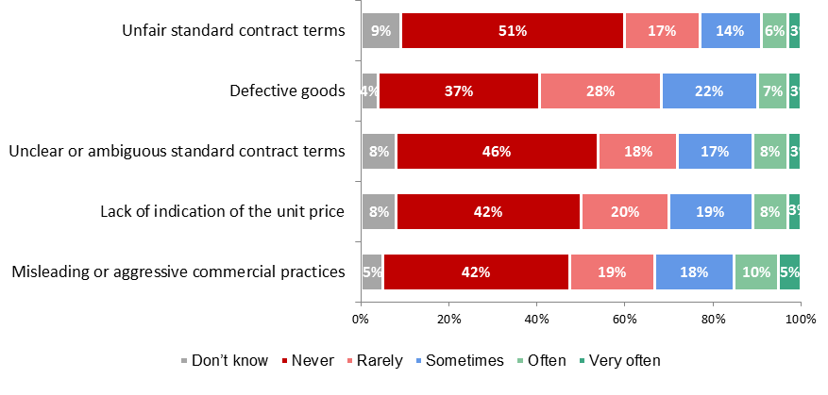

**Tables 2 to 4: Data from the Consumer Market Study to support the Fitness Check of EU consumer and marketing law (2017):[175]**

**Table 2: Action taken to resolve the most recent consumer rights problem at country level by type of the problem (Table 54 (page 173) in the Consumer Market Study)[176]**

|  |  |  |  |  |  |  |  |  |  |
| --- | --- | --- | --- | --- | --- | --- | --- | --- | --- |
|  | You complained to the seller or service provider | You complained to the manufacturer | You complained to a public authority | You complained to a consumer association | You brought the matter to an out-of-court dispute resolution body such as an ombudsman, arbitration, mediation or council | You took the trader to court | You took other actions | | **You did not take any action** |
| Lack of indication of the unit price | 38% | 7% | 3% | 3% | 1% | 0% | 4% | 50% | |
| Defective goods | 75% | 16% | 4% | 3% | 1% | 1% | 2% | **10%** | |
| Misleading or aggressive commercial practices | 46% | 11% | 9% | 9% | 4% | 1% | 8% | **27%** | |
| Unclear or ambiguous standard contract terms | 61% | 13% | 6% | 10% | 3% | 2% | 4% | 18% | |
| Unfair standard contract terms | 57% | 10% | 8% | 8% | 3% | 2% | 5% | 21% | |

Table 3: Reasons for not taking any action by type of consumer rights issue (Table 66 (page 183) in the Consumer Market Study)[177]

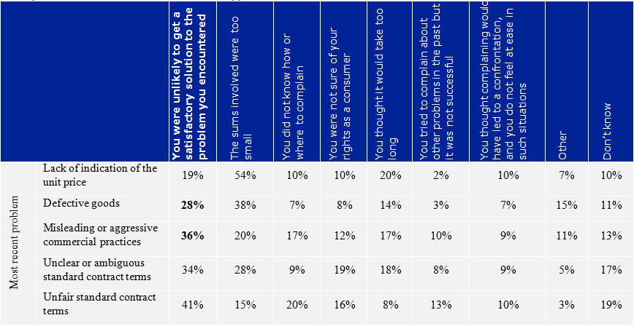

Table 4: Outcome of problem resolution efforts by type of consumer rights issue (Table 71, page 189) in the Consumer Market Study)[178]

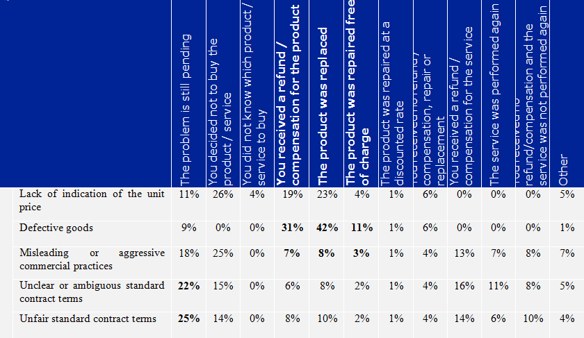

**Table 5: Pre- and post-redress financial detriment (average per respondent who experienced a problem and sought redress, in euro), online survey[179]**



**Tables 6 and 7**[180]

**Table 6: Pre- and post-redress financial detriment, large household appliances market, online survey**



**Table 7: Pre- and post-redress financial detriment (average per respondent who experienced a problem and sought redress, in euro), large household appliances online survey**

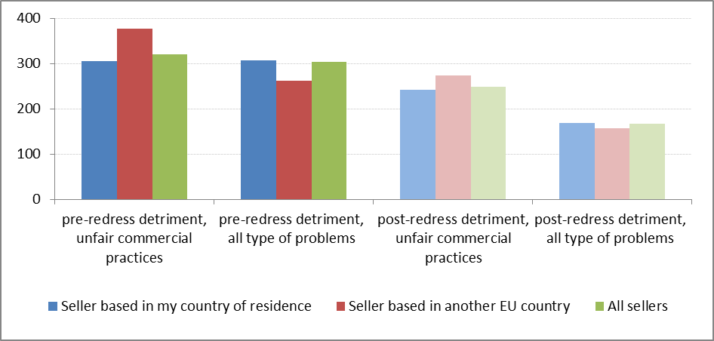

Tables 6 and 7 indicate that consumers who had experienced unfair commercial practices in relation to purchases of large household appliances suffered on average pre-redress financial detriment of EUR 319.40, higher than all types of consumer problems combined (EUR 302.7). After seeking redress, the average financial detriment related to unfair commercial practices was EUR 248.3. This is significantly higher compared to the post-redress financial detriment for all types of problems combined (EUR 167.5). When the seller was based in another EU country, the pre- and post-redress detriment related to unfair practices tended on average to be higher by 23.3% and 13.3% than with sellers based in the country of residence.[181]

**Table 8: Overview of civil remedies in the different Member States:**

|  |  |  |  |  |  |
| --- | --- | --- | --- | --- | --- |
|  | **Existence of a direct link between civil remedies and UCPD breaches** | **Civil remedies for UCPD breaches referred to by the direct link** | | | |
| **Certain breaches of the UCPD** | **Damages** | **Contract termination** | **Price reduction** |
| Austria | - | - | - | - | - |
| Belgium | + | +[182] | - | + | - |
| Bulgaria | +[183] | - | + | + | - |
| Croatia | - | - | - | - | - |
| Cyprus | - | - | - | - | - |
| Czech Republic | + | +[184] | + | - | - |
| Denmark | - | - | - | - | - |
| Estonia | - | - | - | - | - |
| Finland | - | - | - | - | - |
| France | + | +[185] | - | + | - |
| Germany | - | - | - | - | - |
| Greece | + | - | + | - | - |
| Hungary | - | - | - | - | - |
| Ireland | + | +[186] | + | - | - |
| Italy | - | - | - | - | - |
| Latvia | - | - | - | - | - |
| Lithuania | + | - | + | - | - |
| Luxembourg | + | - | - | + | - |
| Malta | - | - | - | - | - |
| Netherlands | + | - | + | + | - |
| Poland | + | - | + | + | - |
| Portugal | + | - | + | + | - |
| Romania | - | - | - | - | - |
| Slovakia | + | - | - | + | - |
| Slovenia | - | - | - | - | - |
| Spain | - | - | - | - | - |
| Sweden | + | - | + | - | - |
| UK | + | +[187] | + | + | + |

**Table 9: If you have been a victim of unfair commercial practices (e.g. if you have purchased a product or a service based on misleading claims, such as misleading green claims, or aggressive practices by traders), have you experienced problems with getting redress from traders?**

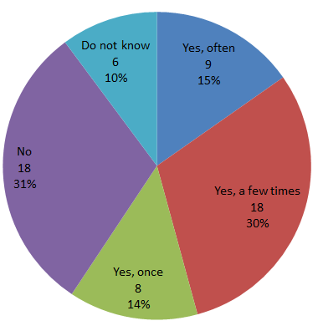

**Table 10: In your professional experience, do consumers experience problems with getting redress from traders when they have been victims of unfair commercial practices? Breakdown by respondent category:[188]**

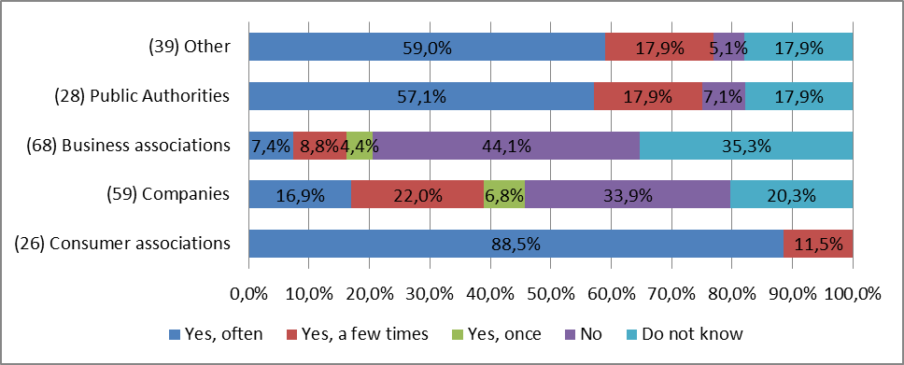

**Table 11: Differences between national rules on remedies for unfair commercial practices cause harm to consumers as they cannot remedy the consequences resulting from unfair commercial practices on the national and cross-border level (based on 313 replies across all stakeholder groups):[189]**

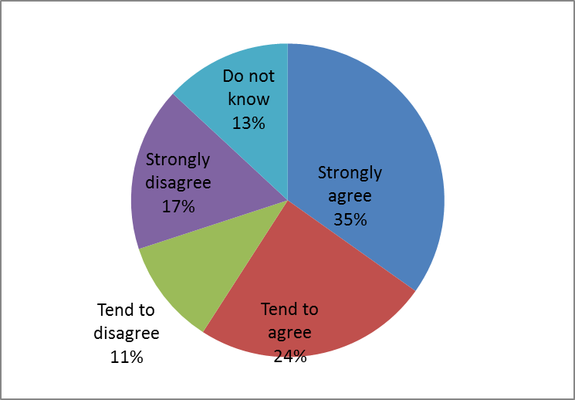

**Table 12: Differences between national rules on remedies for unfair commercial practices cause costs for traders engaging in cross-border trade due to need to adapt to different national rules on remedies (all responses across all stakeholder categories including businesses and business associations; specifically business associations and companies, and companies who declare trading cross border – in absolute numbers):[190]**

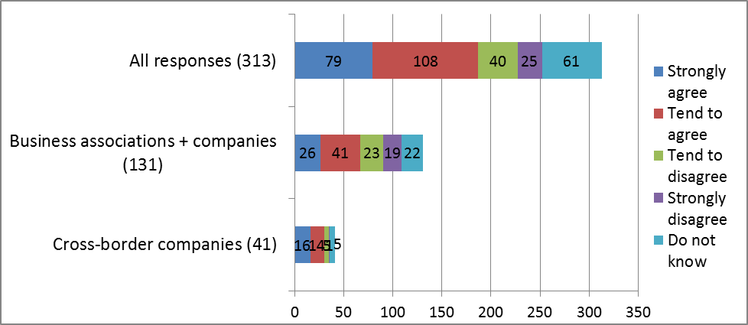

**Table 13: Do these costs (to check compliance with and adjust business practices to national rules related to remedies for consumers that have been harmed by unfair commercial practices) have an impact on your decision to enter other EU markets or not?[191]**

All SMEs consulted:

|  |  |  |
| --- | --- | --- |
|  | Answers | Ratio |
| It encourages my enterprise to enter other EU markets | 26 | 11% |
| It has no significant impact on my enterprise's decision to enter other EU markets | 102 | 44% |
| It discourages my enterprise from entering other EU markets | 47 | 20% |
| Do not know | 59 | 25% |
|  | **234** | 100% |

B2C SMEs consulted:

|  |  |  |
| --- | --- | --- |
| It encourages my enterprise to enter other EU markets | 23 | 11.50% |
| It has no significant impact on my enterprise's decision to enter other EU markets | 83 | 41.50% |
| It discourages my enterprise from entering other EU markets | 46 | 23.00% |
| Do not know | 48 | 24.00% |
|  | **200** | 100.00% |

**Table 14: SMEs views on introducing UCPD remedies: Should there be an EU-wide right for consumers to claim remedies directly from the traders who have harmed them with their unfair commercial practices?[192]**

n=216 (SMEs selling to consumers)

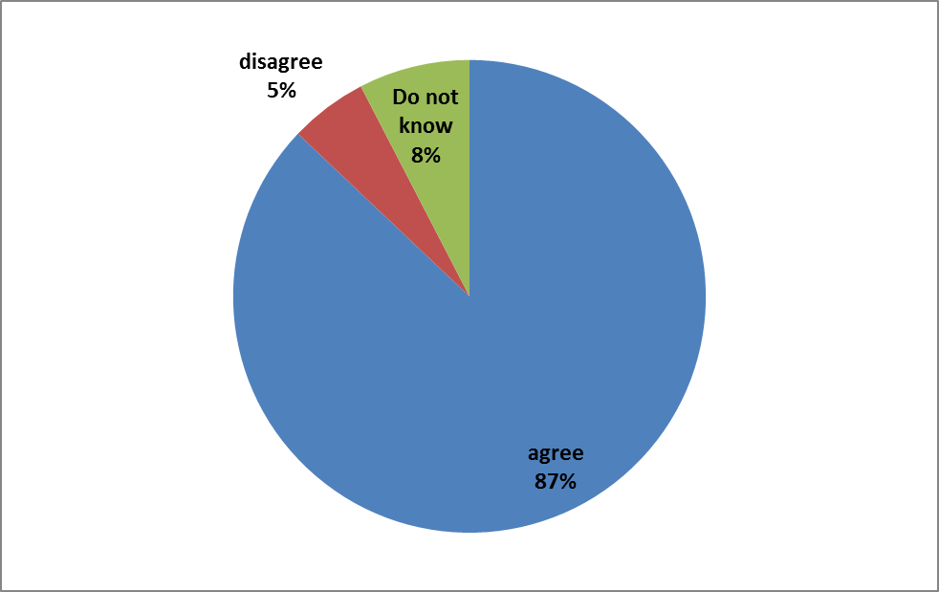

B2C SMEs consulted:

|  |  |  |
| --- | --- | --- |
| Strongly agree | 108 | 47.79% |
| Tend to agree | 88 | 38.94% |
| Tend to disagree | 6 | 2.65% |
| Strongly disagree | 7 | 3.10% |
| Do not know | 17 | 7.52% |
|  | 226 | 100.00% |

Smallest (self-employed, micro and small) SMEs consulted:

|  |  |  |
| --- | --- | --- |
| Strongly agree | 92 | 47.4% |
| Tend to agree | 76 | 39.2% |
| Tend to disagree | 5 | 2.6% |
| Strongly disagree | 6 | 3.1% |
| Do not know | 15 | 7.7% |
|  | 194 | 100.0% |

**Table 15: In your Member State, to what extent would the introduction of an EU-wide right to individual remedies create costs for making amendments to the existing legal framework?[193]**

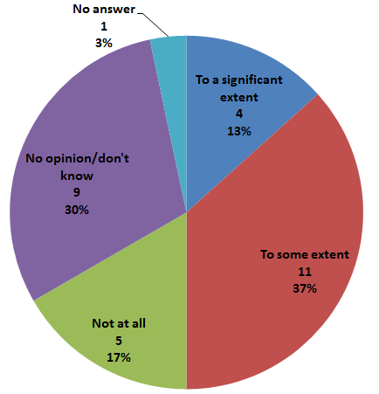

**Table 16: Do you agree that these costs are reasonable, when taking into account the possible benefits for consumers?[194]**

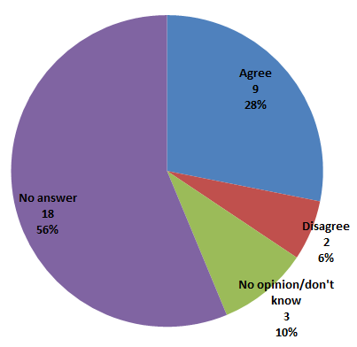

**Question 21 in the public consultation**: What should be done, in your opinion, to ensure that traders comply better with consumer protection rules?: (ID168)Victims of unfair commercial practices should be given rights to claim remedies from the traders (for example, to terminate the contract or claim damages).

**Question 4 in section B.1 of the SME panel consultation**: If a new EU rule was introduced to grant consumers an EU-wide right to claim remedies directly from the trader who has harmed them with unfair commercial practices, would this have an impact on your enterprise's decision to enter other EU markets? n= 205 SMEs selling to consumers

**Question 112 in the public consultation**: Do you agree that introducing an EU-wide right to remedies for victims of unfair commercial practices would bring about benefits, such as: 1) Better compliance by businesses with consumer protection rules; 2) More level playing field to the benefit of compliant traders?; 3) Greater consumer trust?

**Question 6 in section B.1 of the SME panel consultation**: Please estimate the savings for your enterprise of introducing an EU wide right to individual remedies for victims of unfair commercial practices?

You may wish to answer either in staff time or Euros, or both in case you incur staff and other costs.

One-off costs: Please indicate the one-off resources you would need to invest to ensure compliance with this new rule. (e.g. checking compliance with the new rules and adjusting business practices as a result (e.g. update your website), costs of legal/technical advice)

Regular costs: Please estimate the resources you would need to invest on a regular basis to comply with this new rule. (e.g. manage the updated website)

(Note: Please indicate in working days, with 1 working day equalling 8 hours of staff time. Please do not consider staff time for translation. If no staff time was involved, indicate ‘0’.)

**Summary of responses:**

Savings have been obtained by converting full time equivalents using the standard cost model and the second highest ISCO level (ISCO 2 professionals), adding pecuniary costs estimates:

One-off savings

|  |  |  |
| --- | --- | --- |
| **Size class** | **Range of estimated savings in Euro (median/mode)** | **Number of responses** |
| **Micro** | 0 – 24 176 (0/0) | 44 |
| **Small** | 0 – 21 675 (0/0) | 18 |
| **Medium** | 0 – 1 682 (338/0) | 10 |
| **Large** | 0 - 1 000 (0/0) | 4 |
| SMEs | 0 – 24 176 (0/0) | 72 |

Annual regular/running savings

|  |  |  |
| --- | --- | --- |
| **Size class** | **Range of estimated savings in Euro (median/mode)** | **Number of responses** |
| **Micro** | 0 – 10 000 (0/0) | 44 |
| **Small** | 0 – 5 000 (0/0) | 18 |
| **Medium** | 0 – 978 (175/0) | 10 |
| **Large** | 0 (0) | 4 |
| SMEs | 0 – 10 000 (0/0) | 72 |

Note**:** (*) Less than three estimates were received in this category

**Question 123 in the public consultation**: What would be the estimated additional costs for your business (or the businesses you represent) of introducing an EU-wide right to individual remedies for victims of unfair commercial practices?

One-off costs: A self-employed in DE indicated costs of 25% of turnover and an individual in LV estimated zero costs.

Annual running costs: A self-employed in AT indicated costs of 0.6% of turnover, one in DE assumed 35% costs in terms of turnover. A small company in DE projected 5%. Individuals estimated costs of 150% of turnover and EUR 2 000 (2% of turnover) respectively (LV, DE).

**Question 5 in section B.1 in the SME panel consultation**: Please estimate the resources your enterprise would need to invest due to a possible new EU consumer right to claim remedies for harm suffered from unfair commercial practices?

You may wish to answer either in staff time or Euros, or both in case you incur staff and other costs.

One-off costs: Please indicate the one-off resources you would need to invest to ensure compliance with this new rule. (e.g. checking compliance with the new rules and adjusting business practices as a result (e.g. update your website), costs of legal/technical advice)

Regular costs: Please estimate the resources you would need to invest on a regular basis to comply with this new rule. (e.g. manage the updated website)

(Note: Please indicate in working days, with 1 working day equalling 8 hours of staff time. Please do not consider staff time for translation. If no staff time was involved, indicate ‘0’.)

**Summary of responses:**

Costs have been obtained by converting full time equivalents using the standard cost model and the second highest ISCO level (ISCO 2 professionals), adding pecuniary costs estimates:

One-off costs

|  |  |  |
| --- | --- | --- |
| **Size class** | **Range of estimated resources in Euro (median/mode)** | **Number of responses** |
| **Micro** | 0 – 572 484 (322/0) | 51 |
| **Small** | 0 – 101 675 (1 311/0) | 23 |
| **Medium** | 0 – 8 000 (1 287/0) | 11 |
| **Large** | 0 – 5 000 (108/-) | 3 |
| SMEs | 0 – 572 484 (380/0) | 85 |

Note**:** (*) Less than three estimates were received in this category

Annual regular/running costs

|  |  |  |
| --- | --- | --- |
| **Size class** | **Range of estimated resources in Euro (median/mode)** | **Number of responses** |
| **Micro** | 0 – 190 497 (483/0) | 51 |
| **Small** | 0 – 171 551 (1 000 /0) | 23 |
| **Medium** | 0 – 3 200 (698/0) | 11 |
| **Large** | 0 – 15 000 (0/0) | 3 |
| SMEs | 0 – 190 497 (655/0) | 85 |

Note**:** (*) Less than three estimates were received in this category

**Question 109 in the public consultation**: If such an EU-wide consumer right were to be introduced, should it 1) Define which types of remedies should be available to consumers EU-wide; or 2) Require Member States to ensure that consumers have a right to remedies, but leave the types of remedies to be defined at national level.

**Question 110 in the public consultation:** Which types of EU-wide remedies should be introduced in case a consumer is a victim of an unfair commercial practice (multiple replies possible)? Right to terminate the contract and to get a refund of the price paid; Right to receive compensation for the damage suffered; Right to a price reduction; Other.

## 3. Stakeholder views

**Improve compliance with EU consumer law**

In the public consultation, in response to a question about what should be done to ensure that traders comply better with consumer protection rules,[195] 63% (240) of all respondents indicated that victims of unfair commercial practices should be given rights to claim remedies from the traders. 16% disagreed with this. When broken down by respondent group, the responses to this questions show that MS authorities (25 of 28), consumer associations (all 27 responding) and citizens (86 of 93) agreed that victims of unfair commercial practices should be given rights to claim remedies to ensure that traders comply better with consumer protection rules. On the other hand, only 31% of the 121 companies agreed with this (12% of the responding companies disagreed) and 52% of 69 business associations disagreed (35% agreed). Out of the companies that agreed (38), over 70% were SMEs. 27% of the SMEs replying to this question agreed (9% disagreed and 64% said they did not know). 11 of 22 large companies agreed (6 disagreed and 5 did not know).

**Protect the economic interests of consumers and ensure a high level of consumer protection**

In the SME panel consultation, a clear majority (87%, of a total of 263 replies) supported introducing an EU-wide right to remedies. The percentages were similar when the responses were filtered for B2C companies and for SMEs (see Table 14 in Section 2 of this Annex).

In the public consultation for the Fitness Check, 95% of consumer associations and 75% of consumer respondents and public authorities agreed that consumer protection against unfair commercial practices should be strengthened by introducing a right to remedies. In contrast, only 10% of business associations agreed with this, while 64% disagreed. Responding businesses were split in this respect, with 45% agreeing and 37% disagreeing.

**Deciding UCPD remedies on national or EU level**

In the public consultation for this IA, 52% (65) of respondents said that it should be decided at EU level which remedies should be made available for breaches of the UCPD, while 38% (48) said the choice of remedies should be left to MS.[196] A breakdown by respondent group of responses to this question shows that, out of the 16 responding consumer associations, 13 supported defining UCPD remedies on EU level, while 3 said it should be left to the MS. Out of the 33 responding business associations, 20 supported leaving this to the national level, whilst 6 were in favour of rather harmonising the remedies at EU level. Out of the 17 responding MS authorities, 8 said that the types of remedies should be defined at national level and 7 MS authorities preferred defining them at EU-level. 23 of the 29 citizens replying to this question said that the type of remedies should be defined at EU level, while 6 preferred leaving the choice to the MS. Of the 20 responding companies (of which 14 SMEs and 6 large companies), 9 chose determining the types at EU-level, while 8 preferred leaving the choice to the MS (3 selected "do not know"). When looking at possible difference of views between SMEs and larger companies among the 20 responding ones, it appears that 6 out of 14 SMEs preferred leaving the choice to the MS, whereas 5 indicated that this should be decided at EU level. An opposite trend is to be observed among the 6 large companies, 4 of which supporting the option of deciding this rather at EU level. This question was not asked in the CPC and SME consultations.

**Frequently used UCPD remedies**

In reply to the CPC/CPN/CMEG survey, 15 MS authorities indicated that the most frequently used UCPD remedy in their countries today is the right to terminate the contract and to get a refund. The 15 MS are HR, DK, EE, FI, HU, IE, IT, LT, MT, NL, PT, RO, SK, ES, SW.

**UCPD remedies with added value**

Also in reply to the CPC CPC/CPN/CMEG survey, 20 MS indicated that there would be added value in introducing an EU-wide right to terminate the contract and get a refund of the price paid. The MS are AT, BE, BG, HR, CY, DK, EE, FR, HU, IE, LV, LU, MT, NL, PL, PT, RO, SK, ES, SE. 15 MS authorities said there would be added value in introducing an EU-wide right to compensation for damages under the UCPD. The 15 MS are AT, BE, BG, CY, HR, DK, EE, FI, LV, IE, MT, NL, PL, RO, ES.

In the public consultation, to a question about which types of EU-wide remedies should be introduced,[197] 12 of the 16 responding MS authorities, 26 of the 28 citizens and all the 16 consumer associations replying indicated the right to terminate the contract and get refund of the price paid. 6 of the 24 responding business associations agreed, along with 8 of 13 SMEs and 4 of 5 large companies. 9 of the 16 responding MS authorities, 15 of the responding 16 consumer associations, 23 of 28 citizens, 10 of 24 business associations, 5 of 13 SMEs and 2 of 5 large companies indicated that a right to compensation for damages should be introduced.

**Promote the smooth functioning of the internal market**

On increased consumer trust, the mystery shopping exercise for the Consumer Market Study supporting the Fitness Check found that consumers may not actually be aware of differences in the national consumer laws, but still suspect that such differences exist. This may lead consumers to avoid cross-border purchases. Consumers are also concerned about possible differences in their rights, even if their rights towards traders in other Member States are the same or even better than in their own country.[198]

In the public consultation, 64% of all respondents agreed that introducing such rights would contribute to greater consumer trust.[199] The agreeing respondents were: All 16 consumer associations, 13 of 16 MS authorities, 25 of 28 individuals, 10 of 21 companies (6 of 15 SMEs and 4 of 6 large companies), 14 of 45 business associations (of the 45, 27 disagreed, 14 agreed and the rest did not know) and 10 of 11 other stakeholders (NGOs, associations etc.).

Also in the public consultation, 67% of all respondents agreed that introducing an EU-wide right to UCPD remedies wold create a more level playing field for compliant traders. The agreeing respondents were: All 16 consumer associations, 13 of 16 MS authorities, 26 of 28 citizens, 13 of 21 companies (9 of 15 SMEs and 4 of 6 large companies), 13 of 45 business associations (28 disagreed and 4 did not know) and all 11 other stakeholders.

In the SME consultation, 25% of the (205) respondent SMEs stated that introducing an EU-wide right to remedies under the UCPD would encourage their enterprise to enter other EU markets.[200]

**Costs related to amending national rules**

In the CPC CPC/CPN/CMEG survey, MS authorities gave diverging answers when asked if the introduction of EU-wide rights to UCPD remedies would create costs related to amending national rules. A majority of the respondents agreed that costs related to amending national rules to introduce UCPD remedies would be reasonable. Data on responses to these questions is provided in Tables 15 - 16 in subsection 2 of this Annex.

# Annex 9: Additional data on the Injunctions Directive

## 1. Detailed problem description

|  |
| --- |
| The risk of mass harm situations that affect the collective interests of consumers increases constantly in light of globalisation and digitalisation.[201],[202] Infringing traders may affect thousands or even millions of consumers with the same misleading advertisement or unfair standard contract terms in various economic sectors, such as telecommunications, financial services and energy.[203] The "Dieselgate" scandal is a greatly publicized example of mass harm situations taking place across the EU.[204]  **Examples of mass harm:**   * In DE, one of Europe's largest network-independent telecoms providers offered consumers contracts that included a significant fee for "non-use" that has been found unfair within an injunction action.[205] * A consumer credit company in Latvia misled consumers with respect to interest rates in credit cards leaving several thousands of consumers with harm up to €10,000. [206] * Energy suppliers in the UK overcharged approximately four million households due to billing blunders that caused detriment of almost £300m.[207] |

In mass harm situations, the existing individual enforcement and redress possibilities appear insufficient and infringing traders are not sufficiently deterred from non-compliance. As demonstrated by the Fitness Check, reliance on individual private enforcement results in consumerdetriment and the under-deterrence of infringements.[208] Given the low awareness of their rights, consumers may not detect the illegal practice in the first place. For instance, consumers may not see the link between the misleading character of the advertising and its effects on their economic behaviour and may not even realise that a breach of the UCPD takes place. Consumers may not be adequately informed about the relevant legal consequences and the remedies available to them. Consumers might not even have a direct right to remedies, as is the case with UCPD remedies in certain Member States. Moreover, consumers may not be able to identify the small amount of loss in each case (e.g. a few euros in monthly telecommunication or energy services bills), yet the aggregated amount of harm may be significant. Furthermore, even if consumers are aware of the infringement and their related loss, they may rationally decide not to take legal action due to the overall negative balance of the perceived costs and benefits. Given the above, it is even less probable that individual consumers would take an action for stopping illegal practices in mass harm situations for the protection of collective interests of consumers, even if possibilities for this are ensured by law in some Member States.[209]

**Many consumers affected by a breach of EU consumer law do not seek individual redress:**

The 2017 Consumer Conditions Scoreboard reported that in 2016 almost a third (6.1 percentage points more than in 2014) of the consumers having faced a problem within the EU, whether domestically or cross-border, did not follow it up despite feeling it would have been legitimate to do so. The main reasons for not acting are: excessive length of the procedures (for 32.5% of those who didn't take action); perceived unlikelihood of obtaining redress (19.6%); previous experience of complaining unsuccessfully (16.3%); uncertainty about consumer rights (15.5%); not knowing where or how to complain (15.1%) and psychological reluctance (13.3%).[210] Compared with 2014, consumers appear less inclined to take their complaints to court or to an out-of-court dispute resolution body (respectively -1 and -1.7, statistically significant decreases).[211] The survey carried out within the 2017 Study on Procedural Protection of Consumers echoed the above results. [212]

A comparison of this data with EC data from 2008 shows that EU consumers today face the same problems while seeking redress individually as ten years ago.[213]

Several instruments for ensuring enforcement of EU consumer law and consumer redress already exist at European level.[214]However, there is a gap of private enforcement, including consumer redress in mass harm situations. Most EU-level private enforcement instruments which are primarily aimed at individual consumer disputes, were not designed to address the procedural specificities of mass harm or to take into account the collective interests of consumers.[215] Furthermore, public enforcement alone is not sufficient either. Public authorities are often not able or willing to follow up on each infringement due to multifaceted reasons, including resource limitations and political discretion concerning enforcement priorities. The revised CPC Regulation is also not able to address all aspects of cross-border mass harm situations, in particular consumer redress. It ensures that national consumer enforcement authorities in all Member States have certain minimum enforcement powers to stop cross-border infringements of EU laws enumerated in its Annex. However, these minimum powers do not include the power to order redress, as public enforcers only have the possibility to agree to voluntary remedial commitments with the trader.[216]

The need for an EU enforcement instrument that addresses the collective interests of consumers was already evident in 1998, when the Injunctions Directive was first adopted. The ID made it possible for "qualified entities", mainly consumer organisations and independent public bodies, to bring "actions for an injunction"[217] for the protection of the collective interests of consumers with the primary aim of stopping infringements of EU consumer law. Such actions may be brought to challenge both domestic and cross-border infringements without an explicit mandate from the affected consumers. This makes the ID an instrument particularly relevant for addressing mass harm situations where the interests of a number of consumers have been harmed or may be harmed by the same illegal practice. The 2008 and 2012 Commission reports on the application of the ID as well as the 2017 Fitness Check have all confirmed the significant role of the ID in the EU-level regulatory toolbox.[218] However, these reports have also concluded that there are considerable shortcomings to the current ID, which, if left unaddressed, will continue to hinder its full effectiveness, including its deterrent effect, and efficiency.[219]

**Efficiency aspects of collective injunctions and redress**[220]

In a hypothetical case of unfair standard contract terms, the costs for a lower court procedure borne by an individual consumer has been estimated at EUR 1 095 on average across Member States, within a range between EUR 0 and EUR 7 569 (taking into account lawyer’s fees, court fees and other costs associated with the first instance court procedure for this hypothetical example). If 100 affected consumers would go to court, the sum of the costs for their individual actions would be EUR 109 500. The overall costs of an injunction action could be expected to be significantly lower than the sum of costs for individual actions, due to economies of scale (e.g. with respect to lawyers’ fees). This simplified calculation does not take into account the amount of time saved or the reduced levels of stress for consumers thanks to the fact that the legal action is sought in their protection by a representative entity. Importantly, another benefit of an injunction action that cannot be measured is the number of potential future cases prevented as a result of the injunction order.

The use of injunctions appears to be far from meeting the existing needs. A Commission Study estimated that 120,000 cross-border infringements were committed by traders in the five sectors analysed in 2014.[221] In the survey carried out within the Fitness Check, qualified entities[222] reported a total of 5 763 injunction actions brought in the five year period since June 2011, the large majority originating from Germany, which traditionally relies on the private enforcement of consumer law by publicly funded consumer organisations and active business organisations. Nearly half of the responding qualified entities indicated they did not initiate any injunction actions since June 2011, often due to insufficient financial capacity.

There are significant disparities among Member States in the national legal framework for the injunction procedure[223], its level of use and its effectiveness. The Fitness Check found that the injunction procedure is used relatively often in several Member States mainly for domestic infringements (AT, BE, DK, FI, FR, DE, EL, IE, IT, LV, NL, PT, SE). In others, it is only used to some extent (BG, EE, HU, LU, PL, SK, ES, UK) and in some Member States it is rarely used or not used at all (HR, CY, CZ, LT, MT, RO, SI). [224]

Even in those Member States where injunctions are considered effective and are widely used, their potential is not fully exploited due to a number of procedural elements that are not sufficiently regulated by the ID.[225] Key identified shortcomings are the limited scope, cost[226], length and the complexity[227] of the procedure, as well as its limited effects on consumers.[228] [229]

The scope of the ID is limited to the EU instruments enumerated in its Annex I. It thus leaves out several instruments that are important for the protection of the collective interests of consumers, from various areas such as passenger rights, financial services, environment, energy, telecommunication, data protection.[230] The Fitness Check consultation, next to the previous Commission reports on the application of the ID, demonstrates the relevance of the injunction actions in a large range of economic sectors.[231]

The injunction procedure set out in the ID has limited effects on individual consumers and infringing traders. As reported by the Fitness Check, this constitutes a limitation from an effectiveness and efficiency point of view. The Fitness Check showed that the impact of the ID on the reduction of consumer detriment in the last 5 years was considered to be low, particularly in cross-border situations (Figure 12 in Annex 9). In the ID survey, 54% of all respondents agreed (33% strongly agreed, 21% tended to agree) that consumers suffer harm due to the continuation of infringements caused by the sub-optimal use of injunctions in cross-border situations, whereas 16% disagreed. Injunction orders are not sufficiently publicized. As a result, affected consumers are not aware of the breach identified in the injunction order and the infringing traders are not deterred by the "naming and shaming" effect of such publicity.[232] In most Member States, to obtain redress, consumers may not be able to rely on the injunction order and may have to litigate against that trader for the same issues, including proving the infringement anew. This increases their litigation risk and also generates costs for the court systems. In addition, in some legal systems, prescription periods for bringing damages actions are shorter than the duration of the injunction procedure, including possible appeals.[233] Even when consumers know about the decision stopping an infringement, for the reasons described above, such as rational apathy vis-à-vis small claims, many are unlikely to engage in individual litigation to claim redress for the harm caused by the ceased infringement. As a result, the profits illegally obtained from the infringement remain with the trader.[234] This, coupled with the fact that the existing penalties for non-compliance with the injunction order in the Member States do not seem deterrent enough, does not discourage the trader to continue the infringement and does not sufficiently prevent possible future infringements.[235]

The fact that the injunction procedure set out in the ID primarily produces effects for the future and the lack of clarity about whether it may also cover redress for the victims of the infringement are widely considered by qualified entities as the major reasons for its insufficient effectiveness and deterrence. Qualified entitiesresponding to the Fitness Check survey viewed the ‘possibility to bring an action for damages or redress to be paid to the consumers concerned within the injunction procedure’ as the most beneficial procedural element to be further harmonised in the ID.[236]

In order to address the gap of collective consumer redress, the 2013 Commission Recommendation on Collective Redress explicitly called Member States to ensure in their legal systems the existence of injunctive and compensatory collective redress in all areas of EU law[237]. However, as shown by the 2017 Commission Report, the impact of the Recommendation has been limited. Only a few Member States have introduced or amended their legislation and nine Member States still do not provide for any possibility of claiming compensation collectively.[238] In Member States where compensatory redress exists, it is still reported to be not effective enough to fully reach its objectives[239]. In the survey carried out within the 2017 Study on collective redress, 91.52% of respondents found gaining compensatory redress in mass claims difficult within current national systems.[240] In the 2017 Commission call for evidence on collective redress[241], respondents referred, inter alia, to excessive cost of procedure, overall complexity of procedure, difficult access to evidence and overall length of the procedure as being reasons for not taking a collective action in a mass harm situation.[242] [243]

The findings of the 2017 Study on Procedural Protection of Consumers confirmed that the existing injunctive and compensatory collective redress mechanisms are insufficiently effective in most Member States. The survey carried out within this study revealed that, based on their experience, 50% of the responding lawyers, judges, consumer organisations and ADR entities considered the existing national collective redress mechanisms to be unsatisfactory for both compensatory and injunctive relief.[244] The study also highlighted the lack of a direct effect of injunction procedures on the ability of the victims to obtain redress[245].

Since the ID applies to both domestic and cross-border infringements, problems related to its effectiveness have cross-border implications. In the ID survey, 50% of all respondents agreed, whereas 18.9% disagreed, that differences between national injunction procedures cause costs for qualified entities that wish to bring injunctions before the courts/authorities of other Member States. 54.4% of all respondents agreed, while 15.6% disagreed, that such differences cause harm to consumers due the continuation of the infringement caused by the sub-optimal use of injunctions in cross-border situations. Moreover, 37.8% of all respondents agreed, whereas 22.2% disagreed, that differences between national injunction procedures cause costs for traders engaging in cross-border trade due to the unequal deterrent effect of national procedures.[246] The Fitness Check identified only one Member State (ES) in which a qualified entity reported going abroad to use injunctions.[247] It appears that, in practice, qualified entities do not bring injunctions before another Member State's courts/authorities where the infringement originated, as allowed by Article 4 of the ID, mainly because of additional costs of the procedure (e.g. translations, cost of foreign lawyers). Instead, they challenge cross-border infringements by bringing injunction actions against foreign traders in the courts of their own Member States, which is possible under EU private international law rules. However, the use of injunctions for cross-border infringements is still low and the qualified entities from different Member States are not cooperating with each other sufficiently i.e. they are not exchanging best practices or developing common strategies to challenge widespread infringements affecting at the same time consumers that they represent in different Member States[248]. Only a few cases were reported in which qualified entities brought parallel coordinated actions, each in its own Member State, to tackle the same infringement affecting consumers in those Member States[249]. The ID is not clear on whether it is possible to bring a coordinated action by several entities in front of a court in a single Member State or whether a single qualified entity can bring a single action in the name of qualified entities from other Member States. Whether the action is brought by a qualified entity domestically or abroad, domestic procedures available under the current ID are ultimately not effective enough to address mass harm situations with a cross-border dimension.

## 2. Legal mapping of the national transposition of the ID[250]

**Scope**

According to the Study supporting the Fitness Check, 22 Member States (all except for CY, DK, IE, LV, RO, SE) have extended the scope of the ID to other instruments. These extension include depending of the MS either other consumer law instruments or instruments from other areas of law, e.g. competition law, telecommunications, data protection, anti-discrimination, passenger rights and payment services or both4 Member States (UK, FR, LT, NL) have a different scope for domestic and cross-border infringements. According to the Study on the 2013 Recommendation on Collective Redress, 12 Member States (BG, HR, DK, FR, HU, LT, LU, NL, PT, SL, ES, SE) have extended the ID also to other areas, mainly competition, environment, employment or anti-discrimination.

**Type of procedure (judicial/administrative)**

According to the Study supporting the Fitness Check, in 20 Member States (AT, BE, BG, HR, CY, CZ, DK, FI, DE, EL, IE, IT, LT, LU, NL, PT, SL, ES, SE, UK) the ID procedure is judicial. In 4 Member States (LV, MT, PL, RO) the ID procedure is administrative. In 4 Member States (EE, FR, HU, SK) it may be both judicial and administrative.

**Qualified entities**

According to the Study supporting the Fitness Check, in 4 Member States (AT, DE, RO, EL) only consumer and business organisations are qualified. In 2 Member States (LV, FI) only public authorities are qualified.22 Member States have a mixed system (BE, BG, HR, CY, CZ, FR, HU, IT, LU, MT, NL, PL, PT, SL, DK, EE, IE, LT, ES, SE, UK, SK).

**Funding and access to justice for qualified entities**

According to the Study supporting the Fitness Check, in 24 Member States (AT, BE, BG, HR, CY, Z, DK, EE, FR, DE, EL, HU, IE, IT, LU MT, NL, PL, PT, SL, SK, ES, SE, UK) costs are as a rule borne by the losing party. In 5 Member States (FI, LV, MT, PL, ES) qualified entities are exempted from fees for the administrative procedure. In 2 Member States (HU, SK) consumer organisations are exempted from court fees. In 1 Member State (PT) only public authorities are exempted from court fees. In 2 Member States (FR, EL) consumer organisations can claim the damage to the collective interest of consumers into their own purse.In 1 Member State (NL) pre-trial costs of investigation and claim collection can be fully claimed from the defendant under certain conditions.

**Time limits**

According to the Study supporting the Fitness Check, 17 Member States (AT, BE, BG, DK, FI, FR, DE, EL, IE, IT, LV, MT, NL, PL, SK, ES, UK) have introduced summary procedures. 2 MS (RO, PL) have introduced express time limits for the decision in injunction action.

**Publicity**

According to the Study supporting the Fitness Check, in 4 Member States (BE, HR, DE, ES) the publication of the decision is at the discretion of the court. In 1 Member State (PT) there is mandatory automatic publication of decisions concerning practices that violate consumers’ rights. In 1 Member State (FI) all decisions are published on the websites of the Competition and Consumer Authority. In 1 Member State (PL) the trader can be ordered to inform consumers about the unfairness of a standard term. In 1 Member State (FR) the trader is obliged to inform consumers by all appropriate means about the unfairness of contract terms. For compensatory collective redress, once a case is declared admissible by the court, the courts in 10 Member States (BE, DK, EE, FI, FR, HU, LT, NL, PL, SE) are entrusted with the determination of modalities of publicity.

**Penalties for non-compliance with injunction order**

According to the Study supporting the Fitness Check, all Member States except 3 (SE, HU, EE), foresee sanctions for non-compliance with the injunction order. In 5 Member States (CY, FR, LU, DE, UK) non-compliance is treated as contempt of court or as a criminal offence and may be sanctioned with public law fines and even imprisonment. In 1 Member State (CY), in the case of the infringement of an injunction order, the court can also order the payment of compensation to any person who suffered damage as a result. In 2 Member States (AT, DE) the qualified entity would have to apply to the court again to obtain a penalty order, the amount of which will depend on the severity of the level of non-compliance. In 3 Member States (BG, PL, ES) penalties are calculated per day of non-compliance with the order. In 2 Member States (EL, FR) penalties are paid to the consumer organisation that had obtained the judgment.

**Penalties for the infringement within the injunction procedure**

According to the Study supporting the Fitness Check, in 9 Member States (AT, EL, HU, LV, LT, MT, PL, PT, SL) it is possible to have the claim for penalties for the infringement within the injunction procedure in the fields covered by the transposition of the ID.

**Injunction order as proof of breach for follow-on redress actions**

According to the Study supporting the Fitness Check, in the area of consumer law 4 Member States (BE, BG, DK and IT) allow follow-on actions to rely on the injunction order. In 2 Member States (NL, UK) follow-on actions are possible not as a matter of law but rather of practice.

**Injunctions and redress in one procedure**

According to the Study supporting the Fitness Check, 9 Member States (AT, BG, CZ, DK, HU, LT, PT, ES, UK) have the possibility to provide injunctive relief and redress (including damages actions) in a single procedure. However, this is often a theoretical possibility governed by general procedural rules and not by specific legislation. For instance, it may be possible under the rules of civil procedure for a court to join two related actions in a single procedure. In 9 Member States (AT, BG, EL, HU, IT, LV, LU, SL, UK) qualified entities may claim other measures beyond the injunction (e.g. evidence of compliance with the injunction order). According to the Study on the 2013 Recommendation on Collective Redress, approximately 16 Member States have the possibility to provide injunctive relief and redress (including damages actions) in a single procedure (AT, BE, BG, DK, FI, EL, HU, LT, MT, NL, PL, RO, ES, SI, UK).

**Compensatory collective redress[251]**

According to the Study on the 2013 Recommendation on Collective Redress, 19 Member States provide for some form of compensatory collective redress (AT, BE, BG, DE, DK, FI, FR, EL, HU, IT, LT, MT, NL, PL, PT, RO, ES, SE, UK). In over half of them it is limited to specific sectors, mainly to consumer claims. Only 6 Member States (BG, DK, LT, NL, PT, UK) have taken a horizontal approach in their legislation, allowing for collective compensation proceedings across all areas. In AT there is no proper legal collective redress framework but an extension of traditional multiparty litigation devices to mass claims established by the case law. In NL the available mechanism provides only for a possibility to have an out-of-court settlement approved by the court, but there is no proper judicial collective redress in place. In DE the existing one is limited to investors' claims. Representative collective actions aimed at obtaining compensation are available in BE, BG, EL, FI, FR, LT IT, HU, PL, RO, ES, SE. In 2 Member States (FI and PL) only public authorities are entitled to bring representative actions, while in some others non-governmental entities share this competence with public authorities (HU, DK).

## 3. Outtakes from the qualified entities survey conducted for the Study supporting the Fitness Check of EU consumer and marketing law

**Figure 1: importance of potential obstacles to the effective use of the injunctions procedure related to national infringements**

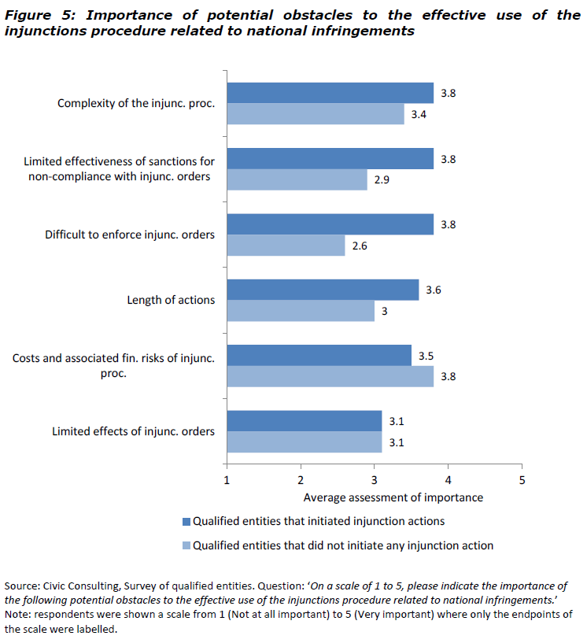

**Figure 2: importance of potential obstacles to the effective use of the injunctions procedure related to cross-border infringements**

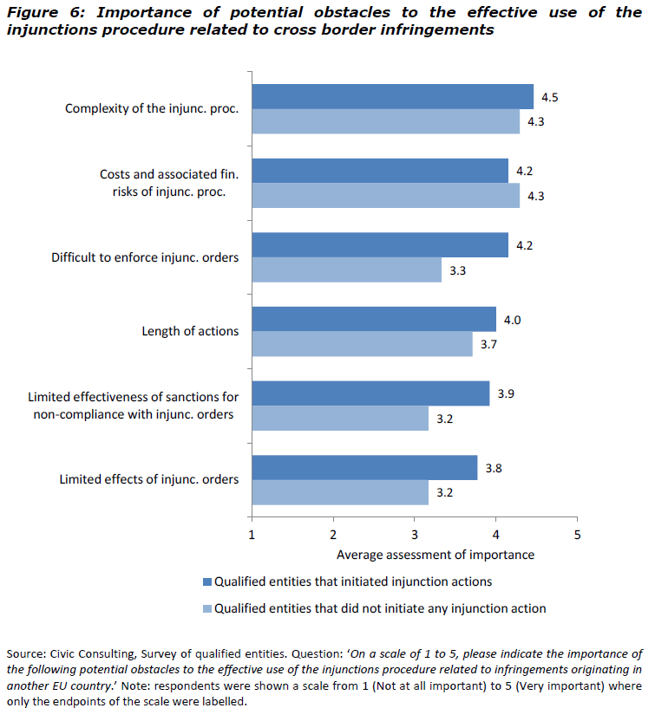

**Figure 3: impact of the injunction procedure on reducing the number of infringements to consumer protection rules**

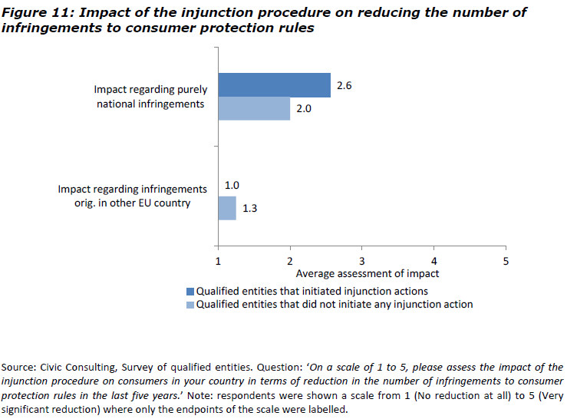

**Figure 4: impact of the injunction procedure on reducing consumer detriment**

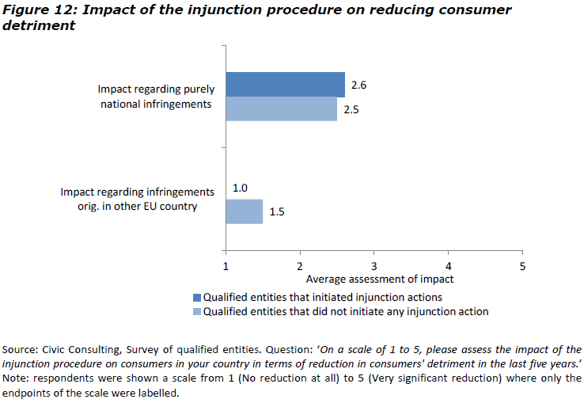

**Figure 5: extent to which further measures to increase the use of the injunction procedure and strengthening cooperation would be useful**

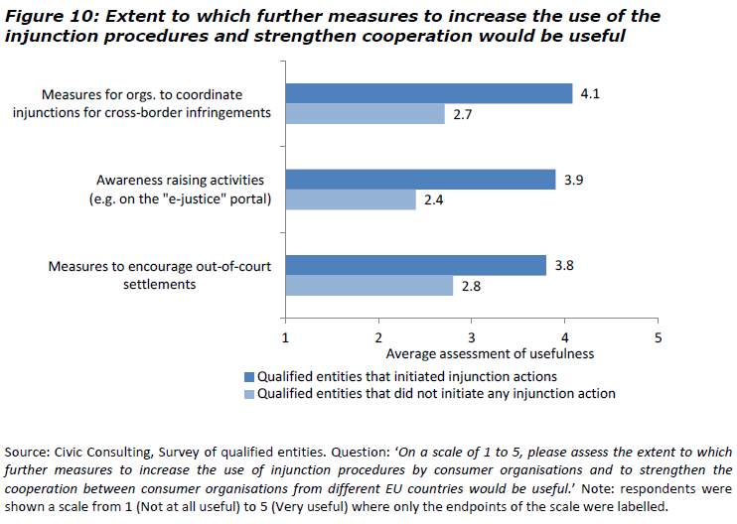

**Figure 6: extent to which further harmonisation of the injunction procedure would be beneficial**

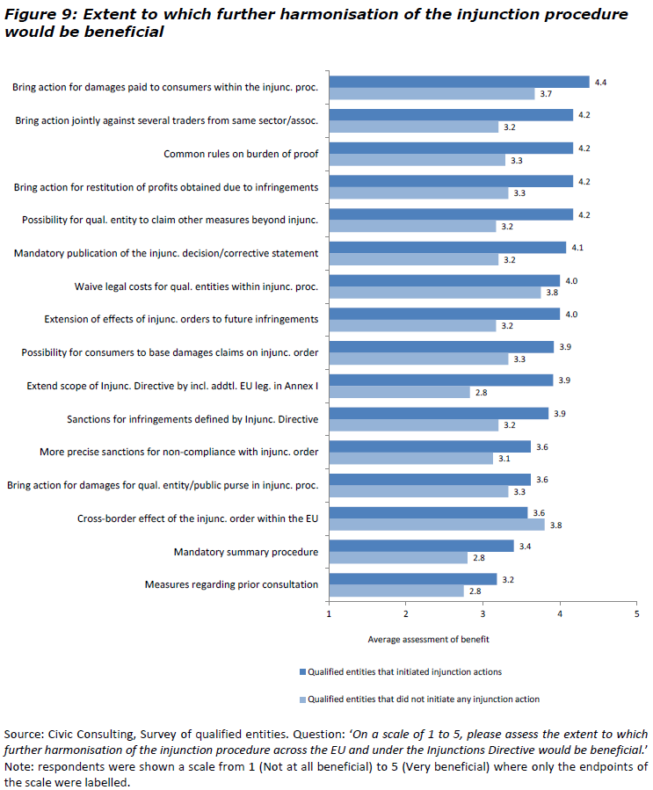

## 4. Outtakes from the survey conducted for the Study supporting the assessment of the implementation of the 2013 Commission Recommendation on collective redress

**Figure 7: risks of abusive litigation**

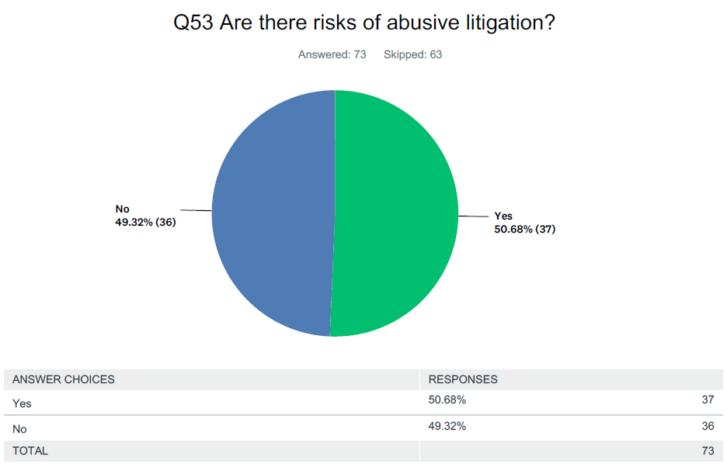

**Figure 8: instances of abusive litigation**

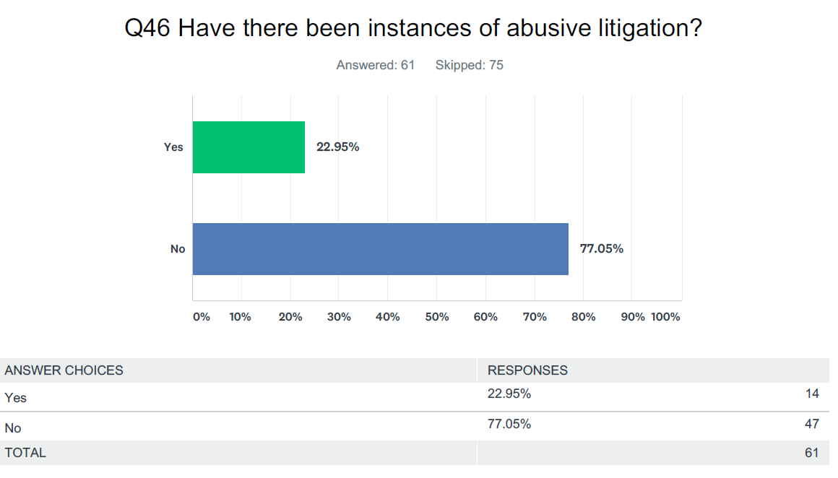

**Figure 9: impact of collective redress on competitiveness**

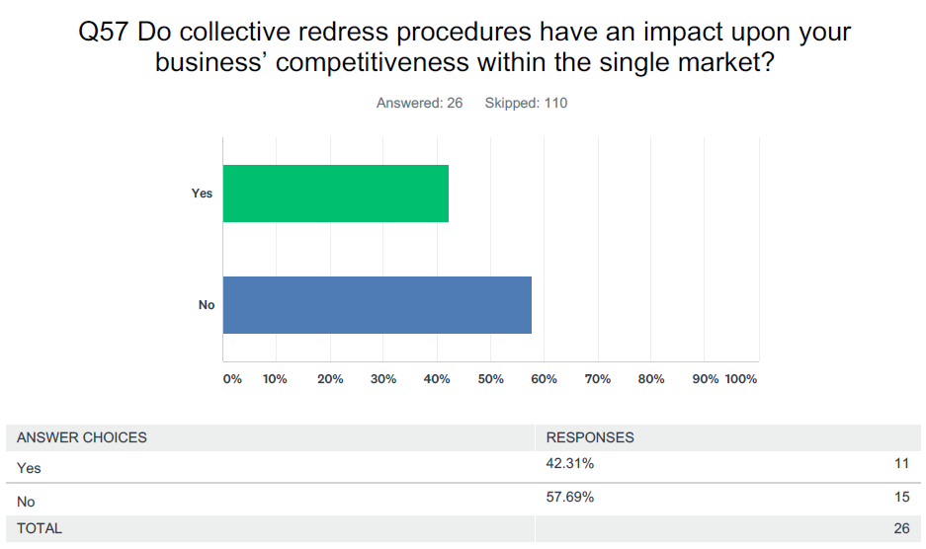

**Figure 10: impact of collective redress on consumer protection**

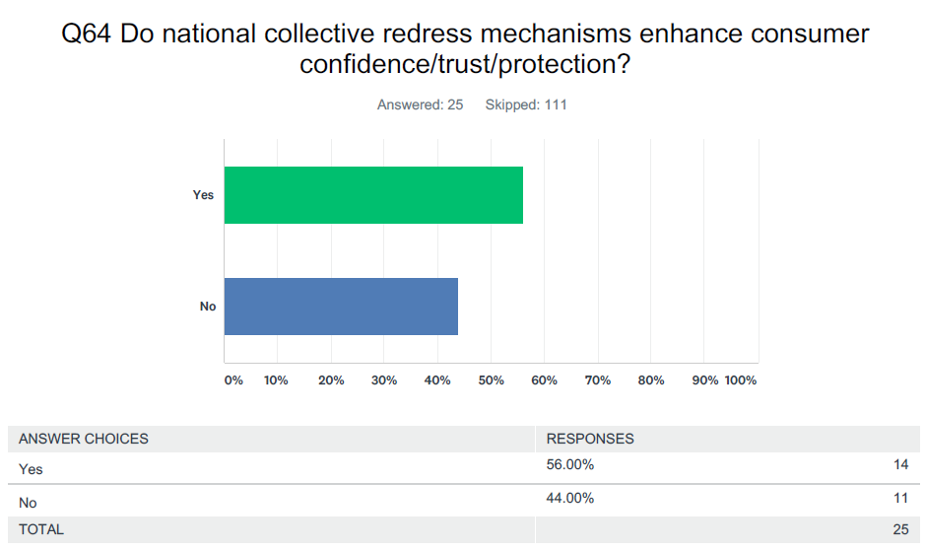

**Figure 11: consumer awareness of collective redress**

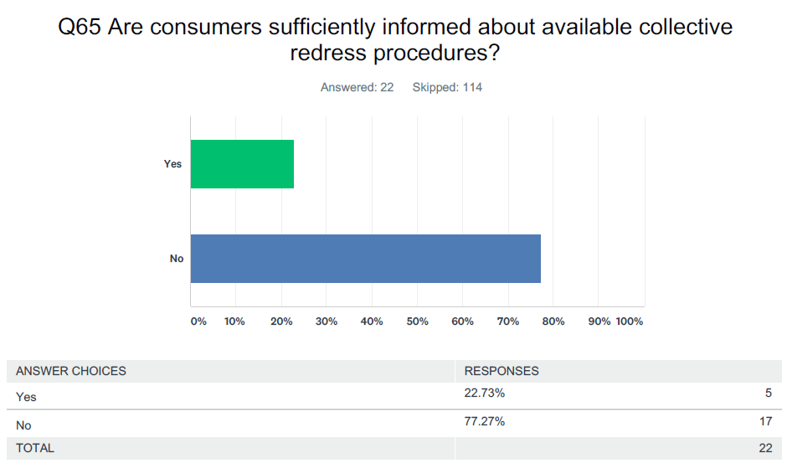

**Figure 12: improvements to national injunctive collective redress measures**

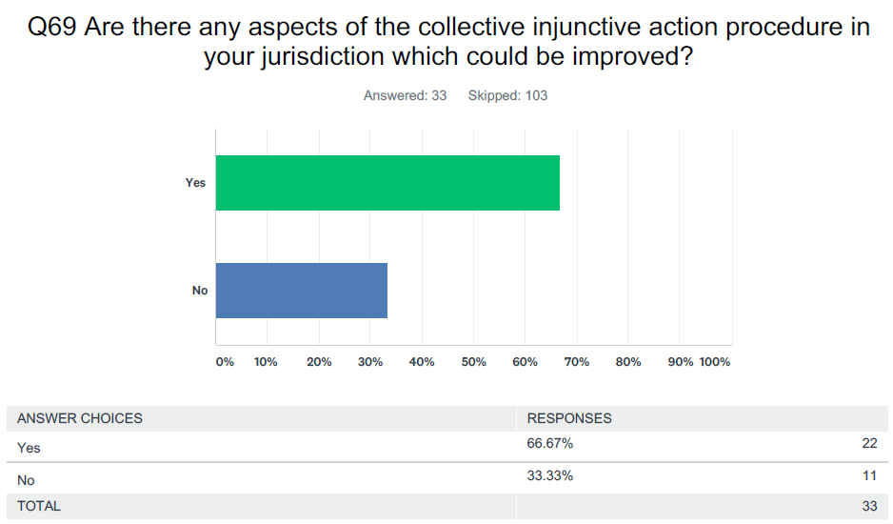

**Figure 13: improvements to national compensatory collective redress measures**

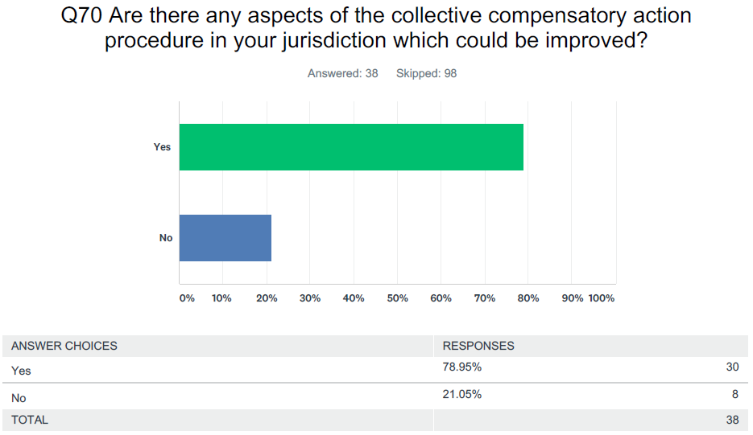

**Figure 14: conflict of interest between third party funder and claimant**

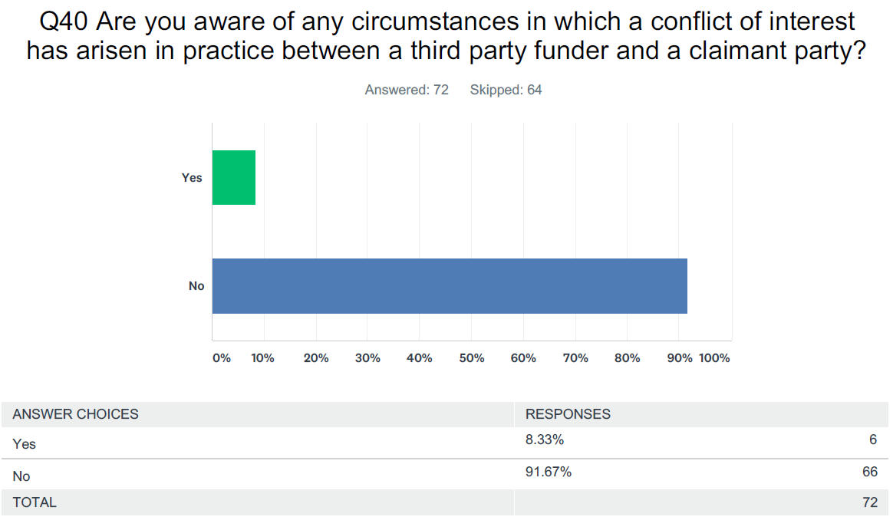

**Figure 15: third party funding attempt to influence decisions of claimant**

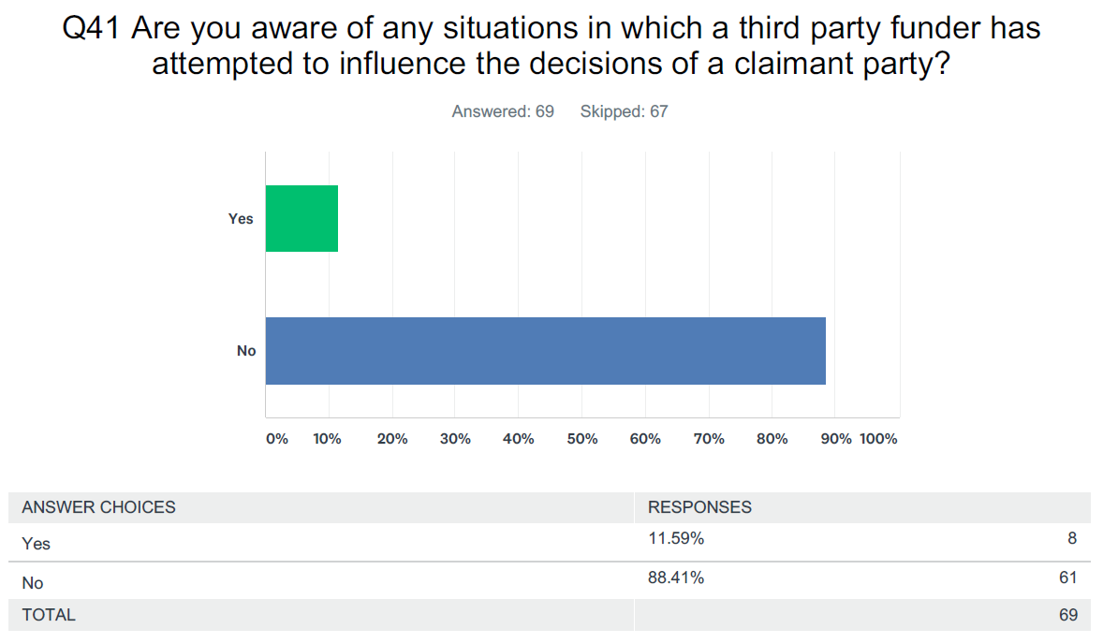

**Figure 16: third party funding against competitor or dependant defendant**

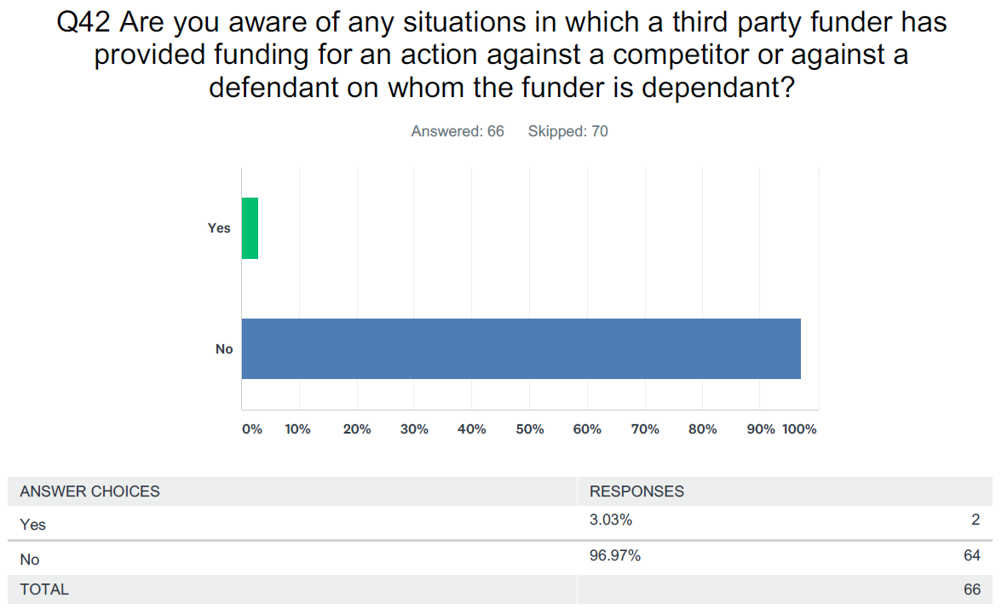

## 5. Outtakes from the ID survey conducted for this Impact Assessment

**Question 12: The Fitness Check concluded that, in its current form, the ID is not sufficiently effective in meeting its objectives. The main obstacles to its effectiveness include the injunction procedure's cost, length, complexity and limited effects on alleviating the harm suffered by the affected consumers. Having in mind the above objective of increasing the effectiveness of the ID, do you agree with the following statements?**

"The scope of the ID should be extended to all EU law relevant for the protection of the "collective interests of consumers" (areas going beyond the existing Annex I to the ID, e.g. passenger rights, energy services, telecommunications, data protection)".

65% of the respondents agreed that the ID's scope should be extended to all EU law relevant for the protection of the collective interests of consumers, while 19% disagreed. As to the responses to the above question by the type of stakeholders: 94% of consumer associations strongly agreed and 6% tended to agree; 52% of Member States authorities strongly agreed (AT, BE, BG, CY, EL, HU, IT, LU, LV, PL, PT, RO, SE, SK, UK + Iceland and NO), while 34% tended to agree (BE, BG, CY,CZ, EE, EI, ES, HU, IT, LT, MT, SE,SI, SE,), 5% tended to disagree (FI+NO) and 9% did not know (DK, SK); 5% of business associations strongly agreed, 15% tended to disagree, 65%strongly disagreed and 15% did not know

"Qualified entities should be able to seek injunctions and consumer redress within a single legal procedure".

As to the responses to the above question by the type of stakeholders: 88% of consumer associations strongly agreed, while 6% tended to agree and 6% tended to disagree; 55% of Member States authorities strongly agreed (AT, BE, BG, CY, CZ, EI, EL, IT, LU, PT, RO, SE, SI, SK, UK + Iceland and NO) while 34% tended to agree (AT, BG, CZ, EE, EL, ES, FI, HU, IT, LU, LT, MT, SE), 5% tended to disagree (PL,SK) and 7% did not know (DK); 5% of business associations strongly agreed, 11% tended to agree, 32% tended to disagree, 47%strongly disagreed and 5% did not know.

**Figure 17: answers to question 12 ID survey about possible amendments to the ID**

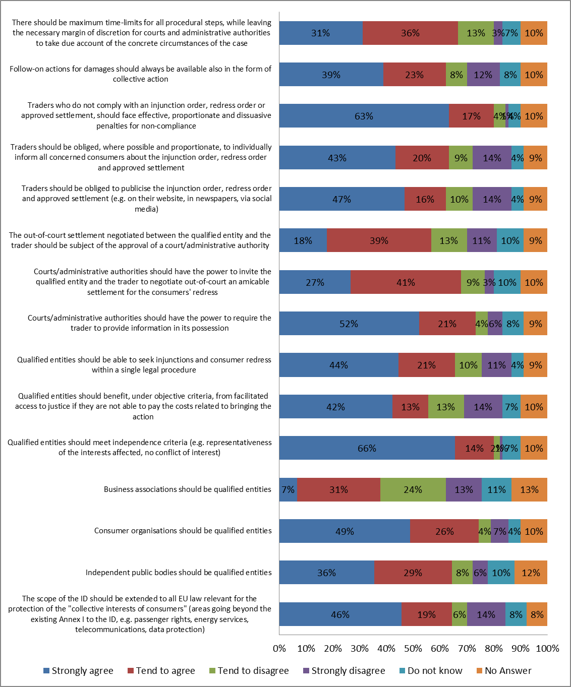

**Question 16: Do you agree that differences between national injunction procedures cause the following problems?**

**Figure 18: answers to question 16 ID survey about current problems**

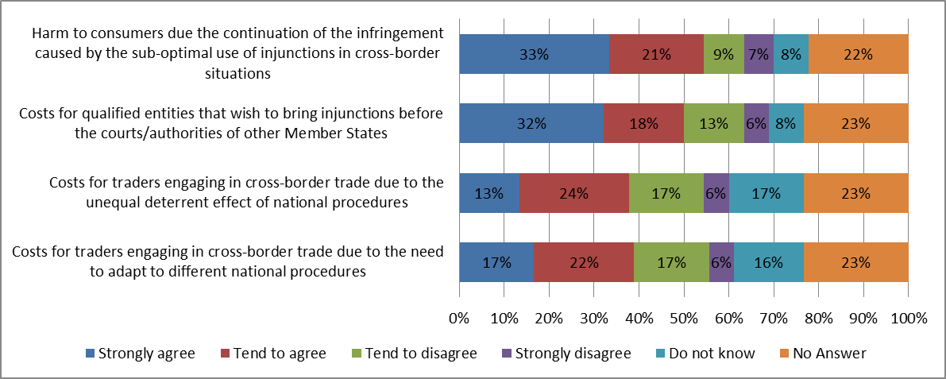

**Policy "option A" foresees a procedure, which has the following features**: - The procedure covers all EU law relevant for the protection of the collective interests of consumers; - Independent public bodies, consumer organisations and business associations are allowed to bring injunctions as qualified entities, subject to independence criteria; - Access to justice is facilitated for qualified entities that are not able to fully cover litigation costs; - Maximum time-limits for each stage of the procedure are defined by law, while leaving discretion for courts/administrative authorities to take due account of the concrete circumstances of the case; - Courts/administrative authorities have the power to require the trader to provide information in its possession needed to assess the lawfulness of the practice subject to the injunctions procedure; - The infringing trader is required to widely publicise about the injunctions order (e.g. website, newspapers, social media) and, where possible, to individually inform thereof all concerned consumers; - Effective, proportionate and deterrent financial penalties are ensured in case of non-compliance by the trader with the outcomes of the procedure ;- All interested consumers can invoke the injunction order as proof of the breach of EU law in follow-on actions.

**Policy "option B" foresees a procedure, in addition to the features of policy option A**, **has the following features concerning** **redress**: - A single procedure ("one stop shop") whereby qualified entities would be able to ask courts/administrative authorities for stopping a breach of the collective interests of consumers (injunction order) and for redress (redress order); - The court/administrative authority would have the power to invite the qualified entity and the trader to negotiate an amicable settlement out-of-court; - If settlement is reached it would be subject to the approval of the court/administrative authority; - If no amicable settlement is reached or if it is not approved, the court/administrative authority would continue collective redress procedures according to national law; - The infringing trader is required to widely publicise about the injunction/redress order and/or approved settlement (e.g. website, newspapers, social media) and, where possible, to individually inform thereof all concerned consumers.

**Question 40: Under option A what would be the impact of the introduction of the above-mentioned new rules on the following?**

**Figure 19: answers to question 40 ID survey about the impact of measure A**

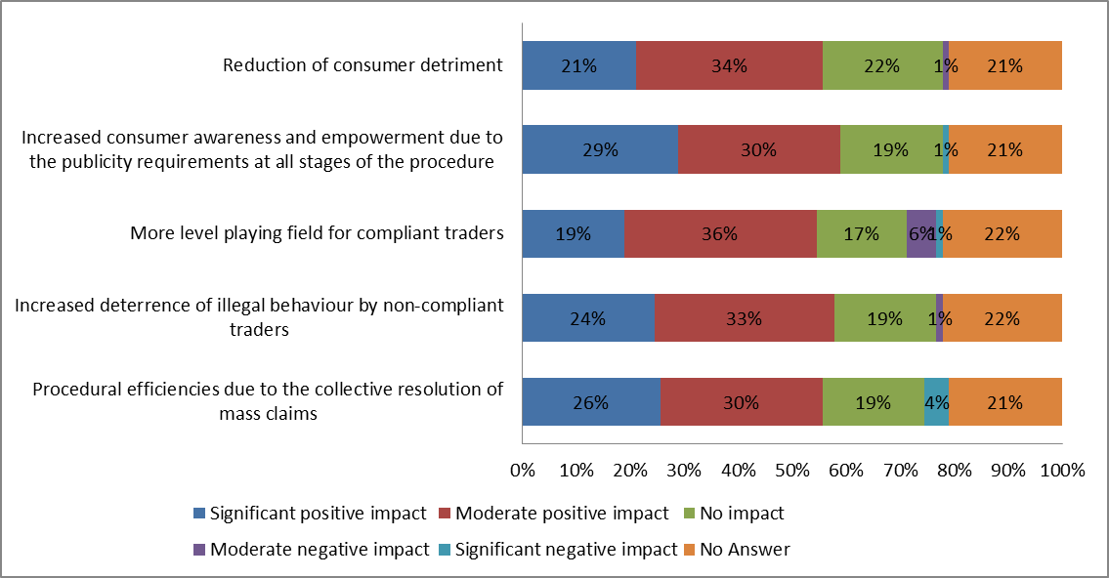

**Question 42: Under option A, what would be the cost impact of the introduction of the above-mentioned new rules on the following?**

**Figure 20: answers to question 42 ID survey about the cost impact of measure A**

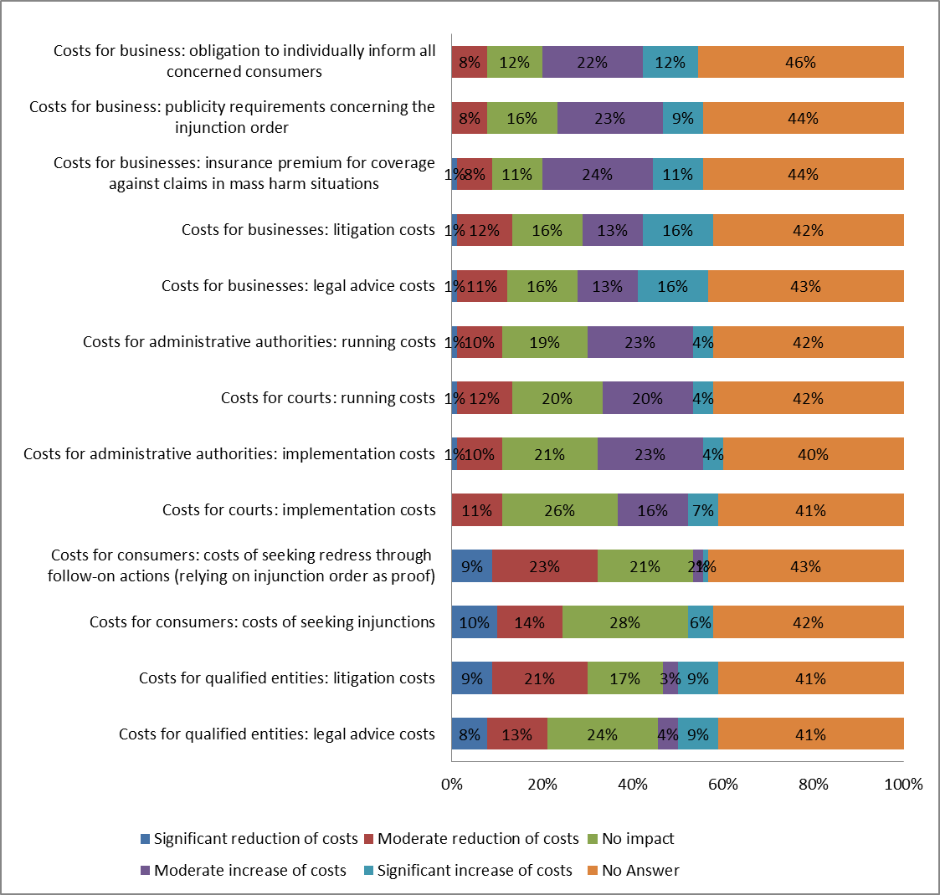

**Question 51: Under option B what would be the impact of the introduction of the above-mentioned new rules on the following?**

**Figure 21: answers to question 51 ID survey about the impact of measure B**

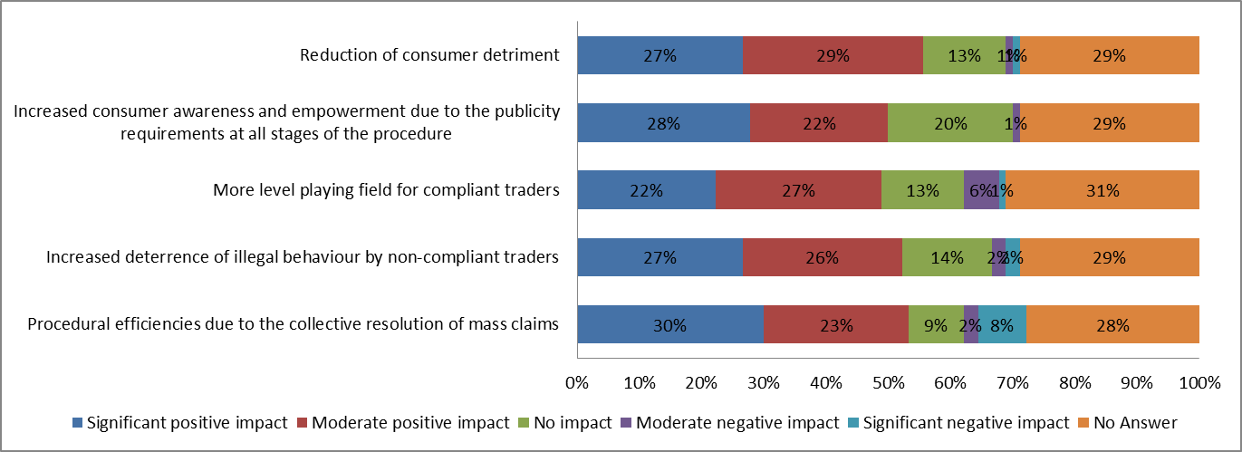

**Question 53: Under option B, what would be the cost impact of the introduction of the above-mentioned new rules on the following?**

**Figure 22: answers to question 53 ID survey about the cost impact of measure B**

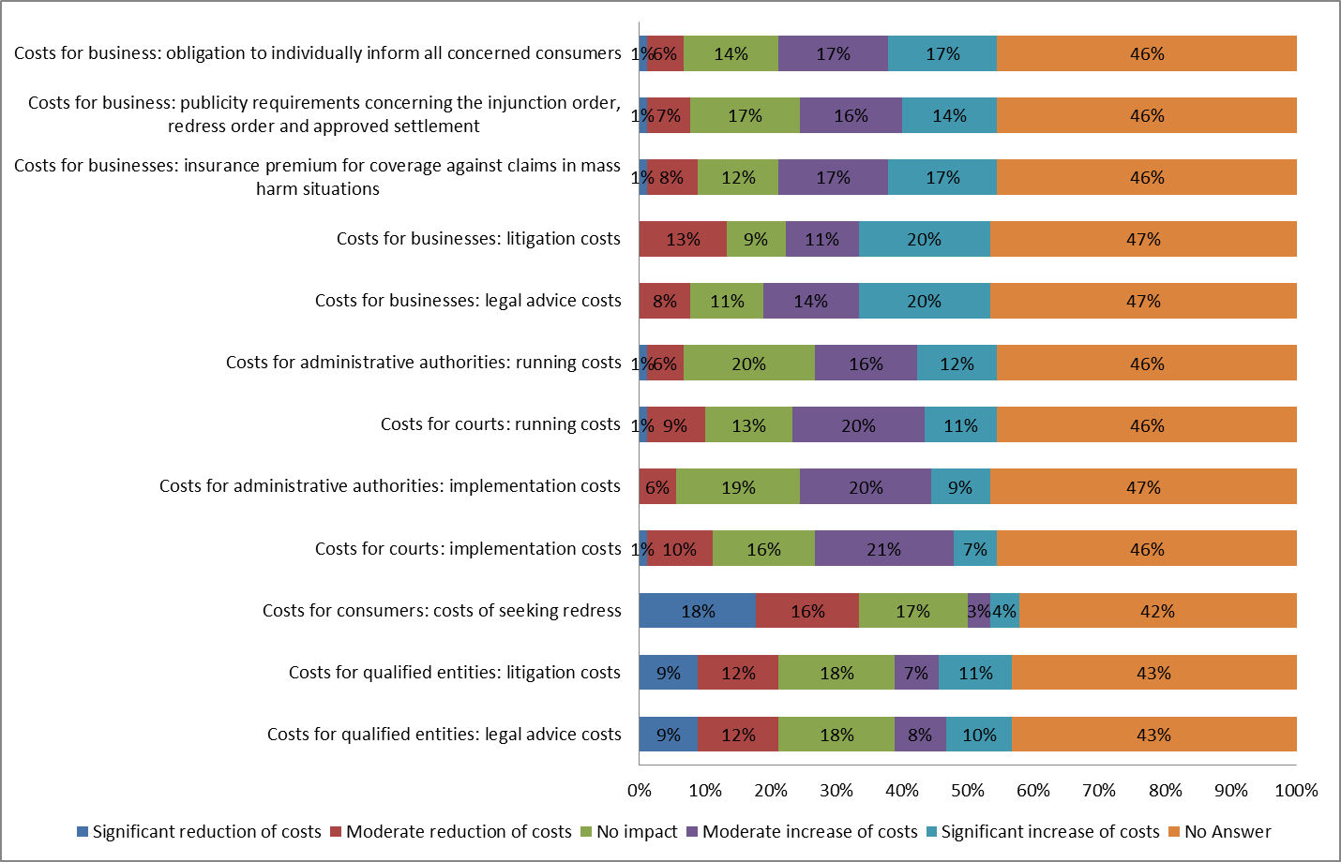

**Question 49 If it is possible to quantify such costs, what would be the estimated costs of adjusting to the new rules of Option A for your institution or business?**

You may wish to answer either in staff time or in amount in Euros, or both. "One-off costs" are the one-off resources you need to invest. "Annual costs" are the resources you need to invest on a regular basis to comply with rules. Do not consider staff time for translation. If no staff time was involved, indicate ‘0’.

**Question 60 If it is possible to quantify such costs, what would be the estimated costs of adjusting to the new rules of Option B for your institution or business?**

You may wish to answer either in staff time or in amount in Euros, or both. "One-off costs" are the one-off resources you need to invest. "Annual costs" are the resources you need to invest on a regular basis to comply with rules. Do not consider staff time for translation. If no staff time was involved, indicate ‘0’.

## 3. Stakeholder views

*3.1 Improved injunctions procedure without redress (measure A)*

***Overall assessment***

The Fitness Check showed that the impact of the ID on the reduction of the number of infringements in the last 5 years was considered to be low, particularly in cross-border situations (Figure 3 in Annex 9). This impact largely depends on the regulatory choices that the Member States have made and whether the Member States have gone beyond the procedural elements provided in the ID. In case the Member States have only implemented the minimum standards prescribed in the current ID, the Fitness Check considered the effectiveness to be insufficient. By targeting the top obstacles reported within the Fitness Check, the overall effectiveness of the ID would be improved and its impact on the reduction of the number of infringements would be increased. In case of remaining infringements, the new measures would constitute a further incentive to reach amicable settlements. As shown by the 2012 Commission Report on the ID, the mere possibility of an injunction action has a deterrent effect. [252] However, this is only the case if the procedure is indeed effective and there is a real chance that injunction actions may be brought forward. In the ID survey, 58% of all respondents considered that measure A would have a positive impact on increasing the deterrence of non-compliance (25% significant positive impact, 33% moderate positive impact), whereas only 1% predicted a moderate negative impact and 19% predicted no impact. 83% of the 41 responding MS authorities and 92.8% of the 14 responding consumer organisations predicted an increase of deterrence, while only 25% of the 12 responding business associations shared this view. Overall, the combination of the proposed amendments under measure A is likely to improve compliance. The specific aspects of the individual amendments will be discussed further below.

***Scope***

The limited scope of the ID prevents it from improving compliance in areas that harm the collective interests of consumers but which are not covered by its Annex I. As echoed by the 2008 and 2012 Reports on the ID and the Fitness Check study, unfair commercial practices and unfair contract terms that are prevalent across many economic sectors, such as telecommunications, tourism and package travel, online and distance sales, financial services, and energy, have remained the most prominent types of infringements for which injunctions are sought. Furthermore, the 2017 Commission Study on measuring consumer detriment in the EU showed that consumers suffered between EUR 20.3 and EUR 58.4 billion detriment due to the problems encountered across six assessed markets, namely clothing and footwear, large household appliances, loans, credit and credit cards, train services, mobile telephone services and electricity services.[253] In the ID survey, 65% of all respondents agreed that the ID's scope should be extended to all EU law relevant for the protection of the collective interests of consumers, while 19% disagreed (Figure 17 in Annex 9). In particular, 86.4% of the 44 responding MS authorities, 100% of the 16 responding consumer organisations and 20% of the 20 responding business associations shared this view. By extending the scope of the ID to additional areas of EU law that may affect the collective interests of consumers, it would become sufficiently future-proof and responsive to the different forms of non-compliance that may emerge in mass harm situations.

***Requirements for qualified entities***

The number and type of qualified entities that may use the ID is limited, as not all Member States allow independent public bodies, consumer organisations and business associations to have the possibility to become qualified entities.The 2017 Study on Procedural Protection of Consumers particularly recommended clarifying and strengthening the role of consumer organisations in the context of collective claims.[254] In the ID survey, 65% of all respondents agreed that independent public bodies should be qualified entities. 64.3% of the 42 responding MS authorities, 100% of the 15 responding consumer organisations and 73.7% of the 19 responding business associations shared this view. 75% of all respondents agreed that consumer organisations should be qualified entities. 84.1% of the 44 responding MS authorities, 100% of the 16 responding consumer organisations and 66.7% of the 18 responding business associations shared this view. The views were divided on the possible role of business associations, where 38% agreed (7% strongly agreed, 31% tended to agree) and 38% disagreed (13% strongly disagreed, 25% tended to disagree) that they should be qualified entities. In particular, 39.5% of the 43 responding MS authorities, 64.3% of the 14 responding consumer organisation and 38.9% of the 18 responding business associations shared this view. Regardless of the qualified entity in question, 80% of all respondents agreed that qualified entities should meet reputability criteria, e.g. concerning their representativeness of the affected interests and to ensure the lack of a conflict of interests, whereas 3% disagreed. This view was strongly shared by 90.5% of the 42 responding MS authorities, 87.5% of the 16 responding consumer organisations and 90% of the 20 business associations. By enabling all categories of qualified entities (consumer organisations, business associations, independent public bodies) to bring injunction actions, provided that they meet reputability criteria, the use of the ID, also for reaching amicable settlements, would increase in most Member States, particularly if certain categories were previously not granted standing.

***Access to justice***

The Fitness Check and all previous Reports on the ID identified the costs and associated financial risks of injunction actions as a key obstacle that contributes to their sub-optimal use, which limits the ID's impact on encouraging compliance. As confirmed by country reports, qualified entities have limited financial and human resources to bring actions, in particular those from smaller Member States. In the ID survey, 55% of all respondents agreed (42% strongly agreed, 13% tended to agree) that qualified entities should benefit, under objective criteria, from facilitated access to justice if they are not able to pay the costs related to bringing the action, whereas 28% disagreed. In particular, 72.1% of the 43 responding MS authorities, 87.6% of the 16 responding consumer organisation and 21% of the 19 responding business associations shared this view. In the mass harm case study of the ID survey, respondents mainly identified lawyers' fees (43%), preparation fees such as collecting information, translation and publicity (41%), costs of paying for the lawyers' fees of the other part in case of loss (40%), costs of paying the other part in case of loss (34%), court/administrative fees (14%) and costs of settling the dispute out-of-court (4%). By enabling underfunded qualified entities to receive, under objective criteria, dedicated financial support, the financial obstacles would be considerably alleviated in most Member States.

***Efficiency***

The Fitness Check and previous Reports on the ID have identified the length of proceedings as a key obstacle, which varies in its level of seriousness depending on the Member State. In the ID survey, 67% of all respondents agreed (31% strongly agreed, 36% tended to agree) that there should be maximum time limits for all procedural steps, while leaving the necessary discretion for courts/authorities to take due account of the concrete circumstances of the case, whereas 16% disagreed. In particular, 72.1% of the 43 responding MS authorities, 93.8% of the 16 responding consumer organisations and 68.4% of the 19 responding business associations shared this view. By ensuring that the expediency of the procedure is duly maintained at all stages of the procedure (e.g. through time limits), while leaving discretion for the court/authority, the length of the injunction action would be significantly shortened in most Member States. Without this intervention, infringing traders may continue to breach EU law for the duration of the proceedings - which could constitute several years in some Member States - while continuing to gain unlawful profits and creating consumer detriment. Another key aspect of ensuring the efficiency and effectiveness of the injunction procedure is the ability of courts/authorities to urgently assess the circumstances concerning the alleged breach affecting the collective interests of consumers, which is currently not regulated in the ID. In the ID survey, 73% of all respondents agreed (52% strongly agreed, 21% tended to agree) that courts/authorities should have the power to require the trader to provide information in its possession in the context of the ID. In particular, 93.2% of the 44 responding MS authorities, 100% of the 16 responding consumer organisations and 42.1% of the 19 responding business associations shared this view.

***Publicity***

Publicity is an important tool for both informing consumers and deterring traders that fear damage to their reputation, which is not sufficiently regulated in the ID. The Fitness Check found that the effectiveness of publicity of the injunction decision generally depends on practicalities such as the placement of the notices in newspapers and on websites that receive wide exposure. In the Study for the evaluation of the 2013 Recommendation on collective redress, 77.27% of respondents did not consider that consumers are sufficiently informed about the available collective redress procedures. In the ID survey, 63% of all respondents agreed (47% strongly agreed, 16% tended to agree) that traders should be obliged to publicise the outcomes of the procedure, whereas 24% disagreed. In particular, 81.8% of the 44 responding MS authorities, 100% of the 16 responding consumer organisations and 10.6% of the 19 responding business associations shared this view. Furthermore, again 63% of all respondents agreed (43% strongly agreed, 20% tended to agree) that traders should also be obliged, where possible and proportionate, to individually inform all concerned consumers, whereas 24% disagreed. In particular, 86.3% of the 44 responding MS authorities, 100% of the 16 responding consumer organisations and 5.3% of the 19 responding business organisations shared this view. By introducing publicity requirements for the traders that cover a broad range of communication channels, there would be increased deterrence, particularly for traders whose economic activity is connected to their reputation. As publication may not always be sufficient, there should also be an obligation, where appropriate, for the trader to inform all victims of the infringement. Publicity would also help compliant traders become more aware of the illegal practices of their non-compliant competitors. However, the publicity requirements would have to be proportional to the stage of the proceedings and other relevant circumstances of the case, taking due account of the risk of reputational damage and of the respect of business secrecy. In particular, publicity for injunction orders with interim effects would have to be more limited than publicity for those with definitive effect, since there would be a possibility that the finding of the breach could be overturned.

***Penalties***

Penalties for non-compliance with the procedural outcomes under the ID are not sufficiently regulated in the ID, which creates an unequally deterrent landscape across the Member States. In the ID survey, 80% of all respondents agreed (63% strongly agreed, 17% tended to agree) that traders who do not comply with the outcomes of the procedure should face effective, proportionate and dissuasive penalties, whereas 6% disagreed. In particular, 89% of the 43 responding MS authorities, 100% of the 16 responding consumer organisations and 84.2% of the 19 responding business associations shared this view. By changing the current regulatory choice on penalties into an obligation to have in place effective, proportionate and dissuasive penalties, infringing traders would be more likely to comply with the outcome of the procedure. By analogy, the deterrence effects discussed regarding penalties for consumer law breaches would apply. The positive impacts of regulating penalties for non-compliance within the injunction procedure is additionally supported by the findings from the Fitness Check showing that systems with clear legal rules on penalties for non-compliance in the injunction order are more effective than systems where the penalties must be obtained through a separate court procedure.

***Effects on consumers***

With targeted improvements, measure A would be able to ensure a higher level of consumer protection than the current ID, but it would fail to fully facilitate consumer redress in mass harm situations, which only measure B could ensure. The Fitness Check showed that the impact of the ID on the reduction of consumer detriment in the last 5 years was considered to be low, particularly in cross-border situations (Figure 12 in Annex 9). In the ID survey, 54% of all respondents agreed (33% strongly agreed, 21% tended to agree) that consumers suffer harm due to the continuation of infringements caused by the sub-optimal use of injunctions in cross-border situations, whereas 16% disagreed.[255] In particular, 85.4% of the 41 responding MS authorities, 84.6% of the 13 responding consumer organisations and 15.4% of the 13 responding business associations shared this view. In the ID survey, 56% of all respondents considered that measure A would have a positive impact on reducing consumer detriment, whereas only 1% predicted a moderate negative impact and 22% predicted no impact. In particular, 90.2% of the 41 responding MS authorities, 73.4% of the 15 responding consumer organisations and 8.3% of the 12 responding business associations shared this view. Furthermore, 59% of all respondents considered that measure A would have a positive impact on increasing consumer awareness and empowerment due to the added publicity requirements for traders, whereas only 1% predicted a significant negative impact and 19% predicted no impact. In particular, 90.3% of the 41 responding MS authorities, 86.7% of the 15 responding consumer organisations and 8.3% of the 12 responding business associations shared this view.

In case only injunctions are improved, even pure injunctive relief may have tangible benefits for consumers. For example, an injunction order would be reducing consumer detriment in case the injunction immediately stops the application of unfair contract terms that contain contractual obligations for consumers.[256] However, the injunction order would have only limited effects on reducing consumer detriment in case additional steps must be taken to seek redress, such as follow-on redress actions. In the ID survey, 69% of all respondents agreed (50% strongly agreed, 19% tended to agree) that once a final injunction decision has been issued, all affected consumers should be able to rely on it as proof of the breach of EU law for their follow-on redress actions, whereas 18% disagreed. In particular, 88.6% of the 44 responding MS authorities, 100% of the 16 responding consumer organisations and 31.6% of the 19 responding business associations shared this view. By introducing the possibility within the ID to use the final injunction decision (with definitive effect) as proof of the breach, consumers would be able to take additional follow-on redress steps more easily.[257] In order to achieve this effect before the courts/authorities across the EU, the ID would introduce the cross-border evidentiary effects of injunction orders as a rebuttable presumptionof the infringement. Furthermore, in the ID survey, 62% of all respondents agreed that follow-on redress actions should *always* be available in the form of collective redress actions, whereas 20% disagreed. In particular, 86.1% of the 43 responding MS authorities, 100% of the 16 responding consumer organisations and 5.3% of the 19 responding business associations shared this view. As explained in section 2.3.5, consumers may rationally decide to forego individual legal actions due to the expected negative balance of costs and benefits of such action, which may be the case even after the possibility to rely on the injunction order as proof has been introduced. Actions initiated by representative bodies may therefore help alleviate the enforcement shortcomings from dispersed individual consumer actions. Since measure A would not prescribe representative collective redress within the injunction procedure, it would however ultimately fail to fully address redress concerns in mass harm situations. For instance in the ID survey, although the responding consumer organisations considered measure A to lower the consumer costs of obtaining redress through the use of follow-on actions (25% significant cost reduction), measure B was viewed much more favourably (57% significant cost reduction) in this respect.

***Effects on fair competition***

With an improved deterrence effect and more harmonised procedural elements across the EU, measure A would ensure the better functioning of the internal market. Furthermore, in the ID survey, 55% of all respondents considered that measure A would have a positive impact on fair competition between compliant and non-compliant traders (19% significant positive impact, 36% moderate positive impact), whereas only 6% predicted a negative impact and 17% predicted no impact at all. In particular, 82.9% of the 41 responding MS authorities, 85.7% of the 14 responding consumer organisations and 8.3% of the 12 responding business associations shared this view.

***Courts/authorities***

The Fitness Check found that collective actions allow for the exploitation of significant economies of scale in the preparation and litigation of cases and may reduce the coordination and transaction costs of bringing together affected consumers. By improving the effectiveness of the ID, these benefits would increase. In the ID survey, 56% of all respondents considered that the introduction of measure A would have a positive impact on the procedural efficiencies due to the collective resolution of mass claims (26% significant positive impact, 30% moderate positive impact), whereas only 4% predicted a negative impact and 19% predicted no impact. In particular, 82.9% of the 41 responding MS authorities, 80% of the 15 responding consumer organisations and 8.3% of the 12 responding business associations shared this view. The national authorities responding to the ID survey did not consider the implementation costs of measure A for courts (28.1% moderate reduction, 37.5% no impact, 34.4% moderate increase) or for administrative authorities (3% significant reduction, 24.2% moderate reduction, 27.3% no impact, 45.5% moderate increase) to be significant. Likewise, they did not consider the running costs due to the possible introduction of measure A for courts (3.1% significant reduction, 28.1% moderate reduction, 28.1% no impact, 40.6% moderate increase) or for administrative authorities (3.1% significant reduction, 25% moderate reduction, 18.8% no impact, 53.1% moderate increase) to be significant. Moreover, when taking into account the possible benefits for consumers, the national authorities considered these costs to be reasonable (9.8% strongly agree, 34.1% tend to agree, 9.8% tend to disagree, 46.3% no opinion/do not know).

***Qualified entities***

The existing costs of bringing actions under the ID would be directly alleviated with financial support for underfunded qualified entities and by shifting the costs of publicity to the trader. Furthermore, qualified entities would also experience cost savings from the procedural efficiencies discussed above. In the context of the hypothetical mass harm case study, the qualified entities responding to the ID survey held mixed views about the impact of Option 4a on their legal advice costs (14.3% significant reduction, 19% moderate reduction, 47.6% no impact, 9.5% moderate increase, 9.5% significant increase) and litigation costs (14.3% significant reduction, 28.6% moderate reduction, 42.9% no impact, 4.8% moderate increase, 9.5% significant increase). The precise impact of measure A on such costs would depend on the financial and legal capacities of the qualified entity in question, as well as the circumstances of the mass harm case. In the cross-border context, the ID survey revealed that 50% of all respondents agreed, whereas 19% disagreed, that the costs faced by qualified entities are problematic when they wish to bring injunction actions before the courts/authorities of other Member States. In particular, 80.5% of the 41 responding MS authorities, 83.3% of the 12 responding consumer organisations and 7.7% of the 13 responding business associations shared this view. By supporting cooperation between qualified entities from different Member States, measure A would facilitate the exchange of best practices and the development of common strategies for tackling cross-border infringements.

***Compliant traders***

The Fitness Check found that compliance with the ID and its national implementation legislation produces no costs for compliant traders other than the regular costs of ensuring that the business practices are indeed compliant. The business associations responding to the ID survey also considered that measure A could increase the insurance premiums for coverage against claims in mass harm situations (54.5% significant increase, 36.4% moderate increase, 9.1% no impact). Furthermore, in the cross-border context, the ID survey revealed that 39% of all respondents agreed, whereas 22% disagreed, that traders engaging in cross-border trade currently experience costs due to the need to adapt to the different national procedures of the ID. In particular, 63.4% of the 41 responding MS authorities, 33.3% of the 12 responding consumer organisations and 23.1% of the 13 responding business associations shared this view. Moreover, 37% of all respondents agreed, whereas 23% disagreed, that such costs would be due to the unequally deterrent effect of different national procedures of the ID. In particular, 61% of the 41 responding MS authorities, 50% of the 12 consumer organisations and 7.7% of the 13 responding business associations shared this view. Further harmonisation of the procedural elements of the ID would alleviate these costs. From a broader perspective, the introduction of targeted amendments that increase the effectiveness of the ID could lead to the increased use of the ID, including the increase of possible frivolous claims against compliant traders. However, this risk is mitigated by the control criteria built into the improved procedure, such as the reputability criteria for qualified entities. Moreover, the Fitness Check found no evidence to suggest that qualified entities have displayed any form of frivolous action in the context of the ID or that they would risk their status as qualified entities to bring such claims. Therefore, the costs of introducing measure A would be insignificant for compliant traders and the costs for traders engaging in cross-border trade would be lowered due to further harmonisation among the national procedures. Furthermore, in case of infringements, non-compliant traders would benefit from enhanced legal certainty and the abilityto resolve mass harm liability through a collective procedure, but only insofar as injunctive relief is available under national law.

*3.2 Improved injunctions procedure with redress (measure B)*

***Overall assessment***

With the improved procedural effectiveness of measure A and additional collective redress possibilities, measure B would improve compliance more than measure A. As highlighted in the 2017 Study supporting the Report on the 2013 Recommendation on collective redress, the mere possibility of a collective redress claim would act as a threat and incite business to comply with the law. In the ID survey, 53% of all respondents considered that measure B would have a positive impact on increasing the deterrence of non-compliance (27% significant positive impact, 26% moderate positive impact), whereas only 4% predicted a negative impact and 14% predicted no impact. In particular, 81.6% of the 38 responding MS authorities, 100% of the 12 responding consumer organisations and 9.1% of the 11 responding business associations shared this view. The increased deterrence effect of better possibilities for redress within the injunction procedure is therefore likely to increase compliance with EU consumer law, in particular concerning businesses that are sensitive to reputational damage. All of the procedural amendments proposed under measure A, which would also be included under measure B, would magnify these effects further and increase the likelihood of improving compliance.

***Effects on consumers***

With the improved procedural effectiveness of measure A and additional collective redress possibilities, measure B would ensure a high level of consumer protection in mass harm situations more than measure A. The Fitness Check identified a trend, in recent years, by courts or public authorities aimed at complementing the injunction orders and procedures with additional remedies, in particular with compensation orders. Furthermore, the Study supporting the Fitness Check suggested that those Member States that introduced redress orders had experienced an increase in the effectiveness of the injunction procedure and reduced consumer detriment. More broadly, in the 2017 Study on collective redress 56% of respondents considered that collective redress would enhance consumer confidence/trust/protection (Figure 10 in Annex 9). The ‘possibility to bring an action for damages or redress to be paid to the consumers concerned within the injunction procedure’ was viewed by qualified entities responding to the Fitness Check surveyas the most beneficial procedural element to be added to the ID (see Figure 6 in Annex 9).

These findings were confirmed by the ID survey in which 65% of all respondents agreed (44% strongly agreed, 21% tended to agree) that qualified entities should be able to seek injunctions and consumer redress within a single procedure, whereas 21% disagreed (11% strongly disagreed, 10% tended to disagree). In particular, 88.6% of the 44 responding MS authorities, 93.8% of the 16 responding consumer organisations and 15.8% of the 19 responding business associations shared this view. By adding a possibility to issue redress in the context of the injunction procedure, the obstacles to individual consumer redress that were highlighted under measure A would be significantly alleviated. In the ID survey, 50% of all respondents considered that measure B would have a positive impact on increasing consumer awareness and empowerment due to the publicity requirements of the traders (28% significant positive impact, 22% moderate positive impact), whereas only 1% predicted a negative impact and 20% predicted no impact. In particular, 81.6% of the 38 responding MS authorities, 91.7% of the 12 responding consumer organisations and 9.1% of the 11 responding business associations shared this view. Furthermore, 56% of all respondents considered that measure B would have a positive impact on reducing consumer detriment (27% significant positive impact, 29% moderate positive impact), whereas 2% predicted a negative impact and 13% predicted no impact. In particular, 89.5% of the 38 responding MS authorities, 100% of the 12 responding consumer organisations and 9.1% of the 11 responding business associations shared this view. Furthermore, the consumer organisations responding to the ID survey considered measure B to have a very positive impact on reducing the consumer costs of seeking redress (57.1% significant reduction).

In order to ensure efficiency, Article 5 of the ID already envisions a form of voluntary negotiation in order to put a stop to the infringement before the court/authority is asked to issue an injunction order. Likewise, depending on the circumstances of the case, an out-of-court negotiation procedure could be beneficial for eliminating the continuing effects of the infringement in the redress stage instead of having the court/authority issue a redress order. In the ID survey, 68% of all respondents agreed (27% strongly agreed, 41% tended to agree) that courts/authorities should have the power to invite the qualified entity and trader to negotiate out-of-court for an amicable settlement on consumer redress, whereas 12% disagreed. In particular, 79.5% of the 44 responding MS authorities, 80% of the 15 responding consumer organisations and 63.2% of the 19 responding business associations shared this view. Furthermore, 57% of all respondents agreed (18% strongly agreed, 39% tended to agree) that the settlement should be subject to the approval of the court/authority, whereas 24% disagreed. In particular, 68.2% of the 44 responding MS authorities, 86.7% of the 15 responding consumer organisations and 35% of the 20 responding business associations shared this view. By introducing the possibility to have out-of-court negotiations for redress together with the other procedural amendments that increase the deterrent effect of the ID, the likelihood of achieving amicable redress outcomes would be increased. By ensuring that the settlement is subject to the approval of the court/authority, the fairness of the redress outcome would be duly scrutinised, taking into account the interests of the consumers that did not participate in the negotiations directly.

***Effects on fair competition***

With an increased deterrence effect, measure B would contribute more to ensuring the better functioning of the internal market than measure A. Furthermore, in the ID survey, 49% of all respondents considered that measure B would have a positive impact on ensuring fair competition between compliant and non-compliant traders (22% significant positive impact, 27% moderate positive impact), whereas only 7% predicted a negative impact and 13% predicted no impact at all. In particular, 83.7% of the 37 responding MS authorities, 90.9% of the 11 responding consumer organisations and 9.1% of the 11 responding business associations shared this view. Moreover, in the 2017 Study on collective redress, 57.69% of business respondents did not consider collective redress procedures to have any negative impact on their business' competitiveness within the internal market (Figure 9 in Annex 9).

***Courts/authorities***

As under measure A, improving the effectiveness of the ID would enable significant economies of scale in the preparation and litigation of cases and may reduce the coordination and transaction costs of bringing together affected consumers not only for injunctive relief but also for redress. Furthermore, in most Member States, the courts/authorities would experience additional procedural efficiencies if both injunctive relief and redress could be assessed within a single procedure, instead of resorting to different proceedings. In the ID survey, 53% of all respondents considered that the introduction of measure B would have a positive impact on the procedural efficiencies due to the collective resolution of mass claims (30% significant positive impact, 3% moderate positive impact), whereas 10% predicted a negative impact and 9% predicted no impact. In particular, 86.8% of the 38 responding MS authorities, 84.6% of the 13 responding consumer organisations and 9.1% of the 11 responding business associations shared this view. The national authorities responding to the ID survey did not consider the implementation costs of measure B for courts (28% moderate reduction, 24% no impact, 41% moderate increase, 7% significant increase) or for administrative authorities (14% moderate reduction, 29% no impact, 43% moderate increase, 14% significant increase) to be significant. Likewise, they did not consider the running costs due to the possible introduction of measure B for courts (28% moderate reduction, 24% no impact, 41% moderate increase, 7% significant increase) and for administrative authorities (14% moderate reduction, 29% no impact, 43% moderate increase, 14% significant increase) to be significant. The expected costs are slightly higher under measure B than under measure A due to the additional procedural elements. However, the national authorities responding to the ID survey considered that, when taking into account the possible benefits for consumers, these costs are reasonable (21% strongly agree, 19% tend to agree, 5% tend to disagree, 5% strongly disagree, 50% no opinion/do not know).

***Qualified entities***

As under measure A, the existing costs of bringing actions under the ID would be directly alleviated with financial support for underfunded qualified entities, by shifting the costs of publicity to the trader and by supporting cooperation between qualified entities from different Member States. In addition, under measure B qualified entities would experience additional procedural efficiencies from the possibility of assessing injunctive relief and redress in a single procedure, which enables them to bear the costs of preparing a single action, not two separate actions. In the context of the hypothetical mass harm case study, the qualified entities responding to the ID survey held mixed views about the impact of measure B on their legal advice costs (19% significant reduction, 9.5% moderate reduction, 38% no impact, 19% moderate increase, 14% significant increase) and litigation costs (19% significant reduction, 14% moderate reduction, 38% no impact, 9.5% moderate increase, 19% significant increase). The precise impact of measure B on such costs would depend on the financial and legal capacities of the qualified entity in question, as well as the circumstances of the mass harm case. More broadly, under measure B qualified entities would benefit from increased possibilities of representing the interests of the victims with due fairness safeguards. The impact of collective redress on access to justice was also acknowledged in the 2017 Study on collective redress, where 63% of the respondents considered that collective redress enhances access to justice and 60% considered such actions to be capable of ensuring the fairness of proceedings.

***Compliant traders***

As under measure A, compliance with measure B produces no costs for compliant traders other than the regular costs of ensuring that the business practices are indeed compliant. The business associations responding to the ID survey considered that measure B could increase the insurance premiums for coverage against claims in mass harm situations (91% significant increase, 9% no impact). The expected insurance figures are higher under measure B than measure A due to the addition of redress claims within the injunction procedure. From a broader perspective, the introduction of targeted amendments under measure A and the added redress possibility under measure B could lead to the increased use of the ID, including the increase of possible frivolous claims. However, this risk is mitigated by the control criteria built into the improved procedure, such as the reputability criteria for qualified entities (e.g. concerning the purpose of the organisation and its financial capacity). In redress cases, the court/authority would further scrutinize the merits and extent of the mass harm alleged by the qualified entity. Importantly, the Fitness Check found no evidence of any form of frivolous action in the context of the ID.

Moreover, the 2017 Study on collective redress, which assessed both compensatory and injunctive collective redress, found that the views were divided with 51% of respondents agreeing and 49% disagreeing that there are risks of abusive litigation (Figure 7 in Annex 9). However, when asked about the actual materialisation of such risks, 77% of all respondents reported that they had never experienced any instances of abusive litigation (Figure 8 in Annex 9). Furthermore, 92% of respondents were not aware of any circumstances in which a conflict of interest has arisen in practice between a third party funder and a claimant, 88% of respondents were also not aware of any situations in which a third party funder has attempted to influence the decisions of the claimant and 97% of respondents were not aware of any situations in which a third party funder provided funding against a competitor or against a defendant on whom the funder is dependant (Figures 14, 15 and 16 in Annex 9). In light of the built-in safeguards and the scrutiny of the financial capacity of the qualified entity, the costs of introducing measure B would be insignificantfor compliant tradersand the costs for traders engaging in cross-border trade would be lowered due to further harmonisation among the national procedures. Furthermore, in case of infringements, non-compliant traders would benefit from enhanced legal certainty and the ability to resolve all aspects of their liability in mass harm situations through a single collective procedure.

# Annex 10: Additional data on transparency of online marketplaces

## 1. Detailed problem description

Online marketplaces execute transactions between two parties via electronic channels. They allow consumers to shop from many different suppliers using the same infrastructure.[258] This leads to the "network effect", attracting more users on several sides of the market: more consumers attract more suppliers and vice versa.[259]

**Figure 1: Description of the network effect**[260]



Over the last years, those marketplaces have experienced substantial growth. They play a prominent role in creating 'digital value' that underpins future economic growth in the EU. They are a major contributor in creating a Digital Single Market (DSM).[261]

Specifically, 30% of internet users use online marketplaces at least once a week.[262] In the EU in 2015, online marketplaces represented 19.6% of total online retail, up from 6.9% in 2006. In the same year, online marketplaces occupied positions 1 (Amazon) and 3 (ebay) of the top 25 online retailers in the EU. The number of online marketplaces ranked among the top EU online retailers passed from 2 in 2006 to 17 in 2015.[263] The Platform Transparency Study indicates that when buying online, preferred sources are those online marketplaces allowing to buy from the marketplace itself as well as from third party suppliers (e.g. Amazon) (71%), followed by online marketplaces only offering to buy only from third party providers (e.g. eBay) (45%), with traditional corporate online shops (e.g. Zara) only coming third (36%):

**Figure 2: Where did you buy or order goods or services for private use over the Internet in the last 12 months? (Platform transparency study, figure 11, n=4802)**

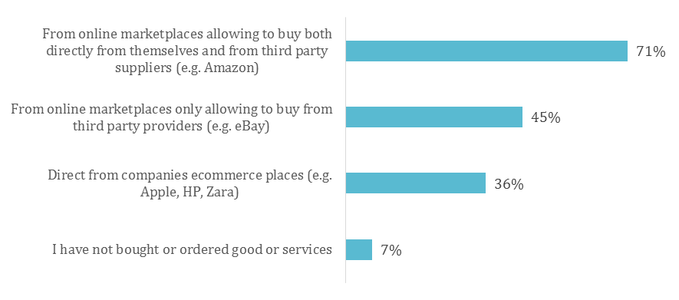

Survey data suggests that a great majority of users consider it beneficial that online marketplaces inform them about the variety of available offers.[264] At the same time, however, in a 2017 survey from 10 Member States[265], 55%of respondents report that they had experienced problems during the past year, frequently related to poor quality or incorrect description of goods or services.[266] Consumers who experienced problems with purchases in platform markets[267] rated their personal detriment[268] low to medium (between 2.01 and 3.76 out of 10)[269]. Even though this is lower than in relevant consumer markets overall, focus groups findings indicate that current users take the view that platforms are a higher risk environment, and that volume of detriment remains relatively low because most transactions involve lower amounts than in regular B2C markets.[270]

Data further reveals that almost 60% of consumers are not sure who is responsible when something goes wrong on platform markets.[271] When facing a problem, 46% of consumers did not take any action at all (mostly due to low amount of money involved or too much effort required). Whilst 30%complained to the provider, 18%complained to the platform.[272]

When buying from a platform, consumers may face difficulties in identifying who is responsible if something goes wrong, as some platforms act both as a marketplace and a retailer.[273] According to the Joint Research Centre, users may be under the impression that the online marketplace is the supplier, whereas in reality the counterpart is a third party.

Although the practices of many of the larger platforms may give users the impression that the platform assumes responsibility for problems in the transactions, the Terms and Conditions of these platforms systematically and explicitly state that the platform is not a party to the contracts and not liable for any problems between the contractual parties. This leads to a discrepancy between perceived platform practices and their Terms and Conditions.[274] 48%of consumers buying on an online marketplace at least sometimes experienced a lack of clarity whether they entered into a contract with the online marketplace itself or with a third party supplier.[275]

**Example of a consumer being confused about the contractual partner**

A consumer booked a holiday through an intermediary website, which handled the reservation, payment and contact with the owner of the booked accommodation. When the consumer wanted to cancel his booking, he sent an e-mail to the intermediary. However, the cancellation was not transmitted to the owner and he was therefore charged the full amount. The website later informed the consumer that it was only acting as an intermediary and that, if he had wanted to cancel a reservation, he would have had to contact the owner of the accommodation directly.

Complaint from a Dutch consumer received by the European Commission

The evaluation of the CRD revealed that, out of 38 respondents reporting problems related to the exercise of the right of withdrawal, no less than 16 had experienced problems in contacting the right person.[276] This issue was also confirmed by consumer associations in interviews, particularly with regard to traders using social media platforms to sell products.[277] In particular, the lack of information on the identity of the trader may create difficulties for consumers wishing to withdraw from a contract.[278]

As a result, consumers buying online also suffer mostly hidden detriment where they are not aware that they only benefit from EU consumer rights in transactions with those contractual partners that are traders, rather than other consumers. 12%of consumers report that, when trying to get a faulty product bought through an online marketplace replaced of repaired, they found that the seller was not a trader and because of that they did not have the EU consumer right to a repair or a replacement. 7% report that for the same reason, they could not withdraw from the contract in the two week cooling off period as is standard in online B2C contracts.[279]

In some instances, consumers wrongly believe they can rely on consumer rights, because they were not aware that the third party provider presenting an offer on the marketplace acted as a consumer. The lack of clarity about the legal status of the contractual partner leaves some consumers unknowingly without adequate protection.[280] While about a third of peer consumers reported to know exactly what their rights are focus group research indicated they may incorrectly assume that B2C online rights apply where they do not.[281] Other research also suggests that many consumers wrongly estimate their actual knowledge of consumer rights.[282]

A targeted consultation of Member States authorities confirmed that consumer complaints in this area are significant. Out of the 36 Member States authorities from 25 EU Member States and Norway replying, no less than 31 reported issues in the area of online marketplaces. In particular, 7 reported that consumers often complained about not being able to enjoy their consumer rights when experiencing problems with goods or services bought on online marketplaces. 19 of them reported that such complaints occurred sometimes and five that this happened only rarely, with only one authority not being aware of any complaints.[283]

|  |
| --- |
| **Example of a consumer being unaware that EU consumer rights do not apply because their contractual partner is not a trader:**  A seller advertised 8 different new or used products on an online marketplace. A consumer purchased one of them, but was not satisfied and wanted to withdraw from the contract. However, only at that moment did the consumer learn that the seller did not qualify as a trader under EU consumer rules, and that he therefore had no right withdraw from the contract.[284] |

Consumer detriment also follows from sub-optimal consumer trust: data suggest that consumers have concerns but these do not prevent them from using platforms.[285] More specifically, the data shows that European consumers have concerns when using an online marketplace in the purchase process. 38% (Spain) to 56% (Poland) of online buyers have concerns about inadequate information when undertaking a transaction online.[286]

Thus, while current users may accept the risk of transactions on online marketplaces, for many other consumers the lack of transparency and clarity about rights and responsibilities, and a lack of trust in the reliability of providers and product information, is an obstacle to shopping.[287]

Data also suggests that confidence is lower in cross-border transactions than domestically.[288] The 2017 Consumer Conditions Scoreboard reports that 72.4% of consumers are confident shopping online domestically, while only 57.8% are confident shopping online cross-border.[289]

Businesses, too, face problems. Online marketplaces are subject to different national requirements on platform transparency. Authorities in 17 Member States report that they require online marketplaces to indicate whether the contract is concluded with the online marketplace itself or with third party suppliers.[290] Indicating whether the third party supplier is acting as a trader or not is required in 15 Member States. 12 Member States require indicating to the consumer whether consumer law applies to the contract. For example, the recently adopted French legislation requires, as from 1 January 2018, online marketplaces to indicate the capacity of the third party supplier, namely whether the offer is made by a trader or a consumer, according to the declared status of the latter. When a good or service is being offered by a consumer on an online marketplace, the latter has to indicate the existence or absence of two key consumer rights, namely the right of withdrawal from distance contracts and the right to a legal guarantee in case of non-conformity of the good with the contract[291]. In Italy, the obligation for online marketplaces to clearly indicate the identity of the trader was confirmed in case law.[292]

The European Commission has sought to ensure that the existing general transparency and professional diligence rules under the UCPD[293] are applied in a way that increases transparency on online marketplaces. However, analyses on national level indicate only little compliance with this guidance.[294] Consumer organisations confirm that there is no improvement of transparency of online marketplaces[295] and that the application of EU consumer law when facilitating contracts on platforms is still unclear, leading to a low legal standard for ensuring the correctness and validity of information provided.[296] Several businesses associations also take the view that the fragmented nature of the EU market for (digital) goods, content and services is still a stumbling block for consumers and businesses.[297]

**Table 1: National requirements on transparency of online marketplaces**[298]

|  | **Obligation to indicate to the consumer buying a good or service on the online marketplace whether the contract is concluded with the online marketplace itself or with third party suppliers** | **Obligation to indicate to the consumer whether a third party supplier is acting as a trader or not** | **Obligation to indicate to the consumer the applicability of consumer law to the contract** |
| --- | --- | --- | --- |
| Austria | No | No | No |
| Belgium | Yes | Yes | Yes |
| Bulgaria | No | No | No |
| Cyprus | Yes | Yes | Yes |
| Czech Republic | No | No | No |
| Denmark | No | Yes | Yes |
| Estonia | Yes | Yes | No |
| Finland | Yes |  | No |
| France | Yes | Yes | Yes |
| Hungary | Yes | No | No |
| Ireland | Yes | Yes |  |
| Italy | Yes |  |  |
| Latvia | Yes | Yes | No |
| Lithuania | Yes | Yes | Yes |
| Luxembourg | No | No | No |
| Malta | Yes | Yes | Yes |
| Netherlands | No | No | No |
| Poland | Yes | Yes | No |
| Portugal | Yes | Yes | Yes |
| Romania | Yes | Yes | Yes |
| Slovak Republic | Yes | Yes | Yes |
| Slovenia | Yes | Yes | Yes |
| Spain |  | Yes | Yes |
| Sweden | Yes |  | Yes |

Member States also provide for different consequences of situations where online marketplaces do not make it sufficiently clear to consumers that they enter into a contract with a third party supplier. Thus, in 11 countries the platform becomes the only party liable for the correct performance of the contract and in 9 countries the platform becomes jointly liable with the third party supplier

**Table 2: Legal consequences in the Member States in case of insufficient clarity of intermediaries[299]**

|  | **The third party supplier remains the only party liable for the correct performance of the contract** | **The intermediary becomes the only party liable for the correct performance of the contract** | **The intermediary becomes jointly liable with the third party supplier for the correct performance of the contract** |
| --- | --- | --- | --- |
| Austria |  | Yes |  |
| Belgium | No | Yes | Yes |
| Bulgaria | Yes | No | No |
| Croatia | No | Yes | No |
| Czech Republic | No | Yes | No |
| Denmark | No | Yes | No |
| Estonia | Yes | No | No |
| Finland | No | No | Yes |
| France | Yes | Yes | Yes |
| Hungary | Yes | No | No |
| Ireland |  | Yes |  |
| Italy | Yes | No | No |
| Latvia | No | Yes | Yes |
| Lithuania | Yes | Yes | No |
| Luxembourg | Yes | No | No |
| Malta | No | Yes | Yes |
| Netherlands | No |  |  |
| Poland | Yes | Yes | Yes |
| Portugal |  |  | Yes |
| Romania | Yes | No | No |
| Slovak Republic | No | No | Yes |
| Sweden |  |  | Yes |

Moreover, even where marketplaces are present in the same Member States, they seem to have different perceptions of what they are required to do under the applicable law. In the public consultation, two major online marketplaces that are active throughout Europe had opposing views of the applicable legal framework: while the first found it very clear and not presenting any barrier to provide services in EU member states, the other was of the opinion that the rules are very complicated and being enforced differently in certain jurisdictions. Similarly, while some online marketplaces thought to be subject to specific information obligations on the identity and legal status of third party suppliers and the applicability of consumer law, some others did not.[300] The platform markets study reveals that also 40% of the third party providers on platforms did not know or were unsure about their rights and responsibilities, and only 30% thought they knew more or less.[301]

Two out of five major online marketplaces replying to the targeted consultation[302] and three out of five online marketplaces in the public consultation stated that, due to the varying national requirements, they incur compliance costs to some extent. This is confirmed by companies and business associations.[303] Online marketplaces report that these costs include time to differentiate the product design as well as legal costs to ensure compliance and adapt terms and conditions. They find it difficult to quantify these costs separately from their general costs.[304]

On one-off costs to adapt to those different national rules, in the public consultation only 10 respondents[305] gave an estimate, ranging for responding companies from 1% to 15% of turnover and from EUR 1 000 to EUR 30 000. Business associations estimated between zero costs and 1% of turnover.

Running costs were estimated by 12 respondents[306]. The estimates of companies ranged from 1% to 25% of turnover (for a self-employed) and from EUR 500 to EUR 20 000 in absolute costs. A European-level business association estimated costs of zero, another one costs of 1% of turnover.

In the SME panel consultation 29%of responding SMEs incur costs from differing national information requirements about the trader with whom consumers are concluding their contracts with and whether consumer law applies.[307] Costs result from working time spent by staff (including training, management and promotion), legal consultations as well as tailor made contracting.[308] While 48 out of 90 respondents said these costs have no significant impact on their decision to enter other EU markets or not, 12 stated they discouraged their enterprise from entering other EU markets.[309]

In addition to the costs due to the legal differences between Member States, the lack of clarity of rules creates further costs for businesses because the consumer may often wrongly contact the platform about a problem with his or her transaction and the platform will then have to individually assess and reply to such complaints.

The SME panel consultation reveals that 1 in 4 respondents incur costs when replying to enquiries from consumers. While 24%of respondents[310] incurred costs by informing consumers who their contracting partner is and whether consumer law applies, 29%do so when explaining whether it is the online marketplace or the third party provider who is liable for the performance of the contracts and for ensuring consumer rights[311]. This may even occur in cases where the online marketplace has no possibilities to intervene in favour of the consumer. In fact, 46%of surveyed consumers stated that when buying or ordering goods or services over the internet, complaints and redress were sometimes difficult or there was no satisfactory response after the complaint.[312]

Currently, in case of problems with products and services sold by third party suppliers, some big online marketplaces offer consumers to step in, and this without regard of whether a complaint is justified or not. This can lead to small third party suppliers having to shoulder the burden for complaints that are not genuine. It can also lead to reduced choice, as only traders with a certain financial weight can enter the market place. In any event, it can potentially push social issues elsewhere and although seemingly beneficial for consumers at first glance, cause problems for consumers later down the line.[313]

|  |
| --- |
| **Example of overly complicated communication with online marketplace:**  A consumer bought an item on an online marketplace that did not correspond to the description on the website. When the seller did not react to the return of the product, there followed an exchange of e-mails with the online marketplace, which led to no result, because the marketplace could not ascertain whether the item had arrived at the seller's.  Consumer complaint from a Bulgarian consumer received by the European Commission. |

As a result of the problems for businesses, despite the advantages of the network effect explained above, many businesses still prefer to sell their products in direct e-commerce: whereas almost nine in ten companies selling on the internet use their commercial website to sell products and/or services (88%), less than half of all companies use online marketplaces to sell their products and services (42%).[314]

## 2. Additional data

**Figure 3: Contractual parties: Who was selling the product? (n=1188)[315]**

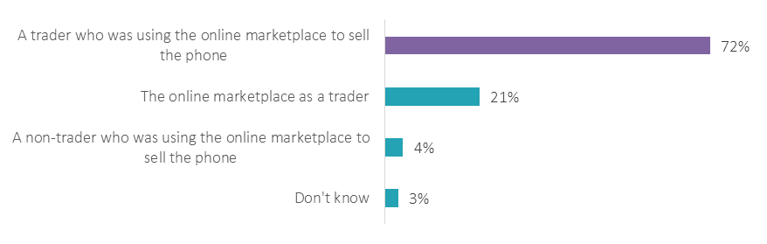

**Figure 4: Contractual parties: Knowing who was actually selling the product on the platform… (n=1188)[316]**

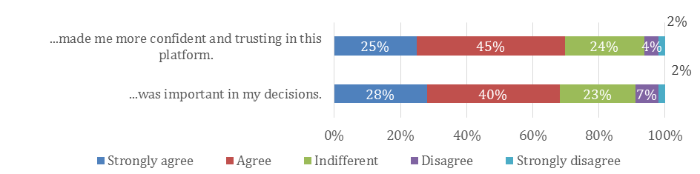

**Figure 5: Views on platform transparency ("Please indicate whether you agree or disagree with the following statements" (n=1601))[317]**

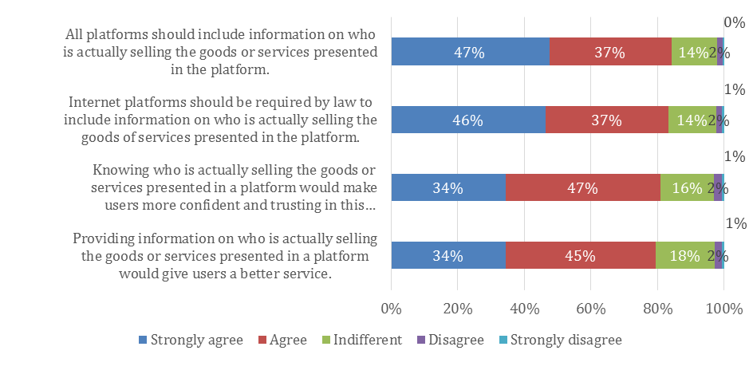

**Question 6 in section C.2 of the SME panel consultation:** "Do you agree that, across the EU, consumers buying on online marketplaces should be informed about a.) whether they buy from the online marketplace itself or from someone else, b.) whether the contracting party declares to be a trader or not c.) whether EU consumer rights apply to their transaction."

**Question 77 in the public consultation**: In your view, would the costs of complying with the information obligations as set out in the previous question be reasonable?

1. <http://ec.europa.eu/info/law/better-regulation/initiatives/ares-2017-3287178_en>
2. <http://ec.europa.eu/info/law/better-regulation/initiatives/ares-2017-5324969_en>
3. <http://ec.europa.eu/newsroom/just/item-detail.cfm?item_id=59332>
4. Available at: <http://ec.europa.eu/newsroom/just/item-detail.cfm?item_id=59332>
5. For more information on these consultation activities carried out for the Fitness check and the CRD evaluation, see the Annexes to the Report on the Fitness check of consumer and marketing law and Annexes to the Commission staff working document on the CRD, available at: <http://ec.europa.eu/newsroom/just/item-detail.cfm?item_id=59332>
6. Of the 58 Business associations replying to this specific question, 34 replied that consumers are often or sometimes not sure whether they bought from the online marketplace itself or from someone else, 11 indicated that consumer do not face such situation and 13 did not know. 30 indicated that consumers often or sometimes (+ 3 replied "once") are not sure which rights they have because it was unclear if the person they bought from was bound by EU consumer rules or not, 11 think this does not happen and 14 do not know.
7. To the question whether consumers experience harm due to fact that they were denied the right of withdrawal, 25 replied no, 21 did not know and 8 replied yes (4 said a few times, 2 said often and 2 once). To a similar question whether consumers experience harm because they were denied a repair of replacement of a faulty product, 22 replied no, 23 did not know and 8 replied yes (6 a few times and 2 once). Similarly, 17 thought that consumers do not experience harm because they do not know to whom to direct their claims, 22 did not know and 16 replied yes they experience harm a few times (8), often (6) and once (2).
8. Out of 48 business associations replying to this question: 20 agree, 21 disagree and 7 do not know.
9. 2 out of 5 in the targeted consultation, 3 out of 5 in the public consultation and 2 out of five in the SME panel consultation.
10. Data from the public consultation. When asked whether they incur compliance costs when trading cross-border due to different national laws, 9 out of 23 companies and 10 out of 42 business associations report that this is the case for the obligation to state whether the contract is concluded with the online marketplace or with the third party supplier. 9 out of 22 companies and 9 out of 42 business associations report costs stemming from requirements to indicate whether a third party supplier is acting as a trader or not. The obligation to indicate the applicability of consumer law to contracts created costs for 11 out of 21 companies and 15 out of 43 business associations.
11. In the targeted consultation for online marketplaces
12. Business associations: 32 of 62 disagreed regarding pre-contractual information and 32 of 57 disagreed regarding right of withdrawal. Companies: due to lack of pre-contractual information: 16 agreed, 18 disagreed, 20 do not know; companies on cross-border consumer harm due to lack of right to withdraw: 17 agreed, 18 disagreed, 18 did not know.
13. Germany
14. This was the answer given by highest number of respondents to these questions regarding both potential new rights.
15. Germany, Czech Republic and Finland.
16. Based on replies to the CPC/CPN/CMEG consultation.
17. It was a multiple-choice question, i.e. respondents could choose several options form the alternatives.
18. Share of responses are very similar across the five Directives: highest share of respondents do not know, some say fines are proportionate, some say they are not proportionate either because fines for stronger companies are too low or because fines for weaker companies are too high.
19. 46% of 41 SMEs agree regarding both, while 42% disagree, 12% do not know regarding insufficient compliance and 34% disagree and 20% do not know regarding insufficient deterrence.
20. In the SME panel consultation this was a single choice question i.e. respondents could choose one option from alternative options. Other ways to set fines were favoured by 30% (Maximum level of fines is expressed as an absolute amount or a percentage of the trader's turnover whichever is higher), 16% (Maximum level of fines is expressed as an absolute lump-sum amount) and 5% of the responding SMEs (Other). In the public consultation it was designed as a matrix question whereby the respondent could express agreement or disagreement (with the usual scale of answer options: strongly agree, tend to agree, tend to disagree, strongly disagree and do not know) to each option listed.
21. Including: level playing field to the benefit of compliant traders, level playing field between the traders operating in different EU Member States, level playing field between traders of different economic strength.
22. Obligation to accept return of goods bought online which consumers have used more than what they could have done in a brick and mortar shop: 34 (36,1%) reported having experienced significant problems often, few times of once. Obligation to reimburse the consumer without having the possibility to inspect the returned goods as soon as the consumer has supplied evidence of having sent them back: 31 (34,1%) reported having experienced significant problems often, few times of once.
23. 33 of 36 regarding the obligation to accept the return of goods used more than necessary and 32 of 35 regarding the obligation to reimburse the consumers before receiving the goods back as soon as the consumer has supplied evidence of having sent them back.
24. For each of these five difficulties, at least 70% and mostly over 80% of the 18 online companies and of the 33 business associations whose members sell online agreed.
25. For all eight (a public and seven targeted) consultations via questionnaire described below, the Commission's EUsurvey tool was used. In addition, some respondents replied via email. Public consultation: MS authorities from France, Austria, UK, Portugal; EU-level business associations; national consumer associations from Portugal, Austria; German Federal Bar, a company. Targeted consultation on online marketplaces: European association representing online traders. Targeted consultation on free digital services: A large internet company. It is important to note, that the consultations are not statistically representative of the target population.
26. All feedbacks are publicly available at: <http://ec.europa.eu/info/law/better-regulation/initiatives/ares-2017-3287178/feedback_en>
27. Independent Retail Europe, European Technology & Travel Services Association, Branchevereniging Organisatie voor Erkende Verhuizers, Bundesverband Möbelspedition und Logistik (AMÖ) e.V., Austrian Federal Economic Chamber, World Federation of Advertisers (WFA), The Federation of European Movers Associations (FEDEMAC), Confederation of Danish Enterprise
28. All feedbacks provided via relevant Webpage are publicly available at: <http://ec.europa.eu/info/law/better-regulation/initiatives/ares-2017-5324969/feedback_en>
29. In addition, the Dutch Ministry of Justice sent their feedback by email.
30. <https://ec.europa.eu/info/business-economy-euro/banking-and-finance/financial-reforms-and-their-progress/regulatory-process-financial-services/expert-groups-comitology-and-other-committees/financial-services-user-group-fsug_en>
31. Information and the questionnaire are available at: <https://ec.europa.eu/info/consultations/public-consultation-targeted-revision-eu-consumer-law-directives_en>.
32. As the public consultation and the SME panel consultation covered more topics and targeted more respondent categories compared to the targeted questionnaires, the analysis of the responses was carried out based on the number of actual respondents to each individual question, therefore the sample varies by question and sub-questions. "Sub-questions" are part of matrix question with an overarching question and different statements with a scale of answer options to each statement.
33. In addition, three email submissions were received within the consultation period from a company, a national consumer association and a Member state authority, outside the EUsurvey tool. Some stakeholders submitted their position by email outside the consultation period and outside EUsurvey tool. The positions expressed in these submissions were reviewed but were not taken into account in the statistical analysis of the closed questions of the EUsurvey questionnaire.
34. It includes one reply from a consumer enforcement authority in Norway.
35. Majority of position papers was a paper by UNITI, as part of a campaign, see below. Other position papers came from businesses, business associations and MS authorities.
36. German Federal Supreme Court has determined that consumers have a right of withdrawal from distance sales contracts for heating oil: Bundesgerichtshof (Federal Court), BGH, 17 June 2015 - VIII ZR 249/14, <http://juris.bundesgerichtshof.de/cgi-bin/rechtsprechung/document.py?Gericht=bgh&Art=en&nr=71692&pos=0&anz=1>
37. Including from 5 large companies.
38. More information on CPC:  [https://ec.europa.eu/info/consumers/consumer-protection-cooperation-regulation_en](%20https://ec.europa.eu/info/consumers/consumer-protection-cooperation-regulation_en%20%20) 
39. More information on the CPN: <http://ec.europa.eu/transparency/regexpert/index.cfm?do=groupDetail.groupDetail&groupID=861&NewSearch=1&NewSearch=1>
40. More information on CMEG: <http://ec.europa.eu/transparency/regexpert/index.cfm?do=groupDetail.groupDetail&groupID=2387>
41. The ECCG consists of one representative of national consumer organisations per country, one member from each European consumer organisation (BEUC and ANEC), two associate members (EUROCOOP and COFACE) and two EEA observers (Iceland and Norway). More information on ECCG <http://ec.europa.eu/transparency/regexpert/index.cfm?do=groupDetail.groupDetail&groupID=849&NewSearch=1&NewSearch=1>
42. In addition, the Dutch Ministry of Justice replied outside of the survey tool.
43. <http://ec.europa.eu/transparencyregister/public/homePage.do>
44. For more information on the activity of the Group, please see: <http://ec.europa.eu/transparency/regexpert/index.cfm?do=groupDetail.groupDetail&groupID=3423>
45. Monetary figures are based on responses to the SME panel consultation, average and median in brackets. Micro-enterprises are included under the 'SME' category.
46. The figures are highly influenced by the outlier value estimated by a Danish micro enterprise (estimates from this country range from zero to EUR 572 484, with average: EUR 149 734, median: EUR 13 227). The 2nd highest estimate was reported by a respondent from EL with EUR 160 000 (average across the 8 replies from that country is EUR 24 375, median: zero, The 3rd biggest range resulted from responses from ES with zero to EUR 101 675 (mean: EUR 16 052, median: EUR 1 796), followed by a PT company that estimated EUR 25 637.
47. The figure is estimated on the basis of the median costs observed from the SME panel consultation (by enterprises size) and the overall number of enterprises in the retail trade industry, broken down by enterprise size – NACE REV2, G (Source Eurostat). Given the limited representativeness of the businesses that responded to the consultations, such estimates should be considered as only indicative and treated with caution.
48. The maximum amount was reported by a micro-enterprise in DK. The four estimates from that country resulted in an average of EUR 49 542 and median of EU 3 835). The 2nd highest value was reported a Portuguese SME (EUR 171 551, another outlier). The average of the 12 estimates from this country amounts to EUR 20 504, the median is EUR 1 609.
49. The figure is estimated on the basis of the median costs observed from the public consultation (by enterprises size) and the overall number of enterprises in the retail trade industry, broken down by enterprise size – NACE REV2, G (Source Eurostat). Such estimates should be considered as only indicative and treated with caution.
50. Notable is the (only) estimate from a micro-enterprise from DK (EUR 48 000). The next highest value was reported by the (only) respondent from SK (EUR 7 933).
51. The figure is estimated on the basis of the median costs observed from the SME panel consultation and the overall number of enterprises in the retail trade industry – NACE REV2, G (Source Eurostat). As the costs estimate for large enterprises are not available, they are assumed to be equal to those of enterprises with less than 250 persons employed. Such estimates should be considered as only indicative and treated with caution.
52. The figure is estimated on the basis of the median costs observed from the SME panel consultation (and the overall number of enterprises in the retail trade industry – NACE REV2, G (Source Eurostat). As the costs estimate for large enterprises are not available, they are assumed to be equal to those of enterprises with less than 250 persons employed. Such estimates should be considered as only indicative and treated with caution.
53. The three respondents from PT estimated costs of zero, EUR 5 782 and EUR 84 301, the 2nd highest estimate (EUR 20 000) originates from the (only) respondent from DK, the 3rd highest from PL (EUR 10 000).
54. The figure is estimated on the basis of the median costs observed from the SME panel consultation (and the overall number of enterprises in the retail trade industry – NACE REV2, G (Source Eurostat). As the costs estimate for large enterprises are not available, they are assumed to be equal to those of enterprises with less than 250 persons employed. However the median was stated at zero. Such estimates should be considered as only indicative and treated with caution.
55. The figure is estimated on the basis of the median costs observed from the SME panel consultation (and the overall number of enterprises in the retail trade industry – NACE REV2, G (Source Eurostat). As the costs estimate for large enterprises are not available, they are assumed to be equal to those of enterprises with less than 250 persons employed. However the median was stated at zero. Such estimates should be considered as only indicative and treated with caution.
56. The figure is estimated on the basis of the median costs observed from the SME panel consultation (and the overall number of enterprises in the retail trade industry – NACE REV2, G (Source Eurostat). As the costs estimate for large enterprises are not available, they are assumed to be equal to those of enterprises with less than 250 persons employed. However the median was stated at zero. Such estimates should be considered as only indicative and treated with caution.
57. The maximum outlier estimate stems from a small enterprise in PT, the next highest value of EUR 20 000 was reported by the (only) respondent from DK
58. The figure is estimated on the basis of the median costs observed from the public consultation (and the overall number of enterprises in the retail trade industry – NACE REV2, G (Source Eurostat). As the costs estimate for large enterprises are not available, they are assumed to be equal to those of enterprises with less than 250 persons employed. Such estimates should be considered as only indicative and treated with caution.
59. The figure is estimated on the basis of the median costs observed from the SME panel consultation (and the overall number of enterprises in the retail trade industry – NACE REV2, G (Source Eurostat). As the costs estimate for large enterprises are not available, they are assumed to be equal to those of enterprises with less than 250 persons employed. Such estimates should be considered as only indicative and treated with caution.
60. Results are summarized in section 6.3.2 of the Impact Assessment
61. Survey on "Consumers attitudes towards cross border trade and consumer protection".
62. The countries with links between remedies and breaches of the UCPD are: BE, BG, CZ, IE, EL, FR, LT, LU, NL, PL, PT, SK, SE and UK.
63. The indicator is the following: "% of retailers who agree that public authorities actively monitor and ensure compliance with consumer legislation in their sector". It was collected through the 2016 edition of the survey on "Retailers' attitudes towards cross border trade and consumer protection", was conducted in the framework of the 2017 Consumer Conditions Scoreboard.
64. European Commission own estimate based on the Special Eurobarometer 342 on Consumer Empowerment. (<http://europa.eu/rapid/press-release_IP-11-455_en.htm>)
65. According to the model regression, the probability of encountering a UCP is equal to 50.061% in countries with remedies and to 54.056% in countries without remedies. Consequently, the difference between the two groups of countries is equal to – 3.99% in percentage points and to -7.39% in relative terms.
66. Equal to 0.144. For more information on the Harmonized Consumer Complaints database see: <https://ec.europa.eu/info/strategy/consumers/consumer-protection/evidence-based-consumer-policy/consumer-complaints-statistics_en>
67. http://ec.europa.eu/consumers/consumer_evidence/market_studies/consumer-detriment/index_en.htm
68. The factors presented in the multiplication are rounded while the result was computed on unrounded figures.
69. The factors presented in the multiplication are rounded while the result was computed on unrounded figures.
70. Results are summarized in section 8.1 of this Impact Assessment
71. See annex 14
72. Unfair Contract Terms Directive 93/13/EEC (the ‘UCTD’); the Consumer Sales and Guarantees Directive 1999/44/EC (the ‘CSGD’); the Price Indication Directive 98/6/EC (the ‘PID’); the Unfair Commercial Practices Directive 2005/29/EC (the ‘UCPD’); the Misleading and Comparative Advertising Directive 2006/114/EC (the ‘MCAD’) and the Injunctions Directive 2009/22/EC (the ‘ID’).
73. SWD (2017) 208 final and SWD(2017) 209 final (both on the Fitness Check) and COM(2017) 259 final, SWD(2017)169 final and SWD(2017) 170 final (on the CRD evaluation), all of 23.5.2017, are available at: <http://ec.europa.eu/newsroom/just/item-detail.cfm?item_id=59332>.
74. Fitness Check Report. SWD, pages 75, 76.
75. Fitness Check Report, Executive Summary, page 2.
76. Fitness Check Report. SWD, page 74.
77. Fitness Check Report. SWD, page 76.
78. Fitness Check Report. SWD, page 78.
79. Fitness Check Report, Executive Summary, page 3.
80. Fitness Check Report. SWD, page 80.
81. Fitness Check Report. SWD, page 79.
82. Fitness Check Report. SWD, page 81.
83. Fitness Check Report. SWD, page 82.
84. Fitness Check Report, Executive Summary, page 3.
85. Fitness Check Report. SWD, page 84.
86. Fitness Check Report, Executive Summary, page 3.
87. CRD Evaluation, SWD, pages 56, 57.
88. COM(2015) 634.
89. COM(2017)650 final
90. For further information, see <https://ec.europa.eu/info/strategy/consumers/consumer-protection/evidence-based-consumer-policy/consumer-scoreboards_en>
91. BG, CY, CZ, EE, FR, HU, IE, IT, LV, LT, MT, PL, PT, RO, SK, ES
92. EE, ES, PL, PT, RO, UK
93. BE, DK, EL, FI, HR, LU, SE and the UK
94. Directive 2013/11/EU of the European Parliament and of the Council of 21 May 2013 on alternative dispute resolution for consumer disputes, available at : <http://eur-lex.europa.eu/legal-content/EN/TXT/?uri=CELEX%3A32013L0011>
95. By Directive 2013/11/EU on alternative dispute resolution
96. Available since 15 February 2016, based on Regulation (EU) No 524/2013 of the European Parliament and of the Council of 21 May 2013 on online dispute resolution for consumer disputes available at :

    <http://eur-lex.europa.eu/legal-content/EN/TXT/?uri=CELEX%3A32013R0524>
97. The Commission adopted its first report on the functioning of the ODR platform on 13 December 2017, see: <https://ec.europa.eu/info/online-dispute-resolution-1st-report-parliament_en>
98. according to which national rules governing actions related to the enforcement of rights which individuals derive from EU law should not be less favourable than those governing similar domestic situations;
99. according to which these should not render impossible in practice or excessively difficult the exercise of rights conferred by EU legal order.
100. Under the recently revised Regulation (EU) 2015/2421 of the European Parliament and of the Council of 16 December 2015 amending Regulation (EC) No 861/2007 establishing a European Small Claims Procedure and Regulation (EC) No 1896/2006 creating a European order for payment procedure, available at : <http://eur-lex.europa.eu/legal-content/EN/ALL/?uri=CELEX%3A32015R2421>
101. According to the revised CPC Regulation 'widespread infringements' are illegal practices having implications in at least three EU Member States. 'Widespread infringement with a Union dimension' are illegal practices which affect a large majority of EU consumers, namely in two-thirds of Member States or more, and amounting to two thirds of the EU population or more (for exact definitions of the above terms please see Article 3 c) and ca) of the revised CPC Regulation).
102. However, the just revised CPC Regulation does not harmonise the penalties for consumer law infringements. Although it was highlighted during the negotiations that "effective, proportionate and dissuasive" penalties in all Member States are essential for the success of the enforcement mechanisms under the Regulation, it was decided that the level of penalties for breaches of EU consumer law may be addressed in accordance with the findings of the Fitness Check. This is reiterated in Recital 16 of the revised CPC Regulation which reads in its last sentence: "In view of the findings of the Commission’s Report of the Fitness Check of consumer and marketing law, it might be considered to be necessary to strengthen the level of penalties for breaches of Union consumer law*.*"
103. This overview is based on the replies of national authorities to the CPC/CPN/CMEG survey that included a number of questions on penalties. It is complemented with other information that Member States' authorities have formally provided to the Commission. Other sources, such as studies and desk research were used to gather information regarding countries whose authorities did not reply to the CPC/CPN/CMEG survey. Only the **highest indicated maximum fines are included in this overview**. Several respondents also reported on the availability of additional fines that are not included in this overview (such as daily fines or conditional (suspended) fines accompanying an injunction order to cease the infringement). Some MS indicated different maximum fines applicable to individuals, legal persons and/or representatives of legal persons. In these cases, this overview only includes the maximum amounts provided for legal persons. Some respondents stated higher maximum fines for repeat offences, which are also not included. Some respondents indicated that different maximum fines apply depending on the specific provision of the Directive that is infringed – in these cases the overview indicates the highest maximum fine. Some respondents indicated that the stated maximum fines only apply in administrative but not in criminal proceedings.
104. In Austria, the enforcement of consumer protection law is mainly sought through injunctions brought by consumer associations (*Verein für Konsumenteninformation, Arbeiterkammer*). The indicated maximum amounts are for administrative fines.
105. In Belgium, there are no administrative fines and penal procedures are applied. Also, a 'transaction' procedure is possible whereby the competent authority proposes the offender to pay a sum of money. If the offender pays it, no further criminal action will be initiated. If the offender does not pay, public prosecutor gets involved.
106. In Denmark, no administrative fines are available but traders breaching the UCPD and PID may be fined by courts in criminal procedure. Infringements of the other directives could be sanctioned in the same way if they constitute an infringement of the UCPD.
107. In Finland, there are no administrative fines for past infringements. A prohibition order reinforced by a fine may be sought from the Market Court. There is no upper limit on any fine; the amount will depend on the nature/scale of the infringement and the company’s turnover. In practice fines tend to be from EUR 50 000 to 100 000. There is also an offence of marketing crime in the Criminal Code punishable by fine or maximum one year of imprisonment.
108. In France, the fine for the infringement of the UCPD can be increased up to 10% of annual average turnover in the past three years or up to 50% of the costs of the activity that constituted unfair commercial practice. There are no specific fines for the breaches of the CSGD – these can be addressed via injunctions or legal proceedings to ensure trader’s compliance with its legal obligations and the court’s decision can be issued subject to penalty.
109. In Germany, the infringements of consumer law provisions are mainly penalised under civil (contract) law, in particular by the granting of entitlements with regard to compensation, contract termination and rescission.
110. In Hungary, maximum fines are set depending on the size of the company – the highest maximum fine for large companies is indicated.
111. In Ireland, monetary penalties for the breaches of the UCPD can only be imposed by a court of law following criminal prosecution. The maximum fine for a first offence is €3,000 for summary convictions and €60,000 for convictions on indictment. There are higher fines for repeat offenders. Penalties for offences relating to pyramid schemes involve a fine of up to €150,000 and a prison term of up to five years.
112. In Latvia, breaches of the UCTD may be addressed as breaches of the UCPD; the same is true for breaches of the CSGD where there is a pattern in the trader's behaviour.
113. In Luxembourg, different maximum fines are provided for the breaches of different obligations under the CRD. The maximum fine is indicated.
114. In Portugal, only the breaches of the UCTD are not covered by administrative fines. A fine of civil nature – penalty payment – can be imposed by court.
115. In Romania, only the court can apply administrative fine for the breaches of the UCTD. As regards UCPD breaches, the maximum penalty depends on the company size: the highest maximum fine is indicated.
116. In Slovenia, the administrative authority can impose a fine of EUR 3 000 whereas higher fines can be imposed by the court.
117. In Spain, the maximum fines are set in legislation according to gravity of the offence: the indicated amount is the maximum for very serious infringements as established in general national legislation. Regional consumer protection laws may contain different rules, for example, providing for no fine for minor infringements, providing for a minimum fine or setting the maximum fine at 10 times of the unlawful profit made or the damage caused by the infringement (instead of 5 times).
118. In Sweden, the law sets the direct fine at not more than 10 % of the annual turnover of the trader and not more than EUR 1 million. The amount of the conditional fine is, according to the present case law of Swedish Patent and Market Court, EUR 100 000 – 200 000 per infringement.
119. In the UK, enforcement authorities do not currently have the power to impose fines for breaches of consumer protection law.
120. In Norway, both suspended administrative fines (enforcement penalties) and direct administrative fines (infringement penalties) can be imposed for the breaches of the UCPD, CRD and PID. Legislation does not set the maximum level of these fines; the amounts indicated regarding UCPD and CRD are for infringement penalties as established in case law (there is no case law yet regarding the PID). There is a maximum suspended administrative fine (enforcement penalty) for the breaches of the UCTD according to case law (no maximum level set in legislation).No fines are provided for the breaches of the CSGD as such, but a misleading use of guarantees could be tackled under UCPD. UCPD has also been used for tackling misleading price information in breach of the PID.
121. Source of information on the average turnover of enterprises in the retail trade sector: Eurostat, Structural Business Statistics-2015. For LT and MT the Eurostat data are not available; so, respectively, LV and CY data are used. Source of the data on penalties: CPC/CPN/CMEG survey. Not all respondents provided estimates of the fines. Replies simply re-stating the maximum fines available for the breaches of the relevant Directive were not taken into account. Where the same indicative range of the fine (from minimum to maximum) was indicated both for the infringement by a large and small company, the highest of these possible fines was used in this overview for the large company and the lowest one was used for the small company. This overview does not include those indications of potential fines where the respondent explains that the actual fine would be definitely below the provided amount without giving more precise estimate. Where both the possible 'direct' fine and 'suspended/conditional' fine was indicated for the same infringement, the higher indicated amount was included in the overview. Some respondents had, in addition to a lump sum, also indicated daily fines associated with an injunction, which are not included in this overview. When a lower amount was indicated for traders – natural persons – and a higher amount was indicated for traders – legal persons – only the higher amount for legal persons was included in the overview.
122. SME Panel question: "Do you consider that in your country the fines imposed for the following breaches of EU consumer law are in general proportionate compared to the traders' economic strength (for example, in terms of turnover)".
123. Replies to CPC/CPC/CMEG survey Q 32: "In your Member State, is the fact that the trader has committed the same or similar breach of consumer law in other Member State(s) taken into account while imposing fines?".
124. Replies to the CPC/CPC/CMEG survey Q 34: "In your Member State, is the fact that the trader has been fined in other Member State(s) for the same or similar breach of consumer law taken into account while imposing fines".
125. Article 1 of the revised CPC Regulation.
126. Regulation (EU) 2016/679 of the European Parliament and of the Council of 27 April 2016 on the protection of natural persons with regard to the processing of personal data and on the free movement of such data, and repealing Directive 95/46/EC (General Data Protection Regulation), available at: <https://ec.europa.eu/info/law/law-topic/data-protection/data-protection-eu_en> , <http://eur-lex.europa.eu/legal-content/EN/TXT/?uri=uriserv:OJ.L_.2016.119.01.0001.01.ENG&toc=OJ:L:2016:119:TOC> .
127. SEC(2012) 72 final, p. 108.
128. Article 23 of the Proposal for a Regulation of the European Parliament and of the Council concerning the respect for private life and the protection of personal data in electronic communications and repealing Directive 2002/58/EC (Regulation on Privacy and Electronic Communications), COM/2017/010 final, available at: <http://eur-lex.europa.eu/legal-content/EN/ALL/?uri=CELEX:52017PC0010>.
129. Chapter V "Fines and periodic penalty payments" of the Proposal for a Directive to empower the competition authorities of the Member States to be more effective enforcers and to ensure the proper functioning of the internal market, COM(2017) 142 final of 22.3.2017 (<http://eur-lex.europa.eu/legal-content/EN/TXT/?uri=CELEX:52017PC0142>), and the accompanying IA SWD(2017) 114 final, p. 20 and 31 (<http://eur-lex.europa.eu/legal-content/EN/TXT/?uri=celex:52017SC0114>).
130. Question 130: "Do you agree that the following measures should be established by EU law regarding penalties

     for breaches of EU consumer protection rules"
131. Question 138 "Do you agree that strengthening penalties at the EU level would bring about benefits, such as:"
132. Q3 in section B.2 of the SME Panel consultation: "In your view, what would be the impact of strengthening penalties under EU consumer protection law on the following?" (n=208: traders selling to consumers, combined result for replies "significant positive impact" and "moderate positive impact")
133. Question Q132: "Do you agree that the following measures should be established by EU law?"
134. Question 2 in section B.2 of the SME Panel.
135. Question 3 in section B.2 SME Panel: For information on the question see Annex 7, subsection 2.
136. Question 38 of the CPC/CPN/CMEG survey: "In your Member State, what type of turnover is taken into account when calculating fines?"
137. Question 134 "What would be the best measure to define the maximum level of fines as % of the trader's turnover?" and Question 136 "What would be the best measure to define the maximum level of fines as % of the trader's turnover?"
138. SME Panel Q4: "What would be the impact of strengthening penalties at EU level on the costs of your enterprise?" n=213.
139. Question 140 "In your view, what would be the effect of establishing EU common rules on penalties for breaches of EU consumer law on the overall costs of administrative and judicial enforcement?" and Question 142 "Do you consider that the possible increase of costs of administrative and judicial enforcement of EU consumer protection rules would be reasonable?"
140. Replies to the CPC/ CPN/ CMEG survey Q 40: "Please provide for highest and lowest fine that national consumer enforcement authorities (or courts) in your Member State imposed on traders in the past year for the following breaches of EU consumer law. If possible please indicate the amount of the fine and % of the trader's turnover that this fine constituted."
141. Replies to the CPC/CPN/CMEG Survey Q30: "In your Member State, what are the criteria for imposing fines for breaches of consumer law?" "+" stands for positive replies, "-" stands for negative replies; blank fields means absence of a reply or unclear reply.
142. The question was: *‘In the past 12 months, have you experienced problem(s) with any goods or services where you thought you had a legitimate cause for complaint related to the following five problem types?*
143. Between 2014 and 2016 consumer exposure to unfair commercial practices by domestic retailers fell by 6.9 percentage points in the EU-28, to 16.8 %.
144. EASA – the European Advertising Standards Alliance, report "European Trends in Advertising Complaints, Copy Advice and Pre-clearance" (2015), p. 11. 45% of complaints lodged by consumers, competitors and other entities with the advertising Self-Regulatory Organisations (SROs) in 23 Member States in 2015 concerned misleading advertising. This was followed by complaints about taste and decency and social responsibility.
145. EASA – the European Advertising Standards Alliance, "Cross Border Complaints Report"(2015), p. 9. In 2015, the largest share of cross-border complaints handled through the EASA (the European Advertising Standards Alliance) SRO network concerned misleading advertisements (64.9% or 72 complaints), out of which 14 complaints (17.5%) were found in breach of the advertising codes.
146. The CSGD also ensures rights to remedies for some victims of unfair commercial practices, but only to a limited extent. Notably, the protection under the CSGD is limited to issues related to conformity with the contract and the right to remedies is only applicable for two years after the purchase. The protection does also not cover the entire spectrum of possible unfair practices, such as aggressive marketing. Furthermore, the CSGD only applies to tangible goods and not to services, for which the risk of misleading or aggressive behaviour is equally high, if not higher.
147. Consumer Market Study to support the Fitness Check of EU consumer and marketing law (2017), p. 161.
148. Idem, p. 173.
149. Idem, p. 183.
150. Idem, p. 189.
151. Study on measuring consumer detriment in the European Union, February 2017, available at: <https://publications.europa.eu/en/publication-detail/-/publication/b0f83749-61f8-11e7-9dbe-01aa75ed71a1/language-en> .
152. The consumer detriment study analysed personal consumer detriment in different product markets and in relation to different problems. The average level of financial detriment before seeking redress across the six markets studied varied between EUR 49.9 and EUR 323.4 per person. Financial detriment after seeking redress varied between EUR 25.1 and EUR 167.5. On average, the highest levels of redress were reported in the clothing, footwear and bags markets. Here, consumers recovered between 50 % and 61 % of their initial costs and losses. By contrast, respondents received the lowest value of redress (as a proportion of their financial detriment) in the mobile telephone services market and the electricity services market. Here, they recovered about 14 % and between 12 % and 21 % of their initial costs and losses respectively.
153. AT, CY, DE, DK, EE, FI, HR, HU, IT, LV, MT, RO, SL, ES.
154. From the CPC/CPN/CMEG consultation, the question was: *If consumers use the existing remedies in your Member State, which existing remedies are the most frequently used?*
155. From the CPC/CPN/CMEG consultation. The question was: *If an EU-wide right to remedies were introduced, which remedies would in your view introduce added value, taking into account the nature and frequency of use of the existing remedies in your Member States?*
156. From the public consultation. The question was: *Which types of EU-wide remedies should be introduced in case a consumer is a victim of an unfair commercial practice?*
157. CPC/CPN/CMEG survey
158. 65% of respondents to the specific question in the OPC: *Which types of EU-wide remedies should be introduced in case a consumer is a victim of an unfair commercial practice (multiple replies possible)?*
159. The question was: *If you have been a victim of unfair commercial practices (e.g. if you have purchased a product or a service based on misleading claims, such as misleading green claims, or aggressive practices by traders), have you experienced problems with getting redress from traders?*.The answer options included *"I have never been victim to unfair commercial practice"*, which was chosen by 29 respondents and *"do not know*", which was chosen by 6. In total, 88 individuals replied to this question. See Table 9 below for a breakdown of consumers' responses.
160. The question was: *In your professional experience, do consumers experience problems with getting redress from traders when they have been victims of unfair commercial practices?* See Table 10 below.
161. The question was: *Do you agree that differences between national rules on remedies for unfair commercial practices cause the following problems? Harm to consumers as they cannot remedy the consequences resulting from unfair commercial practices on the national and cross-border level.* See Table 11 below.
162. From the platform transparency study. The question was: *How often have you: Personally experienced problems with getting individual redress when I am a victim of unfair commercial practices?* 
163. From the public consultation for this IA. See Table 12 below.
164. The question was: *Does your company (or the companies you represent) face costs when trading cross-border due to a need to adapt to current different national laws related to remedies?*
165. From the SME panel consultation. The question was: *Do these costs (to check compliance with and adjust business practices to national rules related to remedies for consumers that have been harmed by unfair commercial practices) have an impact on your decision to enter other EU markets or not?* SME ID126
166. From the SME panel consultation. The question was: *Please estimate the resources your enterprise needs to invest, when selling to another EU country, to check compliance with and adjust business practices to national rules related to remedies for consumers that have been harmed by unfair commercial practices?*
167. One-off costs are initial resources, needed once and not repeated, in order to enter a new EU market, e.g. working hours of staff for initial familiarisation with the rules applicable in the new Member State.
168. Running (or regular) costs are resources needed on a regular basis when trading cross-border, e.g. continuously checking compliance with the rules applicable in the Member State.
169. In a span ranging from EUR zero to more than 350 000. In terms of share of turnover, this represented from zero and up to more than 12 000 per cent.
170. One-off costs represent around a quarter of a percent of the turnover while the annual running costs represent much less than a tenth of a percent of the turnover considering the median among the responding businesses.
171. In a span from EUR zero to more than 43 000.
172. From the public consultation. The question was: *What are your (or the companies' you represent) estimated costs when trading cross-border due to a need to adapt to current different national laws related to remedies? Estimated amount or % of turnover.* 
173. From the position paper "AIM contribution to the European Commission consultation on the targeted review of EU consumer law Directives", October 2017.
174. From the Fitness Check consumer survey (representative total sample of 23'501 respondents in EU28 + NO and IS, number of respondents ranging from 1000 respondents in the largest countries to 250 in the smallest. The survey covered UCPD, UCTD, PID and CSGD. Detailed results are provided in the "Consumer Market Study to support the Fitness Check of EU consumer and marketing law" (2017), available at: <http://ec.europa.eu/newsroom/just/item-detail.cfm?item_id=59332>.
175. <http://ec.europa.eu/newsroom/just/item-detail.cfm?item_id=59332>
176. Base: EU28 respondents had encountered a problem in the past year at least rarely (n = 16,800; of which lack of indication of the unit price n = 2,942; defective goods n = 7,049; misleading or aggressive commercial practices n = 3,941; unclear or ambiguous standard contract terms n = 2,102; unfair standard contract terms n = 721).
177. Base: EU28 respondents that did not take any action on their last problem (n = 4,499)
178. Base: EU28 respondents that took any action to resolve the most recent problem (Q23 = 1-7; n = 12,703)
179. Study on measuring consumer detriment in the European Union, Part 3, Annex XXI, Figure 1, available at: <https://publications.europa.eu/en/publication-detail/-/publication/b0f83749-61f8-11e7-9dbe-01aa75ed71a1/language-en> .
180. Calculations based on Study on measuring consumer detriment in the European Union, available at: <https://publications.europa.eu/en/publication-detail/-/publication/b0f83749-61f8-11e7-9dbe-01aa75ed71a1/language-en>
181. Due to the rather low sample sizes of this the result is not statistically significant at the 5% -level.
182. For seven specific black-listed practices (corresponding to Annex No. 12, 16, 17, 24, 25, 29, 31), the court must apply the remedy, for others it has the discretion whether or not to apply the remedy or modify it.
183. Remedies can be used following an order by the Commission for Consumer Protection prohibiting the application of the unfair commercial practice.
184. Remedies limited to certain UCPD breaches.
185. Remedies provided only for aggressive practices.
186. Remedies not provided for the breach about failing to meet a commitment in a code of practice and the operation of pyramid schemes.
187. Remedies not provided for misleading omissions.
188. From the public consultation (OPCID226)
189. From the public consultation.
190. From the public consultation.
191. From the SME panel consultation.
192. From the SME panel consultation.
193. From the CPC CPC/CPN/CMEG survey.
194. *Idem* CPC/CPN/CMEG survey.
195. Question 21 in the public consultation: For information on the question, see subsection 2 in this Annex.
196. Question 109 in the public consultation, please see the question in Subsection 2 of this Annex.
197. Question 110 in the public consultation, please see the question in Subsection 2 of this Annex.
198. Lot 3 Report, p. 103.
199. Question 112 in the public consultation: For information on the question see the question in Subsection 2 of this Annex.
200. Question 4 in section B.1 of the SME panel consultation: For information on the question see Subsection 2 of this Annex.
201. The problem of mass harm related to both domestic and cross-border infringements of EU law relevant for collective interests of consumers has been already identified in the 2008 Commission Green Paper on collective redress (COM(2008) 794 final, available at <http://ec.europa.eu/consumers/archive/redress_cons/greenpaper_en.pdf>, as well in the 2008 Commission White Paper on Damages actions for breach of the EC antitrust rules, (COM(2008)0165) available at: <http://eur-lex.europa.eu/legal-content/EN/TXT/?uri=CELEX:52008DC0165>. The growth of cross-border infringements has been confirmed in the 2015 Study supporting the IA for the revision of the CPC Regulation (2015 CPC IA Study), available at <https://ec.europa.eu/info/sites/info/files/cpc_review_support_study_1_en.pdf>
202. Breakthroughs such as the internet and the rise of emerging economies have further accelerated global exchanges and transformed their nature, which boosts the capacity of traders to reach a large number of consumers simultaneously. See the Reflection paper on harnessing globalisation, COM(2017) 240 of 10 May 2017. The growth of cross-border infringements and the related consumer detriment is also a product of increasing numbers of businesses operating in more than one Member State, through networks of branches, subsidiaries or agents. This creates conditions for infringing commercial practices to be repeated in other Member States, therefore with a cross-border dimension, 2015 CPC IA Study p. ix, the Commission IA for the revision of the CPC Regulation, Brussels, 25.5.2016 SWD(2016) 164 final, p. 9 available at <http://eur-lex.europa.eu/legal-content/EN/TXT/?qid=1518701034039&uri=CELEX:52016SC0164> . At the same time, as demonstrated by data gathered in the context of the EC works for a DSM Strategy, the top 100 online retailers at the EU level represented 52% of total online retail turnover in 2013, "A Digital Single Market Strategy for Europe - Analysis and Evidence", 6.5.2015, SWD (2015)100 final, p. 8 available at <http://eur-lex.europa.eu/legal-content/EN/TXT/PDF/?uri=CELEX:52015SC0100&from=EN>
203. Several studies and reports have identified the risk of mass harm in different economic sectors: Study regarding the problems faced by consumers in obtaining redress for infringements of consumer protection legislation, and the economic consequences of such problems (2008 Problem Study), p.21, 2012 Commission report on the application of the ID, Brussels, 6.11.2012 COM(2012)635final, p. 4-5 available at: <http://eur-lex.europa.eu/legal-content/EN/TXT/?qid=1434096245408&uri=CELEX:52012DC0635>, 2017 Fitness Check Study Lot 1, part 4, p. 13, EC 2017 Call for evidence on collective redress (hereinafter " 2017 call for evidence on collective redress",) publication planned for January 2018.
204. For several examples of mass harm situations see: 2008 Problem Study, p. 20, Study on the application of Directive 2009/22/EC on injunctions for the protection of consumers’ interests (former Directive 98/27/EC) available at <https://ec.europa.eu/info/files/study-application-directive-2009-22-ec-injunctions-protection-consumers-interests_en>, 2017 Fitness Check, Lot 1 Study, part 4, p. 16 and 2017 call for evidence on collective redress.
205. 2017 call for evidence on collective redress.
206. BEUC position paper "European collective redress – what is the EU waiting for?", Ref: BEUC-X-2017-086 -31/07/201, p. 8
207. <http://www.telegraph.co.uk/bills-and-utilities/gas-electric/four-million-overcharged-due-to-energy-billing-errors/>
208. Fitness Check, Lot 1 Study, Part 1 Main report, p. 159.
209. BE, DK ES, HU, LU, PT.
210. 2017 Consumer Conditions Scoreboard, p. 56.
211. 2017 Consumer Conditions Scoreboard, p. 58, see also data presented in Table 3 of Annex 8.
212. The above Study revealed that the responding consumers did not take any action due to the following reasons: 18% considered the value of the claim to be too small, 17% costs of the procedure too high, 15% perceived lack of confidence in obtaining a satisfactory outcome, 14% length of the procedure, 11% costs and complexity due to the trader being based in another MS, 9% lack of awareness of consumer rights, 9% lack of knowledge of where to make the complaint, 7% previous experience (e.g. past attempts to resolve such problems were unsuccessful), 2017 Study on Procedural Protection of Consumers PI Study, Online Survey Data, p. 40 available at <http://ec.europa.eu/newsroom/just/item-detail.cfm?item_id=612847>
213. 2008 Problem Study, p. 42.
214. For an overview of EU legal framework for the enforcement and consumer redress, see Annex 6.
215. An example of an EU instrument that does take into account collective redress actions is the Antitrust Damages Directive 2014/104/EU which does apply to antitrust collective redress actions in the Member States where they exist.
216. Revised CPC Regulation, Recital 46 and Article 9(4)(c).
217. As defined by Article 2 of the ID.
218. In the Fitness Check public consultation, at least half of respondents of all types, except business associations, agreed that a court issuing an injunction to stop an infringement of consumer rights constitutes either a very effective or rather effective means of protecting consumer rights in the event of a breach of EU consumer law. 64 % of public authorities indicated this to be effective, as did slightly more than half of consumers (53 %). Most public authorities (60 %) and business respondents (55 %) agreed that injunctions by administrative authorities that stop infringements of consumer rights represent a very effective or rather effective means of protecting consumer rights. In contrast, 42 % of consumers and only 20 % of consumer associations agreed that such a mechanism is effective. Injunctions were seen as most effective against the use by traders of unfair standard contract terms (44 %), use by traders of misleading or aggressive commercial practices (44 %) and breaches of traders’ obligations related to the information they are legally required to provide to consumers (43 %).
219. 2008 COM Report on the application of the ID, Brussels, 18.11.2008, COM(2008)756 final, p. 9 available at <http://eur-lex.europa.eu/legal-content/EN/ALL/?uri=CELEX:52008DC0756>, 2012 COM Report on the application of the ID p. 16; Fitness Check, Lot 1 Study, Part 1, p. 235.
220. Fitness Check Study, Lot 1, Part 1, p. 160.
221. Analysed sectors were clothing and sport goods, electronic goods, financial services (with focus on unsecured loans and credit cards), food supplements, tickets for sport/entertainment and cultural events, 2015 CPC IA Study, pp. 10 and vi.
222. In total, 29 qualified entities from 21 Member States (AT, BG, HR, CY, CZ, DK, FI, FI, DE, EL, IE, LV, LT, LU, MT, NL, SK, SI, ES, SE, UK) consisting of 10 public authorities, 17 consumer organisations, 1 private association and 1 business association responded to the survey. Given that the survey did not cover all qualified entities across the EU and in line with a caveat noted in the 2012 Commission report, the number of documented cases does not necessarily mean that these are the only actions for injunctions that have actually been initiated. For the representativeness of the survey, and in particular for comparison between the number of qualified entities responding to the survey and those listed in the list of qualified entities published by the Commission in the OJ under article 4 of the ID (available at <http://eur-lex.europa.eu/legal-content/EN/TXT/?uri=OJ:C:2016:361:TOC> ); see Fitness Check Study, Lot 1, part 4, p. 8.
223. For an overview of national legal framework related to collective injunction and redress actions see subsection 2 of the present Annex.
224. Fitness Check Study, Lot 1, Part 1, p. 131.
225. Fitness Check Study, Lot 1, Part 1, p.115-117.
226. In the Fitness Check public consultation the majority of businesses (71 %), consumer associations (70 %), consumers (69 %) and public authorities (57 %) agree that injunction proceedings being too costly represents a very or rather important problem in terms of protecting the rights of consumers. In contrast, 18 % of business associations considered the problem to be very or rather important.
227. In the Fitness Check public consultation no less than 75% of consumer associations indicated that the problem of injunctions proceedings being too complex/long is either “very important” or “rather important” for protecting consumer rights, followed by consumers (72%), public authorities (68%) and businesses (65%). Among business associations, 23% considered the complexity/length of injunctions proceedings to be an important problem.
228. A majority of qualified entities responding to the above-mentioned Fitness Check survey confirmed difficulties as regards the costs, complexity, length and limited effects of the injunctions procedure both in domestic and cross-border infringements. Regarding difficulties to apply the injunction procedure for domestic infringements, 22 qualified entities identify costs and complexity as problematic, 20 refer to limited effects of the procedure and 19 refer to the length of the procedure. Regarding difficulties to apply the injunction procedure for cross-border infringements, 19 qualified entities refer to the costs and limited effects of the procedure, and 20 identify the complexity and the length of the procedure as problematic. An overview of the obstacles to the effective use of the injunctions directive as reported by qualified entities in the Fitness Check report is presented in Figures 5 and 6 in Annex 9, as well as in Part 4 of the Fitness Check Study, Lot 1.
229. In the ID survey, the fact that not all relevant areas of law are covered by the procedure, the cost and length of the procedures, the lack of funding for qualified entities, the lack of a possibility to seek injunctions and redress within a single procedure, the complexity of the procedures, the lack of effective schemes for the execution of injunction orders, the lack of measures ensuring that consumers are informed about the breach of law affecting them, the insufficient level of traders' compliance with the injunction order and the too strict criteria for qualified entities were all reported as issues significantly contributing to the possible failure of the injunction procedure in effectively stopping the breach of law in their respective Member State; see responses to question 22.
230. Fitness Check Study, Lot 1, Part 1, p. 99 and 236.
231. See Fitness Check Study Lot 1, Part 1, p. 99, Part 2 p. 72-77 and Part 4, p. 13.
232. Consumer organisations are faced with significant costs while informing consumers about the ongoing actions. For instance, in Italy, Altroconsumo paid €130,000 for publishing announcements to the Volkswagen car owners in five Italian newspapers, BEUC position paper "European collective redress – what is the EU waiting for?", Ref: BEUC-X-2017-086 -31/07/201, p. 11.
233. For example, in Germany, the regular prescription period is three years, beginning at the end of the year in which the infringement occurred, whereas litigation of an injunction claim can last much longer than that. In the case of *RWE* that reached the Court of Justice, the first injunction claim was brought on 30 October 2006, whereas the Bundesgerichtshof rendered the last instance on 31 July 2013. Under German law, prescription of individual claims is not suspended while a collective action on the same issue is pending, Fitness Check Study Lot 1, Part 1 p. 121.
234. Fitness Check Study, Lot 1, Part 1, p. 119.
235. Fitness Check Lot 1, Part 1, p. 128.
236. See below Figure 9 in the present Annex.
237. The Recommendation was accompanied by the Communication from the Commission to the European Parliament, the Council, the European economic and Social Committee and the Committee of the Regions "Towards a European Horizontal Framework for Collective Redress", COM(2013) 401 final. The Communication reported the main views expressed in the 2011 public consultation on collective redress and reflected the position of the Commission on some central issues regarding collective redress.
238. CY, CZ, EE, IE, HR, LU, LV, SI. In AT there is no proper legal collective redress framework but an extension of traditional multiparty litigation devices to mass claims established by the case law. In NL the available mechanism provides only for a possibility to have an out-of-court settlement approved by the court, but there is no proper judicial collective redress in place. In DE the existing mechanism is limited to investors' claims. For an overview of national legal framework see Annex 10. For an overview of legislative framework in all Member States on compensatory collective, see the Collective Redress Report as well as subsection 2 of the present Annex for an overview of the national laws.
239. 2017 Study on collective redress.
240. Question 12 of the survey carried out within 2017 Study on collective redress. The empirical exercise within the 2017 Study on collective redress consisted of a short country overview for each jurisdiction, followed by the empirical findings per country which are based on qualitative interviews and an online survey which was distributed amongst stakeholders with relevant experience in the area of mass claims in each Member State. In total, 136 respondents with practical experience in mass claims or with legal reform participated in the study. From these, ca 40 % were interviewed, 60% participated in the online survey. Stakeholders comprise of 24 Lawyers representing claimants, 17 lawyers representing defendants, 21 lawyers representing both, 25 organisations representing/ potentially representing claimants, 10 organisations representing/ potentially representing defendants, 1 claimant, 4 defendants, 5 public authorities representing claimants, 13 judges and 25 categorising themselves as “other” (including academics, ministry representatives, representatives of authorities)
241. 61 responses have been provided to the 2017 call for evidence on collective redress from 16 MS and from United States of America (4 from AT, 10 from BE, 6 from CZ, 11 from DE, 2 from DK, 5 from FI, 4 from FR, 1 from EI, 3 from IT, 1 from LU, 1 from MT, 3 from NL, 1 from PT, 1 from RO, 1 from SE, 5 from UK, 2 from U.S.A.). Among the respondents were 18 consumer associations, 16 business associations, 6 other NGOs, 6 National Ministries, 3 other public bodies/institutions, 2 companies, 3 individuals and other respondents such as 4 law firms. The publication of the results of call for evidence is planned for January 2018
242. Question 30 of the EC 2017 Call for evidence on collective redress "What where the reasons for not bringing an action?".
243. As to the specific procedural modalities that contribute to the possible failure of the collective compensatory procedure to effectively ensure redress, respondents to the ID survey referred to the length, complexity and cost of the procedures, the fact that not all relevant areas of law are covered by the procedure, the too strict criteria and lack of funding for representative entities, the lack of effective schemes for the execution of judgments/decisions providing for redress, the lack of measures ensuring that consumers are informed about the breach of law affecting them, the lack of measures ensuring that consumers affected by the breach can rely on injunction orders to bring their follow-on redress actions, the insufficient level of traders' compliance with the judgments/decisions providing for redress traders, the fact that approval of the out-of-court settlements between the representative entities and traders by court/authority is not regulated by national law, the fact that courts/authorities are not obliged to encourage out-of-court settlements between the representative entities. See responses to question 24.
244. 2017 Study on Procedural Protection of Consumers, Online Survey Data, p. 30.
245. *Ibidem*, p. 271-279.
246. Question 16 ID survey.
247. Fitness Check Study, Lot 1, Part 1, p. 134.
248. In the Fitness Check survey, 71% of responding qualified entities have not cooperated with consumer organisations in other EU countries on injunction actions and 67% have not informed qualified entities from other countries if an infringement affected consumers from their country, Fitness Check Study, Part 1, p. 138.
249. For example, a coordinated "cross-border" action was initiated in May 2009 by a consortium made of France’s UFC-Que Choisir, Portugal’s DECO and Belgium’s Test-Achats.
250. Sources: national reports of the Study supporting the Fitness Check and the 2017 Study on collective redress. The figures from the two studies may differ, since the collective injunctive relief referred to in the 2013 Recommendation went beyond the ID and the national reports of the study may have reflected all mechanisms for injunctive relief available under national law, such as interim measures, not just the specific injunction procedure envisioned under the ID.
251. For full overview of national legislative framework relevant for the common principles for collective redress as set out by the 2013 Recommendation on collective redress, see the EC Report on the assessment of the implementation of this Recommendation available at <http://ec.europa.eu/newsroom/just/item-detail.cfm?item_id=612847> .
252. 2012 Commission Report on the ID, p. 8. The Report was unable to express the impact on the level of compliance in quantitative terms, but the findings were confirmed by the qualitative views of the public authorities and consumer organisations.
253. As outlined above these estimates refer to the revealed personal consumer detriment (sum of total post-redress financial detriment and monetised time loss).
254. An evaluation study of national procedural laws and practices, Strand 2, Procedural Protection of Consumers, JUST/2014/RCON/PR/CIVI/0082, June 2017, Executive Summary page 29, para. 42, available at <http://ec.europa.eu/newsroom/just/item-detail.cfm?item_id=612847>.
255. This impact largely depends on the extent to which the Member States have complemented the injunction relief with redress.
256. For more examples, see the 2012 Commission Report on the ID.
257. Such a solution would be inspired by Article 9 of Antitrust Damages Directive 2014/104/EU.
258. The term 'online marketplace’ is defined in Article 4(1)(f) of Regulation (EU) No 524/2013 on online dispute resolution for consumer disputes, as a service provider allowing consumers and traders to conclude online sales and service contracts on the online marketplace’s website.
259. Bertin Martens (2016) An Economic Policy Perspective on Online Platforms. Institute for Prospective Technological Studies Digital Economy Working Paper 2016/05. JRC101501, p. 3, 6, 8.
260. Study on Online Intermediaries: Impact on the EU economy, Copenhagen Economics for Edima, October 2015, p. 12.
261. Communication on Online Platforms and the DSM, COM(2016) 288 final, SWD(2016) 172 final.
262. Special Eurobarometer 447, p. 12.
263. Néstor Duch-Brown, The Competitive Landscape of Online Platforms, JRC,2017, pages 10-13. Moreover, the total value of goods and services purchased through online intermediaries by private households and the public sector was estimated to be more than 270bn in 2014, with annual growth more than 10% (Study on Online Intermediaries: Impact on the EU economy, Copenhagen Economics for Edima, October 2015, p. 3)
264. Amongst four countries surveyed from 87% in Germany to 70% in Poland, Study on the Benefits of online platforms, by Oxera prepared for Google in October 2015, technical appendix p. 33.
265. Bulgaria, Denmark, France, Germany, Italy, the Netherlands, Poland, Slovenia, Spain, UK.
266. Platform markets study, Final Report p. 116. That study covered so called peer-to-peer platform markets, which provide the possibility of two "peers" entering into contracts with each other via the platform. The study found that on larger peer-to-peer platform markets, consumers can typically buy from other consumers (C2C) as well as from traders (B2C). Where this is the case, they are covered by the definition of "online marketplace".
267. So-called peer-to-peer platform markets, see previous footnote.
268. Personal detriment in this case was defined as financial loss or any other type of harm (e.g. loss of time, stress, etc.).
269. Platform markets study, Final Report, p. 72. Level 0 means “No or negligible detriment” and 10 means “A very significant detriment".
270. Platform markets study, Final Report, p. 73.
271. Results from five main peer platform markets. At the same time, just over 60% of consumers do not know or are unsure about the responsibility of the marketplace, see Platform markets study, Final Report, p.77.
272. Platform markets study, Final Report, p. 95.
273. Bertin Martens (2016) An Economic Policy Perspective on Online Platforms. Institute for Prospective Technological Studies Digital Economy Working Paper 2016/05. JRC101501, p. 8. This depends on the way online marketplaces present the offers, see The challenge of protecting EU consumers in global online markets, report by BEUC and VzBv, November 2017, Point 3.4.3 Intermediary sites.
274. Platform markets study, p. 118.
275. Platform transparency study, p. 20. Similarly, the study finds that 47% of consumers experienced at least sometimes lack of clarity about who is responsible for the performance of the relevant contracts.
276. Study on the application of the CRD, Final report, May 2017, Figure 3-28. The report is available at <http://ec.europa.eu/newsroom/just/item-detail.cfm?item_id=59332>
277. CRD Evaluation SWD, p.31.
278. CRD Evaluation SWD, p. 85.
279. Platform transparency study, page 24.
280. Platform markets study p. 124.
281. Platform markets study, p. 77.
282. Study on consumers’ attitudes towards terms and conditions, European Commission, 2016, final report, page 50.
283. CPC/CPN/CMEG survey, question 5: In your Member State, are you aware of complaints from consumers that experience problems with the goods or services they bought through online marketplaces, but are not granted consumer rights (e.g. right of withdrawal, right to free repair/replacement of faulty good) or do not know whom to contact to claim their rights in case of problems?
284. See reference to the CJEU for a preliminary ruling, Case C-105/17 *Kamenova*.
285. Even the above-mentioned study that highlights users' benefits goes on in finding that among the four sample countries 83% of respondents (PL) to 89% (ES) raise at least one concern about online platforms in general, In particular, consumers' trust in platforms is limited by concerns over inadequate information with the highest number of concerns found with confusing, inappropriate, offensive or untrustworthy information (68% of total survey respondents in PL and DE, 76% in FR and 77% in ES), leaving concerns about privacy and security second place. see Study on the Benefits of online platforms, by Oxera prepared for Google in October 2015, fig. 3.10 consumer concerns and technical appendix p. 24.
286. Study on the Benefits of online platforms, by Oxera prepared for Google in October 2015 technical appendix p. 35. Another source reports that while 89% of consumers state that when buying directly on a brand website, they experience complete trust that the items ordered online would meet their expectations, they only report this in 74% when buying through online marketplaces, see Global Online Shopping Survey 2017 – Consumer Goods, MarkMonitor Online Barometer, Report, p. 12. This is confirmed by a 2016 Eurobarometer survey, where respondents who had heard of or had visited internet-based platforms that enable transactions between people providing and using a service, listed as the main disadvantages of using those services: not knowing who is responsible in the event of a problem (41%), not being able to trust the provider or seller 27%, the risk of being disappointed because the services and goods do not meet expectations (27%), and not having enough information on the service provided (17%), see Flash Eurobarometer 438 (March 2016), “The use of collaborative platforms”, 14,500 respondents in 28 EU Member States.
287. More generally, a report suggests that some consumers do not buy online as opposed to offline because they feel they cannot trust the quality of the items: Global Online Shopping Survey 2017 – Consumer Goods, MarkMonitor Online Barometer, Report, p. 13.
288. As reported in the Fitness Check, also the 2015 Digital Single Market Strategy stressed the yet untapped potential for further growth within the EU, noting EU consumers' difference in confidence about purchasing online from a retailer in their own Member State or from a retailer in another EU Member State.
289. Consumer Conditions Scoreboard 2017, p. 89. In fact, most users purchase over the Internet from national sellers (88% of respondents in the survey of the platform transparency study). Less common are transactions with other countries: slightly more than one in four respondents had bought or ordered from a seller in a different EU country (28%), and slightly less than one in four respondents had bought or ordered from a seller in a non-EU country (23%).
290. CPC/CPN/CMEG survey. Where there are less than 28 replies, some respondents either gave no or no unequivocal answer.
291. (*Loi pour une République numérique* of 7 October 2016, Article 49, available at: <https://www.legifrance.gouv.fr/affichTexte.do?cidTexte=JORFTEXT000033202746&dateTexte=20161212#LEGISCTA000033205027> and *Décret no 2017-1434 du 29 septembre 2017 relatif aux obligations d’information des opérateurs de plateformes numériques*, Article D. 111-8, available at: <https://www.legifrance.gouv.fr/eli/decret/2017/9/29/ECOC1716647D/jo/texte>.
292. Case PS9353 of the Italian Competition Authority against Amazon.
293. European Commission Guidance on the implementation/application of the UCPD, SWD(2016) 163 final.
294. Platform transparency study.
295. Position paper of VzBv in the public consultation.
296. Position paper of BEUC in the public consultation.
297. They observe significant differences in Member State implementation of the CRD and the UCPD. While they also consider fully harmonized rules to address this, they prefer adopting further guidelines and recommendations. See position paper of BusinessEurope and EDiMA.
298. Replies to the CPC/CPC/CMEG survey Q7: "In your Member State, which information obligations are online marketplaces currently subject to (based on all possible legal sources, including case-law)?". Where no reply is listed, respondents either gave no or no unequivocal answer.
299. CPC/CPN/CMEG survey, question 9: "In your Member State, where an intermediary (like for example an online marketplace acting for a third party supplier) fails to make it sufficiently clear to the consumer that they do not enter into a contract with the intermediary, but with a third party supplier, what are the legal consequences of non-compliance (based on all possible legal sources, including case-law)?" Where no reply is listed, respondent either gave no or no unequivocal answer.
300. Questionnaire targeted at platforms, question: In the Member States in which you offer goods and services through your online marketplace, which information obligations are online marketplaces currently subject to (based on all possible legal sources, including case-law)?
301. Platform Markets Study, p. 117.
302. Targeted consultation of online marketplaces, question: "Do you currently incur compliance costs when trading cross-border due to different national laws related to information obligations on online marketplaces?"
303. Data from the public consultation. When asked whether they incur compliance costs when trading cross-border due to different national laws, 9 out of 23 companies and 10 out of 42 business associations report that this is the case for the obligation to state whether the contract is concluded with the online marketplace or with the third party supplier. 9 out of 22 companies and 9 out of 42 business associations report costs stemming from requirements to indicate whether a third party supplier is acting as a trader or not. The obligation to indicate the applicability of consumer law to contracts created costs for 11 out of 21 companies and 15 out of 43 business associations.
304. Based on replies to the targeted consultation of online marketplaces.
305. Four of which active as online marketplaces.
306. Two of which active as online marketplaces.
307. Amongst the replies, 2 out of 5 online marketplaces reported costs. The question was as follows: Does your enterprise incur costs when trading or considering to trade with consumers cross-border due to costs in complying with national rules requiring your enterprise to disclose to consumers with whom they are concluding their contracts and whether consumer law applies.
308. Determining legal obligations as one of the cost factors was also highlighted in the position paper of AIM submitted in this IA.
309. Question: Do the costs in complying with national rules requiring your enterprise to disclose to consumers with whom they are concluding their contracts and whether consumer law applies have an impact on your enterprise's decision to enter other EU markets or not?
310. Out of which, three out of five online marketplaces replying to this specific question reported costs.
311. Out of which, two out of five online marketplaces replying to this specific question reported costs.
312. Platform transparency study, page 20.
313. The challenge of protecting EU consumers in global online markets, report by BEUC and VzBv, November 2017, Point 8.3.4 Online platforms.
314. Flash EB 439, p. 4.
315. Platform transparency study, p. 44. In the experiment respondents visited a mock-up online marketplace selling smartphones. The name and legal status (trader or not) of the third party supplier was indicated on the website. Respondents were later on asked whether or not they could remember who was indicated as the real seller on the website. Out of 1601 respondents, around 74% stated that they could remember who was selling the product. From those making such a claim, around 72% remembered it accurately (i.e. A trader who was using the online market place to sell the phone). While one may argue that 856 out of 1601 respondents (53 %) positively indicating the right contractual partner still includes a high potential for detriment when the contractual partner is not the one that consumer thought it to be, that number has to be put into perspective. As reported in the problem description, around 60 % of consumers entering into transactions on platform markets are unsure about who is responsible for the contract. This shows that the information provided clearly increases awareness of the identity of the contractual partner.
316. Platform transparency study, p. 44.
317. Platform transparency study, p. 45.