

Table of Contents

1 Introduction 3

2 Results of the Consultation 3

3 Status of respondents 3

4 Analysis of responses 5

4.1 The changing retail landscape: adapting to a multi-channel environment 5

4.2 Facilitating retail establishment in the EU 6

4.3 Requirements for the day-to-day operation of retail shops 8

4.3.1 Shop opening hours 8

4.3.2 Sales promotions and discounts 9

4.3.3 Specific distribution channels 9

4.3.4 Sourcing 10

4.3.5 Territorial supply constraints (TSCs) 10

4.3.6 Retail-specific taxes 11

4.3.7 Compliance burden 12

5 Results of other consultation activities 13

5.1 Workshops and studies 13

5.2 Consultation of Member States 14

6 Conclusions 14

# Introduction

This report documents consultation activities carried out in preparation of the retail action announced in the Single Market Strategy[1].

The Commission organised four workshops and commissioned two studies on retail establishment and operational restrictions[2]. In parallel, Member States were closely associated to the preparation work through the Expert Group on the Services Directive[3].

On 17 July 2017, the Commission launched a consultation on 'Retail regulations in a multi-channel environment' to gather further input from stakeholders on best practices in the retail sector, as planned in the Single Market Strategy. This consultation aimed to collect further information in particular on: (i) the implications of the growth of e-commerce and of changing consumer habits for the retail sector and its regulatory framework; and (ii) opportunities and obstacles to the integration of the EU retail market.

# Results of the Consultation

The consultation was publicly available through the EUSurvey tool, and was open for 12 weeks[4]. Stakeholders were informed about the consultation and were encouraged to respond. The consultation was composed of four sections on: i. the changing retail landscape: adapting to a multi-channel environment; ii. facilitating retail establishment in the EU; iii. requirements for the daily operations of retail shops; iv. the issue of compliance or administrative burden on businesses.

The consultation was published in all official EU languages and the respondents could reply in their own language.

It should be noted that many respondents indicated that their contribution can be published provided that their organisation remain anonymous. On this basis, these organisations are referred as 'other' in footnotes.

# Status of respondents

The consultation was concluded on 8 October 2017 and received 99 responses in total. The respondents have activities or are established in 20 Member States. Retail companies accounted for 32 respondents. 19 of them were large retailers (more than 250 employees); 1 medium-sized retailer (up to 250 employees), 5 small retailers (up to 50 employees), 7 micro-seized retailers (up to 10 employees) and 3 retailers classify themselves as self-employed. 14 have an establishment in Member States other than the place where their main headquarters are located, and 12 sell products cross-border. Ten are active in selling both food and non-food, 2 in food only, 9 in non-food products, and 14 classified themselves as specialised retailers (e.g. in furniture, pharmaceuticals, etc.).

The figures below illustrate the diversity of the respondents to this consultation.

**Responses according to sector - Figure 1**

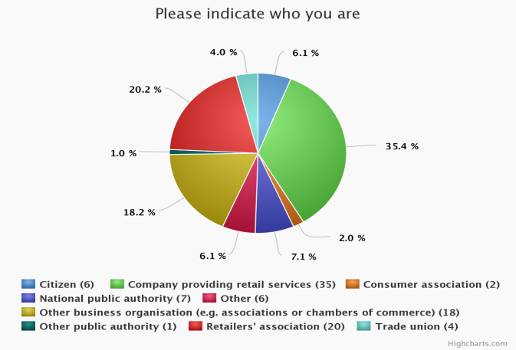

**Place of establishment -Figure 2**

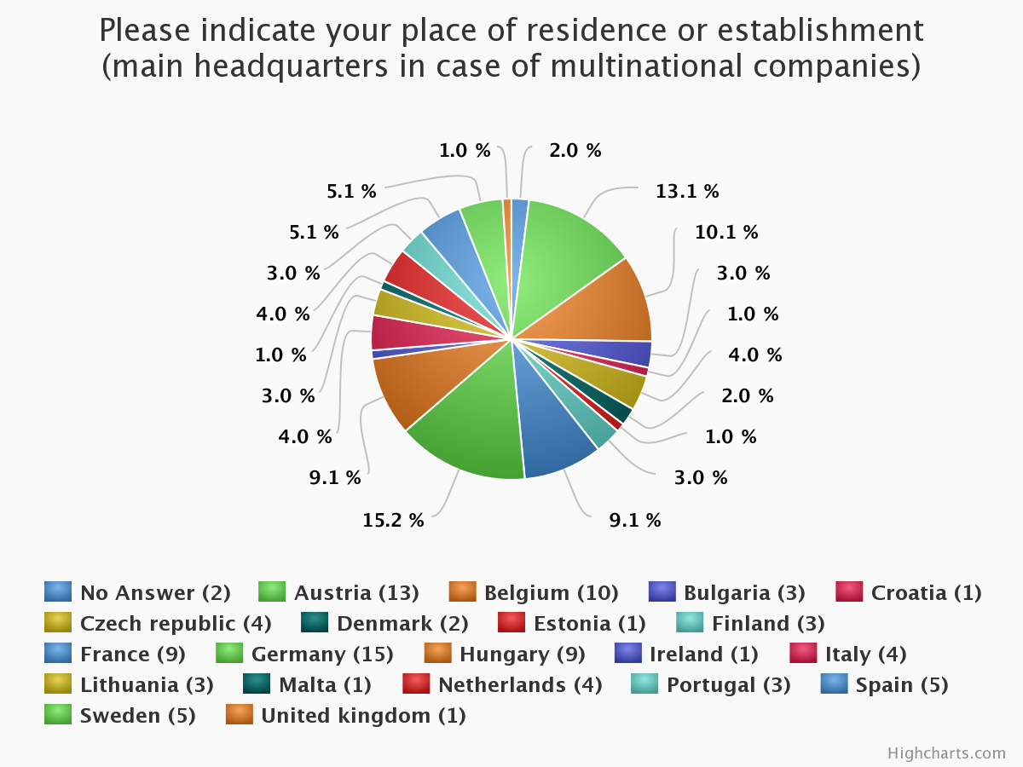

Certain questions were addressed at and limited to particular types of respondents.

Responses to the consultation were voluntary and represent only the views of the respondents. Consequently, they cannot be interpreted as statistically representative of the EU as a whole.

# Analysis of responses

## The changing retail landscape: adapting to a multi-channel environment

All respondents were asked about the impacts of e-commerce. Retailers, retailers' associations, other business organisations, trade unions and consumers confirmed that the sector is undergoing a substantive change due to e-commerce and consumers' evolving expectations. Respondents welcome positively this change.

They stress that e-commerce is dramatically changing **consumer's shopping habits**. The most important change is that consumers can shop at any time and from anywhere.[5] E-commerce brings greater transparency on prices, products and promotions.[6] Quick deliveries directly at home are convenient[7]. E-commerce also increases cross-border trade with consumers ordering from websites located in other Member States. They also stress that the frontiers between pure e-commerce and brick-and-mortar stores are blurring, creating a 'multi-channel' environment.[8]

Some replies indicate that offline retailers, particularly small retailers are facing difficulties to adapt to the digital age developments. Trade unions and chambers of labour express concerns about the consequences of the growth of e-commerce for workers.[9]

Retailers and retailers' associations were asked about the need to **review the regulatory frameworks due to the growth of e-commerce**. Their replies indicate that brick-and-mortar retail is currently subject to more restrictions than e-commerce.[10] Large retail associations emphasize that since many retailers sell both on-line and off-line, it is important to ensure a level playing field for e-commerce and brick-and-mortar retail.[11] Furthermore, they underline that regulatory frameworks should be future-proof and flexible to allow retailers to swiftly adapt to a changing reality.

In their replies, retailers and retailers' associations refer to a broad range of areas.

Some are out of the scope of the open public consultation: taxes, in particular differences in taxation in the Member States and in VAT regimes as well as to the issue of tax avoidance, geoblocking, consumer rules, platforms rules, competition law, product safety, liability of products, labelling and packaging regulations, data issues/privacy and labour law, access to data, unfair competition.[12] Problems of competition and of consumer protection when it comes to products purchased in third countries were also raised.[13]

As regards issues covered by the open public consultation, retailers and retailers' associations mention shop opening hours and urban planning. [14] They suggested that rules on shop opening hours should be modernised for brick and mortar retailers to keep up with competition of on-line retailers. They consider that the urban planning rules should take into consideration the e-commerce dimension and the changing consumer shopping preferences..

Replies also stress that **e-commerce creates opportunities.** Large retailers indicate that e-commerce increases sales volumes, helps them enter new markets and be exposed to more/new customers, makes it easier to grow cross-border, and boosts competition and innovation. Retailer's associations highlight that SMEs are able to grow their business more easily. In that respect, the positive role of platforms is emphasised.

Six public authorities replied to the question on whether the growing of e-commerce played a role in recent reviews of relevant regulatory frameworks. They replied positively but actually referring to the Commission initiatives and not to national legislations. Two respondents refer to national legislative changes (but no further details are provided).

## Facilitating retail establishment in the EU

This section deals with conditions for retail establishment as well as retail establishment procedures. The related questions were asked to retailers, retailers associations and public authorities.

The **regulatory conditions for establishment** often relate to the size of a retail outlet in combination with requirements about the envisaged location in relation to the city centre or products being sold.

When asked about the conditions for retail establishment which create the most important barriers to market entry, over half of the retailers, retailer associations mention at least one of the following concerns:

(i) protectionism and discrimination against innovative business models not commonly found in the country;

(ii) imposed location for new retail outlets;

(iii) difficulties to distinguish between protection of city centres and protection of incumbent retailers;

(iv) product-related conditions;

(v) lack of legal certainty.

Majority of respondents representing the retail sector **called the Commission and Member States to improve conditions for retail establishment**.[15]

They ask the **Commission** to:

* ensure full enforcement of the Services Directive through infringement procedures;
* provide guidance on the compatibility of measures used to regulate retail establishment with the Services Directive;
* ensure a swift adoption of the Commission's proposal on services notifications[16].

They ask the **Member States** for:

* a better/closer association or involvement of retailers in the development of local plans;
* one set of rules applying throughout a Member State;
* guidance to be provided to local authorities;
* greater attention for the effects of online retail on brick-and-mortar shops;
* more flexibility in rental regulations to allow temporary establishment (e.g. pop up stores).

**Retail establishment procedures** encompass e.g. obtaining the necessary permits, contacting relevant public entities, the length of procedures and the transparency of information and decisions.

Retailers and retailers' associations were asked about simplification of establishment procedures. Half of them indicate that retail establishment procedures are too long, too complex and that there is too much uncertainty.[17] One respondent also underlined that competitors often use appeals to unduly delay establishment.[18]

Regarding retail establishment **procedures**, most retailers and retailer associations call on Member States to:

* provide more clarity and predictability;
* introduce short deadlines and sanctions if the deadlines are not met;
* introduce tacit approval when permits/opinions are required from different entities;
* limit the number of impact assessments required, reduce the number of permits required;
* provide justifications when the application is rejected;
* simplify the procedure for SMEs;
* put in place shorter procedures for limited changes or extensions;
* develop a test for appeals from competitors (to avoid abusive appeals);
* introduce phased application procedures to avoid unnecessary costs and work.

All stakeholders were asked in which aspects **online procedures** could help to increase transparency in establishment procedures. The vast majority are largely in favour of using them better and more often, as they improve accessibility and transparency: easier access to the relevant documents, to information (such as decisions whether positive or negative), to the status of individual applications, or online publishing of decisions.[19] Retailer associations indicate that online submission of applications would be particularly important for SMEs. Two retailers' associations insist on the need to allow for direct contact with the authority in charge, in addition to the online procedures[20]. One retailer and one trade federation call for the European Single Digital Gateway to list national and regional establishment procedures.

Public authorities were asked the question on availability of information online. Eight responded explaining that they make a lot of relevant information available, in particular rules on the planning and construction processes.

## Requirements for the day-to-day operation of retail shops

### Shop opening hours

Many Member States apply rules regulating shop opening hours on weekdays, Saturdays, Sundays and public holidays.

All stakeholders were asked what measures on shop opening hours, if any, could be helpful to support retailers and employees, to keep up with e-commerce. The specific situation of small retailers was referred to. Responses from retailers differ between large and medium retailers on the one hand, and small retailers on the other.

Large and medium retailers favour additional flexibility in shop opening hours, or comment positively on Member States which have taken flexible approaches in regulating shop opening hours.[21] They emphasize that a flexible approach help create a level playing field with online retailers and platforms, and help increase the management of customer flows and stock.

By contrast, small retailers and trade unions are critical of more flexible shop opening hours. They state that small retailers do not necessarily have the capacity to have staff available throughout the opening hours allowed by current regulations.[22] They consider that ahead of reforming shop opening hours, authorities should carry out an impact assessment to evaluate the costs and benefits for workers and the society as a whole. A respondent warned of the negative consequences of the liberalisation of shop opening hours on the diversity of retail.[23]

Consumers show mixed feelings. Some state that taking the small retailers' interests into consideration would not benefit consumers, while other consumers believe that respecting and safeguarding the interests of small retailers is quite important.

### Sales promotions and discounts

The focus is on national regulations limiting retailers' freedom to decide on and to advertise or announce end-of-season sales, discounts, end-of-business sales and sales below cost (excluding competition rules).

Authorities were asked whether they consider or had considered the impact of e-commerce when regulating sales promotions and discounts. Four out of eight of them replied positively while the rest did not provide a relevant response.[24]

A question whether sales promotions and discounts influence shopping decisions was asked to all respondents. Consumers, retailers, associations and other business organisations confirmed that e-commerce allows consumers to easily find more information, a wider choice, the best offers and lowest prices for a multitude of products by relying on convenient search tools. As a result, price transparency and competition between and within both online and offline retail has tremendously increased. Furthermore, business organisations and retail associations note that consumers are more and more inclined to look for the most favourable offer beyond their own national markets.

Several responses[25] by large retailers and retailers' associations explicitly state therefore that national rules on sales promotions and discounts have become less relevant for consumers.[26] They say that national restrictions on sales promotions and discounts seem to mainly distort the balance between offline and online retail.

For these respondents, national regulatory frameworks must be designed in a way to allow retailers to determine their own pricing policy for their target markets and consumers. They are of the view that a modern retail environment needs more flexible and dynamic rules to support retailers, especially when they are active cross-border or are considering this step[27].

### Specific distribution channels

Most Member States control the sales of specific products, namely alcohol, tobacco and non-prescription medicines. This can be done through reserving sales to approved outlets, through an authorisation or licensing system or through other means.

The responses of retailers (including pharmacies), retail associations, chambers of commerce and individual consumers[28] focus on restrictions on distribution channels for non-prescription medicines. Retailers and retail and business associations have different views than pharmacists.

Pharmacists and pharmacists' associations from various Member States state that for public health reasons[29], non-prescription medicines should only be sold in pharmacies. The Portuguese association of pharmacies indicate that the reform in Portugal did not produce the expected positive economic effects. [30] In addition, pharmacists and pharmacists' associations warn about the online sale of non-prescription medicines pointing to issue of transportation and the higher risk of counterfeit/non-compliant products.

On the other side, large retailers and retailers' associations[31] indicate that selling non-prescription medicines outside pharmacies would not create any public health risks and, would have positive impact on prices and accessibility. They indicate that specific rules could apply such as selling in a dedicated area and/or under the supervision of a qualified person. Retail SMEs and their association[32] seem however to be reluctant about selling non-prescription medicines outside pharmacies for public health and safety reasons.

Six consumers and consumer associations replied providing mixed views on this topic.

### Sourcing

Restrictions on sourcing refer to **regulations** which limit, directly or indirectly, retailers' possibilities for buy products from anywhere in the EU.

The relevant question was addressed only to retailers and retail associations. Half of the 15 respondents who replied claim that they had encountered regulations concerning sourcing of products.

They mention various national regulations - either adopted or under discussion - which deliberately restrict sourcing. This includes the obligation to source a share of certain products from the national market, or to notify authorities when sourcing products from other Member States, including products already sold in that Member State. Mandatory support or promotion of national supply chains and domestic products are also mentioned.[33]

### Territorial supply constraints (TSCs)

Territorial supply constraints are barriers set by **private parties** that can limit retailers' possibilities to buy products from whom and from where they wish and e.g. by referring them to a specific national subsidiary.

The relevant question was addressed only to retailers and retail associations. Half of the 15 respondents claim that they had encountered or are aware such obstacles. The majority of those who had encountered TSCs state that such practices have negative consequences on their business. The issue appears to arise across a wide variety of products, predominantly branded products, regarding groceries, fast moving consumer goods or medicines.

Retailers and retail associations complain that TSCs deprive them from taking full advantages of the opportunities of the Single Market and undermine their ability to compete, because they cannot source the same products under similar conditions as their competitors established in other Member States..[34] This is fortified by impeding the positive effects that economies of scale for sourcing might offer and by reducing the attractiveness of cross-border activities. Two retail associations state that attempts to purchase products cross-border, e.g. via parallel imports, have given rise to commercial retaliation by individual manufacturers.[35] The issue of dual quality food has also been raised by some respondents.[36]

One main consequence generally mentioned is that consumer prices are higher and in some cases significantly higher, due to higher purchasing prices depending on the respective market. Furthermore, respondents indicate that an artificial division of where to source products from, in the Single Market, leads to a reduction of the overall range of products offered on a given market.

Chambers of labour have also confirmed the existence of TSCs and of their consequences on prices (large price differences for identical products in different Member States).

Some respondents, representing the retail sector or retail associations, indicated that exclusive distribution systems in line with competition law can contribute to the proper functioning of distribution networks. They emphasised that the contractual freedom of manufacturers and wholesalers should be respected.

### Retail-specific taxes

This section relate to retail-specific taxes - exclusively levied on retailers. VAT and taxes on products, such as alcohol, tobacco, energy and sugary products are excluded from the scope of the public consultation.

Retail associations and retailers were asked whether retail-specific taxes apply in Member States where they are present and, if yes, whether different taxation schemes are applied to offline and online retail.

Retailers and retail associations[37] mention retail specific taxes based on selling space, pointing to the fact that online retail is excluded. Most retailers and retail associations that replied mention that even if non-retail specific, property taxes linked to real estate and surface areas or based on the number of sales points, as well as product-specific taxes and advertising taxes fall more heavily on offline retailers.

To a similar question addressed at Member States, 4 of them replied indicating that no retail specific taxes apply on their territory.

Retailers and retail associations were also asked what impact retail-specific taxes have on their cross-border activities. 16 of them indicated that taxes impact their decisions on market entry, investment, costs, profitability, as well as on the competition in the Single Market.

All stakeholders were asked what could be done to ensure that national regulatory frameworks provide for equal treatment between online and offline retail. Four respondents active in the retail sector and 4 business associations indicate that the current VAT regime should be modernised in the e-commerce sector in particular to avoid fraud.

Regarding possible improvements, most of retailers and retail associations (27), as well as 9 other business organisations indicate that:

* there is a need for consistency in tax regimes for online and offline retail. Given that the retail sector considers that its future will combine online and offline sales, any tax that disproportionately affects either of the channels should be reviewed, if not abolished;
* retailers should be taxed in the country where the service or product is purchased;
* online retailers also need to be taxed for their impact on, *inter alia*, local services or infrastructure.

### Compliance burden

The open public consultation asked all stakeholders about possible specific features of retail regulatory frameworks that mostly affect the compliance burden of retailers.

From 31 retailers that responded, 17 did not have an opinion. From 20 retail associations that responded, 5 did not provide their opinion. Among those who expressed their views, most large retailers and retail associations mentioned that relevant EU legislation and differences in its implementation at national level, as well as specific local measures, affect the compliance burden of retailers[38].

The main sources of compliance burden mentioned by retailers include different tax legislations (in particular VAT) across the EU, unfair trading practices laws in certain countries that oblige retailers to adapt their sourcing models and the way they handle their supply chain, disproportionate sanctions applied for minor violations (e.g. expiry of 'best-before dates') and the diverging implementations of the WEEE Directive[39], which create complex administrative and legal barriers for retailers. Disadvantages for offline retailers are also stressed by several respondents (retail associations), as well as the need not to discourage online retailers by putting too large a burden on them.

10 business associations replied, mentioning the following rules as generating compliance burden: opening hours rules, labour law, labelling rules, differentiated tax regimes, advertising law, frequent controls and market surveillance tasks. Two trade unions see no compliance burden.

Other regulations mentioned by the majority of retailers and retail associations as having an effect on the compliance burden are data protection regulations, environmental taxes, consumer rights regulations, packaging taxes/fees, restrictions on sales periods. One large retailer mentioned the burden of audit caused by legislation on the duty of care of parent companies. Long and costly procedures are also mentioned several times. Three retailers and two retail associations stress that the burden is particularly problematic if it affects more heavily SMEs.

Public authorities were asked about difficulties in the enforcement of existing regulations on offline and online retail. In terms of enforcement, three public authorities emphasized that the main difficulties were due to online retailers being registered in third countries.[40]

# Results of other consultation activities

## Workshops and studies

The Commission has engaged in discussions with the stakeholders directly concerned by this action, including retailers, retail associations, representatives of civil society and Member States.

Stakeholders have been consulted on a number of occasions, both in ad hoc meetings and in the context of dedicated workshops.

The Commission hosted two workshops on retail establishment on 8 July 2014 (only with stakeholders) and 3 December 2014 (gathering stakeholders and Member States).

The July workshop gave stakeholders the opportunity to mention the issues on which they would welcome best practices: simplification of procedures including by reducing delays and costs, adopting all-in-one permits[41], reducing abusive appeals against establishment decisions. Participants also highlighted the impact of e-commerce on brick and mortar retail, and the issue of vacant shops, indicating that public authorities need to take this into account.

The workshop of December focused on discussing the results of a study on retail establishment in the 28 Member States[42] commissioned by the Commission. Participants welcomed in particular the section on the economic impact of establishment restrictions.

The Commission also organised two workshops with a particular emphasis on operational restrictions on 8 July 2016 (stakeholders only) and 3 May 2017 (gathering stakeholders and Member States).

In July, the participants highlighted that retail regulations should be non-protectionist, not discriminate between specific groups (*i.e.* by size or home country), reasonable to achieve legitimate goasl, not applied in a disproportionate way and should not prevent retailers from offering consumers the products and services they expect. The growing importance of e-commerce and the way this changes consumers shopping habits (which ultimately also impacts the way brick-and-mortar retailers do business) was stressed by participants.

In May 2017 the discussions focussed on two points: (i) the preliminary results of a study on operational restrictions[43], and (ii) how to assess the economic effects of retail restrictions. Regarding the second issue, the participants stressed the importance of taking into account the costs of compliance. It was also mentioned that particular attention should be paid to the situation of SMEs which face more difficulties in adapting to the digital age and greater compliance costs.

## Consultation of Member States

Member States were consulted through meetings of the Services Directive Expert Group. Regular exchanges of views take place within this Group.

More specifically, on retail establishment, a peer review on national regulations was carried out in 2014 based on detailed questionnaires. Then in 2017, Member States were asked to verify and possibly update the information compiled. In June 2016, Member States were also asked to reply to a detailed questionnaire on operational restrictions.

# Conclusions

This consultation highlights the fact that national retail regulatory frameworks are not fit for a 'multi-channel' environment where retailers need to be able to develop a coherent strategy for on-line and off-line sales. It also confirms the need for all restrictions to be justified and proportionate to the public policy objectives pursued.

The Commission will use the results of the consultations to identify best practices for regulatory frameworks that are fit for both online and offline retail and supportive of a more competitive retail sector as announced in the Single Market Strategy.

1. Communication from the Commission – Upgrading the Single Market: more opportunities for people and business – COM(2015) 550 final of 28.10.2015
2. Legal study on retail establishment through the 28 Member States, <http://ec.europa.eu/DocsRoom/documents/16127>

   The study on operational restrictions is being finalised
3. Directive 2006/123/EC of the European Parliament and of the Council of 12 December 2006 on services in the internal market, OJ L 376/36 (hereinafter "Services Directive").
4. https://ec.europa.eu/info/consultations/public-consultation-retail-regulations-multi-channel-environment_en.
5. As highlighted inter alia by UNI Europa and LBC NVK.
6. Supported by Prof. Doris Hildebrand and the European Healthcare Distribution Association.
7. Opinion of individual consumers and retailers.
8. Besides retailers, this appears to be a strong opinion among trade unions; supported by UNI Europa.
9. Concerns raised by LBC NVK and UNI Europa.
10. , EuroCommerce, Walgreens Boots Alliance and International Council of Shopping Centres and others.
11. Direct Selling Europe, Walgreens Boots Alliance, EuroCommerce and Independent Retail Europe and others.
12. Specifically, Ahold Delhaize, Direct Selling Europe, Dansk Erhverv and others.
13. Detailhandel- NL
14. Direct Selling Europe, SPAR Austria, Swedish Trade Federation, Walgreens Boots Alliance, EuroCommerce, Independent Retail Europe, IKEA Group.
15. Inter alia, Direct Selling Europe, SPAR Europe, Ahold Delhaize, International Council of Shopping Centres, Independent Retail Europe, IKEA Group and others.
16. Proposal for a directive laying down a notification procedure for authorisation schemes and requirements related to services - COM (2016) 821 final – 2016/0398 COD.
17. Supported by International Council of Shopping Centres and others.
18. International Council of Shopping Centres.
19. Independent Retail Europe; Trade Unions such as UNI Europe; also retailers and consumers formulated the same opinion.
20. International Council of Shopping Centres and others.
21. For instance IKEA Group, Walgreens Boots Alliance and others.
22. Indicatively UNI Europa and LBC NVK.
23. See Confcommercio.
24. BM für Wissenschaft, Forschung und Wirtschaft; akkordierte Position Österreichs (Austria); Utrikesdepartementet (Sweden); and 2 other public authorities.
25. International Council of Shopping Centres, Detailhandel, and others.
26. EuroCommerce, Swedish Trade Federation, Detailhandel Nederland and Ahold Delhaize.
27. Handelsveraband Deutschland (HDE) and others.
28. 4 citizens, as well as 2 associations.
29. Need for the consumers to get proper advice, requirements relating to transport and storage, higher risks of counterfeit/non-compliant products.
30. The Portuguese association of pharmacies points to inequalities of access and prices, increase of average price, concentration of the market.
31. For example, Ahold Delhaize, Detailhandel, Finnish Commerce Federation and others.
32. Independent Retail Europe.
33. Supported by retail associations (*inter alia* EuroCommerce, HDE).
34. Particularly, SPAR Austria and Ahold Delhaize.
35. Illustrated by EuroCommerce.
36. SPAR, Ahold Delhaize and others.
37. FCD, EuroCommerce, Independent Retail Europe, IKEA Group, and others.
38. Indicatively, IKEA Group.
39. Directive 2012/19/EU of 14.07.2012 on waste electrical and electronic equipment (WEEE)
40. BM für Wissenschaft, Forschung und Wirtschaft; akkordierte Position Österreichs (Austria) and another public authority; corresponding to 25% of the responses.
41. One permit encompassing all the different permits needed today.
42. [Legal study on retail establishment through the 28 Member States](http://ec.europa.eu/DocsRoom/documents/15154), <http://ec.europa.eu/DocsRoom/documents/16127>.
43. Finalised and to be published at the same time as the Communication.