

|  |
| --- |
|  |

Contents

1. Introduction 3

2. Importance and characteristics of the retail sector in the EU 4

2.1. Economic importance of retail 4

2.2. Digitalisation of the sector 10

2.2.1. E-commerce 10

2.2.2. Digitisation of stores and the supply chain 13

3. How restrictive is the retail sector – Retail Restrictiveness Indicator (RRI) 14

4. Restrictions to the establishment of retail shops 16

4.1. Introduction 16

4.2. Conditions for establishment 19

4.2.1. Conditions relating to size (thresholds) 19

4.2.2. Level of detail in spatial plans 21

4.2.3. Location-specific rules 22

4.2.4. Use of economic data 25

4.3. Procedures for establishment 27

4.3.1. Permits required in the establishment procedure 28

4.3.2. Entities involved in the establishment procedure 30

4.3.3. Impact assessments required in the establishment procedure 32

4.3.4. Length of the establishment procedure 34

4.3.5. Transparency of the procedure for establishment in Member States 35

4.4. Retail Restrictiveness Indicator: results for establishment restrictions 37

4.5. Potential impacts of restrictions to retail establishment 38

4.5.1. Potential impacts on competition 39

4.5.2. Potential impacts on market structure 42

4.5.3. Potential impact on productivity 44

4.5.4. Potential impact on employment 45

4.5.5. Potential impact on innovation 46

4.5.6. Potential impact on consumers 47

5. Operational restrictions 49

5.1. Introduction 49

5.2. Shop opening hours 49

5.3. Product-specific sales restrictions 57

5.4. Sales promotions and discounts 66

5.5. Retail-specific taxes and fees 80

5.6. Sourcing 88

5.6.1. Regulatory sourcing restrictions 89

5.6.2. Territorial supply constraints (TSCs) 91

5.7. Contractual practices of modern retail 96

5.8. Retail Restrictiveness Indicator - results for operational restrictions 100

6. Cost of compliance with regulatory requirements 101

7. Conclusions 105

8. Annex 1: Methodology of assessment of restrictions to retail establishment and operations and values of the Retail Restrictiveness Indicator 107

9. Annex 2: Results of the regression analysis 123

# Introduction

The Single Market Strategy adopted in October 2015 announced that the Commission *"will set out best practices for facilitating retail establishment and reducing operational restrictions in the Single Market. These will provide guidance for Member States to reforms and priority-setting for enforcement policy in the retail sector"*.

Retail and wholesale activities are one of the largest services sector in the European Union. The functioning of the retail market affects the whole economy, because of its size and also because of its linkages with other sectors of the economy. It is also important for consumers who spend 30% of their budgets in shops. Retail brings the Single Market to the EU consumers with a wider choice of products available to consumers.

The digital revolution is dramatically changing the features of retail. This provides opportunities for retailers and consumers but it is also a challenge in particular for traditional retailers, often SMEs which are important players on the retail market. Tomorrow retailing will not be the same as today and multi-channel retail, combining both on-line and off-line, will remain the trend for retail in the coming years..

The assessment of the performance of the EU retail sector shows that there is room for improvement. A better functioning retail Single Market would allow for a more efficient and more innovative retail sector as well as for more competitive consumers prices.

The retail sector is highly regulated in most Member States. This is due to the Member States' willingness to achieve public policy objectives such as the protection of consumers, workers, environment and town and country planning. Often, retail is subject to regulations at national, regional and local level. In the light of the challenges faced by the retail sector, competent authorities need to assess whether their regulatory frameworks are proportionate and effective for the public policy objectives and do not unduly restrict retail development. There is also a need for Member States to check whether national regulations are well-targeted, evidence-based and clearly drafted. Less complex regulations, better awareness of the sector's specificities and policy support would help the retail sector to be flexible and innovative.[1]

The Commission carried out an open public consultation from 17 July to 8 October 2017 to gather the views of retailers, competent authorities, trade unions and citizens and others. Workshops were also held as well as studies carried out. Member States were consulted through meetings of the Services Directive Expert Group. A report documents the consultation activities carried out in preparation of the retail action.[2]

Responses acknowledge the fact that the retail sector is undergoing a massive change due to e-commerce. They also converge to indicate that the trend towards multi-channel retail combining on-line and off-line will continue.

This consultation confirmed that national retail regulatory frameworks are not fit for a multi-channel environment where retailers have to develop a coherent strategy for on-line and off-line sales. It also showed the need to recall that all restrictions should be justified and proportionate to the public policy objectives pursued.

The purpose of this document is to provide the background and evidence that underpins the Communication on a European retail sector fit for the 21st century (hereinafter referred as 'the Communication'). It presents detailed information on particular types of restrictions affecting the retail sector in Europe, their characteristics, justification, scope and scale, as well as their impact on the actual functioning of the sector. Those details form the basis for the best practices put forward in the Communication. They show various approaches adopted in particular Member States, and help to point to good practices.

# Importance and characteristics of the retail sector in the EU

## Economic importance of retail

Retail is the biggest sector in the EU non-financial business economy in terms of number of enterprises and persons employed. It alone represents 4,5% of value added (gross value added, 2015) and 8,6% of employment.[3] Its importance is even more visible when combined with the wholesale sector. The two together produce 10% of EU value added and employ 13% of the total workforce. Retail is also very important for youth employment (around 13% of retail employees are in the 15-24 age range). For many, this is the first job - from all young people employed, 21% worked in retail and wholesale, compared to 14% of people between 25 and 49 years old and 12% for people between 50 and 64 years old.[4] Work in retail can often be combined with other activities, such as studies or household care. This is particularly important for women, who work part-time more often than men (75% of all part-time workers are females), and they account for 63% of those employed in retail companies.

Nearly 5,5 million (23% of all non-financial business economy) companies are active in the EU retail and wholesale sectors (3,6 million in retail and 1,8 million in wholesale, 2015). Most of them are SMEs, which also generate 66% of the sectors' value added and 70% of employment. For all SMEs active in the non-financial sector, 22% of value added comes from retail and wholesale enterprises (compared to 20% by manufacturing and 11% by construction firms, 2015).[5] Running a shop seems to be the most common type of a family business – the number of SMEs per 100 inhabitants was largest in distributive trades and accounted for 1,2 company on average in the EU.

Retail is also closely linked with other sectors of the economy. Its links with the wholesale sector are obviously strong, as are its impacts on the performance of manufacturers of certain products (designed for final consumption), farmers, as well as providers of relevant services, including transportation and logistics, and other business services. The importance of those linkages can be well illustrated by the fact that one of the toughest negotiations happen along the supply chains for different products, when suppliers meet with retailers, and the relations between those parties are often very dynamic. Those linkages with other sectors are however not easy to measure. For example, the value of goods and services purchased for resale in the same condition for the retail sector accounted for 1, 98 trillion EUR (in 2015, EU28)[6], which was 69% of the sector's turnover (2,88 trillion EUR).[7] Another approach looks at the value added being traded between sectors and between countries, and the importance of regulations embodied in one sector for another sector's outcomes. An analysis carried out from this perspective by the Commission[8] concluded that regulatory restrictions in retail account for as much as 32% of all services market related restrictions that are carried over to other sectors. Reducing restrictions in retail would also have positive spill-over effects in other sectors of the economy, in particular upstream in manufacturing. More efficient retail sector and lower consumer prices create more demand and steer it towards more innovative products. More competitive retail can also increase its demand for information technology products and services.

There are different types of retailers on the market. Grocery retailers provide the largest part of retail turnover, from 40% in Austria to 60% in Romania. Among non-grocery specialists, apparel and footwear generate from 4% (Estonia and Finland) to 10% (Italy) of retail sales. Similar relative cross-country differences can be noted for other brick-and-mortar specialist retailers, such as for example health and beauty, home and garden or electronic appliances traders.[9] Those variations often reflect the particularities of market structures – in some countries specialist retailers are still more common whereas in other, clothes, cosmetics or electronics are bought more often in larger grocery outlets or, in particular in the last years, on the Internet.

Finally, retail plays a substantial role for consumers. Expenditure on goods that are normally purchased from retailers accounts for ca. 30% of household budgets (out of which 16% on food and non-alcoholic beverages, 5% on clothing and footwear, over 2% on furniture and household appliances).[10] The average amount spent yearly by a household on goods distributed by retailers ranges from over € 18 000 (Ireland) to € 3 500 (Bulgaria). This expenditure decreased in some countries (Greece and Italy, where between 2012 and 2016 it fell by 2% yearly) and increased in other (Romania +8%, Estonia and Lithuania +6% of yearly growth in the same period).[11] The last three countries also recorded the most dynamic growth of sales in absolute value terms as well as per capita.

The amounts spent, both per household as well as per person (figure 1) depend to a great extent on the level of prices, size of the household and the disposable income, and it is correlated with the GDP per capita. As the recent Consumer Markets Scoreboard reports, price levels in general are strongly positively correlated with income per capita, however price levels for goods are less dispersed in the EU than for services, and they also converge more with time.[12] This might indicate that, in relative terms, consumers in less affluent countries spend more on basic goods (such goods compose a larger share of their household budgets).[13] In any terms, retailers are definitely present in the day-to-day lives of millions of Europeans, and the accessibility of shops, their offer and the extent to which it responds to consumer needs have a real impact on the quality of those lives.

*Figure 1: Value of retail per capita and its correlation with the GDP per capita*

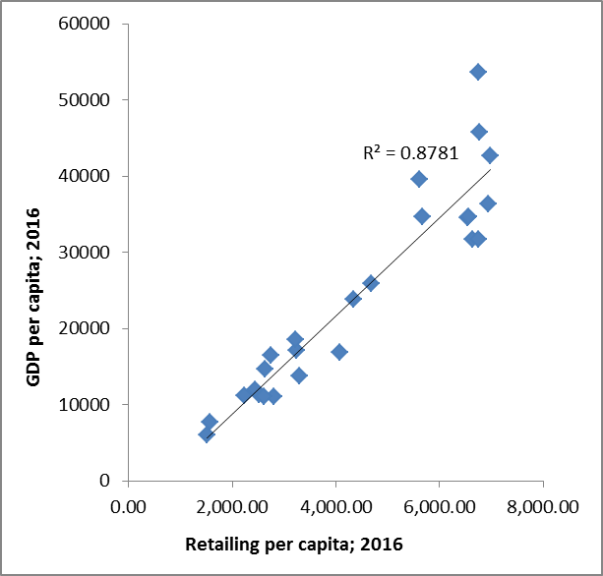

*Source: Euromonitor and Eurostat data*

The performance of retail companies matters not only for those companies themselves but also for the whole economy and for consumers. Establishing good regulatory and other conditions helps retailers to remain competitive and grow, which is a key objective for most of them. Currently, the sector does not belong to the most productive ones. Firstly, the wage-adjusted labour productivity in retail at 125 (for EU28 in 2015) was lower than in wholesale (153), transportation and storage (147) and in manufacturing (153). It was however at similar level as for professional/scientific and technical activities (121) and construction (125). Secondly, the average productivity level of European retail was lower than in the US (although the difference seems to be almost negligible and might stem from differences in measurement and in economic structures)[14]. And thirdly, it has been rather stable in the last years, compared to the US, where it grew significantly[15] or Canada, Japan and Australia, where it also increased however less dynamically[16]. In addition, in majority of Member States, the allocative efficiency in retail has been negative in the last years[17], i.e. productive factors have not been allocated towards their most efficient use.

Compared to other services sectors, retail shows relatively low profitability (figure 2) and a high rate of companies' births and deaths (figure 3), mostly due to the constant need of retail businesses to adapt to market conditions in order to remain competitive and survive. However, both profitability and market dynamism vary significantly among Member States, indicating that there is a margin of improvement of less well performing countries.

*Figures 2 and 3: Gross operating rate and churn rate in retail*

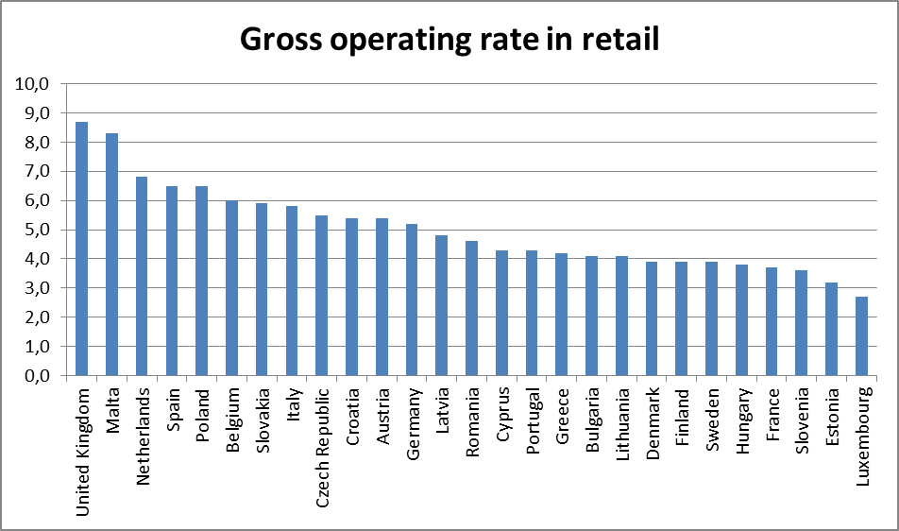

*Source: Eurostat, 2014.*

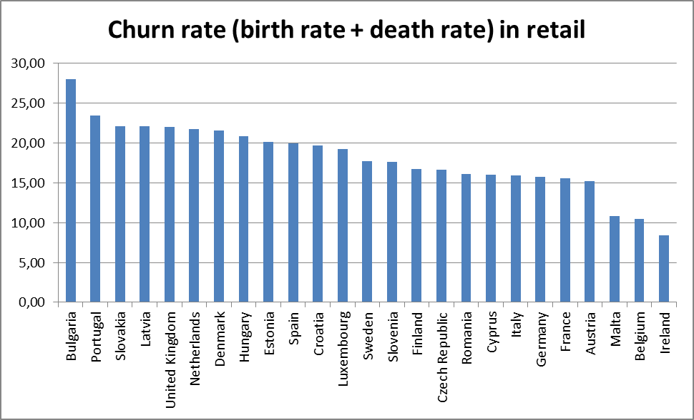

*Source: Eurostat, 2014.*

Innovation in the retail sector, one of the key elements of competitiveness, is difficult to capture. This is because retailers and wholesalers place emphasis on less tangible forms of innovation, such as new business models or processes. A key driver of innovation is the ongoing trend towards digitisation. The retail sector appears to be investing more heavily than all sectors on average in ICT management tools such as electronic supply chains management (24,2% of retail companies against 16.8% for the EU average for all sectors) but remains behind on advanced ICT tools such as cloud computing services.[18] More detailed information on the digitisation trend is presented in section2.2. According to another survey, 74% of retail companies introduced at least one innovation, mostly new or better goods and services, and new or better marketing strategies. However, compared to other service providers and other sectors in general, a smaller proportion of retailers said they invested in any innovation activities (68% compared to 76%). Those that plan such investment in the future would focus on marketing strategies, goods and services, and the main reason for this would be increased competition. A major problem for the commercialisation of retailer's innovative goods or services was the domination of market by established competitors.[19]

Improving performance, productivity and competitiveness is a constant challenge for retail companies. Scaling up seems to be the answer. It allows retailers to be more efficient, remain profitable and develop. The starting point for their development is the domestic market, however it is the cross-border expansion that is the condition to actually build scale.

Due to its cross-border dimension, the sector is also important for the Single Market integration. Brick-and-mortar retail is characterised by a dynamic cross-border expansion of large and medium-sized companies establishing in other Member States. All ten biggest retail companies in the EU are multinational and some of them have shops in the majority if not all of the 28 Member States. Physical premises with foreign-owned banners are established in each Member State however their share in turnover varies from 8 % in Germany to nearly 50% in Latvia (in 2012, figure 4).[20] These are usually large European companies - their share in the number of retail companies is much smaller than the shares in turnover or in value added and the number of persons employed. Foreign retail companies seem to also pay higher salaries than the domestic ones (their share in personnel cost is higher than the share in the number of persons employed), which may indicate that they hire more skilled workforce.

*Figure 4: Turnover generated by domestic and foreign-controlled enterprises in the store-based retail market*

*Source: study carried out for the European Commission by the EMLE (University of Rotterdam); 2018; calculations based on FATS. No data for Belgium, Cyprus, Estonia, Greece, Luxembourg and Malta.*

European retailers are also present globally and four of them (from Germany, France and the UK) are ranked among the ten biggest world retail companies.[21] This picture is changing with the development of multichannel sales – a non-European Internet retailer joined the world top 10 recently, replacing a European brick-and-mortar company.

As retailers are expanding to foreign markets, the regulatory environment that they have to deal with, its complexity and cross-border differences, are crucial to the success of such cross-border investments and operations, in particular for smaller companies. Regulations impact the company's performance and its position in the national market in the first place, and only when the company reaches a certain potential and a stable position there, it can enter a foreign market, provided it can overcome the barriers and fulfil the requirements it faces abroad.

The development of e-commerce has made it possible to reach out to foreign customers without the need to invest in physical premises.

## Digitalisation of the sector

### E-commerce

*Growth of on-line sales*

The growth of e-commerce is one of the key trends affecting the retail sector. The value of on-line sales practically doubled between 2012 and 2017 from €121 bn to €224 bn (figure 5). Mobile sales are quickly becoming an essential part of the e-commerce market: sales through mobile phones, or "m-commerce", accounted for 29% of on-line purchases of goods in 2017, up from only 8.5% in 2012.[22] Products most commonly sold on-line include clothes and sports goods (purchased by 64% of e-buyers in the last 12 months in 2017[23]), household goods (46%), books, magazines and e-learning material (36%) and electronic equipment (25%). However despite this strong growth, the share of goods sold on-line is still only a small part of the retail market. In 2016, on-line sales only accounted for 8% of retail sales, growing from 2% in 2006.

*Figure 5: Value of EU retail sales by sales channels*

*Source: Euromonitor Passport database*

*Use of on-line sales channel by retailers*

While most EU retailers (63%) now have their own website, the share is still lower than most EU companies (77%). 22% of retailers sold on-line in 2016, a share which has been steadily increasing from 13% in 2011. But this does not mean that EU retail companies are not present on-line. European retailers are more likely than other EU companies to use social media (51% of retailers against 47% of EU companies), and slightly more likely to pay to advertise on the internet (26% of retailers against 25% EU average). SMEs are also likely to use on-line platforms as their first means of accessing on-line markets. According to a recent Eurobarometer survey[24], more than four in ten companies use on-line marketplaces to sell their products and services (42%).

E-commerce also offers SMEs the possibility to expand their activities across borders. In 2015, 19% of companies in the retail sector sold on-line, against 17% for the EU economy as a whole. This share has been steadily increasing since 2010, when it stood at 11,7%.[25] Over 40% of European on-line buyers purchase products from abroad at least once a year[26] and nearly 2 out of 3 have bought cross-border at least once in their life. And the potential of e-commerce is significant – between 2012 and 2017, the turnover it generated in the EU grew on average by 11.5% yearly[27] in absolute terms, and the e-commerce share in total retail turnover also grew by 1-2 percentage points yearly on average. However the share of e-commerce in total retail varies greatly between Member States: it accounts for 1.7% of sales in Croatia and almost 16% in Denmark.[28]

*Cross-border sales*

On-line sales are a powerful enabler for cross-border integration. E-commerce increases the choice offered to consumers by giving them access to traders that do not have a physical presence in their own country. Of the consumers that bought on-line in the last twelve months in 2017, 42% bought from sellers in another country. The willingness of consumers to buy on-line from traders located abroad appears to be even higher: according to a recent study[29], 31% of consumers who never bought on-line from sellers located in other countries are ready to do so in the future. This proportion rises to 61% in Poland.

However EU retailers appear to only be slowly grasping the opportunities offered by internet sales. In 2017, only 10% of retailers sold on-line to customers in other countries – only slightly more than the economy-wide average of 9%. As a result, EU retailers also make less money from on-line sales than other types of companies. E-commerce only represented 10% of retailers' turnover in 2017, against 18% for the rest of the economy.[30]

*Barriers to operating on-line*

Overall, a significant share of on-line sales is carried out by retailers operating brick-and-mortar shops. 44% of on-line sales are carried out by physical retailers operating outside of on-line platforms,[31] and further shares of sales are made by traditional retailers selling through on-line marketplaces. The main barriers to selling on-line are related to high delivery costs, expensive guarantees and returns, lack of awareness of rules to follow, insufficient speed of the Internet connection, and other issues.[32] Nonetheless, for these companies established first as physical entities, barriers related to establishment and day-to-day operations will remain important determinants of growth and efficiency.

In addition, traditional retailers are not the only ones operating across sales channels. Sales through on-line-only retailers account for over half of all on-line sales (56% of all internet sales of goods in 2017, up from 50% in 2011) – figure 6. Brick-and-mortar retailers that sell on on-line platforms on-line marketplaces account for a large share of sales (36% in 2015).

*Figure 6: Share of on-line-only retailers in retail sales*

*Source: Euromonitor Passport Database*

However these on-line-only retailers are increasingly opening up physical shops to cater to consumers that wish to handle products or ask for advice before buying, or obtain their product immediately. According to a recent competition inquiry, 8% of respondents to a survey of on-line-only retailers report that they plan to open a brick-and-mortar shop within the next two years.[33] To allow these new hybrid business models to grow, seamless requirements for establishment and daily operations will therefore be important.

In addition, it will be important to clarify how retail-specific rules apply to e-commerce. In a recent survey carried out by the European Commission, national authorities explained that in most cases, rules concerning daily operations in retail – such as rules on promotions and sales – also apply to e-commerce. Furthermore, e-commerce specific rules exist which may affect the growth of on-line sales: certain countries require e-commerce sellers to establish a local website, which in some countries such as Germany requires a physical establishment. In Italy, a license is required from local authorities to start trading on-line. Whereas it is unclear if and how these rules are enforced, these elements add to the legal uncertainty for retailers.

### 2.2.2. Digitisation of stores and the supply chain

E-commerce is only one aspect of the increasing digitisation of the retail sector. Retail business processes are increasingly digitised and automated from the supply chain onwards. The share of retailers that report that their business processes are automatically linked to those of customers or suppliers is higher than the EU average (27% vs 18% of companies). A majority (59%) of retailers use Big Data[34] to optimise their processes – a higher proportion than the EU average of 45%. The use of Big Data extends to on-line sales. According to the Commission's e-commerce sector inquiry, the use of price-tracking technologies is widespread. 53 % of the respondent retailers track the on-line prices of competitors, of which 67 % use automatic software programmes.[35] Technology is also used in-store to respond to the demands of digitally-savvy customers. Shops increasingly offer free wi-fi, touch-screens, or develop mobile apps that can be used to facilitate in-store purchases.

However, many small retailers are still at the early stage of technology usage. There are inherent barriers for technology driven innovation for small retailers including: lack of awareness, difficulty in raising finance, limited availability of expert labour, lack of time to gain new skills, marginal room for risk, as well as regulatory constraints and requirements. Barriers to the adoption of new technologies are arguably higher for small businesses: while large retailers are able to attempt and fail with a new concept without going out of business, small retailers' scope for failure is much more limited.

The use of new technologies and innovation has been linked to increased productivity and growth.[36] Such developments could therefore contribute to improving the performance of the retail sector. Public support can provide resources and expertise to reduce the risk of failure in adopting new technologies, which can be crucial in enabling small retailers to adopt technologies to modernise their business. The Commission is publishing a guide for fostering the revitalisation and modernisation of the small retail sector.[37] This primarily targets the practical actions local authorities can take to tailor initiatives, gathered from across Europe, to encourage small retailers to embrace technological changes and use them to modernise and revitalise.

# How restrictive is the retail sector – Retail Restrictiveness Indicator (RRI)

The retail sector is highly regulated in most Member States. Often, retail is subject to regulations at national, regional and local level. When they restrict the freedom of establishment or the free provision of services in the retail sector, Member States need to ensure that their rules are compatible with the EU law. In particular, because they are discriminatory or are in other ways particularly restrictive, certain requirements have been prohibited by the Services Directive (Article 14). This is the case of economic need tests and involvement of competing operators in the decisions of competent authorities, which are particularly relevant for the retail sector. Other types of requirements can be justified by public policy objectives (Article 15 of the Services Directive). In certain cases, requirements can only be justified on the basis of limited public interests enumerated in EU law (e.g., under Article 3 of the E-commerce Directive and Article 16 of the Services Directive) Furthermore, even to the extent that a public interest can be invoked to justify a restriction, Member States must comply with the principles of non-discrimination, proportionality and legal certainty.

Retailers face establishment restrictions when they seek to open a shop. They also encounter operational restrictions influencing their day-to-day business activities.

Selecting the right location for retail development and the timely start of operations are decisive for business success. Retail establishment restrictions may significantly affect the possibility to open a shop or hinder the development of specific business models or store formats. This document covers both retail establishment conditions and procedures for establishment.

Also operational restrictions may have a negative impact on the daily operations of retail companies. They sometimes become a significant burden for businesses affecting their efficiency, productivity and the quality and price of products offered.

This document examines retail-specific regulations. With the exception of territorial supply constraints, the focus is on regulations put in place by competent authorities and not restrictions created by the behaviour of private operators.

The existing regulatory frameworks have been designed for brick-and-mortar retail. However, e-commerce is growing at double-digit figures in the EU each year and its share in the value of total retail sales is increasing each year.

Since 1998 the OECD has regularly assessed the restrictiveness of regulations governing the retail companies through the product market regulation indicator (PMR). The Commission services attempted to measure the level of restrictiveness of restrictions imposed on the retail sector across the EU with the use of a composite indicator – the Retail Restrictiveness Indicator (RRI). It combines a number of indicators covering key areas of regulatory requirements concerning retail establishment (the establishment pillar) and operations (the operations pillar) - figure 7. It goes further than the OECD indicator to try to better capture the complexity and diversity of the regulatory frameworks in place in the Member States. This will allow comparison between Member States, monitoring of the developments over time and should induce a positive dynamic leading to more open and competitive retail markets.[38]

*Figure 7: Components of the Retail Restrictiveness Indicator*

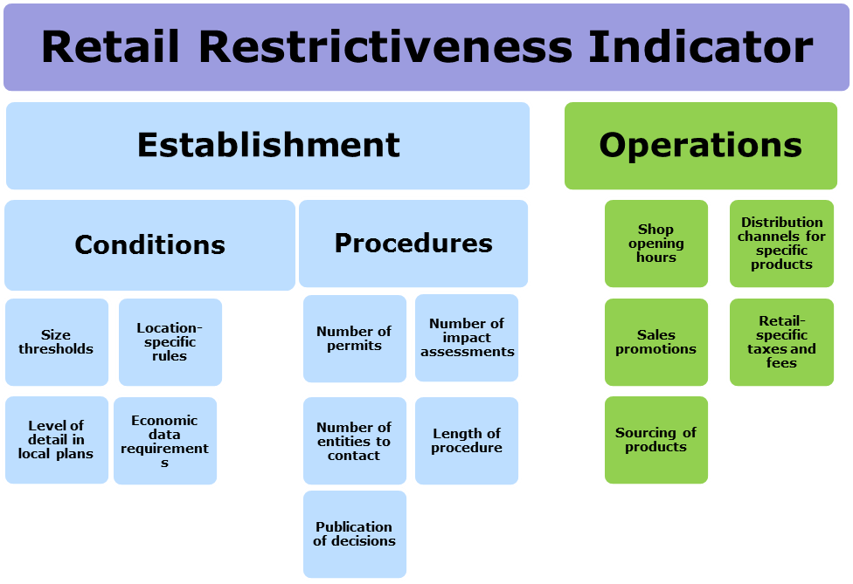

In the overall RRI composite indicator, the part of the indicator covering issues linked to retail establishment (opening of new outlets) has been given a higher importance (60 %), as compared to the part reflecting restrictions to operations (40 %). The methodological details of this exercise are explained in the Annex 1 to this Staff Working Document. They have also been consulted with Member States within the Expert Group on the Services Directive.[39] A relevant statistical assessment of the RRI framework has been carried out by the JRC Competence Centre on Composite Indicators and Scoreboards (COIN).[40]

Figure 8 below presents the overall results for all EU countries, for the end of 2017[41]. Those with stricter requirements were given higher scores. Detailed results for the establishment and the operations parts are presented in dedicated sections of this document.

*Figure 8: The Retail Restrictiveness Indicator*

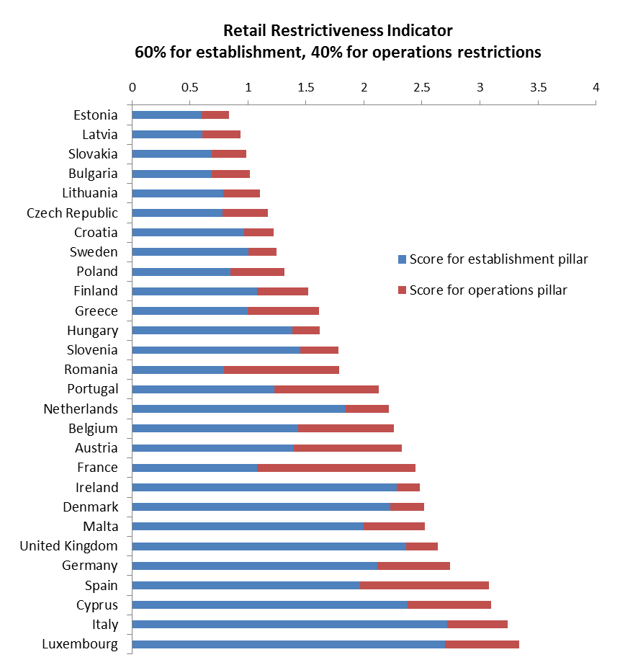

*Source: own calculations based on information collected from Member States and through dedicated studies*

Although the indicator helps to illustrate the restrictiveness level and compare it across the EU, it has its limitations and the results should be viewed in a broader perspective. In particular, information behind the overall values of the RRI and the values for particular indicators can be informative for identification of best practices as well as areas where countries could still improve.

# Restrictions to the establishment of retail shops

## Introduction

Opening new shops is a retailers' way to develop and build scale. The choice of the right format, and hence the right size of a shop is a key element of the decision taking, as is the shop's location and the timely start of operations.

The Commission services carried out an extensive fact-gathering exercise regarding retail establishment both as regards conditions and procedure for establishment. Throughout 2014, the Commission services together with the Member States carried out a peer review of retail establishment regulatory frameworks in the Member States. This exercise was supported by a dedicated study[42] and complemented by two workshops[43] . In addition, some of the questions asked in the open public consultation related to this issue.[44]

Most Member States regulate retail, including the establishment of retail shops. Very often, retail establishment is regulated at regional and/or local level. Retailers enjoy the freedom of establishment and the free movement of services as enshrined in the Treaty and in secondary law such as the Services Directive.[45]

The following provisions of the Services Directive are particularly relevant for retail establishment:

- Articles 9 and following regulate the conditions for authorisation schemes.

- Article 14 prohibits certain particularly restrictive requirements such as economic needs tests;

-Article 15 states that certain other requirements such as territorial restrictions have to be non-discriminatory, duly justified and proportionate.[46]

To the extent that the Services Directive, the E-commerce Directive or other EU secondary law is not relevant, the fundamental freedoms apply, so that restrictions are prohibited unless they are non-discriminatory, justified on the ground of an overriding reason of public interest, proportionate and compliant with legal certainty.

Certain requirements are as such prohibited and may not be justified (e.g. under Article 14 Services Directive). In certain cases, requirements may only be justified on the basis of limited public interests enumerated in EU law (e.g., under Article 3 of the E-commerce Directive and Article 16 of the Services Directive). Furthermore, when setting up authorization schemes and procedures Member States must comply with a number of detailed prescriptions set out in Articles 9-13 Services Directive, which constitute full harmonization and therefore leave no margin of manoeuvre for Member States. Other types of requirements (Article 15 of the Services Directive) can be justified by public policy objectives and Member States enjoy a margin of discretion, which is however limited: Member States must justify these restrictions on the ground of legitimate public interests such as town and country planning, protection of the environment protection of consumers. Such objectives are legitimate and have been recognised as such by the Court of Justice of the European Union (ECJ).[47] These objectives cover a wide range of Member States concerns such as urban planning, maintaining vitality of city-centres, social housing policy, reducing environmental impact and traffic. The protection of cultural heritage is also an objective invoked by Member States to justify restrictions. By contrast, purely economic public interests, such as ensuring the profitability of an undertaking or a class of undertakings or the promotion of the national economy or its proper functioning, can never be invoked by Member States to justify a restriction to the fundamental freedoms.[48]

As indicated above, Member States have a margin of discretion in regulating the retail sector. However when exercising this power, they need to respect EU law and in particular, the freedom of establishment and the free movement of services, including Services Directive.[49] The ECJ confirmed that retail is a service and as such falls within the scope of the Services Directive.[50] The ECJ confirmed[51] that the Services Directive applies to retail establishment irrespective of the way Member States regulate retail establishment, whether through an authorisation scheme or through town and country planning. The ECJ stated in its judgment that the Services Directive allows public policy objectives to be duly taken into account and that Member States have a margin of discretion in the way public policy objectives are fulfilled. However, to be compatible with the Services Directive, Member States need to ensure that regulatory requirements relating to retail establishment are not only justified by an overriding reason relating to the public interest, but are also proportionate.[52]

Within the EU, retail establishment is regulated in very diverse ways. Some Member States provide for a retail establishment authorisation while others regulate retail establishment through planning. In some Member States the two ways may co-exist. Irrespective of the way Member States regulate retail establishment, these rules fall within the scope of the Services Directive.[53]

Under the Services Directive, clear and transparent criteria regarding establishment or free provision of services are important for retailers in order to have legal certainty. In addition, procedural aspects also play an important role. In practice, retail establishment procedures are often long, complex and not transparent. The time it takes to start operations can be delayed by many procedural obstacles. Such delays have a negative impact on the viability of a project – which was designed in a specific market setting – and cause significant costs.

The following chapters provide information on the conditions of and procedures for establishment in the Member States.

## Conditions for establishment

Usually, specific conditions must be met for establishing a new shop. These conditions vary across Member States depending on the size of the shop and on the intended location.

The following sections explore in more detail the rationale and consequences of these conditions.

The information presented reflects the state of play at the end of 2017. Important changes introduced later and brought to the attention of the Commission have also been taken into account.

### Conditions relating to size (thresholds)

Large shops are appealing to consumers who search for a wide choice of products and lower prices. By contrast, small shop would attract consumers looking for convenient and quick shopping, and possibly a more personal contact with the retailer.

Large premises usually mean economies of scale, higher productivity and efficiency. Where retail margins for mass products (fast moving consumer goods, clothing, etc.) are rather low, retailer profits depend on the scale of the turnover. Also, for some specific voluminous products (e.g. furniture or large household appliances) retailers simply need sufficient selling space to display their offer. On the other hand, small shops often apply higher margins and can be more suitable for less populated areas, and for niche products or products that require good customer service and dedicated shop assistants.

Member States often apply different rules to retail establishment projects depending on the size of the planned retail shop (size thresholds). Retailers take the thresholds existing in Member States into account when planning new openings. These thresholds have the effect of artificially shaping the retail landscape. They act as market entry criteria making more difficult or prohibiting the entry on the market of retailers with innovative or new business models not foreseen when the thresholds were set.

Member States justify setting size thresholds for retail shops on the ground of public policy objectives such as environment protection, consumer protection and town and country planning. Shops of different sizes have different impacts on the area. Large outlets have a greater impact on the local environment and usually create more traffic. They can also change the market conditions for consumers as well as for existing operators, create new jobs and bring revenues to local budgets. A small shop usually has a smaller impact, however, a group of smaller shops can have an impact on the area and the local population compared to one larger outlet.

It appears that in most Member States, there is no reliable methodology to define the thresholds. Many authorities simply apply commonly accepted statistical definitions[54], whereas the level of thresholds should be based on objective, transparent and non-discriminatory criteria.

#### Regulation in Member States

Thresholds are very different from one Member State to another. Through thresholds, Member States draw the line between large retail outlets and small retail outlets. In some cases, Member States add other thresholds to define medium retail outlets and extra-large retail outlets. In consequence, the definition of extra-large, large, medium or small retail outlets corresponds to very different situations depending on the Member State. In addition, in some Member States, different thresholds may apply depending on the part of the country where the retailer wishes to establish. This is the case in particular in Member States where retail falls within the competence of regional or local authorities.

The consequences of falling in one or another category vary. Depending on the Member State, it triggers the need to apply for a special retail authorisation, to fulfil additional requirements or provide impact assessments. There may be a ban on establishing above a certain threshold. Thresholds may also determine the authorities competent to deal with the establishment planned.

For example, in Belgium[55], Luxemburg and Hungary the threshold is set at 400 m². Retailers planning to open a shop that is below this threshold would be required to notify the authorities (on top of a usual building or planning permit if such is required for any construction of this size). For a shop above this threshold, they would need to apply for a special retail authorisation.

In Italy, the threshold may even be lower: 150 or 250 m² depending on the area/region. In Spain, where the thresholds are set by the Autonomous Communities, the lowest is 500 m², the highest amounts to 4000 m², whereas the most common one is set at 2500 m². The French authorities have set the threshold for retail authorisation at 1000 m². In Portugal, it depends on whether the retailer intends to build a stand-alone shop (2000 m²) or whether the shop is part of a shopping centre, in which case only shops above 8000 m² would need to be specifically authorised.

Apart from the retail authorisation, some authorities also apply special criteria for large retail shops, such as additional impact assessments or permits from several public bodies, or in general more complex procedures.

In Belgium, retailers have to provide an additional impact report if the planned shop is larger than 1000 m² and an impact assessment if it exceeds 4000 m². In Italy, for shops over 1500 m² or 2500 m² (depending on the region), a prior governmental approval is required.

In Austria and Germany, shops with floor surface above 800m² are subject to an in-depth scrutiny by authorities. In the UK, retailers planning a shop above 2500 m² outside city centres need to undergo a specific procedure. In Cyprus, the authority in charge is different depending on whether the shop surface is below or above 1500 m². In Finland, a retail project above 4000 m² needs to be included in land use plans, whereas in Poland a project of 2000 m² or more is allowed only if the plot is covered by the local plan defining the zones suitable for large shops.

The strictest rules in place forbid operators to build an establishment above a certain size in a certain location. In Denmark, grocery shops cannot be larger than 1200 / 3900 / 5000 m², depending on the location. In Ireland, similar conditions apply to shops above 3000 / 3500 / 4000 m², depending on the region.

### Level of detail in spatial plans

Prohibited restrictions such as economic tests must be abolished by Member States, regardless of where they are set out (in spatial planning rules or elsewhere). Beyond that, rigid planning limits considerably the possibilities to locate shops in zones which are nevertheless dedicated to commercial activities. It may make it more difficult or prohibit the entry to the market of retailers, in particular with innovative or new business models not foreseen when the plans were set.

This is particularly detrimental for large retail shops which, because of their size, will face more difficulties to establish. Member States must prove that such restrictions are non-discriminatory, justified on the basis of an overriding reason of public interest and proportionate. The principle of proportionality may require in certain circumstances that Member States while pursuing legitimate public policy objectives, allow for derogations to planning rules.

The principle of proportionality is also important for the change of use of premises. If the plan allows for a commercial use in general, it is easier for owners or tenants to change the use of premises, for example from a bank to a shop. Such flexibility helps in filling vacant premises in city centres.

In certain Member States, the authorities specify spatial plans with a high level of detail. The specifications can be set out at a more general or more detailed level. The local spatial plans may:

* refer to "commercial use"
* refer to "retail use" or distinguish between food and non-food retail or between small and large shops
* specify the type of products that can be sold (for example furniture shops, DIY, etc.)
* introduce further requirements

The level of detail of the urban plans has an impact on the flexibility of retail establishment and on the structure of the market. That must be taken into account in the proportionality analysis.

***Regulation in Member States***

In most Member States[56], local plans indicate zones dedicated to the "commercial use", which makes such zones open for a wide range of businesses, including retail, food and drink services, financial services, crafts, etc. Similarly, the decisions issued in those countries refer to the "commercial use" too.

In Germany, the Netherlands, Slovenia and Spain, local plans distinguish areas which can be used for retail specifically. In Greece, Italy, Lithuania and Poland, plans also separate areas where large and small shops can be built, whereas in Belgium (Brussels and Wallonia) plans distinguish between food and non-food retail outlets. Finally, the most prescriptive approach to local plans has been observed in Flanders (Belgium), Denmark and Luxemburg, where the types of goods to be sold are specified (going beyond the distinction between food and non-food products), as well as, in some cases, the maximum possible floor space.

The above classification refers to simplified concepts, to allow comparisons between differing national systems – figure 9.

*Figure 9: Level of detail in local spatial plans*

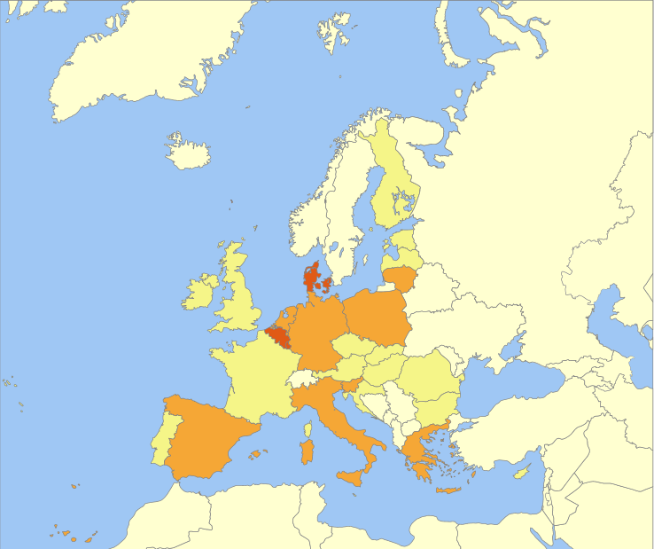

 plans may refer to e.g. types of goods that can be sold

 plans usually refer to "retail use" or designate areas for larger shops

 plans usually refer to "commercial use"

*Source: based on information collected from Member States and through a dedicated study*

### Location-specific rules

Selecting the right location is decisive for business success. However, prohibited restrictions such as economic tests must be abolished by Member States, regardless of where they are set out (in location-specific rules or elsewhere). Beyond that, by introducing or keeping location-specific rules Member States restrict the freedom of establishment, so that they must prove that they are non-discriminatory, justified on the grounds of an overriding reason of public interest and proportionate. In particular, keeping city-centres vibrant is a concern in many Member States. Vacancies of shops in city-centres are becoming more and more frequent and in certain Member States are taking alarming proportions. Whereas this is a legitimate public interest which the Commission shares, Member States must carry out a detailed proportionality test also for those requirements, as is required in the case law.[57]

In France, on average, the percentage of vacant shops was 7.2% in 2012 and is 11.7% in 2017.[58] In the Netherlands, on average, more than 9% of total shop floor area was unoccupied in 2015 and the percentage has been on the rise since 2008.[59] Across the UK, store vacancy rates have increased from 5.4% in December 2008 to 14.1% in March 2013, a rise of 161%. Without intervention, the vacancy rate can rise yet further, perhaps above 20%.[60]

Maintaining the vitality of city-centres is undisputedly a legitimate public objective. As indicated by the ECJ, restrictions relating to the location of retail shops, in particular large ones, appear to be methods suitable for achieving this objective.[61]

Often, public authorities seek to achieve this objective by restricting establishment in the periphery of towns. Their concern is that shops there would attract consumers away from city centres.

Such rules amount to territorial restrictions falling within the scope of Article 15 of the Services Directive. This provision contains a list of restrictions which constitute severe obstacles to the freedom of establishment but could be justified if non-discriminatory, justified on the basis of an overriding reason of public interest and proportionate. As it follows from the case law[62] , territorial restrictions limit the number of retailers and thus hinder new operators from entering the market.

Products-related restrictions which prohibit or limit the establishment of shops depending on the products sold do not appear to be proportionate. They may be based on lists of city centre relevant assortments or on the distinction between voluminous goods and non-voluminous goods. In practice, this leads to the prohibition of the establishment of shops selling these products without further consideration relating for instance to the shop business model. Some formats cannot fit in city centres because they need larger retail space and cannot afford the prices. This means that these shops will neither establish in city centres nor outside city centres. It seems simplistic to consider that since consumers will not be able to purchase products outside city-centres, they will be forced to go into town to get them. Retail is about selling goods but it also consists inter alia of selecting the assortment and offering a variety of services appealing to consumers, to attract and induce them to buy the goods. On-line trade makes this point even more obvious: if it is only to buy goods, consumers may choose to shop on-line ('any time and from anywhere').

In the context of the rapid development of e-commerce, Member States are bound by the principle of proportionality. In that context it is to be ascertained whether in order to improve the vitality of city centres, less restrictive means than restrictions to retail establishment are available to Member States.

In that respect, the Commission is publishing an on-line, easily printable guide[63], aimed primarily at national, regional and local authorities on how they can contribute in compliance with the principle of proportionality to promoting the revitalisation and modernisation of small retailers, with a focus on digitalisation.

The guide proposes practical solutions to revitalise and modernise the small retail sector. They are based on analyses performed on all EU28 Member States that identified over 200 typical local and regional initiatives. The effectiveness of these actions proved to be built on professionalism and competence, the strength of stakeholder relationships, a shared belief and a willingness to change. These elements were found to require the support of a clear organisational structure, community involvement and technology input.

#### Regulation in Member States

In Cyprus, Ireland, Malta and the UK, a retailer is required to consider a city centre location as primary in their establishment plans and only if this is not possible, consider a location further from the city centre. Also in Finland, a retailer would need to apply for a specific derogation to the land use plan to establish outside city centre, and in Germany and Luxemburg, it is difficult or impossible to establish large shops outside town centres as this might have a negative effect on the centres.

There are also rules which specify concretely the type of assortment that can be sold only in shops in city centres. Such restrictions exist in Austria, Germany and in the Netherlands, where the decision is left to municipalities.

In Denmark and Sweden, public authorities take measures to protect city centre retail trade. In Slovenia, when planning shopping areas, a balance between the development of the city centre and the periphery is considered so as to ensure the vitality and attractiveness of the city centre. New shopping areas can be located at the periphery of the settlement only under condition that they do not endanger the vitality of the city centre.

In a number of Member States, there are also rules that actually limit the type of shops that can be established in a city centre, which is sometimes linked to protection of areas of historical interest. For example, in Italy, it is more difficult to open a larger shop in the city centre (the decision has to be taken by a body at a higher level), and some municipalities can impose a total threshold for retail surface for a city.

*Figure 10: Member States with regulations specific to location*

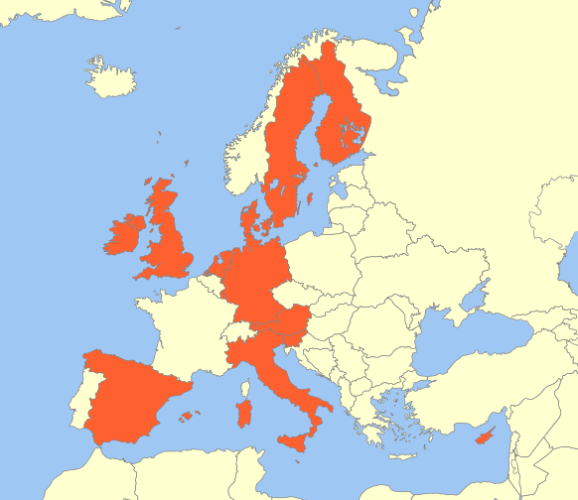

*Source: information collected from Member States and through dedicated studies*

### Use of economic data

The Services Directive, by codifying the case law, prohibits inter alia "economic needs tests" as a requirement for establishment. Under Article 14 (5) Services Directive, economic needs tests are tests that make the granting of an authorisation subject to proof of the existence of an economic need or market demand, an assessment of the potential or current economic effects or the appropriateness of the activity in relation to the economic planning objectives set by the competent authorities. The Services Directive clarifies however that the prohibition set out in this provision does not concern territorial planning requirements which do not pursue economic aims but serve overriding reasons relating to the public interest, such as the protection of the environment, including the urban environment, or the safety of road traffic.

Against this background, many Member States reviewed their conditions for establishment when implementing the Directive and removed economic needs tests[64].

The dividing line between economic needs tests and genuine territorial planning requirements rests not on the form or the name of the rule but on its content. Information which is required to evaluate offer and demand should not be used by competent authorities for the purposes of establishment. Requiring such information could only serve economic aims and as such would constitute an economic needs test within the meaning of Article 14(5) Services Directive.

This is the case of information relating to the number, the types and the formats of existing shops which has a direct meaning to evaluate the offer. In the same way, for the purposes of establishment competent authorities should not use or request information on the purchasing power or household consumption or population in the relevant establishment area as well as information relating to the potential catchment area which has a direct meaning in the definition of demand.

#### Regulation in Member States

In some Member States, municipalities require economic data as part of the process in the application for new establishment – figure 11.

In Denmark, a retail trade analysis is often carried out by municipalities, for which data may be requested from private developers. Its purpose is to assess whether there is a consumer base for more retail units in the area.

In the Netherlands, the municipalities often perform a test aimed at assessing the local market and the need for a new shop. In Sweden, it may happen that municipalities carry out trade assessments, however they do not request data from the applicant.

In some German Länder, for establishment projects exceeding 800 m2, retailers have to provide an assessment of their potential catchment area. Opening of a new shop is prohibited if more than 30% of its turnover would be generated by customers whose place of residence lies outside the city and surrounding area. They also have to provide an impact assessment on the turnover of incumbent retailers established in the city centres. The maximum percentage of turnover which may be distracted from incumbent retailers is set by law.

In both Cyprus and Malta, retailers wishing to open a new shop are requested to provide information concerning, among others, the estimated turnover of the existing outlets as well as the new one.

Also in Ireland and in the UK, the local authorities may request evidence for a need for additional retail floor space.

In Member States with a decentralised structure, the matter of retail establishment is often delegated to the regions and consequently economic data might be requested by regional administrative entities. This is the case in Italy. In the procedure of granting a specific retail authorisation, some of the Italian regions require an applicant to provide data of economic nature. Under Sicilian regional law, establishment of outlets in historical areas requires an assessment of the impact on small local shops. Under Piedmont regional legislation, with respect to establishment of a large shop (bigger than 1.800 m2), data must be provided on the outlet's economic impact on competition in the local market.

In Luxembourg, for the granting of the retail authorisation for a retail outlet larger than 400 m2, the retailer must define the potential the catchment area. Furthermore, the decision-making process takes into account, among others, the impact and consequences of the project on the balance between urban and rural areas (mainly city centre and outskirts) and the number of jobs expected to be created.

*Figure 11: Member States where economic data is required from the retailer*

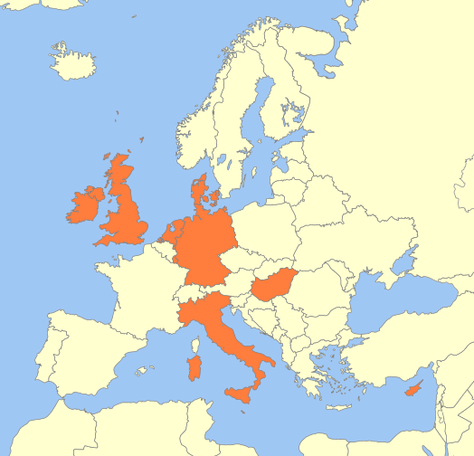

*Source: information collected from Member States and through dedicated studies*

## Procedures for establishment

It is essential for brick-and-mortar retailers to be able to start their operations swiftly and smoothly. In practice, however, brick-and-mortar establishment can be stifled by long, complex and excessively burdensome establishment procedures and by difficulties in finding the relevant information.[65] The time it takes to start operations can be delayed by many procedural obstacles. Such delays are bound to have a negative impact on the viability of a project – which was designed in a specific market setting – and cause significant costs.

In this part examining retail establishment procedures, the focus is on the number of permits required, the number of entities to be contacted or involved in the process, the number of impact assessments required as well as on the often long deadlines and transparency issues.

The following sections explore in more detail the procedural difficulties in the retail establishment procedure.

### Permits required in the establishment procedure

In the establishment process, regardless of whether a specific authorisation is required or whether the establishment is governed by planning rules, retailers often need to obtain several permits to establish a new shop: a planning permit, a building permit, an environmental permit and a special retail authorisation. Permits may be required in case of newly-built premises, a modification of existing premises or a change of use. Such procedures entail a significant investment of time and resources on the retailer's side. This may act as entry costs to the point that firms which would have considered opening an establishment in the absence of regulation decide not to do so.[66]

The objective is not to assess the need for the permits at issue. It is undisputed that a building permit or an environmental permit could be required in particular for large retail establishment. In the same way, a specific retail authorisation may be needed in the light of the objective at stake (town and country planning and protection of the environment). The focus of this part is to identify good practices where some simplification has been introduced to avoid proliferation of permits and alleviate regulatory burden.

The Services Directive provides for an ambitious programme of administrative simplification. Article 5 to 8 of the Services Directive require Member States to simplify procedures, set up Points of single contact, make information on national requirements and procedures easily accessible and provide for the possibility to complete procedures at a distance and by electronic means. Furthermore, Article 13 of the Services Directive oblige Member States to process applications as quickly as possible.[67]

#### Regulation in Member States

In most Member States, urban planning constitutes a basis for establishment decisions. The authorities grant approval for a particular retail project in form of a planning permit (sometimes included in the building permit or another procedure combining two or more permits) which confirms that the project is in compliance with the spatial plans.

Some Member States require a specific retail authorisation to establish a shop. Such authorisation can either replace the planning permit or be required on top of it. While the requirement for the project to comply with the spatial plans typically applies to all projects regardless their size, the specific retail authorisation in most cases applies only to shops above a particular size threshold (see section 3.2.1 on thresholds).

Whether governed by specific retail authorisation or planning regulations, Member States regulatory frameworks often have mixed systems – as illustrated by the map below.

*Figure 12: Retail establishment regulatory frameworks in Member States*

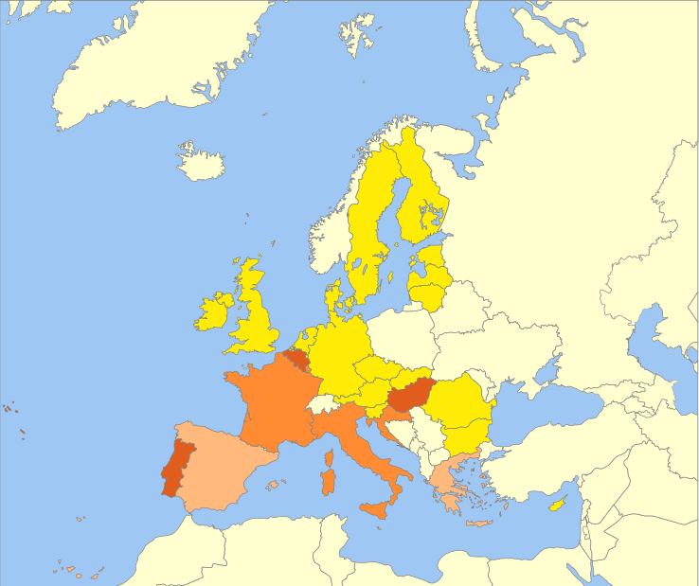

Planning permit or planning approval, also when included in the building permit (Austria, Bulgaria, Cyprus, the Czech Republic, Denmark, Estonia, Finland, Germany, Ireland, Latvia, Lithuania, Malta, the Netherlands, Poland, Romania, Slovakia, Slovenia, Sweden, the United Kingdom)

 Special retail authorisation and/or planning permit/planning approval depending on the location/region (Greece, Spain)

 Special retail authorisation (Croatia, France, Italy, Luxembourg)

 Special retail authorisation and planning permit (Belgium, Hungary, Portugal)

*Source: information collected from Member States and through dedicated studies*

In addition, building permits which confirm project’s compliance with certain technical requirements for construction[68] may be required. For premises of a certain size or deemed to have potentially significant effects on the surroundings, an environmental permit may also be required.

To simplify the administrative process some Member States have introduced fully or partially integrated procedures. All-in-one permits allow retailers to submit a single application instead of having to apply for several permits. Partially integrated permits combine at least two but not all permits required. For example, they can include planning and building permits but other permits such as a specific retail authorisation and/or the environmental permit still have to be applied for separately.

The graph below presents the situation in each Member State.[69]

*Figure 13: Permits required in the establishment process*

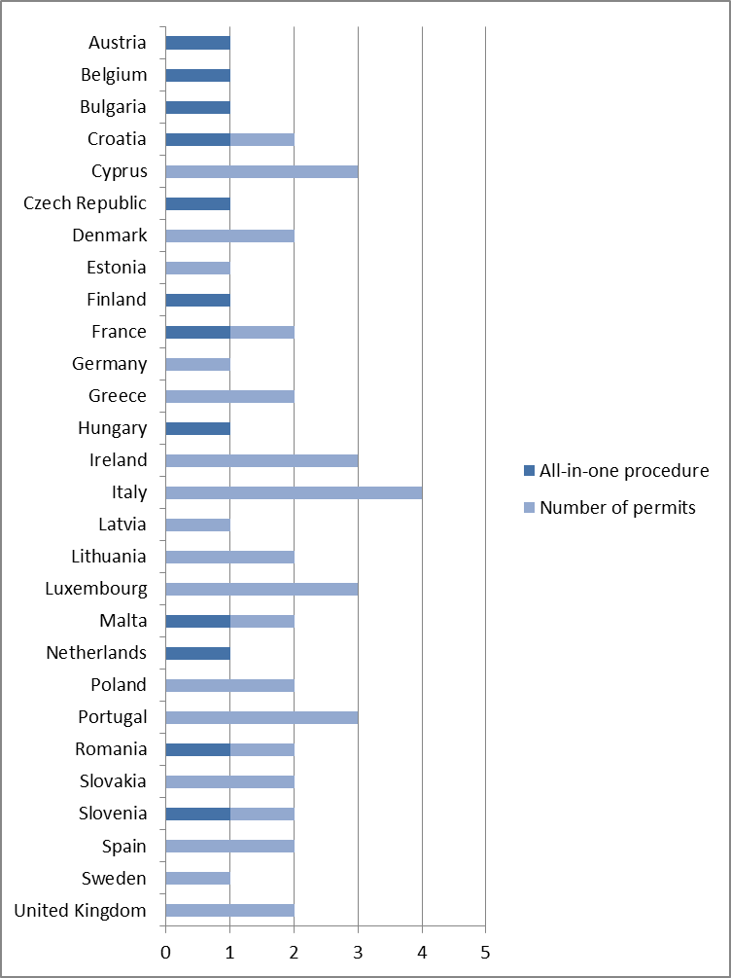

*Source: information collected from Member States and through dedicated studies*

In Estonia, Germany, Latvia and Sweden, only one permit is required. In twelve Member States, simplification efforts have been made and businesses can apply for an all-in-one or a partially integrated permit. For example, in Belgium, new rules adopted by the three regions have recently introduced an integrated procedure allowing businesses to apply for all types of permits in a single application submitted to a one-stop-shop. In France, the building permit includes the specific retail authorisation, and in the Czech Republic, the joint permit replaces the planning permit and the building permit. In Hungary, the so-called merged installation procedure encompasses up to seven different permits.

### Entities involved in the establishment procedure

To assess the administrative burden on the applicant in a retail establishment authorisation procedure it is also important to consider the number of administrative entities which need to be contacted to obtain the necessary permits. Such administrative entities include authorities responsible for planning and building, entities charged with retail development but also those competent for particular issues, such as the protection of the environment. They can be found on different levels of national administration (municipal, regional or central).

The greater the number of authorities that have to be contacted, the more time and resource-consuming the procedure becomes for the applicant. It may be necessary to submit several application files and manage information received from several different authorities in parallel.

In accordance with the Services Directive, Member States have to ensure that service providers can complete all procedures and formalities needed for access to and exercise of their services activities through 'points of single contact'. The points of single contact are meant to be the single institutional interlocutors from the perspective of the service provider so that it does not need to contact several entities to complete all the necessary steps relating to his service activity.[70]

#### Regulation in Member States

In many Member States businesses still need to contact a separate entity for each required permit, e.g. the municipality, a regional authority charged with planning and building matters and a governmental agency for the protection of the environment.

In some Member States, there is only one administrative entity involved in the authorisation procedure.

Several Member States have introduced one-stop-shops representing all administrative entities involved in the authorisation procedure. It means that the applicant needs to contact only one administrative entity and has a single interlocutor on the side of the authorities coordinating the replies from various competent bodies. This is the case in Austria, Belgium, France, Greece, Hungary and the Netherlands.

In France, Italy and Lithuania, it is possible to apply for a retail establishment through a partially integrated contact point where some but not all competent authorities are represented. There, the applicant still needs to contact another entity separately, for example to obtain an environmental permit. It is often the municipality or a planning and building authority that acts as a single or partially integrated point of contact making sure that all other competent authorities are involved.

The graph below shows the number of entities that have to be contacted in each Member State.

*Figure 14: Entities to be contacted in the establishment process*

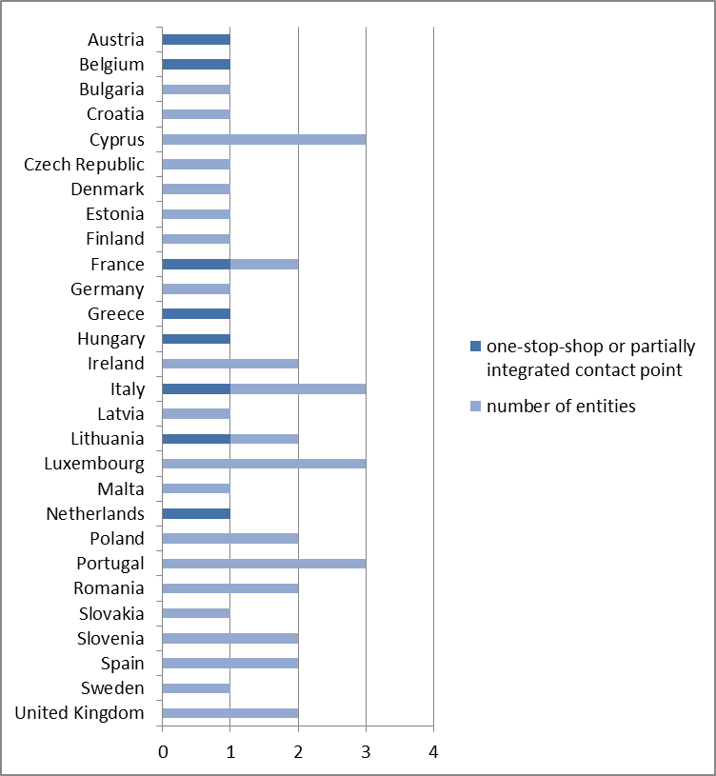

*Source: information collected from Member States and through dedicated studies*

### Impact assessments required in the establishment procedure

Retailers may be requested to provide a large amount of information within the retail establishment process. Competent authorities may require from the applicant to provide studies or other type of analysis or data to assess the various potential impacts of the project.

Such requirements are likely to increase significantly the time needed to prepare the application and may in certain cases be difficult to comply with, for example due to difficulties in gathering the requested data.

Firstly, in line with the section on the use of economic data, some impact assessments should not be requested from retailers as they may entail assessing the existing offer and demand and as such amount to economic needs tests prohibited by the Service Directive.

Regarding data which is not requested in the context of an economic need test, it must be justified on the basis of an overriding reason relating to the public interest and proportionate. Thus, data that is sensitive may be required solely to the extent necessary for the pursuit of an overriding reason relating to the public interest.

In the following description of the regulation in Member States, the focus is on the number of impact assessments required from retailers.

Pursuant to the proportionality principle, Member States are required to eliminate the impact assessments which are not justified and to streamline the other requirements for impact assessments to simplify the decision making process for retail establishment.

#### Regulation in Member States

More than half of Member States do not require applicants to provide specific impact assessments.[71] In those Member States which require impact assessments they mainly concern the impact on the local retail market (in particular, on the city centre), on employment and on traffic. That is likely to constitute an economic need test under Article 14(5) Services Directive ("potential or current economic effects of the activity"). Some Member States combine several of the above mentioned aspects into one analysis (referred to as other impact assessments).

In Italy, Spain and the UK, up to three impact assessments can be required. In seven Member States (Belgium, Cyprus, Germany, Ireland, Luxembourg, Malta, Netherlands) two impact assessments are required, whereas Austria and Hungary request only one.

The retail impact assessment, i.e. the assessment of the project's impact on the local market, appears to be the most frequently requested. Often the objective is to assess the impact of the new shop on the city centre. This is the case of Cyprus, Germany, Ireland, Malta, The Netherlands and the UK.

In most cases, those impact assessments are required only for large retail shops. For example in Belgium the impact of projects above a certain size threshold[72] is assessed against criteria such as the integration in urban pattern, consumer protection, compliance with social and employment law, protection of urban environment. In Luxembourg the retail impact assessment applies to shops above 400m² and in Germany to shops above 800m². In both cases, the catchment area and the impact on city-centres is assessed. [73] In Italy in certain regions socio-economic impacts of medium and large shops, such as for example the impact on employment, are assessed.

*Figure 15: Impact assessments required for the establishment*

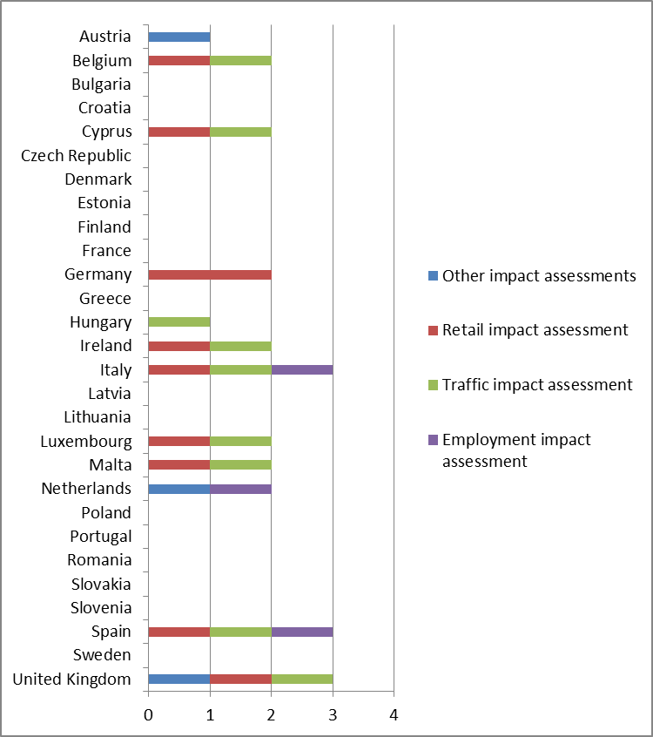

*Source: information collected from Member States and through dedicated studies*

### Length of the establishment procedure

#### Lengthy procedures can have a negative impact on the viability of a project and lead to significant costs for businesses. With the development of e-government and on-line trade, it is not only required under Article 13(3) Services Directive but also important to shorten deadlines for brick-and-mortar retailers to access the market. This would also support pure on-line retailers developing their physical presence.

As emphasized in the responses to the open public consultation, the use of electronic procedures should make establishment procedures shorter.

#### Regulation in Member States

The specificity of the authorisation process, the planning framework in place and the administrative practice differ between Member States resulting in divergent deadlines for establishment decisions.

Deadlines set out in Member States' regulations to complete the formalities to establish a shop[74] range from 1 to 12 months.[75] However, in practice, retailers face procedures of much longer duration.

The type of project and in particular its size and its potential impact on the surroundings may determine the type of procedure to be followed and hence its length. Decisions concerning large retail outlets which require additional impact assessments and additional permits (such as the environmental permit) would typically require more time. Environmental permit procedure can run in parallel to other procedures, but it can also be a pre-condition to apply for other necessary permits. For example in Croatia and Slovenia it is possible to apply for the building permit only once the environmental permit has been granted. The deadlines for issuing environmental permits in principle range from 3 to 18 months. However, in some Member States deadlines are not specified, so that the applicant cannot estimate the time needed to obtain a decision.

In many Member States the conformity of the project with the planning framework can be decisive for the length of the authorisation process. For example in Denmark if the establishment complies with the local plan and does not require an environmental permit, the applicant would only need to obtain a building permit which takes up to 2 months. However, if the decision requires a change in the local plans and such a change is possible in a given Member State, the procedure can take up to 3 years due to public consultations and possible appeals (e.g. in Finland and Sweden).

Although in most Member States the length of the procedure is in principle quite limited, the procedure can often be delayed because of third parties' appeals. Even if a positive decision has been issued, it may take years until the retailer can effectively start its activity in the selected location.

Some Member States have introduced measures to ensure that appeals are based on substantive grounds. In France an administrative appeal is mandatory before a judicial review can be filed in Court. This is supposed to discourage all appeals without substantive grounds at an early stage. Other Member States may require the fulfilment of specific conditions to be eligible for an appeal to avoid opportunistic appeals by third parties, e.g. competitors or civil society, attempting solely or mainly to disrupt the on-going retail establishment project without having substantive grounds to appeal.

### Transparency of the procedure for establishment in Member States

Under Article 13(5-7) Services Directive, competent authorities must inform the applicant of a number of procedural steps and details. The lack of clear communication from the authorities at any stage of the process can be confusing and detrimental for the applicant. For example, if the authorities do not communicate clearly when the file has been deemed admissible, the applicant may not be aware when the procedure officially starts. In Belgium, the legislation specifies that the deadline is counted from the moment when the application file is deemed complete and it also imposes on the authority a deadline to inform the applicant of the completeness of the file. This is however not common in other Member States.

In addition to the burden for the applicant, the lack of transparency can also generate additional burden to the authorities as insufficiently informed applicants are likely to submit incomplete files. Hence, it is important to ensure that all the necessary information about the establishment procedure is made available to the applicant beforehand.

As indicated above, Articles 5 to 8 of the Services Directive provide for administrative simplification and cooperation. Member States are required to simplify administrative procedures, to set up Points of single contact, to provide for the possibility to complete procedures at a distance and by electronic means and to make information on national requirements and procedures easily accessible. In addition, Member States must comply with the specific obligations provided for in Regulation (EU) No 910/2014 of the European Parliament and of the Council.[76] This includes obligations related to the use and acceptance of certain types of electronic signatures, recognition of advanced electronic signatures and advanced electronic signatures based on qualified certificates, provided for in Article 27 of that Regulation and further specified in Commission Implementing Decision (EU) 2015/1506.[77] As emphasized in the responses to the open public consultation, the use of electronic procedures should improve transparency through easier access to the relevant documents, to information, to the status of individual applications. On-line submission of applications would be particularly important for SMEs.

Finally, it is also important that establishment decisions, positive or negative, are made public.

The information below focuses on this aspect ensuing from the principles of legal certainty, good administration and transparency.

#### Regulation in Member States

Publication of both positive and negative decisions does not only comply with the principles of legal certainty and good administration in the ongoing procedures, but also allows future applicants to better prepare for the procedure and assess the chances for a positive decision.

More than half of Member States publish or display in public only positive decisions. In six Member States (Belgium, France, Greece, Lithuania, the Netherlands and Poland) both positive and negative decisions are published. In Cyprus and the Czech Republic access to decisions is possible only upon request or only for interested parties. A number of countries use on-line tools, such as electronic registers, to make decisions available to the public. In Austria, Croatia, Germany, Slovenia and Spain neither positive nor negative decisions are published or publicly displayed.

## Retail Restrictiveness Indicator: results for establishment restrictions

The establishment pillar is part of the overall Retail Restrictiveness Indicator (RRI) – the composite indicator developed by the Commission services and presented in section 3. It measures the level of restrictiveness of Member States. It is composed of the following elements: size thresholds, the level of detail in local plans, the existence of regulations specific to location, the requirements for economic data, the number of permits required, the number of entities to be contacted in the process, the number of impact assessments required, the length of the procedure and the publication of establishment decisions. Details of retail establishment restrictions have been presented in the previous sections of this document.

As figure 16 presents, in the end of 2017[78], the strictest requirements to establish new shops can be observed in Italy, Luxemburg and Cyprus. This stems mainly from a mixture of factors linked to conditions to establishment, mainly the size thresholds, the requirements for economic data and the legislation specific to location. The burden caused by procedural issues (the number of permits, entities to contact, or the length of the procedure) also adds to the picture.

In the least restrictive countries – Estonia, Latvia and Slovakia – the establishment conditions and procedures enable retailers to establish swiftly and within a rather short deadline.

*Figure 16: The retail establishment restrictions pillar of the RRI*

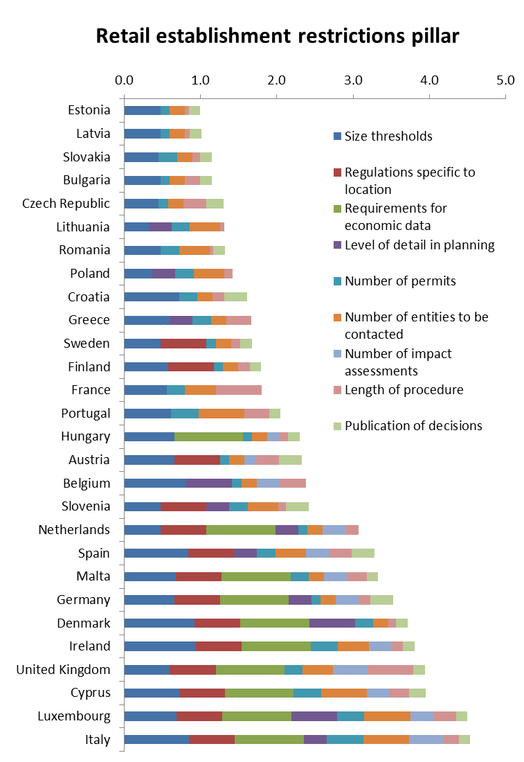

*Source: Own calculations based on information collected from Member States and through dedicated studies*

The restrictiveness level of retail establishment rules can have an impact on the functioning of the retail sector and may explain its suboptimal performance in some areas. The following section assesses the potential impact of restrictions to retail establishment on competition, market structure, productivity, employment, innovation and consumers.

## Potential impacts of restrictions to retail establishment

Restrictions on retail establishment can have inter alia the effect of blocking or reducing market entry and favouring incumbent companies. Although it is not easy to establish and measure a direct clear link between the restrictions to the establishment of new shops and the actual effects on the economic variables, numerous studies have demonstrated negative effects of such barriers on the market structure and unfettered competition as well as indirect negative effects on productivity, employment, prices and innovation. Those impacts are to a great extent confirmed by the present analysis.

While there are ways to assess the impacts of entry restrictions on the economic efficiency, it is much more difficult to measure whether such regulations are effective in achieving the legitimate public policy objectives they pursue. Needless to say, an analysis of the effectiveness of national measures is legally relevant only for those measures which may possibly be justified. By contrast, public measures such as those listed in article 14 Services Directive can never be justified because they either pursue purely economic objectives or they are by definition disproportionate.

In addition, the hitherto approach to retail establishment regulations gains a new dimension in today’s increasingly digitalised retail sector. Since establishment restrictions usually concern solely brick-and-mortar shops, they may cease to be effective in achieving their goals when market actors compete through e-commerce. Only a few Member States have responded to these developments adapting their legislation to account for the establishment of showrooms and pick-up points or are reflecting on doing this in the future. Furthermore, a systematic analysis of the effects of current regulations in the changing retail landscape is lacking.

### Potential impacts on competition

Certain proxies are used to measure the level of competition in a given market: the level of concentration of companies (in terms of their market shares), the mark-ups that the existing companies apply, or the birth rate and the churn rate of retail companies. In the case of retail, competition is particularly important at the local level – how many and what types of shops consumers can effectively choose from in their catchment area. This local level is however the hardest to measure, especially for the whole EU.

Some regulations will keep certain companies or store formats away from the market (e.g. if they determine the admissible type or size of the outlet), others will dissuade certain market players from investing on the market due to likely difficulties in obtaining the necessary decisions. They can also have a discriminatory effect on foreign companies if they target formats and sizes more commonly found abroad.

Studies have shown that the existence of such regulations increases the probability of high concentration[79] and creation of monopolies[80]. It strengthens the position of incumbents inciting them to increase their mark-ups which in turn has a negative impact on economic performance. The analysis of changes in regulation between 1998 and 2007 in France and Italy concluded that barriers to entry were indeed associated to higher mark-ups.[81]

Results of the present analysis indicate that less new retail companies enter the market in Member States with higher establishment restrictions. Also, in those countries, fewer companies leave the market, which in fact may indicate that less efficient companies manage to survive whereas in strong competition conditions they would probably be eliminated from the market. Figures 17 and 18 show that the birth rates and churn rates of such enterprises are negatively correlated with the level of all establishment restrictions analysed combined together.[82]

*Figures 17 and 18: Correlations between the level of restrictiveness of retail establishment and churn and birth rates of retail companies*

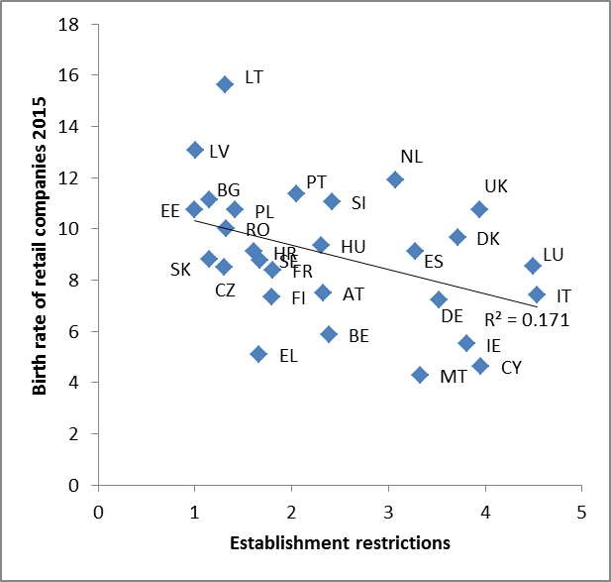 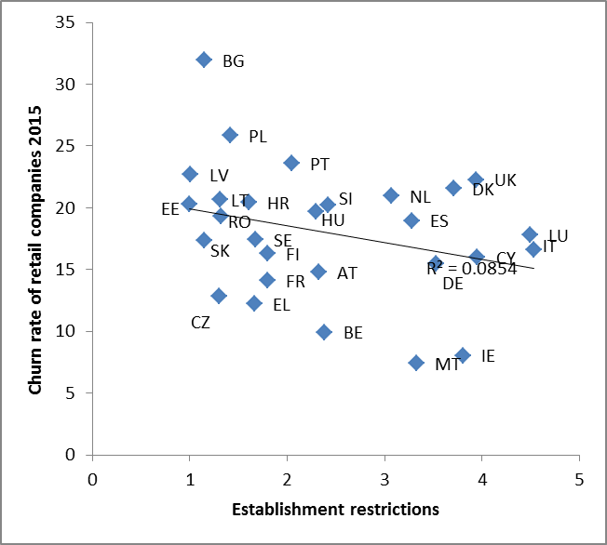

*Source: Own analysis based on information from the retail establishment study, the Member States authorities, and Eurostat*

The links revealed by the correlation analysis have been confirmed by outcomes of a regression analysis.[83] Retail establishment restrictions, in particular the specific requirements linked to size thresholds, seem to have a statistically significant negative impact on the birth rates of retail companies, and a positive impact on the price level index (i.e. lead to higher prices, in particular for prices of food products). They also correlate in a positive direction with the gross operating rate of retail companies.

*Figures 19, 20 and 21: Correlations between the specific requirements linked to size thresholds and birth rates of retail companies, the price level index and the gross operating rate.*

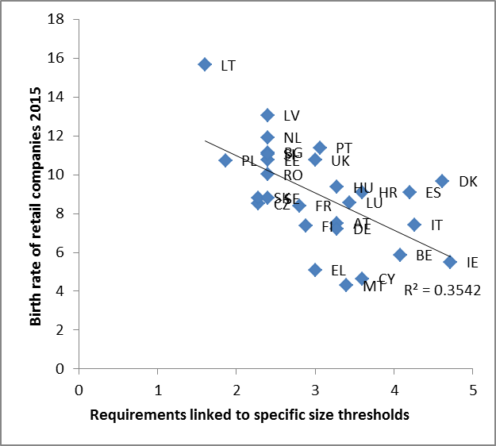 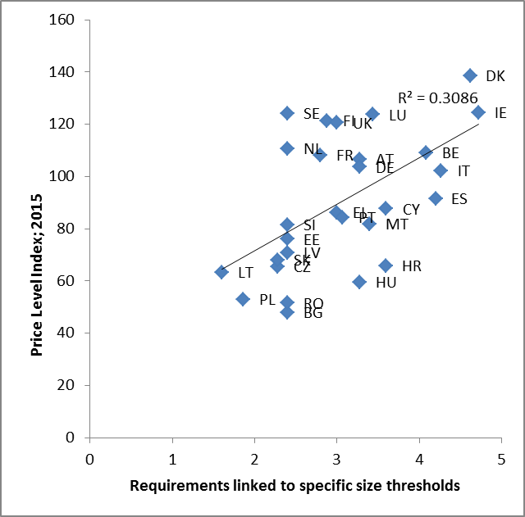

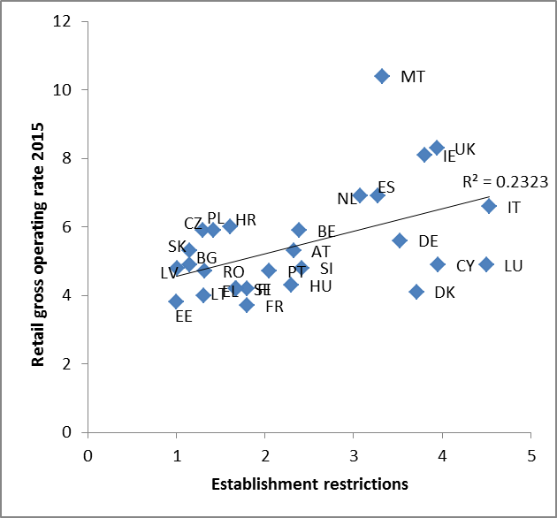

*Source: Own analysis based on information from the retail establishment study, the Member States authorities, Eurostat*

In more detail, in addition to requirements linked to size thresholds, certain other specific restrictions to retail establishment display a particular link with market developments. For example, the retail market is more concentrated in Member States with regulations specific to the location of a retail outlet (in particular defining rules for establishment in or outside city centre). Also, the higher the number of market studies and impact assessments that the retailer needs to submit, the higher the gross operating rate of retail companies.[84] In those more concentrated markets, prices for goods distributed in retail outlets also tend to be higher.

Links between the number of permits required and regulation specific to the location on one side, and competition on the other side, have been confirmed by the outcomes of the economic analysis carried out in the frame of the study on retail establishment restrictions.[85] Higher number of permits seemed to be correlated with higher retailers' margins (the gross operating rates) and with higher concentration in the market (measured as CR5[86] and HHI[87]). The study also identified a negative relationship between the entry rate and market concentration.

In any sense, restrictions concerning establishment of physical shops affect almost solely off-line retailers, which does not help them compete with ever stronger on-line traders. However, in the increasingly multi-channel retail, these restrictions also affect pure on-line retailers wishing to establish their physical presence.

### Potential impacts on market structure

Competition is also linked with the structure of the market and its dynamics. Establishment restrictions can influence the type and the size of firms, the types of store formats that those firms operate (such as hypermarkets, supermarkets, discounters, convenience stores, small independent shops, etc.), the development of the different formats and of the selling space in general, as well as the development of on-line sales.

Analyses have concluded that regulations on size and location of shops had a real effect on companies’ decisions. In Spain the analysis taking into account regional differences in retail establishment regulation showed that such regulations indeed impeded the entry of larger store formats.[88] In England[89], the number of applications for major new retail developments fell significantly after the government introduced additional constraints on the opening of large stores in suburban areas in the mid-nineties and the store sizes decreased.[90]

Even if such regulations do not prevent market entry as such, they may influence retailer’s decision on the location of the store, its size, format and assortment. This may hamper the firm’s ability to adjust to consumers’ preferences and to successfully compete on the market. However, regulations may affect market players differently depending on their business model. For example, grocery retail chains offering different store formats (e.g. hypermarkets, supermarkets as well as convenience stores) can more easily adapt to existing restrictions than non-food stores running a single store format. The effect of entry deterrence will hence be weaker on companies running diverse store formats[91].

Results of a regression analysis[92] show a negative impact of establishment restrictions (in particular, the specific requirements linked to size thresholds, requirements for economic data and the number of permits) on the growth of the number of outlets for supermarkets and on the growth of this format's selling space. In addition, a correlation analysis (some results presented in figure 22) shows a negative link between restrictions to establishment and the growth of the number of outlets and of the selling space of most store formats: supermarkets, hypermarkets and non-grocery stores. However, no strong link could be found between those restrictions and changes in the selling space and the number of traditional shops[93], which would indicate that traditional retailers do not really benefit from such measures (even though the restrictions have often been put in place to protect them against the competition of larger shops). In general, retailers in more restrictive Member States opened in the years analysed not only less shops but also smaller premises – often limiting the accessibility and choice for consumers.

*Figure 22: Correlation between the level of restrictiveness of retail establishment and the growth in the selling space and the number of supermarket and hypermarket outlets*

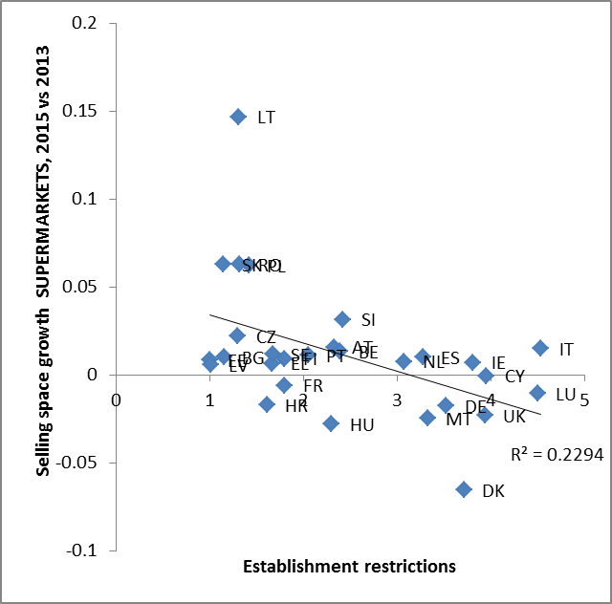 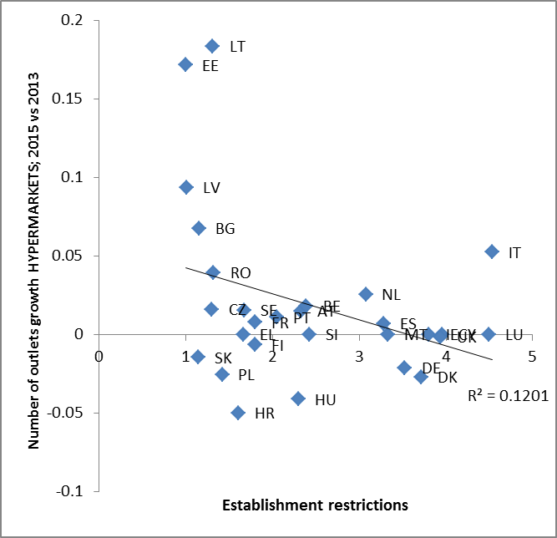

*Source: Own analysis based on information from the retail establishment study, the Member States authorities, and Euromonitor data*

This negative link is confirmed by results of a regression analysis, which also shows a statistically significant negative impact of retail establishment restrictions on the development of supermarkets.

A different pattern could however be observed for discount stores: their number and the selling space grows more in countries where the level of establishment restrictions is higher. A possible explanation can be the generally very dynamic development of this format, which results from a more and more frequent consumer orientation towards lower prices and the improving quality of the discounters' offer. These shops are also rather flexible in terms of location compared to other formats, in particular supermarkets and hypermarkets, as their limited range of goods on offer requires less selling space. In many cases, they may also replace convenience stores, taking over their role of neighbourhood shops. High specific requirements linked to size thresholds seem to particularly positively impact the growth of the selling space of discounters.

The above patterns have been confirmed by results of the economic analysis carried out in the frame of the study on retail establishment restrictions.[94] In countries where more permits and numerous impact assessments and studies were required from retailers, less outlets were opened and less selling space was created. Also the number of entities that retailers have to contact when they apply for an authorisation or a permit is negatively correlated with the dynamics of new stores creation, in particular for small outlets.

The study also showed that specific requirements referring to the size thresholds for shops seem to negatively (and significantly) impact the market dynamics, in particular for supermarkets. Actually, such requirements had the greatest impact on the creation of new stores from all the different regulatory aspects analysed, followed by the number of entities to be contacted and the number of impact assessments to provide. The study concludes that establishment restrictions not only have an impact on the development of new shops, but they also affect different store formats differently.

### Potential impact on productivity

Entry regulation can affect productivity by limiting competition and decreasing the incentives of incumbent firms to become more efficient.

As restrictive regulations often influence shop sizes and their location, they can also limit the company’s ability to choose the most efficient store format for a particular location.[95]

A company may also not be able to establish all the desired formats and achieve economies of scale, which are important for productivity gains. Achieving scale through store format is a key driver of retail performance. Large formats are generally more productive than small formats and specialized formats (e.g. discounters) are more productive than general formats.[96]

Studies have shown that establishment restrictions in retail are associated with lower productivity and that reforms can improve sector’s performance in that respect. Retail reform in Sweden in the 1990s (i.e. easing establishment restrictions and leading to growth of large-scale format stores) led to the highest retail productivity growth compared to US and Europe.[97] Productivity growth in the food retail sector in the UK between 1997 and 2003, measured on the level of retail chains, would have been 0.44% per year in the absence of regulation, whereas the observed growth was only 0.07%.[98] Another study using the differences in restrictiveness of planning policies between local authorities across the UK found that the introduction of stricter zoning regulation directly reduced productivity both by reducing shop size and by forcing retail onto less productive sites.[99] Adopting best practice regulation as measured by the OECD in France and Italy could increase long-run productivity by 3.5 per cent in France and 3 per cent in Italy.[100] In Denmark, planning restrictions which effectively banned the entry of hypermarkets have shaped the market structure with many smaller and less efficient shops and led to a large productivity gap in the retail sector as compared to peer countries.[101] A recent reform relaxed to some extent the retail establishment rules, which is expected to increase productivity by 0.9% in the long run.[102]

A recent Commission analysis showed that there is a link between the restrictiveness in retail and labour productivity. In Member States with less restrictive retail regulations (measured with the OECD Product Market Regulations Index) the (wage-adjusted) labour productivity is lower.[103]

In addition, having to apply to numerous public entities and to provide certain studies or data in order to obtain several different decisions (authorisations, permits and licences) puts a significant burden on retailers. In particular, small companies can find it difficult to comply with such requirements.

### Potential impact on employment

Establishment regulations can hamper job-creation simply by restricting the access of new market players. Increased competition however can lead to the exit of less efficient firms or to incumbents striving for efficiency gains through workforce cuts. The job-creation effect through increased market entry is therefore not obvious. On the other hand, competition could reduce incumbents’ mark-ups, pushing them to selling more in volume and therefore requiring more workforce.[104]

Studies have shown that establishment restrictions have a strong negative effect on employment in the sector. In France, the analysis of the impact of the Loi Royer[105] concluded that the measures put in place have reduced employment in the retail sector by at least 3%.[106] Additional barriers imposed by the Loi Raffarin[107] have been estimated to cause a 6% increase in supermarkets’ costs,[108] which in turn could have also led to the reduction in employment. The analysis of the effects of the regulatory reform of 1998 in Italy[109] showed that it had a clear impact on the performance of the sector, increasing prices and labour costs while reducing productivity and employment.[110]

### Potential impact on innovation

Increased competition can incite market players to look for solutions to increase their efficiency. Investment in ICT leading to the optimisation of processes, such as intelligent stock management or self-service check-outs for customers can be an important factor improving productivity. Given that fixed costs of such investments can be relatively large for small store formats, restrictions on shop sizes are likely to inhibit innovation.

The literature on this subject advocates that in the case of retail, innovation in processes (as opposed to product innovation) is the main determinant of productivity growth. Studies measuring the impact of regulations on innovation found a negative correlation between barriers to entry and innovation, measured through investment in ICT.[111] Removing entry restrictions is hence likely to increase investment in ICT. Also, the present analysis shows that the higher the establishment restrictions, the lower the investment rate of retail companies – figure 23. [112] However, other studies have shown that competition fosters innovation only up to a certain point where benefits from catching-up still exceed the decreasing profits caused by increased competition.[113]

*Figure 23: Correlation between the level of restrictiveness of retail establishment and the investment rate in retail*

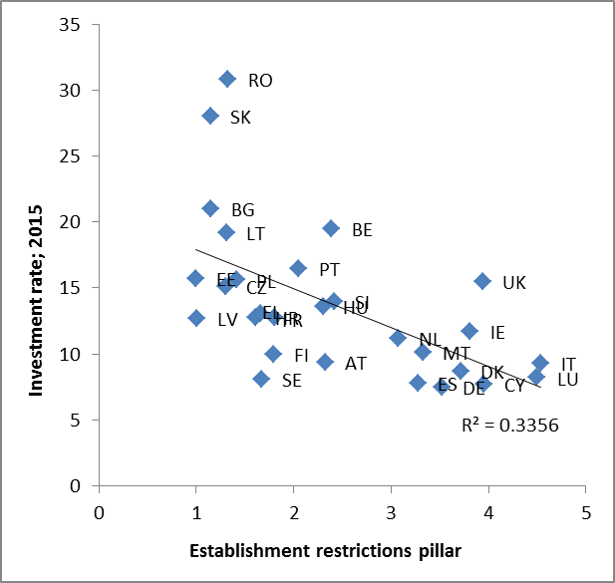

*Source: Own analysis based on information from the retail establishment study, the Member States authorities, and Euromonitor data*

### Potential impact on consumers

Consumers can benefit from increased competition through lower prices and a greater variety of products and store formats in the market. Establishment restrictions that are often put in place to protect consumers' accessibility to retail in both urban and rural areas can in fact reduce affordability and choice of products for consumers.

*Prices*

As already highlighted, entry restrictions are likely to increase mark-ups of incumbent firms and thus lead to higher consumer prices.

Numerous studies have found that removing establishment barriers could decrease prices. The already quoted study analysing the effects of the French reform in mid-nineties (Loi Raffarin) showed that stronger entry deterrence increases both concentration and prices.[114] Also the study analysing local variation in entry regulation in Italian provinces found that barriers exert a strong influence on performance, increasing profit margins and prices. There, stricter entry regulation has been found to increase prices.[115]

Finally, the present analysis reveals that retail establishment restrictions have not only a statistically significant negative impact on the birth and churn rates of retail companies, but also link to higher prices – figure 24. [116]

*Figure 24: Correlation between the level of restrictiveness of retail establishment and the level of prices for food and non-alcoholic beverages*

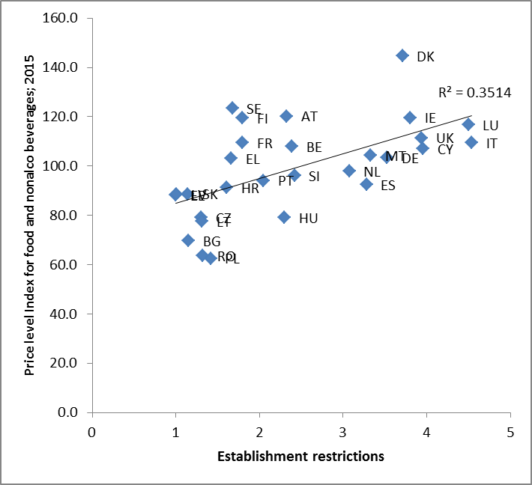

*Source: Own analysis based on information from the retail establishment study, the Member States authorities and Eurostat*

*Choice of shops and products*

Consumers can also benefit from increased competition through increased variety in products and store formats offered on the market. Reducing establishment restrictions allow the entry of different store formats appealing to consumers, and the increased competitive pressure also inclines incumbents to increase and differentiate their product offer**.**[117]

A ban on establishment of shops because of their size would deprive retailers from the possibility to choose the format which would best suit the area, the population and the business model of the retailer. A more complex and burdensome procedure to obtain an authorisation or a permit to establish a large shop may discourage operators from building such premises or make it more costly. Hence, consumers cannot enjoy a larger variety of shops and products.

Limitations as to the location of new shops may also lead to inefficiencies in the market. City centres are often not suited for large shops and if they are not allowed to establish in the outskirts, consumers will simply not be able to enjoy them at all. Consumers may then be faced with higher prices and a limited offer. In addition, such restrictions to location are becoming less effective in times of growing competition coming from on-line sales. Also, this may not be beneficial for independent retailers either, as they would have difficulties to compete with small formats run by large retail chains.

# Operational restrictions

## Introduction

On top of regulations affecting the establishment of retail outlets, retailers have to deal with a number of regulations linked to their daily operations - so called operational restrictions. Such regulations sometimes become a significant burden for businesses, affecting in particular their efficiency, productivity and the quality and price of goods/services offered. Moreover, excessively restrictive or complex regulations can deter or make market entry more burdensome or even induce exit from the market.

This analysis follows the paths of the OECD which, since 1998, has been assessing the restrictiveness of operational regulations governing retail companies in the PMR indicator referred to in section 3. The elements taken on-board in this analysis are very similar to those used by the OECD. However, they are not strictly identical and go further than the OECD's to try to better capture the complexity and diversity of the regulatory frameworks in place in the Member States.

As already indicated, this document examines retail-specific regulations. With the exception of territorial supply constraints, the focus is on regulations put in place by competent authorities and not restrictions created by the behaviour of private operators.

The operational restrictions examined in this context are:

* Shop opening hours
* Product-specific sales restrictions
* Sales, promotions and discounts
* Retail-specific taxes and fees
* Sourcing, including issues linked to territorial supply constraints
* Contractual practices of modern retail

The information presented reflects the state of play for the end of 2017.[118] In some cases, when important changes took place after December 2017, the information has been updated and taken into account.

## Shop opening hours

In addition to the location and shop size, shop opening hours are an important factor influencing consumers' accessibility to a retail outlet.[119] Social and cultural changes of living and working conditions, in particular in large urban areas, influence consumers’ shopping patterns. Due to long working hours late-night and Sunday shopping have become increasingly attractive to many households.

Moreover, e-commerce is dramatically changing consumers' shopping habits. The most important change is that consumers can shop anytime and anywhere as opening hours restrictions do not apply to on-line trade. This puts brick-and-mortar retailers under pressure to keep up with competition.

#### Regulation in Member States

Regulations of shop opening hours vary significantly between Member States. In twelve Member States shop opening hours are unrestricted. In four Member States retailers can choose freely the opening hours except on specific public holidays. Four Member States regulate only Sunday opening hours. Eight Member States have extensive rules regulating opening hours on weekdays, Saturdays and Sundays.

*Figure 25: Shop opening hours regulation in Member States*

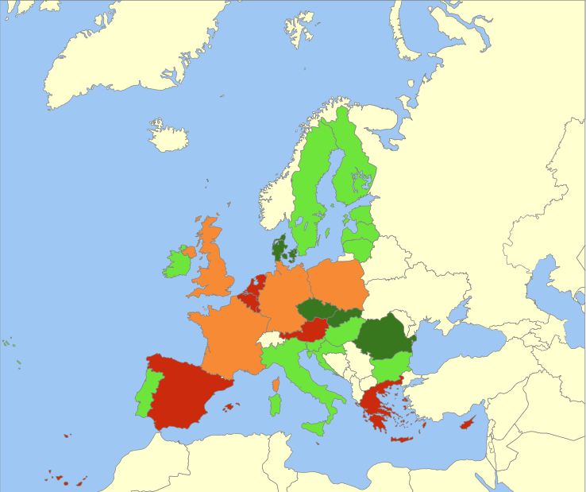

 No restrictions on shop opening hours (Bulgaria, Croatia, Estonia, Finland, Hungary, Ireland, Italy, Latvia, Lithuania, Portugal, Slovenia, Sweden).

 No restrictions, but in principle shops have to remain closed on some public holidays (Czech Republic, Denmark, Romania*, Slovakia).

 Regulation of Sunday opening hours (France, Germany, Poland and the United Kingdom).

 Regulation of weekly, Saturday and Sunday opening hours (Austria, Belgium, Cyprus, Greece, Luxembourg, Malta**, the Netherlands, Spain).  
* In Romania public holidays in the retail sector are set out in the labour legislation

** In Malta opening hours differ between periods of the year, i.e. different rules apply to the period between 8 January and 31 October and to the period between 1 November and 7 January.

*Source: information collected from Member States and through dedicated studies*

The regulatory situation has been changing over the past decades and in recent years there has been a trend in Member States towards reviewing the existing legislation on shop opening hours making the rules more flexible. Recent reforms took place in Denmark (liberalisation of Sunday trading in 2012), Finland (complete liberalisation in 2016), France (increased number of shopping Sundays in 2015), Greece (increased number of shopping Sundays in 2013), Italy (complete liberalisation in 2011), the Netherlands (broadening of the powers of the Dutch municipalities to authorize exemptions from the prohibition to open shops on Sundays and several holidays in 2013), Portugal (complete liberalisation in 2015) and Spain (increased number of weekly trading hours and shopping Sundays in 2012 and 2014)[120].

While most Member States review their regulations to make them more flexible, few countries introduced recently certain limitations. The Czech Republic has introduced in 2016 a prohibition to trade on a number of public holidays.[121] In Hungary the prohibition of Sunday trading introduced in 2015 was repealed in 2016. In Poland the recent regulation will gradually prohibit Sunday trading as of 2018.[122]

*Regulation of weekday and Saturday shop opening hours*

The weekly and Saturday opening hours' regulation usually specifies the time span during the day when shops are allowed to operate. Such regulations can be found in Austria, Belgium, Cyprus, Greece, Luxembourg, Malta, the Netherlands and Spain. The allowed time span is usually quite broad, enabling shops to open from 5 or 6 a.m. to 8 or 9 p.m. Time limits are in some cases more restrictive on Saturdays, e.g. in Austria shops should close by 6 p.m. and in Luxembourg by 7 p.m. on that day. In Spain the regulation specifies in addition the minimum number of hours shops should stay open during the whole week. The Autonomous Communities are free to determine the exact trading hours as long as they do not go below the minimum of 90 hours per week established by the Spanish legislation.

*Regulation of Sunday shop opening hours*

Sunday opening hours are regulated in Austria, Belgium, Cyprus, France, Germany, Greece, Luxembourg, Malta, the Netherlands, Poland, Spain and the United Kingdom.

Three types of regulation can be distinguished[123]:

- Trading allowed on all Sundays, but with some limitations on the opening times applying either only to shops of certain size or assortment (France, the United Kingdom) or to all shops (Luxembourg).

In the UK Sunday operations of small shops (up to 280m2) are unrestricted. Shops above this size threshold are allowed to trade, but only for five to six hours. This applies to all stores regardless of the assortment sold.[124] In France the rules depend on assortment. Food shops are allowed to stay open on Sundays, but not beyond 1 pm. Finally, in Luxembourg all shops are allowed to trade on Sundays regardless of their size and the type of products sold, but only from 6 am to 1 pm.

- Trading allowed only on a limited number of Sundays a year (Belgium – max. 15 Sundays,[125] France – 12 Sundays,[126] Greece – 8 Sundays, Spain - 10 Sundays on average, the regulation differs between Autonomous Communities).

- Trading generally prohibited on Sundays with a possibility for local authorities to grant exceptions for specific areas or in specific circumstances (Austria, Germany, the Netherlands and Poland[127]).

*Special regime for particular types of shops and particular locations*

Most Member States restricting shop opening hours put in place a more flexible regime for shops offering certain daily consumer goods, some particular assortment or located in specific areas and places.

Particular types of shops and particular locations

In most Member States where shop opening hours are restricted shops meeting certain daily consumer needs (such as bakers or newspaper agents) or particular needs (e.g. florists) are allowed to stay open on Sundays even if the general framework prohibits Sunday openings. The same applies to shops in particular locations serving tourists and travellers (petrol stations, train stations and airports). In addition, some Member States allow Sunday opening of shops selling certain assortment, such as for example furniture, DIY or gardening products.[128]

In a few Member States such special regime may concern all small shops provided certain conditions are fulfilled. In Spain where Sunday trading is in principle only allowed on a limited number of Sundays, small shops up to 300m2 are allowed to open without any restrictions. Also in Greece local authorities may allow independent shops under 250m2 (including franchisees, but excluding shops in commercial centres) to open on Sundays.

Tourist areas

In many Member States tourist areas benefit from a more flexible regime or are fully or partially exempted from the regulation applicable to the whole country, in which case the local authorities decide on the opening times. Typically the regulations applying to these areas allow for longer opening hours in the evening during the week and more possibilities to trade on Sundays. Special regimes for tourist areas exist e.g. in France and in Spain and Belgium. In Austria and Greece local authorities can grant exemptions for tourist areas from the general shop opening hours regime.

*Other types of regulation of shop opening hours*

Obligatory closure on public holidays

Some Member States, despite the legislative framework which in principle does not restrict shop opening hours, impose a closure on a number of public holidays. This is the case for example in the Czech Republic, Denmark, Romania and Slovakia. In Slovakia however this obligation does not concern the self-employed, in the Czech Republic small shops (below 200m2) and in Denmark certain types of shops, i.e. shops selling bread, diary, shops in airports, railway and bus stations, smaller shops with low turnover and retail shops in the country side.

Regulation of shop opening hours for particular goods

In some Member States regulations may concern the sale of alcohol for public health reasons and be restricted to particular days and hours. This is the case in Estonia, Finland, Hungary, Latvia and Ireland. In Finland for example alcohol cannot be sold during the night, on Sundays and public holidays.

Rules set at local level

In some Member States local authorities may play a role in determining the applicable rules. For example in the Netherlands and Slovakia it is up to the municipalities to decide on regulations applying on their territory*.* Some Member States foresee also that shop opening hours can be subject to ad-hoc decisions of local authorities which can authorise e.g. Sunday openings not provided for in the relevant legislation.

Shop opening hours and labour legislation

Shop opening hours may also be indirectly impacted by national labour legislation which would specify e.g. the maximum number of working hours per day, the time off that has to be granted to an employee and the additional remuneration for atypical working hours. For example in France the legislation foresees in principle Sunday rest for employees from which derogations are possible but linked to increased remuneration. Such legislation affects the costs incurred by businesses operating outside the typical working hours.

Shop opening hours and e-commerce

While shop opening hours regulation applies typically only to physical shops, it can influence e-commerce by regulating the opening times of pick-up points for goods ordered on-line or the hours when orders are processed. However, in most Member States the legislation does not state explicitly whether certain rules apply to e-commerce or not which may cause uncertainty about the applicability of the rules.[129] As far as on-line orders are concerned, none of the Member States currently restricts their availability unless it concerns the pick-up of specific products the sale of which is restricted to particular hours, e.g. alcohol in Ireland. However, the Sunday closing regulation repealed recently in Hungary restricted the processing of on-line orders on that day.

#### Public policy objectives pursued by Member States

Member States regulating shop opening hours put forward various public policy objectives to justify the legal framework in place. Most often these relate with the need to balance the interests of consumers and of those who work in retail. Some Member States have also referred to the fair competition between businesses. As shown above, in several countries there are special rules for SMEs.

#### Non-regulatory measures influencing shop opening hours

In practice opening hours may also be subject to collective agreements between employers and employees, agreements made by retailers within a sectoral association or restrictions in lease contracts which concern in particular shops in shopping centres obliged to abide by the opening times determined for the whole entity. These may lead to shorter opening hours than those laid down in the legislation.

#### Economic impact

*Effects on the performance of the sector*

Numerous studies have analysed the impact of the deregulation of shop opening hours on economic performance, most often in terms of the retail sector's employment and GDP. Many such analyses have been performed by the Member States who had carried out or were considering reforms in this field.

In the 1990s analysis of the effects of past reforms and impact assessments of planned measures in Germany, Sweden and the Netherlands showed that the liberalisation of shop opening had positive economic effects on the functioning of the sector.

A 1991 study found that the 1974 reform in Sweden had led to an increase of turnover (by 5%), profits (by 3.6%) and the decrease in prices (by 0.6%).[130]

A Dutch study from 1995 measured the possible impact of the planned reform concluding that it would lead to the creation of 15 000 new jobs in the Netherlands (11 000 full time equivalent).[131]

Another study the same year in Germany found that the liberalisation would lead to an average increase in turnover of 2-3% over a three-year period.[132] However only big shops would benefit from the change with a significant increase in turnover (5-7%), while small shops would face a decline (1-2%).

More recently the impact of shop opening hours’ reforms has been looked at in France, Germany, in the Netherlands and in Spain.

In France the Loi Macron enlarged the scope of tourist areas where shop opening hours are more flexible and introduced a possibility to trade on up to 12 Sundays per year instead of 5. The reform was estimated to bring gains in turnover of retail sub-sectors such as DIY, Furniture, sport and garden equipment of €1.2 bn (+/- 20% increase) and 5100 new jobs (+/- 20% increase).[133]. The OECD estimated its impact in terms of GDP to 0.08% in a five-year perspective and 0.13% in a ten-year perspective[134].

In Germany, a 2014 study analysing a posteriori the effects of the 2006 deregulation found that relaxing restrictions on business hours increased employment by 0.4 workers per shop corresponding to an aggregate employment effect of 3 to 4 per cent. The effect was driven by an increase in part-time employment while full-time employment was not affected.[135]

According to the recent data of the Spanish authorities, there has been an upward trend in retail sales and employment since the 2012 liberalisation of shop opening hours which allowed retailers to stay open in total at least 90 hours per week and liberalising Sunday trading.[136]

A 2016 evaluation of the amended Shop Opening Hours Act[137] commissioned by the Dutch government surveyed retailers both in municipalities where local authorities allow Sunday openings and in those where shops have to remain closed. The survey revealed that the liberalisation of rules on Sunday opening hours has led to an increase in revenues for two-thirds of retailers in municipalities where Sunday openings were allowed. Over 30% of shops not open on Sundays experienced a drop in revenues.[138]

According to a survey carried out by the Finnish Commerce Federation in 2016 after the liberalisation of shop opening hours in Finland,[139] over 80% of daily consumer goods shops and almost half of specialised goods shops felt that competition has become tighter due to the reform and 46% of retail businesses have increased the number of employees.

Also studies looking at the effects of deregulation across the EU reached similar conclusions. A study conducted recently for 30 countries (27 MS, Norway, Iceland and Switzerland) which evaluated the impact of changes in shop opening hours regulation between 1999 and 2013 on economic performance concluded that Sunday trade deregulation has a significant positive impact on employment, stemming both from new firms entering the market and from job creation in existing firms. [140]

More flexible regulation is also likely to influence the employment structure of the sector, providing new work possibilities for certain groups of employees. Young people may be open to flexible working arrangements in exchange for increased remuneration. Extension of shop opening hours can also provide for work possibilities to those engaged in other activities most of the time (students, part-time workers, parents taking care of young children). This can allow retailers to flexibly distribute work schedules, at the same time protecting employees who are averse to working beyond regular hours.[141]  The 2016 evaluation of the amended Shop Opening Hours Act in the Netherlands cited above showed that the possibility to work on Sundays was used most often by young employees who could easily combine this job with other engagements during the week and who were keen on receiving the remuneration supplement for Sunday work.

*Effects on different types of businesses*

The deregulation of shop opening hours seems to bring economic benefits to the sector. However, the analyses looking at the effects of such reforms on different types of businesses show a more ambiguous picture.

The analyses show that large stores, in particular chain stores, are more likely to benefit from deregulation. They can use the economies of scale to compensate for additional costs and they have larger staff capacity allowing for more flexible working arrangements. Small shops run by independent retailers may not be able to afford any working time flexibility or additional costs linked to extended working hours. However, whether the regulation would indeed favour larger stores may depend on the small retailer's offer and efficiency. Studies have shown that if small retailer's cost efficiency does not differ significantly from the cost efficiency of a larger chain store, the deregulation might favour the independent retailer.[142] Also, small shops could benefit from unrestricted shop opening hours with increased operations if their offer is complementary to the operations of larger stores.[143]

While many studies have dealt with the impact of shop opening hours' regulation on sales in brick-and-mortar shops, the issue of the possible impact of reforms in this field on the potential shift from or to on-line sales does not seem to have been analysed.

*Effects on consumers*

Extended shop opening hours provide consumers with more flexibility in choosing the shopping time, the possibility to shop after long working hours and on weekends. They are likely to benefit from a better shopping experience (less crowded shops) and an easier access (less traffic). A study which modelled the impact of the liberalisation of shop opening hours in Germany showed that while there was no certainty on benefits for all types of retail businesses, the total welfare and consumer surplus increased unambiguously after the reform.[144]

Studies analysing behaviour patterns show that consumers are likely to spend more time shopping every week when the opening hours have been extended. When the regulation was relaxed in Denmark in 1990s, a consumer survey carried out after the implementation of the reform showed that consumers where using 16% of their total shopping time within the new opening hours introduced by the 1995 Shops Act, i.e. weekday evenings, Saturday afternoons and Sundays.[145]

Another study showed that households in the Netherlands were effectively making use of Sunday shopping possibilities in municipalities where shops were allowed to stay open that day.[146] Two out of three households declared using this opportunity on average nine Sundays per year.[147]

According to the 2016 survey of the Finnish Commerce Federation cited above,[148] families with children and people living in big cities found that the deregulation has made it easier to arrange their everyday life. Three consumers out of five have visited stores during the new opening hours. The opening hours on Saturday nights or Sundays have been used the most.

## Product-specific sales restrictions

Some Member States impose specific distribution channels for alcohol, tobacco, and non-prescription medicines (sometimes known as over-the-counter or OTC medicines), mainly due to public health concerns. This chapter will explore the specificities of sales of non-prescription medicines.

#### Regulation by Member States

*Sales of non-prescription medicines*

The market for non-prescription medicines

Medicines should be sold on prescription when they are likely to cause more effects and adverse reactions[149]. These medicines require higher supervision and shall therefore be prescribed by a medical doctor. Medicinal products contain active substances aiming to treat or prevent diseases and can also cause adverse reactions. Consequently, a number of provisions for the retail sales of medicines with the ultimate goal to protect public health have been adopted at the European Union level as well as by Member States.

In the EU, most non-prescription medicines are sold through pharmacies. The sale of medicines through retail shops, represents a minor share of the non-prescription medicines market.

In practice, there is no single definition of non-prescription medicines and the group of medicines belonging to the 'non-prescription' category varies from country to country. The main types of medicines sold without prescription are cough and cold medicines (20% of the value of non-prescription medicines sold), pain relief (16%), digestive medicines (14%), and vitamins, minerals, supplements (VMS) and tonics (14%).

*Figure 26: Categories of non-prescription medicines in the EU – share of the market in 2010 in value (%)*



*Source: IMS Health[150]*

Total sales of non-prescription medicines in selected EU countries reached €20.6 bn in 2015. This is a fraction (17.5%) of the total market of pharmaceutical products for the same year.

*Figure 27: total sales of non-prescription medicines in selected EU countries (€ million)*

*Source: AEGSP*

Sales outlets for non-prescription medicines

Prescription-only medicines and non-prescription medicines are not always sold in the same outlets. The ECJ has recognised that Member States may restrict the retail sale of prescription-only medicinal products to pharmacists alone, depending on the level of protection of public health they wish to ensure.[151] In practice, all EU countries limit the sales of prescription-only medicines (POM) to pharmacies to ensure the protection of public health.

Sales channels for non-prescription medicines are more diverse. Depending on the country, national legislation determine the person entitled to supply medicines to the public and whether the medicines can be sold in pharmacies, para-pharmacies, or through other outlets such as drugstores, supermarkets or vending machines. In sixteen countries,[152] non-prescription-medicines may only be sold in pharmacies. In countries where the sale of non-prescription medicines is permitted outside pharmacies, other restrictions may apply. They are compatible with the Treaty rules on free movement if they are justified and proportionate. In Denmark, Italy and Portugal, non-prescription medicines must be sold in specific stores or a license may be required. In some countries, they can be sold in specialised or non-specialised stores but the presence of a pharmacist or a health technician is required (Italy, Portugal).

*Figure 28: Sale outlets of non-prescription medicines outside pharmacies in 28 European countries*

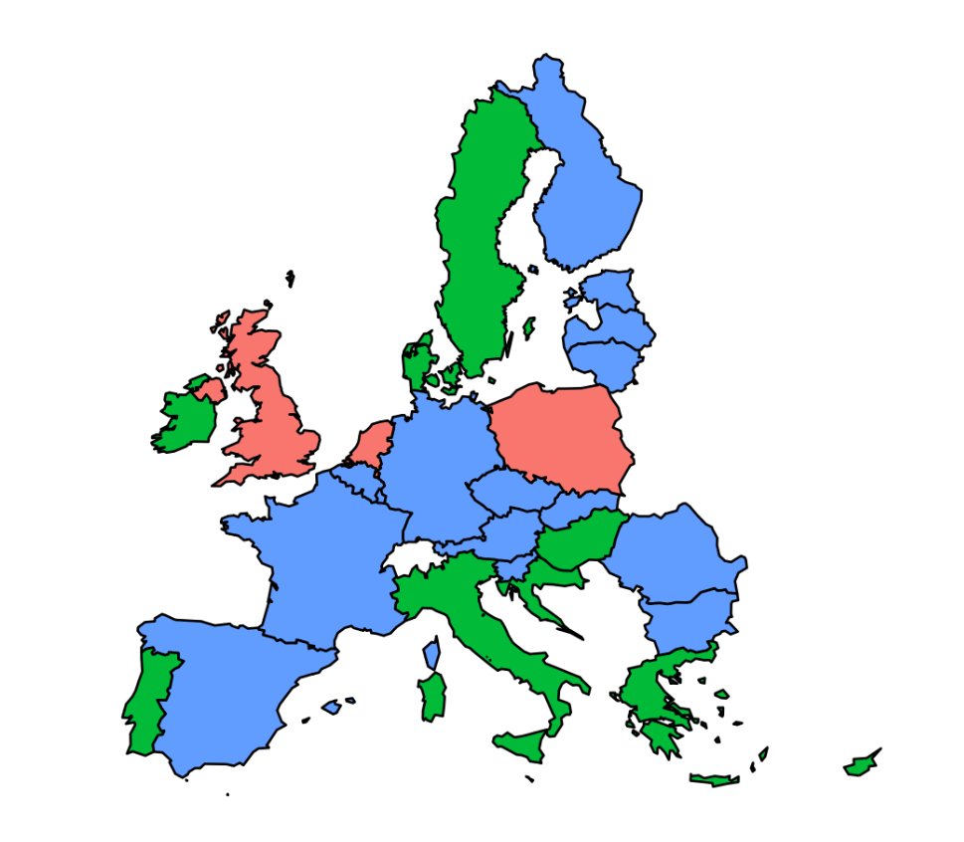

**Key non-prescription medicines are sold outside of pharmacies without additional requirements**

**Other non-prescription medicines are sold outside of pharmacies, or with additional requirements**

**Non-prescription medicines are not sold outside of pharmacies**

*Source: information collected from Member States and through dedicated studies*

In countries where non-prescription medicines can be sold outside of pharmacies, this authorisation may apply to a limited range of products. In Greece, Ireland, or Sweden, only a limited range of non-prescription medicines may be sold outside pharmacies.

Three countries allow a wide range of non-prescription medicines to be freely sold outside of pharmacies: the Netherlands, Poland and the UK. Nonetheless, with the exception of Poland, non-prescription medicines do not make up a significant part of pharmaceutical sales in these countries. Non-prescription medicines account for 13% and 13.5% of the pharmaceutical market in the Netherlands and the UK respectively, and for 32% in Poland.

To determine how restrictive a country’s rules for selling medicines are, it is therefore important to consider not only the outlets authorised to sell medicinal products, but also which medicinal products they can sell.

Recent trends in sales channels for non-prescription medicines

In the last ten years, there has been a trend towards allowing non-prescription medicines outside pharmacies. Reforms were carried out with the objective to respond to the demands of consumers, in certain cases reducing prices for consumers. Reforms have taken place in Portugal (2005), Italy (2007), Sweden (2009) and Denmark (2015). In Portugal and Italy, non-prescription medicines were legally allowed to be sold outside pharmacies. Dedicated stores were created: the presence of a health technician or of a pharmacist is required. In Denmark, as a result of the reform, the sale of several non-prescription medicines was allowed outside pharmacies. Further liberalisation was carried out in 2015. In Sweden, a reform was carried out in 2009. Two of the major changes were a change in ownership regulations (previously all of the pharmacies in Sweden were state-owned by Apoteket AB) and in the regulations concerning sale of non-prescription medicines in other places than pharmacies. Several authorities have followed up on the consequences. In particular, the Swedish Competition Authority submitted a report in 2017[153] that showed that the range of non-prescription medicines has increased, and that they have become cheaper outside of pharmacies. The report concluded that, "at least in this regard, the pharmacy reform has been a success".

The Finnish Competition Authority published a report in 2012 on the provision of pharmaceutical products and proposed for consideration that non-prescription medicines or at least some of them would be sold outside pharmacies. Authorising the sale of non-prescription medicines outside pharmacies was considered but not carried out in Estonia and Latvia.

On-line sales of non-prescription medicines

Non-prescription medicines can be sold on-line. Their sales are increasing. In 2014, on-line OTC sales reached a value of €2.6 billion,[154] and are expected to grow in the future.

*Figure 29: On-line sales of non-prescription medicines in selected EU countries: market and growth forecast (2015 and 2020, in million € and %)*

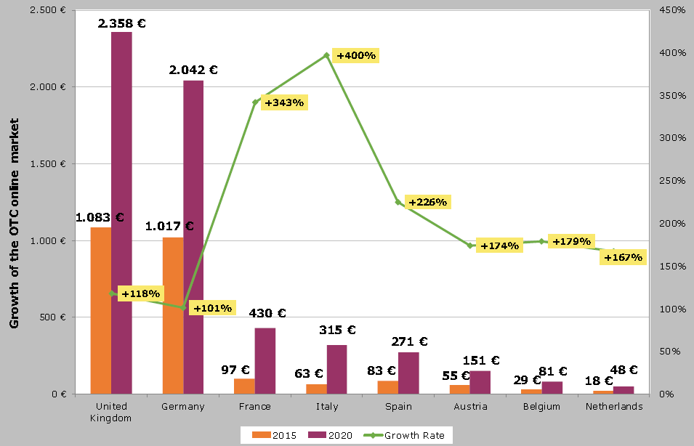

*Source: Shop Apotheke Europe 2017, Annual Report 2016, 93, as quoted in Updated report on liberalising OTC drugs markets in the EU: EE&MC survey, Prof. Mag. Dr. Dr. Doris Hildebrand, Bonn, 2017.*

The main reasons for buying medicines on-line appear to be lower prices (68% of respondents to a survey carried out in Germany) and convenience (ease of ordering and delivery).

*Figure 30: Reasons for using on-line pharmacies*

*Source: Umfrage zu Vorteilen von Online-Apotheken in Deutschland nach Altersgruppe, Statista, 2017.*

Nonetheless, on-line sales of non-prescription medicines remain marginal compared to sales in stores. In Germany, one of the main markets for on-line sales of pharmaceutical products, only 12% of non-prescription medicines were sold on-line in 2015, and 2.5% in Poland.[155]

Contrary to prescription-only medicines, national authorities cannot prohibit cross-border sales of non-prescription medicines via the internet[156] and consumers can in all 28 Member States, for their personal needs, buy on-line non-prescription medicines[157]. EU law establishes conditions for the sales of medicines on-line aimed at ensuring the public health protection and avoiding the entry of falsified medicines in the legal supply chain.[158] Buying on-line, consumers might have concerns whether the seller is a legal or an illegal on-line pharmacy. To address this, a European logo was introduced in 2013 and should be displayed on legal pharmacies.[159] According to the EU legislation, the Member States have to ensure that the person offering the medicinal product for sale is authorised or entitled to supply to the public in accordance with the national legislation in which that person is established In Member States where sales of non-prescription medicines are reserved to pharmacies, competent authorities for health have decided that only pharmacies can sell these products on-line. In addition, certain countries where non-prescription medicines can be sold outside of pharmacies still choose to restrict on-line sales to pharmacies – in practice some countries such as Italy limit licenses for on-line sales of non-prescription medicines to persons operating a physical pharmacy that is open to the public.

#### Public policy objectives pursued by Member States

The main justification for limiting sales of medicines is public health protection. Member States have put forward as a justification the need for appropriate advice on the use, side effects and combination of medicines. It is considered in certain countries that healthcare professionals such as pharmacists provide the necessary safeguards for the retail of medicinal products and are in a position to furnish consumers with appropriate information. Pharmacists have the professional qualifications and education to advise how consumers and patients manage their medicines. Pharmacists also participate in health promotion campaigns. Pharmacists are also responsible for ensuring appropriate storage and traceability of medicines, and for collecting adverse reactions and reporting them to the competent authorities.

#### Economic impact of restrictions to sales of non-prescription medicines

Several Member States have opened up sales of non-prescription medicines to a wider variety of retailers with the aim of improving accessibility and convenience, and respond to the demands of consumers, in certain case reducing prices. It can also have a positive impact on the competitiveness of the retail sector. The evaluation of the impact of these reforms is interesting in trying to estimate the effects of regulations limiting sales channel for non-prescription medicines.

*Prices*

The markets for medicines have many specific features. The price of non-prescription medicines is not determined only by market forces. Some non-prescription medicines are reimbursed, and as with prescription-only medicines, prices and reimbursement levels are determined by Member States. EU legislation on the transparency of pricing and reimbursement of medicinal products (Directive 89/105/EC, or the Transparency Directive) aims at ensuring a certain degree of harmonisation in the way national authorities determine prices for reimbursed products. But the Directive does not affect national policies on the setting of prices of the organisation of social security schemes.

In some Member States, manufacturers are free to set prices from the factory, while distribution prices (wholesale and retail prices) are regulated by fixed or maximum margins or mark-ups (Estonia, Malta, Slovakia, Spain for advertisable non-prescription medicines, and Germany for non-prescription medicines which are nevertheless reimbursable). In other countries prices are regulated at all levels of the value chain. In Austria, Belgium, Greece, Latvia and Luxembourg, prices out of the factory must be approved or at least notified to the competent authorities.[160]

Because the price determinants of non-prescription medicines vary greatly between countries, it is difficult to assess the impact on prices of changes in sales legislation. Studies also stress the fact that medicines prices are determined by a number of factors other than regulation of distribution channels The price elasticity of medicines is low, and lower prices or reductions in prices of prescription and/or reimbursable medicines are usually the result of drops in negotiated prices or reimbursement levels.[161]

Nonetheless, studies that have attempted to compare the prices of selected non-prescription medicines have shown that prices are higher in countries where they are only sold in pharmacies. Comparing the price of a selected basket of pain relief, cough and cold, and digestive medicines, it appears that prices in Romania (where non-prescription medicines are restricted to pharmacies) are more than twice (254%) as high as in the Netherlands, the cheapest country considered.[162] In addition, the price gap has increased throughout the years.[163] Overall, the additional cost to consumers ("consumer damages") of limiting sales of these medicines (pain relief, smoking cessation solutions, and cough and cold and digestive medicines) to pharmacies is estimated at €9.3 bn[164] throughout the EU.

Countries that have chosen to open up sales of non-prescription medicines to sales channels other than pharmacies report that the impact on prices is either neutral or positive. Most recently, the Swedish competition authority assessed the impact of the opening of the Swedish non-prescription medicines market in 2009.[165] On average, the popular non-prescription pharmaceuticals included in the study are sold in other outlets at a price that is 11% lower than in pharmacies. There are, however, major variations both within and between different categories of pharmaceuticals. The greatest difference exists in treatments against aches and fevers, where the prices are an average of 22% lower in outlets that are not pharmacies. The same results were found in Portugal, where prices of non-prescription medicines were on average 13% lower in supermarkets than in pharmacies in 2016,[166] and in Italy, where the difference reaches 10%.[167]

*Accessibility for consumers*

Greater flexibility in the sales of medicines could improve accessibility and could better respond to the demands of consumers. Pharmacy associations have raised concerns that opening up the market for non-prescription medicines may deprive pharmacies of an important source of revenue and lead to closures of pharmacies, particularly outside of cities. It is difficult to state whether such a trend could be confirmed or not. A 2014 report assessed that 58% of EU citizens could reach their nearest pharmacy within 5 minutes, and 98% could reach their nearest pharmacy in 30 minutes.[168] In practice, market opening for non-prescription medicines has often been coupled with the removal of restrictions for pharmacy openings (in Sweden and Denmark for instance). The latter has led to an increase in the number of pharmacies: the Swedish Competition Authority concluded that around 200 new pharmacies had been established within a year from the new regulation (mostly in urban areas), and districts that previously did not have a pharmacy got one.

Furthermore, the development of e-commerce in non-prescription medicines can be expected to have a positive impact on the convenience of patients. Little evidence is available so far, partly because of the conditions that apply in countries where on-line sales are authorised. There are however indications that on-line sales could respond to consumers' demands to medicines. Reasons for the choice of internet as a sales channel include lower prices and the comfort of buying from home.[169]

National rules limiting the number of outlets in one form or the other are restrictions to the freedom of establishment, which are compatible with Article 49 TFEU if their justification on the ground of an overriding reason of public interest or proportionality are demonstrated. The ECJ has ruled for example that a national legislation which lays down, as an essential criterion for determining whether a need for the establishment of a new pharmacy exists, a rigid limit on the "people remaining to be served", where the competent authorities cannot depart from that limit to take account of particular local geographical conditions is contrary to Article 49 TFEU.[170]

*Health and quality of service*

Opening up distribution channels for non-prescription medicines sales has been criticised due to concerns about misuse and a decrease in the quality of service offered to patients. Pharmacists argue that professional advice and care are very important when delivering medicines. They highlight the risks of self-medication, even with commonly used drugs and of medicine interactions, and warn against the risks of an increase in drug use. One possible advantage of the presence of a pharmacist could be to offer individualised advice to patients when they can access their medical records. But although this may become more common with the development of e-health, pharmacists in most European countries cannot currently store patient data or have access to it.[171]

Sales of non-prescription medicines show a slight increase over previous years, but do not appear to follow liberalisation patterns. In the Netherlands, they have even decreased. This may be because even where reforms have taken place, the majority of non-prescription medicines continue to be sold in pharmacies. Except for the Netherlands, most non-prescription medicines are sold in pharmacies and drugstores and other outlets only hold a small share of the market.[172]

Even when liberalisation has taken place, counselling by trained staff continues to be an important factor of choice (for over half of patients in Sweden for instance). Geographic proximity, opening hours and product range were reported as the most important factors in retailer choice.[173]

## Sales promotions and discounts

Sales promotions and discounts are both key for retailers. They provide an opportunity to, *inter alia*, raise brand awareness, increase sales to consumers, attract new customers, establish consumer loyalty or reduce and replenish stock. Sales promotions and discounts can also be part of a retailer's strategy for encouraging the use of a specific distribution channel in a multi-channel environment or for entering a new market.

This section focuses on national regulations limiting retailers' freedom to decide on and to advertise or announce sales promotions and discounts as part of their business operations in the following four categories:

1. Restrictions on end-of-season sales.
2. Restrictions on discounts (outside fixed end-of-season sales periods if existing in a Member State).
3. Restrictions on end-of-business sales.
4. Restrictions on sales below cost (excluding competition rules).

In the absence of exhaustive EU harmonisation, Member States may regulate retail sector activities' including sales promotions and discounts as long as relevant EU legislation is complied with. Around half of the Member States regulate sales promotions and discounts in one or more of the categories mentioned above.

Member States must comply with the fundamental freedoms enshrined in the Treaty. Furthermore, they must comply with EU secondary legislation. So, for example, sales promotions and discounts constitute commercial practises within the meaning of Article 2(d) of the Unfair Commercial Practices Directive ('UCPD'), if they are linked to promotional activities, sale or supply of a product directed to consumers. Sales promotions and discounts fall under the scope of the UCPD,[174] if national authorities or ECJ establish that the relevant national provision has the objective of protecting consumers' economic interests. If a commercial practice does not affect consumers' economic interest to some degree but exclusively relates to business-to-business transactions or harms only competitors' economic interests, the practice falls outside the scope of the UCPD.[175]

In this context also the Misleading and Comparative Advertising Directive is relevant. After the adoption of the UCPD the provisions on misleading advertising have been restricted to business-to-business relations, while the rules on comparative advertising also apply indistinctively in the context of advertisements directed at consumers. In that regard, both Directives complement each other.

The UCPD, which constitutes exhaustive harmonisation, addresses several unfair practices linked to sales promotions and discounts. The UCPD's Annex I includes a prohibition of, *inter alia*, bait advertising or certain competition and prize promotions: this type of behaviour is per se unlawful. Beyond that, as the ECJ clarified, the UCPD precludes any general prohibition on commercial practices like sales promotions and discounts. Hence, of the types of behaviour set out in Annex I are absent, any practice must be assessed on a case-by-case basis in line with the tripartite test in Articles 5-9 UCPD to allow a conclusion on the unfairness of the retailers' activities ensuing from a national regulation or restriction.[176]

In the past, the ECJ has applied this approach to various national rules regarding sales promotions and discounts. The ECJ decided, for example, on the incompatibility with the UCPD of general prohibitions of combined offers[177], of sales with bonuses[178] or of price reduction announcements[179]. The ECJ has ruled that, in so far as that provision pursues objectives relating to consumer protection, the UCPD precludes national provisions establishing the presumption of unlawfulness and prohibiting, generally and pre-emptively, sales below cost without verification of their unlawfulness and without providing an appropriate justification.[180]

Based on the Consumer Rights Directive it is possible for Member States to impose certain pre-contractual information requirements for on-premises sales, *e.g.* the dual display of the regular and the reduced price. This is not possible for distance and off-premises contracts due to full harmonisation. Only Cyprus and Croatia decided to require off-line retailers to display both the regular and the reduced price in-store.

The E-Commerce Directive obliges Member States to ensure that on-line retailers clearly identify promotional offers, such as discounts, premiums, and gifts as well as stating the conditions to qualify for such an offer. Furthermore, on-line retailers have to comply with the law in their home Member State and other Member States cannot restrict these retail services, unless a public policy ground exists or a field referred to in the Annex to the E-Commerce Directive is affected.

***Regulation in Member States***

*General remarks and recent developments*

When it comes to regulating sales promotions and discounts Member States fall into two categories. In total, 15 Member States[181] opted for a complete liberalisation for restrictions encompassed in the scope of the categories examined. The remaining 13 Member States[182] impose restrictions in the analysed categories on retailers' operations to varying degrees. Such restrictions must be analysed against the benchmark of inter alia the fundamental freedoms enshrined in the Treaty. EU secondary law can also be relevant for certain aspects.

*Figure 31: Member States applying restrictions on sales promotions and discounts*

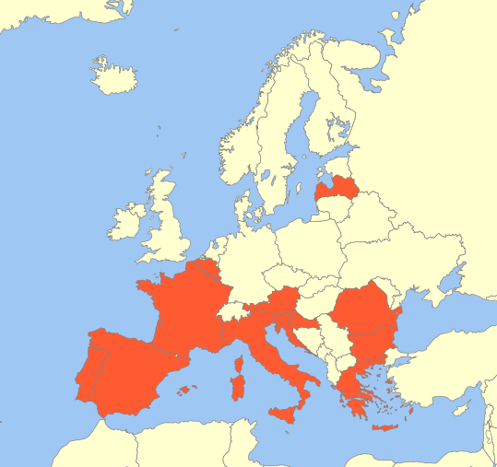

*Source: information collected from Member States and through dedicated studies*

In recent years there has been a trend in Member States towards reviewing and assessing the existing legislation on sales promotions and discounts – either by a general overhaul or by a targeted approach. The majority of Member States adopted liberalizing reforms, while only a few decided to restrict further in their national legislation. The developments in Member States are highlighted in subsequent sections for each category of restrictions.

*Restrictions on end-of-season sales*

In all Member States having restrictions on end-of-season sales the most common practise is fixing the start date and the duration of such sales. Furthermore, Member States also impose notification obligations, a prohibition to apply discounts during a specific period preceding the end-of-season sales period, a prohibition to sell products at a reduced price during end-of-season sales, if they have been purchased within a certain period of time preceding the end-of-season sales, or a prohibition to announce price reductions that will be applied during the end-of-season sales period in advance. These types of regulation exist in ten Member States.[183] Noteworthy is the situation in Spain where, despite the liberalisation at national level to increase competitiveness and growth and to comply with a Spanish Constitutional Court decision declaring that fixing end-of-season sales periods is unconstitutional, some autonomous communities continue to apply restrictions on the periods for end-of-season sales. In Italy national law has delegated the competence for regulating end-of-season sales to the two autonomous provinces of Trento and Bolzano. These Member States also have some exceptions to the abovementioned restrictions in place allowing retailers to deviate from the rules, e.g. for specific touristic or border regions, for private or loyalty sales, for certain products, or if not all reduced products could be sold during the end-of-season sales period.

*Figure 32: Member States applying restrictions on end of season sales*

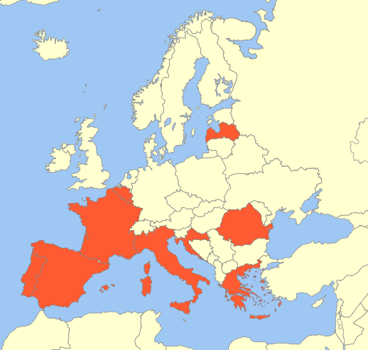

*Source: information collected from Member States and through dedicated studies*

Recently, Portugaldecided to reform its end-of-season sales by changing from fixed dates to only imposing a maximum amount of four months in which retailers can freely decide when to promote end-of-season sales. The rationale behind this reform has been to confer more flexibility for retailers and to increase competition by means of liberalisation. In Portugal, retailers have to notify the Economic and Food Safety Authority in advance of end-of-season sales. Latvia similarly limits the total sales period within a year to three months excluding food, seasonal products and fuel. Romania determines two periods of each three months per year in which retailers can offer end-of-season sales for a maximum duration of 45 days each. Before commencing end-of-season sales retailers have to notify the relevant municipality including information on the products to be sold, the quantity to be sold, the quantity existing in the store and documents coming from the supplier describing the product. In 2016, Cyprus decided to abolish its regime on fixed end-of-season sales periods and the Chamber of Commerce in Slovenia removed rules setting out the seasonal sales of textile products and footwear.

Greece extended the end-of-season sales periods in 2014 by introducing, besides the two fixed end-of-season sales periods, additional intermediate sales periods which can vary depending on the relevant region as well as a sales period of maximum one month during which all the products of a shop can be sold at a discount determined every two years upon decision of the Deputy Governor and after consultation with the municipalities and trade unions. In case not all products are sold during the end-of-season sales, retailers can continue to sell them at a reduced price until the end of stock. For example, Greece allows retailers to sell products at a discount outside the end-of-season sales periods for up to 10 days, if not more than 50% of the total number of products sold in the outlet is subject to the price reduction.

While there is a trend towards liberalisation, this trend is not fully consistent. In 2008, France decided to liberalize its retail laws by introducing, *inter alia*, so called 'floating sales' allowing retailers to choose, after prior authorization, two weeks besides the fixed end-of-season sales periods for offering sales promotions or discounts. In 2015, France abolished 'floating sales' again by arguing that these sales predominantly benefitted large retailers and brands at the expense of small stores being unable to compete. Croatia imposed in 2015 fixed end-of-season sales periods for retailers to safeguard fair competition and consumer protection. Croatia argued that permitting unrestricted sales for retailers has led to a distortion in competition and an abuse in individual cases in which discounts have been advertised, although the products were *de-facto* sold at the regular price.

Luxemburg decided to retain their rules on fixed end-of-season sales periods during the recent 2016 reform, but abolished the prohibition to advertise the upcoming discounts in advance. Interestingly, the end-of-season sales periods are fixed annually by Luxemburg after a joint proposal of all businesses concerned.

The vast majority of Member States that have rules on end-of-season sales apply these indistinctively to on-line and off-line retailers or it is not conclusively resolved whether the restrictions are covering e-commerce. Only Croatia differentiates between on-line and off-line retailers by merely requiring the latter to highlight the reduced and the regular price in the context of sales promotions or discounts. The reason for this distinction is the above-mentioned possibility for Member States to adopt or maintain rules, in line with the Consumer Rights Directive, requiring additional pre-contractual information to be provided by retailers for on-premises sales. Due to the full harmonization of distance and off-premises sales a regulation as in Croatiacan be considered as a permissible information requirement, if it applies only to on-premises sales and at the pre-contractual stage.

*Restrictions on discounts*

Some Member States **[184]** continue to impose general restrictions on sales promotions and discounts. In Member States fixing end-of-season sales periods these rules are typically applicable outside these specific periods to other sales promotions and discounts.

*Figure 33: Member States applying restrictions on discounts*

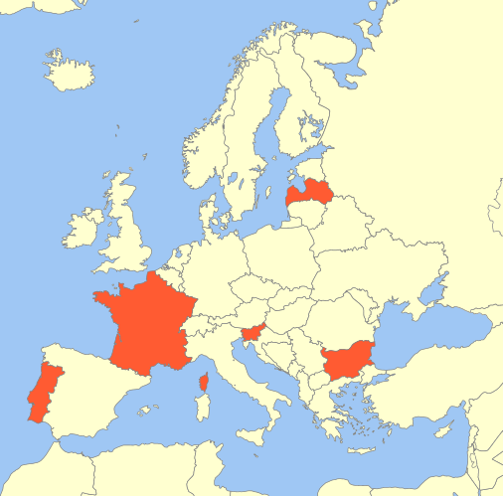

*Source: information collected from Member States and through dedicated studies*

The obligations and restrictions identified in the mentioned Member States include, *inter alia*, limitations to the duration retailers can offer a discount on a specific product or rules on how to announce discounts and present products with reduced prices in store. Portugal recently broadened the scope of its rules to also ensure their application to distance and off-premises sales. Bulgaria is the only Member State that explicitly excludes e-commerce from its restrictions on discounts.

Noteworthy, most Member States also impose requirements on the way in which the reduced and the reference prices have to be displayed and calculated. Predominantly, these requirements are applicable indistinctively to all categories of sales promotions and discounts. Exceptionally, Cyprus and Croatia require only brick-and-mortar retailers to highlight the reduced and the regular price when offering sales promotions or discounts.

Both rely on the possibility entailed in the Consumer Rights Directive to impose specific pre-contractual information to be provided for on-premises sales. Due to the full harmonisation of distance and off-premises sales such a requirement cannot be enforced on on-line retailers. Cyprus limits this requirement to clothing, footwear, home appliances and furniture.

*Restrictions on end-of-business sales*

Ten Member States[185] have rules regulating the commencement of end-of-business sales. A similar clear trend towards liberalization cannot be identified as for restrictions on end-of-season sales.

*Figure 34: Member States applying restrictions on end of business sales*

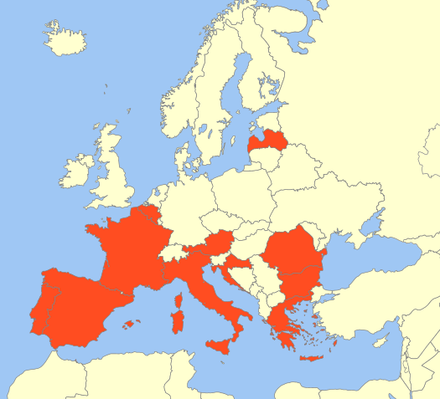

*Source: information collected from Member States and through dedicated studies*

In 2012, Spain increased the time period for offering end-of-business sales from three months to one year to extend the potential benefits for struggling retailers. Belgium abolished the obligation of retailers to notify end-of-business sales in advance in 2013. At the end of 2016, Luxemburg fully abolished its restrictions on end-of-business sales, while Croatia introduced the restrictions set out below fairly recently in 2015.

The most constraining restrictions are imposed in Austria, France, Greece by requiring an authorization for end-of-business sales. In Austria, this authorization is issued by the District Administrative Authority, if the business will be closed or relocated. The authorization also entails the revocation of the respective commercial licence for the business after the end-of-business sale has lapsed. When applying for such an authorization the retailer has to provide extensive information on the business and on the reasons for the end-of-business sale including proof of its necessity. The information must comprise:

* Details about the respective products and their quantity, quality and value;
* The location of the end-of-season sale;
* The period of the end-of-season sale;
* The reasons including proof for the end-of-season sale, *e.g.* decease, business closure, relocation.

The District Administrative Authority needs to request an opinion of the Chamber of Commerce before deciding on the authorization within a month after receipt of the application. In 2016 Austria introduced exceptions in case of an emergency situation, e.g. water, fire or storm damage, prohibiting the regular operation of the shop. Only if such an event can be substantiated, an authorization is not necessary and a notification to the relevant municipality is sufficient. In France, a retailer must be authorized by the relevant municipality for end-of-business sales. Legitimate reasons include the closure, temporary suspension, change of activity, change in the legal form of a company, relocation and renovation of the business. If a retailer cannot prove any of the above-mentioned grounds an end-of-business sale will not be approved, but it remains possible for the retailer to engage in regular sales promotions. When notifying the retailer must provide, *inter alia*, a detailed inventory of the goods subject to the sale and which must be stored on the premises, the period of the sale and the nature of the goods concerned. The end-of-business sale must be accompanied or preceded by relevant advertisement.

In Greece, retailers have to request a licence from the responsible local court to be permitted to offer end-of-business sales. It is only permitted if the business, or parts of it, will be definitely terminated or in case of bankruptcy. During the whole end-of-business sale, and explicitly within the first five days of each month, the retailer has to provide the chamber of commerce with inventory lists setting out the remaining goods.

Compared to Austria, France and Greece the regimes in Italy, Romania, Portugal and some autonomous communities in Spain are less restrictive by requiring end-of-business sales only to be notified to the municipality before the envisaged start depending on the reasons, *e.g.* business closure, renovations and transfer or conversion of the businesses, for the end-of-business sale. The notification must include various information, *e.g.* a detailed inventory of the products to be sold which must be located on the premises, a proof of the declared reason or documents confirming the origin of the products.

In Belgium, Croatia, Latvia and the remaining autonomous communities in Spain retailers planning to engage in or advertise an end-of-business sales need to **self-assess** whether they fulfil the conditions to be permitted to do so. In case of an investigation the retailers must have proof that a legitimate reason has existed or continues to exist with respect to their business. Such legitimate reasons can include, *inter alia*, business closure, renovations, relocations, retirement or *force majeure*. The retailers can only offer products that have been part of the stock at the time. While the other Member States in this category apply all rules indistinctively to on-line and off-line retailers or it is not conclusively resolved whether the restrictions are covering e-commerce, a difference in treatment can be found in Croatia requiring similar to the rule for end-of-business sales explained above only brick-and-mortar retailers to highlight the reduced and the regular price when offering sales promotions or discounts. Contrary, Portugalrecently broadened the scope of its rules to also ensure their application to distance and off-premises sales.

Also the duration of the end-of-business sales can be limited. For example, in Bulgaria, Belgium and Greece, it cannot exceed 6 months.

*Restrictions on sales below cost*

A sale below cost is a practice whereby a retailer sells products at less than the costs of manufacture or purchase. The main reasons for retailers to sell below cost are, *inter alia*, to increase its sales, to have a competitive advantage, to improve its market share or to free itself from certain products.

With respect to sales promotions and discounts directed towards consumers the ECJ has taken the view that, in so far as that provision pursues objectives relating to consumer protection, the UCPD precludes any national provision establishing the presumption of unlawfulness and prohibiting, generally and pre-emptively, sales below cost without verification of their unlawfulness and without providing an appropriate justification.[186]

Seven Member States[187] have specific restrictions on sales below cost which go beyond competition law. While only Portugal has an outright ban of sales below cost linked to sales promotions and discounts, the other restricting Member States also preclude sales below cost, subject to varying methodologies for calculating cost, but allow for certain exceptions. These exceptions either relate to specific circumstances, *e.g.* with respect to perishable goods, end-of-season sales and end-of-business sales, or if particular conditions are met, *e.g.* a certain limit to the occurrences or the duration of sales below cost, specific quantities permitted to be subject to such sales or a notification regime as in Italy.

In 2004, Luxemburg envisaged to support the growth of the national, at that time, underdeveloped e-commerce sector by excluding on-line retailers from the ban on sales below cost. Luxemburgrepealed the prohibition to sell below cost likewise for off-line retailers as part of the recent 2016 reform. Greece also decided to abolish restrictions on sales below cost in 2012.

While the other Member States in this category apply all rules indistinctively to on-line and off-line retail, Italy explicitly excludes e-commerce from its restrictions on sales below cost.

*Figure 35: Member States applying restrictions on sales below cost*

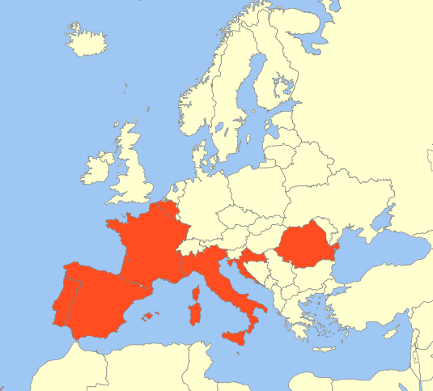

*Source: information collected from Member States and through dedicated studies*

#### Public policy objectives pursued by Member States

Different justifications are advanced by Member States for regulating sales promotions and discounts. The three main justifications are fair competition between retailers, clarity for consumers and consumer protection, and to address unfair trading practices between suppliers and retailers.

Of particular interest is how the respective restrictions contribute towards achieving these envisaged public policy objectives. In this respect, there appears to be a lack of assessment as to the positive or negative effects of restrictions when implementing or reviewing restrictions on sales promotions and discounts. The Member States with such measures have not provided any information or data on the impact of the identified rules on, *inter alia*, quality, pricing or the availability of offers. In addition to that, Member States pursue the same public policy objectives with contradicting policies. Some Member States want to achieve the envisaged goals by liberalizing national rules on sales promotions and discounts, while others pursue the same aims by imposing stricter national rules.

At the same time, the retail landscape has evolved to an extent that is not comparable anymore to the brick-and-mortar retail environment for which most of the rules on sales promotions and discounts have been introduced. Rules that might have been fit for purpose for traditional retail are less likely to achieve the desired effect in today's retail environment, in particular when considering the technical developments of the digital age. Retailers need the freedom to adapt to changing consumer shopping preferences, shifting work environments and the increased competition from on-line retail. More flexible and liberal rules on sales promotions and discounts can facilitate this necessary adaptation ultimately allowing consumers to benefit from more price reductions by saving money.

#### Economic impact

Sales promotions and discounts are marketing and pricing tools commonly used by retailers. From an economic perspective these tools can serve different purposes. They can be used as means to launch new products or services on the market, to attract customers, to establish a competitive advantage and to increase the market share. Additionally, engaging in sales promotions can be an efficient way to clear stock to be able to replenish with new or fresher products.

The OECD has continuously measured the impact of regulating sales promotions and discounts in its Product Market Regulation Indicator.[188] In a recent report on Greece the OECD concluded that such rules limit retailers' ability to optimise their stock, to correspond to their customers' needs and, more generally, to freely choose their marketing and pricing strategy for maximizing profits. In particular, the OECD inferred that fixing periods for end-of-season sales seems to provide insufficient flexibility to meet the specificities of different regions. For example, retailers established in touristic areas may consider offering end-of-season sales as more profitable after a holiday season instead of during the holiday season. The inherent inflexibility of fixed end-of-season sales periods might harm consumers' economic interests, if not in line with changing consumer behaviour or preferences. Therefore, the OECD recommended that the national legislation in Greece should not impose the dates for end-of-season sales, but rather should confer the power to decide on offering such sales to the retailers.[189]

Following OECD’s recommendations, Greece liberalized the regulations on sales promotions and discounts to some extent by introducing local intermediate sales periods. The total overall economic benefit for Greece's economy from this reform has been estimated to be 740 million of euros in increased annual turnover.[190]

Similarly, the OECD has recommended to France to abolish fixing end-of-season sales periods by national law to improve competition and to allow more flexibility for retailers.[191]

On sales below cost, a number of studies have concluded that forbidding them generally generate negative economic effects. In particular, the OECD argues that sales below cost laws do not cause a decline in the market share of high price, low volume retailers. Countries without sales below cost laws continue to have a variety of retailers including small, local retailers. The concerns about the cost of sales below cost laws for consumers appear to be economically sound and empirically supported. First and foremost, such laws are likely to result in consumers paying higher prices.[192]

Allain and Chambolle state that sale below cost laws enable producers to impose industry-wide price-floors to retailers.[193] This mechanism suppresses downstream competition and finally results in higher prices for consumers.

In 2008, France has amended its law regulating sales below cost. In particular, it has changed the way the cost of a certain product is calculated, therefore affecting the threshold below which its sale is forbidden. Before the reform of 2008 the cost of a product, or purchase price, was the price appearing on the invoice and included only those discounts acquired by the retailer at the moment the order was placed. With the 2008 reform it was possible to deduct also the discounts resulting from the annual sales targets and the provision of services by the retailer. A study[194] concludes that the 2008 reform increased competition in the retail sector in France.

*E-Commerce*

Retailers build their commercial strategies increasingly on a multi-channel approach. Both on-line retailing in general and cross-border e-commerce in particular is expanding rapidly. Today, consumers can access on-line shops more conveniently, safely and cheaply - regardless of their location. E-commerce enables retailers to extend the geographical spread of their offers throughout the EU increasing competition.

Both off-line and on-line retailers frequently offer sales promotions or discounts, but they are an essential tool for on-line retailers' success, because the search costs are lower in on-line markets compared to traditional ones and price competition is fierce. It is submitted that for the majority of consumers a reduced price is the most appealing promotional activity offered by on-line retailers.[195]

Other studies conclude that price sensitivity of consumers is higher on-line than off-line mainly due to the fact that on-line sales promotions are stronger signals or price reductions as well as that price discounts as part of loyalty programmes are more profitable on-line than off-line for retailers.[196]

These findings are fortified by the ease for customers to use price comparison tools for finding the best price on-line and to switch vendors in today's e-commerce environment. In 2014, a study[197] confirmed that 74% of EU consumers have used a comparison tool or website and 40% are using them at least once a month. 35% of comparison tools users replied that the use of comparison tools usually results in a purchase. Hence, to remain competitive in the European market on-line retailers must be able to offer competitive prices, if beneficial for their business.

Furthermore, technological developments in e-commerce allow retailers to design cost-effective personalized sales promotions for individual customers.[198] By combining data analytics with their existing data the usage of such targeted promotions can be increased and their usage is growing steadily - particularly in e-commerce. On-line tools deliver new sophisticated functionalities and retailers can fully and efficiently control their on-line promotional activities in real time, *e.g.* ending or amending a campaign depending on the success or identify well-performing elements. Increasingly, retailers have introduced dynamic pricing models based on data from their on-line sales channels for setting prices and for offering discounts.[199]

The ability to engage in targeted sales promotions and use dynamic pricing models can significantly improve the effectiveness of such activities for the benefit of both retailers and consumers, if the national legal frameworks are fit for unlocking this potential and for optimizing the usage of existing technology.

The vast majority of Member States does not apply, or considers applying, specific rules for on-line retail. They simply apply rules for 'traditional retail' equally to e-commerce despite the completely different business models. In a few cases, difference in treatment exists depending on the category of restrictions or when Member States have explicitly excluded on-line retail from the scope of their restrictions. Other Member States have not particularly considered the effects on e-commerce when adopting the restrictions on sales promotions and discounts or it is not explicitly clarified in the laws whether the relevant provisions are also applicable to e-commerce.

Although most Member States state that they apply the same rules it remains unclear how the restrictions in place are applied to e-commerce in practice and how the compliance of on-line retailers is monitored and enforced. In case Member States do not apply restrictions to on-line retailers or cannot ensure their compliance due to, *inter alia*, a lack of resources or existing structures it is doubtful whether enforcing the restrictions solely against off-line retailers is a sound approach or whether a liberalisation of the respective restrictions would be considered.

On-line retailers located in an unrestrictive or less restrictive Member State can have an advantage for engaging in any kind of sales promotion, offer better discounts or more competitive prices without being constrained. On-line retailers established in a more restrictive Member State have to adhere to the restrictions when considering sales promotions and discounts, *e.g.* fixed end-of-season sales periods. Consequently, offers of not or less restricted on-line retailers can be more appealing for consumers – especially since cross-border e-commerce becomes increasingly attractive for consumers and they are more inclined to also switch vendors cross-border. The possibility to flexibly and swiftly promote temporary price reductions is a competitive advantage in the European e-commerce sector considering that the price of a product is still a crucial element for consumer purchase decisions.

For on-line retailers the varying restrictions in the EU have several consequences. Firstly, they have to adapt to different sales periods and national regimes on sales promotions and discounts in the Member States they want to sell in. Secondly, on-line retailers may offer different prices for identical products depending on which website the potential customer is visiting and ordering. Consequently, rolling out EU-wide actions are hampered and linked to increased costs.

In a domestic context similar issues can arise when rules in a Member States differ between regions. If retailers follow the rules of their actual place of establishment, they can be disadvantaged compared to competitors established in a different less or not restrictive region. If they sell to other regions with varying restrictions, *e.g.* regarding the periods for end-of-season sales, they might risk being investigated and fined for not obeying the rules in the differing region.

Considering the steady increase in on-line sales, the growth of e-commerce and the multi-channel future of modern retail it is essential to ensure a balanced and appropriate legal framework on sales promotions and discounts. Bearing in mind that there is a lack of assessment, information and data when implementing or reviewing restrictions on sales promotions it is uncertain whether the envisaged public policy objectives are effectively, adequately and proportionately achieved by relying on the existing restrictions. As a consequence, all players have the chance to seize the positive opportunities e-commerce offers while enjoying sufficient flexibility and independence to meet consumers' demands and adapt to the market reality for brick-and-mortar retail.

## Retail-specific taxes and fees

Retailers, as any other businesses, are subject to numerous taxes and fees. Taxes borne by companies are mainly the corporation tax, business rates (or similar taxes) and social security contributions paid by employers. Such taxes, although often constituting an important financial burden, are not specific to the retail sector and hence they do not discriminate this sector against the others. However, some of them can be particularly burdensome for retailers. For brick-and mortar retailers this is in particular the case with the business rates which are often based on property. Retailers, as other businesses, are also tax collectors. On behalf of the government they collect VAT, excise duties, payroll taxes and employees' national insurance contribution, etc. For retailers engaged in cross-border e-commerce complying with VAT obligations can be burdensome since VAT has to be paid in the country of consumption.[200]

The retail sector is a significant contributor to government revenues. The estimated 2010 total tax collection (taxes borne and collected) in the EU by retailers amounted to € 69 500 billion[201] - figure 36.

*Figure 36: Estimated direct taxation of retail and wholesale firms*

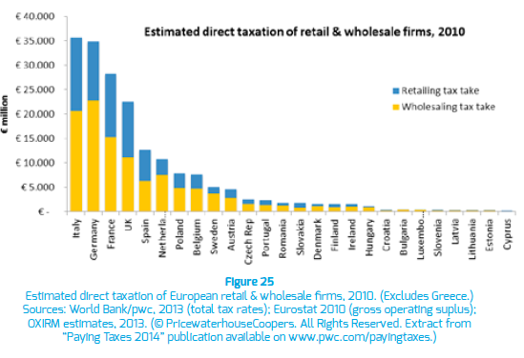

*Source: Retail and wholesale: key sectors for the European economy; SAID Business School and the University of Oxford; Apr 2014*

The structure of the taxes borne by businesses is changing. The share of the corporation tax compared to other taxes has been decreasing in general in the EU.[202] Meanwhile, the share of taxes on property (such as the business rates, particularly important for retailers, as confirmed also by the below UK example) in total taxation revenues increased.[203]

*Figure 37: Taxes borne by sectors*

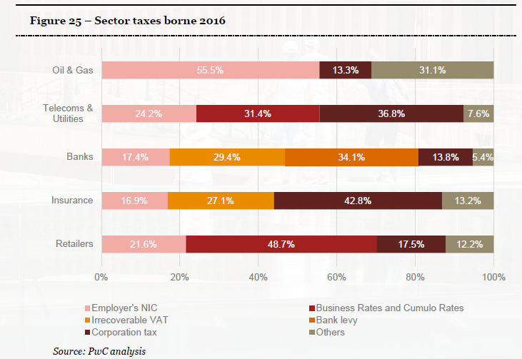

*Source: 2016 Total Tax Contribution survey for the 100 Group; PwC; 2016*

This trend away from taxes based on profits to taxes based on people, production and property affects in particular those running brick-and-mortar shops because people and property components play such an important role in their activities. Indeed, the share of taxes paid by retailers has increased – their share in tax revenues is higher than their share in the GDP.[204]

The retail sector seems to be particularly burdened with business taxes, which are often due to regional or local governments.[205] For example, a study comparing the effective tax rate (the tax paid as a percentage of income before corporate income tax) across different sectors concluded that this rate was the highest for retail.[206]

Digitalisation of the economy in many ways challenges existing tax systems and governments are concerned about maintaining current tax revenues. This has increased the interest in transparency about where in particular multinational companies pay their taxes. Thanks to initiatives of the OECD[207] and EU[208], the transparency of the tax system is improving. Nevertheless there is a risk of an unbalanced tax burden between on-line and off-line businesses. This was also reflected in the recommendations of the High Level Group on retail Competitiveness. The Group called for the creation of a fair EU and, if possible international, level playing field as regards taxation.[209]

***Regulation in Member States***

*Types of taxes*

In addition to the tax burden resulting from the general tax system retailers in some countries have to pay specific taxes and fees which are paid only by retailers. These retail taxes can be levied on the basis of (i) the size of the selling space, (ii) turnover or (iii) a combination of selling space and turnover. A few MS also have (iv) levies or fees linked to retail authorisations, which go beyond covering purely the costs of the authorisation procedure.

Retail-specific taxes based on the outlet size or turnover

Taxes based on *selling space* can be found in some Autonomous Communities in Spain.

In Cataluña retailers exploiting a surface above 2 500m² have to pay a specific tax (IGEC), with a higher rate for surfaces exceeding 5000 m² and 10000 m² respectively. The IGEC is not imposed on collective large retail establishments, irrespective of their sales area. Not every individual retail establishment having a sales area covering 2 500 m² or more ultimately pays the IGEC, for those which are garden centres and those selling vehicles, building materials, machinery and industrial supplies are exempt. Furthermore, a 60% reduction in the taxable amount for the IGEC applies to individual large retail establishments given over essentially to the sale of furniture, sanitary ware and doors and windows and those that are do-it-yourself stores.

The retail specific tax applicable in Asturias (IGEC) applies to retail establishments, whether individual or collective, with a public display and sales area equal to or exceeding 4 000 m². Provided that their public display and sales area does not exceed 10 000 m², the tax is not levied on individual large retail establishments that solely and exclusively pursue any of the following businesses: garden centre, or selling vehicles, construction materials and machinery or industrial supplies.

The retail specific tax applicable in Aragon (IDMGAV) applies to retail establishments with public sales area above 500 m². An exemption from liability to pay the IDMGAV applies to retail establishments whose principal business is the exclusive sale of the following products: machinery, vehicles, tools and industrial supplies; construction materials, plumbing materials, doors and windows, for sale only to professionals; nurseries for gardening and cultivation; fittings for individual, conventional and specialist establishments; motor vehicles, in dealerships and repair workshops; and motor fuel. Retail establishments which are subject to and not exempt from the IDMGAV will not actually have to pay tax if their basis of assessment (sales area + area set aside for other uses + parking area) does not exceed 2 000 m². The type of land on which the retail establishment is situated is taken into consideration, by means of the site coefficient, if the tax base exceeds 2 000 m² and, therefore, there actually is a taxable amount.

The authorities justify the tax with a need to counterbalance the negative impact of large retail outlets on the territory and on the environment.

The compatibility of these taxes with the freedom of establishment and State aid rules has been challenged.[210]

Portugal also has a retail tax based on selling space. This tax is to be paid by owners of food or mixed retail outlets only. The fee is levied on large food retailers (from 2000 m² of sales area upwards). Although the tax was motivated with the objective to fund official controls related to food safety, there is no clear link to the actual official controls of those business operators. In 2016, a Portuguese Court referred questions to the Court of Justice of the European Union concerning the compatibility of this tax with EU law.[211]

A retail tax may also be based on the *company's turnover*. Hungary in 2014 amended its legislation on the food chain inspection fee to introduce effectively a tax on retailers' turnover from food related activities. The rate was progressive ranging from 0% up to 6%, with the highest rate concerning almost exclusively big foreign retailer chains. The Commission found that the tax involved state aid.[212] Hungary suspended the legislation in 2015 and reverted to the previous version of the tax in order for it to comply with state aid rules.[213]

Poland in 2016 adopted legislation introducing a retail-specific tax similar to the Hungarian food inspection fee with the objective to increase the government revenues and to support smaller national retailers. Over a certain turnover thresholds the tax rate was 0,8% and 1,4% respectively. Companies registering yearly turnover of less than 204 million PLN (ca. 49 million €[214]) were excluded. The European Commission objected also to this tax as incompatible with state aid rules and the Polish government withdrew from collecting the tax. It has challenged the Commission's decision.[215]

In France, the retail-specific tax *combines the two approaches of selling space and turnover*. The French tax on commercial premises (TASCOM) applies to businesses exploiting a surface of more than 400 m² and registering an annual turnover of at least € 460 000 per establishment. The actual surface is multiplied by a tariff which varies depending on the turnover per m². The rate of the tax is particularly high for businesses operating commercial surfaces exceeding 2500 m². The French authorities are currently reflecting on increasing the tariffs and the scope of the tax.

These taxes, applicable to companies with a certain turnover or operating shops of a certain size, are mainly paid by retailers with predominately brick-and-mortar shops such as grocery shops (in particular in hypermarkets, supermarkets and discounters), clothing and footwear, furniture, electric and electronic goods or DIY, or department stores.

Retail-specific fees

In addition to annual taxes based on turnover or surface some Member States collect specific fees from retailers linked to retail authorisations.

In Portugal, there is an administration fee for authorisation for large retail shops (=> 2000m²) and shopping centres of =>8000m². In 2016 the issued authorisations generated approximately 228 000 €. Part of this fee covers the cost of the authorisation procedure and another part goes to a fund designed to support modernisation of traditional retail.

*Figure 38: Member States applying retail-specific taxes or fees*

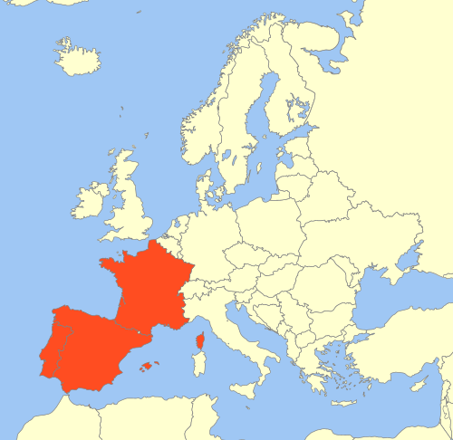

*Source: information collected from Member States and through dedicated studies*

#### Public policy objectives pursued by Member States

Taxes are a way for governments to bring revenue. In addition to the general fiscal objective specific public policy objectives have been put forward for the retail-specific taxes and fees. They may be linked to the use of the funds collected.

The justification of the Spanish retail taxes applicable in three Autonomous Communities, Cataluña Asturias and Aragón (covering ca. 21% of the Spanish population) is to counterbalance negative impacts of large surfaces on urban planning and the environment. An environmental objective can as such justify imposing a tax in so far as the tax is not discriminatory and the objectives are pursued in a consistent and systematic manner. For the Spanish retail taxes, the exemptions, deductions and reductions from the tax however raise doubts as to whether the tax is appropriate for attaining the public policy objective pursued. Retailers which are excluded from the tax may equally impact the environment and town and country planning objectives. In a legal assessment of the Spanish measures, improving the competitive position of small and medium size retailers could constitute an economic objective and as such would not qualify as a legitimate public policy objective.

Moreover, if the reasoning behind a tax or a fee is to fund environment protection, this should not be achieved via a retail-specific means. Such a financial burden should then apply to any operator which might have an impact on the environment, in particular if the justification for the tax is the size of an establishment. Large establishments are not exclusive for retailers – they are also occupied by other service providers or manufacturers (e.g. cinemas, gyms, indoor playgrounds, production units, etc.).

The justification for the retail tax introduced in Poland was to increase government revenues. The French commercial tax has initially been designed to finance the old-age insurance schemes for craft, industrial and trade professions. Nowadays the retail-specific tax is supposed to increase revenues for local governments, which were affected by reduction of other types of taxes (e.g. local business taxes).

Specific fees charged to retailers in some countries are designed to cover the costs of the authorities' activity, such as food controls in Portugal and Hungary.

An important aspect of assessing the impact of the sector-specific financial burdens on retailers would be to explore whether they actually help meet those objectives.

#### Economic impact

As shown above, retail-specific taxes and fees exist, or have been planned, only in a limited number of Member States. The lack of economic analysis of the effects of such taxes is therefore not surprising. Any direct link between retail-specific taxes and fees and general economic outcomes (employment, productivity etc.) would be very difficult to establish. If the tax is simply to provide funds to finance government social policy (such as family allowances), it is difficult to see why the costs should be borne by one particular sector and in particular on a sector which actually has an important impact on household expenditure.[216]

The tax burden of a retail tax based on selling space is born only by brick-and mortar retail. In fact, all the retail-specific taxes and fees described above apply mainly to the off-line commerce. In France, Spain and Portugal, they refer to the selling space. The planned Polish tax also exempted e-commerce from its scope, and the (withdrawn) Hungarian food chain inspection fee referred to stores selling fast moving consumer goods[217]. Such exemptions may seek not to give foreign e-commerce players and advantage, but they reinforce the imbalance between tax burden for on-line and off-line and create complexity for multichannel retailers. Also, taxes based on selling space affect mainly retailers whose business model is based on or includes operating large outlets.

Revenues from taxes based on selling space or turnover that exclude on-line retail are likely to decrease in the future as the share of retail turnover in general generated by e-commerce will keep on increasing. It is however difficult to see how the tax base could be broadened without the effect of favouring foreign e-commerce players.

The existing retail taxes fall heavier on big companies as they start from a certain threshold. For example in Spain (Aragon), the tax applying to companies with stores > 500 m² seems to cover almost half of the most important players selling groceries as well as non-grocery products, most of which are also foreign retailers (French, Swedish, German, etc.). This might deter companies from increasing selling space or turnover above the threshold and hamper small retailers from growing. Moreover, in practice the threshold might deter newcomers. In Catalonia and Asturias, the taxes on operators of stores > 2500 m² as well as > 4000 m² seem to affect almost exclusively foreign companies. This may discourage entry by new competitors in a given region, in particular as the thresholds are the same as for retail establishment restrictions which can lead to distortions in the market structure. The planned Hungarian tax would have been borne mainly by foreign retailers.[218] This did not only result from the fact that the starting threshold and progressive rate but also from the business models of foreign and domestic retailers. The tax favoured franchising models compared to the business models used by foreign retailers.

The discussions in Poland, when plans for a retail tax intensified in 2015, show the difficulties to assess the possible impact of such a tax.[219] The Polish tax was supposed to "protect" or "support" Polish and small enterprises. One consultancy firm however estimated that the tax would be mainly paid by grocery chains (68% of the possible government income of PLN 3,5 billion) but might nevertheless not be favourable for small retailers.[220] The effect could be that the chains would try to move into the smaller stores segment or diversify their organisational structure (franchising, etc.). Also the tax could incentivise a new foreign retailer that would take over a convenience store chain (if this format would not be taxed), or it could encourage a big on-line retailer to enter the Polish market to develop on-line groceries (provided that on-line retail is not taxed).[221]

A report, commissioned in 2015 by the Polish Organisation of Retail and Distribution (POHiD) from PwC,[222] looked at possible impacts of introducing Hungarian regulatory solutions in Poland.[223] The report stated that a direct impact of Hungarian-like taxes and fees could drive the retailers' profitability down to zero. The average increase in consumer prices could amount to 0,8 % of a basket's value, up to 4,6 % in shops of 400-1000 m² (mainly discounters, where the poorer consumers buy). The financial burden from the restrictions depending on turnover could amount to 0,14 – 4,69 % of turnover (depending on the segment of the market), which could force companies to restructure their costs, including cutting employment by 8 700 persons.

## Sourcing

EU retailers source globally. However, for certain sectors, such as food, a large proportion of products sold in Member States are sourced within Europe and within the internal market.[224]

The benefits of sourcing within and throughout the Single market enables retailers to take advantage of lower prices that may be available in other Member States and gain access to the many different products that are available across Europe. For retailers present in more than one Member State, the ability to source centrally or cross-border is equally important to the ability to bundle volumes and create economies of scale. In addition, it can offer more efficiency in organising logistics such as deliveries. There is also a growing desire of retailers to reap the benefits from the Single market in this way. In turn, this can result in a wider choice and lower prices for consumers.

The ability of retailers to source products cross border is affected by both regulatory and private barriers, either directly or indirectly. It is not just the regulations of Member States that can affect how supply chains operate. All the other actors in the chain, be it the producers, distributors, retailers or consumers, also play a role in making sure the EU's single market is not partitioned along national borders.[225] Therefore, this chapter examines how the actions of both Member States and private operators affect sourcing of products within Europe.

### 5.6.1. Regulatory sourcing restrictions

Some Member States are trying to impose obligations for retailers to source a certain share of food products nationally. Various national regulations – either adopted or under discussion – were mentioned by respondents to the public consultation The obligations referred to included requirements to source a share of certain products from the national market, to notify authorities when sourcing products from other Member States, including products already sold in that Member State, and mandatory support or promotion of national supply chains and domestic products. [226]

*Obligations to source a certain share of products nationally and promotion of national supply chains*

In Romania, a law[227] was introduced that, inter alia, requires retailers to source[228] 51% of certain products from short supply chains. Sanctions for non-compliance are high financial penalties.[229]

These measures raise concerns with respect to the freedom of movement of goods and freedom of establishment.[230] They could deter certain retailers from entering the Romanian retail market or extending their existing network of shops as food retailers are not able to make their own commercial decisions as regards the consumable goods they place on offer.

The Bulgarian Parliament also considered, but did not pass,[231] legislation[232] that would require retailers[233] with a turnover of more than 2 million BGN to source domestically certain quantities of domestically produced products traditional to Bulgaria.[234] The draft legislation proposed the proportions would be determined by reference to the annual or seasonal turnover of fresh fruit and vegetables, milk and dairy products and meat and meat products or as a percentage of the assortment of wines and spirits. A high financial penalty up to 10% of the annual turnover of the products from the group to which the failure referred was also proposed. [235] This law, if adopted, would also raise serious concerns from the viewpoint of the fundamental freedoms enshrined in the Treaty.

*Mandatory support or promotion of domestic products*

Some Member States are attempting or have attempted to put in place mandatory obligations to support or promote domestic products. Such rules are in principle incompatible with the EU fundamental freedoms. [236]

The law in Romania referred to above obliges retailers to display products, according to the country of origin, which would enable Romanian products to be distinguished.[237]

In Slovakia, a law[238] required retailers, with a turnover of more than 10 million EUR, to report to the Ministry and display at the entrance to stores and on their website, a biannual report showing the percentage of turnover from the sale of food produced in Slovakia against all food sales. Following the Commission intervention, these provisions were removed.

In the Czech Republic, a law[239] required retailers with a turnover of more than 5 billion CZK, to report to the Ministry and display at the entrance to stores a list of the top five countries from which they sourced food supplies. The list was top down starting with the countries with the highest proportion of foodstuffs acquired from such countries in relation to total food turnover. In both cases, a financial penalty was linked to non-compliance.[240] Also here, following the Commission intervention, these provisions were removed.

While such measures do not enable consumers to assert prejudices directly against concrete imported food products, they aim, at least implicitly, to adjust consumer purchasing preferences and invite consumers to assert prejudices against foreign products.[241] They implicitly aim at prompting consumers to prefer retailers who have the highest or higher percentage of domestic food on offer. They also implicitly intend to encourage the retailers affected to increase the percentage of domestic food marketed, to the detriment of imported products, in order to attract more customers.

#### Public policy objectives pursued by Member States

In Romania, the justification for the sourcing restrictions described above is stated to be the promotion of Romanian products and more specifically the revitalisation of traditional producers, small and family enterprises in the agricultural field.[242]

In Bulgaria, the policy objective of the proposed amendments was stated to secure the interest of Bulgarian farmers against unfair commercial practices in the local market and also against unacceptable actions of traders. Furthermore, it states that the proposed legislation was directly geared towards improving the health of the citizens of the Republic of Bulgaria.[243]

Such objectives are obviously not legitimate interests which can be invoked by Member States to justify restrictions to the fundamental freedoms. [244]

### 5.6.2. Territorial supply constraints (TSCs)

The ability of retailers to source products within and throughout the Single Market may also be affected by barriers imposed by private operators in the supply chain, which restrict the ability of retailers to source products from a Member State of their choosing. As a result, retailers are often forced to source products domestically and/or are prevented from 'parallel trading' products from another Member State. These types of restrictions are known as territorial supply constraints (TSCs).

In concrete terms, this means that a retailer, based in one Member State and dealing with a multi-national supplier is not given the choice to decide from which national entity of the supplier he would preferably source the desired products and is instead referred to a specific national subsidiary. The retailer faces the same barrier if the supplier prevents its network of independent wholesalers from delivering its products cross-border. This has consequences in terms of price and choice of products.

TSCs can take different forms. They may include restrictions of quantities provided by suppliers to wholesalers to avoid them supplying retailers in other Member States. They may also take the form of interruptions to the supply or refusals to supply retailers in other Member States, either directly or for doubtful reasons (e.g. supply/transport shortages).[245] Other practical obstacles to prevent 'parallel trading' include changing packaging to make it harder to sell in other countries, limiting foreign retailers access to rebates and key products to prevent them bringing less expensive products into markets where there are higher prices,[246] modifying product recipes or packaging sizes and restricting the range of products that may be available in a Member State or for a type of retailer, based for example, on store format.[247]

Generally, the products concerned by TSCs are consumer goods under multi-national brand names sold in physical retail. They can be food or non-food goods and often include fast moving consumer goods that belong to the group of 'must-have' products shelved in the majority of supermarkets in those countries where the brand exists.[248]

Retailers and public authorities in Austria, Belgium and Luxembourg, as well as in Spain[249], Croatia, the Czech Republic, the Netherlands, France and Italy[250]have raised the issue of TSCs. Nevertheless these may be present in other Member States.

*Fragmentation of the Single Market*

TSCs can be considered to create anti-competitive obstacles to trade and partition the Single Market along national borders on price and on offer.

Depending on the competitive pressure at retail level, wholesale price differences might translate into retail price differences between EU countries. Through price discrimination, consumers in countries with less competitive pressure are subsidising consumers in countries with higher competitive pressure.

Restricting retailers from supplying their stores with different products, including different versions of branded products available in different EU countries limits the choice given to consumers on the basis of their residence. In the recent 'dual quality food' discussions it was argued that TSCs can deny consumers the choice of a different version of a branded good.[251] Retailers[252] have referred to the constraints placed on retailers by manufacturers, who do not permit cross-border sourcing, and the fragmenting effect this has on the Single Market as a reason why the market is unable to address this problem.[253]

Some consumers can be affected by both price and product differences simultaneously. Consumers in the Czech Republic, Hungary, Slovakia, Slovenia and Poland complain that they can in fact pay more for a branded good, which they perceive is of an inferior quality.

Competition law may catch some scenarios of TSCs.

Where TSCs are imposed by a dominant company, they may fall under Article 102 of the Treaty on the Functioning of the European Union (TFEU) that prohibits the abuse of a dominant market position.[254]

If an agreement between a supplier and an independent wholesaler is aimed at partitioning the Single Market, regardless of whether the supplier is dominant, it may be regarded as a restriction by object under Article 101 TFEU.[255]

Similarly an agreement between a supplier and an independent wholesaler, to restrict the territory into which the buying party to the agreement may sell goods, is classified as a hard-core restriction under Article 4(b) of Regulation 330/2010 (VBER), except in a limited set of circumstances notably designed to enable a supplier to set up exclusive or selective distribution systems.[256] However, even within an exclusive distribution system, bans on passive sales outside of the allocated territory are prohibited.[257] Similarly, within a selective distribution system, the supplier can prohibit appointed distributors from reselling to unauthorised distributors in order to protect the selective character of its network, but must allow (cross-border, both active and passive) supplies between appointed distributors and directly to end users.[258]

Market partitioning can also be achieved by more indirect means than explicit export bans or destination clauses, e.g. by reducing discounts or by charging additional fees in the event of sales outside the destination territory.[259] Such indirect measures are more likely to constitute hard-core restrictions prohibited under competition law if the supplier has mechanisms in place to monitor or verify the destination of the products in question.[260]

However, there are situations which do not fall under competition law. [261] If a supplier has domestic subsidiaries in one or several Member States, the instruction given to those subsidiaries not to supply retailers located outside of their respective Member is a unilateral (intra-group) decision. This cannot be challenged under the competition rules referred to above, if the supplier is not dominant on the relevant market. This is what suppliers are exploiting.

Certain market partitioning behaviour by suppliers is addressed in the Geo-blocking Regulation[262]. It however, does not establish a right for customers to be supplied cross-border. It also does not apply to retailers who wish to buy goods and collect them at the supplier’s premises or organise delivery themselves. This is because it only applies to customers who acquire goods for the sole purpose of end use[263], which excludes customers purchasing goods for subsequent resale[264], and where they do so in the absence of an individually negotiated agreement for the supply[265].

*Objectives pursued by suppliers*

Reasons given for TSCs include logistical optimisation of distribution, higher costs in different markets, different demand in different countries and tax reasons.

Stakeholders raise several reasons for using TSCs to maintain different prices in different Member States. These include wholesale price differences on the grounds of different levels of consumer purchasing power/price elasticity; different consumer preferences and brand perceptions; different market positions for the same product in different markets, e.g. lower wholesale prices may be charged to grow comparatively lower market shares in one market or enter a new market; different labour and advertising costs; and exchange rate fluctuations (if at least one of the compared countries is outside the euro area).

However, where a supplier deliberately pursues a strategy to prevent retailers from buying products at lower prices from another Member State, this results in artificial price differences between the partitioned national markets. Such partitioning and such an artificial price difference to which it gives rise are generally not compatible with the Single Market.[266] Such a strategy may also result in unjustified limitations of consumer choice.

#### Economic impact

A number of studies calculated the substantial benefits for the EU resulting from a completion of the internal market.[267] Introducing barriers to the free movement of goods would pose a threat to reaping these benefits.

Retailers that complain about restrictions on their ability to freely source products in the Single Market consider that they have a negative consequence on their business. TSCs can have negative effects on prices, product range and profit margins but also on quality, delivery time and product characteristics. Only a limited number of companies seem able to counter or remedy the impact of TSCs.

Replying to the Commission open public consultation, the majority of retailers subject to TSCs stated that they have negative consequences on their business. Retailers complain that they are not able to take advantage of the opportunities the Single Market offers. It undermines their ability to compete, because they cannot source the same products under similar conditions as their competitors, especially cross-border. The restrictions impede the positive effects the economics of scale for sourcing might offer and reduce the attractiveness of cross-border activities.[268] This also restricts physical retailers' abilities to compete with on-line retailers.

For consumers TSCs concerning different versions of branded products restrict the choice of products available to them. Also higher wholesale prices may translate into higher consumer prices.[269]

Suppliers (mainly of consumer goods under multi-national brand names) argue retailers will continue to reflect brand strength in retail prices, which means that any cost savings achieved shall not be passed onto consumers.[270] Retailers on the other hand argue that they operate in a business environment which means they will pass on savings, to retain customers and gain a competitive advantage.[271] Similarly, ECB studies[272] have shown that a higher concentration of retailers (including through buying alliances) at national level and the related increase in bargaining power is beneficial for consumers as lower prices are passed on.

## Contractual practices of modern retail

Fair trading practices in the supply chain support a proper functioning of the retail sector.[273] As the retail and processing segments of the food supply chain in particular, have witnessed an increasing concentration across Member States, as well as globally. As a result bargaining power imbalances in trade relations between the actors in the chain have led to potentially unfair trading practices (UTPs).[274] This has led to many Member States introducing regulations to tackle what are understood to be UTPs.[275]

Business models of retailers and their suppliers have evolved greatly over the last few decades, meaning suppliers and retailers have discovered opportunities for collaboration, beyond a pure selling and purchasing relationship, which are mutually beneficial. These are referred to as commercial practices of modern retail. Examples of such practices may include: joint planning and management of promotional activities, collaborative product launches, better demand forecasting and numerous activities relating to optimised supply chain management.

However, some have expressed concern[276] that ambiguity in defining and clearly understanding what practices would be penalised under regulations imposed to proscribe UTPs could reduce the likelihood that mutually beneficial transactions could take place. This chapter therefore, focuses on national regulations limiting, whether directly or indirectly, retailers’ freedom to decide on using commercial practices of modern retail as part of their business operations that can offer advantages for both retailers and suppliers.

In July 2014, the Commission adopted a Communication on tackling UTPs in the business-to-business food supply chain.[277]

The Communication did not foresee regulatory action at EU level and did not prescribe a single solution to address the issue of UTPs. It encouraged stakeholders and Member States to tackle UTPs in an appropriate and proportionate manner, taking into account national circumstances and best practice. It also encouraged operators in the European food supply chain to participate in the Supply Chain Initiative (SCI), a voluntary scheme aimed at promoting best practices and reducing UTPs.

Subsequently, in June 2016, a European Parliament resolution, invited the European Commission to submit a proposal for an EU-level framework concerning UTPs.[278]

In September 2016, the European Economic and Social Committee published a report calling on the Commission and the Member States to take swift action to prevent UTPS by establishing an EU harmonised network of enforcement authorities, to create a level playing field within the Single Market.[279]

In the Council conclusions of December 2016, the Council of Ministers invited the Commission to undertake an impact assessment with a view to proposing an EU legislative framework or other non-legislative measures to address UTPs.[280]

As part of the Commission Work Programme for 2018, the Commission will propose measures to improve the functioning of the food supply chain to help farmers strengthen their position in the market place and help protect them from future shocks. As such, the Commission published an Inception Impact Assessment relating to the initiative to improve the food supply chain on 25 July 2017, looking at UTPs amongst others[281] and launched a public consultation on 16 August 2017.[282] The Commission has adopted a proposal for a Directive of the European Parliament and of the Council on unfair trading practices in business-to-business relationships in the food supply chain.[283]

***Regulation in Member States***

Member States have addressed UTPs using a variety of approaches including legislation and hybrid approaches that combine legislation and self-regulation[284]. Certain Member States have no specific UTP rules[285] or address UTPs through self-regulatory initiatives among market participants.[286]

Among the regulatory approaches, Member States have chosen different ways to address imbalances in bargaining power or economic dependency.

Some Member States - Cyprus, Finland, Germany, Austria and Greece - have adapted or extended existing regulations to account for UTPs, usually involving modifications to the country's competition laws.[287] Others have introduced specific legislation and agencies to tackle UTPs.[288]

Of those that have introduced specific legislation, some Member States, for example Germany[289] and Austria[290], have very general legal provisions requiring an assessment on a case-by-case basis of whether there is a significant economic imbalance between two operators, and whether the stronger operator abused its position to impose unfair terms or conditions on the weaker party.

Other Member States, for example the Czech Republic, Slovakia and Hungary, have chosen to introduce more detailed UTP-specific legislation. Several of these laws contain extensive lists of practices considered to be intrinsically unfair and thus illegal (blacklists),[291] and where unfairness is not assessed on a case-by-case basis. In contrast, in Finland, the law replaces the notion of UTPs with the concept of 'good business practices'. In Poland, the relevant law combines the two by referring to fair dealing ('good practices') as well as having a blacklist of unfair practices.[292] Similarly, in Ireland, the law, accompanied by guidelines, include a grey list and prohibits with the possibility of justified exceptions, certain behaviour. [293]

In Romania, legislation contains an outright ban on charging suppliers payments or fees for any services provided by retailers. Such a general prohibition does not appear proportionate as in certain conditions the agreement may be fair and beneficial to both parties.

***Public policy objectives pursued by Member States***[294]

Most Member States aim to protect the weaker actors in the supply chain against operators with greater bargaining power from imposing trading practices that are generally regarded as unfair. Some Member States specifically recognise the position of SMEs as particularly vulnerable. Other Member States focus on improving the efficiency and competitiveness of the food sector as well as empowering suppliers and strengthening their position in the market.

#### Economic impact

The economic impact of restricting contractual freedom is very hard to quantify. However, faithful cooperation between retailers and their suppliers is key for business success. Business models of both suppliers and retailers have evolved over time and there are many examples demonstrating that collaboration beyond a pure selling/purchasing relationship can be mutually beneficial, in particular in reaching efficiency gains.

In addition some academics[295] refer to a 'rule of reason' regulatory approach which recognises that defining certain business-to-business practices as UTPs instead of ordinary competitive behaviour intended to promote transaction efficiency, can reduce the surplus to a transaction and can harm both parties to it.[296]

## Retail Restrictiveness Indicator - results for operational restrictions

The operational restrictions pillar is part of the overall Retail Restrictiveness Indicator (RRI) – the composite indicator developed by the Commission services and presented in section 3. It measures the level of restrictiveness of Member States. It is composed of the following elements: shop opening hours, sales promotions, sourcing of products, distribution channels for specific products, financial burden (retail-specific and fees). Details of operational restrictions in retail have been presented in the previous sections of this document.

The figure 40 below illustrates the Operational pillar of the RRI composite indicator - the level of limitations and specific requirements at the end of 2017[297]. Values point to France, Spain and Romania as most restrictive countries. This is mainly due to rules on shop opening hours, the fact that the sale of non-prescription medicines is limited to pharmacies and the sales promotions can only take place in certain circumstances. In addition, in Romania, retailers must obey quotas for certain product categories to be sourced from a short supply chain.

On the other hand, in Ireland, Estonia and Hungary, conditions for retail operations are relatively liberal and do not go beyond limiting distribution channels for certain products.

*Figure 40: The retail operational restrictions pillar of the RRI*

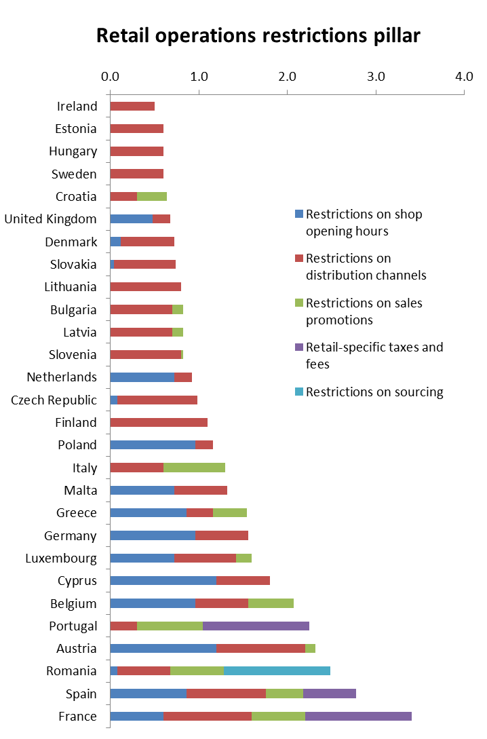

*Source: own calculations based on information collected from Member States and through dedicated studies*

# Cost of compliance with regulatory requirements

The burden of complying with regulations concerning the operation of retail outlets implies a monetary cost referred to as 'the cost of compliance'. A commonly applied methodology to measure compliance costs is to accumulate the costs linked to the purchase of necessary software and equipment, and the costs linked to the administrative tasks that need to be carried out, both in-house as well as outsourced. It should take into account additional tasks only, not the administrative tasks that the company would undertake regardless of regulatory requirements. The administrative cost is usually measured by multiplying the number of hours that an employee must spend on the additional administrative tasks and the cost of an hour of work of this employee.

Measuring the cost for operational restrictions would require distinguishing the software, equipment and tasks implied by such restrictions from all software, equipment and tasks required to comply with all relevant legislation. This is very difficult for companies to single out and report, hence for the purpose of this analysis, the cost of retailers’ compliance with legislation in general is taken into account.

Within the scope of a dedicated study of retail operational restrictions,[298] a survey of 1455 retail companies (of different size categories, selling different types of goods, and active both on-line and/or off-line) was carried out in 28 EU countries. Its results allowed the consultant to estimate the compliance cost in relation to company turnover. To complete the analysis, Eurostat data on wages in retail and estimation of turnover of retail companies was used. This approach seems to have produced rather cautious estimations – in practice, the cost of compliance can even be higher and amount to a larger proportion of a company’s turnover.

Results point to the smallest retailers to bear the highest costs compared to their turnover, both in relation to administrative tasks as well as costs of equipment – figures 41 to 43.

*Figure 41: Burden linked to administrative tasks, in percentage of estimated turnover, by size of firms*



*Figure 42: Burden linked to costs of equipment and systems for compliance, in percentage of estimated turnover, by size of firms*



*Figure 43: Total additional monetary burden as percentage of turnover, per firm size*



*Source: LE Europe, Spark Legal Network and Consultancy, VVA Consulting (2018) "Operational restrictions in the retail sector", study carried out for the European Commission*

Companies definitely perceived different administrative tasks as time consuming, in particular completing paperwork (forms, records, certificates) and having to keep up to date with regulatory changes.

The survey also asked about the impact of a number of specific operational restrictions[299] on business decisions and functioning. Although most respondents considered these impacts to be low, for many the most impacted areas were turnover and profits. Retailers selling on-line felt less impacted. From other restrictions, not necessarily specific to their sector, retailers pointed to complying with consumer rights regulations in their country and providing specified information to consumers before purchase in a number of languages as the most burdensome.

Among on-line and mostly on-line retailers, the most burdensome restrictions appear to concern consumer rights and technical product requirements.

Retailers often complain about disproportionate enforcement measures (see figure 44). The study looked into the intensity of inspections carried out by Member States authorities and the fines imposed at companies. On average, (not surprisingly) larger companies (and also non-specialised stores and specialised food retailers) are inspected more often, which is also associated with a higher probability of a fine (see figure 45). For small companies, however, the fines received amount to a significantly larger share of their turnover.

*Figure 44: Agreement with negative statements about enforcement – number of respondents*



*Source: LE Europe, Spark Legal Network and Consultancy, VVA Consulting (2018) "Operational restrictions in the retail sector", study carried out for the European Commission*

*Figure 45: Average number of inspections per firm in the last year per country and per firm size*



*Source: LE Europe, Spark Legal Network and Consultancy, VVA Consulting (2018) "Operational restrictions in the retail sector", study carried out for the European Commission*

The total monetary burden linked to the cost of compliance with relevant regulations vary across countries and across companies of different sizes, but to a lesser extent across different types of retailers. As a percentage of turnover, it seems to be the highest in Portugal, Poland, Latvia, Romania, France and Austria, and the lowest in Luxemburg, Ireland, Malta, Denmark and Belgium.

The overall monetary value of the compliance cost borne by retail firms is estimated at €26,7 billion[300], which to a large extent falls on micro companies.

*Figure 46: Confidence intervals for total monetary burdens of administrative compliance tasks and equipment and systems for compliance, per country, per firm size, totals in € million*



*Source: LE Europe, Spark Legal Network and Consultancy, VVA Consulting (2018) "Operational restrictions in the retail sector", study carried out for the European Commission*

# Conclusions

The functioning of the retail sector affects the whole economy. The sector contributes significantly to the EU GDP, represents a large share of EU employment and a large number of EU businesses. It is also closely intertwined with other sectors of the economy and can have a considerable impact on their performance. It is also important for consumers who spend 30% of their budgets in shops. Finally, retail brings the Single Market to the EU consumers who have access to a wider choice of products, both on-line and off-line.

The sector is modernising at a very fast pace. Retailers serve customers through increasingly diverse channels. Multi-channel retail will continue to develop to meet evolving consumers' expectations.

These market developments challenge the role that European retailers have played in brick-and mortar retailing. It is an opportunity for growth and expansion for many retailers, but can also be a challenge for some of them, in particular small traditional businesses, which may have difficulties investing in and adapting to new technologies.

The retail sector is subject to various national regulatory frameworks (at national, regional and local level), which can affect the integration and efficiency of the EU retail market. Some of these rules amount to restrictions: some of them are contrary to EU law (be it primary or secondary), whereas other may be justified if they are not discriminatory, if they pursue an overriding reason of public interest and are proportionate. In general, Member States' legitimate public policy objectives include the protection of consumers, workers, environment and town and country planning.

Retail restrictions affect more severely off-line retailers. Regulatory frameworks have been designed for the off-line world. To promote multi-channel retail there is a need to provide a level playing field for both channels.

Regulations on the establishment of shops have a great impact on retailers with physical presence. Many Member States impose stringent conditions linked to the size of shops and their location and burdensome procedures to establish a shop.

Operational restrictions also affect severely the day-to-day business activities of off-line retailers. They include regulations on shop opening hours, distribution channels for certain products, periods and duration of sales promotions, specific taxes and fees and the sourcing of products.

Numerous studies have demonstrated negative effects of such barriers on the functioning of the market. Restrictive and complex regulations may have a negative impact on competition as well as indirect effects on productivity, employment, prices and innovation. They may become a significant burden for businesses, discouraging them from entering the market or inducing their exit.

Restrictive requirements concerning the establishment of new shops may have a negative impact in particular on market structure and dynamics. They may influence the retailer’s decision on market entry, the location of the shop, its size, format and assortment. Even if such regulations do not prevent market entry as such, they may hamper the firm’s ability to adjust to consumers’ preferences and to successfully compete on the market. Such regulations may also have a discriminatory effect on foreign companies if they target formats and sizes more commonly found abroad.

Those impacts are to a great extent confirmed by the present analysis. The economic evidence analysed and the links between the Retail Restrictiveness Indicator and economic outcomes show that there is a significant impact of establishment restrictions on the performance of retailers as well as on consumers. In Member States with higher establishment restrictions, fewer new retail companies enter and leave the market, market concentration and consumer prices are higher.

Stepping up reforms to reduce regulatory barriers in the retail sector would have a number of positive economic effects. Increased competitive pressures would lead to the entry and survival of more efficient and innovative firms. Consumers would enjoy lower prices, more variety, innovation and higher quality. This would also have positive spill-over effects in other sectors of the EU economy. This is particularly needed in the wake of the digital revolution. Retail regulatory frameworks should be modernised to allow retailers to better address the challenges they are facing without prejudicing the public policy objectives at stake.

In its Communication on a European retail sector fit for the 21st century, which this Staff Working Document accompanies, the Commission identifies best practices to modernise regulatory framework for retail. The best practices proposed should guide Member States' reforms to support a European retail sector fit for the 21st century.

# Annex 1: Methodology of assessment of restrictions to retail establishment and operations and values of the Retail Restrictiveness Indicator

I. Indicators within the RRI composite indicator

This annex provides an explanation of the methodology used in assessing restrictions to retail establishment and operations presented in the Staff Working Document underpinning the Communication on best practices to facilitate retail establishment and operations.

The objective of the analysis was to identify barriers to both retail establishment, i.e. restrictions to open retail outlets, and retail operations across 28 Member States and to assess on this basis the level of restrictiveness of Member States' regulations in this area. A composite indicator (Retail Restrictiveness Indicator, RRI) is constructed to illustrate the different levels of restrictiveness for different regulatory aspects. Results of an analysis of economic impact of such restrictions are presented in the Staff Working Document.

*Scope of the assessment*

The overall assessment of restrictiveness is based on the analysis of a set of aspects regulating the functioning of the retail sector. The RRI composite indicator consists of nine indicators related to retail establishment (the establishment pillar) and five indicators related to retail operations (the operations pillar).

**Establishment restrictions**

The pillar on retail establishment restrictions has been divided into two sub-pillars: conditions and procedures related to the establishment of shops.

**Establishment conditions sub-pillar**

1. Specific restrictions linked to size thresholds

The requirements for retail establishment[301] are often linked to the size of the planned outlet. The requirements are typically more complex and burdensome for large outlets. This appears to be justified as large shops have potentially more impact on the traffic, the environment, etc. However, the proportionality and appropriateness of such requirements may raise doubts.

1. Requirement to provide economic data

In the framework of retail establishment procedure, companies may be required to provide economic data. Such a requirement is often part of a market study or an impact assessment covered under point 7[302], however here it is assessed separately. In some cases, there is a risk that such data may be used for economic need tests which are prohibited under Article 14 of the Services Directive.[303]

1. Existence of regulations specific to the location of the outlet (city centre/ outside city centre)

Establishment regulations may contain specific requirements concerning the location of a retail outlet. Such requirements often concern locations in the city or town centre or, on the contrary, outside the city/town centre, in the periphery or the so-called green field locations. This reduces the flexibility of location choice for retailers, making establishment more difficult or even impossible in some cases.

1. Level of detail in spatial plans

Local spatial plans define the type of constructions or activity that can be present in certain zones of the area they cover. These definitions can range from a rather broad “commercial use”, i.e. business activities such as retail, food and drink or financial services, to a very high level of detail, stating even the types of goods that shops located in the area can sell. The level of detail of the plans (and permits) has an impact on the flexibility of retail establishment. This is particularly important for the change of use. If the plan or permit allows for a commercial use in general, it should be easier for owners or tenants to change the use of premises, for example from a bank to a shop.

**Establishment procedures sub-pillar**

1. Number of permits required to establish

The authorization to set up a retail outlet may require applying for several permits. A large number of permits may constitute a burden for the applicant.

The assessment takes into account the permits that are most frequently required, such as the planning permit, the building permit, the environmental permit and the special retail authorisation. In some MS the procedures are streamlined through an all-in-one permit, combining all of the necessary permits or some of them into one procedure. This is reflected in the analysis.

The analysis does not take into account trade licences, registrations with a register of economic activities, permits linked to the opening of the premises to the public or to the type of assortment sold (e.g. food licences).

1. Number of administrative entities to be contacted, incl. the existence of one-stop- shops

To apply for an authorisation, companies may need to contact several administrative entities. An administrative entity taken into account in the assessment is a public body whose opinion or decision is required in the establishment process. It includes for example a municipality, a ministry or an environmental authority in case an environmental permit is required, etc.

A large number of entities that need to be contacted may constitute a burden for the applicant. In some MS authorisation procedures are processed through a one-stop-shop, meaning that retailers submit all applications or some of them through one entity. This is reflected in the analysis.

The analysis does not take into account company registration in a trade register or other necessary steps concerning the setting up of a company, but only steps in a procedure for opening of a particular retail outlet.

1. Number of market studies and impact assessments required in the establishment procedure

In the framework of an authorisation procedure, companies may be required to carry out studies and/or impact assessments concerning the planned setting up of an outlet. Such a requirement may constitute a burden for the applicant.

The analysis includes the most often required studies, such as retail impact assessment, impact assessment related to employment, traffic impact assessment as well as other impact assessment, e.g. related to construction.

Only studies and assessments carried out or provided by the applicant are taken into account. Studies done by authorities themselves are excluded.

1. Length of procedure

The specificity of the authorisation process and the planning framework in place differ between Member States resulting in divergent deadlines for authorisation decisions. Before a retail company can start building a new outlet, it may need weeks or months to obtain all necessary decisions. This analysis focuses on deadlines for the planning, building and retail permits. In Member States where several permits are required, the actual deadlines often sum up rather than run in parallel. In addition, the regulatory deadlines considered in this analysis may differ from the administrative practice.

1. Publication of decisions

Publication of results of the authorisation process does not only serve the information and transparency purpose, but also allows future applicants to better prepare for the procedure and assess the chances for a positive decision. In practice, some authorities make public both positive and negative decisions, some only positive ones, whereas in other cases, information is only available upon request or not accessible at all.

**Operational restrictions**

1. Shop opening hours

Regulation of shop opening hours varies significantly between Member States. In some, this is not regulated at all, other restrict shop opening only on certain public holidays or/and on Sundays. Most restrictive countries regulate opening hours on weekdays, Sundays and public holidays. The analysis takes into account all these situations.

1. Distribution channels for certain products

Member States control the sales of specific products, namely tobacco, alcohol and non-prescription medicines (sometimes known as over-the-counter or OTC medicines) in different ways. Restrictions may relate to the types of outlets where those products can be sold and other conditions, such as the hours, the age of a buyer, or the substances and their doses. At their most restrictive, these rules can amount to a state monopoly.

1. Sales promotions

The analysis focuses on national regulations limiting retailers' freedom to decide on and to advertise or announce sales promotions and discounts as part of their business operations in the following four categories: a) restrictions on end-of-season sales; b) restrictions on discounts (outside fixed end-of-season sales periods if existing in a Member State); c) restrictions on end-of-business sales; and d) restrictions on sales below cost (excluding competition rules on predatory pricing).

1. Retail-specific taxes and fees

In addition to the tax burden resulting from the general tax system, retailers in some countries have to pay specific taxes and fees which are paid only by retailers. These retail taxes can be levied on the basis of (i) the size of the selling space, (ii) turnover or (iii) a combination of selling space and turnover. A few MS also have (iv) levies or fees linked to retail authorisations (beyond covering its cost). Corporation tax, business rates (or similar taxes) and social security contributions paid by employers, although often constituting an important financial burden, are not specific to the retail sector and hence are excluded from the analysis.

1. Restrictions on sourcing

Sourcing within and throughout the Single Market enables retailers to benefit from lower prices and can give them access to the many different products that are available across Europe. In turn, this can result in a wider choice and lower prices for consumers. There are however national regulations and private barriers which limit retailers' possibilities for sourcing products cross border. The indicator takes into account the regulatory limitations only.

II. Scoring methods

The RRI composite indicator consists of two main pillars: the establishment and the operational restrictions. The first one weights 60% and the latter 40% in the overall RRI composite indicator values. As presented in the figure below, each of the pillars is composed of a number of particular indicators, which conceptually and statistically belong to this pillar. In some cases, the particular indicators are broken down even further and comprise a number of elements. The weights of those particular elements within each of the indicators are established, then the weights of the particular indicators within the pillar.

Figure: Structure of the Retail Restrictiveness Indicator



Values assigned to each indicator range from 0 to 6 points, where 0 indicates the least and 6 the most restrictive regulations.

**Indicators for the Establishment pillar[304]**

1. Specific requirements for entry linked to size thresholds

This question assesses the specific authorisation requirements linked to the size of the planned outlet. The requirements are ranked according to their restrictiveness, from the least restrictive (rank 1) to the most restrictive one (rank 6).

Scoring method:

|  |  |
| --- | --- |
| Simple notification (there is no authorisation procedure, the retailer notifies the establishment to the relevant authorities, there are no additional requirements) | rank 1.2 |
| Notification/ Authorisation simple (the retailer needs to apply for an authorisation, but the procedure is relatively simple (e.g. does not require an opinion of a special committee and it is not a retail-specific authorisation), when the shop complies with the local plans | rank 2.4 |
| Retail specific authorisation or a sequential system for location, or a special procedure (the retailer needs to apply for a retail authorisation, but the process is relatively straightforward) | rank 3.6 |
| **Retail specific autorisation plus** (additional requirements, Impact Assessments, conformity with plans, more complex procedure such as a special committee) | rank 4.8 |
| Ban with with exceptions or limited to certain shops or a few regions (above a certain size threshold it is in general not possible to establish a retail outlet, but derogations exist, e.g. for certain areas or certain types of shops) | rank 6 |

The procedures are assessed for 6 outlet size categories (in m2 of selling area): 0 - 499 m2, 500 - 999 m2 , 1000 - 2499 m2 , 2500 - 4999 m2 , 5000 - 9999 m2 and greater than 10000 m2 . Results per country are then computed depending on the type of requirement in each of the size categories.

For each size category the relevant requirement is identified. If the requirement applies to the whole size category, 1 point is attributed; if the size threshold above which the requirement changes differs from the given categories, the relevant proportion of points is attributed. The final score is a sum of the scores given for the coverage of each requirement among the six threshold categories multiplied by the importance score (rank) of each requirement.

Example:

Member State X applies a simple notification procedure for outlets up to 400 m2 (score of 0.8 in the column 0-­499m2), a simple authorisation for outlets between 400 and 1000 m2 (score of 0.2 in the 0-499m2 column and score 1 in the 500-999 m2 column) and a retail specific authorisation as of 1000 m2.

The score is computed in the following way:

The notification category has a coverage score of 0.13 (0.8 divided by 6, i.e. the maximum coverage score) multiplied by the importance score 1.2 (=0.156)

The authorisation simple category has a coverage score of 0.2 (1 + 0.2 divided by 6) multiplied by the importance score 2.4 (=0.48)

The retail specific authorisation category has a coverage score of 0.66 (4 divided by 6) multiplied by the importance score of 3.6 (=2.4).

The total score is a sum of the scores for each requirement, which for Member State X equals to 3.04.

|  |  |  |  |  |  |  |  |  |  |
| --- | --- | --- | --- | --- | --- | --- | --- | --- | --- |
|  | Importance  score | Greater than 10000 m2 | 9999 -  5000  m2 | 4999 -  2500  m2 | 2499­  1000  m2 | 999 -  500  m2 | 499 - 0 m2 | Coverage | Score |
| No restriction |  |  |  |  |  |  |  | 0 | 0 |
| Simple notifications | 1.2 |  |  |  |  |  | 0.8 | 0.13 | 0.156 |
| Authorisation  simple | 2.4 |  |  |  |  | 1 | 0.2 | 0.2 | 0.48 |
| Retail specific authorisation | 3.6 | 1 | 1 | 1 | 1 |  |  | 0.66 | 2.4 |
| Retail specific authorisation + | 4.8 |  |  |  |  |  |  | 0 | 0 |
| Ban with exceptions | 6 |  |  |  |  |  |  |  |  |

1. Existence of regulations specific to location

The assessment takes into account the existence of regulatory requirements for a specific location of an outlet, mainly city centre and outside city centre. The scoring does not differentiate between regulations specific to city centre and regulations specific to periphery.

Scoring method:

|  |  |
| --- | --- |
| Existence of requirement specific to location | 6 points |
| No requirement specific to location | 0 points |

1. Requirements for economic data

The assessment is based on the existence of regulatory requirements to provide economic data in the framework of an authorisation procedure.

Scoring method:

|  |  |
| --- | --- |
| Economic data is required | 6 points |
| Economic data is not required | 0 points |

1. Level of detail in spatial plans

The assessment distinguishes four situations, to each of which a value is assigned following the below pattern.

|  |  |
| --- | --- |
| Plans refer to types of products that can be sold | 6 points |
| Plans refer to types of shops that can be established, e.g. food or non-food | 4.5 points |
| Plans refer to “retail use” or distinguish areas designated for larger outlets | 3 points |
| Plans refer to “commercial use” | 0 points |

1. Number of permits

The assessment is based on the number of permits required in an authorisation procedure. The analysis is limited to 4 permits most frequently required, i.e. the planning permit, the building permit, the environmental permit and the special retail authorisation. It also takes into account the existence of all­-in-one processes.

Scoring method:

|  |  |
| --- | --- |
| a planning permit is required in legislation | 1 point |
| a building permit is required in legislation | 1 point |
| an environmental permit is required in legislation[305] | 1 point |
| a special retail authorisation is required in legislation[306] | 1 point |
| all-in-one process (covering any of the permits taken into account in the analysis)[307] | 1 point |

The maximum number of permits is 4. The all-in-one process is not counted as an additional permit but as an alternative procedure. Then the number of points obtained (maximum 4) is scaled to 6 points.

1. Number of administrative entities to be contacted

The assessment is based on the number of entities that the applicant needs to contact in an authorisation procedure. It also takes into account the existence of one-stop-shops.

Scoring method:

Each entity that needs to be contacted[308]

1 point

The country with the maximum number of entities identified obtains the maximum value, and then the other countries obtain a proportionate number of points, based on the number of entities observed. For example, the highest number is 3 entities and is observed for country X, which obtains 6 points. In country Y, the retailer contacts 1 entity (e.g. a one-stop shop), and the country obtains 2 points ((1/3)*6).

1. Number of market studies and impact assessments required in the establishment procedure

The assessment is based on the number of studies and impact assessment that an applicant is obliged to submit in an authorisation procedure. It includes studies most often required in such cases, such as retail impact assessment, impact assessment related to employment, traffic impact assessment as well as other impact assessment, e.g. related to construction.

Scoring method:

Each study or impact assessment required[309]

1 point

Then the number of points obtained (maximum 4) is scaled to 6 points.

1. Length of procedure

Values are assigned proportionately to the length of certain procedures established in the regulations. The length is accumulated in cases when certain steps in the procedure are sequential. It is not accumulated in cases when certain procedures may be run in parallel. Then the longest procedure is taken into account. The value for a given country is proportionate to the maximum length of the procedure identified among all the countries, and then scaled to 6.

For example, the longest procedure lasts 12 months and is observed for country X, which obtains 6 points. In country Y, the procedure lasts 4 months, and the country obtains 2 points ((4/12)*6).

1. Publication of decisions

This indicator assess the transparency of establishment decisions, looking at their accessibility to the public, e.g. whether they are published online or in local press.

|  |  |
| --- | --- |
| No decisions are publicly available | 6 points |
| Decisions are available only upon request | 4.5 points |
| Only positive decisions are publicly available | 3 points |
| Both positive and negative decisions are publicly available | 0 points |

**Indicators for the Operational pillar[310]**

1. Shop opening hours

The indicator distinguishes between weekly and Sunday /public holidays opening hours.

Weekly opening hours

|  |  |
| --- | --- |
| Weekly opening hours are regulated | 6 points |
| Weekly opening hours are not regulated | 0 points |

Sunday/ public holidays opening hours

|  |  |
| --- | --- |
| Sunday trading is not allowed | 6 points |
| Shops can open on a limited number of Sundays per year | 4,24-5 points  Score is attributed within the above range of points depending on the number of Sundays per year when shops are allowed to open:  0-5 Sundays: 5 points  6-10 Sundays: 4,75 points  11-15 Sundays: 4,5 points  >15 Sundays : 4,25 points |
| * Some shops are allowed to open on Sundays (e.g. up to a certain size or selling particular assortment);   or   * all shops are allowed to open, but for a limited number of hours;   or   * shops in certain parts of the country and major cities benefit from a more flexible regime than others (due to a different regime for tourist areas or particular municipal regulation) | 3 points |
| No restrictions on Sunday trading, but obligatory closure on some public holidays | 0.25-1 point  Score is attributed within the above range of points depending on the number of public holidays per year when shops have to stay closed.  1-5: 0,25  5,5-10: 0,5  10,5-15: 0,75  >15: 1 |

In certain Member States the different types of regulation may coexist (for example, depending on the type, size or location of a shop a Member State may allow its regular Sunday opening or only on a limited number of Sundays per year). In case of such co-existing regulatory regimes Member States receive an average of scores of all categories they fall into.

1. Distribution channels for certain products

The score is composed of scores for three types of restrictions: on non-prescription medicines (50% of the final score), on alcohol (25% of the final score) and on tobacco (25% of the final score).

|  |  |  |
| --- | --- | --- |
| Non-prescription medicines | 6 points if no medicines are sold outside pharmacies  3 points if other non-prescription medicines are sold outside of pharmacies or if four key types of medicines (aspirine, cough and cold medicines, digestive medicines and smoking cessation medicines) are sold with additional conditions (e.g. presence of a pharmacist)  0 points if the four key types of medicines are sold outside of pharmacies without additional requirements | 50% of the final score |
| Alcohol | 6 points if sold only through a monopoly  4 if a license is needed and further requirements are imposed (e.g. only certain types of shops can hold a license)  2 if a license is needed with no other specific requirements  0 if no requirements | 25% of the final score |
| Tobacco | 6 points if sold only by monopoly or equivalent system  4 points if a license or authorisation is needed  2 points if no license but other requirements exist (e.g. only sold in dedicated shops)  0 points if no requirements | 25% of the final score |

1. Sales promotions

Values range from 0 to 6, and are assigned according to the scheme below. The final score consists of the scores for each type of sales promotions: end-of-season sales (30%), end-of-business sales (20%), other regulations on sales promotions (20%) and sales below cost (30%).

Scoring method:

|  |  |
| --- | --- |
| End-of-seasons sales | Accumulation of points for any of the restrictions observed (they might occur simultaneously):  3 points for notification obligation; 1,5 points for restrictions on discounts prior to or outside end-of-season sales (e.g. on quantity or duration); 1 point for restrictions on announcing price reductions prior to end-of-season sales; 0,5 point for prohibition to discount if products purchased during certain period before end-of-season sales; 0 points for no specific rules on end-of-season sales |
| End-of-business sales | One of the following situations occurs:  6 points for authorisation requirement;  4 points for notification requirement;  2 points for self-assessment;  0 points for no specific rules on end-of-business sales |
| Other regulations on sales promotions | Accumulation of points for any of the restrictions observed (they might occur simultaneously):  0,5 point for any restriction (e.g. obligation on % of products value, limited duration of certain discounts, designated areas, etc.) |
| Sales below costs | One of the following situations occurs:  6 points if banned completely;  4 points if exceptions with authorisation requirement;  2 points if exceptions;  0 points if allowed |

1. Retail-specific taxes and fees

The assessment looks into the retail-specific taxes and fees, taking into account their coverage and the basis for calculation.

Scoring method:

|  |  |
| --- | --- |
| Two different types of taxes or a double basis for calculation | 6 points |
| One type of tax/fee or a limited coverage (big stores or food retail) | 3 points |
| No tax/fee | 0 points |

1. Restrictions on sourcing

This indicator distinguishes two situations: when sourcing of products is restricted, e.g. through quotas of products that must be sourced domestically, and when retailers are not bound by regulations limited the way they source products.

Scoring method:

|  |  |
| --- | --- |
| Sourcing of products is restricted | 6 points |
| Sourcing of products is not restricted | 0 points |

III. Values of the RRI

Values for each indicator within the RRI for each Member State have been attributed following the methodology explained above.

**Values for the Establishment pillar[311]**



**Values for the Operational pillar[312]**



**Values for the overall RRI**



# Annex 2: Results of the regression analysis

Results of the regression analysis of possible impacts of the level of establishment restrictions on certain economic outcomes of the retail sector point in the direction of more restrictions having negative consequences. Due to a small number of observations (28), this analysis has its statistical limitations. Figures below present the results of the regression analysis that have been taken into account, while bearing in mind their limitations.

*Figure A: Results of a regression analysis of impacts of establishment restrictions on the birth rates for retail*

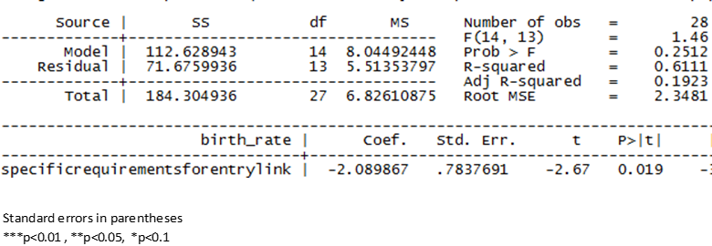

*Source: own analysis based on information from the retail establishment study, the Member States authorities, and Eurostat and Euromonitor*

*Figure B: Results of a regression analysis of impacts of particular establishment restrictions*

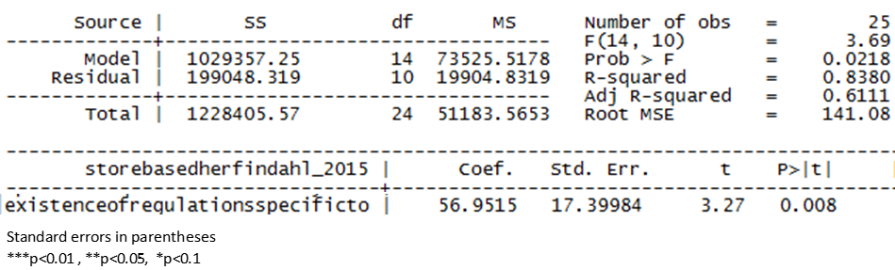

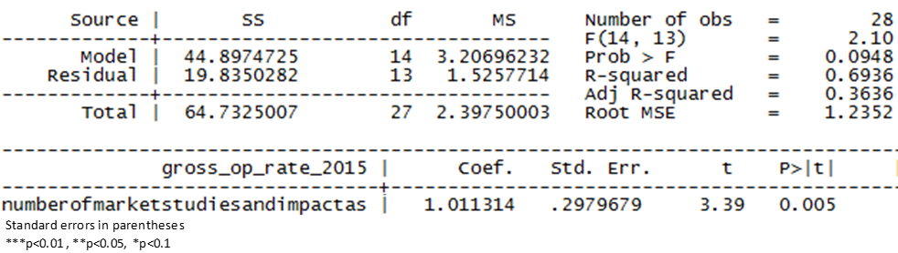

*Source: own analysis based on information from the retail establishment study, the Member States authorities, and Eurostat and Euromonitor*

*Figure C: Regression analysis - the level of restrictiveness of retail establishment and the growth in the selling space and the number of supermarket outlets*

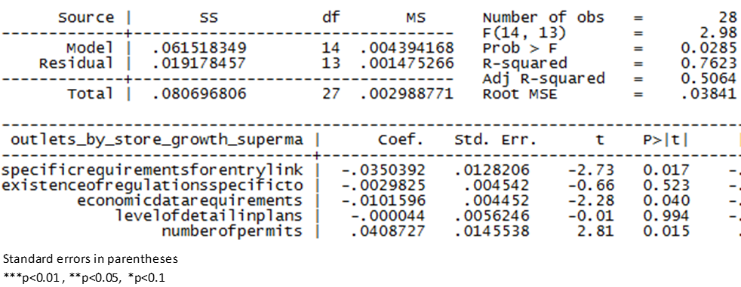

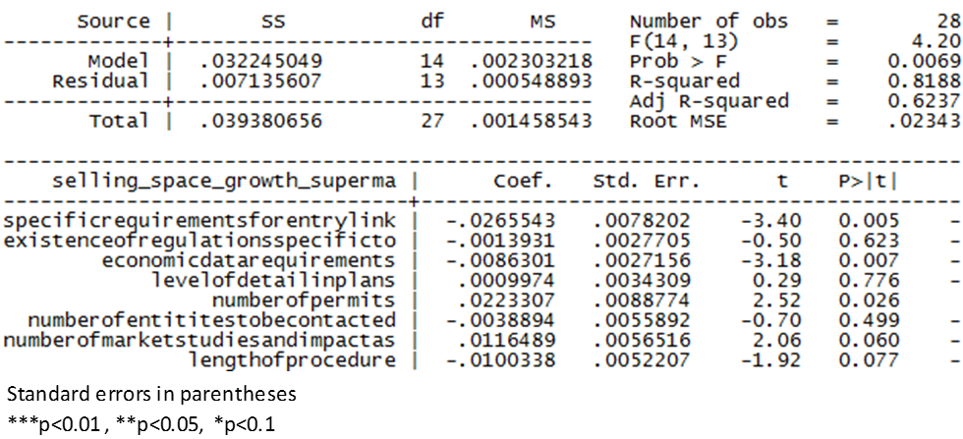

*Source: own analysis based on information from the retail establishment study, the Member States authorities, and Euromonitor data*

1. European Commission, High Level Group on Retail Competitiveness (2015), *Report of the preparatory working group on innovation*; https://ec.europa.eu/growth/single-market/services/retail_en.
2. Commission Staff Working Document *"Public Consultation on Retail regulations in a multi-channel environment – Synopsis Report"*, SWD(2018) 237.
3. Eurostat data, 2015.
4. Eurostat, Labour Force Survey 2016.
5. 2016 SMEs performance review; <https://ec.europa.eu/growth/smes/business-friendly-environment/performance-review-2016_en>.
6. The value of purchases of goods and services for the retail sector accounts for 2,38 trillion EUR (2015; Eurostat).
7. Eurostat SBS data <http://ec.europa.eu/eurostat/web/structural-business-statistics/data/database>.
8. European Commission DG Internal Market, Industry, Entrepreneurship and SMEs, *Background documents for the European Semester* (2018) *The EU retail sector*.
9. Euromonitor data, 2016.
10. Ibid.
11. Ibid.
12. Consumer Markets Scoreboard 2016; <http://ec.europa.eu/consumers/consumer_evidence/consumer_scoreboards/12_edition/docs/consumer_markets_scoreboard_2016_en.pdf>.
13. Although price dispersion for non-durable goods (e.g. food) is still higher than for semi-durable ones.
14. T. Harchaoui, *The Europe-U.S. Retail Trade Productivity Gap in a Rear-view Mirror*, University of Groningen, 2012; <http://www.rug.nl/research/portal/en/publications/the-europeus-retail-trade-productivity-gap-in-a-rearview-mirror(7bd88d44-13c9-4402-9dba-94d471e1bf2e).html>.
15. Data on EU from Eurostat, data on the US from the Bureau of Labor Statistics, according to which the retail productivity in the US grew by 15% between 2007 and 2015; <https://www.bls.gov/lpc/tables.htm>.
16. Data provided by the Japan Productivity Centre; http://www.jpc-net.jp/eng/stats.

    Data for Australia taken from the Australian Government Productivity Commission report, 2016; <https://www.pc.gov.au/research/ongoing/productivity-update/2016/productivity-update-2016.pdf>.

    Data for Canada taken from the Statistics Canada; <https://www.statcan.gc.ca/eng/nea/list/prod>.
17. Eurostat data for 2008-2014; allocative efficiency captures the extent to which more productive firms have higher market shares
18. Digital Agenda Scoreboard, European Commission 2015; <https://ec.europa.eu/digital-single-market/en/digital-scoreboard>.
19. 2015 Innobarometer; <http://ec.europa.eu/growth/industry/innovation/facts-figures/innobarometer_en>.
20. J. Kantorowicz, T. Hlobil, M. Buiten, University of Rotterdam, *Store-based retail market openness: measuring cross-border operations and investment*; analysis carried out for the European Commission.
21. According to the 2016 ranking of Deloitte; <https://www2.deloitte.com/content/dam/Deloitte/global/Documents/consumer-industrial-products/gx-cip-2017-global-powers-of-retailing.pdf>.
22. Euromonitor data, 2017.
23. Eurostat isoc_ec_ibuy.
24. Flash Eurobarometer 439: The use of on-line marketplaces and search engines by SMEs.
25. Digital Agenda Scoreboard, European Commission 2015.
26. Eurostat, Digital Economy and Society Index, isoc_ec_ibuy.
27. Euromonitor data, 2017.
28. Ibid.
29. [DPD Group E-shopper Barometer Report](https://www.dpd.com/home/insights/e_shopper_barometer), 2017.
30. Eurostat, Digital Economy and Society Index, isoc_ec_ibuy.
31. Euromonitor data, 2017.
32. Flash Eurobarometer 413: Companies engaged in online activities; 2015, page 41
33. European Commission e-commerce sector inquiry, 2015; http://ec.europa.eu/competition/antitrust/sector_inquiries_e_commerce.html.
34. Data sets so voluminous and complex that usual data processing software is insufficient to process it. This term often refers to user behaviour analytics and other advanced data analytics.
35. European Commission e-commerce sector inquiry, 2015; <http://ec.europa.eu/competition/antitrust/sector_inquiries_e_commerce.html>.
36. European Commission, *Report on single market integration and competitiveness in the EU and its member states – 2015*; http://ec.europa.eu/DocsRoom/documents/13418?locale=en.
37. The guide has been produced based on the findings of the study *Development of Solutions and an On-line Guide on Fostering the Revitalisation and Modernisation of the Small Retail Sector* commissioned by the European Commission and conducted by Ecorys, the Retail Management Institute of Saïd Business School (University of Oxford) and Gartner.
38. The indicator constitutes a factual overview of restrictions in Member States. Rules on distribution channels for specific products, such as alcohol, tobacco and non-prescription medicines are included for the sake of completeness of the restrictiveness picture. This is without prejudice to the health and societal policy objectives pursued by Member States. The Commission shares these objectives and has developed dedicated policies and legislation, particularly on restriction of tobacco sales and advertising, and to guarantee high standards of quality and safety of medicinal products. It also supports Member States policies on the reduction of alcohol related harm.
39. The Expert Group has been set up for the Commission to work with Member States to ensure the effective implementation and enforcement of the Services Directive as well as the further development of certain of the obligations contained in the Directive. It is composed of representatives of Member States.
40. The Joint Research Centre (JRC) Competence Centre on Composite Indicators and Scoreboards (COIN), *Statistical assessment of the Retail Restrictiveness Indicator (RRI)*; analysis carried out for the European Commission.
41. In some cases, when important changes took place after December 2017, the information has been updated and taken into account in the scores.
42. Holland van Gijzen Advocaten (2016) *Legal study on retail establishment through the 28 Member States: Restrictions and freedom of establishment* carried out for the European Commission, <http://ec.europa.eu/DocsRoom/documents/16127>.
43. On 8 July and 3 December 2014.
44. Commission Staff Working Document *"Public Consultation on Retail regulations in a multi-channel environment – Synopsis Report"*, SWD(2018) 237.
45. The ECJ confirmed that retail falls within the scope of the Services Directive (see judgment of 30 January 2018, Visser Vastgoed Beleggingen, C-31/16).
46. For further clarification regarding these provisions, please refer to the Handbook on the implementation of the Services Directive <https://publications.europa.eu/en/publication-detail/-/publication/a4987fe6-d74b-4f4f-8539-b80297d29715>.
47. Judgment of the Court of 24 March 2011, European Commission v Spain, Case C-400/08, EU:C:2011:172.
48. Judgments of 22 December 2010, Yellow Cab, C‑338/09, para. 51; of 21 December 2016, AGET Iraklis, C‑201/15, para. 72.
49. Directive 2006/123/EC on services in the internal market.
50. Judgment of 30 January 2018, Visser Vastgoed Beleggingen, C-31/16.
51. Judgment of 30 January 2018, Visser Vastgoed Beleggingen, C-31/16, par.124.
52. Article 15(3)(c) of the Services Directive.
53. Judgment of 30 January 2018, Visser Vastgoed Beleggingen, C-31/16.
54. Such definitions related to the size of shop have been developed by statistical institutes or market research companies for data collection purposes, e.g. Eurostat uses size thresholds to classify the data on shops' sales area.
55. In Wallonia and Flanders, rules currently under revision in the Brussels region.
56. Austria, Bulgaria, Croatia, Cyprus, the Czech Republic, Estonia, Finland, France, Hungary, Ireland, Latvia, Malta, Portugal, Romania, Slovakia, Sweden and the UK.
57. Visser, cit. para. 129. See also judgment of 6 March 2018, Segro and Horvath, C‑52/16 and C‑113/16, para. 85.
58. ### Le Procos, fédération pour l’urbanisme et le développement du commerce spécialisé.

   
59. Government of the Netherlands - Environmental Data Compendium.
60. Centre for Retail Research – the UK.
61. Judgment of 24 March 2011, European Commission v Spain, C-400/08, paragraph 80.
62. See to that effect Handbook on the implementation of the Services Directive, <https://publications.europa.eu/en/publication-detail/-/publication/a4987fe6-d74b-4f4f-8539-b80297d29715>.
63. The guide has been produced based on the findings of the study "Development of Solutions and an On-line Guide on Fostering the Revitalisation and Modernisation of the Small Retail Sector" commissioned by the European Commission and conducted by Ecorys, the Retail Management Institute of Saïd Business School (University of Oxford) and Gartner.
64. Economic needs test have been removed in Belgium, France, Luxembourg, Italy, the Netherlands, Romania and from the concerned regions of Spain.
65. See notably the Commission Staff Working Document *"Public Consultation on Retail regulations in a multi-channel environment – Synopsis Report"*, SWD(2018) 237.
66. A. Pozzi, F. Schivardi (2015) *Entry regulation in retail markets*.
67. For further details – see Handbook on the implementation of the services directive point 5 <https://publications.europa.eu/en/publication-detail/-/publication/a4987fe6-d74b-4f4f-8539-b80297d29715>.

   
68. Other permits required to open a shop have not been listed here, as they either concern the operation of a shop rather than establishment (e.g. permits to sell food or other product-specific licences) or they only apply to projects in particular locations (e.g. heritage protection or nature conservation permits), or use permits which allow opening the premises to the public.
69. The scope of the analysis is limited to four types of permits, i.e. the planning permit, the building permit, the specific retail authorisation and the environmental permit.
70. For further details – see Handbook on the implementation of the services directive point 5.2 <https://publications.europa.eu/en/publication-detail/-/publication/a4987fe6-d74b-4f4f-8539-b80297d29715>.
71. In accordance with the EU law, environment impact assessments are often required, in particular for large retail shops. These are not accounted for in this document.
72. Rules vary depending on the region.
73. In Germany retailers may be required two provide two separate impact assessment on the impact of the project on the catchment area and the city centre.
74. Only permits related to the premises and not to the activity, such as food permits, are taken into account (i.e. planning permit, building permit, special retail authorisation, environmental permit).
75. These deadlines concern a completion of formalities to obtain a planning and/or a building permit and/or a special retail authorisation. It does not include the environmental permit and refers only to situations when the project is in conformity with the local plans.
76. Regulation (EU) No 910/2014 of the European Parliament and of the Council of 23 July 2014 on electronic identification and trust services for electronic transactions in the internal market and repealing Directive 1999/93/EC (OJ L 257, 28.8.2014, p. 73).
77. Commission Implementing Decision (EU) 2015/1506 of 8 September 2015 laying down specifications relating to formats of advanced electronic signatures and advanced seals to be recognised by public sector bodies pursuant to Articles 27(5) and 37(5) of Regulation (EU) No 910/2014 of the European Parliament and of the Council on electronic identification and trust services for electronic transactions in the internal market (OJ L 235, 9.9.2015, p. 37).
78. In some cases, when important changes took place after December 2017, the information has been updated and taken into account in the scores.
79. M. Bertrand, F. Kramarz (2004) *Does entry regulation hinder job creation? Evidence from the French retail industry.*
80. R. Griffith, H. Harmgat (2008) *Supermarkets and planning regulation.*
81. F. Daveri, R. Lecat, M.L. Parisi (2011) *Service deregulation, competition and the performance of French and Italian firms*.
82. Data for the RRI reflect the state of play for 2017. In some cases, when important changes took place after December 2017, the information has been updated and taken into account in the scores. The most recent data from Eurostat available at the time of the analysis is for 2015.
83. Due to a small number of observations, this analysis has its statistical limitations. More details can be found in Annex 2 to this SWD.
84. This is an indicator of profitability that corresponds to the share of gross operating surplus in turnover. The gross operating surplus is the surplus generated by operating activities after the labour factor input has been deducted. It can be calculated from the value-added at factor cost less the personnel costs. Turnover is the total of all sales (excluding VAT) of goods and services carried out by the enterprise of a given sector during the reference period; <http://ec.europa.eu/eurostat/web/products-datasets/-/tin00155>.
85. Holland van Gijzen Advocaten (2016) *Legal study on retail establishment through the 28 Member States: Restrictions and freedom of establishment* carried out for the European Commission; <http://ec.europa.eu/DocsRoom/documents/16127>.
86. CR5 is a sum of market shares of the five largest retail companies in a Member State.
87. The Herfindahl-Hirschman index (HHI) is a commonly accepted measure of market concentration. It is calculated by squaring the [market share](https://www.investopedia.com/terms/m/marketshare.asp) of each firm competing in a market, and then summing the resulting numbers, and can range from close to zero to 10,000.
88. L. Orea (2012) *Entry deterrence through regional regulation and strict licensing policy: An analysis of the large retail establishments in Spain.*
89. As compared to Scottland and Northern Ireland where the regulation was less stringently implemented.
90. P. Cheshire, C. Hilber, I. Kaplanis (2011) *Evaluating the Effects of Planning Policies on the Retail Sector: Or do Town Centre First Policies Deliver the Goods?*
91. A. Pozzi, F. Schivardi (2015) *Entry regulation in retail markets.*
92. Data for the RRI reflect the state of play for 2017. In some cases, when important changes took place after December 2017, the information has been updated and taken into account in the scores. The most recent data from Eurostat available at the time of the analysis is for 2015.
93. The only (rather weak) correlation found was a negative link between the number of entities to be contacted and the growth of the selling space and number of traditional shops.
94. Holland van Gijzen Advocaten (2016) *Legal study on retail establishment through the 28 Member States: Restrictions and freedom of establishment* carried out for the European Commission; <http://ec.europa.eu/DocsRoom/documents/16127>.
95. Holland van Gijzen Advocaten (2016) *Legal study on retail establishment through the 28 Member States: Restrictions and freedom of establishment* carried out for the European Commission, <http://ec.europa.eu/DocsRoom/documents/16127>.
96. Mc Kinsey (2010) *Creating Economic Growth In Denmark Through Competition.*
97. Ibid.
98. Cheshire et al. (2011) *Evaluating the Effects of Planning Policies on the Retail Sector: Or do Town Centre First Policies Deliver the Goods?*
99. Spatial Economics Research Centre at the London School of Economics as quoted in Cheshire et al. (2011).
100. Daveri et al. (2011) *Service deregulation, competition and the performance of French and Italian firms.*
101. Danish Competition Authority (2012) *The Danish grocery market.*
102. Ministry of Finance, Denmark (2016) *Effekt ved aftale om planloven.*
103. European Commission DG Internal Market, Industry, Entrepreneurship and SMEs, *Background documents for the European Semester* (2018) *The EU retail sector*.
104. A. Pozzi, F. Schivardi (2015) *Entry regulation in retail markets*.
105. Legislation passed in France in 1973, which limited the physical size of certain businesses, for example, it introduced a special permit for businesses > 1000 m² in towns with less than 40 000 inhabitants.
106. M. Bertrand, F. Kramarz (2004) *Does entry regulation hinder job creation? Evidence from the French retail industry.*
107. Legislation introduced in France in 1996, which strengthened the provisions of the Loi Royer by lowering the size threshold to 300 m².
108. S. Jódar (2009) *Asymmetric entry regulations: Evidence for the French retail industry*, Jornadas de Economía Industrial as quoted in J. Asensio (2012) *Regional retail regulation and supermarket entry in Spain.*
109. The regulation introduced maximum floor space allowed per province.
110. F. Schivardi and E. Viviano (2010) *Barriers in retail trade.*
111. F. Schivardi and E. Viviano (2010) *Barriers in retail trade.*
112. Data for the RRI reflect the state of play for 2017. In some cases, when important changes took place after December 2017, the information has been updated and taken into account in the scores. The most recent data from Eurostat available at the time of the analysis is for 2015.
113. Daveri et al. (2011) *Service deregulation, competition and the performance of French and Italian firms.*
114. M. Bertrand, F. Kramarz (2004) *Does entry regulation hinder job creation? Evidence from the French retail industry.*
115. F. Schivardi, E. Viviano (2010) *Barriers in retail trade.*
116. Data for the RRI reflect the state of play for 2017. In some cases, when important changes took place after December 2017, the information has been updated and taken into account in the scores. The most recent data from Eurostat available at the time of the analysis is for 2015.
117. EY, Cambridge Econometrics, Arcadia International for the European Commission (2014) *The economic impact of modern retail on choice and innovation in the EU food sector*

     <http://ec.europa.eu/competition/sectors/agriculture/retail_study_report_en.pdf>.
118. Information was collected through dedicated studies and from Member States.
119. Report of the European Commission of 5 July 2010 *Retail market monitoring report:* *Towards more efficient and fairer retail services in the internal market for 2020,* COM(2010)355 final.
120. The reform on the level of the central government sets minimum regulatory requirements. Building on this, the Autonomous Communities have the competence to adopt more specific rules on shop opening hours.
121. With the exception i.a. of shops up to 200m2.
122. It does not concern i.a. shops which do not employ any staff, i.e. run by the owners themselves.
123. Some countries can be classified in more than one category, given that regulation differs depending on the type of shop.
124. The regulation, with some variations, applies in England, Wales and Northern Ireland, while shop opening hours are unrestricted in Scotland.
125. In Belgium retailers can also choose to trade on Sundays if they choose another 24h period during the week when their shop will remain closed.
126. For non-food shops.
127. In Poland the recently adopted legislation will restrict Sunday trading gradually as of 2018, allowing shops to stay open two Sundays a month in the first phase of implementation (2018), one Sunday a month in the second phase (2019) and finally fully restricting Sunday trading as of 2020.
128. In the case of France it is a derogation from the principle of Sunday rest enshrined in the labour legislation.
129. The Czech Trade Inspection Authority has been investigating if the fact of keeping e-commerce pick-up premises open on a public holiday when trading is normally prohibited constitutes a breach of the shop opening hours legislation as mentioned in as quoted in LE Europe, Spark Legal Network and Consultancy, VVA Consulting (2018) *Operational restrictions in the retail* sector, study carried out for the European Commission.
130. Civildepartement, Sweden (1991) *Betänkande av 1989 ärs äffarstidsutredning* as quoted in D. Pilat (1997) *Regulation and performance in the distribution sector*, OECD Economic Department Working Papers No. 180.
131. Centraal Planbureau (CPB), the Netherlands (1995) *Economische effecten van liberalisering van winkeltijden in Nederland*, Working Paper No. 74 as quoted in D. Pilat (1997) *Regulation and performance in the distribution sector*, OECD Economic Department Working Papers No. 180.
132. Ifo Institute (1995) *Überprüfung des Ladenschlussgesetzes vor dem Hintergrund der Erfahrungen im In- und*

     *Ausland - Zusammenfassung der Untersuchungsergebnisse des Ifo Institute*, Ifo Schnelldienst,

     Vol. 48, 24/1995, pp. 11-25 as quoted in D. Pilat (1997) *Regulation and performance in the distribution sector*, OECD Economic Department Working Papers No. 180.
133. Study carried out by Capgemini Consulting for the French authorities (Direction Générale des Entreprises), 2013.
134. OECD September 2015: France. Évaluation de certaines mesures de la Loi pour la croissance, l’activité et l’égalité des chances économiques et perspectives de futures réformes.
135. M. Bossler, M. Oberfichtner, (2014) *The employment effect of deregulating shopping hours: Evidence from German retailing*, Diskussionspapiere, Universität Erlangen-Nürnberg, Lehrstuhl für VWL, insbes. Arbeitsmarkt- und Regionalpolitik, No. 91.
136. Reply of the Spanish authorities to the European Commission questionnaire on operational restrictions.
137. The 2013 amendments broadened Dutch municipalities’ powers to authorize exemptions from the prohibition to open shops on Sundays and several holidays.
138. Ministerie van Economische Zaken (2016) *Evaluatie Winkeltijdenwet* <https://www.rijksoverheid.nl/documenten/rapporten/2016/11/01/evaluatie-winkeltijdenwet>.
139. Finnish Commerce Federation (2016) http://kauppa.fi/eng/press_releases/the_deregulation_of_opening_hours_has_increased_competition_and_facilitated_the_everyday_life_of_consumers_25883.
140. C. Genakos, S. Danchev (2015) *Evaluating the Impact of Sunday Trading Deregulation.*
141. Ibid.
142. T. Wenzel (2011) *Deregulation of Shopping Hours: The Impact on Independent Retailers and Chain Stores.*
143. C. Genakos, S. Danchev (2015) *Evaluating the Impact of Sunday Trading Deregulation.*
144. T. Wenzel (2011) *Deregulation of Shopping Hours: The Impact on Independent Retailers and Chain Stores.*
145. A. Hoffmann, M. Konnerup, M. Gørtz, A.H. Larsen, N. Lund, A. Madsen (1999): *An Analysis of the Danish Shops Act – Consequences for Shops, Consumers and Employees* for theDanish Ministry of Trade and Industry.
146. After a liberalisation of the Dutch Shop Opening Hours Act in 2013.
147. GfK Supermarktkengetallen, Week 04 2016; http://www.gfk.com/fileadmin/user_upload/country_one_pager/NL/documents/GfK_Kengetallen_Supermarkten_januari_2016_vM.pdf.
148. Finnish Commerce Federation (2016); http://kauppa.fi/eng/press_releases/the_deregulation_of_opening_hours_has_increased_competition_and_facilitated_the_everyday_life_of_consumers_25883.
149. Article 71 of Directive 2001/83/EC on medicinal products for human use provides that "medicinal products shall be subject to medical prescription where they:

     - are likely to present a danger either directly or indirectly, even when used correctly, if utilized without medical supervision, or

     - are frequently and to a very wide extent used incorrectly, and as a result are likely to present a direct or indirect danger to human health, or

     - contain substances or preparations thereof, the activity and/or adverse reactions of which require further

     investigation, or

     - are normally prescribed by a doctor to be administered parenterally".
150. IMS Health, <http://www.imshealth.com/imshealth/Global/Content/Consumer%20Health/Documents/The_Rising_Tide_O_OTC_Europe.pdf> (retrieval date: 08.05.2011).
151. Judgment of 19 May 2009 in Joined Cases C-171/07 and C-172/07 Apothekerkammer des Saarlandes and Others v Saarland, EU:C:2009:316.
152. Austria, Belgium, Bulgaria, Czech Republic, Estonia, Finland, France, Germany, Latvia, Lithuania, Luxembourg, Malta, Romania, Slovakia, Slovenia, Spain.
153. [Prisutveckling på receptfria läkemedel sedan omregleringen Har priserna på receptfria läkemedel blivit lägre på grund av ökad konkurrens? Rapport 2017:3](http://www.konkurrensverket.se/globalassets/publikationer/rapporter/lakemedel-20173.pdf), Konkurrensverket.
154. D. Hildebrand (2017) *Updated report on liberalising OTC drugs markets in the EU*: EE&MC survey, based on data from the following countries: Austria, Belgium, Bulgaria, Czech Republic, Denmark, France, Germany, Hungary, Italy, Netherlands, Norway, Poland, Portugal, Romania, Slovakia, Spain, Sweden and the United Kingdom.
155. F. Wartenberg (2017) *OTC, Self-care Medical Devices, Food Supplements and Herbal Products*: *Market trends and Opportunities in Germany and Central Europe*, as quoted in D. Hildebrand, 2017.
156. Judgment of 11 December 2003, Deutscher Apothekerverband eV v 0800 DocMorris NV and Jacques Waterval, C-322/01, EU:C:2003:664.
157. Judgement of 7 March 1989, Schumacher v Hauptzollamt Frankfurt am Main-Ost, C-215/87, [1989] ECR 617
158. Article 85c) of Directive 2011/62/EC on falsified medicinal products.
159. Directive 2011/62/EU on falsified medicinal products harmonises conditions and safety standards for the distance sales of medicinal products. In particular, it introduces a common, EU-wide logo to identify legal on-line pharmacies. The logo must be displayed on the website of on-line medicine retailers and must redirect to a webpage of the national authority of the Member State in which the retailer is established, showing the list of legally operating on-line pharmacies and retailers registered in that Member State.
160. D. Hildebrand, 2017.
161. Etude comparative des prix des médicaments entre la France et l’Allemagne, Centre Européen de la Consommation, 2012.
162. D. Hildebrand, 2017.
163. D. Hildebrand, 2018. Between 2011 and 2017, in 9 Member States difference to the Dutch price for the basket increased, whereas it decreased in 2 Member States.
164. Ibid.
165. Konkurrensverket, [*Prisutveckling på receptfria läkemedel sedan omregleringen Har priserna på receptfria läkemedel blivit lägre på grund av ökad konkurrens?* Rapport 2017:3](http://www.konkurrensverket.se/globalassets/publikationer/rapporter/lakemedel-20173.pdf).
166. [Medicamentos mais baratos no híper](https://saudeonline.pt/2016/11/24/medicamentos-mais-baratos-nos-hiper-mas-mais-procurados-nas-farmacias/). Testesaúde 124, 24 November 2016.
167. <http://www.vita.it/it/article/2016/11/29/i-farmaci-al-supermercato-costano-il-10-in-meno/141768/> accessed on 27 April 2017.
168. PGEU Annual Report 2014.
169. [Press release by Datamar International s.r.o.](http://www.datamar.cz/cs/content/tiskov%C3%A1-zpr%C3%A1va), 6 December 2016.
170. Judgment of 13 February 2014 , Susanne Sokoll-Seebacher, C-367/12.
171. Although in several countries pharmacies cannot store patient data – eg. Finland, Greece, Portugal, Romania or store and access it: Austria, Bulgaria, Croatia, Denmark, Estonia, Finland, Greece, Latvia, Lithuania, Luxembourg, Portugal, Romania.
172. James Dudley International, Ltd (2016) *OTC Distribution in Europe The New Global Agenda* - New 2016 Edition.
173. H. Håkonsena, K. Andersson Sundella, J. Martinssonb, T. Hedenruda (2016) *Consumer preferences for over-the-counter drug retailers in the reregulated Swedish pharmacy market*, Health Policy 120. pp. 327–333.
174. Judgment of 9 November 2010, *Mediaprint Zeitungs- und Zeitschriftenverlag*, Case C-540/08, EU:C:2010:660 paragraph 18; Judgment of 14 January 2010, Zentrale zur Bekämpfung unlauteren Wettbewerbs eV v Plus Warenhandelsgesellschaft mbH, C-304/08, EU:C:2010:12, paragraph 37.
175. Order of 8 September 2015, *Cdiscount,* C-13/15, EU:C:2015:560. Seven Member States currently apply the UCPD also to B2B relationships and, hence, extend the scope of application of the UCPD significantly in their national legislation.
176. Order of 30 June 2011, Wamo BVBA v JBC NV and Modemakers Fashion NV, C-288/10, EU:C:2011:443, paragraphs 34 ff.
177. Judgment of 23 April 2009, Joined Cases C-261/07 and C-299/07 VTB-VAB NV v Total Belgium NV and Galatea BVBA v Sanoma Magazines Belgium NV, EU:C:2009:244; Judgment of 11 March 2010, Telekommunikacja Polska SA w Warszawie v Prezes Urzędu Komunikacji Elektronicznej, C-522/08, EU:C:2010:135; Judgment of 18 July 2013, Citroën Belux NV v Federatie voor Verzekerings- en Financiële Tussenpersonen, C-265/12*, EU:C:2013:498.*.
178. Judgment of 9 November 2010, Mediaprint Zeitungs- und Zeitschriftenverlag GmbH & Co. KG v "Österreich"-Zeitungsverlag GmbH, C-540/08, EU:C:2010:660.
179. Order of 30 June 2011, Wamo BVBA v JBC NV and Modemakers Fashion NV, C-288/10, EU:C:2011:443; Order of 15 December 2011, INNO NV v Unie van Zelfstandige Ondernemers VZW (UNIZO) and Others, C-126/11 *EU:C:2011:851*; Order of 8 September 2015, *Cdiscount,* C-13/15, EU:C:2015:560; Judgment of 17 January 2013, Georg Köck v Schutzverband gegen unlauteren Wettbewerb, C-206/11, EU:C:2013:14.
180. Order of 7 March 2013, Euronics Belgium CVBA v Kamera Express BV and Kamera Express Belgium BVBA, C-343/12, EU:C:2013:154.
181. Cyprus, the Czech Republic, Germany, Denmark, Estonia, Finland, Hungary, Ireland, Lithuania, Malta, the Netherlands, Poland, Slovakia, Sweden, the UK.
182. Austria, Belgium, Bulgaria, Croatia ,Greece, France, Italy, Latvia, Luxembourg, Portugal, Romania, Slovenia, Spain.
183. Belgium, Croatia, Greece, France, Italy, Latvia, Luxembourg, Portugal, Romania, Spain.
184. Bulgaria, France, Latvia, Portugal, Slovenia.
185. Austria, Belgium, Croatia, Greece, France, Italy, Latvia, Portugal, Romania, Spain.
186. Order of 7 March 2013, Euronics Belgium CVBA v Kamera Express BV and Kamera Express Belgium BVBA, C-343/12, EU:C:2013:154.
187. Belgium, Croatia, France, Italy, Portugal, Romania, Spain.
188. OECD, Product Market Regulation 2013; http://www.oecd.org/economy/growth/indicatorsofproductmarketregulationhomepage.html.
189. OECD Competition assessment review on Greece, 2013.
190. OECD Economic surveys, Greece, 2016.
191. OECD Economic surveys, France, 2015.
192. OECD *Resale below cost laws and regulations*, OECD Journal: Competition law and policy, Vol. 9/1, 2007.
193. M. L. Allain, C. Chambolle (2011) *Anti-Competitive effects of resale below cost laws*, International Journal of Industrial Organisation.
194. P. Biscourp (2014) *Reglementer ou liberaliser: les relations commerciales en France des annees 1990 aux annees 2000.*
195. R. Becerril-Arreolan, M. Leng, M. Parlar(2013) *On-line retailers' promotional pricing, free-shipping threshold, and inventory decisions*, European Journal of Operational Research 230 (2013), p. 272.
196. P. Kopalle, D. Biswas, P. Chintagunta, J. Fan, K. Pauwels, B. Ratchford, J. Sills (2009) *Retailer pricing and competitive effects*, Journal of Retailing 85 (1, 2009), p. 66.
197. ECME Consortium/Deloitte (2013) *Study on the coverage, functioning and consumer use of comparison tools and third-party verification schemes for such tools* carried out for the European Commission.
198. K.L. Ailawadi, J.P. Beauchamp, N. Donthu, D. Gauri, V. Shankar (2009) *Communication and Promotion Decisions in Retailing*, Journal of Retailing 85 (1, 2009), p. 51.
199. D. Grewal, L. Kusum, L. Ailawadi, D. Gauri, K. Hall, P. Kopalle, J. R. Robertson (2011), *Innovations in Retail Pricing and Promotions*, Journal of Retailing 87S (1, 2011), p. 44 ff.
200. To help cross-border e-commerce, the Digital Single Market Strategy of 2015 included an action to simplify VAT procedures. The related legislation was adopted in December 2017 with Directive 2017/2455 amending Directive 2006/112/EC and Directive 2009/132/EC as regards certain value added tax obligations for supplies of services and distance sales of goods.
201. SAID Business School and the University of Oxford (2014) *Retail and wholesale: key sectors for the European economy.*
202. The share of taxes on income and profits of corporates in total taxation decreased in most of the 22 EU countries covered by the OECD data. Between 2011 and 2014, Luxembourg had the biggest average yearly drop (-1 p.p.), then -0,7 p.p. in Greece, -0,4 p.p. in Finland and -0,3 p.p. in both Sweden and the UK. However, the share increased in some countries: e.g. by 0,5 p.p. in Latvia and Slovakia. Source: own calculations based on <http://stats.oecd.org>.
203. The share of taxes on property in total taxation increased in 18 out of the 22 EU countries covered by the OECD data. Between 2011 and 2014, Ireland noted the highest average yearly growth (+0,6 p.p.), then +0,5 p.p. in Italy. In general, those shares in total taxation revenue vary across countries, ranging from 1% in Estonia to 13% in the UK. Source: own calculations based on <http://stats.oecd.org>.
204. According to the study *Retail and wholesale: key sectors for the European economy*, in 2010 retail and wholesale contribution to the total tax intake of the European business economy was 16,5%.
205. Based on OECD data; <http://stats.oecd.org/index.aspx?DataSetCode=REV>.
206. PwC (2016) *Retail sector: Tax rate benchmarking*; surveying 49 retail companies, of which 27 were headquartered in the US; <https://www.pwc.com/gx/en/retail-consumer/pdf/Tax-rate-benchmarking-study-retail.pdf>.
207. For example, the OECD-based Base Erosion and Profit Shifting Initiative (BEPS); <http://www.oecd.org/tax/exchange-of-tax-information/>.
208. The tax transparency package adopted by the EU in 2015; in operation since January 2017.
209. See HLG on retail competiveness report p. 4.
210. Pending cases C-233/16 to 237/16. In 2015, the Commission opened an infringement procedure against the tax in Cataluña. In 2016 the Spanish Supreme Court referred cases to the Court of Justice of the European Union against the retail taxes in the three Autonomous Communities mentioned above.
211. Judgment of 26 July 2017, Superfoz – Supermercados Lda v Fazenda Pública, C‑519/16, EU:C:2017:601.
212. The Commission adopted a final State aid decision on 04.07.2016. See <http://ec.europa.eu/competition/elojade/isef/case_details.cfm?proc_code=3_SA_40018>
213. The rule is that all companies should be treated alike so that the contributions are levied on non-discriminatory terms. A progressive rate structure of the HU tax provides a selective advantage to companies subject to the lower rates (for companies with a lower turnover).
214. Based on exchange rates from June 2017.
215. Previously a retail specific tax was introduced in 2010 in Hungary but it was withdrawn, following a judgement of the European Court of Justice of 2014. See Judgment of 5 February 2014, Hervis Sport- és Divatkereskedelmi Kft. v Nemzeti Adó- és Vámhivatal Közép-dunántúli Regionális Adó Főigazgatósága, C-385/12, EU:C:2014:47*.* Due to a progressive rate (0,1%, 0,4% and 2,5%), companies with larger revenues had to pay higher taxes (expressed as a percentage of turnover).. Because the law took into account the revenues of the entire corporate group, foreign operators could fall under a higher rate than their Hungarian competitors, even if their presence in Hungary was rather small. The ECJ judgement was based on the argument on an indirect discrimination of companies established in another Member State.
216. For example, the French TASCOM increased by 50% in 2015 without any other justification <http://www.fcd.fr/qui-sommes-nous/actualites-de-la-fcd/detail/commerce-et-distribution-pour-une-politique-davenir-claire-et-ambitieuse/>.
217. Although the fee applied to all food chain operators, the 2015 progressive rate structure was introduced for stores selling so-called “fast-moving consumer goods”; <http://europa.eu/rapid/press-release_IP-16-2404_en.htm>.
218.
219. OC&C Strategy Consultants and CRIDO Taxand (2015) *Ocena efektów planowanego podatku od handlu detalicznego*.
220. The assumptions of this assessment was based on the preliminary plan which was different than what was finally adopted in 2016. The preliminary plan referred to the selling space (threshold of 250 m²) and the turnover per shop (over 2 million PLN quarterly) as the criteria to include retailers from the tax. It also envisaged a progressive rate depending on the turnover, and excluded on-line traders from its scope.
221. The report also concluded that in short term big retailers would increase consumer prices or try to squeeze the prices they pay to their suppliers. Some stakeholders claim that the latter has been actually happening already in 2016, in the view of the upcoming retail tax.
222. PWC (2015) *Rynek handlu detalicznego w Polsce: Potencjalne skutki wprowadzenia węgierskich rozwiązań regulacyjnych dla polskich sieci handlowych.*
223. It covered the Hungarian retail tax (in operation until January 2013), the tax on income from advertisements and the progressive food inspection fee (withdrawn), the ban on Sunday opening, and other operational restrictions.
224. Almost three quarters of EU food and drink exports are destined for the Single Market, Food Drink Europe - Data and Trends – EU Food and Drink Industry – October 2017 (<http://www.fooddrinkeurope.eu/uploads/publications_documents/DataandTrends_Report_2017.pdf>)
225. "*An agreement which might tend to restore the divisions between national markets is liable to frustrate the Treaty’s objective of achieving the integration of those markets through the establishment of a single market. Thus, agreements which are aimed at partitioning national markets according to national borders or make the interpenetration of national markets more difficult must be regarded, in principle, as agreements whose object is to restrict competition within the meaning of Article 101(1) TFEU*" Judgment of 4 October 2011, Football Association Premier League Ltd and Others v QC Leisure and Others and Karen Murphy v Media Protection Services Ltd, C-403/08 and C-429/08*, EU:C:2011:631*.
226. Commission Staff Working Document *"Public Consultation on Retail regulations in a multi-channel environment – Synopsis Report"*, SWD(2018) 237.
227. Law 150/2016 which modifies and amends Law 321/2009 on the trade of food products. Published in the Official Gazette no. 534 of 15.07.2016.
228. Requiring products to be from basic raw materials coming from Romanian sources i.e. from farms and production facilities located in Romania. The law refers to a 'direct partnership', which is a commercial relationship between the retailer and agricultural cooperatives, associations of agricultural producers, commercial agricultural production companies or agri-food producers, excluding intermediaries, in which a commercial contract is concluded for at least 12 months. A 'direct partnership' is equivalent to referring to a 'national' supplier as it is only Romanian producers or cooperatives which would be able to enter into such direct partnerships with retailers due to linguistic and practical arrangements. Another modification stipulates that the payment for fresh products shall be done to the producer within seven business days. The law could come into force on 1 January 2018.
229. Between 100,000 and 150,000 lei (approximately EUR 25,000 to 37,000) (Article 16(1)(a) to (c), Law 321/2009 (as amended).
230. European Commission MEMO/17/234, February 2018; <http://europa.eu/rapid/press-release_MEMO-17-234_en.htm>.
231. On 18 October 2016, a proposal for an 'Act amending and supplementing of the Act on Food' was submitted to the National Assembly and pursued by the subsequent government. A vote on the draft was scheduled for Autumn 2017, but did not pass.
232. Act amending and supplementing of the Act on Food (Prom. SG no. 90 of 1999, amended SG no. 102 of 2003, amended SG no. 70 of 2004, amended SG no. 87, 99 and 105 of 2005, …am. SG no., 44 of 2016), proposed new Article 23a.
233. The draft Act refers to "undertakings trading in food".
234. Bulgarian products proposed were those where the raw materials for the production of the food are produced in Bulgaria.
235. At least 51% of fresh fruit and vegetables (in season) and at least 30% otherwise; at least 70% of milk and dairy products; at least 25% of meat and meat products (except chicken) and at least 50% of chicken meat and chicken meat products; at least 75% of wines and spirits (Article 3, draft 'Act amending and supplementing of the Act on Food').
236. Judgment of 24 November 1982, Commission v Ireland ("Buy Irish"), Case 249/81.
237. Article 10(6) and 10(1), Law 321/2009 (as amended).
238. Act No. 152/1995 Coll. on food, as amended by Act No. 36/2014 Coll (section 12a). Repealed.
239. Czech Act No. 110/1997 Coll on food and tobacco products (as amended, in particular, by Act No. 139/2014 Coll) (relevant provisions now repealed).
240. In Slovakia, 100 EUR to 100,000 EUR (§28(2)(q) of Act Act No. 152/1995 Coll. on food, as amended by Act No. 36/2014 Coll (not in force). In the Czech Republic, up to 1,000,000 CZK (§17(11) of Czech Act No. 110/1997 Coll on food and tobacco products (as amended, in particular, by Act No. 139/2014 Coll)(repealed)).
241. In Judgment of of 24 November 1982, Commission of the European Communities v Ireland (Buy Irish Case) C-249/81, EU:C:1982:402 (the Court declared in that case that a campaign, adopted by the Irish Government to promote the sale of Irish products, could be considered as a reflection of the government's intention to substitute domestic products for imported products on the Irish market and to thereby check the flow of imports from other Member States. In Judgment of 5 November 2002, Commission of the European Communities v Federal Republic of Germany, C-325/00*,* EU:C:2002:633,the Court declared that a scheme set up in order to promote the distribution of agricultural and food products made in Germany and for which the advertising message underlines the German origin of the relevant products, may encourage consumers to buy such labelled products to the exclusion of imported products (paragraph 23). In Judgment of 16 July 2015, Unione Nazionale Industria Conciaria (UNIC) and Unione Nazionale dei Consumatori di Prodotti in Pelle, Materie Concianti, Accessori e Componenti (Uni.co.pel) v FS Retail and Others Request for a preliminary ruling from the Tribunale di Milano C-95/14, EU:C:2015:492*,* the Court declared that national legislation that prohibits, inter alia, the marketing of leather components of footwear coming from other Member States, or coming from non-member countries and already marketed in another Member State or in the Member State concerned, when those products do not bear a label indicating their country of origin is contrary to Article 34 TFEU. This is based on the reasoning that such requirements enable consumers to distinguish between domestic and imported goods and that this enables them to assert any prejudices which they may have against foreign goods. Within the internal market, the origin-marking requirement not only makes the marketing in a Member State of goods produced in other Member States in the sectors in question more difficult, it also has the effect of slowing down economic interpenetration in the European Union by handicapping the sale of goods produced as the result of a division of labour between Member States (see, further to that effect, the judgment of 25 April 1985, Commission of the European Communities v United Kingdom of Great Britain and Northern Ireland, C-207/83, EU:C:1985:161, paragraph 17).
242. The policy objective is provided for in the rationale of the law.
243. LE Europe, Spark Legal Network and Consultancy, VVA Consulting (2018*) Operational restrictions in the retail sector*, study carried out for the European Commission.
244. Judgment of 21 December 2016, AGET Iraklis, C-201/15.
245. BSH Consultants, Presentation to the High Level Forum Expert Group for the Single Market, 9 November 2017, provided examples as follows: (1) International sweets manufacturer who gave a written refusal to sell from anywhere other than the national office to a retailer, (2) International ice manufacturer who refused to sell to a retailer other than from the national office based on a company policy that does not support cross-border, (3) International detergent manufacturer who refused to sell to a retailer a specific detergent due to marketing reasons.
246. See Commission Press Release of 30 June 2016 at <http://europa.eu/rapid/press-release_IP-16-2361_en.htm> and Commission Press Release of 30 November 2017 at http://europa.eu/rapid/press-release_IP-17-5041_en.htm.
247. Retailers' association and BSH Consultants, Presentation to the High Level Forum Expert Group for the Single Market, 9 November 2017, provided an example of an international chocolate manufacturer who refused delivery because the Austrian wholesale subsidiary only had brand rights for Austria.
248. A leading retailer advised of 200-300 products in 2017, which are affected by TSCs.
249. LE Europe, Spark Legal Network and Consultancy, VVA Consulting (2018) *Operational restrictions in the retail sector*, study carried out for the European Commission
250. Commission Staff Working Document *"Public Consultation on Retail regulations in a multi-channel environment – Synopsis Report"*, SWD(2018) 237.
251. Dual quality has also been claimed in non-food products including cars, cosmetic creams and washing powders.
252. High Level Forum on a Better Functioning Food Supply Chain, 20 June 2017.
253. The draft paper ‘Towards a HLF Code of Good Practice in addressing ‘dual quality food’ forming the conclusions of the brainstorming session of the internal market subgroup of the High Level Forum for a better functioning food supply chain of December 2017, includes a call on the European Commission to assess the impact of so called ‘territorial supply constraints’ on consumer choice in various Member States. The final version should be endorsed in December 2018.
254. In *British Leyland*, a dominant company was found to have violated Article 102 TFEU by refusing to issue type certificates for vehicles that had been re-imported to the UK from the continent; the Court held that this refusal manifested ‘*a deliberate intention […] to create barriers to re-importations.*’ (Judgment of of 11 November 1986, British Leyland Public Limited Company, Case 226/84, ECLI:EU:C:1986:421, paragraph 24); In *Irish Sugar*, a dominant company granted a special rebate to customers solely by reference to their geographical location which was intended to deter imports of sugar, including re-imports of its own sugar, from a neighbouring Member State (Judgment of 7 October 1999, Irish Sugar plc v Commission of the European Communities, T-228/97, EU:T:1999:246, paragraph 185). The European Commission is currently investigating *Anheuser-Busch InBev SA*, which might have abused its dominant position on the Belgian beer market by hindering imports of its beer from neighbouring countries (Commission Press Release of 30 June 2016, at <http://europa.eu/rapid/press-release_IP-16-2361_en.htm> and Commission Press Release of 30 November 2017, at http://europa.eu/rapid/press-release_IP-17-5041_en.htm).
255. *"[A]n agreement between producer and distributor which might tend to restore the national divisions in trade between Member States might be such as to frustrate the most fundamental objectives of the Community. The Treaty, whose preamble and content aim at abolishing the barriers between States, and which in several provisions gives evidence of a stern attitude with regard to their reappearance, could not allow undertakings to reconstruct such barriers*." Judgment of 13 July 1966 in Joined Cases 56/64 and 58/64, *Établissements Consten S.à.R.L. and Grundig-Verkaufs-GmbH v Commission of the European Economic Community,* ECLI:EU:C:1966:41, paragraph 340; see also Judgment of 4 October 2011 in Joined Cases C-403/08 and C-429/08 *Football Association Premier League Ltd*, ECLI:EU:C:2011:631, paragraph 139; Judgment of 6 October 2009 in Cases C-501, 513, 515, 519/06 *GlaxoSmithKline Services Unlimited v Commission*, ECLI:EU:C:2009:610, paragraph 61; Judgment of the Court of Justice of 16 September 2008 in Joined Cases C-468/06 to C-478/06 *Sot.Lélos kai Sia and Others*, ECLI:EU:C:2008:504, paragraph 65.
256. Commission Guidelines on vertical restraints, OJ C 130, 19.05.2010, p. 1 (Vertical Guidelines), paragraph 51.
257. Article 4 b)(i) of the VBER and paragraph 51 of the Vertical Guidelines. "Passive" sales mean responding to unsolicited requests from individual customers including the delivery of goods or services to such customers. General advertising or promotion that reaches customers in other distributors' territories but which is a reasonable way to reach customers outside those territories, for instance to reach customers in one's own territory, are considered passive selling (paragraph 51 2nd indent of the Vertical Guidelines). This would include, for example, the operation of a general (non-targeted or territory-specific) website which triggers customer requests from outside the territory.
258. Article 4 (c) and (d) of the VBER and Vertical Guidelines, paragraphs 55-56.
259. For the exclusion from a bonus system, see Judgment of the General Court of 9 July 2009, Case T-450/05 *Automobiles Peugeot SA, Peugeot Nederland NV* v *Commission,* ECLI:EU:T:2009:262, paragraph 47. See paragraph 50 of the Guidelines on Vertical Restraints, C 130 of 19.5.2010, p. 1. In the *DUC/Dong* case a use restriction under which the buyer had to report to his suppliers the volumes sold to certain customer groups in order to benefit from a special price formulae, has been considered such a hard-core restriction. The case was settled between the Commission and the parties, IP 03/566.
260. Commission Guidelines on vertical restraints, OJ C 130, 19.05.2010, paragraph 50 (Vertical Guidelines).
261. On 31 May 2022, the validity period of the Commission Regulation relating to the exemptions of certain categories of vertical agreements and concerted practices will end (Regulation No. 330/2010 of 20 April 2010 on the application of Article 101(3) TFEU). It will need to be reviewed before its renewal. The accompanying Commission Guidelines on vertical restraints will also need to be reviewed at that time. The Geo-blocking Regulation enables customers to benefit from the same conditions as those customers located in the place of supply, for example, if they arranged collection of a delivery themselves. However, it excludes purchases for subsequent resale from its scope and would not apply if a supply contract is individually negotiated.
262. Regulation on addressing unjustified geo-blocking and other forms of discrimination based on customers’ nationality, place of residence or place of establishment within the internal market and amending Regulations (EC) No. 2006/2004 and (EU) 2017/2394 and Directive 2009/22/EC (Regulation (EU) 2018/302 of 28 February 2018) (O.J. L 60, 2.3.2018, page 1) (Geo-blocking Regulation), which clarifies certain situations where different treatment cannot be justified under Article 20(2) of the Services Directive. Geo-blocking is a discriminatory practice that prevents online customers from accessing and purchasing products or services from a website based in another Member State. It also occurs when certain traders apply different general conditions of access to their goods and services with respect to such customers from other Member States, both online and offline. The new rules, which shall enter into force by the end of 2018, will address unjustified geo-blocking in the sale of goods (without physical delivery), the sale of electronically supplied services and the sale of services provided in a specific physical location.
263. Both consumers and undertakings (Article 2(13) of the Geo-blocking Regulation).
264. Recital 16 of the Geo-blocking Regulation.
265. Article 2(14) of the Geo-blocking Regulation.
266. Judgment of 4 October 2011 in Joined Cases C-403/08 and C-429/08 *Football Association Premier League Ltd*, ECLI:EU:C:2011:631, paragraph 115
267. European Parliament, *Mapping the cost of non-Europe 2014-2019*, 2015; European Parliament, *The cost of non-Europe in the single market,* 2014.
268. Commission Staff Working Document *"Public Consultation on Retail regulations in a multi-channel environment – Synopsis Report"*, SWD(2018) 237.
269. Further investigation into the price differences was called for by BEUC at the High Level Forum on a Better Functioning Food Supply Chain, 6 December 2017. This was also supported by EuroCommerce.
270. RBB Economics (2013) *Territorial supply constraints: the economic arguments*; <http://www.aim.be/uploads/meeting_documents/RBB_AIM_Report_April_2013.pdf>.
271. M. Corstjens and R. Steele (2008) *An international empirical analysis of the performance of manufacturers and retailers,* Journal of Retailing and Consumer Services 15 (2008) 224-236.
272. European Central Bank (2014) *Retail market structure and consumer prices in the Euro Area*; <http://www.ecb.europa.eu/pub/pdf/scpwps/ecbwp1744.en.pdf>, See also European Central Bank (2014) *Within- and cross-country price dispersion in the Euro Area*; <http://www.ecb.europa.eu/pub/pdf/scpwps/ecbwp1742.en.pdf>.
273. This has been recognised by the Supply Chain Initiative (2011) for example, in their list of what are considered good business practices (e.g. use of written agreements, no unilateral changes in contract terms, not revealing or misusing confidential information etc.).
274. J. Falkowski, C. Ménard, R.J. Sexton, J. Swinnen and S. Vandevelde (authors), F. Di Marcantonio and P. Ciaian (editors) (2017), *Unfair Trading Practices in the food supply chain: A literature review on methodologies, impacts and regulatory aspects,* European Commission, Joint Research Centre, p. 4.
275. UTPs can broadly be defined as practices that grossly deviate from good commercial conduct, are contrary to good faith and fair dealing and are unilaterally imposed by one trading partner on another. Communication of the European Commission of 15 July 2014, *Tackling unfair trading practices in the business-to-business food supply chain*, COM(2014)472 final.
276. J. Falkowski et al. (2017), p. 9.
277. Communication of the European Commission of 15 July 2014, *Tackling unfair trading practices in the business-to-business food supply chain*, COM(2014)472 final.
278. 7 June 2016, European Parliament resolution on unfair trading practices in the food supply chain (2016/2065(INI)).
279. Report from the Commission to the European Parliament and the Council on *unfair business-to-business trading practices in the food supply chain*, COM(2016) 32 final.
280. Council conclusions of 12 December 2016, *Strengthening farmers' positions in the food supply chain and tackling unfair trading practices.*
281. http://ec.europa.eu/info/law/better-regulation/initiatives/ares-2017-3735471_en.
282. https://ec.europa.eu/info/consultations/initiative-improve-food-supply-chain_en.
283. COM(2018) 173.
284. In some cases (Spain, Portugal, the Slovak Republic), there is a double track including both legislation and codes of conduct with the latter playing a complementary role explicitly acknowledged in legislation; in other cases the code of conduct definition of UTPs has been incorporated by reference in legislation (Italy); in other cases the hybrid is private rule making and public enforcement (UK Grocery Code and Adjudicator).
285. Estonia, Luxembourg, Malta, the Netherlands, Belgium, Denmark, Finland and Sweden.
286. Belgium, the Netherlands, Finland and Estonia have a voluntary platform established with the aim of bringing together the different actors in the food value chain and resolving issues with UTPs internally.
287. J. Falkowski et al (2017), p. 44.
288. Bulgaria, Croatia, Czech Republic, France, Hungary, Italy, Ireland, Latvia, Lithuania, Portugal, Romania, Slovakia, Slovenia, Spain and the United Kingdom.
289. For example, Articles 19 and 20 of the Act against Restraints of Competition address amongst others situations of economic dependency that are based on the concept of relative market power and which allow an effective approach on a case-by-case basis. Source: A. Renda, F. Cafaggi, J. Pelkmans, P. Iamiceli and others (2014) *Study on the Legal Framework covering Business-to-Business unfair trading practices in the retail supply chain* carried out for the European Commission in particular Annex 1, National Reports. The information was updated where pertinent following Member States replies to a Commission questionnaire in November 2017.
290. UTPs are covered by the Competition Act, which goes beyond the scope of EU competition law by addressing the abuse of economic dependence, the Act against Unfair Competition (UWG) and the Act on Local Supply ('Nahversorgungs-Gesetz'), which prohibits a number of practices, including discrimination. Source: A. Renda, F. Cafaggi, J. Pelkmans, P. Iamiceli and others (2014) *Study on the Legal Framework covering Business-to-Business unfair trading practices in the retail supply chain* carried out for the European Commission, in particular Annex 1, National Reports. The information was updated where pertinent following Member States replies to a Commission questionnaire in November 2017.
291. For example, in Bulgaria, the Foodstuffs Act includes a black list of prohibited UTPS in the food supply chain and in Croatia, the Law on Trade defines and prohibits UTPs and enumerates a number of different types of conduct that are specifically considered to be UTPs. Source: A. Renda, F. Cafaggi, J. Pelkmans, P. Iamiceli and others (2014) *Study on the Legal Framework covering Business-to-Business unfair trading practices in the retail supply chain* carried out for the European Commission, in particular Annex 1, National Reports. The information was updated where pertinent following Member States replies to a Commission questionnaire in November 2017.
292. The Act on Combating Unfair Competition. Source: A. Renda, F. Cafaggi, J. Pelkmans, P. Iamiceli and others (2014) *Study on the Legal Framework covering Business-to-Business unfair trading practices in the retail supply chain* carried out for the European Commission, in particular Annex 1, National Reports. The information was updated where pertinent following Member States replies to a Commission questionnaire in November 2017.
293. Part 6 of the Competition and Consumer Protection Act 2014 enables the Minister for Jobs, Enterprise and Innovation to make regulations to regulate certain practice sin the grocery goods sector. These were signed into law in January 2016 and entered into force on 30 April 2016. Source: A. Renda, F. Cafaggi, J. Pelkmans, P. Iamiceli and others (2014) *Study on the Legal Framework covering Business-to-Business unfair trading practices in the retail supply chain* carried out for the European Commission, in particular Annex 1, National Reports. The information was updated where pertinent following Member States replies to a Commission questionnaire in November 2017.
294. A. Renda, F. Cafaggi, J. Pelkmans, P. Iamiceli and others (2014) *Study on the Legal Framework covering Business-to-Business unfair trading practices in the retail supply chain* carried out for the European Commission, in particular Annex 1, National Reports. The information was updated where pertinent following Member States replies to a Commission questionnaire in November 2017.
295. Falkowski, J., C. Ménard, R.J Sexton, J. Swinnen and S. Vandevelde (authors), Marcantonio, F. Di and P. Ciaian (editors) (2017), *Unfair Trading Practices in the food supply chain: A literature review on methodologies, impacts and regulatory aspects,* European Commission, Joint Research Centre.
296. Sexton (2017) proposes criteria for this 'rule of reason' approach, which firstly examines whether the alleged action has a clear efficiency motivation, secondly examines if a simpler means than the alleged UTP is available to the accused party to extract economic surplus, and thirdly examines if the business relationship in question is likely to be long term, as it is unlikely a business would disrupt a long term relationship by engaging in a UTP.
297. In some cases, when important changes took place after December 2017, the information has been updated and taken into account in the scores.
298. LE Europe, Spark Legal Network and Consultancy, VVA Consulting *(2018) Operational restrictions in the retail sector, study carried out for the European Commission.*
299. Restrictions on sales promotions, on opening hours, product-specific restrictions on selling and restrictions on sourcing.
300. With a confidence interval of 95%, the cost ranges between €22,6 and €30,9 billion. Source: the LE study of retail operational restrictions.
301. European Commission (2015): A Single Market Strategy for Europe - Analysis and Evidence, SWD(2015)202 final The term "authorisation" does not only refer to special retail establishment authorisations that exist in some Member States, but in line with the provisions of the Services Directive (article 4) it encompasses any procedure under which a provider or a recipient is in effect required to obtain from a competent authority a formal decision, or an implied decision, concerning access to a service activity, or the exercise thereof. In those Member States where retail establishment rules are imbedded in the planning rules, all permits, irrespective of the terminology used at national level, which have an impact on retail establishment, constitute "authorisations" for the purpose of this assessment.
302. Requirement to provide economic data is a qualitative assessment. Under point 7 a retail impact assessment, often based on a requirement to provide economic data, counts only as one of the many market studies adding up to the administrative burden.
303. Art.14.5 of the Directive 2006/123/EC (the Services Directive) prohibits making the granting of authorisation subject to proof of the existence of an economic need or market demand, an assessment of the potential or current economic effects of the activity or an assessment of the appropriateness of the activity in relation to the economic planning objectives set by the competent authority. This prohibition does not apply to planning requirements which do not pursue economic aims but serve overriding reasons relating to the public interest.
304. Based on information gathered by the Commission in the retail establishment peer review process and in the framework of the " *Legal study on retail establishment through the 28 Member States: Restrictions and freedom of establishment*" by Holland van Gijzen Advocaten. Reviewed through a consultation of Member States.
305. 0 points are allocated when only an environmental IA (EIA) is required
306. Other than a trade licence
307. It is assumed that the burden of an all-in-one process for the applicant equals the burden when one permit needs to be obtained, therefore 1 point
308. Excluded: trade register (or trade licensing office), tax register, entities contacted (consulted) by the authorities and not by the entrant directly, environmental authority in cases an EIA (not permit) is required. One-stop-shop equals the burden of contacting one authority.
309. Excluded: environmental impact assessment (given that these requirements or covered by the Directive [2014/52/EU](http://eur-lex.europa.eu/legal-content/EN/TXT/?uri=CELEX:32014L0052) ) and requirements to provide data or replies to checklists, which do not require the entrant to carry out an additional analysis. All studies and analyses carried out by the authority are also excluded.
310. Based on information gathered by the Commission through consultations of Member States and in the framework of the study by LE Europe, Spark Legal Network and Consultancy, VVA Consulting (2018) *Operational restrictions in the retail sector*, carried out for the European Commission.
311. Based on information gathered by the Commission in the retail establishment peer review process and in the framework of the " *Legal study on retail establishment through the 28 Member States: Restrictions and freedom of establishment*" by Holland van Gijzen Advocaten. Reviewed through a consultation of Member States.
312. Based on information gathered by the Commission through consultations of Member States and in the framework of the study by LE Europe, Spark Legal Network and Consultancy, VVA Consulting (2018) *Operational restrictions in the retail sector*, carried out for the European Commission