

**Annex 1**

**Vaccination coverage in the EU**

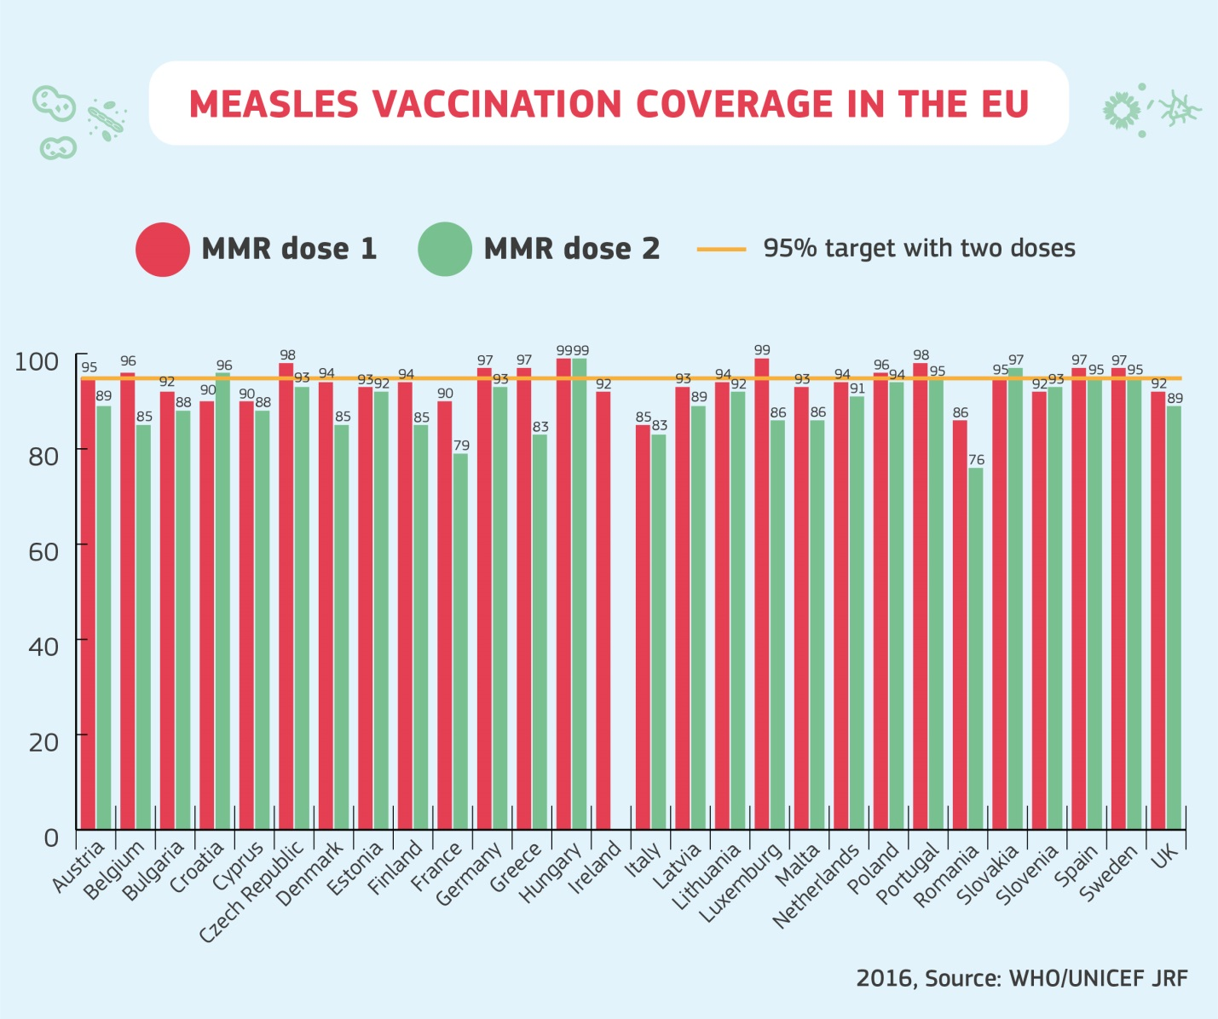

Figure 1: Measles Vaccination Coverage Rates in the EU in 2016 (Source: WHO/UNICEF JRF)

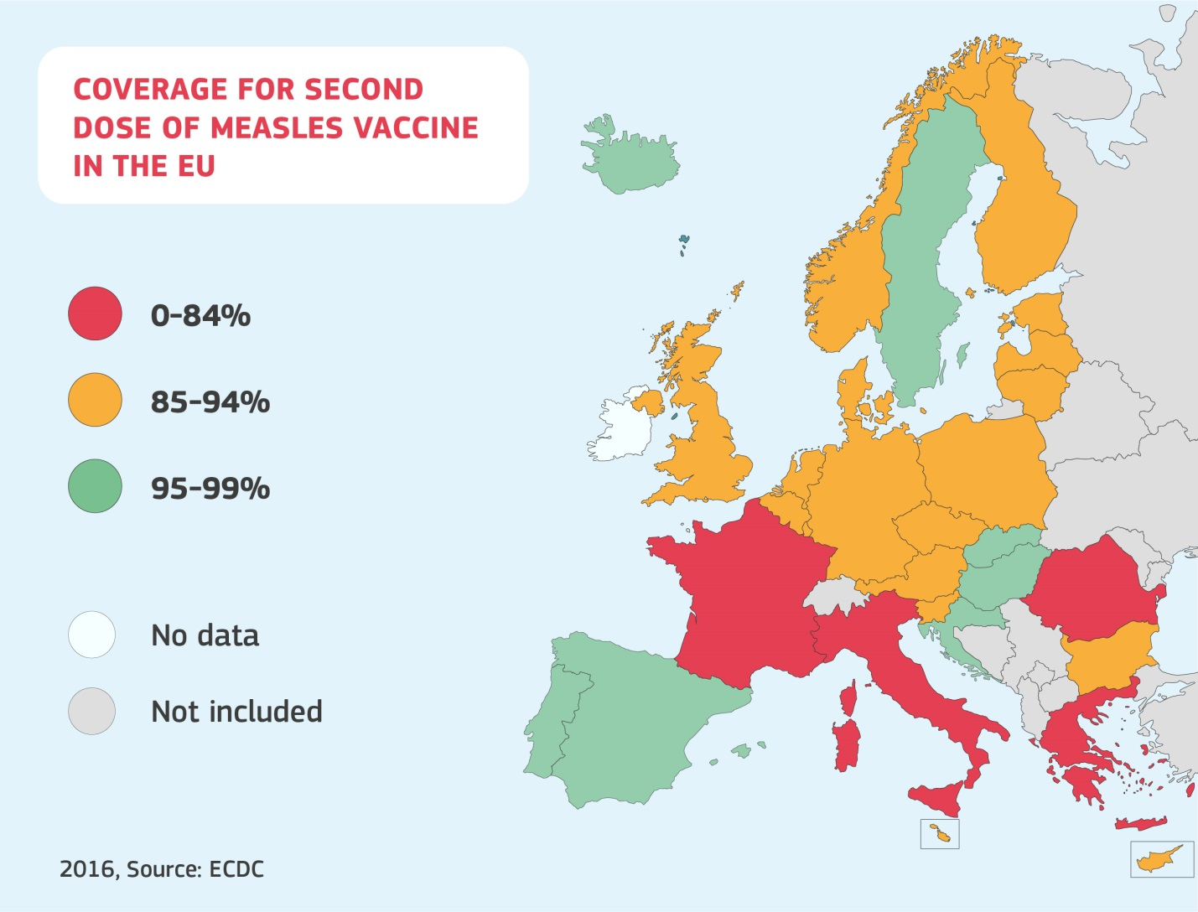

Figure 2: Coverage for second dose of measles vaccine in the EU (Source: ECDC)

**Annex 2**

**Determinants of hesitancy**

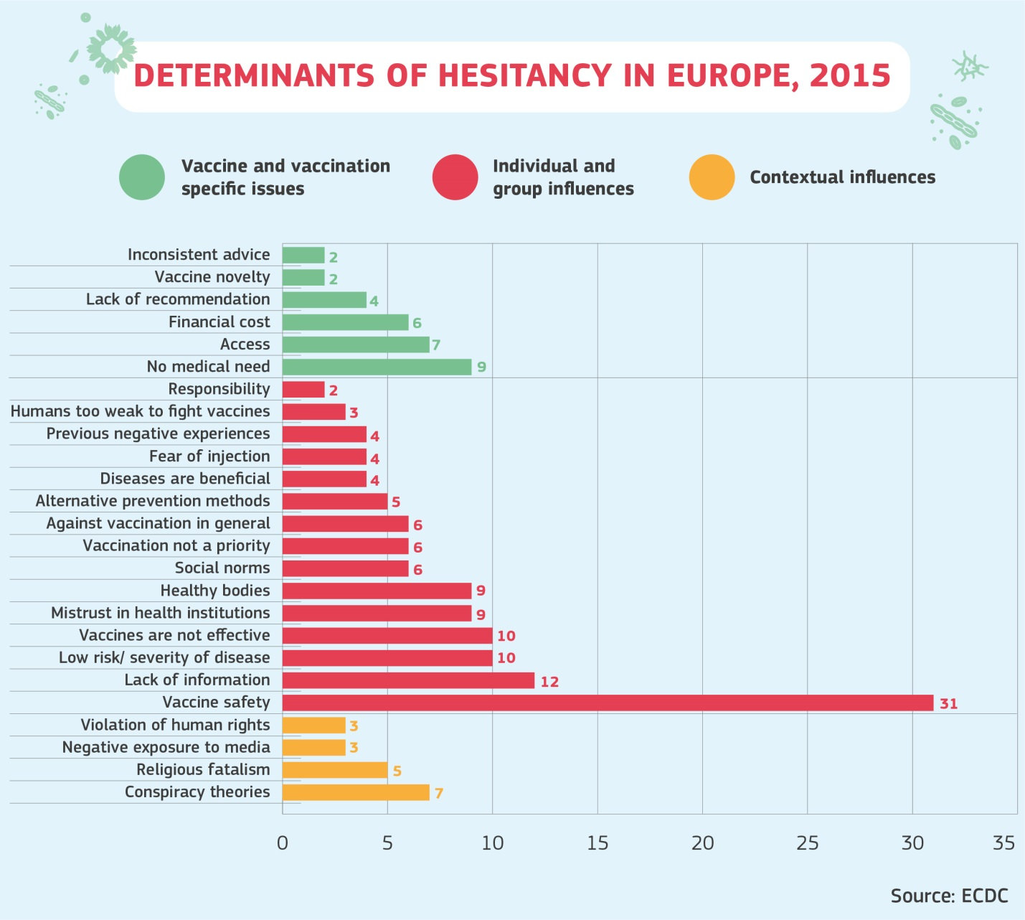

Figure 3: Determinants of hesitancy in Europe, 2015 (Source: ECDC) [1]

1. European Centre for Disease Prevention and Control. Rapid literature review on motivating hesitant population groups in Europe to vaccinate. Stockholm: ECDC, 2015. <https://ecdc.europa.eu/sites/portal/files/media/en/publications/Publications/vaccination-motivating-hesistant-populations-europe-literature-review.pdf>