

Table of contents

Annex 1: Procedural information

Annex 2: Stakeholder consultation

Annex 3: Who is affected and how?

Annex 4: Analytical methods

Annex 5: Early discarded options

Annex 6: ccTLD registry best practices

Annex 7: Vertical Integration

Annex 8: Total costs estimation in the 2018 budget of EURid

Annex 9: Administrative Burden for the .eu Registry

1. Standard Cost Model – Administrative Burden for the current .eu Registry under the BASELINE (Table 11)

2. Standard Cost Model – Administrative Burden for the .eu Registry under the Modernisation Option (Table 12)

3. Standard Cost Model – Administrative Burden for the .eu Registry under the Separate Governance Option (Table 13)

4. Standard Cost Model – Administrative Burden for the .eu Registry under the EUIPO Option (Table 14)

Annex 10: Administrative Burden for the European Commission

1. Standard Cost Model – Administrative Burden for the European Commission under the Baseline (Table 15)

2. Standard Cost Model – Administrative Burden for the European Commission under the Modernisation Option (TABLE 16)

3. Standard Cost Model – Administrative Burden for the European Commission under the Separate Governance Option (table 17)

4. Standard Cost Model – Administrative Burden for the European Commission under the EUIPO Option (table 18)

Annex 11: Cost estimation for the operation of the multi-stakeholder separate body

Annex 12: Cost for transferring the .eu Registry to the EUIPO and cost for running the .eu Registry by EUIPO

Annex 13: Indicators to monitor actual impacts

**Annex 1: Procedural information**

**Lead DG, CWP references**

This Impact Assessment was prepared by Directorate E "Future Networks" of Directorate General "Communications Networks, Content and Technology".

The Commission Work Programme reference of the initiative "Evaluation of Regulation EC 733/2002 establishing the ‘.eu’ top-level domain (TLD) and Regulation EC 784/2004 laying down public policy rules concerning the implementation and functions of the .eu TLD" is COM(2016) 710 final, particularly Annex 2[1].

**Organisation and timing**

Several other services of the commission with a policy interest in the assessment of the initiative have been associated in the development of this analysis.

The Directorates General participating in the Inter-service Group chaired by the Secretariat General included:

* The Secretariat General
* The Legal Service
* The Publications Office
* DG Migration and Home Affairs
* DG Eurostat
* DG Trade
* DG Joint Research Centre
* DG Informatics
* DG Communication

Meetings of the Inter-service Steering Group were held on:

* 28th March 2017. The draft inception impact assessment and the draft terms of reference for the evaluation and impact assessment were discussed.
* 15th December 2017. The draft evaluation and IA were discussed.

**Consultation of the Regulatory Scrutiny Board**

The Regulatory Scrutiny Board (RSB) hearing was scheduled for 14 February 2018. The initiative was treated in written procedure instead. The RSB recommendations led to the following changes:

The findings of the evaluations were explicitly included in the problem definition section. The magnitude of the problem was clarified. The relative lack of stakeholder interest was highlighted, it was explained that this is due to the fact that the problem is more of a technical and administrative nature than a broader policy problem.

The text was amended to treat the baseline as an option, instead of discarding it as inappropriate (its impacts had either way been assessed and used as reference when assessing the other options). The possible effect of BREXIT on the level of .eu registrations was added in the baseline.

The description of the options was streamlined to refrain from entering into analysis of the impacts or early conclusions. The separate governance option was further elaborated to explain what kind of legal requirements will be introduced regarding the establishment and functioning of the separate body and the tasks and powers of the Commission. The text on early discarded options was redrafted (including moving some parts of annex 5 into the report) to provide stronger argumentation for discarding the options.

The numbering of options was corrected to remain consistent throughout the report.

In the impacts section, the comparison of the options was further elaborated and the scoring system in the comparison table was adjusted to better reflect the analysis of the impacts of the different options. A tabular overview of the regulatory costs for the various options was introduced to facilitate the comparison. The scoring was also updated in the sensitivity analysis provided in annex 4.

The preferred option section was amended to address further clarifications on the vertical integration and the eligibility criteria. Regarding vertical integration, it was clarified that the price of the registration of a .eu domain name will not be stipulated in the contract between the Commission and the Registry. Furthermore, a more clear explanation on how the strict requirements (prohibition) of vertical integration will affect the .eu Registry was provided. Concerning the eligibility criteria, it was specified that that the intention is to introduce citizenship as a criterion for registration for natural persons while keeping residency as the criterion for both natural and legal persons. The entire Impact Assessment reflects this amendments and clarifications.

In the monitoring section, the indicators proposed were linked to operational objectives which in turn were linked to the four specific objectives of the initiative. A table was included to clarify the links. It was also clarified that these criteria for success of the preferred option will be regularly evaluated through the report the Commission has to submit regularly (every two years under the current framework) to the European Parliament and the Council on the implementation, effectiveness, and functioning of the .eu TLD.

**Evidence, sources and quality**

The Commission gathered qualitative and quantitative evidence from various sources:

***Public consultation***:

‘Public consultation on the evaluation and revision of the .eu top-level domain regulation’

***Surveys:***

EURid registrar survey (October 2017)

* Eligibility, regulatory framework, vertical integration
* Role in Internet Governance.

CENTR survey (ccTLD registries) (July - Sept 2017)

* .eu regulatory framework
* Fact finding ccTLD practices (eligibility, framework, registry’s involvement in Internet Governance)
* Surplus

***Stakeholder meetings:***

Brainstorming session with EURid (11.07.2017)

* .eu regulatory framework

Meeting with EURid Registrar Advisory Board (17.05.2017)

* Eligibility, vertical integration

Session at joint HLIG/CENTR meeting (4.10.2017)

* Role of ccTLDs in Internet Governance

European ccTLD registry .at  (5.10.2017)

* Fact finding - regulatory framework nic.at/Internet Foundation Austria

Meeting with ICANN (27.09.2017)

* Fact finding
* Regulatory framework
* Internet Governance

***European Commission's internal meetings:***

EC Cybersecurity Unit (H.1, CNECT) (12.11.2017)

* impact NIS Directive on DNS  (MS to assess whether ccTLD is ‘operator of essential services')

EC Legal Service SJ (29.06.2017 and 21.11.2017)

* Update regulatory framework
* GDPR implications

EC Legal Affairs Unit (R.4, CNECT)  (21.11.2017)

* Legal simplification options

EC Competition Digital Taskforce (EC Digital TF, DG COMP) (27.11.2017)

* Vertical Integration
* Budget and non-profit/profit operator structure

***Written stakeholder contributions:***

Open-Xchange (2.8.2017)

* DNS security, DNSSEC

MARQUES, the European Association of Trade Mark Owners (25.08.2017)

* Regulatory framework
* Role in Internet Governance

ECTA, European Communities Trade Mark Association (13.06.2017)

EURid (18.06.2017)

* Regulatory framework

EUIPO, European Union Intellectual Property Office (26.9.2017)

* Regulatory framework and operational perspectives

**EXTERNAL REFERENCES:**

* EURid, EURid's Quarterly update, Q3 2017 Progress Report
* EURid, EURid's Quarterly update, Q2 2017 Progress Report
* EURid, Annual report, 2016
* EURid, Environmental Statement, 2015-2017, ‘Going green’, <https://eurid.eu/en/going-green/>
* EURid, 'Another reforestation project undertaken by EURid' <https://eurid.eu/en/news/another-reforestation-project-undertaken-by-eurid/>
* EURid, ‘Website usage trends among top-level domains' 2014, [https://eurid.eu/media/filer_public/03/2c/032cbaa0-b61f-4bc9-87a4-188a256d6a35/websiteusagetrends2014_eurid.pdf and 2011](https://eurid.eu/media/filer_public/03/2c/032cbaa0-b61f-4bc9-87a4-188a256d6a35/websiteusagetrends2014_eurid.pdf%20and%202011), <https://eurid.eu/media/filer_public/7b/93/7b93d320-99c7-45e3-ae77-d7418fb73691/insights_cat_nov2011.pdf>
* EURid, .eu awareness study, 2015, <https://eurid.eu/media/filer_public/0a/19/0a1926a8-63d1-49c1-8543-21aaf06d9358/eurid_awareness_survey_2015.pdf>
* EURid, Registrar Advisory Board established, Domainpulse, October 2008, <http://www.domainpulse.com/2008/10/07/eurid-registrar-advisory-board-established/>
* The Verisign Domain Name Industry Brief, Volume 14 – Issue 3 – September 2017 , <https://www.verisign.com/assets/domain-name-report-Q22017.pdf>
* UNESCO, VeriSign, EURid, World Report on Internationalised Domain Names, <http://idnworldreport.eu/>
* ICANN, Governance Guidelines, May 2012, <https://www.icann.org/resources/pages/guidelines-2012-05-15-en>
* CENTR, Domain Wire, 2017/2, ‘Median growth’ chart, [https://www.centr.org/statistics-centr/quarterly-reports.html#](https://www.centr.org/statistics-centr/quarterly-reports.html)
* CENTR, Open stats tool, gTLD stats, market overview, <https://stats.centr.org/gtlds>
* OECD, Council Recommendation on Principles for Internet Policy Making, 2011, https://www.oecd.org/Internet/ieconomy/49258588.pdf
* Domain Incite, 'Four in ten new gTLDs are shrinking', 18 September 2017 <http://domainincite.com/22111-four-in-10-new-gtlds-are-shrinking>
* Digital Economy Act 2010, ‘Powers in relation to Internet domain registries’, [https://www.legislation.gov.uk/ukpga/2010/24/crossheading/powers-in-relation-to-Internet-domain-registries](https://www.legislation.gov.uk/ukpga/2010/24/crossheading/powers-in-relation-to-internet-domain-registries)
* Internet World Stats, Internet Users in The European Union 2017, [http://www.Internetworldstats.com/stats9.htm](http://www.internetworldstats.com/stats9.htm)
* Registry Backend Overview, Statistics, <https://ntldstats.com/backend>
* AFNIC, Evolution of the .fr and .re registration rules and procedures on March 30th, 2009, <https://www.afnic.fr/en/about-afnic/news/general-news/2724/show/evolution-of-the-fr-and-re-registration-rules-and-procedures-on-march-30th-2009.html>
* 'Earn money on YouTube' The Guardian, 2012 https://www.theguardian.com/money/2012/jan/13/earn-money-youtube-viral-video
* Net Mundial Multistakeholder Statement, 2014, 2014 <http://netmundial.br/wp-content/uploads/2014/04/NETmundial-Multistakeholder-Document.pdf>
* The Registrar, 'That apple.com link you clicked on? Yeah, it's actually Russian', https://www.theregister.co.uk/2017/04/18/homograph_attack_again/
* <https://onlinedomain.com/>
* Trends on Facebook, <https://trends.google.co.uk/trends/explore?q=EURid,Facebook>

**Annex 2: Stakeholder consultation**

The stakeholder consultation is part of the [Regulatory Fitness and Performance Programme (REFIT) review of the .eu TLD regulations.](https://ec.europa.eu/info/law/better-regulation/initiatives/ares-2017-2402460_en) It sought to gather input for the evaluation, assessing the .eu Regulations against the evaluation criteria of effectiveness, efficiency, coherence, relevance and EU added value. It further aimed to collect input on issues that may need to be reviewed within the current .eu legal framework through eventual legislative and/or non-legislative initiatives.

**Stakeholders’ consultation Strategy**

The consultation strategy supporting the revision of the .eu TLD name Regulations distinguished between three groups of stakeholders: (1) the parties directly impacted by the regulations in their day-to-day activities, i.e. the .eu Registry operator and the .eu registrars, and therefore well placed to assess the current .eu framework and potential options for the revision; (2) the .eu peers and other stakeholders in the Domain Name System (DNS) ecosystem, well placed to evaluate the .eu framework and future options against current practices in the DNS ecosystem; and (3) stakeholders that potentially benefit from the contribution of the .eu TLD name to the EU Digital Single Market and the online EU identity, and as such indirectly impacted by the .eu regulatory framework.

The consultation strategy included a public consultation, direct outreach and ad-hoc meetings with stakeholders, a roundtable discussion with European registries, a survey amongst European ccTLD registries, and a survey targeting the current .eu registrars. The public consultation also triggered a number of written contributions from stakeholders.

*Public consultation*

The ‘Public consultation on the evaluation and revision of the .eu top-level domain regulations’[2] was held between 12 May and 4 August 2017 and received 43 replies from respondents in 17 Member States. It gathered input from stakeholders on the functioning of the current regulatory framework, opinions on possible future options for the .eu regulatory framework, and views on the role of a .eu operator in the wider Internet Governance ecosystem. The report on the responses received was published on 10 November 2017[3]. An analytical report of the public consultation is provided below.

*Surveys*

The Commission worked with the current .eu operator (EURid) to survey the base of .eu registrars. The registrars were invited to assess the suitability of the .eu framework to set policies and procedures for registering a .eu TLD name. In addition the survey solicited views on future options for the eligibility criteria for registering a .eu TLD name, and on the current restriction on the vertical integration of the .eu Registry operator. The registrar survey was conducted between 29 August and 29 September 2017 and received 59 responses, a 33% response rate.

The Commission worked with the current .eu operator (EURid) to launch a survey among the membership of the Council of European National Top-Level Domain Registries (CENTR). The European ccTLD operators responding to the survey were asked to express on the objectives and the effectiveness of the current .eu framework, as well as to provide information on their own legal and regulatory practices for organising the operation of their ccTLD(s). The survey received 11 responses between July and end September 2017.

*Meetings with stakeholders*

The Commission organised a brainstorming session on the revision of the .eu regulatory framework with the current .eu Registry operator, the European Registry of Internet Domain Names (EURid) (Brussels, 11 July 2017).

The Commission consulted with .eu Registrars on the Refit of the .eu regulatory framework, the current eligibility criteria for registering a .eu TLD name, and on the restriction on the vertical integration of the .eu Registry operator at the meeting of the EURid Registrar Advisory Board (Florence, 17 May 2017).

The Commission organised a session on the .eu Refit and the involvement of ccTLDs in Internet Governance at the joint meeting between the European Commission’s High Level Group on Internet Governance (HLIG - E02450) and the Council of European National Top-Level Domain Registries (CENTR) (Brussels, 4 October 2017). In addition, the Commission reached out to individual ccTLD operators to collect insight in current practices and models for organising the management of a country code TLD registry.

The Commission met with the Internet Corporation For Assigned Names and Numbers (ICANN), the not-for-profit organisation responsible for the coordination and maintenance of the domain name system (DNS), to gather general information and background on the evolution of the DNS, and to exchange views on current practices in the management of TLDs in the DNS ecosystem (Brussels, 27 September 2017).

The Commission met internally with different services on issues related to the management of the European Top-Level Domain and to discuss possible future options. The Commission (CNECT E.3) met with the Commission’s Cybersecurity Unit (H.1) on the impact of the NIS Directive on the DNS ecosystem; with the Commission’s Legal Service (SJ.A) and Legal Affairs Unit (R.4 CNECT) to gather insights on the legal simplification options for the regulations and with special attention to a revision of the process to change the ‘List of reserved names by the Member States’; with the Commission's Competition law Digital taskforce (COMP.C.TF) on the issue of Vertical Integration and Registry Operator's budget oversight by the European Commission.

*Written Contributions from stakeholders*

The Commission received written contributions from the European Communities Trade Mark Association (ECTA) (13 June 2017) on the topics of vertical integration, European identity, trust and security on the web, and young people and social media; from the European Registry of Internet Domain Names (EURid) (18 July 2017) on the current registry operator's opinion on the revision of the .eu regulatory framework; from Open-Xchange (OX) (2 August 2017) on the implementation of DNSSEC for .eu; from the European Association of Trade Mark Owners (MARQUES) (2 August 2017) on the value of .eu for brand owners and the appropriateness of the .eu regulatory framework; form the European Union Intellectual Property Office (EUIPO) (26 September 2017) on the future of the .eu TLD.

**Summary of stakeholders’ views on the main issues related to the .eu regulatory framework**

Views in relation to Evaluation SWD:

*Relevance of the .eu regulatory framework*

88% of the respondents to the stakeholder consultation and 73% of the respondents to the survey among European ccTLDs considered the general objective of the .eu regulatory framework, to create a .eu-top-level domain to contribute to the DSM by encouraging and increasing secure and reliable e-commerce and build a strong digital identity for people and organisations in the EU, still relevant.

The EC received stakeholder contributions that recognised ‘the value of the .eu TLD domain name’ (MARQUES) and confirmed that ‘.eu can and should contribute to the creation of a shared digital identity for European citizens and companies’ (Open-Xchange).

*Effectiveness and Efficiency of the .eu regulatory framework*

The feedback on the stakeholder consultation provided elements for an evaluation of the effectiveness of the regulatory framework and the creation of .eu in contributing to the DSM by encouraging and increasing secure and reliable e-commerce, and build a strong digital identity for people and organisations in the EU:

* 70% indicated that a .eu extension significantly of or moderately affects their trust in a website;
* 60% answered that, as a consumer, they would rather buy from a .eu website than from a website with a generic extension;
* 54% said to prefer a .eu website over websites with another country code.

Further, most respondents to the stakeholder survey agreed that .eu has significantly or moderately promoted:

* a clearly identifiable digital identity for citizens and business in the EU (81%);
* a cross-border access to the online marketplace (65%);
* a secure and reliable e-commerce in the EU (58%).

The European ccTLD operators were asked to assess to what extent a ccTLD could benefit from a regulatory framework. 45% of the respondents to the survey stated that ‘having a regulatory framework poses moderate to significant benefits for ccTLDs’. The others answered that a framework provides little (45%) or no (9%) benefit.

The EC received stakeholder contributions that indicated that the framework:

* has been successful in:
  + assigning a well-performing registry operator, which ‘has been stable, secure and very well managed’, with staff that ‘are supportive and understand the needs of business’ (MARQUES);
  + allowing the registry operator to work ‘to improve security in the Internet’ which ‘has certainly improved trust amongst users’ (ECTA);
* while imposing some constraints:
  + for the .eu Registry operator, by limiting its possibilities to ‘embark on long term innovative projects as well as to diversify its business’, and to ‘compete against the competitive business models and market players’ (EUIPO);
  + for the EU Commission by restricting ‘the promotion of the EU identity’ and potentially ‘put at risk the business continuity of the .eu TLD’ (EUIPO); and
  + for the end-user ‘due to the misalignment of the available dispute resolution mechanisms with user needs’ (EUIPO).

*Coherence of the .eu regulatory framework*

65% of the respondents to the stakeholder consultation significantly or moderately agreed that the regulatory framework is coherent with the EU priority for the completion of the EU DSM; a small minority thought opposite and 25% answered ‘do not know’.

56% of the respondents to the stakeholder consultation significantly or moderately agreed that the regulatory framework is coherent with global domain name industry best practices; a few did not agree and 33% answered ‘do not know’.

The coherence with industry best practices was also discussed that the EC‘s meeting with ICANN where it was explained that individual ccTLDs historically have their own rules, that there exists a very good best practice exchange among European ccTLD operators, that some registrars call for a harmonisation of the rules and procedures similar to the ongoing harmonisation in the gTLD space, and that there are some signs of more harmonisation among ccTLDs. On the latter, 54% of the respondents to the European registries survey reported ‘that there was no need for streamlining any TLD operational areas at the EU level’.

51% of the respondents to the stakeholder consultation significantly or moderately agreed that the regulatory framework is coherent with policies set by other European ccTLDs while 40 % answered ‘do not know’.

*Added value of the .eu regulatory framework*

The EU action, with the establishment of legislation on the .eu, provided added value according to 70% of the respondents to the stakeholder consultation, and 79% indicated that the action resulting from the .eu framework provided an added value in terms of building a stronger digital identity for people and organisations in the EU. The European ccTLDs had a less outspoken opinion on whether the EU action provided added value: 40% of those answering the European registry survey said ‘yes’ while half of the respondents were ‘not sure’.

Views in relation to Impact Assessment report:

*The .eu eligibility criteria*

Stakeholder views on a liberalisation of the eligibility criteria for registering a .eu TLD name are mixed, with arguments in favour of eliminating - territoriality is outdated in a global and digital world; liberalisation would make .eu more competitive; an increase of cybersquatting can be reasonably prevented - and arguments in favour of maintaining the restrictions - liberalisation might limit the possibilities for obtaining a .eu TLD name for those seated within the EU; liberalisation could lead to more cybersquatting; dealing with owners outside the EU could complicate the negotiation or conflict process in case of cybersquatting (ECTA). Registrars pointed to the cost of verification and validation of the registrant’s identity and the sometimes complex process of checking the information provided, as the identification of individuals falls under Member States’ competence, and they requested as few eligibility criteria as possible (.eu Registrar Board).

A majority of the respondents to the stakeholder consultation would agree with relaxing the eligibility criteria to allow any European citizen to register a .eu TLD name, regardless of whether or not they are resident in the EU, but would disagree with relaxing the criteria for companies and organisations, or with eliminating all criteria. Respondents to the registrar survey agreed that EU citizens (83% agree) and companies operating within the EU (79% agree) should be able to register a .eu name regardless of whether or not they are resident of, or established within the EU. The surveyed registrars remained ambivalent about completely open registration criteria (44% agree; 38% disagree). Individual respondents to both the stakeholder consultation and the registrar survey pointed at the need for a solution or a transition phase in case eligibility conditions change (e.g. for citizens temporarily or definitely residing outside the EU, and for UK registrants after Brexit).

The current .eu Registry operator ‘supports the citizenship of EU and/or EEA countries as an eligibility criteria, as opposed to the current residency requirement that penalises those EU/EEA citizens who are forced to move their residency abroad because of various factors, but continue to maintain their EU/EEA nationality, and therefore their passport’ (EURid).

*Vertical integration of the .eu Registry operator*

One stakeholder stated that the restriction on the .eu Registry operator to act as a registrar for .eu ‘is not representative of the current market trend and its limitations greatly affect the positioning of .eu in the current environment leaving the .eu Registry with little direct access to their end-users to intervene and actively promote their TLD. Moreover initiatives such as free domain names to schools and universities to boost customer acquisition and retention with the new generation are not possible since they will not be supported by the current registrars’ (EUIPO). The current registry operator also recommended removing the clause that prohibits vertical integration and argued that this would help ‘compliance with the broader EU competition rules that ought to be guaranteed at all levels, whereas at present the registry operator is discriminated in comparison with its industry peers and sales channel’ (EURid).

The respondents to the stakeholder consultation were divided over the question whether the .eu Registry operator should be free to offer .eu TLD names to the end users, or to end users in underserved markets. While overall a majority of the respondents supported a removal of the restriction, there was strong opposition within the group of business representatives. Similarly, of all respondents a majority said to expect end users to benefit from direct registrations, while a majority of the business representatives did not share this opinion. Private individuals were divided on whether allowing direct registrations could have potential positive side effects and tended to disagree that there might be negative side effects. Within the subgroup of business representatives, a majority indicated to expect negative side effects and disagreed that allowing direct registration could trigger unintended positive side effects.

The respondents to the registrar survey were strongly opposed to letting the .eu Registry operator free to offer domain names directly to the end user (86% disagreed), or to allowing the registry to offer .eu TLD names directly in underserved markets (66% disagreed). Registrars disagreed (68%) with the idea that allowing direct registrations could benefit end users.

.eu registrars opposed vertical integration because it would increase and distort competition. Some registrars mentioned, by means of alternative, opportunities for cooperation with the registry to increase the .eu market penetration in underserved markets. Registrars also warned about the cost of a registry-registrar integration. (.eu Registrar Board)

*Policy framework to set the .eu rules and procedures*

The combination of a multistakeholder policy development process by the .eu Registry and approval by the Commission was most (49%) suggested as most suitable framework by the respondents to the registrar survey, followed by ‘policies and procedures developed by the .eu Registry operator’s board’ (44%). Overall there were lower levels of support in the suitability of procedures and policies determined by the European Commission.

A majority (73%) of participants to the European registries survey recommended that in light of the evolving domain name landscape any regulatory framework is best limited to set key principles, while the policies and procedures are included in a more flexible document. 85% of the respondents to the registrar survey agreed that the .eu regulatory framework should be as light as possible to better accommodate possible, future changes in the Internet landscape. 65% of the registrars supported the view that policies and procedures should be set out in the regulatory framework.

The current registry operator provided detailed suggestions on what parts of the current Regulations would ‘better be placed in a ‘Policy and Procedures’ document that would complement the revised Regulation and be agreed between the European Commission and the Registry Operator’. According to the registry operator, such a document ‘should include some of the registration procedures that are likely to need updating in the near future due to possible changes to best practices in the domain name industry’ and would therefore ‘enable the European Commission and the registry to modify those procedures quickly without having to go through the lengthy process of updating the a EC Regulation’ (EURid).

*Governance model*

In the results of the public consultation, the governance model where the detailed policies and procedures are developed by the .eu operator through a multistakeholder process and approved by the European Commission stood out as most preferred option. A majority of the respondents (74%) and a majority within both subgroups of private individuals (80%) and business representatives (66%) showed clear preference for this model, while no respondent marked this option as ‘least preferable’. The governance model where the policies and procedures are approved by the .eu Registry board was less or least preferred by a majority (68%) of the respondents to the public consultation. Views were mixed with regard to the other options (ordered by declining preference): policies and procedures determined by the European Commission; policies and procedures developed through a multistakeholder process; policies and procedures set by EU regulation.

*The not-for-profit requirement for the registry operator and use of the surplus*

The respondents to the stakeholder consultation almost unanimously agreed (93% agreed of which 70% strongly agreed) that the .eu Registry should continue to be operated by a not-for-profit organisation. Two respondents did not agree, they suggested that the registry should be operated by a private company and the public sector.

The current .eu Registry operator recommended ‘keeping a not-for-profit organisation’ as key requirement for the registry operator’, and supported ‘the use of the surplus to further promote the .eu TLD, and possible actions within the Internet governance landscape’ (EURid).

A majority of the respondents to the stakeholder consultation (70%) agreed that any surplus generated by the .eu registration fees should be allocated for supporting EU priorities in Internet Governance and EU Internet governance related projects. Several respondents made suggestions on how to use the surplus. Among the most cited were supporting Internet governance and multistakeholderism, investing in improving security and developing the Internet infrastructure, and enhancing Internet access and inclusiveness.

The European registry survey did not provide a clear opinion on whether the .eu surplus should go back to the EU budget (40% agree, 20% neutral, 40% disagree). Supporting the EU priorities in Internet governance related projects was the most suggested as alternative to use the surplus.

*The role of the .eu Registry in the wider Internet governance ecosystem*

The respondents to the stakeholder consultation were indecisive on whether the .eu Registry has a role within the wider Internet governance ecosystem, beyond the smooth and secure operation of the .eu TLD name (30% yes, 30% no, 40% ‘I don’t know’). While some participants to the registrar survey agreed (39%), most had no opinion (44% ‘I don’t know’) on whether .eu has a role in the Internet governance ecosystem. Some registrars added concrete suggestions for initiatives or projects.

One stakeholder indicated that by more fully participating in Internet governance, the .eu Registry could give European brands ‘a voice at the table where policy is made for the Internet’ (MARQUES).

The Commission discussed the role of a ccTLD registry in Internet Governance with .eu’s peers at the HLIG/CENTR meeting, where some participants suggested - in line with their own activities at national level - that .eu should serve as a centre of competence on Internet Governance, on domain names and on Internet related issues, promote a free and open Internet, stimulate Internet Governance discussions, and support the further technical development of the Internet and DNS.

.**eu REFIT Stakeholder Consultation**

**Analysis of online public consultation inputs**

1. Background and Objectives of the Consultation

The .eu top-level domain (TLD) was established by Regulation EC 733/2002 of 22 April 2002 and is governed by the implementing rules of Regulation EC 874/2004 of 28 April 2004. On 12 May 2017 the European Commission launched a public consultation[4] to collect community input on whether the .eu legal framework still serves its purpose. The online consultation ran for 12 weeks and closed on 8 August 2017.

The consultation is a part of the REFIT review of the .eu TLD regulations and covers:

* The assessment of the overall functioning of the current framework;
* The possible future options for the .eu regulatory framework;
* The role of the .eu TLD operator in the Internet Governance ecosystem.

1. Methodology and Respondents

The Commission sought stakeholders’ views through an online questionnaire. Forty-four contributions had been received on the closing date: 43 responses on the online questionnaire and 1 written contribution.

Twenty-five (25) responses came from *citizens/private individuals* residing in 12 EU Members States. Most of them were between *25 and 65 years old* (19 out of 25). Fifteen (15) responses came from *business representatives*, one from an *association,* and one from the *public sector.* The companies/organisations that participated are active in 9 Member States. Overall, contributions came from respondents in 17 Member States[5] and from one citizen residing outside the EU (indicated as *‘other*’).

|  |  |  |  |  |
| --- | --- | --- | --- | --- |
| Table 6: Type of respondents - absolute numbers | |  | Table 7: Respondents - Age distribution 'Citizens/Private individuals’ - absolute numbers | |
| *Citizens/Private individuals* | *25* | *Age < 25* | *3* |
| *Business representatives* | *15* | *25 < Age < 65* | *19* |
| *Association* | *1* | *65 < Age* | *3* |
| *Public* | *1* | **Total** | **25** |
| *Other* | *1* |  |  |
| **Total** | **43** |  |  |

Figure 6: Geographic distribution of survey respondents

The fifteen (15) *business representatives* mainly work for companies providing *IT-services* (10 out of 15). There was one submission from the *energy sector* and one respondent indicated to work for a *research, scientific or education* institution. Three (3) responded *‘other’* but specified that they were with a company that provides advice or consultancy services.

Eight (8) respondents work for a company that provides domain name registration services: two (2) as a *registry,* four (4) as a *registrar,* and two (2) combine both registry and registrar functions.

A majority of the respondents holds one or more domain names. 26 out of 43 have a *.eu TLD name*; 28 have *a domain name, other than a .eu TLD name[6]*. It is possible to have .eu and other domain names at the same time. In general, those that have a .eu TLD name are actively using it (21 out of 26), while four (4) said *‘it is just registered’* and one (1) *‘cancelled the domain name’.*

Figure 7: .eu domain holders among the survey participants (number of respondents)

1. Overall functioning of the current regulatory framework
   1. *Assessment of the* ***relevance*** *of the regulatory framework for the .eu*

The main aim of the .eu top-level domain is to contribute effectively to the Digital Single Market by encouraging and increasing secure and reliable e-commerce and build a strong digital identity for people and organisations in the European Union. 38 respondents (88%) find the current objectives of the .eu regulatory framework still relevant to address the needs of EU citizens and businesses.

14 respondents (33%) indicated that the objectives of the .eu TLD should be complemented. Their suggestions can be clustered in three groups:

1. .eu to foster the creation of ‘a unified environment for culture, information and discussion in Europe’ and encourage ‘civil society and associations (…) to use .eu’;
2. More stringent legislation on the use of .eu to block ‘abuses of the extension’, handle ‘cybersquatting issues and domain disputes’, and ‘limit the use to effective users’;
3. More flexible eligibility requirements for ‘people and organisations who have an interest in the EU (…) but who are not necessarily based in a member state’.
   1. Assessment of the **effectiveness** of the regulatory framework for the .eu

30 respondents (70%) indicated that a .eu extension significantly or moderately affects their trust in a website. 26 (60%) answered that, as a consumer, they would rather buy from a .eu website than from a website with a generic extension. 23 (54%) said to prefer a .eu website over websites with another country code.

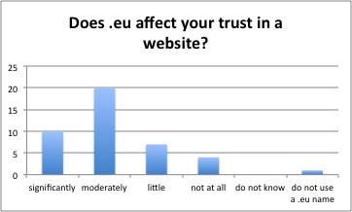 Respondents explained that trust in a .eu website is based on the expectation that ‘EU privacy and consumer protection laws will be applicable’. Others answered that a .eu extension makes a company ‘more international’ while ‘using a local country code (…) gives the image that the company aims only to customers of its own country’. For some respondents the preference for .eu ‘has more to do with the perceived trust on specific ccTLDs than the assumption that a .eu site is more trustworthy’. They have ‘in general more trust in .eu than in non-European country codes’ while ‘slightly more trust in .eu than in eastern European country codes’. Only one respondent said that a .eu extension decreases the level of trust.

Figure 8: 'When a website has a .eu extension, does that affect how much you trust it?

Eleven (11) business representatives use a .eu name. 6 of them (55%) said that .eu significantly or moderately helped to expand their online business cross border, while 3 (27%) said that there was little or no effect. The opinions are less clear for the effect of a .eu on turnover or on the ability to attract customers from other countries.

* 1. Assessment of the **efficiency** of the regulatory framework for the .eu

For a majority of the respondents the .eu has significantly or moderately promoted ‘*a clearly identifiable digital identity for citizens and business in the EU*’ (81%), ‘*cross-border access to the online market place*’ (65%), and a ‘*secure and reliable e-commerce in the EU*’ (58%).

In general, neither private individuals nor business representatives consider the cost for holding a .eu TLD name significant. The domain holders were fairly positive about the cost-benefit ratio: 19 of the 34 (56%) holders of a .eu name gave a clear positive assessment while only two (2) respondents said that costs exceed the benefits.

Seven (7) respondents suggested simplifying the .eu regulatory framework. Most respondents, however, answered that there were ‘no’ (18 responses) or that they were ‘not aware’ (18 responses) of areas that could be simplified. Similarly, ten (10) respondents answered that some areas of the framework could be ‘changed or eliminated, to reduce regulatory burdens’ while the majority saw ‘no’ (16 responses) or was ‘not aware’ (17 responses) of areas that could be simplified.

There were several requests to relax the eligibility criteria. Other suggestions included: safeguards to fight (DNS) abuse, a clarification of the non-profit objective and use of revenue, amendments to the Alternative Dispute Resolution Rules (ADR), (deletion of) sunrise details, inclusion of direct registrations in underserved markets.

* 1. Assessment of the **coherence** of the regulatory framework for the .eu

The regulatory framework is coherent with the EU priority for the completion of a European Digital Single Market say 28 or 65% of the respondents (significantly or moderately agree). Only one (1) respondent saw a discrepancy between the framework and the EDSM objectives. Eleven (11) ‘do not know’. Some commented that the .eu helps to create a conscience of one market and to build ’a strong and reliable digital identity for people and organisations in the European Union’. Others said that the .eu has a very limited impact and that other important aspects of the EDSM still need to be filled in.

The .eu regulatory framework is coherent with global domain name industry best practices say 24 respondents (56%) (significantly or moderately agree). Most business representatives agree while a large group of private individuals ticked the ‘do not know’ option. One respondent noted that there might be legitimate deviations from what some define as industry best practices because of the .eu objectives and the European understanding of privacy and trade. Others suggested the framework ‘to mandate adoption by the .eu Registry, registrars and registrants of modern DNS security technologies’ or asked to lift restrictions that might prevent registrars from ‘mitigating some forms of abuse more easily’. The Commission also received a written contribution asking for regulatory action to speed up the adoption and deployment of DNSSEC.

22 respondents (51%) consider the .eu framework more or less coherent with domain name policies set for other European country code Top Level Domains, while a large group of 17 (40%) did not know the answer on this question. While one respondent reiterated that .eu has its own status and origin, several others indicated that .eu could serve as ‘a benchmark for other ccTLDs’ in Europe.

* 1. Assessment of the **added value** of the regulatory framework for the .eu

70% of the respondents (30 out of 43) agreed that the EU action – with the establishment of legislation on the .eu – provided an added value in terms of *encouraging cross-border secure and reliable e-commerce*. Private individuals and business representatives equally agree with the statement. According to the respondents the .eu regulatory framework encouraged cross-border secure and reliable e-commerce because it increased trust, security and reliability; created a feeling of proximity and belonging to an EU community; helped businesses and organisations to create awareness about the European rather than country-wide scope of their services and activities; and encouraged the development of a competitive registrar market. Others see no direct link between a TLD extension (a label or identifier) and the encouragement of commercial activities. Some suggested that contractual policies would be more adequate than a regulatory framework as ‘they are more agile and responsive’ and that ‘achievements (…) could have been realised more quickly and more flexibly by a much lighter decision-making process, including more effective multi-stakeholder participation’.

A large majority of 34 respondents (79%) agreed that the action resulting from the .eu framework provided an added value in terms of *building a stronger digital identity for people and organisations in the EU*. .eu helps companies and organisations to be recognized as being European ‘which in some sectors has added value’ and ‘adds trusts especially regarding privacy’. Within Europe ‘it signals a cross-border, translational mindset’ or scope of one’s business, and fosters a cross-border identity and feeling to belong to the EU. Two respondents argued that having no legislation or having simple ‘contractual policies’ would be more efficient. Two respondents didn’t attribute any significant added value to the framework.

1. Possible future options for the .eu regulatory framework
   1. .eu TLD eligibility criteria

Under the current eligibility criteria for registration, the .eu TLD is available for residents of and organisations/companies established in EU members states plus Iceland, Norway or Lichtenstein (EEA). The respondents were asked to express preference on the following three options:

*(A) A .eu TLD should be available for registration by any European citizen, regardless of whether or not they are resident in the EU.*

*(B) A .eu TLD name should be available for registration by any company/organisation regardless of whether or not they are established in the EU.*

*(C) A .eu TLD name should be available for registration by anyone regardless of their residency or nationality criteria.*

There is clear support for option (A) and an outspoken disagreement with option (B) and (C). However a considerable minority supports (B) or (C) and disagrees with (A).

|  |  |  |
| --- | --- | --- |
|  |  |  |

Figure 9: .eu eligibility criteria – EU citizens regardless of country of residence (A); EU company/organisation regardless of country of establishment (B); available for anyone, regardless of residency or nationality criteria.

Several respondents link the .eu eligibility criteria with trust. They state amongst other that ‘a big part of the value (trust) comes from the fact that there is this direct link with the EU’ and the expectation ‘to find a company established in Europe that follows European regulations’. They warn that relaxing the eligibility criteria could make ‘the use of the .eu TLD misleading’. Other respondents are more relaxed on whether EU citizens residing outside the EU – temporarily or definite – could register or keep their registered .eu TLD name. A few alternative and additional eligibility criteria were suggested, e.g. allow registrations for companies based in the EU and their worldwide subsidiaries, prohibit registration by for persons or companies that had legal problems with the use of domain names, and create a transition phase for when eligibility conditions change (for example .eu registrants in the case of Brexit).

* 1. .eu TLD registry

A large majority of 35 respondents (81%) showed a mild to strong preference[7] for a *.eu regulatory framework* that *sets policy and procedures to be followed by the registry operator.*

The respondents are divided over the question whether *the .eu Registry operator should be free to offer .eu TLD names directly to end users*, with a light tendency to support direct registrations. Private individuals are most outspoken in favour while opinions amongst business representatives are mixed and almost half of them strongly oppose direct registrations.

Similarly, respondents are divided on whether *the .eu Registry operator should be free to offer .eu TLD names directly to end users in underserved markets where end-users have difficulties in finding a local domain name provider*. The overall support for direct registrations in underserved markets hides that there is strong opposition within the business representatives.

|  |  |
| --- | --- |
|  |  |
| Figure 10: ‘The .eu Registry operator should be free to offer .eu registrations directly to end users.’ | Figure 11: ‘The .eu Registry operator should be free to offer .eu registrations directly to end users in underserved markets where end users have difficulties in finding a local domain name provider. |

Overall, respondents think that *allowing the .eu Registry operator to offer domain names directly to end users is likely to benefit end users.* A majority of the business representatives, however, disagrees with this statement.

A small majority of the respondents does not expect *unintended positive side effects* from direct registrations*.* Surprisingly, a similar small majority also doesn’t expect *unintended negative side effects.* Private individuals are divided on the potential positive effects but tend to disagree that there might be negative side effects. The majority of business representatives expects negative side effects and disagrees that there might be unintended positive side effects.

A high price for direct registrations could minimise unintended side effects suggest two respondents. Others look at the supervisory board and increased transparency to handle or avoid side effects. One respondent concluded that ‘unless the registry can offer a service or product that is not so interesting for registrars (…) it makes no sense (…) to competedirectly with a mature multi-million EUR industry’. Another respondent added that the ‘potential anti-competitive effects of unfair competition by vertically integrated gTLD registrars, need to be thoroughly analysed and reported a matter of general concern for the ccTLD community in Europe and elsewhere’.

There is almost unanimous and strong support for the requirement that the *.eu TLD operator should continue to be operated by a non-for profit organisation/association.* 40 respondents (93%) support this statement,with a large majority (70%) strongly agreeing. All business representatives agreed that the .eu Registry operator should be not for profit. Two respondents did not agree, they suggested a private company and the public sector as alternative operator.

The respondents were requested to choose the most suitable governance framework to determine detailed policies and procedures for .eu. Below are the different options, ordered by preference – most preferred first.

1. *Published policies and procedures developed by the .eu Registry operator through a multistakeholder process and approved by the European Commission.*
2. *Published policies and procedures determined by the European Commission.*
3. *Published policies and procedures developed through a multistakeholder process.*
4. *EU Regulation.*
5. *Policies and procedures developed and approved by the .eu Registry operator’s board.*

|  |  |
| --- | --- |
|  |  |
|  |  |
|  | Figure 11: preferred governance framework to determine the detailed policies and procedures for .eu |

Option (A) stands out as most preferred governance framework to determine the detailed policies and procedures for the .eu Registry operator. A large majority of 32 respondents (74%) has a clear preference[8] and no respondent marked option (A) as ‘least preferable’. (A) is preferred within the subgroups private individuals (20 out of 25, 80%) and business representatives (10 out of 15, 66%).

Only option (E) is clearly disapproved of. It is the only governance framework that is less or least preferred[9] by a majority of the respondents (29 out of 43, 68%), and a majority of the private individuals and the business representatives.

Some respondents commented on their preferred choice. They underlined amongst other the importance of transparency, a good collaboration with the registrars, they saw a coordinating role for the European Commission or an authoritative role for the Parliament, or want to link .eu rules and procedures to the ICANN multistakeholder process.

1. Internet Governance wider ecosystem

A majority of the respondents (30 out of 43, 70%) agrees that any surplus generated by the fee associated to the .eu TLD name that is not spent by the .eu Registry operator should be allocated for supporting EU priorities in Internet governance and EU Internet governance related projects. There’s equal support amongst the private individuals and business representatives.

Several respondents suggested activities and projects that could be supported from the surplus.

Most prominent are suggestions to use the surplus to support Internet governance and multistakeholderism and promote EU participation; to invest in improving security and developing the Internet infrastructure; and to enhance Internet access and inclusiveness (including Internet literacy among the elderly, unemployed, poor, children, etc.).

These are followed by suggestions to promote the use of .eu, establish a stronger EU (online) identity, educate businesses and users to maximise their online presence and support Internet startups. Two respondents also mentioned initiatives to support Net Neutrality.

Finally, there were suggestions mentioned by only one respondent, such as supporting the participation of EU citizens in the work of the EU institutions, reduce the cost of a .eu TLD name, software development and other projects that benefit the Internet at large.

Views are mixed on the question whether the .eu Registry has *a role, within the wider Internet governance ecosystem*, beyond the smooth and secure operation of the .eu TLD name. 13 respondents (30%) said ‘yes’, 13 said ‘no’, while 17 respondents (40%) answered ‘I do not know’. Also within the subgroups of private individuals and business representatives, there’s no clear preference in favour or against a role for the .eu Registry operator beyond operating the .eu TLD name.

Some suggested that the .eu Registry operator could be involved in education, capacity building and awareness rising on domain names and Internet/Internet governance – one suggested in particular educating and informing MEPs and legislators; help fighting cyber-crime; act as a facilitator for Internet governance activities; or help to harmonise and standardise ccTLD practices in Europe.

**Annex 3: Who is affected and how?**

**Practical implications of the initiative**

This initiative concerns the functioning and management of a top-level domain name (ccTLD). This is a predominantly technical, sector-specific issue pertaining to the domain name system (DNS) industry. Moreover the initiative is aimed at better enabling an already well-established domain to function within a changed and continuously evolving environment.

The impact of the intervention is going to be limited and to affect the following stakeholders: first and foremost the Registry that will have to implement the new framework and secondly the European Commission.

The network of accredited registrars will hardly feel any impact. Registries of other TLDs and other stakeholders in the domain name ecosystem will not be affected by the intervention. Neither will Member States' administrations.

End users, i.e. registrants or potential registrants (citizens and SMEs), will only be indirectly impacted to the extent the preferred option will ensure they will continue to enjoy the benefit that the .eu TLD brings to them (deriving from the link to the online EU identity and the single market) provided they choose to use a .eu TLD.

**Summary of costs and benefits**

Tables 8, 9. Overview of benefits and costs

|  |  |  |
| --- | --- | --- |
| ***I. Overview of Benefits (total for all provisions) – Preferred Option*** | | |
| ***Description*** | ***Amount*** | ***Comments*** |
| ***Direct benefits*** | | |
| Compliance cost reductions by reducing the governance cost for the .eu Registry (as some of these tasks will be taken over by the multistakeholder separate body) | € 170.00 | Reduced compliance cost for the .eu Registry |
| Compliance cost reductions by reducing time to be devoted at Commission level to the implementation of the .eu Regulations (as the Regulations will be simpler) | € 57.200 | Reduced compliance cost for the Commission |
| Administrative burden reductions by omission of the IO of attending informal meetings to discuss specific actions including possible refinements to the Regulations | € 4.570 | Reduced administrative burden for the .eu Registry |
| Administrative burden reductions by omission of the IO of attending informal meetings to discuss specific actions including possible refinements to the Regulations | € 4.644 | Reduced administrative burden for the Commission |
| Reduced delay costs | By the lead time currently needed to amend the Regulations | For the end users by the timely availability of technical and market innovations in the domain name sector |
| ***Indirect benefits*** | | |
| A better functioning .eu TLD | Ensuring the availability of the .eu benefit (B) | For end users |
| Increased ability of Registry staff to focus on the registrar channel as a result of simplifying administrative requirements | Improved service | For registrars |

|  |  |  |  |  |  |
| --- | --- | --- | --- | --- | --- |
| ***II. Overview of costs – Preferred option*** | | | | | |
|  | | .eu Registry | | European Commission | |
| One-off | Recurrent | One-off | Recurrent |
|  | Direct costs |  |  |  |  |
| Indirect costs |  |  |  |  |
| **Supporting the multi-stakeholder separate body** | Direct costs |  |  |  | € 50.000 |
| Indirect costs |  |  |  | Oversight over the separate body[10] |

**Annex 4: Analytical methods**

This annex provides a description of the methodological approach to the impact assessment by summarising the main methodological elements.

The analysis was conducted through the standard cost model for estimating administrative costs and complemented by a multi-criteria analysis to analyse the policy options.

**Impact assessment framework**

The evaluation attached to this impact assessment considered how successful the current EU legal framework has been in achieving or progressing towards the objectives of setting up the '.eu' Top Level Domain, to be  ‘a key building block for electronic commerce in Europe’, and support the objectives of Art 114 of the Treaty [functioning of internal market].

Both positive and negative aspects in relation to the above mentioned objectives were assessed. These were also evaluated in the light of the described market developments.

**Data collection and analytical exercises**

The impact assessment relied on a number of different data sources, including a public consultation on the evaluation and revision of the .eu top-level domain regulation; the results of external surveys respectively commissioned by EURid and CENTR; written contributions provided by Open-Xchange, the European Association of Trade Mark Owners (MARQUES), the European Communities Trade Mark Association (ECTA), and the European Union Intellectual Property office (EUIPO); and external references from relevant stakeholders including EURid, Verisign, ICANN, CENTR, AFNIC and OECD. See Annex I for further details.

**Challenges and limitations**

One of the major limitations of this exercise was the low level of awareness of detail of the .eu Regulations amongst the interested stakeholders. This was clearly showed by the high levels of ‘don’t know’ responses in our public consultation. One possible reason for this is that neither end-users nor ccTLD registries are directly involved or impacted by the .eu Regulations – although the EU citizen does indirectly experience an impact on the market performance of .eu TLD from the .eu Regulations.

Furthermore, it needs to be considered that input provided by the various ccTLD registries might have been subject to partisan reasoning. Recognising the limitations of this qualitative data, statistical and quantitative evidence was given the due importance.

**Multicriteria analysis of options ranking**

To draw conclusions from the options comparison table, a sensitivity analysis helped to check that options' ranking was not sensitive to the method used:

* aggregative methods (simple aggregation versus weighted sum which neutralises the number of sub-criteria, giving equal weight to overall effectiveness, overall efficiency and coherence)
* Condorcet outranking matrix (partially compensatory) based on individual sub-criteria (without weights).



Further sensitivity analysis was done on the options’ scores, comparing the above ranking results with those of an initial set of scores (shown below), on which further analysis had identified inconsistencies. This set differed from the revised scores above on 4 elements of the matrix (highlighted above in yellow: option 2: reg. costs ++ changed to +; option 3: S04 + changed to ++ and reg. costs ++ changed to +; option 5(b)(i): S03 changed 0 to +).   
The differences with the results above (copied below on the right) show that the revision increased slightly the distance between best and second best options.

Condorcet results (only partially compensatory) show the revision increased further the distance between the worst (status quo) and third best options.



**Annex 5: Early discarded options**

**OPTION 1: COMMERCIALISATION**

This option would provide a high level of flexibility, allowing the registry to adapt quickly to changing circumstances. On the other hand, it would significantly limit oversight by the European Commission. The Registry might still have to operate within an established framework and abiding certain conditions, however, it could act in a purely commercial environment, seeking profit.

The option is likely to create a fully commercial .eu TLD in which there would be little guarantee that EU values or objectives would be prioritised and adequately pursued.

The option is weak both from a political and legal point of view. Politically, it would be hard to convince the Council and the European Parliament to give away a substantial part of their indirect oversight over the .eu TLD. Moreover, weakening the involvement of the EU in an area which is becoming highly sensitive (such as the policy-making in the DNS space) and in a political context where increased political attention is given to issues related to the security and trust on the Internet, would not be in line with the current political context.

Such an option does not have support from stakeholders: in the online public consultation, 70% of respondents strongly agreed that the .eu TLD should continue to be operated by a non-for-profit organisation.

Moreover, having a "for profit" operator might have consequences in terms of EU competition law if the European Commission would like to have a say on where and how to allocate the profits generated by the sale of the .eu TLD name.

Despite guaranteeing a strong level of flexibility, this option encounters several weaknesses in terms of feasibility, both from a political and legal point of view. Moreover, the .eu TLD has a strong association with European identity – a full externalisation of its management might undermine that unique aspect. Therefore this option is not appropriate to achieve the objectives specified in section 4.

**OPTION 4: INSTITUTIONALISATION**

a: INTERNALISATION

DG DIGIT already confirmed that it would still be necessary to have a contract with an external provider to ensure the necessary daily operational activities. This option does not seem to bring a clear added value.

This option is therefore not technically feasible and it was discarded.

b: EU AGENCY (ENISA)

The transition of the management of the .eu TLD to an EU agency is a delicate process which requires careful planning and preparation. It could even be interpreted by the market as a lack of confidence by the EU Commission in existing arrangements. Therefore appropriate measures should be taken to mitigate these risks.

One of the main, negative perceptions of the .eu TLD at present is that it is seen as too "institutional" compared with other more innovative TLDs. Having an EU agency manage the .eu TLD would reinforce and strengthen that perception.

On the other hand, this option would certainly provide the EU institutions with a strong oversight, as well as increased stability and business continuity, over the management of the .eu TLD.

The option of moving the .eu Registry to ENISA is also early discarded despite some potentially interesting synergies which could be developed in the area of cybersecurity. Considering that the extension of the mandate of ENISA, as part of the cybersecurity package currently being examined by co-legislators, already foresees a number of new tasks for this agency, incorporation of the .eu is not a realistic option. Moreover, this agency does not currently have the technical capacity for the operation and management of the .eu. Acquiring it would be costly and inefficient.

**Annex 6: ccTLD registry best practices**

Over the past twenty years, the country code Top-Level Domain (ccTLDs) community experienced major changes. Most of the ccTLDs were born in the eighties in a pure academic environment as Internet was brought to the various countries via the university networks. Therefore, at the very beginning ccTLDs were a local “service” with very limited knowledge of what was going on among their peers.

The domain name environment knew a sort of golden age at the end of the 90’ when many ccTLDs saw that the demand for domain name was becoming higher and therefore, it was time for them to update their policies and procedures and be closer to the market. It was the time many ccTLDs decided to get deregulated by softening their registration rules, by opening to other countries, by learning from other industry peers’ best practices. It was the time when the regional ccTLDs organisations were established with the objective to help the dialogue among ccTLDs, to assert their rights in the rising ICANN landscape and to facilitate the best practice sharing, keeping in mind that each ccTLD is almost unique because of the specific context where it has grown.

In May 2001, the Council of European Top Level Domain Registries (CENTR)[11], the ccTLD organisation mainly for the European region, published the very first document about best practice guidelines for ccTLD managers[12]. The document represented a landmark for ccTLD for several years and contributed to strengthening the need for ccTLDs operators to have a look at what others are doing before making changes in their policies. The guidelines contain a clear reference to Internet best practice principles that are:

* self-regulation;
* bottom-up authority (the Internet consists of cooperative networks);
* consensus (requirement for self-regulation);
* transparency (requirement for self-regulation);
* cooperation based on trust and fairness.

Those principles still are still valid nowadays and are followed by the Internet operators.

The net is quite rich of presentations about ccTLD best practices mainly given by ccTLD regional organisations’ and/or ICANN representatives[13]. Over the years both ICANN and ISOC have developed numerous joint ccTLD tutorials for various regions of the world, with the ultimate intent to improve the literacy of those ccTLD operators who did not have the capacity to attend international forums[14].

One of the very first and still most interesting ccTLD best practices’ presentations on domain name policy models[15] is the one by Hilde Thunem, CEO of NORID, the .no registry manager, who made an excellent analysis of the correlation between requirement for a domain name applicant and the number of domain names allowed per applicant. The assessment showed that in most of the cases the more relaxed are the eligibility criteria, the higher are the chances to have more registrations even if at some risk.

So far, ccTLD best practices have been investigated at various levels, not only in high-level areas such as the registry governance model, interaction between the registry and its sale channel, the pricing schemes, business continuity but also in more detailed aspects such as domain name transfer, bona vacantia, launch of Internationalised Domain Names at the second or top level, use of DNSSEC and authentication methods for registrars.

The World Intellectual Property Organisation published a best practice document for ccTLDs for the Prevention and Resolution of Intellectual Property Disputes[16]. In late 2006 the Organisation for Economic Cooperation and development delivered a study on the evolution in the management of the ccTLDs[17] that contains some useful comparisons among ccTLD policies despite of also containing numerous factual mistakes and wrong assumptions.

The dynamics between ccTLDs and the local dimension of Internet governance have also been extensively investigated. One of the most complete studies in this respect remains the one produced by Carolina Aguerre, former Latin America country code TLD Organisation manager (LACTLD). Her working paper “*incorporates institutionalism as a framework for mapping the main players which are determining the particular organizational field of national Internet Governance and the role played by ccTLDs. The analysis shows that the Internet organizational field is highly politically dependent from a domestic/local perspective and that the institutions which are involved in Internet Governance, including ccTLDs are pursuing active policies in trying to configure a field that is not yet institutionalized[18].*“

At present, CENTR remains the most proactive and valuable source of ccTLD registry best practices. Since 2002, every 2 or 3 years the CENTR A-level survey has given an insight on the organisation and main policy rules of the registries in the CENTR community with an average participation of 50 registries. There is no CENTR registry member that has implemented changes in its policies and procedures without having had a look and a careful read of the latest CENTR A-Level survey that recently was replaced by the online CENTR registry dashboard. Over the past years, the most active discussions and information exchange at CENTR level have been about the registry deregulations, domain name pricing schemes and technical aspects like the Extensible Provisioning Protocol.

To sum up, there is plenty of literature, including presentations, on ccTLD best practices that have been developed over the past twenty years. However, it is worth to highlight that each ccTLD continues to be strongly linked to its historical, cultural and economic background. Many ccTLDs have implemented policies and procedures that recall the most common ones in the industry. Others are still well catering for their local community even if their governance and policies are far from being in line with the market, and many are in the process of shaping and/or redesigning their policies thanks to the lessons learnt by other players[19].

**Annex 7: Vertical Integration**

**Vertical Integration models:**

There are three registration models currently observed in the domain name environment:

•Vertical Integration (closed model: this means that consumers can only register a domain name under a specific extension directly with the registry, without going through an intermediary (registrar). The advantage of this model is that all the registration steps are fully controlled. This is the model that the .com top-level domain had at the very beginning before the US Government decided to enhance the market competition by separating the registry and registrar functions[20].

•Vertical Separation (also known as Registry-Registrar-Registrant model - ‘3 Rs’ model): this is currently the most common model. The most direct benefit is that it offloads interaction and support for end-users from the registry, and does not impact the registry´s professional and unbiased reputation. Often this model is anchored in registries´ laws or articles of association. At the same time, good relations between the registry and the registrars are of paramount importance, as the accredited registrar network is the only sales channel for the TLD.

• Mixed model: the registry offers both the direct registration model and the Registry-Registrar-Registrant model. Often the direct registrations are reserved for special holders (public institutions) or specific cases (so-called ‘last resort’ registries). This is the model that more than ten European ccTLD registries still have, including the .se registry that has used its own registrar for specific campaigns over the past years. With the introduction of new gTLDs, ICANN lifted the previous ban on vertical integration within the gTLD space. This provides the market with a benefit that new gTLDs which have niche or specialist market offerings (that may not be attractive for registrars to support) can reach end-users directly.

**European market overview:**

Out of a sample of twenty-nine ccTLD registries, eighteen[21] use the ‘3 Rs’ registration model, ten[22] use the Mixed registration model and only one[23] uses the Vertical Integration model.[24] The current predominant model in the region is the Registry-Registrar-Registrant model, with several registries having shifted their registration models from Direct or Mixed to the ‘3 Rs’ model as the market has evolved. However, it is worth highlighting that most of the European registries cater exclusively or primarily for their local market and can count, therefore on a solid network of local registrars. The .eu Registry currently offers the .eu – and its equivalent in Cyrillic – to 31 different countries where there are significant imbalances in the presence or involvement of registrars.

According to the results of a CENTR survey conducted in Q1 2017, no European registries are considering (re)introducing direct registrations in the future. Indeed, several registries[25] have recently changed their registration model to phase out direct registrations, and offer only the Registry-Registrar-Registrant model. The main reason of the full switch to the 3Rs model only is their acknowledgement of having reached a mature, accredited registrar base that could well support their TLD.

**Annex 8: Total costs estimation in the 2018 budget of EURid**

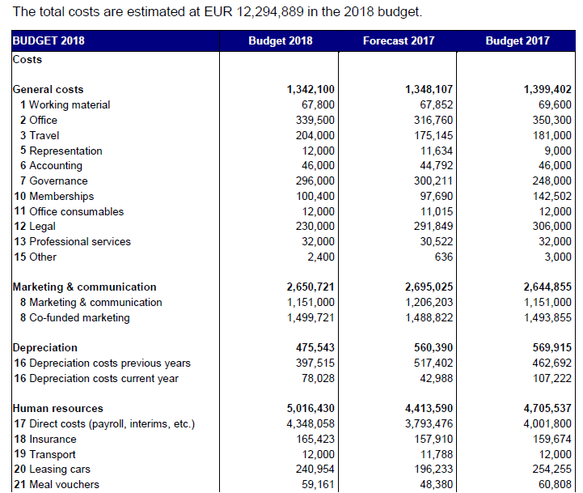

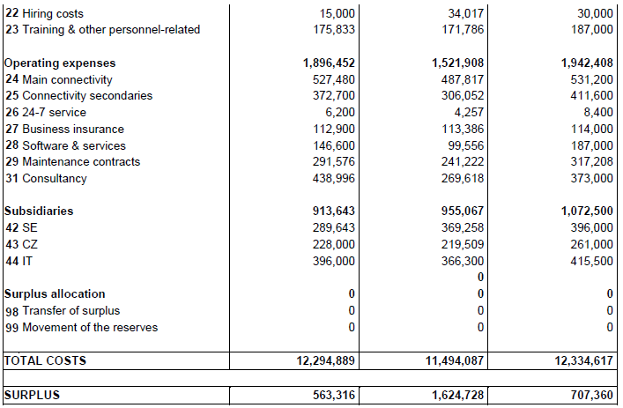

**Annex 9: Administrative Burden for the .eu Registry**

1. **Standard Cost** Model – Administrative Burden for the current .eu Registry under the BASELINE (Table 11)

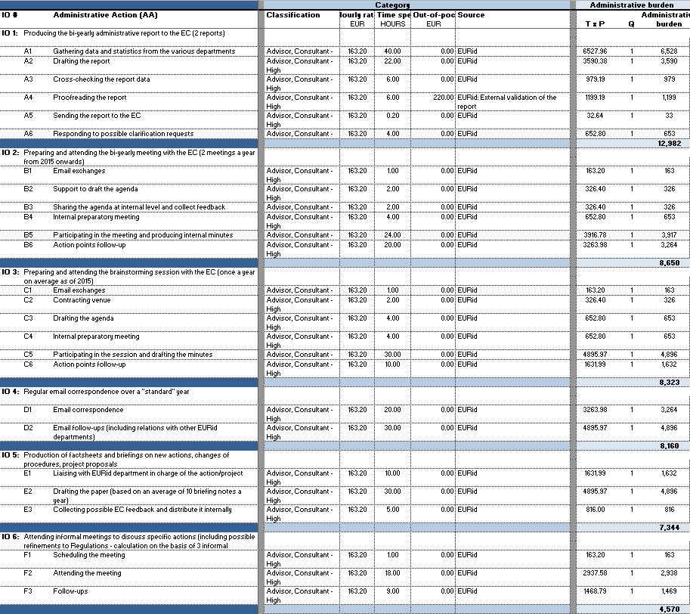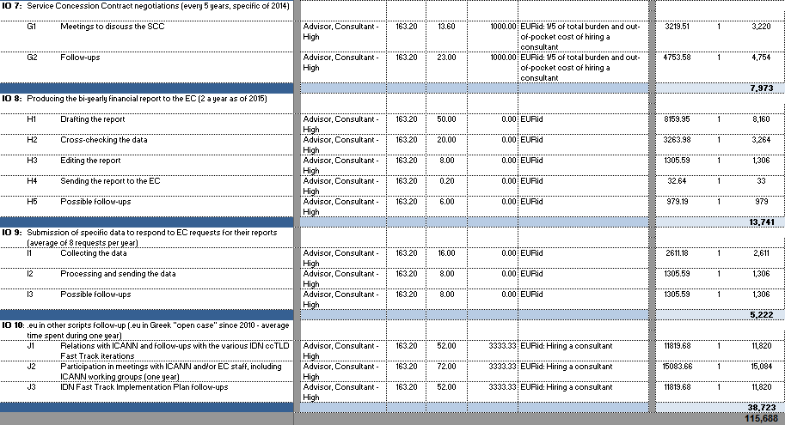

**2. Standard Cost Model – Administrative Burden for the .eu Registry under the Modernisation Option (Table 12)** 



**3. Standard Cost Model – Administrative Burden for the .eu Registry under the Separate Governance Option (Table 13)**

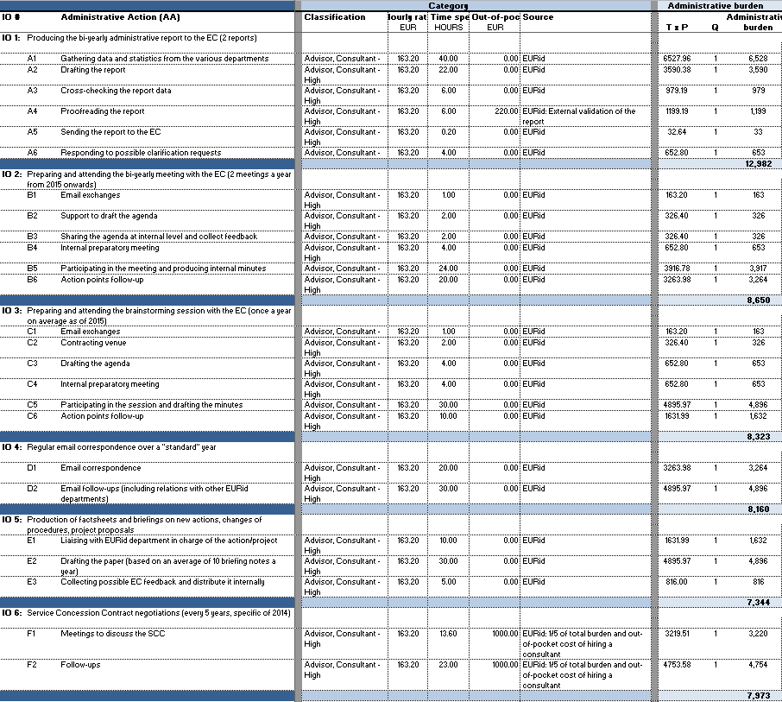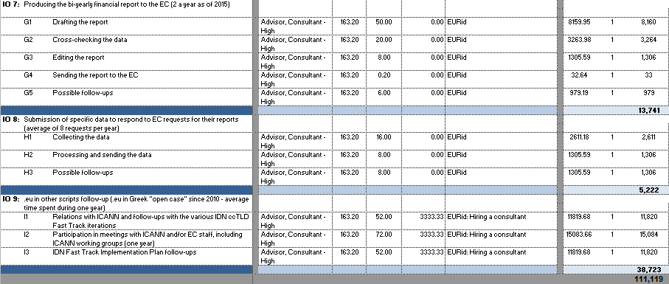

**4. Standard Cost Model – Administ**rative Burden for the .eu Registry under the EUIPO Option (Table 14)

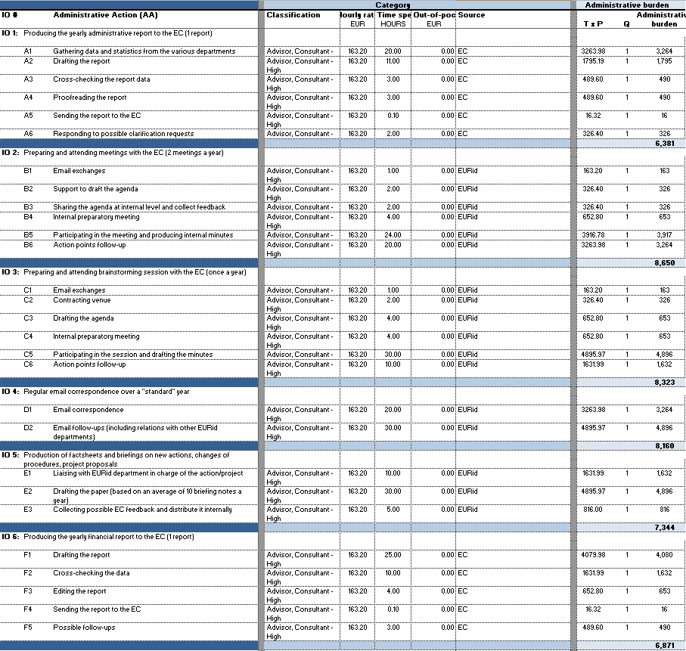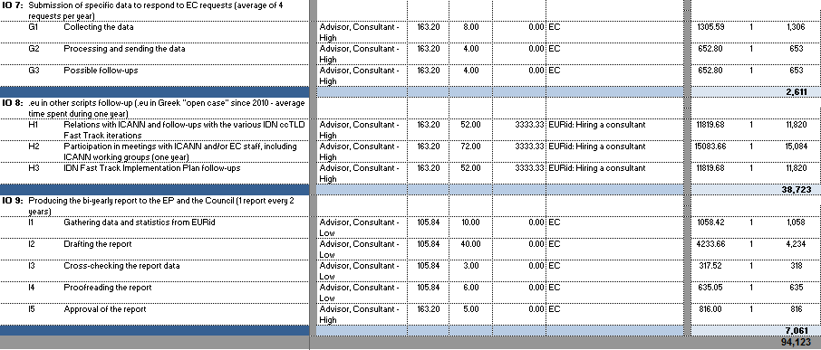

**Annex 10: Administrative Burden for the European Commission**

**1. Standard Cost Model – Administrative Burden for the European Commission under the Baseline (Table 15)**

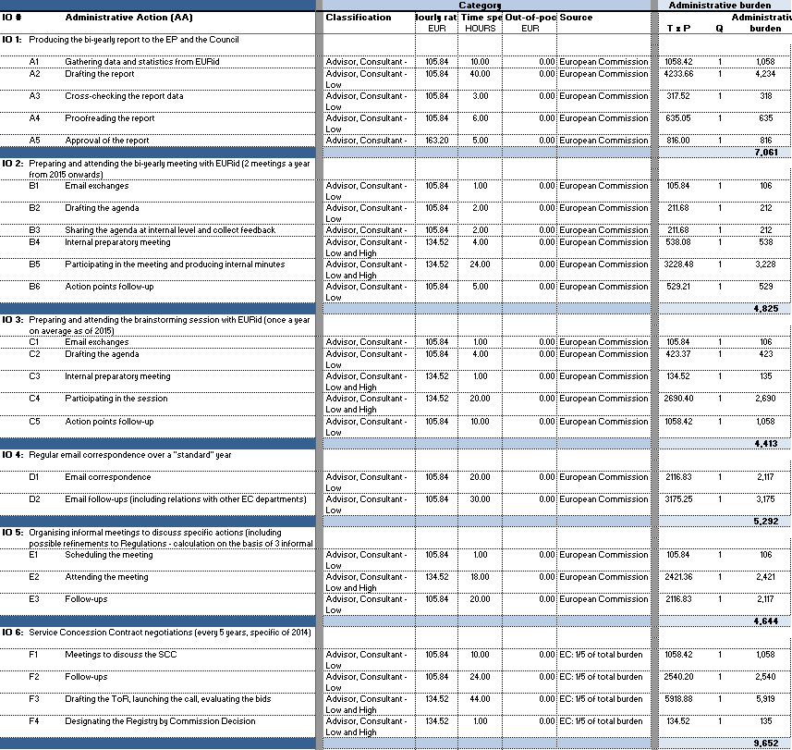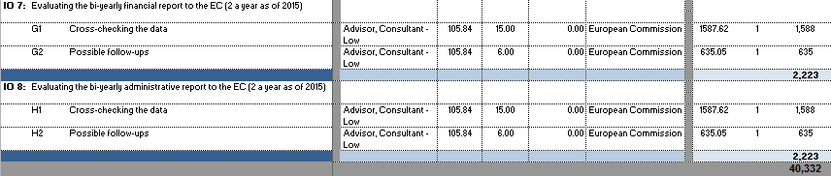

1. **Standard Cost Model – Administrative Burden for the European Commission under the Modernisation Option (TABLE 16)**



1. **Standard Cost Model – Administrative Burden for the European Commission under the Separate Governance Option (table 17)**

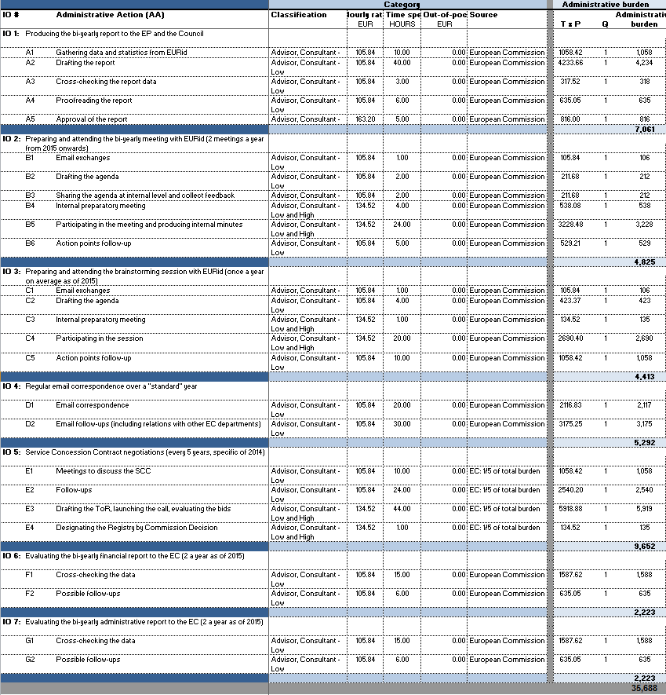

**Annex 11: Cost estimation for the operation of the multi-stakeholder separate body**

Considering the multi-stakeholder separate body will consist of 7 members, observers from all EU Member States (MS) and the European Parliament (EP) and that it will physically meet two times a year, the following cost estimation is made:

Table 19. Cost estimation for the multistakeholder separate body

|  |  |  |
| --- | --- | --- |
| Category of cost |  | Amount |
| Reimbursement of experts travel and subsistence |  | € 16.000[26] |
|  |  |  |
| Other costs in relation to activitites of the .eu Multistakeholder Council  (e.g. for external reports, studies, etc.) |  | €5.000 |
| Meetings organisation (Expenses for venue, catering, etc.) |  | € 4.000 |
| Total for one meeting |  | € 25.000 |
| Total for two meetings per year |  | € 50.000 |

**Annex 12: Cost of transferring the .eu Registry to the EUIPO and cost of running the .eu Registry by EUIPO**

According to EUIPO's calculations the cost to implement the transition amounts to €1.688.400 for an 18-month transition period. The annual cost for running the .eu Registry after the 18-mont transition period would be €10.465.724[27].

Table 20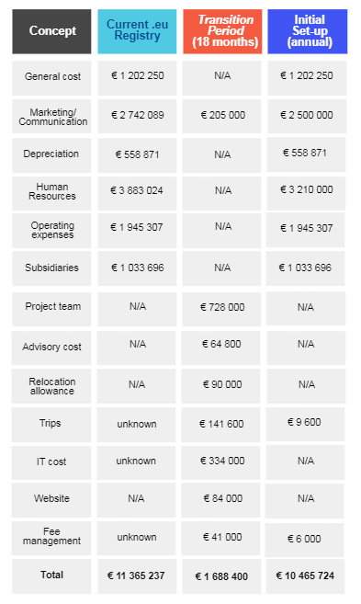

More in detail, EUIPO is estimating transfer cost[28] as follows:

|  |
| --- |
| The following cost elements are considered and detailed:   * Human resources * Travel costs * Infrastructure * Subsidiary Offices * Marketing and Communication * IT costs * Website * Fee management |

**Human resources**

Project Team

For the **transition phase** of EUIPO as .**eu Registry**, a project team[29] of around 6 FTEs is envisaged. This will cover a Project manager (50%), Project lead (100%), Process improvement manager (100%), IT expert (70%), HR expert (50%), Finance expert (50%), Marketing/ Communication expert (50%), Legal expert (30%) and Project support (100%). Considering preparatory work and closure of the project, a timeframe of **18 months** is envisaged.

Table 21. .eu Registry - cost estimate - project team

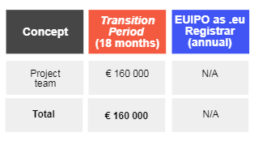

Governance Board

At present, the .**eu Registry** is overseen by a Strategic Committee and Board of Directors. It is envisaged by the EC that these structures in their current form will cease to exist, replaced by a new Governance Board made up of the EC, the EUIPO and additional stakeholders identified with the EC.

As the final structure is not yet defined, it will be assumed that the current expenditures foreseen (detailed numbers are not available to the EUIPO) for the governing bodies will be maintained.

The work needed to implement this change of the governing board will be covered by the project team.

Advisory Costs

To assure success as **.eu Registry,** it will be important for the EUIPO to receive high level guidance from the beginning of the transition period. With this in mind, it is considered appropriate for the EUIPO to have at its disposal independent advisory support from domain name registry experts. This could be covered by the statutory solution of special advisors.

It is expected that the costs attributed to contracting such advisors be partly recovered by the reduction of management needs, since it is already expected that during the transition period a number of managers will no longer continue.

Table 22. .eu Registry - cost overview advisory costs

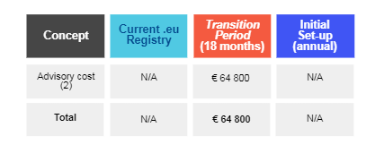

.eu Registry Workforce

In the case of the EUIPO as **.eu Registry**, a gradual move of staff to the EUIPO is foreseen, acquiring people from EURid and externally. Though many synergies can be created by moving the service to the EUIPO, it is considered pragmatic to consider that not all efficiency gains will be materialised during the transition phase. This will be further improved once the initial structure at the EUIPO is set-up and the permanent workforce planning finalised. Once these elements are clear and posts made available in the establishment plan (or in the case of Contract Agents an increase in budget is approved), the necessary selection procedures can be launched.

To accommodate this interim solution the EUIPO has several framework contracts covering a variety of profiles. If a profile cannot be covered by an existing framework contract, a call for tender will be launched. Alternatively, immediate solutions such as making available Contract Agent positions for the transition period could be explored with the EC.

Given that the EUIPO does not have any specific information as to the individual salaries or contractual termination periods of the people working at EURid, it is considered that, in principle the expenditure for salaries can be maintained during the transition period.

It could be even expected that short term efficiency gains will be achieved during the transition period. By way of example, the current .eu Registry headcount in the customer services is 21 FTEs. With the existing EUIPO customer and technical service in place covering all EU languages, a reduction of the team, after knowledge transfer, can be expected.

Table 23. .eu Registry - cost estimate - .eu Registry workforce

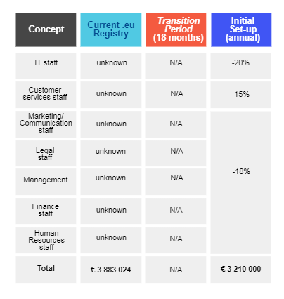

Possible Relocation Costs/ Acquisition Costs

With the potential for the EUIPO to take on a number of current .eu staff or external staff, relocation packages should be considered should the EUIPO become **.eu Registry**.

Table 24. .eu Registry - cost estimate - relocation/ acquisition costs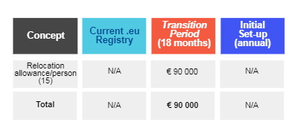

**Travel costs (additional costs related to the transfer excluding .eu business travels)**

The transfer of the **.eu Registry** will require frequent visits to the EC as well as to the EURid headquarters and its subsidiaries. This will be particularly necessary at the beginning of the transition period in order to map precisely the activities performed, evaluate the state of the legal, financial and technical situation and define a detailed roadmap.

These visits will also serve to identify key personnel, key activities and involvements in initiatives, working groups and other business obligations.

Taking the above into consideration, it is envisaged that initially the project team embark on 2 one week visits to Brussels in order to evaluate and effectively plan for the move. These visits should be built upon with regular follow-up meetings until the end of the transition period of 1-2 trips per month.

With the move to Alicante, a new need to for regular trips to Brussels to meet with the EC needs to be introduced. To this end, four coordination visits are foreseen after the transition period.

As the subsidiaries will also be maintained during the transition phase, three trips per subsidiary are foreseen during the transition phase to map activities, get an overview of the legal, financial and technical situation and to foster strong communication.

Additionally, during the transition phase some additional business travel by the EUIPO is foreseen to accompany EURid staff on important business trips for knowledge transfer and to gain an overview of activities. At this stage the schedule is not available, therefore around 20 business trips (12 International and 8 European) will be considered.

Table 25. .eu Registry - cost estimate - travel expenses[30]

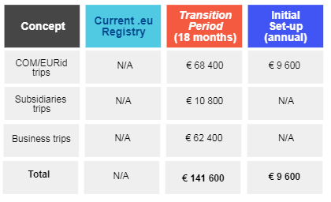

**Infrastructure**

No burdensome cost would be expected for the EUIPO in terms of the provision of physical space needed to accommodate additional staff due to the expansion of activities. With a new building recently inaugurated at the EUIPO premises in Alicante to support growth of operations, including dedicated project areas for use in internal or external projects based on priorities, the acquisition of new staff could be absorbed. Should it be needed, the outsourcing of some external services to nearby buildings could also be considered to provide additional space, as is current EUIPO practice.

In terms of space to house the two data centres, no additional cost would be supposed for the EUIPO with room in both its onsite and offsite back- up data centre to cover needs.

**Subsidiaries**

The .**eu Registry** maintains three subsidiary offices in Sweden, Italy and the Czech Republic that are envisaged to remain. No additional costs are foreseen to be associated with the subsidiary offices during the transition period.

Table 26. .eu Registry - cost estimate - subsidiaries

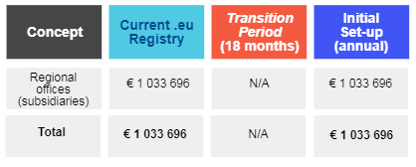

**Marketing and Communication**

In terms of marketing and communication, an extensive awareness campaign will be launched during the transition period to inform users, staff and other stakeholders of the transfer of responsibilities. This will be done both through EUIPO’s own (IP and general public) channels and the well-established channels of the .eu Registry including social networks. During this campaign the values of the EUIPO and the .eu domain name in terms of quality and European identity will be particularly promoted, with a special emphasis on accessibility and security. This would see the .eu strengthened and more competitive with its visibility improved to the general public and in particular SMEs.

Following the transition period, synergies will lead to the social media channels of the EUIPO absorbing those of the .eu Registry.

Marketing strategies such as co-funded marketing whereby part of the revenue generated by each .eu Registrar is reinvested for marketing campaigns focussed solely on the .eu domain will be continued until further decision.

Table 27. .eu Registry - cost estimate - marketing and communication

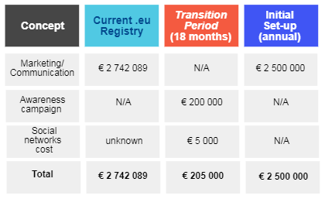

**IT costs**

The EUIPO has recently built up a highly available and reliable data centre meeting the highest standards including those of the Uptime Institute © for TIER IV configuration. Its design is such as to face up to any problem without affecting system availability. Used also as a disaster recovery for other agencies such as EFCA, the EUIPO has obtained good understanding of the effort needed to set-up and maintain them.

That being said, as the EUIPO has no detailed information on the number of applications run by the .eu or if the .eu Registry owns the servers, the dimensions of the requirements are unknown. To provide a reasonable estimate in the case of the EUIPO becoming **.eu Registry**, it has been assumed that the EUIPO reuse all of its corporate servers (email, network equipment, communication lines) and provision only for the servers, hosting applications or databases that are not currently supported by its existing infrastructure. Based on this assumption ten physical servers would provide three to four environments for each data centre. The servers themselves constitute a significant cost driver. These expenses however would not be incurred in the instance that the servers currently used by the .eu are owned by them and that their transfer to the EUIPO is made possible.

Besides the data centre, a number of additional cost areas, listed below, would need to be considered for the transition phase. It should be noted that overall the EUIPO would be in the position to generate savings from the beginning of the initial set-up.

Table 28. .eu Registry - cost estimate - IT costs

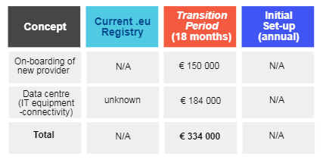

**Website**

Understanding the .eu website to be an asset owned by the EC, as .**eu Registry** the EUIPO would foresee maintaining the existing website carrying out a rebranding to reflect new ownership. The costs attributed to this rebranding are reflected in the transition period.

Table 29. .eu Registry - cost estimate - website

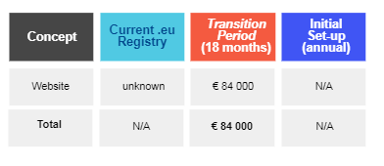

**Fee management**

The .eu domain is currently sold by registrars who make initial prepayment of €2 500 serving as a credit from which registration fees are deducted. The balance of this prepayment is topped up via monthly invoices corresponding to activity once they start registering domain names. A post-payment scenario is also available to .eu Registrars after two years who have a European bank account and are subject to the Single Euro Payment Area (SEPA).

During the transition period, it is foreseen to keep the existing fee management system run by EURid in place. The system will be fed into EUIPOs SAP accounting system via semi-automatic data extraction where .eu revenues will be separately accounted for.

Expenses on the other hand will be managed separately, using Activity Based Budgeting and Management (ABB/ABM). In a second step, further integration with the EUIPO Back Office will be envisaged.

Table 30. .eu Registry - cost estimate - fee management

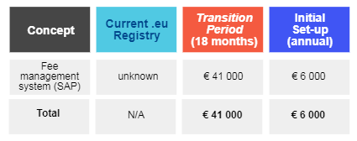

**Annex 13: Indicators to monitor actual impacts**

The following set of indicators, which are relevant to the TLD market, will be used to evaluate the actual impacts of the preferred option:

* Registration volumes and renewal rates

For any TLD that entered the domain name market after the big domain expansion of the late nineties - early years of the third millennium, having reached a stable volume of over 3.7 million domain name is an indicator of the TLD’ health (e.g. other TLDs introduced in the 2004 gTLD round, such as .tel, .asia and .mobi never reached even half million registrations despite of massive and more aggressive marketing campaigns at their sale channel’ level).

Furthermore, renewal rates above 75% are also considered an indicator of a TLD health and stability (see the latest ICANN gTLD marketplace index at <https://www.icann.org/en/system/files/files/gtld-marketplace-health-index-beta-14dec17-en.pdf> ).

* Number of DNSSEC signed domain names

DNSSEC (Domain Name System Security Extensions) is an Internet security protocol that helps to reduce the risk that visitors to your website are led to fake websites if they type your website address, protected with DNSSEC technology, into their browser.

Having 10% of correctly DNSSEC signed domain names out of the overall portfolio can be considered also an indicator of the registry’ good work to promote the security and stability of the entire TLD infrastructure.

* Registrar network expansion rates and geographical gap filling performances

Number of new registrars accredited each year, number of registrars by geographical distribution.

In the current EC Regulation, the .eu Registry operator must ensure to have accredited registrars in as many EU countries as possible. The current registrar network expansion is about 10 new registrars each quarter. That is also a good indicator of whether a TLD is still appealing.

* .eu perception among end-users

See <https://eurid.eu/media/filer_public/0a/19/0a1926a8-63d1-49c1-8543-21aaf06d9358/eurid_awareness_survey_2015.pdf>

67% of the interviewed consumers in 2015 knew about the availability and existence of the .eu TLD. As the survey states, this is a significant increase against 56% in 2010. The survey also links the highest awareness rates to the highest registration numbers in certain countries. Again, this is an indicator of the good performance of the .eu TLD and its registry operator.

* Click-through rates (CTR) and impressions of awareness campaigns

The .eu Registry operator regularly benchmarks its online awareness campaigns against the market.

*If we consider the “standard” CTR metric, i.e.* the number of clicks that an ad receives divided by the number of times the ad is shown (clicks ÷ impressions = CTR), EURid’s latest campaigns reached the following results:

Figure 5. Click-through rates (CTR) of EURid's latest campaign

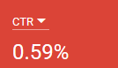

*Considering that the average display CTR in April 2017 was 0.22% (source:* [*http://www.richmediagallery.com/tools/benchmarks*](http://www.richmediagallery.com/tools/benchmarks)*), this can be considered an above average CTR.*

* Social media positive followers and engagement rates

The .eu Registry operator has managed to optimise its social media presence.

In November 2017, its Influence score rose to 100% and its engagement score recorded a score of 41%. The Twitter engagement and influence benchmark table against industry peers is a valuable indicator of the ability of the registry to reach out to various stakeholders and to be seen as an industry leader.

Chart 1. Engagement and influence rates of different registries

* Robustness and resilience of the technical infrastructure

Storage and rackspace capacities, redundancy of the network for back-up in case of failures, time of back-up in case of failures, datacentre distribution, anycast networks configuration and resilience.

Registered .eu and .ею domain names are stored on 4 unicast name servers, located in Europe, and 2 anycast meshes located throughout the world (see the table below). EURid's name servers are updated dynamically.

The number of anycast networks and the infrastructure distribution are also a good indicator of the robustness, resilience and stability of the .eu technical infrastructure.

* Annual vulnerability and penetration tests rates

Percentage of the system vulnerability against external attacks, number and outcome of penetration tests.

This is part of the business continuity exercise. A registry that regularly runs vulnerability and penetration test shows that it cares for its infrastructure’ robustness and resilience. One test a year is a good indicator.

* Long-term financial sustainability indicators including percentage of bad-debtors

Percentage of bad-debtors among registrars; level and distribution of reserves to ensure long term financial sustainability in case of attacks.

Considering the special framework in which EURid operates and the fact that any surplus is returned to the EU budget, the .eu Registry operator has built a reserve system to allow the registry to continue to operate and/or wind-up. Having an operational, financial sustainability of 6-8 months in case of a dramatic drop in new registrations and/or renewals is a good indicator of a healthy financial system.

* Standards and service levels for customer support (end users) including responsiveness rates

Number of tools to communicate with end-users, response rates to end-users requests via the different tools

Indicators of a good customer service to end users are the number of tools the end user can use to interact with the registry. Also, the annual number of complaints against the service received is a good indicator of the service level.

* Standards and service levels for customer support (registrars) including responsiveness rates

Number of tools to communicate with registrars, response rates to registrars (with the current registry the time to respond to a registrar request must be within 4 hours)

Indicators of a good customer service to registrars are the number of tools the end user can use to interact with the registry. For example in the case of the current .eu Registry operator, we have: 24 EU language support during office hours via email and phone, 24/7 phone service during non-office hours (EN only), chat tool, webinars, registry.eu, postal service to four EURid offices. Also, the number of registrar complaints against the service received is a good indicator of the service level.

* Registrar satisfaction survey ratings

See <https://eurid.eu/en/news/registrar-satisfaction-survey-2015-findings/>

A constantly growing registrar satisfaction rate is an indicator of the how registrars appreciate the registry service.

Other ratings in standard registrar satisfaction surveys are indicators of the registrar satisfaction against the various registry services and/or performances.

* Number of assessed risks, number of business continuity plan exercises over a year, non-conformities out of BCP exercises

A yearly BCP exercise is considered the standard practice of having a good business continuity planning in the TLD industry.

Furthermore, a full risk assessment – covering not only technical, but also administrative, financial, legal and external risks – is an indicator of a registry’ readiness to cope with contingencies.

Audited BCP exercises ending with few if no non-conformities are a good indicator of a registry having a robust preparation to deal with unforeseen situations.

* Disaster recovery timeframes

Time to recover the business in case of major contingencies

This depends much on the kind of disaster. On average, any registry should be able to resume its core function – registration of domain names, availability and reachability of the registered domain names, other operations for registered domain names – in few hours after the disaster takes place.

The technical infrastructure distribution at geographical and provider level helps to ensure immediate recovery times.

* Number of Court cases per year and possible financial costs

There are no indicators on the average number of Court cases that could be considered as acceptable for a registry. Most of the times, such number is linked to the overall number of registered domains. Therefore, 1 or 2 cases per million registered domain names can be considered as acceptable.

* Number of abuses on .eu TLD names

Even for this element there are no-industry standard indicators. However, a registry listed as having high number of domain names used for abuses in one of the industry report about abuses (e.g. The Global Phishing Report table of TLD contains indicators on what the reported levels of domain names registered for phishing abuses can be “tolerable” under a TLD. See <https://docs.apwg.org/reports/APWG_Global_Phishing_Report_2015-2016.pdf> ) may run into reputational risks.

* Number of international engagement MoU and/or agreements

An indicator of a registry with a strong international engagement is the number of official partnerships established with industry peers, including participation in international working groups, chairmanship of industry organisations, public acknowledgements of the registry expertise in certain areas.

* Number of publications

The number of publications of a registry is also a good indicator of the registry expertise in certain areas. If those publications are also made in cooperation with other parties, that should be also seen as a good indicator of the registry being seen as an expert in that area.

* Number and importance of findings of external audits on the .eu Registry

One or two minor findings that only need to be addressed by a recommendation to the Registry are acceptable. A finding such as conflict of interest or mismanagement is considered completely unacceptable.

1. Commission Work Programme 2017, Delivering a Europe that protects, empowers and defends, <https://ec.europa.eu/info/sites/info/files/cwp_2017_en.pdf>; Annex 2, <https://ec.europa.eu/info/sites/info/files/cwp_2017_annex_ii_en.pdf>
2. See https://ec.europa.eu/digital-single-market/en/news/public-consultation-evaluation-and-revision-eu-top-level-domain-regulations
3. See <https://ec.europa.eu/digital-single-market/en/news/summary-report-public-consultation-evaluation-and-revision-eu-top-level-domain-regulations>
4. <https://ec.europa.eu/digital-single-market/en/news/commission-launches-public-consultation-review-rules-eu-top-level-domain>
5. ‘*Country of residence’* (private individuals), ‘*place of operation’* (business), ‘*legal seat’* (association or public sector).
6. .be, .biz, .co.uk, .com, .cz, .de, .fr, .gr, .info, .it, .net, .nl, .org, .party, .vlaanderen; and two respondents indicated to have ‘several hundreds’ and ‘several others’.
7. Mild to strong preference = answers 3, 4 or 5 on a scale between ‘0 – Strongly disagree’ and ‘5 – Strongly agree’.
8. Clear preference = answered 1, 2 or 3 on a scale between ‘1 – More preferable’ and ‘6 – Least preferable’.
9. Less to least preferable = answers 4, 5 or 6 on a scale between ‘1 – More preferable’ and ‘6 – Least preferable’.
10. This cost is included when calculating the overall compliance cost compared to the baseline for the preferred option. The reduction of € 57.200 mentioned above for Commission compliance cost takes into account the extra cost for the additional activity to exercise oversight over the multi-stakeholder separate body.
11. [www.centr.org](http://www.centr.org)
12. <https://archive.icann.org/en/cctlds/centr-2nd-best-practices-20may01.htm>
13. <https://www.iana.org/about/presentations/davies-sofia-bestpractice-061025.pdf>, <https://www.pacnog.org/pacnog4/presentations/save-cctld-best-prac.pdf>
14. [www.isoc.org/educpillar/cctld/sofia.shtml](http://www.isoc.org/educpillar/cctld/sofia.shtml)
15. <http://slideplayer.com/slide/8979918/>
16. <http://www.wipo.int/export/sites/www/amc/en/docs/bestpractices.pdf>
17. <https://www.oecd.org/sti/ieconomy/37730629.pdf>
18. <http://udesa.edu.ar/sites/default/files/imported-36b0a836a5c89c440f181dc242cbb5598716f1bf-8-ccTLDs_aguerre.pdf>
19. See Nominet presentation at ICANN57 meeting on new TLD services (<https://ccnso.icann.org/en/meetings/hyderabad57/presentations.htm>), the one by IIS, the .se registry, on legal challenges at ICANN54 (<https://ccnso.icann.org/en/meetings/dublin54/presentations.htm>), and the one by .co on their involvement in cybersecurity matters (<https://ccnso.icann.org/sites/default/files/file/field-file-attach/2016-12/presentation-how-co-handles-cs-matters-29jun16-en.pdf> ).
20. See US Government White Paper, 1998, section 6 <https://www.icann.org/resources/unthemed-pages/white-paper-2012-02-25-en>
21. .be, .ca, .ch/.li, .cz, .fr, .hu, .it, .lt, .me, .nl, .pl, .ru, .se, .si, .ua, .dk, .il.
22. .at, .de, .es, .hr, .ie, .lu, .pt, .rs, .uk, .lv.
23. .is.
24. The information comes from registry websites, statistics available on CENTR’s (Council of European National Top-Level Domain Registries) website (<https://www.centr.org/>) and the website of each registry operator.
25. E.g. .fi, .pl, .ch, .il (partially).
26. This amount is estimated taking into account the Commission Decision on Rules on the reimbursement of expenses incurred by people from outside the Commission invited to attend meetings in an expert capacity, of 5 December 2007.
27. The figures used for the current .eu Registry.eu Registry.eu Registry are from 2016 EURid budget.
28. Excluded in the transition cost calculation are any costs related to redundancy payments of current .eu Registry staff that will not be maintained. The same applies to contractual obligations where financial damages may be incurred for example in the case of termination.
29. Made up of both internal and external resources based on the cost of projects run by the EUIPO.
30. EUIPO calculates on an average €4 400 per international trip/person and €1 200 for a European trip/ person.