

**1. Introduction**

In 2006, the .eu Top Level Domain (TLD) was established to enable European businesses and citizens to participate in ecommerce and to enhance participation in the online single market. This was done at the initiative of the European Commission, through two legislative instruments:

* Regulation (EC) No 733/2002 of the European Parliament and of the Council of 22 April 2002 on the implementation of the .eu Top Level Domain;
* Commission Regulation (EC) No 874/2004 of 28th April 2004 laying down public policy rules (PPR), concerning the implementation and functions of the .eu TLD, and the principles governing registration,[1]

together referred to as the ".eu Regulations" in this document.

Much has changed in the online environment, since the .eu Regulations were fist adopted. In 2002, less than 10% of the world’s population was online; by 2017, almost half the world is connected to the Internet.[2] Social media platforms did not exist in the early part of the century -Facebook, which now counts 2 billion monthly users, was not established until 2004, with Twitter following in 2006. Apple’s iPhone - which revolutionised both telephony and Internet usage patterns, and brought ‘apps’ to the market - was not launched until 2007. In 2013, a massive expansion of the domain name market began with the introduction of more than 1300 new generic Top Level Domains (gTLDs) – providing EU consumers with extended choice and new business models into the domain name industry.

Since the adoption of the first of the .eu Regulations, 15 years ago, the EU political and legislative context, with regard to the Internet, has also changed significantly. From a political and regulatory backwater in the early 2000s, the impact of Internet technologies is now driving major legislative programmes and strategies such as the Digital Single Market, and the security risks associated with the online environment are recognised as posing critical threats to economic and social well-being[3] .

As you will see in the analysis of the answers to the evaluation in section 5, this legal framework drafted in the early 2000's is outdated and generates cumbersome administrative constraints which are negatively impacting both the Commission and the registry operator when it comes to the day-to-day management of the .eu domain. Meanwhile, the .eu TLD's competitiveness and ability to respond to market changes is undermined.

**Purpose and scope**

The [2017 Commission Work Programme](https://connected.cnect.cec.eu.int/external-link.jspa?url=https%3A%2F%2Fec.europa.eu%2Fcommission%2Fwork-programme-2017_en)[4] included the revision and modernisation of the .eu Regulations under the Regulatory Fitness and Performance Programme (REFIT). This is to ensure that the .eu legal framework still serves its intended purpose in the context of the above mentioned new market and regulatory environment.

This report is an Evaluation of Regulation EC 733/2002 establishing the .eu top-level domain (TLD) and Commission Regulation EC 784/2004 laying down public policy rules concerning the implementation and functions of the .eu TLD. It considers the extent to which the .eu Regulations have fulfilled their original objectives, and whether they remain fit for purpose, given the significant developments in the marketplace, technology and regulatory environments since their first adoption.

In compliance with the Better Regulation Guidelines, this evaluation will assess the effectiveness, efficiency, relevance, coherence and EU added value of the .eu domain name legal framework. It also covers its implementation across the European Union since the adoption of the first Regulation in 2002.

This evaluation report of the current .eu regulatory framework was conducted thoroughly by using both quantitative and qualitative approaches. While the .eu TLD is available in EEA countries, and thus the quantitative registration figures include EEA countries, this evaluation report focuses on the EU alone.

This evaluation report should be read with the accompanying Impact Assessment which has been developed in a back-to-back process.

**2. Background to the intervention**

**2.1 Description of the intervention and its objectives**

In 1999, following the input received from European industry representatives[5], the Commission initiated the process which led to the establishment of the .eu TLD in 2006[6].

The Commission Communication of 2000 described the problem as it was perceived at the time, and the added value intended to be created through the .eu TLD:

*The Commission considers that the creation of the .EU Domain would be a decisive element for accelerating e-economy and e-commerce in Europe at a time when the single currency will soon be a reality. The existing generic TLD, .COM, is already congested. Thus, .EU would expand the Domain Name Space and at the same time would enhance the interconnection and interoperability of European companies, organisations and individuals. It would give users who wish to operate across the Internal Market a specific European identification which will be recognised globally. It will also avoid the necessity of registration in different Member States. Indirectly, it would also increase consumer confidence in the use of the Internet among European users, since European law, data and consumer protection rules would apply[7].*

Through the .eu TLD, end-users operating across the Internal Market were to be provided with a specific European identification. This was also intended to promote the European Union image within the global online arena. The .eu TLD aimed to facilitate a clearly identified link between undertakings, organisations and natural persons with the Union. European citizens were to be equipped with a safer place in cyberspace in which their rights as consumers and individuals would be protected by European rules, standards, and courts[8].

The .eu TLD's key objective was to promote the use of, and access to, the Internet and online marketplace, in accordance with Article 170 of the TFEU on Trans-European Networks, by providing a complementary registration domain to existing ccTLDs and gTLDs[9], and in consequence increase choice and competition. Domain names are part of a series of factors that enable internet access alongside essential physical infrastructure, low prices for internet services (dependent on vibrant competition amongst providers), and high speed broadband. Once basic access is possible, domain name registration enables access and use of the Internet and online marketplace, through the development of websites and email necessary to conduct e-commerce. This was particularly true in the early 2000s before the advent of substitutes such as apps and social media, but it remains the case that domain names (websites, email) remain key component of access to and use of the Internet.

To meet the above-mentioned objectives, today's regulatory framework sets out the conditions for the .eu TLD implementation and establishes the general policy framework within which the .eu Registry, appointed by the Commission in accordance with .eu Regulations EC 733/2002 and EC 784/2004 , performs its functions.

The diagram below summaries how the .eu Regulations intended to address the identified core needs such as accelerating e-commerce and promoting a European digital identity.

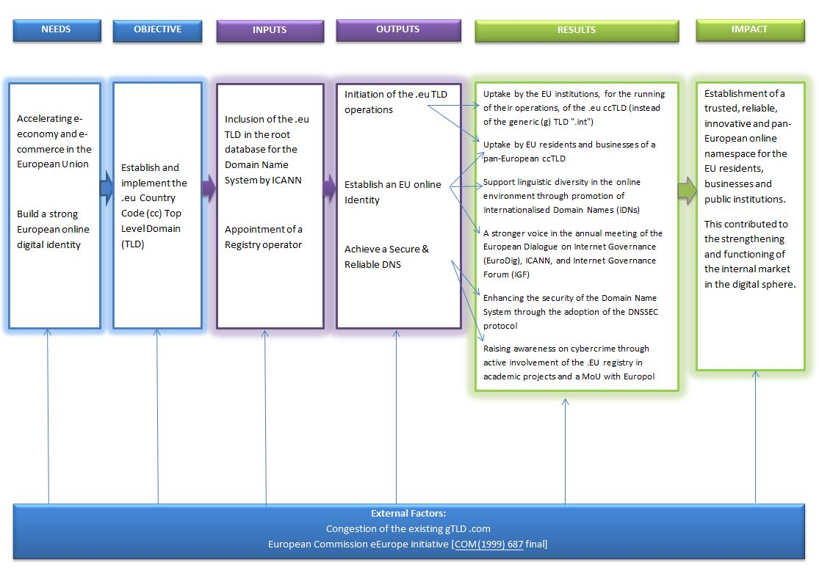

2.2 Baseline and points of comparison

Prior to the establishment of the “.eu” Top Level Domain, individual EU residents or companies established in the EU were not provided with the option of having a pan-European internet identity for their online presence – generally websites and e-mail addresses. The EU institutions, for the running of their operations, were using the generic TLD ".int" reserved for use by international organisations.

Ahead of the publication of the original legislative proposal[10],no impact assessment as per Better Regulation provisions[11] was conducted. The absence of such input prevents the delivery of an exhaustive description of the situation before the initial legislative act was delivered.

However, a public consultation and several meetings with stakeholders were carried out. The summary report[12] of such survey suggests that the gTLDs Domain Name space of the early 2000 was viewed by stakeholders as congested, due to a dominant position held by the gTLD .com. Thus, in the words of the Commission Communication in 2000, the creation of a .eu TLD was aimed at expanding the DNS market offering of the time, while enhancing the interconnection and interoperability of European companies, organisations and individuals. An expansion of the DNS market through the addition of the TLD would have contributed to the interconnection of Europeans by providing an additional online namespace which would enable Europeans to connect and communicate with one another.

**3. Implementation / state of Play**

**Description of the current situation**

***Launch of the .eu Top Level Domain***

The .eu Regulations were implemented first through the delegation of the .eu TLD in the DNS root zone managed by the Internet Assigned Numbers Authority (IANA)[13] under the Internet Corporation for Assigned Names and Numbers (ICANN)[14] at the request of the Commission, secondly through the appointment of a registry operator responsible for the management of the .eu TLD, EURid, following a call for expressions of interest, and thirdly through the launch of the .eu TLD to the market in 2006.

The top level domain (TLD) .eu opened for registration in April 2006. Its foundation aimed to promote the European Union’s image on the global information networks and bring an added value to the internet naming system in addition to the national ccTLDs.[15]

***The .eu registry and its relationship with the Commission***

The .eu registry is the entity responsible for the organisation, administration and management of the .eu TLD. The original registry operator, EURid, continues to operate the .eu TLD. EURid is a Europe-wide non-profit organisation with its head office in Diegem (Belgium) and regional offices in Stockholm, Prague, and Pisa. The .eu Registry was appointed by the Commission[16], following a call for expression of interest[17]. As foreseen in the .eu Regulations, the Commission signed a first service concession contract with the .eu Registry on 12 October 2004, extended by 5 years in October 2009[18]. EURid was awarded a second service concession contract on 12th April 2014, following a call for expressions of interest and the European Commission Implementing Decision of 11th April 2014.[19]

The .eu TLD implementation was pursued by the European Commission due to it is EU-wide nature. The appointed registry operator comes directly from the private-sector (not-for-profit) and its operations are monitored by the EU Commission[20]. This model is widely used within the European Economic Area since the 1990s, for example in Germany, the UK, Austria, Belgium, Sweden, Netherlands, Switzerland and Norway[21].

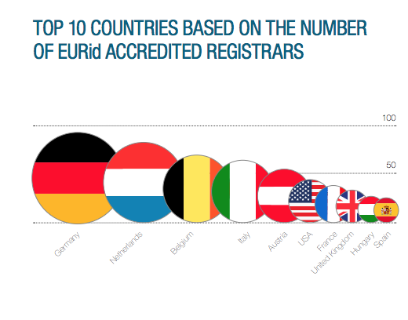***Market performance of the .eu Registry***

The .eu Registry has a network of more than 700 accredited registrars throughout the world.[22] It is respected in the domain name industry and is recognised by the downstream registrars (retailers) as outstanding in comparison to its peers. For example, in 2017 EURid was awarded CENTR’s[23] registry of the year, voted by more than 100 registrars[24] to honour ccTLD registry projects, teams and people having a positive impact in the Domain Name industry. In 2013, EURid was presented the CENTR award for the best marketing programme for registrars[25].

Despite entering the market in 2006 – much later than the years of the rapid growth in European domain name registrations - the .eu TLD has established itself as a valuable option for any European resident choosing a domain name for their Internet presence.

Today, the total number of .eu registrations is above 3.7 million with more than 200,000 new registrations in Q3 2017[26] making the European Union's domain name the 4th largest ccTLD in the EU[27], and 8th largest ccTLD in the world[28]. The table below shows the distribution of .eu registrations by country of registrant.

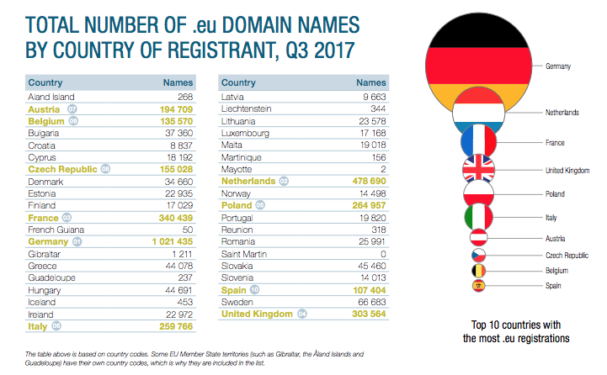

The .eu TLD market performance needs to be analysed in the context of an online domain name environment impacted by extensive technological changes. For example the popularity of online social media platforms, the growth of mobile the launch of ICANN’s new gTLD programme, which resulted in more than 1300 new TLDs being available for EU consumers, has dramatically changed the domain name offer - some of the new gTLDs compete the .eu ccTLD by appealing to alternative geographic, European identities (e.g. .berlin, .paris, .amsterdam, .bayern, .hamburg). Others compete indirectly with the .eu TLD by diverting particular interest groups away from the .eu domain (.casa, .solutions, .shop, .cloud, etc).

***Technical and operational systems***

Today's .eu Registry Operator operates its own technical registry services and infrastructure, including the public WHOIS lookup service for .eu. EURid supports resolution of domain names through both IPv4 and IPv6 protocols[29], and is actively promoting adoption of a security protocol (called DNSSEC) which enhances the security of the Domain Name System. Nearly 350,000 .eu domains are signed with DNSSEC[30].

To cope with the volume of DNS and WHOIS queries, while guaranteeing uninterrupted resolution of .eu domains, EURid has also contracted anycast nameservers' operators[31]. EURid’s technical team has developed its own open source nameserver implementation (called YADIFA), a high performance, portable and standards compliant nameserver implementation software[32].

EURid was one of the first European registries that developed a full Business Continuity Plan (BCP) in 2007, based on an in-depth risk assessment and a disaster recovery plan[33]. Since then, EURid has been running one BCP exercise on a yearly basis . The registry has also voluntarily adopted and adheres to international standards for information assurance, including ISO 27001[34].

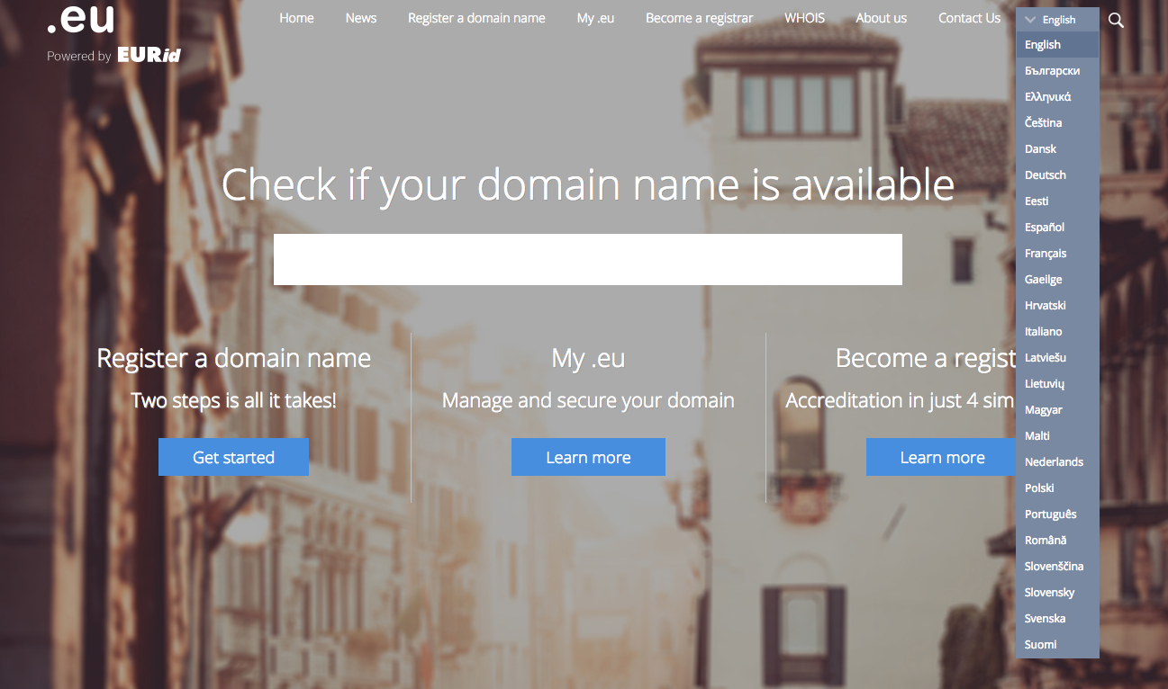***Support for linguistic diversity***

The .eu Registry provides customer support and translation of key documents in all 24 official languages of the European Union (even Maltese and Gaelic which are no longer routinely supported by the EU institutions), pursuant to the obligation set out at Recitals (2), (7) and Article 6 of .eu Regulation 784/2004.

Further to the obligations set out in Article 6 of .eu Regulation 874/2004, the .eu Registry has supported linguistic diversity in the online environment through its active promotion of Internationalised Domain Names (IDNs), distinguished by accents or diacritics, and in scripts other than Latin. IDNs play a crucial role in supporting the varied linguistic landscape of the European Union.

The .eu Registry first launched IDNs at the second level (see diagram) in 2009, to support domain names in Latin, Latin extended, Greek, Greek extended, Cyrillic and Cyrillic extended scripts[35]. At the close of the third quarter of 2017, there were over 42,000 IDN registrations under .eu and .ею.[36]

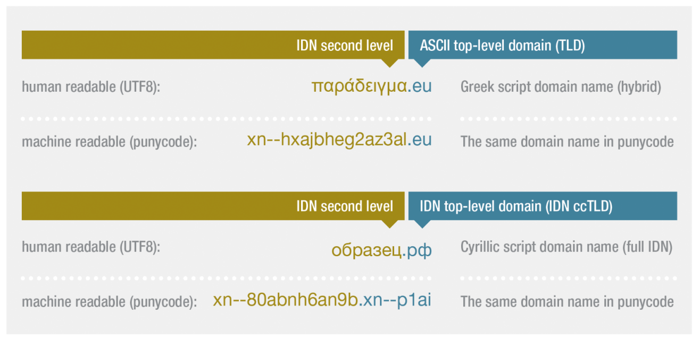

In 2009 ICANN launched a process[37] to enable ccTLD registry operators to provide Top Level Domains in non-ASCII scripts (such as Cyrillic and Greek for example). At the Commission’s request, the .eu Registry applied through the ICANN process for .eu in Cyrillic and in Greek scripts. The objective, in line with the EU’s support for linguistic diversity, is to enable Bulgarian and Greek internet users to benefit from being able to register .eu domain names in their own language. The delegation[38] and launch[39] of the .ею TLD (Cyrillic script, to support the Bulgarian language) took place in 2016. The .eu registry has persisted with the .ευ (.eu in Greek) application despite numerous setbacks, and has been active in working groups relating to improving the IDN ccTLD Fast Track evaluation process[40].

The .eu Registry partners with UNESCO, and others to produce the annual World Report on Internationalised Domain Names[41], a project which has been running since 2011. The World Report tracks the implementation of IDNs throughout the world, and at the European level. It has become a respected and well-referenced resource for industry and researchers, and supports the EU goal of enhancing linguistic diversity in the online environment. The first Memorandum of Understanding with UNESCO was signed in 2013 and was renewed in 2017. The MoU foresees cooperation of the two parties to promote online linguistic diversity. The .eu Registry has presented the annual World Report on IDNs with the support and participation of representatives from the Commission, at successive UN Internet Governance Fora[42], at the European Parliament, and will launch the 2017 issue in collaboration with the European Internet Forum[43].

***Monitoring of the .eu TLD by the Commission***

Monitoring arrangements are conducted according to the provisions of the .eu regulations and the Service Concession Contract, and include the following:

* The Commission is to provide a report to the European Parliament and the Council on the implementation, effectiveness and functioning of the .eu TLD, one year after adoption of the first .eu Regulation and thereafter every two years[44].
* At the end of the start-up phase[45] of the .eu TLD, the .eu Registry was required to provide an independent audit and report its findings to the Commission[46].
* The .eu Registry is required to provide administrative and financial bi-yearly (formerly quarterly) and annual reports to the Commission on key metrics, progress against the annual Operating Plan objectives and possible changes in strategy, which are also published on the registry’s website[47].
* The Service Concession Contract contains detailed financial and governance requirements aimed at monitoring the performance and good practices of the .eu Registry, for example with obligations to seek Commission approval before the appointment of any managers, to seek three competitive quotes for any expenditure over and above [€5,000], and to undertake written cost-benefit analysis prior to such high expenditure.
* Bi-yearly official meetings take place between Commission staff and informal meetings are held with EURid’s External Relations Manager to ensure that the Commission is kept fully informed and up-to-date of all developments.

**4. Method**

**Short description of methodology**

In order to gather input for this evaluation, the European Commission collected the views from stakeholders through an (online) open public consultation on the potential revision of the .eu top-level domain (TLD) Regulations.

The Commission took active steps to bring the consultation to the attention of relevant stakeholders. The consultation was announced with a news article on the Digital Single Market section of the Commission website[48], on the Commission’s consultation pages[49], on Digibytes[50] and on Twitter[51]. The announcement of the consultation was picked up in some online news and Member States' websites[52]. The consultation was available for online submissions[53] and ran from 12 May to 4 August 2017 - a summary report, along with the questions asked, is available at Annex 2.

Alongside the public consultation, the Commission conducted targeted consultations with relevant stakeholders including operators of European ccTLDs, registrars, the .eu Registry, ICANN, current and former regulators at the Member State and EU levels. The Commission received a small number of written contributions from stakeholders outside of the online consultation, for example from MARQUES, Open-Xchange, EUIPO and ECTA. A full list of the consultations conducted is at Annex 2.

The input from stakeholders was complemented with a wide range of existing, respected secondary sources, for example on the market penetration and renewal rates of .eu and competitor TLDs. Appropriate references are given in the text of this report to such third party sources.

**Limitations and robustness of findings**

Overall, the participation in the public consultation was low. A total of 43 responses was received, which exhibit varying levels of understanding on the subject matter. The response rate was in line with expectations given that the consultation was conducted during the summer months, and there is generally a low level of end-user interest and participation in the operation and regulation of technical infrastructure.

The response rate from a CENTR survey of ccTLD operators produced a low number of responses (11), but these represented relatively more expert stakeholders from large, medium and small ccTLD registries throughout the region, who manage a total of more than 38 million domains.

One of the major limitations of both questionnaires is the low level of awareness of the detail of the .eu Regulations, even among industry peers. This resulted in high levels of ‘don’t know’ responses in answer to questions about the detail of the .eu Regulations. One possible reason for this is that neither end-users nor different ccTLD registries are directly involved or impacted by the .eu Regulations – although the EU citizen does indirectly experience the impact of the .eu Regulations through the availability, pricing and policies of the .eu TLD.

These limitations were mitigated by complementing surveys with targeted consultations and workshops. Both the Commission and the .eu Registry have provided detailed input through workshops in line with Better Regulations guidelines (in the case of the Commission), and targeted 1:1 consultations (in the case of the .eu Registry).

**5. Analysis and answers to the evaluation questions**

**5.1. Effectiveness**

This section will consider how successful the EU intervention has been in achieving or progressing towards its objectives of creating the'.eu' Top Level Domain, to be ‘a key building block for electronic commerce in Europe’, and support the objectives of Art 114 of the Treaty [functioning of internal market][54].

The regulations enabled the .eu TLD to be included in the root database for the domain name system by ICANN (2005), and subsequently launched to the market in 2006.

***Adoption rates and growth***

The .eu TLD is one of the largest ccTLDs in the EU, and has grown to 3.7 m registrations since its launch in 2006.

Average annual growth for .eu has been +4.6% over the past ten years[55]. Over the past five years, however, growth has remained relatively static and 2016 saw negative growth for the first time in .eu’s history.

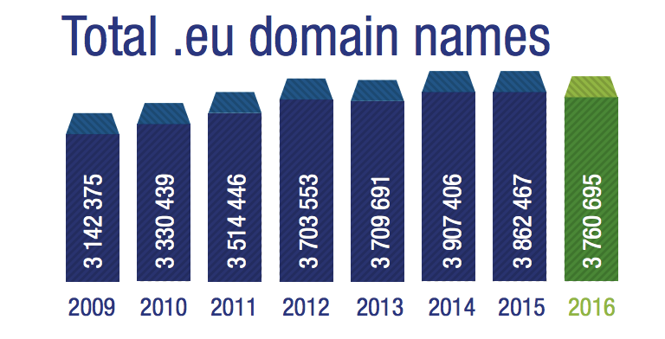

Growth rates in the wider market have been declining for some years. According to the Council for European National Top-Level Domain Registries, CENTR, median growth across European national ccTLDs has declined from 0.6% in 2013 to below 0.2% in 2017[56]. During the year to December 2016, three of the largest TLDs in the world experienced negative growth: .net (-4.5%), .uk (-0.5%) and .org (-4.2%)[57]. Meanwhile, the new gTLD environment exhibits high volatility – for example .loan had higher than 700% growth in 2016[58], and .xyz dropped more than 50% of its domains in a single month (August 2017)[59].

Decreasing growth rates across the ‘legacy’ domain names in developed markets such as North America and the European Union can be linked to several factors – including a change from under-supply to over-supply and consequent increased competitiveness, fewer marketing promotions by those registrars that became involved in new gTLD registries, and in some cases stagnant economy.

When a domain name is created, a contract is entered into between the end user and the retailer (a registrar) for a specific period of time – between 1 month and 10 years in duration. When the domain name expires at the end of the term, two things can happen: either the domain name is cancelled and ceases to exist, or it is renewed for successive periods of one year and remains in use. The renewal rate of a particular Top Level Domain (TLD) is the percentage of domains that are renewed. Renewal rates[60] are more difficult to affect through price promotions (and/or other marketing initiatives) which aim at the acquisition of new customers. For this reason, renewal rates are viewed in the domain name industry as a sign of quality – domains that are in use are more likely to renew than those that are not in use. Renewals of .eu domains consistently average around 80%. That is a 13% higher renewal rate than for .com and .net[61], but 4% below the average for ccTLD CENTR members[62]. Renewal rates amongst new generic Top Level Domains (gTLDs) are still highly variable, consistent with new market offerings: some are experiencing renewal rates as low as 10-15%[63].

Overall, declining annual growth and the lowest penetration per 1,000 of population in its target market indicate room for improvement in terms of market penetration[64].

***Supporting ecommerce and the internal market***

To be effective in supporting ecommerce and the internal market, there should be evidence of uptake of the .eu TLD by businesses. Determining the use of domain names requires analysis of the way that they are used. The .eu Registry has undertaken two studies which evaluate the way that .eu domain names are being used, and makes comparisons with other popular Top Level Domains (TLDs) such as .com. According to the .eu Registry’s website analysis studies in 2011 and 2014, the .eu performs higher than comparator TLDs in relation to business use[65].

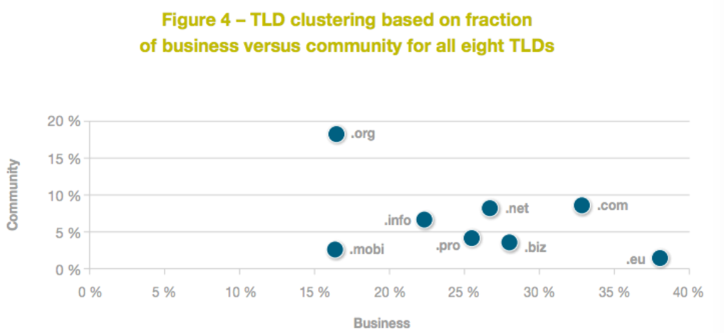

The figure above (fig.4), taken from a study on web site usage across several TLDs in 2014 conducted by the .eu Registry, measures the percentage of each TLD used for ‘business’ and ‘community’ purposes (the x and y axis of fig. 4). The analysis indicates that .eu has the highest rate of business use (38%) amongst the sample TLDs, compared with 33% for .com, the next most popular for business. Business use is the most likely to have ecommerce applications. According to this analysis, .org is the most popular for ‘community’ use.

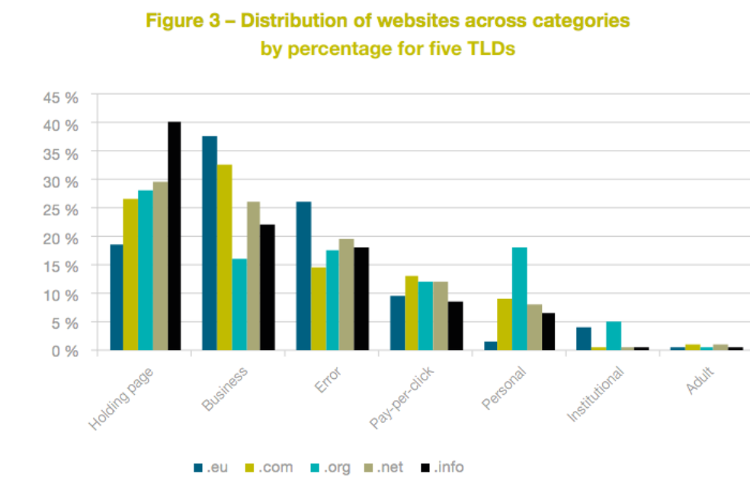

The figure above (fig. 3) also taken from the 2014 .eu Registry web analysis study makes a comparison of the percentage usage rates for different types of web content amongst the five TLDs included in the study (.eu, .com, .org, .net and .info). The study indicates that the rate of ‘business’ use in .eu is 37%, the highest among all the TLDs in the study. The .eu TLD is also popular for ‘institutional’ use (alongside .org). Another feature of .eu is that it has lower rates of ‘junk’ type usage than comparison TLDs, for example holding page[66], pay per click[67] and adult, suggesting that the .eu TLD is more likely to be associated with quality content than the comparator TLDs. The only exception is a relatively high rate of ‘error’, 25% for .eu, meaning that a web page cannot be reached. This is consistent with lower rates of holding pages and pay per click, which are customarily used in other TLDs (such as .com, and .info) for domains with no unique or active content, and which are used instead to generate advertising revenue from web or search traffic to the domain name in question.

Research conducted by the .eu registry shows links between the .eu TLD and "European values". A customer awareness study in 2015[68] received 4,900 responses from 27 countries. It not only showed that 67% of respondents were aware the existence of the .eu TLD (up from 56% in 2010), but it also revealed that the term ‘European’ was the strongest association for the .eu domain, along with "professional" and "commercial activities".

As well as this quantitative evidence from research conducted by the .eu Registry, there is qualitative evidence in relation to the .eu TLD and the digital single market. In the stakeholder questionnaire conducted for the REFIT process, eleven respondents were businesses that use a .eu domain, and more than half (55%) indicated that the .eu extension significantly or moderately helped to expand their online business cross border, while 27% said there was little or no effect.

For a majority of the respondents to the stakeholder questionnaire the .eu has significantly or moderately promoted ‘*a clearly identifiable digital identity for citizens and business in the EU*’ (81%), ‘*cross-border access to the online market place*’ (65%), and a ‘*secure and reliable e-commerce in the EU*’ (58%). Similar sentiments are expressed in customer testimonials published by the .eu Registry, for example “*We’ve chosen .eu because we are a European company that does business within Germany and all over Europe and .eu fit.*”. (Leguano.eu), “*Having a .eu domain name has really helped our business grow as our website is better accepted within Europe.”* (Angel-baby.eu)[69].

***Effectiveness in the management and corporate of the .eu Registry***

Despite detailed provisions relating to the start-up of the .eu TLD, many of which are now outdated or obsolete (see ‘Relevance’ below), the .eu Regulations contain no provisions regarding the corporate governance of the registry operator. For example, there is no guidance on how long individual board members are permitted to serve, nor on how conflicts of interest should be managed. The CEO, and three of the five board directors[70] have all been in place since the foundation of the company in 2004.

An audit report into the governance of the .eu Registry, conducted on behalf of the Commission in 2013, highlighted a number of concerns including potential commercial conflicts of interest. The second service concession contract between the Commission and the .eu Registry contains extensive provisions relating to management of potential conflicts of interest, and gives extensive powers for the Commission to intervene. However, no action has been taken by the Commission in relation to concerns that have existed for some time, indicating low effectiveness in the current regulatory relationship.

***Effectiveness of market***

According to the .eu Regulations, the .eu Registry itself cannot act as registrar. Therefore, the .eu Registry currently relies on 712 accredited registrars. The number of accredited registrars has dropped slightly in the last two years – there were 751 at the end of Q1 2015.

Reorganisation and acquisitions among registrars are partly responsible for the drop in the number of accredited registrars. The top 10 registrars account for 36% of .eu registrations, and the top 100 more than 85% of .eu registrations. The large number .eu registrars indicates strong competition in the market at the level of registrar (retailers for .eu domain names), despite a slight drop in the number of registrars overall.

Over the past five years, there has been a vast increase in choice of TLD available to EU citizens with the launch of ICANN’s new gTLD programme. An increase in number of available TLDs to the market has reversed the previous power balances between some registries and registrars.

Competition amongst registries has intensified to ensure that their TLD is prominent in the registrar shelf-space – to be more visible to end-user customers. Some registrars are more proactive than others in marketing the .eu TLD to end-users. For example, at the current time, the .eu accredited registrars in Bulgaria, Romania, Lithuania, Latvia, Finland and Malta offer several other TLDs for sale, and are not proactively marketing .eu to their customers. As a result, in some EU Member States, access to .eu domains is limited, and therefore opportunities to participate in ecommerce within the single market. Comments from the stakeholder questionnaire included a suggestion that the .eu Registry should be able to offer direct registrations in underserved markets.

The stakeholder consultation provided a number of indications of the effectiveness of the regulatory framework and the creation of .eu in contributing to the DSM by encouraging and increasing secure and reliable e-commerce and build a strong digital identity for people and organisations in the EU:

* + 70% indicated that a .eu extension significantly of or moderately affects their trust in a website;
  + 60% answered that, as a consumer, they would rather buy from a .eu website than from a website with a generic extension;
  + 54% said to prefer a .eu website over websites with another country code.

Further, most respondents to the stakeholder survey agreed that .eu has significantly or moderately promoted

* + a clearly identifiable digital identity for citizens and business in the EU (81%);
  + cross-border access to the online marketplace (65%);
  + a secure and reliable e-commerce in the EU (58%).

**5.2. Efficiency**

This section analyses the progress made towards achieving the objectives of the intervention. It assesses the progress made to date, the role of the EU action in delivering the observed changes, and evaluates the relationship between the resources used by the intervention and the changes generated by it.

***Financial position and contribution to Commission budget and goals***

No tax-payer funds have been used in the establishment or operation of the .eu TLD, apart from those needed by the Commission to perform its monitoring function. EURid operates on a not-for-profit basis and pays over any financial surplus to the EU budget after the end of each financial year. In its most recent financial year (2016), its turnover was €14.4m, and its financial surplus was €2.7m. Revenue increased by 4.41% and costs decreased by 7.44% during the 2016 financial year. Since 2010, EURid has contributed a total of €6 m to the European Union budget (see figure below).

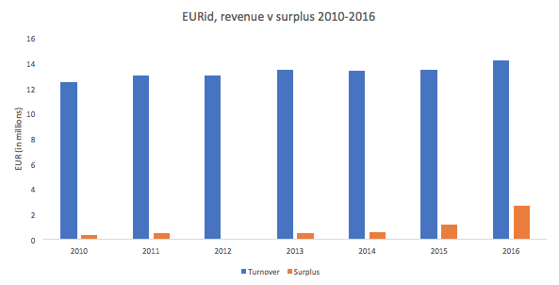In addition to transferring the annual surplus to the European Union budget , the .eu Registry has supported and financed numerous projects to further EU objectives which might otherwise have had to be paid for by the EU taxpayer, for example:

* EURid agreed to host, sponsor and organise the annual meeting of the European Dialogue on Internet Governance, EuroDIG, in 2016, in partnership with the Commission[71]. The cost of 350 000 EUR was borne by EURid.
* EURid agreed to host an ICANN meeting in Brussels in 2010[72], following a request by the Commission. The cost of 450 000 EUR was borne by EURid
* EURid is the first and currently the only European TLD registry to have achieved EU Eco-Management and Audit Scheme (EMAS) registration. Since its adoption of EMAS in 2012[73], EURid has increased its use of renewable energy, reduced its carbon footprint and offsets CO2 emissions[74] and supports environmental projects such as ‘+BEARS –CO2’[75].
* In 2014, EURid launched the ‘.eu Web Awards’ which recognises the best of .eu websites from across the EU[76] and incorporates EU strategic priorities such as "combatting climate change" and "EU identity" in its award categories.
* EURid proactively participates in international internet governance processes, such as ICANN and the UN Internet Governance Forum. For example, EURid’s External Relations Manager has been chairing the ICANN ccNSO Strategic and Operating Plan Working Group since 2013[77] and has been participating in working groups relating to IDN projects since 2009.[78]
* Since 2013, EURid has organised and delivered seminars on internet governance, law and cybersecurity at College of Europe in Bruges[79], the Scuola Superiore Sant’Anna in Pisa[80], and University of Southern Bohemia in Ceské Budèjovice[81].
* In 2016, EURid signed a memorandum of understanding with EUROPOL engage in joint efforts related to fighting cybercrime, to exchange statistical data and trends pertaining to cybercrime, and to commit to cooperate on projects designed to combat cybercrime[82]. Through the MoU, EURid voluntarily cooperated in the high profile operation Avalanche case, coordinated by EUROPOL with the cooperation of the US Federal Bureau of Investigation (FBI) and numerous domain name registries[83].
* In 2017, EURid signed a memorandum of understanding with ‘Together against Cybercrime International’ with the goal of promoting Internet Governance and increasing awareness of the domain name system.[84]
* In 2012, EURid signed a MoU with UNESCO to further promote online multilingualism and participate in common projects to support linguistic diversity.[85]

***Cost of .eu domains***

In general, neither private individuals nor business representatives consider the cost[86] for holding a .eu domain name significant. The domain holders were fairly positive about the cost-benefit ratio: 19 of the 34 (56%) holders of a .eu name gave a clear positive assessment while only two (2) respondents said that costs exceed the benefits.

Since January 2013, in order to remain in line with its contractual obligation to work at cost, the .eu Registry changed the renewal and term extension fee of a domain name from €4 to €3.75. At the same time, to be more competitive in the dynamic TLD market, EURid launched the Customised Reduction Schemes (CRS) for its registrars, which enable reduced new registration fees according to the registrar’s sales volumes. As of January 2017, the basic fee for a new domain name for those registrars subscribing to the CRS is €1.75. In Q1 2017 98% of registrations were made by the 331 registrars who joined the CRS in 2017.

The price referred to above is the price the .eu Registry sells to Registrars. The price the end users get depends then on the Registrars and any additional services they provide with the domain name. Retail prices for .eu TLDs can vary from as low as €0.99 (special registrar promotions) up to €100 or €200 if the domain is bought with value-added services such as content management, security features, or many email addresses.

***Costs and benefits of regulation***

The .eu legal framework foresees the allocation of a registry to organise, administer and manage the .eu TLD. EURid was established as a joint venture between the ccTLD operators of Belgium, Sweden, Italy and Czech Republic, with the sole intention of running the newly established TLD. Therefore all of EURid's costs are linked with the implementation of the .eu legal framework (compliance cost). The total costs of fiscal year 2016 were € 11.365.237[87].

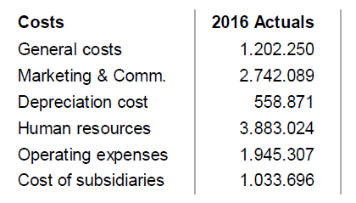

The .eu Regulations create a regulatory role for the European Commission in relation to the .eu registry, EURid. The regulatory relationship is further elaborated in the current Service Concession contract,. The Commission incurs the cost of managing the relationship. The calculations below further take into account:

* Periods when amendments to the Regulations have to be introduced to allow technical updates; and
* Periods when the service concession contract has to be negotiated (through a new call for expression of interest) or renegotiated (through extension of the existing contract).

There need to be two Commission officials devoting 50 % of their time to the required action relating to .eu TLD, and a head of unit devoting 5%. Considering the average total cost of a Commission official is 143.000 €[88], the compliance cost for the Commission equals to 150.150 €[89].

Under current .eu Regulations the actor incurring external administrative burden is the .eu Registry. An examination of the mandatory information obligations (IO) EURid currently has with regard to the European Commission through the 'Standard Cost Model' (SCM) reveals that the .eu Registry is incurring a cost from administrative burden that equals to €115.688. Ten IOs need to be carried out by EURid. Please see the tables with detailed calculations of these ten IOs in Annex 9.

Some internal administrative burden is felt at Commission level. In particular eight IOs are part of Commission's workload when it comes to implementing the current .eu framework. According to SCM calculations in Annex 10 the Commission is incurring a cost from administrative burden that equals to €40.322.

The .eu Regulations, particularly the Public Policy Rules, contain a level of detail which is now out of step with market best practices and creates delay costs. For the .eu registry and the Commission to be able to implement changes in its market offering in order to keep up with technical changes and support linguistic diversity has proven time consuming:

* Amendments to the Regulations were necessary to implement updates in technical standards relating to internationalised domain names (.eu supports all 24 official languages of the EU, including Bulgarian and Greek, which require domain names in Cyrillic and Greek scripts). Whereas DENIC, the private sector German ccTLD, and NIC.AT, the Austrian ccTLD, were able to implement changes to the technical standards[90] within one month of their publication, it took the .eu Registry and the Commission 19 months’ work to update the Commission Regulation 874/2004 for implementing a minor technical changes and updating the list of reserved domain names. Changes within the competent European Commission staff also contributed to such delay.
* To clarify that technical checks would take place prior to and not only after a domain name was registered, necessary to implement a security feature for Greek and Cyrillic domain names (homoglyph bundling, to avoid homograph attacks[91]) took 37 months, due to delays in consultations with Member States conducted by the Commission.

These lead times for updating the regulations are the norm in terms of the time taken to update or conceive EU legislation, with all the associated obligations for analysis, consultation, publication and approval. The key issue in the context of the .eu TLD is that other TLD operators do not have to seek updates of primary legislation in order to implement technical standards – which change frequently. Therefore the inflexibility of the .eu Regulations place the .eu registry operator at a disadvantage compared to its competitors, and EU citizens who wish to register a .eu domain do not receive the benefits of the latest technical standards.

There are also enforcement costs stemming from the current .eu legal framework. The .eu Registry is obliged to run an annual external audit on its financial accounts. The amount paid annually to the external auditors equals to 29.000 €. In addition the Commission is entitled to run an independent external audit on the .eu Registry if it so wishes. The cost for running such an audit with an external auditing company is estimated around €100.000.

The following table summarises the compliance costs, administrative burden, delay costs and enforcement costs:

|  |  |  |
| --- | --- | --- |
| ***Regulatory costs*** | | |
| ***Description*** | ***Amount*** | ***Comments*** |
| Compliance cost | € 11.365.237  *Recurrent* | for the .eu Registry |
| Compliance cost | € 150.150  *Recurrent* | for the Commission |
| Administrative burden | € 115.688  *Recurrent* | for the .eu Registry |
| Administrative burden | € 40.322  *Recurrent* | for the Commission |
| Delay costs | By the lead time necessary to amend the Regulations  *Recurrent* | For the end users due to delayed availability of technical and market innovations in the domain name sector |
| Enforcement costs | € 29.000  *Recurrent* | for the .eu Registry |
| Enforcement costs | € 100.000  *Recurrent[92]* | for the Commission |

The regulatory costs are shared by the Commission and the .eu Registry, nevertheless they have an impact on the EU citizen: Commission costs are directly borne by the EU taxpayer, and the registry costs have an indirect impact as they reduce the level of surplus which is returned each year by the registry to the European Union.

Considering the .eu Regulations are detailed and to some extent outdated there is potential for simplification and burden reduction. Options to achieve cost savings with respect to regulatory costs are proposed and actual cost reduction they would bring is analysed in the Impact Assessment.

***Inflexible administrative provisions***

Significant resources at both Commission and registry level are consumed in administering and implementing the list of reserved domain name by the EU institutions.[93] This is partly due to the level of inflexibility provided by the Commission Regulation 874/2004:

* Art 9, para 2 of Commission Regulation 874/2004 foresees the procedure for the Commission to notify reserved names for the Institutions. The Regulation foresees this as a one-off event, and contains no procedure to reserve new names at the future or remove names from the lists once created. This creates problems and friction between the Commission and the .eu Registry. It has often been the case that because of bureaucratic, inflexible rules, the Commission has not been able to obtain the reservation of a chosen domain name. While the cost to the EU tax payer of such transactions is low, the impact on the EU institutions is more onerous: either going through time-consuming processes dictated by the .eu Regulations (involving the Commission) or paying for domain names in the open market in order to obtain a domain name more quickly. Meanwhile, the intended uniform use of .eu for the online presence of European institutions has become eroded, for example through the use of .org and other TLDs.
* Art 17 provides 5 names that the Registry operator can reserve for itself. This is too detailed to be set out at the level of Regulation.  A general permission for the registry to reserve a reasonable number of domain names for its operational functions would be more appropriate.
* Chapter VI of Commission Regulation 874/2004 sets out rules for the resolution of domain name disputes (the .eu Alternative Dispute Resolution (ADR) tool). Having such detailed provisions at the level of Regulation prevents flexibility or changes to practices in response to market conditions. Despite provisions in regulation 733/2002 that the dispute resolution should reflect international best practices, the .eu ADR, in compliance with rules laid down by Regulation 874/2004, is inconsistent with international best practices subject to constant changes.

Respondents to the registry questionnaire mentioned the need for ‘more flexible policy making in response to market’, the need to ‘continuously adjust the operational aspects resulting from the natural evolution of the internet’. Several registries reported that they had not taken any element from the .eu Regulatory framework or incorporated them into their policies or procedures. These answers, combined with the administrative experiences highlighted above, indicate a potential lack of efficiency in the current .eu Regulations, in that they have not been used as a model by others.

Seven respondents to the stakeholder questionnaire suggested simplifying the .eu regulatory framework. Most respondents, however, answered that there were ‘no’ (18 responses) or that they were ‘not aware’ (18 responses) of areas that could be simplified. Similarly, ten (10) respondents answered that some areas of the framework could be ‘changed or eliminated, to reduce regulatory burdens’ while the majority saw ‘no’ (16 responses) or was ‘not aware of’ (17 responses) areas that could be simplified. These answers indicate both a low level of awareness among stakeholders external to the domain name industry of the detail of .eu Regulations. They also support the view that the current .eu Regulations may be over detailed and inflexible.

Other suggestions from the stakeholder and registry questionnaires included: clarification of the use of revenue, amendments to the Alternative Dispute Resolution Rules (ADR), deletion of detailed ‘sunrise’ provisions, meaning the original start-up mechanisms for .eu which aimed to protect the interest of intellectual property rightsholders against speculation, as known as ‘cybersquatting’. These provisions have not been in operation since 2006.

The European ccTLD operators was asked to assess to what extent a ccTLD could benefit from a regulatory framework. Of the respondents to the survey 45% stated that ‘having a regulatory framework poses moderate to significant benefits for ccTLDs’, while most others consider it provides little benefit.

The EC received stakeholder contributions that indicated that the framework has been successful in

* + assigning a well-performing registry operator, which ‘has been stable, secure and very well managed’, with staff that ‘are supportive and understand the needs of business’ (MARQUES);
  + allowing the registry operator to work ‘to improve security in the Internet’ which ‘has certainly improved trust amongst users’ (ECTA);

while imposing some constraints

* + for the .eu registry operator, by limiting its possibilities to ‘embark on long term innovative projects as well as to diversify its business’, and  to ‘compete against the competitive business models and market players’,
  + for the EU Commission by restricting ‘the promotion of the EU identity’ and potentially ‘put at risk the business continuity of the .eu TLD’, and
  + for the end-user ‘due to the misalignment of the available dispute resolution mechanisms with user needs’. (EUIPO)

**5.3. Relevance**

The following section considers the relationship between the needs and problems in society and the objective of the intervention, and how these last ones correspond to the wider EU policy goals and priorities.

88% of those who responded to the stakeholder consultation, and 70% of responses to the registry questionnaire agreed that the objectives of the regulatory framework are still relevant in order to address today’s needs of EU citizens and businesses.

The .eu Regulations are highly detailed and in some cases restrictive. Reflecting practices in the domain name market at the time when the .eu Regulations were drafted (2002-2004), the details of the .eu Regulations are no longer in step with international best practices. For example:

* Art 3(2) of Regulation 733/2002 states that the Registry shall be a non-profit organisation. While many of the EU ccTLDs continue to be organised as non-profit organisations[94], in recent years different business models have evolved, for example in the context of new gTLD registries, and the development of technical backend providers[95].

At the same time:

* Neither of the .eu Regulations refers to ‘multi-stakeholderism', which has become the widely accepted form of good practice for internet governance[96]
* Neither of the .eu Regulations mention cybersecurity or security, which has emerged as a major concern in recent years, reflected in the NIS Directive.

The absence of these matters in the .eu Regulations does not, of course, mean that the .eu TLD cannot support such objectives. However, a revision of the Regulations will give an opportunity to review coherence with current EU objectives and international best practices.

The .eu Regulations also contain detailed provisions covering matters that have long ceased to be relevant – for example:

* Start up provisions including sunrise period, selection of validation agents and sunrise dispute resolution are no longer relevant as they lay out rules for events which ended more than a decade ago. Examples include Art 6(1), Art 7, the entirety of Chapter IV (Arts 10-14) of 874/2004.
* Provisions relating to the death or winding up of a domain name holder (Art 19, 874/2004) are no longer relevant, as such situations are adequately dealt with by international and domestic law.

Eligibility criteria – creating restrictions on those eligible to register in a TLD – were reasonably commonplace in the early years of the commercial domain name market within the .eu. However, the market changed considerably since then. In the year that the .eu TLD was launched, the OECD noted[97] a trend towards ‘liberalisation’ of the ccTLD namespace. In this context, liberalisation means the elimination of rules seeking to restrict those eligible to register in a particular TLD.

The purpose of eligibility criteria is to reduce speculation, cybersquatting, or domain name disputes between intellectual property holders and domain name users. However, in practice, the real reduction was in overall registrations, leading to a loss of market share. Such restrictions are also easy to circumvent through the use of proxies, ie. a person or organisation who does not comply with the relevant restrictions arranges for registration of a domain name through a third party proxy.

Some of the larger ccTLDs, such as Nominet, have for at least 20 years been fully open to any customer on a first-come, first-served basis. As domain name dispute resolution processes such as ICANN’s UDRP[98] and the .eu ADR[99] came into being, much of the market adopted fully open, first-come, first-served registration policies confident that disputes could be managed after the fact, rather than in advance. Registries that have eliminated eligibility criteria experienced rapid growth in domain name registrations afterwards, for example Afnic (France)[100] and Red.es (Spain)[101]. The .eu Regulations contain so-called ‘eligibility criteria’, which determine who has the right to register domain names in .eu. The .eu Regulations require all .eu registrants to be based in the EU. The inclusion of eligibility criteria of .eu is out of step with market practices within the EU ccTLDs, and this is a particular concern given increased competition in the market.

Feedback from the 43 responses in the stakeholder questionnaire was mixed: offering both strong support for retaining eligibility criteria and several responses suggesting relaxing the eligibility criteria. The preferred option from the stakeholder survey was to open up registrations to EU citizens regardless of whether or not they are resident in the EU or in EEA. In contrast, 80% of respondents in the registry questionnaire favoured no restriction (anyone in the world can register).

88% of the respondents to the stakeholder consultation and 73% of the respondents to the survey among European ccTLDs consider the general objective of the .eu regulatory framework, to create a .eu-top-level domain to contribute to the DSM by encouraging and increasing secure and reliable e-commerce and build a strong digital identity for people and organisations in the EU, still relevant.

The EC received stakeholder contributions that recognised ‘the value of the .eu domain name’ (MARQUES) and confirmed that ‘.eu can and should contribute to the creation of a shared digital identity for European citizens and companies’ (Open-Xchange).

**5.4. Coherence**

This section considers both ‘internal’ coherence, meaning an assessment of how different components of the interventions operate together to achieve given objectives, and ‘external’ coherence with other interventions at EU, Member State or international level.

***Coherence with EU values and objectives***

The original objectives behind the .eu Regulations included the enhancement of e-commerce and the internal market.

Since the .eu Regulations were enacted, there have been significant developments in EU objectives and legislation relating to the digital environment, including the recognition of the risks posed by cybercrime and poor standards of cybersecurity in eroding trust (eg the NIS Directive 2016[102]), and development of a Digital Single Market[103] strategy, including a focus on start-ups[104].

Nevertheless, there is some evidence that the .eu TLD is associated with the values of the European Union. For example, in the stakeholder questionnaire, 70% of respondents indicated that a .eu extension significantly or moderately affects their trust in a website, and 60% replied that they would rather buy from a .eu website compared with websites with other country codes. Comments to the questionnaire suggest that respondents associate the .eu extension with an expectation that ‘EU privacy and consumer protection laws’ will apply, or that the website operator has a ‘more international’ outlook. Market research conducted by the .eu Registry in 2015 amongst 4,900 respondents across 27 countries indicated strong associations with the terms ‘European’, ‘Official website of the EU institutions’, ‘International’, ‘Trustful’ and ‘Innovative’[105].Qualitative evidence from customer testimonials indicate that the intervention remains coherent with EU values and goals such as the Digital Single Market, ‘.*eu is a way for us to show that we are part of a larger whole, a larger collaboration*’ (Foodtours.eu)[106], *‘Our goal is to not only promote tourism in Croatia, but also to encourage young people to travel across Europe.’* (HelloCroatia.eu).

There is a link between the .eu TLD and the goal of enhancing EU identity, although this is not mentioned in the .eu Regulations. One of EURid’s marketing strapline includes ‘your European identity’.

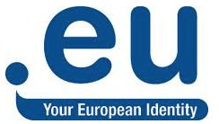

***Coherence with obligations on linguistic diversity***

Article 6(2) of 874/2004 imposes an obligation on the registry to translate certain communications in all official EU languages. The Commission itself no longer produces translations in Maltese and Gaelic for many documents. This obligation is therefore no longer coherent with Commission practice, and presents a cost[107] and operational burden for the .eu registry which other competitors do not have.

***Coherence with regulatory frameworks for ccTLDs in other EU countries***

The regulatory framework for the .eu TLD, deriving its authority from primary legislation and establishing a close regulatory relationship between the registry and regulator, is not the norm across the EU. Most EU member states have not adopted regulatory frameworks in relation to their ccTLD, which find their formal operational basis in ICANN-related soft legal tools[108]. For example, from the registry survey undertaken in line with the Better Regulation guidelines, of 10 registries who responded to the question ‘does your registry have a similar regulatory framework to the .eu TLD?’ 70% answered ‘no’.

While the .eu’s regulatory position represents a particular case compared to its ccTLD counterparts in the EU, such an arrangement is not out of step. Over the past decade, some Member State governments have passed domestic legislation covering aspects of their ccTLD’s governance (eg UK)[109], or undertaken a re-bid of their ccTLD (France)[110]. Others are operated from within the public sector (eg Spain). Respondents to the registry survey were evenly split as to whether they considered any benefit in having a legal / regulatory framework behind a ccTLD.

***Coherence with international obligations – internet governance***

Since the .eu Regulations were introduced, international thinking in relation to internet governance has advanced and converged into support for multi-stakeholder processes. For example the European Commission[111], OECD[112], Net Mundial[113] and the ICANN IANA transition[114] all support multi-stakeholderism[115] as the most effective form of internet governance. Recital (9) of Regulation 877/2002 refers to principles of ‘non-interference, self-management and self-regulation,’ but neither regulation refers to multi-stakeholder governance. This alone would not justify a revision of the .eu Regulations, but there is an opportunity to review whether a mention would be appropriate should the .eu Regulations be amended.

While the current registry operator, EURid, is active in the field of internet governance, there is no obligation for it do so in the .eu Regulations [although there are obligations in the private service concession contract.] In the registry questionnaire, 70% of respondents said that a registry should be involved in Internet governance activities significantly (60%) or moderately (10%). While one commentator noted that there was not much 'added value in continuing [internet governance] talks, others highlighted clear benefits such as the commitment 'to an open, secure and single internet’, or guaranteeing ‘participation and effective contribution of all stakeholders’.

With regard to the .eu TLD’s own policies, these are set out in the .eu Regulation 874/2004 (the Public Policy Rules). The .eu Registry will usually consult with its Registrar Advisory Board[116] on operational and contractual changes with the supply chain, but this falls short of the multi-stakeholder ideal which incorporates government, private sector, and civil society on an equal footing. Responses to the stakeholder questionnaire were most in favour of published policies and procedures developed by the .eu registry operator through a multi-stakeholder process and approved by the European Commission[117]. This suggests that some individuals expect multi-stakeholder processes to be established at the level of the .eu TLD, not just at international levels. The current .eu Regulations are not coherent with such an aim.

***Registry structure – coherence with market norms***

Article 3(2) of Regulation 733/2002 states that the Registry shall be a non-profit organisation, formed in accordance with the law of a Member State and having its registered office, central administration and principal place of business within the Community. This is no longer coherent with changes in the international market and could restrict the choice available to the Commission on future rebids of the .eu registry.

Since the launch of the ICANN new gTLD programme in 2012, the registry market has seen an evolution through the availability of ‘packaged’ technical-backend registry functions – often (but not always) run on a for-profit basis by organisations having their principal place of business outside the Community. Analysis of the market-share of technical back-end providers in the new gTLD space indicates that more than 90% of the market is controlled by seven organisations (Neustar, CentralNIC, ZDNS, Rightside, Nominet, and Afilias, see figure below)

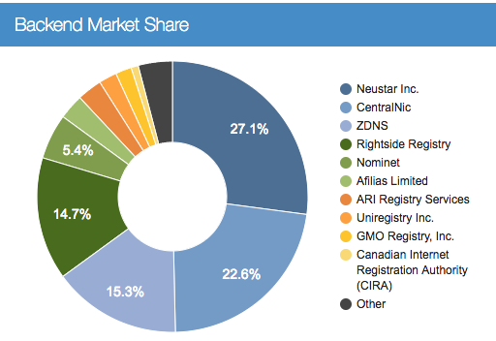[118]

***Prohibition on registry operating as a registrar – coherence with market practices***

Art 3(4) of Regulation 733/2002 states that the .eu TLD Registry shall not act itself as Registrar. This is no longer coherent with market practice in the ICANN environment, where a prohibition on so-called vertical integration was lifted in 2010. There continue to be strong market and policy reasons for caution with regard to a registry acting also as registrar, given that registries are dependent on strong relationships with the registrar channel in order to achieve market success. Most registrars market several TLDs, and make their margins through value-add services such as hosting, websites and email services. Registries like EURid typically do not offer such value-add services, nor do they offer more than one TLD typically. Some of the registrars are large international corporations, with significant market power (eg GoDaddy, which manages more than 73 million domain names from many TLDs[119]), and there is significant commercial risk for a registry entering into direct competition with its own marketing channel – particularly if this raises suspicions among registrars that the registry will seek to give itself preferential business terms. Such concerns are reduced in the context of a non-profit like EURid which has obligations to deal with all registrars on the equal terms. The current prohibition also prevents the .eu registry from stepping in to provide access to .eu TLD in underserved markets such as Bulgaria, Romania, Lithuania, Latvia, Finland, and Malta. It also subjects the .eu registry to a restriction which places it at a potential disadvantage in comparison with its competitors. In any event, having such a provision at the level of primary legislation might be unduly restrictive and out of step with current industry practices, placing the .eu TLD at a disadvantage in the market.

65% of the respondents to the stakeholder consultation (significantly or moderately) agreed that the regulatory framework is coherent with the EU priority for the completion of the European Digital Single Market, a small minority thought opposite and  25% answered ‘do not know’.

56% of the respondents to the stakeholder consultation (significantly or moderately) agreed that the regulatory framework is coherent with global domain name industry best practices, a few did not agree and 33% answered ‘do not know’.

The coherence with industry best practices was also discussed that the EC‘s meeting with ICANN where it was explained that individual ccTLDs historically have their own rules, that there’s a very good best practice exchange among European ccTLD operators, that there’s a call from registrars for a harmonisation similar to the ongoing harmonisation in the gTLD space, and that there are some signs of more harmonisation among ccTLDs.

51% of the respondents to the stakeholder consultation (significantly or moderately) agreed that the regulatory framework is coherent with policies set for other European ccTLDs while 40 % answered ‘do not know’.

**5.5. EU Added value**

**Necessity of EU action**

The .eu domain has by definition a cross-border dimension: it is the TLD of the European Union and is a symbol of the European online identity. The existence of a specific domain name for the European Union under a very clear and identifiable common label is an important and valuable building block for the European online identity.

The action of the .eu TLD cannot be sufficiently achieved by the Member States and can therefore, by reason of the scale and effects of the action, be better achieved at EU level.

The .eu TLD was established as a country code TLD (ccTLD) such as .de, .be or .uk, rather than as a generic TLD (.com, .berlin). This has important consequences in that ccTLD policies (regarding for instance rules for registration, accreditation of registrars, security related policies and data protection policies) are managed according to the relevant jurisdiction, oversight and governance mechanisms within the country/public administration, with no role for ICANN[120]. The ultimate public policy authority for a national ccTLD Registry rests with the relevant government or public authority. Accordingly, regarding the .eu domain name, public policy responsibility rests with the European Union.

Its regulation is therefore within EU competence and cannot be delegated to the Member States. This does not affect how each Member State manages its own ccTLD.

**Added value of EU action**

* The .eu is regulated at EU level because of its very nature. The existence of the .eu domain is highly symbolic and reflects the existence of a European online community (of citizens, institutions and businesses) who wishes to be clearly identified as such. The .eu TLD gives users wishing to operate across the Single Market a specific European connotation which is recognised globally[121].
* A regulatory framework at EU level for the .eu is useful in order to continue providing for and expanding a domain name space on the internet under the .eu TLD, in which relevant EU law, data and consumer protection rules are applicable.
* Regulatory action taken at Member States level would not be able to deliver on the general objective standing behind the creation and management of a trusted and innovative namespace for the EU, to promote the European Union's image on the internet and bringing an added value in terms of increased choice for users, in addition to the national ccTLDs.
* Moreover, the .eu TLD gives the EU a "seat at the table" in international and multistakeholder discussions around the domain name system and rules regarding ccTLDs on the global internet[122].

The EU action, with the establishment of legislation on the .eu, provided added value according to 70% of the respondents to the stakeholder consultation, and 79% indicated that the action resulting from the .eu framework provided an added value in terms of building a stronger digital identity for people and organisations in the EU. The European ccTLD registries had a less outspoken opinion on whether the EU action provided added value: 40% of those answering the European ccTLD survey said ‘yes’ while half of the respondents were ‘not sure’.

**6. Conclusions**

The original .eu Regulations were pivotal in enabling the creation of a dedicated namespace for the European Union. The .eu TLD, first launched in 2006 in accordance with the .eu Regulations, is a success. Despite being a late-comer[123] to the European TLD market, the .eu Registry has managed to establish a healthy market share throughout the EU and EEA, building excellent relationships with its channel to market of 700 registrars. Its rate of renewal and growth are in line with industry trends in the EU.

The .eu Registry operates its own technical and operational systems, following industry best practices for resilience and cybersecurity, for instance by adopting the DNSSEC protocol enhancing the security of the Domain Name System. It supports all 24 official languages of the EU and has been a tireless advocate for online linguistic diversity through internationalised domain names[124], distinguished by accents or diacritics, and in scripts other than Latin. The Commission monitors adherence to the .eu Regulations, by means of a service concession contract with the .eu Registry. Regular reports are delivered to the European Parliament and Council.

The operation of the .eu TLD is self-funded, and results in the .eu Registry’s surplus being paid over to the EU budget each year. In addition to the €6 m direct contribution to the European Union budget, the .eu Registry undertakes numerous public benefit activities which might otherwise have to be funded by the EU taxpayer. For example, the sponsoring of the European dialogue on Internet Governance (EuroDIG)[125], or the launch of the .eu Web awards[126].

In conducting this evaluation of the .eu regulatory intervention, the Commission consulted with relevant stakeholders. Efforts were made to bring the survey to the attention of stakeholders, including through news releases and Twitter. The number of responses to the stakeholder survey was low, reflecting the technical subject-matter, a low level of public awareness of the detail of the .eu Regulations. The stakeholder survey was supplemented with a survey of European ccTLD registries, written contributions from a number of stakeholders, and proactive 1:1 consultations by the Commission with key stakeholders including the current .eu Registry.

The .eu Regulations have been **efficient** in making .eu domains widely available throughout the EU, at a low cost for the consumers[127], providing an identifiable link between the TLD and the European Union. However, their rigid requirements are causing inefficiencies which place the .eu TLD at a competitive disadvantage in the market, reducing the possible benefits in terms of supporting ecommerce or the single market.

While the .eu Regulations have been **effective** in supporting ecommerce and the internal market with the .eu TLD being particular appealing for business use[128], there are starting to be early signs of relative decline in the .eu TLD’s performance. Growth of the .eu TLD has slowed down since 2012, and there have been two consecutive years of negative growth since 2015.

Over the years, it has become apparent that the .eu Regulations reflect the domain name market as it was in 2002-2004, and are no longer effective, efficient, or coherent in today’s fast-changing technological market environment. With detailed provisions, which are time-consuming and costly to change, the .eu TLD is unable to implement operational or technical changes as swiftly as the market demands and as its competitors are able to. Cumbersome administrative provisions have an adverse impact on the online presence of EU institutions especially in terms of reputation[129].

The objectives of the .eu Regulations continue to be **relevant** to EU citizens, as indicated in the registry and stakeholder survey responses, and the a high level of uptake, active usage, and renewal of .eu domains by business and institutions throughout the EU. However, the .eu Regulations are now no longer in step with international best practices. The rules for registration (‘eligibility criteria’) restrict the availability of .eu domains to registrants located in the EU and EEA. The majority of registrars in the survey were in favour of elimination of all restrictions; feedback from the stakeholder survey was mixed.

The regulatory framework for the .eu TLD is no longer **coherent** with its objectives. Most ccTLDs within the EU are not subject to the same regulatory burdens as the .eu TLD, which risks placing the .eu Registry at a competitive disadvantage amid toughening market conditions.

There is evidence that the .eu TLD creates associations in the minds of consumers with the values of the European Union. However, the .eu Regulations predate and therefore do not reference subsequent EU strategies and legislation which could not have been foreseen when the .eu Regulations were first developed, such as the Digital Single Market, and in particular its focus on start-ups and the NIS Directive. While these issues are not sufficient to merit revision of the .eu Regulations in and of themselves, there may be an opportunity to bring the .eu Regulations more into line with current strategies should the decision be made to amend them.

Neither the .eu Regulations nor the operation of the .eu Registry are coherent with international best practices in relation to internet governance, which favours a multi-stakeholder approach rather than governmental regulation. Other inconsistencies include the .eu Regulations stipulation on a certain type of structure for the .eu Registry operator, which would exclude from future bids some of the leading players in the market, and a prohibition on so-called ‘vertical integration’ (i.e. registry acting as registrar) which does not affect the .eu TLD’s competitors.

As a namespace for the European Union, the .eu TLD is a particular example of **EU added value.** The principle of subsidiarity is respected, as the .eu TLD belongs to the European Union[130] and hence has to be organised at the level of the Union rather than any Member State(s). Representing an online identity for EU citizens, the .eu TLD is therefore within EU competence and cannot be delegated to Member States. Fulfilment of EU goals and objectives, such as smooth implementation of the Digital Single Market, necessitate the maintenance of a trusted .eu namespace. Coordinated action at the EU level can ensure a higher level of security and adherence to EU values than would be the case at Member State level.

In conclusion, the overall objectives behind the original intervention remain relevant – the .eu domain has become established as a contributor to e-commerce and the single market. Meanwhile, the external environment has changed: any technological industry is fast moving and to survive, market players need to be flexible and responsive. The market is still feeling the impact of a market shock from the introduction of new gTLDs, combined with slowing rates of growth across the domain market in the EU. These factors are causing an evolution in the business models of registries and practices. To fulfil its potential as a trusted, innovative namespace for the European Union, the .eu TLD should be enabled to compete on an equal footing in the market, while supporting governance and operations that adhere to the highest standards, EU rules and values and international best practices.

**Annex I: Evaluation Questions**

List of evaluation questions used to assess the relevance, effectiveness, efficiency, coherence, and added value of current regulatory framework for the .eu.

RELEVANCE:

* Are the current objectives of the regulatory framework for the .eu still relevant to address today's needs of EU citizens and businesses? Do such objectives meet with the EU wider EU policy goals and priorities?

EFFECTIVENESS:

* How successful has the EU intervention been in achieving or progressing in establishing the .eu TLD?
* How effective were the .eu regulations in supporting the objectives laid down by art. 114 of TFEU [functioning of the internal market]?
* How successful has were the .eu regulations in making .eu TLD a 'key building block for e-commerce in Europe?

EFFICIENCY:

* To what extent the .eu TLD promoted cross-border access to the online market place, a secure and reliable e-commerce in the EU, and a clearly identifiable digital identity for citizens and businesses in the EU?

COHERENCE:

* To what extent is the .eu regulatory framework coherent with global domain name industry best practices and public polices set for other European country code Top Level Domains (such as .be, .es, etc.)?
* To what extent is the .eu regulatory framework coherent with today's EU policy goals and priorities?

EU ADDED VALUE

* Did the .eu regulations provide an added value in building a stronger digital identity for people and organisations in the EU?

Glossary

|  |  |
| --- | --- |
| ***Term or acronym*** | ***Meaning or definition*** |
| PPRs | Public Policy Rules |
| ADR | The alternative dispute resolution (ADR) is a mechanism available in place of traditional courts. ADR tools include arbitration and mediation. Online dispute rresolution (ODR) uses the Internet and technology in the process of dispute resolution. |
| ASCII | Abbreviated from American Standard Code for Information Interchange. It is a code for representing 128 English characters as numbers, with each letter assigned a number from 0 to 127. |
| BCP | A business continuity plan (BCP) is a plan to help ensure that business processes can continue during a time of emergency or disaster. |
| ccNSO | The Country Code Names Supporting Organisation, a body created within the ICANN. The purpose of the ccNSO is to engage and provide leadership in activities relevant to country-code top-level domains. |
| ccTLDs | A country code top-level domain (ccTLDs) is an Internet top-level domain generally used or reserved for a country, sovereign state, or dependent territory identified with a country code |
| CENTR | Association of European country code top-level domain name registries (CENTR). |
| CTR | A Click-through (CTR) rate is the ratio of users who click on a specific link to the number of total users who view a page, email, or advertisement. |
| DNS | The Domain Name System (DNS) is a hierarchical decentralized naming system for computers, services, or other resources connected to the Internet or a private network. It translates Internet domain names into IP addresses, used by computers and other devices to identify a certain Internet resource. |
| DNSSEC | The Domain Name System Security Extensions (DNSSEC) is a suite of Internet Engineering Task Force specifications for securing certain kinds of information provided by the Domain Name System as used on Internet Protocol networks. |
| DSM | 1 - Demand Side Management (DSM) techniques provide variety of measures to reduce energy consumption, which leads to more manageable demand.  2 - The Digital Single Market (DSM) is a strategy of the European Commission to ensure access to online activities for individuals and businesses under conditions of fair competition, consumer and data protection, removing geo-blocking and copyright issues. |
| ECTA | European Communities Trade Mark Association (ECTA) promotes the knowledge and professionalism of members and owners alike in the fields of trade marks, designs and related rights, within the European Union. |
| EEA | The European Economic Area (EEA) unites the EU Member States and the three EEA EFTA States (Iceland, Liechtenstein, and Norway) into an Internal Market governed by the same basic rules. |
| EMAS | The EU Eco-Management and Audit Scheme (EMAS) is a premium management instrument developed by the European Commission for companies and other organisations to evaluate, report, and improve their environmental performance. |
| ENISA | The European Network and Information Security Agency (ENISA) is a European Union (EU) agency dedicated to preventing and addressing network security and information security problems. |
| EUIPO | EUIPO is the European Union Intellectual Property Office responsible for managing the EU trade mark and the registered Community design. |
| EURid | EURid is the registry manager of the .eu and .ею (Cyrillic script) country code top-level domains upon appointment of the European Commission in 2003. |
| EUROPOL | The European Union Agency for Law Enforcement Cooperation (Europol), is the [law enforcement agency](https://en.wikipedia.org/wiki/Law_enforcement_agency) of the [European Union](https://en.wikipedia.org/wiki/European_Union) formed in 1998 to handle [criminal intelligence](https://en.wikipedia.org/wiki/Criminal_intelligence) and combat serious international [organised crime](https://en.wikipedia.org/wiki/Organised_crime) and [terrorism](https://en.wikipedia.org/wiki/Terrorism) through cooperation between competent authorities of EU [Member States](https://en.wikipedia.org/wiki/Member_state_of_the_European_Union). |
| GAC | The Governmental Advisory Committee (GAC) is an advisory committee to ICANN. It provides advice to ICANN on public policy aspects of ICANN’s responsibilities with regard to the Internet Domain Name System (DNS). |
| gTLDs | A Generic top-level domain (gTLD) is an Internet domain name extension with three or more characters. It is one of the categories of the top level domain (TLD) in the Domain Name System (DNS) maintained by the Internet Assigned Numbers Authority. |
| IANA | The Internet Assigned Numbers Authority (IANA) is a department of ICANN, a non-profit private American corporation that oversees global IP address allocation, autonomous system number allocation, root zone management in the Domain Name System (DNS), media types, and other Internet Protocol-related symbols and Internet numbers. |
| ICANN | The Internet Corporation for Assigned Names and Numbers (ICANN) is a  non-profit organization responsible for coordinating the maintenance and procedures of several databases related to the namespaces of the Internet, ensuring the network's stable and secure operation. |
| IDNs | Internationalized Domain Names (IDNs) enable people around the world to use domain names in local languages and scripts. IDNs are formed using characters from different scripts, such as Arabic, Chinese, Cyrillic or Devanagari. These are encoded by the Unicode standard and used as allowed by relevant IDN protocols. |
| IETF | The IETF (Internet Engineering Task Force) is the body that defines standard Internet operating protocols such as TCP/IP. It operates under the auspices of the Internet Society. |
| MARQUES | Association of European Trade Mark Owners - represents trade mark owners' interest before the relevant EU and other international bodies in all relevant areas. |
| OECD | The Organisation for Economic Co-operation and Development (OECD) is an intergovernmental economic organisation with 35 member countries, founded in 1960 to stimulate economic progress and world trade. |
| Open-Xchange | Provider of open source software for hosting, service providers and telecommunications company. |
| PPPs | Public Policy Procedures |
| RECAST | Like codification, it brings together in a single new act a legislative act and all the amendments made to it. The new act passes through the full legislative process and repeals all the acts being recast. But unlike codification, recasting involves new substantive changes, as amendments are made to the original act during preparation of the recast text. |
| REFIT | The Commission's Regulatory Fitness and Performance (REFIT) programme ensures that EU legislation delivers results for citizens and businesses effectively, efficiently and at minimum cost. REFIT aims to keep EU law simple, remove unnecessary burdens and adapt existing legislation without compromising on policy objectives. Regulatory Fitness and Performance Programme (key component in the Better Regulation strategy of the EC) |
| Registrant | A registrant is the person or company who registers a domain name. Registrants can manage their domain name’s settings through their registrar. |
| Registrar | The registrar is an accredited organisation that sells domain names to the public. Some have the ability to sell top-level domain names (TLDs) like .com, .net, and .org or country-code top-level domain names (ccTLDs) such as .us, .ca, and .eu. |
| Registry | A domain name registry is the manager organisation of all Top-level domains name. The registry operator keeps the master database, creates domain name extensions, sets the rules for that domain name, and works with registrars to sell domain names to the public. Internet users do not interact directly with the registry operator. |
| SMEs | Small and Medium EnterprisesEntreprises |
| TLD | Top Level Domain. A TLD is the highest level in the hierarchical DNS of the Internet. The DNS includes two main types of top‑level domains:  generic top‑level domains (gTLDs) and country code top‑level domains (ccTLDs). Iincluded traditional TLDs such as com, .info, .net, and .org, as well as relatively new gTLDs (introduced starting 2014) such as .pub, . رازاب (bazaar), .rentals,  .ngo, or .游戏 (game). |
| UDRP | The Uniform Dispute Resolution Policy (UDRP) developed by ICANN and the World Intellectual Property Organization (WIPO) provides mechanisms that have significantly reduced cybersquatting. |
| UNESCO | The United Nations Educational, Scientific and Cultural Organization (UNESCO) is a specialized agency of the United Nations (UN).The United Nations Educational, Scientific and Cultural Organization |
| WHOIS | Database for domain names and IP addresses including data about the registrants. |
| YADIFA | Open source name server implemented by EURid. |

1. Commission Regulation (EC) No 1654/2005 of 10th October 2005 (OJ L 266, 11.10.2005, p. 35), Commission Regulation (EC) No 1255/2007 of 25th October 2007 (OJ L 282 26.10.2007, p. 16), Commission Regulation (EC) No 560/2009 of 26th June (OJ L 166, 27.6.2009, p. 3), Commission Regulation (EU) No 516/2015 of 26th March 2015 (OJ L 82, 27.03.2015, p.14).
2. ITU stats, <https://www.itu.int/en/ITU-D/Statistics/Documents/facts/ICTFactsFigures2017.pdf>
3. For example, see recital 2 to the Directive (EU) 2016/1148 on security of network and information systems, *“The magnitude, frequency and impact of security incidents are increasing, and represent a major threat to the functioning of network and information systems. Those systems may also become a target for deliberate harmful actions intended to damage or interrupt the operation of the systems. Such incidents can impede the pursuit of economic activities, generate substantial financial losses, undermine user confidence and cause major damage to the economy of the Union.*”
4. <https://ec.europa.eu/commission/work-programme-2017_en>
5. Communication from the Commission to the European Parliament and the Council - Internet domain name system - creating the .EU top level domain - /* COM/2000/0421 final *.
6. See Introduction section above for further details.
7. *Ibid.*
8. <http://europa.eu/rapid/press-release_MEMO-05-457_en.htm?locale=en>
9. For a brief explanation and examples of the terms ccTLD and gTLD, see glossary.
10. Regulation (EC) No 733/2002.
11. <https://ec.europa.eu/info/better-regulation-guidelines-and-toolbox_en>
12. Communication from the Commission to the European Parliament and the Council - Internet domain name system - creating the .EU top level domain - /* COM/2000/0421 final *.
13. The Internet Assigned Numbers Authority (IANA) is the entity responsible, under ICANN, of the global coordination of the DNS Root, IP addressing, and other Internet protocol resources. Today, the mentioned tasks are transferred to ICANN's entity Public Technical Identifiers (PTI) <https://pti.icann.org/>. For further details on delegation of the .eu TLD in the DNS root zone, see IANA report <https://www.iana.org/reports/2005/eu-report-05aug2005.pdf>
14. The Internet Corporation for Assigned Names and Numbers (ICANN) is a nonprofit organisation responsible for coordinating the maintenance and procedures of several databases related to the namespaces of the Internet, ensuring the network's stable and secure operation. <https://www.icann.org>
15. Recital 10, Regulation (EC) No 733/2002.
16. Commission Decision on the designation of the “.eu” TLD Registry, OJ L 128 of 24.5.2003, p. 29
17. Call for expressions of interest for the selection of the .eu TLD Registry (2002/C 208/08), OJ C 208 of 3.9.2002, p. 6.
18. See paragraph 3.1, Communication from the Commission to the European Parliament and the Council - Report on the implementation, functioning and effectiveness of the “.eu” TLD, 2007, http://eur-lex.europa.eu/legal-content/EN/TXT/?uri=CELEX:52007DC0385
19. European Commission Implementing Decision of 11th April 2014 on the designation of the .eu Top Level Domain Registry, published in the Official Journal (L109/41) on 12th April 2014.
20. See below section "Monitoring of the .eu TLD by the Commission"
21. For further information, see list of CENTR members <https://www.centr.org/about/members.html>
22. Source, EURid Quarterly Reports, Q3 2017, <https://eurid.eu/media/filer_public/62/aa/62aa8f63-e0ff-42c9-9fdf-b50e2c45601f/quarterly_report_q3_2017.pdf>
23. CENTR is the association of European country code top-level domain name registries.
24. Registries exceptional initiatives shine at 2017 CENTR awards <https://centr.org/news/news/registries-exceptional-initiatives-shine-at-2017-centr-awards.html>
25. <https://www.centr.org/events/centr-awards.html>
26. EURid Quarterly Report, Q3 2017, <https://eurid.eu/media/filer_public/62/aa/62aa8f63-e0ff-42c9-9fdf-b50e2c45601f/quarterly_report_q3_2017.pdf>
27. Narrative excludes non-EU ccTLDs .cn and .ru. <https://eurid.eu/media/filer_public/51/43/51430f6b-1bb7-45ed-b995-c6cd462b1056/quarterly_report_q2_2017.pdf>
28. Verisign Domain Name Industry Brief, <https://www.verisign.com/assets/domain-name-report-Q22017.pdf>
29. For more detail on EURid’s infrastructure and services, see <https://eurid.eu/en/about-us/eu-infrastructure-and-services/>
30. EURid annual report, 2016 <https://eurid.eu/media/filer_public/61/6a/616a9b08-13ca-4379-8e11-0a3580201bb5/annual_report_2016.pdf>
31. See ‘Nameservers’ at <https://eurid.eu/en/about-us/eu-infrastructure-and-services/>
32. For more details see <http://www.yadifa.eu/>
33. See for example ‘.eu passes disaster tests’, 2011 <https://news.cision.com/eu-and-eurid/r/eu-passes-disaster-tests,c9143517>, and 2015 <https://eurid.eu/en/news/bcp-test-successfully-completed/>
34. The ISO/IEC 27000 family of standards helps organizations keep information assets secure.
35. See IDNs State of Play, 2011, section 4.4 “.eu and IDNs” <https://eurid.eu/media/filer_public/f8/14/f814332f-b03d-4fa0-9c09-86f426de4550/insights_idns.pdf>
36. See <https://eurid.eu/media/filer_public/62/aa/62aa8f63-e0ff-42c9-9fdf-b50e2c45601f/quarterly_report_q3_2017.pdf>
37. For more information about the IDN ccTLD Fast Track process, see <https://www.icann.org/resources/pages/fast-track-2012-02-25-en>
38. See ICANN ‘IDN ccTLD request from the European Commission successfully passes string similarity evaluation’, 2 December 2015, <https://www.icann.org/news/announcement-2015-12-02-en>
39. **See България вече има своя домейн на кирилица .ею at** [**https://eurid.eu/en/news/blgariia-veche-ima-svoia-domein-na-kirilitsa-eiu/**](https://eurid.eu/en/news/blgariia-veche-ima-svoia-domein-na-kirilitsa-eiu/)
40. For example, EURid’s Giovanni Seppia was a member of the ICANN IDN ccPDP Working Group, from 2012-2013; see final report <https://ccnso.icann.org/sites/default/files/filefield_37897/idn-ccpdp-final-29mar13-en.pdf>,
41. <http://idnworldreport.eu/>, and see archives at <http://idnworldreport.eu/previous-years/>
42. See WS19: Enhancing linguistic and cultural diversity in cyberspace (IGF 2016) <https://igf2016.intgovforum.org/>; WS11 Languages on the move: deploying multilingualism in the net (IGF 2014) <http://www.intgovforum.org/cms/wks2014/index.php/proposal/view_public/11>; WS88 Building bridges to online multilingualism (IGF 2013) <http://www.intgovforum.org/cms/categoryblog/121-preparatory-process-42721/1428--ws-88-building-bridges-to-online-multilingualism>; sessions at the 2012 and 2011 IGF.
43. Language access to the internet, 10 January 2018 <https://www.eifonline.org/events/840-language-access-to-the-internet.html>
44. Article 8, .eu Regulation 733/2002. The 2015 Commission report can be found at <https://ec.europa.eu/transparency/regdoc/rep/1/2015/EN/1-2015-680-EN-F1-1.PDF>
45. This relates to phased registration mechanisms designed for the initiation of .eu operations in 2006. Such mechanisms aimed to protect the interest of intellectual property rightsholders against speculation, as known as ‘cybersquatting’. These provisions have not been in operation since 2006.
46. Article 12(5) .eu Regulation 874/2004.
47. <https://eurid.eu/en/about-us/publications/quarterly-report-archive/>
48. <https://ec.europa.eu/digital-single-market/en/news/public-consultation-evaluation-and-revision-eu-top-level-domain-regulations>
49. <https://ec.europa.eu/info/consultations/public-consultation-fintech-more-competitive-and-innovative-european-financial-sector_en?field_consultation_status_value=All&field_core_policy_areas_target_id_selective=All&page=6>
50. <https://ec.europa.eu/digital-single-market/en/news/commission-launches-public-consultation-review-rules-eu-top-level-domain>
51. <https://twitter.com/eu_commission/status/862982286433812480> received 55 retweets and 43 likes.
52. See for example <https://dig.watch/events/european-commission-public-consultation-evaluation-and-revision-eu-top-level-domain>, <https://www.mtitc.government.bg/en/category/1/european-commission-has-opened-public-consultation-evaluation-and-revision-eu-top-level-domain-tld-regulations>
53. <https://ec.europa.eu/info/consultations/public-consultation-evaluation-and-revision-eu-top-level-domain-regulations_en>
54. Official Journal 096 E, 27/03/2001 P. 0333 – 0335.
55. Source, EURid annual report 2016 <https://eurid.eu/media/filer_public/61/6a/616a9b08-13ca-4379-8e11-0a3580201bb5/annual_report_2016.pdf>
56. Source: CENTR Domain Wire, 2017/2, ‘Median growth’ chart, page 5 [https://www.centr.org/statistics-centr/quarterly-reports.html#](https://www.centr.org/statistics-centr/quarterly-reports.html)
57. *ibid,* p2 (Top 10 Largest TLDs).
58. See CENTR’s open stats tool, gTLD stats, market overview <https://stats.centr.org/gtlds>
59. See ntldstats.com for .xyz (August 2017) <https://ntldstats.com/tld/xyz>
60. Note that few registries publish their renewal rates, and variations exist to the methodologies used to calculate renewal rates owing to different operational practices. Comparisons in this section are offered for information, but do not have a high degree of confidence.
61. Source OnlineDomain.com, 29 April 2017, Versign ends 1st Quarter of 2017 with 143.6 million .com and .net domain names. <https://onlinedomain.com/2017/04/29/domain-name-news/verisign-ends-1st-quarter-2017-143-6-million-com-net-domain-names/>
62. Figures obtained direct from CENTR.
63. Domain Incite, Four in 10 new gTLDs are shrinking 18 September 2017 <http://domainincite.com/22111-four-in-10-new-gtlds-are-shrinking>
64. See ‘baseline’ above.
65. See ‘Website usage grends among top-level domains 2014 [https://eurid.eu/media/filer_public/03/2c/032cbaa0-b61f-4bc9-87a4 188a256d6a35/websiteusagetrends2014_eurid.pdf](https://eurid.eu/media/filer_public/03/2c/032cbaa0-b61f-4bc9-87a4%20188a256d6a35/websiteusagetrends2014_eurid.pdf), and 2011 <https://eurid.eu/media/filer_public/7b/93/7b93d320-99c7-45e3-ae77-d7418fb73691/insights_cat_nov2011.pdf>
66. A holding page is the term used in the internet industry for a ‘coming soon’, ‘under construction’ websites. The domain name resolves to a single page website which contains a message saying that the full website will be coming soon, or is under construction.
67. ‘pay per click’ is an internet advertising model, used to direct internet traffic to websites on which an advertiser pays the website owner a fee each time an advertisement is clicked by an internet user.
68. EURid 2015 .eu awareness study <https://eurid.eu/media/filer_public/0a/19/0a1926a8-63d1-49c1-8543-21aaf06d9358/eurid_awareness_survey_2015.pdf>
69. See ‘Share your story’ <http://ambitionhasanaddress.eurid.eu/en/>
70. See appointed dates for directors from company search <http://kbopub.economie.fgov.be/kbopub/toonondernemingps.html?ondernemingsnummer=864240405> three of five were appointed on 29 February 2004, and one other individual was appointed 2009.
71. See <https://www.eurodig.org/index.php?id=663>
72. See <http://archive.icann.org/en/meetings/brussels2010/>
73. See ‘Going green’, EURid <https://eurid.eu/en/going-green/>
74. See ‘EURid’s Environmental Statement, 2015-2017, <https://eurid.eu/media/filer_public/d6/f9/d6f96d27-bcf4-4d8e-8a7e-911a883a75d9/env-decl-en-validated-2017.pdf>
75. See ‘Another reforestation project undertaken by EURid’ <https://eurid.eu/en/news/another-reforestation-project-undertaken-by-eurid/>
76. See <http://webawards.eurid.eu/>
77. See <https://ccnso.icann.org/en/workinggroups/sopiwg.htm>
78. <http://www.eurojust.europa.eu/press/Documents/Operation%20Avalanche%20infographic.pdf>
79. See <https://eurid.eu/mt/bar/eurid-holds-internet-governance-seminar-at-the-college-of-europe/>
80. See <https://eurid.eu/fr/actualites/eurid-holds-internet-law-and-governance-course-in-pisa/>
81. See <https://eurid.eu/pt/noticias/internet-governance-course/>
82. See <https://www.europol.europa.eu/newsroom/news/europol-enhances-cybercrime-and-internet-security-cooperation-signing-mou-eurid>
83. See EUROPOL (1 December 2016): ‘Avalanche’ network dismantled in international cyber operation <https://www.europol.europa.eu/newsroom/news/%E2%80%98avalanche%E2%80%99-network-dismantled-in-international-cyber-operation>
84. See EURid quarterly report, Q3, 2017, <https://eurid.eu/media/filer_public/62/aa/62aa8f63-e0ff-42c9-9fdf-b50e2c45601f/quarterly_report_q3_2017.pdf>
85. See, <https://eurid.eu/fr/actualites/eurid-signs-mou-with-unesco/>
86. Since January 2013, in order to remain in line with its contractual obligation to work at cost, the .eu Registry changed the renewal and term extension fee of a domain name from €4 to €3.75. At the same time, to be more competitive in the dynamic TLD market, EURid launched the Customised Reduction Schemes for its registrars, which allow reduced new registration fees according to the registrar’s sales volumes. As of January 2017, the basic fee for a new domain name for those registrars subscribing to the CRS is €1.75. The aforementioned price is the price the .eu registry sells to registrars. The price the end users get depends then on the registrars and the additional services they provide the domain name with. It could vary from 0.99 EUR (special registrar promotions) up to 100 or 200 EUR if the domain is bought with content management, security features, many email addresses.
87. EURid Financial Report H2 2016.
88. Average total cost in legislative financial files.
89. 2 x (50% x 143.000) + 1 x (5% x 143.000) = 143.000 + 7.150 = 150.150 €.
90. The technical standards for internationalised domain names were updated (IDNA 2008) to support a small number of characters within the domain name system. Of the four characters implemented by the standard, only two are relevant to European languages, namely the German sharp ‘s’ (ß), and the Greek terminating sigma (ς). For guidance on the IDNA 2008 standard, see <http://unicode.org/reports/tr46/#IDNA2008-Section>
91. For a more in-depth explanation of homoglyph bundling and an example of a homograph attack see <https://eurid.eu/en/other-infomation/faq/technical-and-privacy-enquiries/what-is-homoglyph-bundling-does-eurid-offer-it/> and <https://www.theregister.co.uk/2017/04/18/homograph_attack_again/>
92. Recurrence at the Commission's discretion.
93. This list of reserved names by the EU Institutions is kept, managed and implemented both by the Registry Operator and the EU Commission's DG COMP.
94. Some a non-profit private sector organisations (DENIC, Nominet), some are non-profit Foundations (SIDN, DNSBE), others are operated from government (REDES, FICORA, NASK).
95. See nTLDStats, <https://ntldstats.com/backend> which indicates that more than 90% of the new gTLD registrations are provided by just seven backend providers: Neustar, CentralNic, ZDNS, Rightside, Nominet, Afilias and ARI.
96. See references under ‘Coherence’ below.
97. Evolution in the management of country code Top-level domain names, OECD, 2016 <https://www.oecd.org/sti/ieconomy/37730629.pdf>
98. <https://www.icann.org/resources/pages/policy-2012-02-25-en>
99. <https://eu.adr.eu/>
100. <https://www.afnic.fr/en/about-afnic/news/general-news/2724/show/evolution-of-the-fr-and-re-registration-rules-and-procedures-on-march-30th-2009.html>
101. Spain liberalised its ccTLD .es at the end of 2004 and saw growth of 250% in 2005 (OECD, 2016).
102. <https://ec.europa.eu/digital-single-market/en/network-and-information-security-nis-directive>
103. <https://ec.europa.eu/digital-single-market/en/policies/shaping-digital-single-market>
104. <https://ec.europa.eu/digital-single-market/en/policies/startup-europe>
105. See <https://eurid.eu/media/filer_public/0a/19/0a1926a8-63d1-49c1-8543-21aaf06d9358/eurid_awareness_survey_2015.pdf>
106. See “Success stories” at <https://eurid.eu/en/register-a-eu-domain/#nav_register_domain>
107. Total Marketing & Communications costs, including translations, in 2016 amounted to EUR2.742.089, Eurid Financial Report H2 2016.
108. Contracts, MOUs, and accountability frameworks. For more detailed information, <https://archive.icann.org/meetings/losangeles2014/en/schedule/wed-ccnso-members/presentation-cctlds-national-legislation-15oct14-en.pdf>.
109. Digital Economy Act 2010, sections 19-21 ‘Powers in relation to internet domain registries’ <https://www.legislation.gov.uk/ukpga/2010/24/crossheading/powers-in-relation-to-internet-domain-registries>, passed following corporate governance concerns relating to the UK registry during 2008-2010.
110. AFNIC awarded .fr management after competitive tender, A ministerial order from Ministry of Industrial Affairs, February 2010 <https://www.afnic.fr/en/about-afnic/news/general-news/2782/show/afnic-awarded-fr-management-after-competitive-tender.html>
111. COMMUNICATION FROM THE COMMISSION TO THE EUROPEAN PARLIAMENT, THE COUNCIL, THE EUROPEAN ECONOMIC AND SOCIAL COMMITTEE AND THE COMMITTEE OF THE REGIONS Internet Policy and Governance Europe's role in shaping the future of Internet Governance (2014)   <http://eur-lex.europa.eu/legal-content/EN/TXT/?uri=CELEX:52014DC0072>
112. OECD Council Recommendation on Principles for Internet Policy Making, 2011 <https://www.oecd.org/internet/ieconomy/49258588.pdf>
113. Net Mundial Multistakeholder Statement, 2014 <http://netmundial.br/wp-content/uploads/2014/04/NETmundial-Multistakeholder-Document.pdf>
114. See <https://www.icann.org/news/announcement-2016-10-01-en>
115. For further details, see <https://www.diplomacy.edu/IGFLanguage/multistakeholderism>
116. See EURid Registrar Advisory Board established, Domainpulse, October 2008, http://www.domainpulse.com/2008/10/07/eurid-registrar-advisory-board-established/
117. Source: stakeholder questionnaire, 2017, see Annex 2.
118. Source nTLD Stats <https://ntldstats.com/backend>.
119. See <https://uk.godaddy.com/> “We’re the world’s leading domain registrar, with 17 million happy customers and 73 million domains under management; we know how to set you up for success online.”
120. <https://www.icann.org/resources/pages/cctld-2012-02-25-en>
121. There are over 200 testimonial videos published on EURid YouTube channel highlighting the transnational added value for users opting for a .eu TLD: <https://www.youtube.com/user/Europeanregistry>
122. The European Commission is a full Member of the Governmental Advisory Committee (GAC) of ICANN, along with all EU Member States. The GAC provides public policy advice to ICANN, in charge of policy-making in the DNS space. As a GAC Member, the European Commission has the objective to avoid inconsistencies with the EU acquis, as well as to ensure the security, stability, resilience and reliability of networks and information systems.
123. The .eu entered the market in 2006, much later than the years of the rapid growth in European domain name registrations of the early 2000s. Coming after the first wave of ccTLDs and gTLDs (such as .de, .fr, .uk and .com), the .eu TLD had to make space for itself in markets that had already become established.
124. The .eu Registry first launched IDNs at the second level (see diagram) in 2009, to support domain names in Latin, Latin extended, Greek, Greek extended, Cyrillic and Cyrillic extended scripts.
125. See <https://www.eurodig.org/index.php?id=663>
126. See <http://webawards.eurid.eu/>
127. Since January 2013, the renewal and term extension fee of a domain is available at €3.75. While, the basic fee for a new domain name for those registrars subscribing to the CRS is €1.75. The aforementioned price is the price the .eu registry sells to registrars. The price the end users get depends then on the registrars and the additional services they provide the domain name with.
128. See above, Section 5.1.
129. See above, Section 5.2, Inflexible administrative provisions.
130. As per Article 7, Regulation 733/2002.